|  |  |
| --- | --- |
| **PART E** | **PLANT INFRASTRUCTURE DETAILS** |

1. **PLANT LOCATIONS:**

The proposed project will be located at Jabbar (Maghar East), Mehdawal, Santkabir Nagar, UP on the land area measuring 1.012 hectare as per the documents provided by the company.

1. Distance from the Gorakhpur (Main city): About 47 km
2. Distance from the Gorakhpur railway station: 48 Km
3. Distance from Gorakhpur Airport – 55 km
4. Distance from the State Capital (Lucknow) - 251 Km
5. Distance from the National Capital - 782 Km
6. **LAND DETAILS**

The factory land is situated at Jabbar (Maghar East), Mehdawal, Santkabir Nagar, UP. The Land is registered in the name of the all partners. Total Area of the land is 1.012 hectare. Land use conversion has also been completed till date.

The promoters have a proper legal standing for putting up the proposed project. The master plan for the proposed use of site, has been prepared in accordance with the requirements of the project with due considerations of the requirements of machines and equipment’s, the facilities and user amenities required.

**Layout - Design of the Whole Project**

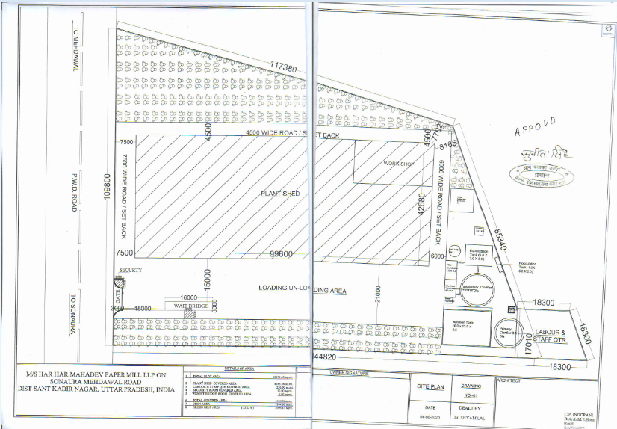

***Source:*** *Data/ Information provided by the company*

1. **BUILDING & CIVIL WORKS**

For Building and Civil Works, company has engaged Architect **C.P. Hingorani** to develop the building plans. However, the same has not been approved by the any competent authority.

Company has also taken detailed estimate for construction according to which it total proposed shed area is 4050.93 Sq. mt/ 43605 Sq. ft and RCC area is 1627.1 Sq. mt/17514.42 Sq. ft. as shown in plan above.

The total cost of civil work proposed to be Rs 5.24 Crores (as per quotation) which comes to be 842.33 per Sq. feet and appears reasonable as per the type of construction and statement of construction estimate shown to us.

As per the details provided by the Company, the boundary walls have been erected and civil materials like cement, Iron bars and other building materials have been arriving on the site for the construction purpose.

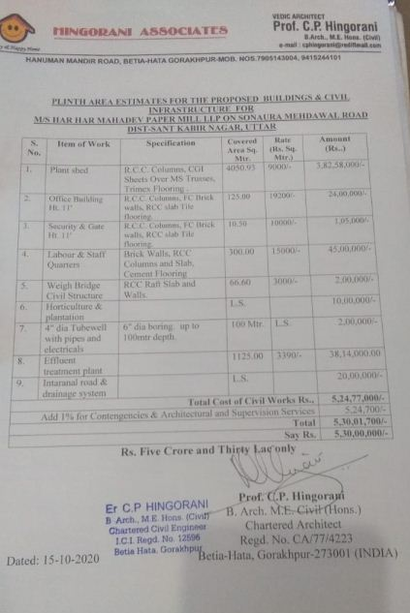**Table - BUIDLING & CIVIL WORK QUOTATION**

***Source:*** *Data/ Information provided by the company*

1. **PHOTOGRAPHS OF THE PROJECT** 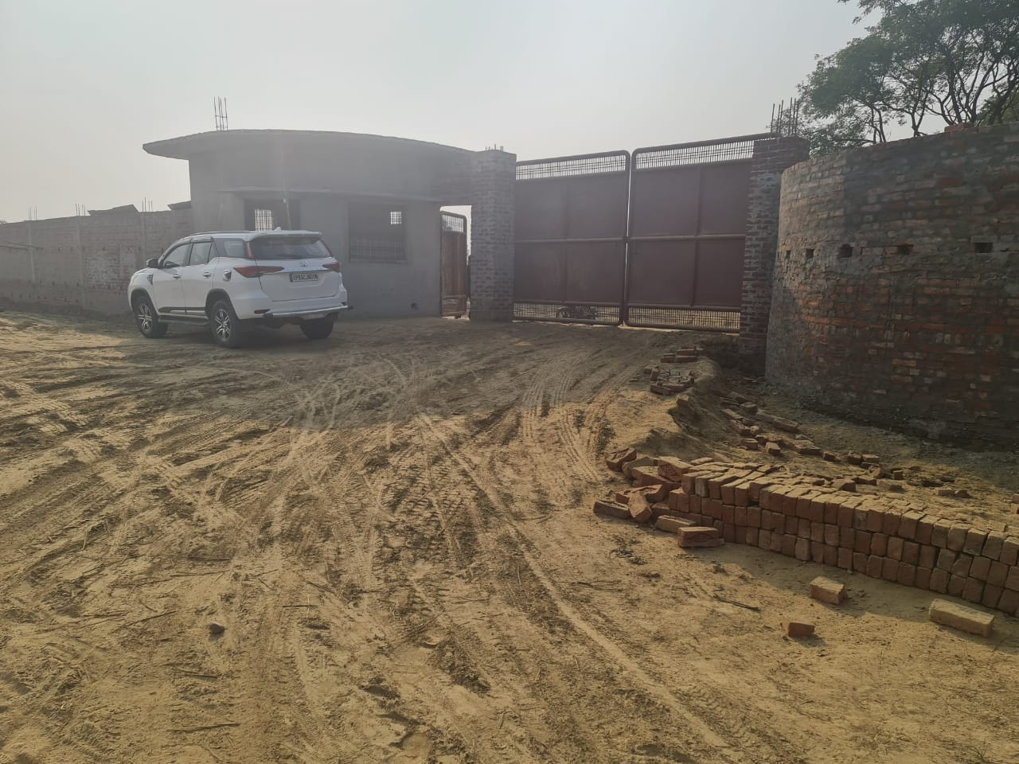

***Source-*** *Data/information provided by the company*

1. **PLANT & MACHINERY DETAILS**

For complete setup and assistance for proposed unit, the promoters have decided to go with ***‘Excel Paper Tech Engineers’*** a very renowned manufacturer and supplier of Kraft Paper Plant and having well engineered technology and who will look after from the stretch i.e. from construction of shed and building to procurement and installation of machineries required to trial run of production. The estimated cost of whole Plant and Machinery would be Rs 15.12 Crores(as per quotation). A quotation has been attached that is provided by the Excel Paper Tech Engineers below.

Apart of above, as per the discussion with concerned officials of Excel Paper Tech Engineers some extra costs that would be incurred are for instance, Transport cost Rs 60-70 lakhs (approx.), accommodation charges Rs 20 lakhs (approx.), Other MILD expenses Rs 10 lakhs (approx.).

1. UTILITIES
2. **Electricity: -**

Power requirement is 2600 KVA.

Steam & Fuel is required for steam generation. The steam requirement is about 2.3 tons for one ton of paper production.

1. **Water: -**

Water is required for pulp washing, steam raising and general cleaning. 200 Kl ground water is required per day for cleaning.

1. **Transportation: -**

Company has planned to transport their product to the market with the help of hired vehicles. These vehicles will carry the products to the required places when needed.

1. **Pollution Control Management: -**

The unit has planned to dispose off the wastes in the following manners:

***Air Pollution Control:***

* The boiler has been provided with multi dust collector to maintain particulate matter emissions within permissible limit.
* CPCB guidelines for Fugitive dust emission control are being / will be followed.
* All the roads are concreted to control the fugitive dust emissions.
* Ambient air quality and stack emissions are regularly monitored and effective controls exercised, so as to keep the emission within the statutory limits and same will be continued.

***Water Pollution Control:***

* The waste water generated from the process is being/will be treated in ETP.
* Effluent discharge parameter values are being/ will be kept under the prescribed limits, so there will be minimal impact on the groundwater.
* The 100% of the waste water produced in the production process will be reused in other processes of production.

***Noise Pollution Control:***

* The unit has made efforts in minimizing the noise pollution by installing silent generators and less noise making machines. The machines installed are of latest technologies which consider the elimination of noise pollution.
* Proper maintenance, oiling and greasing of machines at regular intervals is being/will be done to reduce generation of noise.
* Regular monitoring of noise level is being/will be carried out.

***Solid Waste Control:***

* The ash collected from machineries will be temporarily stored in a shed or chamber closed from at least three sides and a roof, with access only from the front side for ash removal purpose.
* The ash will be disposed of in such a way that the secondary emission of ash does not occur.
* Other solid wastes will be used in filling of the uneven factory land.
* Apart from the above measures, Plantation will be done on the unused factory land to minimize the effect of pollution. Plantation of selected tree species, which are suitable to area condition, has been done for attenuation of air & noise pollution.

|  |  |
| --- | --- |
| **PART F** | **PLANT TECHNICAL DETAILS** |

1. **MANUFACTURING PROCESS**

The process to be adopted for manufacturing Kraft paper from waste paper is the conventional method of mechanical pulping and it is a well-established one. The major stages involved in the process are pulping, stock preparation and paper making.

PULPING:

Waste paper is sorted manually to remove impurities and then transported to the hydro pulper. With the addition of water in the hydra pulper the waste paper is slushed to form pulp. The pulp from the hydro pulper at 4% consistency is screened through a Johnson screen at a consistency level of 1%. Further impurities like stapler pins, etc. are removed in the sand trap. To remove light plastic articles, the pulp is sent through turbo separator after which the pulp is thickened to 4% consistency level and fed through refiners to obtain the requisite degree of fineness. The waste paper pulp is then taken to the next section.

STOCK PREPARATION:

In this section, the pulp is treated with chemicals, necessary filling materials and dyes are added to it. The various chemicals and dyes added to the pulp are normally Alum, Rosin, Caustic Soda, Silicate, Acid orange, Methyl Violet, Malaite Green, Direct Black etc. to obtain various grades of paper.

The requirement of various chemicals and the quality varies with variety of paper to be produced. The treated pulp which is ready for paper making is kept in the stock chest with continuous stirring up with the help of agitators. The pulp stock is then sent to head box of paper machine after cleaning it through centri-cleaners to remove heavy particles, additives etc.

PAPER MAKING:

Paper making process consists of two stages-

1. Wet Stage
2. Dry Stage

Machineries in the wet stage are generally called wet part and similarly dry stage machineries called as dry part.

In the wet part, an endless wire mesh running on rolls will continuously drain water from the pulp. Pulp enters the paper machine Head Box at a consistency of 0.5% to 1%. Application of vacuum in the Hydrofoils positioned under the wire enables removal of water. The pulp now forms into a wet mat. This is now lifted off and sent through a press for further removal of water.

The web is now dried over steam heated MG cylinder where the dry part starts. The paper obtained after drying is the final product with monoglazing. The final moisture context in paper is about 3 to 5%. Final product is slit and rewound paper core into reels and labelled.

Various grades of paper with different grammage are manufactured by adjusting the valve and sluices at the Head Box.

The plant can be run continuously for a given variety of paper without interruption. However, to change over from one variety to other, the paper making operation has to be interrupted depending on the changes required to be made either in pulping stage or in stock preparation.

1. **PROCESS FLOW CHART**

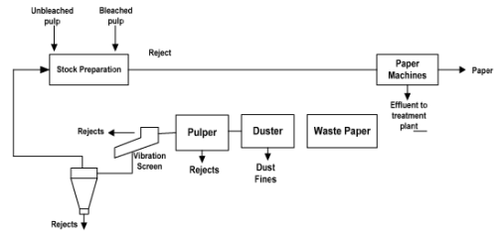

*Source- Data/information provided by the company*

1. RAW MATERIAL USED:

As per the information provided by the company, Kraft waste and No.1 white cutting waste are two varieties of the major raw materials used in the Kraft Paper manufacturing.

As per the information provided by the company, the waste paper is available on demand from local as well as imported. Company is having plan to buy the raw material at a reasonable price on spot. So, company has not identified any specific suppliers of raw material. Banian cutting pulp is also added based on the high burst factor requirement in the final product. Apart from paper, a few chemicals and dyers are required in small quantities.

1. MANPOWER REQUIREMENT: -

The total required manpower as estimated by the company for the proposed project is 50 resources. The annual tentative expenditure as projected by the Company is INR 23.63 lakhs for FY 2021-22 (including labour wages and staff Salaries) amounts to about 2.00% of the sales of the company. Thereafter, an escalation of 20% per annum has been assumed on the Employment Benefit Expenses as per general paper industry standard.

The detailed manpower requirement as identified by the Project Company is mentioned below: -

**Table 5: Plant Workers requirement**

|  |  |  |  |  |  |
| --- | --- | --- | --- | --- | --- |
| **Particular** | **Production In-charge** | **Skilled Manpower** | **Unskilled Labour** | **Supervisor** | **Total** |
| Production Workers | 2 | 10 | 20 | 5 | 37 |

**Table 6: Administrative Staff requirement**

|  |  |  |  |  |  |  |
| --- | --- | --- | --- | --- | --- | --- |
| **Particular** | **Sales Manager** | **Accountant** | **Clerk** | **Peon** | **Guards** | **Total** |
| Administrative Staff | 4 | 1 | 2 | 2 | 4 | 13 |

|  |  |
| --- | --- |
| **PART G** | **PRODUCT PROFILE** |

1. **PRODUCT DETAILS: -**

This factory will be producing the Kraft paper range from 80 GSM to 180 GSM which will be used for the manufacturing of corrugated boxes.

Kraft paper, Brown paper or wrapping paper is made from variety of raw materials, e.g. bagasse, ground wood, straw, waste paper, in various combinations or alone, waste carton boxes etc. 'Kraft' mean strength and that is why its name. It is leading paper for wrapping heavy bundles. After corrugation it is used in many types of packing and it is an important packaging material.

1. **SUPPLY CHANNEL: -**

Company products will be supplied in the market with the help of Brokers. Company will sell its products to the brokers who in their turn will sell it to the market and will realize the cash receivable from the debtors within in 70 days (approx.)

**Table 7:- LIST OF DISTRIBUTORS**

|  |  |  |
| --- | --- | --- |
| **SR NO.** | **NAME OF DISTRIBUTORS** | **ADDRESS** |
| 1 | Harhar Mahadev Packers | Omkar Nagar maniram Gorakhpur |
| 2 | Dewan Packers | Gida, Gorakhpur |
| 3 | Shiva Packers | Not Provided |
| 4 | Bala Ji Packers | Not Provided |
| 5 | Purvanchal Packers | Bargadwa Gorakhpur |
| 6 | Jaiswal Packers | Not Provided |

1. **PRODUCT MARKETTING & SELLING STRATEGIES: -**

As per the information provided by the company and consultant, the company will be producing quality 100 TPD 80 to 180 GSM Kraft paper with latest technology machineries and will sell at a competitive price.

As per information obtained from the company and consultant, they will be selling product through the brokers at a commission of 15-20 paise per kg. Then brokers or distributors are already having business relationship with promoters. As promoters are already purchasing Kraft paper from the brokers earlier. Now these brokers will also sell the Kraft paper of the Harhar Mahadev Mills in the market.

1. **PICTURES OF THE PROPOSED PRODUCT**





***Source*** *- Pics obtained from the Indiamart.com*

|  |  |
| --- | --- |
| **PART H** | **INDUSTRY OVERVIEW of Auto Prodcuts** |