**REPORT FORMAT:** V-L7 | Version: 5.0\_2017

**File No.: VIS(2021-22)-PL1025-870-1128 Dated: 14.05.2022**

**VALUATION REPORT**

**OF**

**GROUP HOUSING SOCIETY**

**GIRIRAJ DREAMS**

**SITUATED AT**

**GIRIRAJ DREAMS, C.T.S 271 TO 279, 76, 2026, VILLAGE-NAUPADA, SWAMI VIVEKANAND ROAD, THANE(W)-400602, TALUKA & DISTRICT-THANE**

**DEVELOPED & PROMOTED BY**

**M/S. PRIDE DREAM REALTOR PVT.LTD.**

**A/C. M/S. PRIDE DREAM REALTOR PVT.LTD.**

**REPORT PREPARED FOR**

**STATE BANK OF INDIA, SME WAGLE INDUSTRIAL ESTATE BRANCH (01053), 101, 1ST FLOOR, BHOOMI VELOCITY, B-39, ROAD NO.23, WAGLE ESTATE, THANE**

***\*\*Important - In case of any query/ issue or escalation you may please contact Incident Manager***

***at valuers@rkassociates.org. We will appreciate your feedback in order to improve our services.***

***NOTE: As per IBA Guidelines please provide your feedback on the report within 15 days of its submission after which report will be considered to be correct.***

|  |  |  |
| --- | --- | --- |
| **TABLE OF CONTENTS** | | |
| **SECTIONS** | **PARTICULARS** | **PAGE NO.** |
| **Part A** | **SUMMARY OF THE VALUATION REPORT** |  |
| 1. General Details of the Project | 03 |
| 1. Brief Description of the Property Under Valuation | 04 |
| 1. Valuation Summary | 10 |
| 1. Enclosures | 10 |
| **Part B** | **RKA FORMAT OF VALUATION REPORT** |  |
| 1. Introduction | 11 |
| 1. Physical Characteristics of the Property | 11 |
| 1. Boundary Schedule of the property | 12 |
| 1. Town Planning/ Zoning Parameters | 13 |
| 1. Document Details and Legal Aspects of the Property | 14 |
| 1. Economic Aspects of the Property | 14 |
| 1. Socio - Cultural Aspects of the Property | 15 |
| 1. Functional And Utilitarian Services, Facilities & Amenities | 15 |
| 1. Infrastructure Availability | 16 |
| 1. Marketability Aspects of the Property | 16 |
| 1. Engineering And Technology Aspects of the Property | 16 |
| 1. Environmental Factors | 17 |
| 1. Architectural And Aesthetic Quality of the Property | 17 |
| 1. Project Details | 17 |
| 1. Valuation | 18 |
| 1. Declaration | 19 |
| 1. Valuation Company Details | 19 |
| 1. Enclosed Documents | 19 |
| **Part C** | **AREA DESCRIPTION OF THE PROPERTY** |  |
|  | 1. Land & Building Area Details | 20 |
| **Part D** | **PROJECT APPROVAL DETAILS** | 25 |
| **Part E** | **VALUATION ASSESSMENT OF THE PROPERTY** | 26 |
|  | Enclosure – 1: Valuer’s Remarks | 41 |
| Enclosure – 2: Google Map Location | 43 |
| Enclosure – 3: Photographs | 44 |
| Enclosure – 4: Price Trend References | 48 |

|  |  |
| --- | --- |
| **PART A** | **SUMMARY OF THE VALUATION REPORT** |

|  |  |  |  |  |  |  |
| --- | --- | --- | --- | --- | --- | --- |
| **S.NO.** | **CONTENTS** | **DESCRIPTION** | | | | |
|  | **GENERAL DETAILS** | | | | | |
|  | Report prepared for | Bank | | | | |
|  | Name & Address of Organization | State Bank Of India, SME Wagle Industrial Estate Branch (01053), 101, 1st Floor, Bhoomi Velocity, B-39, Road No.23, Wagle Estate, Thane | | | | |
|  | Name of Borrower unit | M/s. Pride dream realtor Pvt. ltd. | | | | |
|  | Name of Property Owner | M/s. Pride dream realtor Pvt. ltd. | | | | |
|  | Address & Phone Number of the owner | Registered Office: 204, 2nd Floor, B-Wing, Sai Tirth Tower, Siddhaarth Nagar, Kopri Colony, Thane East, Mumbai | | | | |
|  | Type of the Property | Group Housing Society | | | | |
|  | Type of Loan | Project Financing | | | | |
|  | Type of Valuation | Group Housing Society Value | | | | |
|  | Report Type | Plain Asset Valuation | | | | |
|  | Date of Inspection of the Property | 3 March 2022 | | | | |
|  | Date of Valuation Report | 14 May 2022 | | | | |
|  | Surveyed in presence of | Developer's Representative | | Mr. Nitin Karia  🕿 9920659593 | | |
|  | Purpose of the Valuation | Periodic Re-valuation | | | | |
|  | Scope of the Report | Non Binding Opinion on General Prospective Valuation Assessment of the Property identified by Property owner or through its representative | | | | |
|  | Out-of-Scope of Report | 1. Verification of authenticity of documents from originals or cross checking from any Govt. deptt. 2. Legal aspects of the property. 3. Identification of the property is only limited to cross verification from its boundaries at site if mentioned in the provided documents. 4. Getting cizra map or coordination with revenue officers for site identification. 5. Measurement of the property as a whole. 6. Measurement is only limited upto sample random measurement. 7. Drawing Map & design of the property. | | | | |
|  | Documents provided for perusal | **Documents Requested** | | **Documents Provided** | | **Documents Reference No.** |
| Total **04** documents requested. | | Total **04** documents provided. | | **04** |
| Property Title document | | Approve Maps  (3 No.) | | Dated:  30/04/2021 |
| Project Approval Documents | | Charter Accountant Certificate | | Dated:  17/02/2022 |
| Approved Map | | Commencement Certificate | | Dated: 30/04/2021 |
| Structural Stability Certicate | | NOC from Fire Service Department | | Dated:  21/10/2019 |
| Copy of RERA Registration Certificate | | RERA certificate | | Dated:  04/09/2018 |
|  | Identification of the property |  | Cross checked from boundaries of the property mentioned in the deed | | | |
|  | Done from the name plate displayed on the property | | | |
|  | Identified by the Bank representative | | | |
|  | Identified by the Owner/ Owner’s representative | | | |
|  | Enquired from local residents/ public | | | |
|  | Identification of the property could not be done properly | | | |
|  | Survey was not done | | ---- | |

|  |  |
| --- | --- |
|  | **BRIEF DESCRIPTION OF THE PROPERTY UNDER VALUATION** |
|  | **C:\Users\engineer11\Desktop\pdrl\pdrl\pdrl\VIS(2021-22)-PL1025-870-1128_printing_1650447088\uploads\VIS(2021-22)-PL1025-870-1128\SiteImage\IMG-20220304-WA0052.jpg**  ***Snapshot of the Asset/ Property Under Valuation***  **Brief description of the Property under Valuation:** This Valuation report is prepared for the Group Housing Project named as **“Giriraj Dreams”** being developed at the aforesaid address having **total** **land area admeasuring 2830.47 sq.mtr.** asper the approved Map and the Copy of TIR dated: -21/06/2018 which was Grasped by us from Maharastra RERA site.  The subject Property is owned by State bank of India Employee Co-operative Housing Society Ltd, Thane and being developed by M/s. Pride dream Realtors Pvt. Ltd., the RERA for the subject project is valid till 31/12/2022 whereas the developer has applied for the renewal of the Plan as per the information during the site survey. Keeping the renewal of the plan in consideration, the completion is expected to be delayed and is forecasted till 2024 (for the complete Construction of 27th floor with Occupational Certificate).  The developer of the project has proposed to develop a residential Building on the said land having total land area admeasuring ~2830.47 sq.mtr. The complete project comprising of 106 residential units and comprises of only one tower.    **Purpose of Valuation:**  M/s. Pride Dream Realtors Pvt. Ltd. has mortgage/ hypothecate this project to State Bank Of India, SME Wagle Industrial Estate Branch (01053), 101, 1st Floor, Bhoomi Velocity, B-39, Road No.23, Wagle Estate, Thane for obtaining financial assistance. The Bank has approached us to provide the Fair market value of the Project for the periodic valuation. As per the details provided by the company, out of the total proposed 106 units, company has already booked 32 dwelling units as on date of site survey and balance 23 dwelling units are yet to be sold. For the Refugee, the total units are 03 and apart from all there are 48 rehab units for the members of the owner society. As per the purpose of the report and the current status of the Project in this Valuation Report, assessment of the Valuation of unsold units has been done as per market approach and from which total balance cost to be incurred and other charges for completing the sale of units has been deducted, to arrive at the Fair Market Valuation of the Project and apart from that we have also created cash flow model for booked units receivables as per data/ information provided by the Bank.  Booked & unsold units have been taken on the basis of the Inventory Sheet provided to us by the Bank which has been relied upon in good faith. The Financer is advised to legally check the ownership status of these units. Legal & other ownership rights distribution if any has not been considered in this report since no such thing has been informed to us by the builder company or Bank.  **Statutory Approvals & NOC’s:**  The developer has obtained most of the statutory approvals & NOC’s from competent authorities as per the information provided to us at the site. These NOC’s and Approvals are further described in Part-C **(Statutory Approvals & NOCs Details).** However, few of the documents list below were not produced to us: -   1. Height Clearance NOC from AAI 2. NOC from Pollution Control Board 3. Electricity & Water Assurance Certificate   **Construction Status:**  During our site survey on dated March 03, 2022, the construction status of the “Giriraj Dreams” project is as follows. The RCC frame structure and Brick work up to 23rd floor is complete whereas the slab work of 24th to 26th floor was in progress during the site visit. The Above construction status is as per the information provided during site survey and data available for the subject project.  **Project Location:**  The subject project is located in the Navpauda near Malhar Cinema, Thane and the subject project has access from 30 ft. wide Swami Vivekananda Road. The nearest main road to the Subject Property is Gokhale Road about 250mtr. from the subject project. There are Several other group housing projects present in the subject locality. The subject locality is a developed area and infrastructure facilities are available in the close vicinity. |

|  |  |
| --- | --- |
|  | **VALUATION METHODOLOGY** |
|  | **Market Value:**  Comparable Market Sales Approach & Residual Method.  **Description:**  The Valuation of the unsold inventory has been carried out on the basis of ‘Comparable Market Sale Approach’ and we believe that all these unsold inventories would be monetized or sold out in micro market in Three years. Therefore, for the Valuation purpose we have assumed that based on current market condition and market demand, these unsold inventories can be monetized or sold out over a three year span for the project and accordingly we have calculated the Net Present Value (Discounted Cash Flow Method) of the project by giving discount for the market & business risk. |
| **Market Rate Adopted:**  As per our extensive market research & information available in the public domain, conversations with market participants, we came to know that secondary market for the units of the subject project is not developed as yet. Hence, for the valuation purpose we have adopted the rates of developer to be the market rate of the flats of subject project i.e. **Rs.21,000/- to Rs.22,500/- per sq.ft. on Usable Area** for residential units. |
| **Inventory Under Valuation:**  The developer of the project has mortgage this project to the bank for the financial assistance for the following unsold inventory:    All the units’ details have been taken on the basis of the Inventory Sheet provided to us by the Client which has been relied upon in good faith. The bank is advised to legally check the status of these units. Legal & other ownership rights distribution if any has not been considered in this report since no such thing was informed to us by the Bank. |
| **Inventory Absorptions Rate:** An absorption rate provides insight on the rate at which unsold inventory will sell. It will depend upon the demand and supply scenario in the micro market. Therefore, after looking at the current real estate market senario, we are of the view that subject unsold inventory should get absorbed in span of three years time depdening on the phase of the project. |
| **Appreciation in sale price:**  To arrive at the expected appreciation in the sale price of unsold inventory we have taken care of the following points:-   * The supply and demand dynamics of a particular location. * The interest rates banks charge for home loans, meaning the cost of borrowing. * Growth in local population, leading to increased demand. * Development of basic infrastructure like School, Hospital, Transportation & Local Market.   Hence considering all the above factors, we have taken 2.5% appreciation in unsold inventory for the year after the construction of the project as with time more units gets booked over time & occpancy will increases thus resulting in rate increase over time. |
| **Discount Rate:**  As per the international Valuation Standard hand book, **‘**The rate at which the forecasted cash flow is discounted should reflect not only the time value of money, but also the risks associated with the type of cashflow and the future operations of the asset’.  The discount rate or WACC has been taken as per the discussion with the market participants based on the current real estate markets scenario in Mumbai and based on the current rate of lending by the Indian scheduled banks in real estate sector. The discount rate for the projects depends upon the liquidity factor & Demand and supply gap in the market. Presently Mumbai real estate is considered to be Stable and the realisation of the units in the redevelopment project is considered to be good. But the return on investment in such project is low as compare to new developed society due to availability of 60-70% of the total unit for sale .In Banking also the minimum ROI on real estate Projects is prevailing from minimum 12% to 18% depending upon the Project profile and creditworthiness of the developer company. Therefore we have taken discount rate or ROR as 15.84% which any buyer would be expecting in present market scenario & condition.  For the calculation of discount rate we have assumed 25% of capex as debt and 75% of capex as equity @ 12.50% & 16.7% interest rate. 16.7% of equity interest rate is adopted considering the Low risk involved in such real estate projects in present scenario. By this WACC arrived is 15.67%. |
| **Balance Cost to be incurred for construction:**  The Balance cost of the project has been taken on the basis of CA Certificate provided by the company and we have relied upon it in good faith. Further the balance cost incurred is adjusted accordingly to get the incurred Construction cost on 03/03/2022 (i.e. on Site Visit date). |

|  |  |  |
| --- | --- | --- |
|  | **VALUATION SUMMARY** | |
|  | Total Govt. Guideline Value | **NA** |
|  | Total Prospective Fair Market Value | **Rs.45,00,00,000/-** |
|  | Total Expected Realizable/ Fetch Value | **Rs.36,00,00,000/-** |
|  | Total Expected Distress/ Forced Sale Value | **Rs.31,50,00,000/-** |
|  | Valuation of structure for Insurance purpose | **NA** |
|  | **ENCLOSURES** | |
|  | **Part B** | **Valuation Report as per RKA Format Annexure-II** |
|  | **Part C** | **Area description of the Property** |
|  | **Part D** | **Valuation Assessment of the Property** |
|  | Enclosure 1 | Valuer’s Remark - Page No.37-38 |
|  | Enclosure 2 | Screenshot of the price trend references of the similar related properties available on public domain - Page No.45-47 |
|  | Enclosure 3 | Google Map – Page No.39 |
|  | Enclosure 4 | Photographs – Pages 05 |
|  | Enclosure 5 | Copy of Circle Rate – Pages 01 |
|  | Enclosure 6 | Survey Summary Sheet – Pages x |
|  | Enclosure 7 | Copy of relevant papers from the property documents referred in the Valuation – Pages 12 |

|  |  |
| --- | --- |
| **PART B** | **VALUATION REPORT AS PER RKA FORMAT** |

|  |  |
| --- | --- |
| Name & Address of Branch: | State Bank Of India, SME Wagle Industrial Estate Branch (01053), 101, 1st Floor, Bhoomi Velocity, B-39, Road No.23, Wagle Estate, Thane |
| Name of Customer (s)/ Borrower Unit | M/s. Pride dream realtor Pvt. ltd. |

|  |  |  |
| --- | --- | --- |
| **S.NO.** | **CONTENTS** | **DESCRIPTION** |
|  | **INTRODUCTION** | |
|  | Name of Property Owner | M/s. Pride dream realtor Pvt. ltd. |
|  | Address & Phone Number of the Owner | Registered Office: A-26, New Krishna Park, Najafgarh Road, New Delhi |
|  | Purpose of the Valuation | Distress Sale for NPA a/c |
|  | Date of Inspection of the Property | 4 April 2022 |
|  | Date of Valuation Report | 18 May 2022 |
|  | Name of the Developer of the Property | M/s. Pride dream realtor Pvt. ltd. |
| Type of Developer | Private developer promoted |

|  |  |  |  |  |  |  |  |
| --- | --- | --- | --- | --- | --- | --- | --- |
|  | **PHYSICAL CHARACTERISTICS OF THE PROPERTY** | | | | | | |
|  | **Location attribute of the property** | | | | | | |
|  | Nearby Landmark | | Near Malhar Cinema | | | | |
|  | Postal Address of the Property | | Giriraj Dreams, C.T.S 271 To 279, 76, 2026, Village-Naupada, Swami Vivekanand Road, Thane(W)-400602, Taluka & District-Thane | | | | |
|  | Area of the Plot/ Land as per approved map | | Total Project Land: 2830.47 sq.mtr./30,467 sq.ft. | | | | |
| *Also please refer to Part-B Area description of the property. Area measurements considered in the Valuation Report is adopted from relevant approved documents or actual site measurement whichever is less. Verification of the area measurement of the property is done only based on sample random checking.* | | | | |
|  | Type of Land | | Solid | | | | |
|  | Independent access/ approach to the property | | Clear independent access is available | | | | |
|  | Google Map Location of the Property with a neighborhood layout map | | Enclosed with the Report | | | | |
| Coordinates or URL: 19°11'32.6"N 72°58'14.7"E | | | | |
|  | Details of the roads abutting the property | | | | | | |
|  | * Main Road Name & Width | | Gokhale Road | | | 40 ft. | |
|  | * Front Road Name & width | | Swami Vivekanand Road | | | 30 ft. | |
|  | * Type of Approach Road | | Bituminous Road | | | | |
|  | * Distance from the Main Road | | 250 mtr. | | | | |
|  | Description of adjoining property | | Other group housing projects and colony nearby | | | | |
|  | Plot No./ Survey No. | | CTS 271 TO 279, 76, 2026 | | | | |
|  | Mauza/ Block | | Naupada | | | --- | |
|  | Sub registrar | | Thane | | | | |
|  | District | | Thane | | | | |
|  | Any other aspect | | | | | | |
|  | * City Categorization | | Metro City | | | Urban | |
|  | * Characteristics of the locality | | Good | | | Within well developed area | |
|  | * Property location classification | | Ordinary location within the locality | | None | | None |
|  | * Property Facing | | West Facing | | | | |
|  | Covered Built-up área description  *(Plinth/ Carpet/ Saleable Area)* | | Please refer building sheet | | | | |
| *Also please refer to Part B - Area description of the property. Area measurements considered in the Valuation Report is adopted from relevant approved documents or actual site measurement whichever is less. Verification of the area measurement of the property is done only based on sample random checking..* | | | | |
|  | **Boundaries schedule of the Property** | | | | | | |
|  | Are Boundaries matched | | No, boundaries are not mentioned in the documents. | | | | |
|  | **Directions** | **As per Sale Deed/TIR** | | **Actual found at Site** | | | |
| East | S.No.41 Hissa No.5 and by 30ft. wide road | | Road | | | |
| West | S.No.41 Hissa No.4 Part and by S.No.38 Hissa No. 1 Part | | Mani Manek CHS and Road | | | |
| North | S.No.41 Hissa No.4 Part | | Road | | | |
| South | S.No. 38 Hissa No.2 & T.P.S 30ft wide road | | Neelkamal CHS | | | |

|  |  |  |  |
| --- | --- | --- | --- |
|  | **TOWN PLANNING / ZONING PARAMETERS** | | |
|  | Master Plan provisions related to property in terms of Land use | Residential Group Housing Society | |
| 1. Any conversion of land use done | No | |
| 1. Current activity done in the property | Construction of Group Housing Society is going on at the site | |
| 1. Is property usage as per applicable zoning | Yes is being used for construction of residential project | |
| 1. Any notification on change of zoning regulation | NA | |
| 1. Street Notification | Residential | |
|  | Provision of Building by-laws as applicable | **PERMITTED** | **CONSUMED** |
| 1. FAR/ FSI | Please refer to area chart description | Please refer to area chart description |
| 1. Ground coverage | ----------------do------------- | ----------------do------------- |
| 1. Number of floors | ----------------do------------- | ----------------do------------- |
| 1. Height restrictions | ----------------do------------- | ----------------do------------- |
| 1. Front/ Back/ Side Setback | ----------------do------------- | ----------------do------------- |
|  | Status of Completion/ Occupational certificate | Under construction | Under construction |
|  | Comment on unauthorized construction if any | The constructed towers are appeared to be constructed as per the approved map | |
|  | Comment on Transferability of developmental rights | As per regulation of Thane Municipal Corporation | |
|  | 1. Planning Area/ Zone | Mumbai metropolitan Region | |
| 1. Master Plan currently in force | Regional Plan of Mumbai Metropolitan Region, 2021 | |
| 1. Municipal limits | Thane Municipal Corporation | |
|  | Developmental controls/ Authority | Thane Municipal Corporation | |
|  | Zoning regulations | Residential Group Housing Project | |
|  | Comment on the surrounding land uses & adjoining properties in terms of uses | All adjacent properties are used for residential purpose | |
|  | Comment of Demolition proceedings if any | No information available to us | |
|  | Comment on Compounding/ Regularization proceedings | No information available to us | |
|  | Any other aspect | | |
| 1. Any information on encroachment | No | |
| 1. Is the area part of unauthorized area/ colony | No (As per general information available) | |

|  |  |  |  |  |  |  |
| --- | --- | --- | --- | --- | --- | --- |
|  | **DOCUMENT DETAILS AND LEGAL ASPECTS OF THE PROPERTY** | | | | | |
|  | Ownership documents provided | Copy of TIRs | -- | | | -- |
|  | Names of the Legal Owner/s | M/s. Pride dream realtor Pvt. ltd. | | | | |
|  | Constitution of the Property | Free hold, complete transferable rights | | | | |
|  | Agreement of easement if any | Not required | | | | |
|  | Notice of acquisition if any and area under acquisition | No, as per general information available in the public domain | | | | |
|  | Notification of road widening if any and area under acquisition | No, as per general information available in the public domain | | | | |
|  | Heritage restrictions, if any | No | | | | |
|  | Comment on Transferability of the property ownership | Free hold, complete transferable rights | | | | |
|  | Comment on existing mortgages/ charges/ encumbrances on the property, if any | No Information available to us. Bank to obtain details from the Developer | | | ---- | |
|  | Comment on whether the owners of the property have issued any guarantee *(personal or corporate)* as the case may be | No Information available to us. Bank to obtain details from the Developer | | | ---- | |
|  | **Building plan sanction:** | | | | | |
| 1. Authority approving the plan | Thane Municipal Corporation | | | | |
| 1. Name of the office of the Authority | Thane Municipal Corporation | | | | |
| 1. Any violation from the approved Building Plan | Not applicable since the construction work is in progress | | | | |
|  | Whether Property is Agricultural Land if yes, any conversion is contemplated | No not an agricultural property | | | | |
|  | Whether the property SARFAESI complaint | Yes | | | | |
|  | 1. Information regarding municipal taxes *(property tax, water tax, electricity bill)* | Tax name | | NA | | |
| Receipt number | | NA | | |
| Receipt in the name of | | NA | | |
| Tax amount | | NA | | |
| 1. Observation on Dispute or Dues if any in payment of bills/ taxes | Not Known to us | | | | |
| 1. Is property tax been paid for this property | NA | | | | |
| 1. Property or Tax Id No. | NA | | | | |
|  | Whether entire piece of land on which the unit is set up / property is situated has been mortgaged or to be mortgaged | No information available to us | | | | |
|  | Qualification in TIR/Mitigation suggested if any | None | | | | |
|  | Any other aspect | | | | | |
| 1. Since how long owners owing the Property | 58 years | | | | |
| 1. Year of Acquisition/ Purchase | 1964 | | | | |
| 1. Property presently occupied/ possessed by | Developer | | | | |
| 1. Title verification | To be done by the competent Advocate | | | | |
| 1. Details of leases if any | NA | | | | |

|  |  |  |
| --- | --- | --- |
|  | **ECONOMIC ASPECTS OF THE PROPERTY** | |
|  | Reasonable letting value/ Expected market monthly rental | Not Applicable |
|  | Is property presently on rent | Not Applicable |
| 1. Number of tenants | Not Applicable |
| 1. Since how long lease is in place | Not Applicable |
| 1. Status of tenancy right | Not Applicable |
| 1. Amount of monthly rent received | Not Applicable |
|  | Taxes and other outgoing | Refer Outflow sheet attached in the later part of report |
|  | Property Insurance details | Developer/Owner to provide this information |
|  | Monthly maintenance charges payable | Developer/Owner to provide this information |
|  | Security charges, etc. | Developer/Owner to provide this information |
|  | Any other aspect | NA |

|  |  |  |
| --- | --- | --- |
|  | **SOCIO - CULTURAL ASPECTS OF THE PROPERTY** | |
|  | Descriptive account of the location of the property in terms of Social structure of the area in terms of population, social stratification, regional origin, age groups, economic levels, location of slums/ squatter settlements nearby, etc. | Medium Income Group |
|  | Whether property belongs to social infrastructure like hospital, school, old age homes etc. | No |

|  |  |  |  |  |  |  |  |
| --- | --- | --- | --- | --- | --- | --- | --- |
|  | **FUNCTIONAL AND UTILITARIAN SERVICES, FACILITIES & AMENITIES** | | | | | | |
|  | Description of the functionality & utility of the property in terms of: | | | | | | |
|  | 1. Space allocation | | | | Yes (Proposed) | | |
| 1. Storage spaces | | | | Yes (Proposed) | | |
| 1. Utility of spaces provided within the building | | | | Yes (Proposed) | | |
| 1. Car parking facilities | | | | Yes (Proposed) | | |
| 1. Balconies | | | | Yes (Proposed) | | |
|  | Any other aspect | | | | | | |
|  | 1. Drainage arrangements | | | | Yes (Proposed) | | |
| 1. Water Treatment Plant | | | | Yes (Proposed) | | |
| 1. Power Supply arrangements | | Permanent | | Will be obtained by individual flat owners as per sanctioned load | | |
| Auxiliary | | Yes (Proposed) | | |
| 1. HVAC system | | | | No | | |
| 1. Security provisions | | | | Yes/ Private security guards | | |
| 1. Lift/ Elevators | | | | Yes, will be installed | | |
| 1. Compound wall/ Main Gate | | | | Yes | | |
| 1. Whether gated society | | | | Yes | | |
| 1. Internal development | | | | | | |
| Garden/ Park/ Land scraping | Water bodies | | Internal roads | | Pavements | Boundary Wall |
| Yes | No | | No | | Yes | Yes |

|  |  |  |  |  |  |  |  |  |
| --- | --- | --- | --- | --- | --- | --- | --- | --- |
|  | **INFRASTRUCTURE AVAILABILITY** | | | | | | | |
|  | Description of Aqua Infrastructure availability in terms of: | | | | | | | |
|  | 1. Water Supply | | | | Existed in the area | | | |
| 1. Sewerage/ sanitation system | | | | Underground | | | |
| 1. Storm water drainage | | | | Yes (Proposed) | | | |
|  | Description of other Physical Infrastructure facilities in terms of: | | | | | | | |
|  | 1. Solid waste management | | | | No information Available | | | |
| 1. Electricity | | | | Yes | | | |
| 1. Road and Public Transport connectivity | | | | Yes | | | |
| 1. Availability of other public utilities nearby | | | | Transport, Market, Hospital etc. available at some distance | | | |
|  | Proximity & availability of civic amenities & social infrastructure | | | | | | | |
|  | School | Hospital | Market | Bus Stop | | Railway Station | Metro | Airport |
| 200 m | 280 m | 1.1 Km | 2 Km | | 1.8 Km | 23 km | 20 Km |
|  | Availability of recreation facilities (parks, open spaces etc.) | | | Yes ample recreational facilities are available in the vicinity. | | | | |

|  |  |  |  |
| --- | --- | --- | --- |
|  | **MARKETABILITY ASPECTS OF THE PROPERTY:** | | |
|  | Marketability of the property in terms of | | |
|  | 1. Location attribute of the subject property | Normal | |
| 1. Scarcity | Similar kind of properties are easily available on demand. | |
| 1. Market condition related to demand and supply of the kind of the subject property in the area | Normal demand for such properties in the market | |
| 1. Comparable Sale Prices in the locality | Please refer to Part C: Valuation Assessment of the Property. | |
|  | Any other aspect which has relevance on the value or marketability of the property | No | |
|  | 1. Any New Development in surrounding area | Other Group Housing project | NA |
| 1. Any negativity/ defect/ disadvantages in the property/ location | No | NA |

|  |  |  |  |  |
| --- | --- | --- | --- | --- |
|  | **ENGINEERING AND TECHNOLOGY ASPECTS OF THE PROPERTY:** | | | |
|  | Type of construction & design | RCC framed pillar beam column structure on RCC slab | | |
|  | Method of construction | Construction done using professional contractor workmanship based on architect plan(Partially Complete) | | |
|  | Specifications | | | |
| 1. Class of construction | Class B construction | | |
| 1. Appearance/ Condition of structures | Internal – Under construction | | |
| External – Under Construction | | |
| 1. Roof | **Floors/ Blocks** | | **Type of Roof** |
| RCC Beam column Structure with Brick walls | | RCC (Proposed) |
| 1. Floor height | 10 ft. for each floor (Proposed) | | |
| 1. Type of flooring | Vitrified tiles, Ceramic Tiles (proposed) | | |
| 1. Doors/ Windows | Wooden frame with glass panel windows (proposed) | | |
| 1. Interior Finishing | Neatly plastered and putty coated walls (proposed) | | |
| 1. Exterior Finishing | Simple plastered walls (proposed) | | |
| 1. Interior decoration/ Special architectural or decorative feature | Simple plain looking structure. (proposed) | | |
| 1. Class of electrical fittings | Internal/ Normal quality fittings (proposed) | | |
| 1. Class of sanitary & water supply fittings | Internal/ Normal quality fittings (proposed) | | |
|  | Maintenance issues | Not applicable since construction work is in progress | | |
|  | Age of building/ Year of construction | Under Construction | Under Construction | |
|  | Total life of the structure/ Remaining life expected | Approx. 60-65 years  *(After Completion)* | Approx. 60-65 years  *(After Completion)* | |
|  | Extent of deterioration in the structure | Not applicable since subject project is under construction | | |
|  | Structural safety | Proposed RCC structure so assumed to be structurally stable | | |
|  | Protection against natural disasters viz. earthquakes etc. | Proposed RCC structure so able to withstand moderate intensity earthquakes | | |
|  | Visible damage in the building if any | Not applicable since subject project is under construction | | |
|  | System of air conditioning | Yes (Proposed) | | |
|  | Provision of firefighting | Yes (Proposed) | | |
|  | Status of Building Plans/ Maps | Building plans are approved by the concerned authority | | |
|  | 1. Is Building as per approved Map | Not applicable since subject project is under construction | | |
| 1. Details of alterations/ deviations/ illegal construction/ encroachment noticed in the structure from the original approved plan | Permissible Alterations | | NA |
| Not permitted alteration | | NA |
| 1. Is this being regularized | Yes | | |

|  |  |  |
| --- | --- | --- |
|  | **ENVIRONMENTAL FACTORS:** | |
|  | Use of environment friendly building materials like fly ash brick, other Green building techniques if any | No information available to us |
|  | Provision of rainwater harvesting | No |
|  | Use of solar heating and lighting systems, etc. | No such information provided on site |
|  | Presence of environmental pollution in the vicinity of the property in terms of industries, heavy traffic, etc. if any | Yes, normal vehicular pollution is present in the atmosphere |

|  |  |  |
| --- | --- | --- |
|  | **ARCHITECTURAL AND AESTHETIC QUALITY OF THE PROPERTY:** | |
|  | Descriptive account on whether the building is modern, old fashioned, etc., plain looking or with decorative elements, heritage value if applicable, presence of landscape elements,  etc. | Modern structure (Proposed) |

|  |  |  |
| --- | --- | --- |
|  | **PROJECT DETAILS:** | |
|  | Name of the Developer | M/s. Pride Dream Realtor Pvt. Ltd. |
|  | Name of the Architect | Sandeep Ganesh Prabhu (Certificate:-116BA2) |
|  | Developer market reputation | New small scale builder with no track record of any past Project. Entered into market with few residential projects. |
|  | Proposed completion date of the Project | 31/12/2022 (as per RERA) |
|  | Progress of the Project | Currently the Project is under construction |
|  | Other Salient Features of the Project | High end modern apartment,  Ordinary Apartments,  Affordable housing,  Club,  Swimming Pool,  Play Area,  Walking Trails,  Gymnasium,  Convenient Shopping,  Parks,  Multiple Parks,  Kids Play Area, (Amenities are yet to be constructed) |

|  |  |  |
| --- | --- | --- |
|  | **VALUATION:** | |
|  | Methodology of Valuation – Procedures adopted for arriving at the Valuation | Please refer to ***Point 1 (K, L & M) of the Part D: Valuation Assessment Factors*** of the report. |
|  | Prevailing Market Rate/ Price trend of the Property in the locality/ city from property search sites | Please refer to the Point ***‘L’ of the Part D: Valuation Assessment Factors*** of the report and the screenshot annexure in the report. |
|  | Guideline Rate obtained from Registrar’s office/ State Govt. gazette/ Income Tax Notification | Please refer to the Point ***‘K’ of the Part D: Valuation Assessment Factors*** of the report and the screenshot annexure in the report. |
|  | **Summary of Valuation** | For detailed Valuation calculation please refer to ***Point 2, 3 & 4 of the Part D: Valuation Assessment Factors*** of the report. |
| 1. **Guideline Value** | NA |
| * **Land** | NA |
| * **Building** | NA |
| **BY USING PROJECT RESIDUAL METHOD.** | |
| 1. **Prospective Fair Market Value of unsold units** | **Rs.45,00,00,000/-** |
| 1. **Expected Realizable Value** | **Rs.36,00,00,000/-** |
| 1. **Expected Forced/ Distress Sale Value** | **Rs.31,50,00,000/-** |
| 1. **Valuation of structure for Insurance purpose** | NA |
|  | 1. Justification for more than 20% difference in Market & Circle Rate | Circle rates are determined by the District administration as per their own theoritical internal policy and Market rates are adopted based on Discounted Cash Flow Method. |
| 1. Details of last two transactions in the locality/ area to be provided, if available | No authentic last two transactions details could be known. However prospective transaction details as per information available on public domain and gathered during site survey mentioned in Point L of the Part C: Valuation Assessment Factors of the report and the screenshot annexure in the report can be referred. |

|  |  |  |
| --- | --- | --- |
|  | **Declaration**  *(Also see Enclosure: 1 Valuer’s Remarks)* | 1. The information provided is true and correct to the best of my knowledge and belief. 2. The analysis and conclusions are limited by the reported assumptions, conditions and the information came to knowledge during the course of the work. 3. I/ firm have read the Handbook on Policy, Standards and Procedures for Real Estate Valuation by Banks and HFIs in India, 2011 issued by IBA and NHB, fully understood the provisions of the same and followed the provisions of the same to the best of my ability and this report is in conformity to the Standards of Reporting enshrined in the above Handbook. 4. No employee or member of R.K Associates has any direct/ indirect interest in the property. 5. Our authorized surveyor by name of AE Sachin Pandey has visited the subject property on 16 September 2021 in the presence of the developer’s representative. 6. I am a registered Valuer under Section 34 AB of Wealth Tax Act, 1957. 7. I/ firm is an approved Valuer under SARFAESI Act – 2002 and approved by the Bank. 8. We have submitted Valuation report directly to the Bank. 9. This valuation work is carried out by our Engineering team on the request from **PNB Housing Finance Limited, KG Marg, Connaught Place, New Delhi** |

|  |  |
| --- | --- |
| **PART C** | **AREA DESCRIPTION OF THE PROPERTY** |

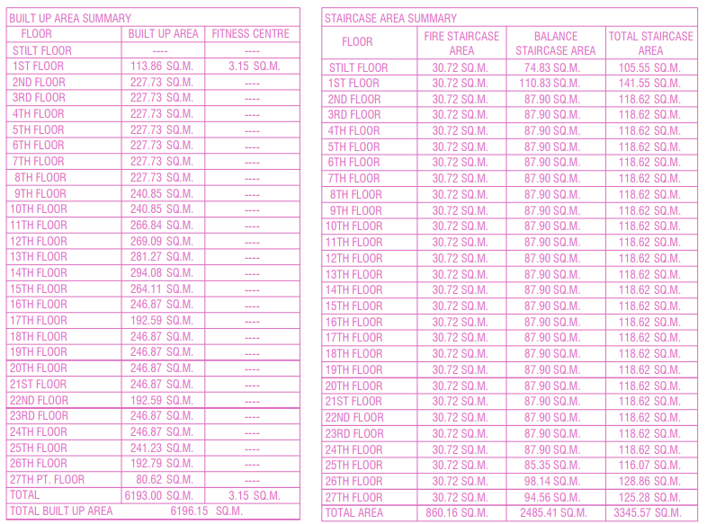

*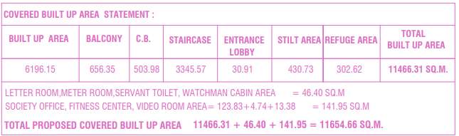*

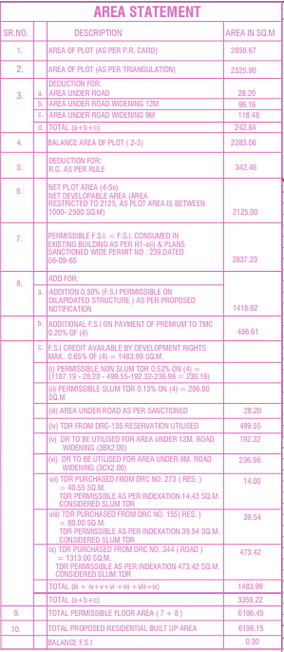

**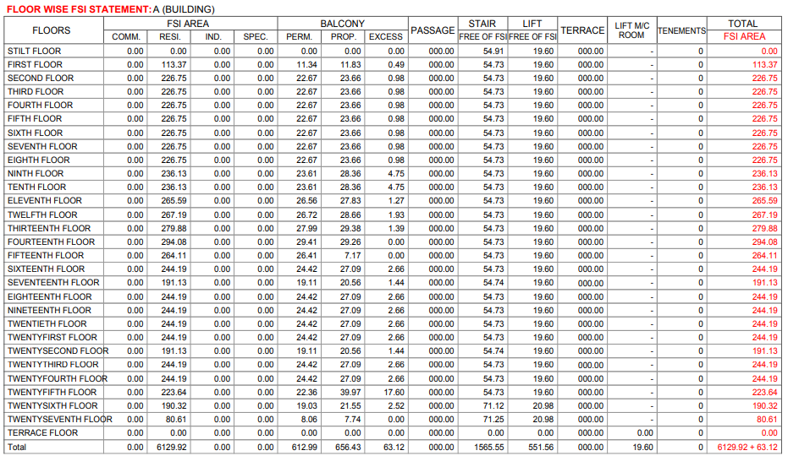**

**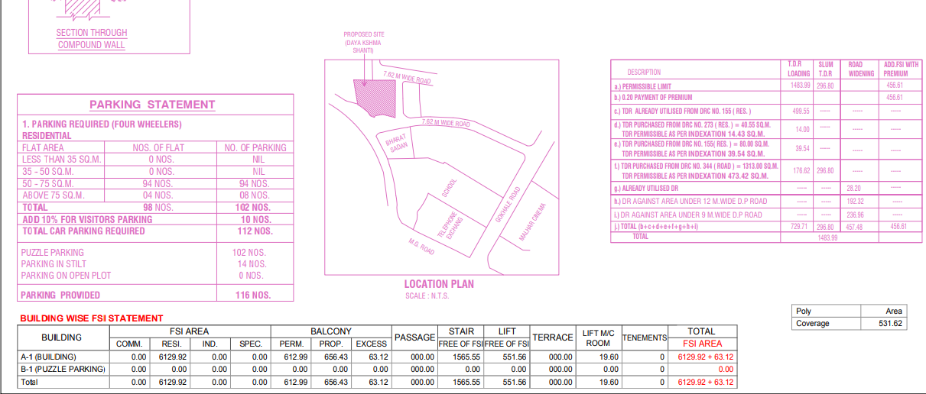**

|  |  |
| --- | --- |
| **PART D** | **PROJECT APPROVAL DETAILS** |

|  |  |  |  |
| --- | --- | --- | --- |
| **S.No.** | **REQUIRED APPROVALS** | **REFERENCE NO./ DATE** | **STATUS**  (Approved/ Applied For/ Pending) |
|  | Approved Building Plans From Government of Maharashtra | Certificate No.26ACEC3A0100512E  Dated: 30/04/2021 | Approved |
|  | Commencement Certificate | No. TMC/TDD/3588/21  Dated: 30/04/2021 | Approved |
|  | Provisional NOC from Fire Authority | Dated;21/10/2019 | Approved |
|  | RERA Registration Certificate issued from Maharashtra RERA | Registration No. P51700017669  Dated: 04/09/2018 | Approved |
|  | NOC for Height Clearance from Airport Authority of India | ---- | Not Provided |
|  | Environmental clearance NOC from SEIAA | ---- | Not Provided |
|  | NOC from Pollution Control Board | ---- | Not Approved |
|  | Structural Stability Certificate | ---- | Not Provided |
|  |  |  |  |

***OBSERVATIONS:*** *Project meets preliminary necessary compliance statutory approvals as per the information provided to us at the site however few NOCs & approvals are not provide to us.*

|  |  |
| --- | --- |
| **PART E** | **VALUATION ASSESSMENT OF THE PROPERTY** |

|  |  |  |  |  |  |  |  |  |  |
| --- | --- | --- | --- | --- | --- | --- | --- | --- | --- |
|  | **ASSESSMENT FACTORS** | | | | | | | | |
|  | Valuation Type | | Project Valuation | | | | | Group Housing Society Value | |
|  | Scope of the Valuation | | Non Binding Opinion on General Prospective Valuation Assessment of the Property identified by Property owner or through its representative | | | | | | |
|  | Property Use factor | | Group Housing Society Project | | | | | | |
|  | Legality Aspect Factor  *(Refer clauses 2 & 4 of Part-E)* | | Positive as per documents produced to us | | | | | | |
|  | Land Physical factors | | **Shape** | | **Size** | | **Level** | | **Frontage to depth ratio** |
| Irregular | | Large | | On Road Level | | Normal frontage |
|  | Property location category factor | | **City Categorization** | | **Locality Categorization** | | **Property location classification** | | **Floor Level** |
| Metro City | | Good | | On wide approach road | | Above 10th floor |
| Property within developing Residential zone | | Near to Market | |
| NA | |
|  | Any New Development in surrounding area | | Construction of Other Group Housing Project in Progress | | | NA | | | |
|  | Property overall usability Factor | | Normal | | | | | | |
|  | Comment on Property Salability Outlook | | Easily sellable | | | | | | |
|  | Comment on Demand & Supply in the Market | | Normal demand of such properties in the market | | | | | | |
|  | Methodology/ Basis of Valuation | |  | | | | | | |
| *As per the current status of the Project this Project Valuation report is assessed assuming that in the eventuality for the need of sale of this Project the interested buyer would be any developer only who will be interested in operating this Project taking over from the current developer.*  *This report is prepared for the purpose of creating equitable mortgage to the financer and this whole Project is put as mortgage for it.*  *Since this is a licensed land for the purpose of development of Group Housing Society where some units have been booked and some are still unsold. Ultimately in the eventuality of sale or recovery financer would be able to sell unsold units only and no other part of the Project like Land or booked units will remain sellable.*  *Hence this Valuation is assessed by calculating the Valuation of unsold units as per current market rates and deduct the total balance cost to be put in the Project to make it complete plus profit margin of any prospective investor (buyer), to arrive at the Fair Market Valuation of the Project.*  *Booked & unsold units have been taken on the basis of the Inventory Sheet provided to us by the developer which has been relied upon in good faith. Financer is advised to legally check the status of these units through Title Investigation Report. Legal & other ownership rights distribution if any has not been considered in this report since no such thing informed to us by the builder company.* | | | | | | |
|  | | | | | | |
|  | Details of the sources from where the information is gathered on prevailing market Rate/ Price trend of the property *(from property search sites & local information)* | | | | | | | | |
| 1. Name: Om Sai Properties, Property Dealers Contact No.: +91- 07045759996 | | | *As per our telephonic conversation with Concern Dealer, we came to know that flats are available for direct booking from the developer.*  *Further we came to know that the prevailing market rates for flats in the subject society is between Rs.20,000/- to Rs.25,000/- per sq.ft on Super area depending on location, size of the flat, floor level etc.* | | | | | |
|  | Adopted Rates Justification | Rates taken as per market survey. | | | | | | | |
|  | **Inventory Absorptions Rate:** | An absorption rate provides insight on the rate at which unsold inventory are selling. It will depend upon the demand and supply gap in micro market. Therefore, for “Giriraj Dreams” Project, after looking the current realestate market senario, we are on the view that subject unbooked inventory will be absorbed in different time span as shown Below. | | | | | | | |
|  | **Appreciation in Sale Price** | For arriving at the appreciation in sale price of unbooked inventory we have taking care following points:-   * The supply and demand dynamics of a particular location. * The interest rates banks charge for home loans, meaning the cost of borrowing. * Growth in local population, leading to increased demand * Development of basic infrastructure like School, Hospital, Transportation & Local Market.   Hence considering all the above factors, we have taken 2.5% appreciation in unsold inventory for Last year of realisation since the construction of the project is assumed to be completed by next year and as more units gets booked over time & occpancy increases rate increases over time. | | | | | | | |
|  | **Balance cost to be incurred for construction** | The construction cost of the project has been taken on the basis of CA Certificate provided by the company and we have relied upon it in good faith. Further the Construction cost incurred is assumed by 5% more than that on 31-12-2021 to get the incurred Construction cost on 03/03/2022 (i.e. Site Visit date) | | | | | | | |
|  | **Discount Rate** | As per the international Valuation Standard hand book, **‘**The rate at which the forecasted cash flow is discounted should reflect not only the time value of money, but also the risks associated with the type of cashflow and the future operations of the asset’.  The discount rate or WACC has been taken as per the discussion with the market participants based on the current real estate markets scenario in Mumbai and based on the current rate of lending by the Indian scheduled banks in real estate sector. The discount rate for the projects depends upon the liquidity factor & Demand and supply gap in the market. Presently Mumbai real estate is considered to be Stable and the realisation of the units in the redevelopment project is considered to be good. But the return on investment in such project is low as compare to new developed society due to availability of 60-70% of the total unit for sale .In Banking also the minimum ROI on real estate Projects is prevailing from minimum 12% to 18% depending upon the Project profile and creditworthiness of the developer company. Therefore we have taken discount rate or ROR as 15.84% which any buyer would be expecting in present market scenario & condition.  For the calculation of discount rate we have assumed 25% of capex as debt and 75% of capex as equity @ 12.50% & 16.7% interest rate. 16.7% of equity interest rate is adopted considering the Low risk involved in such real estate projects in present scenario. By this WACC arrived is 15.67%. | | | | | | | |

* **PROJECT INFLOW MODEL:**

1. **Receivables of Booked Flats**

As per the data provided to us by the Bank the total receivables of Different Phases are as follow: -



1. **Market Sale Value:**

The current Market rates of the property have been taken after several discussions with market participants & market researches on public domain and came to the following conclusion: -

1. Secondary market for the subject project is not yet developed and the flats are available on fresh booking only. As per the market feedback we came to know that the prevailing market rates for flats in subject project is between Rs.20,000/- to Rs.23,000/- per sq.ft. on super area
2. The complete project comprising of 106 residential units and comprises of only one tower. Currently the RCC frame structure and Brick work up to 23rd floor is complete whereas the slab work of 24th and 26th floor was in progress during the site visit.
3. Transaction rates of primary sale & secondary sale will always have some difference as per general market practice. Secondary market for the flats in the subject project is yet to be develop and there are no data available on public domain for resale flats in this project.
4. Therefore, based on these facts rates per floor have been adopted judiciously.

Therefore, for the Valuation purpose for flats of this project we have taken market rate range of Rs.21,000/- to Rs.22,500/- per sq.ft. on Usable Area (Including other charges like PLC, EDC & IDC) these rates depends upon the characteristics of the unsold dwelling units. These are the prevailing market rates for Different Type of Units in the subject Project.



1. **THE GIRIRAJ DREAMS INFLOW MODEL:**



* **PROJECT OUT FLOW:**

1. **CAPEX (Capital Expenditure):**

**CONSTRUCTION COST YET TO BE INCURRED:** The construction cost of the project has been taken on the basis of CA Certificate provided by the company and we have relied upon it in good faith. Further the Construction cost incurred is assumed by 5% more than that on 31-12-2021 to get the incurred Construction cost on 03/03/2022 (i.e. Site Visit date)



**FINANCIAL CHARGES:** As per the information/ data provided to us by the company, Financial Charges during the construction of the project will be Rs.4,75,69,419/- whereas during the phase of construction till date fund toward this head has been utilized and only the remaining cost will be added toward the outflow. We have considered the charges as on 31/12/2021 for the valuation as financial charges are subject to actual basis and can’t be depicted based on progress.



1. **OPEX (Operational Expenditure):**

**ADMINISTRATIVE EXPENSES:** As per the information & data provided to us, Administrative Charges during the construction of the project will be Rs.13,03,36,500/- The construction cost of the project has been taken on the basis of CA Certificate provided by the company and we have relied upon it in good faith. Further the Construction cost incurred is assumed to be 4% more than that on 31-12-2021 to get the incurred Administration cost on 03/03/2022 (i.e. Site Visit date)



**MARKETING EXPENSES:** As per the information & data provided to us, Marketing Charges for the project is not mentioned in the CA certificate provided. So, the Marketing Expense are assumed to be 1% of the total project cost estimated as per Real estate industry trend.



* **PROJECT NET PRESENT VALUE (NPV):**





|  |  |
| --- | --- |
|  | **Concluding Comments/ Disclosures if any** |
| 1. This tie up report is done for the property found on as-is-where basis as shown on the site by the Bank/ customer of which photographs is also attached with the report. 2. Reference of the property is also taken from the copies of the documents/ information which interested organization or customer could provide to us out of the standard checklist of documents sought from them and further based on our assumptions and limiting conditions. All such information provided to us has been relied upon in good faith and we have assumed that it is true and correct. However we do not vouch the absolute correctness of the property identification, exact address, physical conditions, etc. based on the documents provided to us since property shown to us may differ on site Vs as mentioned in the documents or incorrect/ fabricated documents may have been provided to us. 3. Legal aspects for eg. investigation of title, ownership rights, lien, charge, mortgage, lease, verification of documents from originals or from any Govt. department, etc. has to be taken care by legal experts/ Advocates and same has not been done at our end. 4. This report only contains opinion based on technical & market information which came to our knowledge during the course of the assignment. It doesn’t contain any recommendations. 5. This report only contains opinion based on technical & market information which came to our knowledge during the course of the assignment. It doesn’t contain any recommendations. 6. This report is prepared following our Standard Operating Procedures & Best Practices and will be subject to Limitations, Conditions, Valuer’s Remarks, Important Notes, Valuation TOS and basis of computation & working as described above. 7. The use of this report will become valid only after payment of full fees as per the Payment Terms. Using this report or any part content created in this report without payment of charges will be seen as misuse and unauthorized use of the report. |
|  | **IMPORTANT KEY DEFINITIONS** |
| ***Fair Value*** *suggested by the competent Valuer is that prospective estimated amount in his expert & prudent opinion of the subject asset/ property without any prejudice after he has carefully & exhaustively evaluated the facts & information came in front of him or which he could reasonably collect during the course of the assessment related to the subject asset on an as-is, where-is basis in its existing conditions, with all its existing advantages & disadvantages and its potential possibilities which is just & equitable at which the subject asset/ property should be exchanged between a willing buyer and willing seller at an arm’s length transaction in an open & unrestricted market, in an orderly transaction after proper marketing, wherein the parties, each acted knowledgeably, prudently without any compulsion on the date of the Report.*  *Fair Value without using the term “Market” in it describes that the value suggested by the Valuer may not mandatorily follow or may not be in complete consonance to the established Market in his expert opinion. It may or may not follow market dynamics. But if the suggested value by the valuer is not within the prevailing Market range or is assessed for an asset is located in an un-established Market then the valuer will give reasonable justification & reasoning that for what reasons the value suggested by him doesn’t follow the prevailing market dynamics.* |
| ***Fair Market Value*** *suggested by the competent Valuer is that prospective estimated amount in his expert & prudent opinion of the subject asset/ property without any prejudice in consonance to the Market dynamics after he has carefully & exhaustively evaluated the facts & information came in front of him or which he could reasonably collect during the course of assessment related to the subject asset on an as-is, where-is basis in its existing conditions, with all its existing advantages & disadvantages and its potential possibilities which is just & equitable at which the subject asset/ property should be exchanged between a willing buyer and willing seller at an arm’s length transaction in an open & unrestricted market, in an orderly transaction after proper marketing, wherein the parties, each acted knowledgeably, prudently without any compulsion on the date of the Report.*  *Here the words “in consonance to the established Market” means that the Valuer will give opinion within the realms & dynamics of the prevailing market rates after exhaustively doing the micro market research. However due to the element of “Fair” in it, valuer will always look for the factors if the value should be better than the market realms which is just & equitable backed by strong justification and reasoning.* |
| ***Market Value*** *suggested by the competent Valuer is that prospective estimated amount which is average price of the similar comparable assets prevailing in an open & established market during the near period of the date of valuation at which the subject asset/ property should be exchanged between a willing buyer and willing seller on an as-is, where-is basis in its existing conditions, with all its existing advantages & disadvantages and its potential possibilities at an arm’s length transaction in an open, established & unrestricted market, in an orderly transaction, wherein the parties, each acted without any compulsion on the date of the Valuation.*  *Using the term “Market Value” without “Fair” omits the elements of proper marketing, acting knowledgeably & prudently.*  *Market and market participants can be sentimental, inclined towards the transaction without the element of complete knowledge & prudence about facts or due diligence of the asset therefore “each acted knowledgeably, prudently” has been removed from the marker Value definition.* |
| ***Realizable Value*** *is that minimum prospective estimated value of the asset/ property which it may be able to fetch at the time of actual property transaction factoring in the element of discount due to the prospects of deep negotiations between the buyer & seller when the parties in-principally find Fair Market Value reasonable and sits together to close the deal and the transaction across the table. Discount percentage on the Fair Market Value due to negotiation will depend on the nature, size, various salability prospects of the subject asset, the needs of the buyer & the seller and kind of payment terms. In some of the cases Realizable and Fair Market Value may also be equal.* |
| ***Distress Sale Value\**** *is that value when the property is attached with any process such as mortgaged financing, financial or operational dues which is under any stress condition or situation and the stakeholders are under process of finding resolution towards it to save the property from being attached to a formal recovery process. In this type of sale, minimum fetch value assessed will always be less than the estimated Fair Market Value where the discount of percentage will depend upon various circumstances and factors such as nature, size, salability prospects of the property and kind of encumbrance on the property. In this type of sale, negotiation power of the buyer is always more than the seller and eagerness & pressure of selling the property will be more on the seller than the buyer.* |
| ***Liquidation Value*** *is the amount that would be realized when an asset or group of assets are sold due to any compulsion or constraints such as in a recovery process guided by statute, law or legal process, clearance sale or any such condition or situation thereof where the pressure of selling the asset/ property is very high to realize whatever maximum amount can be from the sale of the assets in a limited time for clearance of dues or due to closure of business. In other words, this kind of value is also called as forced sale value.* |
| ***Difference between Costs, Price & Value:*** *Generally, these words are used and understood synonymously. However, in reality each of these has a completely different meaning, premise and also having different definitions in professional & legal terms. Therefore, it is our professional responsibility to describe the definitions of these words to avoid ambiguity & confusion in the minds of the user of this report.*  *The* ***Cost*** *of an asset represents the actual amount spend in the construction/ actual creation of the asset.*  *The* ***Price*** *is the amount paid for the procurement of the same asset.*  *The* ***Value*** *is defined as the present worth of future rights in the property/ asset and is a hypothetical or notional price that buyers and sellers are most likely to conclude for a good or service. Value is not a fact, but an estimate of the likely price to be paid for a good or service at a given time in accordance with a particular definition of value.*  *Therefore, in actual for the same asset/ property, cost, price & value remain different since these terms have different usage & meaning.* |
|  | ***Enclosures with the Report:***   * *Enclosure I:* Screenshot of the price trend references of the similar related properties available on public domain - Page No. 31 * *Enclosure II: Google Map Location Page No. 32* * *Enclosure III: Photographs of the property Page No. 33* * *Enclosure IV: Copy of Circle Guideline Rate Page No. 36* * *Enclosure V: Other Relevant Documents/Articles taken for reference Page No. 37* * *Enclosure VI: Valuer’s Important Remarks Page No. 39* |

**IMPORTANT NOTES**

***DEFECT LIABILITY PERIOD****- In case of any query/ issue or escalation you may please contact Incident Manager by writing at valuers@rkassociates.org. We try our level best to ensure maximum accuracy in the Calculations done, Rates adopted and various other data points & information mentioned in the report but still can’t rule out typing, human errors, assessment or any other mistakes. In case you find any mistake, variation, discrepancy or inaccuracy in any data point mentioned in the report, please help us by bringing all such points into our notice in writing at valuers@rkassociates.org* *within 30 days of the report delivery, to get these rectified timely, failing which R.K Associates shouldn’t be held responsible for any inaccuracy in any manner. Also, if we do not hear back anything from you within 30 days, we will assume that the report is correct in all respect and no further claim of any sort will be entertained thereafter. We would welcome and appreciate your feedback & suggestions in order to improve our services.*

*Our* ***DATA RETENTION POLICY*** *is of* ***ONE YEAR****. After this period we remove all the concerned records related to the assignment from our repository. No clarification or query can be answered after this period due to unavailability of the data.*

***COPYRIGHT FORMAT*** *- This report is prepared on the copyright format of R.K Associates to serve our clients in the best possible way. Legally no one can copy or distribute this format without prior approval from R.K Associates. It is meant only for the organization as mentioned on the cover page of this report. Distribution or use of this format or any content of this report wholly or partially other than R.K Associates will be seen as unlawful act and necessary legal action can be taken against the defaulters.*

***IF REPORT IS USED FOR BANK/ FIs***

***NOTE:*** *As per IBA Guidelines in case the valuation report submitted by the valuer is not in order, the banks / FIs shall bring the same to the notice of the valuer within 15 days of submission for rectification and resubmission. In case no such communication is received, it shall be presumed that the valuation report has been accepted.*

***At our end we have not verified the authenticity of any documents provided to us. Bank is advised to verify the genuineness of the property documents before taking any credit decision.***

***Terms of Services & Valuer’s Important Remarks are available at www.rkassociates.org for reference.***

|  |  |  |
| --- | --- | --- |
| **SURVEY ANALYST** | **ENGINEER ANALYST** | **L1/ L2 REVIEWER** |
| Abhishek Shanbhag | Abhishek Sharma | Choose an item. |
|  |  |  |

**ENCLOSURE VIII**

|  |  |
| --- | --- |
| **PART D** | **VALUER’S IMPORTANT REMARKS** |

|  |  |
| --- | --- |
|  | Valuation is done for the asset found on as-is-where basis which owner/ owner representative/ client/ bank has shown/ identified to us on the site unless otherwise mentioned in the report of which some reference has been taken from the information/ data given in the copy of documents provided to us and informed verbally or in writing out of the standard checklist of documents sought from the client & its customer which they could provide within the reasonable expected time out of the standard checklist of documents sought from them and further based on certain assumptions and limiting conditions. The information, facts, documents, data which has become primary basis of the report has been supplied by the client which has been relied upon in good faith and is not generated by the Valuer. |
|  | The client/ owner and its management/ representatives warranted to us that the information they have supplied was complete, accurate and true and correct to the best of their knowledge. All such information provided to us either verbally, in writing or through documents has been relied upon in good faith and we have assumed that it is true & correct without any fabrication or misrepresentation. I/We shall not be held liable for any loss, damages, cost or expenses arising from fraudulent acts, misrepresentations, or willful default on part of the owner, company, its directors, employee, representative or agents. |
|  | Legal aspects for eg. Investigation of title, ownership rights, lien, charge, mortgage, lease, sanctioned maps, verification of documents provided to us such as title documents, Map, etc. from any concerned Govt. office etc. have to be taken care by legal expert/ Advocate and same is not done at our end. It is assumed that the concerned Lender/ Financial Institution has asked for the valuation of that property after satisfying the authenticity of the documents given to us for which the legal verification has been already taken and cleared by the competent Advocate before requesting for the Valuation report. I/ We assume no responsibility for the legal matters including, but not limited to, legal or title concerns. |
|  | In the course of the valuation, we were provided with both written and verbal information. We have however, evaluated the information provided to us through broad inquiry, analysis and review but have not carried out a due diligence or audit of the information provided for the purpose of this engagement. Our conclusions are based on the assumptions and other information provided to us by the client during the course of the assessment. |
|  | Getting cizra map or coordination with revenue officers for site identification is a separate activity and is not part of the Valuation services and same has not been done in this report unless otherwise stated. |
|  | We have made certain assumptions in relation to facts, conditions & situations affecting the subject of, or approach to this exercise that has not been verified as part of the engagement rather, treated as “a supposition taken to be true”. If any of these assumptions prove to be incorrect then our estimate on value will need to be reviewed. |
|  | This is just an opinion report based on technical & market information having general assessment & opinion on the indicative, estimated Market Value of the property for which Bank has asked to conduct the Valuation. It doesn’t contain any other recommendations of any sort including but not limited to express of any opinion on the suitability or otherwise of entering into any transaction with the borrower. |
|  | We have relied on the data from third party, external sources & information available on public domain to conclude the valuation. These sources are believed to be reliable and therefore, we assume no liability for the truth or accuracy of any data, opinions or estimates furnished by others that have been used in this analysis. Where we have relied on the data, opinions or estimates from external sources, reasonable care has been taken to ensure that such data is extracted from authentic sources, however we still can’t vouch its authenticity, correctness, or accuracy. |
|  | Analysis and conclusions adopted in the report are limited to the reported assumptions, conditions and information came to our knowledge during the course of the work and based on the Standard Operating Procedures, Best Practices, Caveats, Limitations, Conditions, Remarks, Important Notes, Valuation TOR and definition of different nature of values. |
|  | Value varies with the Purpose/ Date/ Asset Condition & situation/ Market condition, demand & supply, asset utility prevailing on a particular date/ Mode of sale. The indicative & estimated prospective Value of the asset given in this report is restricted only for the purpose and other points mentioned above prevailing on a particular date as mentioned in the report. If any of these points are different from the one mentioned aforesaid in the Report then this report should not be referred. |
|  | Our report is meant ONLY for the purpose mentioned in the report and should not be used for any other purpose. The Report should not be copied or reproduced for any purpose other than the purpose for which it is prepared for. I/we do not take any responsibility for the unauthorized use of this report. |
|  | We owe responsibility only to the authority/client that has appointed us as per the scope of work mentioned in the report. We will not be liable for any losses, claims, damages or liabilities arising out of the actions taken, omissions or advice given by any other person. In no event shall we be liable for any loss, damages, cost or expenses arising in any way from fraudulent acts, misrepresentations or willful default on part of the client or companies, their directors, employees or agents. |
|  | This report is having limited scope as per its fields & format to provide only the general basic idea of the value of the property prevailing in the market based on the site inspection and documents/ data/ information provided by the client. The suggested indicative prospective estimated value should be considered only if transaction is happened as free market transaction. |
|  | The sale of the subject property is assumed to be on an all cash basis. Financial arrangements would affect the price at which the property may sell for if placed on the market. |
|  | The actual realizable value that is likely to be fetched upon sale of the asset under consideration shall entirely depend on the demand and supply of the same in the market at the time of sale. |
|  | While our work has involved an analysis & computation of valuation, it does not include detailed estimation, design/ technical/ engineering/ financial/ structural/ environmental/ architectural/ compliance survey/ safety audit & works in accordance with generally accepted standards of audit & other such works. The report in this work in not investigative in nature. It is mere an opinion on the likely estimated valuation based on the facts & details presented to us by the client and third party market information came in front of us within the limited time of this assignment, which may vary from situation to situation. |
|  | Where a sketched plan is attached to this report, it does not purport to represent accurate architectural plans. Sketch plans and photographs are provided as general illustrations only. |
|  | Documents, information, data including title deeds provided to us during the course of this assessment by the client is reviewed only upto the extent required in relation to the scope of the work. No document has been reviewed beyond the scope of the work. These are not reviewed in terms of legal rights for which we do not have expertise. Wherever any information mentioned in this report is mentioned from the documents like owners name, etc., it is only for illustration purpose and may not necessary represent accuracy. |
|  | The report assumes that the borrower/company/business/asset complies fully with relevant laws and regulations applicable in its area of operations and usage unless otherwise stated, and that the companies/business/assets is managed in a competent and responsible manner. Further, as specifically stated to the contrary, this report has given no consideration to matters of a legal nature, including issues of legal title and compliance with relevant laws, and litigations and other contingent liabilities that are not recorded/reflected in the documents/ details/ information/ data provided to us. |
|  | This valuation report is not a qualification for accuracy of land boundaries, schedule (in physical terms), dimensions & identification. For this land/ property survey report can be sought from a qualified private or Govt. surveyor. |
|  | This Valuation report is prepared based on the facts of the property on the date of the survey. Due to possible changes in market forces, socio-economic conditions, property conditions and circumstances, this valuation report can only be regarded as relevant as at the valuation date. Hence before financing, Banker/ FI should take into consideration all such future risk and should loan conservatively to keep the advanced money safe in case of the downward trend of the property value. |
|  | Valuation of the same asset/ property can fetch different values under different circumstances & situations. For eg. Valuation of a running/ operational shop/ hotel/ factory will fetch better value and in case of closed shop/ hotel/ factory it will have considerable lower value. Similarly, an asset sold directly by an owner in the open market through free market transaction then it will fetch better value and if the same asset/ property is sold by any financer due to encumbrance on it, will fetch lower value. Hence before financing, Lender/ FI should take into consideration all such future risks while financing and take decision accordingly. |
|  | Valuation is done for the property identified to us by the owner/ owner representative. At our end we have just visually matched the land boundaries, schedule (in physical terms) & dimensions of the property with reference to the documents produced for perusal. Method by which identification of the property is carried out is also mentioned in the report clearly. Responsibility of identifying the correct property to the Valuer/ its authorized surveyor is solely of the client/ owner for which Valuation has to be carried out. It is requested from the Bank to cross check from their own records/ information if this is the same property for which Valuation has to be carried out to ensure that owner has not misled the Valuer company or misrepresented the property due to any vested interest. Where there is a doubt about the precision position of the boundaries, schedule, dimensions of site & structures, it is recommended that a Licensed Surveyor be contacted. |
|  | In India more than 70% of the geographical area is lying under rural/ remote/ non municipal/ unplanned area where the subject property is surrounded by vacant lands having no physical demarcation or having any display of property survey or municipal number / name plate on the property clearly. Even in old locations of towns, small cities & districts where property number is either not assigned or not displayed on the properties clearly and also due to the presence of multiple/ parallel departments due to which ownership/ rights/ illegal possession/ encroachment issues are rampant across India and due to these limitations at many occasions it becomes tough to identify the property with 100% surety from the available documents, information & site whereabouts and thus chances of error, misrepresentation by the borrower and margin of chances of error always persists in such cases. To avoid any such chances of error it is advised to the Bank to engage municipal/ revenue department officials to get the confirmation of the property to ensure that the property shown to Valuer/ Banker is the same as for which documents are provided. |
|  | If this Valuation Report is prepared for the Flat/ dwelling unit situated in a Group Housing Society or Integrated Township then approvals, maps of the complete group housing society/ township is out of scope of this report and this report will be made for the specific unit based on the assumption that complete Group Housing Society/ Integrated Township and the subject unit must be approved in all respect. |
|  | Due to fragmented & frequent change in building/ urban planning laws/ guidelines from time to time, different laws/ guidelines between regions/ states and no strict enforceability of Building Bye-Laws in India specially in non-metro and scale b & c cities & Industrial areas, property owners many times extend or make changes in the covered area/ layout from the approved/ applicable limits. There are also situations where properties are decades old when there was no formal Building Bye-Laws applicable the time when the construction must have been done. Due to such discrete/ unplanned development in many regions sometimes it becomes tough for the Valuer to determine the exact lawful situation on ground. Unless otherwise mentioned in the report, the covered area present on the site as per site survey will be considered in the Valuation. |
|  | Area of the large land parcels of more than 2500 sq.mtr or of uneven shape in which there can be practical difficulty in sample measurement, is taken as per property documents which has been relied upon unless otherwise stated. |
|  | Drawing Map, design & detailed estimation of the property/ building is out of scope of the Valuation services. |
|  | Valuation is a subjective field and opinion may differ from consultant to consultant. To check the right opinion, it is important to evaluate the methodology adopted and various data point/ information/ factors/ assumption considered by the consultant which became the basis for the Valuation report before reaching to any conclusion. |
|  | Although every scientific method has been employed in systematically arriving at the value, there is, therefore, no indisputable single value and the estimate of the value is normally expressed as falling within a likely range. |
|  | Value analysis of any asset cannot be regarded as an exact science and the conclusions arrived at in many cases will, of necessity, be subjective and dependent on the exercise of individual judgment. Given the same set of facts and using the same assumptions, expert opinions may differ due to the number of separate judgment decisions, which have to be made. Therefore, there can be no standard formula to establish an indisputable exchange ratio. In the event of a transaction, the actual transaction value achieved may be higher or lower than our indicative analysis of value depending upon the circumstances of the transaction. The knowledge, negotiability and motivations of the buyers and sellers, demand & supply prevailing in the market and the applicability of a discount or premium for control will also affect actual price achieved. Accordingly, our indicative analysis of value will not necessarily be the price at which any agreement proceeds. The final transaction price is something on which the parties themselves have to agree. However, our Valuation analysis can definitely help the stakeholders to take informed and wise decision about the Value of the asset and can help in facilitating the arm’s length transaction. |
|  | This Valuation is conducted based on the macro analysis of the asset/ property considering it in totality and not based on the micro, component, or item wise analysis. Analysis done is a general assessment and is not investigative in nature. |
|  | This report is prepared on the RKA V-L1 (Basic) Valuation format as per the client requirement and scope of work. This report is having limited scope as per its fields & format to provide only the general estimated & indicative basic idea of the value of the property prevailing in the market based on the information provided by the client. No detailed analysis, audit or verification has been carried out of the subject property. There may be matters, other than those noted in this report, which might be relevant in the context of the transaction and which a wider scope might uncover. |
|  | This is just an opinion report and doesn’t hold any binding on anyone. It is requested from the concerned Client/ Bank/ Financial Institution which is using this report for mortgaging the property that they should consider all the different associated relevant & related factors & risks before taking any business decision based on the content of this report. |
|  | All Pages of the report including annexures are signed and stamped from our office. In case any paper in the report is without stamp & signature then this should not be considered a valid paper issued from this office. |
|  | As per IBA Guidelines & Bank Policy, in case the valuation report submitted by the valuer is not in order, the banks / FIs shall bring the same to the notice of the valuer within 15 days of submission for rectification and resubmission. In case no such communication is received, it shall be presumed that the valuation report has been accepted. |
|  | **Defect Liability Period is 15 DAYS.** We request the concerned authorized reader of this report to check the contents, data, information, and calculations in the report within this period and intimate us in writing at [**valuers@rkassociates.org**](mailto:valuers@rkassociates.org) within 15 days of report delivery, if any corrections are required or in case of any other concern with the contents or opinion mentioned in the report. If no intimation is received within 15 (Fifteen) days in writing from the date of issuance of the report, then it shall be considered that the report is complete in all respect and has been accepted by the client upto their satisfaction & use and further to which R.K Associates shall not be held responsible in any manner. After this period no concern/ complaint/ proceedings in connection with the Valuation Services will be entertained due to possible change in situation and condition of the property. |
|  | Though adequate care has been taken while preparing this report as per its scope, but still we can’t rule out typing, human errors, over sightedness of any information or any other mistakes. Therefore, the concerned organization is advised to satisfy themselves that the report is complete & satisfactory in all respect. Intimation regarding any discrepancy shall be brought into our notice immediately. If no intimation is received within 15 (Fifteen) days in writing from the date of issuance of the report, to rectify these timely, then it shall be considered that the report is complete in all respect and has been accepted by the client upto their satisfaction & use and further to which R.K Associates shall not be held responsible in any manner. |
|  | Our Data retention policy is of **ONE YEAR**. After this period we remove all the concerned records related to the assignment from our repository. No clarification or query can be answered after this period due to unavailability of the data. |
|  | This Valuation report is governed by our (1) Internal Policies, Processes & Standard Operating Procedures, (2) R.K Associates Quality Policy, (3) Valuation & Survey Best Practices Guidelines formulated by management of R.K Associates, (4) Information input given to us by the customer and (4) Information/ Data/ Facts given to us by our field/ office technical team. Management of R.K Associates never gives acceptance to any unethical or unprofessional practice which may affect fair, correct & impartial assessment and which is against any prevailing law. In case of any indication of any negligence, default, incorrect, misleading, misrepresentation or distortion of facts in the report then we request the user of this report to immediately or atleast within the defect liability period to bring all such act into notice of R.K Associates management so that corrective measures can be taken instantly. |
|  | R.K Associates never releases any report doing alterations or modifications by pen. In case any information/ figure of this report is found altered with pen then this report will automatically become null & void. |
|  | We are fully aware that based on the opinion of value expressed in this report, we may be required to give testimony or attend court / judicial proceedings with regard to the subject assets, although it is out of scope of the assignment, unless specific arrangements to do so have been made in advance, or as otherwise required by law. In such event, the party seeking our evidence in the proceedings shall bear the cost/professional fee of attending court / judicial proceedings and my / our tendering evidence before such authority shall be under the applicable laws. |
|  | The final copy of the report shall be considered valid only if it is in hard copy on the company’s original letter head with proper stamp and sign on it of the authorized official upon payment of the agreed fees. User shall not use the content of the report for the purpose it is prepared for only on draft report, scanned copy, email copy of the report and without payment of the agreed fees. In such a case the report shall be considered as unauthorized and misused. |

**ENCLOSURE 2 – GOOGLE MAP LOCATION**

**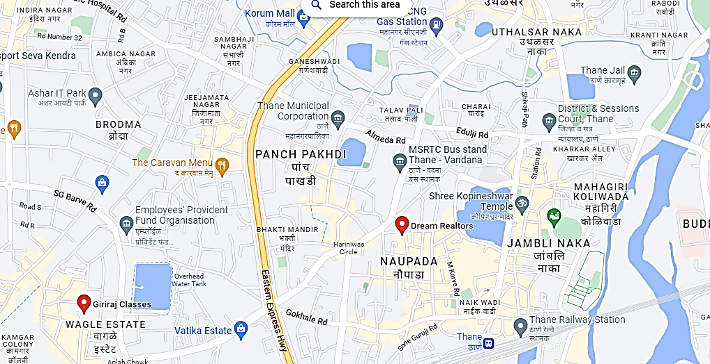**

**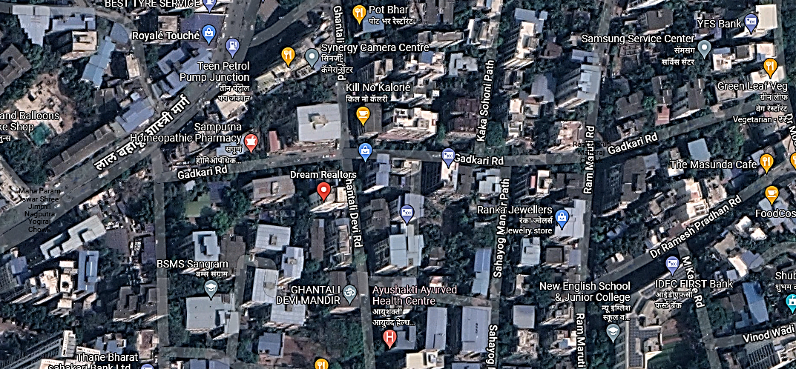**

**ENCLOSURE 3 – PHOTOGRAPHS**

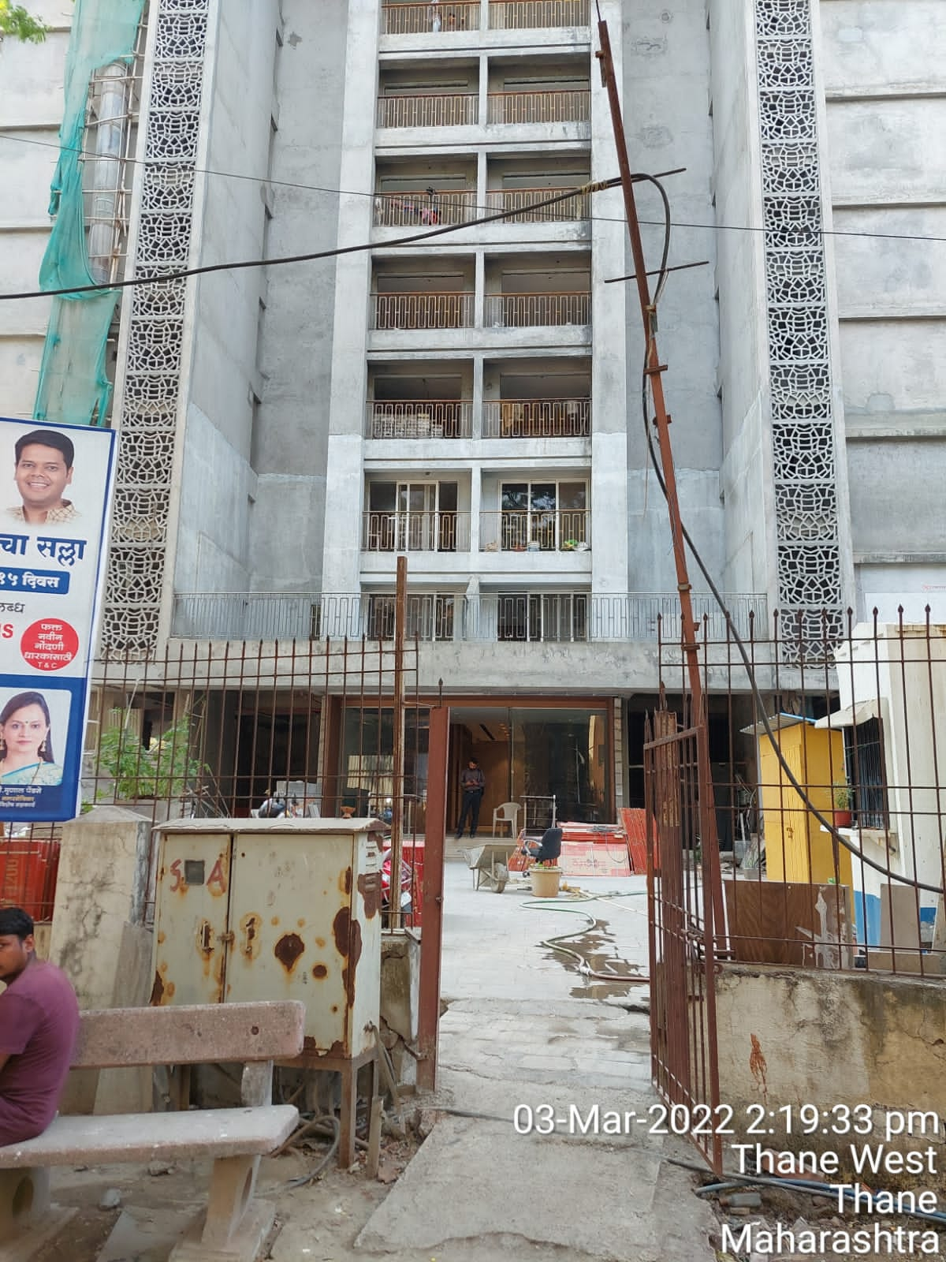

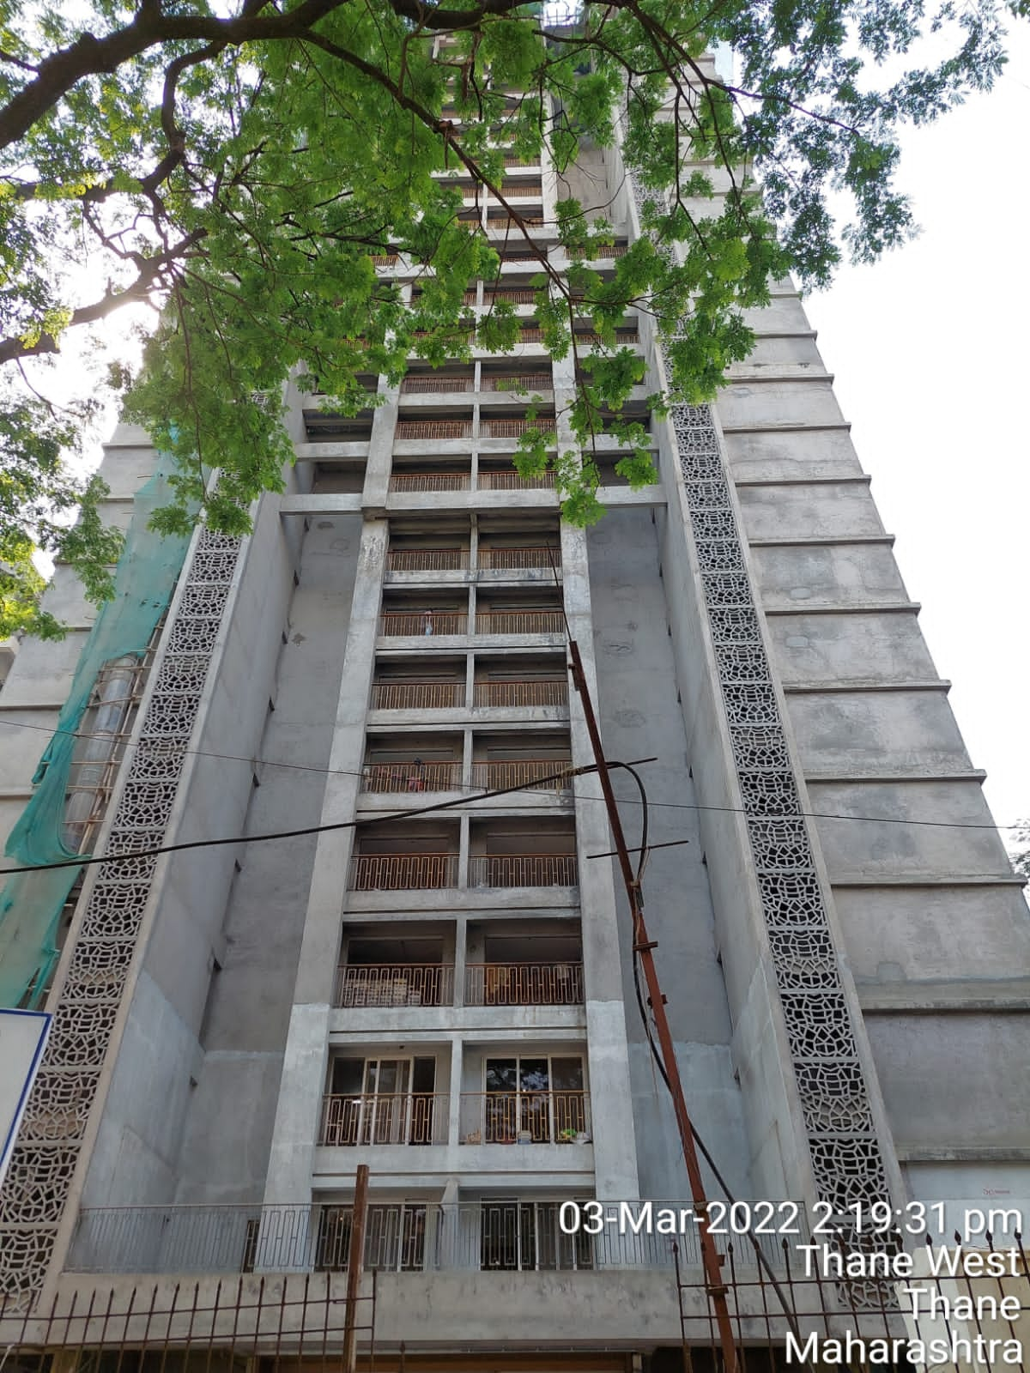

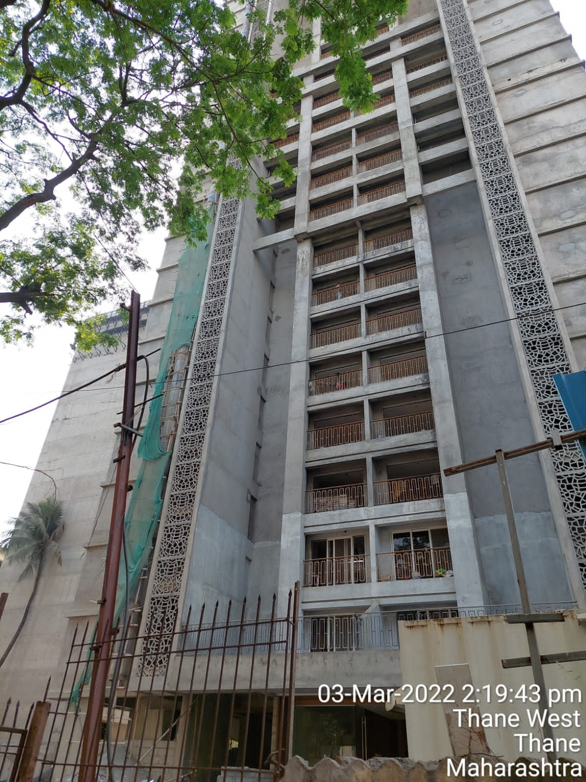

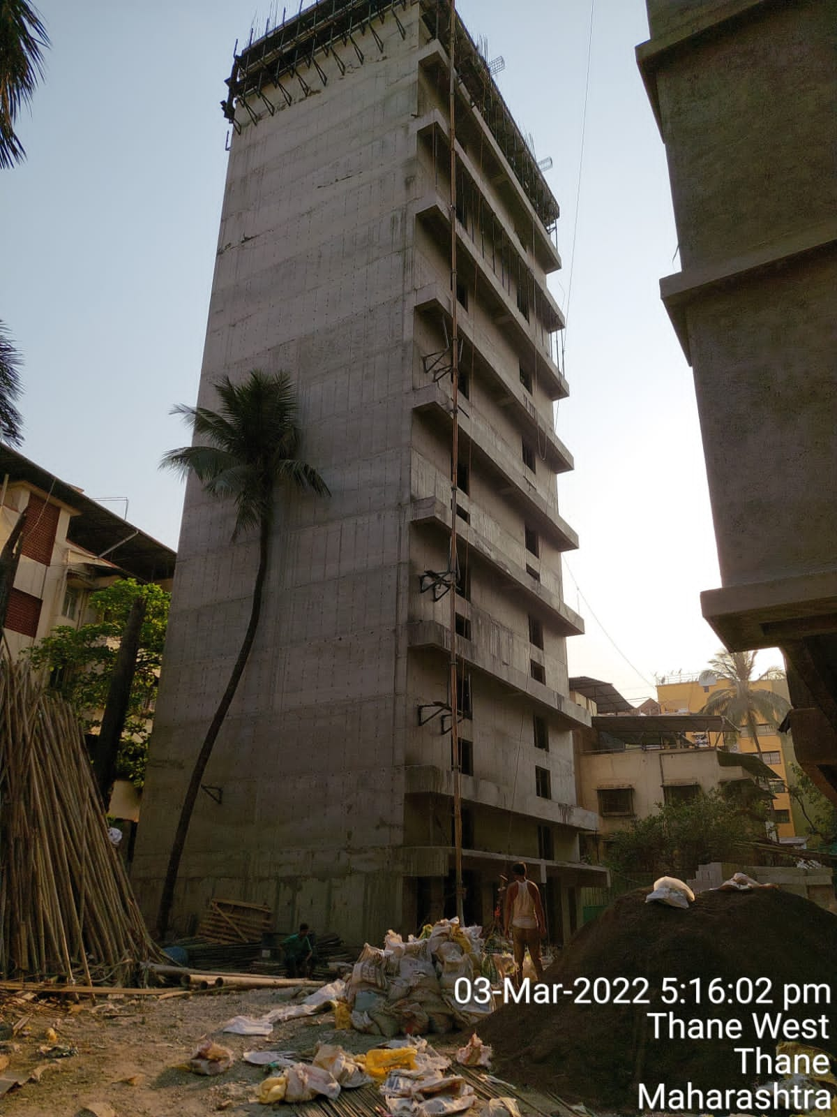

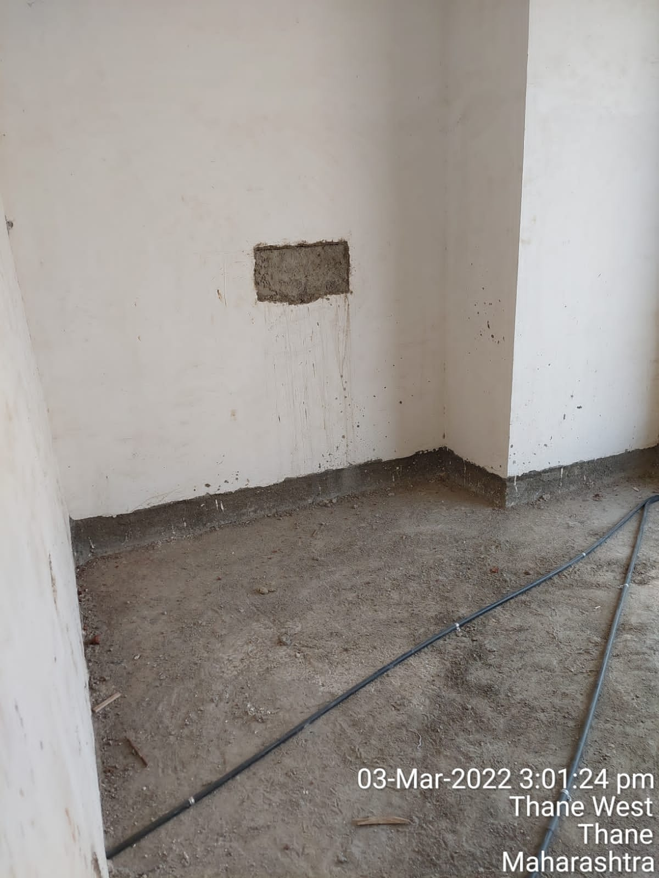

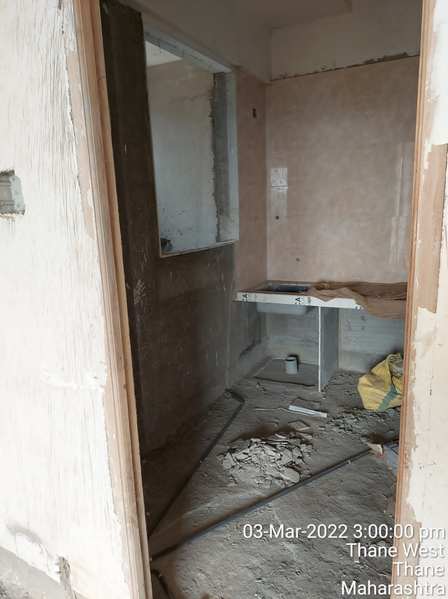

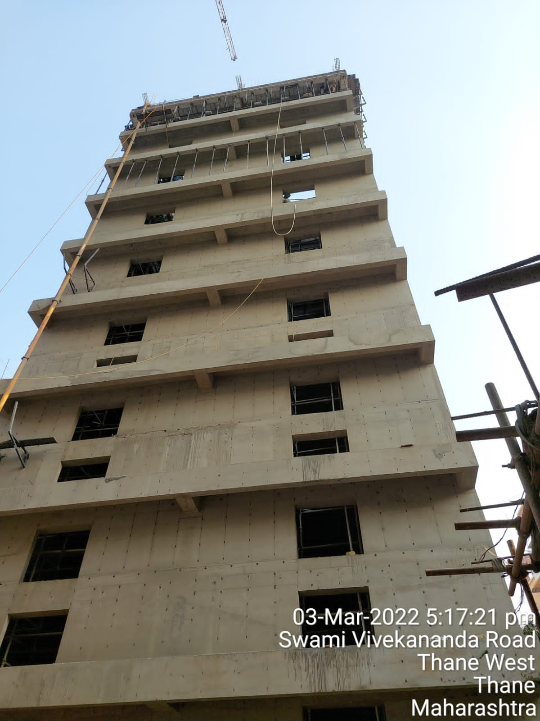

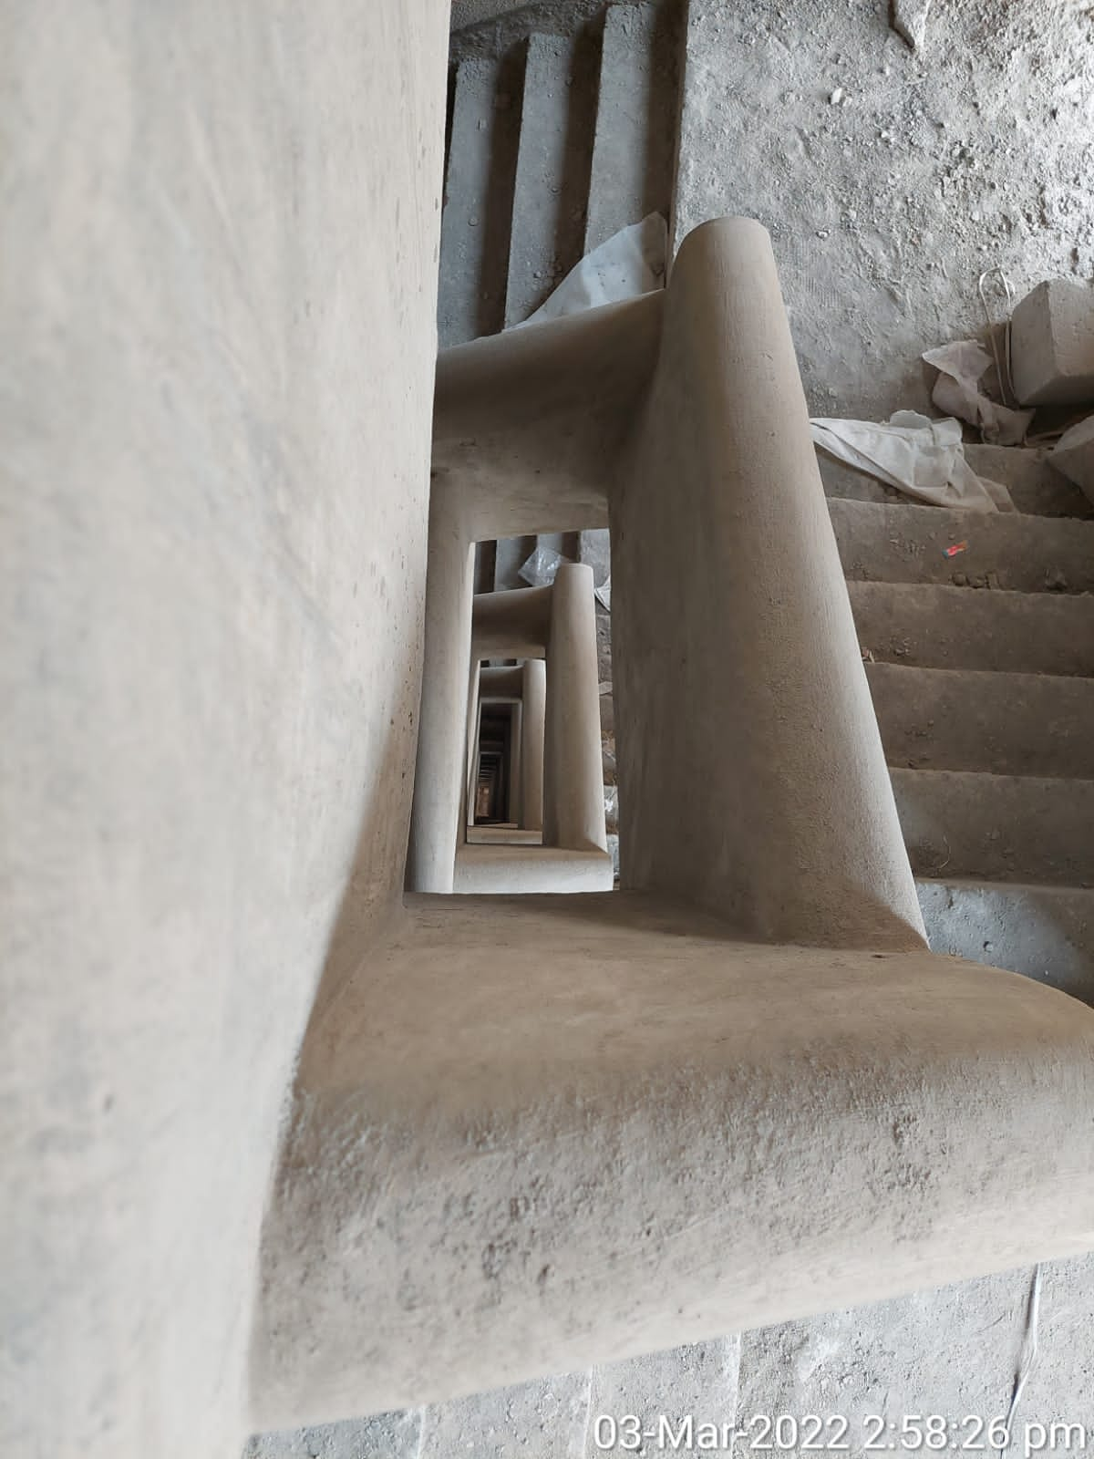

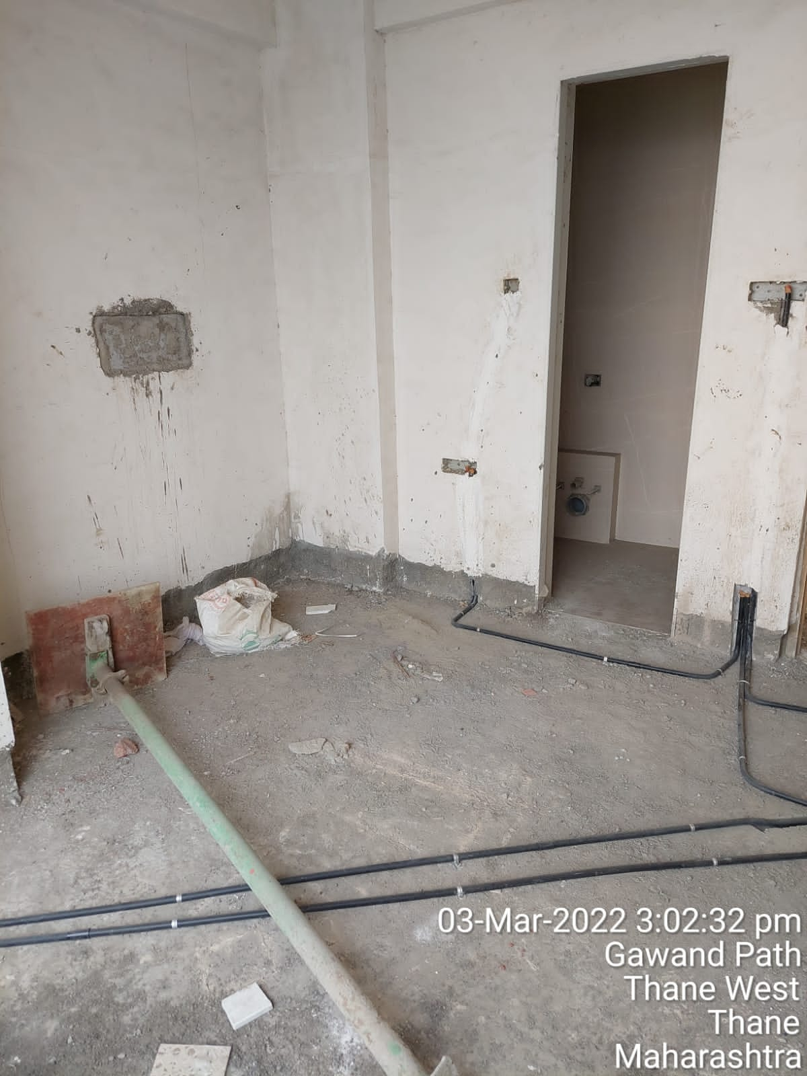

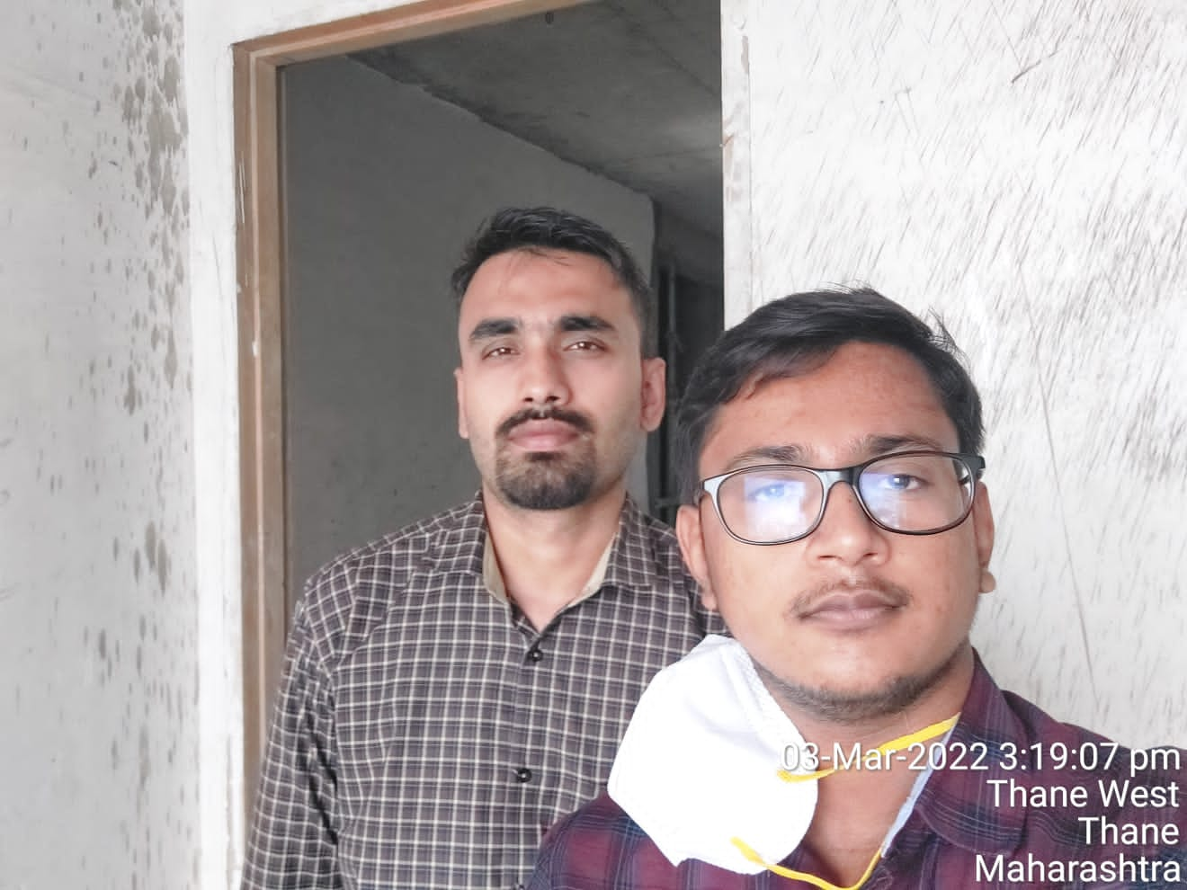

**ENCLOSURE 4 – PRICE TREND REFRENCES**







