**REPORT FORMAT:** V-L1 (Basic) | Version: 4.2_2017

**FILE NO. VIS(2021-22)-PL-1028-872-1130 DATED: 28/02/2022**

**VALUATION REPORT**

**OF**

**PRIVATE VEHICLE**

**OWNER/S**

**M/S.** **SAMTEL COLOR LIMITED**

**A/C: M/S.** **SAMTEL COLOR LIMITED**

**REPORT PREPARED FOR**

**ADV. SANJAY GUPTA (LIQUIDATOR OF M/S. SAMTEL COLOR LIMITED)**

**IP REGISTRATION NO. IBBI/IPA-001/IP-P00117/2017-2018/10252**

***\*\*Important - In case of any query/ issue/ concern or escalation you may please contact Incident Manager @ valuers@rkassociates.org. We will appreciate your feedback in order to improve our service.***

***NOTE: As per IBA Guidelines please provide your feedback on the report within 15 days of its submission after which report will be considered to be correct.***

|  |  |
| --- | --- |
| **PART A** | **GENERAL** **DESCRIPTION** |

|  |  |  |
| --- | --- | --- |
| **S.NO.** | **PARTICULARS** | **DESCRIPTION** |
|  | Valuation prepared for | Adv. Sanjay Gupta (Liquidator of M/s. Samtel Color Limited)  IP Registration No. IBBI/IPA-001/IP-P00117/2017-2018/10252 |
|  | Date of Appointment | 16-02-2022 |
|  | Date of Inspection | 21-02-2022 |
|  | Date of Valuation Report | 28-02-2022 |
|  | Date of Valuation | 16-01-2018 |
|  | Car Inspection done at Location | R-2/237, Raj Nagar, Ghaziabad |
|  | Current Owner | M/s. Samtel Color Limited |
|  | Purpose of Valuation | Liquidation Value in accordance with Insolvency and Bankruptcy Code, 2016 |
|  | Vehicle RC Number | DL-7C-G-1881 |
|  | Engine Number | 2AZ2359854 |
|  | Chassis Number | JTNBE40K 903048223 |
|  | Odometer Reading | 149828 km. |
|  | Manufacturer Name | Toyota |
|  | Model Type | Camry W-1 (J-6) |
|  | Vehicle Type | Four Wheeler, 5 Seating Capacity (Person) |
|  | Body Type | Saloon |
|  | Color | Light Blue |
|  | Engine Capacity | 2362 cc |
|  | Year of Manufacturing | 08/2006 |
|  | Age of Car | 15 Years 6 months |
|  | Condition | Bad |
|  | Add on features available | Air-conditioner, Power Steering, Airbags, Power Windows, Central Locking |
|  | Insurance | Not Available |
|  | Pollution | Not Available |
|  | Service Record | Details not provided to us |
|  | Has the car driven for inspection? | No |
|  | Current production status of the model in market | Discontinued, no more in production |

|  |  |
| --- | --- |
| **PART B** | **VALUATION ASSESSMENT OF ASSETS** |

|  |  |  |
| --- | --- | --- |
| **S.NO.** | **PARTICULARS** | **DESCRIPTION** |
|  | Original Purchase Price | Approx. Rs.24,49,000/- (as on public domain) |
|  | Resale price range for same model | Rs.80,429/- to Rs.96,772/- (as per information available on public domain, attached below) |
|  | Depreciation Calculated | Depreciation is not considered as the Registration Certificate of the vehicle has expired. It has to be renewed. |
|  | Current Market Value of this Car as per current condition | **Rs.80,000/- (Scrap Value)** |
|  | Distress Sale Value (@ ~15% less) | **Rs.68,000/-** |
| **Remarks:**  *This particular model has been discontinued by the manufacturer company and hence it is no more in production. The Registration Certificate of the vehicle has expired, it has to be renewed. And the vehicle is not in running condition at the time of survey.*  *Based on the review of the market deals currently available in the market for the same model and based on the condition of the subject car, we are of the opinion that* ***Rs.80,000/- (Rupees Eighty Thousand Only)*** *would be reasonable**value for this car.* | | |

|  |  |  |  |
| --- | --- | --- | --- |
|  | **Name & Address of Valuer company** | | **Signature of the authorized person** |
|  | M/s R.K. Associates Valuers & Techno Engineering Consultants Pvt. Ltd. 2nd Floor, D-39, Sector-2, Noida, Uttar Pradesh-201301 | |  |
|  | **Total Number of Pages in the Report with enclosures** | 12 | |
|  | **Engineering Team worked on the report** | ***SURVEYED BY: Er. Ritesh Kumar Singh*** | |
| ***PREPARED BY: AE Manas Upmanyu*** | |
| ***REVIEWED BY: HOD Valuations*** | |
|  | **List of Enclosures** | 1. *Assumptions/ Remarks* 2. *Valuer’s Remarks* 3. *Reference from Public Domain* 4. *Photographs* 5. *Copy of RC* | |

|  |  |
| --- | --- |
|  | **ASSUMPTIONS/ REMARKS** |
|  | Information of the average market rates is taken based on the verbal market survey in the subject area from the local people, property agents, recent deals, demand-supply, internet postings which has been relied upon. No written record is generally available for such market information. |
|  | Sale transaction method of the asset is assumed as free market transaction while assessing Prospective Fair Market Value of the asset. |
|  | All area measurements are on approximate basis. Verification of the area measurement of the property is done only based on sample random checking and not based on full scale measurement. Area of the large land parcels of more than 2500 sq.mtr or of uneven shape, is taken as per property documents which has been relied upon. |
|  | Legal aspects are not considered in this report. It is assumed and taken into account that the concerned Bank/ Financial Institution has first got the legal verification cleared by the competent Advocate before requesting for the Valuation report. |
|  | This report is prepared based on the copies of the documents/ information which interested organization or customer could provide to us out of the standard checklist of documents sought from them and further based on our assumptions and limiting conditions. All such information provided to us has been relied upon and we have assumed that it is true and correct. Verification or cross checking of the documents provided to us from the originals has not been done at our end. If at any time in future it’s found or came to our knowledge that misrepresentation of facts or incomplete or distorted information has been provided to us then this report will automatically become null & void. |
|  | Valuation is done for the property identified to us by the owner/ owner representative. Responsibility of identifying the correct property to the Valuer/ its authorized surveyor is solely of the client/ owner for which Valuation has to be carried out. At our end we can just cross verify the identification of the property with reference to the documents produced for perusal. Method by which identification of the property is carried out is also mentioned in the report clearly. It is requested from the Bank to cross check from their own records/ information if this is the same property for which Valuation has to be carried out to ensure that owner has not misled the Valuer company or misrepresented the property due to any vested interest. |
|  | In India more than 70% of the geographical area is lying under rural/ remote/ non municipal/ unplanned area where the subject property is surrounded by vacant lands having no physical demarcation or having any display of property survey or municipal number / name plate on the property clearly. Even in old areas of towns, small cities & districts where property number is not assigned clearly and not displayed on the properties, also due to the presence of multiple/ parallel departments (errors for in property registration) it becomes tough to identify the property with 100% surety from the available documents, information & site whereabouts and chances of error & misrepresentation by the borrower and margin & chances of error always persists in such cases. To avoid any such chances of error it is advised to the Bank to engage municipal/ revenue department officials to get the confirmation of the property to ensure that the property shown to Valuer/ Banker is the same as for which documents are provided. |
|  | If this Valuation Report is prepared for the Flat/ dwelling unit situated in a Group Housing Society or Integrated Township then it is assumed that the Banker or the concerned organization has satisfied themselves with the approval of the Group Housing Society/ particular floor & building before allotting the Valuation case to the Valuer company. |
|  | Due to fragmented & frequent change in building/ urban planning laws/ guidelines from time to time, different laws/ guidelines between regions/ states and no strict enforceability of Building Bye-Laws in India specially in non-metro and scale b & c cities & Industrial areas, property owners many times extend or make changes in the covered area/ layout out of approved/ applicable limits or the properties are decades old for which no formal Building Bye-Laws were applicable. Due to such discrete/ unplanned development in many regions sometimes it becomes tough to determine the exact lawful situation on ground for the Valuer. In case nothing specific is noted on the covered built-up area considered in the Valuation Report, the covered area present on the site as per site survey will be considered in the Valuation. |
|  | Valuation is a subjective field and opinion may differ from consultant to consultant. To check the right opinion, it is important to evaluate the methodology adopted and various factors/ basis considered during the course of assessment before reaching to any conclusion. |
|  | At the outset, it is to be noted that Value analysis of any asset cannot be regarded as an exact science and the conclusions arrived at in many cases will, of necessity, be subjective and dependent on the exercise of individual judgment. Given the same set of facts and using the same assumptions, expert opinions may differ due to the number of separate judgment decisions, which have to be made. Therefore, there can be no standard formulae to establish an indisputable exchange ratio. In the event of a transaction, the actual transaction value achieved may be higher or lower than our indicative analysis of value depending upon the circumstances of the transaction. The knowledge, negotiability and motivations of the buyers and sellers and the applicability of a discount or premium for control will also affect actual price achieved. Accordingly, our indicative analysis of value will not necessarily be the price at which any agreement proceeds. The final transaction price is something on which the parties themselves have to agree. However our Valuation analysis can definitely help the stakeholders to make them informed and wise decision about the Value of the asset and can help in facilitating the arm’s length transaction. |

**ENCLOSURE: 1– VALUER’S REMARKS**

|  |  |
| --- | --- |
|  | **Fair Market Value** suggested by the competent Valuerin his opinionis an prospective estimated amount without any prejudiceafter evaluating all the facts related to the subject propertyat which the subject Asset should be exchanged on the date of Valuation between a willing buyer and willing seller at an arm’s length transaction after proper marketing, wherein the parties, each acted knowledgeably, prudently and without any compulsion. |
|  | **Realizable Value** is the minimum prospective value of the property which it may be able to realize at the time of actual property transaction factoring in potential prospects of deep negotiations carried out between the buyer & seller for ultimately finalizing the transaction. Realizable value may be 10-20% less of the Fair Market Value depending on the salability prospects of the subject property. |
|  | **Forced/ Distress Sale Value** is the value when the property has to be sold due to financial encumbrances or any other constraint or have become a disputed property or as a part of a recovery process. In this type of sale minimum disposable value is assessed which varies from 20-35% less from the Fair Market Value based on the salability prospects of the property. |
|  | Best rates are rationally adopted based on the facts of the case came to our knowledge during the course of the assignment considering many factors like nature of property, location, approach, market situation and trends. |
|  | Construction rates are adopted based on present replacement cost of construction and calculating applicable depreciation & deterioration factor as per its existing condition, specifications based on the visual observation of the structure. No physical tests have been carried out in respect of it. |
|  | No employee or member of R.K Associates has any direct/ indirect interest in the property. |
|  | Sale transaction method of the asset is assumed as free market transaction while assessing Fair Prospective Market Value of the asset. |
|  | Area measurements considered in the Valuation Report pertaining to Land & Building is adopted from relevant approved documents or actual site measurement whichever is less. All area measurements are on approximate basis only. |
|  | This report is having limited scope as per its fields to provide only the general basic idea of the value of the property prevailing in the market based on the documents/ data/ information provided by the client. The suggested value should be considered only if transaction is happened as free market transaction. |
|  | The condition assessment and the estimation of residual economic life of the structure is based on the visual observations and appearance found during the site survey. We have not carried out any structural design or stability study; nor carried out any physical tests to assess structural integrity & strength. |
|  | Secondary/ Tertiary costs related to asset transaction like Stamp Duty, Registration charges, Brokerage, etc. pertaining to the sale/ purchase of this property are not considered while assessing the Market Value. |
|  | This report is prepared based on the copies of the documents/ information which interested organization or customer could provide to us out of the standard checklist of documents sought from them and further based on our assumptions and limiting conditions. All such information provided to us has been relied upon and we have assumed that it is true and correct. Verification or cross checking of the documents provided to us from the originalshas not been done at our end. If at any time in future it’s found or came to our knowledge that misrepresentation of facts or incomplete or distorted information has been provided to us then this report will automatically become null & void. |
|  | Investigation of title of the property and its legal right is beyond the scope of this report. If this property is offered as collateral security, the concerned financial institution is requested to verify & satisfy themselves on the ownership & legality of the property shown in this valuation report with respect to the latest legal opinion. |
|  | Value varies with the Purpose/ Date/ Condition of the market. This report should not to be referred if any of these points are different from the one mentioned aforesaid in the Report. The Value indicated in the Valuation Report holds good only upto the period of 3 months from the date of Valuation. |
|  | Analysis and conclusions adopted in the report are limited to the reported assumptions, conditions and information came to our knowledge during the course of the work. |
|  | This report is prepared on the RKA V-L3 (Medium) Valuation format as per the client requirement, charges paid and the time allotted. This report is having limited scope as per its fields to provide only the general estimated basic idea of the value of the property prevailing in the market based on the information provided by the client. The Valuation assessed in this Valuation Report should hold good only if transaction is happened as per free market transaction. No detailed analysis or verification of the information is carried upon pertaining to the value of the subject property. No claim for any extra information will be entertained whatsoever be the reason. For any extra work over and above the fields mentioned in the report will have an extra cost which has to be borne by the customer. |
|  | This is just an opinion report and doesn’t hold any binding on anyone. It is requested from the concerned Financial Institution which is using this report for mortgaging the property that they should consider all the different associated relevant & related factors also before taking any business decision based on the content of this report. |
|  | This Valuation report is prepared based on the facts of the property on the date of the survey. However in future property Market may go down, property conditions may change or may go worse, Property reputation may differ, Property vicinity conditions may go down or become worse, Property market may change due to impact of Govt. policies or effect of World economy, Usability prospects of the property may change, etc. Hence before financing, Banker/ FI should take into consideration all such future risk and should loan conservatively to keep the advanced money safe in case of the downward trend of the property value. |
|  | All Pages of the report including annexures are signed and stamped from our office. In case any paper in the report is without stamp & signature then this should not be considered a valid paper issued from this office. |
|  | Defect Liability Period is **30 DAYS**. We request the concerned authorized reader of this report to check the contents, data and calculations in the report within this period and intimate us in writing if any corrections are required or in case of any other concern with the contents or opinion mentioned in the report. Corrections only related to typographical, calculation, spelling mistakes will be entertained within the defect liability period. No request for any illegitimate value revision, date change or any other change will be entertained other than the one mentioned above. |
|  | R.K Associates encourages its customers to give feedback or inform concerns over its services through proper channel at [**valuers@rkassociates.org**](mailto:valuers@rkassociates.org) in writing within 30 days of report delivery. After this period no concern/ complaint/ proceedings in connection with the Valuation Services can be entertained due to possible change in situation and condition of the property. |
|  | Our Data retention policy is of **ONE YEAR**. After this period we remove all the concerned records related to the assignment from our repository. No clarification or query can be answered after this period due to unavailability of the data. |
|  | This Valuation report is governed by our (1) Internal Policies, Processes & Standard Operating Procedures, (2) R.K Associates Quality Policy, (3) Valuation & Survey Best Practices Guidelines formulated by management of R.K Associates, (4) Information input given to us by the customer and (4) Information/ Data/ Facts given to us by our field/ office technical team. Management of R.K Associates never gives acceptance to any unethical or unprofessional practice which may affect fair, correct & impartial assessment and which is against any prevailing law. In case of any indication of any negligence, default, incorrect, misleading, misrepresentation or distortion of facts in the report then it is the responsibility of the user of this report to immediately or atleast within the defect liability period bring all such act into notice of R.K Associates management so that corrective measures can be taken instantly. |
|  | R.K Associates never releases any report doing alterations or modifications from pen. In case any information/ figure of this report is found altered with pen then this report will automatically become null & void. |
|  | If this report is prepared for the matter under litigation in any Indian court, no official or employee of R.K Associates will be under any obligation to give in person appearance in the court as a testimony. For any explanation or clarification, only written reply can be submitted on payment of charges by the plaintiff or respondent which will be 10% of the original fees charged where minimum charges will be Rs.2500/-. |

**For R.K Associates Valuers & Techno Engineering Consultants Pvt. Ltd.**

**(Engineering Team)**

**ENCLOSURE: 2 – REFRENCE FROM PUBLIC DOMAIN**

**FOR SUBJECT CAR MODEL:**

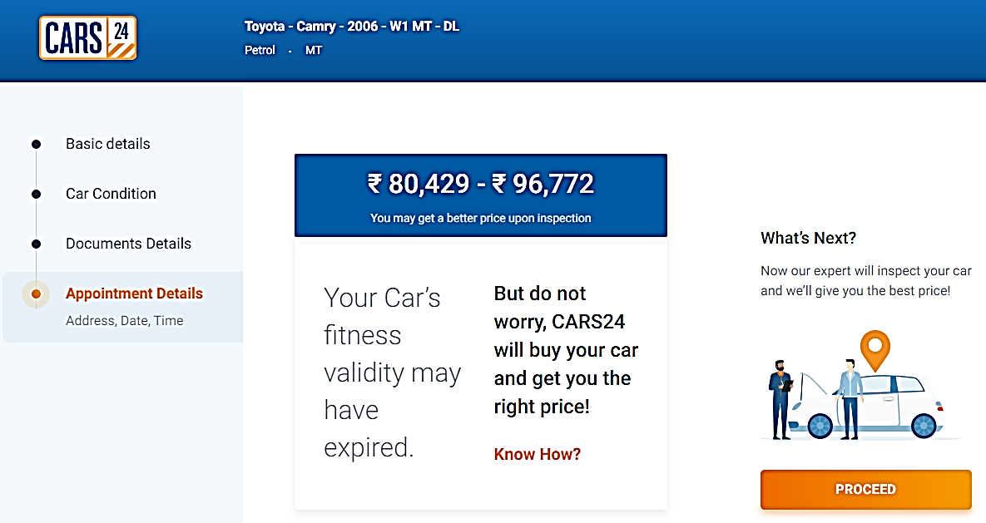

**FOR NEW CAR:**

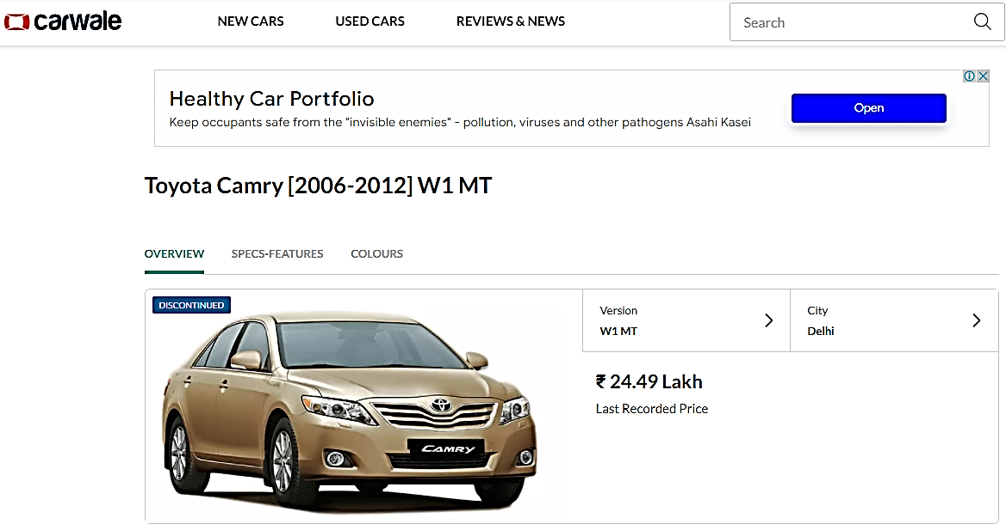

**ENCLOSURE: 3 – PHOTOGRAPHS**

