**VRN NO. IOVRVF/FVA/2021-2022/567**

**CASE NO. VIS(2021-22)PL1038-880-1146 DATED: 12/03/2022**

**VALUATION REPORT**

**OF**

|  |  |
| --- | --- |
| **NATURE OF ASSET** | **BUILT-UP UNIT** |
| **CATEGORY OF ASSET** | **RESIDENTIAL** |
| **TYPE OF ASSET** | **RESIDENTIAL APARTMENT IN MULTISTORIED BUILDING** |

**SITUATED AT**

**FLAT NO. J-65, SIXTH FLOOR, BLOCK – J, DIAMOND DISTRICT, KODIHALLI VILLAGE, BANGLORE AIRPORT ROAD, VARTUR HOBLI, BANGLORE SOUTH TALUK, BANGLORE, KARNATAKA**

**REPORT PREPARED FOR**

**MR. ASHUTOSH AGARWALA**

*(IP REG. NO. IBBI/IPA-001/IP-P-01123/2018-2019/11901)*

**LIQUIDATOR OF COX AND KINGS LIMITED**

***\*\*Important - In case of any query/ issue or escalation you may please contact Manager at*** [***valuers@rkassociates.org***](mailto:valuers@rkassociates.org) ***/*** [***futurevalue@futurevalueco.com***](mailto:futurevalue@futurevalueco.com)

|  |
| --- |
| **ASSET/ PROPERTY UNDER VALUATION** |

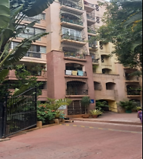

**SITUATED AT**

**UNIT BEARING J-65, SIXTH FLOOR, BLOCK – J, DIAMOND DISTRICT, KODIHALLI VILLAGE, BANGLORE AIRPORT ROAD, VARTUR HOBLI, BANGLORE SOUTH TALUK, BANGLORE, KARNATAKA**

|  |
| --- |
| **VALUATION ASSESSMENT** |

|  |  |
| --- | --- |
| Name of Liquidator | Mr. Ashutosh Agarwala |
| Name of Corporate Debtor | M/s. Cox and Kings Limited |
| Purpose of the Valuation | To determine the Fair Value & Liquidation Value (Realizable Value) under asset category Built-up unit (Flat), in accordance with regulation 35 of IBBI (Insolvency Resolution for Corporate Persons) Regulations 2016. (Liquidation Process) |
| Date of Valuation | 16-12-2021 Liquidation Commencement Date |
| Date of site visit | 10-03-2022 |
| Date of valuation report | 03-03-2022 |

|  |  |  |  |  |  |  |  |  |  |  |  |  |  |  |
| --- | --- | --- | --- | --- | --- | --- | --- | --- | --- | --- | --- | --- | --- | --- |
|  | **Property Details** | | | | | | | | | | | | | |
|  | Address | | Unit Bearing J-65, Sixth Floor, Block – J, Diamond District, Survey No. 153, 158, 159, 160/1 and others, Kodihalli Village, Banglore Airport Road, Vartur Hobli, Banglore South Taluk, Banglore, Karnataka. | | | | | | | | | | | |
|  | Nearby Landmark | | Near Kanakdasa Park | | | | | | | | | | | |
|  | Google Map | | Enclosed with the Report | | | | | | | | | | | |
| Coordinates or URL: 12°57'34.7"N 77°38'36.6"E | | | | | | | | | | | |
|  | Independent access to the property | | Clear independent access is available | | | | | | | | | | | |
|  | Type of ownership | | Company owned | | | | | | | | | | | |
|  | Constitution of the Property | | Free Hold | | | | | | | | | | | |
|  | Is the property merged or colluded with any other property | | Can’t Comment | | | | | | | | | | | |
| Comments: None | | | | | | | | | | | |
|  | **BRIEF DESCRIPTION OF THE PROPERTY UNDER VALUATION** | | | | | | | | | | | | | |
|  | This opinion on valuation is prepared for the residential flat situated at the aforesaid address having total super built-up area admeasuring 1638 sq.ft. (152.17 sq.mtr) as per the documents provided to us.  The subject property is a free hold flat owned by Ms. Cox and Kings (India) Limited through an agreement to sale dated 10th Nov 2000 as per the documents provided by the Liquidator team.  This is 3BHK residential flat situated on the 6th floor of housing society named “Diamond District Co-Operative Housing Society” in the Block-J of the said society in the jurisdiction of “Bruhat Bengaluru Mahanagara Palike”.  This is a residential property, during the site survey only outside visit could be conducted. Since the door was locked Internal survey of the subject property could not be conducted, as per the information provided by the Liquidator team the flat is in good condition and recent maintenance has been done.  Flat is currently locked and internal survey was not possible. The property was identified with the help of bank notice affixed on main door and name plate on the front door of the flat.  The subject society is located in the midst of developed residential cum commercial area of Kodihali located on the crossing of Old HAL Airport Road and Intermediate Ring Road.  The subject property can be easily approached through Old Airport road and the nearest railway station is Baiyappanahalli which is approx. 5 km.  The nearest metro station is “Indira Nagar” which is at a distance of 5 Km from the society.  This report only contains general assessment & opinion on the Guideline Value and the indicative, estimated Market Value of the property found on as-is-where basis on site for which the Liquidator has shown & asked us to conduct the Valuation for which photographs is also attached with the report. No legal aspects in terms of ownership or any other legal aspect is taken into consideration. It doesn’t contain any due-diligence other than the valuation assessment of the property shown to us on site. Information/ data/ documents given to us by Liquidator team has been relied upon in good faith. This report doesn’t contain any other recommendations of any sort. | | | | | | | | | | | | | |
|  | **Document Details** | | **Status** | | | | **Name of Approving Auth.** | | | | **Approval No.** | | | |
|  | Layout Plan | | Not Available | | | | --- | | | | ---- | | | |
|  | Building plan | | Not Available | | | | --- | | | | ---- | | | |
|  | Construction Permission | | Not Available | | | | --- | | | | ---- | | | |
|  | Legal Documents | | Available | | | | Sales Deed | | | Share Certificate | | | | Name Change Certificate |
|  | **Physical Details of the Property** | | | | | | | | | | | | | |
|  | Adjoining Properties | | **Directions** | | **As per Sale Deed/TIR** | | | | | | | **As per site survey** | | |
| **North** | | Not Mentioned in the documents | | | | | | | Other Flats | | |
| **South** | | Not Mentioned in the documents | | | | | | | Other Flats | | |
| **East** | | Not Mentioned in the documents | | | | | | | Open To Sky | | |
| **West** | | Not Mentioned in the documents | | | | | | | Entry / Corridor | | |
|  | Are Boundaries matched | | Boundaries are not mentioned in the documents. | | | | | | | | | | | |
|  | Plot demarcation | | Not applicable since subject property is a built-up unit in Group Housing Project | | | | | | | | | | | |
|  | Approved land Use | | Residential as per zoning regulation of Bangalore Development Authority | | | | | | | | | | | |
|  | Type of Property | | Residential Apartment in mid-rise building | | | | | | | | | | | |
|  | DETAILS OF FLAT (AS PER DOCUMENTS/INFORMATION PROVIDED) | | | | | | | | | | | | | |
|  | No. of bed rooms | Living/ Dining area | | Toilets | | | | Kitchen | | | | | Other rooms | |
| 03 | 01 | | 03 | | | | 01 | | | | | 01 Drawing Room | |
|  | Total no. of floors of the property | | Ground + 7 Floors | | | | | | | | | | | |
|  | Floor on which the property is located | | Sixth Floor | | | | | | | | | | | |
|  | Approx. age of the property | | Above 20 years | | | | | | | | | | | |
|  | Residual age of the property | | No Information available. | | | | | | | | | | | |
|  | Type of structure | | RCC framed pillar, beam, column structure on RCC slab | | | | | | | | | | | |
|  | Condition of the Structure | | Good | | | | | | | | | | | |
|  | Finishing of the building | | Good | | | | | | | | | | | |
|  | **Tenure/ Occupancy/ Possession Details** | | | | | | | | | | | | | |
|  | Property presently possessed/ occupied by | | | | | Vacant | | | | | | | | |
|  | Status of Tenure | | | | | NA | | | | | | | | |
|  | No. of years of occupancy | | | | | NA | | | | | | | | |
|  | Relationship of tenant or owner | | | | | NA | | | | | | | | |
|  | **Stage of Construction** | | | | | Constructed property in use | | | | | | | | |
|  | If under construction then extent of completion | | | | | NA | | | | | | | | |
|  | **Violation in the property** | | | | | | | | | | | | | |
|  | 1. **Violation if any observed** | | 1. **Nature and extent of violation** | | | | | | 1. **Any other negativity, defect or drawback in the property** | | | | | |
|  | Cannot comment since copy of approved building plans/map not provided to us | | Cannot comment since copy of approved building plans/map not provided to us | | | | | | No | | | | | |

|  |  |  |  |  |
| --- | --- | --- | --- | --- |
|  | **Constructed Covered Area** | | | |
|  | Area as per documents | | Area as per site survey | **Area considered for Valuation** |
| 1638 sq.ft / 152.17 sq.mtr  (Super Built-up Area) | | Considered as per documents | 1638 sq.ft. / 152.17 sq.mtr.  (Super Built-up Area) |
| Area adopted on the basis of | Property documents only, since internal site survey not conducted. | | |

|  |  |  |  |  |  |
| --- | --- | --- | --- | --- | --- |
|  | **PROCEDURE OF VALUATION ASSESSMENT** | | | | |
|  | Important Dates | **Date of Inspection of the Property** | | **Date of Valuation Assessment** | **Date of Valuation Report** |
| 10 March 2022 | | 16 December 2021 | 12 March 2022 |
|  | Liquidator | Mr. Ashutosh Agarwala (Liquidator of M/s. Cox & Kings Limited) | | | |
|  | Intended Use | Only for the intended user, purpose of the assignment as per the scope of the assessment. | | | |
|  | Purpose of Valuation | For Liquidation proceedings under IBC, 2016 | | | |
|  | Scope of the Assessment | To estimate the liquidation value of Land and Building of the Company/ Corporate Debtor in terms of Regulation 35(2) of the IBBI ( Liquidation Process) Regulations, 2016. | | | |
|  | Restrictions | This report should not be referred for any other purpose, by any other user and for any other date other then as specified above. | | | |
|  | Manner in which the property is identified | ☒ | Done from the name plate displayed on the property | | |
| ☒ | Enquired from local residents/ public | | |
|  | Type of Survey conducted | This is a residential property, during the site survey only outside visit could be conducted. Since the door was locked Internal survey of the subject property could not be conducted, as per the information provided by the Liquidator team the flat is in good condition and recent maintenance has been done. | | | |

|  |  |  |  |  |  |  |  |  |  |  |  |  |
| --- | --- | --- | --- | --- | --- | --- | --- | --- | --- | --- | --- | --- |
|  | **ASSESSMENT FACTORS** | | | | | | | | | | | |
|  | Nature of the Valuation | Fixed Assets Valuation | | | | | | | | | | |
|  | Nature/ Category/ Type/ Classification of Asset under Valuation | **Nature** | | | | **Category** | | | | | **Type** | |
| BUILT-UP UNIT | | | | RESIDENTIAL | | | | | RESIDENTIAL APARTMENT IN MULTISTORIED BUILDING | |
| **Classification** | | | | Personal use and rental income purpose asset | | | | | | |
|  | Type of Valuation *(Basis of Valuation as per IVS)* | Primary Basis | | | Market Value & Govt. Guideline Value for assessment of Fair Value & Liquidation Value as per (a) to (f) as mentioned in the later part of report | | | | | | | |
|  | Present market state of the Asset assumed *(Premise of Value as per IVS)* | Under Liquidation stage | | | | | | | | | | |
| **Reason:** Asset under IBC Liquidation stage | | | | | | | | | | |
|  | Property Use factor | **Current/ Existing Use** | | | | | **Highest & Best Use**  *(in consonance to surrounding use, zoning and statutory norms)* | | | | **Considered for Valuation purpose** | |
| Residential | | | | | Residential | | | | Residential | |
|  | Legality Aspect Factor | Assumed to be fine as per copy of the documents & information produced to us.  However Legal aspects of the property of any nature are out-of-scope of the Valuation Services. In terms of the legality, we have only gone by the documents provided to us in good faith.  Verification of authenticity of documents from originals or cross checking is not in our scope. | | | | | | | | | | |
|  | Class/ Category of Group Housing Society/ Township/ Apartments | Normal Middle class Housing Project | | | | | | | | | | |
|  | Flat Physical Factors | **Shape** | | | | | | **Size** | | **Layout** | | |
| Not Applicable | | | | | | Medium | | 3 BHK | | |
|  | Property Location Category Factor | **City Categorization** | | **Locality Characteristics** | | | | | **Property location characteristics** | | | **Floor Level** |
| Metro City | | Good | | | | | On Wide Road | | | 6th Floor |
| Urban developed | | HIG | | | | | Good location within locality | | |
| Within main city | | | | | Near to Market | | |
| **Property Facing** | | | | | | | | | | |
| West Facing | | | | | | | | | | |
|  | Physical Infrastructure availability factors of the locality | **Water Supply** | | **Sewerage/ sanitation system** | | | | | **Electricity** | | | **Road and Public Transport connectivity** |
| Yes from municipal connection | | Underground | | | | | Yes | | | Easily available |
| **Availability of other public utilities nearby** | | | | | | | **Availability of communication facilities** | | | |
| Transport, Market, Hospital etc. are available in close vicinity | | | | | | | Major Telecommunication Service Provider & ISP connections are available | | | |
|  | Social structure of the area (in terms of population, social stratification, regional origin, age groups, economic levels, location of slums/ squatter settlements nearby, etc.) | High Income Group | | | | | | | | | | |
|  | Neighbourhood amenities | Good | | | | | | | | | | |
|  | Any New Development in surrounding area | Not Known | | | | | | | | | | |
|  | Any specific advantage/ drawback in the property | The location of the subject property is very good with transport facility and civic amenities available in close vicinity to the subject property. | | | | | | | | | | |
|  | Property overall usability/ utility Factor | Normal | | | | | | | | | | |
|  | Do property has any alternate use? | None | | | | | | | | | | |
|  | Is property clearly demarcated by permanent/ temporary boundary on site | NA | | | | | | | | | | |
|  | Is the property merged or colluded with any other property | Can’t Comment | | | | | | | | | | |
|  | Is independent access available to the property | Clear independent access is available | | | | | | | | | | |
|  | Is property clearly possessable upon sale | Yes | | | | | | | | | | |
|  | Best Sale procedure to realize maximum Value *(in respect to Present market state or premise of the Asset as per point (iv) above)* | Liquidation Value | | | | | | | | | | |
| Liquidation Sale (Forced Sale) | | | | | | | | | | |
|  | Hypothetical Sale transaction method assumed for the computation of valuation | Liquidation Value | | | | | | | | | | |
| Liquidation Sale (Forced Sale) | | | | | | | | | | |
|  | Approach & Method of Valuation Used | **Built-up**  **Unit** | **Approach of Valuation** | | | | | | **Method of Valuation** | | | |
| **Market Approach** | | | | | | **Market Comparable Sales Method** | | | |

|  |  |  |
| --- | --- | --- |
|  | Size of Flat | Super Built-up Area – 1,638 sq.ft. / 152.17 sq.mtr. |
| Total extent of the Flat | Super Built-up Area – 1,638 sq.ft. / 152.17 sq.mtr. |
| Area adopted on the basis of | Property documents only since site measurement couldn't be carried out |
| Prevailing market rate (Along with details /reference of at least two latest deals/transactions with respect to adjacent properties in the areas)  **References on prevailing market Rate/ Price trend of the property and Details of the sources from where the information is gathered (from property search sites & local information)**   1. **Name**: Kumar Property Dealer ( Property Dealer)   **Contact No.**: +91-99450 74643  **Size of the Property**: Approx. 1,300-1,600 sq.ft on super built up area  **Rates/ Price informed**: Rs.5,500/- to Rs.6,500/- per sq.ft  **Comment**: As per the discussion held with the above mentioned property dealer we came to know that the rates in the concerned area for residential flats in the subject locality ranges between Rs.5,500/- to Rs.6,500/- per sq.ft on super built up area for flats on re-sale. The rate for flats in new residential society is on the higher sides. One car parking space is available with flats on re-sale.   1. **Name**: Mr. Manjunath Realtors   **Contact No.**: +91-99454 05777  **Size of the Property**: Approx. 1,300-1,600 sq.ft on super built up area.  **Rates/ Price informed**: Rs.6,000/- to Rs.7,000/- per sq.ft.  **Comment**: As per the discussion held with the above mentioned property dealer we came to know that the rates in the concerned area for residential flats in the subject locality ranges between Rs.6,000/- to Rs.7,000/- per sq.ft on super built up area for flats on re-sale. The rate for flats in new residential society is on the higher sides ranging up to 1.25 Cr. with extra charges for parking and amenities.   1. **Bank e-auction analysis**:     ***Source:*** [***https://indianbankseauction.com/SearchProperty/SearchProperty***](https://indianbankseauction.com/SearchProperty/SearchProperty)  **Comment**: During the due diligence of the said property in Varthur Hobli, Bangalore near-by properties we could found one flat property at project “Sraddha Tulip” at K R Puram Hobli, Bangalore. With Reserve price of Rs.3,392/- per sq.ft (auction price).  **Inference for our project**: **1.)** **Location:** Our project is at main HAL Old Airport Road which is good and prime commercial cum residential zone.  **2.)** **Distance:** Comparable project is at a distance of 10 km from our project.  **3.)** **Amenities:** Our project is having gated campus amenities more than the comparable project.  *During our micro market survey and discussion with local inhabitants and property dealer we came to know following information:*   1. *The prevailing rate for residential flats in the subject locality mainly ranges from Rs.5,000/- to Rs.7,000/- per sq.ft on super built up area for flats in old residential societies.* 2. *The rate for residential flats in new residential society is on the higher side.* 3. *The subject locality is well connected with road facility and can be easily approached through the Old airport road.* 4. *The subject locality also has good proximity to civic amenities with the nearest railway station and metro station available within a proximity of around 5km.* 5. *The subject locality is located in the developed commercial cum residential area on Old Airport road.* 6. *The car parking space is available with the flats which are on resale and for new developing residential societies the car parking space and other amenities are available on extra payment to the developer.*   *The available market rates for residential flats in the subject locality mainly ranges from Rs.5,000/- to Rs.7,000/- per sq.ft on super built – up area.*  *Since the subject property is a residential flat in the residential society named “Diamond District” on the old Airport road. Therefore, considering all the above factors such as floor, amenities and size of the property we are in the view that the rate for the subject apartment property can be considered* ***Rs.6,200/- per sq.ft*** *on super built up area for fair value assessment.*  *No authentic last two transactions details could be known. However prospective transaction details as per information available on public domain and gathered during site survey is mentioned above. Valuation Assessment Factors of the report and the screenshots of the references are annexed in the report for reference.*  *For Liquidation value (a) An asset on a standalone basis, (b) The assets in a slump sale, (c) A set of assets collectively, (d) The assets in parcels will have lower value as compare to going concern liquidation values of The corporate debtor as a going concern, (f) The business(s) of the corporate debtor as a going concern.*  *In our case we have considered discounting of 20% on Fair Value for Liquidation value for point (a) to (d). And a discounting of 15% on Fair Value for Liquidation value for point (e) & (f).*  *In our opinion the above considered Liquidation values is reasonable for transaction of the subject property.* | |
|  | Any other aspect which has relevance on the value or marketability of the property | The subject property is currently vacant and has been closed and unused for a long period of time.  The subject residential society is located in well-developed residential cum commercial area on the Old airport road.  Valuation of the same asset/ property can fetch different values under different circumstances & situations. For e.g. Valuation of a running/ operational shop/ hotel/ factory will fetch better value and in case of closed shop/ hotel/ factory it will fetch considerably lower value. Similarly, an asset sold directly by an owner in the open market through free market arm’s length transaction then it will fetch better value and if the same asset/ property is sold by any financer or court decree or Govt. enforcement agency due to any kind of encumbrance on it then it will fetch lower value.  This Valuation report is prepared based on the facts of the property & market situation on the date of the survey. It is a well-known fact that the market value of any asset varies with time & socio-economic conditions prevailing in the region/ country. In future property market may go down, property conditions may change or may go worse, property reputation may differ, property vicinity conditions may go down or become worse, property market may change due to impact of Govt. policies or effect of domestic/ world economy, usability prospects of the property may change, etc. |
|  | Considered Rates Justification | As per the thorough property & market factors analysis as described above, the considered estimated market rates appears to be reasonable in our opinion. |

|  |  |  |
| --- | --- | --- |
|  | Fair Value: Comparable Weighted & Adjusted Rate of the subject Property *(average of all comparable)* | Rs.6,200/- per sq.ft on Super Built up area. |
| **Liquidation Value** | **Liquidation Value (a) to (d) is Rs.4,960/- per sq.ft on Super Built up area**  **Liquidation Value (e) & (f) (Going Concern) is Rs.5,270/- per sq.ft on Super Built up area** |
|  | **Basis of computation, working & Caveats** | |
| * *Valuation of the asset is done as found on as-is-where basis on the site as identified to us by owner representative during site inspection by our engineer/s unless otherwise mentioned in the report.* * *Analysis and conclusions adopted in the report are limited to the reported assumptions, conditions and information came to our knowledge during the course of the work and based on the Standard Operating Procedures, Best Practices, Caveats, Limitations, Conditions, Remarks, Important Notes, Valuation TOR and definition of different nature of values.* * *For knowing comparable market rates, significant discreet local enquiries have been made from our side. Thereafter based on this information and various factors of the property, rate has been judiciously taken considering the factors of the subject property, market scenario and weighted adjusted comparison with the comparable properties unless otherwise stated.* * *References regarding the prevailing market rates and comparable are based on the verbal/ informal/ secondary/ tertiary information which are collected by our team from the local people/ property consultants/ recent deals/ demand-supply/ internet postings/auction data of banks are relied upon as may be available or can be fetched within the limited time & resources of the assignment during market survey in the subject location. No written record is generally available for such market information except for the Govt. Guideline Rates which has to be relied upon.* * *Area measurements considered in the Valuation Report pertaining to asset/ property is adopted from relevant approved documents or sample site measurement whichever is less unless otherwise mentioned.* * *Construction rates or construction quality assessment are adopted based on the present market replacement cost of construction and calculating applicable depreciation & deterioration factor as per its age, existing condition & specifications based on visual observation only of the structure. No structural, physical tests have been carried out in respect of it. No responsibility is assumed for latent defects of any nature whatsoever, which may affect value, or for any expertise required to disclose such conditions. The condition assessment and the estimation of the residual economic life of the structure are only based on the visual observations and appearance found during the site survey.* * *Any kind of unpaid statutory, utilities, lease, interest or any other pecuniary dues on the asset or on its owners has not been factored in the Valuation.* * *This Valuation is conducted based on the macro analysis of the asset/ property considering it in totality and not based on the micro, component or item wise analysis. Analysis done is a general assessment and is neither investigative in nature nor an audit activity.* | |
|  | **ASSUMPTIONS** | |
| 1. *Documents/ Information/ Data provided by the Liquidator team/ property owner or his representative both written & verbally is true and correct without any fabrication and has been relied upon in good faith.* 2. *Local verbal enquiries during micro market research came to our knowledge are assumed to be taken on record as true, factual & reliable.* 3. *The assets and interests therein have been valued free and clear of any liens or encumbrances unless stated otherwise. No hidden or apparent conditions regarding the subject assets or their ownership are assumed to exist. No opinion of title is rendered in this report and a good title is assumed unless stated otherwise.* 4. *It is assumed that the concerned Lender/ Financial Institution has asked for the valuation of that property after satisfying the authenticity of the documents given to us and for which the legal verification has been already taken and cleared by the competent Advocate before requesting for the Valuation report. I/ We assume no responsibility for the legal matters including, but not limited to, legal or title concerns.* 5. *Payment condition during transaction in the Valuation has been considered on all cash bases which includes both formal & informal payment components as per market trend.* 6. *Sale transaction method of the asset is assumed as Free market transaction without any compulsion unless otherwise mentioned while assessing Indicative & Estimated Fair Prospective Market Value of the asset unless otherwise stated.* 7. *If this Valuation Report is prepared for the Flat/ dwelling unit situated in a Group Housing Society or Integrated Township then approvals, maps of the complete group housing society/ township is out of scope of this report. This valuation report is prepared for the specific unit based on the assumption that complete Group Housing Society/ Integrated Township is approved and complied with all relevant laws and the subject unit is also approved within the Group Housing Society/ Township.* | |
|  | **LIMITATIONS** | |
| As mentioned above. | |

|  |  |  |  |  |
| --- | --- | --- | --- | --- |
|  | **VALUATION COMPUTATION OF BUILT-UP DWELLING UNIT** | | | |
|  | **Particulars** | | **Govt. Circle/ Guideline Value** | Indicative & Estimated Prospective Fair Market Value |
|  | Built-up Unit Value | Rate range | Rs.74,500/- per sq.mtr For Ground Floor | Rs.5,000/- to Rs.7,000/- per sq.ft on super built up area |
| Rate adopted | Rs.74,500/- per sq.mtr For Ground Floor | Rs.6,200/- per sq. ft. on super built up area |
| Covered Area | 1,638 sq.ft / 152.17 sq.mtr Super Built up Area | 1,638 sq.ft / 152.17 sq.mtr Super Built up Area |
| Class of construction | Class B construction (Good) | Class B construction (Good) |
| Valuation Calculation | Please see annexure in later part of report | Rs.6,200/- per sq.ft X 1,638 sq.ft |
| **Total Value** | Rs.1,16,43,364/- | **Rs.1,01,55,600/-** |
|  | Depreciation percentage  *(assuming salvage value % per year)* | | NA | *(Above replacement rate is calculated after deducting the prescribed depreciation)* |
|  | Age Factor | | 1990-2000 (0.9) | Construction older than 25 years and above |
|  | Structure Type/ Condition | | Pucca (1.0) | RCC framed pillar, beam, column structure on RCC slab/ Good |
|  | Built-up Unit Value (A) | | Rs.1,16,43,364/- | **Rs.1,01,55,600/-** |

|  |  |  |  |
| --- | --- | --- | --- |
|  | **CONSOLIDATED VALUATION ASSESSMENT OF THE ASSET** | | |
| **S. No.** | **Particulars** | **Govt. Circle/ Guideline Value** | **Indicative & Estimated Prospective** Fair Market Value |
|  | Built-up Unit Value (A) | Rs.1,16,43,364/- | Rs.1,01,55,600/- |
|  | Additional Aesthetic Works Value (B) | --- | --- |
|  | **Total Add (A+B)** | Rs.1,16,43,364/- | Rs.1,01,55,600/- |
|  | Additional Premium if any | --- | --- |
| Details/ Justification | NA | NA |
|  | Deductions charged if any | --- | --- |
| Details/ Justification | NA | NA |
|  | **Total Indicative & Estimated Prospective Fair Market Value** | Rs.1,16,43,364/- | Rs.1,01,55,600/- |
|  | **Rounded Off** | Rs.1,16,43,364/- | Rs.1,02,00,000/- |
|  | **Indicative & Estimated Prospective Fair Market Value in words** | RUPEES ONE CRORE AND TWO LAKHS ONLY | |
|  | **Liquidation Value**   1. **An asset on a standalone basis** 2. **The asset in a slump sale** 3. **A set of assets collectively** 4. **The assets in parcels** | --- | **Rs.81,60,000/-**  **(Rupees Eighty One Lakhs and Sixty Thousands Only)** |
|  | **Liquidation Value**  **(e) The corporate debtor as a going concern**  **(f) The business(s) of the corporate debtor as a going concern** | --- | **Rs.86,70,000/-**  **(Rupees Eighty Six Lakhs and Seventy Thousands Only)** |
|  | **Concluding Comments/ Disclosures if any** | | |
| 1. We are independent of Liquidator team/ company and do not have any direct/ indirect interest in the property. 2. This Valuation is done for the property found on as-is-where basis as shown on the site by the liquidator/ owner representative of which photographs is also attached with the report. 3. Reference of the property is also taken from the copies of the documents/ information which interested organization or customer could provide to us out of the standard checklist of documents sought from them and further based on our assumptions and limiting conditions. All such information provided to us has been relied upon in good faith and we have assumed that it is true and correct. However we do not vouch the absolute correctness of the property identification, exact address, physical conditions, etc. based on the documents provided to us since property shown to us may differ on site Vs as mentioned in the documents or incorrect/ fabricated documents may have been provided to us. 4. Legal aspects for eg. investigation of title, ownership rights, lien, charge, mortgage, lease, verification of documents from originals or from any Govt. department, etc. has to be taken care by legal experts/ Advocates and same has not been done at our end. 5. The valuation of an asset is an estimate of the worth of that asset which is arrived at by the Valuer / Valuer’s representative in his domain expert opinion after factoring in multiple parameters and externalities. 6. This report only contains opinion based on technical & market information which came to our knowledge during the course of the assignment. It doesn’t contain any recommendations. | | |
|  | **VALUATION DEFINATIONS, METHADOLOGY AND APPROACH** | | |
| ***Fair Value*** *means the estimated price for the transfer of an asset or liability between identified knowledgeable and willing parties that reflects the respective interests of those parties. suggested by the competent Valuer is that prospective estimated amount in his expert & prudent opinion of the subject asset/ property without any prejudice after he has carefully & exhaustively evaluated the facts & information came in front of him or which he could reasonably collect during the course of the assessment related to the subject asset on an as-is, where-is basis in its existing conditions, with all its existing advantages & disadvantages and its potential possibilities which is just & equitable at which the subject asset/ property should be exchanged between a willing buyer and willing seller at an arm’s length transaction in an open & unrestricted market, in an orderly transaction after proper marketing, wherein the parties, each acted knowledgeably, prudently without any compulsion on the date of the Valuation.*  *Fair Value without using the term “Market” in it describes that the value suggested by the Valuer may not mandatorily follow or may not be in complete consonance to the established Market in his expert opinion. It may or may not follow market dynamics. But if the suggested value by the valuer is not within the prevailing Market range or is assessed for an asset is located in an un-established Market then the valuer will give reasonable justification & reasoning that for what reasons the value suggested by him doesn’t follow the prevailing market dynamics.* | | |
| ***Market Value*** *suggested by the competent Valuer is that prospective estimated amount which is average price of the similar comparable assets prevailing in an open & established market during the near period of the date of valuation at which the subject asset/ property should be exchanged between a willing buyer and willing seller on an as-is, where-is basis in its existing conditions, with all its existing advantages & disadvantages and its potential possibilities at an arm’s length transaction in an open, established & unrestricted market, in an orderly transaction, wherein the parties, each acted without any compulsion on the date of the Valuation.*  *Using the term “Market Value” without “Fair” omits the elements of proper marketing, acting knowledgeably & prudently.*  *Market and market participants can be sentimental, inclined towards the transaction without the element of complete knowledge & prudence about facts or due diligence of the asset therefore “each acted knowledgeably, prudently” has been removed from the marker Value definition.* | | |
| ***Realizable Value*** *is that minimum prospective estimated value of the asset/ property which it may be able to fetch at the time of actual property transaction factoring in the element of discount due to the prospects of deep negotiations between the buyer & seller when the parties in-principally find Fair Market Value reasonable and sits together to close the deal and the transaction across the table. Discount percentage on the Fair Market Value due to negotiation will depend on the nature, size and various salability prospects of the subject asset, the needs of the buyer & the seller and kind of payment terms. In some of the cases Realizable and Fair Market Value may also be equal.* | | |
| ***Liquidation Value*** *The net amount that would be realized if a business is discontinued and its assets are sold individually. “LV is estimated realizable value of the assets of the CD if it were liquidated on the liquidation commencement date (LCD).”*  *When the asset is sold in liquidation, sale value will always be less than fair value, since it depends on various factors such as type & future usage of asset, demand, prevailing site conditions & circumstances, mode of payment & transaction, general depression, negative sentiments, salvage value, as is where basis in case of land & building. Seller is official liquidator and the buyer may be motivated by the knowledge of the limitations of the seller under the circumstances. Since it is majorly as industrial usage limitation, the buyer would, essentially be already in the same business or be willing to enter the same line of business. Buyer will approach and search for similar attributes of property in primary & secondary market. Considering all the factors, location, market factors, ease of acquisition, Liquidation Value is estimated by discount and factoring unpaid liability on land component in Fair Value.*  *The liquidator may sell*  *(a) An asset on a standalone basis;*  *(b) The assets in a slump sale;*  *(c) A set of assets collectively;*  *(d) The assets in parcels;*  *(e) The corporate debtor as a going concern; or*  *(f) The business(s) of the corporate debtor as a going concern* | | |
| ***Valuation approach :*** *Value of a property can be estimated three approaches:*  ***a) Market Approach:*** *It is defined as a valuation technique that uses prices and other relevant information generated by market transactions involving identical or comparable (i.e. similar) assets.*  ***b) Income Approach:*** *This method consists of forecasting the earning expectancy of the subject property as a series of net monetary returns calculated from valuation date to the estimated end of life of ownership or the end of income and working out the present worth of this series at a rate commensurate with relative risk involved.*  ***c) Cost Approach:*** *In this method, the owner value of a tangible service property can be measured by the cost summation method of valuation. This method consists of estimating what the current cost of producing the subject property would be and then applying an appropriate depreciation factor.*  ***Market approach has been adopted as a suitable approach for valuation of the subject Property.*** | | |
|  | ***Enclosures with the Report:***   * *Enclosure: I – Google Map Location* * *Enclosure: II - Photographs of the property* * *Enclosure: III – Copy of Circle Guideline Rate* * *Enclosure: IV – References on price trend of the similar related properties available on public domain* * *Enclosure V: Part D - Valuer’s Important Remarks* | | |

|  |  |
| --- | --- |
|  | **ASSUMPTIONS | REMARKS | LIMITING CONDITIONS** |
|  | Any other aspect which has relevance on the value or marketability of the property: This report is prepared following our standard operating procedures & best practices, limitations, conditions, remarks, Important Notes, Valuation procedure: |
| 1. During the site visit the door was locked with displayed notices. Our valuation report doesn’t verify the condition of **“Lis Pendens”** and there by any conditions which might be not in our knowledge or stated otherwise. |
| 1. This Valuation report is prepared based on the copies of the documents/ information which interested organization or customer could provide to us out of the standard checklist of documents sought from them and further based on our assumptions and limiting conditions. All such information provided to us has been relied upon in good faith and we have assumed that it is true and correct. Verification or cross checking of the copy of the documents provided to us from the originals has not been done at our end. |
| 1. Legal aspects for eg. investigation of title, ownership rights, lien, charge, mortgage, lease, etc. are not considered in this report. It is assumed and taken into account that the concerned has got the legal verification cleared by the competent Advocate while requesting for the Valuation report. |
| 1. Value varies with the Purpose/ Date/ Condition prevailing in the market. We recommend not to refer the Value of the asset given in this report if any of these points are different from the one mentioned aforesaid in the Report. |

|  |  |  |  |
| --- | --- | --- | --- |
|  | **DECLARATION** | | |
|  | 1. The undersigned does not have any direct/indirect interest in the above Company/ Corporate Debtor. 2. The information furnished herein is true and correct to the best of valuer’s knowledge. 3. I have submitted Valuation report directly to the Resolution Professional. 4. This valuation report is carried out on the request from Mr. Ashutosh Agarwala, Liquidator (IBBI Reg. No.: IBBI/IPA-001/IP-P-01123/2018-2019/11901) for M/S. Cox & Kings Limited. 5. During the course of execution of this assignment, I have taken Infrastructure Support/domain expert/Knowledge Service from R.K. Associates Valuers & Techno Engineering consultants (P) Ltd. and its team. However, the valuation has been conducted independently by myself without any prejudice. | | |
|  | **Name & Address of Registered Valuer** | **IBBI Registration No.** | **Signature of the Registered Valuer** |
|  | **Name:** FUTUREVALUE ADVISORS INDIA PVT. LTD.  IBBI Reg. No. IBBI/RV/-E/02/2020/117 (ALL ASSET CLASSES) **Ar.** **Ashish Sawe**  (Director & COO)    401, Nirmal Tower, Barkhamba Road, Connaught Place, New Delhi-110001 | *IBBI/RV/02/2019/11384* |  |

|  |  |  |  |  |  |
| --- | --- | --- | --- | --- | --- |
| **GENERAL DETAILS** | | | | | |
|  | Report prepared for | Liquidator | | | |
|  | Name of Liquidator | Mr. Ashutosh Agarwala | | | |
|  | Name of Corporate Debtor | M/s. Cox and Kings Limited | | | |
|  | Date of Valuation report | 12-03-2022 | | | |
|  | Date of Survey | 10-03-2022 | | | |
|  | Type of the Property | Residential Apartment in mid rise building | | | |
|  | Survey Details | This is a residential property, during the site survey only outside visit could be conducted. Since the door was locked Internal survey of the subject property could not be conducted, as per the information provided by the Liquidator team the flat is in good condition and recent maintenance has been done. | | | |
|  | Type of Valuation | Residential Flat Value | | | |
|  | Report Type | Liquidation Valuation Report | | | |
|  | Surveyed in presence of | No one was present as flat was locked | Name: | Society Guard | |
|  | Purpose of Valuation | To determine the Fair Value & Liquidation Value (Realizable Value) under asset category Land & Building, in accordance with regulation 35 of IBBI (Insolvency Resolution for Corporate Persons) Regulations’2016. (Liquidation Process) | | | |
|  | Important Disclosures | 1. Valuation based on the copy of the documents/ information provided to us by the Liquidator team and has been relied upon in good faith of the property found as per the information given in the documents provided to us and/ or confirmed by the owner/ owner representative to us on site. 2. Getting map or coordination with revenue officers for site identification is a separate activity and is not part of the Valuation services. | | | |
|  | Documents provided for perusal | **Documents Requested** | **Documents Provided** | | **Documents Reference No.** |
| Total **05** documents requested. | Total **03** documents provided. | | 03 |
| Copy of TIR | Sales Deed | | Dated: 10-11-2000 |
| Agreement to Sell | Share Certificate | | Dated: 18-05-2001 |
| Property Title document | Name Change Certificate | | Dated: 29-07-2010 |
| Approved Map | Not Provided | | Not Provided |
| Last paid Municipal Tax Receipt | Not Provided | | Not Provided |
| Title Verification Report | Not Provided | | Not Provided |
|  | Documents received from | Liquidator | | | |

**ENCLOSURE: I– GOOGLE MAP LOCATION**

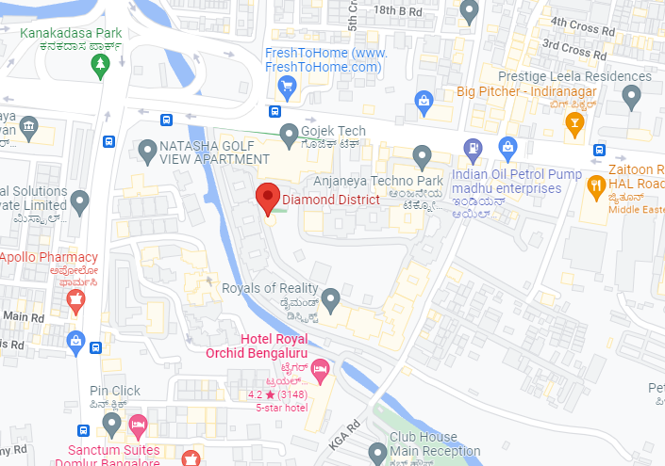

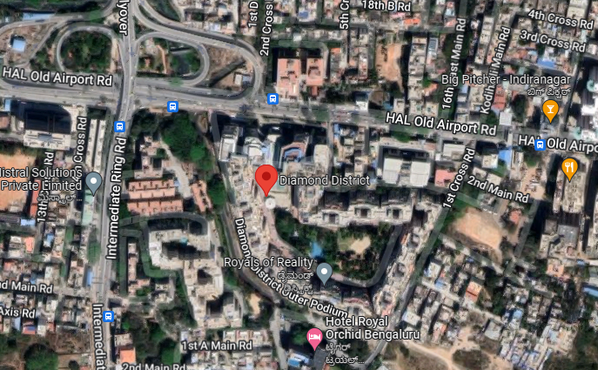

**ENCLOSURE: II – PHOTOGRAPHS OF THE PROPERTY**

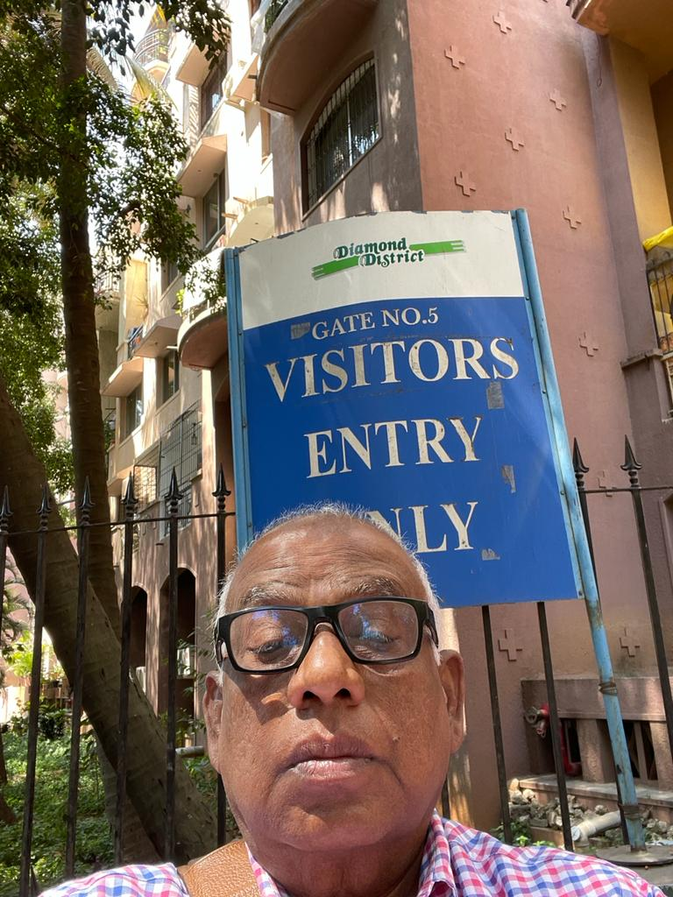

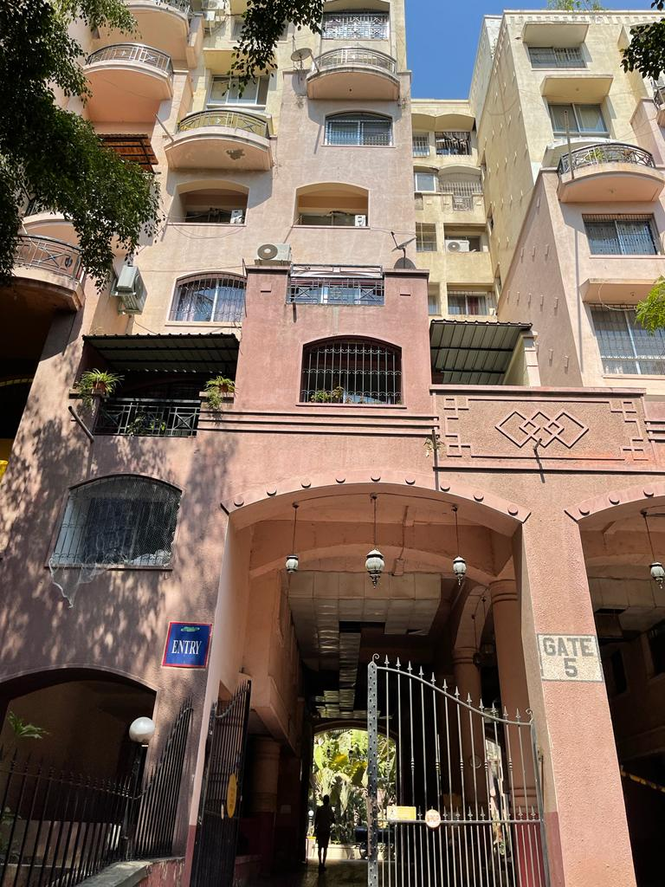

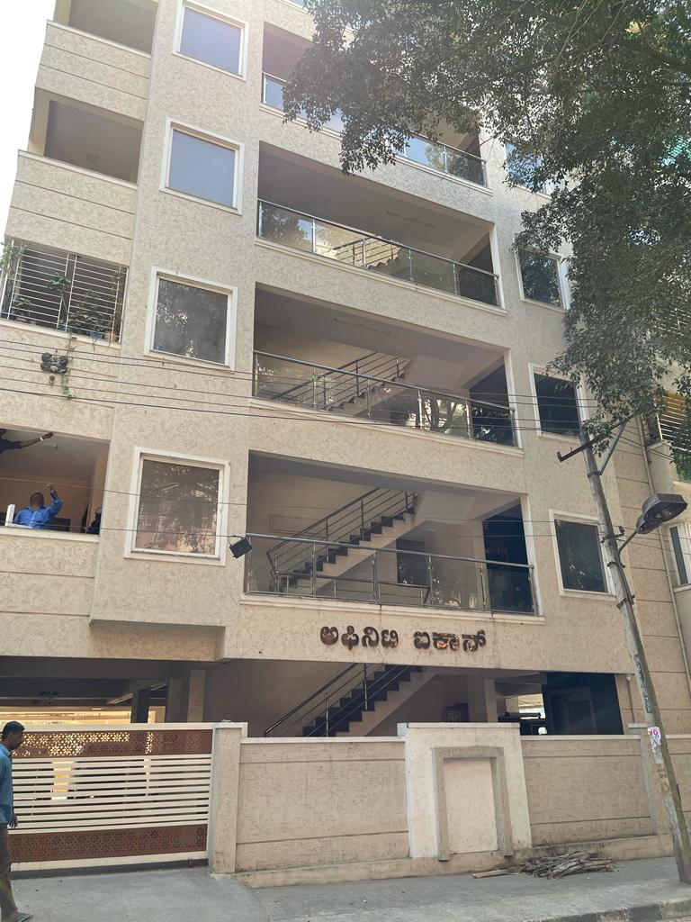

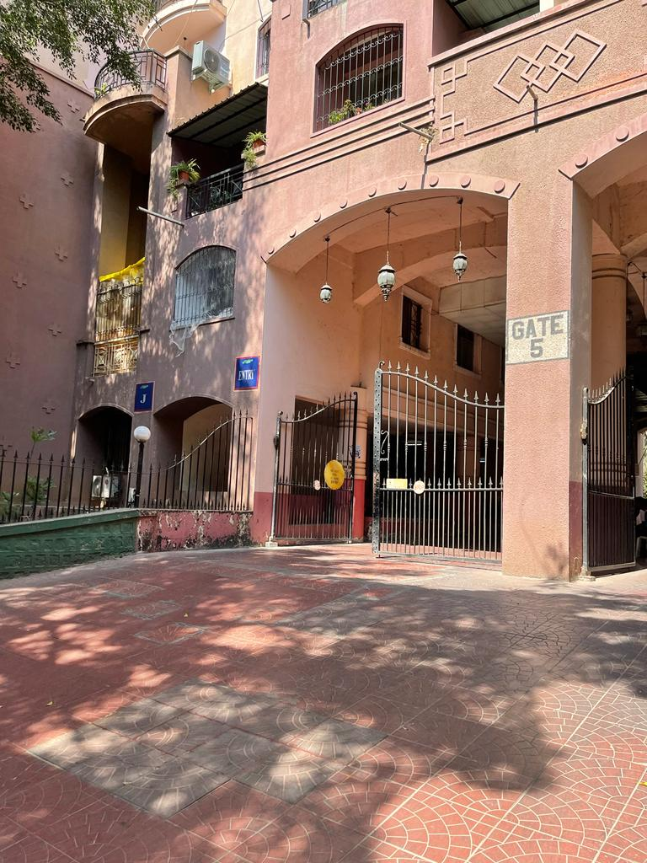

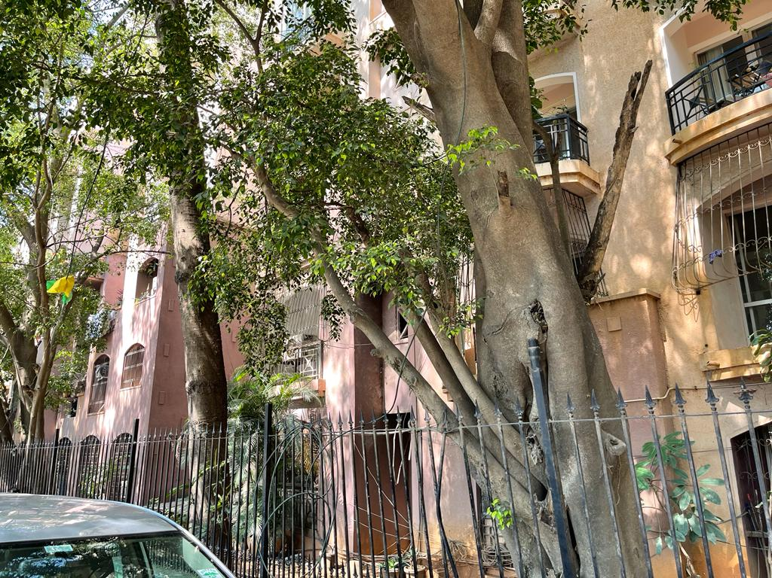

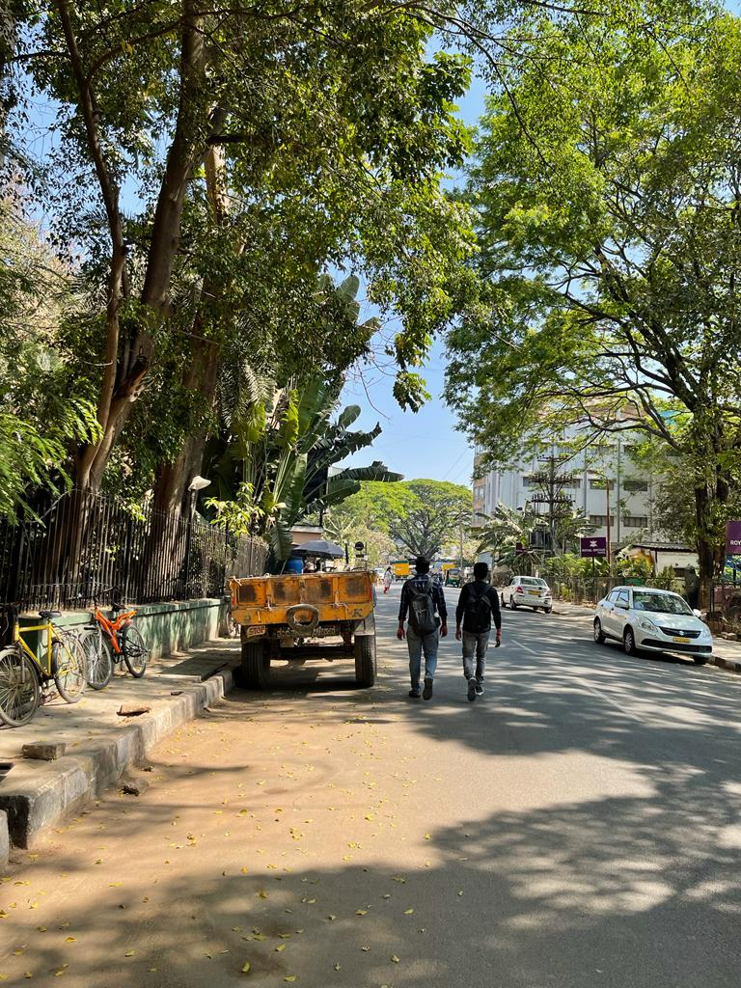

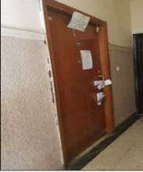

**ENCLOSURE: III – COPY OF CIRCLE RATE**

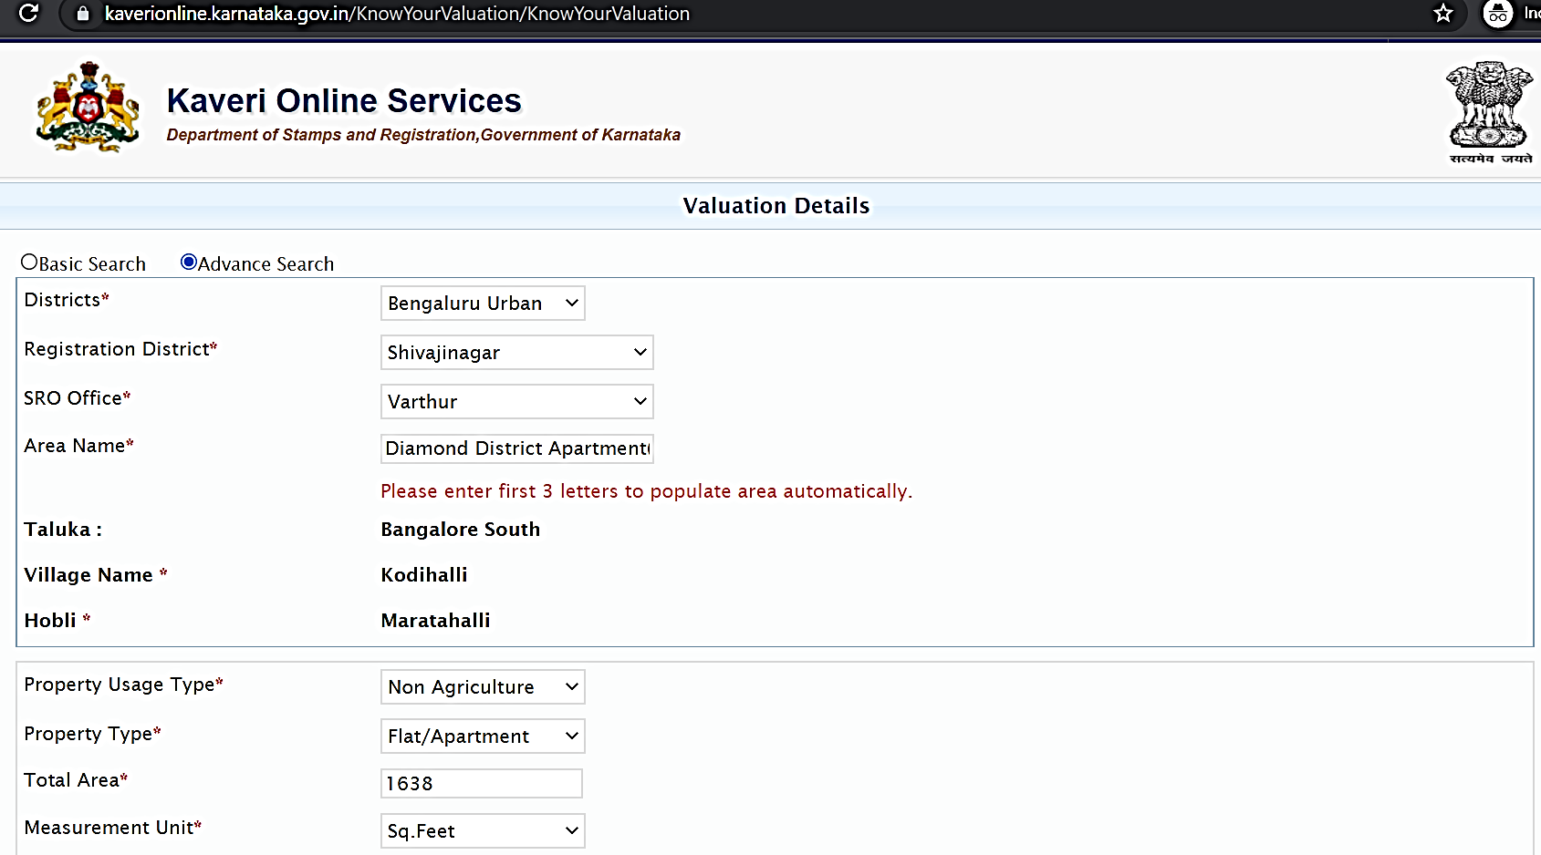

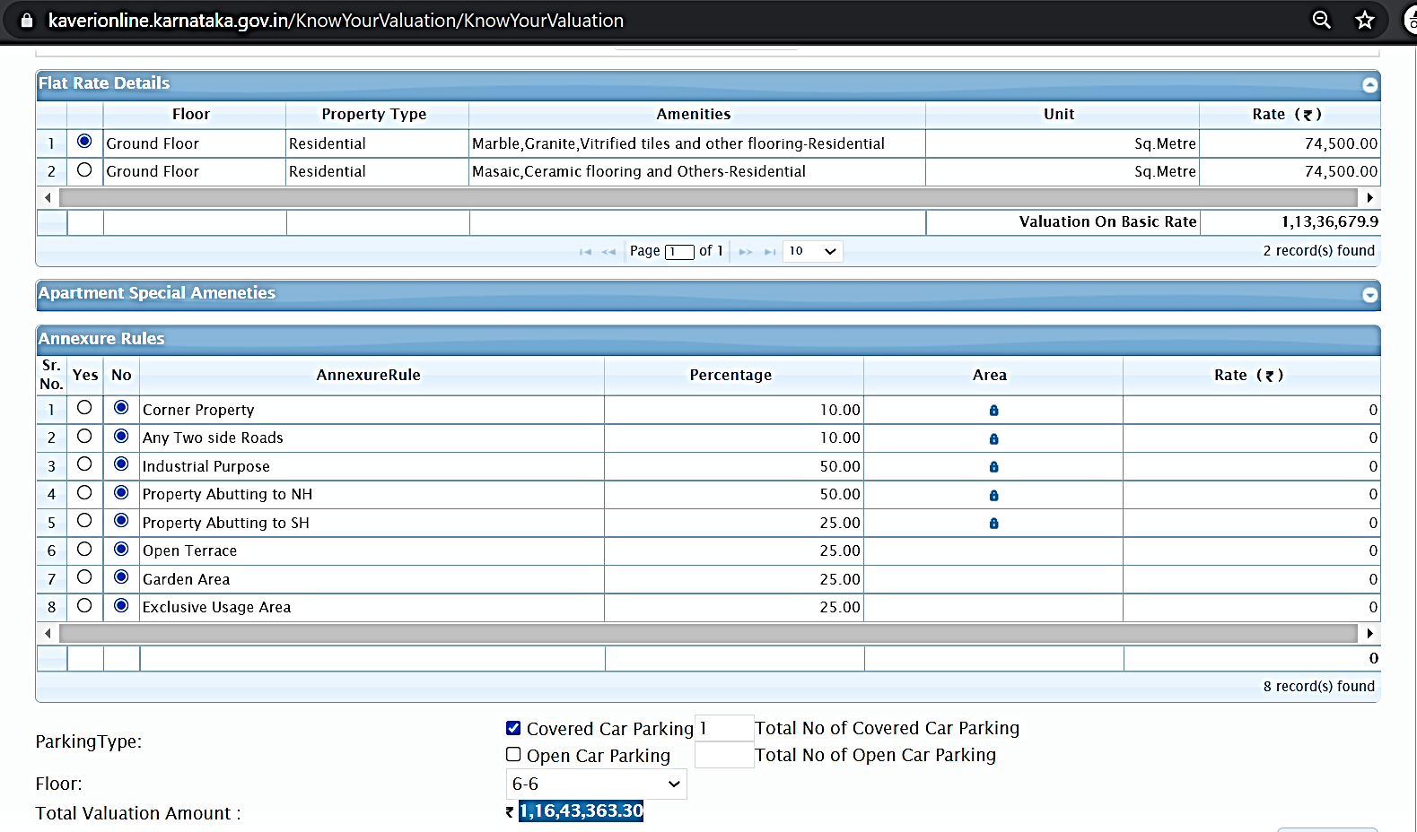

**ENCLOSURE IV - REFERENCES ON PRICE TREND OF THE SIMILAR RELATED PROPERTIES AVAILABLE ON PUBLIC DOMAIN**

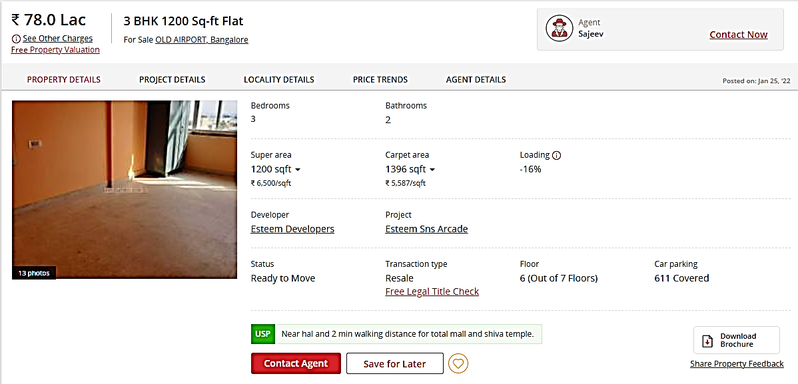

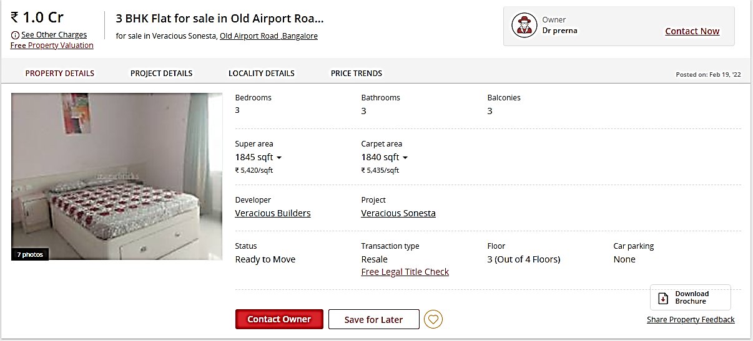

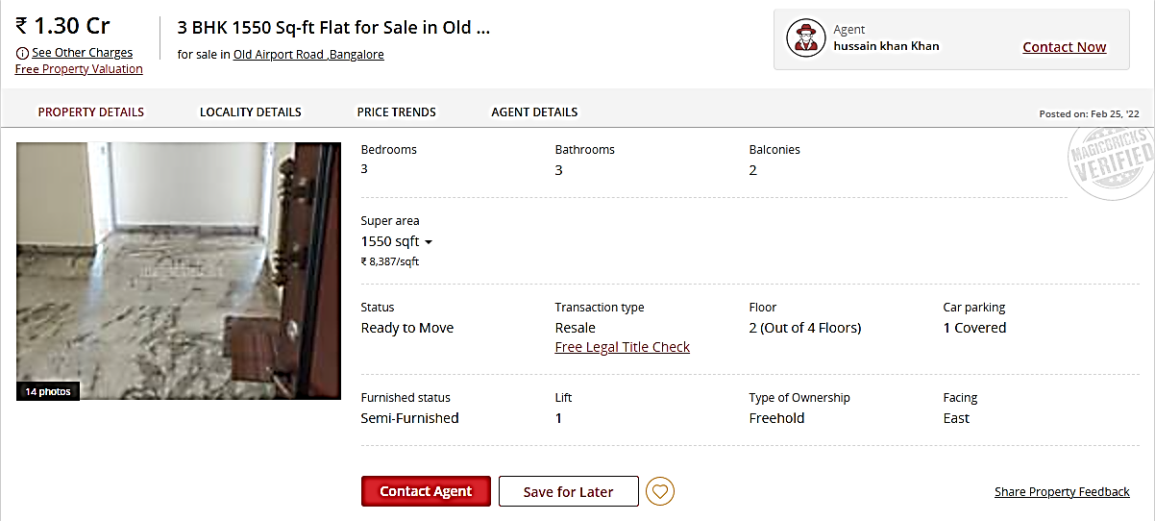

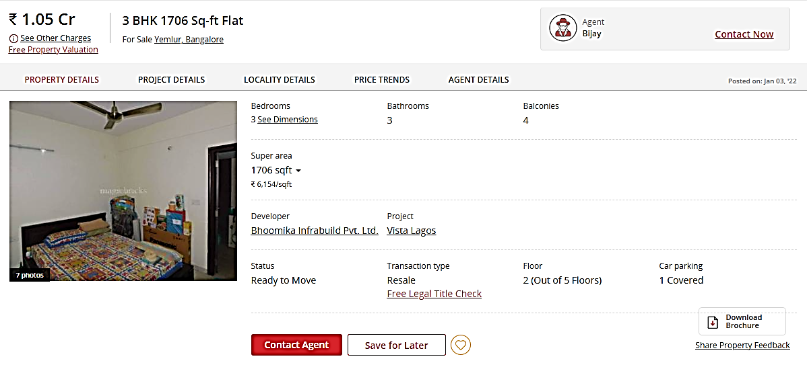

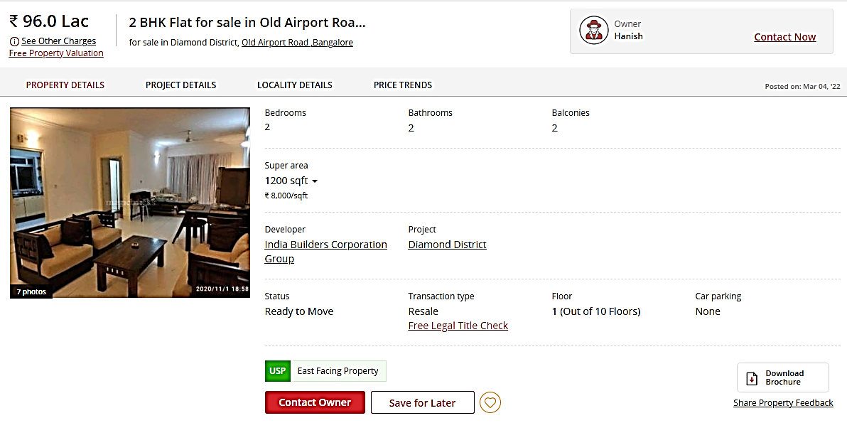

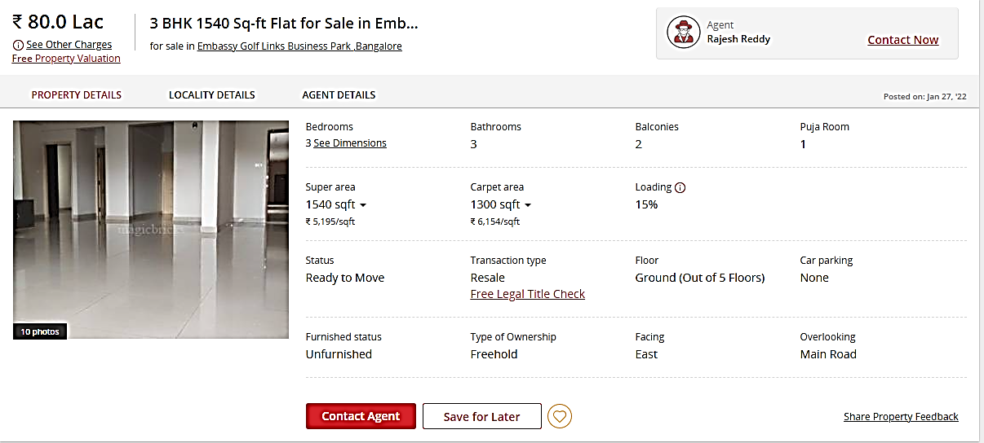

**ENCLOSURE V - VALUER’S PREMISE OF VALUATION**

|  |  |
| --- | --- |
|  | This Valuation report is prepared based on the copies of the documents/ information which the Liquidator team & its customer could provide to us within the reasonable expected time either verbally or in writing out of the standard checklist of documents sought from them and further based on the information came apparently in front of us during the limited available time in the assignment and based on certain assumptions and limiting conditions. The Liquidator team/ owner and its management/representatives warranted to us that the information they supplied was complete, accurate and true and correct to the best of their knowledge. All such information provided to us either verbally, in writing or through documents has been relied upon in good faith and we have assumed that it is true & correct without any fabrication or misrepresentation. I/We shall not be liable for any loss, damages, cost or expenses arising from fraudulent acts, misrepresentations, or wilful default on part of the owner, company, its directors, employee, representative or agents. Verification or cross checking of the documents provided to us from the originals or from any Govt. departments/ authority/ Record of Registrar has not been done at our end. |
|  | The property information, documents, data which has become primary basis of the report has been supplied by the Liquidator team which has been relied upon in good faith and is not generated by the Valuer. |
|  | This is just an opinion report on Valuation based on the copy of the documents/ property information provided to us by the Liquidator team which has been relied upon in good faith of the property found as per the information given in the documents provided to us and/ or confirmed by the owner representative to us on site. |
|  | I/ We assume no responsibility for the legal matters including, but not limited to, legal or title concerns. |
|  | In the course of the valuation, we were provided with both written and verbal information. We have however, evaluated the information provided to us through broad inquiry, analysis and review but have not carried out audit of the information provided for the purpose of this engagement. Our conclusions are based on the assumptions and other information provided to us by the Liquidator team during the course of the assessment. |
|  | Valuation of the asset is done as found on as-is-where on site as identified to us by Liquidator team/ owner/ owner representative during site inspection by our engineer/s unless otherwise mentioned in the report. |
|  | We have made certain assumptions in relation to facts, conditions or situations affecting the subject of, or approach to this exercise that has not been verified as part of the engagement rather, treated as “a supposition taken to be true”. If any of these assumptions prove to be incorrect then our estimate on value will need to be reviewed. |
|  | We have relied on data from third party, external sources & information available on public domain also to conclude the valuation. These sources are believed to be reliable and therefore, we assume no liability for the truth or accuracy of any data, opinions or estimates furnished by others that have been used in this analysis. Where we have relied on data, opinions or estimates from external sources, reasonable care has been taken to ensure that such data has been correctly extracted from those sources and /or reproduced in its proper form and context, however still we can’t vouch its authenticity, correctness or accuracy. |
|  | Analysis and conclusions adopted in the report are limited to the reported assumptions, conditions and information came to our knowledge during the course of the work and based on the Standard Operating Procedures, Best Practices, Caveats, Limitations, Conditions, Remarks, Important Notes, Valuation procedure and definition of different nature of values. |
|  | Value varies with the Purpose/ Date/ Asset Condition & situation/ Market condition, demand & supply, asset utility prevailing on a particular date/ Mode of sale. The indicative & estimated prospective Value of the asset given in this report is restricted only for the purpose and other points mentioned above prevailing on a particular date as mentioned in the report. If any of these points are different from the one mentioned aforesaid in the Report then this report should not be referred. |
|  | This report has been prepared for the purposes stated in the report and should not be relied upon for any other purpose. Our Liquidator team is the only authorized user of this report and is restricted for the purpose indicated in the engagement letter. I/we do not take any responsibility for the unauthorized use of this report. |
|  | Our report is meant for the purpose mentioned in the report and should not be used for any purpose other than the purpose mentioned therein. The Report should not be copied or reproduced without obtaining our prior written approval for any purpose other than the purpose for which it is prepared. |
|  | I/We owe responsibility to only to the authority/Liquidator team that has appointed me/us under the terms of the engagement letters. We will not be liable for any losses, claims, damages or liabilities arising out of the actions taken, omissions or advice given by any other person. In no event shall we be liable for any loss, damages, cost or expenses arising in any way from fraudulent acts, misrepresentations or wilful default on part of the Liquidator team or borrower or companies, their directors, employees, agents or representatives. |
|  | This report is having limited scope as per its fields & format to provide only the general basic idea of the value of the property prevailing in the market based on the documents/ data/ information provided by the Liquidator team. The suggested indicative prospective estimated value should be considered only if transaction is happened as free market transaction. We have assumed market as an efficient market. |
|  | While our work has involved an analysis & computation of valuation it does not include detailed estimation, design/ technical/ engineering/ financial/ structural/ environmental/ architectural/ compliance survey/ safety audit & works in accordance with generally accepted standards of audit & other such works. The report in this work in not investigative in nature except for the valuation part. It is mere an opinion on the likely estimated valuation based on the facts & details presented to us by the Liquidator team and third party market information came in front of us within the limited time of this assignment. |
|  | Under this valuation assignment, we have not made a specific compliance survey or analysis of the various permits and licenses under central, state and local laws / regulations applicable to the operation and use of the subject property, and this valuation does not consider the effect, if any, of non-compliance subject to Govt. approvals. |
|  | This valuation report is not a qualification for accuracy of land boundaries, schedule (in physical terms), dimensions & identification. For this land/ property survey report can be sought from a qualified private or Govt. surveyor. |
|  | This report only contains opinion based on technical & market information which came to knowledge during course of the assignment and as per the information given in the copy of documents, information, data provided to us and/ and confirmed by the owner/ owner representative to us at site verbally and in writing which has been relied upon in good faith. It doesn’t contain any other recommendations of any sort including but not limited to express of any opinion on the suitability or otherwise of entering into any transaction with the Corporate Debtor. |
|  | This Valuation report is prepared based on the facts of the property on the date of the survey. Due to possible changes in market forces, socio-economic conditions, property conditions and circumstances, this valuation report can only be regarded as relevant as at the valuation date. |
|  | Valuation of the same asset/ property can fetch different values under different circumstances & situations. For eg. Valuation of a running/ operational shop/ hotel/ factory will fetch better value and in case of closed shop/ hotel/ factory it will have considerable lower value. Similarly an asset sold directly by an owner in the open market through free market transaction then it will fetch better value and if the same asset/ property is sold by any financer due to encumbrance on it, will fetch lower value. |
|  | Getting location map or coordination with revenue officers for site identification is not done at our end. |
|  | Valuation is done for the property identified to us by the owner/ owner representative. At our end we have just visually matched the land boundaries, schedule (in physical terms) & dimensions of the property with reference to the documents produced for perusal. Method by which identification of the property is carried out is also mentioned in the report clearly. Responsibility of identifying the correct property to the Valuer/ its authorized surveyor is solely of the Liquidator team/ owner for which Valuation has to be carried out. Where there is a doubt about the precision position of the boundaries, schedule, dimensions of site & structures, it is recommended that a Licensed Surveyor can be contacted. |
|  | The report assumes that the Corporate Debtor/company/business/asset complies fully with relevant laws and regulations applicable in its area of operations and usage unless otherwise stated, and that the companies/business/assets will be managed in a competent and responsible manner. Further, as specifically stated to the contrary, this report has given no consideration to matters of a legal nature, including issues of legal title and compliance with local laws, and litigations and other contingent liabilities that are not recorded/reflected in the documents/ details/ information/ data provided to us. |
|  | This Valuation Report is prepared for the Flat/ dwelling unit situated in a Group Housing Society or Integrated Township then approvals, maps of the complete group housing society/ township is out of scope of this report and this report will be made for the specific unit based on the assumption that complete Group Housing Society/ Integrated Township must be approved in all respect. |
|  | Area measurements considered in the Valuation Report pertaining to Land & Building is adopted from relevant approved documents or sample site measurement whichever is less unless otherwise mentioned. All area measurements are on approximate basis only. Measurement verification is only limited upto sample random measurement against the documents produced to us. |
|  | Although scientific method has been employed in systematically arriving at the value, there is, therefore, no indisputable single value and the estimate of the value is normally expressed as falling within a likely range. |
|  | Value analysis of any asset cannot be regarded as an exact science and the conclusions arrived at in many cases will, of necessity, be subjective and dependent on the exercise of individual judgment. Given the same set of facts and using the same assumptions, expert opinions may differ due to the number of separate judgment decisions, which have to be made. Therefore, there can be no standard formula to establish an indisputable exchange ratio. In the event of a transaction, the actual transaction value achieved may be higher or lower than our indicative analysis of value depending upon the circumstances of the transaction. The knowledge, negotiability and motivations of the buyers and sellers and the applicability of a discount or premium for control will also affect actual price achieved. Accordingly, our indicative analysis of value will not necessarily be the price at which any agreement proceeds. The final transaction price is something on which the parties themselves have to agree. However our Valuation analysis can definitely help the stakeholders to make them informed and wise decision about the Value of the asset and can help in facilitating the arm’s length transaction. |
|  | The actual market price achieved may be higher or lower than our estimate of value (or value range of value) depending upon the circumstances of the transaction (for example the competitive bidding environment), the nature of the asset (for example the purchaser’s perception of potential synergies). The knowledge, negotiating ability and motivation of the buyers and sellers, demand & supply prevailing in the market and the applicability of a discount or premium for control will also affect actual market price achieved. Accordingly, our valuation conclusion will not necessarily be the price at which actual transaction will take place. |
|  | References regarding the prevailing market rates and comparable are based on the verbal/ informal/ secondary/ tertiary information collected by our team from the local people/ property consultants/ recent deals/ demand-supply/ internet postings as may be available or can be fetched within the limited time & resources of the assignment during market survey in the subject location are relied upon. No written record is generally available for such market information and analysis has to be derived mostly based on the verbal information which has to be relied upon. |
|  | This report includes both, Govt. Guideline Value and Indicative Estimated Prospective Fair Market Value. As per the current market practice, in most of the cases, formal transaction takes place for an amount less than the actual transaction amount and rest of the payment is normally done informally. |
|  | Construction rates are adopted based on the present market replacement cost of construction and calculating applicable depreciation & deterioration factor as per its age, existing condition & specifications based on visual observation only of the structure. No structural, physical tests have been carried out in respect of it. No responsibility is assumed for latent defects of any nature whatsoever, which may affect value, or for any expertise required to disclose such conditions. |
|  | The condition assessment and the estimation of the residual economic life of the structure is only based on the visual observations and appearance found during the site survey. We have not carried out any structural design or stability study; nor carried out any physical tests to assess structural integrity & strength. |
|  | Any kind of unpaid statutory, utilities, lease, interest or any other pecuniary dues on the asset or on its owners has not been factored in the Valuation. |
|  | This Valuation is conducted based on the macro analysis of the asset/ property considering it in totality and not based on the micro, component or item wise analysis. Analysis done is a general assessment and is not investigative in nature. |
|  | All Pages of the report including annexures are signed and stamped from our office. In case any paper in the report is without stamp & signature then this should not be considered a valid paper issued from this office. |
|  | As per IBA Guidelines, in case the valuation report submitted by the valuer demands any factual correction, the Liquidator team shall bring the same to the notice of the valuer supported with documents within 10 days of submission for rectification and resubmission. In case no such communication is received, it shall be presumed that the valuation report has been accepted. If no intimation is received within 10 (Ten) days in writing from the date of issuance of the report, then it shall be considered that the report is complete in all respect and has been accepted by the Liquidator team upto their satisfaction & use and further to which valuer shall not be held responsible in any manner. |
|  | Though adequate care has been taken while preparing this report as per its scope, but still we can’t rule out typing, human errors, over sightedness of any information or any other mistakes. Therefore the concerned organization is advised to satisfy themselves that the report is complete & satisfactory in all respect. Intimation regarding any discrepancy shall be brought into our notice immediately. |
|  | Valuer encourages its customers to give feedback or inform concerns over its services through proper channel at futurevalue@futurevalueco.com / [valuers@rkassociates.org](mailto:valuers@rkassociates.org) in writing within 10 days of report delivery. After this period no concern/ complaint/ proceedings in connection with the Valuation Services will be entertained due to possible change in situation and condition of the property. |
|  | This Valuation report is governed by our (1) Internal Policies, Processes & Standard Operating Procedures, (2) Valuer Quality Policy, (3) Valuation & Survey Best Practices Guidelines formulated by management of valuer, (4) Information input given to us by the customer and (4) Information/ Data/ Facts given to us by our field/ office technical team. Management of valuer never gives acceptance to any unethical or unprofessional practice which may affect fair, correct & impartial assessment and which is against any prevailing law. In case of any indication of any negligence, default, incorrect, misleading, misrepresentation or distortion of facts in the report then it is the responsibility of the user of this report to immediately or atleast within the defect liability period bring all such act into notice of valuer management so that corrective measures can be taken instantly. |
|  | We owe responsibility to only to the Liquidator team that has appointed us as per the scope of work mentioned in the report. We will not be liable for any losses, claims, damages or liabilities arising out of the actions taken, omissions or advice given by any other person. In no event shall we be liable for any loss, damages, cost or expenses arising in any way from fraudulent acts, misrepresentations or wilful default on part of the Liquidator team or companies, their directors, employees or agents. |
|  | Valuer never releases any report doing alterations or modifications by pen. In case any information/ figure of this report is found altered with pen then this report will automatically become null & void. |
|  | I/We are fully aware that based on the opinion of value expressed in this report, I/we may be required to give testimony or attend court / judicial proceedings with regard to the subject assets, although it is out of scope of the assignment, unless specific arrangements to do so have been made in advance, or as otherwise required by law. In such event, the party seeking our evidence in the proceedings shall bear the cost/professional fee of attending court / judicial proceedings and my / our tendering evidence before such authority shall be under the applicable laws. |

**ENCLOSURE: VI – CONFIDENTIALITY AND DISCLAIMER:**

|  |  |
| --- | --- |
|  | Valuation report is prepared for the exclusive use as per appointment by Liquidator, Contents of the valuation, the purpose of the report and the value conclusions will not be revealed to anyone for other than CIRP purposes or state as per regulation; |
|  | This valuation report sets forth the findings and conclusions, and is based upon an investigation of conditions affecting value, and is subject to the Statement of Limiting Conditions and Definitions. Without reading the Statement of Limiting Conditions and Definitions, this report cannot be fully understood; |
|  | Report shall be used only in its entirety. The contents as contained may not be used for any purpose other than the intended purpose mentioned above. Neither the whole nor any part of the report may be presented to any party other than the instructing party; |
|  | Appearance in Hon’ble NCLT court (if required) only once, subsequent each appearance will attract a fees of INR 20,000/- (Rupees Twenty Thousand only) plus applicable taxes, per appearance irrespective of hearing or not. |
|  | Report is produced on best effort basis information/ Plans/ NOC provided by Contact person/ officials of the company, This Report is neither a structural survey nor environmental aspect study of the asset valued; |
|  | The report is based on the assumption that the development site is suitable for development and the land is contaminated and has not been affected by pollutants of any kind; |
|  | Report assume no responsibility for legal aspect or legality of property ownership in nature neither do we render any opinion to the title clearness which is assumed to be good and marketable for transactions; |
|  | Financial liabilities, taxes, duties, dues, royalties etc, if any, for assets under valuation are not taken into consideration; |
|  | This report does not warrant the accuracy or completeness of any Government, public record information or data sources used to prepare the report; |
|  | The data provided in reports may not be re-sold, re marketed, published, or incorporated into other products or services in any form or manner whatsoever; |
|  | The valuation report will remain valid only for the purpose for which it is made. |
|  | The above declaration and information furnished in the report are true and correct to the best of my knowledge and belief. |

**For Futurevalue Advisors India (P) Ltd**

**Regd. No. IBBI/ RV-E/02/2020/117**

**(Ar. Ashish Sawe)**

**(IBBI Regd. Valuer)**

**Director & COO**

**IBBI/RV/02/2019/11384**

**Place: New Delhi**

**Dated: 12-03-2022**