**File No. :VIS(2021-22)PL-1059-901-1178 Dated: 17/03/2022**

**INDEPENDENT ENGINEERING REPORT**

**OF**

**MOBILE & REFRIGERATOR PLANT**

**(UTTAR PRADESH NOIDA UNIT)**

**SITUATED AT**

**PLOT NO. B-** **B001C, SECTOR-81, NOIDA, DISTRICT- GAUTAM BUDHHA NAGAR,**

**UTTAR PRADESH**

**COMPANY/PROMOTER**



**REPORT PREPARED FOR**

**THE PRADESHIYA INDUSTRIAL & INVESTMENT CORPORATION OF U.P. LIMITED (PICUP), PICUP BHAWAN, GOMTI NAGAR, LUCKNOW-226010 (INDIA)**

***\*\*Important - In case of any query/ issue or escalation you may please contact Incident Manager***

***at le@rkassociates.org. We will appreciate your feedback in order to improve our services.***

***NOTE: Please provide your feedback on the report within 15 days of its submission after which report will be considered to be correct.***

**IMPORTANT NOTICE**

***COPYRIGHT FORMAT:*** *This report is prepared on the copyright format of R.K Associates to serve our clients with the best possible information and analysis to facilitate them to take rational business decisions. Legally no one can copy or distribute this format without prior approval from R.K Associates. It is meant only for the advisory/ reference purpose for the organization/s as mentioned on the cover page of this report. Distribution or use of this format by any organization or individual other than R.K Associates will be seen as an unlawful act and necessary legal action can be taken against the defaulters.*

*This report is intended for the sole use of the intended recipient/s and contains material that is STRICTLY CONFIDENTIAL AND PRIVATE.*

***DEFECT LIABILITY PERIOD:*** *- In case of any query/ issue or escalation you may please contact Incident Manager at le@rkassociates.org. We try to ensure maximum accuracy in the calculations done, rates adopted, assumptions taken and various other data points & information mentioned in the report but even still can’t rule out typing, human errors or any other bonafide mistakes. In case you find any such mistake or inaccuracy in any data point of the report, please help us by bringing all such points into our notice immediately or within 15 days of the report delivery in writing, to rectify these timely failing after which R.K Associates won’t be held responsible for any such inaccuracy in any manner. We would highly appreciate your feedback in order to improve our services.*

|  |  |  |
| --- | --- | --- |
| **TABLE OF CONTENTS** | | |
|  | | |
| **SECTIONS** | **PARTICULARS** | **PAGE NO.** |
| **Part A** | **REPORT SUMMARY** | 03 |
| **Part B** | **INTRODUCTION** | 05 |
|  | 1. Name of the Project | 05 |
| 1. Project Overview | 06 |
| 1. Project Location | 10 |
| 1. Scope of the Report | 11 |
| 1. Purpose of the Report | 11 |
| 1. Survey Details | 12 |
| 1. Methodology Adopted | 12 |
| **Part C** | **PLANT INFRASTRUCTURE SECTIONS & FACILITY DETAILS** | 14 |
| 1. Land Details | 14 |
| 1. Building & Structural Details | 15 |
| 1. Equipment Details   3.1 Main Machinery & Storage Facility 3.2 Expenditure in Imported Plant & Machinery  3.3 Expenditure incurred in Indigenous Plant & Machinery  3.4 Expenditure incurred in Imported Moulds  3.5 Expenditure incurred in Indigenous Moulds  3.6 Expenditure incurred in Misc. Fixed Assets | 15-21 |
| **Part D** | **PROJECT CONSULTANTS, CONTRACTORS & SUPPLIERS** | 22 |
| **Part E** | **PROJECT COST & CURRENT STATUS** | 24 |
| 1. Total Project Cost | 24 |
| 1. Current Status of Expenditure incurred till date along with observations | 25 |
|  | 1. Quarter wise Cost Break-up | 28 |
| **Part F** | **DISCLAIMER** | 32 |

|  |  |
| --- | --- |
| **PART A** | **REPORT SUMMARY** |

|  |  |  |  |
| --- | --- | --- | --- |
| **1.** | **Name of the Project** | **:** | Expansion / diversification of Hand Held Phone & Refrigerator manufacturing unit at existing Noida plant. |
| **2.** | **Project Location** | **:** | Plot No.-B001C, Sector-81 NOIDA, District - Guatam Budhha Nagar,Uttar Pradesh |
| **3.** | **Name of the Company / Promoter** | **:** | M/s. Samsung India Electronics (P) Limited  6th Floor, DLF Centre, Sansad Marg, New Delhi-110001 |
| **4.** | **Prepared for Organization** | **:** | 1. The Pradeshiya Industrial & Investment Corporation of U.P. Ltd. (PICUP), PICUP Bhawan, Gomti Nagar, Lucknow. |
| **5.** | **Chartered Engineer Firm** | **:** | M/s. R. K. Associates Valuers & TechnoEngineering Consultants (P) Ltd. |
| **6.** | **Date of Survey** | **:** | 7th , 8th & 9th March, 2022 |
| **7.** | **Date of Report** | **:** | 16th March, 2022 |
| **8.** | **Report Type** | **:** | Examination & Certification Report of Capital Cost Investment |
| **9.** | **Purpose of the Report** | **:** | To verify and examine capital expenditure status of the Project from 1/07/2018 to 31/03/2021 in regard to the special facilities & incentives given to Mega Projects under Infrastructure and Industrial investment Policy-2012. |
| **10.** | **Scope of the Report** | **:** | To verify and examine capital expenditure status of the Project. |
| **11.** | **Documents produced for Perusal** | **:** | 1. Detailed Project Report 2. Copies of Project Contracts 3. Break-up of the cost heads List of Invoices with Description of the Items 4. Copy of Invoices of Items 5. Copy of CA Certificate 6. Copies of various NOCs & Approvals 7. Information received on e-mail 8. FAR as on 01.08.21 9. Copy of Building Map 10. COD Certificates |
| **12.** | **Annexure with the Report** | **:** | 1. Project Contract Copies 2. Photographs 3. Other annexures (e.g. Invoices, NOCs & Approvals, CA Certificate etc.) 4. COD Certificates |

|  |  |
| --- | --- |
| **PART B** | **INTRODUCTION** |

1. **NAME OF THE PROJECT:** Expansion/ diversification of existing Unit by creating additional capacity of Hand Held Mobile (from 3.30 cr. units per Annum to 12 cr. units per Annum) & Refrigerators (from 18 Lakhs units per Annum to 36 Lakhs Units per Annum) by Samsung India Electronics (P) Limited (SIEL) at Noida, Gautam Budh Nagar District of Uttar Pradesh.

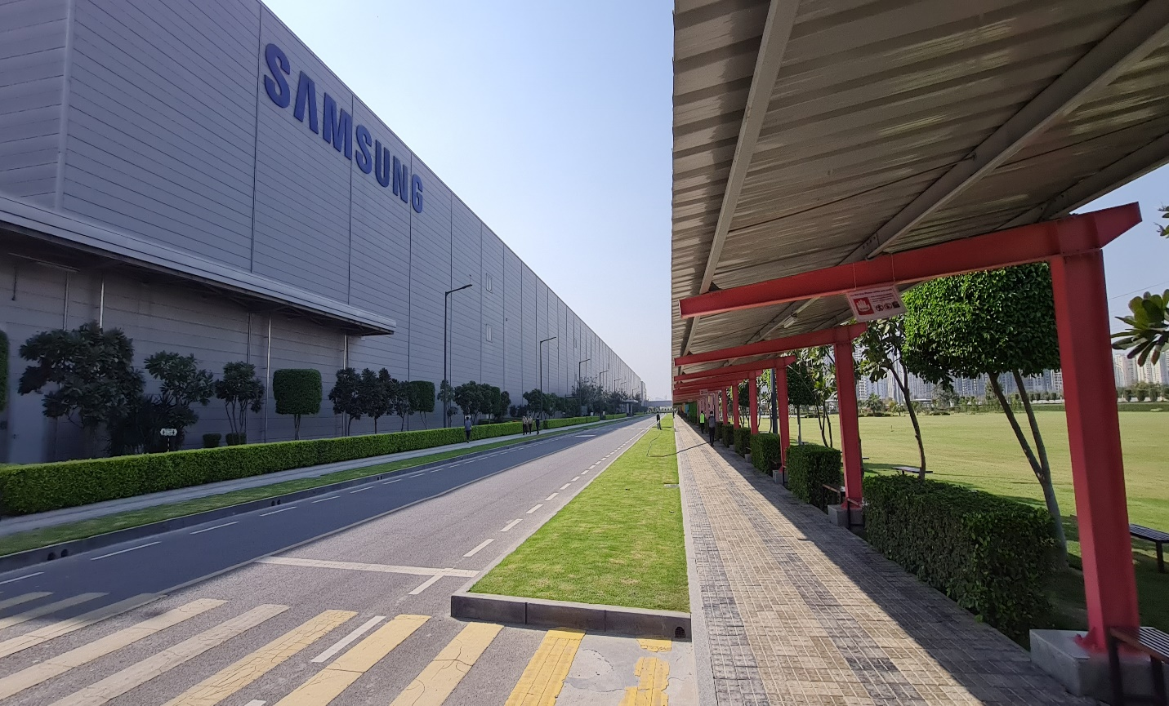

1. **PROJECT OVERVIEW:** M/s. Samsung India Electronics (P) Limited, is a 100% subsidiary of Samsung Electronics Limited, Korea, incorporated under the Indian Companies Act, 1956 (As further amended by Companies Act 2013).

Samsung India Electronics Private Limited (SIEL) is engaged in the business of manufacturing of various consumer electronics and consumer durable items like refrigerators, color televisions, handheld cellular phones, washing machines, air conditioners etc. since 1995 in India.

It is having a full scale manufacturing facility operating at Plot No.B-01, Sector-81, Noida, District Guatam Budhha Nagar,Uttar Pradesh since 1996 which mainly manufactures electronic devices like TV, Handheld devices, Washing Machines. Under the Infrastructure and Industrial investment Policy-2012 company has proposed to increase the production capacity of the Plant by increasing the production capacity of Hand Held Devices (e.g. Mobile Phones, Tablets etc.) to 264% and the production capacity of Refrigerator to 100% by the year 2020 under Mega Projects scheme. For the same SIEL has planned the expansion Project divided into three Phases (Phase I- Rs.571 Cr., Phase II- Rs.2928 Cr. & Phase III- Rs.1416 Cr.) with total investment of Rs.4915 cr. as per the Detailed Project Report dated January 17th 2018.

In this regard SIEL has been issued Letter of comfort (LoC) under Infrastructure and Industrial investment Policy-2012 through its nodal agency PICUP for consideration of its Project under Mega Project Incentives scheme for expansion/ diversification of existing unit by creating additional capacity of Hand Held Mobile, table Computers & Refrigerators with total investment of Rs.4915.00 Cr. at Noida.

The Company informed to the Govt. of U.P that it has made an investment amounting to Rs.4,766.67 Cr. (till 31.03.2021) in the Project in the various heads like Land, Buildings, Plant & Machinery etc.

For the verification of the capital expenditure of Rs.3712.76 Cr. (4,766.67 Cr - 1053.91 Cr.) incurred from 1st July 2018 till 31st March 2021 by the company in the Project, Govt. of UP through PICUP has engaged R.K Associates Valuers & Techno Engineering Consultants (P) Ltd. (R.K Associates). Earlier investment upto date: 1/07/2018 to 31/03/2021 has been already assessed by us in previous report amounting Rs.1,053.91 Cr.

Presently SIEL is having total Land area 2,49,100 sq. mtr. in which land area for existing unit is 1,20,100 sq. mtr. and for the expansion of the Plant, SIEL has acquired additional 1,29,000 sq. mtr. of land form Noida Authority on long term lease for period 90 Years. This newly acquired land (Plot No. B-001C) is located next to the existing land (Plot No. B-01) of SIEL. However later on Plot No. B-001C and Plot No. B-01 (B-01, B-01A & B-01B) are amalgamated into Plot No. B-01 by Noida Industrial Development Authority vide **Letter No.** **Noida/ Industrial/ 2018/ 2489, Dated: 11/06/2018**.

**Table: 1**

|  |  |  |
| --- | --- | --- |
| **S. No.** | **Particulars** | **Area** |
| 1. | Old Land | 1,20,100 sq. mtr. |
| 2. | Expansion Land | 1,29,000 sq. mtr. |
| **3.** | **Total Land area** | **2,49,100 sq. mtr.** |

***Source: Copy of Lease deeds***

**Proposed Expansion Plan**

**Table: 2**

|  |  |  |  |
| --- | --- | --- | --- |
| **PROPOSED EXPANSION PLAN** | | | |
| **S. No.** | **Product** | **Existing Qty. Nos.** | **Proposed Qty. Nos.** |
| **1.** | Hand Held Phones | 3,30,00,000 | 12,00,00,000 |
| **Total** | | **3,30,00,000** | **12,00,00,000** |

***Source: DPR***

**Project Summary of the existing Unit and the expansion of the Project:**

**Table: 3**

*(In Lakhs units per Annum)*

|  |  |  |  |  |
| --- | --- | --- | --- | --- |
| **S. No.** | **Main Production Units** | **Existing Capacity**  *(as on 31.12.2012)* | **Achieved/Proposed Expansion Capacity of the Unit** | **Total Proposed Expansion Capacity of the Unit** |
| 1. | Mobile Phones, Tablets etc. | 330 | 839.5 | 1200 |

***Source: DPR & Information from SIEL***

**Proposed Phase wise investment schedule over the period of 2012-13 to 2021-22 (10 Years) is as follow:**

**Table: 4**

|  |  |  |
| --- | --- | --- |
| **Investment Phase** | **Financial Year** | **Amount**  **(In Cr.)** |
| **Phase-I** | 2012-13 | 10 |
| 2013-14 | 323 |
| 2014-15 | 238 |
| **Phase-II** | 2015-16 | 121 |
| 2016-17 | 138 |
| 2017-18 | 215 |
| 2018-19 | 2454 |
| **Phase-III** | 2019-20 | 1224 |
| 2020-21 | 137 |
| 2021-22 | 55 |
| **Total** | | **4915** |

***Source: DPR***

The Project as proposed comprised of Three Phases:

* **Phase I:** Expansion of Handheld Devices Capacity - *(Expected COD: September 2013).*
* **Phase II:** Further Expansion of Handheld Devices Capacity - *(Expected COD: December 2018).*
* **Phase III:** Expansion of Capacity of Refrigerator and/or diversification into other consumer durables *(Expected COD: December 2022).*

As per current status, SIEL has achieved the production capacity of the proposed Hand Held Devices Plant by 69.96% out of the total proposed capacity of 12,00,00,000.

The scope of this report only includes the assessment & verification of installation, commissioning and capital expenditure of Rs.3712.76 Cr. (4,766.67 Cr - 1053.91 Cr.) incurred from 1st July 2018 till 31st March 2021 by the company in the Project.

In the current capital expenditure of Rs.3712.76 Cr. all the work has been carried out in the new unit as per the chart below:

**Table: 5**

|  |  |  |  |
| --- | --- | --- | --- |
| **S. No.** | **Sections** | | **Amount**  **(In Cr.)** |
|  | **Land & Site Development** | | 48.93 |
|  | **Building & Civil Works** | | 1915.36 |
|  | **Plant & Machinery** | **Indigenous** | 329.25 |
| **Imported** | 1217.78 |
|  | **Misc. Fixed Asset** | | 152.11 |
|  | **Interest During Construction** | | 0 |
|  | **Pre-operative** | | 0 |
|  | **Working Capital** | | 0 |
| **Total** | | | **3663.43** |

*Source: CA Certificate*

However out of the above amount, IE has approved the total Project Cost of Rs.2510.59 cr.

1. **PROJECT LOCATION:** The Mobile & Refrigerator Manufacturing Plant setup by Samsung India Electronics Private Ltd. (SIEL) is located at Plot No. B- B001C, Sector-81, Noida Gautam Budhha Nagar District, Uttar Pradesh State in India and the Project site is well connected by rail, road and airport. The nearest airport from the site is IGI Airport, Delhi located at the distance of 45 km. The Project site is also well connected through Road network and Noida- Greater Noida expressway is about at a distance of 6-7 km. from the Project Site. New Delhi Railway Station is the nearest railway station around 28 km from the project. The nearest metro station is NOIDA sec-81 metro station which lies on Aqua line and is situated at around 1.1 km from the project site.

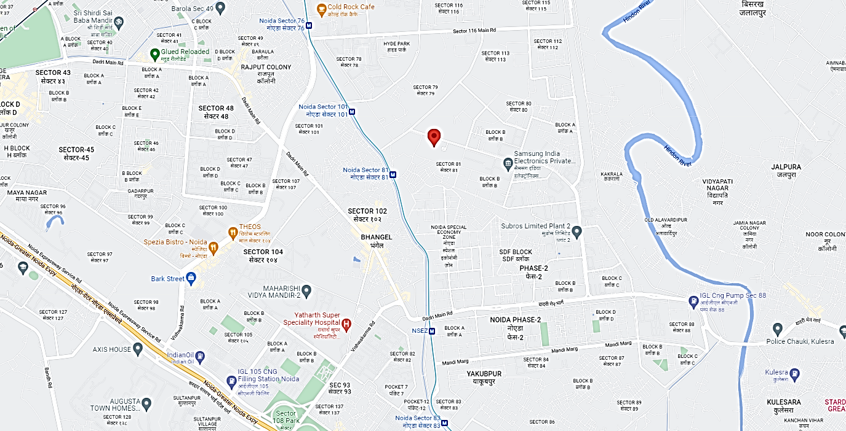

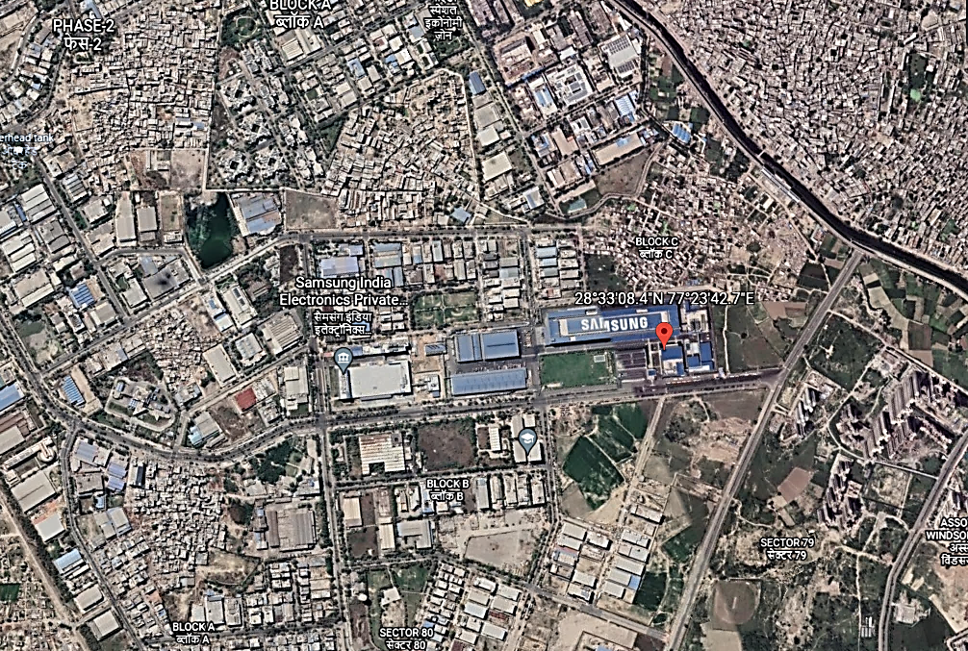

1. **SCOPE OF THE REPORT:** To verify and examine the commissioning, installation and capital expenditure status of the Expansion of the Project popularly named as Samsung India Electronics Private Limited (SIEL) from 01/07/2018 to 31/03/2021 in regard to special facilities & incentives given to Mega Projects under Infrastructure and Industrial investment Policy-2012 of Govt. of U.P.

*All the assessment carried out for the Project is done based on the documents & information provided to us by SIEL and its correlation by the Engineering team through site inspection and various other discussions with the Project proponents and its able resources and thus forming an opinion out of it.*

1. **PURPOSE OF THE REPORT:**  To provide a comprehensive overview of the current status of the project in terms of its Physical progress and Capital Expenditure incurred to enable PICUP to take informed business decision on the Project in relation to special facilities & incentives given to Mega Projects under Infrastructure and Industrial investment Policy-2012 of Govt. of U.P.
2. **SURVEY DETAILS:** This Plant is surveyed by our Engineering team comprising of Civil & Mechanical Engineers Mr. Zaid Ebne Mairaj and Mr. Tejas Bhardwaj on 7th , 8th & 9th March, 2022. Site inspection was done in the presence of company’s representatives. All the details pertaining to physical setup and progress of the Plant have been cross checked as per the documents/ information provided to us.

Team visited different sections of the Plant and verified the main sections like Hand Held Mobile Phones Plant (HHP), Corporate office, RO Plant, Main Utility Building, Scrap yard and found the sections to be operational and in production. Plant and all its installed machinery equipment are found in good working condition.

Due to Plant security restrictions we have not been allowed to take photographs from our camera phone and stickers have been pasted on our camera screens and have been deposited at the security in some sections. We have taken the photographs of the facilities from the camera phone provided by them.

As per information received from the company’s representatives Mr. Rajesh Sehgal (+91-9871899704), this Project has achieved the production capacity of Hand Held Mobile Device to 96 million units per annum on March 2022 and the production capacity of Refrigerator Plant to 1.8 million units per annum on March 2022 respectively. Production capacities have not been verified independently by us.

At the time of survey Plant was found in production and manufacturing of the items was in process.

1. **METHADOLOGY ADOPTED:**
2. Study of Detailed Project Report to know the Project proposed plan & estimates.
3. Study of Project Contract agreements.
4. Site visit by our engineering team to assess the project execution status on the ground at the site.
5. Discussions with the Mechanical Plant Head & Civil Engineering team on the site.
6. Various documents, information & data collected from the company through e-mail.
7. Study and analysis of the documents and information obtained from the company and their correlation with the observations during the site survey.
8. Correlation of the provided information with the Industry standards, CPWD SOR, etc.
9. Other information obtained regarding the project from the sources in the public domain.

|  |  |
| --- | --- |
| **PART C** | **PLANT INFRASTRUCTURE SECTIONS & FACILITY DETAILS** |

* 1. **LAND DETAILS:** SIEL is having total Land area 2,49,100 sq. mtr. out of which land area for existing unit is 1,20,100 sq. mtr. and for the expansion of the Plant, SIEL has acquired 1,29,000 sq. mtr. of land form Noida Authority on long term lease for period 90 Years.

This newly acquired land (Plot No. B-001C) is located next to the previously owned land (Plot No. B-01) of SIEL. However Plot No. B-001C and Plot No. B-01 (B-01, B-01A & B-01B) are amalgamated into Plot No. B-01 by Noida Industrial Development Authority vide **Letter No.** **Noida/ Industrial/ 2018/ 2489, Dated: 11/06/2018**.

**Table: 6**

|  |  |
| --- | --- |
| Total Expenditure for Site & Land Development | |
| PARTICULARS | **DETAILS** |
| Land & Site Development Cost | **Rs.48.93 cr.** |
| Land & Site Development Cost Land & Site Development Cost  *(Along with landscaping)* | **Rs.48.93 cr.** |
| Total Money outlaid till date | **Rs.48.93 cr.** |

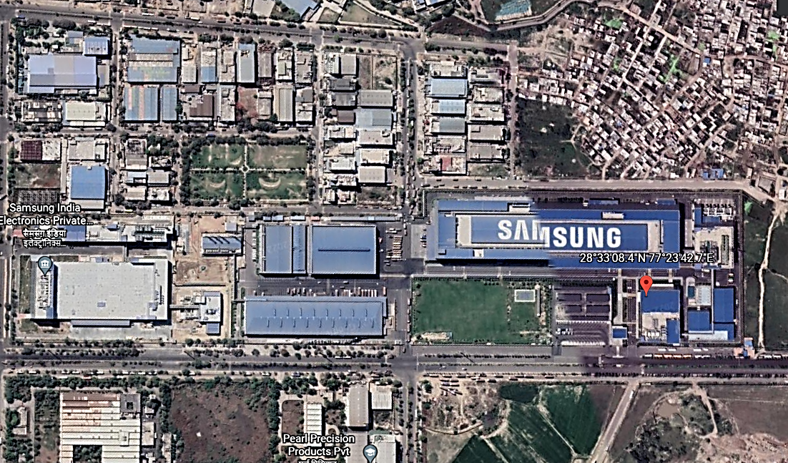

*Area marked with Red is the new land purchased by company while area in yellow is the old land parcel.*

* 1. **BUILDING & STRUCTURAL DETAILS:** Samsung India Electronics Private Limited has shown to have incurred an amount of **Rs.1963.76 Cr.** to construct different Plant Buildings like Hand Held Mobile Phones Building (HHP), Utility Building, Corporate office, Canteen, RO Plant, Main Scrap yard etc. as per FAR provided to us. SIEL has engaged its related company M/s Samsung C&T India Pvt. Ltd. as contractors on turnkey basis where necessary material, Construction Equipment, Labor etc. are provided by Contractor itself. Detailed break-up of the expenditure is given below:

**Table: 7**



**Table: 8**





***Area measurement mentioned above is based on the approved Map provided by the company.***

|  |  |
| --- | --- |
| **Total Estimated Cost allocated in Civil & structure Works** | Rs.1963.76 cr. |
| **Total Money incurred in this investment *(As shown by SIEL)*** | Rs.1963.76 cr. |
| **Total Cost Approved by IE** | Rs.875.84 cr. |
| ***Observations & Remarks:***   * *Total expenditure shown by the SIEL from 1st July 2018 up till 31st March 2021 is of Rs.1963.76 cr. However IE has approved the total cost of Rs.781.98 cr.* * *Area of the Buildings is considered as per the approved map provided to us by the client.* * *All items checked at the site from the details provided by SIEL are as per visual observation and general industry experience. No special tests (Mechanical/ Physical or any other nature) have been carried out to ascertain the authenticity of the same.* * *We have asked for BOQ and breakup of the construction cost from Samsung to do the cost assessment at our end. However, same was not provided to us stating that whole turnkey project was given to Samsung C&T India Pvt. Ltd. and that they do not have any breakup.* * *Therefore, to make assessment, we have estimated the cost based on specification available building wise & which we could best estimate from Market trends/ CPWD rates as per the specifications and construction found on site.* * *Cost approved is as per the CPWD, Industry benchmarks standards based on the area & specifications provided by SIEL.* * *The cost for Design, Project management & Construction management has been additionally taken as 12% as per Industry benchmark.* * *Detailed break-up of expenses please refer to the attached Annexures.* | |

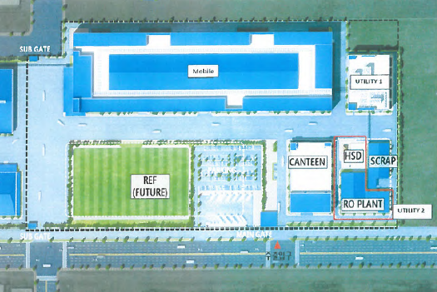

CORPORATE

1. **PLANT & EQUIPMENT DETAILS:** As per original plan mentioned in the Detailed Project Report submitted by the company following main sections, Machinery & equipment were proposed to be installed:
   1. **Main machinery & storage facility:**

**Hand Held Mobile Device Plant (HHP)**

**Table: 9**

| **S. No.** | **Description** | **Line/ Machines** |
| --- | --- | --- |
| **(A)** | **Main Line** | Main Line Machines |
| **(B)** | **SMD/SMT (SURFACE MOUNTING DEVICE)** | Loader |
| Solder Paste Screen Painting Machine |
| Solder Paste Inspecting System (SPI) |
| Carrier Jig |
| Basic Chip Mounter |
| Multi Mounter |
| MAOI |
| Shield Can Mounter |
| Reflow |
| SAOI |
| Inline (Function) Tester |
| Epoxy |
| Globe Top |
| TIM Machine |
| UFR |
| Router |
| **(C)** | **PBA Line** | PBA Line Machines |
| **(D)** | **Sub-Assembly** | ------ |
| **(E)** | **Others** | ------ |

***Source: DPR***

* 1. **Expenditure incurred in Plant & Machinery:** Main production lines of Mobile plants has been imported from South Korea.

Total amount incurred in procuring & commissioning all the machinery with other common auxiliaries for the Mobile Plant is **Rs.1,300.51 Cr.** Break-up of the expenditure is given below:

**Table: 10**



* 1. **Expenditure incurred in Molds Machinery:** Samsung India Electronics Limited invested an amount of **Rs.228.73 Cr.** in order to provide the Molds Machinery for the Mobile Plant with other common auxiliaries. Break-up of the expenditure is given below:

**Table: 11**



* 1. **Expenditure incurred in Miscellaneous Fixed Assets:** SIEL has invested an amount of **Rs.150.42 Cr**. in order to provide the Misc. Fixed Assets like Computers, Software, Furniture & Fixtures etc. Break-up of the expenditure is given below:

**Table: 12**



|  |  |
| --- | --- |
| **PART D** | **PROJECT CONSULTANTS, CONTRACTORS & SUPPLIERS** |

SIEL has engaged its related company as Contractors for the expansion of project mainly for Civil & building related works.

For Plant & Machinery company has done procurement from several different suppliers on its own without engaging one point contact for the same.

Civil Contractors with their scope of work and the Contract price by SEIL is given below:

**Table: 13**





***Source: Contract Copy***

|  |  |
| --- | --- |
| **PART E** | **PROJECT COST & CURRENT STATUS** |

1. **TOTAL PROJECT COST:** As per the Detailed Project Report dated January 17 2018, the total project cost is estimated to be Rs.4915 cr. (Phase I- Rs.571 Cr., Phase II- Rs.2928 Cr. & Phase III- Rs.1416 Cr.).

**Table: 14**

|  |  |  |  |  |  |  |  |  |  |  |  |
| --- | --- | --- | --- | --- | --- | --- | --- | --- | --- | --- | --- |
|  | **PHASE-I** | | | **PHASE-II** | | | | **PHASE-III** | | |  |
| **Investment** | **2012-13** | **2013-14** | **2014-15** | **2015-16** | **2016-17** | **2017-18** | **2018-19** | **2019-20** | **2020-21** | **2021-22** | **TOTAL** |
| **Land** | - | - | - | - | - | 110 | - | - | - | - | **110** |
| **Building** | - | 52 | 122 | 4 | 6 | 7 | 1505 | 276 | - | - | **1972** |
| **Plant & Machinery** | 1 | 238 | 65 | 56 | 84 | 84 | 586 | 746 | 61 | - | **1921** |
| **Utility Machines** | - | 7 | 6 | 1 | 3 | 2 | 364 | 135 | 16 | - | **534** |
| **Moulds** | 9 | 17 | 43 | 58 | 41 | 9 | - | 67 | 60 | 55 | **359** |
| **Others** | - | 9 | 2 | 2 | 4 | 3 | - | - | - | - | **20** |
| **TOTAL** | **10** | **323** | **238** | **121** | **138** | **215** | **2454** | **1224** | **137** | **55** | **4915** |

***Source: DPR***

***{Figure: 1}***

1. **CURRENT STATUS OF EXPENDITURE INCURRED TILL DATE:** The current expenditure incurred by Samsung India Electronics Private Limited in 31st Mar., 2021 for the Mobile & Refrigerator manufacturing Plant is given below:

**Table: 15**

|  |  |  |  |  |
| --- | --- | --- | --- | --- |
| S.NO. | PARTICULARS | TOTAL INCURRED AMOUNT  *(As per SEIL)*  *(From 1/07/2018 up till 31/03/2021)* | TOTAL INCURRED AMOUNT  *(As Approved by IE)*  *(From 1/07/2018 up till 31/03/2021)* | CURRENT STATUS OF WORK AND REMARKS |
| 1. | **Land Development** | 48.93 | 48.93 | **SIEL has shown Rs.48.93 Cr. has been incurred under this head in the period (July 2018 – March 2021).**   * Rs.48.93 was incurred for the site development including development of internal roads, Landscaping, sewage, outer fence, grading work etc. * As per IE review it is found that cost incurred in this head is reasonable and justified and the same have been approved by IE as per the breakup taken from the company of this cost. |
| 2. | **Building &Civil Work** | 1915.36 | 875.84 | **SIEL has shown Rs.1914.83 Cr. has been incurred under this head in the period (July 2018 – Mar., 2021).**  As per IE review it is found that cost incurred in the Buildings is on higher side and cost Approved by IE is **Rs.875.84 cr**.   * *We have asked for BOQ and breakup of the construction cost from Samsung to do the cost assessment at our end. However, same was not provided to us stating that whole turnkey project was given to Samsung C&T India Pvt. Ltd. and that they do not have any breakup.* * *Therefore, to make assessment, we have estimated the cost based on specification available building wise & which we could best estimate from Market trends/ CPWD rates as per the specifications and construction found on site.* * *Cost approved is as per the CPWD, Industry benchmarks standards based on the area & specifications provided by SIEL.* * *The cost for Design, Project management & Construction management has been additionally taken as 12% as per Industry benchmark.*   *Please refer to the detailed building wise breakup sheet of the cost approved by IE in Building & Civil work.* |
| 3. | **Plant & Machinery** | 1547.03 | 1300.52 | **Rs.1300.51 cr. has been incurred under this head in the period (July 2018 – Mar., 2021).**    **During the site survey, approx.. 70% of the major machines & equipment were cross verified at site from the list of machines provided to us by our engineers who reported it to be installed & working.**  **Sample major invoices of amount above Rs.50 Lakhs has been cross verified. Related parties bills have been scrutinized closely which was not found in case of Plant & Machinery.**  *Please refer Annexures for detailed break-up of expenses incurred in Plant & Machinery.* |
| 4. | **Utility Machines** | 0.00 | 0.00 | **No Expenditure incurred in this Head.**  *We believe the machines which needs to be incorporate in this head might be present in some other heads because utility machines are not bifurcated in the FAR provided to us by the client.* |
| 5. | **Moulds** | 0 | 228.73 | **Rs.228.73 cr. has been incurred under this head in the period (July 2018 – Mar., 2021).**  ***This has been cross verified along with the machines and in the same manner as stated above in point 3.*** |
| 6. | **Miscellaneous Assets** | 152.11 | 150.42 | **Rs.150.42 cr. has been incurred under this head in the period (July 2018 – Mar., 2021).**  *(We have collected things like computer, IT & office equipment, furniture fixtures, vehicles, software etc. in this category)*  *Please refer Annexures for detailed break-up.* |
| 7. | **Total** | **3643.43** | **2604.43** | All the expenditure shown above is cross checked with the work done on site and from the respective Invoices/ Bills/ PO.  Only major amount has been cross checked from the Invoices/ Bills/ PO due to voluminous paper of record.  Industry benchmark, Market trends & standards is applied only to Civil works cost for its verification. In case of Plant & Machinery no specific benchmark cost standard is available at least for electronics industry due to wide range of specifications & technology. Therefore for Plant & Machinery cost verification individual invoices and bills are only relied upon. |

1. **QUARTER WISE COST BREAK-UP :-** The cost incurred in this project had been divided on quarterly basis by the IE and same have been attached below. For the cost of Building and civil work, we have calculated the total cost and then divided the same as per the percentage of the cost shown in CA certificates for the cost approved by us:-























**Table: 16**







|  |  |
| --- | --- |
| **PART H** | **DISCLAIMER** |

* + - 1. No employee or member of R.K Associates has any direct/ indirect interest in the Project.
      2. This report is prepared based on the copies of the documents/ information which interested organization or customer could provide to us out of the standard checklist of documents sought from them and further based on our assumptions and limiting conditions. All such information provided to us has been relied upon and we have assumed that it is true and correct. Verification or cross checking of the documents provided to us has not been done at our end from the originals. If at any time in future it’s found or came to our knowledge that misrepresentation of facts or incomplete or distorted information has been provided to us then this report shall automatically become null & void.
      3. This report is a general analysis of the project and not an audit report. All the information gathered is based on the facts seen on the site during survey, verbal discussion & documentary evidence provided by the client and is believed that information given by the company is true best of their knowledge.
      4. All observations mentioned in the report is only based on the visual observation and the documents/ data/ information provided by the client. No mechanical/ technical tests, measurements or any design review have been performed or carried out from our side during Project assessment.
      5. Interested organization should ONLY take this report as an Advisory document from the Financial/ Chartered Engineering firm and it’s specifically advised to the stakeholder to cross verify the original documents for the facts mentioned in the report which can be availed directly from the subject company directly.
      6. In case of any default in loans or the credit facility extended to the borrowing company, R.K Associates shall not be held responsible for whatsoever reason may be and any request for seeking any explanation from the employee/s of R.K Associates will not be entertained at any instance or situation.
      7. This Report is prepared by our competent technical team which includes Engineers and financial experts & analysts.
      8. This is just an opinion report and doesn’t hold any binding on anyone. It is requested from the concerned Financial Institution which is using this report for taking financial decision on the project that they should consider all the different associated relevant & related factors also before taking any business decision based on the content of this report.
      9. All Pages of the report including annexures are signed and stamped from our office. In case any paper in the report is without stamp & signature then this should not be considered a valid paper issued from this office.
      10. Defect Liability Period is **30 DAYS**. We request the concerned authorized reader of this report to check the contents, data and calculations in the report within this period and intimate us in writing if any corrections are required or in case of any other concern with the contents or opinion mentioned in the report. Corrections only related to typographical, calculation, spelling mistakes will be entertained within the defect liability period. No request for any illegitimate value revision, date change or any other facts & figures changes will be entertained other than the one mentioned above.
      11. R.K Associates encourages its customers to give feedback or inform concerns over its services through proper channel at @rkassociates.org in writing within 30 days of report delivery. After this period no concern/ complaint/ proceedings in connection with the Valuation Services can be entertained due to possible change in situation and condition of the property.
      12. Our Data retention policy is of **ONE YEAR**. After this period we remove all the concerned records related to the assignment from our repository. No clarification or query can be answered after this period due to unavailability of the data.
      13. This Valuation report is governed by our (1) Internal Policies, Processes & Standard Operating Procedures, (2) R.K Associates Quality Policy, (3) Valuation & Survey Best Practices Guidelines formulated by management of R.K Associates, (4) Information input given to us by the customer and (4) Information/ Data/ Facts given to us by our field/ office technical team. Management of R.K Associates never gives acceptance to any unethical or unprofessional practice which may affect fair, correct & impartial assessment and which is against any prevailing law. In case of any indication of any negligence, default, incorrect, misleading, misrepresentation or distortion of facts in the report then it is the responsibility of the user of this report to immediately or atleast within the defect liability period bring all such act into notice of R.K Associates management so that corrective measures can be taken instantly.
      14. R.K Associates never releases any report doing alterations or modifications from pen. In case any information/ figure of this report is found altered with pen then this report will automatically become null & void.
      15. If this report is prepared for the matter under litigation in any Indian court, no official or employee of R.K Associates will be under any obligation to give in person appearance in the court as a testimony. For any explanation or clarification, only written reply can be submitted on payment of charges by the plaintiff or respondent which will be 10% of the original fees charged where minimum charges will be Rs.15,000/-.

Place : New Delhi **FOR INTERNAL USE**

Date : 17.03.2022 ***SURVEYED BY: Er. Zaid Ebne Mairaj &***

***Er. Tejas Bhardwaj***

Note : This report contains 45 pages ***PREPARED BY: PE Team***

***REVIEWED BY: MA***

**For R.K Associates Valuers & Techno**

**Engineering Consultants Pvt. Ltd.**

**Project Engineering Team**

***R.K ASSOCIATES IMPORTANT NOTES:***

1. ***DEFECT LIABILITY PERIOD - In case of any query/ issue or escalation you may please contact Incident Manager by writing at le@rkassociates.org. We ensure 100% accuracy in the Calculations done, Rates adopted and various other data points & information mentioned in the report but still can’t rule out typing, human errors or any other mistakes. In case you find any mistake, variation, discrepancy or inaccuracy in any data point of the report, please help us by bringing all such points into our notice in writing at le@rkassociates.org within 30 days of the report delivery, to get these rectified timely, failing which R.K Associates Valuers Techno Engineering Consultants (P) Ltd. won’t be held responsible for any inaccuracy in any manner. Also if we do not hear back anything from you within 30 days, we will assume that report is correct in all respect and no further claim of any sort will be entertained thereafter. We would welcome and appreciate your feedback & suggestions in order to improve our services.***
2. ***COPYRIGHT FORMAT - This report is prepared on the copyright format of R.K Associates Valuers Techno Engineering Consultants (P) Ltd. to serve our clients in the best possible way. Legally no one can copy or distribute this format without prior approval from R.K Associates. It is meant only for the organization as mentioned on the cover page of this report. Distribution or use of this format other than R.K Associates will be seen as unlawful act and necessary legal action can be taken against the defaulter.***