**REPORT FORMAT:** V-L2 (L&B) | Version: 9.0_2019

**FILE NO.: VIS(2021-22)-PL121-Q29-121-149 DATED:29/06/2021**

**VALUATION ASSESSMENT**

**OF**

**INDEPENDENT HOUSE**

**SITUATED AT**

**KHASRA NO. 2 AA KA & 2 BA KHA, VILLAGE-BHIKAMPUR, PRGANA & TEHSIL KOL, DISTRICT ALIGHARH, UTTAR PRADESH**

**OWNER/S**

**M/S. DARSHAN OIL PVT. LTD.**

**A/C: M/S. DARSHAN OIL PVT. LTD.**

**REPORT PREPARED FOR**

**ASSET RECONSTRUCTION COMPANY (INDIA) LTD., THE RUBY 10TH FLOOR, 29 SENAPTI BAPAT MARG, DADAR (WEST), MUMBAI**

***\*\*Important - In case of any query/ issue/ concern or escalation you may please contact Incident Manager @ valuers@rkassociates.org. We will appreciate your feedback in order to improve our services.***

***Valuation TOR is available at*** [***www.rkassociates.org***](http://www.rkassociates.org) ***for reference.***

***NOTE: As per IBA Guidelines please provide your feedback on the report within 15 days of its submission after which report will be considered to be correct.***

|  |  |
| --- | --- |
| **PART A** | **ARCIL FORMAT OF OPINION REPORT ON VALUATION** |

|  |  |  |
| --- | --- | --- |
|  | **SUMMARY** | |
|  | **LOAN** | |
|  | Name of the Borrower: | M/s. Darshan Oil Pvt. Ltd. |
|  | Job entrusted by: | Arcil – Valuation Desk, The Ruby 10th Floor, 29 senapti Bapat Marg, Dadar (West), Mumbai |
|  | **VISIT** | |
|  | Date & time of inspection | 24 June 2021 |
|  | Name of the owner of the property | M/s. Darshan Oil Pvt. Ltd. |
|  | Visit done by | AE Parveen Sharma & AE Hemant Koli |

|  |  |  |  |  |  |
| --- | --- | --- | --- | --- | --- |
|  | **DETAILS** | | | | |
| **S.NO.** | **PARTICULARS** | | **CONTENT** | | |
|  | **LOCATION** | | | | |
|  | Property Address | | Khasra No. 2 Aa Ka & 2 Ba Kha, Village-Bhikampur, Prgana & Tehsil Kol, District Aligharh, Uttar Pradesh | | |
|  | Nearest landmark | | Nearby Fruit market & Opposite Petrol Pump | | |
|  | Nearest bus-stop/ railway station & distance | | Bus Station- 3.3 Km (Aligarh UPSRTC)  Railway Station- 4.3 Km (Mehrawal) | | |
|  | **LAND DETAILS** | | | | |
|  | **BRIEF DESCRIPTION OF THE PROPERTY UNDER VALUATION**  C:\Users\Namrata\OneDrive\Desktop\PL-121- Darshan Oil Ltd\Photos\WhatsApp Image 2021-06-29 at 10.50.32 AM.jpeg  ***Snapshot of the Asset/ Property Under Valuation***  **As per instructions received from ARCIL, our engineer visited the property under report on 24 June 2021 with the view to ascertain the Fair Market Value / RSV / DSV of the property.**  **Plot of Land** on Survey No 2 Aa Ka & 2 Ba Kha  We referred to the Xerox copy of following documents provided to us:   1. Copy of Sale deeds (02 in Nos.) 2. Area statement of the land provided by ARCIL   **Brief Description:** This valuation report is prepared for the industrial property situated at the aforesaid address having total land area of 13493.60 sq.yds. (1.12 Hectares) as per the area statement provided by the ARCIL to us & as per the copy of bhulekh obtained from public domain.  As per the copy of sale deeds provided to us, the subject land is purchased by the virtue of 2 sale deeds dated 27/01/1984 measuring 1 Bigha 15 Biswa 2 Biswansi & 3 Bigha 2 Biswa 2 Biswansi respectively. Since, as per the market survey the 1 bigha in concerned area is 918 sq.yds. or 3025 sq.yds. depdening on kacha or pucca bigha & in the documents it is not mentioned that it is kuccha or pucca bigha. Also, from the bhulekh website the total area is 1.12 Hectares which is approximately equal to area statement provided by the bank. So, for the valuation purpose we have considered the land area of 1.12 Hectares/ 13493.60 sq.yds. only. Screenshot of the same is attached below:    As found during the site survey, the subject property comprised of many structure which were totally in dilapidated condition & also no documentary evidence regarding it’s industrial usage is provided to us. So, we have considered only the agricultural land value for the valuation purpose.  The subject property is not identify to us by its khasra nos since there is not name plate/ signage board displayed on the subject property. The identification of the subject property is only done by owner’s representative only and we have done the valuation for the property which was shown to our surveyor.  The subject property was merged with adjacent plot from the rear side and no demarcation from rear side was there however demarcation from other three side with permanent boundaries are there. There is no main gate/ entry gate of the subject property present.  The subject property is connected to main GT road which is approx. 80 ft. wide via a small corner of the subject land. The GT road is connected to Aligarh By-pass road which is at a distance of which is approx. 1.5 Km.  This report only contains general assessment & opinion on the Guideline Value and the indicative, estimated Market Value of the property found on as-is-where basis on site for which the Bank/ customer has shown & asked us to conduct the Valuation for which photographs is also attached with the report. No legal aspects in terms of ownership or any other legal aspect is taken into consideration. It doesn’t contain any due-diligence other than the valuation assessment of the property shown to us on site. Information/ data/ documents given to us by Bank/ client has been relied upon in good faith. This report doesn’t contain any other recommendations of any sort.  **Nearest Landmark**: Near Fruit Market  **Amenities of the property**: The subject property is situated near to main GT road which is approx. 1 Km from main Aligarh- New Bypass Road.  **Accommodation**: NA  **Area:** 13493.60 sq.yds./1.12 Hecatares (as per area statement provided by the bank & information obtained from bhulekh website)  **Plot area are as follows and considered for valuation:**   |  |  | | --- | --- | | **Survey No.** | **Plot area (Acres/Sq.ft.)** | | 2 Aa Ka | --- | | 2 Ba Kha | --- | | Total | **13493.60 sq.yds.** |  1. Name of the customer and survey number of the plot not found at site. We identified the property with the help of owner’s representative Mr. Khursad Akhtar (+91-9012722786) 2. The land survey No. or Hissa No. of the owner’s property and as such the same has been considered from the documents / Xerox of documents provided to us. 3. Our report is based on actual site visit. | | | | |
|  | Type of Land | | Industrial | | |
|  | Usage of Land | | Industrial Purpose | | |
|  | Location, Street, Ward No. | | Khasra No.2 Aa Ka & 2 Ba Kha Village Bhikampur, Pargana & Tehsil Kol, district Aligharh Matiyar, Uttar Pradesh | | |
|  | Survey / Plot No. of land | | Survey No. 2 Aa Ka & 2 Ba Kha | | |
|  | Give instances of sale of immovable property in the locality on a separate sheet, including the name and address of the property, registration No., sale price and area land sold | | No authentic Sale Instances details could be known. However prospective transaction details as per information available on public domain and gathered during site survey is mentioned in ***Point ‘o’***of **Part C: Valuation Assessment Factors** of the report and the screenshots of the references are annexed in the report for reference. | | |
|  | Market Rates adopted | | **Prevalent Market Rate:** *Rs.6,000/-* to Rs.8,000/- per sq.yds.  **Rate adopted for Valuation:** Rs.7,000/- per sq.yds.  Base Rate -   |  |  |  | | --- | --- | --- | | Particulars | Discount / premium (%) | Estimated Rate (Rs./Sq.yds.) | | Base Rate |  | Rs.7,000/- per sq.yds. | | **Factor Considered\*** | |  | | 1 Shape | (-/+) 00% | Already Included in the Base rate. | | 2 Location | (-/+) 00% | | 3 Amenities | (-/+) 00% | | Estimated Fair Market Rate | | Rs. 9,44,55,200/- |   **\*Above factors are just indicative, you may add other factors respective property.**  Final Adopted rate – Rs.9,45,00,000/-  Factors considered for valuation.  Location and locality, facilities and amenities, business potential, supply of demand, local nearby enquiry, market feedback of investigation  **The land is readily available for sale at the above site as per the rates stated by us.**  **Broker’s enquiry:**   |  |  |  |  | | --- | --- | --- | --- | | **Name of the Broker** | **Telephone / Mobile** | **Rate** | **Rate cross checked by the checkers** | | Shiv Property Dealer | +91-9412274447 | Rs.6,000/- to Rs.10,000/- per sq.yds. | Rs.6,000/- to Rs.8,000/- per sq.yds | | Jain Properties | +91-8923149270 | Rs.7,000/- to Rs.9,000/- per sq.yds. | Rs.7,000/- to Rs.9,000/- per sq.yds | | | |
|  | If sale instances are not available or relied upon, basis of arriving at the land rate | | No authentic last two transactions details could be known. However prospective transaction details as per information available on public domain and gathered during site survey is mentioned in ***Point ‘o’*** of **Part C: Valuation Assessment Factors** of the report and the screenshots of the references are annexed in the report for reference. | | |
|  | Govt. Guideline /Circle/Official Rate | | Rs.4,000/- per sq.mtr.  13493.60 sq.yds./ 11200 sq.mtr.  Land Value- 11200 sq.mtr X Rs.4,000/- per sq.mtr.=  **Rs.4,48,00,000/-** | | |
|  | **BRIEF DESCRIPTION OF THE PROPERTY:** | | | | |
|  | Surrounding | | | | |
| North | | Not clearly identifiable | | |
| South | | Other’s Vacant Plot | | |
| East | | Other’s Vacant Plot | | |
| West | | Road | | |
|  | Proximity to civic amenities-  *(Distance from nearest)* | | | | |
| **Particulars** | **Distance** | | **From** | |
| School | 900 Mtr. | | Krishna International School | |
| Hospital | 1.4 Km | | Shubham Hospital | |
| Park/ Garden | NA ( Rural Area) | | --- | |
| Market/ Complex | 250 Mtr. | | Rajput Market | |
| Main Road | 30 Mtr. approx. | | GT Road 30ft. wide | |
|  | Use of property | | Industrial | | |
|  | Type of Locality | | Rural | | |
|  | Type of Property | | Industrial Property | | |
|  | Classification of locality-high class/ middle class/poor class | | Middle Class | | |
|  | Occupation Status | | Vacant at present since the plant is shutdown from a long time | | |
|  | Name and Registration No. of Co-Op. Housing Society. | | Not applicable since it is an industrial property | | |
|  | No. of floors in the building | | The internal site survey of the property is not done by us since the condition of the building is very poor and depleted | | |
|  | Age of the property (in yrs) | | No information available since no one available from company and as per visual observation and information provided by the security guard, the plant was shut down more than 15-6 years. | | |
|  | Estimated future life of the property (in yrs) | | Not applicable since the condition of the structure is very poor and no maintenance was done since a long time. | | |
|  | Construction Status | | Completed but in poor condition | | |
|  | Completion Status  (If construction is incomplete) | | Particulars | | Content |
| RCC | | NA |
| Brick Work | | NA |
| External Finish | | NA |
| Internal Finish | | NA |
| Water | | NA |
| Electricity | | NA |
| Other infrastructure | | NA |
|  | Whether the construction is as per permission (Field Report) | | Approved map not provided to us | | |
|  | Level of Maintenance | | No maintenance was done since a long time and the condition of the plant is very Poor. | | |
|  | Comment on Structural Soundness: | | Very Poor | | |
|  | Other description (if any): | | This is just a Valuation Report of the property identified to us by the owner/ owner representative based on the copy of the documents/ information provided to us by the client and has been relied upon in good faith.  Legal aspects, Title verification,Verification of authenticity of documents from originals or cross checking from any Govt. deptt. of the property have to be taken care by legal expert/ Advocate. | | |
|  | **VALUATION** | | | | |
| **A.** | | Methodology of Valuation – Procedures adopted for arriving at the Valuation | | Please refer to ***Sub-Point ‘n’ of Point 1 of Part C: Valuation Assessment Factors*** of the report | | |
|  | | Built- up area considered for valuation: | | NA | | |
|  | | Rate per unit | | NA | | |
|  | | Valuation as per above  [(a) Area x (b) Rate per unit] | | NA | | |
|  | | Area under water body | | NA | | |
|  | | Fair Market Value(FMV) after considering depreciation  [Valuation of Land + Valuation of Constructed part]  Residual age/Total age *rate | | Please refer to ***Part C: Valuation Assessment Factors*** of the report and the screenshot annexure in the report. | | |
|  | | Carpet Area (for flat) | | NA | | |
|  | | Source of information about Built-up area | | NA | | |
|  | | Prevailing Market Rate/ Price trend of the Property in the locality/ city from property search sites | | Please refer to the ***Sub-Point ‘o’ of Point 1 of Part C: Valuation Assessment Factors*** of the report and the screenshot annexure in the report. | | |
|  | | Guideline Rate obtained from Registrar’s office/ State Govt. gazette/ Income Tax Notification | | Please refer to ***Part C: Valuation Assessment Factors*** of the report and the screenshot annexure in the report. | | |
|  | | **Summary of Valuation** | | For detailed Valuation calculation please refer to ***Points 1, 2, 3, 4, 5 & 6 of the Part C: Valuation Assessment Factors*** of the report. | | |
| 1. **Guideline Value** | | **Rs.4,48,00,000/- (land value only)** | | |
| 1. **Land** | | **Rs.4,48,00,000/-** | | |
| 1. **Building** | | **NA** | | |
| 1. **Indicative Prospective Estimated Fair Market Value** | | **Rs.9,45,00,000/-** | | |
| 1. **Expected Estimated Realizable Value** | | **Rs.8,03,25,000/-** | | |
| 1. **Expected Forced/ Distress Sale Value** | | **Rs.7,08,75,000/-** | | |

|  |  |
| --- | --- |
| **PART B** | **AREA DESCRIPTION OF THE PROPERTY** |

|  |  |  |  |
| --- | --- | --- | --- |
|  | Land Area | 13493.60 sq.yds/ 1.12 hectares | |
| Area adopted on the basis of | Property documents only since site measurement couldn't be carried out due to large & irregular shape of the property. | |
| Remarks & observations, if any | NA | |
|  | Ground Coverage Area | Permissible  (x% of Plot area) | No information available to us |
| Proposed (x%) | No information available to us |
| Present Status | No information available to us |
|  | FAR | Permissible | No information available to us |
| Proposed (x%) | No information available to us |
| Present Status | No information available to us |
|  | Constructed Area considered for Valuation  (As per IS 3861-1966) | **Covered Area** | NA |
| Area adopted on the basis of | NA | |
| Remarks & observations, if any | NA | |

***Note:***

1. *Area measurements considered in the Valuation Report pertaining to Land & Building is adopted from relevant approved documents or actual site measurement whichever is less. All area measurements are on approximate basis only.*
2. *Verification of the area measurement of the property is done based on sample random checking only.*
3. *Area of the large land parcels of more than 2500 sq.mtr or of uneven shape, is taken as per property documents which has been relied upon.*
4. *Drawing Map, design & detailed estimation of the property/ building is out of scope of the Valuation services.*

|  |  |
| --- | --- |
| **PART C** | **VALUATION ASSESSMENT OF THE PROPERTY** |

|  |  |  |  |  |  |  |  |  |  |  |
| --- | --- | --- | --- | --- | --- | --- | --- | --- | --- | --- |
|  | **ASSESSMENT FACTORS** | | | | | | | | | |
|  | Valuation Type | | | Valuation of Vacant Land | | | | | Vacant Land Value | |
|  | Scope of the Valuation | | | Non binding opinion on the assessment of Plain Asset Valuation of the property is done for the property found as per the information given in the documents and/ or confirmed by the owner/ owner representative. | | | | | | |
|  | Property Use factor | | | **Current Use** | | | | **Highest & Best Use** | | |
| Vacant | | | | Industrial | | |
|  | Legality Aspect Factor | | | Assumed to be positive as per copy of documents & information produced to us. However Legal aspects of the property have to be taken care by Bank empanelled competent Legal expert/ Advocate.  Verification of authenticity of documents from originals or cross checking from any Govt. deptt. has to be taken care by Bank empanelled Legal expert/ Advocate. | | | | | | |
|  | Land Physical factors | | | **Shape** | | **Size** | | **Level** | | **Frontage to depth ratio** |
| Irregular | | Large | | On Road Level | | Less frontage |
|  | Property location category factor | | | **City Categorization** | | **Locality Categorization** | | **Property location classification** | | **Floor Level** |
| Village | | Average | | On Wide Road | | NA |
| Rural | | Within good village area | | Near to Highway | |
| Not Applicable | |
| **Property Facing** | | West Facing | | | | |
|  | Any New Development in surrounding area | | | No new development | | | --- | | | |
|  | Any specific advantage/ drawback in the property | | | The subject property located approx. 1 Km from Aligarh New Bypass Road | | | | | | |
|  | Overall property usability Factor | | | Normal | | | | | | |
|  | Comment on Property Salability Outlook | | | Since the property is mortgaged under NPA account therefore less buyers will be interested and may not fetch its full value | | | | | | |
|  | Comment on Demand & Supply in the Market | | | Since this property is mortgaged under NPA account therefore it will have less demand in the market and will have limited target buyers who deals in such kind of stressed properties. . | | | | | | |
|  | Any other aspect which has relevance on the value or marketability of the property | | | NA  Valuation of the same asset/ property can fetch different values under different circumstances & situations. For eg. Valuation of a running/ operational shop/ hotel/ factory will fetch better value and in case of closed shop/ hotel/ factory it will have considerable lower value. Similarly an asset sold directly by an owner in the open market through free market transaction then it will fetch better value and if the same asset/ property is sold by any financer due to encumbrance on it, will fetch lower value. Hence before financing, Lender/ FI should take into consideration all such future risks while financing.  This Valuation report is prepared based on the facts of the property & market situation on the date of the survey. It is a well-known fact that the market value of any asset varies with time & socio-economic conditions prevailing in the country. In future property market may go down, property conditions may change or may go worse, property reputation may differ, property vicinity conditions may go down or become worse, property market may change due to impact of Govt. policies or effect of World economy, usability prospects of the property may change, etc. Hence before financing, Banker/ FI should take into consideration all such future risk while financing. | | | | | | |
|  | Sale transaction method assumed | | | Public auction (orderly) | | | | | | |
|  | Best Sale procedure to realize maximum Value | | | Public auction (orderly) | | | | | | |
|  | Methodology/ Basis of Valuation | | | **Govt. Guideline Value:** Collector rate of Aligarh, Uttar Pradesh | | | | | | |
| **Market Value:** Market Comparable Sales approach | | | | | | |
| *Valuation of the asset is done as found on as-is-where basis.*  *Valuation is done based on the Valuation best practices, standard operating procedures and definitions prescribed by various organizations like IVSC, Income Tax of India, etc. as defined under.*  *For knowing comparable market rates, significant discreet local enquiries have been made from our side representing ourselves as both buyer and seller for the similar properties in the subject area and thereafter based on this information and various factors of the property, a rate has been judiciously taken considering the market scenario.*  *References regarding the prevailing market rates are based on the verbal/ informal/ secondary/ tertiary information collected during market survey in the subject area from the local people, property consultants, recent deals, demand-supply, internet postings which are relied upon. No written record is generally available for such market information and only the verbal information has to be relied upon.*  *Market Rates are rationally adopted based on the facts of the property that came to our knowledge during the course of the assignment considering many factors like nature of the property, size, location, approach, market situation and trends.*  *The indicative value has been suggested based on the prevailing market rates that came to our knowledge during secondary & tertiary market researches and does not split into formal & informal payment components.*  *Secondary/ Tertiary costs related to asset transaction like Stamp Duty, Registration charges, Brokerage, Bank interest, selling cost, marketing cost, etc. pertaining to the sale/ purchase of this property are not considered while assessing the indicative estimated Market Value.*  *This report includes both, Govt. Guideline Value and Indicative Estimated Prospective Fair Market Value. As per the current market practice, in most of the cases, formal transaction takes place for an amount less than the actual transaction amount and rest of the payment is normally done informally.*  *Construction rates are adopted based on the present market replacement cost of construction and calculating applicable depreciation & deterioration factor as per its existing condition & specifications based on only visual observation of the structure. No structural, physical tests have been carried out in respect of it.*  *Construction rates are adopted based on the plinth area rates prevailing in the market for the structure as a whole and not based on item wise estimation or Bills of Quantity method.*  *The condition assessment and the estimation of the residual economic life of the structure is only based on the visual observations and appearance found during the site survey. We have not carried out any structural design or stability study; nor carried out any physical tests to assess structural integrity & strength.*  *Sale transaction method of the asset is assumed as free market transaction while assessing Indicative & Estimated Fair Prospective Market Value of the asset.*  *Any kind of unpaid statutory, utilities, lease, interest or any other pecuniary dues on the asset has not been factored in the Valuation.*  *This Valuation is conducted based on the macro analysis of the asset/ property and not based on the micro, component or item wise analysis. Analysis done is a general assessment and is not investigative in nature.*  ***Fair Market Value#*** *suggested by the competent Valuer is that prospective estimated amount in his expert & prudent opinion of the subject asset/ property without any prejudice after he has carefully & exhaustively evaluated the facts & information came in front of him related to the subject asset at which the subject asset/ property should be exchanged between a willing buyer and willing seller at an arm’s length transaction in an open & unrestricted market, after proper marketing, wherein the parties, each acted knowledgeably, prudently and without any compulsion on the date of the Valuation.*  *Forced, under compulsion & constraint, obligatory sales transactions data doesn’t indicate the Fair Market Value.*  ***Realizable Value^*** *is the minimum prospective estimated value of the property which it may be able to realize at the time of actual property transaction factoring in the potential prospects of deep negotiations carried out between the buyer & seller for ultimately finalizing the transaction across the table. Realizable value may be 10-20% less than the Fair Market Value depending on the various salability prospects of the subject property and the needs of the buyer & the seller.*  ***Forced/ Distress Sale Value\**** *is the value when the property has to be sold due to any compulsion or constraint like financial encumbrances, dispute, as a part of a recovery process, any defect in the property, legal issues or any such condition or situation. In this type of sale, minimum fetch value is assessed which can be 25-40% less than the estimated Fair Market Value based on the nature, size & salability prospects of the property. In this type of sale, negotiation power of the buyer is always more than the seller and eagerness & pressure of selling the property is more than buying it. Therefore the Forced/ Distress Sale Value will always fetch significantly less value compare to the estimated Fair Market Value.*  ***Liquidation Value*** *is the amount that would be realized when an asset or group of assets are sold on a piecemeal basis that is without consideration of benefits (or detriments) associated with a going-concern business. Liquidation value can be either in an orderly transaction with a typical marketing period or in a forced transaction with a shortened marketing period.*  ***Difference between Cost, Price & Value:*** *Generally these words are used and understood synonymously. However in reality each of these has a completely different meaning, premise and also having different definitions in the professional & legal terms. Therefore to avoid confusion, it is our professional responsibility to describe the definitions of these words to avoid ambiguity & confusion in the minds of the user of this report.*  *The* ***Cost*** *of an asset represents the actual amount spend in the construction/ actual creation of the asset.*  *The* ***Price*** *is the amount paid for the procurement of the same asset.*  *The* ***Value*** *is defined as the present worth of future rights in the property/ asset and depends to a great extent on combination of various factors such as demand and supply, market situation, purpose, situation & needs of the buyer & seller, saleability outlook, usability factor, market perception & reputation. needs of the buyer & seller, saleability outlook, usability factor, market perception & reputation.*  *Therefore in actual for the same asset/ property, cost, price & value remain different since these terms have different usage & meaning.* | | | | | | |
|  | References on prevailing market Rate/Price trend of the property and Details of the sources from where the information is gathered *(from property search sites & local information):* | | | | | | | | | |
|  | Name: | | | Mr. Shiv Property Dealer | | | | | |
| Contact No.: | | | +91-9412274447 | | | | | |
| Nature of reference: | | | Property Consultant | | | | | |
| Size of the Property: | | | General Rate Enquiry | | | | | |
| Location: | | | Village- Bhikampur, near Darshan Oil Pvt. Ltd. | | | | | |
| Rates/ Price informed: | | | Rs.6,000/- to 10,000/-per sq.yds. | | | | | |
| Any other details/ Discussion held: | | | *As per our discussion with above mentioned property dealer, we came to know that demand of the such properties in this locality will depend upon the shape, size, location, frontage and approach road width of the plot & prevailing rates in this locality are between Rs.6,000/- to 10,000/-* per sq.yds. *which are within the radius of approx. 100 mtr. to 500 from the main GT road* | | | | | |
|  | Name: | | | Jain Properties | | | | | |
| Contact No.: | | | +91-8923149270 | | | | | |
| Nature of reference: | | | Property Consultant | | | | | |
| Size of the Property: | | | General Rate Enquiry | | | | | |
| Location: | | | Village- Bhikampur | | | | | |
| Rates/ Price informed: | | | Rs.7,000/- to Rs.10,000/-per sq.yds. | | | | | |
| Any other details/ Discussion held: | | | *As per our discussion with Mr. Jain, we came to know that demand of the such properties in this locality will depend upon the shape, size, location, frontage and approach road width of the plot & prevailing rates in this locality are between Rs.7,000/- to 10,000/-* per sq.yds. *Rates may be on higher side for properties situated on main GT road.* | | | | | |
|  | Name: | | | NA | | | | | |
| Contact No.: | | | NA | | | | | |
| Nature of reference: | | | NA | | | | | |
| Size of the Property: | | | NA | | | | | |
| Location: | | | NA | | | | | |
| Rates/ Price informed: | | | NA | | | | | |
| Any other details/ Discussion held | | | NA | | | | | |
| *NOTE: The given information above can be independently verified to know its authenticity.* | | | | | | | | | |
|  | Adopted Rates Justification | | *As per our discussion with inhabitants & market participants of the subject locality, we came to know following information: -*   1. *The prevailing land rate for non- agricultural land in the subject locality depends upon size, shape, frontage, approach road width, distance of the property from main road, topography of the land & it’s location.* 2. *The subject locality is a semi-urban developing area with few commercial car showrooms, Dhabas, few small restaurants, Petrol Pump etc located nearby.* 3. *The rates in the subject location for the residential plotted colonies is in between Rs.15,000/- to Rs.18,000/- per sq.yds. for small size of plot.* 4. *The prevailing market rates for plots abutting to main GT Road are between Rs.10,000/- to Rs.12,000/- per sq.yds for large plots having good frontage.* 5. *The Circle rates in the subject location are Rs.4,000/- per sq.mtr. for the non-agricultural land.* 6. *Our subject property is an industrial property and frontage of the same is very less.*   *Our subject property is having large land parcel around 13493.60 sq.yds./ 1.12 Hectares and only a corner is barely touching the GT road & it would not be suitable for any commercial usage when compared to other commercial properties in the subject locality.*  *Therefore, considering all the above mentioned factor like size, shape, usage & frontage & depth ratio and also our subject property is a NPA property, we are on the view that Rs.7,000/- per sq.yds. for subject land parcel which seems to be reasonable in our view.*  *We have also weigh the market rate of the subject property by using Land Development method (As market rate for the small size of plots is ranges in between Rs.15,000/- to 20,000/- per sq.yds.) and which is also comes around Rs.6,700/- to 7,200/-per sq.yds. for the such large industrial land parcel after taking appropriate discount. .*  *Also, we came to know that during this COVID Pandemic period there is virtually no enquiry either for sale or for purchase of any property and virtually no sale/ purchase is taking place since the Pandemic started. The real estate market is facing a very critical and uncertain phase. But according to these property dealers the rates quoted by them currently are for the Pre-Pandemic phase. According to them, because of the economic slowdown, losses suffered by businessmen, the loss of jobs or cuts in salaries of the salaried class and also the natural tendency of the people to conserve available liquidity instead of locking it up in an illiquid asset like property or other fixed assets during such economic prolonged, uncertain and distressful times. The demand for properties is expected to fall very significantly in the immediate aftermath of Covid Pandemic. The same is the opinion of a number of reputed real estate consultants who have released their reports on the likely impact on the Real Estate scenario because of disruption caused by the Covid-19 to the economy. In the opinion of all these, the rates of Real Estate are expected to fall at least 10%-15% or even 20% after lockdown is over. But the actual position would be known only once the equilibrium sets in in the real estate market after the Pandemic subsides.*  *Due to this we have taken an additional discounting factor**on prevailing Pre- Lockdown market rate for arriving at**the Realizable value of the subject property.*  *No authentic last two transactions details could be known. However prospective transaction details as per information available on public domain and gathered during site survey is mentioned above. Valuation Assessment Factors of the report and the screenshots of the references are annexed in the report for reference.* | | | | | | | |

|  |  |  |  |
| --- | --- | --- | --- |
|  | **VALUATION OF LAND**  ***Applicable*** | | |
|  | **Particulars** | **Govt. Circle/ Guideline Value** | **Indicative & Estimated Prospective Fair Market Value** |
|  | Prevailing Rate range | Rs.4,000/- per sq.mtr | Rs.6,000/- to Rs.10,000/- per sq.yds |
|  | Rate adopted considering all characteristics of the property | Rs.4,000/- per sq.mtr | Rs.7,000/- per sq.yds |
|  | Total Land Area considered  *(documents vs site survey whichever is less)* | 11200 sq.mtr./13493.60sq.yds | 11200 sq.mtr./ 13493.60 sq.yds |
|  | **Total Value of land (A)** | 11200 X Rs.4000/- per sq.mtr. | 13493.60 x Rs.7,000/- per sq.yds |
| **Rs.4,48,00,000/-** | **Rs.9,44,55,200/-** |

|  |  |  |  |  |
| --- | --- | --- | --- | --- |
|  | **VALUATION OF BUILDING STRUCTURE** | | | |
|  | **Particulars** | | **Govt. Circle/ Guideline Value** | **Indicative & Estimated Prospective Fair Market Value** |
|  | Structure Construction Value | Rate range | NA | NA |
| Rate adopted | NA | NA |
| Covered Area | NA | NA |
| Class of construction | Structure doesn't have any future utility for sale prospects hence no value is considered. | Structure doesn't have any future utility for sale prospects hence no value is considered. |
| Valuation Calculation | NA | NA |
| **Total Value** | **NA** | **NA** |
|  | Depreciation percentage  *(assuming salvage value % per year)* | | NA | NA  *(Above replacement rate is calculated after deducting the prescribed depreciation)* |
|  | Age Factor | | NA | Debris/ wrecked structure |
|  | Structure Type/ Condition | | NA | Structure doesn't have any future utility for sale prospects hence no value is considered./ Debris |
|  | Estimated Construction Depreciated Replacement Value **(B)** | | **NA** | **NA** |

|  |  |  |  |
| --- | --- | --- | --- |
|  | **VALUATION OF ADDITIONAL BUILDING & SITE AESTHETIC WORKS** | | |
|  | **Particulars** | **Specifications** | **Depreciated Replacement Value** |
|  | Add extra for Architectural aesthetic developments, improvements  *(add lump sum cost)* | ---- | ---- |
|  | Add extra for fittings & fixtures  *(doors, windows, wood work, cupboards, modular kitchen, electrical/ sanitary fittings)* | ---- | ---- |
|  | Add extra for services  *(Water, Electricity, Sewerage, Main gate, Boundary, Lift, Auxiliary power, AC, HVAC, Firefighting etc.)* | ---- | ---- |
|  | Add extra for internal & external development  *(Internal roads, Landscaping, Pavements, Street lights, Green area development, External area landscaping, Land development, Approach road, etc.)* | ---- | ---- |
|  | **Depreciated Replacement Value (C)** | **NA** | **NA** |

|  |  |
| --- | --- |
| **PART D** | **CONSOLIDATED VALUATION ASSESSMENT OF THE PROPERTY** |

|  |  |  |  |
| --- | --- | --- | --- |
| **S.No.** | **Particulars** | **Govt. Circle/ Guideline Value** | **Indicative & Estimated Prospective Fair Market Value** |
|  | Land (A) | **Rs.4,48,00,000/-** | **Rs.9,44,55,200/-** |
|  | Structure Construction Value (B) | NA | NA |
|  | Additional Building & Site Aesthetic Works Value (C) | NA | NA |
|  | **Total Add (A+B+C)** | **Rs.4,48,00,000/-**  **(land value only)** | **Rs.9,44,55,200/-** |
|  | Additional Premium if any | ---- | ---- |
| Details/ Justification | NA | NA |
|  | Deductions charged if any | ---- | ---- |
| Details/ Justification | NA | NA |
|  | **Total Indicative & Estimated Prospective Fair Market Value#** | **----** | **Rs.9,44,55,200/-** |
|  | **Rounded Off** | ---- | **Rs.9,45,00,000/-** |
|  | **Expected Realizable Value^ (@ ~20% less)** | ---- | **Rs.7,56,00,000/-** |
|  | **Expected Forced Distress Sale Value* (@ ~25% less)** | ---- | **Rs.7,08,75,000/-** |
|  | Valuation of structure for Insurance purpose | NA | NA |

|  |  |  |
| --- | --- | --- |
|  | **Concluding Comments & Disclosures if any** | 1. This Valuation report is prepared based on the copies of the documents/ information which interested organization or customer could provide to us out of the standard checklist of documents sought from them and further based on our assumptions and limiting conditions. All such information provided to us has been relied upon in good faith and we have assumed that it is true and correct. 2. Legal aspects for eg. investigation of title, ownership rights, lien, charge, mortgage, lease, verification of documents from originals, etc. has to be taken care by legal experts/ Advocates. 3. This report only contains opinion based on technical & market information which came to knowledge during course of the assignment. It doesn’t contain any recommendations. 4. This report is prepared following our Standard Operating Procedures & Best Practices, Limitations, Conditions, Remarks, Important Notes, Valuation TOR. |

|  |  |  |
| --- | --- | --- |
| **3.** | **ENCLOSURES** | |
|  | **Part A** | **Valuation Report as per ARCIL Format** |
|  | **Part B -** Annexure-I | **Area description of the Property** |
|  | **Part C -** Annexure-II | **Valuation Assessment of the Property** |
|  | **Part D -** Annexure-III | **Summary of the Valuation report** |
|  | Annexure - IV | Screenshot of the price trend references of the similar related properties available on public domain - Page No. |
|  | Annexure - V | Google Map |
|  | Annexure - VI | Photographs |
|  | Annexure - VII | Copy of Circle Rate |
|  | Annexure - VIII | Survey Summary Sheet |
|  | Annexure - IX | Valuer’s Remarks |
|  | Annexure - X | Copy of relevant papers from the property documents referred in the Valuation |

|  |  |  |  |  |
| --- | --- | --- | --- | --- |
|  | **DECLARATION BY VALUER FIRM** | | | |
|  | I, hereby, declare that:  a) I/ my representative has personally inspected the property.  b) The information furnished above is true and correct to the best of my knowledge and belief;  c) I/ my representative has no direct or indirect interest in the property being valued;  d) Valuation mentioned in the report is of property shown in the Photograph, as per the address provided.  e) The above mentioned value is an opinion of the valuer. | | | |
|  | **Name & Address of Valuer company** | M/s R.K. Associates Valuers & Techno Engineering Consultants Pvt. Ltd. D- 39, 2nd floor, Sector- 2, Noida | | |
|  | **Enclosed Documents** | **S.No** | **Documents** | **No. of Pages** |
|  | General Details | 02 |
|  | Screenshot of the price trend references of the similar related properties available on public domain | 01 |
|  | Google Map | 01 |
|  | Photographs | 04 |
|  | Copy of Circle Rate | 01 |
|  | Survey Summary Sheet | 02 |
|  | Valuer’s Remark | 02 |
|  | Copy of relevant papers from the property documents referred in the Valuation | 05 |
|  | **Total Number of Pages in the Report with Enclosures** | 31 | | |

**ANNEXURE: I- TECHNICAL DETAILS FOR THE PREMISES**

|  |  |  |
| --- | --- | --- |
| 1. | No. of floors and height of each floor | No internal site survey was done by us since the condition of the structure is very poor and depleted and a lot of wild bushes were grown at the site also. |
| 2. | Year of construction | No internal site survey was done by us since the condition of the structure is very poor and depleted and a lot of wild bushes were grown at the site also. |
| 3. | Estimated future life. | Not Applicable since no maintenance was done from a long time |
| 4. | Type of construction | RCC load bearing structure on pillar beam column and 9" brick walls, GI shed mounted on iron pillars, trusses frame structure, RCC framed pillar beam column structure on RCC slab and GI shed iron pillar, trusses frame structure as observed from outside of the building |
| 5. | Type of foundation | RCC |
| 6. | Walls | |
| External walls | RB Brick wall |
| Partitions | RB Brick wall |
| 7. | Door and windows (floor-wise) | No information available since survey couldn't be done from inside |
| 8. | Flooring (floor-wise) | No information available since survey couldn't be done from inside |
| 9. | Finishing and maintenance | Very Poor |
| 10. | Roofing and terracing. | RCC & GI Shed |
| 11. | Special architectural or decorative features. | Not Applicable |
| 12. | Internal wiring - surface or conduit. | Very Poor |
| Class of fittings superior / ordinary / poor. | Very Poor |
| 13. | Sanitary installations. | No information available since survey couldn't be done from inside |
| Class of fittings superior colored / superior white/ ordinary. | Very Poor |
| 14. | Compound Wall. | Yes from the three side |
| 15. | No. of lifts. | No |
| 16. | Underground sump. | NA |
| Capacity | No information available |
| Type of construction. | NA |
| 17. | Overhead Tank. | NA |
| Where located. | NA |
| Capacity | NA |
| Type of construction. | NA |
| 18. | Pumps Nos. and their horse power. | No information available |
| 19. | Roads and pavings within the compound, approx. area. | Yes but no area were made available to us |
| 20. | Sewage disposal/ whether connected to public sewers. If septic tanks provided, no and capacity. | No |
| 21. | Regards to Aesthetics and environment. | Can't comment due to unavailability of technical information |
| 22. | Safety considerations fires, earthquakes, and tides. | Can't comment due to unavailability of required technical data |

**ANNEXURE: II- ASSUMPTIONS | REMARKS | LIMITING CONDITIONS**

|  |  |
| --- | --- |
|  | Qualification in TIR/Mitigation Suggested, if any:***cannot comment since copy of TIR is not provided to us*** |
|  | Is property SARFAESI compliant: Yes |
|  | Whether property belongs to social infrastructure like hospital, school, old age home etc.:***No*** |
|  | Whether entire piece of land on which the unit is set up / property is situated has been mortgaged or to be mortgaged: ***Yes, is mortgaged*** |
|  | Details of last two transactions in the locality/area to be provided, if available: ***Information couldn’t be found.*** |
|  | Any other aspect which has relevance on the value or marketability of the property: This report is prepared following our standard operating procedures & best practices, limitations, conditions, remarks, Important Notes, Valuation TOR. |
| 1. This Valuation report is prepared based on the copies of the documents/ information which interested organization or customer could provide to us out of the standard checklist of documents sought from them and further based on our assumptions and limiting conditions. All such information provided to us has been relied upon in good faith and we have assumed that it is true and correct. Verification or cross checking of the copy of the documents provided to us from the originals has not been done at our end. |
| 1. Legal aspects for eg. investigation of title, ownership rights, lien, charge, mortgage, lease, etc. are not considered in this report. It is assumed and taken into account that the concerned Bank/ Financial Institution has got the legal verification cleared by the competent Advocate while requesting for the Valuation report. |
| 1. Value varies with the Purpose/ Date/ Condition prevailing in the market. We recommend not to refer the Value of the asset given in this report if any of these points are different from the one mentioned aforesaid in the Report. We also recommend that the indicative estimated Value in the Valuation Report holds good only upto the period of 3 months from the date of Valuation. |

**R.K ASSOCIATES IMPORTANT NOTES**

***DEFECT LIABILITY PERIOD****- In case of any query/ issue or escalation you may please contact Incident Manager by writing at valuers@rkassociates.org. We try our level best to ensure maximum accuracy in the Calculations done, Rates adopted and various other data points & information mentioned in the report but still can’t rule out typing, human errors or any other mistakes. In case you find any mistake, variation, discrepancy or inaccuracy in any data point of the report, please help us by bringing all such points into our notice in writing at* [*valuers@rkassociates.org*](mailto:valuers@rkassociates.org) *within 30 days of the report delivery, to get these rectified timely, failing which R.K Associates won’t be held responsible for any inaccuracy in any manner. Also if we will not hear back anything from you within 30 days, we will assume that report is correct in all respect and no further claim of any sort will be entertained thereafter. We would welcome and appreciate your feedback & suggestions in order to improve our services.*

*Our* ***DATA RETENTION POLICY*** *is of* ***ONE YEAR****. After this period we remove all the concerned records related to the assignment from our repository. No clarification or query can be answered after this period due to unavailability of the data.*

***COPYRIGHT FORMAT*** *- This report is prepared on the copyright format of R.K Associates to serve our clients in the best possible way. Legally no one can copy or distribute this format without prior approval from R.K Associates. It is meant only for the organization as mentioned on the cover page of this report. Distribution or use of this format other than R.K Associates will be seen as unlawful act and necessary legal action can be taken against the defaulters.*

***IF REPORT IS USED FOR BANK/ FIs***

***NOTE:*** *As per IBA Guidelines in case the valuation report submitted by the valuer is not in order, the banks / FIs shall bring the same to the notice of the valuer within 15 days of submission for rectification and resubmission. In case no such communication is received, it shall be presumed that the valuation report has been accepted.*

***At our end we have not verified the authenticity of any documents provided to us. Bank is advised to verify the genuineness of the property documents before taking any credit decision.***

**ANNEXURE: III- REFERENCES ON PRICE TREND OF THE SIMILAR RELATED PROPERTIES AVAILABLE ON PUBLIC DOMAIN**

**(No specific price trend refrences or the subject loclaity found on public domain)**

**ANNEXURE: IV– GOOGLE MAP LOCATION**

# Google Coordinates: 27°55'37.1"N 78°01'45.0"E

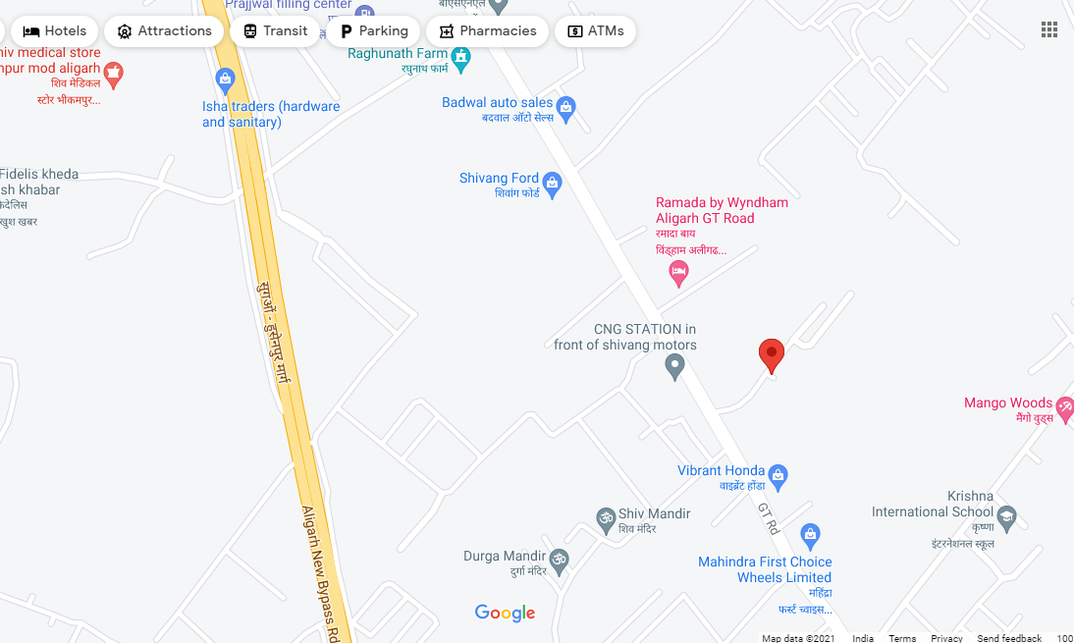

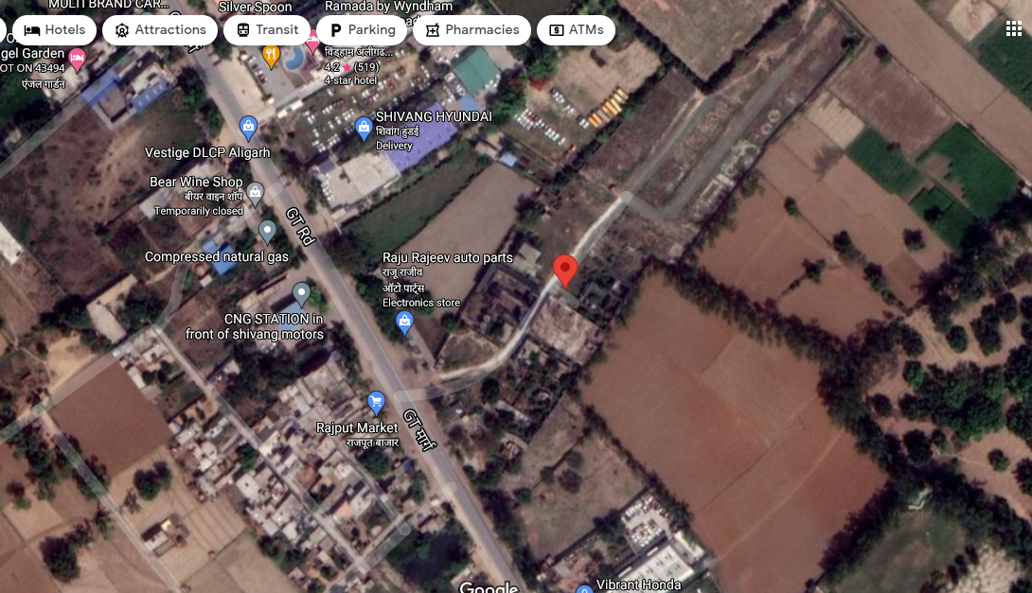

**ANNEXURE: IV – PHOTOGRAPHS OF THE PROPERTY**

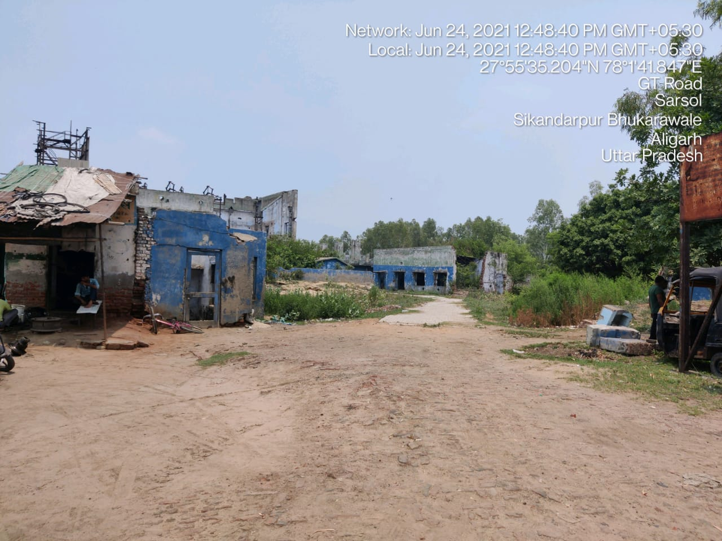

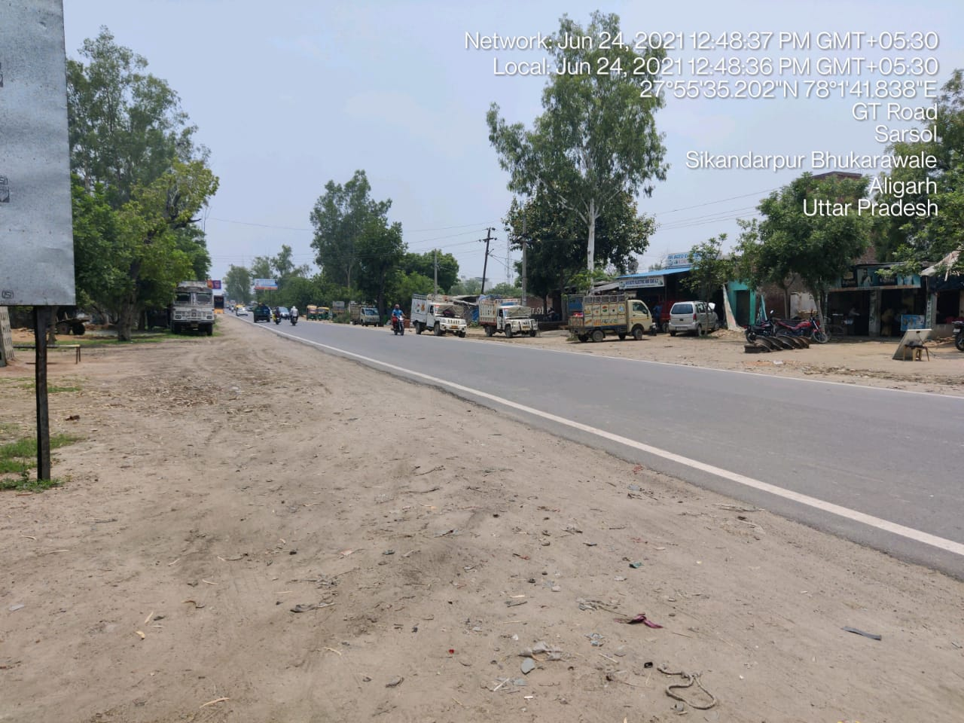

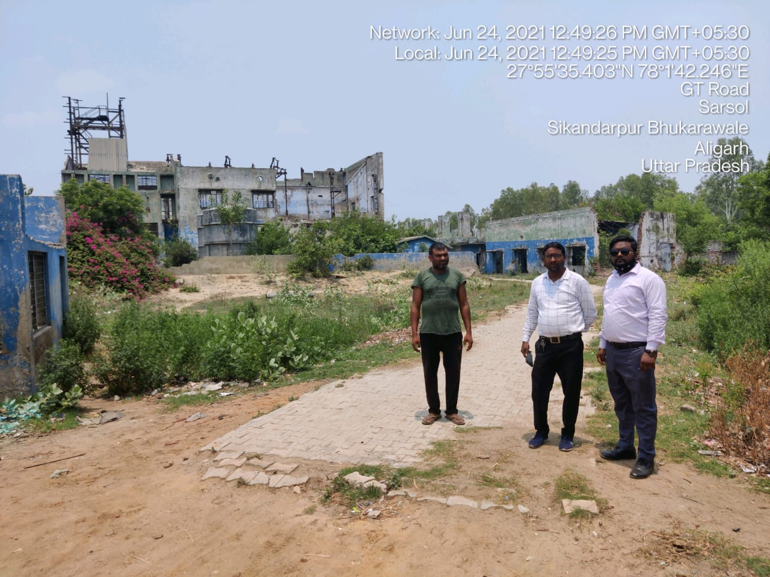

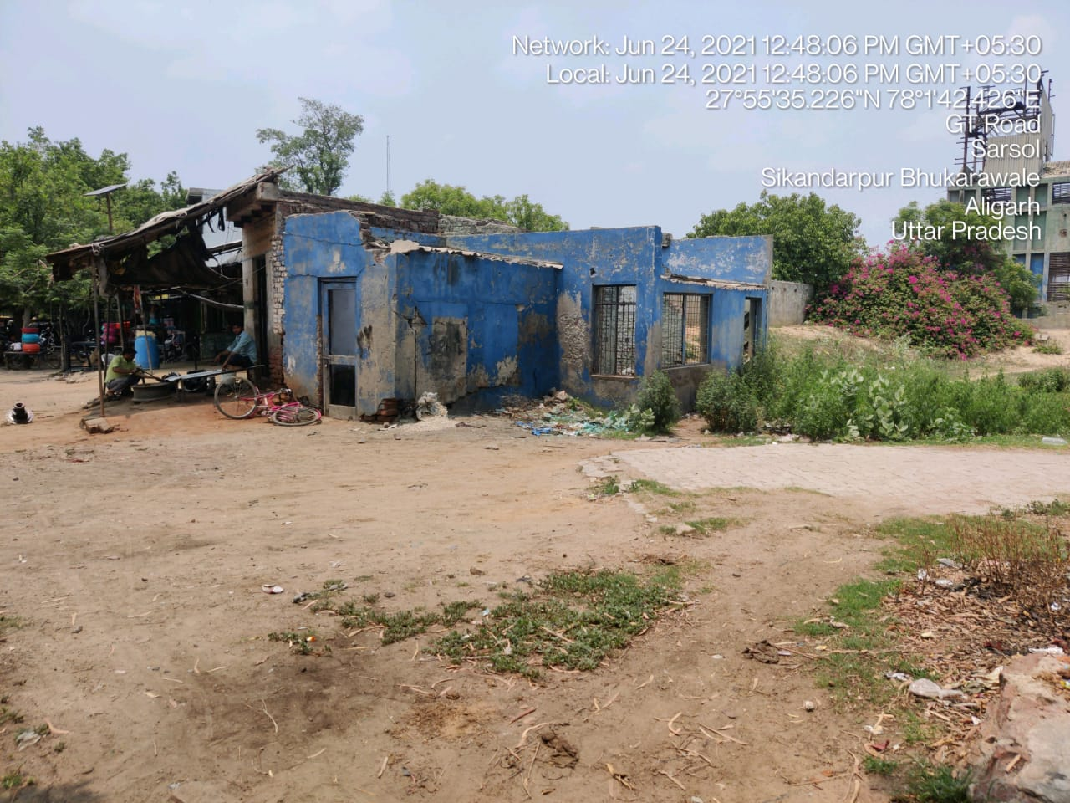

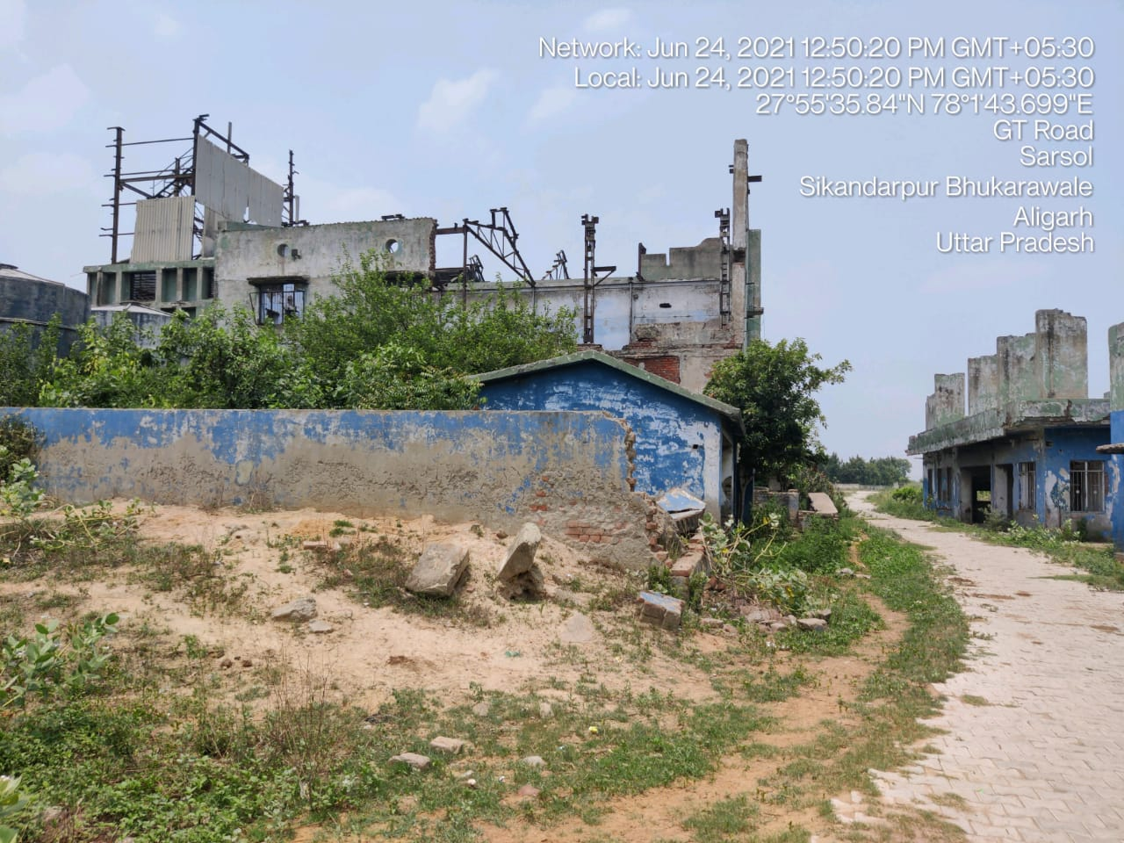

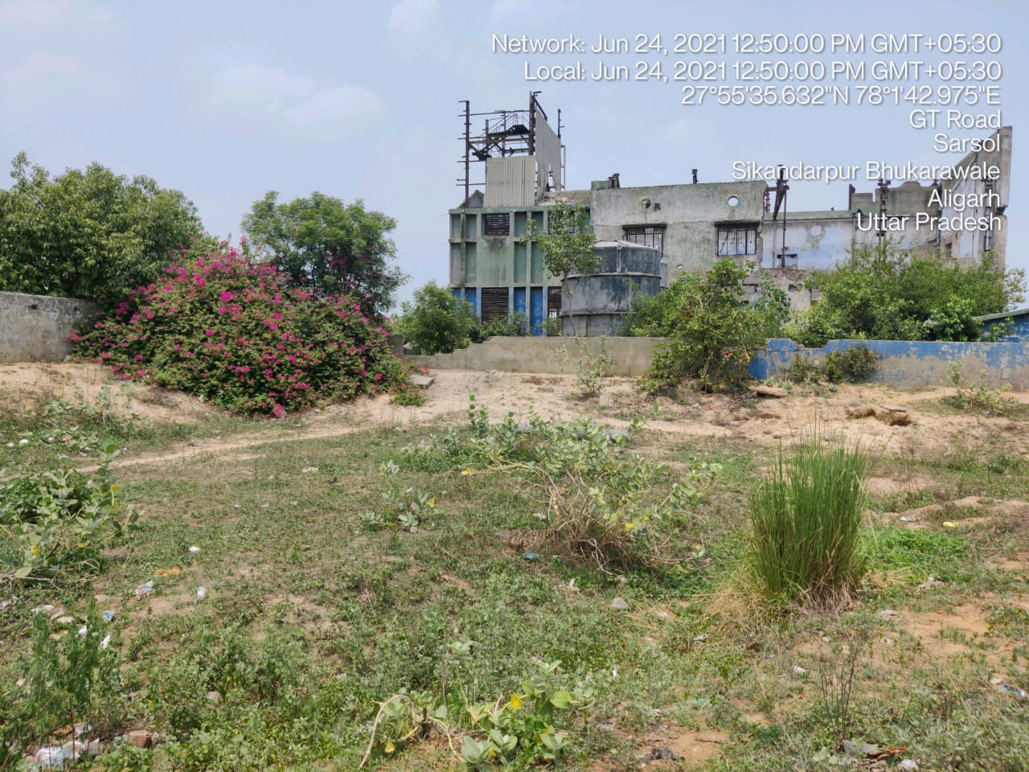

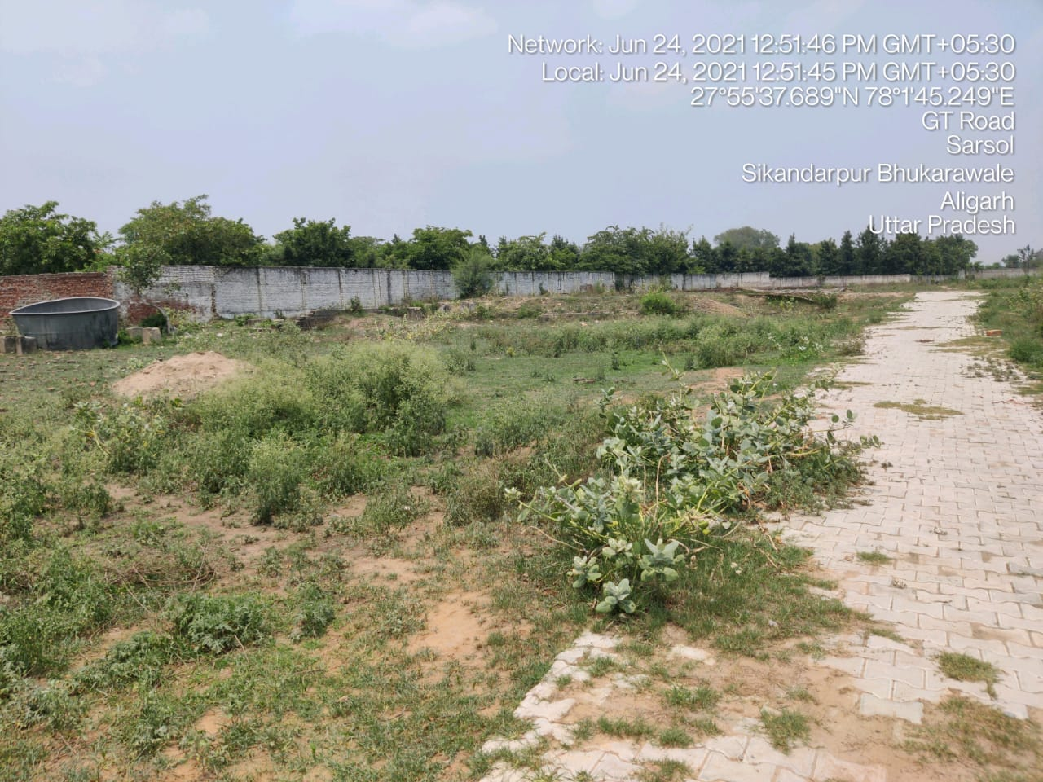

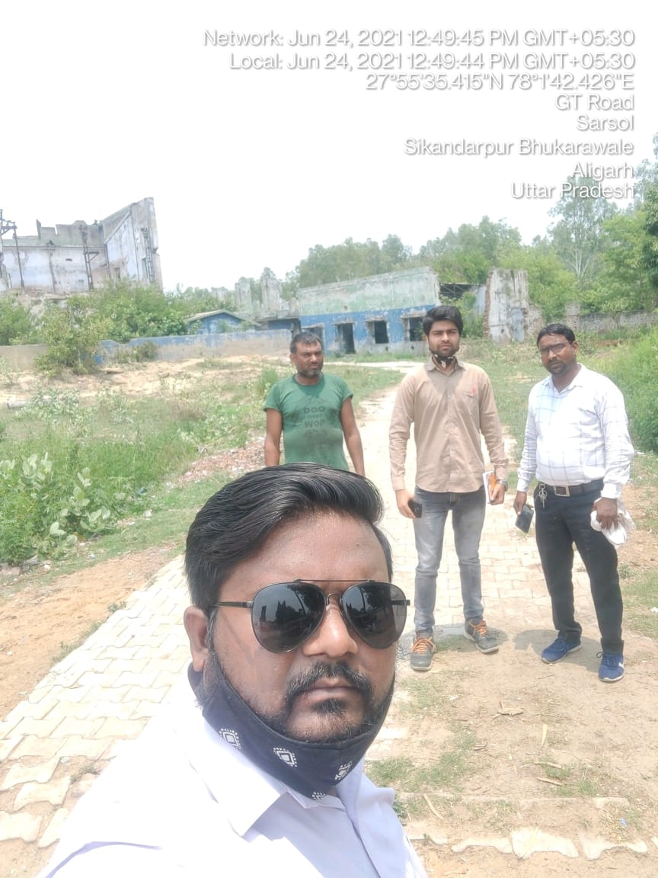

**ANNEXURE: VI– COPY OF CIRCLE RATE**

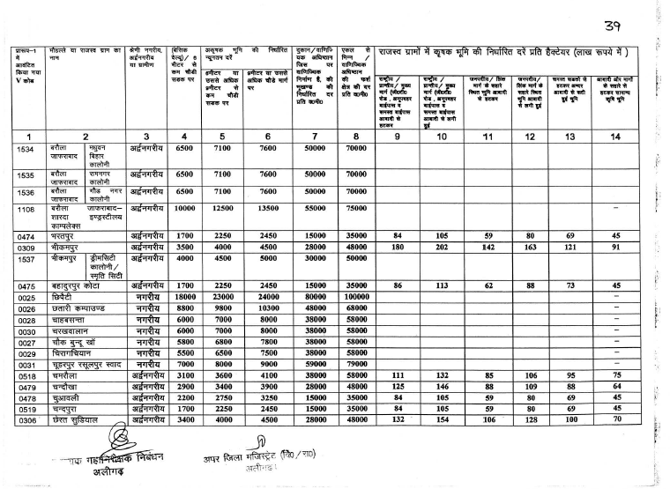

**ANNEXURE: VII – VALUER’S REMARKS**

|  |  |
| --- | --- |
|  | This Valuation report is prepared based on the copies of the documents/ information which interested organization or customer could provide to us out of the standard checklist of documents sought from them and further based on our assumptions and limiting conditions. All such information provided to us has been relied upon in good faith and we have assumed that it is true and correct. Verification or cross checking of the documents provided to us from the originals has not been done at our end. |
|  | Legal aspects for eg. investigation of title, ownership rights, lien, charge, mortgage, lease, verification of documents, etc. have to be taken care by legal expert/ Advocate and same are not done at our end. It is assumed that the concerned Lender/ Financial Institution has asked for the valuation of that property for which the legal verification has been already taken and cleared by the competent Advocate before requesting for the Valuation report. |
|  | Analysis and conclusions adopted in the report are limited to the reported assumptions, conditions and information came to our knowledge during the course of the work. |
|  | Value varies with the Purpose/ Date/ Condition prevailing in the market. We recommend not to refer the indicative & estimated prospective Value of the asset given in this report if any of these points are different from the one mentioned aforesaid in the Report. We also recommend that the indicative estimated Value in the Valuation Report holds good only upto the period of 3 months from the date of Valuation. |
|  | This report is having limited scope as per its fields & format to provide only the general basic idea of the value of the property prevailing in the market based on the documents/ data/ information provided by the client. The suggested indicative prospective estimated value should be considered only if transaction is happened as free market transaction. |
|  | This Valuation report is prepared based on the facts of the property on the date of the survey. It is a well-known fact that the market value of any asset varies with time & socio-economic conditions prevailing in the country. In future property Market may go down, property conditions may change or may go worse, Property reputation may differ, Property vicinity conditions may go down or become worse, Property market may change due to impact of Govt. policies or effect of World economy, Usability prospects of the property may change, etc. Hence before financing, Banker/ FI should take into consideration all such future risk and should loan conservatively to keep the advanced money safe in case of the downward trend of the property value. |
|  | Valuation of the same asset/ property can fetch different values in different situations. For eg. Valuation of a running/ operational shop/ hotel/ factory will fetch better value and in case of closed shop/ hotel/ factory it will have considerable lower value. Similarly an asset sold directly by an owner in the market will fetch better value and if the same asset/ property is sold by any financer due to encumbrance on it will fetch lower value. Hence before financing, Banker/ FI should take into consideration all such future risks and should loan conservatively to keep the advanced money safe in case of any such situation. |
|  | Getting cizra map or coordination with revenue officers for site identification is not done at our end. |
|  | Valuation is done for the property identified to us by the owner/ owner representative. At our end we have just cross verified the identification of the property with reference to the documents produced for perusal. Method by which identification of the property is carried out is also mentioned in the report clearly. Responsibility of identifying the correct property to the Valuer/ its authorized surveyor is solely of the client/ owner for which Valuation has to be carried out. It is requested from the Bank to cross check from their own records/ information if this is the same property for which Valuation has to be carried out to ensure that owner has not misled the Valuer company or misrepresented the property due to any vested interest. |
|  | In India more than 70% of the geographical area is lying under rural/ remote/ non municipal/ unplanned area where the subject property is surrounded by vacant lands having no physical demarcation or having any display of property survey or municipal number / name plate on the property clearly. Even in old locations of towns, small cities & districts where property number is either not assigned or not displayed on the properties clearly and also due to the presence of multiple/ parallel departments due to which ownership/ rights/ illegal possession/ encroachment issues are rampant across India and due to these limitations at many occasions it becomes tough to identify the property with 100% surety from the available documents, information & site whereabouts and thus chances of error, misrepresentation by the borrower and margin of chances of error always persists in such cases. To avoid any such chances of error it is advised to the Bank to engage municipal/ revenue department officials to get the confirmation of the property to ensure that the property shown to Valuer/ Banker is the same as for which documents are provided. |
|  | If this Valuation Report is prepared for the Flat/ dwelling unit situated in a Group Housing Society or Integrated Township then approvals, maps of the complete group housing society/ township is out of scope of this report and this report will be made for the specific unit based on the assumption that complete Group Housing Society/ Integrated Township must be approved in all respect.. |
|  | Due to fragmented & frequent change in building/ urban planning laws/ guidelines from time to time, different laws/ guidelines between regions/ states and no strict enforceability of Building Bye-Laws in India specially in non-metro and scale b & c cities & Industrial areas, property owners many times extend or make changes in the covered area/ layout from the approved/ applicable limits. There are also situations where properties are decades old when there was no formal Building Bye-Laws applicable when the construction must have been done. Due to such discrete/ unplanned development in many regions sometimes it becomes tough to determine the exact lawful situation on ground for the Valuer. In case nothing specific is noted on the covered built-up area considered in the Valuation Report, the covered area present on the site as per site survey will be considered in the Valuation. |
|  | Valuation is a subjective field and opinion may differ from consultant to consultant. To check the right opinion, it is important to evaluate the methodology adopted and various data point/ information/ factors/ assumption considered by the consultant which became the basis for the Valuation report before reaching to any conclusion. |
|  | Value analysis of any asset cannot be regarded as an exact science and the conclusions arrived at in many cases will, of necessity, be subjective and dependent on the exercise of individual judgment. Given the same set of facts and using the same assumptions, expert opinions may differ due to the number of separate judgment decisions, which have to be made. Therefore, there can be no standard formula to establish an indisputable exchange ratio. In the event of a transaction, the actual transaction value achieved may be higher or lower than our indicative analysis of value depending upon the circumstances of the transaction. The knowledge, negotiability and motivations of the buyers and sellers and the applicability of a discount or premium for control will also affect actual price achieved. Accordingly, our indicative analysis of value will not necessarily be the price at which any agreement proceeds. The final transaction price is something on which the parties themselves have to agree. However our Valuation analysis can definitely help the stakeholders to make them informed and wise decision about the Value of the asset and can help in facilitating the arm’s length transaction. |
|  | This report is prepared on the RKA V-L1 (Basic) Valuation format as per the client requirement and scope of work. This report is having limited scope as per its fields & format to provide only the general estimated & indicative basic idea of the value of the property prevailing in the market based on the information provided by the client. No detailed analysis, audit or verification has been carried out of the subject property. |
|  | This is just an opinion report and doesn’t hold any binding on anyone. It is requested from the concerned Client/ Bank/ Financial Institution which is using this report for mortgaging the property that they should consider all the different associated relevant & related factors & risks before taking any business decision based on the content of this report. |
|  | All Pages of the report including annexures are signed and stamped from our office. In case any paper in the report is without stamp & signature then this should not be considered a valid paper issued from this office. |
|  | Defect Liability Period is **30 DAYS**. We request the concerned authorized reader of this report to check the contents, data and calculations in the report within this period and intimate us in writing if any corrections are required or in case of any other concern with the contents or opinion mentioned in the report. Corrections only related to typographical, calculation, spelling mistakes will be entertained within the defect liability period. No request for any illegitimate value revision, date change or any other change will be entertained other than the one mentioned above. |
|  | R.K Associates encourages its customers to give feedback or inform concerns over its services through proper channel at [**valuers@rkassociates.org**](mailto:valuers@rkassociates.org) in writing within 30 days of report delivery. After this period no concern/ complaint/ proceedings in connection with the Valuation Services can be entertained due to possible change in situation and condition of the property. |
|  | Our Data retention policy is of **ONE YEAR**. After this period we remove all the concerned records related to the assignment from our repository. No clarification or query can be answered after this period due to unavailability of the data. |
|  | This Valuation report is governed by our (1) Internal Policies, Processes & Standard Operating Procedures, (2) R.K Associates Quality Policy, (3) Valuation & Survey Best Practices Guidelines formulated by management of R.K Associates, (4) Information input given to us by the customer and (4) Information/ Data/ Facts given to us by our field/ office technical team. Management of R.K Associates never gives acceptance to any unethical or unprofessional practice which may affect fair, correct & impartial assessment and which is against any prevailing law. In case of any indication of any negligence, default, incorrect, misleading, misrepresentation or distortion of facts in the report then it is the responsibility of the user of this report to immediately or atleast within the defect liability period bring all such act into notice of R.K Associates management so that corrective measures can be taken instantly. |
|  | R.K Associates never releases any report doing alterations or modifications by pen. In case any information/ figure of this report is found altered with pen then this report will automatically become null & void. |