**REPORT FORMAT:** CL-1 | Version: 1.0_2018

# Ref. No.: VIS(2021-22)PL-132-122-150 Date: 01/07/2021

* ***CERTIFICATE NAME:*** *Vetting Certificate for construction of Hotel Property situated at Khata No. 303 & 013 (Fasli Year 1416-1421), Khasra No. 345 Gha Min (Old Khasra No. 367 Min), Mauza Kolhupani, Pargana Pachwadoon, Tehsil Vikas Nagar, District Dehradun, Uttarakhand*
* ***PREPARED FOR ORGANIZATION:*** *Punjab National Bank, MCC Branch, Dehradun*
* ***BORROWER'S NAME:*** *M/s. Epicure Hotels & Resorts Pvt. Ltd. (Through its owner Mr. Vidit Garg S/o Mr. K.B. Garg)*
* ***ASSET TYPE:*** *Hotel Property*
* ***CURRENT LOCATION OF THE PROPERTY:*** *Khata No. 303 & 013 (Fasli Year 1416-1421), Khasra No. 345 Gha Min (Old Khasra No. 367 Min), Mauza Kolhupani, Pargana Pachwadoon, Tehsil Vikas Nagar, District Dehradun, Uttarakhand*

# TO WHOM IT MAY CONCERN

|  |  |  |
| --- | --- | --- |
| **S. NO.** | **PARTICULARS** | **DESCRIPTION** |
| **1.** | Date of Survey | 17-06-2021 |
| **2.** | Date of Certificate | 01-07-2021 |
| **3.** | Documents provided for perusal | Approved Map & Sale Deeds |
| **4.** | Location of the Property | Khata No. 303 & 013 (Fasli Year 1416-1421), Khasra No. 345 Gha Min (Old Khasra No. 367 Min), Mauza Kolhupani, Pargana Pachwadoon, Tehsil Vikas Nagar, District Dehradun, Uttarakhand |
| **5.** | Borrower | M/s. Epicure Hotels & Resorts Pvt. Ltd. *(Through its owner Mr. Vidit Garg S/o Mr. K.B. Garg)* |
| **6.** | Type of Asset | Hotel Property |
| **7.** | Type of Assessment | Building, Structure, Civil Work |
| **8.** | Scope of Assessment | Vetting of the price incurred in construction till  date. |
| **9.** | Nature of Structure | Hotel Property |
| **10.** | Year of Construction | Super Structure is completed final finishing work is going on. |
| **11.** | Total Cost Incurred | NA |
| **12.** | Current Estimated Market Value | As per the analysis and prevailing cost in the market for this stage of construction, we are of the view that the rate incurred for construction till date be around Rs.2,500/- per sq. ft. according to which the total amount incurred in the construction till now would be around Rs.5,01,47,975/- for the construction of 1863.51 sq. mtr. (20059.19 sq. ft.) as per the approved map provided to us. The super structure is completed, flooring and other finishing work is completed, final finishing work is going on. |
| **13.** | Condition of the structure | Final finishing work is going on. |

## OBSERVATIONS:

1. We have been provided by the bank/borrower company the copy of the approved map and sale deeds.
2. The super structure is completed, flooring and other finishing work is completed, final finishing work is going on.
3. Other fitting and fixture work is going on.

**As per our analysis and market research the total cost of construction incurred till date be around Rs.5,01,47,975/- which comes to be around Rs.2,500/- per sq. ft. which appears to be reasonable in our view.**

*This certificate is issued at the request of* ***Punjab National Bank, MCC Branch, Dehradun.***

***Disclaimer:***

* 1. *This Certificate is to be referred only for the purpose of the vetting of cost of the construction as per the approved map provided to us by the bank/borrower company.*
  2. *This certificate doesn’t include Drawing, design, and sketch plan in the scope of work.*
  3. *Ownership and other legal point of view in respect of the asset is not considered in this report.*
  4. *This certificate is made at the request of the Bank.*

## For R.K Associates Valuers & Techno FOR INTERNAL USE

**Engineering Consultants (P) Ltd. *TYPED BY: PE Team***

***REVIEWED BY: HOD Engineering***

**(Project Team)**

**GOOGLE LOCATION**

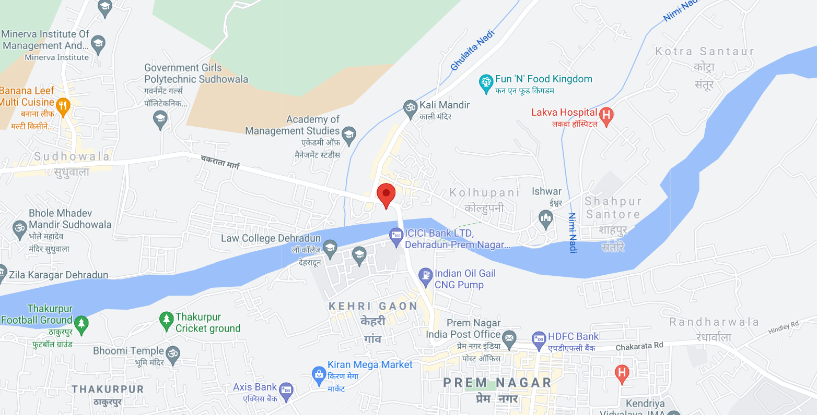

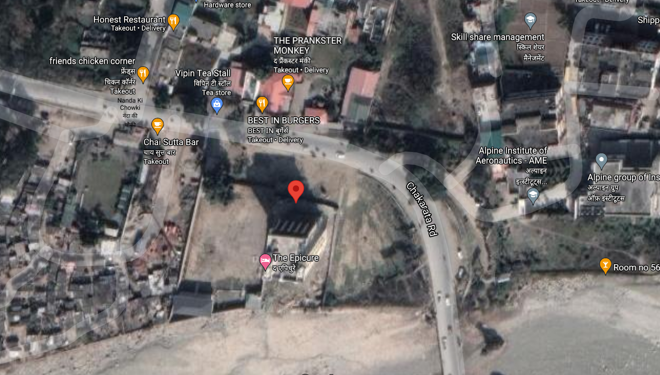

**PHOTOGRAPHS**

