**File No.: VIS(2021-22)-PL162-147-422 Dated: 23.07.2021**

**Amended date: 05-01-2023**

**CAPITAL COST INVESTMENT REPORT**

**OF**

HOUSEHOLD ELECTRONIC MANUFACTURING PLANT

**(UTTAR PRADESH NOIDA UNIT)**

**SITUATED AT**

# PLOT NO. 51, SURAJPUR-KASNA ROAD, UDYOG VIHAR, GREATER NOIDA, DISTRICT- GAUTAM BUDHHA NAGAR, UTTAR PRADESH

**COMPANY/PROMOTER**



**REPORT PREPARED FOR**

**THE PRADESHIYA INDUSTRIAL & INVESTMENT CORPORATION OF U.P. LIMITED (PICUP), PICUP BHAWAN, GOMTI NAGAR, LUCKNOW-226010 (INDIA)**

***\*\*Important - In case of any query/ issue or escalation you may please contact Incident Manager at*** [***le@rkassociates.org.***](mailto:le@rkassociates.org) ***We will appreciate your feedback in order to improve our services.***

***NOTE: Please provide your feedback on the report within 15 days of its submission after which report will be considered to be correct.***

**IMPORTANT NOTICE**

***COPYRIGHT FORMAT:*** *This report is prepared on the copyright format of*

*R.K Associates to serve our clients with the best possible information and analysis to facilitate them to take rational business decisions. Legally no*

*one can copy or distribute this format without prior approval from R.K Associates. It is meant only for the advisory/ reference purpose for the organization/s as mentioned on the cover page of this report. Distribution or use of this format by any organization or individual other than R.K Associates will be seen as an unlawful act and necessary legal action can be taken against the defaulters.*

*This report is intended for the sole use of the intended recipient/s and contains material that is STRICTLY CONFIDENTIAL AND PRIVATE.*

***DEFECT LIABILITY PERIOD:*** *- In case of any query/ issue or escalation you may please contact Incident Manager at* [*le@rkassociates.org.*](mailto:le@rkassociates.org) *We try to ensure maximum accuracy in the calculations done, rates adopted, assumptions taken and various other data points & information mentioned in the report but even still can’t rule out typing, human errors or any other bonafide mistakes. In case you find any such mistake or inaccuracy in any data point of the report, please help us by bringing all such points into our notice immediately or within 15 days of the report delivery in writing, to rectify these timely failing after which R.K Associates won’t be held responsible for any such inaccuracy in any manner. We would highly appreciate your feedback in order to improve our services.*

|  |  |  |
| --- | --- | --- |
| **TABLE OF CONTENTS** | | |
|  | | |
| **SECTIONS** | **PARTICULARS** | **PAGE**  **NO.** |
| **Part A** | **REPORT SUMMARY** | 03 |
| **Part B** | **INTRODUCTION** | 05 |
|  | 1. Name of the Project | 05 |
| 2. Project Overview | 06 |
| 3. Project Location | 09 |
| 4. Scope of the Report | 11 |
| 5. Purpose of the Report | 11 |
| 6. Survey Details | 11 |
| 7. Methodology Adopted | 14 |
| **Part C** | **PLANT INFRASTRUCTURE SECTIONS & FACILITY DETAILS** | 15 |
| 1. Land Details | 15 |
| 2. Building & Structural Details | 15-17 |
| 1. Plant and Machinery Details    1. Expenditure in Imported Plant & Machinery    2. Expenditure incurred in Indigenous & In-house produced Plant & Machinery    3. Expenditure incurred in Imported Moulds and its Machinery    4. Expenditure incurred in Indigenous Moulds and its Machinery | 18-20 |
| 1. Miscellaneous Fixed Assets    1. Expenditure incurred in Imported Mis. Fixed Assets    2. Expenditure incurred in Indigenous Mis. Fixed Assets    3. Expenditure incurred in In-house Mis. Fixed Assets | 21-22 |
| **Part D** | **PROPOSED INVESTMENT AND EXPENDITURE INCURRED** | 23 |
| 1. Total Proposed Investment | 23 |
| 2. Current Status of Expenditure incurred from Jan 01,2015 to Dec 12,2019 | 25 |
| **Part E** | **DISCLAIMER** | 30 |

|  |  |
| --- | --- |
| **PART A** | **REPORT SUMMARY** |

|  |  |  |  |
| --- | --- | --- | --- |
| **1.** | **Name of the Project** | **:** | Expansion / diversification of Refrigerator, Air Conditioner, Washing Machine, Compressor, Motors, Microwave Oven & Water Purifier manufacturing unit at existing Noida plant. |
| **2.** | **Project Location** | **:** | Plot No.51, Udyog Vihar, Surajpur-Kasna Road, District - Gautam Buddha Nagar, Uttar Pradesh |
| **3.** | **Name of the Company / Promoter** | **:** | M/s. LG Electronics India Private Limited  A –Wing, 3rd Floor, District Centre, Saket, New Delhi-110017. |
| **4.** | **Prepared for Organization** | **:** | The Pradeshiya Industrial & Investment Corporation of U.P. Ltd. (PICUP), PICUP Bhawan, Gomti Nagar, Lucknow. |
| **5.** | **Chartered Engineer Firm** | **:** | M/s. R. K. Associates Valuers & Techno Engineering Consultants (P) Ltd. |
| **6.** | **Date of Survey** | **:** | 9th, 10th, 15th & 17th June, 2021 |
| **7.** | **Date of Report** | **:** | 23rd July, 2021 |
| **8.** | **Report Type** | **:** | Examination & Certification Report of Capital Cost Investment |
| **9.** | **Purpose of the Report** | **:** | To verify and examine capital expenditure status of the Project in regard to the special facilities & incentives given to Mega Projects under Infrastructure and Industrial investment Policy-  2012. |

|  |  |  |  |
| --- | --- | --- | --- |
| **10.** | **Scope of the Report** | **:** | To verify and examine capital expenditure status of the Project. |
| **11.** | **Documents produced for Perusal** | **:** | 1. Detailed Project Report 2. Copies of Project Contracts 3. Break-up of the cost heads List of Invoices with Description of the Items 4. Copy of Invoices of Items 5. Copy of CA Certificate 6. Copies of various NOCs & Approvals 7. Information received on e-mail 8. Copy of Bank statements 9. FAR as on 01.08.21 10. Netting Certificates/ Remittance Advice 11. Copy of Building Map 12. COD Certificates |
| **12.** | **Annexure with the Report** | **:** | 1. Project Contract Copies 2. Photographs 3. Other annexures (e.g., Invoices, NOCs & Approvals, CA Certificate etc.) 4. COD Certificates |

|  |  |
| --- | --- |
| **PART B** | **INTRODUCTION** |

1. **NAME OF THE PROJECT:** Expansion/ diversification of existing Unit by creating additional capacity of Refrigerator (from 22 Lakh units per Annum to 23.76 Lakh units per Annum), Air Conditioner (from 4.25 Lakh units per Annum to 7.24 Lakh Units per Annum), Washing Machine (from 16 Lakh units per Annum to 18.14 Lakh units per Annum), Compressor (from 70 Lakh units per Annum to 1.17 Cr units per Annum), Motor (from 2.9 Lakh units per Annum to 31.54 Lakh units per Annum), a new production line setup to build Microwave Oven (5.4 Lakh units per Annum) & Water Purifier (2.20 Lakh units per annum) by LG Electronics India Private Limited at Noida, Gautam Buddha Nagar District of Uttar Pradesh.

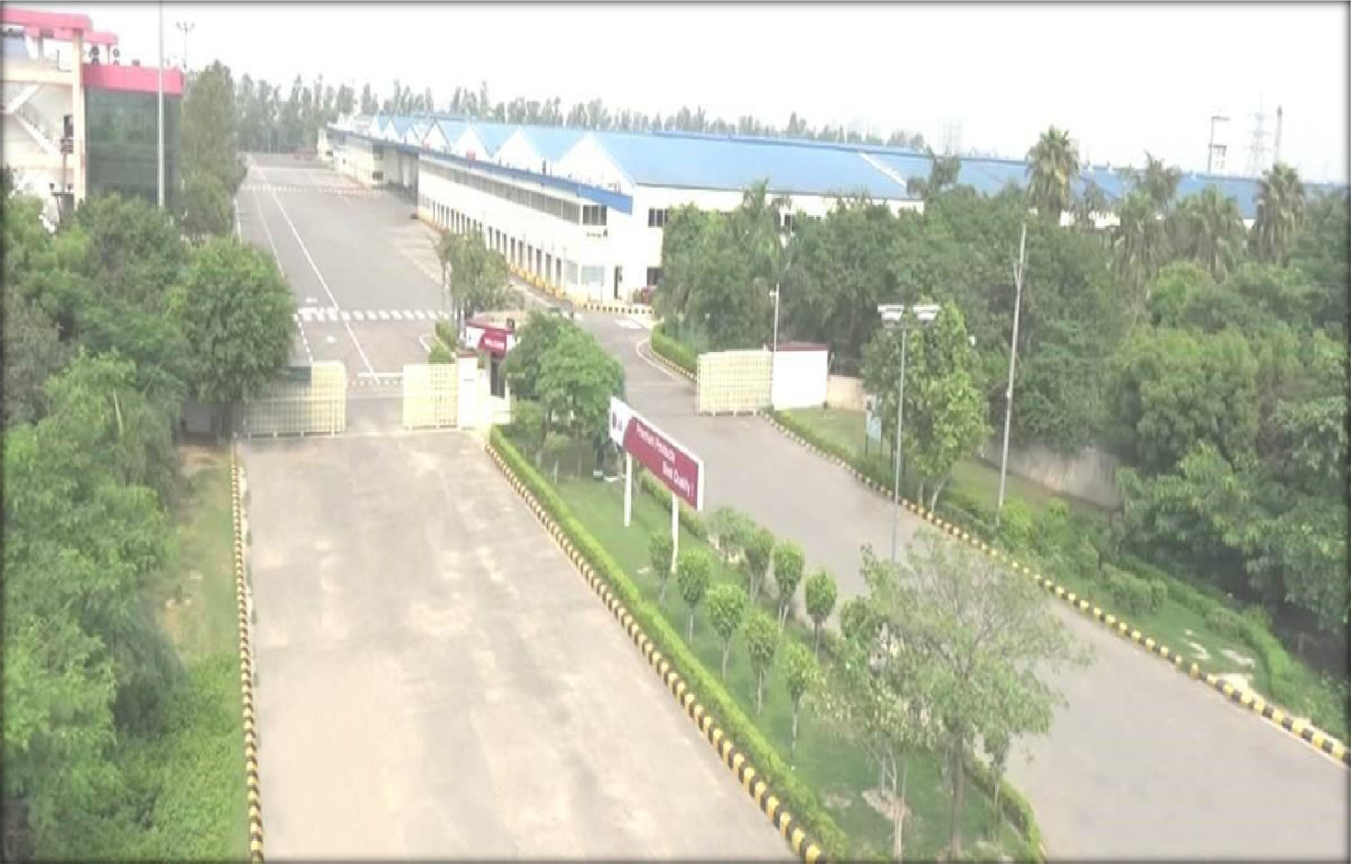

1. **PROJECT OVERVIEW:** M/s. LG Electronics India Private Limited, is a 100% subsidiary of LG Electronics Inc. South Korea, incorporated on January 20th, 1997 under the Indian Companies Act, 1956 (As further amended by Companies Act 2013).

LG Electronics India Private Limited is engaged in the business of manufacturing of various consumer durable items like refrigerators, air conditioners, washing machine, microwave oven, compressors, motors & water purifiers since 1997 in India.

It is having a full-scale manufacturing facility operating at Plot No.51, Udyog Vihar, Surajpur- Kasna Road, Greater Noida, District-Gautam Buddha Nagar, Uttar Pradesh since 1997 which mainly manufactures electronic items like refrigerators, air conditioners, washing machine, microwave oven, compressors, motors & water purifiers.

Under the Infrastructure and Industrial investment Policy-2012, the company has proposed to expand the production capacity of the Plant by increasing the overall production capacity by 71% till year 2020. LG India has proposed to plan for the expansion of the project with total investment of Rs.674 Cr. as per the Detailed Project Report dated June 22nd, 2017.

In this regard, initially LG India has been issued Letter of comfort (LoC) under Infrastructure and Industrial investment Policy-2012 through its nodal agency PICUP for expansion/ diversification of existing unit by increasing additional capacity of Mobile Phones, LED TV, refrigerators, air conditioners, washing machine, microwave oven, compressors, motors & water purifiers with total investment of Rs.1,328 Cr. at Noida.

But due to sluggish projected sales and on the basis of internal evaluation & management decision, the company has deferred the investment plant for Mobile Phones & LED TV and reduced its investment plan to Rs.674 Cr. (in 5 years investment period from year 2015 to year 2019).

The Company informed to the Govt. of U.P that it has made an investment amounting to Rs.597.01 Cr. (from 01.01.2015 to 31.12.2019) in the Project in the various heads like Buildings, Plant & Machinery & other miscellaneous items etc. In support of investment made, company has submitted a certificate from their Statutory Auditors.

For the verification of the capital expenditure incurred by the company in the Project, Govt. of UP through PICUP has engaged R.K Associates Valuers & Techno Engineering Consultants (P) Ltd. (R.K Associates).

As per Detailed Project Report-2017, the company’s total extent Land area is 1,90,232 sq. mtr. which is purchased by Greater Noida Industrial Development Authority was enough for the expansion of this project. So, LG India has not done any new investment for the land.

Following is the proposed expansion plan submitted by the company in its Detailed Project Report-2017:

**Table: 1**

|  |  |  |  |
| --- | --- | --- | --- |
| **PROPOSED EXPANSION PLAN** | | | |
| **S.No.** | **Product** | **Existing Qty Nos** | **Proposed Qty Nos** |
| **1.** | Air Conditioners | 4,25,000 | 7,24,000 |
| **2.** | Washing Machine | 16,00,000 | 18,14,000 |
| **3.** | Refrigerator | 22,00,000 | 23,76,000 |
| **4.** | Compressor (Refrigerator) | 70,00,000 | 1,17,07,000 |
| **5.** | Motor for Compressor | 2,90,000 | 31,54,000 |
| **Total** | | **1,15,15,000** | **1,97,75,000** |

***Source: Detailed Project Report-2017***

**Table: 2**

|  |  |  |
| --- | --- | --- |
| **PROPOSED DIVERSIFICATION PLAN** | | |
| **S.No.** | **Product** | **Proposed Qty Nos** |
| **1.** | Microwave Oven | 5,40,000 |
| **2.** | Water Purifier | 2,20,000 |
| **Total** | | **7,60,000** |

***Source: Detailed Project Report-2017***

As per current status, LG India has achieved the production capacity of all the proposed items as per table below and plans to increase its capacity more in future as per the verbal information provided during the site inspection. The capacities mentioned below is as per information provided by LG and the same as informed by the company to Government of India, Ministry of

Commerce & Industry, Department for Promotion of Industry and Internal Trade (Industrial Entrepreneurs Memorandum Section) and further acknowledged by them.

**Table: 3**

|  |  |  |  |  |  |
| --- | --- | --- | --- | --- | --- |
| **PROJECT SUMMARY OF PROPOSED V/S ACHIEVED CAPACITY** | | | | | |
| **S. No.** | **Main Production Units** | **Existing Capacity**  *(as on 31.12.2014)* | **Proposed Expansion / Diversification**  **Capacity** | **Achieved Capacity** | **%**  **Achieved** |
| **1.** | Air Conditioners | 4,25,000 | 7,24,000 | 6,25,000 | 86% |
| **2.** | Washing Machine | 16,00,000 | 18,14,000 | 25,00,000 | 138% |
| **3.** | Refrigerator | 22,00,000 | 23,76,000 | 29,00,000 | 122% |
| **4.** | Compressor  (Refrigerator) | 70,00,000 | 1,17,07,000 | 1,08,00,000 | 92% |
| **5.** | Motor for  Compressor | 2,90,000 | 31,54,000 | 40,00,000 | 127% |
| **6.** | Microwave Oven | - | 5,40,000 | 4,40,000 | 81% |
| **7.** | Water Purifier | - | 2,20,000 | 3,50,000 | 159% |

***Source: DPR & Information from LG India***

**Table: 4**

|  |  |  |  |  |  |  |
| --- | --- | --- | --- | --- | --- | --- |
| PROPOSED INVESTMENT SCHEDULE | | | | | | |
| **Sections** | **2015** | **2016** | **2017** | **2018** | **2019** | **TOTAL** |
| **Refrigerator** | **43** | **37** | **28** | **55** | **48** | **211** |
| **Washing Machine** | **19** | **22** | **26** | **36** | **43** | **146** |
| **Compressor** | **7** | **40** | **15** | **46** | **28** | **136** |
| **Common Assets** | **13** | **4** | **7** | **11** | **18** | **53** |
| **Motor** | **0** | **5** | **30** | **1** | **15** | **51** |
| **Air Conditioner** | **9** | **3** | **3** | **9** | **11** | **35** |
| **Microwave** | **17** | **1** | **0** | **7** | **6** | **31** |
| **Water Purifier** | **3** | **2** | **1** | **0** | **5** | **11** |
| **Total** | **111** | **114** | **110** | **165** | **174** | **674** |

***Source: Detailed Project Report-2017***

**The scope of this report only includes the assessment & verification of installation, commissioning and capital expenditure of Rs.597.01 crores incurred in between 01.01.2015 & 31.12.2019 in the Project.**

In the current capital expenditure of Rs.597.01 crores company has shown to have carried out the work in the existing running unit as per the chart below:

**Table: 5**

|  |  |  |
| --- | --- | --- |
| **S. No.** | **Sections** | **Amount**  **(In Cr.)** |
| 1. | **Building & Civil Work** | 61.89 |
| 2. | **Plant & Machinery** | 522.67 |
| 3. | **Miss. Fixed Assets** | 12.45 |
| **Total** | | **597.01** |

Accordingly, based on the information, data provided by the company as sought from them as per standard checklist of the documents as per the nature of the Project and based on the site verification and industry standard verified the cost expenditure shown by the company. Section/ asset item wise cost verification analysis is described in the report below.

1. **PROJECT LOCATION:** The electronic household equipment manufacturing unit setup by LG Electronics India Private Limited is located at Plot No.51, Udyog Vihar, Surajpur-Kasna Road, Greater Noida, District - Gautam Budhha Nagar, Uttar Pradesh State in India and the Project site is well connected by rail, road and airport. The nearest airport from the site is IGI Airport, Delhi located at the distance of 45 km. The Project site is also well connected through Road network and Noida - Greater Noida expressway is about at a distance of 6-7 km. from the Project Site. New Delhi Railway Station is the nearest railway station around 28 km from the project.

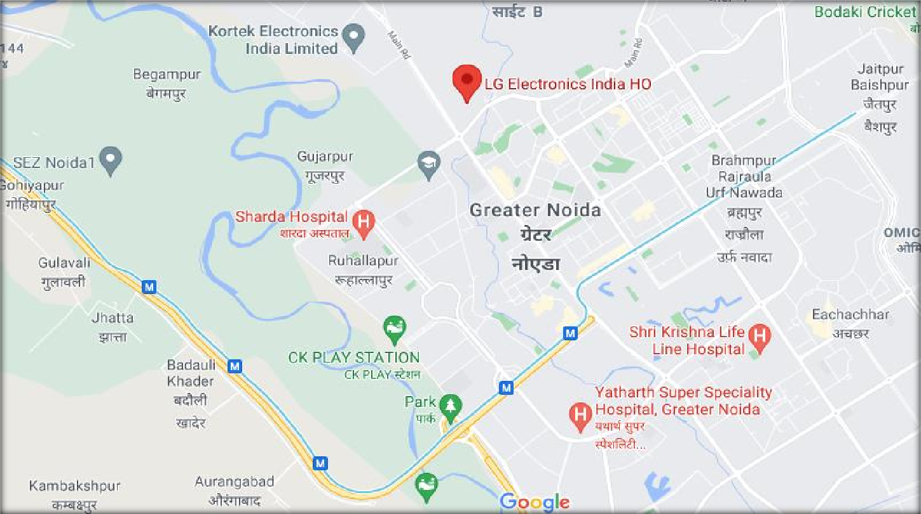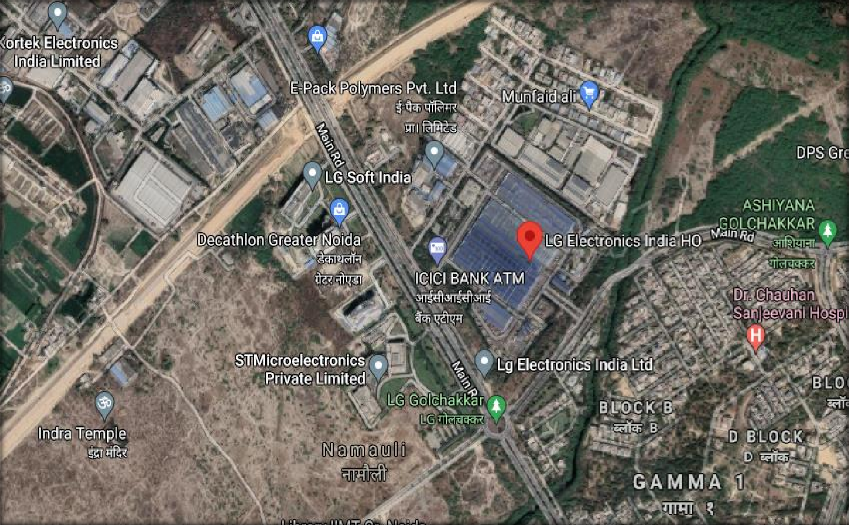

1. **SCOPE OF THE REPORT:** To verify and examine the commissioning, installation and capital expenditure status of the expansion & diversification of the Project popularly named as LG Electronics India Private Limited in regard to special facilities & incentives given to Mega Projects under Infrastructure and Industrial investment Policy-2012 of Govt. of U.P.

*All the assessment carried out for the Project is done based on the documents & information provided to us by LG company officials and its correlation by the Engineering team through site inspection and various other discussions with the Project proponents and its able resources and thus forming an opinion out of it.*

1. **PURPOSE OF THE REPORT:** To provide a comprehensive overview of the current status of the project in terms of its Physical progress and Capital Expenditure incurred to enable PICUP to take informed business decision on the Project in relation to special facilities & incentives given to Mega Projects under Infrastructure and Industrial investment Policy-2012 of Govt. of U.P.
2. **SURVEY DETAILS:** This Plant is surveyed by our Engineering team comprising of Mr. Inderjeet Rathee and Mr. Nikhl Rajan on 9th, 10th, 15th & 17th June, 2021. Site inspection was done in the presence of plant representatives CA Sahil Arora. All the details pertaining to physical setup and progress of the Plant have been cross checked as per the documents provided to us.

Team visited different sections of the Plant and verified the main sections like Ref plant, Warehouse, Air Conditioner Manufacturing Plant, Washing Machine Line, Compressor Line, Motor Line, Microwave Line, Boiler House, Extruder Plant, Chiller Plant, Boiler House, ETP-STP Plant & Other auxiliary buildings and found the sections to be operational and in production. Plant and all its installed machinery equipment are found in good working condition. Moulds which are installed at various manufacturing units of vendors of LG were also cross-verified by us details of those are mentioned below:

**Table: 6**

|  |  |  |  |  |  |
| --- | --- | --- | --- | --- | --- |
| **S.No** | **Location of Asset** | **Capitalisation Number** | **Item Description** | **Capitalisation**  **Description** | **Net Amount**  **Capitalised** |
| 1 | Eail_Ping Telematics Pvt Ltd-Noida_IN002166 | ILIF03171244 | Plastic Injection Mould With Standard Spare Parts,Top Cover Sl22Ey0004,Cabinat Base Mam6262S901 | Cover,Top | 1,01,83,480 |
| 2 | Eail_Starion India Pvt. Ltd.-Noida_IN001947 | ILIF03171243 | Plastic Injection Mould With Standard Spare Parts,Top Cover Sl22Ey0004,Cabinat Base Mam6262S901 | Base,Tub | 1,61,23,843 |
| 3 | IN001089 Diptylal Judge Mal (P) Ltd.-Noida  Plot No. D-55 , Phase Ii Extn. Noida (U.P.) 201305 | ILIF02307027 | I N.Lection Mould- 1. Jet Spray Top Cover | Cover,Top | 1,16,26,294 |
| 4 | IN001089 Diptylal Judge Mal (P) Ltd.-Noida Plot No. D-55 , Phase Ii Extn. Noida (U.P.)  201305 | ILIF02262295 | Spaience Top Cover Mould, Spaience Bear Panel Mould, Spaience Bear Deco Mould | Cover,Top | 97,38,436 |
| 5 | IN001089 Diptylal Judge Mal (P) Ltd.-Noida  Plot No. D-55 , Phase Ii Extn. Noida (U.P.) 201305 | ILIF02704364 | Plastic Injection Moulds With Standard Spare Parts (Mcr 66006311) For Washing Machine | Cover,Top | 92,42,790 |
| 6 | IN001089 Diptylal Judge Mal (P) Ltd.-Noida  Plot No. D-55 , Phase Ii Extn. Noida (U.P.) 201305 | ILIF02316790 | Cap Door Refrigerator 2-Cap Door Refrigerator 3-Leg  Adjust 4-Handle Décor 5-Cap Décor Refrigerator 6- Handel Refrigerator 7-Lokar Sipndel | Handle,Refrigerator | 57,55,524 |
| 7 | IN001089 Diptylal Judge Mal (P) Ltd.-Noida  Plot No. D-55 , Phase Ii Extn. Noida (U.P.) 201305 | ILIF03171201 | Plastic Injection Mould With Standard Spare  Parts,Swaoee Cabinet Mould,Armstrong Top Cover Mould | Cabinet | 2,28,47,625 |
| 8 | IN001122 Paradise Plastic Enterprises Ltd. D- 1,Site-5,Surajpur Indl Area,Kasna  Road,Greater Noida | ILIF02954898 | Plastic Injection Moulds With Standard Spare Parts | Chassis | 64,94,303 |
| 9 | IN001122 Paradise Plastic Enterprises Ltd. D- 1,Site-5,Surajpur Indl Area,Kasna  Road,Greater Noida | ILIF02954938 | Plastic Injection Moulds With Standard Spare Parts | Grille,Front | 56,22,968 |
| 10 | IN001895 Neumann Components P Ltd. Plot No. 35 , Sector -31Greater Noidaupgreater Noida(U.P.) | ILHF03145044 | Mck6921 0701 Cover,Mdx63971 901  Grime.Dlscharge,Mbn64425001 Case .Contro~ Outdoor  ),Mfz65098101 Packing,Base,Plastic In Ecuon Mould With St.Ndard Spare P.Rts,Press Ole With Standard Spare Parts | Bracket,Motor | 57,54,358 |
| 11 | IN001930 PG Electroplast Ltd. P-4/2,4/3&4/4, Site B Upsidcsurajpur Greater Noida | ILIF02420391 | Plastic Injection Mould With Standard Spare-Swadee Base Mould 1 St | Base,Tub | 1,28,26,992 |
| 12 | IN001930 PG Electroplast Ltd. P-4/2,4/3&4/4, Site B Upsidcsurajpur Greater Noida | ILIF02484129 | Tl540 Top Cover Mould 1Ea P/No:Mac69187501 Plastic Injection Mould With Standard Spare Parts | Cover,Top | 1,04,13,934 |
| 13 | IN001930 PG Electroplast Ltd. P-4/2,4/3&4/4, Site B Upsidcsurajpur Greater Noida | ILIF02711865 | Plastic Injection Moulds & Press Die For Manufacturing Or Lg Residentiel Air Conditioner With Standard Spare  Parts | Grille,Front | 91,08,028 |
| 14 | IN001930 PG Electroplast Ltd. P-4/2,4/3&4/4, Site B Upsidcsurajpur Greater Noida | ILIF02497121 | Plastic Injection Mould With Standard Spare Parts _ High Base Mould P/No.3040Eu0002 | Base,Cabinet | 71,17,895 |
| 15 | IN001930 PG Electroplast Ltd. P-4/2,4/3&4/4, Site B Upsidcsurajpur Greater Noida | ILIF02500903 | Inection Mould :Washing Machine Parts -Case Plunger  Valve (Part No:Mbn378581) Base Mid (Part No: Mam619281) Cover Tub (Part No: 3550Eu 1004) | Base,Cabinet | 56,49,974 |
| 16 | IN001930 PG Electroplast Ltd. P-4/2,4/3&4/4, Site B Upsidcsurajpur Greater Noida | ILIF02353041 | Plastic Injection Mould-Swadee Sack Cover Mould 1 St (P/No.: Mck69048701) | Cover,Rear | 52,28,865 |
| 17 | IN001930 PG Electroplast Ltd. P-4/2,4/3&4/4, Site B Upsidcsurajpur Greater Noida | ILIF03165933 | Outer Tub (Part No·3D4<4Euooo2A) | Tub,Outer | 1,82,88,952 |
| 18 | IN001930 PG Electroplast Ltd. P-4/2,4/3&4/4, Site B Upsidcsurajpur Greater Noida | ILIF03160505 | Tools For Pressing Press Dle With Standard Spare Parts,Balance Weight(Cma) | Decor | 58,07,349 |
| 19 | IN001930 PG Electroplast Ltd. P-4/2,4/3&4/4, Site B Upsidcsurajpur Greater Noida | ILIF03142384 | Injection Mould Nozle Lower Part No.  ·5248Ey1019A,Model-Swadee 75 Kg Burgundy | Nozzle,Lower | 54,90,000 |
| 20 | IN001930 PG Electroplast Ltd. P-4/2,4/3&4/4, Site B Upsidcsurajpur Greater Noida | ILIF03165259 | Grille Discharge(Mdx63432010,Chassis(Mbs63085404), Grille Front(Mox6461 2203) | Grille,Front | 51,96,631 |
| 21 | IN001947 Starion India Pvt. Ltd.-Noida Plot No. 11 , Udyog Kendra-Nnagar (U.P.),Greater Noida,Gautam Bud | ILIF02506448 | Swadee Cabinet Mould P/No:3090Ey004A Tl540 Balancer Upper Mould P/No: Mck42733501 Tl540 Balancer Lower Mould P/No: Mck42733601 -Plastic  Injection Mould With Standard Spare Parts | Cabinet | 2,07,06,629 |
| 22 | IN001947 Starion India Pvt. Ltd.-Noida Plot  No. 11 , Udyog Kendra-Nnagar (U.P.),Greater Noida,Gautam Bud | ILIF02348809 | Plastic Injection Mould-Omega Cabinet Mould P/No.: Mbh622268 | Cabinet | 2,06,49,977 |

|  |  |  |  |  |  |
| --- | --- | --- | --- | --- | --- |
| 23 | IN001947 Starion India Pvt. Ltd.-Noida Plot  No. 11 , Udyog Kendra-Nnagar (U.P.),Greater Noida,Gautam Bud | ILIF02483291 | Injection Mould -Raja Pjt Tub Outer | Tub,Outer | 1,75,54,405 |
| 24 | IN001947 Starion India Pvt. Ltd.-Noida Plot  No. 11 , Udyog Kendra-Nnagar (U.P.),Greater Noida,Gautam Bud | ILIF02386724 | Plastic Injection Mould Omega ,Base Mould 1 St | Base,Tub | 1,20,64,433 |
| 25 | IN001947 Starion India Pvt. Ltd.-Noida Plot  No. 11 , Udyog Kendra-Nnagar (U.P.),Greater Noida,Gautam Bud | ILIF02929026 | Plastic Injection Mould | Cabinet | 76,15,123 |
| 26 | IN001947 Starion India Pvt. Ltd.-Noida Plot No. 11 , Udyog Kendra-Nnagar (U.P.),Greater  Noida,Gautam Bud | ILIF02494620 | Plastic Injection Mould With Standard Spare Parts - Inner Tube Base Mould -P/No.:3040Eu1002 | Base,Tub(Inner) | 72,24,381 |
| 27 | IN001947 Starion India Pvt. Ltd.-Noida Plot  No. 11 , Udyog Kendra-Nnagar (U.P.),Greater Noida,Gautam Bud | ILIF02497120 | Swadee Spin Basket | Basket,Spin Dryer | 64,55,610 |
| 28 | IN001947 Starion India Pvt. Ltd.-Noida Plot No. 11 , Udyog Kendra-Nnagar (U.P.),Greater  Noida,Gautam Bud | ILIF02500873 | Plastic In,Iect!On Mold With Standard Spare Pae 1- Omega Spin Basket | Basket,Spin Dryer | 64,34,430 |
| 29 | IN001947 Starion India Pvt. Ltd.-Noida Plot No. 11 , Udyog Kendra-Nnagar (U.P.),Greater  Noida,Gautam Bud | ILIF02409863 | 1. Swadee Balancer Upp &Lwr | Cover,Balance(Upper) | 56,49,451 |
| 30 | IN001947 Starion India Pvt. Ltd.-Noida Plot No. 11 , Udyog Kendra-Nnagar (U.P.),Greater  Noida,Gautam Bud | ILIF03157186 | Mould Of Base.Tub ( Inner Model:Dc Drain Motor Global Common Main Pcba Applicati Seq. | Base,Tub(Inner) | 61,10,000 |
| 31 | IN001988 Kunstocom (India) Limited C-47 & C- 48 Aphase-Iinoidaupphase-Ii, Noida,U.P | ILIF03171275 | Plastic Injection Mould With Standard Spare Parts,Swaoee Cabinet Mould,Armstrong Top Cover  Mould | Cover,Top | 94,17,586 |
| 32 | IN002133 Taehwa Enterprises India Pvt Ltd  Plot No 6 B, Sector-40/41,Ecotech-1, Industrial Area,Kasna, Greater Noida | ILHF02517318 | Bsa Shell,Lower,Bsa Bracket,Mou | Shell,Lower | 1,67,88,846 |
| 33 | IN002133 Taehwa Enterprises India Pvt Ltd  Plot No 6 B, Sector-40/41,Ecotech-1, Industrial Area,Kasna, Greater Noida | ILHF02602228 | Core Stator | Core,Stator | 1,67,62,413 |
| 34 | IN002133 Taehwa Enterprises India Pvt Ltd  Plot No 6 B, Sector-40/41,Ecotech-1, Industrial Area,Kasna, Greater Noida | ILHF02274000 | Press Die For Comressor Along With Standrd Spares 1-  Stator And Rotol' Stamping Die Cma-(Mch623655 ) 2- Rotor Die Cma-(Mch624455 ) | Core,Stator | 1,29,66,984 |
| 35 | IN002133 Taehwa Enterprises India Pvt Ltd  Plot No 6 B, Sector-40/41,Ecotech-1, Industrial Area,Kasna, Greater Noida | ILHF02517287 | Bsa Shell,Upper,Bsa Cover ,Lower | Shell,Upper | 1,10,39,336 |
| 36 | IN002133 Taehwa Enterprises India Pvt Ltd  Plot No 6 B, Sector-40/41,Ecotech-1, Industrial Area,Kasna, Greater Noida | ILHF02820416 | 659160009251,Tool Core Assembly With Panel And Spare Satator (Acn73553808)(Seq-2) | Core Assembly,Stator | 1,01,10,000 |
| 37 | IN002133 Taehwa Enterprises India Pvt Ltd  Plot No 6 B, Sector-40/41,Ecotech-1, Industrial Area,Kasna, Greater Noida | ILHF02820397 | 659160009249,Tool Core Assembly With Panel And Spare Satator (Acn73553808)(Seq-2) | Core Assembly,Stator | 95,10,000 |
| 38 | IN002133 Taehwa Enterprises India Pvt Ltd Plot No 6 B, Sector-40/41,Ecotech-1,  Industrial Area,Kasna, Greater Noida | ILHF02438701 | Shell Upper (1+3) | Shell,Upper | 88,99,502 |
| 39 | IN002133 Taehwa Enterprises India Pvt Ltd Plot No 6 B, Sector-40/41,Ecotech-1,  Industrial Area,Kasna, Greater Noida | ILHF02438608 | Shell Upper | Shell,Upper | 88,86,255 |
| 40 | IN002228 M/S Ezentech (India) Pvt.Ltd. Plot No. 16 , Udyog Kendra , Greater Noida ,  Gautama Budh Nagar , U.P. India | ILHF02431133 | Press Die-Base Single (1Set=3Ea) | Base,Single | 73,93,735 |
| 41 | IN002228 M/S Ezentech (India) Pvt.Ltd. Plot No. 16 , Udyog Kendra , Greater Noida , Gautama Budh Nagar , U.P. India | ILHF03145043 | Mck6921 0701 Cover,Mdx63971 901  Grime.Dlscharge,Mbn64425001 Case .Contro~ Outdoor  ),Mfz65098101 Packing,Base,Plastic In Ecuon Mould With St.Ndard Spare P.Rts,Press Ole With Standard Spare Parts | Panel,Front | 69,91,290 |
| 42 | IN002228 M/S Ezentech (India) Pvt.Ltd. Plot No. 16 , Udyog Kendra , Greater Noida , Gautama Budh Nagar , U.P. India | ILHF03145026 | Mck6921 0701 Cover,Mdx63971 901  Grime.Dlscharge,Mbn64425001 Case .Contro~ Outdoor  ),Mfz65098101 Packing,Base,Plastic In Ecuon Mould With St.Ndard Spare P.Rts,Press Ole With Standard Spare Parts | Cover | 62,03,742 |
| 43 | IN002228 M/S Ezentech (India) Pvt.Ltd. Plot No. 16 , Udyog Kendra , Greater Noida , Gautama Budh Nagar , U.P. India | ILHF03145040 | Mck6921 0701 Cover,Mdx63971 901  Grime.Dlscharge,Mbn64425001 Case .Contro~ Outdoor  ),Mfz65098101 Packing,Base,Plastic In Ecuon Mould With St.Ndard Spare P.Rts,Press Ole With Standard Spare Parts | Base,Outdoor | 51,55,734 |
| 44 | IN002281 Amber Enterprises India Limited C-  3, Upsidc, Site Iv, Kasnagreater Noida | ILHF02532320 | Plastics Injection Mould With Standard Spare Parts | Cover,Protect | 60,56,767 |
| 45 | IN002281 Amber Enterprises India Limited C-  3, Upsidc, Site Iv, Kasnagreater Noida | ILHF02896835 | Plastic Injection Moulds With Standard Spare Parts | Panel,Front | 54,75,132 |
| 46 | IN002281 Amber Enterprises India Limited C-  3, Upsidc, Site Iv, Kasnagreater Noida | ILHF02896909 | Plastic Injection Moulds With Standard Spare Parts | Cover | 53,33,183 |
| 47 | IN019803 Sunplast Electronics Private Limited- Noida B5, Site-B,Industrial Area,Surajpur,Gautam Budh Nagar,Greater  Noida, Up | ILIF02711864 | Plastic Injection Moulds & Press Die For Manufacturing Or Lg Residentiel Air Conditioner With Standard Spare Parts | Chassis | 89,76,411 |
| 48 | IN028501 Aditya Auto Industries Plot No-  32Ecotech-1Extentiongreater Noida U.P | ILHF02276141 | Press Die For Mwo With Spare Parts (20Ltr) Door  Frame+Punchlng Tool (Iset=7Ea) | Frame,Door | 76,97,681 |

Our team visited each and every section of plant and cross verify the condition of all plant & machinery and civil structure.

Photographs have been taken of different machinery and civil structure which was installed at the site.

Some of the photographs have been attached annexed with the report.

As per the documents provided by the company, this Project has achieved the production capacity of Microwave oven to 4.40 Lakh units per annum on 16.03.2015, Water Purifier to 3.5 Lakh unit per annum on 11.01.2016, Compressor to 1.08 Cr units per annum, Motor to 40 Lakh units per annum, Refrigerator to 29 Lakh units per annum, Air-conditioner to 6.25 Lakh units per annum & Washing Machine to 25 Lakh units per annum on 31.12.2019 respectively. Production capacities have not been verified independently by us.

At the time of survey only the all the production lines were fully operational except Refrigeration line which was not in operation because of less demand in the market due to Covid-19 lockdown restrictions.

# METHADOLOGY ADOPTED:

* 1. Study of Detailed Project Report to know the Project proposed plan & estimates.
  2. Study of Project Contract agreements.
  3. Site visit by our engineering team to assess the project execution status on the ground at the site.
  4. Discussions with the Mechanical Plant Head & Civil Engineering team on the site.
  5. Various documents, information & data collected from the company through e-mail.
  6. Study and analysis of the documents and information obtained from the company and their correlation with the observations during site survey.
  7. Correlation of the provided information with the industry standards, CPWD SOR, etc.
  8. Other information obtained regarding the project from the sources in the public domain.

|  |  |
| --- | --- |
| **PART C** | **PLANT INFRASTRUCTURE SECTIONS & FACILITY DETAILS** |

1. **LAND DETAILS:** The company’s total extent Land area 1,90,232 sq. mtr. which is purchased by Greater Noida Industrial Development Authority was enough for the expansion of this project. So LG India has not done any new investment for the land and has not claimed any amount for it.

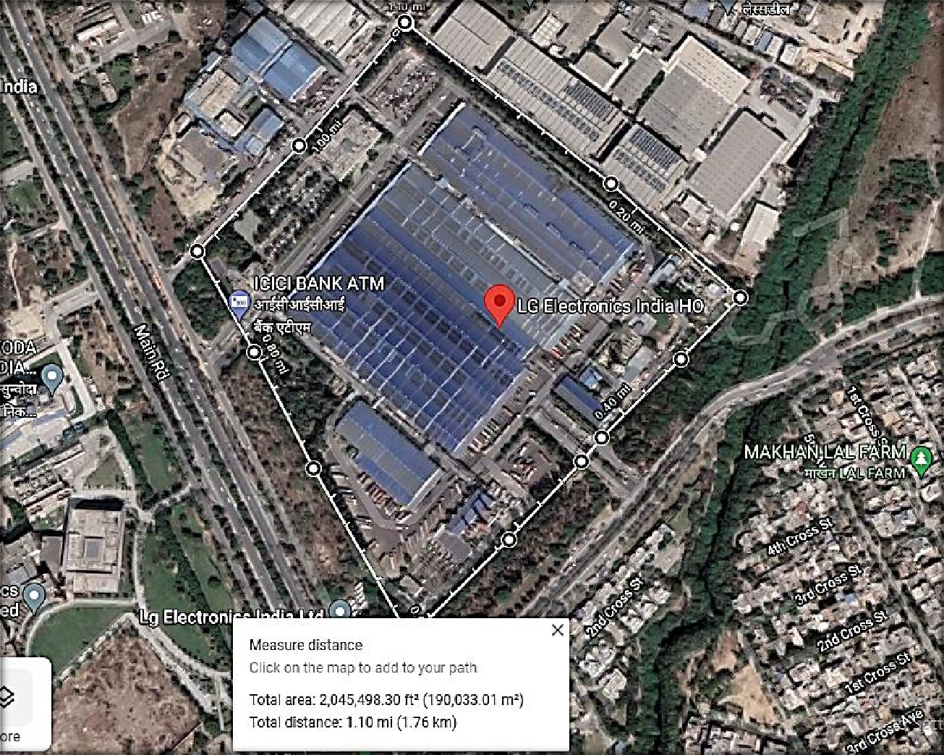

1. **BUILDING & CIVIL DETAILS:** Our team has got one detailed Investment file mentioning the line items of the expenditure incurred in various heads in different Plant sections. Most of the works contains different miscellaneous works. In this sheet company has broadly distributed the works under 4 major heads viz., Building Civil work, Building Utilities, Other Fixed Assets, Plant & Machinery.

LG Electronics India Private Limited has shown to have incurred an amount of Rs.61.89 crores (Building Civil Work = Rs.4.28 crores + Building Utilities = Rs.57.61 crores) as per Investment File sheet of LG. However, during detailed scrutiny of this sheet by our team, it was found that under “Building Utilities” head, company has taken several items which are not related to core Building & civil works such as Boiler for compressor, desktop, AC, blue tooth scanner, CCTVs, LED, LCDs, etc. Therefore, our team has shifted other items not related to core Building & civil works shown by LG in ‘Building Utilities” head amounting of Rs. 42.73 crores to Miscellaneous Fixed Assets by us.

As per information provided to us, major works carried out by LG under building & civil works pertains to construct & renovate the different Plant Buildings like new foundation in ETP & STP Plant, new extension work for Chiller plant (Building-W), some new extension work in powerhouse room in 2019 and other renovation and normal maintenance work like wear and tear and roof replacement work in all the structures in between the period 01.01.2015 to 31.12.2019. Majorly the money has been spent in expansion, extension & alteration of the existing building & structures.

LG has not engaged any single point EPC Contractors for the Civil & building related works. They have engaged local/ daily wage workers for this work.

The expenses incurred as shown by the company during the expansion, extension, alteration & internal changes for different lines are tabulated below:

**Table: 7**

|  |  |  |  |  |  |  |  |  |  |  |  |  |  |
| --- | --- | --- | --- | --- | --- | --- | --- | --- | --- | --- | --- | --- | --- |
| **CIVIL STRUCTURE** | | | | | | | | | | | | | |
| **S. No.** | **Plant Section** | **2015** | | **2016** | | **2017** | | **2018** | | **2019** | | **Total** | |
| **1** | Air-Conditioner | ₹ | - | ₹ | 3,21,623 | ₹ | - | ₹ | 70,67,128 | ₹ | 1,52,44,631 | ₹ | 2,26,33,381 |
| **2** | Common | ₹ | 1,03,81,923 | ₹ | 1,07,81,936 | ₹ | 77,85,732 | ₹ | 57,36,886 | ₹ | 1,15,99,124 | ₹ | 4,62,85,600 |
| **3** | Microwave Oven | ₹ | - | ₹ | - | ₹ | - | ₹ | - | ₹ | 69,74,179 | ₹ | 69,74,179 |
| **4** | Refrigerator | ₹ | 1,53,747 | ₹ | 3,77,924 | ₹ | 14,05,275 | ₹ | 1,41,74,098 | ₹ | 6,22,54,796 | ₹ | 7,83,65,840 |
| **5** | Refrigerator Compressor | ₹ | 17,00,758 | ₹ | - | ₹ | - | ₹ | - | ₹ | 63,10,484 | ₹ | 80,11,242 |
| **6** | Washing Machine | ₹ | 19,00,158 | ₹ | 77,58,514 | ₹ | 41,04,102 | ₹ | 1,16,61,239 | ₹ | 38,57,779 | ₹ | 2,92,81,793 |
| **Total** | | **₹ 1,41,36,586** | | **₹ 1,92,39,997** | | **₹ 1,32,95,108** | | **₹ 3,86,39,351** | | **₹ 10,62,40,992** | | **₹ 19,15,52,034** | |
| *Notes:* | | | | | | | | | | | | | |
| *1. Detailed break-up of Expenditure occurred by company on alteration in civil work for different production line.* | | | | | | | | | | | | | |
| *2. Only major Expenditure incurred are cross checked with the available FAR, Invoices & Bank Statements.* | | | | | | | | | | | | | |

Further bifurcation of the cost incurred based on the nature of the work done related to the building and civil works section wise, as per the details provided to us is shown below:



In the above table, “Other assets related to new civil works” includes Fire & electrical equipments, material loading & unloading utilities and other utilities. Also, the amount incurred (i.e., Rs. 6.67 Cr.) in “Civil work modifications” includes the roof work installations.

As per the discussion with PICUP, the modifications to the existing structures should not be included, since it is categorized under maintenance work and not new work. Therefore, after deducting the amount incurred for the modifications i.e., Rs.6.67 Cr., the final amount incurred related to the building and civil works for the expansion is **Rs.12.49 Cr.**

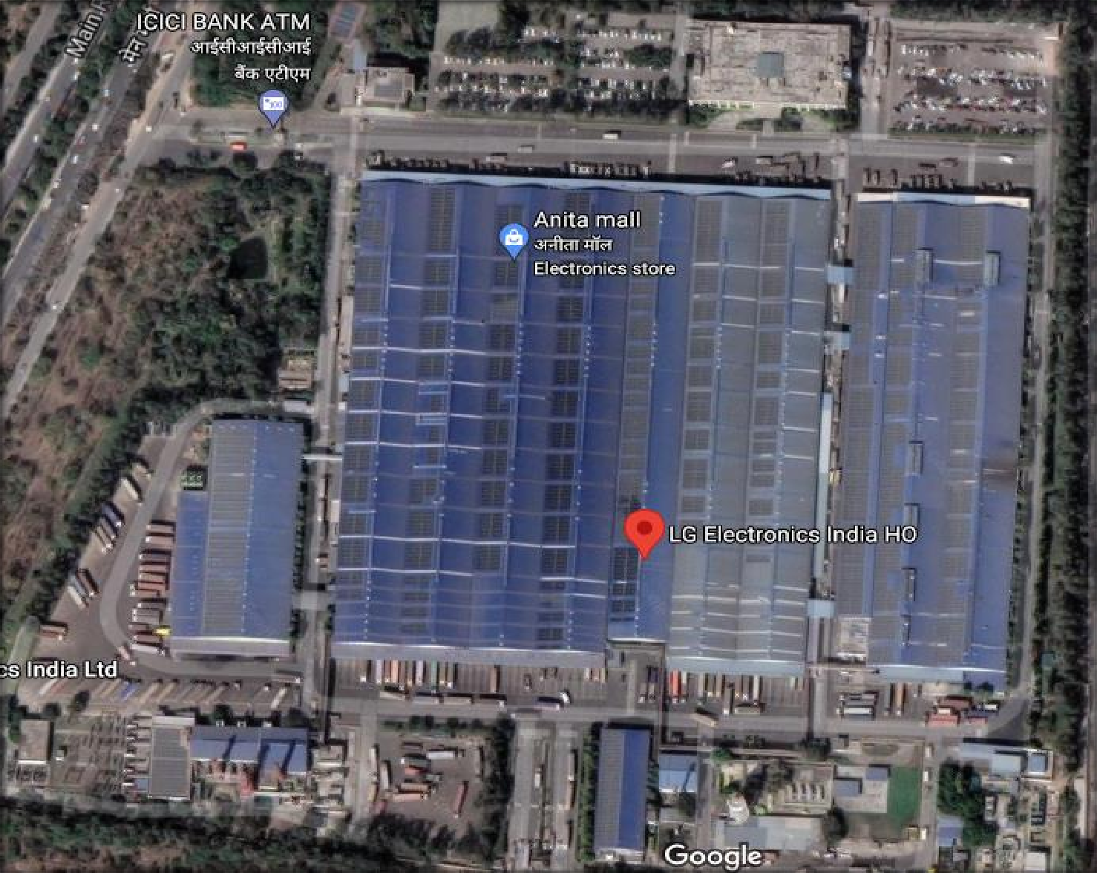

**2**

**1**

**3**

**11**

**4**

**5**

**6**

**7**

**8**

**9**

**10**

**Table: 8**

|  |  |  |  |
| --- | --- | --- | --- |
| **BUILDING DETAILS** | | | |
| **1.** | **Building-K (Admin Block)** | **7.** | **Power House (D.G. Room)** |
| **2.** | **Building-H (Medical Building)** | **8.** | **Boiler House** |
| **3** | **Building-A (Production Area)** | **9.** | **Fire Pump House** |
| **4.** | **Building-B (Production Area)** | **10.** | **STP & ETP** |
| **5.** | **Building-C (Production Area)** | **11.** | **Bulk Storage Area** |
| **6.** | **Building-W (Chiller Plant)** |  | |

1. **PLANT & MACHINERY DETAILS:** For Plant & Machinery company has done procurement from several different suppliers on its own without engaging one point contact for the same.

As per provided FAR (detailed Investment file) expenditure occurred in different heads of the Plant & Machinery is as follows:

**Table: 9**

|  |  |  |
| --- | --- | --- |
| **S.No** | **Type of Expenditure** | **Amount (in Cr.)** |
| **1.** | Expenditure incurred in Imported Plant & Machinery | **332.76** |
| **2.** | Expenditure in Indigenous Plant & Machinery | **87.73** |
| **3.** | Expenditure incurred in Imported Moulds Machinery | **70.68** |
| **4.** | Expenditure in Indigenous Moulds Machinery | **31.49** |
| **Total** | | **522.67** |

Plant & Machinery head is majorly categorized into Imported, Internal & Local. Imported machineries are those which are procured from outside the country, Internal are those items which are produced internally by LG and has been put to use for the Plant, Local includes those items which are procured within the country. This is further classified into moulds and non moulds. Therefore, list of moulds is also shown separately in the summary above.

* 1. **Expenditure incurred in Imported Plant & Machinery:** Main production lines of different sections of the plant has been imported from Japan, South Korea & Europe.

Total amount incurred in procuring & commissioning imported machinery with other common auxiliaries for the different sections of the Plant is **Rs.332.76 Cr.** break-up of the expenditure is given below:

**Table: 10**

|  |  |  |  |  |  |  |  |  |  |  |  |
| --- | --- | --- | --- | --- | --- | --- | --- | --- | --- | --- | --- |
| **IMPORTED PLANT & MACHINERY** | | | | | | | | | | | |
| **S.No** | **Plant Section** | **2015** | | **2016** | **2017** | **2018** | | **2019** | | **Total** | |
| **1** | Air-Conditioner | ₹ | 6,24,59,848 | ₹ 1,33,73,748 | ₹ 5,43,21,773 | ₹ | 4,79,51,730 | ₹ | 44,58,70,037 | **₹** | **62,39,77,137** |
| **2** | Common | ₹ | 15,80,135 | - | ₹ 5,80,46,102 | ₹ | 3,42,38,547 | ₹ | 83,91,430 | **₹** | **10,22,56,214** |
| **3** | Microwave Oven | ₹ | 23,20,38,792 | ₹ 35,06,453 | - | - | | ₹ | 54,96,964 | **₹** | **24,10,42,209** |
| **4** | Motor (Compressor) | - | | ₹ 2,65,49,740 | ₹ 20,44,51,598 | ₹ | 67,15,723 | ₹ | 51,89,285 | **₹** | **24,29,06,346** |
| **5** | Refrigerator | ₹ | 28,66,16,649 | ₹ 26,24,10,796 | ₹ 12,45,46,199 | ₹ | 9,38,42,850 | ₹ | 48,67,12,122 | **₹ 1,25,41,28,617** | |
| **6** | Refrigerator Compressor | ₹ | 3,64,30,673 | ₹ 34,93,62,664 | ₹ 5,28,77,046 | ₹ | 75,73,913 | ₹ | 9,47,97,204 | **₹** | **54,10,41,500** |
| **7** | Washing Machine | ₹ | 5,97,14,644 | ₹ 3,77,57,683 | ₹ 20,23,831 | ₹ | 2,36,38,678 | ₹ | 13,72,26,269 | **₹** | **26,03,61,104** |
| **8** | Water Purifier | ₹ | 3,04,25,379 | ₹ 26,33,502 | ₹ 95,19,146 | ₹ | 1,79,37,211 | ₹ | 14,16,050 | **₹** | **6,19,31,288** |
| **Total** | | **₹ 70,92,66,119** | | **₹ 69,55,94,585** | **₹ 50,57,85,695** | **₹ 23,18,98,652** | | **₹ 1,18,50,99,362** | | **₹ 3,32,76,44,414** | |
| *Notes:* | | | | | | | | | | | |
| *1. Detailed break-up of Expenditure of Imported Plant & Machinery is annexed with the report.* | | | | | | | | | | | |
| *2. Only major Expenditure incurred are cross checked with the available FAR, Invoices & Bank Statements.* | | | | | | | | | | | |

* 1. **Expenditure in Indigenous & In-house Produced Plant & Machinery:** In addition to the imported machinery, LG Electronics India Private Limited has incurred Rs.87.73 Cr. in procuring and commissioning Plant & Machinery from within the country for the different sections of the plant with other common auxiliaries. This includes both domestically procured machinery and in-house manufactured items put to use for Plant. In-house manufactured items only include some parts of refrigeration unit & a LCD TV.

**Table: 11**

|  |  |  |  |  |  |  |  |  |  |  |  |  |  |  |  |
| --- | --- | --- | --- | --- | --- | --- | --- | --- | --- | --- | --- | --- | --- | --- | --- |
| **INDIGENOUS PLANT & MACHINERY** | | | | | | | | | | | | | | | |
| **S.No** | **Plant Section** | **2015** | | **2016** | | **2017** | | **2018** | | **2019** | | **Internal**  **Purchase** | | **Total** | |
| **1** | Air-Conditioner | ₹ | 2,02,92,325 | ₹ | 80,50,458 | ₹ | 52,27,347 | ₹ | 1,41,50,828 | ₹ | 6,37,18,640 | - | | **₹ 11,14,39,598** | |
| **2** | Common | ₹ | 15,07,706 | ₹ | 63,10,610 | ₹ | 1,34,06,296 | ₹ | 96,16,835 | ₹ | 1,67,95,845 | - | | **₹** | **4,76,37,292** |
| **3** | Microwave Oven | ₹ | 3,41,13,125 | ₹ | 14,99,047 | ₹ | 8,71,050 | - | | ₹ | 82,44,131 | - | | **₹** | **4,47,27,353** |
| **4** | Motor (Compressor) | ₹ | 7,02,013 | ₹ | 3,23,08,477 | ₹ | 26,34,855 | ₹ | 6,48,421 | ₹ | 25,12,194 | - | | **₹** | **3,88,05,960** |
| **5** | Refrigerator | ₹ | 3,08,79,297 | ₹ | 2,43,88,853 | ₹ | 3,98,96,560 | ₹ | 4,88,52,547 | ₹ | 13,61,26,866 | ₹ | 5,741 | **₹ 28,01,49,864** | |
| **6** | Refrigerator Compressor | ₹ | 3,89,91,569 | ₹ | 5,40,20,757 | ₹ | 4,27,78,197 | ₹ | 2,40,04,315 | ₹ | 9,05,51,361 | ₹ 22,706 | | **₹ 25,03,68,906** | |
| **7** | Washing Machine | ₹ | 98,76,632 | ₹ | 1,34,88,583 | ₹ | 82,85,022 | ₹ | 1,44,56,894 | ₹ | 4,80,93,783 | - | | **₹** | **9,42,00,915** |
| **8** | Water Purifier | ₹ | 35,37,214 | ₹ | 2,83,285 | ₹ | 31,58,807 | ₹ | 21,36,935 | ₹ | 8,82,000 | - | | **₹** | **99,98,241** |
| **Total** | | **₹ 13,98,99,881** | | **₹ 14,03,50,070** | | **₹ 11,62,58,134** | | **₹ 11,38,66,776** | | **₹ 36,69,24,821** | | **₹ 28,447** | | **₹ 87,73,28,129** | |
| *Notes:* | | | | | | | | | | | | | | | |
| *1. Detailed break-up of Expenditure of Indigenous Plant & Machinery is annexed with the report.* | | | | | | | | | | | | | | | |
| *2. Only major Expenditure incurred are cross checked with the available FAR, Invoices & Bank Statements.* | | | | | | | | | | | | | | | |

* 1. **Expenditure incurred in Imported Moulds & Its Machinery:** LG Electronics India Private Limited invested an amount of Rs.70.68 Cr. in order to provide the Moulds Machinery for the different electronics items and with other common auxiliaries. Break-up of the expenditure is given below:

**Table: 12**

|  |  |  |  |  |  |  |  |  |  |  |  |  |
| --- | --- | --- | --- | --- | --- | --- | --- | --- | --- | --- | --- | --- |
| **IMPORTED MOULDS & ITS MACHINERY** | | | | | | | | | | | | |
| **S.No** | **Plant Section** | **2015** | | **2016** | | **2017** | **2018** | | **2019** | | **Total** | |
| **1** | Air-Conditioner | ₹ | 30,16,825 | - | | ₹ 6,00,45,508 | ₹ | 10,13,20,484 | ₹ | 6,70,63,321 | **₹ 23,14,46,139** | |
| **2** | Microwave Oven | ₹ | 37,68,597 | - | | - | - | | - | | **₹** | **37,68,597** |
| **3** | Refrigerator | ₹ | 7,37,49,995 | ₹ | 7,20,53,787 | - | ₹ | 32,13,173 | ₹ | 38,61,148 | **₹ 15,28,78,103** | |
| **4** | Refrigerator Compressor | - | | - | | - | - | | ₹ | 63,29,586 | **₹** | **63,29,586** |
| **5** | Washing Machine | ₹ | 9,69,85,980 | ₹ | 10,05,12,404 | ₹ 2,00,66,803 | ₹ | 1,15,96,764 | ₹ | 6,21,17,582 | **₹ 29,12,79,534** | |
| **6** | Water Purifier | - | | ₹ | 1,39,72,270 | ₹ 37,33,811 | - | | ₹ | 34,46,424 | **₹** | **2,11,52,505** |
| **Total** | | **₹ 17,75,21,397** | | **₹ 18,65,38,461** | | **₹ 8,38,46,122** | **₹ 11,61,30,421** | | **₹ 14,28,18,062** | | **₹ 70,68,54,464** | |
| *Notes:* | | | | | | | | | | | | |
| *1. Detailed break-up of Expenditure of Imported Moulds & its machinery is annexed with the report.* | | | | | | | | | | | | |
| *2. Only major Expenditure incurred are cross checked with the available FAR, Invoices & Bank Statements.* | | | | | | | | | | | | |

The company has purchased number of moulds for the manufacturing of different consumer goods items and some of these are used within the Plant premises and many are used, located & installed in the premised of Registered Vendors of LG. There are around 48 Registered Vendors of LG where such moulds are provided by LG who do contract manufacturing for LG. List of these 48 Registered Vendors along with the number of moulds lying at their site is attached in the annexure. These moulds include both imported as well as domestically manufactured moulds. For cross checking the moulds lying at Registered Vendors of LG outside the main LG Plant, our team has randomly visited around 15 vendor’s site for the physical verification of the moulds.

The moulds which were installed inside the plant are mainly used for the manufacturing of different products such as refrigerator, microwave oven.

The moulds which were installed at vendor location were being used for the manufacturing of various small parts (handle, LED lights, auxiliary plastic products for every product, switches, rotational knob etc.) for different products which were manufactured across all sections of the plant.

**3.1 Expenditure in Indigenous Moulds & Its Machinery:** In addition to the imported Moulds machinery LG Electronics India Private Limited has incurred Rs.31.49 Cr. in procuring and commissioning indigenous moulds with other common auxiliaries. Break-up of the expenditure is given below:

**Table: 13**

|  |  |  |  |  |  |  |  |  |  |
| --- | --- | --- | --- | --- | --- | --- | --- | --- | --- |
| **INDIGENOUS MOULDS & ITS MACHINERY** | | | | | | | | | |
| **S.No** | **Plant Section** | **2015** | **2016** | **2017** | **2018** | **2019** | | **Total** | |
| **1** | Air-Conditioner | ₹ 28,70,000 | ₹ 59,34,000 | - | ₹ 41,59,000 | ₹ | 34,63,000 | **₹** | **1,64,26,000** |
| **2** | Microwave Oven | ₹ 34,797 | - | - | - | ₹ | 1,02,25,000 | **₹** | **1,02,59,797** |
| **3** | Motor (Compressor) | - | ₹ 1,20,40,000 | - | - | - | | **₹** | **1,20,40,000** |
| **4** | Refrigerator | ₹ 1,28,38,000 | ₹ 86,03,704 | ₹ 1,00,16,000 | ₹ 1,43,39,000 | ₹ | 2,97,78,000 | **₹** | **7,55,74,704** |
| **5** | Refrigerator Compressor | ₹ 32,75,000 | ₹ 1,29,35,000 | - | ₹ 22,10,000 | ₹ | 1,13,45,000 | **₹** | **2,97,65,000** |
| **6** | Washing Machine | ₹ 1,50,31,000 | ₹ 2,58,48,500 | ₹ 1,01,25,600 | ₹ 5,04,06,000 | ₹ | 6,27,21,000 | **₹ 16,41,32,100** | |
| **7** | Water Purifier | - | - | ₹ 11,27,000 | ₹ 55,75,949 | - | | **₹** | **67,02,949** |
| **Total** | | **₹ 3,40,48,797** | **₹ 6,53,61,204** | **₹ 2,12,68,600** | **₹ 7,66,89,949** | **₹ 11,75,32,000** | | **₹ 31,49,00,550** | |
| *Notes:* | | | | | | | | | |
| *1. Detailed break-up of Expenditure of Indigenous Moulds & its machinery is annexed with the report.* | | | | | | | | | |
| *2. Only major Expenditure incurred are cross checked with the available FAR, Invoices & Bank Statements.* | | | | | | | | | |

1. **MISCELLANEOUS FIXED ASSET DETAILS:** Miscellaneous fixed assets items mainly include CCTV camera software, Linear Imager Bluetooth Scanner, Commercial LCD and LED, Plastic Dome Camera with PT, Desktop, Walkie Talkie Accessories, Chairs, Curing Jig, Mobile Phones, Wall Fans, Drill Machines, etc.

As per provided FAR (detailed Investment file) expenditure occurred in different heads of the miscellaneous fixed assets is as follows:

**Table: 14**

|  |  |  |
| --- | --- | --- |
| **S.No** | **Type of Expenditure** | **Amount (in Cr.)** |
| **1.** | Expenditure incurred in Imported Miscellaneous Fixed Assets | **4.64** |
| **2.** | Expenditure incurred in Indigenous Miscellaneous Fixed Assets | **48.89** |
| **3.** | Expenditure incurred in In-house Made Miscellaneous Fixed Assets | **1.65** |
| **Total** | | **55.18** |

* 1. **Expenditure incurred in Imported Miscellaneous Fixed Assets:** LG India has invested an amount of Rs.4.64 Cr. in order to provide the Miscellaneous Fixed Assets like Automated Guided Vehicle, trolley etc. Break-up of the expenditure is given below:

**Table: 15**

|  |  |  |  |  |  |  |  |  |  |  |  |  |  |
| --- | --- | --- | --- | --- | --- | --- | --- | --- | --- | --- | --- | --- | --- |
| **IMPORTED MIS. FIXED ASSETS** | | | | | | | | | | | | | |
| **S.No** | **Plant Section** | **2015** | | **2016** | | **2017** | | **2018** | | **2019** | | **Total** | |
| **1** | Air-Conditioner | ₹ | - | ₹ | - | ₹ | 57,09,192 | ₹ | 46,74,592 | ₹ | - | **₹ 1,03,83,784** | |
| **2** | Common | ₹ | 13,53,609 | ₹ | - | ₹ | - | ₹ | 27,35,506 | ₹ | 7,86,374 | **₹** | **48,75,490** |
| **3** | Refrigerator | ₹ | - | ₹ | 15,14,955 | ₹ | - | ₹ | - | ₹ | 1,79,78,228 | **₹ 1,94,93,183** | |
| **4** | Refrigerator Compressor | ₹ | - | ₹ | - | ₹ | - | ₹ | - | ₹ | 48,90,439 | **₹** | **48,90,439** |
| **5** | Washing Machine | ₹ | - | ₹ | - | ₹ | - | ₹ | 67,83,519 | ₹ | - | **₹** | **67,83,519** |
| **Total** | | **₹ 13,53,609** | | **₹ 15,14,955** | | **₹ 57,09,192** | | **₹ 1,41,93,618** | | **₹ 2,36,55,041** | | **₹ 4,64,26,414** | |
| *Notes:* | | | | | | | | | | | | | |
| *1. Detailed break-up of Expenditure of Assets which are imported is annexed with the report.* | | | | | | | | | | | | | |
| *2. Only major Expenditure incurred are cross checked with the available FAR, Invoices & Bank Statements.* | | | | | | | | | | | | | |

* 1. **Expenditure incurred in Indigenous Miscellaneous Fixed Assets:** LG India has invested an amount of Rs.48.90 Cr. in order to provide the Miscellaneous Fixed Assets like Computer, Software, Scanner, Furniture and other small items etc. Break-up of the expenditure is given below:

**Table: 16**

|  |  |  |  |  |  |  |  |  |  |  |  |  |  |
| --- | --- | --- | --- | --- | --- | --- | --- | --- | --- | --- | --- | --- | --- |
| **INDIGENOUS MIS. FIXED ASSETS** | | | | | | | | | | | | | |
| **S.No** | **Plant Section** | **2015** | | **2016** | | **2017** | | **2018** | | **2019** | | **Total** | |
| **1** | Air-Conditioner | ₹ | 41,22,621 | ₹ | 2,44,84,578 | ₹ | 42,43,645 | ₹ | 68,75,805 | ₹ | 2,12,28,961 | **₹** | **6,09,55,611** |
| **2** | Common | ₹ | 1,97,92,139 | ₹ | 71,11,532 | ₹ | 4,39,65,472 | ₹ | 1,87,62,247 | ₹ | 8,53,61,303 | **₹ 17,49,92,693** | |
| **3** | Microwave Oven | ₹ | 56,71,905 | ₹ | 3,34,301 | ₹ | 7,05,935 | ₹ | 74,675 | ₹ | 89,79,541 | **₹** | **1,57,66,357** |
| **4** | Motor (Compressor) | ₹ | 26,565 | ₹ | 16,87,979 | ₹ | - | ₹ | - | ₹ | - | **₹** | **17,14,544** |
| **5** | Refrigerator | ₹ | 74,90,644 | ₹ | 5,90,183 | ₹ | 43,32,941 | ₹ | 30,40,189 | ₹ | 11,91,04,075 | **₹ 13,45,58,033** | |
| **6** | Refrigerator Compressor | ₹ | 12,14,107 | ₹ | 13,54,793 | ₹ | 77,69,171 | ₹ | 3,90,050 | ₹ | 6,17,55,544 | **₹** | **7,24,83,665** |
| **7** | Washing Machine | ₹ | 45,93,460 | ₹ | 8,24,352 | ₹ | 33,90,628 | ₹ | 19,08,151 | ₹ | 1,52,85,008 | **₹** | **2,60,01,600** |
| **8** | Water Purifier | ₹ | 3,11,735 | ₹ | 21,81,055 | ₹ | 29,000 | ₹ | - | ₹ | - | **₹** | **25,21,790** |
| **Total** | | **₹ 4,32,23,175** | | **₹ 3,85,68,773** | | **₹ 6,44,36,793** | | **₹ 3,10,51,118** | | **₹ 31,17,14,432** | | **₹ 48,89,94,291** | |
| *Notes:* | | | | | | | | | | | | | |
| *1. Detailed break-up of Expenditure of Assets which are indigenous is annexed with the report.* | | | | | | | | | | | | | |
| *2. Only major Expenditure incurred are cross checked with the available FAR, Invoices & Bank Statements.* | | | | | | | | | | | | | |

* 1. **Expenditure incurred in In-house Made Miscellaneous Fixed Assets:** LG India has also installed some miscellaneous items/assets which are produced in-house. Their cost is calculated as cost incurred during the production process in specific product. So according to the FAR and related document provided, an amount of Rs.1.65 Cr is spent by the company for manufacturing of these assets which are being used in different section of the plant. The assets which are produced in this head are like ACs, LCD screen, Fans, Monitors, CCTV Cameras, Dome Camera, etc. Break-up of the expenditure is given below:

**Table: 17**

|  |  |  |  |  |  |  |  |  |  |  |  |  |  |
| --- | --- | --- | --- | --- | --- | --- | --- | --- | --- | --- | --- | --- | --- |
| **IN-HOUSE MANUFACTURED MIS. FIXED ASSETS** | | | | | | | | | | | | | |
| **S.No** | **Plant Section** | **2015** | | **2016** | | **2017** | | **2018** | | **2019** | | **Total** | |
| **1** | Air-Conditioner | ₹ | 5,84,248 | ₹ | 37,644 | ₹ | 90,998 | ₹ | 44,988 | ₹ | 1,94,464 | **₹** | **9,52,343** |
| **2** | Common | ₹ | 16,24,364 | ₹ | 9,26,134 | ₹ | 2,79,572 | ₹ | 13,61,380 | ₹ | 53,59,408 | **₹** | **95,50,857** |
| **3** | Microwave Oven | ₹ | 6,64,017 | ₹ | 5,828 | ₹ | 22,750 | ₹ | - | ₹ | - | **₹** | **6,92,594** |
| **4** | Motor (Compressor) | ₹ | 54,131 | ₹ | 11,47,142 | ₹ | 1,24,534 | ₹ | - | ₹ | - | **₹** | **13,25,806** |
| **5** | Refrigerator | ₹ | 12,93,640 | ₹ | 3,03,366 | ₹ | 22,750 | ₹ | 1,47,566 | ₹ | 3,02,857 | **₹** | **20,70,179** |
| **6** | Refrigerator Compressor | ₹ | 6,10,828 | ₹ | 1,81,560 | ₹ | 68,249 | ₹ | 1,36,113 | ₹ | 1,08,290 | **₹** | **11,05,040** |
| **7** | Washing Machine | ₹ | 5,51,568 | ₹ | 18,107 | ₹ | 65,622 | ₹ | 72,614 | ₹ | 83,955 | **₹** | **7,91,866** |
| **Total** | | **₹ 53,82,795** | | **₹ 26,19,780** | | **₹ 6,74,473** | | **₹ 17,62,662** | | **₹ 60,48,975** | | **₹ 1,64,88,686** | |
| *Notes:* | | | | | | | | | | | | | |
| *1. Detailed break-up of Expenditure of assets which are internally made by LG and put to use is annexed with the report.* | | | | | | | | | | | | | |
| *2. Only major Expenditure incurred are cross checked with the available FAR, Invoices & Bank Statements.* | | | | | | | | | | | | | |

|  |  |
| --- | --- |
| **PART D** | **PROPOSED INVESTMENT & EXPENDITURE INCURRED** |

1. **TOTAL PROPOSED INVESTMENT:** As per the Detailed Project Report, LG has proposed investment of Rs.674 Cr. as per below schedule:

# HIGH LEVEL YEAR WISE INVESTMENT SCHEDULE

|  |  |  |  |  |  |  |
| --- | --- | --- | --- | --- | --- | --- |
| **Investment** | **2015** | **2016** | **2017** | **2018** | **2019** | **TOTAL** |
| **Land** | - | - | - | - | - | **-** |
| **Building** | 3 | 5 | 1 | 3 | 13 | **25** |
| **Plant &**  **Machinery** | 104 | 108 | 108 | 161 | 159 | **640** |
| **Others Miscellaneous**  **Assets** | 4 | 1 | 1 | 1 | 2 | **9** |
| **TOTAL** | **111** | **114** | **110** | **165** | **174** | **674** |

***Source: DPR*** *All Figures in Cr.*

# PLANT SECTION WISE BREAK-UP

**Table: 19**

|  |  |  |  |  |  |  |
| --- | --- | --- | --- | --- | --- | --- |
| **Sections** | **2015** | **2016** | **2017** | **2018** | **2019** | **TOTAL** |
| **Refrigerator** | **43** | **37** | **28** | **55** | **48** | **211** |
| **Washing Machine** | **19** | **22** | **26** | **36** | **43** | **146** |
| **Compressor** | **7** | **40** | **15** | **46** | **28** | **136** |
| **Common Assets** | **13** | **4** | **7** | **11** | **18** | **53** |
| **Motor** | **0** | **5** | **30** | **1** | **15** | **51** |
| **Air Conditioner** | **9** | **3** | **3** | **9** | **11** | **35** |
| **Microwave** | **17** | **1** | **0** | **7** | **6** | **31** |
| **Water Purifier** | **3** | **2** | **1** | **0** | **5** | **11** |
| **Total** | **111** | **114** | **110** | **165** | **174** | **674** |

***Source: DPR*** *All Figures in Cr.*

**ITEM WISE BREAK-UP OF PLANNED INVESTMENT**

100%

90%

80%

70%

60%

50%

40%

30%

20%

10%

0%

Year 2015

Year 2016

Year 2017

Year 2018

Year 2019

Refrigerator

Washing Machine Compressor

Common Assets

Motor Air Conditioner Microwave Oven Water Purifier

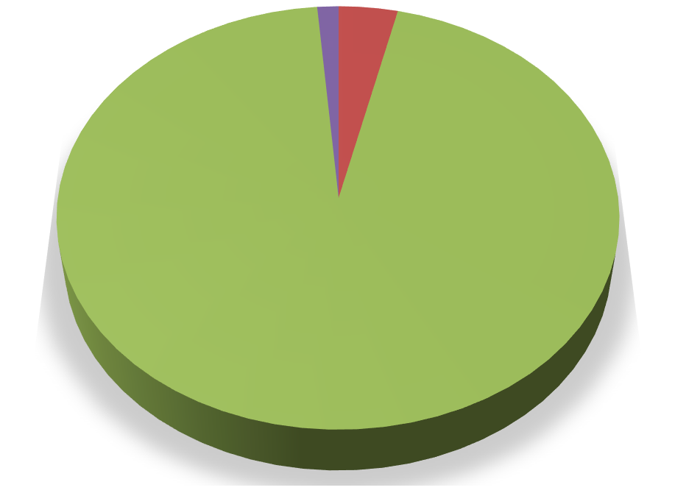

**TOTAL PLANNED INVESTMENT (in Cr.)**

**Other Mis. Assets,**

**9, 1%**

**Building, 25, 4%**

**Land, 0, 0%**

**Plant & Machinery,**

**640, 95%**

Land Building

Plant & Machinery

Other Mis. Assets

1. **CURRENT STATUS OF EXPENDITURE INCURRED FROM Jan 01, 2015 TO Dec 31, 2019:** The current expenditure incurred by LG Electronics India Private Limited for the different manufacturing sections of the Plant incurred between Jan 01, 2015 to Dec 31, 2019 is given below:

**Table: 20**

|  |  |  |  |  |  |  |
| --- | --- | --- | --- | --- | --- | --- |
| **S.**  **NO.** | **PARTICULARS** | **TOTAL ALLOCATED AMOUNT BY LG  (As per DPR)** | **TOTAL AMOUNT SHOWN BY LG** | **AMOUNT AS PER STATUTORY AUDITOR** | **TOTAL APPROVED AMOUNT BY IE** | **CURRENT STATUS OF WORK AND REMARKS** |
| (All figures in Cr.) | | | | | | | |
| **1** | **Building & Civil Works & Utilities (Under “Building” head as per DPR)** | **25** | **61.89** (Building Civil Work = Rs.4.28 Cr. + Building Utilities = Rs.57.61 Cr.) as per Investment File sheet of LG. | **61.89** (As per head Building & Civil Works) | **12.49** (We have considered only core Building & Civil works items in this head filtered from ‘Building Civil Work’ & ‘Building Utilities’ items shown by LG after deducting the cost incurred for maintenance work i.e., Rs.6.67 Cr. majorly for roof replacement work. Other items not related to core Building & civil works shown by LG in ‘Building Utilities” head amounting of Rs.42.73 Cr. have been shifted to Miscellaneous Fixed Assets by us. | **LG has shown Building & Civil Work = Rs.4.28 Cr. & Building Utilities = Rs.57.61 Cr.  Building Civil Work = Rs.4.28 Cr. complete amount has been taken by us in this head.  Under Building Utilities head = Rs.57.61 Cr., LG has also shown various items which are not related to core Building & Civil works such as Boiler for compressor, desktop, AC, blue tooth scanner, CCTVs, LED, LCDs, Water Purifier, Fans, Fire extinguishers, etc., which during our analysis we have shifted to Miscellaneous Fixed Assets head amounting of Rs.42.73 Cr. for clear allocation of the assets. Also, cost incurred for maintenance in Civil Works amounting of Rs.6.67 Cr. has been excluded while approving the cost.  As per IE review, Building & Civil works cost of Rs.12.49 Cr. approved by us has been majorly spent in expansion, extension, & alteration of the building & structures.  Major expenses on sample basis have been cross verified against the invoices, bank statements related to civil work.** *Please refer Annexures-A for detailed break-up of expenses incurred in Building & Civil work.* |
| **2** | **Plant & Machinery** | **640** | **522.67** | **522.67** | **522.67** | **Rs.522.67 Cr. has been incurred under this head in the period (Jan, 2015 – Dec, 2019).  Rs.403.44 Cr. – Imported Machinery Rs.119.22 Cr. – Domestic Machinery  During the site survey, 70% of the major machines & equipment were cross verified at site from the list of machines provided to us by our engineers who reported it to be installed & working.  Sample major invoices of amount above Rs.50 Lacs has been cross verified. Related parties’ bills have been scrutinized closely which appeared to be ok.** |
| **3** | **Miscellaneous Fixed Assets** | **9** (Under “Other Fixed Capital Assets” head as per DPR) | **12.45** (Under “Other Fixed Assets” head as per Investment File sheet of LG) | **12.45** (Under ‘Miscellaneous Fixed Assets’ head as per statutory auditor) | **55.19** (Complete Rs.12.45 Cr. has been approved by us + Rs.42.73Cr. shifted from Building Utilities head to this head by us for the non-core Building & Civil works items) | **Rs.55.19 Cr has been incurred under this head in the period (Jan, 2015 – Dec, 2019).  Complete Rs.12.45 Cr. been approved by us + Rs.42.73 Cr. shifted from Building Utilities head has also been taken to this head by us for the noncore Building & Civil works items.  This head mainly includes items such as Laptops, workstations, Air Conditioners, printers, scanners, cart trolley, CCTV cameras etc., installed by the company during the period (Jan, 2015 – Dec, 2019).** |
| **Total** | | **674** | **597.01** | **597.01** | **590.35** | **All the expenditure shown above is cross checked with the work done on site and from the respective Invoices / Bills / PO / Bank Statements. Only major amount has been cross checked from the Invoices / Bills/ PO due to voluminous paper of record. Industry benchmark & standards is applied only to Civil works cost for its verification. In case of Plant & Machinery no specific benchmark cost standard is available atleast for such kind of large manufacturing plant due to wide range of specifications & technology. Therefore, for Plant & Machinery cost verification individual invoices and bills are only relied upon.** |

**CONCLUSION:**

1. Out of the capital cost investment shown by the company i.e., Rs.597.01 Cr., IE has approved the amount of **Rs.590.35 Cr.** for thecost incurred in the new expansion work of Building & Civil works, Plant & machinery and in other miscellaneous assets.
2. For detailed break-up of the cost incurred in the above items, the IE can be contacted.

|  |  |
| --- | --- |
| **PART E** | **DISCLAIMER** |

1. No employee or member of R.K Associates has any direct/ indirect interest in the Project.
2. This report is prepared based on the copies of the documents/ information which interested organization or customer could provide to us out of the standard checklist of documents sought from them and further based on our assumptions and limiting conditions. All such information provided to us has been relied upon and we have assumed that it is true and correct. Verification or cross checking of the documents provided to us has not been done at our end from the originals. If at any time in future it’s found or came to our knowledge that misrepresentation of facts or incomplete or distorted information has been provided to us then this report shall automatically become null & void.
3. This report is a general analysis of the project and not an audit report. All the information gathered is based on the facts seen on the site during survey, verbal discussion & documentary evidence provided by the client and is believed that information given by the company is true best of their knowledge.
4. All observations mentioned in the report is only based on the visual observation and the documents/ data/ information provided by the client. No mechanical/ technical tests, measurements or any design review have been performed or carried out from our side during Project assessment.
5. Interested organization should ONLY take this report as an Advisory document from the Financial/ Chartered Engineering firm and it’s specifically advised to the stakeholder to cross verify the original documents for the facts mentioned in the report which can be availed directly from the subject company directly.
6. In case of any default in loans or the credit facility extended to the borrowing company, R.K Associates shall not be held responsible for whatsoever reason may be and any request for seeking any explanation from the employee/s of R.K Associates will not be entertained at any instance or situation.
7. This Report is prepared by our competent technical team which includes Engineers and financial experts & analysts.
8. This is just an opinion report and doesn’t hold any binding on anyone. It is requested from the concerned Financial Institution which is using this report for taking financial decision on the project that they should consider all the different associated relevant & related factors also before taking any business decision based on the content of this report.
9. All Pages of the report including annexures are signed and stamped from our office. In case any paper in the report is without stamp & signature then this should not be considered a valid paper issued from this office.
10. Defect Liability Period is **30 DAYS**. We request the concerned authorized reader of this report to check the contents, data and calculations in the report within this period and intimate us in writing if any corrections are required or in case of any other concern with the contents or opinion mentioned in the report. Corrections only related to typographical, calculation, spelling mistakes will be entertained within the defect liability period. No request for any illegitimate value revision, date change or any other facts & figures changes will be entertained other than the one mentioned above.
11. R.K Associates encourages its customers to give feedback or inform concerns over its services through proper channel at valuer[@rkassociates.org](mailto:ers@rkassociates.org) in writing within 30 days of report delivery. After this period no concern/ complaint/ proceedings in connection with the Valuation Services can be entertained due to possible change in situation and condition of the property.
12. Our Data retention policy is of **ONE YEAR**. After this period we remove all the concerned records related to the assignment from our repository. No clarification or query can be answered after this period due to unavailability of the data.
13. This Valuation report is governed by our (1) Internal Policies, Processes & Standard Operating Procedures, (2) R.K Associates Quality Policy, (3) Valuation & Survey Best Practices Guidelines formulated by management of R.K Associates, (4) Information input given to us by the customer and (4) Information/ Data/ Facts given to us by our field/ office technical team. Management of

R.K Associates never gives acceptance to any unethical or unprofessional practice which may affect fair, correct & impartial assessment and which is against any prevailing law. In case of any indication of any negligence, default, incorrect, misleading, misrepresentation or distortion of facts in the report then it is the responsibility of the user of this report to immediately or atleast within the defect liability period bring all such act into notice of R.K Associates management so that corrective measures can be taken instantly.

1. R.K Associates never releases any report doing alterations or modifications from pen. In case any information/ figure of this report is found altered with pen then this report will automatically become null & void.
2. If this report is prepared for the matter under litigation in any Indian court, no official or employee of R.K Associates will be under any obligation to give in person appearance in the court as a testimony. For any explanation or clarification, only written reply can be submitted on payment of charges by the plaintiff or respondent which will be 10% of the original fees charged where minimum charges will be Rs.15,000/-.

|  |  |  |
| --- | --- | --- |
| Place : | New Delhi | **FOR INTERNAL USE** |
| Date : | 23.07.2021 | ***SURVEYED BY: SE Inderjeet Rathee &***  ***Er. Nikhil Rajan*** |
| Note : | This report contains 32 pages | ***PREPARED BY: SE Inderjeet Rathee*** |
|  | (without Enclosure) | ***REVIEWED BY: HOD Engg.*** |

# For R.K Associates Valuers & Techno Engineering Consultants Pvt. Ltd.

**Project Engineering Team**

***R.K ASSOCIATES IMPORTANT NOTES:***

1. ***DEFECT LIABILITY PERIOD - In case of any query/ issue or escalation you may please contact Incident Manager by writing at*** [***le@rkassociates.org.***](mailto:le@rkassociates.org) ***We ensure 100% accuracy in the Calculations done, Rates adopted and various other data points & information mentioned in the report but still can’t rule out typing, human errors or any other mistakes. In case you find any mistake, variation, discrepancy or inaccuracy in any data point of the report, please help us by bringing all such points***

***into our notice in writing at*** [***le@rkassociates.org***](mailto:le@rkassociates.org) ***within 30 days of the report delivery, to get these rectified timely, failing which R.K Associates Valuers Techno Engineering Consultants (P) Ltd. won’t be held responsible for any inaccuracy in any manner. Also if we do not hear back anything from you within 30 days, we will assume that report is correct in all respect and no further claim of any sort will be entertained thereafter. We would welcome and appreciate your feedback & suggestions in order to improve our services.***

1. ***COPYRIGHT FORMAT - This report is prepared on the copyright format of R.K Associates Valuers Techno Engineering Consultants (P) Ltd. to serve our clients in the best possible way. Legally no one can copy or distribute this format without***

***prior approval from R.K Associates. It is meant only for the organization as mentioned on the cover page of this report. Distribution or use of this format other than R.K Associates will be seen as unlawful act and necessary legal action can be taken against the defaulter.***

|  |  |
| --- | --- |
| **PART F** | **PHOTOGRAPHS OF THE PLANT** |

|  |  |
| --- | --- |
|  |  |
|  |  |
|  |  |

|  |  |
| --- | --- |
|  |  |
|  |  |
|  |  |

|  |  |
| --- | --- |
|  |  |
|  |  |
|  |  |

|  |  |
| --- | --- |
|  |  |
|  |  |
|  |  |