**REPORT FORMAT:** V-L2 (L&B) & (P&M) | Version: 9.0\_2019

**FILE NO: VIS (2021-22)-PL-192-183-219 DATED:12/08/2021**

**VALUATION ASSESSMENT**

**OF**

**AMBA 44 MW WIND POWER PLANT**

**SITUATED AT**

**VILLAGE- BHAISADABAR, KHEDAVADA, PIPLODA, AMBA, KHOKHRA, BODINA, NANDLETA, HATNARA, GANESHGANJ, KAMALAKHEDA & BORKHEDA, DISTRICT-RATLAM, MADHYA PRADESH.**

**OWNER/S**

**M/S RENEW POWER PVT. LTD.**

**A/C: M/S RENEW POWER PVT. LTD.**

**REPORT PREPARED FOR**

**STATE BANK OF INDIA, OVERSEAS BRANCH, DELHI**

***\*\*Important - In case of any query/ issue/ concern or escalation you may please contact Incident Manager @ valuers@rkassociates.org. We will appreciate your feedback in order to improve our services.***

***Valuation TOR is available at*** [***www.rkassociates.org***](http://www.rkassociates.org) ***for reference.***

***NOTE: As per IBA Guidelines please provide your feedback on the report within 15 days of its submission after which report will be considered to be correct.***

|  |
| --- |
| **VALUATION ASSESSMENT AS PER SBI FORMAT** |

|  |  |
| --- | --- |
| Name & Address of Branch: | State Bank of India, Overseas Branch, Delhi |
| Name of Customer (s)/ Borrower Unit | M/s. Renew Power Private Limited |

|  |  |  |  |  |  |  |  |
| --- | --- | --- | --- | --- | --- | --- | --- |
| **I.** | **GENERAL** | | | | | | |
|  | Purpose for which the valuation is made | | | For Periodic Re-valuation of the mortgaged property | | | |
|  |  | Date of inspection | | 3 August 2021 & 4 August 2021 | | | |
|  | Date on which the valuation is made | | 12 August 2021 | | | |
|  | List of documents produced for perusal | | | **Documents Requested** | **Documents Provided** | | **Documents Reference No.** |
| Total **09** documents requested. | Total **08** documents provided. | | --- |
| Property Title document | Multiple Sale Deeds | | Multiple Deeds |
| Supply & Development Agreement | Supply & Development Agreement | | Dated: 19/10/2016 |
| Erection & Commissioning Agreement | Erection & Commissioning Agreement | | Dated:- 19/10/2016 |
| Opretion & Maintenance Contract | Opretion & Maintenance Contract | | Dated 08/12/2016 |
| Power Purchase Agreement | 2 Power Purchase Agreement | | Dated: 12/01/2017 & 08/03/2017 |
| Fixed Asset Register | Fixed Asset Register | | Dated 31/03/2021 |
|  | Name of the owner/s | | | M/s. Renew Power Private Limited | | | |
| Address and Phone no. of the owner/s | | | Registered Office: ReNew Power, Commercial Block-1, Zone 6, Golf Course Road, DLF City Phase-V, Gurugram-122009, Haryana | | | |
|  | **Brief Description of the Property**  This Valuation report is prepared for the 44 MW wind power plant situated at the aforesaid address belongs to M/s. Renew Power Pvt. Ltd.  **Introduction**  Detailed Fixed Asset Valuation of 44 MW Wind Power Plant set up by M/s. Renew Power Private Limited (RPPL) at Ratlam District of Madhya Pradesh.  **Change of Name**   |  |  |  |  | | --- | --- | --- | --- | | **S. No** | **Old Name** | **New Name** | **Dated** | | 1 | Original Incorporation | M/s. Renew wind Power Limited | Jan 19, 20011 | | 2 | M/s. Renew wind Power Limited | M/s. Renew Power Ventures Private Limited | June 14, 2012 | | 3 | M/s. Renew Power Ventures Private Limited | M/s. Renew Power Private Limited | April 6, 2018 |   **About the Project**  M/s. Renew Power Private Limited (CWEIPL) has set up a 44 MW Wind Power Plant at Ratlam district of Madhya Pradesh State in India.  The project company has signed agreements with M/s. Gamesa Renewable Pvt. Ltd. for the supply, development, erection, commissioning, operation & maintenance for 44 MW Wind Power Plant.  As per the verbal information provided by the company official the project has achieved its COD on March 31,2017.  As per the scope of work, this Valuation report is prepared for the subject Land & Building and plant & machinery located at the aforesaid address based on the copies of the documents and the information provided by the client which has been relied upon in good faith.  **Land Requirement**  For setup Windmill project of capacity 44 MW, the company had procured total of **82.84 Acres** of land by the virtue of several sale deeds from the M/s. Kshema Power & Infra Company Pvt. Ltd. The extent of area is adequate for current operations.    During the site survey we have observed that all the land parcels on which wind mills are situated is not demarcated and merged with other adjacent land parcels of farmers and can be approached through kuchcha roads only.  Most of the windmills has been set up in between agricultural land which are under the ownership of local farmers. So for making approach road, the company have bought land connecting windmills to the nearest road/ kuchcha road.  **Building and Civil Work**  As per the site survey and provided FAR company does not have any type of civil structure.  **Plant & Machinery Work**  As per the documents provided to us the company has signed agreements on October 19, 2016 with M/s. Gamesa Renewable Private Limited for the supply, development, erection, commissioning, operation & maintenance of the above said 44 MW Wind Power Plant.   |  |  |  | | --- | --- | --- | | **S. No.** | **PARTICULARS** | **DESCRIPTION** | | 1 | Turbine Type | Gamesa G114 | | 2 | Turbine Hub Height | 106 mtr. | | 3 | Turbine Rated Power | 2000 KW | | 4 | No. of Turbine | 22 |   **Project Location**  The project site is located at Ratlam District of Madhya Pradesh. The nearest railway station is Ratlam Railway Junction which is at a distance of 30 km from the Project site. The nearest airport is “Devi Ahilyabai Holkar International Airport, Indore which is about 166 km.  **Balance Of Plant (BOP)**  Setting up of Balance of Plant (BOP) along with its operation and maintenance is being carried by M/s. Gamesa Renewable Pvt. Ltd.  **Plant Capacity**  The total installed capacity of the plant is 44 MW and during our site survey is was operational at ~99% of its capacity.  Z:\In Progress Files\Zaid Ebne Mairaj\delhi\wind power\ratlam windmill survey pics\TimePhoto_20210804_100840.jpg  **Power Purchase Agreement (PPA)**   |  |  |  |  |  | | --- | --- | --- | --- | --- | | **S. No.** | **Purchaser Company** | **Dated** | **Capacity** | **Tariff** | | 1 | M/s. Madhya Pradesh Power Management Company Limited | 25 yrs. from COD | 10 MW | INR 4.78/KWh | | 2 | M/s. Madhya Pradesh Power Management Company Limited | 25 yrs. from COD | 40 MW | INR 4.78/KWh |   **Operation & Maintenance Of The Plant**  As per the copy of agreement/contract provided, the company has signed an agreement with M/s. Gamesa Renewable Pvt. Ltd. for Operation & Maintenance of the plant for the 25-years from date of COD.  **Observation made during the site survey:**  During the site visit, all the WTGs and their auxiliary machinery was in good condition and well maintained by the company. All the WTGs was in operation except for one wind mill (wind mill no. GAK-741).  **Type Of Report**  Detailed Fixed Asset Valuation of the Project.  **Scope Of The Report**  To assess and determine Fair Market Valuation of the Assets of 44 MW Wind Power Plant covering following points:   * Valuation of Land and building. * Valuation of the Plant & Machinery of the Unit * Valuation of other fixed assets of project   This report only contains general assessment & opinion on the Guideline Value and the indicative, estimated Market Value of the property found on as-is-where basis on site for which the Bank/ customer has shown & asked us to conduct the Valuation for which photographs is also attached with the report. No legal aspects in terms of ownership or any other legal aspect is taken into consideration. It doesn’t contain any due-diligence other than the valuation assessment of the property shown to us on site. Information/ data/ documents given to us by Bank/ client has been relied upon in good faith. This report doesn’t contain any other recommendations of any sort. | | | | | | |
|  | Location of property | | | Villages- Bhaisadabar, Khedavada, Piploda, Amba, Khokhra, Bodina, Nandleta, Hatnara, Ganeshganj, Kamalakheda & Borkheda, District- Ratlam, Madhya Pradesh. | | | |
|  | Plot No. / Survey No. | | | | | |
|  | Door No. | | NA | | | |
|  | T. S. No. / Village | | Bhaisadabar, Khedavada, Piploda, Khokhra, Bodina, Nandleta, Hatnara, & Borkheda | | | |
|  | Ward / Taluka | | Ratlam & Piploda | | | |
|  | Mandal / District | | Ratlam | | | |
|  | Date of issue and validity of layout of approved map / plan | | Not Applicable | | | |
|  | Approved map / plan issuing authority | | Not Applicable | | | |
|  | Whether genuineness or authenticity of approved map / plan is verified | | Not Applicable since approved Map not provided to us | | | |
|  | Any other comments by our empanelled Valuers on authenticity of approved plan | | No | | | |
|  | Postal address of the property | | | Villages- Bhaisadabar, Khedavada, Piploda, Khokhra, Bodina, Nandleta, Hatnara, & Borkheda District- Ratlam, Madhya Pradesh. | | | |
|  |  | City / Town | | Villages- Bhaisadabar, Khedavada, Piploda, Khokhra, Bodina, Nandleta, Hatnara, & Borkheda | | | |
|  | Residential Area | | No ( Agricultural) | | | |
|  | Commercial Area | | No | | | |
|  | Industrial Area | | No | | | |
|  | Classification of the area | | | | | | |
|  | High / Middle / Poor | | Poor | | | |
|  | Urban / Semi Urban / Rural | | Rural | | | |
|  | Coming under Corporation limit/ Village Panchayat / Municipality | | | Gram Panchayats | | | |
|  | Whether covered under any State / Central Govt. enactments (e.g. Urban and Ceiling Act) or notified under agency area / scheduled area / cantonment area | | | No | | | |
|  | In case it is an agricultural land, any conversion to house site plots is contemplated | | | As per the sale deeds provided by the company the nature of land is Non-Agriculture. | | | |
|  | **Boundaries of the property** | | | | | | |
| Are Boundaries matched | | | Different boundaries for different plots. | | | |
| **Directions** | | **As per Title Deed** | | | **Actual found at Site** | |
| North | | Different boundaries for different plots. | | | Vacant Agricultural land | |
| South | | Different boundaries for different plots. | | | Vacant Agricultural land | |
| East | | Different boundaries for different plots. | | | Vacant Agricultural land | |
| West | | Different boundaries for different plots. | | | Vacant Agricultural land | |
| 14.1 | **Dimensions of the site** | | **A** | | | **B** | |
| **As per the Deed** | | | **Actuals** | |
| North | | --- | | | --- | |
| South | | --- | | | --- | |
| East | | --- | | | --- | |
| West | | --- | | | --- | |
| 14.2 | Latitude, Longitude & Co-ordinates of Industrial Property | | | Refer to the excel sheet attached below in this report. | | | |
| 15. | Extent of the site | | | Land Area – 82.84 acres/ 33.54 Hectares | | | |
| 16. | Extent of the site considered for valuation (least of 14 A & 14 B) | | | Land Area – 82.84 acres/ 33.54 Hectares | | | |
| 17. | Whether occupied by the owner / tenant? | | | Owner | | | |
| If occupied by tenant, since how long? | | | NA | | | |
| Rent received per month. | | | NA | | | |

|  |  |  |
| --- | --- | --- |
| **II.** | **CHARACTERISTICS OF THE SITE** | |
|  | Classification of locality | Rural Area |
|  | Development of surrounding areas | Nearby properties are being used as agricultural land. |
|  | Possibility of frequent flooding / sub-merging | No |
|  | Feasibility to the Civic amenities like school, hospital, bus stop, market etc. | This is a rural remote area. No recreational facility is available nearby. |
|  | Number of Floors | Not Applicable |
|  | Type of Structure | Not Applicable |
|  | Type of use to which it can be put | Industrial purpose |
|  | Any usage restriction | NA |
|  | Is plot in town planning approved layout? | Still within the limits of Gram Panchayat |
|  | Corner plot or intermittent plot? | NA |
|  | Road facilities | Proper road facilities are not available and in order to reach windmills we have to go through kuchcha roads. |
|  | Type of road available at present | Kuchcha Road |
|  | Width of road – is it below 20 ft. or more than 20 ft. | Less than 20 ft. |
|  | Is it a land – locked land? | No |
|  | Water potentiality | Yes |
|  | Underground sewerage system | No |
|  | Is power supply available at the site? | Yes |
|  | Advantage of the site | Wind Speed is good in the subject area for around 3-4 months every year starting from may. |
|  | Special remarks, if any, like threat of acquisition of land for public service purposes, road widening or applicability of CRZ provisions etc. (Distance from sea-coast / tidal level must be incorporated) | None, in our view |



|  |  |
| --- | --- |
| **PART A** | **VALUATION OF LAND** |

|  |  |  |
| --- | --- | --- |
|  | Size of Plot | Land Area – 82.84 acres/ 33.54 Hectares |
| North & South | NA |
| East & West | NA |
|  | Total extent of the plot | Land Area – 82.84 acres/ 33.54 Hectares |
| Area adopted on the basis of | As per the copy of land summary provided to us by the company. |
| Remarks & observations, if any | None |
|  | Prevailing market rate (Along with details /reference of at least two latest deals/transactions with respect to adjacent properties in the areas) | **References on prevailing market Rate/ Price trend of the property and Details of the sources from where the information is gathered (from property search sites & local information)**   1. **Name**: Mr. Kalru (Habitant of subject location)   **Contact No.**: ----  **Size of the Property**: Approx 5 Acres/12.5 Bigha  **Rates/ Price informed**: For Agricultural land in village Hatnara - Rs.4 Lakh to Rs.5 Lakh per Bigha.  **Comment**: As per the discussion held with the above mentioned habitant of subject locality we came to know that prevailing rate range for Agricultural land is around Rs.4 lakh to Rs.5 Lakh per Bigha for agriculture land.   1. **Name**: Mr. Ram Anand (Habitant of subject location)   **Contact No.**: ---  **Size of the Property**: Approx 7 Acres/17.5 Bigha  **Rates/ Price informed**: For Agricultural land in Village Bhaisadabr- Rs.6,00,000/- to Rs.7,00,000/- per Bigha  **Comment**: As per the discussion held with the above mentioned habitant of subject locality we came to know that prevailing rate range for Agricultural land is around Rs.6,00,000/- to Rs.7,00,000/- per Bigha for agriculture land.   1. **Name**: Mr. Pawan (Habitant of subject location)   **Contact No.**: ---  **Size of the Property**: Approx 3 Acres/7.5 Bigha  **Rates/ Price informed**: For Agricultural land in Village Bodina- Rs.5,00,000/- to Rs.6,00,000/- per Bigha  **Comment**: As per the discussion held with the above mentioned habitant of subject locality we came to know that prevailing rate range for Agricultural land is around Rs.5,00,000/- to Rs.6,00,000/- per Bigha for irrigated land.  *As per our discussion with habitant of the subject locality we came to know that we came to know that the prevailing land rates for agricultural lands in the subject locality depends on the cultivation and irrigation of the land. The prevailing market rates for Agricultural land in the villages in which windmills are situated ranges from Rs.4,00,000/- to Rs.5,00,000/- per bigha in village- Hatnara and Rs.6,00,000/- to Rs.7,00,000/- per bigha in village- Piploda.*  *Therefore, considering all the above mentioned facts different rates have been adopted for land available in different villages which are mentioned in the excel sheet attached below.*  *No authentic last two transactions details could be known. However prospective transaction details as per information available on public domain and gathered during site survey is mentioned above. Valuation Assessment Factors of the report and the screenshots of the references are annexed in the report for reference.* |
|  | Guideline rate obtained from the official website | **Land Value = Rs.2,95,60,583/-**  **(Refer to excel sheet attached below)** |
|  | Assessed / adopted rate of valuation | **(Refer to excel sheet attached below)** |
|  | Estimated value of land **(A)** | **Land Value = RS.12,34,25,000/-** |



|  |  |
| --- | --- |
| **PART B** | **VALUATION OF BUILDING** |

|  |  |  |  |
| --- | --- | --- | --- |
|  | Technical details of the building | | Not Applicable. |
|  | Type of Building (Residential / Commercial/ Industrial) | Not Applicable |
|  | Type of construction (Load bearing / RCC/ Steel Framed) | Not Applicable |
|  | Year of construction | Not Applicable |
|  | Number of floors and height of each floor including basement, if any | Not Applicable |
|  | Plinth area floor-wise | Not Applicable |
|  | Condition of the building | Not Applicable |
|  | Interior Finishing | Not Applicable |
|  | Exterior Finishing | Not Applicable |
|  | Status of Building Plans/ Maps | | Not Applicable |
|  |  | Date of issue and validity of layout of approved map / plan | Not Applicable |
|  | Is Building as per approved Map | Not Applicable |
|  | Whether genuineness or authenticity of approved map / plan is verified | Not Applicable |
|  | Any other comments by our empaneled valuers on authentic of approved plan | Not Applicable |
|  | Details of alterations/ deviations/ illegal construction/ encroachment noticed in the structure from the original approved plan | Not Applicable |

|  |  |  |  |
| --- | --- | --- | --- |
|  | **SPECIFICATIONS OF CONSTRUCTION (FLOOR-WISE) IN RESPECT OF** | | |
| **S.No.** | **Description** | **Ground floor** | **Other floors** |
|  | Foundation | Not Applicable | Not Applicable |
|  | Ground Floor | Not Applicable. | Not Applicable. |
|  | Superstructure | Not Applicable | Not Applicable |
|  | Joinery / Doors & Windows (please furnish details about size of frames, shutters, glazing, fitting etc. and specify the species of timber) | Not Applicable | Not Applicable |
|  | RCC works | Not Applicable | Not Applicable |
|  | Plastering | Not Applicable | Not Applicable |
|  | Flooring, Skirting, dadoing | Not Applicable | Not Applicable |
|  | Special finish as marble, granite, wooden paneling, grills, etc. | Not Applicable | Not Applicable |
|  | Roofing including weather proof course | Not Applicable | Not Applicable |
|  | Drainage | Not Applicable | Not Applicable |

|  |  |  |  |  |
| --- | --- | --- | --- | --- |
| **S.No.** | **Description** | | **Ground floor** | **Other floors** |
|  | Compound wall | | NA | NA |
| Height | | NA | NA |
| Length | | NA | NA |
| Type of construction | | NA | NA |
|  | Electrical installation | | | |
| Type of wiring | | NA | NA |
| Class of fittings (superior / ordinary / poor) | | NA | NA |
| Number of light points | | NA | NA |
| Fan points | | NA | NA |
| Spare plug points | | NA | NA |
| Any other item | | NA | NA |
|  | Plumbing installation | | | |
|  | No. of water closets and their type | NA | NA |
|  | No. of wash basins | NA | NA |
|  | No. of urinals | NA | NA |
|  | No. of bath tubs | NA | NA |
|  | Water meter, taps, etc. | NA | NA |
|  | Any other fixtures | NA | NA |

|  |  |
| --- | --- |
| **PART C** | **EXTRA ITEMS** |

|  |  |  |
| --- | --- | --- |
|  | Portico | NA |
|  | Ornamental front door | NA |
|  | Sit out/ Verandah with steel grills | NA |
|  | Overhead water tank | NA |
|  | Extra steel/ collapsible gates | NA |
|  | **Total (C)** | **NA** |

|  |  |
| --- | --- |
| **PART D** | **AMENITIES** |

|  |  |  |
| --- | --- | --- |
|  | Wardrobes | NA |
|  | Glazed tiles | NA |
|  | Extra sinks and bath tub | NA |
|  | Marble / Ceramic tiles flooring | NA |
|  | Interior decorations | NA |
|  | Architectural elevation works | NA |
|  | Paneling works | NA |
|  | Aluminum works | NA |
|  | Aluminum hand rails | NA |
|  | False ceiling | NA |
|  | **Total (D)** | **NA** |

|  |  |
| --- | --- |
| **PART E** | **MISCELLANEOUS** |

|  |  |  |
| --- | --- | --- |
|  | Separate toilet room | NA |
|  | Separate lumber room | NA |
|  | Separate water tank/ sump | NA |
|  | Trees, gardening | NA |
|  | **Total (E)** | **NA** |

|  |  |
| --- | --- |
| **PART F** | **SERVICES** |

|  |  |  |
| --- | --- | --- |
|  | Water supply arrangements | NA |
|  | Drainage arrangements | NA |
|  | Compound wall | NA |
|  | C. B. deposits, fittings etc. | NA |
|  | Pavement | NA |
|  | **Total (F)** | NA |

|  |  |
| --- | --- |
| **PART C** | **VALUATION OF PLANT AND MACHINERY** |

|  |  |  |  |  |  |  |  |
| --- | --- | --- | --- | --- | --- | --- | --- |
|  | **PLANT & MACHINERY VALUATION PROCEDURE** | | | | | | |
|  | | | | | | | |
| **a.** | **GENERAL DETAILS** | | | | | | |
|  | Scope of the Assessment | | Non Binding Opinion on General Prospective Valuation Assessment of the Plant & Machineries as found on site on as-is-where basis. | | | | |
|  | Out-of-Scope of the Assessment | | 1. Verification of authenticity of documents from originals or cross checking from any Govt. deptt. is not done at our end. 2. Legal aspects & rights of the Plant & Machinery are out-of-scope of this report. 3. Inventorization of P&M is out of scope of work. 4. Componentization of Plant & Machinery is out of scope of this report. 5. Identification of the P&M is only limited to cross verification of major machines & production lines. 6. Technical/ mechanical/ operational testing of the machines is out-of-scope of the report. 7. Comment/ determination on technological aspect is out of scope of this report. 8. Any kind of machine/ process design is out of scope of the report. | | | | |
|  | Information provided/ available for assessment | | **Documents Requested** | | | **Documents Provided** | |
| Total **04** documents requested. | | | Total **01** documents provided. | |
| Detailed Fixed Asset Register/ Inventory Sheet | | | Detailed Fixed Asset Register | |
| Invoices/ Bills | | | None | |
| Purchase Orders | | | None | |
| EPC contract agreements | | | None | |
|  | Identification of the assets | |  | Cross checked from the name of the machines mentioned in the FAR/ Inventory list UIN displayed on the machine | | | |
|  | Identified by the company's representative | | | |
|  | Identified from the available Invoices | | | |
|  | Identification of the machines could not be done properly | | | |
|  | Due to large number of machines/ inventory, only major production lines & machines have been checked | | | |
|  | Physical inspection of the machines could not be done | | |  |
|  | Plant Technical person name, contact number & designation assisted for Survey | | Mr. Anil Namdeo Patil (🕿-+91- 8696484323) | | | | |
|  | Date of Survey | | 3 August 2021 & 4 August 2021 | | | | |
| **b.** | **BRIEF DESCRIPTION OF THE PLANT/ MACHINERY** | | | | | | |
|  | Nature of Plant & Machinery | | Wind Power Plant | | | | |
|  | Size of the Plant | | * Large scale Plant | | | | |
|  | Type of the Plant | | * Fully Automatic | | | | |
|  | Year of Installation/ Commissioning/ COD *(Commercial Operation Date)* | | * 2017 as per the information provided on site | | | | |
|  | Production Capacity | | Approx. 44 MW | | | | |
|  | Capacity at which Plant was running at the time of Survey | | 99% of full capacity | | | | |
|  | Number of Production Lines | | * 22 Wind Mills | | | | |
|  | Condition of Machines | | Good. | | | | |
|  | Status of the Plant | | Partially operational during site survey as 21 out of 22 windmills were working properly while windmill GAK-741 was stopped for minor system fault which can be resolved easily as per information provided. | | | | |
|  | Products Manufactured in this Plant | | Electricity | | | | |
|  | Recent maintenance carried out on | | Only minor regular maintenance | | | | |
|  | Recent upgradation, improvements if done any | | None | | | | |
|  | Total Gross Block & Net Block of Assets | | **Gross Block** | | **Net Block** | | |
| *As on 31/03/2020* | | | | |
| Rs.377,79,82,204/- | | Rs.320,22,09,481/- | | |
|  | Any other Details if any | | NA | | | | |
| **c.** | **LOCATION/ ADDRESS WHERE PLANT/ MACHINES ARE FOUND TO BE INSTALLED** | | | | | | |
|  | All the plant and machinery as per the FAR provided to us was considered to be installed within Villages- Bhaisadabar, Khedavada, Piploda, Khokhra, Bodina, Nandleta, Hatnara, & Borkheda District- Ratlam, Madhya Pradesh.    The subject plant is used for production of electricity. As observed during our site survey the machines were in good condition and out of total 22 WTGs, 21 windmills were operational while windmill no. GA-741 was not in operation due to some minor fault. | | | | | | |
| **d.** | **SURVEY DETAILS** | | | | | | |
|  | Plant has been surveyed by our Engineering Team on 03/08/2021 & 04/08/2021. | | | | | | |
|  | Site inspection was done in the presence of Company’s representative Mr. Anil Namdeo Patil who was available from the company to furnish any specific detail about the Plant & Machinery. | | | | | | |
|  | Our team examined & verified the machines and utilities from the FAR provided by the Company. All the WTGs were verified and found in operational condition. | | | | | | |
|  | At the time of survey the plant was in operational condition at 99% capacity as 1 wind mill was not working. | | | | | | |
|  | Most the details have been cross checked as per the documents provided to us by the company and what was observed at the site. | | | | | | |
|  | Condition of the machines is checked through visual observation only. No technical/ mechanical/ operational testing has been carried out to ascertain the condition and efficiency of machines. | | | | | | |
|  | Site Survey has been carried out on the basis of the physical existence of the assets rather than their technical expediency. | | | | | | |
|  | As per the overall site visit summary, Plant appeared to be in average condition. | | | | | | |
|  | **MANUFACTURING PROCESS** | | | | | | |
|  |  | | | | | | |
|  | **TECHNOLOGY TYPE/ GENERATION USED AND TECHNOLOGICAL COLLABORATIONS IF ANY** | | | | | | |
|  | 1. G114 Model- M/s. Gamesa Renewable Pvt. Ltd. | | | | | | |
|  | **RAW MATERIALS REQUIRED & AVAILABILITY** | | | | | | |
|  | **Type of Raw Material:** | Natural :- Wind | | | | | |
| **Availability:** | Depends upon the weather condition. | | | | | |
|  | **AVAILABILITY & STATUS OF UTILITIES** | | | | | | |
|  | Power/ Electricity | Property itself is a wind power plant. | | | | | |
| Water | NA | | | | | |
| Road/ Transport | Only Kuchcha Roads are available to approach windmills. | | | | | |
|  | **COMMENT ON AVAILABILITY OF LABOUR** | | | | | | |
|  | Not much labours are required. And company have given Operation & Maintenance contract to a third party company. | | | | | | |
|  | **SALES TRANSACTIONAL PROSPECTS OF SUCH PLANTS/ MACHINERY** | | | | | | |
|  | Strategic Sale as part of the complete Project. | | | | | | |
| **Reason:** This is a Large Scale manufacturing plant & can only be sold as an Integrated Industry to preserve its value since complete process line & machines are special purpose machines & can’t be used in any other industry. Demand of used machinery in this kind of Industry of such a scale is high. And sale can be done through strategic sale to the players who are already into same or similar Industry who have plans for expansion or any large conglomefrate who plans to enter into this new Industry | | | | | | |
|  | **DEMAND OF SUCH PLANT & MACHINERY IN THE MARKET** | | | | | | |
|  | Appears to be good as per general information available in public domain. | | | | | | |
|  | **VALUATION PROEDURE** | | | | | | |
|  | **Basic Methodology:** For arriving at fair market value of P&M & other fixed assets our engineering team has rationally applied the mixture of ***‘sales comparison approach (market approach)’ and the ‘cost approach (depreciated replacement cost)’****.* The fair market value of Plant & Machinery on the date of valuation is its cost of reproduction & commissioning on that date less the depreciation & other deterioration deductions (Technological, Economic, Functional obsolescence) or additions for good maintenance from the date of commissioning of the machinery to the date of its valuation. | | | | | | |
|  | Core P&M Asset Valuation is done keeping in mind various factors like technology used, machines availability, its condition, average age, maintenance & service and parts replacement availability of the machines and more importantly demand in the market. | | | | | | |
|  | Main Machinery of this Plant are specific purpose machines used for the Power generation with auxiliary equipment’s such as Transformers, feeders, Grid Lines etc. | | | | | | |
|  | The main data point for the Valuation of Plant & Machinery is the Fixed Asset Register maintained by the company. Plant & Machinery FAR has been provided by the company which has been relied upon in good faith. Provided FAR included assets in different heads like Land, Plant & Machinery, & other assets. Assets under different heads are segregated and are evaluated separately. From the Fixed Asset Register List two key inputs, Date of Capitalization and Cost of capitalization are taken which play vital role in evaluating used Plant & Machinery valuation. | | | | | | |
|  | Provided Capitalization cost include soft cost incurred during the Project establishment like Pre-operative, IDC & Finance cost expenses also. And FAR has breakup of all these cost. So in calculating the Fair market value we have included all these costs. | | | | | | |
|  | For evaluating depreciation, Central Electricity Commission Guidelines & Chart of Companies Act-2013 for ascertaining useful life of different types of machines are followed. Useful life of PV Modules has been taken as 25 years | | | | | | |
|  | On the Depreciated Replacement Cost (DRC) deduction for obsolescence/ deterioration or addition for good maintenance has been taken to arrive at the estimated Prospective Fair Market Value of the machines. | | | | | | |
|  | **Underline assumption** for the evaluation of this Plant & Machinery is that it will be sold as an Integrated Plant and not as discrete/ piecemeal machinery basis. | | | | | | |
|  | **CONSOLIDATED PLANT & MACHINERY VALUATION** | | | | | | |
|  | Consolidated valuation sheet of Plant & Machinery and other asset items are mentioned below with depreciated current market value as per different category of the machines/assets cumulated together. Our engineering team has separated the Cost of Equipment’s in the different sections of the plant. The cost of equipment considered from P&M List includes Pre-operative, Finance, and IDC Charges etc. The capitalized/ purchase cost of machinery considered from P&M List consists of final commissioning of machines which includes freight, taxes, insurance, etc. | | | | | | |



|  |  |
| --- | --- |
| **PART** | **CONSOLIDATED VALUATION ASSESSMENT OF ASSETS** |

|  |  |  |  |  |  |  |  |
| --- | --- | --- | --- | --- | --- | --- | --- |
|  | | **Description** | | **Value by adopting** | | | |
|  | **Valuation of the Property** | | **Cost of Capitalization (Rs.)** | | | **Depreciated Replacement Market Value (Rs.)** |
|  | **Land (A)** | | **Rs.5,37,35,820/-** | | | **Rs.12,34,25,000/-** |
|  | **Buildings & Civil Works (B)** | | **No Civil Structure is Capatalised in Wind Plant** | | | **No Civil Structure is Capatalised in Wind Plant** |
|  | **Plant & Machinery, Other Fixed Assets & Spares (C)** | | **Rs.377,79,82,204/-** | | | **Rs.256,64,10,023/-** |
|  | **Depreciated Asset Replacement Value Total {D= Add (A+B+C)}** | | **Rs.383,17,18,024/-** | | | **Rs.268,98,35,023/-** |
|  | | | | | | |
|  | **Consolidated Fixed Asset Valuation (E)** | | | | **Rs.268,98,35,023/-** | |
|  | **Rounded Off**  *(Depreciated Replacement Market Value)* | | | | **Rs.269,00,00,000/-** | |
|  | **Total Realizable/ Fetch Value of the Plant**  *(Minimum Depreciated Replacement Market Value)* | | | | **Rs.228,65,00,000/-** | |
|  | **Forced/ Distress Sale Value**  *(Orderly Liquidation Value of the assets on On-going Basis)* | | | | **Rs.201,75,00,000/-** | |

**(RUPEES TWO HUNDRED AND SIXTY NINE CRORE ONLY)**

|  |  |  |
| --- | --- | --- |
|  | **Justification for more than 20% difference in Market & Circle Rate** | Circle rates are determined by the District administration as per their own theoretical internal policy and Market rates are adopted based on current practical market dynamics which is explained clearly in Valuation Assessment Factors |

* + - 1. ***REMARKS***
* *Consolidated Fair Market Fixed Asset Valuation of M/s. Renew Power Pvt. Ltd. Amba Plant, Villages- Bhaisadabar, Khedavada, Piploda, Khokhra, Bodina, Nandleta, Hatnara, & Borkheda, District- Ratlam, Madhya Pradesh is well within market scenario and condition of industry.*
* *Fragmented/ Individual component wise may fetch different values, however this Valuation is prepared based on the ongoing concern and the Values has been applied in totality/ group of assets.*
* *This valuation exercise has been performed to reach the prospective fair market value using the depreciated replacement cost approach for setting up such Greenfield projects in current scenario. This should not be treated as the transactional value of these assets.*
* *This valuation assessment doesn’t cover any Enterprise Valuation of the Project which may have additional premium or discounting impact on the overall Project Value due to various other financial conditions of the Project.*
* *All the Values includes soft cost incurred during the Project inception such as Pre-Operative expenses, Finance cost, IDC, etc. since the FAR is capitalized with all these soft cost and break up these cost was available in the FAR.*
* *Any kind of unpaid statutory, utilities, lease, interest or any other pecuniary dues on the asset has not been factored in the Valuation.*
* *Secondary/ Tertiary costs related to asset transaction like Stamp Duty, Registration charges, Brokerage, Bank interest etc. pertaining to the sale/ purchase of this property are not considered while assessing the Market Value.*
* *Discounting factors used in different values assigned like Fair Value, Realizable Value & Distress Value is based on the different condition & situation of the asset realizability and the different processes which has already been tried for the asset sale.*
* *There is no fixed formula for assigning the discounting factors and it depends largely on the nature, type of the asset and the market trend.*
* *As per the scope of the Report, Value assessment is subject to Assumption & Remarks, R.K. Associates Important Notes and Valuer’s Remarks & other enclosed documents with the Report*
  + - 1. ***DEFINITIONS***
* ***Fair Market Value*** *suggested by the competent Valuer is that prospective estimated amount in his expert & prudent opinion of the subject asset/ property without any prejudice after he has carefully & exhaustively evaluated the facts & information came in front of him related to the subject asset at which the subject asset/ property should be exchanged between a willing buyer and willing seller at an arm’s length transaction in an open & unrestricted market, after proper marketing, wherein the parties, each acted knowledgeably, prudently and without any compulsion on the date of the Valuation.*
* *Forced, under compulsion & constraint, obligatory sales transactions data doesn’t indicate the Fair Market Value.*
* ***Realizable Value*** *is the minimum prospective estimated value of the property which it may be able to realize at the time of actual property transaction factoring in the potential prospects of deep negotiations carried out between the buyer & seller for ultimately finalizing the transaction across the table. Realizable value may be 10-20% less than the Fair Market Value depending on the various salability prospects of the subject property and the needs of the buyer & the seller.*
* ***Forced/ Distress Sale Value*** *is the value when the property has to be sold due to any compulsion or constraint like financial encumbrances, dispute, as a part of a recovery process, any defect in the property, legal issues or any such condition or situation. In this type of sale, minimum fetch value is assessed which can be 25-40% less than the estimated Fair Market Value based on the nature, size & salability prospects of the property. In this type of sale, negotiation power of the buyer is always more than the seller and eagerness & pressure of selling the property is more than buying it. Therefore the Forced/ Distress Sale Value will always fetch significantly less value compare to the estimated Fair Market Value.*

|  |  |  |  |  |  |
| --- | --- | --- | --- | --- | --- |
|  | **DECLARATION BY VALUER FIRM** | | | | |
|  | As a result of my appraisal and analysis, it is my considered opinion that the present fair market value of the above property in the prevailing condition with aforesaid specifications is **Rs.269,00,00,000/-** (Rupees Two Hundred And Sixty Nine Crores Only). The Realizable value of the above property is **Rs.228,65,00,000/-** (Rupees Two Hundred And Twenty Eight Crores And Sixty Five Lakhs Only). The book value of the above property is \_\_\_\_\_\_\_\_\_ and the distress value **Rs.201,75,00,000/-** (Rupees Two Hundred And One Crores And Seventy Five Lakhs Only). | | | | |
|  | **Name & Address of Valuer company** | M/s R.K. Associates Valuers & Techno Engineering Consultants Pvt. Ltd. D- 39, 2nd floor, Sector- 2, Noida | | | |
|  | **Enclosed Documents** | **S.No** | **Documents** | | **No. of Pages** |
|  | General Details | | 02 |
|  | Screenshot of the price trend references of the similar related properties available on public domain | | 01 |
|  | Google Map | | 01 |
|  | Photographs | | 05 |
|  | Copy of Circle Rate | | 05 |
|  | Survey Summary Sheet | | 02 |
|  | Valuer’s Remark | | 02 |
|  | Copy of relevant papers from the property documents referred in the Valuation | | 05 |
|  | **Total Number of Pages in the Report with Enclosures** | 44 | | | |
|  | **Engineering Team worked on the report** | ***SURVEYED BY:*** *AE Zaid Ebne Mairaj* | |  | |
| ***PREPARED BY****: AE Zaid Ebne Mairaj* | |  | |
| ***REVIEWED BY: HOD Valuations*** | |  | |

|  |  |  |
| --- | --- | --- |
|  | **DECLARATION BY BANK** | |
|  | The undersigned has inspected the property detailed in the Valuation Report dated on . We are satisfied that the fair and reasonable market value of the property is Rs. ( Rs. only). | |
|  | Name of Bank of Manager |  |
|  | Name of Branch |  |
|  | Signature |  |

**ENCLOSURE: I- ASSUMPTIONS | REMARKS | LIMITING CONDITIONS**

|  |  |
| --- | --- |
|  | Qualification in TIR/Mitigation Suggested, if any:***cannot comment since copy of TIR is not provided to us*** |
|  | Is property SARFAESI compliant: ***Yes*** |
|  | Whether property belongs to social infrastructure like hospital, school, old age home etc.:***No*** |
|  | Whether entire piece of land on which the unit is set up / property is situated has been mortgaged or to be mortgaged: ***Yes, to be mortgaged*** |
|  | Details of last two transactions in the locality/area to be provided, if available: ***Information couldn’t be found.*** |
|  | Any other aspect which has relevance on the value or marketability of the property: This report is prepared following our standard operating procedures & best practices, limitations, conditions, remarks, Important Notes, Valuation TOR. |
| 1. This Valuation report is prepared based on the copies of the documents/ information which interested organization or customer could provide to us out of the standard checklist of documents sought from them and further based on our assumptions and limiting conditions. All such information provided to us has been relied upon in good faith and we have assumed that it is true and correct. Verification or cross checking of the copy of the documents provided to us from the originals has not been done at our end. |
| 1. Legal aspects for eg. investigation of title, ownership rights, lien, charge, mortgage, lease, etc. are not considered in this report. It is assumed and taken into account that the concerned Bank/ Financial Institution has got the legal verification cleared by the competent Advocate while requesting for the Valuation report. |
| 1. Value varies with the Purpose/ Date/ Condition prevailing in the market. We recommend not to refer the Value of the asset given in this report if any of these points are different from the one mentioned aforesaid in the Report. We also recommend that the indicative estimated Value in the Valuation Report holds good only upto the period of 3 months from the date of Valuation. |

**R.K ASSOCIATES IMPORTANT NOTES**

***DEFECT LIABILITY PERIOD****- In case of any query/ issue or escalation you may please contact Incident Manager by writing at valuers@rkassociates.org. We try our level best to ensure maximum accuracy in the Calculations done, Rates adopted and various other data points & information mentioned in the report but still can’t rule out typing, human errors or any other mistakes. In case you find any mistake, variation, discrepancy or inaccuracy in any data point of the report, please help us by bringing all such points into our notice in writing at* [*valuers@rkassociates.org*](mailto:valuers@rkassociates.org) *within 30 days of the report delivery, to get these rectified timely, failing which R.K Associates won’t be held responsible for any inaccuracy in any manner. Also if we will not hear back anything from you within 30 days, we will assume that report is correct in all respect and no further claim of any sort will be entertained thereafter. We would welcome and appreciate your feedback & suggestions in order to improve our services.*

*Our* ***DATA RETENTION POLICY*** *is of* ***ONE YEAR****. After this period we remove all the concerned records related to the assignment from our repository. No clarification or query can be answered after this period due to unavailability of the data.*

***COPYRIGHT FORMAT*** *- This report is prepared on the copyright format of R.K Associates to serve our clients in the best possible way. Legally no one can copy or distribute this format without prior approval from R.K Associates. It is meant only for the organization as mentioned on the cover page of this report. Distribution or use of this format other than R.K Associates will be seen as unlawful act and necessary legal action can be taken against the defaulters.*

***IF REPORT IS USED FOR BANK/ FIs***

***NOTE:*** *As per IBA Guidelines in case the valuation report submitted by the valuer is not in order, the banks / FIs shall bring the same to the notice of the valuer within 15 days of submission for rectification and resubmission. In case no such communication is received, it shall be presumed that the valuation report has been accepted.*

***At our end we have not verified the authenticity of any documents provided to us. Bank is advised to verify the genuineness of the property documents before taking any credit decision.***

**ENCLOSURE: II- REFERENCES ON PRICE TREND OF THE SIMILAR RELATED PROPERTIES AVAILABLE ON PUBLIC DOMAIN**

**(No Reference Available over Internet)**

**ENCLOSURE: III – GOOGLE MAP LOCATION**

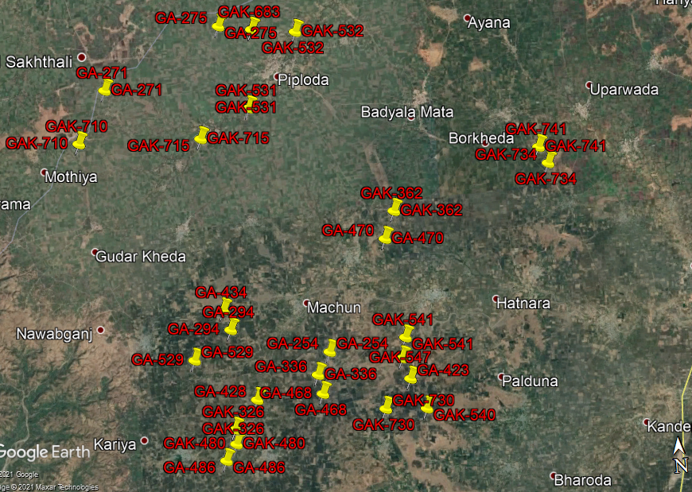

**ENCLOSURE: IV – PHOTOGRAPHS OF THE PROPERTY**

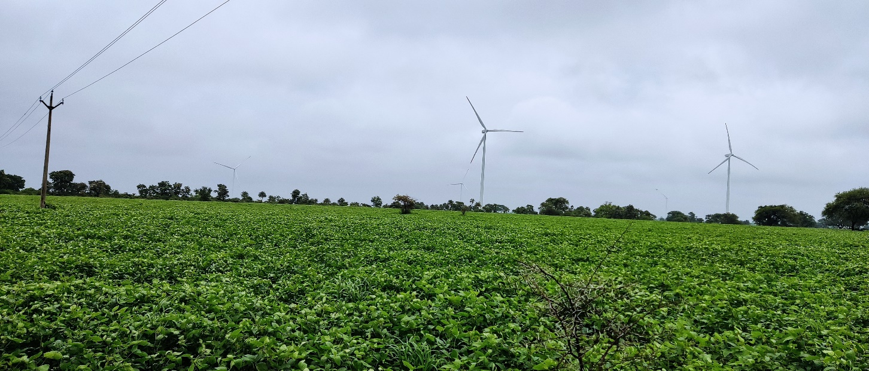

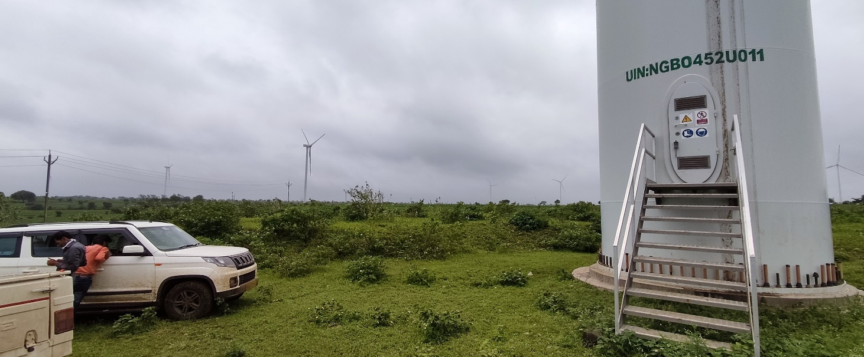

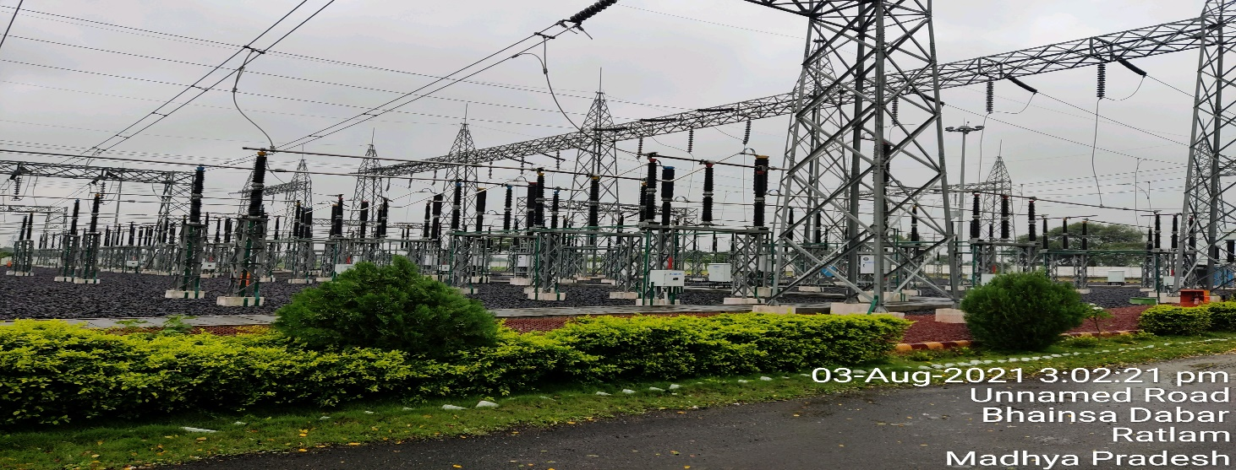

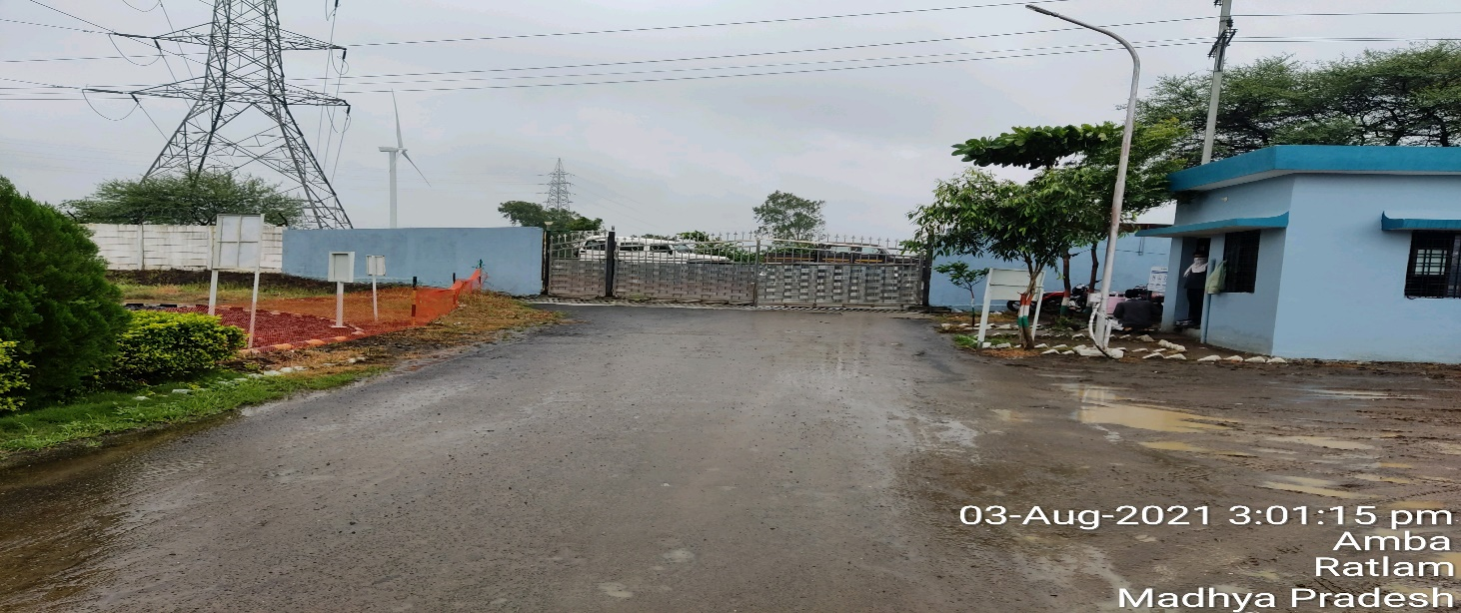

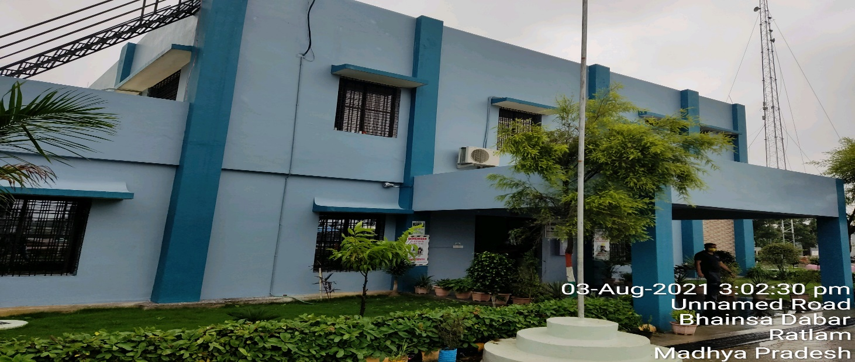

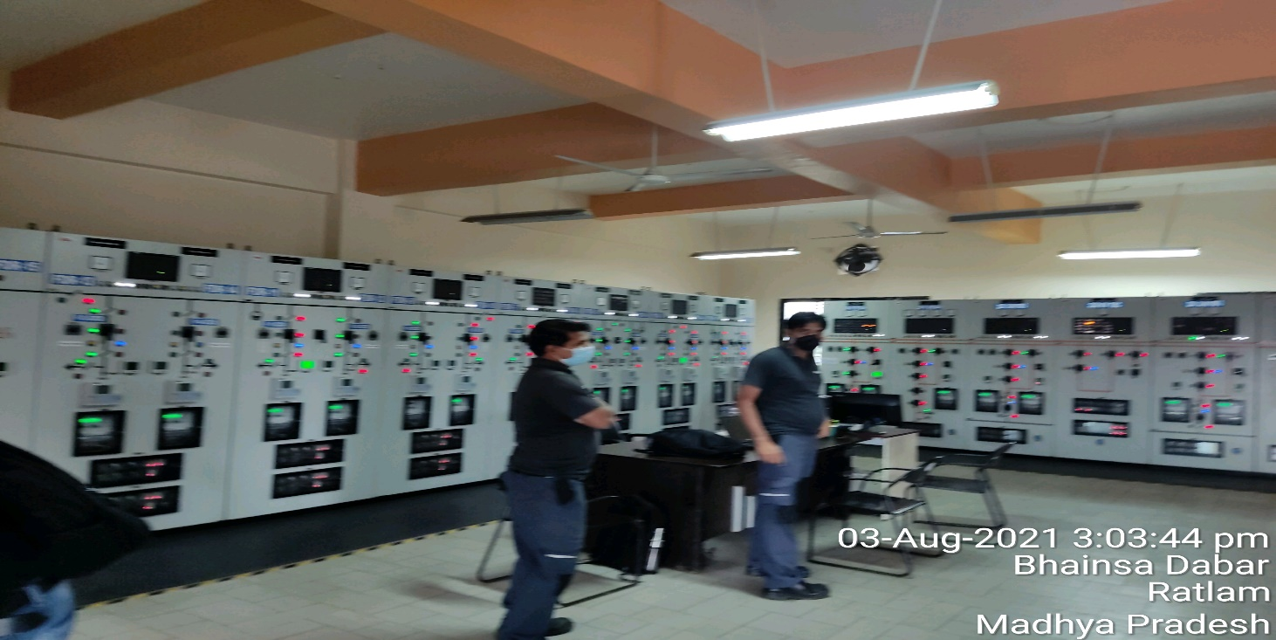

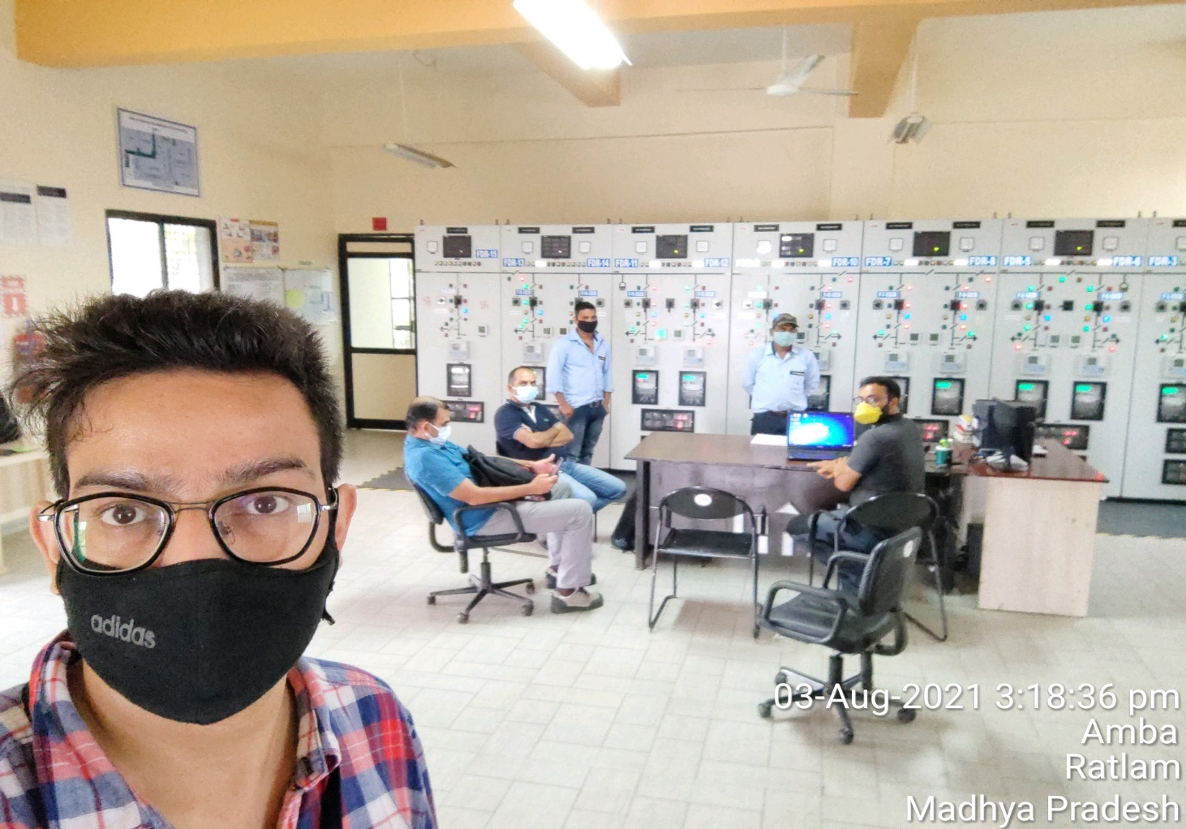

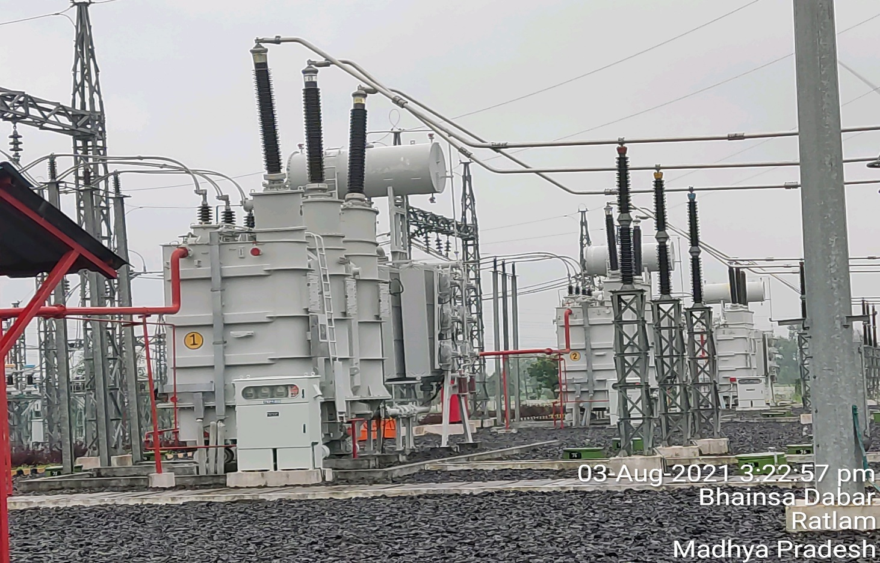

 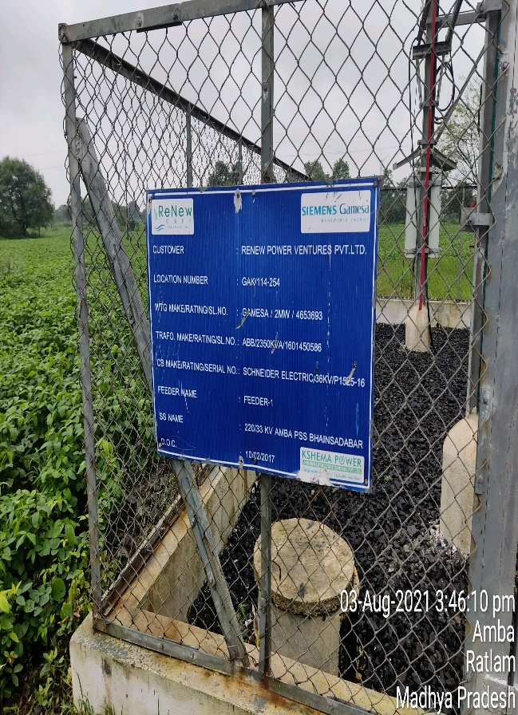

 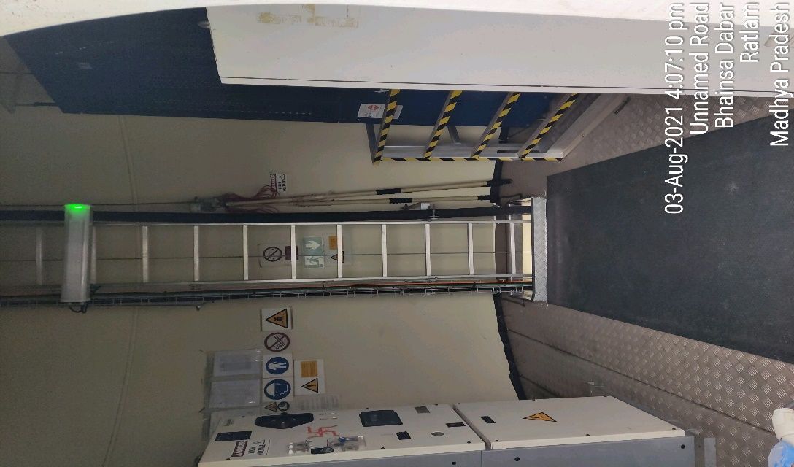

 

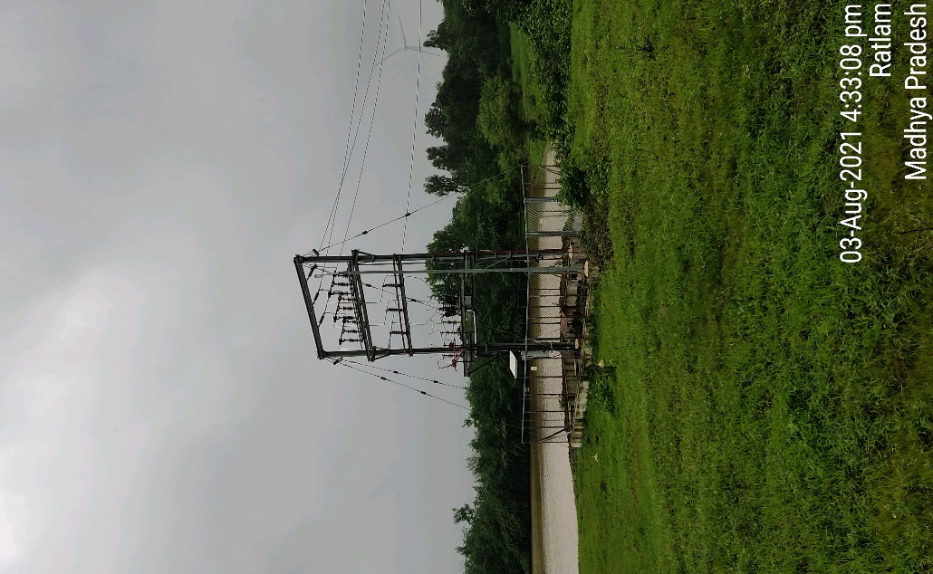 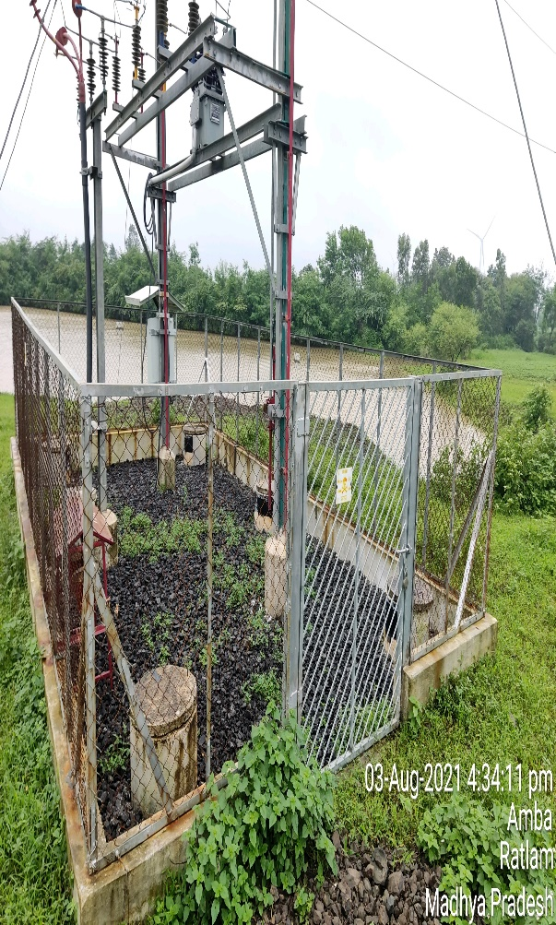

**ENCLOSURE: V– COPY OF CIRCLE RATE**

**VILLAGE- BHAINSA DABAR**

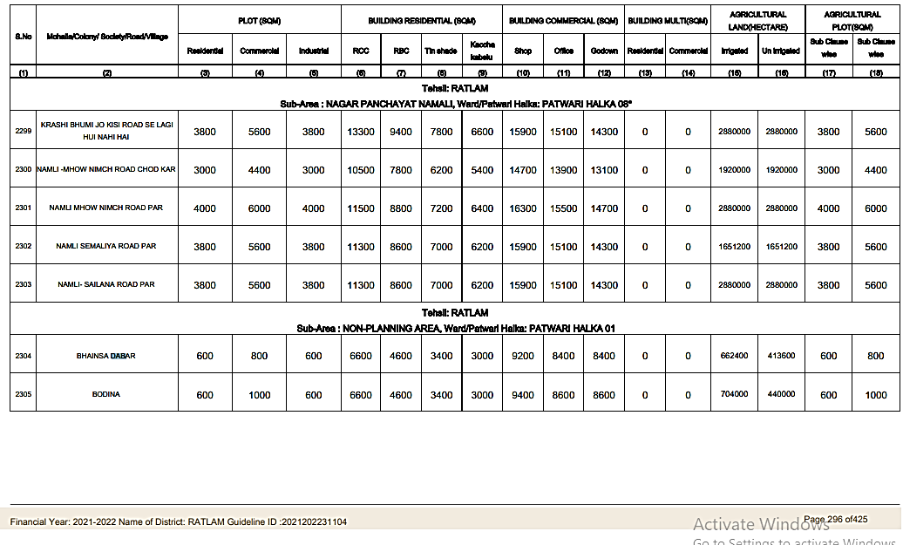

**VILLAGE- KHEDA VADA**

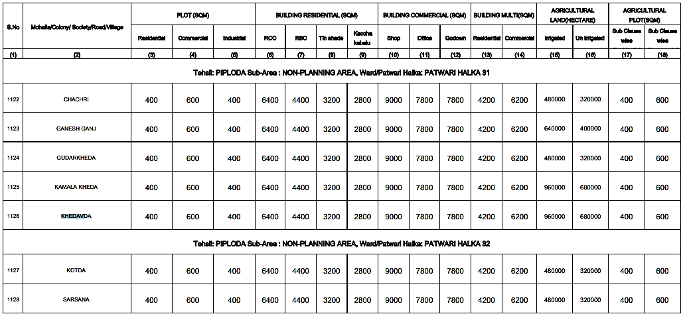

**VILLAGE- PIPODA (HARIJAN BASTI)**

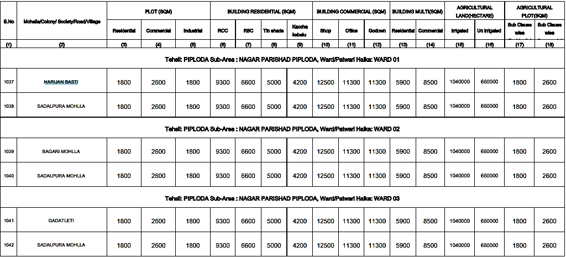

**VILLAGE- BODINA**

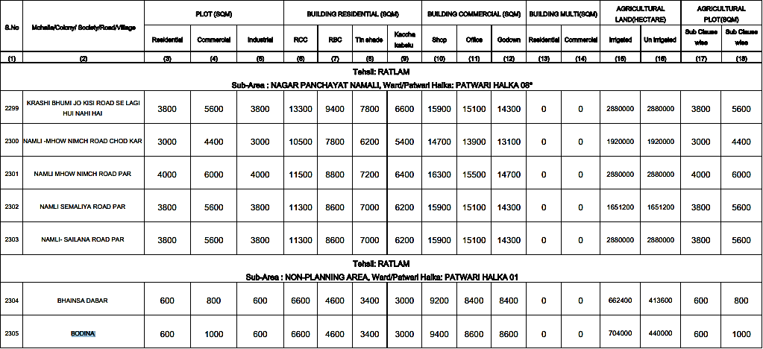

**VILLAGE- NANDLETA**

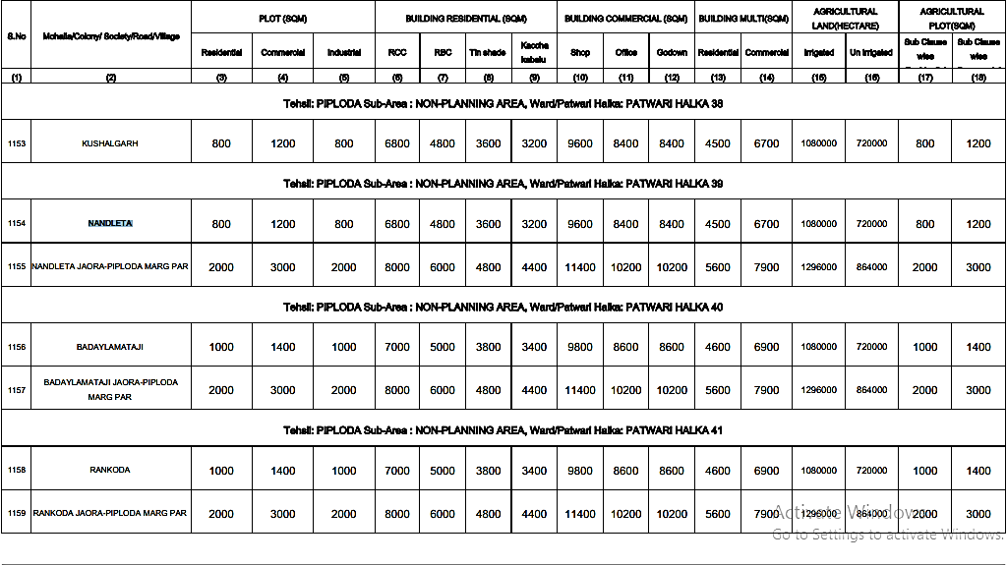

**VILLAGE-** **KHOKHRA**

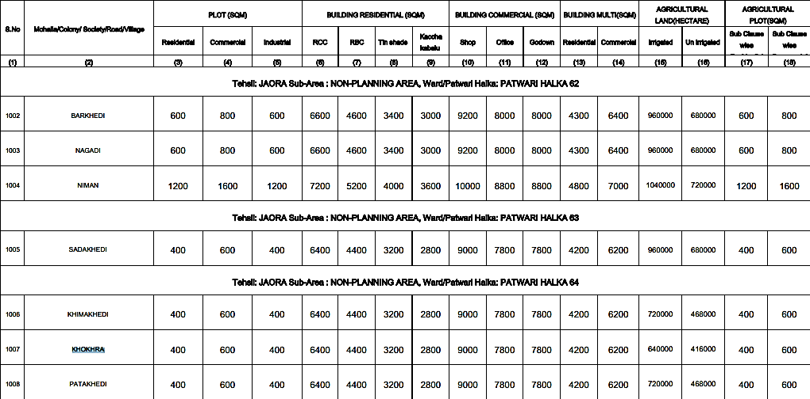

**VILLAGE-** **HATNARA**

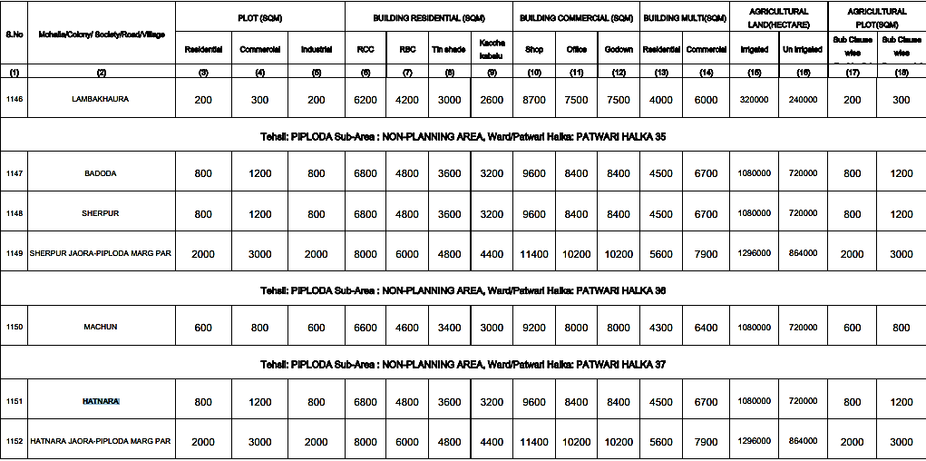

**VILLAGE-** **BORKHEDA**

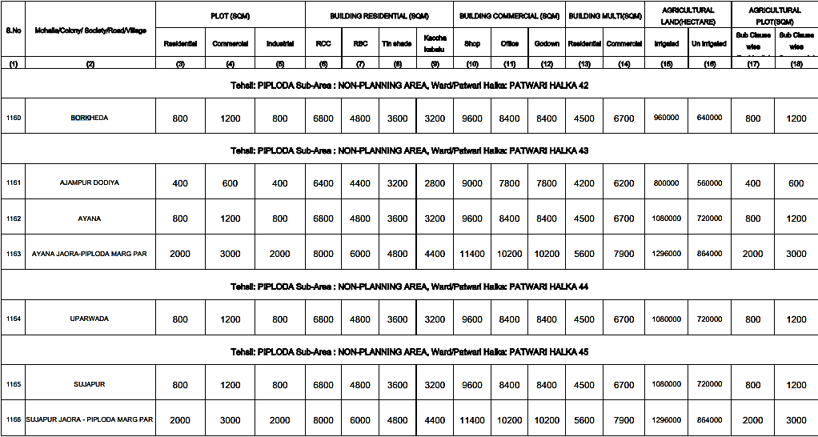

**ANNEXURE: VI- DECLARATION-CUM-UNDERTAKING**

1. I am a citizen of India.
2. No employee or member of R.K Associates has any direct/ indirect interest in the property or become so interested at any time during a period of three years prior to my appointment as valuer or three years after the valuation of assets was conducted by me.
3. The information furnished in our valuation report dated 12/8/2021 is true and correct to the best of my knowledge and belief and we have made an impartial and true valuation of the property.
4. Our authorized Engineer/ surveyor Mr. Zaid Ebne Mairaj have personally inspected the property on 3/8/2021 the work is not subcontracted to any other valuer and is carried out by us.
5. Valuation report is submitted in the format as prescribed by the Bank.
6. We have not been depanelled/ delisted by any other bank and in case any such depanelment by other banks during my empanelment with you, we will inform you within 3 days of such depanelment.
7. We have not been removed/ dismissed from service/employment earlier.
8. We have not been convicted of any offence and sentenced to a term of imprisonment.
9. We have not been found guilty of misconduct in professional capacity.
10. I have not been declared to be unsound mind.
11. We are not undischarged bankrupt, or has not applied to be adjudicated as a bankrupt;
12. We are not an undischarged insolvent.
13. I have not been levied a penalty under section 271J of Income-tax Act, 1961 (43 of 1961) and time limit for filing appeal before Commissioner of Income tax (Appeals) or Income-tax Appellate Tribunal, as the case may be has expired, or such penalty has been confirmed by Income-tax Appellate Tribunal, and five years have not elapsed after levy of such penalty.
14. I have not been convicted of an offence connected with any proceeding under the Income Tax Act 1961, Wealth Tax Act 1957 or Gift Tax Act 1958 and
15. Our PAN Card number/ GST number as applicable is **AAHCR0845G/ 09AAHCR0845G1ZP**
16. We undertake to keep you informed of any events or happenings which would make me ineligible for empanelment as a valuer.
17. We have not concealed or suppressed any material information, facts and records and I have made a complete and full disclosure.
18. We have read the Handbook on Policy, Standards and procedure for Real Estate Valuation, 2011 of the IBA and this report is in conformity to the “Standards” enshrined for valuation in the Part-B of the above handbook to the best of my ability.
19. We have read the International Valuation Standards (IVS) and the report submitted to the Bank for the respective asset class is in conformity to the “Standards” as enshrined for valuation in the IVS in “General Standards” and “Asset Standards” as applicable.
20. I abide by the Model Code of Conduct for empanelment of valuer in the Bank.
21. I am registered under Section 34 AB of the Wealth Tax Act, 1957. (Strike off, if not applicable).
22. I am valuer registered with Insolvency & Bankruptcy Board of India (IBBI) (Strike off, if not applicable).
23. My CIBIL Score and credit worthiness is as per Bank’s guidelines.
24. I am the proprietor / partner / authorized official of the firm / company, who is competent to sign this valuation report.
25. I will undertake the valuation work on receipt of Letter of Engagement generated from the system (i.e. LLMS/LOS) only.
26. Further, I hereby provide the following information**.**

|  |  |  |  |
| --- | --- | --- | --- |
| **S. No.** | **Particulars** | **Valuer comment** | |
|  | Background information of the asset being valued | This is an Industrial property located at address: Villages- Bhaisadabar, Khedavada, Piploda, Khokhra, Bodina, Nandleta, Hatnara, & Borkheda, District- Ratlam, Madhya Pradesh. having total land area as described above as per the documents/ information provided to us by the Bank/ client. | |
|  | Purpose of valuation and appointing authority | Please refer to Page No.01 of the Report. | |
|  | Identity of the Valuer and any other experts involved in the valuation | **Survey Analyst: AE Zaid Ebne Mairaj**  **Engineering Analyst: AE Zaid Ebne Mairaj**  **Valuer/ Reviewer: HOD Engg.** | |
|  | Disclosure of valuer interest or conflict, if any | No relationship with the borrower or any kind of conflict of interest. | |
|  | Date of appointment, valuation date and date of report | **Date of Appointment:** | **6/7/2021** |
| **Date of Survey:** | **3/8/2021 & 4/8/2021** |
| **Valuation Date:** | **12/8/2021** |
| **Date of Report:** | **12/8/2021** |
|  | Inspections and/or investigations undertaken | Yes by our authorized Survey Engineer Mr. Zaid Ebne Mairaj bearing knowledge of that area on3/8/2021. Property was shown and identified byowner’s representative Mr. Anil Namdeo Patil(🕿-86964 84323) | |
|  | Nature and sources of the information used or relied upon | Please refer to Page No. 04 of the Report. | |
|  | Procedures adopted in carrying out the valuation and valuation standards followed | Land value is calculated on the basis of ‘Market Comparable Sales Approach’ and building construction value is calculated on the basis of ‘Depreciated Replacement cost Approach’. Plant & Machinery value is calculated on the basis of ‘Depreciated Replacement cost Approach’. | |
|  | Restrictions on use of the report, if any | Value varies with the Purpose/ Date/ Market & Asset Condition & Situation prevailing in the market. We recommend not to refer the indicative & estimated prospective Value of the asset given in this report if any of these points are different from the one mentioned aforesaid in the Report.  This report has been prepared for the purposes stated in the report and should not be relied upon for any other purpose. Our client is the only authorized user of this report and is restricted for the purpose indicated in the engagement letter. I/we do not take any responsibility for the unauthorized use of this report.  During the course of the assignment we have relied upon various information, data, documents provided by Bank/ client in good faith. If at any point of time in future it comes to knowledge that the information given to us is untrue, fabricated, misrepresented then the use of this report at very moment will become null & void.  This report only contains general assessment & opinion on the indicative, estimated Market Value of the property for which Bank has asked to conduct the Valuation and found as per the information given in the copy of documents, information, data provided to us and/ or confirmed by the owner/ owner representative to us at site which has been relied upon in good faith. It doesn’t contain any other recommendations of any sort including but not limited to express of any opinion on the suitability or otherwise of entering into any transaction with the borrower. | |
|  | Major factors that were taken into account during the valuation | Please refer to Page No. 4-8 of the Report. | |
|  | Major factors that were not taken into account during the valuation | NA | |
|  | Caveats, limitations and disclaimers to the extent they explain or elucidate the limitations faced by valuer, which shall not be for the purpose of limiting his responsibility for the valuation report. | Please see attached Annexure. | |

**Date: 12/8/2021**

**Place:** Noida

**Signature**

**(Authorized Person of R.K Associates Valuers & Techno Engg. Consultants (P) Ltd.)**

**ANNEXURE: VII- MODEL CODE OF CONDUCT FOR VALUERS**

**Integrity and Fairness**

1. A valuer shall, in the conduct of his/its business, follow high standards of integrity and fairness in all his/its dealings with his/its clients and other valuers.
2. A valuer shall maintain integrity by being honest, straightforward, and forthright in all professional relationships.
3. A valuer shall endeavour to ensure that he/it provides true and adequate information and shall not misrepresent any facts or situations.
4. A valuer shall refrain from being involved in any action that would bring disrepute to the profession.
5. A valuer shall keep public interest foremost while delivering his services.

**Professional Competence and Due Care**

1. A valuer shall render at all times high standards of service, exercise due diligence, ensure proper care and exercise independent professional judgment.
2. A valuer shall carry out professional services in accordance with the relevant technical and professional standards that may be specified from time to time.
3. A valuer shall continuously maintain professional knowledge and skill to provide competent professional service based on up-to-date developments in practice, prevailing regulations/guidelines and techniques.
4. In the preparation of a valuation report, the valuer shall not disclaim liability for his/its expertise or deny his/its duty of care, except to the extent that the assumptions are based on statements of fact provided by the company or its auditors or consultants or information available in public domain and not generated by the valuer.
5. A valuer shall not carry out any instruction of the client insofar as they are incompatible with the requirements of integrity, objectivity and independence.
6. A valuer shall clearly state to his client the services that he would be competent to provide and the services for which he would be relying on other valuers or professionals or for which the client can have a separate arrangement with other valuers.

**Independence and Disclosure of Interest**

1. A valuer shall act with objectivity in his/its professional dealings by ensuring that his/its decisions are made without the presence of any bias, conflict of interest, coercion, or undue influence of any party, whether directly connected to the valuation assignment or not.
2. A valuer shall not take up an assignment if he/it or any of his/its relatives or associates is not independent in terms of association to the company.
3. A valuer shall maintain complete independence in his/its professional relationships and shall conduct the valuation independent of external influences.
4. A valuer shall wherever necessary disclose to the clients, possible sources of conflicts of duties and interests, while providing unbiased services.
5. A valuer shall not deal in securities of any subject company after any time when he/it first becomes aware of the possibility of his/its association with the valuation, and in accordance with the Securities and Exchange Board of India (Prohibition of Insider Trading) Regulations, 2015 or till the time the valuation report becomes public, whichever is earlier.
6. A valuer shall not indulge in “mandate snatching or offering ”convenience valuations” in order to cater to a company or client’s needs.
7. As an independent valuer, the valuer shall not charge success fee.
8. In any fairness opinion or independent expert opinion submitted by a valuer, if there has been a prior engagement in an unconnected transaction, the valuer shall declare the association with the company during the last five years.

**Confidentiality**

1. A valuer shall not use or divulge to other clients or any other party any confidential information about the subject company, which has come to his/its knowledge without proper and specific authority or unless there is a legal or professional right or duty to disclose.

**Information Management**

1. A valuer shall ensure that he/ it maintains written contemporaneous records for any decision taken, the reasons for taking the decision, and the information and evidence in support of such decision. This shall be maintained so as to sufficiently enable a reasonable person to take a view on the appropriateness of his/its decisions and actions.
2. A valuer shall appear, co-operate and be available for inspections and investigations carried out by the authority, any person authorised by the authority, the registered valuers organization with which he/it is registered or any other statutory regulatory body.
3. A valuer shall provide all information and records as may be required by the authority, the Tribunal, Appellate Tribunal, the registered valuers organization with which he/it is registered, or any other statutory regulatory body.
4. A valuer while respecting the confidentiality of information acquired during the course of performing professional services, shall maintain proper working papers for a period of three years or such longer period as required in its contract for a specific valuation, for production before a regulatory authority or for a peer review. In the event of a pending case before the Tribunal or Appellate Tribunal, the record shall be maintained till the disposal of the case.

**Gifts and hospitality.**

1. A valuer or his/its relative shall not accept gifts or hospitality which undermines or affects his independence as a valuer.

Explanation: For the purposes of this code the term ‘relative’ shall have the same meaning as defined in clause (77) of Section 2 of the Companies Act, 2013 (18 of 2013).

1. A valuer shall not offer gifts or hospitality or a financial or any other advantage to a public servant or any other person with a view to obtain or retain work for himself/ itself, or to obtain or retain an advantage in the conduct of profession for himself/ itself.

**Remuneration and Costs.**

1. A valuer shall provide services for remuneration which is charged in a transparent manner, is a reasonable reflection of the work necessarily and properly undertaken, and is not inconsistent with the applicable rules.
2. A valuer shall not accept any fees or charges other than those which are disclosed in a written contract with the person to whom he would be rendering service.

**Occupation, employability and restrictions.**

1. A valuer shall refrain from accepting too many assignments, if he/it is unlikely to be able to devote adequate time to each of his/ its assignments.
2. A valuer shall not conduct business which in the opinion of the authority or the registered valuer organisation discredits the profession.

**Miscellaneous**

1. A valuer shall refrain from undertaking to review the work of another valuer of the same client except under written orders from the bank or housing finance institutions and with knowledge of the concerned valuer.
2. A valuer shall follow this code as amended or revised from time to time

Signature of the Valuer: \_\_\_\_\_\_\_\_\_\_\_\_\_\_\_\_

Name of the Valuer: R.K Associates Valuers & Techno Engg. Consultants (P) Ltd.

Address of the Valuer: D-39, Sector-2, Noida-201301

Date: 12/8/2021

Place: Noida

**ENCLOSURE: VI – VALUER’S REMARKS**

|  |  |
| --- | --- |
|  | This Valuation report is prepared based on the copies of the documents/ information which interested organization or customer could provide to us out of the standard checklist of documents sought from them and further based on our assumptions and limiting conditions. All such information provided to us has been relied upon in good faith and we have assumed that it is true and correct. Verification or cross checking of the documents provided to us from the originals has not been done at our end. |
|  | Legal aspects for eg. investigation of title, ownership rights, lien, charge, mortgage, lease, verification of documents, etc. have to be taken care by legal expert/ Advocate and same are not done at our end. It is assumed that the concerned Lender/ Financial Institution has asked for the valuation of that property for which the legal verification has been already taken and cleared by the competent Advocate before requesting for the Valuation report. |
|  | Analysis and conclusions adopted in the report are limited to the reported assumptions, conditions and information came to our knowledge during the course of the work. |
|  | Value varies with the Purpose/ Date/ Condition prevailing in the market. We recommend not to refer the indicative & estimated prospective Value of the asset given in this report if any of these points are different from the one mentioned aforesaid in the Report. We also recommend that the indicative estimated Value in the Valuation Report holds good only upto the period of 3 months from the date of Valuation. |
|  | This report is having limited scope as per its fields & format to provide only the general basic idea of the value of the property prevailing in the market based on the documents/ data/ information provided by the client. The suggested indicative prospective estimated value should be considered only if transaction is happened as free market transaction. |
|  | This Valuation report is prepared based on the facts of the property on the date of the survey. It is a well-known fact that the market value of any asset varies with time & socio-economic conditions prevailing in the country. In future property Market may go down, property conditions may change or may go worse, Property reputation may differ, Property vicinity conditions may go down or become worse, Property market may change due to impact of Govt. policies or effect of World economy, Usability prospects of the property may change, etc. Hence before financing, Banker/ FI should take into consideration all such future risk and should loan conservatively to keep the advanced money safe in case of the downward trend of the property value. |
|  | Valuation of the same asset/ property can fetch different values in different situations. For eg. Valuation of a running/ operational shop/ hotel/ factory will fetch better value and in case of closed shop/ hotel/ factory it will have considerable lower value. Similarly an asset sold directly by an owner in the market will fetch better value and if the same asset/ property is sold by any financer due to encumbrance on it will fetch lower value. Hence before financing, Banker/ FI should take into consideration all such future risks and should loan conservatively to keep the advanced money safe in case of any such situation. |
|  | Getting cizra map or coordination with revenue officers for site identification is not done at our end. |
|  | Valuation is done for the property identified to us by the owner/ owner representative. At our end we have just cross verified the identification of the property with reference to the documents produced for perusal. Method by which identification of the property is carried out is also mentioned in the report clearly. Responsibility of identifying the correct property to the Valuer/ its authorized surveyor is solely of the client/ owner for which Valuation has to be carried out. It is requested from the Bank to cross check from their own records/ information if this is the same property for which Valuation has to be carried out to ensure that owner has not misled the Valuer company or misrepresented the property due to any vested interest. |
|  | In India more than 70% of the geographical area is lying under rural/ remote/ non municipal/ unplanned area where the subject property is surrounded by vacant lands having no physical demarcation or having any display of property survey or municipal number / name plate on the property clearly. Even in old locations of towns, small cities & districts where property number is either not assigned or not displayed on the properties clearly and also due to the presence of multiple/ parallel departments due to which ownership/ rights/ illegal possession/ encroachment issues are rampant across India and due to these limitations at many occasions it becomes tough to identify the property with 100% surety from the available documents, information & site whereabouts and thus chances of error, misrepresentation by the borrower and margin of chances of error always persists in such cases. To avoid any such chances of error it is advised to the Bank to engage municipal/ revenue department officials to get the confirmation of the property to ensure that the property shown to Valuer/ Banker is the same as for which documents are provided. |
|  | If this Valuation Report is prepared for the Flat/ dwelling unit situated in a Group Housing Society or Integrated Township then approvals, maps of the complete group housing society/ township is out of scope of this report and this report will be made for the specific unit based on the assumption that complete Group Housing Society/ Integrated Township must be approved in all respect. |
|  | Due to fragmented & frequent change in building/ urban planning laws/ guidelines from time to time, different laws/ guidelines between regions/ states and no strict enforceability of Building Bye-Laws in India specially in non-metro and scale b & c cities & Industrial areas, property owners many times extend or make changes in the covered area/ layout from the approved/ applicable limits. There are also situations where properties are decades old when there was no formal Building Bye-Laws applicable when the construction must have been done. Due to such discrete/ unplanned development in many regions sometimes it becomes tough to determine the exact lawful situation on ground for the Valuer. In case nothing specific is noted on the covered built-up area considered in the Valuation Report, the covered area present on the site as per site survey will be considered in the Valuation. |
|  | Valuation is a subjective field and opinion may differ from consultant to consultant. To check the right opinion, it is important to evaluate the methodology adopted and various data point/ information/ factors/ assumption considered by the consultant which became the basis for the Valuation report before reaching to any conclusion. |
|  | Value analysis of any asset cannot be regarded as an exact science and the conclusions arrived at in many cases will, of necessity, be subjective and dependent on the exercise of individual judgment. Given the same set of facts and using the same assumptions, expert opinions may differ due to the number of separate judgment decisions, which have to be made. Therefore, there can be no standard formula to establish an indisputable exchange ratio. In the event of a transaction, the actual transaction value achieved may be higher or lower than our indicative analysis of value depending upon the circumstances of the transaction. The knowledge, negotiability and motivations of the buyers and sellers and the applicability of a discount or premium for control will also affect actual price achieved. Accordingly, our indicative analysis of value will not necessarily be the price at which any agreement proceeds. The final transaction price is something on which the parties themselves have to agree. However our Valuation analysis can definitely help the stakeholders to make them informed and wise decision about the Value of the asset and can help in facilitating the arm’s length transaction. |
|  | This report is prepared on the RKA V-L1 (Basic) Valuation format as per the client requirement and scope of work. This report is having limited scope as per its fields & format to provide only the general estimated & indicative basic idea of the value of the property prevailing in the market based on the information provided by the client. No detailed analysis, audit or verification has been carried out of the subject property. |
|  | This is just an opinion report and doesn’t hold any binding on anyone. It is requested from the concerned Client/ Bank/ Financial Institution which is using this report for mortgaging the property that they should consider all the different associated relevant & related factors & risks before taking any business decision based on the content of this report. |
|  | All Pages of the report including annexures are signed and stamped from our office. In case any paper in the report is without stamp & signature then this should not be considered a valid paper issued from this office. |
|  | Defect Liability Period is **30 DAYS**. We request the concerned authorized reader of this report to check the contents, data and calculations in the report within this period and intimate us in writing if any corrections are required or in case of any other concern with the contents or opinion mentioned in the report. Corrections only related to typographical, calculation, spelling mistakes will be entertained within the defect liability period. No request for any illegitimate value revision, date change or any other change will be entertained other than the one mentioned above. |
|  | R.K Associates encourages its customers to give feedback or inform concerns over its services through proper channel at [**valuers@rkassociates.org**](mailto:valuers@rkassociates.org) in writing within 30 days of report delivery. After this period no concern/ complaint/ proceedings in connection with the Valuation Services can be entertained due to possible change in situation and condition of the property. |
|  | Our Data retention policy is of **ONE YEAR**. After this period we remove all the concerned records related to the assignment from our repository. No clarification or query can be answered after this period due to unavailability of the data. |
|  | This Valuation report is governed by our (1) Internal Policies, Processes & Standard Operating Procedures, (2) R.K Associates Quality Policy, (3) Valuation & Survey Best Practices Guidelines formulated by management of R.K Associates, (4) Information input given to us by the customer and (4) Information/ Data/ Facts given to us by our field/ office technical team. Management of R.K Associates never gives acceptance to any unethical or unprofessional practice which may affect fair, correct & impartial assessment and which is against any prevailing law. In case of any indication of any negligence, default, incorrect, misleading, misrepresentation or distortion of facts in the report then it is the responsibility of the user of this report to immediately or atleast within the defect liability period bring all such act into notice of R.K Associates management so that corrective measures can be taken instantly. |
|  | R.K Associates never releases any report doing alterations or modifications by pen. In case any information/ figure of this report is found altered with pen then this report will automatically become null & void. |