**REPORT FORMAT:** V-L3 (Medium) | Version: 8.0\_2019

**File No.:** **VIS(2021-22)-PL238-Q55-209-250 Dated:26.07.2021**

**VALUATION ASSESSMENT**

**OF**

**INDEPENDENT RESIDENTIAL HOUSE**

**SITUATED AT**

**HOUSE NO.228, SITUATED IN BLOCK-C, SECTOR ALPHA-1, GREATER NOIDA, DISTT. GAUTAM BUDH NAGAR, U.P**

**OWNER/S**

**MR. PARDEEP KUMAR GARG & MR. SANJAY KUMAR GARG S/O LATE MR. VED PRAKASH GARG**

**A/C: MR. PARDEEP KUMAR GARG & MR. SANJAY KUMAR GARG**

**REPORT PREPARED FOR**

**MR. PARDEEP KUMAR GARG & MR. SANJAY KUMAR GARG**

***\*\*Important - In case of any query/ issue or escalation you may please contact Incident Manager***

***at valuers@rkassociates.org. We will appreciate your feedback in order to improve our services.***

***NOTE: As per IBA Guidelines please provide your feedback on the report within 15 days of its submission after which report will be considered to be correct.***

|  |  |
| --- | --- |
| **PART A** | **RKAFORMAT OF OPINION REPORT ON VALUATION** |

|  |  |
| --- | --- |
| Name & Address of Branch | Private Client |
| Name of Customer (s)/ Borrower Unit | Mr. Pardeep Kumar Garg & Mr. Sanjay Kumar Garg |

|  |  |  |  |
| --- | --- | --- | --- |
|  | **INTRODUCTION** | | |
|  | **CONTENTS** | | **DESCRIPTION** |
|  | Name of Property Owner | Mr. Pardeep Kumar Garg & Mr. Sanjay Kumar Garg S/o Late Mr. Ved Prakash Garg | |
| Address & Phone Number of the Owner | House No.228, Situated in Block-C, Sector- Alpha 1, Greater Noida, Distt. Gautam Budh Nagar, U.P | |
|  | Purpose of the Valuation | For Net Worth Assessment purpose | |
|  | Date of Inspection of the Property | 23 July 2021 | |
|  | Date of Valuation Report | 26 July 2021 | |
|  | Name of the Developer of the Property | Owners themselves | |
| Type of Developer | Property built by owner's themselves | |

|  |  |  |  |  |  |  |  |  |
| --- | --- | --- | --- | --- | --- | --- | --- | --- |
|  | **PHYSICAL CHARACTERISTICS OF THE PROPERTY** | | | | | | | |
|  | **BRIEF DESCRIPTION OF THE PROPERTY UNDER VALUATION**  **TimePhoto_20210723_155606.jpg**  ***Snapshot of the Asset/ Property Under Valuation***  This Valuation report is prepared for the Residential property situated at the aforesaid address having total land area admeasuring 100.80 sq.mtr (120.54 sq.yds) as per the copy of Transfer deed provided to us by the Client.  The subject properties is a lease hold property and was purchased in year 2019 via transfer deed dated: The Covered area is considered as per mentioned in the deed which is 142.565 sq.mtr./ 1534.55 sq.ft. which is cross checked by sample random measurements taken on site and same is adopted for valuation purpose.  The subject property is located in developed sector of Alpha-I of Greater Noida. The subject property can be clearly approached from a 12 mtr. wide road. The subject property is located at a distance of 450 mtr. from the main road.  This report only contains general assessment & opinion on the Guideline Value and the indicative, estimated Market Value of the property for which Bank has asked to conduct the Valuation and found as per the information given in the copy of documents provided to us and/ or confirmed by the owner/ owner representative to us at site which has been relied upon in good faith. It doesn’t contain any other recommendations of any sort. | | | | | | | |
|  | **Location attribute of the property** | | | | | | | |
|  | Nearby Landmark | | Alpha-1 Metro Station | | | | | |
|  | Postal Address of the Property | | House No. 228, Situated in Block-C, Sector- Alpha 1, Greater Noida, Distt. Gautam Budh Nagar, U.P | | | | | |
|  | Area of the Plot/ Land | | Approx. 100.80 sq.mtr. (120.54 sq.yds) | | | | | |
| *Also please refer to Part-B Area description of the property.Area measurements considered in the Valuation Report is adopted from relevant approved documents or actual site measurement whichever is less. Verification of the area measurement of the property is done only based on sample random checking.* | | | | | |
|  | Type of Land | | Solid Land | | | | | |
|  | Independent access/ approach to the property | | Clear independent access is available | | | | | |
|  | Google Map Location of the Property with a neighborhood layout map | | Enclosed with the Report | | | | | |
| Coordinates or URL: 28°28'22.6"N 77°30'31.8"E | | | | | |
|  | Details of the roads abutting the property | | | | | | | |
|  | 1. Main Road Name & Width | | Alpha Sector Road | | | | 80 mtr. | |
|  | 1. Front Road Name & width | | Internal Road | | | | 12 mtr. | |
|  | 1. Type of Approach Road | | Bituminous Road | | | | | |
|  | 1. Distance from the Main Road | | 450 mtr. | | | | | |
|  | Description of adjoining property | | All adjacent properties are used for residential purpose | | | | | |
|  | Plot No./ Survey No. | | 228 | | | | | |
|  | Village/ Sector | | -- | | | | Alpha-I | |
|  | Sub registrar | | Noida | | | | | |
|  | District | | Guatam Budh Nagar | | | | | |
|  | Any other aspect | | Valuation is done for the property found as per the information given in the copy of documents provided to us and/ or confirmed by the owner/ owner representative to us at site.  Getting cizra map or coordination with revenue officers for site identification is a separate activity and is not part of the Valuation services. | | | | | |
| 1. Identification of the property   *(Property found as per the information given in the documents provided to us and/ or confirmed by the owner/ owner representative to us on site.)* | | ☐ | From Schedule of the Property mentioned in the deed | | | | |
| ☒ | Done from the name plate displayed on the property | | | | |
| ☐ | Identified by the owner | | | | |
| ☐ | Enquired from local residents/ public | | | | |
| ☒ | Identified by owner’s representative | | | | |
| ☐ | Identification of the property could not be done properly | | | | |
| ☐ | Survey was not done | | | | |
| 1. Type of Survey | | Full survey (inside-out with approximate measurements & photographs). | | | | | |
| 1. Is property clearly demarcated by permanent/ temporary boundary on site | | Demarcated with permanent boundary | | | | | |
| 1. Is the property merged or colluded with any other property | | No. It is an independent single bounded property | | | | | |
| ---- | | | | | |
| 1. City Categorization | | Scale-B City | | | | Urban | |
| 1. Characteristics of the locality | | Average | | | | Within urban developed area | |
| 1. Property location classification | | Normal location within locality | | | None | | None |
| 1. Property Facing | | South-West Facing | | | | | |
| Covered Built-up area description  *(Plinth/ Carpet/ Saleable Area)* | | Approx. 142.565 sq.mtr./ 1534.55 sq.ft. | | | | | |
| *Also please refer to Part B - Area description of the property. Area measurements considered in the Valuation Report is adopted from relevant approved documents or actual site measurement whichever is less. Verification of the area measurement of the property is done only based on sample random checking.* | | | | | |
|  | **Boundaries schedule of the Property** | | | | | | | |
|  | Are Boundaries matched | | Yes from the available documents | | | | | |
|  | **Directions** | **As per Title Deed/ TIR** | | | **Actual found at Site** | | | |
| North-East | Plot No.152 | | | House No. 152 | | | |
| South- East | Plot No. 229 | | | House No. 229 | | | |
| North-West | Plot No. 227 | | | House No. 227 | | | |
| South-West | 12 mtr. Wide Road | | | Colony Road | | | |

|  |  |  |  |
| --- | --- | --- | --- |
|  | **TOWN PLANNING/ ZONING PARAMETERS** | | |
|  | Master Plan provisions related to property in terms of Land use | Residential House (Plotted development) | |
| 1. Any conversion of land use done | No | |
| 1. Current activity done in the property | Residential purpose | |
| 1. Is property usage as per applicable zoning | Yes | |
| 1. Any notification on change of zoning regulation | No information available | |
| 1. Street Notification | Residential | |
|  | Provision of Building by-laws as applicable | **PERMITTED** | **CONSUMED** |
| 1. FAR/ FSI | Please refer to area chart description | Please refer to area chart description |
| 1. Ground coverage | ----------------do------------- | ----------------do------------- |
| 1. Number of floors | ----------------do------------- | ----------------do------------- |
| 1. Height restrictions | ----------------do------------- | ----------------do------------- |
| 1. Front/ Back/ Side Setback | ----------------do------------- | ----------------do------------- |
|  | Status of Completion/ Occupational certificate | No information provided | No information provided |
|  | Comment on unauthorized construction if any | Cannot comment since copy of approved map not provided to us | |
|  | Comment on Transferability of developmentalrights | As per regulation of GNIDA | |
|  | 1. Planning Area/ Zone | Greater NOIDA Master Plan | |
| 1. Master Plan currently in force | Greater Noida Master Plan - 2021 | |
| 1. Municipal limits | Greater Noida (GNIDA) | |
|  | Developmental controls/ Authority | Greater Noida (GNIDA) | |
|  | Zoning regulations | Residential colony | |
|  | Comment on the surrounding land uses & adjoining properties in terms of uses | Its a residential colony and all adjacent properties are used for residential purpose | |
|  | Comment of Demolition proceedings if any | Not in our knowledge | |
|  | Comment on Compounding/ Regularization proceedings | Not in our knowledge | |
|  | Any other aspect |  | |
| 1. Any information on encroachment | No | |
| 1. Is the area part of unauthorized area/ colony | No (As per general information available) | |

|  |  |  |  |  |  |  |  |
| --- | --- | --- | --- | --- | --- | --- | --- |
|  | **DOCUMENT DETAILS AND LEGAL ASPECTS OF THE PROPERTY** | | | | | | |
|  | Ownership documents provided | Transfer Deed | NA | | | NA | NA |
|  | Names of the Legal Owner/s | Mr. Pardeep Kumar Garg & Mr. Sanjay Kumar Garg S/o Late Mr. Ved Prakash Garg | | | | | |
|  | Constitution of the Property | Lease Hold | | | | | |
|  | Agreement of easement if any | Not required | | | | | |
|  | Notice of acquisition if any and area under acquisition | Not known to us | | | | | |
|  | Notification of road widening if any and area under acquisition | Not known to us | | | | | |
|  | Heritage restrictions, if any | No | | | | | |
|  | Comment on Transferability of the property ownership | Lease hold, have to take NOC in order to transfer | | | | | |
|  | Comment on existing mortgages/ charges/ encumbrances on the property, if any | Not Known to us | | | -- | | |
|  | Comment on whether the owners of the property have issued any guarantee*(personal or corporate)* as the case may be | Not Known to us | | | NA | | |
|  | **Building plan sanction:** | | | | | | |
| 1. Authority approving the plan | Cannot comment since no approved map given to us | | | | | |
| 1. Name of the office of the Authority | Cannot comment since no approved map given to us | | | | | |
| 1. Any violation from the approved Building Plan | Cannot comment since no approved map given to us | | | | | |
|  | Whether Property is Agricultural Land if yes, any conversion is contemplated | No not an agricultural property | | | | | |
|  | Whether the property SARFAESI complaint | Yes | | | | | |
|  | 1. Information regarding municipal taxes *(property tax, water tax, electricity bill)* | Property Tax | | No information available | | | |
| Water Tax | | No information available | | | |
| Electricity Bill | | Yes, last bill/ payment receipt attached. | | | |
| 1. Observation on Dispute or Dues if any in payment of bills/ taxes | No such information came to knowledge on site | | | | | |
| 1. Is property tax been paid for this property | Information not available. Please confirm from the owner. | | | | | |
| 1. Property or Tax Id No. | NA | | | | | |
|  | Whether entire piece of land on which the unit is set up / property is situated has been mortgaged or to be mortgaged | Not Applicable | | | | | |
|  | Qualification in TIR/Mitigation suggested if any | Cannot comment since copy of TIR not made available to us | | | | | |
|  | Any other aspect | This is just an opinion report on Valuation based on the copy of the documents/ information provided to us by the client and has been relied upon in good faith of the property found as per the information given in the documents provided to us and/ or confirmed by the owner/ owner representative to us on site.  Legal aspects, Title verification,Verification of authenticity of documents from originals or cross checking from any Govt. deptt. of the property have to be taken care by legal expert/ Advocate. | | | | | |
| 1. Since how long owners owing the Property | 02 years | | | | | |
| 1. Year of Acquisition/ Purchase | 2019 | | | | | |
| 1. Property presently occupied/ possessed by | Vacant | | | | | |
| 1. Title verification | Legal aspects or Title verification have to be taken care by competent advocate. | | | | | |
| 1. Details of leases if any | NA | | | | | |

|  |  |  |
| --- | --- | --- |
|  | **ECONOMIC ASPECTS OF THE PROPERTY** | |
|  | Reasonable letting value/ Expected market monthly rental | NA |
|  | Is property presently on rent | No |
| 1. Number of tenants | No information available to us |
| 1. Since how long lease is in place | No information available to us |
| 1. Status of tenancy right | No information available to us |
| 1. Amount of monthly rent received | No information available to us |
|  | Taxes and other outgoing | Owner Company to provide this information |
|  | Property Insurance details | Owner Company to provide this information |
|  | Monthly maintenance charges payable | Owner Company to provide this information |
|  | Security charges, etc. | Owner Company to provide this information |
|  | Any other aspect | NA |

|  |  |  |
| --- | --- | --- |
|  | **SOCIO - CULTURAL ASPECTS OF THE PROPERTY** | |
|  | Descriptive account of the location of the property in terms of Social structure of the area in terms of population, social stratification, regional origin, age groups, economic levels, location of slums/squatter settlements nearby, etc. | Medium Income Group |
|  | Whether property belongs to social infrastructure like hospital, school, old age homes etc. | No |

|  |  |  |  |  |  |  |  |
| --- | --- | --- | --- | --- | --- | --- | --- |
|  | **FUNCTIONAL AND UTILITARIAN SERVICES, FACILITIES & AMENITIES** | | | | | | |
|  | Description of the functionality & utility of the property in terms of : | | | | | | |
|  | 1. Space allocation | | | | Yes | | |
| 1. Storage spaces | | | | Yes | | |
| 1. Utility of spaces provided within the building | | | | Yes | | |
| 1. Car parking facilities | | | | Yes | | |
| 1. Balconies | | | | Yes | | |
|  | Any other aspect | | | | | | |
|  | 1. Drainage arrangements | | | | Yes | | |
| 1. Water Treatment Plant | | | | No | | |
| 1. Power Supply arrangements | | Permanent | | Yes | | |
| Auxiliary | | No | | |
| 1. HVAC system | | | | No | | |
| 1. Security provisions | | | | No | | |
| 1. Lift/ Elevators | | | | No | | |
| 1. Compound wall/ Main Gate | | | | Yes | | |
| 1. Whether gated society | | | | Yes | | |
| 1. Internal development | | | | | | |
| Garden/ Park/ Land scraping | Water bodies | | Internal roads | | Pavements | Boundary Wall |
| No | No | | No | | No | Yes |

|  |  |  |  |  |  |  |  |  |
| --- | --- | --- | --- | --- | --- | --- | --- | --- |
|  | **INFRASTRUCTURE AVAILABILITY** | | | | | | | |
|  | Description of Aqua Infrastructure availability in terms of: | | | | | | | |
|  | 1. Water Supply | | | | Yes | | | |
| 1. Sewerage/ sanitation system | | | | Underground | | | |
| 1. Storm water drainage | | | | Yes | | | |
|  | Description of other Physical Infrastructure facilities in terms of: | | | | | | | |
|  | 1. Solid waste management | | | | Yes, By the authority | | | |
| 1. Electricity | | | | Yes | | | |
| 1. Road and Public Transport connectivity | | | | Yes | | | |
| 1. Availability of other public utilities nearby | | | | Transport, Market, Hospital etc. available in close vicinity | | | |
|  | Proximity & availability of civic amenities & social infrastructure | | | | | | | |
|  | School | Hospital | Market | Bus Stop | | Railway Station | Metro | Airport |
| 50 m | 100 m | 100 m | --- | | 15 km | 350 m | NA |
|  | Availability of recreation facilities (parks, open spaces etc.) | | | It is a developing area and recreational facilities are planned to be developed nearby | | | | |

|  |  |  |  |
| --- | --- | --- | --- |
|  | **MARKETABILITY ASPECTS OF THE PROPERTY:** | | |
|  | Marketability of the property in terms of | | |
|  | 1. Location attribute of the subject property | Average | |
| 1. Scarcity | Similar kind of properties are easily available on demand. | |
| 1. Market condition related to demand and supply of the kind of the subject property in the area | Good demand of such properties in the market | |
| 1. Comparable Sale Prices in the locality | Please refer to Part C: Valuation Assessment of the Property. | |
|  | Any other aspect which has relevance on the value or marketability of the property | No | |
|  | 1. Any New Development in surrounding area | No | NA |
| 1. Any negativity/ defect/ disadvantages in the property/ location | No | NA |

|  |  |  |  |  |
| --- | --- | --- | --- | --- |
|  | **ENGINEERING AND TECHNOLOGY ASPECTS OF THE PROPERTY:** | | | |
|  | Type of construction & design | RCC structure | | |
|  | Method of construction | Regular masonry construction using standard quality material | | |
|  | Specifications | | | |
| 1. Class of construction | Class C construction (Simple/ Average) | | |
| 1. Appearance/ Condition of structures | Internal -Average | | |
| External -Average | | |
| 1. Roof | **Floors/ Blocks** | | **Type of Roof** |
| RCC roofed structure | | RCC |
| 1. Floor height | 12 ft. | | |
| 1. Type of flooring | Simple marble | | |
| 1. Doors/ Windows | Wooden frame & panel doors | | |
| 1. Interior Finishing | Simple Plastered Walls | | |
| 1. Exterior Finishing | Simple plastered walls | | |
| 1. Interior decoration/ Special architectural or decorative feature | Simple plain looking structure. | | |
| 1. Class of electrical fittings | Internal/ Normal quality fittings used | | |
| 1. Class of sanitary & water supply fittings | Internal/ Normal quality fittings used | | |
|  | Maintenance issues | No maintenance issue, structure is maintained properly | | |
|  | Age of building/ Year of construction | Approx. 05 years | Around year-2016 | |
|  | Total life of the structure/ Remaining life expected | Approx. 60-65 years | Approx. 55-60 years subject to proper and timely maintenance | |
|  | Extent of deterioration in the structure | No major deterioration came into notice, only normal wear & tear | | |
|  | Structural safety | Appears to be structurally stable | | |
|  | Protection against natural disasters viz. earthquakes etc. | Since this is a RCC structure so should be able to withstand moderate intensity earthquakes. | | |
|  | Visible damage in the building if any | No visible damages in the structure | | |
|  | System of air conditioning | No Aircondition installed | | |
|  | Provision of firefighting | No firefighting system installed | | |
|  | Status of Building Plans/ Maps | Cannot comment since no approved map given to us | | |
|  | 1. Is Building as per approved Map | Cannot comment since no approved map given to us | | |
| 1. Details of alterations/ deviations/ illegal construction/ encroachment noticed in the structure from the original approved plan | ☐Permissible Alterations | | NA |
| ☐Not permitted alteration | | NA |
| 1. Is this being regularized | No information provided | | |

|  |  |  |
| --- | --- | --- |
|  | **ENVIRONMENTAL FACTORS:** | |
|  | Use of environment friendly building materials like fly ash brick, other Green building techniques if any | Not known to us |
|  | Provision of rainwater harvesting | No |
|  | Use of solar heating and lighting systems, etc. | No |
|  | Presence of environmental pollution in the vicinity of the property in terms of industries, heavy traffic, etc. if any | Yes, normal vehicular pollution present |

|  |  |  |
| --- | --- | --- |
|  | **ARCHITECTURAL AND AESTHETIC QUALITY OF THE PROPERTY:** | |
|  | Descriptive account on whether the building is modern, old fashioned, etc., plain looking or with decorative elements, heritage value if applicable, presence of landscape elements,  etc. | Modern structure |

|  |  |  |
| --- | --- | --- |
|  | **VALUATION:** | |
|  | Methodology of Valuation – Procedures adopted for arriving at the Valuation | Please refer to ***Sub-Point ‘n’ of Point 1 of Part C: Valuation Assessment Factors*** of the report. |
|  | Prevailing Market Rate/ Price trend of the Property in the locality/ city from property search sites | Please refer to the ***Sub-Point ‘o’ of Point 1of Part C: Valuation Assessment Factors*** of the report and the screenshot annexure in the report. |
|  | Guideline Rate obtained from Registrar’s office/ State Govt. gazette/ Income Tax Notification | Please refer to ***Part C: Valuation Assessment Factors*** of the report and the screenshot annexure in the report. |
|  | **Summary of Valuation** | For detailed Valuation calculation please refer to ***Points1, 2, 3, 4, 5 & 6 of the Part C: Valuation Assessment Factors*** of the report. |
| 1. **Guideline Value** | **Rs.49,60,875/-** |
| 1. **Land** | **Rs.28,22,400/-** |
| 1. **Building** | **Rs 21,38,475/-** |
| 1. **Indicative Prospective Estimated Fair Market Value** | **Rs.77,00,000/-** |
| 1. **Expected Estimated Realizable Value** | **NA** |
| 1. **Expected Forced/ Distress Sale Value** | **NA** |
| 1. **Valuation of structure for Insurance purpose** | **NA** |
|  | 1. Justification for more than 20% difference in Market & Circle Rate | Circle rates are determined by the District administration as per their own theoretical internal policy for determining the minimum valuation of the property for property registration purposeand Market rates are adopted based on prevailing market dynamics which is explained clearly in Valuation assessment factors. |
| 1. Details of last two transactions in the locality/ area to be provided, if available | No authentic last two transactions details could be known. However prospective transaction details as per information available on public domain and gathered during site survey is mentioned in ***Point ‘o’***of **Part C: Valuation Assessment Factors** of the report and the screenshots of the references are annexed in the reportfor reference. |

|  |  |  |
| --- | --- | --- |
|  | **Declaration** | 1. The information provided by us is true and correct to the best of my knowledge and belief. 2. The analysis and conclusions are limited by the reported assumptions, limiting conditions, remarks and the information came to knowledge during the course of the work. Please see the Assumptions, Remarks & Limiting conditions described in the Report. 3. I/ firm have read the Handbook on Policy, Standards and Procedures for Real Estate Valuation by Banks and HFIs in India, 2011 issued by IBA and NHB, fully understood the provisions of the same and followed the provisions of the same to the best of my ability and this report is in conformity to the Standards of Reporting enshrined in the above Handbook. 4. No employee or member of R.K Associates has any direct/ indirect interest in the property. 5. Our authorized surveyor Hemant Kohli has visited the subject property on 23 July 2021 in the presence of the owner's representative. 6. I am a registered Valuer under Section 34 AB of Wealth Tax Act, 1957. 7. I/ firm is an approved Valuer under SARFAESI Act – 2002 and approved by the Bank. 8. We have submitted Valuation report directly to the Bank. 9. This valuation work is carried out by our Engineering team on the request from **Mr. Pardeep Kumar Garg & Mr. Sanjay Kumar Garg.** |

|  |  |  |
| --- | --- | --- |
|  | **VALUATION COMPANY DETAILS:** | |
|  | **Name & Address of Valuer company** | M/s R.K. Associates Valuers & Techno Engineering Consultants Pvt. Ltd. D-39, Second Floor, Sector-02, Noida, U.P. |
|  | **Engineering Team worked on the report** | ***SURVEYED BY:*** *Er. Hemant Kohli* |
| ***PREPARED BY:*** *Er. Abhishek Sharma* |
| ***REVIEWED BY: HOD Valuations*** |

|  |  |  |
| --- | --- | --- |
|  | **ENCLOSED DOCUMENTS:** | |
|  | Layout plan sketch of the area in which the property is located with latitude and longitude | Google Map enclosed with coordinates |
|  | Building Plan | Not provided by the owner/ client |
|  | Floor Plan | Not provided by the owner/ client |
|  | Photograph of the property (including geo-stamping with date) and owner (in case of housing loans, if borrower is available) including a “Selfie’ of the Valuer at the site | Enclosed with the report |
|  | Certified copy of the approved / sanctioned plan wherever applicable from the concerned office | Not provided by the owner/ client |
|  | Google Map location of the property | Enclosed with the Report |
|  | Price trend of the property in the locality/city from property search sites viz Magickbricks.com, 99Acres.com, Makan.com etc | Enclosed with the Report |
|  | Any other relevant documents/extracts  *(All enclosures & annexures to remain integral part & parcel of the main report)* | 1. **Part B: Area Description of the Property** 2. **Part C: Valuation Assessment of the Property** 3. **Part D: Summary of the Valuation Repo** 4. Google Map 5. Photographs 6. Copy of Circle Rate 7. Survey Summary Sheet 8. Valuer’s Remark 9. Copy of relevant papers from the property   documents referred in the Valuation |
|  | **Total Number of Pages in the Report with enclosures** | **32** |

|  |  |
| --- | --- |
| **PART B** | **AREA DESCRIPTION OF THE PROPERTY** |

|  |  |  |  |
| --- | --- | --- | --- |
|  | Land Area | 100.80 sq.mtr. (120.54 sq.yds) | |
| Area adopted on the basis of | Property documents & site survey both | |
| Remarks & observations, if any | NA | |
|  | Ground Coverage Area | Permissible  (x% of Plot area) | No information available to us |
| Proposed (x%) | No information available to us |
| Present Status | No information available to us |
|  | FAR | Permissible | No information available to us |
| Proposed(x%) | No information available to us |
| Present Status | No information available to us |
|  | Constructed Area considered for Valuation  (As per IS 3861-1966) | **Built-up Area** | 142.565 sq.mtr/ 1534.55 sq.ft |
| Area adopted on the basis of | Property documents & site survey both | |
| Remarks & observations, if any | NA | |

***Note:***

1. *Area measurements considered in the Valuation Report pertaining to Land & Building is adopted from relevant approved documents or actual site measurement whichever is less. All area measurements are on approximate basis only.*
2. *Verification of the area measurement of the property is done based on sample random checking only.*
3. *Area of the large land parcels of more than 2500 sq.mtr or of uneven shape, is taken as per property documents which has been relied upon.*
4. *Drawing Map, design & detailed estimation of the property/ building is out of scope of the Valuation services.*

|  |  |
| --- | --- |
| **PART C** | **VALUATION ASSESSMENT OF THE PROPERTY** |

|  |  |  |  |  |  |  |  |  |  |  |
| --- | --- | --- | --- | --- | --- | --- | --- | --- | --- | --- |
|  | **ASSESSMENT FACTORS** | | | | | | | | | |
|  | Valuation Type | | | Land & Building Value | | | | | Residential Land & Building Value | |
|  | Scope of the Valuation | | | Non binding opinion on the assessment of Plain Asset Valuation of the property is done for the property found as per the information given in the documents and/ or confirmed by the owner/ owner representative. | | | | | | |
|  | Property Use factor | | | **Current Use** | | | | **Highest &Best Use** | | |
| Residential | | | | Residential | | |
|  | Legality Aspect Factor | | | Assumed to be positive as per copy of documents & information produced to us.However Legal aspects of the property have to be taken care by Bank empanelled competent Legal expert/ Advocate.  Verification of authenticity of documents from originals or cross checking from any Govt. deptt. hasto be taken care by Bank empanelled Legal expert/ Advocate. | | | | | | |
|  | Land Physical factors | | | **Shape** | | **Size** | | **Level** | | **Frontage to depth ratio** |
| Rectangle | | Normal | | On Road Level | | Normal frontage |
|  | Property location category factor | | | **City Categorization** | | **Locality Categorization** | | **Property location classification** | | **Floor Level** |
| Scale-B City | | Average | | Average location within locality | | G+1 |
| Urban | | Within urban developed area | | None | |
| None | |
| **Property Facing** | | South-West Facing | | | | |
|  | Any New Development in surrounding area | | | None | | | --- | | | |
|  | Any specific advantage/ drawback in the property | | | None | | | | | | |
|  | Overall property usability Factor | | | Normal | | | | | | |
|  | Comment on Property Salability Outlook | | | Easily sellable | | | | | | |
|  | Comment on Demand & Supply in the Market | | | Such properties are easily available in the area. | | | | | | |
|  | Any other aspect which has relevance on the value or marketability of the property | | | NA  Valuation of the same asset/ property can fetch different values under different circumstances &situations. For eg. Valuation of a running/ operational shop/ hotel/ factory will fetch better value and in case of closed shop/ hotel/ factory it will have considerable lower value. Similarly an asset sold directly by an owner in the open market through free market transaction then it will fetch better value and if the same asset/ property is sold by any financer due to encumbrance on it, will fetch lower value. Hence before financing, Lender/ FI should take into consideration all such future risks while financing.  This Valuation report is prepared based on the facts of the property & market situation on the date of the survey. It is a well-known fact that the market value of any asset varies with time & socio-economic conditions prevailing in the country. In future property market may go down, property conditions may change or may go worse, property reputation may differ, property vicinity conditions may go down or become worse, property market may change due to impact of Govt. policies or effect of World economy, usability prospects of the property may change, etc. Hence before financing, Banker/ FI should take into consideration all such future risk while financing. | | | | | | |
|  | Sale transaction method assumed | | | Free market transaction at arm's length wherein the parties, after full market survey each acted knowledgeably, prudently and without any compulsion. | | | | | | |
|  | Best Sale procedure to realize maximum Value | | | Free market transaction at arm's length wherein the parties, after full market survey each acted knowledgeably, prudently and without any compulsion. | | | | | | |
|  | Methodology/ Basis of Valuation | | | **Govt. Guideline Value:** Circle rates of Gautam Budh Nagar | | | | | | |
| **Market Value:**Land Value is calculated on the basis of 'Market Comparable Sales approach' and Building construction value is calculated on the basis of 'Depreciated Replacement Cost approach' | | | | | | |
| *Valuation of the asset is done as found on as-is-where basis.*  *Valuation is done based on the Valuation best practices, standard operating procedures and definitions prescribed by various organizationslike IVSC, Income Tax of India, etc. as defined under.*  *For knowing comparable market rates, significant discreet local enquiries have been made from our side representing ourselves as both buyer and seller for the similar properties in the subject area and thereafter based on this information and various factors of the property, a rate has been judiciously taken considering the market scenario.*  *References regarding the prevailing market rates are based on the verbal/ informal/ secondary/ tertiary information collected during market survey in the subject area from the local people, property consultants, recent deals, demand-supply, internet postings which are relied upon. No written record is generally available for such market information and only the verbal information has to be relied upon.*  *Market Rates are rationally adopted based on the facts of the property that came to our knowledge during the course of the assignment considering many factors like nature of the property, size, location, approach, market situation and trends.*  *The indicative value has been suggested based on the prevailing market rates that came to our knowledge during secondary & tertiary market researches and does not split into formal & informal payment components.*  *Secondary/ Tertiary costs related to asset transaction like Stamp Duty, Registration charges, Brokerage, Bank interest, selling cost, marketing cost, etc. pertaining to the sale/ purchase of this property are not considered while assessing the indicative estimated Market Value.*  *This report includes both, Govt. Guideline Value and Indicative Estimated Prospective Fair Market Value. As per the current market practice, in most of the cases, formal transaction takes place for an amount less than the actual transaction amount and rest of the payment is normally done informally.*  *Construction rates are adopted based on the present market replacement cost of construction and calculating applicable depreciation & deterioration factor as per its existing condition &specifications based on only visual observation of the structure. No structural, physical tests have been carried out in respect of it.*  *Construction rates are adopted based on the plinth area rates prevailing in the market for the structure as a whole and not based on item wise estimation or Bills of Quantity method.*  *The condition assessment and the estimation of the residual economic life of the structure is only based on the visual observations and appearance found during the site survey. We have not carried out any structural design or stability study; nor carried out any physical tests to assess structural integrity & strength.*  *Sale transaction method of the asset is assumed as free market transaction while assessing Indicative & Estimated Fair Prospective Market Value of the asset.*  *Any kind of unpaid statutory, utilities, lease, interest or any other pecuniary dues on the asset has not been factored in the Valuation.*  *This Valuation is conducted based on the macro analysis of the asset/ property considering it in totality and not based on the micro, component or item wise analysis. Analysis done is a general assessment and is not investigative in nature*  ***Fair Market Value#*** *suggested by the competent Valueris that prospective estimated amount in his expert & prudent opinion of the subject asset/ property without any prejudice after he has carefully & exhaustively evaluated the facts & information came in front of him related to the subject asset at which the subject asset/ property should be exchanged between a willing buyer and willing seller at an arm’s length transaction in an open & unrestricted market, after proper marketing, wherein the parties, each acted knowledgeably, prudently and without any compulsion on the date of the Valuation.*  *Forced, under compulsion &constraint, obligatory sales transactions data doesn’t indicate the Fair Market Value.*  ***Realizable Value^*** *is the minimum prospective estimated value of the property which it may be able to realize at the time of actual property transaction factoring in the potential prospects of deep negotiations carried out between the buyer & seller for ultimately finalizing the transaction across the table. Realizable value may be 10-20% less than the Fair Market Value depending on the various salability prospects of the subject property and the needs of the buyer & the seller.*  ***Forced/ Distress Sale Value\**** *is the value when the property has to be sold due to any compulsion or constraint like financial encumbrances, dispute, as a part of a recovery process, any defect in the property, legal issues or any such condition or situation. In this type of sale, minimum fetch value is assessed which can be 25-40% less than the estimated Fair Market Value based on the nature, size &salability prospects of the property. In this type of sale, negotiation power of the buyer is always more than the seller and eagerness & pressure of selling the property is more than buying it. Therefore the Forced/ Distress Sale Value will always fetchsignificantly less value compare to the estimated Fair Market Value.*  ***Liquidation Value*** *is the amount that would be realized when an asset or group of assets are sold on a piecemeal basis that is without consideration of benefits (or detriments) associated with a going-concern business. Liquidation value can be either in an orderly transaction with a typical marketing period or in a forced transaction with a shortened marketing period.*  ***Difference between Cost, Price & Value:*** *Generally these words are used and understood synonymously. However in reality each of these has a completely different meaning, premise and also having different definitions in the professional & legal terms. Therefore to avoid confusion, it is our professional responsibility to describe the definitions of these words to avoid ambiguity & confusion in the minds of the user of this report.*  *The* ***Cost*** *of an asset represents the actual amount spend in the construction/ actual creation of the asset.*  *The* ***Price*** *is the amount paid for the procurement of the same asset.*  *The* ***Value*** *is defined as the present worth of future rights in the property/ asset and depends to a great extent on combination of various factors such as demand and supply, market situation, purpose, situation & needs of the buyer & seller, saleability outlook, usability factor, market perception & reputation. needs of the buyer & seller, saleability outlook, usability factor, market perception & reputation.*  *Therefore in actual for the same asset/ property, cost, price & value remain different since these terms have different usage & meaning.* | | | | | | |
|  | References on prevailing market Rate/Price trend of the property and Details of the sources from where the information is gathered *(from property search sites & local information):* | | | | | | | | | |
| i. | Name: | | | Sahara Builder & Properties | | | | | |
| Contact No.: | | | +91-9810441077 | | | | | |
| Nature of reference: | | | Property Consultant | | | | | |
| Size of the Property: | | | 200 sq.mtr | | | | | |
| Location: | | | Alpha 1 | | | | | |
| Rates/ Price informed: | | | Rs.1,30,00,000/- negotiable | | | | | |
| Any other details/ Discussion held: | | | As per the discussion we came to know the following information :-  The Availability of Plot is moderate in the Subject Locality and the price range for Plot in the Concern area is b/w Rs.50,000/- to 60,000/- per sq.mtr. depending on the property size and the Approach Road Width. | | | | | |
| ii. | Name: | | | A.B. Properties | | | | | |
| Contact No.: | | | 09212560089 | | | | | |
| Nature of reference: | | | Property Consultant | | | | | |
| Size of the Property: | | | 100/-sq.mtr | | | | | |
| Location: | | | Alpha 1 | | | | | |
| Rates/ Price informed: | | | Rs.60,000/- per sq.mtr. | | | | | |
| Any other details/ Discussion held: | | | Acc. to the dealer the Availability of Land in the area is Less and the property are mainly available in resale but as per the dealer the rate for land are b/w Rs.55,000/- to Rs.65,000/- per sq.mtr. | | | | | |
| iii. | Name: | | | NA | | | | | |
| Contact No.: | | | NA | | | | | |
| Nature of reference: | | | NA | | | | | |
| Size of the Property: | | | NA | | | | | |
| Location: | | | NA | | | | | |
| Rates/ Price informed: | | | NA | | | | | |
| Any other details/ Discussion held | | | NA | | | | | |
| *NOTE: The given information above can be independently verified to know its authenticity.* | | | | | | | | | |
|  | Adopted Rates Justification | | As per the verbal and telephonic discussion with market participants of subject property we came to know the following information :-   * The prevailing market rate for residential plot in subject locality depends upon the shape, size, frontage, approached road width, location and distance from main road. * Prevailing land rates for residential plot of size approx. 100 sq.mtr. in Sector Alpha-I is between Rs.55,000/- per sq.mtr. to Rs.65,000/- per sq.mtr. * The land rates for large plot size is less as compared to smaller plots. * The availability and demand of land is in the concern area is good.   As the subject property is a residential plot of size 100 sq.mtr. and abutted by a 12 mtr. wide road and located at a distance of 450 mtr. from main road. Thus keeping all the factors in mind we have adopted land rate of Rs.60,000/- per sq.mtr. which seems reasonable in our opinion. | | | | | | | |

|  |  |  |  |
| --- | --- | --- | --- |
|  | **VALUATION OF LAND**  ***Applicable*** | | |
|  | **Particulars** | **Govt. Circle/ Guideline Value** | **Indicative & Estimated Prospective Fair Market Value** |
|  | Prevailing Rate range | Rs.28,000/- per sq.mtr | Rs.55,000/- to Rs.65,000/- per sq.mtr |
|  | Rate adopted consideringall characteristics of the property | Rs.28,000/- per sq.mtr | Rs.60,000/- per sq.mtr |
|  | Total Land Area considered  *(documents vs site survey whichever is less)* | 100.80 sq.mtr./ 120.54 sq.yds | 100.80 sq.mtr./ 120.54 sq.yds |
|  | **Total Value of land (A)** | 100.80 sq.mtr. X Rs.28,000/- per sq.mtr | 100.80 sq.mtr x Rs.60,000/- per sq.mtr |
| **Rs.28,22,400/-** | **Rs.60,48,000/-** |

|  |  |  |  |  |
| --- | --- | --- | --- | --- |
|  | **VALUATION OFBUILDING STRUCTURE** | | | |
|  | **Particulars** | | **Govt. Circle/ Guideline Value** | **Indicative & Estimated Prospective Fair Market Value** |
|  | Structure Construction Value | Rate range | Rs.15,000/- per sq.mtr | Rs.800/- to Rs.1,300/- per sq.ft |
| Rate adopted | Rs.15,000/- per sq.mtr. | Please refer to the attached sheet below |
| Built-up Area | 142.565 sq.mtr/ 1534.555 sq.ft | 142.565 sq.mtr/ 1534.55 sq.ft |
| Class of construction | Class C construction (Simple/ Average) | Class C construction (Simple/ Average) |
|  |  | Valuation Calculation | 142.565 sq.mtr X Rs.15,000/- per sq.mtr. | 1534.555 sq.ft X 1,100 per sq.ft. |
| **Total Value** | **Rs.21,38,475/-** | **Rs.16,88,010/-** |
|  | Depreciation percentage  *(assuming salvage value % per year)* | | NA | NA  *(Above replacement rate is calculated after deducting the prescribed depreciation)* |
|  | Age Factor | | 2000 onwards | 5-10 years old construction |
|  | Structure Type/ Condition | | Pucca (1.0) | RCC framed pillar, beam, column structure on RCC slab/ |
|  | Estimated Construction Depreciated Replacement Value**(B)** | | **Rs.21,38,475/-** | **Rs.16,88,010/-** |

|  |  |  |  |
| --- | --- | --- | --- |
|  | **VALUATION OF ADDITIONAL BUILDING & SITE AESTHETIC WORKS** | | |
|  | **Particulars** | **Specifications** | **Depreciated Replacement Value** |
|  | Add extra for Architectural aesthetic developments, improvements  *(add lump sum cost)* | ---- | ---- |
|  | Add extra for fittings & fixtures  *(doors, windows, wood work, cupboards, modular kitchen, electrical/ sanitary fittings)* | ---- | ---- |
|  | Add extra for services  *(Water, Electricity, Sewerage, Main gate, Boundary, Lift, Auxiliary power, AC, HVAC, Firefighting etc.)* | ---- | ---- |
|  | Add extra for internal & external development  *(Internal roads, Landscaping, Pavements, Street lights, Green area development, External area landscaping, Land development, Approach road, etc.)* | ---- | ----- |
|  | **Depreciated Replacement Value (C)** | **NA** | **NA** |

|  |  |
| --- | --- |
| **PART D** | **CONSOLIDATED VALUATION ASSESSMENT OF THE PROPERTY** |

|  |  |  |  |
| --- | --- | --- | --- |
| **S.No.** | **Particulars** | **Govt. Circle/ Guideline Value** | **Indicative & Estimated Prospective Fair Market Value** |
|  | Land (A) | **Rs.28,22,400/-** | **Rs.60,48,000/-** |
|  | Structure Construction Value (B) | **Rs.21,38,475/-** | **Rs.16,88,010/-** |
|  | Additional Building & Site Aesthetic Works Value (C) | --- | **---** |
|  | **Total Add (A+B+C)** | **Rs.49,60,875/-** | **Rs.77,36,010/-** |
|  | Additional Premium if any | --- | --- |
| Details/ Justification | --- | --- |
|  | Deductions charged if any |  | --- |
|  | Details/ Justification |  | . |
|  | **Net Value** | **---** | **---** |
|  | **Total Indicative & Estimated Prospective Fair Market Value#** | --- | **Rs.77,36,010/-** |
|  | **Rounded Off** | --- | **Rs.77,00,000/-** |
|  | **Expected Realizable Value^(@ ~15% less)** | --- | **NA** |
|  | **Expected Forced Distress Sale Value\*(@ ~25% less)** | --- | **NA** |
|  | Valuation of structure for Insurance purpose | NA | **NA** |

**(Rupees Seventy Seven Lakhs Only)**

|  |  |  |
| --- | --- | --- |
|  | **Concluding Comments& Disclosures if any** | 1. This report is prepared on the request of owner for their internal purpose only. If this report is used for taking any financial assistance than this report will be stand null & void. 2. The subject property is a Lease hold right Property and all the consideration regarding the covered and Plot Area is acc. to the Transfer Deed. 3. As per the client request the subject report is for their internal use and they don’t require the realizable and distress sale value of the property thus same in not provided in this report. 4. This Valuation report is prepared based on the copies of the documents/ information which interested organization or customer could provide to us out of the standard checklist of documents sought from them and further based on our assumptions and limiting conditions. All such information provided to us has been relied upon in good faith and we have assumed that it is true and correct. 5. Legal aspects for eg. investigation of title, ownership rights, lien, charge, mortgage, lease, verification of documents from originals, etc. has to be taken care by legal experts/ Advocates. 6. This report only contains opinion based on technical & market information which came to knowledge during course of the assignment. It doesn’t contain any recommendations. 7. This report is prepared following our Standard Operating Procedures & Best Practices, Limitations, Conditions, Remarks, Important Notes, Valuation TOR. |

|  |  |
| --- | --- |
| **PART E** | **SUMMARY OF THE VALUATION REPORT** |

|  |  |  |  |  |  |  |
| --- | --- | --- | --- | --- | --- | --- |
| **S.NO.** | **CONTENTS** | **DESCRIPTION** | | | | |
|  | **GENERAL DETAILS** | | | | | |
|  | Report prepared for | Individual customer | | | | |
|  | Name & Address of Organization | House No.228, Situated In Block-C, Sector Alpha-1, Greater Noida, Distt. Gautam Budh Nagar, U.P | | | | |
|  | Name of Borrower unit | NA | | | | |
|  | Name of Property Owner | Mr. Pardeep Kumar Garg & Mr. Sanjay Kumar Garg S/o Late Mr. Ved Prakash Garg | | | | |
|  | Address & Phone Number of the owner | House No.228, Situated In Block-C, Sector Alpha-1, Greater Noida, Distt. Gautam Budh Nagar, U.P | | | | |
|  | Address of the property under Valuation | House No.228, Situated In Block-C, Sector Alpha-1, Greater Noida, Distt. Gautam Budh Nagar, U.P | | | | |
|  | Type of the Property | Independent Residential Plotted House | | | | |
|  | Type of Loan | NA | | | | |
|  | Type of Valuation | Residential Land & Building value | | | | |
|  | Report Type | Plain Asset Valuation | | | | |
|  | Date of Inspection of the Property | 23 July 2021 | | | | |
|  | Date of Valuation Report | 26 July 2021 | | | | |
|  | Surveyed in presence of | Owner's representative | | Mr. Mr. Dhruv Garg  🕿8899699199 | | |
|  | Purpose of the Valuation | For Net Worth Assessment purpose | | | | |
|  | Scope of the Report | Non binding opinion on indicative estimated prospective valuation assessment of the property identified by property owner or through its representative | | | | |
|  | Important Disclosures | 1. Legal aspects of the property have to be taken care by legal expert/ advocate. 2. Verification of authenticity of documents from originals or cross checking from any Govt. deptt. has to be taken care by legal expert/ advocate. 3. This is just an opinion report on Valuation based on the copy of the documents/ information provided to us by the client which has been relied upon in good faith of the property found as per the information given in the documents provided to us and/ or confirmed by the owner/ owner representative to us on site. 4. Getting cizra map or coordination with revenue officers for site identification is a separate activity and is not part of the Valuation services. 5. Measurement verification is only limitedupto sample random measurement against the documents produced to us. 6. Drawing Map & design of the property is out of scope of the Valuation services. | | | | |
|  | Documents provided for perusal | **Documents Requested** | | **Documents Provided** | | **Documents Reference No.** |
| Total **05** documents requested. | | Total **01** documents provided | | **01** |
| Property Title document | | Transfer Deed  (Reg. No. 23421) | | Dated: 15/07/2019 |
| Approved Map | | None | | --- |
| Copy of TIR | | None | | --- |
| Inventory sheet of all the units | | None | | --- |
| --- |
| Area details of all units | | None | | - |
|  | Documents received from | Bank | | | | |
|  | Identification of the property | ☐ | Cross checked from Schedule of the property mentioned in the deed | | | |
| ☐ | Done from the name plate displayed on the property | | | |
| ☒ | Identified by theOwner's representative | | | |
| ☒ | Enquired from local residents/ public | | | |
| ☐ | Identification of the property could not be done properly | | | |
| ☐ | Survey was not done | |  | |

|  |  |  |
| --- | --- | --- |
|  | **VALUATION SUMMARY** | |
|  | Total Govt. Guideline Value | **Rs.49,60,875/-** |
|  | Total Indicative & Estimated Prospective Fair Market Value | **Rs.77,00,000/-** |
|  | Total Expected Realizable/ Fetch Value | **NA** |
|  | Total Expected Distress/ Forced Sale Value | **NA** |
|  | Valuation for the purpose of Insurance | **NA** |

|  |  |  |
| --- | --- | --- |
|  | **ENCLOSURES** | |
|  | **Part A** | **Valuation Report as perRKA format Format** |
|  | **Part B -** Annexure-I | **Area description of the Property** |
|  | **Part C -** Annexure-II | **Valuation Assessment of the Property** |
|  | **Part D -** Annexure-III | **Summary of the Valuation report** |
|  | Annexure - IV | Screenshot of the price trend references of the similar related properties available on public domain - Page No.25 |
|  | Annexure-V | Google Map -Page No. 25 |
|  | Annexure-VI | Photographs- Page No.26-29 |
|  | Annexure- VII | Copy of Circle Rate – Page No. 30 |
|  | Annexure-VIII | Survey Summary Sheet – Pages 02 |
|  | Annexure- IX | Valuer’s Remarks -Page No. 31-32 |
|  | Annexure-X | Copy of relevant papers from the property documents referred in the Valuation- Pages-02 |

**R.K ASSOCIATES IMPORTANT NOTES:**

***DEFECT LIABILITY PERIOD****- In case of any query/ issue or escalation you may please contact Incident Manager by writing at valuers@rkassociates.org. We try our level best to ensure maximum accuracy in the Calculations done, Rates adopted and various other data points & information mentioned in the report but still can’t rule out typing, human errors, assessment or any other mistakes. In case you find any mistake, variation, discrepancy or inaccuracy in any data point of the report, please help us by bringing all such points into our notice in writing at* [*valuers@rkassociates.org*](mailto:valuers@rkassociates.org)*within 30 days of the report delivery, to get these rectified timely, failing which R.K Associates won’t be held responsible for any inaccuracy in any manner. Also if we will not hear back anything from you within 30 days, we will assume that report is correct in all respect and no further claim of any sort will be entertained thereafter. We would welcome and appreciate your feedback & suggestions in order to improve our services.*

*Our* ***DATA RETENTION POLICY*** *is of* ***ONE YEAR****. After this period we remove all the concerned records related to the assignment from our repository. No clarification or query can be answered after this period due to unavailability of the data.*

***COPYRIGHT FORMAT*** *- This report is prepared on the copyright format of R.K Associates to serve our clients in the best possible way. Legally no one can copy or distribute this format without prior approval from R.K Associates. It is meant only for the organization as mentioned on the cover page of this report. Distribution or use of this format other than R.K Associates will be seen as unlawful act and necessary legal action can be taken against the defaulters.*

***IF REPORT IS USED FOR BANK/ FIs***

***NOTE:*** *As per IBA Guidelines in case the valuation report submitted by the valuer is not in order, the banks / FIs shall bring the same to the notice of the valuer within 15 days of submission for rectification and resubmission. In case no such communication is received, it shall be presumed that the valuation report has been accepted.*

***At our end we have not verified the authenticity of any documents provided to us. Bank is advised to verify the genuineness of the property documents before taking any credit decision.***

**REFERENCES ONPRICE TREND OF THE SIMILAR RELATED PROPERTIES AVAILABLE ON PUBLIC DOMAIN– ANNEXURE IV**

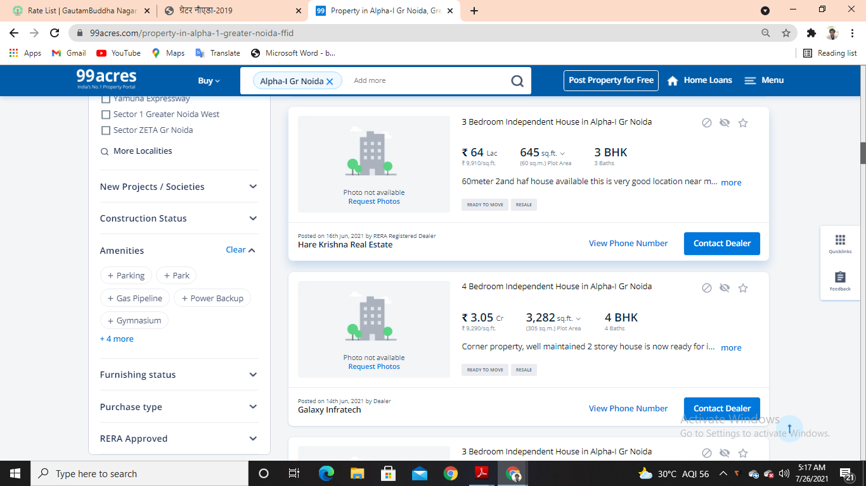

****

**GOOGLE MAP LOCATION– ANNEXURE V**

**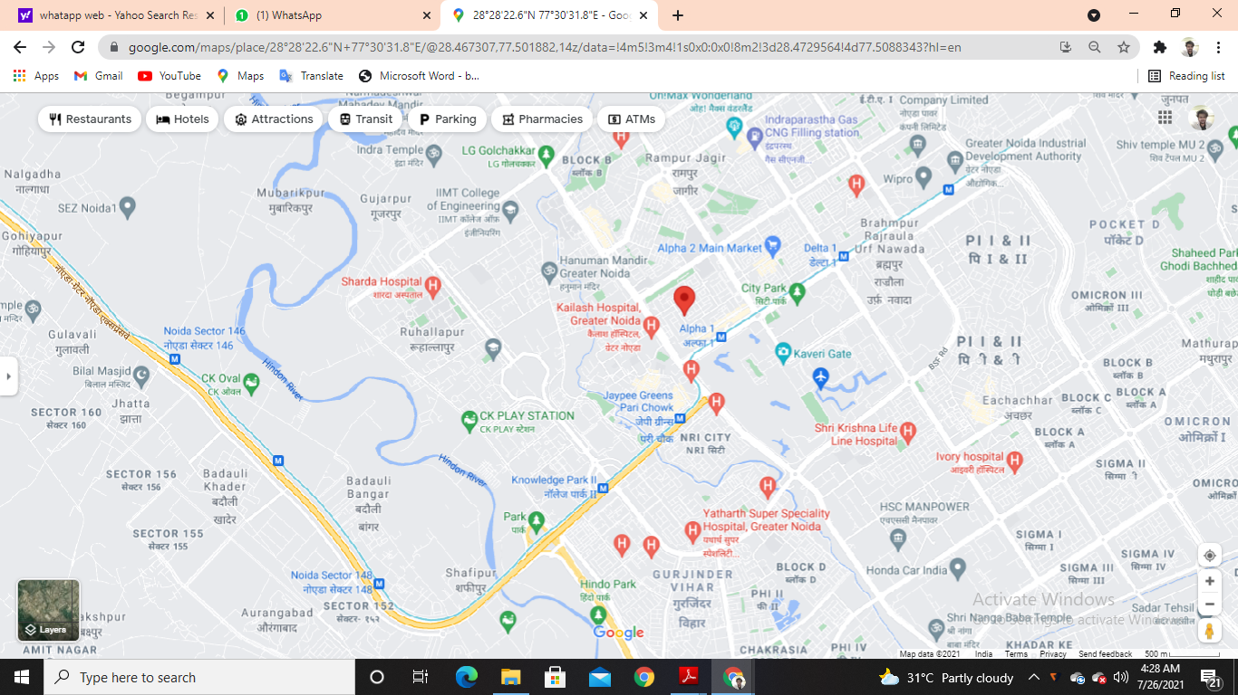**

**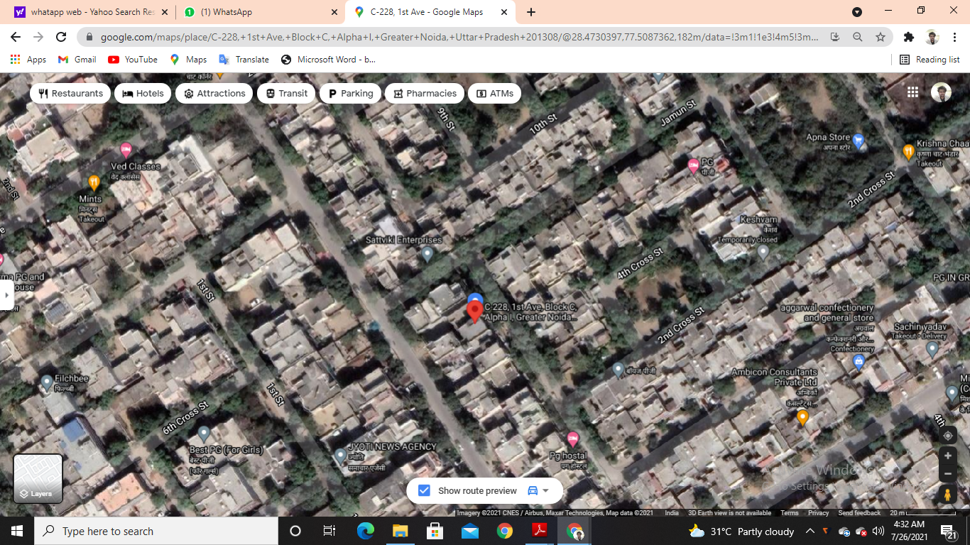**

**PHOTOGRAPHS OF THE PROPERTY– ANNEXURE VI**

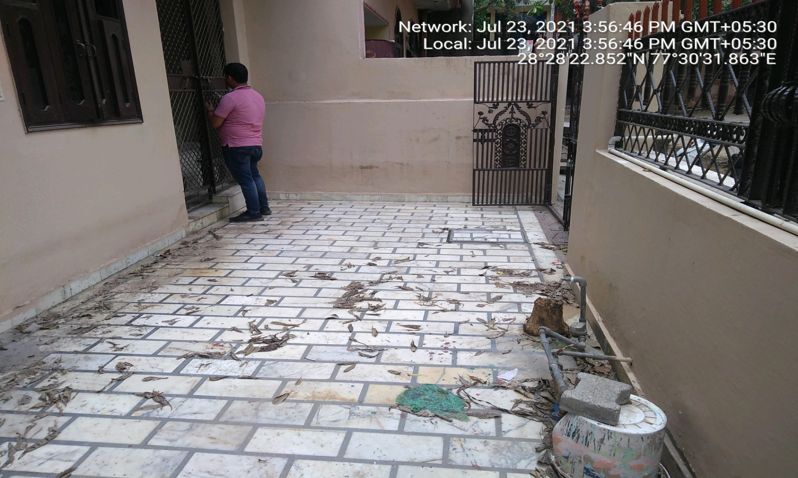

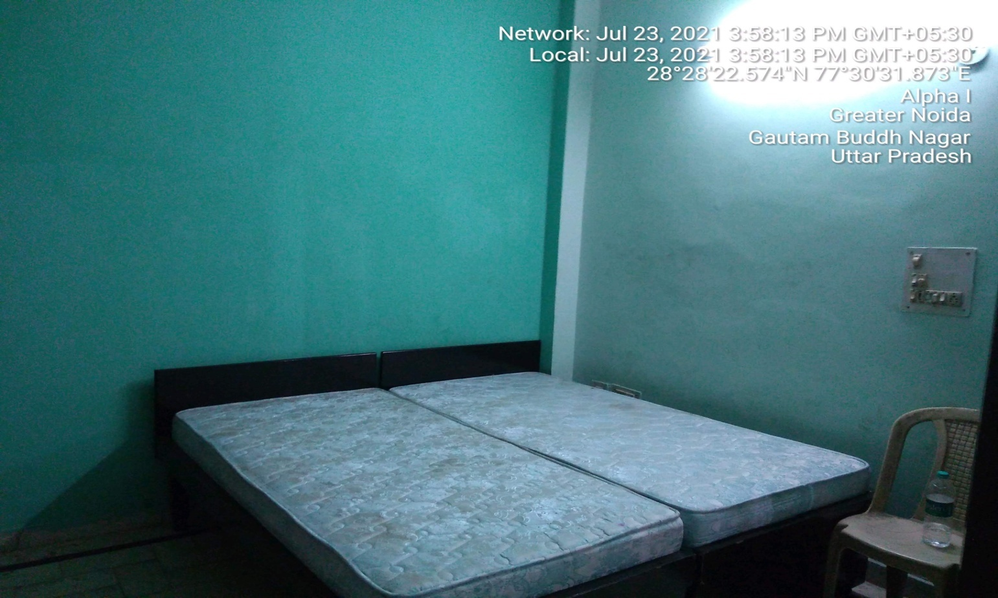

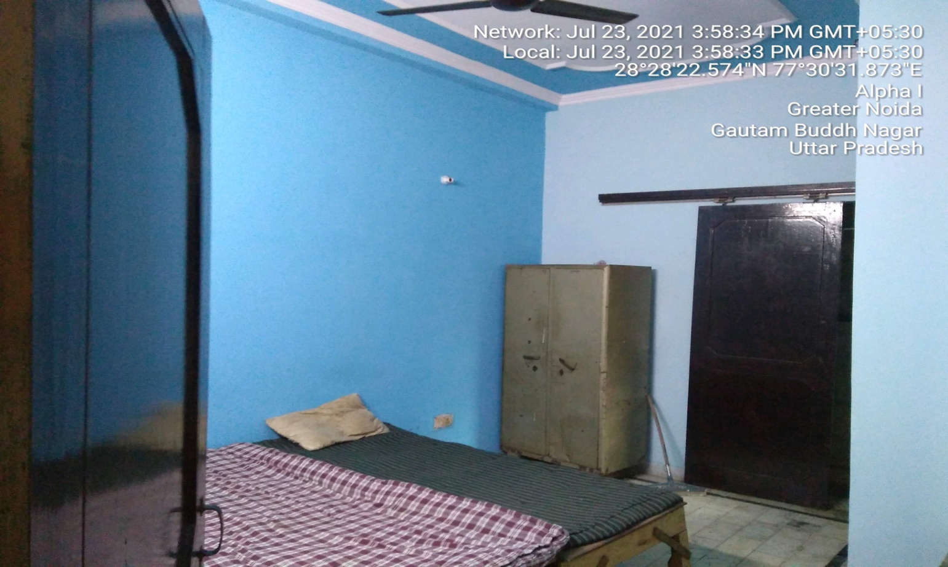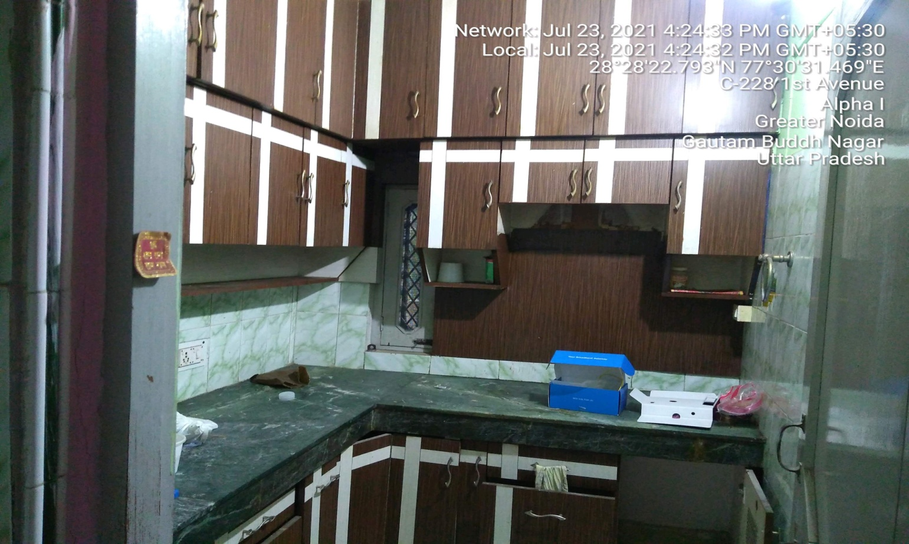

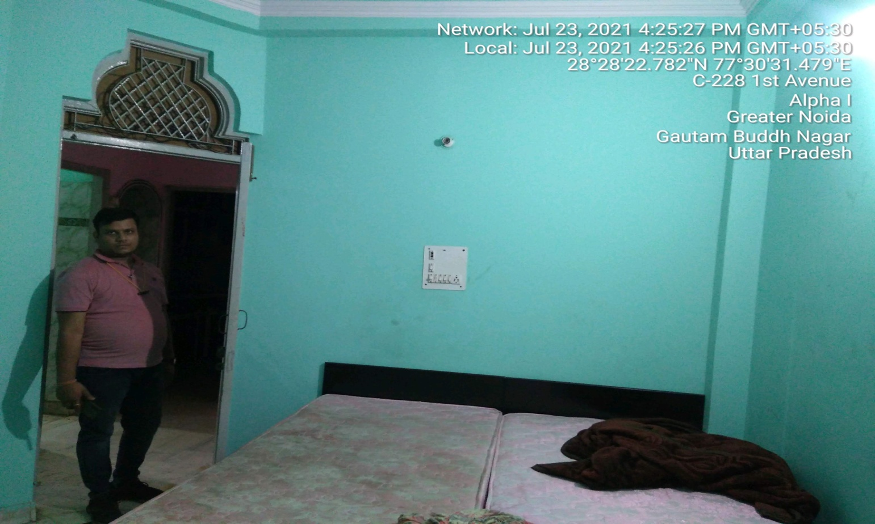 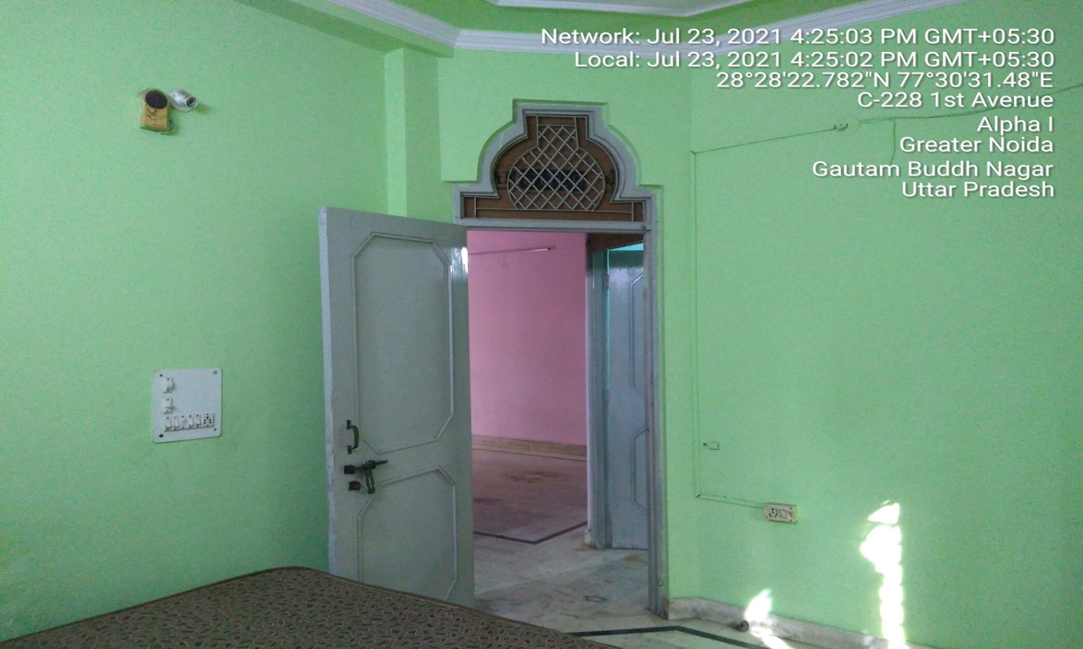

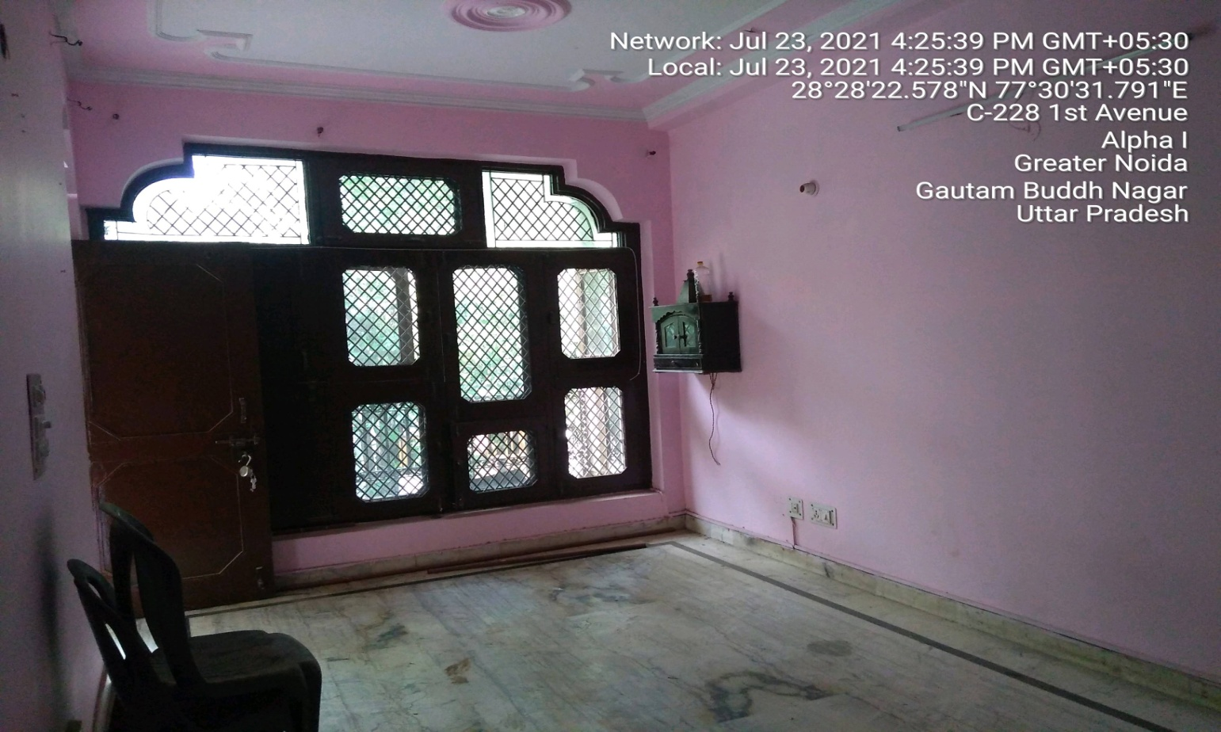

**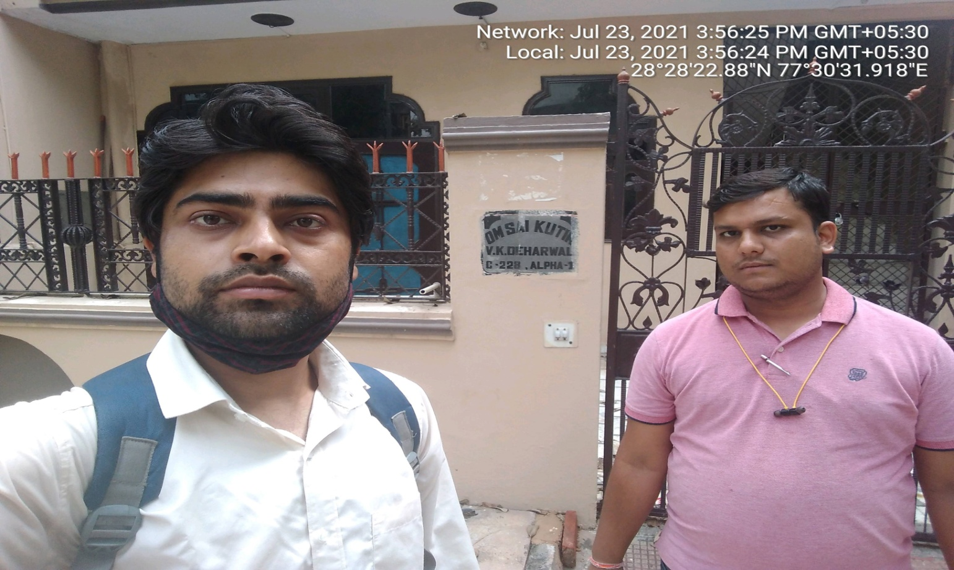**

**COPY OF CIRCLE RATE - ANNEXURE VII**

**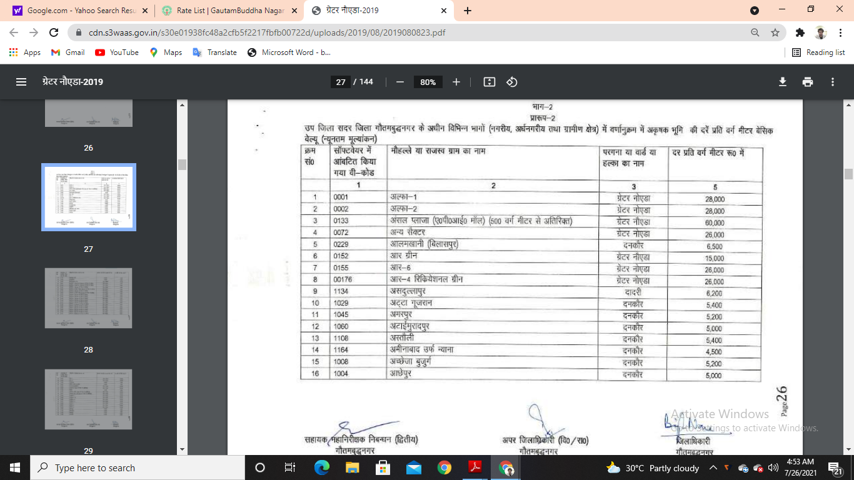**

**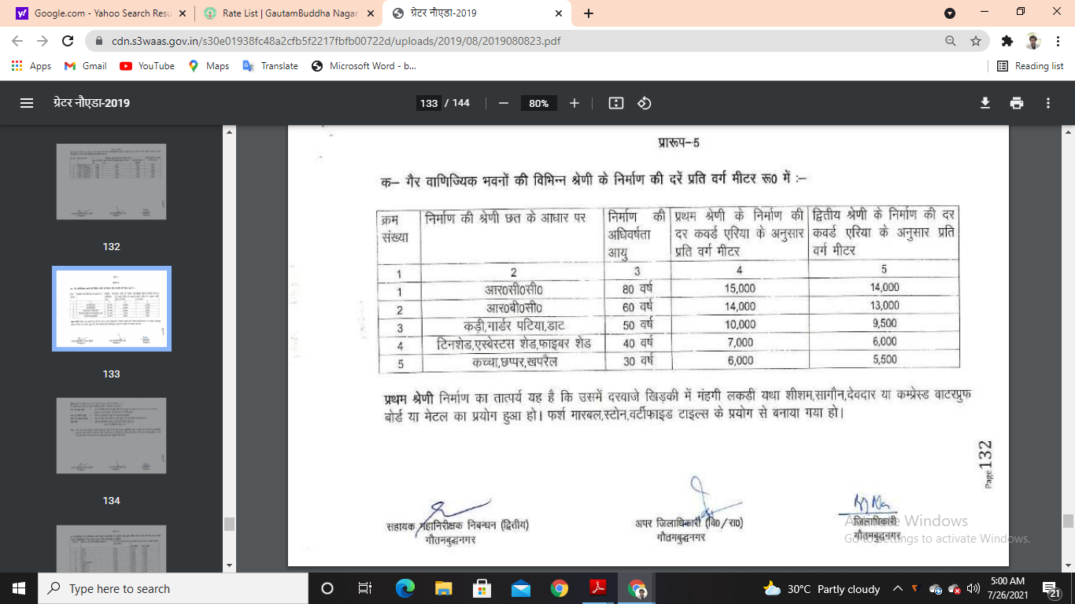**

**VALUER’S REMARKS - ANNEXURE IX**

|  |  |
| --- | --- |
|  | This Valuation report is prepared based on the copies of the documents/ information which interested organization or customer could provide to us out of the standard checklist of documents sought from them and further based on our assumptions and limiting conditions. All such information provided to us has been relied upon in good faith and we have assumed that it is true and correct. Verification or cross checking of the documents provided to us from the originals has not been done at our end. |
|  | Legal aspects for eg. investigation of title, ownership rights, lien, charge, mortgage, lease, verification of documents, etc. have to be taken care by legal expert/ Advocate and same are not done at our end. It is assumed that the concerned Lender/ Financial Institution has asked for the valuation of that property for which the legal verification has been already taken and cleared by the competent Advocate before requesting for the Valuation report. |
|  | Analysis and conclusions adopted in the report are limited to the reported assumptions, conditions and information came to our knowledge during the course of the work. |
|  | Value varies with the Purpose/ Date/ Condition prevailing in the market. We recommend not to refer the indicative & estimated prospective Value of the asset given in this report if any of these points are different from the one mentioned aforesaid in the Report. We also recommend that the indicative estimated Value in the Valuation Report holds good only upto the period of 3 months from the date of Valuation. |
|  | This report is having limited scope as per its fields & format to provide only the general basic idea of the value of the property prevailing in the market based on the documents/ data/ information provided by the client. The suggested indicative prospective estimated value should be considered only if transaction is happened as free market transaction. |
|  | This Valuation report is prepared based on the facts of the property on the date of the survey. It is a well-known fact that the market value of any asset varies with time & socio-economic conditions prevailing in the country. In future property Market may go down, property conditions may change or may go worse, Property reputation may differ, Property vicinity conditions may go down or become worse, Property market may change due to impact of Govt. policies or effect of World economy, Usability prospects of the property may change, etc. Hence before financing, Banker/ FI should take into consideration all such future risk and should loan conservatively to keep the advanced money safe in case of the downward trend of the property value. |
|  | Valuation of the same asset/ property can fetch different values in different situations. For eg. Valuation of a running/ operational shop/ hotel/ factory will fetch better value and in case of closed shop/ hotel/ factory it will have considerable lower value. Similarly an asset sold directly by an owner in the market will fetch better value and if the same asset/ property is sold by any financer due to encumbrance on it will fetch lower value. Hence before financing, Banker/ FI should take into consideration all such future risks and should loan conservatively to keep the advanced money safe in case of any such situation. |
|  | Getting cizra map or coordination with revenue officers for site identification is not done at our end. |
|  | Valuation is done for the property identified to us by the owner/ owner representative. At our end we have just cross verified the identification of the property with reference to the documents produced for perusal. Method by which identification of the property is carried out is also mentioned in the report clearly. Responsibility of identifying the correct property to the Valuer/ its authorized surveyor is solely of the client/ owner for which Valuation has to be carried out.It is requested from the Bank to cross check from their own records/ information if this is the same property for which Valuation has to be carried out to ensure that owner has not misled the Valuer company or misrepresented the property due to any vested interest. |
|  | In India more than 70% of the geographical area is lying under rural/ remote/ non municipal/ unplanned area where the subject property is surrounded by vacant lands having no physical demarcation or having any display of property survey or municipal number / name plate on the property clearly. Even in old locations of towns, small cities & districts where property number is either not assigned or not displayed on the properties clearly and also due to the presence of multiple/ parallel departments due to which ownership/ rights/ illegal possession/ encroachment issues are rampant across India and due to these limitations at many occasions it becomes tough to identify the property with 100% surety from the available documents, information & site whereabouts and thus chances of error, misrepresentation by the borrower and margin of chances of error always persists in such cases. To avoid any such chances of error it is advised to the Bank to engage municipal/ revenue department officials to get the confirmation of the property to ensure that the property shown to Valuer/ Banker is the same as for which documents are provided. |
|  | If this Valuation Report is prepared for the Flat/ dwelling unit situated in a Group Housing Society or Integrated Township then approvals, maps of the complete group housing society/ township is out of scope of this report and this report will be made for the specific unit based on the assumption that complete Group Housing Society/ Integrated Township must be approved in all respect.. |
|  | Due to fragmented & frequent change in building/ urban planning laws/ guidelines from time to time, different laws/ guidelines between regions/ states and no strict enforceability of Building Bye-Laws in India specially in non-metro and scale b & c cities & Industrial areas, property owners many times extend or make changes in the covered area/ layout from the approved/ applicable limits. There are also situations where properties are decades old when there was no formal Building Bye-Laws applicable when the construction must have been done. Due to such discrete/ unplanned development in many regions sometimes it becomes tough to determine the exact lawful situation on ground for the Valuer. In case nothing specific is noted on the covered built-up area considered in the Valuation Report, the covered area present on the site as per site survey will be considered in the Valuation. |
|  | Valuation is a subjective field and opinion may differ from consultant to consultant. To check the right opinion, it is important to evaluate the methodology adopted and various data point/ information/ factors/ assumption considered by the consultant which became the basis for the Valuation report before reaching to any conclusion. |
|  | Value analysis of any asset cannot be regarded as an exact science and the conclusions arrived at in many cases will, of necessity, be subjective and dependent on the exercise of individual judgment. Given the same set of facts and using the same assumptions, expert opinions may differ due to the number of separate judgment decisions, which have to be made. Therefore, there can be no standard formula to establish an indisputable exchange ratio. In the event of a transaction, the actual transaction value achieved may be higher or lower than our indicative analysis of value depending upon the circumstances of the transaction. The knowledge, negotiability and motivations of the buyers and sellers and the applicability of a discount or premium for control will also affect actual price achieved. Accordingly, our indicative analysis of value will not necessarily be the price at which any agreement proceeds. The final transaction price is something on which the parties themselves have to agree. However our Valuation analysis can definitely help the stakeholders to make them informed and wise decision about the Value of the asset and can help in facilitating the arm’s length transaction. |
|  | This report is prepared on the RKA V-L3 (Medium) Valuation format as per the client requirement and scope of work. This report is having limited scope as per its fields & format to provide only the general estimated & indicative basic idea of the value of the property prevailing in the market based on the information provided by the client. No detailed analysis, audit or verification has been carried out of the subject property. |
|  | This is just an opinion report and doesn’t hold any binding on anyone. It is requested from the concerned Client/ Bank/ Financial Institution which is using this report for mortgaging the property that they should consider all the different associated relevant & related factors & risks before taking any business decision based on the content of this report. |
|  | All Pages of the report including annexures are signed and stamped from our office. In case any paper in the report is without stamp & signature then this should not be considered a valid paper issued from this office. |
|  | Defect Liability Period is **30 DAYS**. We request the concerned authorized reader of this report to check the contents, data and calculations in the report within this period and intimate us in writing if any corrections are required or in case of any other concern with the contents or opinion mentioned in the report. Corrections only related to typographical, calculation, spelling mistakes will be entertained within the defect liability period. No request for any illegitimate value revision, date change or any other change will be entertained other than the one mentioned above. |
|  | R.K Associates encourages its customers to give feedback or inform concerns over its services through proper channel at [**valuers@rkassociates.org**](mailto:valuers@rkassociates.org) in writing within 30 days of report delivery. After this period no concern/ complaint/ proceedings in connection with the Valuation Services can be entertained due to possible change in situation and condition of the property. |
|  | Our Data retention policy is of **ONE YEAR**. After this period we remove all the concerned records related to the assignment from our repository. No clarification or query can be answered after this period due to unavailability of the data. |
|  | This Valuation report is governed by our (1) Internal Policies, Processes & Standard Operating Procedures, (2) R.K Associates Quality Policy, (3) Valuation & Survey Best Practices Guidelines formulated by management of R.K Associates, (4) Information input given to us by the customer and (4) Information/ Data/ Facts given to us by our field/ office technical team. Management of R.K Associates never gives acceptance to any unethical or unprofessional practice which may affect fair, correct & impartial assessment and which is against any prevailing law. In case of any indication of any negligence, default, incorrect, misleading, misrepresentation or distortion of facts in the report then it is the responsibility of the user of this report to immediately or atleast within the defect liability period bring all such act into notice of R.K Associates management so that corrective measures can be taken instantly. |
|  | R.K Associates never releases any report doing alterations or modifications by pen. In case any information/ figure of this report is found altered with pen then this report will automatically become null & void. |