**REPORT FORMAT:** V-L11 (Enterprise Valuation) | Version: 1.0_2018

**File No.: VIS (2021-22)-PL297-286-383 Dated: 23.08.2021**

**ENTERPRISE VALUATION REPORT**

**OF**

**M/S. TN (DK) EXPRESSWAYS LIMITED**

**REGISTERED AT**

**MADHUCON HOUSE, PLOT NO.1129/A,RD.36,HITECH CITY RD JUBILEE HILLS, HYDERABAD TG 500033 IN**

**PROMOTERS**

**A/C: M/S. MADHUCON PROJECTS LIMITED-SREI (CONSORTIUM)**

**REPORT PREPARED FOR**

**STATE BANK OF INDIA- 21st FLOOR, MAKER TOWERS E, CUFFE PARADE, MUMBAI-400005 Branch- SARG**

***\*\*Important - In case of any query/ issue or escalation you may please contact Incident Manager***

***At valuers@rkassociates.org. We will appreciate your feedback in order to improve our services.***

***NOTE: As per IBA Guidelines please provide your feedback on the report within 15 days of its submission after which report will be considered to be correct.***

**IMPORTANT NOTICE**

***COPYRIGHT FORMAT:*** *This report is prepared on the copyright format of R. K. Associates Valuers & Techno Engineering Consultants (P) Ltd. (R. K. Associates) to serve our clients with the best possible information and analysis to facilitate them to take rational business decisions. Legally no one can copy or distribute this format without prior approval from R. K. Associates. It is meant only for the advisory/ reference purpose for the organization/s as mentioned on the cover page of this report. Distribution or use of this format or report or any of its content/ information/ data by any organization or individual other than R.K Associates will be seen as an unlawful act and necessary legal action can be taken against the defaulters.*

*This report is intended for the sole use of the intended recipient/s and contains material that is STRICTLY CONFIDENTIAL AND PRIVATE.*

***DEFECT LIABILITY PERIOD:****In case of any query/ issue or escalation you may please contact Incident Manager at valuers@rkassociates.org. Though adequate care has been taken while preparing this report as per its scope, but still we can’t rule out typing, human errors, over sightedness of any information or any other mistakes. Therefore, the concerned organization is advised to satisfy themselves that the report is complete & satisfactory in all respect. Intimation regarding any discrepancy shall be brought into our notice immediately. If no intimation is received within 15 (Fifteen) days in writing from the date of issuance of the report, to rectify these timely, then it shall be considered that the report is complete in all respect and has been accepted by the client up to their satisfaction & use and further to which R.K Associates shall not be held responsible in any manner.*

***Part G: R. K. Associates Important Disclaimer and Remarks*** *are integral part of this report and Feasibility assessment is subject to this section. Reader of the report is advised to read all the points mentioned in these sections carefully.*

| **TABLE OF CONTENTS** | | |
| --- | --- | --- |
|  | | |
| **SECTIONS** | **PARTICULARS** | **PAGE NO.** |
| **Part A** | **INTRODUCTION** |  |
| 1. About the Report | 3 |
| 1. Executive Summary | 3 |
| 1. Type of Report | 4 |
| 1. Purpose of the Report | 4 |
| 1. Scope of the Report | 4 |
| 1. Methodology/ Model Adopted | 5 |
| 1. Data/ Information Received From | 5 |
| 1. Documents/ Data Referred | 5 |
| **Part B** | **About the Company** |  |
| 1. Brief Description About the Company | 6 |
| 1. Company’s Directors | 6 |
| 1. Promoters of The Project Company | 6 |
| 1. Shareholding Pattern | 8 |
| 1. Current operating status of the project company: | 8 |
| **Part C** | **About the Project** | 10 |
| **Part D** | **Assessment of Infrastructure Sector in India** |  |
| 1. Introduction | 13 |
| 1. EPC industry overview | 15 |
| 1. Measures taken by Government of India to Boost The Infrastructure Financing In Union Budget 2020-21 | 22 |
| 1. Key Challenges Faced by the Industry | 27 |
| 1. Outlook of The Infrastructure Sector | 28 |
| 1. Impact Of Covid19 On The Infrastructure Sector | 29 |
| 1. Relief Measures For Covid-19 For Infrastructure Sector | 30 |
| 1. Budget Announcement for Infrastructure Sector in F.Y.2021-22 | 31 |
| **Part E** | **Financial Projections** |  |
| 1. Previous Years Financial Performance | 32 |
| 1. Projected Profit & Loss Statement | 33 |
| **Part F** | **Valuation of the Company** |  |
| 1. Methodology/ Model Adopted | 34 |
| 1. Calculation of Free Cash Flow to Firm | 36 |
| 1. Valuation of Firm | 37 |
| 1. Key Assumptions | 38 |
| **Part G** | Remarks & Declaration | 41 |

|  |  |
| --- | --- |
| **PART A** | **INTRODUCTION** |

1. **ABOUT THE REPORT:** Enterprise Valuation of M/s TN (DK) Expressways Limited, a Special Purpose Vehicle (SPV) established to undertake the implementation of four lane of Karur to Dindigul bypass (from Km 305.600 to Km 373.275) (The Project) on NH-7 with a total length of 68.125 km and Improvement, Operation and Maintenance of 9.6 km from 292.6 to 305.6 of Karur bypass in the state of Tamil Nadu on NH-7 on a Build Operate and Transfer (”BOT”) basis.
2. **EXECUTIVE SUMMARY:** TN(DK) Expressways Limited, a Special Purpose Vehicle (SPV) promoted by Madhucon Projects Limited (MPL) as lead member and its associates and SREI Infrastructure Finance Limited, was established in January 2006 to undertake the implementation of four lane of Karur to Dindigul bypass (from Km 305.600 to Km 373.275) (The Project) on NH-7 with a total length of 68.125 km and Improvement, Operation and Maintenance of 9.6 km from 292.6 to 305.6 of Karur bypass in the state of Tamil Nadu under a Build, Operate and Transfer (BOT-Toll) concession awarded by NHAI.

NH-7, now renamed as NH 44, is the longest National Highway in the country and originates from Varanasi (Km 0.000), in the state of Uttar Pradesh, crosses NH-69 at Nagpur ,NH-9 and 202 at Hyderabad, NH 4 and 209 at Bangalore and ends in Kanyakumari (Km 2369.000) in Tamil Nadu. The project road is part of Bangalore- Salem-Madurai section of NH7 and of North-South corridor being developed by NHDP (Phase II) connecting Srinagar (in J&K) and Kanyakumari.

The concession agreement between TN (DK) Expressways Limited and NHAI was signed on April 20th, 2006. The concession granted to TN (DK) is for a period of 20 years starting from the appointed date. Date of Appointment will begin from 180 days from the concession agreement date i.e. October 17th, 2006. The project execution is through a fixed cost-fixed time EPC contract awarded to Madhucon Projects Limited (MPL).

As per the information provided by the lender, the toll collections of the company remain significantly low as compared to the previous projected revenue estimated by it. This resulted in liquidity crunch in the company and it became unable to pay its’ debt obligation on time. Moreover the restructuring proposal of the debt obligations of the company was rejected by the lenders in February’ 2018. Due to liquidity crunch in the company the major maintenance expenses of the company also got delayed by 50 months (approximately) in Jan’ 2019 instead of Nov’ 2014. Currently the company have an outstanding loan of INR 118.01 Crores which as per revised schedule needs to be paid by quarter ending Mar-23. The financials were classified as NPA in financial year 2018-19. However, we have assumed that it might take the company up to Dec’24 to repay the full debt amount.

Hence, in order to evaluate the current financial position of the company and to take further course of action regarding the borrowing facility extended to it, the lender has approached R.K Associates to determine the Fair value of the enterprise.

1. **TYPE OF THE REPORT:** Enterprise Valuation of M/s TN (DK) Expressways Limited.
2. **PURPOSE OF THE REPORT:** To estimate & determine current Fair Enterprise Value of the SPV Companyto enable the lenders to evaluate the further course of action on this account.
3. **SCOPE OF THE REPORT:** As per the client’s requirement and based on the purpose of the report, RK subject matter expert team has identified following points for arriving at Fair Enterprise Valuation of the Company and describe in-depth detailed assessment of the clear basis of the Valuation assessment.
4. **Business Plan Assessment:**

* Business Model
* Operation and maintenance of Project Site.
* Toll Collection Income from Toll Plazas
* Risk and mitigation strategies

1. **Financial Forecasting:**

* Key Financial Projections
* Key Financial Indicators

1. **Enterprise/ Business Valuation:**

* Based on Discounted Cash Flow Model (Free Cash Flow to Firm)

***NOTES:***

* ***This is just the enterprise valuation of the project based on its income generating capacity/ projections in future years. This Valuation shall not be construed as the physical asset valuation or should be directly related to cost approach or Project cost.***
* ***This Valuation only covers the cash flow generated from 77.725 K.m. toll project of the Company. It does not cover any transaction with the subject company’s subsidiary/ associate/ Joint Venture Companies.***
* ***This Enterprise Valuation report doesn’t cover vetting of the documents/ financial data/ projections or any other information provided to us by the Bank.***
* ***It doesn’t contain the principles of physical asset valuation and is not based on the site inspection of the project.***
* ***This exercise is neither an audit activity nor investigative in nature.***
* ***We have relied on the data provided by the Bank and the Company in good faith.***

1. **METHODOLOGY/ MODEL ADOPTED:** Discounted Cash Flow Model for the calculation of Enterprise Value of the Company.
2. **DATA/INFORMATION RECEIVED FROM:**

All the Data/ Information to perform this Enterprise Valuation Report received from:

|  |  |
| --- | --- |
| ***Particulars*** | ***Details*** |
| Name & Position | Mr. Biswajit Das |
| Organization | State Bank of India |
| Email Address | **sbi.18359@sbi.co.in** |
| Contact No. | +91 8008946076 |

1. **DOCUMENTS/ DATA REFFERED:**
2. Financial Statements of TN (DK) Expressways Limited from FY 15-16 to FY 20-21.
3. Financial Model of the TN (DK) Expressways Limited.
4. Concessionaire agreement between NHAI and TN (DK) Expressways Limited.
5. Data collected from Public sources and Government agencies.
6. Monthly toll collection data from Nov, 2009 to July, 2021.
7. Penalty imposed by NHAI on the Company for delay in Major Maintenance Work.

|  |  |
| --- | --- |
| **PART B** | **ABOUT THE COMPANY** |

1. **BRIEF DESCRIPTION ABOUT THE COMPANY:**

The incorporation details of the Project Company are provided in the table below:

|  |  |
| --- | --- |
| **Name** | M/s. TN (DK) Expressways Limited |
| **CIN** | U45200AP2006PLC048941 |
| **Sector** | Infrastructure - Roads & Highways |
| **Constitution** | Public Limited Company (Closely Held) |
| **Address:** | **Registered Office:**  Madhucon House, 8-2-272/82/A/1129/A, Road no. 36, Jubilee Hills, Hyderabad  **Site:** District: Karur & Dindigul State: Tamil Nadu |
| **Date of Incorporation** | 31st January 2006 |
| **Authorized Capital** | INR 75,00,00,000/- |
| **Issued, Subscribed and Paid-up Capital** | INR 74,66,00,000/- |

**Source:** “http://mca.gov.in/mcafoportal/companyLLPMasterData.do” *and Data provided by the Company*

1. **COMPANY’S DIRECTORS:**

|  |  |  |  |
| --- | --- | --- | --- |
| ***S. No.*** | ***DIN No.*** | ***Director Name*** | ***Begin Date*** |
| 1 | 00022855 | Mr. Srinivasa Rao Kamma | 31/01/2006 |
| 2 | 00368625 | Mr. Madhu Malampati | 16/12/2009 |
| 3 | 02984867 | Mr. Nama Rama Rao | 14/02/2015 |

1. **PROMOTERS OF THE PROJECT COMPANY:**

**BACKGROUND:**

Madhucon group, based out of Hyderabad, Andhra Pradesh, founded and promoted by Mr. N. Nageswara Rao, is one of the major players in Indian infrastructure space having interests in diverse verticals like construction of roads, thermal power projects, mining, real estate, dams, tunnels, aqua ducts, bridges, coal handling plants and other civil projects. The group structure of Madhucon is depicted below:

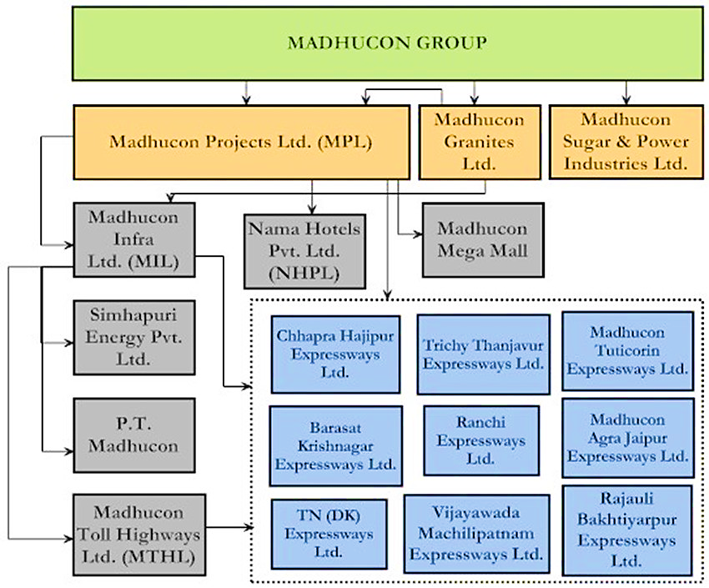

1. **MADHUCON PROJECTS LIMITED (MPL):**

MPL is the flagship company of Madhucon Group. MPL originally incorporated on March 15, 1990, as Madhu Continental Constructions Private Limited was converted into a Public Limited Company in the year 1995 and was renamed as Madhucon Projects Limited. MPL has led the groups foray into infrastructure space like road, energy and mining. MPL has its presence in developing hotels, malls and office complexes through its subsidiaries viz., Nama Hotels Private Limited and Madhucon Mega Mall Private Limited.

1. **MADHUCON INFRA LIMITED (MIL):**

In order to unlock the group valuation and ensure focus on growth in the infrastructure sector, investment in BOT road projects, energy and mining under MPL have been transferred to its subsidiary, Madhucon Infra Limited (MIL). MIL will focus its investments in infrastructure space across transportation, energy and mining in India and other countries.

1. **MADHUCON TOLL HIGHWAYS LIMITED (MTHL):**

Madhucon Group is in the process of reorganizing its structure and has set up a road holding company viz., Madhucon Toll Highways Limited (MTHL). All the road projects under various SPVs are proposed to be vested under MTHL.

1. **Shareholding Pattern of TN(DK) Expressways Limited:**

Details of shareholding pattern of the company are as described below as on 31st March, 2021 are as described below:

| ***(As at March 31,2021)*** | ***Amount(In INR)*** |
| --- | --- |
| Authorized Share Capital  (Equity Share of INR 10/- each) | 7,50,00,000 |
| Issued, Subscribed and Paid-up Capital  (Equity Share of INR 10/- each fully paid-up) | 7,46,60,000 |

| ***(As at March 31,2021)*** | ***Number of share held*** | ***% of holding*** |
| --- | --- | --- |
| Madhucon Infra Limited(Holding Company) | 38,05,50,000 | 50.98% |
| Madhucon Toll Highways Limited  (Subsidiary of Holding Company) | 3,64,77,000 | 48.87% |
| Others | 1,28,000 | 0.17% |
| **Total** | **7,46,60,000** | **100 %** |

Apart from equity capital of Rs.74.66 Cr. in to the project company, till date an amount of Rs.19.05 cr. was infused additionally by the promoter companies as unsecured loans in to the project SPV to service interest and during the construction period to keep the account as standard as per the Information Memorandum shared to us.

1. **CURRENT OPERATING STATUS OF THE PROJECT COMPANY**:

According to the Company, the current operating status of the project is as under:

* The Company has given sub contract of “Major Maintenance Work” (MMW) to M/s TTK Construction (for Overlying Work), M.s PSK Infrastructure and Projects Pvt. Ltd. (for overlying work), M/s RKON Infra Developers Pvt. Ltd (for Kerb Paintings), M/s IQRA Road Safety Solutions (for Thermoplastic Road Marking) and M/s A1ABI Pvt. Ltd. (for Thermoplastic Road Marking).
* It is considered continued delays in repayment of Tamil Nadu Dindigul Karur Expressways Limited’s (TNDK) debt obligations and has also been classified as non-performing asset by the lenders. Despite restructuring of debt in December 2012. The toll collections continue to remain significantly below expectations when compared to initial projected levels. Further, TNDK witnessed 14.12 % decline in toll collections in FY2021 owing to adverse impact of the COVID-19 pandemic. The prospects for traffic growth along the route are modest, given that the stretch is not an arterial route. Poor toll collections, caused major maintenance (MM) reserve could not be created. As per concession agreement, the first MM was due in November 2014. However, due to funding constraints, it was delayed by 50 months and finally commenced in January 2019 with an estimated cost of INR 76.6 Crores, which is being funded through the project cash flows. As on March 31, 2021, 90% of the MM work is completed and expected to be completed by FY2022.
* The principal repayment obligation for FY2022 for TNDK is INR 32.48 Crores which cannot be met through cash flow from operations.

|  |  |
| --- | --- |
| **PART C** | **ABOUT THE PROJECT** |

M/s. TN (DK) Expressways Limited, a special purpose vehicle (SPV) promoted by Madhucon Projects Limited (MPL) as lead member and its associates and SREI Infrastructure Finance Limited, was established in January 2006 to undertake the implementation of four lane of Karur to Dindigul bypass (from Km 305.600 to Km 373.275) (The Project) on NH-7 with a total length of 68.125 km and Improvement, Operation and Maintenance of 9.6 km from 292.6 to 305.6 of Karur bypass in the state of Tamil Nadu under a Build Operate and Transfer (BOT-Toll) concession awarded by NHAI. The details of the project are as provided below:

| **TN-DK EXPRESSWAYS LIMITED – TNDK** | | | | |
| --- | --- | --- | --- | --- |
| Widening existing 2 lane to 4 lane Design Construction, Development, Finance Operation and maintenance of Karur to Dindigul Section (Km 305.600 to Km 373.725) and Improvement, Operation and Maintenance of Karur Bypass (Km 292.600 to 305.600) under NHDP-Phase II on NH7 in the state of Tamilnadu. | | | | |
|  |  |  |  |  |
| Concession Period | 20 years |  | BASIS | BOT |
| Letter of Award Date | 21 Nov 2005 |  |  |  |
| Agreement Date | 20 Apr 2006 |  | Project Cost (INR Cr.) | 375.52 |
| Financial Closure | 11 Oct 2006 |  | Project Asset (INR Cr.) | 385.7 |
| Commencement Date | 17 Oct 2006 |  | Debt (INR Cr.) | 224.00 |
| Project Ends On | 17 Oct 2026 |  | Equity (INR Cr.) | 74.66 |
| Actual C.O.D | 05 Nov 2009 |  | NHAI Construction Grant (INR Cr.) | 74.66 |
|  |  |  | NHAI Operational Grant (INR Cr.) | 11.34 |
| Length - Kms | 77.725 |  | Unsecured Loan by Promoters during Construction (INR Cr.) | 2.20 |
| Laning | 4 |  |  |  |
| Lane - Kms | 310.90 |  | Total Unsecured Loan by Promoters (INR Cr.) | 19.05 |

The project was envisaged to achieve COD on April 16th, 2009. However, according to the TEV study provided by the company, the project got delayed by more than 6 months due to delay in land acquisition and utility shifting and truck transporters strike. The project’s actual C.O.D was November 5th, 2009. Presently, The Highway is operational and a 4x4 toll booth is setup at Karur - Dindigul NH-7 Project, Km - 332, Velanchettiyur Post, Aravakurichi Taluk, Karur - District, Tamilnadu - 639 207 where toll is collected by the Concessionaire.

The Project cost at the time of financial closure was estimated at INR 373.32 Crores. The Project was proposed to be funded by a Promoter’s contribution of INR 74.66 Crores, NHAI construction grant of Rs.74.66 Crores and Rupee term loans of Rs.224.00 Crores leading to a debt to equity (including quasi-equity) ratio of 1.5:1. The project was completed at a cost of Rs.375.51 Crores with a cost overrun of INR 2.19 Crores which was funded by way of promoter contribution. As per the provided Information, the current operating status of the project is as under:

* The Company has given sub contact of “Major Maintenance Work” (MMW) to M/s TTK Construction (for Overlying Work), M/s PSK Infrastructure and Projects Pvt. Ltd (for overlying work), M/s RKON Infra Developers Pvt. Ltd (for Kerb Paintings), M/s IQRA Road Safety Solutions (for Thermoplastic Road Marking) and M/s A1ABI Pvt. Ltd (for Thermoplastic Road Marking).
* As per concession agreement, the first MM was due in November 2014. However, due to funding constraints, it was delayed by 50 months and finally commenced in January 2019 with an estimated cost of Rs. 76.6 Crores, which is being funded through the project cash flows. As on March 31, 2021, 90% of the MM work is completed and expected to be completed by FY2022.
* The lenders have sanctioned a total of 224 Cr for the project in which 118.01 Cr is outstanding as on 31st March 2021.

**Summary of Toll Collection till July, 2021:**

|  |  |  |  |  |  |  |  |  |  |  |  |  |  |  |  |
| --- | --- | --- | --- | --- | --- | --- | --- | --- | --- | --- | --- | --- | --- | --- | --- |
| ***SUMMARY OF TOLL REVENUE COLLECTION AS ON 31st July, 2021*** | | | | | | | | | | | | | | | |
| ***Yearly & Month-wise Actual Revenue [in Crores]*** | | | | | | | | | | | | | | | |
| **Financial year** | **Apr** | **May** | **Jun** | **Jul** | **Aug** | **Sep** | **Oct** | **Nov** | **Dec** | **Jan** | **Feb** | **Mar** | **Total** | **Monthly Average Toll Collection** | **% Change** |
| 2009-10 |  |  |  |  |  |  |  | 1.65 | 2.10 | 2.05 | 1.89 | 2.03 | **9.72** | 1.94 |  |
| 2010-11 | 1.93 | 2.06 | 1.98 | 1.94 | 1.96 | 2.11 | 2.23 | 2.13 | 2.58 | 2.55 | 2.32 | 2.45 | **26.24** | 2.19 | **12.5%** |
| 2011-12 | 2.29 | 2.51 | 2.42 | 2.47 | 2.29 | 2.61 | 2.45 | 2.52 | 2.74 | 2.74 | 3.05 | 3.36 | **31.45** | 2.62 | **19.9%** |
| 2012-13 | 3.26 | 3.46 | 3.32 | 3.39 | 2.85 | 2.69 | 2.81 | 2.71 | 3.24 | 3.16 | 2.90 | 3.24 | **37.03** | 3.09 | **17.7%** |
| 2013-14 | 3.21 | 3.50 | 3.25 | 3.15 | 2.86 | 3.02 | 3.04 | 2.79 | 3.21 | 3.22 | 2.91 | 3.06 | **37.22** | 3.10 | **0.5%** |
| 2014-15 | 2.93 | 3.24 | 3.07 | 3.11 | 2.98 | 3.03 | 3.05 | 3.10 | 3.49 | 3.49 | 3.18 | 3.37 | **38.04** | 3.17 | **2.2%** |
| 2015-16 | 3.31 | 3.71 | 3.47 | 3.41 | 3.47 | 3.23 | 3.51 | 3.21 | 2.21 | 3.77 | 3.62 | 3.75 | **40.67** | 3.39 | **6.9%** |
| 2016-17 | 3.55 | 3.70 | 3.59 | 3.60 | 3.69 | 3.36 | 3.68 | 1.04 | 3.81 | 3.97 | 3.73 | 4.03 | **41.75** | 3.48 | **2.7%** |
| 2017-18 | 3.94 | 4.22 | 3.99 | 3.81 | 4.13 | 4.20 | 4.12 | 4.28 | 4.73 | 4.60 | 3.90 | 4.31 | **50.23** | 4.19 | **20.3%** |
| 2018-19 | 4.17 | 4.59 | 4.26 | 3.98 | 4.45 | 4.24 | 4.49 | 3.45 | 3.95 | 3.88 | 3.57 | 3.96 | **48.99** | 4.08 | **-2.5%** |
| 2019-20 | 3.88 | 4.28 | 3.98 | 3.99 | 4.11 | 4.22 | 4.27 | 4.28 | 4.70 | 4.51 | 4.17 | 3.23 | **49.62** | 4.14 | **1.3%** |
| 2020-21 | 0.56 | 2.95 | 3.22 | 2.77 | 3.18 | 3.74 | 4.00 | 3.72 | 4.34 | 4.63 | 4.53 | 4.98 | **42.62** | 3.55 | **-14.1** |
| 2021-22 | 4.30 | 2.91 | 3.48 | 4.75 | **3.34** | **3.93** | **4.20** | **3.91** | **4.56** | **4.86** | **4,76** | **5.23** | **50.22** | 4.18 | **17.18%** |
| **Total** | **37.33** | **41.13** | **40.03** | **40.37** | **39.47** | **40.56** | **42.05** | **38.97** | **45.87** | **47.43** | **44.53** | **47.00** | **443.86** |  |  |
| ***Average growth rate for the period of FY 2010-21*** | | | | | | | | | | | | | |  | ***6.13%*** |
| ***Average growth rate for the period of FY 2012-21*** | | | | | | | | | | | | | |  | *5.49%* |

**Note:** The toll collection income for the period from Aug, 2021- Mar’ 2022 are projected based on the analysis of actual toll collection for the past years i.e. percentage change in the past collections.

**Observations:**

* Average growth for the period of FY 2010 to FY 2021 is 6.13%.
* The toll collections continue to remain significantly below expectations when compared to initial projected levels. Further, TNDK witnessed 14.12 % decline in toll collections in FY2021 owing to adverse impact of the COVID-19 pandemic. The prospects for traffic growth along the route are modest, given that the stretch is not an arterial route.
* The Toll Collection of all toll plazas on pan India basis was shut down from 25th March 2020 to 20th April 2020 by the Govt. order to NHAI due to Covid-19 Pandemic Lockdown. Due to the shutdown operations, the toll collection for the month of April’2020 is only Rs. 0.56 Crores.
* From April 2021 to July 2021 toll collection has been increased significantly for the same months as compared to previous year which shows trends to significant improvement in the toll collection for the upcoming projected years.

|  |  |
| --- | --- |
| **PART D** | **ASSESSMENT OF INFRASTRUCTURE SECTOR IN INDIA** |

* + - 1. **INTRODUCTION:**

Road infrastructure is the backbone of the Indian economy. Roads and highways form one of the core areas under the infrastructure sector. The Government has been taking measured efforts in providing more efficient transportation, for which they have signiﬁcantly stepped up the highway development and road building program. The Government’s thrust on the Infrastructure sector has remained strong in the Union Budget 2021-122. The infrastructure, one of the capital-intensive sector got a shot in the arm with a sharp increase in Budget outlay and measures that will potentially boost financing through infrastructure debt funds to raise funds by issuing tax efficient "Zero Coupon Bonds". The government has allocated INR 20,000 Crores to set up and capitalize a Development Financial Institution (DFI) called National Bank for Financing Infrastructure and Development (NaBFID)—to act as a provider, enabler and catalyst for infrastructure financing and a Rs 5 lakh crore lending portfolio will be created under the proposed DFI in three years. The National Infrastructure Pipeline, which was launched with 6,835 projects, has now expanded to 7,400 projects.

Budgetary allocation of INR 1,83,101 Cr in Financial Year 2022, the highest ever outlay which is 5.5 times more, from INR 33,414 Cr in Financial Year 2015, announced for Ministry of Road Transport and Highways(MoRTH), of which Rs 1,08,230 crore reserved for capital expenditure. Under the Bharatmala Pariyojana, with an estimated investment of Rs 5.35 lakh crore, already 13,000 km of roads worth Rs 3.3 lakh crore have been awarded for construction. A significant amount of money has been earmarked for ongoing and new economic corridors/expressways.

The MoRTH has achieved the record-breaking milestone of constructing 37 kilometers highways per day in year 2020-21. Length of National Highways has gone up by 50% from 91,287 km to 1, 37,625 km. from April 2014 to 20 March 2021. Despite Covid-19 related impact the sanctioned amount has been increased by 126% in Financial Year 2021 over Financial Year 2020. The sanctioned length in kilometers has also increased by 9% in Financial Year 2021 over Financial Year 2020. The Average annual project award (annual average award length) has increased by 85% during Financial Year 2015 to Financial Year 2021 as compared to FY10 to FY14. The Average annual construction (average annual construction length) has increased by 83% during FY2015 to FY2021 as compared to FY2010 to FY2014. The Cumulative cost of ongoing project works has increased by 54% at the end of Financial Year 2021 compared to Financial Year 2020.

Planning Commission came out with a set of factors to identify sectors that can be classified under the broader infrastructure sector. Natural monopoly, high investment and high level of government regulations were few of the factors that were considered. Based on these factors **Power, Roads, Railways, Ports, Airports, and Telecom** have been grouped under infrastructure sector.

| ***OVERVIEW OF INDIAN INFRASTRUCTURE SECTOR : Key Highlights*** | |
| --- | --- |
| **Power** | * India is the third largest electricity generation country in the world after China and USA. * Public sector companies and State electricity boards dominate both generation and T&D sectors. * 0.4% peak power deficit in FY 2020-21 against 0.7% in FY 2019-20. |
| **Roads (Road & Bridges)** | * With 5.89 million kilometers roads, India has second largest road network in the world comprising of National Highway, State Highways, Project and Rural road. * This road network transports 64.5% of all goods in the country and 90% of India’s total passenger traffic uses road network to commute. * National Highways accounts for only 2.7% of total road network but carries 40% of traffic. |
| **Railways** | * India has fourth largest rail network in the world. * Rail network in the country spans 117,996 Kms of tracks over a route of 66,030 Km making it one of the largest rail networks in Asia. * It is also one of the busiest networks in the world with 22,300 trains running daily. * Low average speeds (Freight - 25.9 kmph: Mail/ Express – 50.6 kmph). Target to increase average speed of freight trains to 50 kmph and Mail/Express trains to 80 kmph by 2020. * Targets to complete Eastern and Western Dedicated Freight Corridors by the end of Dec 2021. |
| **Ports** | * 12 major ports and over 205 notified minor ports along a coastline spanning over 7,517 kilometers. * Over 90% of total trade in volume terms and 70% of total trade in value terms in the country is handled by ports. |
| **Airports** | * Indian aviation sector comprises of over 449 airports and airstrips out of which 125 are owned and operated by Airport Authority of India. * Key Challenges include inadequate capacity in Runways & Aircraft handling and Congestion in Parking Space and Terminal Buildings |
| **Telecom** | * Second largest telecom market in the world after China in terms of subscriber base. * Around 1058. 86 Million subscribers, with a tele density of 83.36%. * Private operators dominate the sector with ~89.78% market share. * Broadband to all villages by 2022 under which 250,000 Gram Panchayats are planned to be connected. * Wi-Fi connectivity to major tourist places and cities. |

* + - 1. **EPC INDUSTRY OVERVIEW:**

Engineering procurement and construction (EPC) contracts are the most common form of contracts used to undertake construction works by the public and private sector on large scale and complex infrastructure projects, such as power plants, petroleum and LNG terminals, steel mills, roads, bridges etc. Under an EPC contract a contractor is obliged to deliver a complete facility to a developer who needs only turnkey to start operating the facility; hence EPC contracts are sometimes called turnkey construction also in contracts. In addition to delivering a complete facility, the contractor must deliver that facility for a guaranteed price by a guaranteed date and it must perform to the specified level. Failure to comply with any requirements will usually result in the contractor incurring monetary liabilities.

1. **EPC PROCESS:**

The most modern variation is called EPCM that is engineering, procurement, construction and management. On a global level, construction industry has completely adopted the EPC contracts and the EPC contractors have limited the otherwise predominant role of engineering consultants. These EPC firms are ready to take the risks associated with managing a project and possess procurement and project.

Competitive forces are driving consolidation of construction in the EPC industry and leading to alliances among the large players. EPC contracts may vary in the basis of assignment of responsibility and related penalties. The relationship between different constituents of the industry is very flexible as shown in the exhibit below.

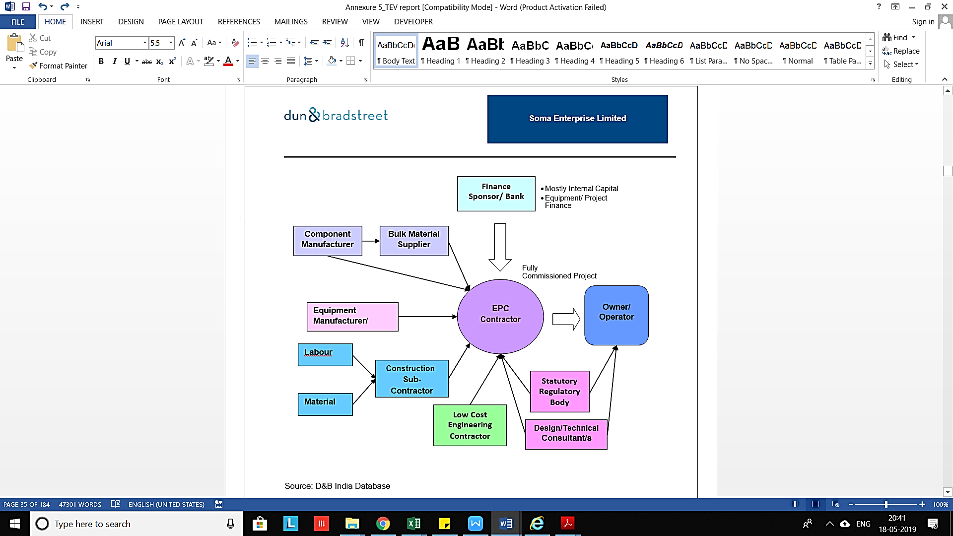

The process of appointing EPC Contractor has been provided in the exhibit below–

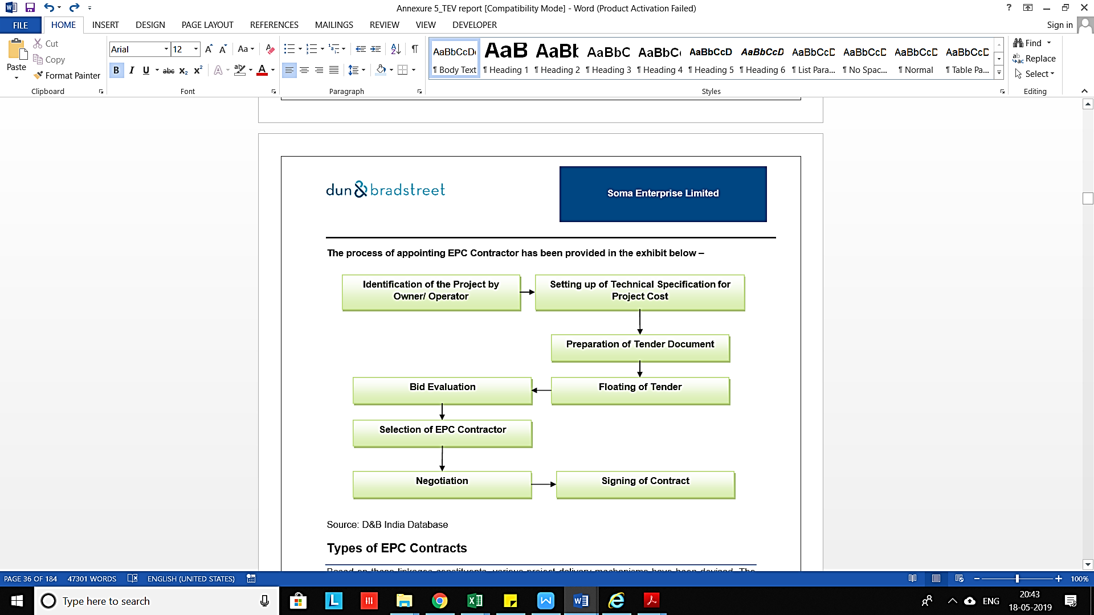

1. **TYPE OF EPC CONTRACTS:**

Based on these linkages constituents, various project delivery mechanisms have been devised. The size and nature of the project also influences the choice of the project delivery mechanism. The different types of contracts are as given here:

1. Engineering, Procurement and Construction (EPC)

* Complete single point responsibility
* Fixed time fixed price contracts, heavy penalties for non-performance
* Escalation possible by mutual consent

1. Lump-sum Turnkey (LSTK)

* Preferred for power and industrial projects
* Engineering Procurement Construction Management (EPCM)
* Responsibility for placement of order for equipment and payment lies with the promoters.
* Fixed time–fixed price contracts
* Lower penalties relative to EPC for non-performance
* Preferred for very large projects in sectors such as petrochemicals, oil and gas and steel

1. Turnkey

* Responsibility to implement complete project
* Fixed price as well as cost plus contracts are possible
* Contractor need not have financial capability
* Preferred for medium and small projects

1. Engineered Packages Route

* Promoter breaks up the project into packages
* Turnkey supply of packages
* Promoter is responsible for project co-ordination

1. Item Rate Contract

* This is the most prevalent contractual mechanism in which: -
* The owner through an appointed consultancy organization does the Engineering.
* Bill of qualities is furnished and tenderer is required to quote the price item-wise.
* The contractor need not have large financial capability in this case.

**EPC Construction Risk Management:**

Often EPC construction contemplates a turnkey approach to project delivery. In other words, the project owner or employer will look to the EPC contractor as the single point of contact for all facets of the project, from basic design through commissioning and start-up of the facility. EPC projects offer a mutually beneficial and exciting form of project delivery for both the owner and the contractor. But, with the EPC contract come many new risks that are often severe due to the complex nature and high cost frequently associated with this type of project. Understanding these risks and some of the other unique characteristics of EPC contracting its critical to a successful project where both the owner and the contractor obtain the high rewards for the risk. Project owners have attempted to shift more risk to the contractor, understanding at least theoretically, that this risk allocation carries a higher price tag. Some important features that differentiate risk in an EPC contract as compared to regular contracts can be seen below:

* Risks traditionally assumed by the owner in design-bid-build and design build contracts may no longer fall under the owner's umbrella of responsibility. For example, the contractor may be required to assume the risk of unforeseen site conditions and may be responsible for events that would traditionally be viewed as force majeure (i.e. beyond the control of either party).
* The greatest risk for the contractor in entering into the EPC contract is not necessarily anything inherent in the EPC form of contracting. Instead, the problems most frequently arise when the contractor commits to a lump sum or fixed price. Despite the inherent risks to the contractor, the project owner cannot assume that lump pricing insulates him from all cost overruns. There are always activities on a project that interfaced business processes such as marketing, sales and customer services. After each phase, reviews are also undertaken.

At the initial stage a strategic review is carried out of the works to be carried out. This is followed by the "offer kick off, which is in the form of proposals submitted by the EPC contractor, defining how and at what price the project should be undertaken. After the contract agreement, review is conducted to ascertain whether the engineering by the contractors conforms to the contractual obligation.

**Development Phase:**

The development phase is the first stage of the EPC project process and covers the important aspects of engineering. This can be viewed as an extension of the planning process. The engineering process produces a range of deliverables, which includes –

* Feasibility Study
* Estimates
* Designs
* Drawings
* Specifications
* Data sheets

**Tests Results:**

Having made a decision to execute the process on EPC turnkey basis, the employer appoints a consultant and states his requirements in the form of a design brief. The consultant then expands the design brief into a more explicit employer’s requirement, taking into account the project development phase during which the design responsibility is handed over to the contractor.

**Financing Stage:**

The employer has to achieve financial closure, which involves the promoters brining in their own funding in the shape of equity as well as organizing loans. This should ideally precede or proceed with parallel with the EPC negotiation process.

**Bidding Award of Contract:**

Having made a decision to benefit from a contractor's expertise and experience by selecting the EPC Turnkey approach the Employer, usually in collaboration with his chosen consultant, will, first of all, express his requirements in the form of a design brief. The consultant, normally employed to oversee the project, advises the Employer from the conceptual stage of the project and is then involved in expanding the brief in to the more explicit "Employer's Requirements"' taking into consideration, up to what stage it has been decided that the design responsibility should be taken over by the successful contractor. The consultant, with or without the aid of the Employer, will then incorporate the Employer's

Requirements into bid documents for presentation to various prequalified bidders before finally being involved in the technical and financial assessment of the successful contractor's bid in response to the same. It can be seen, therefore, in reality that in EPC Turnkey projects contractors may have to assume responsibility for completing and/or developing an incomplete design at any time from briefing onwards.

**Negotiating Stage:**

The consultant incorporates the employer's requirements into the bid documents and brings out a notice for prequalification. This is done so that only established parties are short listed as bidders. Thereafter, a notice inviting tenders (NIT) is issued by the consultant on the employers' behalf. The short-listed contractors are then required to submit a two part proposal. The technical part contains details of all deliverables and processes. Those technical bids that are found satisfactory are put through the commercial bidding process. The price of the bids finally determines the contract award.

**Contract Agreement:**

After the contract has been awarded, the two parties, that is, the contractor and the employer, sign the contract agreement. The contract includes the following aspects to be covered.

* The time and the mode of payment of the works.
* It also consists of the warranty terms and tenure in addition to the damages that would be payable if the contractor deviates from the contract in terms of specified design or commissioning schedule etc.
* The contract also covers the interest payable to the turnkey contractor in case the employer is not able to release funds in time.

**Design and Manufacture of Equipment:**

Once the contract has been signed, the selected EPC contractor assumes his responsibility for satisfying employer's requirements. Verifying does this first the incomplete bid package or basic design and then expanding this design into a complete description of the required project in the form of residual and detailed design, engineering drawings, diagrams, specifications, purchase orders and other specified matters.

**Procurement:**

After the completion of all design related parameters, the procurement process begins. The contractor is responsible for supplying all the equipment and procuring all the equipment from the vendors. In this process, the EPC contractor also assumes responsibility for inventory and materials management.

Procurement becomes important because it is here that project management can be most effective in cutting time without compromising quality. For this, either the EPC contractor puts together a separate team or hires a project management.

**Construction:**

Once the project and related subsystem have been designed, manufactured and supplied, construction begins. This includes pre-installation, civil construction as well as installation of the project at the identified site.

**Training:**

In an EPC contract, it is also the responsibility of the EPC contractor to impart training to a team of engineers or other technical staff of the employer at the site during the pre-commissioning and commissioning of the project. In addition, training programs are also arranged at the supplier's works.

**Commissioning and Handing Over**

This is the final stage of the EPC contract. Once the pre-commissioning and commissioning trials of the individual equipment and of overall systems are complete, the contractor has to commission the contract as per the term of the contract. The contractor has to conduct the trail run or the reliability run– trials at full load, varying loads etc. for a period defined by the contract. Following this demonstration, the project is handed over to the owner.

* With the rapid increase in quantum of projects being announced and complexities in the scope of work, the responsibility of successful project execution has shifted from project owner/developer to EPC contractors.
* Engineering, Procurement and Construction (EPC) is a contract under which the project is executed under a single point responsibility of a contractor. It is also known as a Lump sum Turnkey (LSTK) contract.
* Under EPC contract, a contractor undertakes activities like conceptualizing, designing, procuring equipment and engineering services from various sources for construction, installation and commissioning of the project or plant. EPC is majorly applicable in the industries like infrastructure, transport, chemicals, power, aviation, and oil & gas etc.

1. **Regulatory Scenario**

The government has identified infrastructure as a *priority sector* to bolster GDP growth. Hence, various reforms have been introduced from time to time to attract investment in the infrastructure industry. The government intends to increase share of infrastructure investment to GDP to 9% by end of 12th five- year plan**.**

1. **Impact of Economic Reforms**

Infrastructure sector was opened to private participation post-liberalization in 1991 and currently up to 100% FDI under automatic route is allowed in most sectors/activities. Under this route, no permission from the Central Government is required for FDI inflow, but the same is subject to applicable laws/regulations, security and other conditions. However, participation was low due to high upfront capital investment, long gestation period, and uncertain returns in investment. Public Private Partnership (PPP) project mode was introduced to circumvent this hurdle.

Prevailing regulatory framework consist of close to 32 regulations / laws / statues with wide variation in implementation from state to state. Currently there is no Pan-India regulatory framework governing the sector. In addition, there is no common regulatory authority and nodal implementation agency despite the sector comprising multiple sub-segments like infrastructure construction, real estate construction and industrial construction.

**Major Policy Measures:**

| **Program** | **Focus Area** |
| --- | --- |
| National High Development Program (NHDP) | Highway Development |
| Pradhan Mantri Grameen Sadak Yojana (PMGSY) | Road Infrastructure |
| Deendayal Upadhyaya Gram Jyoti Yojana (DDUGJY) | Power |
| Integrated Power Development Scheme (IPDS) | Power |
| JNNURM | Urban Infrastructure |
| National Maritime Development Program | Ports |
| Ultra Mega Power Projects | Power |
| Jawaharlal Nehru National Solar Mission | Solar Power |
| Saubhagya Scheme | Power |

* + - 1. **MEASURES TAKEN BY GOVERNMENT OF INDIA TO BOOST THE INFRASTRUCTURE FINANCING IN UNION BUDGET 2021-22:**

Infrastructure sector is a key driver for the Indian economy. The sector is highly responsible for propelling India’s overall development and marks intense focus from Government for initiating policies that would ensure time-bound creation of world class infrastructure in the country. Infrastructure sector includes power, bridges, dams, roads, and urban infrastructure development.

* A sharp increase in capital expenditure is proposed at 5.54 lakh crore, from Rs 4.39 lakh crore in 2021 highest ever allocation towards capital expenditure.
* National Infrastructure Pipeline expanded to 7,400 projects, which was launched with 6,835 projects. 217 projects worth over INR 1 lakh crore completed under National Infrastructure Pipeline.
* INR 1.97 lakh crore for PLI schemes has committed by the government covering 13 sectors.
* Alongside PLI, the scheme for Mega Integrated Textile Regions and Apparel Parks (MITRAs) will be rolled out creating world class infrastructure with plug and play facilities to enhancing India’s textiles competitiveness globally, 7 mega textile parks to be established in 3 years.
* The development of a world-class fintech hub at GIFT supported by the government & investor charter to be introduced.
* INR 40,000 crore in next fiscal, increased to up from INR 30,000 crore allocated to rural infrastructure development.
* To increase the investment in India's infrastructure projects, policies will be made to ease for foreign investors. Dividend payments proposed to REIT (Real Estate Investment Trusts) and InvITs (Infrastructure Investment Trusts) exempt from Tax Deducted at Source (TDS).

**INVESTMENTS IN INFRASTRUCTURE SECTOR:**

1. **Tax Exemptions for Sovereign Wealth Funds:** Finance Act 2020 provided tax exemption to notified sovereign wealth funds (SWFs) and pension funds (PFs) to attract the investors having long-term goals of ROI, for specified income earned on investments in specified infrastructure sectors. GOI has proposed measures to provide further thrust to their investments. One of the most important things was to allow SWF/PFs to invest in India through a special purpose vehicle instead of direct investment to ring-fence their liability. Moreover, SWF to allow to invest in India through a special purpose vehicle (instead of direct investment) to ring-fence their liability. It is now proposed to allow SWF to invest through a domestic holding company which is set up after 1 April 2021 with a minimum 75% investment in eligible infrastructure entity. Currently, tax exemption on SWF investment in AIF is available if AIF makes 100% investment in eligible infrastructure companies as well as where AIF invests at least 50% in infrastructure entities or in an InvIT.
2. **National Infrastructure Pipeline:** The government has extended its Rs 111-lakh-crore ($1.5 trillion) National Infrastructure Pipeline to cover more projects by 2025 in an effort to shore up economic growth as the nation recovers from the pandemic-induced recession. The National Infrastructure Pipeline, which was launched with 6,835 projects, has now expanded to 7,400 projects. Around 217 projects worth Rs 1.10 lakh crore have been completed.
3. **POWER, OIL AND GAS:**

At present India is the third-largest producer and fourth-largest consumer of electricity in the world and had an installed power capacity of 382151.22 MW as of March 2021.

1. Budgetary allocation of INR 3.05 lakh crore for the power sector.
2. Government has proposed to create a framework to give consumers alternatives to choose from more than one power Distribution Company to avoid monopoly of Distribution Companies (DISCOMS).
3. Establishment of an independent gas transport system operator for facilitation and coordination of booking of common carrier capacity encompassing all the natural gas pipelines in a non-discriminatory open access basis.
4. Power transmission assets of INR 7000 crores to be transferred to Power Grid Corporation of India (PGCIL) InVits.
5. 100 more cities to be added in the next 3 years to the gas distribution network.
6. Ujjwala scheme extended to cover 1 crore more beneficiaries.
7. Gas pipeline project to be taken up in Jammu and Kashmir.
8. INR 1,000 crore to solar energy corporation of India and INR 1,500 crore to renewable energy development agency.
9. Introduction of schemes for DISCOMS for infrastructure creation like pre-paid smart metering and feeder up gradation worth INR 3.05 lakh crores.
10. Announcement of Hydrogen Energy Mission to generate hydrogen from green power sources.
11. A phased manufacturing plan for solar cells to build up domestic capacity, and solar panels to be notified.
12. Duty on solar inverters raised from 5% to 20% and on solar lanterns raised from 5% to 15%, to encourage domestic production.
13. **ROADS:**
14. An additional 8,500 Kilometers (KMs) of National Highways will be awarded by March 2021, and works on 11,500 KMs of National Highway corridor will be completed this year. Planned economic corridors include:
15. INR 1.03 lakh crore for development of 3,500 KMs of National Highway works in Tamil Nadu, including Madurai-Kollam Corridor.
16. INR 65,000 crore for development of 1,100 KMs of National Highways works in Kerala, including 600 KMs of Mumbai-Kanyakumari Corridor.
17. INR 25,000 crore for development of 675 KMs of Highway work in West Bengal, including up gradation of existing Kolkata – Siliguri Road.
18. 1,300 km in Assam in the next 3 years.
19. Voluntary Vehicle Scrapping Policy: Vehicles to undergo fitness test at automatic fitness centers on a voluntary basis. All private vehicles beyond 20 years and commercial vehicles older than 15 years old will have to undergo fitness test.
20. National Highway Authority of India (NHAI) sponsored InvIT to be launched with 5 operational toll roads.
21. Centre to provide INR 18,000 crore for public buses.
22. Advanced Traffic management system with speed radars, variable message signboards, GPS enabled recovery vans will be installed in all new four and six lane highways.
23. Major Expressways/Corridors:
24. Delhi-Mumbai Expressway: Remaining 260 km will be awarded before 31st March 2021.
25. Bengaluru – Chennai Expressway: 278 KM will be initiated in the current financial year. Construction will begin in 2021-22.
26. Delhi-Dehradun economic corridor: 210 KM corridor will be initiated in the current financial year. Construction will begin in 2021-22.
27. Kanpur-Lucknow Expressway: 63 KM expressway providing an alternate route to NH 27 will be initiated in 2021-22.
28. Chennai – Salem corridor: 277 KM expressway will be awarded and construction would start in 2021-22.
29. Raipur-Vishakhapatnam: 464 km passing through Chhattisgarh, Odisha and North Andhra Pradesh will be awarded in the current year. Construction will start in 2021-22.
30. Amritsar-Jamnagar: Construction will commence in 2021-22.Delhi –Katra: Construction will commence in 2021-22.
31. **RAILWAYS:**
32. Railways to monetize dedicated fright corridor assets for operations and maintenance after commissioning.
33. INR 1.10 lakh crore outlay for railways, of which Rs 1.7 lakh crore for capital expenditure. Central fiscal funding for Kochi Metro, Chennai Metro, Bengaluru Metro, Nagpur Metro and Nasik Metro projects.
34. Metro lite/Metroneo systems requiring lower outlay and higher comfort and convenience to be deployed.
35. National Rail Plan 2030 to create a future ready railway system to bring down the logistics cost of industry at the core of the ‘Make in India’ strategy.
36. Western Dedicated Freight Corridor and Eastern Dedicated Freight Corridor to be commissioned by June 2022. Sonnagar-Dankuni section to be implemented through Public-Private Partnership (PPP) mode.
37. Total broad-gauge network electrified to reach 72% of the entire route length up from 65% in the previous year.
38. Introduction of modern Vista dome Linke Hofmann Busch (LHB) coaches for a safer travel experience.
39. Indigenously produced cutting edge anti-collision system on high density routes to reduce manual errors.
40. **HOUSING:**
41. Affordable housing projects will get a tax holiday for one year till 31st March 2022.
42. Additional deduction of interest: INR 1.5 lakhs for loans taken up to 31st March for the purchase of affordable housing.
43. Affordable rental housing for migrant workers - tax exemption for notified affordable rental housing projects.
    * + 1. **KEY CHALLENGES FACED BY THE INDUSTRY:**
44. **Planning oriented issues:**
45. There is a significant shortfall in planned investments.
46. Several of the announced projects are yet to be completed due to delay in Implementation and execution.
47. Not able to get Land-acquisition and environmental clearances.
48. Improper and Inappropriate structuring of the projects, with no demarcation of risks between Government and private sector. Absence of a proper dispute resolution mechanism between private players and government agencies. Developing a technically sound and Well-Equipped Regulator.
49. **Financial oriented issues:**
50. There are time and cost overruns.
51. Burden on developers, because of execution delay,
52. Cautious approach by Banks in lending to infrastructure sectors.
53. There must be an overhaul of the current way of doing business in this sphere and a better practical and problem solving approach.
54. Removing the difficulties in raising funds, as banks have restricted exposure to the sector and funds from abroad lack a suitable avenue to invest.
    * + 1. **OUTLOOK OF THE INFRASTRUCTURE SECTOR:**
55. India is expected to become the world's third largest construction market by 2022.
56. India will require investment worth Rs 50 trillion across infrastructure by 2022 for a sustainable development in the country.
57. Favorable valuations make the sector an attractive opportunity.
58. Only 24% of the National Highway network in India is four-lane therefore presents an immense scope for improvement. The regional connectivity scheme gives opportunity for development of airports.
59. The Union Budget 2021 to support initiatives such as “Housing for all" and "smart cities mission" the government allocated Rs 13750 Cr to Amrut and smart cities mission.
60. NaBFID development has been proposed to fund infrastructure projects. Huge investment in infrastructure (e.g. Reliance Digital Fiber Infrastructure Trust Investment of US $ 1 billion) have provided momentum to overall investment in India. The construction development and infrastructure activity sectors received FDI inflow amounting to US $ 25.93 billion and US $ 26.08 billion respectively between April 2000 and March 2021. In FY 2021 Infrastructure activity accounted for 13% share of total FDI inflows of US $ 81.72 billion.

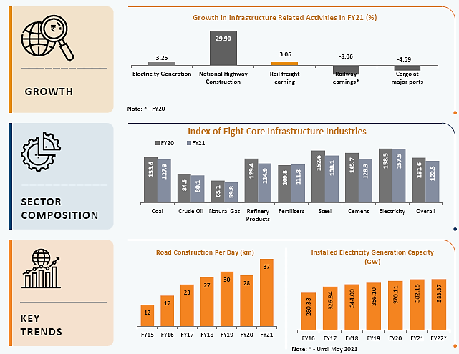

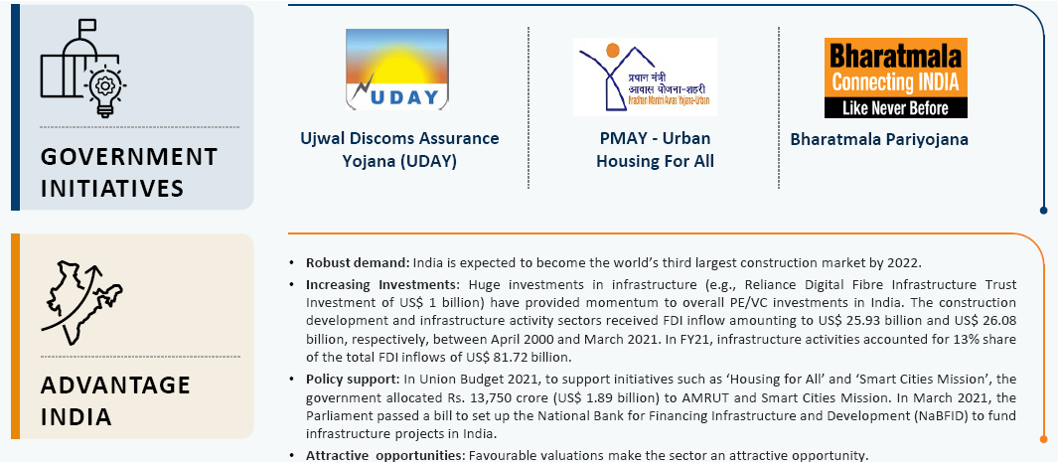

* + - 1. **IMPACT OF COVID19 ON THE INFRASTRUCTURE SECTOR:**

Covid19 is having deleterious impact on the already ailing infrastructure sector of the Indian economy. The following below points exhibit the troubles faced by this sector on account of coronavirus. Infrastructure projects in India are infamous for cost overruns and delays, and they are set for even more pain as the coronavirus sweeps through Asia’s third-largest economy.

* The restrictions imposed by the Government of India, State Governments and the Union Territories to control the spread and impact of the virus have prevented work on projects, adversely impacted supply chains, plant, equipment, materials and manpower.
* The lockdown had noticeable impact on the output of the infrastructure sector – including but not limited to sub-sectors of construction, power, and transport. While this can be attributed to a lot of factors, the shortfall of human capital making things worse.
* Construction of everything from roads to ports were behind schedule by an average three-and-a-half years, according to an analysis by the Statistics Ministry.
* Companies in toll collections business; distribution companies struggling to pay the dues to the power generation companies; and complete shutdown of air and sea travel hitting airport and port operators. The dramatic fall in demand is compounding the woes of these sub-sectors.
* Delays and disruptions to completion of projects are inevitable with mounting losses, escalating cost and expenses, which is displayed in the following table.
  + - 1. **RELIEF MEASURES FOR COVID19 FOR INFRASTRUCTURE SECTOR:**

1. Utmost priority to infrastructure development is given by the government and has set a target of road construction of worth Rs.15 lakh crore in the next two years.
2. The Ministry of Railways announced to monetize assets including Eastern and Western Dedicated Freight Corridors after commissioning, induction of 150 modern rakes through PPP, station redevelopment through PPP, railway land parcels, multifunctional complexes (MFC), railway colonies, hill railways and stadiums.
3. The government announced a long-term US$ 82 billion plan to invest in the country’s seaports In March 2021. approx. 574 projects have been identified, under the Sagarmala project, for implementation through 2035.
4. The Ministry of Power released the draft National Electricity Policy (NEP) 2021 and created an expert committee including members from state governments, the Ministry of New and Renewable Energy (MNRE), NITI Aayog and the Central Electricity Authority (CEA).
5. Rs. 18,998 crore has been announced by the government for metro projects.
6. Mega Investment Textiles Parks (MITRA) scheme was launched to establish world-class infrastructure in the textile sector and establish seven textile parks over three years.
7. The government announced Rs. 305,984 crore (US$ 42 billion) over the next five years for a revamped, reforms-based and result-linked new power distribution sector scheme.

|  |  |
| --- | --- |
| **PART E** | **FINANCIAL PROJECTIONS** |

1. **Previous Year’s Financial Performance:**

The financial performance of the company from Financial Year 2015 to Financial Year 2021 is as presented below:

|  |  |  |  |  |  |  |  |
| --- | --- | --- | --- | --- | --- | --- | --- |
| ***PARTICULARS*** | ***Mar-15*** | ***Mar-16*** | ***Mar-17*** | ***Mar-18*** | ***Mar-19*** | ***Mar-20*** | ***Mar-21*** |
|  |  |  |  |  |  |  |  |
| **TOTAL INCOME** | **38.17** | **40.93** | **42.21** | **54.18** | **53.76** | **63.55** | **67.44** |
|  |  |  |  |  |  |  |  |
| **TOTAL EXPENSES** | 11.12 | 10.32 | 12.26 | 12.82 | 30.34 | 37.77 | 68.42 |
|  |  |  |  |  |  |  |  |
| **EBITDA** | **27.05** | **30.61** | **29.95** | **41.36** | **23.42** | **25.78** | **-0.98** |
| *EBITDA %* | *70.87%* | *74.79%* | *70.96%* | *76.34%* | *43.56%* | *40.57%* | *-1.45%* |
|  |  |  |  |  |  |  |  |
| Depreciation and Amortization | 10.66 | 13.41 | 17.99 | 15.93 | 15.12 | 24.07 | 25.58 |
|  |  |  |  |  |  |  |  |
| **EBIT** | **16.39** | **17.20** | **11.96** | **25.43** | **8.30** | **1.71** | **-26.56** |
| *EBIT %* | *42.94%* | *42.02%* | *28.34%* | *46.94%* | *15.44%* | *2.69%* | *-39.38%* |
|  |  |  |  |  |  |  |  |
| Finance Cost | 25.93 | 24.58 | 23.78 | 21.60 | 13.82 | 9.72 | 1.79 |
|  |  |  |  |  |  |  |  |
| **Profit Before Tax** | **-9.54** | **-7.38** | **-11.82** | **3.83** | **-5.52** | **-8.01** | **-28.35** |
| *PBT %* | *-24.99%* | *-18.03%* | *-28.00%* | *7.07%* | *-10.26%* | *-12.60%* | *-42.04%* |
|  |  |  |  |  |  |  |  |
| Tax Expense | 0.00 | 0.00 | 0.00 | 0.00 | 0.00 | 0.00 | 0.00 |
| *Effective Tax Rate* | 0.00% | 0.00% | 0.00% | 0.00% | 0.00% | 0.00% | 0.00% |
|  |  |  |  |  |  |  |  |
| **Profit (Loss) after Tax** | **-9.54** | **-7.38** | **-11.82** | **3.83** | **-5.52** | **-8.01** | **-28.35** |
| *PAT %* | *-24.99%* | *-18.03%* | *-28.00%* | *7.07%* | *-10.26%* | *-12.60%* | *-42.04%* |

***Source:*** *Audited Annual Financials provided by the Bank/Company*

**Previous Year’s Financial Analysis:**

1. Revenue of the company has increased steadily from F.Y.15 to F.Y.21 at a CAGR of 9.95 %.
2. However, expenses of the company have been increased at a CAGR of 35.37 % over the same period.
3. EBIDTA and EBIT Margin has been declined significantly over last three financial years due to significant increase in Operating Expenses of the project which includes Major Maintenance Expenses (MMR).

Based on the data/ information/ inputs provided by the bank officials and the assessment & analysis conducted by us, financial projections of the company have been estimated as provided below by the way of several different financial indicators and assumptions.

1. **Projected Profit & Loss Statement:**

|  |  |  |  |  |  |  |  |
| --- | --- | --- | --- | --- | --- | --- | --- |
| **Particulars** | **Mar-21** | **Mar-22** | **Mar-23** | **Mar-24** | **Mar-25** | **Mar-26** | **Oct-26** |
| **Actual** | **Estimated** | **Estimated** | **Estimated** | **Estimated** | **Estimated** | **Estimated** |
| *(INR Crores, Unless Otherwise Specified)* | | | | | | | |
| Toll Rev | 42.62 | 50.22 | 51.72 | 53.27 | 54.87 | 56.52 | 31.74 |
| *% Change* | *-14.02%* | *17.82%* | *3%* | *3%* | *3%* | *3%* | *-23.90%* |
|  |  | *2.5%* | *2.5%* | *2.5%* | *2.5%* | *2.5%* | *2.5%* |
| O&M Expense | 18.90 | 19.37 | 19.85 | 20.41 | 20.86 | 21.38 | 11.87 |
| *% Change* | *249%* | *2.5%* | *2.5%* | *2.8%* | *2.2%* | *2.5%* | *-44%* |
|  |  | *5%* | *5%* | *5%* | *5%* | *5%* | *5%* |
| G&A Expense | 3.11 | 3.27 | 3.43 | 3.60 | 3.78 | 3.97 | 2.28 |
| *% Change* | *4%* | *5%* | *5%* | *5%* | *5%* | *5%* | *-42%* |
| MMR Expense | 11.99 |  |  |  | 41.78 | 41.97 |  |
| Total Expenses | 34.00 | 22.63 | 23.28 | 24.01 | 66.42 | 67.32 | 14.16 |
| **EBIDTA** | **8.62** | **27.58** | **28.44** | **29.27** | **(11.55)** | **(10.80)** | **17.58** |
| Amortization | 25.58 | 31.27 | 37.95 | 39.09 | 40.27 | 41.47 | 23.29 |
| **EBIT** | **(16.96)** | **(3.69)** | **(9.51)** | **(9.82)** | **(51.81)** | **(52.28)** | **(5.71)** |
| Interest Expense | 15.30 | 15.34 | 13.44 | 8.34 | 3.21 | (0.00) | - |
| **PBT** | **(32.25)** | **(19.03)** | **(22.95)** | **(18.16)** | **(55.02)** | **(52.28)** | **(5.71)** |
| Tax | - | - | - | - | - | - | - |
| **PAT** | **(32.25)** | **(19.03)** | **(22.95)** | **(18.16)** | **(55.02)** | **(52.28)** | **(5.17)** |

**Notes:** *For Key Assumptions related to projections, please refer section 4 of Part F.*

|  |  |
| --- | --- |
| **PART F** | **VALUATION METHODOLOGY** |

1. **METHODOLOGY / MODEL ADOPTED:**

Out of the various models & theories available we have adopted the most widely used & acceptable Free Cash Flow to Firm Model for the calculation of Enterprise Value of the Company.

* The Discounted cash flow method is similar to the method used for public companies.
* FCFF is more practical when substantial capital changes are expected because weighted average cost of capital (WACC) is less sensitive to the changes in capital structure.

**Rationale for using “FCFF Model” for the Enterprise Valuation:**

* The 3 Broad Model of Company Valuation are - Present Value (Discounted Cash Flow Models), Asset Based and Market Multiple.
* Asset Based Model is inappropriate as the Company is a going concern and the model is unable capture the Value of the company.
* Market Multiple Approach is also rejected as the company is not listed and there are not enough recent prior comparable transactions for the mid-scale steel producing industry.
* Hence the most appropriate Model to Value the Company in this case will be Present Value Model.
* The Present Value Model gives us the variety of input options to use while calculating the Value of the firm - Dividend, Free Cash Flow to the Firm, Free Cash Flow to Equity, Capitalized Cash Flows and Residual Earnings.
* Dividends cannot be used as the Company has no history of paying dividends and we don’t foresee any dividend payments to occur in the future also due to the high leverage of the firm.
* The best method input option for the Present Value Model will be FCFF as it represents the benefits accruable to all the stakeholders in the Business enterprise.

**FCFF Model Formula and Key Inputs:**

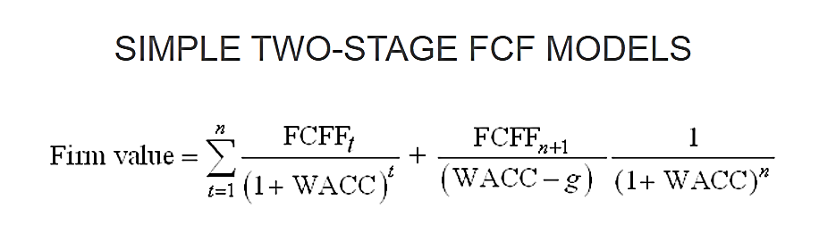

* **Free Cash Flow to Firm (FCFF):** FCFF is the [cash](http://www.investinganswers.com/node/5011) available to pay investors after a company pays its costs of doing business, invests in short-term assets like [inventory](http://www.investinganswers.com/node/2474), and invests in assets like property, plants and equipment.

*FCFF = Net Income + Non-Cash Charges + Interest (1- Tax Rate) – Working Capital Investment – Fixed Capital Investment.*

* **Weighted Average Cost of Capital (WACC):** The weighted average cost of capital (WACC) is the rate that a company is expected to pay on average to all its security holders to finance its assets. The WACC is commonly referred to as the firm’s cost of capital. WACC is used as the discount rate to discount FCFF.

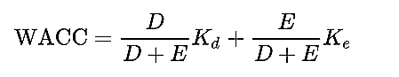

Where D is the total debt, E is the shareholders equity and Kd and Ke are the cost of debt (after tax) and cost of equity, respectively.

1. **CALCULATION OF FREE CASH FLOW TO FIRM (FCFF):**

|  |  |  |  |  |  |  |
| --- | --- | --- | --- | --- | --- | --- |
| ***Operating Summary*** | ***Mar-22*** | ***Mar-23*** | ***Mar-24*** | ***Mar-25*** | ***Mar-26*** | ***Oct-26*** |
| ***Estimated*** | ***Estimated*** | ***Estimated*** | ***Estimated*** | ***Estimated*** | ***Estimated*** |
| **Toll Revenue** | **50.22** | **51.72** | **53.27** | **54.87** | **56.52** | **31.74** |
| *% Growth* | *17.82%* | *3.00%* | *3.00%* | *3.00%* | *3.00%* | *-23.90%* |
| **EBITDA** | **27.58** | **28.44** | **29.27** | **(11.55)** | **(10.80)** | **17.58** |
| *EBITDA Margin* | *54.93%* | *54.99%* | *54.94%* | *-21.04%* | *-19.11%* | *55.39%* |
| **EBIT** | **(3.69)** | **(9.51)** | **(9.82)** | **(51.81)** | **(52.28)** | **(5.71)** |
| *EBIT Margin* | *-7.35%* | *-18.39%* | *-18.44%* | *-94.42%* | *-92.49%* | *-17.99%* |
| Less: Taxes | - | - | - | - | - | - |
| **NOPAT** | **(3.69)** | **(9.51)** | **(9.82)** | **(51.81)** | **(52.28)** | **(5.71)** |
| *% Sales* | *-7.35%* | *-18.39%* | *-18.44%* | *-94.42%* | *-92.49%* | *-17.99%* |
| Add: Amortization | 31.27 | 37.95 | 39.09 | 40.27 | 41.47 | 23.29 |
| *% Sales* | *62.28%* | *73.38%* | *73.38%* | *73.38%* | *73.38%* | *73.28%* |
| Less: WCC | - | - | - | - | - | - |
| *% Sales* | *0%* | *0%* | *0%* | *0%* | *0%* | *0%* |
| Less: CAPEX | 0.40 | 0.43 | 0.45 | 0.48 | 0.51 | 0.54 |
| *% Sales* | *0.80%* | *0.83%* | *0.85%* | *0.88%* | *0.90%* | *1.70%* |
| Adj: Other Receivable/ (Payable) | 0.00 | 0.00 | 0.00 | 0.04 | 0.00 | -1.98 |
| **Free Cash Flow to the Firm** | **27.18** | **28.01** | **28.82** | **(11.98)** | **(11.31)** | **15.06** |

**3. VALUATION OF FIRM:**

**Table: WACC Calculations**

|  |  |  |  |
| --- | --- | --- | --- |
| ***Weighted Average Cost of Capital*** | | | |
| **Particular** | **Amounts** | **Weightage** | **Discount Rate** |
| *INR Crores, Unless Otherwise Specified* | | | |
| *Debt* | 118.01 | 55.74% | 13.00% |
| *Equity* | 93.71 | 44.26% | 18.45% |
| **Total Capital** | **211.72** | **100%** | **15.41%** |

The Inputs used to Value the firm:

**Table: Inputs**

|  |  |
| --- | --- |
| ***Inputs*** | |
| **Valuation Date** | **23-Aug-21** |
| **WACC** | **15.41%** |
| **Company’s Risk Premium** | **2%** |
| **Discount Rate** | **17.41%** |
| **Discount Rate Change** | **1%** |

**Table: Present Value of Discounted Cash flow over the projection period**

|  |  |  |
| --- | --- | --- |
| ***CUMULATIVE DISCOUNTED CASH FLOW OVER THE PROJECTION PERIOD*** | | |
| **Scenario** | **Discount Rate** | **PV of FCF During Projection Period (In Crores.)** |
| *INR Crores, Unless Otherwise Specified* | | |
| *Bull Scenario* | 16.41% | 60.49 |
| ***Present Scenario*** | **17.41%** | **59.77** |
| *Bear Scenario* | 18.41% | 59.06 |

|  |
| --- |
| ***ENTERPRISE VALUE OF THE FIRM*** |
| **INR 59.77 Crores** |
| **INR Fifty Nine Crores and seventy seven Lakhs** |

**Notes:-**

* Under Valuation Inputs section, the discount rate change measures the sensitivity of Firm Value to a (+/-) 1% change.
* The Company account has been converted to Non-Performing Asset (NPA) from FY 18-19. We have assumed that the company will repay its pending dues and remaining debt till 31st March, 2025.
* The overall valuation is estimated based on the financial statements up to FY 2020-21 and further from 2021-22 onwards; it has been projected based on the previous data as reference.
* The Enterprise Value of the firm is INR **59.77** Crores as on 23 August, 2021 based on the Industry analysis, historical analysis and assumptions taken for the explicit period upto the dated end of the concession period and handed over to NHAI i.e. present value of estimated unlevered free cash flow available to the firm beyond the actuals.

1. **KEY ASSUMPTIONS:**
2. **Revenue Projections:**

* The main source of revenue i.e. toll collection is only considered in the revenue projections. For previous year’s toll collection figures, we have relied upon the data provided by the bank and no independent verification of the same done by us.
* Projections have been taken till 17th October 2026 as per concession period end date.
* The average growth rate in the toll revenue is 6.13 % and 5.49 % for the period of FY 2010-21 and FY 2012-21 respectively.
* The assumed Toll revenue growth rate for the projection period is as follows:

|  |  |  |  |  |  |  |
| --- | --- | --- | --- | --- | --- | --- |
| **Financial Year Ending** | **Mar-22** | **Mar-23** | **Mar-24** | **Mar-25** | **Mar-26** | **Oct-26** |
| *Toll Revenue Growth Rate* | 17.82% | 3.00% | 3.00% | 3.00% | 3.00% | -23.90% |

* The assumed revenue growth rates has two components:
* Highway traffic growth component; and
* Wholesale price index (WPI) component
* The WPI rate is allowed to pass through in the toll rates as per the Schedule-G of the Concessionaire Agreement. The toll rates are revised on an annual basis.
* The Average annual WPI escalation rate is 2.50% from FY 2012 to FY 2020.
* It is assumed that the company will complete all the pending maintenance work at the earliest and will do the routine & major maintenance work as per the concessionaire agreement schedule. So that the highway condition is good and will not hinder the toll traffic.
* NHAI has made a claim against the company of Rs 77.56 Cr for the delayed MMR work and violation of various clauses of the concessionaire agreement. The given claim amount is not included in the financial projections as the company is not generating enough cash flow to pay the claimed amount. However this is the liability on the company.

1. **Cost Projections:**

* The Operation and Maintenance (O&M) expenses are considered on the basis of previous years’ expenses with an estimated O&M annual inflation of 2.5%.
* The General and administrative (G&A) expenses are considered on the basis of previous years’ expenses with an estimated G&A annual inflation of 5%.
* In FY21, MMW expenses of INR11.99 Crores was considered as it is the pending payable amount of the ongoing MMW contracts. In FY 24 and FY 25, next Major maintenance work is considered as per the average of previous and actual estimated costs with an expected annual inflation of 3%.

1. **Depreciation and Amortization:**

* Since the size of the Intangible assets of the company is much greater than the tangible assets and amortization of intangible assets is also larger compared to depreciation of tangible assets, therefore only the amortization amount is considered in the projections?
* As per the Accounting Standard, amortization of Intangible assets is done on the basis of the remaining intangible assets, zero salvage value and the projected revenue during the remaining concessionaire period.

1. **Fixed Capital Investments**

* The Fixed Capital investment is based on assessment of previous year financials.
* We have assumed the growth rate of 6% on fixed capital investments.

|  |  |
| --- | --- |
| **Declaration** | 1. *The undersigned does not have any direct/indirect interest in the Project Company.* 2. *The information furnished herein is true and correct to the best of our knowledge.*   *This valuation work is carried out by our Financial & Market Research Analysis team on the request from* ***STATE BANK OF INDIA- 21st FLOOR, MAKER TOWERS E, CUFFE PARADE, MUMBAI-400005 Branch- SARG***   1. *We have submitted Valuation report directly to the Bank.* |
| **Name & Address of Valuer company** | **Signature of the authorized person** |
| M/s. R.K Associates Valuers & Techno Engineering Consultants (P) Ltd.  **Corporate Office:**  D-39, 2nd Floor, Sector- 2, Noida, Uttar Pradesh- 201301, India |  |
| **Enclosed Documents** | 1. Valuer’s Remark - Page No. 41 |
| **Number of Pages in the Report** | 47 pages |
| **Financial & Market Research Analysis Team worked on the report** | ***PREPARED BY: Mr. Gaurav Kumar*** |

**For R.K Associates Valuers & Techno Place : Noida**

**Engineering Consultants (P) Ltd. Date : 23.08.2021**

**(Authorized Signatory)**

**Valuations**

|  |  |
| --- | --- |
| **PART G** | **REMARKS & DECLARATION** |

1. No employee or member of R.K Associates has any direct/ indirect interest in the Project.
2. This is just an opinion report on Valuation based on the copy of the documents/ information provided to us by the client which has been relied upon in good faith and the assessment and assumptions done by us.
3. This report is prepared based on the copies of the documents/ information which the Bank/ Company has provided to us out of the standard checklist of documents sought from them and further based on our assumptions and limiting conditions. The client/owner and its management/representatives warranted to us that the information they supplied was complete, accurate and true and correct to the best of their knowledge. All such information provided to us has been relied upon in good faith and we have assumed that it is true and correct in all respect. I/We shall not be liable for any loss, damages, cost or expenses arising from fraudulent acts, misrepresentations, or wilful default on part of the owner, company, its directors, employee, representative or agents. Verification or cross checking of the documents provided to us from the originals or from any Govt. departments/ Record of Registrar has not been done at our end since this is beyond the scope of our work. If at any time in future, it is found or came to our knowledge that misrepresentation of facts or incomplete or distorted information has been provided to us then this report shall automatically become null & void.
4. This Valuation is prepared based on the current financial status of the company, financial data, other facts & information provided by the client in writing & during verbal discussion during the course of the assignment and based on certain assumptions which are specifically mentioned in the Valuation section of the Report.
5. Key assumptions in the report is taken based on data, information, inputs, financial statements etc. provided by the client to us during the course of the assessment and on the basis of the assessment done by us and we have assumed that all such information is true & factual to the best of the knowledge of the promoter company.
6. Sale transaction method of the asset is assumed as free market transaction while assessing Prospective Fair Market Value of the asset.
7. Legal aspects for e.g. investigation of title, ownership rights, lien, charge, mortgage, lease, sanctioned maps, verification of documents, etc. have not been done at our end and same has to be taken care by legal expert/ Advocate. It is assumed that the concerned Lender/ Financial Institution has satisfied them with the authenticity of the documents, information given to us and for which the legal verification has been already taken and cleared by the competent Advocate before requesting for this report. I/ We assume no responsibility for the legal matters including, but not limited to, legal or title concerns.
8. All observations mentioned in the report is only based on the visual observation and the documents/ data/ information provided by the client. No mechanical/ technical tests, measurements or any design review have been performed or carried out from our side during Project assessment.
9. Bank/FII should ONLY take this report as an Advisory document from the Financial/ Chartered Engineering firm and its specifically advised to the creditor to cross verify the original documents for the facts mentioned in the report which can be availed from the borrowing company directly.
10. In case of any default in loans or the credit facility extended to the borrowing company, R.K Associates shall not be held responsible for whatsoever reason may be and any request for seeking any explanation from the employee/s of R.K Associates will not be entertained at any instance or situation.
11. We have relied on data from third party, external sources & information available on public domain also to conclude this report. These sources are believed to be reliable and therefore, we assume no liability for the truth or accuracy of any data, opinions or estimates furnished by others that have been used in this analysis. Where we have relied on data, opinions or estimates from external sources, reasonable care has been taken to ensure that such data has been correctly extracted from those sources and /or reproduced in its proper form and context, however still we can’t vouch its authenticity, correctness or accuracy.
12. This Report is prepared by our competent technical team which includes financial experts & analysts.
13. Value varies with the Purpose/ Date/ Condition of the market. This report should not to be referred if any of these points are different from the one mentioned aforesaid in the Report.
14. Analysis and conclusions adopted in the report are limited to the reported assumptions, conditions and information came to our knowledge during the course of the work.
15. This report is having limited scope as per its fields to provide only the general indication of the Value of Equity of the companies prevailing in the market based on the documents/ data/ information/ financial statements provided by the client and the assessment and assumption taken by us. The suggested value should be considered only if transaction is happened as free market transaction.
16. Secondary/ Tertiary costs related to transaction like Stamp Duty, Registration charges, Brokerage, etc. pertaining to the sale/ purchase of the company are not considered while assessing the Market Value.
17. Appropriate methodology & assumptions are rationally adopted based on the facts of the case came to our knowledge during the course of the assignment considering many factors like nature of Industry, current market situation and trends.
18. Valuation is a subjective field and opinion may differ from consultant to consultant. To check the right opinion, it is important to evaluate the methodology adopted and various factors/ basis considered during the course of assessment before reaching to any conclusion.
19. At the outset, it is to be noted that Value analysis cannot be regarded as an exact science and the conclusions arrived at in many cases will, of necessity, be subjective and dependent on the exercise of individual judgment. Given the same set of facts and using the same assumptions, expert opinions may differ due to the number of different factors, which have to be made. Therefore, there can be no standard formulae to establish an indisputable exchange ratio. In the event of a transaction, the actual transaction value achieved may be higher or lower than our indicative analysis of value depending upon the circumstances of the transaction. The knowledge, negotiability and motivations of the buyers and sellers and the applicability of a discount or premium for control will also affect actual price achieved. Accordingly, our indicative analysis of value will not necessarily be the price at which any agreement proceeds. The final transaction price is something on which the parties themselves have to agree. However our Valuation analysis can definitely help the stakeholders to make them informed and wise decision about the Value of the asset and can help in facilitating the arm’s length transaction.
20. This report is prepared on the Enterprise Valuation format as per the client requirement. This report is having limited scope as per its fields to provide only the indicative Fair value of the company based on the current financial position, future prospects & current Industry trends. The Valuation assessed in this Valuation Report should hold well only if transaction is happened as per free market transaction. No detailed analysis or verification of the information is carried upon pertaining to the value of the shares of the subject companies. No claim for any extra information will be entertained whatsoever be the reason. For any extra work over and above the fields mentioned in the report will have an extra cost which has to be borne by the customer.
21. As per the scope of the report no site survey has been carried out by us and no thorough vetting of the documents/ information provided to us has been done at our end.
22. This is just an opinion report and doesn’t hold any binding on anyone. It is requested from the concerned stakeholder which is using this report that they should consider all the different associated relevant & related factors also before taking any business decision based on the content of this report.
23. Though adequate care has been taken while preparing this report as per its scope, but still we can’t rule out typing, human errors, over sightedness of any information or any other mistakes. Therefore, the concerned organization is advised to satisfy themselves that the report is complete & satisfactory in all respect. Intimation regarding any discrepancy shall be brought into our notice immediately. If no intimation is received within 15 (Fifteen) days in writing from the date of issuance of the report, to rectify these timely, then it shall be considered that the report is complete in all respect and has been accepted by the client up to their satisfaction & use and further to which R.K Associates shall not be held responsible in any manner.
24. This Valuation report is prepared based on the facts of the companies provided to us during the course of the assignment. However, in future the assumptions taken may change or may go worse due to impact of Govt. policies or effect of World economy, Industry/ market scenario may change, etc. Hence before taking any business decision the user of this report should take into consideration all such future risk.
25. The documents, information, data provided to us during the course of this assessment by the client is reviewed only up to the extent required in relation to the scope of the work. No document has been reviewed beyond the scope of the work.
26. In case of any default in repayment of credit facility extended to the borrowing company, as estimated by us, R.K Associates shall not be held responsible for whatsoever reason may be and any request for seeking any explanation from the employee/s of R.K Associates will not be entertained at any instance or situation.
27. This report only contains general assessment & opinion as per the scope of work evaluated and based on technical & market information which came to knowledge during course of the assignment as per the information given in the copy of documents, information, data provided to us and/ and confirmed by the owner/ owner representative to us at site which has been relied upon in good faith. It doesn’t contain any other recommendations of any sort including but not limited to express of any opinion on the suitability or otherwise of entering into any transaction with the borrower.
28. This report is prepared following our Standard Operating Procedures & Best Practices, Limitations, Conditions, Remarks, Important Notes, Valuation TOR.
29. Valuation is done based on the Industry wide general accepted norms and based on the international standards & best practices for equity valuations.
30. Any kind of unpaid statutory, utilities, lease, interest or any other pecuniary dues on the asset has not been factored in the Valuation.
31. This Valuation is conducted based on the macro analysis of the asset/ property and operations of the companies and not based on the micro, component or item wise analysis. Analysis done is a general assessment and is not investigative in nature.
32. All Pages of the report including annexures are signed and stamped from our office. In case any paper in the report is without stamp & signature then this should not be considered a valid paper issued from this office.
33. Defect Liability Period is **15 DAYS**. We request the concerned authorized reader of this report to check the contents, data and calculations in the report within this period and intimate us in writing if any corrections are required or in case of any other concern with the contents or opinion mentioned in the report. Corrections only related to typographical, calculation, spelling mistakes, incorrect data/ figures/ statement will be entertained within the defect liability period. Any new changes for any additional information in already approved report will be regarded as additional work for which additional fees may be charged. No request for any illegitimate change in regard to any facts & figures will be entertained.
34. R.K Associates encourages its customers to give feedback or inform concerns over its services through proper channel at valuers@rkassociates.org in writing within 15 days of report delivery. After this period no concern/ complaint/ proceedings in connection with the Financial Feasibility Study Services will be entertained due to possible change in situation and condition of the subject Project.
35. Our Data retention policy is of **ONE YEAR**. After this period we remove all the concerned records related to the assignment from our repository. No clarification or query can be answered after this period due to unavailability of the data.
36. This Enterprise Valuation report is governed by our (1) Internal Policies, Processes & Standard Operating Procedures, (2) R.K Associates Quality Policy, (3) Valuation & Survey Best Practices Guidelines formulated by management of R.K Associates, (4) Information input given to us by the customer and (4) Information/ Data/ Facts given to us by our field/ office technical team. Management of R.K Associates never gives acceptance to any unethical or unprofessional practice which may affect fair, correct & impartial assessment and which is against any prevailing law. In case of any indication of any negligence, default, incorrect, misleading, misrepresentation or distortion of facts in the report then it is the responsibility of the user of this report to immediately or at least within the defect liability period bring all such act into notice of R.K Associates management so that corrective measures can be taken instantly.
37. R.K Associates never releases any report doing alterations or modifications from pen. In case any information/ figure of this report is found altered with pen then this report will automatically become null & void.
38. If this report is prepared for the matter under litigation in any Indian court, no official or employee of R.K Associates will be under any obligation to give in person appearance in the court as a testimony. For any explanation or clarification, only written reply can be submitted on the additional payment of charges.