**REPORT FORMAT:** CL-1 | Version: 1.0_2018

**FILE NO: VIS(2021-22)-PL329-294-464 Date:** **23-07-2021**

* ***CERTIFICATE NAME:*** *Vendor verification Certificate for Machines and Equipment installed in the Biscuit Manufacturing Plant set up by M/s. Sakambari Processors Pvt. Ltd. at R. S. Dag no.-1, 2, 3, 793 & 312, Khatian No. 645, 350, 521, 62 & 123, Mouza - Kagnan & Beraberi, P.O. Makalpur, P.S.- Dadpur, District- Hooghly, West Bengal.*
* ***PREPARED FOR ORGANIZATION:*** *State Bank of India, SME Branch, Durgapur.*
* ***BORROWER COMPANY’S NAME:*** *M/s. Sakambari Processors Pvt. Ltd.*
* ***ASSET TYPE****: Machinery for Biscuit manufacturing & packaging plant.*
* ***CURRENT LOCATION OF THE MACHINES****: M/s. Sakambari Processors Pvt. Ltd. at R. S. Dag no.-1,2,3,793 & 312, Khatian No. 645,350, 521, 62 & 123, Mouza - Kagnan & Beraberi, P.O. Makalpur, P.S.- Dadpur, District- Hooghly, West Bengal.*

**TO WHOM IT MAY CONCERN**

|  |  |  |
| --- | --- | --- |
| **S. NO.** | **PARTICULARS** | **DESCRIPTION** |
|  | Date of Survey | 16-07-2021 |
|  | Date of Certificate | 23-07-2021 |
|  | Documents provided for perusal | List of Machinery along with the invoices of all the machinery |
|  | Current Location of the Machines | R. S. Dag no.-1,2,3,793 & 312, Khatian No. 645,350, 521, 62 & 123, Mouza - Kagnan & Beraberi, P.O. Makalpur, P.S.- Dadpur, District- Hooghly, West Bengal. |
|  | Borrowing Company | M/s. Sakambari Processors Pvt. Ltd. |
|  | Type of Asset | Different types of machinery installed at Biscuit manufacturing Plant. |
|  | Type of Assessment | Only Machinery |
|  | Scope of Assessment | Verification of the Vendors from which machines has been purchased. |
|  | Nature of Machinery | Machinery for Biscuit manufacturing Plant. |
|  | Year of Manufacturing | 2017 |
|  | Condition of Machine | Average. |

**OBSERVATIONS:**

1. We have been provided by the borrower company the copy of the Invoices for machines issued by the proposed suppliers of the machines at the time of sale.
2. As per the information provided to us by the company’s officials, these machines has been installed for the purpose of Biscuit manufacturing.
3. **COMPANY CREDENTIALS OF PROPOSED EQUIPMENT SUPPLIERS:-**

**For the verification of Company/Firm credentials from which the borrower company has purchased plant & equipment, we have tried to obtain information available in the Public Domain and Government portals like Ministry of Corporate Affairs (MCA) and Goods and Service Tax (GST) in respect of these companies/firms and we found that these companies are actively working in their respective fields currently.**

**The information regarding these companies/firms that we have provided herewith is only what is available from the public domain as could be accessed by us and has been reproduced here as found by us. This information has been taken from the Government run websites and we have carried out independent investigations at our end to verify this information. Though from the information available in the public domain these companies appear to be well established and operational companies currently, we cannot certify or predict what their status would be in future.**

**Source of Information:-**

Ministry of Corporate Affairs:- <http://www.mca.gov.in/>

Goods and Service Tax:- <https://www.gst.gov.in/>

|  |  |  |  |  |
| --- | --- | --- | --- | --- |
| **S.NO** | **COMPANY NAME** | **LAST GST FILLING DATE** | **COMPANY WEBSITE** | **PRESENCE ON PUBLIC DOMAIN** |
| 1 | AMAZE POWER | 17-07-2021 | <https://www.amazepower.in/> | INDIAMART |
| 2 | POWER SYSTEM | 15-07-2021 | <http://www.powersystem.in/> | INDIAMART |
| 3 | BHAR HARDWARE | 14-07-2021 | NOT FOUND | JUSTDIAL |
| 4 | M.S. TECHNOLOGIES | 25-06-2021 | NOT FOUND | INDIAMART |
| 5 | WESMAN | 22-07-2021 | <http://wesman.com/> | INDIAMART |
| 6 | MADAN PAL & SONS | 18-07-2021 | NOT FOUND | INDIAMART |
| 7 | SHIBHAM | 21-04-2021 | NOT FOUND | NOT FOUND |
| 8 | BENGAL PIPE & FITTINGS | 20-07-2021 | NOT FOUND | JUSTDIAL |
| 9 | DASHMESH REFRIGIRATION | 21-07-2021 | NOT FOUND | NOT FOUND |
| 10 | HAZRA INDUSTRIES | 21-07-2021 | <http://www.hazraindustries.com/contact-us.html> | INDIAMART |
| 11 | KHOSLA ELECTRONICS | 20-07-2021 | <https://khoslaonline.com/> | INDIAMART |
| 12 | PIN POINT LOGISTICS | 17-07-2021 | NOT FOUND | NOT FOUND |
| 13 | HIMMAT ELECTRICALS & ELECTRONICS | 22-07-2021 | NOT FOUND | INDIAMART, JUSTDIAL |
| 14 | ARGHA ENTERPRISE | 19-07-2021 | NOT FOUND | JUSTDIAL |
| 15 | MAA DAYOMAYEE MARBLE CENTER | 20-07-2021 | NOT FOUND | JUSTDIAL |
| 16 | IMPARATY CONSTRUCTION | 24-06-2021 | NOT FOUND | NOT FOUND |
| 17 | ASHOK KUMAR & BROS | 20-07-2021 | NOT FOUND | INDIAMART, JUSTDIAL |
| 18 | AMRUT & CO | 13-07-2021 | NOT FOUND | INDIAMART, JUSTDIAL |
| 19 | NANAK CODING SYSTEM | 23-07-2021 | <http://www.nanakenterprises.co.in/> | INDIAMART, JUSTDIAL |
| 20 | CONTROL PRINT LTD | 14-07-2021 | NOT FOUND | NOT FOUND |
| 21 | AGNI KANCHAN | 19-06-2018 | NOT FOUND | JUSTDIAL, FACEBOOK |
| 22 | KGK JET INDIA PVT LTD | 19-07-2021 | <https://www.kgkjetindia.org/> | INDIAMART, JUSTDIAL |
| 23 | MAKE WELL ENGINEERING | 21-07-2021 | <https://makewellengineering.com/> | INDIAMART, JUSTDIAL, TRADEINDIA |
| 24 | POORVA ENGINEERING & TOOLS PVT LTD | 14-07-2021 | NOT FOUND | INDIAMART, TRADEINDIA |
| 25 | RAJDEEP ENTERPRISE | 20-07-2021 | NOT FOUND | NOT FOUND |
| 26 | HEIZA CHEM ENGINEERS PVT. LTD. | 23-07-2021 | NOT FOUND | INDIAMART, JUSTDIAL |
| 27 | ROSHAN INDUSTRIES | 21-07-2021 | NOT FOUND | INDIAMART, JUSTDIAL, TRADEINDIA |

**Company credentials are listed below:-**

1. **AMAZE POWER**

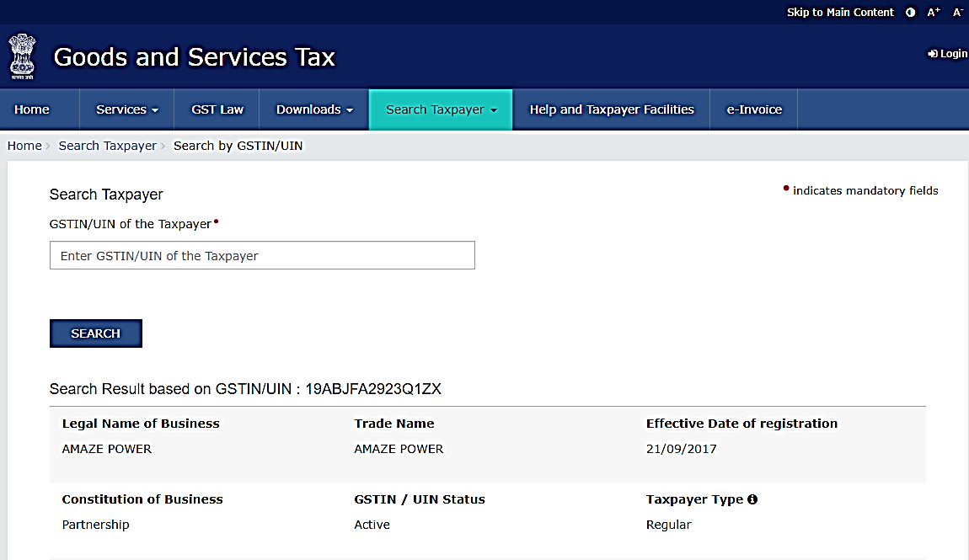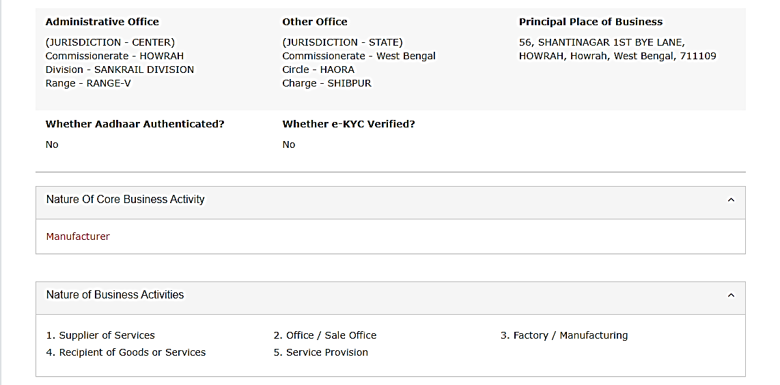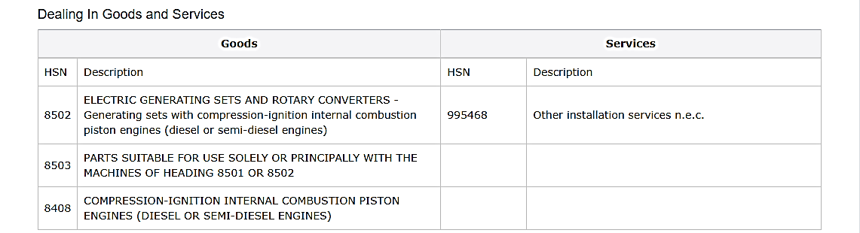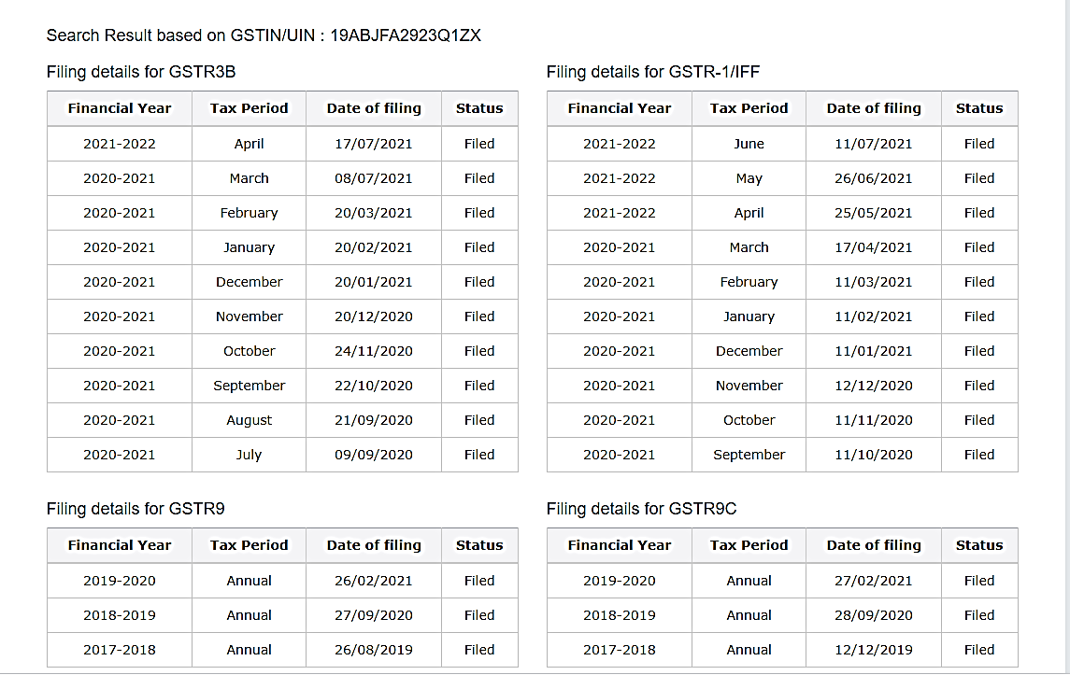

1. **POWER SYSTEM**

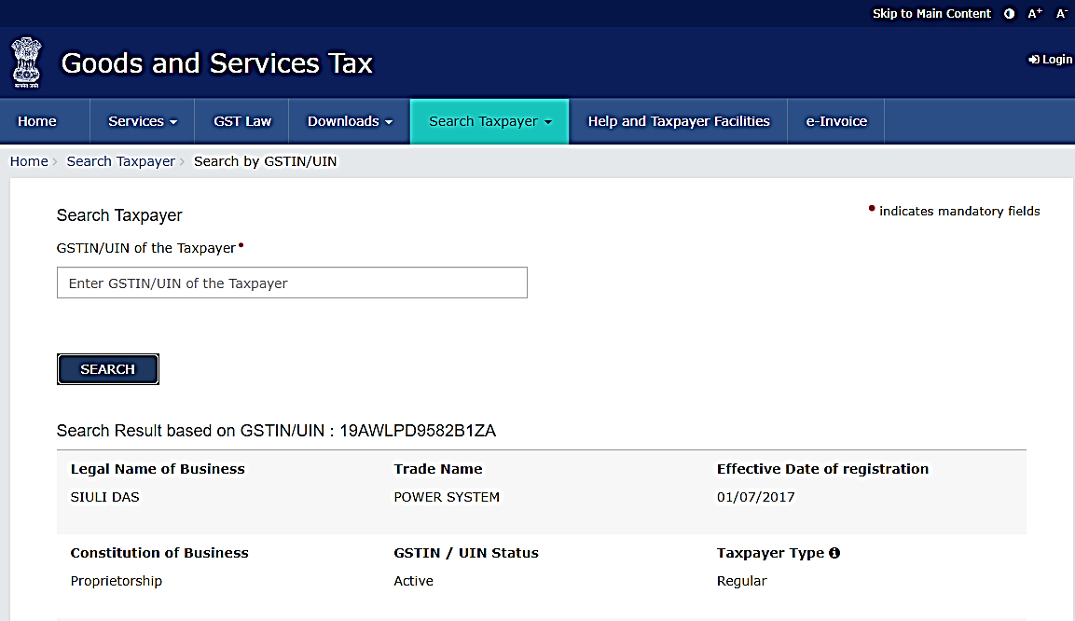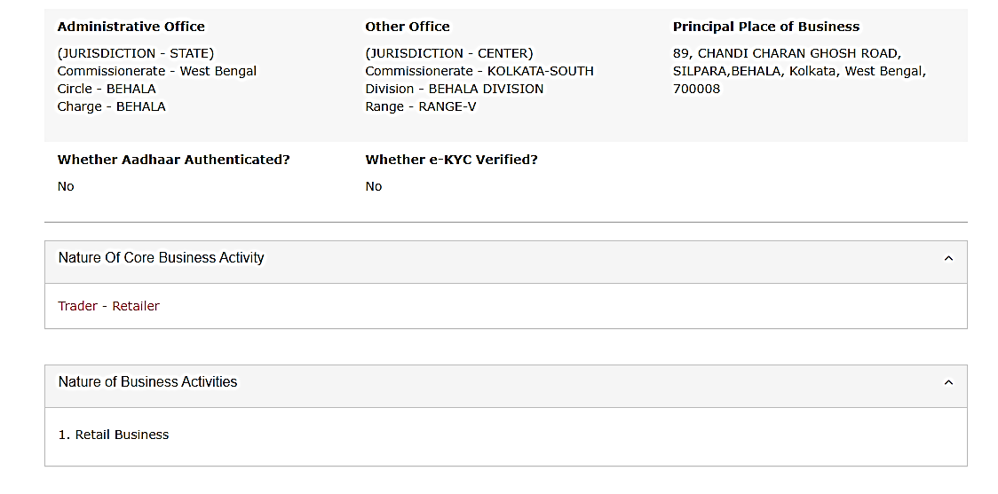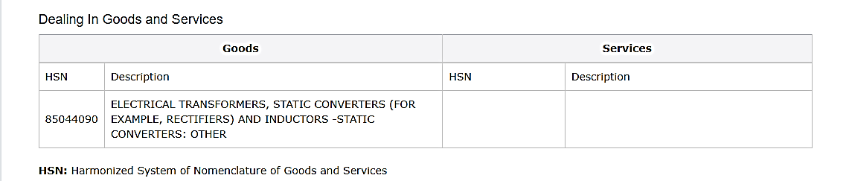

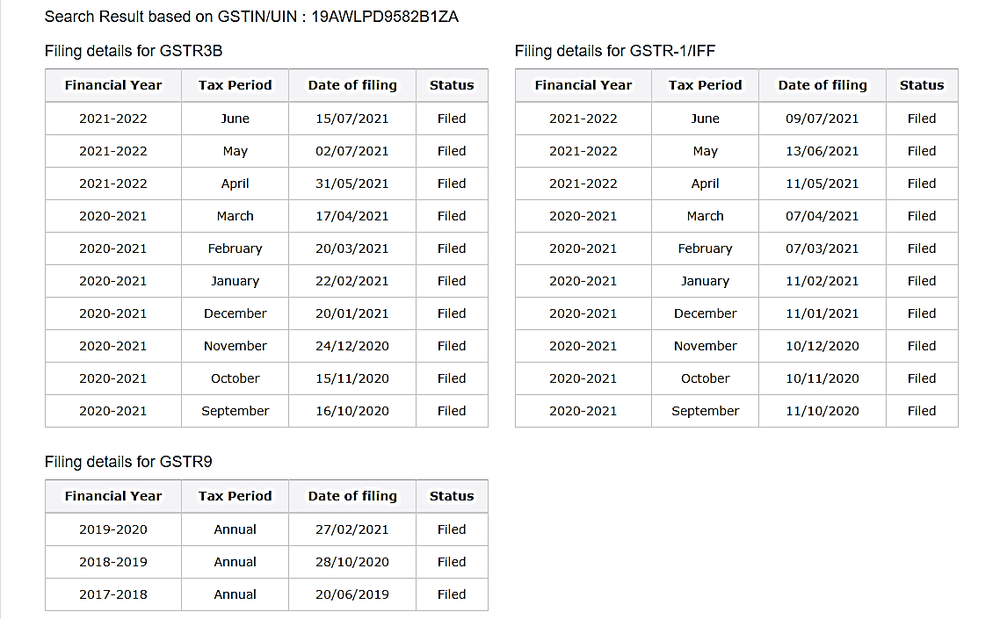

1. **BHAR HARDWARE**

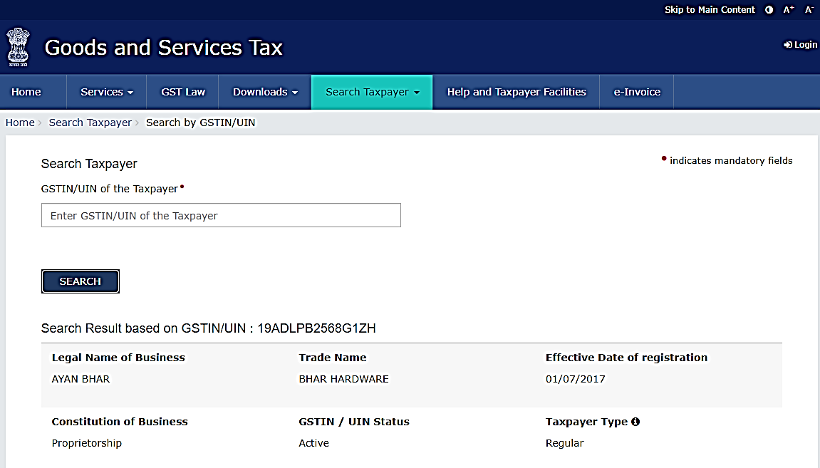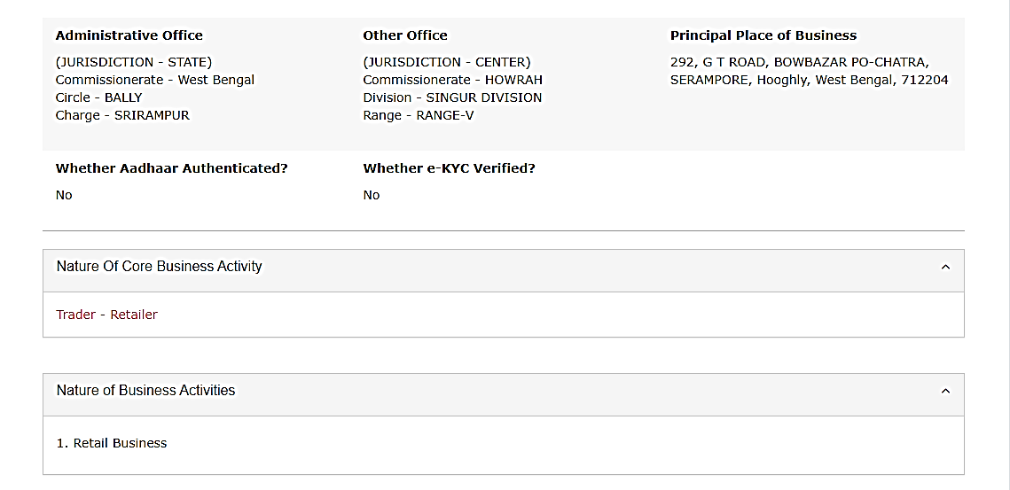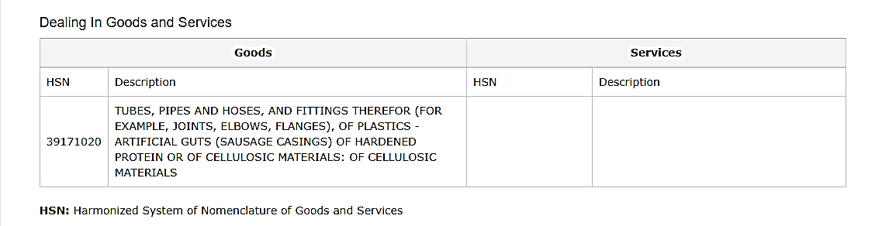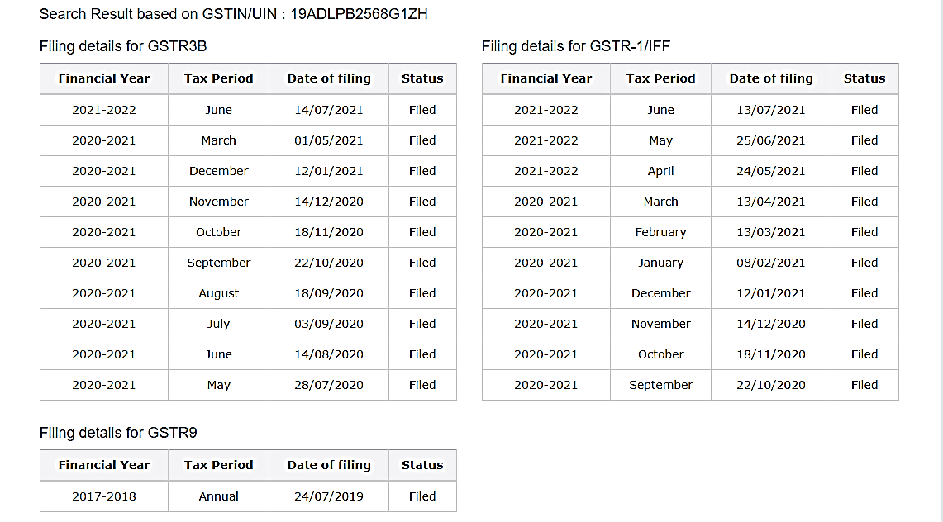

1. **M.S. TECHNOLOGIES**

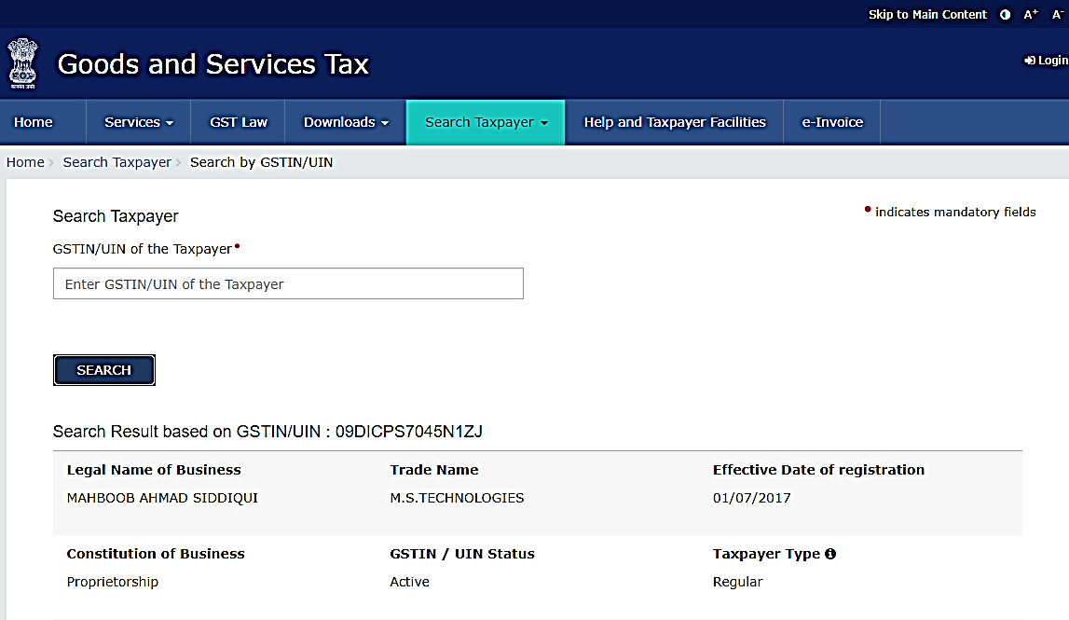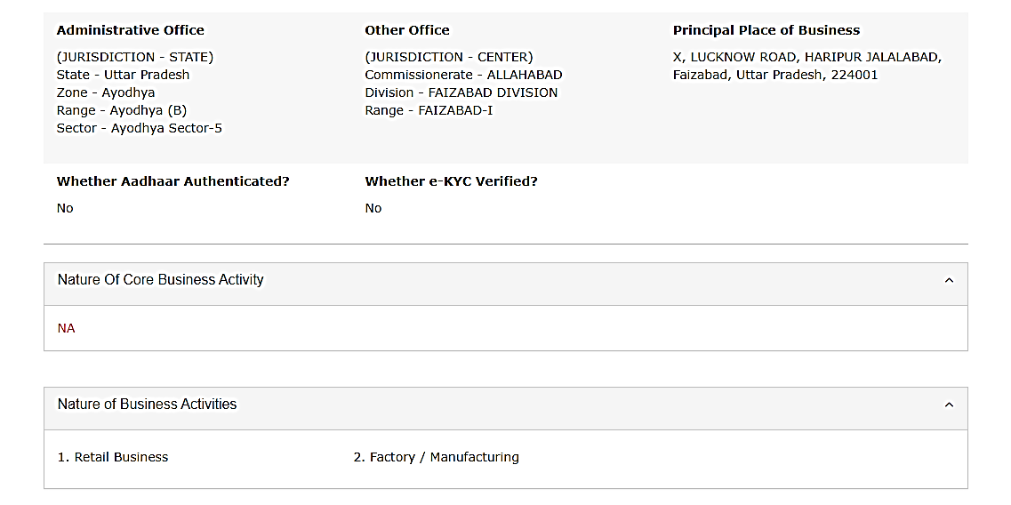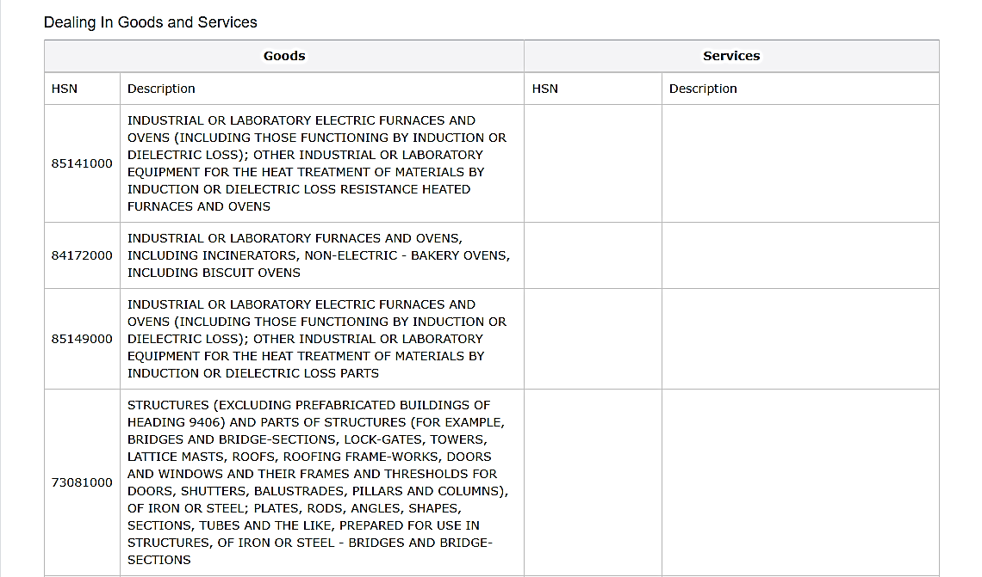

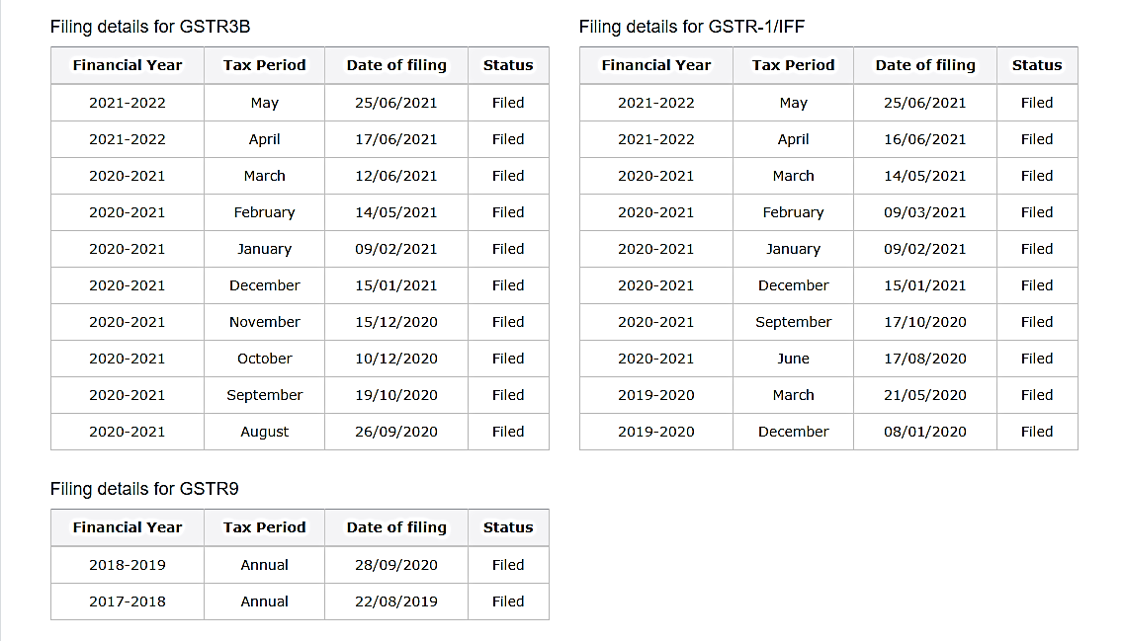

1. **WESMAN THERMAL ENGINEERING PROCESSES PVT. LTD.**

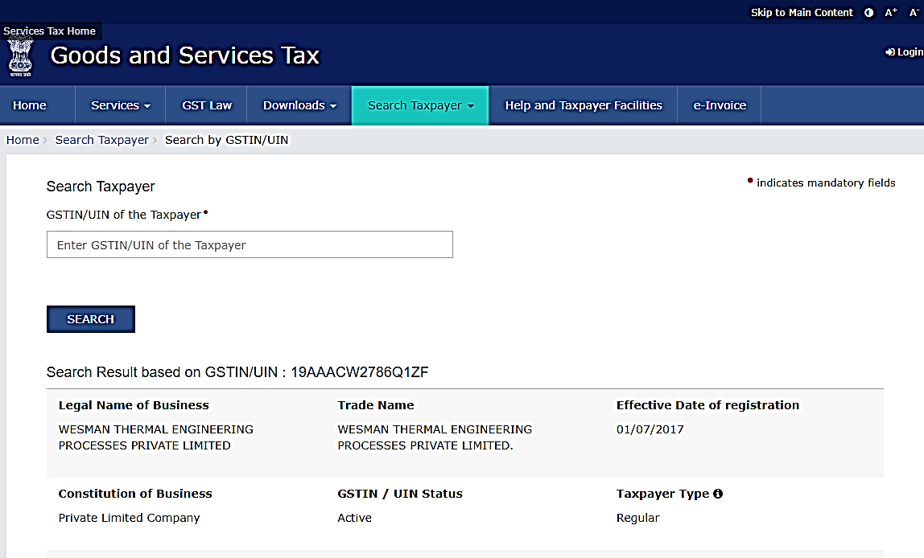

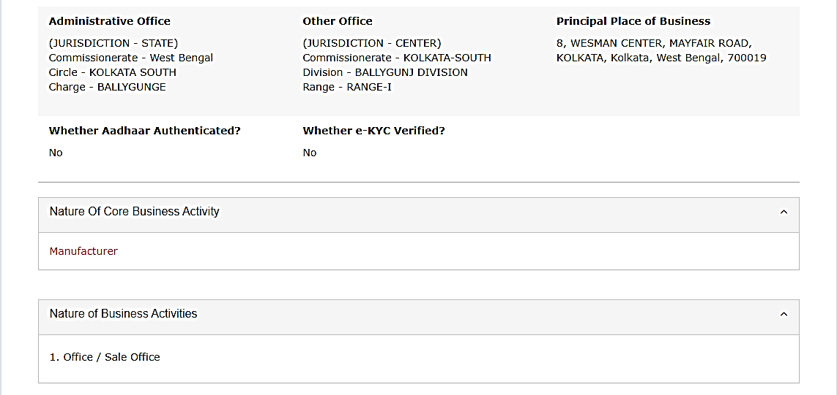

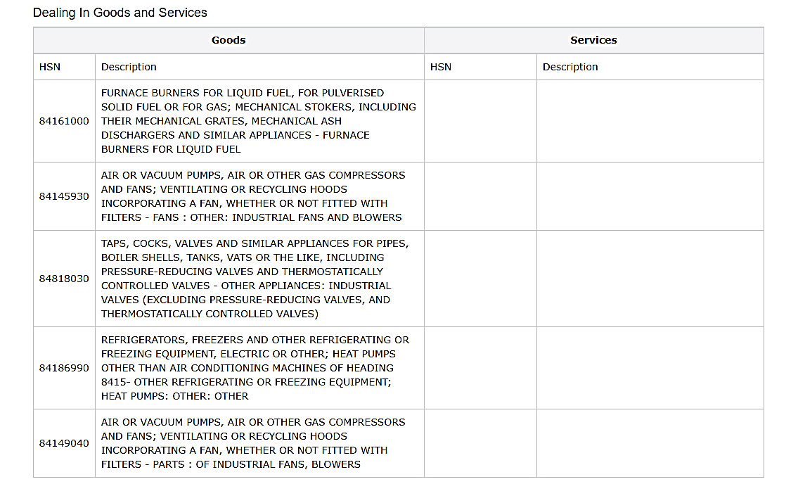

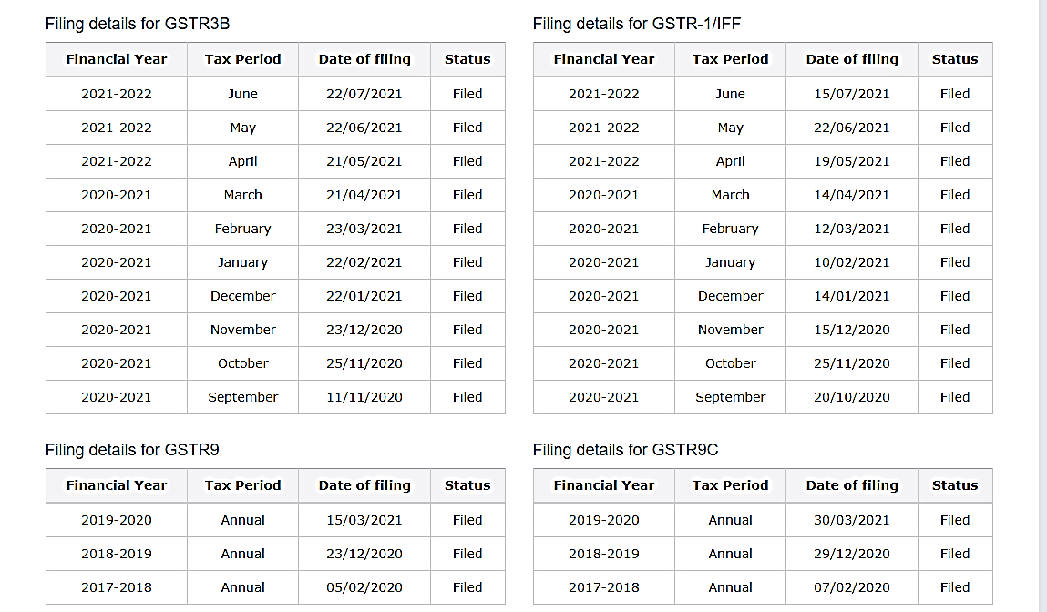

1. **MADAN PAL & SONS**

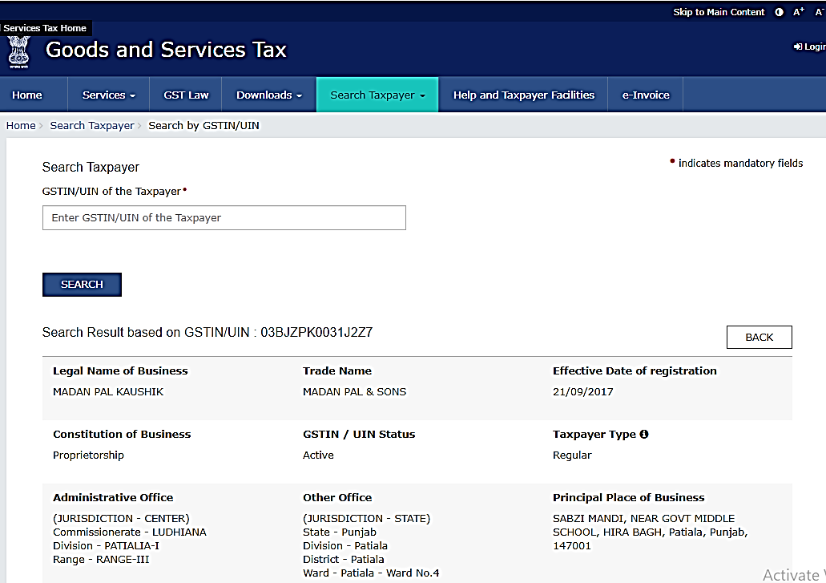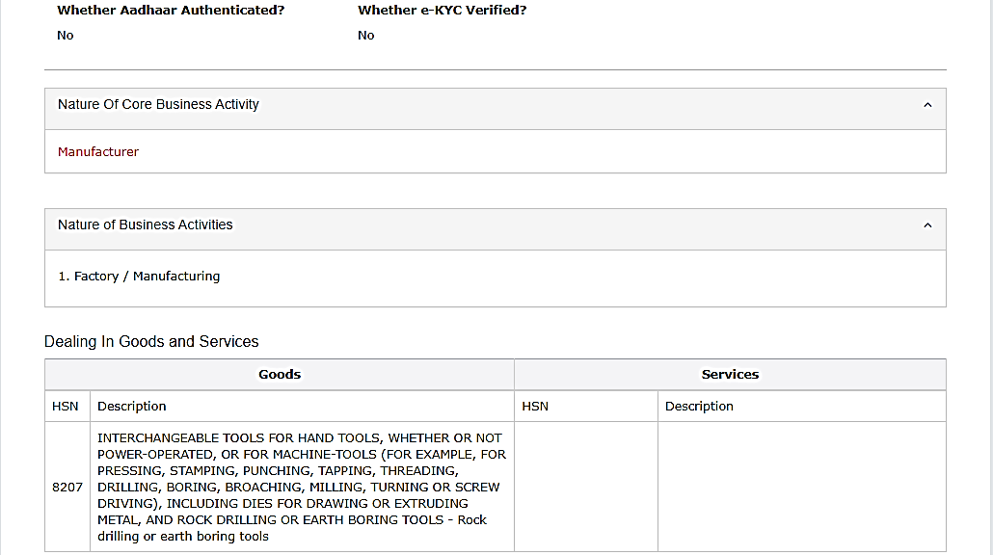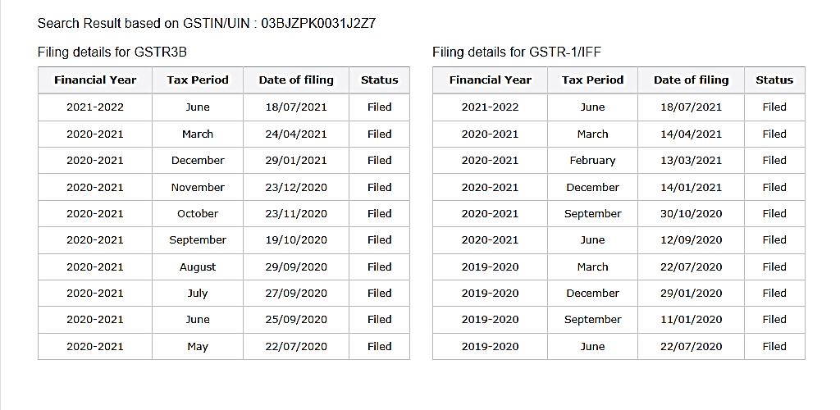

1. **SHIBHAM**

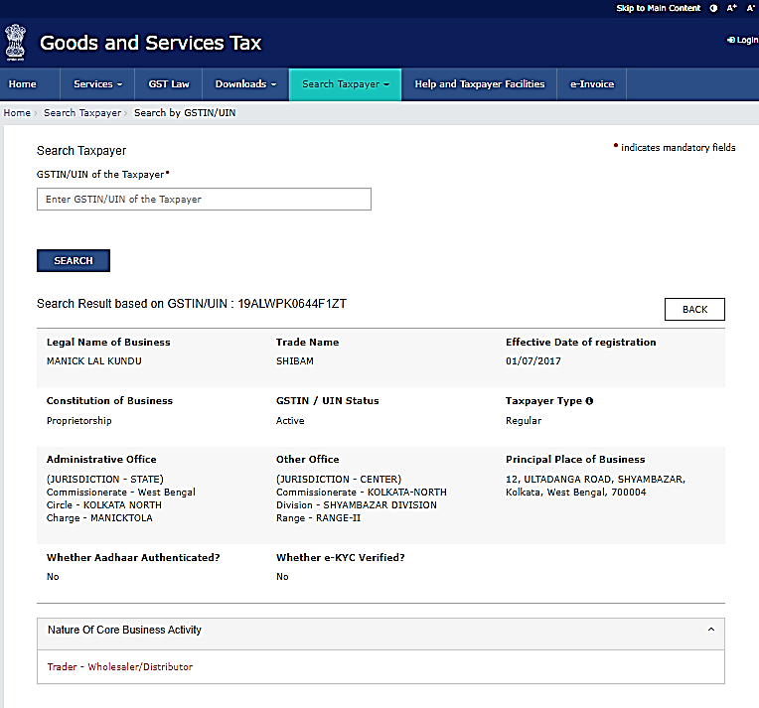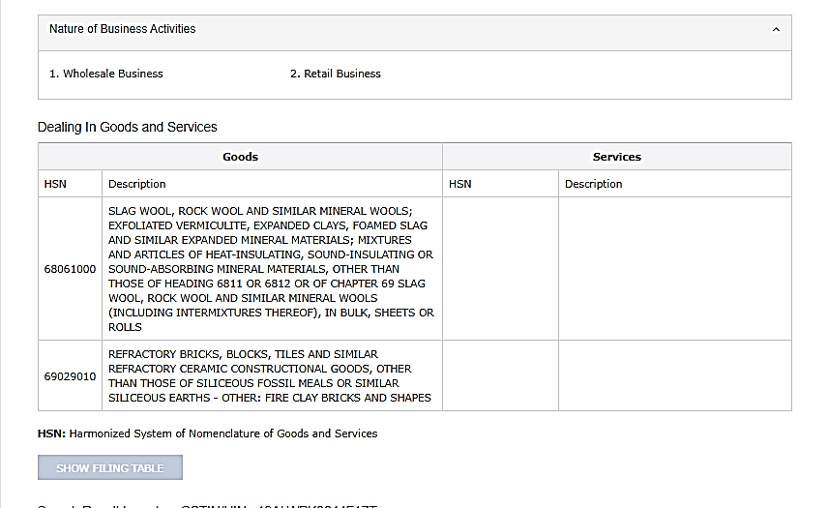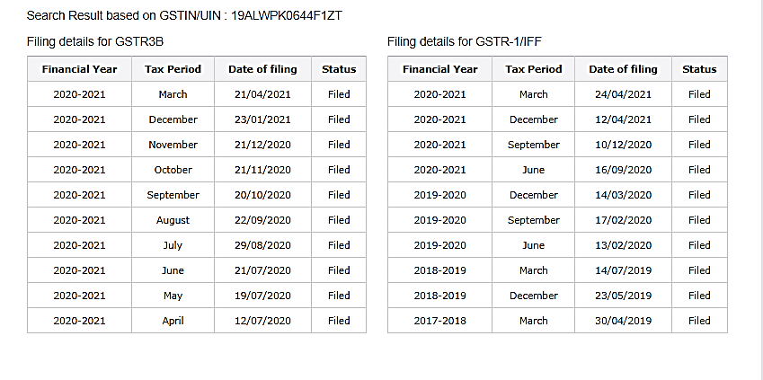

1. **BENGAL PIPE & FITTINGS**

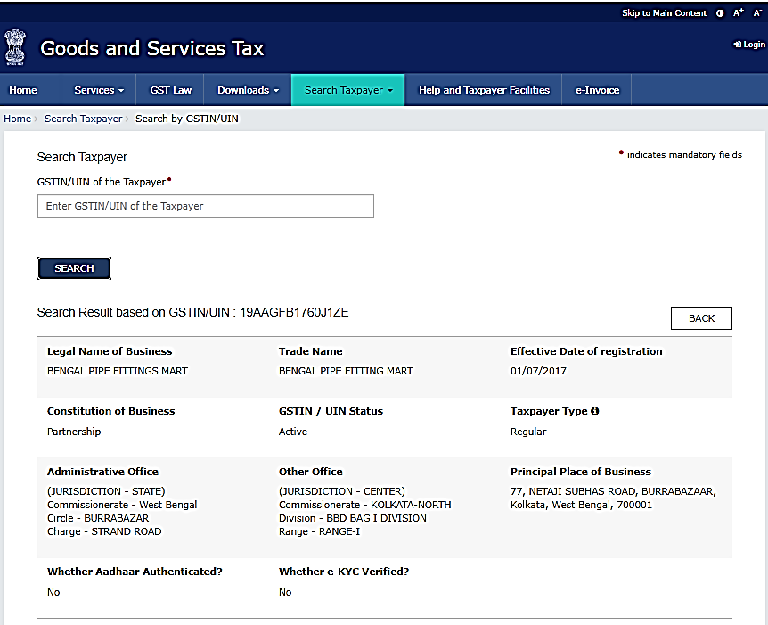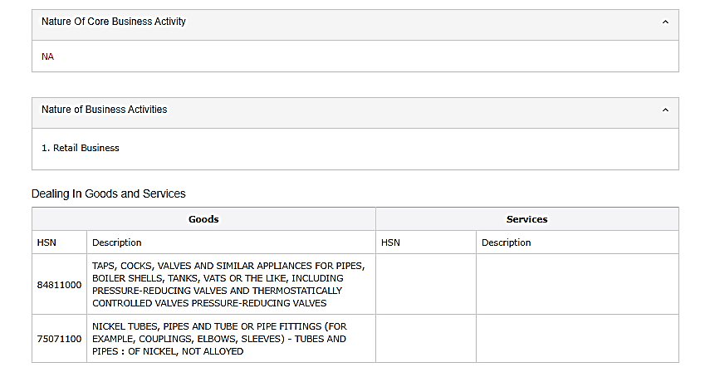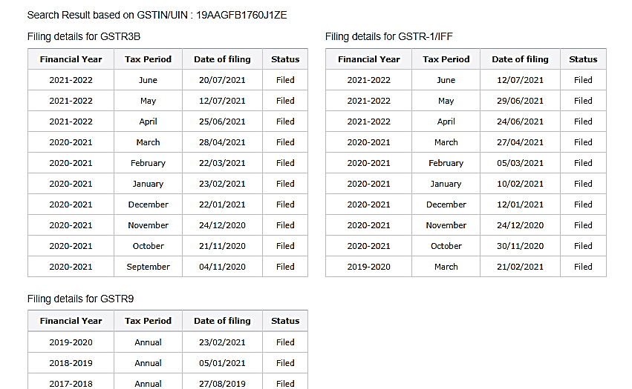

1. **DASHMESH REFRIGIRATION**

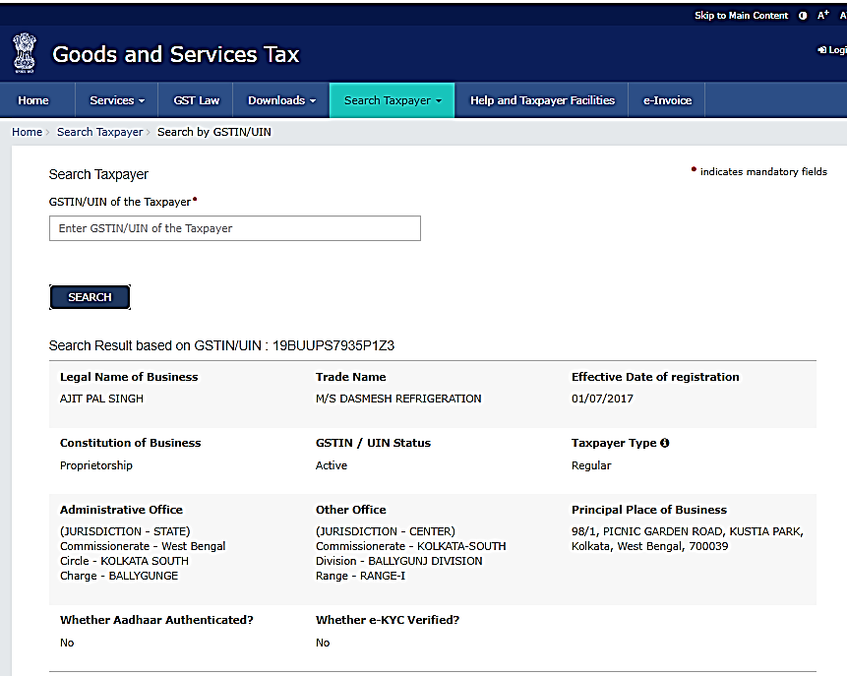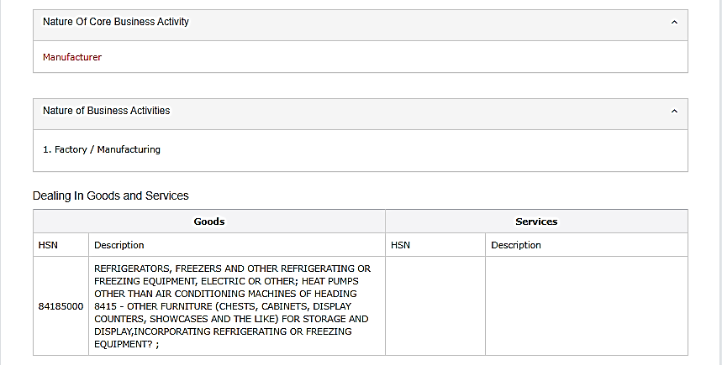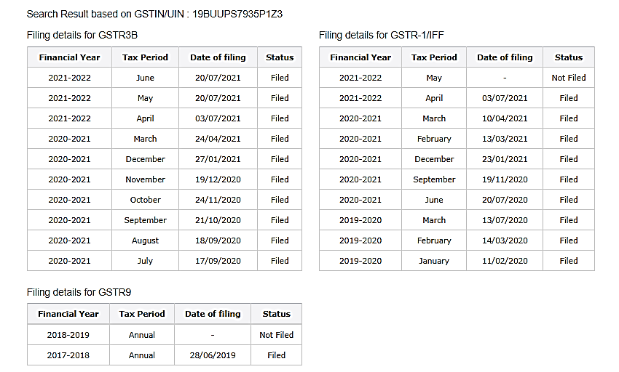

1. **HAZRA INDUSTRIES**

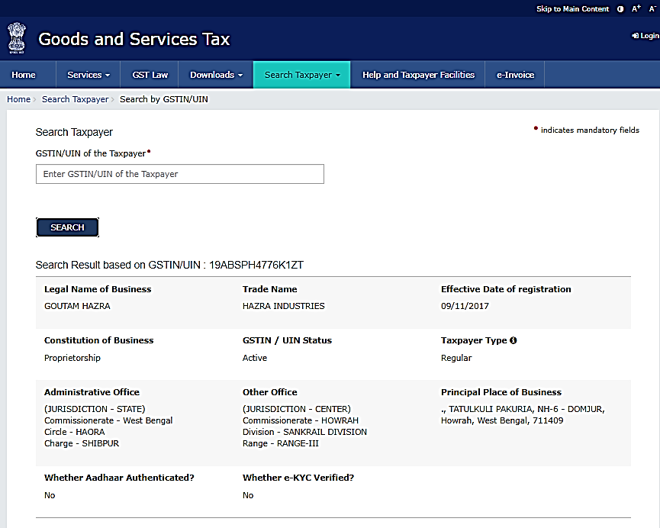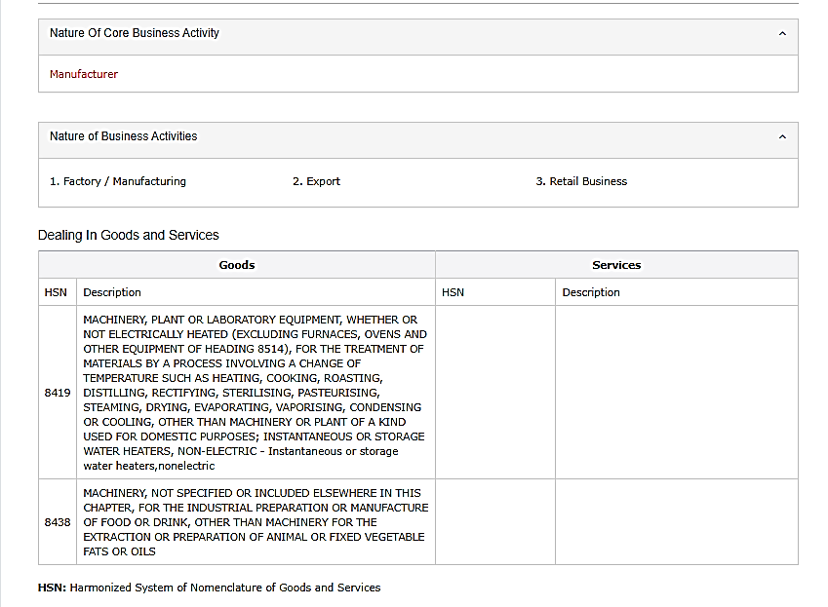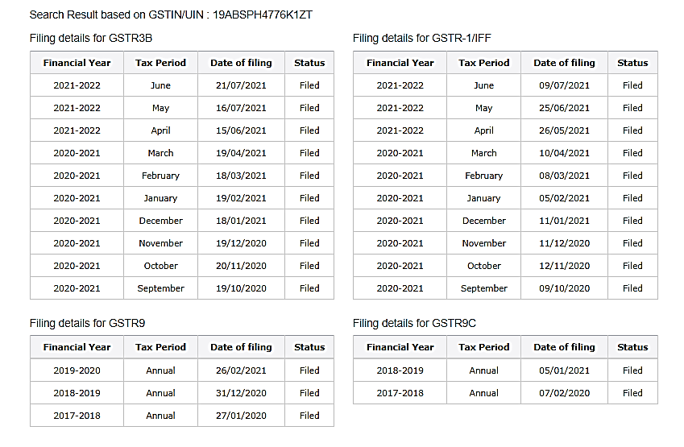

1. **KHOSLA ELECTRONUICS**

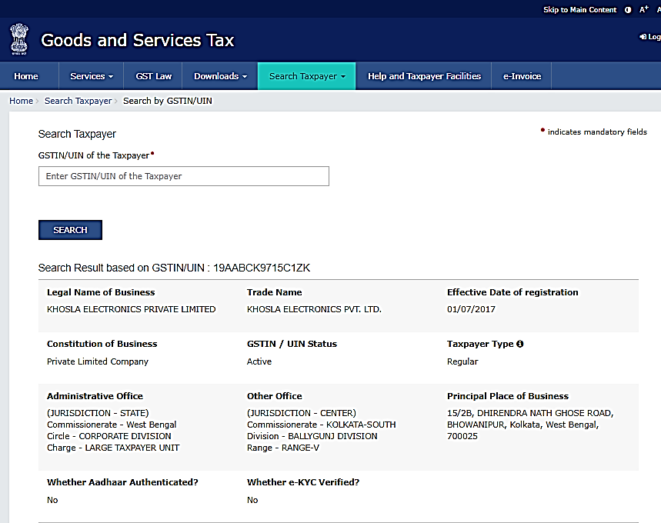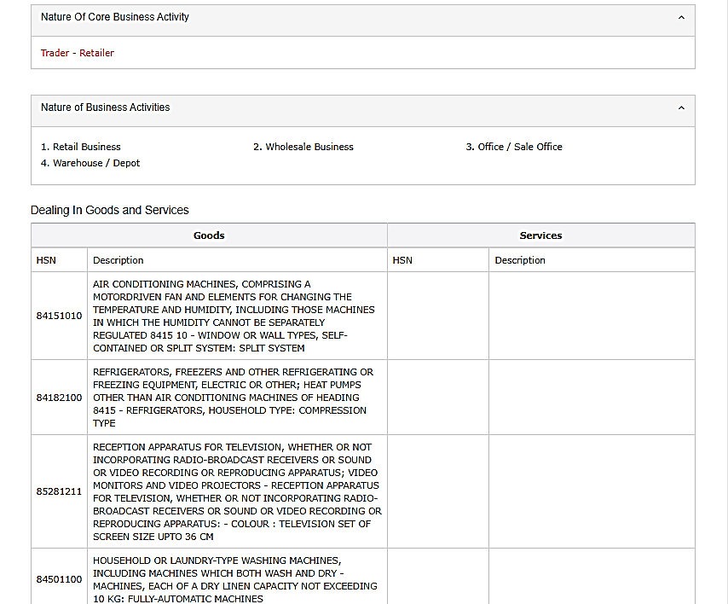

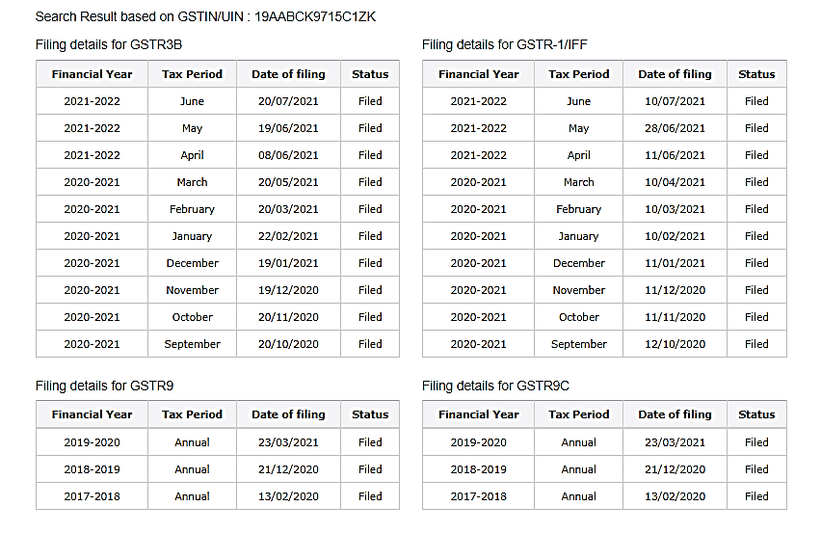

1. **PIN POINT LOGISTICS**

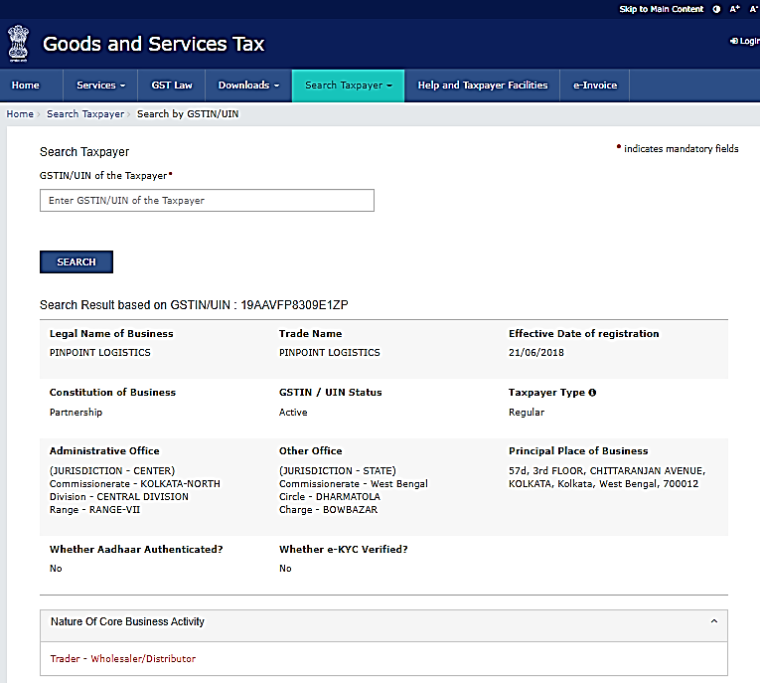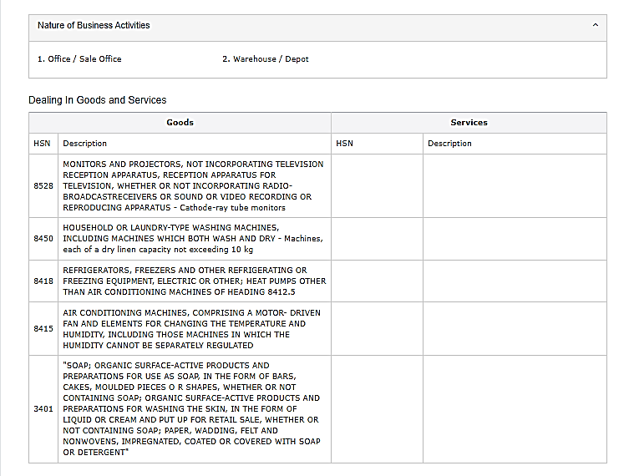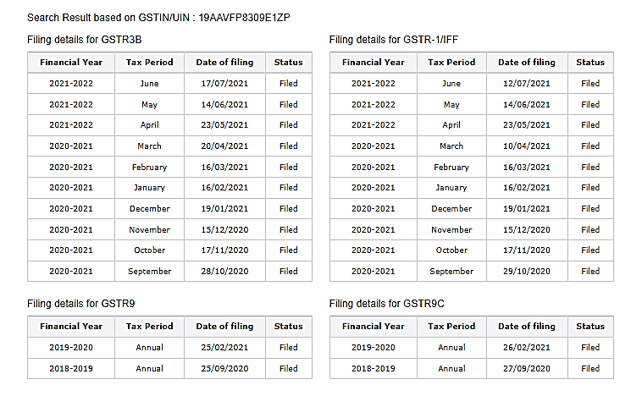

1. **HIMMAT ELECTRICALS & ELECTRONICS**

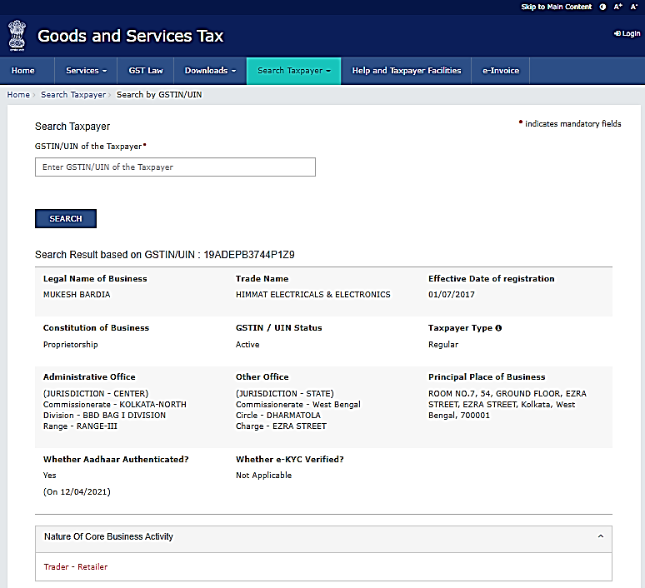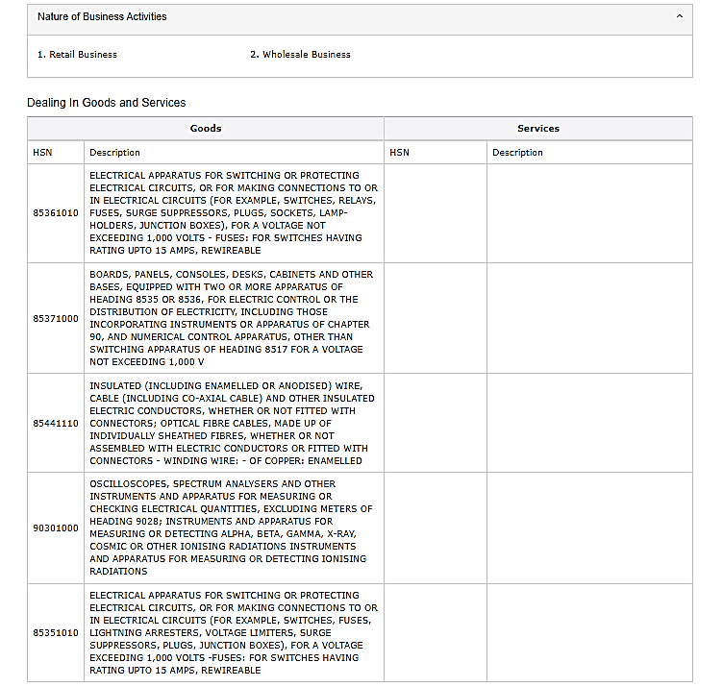

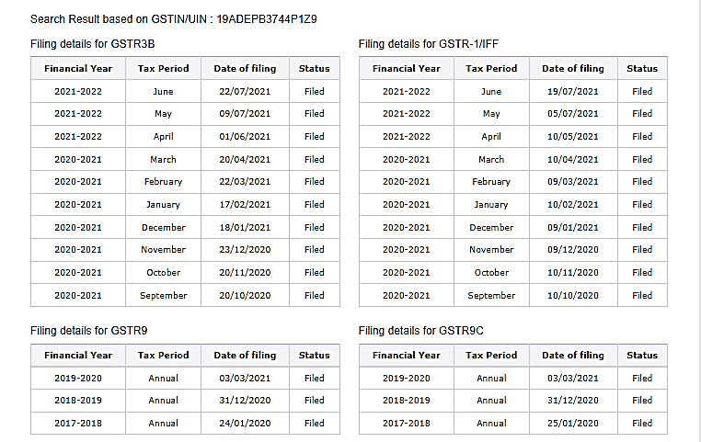

1. **ARGHA ENTERPRISE**

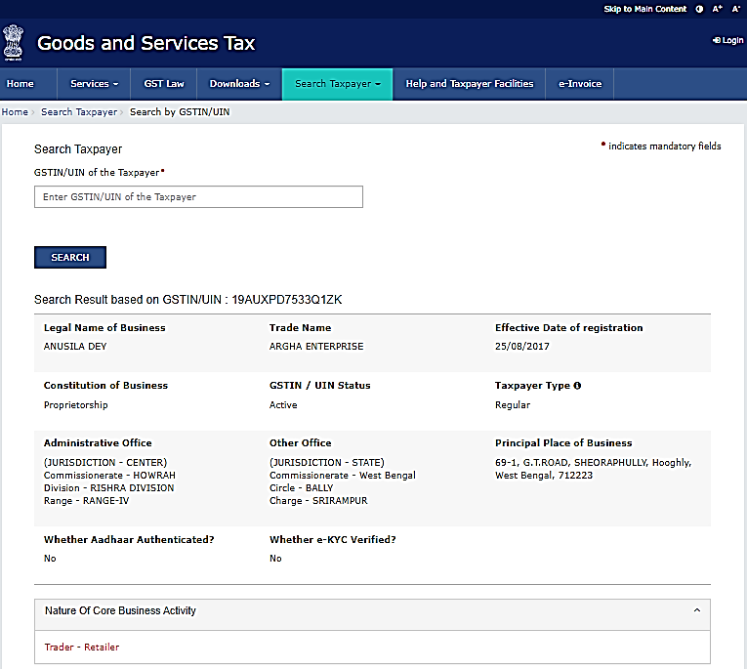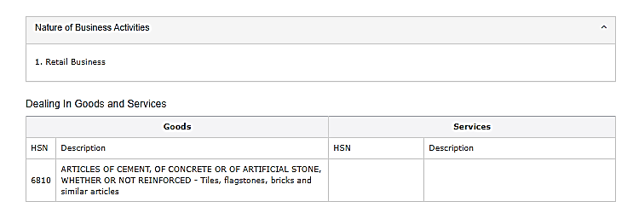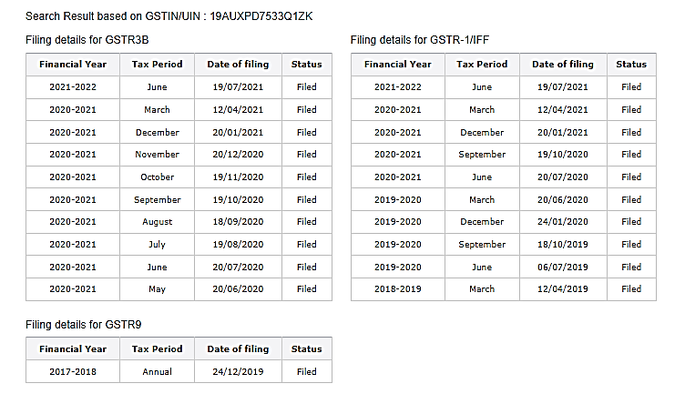

1. **MAA DAYAMOYEE MARBLE CENTER**

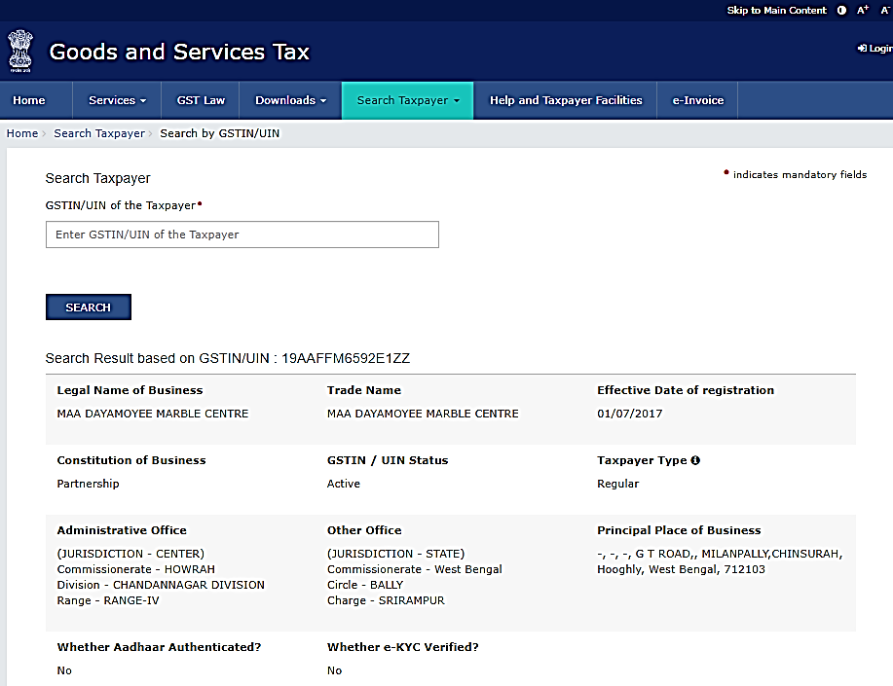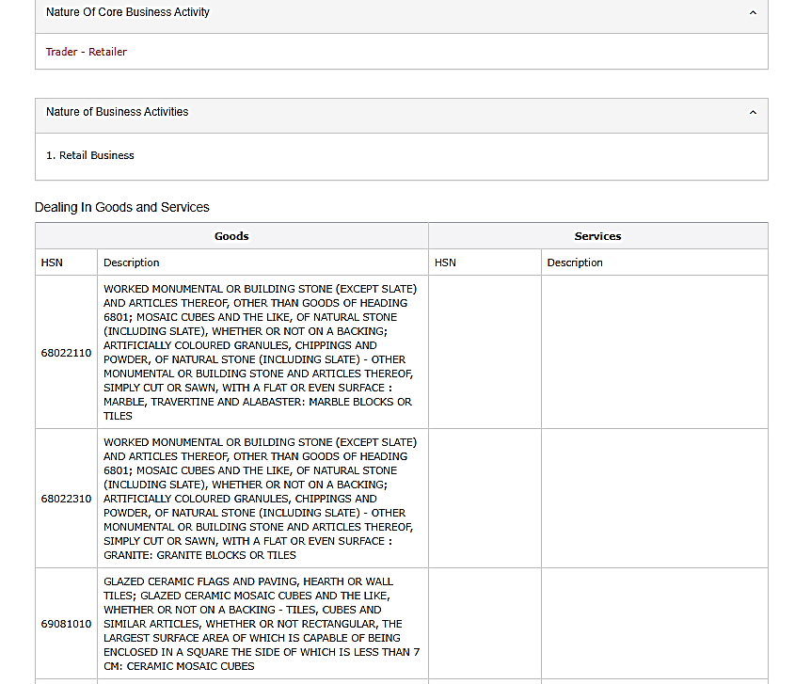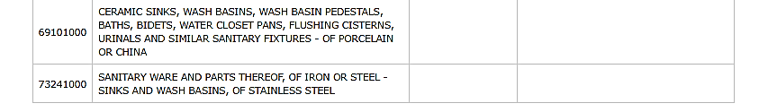

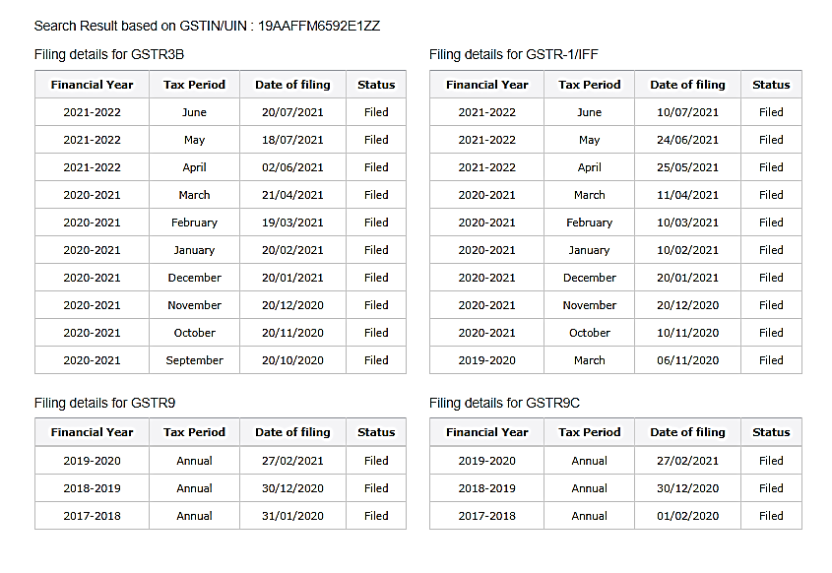

1. **IMPARATY CONSTRUCTION**

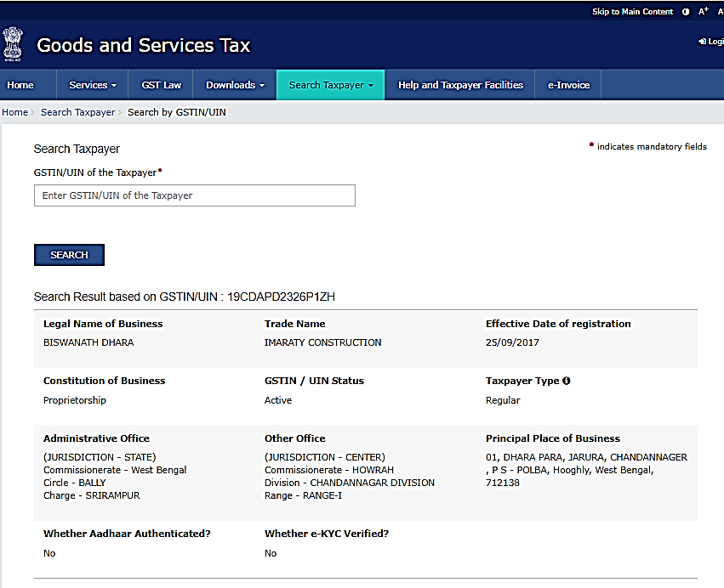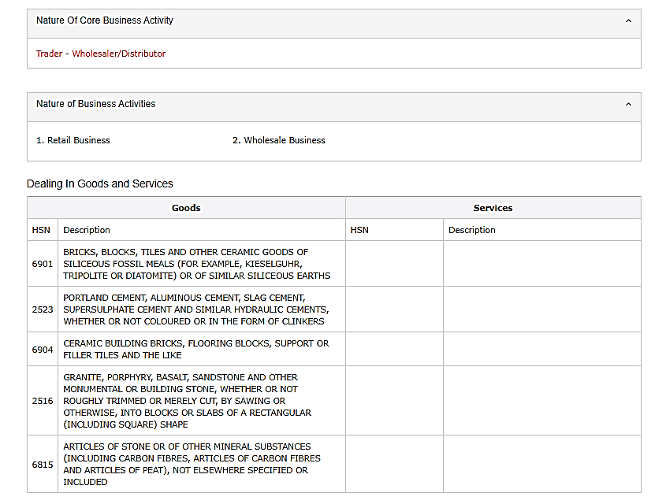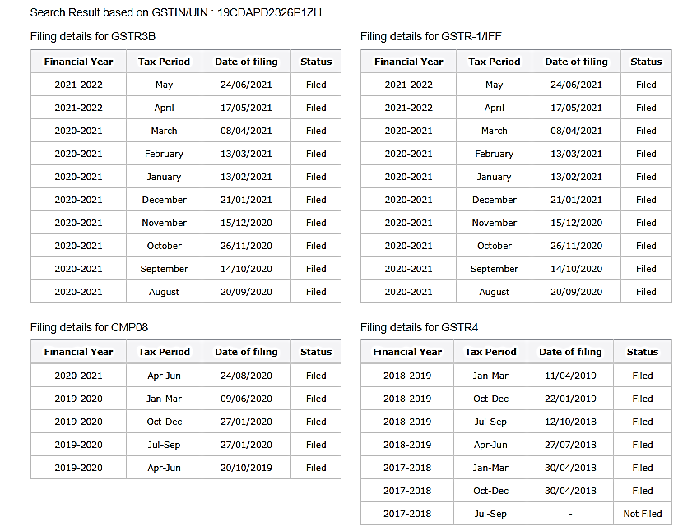

1. **ASHOK KUMAR & BROS**

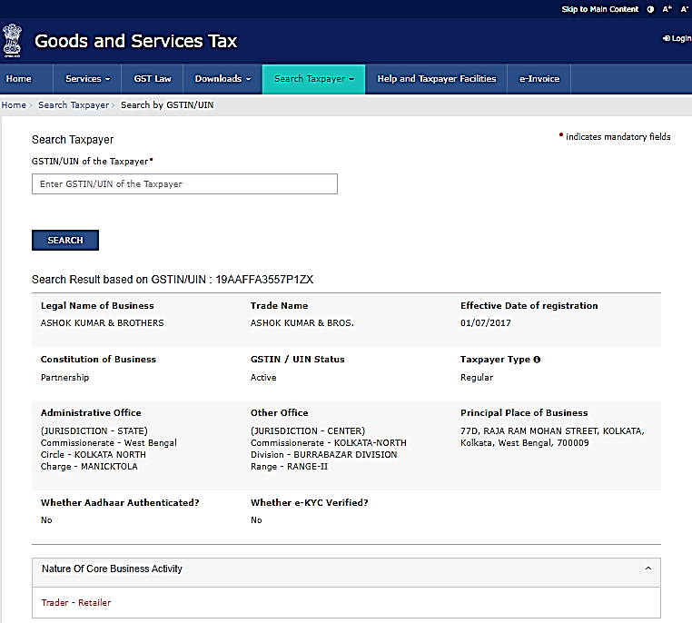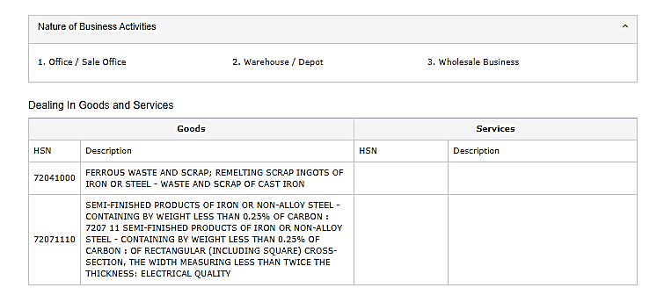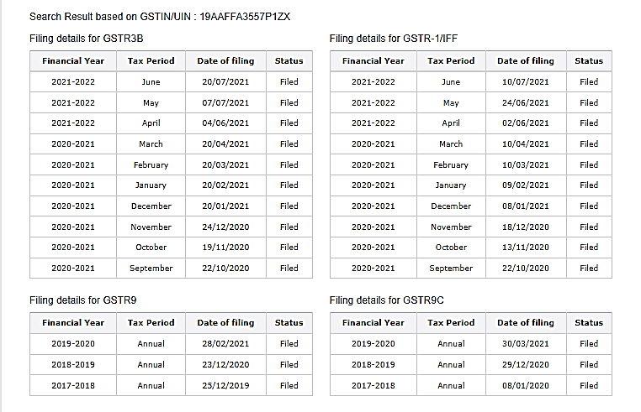

1. **AMRUT & CO.**

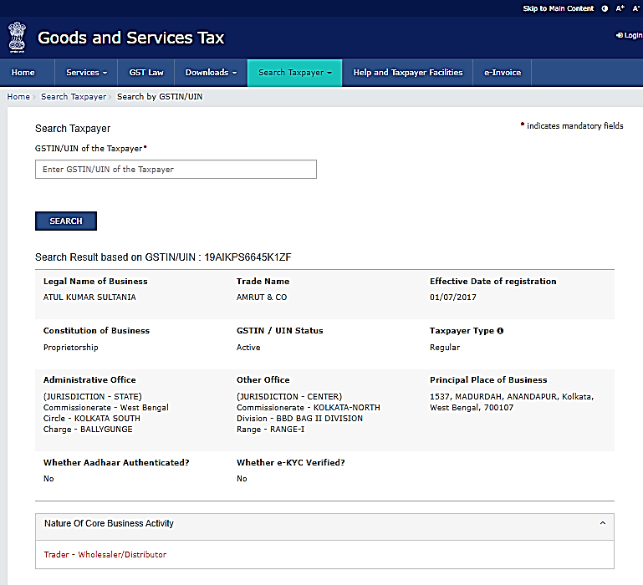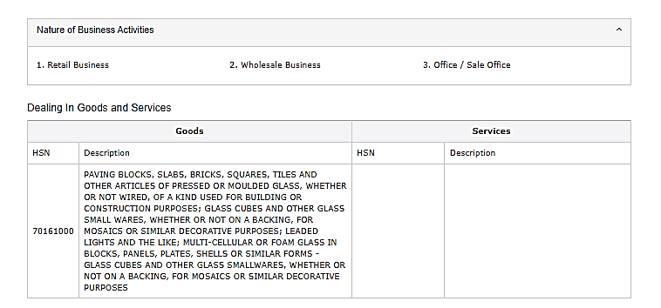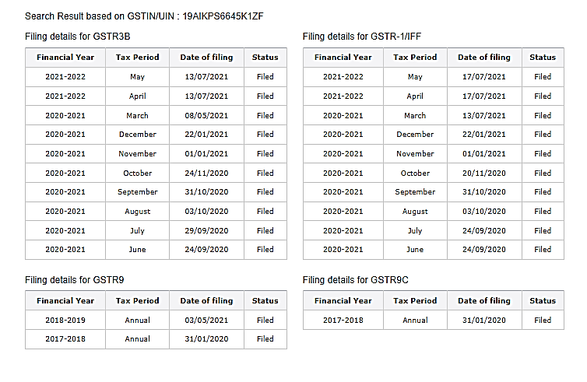

1. **NANAK CODING SYSRTEM**

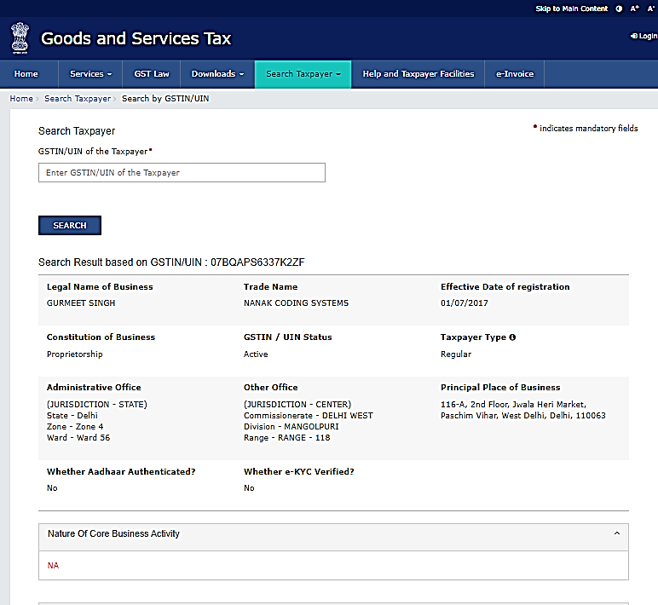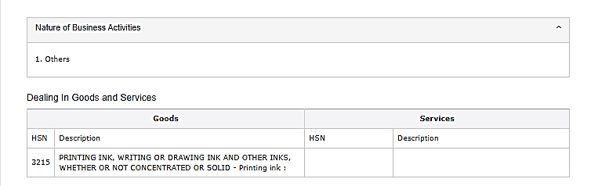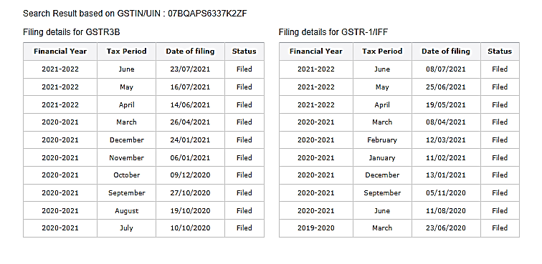

1. **CONTROL PRINT LTD.**

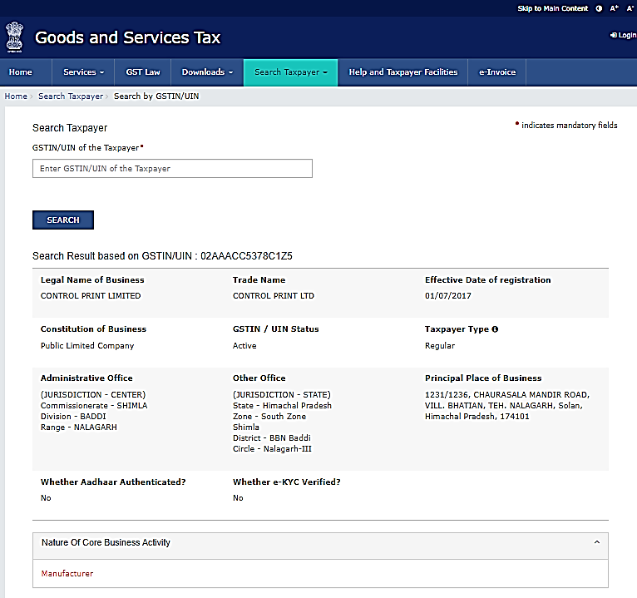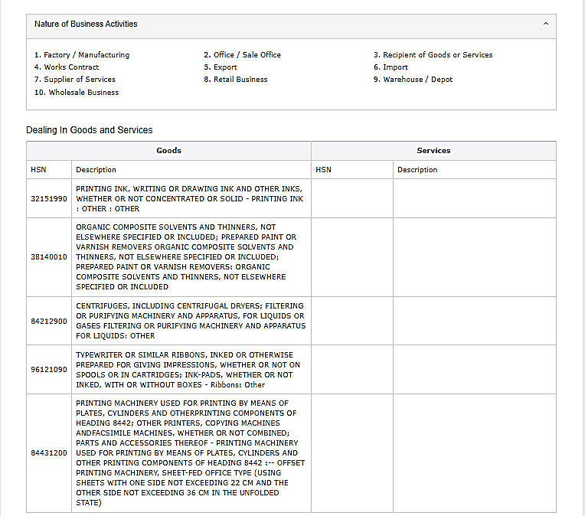

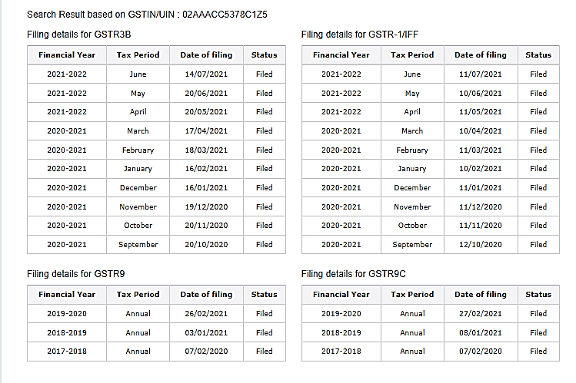

1. **AGNI KANCHAN**

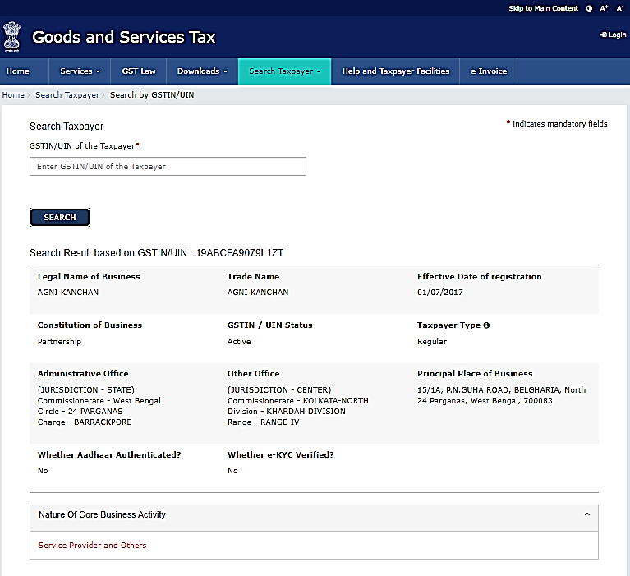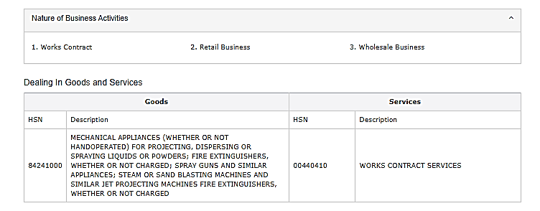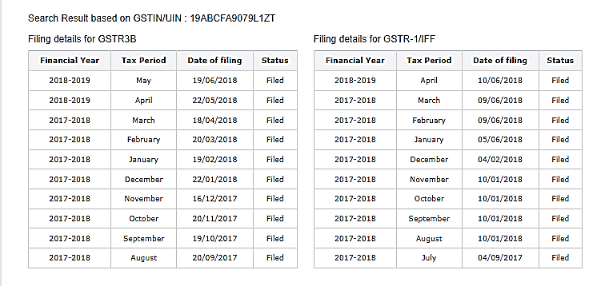

1. **KGK JET INDIA PVT. LTD.**

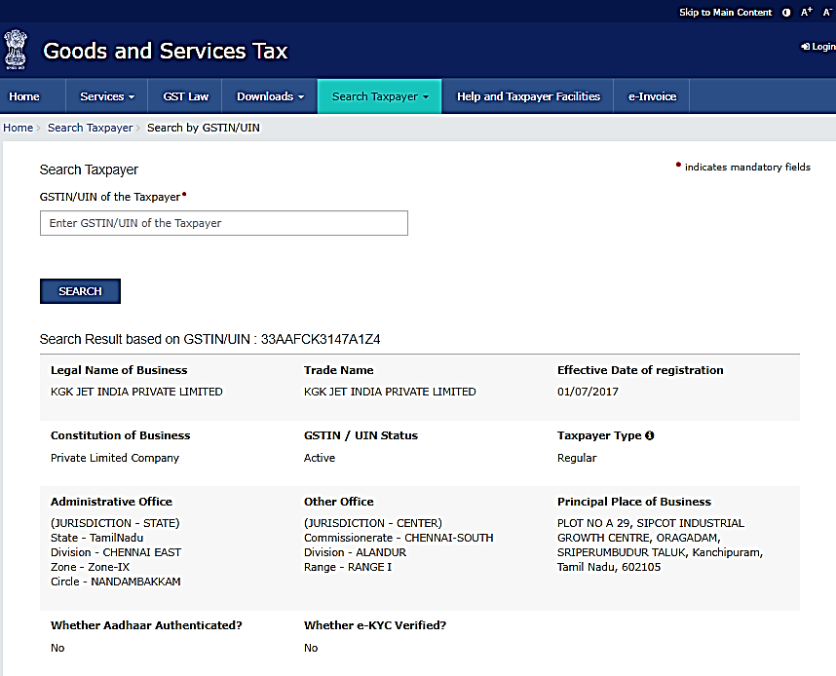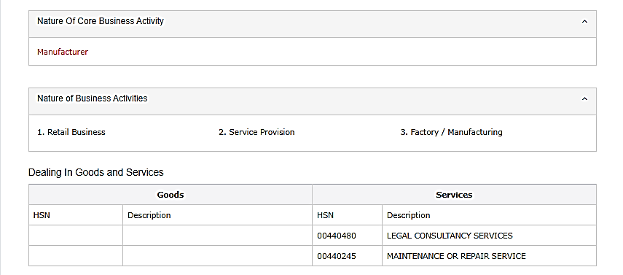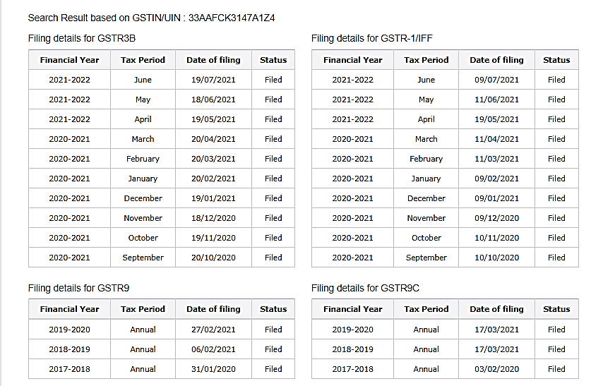

1. **MAKE WELL ENGINERRING**

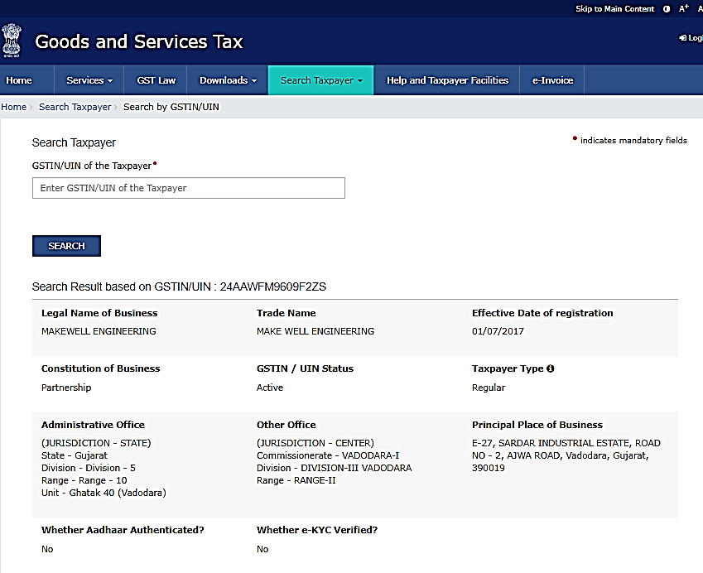

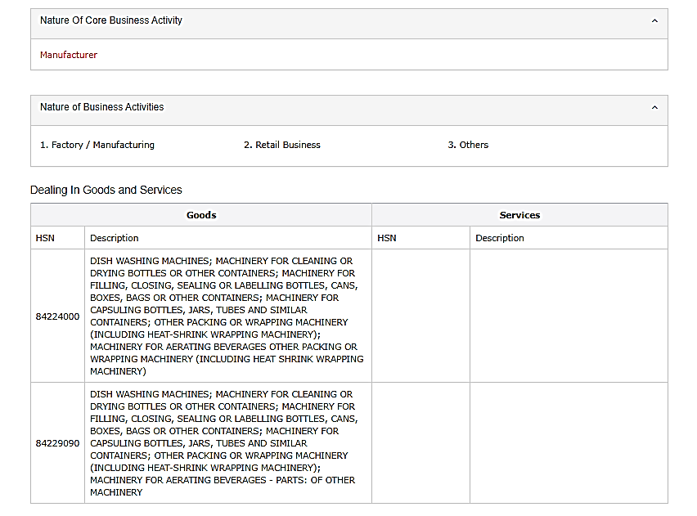

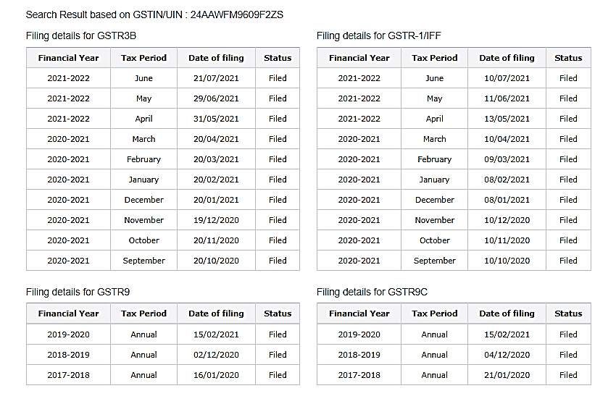

1. **POORVA ENGINEERING AND TOOLS PVT LTD**

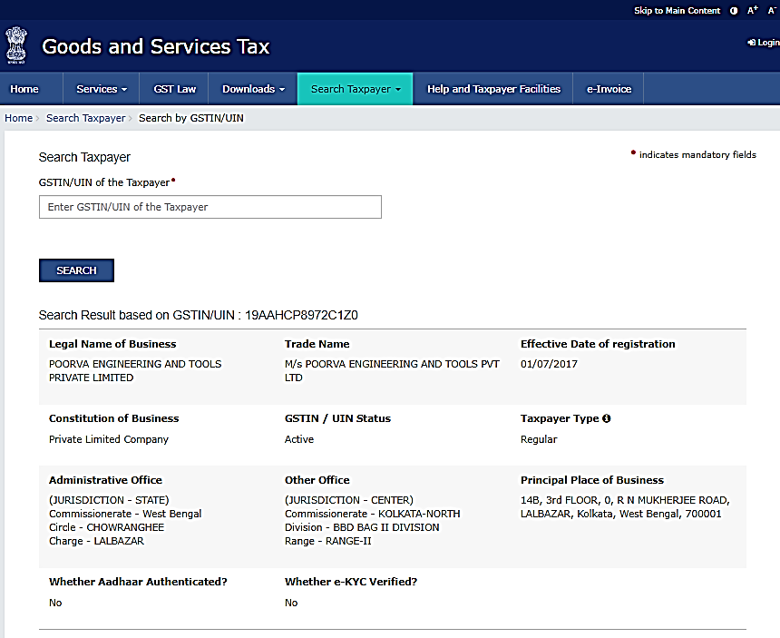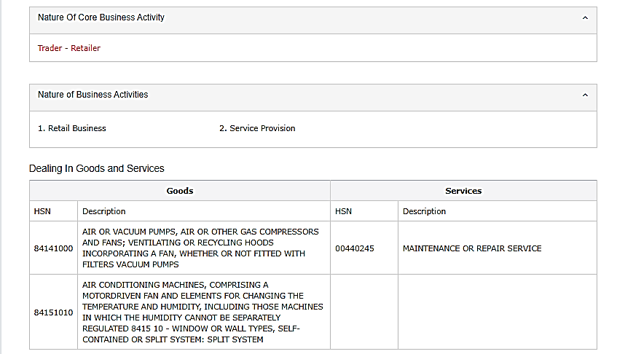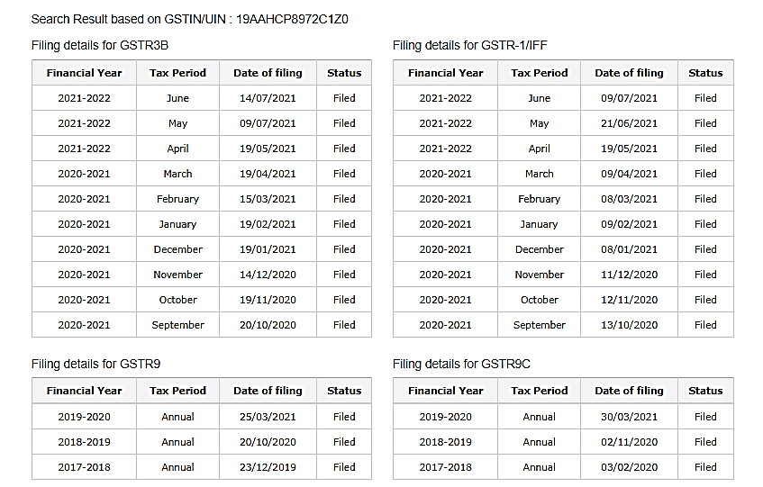

1. **RAJDEEP ENTERPRISE**

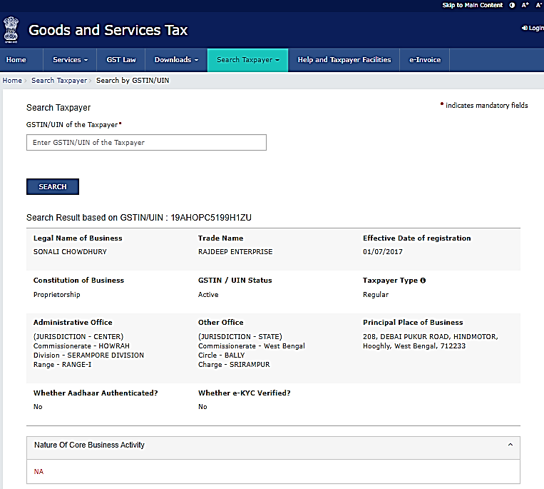

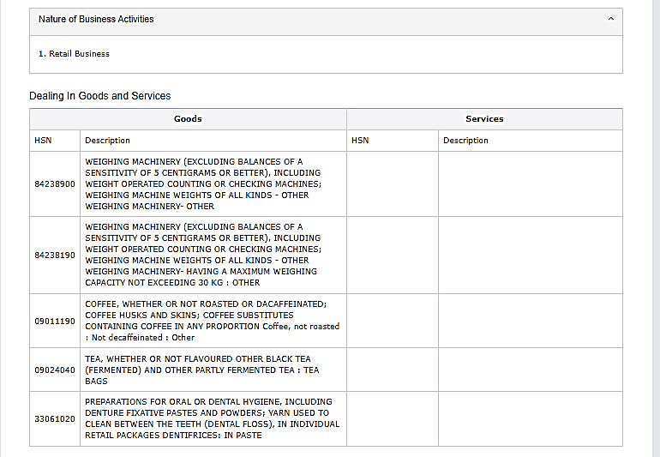

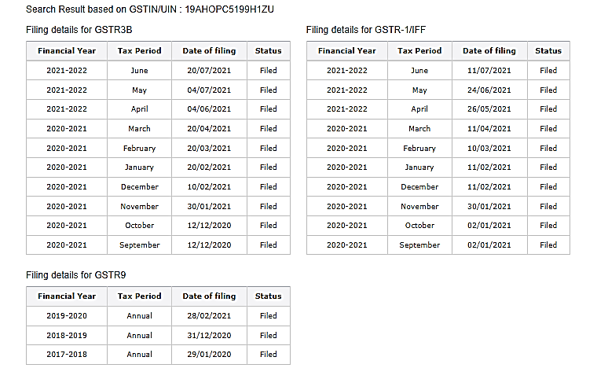

1. **HEIZA CHEM ENGINEERS PVT. LTD.**

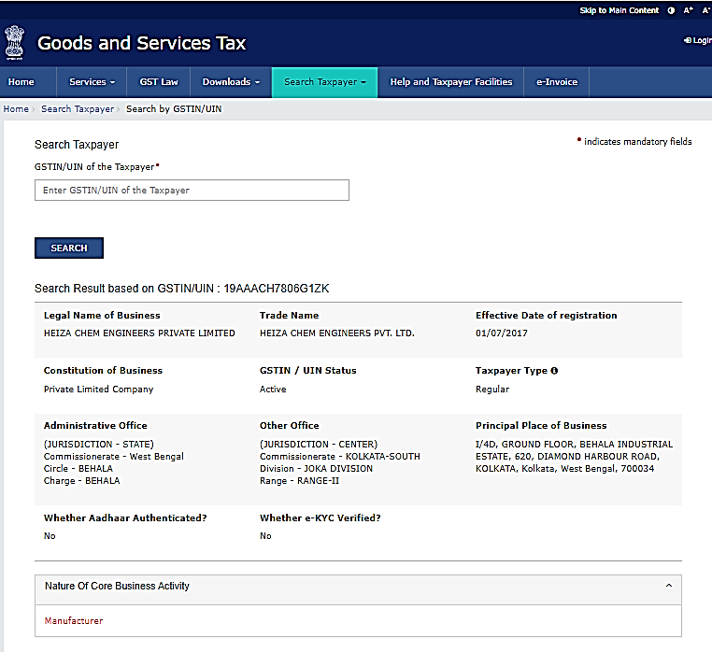

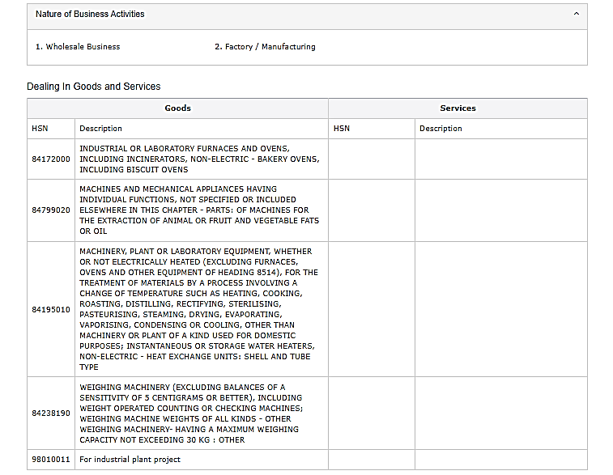

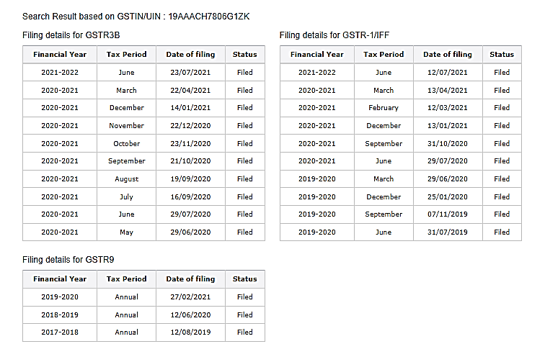

1. **ROSHAN INDUSTRIES**

