**REPORT FORMAT:** CL-1 | Version: 1.0_2018

**Ref. No: VIS(2021-22)PL-336-301-365 Date: 17-08-2021**

* ***CERTIFICATE NAME:*** *Valuation Certificate of Stock present at M/s. Window Viesta Building systems facility near Holy Angel School at Lal Tappar Industrial Area, Majri grant, Dehradoon,*
* ***PREPARED FOR ORGANIZATION:*** *Punjab National Bank, Vidhan Sabha Branch, Dehradun.*
* ***BORROWER COMPANY’S NAME:*** *M/s. Window Viesta Building systems*
* ***ASSET TYPE****: UPVC profile Section, Steel Angle Section & Gasket.*
* ***CURRENT LOCATION OF THE MATERIAL****: Facility near Holy Angel School at Lal Tappar Industrial Area, Majri grant, Dehradoon.*

**TO WHOM IT MAY CONCERN**

|  |  |  |
| --- | --- | --- |
| **S. NO.** | **PARTICULARS** | **DESCRIPTION** |
|  | Date of Survey | 05-08-2021 |
|  | Date of Certificate | 17-08-2021 |
|  | Documents provided for perusal | List of Stock of different material including UPVC profile section, Steel angle section & Gasket as certified by the owner |
|  | Current Location of the Material | *Facility near Holy Angel School at Lal Tappar Industrial Area, Majri grant, Dehradoon.* |
|  | Borrowing Company | M/s. Window Viesta Building System |
|  | Type of Asset | UPVC profile section, Steel angle section & Gasket which can be sold in the market. |
|  | Type of Assessment | Market Value of Stock of different items located at the above site. |
|  | Scope of Assessment | Assessing the market value of the Stock of UPVC profile section, Steel angle section & Gasket lying at the above site. |
|  | Nature of Material | UPVC profile section, Steel angle section & Gasket, used for construction of windows and doors. |
|  | Year of Manufacturing | No information available to us |
|  | Total Purchase Cost | Not Available to us |
|  | Current Estimated Market Value | The range of current market rates of such type of materials are verified from various dealers and on public domain. We are of the view that the Market Value of the total stock as per the list of Stock provided to us by the client is approx. Rs.7,31,000/- |
|  | Condition of Stock | Cannot comment since no quality test has been done. The stock was lying within a building. |



**OBSERVATIONS:**

1. We have been provided by the bank/borrower company the copy of the list of stock present at the site with quantity and have accepted it in good faith for valuation purposes.
2. We have contacted several dealers for the rates of similar material and also enquired in the public domain.
3. The site survey was carried out by our surveyor Mr. Deepak Joshi on August 5, 2021 in the presence of Mr. Kulbir Singh ( Bank Representative).
4. No one was available from owner’s side during survey to identify stock.

**Based on the information gathered and enquiries made by us in the market and references found in the public domain for similar materials, it is certified that total current market price of the stock listed in the provided list should be around Rs.7,31,000/- (Rupees Seven Lakhs Thirty One Thousand Only)**

*This certificate is issued at the request of* ***Punjab National Bank, Vidhan Sabha Branch, Dehradun.***

***Disclaimer:***

1. *This Certificate is to be referred only for the purpose of estimating the market value of the Stock present at site as per the list provided to us by the bank/borrower company.*
2. *We have not carried out any technical or mechanical testing to test the quality or any other technical investigation regarding the specifications or quality of the stock lying at the site.*
3. *Ownership and other legal point of view in respect of the asset is not considered in this report.*
4. *This certificate is made at the request of the Bank.*

**For R.K Associates Valuers** **& Techno** **FOR INTERNAL USE**

**Engineering Consultants (P) Ltd. *TYPED BY: AE Zaid Ebne Mairaj***

***REVIEWED BY: HOD Engineering***

**(Project Team)**

**GOOGLE MAP LOCATION OF THE SITE WHERE STOCK IS PRESENT**

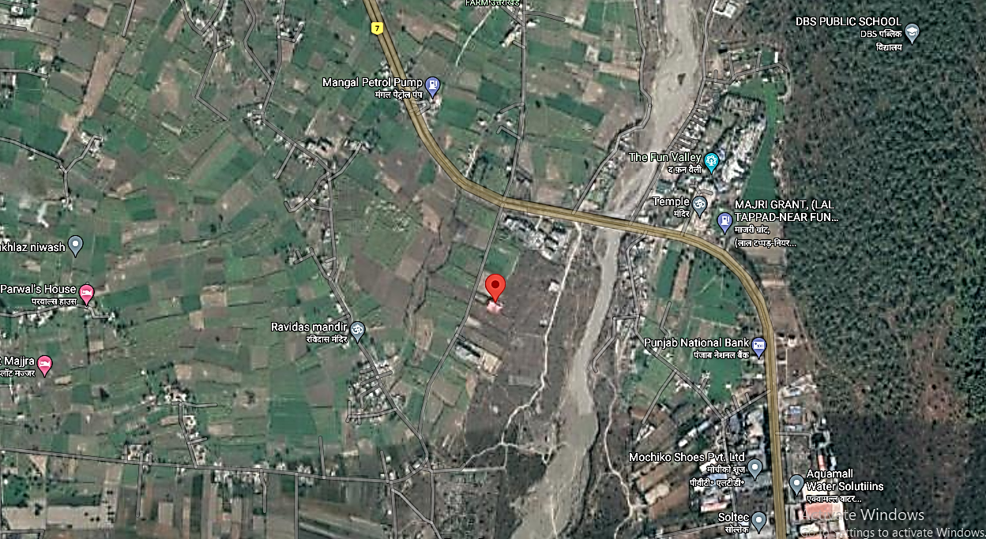

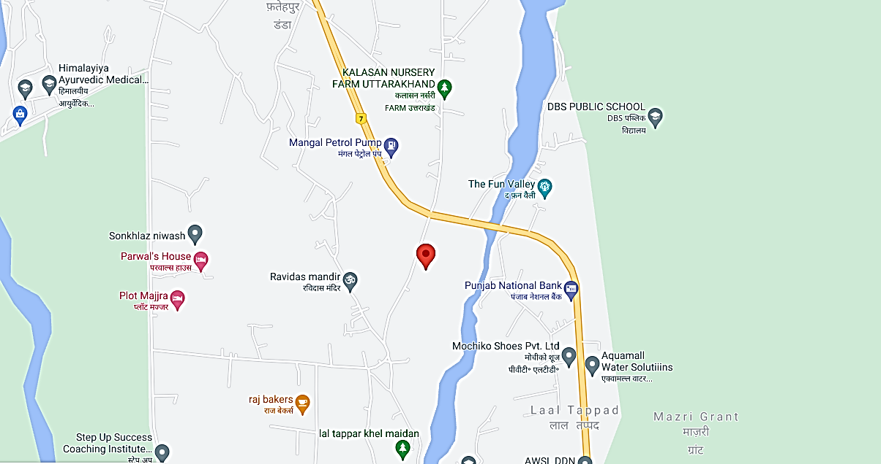

**PHOTOGRAPHS OF THE STOCK**

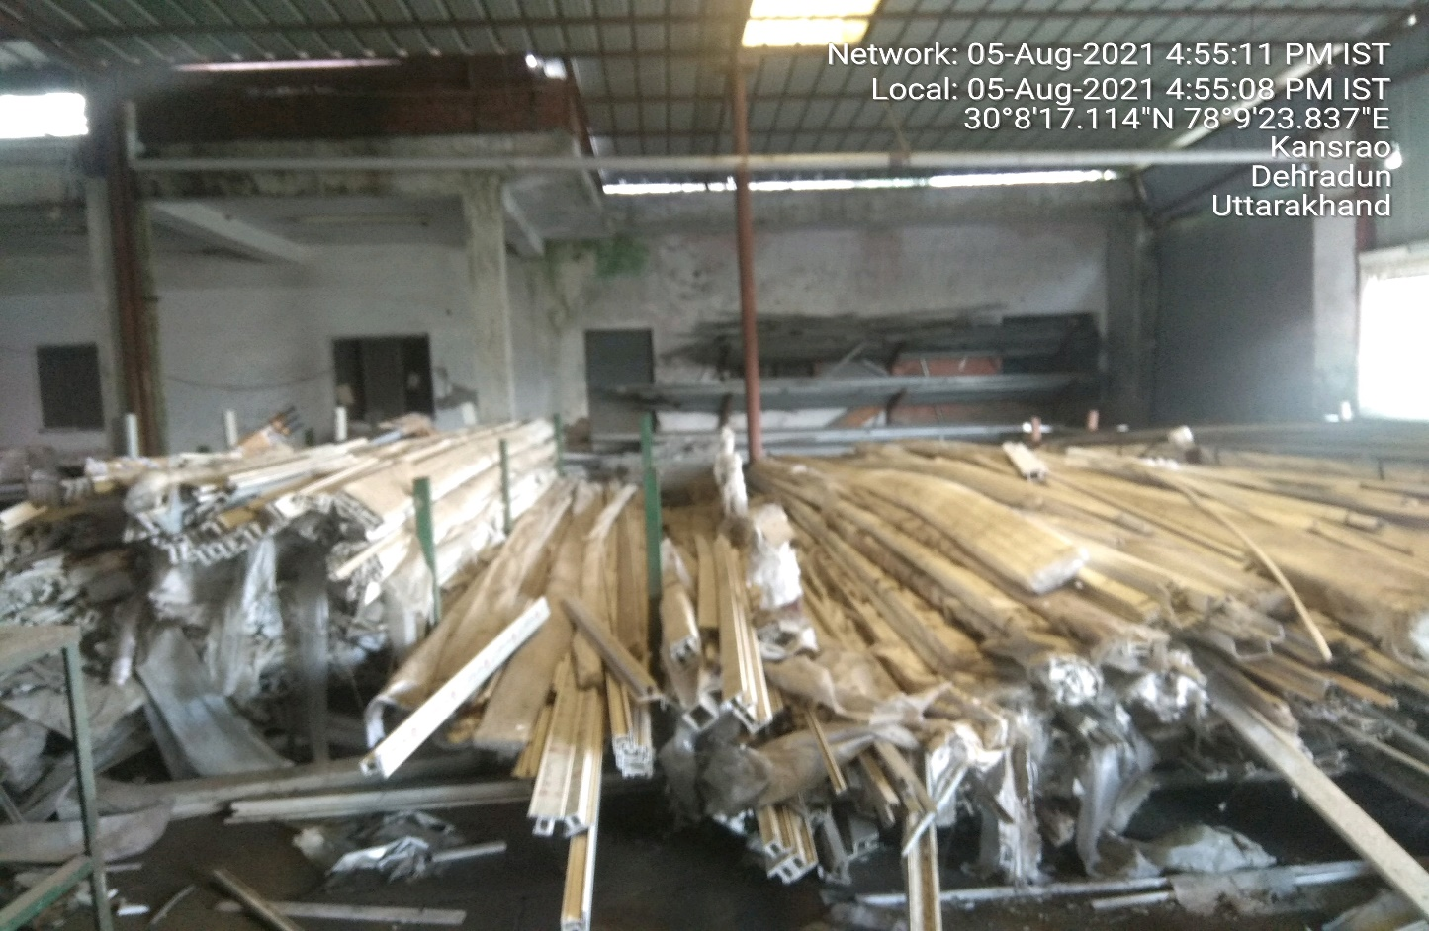

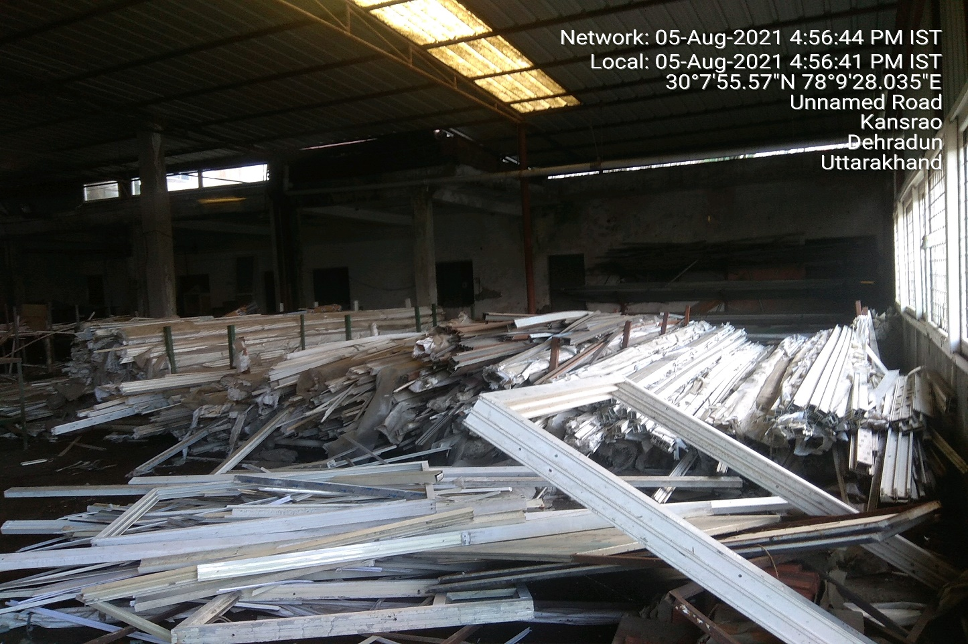

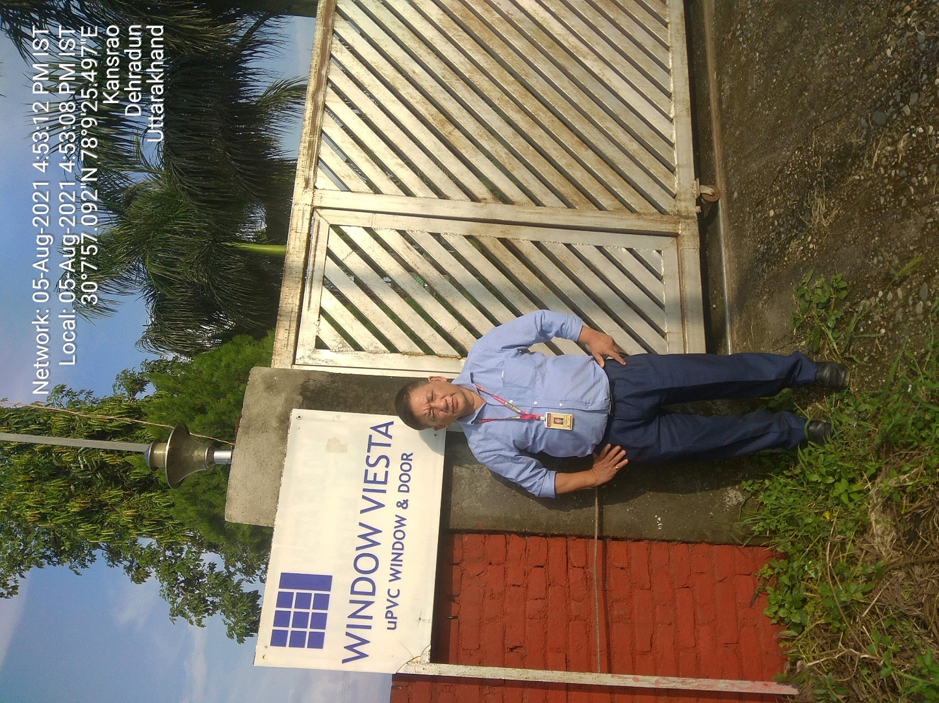

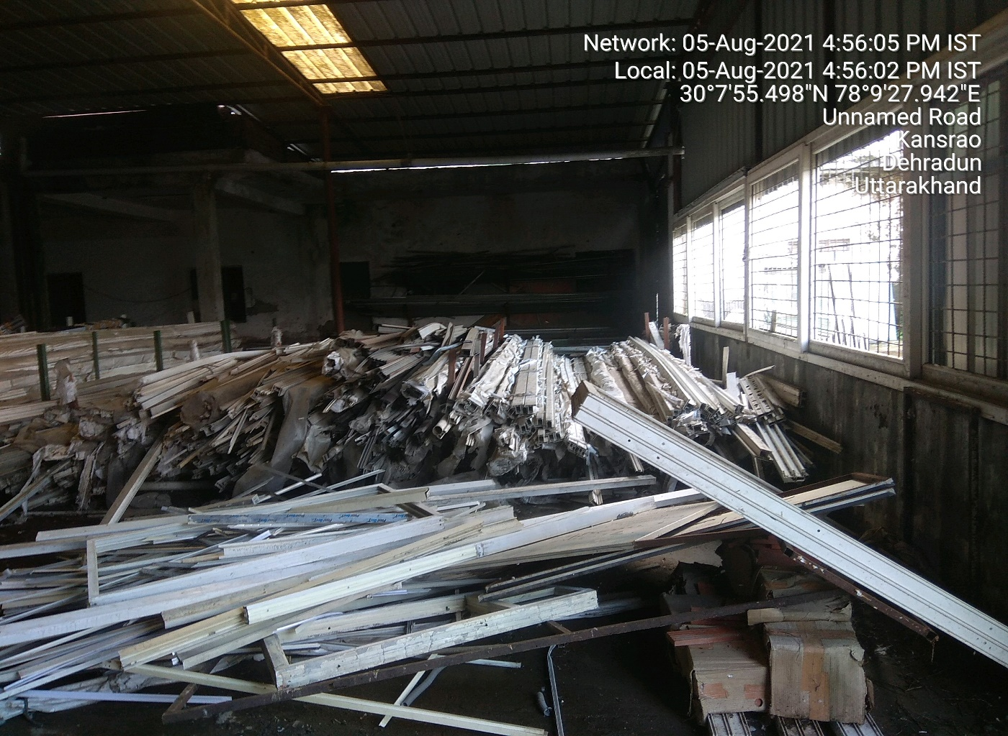

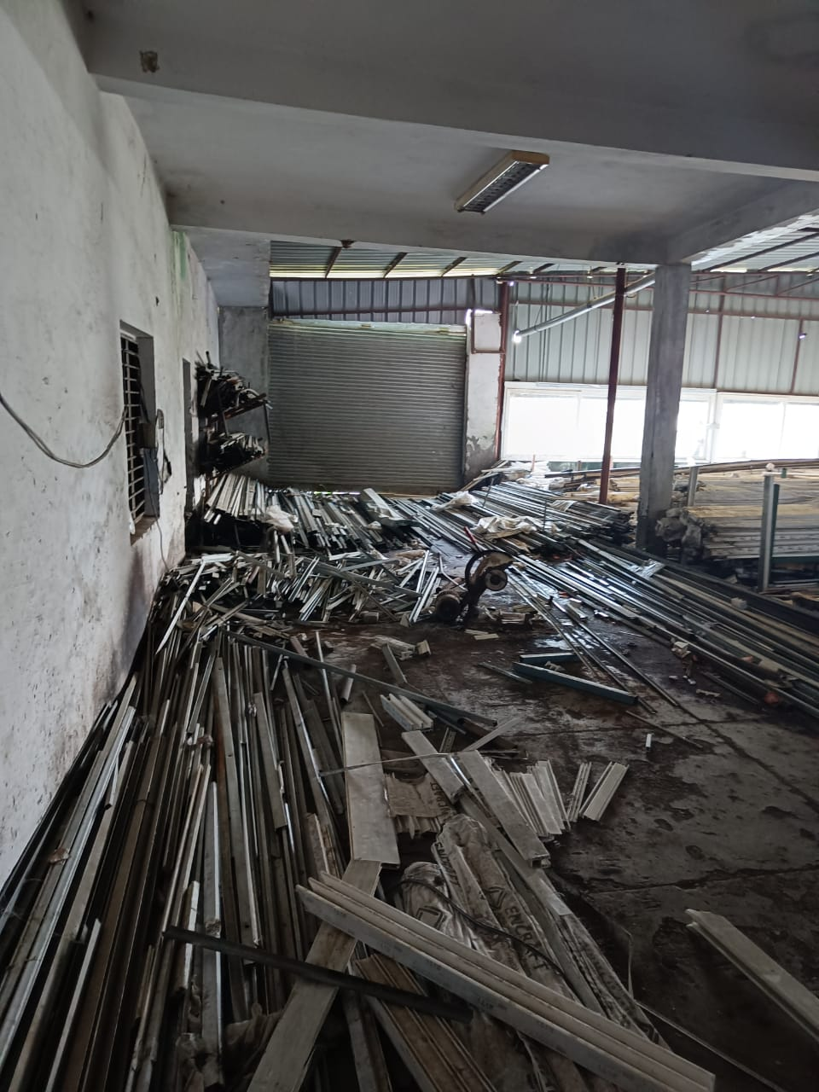

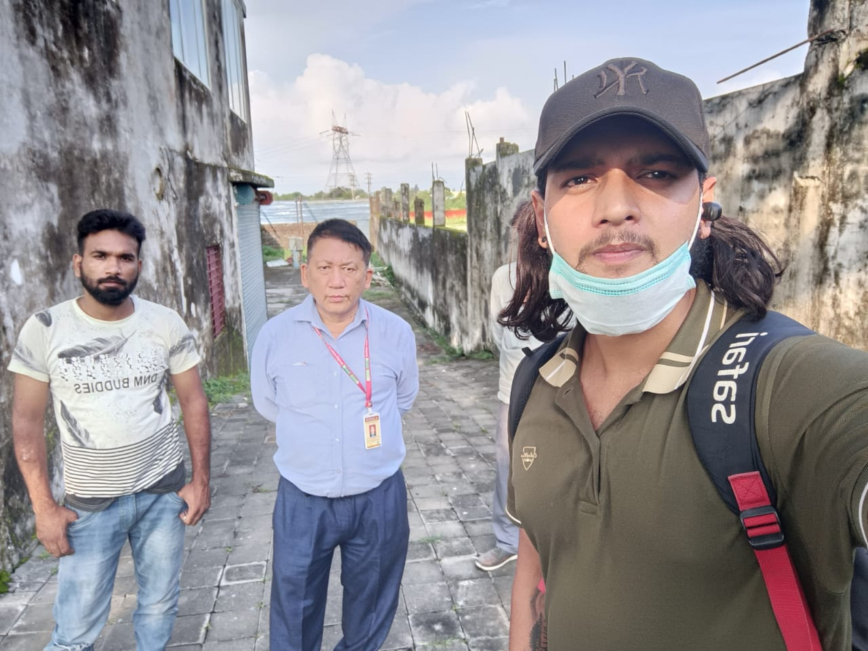

**REFERENCES FROM PUBLIC DOMAIN**

