**File No. : VIS (2021-22)-PL365-326-421 Dated: 30.08.2021**

**MARKET ANALYSIS REPORT**

**OF**

**REAL ESTATE PROJECT**

(PARAS QUARTIER)

**SITUATED AT**

**ICONIC TOWER, PARAS QUARTIER, SECTOR 2, GWAL PAHARI, GURUGRAM**

**DEVELOPER/ PROMOTER**

**M/S. FANTASY BUILDWELL PRIVATE LIMITED**

To,

The Chief Manager,

State Bank of India, Commercial Branch,

Nehru Place, New Delhi-1100019

**SUB: Market analysis report for prevailing market of Paras Quartier Real Estate Project located at Iconic Tower, Paras Quartier, Sector 2, Gwal Pahari, Gurugram.**

**Dear Sir,**

Please refer to the Valuation reports vide File No. VIS(2021-22)-PL148-Q32-145-191 dated: 03rd August of 2021 for the unsold inventory of real estate project of Paras Quartier submitted by us to yourselves in August-2021.

Further to it, lender wanted a short market analysis report regarding prevailing market rate of the subject project.

Therefore at your request of Client, we have prepared this market analysis report based on market research done by us.

|  |
| --- |
| **MARKET ANALYSIS REPORT** |

1. **Project Name:** Residential Group Housing Project i.e. **‘Paras Quartier**’
2. **Promoter Name:** M/s. Fantasy Buildwell Private Limited
3. **Total Number of Tower & Floors:** 03 Residential Towers i.e. Tower-1 (G+31 Floor), Tower-2 (G+08 Floor) and Tower-3 (G+43 Floors) and for the market purpose developer has renamed the towers-3 as Iconic Tower.

1. **Project Category:** High End Residential Project
2. **City Categorization:** Urban Developing Sector/ Metro City
3. **Amenities:** It is a developing area and recreational facilities are available within the vicinity of plant:

|  |  |  |  |  |  |  |
| --- | --- | --- | --- | --- | --- | --- |
| **School** | **Hospital** | **Market** | **Bus Stop** | **Railway Station** | **Metro** | **Airport** |
| 1.5 Km | 03 Km | 500 Km | 05 Km | 20 Km | 07 Km | 20 Km |

1. **Project Status:** Super Structure work is completed and finishing work is going on Iconic Tower
2. **Age:** Newly Construction Project
3. **Market Price:** Rs.10,000/- to Rs.13,000/- per sq.ft. including all the charges
4. **Location:** The location of the subject project is in a good developing Sector-02, Gwal Pahari and close to South Delhi in which other group housing projects are also under development. Its proximity provides easy access to Gurgaon- Faridabad Expressway, Indira Gandhi International Airport, Teri Golf Course and Golf Course Road and more infrastructure developments are proposed in this area in future.

**Gurugram:** Gurugram is a city located in the northern India State of Haryana and close to the Delhi- Haryana border and also one of the major satellites cities of Delhi and also part of National Capital Region of India.

Gurugram has become a leading financial centre in India after Mumbai & Chennai.

The prominent business locations in Gurugram are Gurugram CBD i.e. include of DLF Cyber City, MG Road, Golf Course Road and Gurugram Other’s Golf Course Extension/ Sohna Road, National Highway-08, Udhyog Vihar & Institutional Area etc.

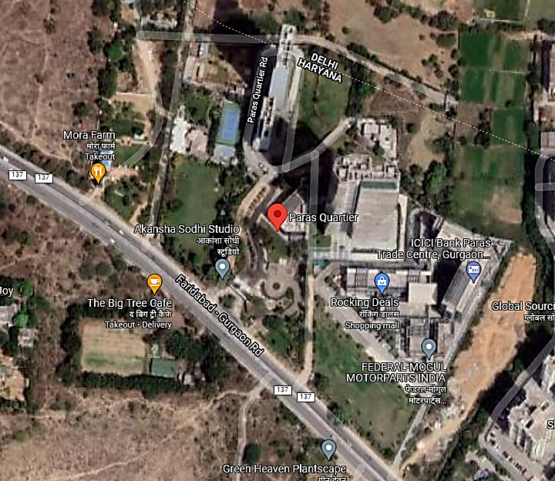

|  |
| --- |
| **COMPARABLE LIST OF SIMILAR GROUP HOUSING PROJECT** |



**Therefore, considering neighborhood similar kind of project having similar specification we have weight out the market price for the captioned project and the arrived market price for the project is ranges in between Rs.11,000/- to Rs.12,500/- per sq.ft. Considering the High End Luxury project with specification and unit size.**

**Remarks:**

1. *This Market Analysis report has been prepared on the request of client for State Bank of India, Commercial Branch, New Delhi and this report is valid only for their internal use.*
2. *All the reference use in this report has been taken from the public domain or their company official website.*
3. *We have done various market research for comparable project and quoted price are taken after several discussion with market participants only.*
4. *We have not done any technical or financial due diligence for the subject project and this report is valid only for subject project as on date of report.*
5. *The specification information has been provided by the project company and same has been taken on good faith.*
6. *This certificate doesn’t include Drawing, design, and sketch plan in the scope of work.*
7. *Ownership and other legal point of view in respect of the asset is not considered in this report.*

*Annexure:*

1. *Project Specification List*
2. *Market rate reference available on public domain*

**For R.K Associates Valuers** **& Techno** **FOR INTERNAL USE**

**Engineering Consultants (P) Ltd. *TYPED BY: PE Team***

***REVIEWED BY: HOD Engineering***

**(Project Team)**