REPORT FORMAT: V-L1 (Basic) | Version: 8.0_2019

FILE NO.: VIS(2021-22)-PL402-Q98-359-459 DATED:28-09-2021

VALUATION ASSESSMENT

OF

RESIDENTIAL FLAT

SITUATED AT

FLAT NO. 704, 7TH FLOOR, B WING, PRAKRITI CO-OP HOUSING SOCIETY LTD., PLOT NO-217-A, FINAL PLOT NO. 151, SUB-PLOT NO.-A, T.P. SCHEME NO.-1, SITUATED AT NAUPADA NOW KNOWN AS WAGLE ESTATE, RAGUNATH NAGAR ROAD, DISTRICT- THANE (WEST), MAHARASHTRA
OWNER/S

MRS. MUGDHA DILIP NAIK

A/C: MRS. MUGDHA DILIP NAIK
REPORT PREPARED FOR

PUNJAB NATIONAL BANK, CIRCLE SASTRA CELL, MUMBAI CITY CIRCLE, MAKER TOWER E, 18TH FLOOR, CUFFE PARADE, MUMBAI
**Important - In case of any query/ issue/ concern or escalation you may please contact Incident Manager @ valuers@rkassociates.org. We will appreciate your feedback in order to improve our services.

Valuation TOR is available at www.rkassociates.org for reference.

NOTE: As per IBA Guidelines please provide your feedback on the report within 15 days of its submission after which report will be considered to be correct.

ASSET/ PROPERTY UNDER VALUATION

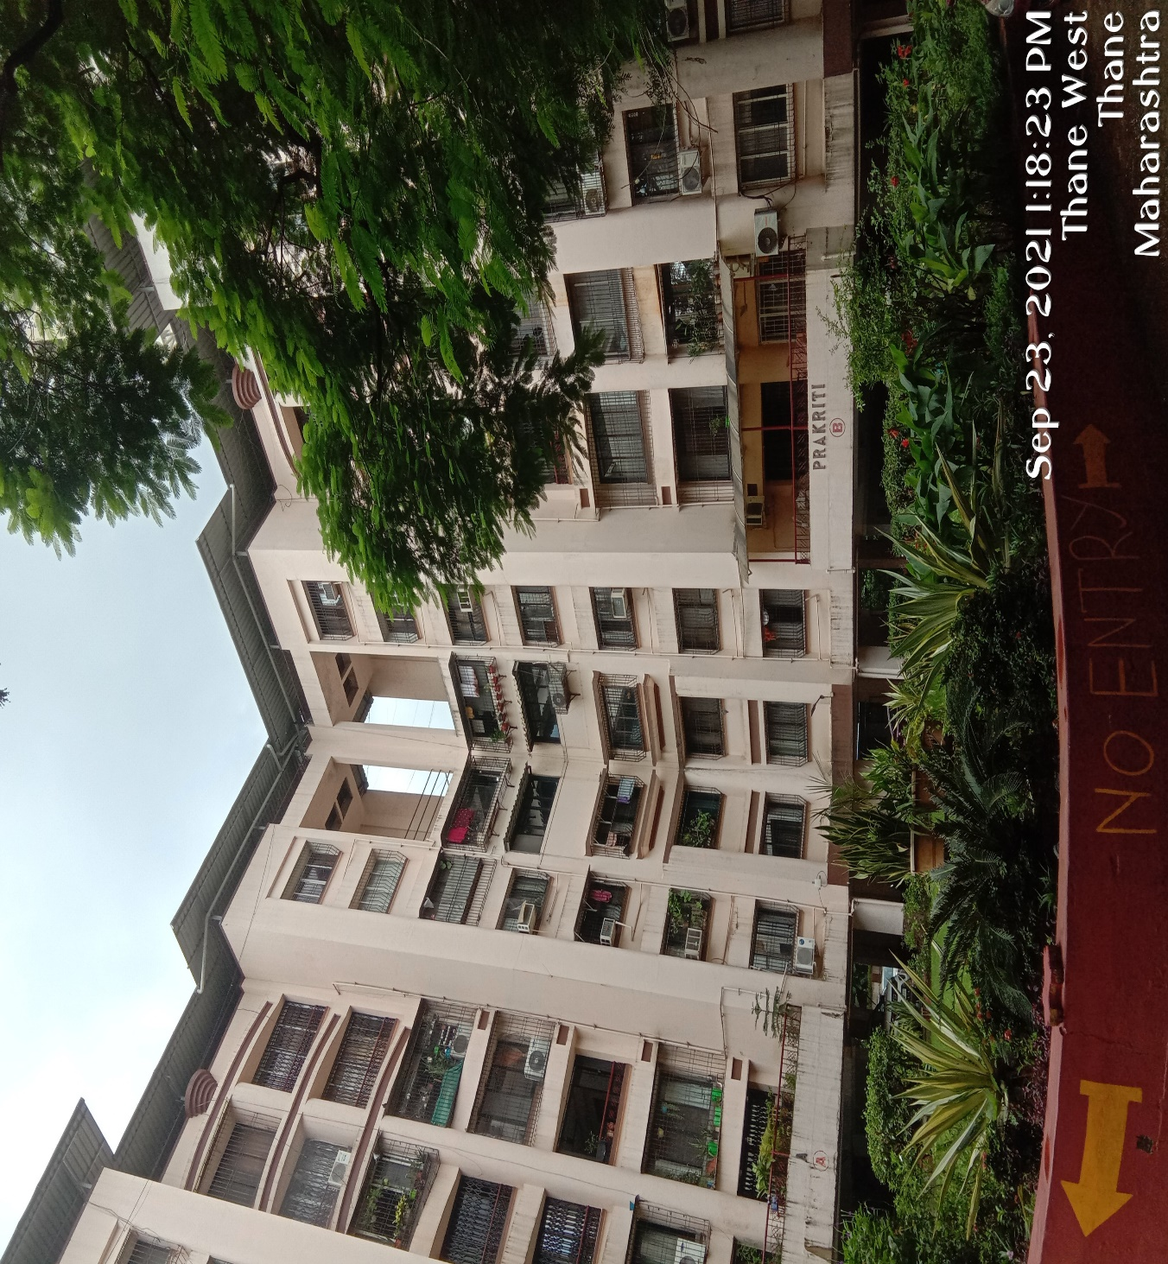

SITUATED AT

FLAT NO. 704, 7TH FLOOR, B WING, PRAKRITI CO-OP HOUSING SOCIETY LTD., PLOT NO-217-A, FINAL PLOT NO. 151, SUB-PLOT NO.-A, T.P. SCHEME NO.-1, SITUATED AT NAUPADA NOW KNOWN AS WAGLE ESTATE, RAGUNATH NAGAR ROAD, DISTRICT- THANE (WEST), MAHARASHTRA

VALUATION ASSESSMENT AS PER PNB FORMAT

Name & Address of Branch: | Punjab National Bank, Circle Sastra Cell, Mumbai City Circle, Maker Tower E, 18th Floor, Cuffe Parade, Mumbai
Name of Customer (s)/ Borrower Unit | Mrs. Mugdha Dilip Naik

1. | Customer Details
i. | Owner’s Name |  | Mrs. Mugdha Dilip Naik
ii. | Application No. |  | NA
2. | Property Details
i. | Address |  | Flat No. 704, 7th Floor, B Wing, Prakriti Co-Op Housing Society Ltd., Plot No-217-A, Final Plot No. 151, Sub-Plot No.-A, T.P. Scheme No.-1, Situated At Naupada Now Known As Wagle Estate, Ragunath Nagar Road, District- Thane (West), Maharashtra
ii. | Nearby Landmark |  | Near Mittal Park
iii. | Google Map |  | Enclosed with the Report
 |  |  | Coordinates or URL: 19°11'31.2"N 72°57'41.0"E
iv. | Independent access to the property |  | Clear independent access is available
v. | Type of ownership |  | Single ownership
vi. | Constitution of the Property |  | Free Hold
vii. | Is the property merged or colluded with any other property |  | No
 |  |  | Comments: None
3. | Document Details |  | Status |  | Name of Approving Auth. |  |  |  | Approval No.
i. | Layout Plan |  | No information provided |  | --- |  |  |  | ---
ii. | Building plan |  | No information provided |  | --- |  |  |  | ---
iii. | Construction Permission |  | No information provided |  | --- |  |  |  | ---
iv. | Legal Documents |  | Available |  | Copy of TIR |  | --- |  |  |  | ---
4. | Physical Details of the Property
i. | Adjoining Properties |  | Directions |  | As per Sale Deed/TIR |  |  |  | Actual found at Site
 |  |  | North |  | Property of M/s Premier Rubber |  |  |  | Lobby/Flat No.701
 |  |  | South |  | Property of M/s. Kanshiram Kedarnath |  |  |  | Mittal park
 |  |  | East |  | Property of A.G. Mitbawankar |  |  |  | Flat No.703
 |  |  | West |  | Property of Velji Monji |  |  |  | Ground Facing
ii. | Are Boundaries matched |  | No, not from the available documents
iii. | Plot demarcation |  | Yes
iv. | Approved land Use |  | Residential as per property documents
v. | Type of Property |  | Residential Apartment in multistoried building
vi. | No. of bed rooms | Living/ Dining area |  | Toilets |  | Kitchen |  |  |  | Other rooms
 | 01 | 01 |  | 01 |  | 01 |  |  |  | 00
vii. | Total no. of floors of the property |  | Stilt + 7 Floors
viii. | Floor on which the property is located |  | Seventh Floor
ix. | Approx. age of the property |  | 22 years
x. | Residual age of the property |  | Approx. 40-45 years, depending upon proper & timely maintenance.

xi. | Type of structure | RCC framed pillar, beam, column structure on RCC slab
xii. | Condition of the Structure | Average
xiii. | Finishing of the building | Simple plastered wall
5. | Tenure/ Occupancy/ Possession Details
i. | Property presently possessed/ occupied by |  | Owner Occupied
ii. | Status of Tenure |  | NA
iii. | No. of years of occupancy |  | NA
iv. | Relationship of tenant or owner |  | NA
6. | Stage of Construction |  | Constructed property in use.
 | If under construction then extent of completion |  | NA
7. | Violation in the property
 | i. Violation if any observed | ii. Nature and extent of violation |  | iii. Any other negativity, defect or  drawback in the property
 | Cannot comment since copy  of approved building plans/map not provided to us | NA |  | No

8. | AREA DETAILS OF THE PROPERTY
i. | Land area(as per documents/ site survey, whichever is less)  (Not considered since this is a Built-up Dwelling Unit Valuation)
 | Area as per documents | Area as per site survey |  | Area considered for Valuation
 | NA | NA |  | NA
 | Area adopted on the basis of | NA
 | Remarks & Observations | Area measurements considered in the Valuation Report pertaining to Land is adopted from relevant documents produced to us or actual site measurement, whichever is less. All area measurements are on approximate basis only. Verification of the area measurement of the property is done based on sample random checking only. Area of the large land parcels of more than 2500 sq.mtr or of uneven shape, is  taken as per property documents which has been relied upon.
ii. | Built-Up Area(As per IS 3861-1966)
 | Area as per documents |  | Area as per site survey |  | Area considered for Valuation
 | 725 sq. ft./ 67.35 sq. mtr, |  | Carpet Area- 585 sq. ft./ 54.35 |  | 725 sq. ft./ 67.35 sq. mtr,
 | Area adopted on the basis of | Property documents and site survey both
 | Remarks & Observations | Area measurements considered in the Valuation Report pertaining to Building is adopted from relevant property document or actual site measurement. All area measurements are on approximate basis only. Verification of the area measurement of the property is done based on sample random checking only.

9. | VALUATION ASSESSMENT
A. | ASSESSMENT FACTORS
i. | Valuation Type | Built-up unit value (sold-purchased as a seperate dwelling unit) |  | Residential flat Value
ii. | Scope of the Valuation | Non binding opinion on the assessment of Plain Asset Valuation of the property  identified to us by the owner or through his representative.
iii. | Property Use factor | Current Use | Highest &Best Use
 |  | Residential | Residential
iv. | Legality Aspect Factor | Assumed to be positive as per copy of documents & information produced to us. However Legal aspects of the property are out-of-scope of the Valuation Services.

 |  | Verification of authenticity of documents from originals or cross checking from any Govt. deptt. have to be taken care by Legal expert/ Advocate.
v. | Land Physical factors | Shape | Size |  | Level | Frontage to depth  ratio
 |  | Not Applicable | Not Applicable |  | Not Applicable | Not Applicable
vi. | Property location category factor | City  Categorization | Locality  Categorization |  | Property location  classification | Floor Level
 |  | Metro City | Good |  | Near to Market | Seventh floor
 |  | Urban | Within urban developed area |  | Near to road
 |  |  |  |  | None
 |  | Property Facing | North Facing
vii. | Any New Development in  surrounding area | No |  | ---
viii. | Any specific advantage/  drawback in the property | NA
ix. | Property overall usability Factor | Normal
x. | Comment on Property Salability Outlook | Easily sellable
xi. | Comment on Demand & Supply in the Market | Such properties are easily available in the area
xii. | Any other aspect which has relevance on the value or marketability of the property | NA  Valuation of the same asset/ property can fetch different values under different circumstances & situations. For eg. Valuation of a running/ operational shop/ hotel/ factory will fetch better value and in case of closed shop/ hotel/ factory it will have considerable lower value. Similarly an asset sold directly by an owner in the open market through free market transaction then it will fetch better value and if the same asset/ property is sold by any financer due to encumbrance on it, will fetch lower value. Hence before financing, Lender/ FI should take into consideration all such future risks while financing.  This Valuation report is prepared based on the facts of the property & market situation on the date of the survey. It is a well-known fact that the market value of any asset varies with time & socio-economic conditions prevailing in the country. In future property market may go down, property conditions may change or may go worse, property reputation may differ, property vicinity conditions may go down or become worse, property market may change due to impact of Govt. policies or effect of World economy, usability prospects of the property may change, etc. Hence before financing, Banker/ FI should take into consideration all such future risk while  financing.
xiii. | Sale transaction method assumed | Free market transaction at arm's length wherein the parties, after full market survey each acted knowledgeably, prudently and without any compulsion.
xiv. | Best Sale procedure to realize maximum Value | Free market transaction at arm's length wherein the parties, after full market survey each acted knowledgeably, prudently and without any compulsion.
xv. | Methodology/ Basis of Valuation | Govt. Guideline Value: Collector Rates of Mumbai, Maharashtra, Year 2020-21
 |  | Market Value: Market Comparable Sales approach
Valuation of the asset is done as found on as-is-where basis.

Valuation is done based on the Valuation best practices, standard operating procedures and definitions prescribed by various organizations like IVSC, Income Tax of India, etc. as defined under.

For knowing comparable market rates, significant discreet local enquiries have been made from our side representing ourselves as both buyer and seller for the similar
properties in the subject area and thereafter based on this information and various factors of the property, a rate has been judiciously taken considering the market

scenario.

References regarding the prevailing market rates are based on the verbal/ informal/ secondary/ tertiary information collected during market survey in the subject area from the local people, property consultants, recent deals, demand-supply, internet postings which are relied upon. No written record is generally available for such market information and only the verbal information has to be relied upon.

Market Rates are rationally adopted based on the facts of the property that came to our knowledge during the course of the assignment considering many factors like nature of the property, size, location, approach, market situation and trends.

The indicative value has been suggested based on the prevailing market rates that came to our knowledge during secondary & tertiary market researches and does not split into formal & informal payment components.

Secondary/ Tertiary costs related to asset transaction like Stamp Duty, Registration charges, Brokerage, Bank interest, selling cost, marketing cost, etc. pertaining to the sale/ purchase of this property are not considered while assessing the indicative estimated Market Value.

This report includes both, Govt. Guideline Value and Indicative Estimated Prospective Fair Market Value. As per the current market practice, in most of the cases, formal transaction takes place for an amount less than the actual transaction amount and rest of the payment is normally done informally.

Construction rates are adopted based on the present market replacement cost of construction and calculating applicable depreciation & deterioration factor as per its existing condition &specifications based on only visual observation of the structure. No structural, physical tests have been carried out in respect of it.

Construction rates are adopted based on the plinth area rates prevailing in the market for the structure as a whole and not based on item wise estimation or Bills of Quantity method.

The condition assessment and the estimation of the residual economic life of the structure is only based on the visual observations and appearance found during the site survey. We have not carried out any structural design or stability study; nor carried out any physical tests to assess structural integrity & strength.

Sale transaction method of the asset is assumed as free market transaction while assessing Indicative & Estimated Fair Prospective Market Value of the asset.

Any kind of unpaid statutory, utilities, lease, interest or any other pecuniary dues on the asset has not been factored in the Valuation.

This Valuation is conducted based on the macro analysis of the asset/ property considering it in totality and not based on the micro, component or item wise analysis. Analysis done is a general assessment and is not investigative in nature.

Fair Market Value# suggested by the competent Valuer is that prospective estimated amount in his expert & prudent opinion of the subject asset/ property without any prejudice after he has carefully & exhaustively evaluated the facts & information came in front of him related to the subject asset at which the subject asset/ property should be exchanged between a willing buyer and willing seller at an arm’s length transaction in an open & unrestricted market, after proper marketing, wherein the parties, each acted knowledgeably, prudently and without any compulsion on the date of the Valuation.

Forced, under compulsion &constraint, obligatory sales transactions data doesn’t

indicate the Fair Market Value.

Realizable Value^ is the minimum prospective estimated value of the property which it may be able to realize at the time of actual property transaction factoring in the potential prospects of deep negotiations carried out between the buyer & seller for ultimately finalizing the transaction across the table. Realizable value may be 10-20% less than the Fair Market Value depending on the various salability prospects of the subject property and the needs of the buyer & the seller.

Forced/ Distress Sale Value* is the value when the property has to be sold due to any compulsion or constraint like financial encumbrances, dispute, as a part of a recovery process, any defect in the property, legal issues or any such condition or situation. In this type of sale, minimum fetch value is assessed which can be 25-40% less than the estimated Fair Market Value based on the nature, size &salability prospects of the property. In this type of sale, negotiation power of the buyer is always more than the seller and eagerness & pressure of selling the property is more than buying it. Therefore the Forced/ Distress Sale Value will always fetchsignificantly less value compare to the estimated Fair Market Value.

Liquidation Value is the amount that would be realized when an asset or group of assets are sold on a piecemeal basis that is without consideration of benefits (or detriments) associated with a going-concern business. Liquidation value can be either in an orderly transaction with a typical marketing period or in a forced transaction with a shortened marketing period.

Difference between Cost, Price & Value: Generally these words are used and understood synonymously. However in reality each of these has a completely different meaning, premise and also having different definitions in the professional & legal terms. Therefore to avoid confusion, it is our professional responsibility to describe the definitions of these words to avoid ambiguity & confusion in the minds of the user of this report.

The Cost of an asset represents the actual amount spend in the construction/ actual creation of the asset.

The Price is the amount paid for the procurement of the same asset.

The Value is defined as the present worth of future rights in the property/ asset and depends to a great extent on combination of various factors such as demand and supply, market situation, purpose, situation & needs of the buyer & seller, saleability outlook, usability factor, market perception & reputation. needs of the buyer & seller, saleability outlook, usability factor, market perception & reputation.

Therefore in actual for the same asset/ property, cost, price & value remain different since these terms have different usage & meaning.
xvi. | References on prevailing | 1. | Name: | Rajesh Rasale
 | market Rate/ Price trend of |  | Contact No.: | 9833080910
 | the property and Details of
 |  |  | Nature of reference: | Property Consultant
 | the sources from where the
 |  |  | Size of the Property: | 700 sq. ft (Built-up area)
 | information is gathered (from
 |  |  | Location: | Naupada, Thane West
 | property search sites & local
 |  |  | Rates/ Price informed: | Rs.12,000. to Rs.14,000/- per sq. ft on Built-up Area
 | information)
 |  |  | Any other details/ | As per the discussion held with the above mentioned property dealer we came to know that the rates in the concerned area ranges between Rs.12,000/- to Rs.14,000/- per sq. ft. on Built-up area
 |  | 2. | Name: | Mr. Amol Pande
 |  |  | Contact No.: | 7961343735
 |  |  | Nature of reference: | Property Consultant
 |  |  | Size of the Property: | 550 sq. ft (Built-up area)
 |  |  | Location: | Naupada, Thane West
 |  |  | Rates/ Price informed: | Rs.13,000. to Rs.15,000/- per sq. ft on Built-up Area
 |  |  | Any other details/ Discussion held: | As per the discussion held with the above mentioned property dealer we came to know that the rates in the concerned area ranges between Rs.13,000/- to Rs.15,000/- per sq. ft. on Built-up area
 |  | 3. | Name: | NA
 |  |  | Contact No.: | NA
 |  |  | Nature of reference: | NA
 |  |  | Size of the Property: | NA
 |  |  | Location: | NA
 |  |  | Rates/ Price informed: | NA
 |  |  | Any other details/ Discussion held: | NA
 | NOTE: The given information above can be independently verified to know its authenticity.
xvii. | Adopted Rates Justification | As per our discussion with the habitants and market participants of the subject locality we came to know the following information: -  - The prevailing market rate for the residential flat in the subject locality depends on the size, floor level, amenities in the building, location, age of the society & construction quality etc.  - The prevailing rate for the flat having area approx. 700 sq. ft. of built-up area located in the subject locality is between Rs.12,000/- to Rs.15,000/- per sq. ft. on built-up area  - The subject locality is a developed residential area of Thane.  - The demand and availability for residential flats is good in the subject area.  As per our discussion with local property dealers, we came to know that the prevailing market rate for Residential Flat in the subject locality is between Rs.12,000/- to Rs.15,000/- per sq. ft which depended on the size of the Flat, location and the society etc. Thus, keeping all the factors in mind, like the age of the building, condition, floor over which the property is situated etc we have adopted the rate of Rs.13,000/- per sq. ft. on built-up area which seems reasonable in our opinion.

B. | VALUATION CALCULATION
a. | GUIDELINE/ CIRCLE VALUE
i. | Land Value(Not considered since this is a built-up unit valuation) | Total Land Area considered as per documents/ site  survey (whichever is less) | Prevailing Rates Range | Rates adopted (considering all characteristics& assessment factors of the property)
 |  | NA | NA | NA
 | Total Land Value (a) | NA
 |  | NA
ii. | Built-up Dwelling Unit Value | Built-Up unit value

 |  | Structure Type | Construction category |  |  | Age Factor
 |  | RCC framed pillar, beam, column structure on RCC slab | Class D construction (Poor) |  |  | Construction older than 15 years and above
 |  | Rate range | Rate adopted |  |  | Built-up Area
 |  | Rs.1,16,200/- per sq. mtr. | Rs.1,16,200/- per sq. mtr. |  |  | 725 sq. ft./ 67.35 sq. mtr,
 | Total Built-up Dwelling Unit Value(b) | Rs.1,16,200/- per sq. mtr X 67.35 sq. mtr,
 |  | Rs.78,26,070/-
iii. | TOTAL GUIDELINE/ CIRCLE  RATE VALUE: (a+b) | Rs.78,26,070/-
b. | INDICATIVE ESTIMATED PROSPECTIVE FAIR MARKET VALUE
i. | Land Value(Not considered since this is a built-up unit valuation) | Total Land Area considered as per documents/ site  survey (whichever is less) | Prevailing Rates Range |  |  | Rate adopted  (considering all characteristics& assessment factors of the property)
 |  | NA | NA |  |  | NA
 | Total Land Value (a) | NA
 |  | NA
ii. | Built-up Dwelling Unit Value | Built-Up unit value
 |  | Structure Type | Construction category |  |  | Structure Condition
 |  | RCC framed pillar, beam, column structure on RCC slab | Class D construction (Poor) |  |  | Debris
 |  | Age Factor |  |  | Built-up Area
 |  | Construction older than 15 years and above |  |  | 725 sq. ft./ 67.35 sq. mtr,
 |  | Rate range |  |  | Rate adopted
 |  | Rs.12,000/- to Rs.14,000/-per sq.ft |  |  | Rs.13,000/- per sq. ft
 | TotalBuilt-up Dwelling Unit  ValueValue (b) | 725 sq. ft x Rs.13,000/- per sq. ft
 |  | Rs.94,25,000/-
iii. | Add extra for Architectural aesthetic developments, improvements (c)  (add lump sum cost) |  |  | NA
iv. | Add extra for fittings & fixtures (d)  (doors, windows, wood work, cupboards, modular kitchen, electrical/ sanitary fittings) |  |  | NA
v. | Add extra for services(e)  (water, electricity, sewerage, main gate, boundary, lift, etc.) |  |  | NA
vi. | TOTAL VALUE: (a+b+c+d+e) |  |  | Rs.94,25,000/-
vii. | Additional Premium if any |  |  | NA
 | Details/ Justification |  |  | NA
viii. | Deductions charged if any |  |  | NA
 | Details/ Justification |  |  | NA
ix. | TOTAL INDICATIVE ESTIMATED PROSPECTIVE FAIR  MARKET VALUE#: (vi+vii+viii) |  |  | Rs. 94,25,000/-
x. | ROUND OFF |  |  | Rs.94,00,000/-
xi. | IN WORDS |  |  | Rupees Ninety Four Lakhs only
xii. | EXPECTED REALIZABLE/ FETCH VALUE^(@ ~15% less) |  |  | Rs.79,90,000/-
xiii. | EXPECTED FORCED/ DISTRESS SALE VALUE*(@ ~25%  less) |  |  | Rs.70,50,000/-
xv. | Justification for more than 20%  difference in Market & Circle Rate | Circle rates are determined by the District administration as per their own  theoretical internal policy and Market rates are adopted based on current  practical market dynamics which is explained clearly in Valuation Assessment Factors
xvi. | Concluding comments &  Disclosures if any | - This Valuation report is prepared based on the copies of the documents/ information which interested organization or customer could provide to us out of the standard checklist of documents sought from them and further based on our assumptions and limiting conditions. All such information provided to us has been relied upon in good faith and we have assumed that it is true and correct.  - Legal aspects for eg. Investigation of title, ownership rights, lien, charge, mortgage, lease, verification of documents from originals, etc. has to be taken care by legal experts/ Advocates.  - This report only contains technical & market information which came to knowledge during course of the assignment. It doesn’t contain any recommendations.  - This report is prepared following our Standard Operating Procedures & Best Practices, Limitations, Conditions, Remarks, Important Notes, Valuation TOR.

10. | ASSUMPTIONS | REMARKS | LIMITING CONDITIONS
i. | Qualification in TIR/Mitigation Suggested, if any: None
ii. | Is property SARFAESI compliant: Yes
iii. | Whether property belongs to social infrastructure like hospital, school, old age home etc.: No
iv. | Whether entire piece of land on which the unit is set up / property is situated has been mortgaged or to be mortgaged: Yes, mortgaged with the bank
v. | Details of last two transactions in the locality/area to be provided, if available: Information couldn’t be found.
vi. | Any other aspect which has relevance on the value or marketability of the property: This report is prepared following our standard operating procedures & best practices, limitations, conditions, remarks, Important Notes, Valuation TOR.
a. This Valuation report is prepared based on the copies of the documents/ information which interested organization or customer could provide to us out of the standard checklist of documents sought from them and further based on our assumptions and limiting conditions. All such information provided to us has been relied upon in good faith and we have assumed that it is true and correct. Verification or cross checking of the copy of
the documents provided to us from the originals has not been done at our end.
 | b. Legal aspects for eg. investigation of title, ownership rights, lien, charge, mortgage, lease, etc. are not considered in this report. It is assumed and taken into account that the concerned Bank/ Financial Institution has got the legal verification cleared by the competent Advocate while requesting for the Valuation report.
c. Value varies with the Purpose/ Date/ Condition prevailing in the market. We recommend not to refer the Value of the asset given in this report if any of these points are different from the one mentioned aforesaid in the
Report. We also recommend that the indicative estimated Value in the Valuation Report holds good only upto the period of 3 months from the date of Valuation.

11. | DECLARATION
- The property was inspected by our authorized surveyor on 23 September 2021 by name A.E. Abhishek Shanbhag in the presence of owner’s representative.
- The undersigned does not have any direct/indirect interest in the above property.
- The information furnished herein is true and correct to the best of our knowledge.
- We have submitted Valuation report directly to the Bank.
- This valuation report is carried out by our Engineering team on the request from Punjab National Bank, Circle Sastra Cell, Mumbai City Circle, Maker Tower E, 18th Floor, Cuffe Parade, Mumbai
12. | Name & Address of Valuer company | M/s R.K. Associates Valuers & Techno Engineering Consultants Pvt. Ltd.  D-39, 2nd Floor, Sector-02, Noida
13. | Enclosed Documents | S.No. | Documents |  | No. of Pages
 |  | i. | General Details |  | 02
 |  | ii. | Screenshot of the price trend references of the similar related properties available on public domain |  | 01
 |  | iii. | Google Map |  | 01
 |  | iv. | Photographs |  | 02
 |  | v. | Copy of Circle Rate |  | 01
 |  | vi. | Survey Summary Sheet |  | ---
 |  | vii. | Valuer’s Remark |  | 02
 |  | viii. | Copy of relevant papers from the property documents referred in the Valuation |  | ---
14. | Total Number of Pages in the Report with Enclosures | 21
15. | Engineering Team worked on the report | SURVEYED BY:A.E. Abhishek Shanbhag
 |  | PREPARED BY: A.E. Zaid Ebne Mairaj
 |  | REVIEWED BY: HOD Valuations

R.K ASSOCIATES IMPORTANT NOTES: ANNEXURE - I

DEFECT LIABILITY PERIOD - In case of any query/ issue or escalation you may please contact Incident Manager by writing at valuers@rkassociates.org. We try our level best to ensure maximum accuracy in the Calculations done, Rates adopted and various other data points & information mentioned in the report but still can’t rule out typing, human errors or any other mistakes. In case you find any mistake, variation, discrepancy or inaccuracy in any data point of the report, please help us by bringing all such points into our notice in writing at valuers@rkassociates.orgwithin 30 days of the report delivery, to get these rectified timely, failing which R.K Associates won’t be held responsible for any inaccuracy in any manner. Also if we will not hear back anything from you within 30 days, we will assume that report is correct in all respect and no further claim of any sort will be entertained thereafter. We would welcome and appreciate your feedback & suggestions in order to improve our services.

Our DATA RETENTION POLICY is of ONE YEAR. After this period we remove all the concerned records related to the assignment from our repository. No clarification or query can be answered after this period due to unavailability of the data.

COPYRIGHT FORMAT - This report is prepared on the copyright format of R.K Associates to serve our clients in the best possible way. Legally no one can copy or distribute this format without prior approval from R.K Associates. It is meant only for the organization as mentioned on the cover page of this report. Distribution or use of this format other than R.K Associates will be seen as unlawful act and necessary legal action can be taken against the defaulters.

IF REPORT IS USED FOR BANK/ FIs

NOTE: As per IBA Guidelines in case the valuation report submitted by the valuer is not in order, the banks / FIs shall bring the same to the notice of the valuer within 15 days of submission for rectification and resubmission. In case no such communication is received, it shall be presumed that the valuation report has been accepted.

At our end we have not verified the authenticity of any documents provided to us. Bank is advised to verify the genuineness of the property documents before taking any credit decision.

GENERAL DETAILS – ANNEXURE-II
1. | Report prepared for | Bank
2. | Name & Address of the Organization | Punjab National Bank, Circle Sastra Cell, Mumbai City Circle, Maker Tower E, 18th Floor, Cuffe Parade, Mumbai
3. | Name of Borrower | Mrs. Mugdha Dilip Naik
4. | Credit Analyst | Mr. Sudhir Gaikwad (-9967903697) (cs6041@pnb.co.in)
5. | Type of Loan | Business Loan
6. | Report Format | V-L1 (Basic) | Version: 8.0_2019
7. | Date of Valuation | 28 September 2021
8. | Date of Survey | 23 September 2021
9. | Type of the Property | Residential Apartment in low rise building
10. | Type of Survey | Only photographs taken (No sample measurement verification),
11. | Type of Valuation | Residential Flat Value
12. | Report Type | Plain Asset Valuation
13. | Surveyed in presence of | Owner's representative |  | Name: | Mr. Mandar Naik (-9769709252)
14. | Purpose of Valuation | For Distress Sale of mortgaged assets under NPA a/c
15. | Scope of the Report | Non binding opinion on indicative estimated prospective valuation  assessment of the property identified by property owner or through its representative
16. | Important Disclosures | - Legal aspects of the property have to be taken care by legal expert/  advocate.  - Verification of authenticity of documents from originals or cross checking from any Govt. deptt. has to be taken care by legal expert/ advocate.  - This is just an opinion report on Valuation based on the copy of the documents/ information provided to us by the client and has been relied upon in good faith of the property found as per the information given in the documents provided to us and/ or confirmed by the owner/ owner representative to us on site.  - Getting cizra map or coordination with revenue officers for site identification is a separate activity and is not part of the Valuation services.  - Measurement verification is only limited upto sample random measurement against the documents produced to us.  - Drawing Map & design of the property is out of scope of the Valuation  services.
17. | Documents provided for perusal | Documents Requested |  | Documents Provided |  | Documents  Reference No.
 |  | Total 05 documents  requested. |  | Total 01 documents  provided. |  | 01
 |  | Copy of TIR |  | Copy of TIR |  | Dated:22/05/2018
 |  | Agreement to Sell |  | None |  | ---
 |  | Approved Map |  | None |  | --
 |  | Last paid Electricity Bill |  | Letter to Bank |  | ---
 |  | Last paid Municipal Tax Receipt |  | Letter of Advocate |  | ---
18. | Documents received from | Bank
19. | Identification of the property  (Identification of the property is only limited to cross verification from its boundaries at site if mentioned in the provided documents). | ☐ | Cross checked from the boundaries of the property or address  mentioned in the old valuation report
 |  | ☒ | Done from the name plate displayed on the property
 |  | ☒ | Identified by the owner/ owner’s representative
 |  | ☐ | Enquired from local residents/ public
 |  | ☐ | Identification of the property could not be done properly

 |  | ☐ | Survey was not done
20. | Enclosures | - Valuation Report as per PNB Format Annexure-1  - R.K Associates Important Notes  - Screenshot of the Price trend references of the similar related properties available on public domain - Page No.14  - Google Map – Page No.15  - Photographs – Pages16 - 20  - Copy of Circle Rate – Pages21  - Valuer’s Remark - Page No.22-23  - Copy of relevant papers from the property documents referred in the Valuation – Pages x

ENCLOSURE: III - REFERENCES ON PRICE TRENDOF THE SIMILAR RELATED PROPERTIES AVAILABLE ON PUBLIC DOMAIN

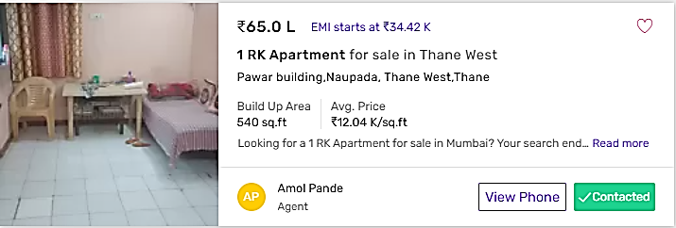
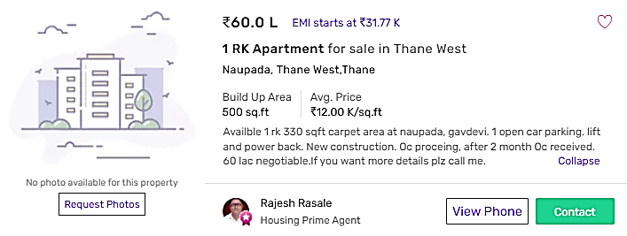

ENCLOSURE: IV– GOOGLE MAP LOCATION

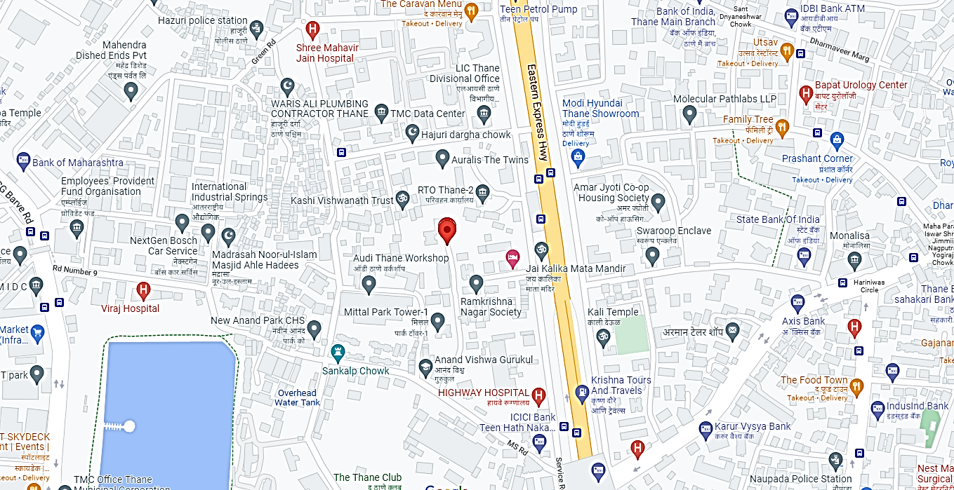

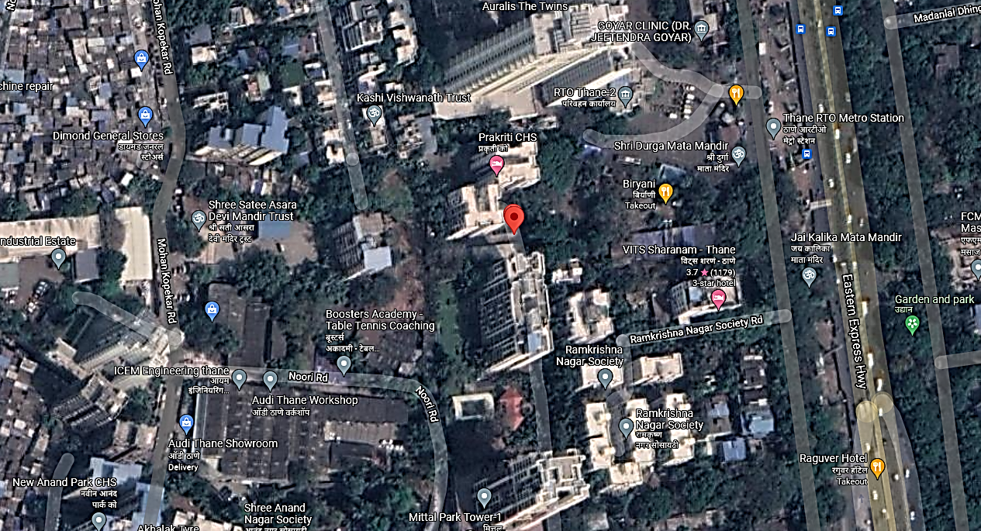

ENCLOSURE: V– PHOTOGRAPHS OF THE PROPERTY

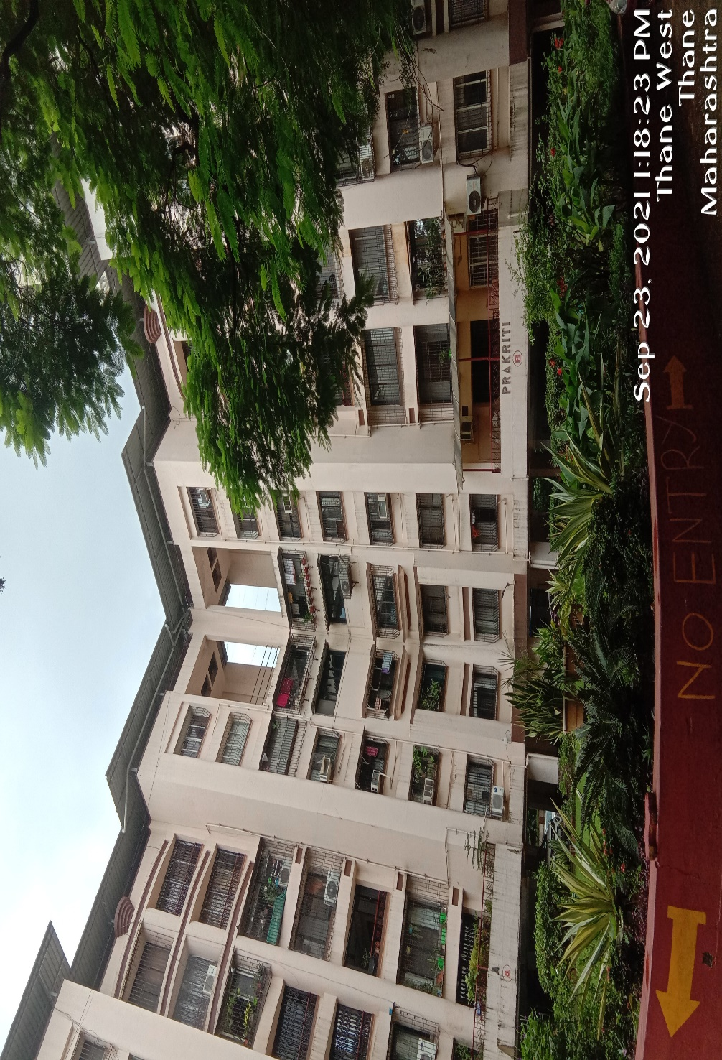

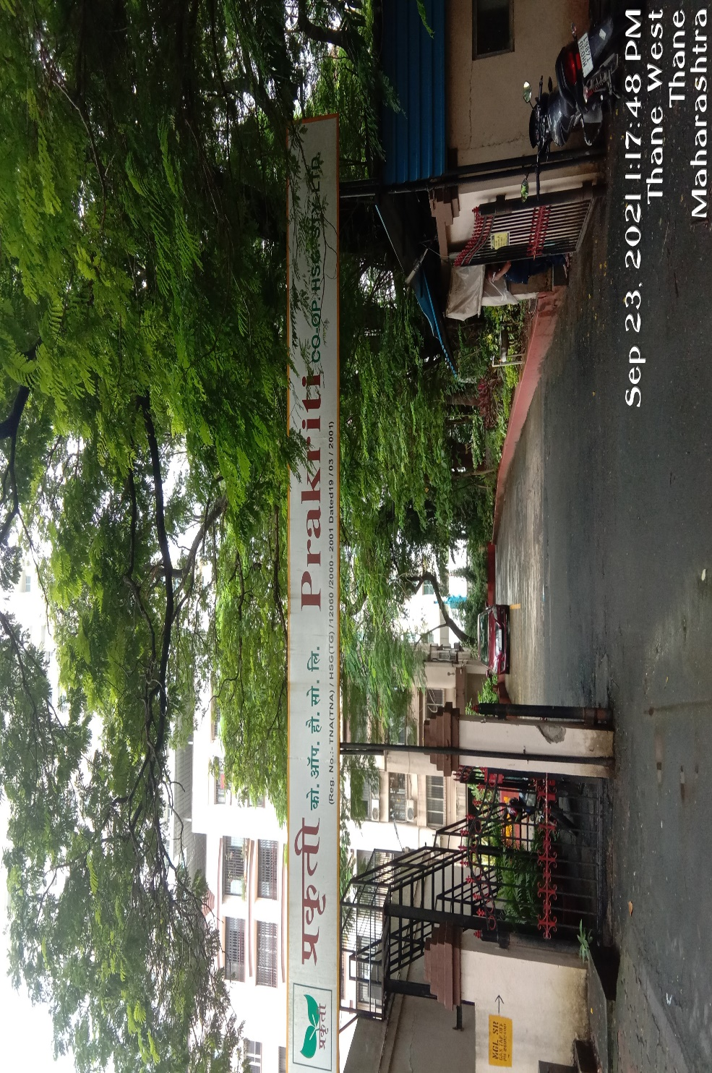
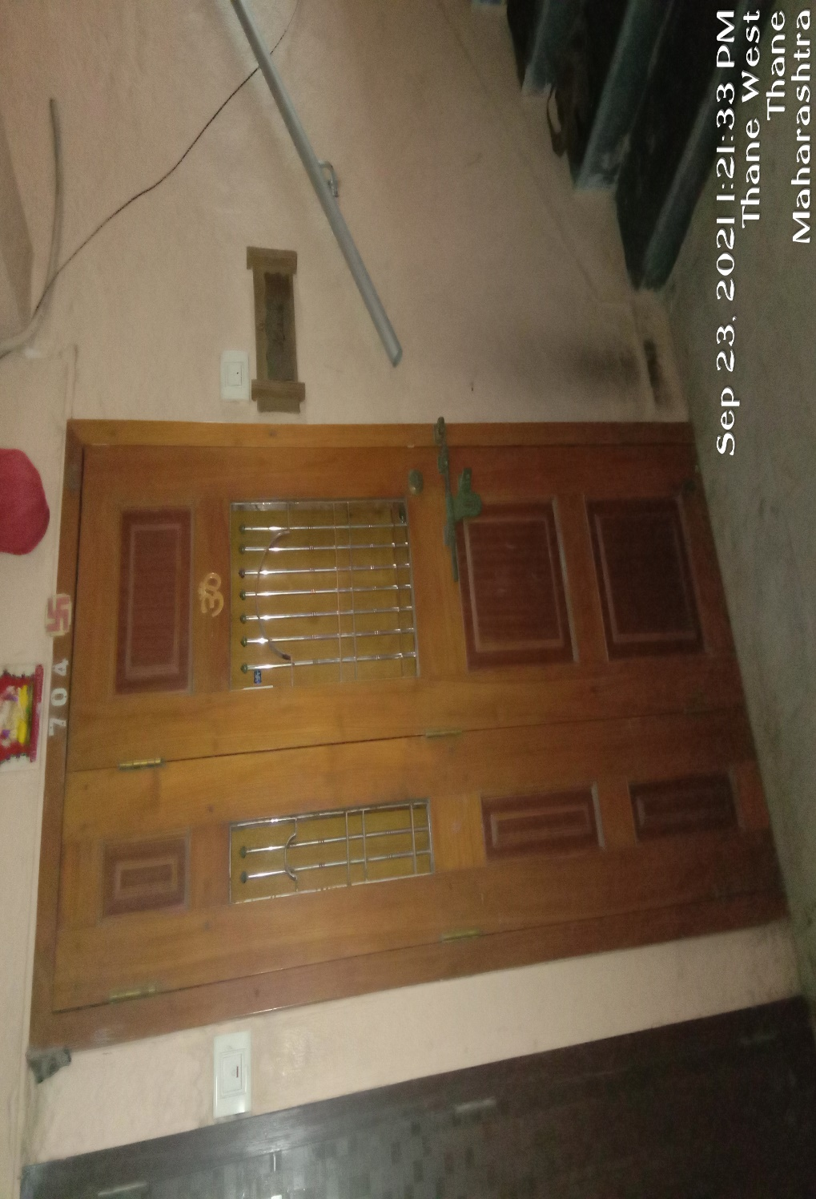

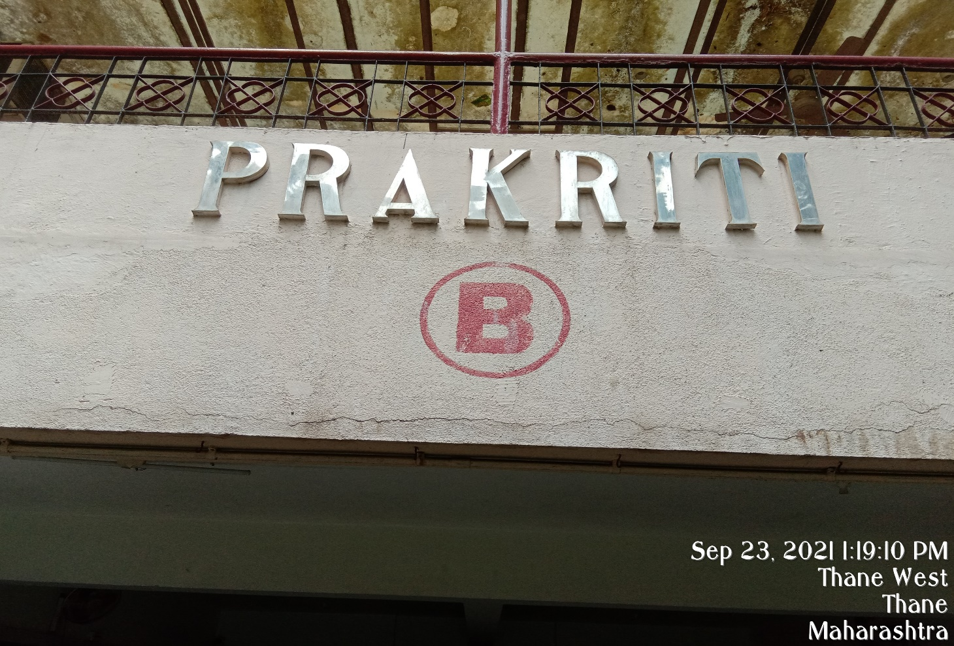
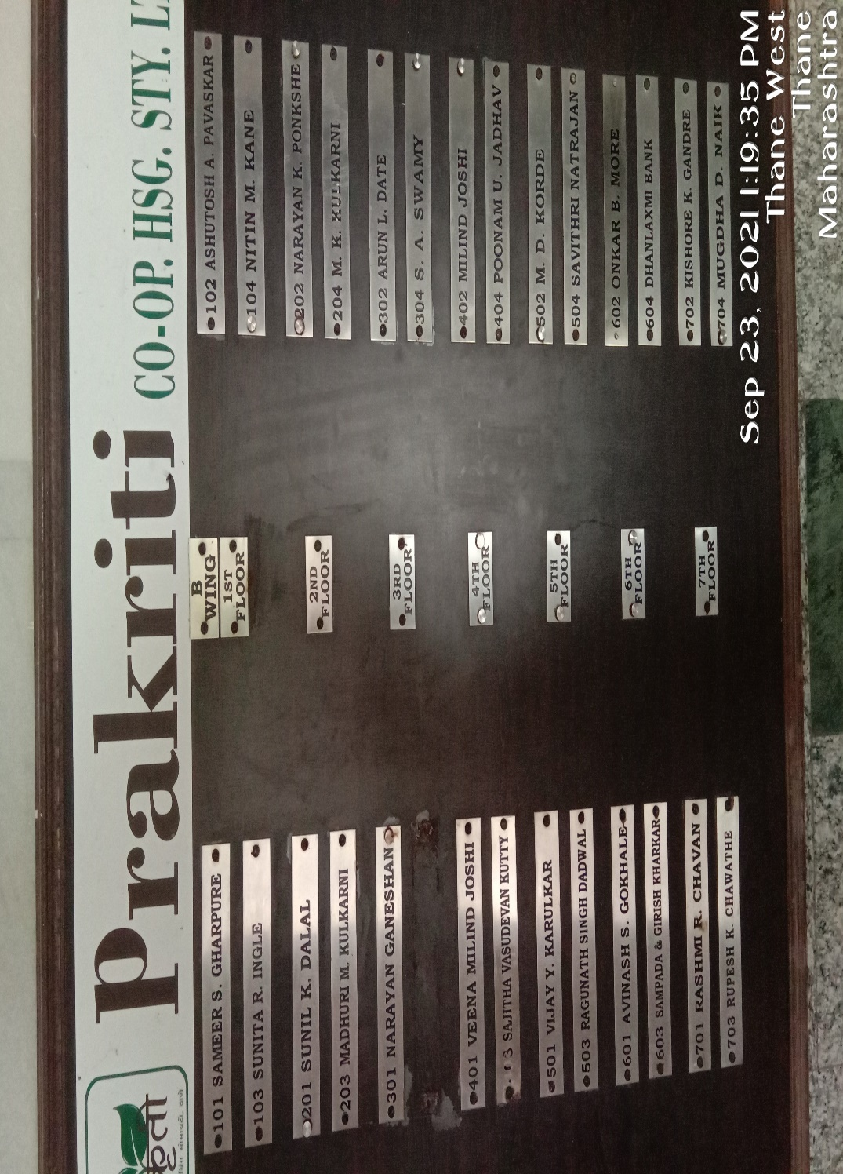

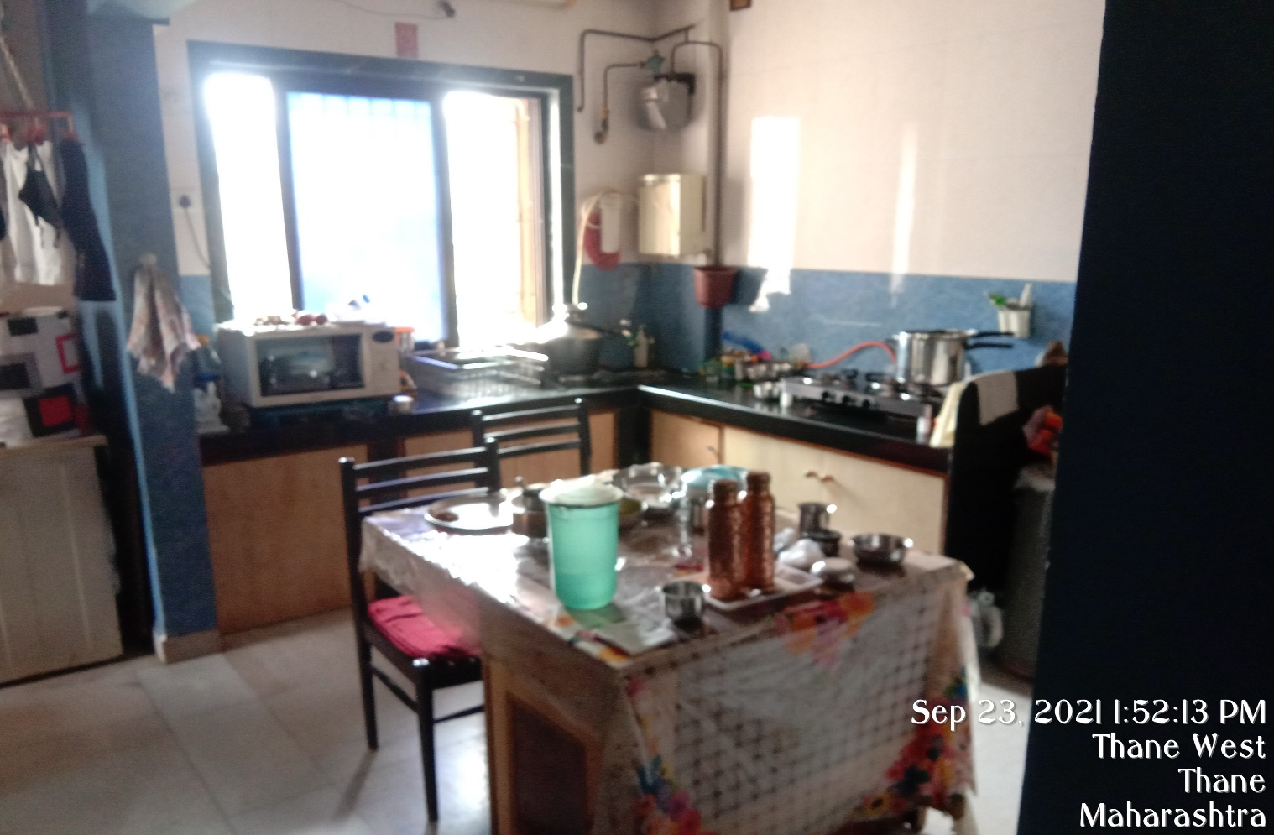

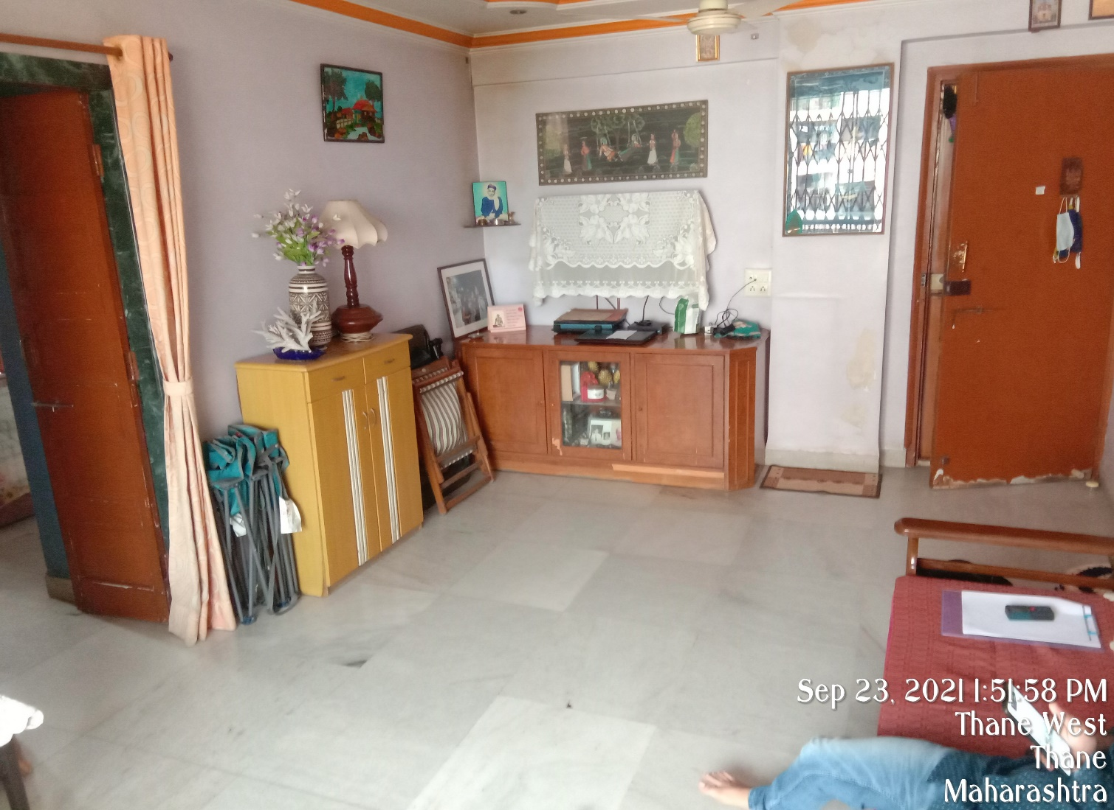



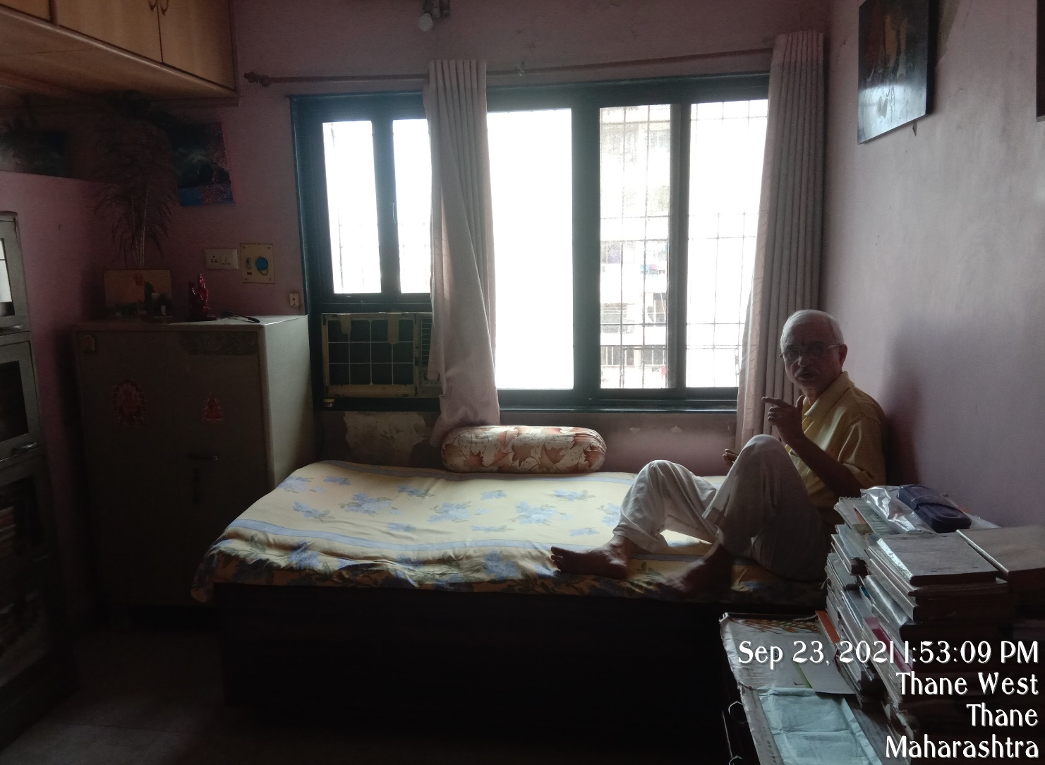

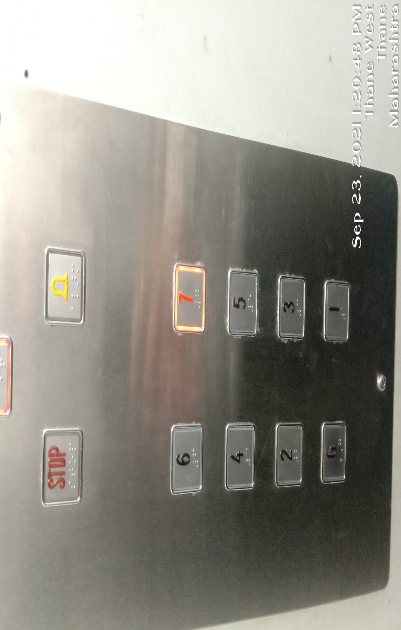

ENCLOSURE: VI – COPY OF CIRCLE RATE

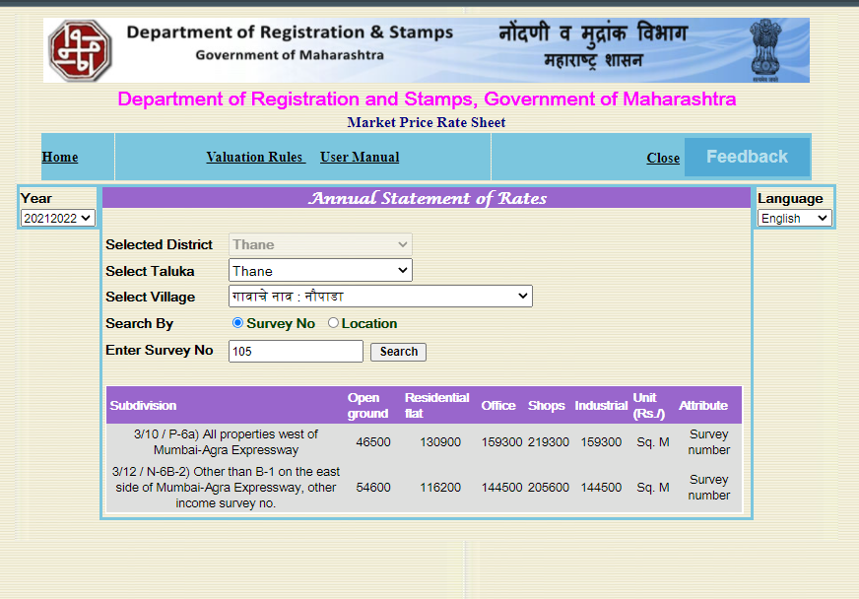

ENCLOSURE: VIII – VALUER’S REMARKS

1. | This Valuation report is prepared based on the copies of the documents/ information which interested organization or customer could provide to us out of the standard checklist of documents sought from them and further based on our assumptions and limiting conditions. All such information provided to us has been relied upon in good faith and we  have assumed that it is true and correct. Verification or cross checking of the documents provided to us from the originals has not been done at our end.
2. | Legal aspects for eg. investigation of title, ownership rights, lien, charge, mortgage, lease, verification of documents, etc. have to be taken care by legal expert/ Advocate and same are not done at our end. It is assumed that the concerned Lender/ Financial Institution has asked for the valuation of that property for which the legal verification has been already taken and cleared by the competent Advocate before requesting for the Valuation report.
3. | Analysis and conclusions adopted in the report are limited to the reported assumptions, conditions and information  came to our knowledge during the course of the work.
4. | Value varies with the Purpose/ Date/ Condition prevailing in the market. We recommend not to refer the indicative & estimated prospective Value of the asset given in this report if any of these points are different from the one mentioned aforesaid in the Report. We also recommend that the indicative estimated Value in the Valuation Report holds good  only upto the period of 3 months from the date of Valuation.
5. | This report is having limited scope as per its fields & format to provide only the general basic idea of the value of the property prevailing in the market based on the documents/ data/ information provided by the client. The suggested indicative prospective estimated value should be considered only if transaction is happened as free market transaction.
6. | This Valuation report is prepared based on the facts of the property on the date of the survey. It is a well-known fact that the market value of any asset varies with time & socio-economic conditions prevailing in the country. In future property Market may go down, property conditions may change or may go worse, Property reputation may differ, Property vicinity conditions may go down or become worse, Property market may change due to impact of Govt. policies or effect of World economy, Usability prospects of the property may change, etc. Hence before financing, Banker/ FI should take into consideration all such future risk and should loan conservatively to keep the advanced  money safe in case of the downward trend of the property value.
7. | Valuation of the same asset/ property can fetch different values in different situations. For eg. Valuation of a running/ operational shop/ hotel/ factory will fetch better value and in case of closed shop/ hotel/ factory it will have considerable lower value. Similarly an asset sold directly by an owner in the market will fetch better value and if the same asset/ property is sold by any financer due to encumbrance on it will fetch lower value. Hence before financing, Banker/ FI should take into consideration all such future risks and should loan conservatively to keep the advanced  money safe in case of any such situation.
8. | Getting cizra map or coordination with revenue officers for site identification is not done at our end.
9. | Valuation is done for the property identified to us by the owner/ owner representative. At our end we have just cross verified the identification of the property with reference to the documents produced for perusal. Method by which identification of the property is carried out is also mentioned in the report clearly. Responsibility of identifying the correct property to the Valuer/ its authorized surveyor is solely of the client/ owner for which Valuation has to be carried out.It is requested from the Bank to cross check from their own records/ information if this is the same property for which Valuation has to be carried out to ensure that owner has not misled the Valuer company or misrepresented  the property due to any vested interest.
10. | In India more than 70% of the geographical area is lying under rural/ remote/ non municipal/ unplanned area where the subject property is surrounded by vacant lands having no physical demarcation or having any display of property survey or municipal number / name plate on the property clearly. Even in old locations of towns, small cities & districts where property number is either not assigned or not displayed on the properties clearly and also due to the presence of multiple/ parallel departments due to which ownership/ rights/ illegal possession/ encroachment issues are rampant across India and due to these limitations at many occasions it becomes tough to identify the property with 100% surety from the available documents, information & site whereabouts and thus chances of error, misrepresentation by the borrower and margin of chances of error always persists in such cases. To avoid any such chances of error it is advised to the Bank to engage municipal/ revenue department officials to get the confirmation of the property to  ensure that the property shown to Valuer/ Banker is the same as for which documents are provided.
11. | If this Valuation Report is prepared for the Flat/ dwelling unit situated in a Group Housing Society or Integrated Township then approvals, maps of the complete group housing society/ township is out of scope of this report and this  report will be made for the specific unit based on the assumption that complete Group Housing Society/ Integrated Township must be approved in all respect..
12. | Due to fragmented & frequent change in building/ urban planning laws/ guidelines from time to time, different laws/

guidelines between regions/ states and no strict enforceability of Building Bye-Laws in India specially in non-metro and scale b & c cities & Industrial areas, property owners many times extend or make changes in the covered area/ layout from the approved/ applicable limits. There are also situations where properties are decades old when there was no formal Building Bye-Laws applicable when the construction must have been done. Due to such discrete/ unplanned development in many regions sometimes it becomes tough to determine the exact lawful situation on ground for the Valuer. In case nothing specific is noted on the covered built-up area considered in the Valuation Report, the covered
area present on the site as per site survey will be considered in the Valuation.
13. | Valuation is a subjective field and opinion may differ from consultant to consultant. To check the right opinion, it is important to evaluate the methodology adopted and various data point/ information/ factors/ assumption considered by the consultant which became the basis for the Valuation report before reaching to any conclusion.
14. | Value analysis of any asset cannot be regarded as an exact science and the conclusions arrived at in many cases will, of necessity, be subjective and dependent on the exercise of individual judgment. Given the same set of facts and using the same assumptions, expert opinions may differ due to the number of separate judgment decisions, which have to be made. Therefore, there can be no standard formula to establish an indisputable exchange ratio. In the event of a transaction, the actual transaction value achieved may be higher or lower than our indicative analysis of value depending upon the circumstances of the transaction. The knowledge, negotiability and motivations of the buyers and sellers and the applicability of a discount or premium for control will also affect actual price achieved. Accordingly, our indicative analysis of value will not necessarily be the price at which any agreement proceeds. The final transaction price is something on which the parties themselves have to agree. However our Valuation analysis can definitely help the stakeholders to make them informed and wise decision about the Value of the asset and can  help in facilitating the arm’s length transaction.
15. | This report is prepared on the RKA V-L1 (Basic) Valuation format as per the client requirement and scope of work. This report is having limited scope as per its fields & format to provide only the general estimated & indicative basic  idea of the value of the property prevailing in the market based on the information provided by the client. No detailed analysis, audit or verification has been carried out of the subject property.
16. | This is just an opinion report and doesn’t hold any binding on anyone. It is requested from the concerned Client/ Bank/ Financial Institution which is using this report for mortgaging the property that they should consider all the different associated relevant & related factors & risks before taking any business decision based on the content of this report.
17. | All Pages of the report including annexures are signed and stamped from our office. In case any paper in the report is without stamp & signature then this should not be considered a valid paper issued from this office.
18. | Defect Liability Period is 30 DAYS. We request the concerned authorized reader of this report to check the contents, data and calculations in the report within this period and intimate us in writing if any corrections are required or in case of any other concern with the contents or opinion mentioned in the report. Corrections only related to typographical, calculation, spelling mistakes will be entertained within the defect liability period. No request for any illegitimate value  revision, date change or any other change will be entertained other than the one mentioned above.
19. | R.K Associates encourages its customers to give feedback or inform concerns over its services through proper channel at valuers@rkassociates.org in writing within 30 days of report delivery. After this period no concern/ complaint/ proceedings in connection with the Valuation Services can be entertained due to possible change in  situation and condition of the property.
20. | Our Data retention policy is of ONE YEAR. After this period we remove all the concerned records related to the  assignment from our repository. No clarification or query can be answered after this period due to unavailability of the data.
21. | This Valuation report is governed by our (1) Internal Policies, Processes & Standard Operating Procedures, (2) R.K Associates Quality Policy, (3) Valuation & Survey Best Practices Guidelines formulated by management of R.K Associates, (4) Information input given to us by the customer and (4) Information/ Data/ Facts given to us by our field/ office technical team. Management of R.K Associates never gives acceptance to any unethical or unprofessional practice which may affect fair, correct & impartial assessment and which is against any prevailing law. In case of any indication of any negligence, default, incorrect, misleading, misrepresentation or distortion of facts in the report then it  is the responsibility of the user of this report to immediately or atleast within the defect liability period bring all such act into notice of R.K Associates management so that corrective measures can be taken instantly.
22. | R.K Associates never releases any report doing alterations or modifications by pen. In case any information/ figure of this report is found altered with pen then this report will automatically become null & void.

