**REPORT FORMAT:** V-L7 | Version: 5.0_2017

**File No.: VIS(2021-22)-PL429-386-499 Dated: 23.09.2021**

**VALUATION REPORT**

**OF**

**GROUP HOUSING SOCIETY**



**SITUATED AT**

**KHASRA NO. 139, 140, 141, 144, 145, 146, 147, 148, 153/1, 197, 198, 199, 200, 202, 203, 204, 205, 254, 117, 118, 193, 195, 196, 201, 207 TO 209, 211, 1266/138, VILLAGE-KHAJURIWAS, ALWAR, BYPASS ROAD, BHIWADI, ALWAR - 301019 (RAJASTHAN)**

**DEVELOPED & PROMOTED BY**

**M/S. STAR RAISON LANDMARKS**

**A/C. M/S. STAR RAISON LANDMARKS**

**REPORT PREPARED FOR**

**PNB HOUSING FINANCE LIMITED, KG MARG, CONNAUGHT PLACE, NEW DELHI**

***\*\*Important - In case of any query/ issue or escalation you may please contact Incident Manager***

***at valuers@rkassociates.org. We will appreciate your feedback in order to improve our services.***

***NOTE: As per IBA Guidelines please provide your feedback on the report within 15 days of its submission after which report will be considered to be correct.***

|  |  |  |
| --- | --- | --- |
| **TABLE OF CONTENTS** | | |
| **SECTIONS** | **PARTICULARS** | **PAGE NO.** |
| **Part A** | **SUMMARY OF THE VALUATION REPORT** |  |
| 1. General Details of the Project | 03 |
| 1. Brief Description of the Property Under Valuation | 04 |
| 1. Valuation Summary | 10 |
| 1. Enclosures | 10 |
| **Part B** | **RKA FORMAT OF VALUATION REPORT** |  |
| 1. Introduction | 11 |
| 1. Physical Characteristics of the Property | 11 |
| 1. Boundary Schedule of the property | 12 |
| 1. Town Planning/ Zoning Parameters | 13 |
| 1. Document Details and Legal Aspects of the Property | 14 |
| 1. Economic Aspects of the Property | 14 |
| 1. Socio - Cultural Aspects of the Property | 15 |
| 1. Functional And Utilitarian Services, Facilities & Amenities | 15 |
| 1. Infrastructure Availability | 16 |
| 1. Marketability Aspects of the Property | 16 |
| 1. Engineering And Technology Aspects of the Property | 16 |
| 1. Environmental Factors | 17 |
| 1. Architectural And Aesthetic Quality of the Property | 17 |
| 1. Project Details | 17 |
| 1. Valuation | 18 |
| 1. Declaration | 19 |
| 1. Valuation Company Details | 19 |
| 1. Enclosed Documents | 19 |
| **Part C** | **AREA DESCRIPTION OF THE PROPERTY** |  |
|  | 1. Land & Building Area Details | 20 |
| **Part D** | **PROJECT APPROVAL DETAILS** | 25 |
| **Part E** | **VALUATION ASSESSMENT OF THE PROPERTY** | 26 |
|  | Enclosure – 1: Valuer’s Remarks | 41 |
| Enclosure – 2: Google Map Location | 43 |
| Enclosure – 3: Photographs | 44 |
| Enclosure – 4: Price Trend References | 48 |

|  |  |
| --- | --- |
| **PART A** | **SUMMARY OF THE VALUATION REPORT** |

|  |  |  |  |  |  |  |
| --- | --- | --- | --- | --- | --- | --- |
| **S.NO.** | **CONTENTS** | **DESCRIPTION** | | | | |
|  | **GENERAL DETAILS** | | | | | |
|  | Report prepared for | Bank | | | | |
|  | Name & Address of Organization | PNB Housing Finance Limited, KG Marg, Connaught Place, New Delhi | | | | |
|  | Name of Borrower unit | M/s. Star Raison Landmarks. | | | | |
|  | Name of Property Owner | M/s. Star Raison Landmarks. | | | | |
|  | Address & Phone Number of the owner | Registered Office: A-26, New Krishna Park, Najafgarh Road, New Delhi | | | | |
|  | Type of the Property | Group Housing Society | | | | |
|  | Type of Loan | Project Financing | | | | |
|  | Type of Valuation | Group Housing Society Value | | | | |
|  | Report Type | Plain Asset Valuation | | | | |
|  | Date of Inspection of the Property | 16 September 2021 | | | | |
|  | Date of Valuation Report | 23 September 2021 | | | | |
|  | Surveyed in presence of | Developer's Representative | | Mr. Dev Pal  🕿 9785642002 | | |
|  | Purpose of the Valuation | Distress Sale for NPA a/c | | | | |
|  | Scope of the Report | Non Binding Opinion on General Prospective Valuation Assessment of the Property identified by Property owner or through its representative | | | | |
|  | Out-of-Scope of Report | 1. Verification of authenticity of documents from originals or cross checking from any Govt. deptt. 2. Legal aspects of the property. 3. Identification of the property is only limited to cross verification from its boundaries at site if mentioned in the provided documents. 4. Getting cizra map or coordination with revenue officers for site identification. 5. Measurement of the property as a whole. 6. Measurement is only limited upto sample random measurement. 7. Drawing Map & design of the property. | | | | |
|  | Documents provided for perusal | **Documents Requested** | | **Documents Provided** | | **Documents Reference No.** |
| Total **04** documents requested. | | Total **07** documents provided. | | --- |
| Property Title document | | Lease Deeds  (3 No.) | | --- |
| Project Approval Documents | | Copy of TIR  (1 No.) | | Dated:  31/07/2017 |
| Approved Map | | Enviromental clearance NOC from SEIAA | | Dated: 12/06/2016 |
| Structural Stability Certicate | | CA Certificate | | Dated: 27/09/2017 |
| Copy of RERA Registration Certificate | | NOC from Fire Service Department | | Dated:  20/01/2016 |
| NA | | Approved Map  (2 No.) | | Dated:  22/02/2012 & 03/08/2017 |
| NA | | Certificate For Extension of Registration of project | | Dated:22/12/2020 |
|  | Identification of the property |  | Cross checked from boundaries of the property mentioned in the deed | | | |
|  | Done from the name plate displayed on the property | | | |
|  | Identified by the Bank representative | | | |
|  | Identified by the Owner/ Owner’s representative | | | |
|  | Enquired from local residents/ public | | | |
|  | Identification of the property could not be done properly | | | |
|  | Survey was not done | | ---- | |

|  |  |
| --- | --- |
|  | **BRIEF DESCRIPTION OF THE PROPERTY UNDER VALUATION** |
|  | **Y:\Jitender sharma\Ms Star Raison Landmark\Photos\WhatsApp Image 2021-09-21 at 1.22.27 PM (4).jpeg**  ***Snapshot of the Asset/ Property Under Valuation***  **Brief description of the Property under Valuation:** This Valuation report is prepared for the Group Housing Project named as **“The Essentia”** being developed at the aforesaid address having **total** **land area admeasuring (50684.03 sq.mtr.)** out of which the approved net plot area is 48648.12 sq.mtr. as per the copy of RERA certificate & approved map provide to us.  Copy of Lease Deeds were Grasped by us from Rajasthan RERA site. As per the lease deed obtained the land parcel is acquired in following manner listed below: -  The land area taken in the valuation report is on the basis of copy of lease deed and the approved map provided to us. We have not measured the land area on site/ cizra map & practically it is not possible to measure each and every land parcel so we have relied upon the information provided to us by the bank in good faith.  The subject project is owned and developed by M/s. Star Raison Landmarks. As per our discussion with the developer’s representative the phase-I of the subject project is completed and as per the clause mentioned in the copy of Extension Certificate:  *“The registration is extended by a period of 12 Months commencing from 01-01-2021 and shall be valid up to 31-12-2021 unless further extended by the Real Estate Regulatory Authority in accordance with section 6 of the Act read with rule 7 of the Rajasthan Real Estate (Regulation and Development) Rules, 2017 or in accordance with section 6 read with section 7, 8 and 37 of the Act.”*  We haven’t got any information regarding the completion date of the phase-II of the subject project but as per the slow pace of construction of phase-II of the project we are of the view that it will get completed by FY2022-23. Phase-3 of the subject project is not yet commenced and as per the developer representative the phase-3 of the subject project will be launched in future however no dates has been disclosed to us.  The developer of the project has proposed to develop a residential Group Housing Society on the total land area admeasuring ~12.02 acres having 07 residential towers. Out of which developer has launched only two towers namely Tower-B & Tower-D in Phase-1 and Tower A & F1-F2 Comprised in second phase and Tower C, E & G proposed in Phase-3.    **Purpose of Valuation:**  M/s. Star Raison Landmarks has mortgage/ hypothecate this project to PNB Housing Finance Limited, KG Marg, Connaught Place, New Delhi for obtaining financial assistance. But the subject account is declared as NPA and the bank has approached us to take valuation opinion for distress sale of the subject project. As per the details provided by the company, out of the total proposed 1680 residential units in all the Phases, company has already booked 1110 dwelling units as on date of site survey and balance 570 dwelling units are yet to be sold. For the commercial, the total units are 146 and all the commercial units are unsold as per the data provided. As per the purpose of the report and the current status of the Project in this Valuation Report, assessment of the Valuation of unsold units has been done as per market approach and from which total balance cost to be incurred and other charges for completing the sale of units has been deducted, to arrive at the Fair Market Valuation of the Project and apart from that we have also created cash flow model for booked units receivables as per data/ information provided by the Bank.  Booked & unsold units have been taken on the basis of the Inventory Sheet provided to us by the Bank which has been relied upon in good faith. The Financer is advised to legally check the ownership status of these units. Legal & other ownership rights distribution if any has not been considered in this report since no such thing has been informed to us by the builder company or Bank.  **Statutory Approvals & NOC’s:**  The developer has obtained most of the statutory approvals & NOC’s from competent authorities as per the information provided to us at the site. These NOC’s and Approvals are further described in Part-C **(Statutory Approvals & NOCs Details).** However, few of the documents list below were not produced to us: -   1. Height Clearance NOC from AAI 2. NOC from Pollution Control Board 3. Electricity & Water Assurance Certificate   **Construction Status:**  During our site survey on dated September 16th, 2021, the construction status of the “The Essentia” project is as follows: -    The Above construction status is as per the information provided during site survey and data available for the subject project.  **Project Location:**  The subject project is located in the Sector-22, Alwar Bypass Road, Bhiwadi and the subject project has access from 60 ft. wide Burhi Bawal-Dharuhera Road. There are few other group housing projects present in the subject locality like Nimai Greens and Nimai Arcade etc. The subject locality is a developing area and more infrastructure facilities are proposed in the future. |

|  |  |
| --- | --- |
|  | **VALUATION METHODOLOGY** |
|  | **Market Value:**  Comparable Market Sales Approach & Residual Method.  **Description:**  The Valuation of the unsold inventory has been carried out on the basis of ‘Comparable Market Sale Approach’ and we believe that all these unsold inventories would be monetized or sold out in micro market in four years. Therefore, for the Valuation purpose we have assumed that based on current market condition and market demand, these unsold inventories can be monetized or sold out over a four year span for phase-2 & commercial units and seven years for phase-3 of the project and accordingly we have calculated the Net Present Value (Discounted Cash Flow Method) of the project by giving discount for the market & business risk. |
| **Market Rate Adopted:**  As per our extensive market research & information available in the public domain, conversations with market participants, we came to know that secondary market for the units of the subject project is not developed as yet. Hence, for the valuation purpose we have adopted the rates of developer to be the market rate of the flats of subject project i.e. **Rs.2,300/- to Rs.3,000/- per sq.ft. on Super Area** for residential and **Rs 5,500/- to Rs 6,000/- per sq.ft.** on super area for the commercial units. |
| **Inventory Under Valuation:**  The developer of the project has proposed to mortgage/ hypothecate this project to the bank for the financial assistance for the following unsold inventory:    All the units’ details have been taken on the basis of the Inventory Sheet provided to us by the Bank which has been relied upon in good faith. The bank is advised to legally check the status of these units. Legal & other ownership rights distribution if any has not been considered in this report since no such thing was informed to us by the Bank. |
| **Inventory Absorptions Rate:** An absorption rate provides insight on the rate at which unsold inventory will sell. It will depend upon the demand and supply scenario in the micro market. Therefore, after looking at the current real estate market senario, we are of the view that subject unsold inventory should get absorbed in span of four to seven years time depdening on the phase of the project. |
| **Appreciation in sale price:**  To arrive at the expected appreciation in the sale price of unsold inventory we have taken care of the following points:-   * The supply and demand dynamics of a particular location. * The interest rates banks charge for home loans, meaning the cost of borrowing. * Growth in local population, leading to increased demand. * Development of basic infrastructure like School, Hospital, Transportation & Local Market.   Hence considering all the above factors, we have taken 2.5% appreciation in unsold inventory for each year since the construction of the project will get progress with time and more units gets booked over time & occpancy increases rate increases over time. |
| **Discount Rate:**  As per the international Valuation Standard hand book, **‘**The rate at which the forecasted cash flow is discounted should reflect not only the time value of money, but also the risks associated with the type of cashflow and the future operations of the asset’.  The discount rate or WACC has been taken as per the discussion with the market participants based on the current real estate markets scenario in India and more importantly based on the current rate of lending by the Indian scheduled banks in real estate sector. The discount rate for the projects depends upon the liquidity factor & Demand and supply gap in the market. Presently real estate is considered to be risky sector due to the large unsold inventory, thus having supply much more than the demand. In Banking also the minimum ROI on real estate Projects is prevailing from minimum 12% to 18% depending upon the Project profile and creditworthiness of the developer company. Therefore we have taken minimum discount rate or ROR as 17.25% which any buyer would be expecting in present market scenario & condition.  For the calculation of discount rate we have assumed 50% of capex as debt and 50% of capex as equity @ 12.50% & 22% interest rate. 22% of equity interest rate is adopted considering the risk factor involved in real estate projects in present scenario. By this WACC arrived is 17.25%. |
| **Balance Cost to be incurred for construction:**  The balance cost of construction of the project has been taken as per the information/ data Flourish in the CA certificate provided to us by the Bank and is distributed among different phases on pro-rata basis, which we have relied upon in good faith.  Due to unavailability of discreet data (bills of quantity/ item wise) from the client we could not do the detailed cost estimation for the subject project and it has been calculated on the basis of cost of construction of the project. |

|  |  |  |
| --- | --- | --- |
|  | **VALUATION SUMMARY** | |
|  | Total Govt. Guideline Value | **NA** |
|  | Total Prospective Fair Market Value | **Rs.76,00,00,000/-** |
|  | Total Expected Realizable/ Fetch Value | **Rs.61,00,00,000/-** |
|  | Total Expected Distress/ Forced Sale Value | **Rs.54,00,00,000/-** |
|  | Valuation of structure for Insurance purpose | **NA** |
|  | **ENCLOSURES** | |
|  | **Part B** | **Valuation Report as per RKA Format Annexure-II** |
|  | **Part C** | **Area description of the Property** |
|  | **Part D** | **Valuation Assessment of the Property** |
|  | Enclosure 1 | Valuer’s Remark - Page No.37-38 |
|  | Enclosure 2 | Screenshot of the price trend references of the similar related properties available on public domain - Page No.45-47 |
|  | Enclosure 3 | Google Map – Page No.39 |
|  | Enclosure 4 | Photographs – Pages 05 |
|  | Enclosure 5 | Copy of Circle Rate – Pages 01 |
|  | Enclosure 6 | Survey Summary Sheet – Pages x |
|  | Enclosure 7 | Copy of relevant papers from the property documents referred in the Valuation – Pages 12 |

|  |  |
| --- | --- |
| **PART B** | **VALUATION REPORT AS PER RKA FORMAT** |

|  |  |
| --- | --- |
| Name & Address of Branch: | PNB Housing Finance Limited, KG Marg, Connaught Place, New Delhi |
| Name of Customer (s)/ Borrower Unit | M/s. Star Raison Landmarks |

|  |  |  |
| --- | --- | --- |
| **S.NO.** | **CONTENTS** | **DESCRIPTION** |
|  | **INTRODUCTION** | |
|  | Name of Property Owner | M/s. Star Raison Landmarks |
|  | Address & Phone Number of the Owner | Registered Office: A-26, New Krishna Park, Najafgarh Road, New Delhi |
|  | Purpose of the Valuation | Distress Sale for NPA a/c |
|  | Date of Inspection of the Property | 16 September 2021 |
|  | Date of Valuation Report | 23 September 2021 |
|  | Name of the Developer of the Property | M/s. Star Raison Landmarks |
| Type of Developer | Private developer promoted |

|  |  |  |  |  |  |  |  |
| --- | --- | --- | --- | --- | --- | --- | --- |
|  | **PHYSICAL CHARACTERISTICS OF THE PROPERTY** | | | | | | |
|  | **Location attribute of the property** | | | | | | |
|  | Nearby Landmark | | Near Power Grid | | | | |
|  | Postal Address of the Property | | Khasra No. 139, 140, 141, 144, 145, 146, 147, 148, 153/1, 197, 198, 199, 200, 202, 203, 204, 205, 254, 117, 118, 193, 195, 196, 201, 207 to 209, 211, 1266/138, Village-Khajuriwas, Alwar, Bypass Road, Bhiwadi, Alwar - 301019 (Rajasthan) | | | | |
|  | Area of the Plot/ Land as per approved map | | Total Project Land: 12.02 Acres (48648.12 sq.mtr.) | | | | |
| *Also please refer to Part-B Area description of the property. Area measurements considered in the Valuation Report is adopted from relevant approved documents or actual site measurement whichever is less. Verification of the area measurement of the property is done only based on sample random checking.* | | | | |
|  | Type of Land | | Solid | | | | |
|  | Independent access/ approach to the property | | Clear independent access is available for project on 12.02 Acres | | | | |
|  | Google Map Location of the Property with a neighborhood layout map | | Enclosed with the Report | | | | |
| Coordinates or URL: 28°11'04.0"N 76°49'11.9"E | | | | |
|  | Details of the roads abutting the property | | | | | | |
|  | * Main Road Name & Width | | Alwar-Bhiwadi Road | | | 24 mtr. | |
|  | * Front Road Name & width | | Alwar-Bhiwadi Road | | | 24 mtr. | |
|  | * Type of Approach Road | | Bituminous Road | | | | |
|  | * Distance from the Main Road | | On Main Alwar-Bhiwadi Road | | | | |
|  | Description of adjoining property | | Other group housing projects and colony nearby | | | | |
|  | Plot No./ Survey No. | | Khasra No. 139, 140, 141, 144, 145, 146, 147, 148, 153/1, 197, 198, 199, 200, 202, 203, 204, 205, 254, 117, 118, 193, 195, 196, 201, 207 to 209, 211, 1266/138 | | | | |
|  | Mauza/ Block | | Khajuriwas | | | --- | |
|  | Sub registrar | | Bhiwadi | | | | |
|  | District | | Alwar | | | | |
|  | Any other aspect | | | | | | |
|  | * City Categorization | | Scale-C City | | | Urban developing | |
|  | * Characteristics of the locality | | Average | | | Within developing Residential zone | |
|  | * Property location classification | | Ordinary location within the locality | | None | | None |
|  | * Property Facing | | West Facing | | | | |
|  | Covered Built-up área description  *(Plinth/ Carpet/ Saleable Area)* | | Please refer building sheet | | | | |
| *Also please refer to Part B - Area description of the property. Area measurements considered in the Valuation Report is adopted from relevant approved documents or actual site measurement whichever is less. Verification of the area measurement of the property is done only based on sample random checking..* | | | | |
|  | **Boundaries schedule of the Property** | | | | | | |
|  | Are Boundaries matched | | No, boundaries are not mentioned in the documents. | | | | |
|  | **Directions** | **As per Sale Deed/TIR** | | **Actual found at Site** | | | |
| East | NA | | Vacant Land | | | |
| West | NA | | Road | | | |
| North | NA | | Avlon Garden | | | |
| South | NA | | Nimai Green | | | |

|  |  |  |  |
| --- | --- | --- | --- |
|  | **TOWN PLANNING / ZONING PARAMETERS** | | |
|  | Master Plan provisions related to property in terms of Land use | Residential Group Housing Society | |
| 1. Any conversion of land use done | No | |
| 1. Current activity done in the property | Construction of Group Housing Society is going on at the site | |
| 1. Is property usage as per applicable zoning | Yes is being used for construction of residential project | |
| 1. Any notification on change of zoning regulation | NA | |
| 1. Street Notification | Residential | |
|  | Provision of Building by-laws as applicable | **PERMITTED** | **CONSUMED** |
| 1. FAR/ FSI | Please refer to area chart description | Please refer to area chart description |
| 1. Ground coverage | ----------------do------------- | ----------------do------------- |
| 1. Number of floors | ----------------do------------- | ----------------do------------- |
| 1. Height restrictions | ----------------do------------- | ----------------do------------- |
| 1. Front/ Back/ Side Setback | ----------------do------------- | ----------------do------------- |
|  | Status of Completion/ Occupational certificate | No such information provided to us | No such information provided to us |
|  | Comment on unauthorized construction if any | The constructed towers are appeared to be constructed as per the approved map | |
|  | Comment on Transferability of developmental rights | As per regulation of Bhiwadi Development Authority | |
|  | 1. Planning Area/ Zone | Greater Bhiwadi- Master Plan | |
| 1. Master Plan currently in force | Greater Bhiwadi - Master Plan | |
| 1. Municipal limits | Bhiwari Municipal Council | |
|  | Developmental controls/ Authority | Bhiwadi Development Authority | |
|  | Zoning regulations | Residential Group Housing Project | |
|  | Comment on the surrounding land uses & adjoining properties in terms of uses | All adjacent properties are used for residential purpose | |
|  | Comment of Demolition proceedings if any | No information available to us | |
|  | Comment on Compounding/ Regularization proceedings | No information available to us | |
|  | Any other aspect | | |
| 1. Any information on encroachment | No | |
| 1. Is the area part of unauthorized area/ colony | No (As per general information available) | |

|  |  |  |  |  |  |  |
| --- | --- | --- | --- | --- | --- | --- |
|  | **DOCUMENT DETAILS AND LEGAL ASPECTS OF THE PROPERTY** | | | | | |
|  | Ownership documents provided | Lease Deeds | Other NOC’s and the Approval | | | Approved Map |
|  | Names of the Legal Owner/s | M/s. Star Raison Landmarks | | | | |
|  | Constitution of the Property | Lease hold, have to take NOC in order to transfer | | | | |
|  | Agreement of easement if any | Not required | | | | |
|  | Notice of acquisition if any and area under acquisition | No, as per general information available in the public domain | | | | |
|  | Notification of road widening if any and area under acquisition | No, as per general information available in the public domain | | | | |
|  | Heritage restrictions, if any | No | | | | |
|  | Comment on Transferability of the property ownership | Lease hold, have to take NOC in order to transfer | | | | |
|  | Comment on existing mortgages/ charges/ encumbrances on the property, if any | No Information available to us. Bank to obtain details from the Developer | | | ---- | |
|  | Comment on whether the owners of the property have issued any guarantee *(personal or corporate)* as the case may be | No Information available to us. Bank to obtain details from the Developer | | | ---- | |
|  | **Building plan sanction:** | | | | | |
| 1. Authority approving the plan | Bhiwadi Development Authority | | | | |
| 1. Name of the office of the Authority | Bhiwadi Development Authority | | | | |
| 1. Any violation from the approved Building Plan | Not applicable since the construction work is in progress | | | | |
|  | Whether Property is Agricultural Land if yes, any conversion is contemplated | No not an agricultural property | | | | |
|  | Whether the property SARFAESI complaint | Yes | | | | |
|  | 1. Information regarding municipal taxes *(property tax, water tax, electricity bill)* | Tax name | | NA | | |
| Receipt number | | NA | | |
| Receipt in the name of | | NA | | |
| Tax amount | | NA | | |
| 1. Observation on Dispute or Dues if any in payment of bills/ taxes | Not Known to us | | | | |
| 1. Is property tax been paid for this property | NA | | | | |
| 1. Property or Tax Id No. | NA | | | | |
|  | Whether entire piece of land on which the unit is set up / property is situated has been mortgaged or to be mortgaged | No information available to us | | | | |
|  | Qualification in TIR/Mitigation suggested if any | None | | | | |
|  | Any other aspect | | | | | |
| 1. Since how long owners owing the Property | Land purchased in several patches in different years | | | | |
| 1. Year of Acquisition/ Purchase | Land purchased in several patches in different years | | | | |
| 1. Property presently occupied/ possessed by | Developer | | | | |
| 1. Title verification | To be done by the competent Advocate | | | | |
| 1. Details of leases if any | NA | | | | |

|  |  |  |
| --- | --- | --- |
|  | **ECONOMIC ASPECTS OF THE PROPERTY** | |
|  | Reasonable letting value/ Expected market monthly rental | NA |
|  | Is property presently on rent | No |
| 1. Number of tenants | NA |
| 1. Since how long lease is in place | NA |
| 1. Status of tenancy right | NA |
| 1. Amount of monthly rent received | NA |
|  | Taxes and other outgoing | Developer/Owner to provide this information |
|  | Property Insurance details | Developer/Owner to provide this information |
|  | Monthly maintenance charges payable | Developer/Owner to provide this information |
|  | Security charges, etc. | Developer/Owner to provide this information |
|  | Any other aspect | NA |

|  |  |  |
| --- | --- | --- |
|  | **SOCIO - CULTURAL ASPECTS OF THE PROPERTY** | |
|  | Descriptive account of the location of the property in terms of Social structure of the area in terms of population, social stratification, regional origin, age groups, economic levels, location of slums/ squatter settlements nearby, etc. | Urban Developing area |
|  | Whether property belongs to social infrastructure like hospital, school, old age homes etc. | No |

|  |  |  |  |  |  |  |  |
| --- | --- | --- | --- | --- | --- | --- | --- |
|  | **FUNCTIONAL AND UTILITARIAN SERVICES, FACILITIES & AMENITIES** | | | | | | |
|  | Description of the functionality & utility of the property in terms of: | | | | | | |
|  | 1. Space allocation | | | | Yes (Proposed) | | |
| 1. Storage spaces | | | | Yes (Proposed) | | |
| 1. Utility of spaces provided within the building | | | | Yes (Proposed) | | |
| 1. Car parking facilities | | | | Yes (Proposed) | | |
| 1. Balconies | | | | Yes (Proposed) | | |
|  | Any other aspect | | | | | | |
|  | 1. Drainage arrangements | | | | Yes (Proposed) | | |
| 1. Water Treatment Plant | | | | Yes (Proposed) | | |
| 1. Power Supply arrangements | | Permanent | | Will be obtained by individual flat owners as per sanctioned load | | |
| Auxiliary | | Yes (Proposed) | | |
| 1. HVAC system | | | | No | | |
| 1. Security provisions | | | | Yes/ Private security guards | | |
| 1. Lift/ Elevators | | | | Yes, will be installed | | |
| 1. Compound wall/ Main Gate | | | | Yes | | |
| 1. Whether gated society | | | | Yes | | |
| 1. Internal development | | | | | | |
| Garden/ Park/ Land scraping | Water bodies | | Internal roads | | Pavements | Boundary Wall |
| Yes | Yes | | Yes | | Yes | Yes |

|  |  |  |  |  |  |  |  |  |
| --- | --- | --- | --- | --- | --- | --- | --- | --- |
|  | **INFRASTRUCTURE AVAILABILITY** | | | | | | | |
|  | Description of Aqua Infrastructure availability in terms of: | | | | | | | |
|  | 1. Water Supply | | | | No information Available | | | |
| 1. Sewerage/ sanitation system | | | | Underground | | | |
| 1. Storm water drainage | | | | No information Available | | | |
|  | Description of other Physical Infrastructure facilities in terms of: | | | | | | | |
|  | 1. Solid waste management | | | | No information Available | | | |
| 1. Electricity | | | | Yes | | | |
| 1. Road and Public Transport connectivity | | | | Yes | | | |
| 1. Availability of other public utilities nearby | | | | Transport, Market, Hospital etc. available at some distance | | | |
|  | Proximity & availability of civic amenities & social infrastructure | | | | | | | |
|  | School | Hospital | Market | Bus Stop | | Railway Station | Metro | Airport |
| 1.2 Km | 5 Km | 4.5 Km | 05 Km | | 28 Km | NA | 60 Km |
|  | Availability of recreation facilities (parks, open spaces etc.) | | | It is a developing area and recreational facilities are planned to be developed nearby | | | | |

|  |  |  |  |
| --- | --- | --- | --- |
|  | **MARKETABILITY ASPECTS OF THE PROPERTY:** | | |
|  | Marketability of the property in terms of | | |
|  | 1. Location attribute of the subject property | Normal | |
| 1. Scarcity | Similar kind of properties are easily available on demand. | |
| 1. Market condition related to demand and supply of the kind of the subject property in the area | Normal demand for such properties in the market | |
| 1. Comparable Sale Prices in the locality | Please refer to Part C: Valuation Assessment of the Property. | |
|  | Any other aspect which has relevance on the value or marketability of the property | No | |
|  | 1. Any New Development in surrounding area | No | NA |
| 1. Any negativity/ defect/ disadvantages in the property/ location | Yes, the subject project is under NPA account | NA |

|  |  |  |  |  |
| --- | --- | --- | --- | --- |
|  | **ENGINEERING AND TECHNOLOGY ASPECTS OF THE PROPERTY:** | | | |
|  | Type of construction & design | RCC framed pillar beam column structure on RCC slab (Partially Complete) | | |
|  | Method of construction | Construction done using professional contractor workmanship based on architect plan(Partially Complete) | | |
|  | Specifications | | | |
| 1. Class of construction | Class C construction | | |
| 1. Appearance/ Condition of structures | Internal – Under construction | | |
| External – New construction (for Phase-1 and Commercial) Under construction (for Phase-2) and Phase-3 (Proposed) | | |
| 1. Roof | **Floors/ Blocks** | | **Type of Roof** |
| Multiple Towers | | RCC (Proposed) |
| 1. Floor height | 10 ft. for each floor (Proposed) | | |
| 1. Type of flooring | Vitrified tiles, Ceramic Tiles (proposed) | | |
| 1. Doors/ Windows | Wooden frame with glass panel windows (proposed) | | |
| 1. Interior Finishing | Neatly plastered and putty coated walls (proposed) | | |
| 1. Exterior Finishing | Simple plastered walls (proposed) | | |
| 1. Interior decoration/ Special architectural or decorative feature | Simple plain looking structure. (proposed) | | |
| 1. Class of electrical fittings | Internal/ Normal quality fittings (proposed) | | |
| 1. Class of sanitary & water supply fittings | Internal/ Normal quality fittings (proposed) | | |
|  | Maintenance issues | Not applicable since construction work is in progress | | |
|  | Age of building/ Year of construction | Phase-I & Commercial = 2 years  Phase-2 = Under Construction  Phase-3 = Proposed | Phase-I & Commercial = 2 years  Phase-2 = Under Construction  Phase-3 = Proposed | |
|  | Total life of the structure/ Remaining life expected | Approx. 60-65 years  *(After Completion)* | Approx. 60-65 years  *(After Completion)* | |
|  | Extent of deterioration in the structure | Not applicable since subject project is under construction | | |
|  | Structural safety | Proposed RCC structure so assumed to be structurally stable | | |
|  | Protection against natural disasters viz. earthquakes etc. | Proposed RCC structure so able to withstand moderate intensity earthquakes | | |
|  | Visible damage in the building if any | Not applicable since subject project is under construction | | |
|  | System of air conditioning | No | | |
|  | Provision of firefighting | Yes (Proposed) | | |
|  | Status of Building Plans/ Maps | Building plans are approved by the concerned authority | | |
|  | 1. Is Building as per approved Map | Not applicable since subject project is under construction | | |
| 1. Details of alterations/ deviations/ illegal construction/ encroachment noticed in the structure from the original approved plan | Permissible Alterations | | NA |
| Not permitted alteration | | NA |
| 1. Is this being regularized | No information provided | | |

|  |  |  |
| --- | --- | --- |
|  | **ENVIRONMENTAL FACTORS:** | |
|  | Use of environment friendly building materials like fly ash brick, other Green building techniques if any | No information available to us |
|  | Provision of rainwater harvesting | No |
|  | Use of solar heating and lighting systems, etc. | No such information provided on site |
|  | Presence of environmental pollution in the vicinity of the property in terms of industries, heavy traffic, etc. if any | Yes, normal vehicular pollution is present in the atmosphere |

|  |  |  |
| --- | --- | --- |
|  | **ARCHITECTURAL AND AESTHETIC QUALITY OF THE PROPERTY:** | |
|  | Descriptive account on whether the building is modern, old fashioned, etc., plain looking or with decorative elements, heritage value if applicable, presence of landscape elements,  etc. | Modern structure (Proposed) |

|  |  |  |
| --- | --- | --- |
|  | **PROJECT DETAILS:** | |
|  | Name of the Developer | M/s. Star Raison Landmarks |
|  | Name of the Architect | Space Designers Internationals (B-34, Sector 67, Noida) |
|  | Developer market reputation | Mid scale builder with successful track record of Project deliveries. |
|  | Proposed completion date of the Project | Not available for Phase 1 and 3 |
|  | Progress of the Project | Phase-1 and Commercial: Complete  Phase-2: Under construction  Phase-3: Proposed |
|  | Other Salient Features of the Project | High end modern apartment,  Ordinary Apartments,  Affordable housing,  Club,  Swimming Pool,  Play Area,  Walking Trails,  Gymnasium,  Convenient Shopping,  Parks,  Multiple Parks,  Kids Play Area, (Amenities are yet to be constructed) |

|  |  |  |
| --- | --- | --- |
|  | **VALUATION:** | |
|  | Methodology of Valuation – Procedures adopted for arriving at the Valuation | Please refer to ***Point 1 (K, L & M) of the Part D: Valuation Assessment Factors*** of the report. |
|  | Prevailing Market Rate/ Price trend of the Property in the locality/ city from property search sites | Please refer to the Point ***‘L’ of the Part D: Valuation Assessment Factors*** of the report and the screenshot annexure in the report. |
|  | Guideline Rate obtained from Registrar’s office/ State Govt. gazette/ Income Tax Notification | Please refer to the Point ***‘K’ of the Part D: Valuation Assessment Factors*** of the report and the screenshot annexure in the report. |
|  | **Summary of Valuation** | For detailed Valuation calculation please refer to ***Point 2, 3 & 4 of the Part D: Valuation Assessment Factors*** of the report. |
| 1. **Guideline Value** | NA |
| * **Land** | NA |
| * **Building** | NA |
| **BY USING PROJECT RESIDUAL METHOD.** | |
| 1. **Prospective Fair Market Value of unsold units** | **Rs.76,00,00,000/-** |
| 1. **Expected Realizable Value** | **Rs.61,00,00,000/-** |
| 1. **Expected Forced/ Distress Sale Value** | **Rs.54,00,00,000/-** |
| 1. **Valuation of structure for Insurance purpose** | NA |
|  | 1. Justification for more than 20% difference in Market & Circle Rate | Circle rates are determined by the District administration as per their own theoritical internal policy and Market rates are adopted based on Discounted Cash Flow Method. |
| 1. Details of last two transactions in the locality/ area to be provided, if available | No authentic last two transactions details could be known. However prospective transaction details as per information available on public domain and gathered during site survey mentioned in Point L of the Part C: Valuation Assessment Factors of the report and the screenshot annexure in the report can be referred. |

|  |  |  |
| --- | --- | --- |
|  | **Declaration**  *(Also see Enclosure: 1 Valuer’s Remarks)* | 1. The information provided is true and correct to the best of my knowledge and belief. 2. The analysis and conclusions are limited by the reported assumptions, conditions and the information came to knowledge during the course of the work. 3. I/ firm have read the Handbook on Policy, Standards and Procedures for Real Estate Valuation by Banks and HFIs in India, 2011 issued by IBA and NHB, fully understood the provisions of the same and followed the provisions of the same to the best of my ability and this report is in conformity to the Standards of Reporting enshrined in the above Handbook. 4. No employee or member of R.K Associates has any direct/ indirect interest in the property. 5. Our authorized surveyor by name of AE Sachin Pandey has visited the subject property on 16 September 2021 in the presence of the developer’s representative. 6. I am a registered Valuer under Section 34 AB of Wealth Tax Act, 1957. 7. I/ firm is an approved Valuer under SARFAESI Act – 2002 and approved by the Bank. 8. We have submitted Valuation report directly to the Bank. 9. This valuation work is carried out by our Engineering team on the request from **PNB Housing Finance Limited, KG Marg, Connaught Place, New Delhi** |

|  |  |  |  |
| --- | --- | --- | --- |
|  | **Name & Address of Valuer company** | **Wealth Tax Registration No.** | **Signature of the authorized person** |
|  | M/s R.K. Associates Valuers & Techno Engineering Consultants Pvt. Ltd.  D-39, Sector-2, Noida | 2303/ 1988 |  |
|  | **Total Number of Pages in the Report with enclosures** | 48 | |
|  | **Engineering Team worked on the report** | ***SURVEYED BY AE Sachin Pandey*** | |
| ***PREPARED BY AE Abhishek Sharma:*** | |
| ***REVIEWED BY: HOD Valuations*** | |

|  |  |  |
| --- | --- | --- |
|  | **Enclosed Documents**  *(All enclosures & annexures to remain integral part & parcel of the main report)* | 1. **Part C: Area Description of the Property** 2. **Part D: Valuation Assessment of the Property** 3. Assumption & Remarks 4. Valuer’s Remark - Page No.37-38 5. Google Map – Page No.39 6. Photographs – Pages 05 7. Copy of Circle Rate – Pages 01 8. Survey Summary Sheet – Pages x 9. Copy of relevant papers from the property documents referred in the Valuation – Pages 12 |

|  |  |
| --- | --- |
| **PART C** | **AREA DESCRIPTION OF THE PROPERTY** |

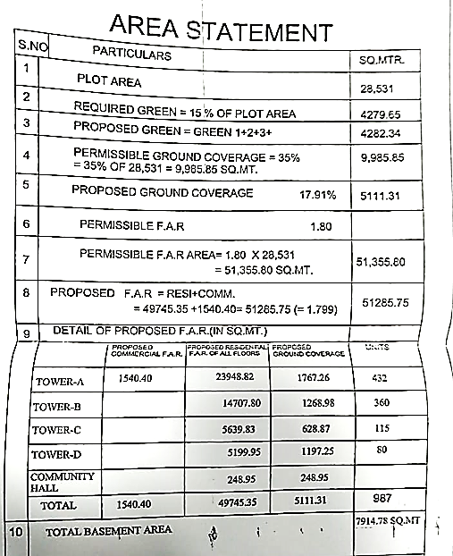

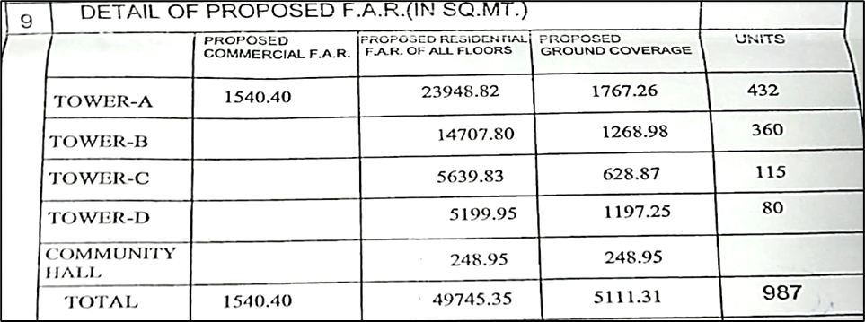

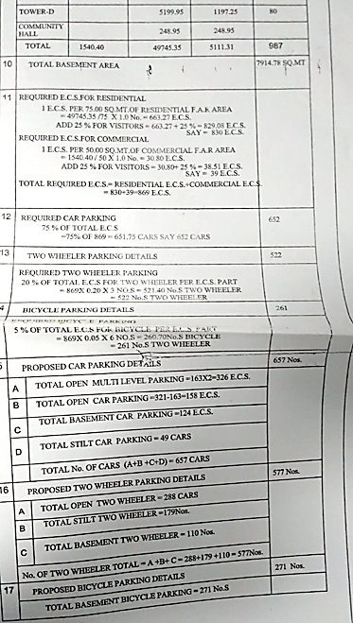

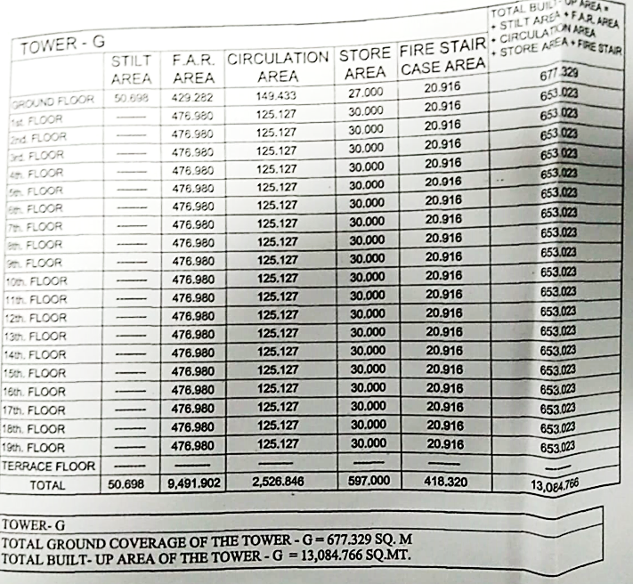

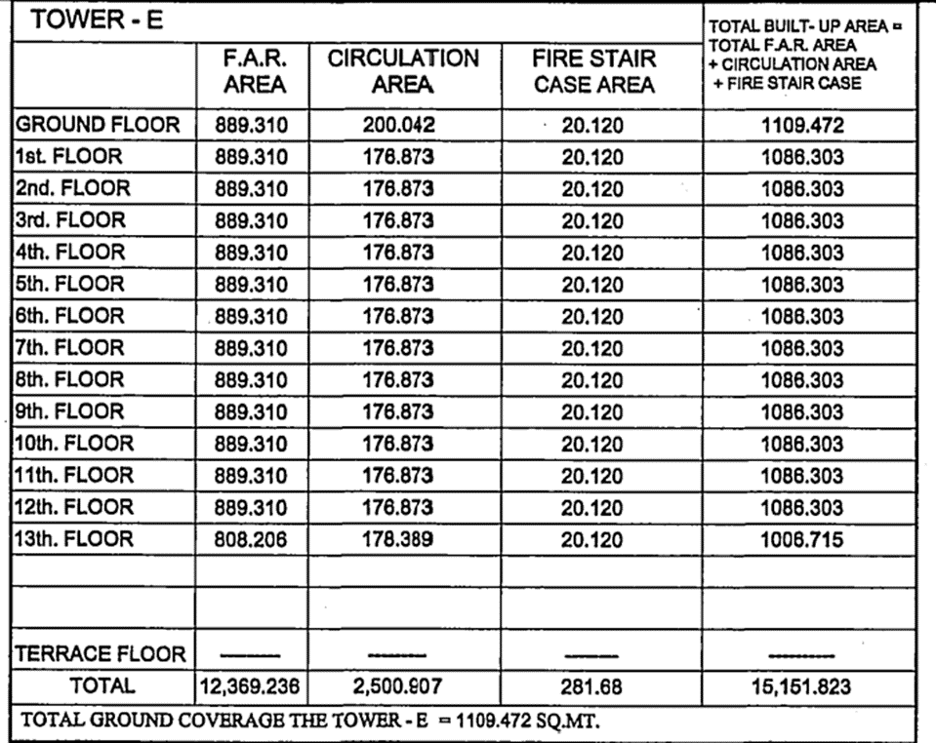

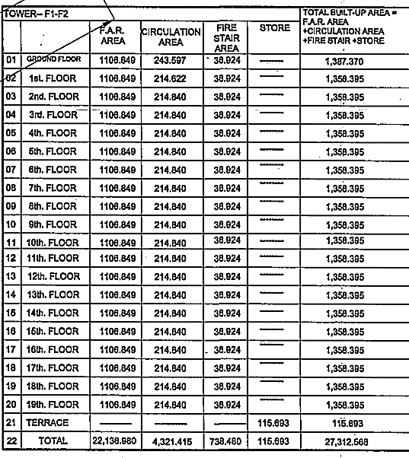

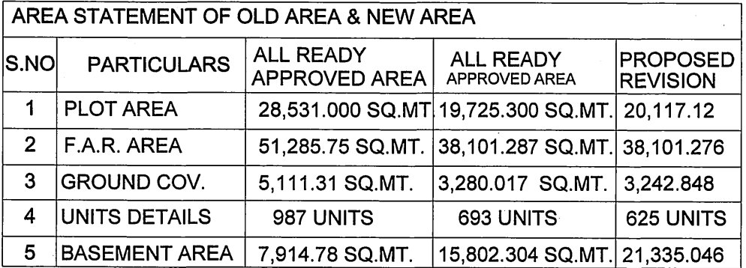

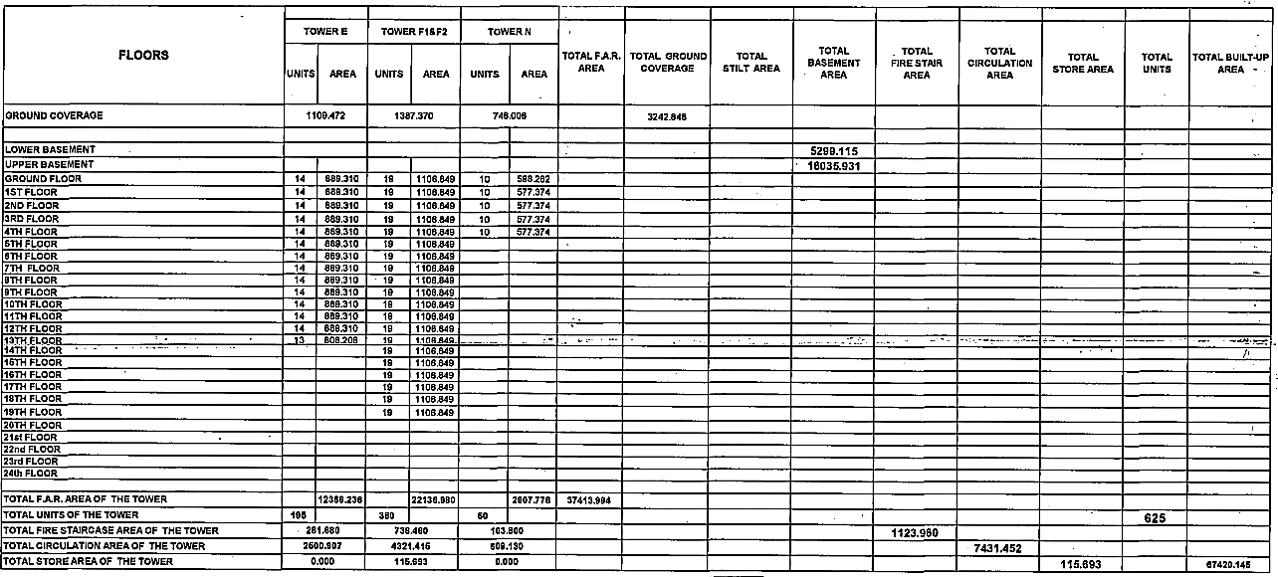

*(The above area statement of the project is for the Phase-2 of the project proposed on ~4.97 acres (20117.12 sq.mtr.) of land and bifuracation of the subject project phase is mentioned in the approved building plans provided to us. However, For the Phase-1 and the Phase-3 we have been provided with the Map Although no bifurcation for the respective Tower area is provided in the Map.Super area for the units are provided by the Bank*

|  |  |
| --- | --- |
| **PART D** | **PROJECT APPROVAL DETAILS** |

|  |  |  |  |
| --- | --- | --- | --- |
| **S.No.** | **REQUIRED APPROVALS** | **REFERENCE NO./ DATE** | **STATUS**  (Approved/ Applied For/ Pending) |
|  | Approved Building Plans from Town Development Authority, Bhiwadi | Approval Order No.4929-30/17  Dated: 03/08/2017 | Approved |
|  | Certificate For Extension of Registration of Project | Registration No. RAJ/P/2018/728  Dated: 22/12/2020 | Approved |
|  | Approved Map for 28531 sq.mtr. area | Dated: 22/02/2012 | Approved |
|  | Approved Map for 20117.12 sq.mtr. area | Letter No.4929-30/17  Dated: 03/08/2017 | Approved |
|  | NOC for Height Clearance from Airport Authority of India | ---- | Not Provided |
|  | Environmental clearance NOC from SEIAA | Letter No. FA(4)/SEIAA/SEAC/Raj/Sectt/project/Cat. 8(a)/B2 (10719)/14-15  Dated: 12/06/2016 | Approved |
|  | NOC from Pollution Control Board | ---- | Not Approved |
|  | Provisional NOC from Fire Authority | No. N/PA/BHI/Firefighting/4070  Dated: 20/01/2016 | Approved |
|  | RERA Registration Certificate issued from Rajasthan RERA | Registration No.  Dated: 30/08/2019 | Approved |
|  | Structural Stability Certificate | ---- | Not Provided |
|  |  |  |  |

***OBSERVATIONS:*** *Project meets preliminary necessary compliance statutory approvals as per the information provided to us at the site however few NOCs & approvals are not provide to us.*

|  |  |
| --- | --- |
| **PART E** | **VALUATION ASSESSMENT OF THE PROPERTY** |

|  |  |  |  |  |  |  |  |  |  |
| --- | --- | --- | --- | --- | --- | --- | --- | --- | --- |
|  | **ASSESSMENT FACTORS** | | | | | | | | |
|  | Valuation Type | | Project Valuation | | | | | Group Housing Society Value | |
|  | Scope of the Valuation | | Non Binding Opinion on General Prospective Valuation Assessment of the Property identified by Property owner or through its representative | | | | | | |
|  | Property Use factor | | Group Housing Society Project | | | | | | |
|  | Legality Aspect Factor  *(Refer clauses 2 & 4 of Part-E)* | | Weak as per documents produced to us | | | | | | |
|  | Land Physical factors | | **Shape** | | **Size** | | **Level** | | **Frontage to depth ratio** |
| Irregular | | Very Large | | On Road Level | | Normal frontage |
|  | Property location category factor | | **City Categorization** | | **Locality Categorization** | | **Property location classification** | | **Floor Level** |
| Scale-C City | | Average | | Ordinary location within the locality | | NA |
| Property within developing Residential zone | | NA | |
| NA | |
|  | Any New Development in surrounding area | | No | | | NA | | | |
|  | Property overall usability Factor | | Normal | | | | | | |
|  | Comment on Property Salability Outlook | | Easily sellable | | | | | | |
|  | Comment on Demand & Supply in the Market | | Normal demand of such properties in the market | | | | | | |
|  | Methodology/ Basis of Valuation | |  | | | | | | |
| *As per the current status of the Project this Project Valuation report is assessed assuming that in the eventuality for the need of sale of this Project the interested buyer would be any developer only who will be interested in operating this Project taking over from the current developer.*  *This report is prepared for the purpose of creating equitable mortgage to the financer and this whole Project is put as mortgage for it.*  *Since this is a licensed land for the purpose of development of Group Housing Society where some units have been booked and some are still unsold. Ultimately in the eventuality of sale or recovery financer would be able to sell unsold units only and no other part of the Project like Land or booked units will remain sellable.*  *Hence this Valuation is assessed by calculating the Valuation of unsold units as per current market rates and deduct the total balance cost to be put in the Project to make it complete plus profit margin of any prospective investor (buyer), to arrive at the Fair Market Valuation of the Project.*  *Booked & unsold units have been taken on the basis of the Inventory Sheet provided to us by the developer which has been relied upon in good faith. Financer is advised to legally check the status of these units through Title Investigation Report. Legal & other ownership rights distribution if any has not been considered in this report since no such thing informed to us by the builder company.* | | | | | | |
| *Valuation of the asset is done as found on as-is-where basis.*  *Valuation is done based on the Valuation best practices, standard operating procedures and definitions prescribed by various organizations like IVSC, Income Tax of India, etc. as defined under.*  *For knowing comparable market rates, significant discreet local enquiries have been made from our side representing ourselves as both buyer and seller for the similar properties in the subject area and thereafter based on this information and various factors of the property, a rate has been judiciously taken considering the market scenario.*  *References regarding the prevailing market rates are based on the verbal/ informal/ secondary/ tertiary information collected during market survey in the subject area from the local people, property consultants, recent deals, demand-supply, internet postings which are relied upon. No written record is generally available for such market information and only the verbal information has to be relied upon.*  *Market Rates are rationally adopted based on the facts of the property that came to our knowledge during the course of the assignment considering many factors like nature of the property, size, location, approach, market situation and trends.*  *The indicative value has been suggested based on the prevailing market rates that came to our knowledge during secondary & tertiary market researches and does not split into formal & informal payment components.*  *Secondary/ Tertiary costs related to asset transaction like Stamp Duty, Registration charges, Brokerage, Bank interest, selling cost, marketing cost, etc. pertaining to the sale/ purchase of this property are not considered while assessing the indicative estimated Market Value.*  *This report includes both, Govt. Guideline Value and Indicative Estimated Prospective Fair Market Value. As per the current market practice, in most of the cases, formal transaction takes place for an amount less than the actual transaction amount and rest of the payment is normally done informally.*  *Construction rates are adopted based on the present market replacement cost of construction and calculating applicable depreciation & deterioration factor as per its existing condition & specifications based on only visual observation of the structure. No structural, physical tests have been carried out in respect of it.*  *Construction rates are adopted based on the plinth area rates prevailing in the market for the structure as a whole and not based on item wise estimation or Bills of Quantity method.*  *The condition assessment and the estimation of the residual economic life of the structure is only based on the visual observations and appearance found during the site survey. We have not carried out any structural design or stability study; nor carried out any physical tests to assess structural integrity & strength.*  *Sale transaction method of the asset is assumed as free market transaction while assessing Indicative & Estimated Fair Prospective Market Value of the asset.*  *Any kind of unpaid statutory, utilities, lease, interest or any other pecuniary dues on the asset has not been factored in the Valuation.*  *This Valuation is conducted based on the macro analysis of the asset/ property considering it in totality and not based on the micro, component or item wise analysis. Analysis done is a general assessment and is not investigative in nature*  ***Fair Market Value#*** *suggested by the competent Valuer is that prospective estimated amount in his expert & prudent opinion of the subject asset/ property without any prejudice after he has carefully & exhaustively evaluated the facts & information came in front of him related to the subject asset at which the subject asset/ property should be exchanged between a willing buyer and willing seller at an arm’s length transaction in an open & unrestricted market, after proper marketing, wherein the parties, each acted knowledgeably, prudently and without any compulsion on the date of the Valuation.*  *Forced, under compulsion & constraint, obligatory sales transactions data doesn’t indicate the Fair Market Value.*  ***Realizable Value^*** *is the minimum prospective estimated value of the property which it may be able to realize at the time of actual property transaction factoring in the potential prospects of deep negotiations carried out between the buyer & seller for ultimately finalizing the transaction across the table. Realizable value may be 10-20% less than the Fair Market Value depending on the various salability prospects of the subject property and the needs of the buyer & the seller.*  ***Forced/ Distress Sale Value\**** *is the value when the property has to be sold due to any compulsion or constraint like financial encumbrances, dispute, as a part of a recovery process, any defect in the property, legal issues or any such condition or situation. In this type of sale, minimum fetch value is assessed which can be 25-40% less than the estimated Fair Market Value based on the nature, size & salability prospects of the property. In this type of sale, negotiation power of the buyer is always more than the seller and eagerness & pressure of selling the property is more than buying it. Therefore the Forced/ Distress Sale Value will always fetch significantly less value compare to the estimated Fair Market Value.*  ***Liquidation Value*** *is the amount that would be realized when an asset or group of assets are sold on a piecemeal basis that is without consideration of benefits (or detriments) associated with a going-concern business. Liquidation value can be either in an orderly transaction with a typical marketing period or in a forced transaction with a shortened marketing period.*  ***Difference between Cost, Price & Value:*** *Generally these words are used and understood synonymously. However in reality each of these has a completely different meaning, premise and also having different definitions in the professional & legal terms. Therefore to avoid confusion, it is our professional responsibility to describe the definitions of these words to avoid ambiguity & confusion in the minds of the user of this report.*  *The* ***Cost*** *of an asset represents the actual amount spend in the construction/ actual creation of the asset.*  *The* ***Price*** *is the amount paid for the procurement of the same asset.*  *The* ***Value*** *is defined as the present worth of future rights in the property/ asset and depends to a great extent on combination of various factors such as demand and supply, market situation, purpose, situation & needs of the buyer & seller, saleability outlook, usability factor, market perception & reputation. needs of the buyer & seller, saleability outlook, usability factor, market perception & reputation.*  *Therefore, in actual for the same asset/ property, cost, price & value remain different since these terms have different usage & meaning.* | | | | | | |
|  | Details of the sources from where the information is gathered on prevailing market Rate/ Price trend of the property *(from property search sites & local information)* | | | | | | | | |
| 1. Name: Mathur Associates, Property Dealers Contact No.: +91-8800663999 | | | *As per our telephonic conversation with Mr. Vikas, we came to know that flats are available for direct booking from the developer.*  *Further we came to know that the prevailing market rates for flats in the subject society is between Rs.2,500/- to Rs.3,000/- per sq.ft on super area depending on location, size of the flat, floor level etc. The rate range from Rs.5,500/- to Rs.6,000/- per sq.ft. on super area for Commercial Unit.* | | | | | |
|  | Adopted Rates Justification | Rates taken as per market survey. | | | | | | | |
|  | **Inventory Absorptions Rate:** | An absorption rate provides insight on the rate at which unsold inventory are selling. It will depend upon the demand and supply gap in micro market. Therefore, for “The Essentia” Project, after looking the current realestate market senario, we are on the view that subject unbooked inventory will be absorbed in different time span as shown Below. | | | | | | | |
|  | **Appreciation in Sale Price** | For arriving at the appreciation in sale price of unbooked inventory we have taking care following points:-   * The supply and demand dynamics of a particular location. * The interest rates banks charge for home loans, meaning the cost of borrowing. * Growth in local population, leading to increased demand * Development of basic infrastructure like School, Hospital, Transportation & Local Market.   Hence considering all the above factors, we have taken 2.5% appreciation in unsold inventory for each year since the construction of the project will get progress with time and more units gets booked over time & occpancy increases rate increases over time. | | | | | | | |
|  | **Balance cost to be incurred for construction** | The balance cost of construction of the project has been taken as per the information provided by the company official, which we have relied upon in good faith.  Due to unavailability of discreet data (bills of quantity/ item wise) from the client we could not do the detailed cost estimation for the project phase and it has been calculated on the basis of cost yet to to be incurred in constructon of the project. | | | | | | | |
|  | **Discount Rate** | As per the international Valuation Standard hand book, **‘**The rate at which the forecasted cash flow is discounted should reflect not only the time value of money, but also the risks associated with the type of cashflow and the future operations of the asset’.  The discount rate or WACC has been taken as per the discussion with the market participants based on the current real estate markets scenario in India and more importantly based on the current rate of lending by the Indian scheduled banks in real estate sector. The discount rate for the projects depends upon the liquidity factor & Demand and supply gap in the market. Presently real estate is considered to be risky sector due to the large unsold inventory, thus having supply much more than the demand. In Banking also the minimum ROI on real estate Projects is prevailing from minimum 12% to 18% depending upon the Project profile and creditworthiness of the developer company. Therefore we have taken minimum discount rate or ROR as 17.25% which any buyer would be expecting in present market scenario & condition.  For the calculation of discount rate we have assumed 50% of capex as debt and 50% of capex as equity @ 12.50% & 22% interest rate. 22% of equity interest rate is adopted considering the risk factor involved in real estate projects in present scenario. By this WACC arrived is 17.25%. | | | | | | | |

* **PROJECT INFLOW MODEL:**

1. **Receivables of Booked Flats**

As per the data provided to us by the Bank the total receivables of Different Phases are as follow: -



1. **Market Sale Value:**

The current Market rates of the property have been taken after several discussions with market participants & market researches on public domain and came to the following conclusion: -

1. Secondary market for the subject project is not yet developed and the flats are available on fresh booking only. As per the market feedback we came to know that the prevailing market rates for flats in subject project is between Rs.2,500/- to Rs.3,000/- per sq.ft. on super area for phase-1 & 2 of the project. Construction of Phase-3 of project is not yet started and proposed in future. Due to the ongoing covid-19 pandemic the economic conditions of the market is down and the subject project is also mortgaged under NPA account so in future the developer needs to launch the phase-3 of the subject project with some discount at the present rate of the flats to make the subject project viable so we have assume the market rate of flats of phase-3 should be around Rs.2,300/- per sq.ft. on super area which is reasonable in our opinion.
2. The Market rate for the commercial unit is range between Rs.5,500/- to Rs.6,000/- per sq.ft. in the subject locality.
3. The complete project is comprising of 07 residential towers and developer has plan to launch the whole project towers in Three phase. At present developer has launched and completed phase-I comprises of towers i.e., Tower-B & D of the project and the phase-2 is under Construction comprising of Tower A & F1-F2 under the name of “The Essentia”. whereas The construction work of phase-III is Proposed and not yet Started.
4. Transaction rates of primary sale & secondary sale will always have some difference as per general market practice. Secondary market for the flats in the subject project is yet to be develop and there are no data available on public domain for resale flats in this project.
5. Therefore, based on these facts rates per floor have been adopted judiciously.

Therefore, for the Valuation purpose for flats of this project we have taken market rate range of Rs.2,300/- to Rs.3,000/- per sq.ft. on Super Area (Including other charges like PLC, EDC & IDC) and Rs.5,500/- to Rs.6,000/- per sq.ft. for commercial units, these rates depends upon the characteristics of the unsold dwelling units. These are the prevailing market rates for Different Phases in the subject Project.



1. **THE ESSENTIA INFLOW MODEL:**







* **PROJECT OUT FLOW:**

1. **CAPEX (Capital Expenditure):**

**CONSTRUCTION COST YET TO BE INCURRED:** The construction cost of the project has been taken on the basis of cost of expenses provided by the company and we have relied upon in good faith.



**FINANCIAL CHARGES:** As per the information/ data provided to us by the company, Financial Charges during the construction of the project will be Rs.1,50,00,000/- and the same is taken in this project valuation report and bifurcated respectively for different Phases on Pro-rata Basis.



1. **OPEX (Operational Expenditure):**

**ADMINISTRATIVE EXPENSES:** As per the information & data provided to us, Administrative Charges during the construction of the project will be Rs.33,00,00,000/- and bifurcated respectively for different Phases on Pro-rata Basis



**MARKETING EXPENSES:** As per the information & data provided to us, Marketing Charges of the project will be Rs.8,36,00,000/- and bifurcated respectively for different Phases on Pro-rata Basis



* **PROJECT NET PRESENT VALUE (NPV):**







**(Rupees Seventy-Six Crores Only)**

|  |  |  |
| --- | --- | --- |
|  | **Concluding comments if any** | As per the scope of the assignment,Value assessment is subject to R.K Associates Important Notes and Valuer’s Remarks *(Enclosure: 1)* & other enclosed documents with the Report which will remain part & parcel of the report. |

|  |  |
| --- | --- |
|  | **ASSUMPTIONS/ REMARKS** |
|  | Information of the average market rates is taken based on the verbal market survey in the subject area from the local people, property agents, recent deals, demand-supply, internet postings which has been relied upon. No written record is generally available for such market information. |
|  | Sale transaction method of the asset is assumed as free market transaction while assessing Prospective Fair Market Value of the asset. |
|  | All area measurements are on approximate basis. Verification of the area measurement of the property is done only based on sample random checking and not based on full scale measurement. Area of the large land parcels of more than 2500 sq.mtr or of uneven shape, is taken as per property documents which has been relied upon. |
|  | Legal aspects are not considered in this report. It is assumed and taken into account that the concerned Bank/ Financial Institution has first got the legal verification cleared by the competent Advocate before requesting for the Valuation report. |
|  | This report is prepared based on the copies of the documents/ information which interested organization or customer could provide to us out of the standard checklist of documents sought from them and further based on our assumptions and limiting conditions. All such information provided to us has been relied upon and we have assumed that it is true and correct. Verification or cross checking of the documents provided to us from the originals has not been done at our end. If at any time in future it’s found or came to our knowledge that misrepresentation of facts or incomplete or distorted information has been provided to us then this report will automatically become null & void. |
|  | Valuation is done for the property identified to us by the owner/ owner representative. Responsibility of identifying the correct property to the Valuer/ its authorized surveyor is solely of the client/ owner for which Valuation has to be carried out. At our end we can just cross verify the identification of the property with reference to the documents produced for perusal. Method by which identification of the property is carried out is also mentioned in the report clearly. It is requested from the Bank to cross check from their own records/ information if this is the same property for which Valuation has to be carried out to ensure that owner has not misled the Valuer company or misrepresented the property due to any vested interest. |
|  | In India more than 70% of the geographical area is lying under rural/ remote/ non municipal/ unplanned area where the subject property is surrounded by vacant lands having no physical demarcation or having any display of property survey or municipal number / name plate on the property clearly. Even in old areas of towns, small cities & districts where property number is not assigned clearly and not displayed on the properties, also due to the presence of multiple/ parallel departments (errors for in property registration) it becomes tough to identify the property with 100% surety from the available documents, information & site whereabouts and chances of error & misrepresentation by the borrower and margin & chances of error always persists in such cases. To avoid any such chances of error it is advised to the Bank to engage municipal/ revenue department officials to get the confirmation of the property to ensure that the property shown to Valuer/ Banker is the same as for which documents are provided. |
|  | If this Valuation Report is prepared for the Flat/ dwelling unit situated in a Group Housing Society or Integrated Township then it is assumed that the Banker or the concerned organization has satisfied themselves with the approval of the Group Housing Society/ particular floor & building before allotting the Valuation case to the Valuer company. |
|  | Due to fragmented & frequent change in building/ urban planning laws/ guidelines from time to time, different laws/ guidelines between regions/ states and no strict enforceability of Building Bye-Laws in India specially in non-metro and scale b & c cities & Industrial areas, property owners many times extend or make changes in the covered area/ layout out of approved/ applicable limits or the properties are decades old for which no formal Building Bye-Laws were applicable. Due to such discrete/ unplanned development in many regions sometimes it becomes tough to determine the exact lawful situation on ground for the Valuer. In case nothing specific is noted on the covered built-up area considered in the Valuation Report, the covered area present on the site as per site survey will be considered in the Valuation. |
|  | Valuation is a subjective field and opinion may differ from consultant to consultant. To check the right opinion, it is important to evaluate the methodology adopted and various factors/ basis considered during the course of assessment before reaching to any conclusion. |
|  | At the outset, it is to be noted that Value analysis of any asset cannot be regarded as an exact science and the conclusions arrived at in many cases will, of necessity, be subjective and dependent on the exercise of individual judgment. Given the same set of facts and using the same assumptions, expert opinions may differ due to the number of separate judgment decisions, which have to be made. Therefore, there can be no standard formulae to establish an indisputable exchange ratio. In the event of a transaction, the actual transaction value achieved may be higher or lower than our indicative analysis of value depending upon the circumstances of the transaction. The knowledge, negotiability and motivations of the buyers and sellers and the applicability of a discount or premium for control will also affect actual price achieved. Accordingly, our indicative analysis of value will not necessarily be the price at which any agreement proceeds. The final transaction price is something on which the parties themselves have to agree. However our Valuation analysis can definitely help the stakeholders to make them informed and wise decision about the Value of the asset and can help in facilitating the arm’s length transaction. |

**ENCLOSURE 1 – VALUER’S REMARKS**

|  |  |
| --- | --- |
|  | **Fair Market Value** suggested by the competent Valuerin his opinionis an prospective estimated amount without any prejudiceafter evaluating all the facts related to the subject propertyat which the subject Asset should be exchanged on the date of Valuation between a willing buyer and willing seller at an arm’s length transaction after proper marketing, wherein the parties, each acted knowledgeably, prudently and without any compulsion. |
|  | **Realizable Value** is the minimum prospective value of the property which it may be able to realize at the time of actual property transaction factoring in potential prospects of deep negotiations carried out between the buyer & seller for ultimately finalizing the transaction. Realizable value may be 10-20% less of the Fair Market Value depending on the salability prospects of the subject property. |
|  | **Forced/ Distress Sale Value** is the value when the property has to be sold due to financial encumbrances or any other constraint or have become a disputed property or as a part of a recovery process. In this type of sale minimum disposable value is assessed which varies from 20-35% less from the Fair Market Value based on the salability prospects of the property. |
|  | Best rates are rationally adopted based on the facts of the case came to our knowledge during the course of the assignment considering many factors like nature of property, location, approach, market situation and trends. |
|  | Construction rates are adopted based on present replacement cost of construction and calculating applicable depreciation & deterioration factor as per its existing condition, specifications based on the visual observation of the structure. No physical tests have been carried out in respect of it. |
|  | No employee or member of R.K Associates has any direct/ indirect interest in the property. |
|  | Sale transaction method of the asset is assumed as free market transaction while assessing Fair Prospective Market Value of the asset. |
|  | Area measurements considered in the Valuation Report pertaining to Land & Building is adopted from relevant approved documents or actual site measurement whichever is less. All area measurements are on approximate basis only. |
|  | This report is having limited scope as per its fields to provide only the general basic idea of the value of the property prevailing in the market based on the documents/ data/ information provided by the client. The suggested value should be considered only if transaction is happened as free market transaction. |
|  | The condition assessment and the estimation of residual economic life of the structure is based on the visual observations and appearance found during the site survey. We have not carried out any structural design or stability study; nor carried out any physical tests to assess structural integrity & strength. |
|  | Secondary/ Tertiary costs related to asset transaction like Stamp Duty, Registration charges, Brokerage, etc. pertaining to the sale/ purchase of this property are not considered while assessing the Market Value. |
|  | This report is prepared based on the copies of the documents/ information which interested organization or customer could provide to us out of the standard checklist of documents sought from them and further based on our assumptions and limiting conditions. All such information provided to us has been relied upon and we have assumed that it is true and correct. Verification or cross checking of the documents provided to us from the originals has not been done at our end. If at any time in future it’s found or came to our knowledge that misrepresentation of facts or incomplete or distorted information has been provided to us then this report will automatically become null & void. |
|  | Investigation of title of the property and its legal right is beyond the scope of this report. If this property is offered as collateral security, the concerned financial institution is requested to verify & satisfy themselves on the ownership & legality of the property shown in this valuation report with respect to the latest legal opinion. |
|  | Value varies with the Purpose/ Date/ Condition of the market. This report should not to be referred if any of these points are different from the one mentioned aforesaid in the Report. The Value indicated in the Valuation Report holds good only upto the period of 3 months from the date of Valuation. |
|  | Analysis and conclusions adopted in the report are limited to the reported assumptions, conditions and information came to our knowledge during the course of the work. |
|  | This report is prepared on the RKA V-L3 (Medium) Valuation format as per the client requirement, charges paid and the time allotted. This report is having limited scope as per its fields to provide only the general estimated basic idea of the value of the property prevailing in the market based on the information provided by the client. The Valuation assessed in this Valuation Report should hold good only if transaction is happened as per free market transaction. No detailed analysis or verification of the information is carried upon pertaining to the value of the subject property. No claim for any extra information will be entertained whatsoever be the reason. For any extra work over and above the fields mentioned in the report will have an extra cost which has to be borne by the customer. |
|  | This is just an opinion report and doesn’t hold any binding on anyone. It is requested from the concerned Financial Institution which is using this report for mortgaging the property that they should consider all the different associated relevant & related factors also before taking any business decision based on the content of this report. |
|  | This Valuation report is prepared based on the facts of the property on the date of the survey. However in future property Market may go down, property conditions may change or may go worse, Property reputation may differ, Property vicinity conditions may go down or become worse, Property market may change due to impact of Govt. policies or effect of World economy, Usability prospects of the property may change, etc. Hence before financing, Banker/ FI should take into consideration all such future risk and should loan conservatively to keep the advanced money safe in case of the downward trend of the property value. |
|  | All Pages of the report including annexures are signed and stamped from our office. In case any paper in the report is without stamp & signature then this should not be considered a valid paper issued from this office. |
|  | Defect Liability Period is **30 DAYS**. We request the concerned authorized reader of this report to check the contents, data and calculations in the report within this period and intimate us in writing if any corrections are required or in case of any other concern with the contents or opinion mentioned in the report. Corrections only related to typographical, calculation, spelling mistakes will be entertained within the defect liability period. No request for any illegitimate value revision, date change or any other change will be entertained other than the one mentioned above. |
|  | R.K Associates encourages its customers to give feedback or inform concerns over its services through proper channel at [**valuers@rkassociates.org**](mailto:valuers@rkassociates.org) in writing within 30 days of report delivery. After this period no concern/ complaint/ proceedings in connection with the Valuation Services can be entertained due to possible change in situation and condition of the property. |
|  | Our Data retention policy is of **ONE YEAR**. After this period we remove all the concerned records related to the assignment from our repository. No clarification or query can be answered after this period due to unavailability of the data. |
|  | This Valuation report is governed by our (1) Internal Policies, Processes & Standard Operating Procedures, (2) R.K Associates Quality Policy, (3) Valuation & Survey Best Practices Guidelines formulated by management of R.K Associates, (4) Information input given to us by the customer and (4) Information/ Data/ Facts given to us by our field/ office technical team. Management of R.K Associates never gives acceptance to any unethical or unprofessional practice which may affect fair, correct & impartial assessment and which is against any prevailing law. In case of any indication of any negligence, default, incorrect, misleading, misrepresentation or distortion of facts in the report then it is the responsibility of the user of this report to immediately or atleast within the defect liability period bring all such act into notice of R.K Associates management so that corrective measures can be taken instantly. |
|  | R.K Associates never releases any report doing alterations or modifications from pen. In case any information/ figure of this report is found altered with pen then this report will automatically become null & void. |
|  | If this report is prepared for the matter under litigation in any Indian court, no official or employee of R.K Associates will be under any obligation to give in person appearance in the court as a testimony. For any explanation or clarification, only written reply can be submitted on payment of charges by the plaintiff or respondent which will be 10% of the original fees charged where minimum charges will be Rs.2500/-. |

**ENCLOSURE 2 – GOOGLE MAP LOCATION**

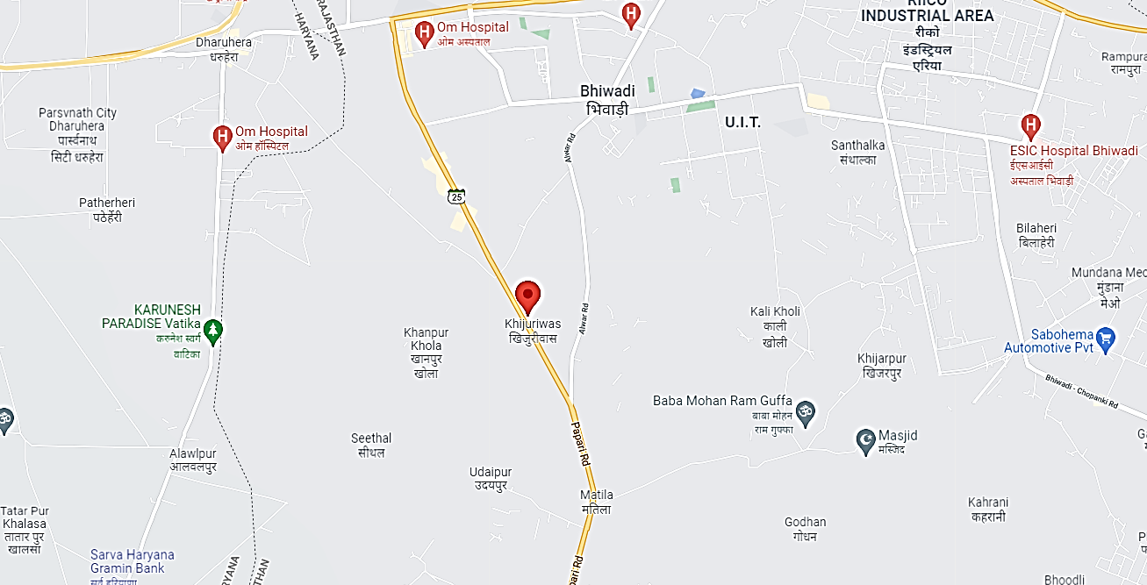

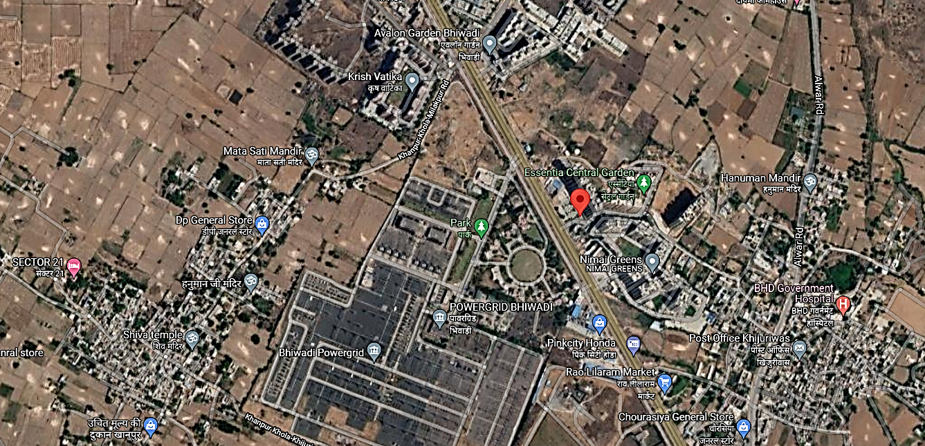

**ENCLOSURE 3 – PHOTOGRAPHS**

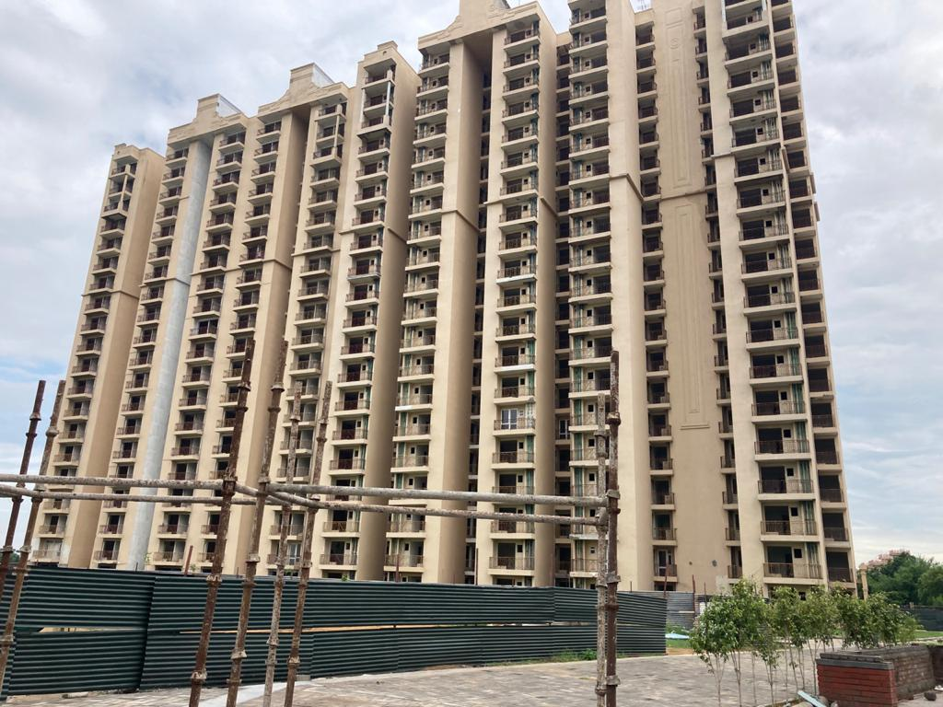

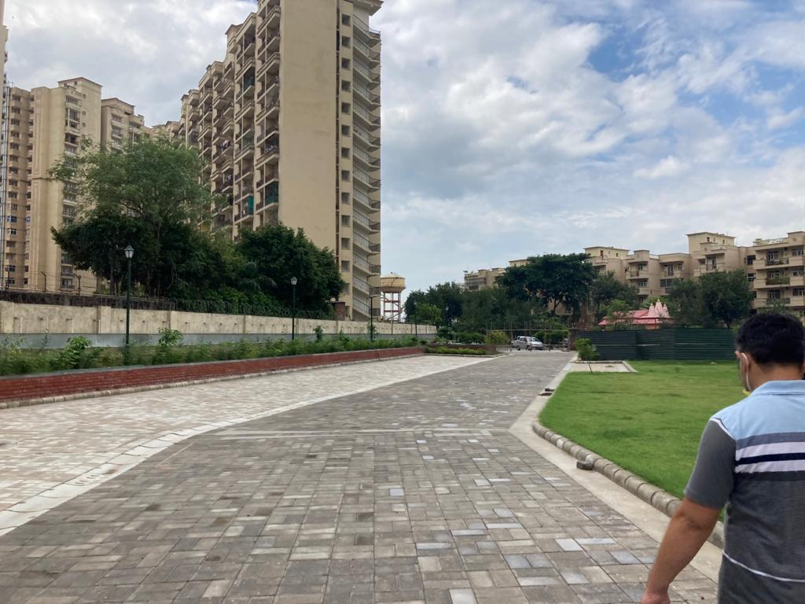

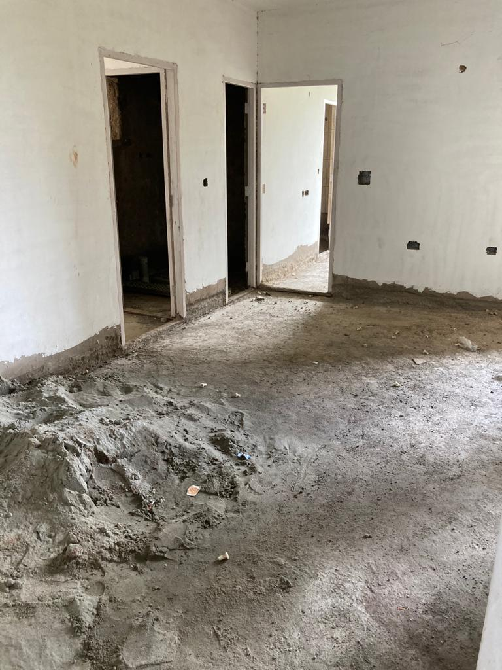

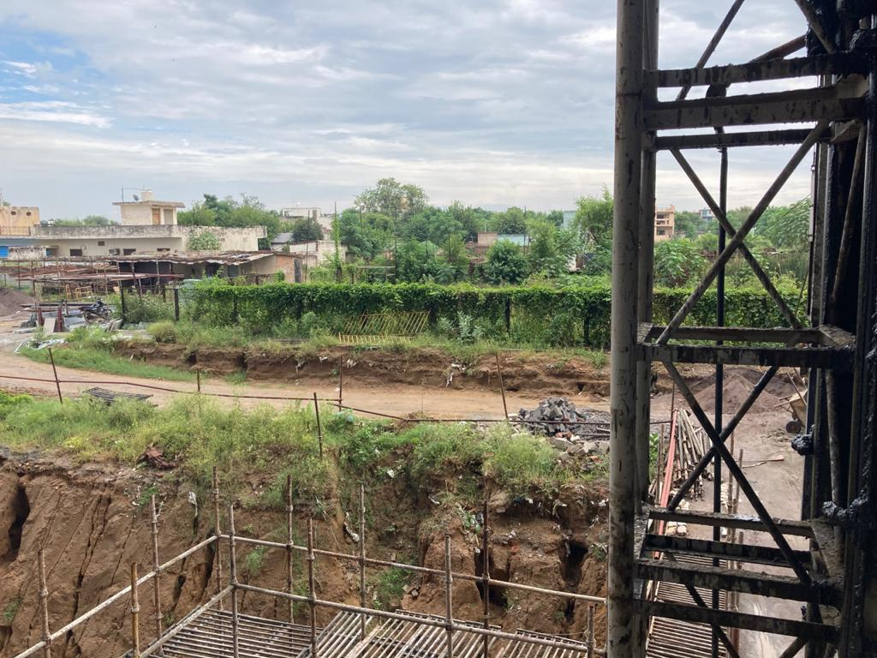

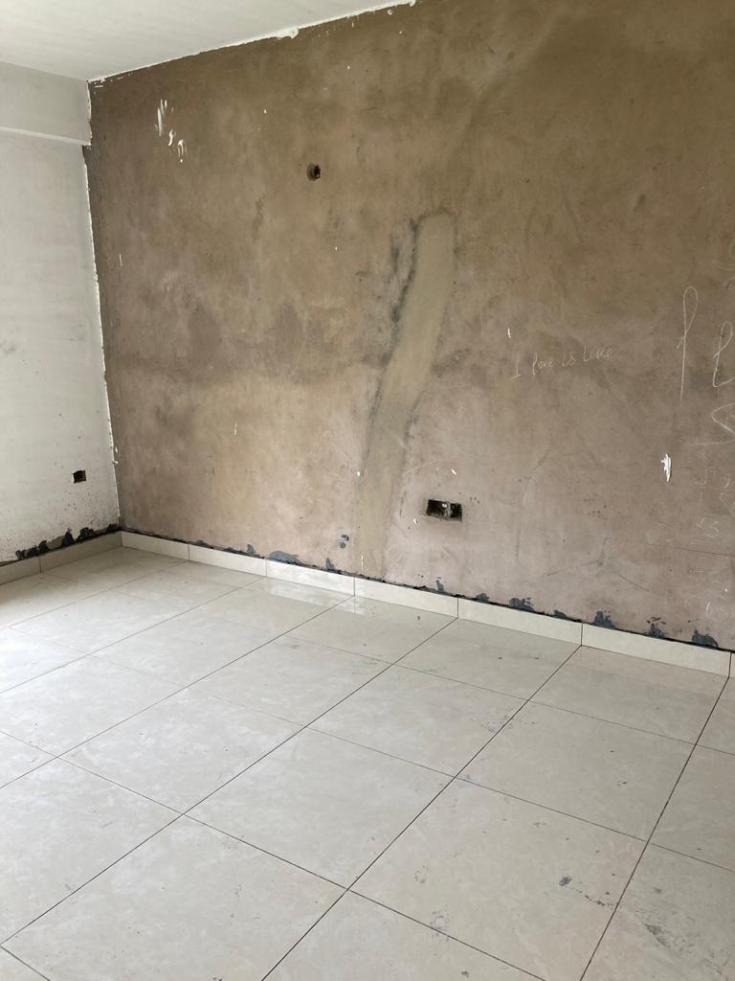

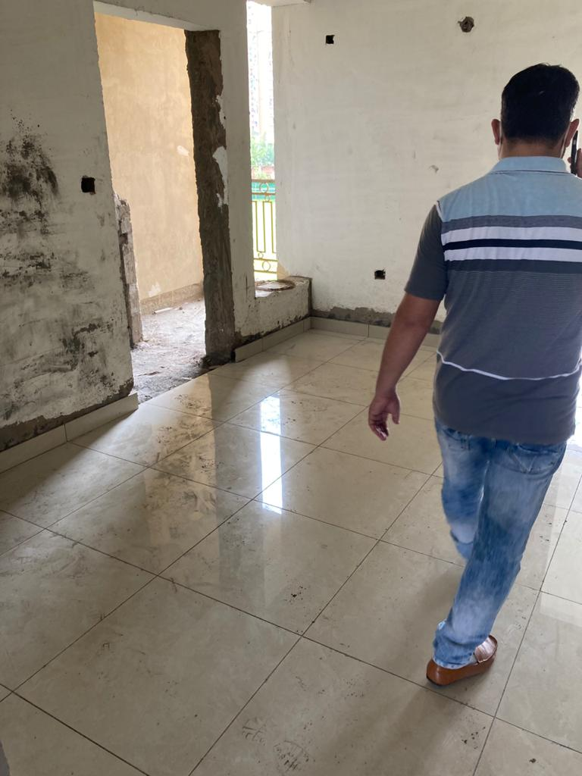

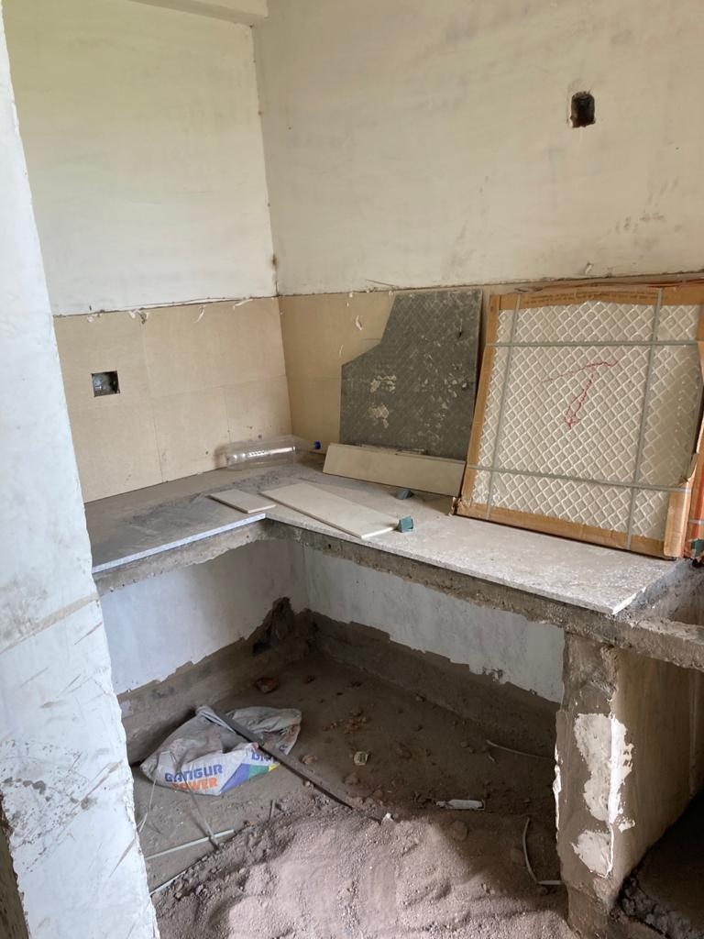

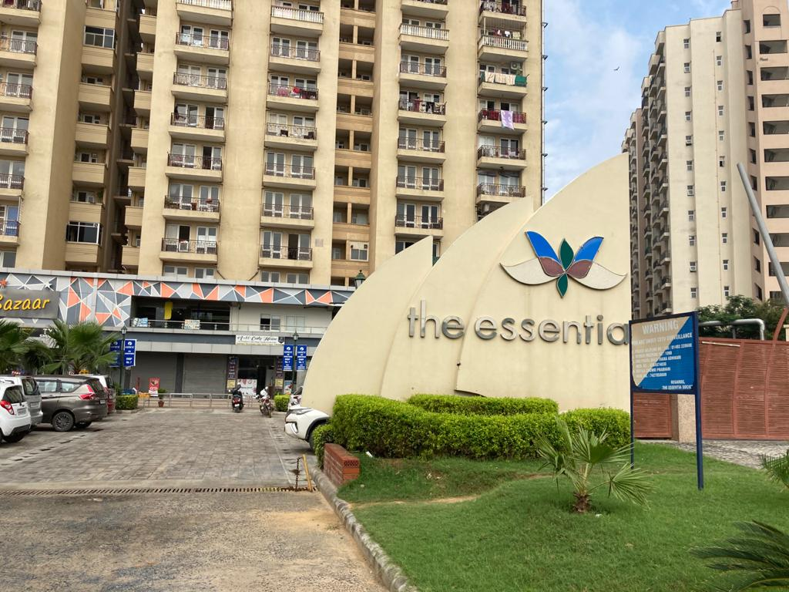

**ENCLOSURE 4 – PRICE TREND REFRENCES**

