**REPORT FORMAT:** CL-1 | Version: 1.0_2018

# FILE No.: VIS(2021-22)-PL438-Q107-392 Date: 23-09-2021

* ***CERTIFICATE* NAME:** *Cost Vetting Certificate for New solar power plant which is proposed to be installed at different sites in Maharashtra.*
* ***PREPARED FOR ORGANIZATION:*** *State Bank of India, Shiv Sagar Estate Branch, Mumbai*
* ***BORROWER COMPANY’S NAME:*** *M/s. Eurja Energy Generation Private Limited.*
* ***ASSET TYPE****: Machineries for 5 MW Solar Power Plant.*
* ***CURRENT LOCATION OF THE MACHINES****: Proposed to be Installed*

**TO WHOM IT MAY CONCERN**

|  |  |  |
| --- | --- | --- |
| **S. NO.** | **PARTICULARS** | **DESCRIPTION** |
| 1. | Date of Survey | Not Applicable |
| 2. | Date of Certificate | 23-09-2021 |
| 3. | Documents provided for perusal | 1. Detailed Project reports. 2. Purchase Bills. |
| 4. | Current Location of the Machines | Proposed to be install at Different Locations in Maharashtra. (shown in the table attached below) |
| 5. | Borrowing Company | M/s. Eurja Energy Generation Private Limited |
| 6. | Type of Asset | Machinery required for installing 5 MW Solar Power plant. |
| 7. | Type of Assessment | Cost vetting |
| 8. | Scope of Assessment | Cost Vetting of the new equipment which have to be/ already purchased by the company |
| 9. | Nature of Machinery | Solar Energy Plant machines |
| 10. | Year of Manufacturing | Plant is currently being installed. |
| 11. | Total Purchase Cost | Rs.17.92 Cr. (*Total project Cost including supply, installation, overheads & freight as per the detailed project report provided by the company)*. |
| 12. | Current Estimated Market Value | The range of current market rates of such type of machinery & equipment’s is verified from various suppliers and also from the public domain for the new machinery and equipment’s.  Company have used/proposed to use PVC Poly crystalline silicon modules in these solar power plant and for the same they have quoted 17.92 Cr for 5 Megawatt of plant which translates to ~Rs.3.584 Cr per Mega Watt.  As per quotes received from market we are of the view that rate range for similar kind of solar power plant using PVC Poly crystalline silicon modules should be ₹3,30,00,000/- to ₹4,00,00,000/- per Megawatt.  We are of the view that the rate as per the list of machinery and their total purchase price provided to us by the company/ bank are quite reasonable when compared to the rates of similar machines currently prevailing in the market. |
| 13. | Condition of Machine | Below attached table explained the status of the project. |

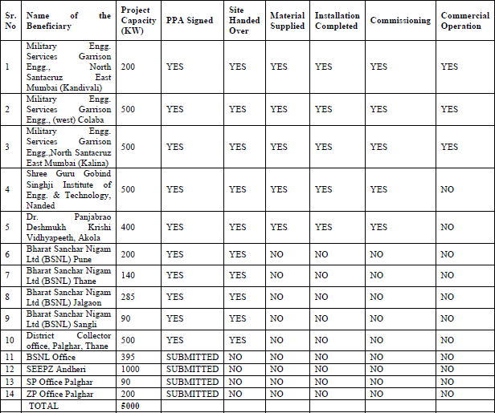

*(Source: Detailed Project report)*





**OBSERVATIONS:**

1. We have been provided with the copy of bills with cost of machines/ equipment by the borrower company.
2. As per the information provided by the company officials these items are already/planned to be installed at different location in Maharashtra.
3. We have contacted several suppliers for similar items and also enquired in the public domain. Accordingly we have got the quotation from the suppliers and we find that the price given in the purchase order provided to us is well within the price range of similar items available in the market and seems to be reasonable.
4. Company have used/proposed to use PVC Poly crystalline silicon modules and pure sine wave grid connected solar inverter for converting DC power into AC Power (as per DPR) in these solar power plant and for the same they have quoted 17.92 Cr for 5 Megawatt of plant which translates to ~Rs.3.584 Cr per Megawatt.

* **Based on the information provided by the company (M/s. Eurja Energy Generation Private Limited.) and enquiries made by us in the open market and references found in the public domain for similar machines/items, it is certified that total market cost for setup plants of similar specification should be around ₹3,30,00,000/- to ₹4,00,00,000/- per Megawatt and therefore the total purchase price of Rs.17,92,00,000/- for 5 Megawatt i.e. Rs.3,58,40,000/- per Megawatt (as per the DPR & bills provided to us by the company) appears to be reasonable.**

***Disclaimer:***

* 1. *We can’t comment about the current status of machines whether these are purchased, installed or in transit. This cost vetting is done only on the basis of Bills and Detailed Project report provided to us by the company and we don’t recommend any sort of recommendation in our Certificate.*
  2. *The estimated cost verification of item to item can’t exactly match as per our vetting due to several market consideration. In some of the items it is lower while in some of the items price comes to be higher but on an average the price as per list provided to us falls in the range as confirmed by us.*
  3. *There can be variation in the estimated price if the specification & make of any items procured is different from the list provided to us during assessment.*
  4. *The estimated cost verification is made based on the third party information which has been replied upon in good faith.*
  5. *The estimated price may vary at the time of actual procurement because of change in prices in the market for such kind of machinery/items for which we will not have any control. The cost vetting is only limited to the date of Certificate issued. We do not assume any responsibility in change of prices of the said machinery/items after this date.*
  6. *This certificate doesn’t include any work related to drawing, design, sketch plan, procurement of the machines.*
  7. *Ownership and other legal point of view in respect of the asset is not considered in this report as same is out of scope of this certificate.*
  8. *This certificate is made at the request of the Bank.*

**For R.K Associates Valuers** **& Techno** **FOR INTERNAL USE Engineering Consultants (P) Ltd. *TYPED BY: AE Zaid Ebne Mairaj***  ***REVIEWED BY: HOD Engineering*** **(Project Team)**

# ANNEXURE: - I (COMPARISON SUMMARY)

# 

# ANNEXURE: - II (QUOTATION FROM MARKET)

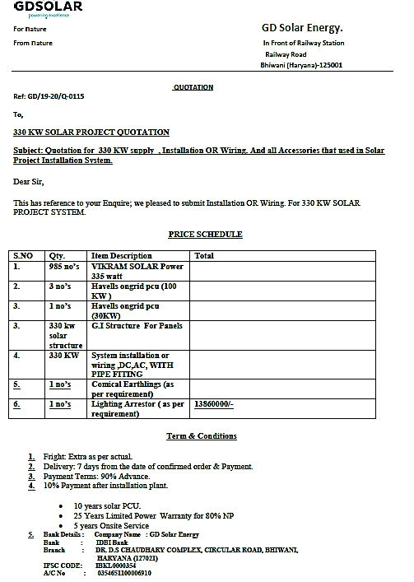

**(Quote- 330 Kw Solar Power Plant (including GST and other installation charges))**