REPORT FORMAT: V-L4 (Medium L&B and P&M) | Version: 8.0_2019

File No.: VIS(2021-22)-PL514-Q118-449-564 Dated: 30.09.2021

VALUATION ASSESSMENT

OF

INDUSTRIAL PROPERTY

SITUATED AT
PLOT NO. D-4 A, KHASRA NO. 1/1/3 MIN, KHATAUNI S.NO. 833 (FASLI YEAR 1394-1399), MAUZA CENTRAL HOPE TOWN, PARGANA PACHWA DOON, TEHSIL VIKAS NAGAR, DISTRICT DEHRADUN, UTTARAKHAND

OWNER/S

M/S. HEMCO GARMENTS PVT. LTD.
(THROUGH ITS AUTHORISED SIGNATORY MR. NAKUL RANA S/O. MR. RAJIV KUMAR)

A/C: M/S. HEMCO GARMENTS PVT. LTD. REPORT PREPARED FOR
MR. RAVI SHANKAR KUMAR

**Important - In case of any query/ issue or escalation you may please contact Incident Manager at valuers@rkassociates.org. We will appreciate your feedback in order to improve our services.

NOTE: As per IBA Guidelines please provide your feedback on the report within 15 days of its submission after which report will be considered to be correct.

PART A | RKA FORMAT OF REPORT ON VALUATION

Name & Address of Branch | Mr. Ravi Shankar Kumar
Name of Customer (s)/ Borrower Unit | M/s. Hemco Garments Pvt. Ltd.

S.NO. | CONTENTS | DESCRIPTION
1. | INTRODUCTION
a. | Name of Property Owner | M/s. Hemco Garments Pvt. Ltd.
 | Address & Phone Number of the  Owner | Registered Office at J-203 Saket, New Delhi 110017
b. | Purpose of the Valuation | For General Value Assessment
c. | Date of Inspection of the Property | 29 September 2021
d. | Date of Valuation Report | 30 September 2021
e. | Name of the Developer of the  Property | Owners themselves
 | Type of Developer | Property built by owner's themselves

2. | PHYSICAL CHARACTERISTICS OF THE PROPERTY
BRIEF DESCRIPTION OF THE PROPERTY UNDER VALUATION
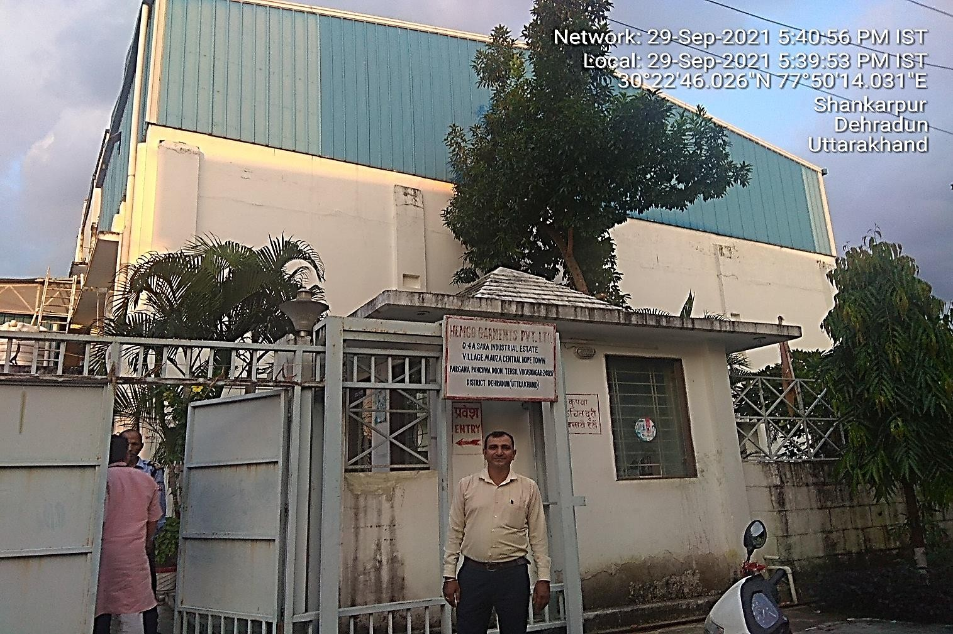
Snapshot of the Asset/ Property Under Valuation

This Valuation report is prepared for the industrial property situated at the aforesaid address having total land area admeasuring 1750 sq. mtr. (2092.98 sq. yd.) as per the Sale Deed. This is a free hold land purchased by the virtue of sale deed dated September 19, 2013.

The property is being used for industrial purpose. The covered area of the property at the time of site survey is 18529.91 sq. ft. of RCC roofed on Ground Floor and First Floor and 9150.64 sq. ft. of Tin Shed on Second Floor.

On ground floor there are 5 offices, 1 Reception, 1 Conference Room, 2 Lobby, 1 Store, 2 Laboratory,
1 Staff Cabin, 1 Cosmetic Section, 1 Godown, 2 Washrooms, 1 Kitchen. On First Floor there are 3 Stores, 1 Lobby and 1 Liquid filling section and on Second Floor there are 2 Halls, 1 Liquid filling section and 1 Manufacturing section.

This industrial unit is being used for the production of daily use products like soaps, Detergents, Toilet Cleaner, Floor Cleaner, Glass Cleaner, Dish Wash Liquid, Dish Wash Bar, Detergent Bar, etc. the unit was incepted in the year 2014 and currently was in operational condition and appeared to be maintained properly.

The subject property is located in the midst of developed industrial area of Sara Industrial Estate near Dehradun. This property is clearly approached by road of width 50 ft. the nearby landmark of the property is Keron Pharmaceuticals.

This report only contains general assessment & opinion on the Guideline Value and the indicative, estimated Market Value of the property for which Bank has asked to conduct the Valuation and found as per the information given in the copy of documents provided to us and/ or confirmed by the owner/ owner representative to us at site which has been relied upon in good faith. It doesn’t contain any
other recommendations of any sort.
a. | Location attribute of the property
i. | Nearby Landmark | Keron Pharmaceuticals
ii. | Postal Address of the Property | Plot No. D-4A, Khasra No. 1/1/3 Min, Khatauni S.No. 833 (Fasli Year 1394-1399), Sara Industrial Estate, Mauza Central Hope Town, Pargana Pachwa Doon, Tehsil Vikas  Nagar, District Dehradun, Uttarakhand
iii. | Area of the Plot/ Land | Approx. 1750 sq. mtr. (2092.98 sq. yd.)
Also please refer to Part-B Area description of the property. Area measurements considered in the Valuation Report is adopted from relevant approved documents or actual site measurement whichever is less. Verification of the area measurement of the property is done only based on sample
random checking.
iv. | Type of Land | Solid Land
v. | Independent access/ approach to the  property | Clear independent access is available
vi. | Google Map Location of the Property  with a neighborhood layout map | Enclosed with the Report
 |  | Coordinates or URL: 30°22'37.8"N 77°49'59.3"E

vii. | Details of the roads abutting the property
 | i.Main Road Name & Width | Chakrata Road |  |  | 80 ft.
 | ii. Front Road Name & width | Sara Industrial Estate Road |  |  | 50 mtr.
 | iii. Type of Approach Road | Bituminous Road
 | iv. Distance from the Main Road | Approx. 800 mtr. away from the main road
viii. | Description of adjoining property | Notified Industrial area so all adjacent land use is Industrial
ix. | Plot No./ Survey No. | Plot No. D-4A, Sara Industrial Estate
x. | Zone/ Block | Industrial |  |  | ---
xi. | Sub registrar | Vikas Nagar
xii. | District | Dehradun, Uttarakhand
xiii. | Any other aspect | Valuation is done for the property found as per the information given in the copy of documents provided to us and/ or confirmed by the owner/ owner representative to us at site.  Getting cizra map or coordination with revenue officers for site identification is a separate activity and is not part of the  Valuation services.
 | i. Identification of the property  (Property found as per the information given in the documents provided to us and/ or confirmed by the owner/ owner representative to us on site.) | ☒ | Cross checked from boundaries or address of the  property mentioned in the deed
 |  | ☒ | Done from the name plate displayed on the property
 |  | ☐ | Identified by the owner
 |  | ☐ | Enquired from local residents/ public
 |  | ☒ | Identified by owner’s representative
 |  | ☐ | Identification of the property could not be done properly
 |  | ☐ | Survey was not done
 | ii. Type of Survey | Full survey (inside-out with approximate measurements &  photographs).
 | iii. Is property clearly demarcated by permanent/ temporary  boundary on site | Demarcated with permanent boundary
 | iv. Is the property merged or  colluded with any other property | No. It is an independent single bounded property
 |  | ---
 | v. City Categorization | Scale-C City |  |  | Urban developing
 | vi. Characteristics of the locality | Ordinary |  |  | Within averagely  maintained Industrial area
 | vii. Property location classification | On Wide Road |  | None |  | None
 | viii. Property Facing | South Facing
 | Covered Built-up area description  (Plinth/ Carpet/ Saleable Area) | Approx. RCC Roofed: 18529.91 sq. ft.  Tin shed: 9150.64 sq. ft.
 |  | Also please refer to Part B - Area description of the property. Area measurements considered in the Valuation Report is adopted from relevant approved documents or actual site measurement whichever is less. Verification of the area measurement of the property is done only based on sample random checking.

b. | Boundaries schedule of the Property
i. | Are Boundaries matched |  | Yes from the available documents
ii. | Directions | As per Sale Deed/TIR |  | Actual found at Site
 | East | Plot No. D-4 |  | Plot No. D-4
 | West | Plot No. D-5 |  | Plot No. D-5
 | North | Others Property |  | Others Property
 | South | Road |  | Road

3. | TOWN PLANNING/ ZONING PARAMETERS
a. | Master Plan provisions related to property in  terms of Land use | Industrial
 | i. Any conversion of land use done | Must have been obtained by the Developers of  Industrial Estate
 | ii. Current activity done in the property | Used as Industrial purpose
 | iii. Is property usage as per applicable  zoning | Yes, used as Industrial as per zoning
 | iv. Any notification on change of zoning  regulation | No information available
 | v. Street Notification | Industrial
b. | Provision of Building by-laws as applicable | PERMITTED | CONSUMED
 | i. FAR/ FSI | Please refer to area chart  description | Please refer to area chart  description
 | ii. Ground coverage | ----------------do------------- | ----------------do-------------
 | iii. Number of floors | ----------------do------------- | ----------------do-------------
 | iv. Height restrictions | ----------------do------------- | ----------------do-------------
 | v. Front/ Back/ Side Setback | ----------------do------------- | ----------------do-------------
c. | Status of Completion/ Occupational  certificate | No information provided | No information provided
d. | Comment on unauthorized construction if any | Cannot comment since no approved map given to us
e. | Comment on Transferability of  developmentalrights | As per regulation of SIDA
f. | 1. Planning Area/ Zone | Sara Industrial Area, Selaqui, Dehradun
 | 2. Master Plan currently in force | Dehradun Master Plan- 2025
 | 3. Municipal limits | Area not within Municipal Limits
g. | Developmental controls/ Authority | SIDA
h. | Zoning regulations | Industrial
i. | Comment on the surrounding land uses &  adjoining properties in terms of uses | Notified Industrial area so all adjacent land use is  Industrial
j. | Comment of Demolition proceedings if any | Not in our knowledge
k. | Comment on Compounding/ Regularization  proceedings | Not in our knowledge
l. | Any other aspect
 | i. Any information on encroachment | No
 | ii. Is the area part of unauthorized area/  colony | No (As per general information available)

4. | DOCUMENT DETAILS AND LEGAL ASPECTS OF THE PROPERTY
a. | Ownership documents provided | Sale deed | None |  |  | None
b. | Names of the Legal Owner/s | M/s. Hemco Garments Pvt. Ltd.
c. | Constitution of the Property | Free hold, complete transferable rights
d. | Agreement of easement if any | Not required
e. | Notice of acquisition if any and area under  acquisition | Not known to us
f. | Notification of road widening if any and area  under acquisition | Not known to us
g. | Heritage restrictions, if any | No
h. | Comment on Transferability of the property  ownership | Free hold, complete transferable rights
i. | Comment on existing mortgages/ charges/  encumbrances on the property, if any | Not Known to us |  |  | ---
j. | Comment on whether the owners of the property have issued any guarantee(personal  or corporate) as the case may be | Not Known to us |  |  | ---
k. | Building plan sanction:
 | i. Authority approving the plan | Cannot comment since no approved map given to us
 | ii. Name of the office of the Authority | Cannot comment since no approved map given to us
 | iii. Any violation from the approved Building  Plan | Cannot comment since no approved map given to us
l. | Whether Property is Agricultural Land if yes,  any conversion is contemplated | No not an agricultural property
m. | Whether the property SARFAESI complaint | Yes
n. | i. Information regarding municipal taxes  (property tax, water tax, electricity bill) | Property Tax |  | No information available
 |  | Water Tax |  | No information available
 |  | Electricity Bill |  | No information available
 | ii. Observation on Dispute or Dues if any in  payment of bills/ taxes | No such information could be gathered on site
 | iii. Is property tax been paid for this  property | Information not available. Please confirm from the  owner.
 | iv. Property or Tax Id No. | Not provided
o. | Whether entire piece of land on which the unit is set up / property is situated has been  mortgaged or to be mortgaged | No information available to us
p. | Qualification in TIR/Mitigation suggested if any | Legal opinion has to be given by Advocate/ legal  expert.
q. | Any other aspect | This is just an opinion report on Valuation based on the copy of the documents/ information provided to us by the client and has been relied upon in good faith of the property found as per the information given in the documents provided to us and/ or confirmed by the owner/ owner representative to us on site.  Legal aspects, Title verification, Verification of

authenticity of documents from originals or cross checking from any Govt. deptt. of the property have to
be taken care by legal expert/ Advocate.
 | 1. Since how long owners owing  the Property | 8-years
 | 2. Year of Acquisition/ Purchase | Year- 2013
 | 3. Property presently occupied/  possessed by | Owner
 | 4. Title verification | Legal aspects or Title verification have to be taken  care by competent advocate.
 | 5. Details of leases if any | NA

5. | ECONOMIC ASPECTS OF THE PROPERTY
a. | Reasonable letting value/ Expected market  monthly rental | NA
b. | Is property presently on rent | No
 | a) Number of tenants | NA
 | b) Since how long lease is in place | NA
 | c) Status of tenancy right | NA
 | d) Amount of monthly rent received | NA
c. | Taxes and other outgoing | Owner Company to provide this information
d. | Property Insurance details | Owner Company to provide this information
e. | Monthly maintenance charges payable | Owner Company to provide this information
f. | Security charges, etc. | Owner Company to provide this information
g. | Any other aspect | NA

6. | SOCIO - CULTURAL ASPECTS OF THE PROPERTY
a. | Descriptive account of the location of the property in terms of Social structure of the area in terms of population, social stratification, regional origin, age groups, economic levels, location of slums/squatter  settlements nearby, etc. | Industrial area
b. | Whether property belongs to social  infrastructure like hospital, school, old age homes etc. | No

7. | FUNCTIONAL AND UTILITARIAN SERVICES, FACILITIES & AMENITIES
a. | Description of the functionality & utility of the property in terms of :
 | a. Space allocation | Yes
 | b. Storage spaces | Yes
 | c. Utility of spaces provided within the  building | Yes
 | d. Car parking facilities | Yes
 | e. Balconies | No

b. | Any other aspect
 | a. Drainage arrangements |  |  |  | Yes
 | b. Water Treatment Plant |  |  |  | Yes
 | c. Power Supply  arrangements |  | Permanent |  | Yes
 |  |  | Auxiliary |  | Yes, D.G sets
 | d. HVAC system |  |  |  | No
 | e. Security provisions |  |  |  | Yes
 | f. Lift/ Elevators |  |  |  | No
 | g. Compound wall/ Main Gate |  |  |  | Yes
 | h. Whether gated society |  |  |  | No
 | i. Internal development
 | Garden/ Park/  Land scraping | Water bodies |  | Internal roads |  | Pavements | Boundary Wall
 | No | No |  | No |  | Yes | Yes

8. | INFRASTRUCTURE AVAILABILITY
a. | Description of Aqua Infrastructure availability in terms of:
 | i. Water Supply |  |  |  | Yes
 | ii. Sewerage/ sanitation system |  |  |  | Underground
 | iii. Storm water drainage |  |  |  | Yes
b. | Description of other Physical Infrastructure facilities in terms of:
 | a. Solid waste management |  |  |  | Yes, by selves
 | b. Electricity |  |  |  | Yes
 | c. Road and Public Transport connectivity |  |  |  | Yes
 | d. Availability of other public utilities  nearby |  |  |  | Transport, Market, Hospital etc. available in close  vicinity
i. | Proximity & availability of civic amenities & social infrastructure
 | School | Hospital | Market | Bus Stop |  | Railway  Station | Metro | Airport
 | 1.5 km | 2 Km | 2 km | 1 km |  | 30 Km | --- | 75 km
 | Availability of recreation facilities (parks, open spaces etc.) |  |  | This is a semi urban area. No recreational facility is  available nearby.

9. | MARKETABILITY ASPECTS OF THE PROPERTY:
i. | Marketability of the property in terms of
 | i. Location attribute of the subject property | Normal
 | ii. Scarcity | Similar kind of properties are easily available on  demand.
 | iii. Market condition related to demand and supply of the kind of the subject property  in the area | Good demand of such properties in the market
 | iv. Comparable Sale Prices in the locality | Please refer to Part C: Valuation Assessment of the  Property.
ii. | Any other aspect which has relevance on the | No

 | value or marketability of the property
 | i. Any New Development in surrounding  area | No | NA
 | ii. Any negativity/ defect/ disadvantages  in the property/ location | No | NA

10. | ENGINEERING AND TECHNOLOGY ASPECTS OF THE PROPERTY:
a. | Type of construction & design | RCC framed pillar, beam, column structure on RCC  slab & tin Shed
b. | Method of construction | Regular masonry construction using standard quality  material
c. | Specifications
 | a. Class of construction | Class B construction (Good)
 | b. Appearance/ Condition of structures | Internal -Good
 |  | External - Good
 | c.Roof | Floors/ Blocks |  | Type of Roof
 |  | GF |  | RCC
 |  | FF |  | RCC
 |  | SF |  | Tin shed
 | d. Floor height | Varying from 10 ft. to 20 ft.
 | e. Type of flooring | Vitrified tiles, PCC, Kota stone
 | f. Doors/ Windows | Aluminum flushed doors & windows, Wooden frame &  panel doors
 | g. Interior Finishing | Simple Plastered Walls
 | h. Exterior Finishing | Simple plastered walls
 | i. Interior decoration/ Special architectural  or decorative feature | Simple plain looking structure.
 | j. Class of electrical fittings | Internal/ Normal quality fittings used
 | k.Class of sanitary & water supply fittings | Internal/ Normal quality fittings used
d. | Maintenance issues | No maintenance  properly | issue, structure |  | is maintained
e. | Age of building/ Year of construction | Approx. 8 years |  | Around year-2013
f. | Total life of the structure/ Remaining life expected | RCC: Approx. 60-65 Years  Tin shed: Approx. 25-30  years |  | RCC: Approx. 50-55 year Tin Shed: Approx. 17-22 years, subject to proper  and timely maintenance
g. | Extent of deterioration in the structure | No deterioration  observation | came into notice |  | through visual
h. | Structural safety | Appears to be structurally stable
i. | Protection against natural disasters viz.  earthquakes etc. | Should be able to withstand moderate intensity  earthquakes
j. | Visible damage in the building if any | No visible damages in the structure
k. | System of air conditioning | Some rooms are covered with windows AC
l. | Provision of firefighting | Fire Extinguishers available
m. | Status of Building Plans/ Maps | Cannot comment since no approved map given to us

 | 6. Is Building as per approved Map | Cannot comment since no approved map given to us
 | 7. Details of alterations/ deviations/ illegal construction/ encroachment noticed in the structure from the original approved  plan | - Permissible Alterations | NA
 |  | - Not permitted alteration | NA
 | 8. Is this being regularized | No information provided

11. | ENVIRONMENTAL FACTORS:
a. | Use of environment friendly building materials like fly ash brick, other Green building  techniques if any | Not known to us
b. | Provision of rainwater harvesting | No
c. | Use of solar heating and lighting systems, etc. | No
d. | Presence of environmental pollution in the vicinity of the property in terms of industries,  heavy traffic, etc. if any | Yes, normal vehicular and industrial pollution present

12. | ARCHITECTURAL AND AESTHETIC QUALITY OF THE PROPERTY:
a. | Descriptive account on whether the building is modern, old fashioned, etc., plain looking or with decorative elements, heritage value if applicable, presence of landscape elements,  etc. | Plain looking simple structure

13. | VALUATION:
i. | Methodology of Valuation – Procedures  adopted for arriving at the Valuation | Please refer to Sub-Point ‘n’ of Point 1 of Part C:  Valuation Assessment Factors of the report.
i. | Prevailing Market Rate/ Price trend of the Property in the locality/ city from property  search sites | Please refer to the Sub-Point ‘o’ of Point 1 of Part C: Valuation Assessment Factors of the report and  the screenshot annexure in the report.
i. | Guideline Rate obtained from Registrar’s  office/ State Govt. gazette/ Income Tax Notification | Please refer to Part C: Valuation Assessment  Factors of the report and the screenshot annexure in the report.
. | Summary of Valuation | For detailed Valuation calculation please refer to  Points 1, 2, 3, 4, 5 & 6 of the Part C: Valuation Assessment Factors of the report.
 | i. Guideline Value | Rs.3,66,52,797/-
 | a. Land | Rs. 96,25,000/-
 | b. Building | Rs.2,70,27,797/-
 | ii. Indicative Prospective Estimated  Fair Market Value | Rs.6,89,00,000/-
 | iii. Expected Estimated Realizable  Value | Rs.5,85,65,000/-
 | iv. Expected Forced/ Distress Sale  Value | Rs.5,16,75,000/-

 | v. Valuation of structure for Insurance  purpose | ---
. | 1. Justification for more than 20% difference in Market & Circle Rate | Circle rates are determined by the District administration as per their own theoretical internal policy for determining the minimum valuation of the property for property registration purpose and Market rates are adopted based on prevailing market dynamics which is explained clearly in Valuation  assessment factors.
 | 2. Details of last two transactions in the locality/ area to be provided, if available | No authentic last two transactions details could be known. However prospective transaction details as per information available on public domain and gathered during site survey is mentioned in Point ‘o’ of Part C: Valuation Assessment Factors of the report and the screenshots of the references are  annexed in the report for reference.

14.
Declaration
- The information provided by us is true and correct to the best of my knowledge and belief.
- The analysis and conclusions are limited by the reported assumptions, limiting conditions, remarks and the information came to knowledge during the course of the work. Please see the Assumptions, Remarks & Limiting conditions described in the Report.
- I/ firm have read the Handbook on Policy, Standards and Procedures for Real Estate Valuation by Banks and HFIs in India, 2011 issued by IBA and NHB, fully understood the provisions of the same and followed the provisions of the same to the best of my ability and this report is in conformity to the Standards of Reporting enshrined in the above Handbook.
- No employee or member of R.K Associates has any direct/ indirect interest in the property.
- Our authorized surveyor AE Deepak Joshi has visited the subject property on 29 September 2021 in the presence of the owner's representative.
- I am a registered Valuer under Section 34 AB of Wealth Tax Act, 1957.
- I/ firm is an approved Valuer under SARFAESI Act – 2002 and approved by the Bank.
- We have submitted Valuation report directly to the Bank.
- This valuation work is carried out by our Engineering team on the request from Mr. Ravi Shankar Kumar

15. | VALUATION COMPANY DETAILS:
a. | Name & Address of Valuer  company | M/s R.K. Associates Valuers & Techno Engineering Consultants Pvt. Ltd.  G-183, Preet Vihar, Delhi-110092
b. | Engineering Team worked on the report | SURVEYED BY: AE Deepak Joshi
 |  | PREPARED BY: AE Nikhil Rajan
 |  | REVIEWED BY: HOD Valuations

16. | ENCLOSED DOCUMENTS:
a. | Layout plan sketch of the area in which the  property is located with latitude and longitude |  | Google Map enclosed with coordinates
b. | Building Plan |  | Not provided by the owner/ client
c. | Floor Plan |  | Not provided by the owner/ client
d. | Photograph of the property (including geo- stamping with date) and owner (in case of housing loans, if borrower is available)  including a “Selfie’ of the Valuer at the site |  | Enclosed with the report
e. | Certified copy of the approved / sanctioned  plan wherever applicable from the concerned office |  | Not provided by the owner/ client
f. | Google Map location of the property |  | Enclosed with the Report
g. | Price trend of the property in the locality/city from property search sites viz Magickbricks.com, 99Acres.com, Makan.com  etc |  | Enclosed with the Report
h. | Any other relevant documents/extracts  (All enclosures & annexures to remain integral part & parcel of the main report) |  | a. Part B: Area Description of the Property  b.Part C: Valuation Assessment of the Property  c. Part D: Summary of the Valuation Repo  d.Google Map  e. Photographs  f. Copy of Circle Rate g.Survey Summary Sheet h.Valuer’s Remark  i. Copy of relevant papers from the property  documents referred in the Valuation
i. | Total Number of Pages in the Report with  enclosures

PART B | AREA DESCRIPTION OF THE PROPERTY

1. | Land Area | 1750 sq.mtr. (2092.98 sq.yds.)
 | Area adopted on the basis of | Property documents only since site measurement couldn't be carried out
 | Remarks & observations, if any | ---
2. | Ground Coverage Area | Permissible  (x% of Plot area) | No information available to us
 |  | Proposed (x%) | No information available to us
 |  | Present Status | No information available to us
3. | FAR | Permissible | No information available to us
 |  | Proposed (x%) | No information available to us
 |  | Present Status | No information available to us
4. | Constructed Area considered for Valuation  (As per IS 3861-1966) | Covered Area | GF (RCC): 9379.27 sq.ft. (871.36 sq.mtr.)
 |  |  | FF (RCC): 9150.64 sq. ft. (850.12 sq. mtr.)
 |  |  | SF (Tin shed): 9150.64 sq. ft. (850.12 sq. mtr.)
 | Area adopted on the basis of | Site Survey
 | Remarks & observations, if any | ---

Note:

  - Area measurements considered in the Valuation Report pertaining to Land & Building is adopted from relevant approved documents or actual site measurement whichever is less. All area measurements are on approximate basis only.

  - Verification of the area measurement of the property is done based on sample random checking only.

  - Area of the large land parcels of more than 2500 sq.mtr or of uneven shape, is taken as per property documents which has been relied upon.

  - Drawing Map, design & detailed estimation of the property/ building is out of scope of the Valuation services.

PART C | VALUATION ASSESSMENT OF THE PROPERTY

a. | ASSESSMENT FACTORS
a. | Valuation Type | Land & Building and Plant & Machinery  Value |  |  |  | Industrial Land & Building  and Plant & Machinery Value.
b. | Scope of the Valuation | Non binding opinion on the assessment of Plain Asset Valuation of the  property is done for the property found as per the information given in the documents and/ or confirmed by the owner/ owner representative.
c. | Property Use factor | Current Use |  |  | Highest & Best Use
 |  | Industrial |  |  | Industrial
d. | Legality Aspect Factor | Assumed to be positive as per copy of documents & information produced to us. However Legal aspects of the property have to be taken care by Bank empanelled competent Legal expert/ Advocate.  Verification of authenticity of documents from originals or cross checking from any Govt. deptt. has to be taken care by Bank empanelled Legal expert/ Advocate.
e. | Land Physical factors | Shape | Size |  | Level |  | Frontage to  depth ratio
 |  | Rectangle | Large |  | On Road Level |  | Normal frontage
f. | Property location category factor | City Categorization | Locality Categorization |  | Property location  classification |  | Floor Level
 |  | Scale-C City | Ordinary |  | Ordinary location within the locality |  | GF+FF+SF
 |  | Urban developing | Within averagely  maintained Industrial area |  | None
 |  |  |  |  | None
 |  | Property Facing | South Facing
g. | Any New Development in  surrounding area | None |  | ---
h. | Any specific advantage/  drawback in the property | None
i. | Overall property usability  Factor | Normal
j. | Comment on Property  Salability Outlook | Easily sellable
k. | Comment on Demand &  Supply in the Market | Good demand of such properties in the market.
l. | Any other aspect which has relevance on the value or marketability of the property | NA  Valuation of the same asset/ property can fetch different values under different circumstances & situations. For eg. Valuation of a running/ operational shop/ hotel/ factory will fetch better value and in case of closed shop/ hotel/ factory it will have considerable lower value. Similarly an asset sold directly by an owner in the open market through free market transaction  then it will fetch better value and if the same asset/ property is sold by any

financer due to encumbrance on it, will fetch lower value. Hence before financing, Lender/ FI should take into consideration all such future risks while financing.

This Valuation report is prepared based on the facts of the property & market situation on the date of the survey. It is a well-known fact that the market value of any asset varies with time & socio-economic conditions prevailing in the country. In future property market may go down, property conditions may change or may go worse, property reputation may differ, property vicinity conditions may go down or become worse, property market may change due to impact of Govt. policies or effect of World economy, usability prospects of the property may change, etc. Hence before financing, Banker/ FI should
take into consideration all such future risk while financing.
m. | Sale transaction method assumed | Free market transaction at arm's length wherein the parties, after full market survey each acted knowledgeably, prudently and without any compulsion.
n. | Best Sale procedure to realize maximum Value | Free market transaction at arm's length wherein the parties, after full market survey each acted knowledgeably, prudently and without any compulsion.
o. | Methodology/ Basis of Valuation | Govt. Guideline Value: Collector rate of Dehradun year-2021
Market Value: Assessment of Premium charges to be paid on transfer of
Lease hold rights and Building construction value is calculated on the basis of 'Depreciated Replacement Cost approach'
Valuation of the asset is done as found on as-is-where basis.

Valuation is done based on the Valuation best practices, standard operating procedures and definitions prescribed by various organizations like IVSC, Income Tax of India, etc. as defined under.

For knowing comparable market rates, significant discreet local enquiries have been made from our side representing ourselves as both buyer and seller for the similar properties in the subject area and thereafter based on this information and various factors of the property, a rate has been judiciously taken considering the market scenario.

References regarding the prevailing market rates are based on the verbal/ informal/ secondary/ tertiary information collected during market survey in the subject area from the local people, property consultants, recent deals, demand-supply, internet postings which are relied upon. No written record is generally available for such market information and only the verbal information has to be relied upon.

Market Rates are rationally adopted based on the facts of the property that came to our knowledge during the course of the assignment considering many factors like nature of the property, size, location, approach, market situation and trends.

The indicative value has been suggested based on the prevailing market rates that came to our knowledge during secondary & tertiary market researches and does not split into formal & informal payment components.

Secondary/ Tertiary costs related to asset transaction like Stamp Duty, Registration charges, Brokerage, Bank interest, selling cost, marketing cost, etc. pertaining to the sale/ purchase of this property are not considered while assessing the indicative estimated Market Value.

This report includes both, Govt. Guideline Value and Indicative Estimated
Prospective Fair Market Value. As per the current market practice, in most of the cases, formal transaction takes place for an amount less than the actual transaction

amount and rest of the payment is normally done informally.

Construction rates are adopted based on the present market replacement cost of construction and calculating applicable depreciation & deterioration factor as per its existing condition & specifications based on only visual observation of the structure. No structural, physical tests have been carried out in respect of it.

Construction rates are adopted based on the plinth area rates prevailing in the market for the structure as a whole and not based on item wise estimation or Bills of Quantity method.

The condition assessment and the estimation of the residual economic life of the structure is only based on the visual observations and appearance found during the site survey. We have not carried out any structural design or stability study; nor carried out any physical tests to assess structural integrity & strength.

Sale transaction method of the asset is assumed as free market transaction while assessing Indicative & Estimated Fair Prospective Market Value of the asset.

Any kind of unpaid statutory, utilities, lease, interest or any other pecuniary dues on the asset has not been factored in the Valuation.

This Valuation is conducted based on the macro analysis of the asset/ property considering it in totality and not based on the micro, component or item wise analysis. Analysis done is a general assessment and is not investigative in nature.

Fair Market Value# suggested by the competent Valuer is that prospective estimated amount in his expert & prudent opinion of the subject asset/ property without any prejudice after he has carefully & exhaustively evaluated the facts & information came in front of him related to the subject asset at which the subject asset/ property should be exchanged between a willing buyer and willing seller at an arm’s length transaction in an open & unrestricted market, after proper marketing, wherein the parties, each acted knowledgeably, prudently and without any compulsion on the date of the Valuation.

Forced, under compulsion & constraint, obligatory sales transactions data doesn’t indicate the Fair Market Value.

Realizable Value^ is the minimum prospective estimated value of the property which it may be able to realize at the time of actual property transaction factoring in the potential prospects of deep negotiations carried out between the buyer & seller for ultimately finalizing the transaction across the table. Realizable value may be 10- 20% less than the Fair Market Value depending on the various salability prospects of the subject property and the needs of the buyer & the seller.

Forced/ Distress Sale Value* is the value when the property has to be sold due to any compulsion or constraint like financial encumbrances, dispute, as a part of a recovery process, any defect in the property, legal issues or any such condition or situation. In this type of sale, minimum fetch value is assessed which can be 25-40% less than the estimated Fair Market Value based on the nature, size & salability prospects of the property. In this type of sale, negotiation power of the buyer is always more than the seller and eagerness & pressure of selling the property is more than buying it. Therefore the Forced/ Distress Sale Value will always fetch significantly less value compare to the estimated Fair Market Value.

Liquidation Value is the amount that would be realized when an asset or group of assets are sold on a piecemeal basis that is without consideration of benefits (or
detriments) associated with a going-concern business. Liquidation value can be either in an orderly transaction with a typical marketing period or in a forced

transaction with a shortened marketing period.

Difference between Cost, Price & Value: Generally these words are used and understood synonymously. However in reality each of these has a completely different meaning, premise and also having different definitions in the professional & legal terms. Therefore to avoid confusion, it is our professional responsibility to describe the definitions of these words to avoid ambiguity & confusion in the minds of the user of this report.

The Cost of an asset represents the actual amount spend in the construction/ actual creation of the asset.

The Price is the amount paid for the procurement of the same asset.

The Value is defined as the present worth of future rights in the property/ asset and depends to a great extent on combination of various factors such as demand and supply, market situation, purpose, situation & needs of the buyer & seller, saleability outlook, usability factor, market perception & reputation. needs of the buyer & seller, saleability outlook, usability factor, market perception & reputation.

Therefore in actual for the same asset/ property, cost, price & value remain different since these terms have different usage & meaning.
p. | References on prevailing market Rate/Price trend of the property and Details of the sources from where  the information is gathered (from property search sites & local information):
 | i. | Name: |  |  | Sai Properties
 |  | Contact No.: |  |  | +91-9759175913
 |  | Nature of reference: |  |  | Property Consultant
 |  | Size of the Property: |  |  | 1500 mtr. approx.
 |  | Location: |  |  | Near Keron Pharmaceuticals
 |  | Rates/ Price informed: |  |  | Rs.8,000/- to Rs.10,000/- per sq. mtr.
 |  | Any other details/ Discussion held: |  |  | As per the discussion with market participants we came to know that the  rates of industrial land in this area are between Rs.8,000/- to Rs. 10,000/- per sq. mtr.
 | ii. | Name: |  |  | Mr. R. K. Sharma
 |  | Contact No.: |  |  | +91-9837060388
 |  | Nature of reference: |  |  | Property Consultant
 |  | Size of the Property: |  |  | 1500 mtr. approx.
 |  | Location: |  |  | Sara Industrial area
 |  | Rates/ Price informed: |  |  | Rs. 7,500/- to Rs. 8,000/- per sq. mtr.
 |  | Any other details/ Discussion held: |  |  | As per the discussion with market participants we came to know that the  rates of industrial land in this area are between Rs.7,500/- to Rs.8,000/- per sq. mtr.
 | iii. | Name: |  |  | NA
 |  | Contact No.: |  |  | NA
 |  | Nature of reference: |  |  | NA
 |  | Size of the Property: |  |  | NA
 |  | Location: |  |  | NA
 |  | Rates/ Price informed: |  |  | NA
 |  | Any other details/ Discussion held |  |  | NA
 | NOTE: The given information above can be independently verified to know its authenticity.
q. | Adopted Rates  Justification |  | The location of the subject property is in the developing area and demand of the  property is good. The subject property is developed and being used for the industrial

purpose by the concerned company. As per the present market survey & verbal communication with local dealers we got the mixed information for the land in this developing area. As per market survey & verbal conversation with local property consultant we got the following information:-

- The market rates for industrial plots will depend upon the size, location, approach road width, nearby amenities & shape.
- The asking price for the large industrial plots in this locality is varying in between Rs.7,500/- to Rs.10,000/-per sq. mtr.

And aforesaid project land shape is rectangular, area of land is large & useful for industrial purpose. Hence taking into consideration all these factors like size and shape of the plot, location of the property, market condition, rate ratio for the land & current activity on the land, we are of the view that the appropriate rate range for such a land parcel cumulatively can be considered between Rs.7,500/- to Rs.10,000/- per sq. mtr. and for the valuation purpose we have adopted Rs.8,000/- per sq. mtr. which appears to be reasonable in our view.

b. | VALUATION OF LAND  Applicable
 | Particulars | Govt. Circle/ Guideline Value | Indicative & Estimated Prospective  Fair Market Value
i. | Prevailing Rate range | Rs.5,500/- per sq.mtr | Rs.7,500/- to Rs.10,000/- per sq.mtr.
ii. | Rate adopted considering all  characteristics of the property | Rs.5,500/- per sq.mtr | Rs.8,000/- per sq.mtr.
iii. | Total Land Area considered  (documents vs site survey whichever is less) | 1750 sq.mtr. (2092.98 sq.yds.) | 1750 sq.mtr. (2092.98 sq.yds.)
iv. | Total Value of land (A) | 1750 sq. mtr. x Rs.5,500/- per  sq.mtr | 1750 sq. mtr. x Rs.8,000/- per sq.  mtr.
 |  | Rs.96,25,000/- | Rs.1,40,00,000/-

c. | VALUATION OF BUILDING STRUCTURE
 | Particulars |  | Govt. Circle/ Guideline Value | Indicative & Estimated  Prospective Fair Market Value
a. | Structure Construction Value | Rate range | RCC: Rs.12,000/- per sq.mtr Tin Shed: Rs.10,000/- per sq. mtr. | RCC: Rs.1,000/- to Rs.1,200/- per sq.ft.  Tin Shed: Rs.600/- to Rs.700/- per  sq. ft.
 |  | Rate adopted | RCC: Rs.12,000/- per sq.mtr Tin Shed: Rs.10,000/- per sq.  mtr. | RCC: Rs.1,100/- per sq.ft. Tin Shed: Rs.600/- per sq. ft.
 |  | Covered  Area | RCC: 18529 sq. ft. (1721.35 sq.  mtr.)  Tin Shed: 9150.64 sq. ft. (850 | RCC: 18529 sq. ft. (1721.35 sq.  mtr.)  Tin Shed: 9150.64 sq. ft. (850 sq.

 |  |  | sq. mtr.) | mtr.)
 |  | Class of  construction | Class B construction (Good) | Class B construction (Good)
 |  | Valuation Calculation | RCC: 1721.35 sq. mtr. x Rs. 12,000/- per sq. mtr. x 0.927  = Rs.1,91,48,297/-  Tin Shed: 850 sq. mtr. x Rs. 10,000/- per sq. x 0.927 mtr.  = Rs.78,79,500/- | RCC: 18529 sq. ft. x Rs.1,100/- per sq. ft.  = Rs.2,03,81,900/-  Tin Shed: 9150.64 sq. ft. x Rs.600/- per sq. ft.  = Rs.54,90,384/-
 |  | Total Value | Rs.2,70,27,797/- | Rs.2,58,72,284/-
b. | Depreciation percentage  (assuming salvage value % per year) |  | NA | NA  (Above replacement rate is calculated after deducting the prescribed depreciation)
c. | Age Factor |  | 2000 onwards | 5-10 years old construction
d. | Structure Type/ Condition |  | Pucca (1.0) | RCC framed pillar, beam, column structure on RCC slab & Tin Shed/  Good
e. | Estimated Construction  Depreciated Replacement Value (B) |  | Rs.2,70,27,797/- | Rs.2,58,72,284/-

d. | VALUATION OF ADDITIONAL BUILDING & SITE AESTHETIC WORKS
 | Particulars | Specifications | Depreciated Replacement Value
a) | Add extra for Architectural aesthetic developments, improvements  (add lump sum cost) | ---- | ----
b) | Add extra for fittings & fixtures  (doors, windows, wood work, cupboards, modular kitchen, electrical/ sanitary fittings) | ---- | ----
c) | Add extra for services  (Water, Electricity, Sewerage, Main gate,  Boundary, Lift, Auxiliary power, AC, HVAC, Firefighting etc.) | ---- | ----
d) | Add extra for internal & external development  (Internal roads, Landscaping, Pavements, Street lights, Green area development, External area landscaping, Land  development, Approach road, etc.) | ---- | ----
e) | Depreciated Replacement  Value (C) | NA | NA

PART D | VALUATION OF PLANT AND MACHINERY

 | PLANT & MACHINERY VALUATION PROCEDURE
a. | GENERAL DETAILS
ix. | Scope of the Assessment | Non Binding Opinion on General Prospective Valuation  Assessment of the Plant & Machineries as found on site on as-is-where basis.
x. | Out-of-Scope of the Assessment | - Verification of authenticity of documents from originals or cross checking from any Govt. deptt. is not done at our end.  - Legal aspects & rights of the Plant & Machinery are out-of-scope of this report.  - Inventorization of P&M is out of scope of work.  - Componentization of Plant & Machinery is out of scope of this report.  - Identification of the P&M is only limited to cross verification of major machines & production lines.  - Technical/ mechanical/ operational testing of the machines is out-of-scope of the report.  - Comment/ determination on technological aspect is out of scope of this report.  - Any kind of machine/ process design is out of scope of the report.
xi. | Information provided/ available for assessment | Documents Requested |  | Documents Provided
 |  | Total 02 documents  requested. |  | Total 01 documents  provided.
 |  | Detailed Fixed Asset  Register/ Inventory Sheet |  | Fixed Asset Register
 |  | Invoices/ Bills |  | ---
xii. | Identification of the assets | ☒ | Cross checked from the name of the machines mentioned in the FAR/ Inventory list name plate  displayed on the machine
 |  | ☒ | Identified by the company's representative
 |  | ☐ | Identified from the available Invoices
 |  | ☐ | Identification of the machines could not be done  properly
 |  | ☐ | Due to large number of machines/ inventory, only major  production lines & machines have been checked
 |  | ☐ | Physical inspection of the machines could not be done
xiii. | Plant Technical person name, contact number & designation assisted for  Survey | Mr. Ravi Shankar Kumar Mob: 9557339393
xiv. | Date of Survey | 29 September 2021
b. | BRIEF DESCRIPTION OF THE PLANT/ MACHINERY
i. | Nature of Plant & Machinery | Plant & Machinery for Manufacturing of Soap, Detergent,  Floor Cleaners, Glass Cleaners etc.

ii. | Size of the Manufacturing Unit | Medium scale Plant
iii. | Type of the Manufacturing Unit | Semi Automatic
iv. | Year of Installation/ Commissioning/  COD (Commercial Operation Date) | Partly 2014 and partly 2017
v. | Production Capacity | Not Known
vi. | Capacity at which Plant was running at  the time of Survey | Not Known
vii. | Number of Production Lines | 5
viii. | Condition of Machines | Good.
ix. | Status of the Plant | Operational
x. | Products Manufactured in this Plant | Soap, Detergent, Toilet Cleaner, Floor Cleaner, etc.
xi. | Recent maintenance carried out on | No information available, but the plant & machinery appeared  to be reasonably well maintained
xii. | Recent upgradation, improvements if  done any | None
xiii. | Total Gross Block & Net Block of Assets | Gross Block | Net Block
 |  | NA
 |  | NA | NA
xiv. | Any other Details if any | ---
c. | LOCATION/ ADDRESS WHERE PLANT/ MACHINES ARE FOUND TO BE INSTALLED
All the plant and machinery as per the list provided to us was considered to be installed inside the
factory which is located inside the premises of M/s. Hemco Garments Pvt. Ltd., at Sara Industrial Estate, Mauza Central Hope Town, Pargana Pachwa Doon, District Dehradun.
d. | SURVEY DETAILS
i. | Plant has been surveyed by our Engineering Team on 29/09/2021.
ii. | Site inspection was done in the presence of Owner's representative Mr. Ravi Shankar Kumar who was  available from the company to furnish any specific detail about the Plant & Machinery.
iii. | Our team examined & verified the machines and utilities from the FAR provided by the Company. Only  major machinery, process line & equipment has been verified.
iv. | Photographs have also been taken of most of the Machines and its accessories installed there.
v. | All the details have been cross checked as per the documents provided to us by the company and  what was observed at the site.
vi. | Condition of the machines is checked through visual observation only. No technical/ mechanical/  operational testing has been carried out to ascertain the condition and efficiency of machines.
vii. | Site Survey has been carried out on the basis of the physical existence of the assets rather than their  technical expediency.
viii. | As per the overall site visit summary, Plant appeared to be in good condition.
j. | MANUFACTURING PROCESS
 | No available

k. | TECHNOLOGY TYPE/ GENERATION USED AND TECHNOLOGICAL COLLABORATIONS IF ANY
 | No information available
l. | RAW MATERIALS REQUIRED & AVAILABILITY
 | Type of Raw Material: | Soda Ash, Acid Slurry, and many other chemicals
 | Availability: | Available without any problem
m. | AVAILABILITY & STATUS OF UTILITIES
 | Power/ Electricity | Available
 | Water | Available
 | Road/ Transport | Available
n. | COMMENT ON AVAILABILITY OF LABOUR
Appears to be easily & adequately available and no labour issues came to our knowledge during site
inspection.
o. | SALES TRANSACTIONAL PROSPECTS OF SUCH PLANTS/ MACHINERY
 | Strategic Sale as part of the complete Project.
Reason: This is a Medium Scale Plant and can only be sold only as an Integrated Industry to preserve
its value since complete process line & machines are special purpose machines and can't be used in any other Industry.
p. | DEMAND OF SUCH PLANT & MACHINERY IN THE MARKET
 | Appears to be moderate as per general information available in public domain.
q. | VALUATION PROEDURE
i. | Basic Methodology: For arriving at fair market value of P&M & other fixed assets our engineering team has rationally applied the mixture of ‘sales comparison (market approach)’ and the disposable value approach’. The fair market value of Plant & Machinery on the date of valuation is its cost of reproduction & commissioning on that date less the depreciation & other deterioration deductions (Technological, Economic, Functional obsolescence) or additions for good maintenance  from the date of commissioning of the machinery to the date of its valuation.
ii. | Core P&M Asset Valuation is done keeping in mind various factors like technology used, machines  availability, its condition, average age, maintenance & service and parts replacement availability of the machines and more importantly demand in the market.
iii. | Main Machinery of this Plant are specific purpose machines used for the manufacturing of Soap,  Detergent, Toilet Cleaners, Floor Cleaners, Glass Cleaners, Dish Wash Bar, Detergent Bar, etc.
iv. | The main data point for the Valuation of Plant & Machinery is the Fixed Asset Register maintained by the company. Plant & Machinery FAR has been provided by the company which has been relied upon in good faith. From the Fixed Asset Register List two key inputs, Date of Capitalization and Cost of  capitalization are taken which play vital role in evaluating used Plant & Machinery valuation.
v. | Provided Capitalization cost in FAR doesn't include any kind of soft cost like pre-operative, finance,  IDC expenses, etc. incurred during establishment of the Project.

vi. | For calculating Replacement Cost of the machines as on date Cost Inflation Index is taken into consideration since this Plant is 6-7 years old and since then fluctuation has occurred in the prices of  metals or industrial commodities.
vii. | On the Depreciated Replacement Cost (DRC) deduction for obsolescence/ deterioration or addition for good maintenance has been taken to arrive at the estimated Prospective Fair Market Value of the  machines.
viii. | Underlying assumption for the evaluation of this Plant & Machinery is that it will be sold as an  Integrated Plant and not as discrete/ piecemeal machinery basis.
r. | CONSOLIDATED PLANT & MACHINERY VALUATION
Consolidated valuation sheet of Plant & Machinery and other asset items are mentioned below with depreciated current market value as per different category of the machines/assets cumulated together. Our engineering team has separated the Cost of Equipment’s in the different sections of the plant. The cost of equipment considered from P&M List doesn't includes Pre-operative, Finance, and IDC Charges etc. The capitalized/ purchase cost of machinery considered from P&M List consists of final
commissioning of machines which includes freight, taxes, insurance, etc.

Sr.No. | Asset Description | Date of Capitalization | Date of Valuation | Age of the Asset (Year) | Economic Life of the Asset  (Years) | Depreciation Factor | Cost of Capitalization (INR) |  | Gross Current Replacement Cost (GCRC) (INR) |  | Depreciation |  | Current Depreciated Value (INR) |  | Prospective Fair Market Value (INR)
1 | DETERGENT POWDER PLANT | 3/31/2014 | 9/30/2021 | 7.51 | 20 | 0.05 | ₹ | 2,853,757.00 | ₹ | 2,939,369.71 | ₹ | 1,048,106.76 | ₹ | 1,891,262.95 | ₹ | 1,607,573.51
2 | VIBROSIEVER-48"SS | 3/31/2014 | 9/30/2021 | 7.51 | 20 | 0.05 | ₹ | 393,412.00 | ₹ | 405,214.36 | ₹ | 144,489.45 | ₹ | 260,724.91 | ₹ | 221,616.17
3 | DETERGENT POWDER PLANT | 3/31/2014 | 9/30/2021 | 7.51 | 20 | 0.05 | ₹ | 4,109,100.00 | ₹ | 4,232,373.00 | ₹ | 1,509,159.85 | ₹ | 2,723,213.15 | ₹ | 2,314,731.18
4 | TWIN PLODDER, HORIZONTAL | 3/31/2014 | 9/30/2021 | 7.51 | 20 | 0.05 | ₹ | 3,244,807.00 | ₹ | 3,309,703.14 | ₹ | 1,180,158.53 | ₹ | 2,129,544.61 | ₹ | 1,810,112.92
5 | SPECTROPHOTOMETER | 3/31/2014 | 9/30/2021 | 7.51 | 10 | 0.10 | ₹ | 380,327.00 | ₹ | 387,933.54 | ₹ | 276,655.07 | ₹ | 111,278.47 | ₹ | 94,586.70
6 | WEIGHING SCALE | 3/31/2014 | 9/30/2021 | 7.51 | 15 | 0.06 | ₹ | 85,951.00 | ₹ | 91,967.57 | ₹ | 43,724.49 | ₹ | 48,243.08 | ₹ | 41,006.62
7 | WEIGHING SCALE | 3/31/2014 | 9/30/2021 | 7.51 | 15 | 0.06 | ₹ | 352,577.00 | ₹ | 377,257.39 | ₹ | 179,360.91 | ₹ | 197,896.48 | ₹ | 168,212.01
8 | HAND PALET | 3/31/2014 | 9/30/2021 | 7.51 | 15 | 0.06 | ₹ | 8,796.00 | ₹ | 8,883.96 | ₹ | 4,223.73 | ₹ | 4,660.23 | ₹ | 3,961.19
9 | BOX STRAPING MACHINE, BAND SEALER | 3/31/2014 | 9/30/2021 | 7.51 | 15 | 0.06 | ₹ | 125,172.00 | ₹ | 126,423.72 | ₹ | 60,106.11 | ₹ | 66,317.61 | ₹ | 56,369.97
10 | INDUCTION SEALING MACHINE | 3/31/2014 | 9/30/2021 | 7.51 | 25 | 0.04 | ₹ | 37,307.00 | ₹ | 38,426.21 | ₹ | 10,961.47 | ₹ | 27,464.74 | ₹ | 23,345.03
11 | MANUFACTURING TANK | 3/31/2014 | 9/30/2021 | 7.51 | 20 | 0.05 | ₹ | 115,770.00 | ₹ | 143,554.80 | ₹ | 51,188.10 | ₹ | 92,366.70 | ₹ | 78,511.69
12 | MANUFACTURING TANK | 3/31/2014 | 9/30/2021 | 7.51 | 20 | 0.05 | ₹ | 115,770.00 | ₹ | 143,554.80 | ₹ | 51,188.10 | ₹ | 92,366.70 | ₹ | 78,511.69
13 | INKJET PRINTER FOR CODING | 3/31/2014 | 9/30/2021 | 7.51 | 15 | 0.06 | ₹ | 825,172.00 | ₹ | 849,927.16 | ₹ | 404,084.09 | ₹ | 445,843.07 | ₹ | 378,966.61
14 | LAB EQUIPMENTS | 3/31/2014 | 9/30/2021 | 7.51 | 10 | 0.10 | ₹ | 50,698.00 | ₹ | 53,739.88 | ₹ | 38,324.63 | ₹ | 15,415.25 | ₹ | 13,102.96
15 | LAB EQUIPMENTS | 3/31/2014 | 9/30/2021 | 7.51 | 10 | 0.10 | ₹ | 38,488.00 | ₹ | 40,797.28 | ₹ | 29,094.61 | ₹ | 11,702.67 | ₹ | 9,947.27
16 | SOAP PLANT | 3/31/2014 | 9/30/2021 | 7.51 | 20 | 0.05 | ₹ | 500,000.00 | ₹ | 515,000.00 | ₹ | 183,636.30 | ₹ | 331,363.70 | ₹ | 281,659.14
17 | ETP PLANT FRP TANK | 3/31/2014 | 9/30/2021 | 7.51 | 20 | 0.05 | ₹ | 126,888.00 | ₹ | 129,425.76 | ₹ | 46,150.03 | ₹ | 83,275.73 | ₹ | 70,784.37
18 | ETP PLANT SLUDGE DEWATERING TANK | 3/31/2014 | 9/30/2021 | 7.51 | 20 | 0.05 | ₹ | 412,175.00 | ₹ | 420,418.50 | ₹ | 149,910.87 | ₹ | 270,507.63 | ₹ | 229,931.48
19 | ETP PLANT SLUDGE REACTOR DIA | 3/31/2014 | 9/30/2021 | 7.51 | 20 | 0.05 | ₹ | 412,175.00 | ₹ | 420,418.50 | ₹ | 149,910.87 | ₹ | 270,507.63 | ₹ | 229,931.48
20 | TOILET CLEANER PLANT HOLDING TANK | 3/31/2014 | 9/30/2021 | 7.51 | 20 | 0.05 | ₹ | 412,175.00 | ₹ | 420,418.50 | ₹ | 149,910.87 | ₹ | 270,507.63 | ₹ | 229,931.48
21 | TOILET CLEANER PLANT MANUFACTURING TANK | 3/31/2014 | 9/30/2021 | 7.51 | 20 | 0.05 | ₹ | 502,715.00 | ₹ | 512,769.30 | ₹ | 182,840.89 | ₹ | 329,928.41 | ₹ | 280,439.15
22 | TOILET CLEANER PLANT STORAGE TANK | 3/31/2014 | 9/30/2021 | 7.51 | 20 | 0.05 | ₹ | 209,924.00 | ₹ | 214,122.48 | ₹ | 76,350.80 | ₹ | 137,771.68 | ₹ | 117,105.93
23 | ETP & STP PLANT PARTS | 3/31/2014 | 9/30/2021 | 7.51 | 20 | 0.05 | ₹ | 466,979.00 | ₹ | 476,318.58 | ₹ | 169,843.46 | ₹ | 306,475.12 | ₹ | 260,503.85
24 | ETP & STP PLANT PARTS | 3/31/2014 | 9/30/2021 | 7.51 | 20 | 0.05 | ₹ | 407,975.00 | ₹ | 416,134.50 | ₹ | 148,383.30 | ₹ | 267,751.20 | ₹ | 227,588.52
25 | TOILET CLEANER PARTS | 3/31/2014 | 9/30/2021 | 7.51 | 20 | 0.05 | ₹ | 85,050.00 | ₹ | 86,751.00 | ₹ | 30,933.27 | ₹ | 55,817.73 | ₹ | 47,445.07
26 | ETP & STP PLANT | 3/31/2014 | 9/30/2021 | 7.51 | 20 | 0.05 | ₹ | 343,822.00 | ₹ | 350,698.44 | ₹ | 125,050.42 | ₹ | 225,648.02 | ₹ | 191,800.82
27 | MANUFACTURING TANK | 3/31/2014 | 9/30/2021 | 7.51 | 20 | 0.05 | ₹ | 235,400.00 | ₹ | 249,524.00 | ₹ | 88,974.11 | ₹ | 160,549.89 | ₹ | 136,467.41
28 | MANUFACTURING TANK | 3/31/2014 | 9/30/2021 | 7.51 | 20 | 0.05 | ₹ | 191,500.00 | ₹ | 202,990.00 | ₹ | 72,381.23 | ₹ | 130,608.77 | ₹ | 111,017.46
29 | WEIGHING SCALE | 3/31/2014 | 9/30/2021 | 7.51 | 15 | 0.06 | ₹ | 58,475.00 | ₹ | 62,568.25 | ₹ | 29,747.06 | ₹ | 32,821.19 | ₹ | 27,898.01
30 | WEIGHING SCALE | 3/31/2014 | 9/30/2021 | 7.51 | 15 | 0.06 | ₹ | 22,518.00 | ₹ | 24,094.26 | ₹ | 11,455.23 | ₹ | 12,639.03 | ₹ | 10,743.18

31 | MANUFACTURING TESTING MACHINE & LAB EQUIPMENTS |  | 3/31/2014 | 9/30/2021 | 7.51 | 15 | 0.06 | ₹ | 741,421.00 | ₹ | 785,906.26 | ₹ | 373,646.39 | ₹ | 412,259.87 | ₹ | 350,420.89
32 | MANUFACTURING TESTING MACHINE & LAB EQUIPMENTS |  | 3/31/2014 | 9/30/2021 | 7.51 | 15 | 0.06 | ₹ | 86,810.00 | ₹ | 92,018.60 | ₹ | 43,748.75 | ₹ | 48,269.85 | ₹ | 41,029.37
33 | MANUFACTURING TESTING MACHINE & LAB EQUIPMENTS |  | 3/31/2014 | 9/30/2021 | 7.51 | 15 | 0.06 | ₹ | 120,750.00 | ₹ | 127,995.00 | ₹ | 60,853.15 | ₹ | 67,141.85 | ₹ | 57,070.57
34 | MANUFACTURING TESTING MACHINE & LAB EQUIPMENTS |  | 3/31/2014 | 9/30/2021 | 7.51 | 15 | 0.06 | ₹ | 39,728.00 | ₹ | 42,111.68 | ₹ | 20,021.32 | ₹ | 22,090.36 | ₹ | 18,776.81
35 | MANUFACTURING TESTING MACHINE & LAB EQUIPMENTS |  | 3/31/2014 | 9/30/2021 | 7.51 | 15 | 0.06 | ₹ | 22,357.00 | ₹ | 23,698.42 | ₹ | 11,267.03 | ₹ | 12,431.39 | ₹ | 10,566.68
36 | MANUFACTURING TESTING MACHINE & LAB EQUIPMENTS |  | 3/31/2014 | 9/30/2021 | 7.51 | 15 | 0.06 | ₹ | 42,000.00 | ₹ | 44,520.00 | ₹ | 21,166.31 | ₹ | 23,353.69 | ₹ | 19,850.63
37 | MANUFACTURING TESTING MACHINE & LAB EQUIPMENTS |  | 3/31/2014 | 9/30/2021 | 7.51 | 15 | 0.06 | ₹ | 92,698.00 | ₹ | 98,259.88 | ₹ | 46,716.07 | ₹ | 51,543.81 | ₹ | 43,812.24
38 | MANUFACTURING TESTING MACHINE & LAB EQUIPMENTS |  | 3/31/2014 | 9/30/2021 | 7.51 | 15 | 0.06 | ₹ | 108,188.00 | ₹ | 114,679.28 | ₹ | 54,522.40 | ₹ | 60,156.88 | ₹ | 51,133.34
39 | MANUFACTURING TESTING MACHINE & LAB EQUIPMENTS |  | 3/31/2014 | 9/30/2021 | 7.51 | 15 | 0.06 | ₹ | 84,503.00 | ₹ | 89,573.18 | ₹ | 42,586.12 | ₹ | 46,987.06 | ₹ | 39,939.00
40 | MANUFACTURING TESTING MACHINE & LAB EQUIPMENTS |  | 3/31/2014 | 9/30/2021 | 7.51 | 15 | 0.06 | ₹ | 392,196.00 | ₹ | 415,727.76 | ₹ | 197,651.02 | ₹ | 218,076.74 | ₹ | 185,365.23
41 | MANUFACTURING TESTING MACHINE & LAB EQUIPMENTS |  | 3/31/2014 | 9/30/2021 | 7.51 | 15 | 0.06 | ₹ | 28,219.00 | ₹ | 29,912.14 | ₹ | 14,221.24 | ₹ | 15,690.90 | ₹ | 13,337.26
42 | MANUFACTURING TESTING MACHINE & LAB EQUIPMENTS |  | 3/31/2014 | 9/30/2021 | 7.51 | 15 | 0.06 | ₹ | 105,495.00 | ₹ | 111,824.70 | ₹ | 53,165.24 | ₹ | 58,659.46 | ₹ | 49,860.54
43 | MANUFACTURING TESTING MACHINE & LAB EQUIPMENTS |  | 3/31/2014 | 9/30/2021 | 7.51 | 15 | 0.06 | ₹ | 19,527.00 | ₹ | 20,698.62 | ₹ | 9,840.82 | ₹ | 10,857.80 | ₹ | 9,229.13
44 | MANUFACTURING TESTING MACHINE & LAB EQUIPMENTS |  | 3/31/2014 | 9/30/2021 | 7.51 | 15 | 0.06 | ₹ | 73,028.00 | ₹ | 77,409.68 | ₹ | 36,803.18 | ₹ | 40,606.50 | ₹ | 34,515.53
45 | TUBE FILLING MACHINE |  | 3/31/2014 | 9/30/2021 | 7.51 | 20 | 0.05 | ₹ | 1,499,399.00 | ₹ | 1,529,386.98 | ₹ | 545,341.69 | ₹ | 984,045.29 | ₹ | 836,438.50
46 | OINTMENT CREAM PLANT |  | 3/31/2014 | 9/30/2021 | 7.51 | 20 | 0.05 | ₹ | 3,182,685.00 | ₹ | 3,246,338.70 | ₹ | 1,157,564.33 | ₹ | 2,088,774.37 | ₹ | 1,775,458.21
47 | BAG SEWING MACHINE |  | 3/31/2014 | 9/30/2021 | 7.51 | 20 | 0.05 | ₹ | 14,123.00 | ₹ | 15,111.61 | ₹ | 5,388.43 | ₹ | 9,723.18 | ₹ | 8,264.71
48 | VERTICAL HYDRAULIC LIFT |  | 3/31/2014 | 9/30/2021 | 7.51 | 20 | 0.05 | ₹ | 1,122,580.00 | ₹ | 1,156,257.40 | ₹ | 412,292.88 | ₹ | 743,964.52 | ₹ | 632,369.84
49 | PLC CONTROL PANNEL |  | 3/31/2014 | 9/30/2021 | 7.51 | 15 | 0.06 | ₹ | 71,400.00 | ₹ | 72,828.00 | ₹ | 34,624.89 | ₹ | 38,203.11 | ₹ | 32,472.64
50 | MANUFACTURING TANK |  | 3/31/2014 | 9/30/2021 | 7.51 | 20 | 0.05 | ₹ | 116,000.00 | ₹ | 122,960.00 | ₹ | 43,844.50 | ₹ | 79,115.50 | ₹ | 67,248.17
51 | DM WATER PLANT EQUIPMENTS |  | 3/31/2014 | 9/30/2021 | 7.51 | 15 | 0.06 | ₹ | 63,240.00 | ₹ | 64,504.80 | ₹ | 30,667.76 | ₹ | 33,837.04 | ₹ | 28,761.48
52 | MANUFACTURING TANK |  | 3/31/2014 | 9/30/2021 | 7.51 | 20 | 0.05 | ₹ | 102,000.00 | ₹ | 108,120.00 | ₹ | 38,552.93 | ₹ | 69,567.07 | ₹ | 59,132.01
53 | LAB EQUIPMENTS |  | 3/31/2014 | 9/30/2021 | 7.51 | 10 | 0.10 | ₹ | 50,057.00 | ₹ | 53,060.42 | ₹ | 37,840.07 | ₹ | 15,220.35 | ₹ | 12,937.29
54 | LIQUID BLUE PLANT |  | 3/31/2014 | 9/30/2021 | 7.51 | 20 | 0.05 | ₹ | 2,206,785.00 | ₹ | 2,250,920.70 | ₹ | 802,622.82 | ₹ | 1,448,297.88 | ₹ | 1,231,053.20
55 | LIQUID BLUE PLANT |  | 3/31/2014 | 9/30/2021 | 7.51 | 20 | 0.05 | ₹ | 1,598,506.00 | ₹ | 1,630,476.12 | ₹ | 581,387.58 | ₹ | 1,049,088.54 | ₹ | 891,725.26
56 | LIQUID BLUE PLANT |  | 3/31/2014 | 9/30/2021 | 7.51 | 20 | 0.05 | ₹ | 1,396,175.00 | ₹ | 1,424,098.50 | ₹ | 507,798.41 | ₹ | 916,300.09 | ₹ | 778,855.08
57 | BOTTEL FILLING MACHINE |  | 3/31/2014 | 9/30/2021 | 7.51 | 20 | 0.05 | ₹ | 2,006,460.00 | ₹ | 2,066,653.80 | ₹ | 736,917.79 | ₹ | 1,329,736.01 | ₹ | 1,130,275.61
58 | MACHINERY ASSEMBLING & PARTS |  | 3/31/2014 | 9/30/2021 | 7.51 | 20 | 0.05 | ₹ | 18,360.00 | ₹ | 18,910.80 | ₹ | 6,743.12 | ₹ | 12,167.68 | ₹ | 10,342.52
59 | CENTRIFUGAL PUMP |  | 3/31/2014 | 9/30/2021 | 7.51 | 20 | 0.05 | ₹ | 57,158.00 | ₹ | 60,015.90 | ₹ | 21,400.19 | ₹ | 38,615.71 | ₹ | 32,823.35
60 | BOTTEL LABELLING MACHINE |  | 3/31/2014 | 9/30/2021 | 7.51 | 20 | 0.05 | ₹ | 374,575.00 | ₹ | 385,812.25 | ₹ | 137,571.14 | ₹ | 248,241.11 | ₹ | 211,004.95
61 | BOTTEL LABELLING MACHINE |  | 3/31/2014 | 9/30/2021 | 7.51 | 20 | 0.05 | ₹ | 785,101.00 | ₹ | 808,654.03 | ₹ | 288,346.09 | ₹ | 520,307.94 | ₹ | 442,261.75
62 | HAND PALET |  | 3/31/2014 | 9/30/2021 | 7.51 | 15 | 0.06 | ₹ | 91,800.00 | ₹ | 92,718.00 | ₹ | 44,081.27 | ₹ | 48,636.73 | ₹ | 41,341.22
63 | POUCH PACKAGING MACHINE |  | 3/31/2014 | 9/30/2021 | 7.51 | 20 | 0.05 | ₹ | 1,009,344.00 | ₹ | 1,039,624.32 | ₹ | 370,704.40 | ₹ | 668,919.92 | ₹ | 568,581.93
64 | POUCH LIQUID PACKAGING MACHINE |  | 3/31/2014 | 9/30/2021 | 7.51 | 20 | 0.05 | ₹ | 998,272.00 | ₹ | 1,028,220.16 | ₹ | 366,637.96 | ₹ | 661,582.20 | ₹ | 562,344.87
65 | COLLER TYPE POUCH PACKAGIMG MACHINE |  | 3/31/2014 | 9/30/2021 | 7.51 | 20 | 0.05 | ₹ | 756,895.00 | ₹ | 779,601.85 | ₹ | 277,986.80 | ₹ | 501,615.05 | ₹ | 426,372.80
66 | AUTOMATIC REWINDER MACHINE |  | 3/31/2014 | 9/30/2021 | 7.51 | 20 | 0.05 | ₹ | 194,950.00 | ₹ | 200,798.50 | ₹ | 71,599.79 | ₹ | 129,198.71 | ₹ | 109,818.90
67 | DG set |  | 8/16/2017 | 9/30/2021 | 4.13 | 20 | 0.05 | ₹ | 1,829,000.00 | ₹ | 1,865,580.00 | ₹ | 365,628.12 | ₹ | 1,499,951.88 | ₹ | 1,274,959.09
68 | Cutting Machine |  | 6/24/2017 | 9/30/2021 | 4.27 | 20 | 0.05 | ₹ | 557,600.00 | ₹ | 563,176.00 | ₹ | 114,259.15 | ₹ | 448,916.85 | ₹ | 381,579.32
69 | Servo transformer 400Kva |  | 8/17/2017 | 9/30/2021 | 4.12 | 20 | 0.05 | ₹ | 531,000.00 | ₹ | 536,310.00 | ₹ | 105,039.62 | ₹ | 431,270.38 | ₹ | 366,579.82
70 | SS 304 Conveyor with control Panel |  | 7/9/2020 | 9/30/2021 | 1.23 | 10 | 0.10 | ₹ | 46,000.00 | ₹ | 46,460.00 | ₹ | 5,417.36 | ₹ | 41,042.64 | ₹ | 34,886.24
71 | SS 304 Conveyor with control Panel |  | 7/9/2020 | 9/30/2021 | 1.23 | 10 | 0.10 | ₹ | 48,500.00 | ₹ | 48,985.00 | ₹ | 5,711.79 | ₹ | 43,273.21 | ₹ | 36,782.23
72 | Wrapping Machine |  | 7/6/2020 | 9/30/2021 | 1.24 | 15 | 0.06 | ₹ | 550,000.00 | ₹ | 555,500.00 | ₹ | 43,471.05 | ₹ | 512,028.95 | ₹ | 435,224.61
73 | Auto Cutting cum Stamping Machine |  | 7/11/2020 | 9/30/2021 | 1.22 | 15 | 0.06 | ₹ | 105,000.00 | ₹ | 106,050.00 | ₹ | 8,207.01 | ₹ | 97,842.99 | ₹ | 83,166.54
74 | Two Way Mouth Cone S.S. |  | 7/11/2020 | 9/30/2021 | 1.22 | 15 | 0.06 | ₹ | 410,000.00 | ₹ | 414,100.00 | ₹ | 32,046.42 | ₹ | 382,053.58 | ₹ | 324,745.54
75 | Plastic pallets |  | 6/2/2017 | 9/30/2021 | 4.33 | 15 | 0.06 | ₹ | 96,900.00 | ₹ | 97,869.00 | ₹ | 26,848.28 | ₹ | 71,020.72 | ₹ | 60,367.61
76 | VCB 11Kv |  | 9/2/2017 | 9/30/2021 | 4.08 | 15 | 0.06 | ₹ | 396,800.00 | ₹ | 400,768.00 | ₹ | 103,544.54 | ₹ | 297,223.46 | ₹ | 252,639.94
 | Wrapping machine for bar line |  | 1/8/2017 | 9/30/2021 | 4.73 | 15 | 0.06 | ₹ | 4,248,000.00 | ₹ | 4,290,480.00 | ₹ | 1,284,949.78 | ₹ | 3,005,530.22 | ₹ | 2,554,700.69
 | Wrapping machine for bar line |  | 1/8/2017 | 9/30/2021 | 4.73 | 15 | 0.06 | ₹ | 501,500.00 | ₹ | 506,515.00 | ₹ | 151,695.46 | ₹ | 354,819.54 | ₹ | 301,596.61
77 | Bar Pneumatic Cutter with Conveyor |  | 2020 | 9/30/2021 | 1.00 | 15 | 0.06 | ₹ | 74,340.00 | ₹ | 75,083.40 | ₹ | 4,755.28 | ₹ | 70,328.12 | ₹ | 59,778.90
78 | BAR CUTTING STAMPER |  | 2020 | 9/30/2021 | 1.00 | 15 | 0.06 | ₹ | 483,800.00 | ₹ | 488,638.00 | ₹ | 30,947.07 | ₹ | 457,690.93 | ₹ | 389,037.29
79 | BAR FEEDING CONVEYAR |  | 2020 | 9/30/2021 | 1.00 | 15 | 0.06 | ₹ | 54,280.00 | ₹ | 54,822.80 | ₹ | 3,472.11 | ₹ | 51,350.69 | ₹ | 43,648.09
80 | BAR WRAPING M/C |  | 2020 | 9/30/2021 | 1.00 | 15 | 0.06 | ₹ | 652,540.00 | ₹ | 659,065.40 | ₹ | 41,740.81 | ₹ | 617,324.59 | ₹ | 524,725.90
81 | LIQUIED BULE MIXER 1000KG |  | 2014 | 9/30/2021 | 7.00 | 15 | 0.06 | ₹ | 1,400,000.00 | ₹ | 1,414,000.00 | ₹ | 626,873.33 | ₹ | 787,126.67 | ₹ | 669,057.67
82 | HOT AIR TUNNEL |  | 2014 | 9/30/2021 | 7.00 | 12 | 0.08 | ₹ | 150,000.00 | ₹ | 151,500.00 | ₹ | 83,956.25 | ₹ | 67,543.75 | ₹ | 57,412.19
83 | SERVO TRANSFORMER | 600KVA | 2017 | 9/30/2021 | 4.00 | 12 | 0.08 | ₹ | 480,000.00 | ₹ | 484,800.00 | ₹ | 153,520.00 | ₹ | 331,280.00 | ₹ | 281,588.00
84 | LIFT 2000MT CAPACITY |  | 2014 | 9/30/2021 | 7.00 | 12 | 0.08 | ₹ | 1,400,000.00 | ₹ | 1,414,000.00 | ₹ | 783,591.67 | ₹ | 630,408.33 | ₹ | 535,847.08
85 | VCB 11 KVA |  | 2017 | 9/30/2021 | 4.00 | 11 | 0.09 | ₹ | 275,000.00 | ₹ | 277,750.00 | ₹ | 95,950.00 | ₹ | 181,800.00 | ₹ | 154,530.00
 | Total |  |  |  |  |  |  | ₹ | 51,087,920.00 | ₹ | 52,331,639.23 | ₹ | 18,224,053.61 | ₹ | 34,107,585.62 | ₹ | 28,991,447.78
Notes:-
1. Asset items pertaining to Hemco Garments Pvt. Ltd. is only considered in this report.
2. The Machines considered for the Valuation are located at premises of M/s. Hemco Garments Pvt. Ltd. Mauza Central Hope Town, Pargana Pachwa Doon, Tehsil Vikas Nagar, District Dehradun.
3. All the details related to the cost, date and description of the Plant & Machinery along with the related equipments has been provided to us the client and have been accepted in good faith by us.
4. For evaluating the Gross current replacement cost of the machines and equipments, we have adopted the inflation rate occurred in the manufacturing of that respective commodity. For which we have used the whole
sale price index provided the Government through www.eaindustry.nic.in
5. During the site visit, plant was in operational condition. Our engineering team visited all the sections and inspected the machines and equipments on the basis of their physical existence and condition. No technical
testing or performance evaluation of these machines was carried out. Only the major items of plant & machinery were verified and the rest of the items were assumed to be present at the site in good faith.
6. The average useful life of machines considered for the Valuation purpose has been taken according to the Companies Act 2013 and varies from 7-20 years based on the type of machine..

PART D | CONSOLIDATED VALUATION ASSESSMENT OF THE INDUSTRY

S.No. | Particulars | Govt. Circle/ Guideline  Value | Indicative & Estimated  Prospective Fair Market Value
1. | Land (A) | Rs.96,25,000/- | Rs.1,40,00,000/-
2. | Structure Construction Value (B) | Rs.2,70,27,797/- | Rs.2,58,72,284/-
3. | Additional Building & Site Aesthetic Works Value (C) | --- | ---
4. | Plant & Machinery Value (D) | ---- | Rs.2,89,91,447/-
5. | Total Add (A+B+C+D) | Rs.3,66,52,797/- | Rs.6,88,63,731/-
6. | Additional Premium if any | --- | ---
 | Details/ Justification | --- | ---
7. | Deductions charged if any | --- | ---
 | Details/ Justification | --- | ---
8. | Total Indicative & Estimated  Prospective Fair Market Value# | --- | Rs.6,88,63,731/-
9. | Rounded Off | --- | Rs.6,89,00,000/-
10. | Expected Realizable Value^ (@  ~15% less) | --- | Rs.5,85,65,000/-
11. | Expected Forced Distress Sale  Value* (@ ~25% less) | --- | Rs.5,16,75,000/-
12. | Valuation of structure for  Insurance purpose | NA | --
- This Valuation report is prepared based on the copies of the documents/ information which interested organization or customer could provide to us out of the standard checklist of documents sought from them and further based on our assumptions and limiting conditions. All such information provided to us has been relied upon in good faith and we have assumed that it is true and correct.
- Legal aspects for eg. investigation of title, ownership rights, lien, charge, mortgage, lease, verification of documents from originals, etc. has to be taken care by legal experts/ Advocates.
- This report only contains opinion based on technical & market information which came to knowledge during course of the assignment. It doesn’t contain any recommendations.
- This report is prepared following our Standard Operating Procedures & Best Practices, Limitations, Conditions, Remarks, Important Notes, Valuation TOR.

(Rupees Six Crore Eighty Nine Lakhs Only)
Concluding Comments & Disclosures if any
13.

PART E | SUMMARY OF THE VALUATION REPORT

S.NO. | CONTENTS | DESCRIPTION
1. | GENERAL DETAILS
a. | Report prepared for | Individual customer
b. | Name & Address of Organization | Mr. Ravi Shankar Kumar (:+91-9557339393)
c. | Name of Borrower unit | M/s. Hemco Garments Pvt. Ltd.
d. | Name of Property Owner | M/s. Hemco Garments Pvt. Ltd.
e. | Address & Phone Number of the  owner | Registered Office at J-203 Saket, New Delhi 110017
f. | Address of the property under Valuation | Plot No. D-4A, Khasra No. 1/1/3 Min, Khatauni S.No. 833 (Fasli Year 1394-1399), Sara Industrial Estate, Mauza Central Hope Town, Pargana Pachwa Doon, Tehsil Vikas Nagar, District  Dehradun, Uttarakhand
g. | Type of the Property | Industrial Land & Building and Plant & Machinery
h. | Type of Loan | NA
i. | Type of Valuation | Industrial Land & Building and Plant & Machinery Valuation
j. | Report Type | Plain Asset Valuation
k. | Date of Inspection of the Property | 29 September 2021
l. | Date of Valuation Report | 30 September 2021
m. | Surveyed in presence of | Owner's representative | Mr. Ravi Shankar Kumar  (9557339393)
n. | Purpose of the Valuation | For General Value Assessment
o. | Scope of the Report | Non binding opinion on indicative estimated prospective valuation assessment of the property identified by property  owner or through its representative
p. | Important Disclosures | - Legal aspects of the property have to be taken care by legal expert/ advocate.  - Verification of authenticity of documents from originals or cross checking from any Govt. deptt. has to be taken care by legal expert/ advocate.  - This is just an opinion report on Valuation based on the copy of the documents/ information provided to us by the client which has been relied upon in good faith of the property found as per the information given in the documents provided to us and/ or confirmed by the owner/ owner representative to us on site.  - Getting cizra map or coordination with revenue officers for site identification is a separate activity and is not part of the Valuation services.  - Measurement verification is only limited upto sample random measurement against the documents produced to us.  - Drawing Map & design of the property is out of scope of the  Valuation services.
q. | Documents provided for perusal | Documents  Requested | Documents  Provided | Documents  Reference No.

 |  | Total 05 documents requested. |  | Total 02  documents provided |  | 02
 |  | Property Title document |  | Sale Deed |  | Deed no.: 7996/13  Date:  19/09/2013
 |  | Approved Map |  | Fixed Asset Register |  | ---
 |  | Copy of TIR |  | Old Valuation  report |  | 26/08/2019
 |  | Last paid Electricity Bill |  | None |  | ---
 |  | Last paid Municipal Tax Receipt |  | None |  | ---
r. | Documents received from | Customer
s. | Identification of the property | ☒ | Cross checked from boundaries of the property or address  mentioned in the deed
 |  | ☒ | Done from the name plate displayed on the property
 |  | ☒ | Identified by theOwner's representative
 |  | ☒ | Enquired from local residents/ public
 |  | ☐ | Identification of the property could not be done properly
 |  | ☐ | Survey was not done

2. | VALUATION SUMMARY
a) | Total Govt. Guideline Value | Rs.3,66,52,797/-
b) | Total Indicative & Estimated  Prospective Fair Market Value | Rs.6,89,00,000/-
c) | Total Expected Realizable/ Fetch  Value | Rs.5,85,65,000/-
d) | Total Expected Distress/ Forced Sale  Value | Rs.5,16,75,000/-
e) | Valuation for the purpose of Insurance | --

3. | ENCLOSURES
a. | Part A | Valuation Report as per RKA format
b. | Part B - Annexure-I | Area description of the Property
c. | Part C - Annexure-II | Valuation Assessment of the Property
d. | Part D - Annexure-III | Summary of the Valuation report
e. | Annexure - IV | Screenshot of the price trend references of the similar related  properties available on public domain - Page No.00
f. | Annexure - V | Google Map
g. | Annexure - VI | Photographs
h. | Annexure - VII | Copy of Circle Rate
i. | Annexure - VIII | Survey Summary Sheet
j. | Annexure - IX | Valuer’s Remarks

k. | Annexure - X | Copy of relevant papers from the property documents  referred in the Valuation

R.K ASSOCIATES IMPORTANT NOTES:

DEFECT LIABILITY PERIOD - In case of any query/ issue or escalation you may please contact Incident Manager by writing at valuers@rkassociates.org. We try our level best to ensure maximum accuracy in the Calculations done, Rates adopted and various other data points & information mentioned in the report but still can’t rule out typing, human errors, assessment or any other mistakes. In case you find any mistake, variation, discrepancy or inaccuracy in any data point of the report, please help us by bringing all such points into our notice in writing at valuers@rkassociates.org within 30 days of the report delivery, to get these rectified timely, failing which R.K Associates won’t be held responsible for any inaccuracy in any manner. Also if we will
not hear back anything from you within 30 days, we will assume that report is correct in all respect and no further claim of any sort will be entertained thereafter. We would welcome and appreciate your feedback & suggestions in order to improve our services.

Our DATA RETENTION POLICY is of ONE YEAR. After this period we remove all the concerned records related to the assignment from our repository. No clarification or query can be answered after this period due to unavailability of the data.

COPYRIGHT FORMAT - This report is prepared on the copyright format of R.K Associates to serve our clients in the best possible way. Legally no one can copy or distribute this format without prior approval from R.K Associates. It is meant only for the organization as mentioned on the cover page of this report. Distribution or use of this format other than R.K Associates will be seen as unlawful act and necessary legal action can be taken against the defaulters.

IF REPORT IS USED FOR BANK/ FIs
NOTE: As per IBA Guidelines in case the valuation report submitted by the valuer is not in order, the banks / FIs shall bring the same to the notice of the valuer within 15 days of submission for rectification and resubmission. In case no such communication is received, it shall be presumed that the valuation report has been accepted.

At our end we have not verified the authenticity of any documents provided to us. Bank is advised to verify the genuineness of the property documents before taking any credit decision.

REFERENCES ON PRICE TREND OF THE SIMILAR RELATED PROPERTIES AVAILABLE ON PUBLIC DOMAIN– ANNEXURE IV

NO REFERENCE AVAIALBLE ON PUBLIC DOMAIN

GOOGLE MAP LOCATION– ANNEXURE V
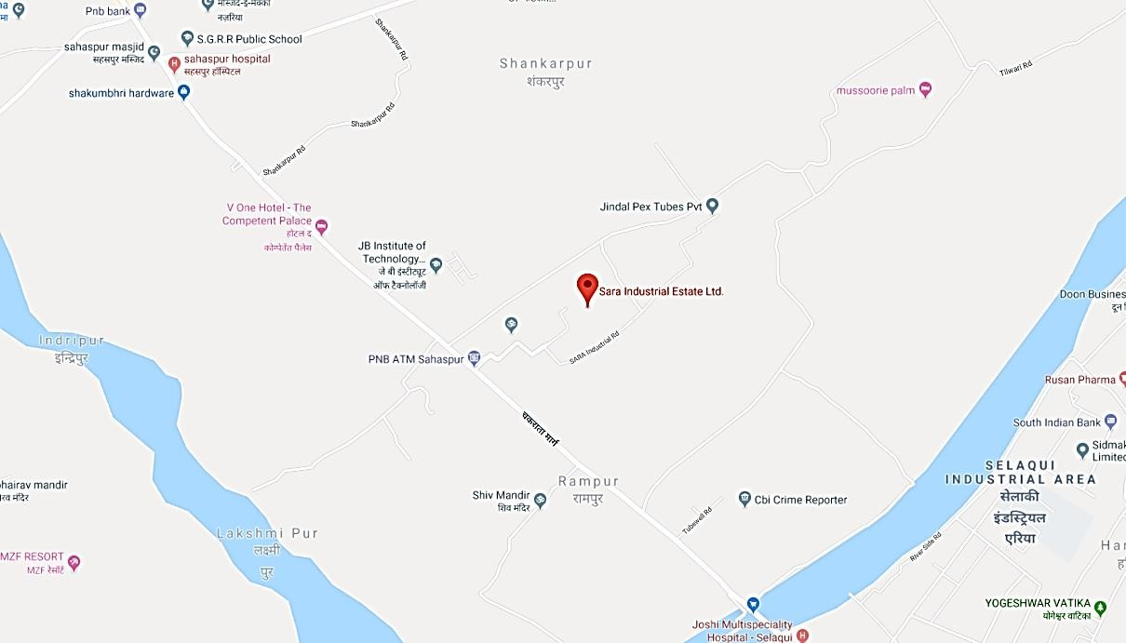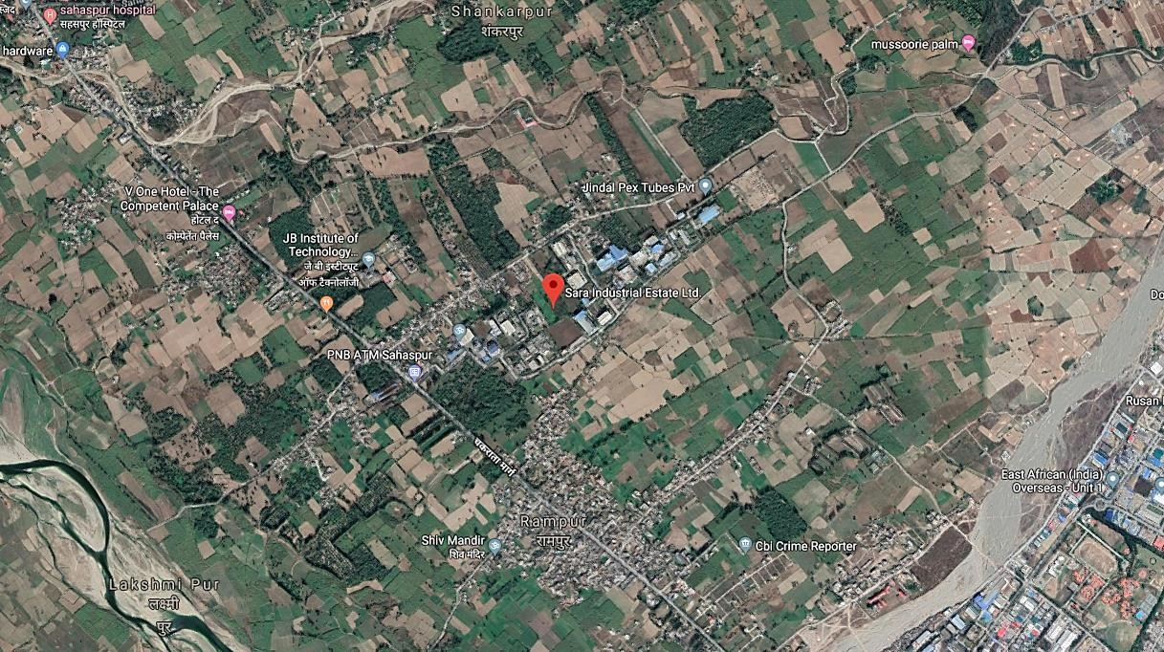

PHOTOGRAPHS OF THE PROPERTY – ANNEXURE VI
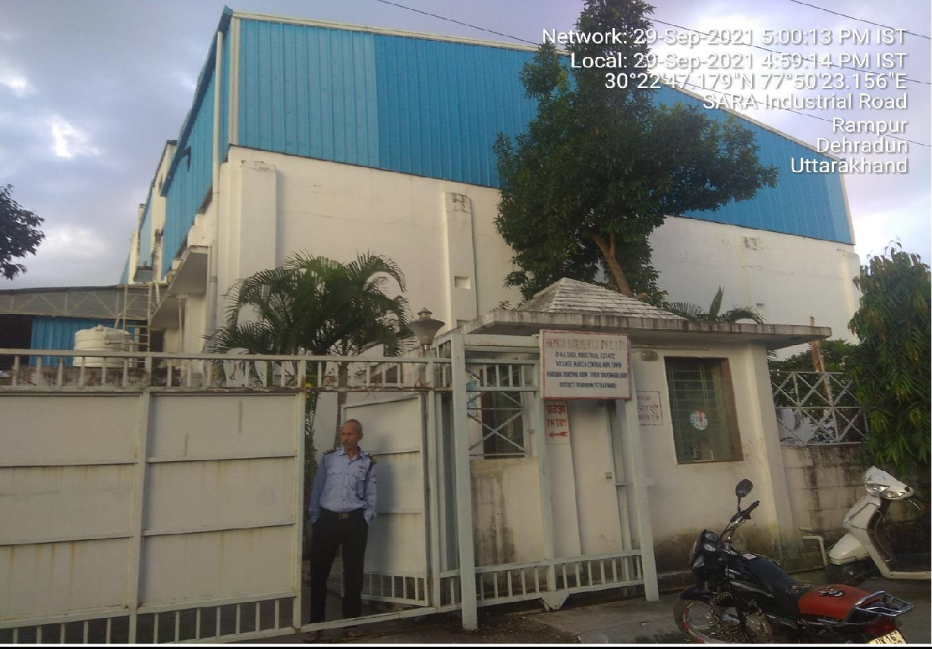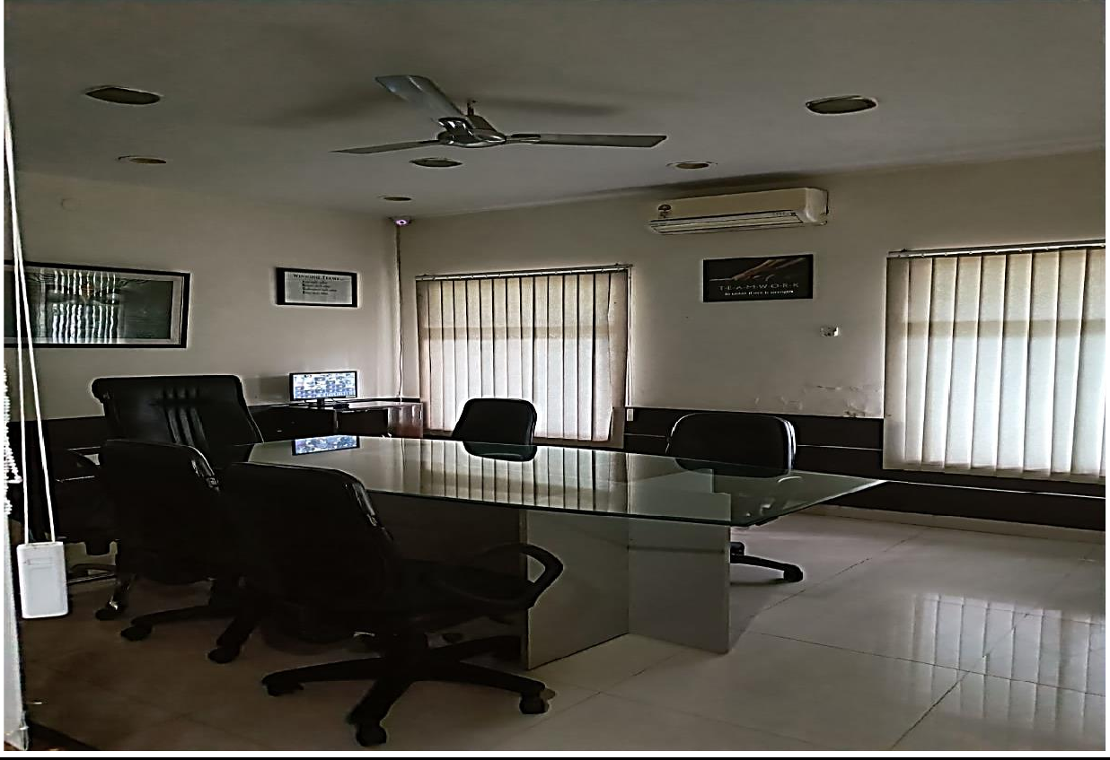

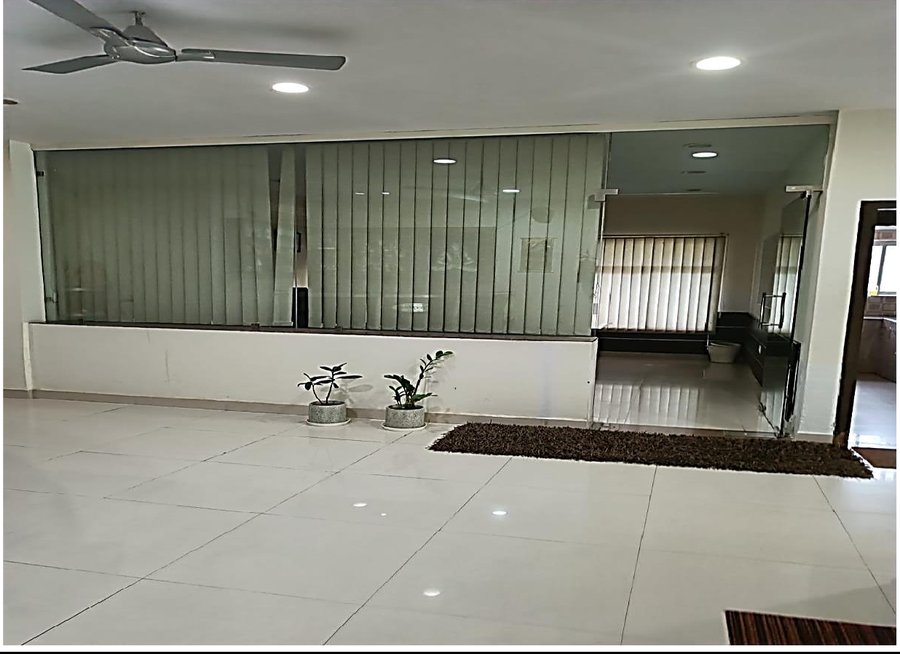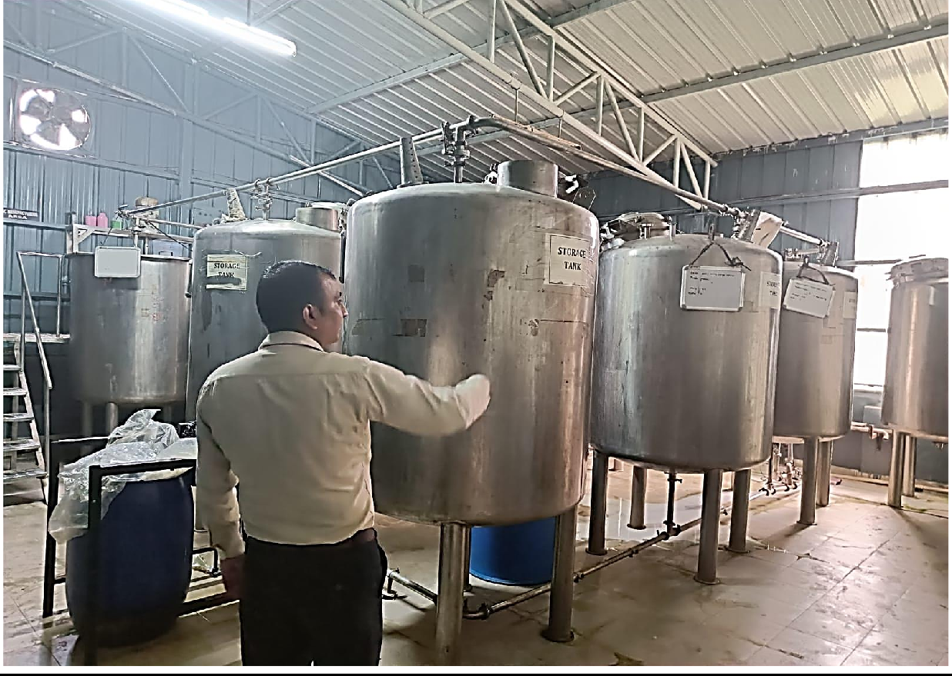

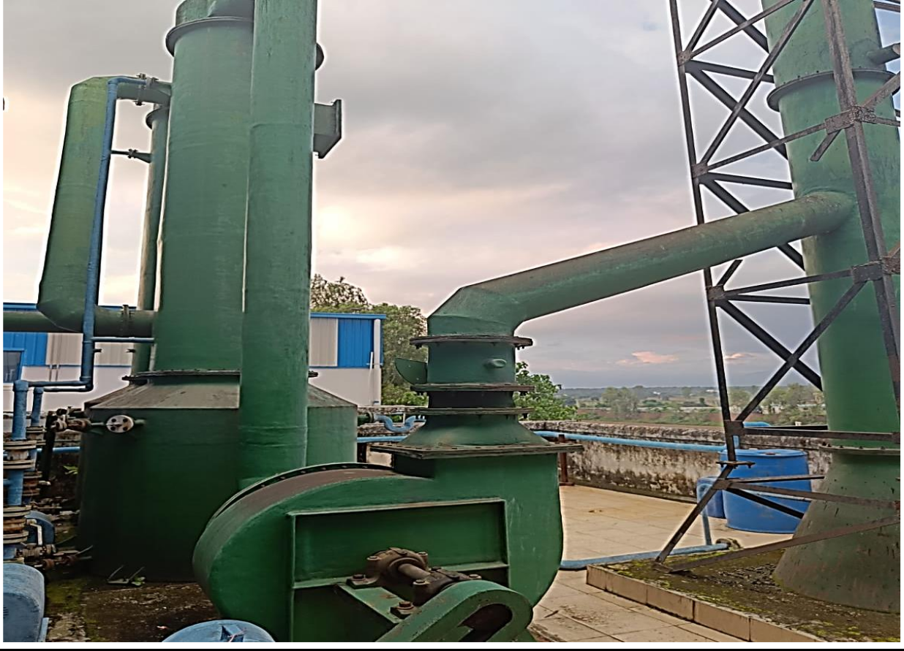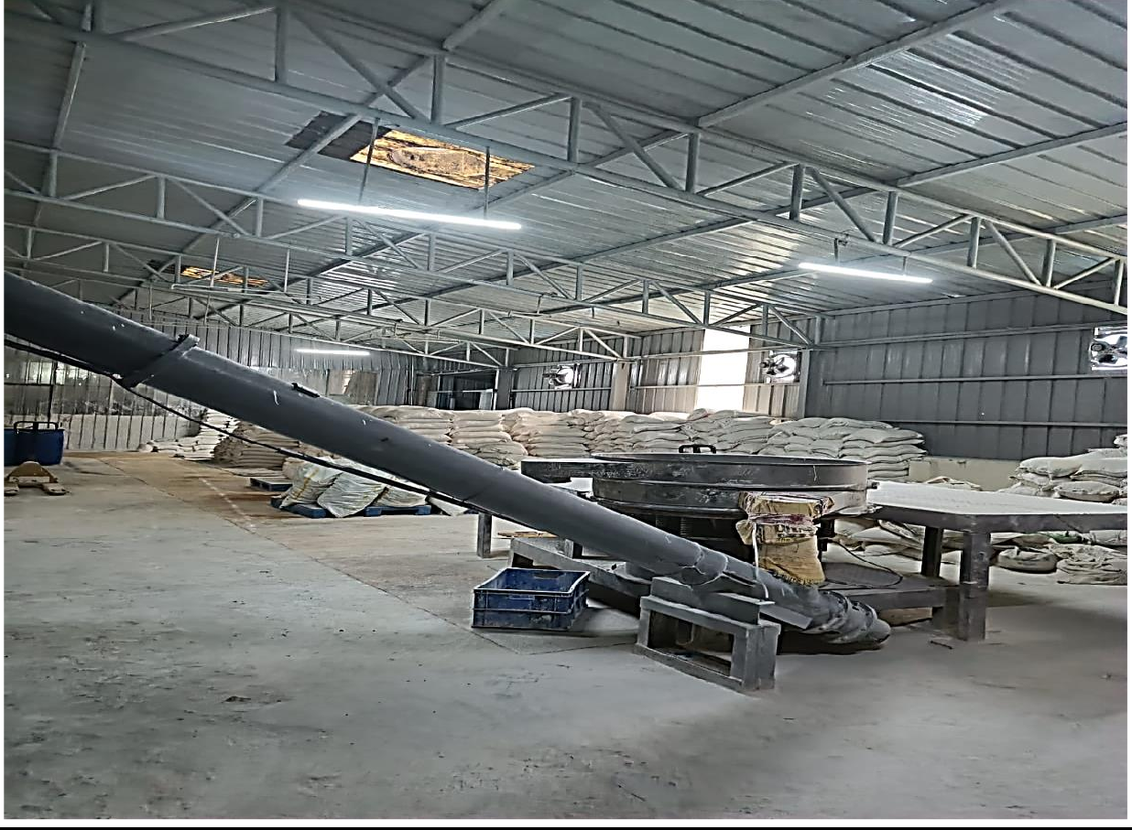

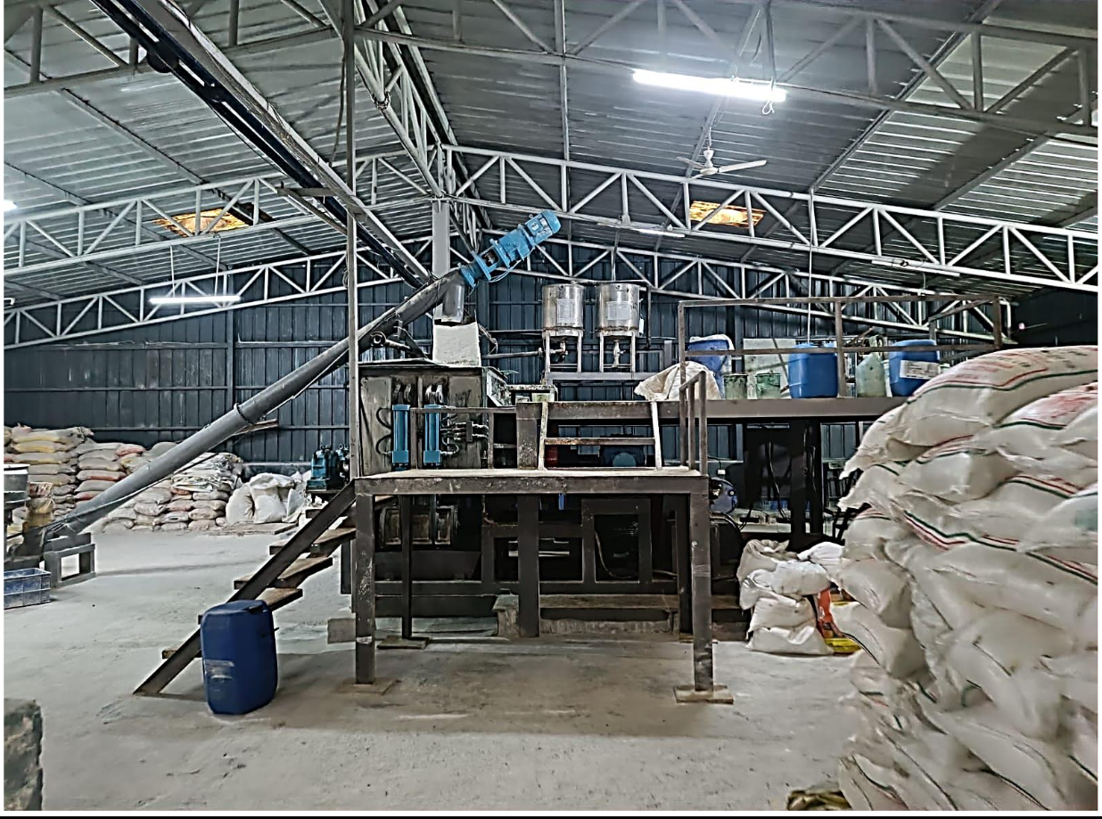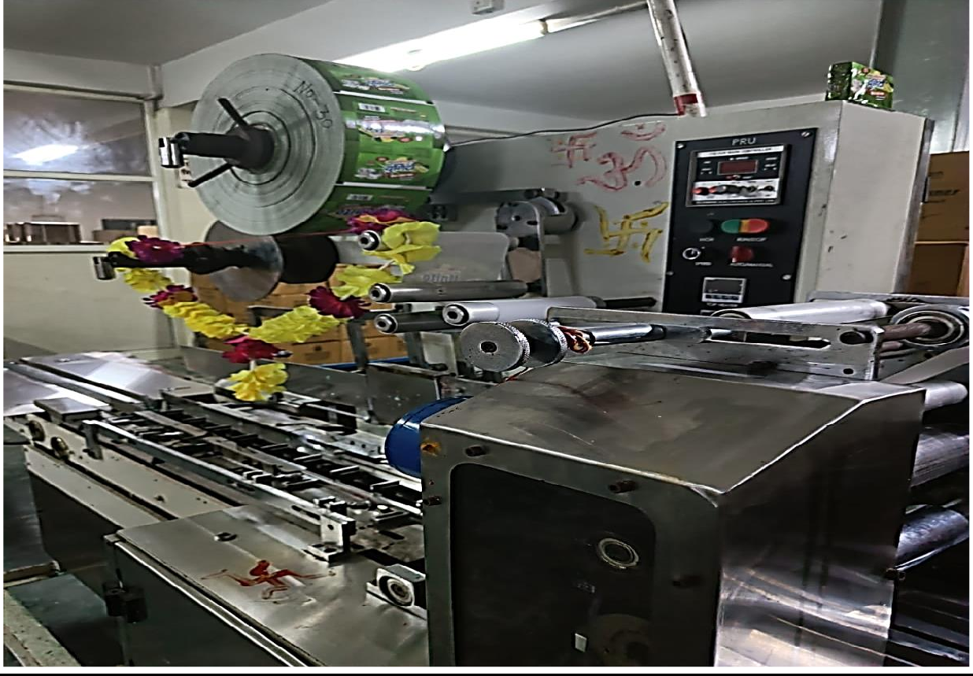

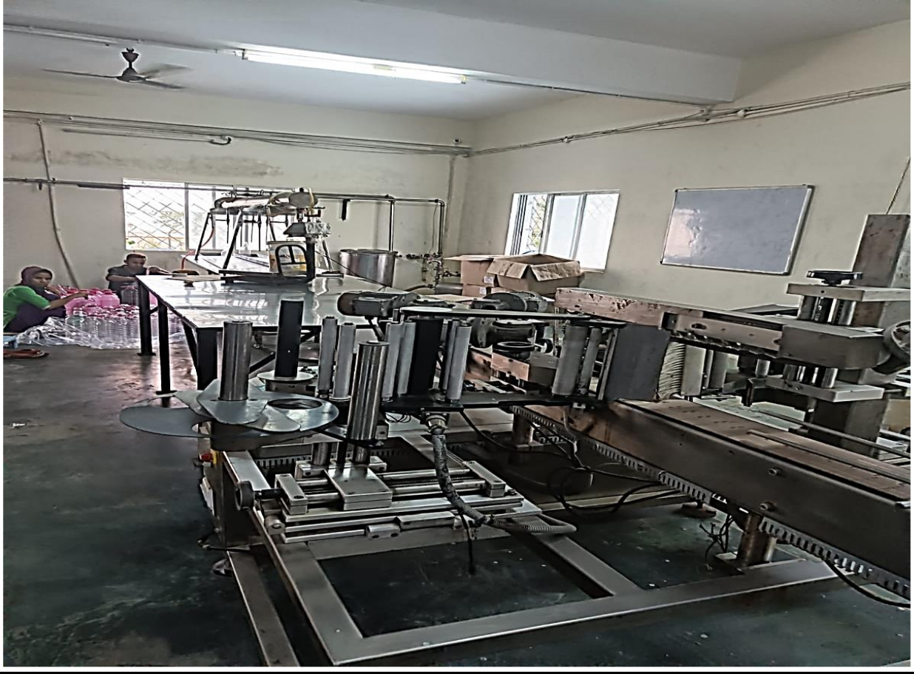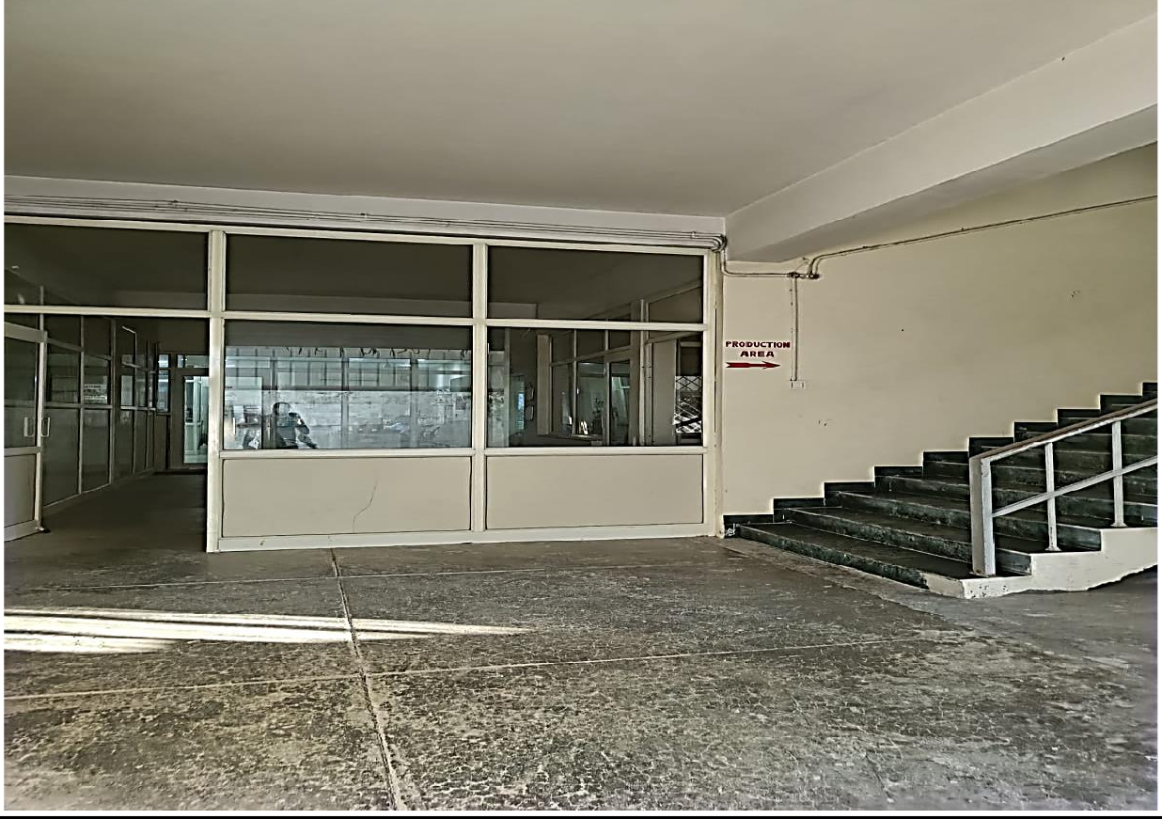

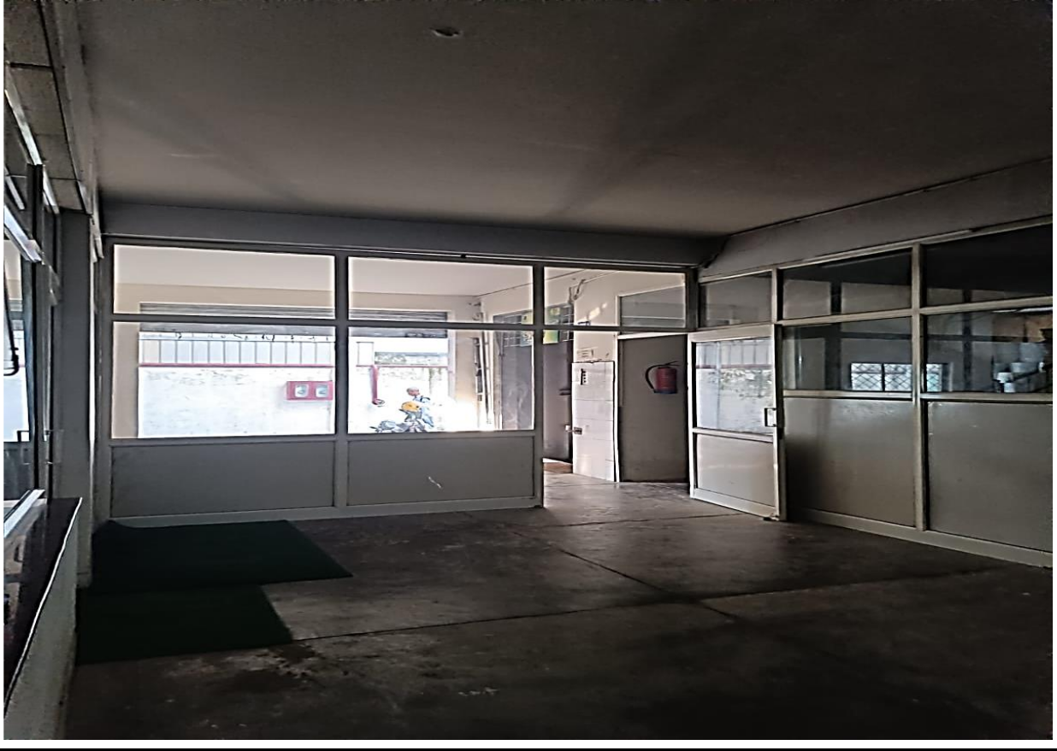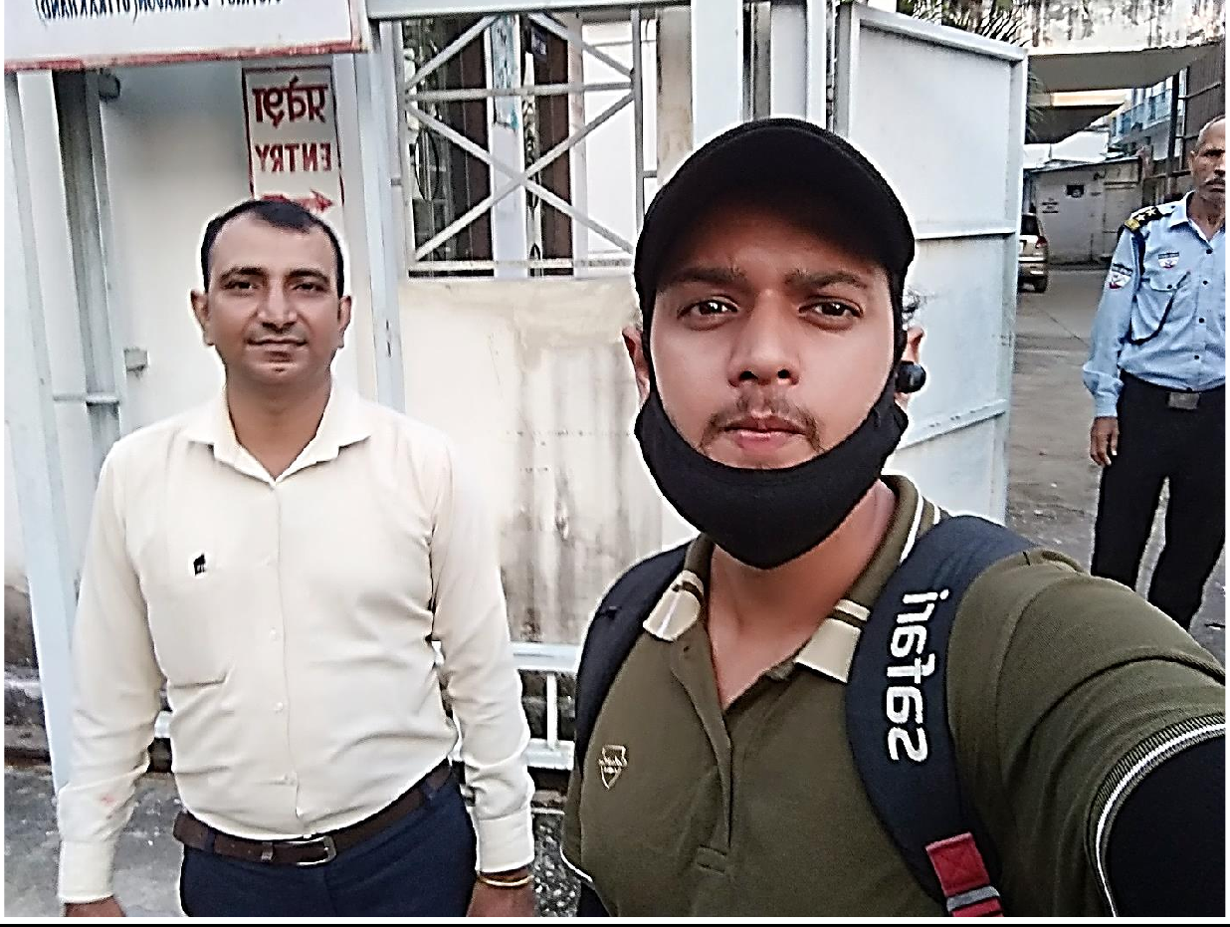

COPY OF CIRCLE RATE - ANNEXURE VII
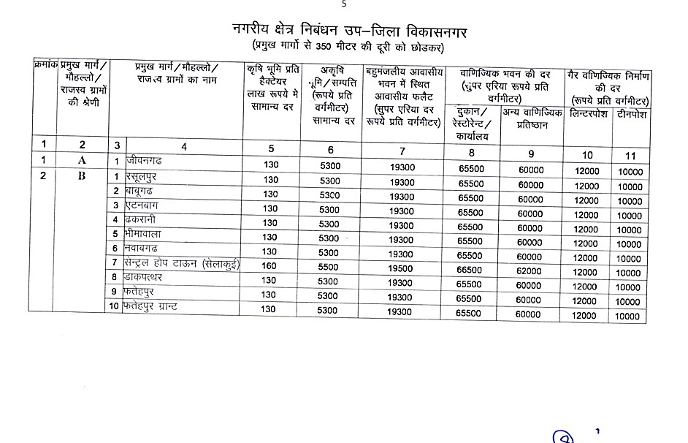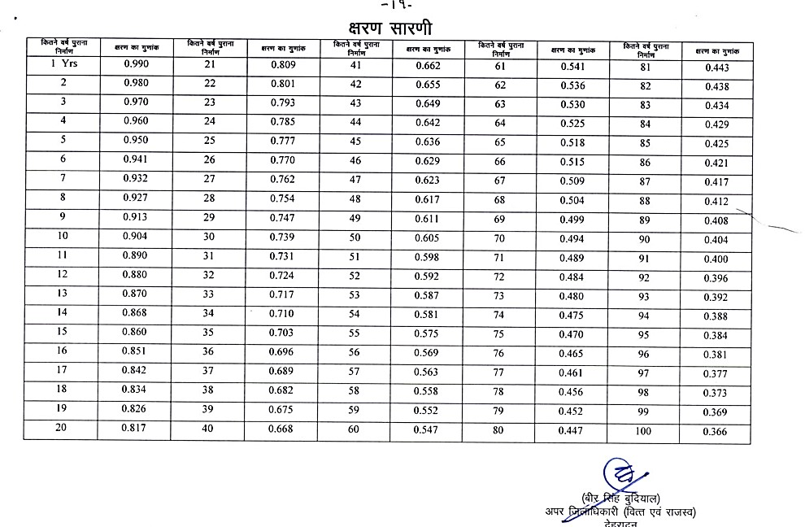

VALUER’S REMARKS - ANNEXURE IX

a) | This Valuation report is prepared based on the copies of the documents/ information which interested organization or customer could provide to us out of the standard checklist of documents sought from them and further based on our assumptions and limiting conditions. All such information provided to us has been relied upon in good faith and we have assumed that it is true and correct. Verification or cross checking of the documents provided to us from  the originals has not been done at our end.
b) | Legal aspects for eg. investigation of title, ownership rights, lien, charge, mortgage, lease, verification of documents, etc. have to be taken care by legal expert/ Advocate and same are not done at our end. It is assumed that the concerned Lender/ Financial Institution has asked for the valuation of that property for which the legal  verification has been already taken and cleared by the competent Advocate before requesting for the Valuation report.
c) | Analysis and conclusions adopted in the report are limited to the reported assumptions, conditions and information came to our knowledge during the course of the work.
d) | Value varies with the Purpose/ Date/ Condition prevailing in the market. We recommend not to refer the indicative & estimated prospective Value of the asset given in this report if any of these points are different from the one mentioned aforesaid in the Report. We also recommend that the indicative estimated Value in the Valuation Report holds good only upto the period of 3 months from the date of Valuation.
e) | This report is having limited scope as per its fields & format to provide only the general basic idea of the value of the property prevailing in the market based on the documents/ data/ information provided by the client. The suggested indicative prospective estimated value should be considered only if transaction is happened as free  market transaction.
f) | This Valuation report is prepared based on the facts of the property on the date of the survey. It is a well-known fact that the market value of any asset varies with time & socio-economic conditions prevailing in the country. In future property Market may go down, property conditions may change or may go worse, Property reputation may differ, Property vicinity conditions may go down or become worse, Property market may change due to impact of Govt. policies or effect of World economy, Usability prospects of the property may change, etc. Hence before financing, Banker/ FI should take into consideration all such future risk and should loan conservatively to keep the advanced  money safe in case of the downward trend of the property value.
g) | Valuation of the same asset/ property can fetch different values in different situations. For eg. Valuation of a running/ operational shop/ hotel/ factory will fetch better value and in case of closed shop/ hotel/ factory it will have considerable lower value. Similarly an asset sold directly by an owner in the market will fetch better value and if the same asset/ property is sold by any financer due to encumbrance on it will fetch lower value. Hence before  financing, Banker/ FI should take into consideration all such future risks and should loan conservatively to keep the advanced money safe in case of any such situation.
h) | Getting cizra map or coordination with revenue officers for site identification is not done at our end.
i) | Valuation is done for the property identified to us by the owner/ owner representative. At our end we have just cross verified the identification of the property with reference to the documents produced for perusal. Method by which identification of the property is carried out is also mentioned in the report clearly. Responsibility of identifying the correct property to the Valuer/ its authorized surveyor is solely of the client/ owner for which Valuation has to be carried out. It is requested from the Bank to cross check from their own records/ information if this is the same  property for which Valuation has to be carried out to ensure that owner has not misled the Valuer company or misrepresented the property due to any vested interest.
j) | In India more than 70% of the geographical area is lying under rural/ remote/ non municipal/ unplanned area where the subject property is surrounded by vacant lands having no physical demarcation or having any display of property survey or municipal number / name plate on the property clearly. Even in old locations of towns, small cities & districts where property number is either not assigned or not displayed on the properties clearly and also due to the presence of multiple/ parallel departments due to which ownership/ rights/ illegal possession/ encroachment issues are rampant across India and due to these limitations at many occasions it becomes tough to identify the property with 100% surety from the available documents, information & site whereabouts and thus chances of error, misrepresentation by the borrower and margin of chances of error always persists in such cases. To avoid any such chances of error it is advised to the Bank to engage municipal/ revenue department officials to get the confirmation of the property to ensure that the property shown to Valuer/ Banker is the same as for which  documents are provided.
k) | If this Valuation Report is prepared for the Flat/ dwelling unit situated in a Group Housing Society or Integrated Township then approvals, maps of the complete group housing society/ township is out of scope of this report and this report will be made for the specific unit based on the assumption that complete Group Housing Society/ Integrated Township must be approved in all respect..

l) | Due to fragmented & frequent change in building/ urban planning laws/ guidelines from time to time, different laws/ guidelines between regions/ states and no strict enforceability of Building Bye-Laws in India specially in non-metro and scale b & c cities & Industrial areas, property owners many times extend or make changes in the covered area/ layout from the approved/ applicable limits. There are also situations where properties are decades old when there was no formal Building Bye-Laws applicable when the construction must have been done. Due to such discrete/ unplanned development in many regions sometimes it becomes tough to determine the exact lawful situation on ground for the Valuer. In case nothing specific is noted on the covered built-up area considered in the Valuation  Report, the covered area present on the site as per site survey will be considered in the Valuation.
m) | Valuation is a subjective field and opinion may differ from consultant to consultant. To check the right opinion, it is important to evaluate the methodology adopted and various data point/ information/ factors/ assumption considered  by the consultant which became the basis for the Valuation report before reaching to any conclusion.
n) | Value analysis of any asset cannot be regarded as an exact science and the conclusions arrived at in many cases will, of necessity, be subjective and dependent on the exercise of individual judgment. Given the same set of facts and using the same assumptions, expert opinions may differ due to the number of separate judgment decisions, which have to be made. Therefore, there can be no standard formula to establish an indisputable exchange ratio. In the event of a transaction, the actual transaction value achieved may be higher or lower than our indicative analysis of value depending upon the circumstances of the transaction. The knowledge, negotiability and motivations of the buyers and sellers and the applicability of a discount or premium for control will also affect actual price achieved. Accordingly, our indicative analysis of value will not necessarily be the price at which any agreement proceeds. The final transaction price is something on which the parties themselves have to agree. However our Valuation analysis  can definitely help the stakeholders to make them informed and wise decision about the Value of the asset and can help in facilitating the arm’s length transaction.
o) | This report is prepared on the RKA V-L3 (Medium) Valuation format as per the client requirement and scope of work. This report is having limited scope as per its fields & format to provide only the general estimated & indicative basic idea of the value of the property prevailing in the market based on the information provided by the client. No detailed analysis, audit or verification has been carried out of the subject property.
p) | This is just an opinion report and doesn’t hold any binding on anyone. It is requested from the concerned Client/ Bank/ Financial Institution which is using this report for mortgaging the property that they should consider all the  different associated relevant & related factors & risks before taking any business decision based on the content of this report.
q) | All Pages of the report including annexures are signed and stamped from our office. In case any paper in the report is without stamp & signature then this should not be considered a valid paper issued from this office.
r) | Defect Liability Period is 30 DAYS. We request the concerned authorized reader of this report to check the contents, data and calculations in the report within this period and intimate us in writing if any corrections are required or in case of any other concern with the contents or opinion mentioned in the report. Corrections only related to typographical, calculation, spelling mistakes will be entertained within the defect liability period. No  request for any illegitimate value revision, date change or any other change will be entertained other than the one mentioned above.
s) | R.K Associates encourages its customers to give feedback or inform concerns over its services through proper channel at valuers@rkassociates.org in writing within 30 days of report delivery. After this period no concern/ complaint/ proceedings in connection with the Valuation Services can be entertained due to possible change in  situation and condition of the property.
t) | Our Data retention policy is of ONE YEAR. After this period we remove all the concerned records related to the  assignment from our repository. No clarification or query can be answered after this period due to unavailability of the data.
u) | This Valuation report is governed by our (1) Internal Policies, Processes & Standard Operating Procedures, (2) R.K Associates Quality Policy, (3) Valuation & Survey Best Practices Guidelines formulated by management of R.K Associates, (4) Information input given to us by the customer and (4) Information/ Data/ Facts given to us by our field/ office technical team. Management of R.K Associates never gives acceptance to any unethical or unprofessional practice which may affect fair, correct & impartial assessment and which is against any prevailing law. In case of any indication of any negligence, default, incorrect, misleading, misrepresentation or distortion of facts in the report then it is the responsibility of the user of this report to immediately or atleast within the defect liability period bring all such act into notice of R.K Associates management so that corrective measures can be  taken instantly.
v) | R.K Associates never releases any report doing alterations or modifications by pen. In case any information/ figure of this report is found altered with pen then this report will automatically become null & void.

