File No.: VIS (2021-22)-PL559-Q133-512-648 Dated: 19.11.2021

TECHNO-ECONOMIC
VIABILITY STUDY REPORT

OF

M/S SITARGANJ FIBRES LIMITED

SITUATED AT
VILLAGE SARKARA, NEAR AMARIYA ROAD, KASBA & TEHSIL – SITARGANJ DISTRICT –UDHAM SINGH NAGAR (U.K)

REPORT PREPARED FOR
STATE BANK OF INDIA SME ROORKEE, DISTRICT-HARIDWAR U.K

**Important - In case of any query/ issue or escalation you may please contact Incident Manager Valuers@rkassociates.org. We will appreciate your feedback in order to improve our services.

NOTE: As per IBA Guidelines please provide your feedback on the report within 15 days of its submission after which report will be considered to be correct
IMPORTANT NOTICE

COPYRIGHT FORMAT: This report is prepared on the copyright format of R. K. Associates Valuers & Techno Engineering Consultants (P) Ltd. (R. K. Associates) to serve our clients with the best possible information and analysis to facilitate them to take rational business decisions. Legally no one can copy or distribute this format without prior approval from R. K. Associates. It is meant only for the advisory/ reference purpose for the organization/s as mentioned on the cover page of this report. Distribution or use of this format or report or any of its content/ information/ data by any organization or individual other than R.K Associates will be seen as an unlawful act and necessary legal action can be taken against the defaulters.
This report is intended for the sole use of the intended recipient/s and contains material that is STRICTLY CONFIDENTIAL AND PRIVATE.

DEFECT LIABILITY PERIOD: In case of any query/ issue or escalation you may please contact Incident Manager at valuers@rkassociates.org. Though adequate care has been taken while preparing this report as per its scope, but still we can’t rule out typing, human errors, over sightedness of any information or any other mistakes. Therefore, the concerned organization is advised to satisfy themselves that the report is complete & satisfactory in all respect. Intimation regarding any discrepancy shall be brought into our notice immediately. If no intimation is received within 15 (Fifteen) days in writing from the date of issuance of the report, to rectify these timely, then it shall be considered that the report is complete in all respect and has been accepted by the client up to their satisfaction & use and further to which R.K Associates shall not be held responsible in any manner.

Part L: R. K. Associates Important Disclaimer and Remarks are integral part of this report and Feasibility assessment is subject to this section. Reader of the report is advised to read all the points mentioned in these sections carefully.

PART A | REPORT SUMMARY

- Name of the Company: | M/s. Sitarganj Fibres Limited
- Address of the Company: | Village Sarkara, near Amariya road, Kasba & Tehsil –Sitarganj district– Udham Singh Nagar, Uttarakhand
- Project Name : | M/s. Sitarganj Fibres Limited
- Project Location: | Village Sarkara, near Amariya road, Kasba & Tehsil –Sitarganj district– Udham Singh Nagar, Uttarakhand
- Project Type: | Polyester Fiber Plant
- Project Industry: | Manufacturing of all kind of Yarns, fibres and other textile products
- Product Type/ Deliverables: | Manufacturing of all kind of yarns and fibres
- Report Prepared for Organization: | State Bank of India SME Roorkee, District–Haridwar, Uttrakhand
- TEV Consultant Firm: | M/s. R.K Associates Valuers & Techno Engineering Consultants (P) Ltd.
- Report type: | Techno-Economic Viability Report
- Purpose of the Report: | To assess Project’s Techno Economic Viability for the purpose of seeking external financial assistance on the Project.
- Scope of the Report: | Assessment of key financial metrics of the project as per Financial Projections submitted by the Bank to assess Techno-Financial viability of the Project.
- Date of Report: | 19TH November, 2021

- Documents referred for the Project : A. PROJECT PLANNING DOCUMENTS:
- Project information memorandum
- Financial Projections of the Project
- Project proposed Schedule
- Layout and Master Plan

B. PROCUREMEMNT DOCUMENTS:
- List of Plant & Machinery along with acquisition costs for the same
- Product Segregation of three major categories
- List of Raw Material Suppliers
- List of major customers of the company
- Process Flow document
- Manpower requirement plan

- Means of Finance: Equity + Debt (Currently WCL required)

Key Indicators | Value
Average ISCR | 3.36
Average EBITDA Margin % | 5.63 %
- Key Financial Indicators

Note: Above financial indicators are based on the financial projections of the company, provided by the client/ company.

PART B | INTRODUCTION

- ABOUT THE REPORT:
Techno Economic Viability Study Report of the manufacturing unit of all kind of yarns, fibres and other textiles products with the capacity of 21,600 TPA being proposed to be operated by M/s. Sitarganj Fibres Limited.

- EXECUTIVE SUMMARY:
M/s Sitarganj Fibers Pvt Ltd was incorporated as a Pvt limited Company under the Companies Act 1956 on 26.03.2012 with the objective of carrying on the business of manufacturing all kinds of yarns, fibers and other textile products.

The entire paid up capital of the Company was held by M/s Obeetee Textiles Pvt Ltd as such it was a wholly owned subsidiary. M/s Obeetee Textiles Pvt Ltd was engaged in the business of manufacturing Non-Woven Textile products meant for exhibitions, Automobiles, Industrial and Domestic purposes, which was carried in Unit-I & II at Bisunderpur, Mirzapur (UP) and manufacturing of Recycled Polyester Staple Fiber meant for spinning, Non-Woven and other Technical Textile products (RPSF Business) which was carried out in Unit III located at Sitarganj.

Later on M/s Obeetee Textiles Pvt Ltd demerged the PSF Business and transfer and vest the same in M/s Sitarganj Fibers Pvt Ltd while retaining the residual business with itself. The proposed demerger was expected to benefit both the Demerged/Transferor Company and the Resulting/Transferee Company and their all stakeholders and result in unlocking and maximizing shareholders value.

M/s Obeetee Textiles Pvt Ltd moved an application before Honble High Court of Judicature, Allahabad under section 391 & 394 of the Companies Act,1956 and vide orders dated 18.12.2012 passed in Company Petition No.27 of 2012, the ownership was transferred and demerged from Demerged/Transferor Company M/s Obeetee Textiles Pvt Ltd in favour of its wholly owned subsidiary M/s Sitarganj Fibers Pvt Ltd and the property of the factory land and building was mutated in the name of Resulting/Transferee company M/s Sitarganj Fibers Pvt Ltd. Further the status of the company M/s Sitarganj Fibers Pvt Ltd changed from Pvt. Ltd. to Public Ltd (M/s Sitarganj Fibers Ltd) on 13.07.2019.

Moreover, M/s Sitarganj Fibers Limited is a Public incorporated on 26 March 2012. It is classified as Non-govt. Company and is registered at Registrar of Companies, Kanpur. Its authorized share capital is INR 150,000,000 and its paid up capital is INR 3.00 Crores The company is involved in manufacturing of all kind of yarns, fibers and other textiles products.

M/s Sitarganj Fibers Limited's Annual General Meeting (AGM) was last held on 30 September 2020 and as per records from Ministry of Corporate Affairs (MCA), its balance sheet was last filed on 31 March 2020.

Sitarganj Fibers Limited's Corporate Identification Number is (CIN) U17291UP2012PLC049535 and its registration number is 49535, Email address is sitarganjfiberslimited@gmail.com and its registered address is C-69, Sector-58 Noida- 201 307 NOIDA UP 201307 IN

NCLT Case of the Company (Under Insolvency Resolution process for Corporate Persons):

The company was originally financed by Punjab National Bank in the year 2013. Company’s operation were closed in FY2015 due to financial losses and further account was declared NPA in the records of Punjab National Bank which has the claim amount of Rs.71.83 Cr. against the company.

Corporate Insolvency Resolution Process (CIRP) was initiated in April, 2019,. For the recovery of its dues, Punjab National Bank the lone financial creditor of the company has taken the company into NCLT. As per the order of National Company Law Tribunal, Allahabad (NCLT) under the provisions of the Insolvency & Bankruptcy Code, 2016 ("Code"), Sitarganj Fibers Ltd, had undergone through the Corporate Insolvency Resolution Process ("CIRP") effective 9/4/2019. Shri Babu Lal Patwari on 13.09.2019 filed an application under Insolvency & Bankruptcy Code & put forth a resolution plan to National Company Law Tribunal, Allahabad Bench in the instant case of Punjab National Bank (financial creditor) versus M/s Sitarganj Fibers Ltd (CA No.398/2019) for the purchase of the factory & revival of the operations of the business.

According to the list of creditors of the company as provided in the information memorandum, Punjab National Bank was the only financial creditor of the company and claimed an amount of Rs.71.83 Cr as on the CIRP (Insolvency Resolution of Corporate Persons) commencement date.

Shri Babu Lal Patwari proposed a resolution plan for the payment of an amount of Rs.13.10 Cr to corporate creditor within 4 months from the date of approval plan by the NCLT with a condition that the all the previous contingent & Statutory liabilities of the company to be treated as NIL and immunity against the previous pending litigations against the company.
National Company Law Tribunal, Allahabad on 07.02.2020 approved the resolution plan submitted by Shri Babulal Patwari. On 06.06.2020 the resolution applicant Shri Babu Lal Patwari made the final payment to PNB payable against the resolution plan of M/s Sitarganj Fibers Ltd and the physical possession of the factory (including plant & machinery, other fixtures) located at Sitarganj was handed over to him. With the approval of the resolution plan, the previous issued equity share capital of Rs.9.51 Cr gets fully reduced to stand as nil and stood extinguished. The previous directors of the company got retired and new directors Shri Babu Lal Patwari, Shri Karan Patwari and Shri Harish Kumar since got inducted as the new directors of the company as such there is a total change of the management. The new directors has proposed to infuse fresh capital of Rs.9.50 Cr in the business of which they have already raised PUC of Rs.3.00 Cr which has since been updated in MCA portal and the rest of the PUC shall be raised before disbursement of CC limit. All the previous bank charges has since been satisfied in the MCA portal.

M/s Sitarganj Fibers Limited has one manufacturing facility to manufacture polyester fibre of capacity 21,600 ton per annum located at Sitarganj, Uttarakhand. Site inspection of the Plant has been carried out by our Engineer on 09/11/2021 subject to the scope of work.

Presently, unit is not operational, however for trail run company has operated the Plant in February, 2021 and have made the production of around 3000 tons. Few latest Invoices has been taken from the company in this regard. However on the day of site inspection this Plant was not operational. After purchasing the Plant through NCLT, the new management of the company has overhauled and refurbished the Plant fully. New management has added few new machineries also in the Plant, list of which is added in the later section of the report. As per visual observation during site visit, Plant condition appeared to be good. Under Single Window Clearance System, the new management has applied & obtained the statutory approvals.

As found installed machinery on site, this Plant is using 170 Diameter extruder of 30 Ton capacity as per its plate description. The extruder has been supplied by ZhangiaganG Yongxing Machinery Co., Ltd. which is reputed supplier of this type of machinery. The plant is also using Dryers supplied by ZhangiaganG Yongxing Machinery Co., Ltd. which is having drying capacity of 1800Kg Per day.

Company with new management now requires working capital of INR 34.00 Crores as per working capital gap and analysis of Assessed Banking Finance to start the operation of the Plant. For this company has approached State Bank of India, Roorkee Branch to avail this facility. To check Project’s techno-economic viability study before taking any decision on the company’s working capital loan, SBI has appointed us as the consultant.

- PURPOSE OF THE REPORT: To assess the Techno-Financial Feasibility of the proposed project of seeking external financial assistance on the Project.

- SCOPE OF THE REPORT: Assessment of key financial metrics of the project as per Financial Projections submitted by the Bank to assess Techno-Financial viability of the Project of the manufacturer of all kind of Yarns, fibres and other textiles products as per the data/information provided by the promoter/stakeholder.

NOTES:
- Scrutiny about the company, its background or its promoters is out-of-scope of this report.
- This report is only an opinion in respect to Technical and Financial Feasibility of the project as per the future financial projections provided by the firm and doesn’t contains any recommendations including taking decision on the financial exposure.
- Product’s local and regional factors have not been assessed at our end.
- Detailed Industry analysis and its economic projections is out of scope of the report.
- Any point mentioned in the report beyond scope of work is only for general illustration purpose.

- METHODOLOGY/ MODEL ADOPTED:
- Data/ Information collection.
- Review of Data/ Information collected related to TEV study.
- Review of the new proposed project.
- Calculation of key financial indicators and ratio analysis including for the projected Interest Service Coverage Ratio and EBITDA Margin.
- General review & assessment of technology used and financial projections provided by the company/promoters.
- Final conclusion.

- DATA/ INFORMATION RECEIVED FROM:
All the data/Information has been received from Mr Gobbind Singh Bhist, who is currently working as CFO of M/s Sitarganj Fibers Limited and the required details about him shown in the below table:
Table: Person from Whom Data Obtained
Particulars | Details
Name | Mr Gobbind Singh Bhist
Company | M/S. Sitarganj Fibers Limited
Email Address | Gobbind972@gmail.com
Contact No. | +91 7500247060

- DOCUMENTS / DATA REFFERED:
Below are the list of Data/Documents referred for the preparation of this Techno-Financial Viability Report:

- Financial Projections of the company.
- Information memorandum and description of the company.
- Proposed project cost
- List of Raw Material Suppliers.
- Description of the expected customers of the company.
- Organisational chart and Flow chart.
- List of Plant and Machinery along with their acquisition cost.
- Layout Plan.
- Man power proposal
- Current shareholding pattern of the company
- Details of the promoters
- Details of GST Registration
- Detailed Project Report

PART C | COMPANY PROFILE

- COMPANY OVERVIEW:
M/s Sitarganj Fibers Pvt Ltd was incorporated as a Pvt limited Company under the Companies Act 1956 on 26.03.2012 with the objective of carrying on the business of manufacturing all kinds of yarns, fibers and other textile products. The entire paid up capital of the Company was held by M/s Obeetee Textiles Pvt Ltd as such it was a wholly owned subsidiary. M/s Obeetee Textiles Pvt Ltd was engaged in the business of manufacturing Non-Woven Textile products meant for exhibitions, Automobiles, Industrial and Domestic purposes, which was carried in Unit-I & II at Bisunderpur, Mirzapur (UP) and manufacturing of Recycled Polyester Staple Fiber meant for spinning, Non-Woven and other Technical Textile products (RPSF Business) which was carried out in Unit III located at Sitarganj.

Later on M/s Obeetee Textiles Pvt Ltd demerge the PSF Business and transfer and vest the same in M/s Sitarganj Fibers Pvt Ltd while retaining the residual business with itself. The proposed Demerger was expected to benefit both the Demerged/Transferor Company and the Resulting/Transferee Company and their all stakeholders and result in unlocking and maximizing shareholders value.

M/s Obeetee Textiles Pvt Ltd moved an application before Honble High Court of Judicature, Allahabad under section 391 & 394 of the Companies Act,1956 and vide orders dated 18.12.2012 passed in Company Petition No.27 of 2012, the ownership was transferred and demerged from Demerged/Transferor Company M/s Obeetee Textiles Pvt Ltd in favour of its wholly owned subsidiary M/s Sitarganj Fibers Pvt Ltd and the property of the factory land and building was mutated in the name of Resulting/Transferee company M/s Sitarganj Fibers Pvt Ltd. Further the status of the company M/s Sitarganj Fibers Pvt Ltd changed from pvt. Ltd. to public ltd (M/s Sitarganj Fibers Ltd) on 13.07.2019.

Moreover, M/s Sitarganj Fibers Limited is a Public incorporated on 26 March 2012. It is classified as Non-govt. Company and is registered at Registrar of Companies, Kanpur. Its authorized share capital is INR 150,000,000 and its paid up capital is INR 3.00 Crore. The company is involved in manufacturing of all kind of yarns, fibers and other textiles products.

M/s Sitarganj Fibers Limited's Annual General Meeting (AGM) was last held on 30 September 2020 and as per records from Ministry of Corporate Affairs (MCA), its balance sheet was last filed on 31 March 2020.

M/s Sitarganj Fibers Limited's Corporate Identification Number is (CIN) U17291UP2012PLC049535 and its registration number is 49535, Email address is sitarganjfiberslimited@gmail.com and its registered address is C-69, Sector-58 Noida- 201 307 NOIDA UP 201307 IN

UDYAM REGISTRATION CERTIFICATE OF THE FIRM:

M/s Sitarganj Fibres Limited is registered as a MSME and the certificate for the same is attached in the below picture:

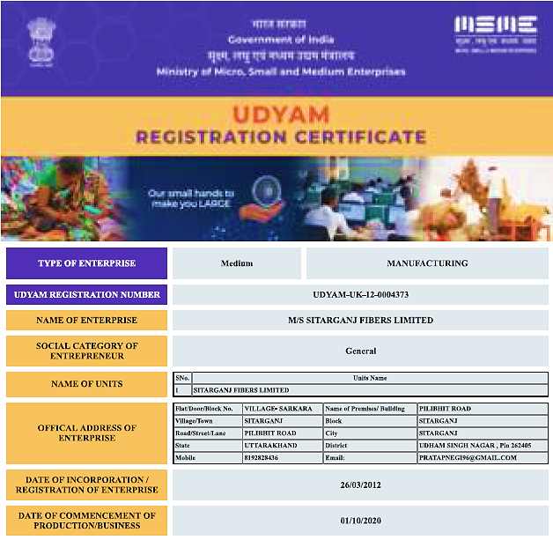
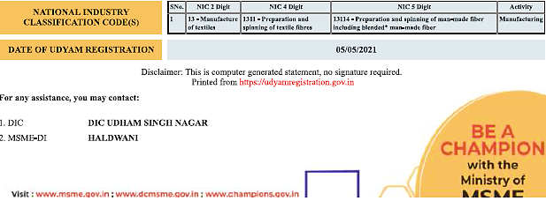

- PROPOSED SHAREHOLDING DETAILS:
As per MCA Portal, the paid-up share capital of the Company is NIL pursuant to the NCLT Order dated February 7, 2020.

As informed by the Company and on the basis of the documents provided by the Company, the paid-up share capital of the Company is INR 3 Crores, and the same have been updated on the Ministry of Corporate Affairs (MCA) Portal.

Table: Shareholding Details of the Company

S. No. | Name of Shareholders | Number of Equity Shares | Face Value | Total Amount | % of Shareholding
1. | Mr. Babulal Patwari | 10,00,000 | 10 | 1,00,00,000 | 33.33 %
2. | Mr. Harish Kumar | 10,00,000 | 10 | 1,00,00,000 | 33.33 %
3. | Mr. Karan Patwari | 2,00,000 | 10 | 20,00,000 | 6.67 %
4. | Mr. Akash Munjal | 2,00,000 | 10 | 20,00,000 | 6.67 %
5. | Mr. Sumit Patwari | 1,50,000 | 10 | 15,00,000 | 5 %
6. | Mr. Amit Patwari | 1,50,000 | 10 | 15,00,000 | 5 %
7. | Mr. Dhruv Munjal | 1,50,000 | 10 | 15,00,000 | 5 %
8. | Ms. Reeta Munjal | 1,50,000 | 10 | 15,00,000 | 5 %
 | Total | 30,00,000 |  | 30,00,000 | 100
Source: Data/Information provided by the Company

- KEY PARTNERS/DIRECTORS PROFILE:

Table: Directors Details

DIN/PAN | NAME | APPOINTMENT DATE | EDUCATION & EXPERINCE | AGE | ADDRESS
07568113 | Harish Kumar | 13/07/2020 | M.A (25 Years) | 51 Years | R/o Mahesh Pura Khanpur Udham Singh Nagar
07877058 | Babulal Patwari | 13/07/2020 | M.A (30 Years) | 58 Years | R/o C-34 Alliance Colony Rudrapur Udham Singh Nagar
07877078 | Karan Patwari | 13/07/2020 | M.B.A (10 Years) | 28 Years | R/o C-34 Alliance Colony Rudrapur Udham Singh Nagar
Source: Data/ Information provided by the Company

PART E | PLANT INFRASTRUCTURE DETAILS

- PROPOSED PLANT LOCATION:
The manufacturing facility of M/s. Sitarganj Fibres Limited has been setup at Village Sarkanda, Sitarganj, District Uddham Singh Nagar, and Uttarakhand. As per the sale deeds the land area aggregates to a total of 10.60 Acres (42,896.68 m²).

Connectivity | Details
Railways | Kiccha Railway station which is approximately 29 Km from Project Site
Airport | Pantnagar Airport which is Approximately 46 Km from Project Site
Road | National Highway 30 which is approx. 650 m from the Project site
Port | Haldia Port which is about 1396 Km from Project site.

Sitarganj is located at 28.93°N 79.70°E. It has an average elevation of 298 metres (978 feet). The City is located between three major water reservoirs naming: Baigul Fish Reservoir, Dhora Reservoir and Nanak Sagar Reservoir which are used mainly for fisheries.

Baigul or Sukhi is a small tributary originating from the foothills of Kumaon Himalayas which was harnessed in 1967 for irrigation and flood control purpose. Baigul has an area of 2695 ha with an elevation of 211 m from the sea-level. The drainage area of 305 km² is fed from southwest monsoon and local catchment of wooded forest.

Dhora Dam is located near Dineshpur constructed on river Dhora, Length of the Dam is 9700 m and Volume of the dam is 50.70 * 10³ m³. Irrigation potential of this dam is 14,600 hectares.

Nanak Sagar Dam has been constructed on river Saryu or deoha at Nanak Matta forming Nanak Sagar which adds up to the beauty of Nanakmatta which is a nearby town to sitarganj. Length of the Dam is 19,700 m and Volume of the dam is 3833 * 10³ m³. Irrigation potential of this dam is 39,200 hectares.

Sitarganj comes under the Terai Agro Climatic zone of Uttarakhand. Its regional connectivity (50–100 km) to major towns and cities: Rudrapur, Haldwani, Moradabad, Rampur, Kashipur and across states (300-500 km) to Uttar Pradesh, Delhi.
It is near to Nainital (a hill station) and Indo-Nepalese border. Sitarganj is closer to Nanak Matta Gurudwara temple which is a famous shrine and big Nanak Sagar dam (12 km from Sitarganj).

Google Map Location:

Location: Project location would be 28°51'19.1"North and 79°42'04.0"East in Sitarganj, Uttarakhand. Location as per the Google map gas been attached below:

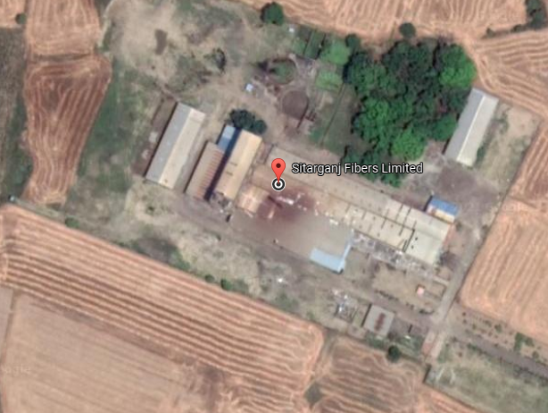

Google Map Layout:

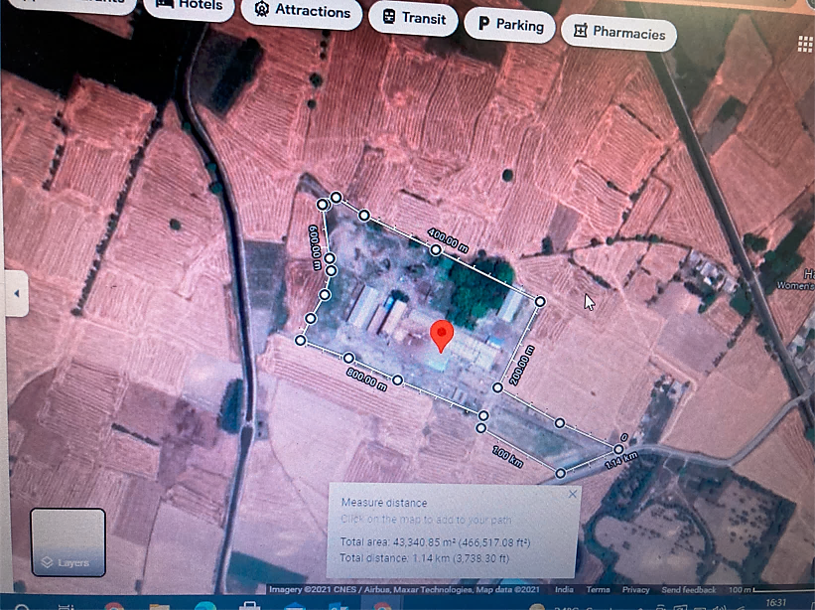

- LAND DETAILS:
Land at Khasra Nos. 392/3,393, 397/3, 392/1/,397/757/1, 397/2, 372, 373, 397/4 & 392/2 belonged to M/s Welmasa Fibres Private Limited which was mortgaged to The J&K Bank Limited for availing credit facilities by the company. Since M/s Welmassa Fibres Private Limited was unable to pay the credit facilities, the bank decided to sell the land as recovery measure. Under the same action the said land was purchased by M/s Obeetee Textiles Private Limited.

Land at Khata No. 188, Khet No. 397/757/2 Khata no. 186, Khata No. 187 has been purchased by M/s Obeetee Textiles Private Limited from M/s Welmassa Fibres Private Limited.

Further details of land are as below:

Sr. No. | Particulars | Plot Details | Plot Details
1. | Plot/Gata No. | Khasra Nos. 392/3,393, 397/3, 392/1/,397/757/1, 397/2, 372, 373, 397/4 & 392/2 | Khata No. 188, Khet No. 397/757/2 Khata no. 186, Khata No. 187
2. | Consideration Price | Rs. 1,35,00,000 | Rs. 53,00,000
3. | Stamp Duty | Rs. 8,10,000 | Rs. 3,18,000
4. | Seller | Irshad Hussain S/o Mustakh Hussain, M/s Welmassa Fibres Private limited | The Jammu and Kashmir Bank Limited
5. | Buyer | Rajeev Kumar Garg, M/s Obeetee Textiles Private Limited | Rajeev Kumar Garg, M/s Obeetee Textiles Private Limited
6. | Area of Land as per Sale deed | 7.40 Acre (29,946.70m²) | 3.20 Acre (12,949.90m²)
7. | Date of Sale Deed | 22nd June 2010 | 21st July 2010
8. | Document Number | 2981 | 3349

- Current Status of the Project:
As per site Survey conducted by our team, all the machineries as listed in Clause 4.0 of this report are were installed at site. However no commercial production was observed during site visit.

- BUILDING & CIVIL WORKS:
M/s Sitarganj Fibers Limited was originally financed by Punjab National Bank in the year 2013 and its operation were closed in FY2015. As per the order of National Company Law Tribunal, Allahabad (NCLT) under the provisions of the Insolvency & Bankruptcy Code, 2016 ("Code"), Sitarganj Fibers Ltd, had undergone through the Corporate Insolvency Resolution Process ("CIRP") effective 09/04/2019. Shri Babu Lal Patwari on 13/09/2019 filed an application under Insolvency & Bankruptcy Code & put forth a resolution plan to National Company Law Tribunal, Allahabad Bench in the instant case of Punjab National Bank (financial creditor) versus M/s Sitarganj Fibers Ltd (CA No.398/2019) for the purchase of the factory & revival of the operations of the business.

According to the list of creditors of the company as provided in the information memorandum, Punjab National Bank was the only financial creditor of the company and claimed an amount of Rs.71.83 Cr as on the CIRP (Insolvency Resolution of Corporate Persons) commencement date. Shri Babu Lal Patwari proposed a resolution plan for the payment of an amount of Rs.13.10 Cr to corporate creditor within 4 months from the date of approval plan by the NCLT with a condition that the all the previous contingent & Statutory liabilities of the company to be treated as NIL and immunity against the previous pending litigations against the company.

National Company Law Tribunal, Allahabad on 07/02/2020 approved the resolution plan submitted by Shri Babul Lal Patwari. On 06.06.2020 the resolution applicant Shri Babu Lal Patwari made the final payment to PNB payable against the resolution plan of M/s Sitarganj Fibers Ltd and the physical possession of the factory (including plant & machinery, other fixtures) located at Sitarganj was handed over to him.

As per the details furnished by the company the production plant is having Steel shed Carpet area ad-measuring approx. 6290.00 m² and RCC Block Carpet area ad-measuring approx. 3284.40 m². Details of structures already constructed on site is as below:

Sr. No. | Particulars | Type of Structure | Approx. Plinth Area (Ft²) | Roof Height
1. | Spinning Mill Hall | RCC | 6,164.00 | 60’
2. | Plant Shed | RCC and Tin Shed | 32,057.00 | 40’
3. | Office | RCC | 4,182.00 | 24’
4. | Boiler and workshop shed | Steel Frame and Tin shed | 18,742.00 | 15’
5. | Generator room and weigh bridge room | RCC | 1,186.00 | 11’
6. | Verandah | Tin shed | 8,725.00 | 15’
7. | Generator area | Tin shed | 2,046.00 | 11’
8. | Guard Room | RCC | 526.00 | 11’
9. | Godown | RCC and Tin shed | 7,814.00 | 20’
10. | Parking area | Tin shed | 2,835.00 | 10’
11. | Front Office structure | RCC | 685.00 | 10’
12. | Open Shed | Tin shed | 7,412.00 | 15’
Source: M/s Sitarganj Fibers Limited (Herein referred as “Company”)

SITE PICTURES CAPTURED DURING THE SITE SURVEY

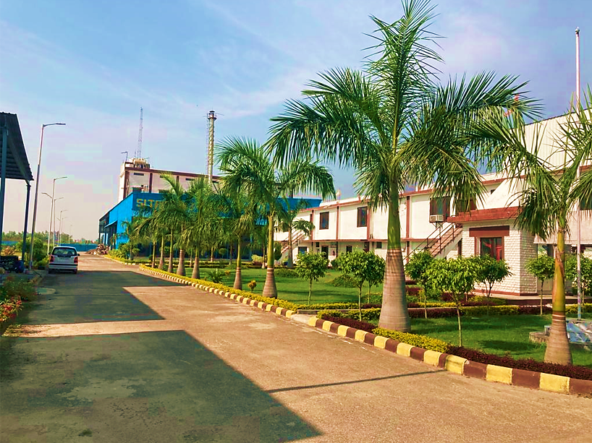
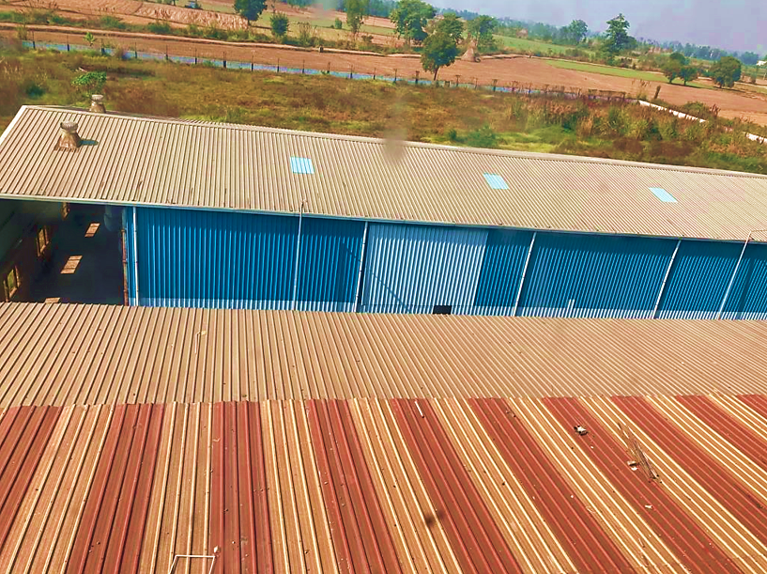
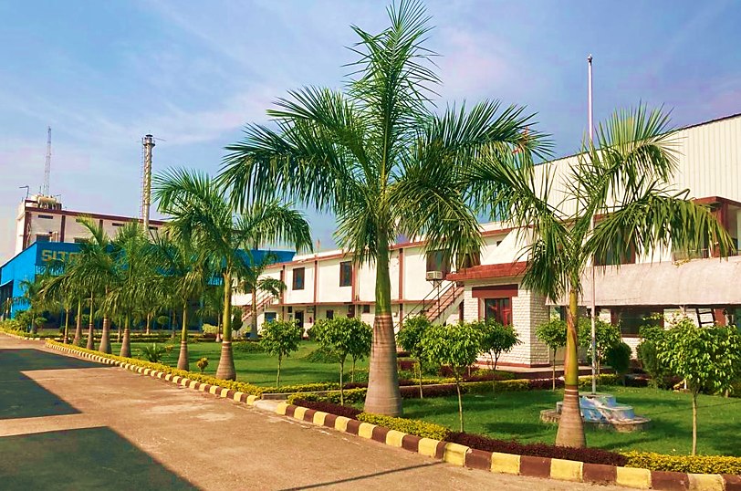

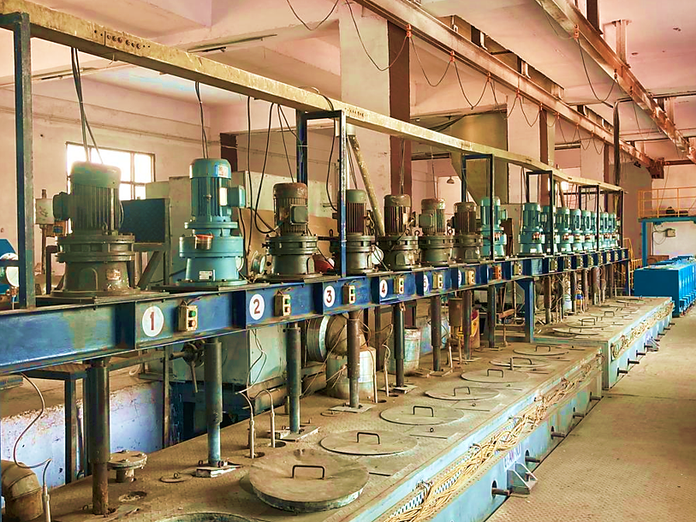

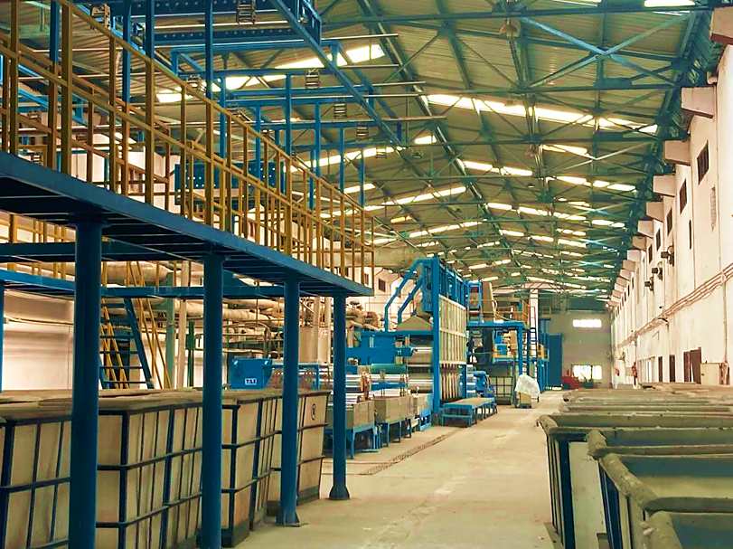

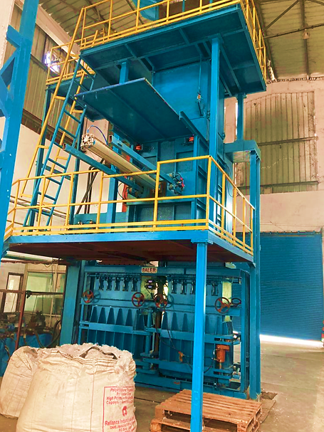

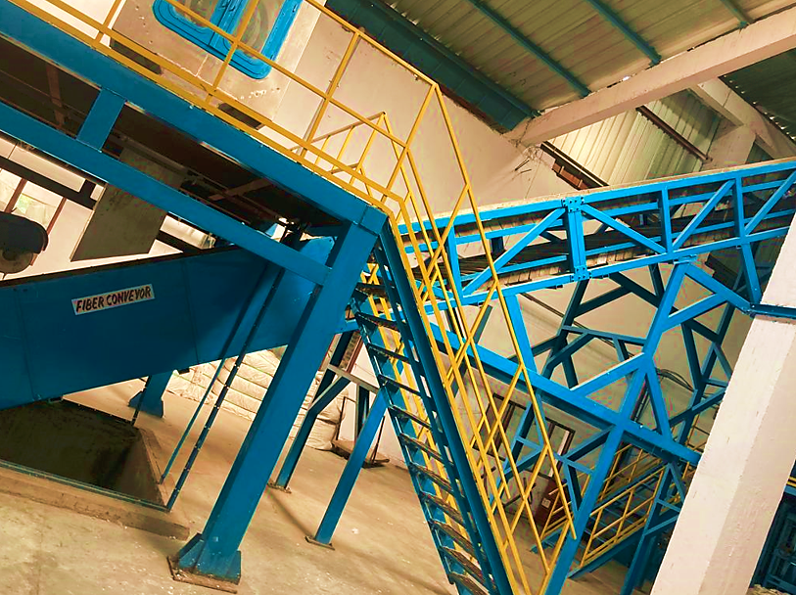

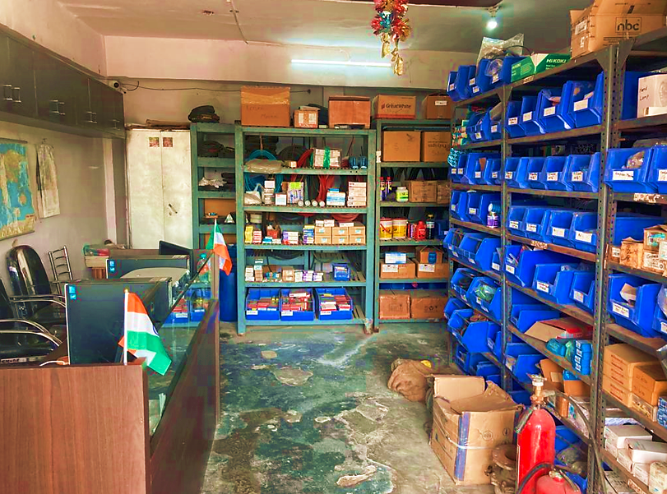

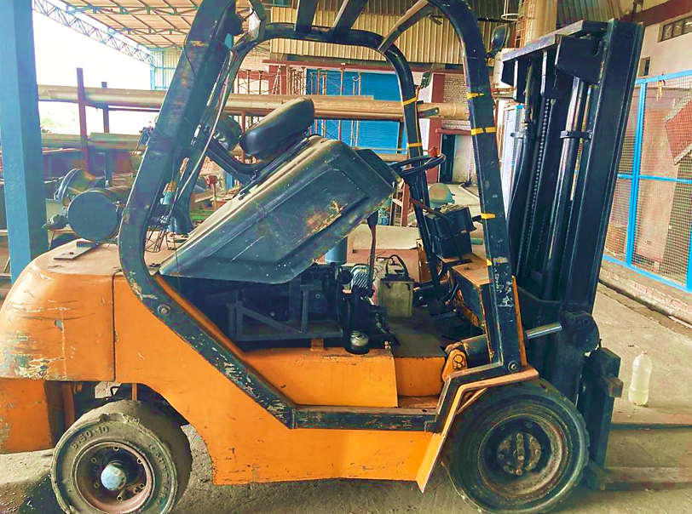

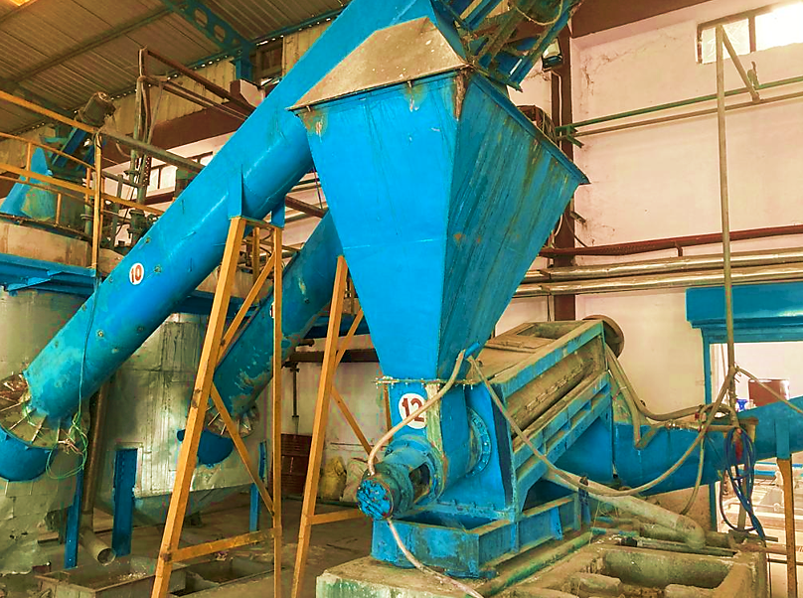
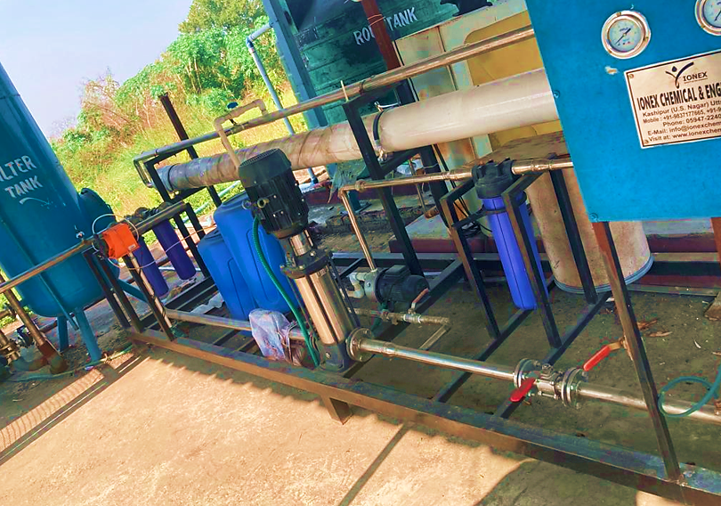

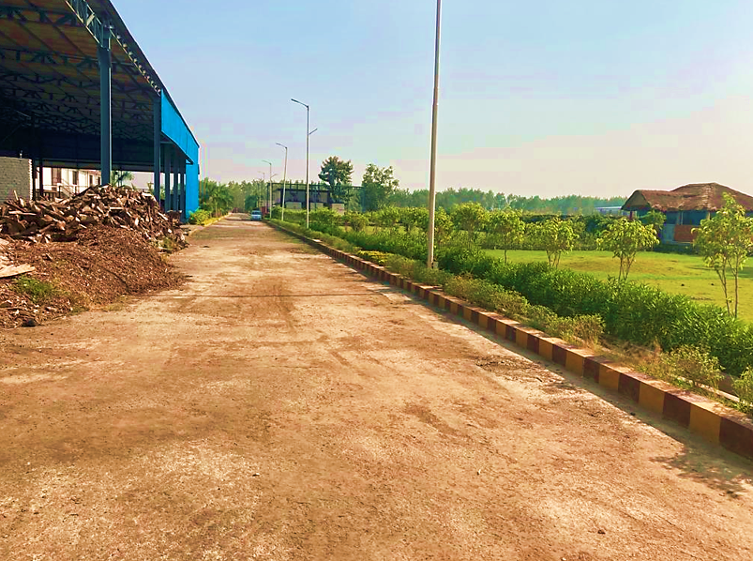
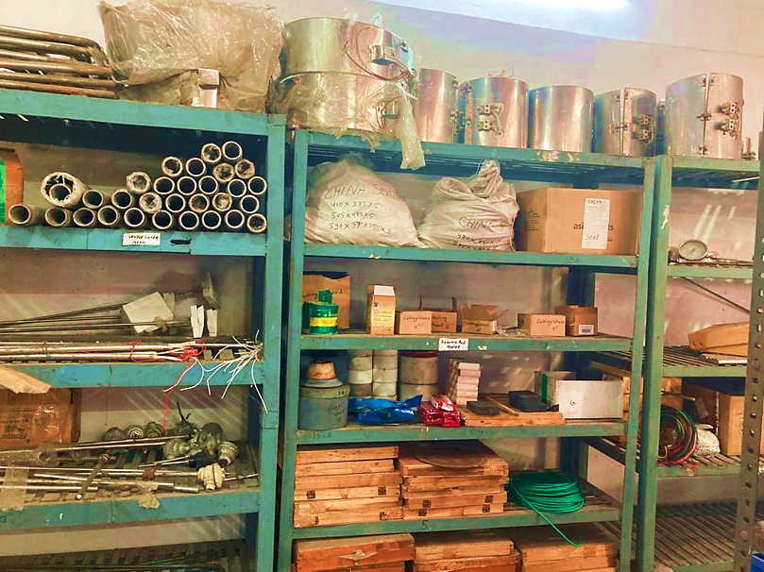

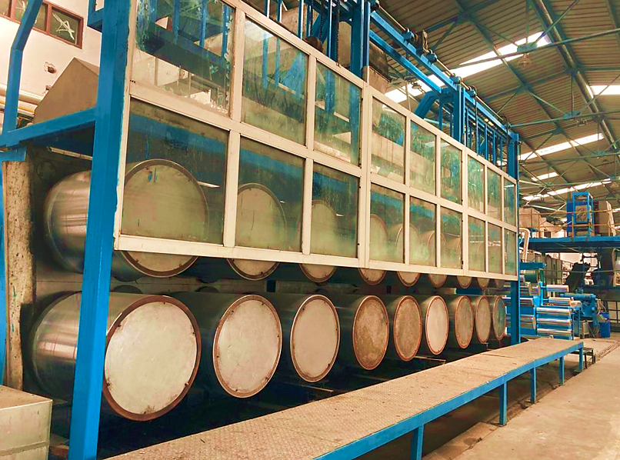
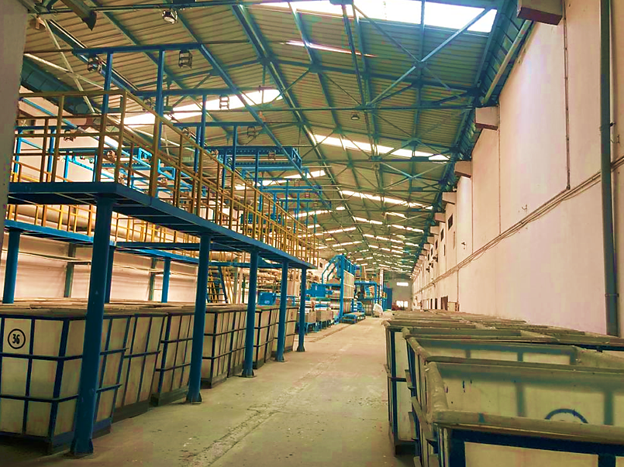

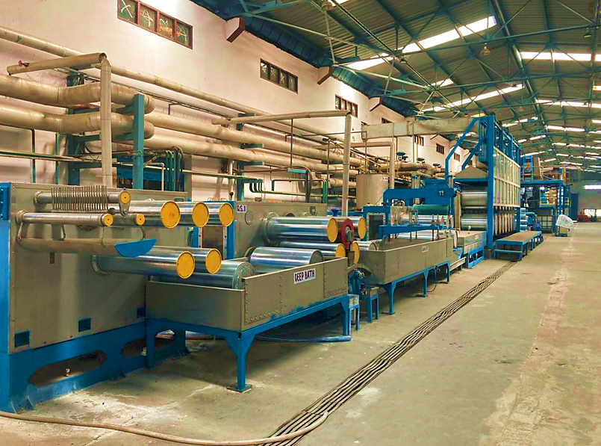
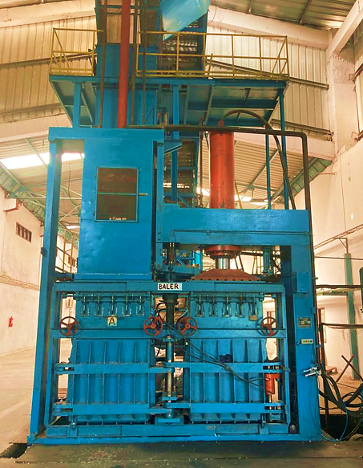

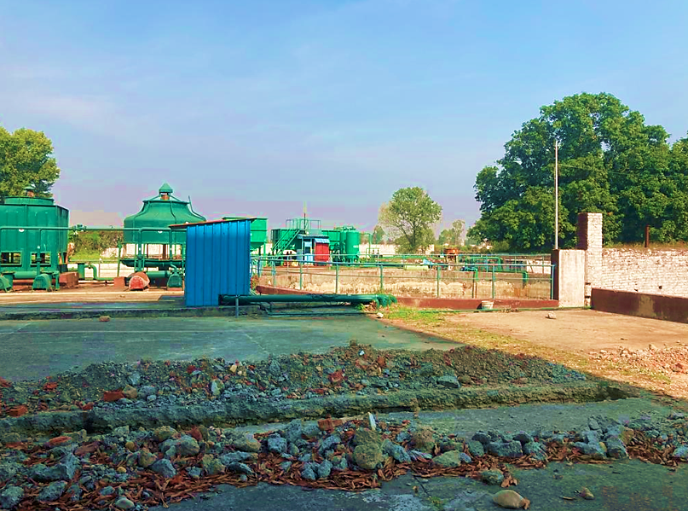
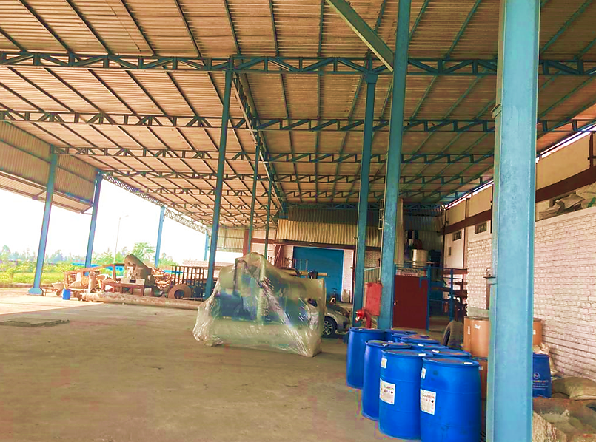

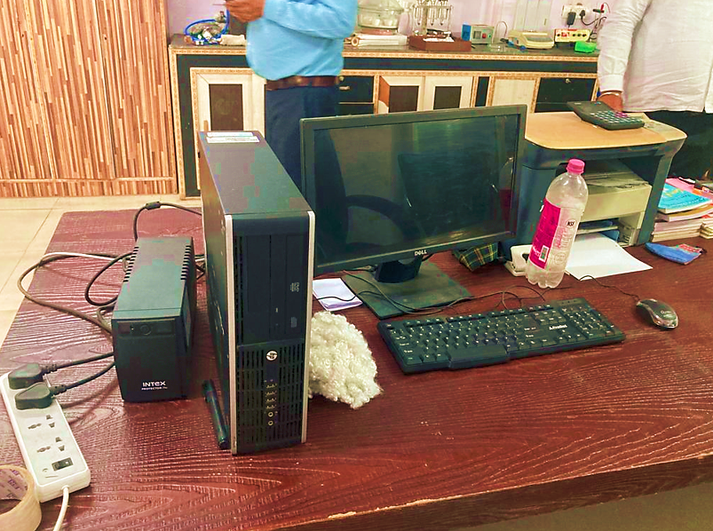
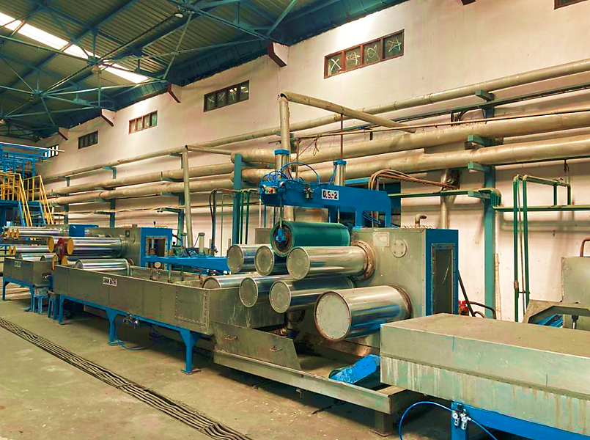

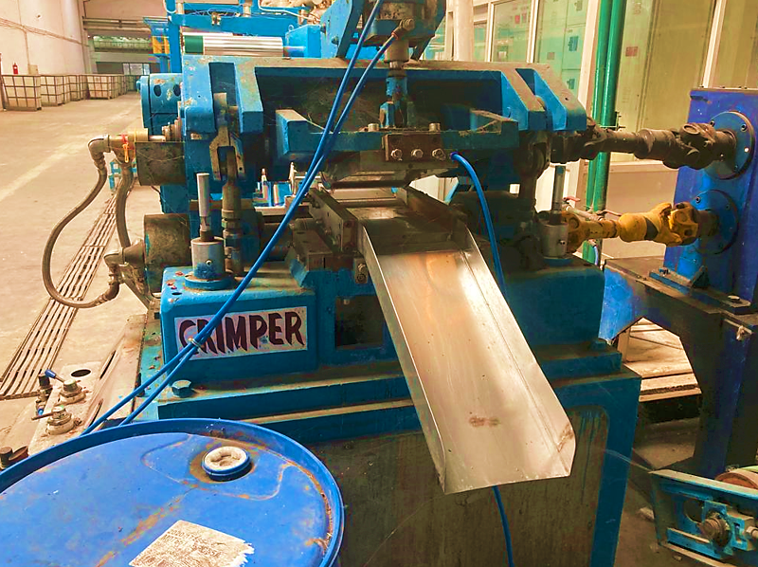
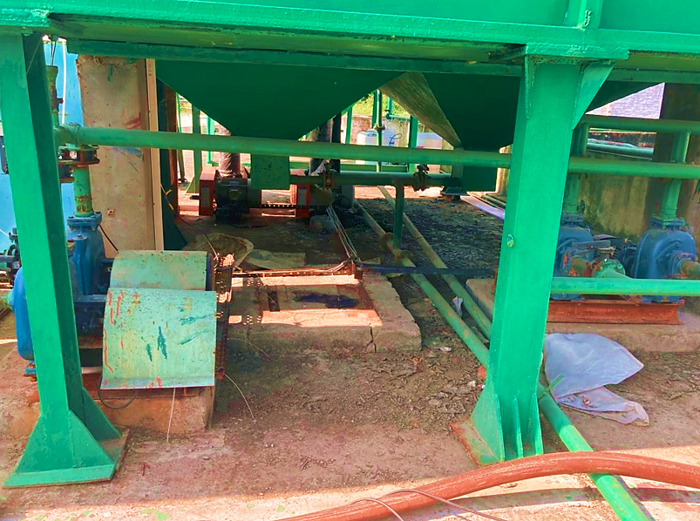

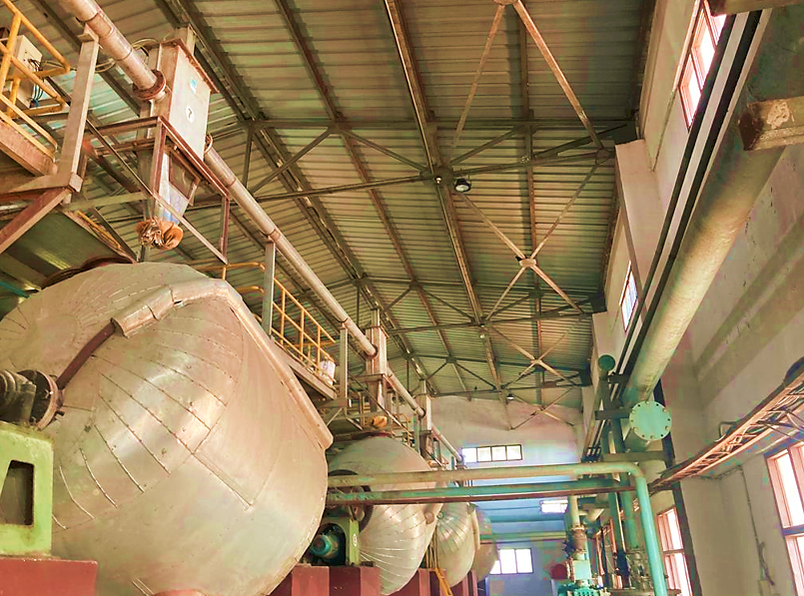
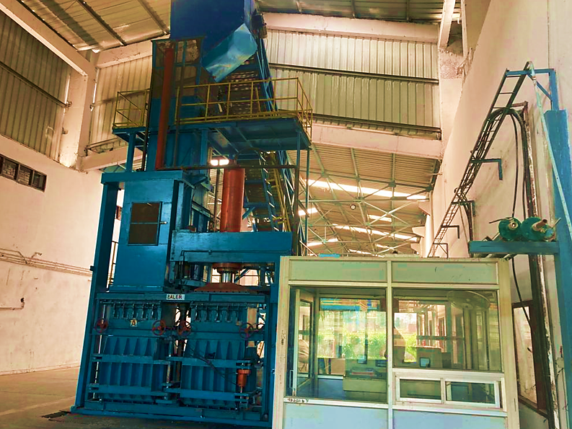

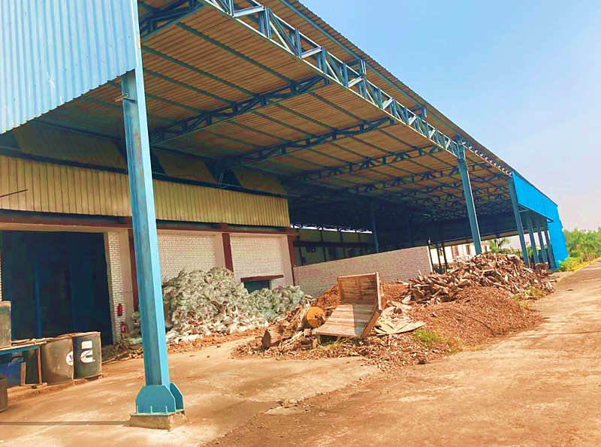
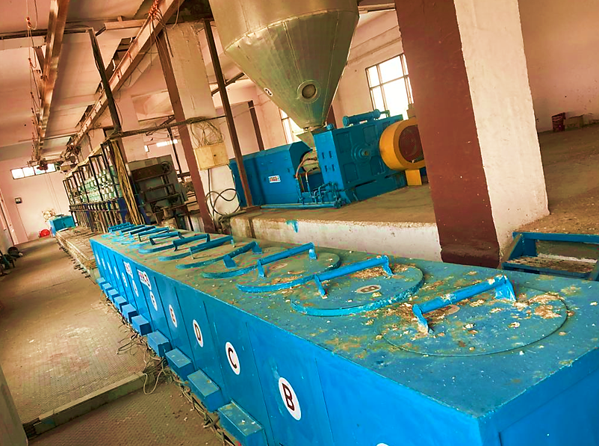

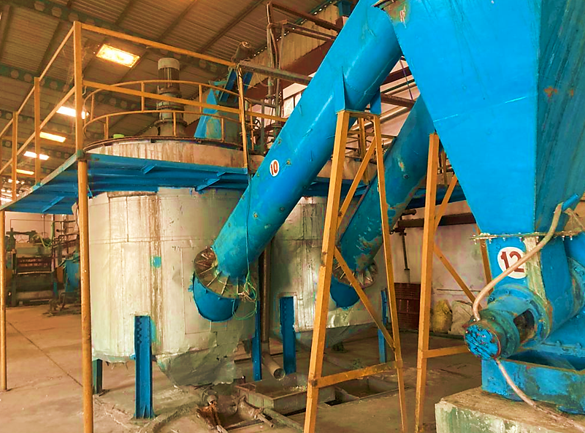

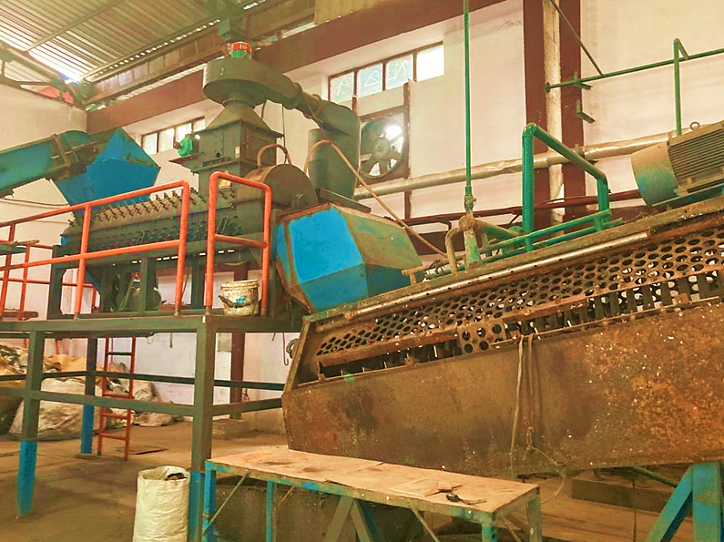

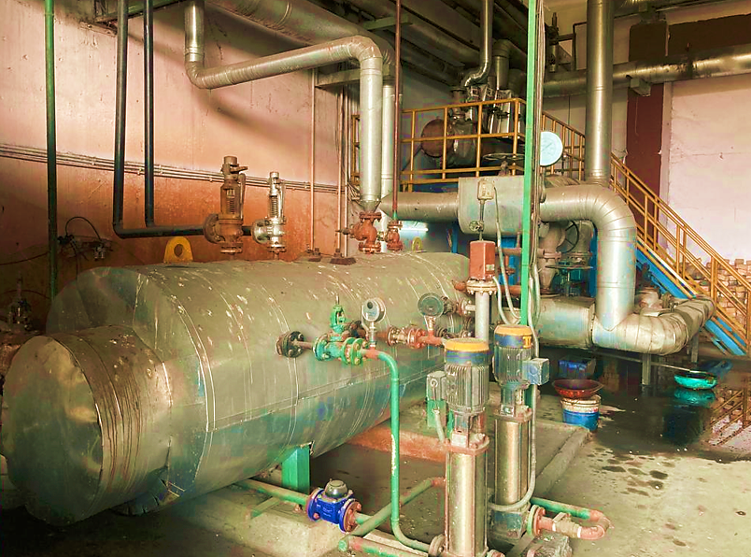

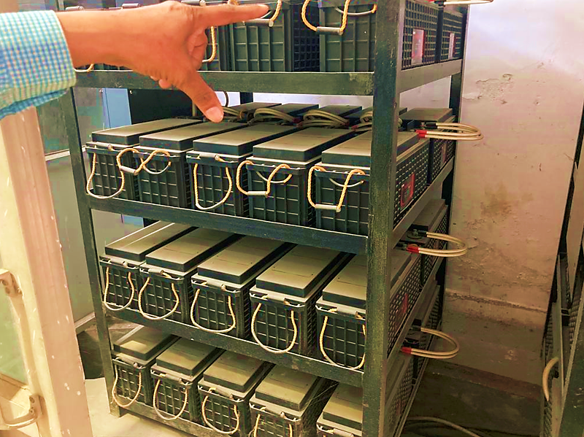

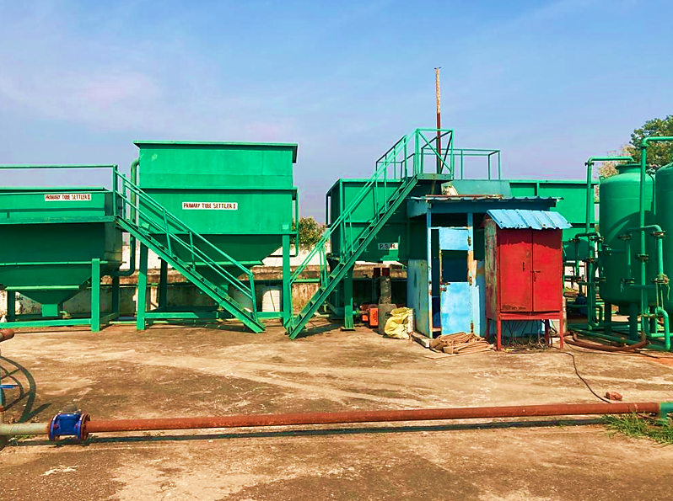
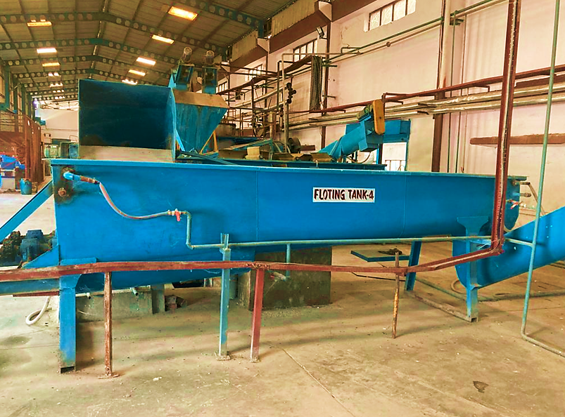

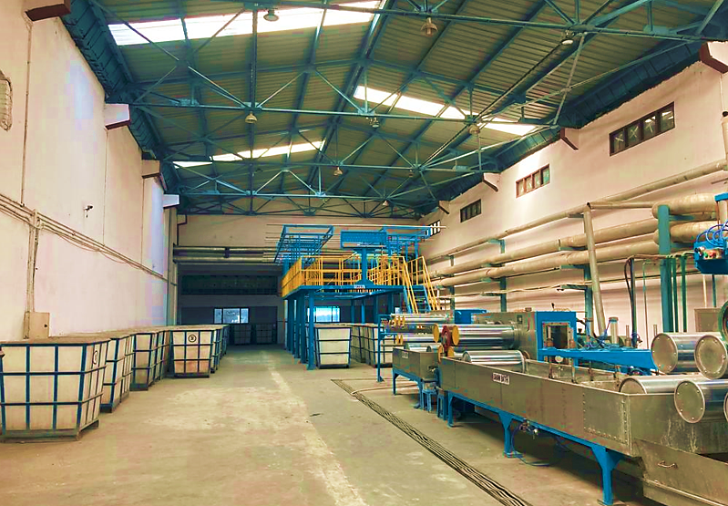

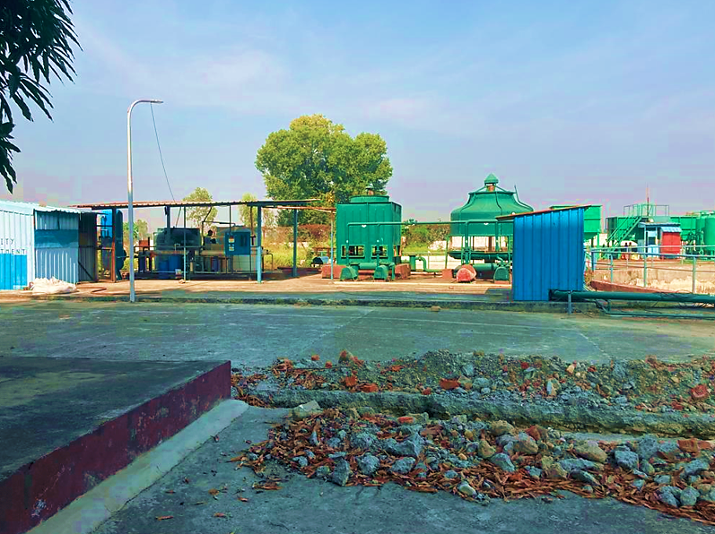

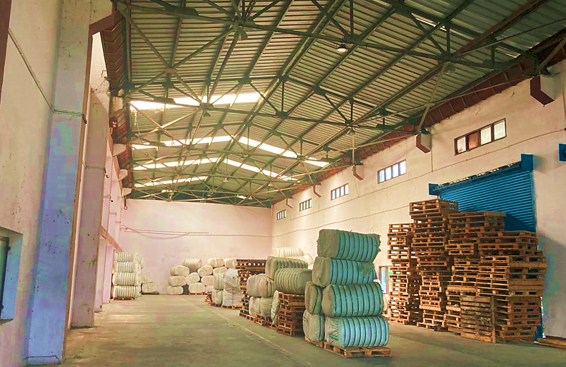

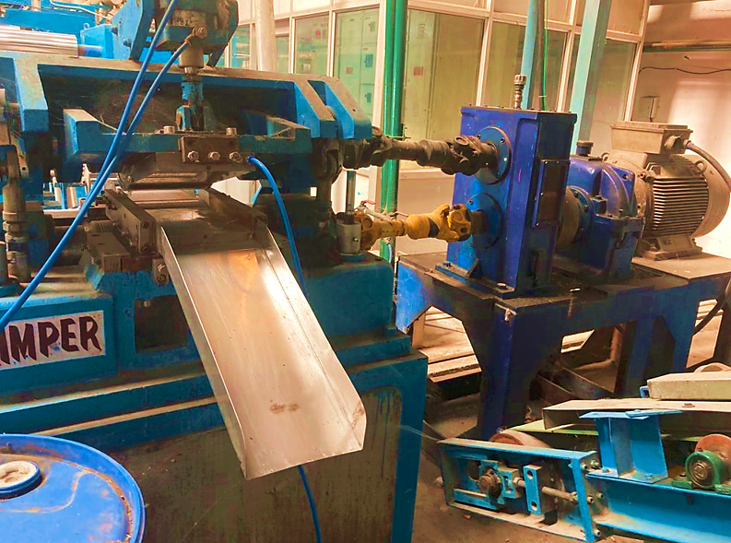

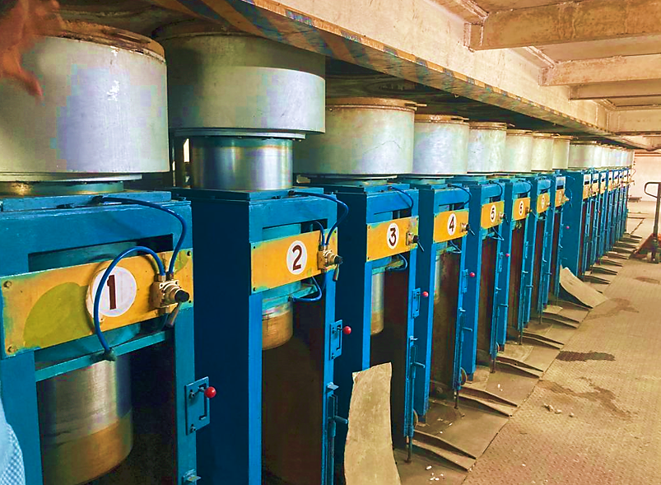
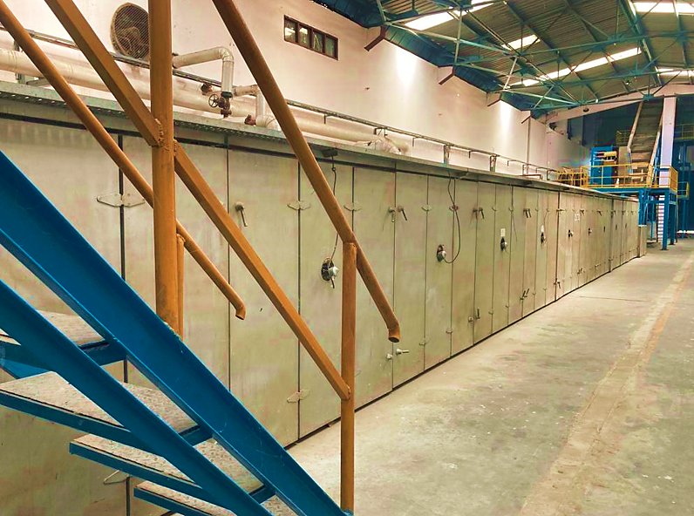

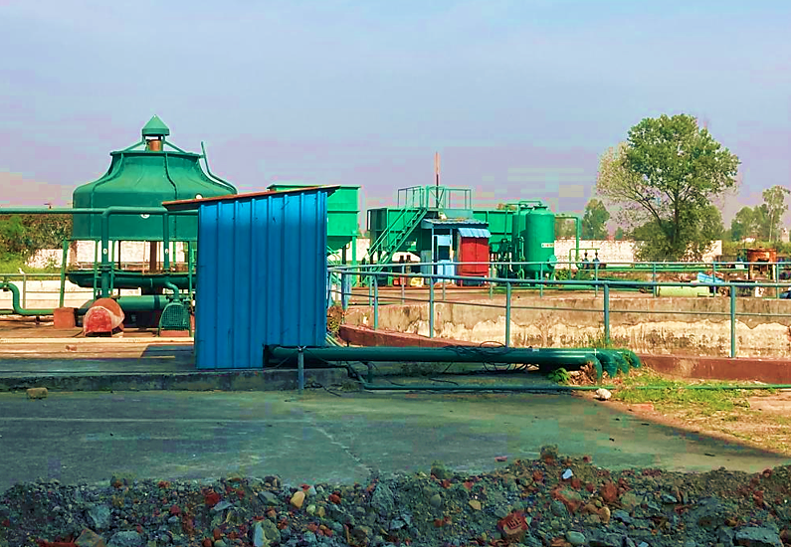
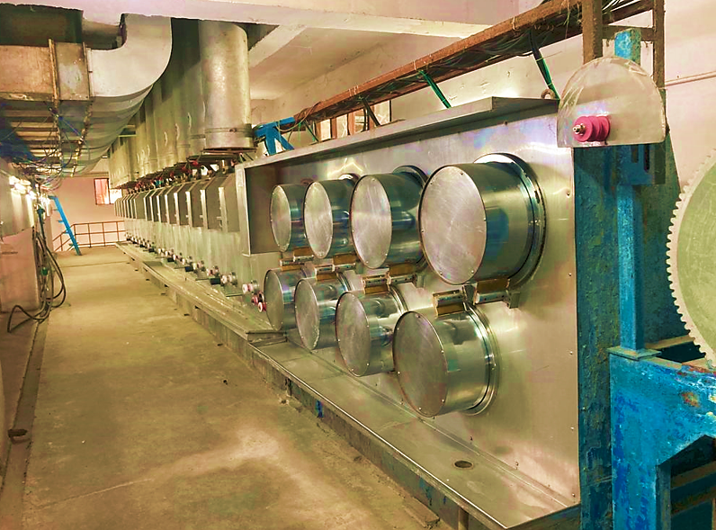

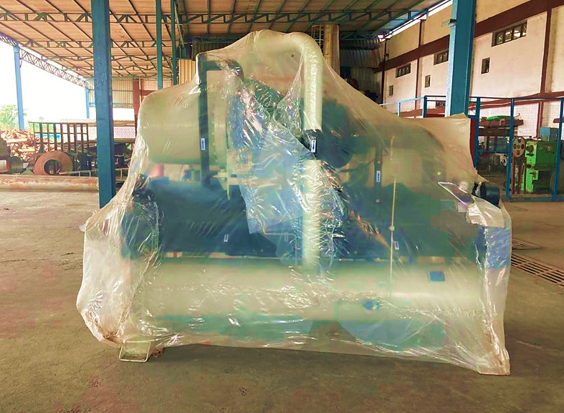
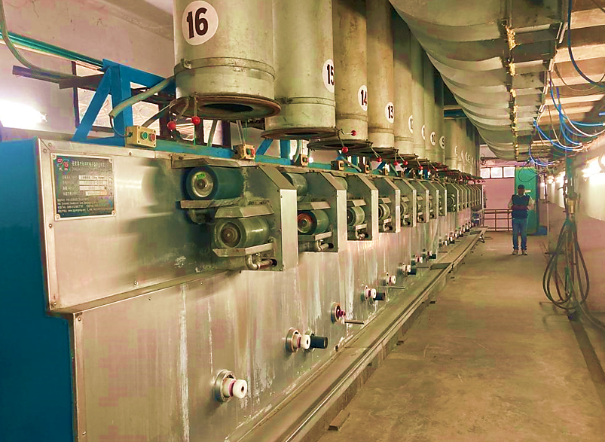

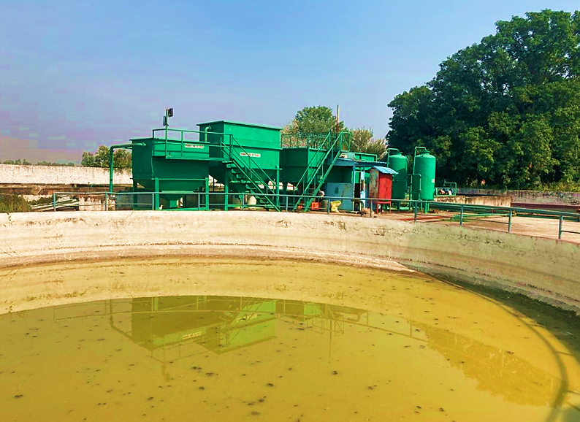
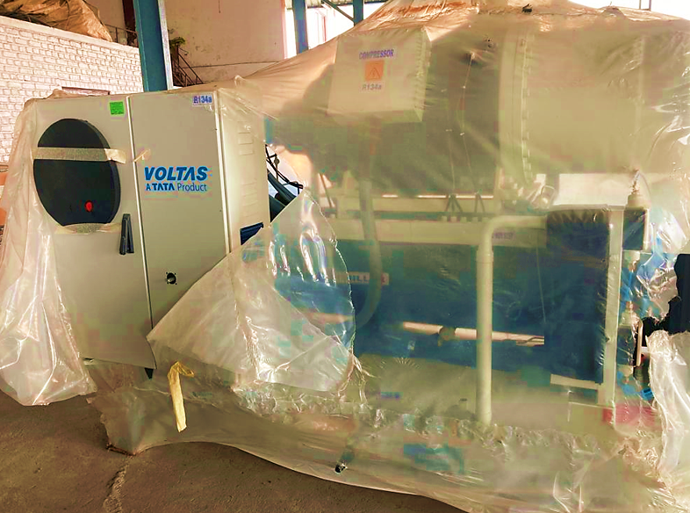

- PLANT AND MACHINERY DETAILS:
As per the details provided by the company, following machineries are already installed at the site and were also physically verified on site Visit:

Sr. No. | ITEM | DRIVES | CAPACITY | QTY (Nos.) | Country Of Origin | Supplier
1. | Vacuum Dryer with auto feed system | - | 1800 Kg/dryer | 10 | China | ZhangiaganG Yongxing Machinery Co., Ltd.
2. | Extruder (170 Diameter) | With AC Inverters | 30 ton/day | 02 | China
3. | Spinning beam with accessories | With AC Inverters | 30 tons/day | 02 | China
 | 16 (8x2) spinning positions |  | - | - | -
 | Continuous filtration system |  | - | - | -
4. | Take up unit | With AC Inverters | 60 tons/day | 01 | China
5. | Can Travers unit | With AC Inverters | 60 tons/day | 01 | China
6. | Cans | - | 800 kg | 150 | China
7. | Draw Line | With AC Inverters | 60 tons/day | 01 | China
 | Annealer: 18 rolls (820 Dia x 900) |  | - | - | -
 | Crimper: 24 lac tow denier |  | - | - | -
8. | Baler Twin Box turn type | - | up to 290 kg/ Bale | 02 | China
9. | Pneumatic conveying system | With AC Inverters | 60 t/day | 01 | Mecaber, Mumbai
10. | PET Crushing and Washing Line |  | 60t/Day | 01 | China
11. | Lab Equipment’s & all major apparatus | - | - | 14 | China

LIST OF MAIN UTILITY EQUIPMENTS:

Below is the tabulated representation of main utility equipment:

Sr. No. | Item | Year of Make | Capacity | Quantity | Supplier
1. | DG set with Load Shredder mode | 2011 | 500 KVA | 3 | Kirloskar make
2. | Transformer | 2010 | 2000 KVA | 1 | Crompton Greaves
3. | VCB | 2010 | 800 Amp. | 1 | Crompton Greaves
4. | UPS | 2021 | 400 KVA | 1 | Riello Aros, Italy
5. | Thermo pack | 2010 | 30,000 Kcal | 1 | Thermotech
6. | Steam Generator | 2010 | 1 ton/hr | 1 | Savior boilers
7. | Air Compressor (Screw) | 2010 | 41 CFM | 3 | Ingersoll Rand
8. | Chiller | 2021 | 150 Tr | 1 | No Supplier Details Provided
9. | AHU | 2010 | 45,000 m³/h | 1 | No Supplier Details Provided
10. | ETP | 2011 | 300 KLD | 1 | Indo-equip
11. | RO plant | 2021 | 5m³/hr | 1 | Ionex
12. | Fork Lifts | 2011 | 3 tons | 2 | ACE
13. | Pallets | 2011 | 2.5 tons | 4 | Hark
14. | Weighing balance | 2011 | 500 kg | 2 | No Supplier Details Provided
15. | Weighing balance | 2012 | 300 kg | 1 | No Supplier Details Provided
16. | Weighing balance | 2013 | 100 kg | 1 | No Supplier Details Provided
17. | Weighing bridge | 2013 | 80 MT | 1 | No Supplier Details Provided
18. | Weighing balance | 2014 | 5 kg | 1 | No Supplier Details Provided

STATUS OF COMMERCIAL OPERATION’s IN THE PROJECT:

During Site visit all the above listed machineries were physically verified on site. However no Commercial Manufacturing activity was observed to be under progress.

Manufacturing status in the plant was discussed with the concerned person of M/s Sitarganj Fibers limited. Accordingly, the person has informed that the last manufacturing process was undertaken in early October for which the person has also provided the commercial invoices Dated 12th October 2021 and 14th October 2021. According to the commercial invoices the company has supplied a total of 9431.10 Kg (9 MT) of Polyester Staple Fibre (PSF) to M/s Shree Ganesh Trading which is also one of their proposed Buyer.

- UTILITIES:
Details of Water and Electricity are described as below:

- Electricity
The company has obtained electricity connection from Uttarakhand Power Corporation Limited (UPCL) vide Customer Account Number 42000975261. The company has provided the bill for bill period 31st August 2021 to 30th September 2021 for contractual load of 1800KVA.

- Water
The company has not obtained any permanent water connection and is currently extracting water from Borewell. The company has to obtain approval from UJVNL/CGWA for abstracting Ground water. As well as the company is having the Rain water harvesting system 10,00,000 per annum capacity which is sufficient to run the unit smoothly.

PART F | PROJECT TECHNICAL DETAILS

- MANUFACTURING PROCESS:
Worldwide millions of PET bottle are consumed daily and thrown to trash. PET is also called polyester. Polyester is a synthetic polymer made of purified terephthalic acid (PTA) or its dimethyl ester dimethyl terephthalate (DMT) and monoethylene glycol (MEG).Since PET bottles are practically non bio-degradable, it is very difficult to dispose them. New technology was developed in Europe, Korea and finally China which helped in recycling these post consumed PET bottles to make man-made fibres like Recycled Polyester Staple Fibre (PSF). These fibres are then used to make non-woven carpet for auto-mobiles, making quilts, yarns, pillows etc.



Steps for Production of Recycled polyester Staple Fibre is as below:

Step 1: First bottles arrived in a factory, collected from trash, in bale form.

Step 2: These bales are opened and manually sorted to take out contaminations like iron, PVC, stones etc.

Step 3: Once cleared these PET bottles are crushed to make 12-15 mm flakes and are hot washed in chemical solution containing 2% solution of Sodium Hydroxide. This chemical helps in taking out glue from bottles and also cleaning them. The overall contaminations in PET flakes should not be more than 200 ppm.

Step 4: These flakes are then dried and taken to vacuum driers where surface moisture as well as inherent moisture is taken out and flakes becomes soft/crystallized & dried. Moisture held within the PET flakes itself is known as inherent moisture. The Driers helps to reduce the inherent moisture to less than 200 PPM.

Step 5: These dried flakes are then taken to Extruder for spinning. Spinneret are available to make either hollow or solid PSF of varying denier (1.5Den-50Den). Filaments coming out of spinning are collected in cans or bobbins. This completes the spinning.

Step 6: Hollow and Solid PSF can be treated to make Siliconized, conjugated, polyfill, harsh, bouncy, anti-static and anti-fungal.

Step 7: These cans are taken to Creel area where many cans or bobbins are combined to make tow and stretched several times in a chemical hot bath to make fibre.

Step 8: These fibres are then dried and relaxed in a relaxer and cut in various cut length before bale packing.

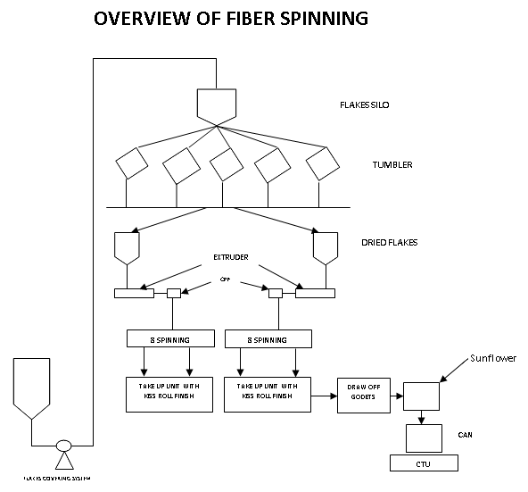
- PLANT TECHNICAL SPECIFICATIONS:
The company has proposed to design the process flow of production of Recycled polyester Staple Fibre (PSF) for which the company has deployed the following machineries

Sr. No. | Item | Capacity | Quantity (Nos.)
1. | Vacuum Dryer with auto feed system | 1800 Kg/dryer | 10
2. | Extruder (170 Diameter) | 30 ton/day | 02
3. | Spinning beam with accessories | - Tons/day | 02
 | - 16 (8x2) spinning positions | - | -
 | - Continuous filtration system | - | -
4. | Take up unit | 60 tons/day | 01
5. | Can Travers unit | 60 tons/day | 01
6. | Cans | 800 kg | 150
7. | Draw Line | 60 tons/day | 01
 | - Annealer:18 rolls (820dia x 900) | - | -
 | - Crimper: 24 lac tow denier | - | -
8. | Baler Twin Box turn type | Up to 290 kg/ Bale | 02
9. | Pneumatic conveying system | 60 Ton/day | 01
10. | Lab Equipment’s & all major apparatus | - | 14

- ANALYSIS OF MACHINERY SUPPLIERS AND PRODUCTION CAPACITY BASED ON MACHINERY INFORMATION PROVIDED BY THE COMPANY:

Sr. No. | Item | Capacity | Supplier | Remarks
1. | Vacuum Dryer with auto feed system | 1800 Kg/dryer | Zhangiagan G Yongxing Machinery Co., Ltd. | As per information in Public Domain Zhangiagan G Yongxing Machinery Co., Ltd. Is a reputed supplier of all these machineries.
2. | Extruder (170 dia) | 30 ton/day
3. | Spinning beam with accessories | 30 tons/day
 | - 16 (8x2)spinning positions | -
 | - continuous filtration system | -
4. | Take up unit | 60 tons/day
5. | Can Travers unit | 60 tons/day
6. | Cans | 800 kg
7. | Draw Line | 60 tons/day
 | -Annealer:18 rolls (820dia x 900) | -
 | -Crimper: 24 lac tow denier | -
8. | Baler Twin Box turn type | Up to 290 kg/ Bale
9. | Pneumatic conveying system | 60 t/day
10. | Lab Equipment’s & all major apparatus | -
11. | DG set with Load Shredder mode | 500 KVA | Kirloskar Oil Engines Limited (KOEL) | As per Information available in Public domain Kirloskar Oil engines Limited (KOEL) is a reputed supplier of DG sets
12. | Transformer | 2000 KVA | Crompton Greaves | As per Information available in Public Domain CG Power and Industrial Solution Limited Erst. Crompton greaves limited is a reputed supplier of Transformer and VCB.
13. | VCB | 800 Amp. | Crompton Greaves
14 | UPS | 400 KVA | Riello Aros | As per Information available in Public Domain Riello Aros is a reputable supplier of Universal Power Source equipment’s.
15. | Thermopack | 30,000 Kcal | Thermotech Systems Limited | As per Information available in Public Domain Thermotech systems limited is a reputable supplier of Thermopack.
16. | Steam Generator | 1 ton/hr | Saviour Boilers Private Limited | As per information available in Public Domain Saviour Boilers Private Limited is a reputed supplier of Steam Generator.
17. | Air Compressor (Screw) | 41 CFM | Ingersoll Rand | As per information Available in Public Domain Ingersoll rand is a reputable supplier of Air Compressor.
18. | Chiller | 150 Tr | No Supplier Details Provided | -
19. | AHU | 45,000 m³/h | No Supplier Details Provided | -
20. | ETP | 300 KLD | Indo-equip | No information available in Public Domain
21. | RO plant | 5m³/hr | Ionex Envirotech Private Limited | As per Information available in Public domain Ionex Envirotech Private limited is a reputable supplier of RO Plants.
22. | Fork Lifts | 3 Tons | Action Construction Equipment (ACE) | As per information available in Public Domain ACE is a reputable supplier of Fork Lifts.
23. | Pallets | 2.5 Tons | Hark Engineers Private Limited | As per information available in Public Domain Hark engineers Private Limited is a reputable supplier of Pellets.
24. | Weighing balance | 500 kg | No Supplier Details Provided | -
25. | Weighing balance | 300 kg | No Supplier Details Provided | -
26. | Weighing balance | 100 kg | No Supplier Details Provided | -
27 | Weighing bridge | 80 MT | No Supplier Details Provided | -
28. | Weighing balance | 5 kg | No Supplier Details Provided | -

The plant is having a total capacity of 21,600 ton per annum, considering a 2.5 ton per annum capacity. Below is the tabulated representation of the proposed capacity of the plant:

PRODUCTION CAPACITY OF INTAKE UNIT
Particulars | Capacity | UOM | Remarks
Capacity of Raw Material Intake Unit | 60.00 | Ton/Day | Intake capacity of First step in Manufacturing Process.
Quantity of Intake Unit | 1.00 | Nos | -
Hours in a Day | 24.00 | Hours | -
Raw material take up capacity Per Hour | 2.50 | Ton/Hour | Raw material Take up capacity Per Hour in the Intake Unit.
No. of Working hours in a Day | 24.00 | Hours | -
No. of Working Days in an Year | 360.00 | Days/Year | -
Total Production Capacity per Year | 21600.00 | Ton/Year | Considering 2.5 Tons/Hour Production capacity.

Below is the tabulated and graphical representation of production capacity of conveying system:

PRODUCTION CAPACITY OF CONVEYING SYSTEM
Capacity of Conveying System | 60.00 | Ton/Day | Conveying capacity of Finished Goods.
Quantity of Conveying Systems | 1.00 | Nos | -
Hours in a Day | 24.00 | Hours | -
Raw Material Conveying capacity Per Hour | 2.50 | Ton/Hour | Conveying capacity of Finished Goods Per Hour.
No. of Working hours in a Day | 24.00 | Hours | -
No. of Working Days in an Year | 360.00 | Days/Year | -
Total Conveying capacity in an year | 21600.00 | Ton/Year | Considering 2.5 Tons/Hour Conveying Capacity.

PRODUCTION CAPACITY OF EXTRUDER MACHINE
Capacity of Extruder Machine | 30.00 | Ton/Day | Extruding capacity of Goods.
Hours in Day | 24.00 | Hours | -
Quantity of Extruder Unit | 2.00 | Nos | -
Quantity of Extruded good Produced Per Hour/Per machine | 1.25 | Ton/Hour/Machine | Extruding capacity of Goods Per Hour.
No. of Working hours in a Day | 24.00 | Hours | -
No. of Working Days in an Year | 360.00 | Days/Year | -
Total Extrusion Capacity in an year | 21600.00 | Ton/Year | Considering 1.25 Tons/Hour/ Machine Extrusion Capacity.

Below is the tabulated and graphical representation of spinning machine:

PRODUCTION CAPACITY OF SPINNING MACHINE
Capacity of Spinning Machine | 30.00 | Ton/Day | Spinning capacity of Goods.
Hours in Day | 24.00 | Hours | -
Quantity of Spinning machines | 2.00 | Nos | -
Quantity of Spinning goods Produced Per Hour/Per machine | 1.25 | Ton/Hour/Machine | Spinning Capcity of Goods Per Hour/Per Machine.
No. of Working hours in a Day | 24.00 | Hours | -
No. of Working Days in an Year | 360.00 | Days/Year | -
Total Spinning Capacity in an year | 21600.00 | Ton/Year | Considering 1.25 Tons/Hour/ Machine Spinning Capacity.

Below is the tabulated and graphical representation of production capacity of Vacuum Dryer:

PRODUCTION CAPACITY OF VACCUM DRYER
Capacity of Vacuum Dryer | 1.80 | Tons/ Dryer | Drying Capacity of Each Dryer.
Quantity of Dryers | 10 | Nos | -
Total Dryer Capacity | 18.00 | Tons | Total Drying capacity in the Project.
Production Capacity Per Hour | 2.50 | tons | -
Total Working Hours | 24 | Hours | -
Total Production capacity Per day | 60 | Ton | -
Total Number of Runs required for each Dryer per day | 3.33 | Times/Day | -
Total Runs of 1 Dryer Per Year | 1200 | Times/ Year | Considering 100% Operational Efficiency.

- RAW MATERIALS:

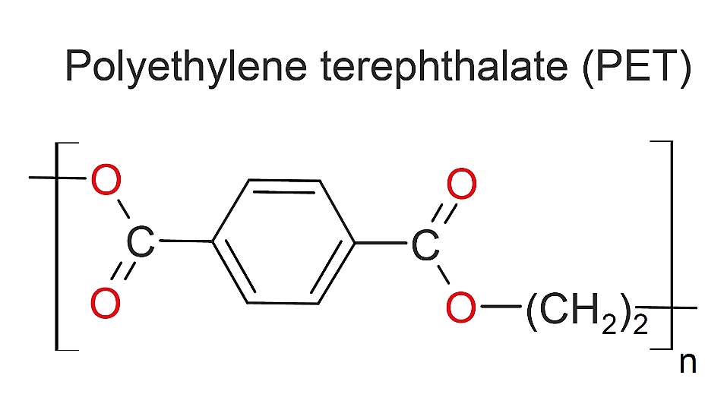

The Main raw material to be used for Production of Recycled Polyester Staple Fiber (PSF) is PET bottle where PET stands for “Polyethylene terepthalate”.

PET, which stands for polyethylene terephthalate, is a form of polyester (just like the clothing fabric). It is extruded or moulded into plastic bottles and containers for packaging foods and beverages, personal care products, and many other consumer products.
PET is a highly valued packaging material because it is strong yet lightweight, non-reactive, economical, and shatterproof. PET's safety for food, beverage, and personal care, pharmaceutical and medical applications is recognized by health authorities around the world.

PET containers are popular for packaging sodas, water, juices, salad dressings, cooking oil, peanut butter, shampoo, liquid hand soap, mouthwash, pharmaceuticals, even tennis balls. Virtually all single-serving and 2-liter bottles of carbonated soft drinks and water sold in the U.S. are made from PET. Special grades of PET are used for carry-home prepared food containers that can be warmed in the oven or microwave.

PET is recyclable and highly sustainable. It can be recovered and recycled again and again –– back into containers for foods, beverages and personal care products – or into carpet and clothing fibres, automotive parts, construction materials, industrial strapping or other packaging materials. Approximately 1.5 billion pounds of used PET bottles and containers are collected in the U.S. each year for recycling. PET is the most recycled plastic in the U.S.

PET is a remarkably energy-efficient packaging material, with an environmental impact that compares very favourably to glass, aluminium and other container materials. Although PET's feedstock are derived from crude oil and natural gas, approximately 40% of that energy is trapped within the PET polymer for recapture and reuse every time PET is recycled. And because PET is very strong yet lightweight, it allows more product to be delivered with less packaging, less weight and less fuel for transport. These factors help explain why life cycle studies of PET have consistently shown it to be a highly sustainable material with a positive environmental profile.

Recycling used PET bottles and jars into new food-grade PET bottles and containers is a key example of the environmental benefits and sustainability of PET as a packaging material. The development of modern and efficient plants dedicated to the closed-loop recycling of PET bottles continues to increase around the world.

- SOURCE OF PROCUREMENT
The Main raw material to be used for Production of Recycled Polyester Staple Fiber (PSF) is PET bottle. M/s Sitarganj Fibers Limited has planned to buy Raw materials from below mentioned suppliers:

    - M/s Anisha Impex Limited
    - M/s A. Rahaman enterprises
    - M/s Danish Old plastic suppliers.
    - M/s Kanak Plastic
    - M/s maa Kamakhya Traders
    - M/s PNGL International
    - M/s Radhey enterprises
    - M/s Vansh Polypack LLP

- MANPOWER:
Detailed list of Workforce Planning of the project is as below:

Sr. No. | Particulars | No. of Employees
1. | Plant Head/Manager | 1
2. | Technician and Marketing | 35
3. | Skilled Labour | 85
4. | Unskilled Labour | 40
5. | Supporting staff | 8
6. | Security Guard | 4
7. | Account and Finance | 3
 | Total Workforce Planned | 176

PART G | PRODUCT PROFILE

- INTRODUCTION:
Polyester staple fibre (PSF) is a material produced from Used Pet Bottles with a variety of uses in the textile, automotive and furniture industries. The Phrase "Staple Fibre" often refers to a kind of natural fibre such as cotton or wool, which can be twisted to form yarn.

Polyester has many industrial applications because of its special characteristics, especially its resistance to stretching or shrinking and general strength as a fibre. It also dries quickly, while remaining crisp and strong afterwards, so this material is easily washed. Polyester staple fibre resists wrinkles, mildew, general surface damage and most chemicals. This material also holds creases and pleats well, as long as they have been heat-set first.

Polyester staple fibre is the main fibre used in fabrics, worldwide. Amongst several other modes of recyclable fibre, regenerated polyester staple fibre occupy the prime place. The main advantage of PSF is the low cost comparing the virgin fibre.

PSF is mainly classified as Textile fibre, Hollow Polyester staple fibre & solid fibre. Hollow PSF can also have some properties like Conjugated, Siliconized, Slick and Dry PSF. These properties are usually represented as HSC (Hollow Conjugated Siliconized), HCNS (Hollow Conjugate Non-Siliconized) or Slick PSF that has a smooth finish. Depending on the lustre, PSF can be classified as Semi Dull and Bright.

The textile fibres is used in spinning mills for yarn production other uses include for cushions, Quilts, Furniture items, sofas, Carpets, bags, rugs and automotive industries. The main market comprises of area involved in spinning mills in Rajasthan (Bhilwara), Haryana (Panipat, Bhiwadi), Punjab (Ludhiana and Amritsar), Himanchal Pradesh (Baddi) and other sectors throughout the India. The company proposes to supply fibers to various leading textile mills Which will use the same for producing different types of yarns (100% polyester yarn, cotton blended yarn, polyester-acrylic blended yarn, polyester viscose blended yarn, etc.) as well as cushioning products (carpets, sofa, dolls, toys, mattress, furniture, toys, dolls, etc.).

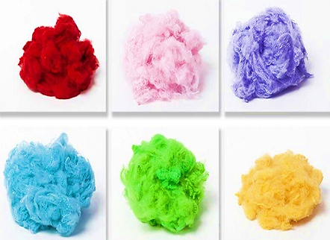

- PRODUCT SPECIFICATIONS:
Polyester Staple fibre (PSF) is somewhat Polyester fibre made directly from PTA and MEG or PET Chips or from Recycled PET Bottle Flakes. PSF produced using PTA and MEG or PET Chips is known as Virgin PSF and PSF produced using Recycled PET Flakes is called Recycled PSF. 100% virgin PSF is typically unreasonable than recycled PSF and is also more hygienic. Polyester Staple Fiber is generally used in spinning, weaving non-woven.

PSF is mainly used for fibre fillings in cushions and sofa. It is also used generally in spinning to make Polyester Spun Yarn which is then knitted or weaved into fabrics. PSF is mainly classified Solid and Hollow Polyester staple fibre. Hollow PSF can also have a few properties like Conjugated, Siliconized, Slick and Dry PSF. These properties are normally represented to as HSC (Hollow Conjugated Siliconized), HCNS (Hollow Conjugate Non-Siliconized) or Slick PSF that has a smooth finish. Depending upon the lustre, PSF can be classified as Semi Dull and Bright. By mixing colour master-batch, dope dyed PSF can also be obtained in Optical White, Black and a several colours.

Polyester Staple fibre is available in various Deniers with various cut-lengths. It is mainly available in 1.4D, 1.5D, 3D, 6D, 7D, 15D and cut lengths like 32mm, 38mm, 44mm, 64mm. PSF is mainly produced in India, China, Taiwan, Indonesia, Vietnam, Malaysia, and Korea. All Denier specifications for all Fibers that will be produced at Sitarganj Fibers is as below:

Sr. No. | Properties | Unit | 1.5 SNS | 3.0 SNS | 6.0 HNS | 6.0 HS | 15.0 HS | 15.0 HNS | 15.0 SNS
1. | Denier | NA | 1.0 - 2.0 | 2.5 – 3.5 | 5.0 – 7.0 | 5.0 – 7.0 | 9.0 – 13.0 | 9.0 – 13.0 | 9.0 – 13.0
2. | Tenacity | g/d | > 4.0 | > 3.0 | > 3.5 | > 3.5 | > 3.0 | > 3.0 | > 3.0
3. | Elongation | % | 40 - 70 | 40-70 | 60 - 90 | 40 – 70 | 60 - 90 | 60 - 90 | 60 - 90
4. | Crimp Per CM | No. | 3.0 – 4.5 | 2.6 – 3.6 | 1.5 – 3.5 | 1.5 – 2.5 | 1.0 – 2.5 | 1.4 – 3.0 | 1.4 – 3.0
5. | Moisture | % | MAX 0.5 | MAX 0.5 | MAX 0.5 | Max 0.5 | MAX 0.5 | Max 0.5 | MAX 0.5
6. | Finish on Fibre | % | 0.10 - 0.20 | 0.10 - 0.20 | 0.10 – 0.20 | 0.050 – 0.150 | 0.10 – 0.20 | 0.10 – 0.20 | 0.10 – 0.20
7. | L-Colour | NA | > 70 | MIN 70 | MIN 70 | MIN 70 | MIN 70 | MIN 70 | MIN 70
8. | 'b' Colour | NA | < 3.0 | < 3.0 | < 3.0 | < 3.0 | < 3.0 | < 3.0 | < 3.0

- PRODUCT PROPERTIES:
Polyester is a category of polymer whose monomer contains the ester functional group. The most common polyester for fibre purposes is poly (ethylene terephthalate), or simply PET. This is also the polymer used for many soft drink bottles and it is becoming increasingly common to recycle them after use by re-melting the PET and extruding it as fibre. This saves valuable petroleum raw materials, reduces energy consumption, and eliminates solid waste sent to landfills.

PET is made by reacting ethylene glycol with either terephthalic acid or its methyl ester in the presence of an antimony catalyst. The reaction is carried out at high temperature and vacuum to achieve the high molecular weights need to form useful fibres. PET is melt spun.

Today over 70 to 75% of the polyester is produced by CP (continuous polymerization) process using PTA (Purified Terephthalic Acid) and MEG. The old process is called the Batch process using DMT (Dimethyl Terephthalate) and MEG (Mono Ethylene Glycol). Catalysts like 5b3O3 (ANTIMONY TRIOXIDE) are used to start and control the reaction.

TiO2 (Titanium dioxide) is added to make the polyester fiber/filament dull. Spin finishes are added at melt spinning and draw machines to provide static protection and have cohesion and certain frictional properties to enable fiber to get processed through textile spinning machinery without any problem.

Properties of Polyester Fibres
- Denier: 0.5D – 15D
- Tenacity : Dry 3.5 – 7.0 : wet 3.5 – 7.0
- %Elongation at break: Dry 15 – 45: wet 15 45
- %Moisture Regain: 0.4
- Shrinkage in Boiling Water: 0 – 3
- Crimps per Inch: 12 -14%
- Dry Heat Shrinkage: 5 – 8 (at 180 C for 20 min)
- Specific Gravity: 1.36 – 1.41%
- Elastic Recovery @2% =98 : @5% = 65
- Glass Transition Temp: 80 degree C
- Softening temp: 230 – 240 degree C
- Melting point: 260 – 270 degree C
- Effect of Sunlight: turns yellow, retains 70 – 80% tenacity at long exposure
- Resistance to Weathering: good
- Rot Resistance: high
- Alkali Resistance: damaged by CON alkali
- Acid Resistance: excellent
- Organic Chemical Resistance: good
Physical Properties of Polyester Fibres
- Thickness : 1.2D, 1.5D , 2.0D
- Colour: white
- Length: Variable cut lengths
- Density : 1.39 g/cc
- Tenacity : high, 40 to 80 cN/tex
- Moisture regain : 0.4 % (at 65% R.H and 20°C)
- Elongation: high, 15 to 45%
- Flame reaction: melts, shrinks, black fumes
- Melting point: 260°C
Characteristics Of Polyester Fibres:
- Good strength
- Low absorbency
- Resistant to stretching and shrinking
- Resistant to most chemicals
- Easy to wash – Quick-drying
- Crisp and resilient when wet or dry
- Wrinkle and abrasion-resistant
- Retains heat-set pleats and creases

- APPLICATIONS OF POLYESTER STAPLE FIBER (PSF)
Polyester Staple Fibre is used for below mentioned purposes:

Needle Punched Fabrics: Needle punched non-woven fabrics are widely use in quilt, winter cloth, sleeping bags, car fabrics etc. the recycled fibres give good strength to this needle punch fabrics. They are more economical than virgin polyester or polypropylene needle punched fabrics. These fibres are produced in many dope dyed shades, for matching the carmakers preference on the fabric colour.
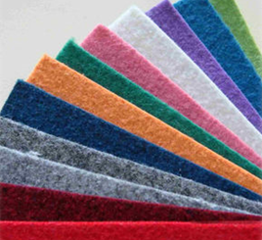
Geotextiles: Performance of geotextile is commonly termed durability when it is used to making roads, pools and used in constructions. Due to the good strength of the recycled solid non siliconsied fibre, the fabrics durability can be increased manifold and give it a long life. Fillings (Toys, Pillow, Sofa & Furniture’s), Recycled polyester solid fibre is one of the major products used for filling materials in pillows, sofas, toys etc.

The fibres provide more firmness, and give a good resilience for cushions, pillows and sofas. Using recycled polyester fiber is cost effective and good for environment as well. Automotive (Car): Fabric made from Recycled Polyester Staple fibre is present in almost all cars worldwide, due to its cost effectiveness and long life. It helps keep the costs low which get passed on to the customer and also creates a good feel and finish to the car.

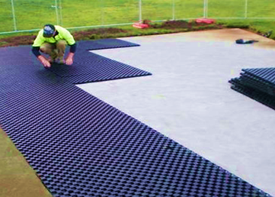

Filtration Industries: Filtering non-woven fabrics are used for air filtration, water filtration and oil filtration sectors. A filtration fabric made out of recycled polyester is cheaper and hygienic to use.

The finished products of the company is an industrial product which will be used by textile mills for producing different types of yarns (100% polyester yarn, cotton blended yarn, polyester acrylic blended yarn, polyester viscose blended yarn, etc.) as well as cushioning products (carpets, sofa, dolls, toys, mattress, furniture etc. and in automobile sector). The raw material being used by the company does not have any other significant usage apart from in RPSF manufacturing as such is easily available through organized dealers.



- QUANTITY DETAILS:
As per the details provided by the company following machineries have already been installed on site:

Sr. No. | Item | Capacity | Quantity (Nos.)
1. | Vacuum Dryer with auto feed system | 1800 Kg/dryer | 10
2. | Extruder (170 Diameter) | 30 ton/day | 02
3. | Spinning beam with accessories | 30 tons/day | 02
 | - 16 (8x2) spinning positions
 | - Continuous filtration system
4. | Take up unit | 60 tons/day | 01
5. | Can Travers unit | 60 tons/day | 01
6. | Cans | 800 kg | 150
7. | Draw Line | 60 tons/day | 01
 | - Annealer:18 rolls (820dia x 900)
 | - Crimper: 24 lac tow denier
8. | Baler Twin Box turn type | up to 290 kg/ Bale | 02
9. | Pneumatic conveying system | 60 t/day | 01
10. | Lab Equipment’s & all major apparatus | - | 14

- MARKETING, SELLING & DISTRIBUTION PLAN:
A marketing plan is a strategic roadmap that businesses uses to organise, execute and track their marketing strategy over a given time period. Marketing plans can include separate marketing strategies for the various marketing teams across the company, but all of them work towards the same business goals.

Marketing Outlook of Polyester Staple Fibres



The Global Polyester Staple Fiber (PSF) Market is projected to register a CAGR of more than 4% during the forecast period.

Due to the global lockdown imposed due to the coronavirus (COVID-19) pandemic, the apparel and textile industries have been hampered in different regions. Supply chains, logistic processes, and worker availability have all weakened as a result of the coronavirus pandemic, causing the apparel and textile industry's operations to be moderately hampered.

The textile industries in countries, like Vietnam and Bangladesh, with low to medium-sized lean production strategy companies, have been pushed to bankruptcy, which curtailed the market demand for polyester staple fiber in the first half of 2020. Since polyester staple fibers are mostly used in the clothing and garment industries, the decline of this end-use sector is directly restricting the development of the polyester staple fiber market during the COVID-19 outbreak.

Over the medium term, the major factors driving the market studied are increasing demand from the textile industry for making apparel and rising demand from the home furnishing segment. Growing awareness regarding recycled polyester staple fiber due to increasing environmental concern is expected to offer various lucrative opportunities for the growth of the market.
By application, the apparel segment is expected to dominate the market owing to the increase in the usage of polyester staple fiber for making apparel as it is cheaper than cotton.

Asia-Pacific region dominated the polyester staple fiber market across the globe with the largest consumption from countries such as China and India.

Key Market Trends Increasing Demand from Textile Segment

- Polyester Staple fiber (PSF) is a synthetic man-made fiber made directly from purified terephthalic acid (PTA) & mono ethylene glycol (MEG) or polyethene terephthalate (PET) /Polyester waste or from recycled post consumed PET bottle flakes.

- The growing usage of polyester staple fiber in making sportswear, active wear, and intimate wear is stimulating the demand for polyester staple fiber in the apparel segment and thus, propelling its market.

- Additionally, the increase in the usage of polyester staple fiber as a substitute for cotton owing to properties such as cheaper, thinner, and availability in different designs and colours is boosting the polyester staple fiber market.

- Furthermore, there are several hi-tech varieties of polyester staple fiber available which have antimicrobial properties and offer advanced protection against bad odour and infections. Owing to these properties the polyester staple fiber market is expected to propel during the forecast period.

- The revenue from the apparel market was estimated at USD 1,942,644 million for 2020 and the market is further expected to grow at a CAGR of over 4% during the forecast period. This would create ample opportunities for the polyester staple fiber market to grow during the forecast period.

- The German textile industry had an annual turnover of around EUR 30 billion in 2019. The textiles and clothing industry is the second-largest consumer goods industry in Germany. The growing demand for technical textiles is expected to drive the market, substantially, in this region.

- Germany has an exceptionally high export rate, of about 40%, from its textile and clothing industry. Also, it has been estimated that technical textiles used in various high-tech products generated a revenue of over 30%. Integration of technology and smart textiles (technical textiles) for medical, automotive, aerospace, and construction applications provide long-term growth, supporting the regional industrial growth. It was estimated that about 1/4th of the technical textiles produced in Europe are produced in Germany.

- The COVID-19 pandemic is an once-in-a-lifetime public health emergency that has wreaked havoc on the global economy. Despite this downturn, the textile and apparel industry may be a major source of jobs and development in some countries.

- The textile and apparel industry is considered a starter sector on the path to industrialization, so countries rebuilding after COVID-19 are more likely to focus on the textile and apparel industry. When the industry grows, it provides a foundation for more technologically challenging industries to grow through. In reality, many developing countries' growth and development strategies rely heavily on the textiles and apparel industry.

- Owing to all the above-mentioned factors for polyester staple fiber, its market is expected to grow rapidly over the forecast period.

Asia-Pacific Region to Dominate the Market:

Asia-Pacific region is expected to dominate the market for polyester staple fiber market during the forecast period. In countries like China, India, and South Korea, owing to an increase in demand from various applications in apparel, automotive, and home furnishing coupled with rising population, changing lifestyles, economic growth, and rising per capita income, the demand for polyester staple fiber has been increasing in the region.

The rising demand from the home furnishing segment for making pillows, sofas, bed sheets, carpets, and rugs is increasing the demand for polyester staple fiber in the region and thus, propelling its market.

Additionally, polyester staple fiber is available in the market in different colours, forms, and fabric and they are more affordable than other fibers, owing to which, there is a surge in the demand for polyester staple fiber among consumers

Furthermore, consumers are opting for sustainable fashion manufactured from recycled and environmentally friendly products like polyester staple fiber. The availability of sustainable clothing in bright colours, stylish design, and attractive prints is further boosting the polyester staple fiber market.

The Asia-Pacific home furniture & decor market is expected to grow at a CAGR of over 5% during the forecast period. This would create lucrative opportunities for the polyester staple fiber market to propel soon.
Some of the major companies operating in the Asia-Pacific region are - TORAY INDUSTRIES, INC., Reliance Industries Limited., and Bombay Dyeing.

The aforementioned factors, coupled with government support, are contributing to the increasing demand for polyester staple fiber during the forecast period.

More than 40% of the world’s production of clothing and textiles is in China and India. India and China are projected to become the largest GDP by 2050.

The negative effect of the novel coronavirus on the textile and textile goods (TPT) sector in the Asia-Pacific (APAC) region in 2020 resulted in a decrease in retail sales in key export markets, as well as staff and businesses across supply chains. Few could have predicted the magnitude of the health and economic catastrophe that would ensue when news of the novel coronavirus circulating in parts of China first surfaced.

China was noticed promoting and undergoing a process of continuous urbanization, with a target rate of 60% for 2020. The increased living spaces required in the urban areas resulting from urbanization and the desire of middle-class urban residents to improve their living conditions may have a profound effect on the housing market, and thereby increase the residential construction in the country, which in turn will have a positive effect on the polyester staple fiber market in the country.

The Chinese government is planning Xinjiang as the hotbed for textile and apparel manufacturing and has invested USD 8 billion. It is expected that China's northwest region is to become the country's largest textile production base by 2030.

The Indian textiles and apparel (T&A) industry accounts for approximately 4% of the global T&A market. The T&A industry is one of the largest and the most important sectors for the Indian economy in terms of output, foreign exchange earnings, and employment. The industry contributes approximately 7% to industrial output in value terms, 2% to the GDP, and 15% to the country’s export earnings.

According to India Brand Equity Foundation, India’s textile and apparel exports stood at USD 38.70 billion in FY19 and are expected to increase to USD 82.00 billion by 2021 from USD 22.95 billion in FY20 (up to November 2019).

The textile industry in the country is majorly contributed by the Ministry of Micro, Small and Medium Enterprises (MSME’s) with around 60%. The recent structural and financial reforms announced by the government for MSME’s are expected to offer support to the textile industry.

Currently, due to the COVID-19 outbreak, economic activities and industrial manufacturing activities have been affected significantly in the region. However, industrial production is returning to pre-COVID scenario in the region. Hence, from the above-mentioned factors, the demand for polyester staple fiber in the region is estimated to grow during the forecast period.

Competitive Landscape



The Polyester Staple Fiber (PSF) market is highly fragmented with the top 5 players accounting for a minimal share of the market. Some of the key companies in the market include TORAY INDUSTRIES, INC, Alpek S.A.B. de C.V., Reliance Industries Limited, Bombay Dyeing, and W. Barnet GmbH & Co. KG.

As of now the project company is aiming to sell its product directly to the following companies:

- F. D Copeland and Sons Ltd.
- Ganpati Tex Trade
- Suryaodaya Textiles Private Limited
- Shree Ganesh trading
- Sunheri yarna and Fibres Private Limited
- Orient syntax
- Shivi International
- Khurana traders
- Shree Radhika Fibres
- Satin Touch comforts private Limited
- Devashi polytex private Limited
- Tee ess industries
- Daivuk Fibres
- Kaylon enterprises
PART H | INDUSTRY OVERVIEW & ANALYSIS

- INTRODUCTION:
Textiles sector in the Indian economy is one of the oldest industries, dating back to several centuries. The industry is highly varied, from hand-spun and hand-woven textiles sectors to the capital-intensive sophisticated mills sector on the other end. The decentralised power looms/ hosiery and knitting sector forms the largest component in the textiles sector. The close linkage of textiles industry to agriculture (as highly dependent on agriculture for raw materials such as cotton) and the ancient culture and traditions of the country in terms of textiles makes it unique in comparison to other industries in the country. India’s textiles industry has a capacity to produce wide variety of products suitable for different market segments, both within India and across the world.

- MARKET INSIGHT:
India’s textiles industry contributed 7% to the industry output (by value) in 2018-19. The Indian textiles and apparel industry contributed 2% to the GDP, 12% to export earnings and held 5% of the global trade in textiles and apparel in 2018-19. The share of the India’s textiles and apparel exports in mercantile shipments was 11% in 2019-20. Textiles industry has around 4.5 crore employed workers including 35.22 lakh handloom workers across the country.

Cotton production is expected to reach 37.10 million bales and consumption is expected to reach 114 million bales in FY 2021—13% growth over the previous year. The domestic textiles and apparel market stood at an estimated US$ 100 billion in FY 2019. The production of raw cotton in India is estimated to have reached 35.4 million bales in FY 2020. During FY 2019, production of fibre in India stood at 1.44 million tonnes (MT) and reached 2.40 MT in FY 2021 (till January 2021), while that for yarn, the production stood at 4,762 million kgs during same period. Exports of textiles (RMG of all textiles, cotton yarn/fabs./made-ups/handloom products, man-made yarn/fabs./made-ups, handicrafts excl. handmade carpets, carpets and jute mfg. including floor coverings) stood at US$ 2.99 billion, as of June 2021. In July 2021, exports of cotton yarn/fabrics/made-ups, handloom products, etc., from India increased by 50.86% in June 2021 over June 2019.

Indian textiles and apparel industry contributed 2.3% to the GDP of India, 13% to industrial production and 12% to export earnings

- RECENT INVESTMENTS:
The textiles sector has witnessed an upward trend in investment during the last five years. The industry including dyed and printed attracted Foreign Direct Investment (FDI) worth US$ 3.75 billion from April 2000 to March 2021.

In May 2021, Indo Count Industries Ltd. (ICIL), announced an investment of INR 200 crore to expand its production capacity. The production-linked incentive (PLI) scheme for man-made fibre and technical textiles will help boost manufacturing, increase exports and attract investments into the sector.

- GOVERNMENT INITIATIVES:
Indian government has come up with several export promotion policies for the textiles sector, 100% FDI has also been allowed by the government in the sector under the automatic route.

Government of India making the industry favourable for the purpose of investments, employments and to appreciate new players in the industry with strategic investments technological advancement.

Below are few important initiatives taken by the Indian Government:

- Minister of State (MoS), Ministry of Petroleum & Natural Gas and Labour & Employment, launched ONGC-supported Assam handloom project ‘Ujjwal Abahan’ In August 2021, through the virtual platform. The project will support and train more than 100 artisans of Bhatiapar of Sivasagar, Assam in Hathkharga handicraft.

- Flipkart and Himachal Pradesh State Handicrafts and Handloom Corporation Ltd. (HPSHHCL) signed a memorandum of understanding (MoU) in August 2021, to help the state’s master craftsmen, weavers and artisans showcase their hallmark products on e-commerce platforms.

- Union Minister of Textiles, Commerce and Industry, Consumer Affairs & Food and Public Distribution had make the commitment in August 2021, to boost production capacities of handloom sector from existing INR 60,000 crore to INR 125,000 crore in three years, the target is being set to increase exports of handloom items from existing INR 2,500 crore to INR 10,000 crore in three years. A high level committee will be constituted consisting of all weavers, trainer equipment makers, marketing experts and other stake holders to recommend ways and means to achieve these objectives and enhance overall progress of the handloom sector.

- Government has extended the Rebate of State and Central Taxes and Levies (RoSCTL) scheme In July 2021, for exports of apparel/garments and made-ups until March 2021. This will help boost exports and enhance competitiveness in the labour-intensive textiles sector.

- Union Ministry has assured strong support from the Textile Ministry to reduce industry’s dependence on imported machine tools by partnering with engineering organisations for machinery production, a new PLI scheme will be implemented for the textile industry, aiming to develop Man Made Fiber (MMF) apparel and technical textiles industry by providing incentive from 3-15% on stipulated incremental turnover for five years.

- To support the handloom weavers/weaver entrepreneurs, the Weaver MUDRA Scheme was launched by the government to provide margin money assistance at 20% of the loan amount subject to a maximum of INR 10,000 per weaver. The loan is provided at an interest rate of 6% with credit guarantee of three years.

- Gorakhpur is on track to become a major garment manufacturing centre, boosting the economy in eastern Uttar Pradesh. The Gorakhpur Industrial Development Authority (GIDA) will provide four acres of land for construction of a flattened factory and will enable accessible to entrepreneurs.

- The Ministry of Textiles favoured limited deal for the India-UK free trade agreement in March 2021, which could boost the garments sector. In 2020-21, the UK is India's fourteenth largest trading partner, accounting for US$ 8.7 billion in exports and US$ 6.7 billion in imports. Under the proposed trade agreement, the Textile Ministry expects more market access for the Indian textiles and clothing sector in order to achieve its full potential.

- In March 2021, under the ongoing sub-mission on agroforestry (SMAF) scheme, the Ministry of Agriculture and Farmers Welfare signed a memorandum of understanding (MoU) with the Central Silk Board, under the Ministry of Textiles, on a convergence model to implement agroforestry in the silk sector.

- In March 2021, toys were identified as one of the 24 primary sectors listed under the self-reliant India initiative. The Department for Promotion of Industry and Internal Trade (DPIIT) has developed a ‘National Action Plan’ for toys that calls on several central ministries, including textiles, MSME, I&B, Education, DPIIT (under the Ministry of Commerce) and other departments, to nurture and promote the industry.

- Effective 01 January 2021, to boost exports, government have extended the benefit of the Scheme for Remission of Duties and Taxes on Exported Products (RoDTEP) to all exported goods. To support the handloom and handicrafts sector, the government has taken steps to on-board weavers/artisans on Government e-Marketplace (GeM), provide a wider market and enable them to sell their products directly to various government departments and organisations. As of December 31, 2020, 171,167 weavers/artisans/handloom entities have been registered on the GeM portal.

- Defence Research and Development Organisation (DRDO) is helping the Indian textile industry to produce yarns and eliminate dependence on import of Chinese and other foreign clothing for military uniforms. Indian defence sector has expressed support towards the Indian technical textile sector.

- In March 2021, while addressing the 9th edition of TECHNOTEX 2021 organized by FICCI, Chief of Defence Staff appreciated the innovations in Indian technical textile and appreciated armed forces for reducing imports and instead procure technical textiles from Indian industries as a part of the Atmanirbhar Bharat initiative.

- In October 2020, the Cabinet Committee on Economic Affairs chaired by PM, approved mandatory packaging of 100% food grains and 20% sugar in jute bags. Under the Jute Packaging Materials (Compulsory Use in Packing Commodities) Act, 1987, the government is required to consider and provide for the compulsory use of jute packaging materials for supply.

- Government launched production linked incentive scheme to provide incentives for manufacture and export of specific textile products made of man-made fibre. On September 2, 2020, the Union Cabinet approved signing an MOU between textile committee, India and M/s Nissenken Quality Evaluation Centre, Japan, for improving quality and testing Indian textiles and clothing for the Japanese market. This India-Japan pact on cooperation in textiles will facilitate Indian exporters to meet the requirements of Japanese importers as per the latter’s technical regulations.

- Under Union Budget 2020-21, a National Technical Textiles Mission is proposed for a period from 2020-21 to 2023-24 at an estimated outlay of INR 1,480 Crore.

- In 2020, New Textiles Policy 2020 is expected to be released by the Ministry of Textiles.

- The Directorate General of Foreign Trade (DGFT) has revised rates for incentives under the Merchandise Exports from India Scheme (MEIS) for two subsectors of Textiles Industry - readymade garments and made-ups - from 2% to 4%.

- The Government of India has taken several measures including Amended Technology Up-gradation Fund Scheme (A-TUFS), estimated to create employment for 35 lakh people and enable investment worth INR 95,000 Crore by 2022.

- Integrated Wool Development Programme (IWDP) was approved by Government of India to provide support to the wool sector, starting from wool rearer to end consumer, with an aim to enhance quality and increase production during 2017-18 and 2019-20.

- ACHIEVEMENTS:
Below are the achievements of the Government in the past few years to utilise the capacity of Indian textiles Industry:
- In June 2021, KVIC recorded a 7.71% growth in gross annual turnover to INR 95,741.74 crore from INR 88,887 Crore in FY 2020.

- In CY2020, Cotton Corporation of India made a record procurement of ~ 151 lakh bales under MSP operations, which is ~ 290% higher than 38.43 lakh bales procured during the corresponding period last year.

- I-ATUFS, a web-based claims monitoring and tracking mechanism was launched on April 21, 2016. 381 new block level clusters were sanctioned.

- Under the Scheme for Integrated Textile Parks (SITP), 59 textile parks were sanctioned, out of which, 22 have been completed.

- Employment increased to 45 million in FY 2019 from 8.03 in FY 2015.

- Exports of readymade garments (of all textiles) was worth US$ 1.19 billion as of December 2020.

- ROAD AHEAD:
India is working on major initiatives, to boost its technical textile industry. Owing to the pandemic, the demand for technical textiles in the form of PPE suits and equipment is on rise. Government is supporting the sector through funding and machinery sponsoring.
Top players in the sector are attaining sustainability in their products by manufacturing textiles that use natural recyclable materials.

The future for the Indian textiles industry looks promising, forced by strong domestic consumption as well as export demand. Due to rise of consumerism and disposable income, the retail sector has experienced a rapid growth in the past decade with the entry of several international players like Marks & Spencer, Guess and Next into the Indian market.

High economic growth has resulted in higher disposable income. This has led to rise in demand for products creating a huge domestic market.

Textile Industry & Market Growth in India

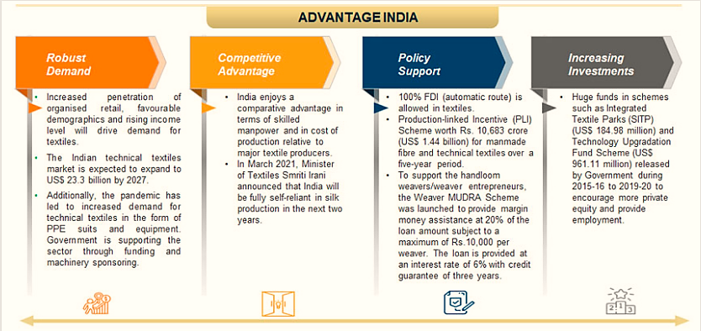
Source: www.ibef.org

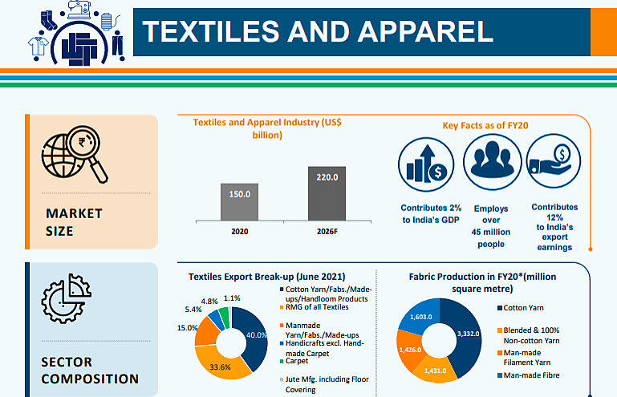
Name of some Big Players are as given as below:

  - Sutlej Textiles and Industries Limited, which is a leading producer of value-added yarns, the company is having a total sales of INR 677.1 Crores in the Q1 of 2021 and the company is having the presence of more than 60 countries

  - Arvind Limited with 15 global apparel brands

  - Vardhman Textiles, which is a second largest producer of sewing threads in India

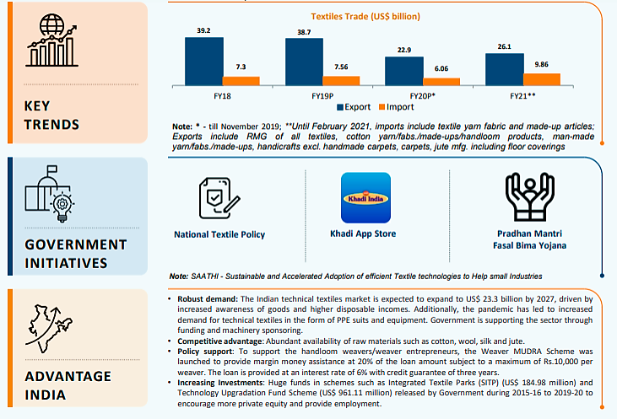

SWOT ANALYSIS OF INDIAN TEXTILES INDUSTRY

SWOT is s

PART I | PROJECT SCHEDULE

As per information, the plant is scheduled to be operational from the financial year 2022-23. Presently, unit is not operational, however for trail run company has operated the Plant in February, 2021 and have made the production of around 3000 tons. Few latest Invoices has been taken from the company in this regard.

However on the day of site inspection this Plant was not operational. After purchasing the Plant through NCLT, the new management of the company has overhauled and refurbished the Plant fully. New management has added few new machineries also in the Plant, list of which is added in the later section of the report. As per visual observation during site visit, Plant condition appeared to be good. Under Single Window Clearance System, the new management has applied & obtained the statutory approvals.

PART J | STATUTORY APPROVALS | LICENCES | NOC
Under “Single Window Clearance System”, the new management has applied & obtained the statutory approvals as per shown in the below table:
S.No. | REQUIRED APPROVALS | REFERENCE NO./ DATE | STATUS  (Approved/ Applied For/ Pending)
 | Land conversion to Industrial/ non agriculture | NA | The subject Plant has been taken over by the new management through NCLT since the company was under Corporate Insolvency Resolution Process. Hence we assume that the subject Plant must be having converted land on Industrial/ Non Agriculture land.
 | Factory Registration | NA | Pending
 | Department of Labour, Government of Uttarakhand
 | Factory Layout Plan Approval | NA | The subject Plant has been taken over by the new management through NCLT since the company was under Corporate Insolvency Resolution Process. Hence we assume that the subject Plant must be having converted land on Industrial/ Non Agriculture land.
 | Factory Plan Layout Approval under Factory Act 1948/ Labour Department (Director, Directorate of Industrial Safety & Health)/ Town Planning Department
 | Provisional Fire NOC (pre sanction) | 17/07/2020 | On the basis of Fire station in charge report consent for principle approval is given but it will be necessary for the investor to make all the fire and life safety arrangements according to national building code and Uttarakhand building by laws and get all the required NOC from the department.
 | Uttarakhand Fire and Emergency Services
 | Fire NOC (on completion) | NA | To be taken before starting operation
 | Uttarakhand Fire and Emergency Services
 | Information Entrepreneurs Memorandum (IEM) | NA | NA
 | Industrial Development Department, Government of Uttarakhand
 | Power Load Sanction | 20/07/2020 | Yes, Electricity Connection Can be Given as per UERC Regulation's
 | Uttarakhand Electricity Regulatory Commission (Release of new LT Connections, Enhancement and Reduction of Loads) Regulations, 2012
 | Consent to establish (under Water Act & Air Act) | NA | Pending
 | Uttarakhand Pollution Control Board, Government Of Uttarakhand
 | Consent to operate (under Water Act & Air Act) | NA | To be taken before starting operation
 | Uttarakhand Pollution Control Board, Government Of Uttarakhand
 | Import-Export License | NA | Initially company is not having any plan to generate the sales from export.
 | Registration under contract Labour act | 16/07/2020 | Approved
 | Labour Acts Management System, Government of Uttarakhand

Observation Note:
  - The detailed information about the “STATUTORY APPROVALS /LICENCES/NOC” have been shared by the project client/company as per the comments mentioned in the above table.
  - The new management has applied & obtained various the statutory approvals under Single Window Clearance System of Uttarakhand Government as mentioned above separately. Copy of approval of Single Window Clearance is attached with the report. For Reference Single Window Clearance Certificate is attached in the below picture which is shared by the banker.
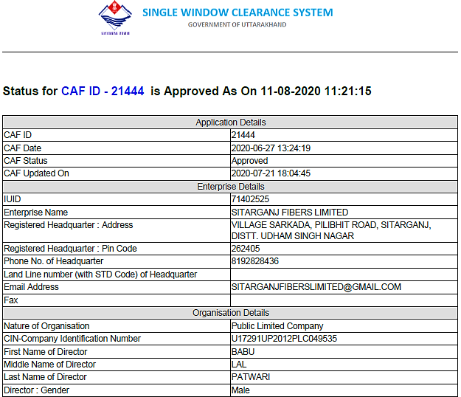

PART K | COMPANY’S FINANCIAL FEASIBILITY

- PROJECTIONS OF THE FIRM: Financial projections of the firm are done From FY 2022-23 to FY 2024-25 to assess the company’s financial feasibility as per projections provided by the client:
- PROJECTED PROFIT & LOSS ACCOUNT FROM FY2022-23 TO FY2024-25:

Particulars  (INR Crores) | FY 2022-23 | FY2023-24 | FY2024-25
Gross Sales
Domestic Sales | 149.79 | 166.27 | 174.58
Export Sales | 0.00 | 0.00 | 0.00
Other Income | 0.00 | 0.00 | 0.00
Total | 149.79 | 166.27 | 174.58
Less: Excise Duty | 0.00 | 0.00 | 0.00
Net Sales | 149.79 | 166.27 | 174.58
Cost of Sales
Raw Material
Imported | 0.00 | 0.00 | 0.00
Indigenous | 119.66 | 121.34 | 119.81
Other Spares
Imported | 0.00 | 0.00 | 0.00
Indigenous | 4.65 | 6.51 | 9.61
Power, Electricity, Fuel | 8.45 | 10.10 | 10.78
Direct Labour | 3.01 | 4.80 | 5.20
Other Expenses
Repair & Maintenance | 9.01 | 10.24 | 10.80
Other overheads | 0.09 | 0.10 | 0.14
Depreciation | 0.85 | 0.74 | 0.77
Subtotal | 145.72 | 153.83 | 157.11
Add: Opening Stock-In-Process | 7.00 | 8.00 | 9.00
Less: Closing Stock-in-Process | 8.00 | 9.00 | 10.00
Cost of production | 144.72 | 152.83 | 156.11
Add: opening stock of finished goods | 1.96 | 11.32 | 14.84
Less: Closing Stock of finished goods | 11.32 | 14.84 | 15.00
Total Cost of Sales | 135.36 | 149.31 | 155.95
Selling, General & Administration Expenses | 6.77 | 8.40 | 9.61
Subtotal | 142.13 | 157.71 | 165.56
Operating Profit before Interest | 7.66 | 8.56 | 9.02
Interest Paid | 2.74 | 2.74 | 2.74
Operating Profit after Interest | 4.92 | 5.82 | 6.28
Provision for taxes | 1.23 | 1.45 | 1.57
Net profit/Loss | 3.69 | 4.36 | 4.71
Retained Profit/Loss for the year | 3.69 | 4.36 | 4.71

- PROJECTED BALANCE SHEET FROM FY2022-23 TO FY2024-25:

Particulars  (INR Crores) | FY 2022-23 | FY 2023-24 | FY 2024-25
Liabilities
Current Liabilities
Short term borrowing from bank
From Applicant Bank | 34.00 | 34.00 | 34.00
From other Bank | 0.00 | 0.00 | 0.00
Subtotal | 34.00 | 34.00 | 34.00
Short term borrowing from others | 0.00 | 0.00 | 0.00
Sundry Creditors | 1.82 | 2.50 | 2.61
Provision for taxation | 1.23 | 1.45 | 1.57
Other statutory liabilities (Due within one year) | 0.53 | 0.46 | 0.48
Other Current Liabilities & Provision | 0.38 | 0.55 | 0.75
Subtotal | 3.96 | 4.96 | 5.41
Total Current Liabilities | 37.96 | 38.97 | 39.41
Term Loan | 0.00 | 0.00 | 0.00
Other term liabilities | 14.60 | 14.60 | 14.60
Deferred tax Liabilities | 0.00 | 0.00 | 0.00
Total Term Liabilities | 14.60 | 14.60 | 14.60
Total Outside Liabilities | 52.56 | 53.57 | 54.01
Net Worth
Ordinary Share Capital | 9.50 | 9.50 | 9.50
Other Reserves | 0.00 | 0.00 | 0.00
(+)/(-) in P & L Account | 3.69 | 8.05 | 12.77
Net Worth | 13.19 | 17.56 | 22.27
Total Liabilities | 65.75 | 71.12 | 76.28
Assets
Current Assets
Cash and bank Balances | 0.10 | 0.07 | 0.06
Investments:
Government and other long term | 0.00 | 0.00 | 0.00
LC/ BG Margin/ FD’s with banks | 0.00 | 0.00 | 0.00
Receivables other than deferred and exports | 12.09 | 11.30 | 13.99
Expenses receivables (including bills purchased and discounted by banks) | 0.00 | 0.00 | 0.00
Subtotal | 12.09 | 11.30 | 13.99
Inventory:
Raw Material:
Imported | 0.00 | 0.00 | 0.00
Indigenous | 18.10 | 18.15 | 19.70
Stock-in-Process | 8.00 | 9.00 | 10.00
Finished Goods | 11.32 | 14.84 | 15.00
Other consumable spares
Imported | 0.00 | 0.00 | 0.00
Indigenous | 0.61 | 0.82 | 0.87
Subtotal | 38.03 | 42.81 | 45.57
Advance to suppliers of raw material and stores & spares | 0.58 | 1.50 | 1.50
Advance payment of taxes | 0.33 | 0.96 | 0.96
Other Current Assets | 0.66 | 0.69 | 0.67
Total Current Assets | 51.79 | 57.33 | 62.75
Fixed Assets
Gross Block | 16.07 | 16.07 | 16.07
Depreciation to date | 2.54 | 3.28 | 4.05
Net Block | 13.53 | 12.79 | 12.02
Other Non-Current Assets
Security Deposits | 0.43 | 1.00 | 1.50
Deferred tax assets | 0.00 | 0.00 | 0.00
Total other Non-Current Assets | 0.43 | 1.00 | 1.50
Total Assets | 65.75 | 71.12 | 76.27
Check | 0.00 | 0.00 | 0.00

- PROJECTED CASH FLOW FROM FY2022-23 TO FY2024-25:

Particulars  (INR Crores) | FY 2022-23 | FY 2023-24 | FY 2024-25
Cash flow from Operating Activities
Profit Before tax (PBT) | 4.92 | 5.82 | 6.28
Add: Interest & Finance Charges | 2.74 | 2.74 | 2.74
Depreciation | 0.85 | 0.74 | 0.77
Misc. Expenses Written off | 0.00 | 0.00 | 0.00
Operating Profit before working Capital Changes | 8.51 | 9.30 | 9.79
Add:
(+)/(-) in Sundry Debtors | 0.00 | 0.79 | -2.69
(+)/(-) in Inventory | 0.00 | -4.78 | -2.76
(+)/(-) in Loans & Advances | 0.00 | -1.55 | 0.00
(+)/(-) in Other Current Assets | -0.03 | 0.02 | 0.67
(+)/(-) in trade creditors | 0.00 | 0.68 | 0.11
(+)/(-) in other payables | 0.00 | 0.15 | 0.14
(+)/(-) in Other Current Liability | 0.00 | 0.17 | 0.20
Less:
Dividend Received | 0.00 | 0.00 | 0.00
Interest Received | 0.00 | 0.00 | 0.00
Other Non-Operating Income | 0.00 | 0.00 | 0.00
Provision for Income Tax | 1.23 | 1.45 | 1.57
CFO | 7.28 | 3.28 | 3.24
Cash flow from Investing Activities
Increase/Decrease in other Non-Current Assets | 0.00 | -0.57 | -0.50
CFO | 0.00 | -0.57 | -0.50
Cash Flow From Financing Activity
Payment of Dividend and Dividend Tax | 0.00 | 0.00 | 0.00
Interest and finance changes paid | 2.74 | 2.74 | 2.74
Net Cash flow from financing Activity | -2.74 | -2.74 | -2.74
Net Increase/Decrease in CASH | 4.54 | -0.03 | 0.00
Opening Balance | 0.00 | 4.54 | 4.51
Closing Balance | 4.54 | 4.51 | 4.50
Cash balance as per CMA | 0.10 | 0.07 | 0.06
Difference in cash Balance, if any | 4.40 | 4.40 | 4.40
CLOSING CASH BALANCE

- Estimated Key Financial Metrics:

Particulars  (INR Crores) | FY 2022-23 | FY 2023-24 | FY 2024-25
Net Sales Value | 149.79 | 166.27 | 174.58
EBITDA | 8.51 | 9.30 | 9.79
EBITDA Margin % | 5.68 % | 5.59 % | 5.61 %
Liquidity Ratio
Current Ratio | 1.36 | 1.47 | 1.59
Net Working Capital | 13.83 | 18.37 | 23.34
NWC/ Sales (%) | 9.23 % | 11.05 % | 13.37 %
Assessed Bank Finance/ Total Current Assets | 65.65 % | 59.31 % | 54.18 %
ABF/ Gross Sales | 22.70 % | 20.45 % | 19.48 %
Coverage Ratio
Interest Coverage Ratio | 3.11 | 3.39 | 3.57
Operating Cost/ Sales (%) | 94.89 % | 94.85 % | 94.83 %
Interest/ Cost of Sales | 2.02 % | 1.84 % | 1.76 %
Turnover Ratio
Profit Before Tax/ Net Sales (%) | 3.28 % | 3.50 % | 3.60 %
Sales to Tangible Assets | 2.28 | 2.34 | 2.29
PBT/TTA (%) | 7.48 % | 8.18 % | 8.23 %
PBT/TNW (%) | 37.30 % | 33.15 % | 28.21 %
Solvency Ratio
TOL/TNW | 3.98 | 3.05 | 2.43
TOL/ Adj. TNW | 3.98 | 3.05 | 2.43
Profitability Ratio
Operating Profit Margin (%) | 3.28 % | 3.50 % | 3.60 %
Return on Equity (%) | - | 45.95 % | 49.58 %
Assessed Bank Finance (ABF)
Total Current Assets | 51.79 | 57.33 | 62.75
Other Current Liability | 3.96 | 4.96 | 5.41
Working Capital Gap | 47.83 | 52.37 | 57.34
Net Working Capital | 13.83 | 18.37 | 23.34
Assessed Bank Finance | 34.00 | 34.00 | 34.00
NWC/TCA (%) | 26.70 % | 32.03 % | 37.20 %
OCL/TCA (%) | 4.13 % | 4.30 % | 4.46 %
OCA/TCA (%) | 3.22 % | 5.62 % | 5.O8 %
Interest Service Coverage Ratio (ISCR) | 3.11 | 3.39 | 3.57
ROCE | 12.94 | 13.08 | 12.84
PAT | 3.69 | 4.36 | 4.71
PAT margin (%) | 2.46 % | 2.63 % | 2.70 %
Cash Accruals | 4.54 | 5.10 | 5.48

GRAPHICAL REPRESENTATION OF KEY FINANCIAL INDICATOR:

INTEREST SERVICE COVERAGE RATIO DURING THE ESTIMATED PERIOD

As a key financial indicator of the project, ISCR is having a fair growth during the forecasted period, below is the graphical representation of ISCR during the forecasted period. Average ISCR is 3.36 over the forecasted period.

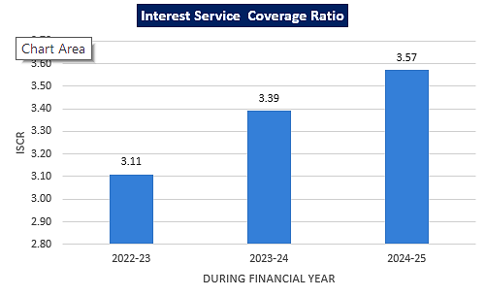

PROJECTED EBITDA MARGIN (%)

Below graph shows the EBITDA Margin of the project during the forecasted period, while margin is higher in the initial financial year and lower but gradually growing in the later years.

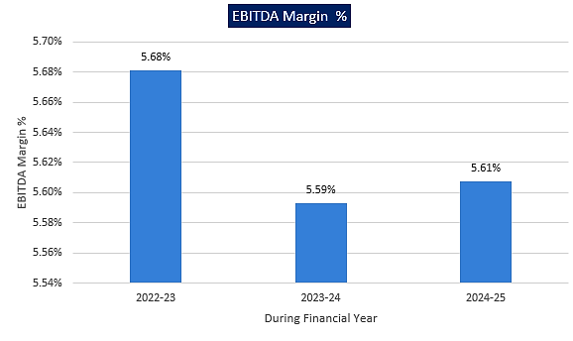

PROFIT AFTER TAX MARGIN OVER THE ESTIMATED PERIOD

Below graph shows the profit after tax margin over the forecasted period:

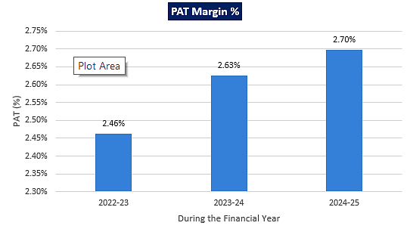
PROFIT BEFORE TAX TO TOTAL NET WORTH OVER THE ESTIMATED PERIOD

Below is the graphical representation of Profit before Tax to Total Net Worth ratio over the forecasted period:

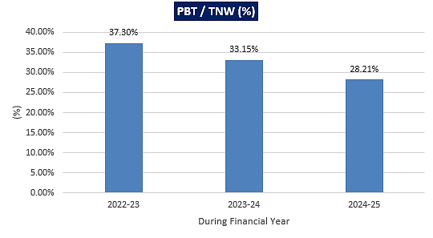

TOTAL OUTSTANDING LIABILITY TO TOTAL NET WORTH OVER THE ESTIMATED PERIOD

Below is the graphical representation of Total other Liability to Total Net Worth:

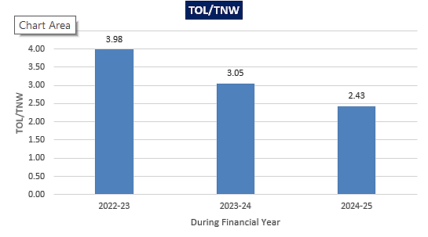

RETURN ON CAPITAL EMPLOYED (ROCE) OVER THE ESTIMATED PERIOD

Below is the graphical representation of Return on Capital Employed (ROCE) over the forecasted period:

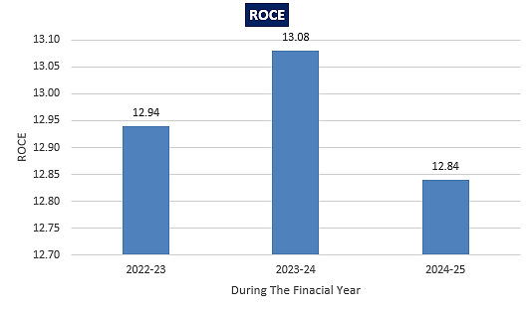

BREAK EVEN SALES % OVER THE ESTIMATED PERIOD

Below graph shows the Break-Even Sales % over the forecasted period:

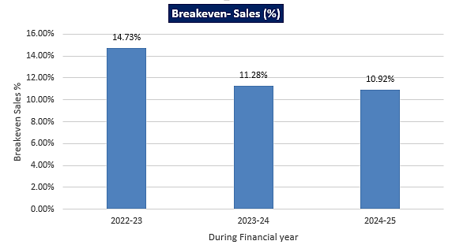

- ASSUMPTIONS & BASIS:

Sl. No. | Item | Assumptions and Basis
 | General | - Financial model has been provided to us by the Bank/ client based on which the key financial ratios which are required to take lending decision has been calculated.  - The projections of the firm are done for the period from FY 2022-23 to FY 2024-25 based on the assumption of production capacity and expected units sold for the period multiply by average selling price per unit.  - Projections are done based on the expected growth of the industry during the forecast period.  - Cost based model is considered in the provided future financial projections.
 | Revenue | - First full operating period has been considered as FY 2022-23.  - Revenue shown will be generated from domestic as well as export sale, while initially company is planning to generate the revenue from domestic sales only.  - As per the provided projections, revenue will be generated as INR 149.79 Crore, INR 166.27 Crore, and INR 174.58 Crore during the forecasted period.  - 11% growth rate in sales is being considered during the projection period.
 | Capacity Utilisation | - As per the DPR and technical analysis of the plant & machinery, the total installed capacity of the plant of M/s Sitarganj Fibers Limited will be 21,600.00 Ton in a year. Accordingly there would be a 2.50 ton/hour capacity of the plant, and the plant is assumed to be running 24 hours per day, there would be 30 days have been assumed in a month for the projected period, and there would total 12 months in a year. Thus it calculates the total installed capacity of 21,600 ton per annum.  - In the provided model, Capacity utilisation have been considered as 80 % during the first financial year and 85 % for the later year.  - We have assessed the rational for achieving 80% in the first year of operation itself on which Bank has submitted the confirmed order tie-ups with the related parties of the company which is up to 70% of the assumed projections.  - Thus there is a proposed production of 17,280 Ton at 80% capacity of polyester fiber and 18,360 Ton for the upcoming two years at 85 % capacity.
 | Price | - As per market analysis Polyester Fiber prices in India ranges from INR 21.00 per kg to INR 210.00 per kg.  - Average Selling rate is being considered as INR 81.00 per kg as per the marginal cost of production by M/s Sitarganj Fibers Limited
 | Cost of Goods Sold | - Waste plastic will be using as raw material for the production of the proposed product.  - The cost for the raw material is being assumed as @ 75 % of the total sales value.  - Consumable stores has a direct relation to receipt for the proposed project, which has been assumed at 7.5 % of the gross receipt.  - There is a 10 % increase in have been considered in the labour expenses.  - As an essential factor of production, a 5 % increment have been considered in the power and fuel cost.  - As per the UPCL tariff electricity charges will be @ Rs. 6 per unit and there would be differ energy charges per annum based on the capacity utilisation during the production.  - Depreciation have been charged on the basis of Written down Value method during the forecasted period.  - A 15 % increment have been assumed in the S G & A expense over the forecasted period
 | Assessed Banking Finance (ABF) | - When we adjust other liabilities from the Total current Assets, we will be getting a working capital gap and Net Working Capital will be adjusted from working capital gap, we will be getting the Assessed Banking Finance as INR 34.00 Crore.  - The company is having an average EBITDA margin of 5.63 %, which shows the project’s capacity to be generated a fair enough operating income to meet the any kind of time liability

Conclusion:
      - As per the provided financial projections provided by the client, ISCR and EBIDTA margin is positive in all years starting from initial year on 80% utilization capacity which has assumed maximum up to 85% up to end of 3rd year.
      - Average ISCR and EBIDTA margin is 3.36, and 5.63% respectively.
      - Based on the above key financial ratios of the Project during the forecast period for the proposed project shows that the project looks financially viable if the Project Company & promoters are able to maintain minimum capacity utilization, revenue and can contain cost as assumed above.

PART K | CONCLUSION

Based on the assessment of key financial metrics of the project as per Financial Projections submitted by the Bank to assess Techno-Financial viability of the Project and further based on the technological, economical and market analysis factor information provided to us, various Industry assumptions taken, product pricing to be adopted by the company, the Project appears to be Techno-commercially viable subject to the risks, threats, weaknesses, limitations of the product as detailed previously.

While it is not avoidable that the future projections may change in the upcoming years due to various factors impacting the operational, managerial, financial efficiency and economies of scale of the project.

As per financial projections provided to us for the estimated period, Average ISCR and EBITDA Margin of the project comes out to be 3.36 and 5.63% respectively, where higher ISCR is the indicator of the project capability to pay out its outstanding interest for the proposed working capital facility on time and EBITDA margin shows the capability of the project to generate the operating profits over the forecasted period subject to the company achieves the projected capacity utilization, sales and contain the cost as submitted by them in the financial projections. In this report we have only computed the key financial metrics based on the financial projections provided to us.

After considering the high demand of the yarns and fibres of high quality in the textiles industry, existing machinery used by the Plant, easy availability of raw material, expected customer wise revenue, financial analysis of the project based on the assumptions taken over the projected period, it appears reasonable to comment that the proposed project is Technically and Economically Viable subject to current assumptions considered and occurring the same in the upcoming years same as the forecasted period which is dependent on the sincerity and efforts of the management and various micro and macroeconomic & industry situation.

Indian Economy is reviving rapidly from the slowdown of the adverse impact of Covid Pandemic which was the cause of shut down of Industrial production all over the country due to countrywide lockdown imposed by the Government of India. All the credit giving institution nationally and internationally are projecting Indian GDP growth rate in the tuning with historical growth and same can be seen i.e. all the indicators in the economy are showing a sharp upward trends and a few steps taken by the government like “Atmanirbhar Bharat” and world’s largest free vaccination program to mitigate the covid19 impact, a very positive environment have been created for MSME’s and others to operate the businesses in the economy at an optimistic capacity.

We have tried our level best to analyse the Project techno-economic feasibility of the Project based on the Industry research, Project information and various futuristic assumption taken. However achieving the financial milestones depends on the ability, sincerity and efforts of the company, promoters and its key managerial performance. Management must not avoid the strategically advancement of price, place, promotion, production and risk aligned with these factors. Technological advancement is also must to ripe the existing opportunity with respect to time and get the advantage over the competitors.

Declaration | - The undersigned does not have any direct/indirect interest in the above property.  - The information furnished herein is true and correct to the best of our knowledge, logical and scientific assumptions.  - This TEV Report is carried out by our Financial Analyst team on the request from State Bank of India, SME, Roorkee.  - Meeting of Financial projections will be subject to subject to the market & economy stability factors, judicious business operations and proper & timely implementation of its process & product re-engineering & improvements plans for achieving high productivity, efficiency and achieving cost saving benefits.  - We have submitted TEV report to the Client.
Name & Address of consultant company |  |  | Signature of the authorized person
M/s. R.K. Associates Valuer & Techno Engineering Consultants Pvt. Ltd.
D-39, 2nd Floor. Sector-2, Noida- 201301
Enclosed Documents |  | Disclaimer & Remarks 97-101
Number of Pages in the Report |  | 101
Financial Analyst Team worked on the report |  | PREPARED BY: Mr Gaurav Kumar (Financial & Market Research Analyst)
 |  | REVIEWED BY: HOD Project
For R.K Associates Valuer & Techno Place: Noida

Engineering Consultants (P) Ltd. Date: 19/11/2021

(Authorized Signatory)

PART L | DISCLAIMER | REMARKS

- No employee or member of R.K Associates has any direct/ indirect interest in the Project.

- This report is prepared based on the copies of the documents/ information which the Bank/ Company has provided to us out of the standard checklist of documents sought from them and further based on our assumptions and limiting conditions. The client/owner and its management/representatives warranted to us that the information they supplied was complete, accurate and true and correct to the best of their knowledge. All such information provided to us has been relied upon in good faith and we have assumed that it is true and correct in all respect. I/We shall not be liable for any loss, damages, cost or expenses arising from fraudulent acts, misrepresentations, or wilful default on part of the owner, company, its directors, employee, representative or agents. Verification or cross checking of the documents provided to us from the originals or from any Govt. departments/ Record of Registrar has not been done at our end since this is beyond the scope of our work. If at any time in future, it is found or came to our knowledge that misrepresentation of facts or incomplete or distorted information has been provided to us then this report shall automatically become null & void.

- Legal aspects for e.g. investigation of title, ownership rights, lien, charge, mortgage, lease, sanctioned maps, verification of documents, etc. have not been done at our end and same has to be taken care by legal expert/ Advocate. It is assumed that the concerned Lender/ Financial Institution has satisfied them with the authenticity of the documents, information given to us and for which the legal verification has been already taken and cleared by the competent Advocate before requesting for this report. I/ We assume no responsibility for the legal matters including, but not limited to, legal or title concerns.

- This report is a general analysis of the project based on the scope mentioned in the report. This is not an Audit report, Design document, DPR or Techno feasibility study. All the information gathered is based on the facts seen on the site during survey, verbal discussion & documentary evidence provided by the client and is believed that information given by the company is true best of their knowledge.

- This Techno Economic-Viability study is prepared based on certain futuristic assumption which are intra dependent on economic, market and sectorial growth condition in future and socio-economic, socio-political condition at macro and micro level.

- Meeting of assumption and financial ratio will entirely depend on the sincerity and efforts of the company, promoters and its key managerial performance.

- All observations mentioned in the report is only based on the visual observation and the documents/ data/ information provided by the client. No mechanical/ technical tests, measurements or any design review have been performed or carried out from our side during Project assessment.

- Bank/FII should ONLY take this report as an Advisory document from the Financial/ Chartered Engineering firm and its specifically advised to the creditor to cross verifies the original documents for the facts mentioned in the report which can be availed from the borrowing company directly.

- In case of any default in loans or the credit facility extended to the borrowing company, R.K Associates shall not be held responsible for whatsoever reason may be and any request for seeking any explanation from the employee/s of R.K Associates will not be entertained at any instance or situation.

- The documents, information, data provided to us during the course of this assessment by the client are reviewed only up to the extent required in relation to the scope of the work. No document has been reviewed beyond the scope of the work.

- This report only contains general assessment & opinion as per the scope of work evaluated as per the information given in the copy of documents, information, data provided to us and/ and confirmed by the owner/ owner representative to us at site which has been relied upon in good faith. It doesn’t contain any other recommendations of any sort including but not limited to express of any opinion on the suitability or otherwise of entering into any transaction with the borrower.

- We have relied on data from third party, external sources & information available on public domain also to conclude this report. These sources are believed to be reliable and therefore, we assume no liability for the truth or accuracy of any data, opinions or estimates furnished by others that have been used in this analysis. Where we have relied on data, opinions or estimates from external sources, reasonable care has been taken to ensure that such data has been correctly extracted from those sources and /or reproduced in its proper form and context, however still we can’t vouch its authenticity, correctness or accuracy.

- This Report is prepared by our competent technical team which includes Engineers and financial experts & analysts.

- This is just an opinion report and doesn’t hold any binding on anyone. It is requested from the concerned Financial Institution which is using this report for taking financial decision on the project that they should consider all the different associated relevant & related factors also before taking any business decision based on the content of this report.

- All Pages of the report including annexure are signed and stamped from our office. In case any paper in the report is without stamp & signature then this should not be considered a valid paper issued from this office.

- Though adequate care has been taken while preparing this report as per its scope, but still we can’t rule out typing, human errors, over sightedness of any information or any other mistakes. Therefore, the concerned organization is advised to satisfy themselves that the report is complete & satisfactory in all respect. Intimation regarding any discrepancy shall be brought into our notice immediately. If no intimation is received within 15 (Fifteen) days in writing from the date of issuance of the report, to rectify these timely, then it shall be considered that the report is complete in all respect and has been accepted by the client up to their satisfaction & use and further to which R.K Associates shall not be held responsible in any manner.

- Defect Liability Period is 15 DAYS. We request the concerned authorized reader of this report to check the contents, data and calculations in the report within this period and intimate us in writing if any corrections are required or in case of any other concern with the contents or opinion mentioned in the report. Corrections only related to typographical, calculation, spelling mistakes, incorrect data/ figures/ statement will be entertained within the defect liability period. Any new changes for any additional information in already approved report will be regarded as additional work for which additional fees may be charged. No request for any illegitimate change in regard to any facts & figures will be entertained.

- R.K Associates encourages its customers to give feedback or inform concerns over its services through proper channel at valuers@rkassociates.org in writing within 15 days of report delivery. After this period no concern/ complaint/ proceedings in connection with the Techno- Economic Viability Study Services will be entertained due to possible change in situation and condition of the subject Project.

- Our Data retention policy is of ONE YEAR. After this period, we remove all the concerned records related to the assignment from our repository. No clarification or query can be answered after this period due to unavailability of the data.

- This Techno Economic Viability Study report is governed by our (1) Internal Policies, Processes & Standard Operating Procedures, (2) Information/ Data/ Inputs given to us by the client and (3) Information/ Data/ Facts given to us by our field/ office technical team. Management of R.K Associates never gives acceptance to any unethical or unprofessional practice which may affect fair, correct & impartial assessment and which is against any prevailing law. In case of any indication of any negligence, default, incorrect, misleading, misrepresentation or distortion of facts in the report then it is the responsibility of the user of this report to immediately or at least within the defect liability period bring all such act into notice of R.K Associates management so that corrective measures can be taken instantly.

- R.K Associates never releases any report doing alterations or modifications from pen. In case any information/ figure of this report is found altered with pen then this report will automatically become null & void.

- If this report is prepared for the matter under litigation in any Indian court, no official or employee of R.K Associates will be under any obligation to give in person appearance in the court as a testimony. For any explanation or clarification, only written reply can be submitted on payment of charges by the plaintiff or respondent which will be 10% of the original fees charged where minimum charges will be INR 15,000/.

