File No.: VIS (2021-22)-PL660-576-743 Dated: 26.11.2021

TECHNO-ECONOMIC
VIABILITY STUDY REPORT

OF

M/S OCTOCHEM PHARMA AND FLAVOURS PRIVATE LIMITED

SITUATED AT
GATA NO. 331, 332, 335 AATA, CHANDAUSI BEHAJOI ROAD, SAMBHAL, U.P, 244412

REPORT PREPARED FOR

MCC MORADABAD, PUNJAB NATIONAL BANK

**Important - In case of any query/ issue or escalation you may please contact Incident Manager Valuers@rkassociates.org. We will appreciate your feedback in order to improve our services.

NOTE: As per IBA Guidelines please provide your feedback on the report within 15 days of its submission after which report will be considered to be correct
IMPORTANT NOTICE

COPYRIGHT FORMAT: This report is prepared on the copyright format of R. K. Associates Valuers & Techno Engineering Consultants (P) Ltd. (R. K. Associates) to serve our clients with the best possible information and analysis to facilitate them to take rational business decisions. Legally no one can copy or distribute this format without prior approval from R. K. Associates. It is meant only for the advisory/ reference purpose for the organization/s as mentioned on the cover page of this report. Distribution or use of this format or report or any of its content/ information/ data by any organization or individual other than R.K Associates will be seen as an unlawful act and necessary legal action can be taken against the defaulters.
This report is intended for the sole use of the intended recipient/s and contains material that is STRICTLY CONFIDENTIAL AND PRIVATE.

DEFECT LIABILITY PERIOD: In case of any query/ issue or escalation you may please contact Incident Manager at valuers@rkassociates.org. Though adequate care has been taken while preparing this report as per its scope, but still we can’t rule out typing, human errors, over sightedness of any information or any other mistakes. Therefore, the concerned organization is advised to satisfy themselves that the report is complete & satisfactory in all respect. Intimation regarding any discrepancy shall be brought into our notice immediately. If no intimation is received within 15 (Fifteen) days in writing from the date of issuance of the report, to rectify these timely, then it shall be considered that the report is complete in all respect and has been accepted by the client up to their satisfaction & use and further to which R.K Associates shall not be held responsible in any manner.

Part M: R. K. Associates Important Disclaimer and Remarks are integral part of this report and Feasibility assessment is subject to this section. Reader of the report is advised to read all the points mentioned in these sections carefully.

PART A | REPORT SUMMARY

- Name of the Company: | M/s Octochem Pharma And Flavours Private Limited
- Address of the Company: | Gata No 331, 332 and 335, Near Kastoorba Gandhi Vidhyalaya, Village-Aata Chandausi, Behjoi Road, Sambhal, UP-244412. Chandausi, U.P, India
- Project Name : | M/s Octochem Pharma And Flavours Private Limited
- Project Location: | Gata No. 331, 332, 335 Aata, Chandausi Behajoi Road, Sambhal U.P, 244412
- Project Type: | Manufacturing of Mentha oil based product such as Menthol Crystal, Menthol Flakes, Mint Products, L-Menthol oil & other essential and Botanical oils etc.
- Project Industry: | Mentha oil based product such as Menthol Crystal, Menthol Flakes, Mint Products, L-Menthol oil & other essential and Botanical oils etc. manufacturing
- Product Type/ Deliverables: | Manufacturing of Mentha oil based product such as Menthol Crystal, Menthol Flakes, Mint Products, L-Menthol oil & other essential and Botanical oils etc.
- Report Prepared for Organization: | Punjab National Bank
- TEV Consultant Firm: | M/s. R.K Associates Valuers & Techno Engineering Consultants (P) Ltd.
- Report type: | Techno-Economic Viability Report
- Purpose of the Report: | To assess Project’s Techno Economic Viability for the purpose of seeking external financial assistance on the Project.
- Scope of the Report: | To assess, evaluate & comment on techno-Financial viability of the Project as per the  Projections and Project.
- Date of Report: | 26th November, 2021

- Documents referred for the Project: A. PROJECT PLANNING DOCUMENTS:

- Project information memorandum
- Financial Projections of the Project
- Project proposed Schedule
- Layout and Master Plan
- Quotation of plant and machinery
- Implementation schedule of the plant

B. PROCUREMEMNT DOCUMENTS:

- List of Plant & Machinery along with acquisition costs for the same
- Product Segregation of three major categories
- List of Raw Material Suppliers
- List of major customers of the company
- Process Flow document
- Manpower requirement plan

- Means of Finance: Equity + Debt (70% + 30%)

Key Indicators | Value
Average DSCR | 4.31
EBITDA Margin % | 7.21 %
- Key Financial Indicators

Note: Above financial indicators are based on the financial projections of the proposed project provided by the firm and assessment and analysis of the same done by us.

PART B | INTRODUCTION

- ABOUT THE REPORT:
Techno Economic Viability Study Report of the green field Manufacturing of Mentha oil based product such as Menthol Crystal, Menthol Flakes, Mint Products, L-Menthol oil & other essential and Botanical oils etc. manufacturing unit with the capacity of 112.36 TPM setup by M/s Octochem Pharma And Flavours Private Limited, The proposed project will be having two manufacturing Unit in which Unit 1 will be having utilisation capacity of 76.12 TPM and Unit 2 will be operating at utilisation capacity of 36.25 TPM which may increase subject to proper maintainenance of Machineries and deployment of manpower in the plant.

- EXECUTIVE SUMMARY:
M/s Octochem Pharma And Flavours Private Limited incorporated on 1st December 2020 is established for the manufacturing of Mentha oil based product such as Menthol Crystal, Menthol Flakes, Mint Products, L-Menthol oil & other essential and Botanical oils etc. to be situated at Gata No 331, 332 and 335, Near Kastoorba Gandhi Vidhyalaya, Village-Aata Chandausi, Behjoi Road, Sambhal, UP-244412. Chandausi, U.P, India.

The company is registered at ROC-Kanpur and established as a Non-Government company limited by shares, The proposed project is being promoted by Mr. Dinesh Kumar Agrawal who is already running Mentha based industry since 22nd April 1998 through M/s Shree Balaji Aromatics Private Limited, which is a leading manufacturer & exporter of Menthol Crystals and its allied products etc. and dealing with M/s Octochem Pharma And Flavours Private since 20th September 2011. As per information provided by the company, the manufacturing facility is proposed to operate with two manufacturing units (Unit-1 and Unit-2) with a total Production capacity of 112.36 Ton per month (TPM).

Moreover, the company is incorporated as unlisted private company with CIN Number U24304UP2020PTC138657 under the directorship of M/r Dinesh Kumar Agrawal, M/r Shyam Agrawal and M/r Chandan Agarwal. The company is currently having an authorized share capital of INR 6.00 Crore and the total paid-up capital is INR 2.01 Crore.

Proposed Project cost: The total project cost is estimated as INR 28.20 Crore including trial run cost.

Project funding: As stated above, the total project cost is INR 28.20 Crores. The Company is approaching the financial institution for a total of INR 21 Crores out of total INR 28.20 Crores. INR 12 Crores will be for machinery and INR 9 Crores for working capital loan. Rest amount will be infused by the promoters.

Current status of the Project: The company has purchased 3 number of lands ad-measuring 0.380 Hectares (3800 m²), 895 Gaj (748.30 m²) and 0.769 Hectares (7690 m²) respectively aggregating to a total of 12,238.30 m² for the project at the described location. Layout and master plan also have been prepared with the help of appointed architect. Boundary wall of the site has been completed and grading and foundation is also finished. Boundary wall of the Plant is complete.
Building civil works of Flakes and processing area is at its finishing stage and foundation works of store and dispatch area are finished. Hydrogen Block, Water tank, distillation plant, boiler works are yet to start. Currently company is planning to initiate the conversation with financial institutions to fund the project.
Company is approaching the financial institutions for a total debt fund of INR 21.00 Crore, from which INR 12.00 Crore will be taken for Plant and Machinery procurement and INR 9.00 Crores will be taken as working capital Loan.

Therefore to take the decision on financial assistance to be provided or not to the company, Banker has appointed us as TEV consultant to review technical, commercial and financial viability of the project based on our independent EIC research and information/data provided to us about the project by M/s Octochem Pharma and Flavours Private Limited.

- PURPOSE OF THE REPORT: To assess the Techno-Financial Feasibility of the green field proposed project of seeking external financial assistance on the Project.

- SCOPE OF THE REPORT: To assess, evaluate & comment on Techno-Financial Feasibility of the proposed manufacturing facility setting up by M/s Octochem Pharma and Flavours Pvt Ltd in Chandausi, which is the heart of "Mint and Essential Oil Growing belt" in India and is blessed with ideal soil and climatic conditions for the cultivation of these herbs, as per the data/information provided by the promoter/stakeholder and our independent EIC research.

NOTES:

- Project status is taken as per the information provided by the company/promoter/stakeholder.
- Site inspection has been carried out of the proposed site.
- Scrutiny about the company, its background or its promoters is out-of-scope of this report.
- This report is only an opinion in respect to Technical and Financial Feasibility of the project as per the future Projections provided by the firm and independent analysis done by us and doesn’t contains any recommendations including taking decision on the financial exposure.
- METHODOLOGY/ MODEL ADOPTED:

- Data/ Information collection.
- Review of Data/ Information collected related to TEV study.
- Review of the new proposed project.
- Independent review & assessment of technology used and financial projections provided by the company/promoters.
- Projections have been analysed by us independently as per the trends and futuristic growth opportunity of the industry and company.
- Projections of Revenue, Expenses, P&L, Balance Sheet, fixes assets, COGS.
- Calculation of key financial indicators and ratio analysis including Interest Service Coverage Ratio, EBITDA Margin.
- Final conclusion.

- DATA/ INFORMATION RECEIVED FROM:
All the data/Information has been received through Mrs Abhilasha Cashyap (Banker), from the director of the company and the required details about him/her shown in the below table:

Table: Person from Whom Data Obtained

Particulars | About the Banker | About the Directors
Name | Ms Abhilasha Cashyap | Mr Chandan Agarwal
Company | MCC Moradabad (Punjab National Bank) | M/s Octochem Pharma And Flavours Private Limited
Email Address | clpc6049@pnb.co.in | chandan@octochem.in
Contact No. | +91 7060355306 | 9971773414

- DOCUMENTS / DATA REFFERED:
Below table shows the list of Data/Documents referred for the purpose of preparation of this Techno-Economic Viability Report:

List of data/documents referred:
S. No. | Description
 | Financial Projection for the estimated period in the Excel Sheet with all the detailed assumption consideration
 | Information Memorandum and description about the company
 | List of Raw material supplier
 | Description of expected customers of the company
 | Organization Chart and Flow Chart
 | List of Plant and Machinery along with their along with their acquisition cost
 | Layout Plan
 | Manpower Proposal

PART C | COMPANY PROFILE

- COMPANY OVERVIEW:
M/s Octochem Pharma And Flavours Private Limited incorporated on 1st December 2020 is established for the manufacturing of Mentha oil based product such as Menthol Crystal, Menthol Flakes, Mint Products, L-Menthol oil & other essential and Botanical oils etc. to be situated at Gata No 331, 332 and 335, Near Kastoorba Gandhi Vidhyalaya, Village-Aata Chandausi, Behjoi Road, Sambhal, UP-244412. Chandausi, U.P, India.

The company is registered at ROC-Kanpur and established as a Non-Government company limited by shares, The proposed project is being promoted by Mr Dinesh Kumar Agrawal who is already running Mentha based industry since 22nd April 1998 through M/s Shree Balaji Aromatics Private Limited, which is a leading manufacturer & exporter of Menthol Crystals and its allied products etc. and dealing with M/s Octochem Pharma And Flavours Private since 20th September 2011. This manufacturing facility will be proposed to operate with two manufacturing units with a proposed capacity utilization of 112.36 Ton per Month.

Chandausi, District- Sambhal is considered the main market for quoting Mentha sprice in the world.

There is a growing demand of mint worldwide due to usage of it and its by-products in the various industries in the various means. National health commission of China had a TCM chapter in its corona virus guidelines. Six traditional remedies had been advertised as Covid-19 treatments, the two prominent ones being Liahua Quingwen containing 13 herbs such as forsthiya suspense and Rhodiola rose and Jinhua Quinggan which was developed during the 2009 H1N1 outbreak and is made up of 12 components including honeysuckle, Mint, Liquorice.

Udyam Registration Certificate:

The company is registered as Micro, Small and Medium Enterprise (MSME) with the Udyam Registration Number UDYAM-UP-65-0001109.

It would be beneficial for the company to get all the benefits from the schemes/incentives announced by the government fort the MSMEs.

The Certificate is attached below issued to the company by Ministry of MSME:

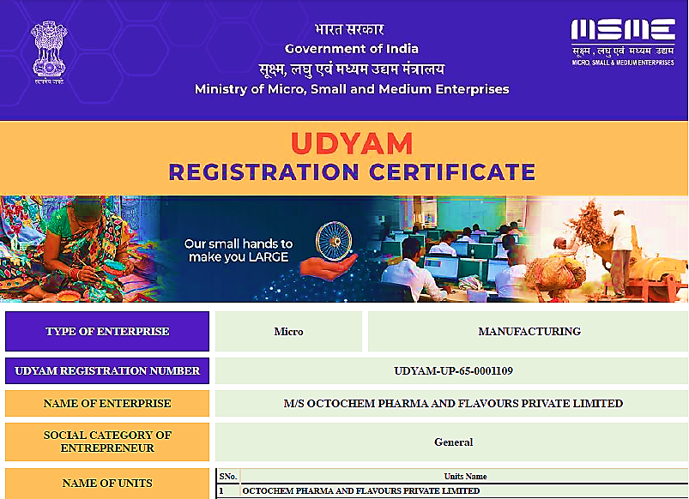
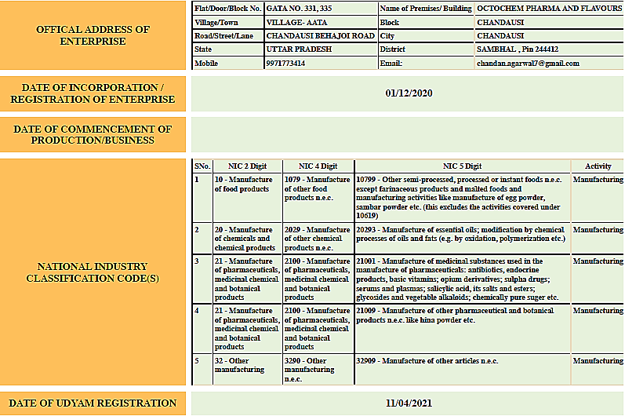

Importer-Exporter Code:

M/s Octochem Pharma and Flavours Private Limited have been obtained an Importer-Exporter Code (IEC) AADC0331Q with details as below:

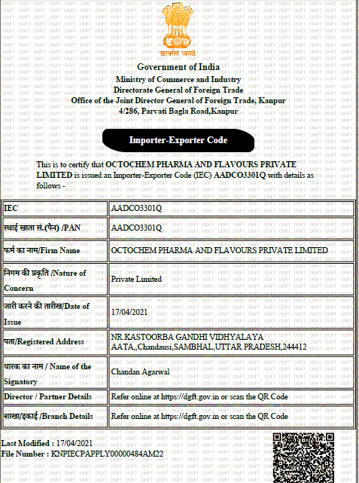

- PROPOSED SHAREHOLDING DETAILS:
As per Notes provided by the company, the company is having authorized share capital is INR 6.00 Crores and issued, subscribed, called and paid up is INR 2.01 Crores as on 31st March 2022 (Source: Ministry of Corporate Affairs).

Proposed Share Capital Details
PARTICULARS | AMOUNT AS ON 31ST MARCH 2022 | AMOUNT AS ON 31ST MARCH 2021
CAPITAL:
Authorised Share Capital
6000000 Equity Shares of Rs10/- each | INR 6,00,00,000 | INR 10,00,000
(P.Y.100000 Equity Shares of Rs.10/- each)
ISSUED ,SUBSCRIBED,CALLED AND PAID UP:
INR 2.01 Crore fully paid up (Source: MCA) | INR 2,01,00,000 | INR 1,00,000
(P.Y.10000 Equity Shares of Rs10/- each fully paid up)
Sources: Ministry of Corporate Affairs

The reconciliation of number of equity shares outstanding at the beginning and at the end of the year is shown in the below table:

PARTICULAR | Number of shares as on 31st March 2022 | Amount as on 31st March 2022
Number of shares at the beginning of the year | 10,000 | INR 1,00,000
Add: Issued during the Year | 5,99,000 | INR 5,99,00,000
Number of shares at the end of the Year | 60,00,000 | INR 6,00,00,000

Below table shows the details of equity shares held by shareholders holding more than 5% shares in the paid-up equity capital of the Company:

Name of the shareholder | Number of shares as on 31st March 2022 | % of Shareholding
Dinesh Kumar Agrawal | 13,00,000 | 22 %
Shyam Agrawal | 17,00,000 | 28 %
Chandan Agrawal | 17,00,000 | 28 %
Poonam Agrawal | 13,00,000 | 22 %
Total | 60,00,000 | 100 %
Source: Data/Information provided by the Company
- KEY PARTNERS/DIRECTORS PROFILE:

Table: Directors Details

DIN | NAME | APPOINTMENT DATE | EDUCATION & EXPEREINCE | ROLE AT OCTOCHEM
00441694 | Dinesh Kumar Agarwal | 1st December 2020 | Managing Director –Shree Balaji Aromatics Pvt Ltd (Bank Account-PNB IBB Moradabad) | Director
08978433 | Shyam Agarwal | 1st December 2020 | IIT Rank- 6300  IIT Delhi- B Tech (CSE)  NUS Singapore- Machine Learner Researcher, Engineer at Circle of Life From June 2019-December 2019 | Director  Technical and Operations
07029982 | Chandan Agarwal | 1st December 2020 | Amity University- B Tech (CSE), Project Engineer at WIPRO From June 2012-May 2014,  Sales and Marketing Head at Shree Balaji Aromatics Pvt Ltd | Director  Sales and Marketing Management
Source: Data/ Information provided by the Company

PART E | PLANT INFRASTRUCTURE DETAILS

- PROPOSED PLANT LOCATION:
The manufacturing facility of M/s. Octochem Pharma and Flavours Private Limited is proposed to be setup at Plot/Gata No. 331, 332, 335 Village Aata, Tehsil Chandausi, District Sambhal, Uttar Pradesh. The company has purchased 3 number of lands ad-measuring 0.380 Hectares (3800 m²), 895 Gaj (748.30 m²) and 0.769 Hectares (7690 m²) respectively aggregating to a total of 12,238.30 m² for the project at the described location.

Connectivity | Details
Rail | Chandausi Junction is the nearest Railway Station
Airport | Pantnagar Airport-93.20 Km
Road | State Highway 39 (1.1 Km)
Port | Kandla Port-1261 Km

Zonal Railway Training Institute (ZRTI) at Chandausi, Moradabad UP is the oldest (and North India's only) Railway Training Institute, where group C railway employees like Driver, Guard, Ticket Checker, Station Master, Traffic Inspector, Commercial Inspector, JE (signal & Telecom) etc. are trained for initial, promotional and refresher courses. ZRTI is an ISO 9001 Institute.

As per provisional data of 2011 census, Chandausi had a population of 1, 14,254 out of which males were 60,238 and females were 54,016. The literacy rate was 72.63 percent.

The climate of the area is similar to that of the Indo-Gangetic Plain, with hot dry summers and cold winters and an average of 35 inches of rainfall.

Google Map:

Location: Project location would be 28°27'22.8"North and 78°44'07.7"East in Chandausi, Uttar Pradesh. Location as per the Google map gas been attached below:
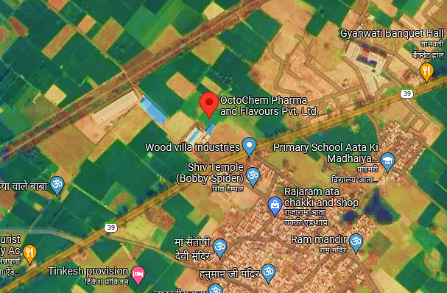

Google Layout Plan: Demarcation of the land on the Google map is as shown in the below picture:

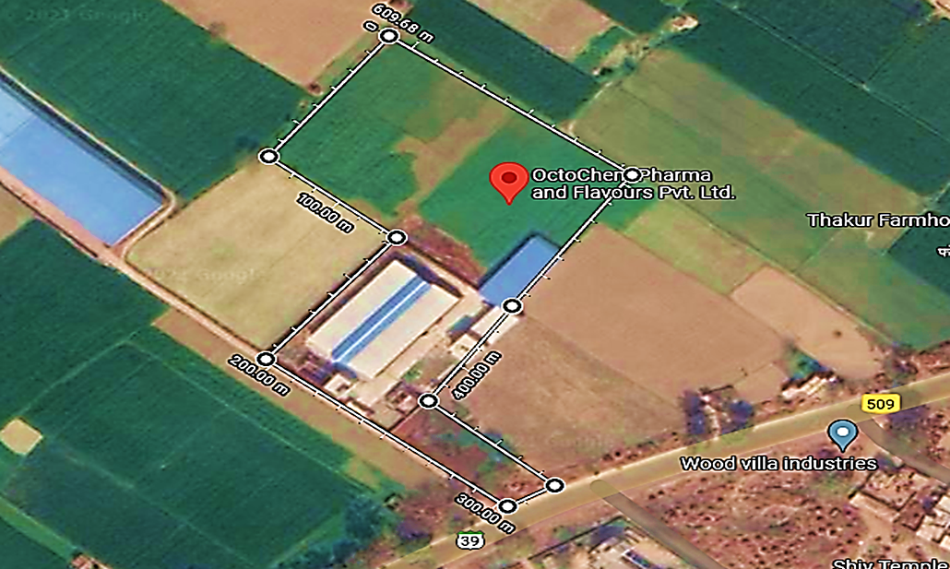

- LAND DETAILS: The details of land purchased to execute the works in the Project Area as below:

Sr. No. | Particulars | Plot Details
1. | Plot/Gata No. | 331 | 332 | 335
2. | Consideration Price | Rs. 11,27,000/- | Rs.84,32,000/- | Rs. 42,30,000/-
3. | Stamp Duty | Rs. 59,000/- | Rs. 69,000/- | Rs. 2,96,100
4. | Seller Name | Shakuntla Devi | Atul Kumar Agarwal | Bhagwandas
5. | Buyer Name | Poonam Agarwal | Dinesh Kumar Agarwal | Dinesh Kumar Agarwal
6. | Area of Land as per Sale deed | 0.380 Hectares (3800 m²) | 895 Gaj (748.30 m²) | 0.769 Hectares (7690 m²)
7. | Date of Sale Deed | 9th July 2012 | 23rd September 2021 | 23rd January 2015
8. | Document Number. | 8468 | 21595 | 1320

Site Pictures:

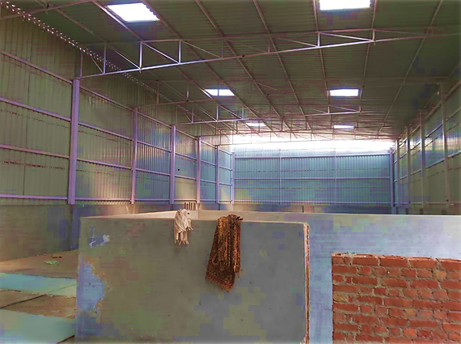

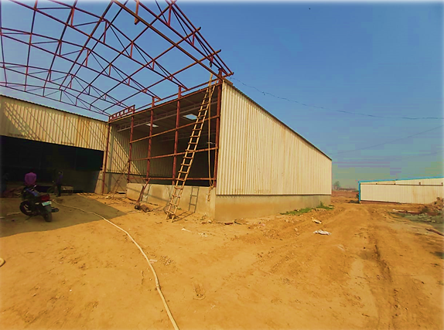

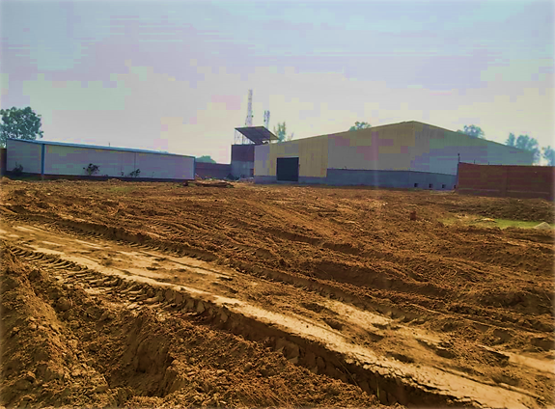
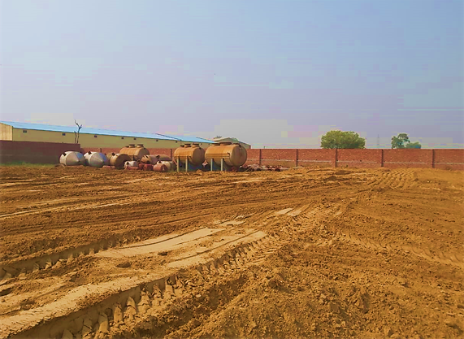

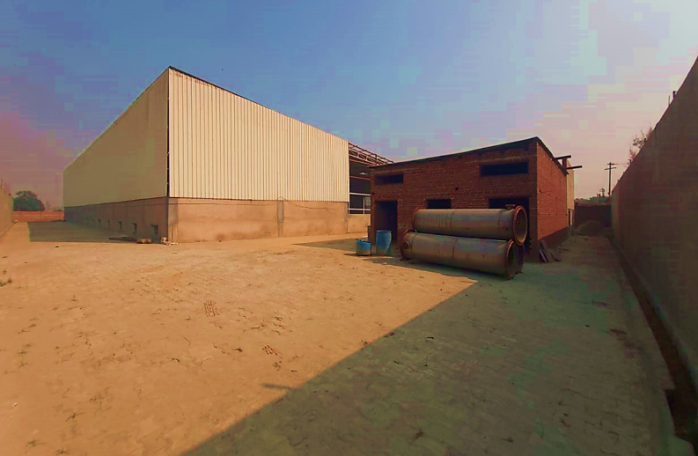

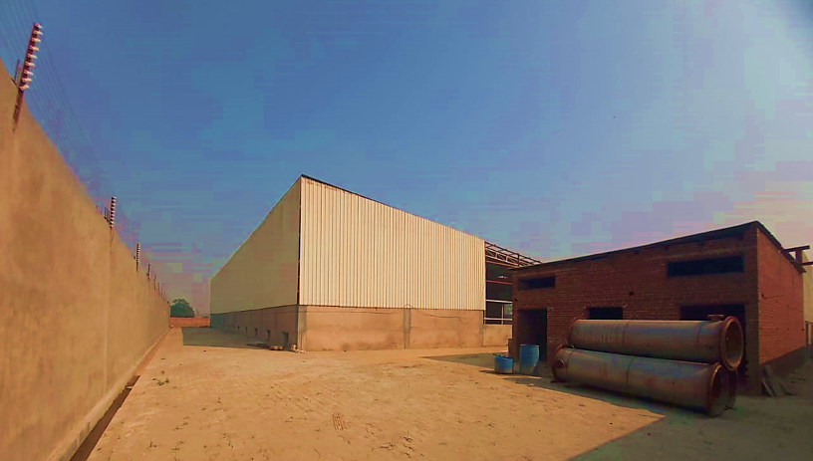

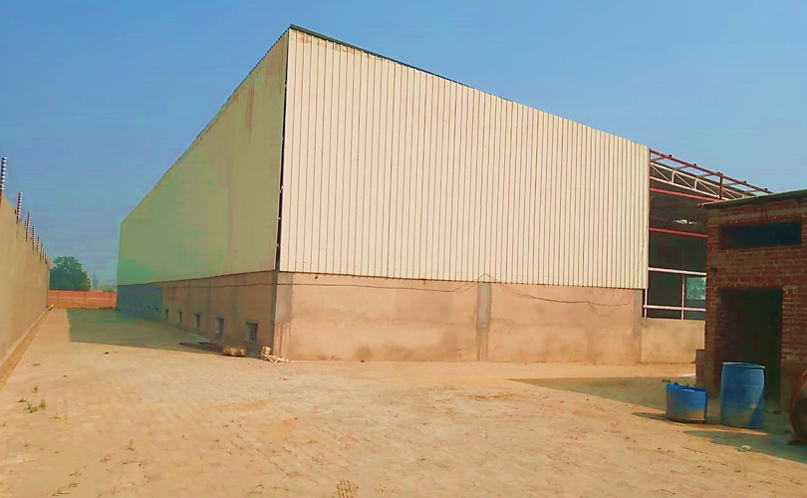

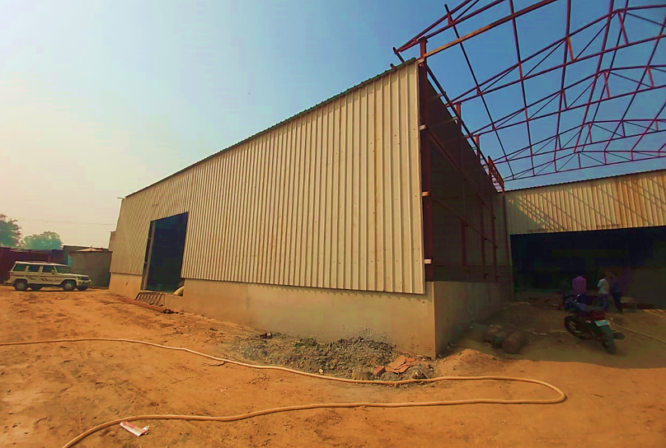

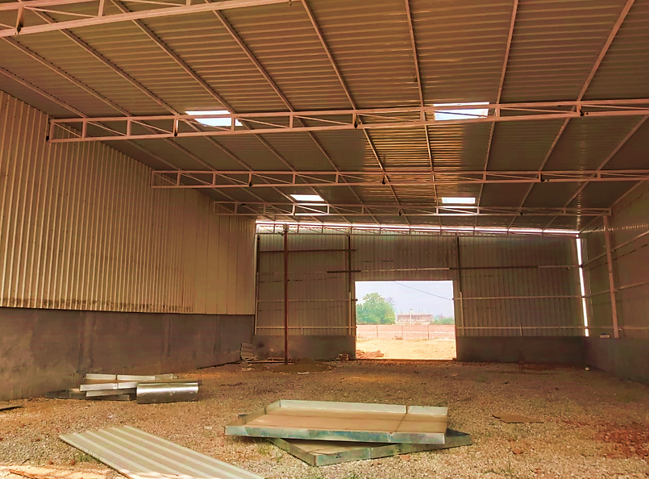
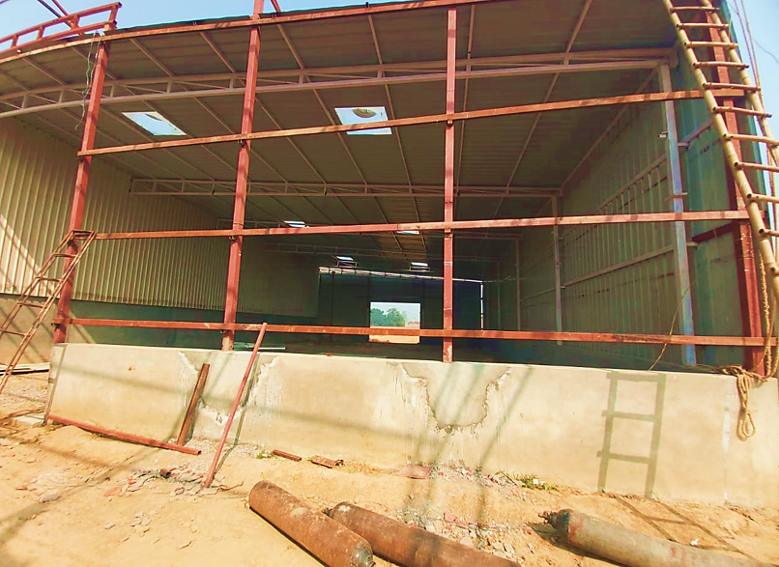

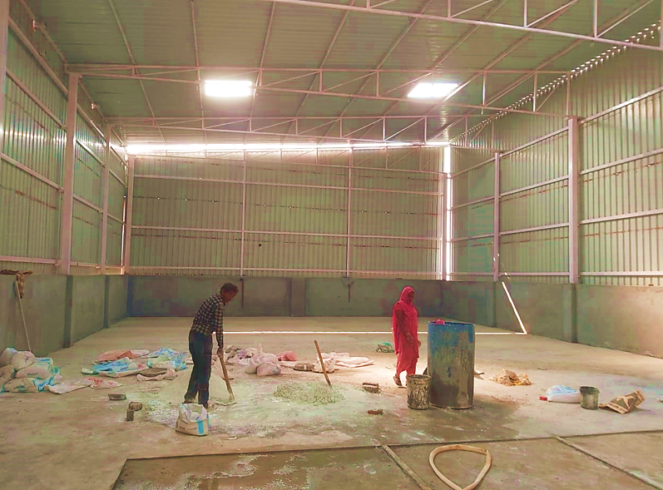
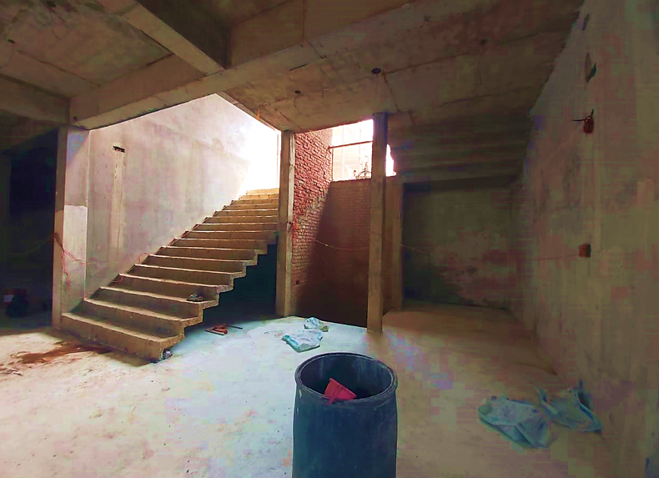

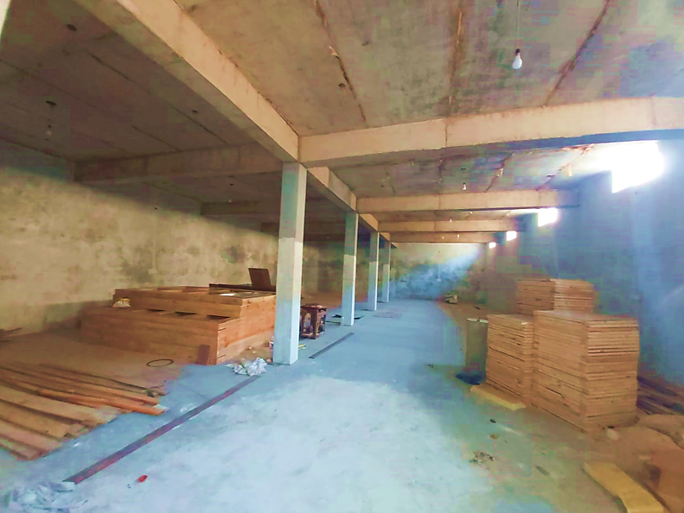

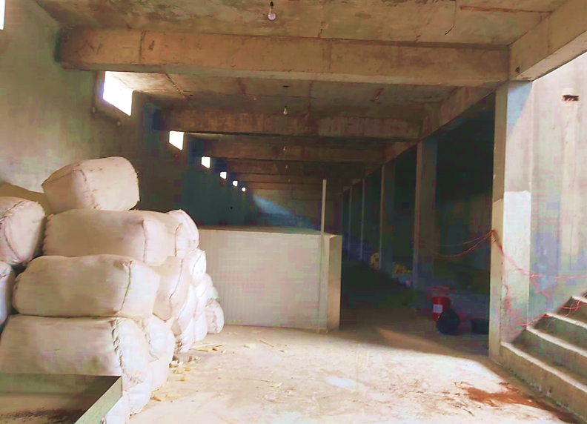

- BUILDING & CIVIL WORKS: The company has planned to construct 9 numbers of structures with area listed as below:

Sr. No. | Description | Area
1. | Hydrogen Block | 111.53 m²
2. | Water tank area | 155.38 m²
3. | Reactor area | 223.16 m²
4. | Distillation plant | 502.11 m²
5. | Boiler | 557.66 m²
6. | Store 1 | 373.48 m²
7. | Dispatch | 278.78 m²
8. | Flakes and packing | 658.81 m²
9. | Store 2 | 278.78 m²
 | Total | 3139.69 m²

As per site survey it has been observed that Flakes and Packing area, Store are in their advance stages for structure completion. Remaining structures are yet to be started.

LAYOUT - DESIGN OF THE WHOLE PROJECT:

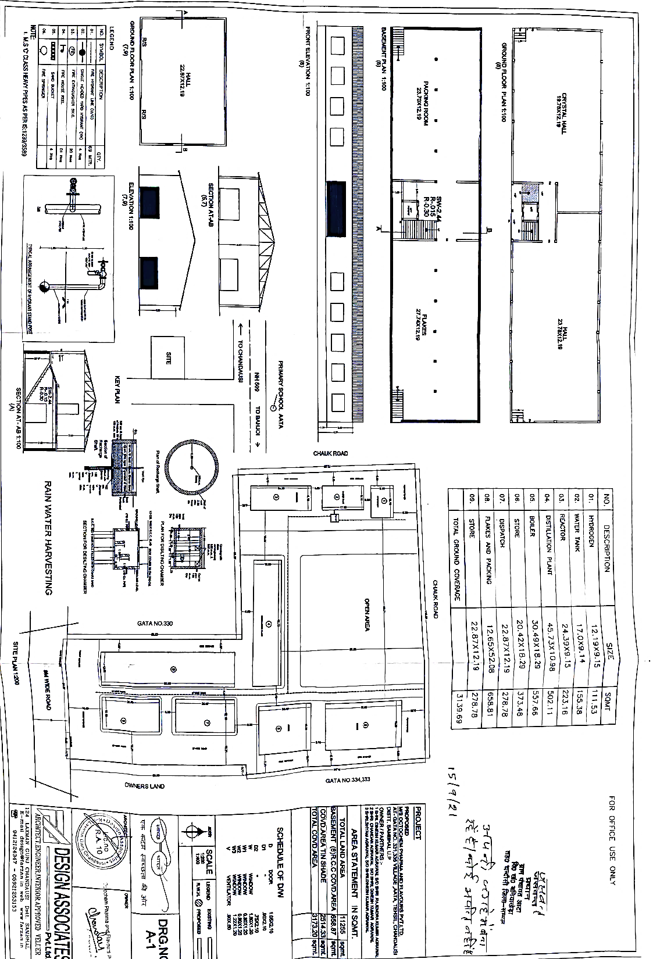

- PLANT AND MACHINERY DETAILS:
The project company has proposed to install the below mentioned machineries in the project:
Machinery Name | Capacity | Quantity | Supplier
Menthol Flakes Deep Freezer Machinery | 4.5 MT | 6 | M/s Tanya Refrigeration Works
Menthol Flakes Deep Freezer Machinery | 3.5 MT | 4 | M/s Tanya Refrigeration Works
Menthol Flakes Deep Freezer Machinery (SS Bold Crystal Chamber) | 4.0 MT | 9 | M/s Tanya Refrigeration Works
Menthol Crystal Deep Freezer Machinery (Storage tank with Heating Coil and Jacket) | - | 1 | M/s Tanya Refrigeration Works
Distillation Colum’s/Colum Machinery equipment’s | - | 1 | M/s Anshika enterprises
Centrifugal machine | - | 8 | M/s NSI Equipment’s Pvt. Ltd.
High mass transfer Area autoclave for Hydrogenation | 2 L | 1 | M/s Nano mag technologies private limited
Precious metal catalyst Filter Model | - | 1
Hydro generator | 3 KL | 1
Lab Auto Sampler | - | 1 | M/s Agilent technologies
Gas chromatograph | - | 1 | M/s Newchrom technologies
Diesel Generator | 125 KVA and 250 KVA | 1 | M/s Gainwell Commsales Private Limited
Silent Diesel Generator | 600 Kva | 1 | M/s Gainwell Commsales Private Limited
Forklift |  | 1 | M/s Shiv equipment’s Private Limited
Transformer | 500 KVA | 1 | M/s Sai electrical
Thermic Fluid heater | - | 1 | M/s Urjex Boilers Private Limited

- UTILITIES: Details of Water, Electricity and other utilities are describes as below:

- Electricity:
For Unit-1 Total Power Load of 200KVA is required in peak time with full capacity. For Unit-2 which is mainly based upon boiler and boiler shall be fuelled by wood. To fulfil the power requirements, the electric connection shall be arranged from UPSEB. Besides, 2 generators of 125 KV, 250 KVA & 600 KVA shall be installed at the site for uninterrupted supply.

- Water:
As per information provided by the company abundant Water is available at unit and the company will ensure the availability of required water at the site in due course of time.
PART F | PROJECT TECHNICAL DETAILS

- MANUFACTURING PROCESS: The formation of menthol crystals involves:

- Freezing of the Mentha oil.
- Removal of the oil crystals from the residual oil by centrifuging.
- Drying of the crystals.

After collection of the mint oil from farmers/brokers, it should be filtered prior to cooling as it usually contains some water and mucilaginous impurities, which prevent ready formation of the menthol crystals. For crystallization some producers use filter and centrifuge the oil.

- Crystallization:
Purified oil is slowly and gradually cooled progressively to lower temperature whereby menthol crystals form in each operation. The freezing process usually comprises three steps (I) cool at 14C (II) 10C and (III) –5OC for hours. Sometimes, actual process takes 48 hours and cooling up to -20 C temperature. The gradual and slow cooling permits the formation of large and more regular crystals.

- Separation of Menthol Crystals from the De-Mentholised Oil:
This is performed by first decanting the remaining liquid oil from the crystal and centrifuging the crystals in large centrifuges rotating at the speed of about 1200 RPM.

- Drying of the Menthol Crystals:
The centrifuged crystals are spread upon the trays in large compartments Or Special room dried for approximately 36 hours in a slow current of air at a temperature of about 26 C. This operation must be undertaken very carefully.

The below flowchart shows the by- product details of menthe oil:

- PLANT TECHNICAL SPECIFICATIONS:
The company has proposed to design the process flow of production of Menthol for which the company will deploy the following machineries.

Machinery Name | Capacity | Purpose in the project
Menthol Flakes Deep Freezer machinery | 4.5 MT | Facilitating Crystallisation process.
Menthol Flakes Deep Freezer machinery | 3.5 MT
Menthol Flakes Deep Freezer machinery (SS Bold Crystal Chamber) | 4.0 MT
Menthol Crystal Deep Freezer Machinery (Storage tank with Heating Coil and Jacket) | -
Distillation Colum’s/Colum Machinery equipment’s | - | For carrying out Fractional Distillation
Centrifugal machine | - | Facilitating Separation Process
High mass transfer Area Autoclave for Hydrogenation | 2 L | Sterilising Mentha Crystals
Precious metal catalyst Filter Model | - | Facilitating Catalysing process during Hydrogenation.
Hydro generator | 3 KL | Facilitating Hydrogenation Process
Lab Auto Sampler | - | Collecting samples from the batch for batch testing
Gas chromatograph | - | Facilitating Gas chromatography
Diesel Generator | 125 KVA and 250 KVA | To power the plant on day to day basis and in emergency also.
Silent DG set | 600 KVA | To power the plant in emergency
Forklift | - | Facilitating Movement of Goods in the factory premises
Distribution Transformer | 500KVA | To Step up/Step Down Voltage
Thermic Fluid heater | - | Thermic Fluid heater will be used to produce heat

Some of the pics of the proposed machinery shared by the company are shown in the below pics:

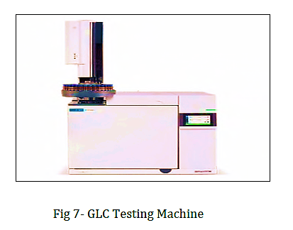
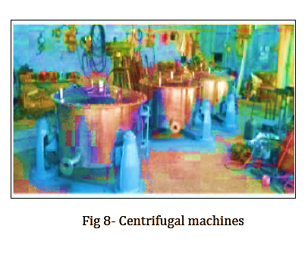

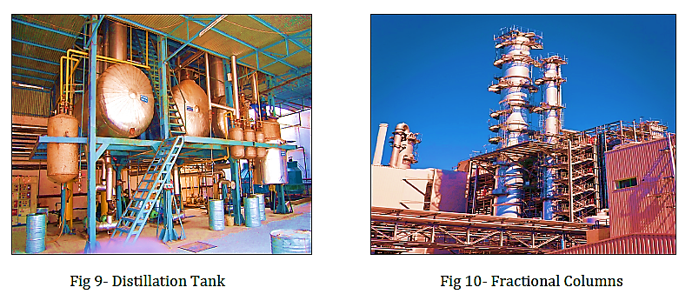
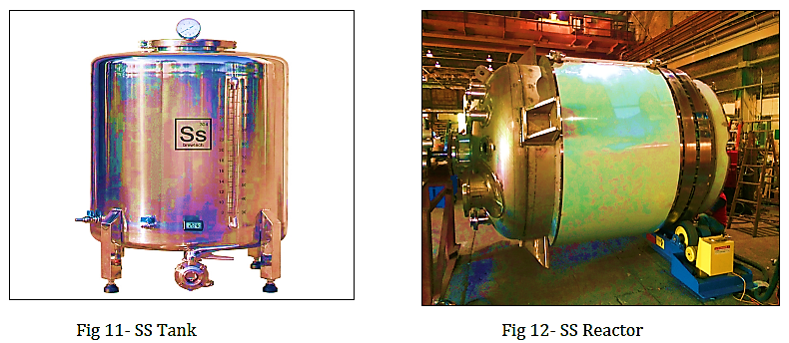

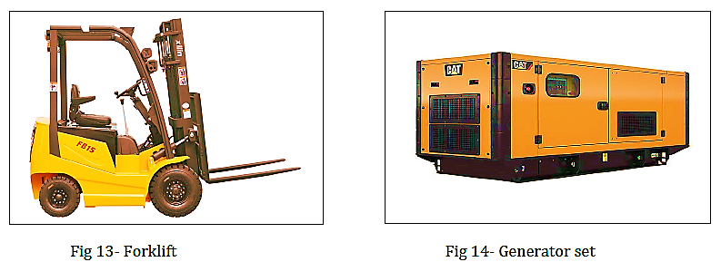

- RAW MATERIALS:
The primary raw materials used for the production of Menthols are Mentha Arvensis Oil, De-Mentholised Oil/DMO and Limonene.

MENTHA ARVENSIS

The wild mint (Latin: Mentha arvensis; French: menthe; Marie-Victorin, 1964) is a 0.5-m-tall perennial herb with square stems, slightly hairy to smooth leaves that are strongly aromatic when crushed. The plant grows throughout North America and prefers prairie ravines, stream and lake margins, low woods, and backyards.

It is also native to Eurasia. The plant (all parts) has a history of use as a phyto-medicine, usually infused, for a variety of purposes. Elders in Saskatchewan use leaves and stems to make an infusion to prevent colds. In addition to infused plant parts, mint essential oils have applications in food flavouring and preservation, as fragrance, and in medicine.

Essential oils are volatile products of secondary plant metabolism. A primary chemical constituent in M. arvensis has been determined to be menthol. Mint plant preparations, such as essential oil, show very good antimicrobial and cytotoxic activities. A recent study in mice exposed to ionizing radiation indicates that M. arvensis leaf extract confers protection against radiation-induced sickness, gastrointestinal, and bone marrow deaths. Ionizing radiation is an important source of mutational damage to DNA. Further testing of efficacious compounds in animal models is needed.

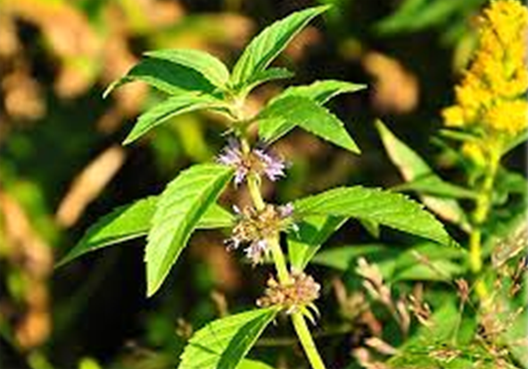

The four most commonly cultivated species are:

  - Japanese Mint/Menthol Mint (Marvensis)
  - Peppermint (M.piperita)
  - Spearmint (M. spicata)
  - Bergamot mint (M. citrate)

All are herbaceous plants, readily sending out runners (rainy season) and stolons (winter), which develop new roots and shoots at the nodes and form plants. The entire aerial shoots together with foliage is a source of essential oil rich in menthol, carvone, linalool and linanyl acetate having use in pharmaceutical preparations and flavour industry.

For the past four decades, mints are commercially cultivated in India. Of these, the Japanese Mint, yielding menthol is grown extensively in northern India. Other major producing countries are China and Brazil and to a smaller extent Thailand and Vietnam.

Estimated Area and Production of Mint in India and Abroad
Species | Area (hect.) | Production (tonnes of Oil) | Total world production (tonnes of Oil) | Major Producing Countries
Japanese mint | 60,000 | 12,000 | 16,000 | India, China, Brazil
Peppermint | 2,500 | 200 | 4,000 | USA, France, former USSR, Brazil, India
Bergamot mint | 1,200 | 150 | 200 | USA, Brazil, Thailand
Spearmint | 3,000 | 300 | 2,000 | USA, China, former USSR, India

Japanese Mint (Mentha arvensis var piperascense) is an aromatic perennial herb, grown as an annual in sub-tropical parts of north India. The over-ground herb (foliage) on distillation yields an essential oil, containing high (75 – 80%) menthol content. The oil has a bitter cooling taste, harsh odour and is the principal source of menthol. It is used in combating cold, used as an ingredient in cough drops and related pharmaceuticals, dentifrices, cosmetics, mouth washes, scenting of tobacco products and flavouring of beverages. Synthetic menthol has also come in market but its volumes are meagre due to high cost of production. Besides, natural menthol is preferred in food and flavour industry.
De-Mentholised Mint Oil also known as Corn Mint Oil, mint Oil is a bi product obtained in the process of producing Menthol crystals.

GENERAL CHARACTERISTICS
Product | Dementholised Mint oil
Botanical Name | Mentha Arvensis Herb
Family | Lamiaceae
Part of the plant used | Leaves
Appearance | Clear liquid
Colour | Colourless
Taste | Minty taste

MENTHOLISED OIL



When Mentha oil is crystallized, 55 to 65% of the material crystallized, rest of the material remains liquid which contains lesser L Menthol content. As most of the L menthol crystallizes remaining oil is named as De Mentholised Mint Oil or De-Mentholised Peppermint Oil. This is mainly used in Flavour and Fragrances, Confectionary, Pharmaceuticals etc.

Dementholised Peppermint Oil is used in the various industries of pharmaceutical, drug, food & drink, beauty & cosmetics products and much more. This oil is extracted from steam distillation, which is also used in the cool-rub and allows in offering a cool relaxing experience.
Dementholised Mint Oil is processed using deep freezing and centrifuging procedure of Mentha Arvensis oil and contains 30% to 56% of L-menthol as its primary component. The other primary chemical elements of Dementholised mint oil are Isomenthone, Neomenthol, L-Menthone, L-limonene, beta pinene, alpha pinene, methyl acetate, pipretone. Dementholised organic peppermint oil is available in two qualities - terpene and terpeneless

- Analysis of Raw Material:
The company has proposed to purchase 118.50 Tons per month of Raw material (Mentha Arvensis oil and Limonene) for production of 112.36 Tons per month of Finished good. Thus The Company will be in surplus of 6.14 ton per month which is inclusive of raw material inventory and wastage of approximately 0.25%. Raw Material analysis is as below:

Particulars | Quantity/Month | Quantity/Year
Total estimated Production | 112.36 | 1348.32
To estimated purchase of Raw material | 118.50 | 1422.00
Surplus Raw material | 6.14 | 73.68
Wastage@0.25% | 0.02 | 0.18
Raw Material Inventory (Buffer Raw Material stock) | 6.12 | 73.50

- SOURCE OF PROCUREMENTThe project company has planned buy Raw materials from below mentioned suppliers:

- Ganpati Agri Business Pvt. Ltd.
As per information available in public domain Ganpati Agri Business Private Limited came into being in the year 2011, and under astute leadership of Mr. Atul Kumar Singh (MD) who possesses sound experience in mint, flavour and fragrance industry. Their modernistic plant is situated at Barabanki, Deva Road, and Uttar Pradesh, which is known as a mint growing area.

As per the details available in the public domain. The company was incorporated with two directors Mr. Atul Kumar Singh Nikhil and Mrs. Anjali Singh. Both the directors are already associated with the trading of raw material like Rice Bran Extracts and Mustard cake and other product which are used in extraction industry. They are engaged in this business since last 20 years and they are well aware about this industry.

The area where the industry has been established is industrially developed area land measuring 40,000 Square Meters and has all the facilities and infrastructure available at site like transport, rail rack point & power supply etc. In this area power supply is available for 24x7 and 35 Km from Chaudhary Charan Singh Airport, Lucknow, and Uttar Pradesh.

- S Chemicals, Chandausi
As per the details available in Public Domain, M/s P.S. Mint & Allied Products Pvt Ltd. was incorporated in the year 2007 and their main firm, S. CHEMICALS was incorporated in the year 1979 by SHREE PAPPU SETH JI, and everybody knows him for his honesty in all our Mentha Industry since 1979. Their firm is situated at Bisauli Gate Chandausi (U.P.) INDIA.

- Marnial Chemicals, Sitapur There is no information in Public Domain regarding their supplier for subject raw materials.

- Maa Shardey Trading Corporation, Barabanki There is no information in Public Domain regarding their supplier for subject raw materials.

- Simaran Trading Corporation, Ludhiana There is no information in Public Domain regarding their supplier for subject raw materials.

- Tirupati Traders, Chandasui There is no information in Public Domain regarding their supplier for subject raw materials.

- Gupta Traders, Barabanki There is no information in Public Domain regarding their supplier for subject raw materials.

- Jai Mata Di Traders, Barabanki There is no information in Public Domain regarding their supplier for subject raw materials.

- Sahara Traders, Kalan There is no information in Public Domain regarding their supplier for subject raw materials.

- Sakti Trader, Chhatarpur There is no information in Public Domain regarding their supplier for subject raw materials.

- ANALYSIS OF MACHINERY, SUPPLIERS AND THEIR RELEAVNCE: Summary of production capacity is shown in the below table:

SUMMARY OF PRODUCTION CAPACITY
Product | Machine Name | Machine Capacity (MT) | Total Number of machines  (Nos) | Total Production Capacity | Capacity Utilization assumed | Capacity Utilisation as per assumption | Net Output Breakup
 |  |  |  |  |  |  | Wastage considered@ 0.25%  (MT) | Mentha Flakes @68%  (MT) | DMO@31.75%  (MT)
Mentha Flakes and DMO Production | Mentha Flakes Deep Freezer | 8.00 | 10.00 | 80.00 | 60% | 48.00 | 0.12 | 32.56 | 15.32
Mentha Crystals and DMO Production | Mentha Crystals Deep Freezer | 4.00 | 9.00 | 36.00 | 60% | 21.60 | 0.05 | 14.65 | 6.89
Total Production Assumed for 1 Cycle |  | 12.00 | 19.00 | 116.00 | 60% | 69.60 | 0.17 | 47.21 | 22.22

Machinery Name | Capacity | Quantity |  | Supplier | PO/ Quotation Number | PO/ Quotation Basic amount |  | GST Amount | Total Amount
Menthol Flakes Deep Freezer machinery | 4.5 MT | 6 |  | M/s Tanya Refrigeration Works | 23 | 94.50 |  | 17.01 | 111.51
Menthol Flakes Deep Freezer machinery | 3.5 MT | 4 |  | M/s Tanya Refrigeration Works | 23 | 54.00 |  | 9.72 | 63.72
Menthol Flakes Deep Freezer machinery (SS Bold Crystal Chamber)* | 4.0 MT | 9 |  | M/s Tanya Refrigeration Works | 24 | 79.65 |  | 14.34 | 93.99
Menthol Crystal Deep Freezer Machinery (Storage tank with Heating Coil and Jacket) Accessories * | - | 1 |  | M/s Tanya Refrigeration Works | 24 | 84.00 |  | 15.11 | 99.11
Distillation Colum’s/ Colum Machinery equipment’s | - | 1 |  | M/s Anshika enterprises | AE/QUOT-110/21 | 761.45 |  | 137.06 | 898.51
Centrifuge machine | - | 8 |  | M/s NSI equipment’s Pvt. Ltd. | - | 59.20 |  | 10.65 | 69.85
High mass transfer Area autoclave for Hydrogenation | 2 L | 1 |  | M/s Nano Mag technologies private limited | NMT/08-21/01619 | 2.44 |  | 0.44 | 2.88
Precious metal catalyst Filter Model | - | 1 |  |  | NMT/08-21/01600 | 12.50 |  | 2.25 | 14.75
Hydro generator | 3 KL | 1 |  |  | NMT/07-21/01409-1 | 59.00 |  | 10.62 | 69.62
Lab Auto Sampler | - | 1 |  | M/s Agilent technologies | IN-J9TG40-1020-163 | 53.66 |  | 9.66 | 63.32
Gas chromatograph | - | 1 |  | M/s Newchrom technologies | NT/QTN/120/21-22 | 5.37 |  | 0.97 | 6.34
Diesel Generator (125 Kva+250kva) | 125 KVA and 250 KVA | 1 |  | M/s Gainwell Commsales Private Limited | GCPL/E&T/NR/2021/0627/R0 | 27.70 |  | 4.99 | 32.69
Silent DG | 600 KVA | 1 |  |  | GCPL/E&T/NR/2021/0917/R0 | 38.50 |  | 6.93 | 45.43
Forklift | 500 KVA | 1 |  | M/s Shiv equipment’s Private Limited | SEPL01/Hyundai/2021/sept. | 12.63 |  | 0.00 | 12.63
Transformer* | - | 1 |  | M/s Sai Electricals | 24402.00-Rev-0 dated 18.09.2021 | 15.60 |  | 2.80 | 18.40
Thermic Fluid heater |  | 1 |  | M/s Urjex Boilers Private Limited | UBPL / SAL / 840 / UR / MS / 4770 | 14.70 |  | 2.65 | 17.35
Total |  |  |  |  |  | 1374.90 |  | 245.21 | 1620.10
Note: Bank to Obtain the Copies of All the Final Purchase Orders from the company.

Details of Machineries Being purchased in the project and their respective functions in the Process
Machinery Name |  |  | General Functioning of Machinery |  |  |  | Utilisation of the machinery in the project
Menthol Flakes Deep Freezer machinery |  |  | A deep freezer focuses on maintaining low temperatures that help keep the products at extremely low temperatures to not only extend shelf life, but to also make sure the product does not lose quality. In contrast to a regular freezer, a deep freezer can reach temperatures of – 50C to -60 Degrees Celsius within an hour to a few minutes.  This allows for rapid freezing of products and is especially useful in industries such as food processing, manufacturing and catering.  Many businesses often use a deep freezer or a flash freezer prior to storing their inventory in a storage freezer. This is why when it comes to industrial or commercial freezing, deep freezers and flash freezers are some of the highest sought after in the market.  In fact, one could state that they are absolutely essential for any food related business that is hoping to push its boundaries and make its mark on the market with exceptionally high quality products that makes them stand out from the rest of the competition |  |  |  | Deep Freezers will be used for progressive chilling of Mentha oil which will result in separation of menthol in crystalline form.
Menthol Flakes Deep Freezer machinery
Menthol Flakes Deep Freezer machinery (SS Bold Crystal Chamber)
Menthol Crystal Deep Freezer Machinery (Storage tank with Heating Coil and Jacket)
Distillation Colum’s/Colum Machinery equipment’s |  |  | A distillation column is an essential item used in the distillation of liquid mixtures to separate the mixture into its component parts, or fractions, based on the differences in volatilities. Fractionating columns are used in small scale laboratory distillations as well as large scale industrial distillations. |  |  |  | DMO Prepared in First step will be subjected to Fractional Distillation which will further produce Terpines and All grade Peppermint Oil. Peppermint oil will be further used to produce Alpha pinine, Beta Pinene, Liminene, L menthol and Hexanol
Centrifuge machine |  |  | Centrifuge machine is an electronic equipment used for the separation of components in a sample mixture, such as a mixture of suspended solids or two or more immiscible liquids.  The equipment is fixed at the axis of rotation and centrifugal forces cause the samples to separate such that the denser materials are settled below the lighter ones. The sample is contained in conical or round tubes, often referred as the centrifuge tubes, and placed within the rotor, in a balancing position, and covered with a lid to prevent spillage, and any accidents or disasters.  The rpm (rotation per minute), i.e. centrifugal speed, the duration of rotation, the temperature can be adjusted, based on the sample requirement. |  |  |  | During Progressive chilling of Mentha Oil less than 100% of the oil converts to mentha crystals. Thus to filter out the Menthol oil and mentha crystals, centrifugal machine is used.
Autoclave |  |  | An autoclave is a machine used to carry out industrial and scientific processes requiring elevated temperature and pressure in relation to ambient pressure/temperature.  Autoclaves are used in medical applications to perform sterilization and in the chemical industry to cure coatings and vulcanize rubber and for hydrothermal synthesis. Industrial autoclaves are used in industrial applications, especially in the manufacturing of composites. |  |  |  | The autoclave machines will be used for sterilising of Mentha Crystals.
Hydro generator |  |  | Hydrogenation Process is carried out using Hydro generator. Hydrogenation is a chemical reaction between molecular hydrogen and an element or compound, ordinarily in the presence of a catalyst.  Hydrogenation is used to solidify, preserve or purify mentha crystals. |  |  |  | Hydro generator will be used for Hydrogenation process of Mentha Oil
Precious Metal-Catalyst Filter Model |  |  | Hydrogenation is a chemical reaction between molecular hydrogen and another compound or element, usually in the presence of a catalyst such as nickel, palladium or platinum. |  |  |  | This equipment is used to release catalyst material in control environment.
Lab Auto Sampler |  |  | Auto samplers are devices that are used in the periodic retrieval of samples for analysis |  |  |  | Auto sampler will be used for Testing of samples collected from batch of production.
Gas chromatograph |  |  | A gas chromatograph is a chemical analysis instrument for separating chemicals in a complex sample. A gas chromatograph is made up of a narrow flow-through tube, known as the column, through which the sample passes in a gas stream (the carrier gas) at different rates depending on their various chemical and physical properties and their interaction with a specific column lining or filling, called the 'stationary phase'. As the chemicals exit the end of the column, they are detected and identified electronically. The function of the stationary phase in the column is to separate different components, causing each one to exit the column at a different time. Other parameters that can be used to alter the order or time of retention are the carrier gas flow rate, column length and the temperature |  |  |  | Gas chromatographs will be used for analysing the manufactured Product.
Forklift |  |  | A forklift is a powered industrial truck used to lift and move materials over short distances. |  |  |  | Forklift will be used to move and transport the finished product to dispatch areas.
Transformer |  |  | A transformer is an electrical device that trades voltage for current in a circuit, while not affecting the total electrical power. This means it takes high-voltage electricity with a small current and changes it into low-voltage electricity with a large current, or vice versa. One thing to know about transformers is that they only work for Alternating Current (AC), such as you get from your wall plugs, not Direct Current (DC). |  |  |  | Transformer will be used to supply electricity in the unit.
Thermic Fluid heater |  |  | A thermal fluid system, also known as a hot oil, thermal liquid (or sometimes Downtherm) system, is an industrial heating system wherein a special heat transfer liquid is recirculated by a pump through a fired heat exchanger where its temperature is raised for use in heating various processes |  |  |  | Thermic Fluid heater will be used to produce Alpha pinine, Beta Pinene, Liminene, L menthol and Heaxanol

Below table shows the analysis of expected suppliers:

SUPPLIER's ANALYSIS
Machinery Name | Supplier Name | Remarks
Menthol Flakes Deep Freezer machinery | M/s Tanya Refrigeration Works | As per information available in Public Domain M/s Tanya Refrigeration works is a reputed suppliers of Deep Freezers
Menthol Flakes Deep Freezer machinery
Methol Flakes Deep Freezer machinery (SS Bold Crystal Chamber)
Menthol Crystal Deep Freezer Machinery (Storage tank with Heating Coil and Jacket)
Distillation Colum’s/Colum Machinery equipment’s | M/s Anshika enterprises | No information available in Public Domain for M/s Anshika Enterprises.
Centrifuge machine | M/s NSI Equipment’s Private Limited | As per Information Available in Public domain M/s NSI equipment’s Private Limited is a reputed Supplier of Centrifuge machines
Autoclave | M/s Nano Mag technologies Private Limited | As per Information available in Public Domain M/s Nano mag technologies Private Limited is a reputed supplier of Autoclave, Hydro generator and Precious Metal Catalyst Filter Model
Hydro generator
Precious Metal-Catalyst Filter Model
Lab Auto Sampler | M/s Agilent Technologies | No information available in Public Domain for M/s Agilent Technologies
Gas chromatograph | M/s Newchrom Technologies | As per Information available in Public domain M/s Newchrom Technologies is a reputed supplier of Gas Chromatograph.
Forklift | M/s Shiv equipment’s private limited | As per information available in Public Domain M/s Shiv equipment Private Limited is a reputed supplier of Forklift
Diesel Generator | M/s Gainwell Commosales Pvt Ltd | As per information available in Public domain M/s Gainwell Commosales Pvt Ltd is a reputed supplier of DG Sets.
Silent DG set | M/s Gainwell Commosales Pvt Ltd
Transformer | M/s Sai electrical | As per Information available in Public Domain M/s Sai electrical is a reputable supplier of Transformer.
Thermic Fluid heater | M/s Urjex Boilers Private Limited | As per information available in Public domain M/s Urjex Boilers Private Limited is a reputed supplier of Thermic Fluid Heater

- MANPOWER: Company has not been planned any kind of manpower till now, as per discussion with the company they will be planning it in due course of time. As per the company profile over linkedin, it is expected to be 11-50 employees will be required to operate efficiently.

PART G | PRODUCT PROFILE

- INTRODUCTION:
Mentha oil is one of the important agricultural essential oils and is extracted from the medicinal botanical herb of Mentha Arvensis through distillation process by the farmers. It is widely used in pharmaceuticals, foods and flavourings.

In addition to being a popular flavouring agent in food and confectionery preparation, natural menthol has cooling and soothing effect on skin and mucous membrane of human body, making it a useful ingredient in pharmaceuticals and cosmetics industry.

The company is setting up their manufacturing unit in Chandausi, which is the heart of "Mint and Essential Oil Growing belt" in India and is blessed with ideal soil and climatic conditions for the cultivation of these herbs.



India produces 90% of the world’s menthol production and of which 85% of share is produced in Uttar Pradesh.

- PRODUCT SPECIFICATIONS:
Menthol is an organic compound, more specifically a Mono-terpenoid, made synthetically or obtained from the oils of corn mint, peppermint, or other mints. It is a waxy, crystalline substance, clear or white in colour, which is solid at room temperature and melts slightly above. The main form of menthol occurring in nature is (−)-menthol. Menthol has local anaesthetic and counterirritant qualities, and it is widely used to relieve minor throat irritation.

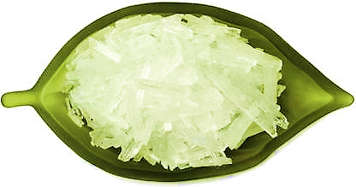

- PRODUCT PROPERTIES: Properties of Menthol are as below:



- Boiling point: 212 °C
- IUPAC ID: (1R, 2S, 5R)-2-isopropyl-5-methylcyclohexanol
- Density: 890 kg/m³
- Molar mass: 156.27 g/mol
- Solubility in water: Slightly soluble, (−)-isomer
- Melting point: 36–38 °C (97–100 °F; 309–311 K) racemic; 42–45 °C, (−)-isomer, α crystalline form

- APPLICATION’s OF MENTHOL:
Menthol is used for below mentioned purposes:

- In non-prescription products for short-term relief of minor sore throat and minor mouth or throat irritation. Examples: lip balms and cough medicines.
- As an antipruritic to reduce itching.
- As a topical analgesic, it is used to relieve minor aches and pains, such as muscle cramps, sprains, headaches and similar conditions, alone or combined with chemicals such as camphor, eucalyptus oil or capsaicin. Examples: Tiger Balm, or Icy Hot patches.
- As a penetration enhancer in transdermal drug delivery.
- In decongestants for chest and sinuses (cream, patch or nose inhaler). Examples: Vicks VapoRub, Mentholatum, VapoRem, Mentisan.
- In certain medications used to treat sunburns, as it provides a cooling sensation (then often associated with aloe).
- In aftershave products to relieve razor burn.
- As a smoking tobacco additive in some cigarette brands, for flavour, and to reduce throat and sinus irritation caused by smoking. Menthol also increases nicotine receptor density, increasing the addictive potential of tobacco products.
- Commonly used in oral hygiene products and bad-breath remedies, such as mouthwash, toothpaste, mouth and tongue sprays, and more generally as a food flavour agent; such as in chewing gum and candy.
- As a pesticide against tracheal mites of honey bees.
- In perfumery, menthol is used to prepare Menthyl esters to emphasize floral notes (especially rose).
- In first aid products such as "mineral ice" to produce a cooling effect as a substitute for real ice in the absence of water or electricity (pouch, body patch/sleeve or cream).
- In various patches ranging from fever-reducing patches applied to children's foreheads to "foot patches" to relieve numerous ailments (the latter being much more frequent and elaborate in Asia, especially Japan: some varieties use "functional protrusions", or small bumps to massage one's feet as well as soothing them and cooling them down)
- In some beauty products such as hair conditioners, based on natural ingredients (e.g., St. 􀀀Ives).
- As antispasmodic and smooth muscle relaxant in upper gastrointestinal endoscopy.



- QUANTITY DETAILS: The Production quantity details of the Project is as below:

Product | Unit | Production Quantity Per Month (As per Company)
Menthol Flakes | 1 | 34.88 Tons
DMO (De-Mentholised Oil) | 1 | 0.84 Tons
Mentha Crystals | 1 | 26.33 Tons
DMO Lind | 1 | 14.07 Tons
Terpene | 2 | 5.40 Tons
Menthone | 2 | 7.20 Tons
L-Menthol | 2 | 18.00 Tons
CIS-Hexanol | 2 | 0.22 Tons
Carvacrol/Carvone | 2 | 4.92 Tons
Di-Hydro Carvone | 2 | 0.51 Tons
Total |  | 112.36 Ton

Process of Mentha Oil

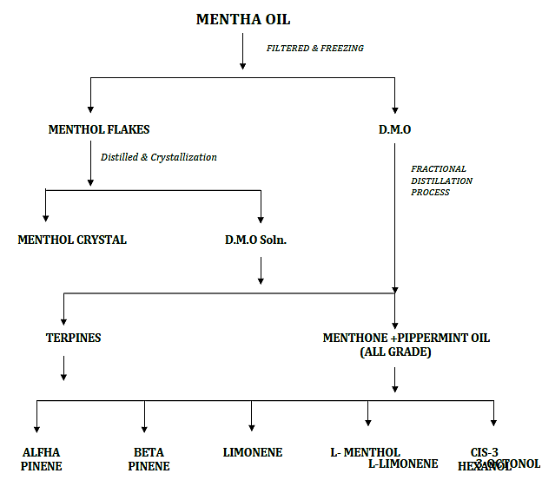

Above flowchart shows the Mentha oil processing from initial stage to getting the final by-products and visualization of the stages to get the proposed finished goods.

- MARKETING, SELLING & DISTRIBUTION PLAN:
The consumption pattern of Mentha in India has made it an important crop. Mentha in India has reached out to almost all the households and has made a major impact because of the qualities present in it.

The global demand for Mentha oil can be attributed to the increased usage of Mentha oils owing to the high demand in pharmaceuticals, fragrances in personal care products such as cosmetics, oral care, cigarettes, and flavouring segments. The growing consumer preference for natural and organic personal care products due to increasing awareness regarding the potential side effects of inorganic products is expected to further fuel the growth of this market.

India exports different types of mint-oil to countries including China, U.S., Singapore, Netherlands, Germany, UK, France, Brazil and Japan. The major export varieties include Mentha Arvensis oil, Peppermint oil (Mentha pipertia), De-Mentholised mint-oil, and Spearmint oils.

Also, India is exporting mints and its derivatives throughout the world and last year total export of menthol oil is 18,000 Tonnes and domestic consumption is approx. 19,000 Tonnes.

The end uses of menthol crystals are cosmetics and pharmaceutical, which prefers natural products to attract the customers. Menthol crystals have various benefits in personal care are used by various medicinal therapies available today. The natural sources of menthol crystals include peppermint, corn mint, and other mint plants.

Emerging economies are gaining advantage of large population base with increasing income and increasing per capita spending. Emerging countries such as China and India has witnessed a strong growth in terms of production as well as consumption of Menthol crystals

Some of the market participants identified across the value chain of global Menthol crystals market are:

- Mannix Marketing, Inc.
- Majestic Mountain Sage Inc.
- Tenda Horse Products LLC.
- F. Suter & Co. Limited
- Silverline Chemicals
- Archer Daniels Midland
- Hershey
- Barry Callebaut
- Lindt & Sprungli
- Olam International
- Nestle
- Wrigley Jr. Company
- Gold Cost Ingredients, Inc.
- Kanegrade Limited
- Vital Flavours
- Ricola

As of now the project company is aiming to sell its product directly to the following company:

Company | Address | Website | Products Company Deals in
F. D Copeland and Sons Ltd. | Colanol House, 5 Westfield Street, London, SE18 5TL, United Kingdom | - | Website not found at the time of Verification
Prinova Europe | 10 Aldersgate St, London EC1A 4HJ, United Kingdom | https://www.prinovaglobal.com | Ingredients, Premixes, Fragrances, Essential oils etc.
Norex Flavours Pvt. Ltd. | Gajraula - Chandpur Rd, Dhanaura, Uttar Pradesh 244231 | https://www.menthol-mint.com | Fragrances, Fruity and Natural Fragrances, Aromatic essential oils, Candle and soal Fragrance, essential oils etc.
Anhui Tonghui Perfume Co. Lt. | Mr. David Wu, Southern NewZone Bozhou City Anhui, China | http://ahthxl.com | Peppermint oil, Natural Menthol etc.
Swati Menthol And Allied Chemicals Limited | Opposite Akashwani , Bareilly Road Rampur- 244901, Uttar Pradesh, India | https://swatimenthol.com | Natural Mint products, essential and aromatic oils etc.
Neeru Menthol Private Limited | Panwaria Bareilly Road, Rampur-244901 (U.P) India | https://www.neerumenthol.com | Natural Mentha oil and products, Essential oils, Aromas etc.
Ventos (Spain) | Crta. Reial 120 B 08960 Sant Just Desvern BARCELONA, SPAIN | https://www.ventos.com/en/ | Aroma chemcials, Essential oils etc.
Callisions Flavours (India) Pvt. Ltd. | 1614, 1615, MAKER TOWER E, CUFFE PARADE, Mumbai- 400005 Maharashtra – India | https://www.callisons.com/ | Oral care, Gum, Confectionary, beverage etc.
Fine Organics | C-7, Roshan Bagh, Industrial Area, Civil Lines, Rampur, Uttar Pradesh 244901 | https://www.fineorganics.com/global/products | Food additives, Additives for Cosmetics and pharma etc.
Kancor Ingredients Limited | NH 24, C.B.Ganj, Bareilly, Uttar Pradesh 243502 | https://manekancor.com/ | Oleoresins, Essential oils and Isolates, Natural colours, Nartural Antioxidants etc.

Conclusion (Technically Viability):

Based on the pre-planning of the company’s management of selling and distribution strategy of the finished goods to generate revenue & market segmentation, globally increasing demand of the Mentha by-products in various industries & applicability of these products, current technology is being used for production, availability of raw material & Raw material supplier’s capacity as the project is situated in the main belt of Mentha production, machinery is being used for manufacturing and manufacturing facility, capacity utilization analysis, it can be commented positively that the proposed project is seeming technically viable.

While it would be depending on the management’s capability in future that how efficiently inventory management will being done, what would be the marketing and advertisement strategy and what would be the price, place, promotion and production strategy and how technological advancement will be applied after initiation of the production.

PART H | INDUSTRY OVERVIEW & ANALYSIS

- INTRODUCTION:
Mentha oil is one of the important agricultural essential oils and is extracted from the medicinal botanical herb of Mentha Arvensis through distillation process by the farmers.

Menthol mint (Mentha Arvensis) is a popular essential oil bearing, short duration cash crop, well fitted in traditional cropping system like paddy-wheat-mint, paddy-mustard-mint, paddy-potato-mint, maize-wheat-mint without affecting the existing cropping system. It can be cultivated in well-drained, deep, fertile, organically rich soils with good moisture retaining capacity, neutral in pH and texture ranging from sandy-loam to clay-loam. Majority of marginal and small land-holding farmers start sowing of mint from January and continue till March in North India, for its essential oil derived aroma compounds obtained through distillation of shoot biomass are traded globally.

Menthol crystals is a type of alcohol, which is produced from mint oils after passing through various processes including extraction, distillation, filtration and crystallization. Menthol crystals are clear crystals at room temperature and are used in various application in food, cosmetics and pharmaceutical industry.

Menthol crystals pharmaceutical applications include decongestants, lip balms, topical analgesic, skin care products, and dental floss, massage oils and cough medicines. Cosmetics applications of menthol crystals includes perfumes, laundry products, soap making, toothpaste, body sprays, creams and others. Menthol crystals can be produced by natural as well as synthetic ways. Natural menthol crystal constitute major part of the market.

It is widely used in pharmaceuticals, foods and flavouring. In addition to being a popular flavouring agent in food and confectionery preparation, natural menthol has cooling and soothing effect on skin and mucous membrane of human body, making it a useful ingredient in pharmaceuticals and cosmetics industry. India produces 90% of the world’s menthol production and of which 85% of share is produced in Uttar Pradesh.

Yield and Profit

The yield and profit from menthol mint depends on various factors like planting material, method of cultivation, management practices, frequency of harvesting in a year, climatic factors, market price etc. Generally, mint has planted by two different methods i.e. direct planting of suckers/roots in the fields during the months of December-January and through nursery raising, transplanting during February and March. If farmers cultivate mint through direct method, it will be ready for harvesting in 110-120 days, whereas transplanting method will take 80-90 days for harvesting.

In North India, maximum two subsequent harvests are taken by farmers at 40-45 days intervals and obtain about 25-30 Ton/hectare, green herbs (250kg oil/hectare). The total cost of cultivation incurred approximately Rs. 50k-60k/hectare and Net profit Rs.1.70-1.80 lakh/hectare.

In India, Uttar Pradesh is the leading mint producing state accounts for 80-85% of Indian mint production and remaining 15-20% comes from Punjab, Bihar, M.P., Haryana, Himachal Pradesh etc. In Uttar Pradesh, it is mainly cultivated by marginal and small land-holding farmers on a large scale and commercial basis in Barabanki, Moradabad, Sambhal, Badaun, Chandausi, Ambedkar Nagar, Sitapur, Pratapgarh, Bareilly, Rampur, Lakhimpur districts, Rai Bareli and Lucknow etc.

Production, Export and Major Export Destination

India is a major producer and exporter of menthol mint. During last decade, (2000-01 to 2017-18) India has produced around 80% of global mint oil and exported about 75%. The production and export varied between 14.50Mt to 29.50Mt and 4.19Mt- 25.75Mt during the decade (DGCI&S, 2018). Cultivation is increasing due to its growing national demand and export potential to other countries.

The major export destinations of Indian mint oil are China, USA, Singapore, Germany, Japan, Netherlands, United Kingdom, Paraguay, Hong Kong, Argentina, Brazil and France etc. Apart from India; China, Brazil and United States are also stepping up in the global market of menthol mint oil.

- MENTHOL MARKET OVERVIEW:
Menthol is an organic compound that occurs naturally in mint and some other plants. It can be made systematically. Pure menthol is a crystalline solid and is widely used in cough and cold remedies because of its soothing effects and as a flavouring in candy, chewing gum, medical products and cigarettes. Mentha oil is a colourless or pale yellow, clear liquid. It has a characteristic, pleasant aroma and has a pungent taste, followed by a cool aftertaste.

The increasing demand for natural and organic personal care products is a key growth driver for the Mentha oil market. The popularity of organic and natural products has increased due to rising awareness of adverse effects of chemical based products and the health benefits of using organic products.
Organic and natural personal care products are made using natural ingredients, which includes Mentha oil because of its characteristics of being a denaturant, flavouring agent, and fragrance ingredient.

Europe accounted for the major share in the global Menthol crystals market, followed by North America, however the growth is more in Asian region. Asia Pacific stands after North America in terms of total demand for Menthol crystals.

North American and Europe are established markets for Menthol crystals but the growth seems to be coming down due various challenges of developed markets. Slower economic growth in Europe is another hurdle in the Menthol crystals market growth in Europe.

Middle East & Africa and Latin America are smaller markets for Menthol crystals as compared to other regions, however Middle East & Africa is expected a strong growth in terms of both value and volume.

The data of the report is based on the menthol product with purity of 99% MIN. And other products in lower menthol purity have been converted in the equivalent of 100%. However variations in climatic conditions tend to effect the overall menthol supply.

India is the world’s largest producer of mints and its derivatives. In 2019 total production of Mentha Arvensis oil is approximately 40,000 Tonnes. In year 2020 total production of Mentha Arvensis oil is approx. 45,000 Tonnes.

The below graph shows the comparison between production of Mentha Arvensis oil in the years 2019 and 2020:

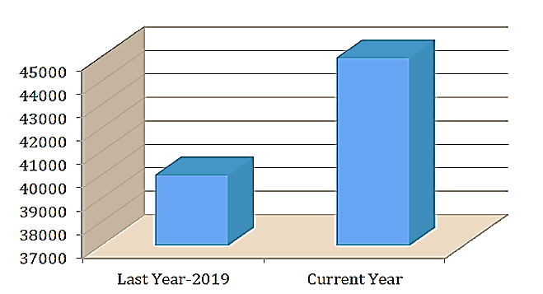

Also, India is exporting mints and its derivatives throughout the world and last year total export of menthol oil is 18,000 Tonnes and domestic consumption is approx. 19,000 Tonnes.

Below graph shows the comparison between total export and domestic consumption of mints and its derivatives:

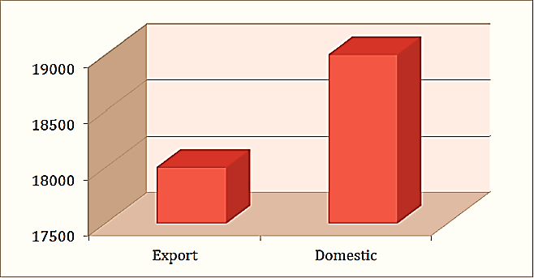

The consumption pattern of Mentha in India has made it an important crop. Mentha in India has reached out to almost all the households and has made a major impact because of the qualities present in it. The global demand for Mentha oil can be attributed to the increased usage of Mentha oils owing to the high demand in pharmaceuticals, fragrances in personal care products such as cosmetics, oral care, cigarettes, and flavouring segments.

The growing consumer preference for natural and organic personal care products due to increasing awareness regarding the potential side effects of inorganic products is expected to further fuel the growth of this market. The increasing demand for natural and organic personal care products is a key growth driver for the Mentha oil market.

The popularity of organic and natural products has increased due to rising awareness of adverse effects of chemical based products and the health benefits of using organic products.

Below graph shows the export data and list of countries buying menthol irrespective to the amount for the Financial Year 2019:

TOP BUYER COUNTRY

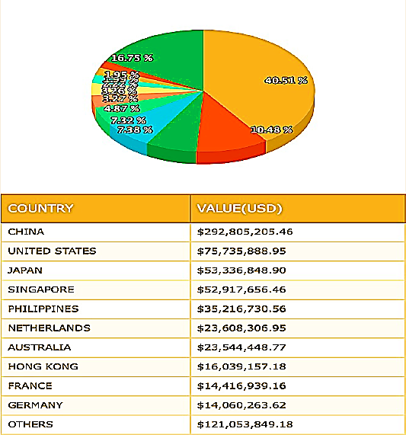
Reference https://www.thedollarbusiness.com/

Organic and natural personal care products are made using natural ingredients, which includes Mentha oil because of its characteristics of being a denaturant, flavouring agent, and fragrance ingredient. India exports different types of mint-oil to countries including China, U.S., Singapore, Netherlands, Germany, UK, France, Brazil and Japan. The major export varieties include Mentha Arvensis oil, Peppermint oil (Mentha pipertia), De-mentholised mint-oil, and Spearmint oils.

Mentha oil is one of the important agricultural essential oils and is extracted from the medicinal botanical herb of Mentha Arvensis through distillation process by the farmers.

- MENTHOL MARKET DERIVERS AND RESTRAINS:
Growth of synthetic menthol market is driven, primarily, by increasing demand from key end use industries such as pharmaceuticals, food and beverages, and cosmetics industries, among others. Synthetic menthol is relatively higher in purity. Moreover, over the recent past, drop in crude oil prices has in turn resulted in a drop-in price of raw materials required for the production of synthetic menthol, making production more cost effective.
Demand for synthetic menthol over the past couple of years has exceeded the actual supply. Moreover, a handful of players operate in global synthetic menthol market. As such supply security is one of the factors that is expected to influence the growth of the market.

Moreover, supply of raw materials required for synthetic menthol production is ample, thus ensuring consistency in production. Consequently, synthetic menthol has emerged as a viable alternative for natural menthol. Currently, natural menthol dominates the overall consumption of menthol across the globe. However, consumption of synthetic menthol is expected to witness a relatively faster growth over the forecast period.

Production Volume of Menthol in India from FY 2013 to FY 2020:

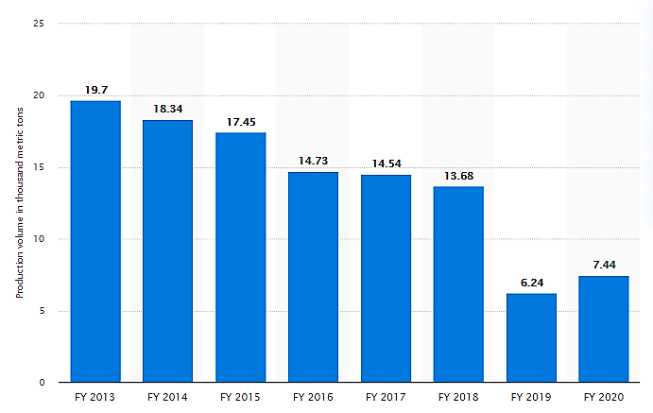

In fiscal year 2020, the production volume of menthol across India was around 7,400 metric tons. With a coverage of over 80 thousand products, the south Asian country was the sixth largest producer of chemicals in the world and the fourth largest in Asia.
The global mint essential oil market demand was USD 177.88 million in 2018 and is expected to expand at a 9.2% CAGR over the forecast period. Growth of end-use industries, such as aromatherapy, personal care and cosmetics, pharmaceuticals and food and beverage are expected to propel the product demand in the forthcoming years. Rapid technological advancements in oil extraction methods is anticipated to fuel the production and positively influence the growth.

Role of CSIR-CIMAP in Menthol industry

CSIR-CIMAP has played a major role in developing menthol industry in India from menthol importing country to the largest global producer & exporter of menthol mint oil by increasing its cultivation, developing short- duration & high yielding varieties and also superior agro-production and processing technologies, which enhanced the income of nearly 0.6 million farming families. CSIR-CIMAP is major source of quality planting material followed by demonstration and dissemination of improved plant varieties (short-duration and diseases resistant menthol-rich) and agro-technologies among the growers and entrepreneurs all over the India. Development of a novel agro-system “Early Mint Technology (EMT)” which potentially reduces harvesting time by 20-30 days, increases the productivity by 15-20%, and minimizes expenditure on land, labour, water and fuel of about 20-25%.

- Developed and disseminated the low cost, efficient boiler operated steam distillation units to farmers and entrepreneurs for large-scale operations and directly fired-type field distillation units for small-scale production of essential oils from mints and other aromatic crops
- Designed and developed many implements like Mentha-harvester, Solar Powered Distillation Unit and Tractor-Trolley Mounted Directly-Fired Type Mobile Distillation Unit, etc. for harvesting and post-harvest processing of mints
- Organizes the several awareness programmes, demonstrations, training programs, conferences, workshops and seminars/webinars to promote mint cultivation from farmer’s field to national-level. It provides opportunities for farmers, farm women and entrepreneur to raise their incomes by adopting new technologies.
- From 2004, CSIR-CIMAP continuously organized the Kisan Mela every year in the end of January month for dissemination, demonstration of new varieties and technologies and for distribution of planting material (suckers) among the farmers. In occasion of 16th Kisan Mela, CSIR-CIMAP released a high yielding variety of menthol mint ‘CIM- Unnati’, which can produce about 180-190 kg essential oil per hectare. It has 20% higher essential oil and has the potential of doubling the menthol mint farmer’s income.
The mint oils used in a wide variety of consumer goods such as detergents, soaps, toilet products, cosmetics, pharmaceuticals, perfumes, confectionery food products and beverages. Therefore the demand from consumption sector is growing continuously.

Introduction of future trading in marketing of menthol mint, the hedgers (farmers or producer) eliminating the price risk and speculators (Investors and traders) gains financial reward from capitalizing on pricing volatility.

Mentha cultivation may lead to intensive cropping and maximizing the annual returns of farmer's from a particular piece of land. Mentha are being widely cultivated in Indo-Gangetic Plains enabling India to emerge as the largest producer of mint oil in the world.

While the risk and uncertainties are inherent in weather, climate, yields, prices, government policies, global markets, and production factors that affect mint farming, farm income and sustainability in future.

After all India is the largest producer of menthol mint oil in the world with over 29.50 million tons of production and 25.75 million tons of export. The remarkable growth in production and export of mint oil in recent years and this trend is almost certain to continue in future. The existing of wide range of natural endowment, favourable climatic condition and support of CSIR-CIMAP in development and dissemination of improved plant varieties, agro-production and processing technologies offers vast potential for cultivation of natural Mentha oil and employment generation for millions of farming families throughout the country. However, there is a need to tape this potential so that production and household employment will expand and Mentha growers will get more benefit.

SWOT ANALYSIS OF THE COMPANY

PART I | PROJECT COST

The total expected project cost is bifurcated as shown in the below table:

PARTICULARS | INR CRORE
Land | Land is owned by the promoters so no cost has been assumed for the land during the forecasted period.
Site development | Site development is being done by the company from their own sources
Building & Civil Works | Site development is being done by the company from their own sources
Plant and Machinery | 16.20
Working Capital | 12.00
TOTAL COST | INR 28.20 Crores
Note: Information regarding the Cost projections have been provided by the company.
Notes:

- The Genuineness/credentials of the supplier/dealer envisaged by the company by reference to the website of supplier/dealer or by adopting other means such as search the internet, making telephone call etc. Correctness of cost/price of asset being financed by the bank has been verified by Necessary evidence/quotation. On analysing the cost of machineries by quotation it is observed that the cost of plant and machinery is at competitive price.
- Land cost is taken as per actual cost as mentioned in land deeds/Purchase order.
- Plant Machinery cost is as per the offers/ estimates company has got from various vendors/ suppliers.
- Out of INR 16.20 Crores of Plant & Machinery, The Company is planning to take a loan term loan of INR 12.00 Crores to procure the machinery.
- Out of INR 12.00 Crores of working capital requirement, management will be approaching the banks to take a WCL of INR 9.00 Crores.
- Thus the total project cost will be INR 28.20 Crores.

PART I | PROJECT SCHEDULE

Below is the tabulated presentation of the status of the project showing expected duration shared by the project manager of the company. The project is expected to be complete soon.

S. No. | Activity | Schedule date of commencement | Schedule date of completion
1. | Land Acquisition | Owned by Sh. Dinesh Kumar Agarwal, Smt. Poonam Agarwal and M/s Shri Balaji Aromatics Limited | To be leased out in the name of M/s Octochem Pharma and Flavours Private Limited.
2. | Site Development | Already commenced in the month of April 2021 | Completed
3. | Civil Construction Work | Already commenced in the month of April 2021 | October 2021
4. | Order and Receiving of Plant and Machinery | Unit 1 and Unit 2-Already commenced in the month of July 2021 | Unit 1: December 2021  Unit 2: March 2022
5. | Installation of Plant and Machinery | Unit 1: January 2022  Unit 2: April 2022 | Unit 1: February 2022  Unit 2: July 2022
6. | Trial Run | Unit 1: March 2022  Unit 2: August 2022 | Unit 1: March 2022  Unit 2: August 2022
7. | Commercial Production | Unit 1-April 2022  Unit 2: September 2022 | Unit 1: April 2022  Unit 2: September 2022
Note: The detailed information of the project schedule have been shared by the company.

PART J | STATUTORY APPROVALS | LICENCES | NOC

Statutory Approvals, Licences, NOC,s which are required by the project company to setting up the new Industrial project in state of Uttar Pradesh and the status of the approvals are shown in the below table:

S.No. | REQUIRED APPROVALS | REFERENCE NO./ DATE | STATUS  (Approved/ Applied For/ Pending)
 | Land conversion to Industrial/ non agriculture | NA | As per Land deed, land is Industrial Land.
 | Factory Registration | NA | To be taken after start of production
 | Chief Inspector of Labour Commissioner Organisation, As per the provisions under the Factory Act, 1948
 | Factory Layout Plan Approval | NA | Approved from local Panchayat body since the area falls in Village
 | Factory Plan Layout Approval from concerned local authority
 | Provisional Fire NOC (pre sanction) | 02/04/2021 | UPFS/2021/30298/SBL/SAMBHAL/161/JD  Approved
 | Fire Services Department, UP
 | Fire NOC (on completion) | NA | To be taken after start of production
 | Fire Services Department, UP
 | Permission for drawing ground water for Industrial purposes | NA | Not Applicable
 | Uttar Pradesh Ground Water (Management and Regulation) Act, 2019
 | Information Entrepreneurs Memorandum (IEM) | NA | Not mandatory
 | Infrastructure & Industrial Development Department, Government of Uttar Pradesh
 | Power Load Sanction | NA | To be applied in due course
 | UP Electricity Regulatory Commission
 | Consent to establish (under Water Act & Air Act) | NA | To be taken after start of production
 | Uttar Pradesh Pollution Control Board, Government Of Uttar Pradesh
 | Uttar Pradesh Pollution Control Board, Government Of Uttar Pradesh
 | Import-Export License | NA | M/s Octochem Pharma and Flavours Private Limited have been obtained an Importer-Exporter Code (IEC) AADC0331Q
Observation Note: The detailed information about the “STATUTORY APPROVALS /LICENCES/NOC” have been shared by the Client/Company as per the comments mentioned in the above table.

PART K | FINANCIAL FEASIBILTY OF THE COMPANY

- PROJECTIONS OF THE FIRM: The projections of the firm are done From FY 2023 to FY 2030 are shown as below:

- PROJECTED PROFIT & LOSS ACCOUNT FROM FY2023 TO FY 2030:

Particulars  (INR Lakhs) | FY 2023 | FY2024 | FY2025 | FY2026 | FY2027 | FY2028 | FY2029 | FY2030
Net Sales | 8500.00 | 9265.00 | 10098.85 | 11007.75 | 11998.44 | 13078.30 | 14255.35 | 15538.33
Capacity | 57.19% | 62.34% | 67.95% | 74.06% | 80.73% | 87.99% | 95.91% | 104.54%
Other Income
Export Incentives | 510.00 | 555.90 | 605.93 | 660.46 | 719.91 | 784.70 | 855.32 | 932.30
Total Income | 9010.00 | 9820.90 | 10704.78 | 11668.21 | 12718.35 | 13863.00 | 15110.67 | 16470.63
Cost of Sales
Purchases | 9000.00 | 9110.00 | 9382.20 | 10069.84 | 10921.24 | 11919.67 | 12848.06 | 13975.02
Direct Expenses | 220.00 | 230.00 | 240.00 | 275.00 | 290.00 | 398.00 | 430.00 | 490.00
Chemicals & Consumables | 5.00 | 5.25 | 5.51 | 5.79 | 8.08 | 10.48 | 14.01 | 17.71
Packing Materials | 12.00 | 12.20 | 12.40 | 16.60 | 20.88 | 24.22 | 28.62 | 33.09
Add: Opening Stock | 0.00 | 1010.00 | 1350.00 | 1220.00 | 1070.00 | 900.00 | 910.00 | 850.00
Less: Closing Stock | 1010.00 | 1350.00 | 1220.00 | 1070.00 | 900.00 | 910.00 | 850.00 | 820.00
Total Cost of Sales | 8227.00 | 9017.45 | 9770.11 | 10517.24 | 11410.20 | 12342.37 | 13380.69 | 14545.82
Gross Profit | 783.00 | 803.45 | 934.67 | 1150.98 | 1308.15 | 1520.63 | 1729.99 | 1924.81
Selling, General and Administrative Expenses
Power & Fuel | 62.04 | 57.25 | 76.38 | 86.01 | 94.86 | 114.86 | 137.64 | 148.82
Rent - Land | 0.60 | 0.60 | 0.60 | 0.60 | 0.60 | 0.60 | 0.60 | 0.60
Salary & Wages | 35.00 | 35.61 | 42.24 | 42.97 | 43.73 | 44.49 | 45.27 | 48.06
Repair & Maintenance | 2.85 | 2.90 | 7.95 | 8.09 | 8.23 | 8.38 | 8.52 | 10.67
Insurance | 1.00 | 1.00 | 1.00 | 1.00 | 1.00 | 1.00 | 1.00 | 1.00
Other Admin overheads | 50.00 | 51.25 | 62.53 | 84.09 | 98.20 | 125.65 | 158.79 | 182.76
Selling & Distribution Expenses | 100.00 | 80.00 | 65.00 | 78.00 | 94.00 | 101.00 | 139.00 | 152.00
Sub Total | 251.49 | 228.61 | 255.70 | 300.77 | 340.62 | 395.98 | 490.83 | 543.92
EBIDTA | 531.51 | 574.84 | 678.97 | 850.21 | 967.54 | 1124.65 | 1239.16 | 1380.89
EBITDA Margin (%) | 5.90 % | 5.85 % | 6.34 % | 7.29 % | 7.61 % | 8.11 % | 8.20 % | 8.38 %
Depreciation | 212.52 | 192.45 | 168.62 | 147.74 | 129.46 | 113.44 | 99.41 | 87.11
EBIT | 319.00 | 382.39 | 510.35 | 702.46 | 838.08 | 1011.21 | 1139.75 | 1293.78
EBIT Margin % | 3.54 % | 3.89 % | 4.77 % | 6.02 % | 6.59 % | 7.29 % | 7.54 % | 7.86 %
Interest on Term Loan | 86.40 | 85.29 | 72.00 | 58.71 | 45.42 | 32.12 | 18.83 | 2.31
Interest on working Capital Loan | 64.80 | 64.80 | 64.80 | 64.80 | 64.80 | 64.80 | 64.80 | 64.80
Interest on Unsecured Loans | 7.00 | 7.00 | 7.00 | 7.00 | 7.00 | 7.00 | 7.00 | 7.00
Sub Total | 158.20 | 157.09 | 143.80 | 130.51 | 117.22 | 103.92 | 90.63 | 74.11
Profit Before Tax | 160.80 | 225.30 | 366.55 | 571.96 | 720.86 | 907.29 | 1049.12 | 1219.67
Income Tax @ 25% | 40.20 | 56.32 | 91.64 | 142.99 | 180.22 | 226.82 | 262.28 | 304.92
Net Profit After Taxes | 120.60 | 168.97 | 274.91 | 428.97 | 540.65 | 680.47 | 786.84 | 914.75
Cash Profit | 333.11 | 361.42 | 343.53 | 576.71 | 670.10 | 793.91 | 886.25 | 1001.87
Repayment of term loan | 15.38 | 184.62 | 184.62 | 184.62 | 184.62 | 184.62 | 184.62 | 76.92
Interest Coverage Ratio | 3.36 | 3.66 | 4.72 | 6.51 | 8.25 | 10.82 | 13.67 | 18.63
Gross Profit Margin Ratio | 9.21 | 8.67 | 9.26 | 10.46 | 10.90 | 11.63 | 12.14 | 12.39
Net Profit Margin Ratio | 0.01 | 0.02 | 0.03 | 0.04 | 0.05 | 0.05 | 0.06 | 0.06
Profit/Loss for the year | 120.60 | 168.97 | 274.91 | 428.97 | 540.65 | 680.47 | 786.84 | 914.75

- PROJECTED BALANCE SHEET FROM FY2023 TO FY2030:

Particulars  (INR Lakhs) | FY 2023 | FY2024 | FY2025 | FY2026 | FY2027 | FY2028 | FY2029 | FY2030
Shareholder’s Equity & Liabilities:
Capital | 600.00 | 720.60 | 889.57 | 1164.48 | 1593.45 | 2134.10 | 2814.56 | 3601.40
Add: Net Profit | 120.60 | 168.97 | 274.91 | 428.97 | 540.65 | 680.47 | 786.84 | 914.75
Less: Dividends | 0.00 | 0.00 | 0.00 | 0.00 | 0.00 | 0.00 | 0.00 | 0.00
Net Balance of Capital | 720.60 | 889.57 | 1164.48 | 1593.45 | 2134.10 | 2814.56 | 3601.40 | 4516.15
Term Loan | 1000.00 | 815.38 | 630.77 | 446.15 | 261.54 | 76.92 | 0.00 | 0.00
Working Capital Limit | 900.00 | 900.00 | 900.00 | 900.00 | 900.00 | 900.00 | 900.00 | 900.00
Unsecured Loans | 200.00 | 200.00 | 200.00 | 200.00 | 200.00 | 200.00 | 200.00 | 200.00
Sundry Creditors | 809.36 | 967.21 | 1165.14 | 1359.94 | 1580.12 | 1817.85 | 2174.20 | 2400.09
Other Liabilities (Loan Repayment) | 184.62 | 184.62 | 184.62 | 184.62 | 184.62 | 184.62 | 76.92 | 0.00
Total | 3093.97 | 3067.21 | 3080.53 | 3090.70 | 3126.28 | 3179.39 | 3351.12 | 3500.09
Total Liabilities | 3814.57 | 3956.78 | 4245.01 | 4684.15 | 5260.37 | 5993.95 | 6952.52 | 8016.25
Assets
Fixed Assets | 1507.61 | 1365.15 | 1246.54 | 1148.79 | 1069.33 | 1005.89 | 956.48 | 919.37
Current Assets
Closing Stock | 1010.00 | 1350.00 | 1220.00 | 1070.00 | 900.00 | 910.00 | 850.00 | 820.00
Sundry Debtors | 980.34 | 735.25 | 1001.62 | 1082.55 | 1210.33 | 1406.22 | 1676.57 | 2083.44
Other Current Assets | 186.62 | 343.26 | 538.91 | 1030.62 | 1455.29 | 1938.50 | 2527.80 | 2901.74
Total Current Assets (other than Cash) | 2176.96 | 2428.51 | 2760.53 | 3183.17 | 3565.62 | 4254.72 | 5054.37 | 5805.18
Add: Cash & Cash Equivalents | 130.00 | 163.12 | 237.95 | 352.19 | 625.42 | 733.35 | 941.66 | 1291.70
Total Current Assets | 2306.96 | 2591.63 | 2998.48 | 3535.36 | 4191.04 | 4988.07 | 5996.03 | 7096.88
Total Assets | 3814.57 | 3956.78 | 4245.01 | 4684.15 | 5260.37 | 5993.95 | 6952.52 | 8016.25
Check | 0.0 | 0.0 | 0.0 | 0.0 | 0.0 | 0.0 | 0.0 | 0.0

- PROJECTED FUND FLOW FROM FY2023 TO FY2030:

Particulars  (INR Lakhs) | FY 2023 | FY2024 | FY2025 | FY2026 | FY2027 | FY2028 | FY2029 | FY2030
Source of Fund
Increase in Capital | 720.60 | 168.97 | 274.91 | 428.97 | 540.65 | 680.47 | 786.84 | 914.75
Add: Depreciation | 212.52 | 192.45 | 168.62 | 147.74 | 129.46 | 113.44 | 99.41 | 87.11
Increase in Term Loans | 1200.00 | 0.00 | 0.00 | 0.00 | 0.00 | 0.00 | 0.00 | 0.00
Increase in Working Capital Limit | 900.00 | 0.00 | 0.00 | 0.00 | 0.00 | 0.00 | 0.00 | 0.00
Increase in Unsecured Loan | 200.00 | 0.00 | 0.00 | 0.00 | 0.00 | 0.00 | 0.00 | 0.00
Increase in Current Liabilities | 993.97 | 157.85 | 197.94 | 194.79 | 220.19 | 237.73 | 248.65 | 148.97
Decrease in Fixed Assets | 0.00 | 0.00 | 0.00 | 0.00 | 0.00 | 0.00 | 0.00 | 0.00
Decrease in Current Assets | 0.00 | 0.00 | 0.00 | 0.00 | 0.00 | 0.00 | 0.00 | 0.00
Total Source of Fund | 4227.08 | 519.28 | 641.47 | 771.50 | 890.29 | 1031.64 | 1134.90 | 1150.84
Application of Funds
Increase in Fixed Assets | 1720.12 | 0.00 | 0.00 | 0.00 | 0.00 | 0.00 | 0.00 | 0.00
Increase in Current Assets | 2176.96 | 251.55 | 332.02 | 422.64 | 382.45 | 689.10 | 799.66 | 750.81
Decrease in Unsecured Loans | 0.00 | 0.00 | 0.00 | 0.00 | 0.00 | 0.00 | 0.00 | 0.00
Decrease in Term Loans | 15.38 | 184.62 | 184.62 | 184.62 | 184.62 | 184.62 | 184.62 | 76.92
Decrease in WC Limit | 0.00 | 0.00 | 0.00 | 0.00 | 0.00 | 0.00 | 0.00 | 0.00
Decrease in Current Liabilities | 0.00 | 0.00 | 0.00 | 0.00 | 0.00 | 0.00 | 0.00 | 0.00
Total | 3912.47 | 436.16 | 516.63 | 607.26 | 567.06 | 873.72 | 984.27 | 827.73
Opening Balance | 0.00 | 314.61 | 397.73 | 522.56 | 686.80 | 1010.03 | 1167.97 | 1318.58
Surplus/Deficit | 314.61 | 83.12 | 124.83 | 164.24 | 323.23 | 157.92 | 150.63 | 323.11
Closing Balance | 314.61 | 397.73 | 522.56 | 686.81 | 1010.04 | 1167.96 | 1318.59 | 1641.70

- DEPRECIATION SCHEDULE FROM FY2023 TO FY2030:

Particulars  (INR Lakhs) | FY 2023 | FY2024 | FY2025 | FY2026 | FY2027 | FY2028 | FY2029 | FY2030
Name of Assets
Land | 0.00 | 0.00 | 0.00 | 0.00 | 0.00 | 0.00 | 0.00 | 0.00
Building | 100.00 | 90.00 | 81.00 | 72.90 | 65.61 | 59.05 | 53.14 | 47.83
Less: Depreciation @ 10% | 10.00 | 9.00 | 8.10 | 7.29 | 6.56 | 5.90 | 5.31 | 4.78
Plant & Machinery | 1620.12 | 1417.61 | 1234.15 | 1073.64 | 933.18 | 810.28 | 702.75 | 608.65
Additions: | 0.00 | 50.00 | 50.00 | 50.00 | 50.00 | 50.00 | 50.00 | 50.00
Less: Depreciation @ 12.5 % | 202.52 | 183.45 | 160.52 | 140.45 | 122.90 | 107.54 | 94.09 | 82.33
MFA | 0.00 | 0.00 | 0.00 | 0.00 | 0.00 | 0.00 | 0.00 | 0.00
Less: Depreciation @ 12.5 % | 0.00 | 0.00 | 0.00 | 0.00 | 0.00 | 0.00 | 0.00 | 0.00
Total Assets O/B | 1720.12 | 1507.61 | 1365.15 | 1246.54 | 1148.79 | 1069.33 | 1005.89 | 956.48
Additions: | 0.00 | 50.00 | 50.00 | 50.00 | 50.00 | 50.00 | 50.00 | 50.00
Total Depreciation | 212.53 | 192.45 | 168.62 | 147.74 | 129.46 | 113.44 | 99.41 | 87.11
Total WDV | 1507.61 | 1365.15 | 1246.54 | 1148.79 | 1069.33 | 1005.89 | 956.48 | 919.37

- BASIS OF PROJECTION OF SALES/REVENUE:

Particulars  (INR Crores) | Quantity per month in Ton | Rate per Ton | Total Amount Per Month | Number of Months | Total Amount Per Year
Sale of Unit Number 1
A1 Menthol Flakes | 34.88 | 11.50 | 401.06 | 12.00 | 4812.75
A2 DMO | 0.84 | 8.20 | 6.91 | 12.00 | 82.95
B1 Mentha Crystal | 26.33 | 12.50 | 329.13 | 12.00 | 3949.50
B2 DMO Lind | 14.07 | 9.50 | 133.67 | 12.00 | 1603.98
Total Sales of Unit 1 | 76.12 |  | 870.77 |  | 10449.18
Sale of Unit Number 2
D1 Terpene | 5.40 | 1.50 | 8.10 | 12.00 | 97.20
D2 Menthone | 7.20 | 10.50 | 75.60 | 12.00 | 907.20
D3 L-Menthol | 18.00 | 11.00 | 198.00 | 12.00 | 2376.00
D4 CIS Hexanol | 0.22 | 250.00 | 54.00 | 12.00 | 648.00
E1. Carvacrol/ Carvone | 4.92 | 6.00 | 29.52 | 12.00 | 354.24
E2. Di-Hydro Carvone | 0.51 | 5.10 | 2.60 | 12.00 | 31.21
Total Sales of Unit 2 | 36.25 |  | 367.82 | 4413.85
Total Sales From Unit 1 and Unit 2 | 112.36 |  | 1238.59 | 14863.03

- ESTIMATED KEY METRICS:

Particulars  (INR Crores) | FY 2023 | FY2024 | FY2025 | FY2026 | FY2027 | FY2028 | FY2029 | FY2030
Revenue | 8500.00 | 9265.00 | 10098.85 | 11007.75 | 11998.44 | 13078.30 | 14255.35 | 15538.33
Gross Profit | 783.00 | 803.45 | 934.67 | 1150.98 | 1308.15 | 1520.63 | 1729.99 | 1924.81
EBIDTA | 531.51 | 574.84 | 678.97 | 850.21 | 967.54 | 1124.65 | 1239.16 | 1380.89
EBITDA Margin (%) | 5.90 % | 5.85 % | 6.34 % | 7.29 % | 7.61 % | 8.11 % | 8.20 % | 8.38 %
EBIT | 319.00 | 382.39 | 510.35 | 702.46 | 838.08 | 1011.21 | 1139.75 | 1293.78
EBIT Margin % | 3.54 % | 3.89 % | 4.77 % | 6.02 % | 6.59 % | 7.29 % | 7.54 % | 7.86 %
Gross Profit Margin Ratio | 9.21 | 8.67 | 9.26 | 10.46 | 10.90 | 11.63 | 12.14 | 12.39
Net Profit Margin Ratio | 0.01 | 0.02 | 0.03 | 0.04 | 0.05 | 0.05 | 0.06 | 0.06
Quick Ratio | 1.30 | 1.08 | 1.32 | 1.60 | 1.86 | 2.04 | 2.29 | 2.62
Current Ratio | 1.22 | 1.26 | 1.33 | 1.45 | 1.57 | 1.72 | 1.90 | 2.15
Debt | 1200.00 | 1015.38 | 830.77 | 646.15 | 461.54 | 276.92 | 200.00 | 200.00
Equity | 720.60 | 889.57 | 1164.48 | 1593.45 | 2134.10 | 2814.56 | 3601.40 | 4516.15
D/E Ratio | 1.67 | 1.14 | 0.71 | 0.41 | 0.17 | 0.22 | 0.10 | 0.06
Total outside liability to Net Worth | 3.14 | 2.63 | 2.11 | 1.61 | 1.25 | 0.99 | 0.83 | 0.70
DSCR | 4.12 | 1.66 | 2.01 | 2.61 | 3.11 | 3.81 | 4.45 | 12.68

- PROJECTED METRICS CALCULATED:

Particulars | Value
Average DSCR | 4.31
EBITDA Margin | 5.85-8.38 % over the estimated period.

- BREAKEVEN ANALYSIS OF THE PROJECT:

Break Even Point
 |  | (Amounts in Lakhs)
Sr. No. | Particulars | FY 2022-23 | FY 2023-24
A | Sales (a+b+c) | 10020.00 | 10160.90
 | Projected Sales/Receipts (a) | 8500.00 | 9265.00
 | Other Operating Income (b) | 510.00 | 555.90
 | Increase in Stock (c) | 1010.00 | 340.00
B | Variable Cost (i+ii+iii+iv) | 9463.36 | 9570.29
 | Consumables@100% (i) | 9000.00 | 9110.00
 | Direct Expenses @ 100%(ii) | 334.04 | 340.31
 | Administrative & other Expenses @ 50%(iii) | 80.72 | 71.38
 | Interest on WC @ 75 %(iv) | 48.60 | 48.60
C | Contribution (A-B) | 556.64 | 590.61
 | Sales - Variable Cost
D | Fixed Cost (1+2+3+4) | 395.83 | 365.33
 | Administrative Exp.& other @ 50% (1) | 80.72 | 71.38
 | Depreciation (2) | 212.51 | 192.46
 | Interest on WC @ 25 % (3) | 16.20 | 16.20
 | Interest on Term Loan (4) | 86.40 | 85.29
E | Break Even Point (In value) (D/C*Sales) | 7125.28 | 6285.17
 | Break Even point(%) at utilized capacity (D/C*100) | 71.11 % | 61.86 %

Below is the graphical representation of different financial metrics calculated for the estimated Period:

PROJECTED REVENUE GROWTH RATE:

PROJECTED GROSS MARGIN:

PROJECTED EBITDA MARGIN:

PROJECTED DEBT-SERVICE COVERAGE RATIO OVER THE ESTIMATED PERIOD:

ASSUMPTIONS & BASIS:

Sl. No. | Item | Assumptions and Basis
 | General | - The projections of the firm are done for the period from FY 2023 to 2030 based on the assumption of production capacity and expected units sold for the period multiply by average selling price per unit.  - Projections are done based on the expected growth of the industry during the forecast period.  - We have considered Revenue based model while making the future financial projections.
 | Revenue | - First full operating period has been considered as FY 2023.  - Revenue figures shown for the forecast period have been considered the efficiency improvement factor for these periods.  - As per revenue build-up model, the main sources of revenue will be Menthol Flakes, DMO, Mentha Crystal, DMO Lind, Terpene, Menthone, L-Menthol, CIS Haxanol, Carvacrol/ Carvone, Di-Hydro Carvone.  - There would be an export incentive considered for the estimated period, which has been taken as 6 % of the total sales for the respectively financial year  - Thus the total income for the year would be an addition of total sales and export incentives, while taking into consideration of described capacity utilization for the respective year  - Sales has been bifurcated as Domestic Sale and Export.  - Company is planning to export 52% of the total Sales due to high demand of the finished goods in the international market and 48 % will be sold out in the domestic market
 | Price | - Menthol Flakes: INR 11.50 Lakhs per ton, DMO: INR 8.20 Lakhs per ton, Mentha Crystal: INR 12.50 Lakhs per ton, DMO Lind: INR 9.50 Lakhs per ton, Terpene INR 1.50 Lakhs per ton, Menthone: INR 10.50 Lakhs per ton, L-Menthol: INR 11.00 Lakh per ton, CIS Haxanol: INR 250.00 Lakhs per ton, Carvacrol/Carvone: INR 6.00 Lakhs per ton, Di-Hydro Carvone: INR 5.10 Lakhs per ton is being proposed by the company respectively which seems to be reasonable after considering the cost of manufacturing finished good, margin and historical price analysis.
 | Capacity Utilization | - Capacity utilization have been considered as 57.19 % for the first year, while there is a reasonable increment for the upcoming years 62.34 %, 67.95 %, 74.06 %, 80.73 %, 87.99 %, 95.91 % respectively up to FY 2029, In FY2030 the capacity utilization will be more than 100% due to considered base value amount of INR 14,863.03 Lakhs for the calculation of capacity utilization. Thus the company is supposed to increase the manufacturing quantity to increase the base value considered for calculation of capacity utilization to achieve the economies of scale.  - Capacity utilisation seems to be reasonable as the new business will take time to get the synergies and achieving the pre-set goal and market dynamics will be a key factor to play an important role.
 | Cost of Goods Sold | - Cost of Sales includes the purchase of raw material, Direct Expenses, Chemicals & Consumables, packing materials and other expenses  - Cost of Goods Sold is being calculated as INR 82.27 Crores for the first year during estimated period
 | Working Capital | - Company is required a total of INR 9.00 Crore of working capital to start the operations and getting the economies of scale.
 | Loan & Interest | - M/s Octochem is approaching financial Institutions/Banks for funding the project through debt instrument.  - Company is planning take a total loan amounting INR 21.00 Crore, which includes term loan amounts to INR 12.00 Crore and working capital loan of INR 9.00 Crore  - Interest rate has been considered as @ 7.20 % per annum  - Total repayment period will be 84 months (Inclusive of 6 months of moratorium period) i.e. 78 monthly instalments  - Moratorium period will be of 6 months (From the date of COD of Unit No. 2 i.e. September, 2022
 | Depreciation | - Depreciation rate for the building has been considered as 10%  - Depreciation rate for Plant & Machinery has been considered as @ 12.5 %  - Depreciation rate for MFA has been considered as @ 12.5 %

CONCLUSION:

Hence based on the above assumption and analysis of the estimated period, the proposed project seems to be financially and economically viable as all the calculated key financial matrices for the projected period indicates a positive outcome subject to the reasonability of all the assumptions considered over the estimated period.

While it is not avoidable that the future projections may change in the upcoming years due to various factors impacting the operational, managerial, financial efficiency and economies of scale of the project.

As of now based on Average Debt Service Coverage Ratio (DSCR) of 4.31 over the projection period, it can be commented positively that the proposed project will be capable enough to generate the required margins to pay back its outstanding debts on time over the estimated period.

PART L | CONCLUSION

Based on the technological, economical and market analysis done above, various Industry assumptions taken, product pricing to be adopted by the company, the Project appears to be Techno-commercially viable subject to the risks, threats, weaknesses, limitations of the product as detailed previously.

While it is not avoidable that the future projections may change in the upcoming years due to various factors impacting the operational, managerial, financial efficiency and economies of scale of the project.

As per financials projections for the estimated period Average DSCR and EBITDA Margin of the project is 4.31 and 7.21% respectively, which shows the capability of the project to generate the operating profits over the forecasted period and higher DSCR is the indicator of the project capability to pay out its outstanding debts on time.

After considering the demand of the by-products of menthe oil and uses of the same in the various industries, existing technology and machinery will being used with the described specifications, bargaining power of buyers and suppliers, financial analysis of the project based on the assumptions taken over the projected period it is seeming reasonable to comment positively that the proposed project is Technically and Economically Viable subject to current assumptions considered and occurring the same in the upcoming years same as the forecasted period.

We have tried our level best to analyse the Project techno-economic feasibility of the Project based on the Industry research, Project information and various futuristic assumption taken. However achieving the financial milestones depends on the ability, sincerity and efforts of the company, promoters and its key managerial performance.

Management must not avoid the strategically advancement of price, place, promotion, production and risk aligned with these factors. Technological advancement is also must to ripe the existing opportunity with respect to time and get the advantage over the competitors.

Declaration | - The undersigned does not have any direct/indirect interest in the above property.  - The information furnished herein is true and correct to the best of our knowledge, logical and scientific assumptions.  - This TEV Report is carried out by our Financial Analyst team on the request from MCC Moradabad, Punjab National Bank.  - Meeting of Financial projections will be subject to subject to the market & economy stability factors, judicious business operations and proper & timely implementation of its process & product re-engineering & improvements plans for achieving high productivity, efficiency and achieving cost saving benefits.  - We have submitted TEV report to the Banker.
Name & Address of consultant company |  |  | Signature of the authorized person
M/s. R.K. Associates Valuer & Techno Engineering Consultants Pvt.
D-39, 2nd Floor. Sector-2, Noida- 201301
Enclosed Documents |  | Disclaimer & Remarks 78-81
Number of Pages in the Report |  | 81
Financial Analyst Team worked on the report |  | PREPARED BY: By Mr. Gaurav Kumar(Financial and Market Research Analyst)
 |  | REVIEWED BY: HOD Project

For R.K Associates Valuer & Techno Place: Noida

Engineering Consultants (P) Ltd. Date: 26/11/2021

(Authorized Signatory)

PART M | DISCLAIMER | REMARKS

- No employee or member of R.K Associates has any direct/ indirect interest in the Project.

- This report is prepared based on the copies of the documents/ information which the Bank/ Company has provided to us out of the standard checklist of documents sought from them and further based on our assumptions and limiting conditions. The client/owner and its management/representatives warranted to us that the information they supplied was complete, accurate and true and correct to the best of their knowledge. All such information provided to us has been relied upon in good faith and we have assumed that it is true and correct in all respect. I/We shall not be liable for any loss, damages, cost or expenses arising from fraudulent acts, misrepresentations, or wilful default on part of the owner, company, its directors, employee, representative or agents. Verification or cross checking of the documents provided to us from the originals or from any Govt. departments/ Record of Registrar has not been done at our end since this is beyond the scope of our work. If at any time in future, it is found or came to our knowledge that misrepresentation of facts or incomplete or distorted information has been provided to us then this report shall automatically become null & void.

- Legal aspects for e.g. investigation of title, ownership rights, lien, charge, mortgage, lease, sanctioned maps, verification of documents, etc. have not been done at our end and same has to be taken care by legal expert/ Advocate. It is assumed that the concerned Lender/ Financial Institution has satisfied them with the authenticity of the documents, information given to us and for which the legal verification has been already taken and cleared by the competent Advocate before requesting for this report. We assume no responsibility for the legal matters including, but not limited to, legal or title concerns.

- This report is a general analysis of the project based on the scope mentioned in the report. This is not an Audit report, Design document, DPR or Techno feasibility study. All the information gathered is based on the facts seen on the site during survey, verbal discussion & documentary evidence provided by the client and is believed that information given by the company is true best of their knowledge.

- This Techno Economic-Viability study is prepared based on certain futuristic assumption which are intra dependent on economic, market and sectorial growth condition in future and socio-economic, socio-political condition at macro and micro level.

- Meeting of assumption and financial ratio will entirely depend on the sincerity and efforts of the company, promoters and its key managerial performance.

- All observations mentioned in the report is only based on the visual observation and the documents/ data/ information provided by the client. No mechanical/ technical tests, measurements or any design review have been performed or carried out from our side during Project assessment.

- Bank/FII should ONLY take this report as an Advisory document from the Financial/ Chartered Engineering firm and its specifically advised to the creditor to cross verifies the original documents for the facts mentioned in the report which can be availed from the borrowing company directly.

- In case of any default in loans or the credit facility extended to the borrowing company, R.K Associates shall not be held responsible for whatsoever reason may be and any request for seeking any explanation from the employee/s of R.K Associates will not be entertained at any instance or situation.

- The documents, information, data provided to us during the course of this assessment by the client are reviewed only up to the extent required in relation to the scope of the work. No document has been reviewed beyond the scope of the work.

- This report only contains general assessment & opinion as per the scope of work evaluated as per the information given in the copy of documents, information, data provided to us and/ and confirmed by the owner/ owner representative to us at site which has been relied upon in good faith. It doesn’t contain any other recommendations of any sort including but not limited to express of any opinion on the suitability or otherwise of entering into any transaction with the borrower.

- We have relied on data from third party, external sources & information available on public domain also to conclude this report. These sources are believed to be reliable and therefore, we assume no liability for the truth or accuracy of any data, opinions or estimates furnished by others that have been used in this analysis. Where we have relied on data, opinions or estimates from external sources, reasonable care has been taken to ensure that such data has been correctly extracted from those sources and /or reproduced in its proper form and context, however still we can’t vouch its authenticity, correctness or accuracy.

- This Report is prepared by our competent technical team which includes Engineers and financial experts & analysts.

- This is just an opinion report and doesn’t hold any binding on anyone. It is requested from the concerned Financial Institution which is using this report for taking financial decision on the project that they should consider all the different associated relevant & related factors also before taking any business decision based on the content of this report.

- All Pages of the report including annexure are signed and stamped from our office. In case any paper in the report is without stamp & signature then this should not be considered a valid paper issued from this office.

- Though adequate care has been taken while preparing this report as per its scope, but still we can’t rule out typing, human errors, over sightedness of any information or any other mistakes. Therefore, the concerned organization is advised to satisfy themselves that the report is complete & satisfactory in all respect. Intimation regarding any discrepancy shall be brought into our notice immediately. If no intimation is received within 15 (Fifteen) days in writing from the date of issuance of the report, to rectify these timely, then it shall be considered that the report is complete in all respect and has been accepted by the client up to their satisfaction & use and further to which R.K Associates shall not be held responsible in any manner.

- Defect Liability Period is 15 DAYS. We request the concerned authorized reader of this report to check the contents, data and calculations in the report within this period and intimate us in writing if any corrections are required or in case of any other concern with the contents or opinion mentioned in the report. Corrections only related to typographical, calculation, spelling mistakes, incorrect data/ figures/ statement will be entertained within the defect liability period. Any new changes for any additional information in already approved report will be regarded as additional work for which additional fees may be charged. No request for any illegitimate change in regard to any facts & figures will be entertained.

- R.K Associates encourages its customers to give feedback or inform concerns over its services through proper channel at valuers@rkassociates.org in writing within 15 days of report delivery. After this period no concern/ complaint/ proceedings in connection with the Techno- Economic Viability Study Services will be entertained due to possible change in situation and condition of the subject Project.

- Our Data retention policy is of ONE YEAR. After this period, we remove all the concerned records related to the assignment from our repository. No clarification or query can be answered after this period due to unavailability of the data.

- This Techno Economic Viability Study report is governed by our (1) Internal Policies, Processes & Standard Operating Procedures, (2) Information/ Data/ Inputs given to us by the client and (3) Information/ Data/ Facts given to us by our field/ office technical team. Management of R.K Associates never gives acceptance to any unethical or unprofessional practice which may affect fair, correct & impartial assessment and which is against any prevailing law. In case of any indication of any negligence, default, incorrect, misleading, misrepresentation or distortion of facts in the report then it is the responsibility of the user of this report to immediately or at least within the defect liability period bring all such act into notice of R.K Associates management so that corrective measures can be taken instantly.

- R.K Associates never releases any report doing alterations or modifications from pen. In case any information/ figure of this report is found altered with pen then this report will automatically become null & void.

- If this report is prepared for the matter under litigation in any Indian court, no official or employee of R.K Associates will be under any obligation to give in person appearance in the court as a testimony. For any explanation or clarification, only written reply can be submitted on payment of charges by the plaintiff or respondent which will be 10% of the original fees charged where minimum charges will be INR 15,000/.

