**REPORT FORMAT:** V-L3 (Medium) | Version: 6.0_2018

**File No.: VIS (2021-22)-PL674-585-755 Dated:03.01.2022**

**PROJECT TIE -UP REPORT**

**OF**

**GROUP HOUSING SOCIETY**

**EUREKA PARK**

**SITUATED AT**

**PLOT NO. SC-02/A1, SPORTS CITY, SECTOR-150, NOIDA, UTTAR PRADESH**

**DEVELOPED & OWNED BY**

**M/S. LAND KART BUILDERS PVT. LTD.**

**REPORT PREPARED FOR**

**STATE BANK OF INDIA, HLST BRANCH, NOIDA, UTTAR PRADESH**

***\*\*Important - In case of any query/ issue or escalation you may please contact Incident Manager***

***at valuers@rkassociates.org. We will appreciate your feedback in order to improve our services.***

***NOTE: As per IBA Guidelines please provide your feedback on the report within 15 days of its submission after which report will be considered to be correct.***

|  |  |
| --- | --- |
| **PART A** | **SUMMARY OF THE PROJECT TIE-UP REPORT** |

|  |  |  |  |  |  |  |
| --- | --- | --- | --- | --- | --- | --- |
| **S.NO.** | **CONTENTS** | **DESCRIPTION** | | | | |
|  | **GENERAL DETAILS** | | | | | |
|  | Report prepared for | Bank | | | | |
|  | Name & Address of Organization | State Bank of India, HLST Branch, Noida, U.P | | | | |
|  | Name of Promoter | M/s. Land Kart Builders Pvt. Ltd. | | | | |
|  | Name of Property Owner | M/s. Land Kart Builders Pvt. Ltd. | | | | |
|  | Address & Phone Number of the owner | Registered Office : 7th Floor, Tower-B, Plot No.08, Sector-127, Noida - 201301 | | | | |
|  | Type of the Property | Group Housing society | | | | |
|  | Type of Loan | NA | | | | |
|  | Type of Valuation | Project Tie-up Report | | | | |
|  | Report Type | Project Tie-Up Report | | | | |
|  | Date of Inspection of the Property | 29 November 2021 | | | | |
|  | Date of Valuation Report | 3 January 2022 | | | | |
|  | Surveyed in presence of | Promoter's representative | | Mrs. Minakshi  Contact No.8802570553 | | |
|  | Purpose of the Valuation | Project Tie- up Report | | | | |
|  | Scope of the Report | Project Tie- Up Report | | | | |
|  | Out-of-Scope of Report | 1. Verification of authenticity of documents from originals or cross checking from any Govt. deptt. is not done at our end. 2. Legal aspects of the property are out-of-scope of this report. 3. Identification of the property is only limited to cross verification from its boundaries at site if mentioned in the provided documents. 4. Getting cizra map or coordination with revenue officers for site identification is not done at our end. 5. Measurement is only limited upto sample random measurement. 6. Measurement of the property as a whole is not done at our end. 7. Drawing Map & design of the property is out of scope of the work. | | | | |
|  | Documents provided for perusal | **Documents Requested** | | **Documents Provided** | | **Documents Reference No.** |
| Total **05** documents requested. | | Total **05** documents provided. | | **07** |
| Property Title document | | Sub - Lease Deed | | Dated  15/06/2016 |
| Approved Map | | Sanctioned letter of building plans from NOIDA *(obtained from UP-RERA)* | | Dated  24/10/2016 |
| Copy of TIR | | Approved Map | | IV-1500/934 |
| Project Approval Letter | | Height Clearance NOC from Airport Authority of India | | Dated  18/05/2015 |
| Project NOC’s issued from the concern authority | | Enviromental clearance NOC from SEIAA | | Dated  07/10/2016 |
| None | | Copy of RERA Certificate | | UPRERAPRJ469983 |
| None | | NOC from Pollution control Board, U.P | | Dated  02/10/2019 |
| None | | NOC from Fire Service Department, Lucknow | | Dated  21/04/2015 |
| None | | None | | ---- |
| None | | None | | ---- |
|  | Identification of the property | ☐ | Cross checked from boundaries of the property mentioned in the deed | | | |
| ☒ | Done from the name plate displayed on the property | | | |
| ☒ | Identified by the Promoter's representative | | | |
| ☐ | Enquired from local residents/ public | | | |
| ☐ | Identification of the property could not be done properly | | | |
| ☐ | Survey was not done | |  | |
|  | **BRIEF DESCRIPTION OF THE PROPERTY UNDER VALUATION** | | | | | |
|  | This project tie-up report is prepared for group housing project **“Eureka Park”** being developed at the aforesaid address having total land admeasuring 83970 sq.mtr. / 20.75 Acres as per the sub-lease deed provided to us by the bank.  This is a Lease hold land purchased by the virtue of a sub - lease deed executed in favour of M/s. Lotus Greens Construction Pvt. Ltd. by Noida Authority for the developing a group housing society on total land area measuring 12,00,000 sq. mtr. Further the lessee (M/s. Lotus Greens Construction Pvt. Ltd.) has sub- divided this whole project land into thirteen different plots, namely nos. SC-02/A, SC-02/A1 to SC-02/A10, SC-02/H&I and SC-02/J&K with each having different land area’s and has transferred these various land parcels to twelve different Special Purpose Companies (SPC’s) by execution of sub lease deeds in their favor and these land parcel are leased for 90- years starting from 14 Dec 2014.  **This project Tie- Up report is prepared for the project being developed at plot No. SC-02/A1 having total land area measuring 83970.00 m2 (20.75 acres).**  This land parcel has been transferred by the Lessee in favour M/s. Land Kart Builder Pvt. Ltd. (which is a 100% owned subsidiary company of M/s. Lotus Greens Construction Pvt. Ltd) by the virtue of sub- lease deed dated on 15 Jun 2016.  Further, the sub- lessee M/s. Land Kart Builders Pvt. Ltd. (Referred to as Promoter) has given all the development & marketing rights to M/s. Tata Value Homes Limited (Referred to as developer) by the virtue of Development Management Agreement (DMA) signed between them.  The developer of the project has proposed to develop a modern group housing project with all the basic amenities in the name of ‘Eureka Park.’ As per the copy of master plan, this project is comprised of 20 towers. The details of each tower are tabulated below:-   |  |  |  |  |  | | --- | --- | --- | --- | --- | | **Sr. No** | **Tower Details** | **Total no of  Towers** | **Total no of  Floors** | **Total no of  Dwelling units** | | 1 | Type A | 7 | S+28 | 980 | | 2 | Type B1 | 2 | G/S+28 | 224 | | 3 | Type B2 | 4 | G/S+28 | 448 | | 4 | Type C1 | 1 | G/S+22 | 88 | | 5 | Type C2 | 6 | G/S+22 | 528 | | **Total** | | | | **2268** |     The developer of the project has proposed to develop the whole project in two phases i.e. phase-I & phase-II and each phase consist of 10 towers. At present, developer has launched the phase-II of the project and only 3BHK inventory has been launched and details of the project is tabulated below:-    Developer has obtained most of the preliminary necessary statutory approvals from different government agencies to develop a Sports City comprising of 20 High Rise Towers and 02 commercial units. This is as a modern housing society being developed with all basic & urban facilities and amenities.  As per the site survey the phase-II of the Eureka project is not started yet and only 3BHK topology has been launched.  The location of the subject project is in a good developing Sector-150, Noida in which other group housing projects are proposed and some are under development. Subject project is located 5 Km from main Noida-Greater Noida Expressway which is 160 mtr wide. | | | | | |

|  |  |  |
| --- | --- | --- |
|  | **ENCLOSURES** | |
|  | **Part B** | **Valuation Report as per SBI Format Annexure-II** |
|  | **Part C** | **Area description of the Property** |
|  | **Part D** | **Valuation Assessment of the Property** |
|  | Enclosure 1 | Valuer’s Remark - Page No. 39-40 |
|  | Enclosure 2 | Screenshot of the price trend references of the similar related properties available on public domain - Page No. 41-44 |
|  | Enclosure 3 | Google Map – Page No.45 |
|  | Enclosure 4 | Photographs – Pages 03 |
|  | Enclosure 5 | Copy of Circle Rate – Page 01 |
|  | Enclosure 6 | Survey Summary Sheet – Pages xx |
|  | Enclosure 7 | Copy of relevant papers from the property documents referred in the Valuation – Pages 06 |

|  |  |
| --- | --- |
| **PART B** | **SBI FORMAT OF VALUATION REPORT** |

|  |  |
| --- | --- |
| Name & Address of Branch | State Bank of India, HLST Branch, Noida |
| Name of Promoter | M/s. Land Kart Builders Pvt. Ltd. |

|  |  |  |
| --- | --- | --- |
| **S.NO.** | **CONTENTS** | **DESCRIPTION** |
|  | **INTRODUCTION** | |
|  | Name of Property Owner | M/s. Land Kart Builders Pvt. Ltd. |
| Address & Phone Number of the Owner | Registered Office : 7th Floor, Tower-B, Plot No.08, Sector-127, Noida - 201301 |
|  | Purpose of the Valuation | Project Tie-up Report |
|  | Date of Inspection of the Property | 29 November 2021 |
|  | Date of Valuation Report | 1 December 2021 |
|  | Name of the Developer of the Property | M/s. Land Kart Builders Pvt. Ltd. |
| Type of Developer | Private developer promoted |

|  |  |  |  |  |  |  |  |  |
| --- | --- | --- | --- | --- | --- | --- | --- | --- |
|  | **PHYSICAL CHARACTERISTICS OF THE PROPERTY** | | | | | | | |
|  | **Location attribute of the property** | | | | | | | |
|  | Nearby Landmark | | Near- ATS Pristine Golf Villas | | | | | |
|  | Postal Address of the Property | | Plot No. SC-02/A1, Sports City, Sector-150, Noida, Uttar Pradesh | | | | | |
|  | Area of the Plot/ Land | | 83970 sq.mtr. (20.75 Acres) | | | | | |
| *Also please refer to Part-B Area description of the property.All area measurements are on approximate basis. Verification of the area measurement of the property is done only based on sample random checking and not based on full scale measurement.* | | | | | |
|  | Type of Land | | Solid/ On road level | | | | | |
|  | Independent access/ approach to the property | | Clear independent access is available | | | | | |
|  | Google Map Location of the Property with a neighborhood layout map | | Enclosed with the Report | | | | | |
| Coordinates or URL: 28°25'11.6"N 77°29'01.1"E | | | | | |
|  | Details of the roads abutting the property | | | | | | | |
|  | 1. Main Road Name & Width | | Noida- Greater Noida Expressway | | | | 160 mtr wide road | |
|  | 1. Front Road Name & width | | Private Road | | | | 18 mtr wide road | |
|  | 1. Type of Approach Road | | Bituminous Road | | | | | |
|  | 1. Distance from the Main Road | | 3.5 km from Noida-Greater Expressway | | | | | |
|  | Description of adjoining property | | Residential Area | | | | | |
|  | Plot No./ Survey No. | | Plot No. REP-1 | | | | | |
|  | Zone/ Sector | | Residential | | | | Sector-150 | |
|  | Sub registrar | | Noida | | | | | |
|  | District | | Gautam Buddha Nagar, Uttar Pradesh | | | | | |
|  | Any other aspect | | Valuation is done for the property identified to us by the owner/ owner representative. Responsibility of identifying the correct property to the Valuer/ its authorized surveyor is solely of the client/ owner for which Valuation has to be carried out. At our end we have just cross verified the identification of the property with reference to the documents which client could provide to us for perusal as per our standard checklist of the documents requested from them. Method by which identification of the property is carried out is also mentioned in the report clearly. In case the property mentioned in the Valuation report is not the same on which security mortgage has been or has to be created then please inform the Valuer office immediately.  Identification of the property is only limited to cross verification from its boundaries at site if mentioned in the provided documents.  Getting cizra map or coordination with revenue officers for site identification is out of scope of this assignment and has not been done and has not been done at our end. | | | | | |
|  | 1. Identification of the property | | ☐ | Cross checked from boundaries of the property mentioned in the deed | | | | |
| ☒ | Done from the name plate displayed on the property | | | | |
| ☒ | Identified by the developer’s representative | | | | |
| ☐ | Enquired from local residents/ public | | | | |
| ☐ | Identification of the property could not be done properly | | | | |
| ☐ | Survey was not done | | | | |
|  | 1. Is property clearly demarcatedby permanent/ temporary boundary on site | | Yes | | | | | |
|  | 1. Is the property merged or colluded with any other property | | No, it is an independent single bounded property | | | | | |
| NA | | | | | |
|  | 1. City Categorization | | Metro City | | | | Urban developing | |
|  | 1. Characteristics of the locality | | Good | | | | Within Residential Developed Zone | |
|  | 1. Property location classification | | Ordinary location within the locality | | | Corner | | None |
|  | 1. Property Facing | | West Facing | | | | | |
|  | Covered Built-up area description  *(Plinth/ Carpet/ Saleable Area)* | | Please refer to the attached sheet below. | | | | | |
| *Also please refer to Part C - Area description of the property. All area measurements are on approximate basis. Verification of the area measurement of the property is done only based on sample random checking and not based on full scale measurement.* | | | | | |
|  | **Boundaries schedule of the Property** | | | | | | | |
|  | Are Boundaries matched | | No, boundaries are not mentioned in the documents. | | | | | |
|  | **Directions** | **As per Lease Deed** | | | **Actual found at Site** | | | |
| North | NA | | | Entry | | | |
| South | NA | | | River Band | | | |
| East | NA | | | Eldeco green | | | |
| West | NA | | | Road | | | |

|  |  |  |  |
| --- | --- | --- | --- |
|  | **TOWN PLANNING/ ZONING PARAMETERS** | | |
|  | Master Plan provisions related to property in terms of Land use | Residential | |
| 1. Any conversion of land use done | NA | |
| 1. Current activity done in the property | Construction of Residential Apartment in multistoried building | |
| 1. Is property usage as per applicable zoning | Yes | |
| 1. Any notification on change of zoning regulation | No | |
| 1. Street Notification | Residential | |
|  | Provision of Building by-laws as applicable | **PERMITTED** | **CONSUMED** |
| 1. FAR/ FSI | Please refer to area chart description | Please refer to area chart description |
| 1. Ground coverage | ----------------do------------- | ----------------do------------- |
| 1. Number of floors | ----------------do------------- | ----------------do------------- |
| 1. Height restrictions | ----------------do------------- | ----------------do------------- |
| 1. Front/ Back/ Side Setback | ----------------do------------- | ----------------do------------- |
|  | Status of Completion/ Occupational certificate | Not applicable since subject project is under construction | Not applicable since subject project is under construction |
|  | Comment on unauthorized construction if any | Not applicable since subject project is under construction | |
|  | Comment on Transferability of developmentalrights | As per regulation of Greater Noida Industrial Development Authority (NOIDA) | |
|  | 1. Planning Area/ Zone | NOIDA Master Plan | |
| 1. Master Plan currently in force | NOIDA Master Plan - 2031 | |
| 1. Municipal limits | NOIDA | |
|  | Developmental controls/ Authority | NOIDA | |
|  | Zoning regulations | Residential | |
|  | Comment on the surrounding land uses & adjoining properties in terms of uses | Other Group Housing Socities is under construction | |
|  | Comment of Demolition proceedings if any | Not applicable, since project is under construction | |
|  | Comment on Compounding/ Regularization proceedings | Not Applicable since construction of the project is going on | |
|  | Any other aspect |  | |
| 1. Any information on encroachment | No | |
| 1. Is the area part of unauthorized area/ colony | No (As per general information available) | |

|  |  |  |  |  |  |  |
| --- | --- | --- | --- | --- | --- | --- |
|  | **DOCUMENT DETAILS AND LEGAL ASPECTS OF THE PROPERTY** | | | | | |
|  | Ownership documents provided | Sub Lease Deed | None | | | None |
|  | Names of the Legal Owner/s | M/s. Land Kart Builders Pvt. Ltd. | | | | |
|  | Constitution of the Property | Lease hold, have to take NOC in order to transfer | | | | |
|  | Agreement of easement if any | Not required | | | | |
|  | Notice of acquisition if any and area under acquisition | No, as per general information available in the public domain | | | | |
|  | Notification of road widening if any and area under acquisition | No, as per general information available in the public domain | | | | |
|  | Heritage restrictions, if any | No | | | | |
|  | Comment on Transferability of the property ownership | Lease hold, have to take NOC in order to transfer | | | | |
|  | Comment on existing mortgages/ charges/ encumbrances on the property, if any | No Information available to us. Bank to obtain details from the Developer | | | NA | |
|  | Comment on whether the owners of the property have issued any guarantee*(personal or corporate)* as the case may be | No Information available to us. Bank to obtain details from the Developer. | | | NA | |
|  | **Building plan sanction:** | | | | | |
| 1. Authority approving the plan | NOIDA | | | | |
| 1. Name of the office of the Authority | NOIDA | | | | |
| 1. Any violation from the approved Building Plan | Not applicable since subject project is under construction | | | | |
|  | Whether Property is Agricultural Land if yes, any conversion is contemplated | No, not an agricultural property | | | | |
|  | Whether the property SARFAESI complaint | Yes | | | | |
|  | 1. Information regarding municipal taxes *(property tax, water tax, electricity bill)* | Tax name | | --- | | |
| Receipt number | | --- | | |
| Receipt in the name of | | --- | | |
| Tax amount | | --- | | |
| 1. Observation on Dispute or Dues if any in payment of bills/ taxes | Not known to us | | | | |
| 1. Is property tax been paid for this property | Not available. Please confirm from the owner. | | | | |
| 1. Property or Tax Id No. | Not provided | | | | |
|  | Whether entire piece of land on which the unit is set up / property is situated has been mortgaged or to be mortgaged | No information provided to us | | | | |
|  | Qualification in TIR/Mitigation suggested if any | Copy of TIR not given to us, hence cannot comment | | | | |
|  | Any other aspect | | | | | |
| 1. Since how long owners owing the Property | 05 Years as per lease deed | | | | |
| 1. Year of Acquisition/ Purchase | Year 2016 as per lease deed | | | | |
| 1. Property presently occupied/ possessed by | Developer | | | | |
| 1. Title verification | To be done by the competent Advocate | | | | |
| 1. Details of leases if any | Yes, Sub-lease was executed in favor of the sub lessee on 15/06/2016 | | | | |

|  |  |  |
| --- | --- | --- |
|  | **ECONOMIC ASPECTS OF THE PROPERTY** | |
|  | Reasonable letting value/ Expected market monthly rental | NA |
|  | Is property presently on rent | No |
| 1. Number of tenants | NA |
| 1. Since how long lease is in place | NA |
| 1. Status of tenancy right | NA |
| 1. Amount of monthly rent received | NA |
|  | Taxes and other outgoing | Owner/Developer company to provide this information |
|  | Property Insurance details | Owner/Developer company to provide this information |
|  | Monthly maintenance charges payable | Owner/Developer company to provide this information |
|  | Security charges, etc. | Owner/Developer company to provide this information |
|  | Any other aspect | NA |
|  | **SOCIO - CULTURAL ASPECTS OF THE PROPERTY** | |
|  | Descriptive account of the location of the property in terms of Social structure of the area in terms of population, social stratification, regional origin, age groups, economic levels, location of slums/squatter settlements nearby, etc. | Urban Developing Area |
|  | Whether property belongs to social infrastructure like hospital, school, old age homes etc. | No |

|  |  |  |  |  |  |  |  |
| --- | --- | --- | --- | --- | --- | --- | --- |
|  | **FUNCTIONAL AND UTILITARIAN SERVICES, FACILITIES & AMENITIES** | | | | | | |
|  | Description of the functionality & utility of the property in terms of : | | | | | | |
|  | 1. Space allocation | | | | Yes (Proposed) | | |
| 1. Storage spaces | | | | Yes (Proposed) | | |
| 1. Utility of spaces provided within the building | | | | Yes (Proposed) | | |
| 1. Car parking facilities | | | | Yes (Proposed) | | |
| 1. Balconies | | | | Yes (Proposed) | | |
|  | Any other aspect | | | | | | |
|  | 1. Drainage arrangements | | | | Yes (Proposed) | | |
| 1. Water Treatment Plant | | | | Yes (Proposed) | | |
| 1. Power Supply arrangements | | Permanent | | Yes, for construction & office purpose at present | | |
| Auxiliary | | DG will be installed | | |
| 1. HVAC system | | | | No | | |
| 1. Security provisions | | | | Yes/ Private security guards | | |
| 1. Lift/ Elevators | | | | Yes (Proposed) | | |
| 1. Compound wall/ Main Gate | | | | Yes | | |
| 1. Whether gated society | | | | Yes | | |
| 1. Internal development | | | | | | |
| Garden/ Park/ Land scraping | Water bodies | | Internal roads | | Pavements | Boundary Wall |
| Yes (Proposed) | Yes (Proposed) | | Yes (Proposed) | | Yes (Proposed) | Yes/ 6’ high 9” brick wall |

|  |  |  |  |  |  |  |  |  |
| --- | --- | --- | --- | --- | --- | --- | --- | --- |
|  | **INFRASTRUCTURE AVAILABILITY** | | | | | | | |
|  | Description of Aqua Infrastructure availability in terms of: | | | | | | | |
|  | 1. Water Supply | | | | Yes (Proposed) | | | |
| 1. Sewerage/ sanitation system | | | | Underground (Proposed) | | | |
| 1. Storm water drainage | | | | Yes (Proposed) | | | |
|  | Description of other Physical Infrastructure facilities in terms of: | | | | | | | |
|  | 1. Solid waste management | | | | Yes, to be done by Authority (Proposed) | | | |
| 1. Electricity | | | | Yes, for construction & office purpose at present | | | |
| 1. Road and Public Transport connectivity | | | | Yes | | | |
| 1. Availability of other public utilities nearby | | | | Transport, Market, Hospital etc. are available in close vicinity | | | |
|  | Proximity & availability of civic amenities & social infrastructure | | | | | | | |
|  | School | Hospital | Market | Bus Stop | | Railway Station | Metro | Airport |
| 6 km | 7 km | 3.5 km | 6 km | | 36 km | 6 km | 55 km |
|  | Availability of recreation facilities (parks, open spaces etc.) | | | It is a developing area and recreational facilities are planned to be developed nearby | | | | |

|  |  |  |  |
| --- | --- | --- | --- |
|  | **MARKETABILITY ASPECTS OF THE PROPERTY:** | | |
|  | Marketability of the property in terms of | | |
|  | 1. Location attribute of the subject property | Good | |
| 1. Scarcity | Similar kind of properties are easily available on demand. | |
| 1. Market condition related to demand and supply of the kind of the subject property in the area | Good demand of such properties in the market. | |
| 1. Comparable Sale Prices in the locality | Please refer to Part C: Valuation Assessment of the Property. | |
|  | Any other aspect which has relevance on the value or marketability of the property | No | |
|  | 1. Any New Development in surrounding area | Yes |  |
| 1. Any negativity/ defect/ disadvantages in the property/ location | No | Construction of many other group housing societies is in progress. |

|  |  |  |  |  |
| --- | --- | --- | --- | --- |
|  | **ENGINEERING AND TECHNOLOGY ASPECTS OF THE PROPERTY:** | | | |
|  | Type of construction & design | RCC framed structure (under construction) | | |
|  | Method of construction | Construction done using professional contractor workmanship based on architect plan (under construction) | | |
|  | Specifications | | | |
| 1. Class of construction | Under construction | | |
| 1. Appearance/ Condition of structures | Internal -Under construction | | |
| External -Under construction | | |
| 1. Roof | **Floors/ Towers** | | **Type of Roof** |
| 20 Towers, Proposed to be B+S+22 to B+S+28 Story as per the master site plan | | RCC (Proposed) |
| 1. Floor height | Approx. 10 feet (Proposed) | | |
| 1. Type of flooring | Ceramic Tiles, Vitrified tiles (Proposed) | | |
| 1. Doors/ Windows | Wooden frame & panel doors, Wooden frame & panel doors (Proposed) | | |
| 1. Interior Finishing | Neatly plastered and putty coated walls (Proposed) | | |
| 1. Exterior Finishing | Simple plastered walls (Proposed) | | |
| 1. Interior decoration/ Special architectural or decorative feature | Good looking interiors. Medium use of interior decoration. (Proposed) | | |
| 1. Class of electrical fittings | Internal/ High quality fittings used (Proposed) | | |
| 1. Class of sanitary & water supply fittings | Internal/ High quality fittings used (Proposed) | | |
|  | Maintenance issues | Not Applicable since construction work is in progress | | |
|  | Age of building/ Year of construction | Under Construction | Under Construction | |
|  | Total life of the structure/ Remaining life expected | Approx. 60-65 years  (After Completion) | Approx. 60-65 years  (After Completion) | |
|  | Extent of deterioration in the structure | Not Applicable as construction work is in progress | | |
|  | Structural safety | Not Applicable since construction work of the project is in progress | | |
|  | Protection against natural disasters viz. earthquakes etc. | Proposed to be designed for seismic consideration for Zone IV | | |
|  | Visible damage in the building if any | Not Applicable since construction work of the project is in progress | | |
|  | System of air conditioning | Under construction property | | |
|  | Provision of firefighting | Yes (Proposed) | | |
|  | Status of Building Plans/ Maps | Building plans are approved by the development authority | | |
|  | 1. Is Building as per approved Map | Cannot comment since construction of the project in progress | | |
| 1. Details of alterations/ deviations/ illegal construction/ encroachment noticed in the structure from the original approved plan | ☐Permissible Alterations | | Not Applicable |
| ☐Not permitted alteration | | Not Applicable |
| 1. Is this being regularized | NA | | |

|  |  |  |
| --- | --- | --- |
|  | **ENVIRONMENTAL FACTORS:** | |
|  | Use of environment friendly building materials like fly ash brick, other Green building techniques if any | No information available to us |
|  | Provision of rainwater harvesting | Yes (Proposed) |
|  | Use of solar heating and lighting systems, etc. | No information available to us |
|  | Presence of environmental pollution in the vicinity of the property in terms of industries, heavy traffic, etc. if any | Yes, normal vehicle & Construction pollution are present in atmosphere |

|  |  |  |
| --- | --- | --- |
|  | **ARCHITECTURAL AND AESTHETIC QUALITY OF THE PROPERTY:** | |
|  | Descriptive account on whether the building is modern, old fashioned, etc., plain looking or with decorative elements, heritage value if applicable, presence of landscape elements,  etc. | Not Applicable since construction work of the project is in progress |

|  |  |  |
| --- | --- | --- |
|  | **PROJECT DETAILS:** | |
|  | Name of the Developer | M/s. Land Kart Builders Pvt. Ltd.  (100% Owned Subsidiary Company of M/s. Lotus Greens Constructions Pvt. Ltd.) |
|  | Name of the Architect | AR. Smita Jain  CA No. 2014/62840 |
|  | Developer market reputation | Established Builder with years long experience in market and have successfully delivered multiple Projects. |
|  | Proposed completion date of the Project | As per RERA- 30-09-2026 (For Phase-II) |
|  | Progress of the Project | Refer to the sheet attached on page no.25 & 26 |
|  | Other Salient Features of the Project  (Proposed) | ☒ High end modern apartment, ☐ Ordinary Apartments, ☐ Affordable housing, ☒ Club, ☒ Swimming Pool, ☒ Play Area, ☒ Walking Trails, ☐ Gymnasium, ☒ Convenient Shopping, ☒ Parks, ☐ Multiple Parks, ☒ Kids Play Area` |

|  |  |  |
| --- | --- | --- |
|  | **VALUATION:** | |
|  | Methodology of Valuation – Procedures adopted for arriving at the Valuation | Please refer to ***Sub-Point ‘n’ of Point 1 of Part D: Valuation Assessment Factors*** of the report. |
|  | Prevailing Market Rate/ Price trend of the Property in the locality/ city from property search sites | Please refer to the ***Sub-Point ‘o’ of Point 1of Part D: Valuation Assessment Factors*** of the report and the screenshot annexure in the report. |
|  | Guideline Rate obtained from Registrar’s office/ State Govt. gazette/ Income Tax Notification | Please refer to ***Part D: Valuation Assessment Factors*** of the report and the screenshot annexure in the report. |
|  | **Summary of Valuation** | For detailed Valuation calculation please refer to ***Point 1, 2, 3 & 4 of the Part D: Valuation Assessment Factors*** of the report. |
| 1. **Guideline Value** | **Rs.487,02,60,000/-** |
| 1. **Land** | **Rs.487,02,60,000/-** |
| 1. **Building** | NA |
| 1. **Prospective Fair Market Value** | **Rs.8,26,68,00,000/-** |
| 1. **Realizable Value** | **Rs.702,67,80,000/-** |
| 1. **Distress Value\*** | **Rs.620,01,00,000/-** |
| 1. **Valuation of structure for Insurance purpose** | **Rs.8,26,68,00,000/-** |
|  | 1. Justification for more than 20% difference in Market & Circle Rate | Circle rates are determined by the District administration as per their own theoretical internal policy and Market rates are adopted based on current practical market dynamics which is explained clearly in Valuation assessment factors. |
| 1. Details of last two transactions in the locality/ area to be provided, if available | No authentic last two transactions details could be known. However prospective transaction details as per information available on public domain and gathered during site survey is mentioned in ***Point ‘o’***of **Part D: Valuation Assessment Factors** of the report and the screenshots of the references are annexed in the reportfor reference. |

|  |  |  |
| --- | --- | --- |
|  | **Declaration**  *(Also see Enclosure: 1 Valuer’s Remarks)* | 1. The information provided is true and correct to the best of my knowledge and belief. 2. The analysis and conclusions are limited by the reported assumptions, limiting conditions and the information came to knowledge during the course of the work. Please see the Assumptions Remarks & Limiting conditions described in Part D: Valuation assessment section of the Report. 3. I/ firm have read the Handbook on Policy, Standards and Procedures for Real Estate Valuation by Banks and HFIs in India, 2011 issued by IBA and NHB, fully understood the provisions of the same and followed the provisions of the same to the best of my ability and this report is in conformity to the Standards of Reporting enshrined in the above Handbook. 4. No employee or member of R.K Associates has any direct/ indirect interest in the property. 5. Our authorized surveyor by name of AE Harshit Mayank has visited the subject property on 29 November 2021 in the presence of the developer’s representative. 6. I am a registered Valuer under Section 34 AB of Wealth Tax Act, 1957. 7. I/ firm is an approved Valuer under SARFAESI Act – 2002 and approved by the Bank. 8. We have submitted Valuation report directly to the Bank. 9. This valuation work is carried out by our Engineering team on the request from **STATE BANK OF INDIA, HLST, NOIDA.** |

|  |  |  |  |
| --- | --- | --- | --- |
|  | **VALUATION COMPANY DETAILS:** | | |
|  | **Name & Address of Valuer company** | **Wealth Tax Registration No.** | **Signature of the authorized person** |
|  | **M/s R.K. Associates Valuers & Techno Engineering Consultants Pvt. Ltd. G-183, Preet Vihar, Delhi-110092** | 2303/ 1988 |  |
|  | **Total Number of Pages in the Report with enclosures** | 49 | |
|  | **Engineering Team worked on the report** | ***SURVEYED BY:*** *AE Harshit Mayank* | |
| ***PREPARED BY:*** *Er. Ritesh kumar Singh* | |
| ***REVIEWED BY: HOD Valuations*** | |

|  |  |  |
| --- | --- | --- |
|  | **ENCLOSED DOCUMENTS:** | |
|  | Layout plan sketch of the area in which the property is located with latitude and longitude | Google Map enclosed with coordinates |
|  | Building Plan | Enclosed with the report |
|  | Floor Plan | Enclosed with the report |
|  | Photograph of the property (including geo-stamping with date) and owner (in case of housing loans, if borrower is available) including a “Selfie’ of the Valuer at the site | Enclosed with the report |
|  | Certified copy of the approved / sanctioned plan wherever applicable from the concerned office | Enclosed with the report |
|  | Google Map location of the property | Enclosed with the Report |
|  | Price trend of the property in the locality/city from property search sites viz Magickbricks.com, 99Acres.com, Makan.com etc | Enclosed with the Report |
|  | Any other relevant documents/extracts  *(All enclosures & annexures to remain integral part & parcel of the main report)* | 1. **Part C: Area Description of the Property** 2. **Part D: Valuation Assessment of the Property** 3. Assumption, Remarks& Limiting conditions 4. Valuer’s Remark - Page No.39-40 5. Google Map – Page No.45 6. Photographs – Pages 03 7. Copy of Circle Rate – Pages 01 8. Survey Summary Sheet – Pages xx 9. Copy of relevant papers from the property documents referred in the Valuation – Pages 06 |

|  |  |
| --- | --- |
| **PART C** | **AREA DESCRIPTION OF THE PROPERTY** |

|  |  |  |  |  |  |
| --- | --- | --- | --- | --- | --- |
|  | Land Parcel Area | | | 83970 m2‬ (20.75 Acres)‬‬‬‬‬‬ (for whole Project) | |
|  | Land Parcel Area | | | 30166 m2 (for Phase-II) | |
|  | Ground Coverage Area | Proposed | | 10679.615 m2 (for whole Project) | |
| Permissible | | -- | |
|  | Covered Area | **UNDER FAR** | | **Proposed** | **Present Status** |
| Residential | | 203605.522 m2 | Under Construction |
| Commercial | | 435.080 m2 |
| Sports Centre | | 1523.446 m2 |
| TOTAL | **Proposed** | 205564.048 m2 |
| **Permissible** | No such information mentioned in the provided documents |
| 15 % Facility FAR | **Proposed** | 33699.621 m2 |
| **Permissible** | No such information mentioned in the provided documents |
| Total | **Proposed** | 239263.669 m2  **(2575410.20 ft.2)** |
| **Permissible** | No such information mentioned in the provided documents |
| **UNDER NON FAR** | | | |
| Stilt | | 4385.686 m2 | Under Construction |
| Basement Area | | 65317.126 m2 |
| TOTAL | **Proposed** | 69702.812 m2 **(750274.098 ft2)** |
| Permissible | NA |
|  | Open/ Green Area | Proposed | | 39077.624 m2 | |
| Minimum Required | | 36645.193 m2 | |
|  | Density | Proposed | | 10206 Persons (for whole Project) | |
| Permissible | | No such information mentioned in the provided documents | |
|  | Plinth/ Built-up Area  **(As per IS** 3861-1966) | | | 308966.481 m2 (FAR + NON FAR) | |
|  | Carpet Area | | | 6275.59 ft2 (for Phase-II) | |
|  | Net Floor Area | | | NA | |
|  | Super Area | | | 10155 ft2 (for Phase-II) | |
|  | Shed Area | | | NA | |
|  | Salable Area | | | 10155 ft2 (for Phase-II) | |

|  |  |  |  |  |  |
| --- | --- | --- | --- | --- | --- |
| **Total Blocks/ Floors/ Flats** | | | | | |
|  | **Approved as per Sanctioned Plan** | | **Actually provided (Phase-I)**  (as per inventory list/ brochure) | | **Current Status** |
| **Phase-I & II**  **Tower Type – A (7 Nos):** S+28 Floors – 980 DUs  **Tower Type – B1 (2 Nos):**  G/S+28 Floors – 224 DUs  **Tower Type – B2 (4 Nos):**  G/S+28 Floors – 448 DUs  **Tower Type – C1 (1 Nos):**  G/S+22 Floors – 88 DUs  **Tower Type – C2 (6 Nos):**  G/S+22 Floors – 528 DUs  **Total DUs** : 2268 DU | | **Phase-II**  **Tower Type – B1 (Tower No. 14):**  G/S+28 Floors – 112 DUs  **Tower Type – B2 (Tower No. 11 & 13):**  G/S+28 Floors – 224 DUs  **Tower Type – C2 (Tower No. 15 & 18):**  G/S+22 Floors – 352 DUs  **Total DUs** : = 688 DU (In Phase-II of only 3BHK topology) | | Construction not started yet |
| **2.** | Total no. of Flats/ Units | **Main Units** | **688 DUs (in Phase-II)** | | |
| **Service Units** | NA | | |
| Type of Flats | | 3BHK + 2 Toilet & 3BHK + 3 Toilet + 1 Servant room | | |
| Number of Car Parking available | | Required | 2584 ECS | |
| Basement Car Parking | 2014 ECS | |
| Stilt Car Parking | 80 ECS | |
| Open Car Parking | 501 ECS | |
| **Total** | 2596 ECS | |

|  |  |
| --- | --- |
| **PART D** | **PROJECT APPROVAL DETAILS** |

|  |  |  |  |
| --- | --- | --- | --- |
| **S.No.** | **REQUIRED APPROVALS** | **REFERENCE NO./ DATE** | **STATUS**  (Approved/ Applied For/ Pending) |
|  | Approved Building Plan | Letter No.IV-1500/934  (Dated:24/10/2016 valid for 5 years) | Approved |
|  | Building Plan Approval Letter | Letter No. Noida/M.V.N/2016/IV-1500/934  (Dated:24/10/2016 valid for 5 years) | Approved |
|  | NOC from Airport Authority of India | No. AAI/R.Hq/NR/ATM/NOC/2015/164/2642-45  (Dated:18/05/2015 valid for 5 years) | Approved |
|  | Environmental clearance NOC from SEIAA | Ref No. 276/Parya/SEAC/2901/2016  (Dated:07/10/2016 valid for 5 years) | Approved |
|  | NOC from Pollution Control Board | Ref No. 60668/UPPCB/Noida(UPPCBRO)/CTE/NOIDA/2019  (Dated:02/10/2019 valid for 5 years) | Approved |
|  | Provisional NOC from Fire Authority | Letter No.Bha-16/J.D/Fa.Sa/Lucknow-15/165  (Dated: 21/04/2015 valid for 5 years) | Approved |
|  | Certificate of assurance for Water Supply | --------- | --------- |
|  | Certificate of assurance for Electricity Supply | --------- | --------- |
|  | NOC from Forest Department | --------- | --------- |
|  | NOC for ground water extraction | --------- | --------- |
|  | NOC from Sewerage and Solid Waste Authority | --------- | --------- |
|  | RERA Registration Certificate | RERA No. UPRERAPRJ469983  (Dated: 01/10/2021 valid for 5 years) | Approved |
|  | Structural Stability Certificate | --------- | --------- |

***OBSERVATIONS:*** ***-*** *Project meets preliminary necessary compliance statutory approvals. NOC from Airport Authority of India has expired and the bank is advised to check the extension of the same from the developer.*

|  |  |
| --- | --- |
| **PART E** | **VALUATION ASSESSMENT OF THE PROPERTY** |

|  |  |  |  |  |  |  |  |  |  |  |
| --- | --- | --- | --- | --- | --- | --- | --- | --- | --- | --- |
|  | **ASSESSMENT FACTORS** | | | | | | | | | |
|  | Valuation Type | | | Group Housing Society Value | | | | Group Housing Society Value | | |
|  | Scope of the Valuation | | | To assess Project Establishment Replacement Value | | | | | | |
|  | Property Use factor | | | **Current Use** | | | | | **Highest &Best Use** | |
| Construction of Group Housing Society | | | | | Group Housing Society | |
|  | Legality Aspect Factor  *(Refer sub clause I & j of Point 7)* | | | Positive as per documents produced to us | | | | | | |
|  | Land Physical factors | | | **Shape** | | **Size** | | | **Level** | **Frontage to depth ratio** |
| Irregular | | Large | | | On Road Level | Normal frontage |
|  | Property location category factor | | | **City Categorization** | | **Locality Categorization** | | | **Property location classification** | **Floor Level** |
| Metro City | | Good | | | On wide approach road | Not Applicable |
| Property within developed residential zone | | | NA |
| NA |
| **Property Facing** | | West Facing | | | | |
|  | Any New Development in surrounding area | | | Other development | | | Development of other group housing projects is going on. | | | |
|  | Any specific advantage/ drawback in the property | | | No | | | | | | |
|  | Overall property usability Factor | | | Normal | | | | | | |
|  | Comment on Property Salability Outlook | | | Easily sellable | | | | | | |
|  | Comment on Demand & Supply in the Market | | | Good demand of such properties in the market | | | | | | |
|  | Sale transaction method assumed | | | Free market transaction at arm's length wherein the parties, after full market survey each acted knowledgeably, prudently and without any compulsion. | | | | | | |
|  | Best Sale procedure to realize maximum Value | | | Free market transaction at arm's length wherein the parties, after full market survey each acted knowledgeably, prudently and without any compulsion. | | | | | | |
|  | Methodology/ Basis of Valuation | | | **Govt. Guideline Value: Circle Rates of NOIDA-2019** | | | | | | |
| **Market Value:** Land Value is calculated on the basis of 'Market Comparable Sales approach' and Building construction value is calculated on the basis of 'Depreciated Replacement Cost approach' | | | | | | |
| *For knowing comparable market sales, significant local enquiries has been made from our side representing ourselves as both buyer and seller of the similar property and thereafter based on this information and various factors of the property, a rate has been judiciously taken seeing the market scenario. Kindly please refer below section to know the name & contact numbers from whom enquiries have been made.* | | | | | | |
|  | References on prevailing market Rate/Price trend of the property and Details of the sources from where the information is gathered *(from property search sites & local information)* | | | | | | | | | |
|  | Name: | | | NA | | | | | |
| Contact No.: | | | ---- | | | | | |
| Nature of reference: | | | ---- | | | | | |
| Size of the Property: | | | ---- | | | | | |
| Location: | | | ---- | | | | | |
| Rates/ Price informed: | | | ---- | | | | | |
| Any other details/ Discussion held: | | | ---- | | | | | |
|  | Name: | | | NA | | | | | |
| Contact No.: | | | ---- | | | | | |
| Nature of reference: | | | ---- | | | | | |
| Size of the Property: | | | ---- | | | | | |
| Location: | | | ---- | | | | | |
| Rates/ Price informed: | | | ---- | | | | | |
| Any other details/ Discussion held: | | | ---- | | | | | |
|  | Adopted Rates Justification | | *This land is for the specific purpose to develop group housing society. And Group Housing project land is mostly directly auctioned by the authority. No other sale purchase information could be known from the market survey because of very few transactions taking place in the market at present for such type of land. This project land is situated on 18 mtr. wide Road. Hence, considering all these factors and premium for the development of the land, the prevailing rates for these type of specific land should be between Rs.30,000/- per sq. mtr. to Rs.35,000/- per sq.mtr. We have taken Rs.32,000/- per sq. mtr. as the land rate which in our opinion seems to be reasonable. .* | | | | | | | |

|  |  |  |  |
| --- | --- | --- | --- |
|  | **VALUATION OF LAND** | | |
|  | **Particulars** | **Govt. Circle/ Guideline Value** | **Prospective Fair Market Value** |
|  | Prevailing Market Rate range | Rs.58,000/- per m2 | Rs.30,000/- to Rs.35,000/- per m2 |
|  | Rate adopted considering all characteristics of the property | Rs.58,000/- per m2 | Rs.32,000/- per m2 |
|  | Total Development Land Area considered *(documents vs site survey whichever is less)* | 83970 m2‬ (20.75 Acres)‬‬‬‬‬‬ | 83970 m2‬ (20.75 Acres)‬‬‬‬‬‬ |
|  | Total Permissible FAR | 83970 m2‬ x Rs.58,000/-per m2 | 83970 m2‬ x Rs.32,000/- per m2 |
|  | **Total Value of land (A)** | **Rs.487,02,60,000/-** | **Rs.268,70,40,000/-** |

|  |  |  |  |  |
| --- | --- | --- | --- | --- |
|  | **VALUATION OF BUILDING CONSTRUCTION** | | | |
|  | **Particulars** | | **Expected Building Construction Value** | |
| **FAR** | **NON FAR** |
| Structure Construction Value | Rate range | Rs.1,200/- to 1,700/- per ft.2 | Rs.1,000/- to 1,500/- per ft.2 |
| Rate adopted | Rs.1,550/- per ft.2 | Rs.1,250/- per ft.2 |
| Covered Area | 239263.669 m2/ 2575410.20 ft.2 | 69702.812 m2 / 750274.098 ft.2 |
| Valuation Calculation | Rs.1,550/- per ft.2 X 2575410.20 ft.2 | Rs.1,250/-per ft.2 X 750274.098 ft.2 |
| **Total Value** | **Rs.399,18,85,810/-** | **Rs.93,78,42,623/-** |
|  | Depreciation percentage  *(assuming salvage value % per year)* | | NA  *(Above replacement rate is calculated after deducting the prescribed depreciation)* | |
|  | Age Factor | | Under construction | |
|  | Structure Type/ Condition | | RCC framed structure (Proposed) | |
|  | Construction Depreciated Replacement Value **(B)** | | **Rs.492,97,28,433/-** | |

|  |  |  |  |
| --- | --- | --- | --- |
|  | **VALUATION OF ADDITIONAL BUILDING & SITE AESTHETIC WORKS** | | |
|  | **Particulars** | **Specifications** | **Depreciated Replacement Value** |
|  | Add extra for Architectural aesthetic developments, improvements  *(add lump sum cost)* | ---- | ---- |
|  | Add extra for fittings & fixtures  *(doors, windows, wood work, cupboards, modular kitchen, electrical/ sanitary fittings)* | ---- | Rs.25,00,00,000/- |
|  | Add extra for services  *(Water, Electricity, Sewerage, Main gate, Boundary, Lift, Auxiliary power, AC, HVAC, Firefighting etc.)* | ---- | Rs.25,00,00,000/- |
|  | Add extra for internal & external development  *(Internal roads, Landscaping, Pavements, Street lights, Green area development, External area landscaping, Land development, Approach road, etc.)* | ---- | Rs.15,00,00,000/- |
|  | **Depreciated Replacement Value (C)** | **NA** | **Rs.65,00,00,000/-** |

|  |  |  |
| --- | --- | --- |
|  | **MARKET/ SALABLE VALUE OF THE FLATS** | |
|  | Total No. of Flats  (Launched at present) | 688 DUs (In Phase-II of only 3BHK topology) |
|  | Total No. Villas  (Launched at present) | NA |
|  | Total No. of Studio apartments  (Launched at present) | NA |
|  | Total Proposed Salable Area | 10155 sq.ft (for Phase-II for only 3BHK topology ) |
|  | Launch Price = (approx.)  (including PLC + Car Parking + EDC + IDC + Club & other charges) | Rs.4,800 to Rs.5,500 per sq.ft on super area |
| Government Circle rate | Rs.40,000/- per sq.mtr. (Rs.3716/-per sq.ft.) on super area |
| Present Market Rate  (including PLC + Car Parking + EDC + IDC + Club & other charges) | Rs.6,000 to Rs.6,500 per sq.ft on super area |
|  | Remark | *The subject project is significantly new in the market and as per the information gathered on public domain there is no proper secondary market developed yet for this project and only the booking rate quote by the developer is available in the market. The booking value of the proposed Flats varies from floor to floor, size and location of the flat & villa i.e. park facing, corner etc. This will be a modern society and the builder proposes to construct modern flats as per the information available on public domains. As per information gathered from the public domain & market participants of that area, and it is found that booking rate for these flats is between Rs.6,000/- to Rs.6,500/- per sq.ft. on super area.* |



**Note:** Normally, apart from the Basic Sale Price (BSP) mentioned in the Agreement to Sale, a one-time cost of additional amenities & other costs related to the property which are permanent in nature and add up to the realizable value of security/property (viz. Township Corpus Fund, One Time Maintenance fund/deposit/corpus, Development Charges, Premium for insurance of Mortgaged Property, Electrical Fittings, One Time Generator Charges, Club House Membership Charges, Electricity/Water/Sewerage Board one time charges/deposits, cost of rooftop Solar Photo Voltiac System) are charged. Now GST will be added as part of Project Cost for assessing the loan amount in lieu of VAT, Service Tax, etc. However, Stamp Duty, Registration Charges and other documentation Charges, which are not realizable in nature will not be included in the value of the property/agreement to sale for arriving at the loan eligibility.

|  |  |  |  |
| --- | --- | --- | --- |
|  | **CONSOLIDATED VALUE** | | |
|  | **Particulars** | **Govt. Circle/ Guideline Value** | **Prospective Fair Market Value** |
|  | Land (A) | **Rs.487,02,60,000/-** | **Rs.268,70,40,000/-** |
|  | Structure Construction Value(B) | NA | **Rs.492,97,28,433/-** |
|  | Additional Building & Site Aesthetic Works Value (C) | NA | **Rs.65,00,00,000/-** |
|  | **Total Add (A+B+C)** | **Rs.487,02,60,000/-**  **(Land Value Only)** | **Rs.826,67,68,433/-** |
|  | Additional Premium if any | **----** | **----** |
| Details/ Justification | **----** | **----** |
|  | Deductions charged if any | **----** | **----** |
| Details/ Justification | **----** | **----** |
|  | **Total Prospective Fair Market Value#** | **NA** | **Rs.826,67,68,433/-** |
|  | **Rounded Off** | ---- | **Rs.826,68,00,000/-**  **(After Completion of the whole project)** |
|  | **Realizable Value** |  | **Rs.702,67,80,000/-** |
|  | **Distress Value\*** |  | **Rs.620,01,00,000/-** |
|  | Valuation of structure for Insurance purpose | NA | **NA** |

**(Rupees Eight Hundred Twenty Six Crores Sixty Eight Lakhs Only)**

|  |  |  |
| --- | --- | --- |
|  | **Concluding comments if any** | 1. Valuation of the asset is done as found on as-is-where basis. 2. Any kind of unpaid statutory, utilities, lease, interest or any other pecuniary dues on the asset has not been factored in the Valuation. 3. Secondary/ Tertiary costs related to asset transaction like Stamp Duty, Registration charges, Brokerage, Bank interest etc. pertaining to the sale/ purchase of this property are not considered while assessing the Market Value. 4. As per the scope of the assignment,Value assessment is subject to **Assumptions, Remarks & Limiting Conditions mentioned in Point ‘7’ below, R.K Associates Important Notes and Valuer’s Remarks*(Enclosure: 1)*& other enclosed documents**with the Report which will remain part & parcel of the report. Without these enclosures/ documents report shall stand null & void. |

|  |  |
| --- | --- |
|  | **ASSUMPTIONS | REMARKS | LIMITING CONDITIONS** |
|  | Information of the average market rates is taken based on the verbal market survey in the subject area from the local people, property agents, recent deals, demand-supply, internet postings which has been relied upon. No written record is generally available for such market information and only the verbal information has to be relied upon. |
|  | Forced, compulsion, constraint, obligatory sales transactions data doesn’t forms part of the Fair Market Valuation exercise. |
|  | Sale transaction method of the asset is assumed as free market transaction while assessing Prospective Fair Market Value of the asset. |
|  | This Valuation report is prepared based on the facts of the property on the date of the survey. However in future property Market may go down, property conditions may change or may go worse, Property reputation may differ, Property vicinity conditions may go down or become worse, Property market may change due to impact of Govt. policies or effect of World economy, Usability prospects of the property may change, etc. Hence before financing, Banker/ FI should take into consideration all such future risk and should loan conservatively to keep the advanced money safe in case of the downward trend of the property value. |
|  | Valuation of the same asset/ property can fetch different values in different situations. For eg. Valuation of a running/ operational shop/ hotel/ factory will fetch better value and in case of closed shop/ hotel/ factory it will have considerable lower value. Similarly an asset sold directly by an owner in the market will fetch better value and if the same asset/ property is sold by any financer due to encumbrance on it will fetch lower value. Hence before financing, Banker/ FI should take into consideration all such future risks and should loan conservatively to keep the advanced money safe in case of any such situation. |
|  | This report is prepared based on the copies of the documents/ information which interested organization or customer could provide to us out of the standard checklist of documents sought from them and further based on our assumptions and limiting conditions. All such information provided to us has been relied upon and we have assumed that it is true and correct. Verification or cross checking of the documents provided to us from the originals has not been done at our end. If at any time in future it’s found or came to our knowledge that misrepresentation of facts or incomplete or distorted information has been provided to us then this report will automatically become null & void. |
|  | Getting cizra map or coordination with revenue officers for site identification is not done at our end. |
|  | All area measurements are on approximate basis. Verification of the area measurement of the property is done only based on sample random checking and not based on full scale measurement. Area of the large land parcels of more than 2500 sq.mtr or of uneven shape, is taken as per property documents which has been relied upon. |
|  | Legal aspects for eg. ownership rights, lien, charge, mortgage, etc. are not considered in this report. It is assumed and taken into account that the concerned Bank/ Financial Institution has first got the legal verification cleared by the competent Advocate before requesting for the Valuation report. In case Valuation is obtained before taking legal scrutiny or opinion then it is expected from the Bank to inform back the Valuer timely about such change of rights on the property as soon as it comes into the notice of the Bank/ Financer which may affect their charge on the mortgage asset so that accordingly Valuation modification can be done only for that portion for which the Bank has complete charge/ rights. |
|  | Investigation of title of the property and its legal right is beyond the scope of this report. If this property is offered as collateral security, then concerned financial institution is requested to verify & satisfy themselves on the ownership & legality of the property shown in this valuation report with respect to the latest legal opinion. |
|  | Valuation is done for the property identified to us by the owner/ owner representative. Responsibility of identifying the correct property to the Valuer/ its authorized surveyor is solely of the client/ owner for which Valuation has to be carried out. At our end we can just cross verify the identification of the property with reference to the documents produced for perusal. Method by which identification of the property is carried out is also mentioned in the report clearly. It is requested from the Bank to cross check from their own records/ information if this is the same property for which Valuation has to be carried out to ensure that owner has not misled the Valuer company or misrepresented the property due to any vested interest. |
|  | In India more than 70% of the geographical area is lying under rural/ remote/ non municipal/ unplanned area where the subject property is surrounded by vacant lands having no physical demarcation or having any display of property survey or municipal number / name plate on the property clearly. Even in old locations of towns, small cities & districts where property number is either not assigned ornot displayed on the properties clearly and also due to the presence of multiple/ parallel departments due to which ownership/ rights/ illegal possession/ encroachment issues are rampant across India anddue to these limitations at many occasions it becomes tough to identify the property with 100% surety from the available documents, information & site whereabouts and thus chances of error, misrepresentation by the borrower and margin of chances of error always persists in such cases. To avoid any such chances of error it is advised to the Bank to engage municipal/ revenue department officials to get the confirmation of the property to ensure that the property shown to Valuer/ Banker is the same as for which documents are provided. |
|  | If this Valuation Report is prepared for the Flat/ dwelling unit situated in a Group Housing Society or Integrated Township then it is assumed that the Banker or the concerned organization has satisfied themselves with the approval of the Group Housing Society/ particular floor & building before allotting the Valuation case to the Valuer company. |
|  | Due to fragmented & frequent change in building/ urban planning laws/ guidelines from time to time, different laws/ guidelines between regions/ states and no strict enforceability of Building Bye-Laws in India specially in non-metro and scale b & c cities & Industrial areas, property owners many times extend or make changes in the covered area/ layout from the approved/ applicable limits. There are also situations where properties are decades old when there was no formal Building Bye-Laws applicable when the construction must have been done. Due to such discrete/ unplanned development in many regions sometimes it becomes tough to determine the exact lawful situation on ground for the Valuer. In case nothing specific is noted on the covered built-up area considered in the Valuation Report, the covered area present on the site as per site survey will be considered in the Valuation. |
|  | In case of Valuation of Plant & Machinery or equipment, condition of machines is evaluated by visual observation only. No technical/ mechanical testing of any kind has been carried out at our end to ascertain the condition and efficiency of the machines. Valuation of Plant & Machinery is done on the basis of physical existence of the assets rather than their technical expediency. |
|  | Secondary/ Tertiary costs related to asset transaction like Stamp Duty, Registration charges, Brokerage, Bank interest,etc. pertaining to the sale/ purchase of this property are not considered while assessing the Market Value. |
|  | Any kind of unpaid statutory, utilities, lease, interest or any other pecuniary dues on the asset has not been factored in the Valuation. |
|  | Valuation is a subjective field and opinion may differ from consultant to consultant. To check the right opinion, it is important to evaluate the methodology adopted and various data point/ information/ factors/ assumption considered by the consultant which became the basis for the Valuation report before reaching to any conclusion. |
|  | At the outset, it is to be noted that Value analysis of any asset cannot be regarded as an exact science and the conclusions arrived at in many cases will, of necessity, be subjective and dependent on the exercise of individual judgment. Given the same set of facts and using the same assumptions, expert opinions may differ due to the number of separate judgment decisions, which have to be made. Therefore, there can be no standard formulae to establish an indisputable exchange ratio. In the event of a transaction, the actual transaction value achieved may be higher or lower than our indicative analysis of value depending upon the circumstances of the transaction. The knowledge, negotiability and motivations of the buyers and sellers and the applicability of a discount or premium for control will also affect actual price achieved. Accordingly, our indicative analysis of value will not necessarily be the price at which any agreement proceeds. The final transaction price is something on which the parties themselves have to agree. However our Valuation analysis can definitely help the stakeholders to make them informed and wise decision about the Value of the asset and can help in facilitating the arm’s length transaction. |

**R.K ASSOCIATES IMPORTANT NOTES:**

1. ***DEFECT LIABILITY PERIOD****- In case of any query/ issue or escalation you may please contact Incident Manager by writing at valuers@rkassociates.org. We ensure 100% accuracy in the Calculations done, Rates adopted and various other data points & information mentioned in the report but still can’t rule out typing, human errors or any other mistakes. In case you find any mistake, variation, discrepancy or inaccuracy in any data point of the report, please help us by bringing all such points into our notice in writing at* [*valuers@rkassociates.org*](mailto:valuers@rkassociates.org)*within 30 days of the report delivery, to get these rectified timely, failing which R.K Associates won’t be held responsible for any inaccuracy in any manner. Also if we will not hear back anything from you within 30 days, we will assume that report is correct in all respect and no further claim of any sort will be entertained thereafter. We would welcome and appreciate your feedback & suggestions in order to improve our services.*
2. ***COPYRIGHT FORMAT*** *- This report is prepared on the copyright format of R.K Associates to serve our clients in the best possible way. Legally no one can copy or distribute this format without prior approval from R.K Associates. It is meant only for the organization as mentioned on the cover page of this report. Distribution or use of this format other than R.K Associates will be seen as unlawful act and necessary legal action can be taken against the defaulters.*

***IF REPORT IS USED FOR BANK/ FIs***

***NOTE:*** *As per IBA Guidelines in case the valuation report submitted by the valuer is not in order, the banks / FIs shall bring the same to the notice of the valuer within 15 days of submission for rectification and resubmission. In case no such communication is received, it shall be presumed that the valuation report has been accepted.*

***At our end we have not verified the authenticity of any documents provided to us. Bank is advised to verify the genuineness of the property documents before taking any credit decision.***

**ENCLOSURE: 1– VALUER’S REMARKS**

|  |  |
| --- | --- |
|  | **Fair Market Value#**suggested by the competent Valueris that prospective estimated amountof the subject asset/ property in his expert & prudent opinionwithout any prejudiceafter he has carefully & exhaustively evaluated all the facts & information related the subject asset at which the subject asset/ property should be exchanged between a willing buyer and willing seller at an arm’s length transaction after proper marketing, wherein the parties, each acted knowledgeably, prudently and without any compulsion on the date of the Valuation. |
|  | **Realizable Value^** is the minimum prospective value of the property which it may be able to realize at the time of actual property transaction factoring in potential prospects of deep negotiations carried out between the buyer & seller for ultimately finalizing the transaction. Realizable value may be 10-20% less of the Fair Market Value depending on the various salability prospects of the subject property. |
|  | **Forced/ Distress Sale Value\*** is the value when the property has to be sold due to any compulsion or constraint like financial encumbrances, dispute, as a part of a recovery process, any defect in the property, having unclear title or any such sort of condition or situation. In this type of sale minimum disposable value is assessed which varies from 20-35% less from the Fair Market Value based on the nature, size &salability prospects of the property. In this type of sale negotiation power of the buyer is always more than the seller and eagerness of selling the property is more than buying it. Therefore the Forced/ Distress Sale Value always fetches less value. |
|  | Best rates are rationally adopted based on the facts of the case came to our knowledge during the course of the assignment considering many factors like nature of the property, size, location, approach, market situation and trends. |
|  | Construction rates are adopted based on present replacement cost of construction and calculating applicable depreciation & deterioration factor as per its existing condition, specifications based on the visual observation of the structure. No structural, physical tests have been carried out in respect of it. |
|  | This Valuation report is prepared based on the facts of the property on the date of the survey. However in future property Market may go down, property conditions may change or may go worse, Property reputation may differ, Property vicinity conditions may go down or become worse, Property market may change due to impact of Govt. policies or effect of World economy, Usability prospects of the property may change, etc. Hence before financing, Banker/ FI should take into consideration all such future risk and should loan conservatively to keep the advanced money safe in case of the downward trend of the property value. |
|  | Valuation of the same asset/ property can fetch different values in different situations. For eg. Valuation of a running/ operational shop/ hotel/ factory will fetch better value and in case of closed shop/ hotel/ factory it will have considerable lower value. Similarly an asset sold directly by an owner in the market will fetch better value and if the same asset/ property is sold by any financer due to encumbrance on it will fetch lower value. Hence before financing, Banker/ FI should take into consideration all such future risk and should loan conservatively to keep the advanced money safe in case of any such situation. |
|  | No employee or member of R.K Associates has any direct/ indirect interest in the property. |
|  | Sale transaction method of the asset is assumed as free market transaction while assessing Fair Prospective Market Value of the asset. |
|  | Area measurements considered in the Valuation Report pertaining to Land & Building is adopted from relevant approved documents or actual site measurement whichever is less. All area measurements are on approximate basis only. |
|  | This report is having limited scope as per its fields to provide only the general basic idea of the value of the property prevailing in the market based on the documents/ data/ information provided by the client. The suggested value should be considered only if transaction is happened as free market transaction. |
|  | The condition assessment and the estimation of residual economic life of the structure is based on the visual observations and appearance found during the site survey. We have not carried out any structural design or stability study; nor carried out any physical tests to assess structural integrity & strength. |
|  | This report is prepared based on the copies of the documents/ information which interested organization or customer could provide to us out of the standard checklist of documents sought from them and further based on our assumptions and limiting conditions. All such information provided to us has been relied upon and we have assumed that it is true and correct. Verification or cross checking of the documents provided to us from the originalshas not been done at our end. If at any time in future it’s found or came to our knowledge that misrepresentation of facts or incomplete or distorted information has been provided to us then this report will automatically become null & void. |
|  | Investigation of title of the property and its legal right is beyond the scope of this report. If this property is offered as collateral security, then concerned financial institution is requested to verify & satisfy themselves on the ownership & legality of the property shown in this valuation report with respect to the latest legal opinion. |
|  | Value varies with the Purpose/ Date/ Condition of the market. This report should not to be referred if any of these points are different from the one mentioned aforesaid in the Report. The Value indicated in the Valuation Report holds good only upto the period of 3 months from the date of Valuation. |
|  | Analysis and conclusions adopted in the report are limited to the reported assumptions, conditions and information came to our knowledge during the course of the work. |
|  | This report is prepared on the RKA V-L6 (Medium) Valuation format as per the client requirement, charges paid and the time allotted. This report is having limited scope as per its fields to provide only the general estimated basic idea of the value of the property prevailing in the market based on the information provided by the client. The Valuation assessed in this Valuation Report should hold good only if transaction is happened as per free market transaction. No detailed analysis or verification of the information is carried upon pertaining to the value of the subject property. No claim for any extra information will be entertained whatsoever be the reason. For any extra work over and above the fields mentioned in the report will have an extra cost which has to be borne by the customer. |
|  | This is just an opinion report and doesn’t hold any binding on anyone. It is requested from the concerned Client/ Bank/ Financial Institution which is using this report for mortgaging the property that they should consider all the different associated relevant & related factors also before taking any business decision based on the content of this report. |
|  | All Pages of the report including annexures are signed and stamped from our office. In case any paper in the report is without stamp & signature then this should not be considered a valid paper issued from this office. |
|  | Defect Liability Period is **30 DAYS**. We request the concerned authorized reader of this report to check the contents, data and calculations in the report within this period and intimate us in writing if any corrections are required or in case of any other concern with the contents or opinion mentioned in the report. Corrections only related to typographical, calculation, spelling mistakes will be entertained within the defect liability period. No request for any illegitimate value revision, date change or any other change will be entertained other than the one mentioned above. |
|  | R.K Associates encourages its customers to give feedback or inform concerns over its services through proper channel at [**valuers@rkassociates.org**](mailto:valuers@rkassociates.org) in writing within 30 days of report delivery. After this period no concern/ complaint/ proceedings in connection with the Valuation Services can be entertained due to possible change in situation and condition of the property. |
|  | Our Data retention policy is of **ONE YEAR**. After this period we remove all the concerned records related to the assignment from our repository. No clarification or query can be answered after this period due to unavailability of the data. |
|  | This Valuation report is governed by our (1) Internal Policies, Processes & Standard Operating Procedures, (2) R.K Associates Quality Policy, (3) Valuation & Survey Best Practices Guidelines formulated by management of R.K Associates, (4) Information input given to us by the customer and (4) Information/ Data/ Facts given to us by our field/ office technical team. Management of R.K Associates never gives acceptance to any unethical or unprofessional practice which may affect fair, correct & impartial assessment and which is against any prevailing law. In case of any indication of any negligence, default, incorrect, misleading, misrepresentation or distortion of facts in the report then it is the responsibility of the user of this report to immediately or atleast within the defect liability period bring all such act into notice of R.K Associates management so that corrective measures can be taken instantly. |
|  | R.K Associates never releases any report doing alterations or modifications from pen. In case any information/ figure of this report is found altered with pen then this report will automatically become null & void. |
|  | If this report is prepared for the matter under litigation in any Indian court, no official or employee of R.K Associates will be under any obligation to give in person appearance in the court as a testimony. For any explanation or clarification, only written reply can be submitted on payment of charges by the plaintiff or respondent which will be 10% of the original fees charged where minimum charges will be Rs.2500/-. |

**ENCLOSURE: 2– REFERENCE FROM PUBLIC DOMAIN**

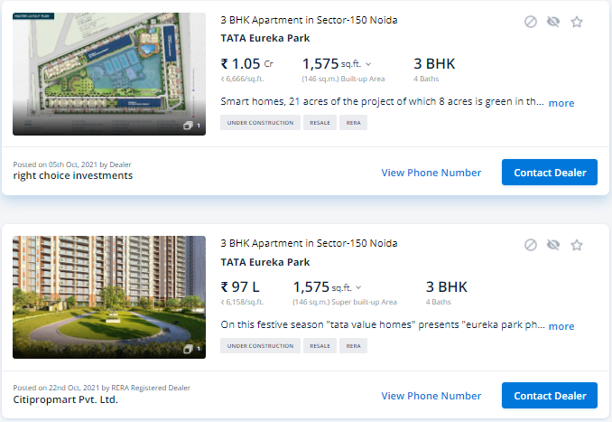

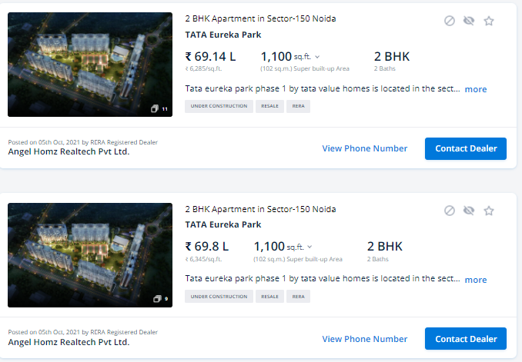

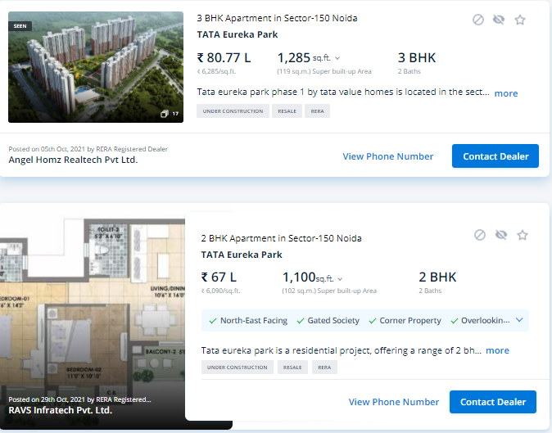

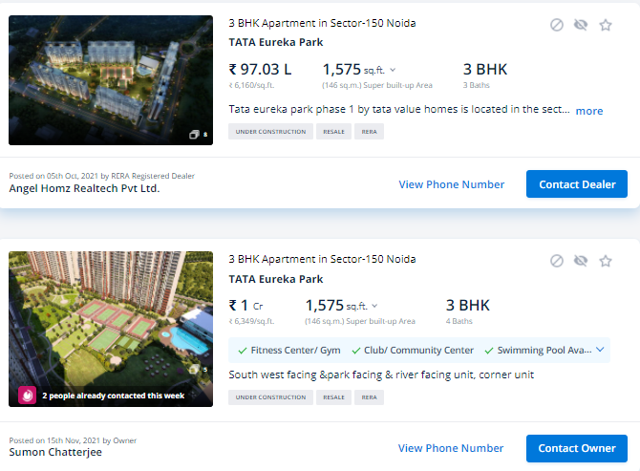

**ENCLOSURE: 3– GOOGLE MAP LOCATION**

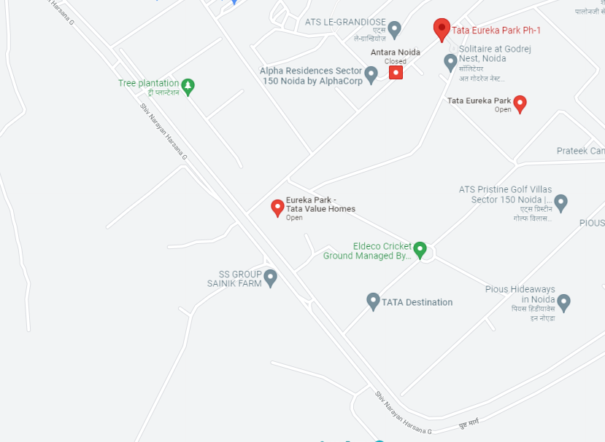

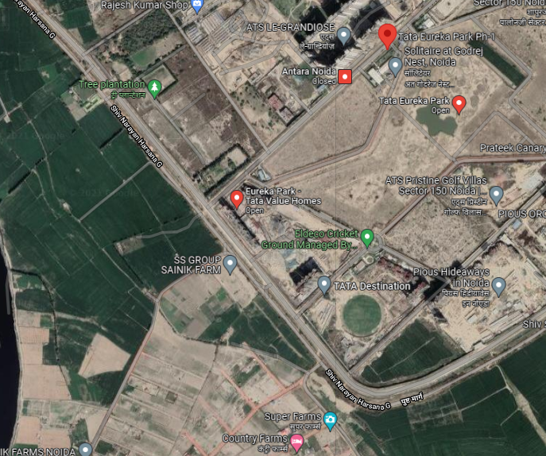

**ENCLOSURE: 4– CIRCLE RATES**

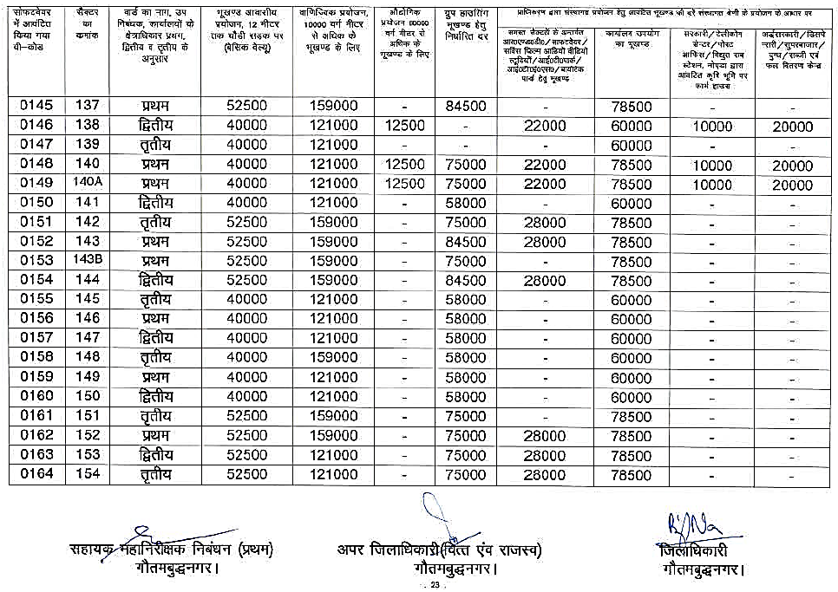

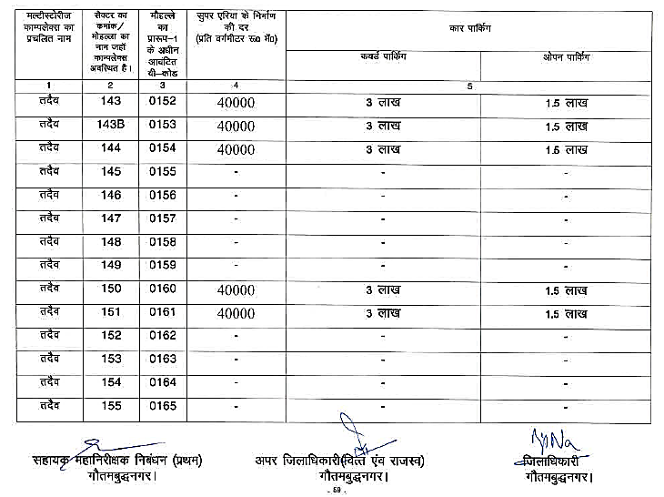

**ENCLOSURE: 5– PHOTOGRAPHS**

