**VRN NO. IOVRVF/FVS/2021-2022/192**

**FILE NO. VIS (2021-22)-PL-71-60-74**

**VALUATION ASSESSMENT**

**OF**

**RESIDENTIAL FLAT**

**SITUATED AT**

**FLAT NO. 2588, FIRST FLOOR, SECTOR-D, POCKET-02, VASANT KUNJ, NEW DELHI-110070**

**CORPORATE DEBTOR**

**M/S VISA INTERNATIONAL LIMITED**

**OWNER/S**

**M/S. VISA INTERNATIONAL LIMITED**

**REPORT PREPARED FOR**

**MR. ASHOK KUMAR GULLA**

**RESOLUTION PROFESSIONAL OF M/. VISA INTERNATIONAL LIMITED.**

**(IBBI/IPA-003/IP-N00024/2017-2018/10174)**

***\*\*Important - In case of any query/ issue or escalation you may please contact Manager at*** [***valuers@rkassociates.org***](mailto:valuers@rkassociates.org) ***/ [futurevalue@futurevalueco.com](mailto:futurevalue@futurevalueco.com)***

|  |
| --- |
| **ASSET/ PROPERTY UNDER VALUATION** |

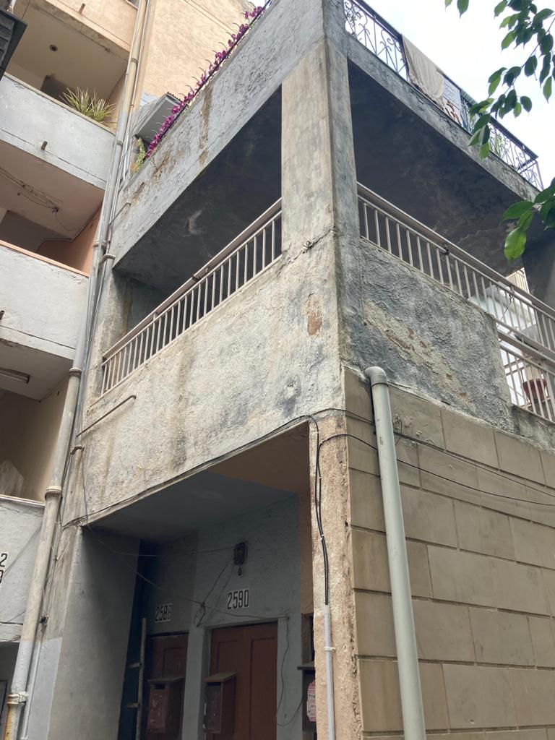

**SITUATED AT**

**FLAT NO. 2588, FIRST FLOOR, SECTOR-D, POCKET-02, VASANT KUNJ, NEW DELHI-110070**

|  |
| --- |
| **VALUATION ASSESSMENT** |

|  |  |
| --- | --- |
| Name of Liquidator | Mr. Ashok Kumar Gulla |
| Name of Corporate Debtor | M/s. Visa International Ltd. |
| Purpose of the Valuation | To determine the Fair Value & Liquidation Value (Realizable Value) under asset category Land & Building, in accordance with regulation 35 of IBBI (Insolvency Resolution for Corporate Persons) Regulations’2016. (Liquidation Process) |
| Date of Valuation | 11-05-2021 Liquidation Commencement Date |
| Date of site visit | 25-06-2021 |
| Date of valuation report | 20-07-2021 |

|  |  |  |  |  |  |  |  |  |  |  |  |  |  |  |  |
| --- | --- | --- | --- | --- | --- | --- | --- | --- | --- | --- | --- | --- | --- | --- | --- |
|  | **Property Details** | | | | | | | | | | | | | | |
|  | Address | | Flat No. 2588, First Floor, Sector-D, Pocket-02, Vasant Kunj, New Delhi-110070 | | | | | | | | | | | | |
|  | Nearby Landmark | | Jagannath Temple | | | | | | | | | | | | |
|  | Google Map | | Enclosed with the Report | | | | | | | | | | | | |
| Coordinates or URL:28°30'33.6"N 77°09'53.8"E | | | | | | | | | | | | |
|  | Independent access to the property | | Clear independent access is available | | | | | | | | | | | | |
|  | Type of ownership | | Company owned | | | | | | | | | | | | |
|  | Constitution of the Property | | Lease Hold | | | | | | | | | | | | |
|  | Is the property merged or colluded with any other property | | No | | | | | | | | | | | | |
| Comments:None | | | | | | | | | | | | |
|  | **Document Details** | | **Status** | | | | **Name of Approving Auth.** | | | | | **Approval No.** | | | |
|  | Layout Plan | | Assumed to be available since this is a Govt. Development Authority developed property | | | | DDA | | | | | ---- | | | |
|  | Building plan | | Assumed available as it is a DDA property | | | | DDA | | | | | ---- | | | |
|  | Construction Permission | | Assumed availabe since this is a DDA property | | | | DDA | | | | | ---- | | | |
|  | Legal Documents | | Available | | | | Tenancy Agreement | | | | Agreement to Sell | | | | Power of Attorney |
|  | **Physical Details of the Property** | | | | | | | | | | | | | | |
|  | Adjoining Properties | | **Directions** | | **As per Sale Deed/TIR** | | | | | | | | **As Per Old Valuation Report** | | |
| **North** | | NA | | | | | | | | Flat No. 2587 | | |
| **South** | | NA | | | | | | | | Open/Service lane below | | |
| **East** | | NA | | | | | | | | Open/Service lane below | | |
| **West** | | NA | | | | | | | | Open/Service lane below | | |
|  | Are Boundaries matched | | No, Boundaries are not mentioned in the documents. | | | | | | | | | | | | |
|  | Plot demarcation | | Not applicable since subject property is a built-up unit | | | | | | | | | | | | |
|  | Approved land Use | | Residentialas per zoning regulation | | | | | | | | | | | | |
|  | Type of Property | | Residential Apartment in low rise building | | | | | | | NA | | | | | |
|  | No. of bed rooms | Living/ Dining area | | Toilets | | | | Kitchen | | | | | | Other rooms | |
| 03 | 01 | | 03 | | | | 01 | | | | | | 01 Drawing Room | |
|  | Total no. of floors of the property | | 3 (Ground + First + Second Floor) | | | | | | | | | | | | |
|  | Floor on which the property is located | | First Floor | | | | | | | | | | | | |
|  | Approx. age of the property | | Approx. 30 Years as per copy of previous valuation report | | | | | | | | | | | | |
|  | Residual age of the property | | Approx. 35-40 years subject to proper and timely maintenance. | | | | | | | | | | | | |
|  | Type of structure | | RCC framed pillar, beam, column structure on RCC slab as per copy of previous valuation report | | | | | | | | | | | | |
|  | Condition of the Structure | | Average | | | | | | | | | | | | |
|  | Finishing of the building | | Average | | | | | | | | | | | | |
|  | **Tenure/ Occupancy/ Possession Details** | | | | | | | | | | | | | | |
|  | Property presently possessed/ occupied by | | | | | Vacant | | | | | | | | | |
|  | Status of Tenure | | | | | NA | | | | | | | | | |
|  | No. of years of occupancy | | | | | NA | | | | | | | | | |
|  | Relationship of tenant or owner | | | | | NA | | | | | | | | | |
|  | **Stage of Construction** | | | | | Constructed property in use | | | | | | | | | |
|  | If under construction then extent of completion | | | | | NA | | | | | | | | | |
|  | **Violation in the property** | | | | | | | | | | | | | | |
|  | 1. **Violation if any observed** | | 1. **Nature and extent of violation** | | | | | | 1. **Any other negativity, defect or drawback in the property** | | | | | | |
|  | Yes, an extra servant quarter and extra balcony is constructed. | | NA | | | | | | No | | | | | | |

|  |  |  |  |  |  |
| --- | --- | --- | --- | --- | --- |
|  | **AREA DETAILS OF THE PROPERTY** | | | | |
|  | **Land area***(as per documents/ site survey, whichever is less)*  *(Not considered since this is a Built-up Dwelling Unit Valuation)* | | | | |
|  | Area as per documents | Area as per site survey | | **Area considered for Valuation** | |
| NA | NA | | NA | |
| Area adopted on the basis of | NA | | | |
| Remarks & Observations | Not relevant in our cases, as it is residential flat sold on FAR/FSI basis | | | |
|  | **ConstructedCovered Area** | | | | |
|  | Area as per documents | | Area as per site survey | | **Area considered for Valuation** |
| **Flat No- 2588**  **1400 sq. ft. (super Built up Area)** | | ---- | | **Flat No. 2588**  **1400 sq. ft. (super Built up Area)** |
| Area adopted on the basis of | Property documents and sample measurements only. | | | |
| Remarks & Observations | Area measurements considered in the Valuation Report pertaining to Building is adopted from relevant documents produced to us or actual site measurement, whichever is less. | | | |

|  |  |  |  |  |  |  |  |  |  |
| --- | --- | --- | --- | --- | --- | --- | --- | --- | --- |
|  | **VALUATION ASSESSMENT** | | | | | | | | |
|  | **ASSESSMENT FACTORS** | | | | | | | | |
|  | Valuation Type | Built-up unit value (sold-purchased as a seperate dwelling unit) | | | | | | Residential flat Value | |
|  | Scope of the Valuation | To assess Plain Asset Valuation. | | | | | | | |
|  | Property Use factor | **Current Use** | | | | | **Highest &Best Use** | | |
| Residential | | | | | Residential | | |
|  | Legality Aspect Factor | Report assumed no responsibility of legal aspect or legality of property ownership. | | | | | | | |
|  | Land Physical factors | **Shape** | | **Size** | | | **Level** | | **Frontage to depth ratio** |
| Not Applicable | | Not Applicable | | | Not Applicable | | Not Applicable |
|  | Property location category factor | **City Categorization** | | **Locality Categorization** | | | **Property location classification** | | **Floor Level** |
| Metro City | | Good | | | Normal location within locality | | First Floor |
| Urban developed | | Within good urban developed area | | | None | |
| None | |
| **Property Facing** | | North Facing | | | | | |
|  | Any New Development in surrounding area | None | | | |  | | | |
|  | Any specific advantage/ drawback in the property | Under liquidation | | | | | | | |
|  | Property overall usability Factor | Good | | | | | | | |
|  | Comment on Property Saleability Outlook | Since, the property is under liquidation, buyers will be motivated with this fact, and property may not fetch its open market value | | | | | | | |
|  | Comment on Demand & Supply in the Market | Demand for premium commercial properties are constant in the market stills the assets are under liquidation category for a typical set buyers for stressed properties. | | | | | | | |
|  | Any other aspect which has relevance on the value or marketability of the property | NA  We have considered market as efficient market.  This Valuation report is prepared based on the facts of the property & market situation on the date of the survey. It is a well-known fact that the market value of any asset varies with time & socio-economic conditions prevailing in the country. In future property market may go down, property conditions may change or may go worse, property reputation may differ, property vicinity conditions may go down or become worse, property market may change due to impact of Govt. policies or effect of World economy, usability prospects of the property may change, etc. Hence before financing, Banker/ FI should take into consideration all such future risk while financing. | | | | | | | |
|  | Sale transaction method assumed | Free market transaction at arm's length wherein the parties, after full market survey each acted knowledgeably, prudently and without any compulsion. | | | | | | | |
|  | Best Sale procedure to realize maximum Value | Liquidation Sale (orderly) | | | | | | | |
|  | Methodology/ Basis of Valuation | **Govt. Guideline Value:** Collector rates of Delhi. | | | | | | | |
| **Market Value:** Market Comparable Sales approach | | | | | | | |
| *Valuation of the asset is done as found on as-is-where basis.*  *Valuation is done based on the Valuation best practices, standard operating procedures and definitions prescribed by various organizations like IVSC, Income Tax of India, etc. as defined under.*  *For knowing comparable market rates, significant discreet local enquiries have been made from our side representing ourselves as both buyer and seller for the similar properties in the subject area and thereafter based on this information and various factors of the property, a rate has been judiciously taken considering the market scenario.*  *References regarding the prevailing market rates are based on the verbal/ informal/ secondary/ tertiary information collected during market survey in the subject area from the local people, property consultants, recent deals, demand-supply, internet postings which are relied upon. No written record is generally available for such market information and only the verbal information has to be relied upon.*  *Market Rates are rationally adopted based on the facts of the property that came to our knowledge during the course of the assignment considering many factors like nature of the property, size, location, approach, market situation and trends.*  *The indicative value has been suggested based on the prevailing market rates that came to our knowledge during secondary & tertiary market researches and does not split into formal & informal payment components.*  *Secondary/ Tertiary costs related to asset transaction like Stamp Duty, Registration charges, Brokerage, Bank interest, selling cost, marketing cost, etc. pertaining to the sale/ purchase of this property are not considered while assessing the indicative estimated Market Value.*  *This report includes both, Govt. Guideline Value and Indicative Estimated Prospective Fair Market Value. As per the current market practice, in most of the cases, formal transaction takes place for an amount less than the actual transaction amount and rest of the payment is normally done informally.*  *Construction rates are adopted based on the present market replacement cost of construction and calculating applicable depreciation & deterioration factor as per its existing condition &specifications based on only visual observation of the structure. No structural, physical tests have been carried out in respect of it.*  *Construction rates are adopted based on the plinth area rates prevailing in the market for the structure as a whole and not based on item wise estimation or Bills of Quantity method.*  *The condition assessment and the estimation of the residual economic life of the structure is only based on the visual observations and appearance found during the site survey. We have not carried out any structural design or stability study; nor carried out any physical tests to assess structural integrity & strength.*  *Sale transaction method of the asset is assumed as free market transaction while assessing Indicative & Estimated Fair Prospective Market Value of the asset.*  *Any kind of unpaid statutory, utilities, lease, interest or any other pecuniary dues on the asset has not been factored in the Valuation.*  *This Valuation is conducted based on the macro analysis of the asset/ property considering it in totality and not based on the micro, component or item wise analysis. Analysis done is a general assessment and is not investigative in nature.*  ***Fair Market Value#*** *suggested by the competent Valuer is that prospective estimated amount in his expert & prudent opinion of the subject asset/ property without any prejudice after he has carefully & exhaustively evaluated the facts & information came in front of him related to the subject asset at which the subject asset/ property should be exchanged between a willing buyer and willing seller at an arm’s length transaction in an open & unrestricted market, after proper marketing, wherein the parties, each acted knowledgeably, prudently and without any compulsion on the date of the Valuation.*  *Forced, under compulsion &constraint, obligatory sales transactions data doesn’t indicate the Fair Market Value.*  ***Realizable Value^*** *is the minimum prospective estimated value of the property which it may be able to realize at the time of actual property transaction factoring in the potential prospects of deep negotiations carried out between the buyer & seller for ultimately finalizing the transaction across the table. Realizable value may be 10-20% less than the Fair Market Value depending on the various salability prospects of the subject property and the needs of the buyer & the seller.*  ***Liquidation Value*** *The net amount that would be realized if a business is discontinued and its assets are sold individually. “LV is estimated realizable value of the assets of the CD if it were liquidated on the liquidation commencement date (LCD).”*  *When the asset is sold in liquidation, sale value will always be less than fair value, since it depends on various factors such as type & future usage of asset, demand, prevailing site conditions & circumstances, mode of payment & transaction, general depression, negative sentiments, salvage value, as is where basis in case of land & building. Seller is official liquidator and the buyer may be motivated by the knowledge of the limitations of the seller under the circumstances. Since it is majorly as industrial usage limitation, the buyer would, essentially be already in the same business or be willing to enter the same line of business. Buyer will approach and search for similar attributes of property in primary & secondary market. Considering all the factors, location, market factors, ease of acquisition, Liquidation Value is estimated by discount and factoring unpaid liability on land component in Fair Value.*  *The liquidator may sell*  *(a) An asset on a standalone basis;*  *(b) The assets in a slump sale;*  *(c) A set of assets collectively;*  *(d) The assets in parcels;*  *(e) The corporate debtor as a going concern*  *(f) The business(s) of the corporate debtor as a going concern.*  ***Difference between Cost, Price & Value:*** *Generally these words are used and understood synonymously. However in reality each of these has a completely different meaning, premise and also having different definitions in the professional & legal terms. Therefore to avoid confusion, it is our professional responsibility to describe the definitions of these words to avoid ambiguity & confusion in the minds of the user of this report.*  *The* ***Cost*** *of an asset represents the actual amount spend in the construction/ actual creation of the asset.*  *The* ***Price*** *is the amount paid for the procurement of the same asset.*  *The* ***Value*** *is defined as the present worth of future rights in the property/ asset and depends to a great extent on combination of various factors such as demand and supply, market situation, purpose, situation & needs of the buyer & seller, saleability outlook, usability factor, market perception & reputation. needs of the buyer & seller, saleability outlook, usability factor, market perception & reputation.*  *Therefore in actual for the same asset/ property, cost, price & value remain different since these terms have different usage & meaning.* | | | | | | | |
|  | References on prevailing market Rate/ Price trend of the property and Details of the sources from where the information is gathered *(from property search sites & local information)* |  | Name: | | Mr. Bharat Madan | | | | |
| Contact No.: | | 9899103602 | | | | |
| Nature of reference: | | Property Consultant | | | | |
| Size of the Property: | | 3 BHK flat | | | | |
| Location: | | Vasant Kunj D Block | | | | |
| Rates/ Price informed: | | Rs.2.25 crores to 3.0 crores (Lump sum) | | | | |
| Any other details/ Discussion held: | | According to the property dealer, at present during the continuing Covid pandemic, there are virtually no inquiries for real estate or any transactions taking place. The market is in an uncertain state and it is expected that the market rates will fall once the Pandemic subsides since there is a considerable loss  to the economy and businesses due to the Pandemic and consequent lockdown and the sentiments among the general people are very weak and people will hesitate a lot to lock up their available liquidity in an illiquid asset like in real estate in this environment. Due to the ongoing pandemics the real estate market in all over India declines and the rates go down anywhere in the region of 5% to 10% or even upto 15% at some places.  As per the telephonic discussion with Mr. Vikas he informed that he had a flat available on Ground floor in D block pocket 2 and demanding Rs.2.50 crore. | | | | |
|  | Name: | | M/s. Shiv Estate | | | | |
| Contact No.: | | 9311960240 | | | | |
| Nature of reference: | | Property Consultant | | | | |
| Size of the Property: | | 3 BHK | | | | |
| Location: | | Vasant Kunj D Block | | | | |
| Rates/ Price informed: | | Rs.2.10 crore to 3.0 crores (Lumpsum) | | | | |
| Any other details/ Discussion held: | | According to the property dealer, at present during the continuing Covid pandemic, there are virtually no inquiries for real estate or any transactions taking place. The market is in an uncertain state and it is expected that the market rates will fall once the Pandemic subsides since there is a considerable loss  to the economy and businesses due to the Pandemic and consequent lockdown and the sentiments among the general people are very weak and people will hesitate a lot to lock up their available liquidity in an illiquid asset like in real estate in this environment. Due to the ongoing pandemics the real estate market in all over India declines and the rates go down anywhere in the region of 5% to 10% or even upto 15% at some places.  As per the telephonic discussion with Mr. Gaurav he informed that the prevailing market rate for flats in D block pocket 2 is between Rs.2.10 Cr. to Rs.3.5 Cr. | | | | |
|  | Name: | | Mr. Mahender Singh | | | | |
| Contact No.: | | +91-8585907366 | | | | |
| Nature of reference: | | Property consultants | | | | |
| Size of the Property: | | 3 BHK | | | | |
| Location: | | Vasant Kunj D Block | | | | |
| Rates/ Price informed: | | Rs. 2.50/- crore (lumpsum) | | | | |
| Any other details/ Discussion held: | | According to the property dealer, at present during the continuing Covid pandemic, there are virtually no inquiries for real estate or any transactions taking place. The market is in an uncertain state and it is expected that the market rates will fall once the Pandemic subsides since there is a considerable loss  to the economy and businesses due to the Pandemic and consequent lockdown and the sentiments among the general people are very weak and people will hesitate a lot to lock up their available liquidity in an illiquid asset like in real estate in this environment. Due to the ongoing pandemics the real estate market in all over India declines and the rates go down anywhere in the region of 5% to 10% or even upto 15% at some places.  As per the telephonic discussion with Mr. Mahender, he informed that he had a flat available on first floor in D block pocket 2 and demanding Rs. 2.50 crore. He said currently no any leasehold flats is available for sale in this area. | | | | |
| *NOTE: Because of COVID and pandemic situation, sale instances were relied as the above mentioned.* | | | | | | | | |
|  | Adopted Rates Justification | As per our discussion with the property dealers, we came to know that during this Covid Pandemic period there is virtually no enquiry either for sale or for purchase of any property and virtually no sale/ purchase is taking place since the Pandemic started. The real estate market is facing a very critical and uncertain phase. But according to these property dealers the rates quoted by them currently are for the Pre-Pandemic phase. According to them, because of the economic slowdown, losses suffered by businessmen, the loss of jobs or cuts in salaries of the salaried class and also the natural tendency of the people to conserve available liquidity instead of locking it up in an illiquid asset like property or other fixed assets during such economic prolonged, uncertain and distressful times. The demand for properties is expected to fall very significantly in the immediate aftermath of Covid Pandemic. The same is the opinion of a number of reputed real estate consultants who have released their reports on the likely impact on the Real Estate scenario because of disruption caused by the Covid-19 to the economy. Due to the ongoing pandemics the real estate market in all over India declines and the rates go down anywhere in the region of 5% to 10% or even upto 15% at some places.  *As per the telephonic discussion with the market participants we came to know that the rates in the concerned area vary from Rs.18,000/- to Rs.20,000/- per sq.ft. for 3 BHK freehold flats on ground floor. The rates of flats on first floor is around Rs.16,000/- to Rs.18,000/- per sq.ft. on Super Built-up area. Also, these rates may vary depending upon the, size of the flats, their location facing and constitution of property. Since this property is leasehold as no conveyance deed of the said property is provided. The rates of leasehold flats is somewhat lesser than freehold flats. Keeping all the things into consideration that may vary, we have adopted the rate range of of Rs.16,000/- to Rs.18,000/- per sq.ft. for 3 BHK flats on ground floor and Rs.14,000/- to Rs.16,000/- per sq.ft. on first floor for valuation purposes which seems reasonable in our view.* | | | | | | | |

|  |  |  |  |  |  |  |
| --- | --- | --- | --- | --- | --- | --- |
|  | **VALUATION CALCULATION** | | | | | |
|  | **GUIDELINE/ CIRCLE VALUE** | | | | | |
|  | **Land Value***(Not considered since this is a built-up unit valuation)* | **Total Land Area considered as per documents/ site survey** *(whichever is less)* | **Prevailing Rates Range** | | | **Rates adopted**  (considering all characteristics& assessment factors of the property) |
| NA | NA | | | NA |
| ***Total Land Value (a)*** | NA | | | | |
| Not relevant in our cases, as it is residential flat sold on FAR/FSI basis. | | | | |
|  | **Built-up Dwelling Unit Value** | **Built-Up unit value** | | | | |
| **Structure Type** | **Construction category** | | | **Age Factor** |
| RCC framed pillar, beam, column structure on RCC slab | Class B construction (Good) | | | 30 years old construction |
| **Rate range** | **Rate adopted** | | | **Super Area** |
| Refer to Page No.17 of the report | Refer to Page No.17 of the report | | | 1400 sq.ftsuper Built up Area  (130.06) sq.mtr |
| ***TotalBuilt-up Dwelling Unit Value(b)*** | Please see the attached list | | | | |
| **Rs. 79,24,800/-** | | | | |
|  | **TOTAL GUIDELINE/ CIRCLE RATE VALUE: (a+b)** | **Rs. 79,24,800/- (Built-up unit value)** | | | | |
|  | | | | | | |
|  | **ESTIMATED FAIR VALUE** | | | | | |
|  | **Land Value***(Not considered since this is a built-up unit valuation)* | **Total Land Area considered as per documents/ site survey** *(whichever is less)* | **Prevailing Rates Range** | | | **Rate adopted**  (considering all characteristics& assessment factors of the property) |
| NA | NA | | | NA |
| ***Total Land Value (a)*** | NA | | | | |
| Not relevant in our cases, as it is residential flat sold on FAR/FSI basis. | | | | |
|  | **Built-up Dwelling Unit Value** | **Built-Up unit value** | | | | |
| **Structure Type** | **Construction category** | | | **Structure Condition** |
| RCC framed pillar, beam, column structure on RCC slab | Class B construction (Good) | | | Good |
| **Age Factor** | | | **Super Area** | |
| 30 years old construction | | | 1400 sqft (super Built up Area**)**  (130.06) sq.mtr | |
| **Rate range** | | | **Rate adopted** | |
| Rs.14,000/- to Rs.16,000/- per sq.ft. | | | Rs.15,000/- per sq.ft. | |
| ***TotalBuilt-up Dwelling Unit ValueValue (b)*** | Rs.15,000/per -sq.ft X 1400 sq. ft. | | | | |
| **Rs.2,10,00,000/-** | | | | |
|  | **Add extra for Architectural aesthetic developments, improvements *(c)***  *(add lump sum cost)* | | | NA | | |
|  | **Add extra for fittings & fixtures *(d)***  *(doors, windows, wood work, cupboards, modular kitchen, electrical/ sanitary fittings)* | | | NA | | |
|  | **Add extra for services*(e)***  *(water, electricity, sewerage, main gate, boundary, lift, etc.)* | | | NA | | |
|  | **TOTAL VALUE: (a+b+c+d+e)** | | | **Rs.2,10,00,000/-** | | |
|  | **Additional Premium if any** | | | NA | | |
| **Details/ Justification** | | | NA | | |
|  | **Deductions charged if any** | | | NA | | |
| **Details/ Justification** | | | NA | | |
|  | **TOTAL ESTIMATED FAIR VALUE#: (vi+vii+viii)** | | | **Rs.2,10,00,000/-** | | |
|  | **ROUND OFF** | | | **Rs.2,10,00,000/-** | | |
|  | **IN WORDS** | | | **Rupees Two Crore Ten Lakhs only/-** | | |
|  | **LIQUIDATION VALUE (REALIZABLE VALUE AS PER REGULATION 32) {(a) to (f)- for residential properties}^(@ ~20% less)** | | | **Rs. 1,68,00,000/-**  **Rupees One Crore Sixty Eight Lakhs Only** | | |
| **For Futurevalue Advisors India (P) Ltd**  **Regd. No. IBBI/ RV-E/02/2020/117**  **( Ar. Ashish Sawe)**  **(IBBI Regd. Valuer)**  **Director & COO**  **IBBI/RV/02/2020/11384**  **Place :New Delhi**  **Dated: 20.07.2021** | | | | | | |
|  | **Justification for more than 20% difference in Market & Circle Rate** | Circle rates are determined by the District administration as per their own theoretical internal policy and Market rates are adopted based on current practical market dynamics which is explained clearly in Valuation Assessment Factors | | | | |
|  | **Concluding comments & Disclosures if any** | 1. The Subject Property is located in the prime location of the city and it is maintained properly, considering these factors we have adopted 20% less for arriving at liquidation Value. 2. Currently, as per the micro & macro market research, the demand for property is weak and the enquiries and the transactions are negligible. In these uncertain times, people are likely to be very cautious in their expenditures in general and are and will be averse to lock up their available liquidity in the acquisition of fixed assets like property. A potential buyer of property if any, may consider acquiring a property only if he gets a really good bargain, at a substantial discount to the rates prevailing before the Covid Pandemic. 3. We have taken ownership as per Agreement to Sale and Tenancy Agreement only, as no any other document has been provided by the Liquidator. 4. The Liquidator is hereby requested to verify the ownership of said property by the competent authority at its own level. 5. This Valuation report is prepared based on the copies of the documents/ information which interested organization or customer could provide to us out of the standard checklist of documents sought from them and further based on our assumptions and limiting conditions. All such information provided to us has been relied upon in good faith and we have assumed that it is true and correct. 6. Legal aspects for eg. investigation of title, ownership rights, lien, charge, mortgage, lease, verification of documents from originals, etc. has to be taken care by legal experts/ Advocates. 7. This report only contains technical & market information which came to knowledge during course of the assignment. It doesn’t contain any recommendations. 8. This report is prepared following our Standard Operating Procedures & Best Practices, Limitations, Conditions, Remarks, Important Notes, Valuation TOR. | | | | |

|  |  |
| --- | --- |
|  | **ASSUMPTIONS | REMARKS | LIMITING CONDITIONS** |
|  | Qualification in TIR/Mitigation Suggested, if any:***Cannot comment since copy of TIR is not provided*** |
|  | Is property SARFAESI compliant:***Yes*** |
|  | Whether property belongs to social infrastructure like hospital, school, old age home etc.:***No*** |
|  | Whether entire piece of land on which the unit is set up / property is situated has been mortgaged or to be mortgaged:***Already mortgaged*** |
|  | Details of last two transactions in the locality/area to be provided, if available:***Information couldn’t be found.*** |
|  | Any other aspect which has relevance on the value or marketability of the property:This report is prepared following our standard operating procedures & best practices, limitations, conditions, remarks, Important Notes, Valuation TOR. |
| 1. This Valuation report is prepared based on the copies of the documents/ information which interested organization or customer could provide to us out of the standard checklist of documents sought from them and further based on our assumptions and limiting conditions. All such information provided to us has been relied upon in good faith and we have assumed that it is true and correct. Verification or cross checking of the copy of the documents provided to us from the originals has not been done at our end. |
| 1. Legal aspects for eg. investigation of title, ownership rights, lien, charge, mortgage, lease, etc. are not considered in this report. It is assumed and taken into account that the concerned Bank/ Financial Institution has got the legal verification cleared by the competent Advocate while requesting for the Valuation report. |
| 1. Value varies with the Purpose/ Date/ Condition prevailing in the market. We recommend not to refer the Value of the asset given in this report if any of these points are different from the one mentioned aforesaid in the Report. We also recommend that the indicative estimated Value in the Valuation Report holds good only upto the period of 3 months from the date of Valuation. |

|  |  |  |  |  |
| --- | --- | --- | --- | --- |
|  | **DECLARATION** | | | |
|  | 1. The undersigned does not have any direct/indirect interest in the above property. 2. The information furnished herein is true and correct to the best of our knowledge. 3. We have submitted Valuation report directly to the Liquidator. 4. This valuation report is carried out by our Engineering team on the request from **Mr. Ashok Kumar Gulla (IBBI/IPA-003/IP-N00024/2017-2018/10174) Liquidator of M/s. Visa International Limited** | | | |
|  | **Name & Address of Valuer company** | Signature of the Registered Valuer | | |
| Name: Ashish Sawe  *(IBBI Registered No.: IBBI/RV/02/2019/11384)* | | | |
|  | **Enclosed Documents** | **S.No.** | **Documents** | **No. of Pages** |
|  | General Details | 02 |
|  | Screenshot of the price trend references of the similar related properties available on public domain | 00 |
|  | Google Map | 01 |
|  | Photographs | 04 |
|  | Copy of Circle Rate | 01 |
|  | Survey Summary Sheet | 02 |
|  | Confidentialty Disclaimer | 02 |
|  | Copy of relevant papers from the property documents referred in the Valuation |  |
|  | **Total Number of Pages in the Report with Enclosures** | 23 | | |

|  |  |  |  |  |  |  |
| --- | --- | --- | --- | --- | --- | --- |
| **GENERAL DETAILS** | | | | | | |
|  | Report prepared for | Liquidator | | | | |
|  | Name of Liquidator | Mr. Ashok Kumar Gulla | | | | |
|  | Name of Corporate Debtor | M/s. Visa International Ltd. | | | | |
|  | Date of Valuation report | 20 July 2021 | | | | |
|  | Date of Survey | 25 June 2021 | | | | |
|  | Type of the Property | Residential Apartment in low rise building | | | | |
|  | Type of Survey | Half Survey (Approximate sample random measurement verification from outside only & photographs), | | | | |
|  | Type of Valuation | Residential Flat Value | | | | |
|  | Report Type | Plain Asset Valuation | | | | |
|  | Surveyed in presence of | Owner's representative | | Name: | Mr. Pawan Shukla  Mob-9717927164 | |
|  | Purpose of Valuation | To determine the Fair Value & Liquidation Value (Realizable Value) under asset category Land & Building, in accordance with regulation 35 of IBBI (Insolvency Resolution for Corporate Persons) Regulations’2016. (Liquidation Process) | | | | |
|  | Scope of the Report | Non binding opinion on indicative estimated prospective valuation assessment of the property identified by property owner or through its representative | | | | |
|  | Important Disclosures | 1. Valuation based on the copy of the documents/ information provided to us by the client and has been relied upon in good faith of the property found as per the information given in the documents provided to us and/ or confirmed by the owner/ owner representative to us on site. 2. Getting map or coordination with revenue officers for site identification is a separate activity and is not part of the Valuation services. 3. Measurement verification is only limited upto sample random measurement against the documents produced to us. We have taken engineering services of RK Associates as domain expert. | | | | |
|  | Documents provided for perusal | **Documents Requested** | | **Documents Provided** | | **Documents Reference No.** |
| Total **05** documents requested. | | Total**06**documents provided. | | 06 |
| Copy of TIR | | Tenancy Agreement | | Dated: 01/07/2017 |
| Agreement to Sell | | Power of Attorney | | Dated 16/03/1990 |
| Property Title document | | Agreement to Sell | | Dated 26/10/1989 |
| Approved Map | | Possession Letter | | Dated 10/06/1988 |
| Last paid Municipal Tax Receipt  Title Verification Report | | Allottment Papers of previous Owner  Legal Report | | Dated 28/04/1988  Dated 18/12/2019 |
|  | Documents received from | Liquidator | | | | |
|  | Identification of the property  *(Identification of the property is only limited to cross verification from its boundaries at site if mentioned in the provided documents).* | **☒** | Done by company official. | | | |
|  | Enclosures | 1. Screenshot of the Price trend references of the similar related   properties available on public domain - Page No.21   1. Google Map – Page No.14 2. Photographs – Pages 05 3. Copy of Circle Rate – Pages20 4. Survey Summary Sheet – Pages 02 5. Confidentiality Disclaimer - Page No.22-23 6. Copy of relevant papers from the property documents referred in the   Valuation – Pages 02 | | | | |

**ENCLOSURE: IV– GOOGLE MAP LOCATION**

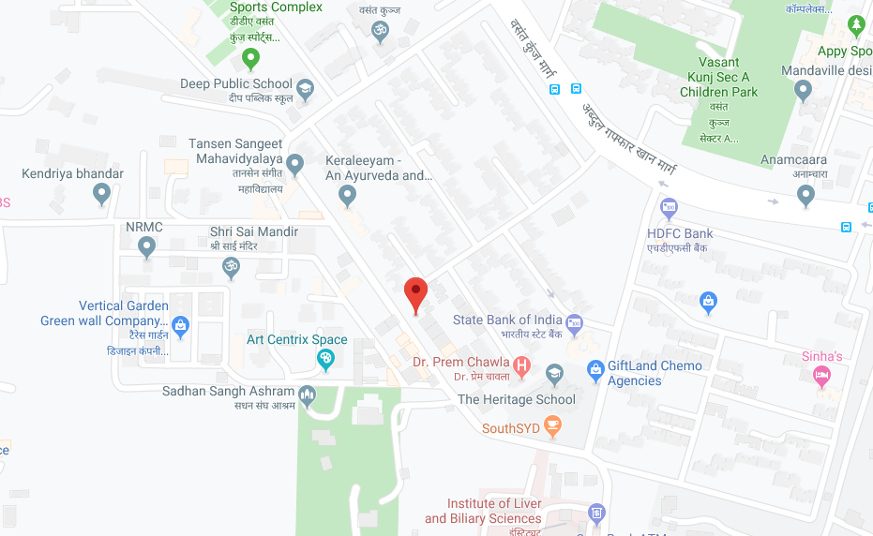

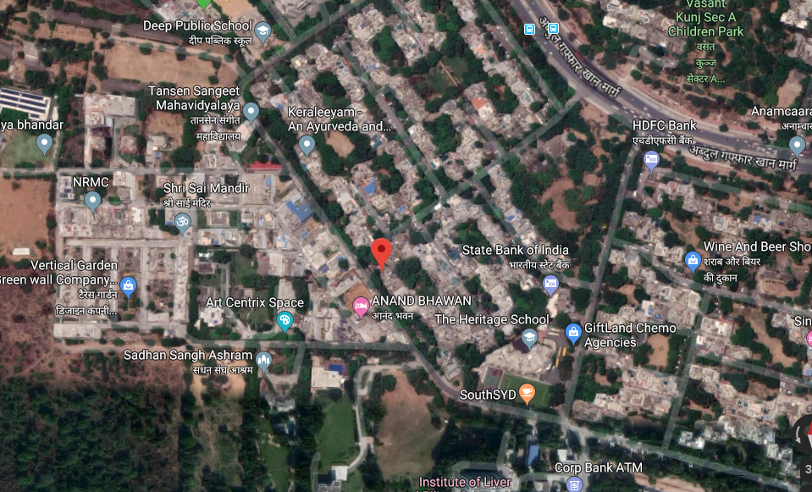

**ENCLOSURE: V– PHOTOGRAPHS OF THE PROPERTY**

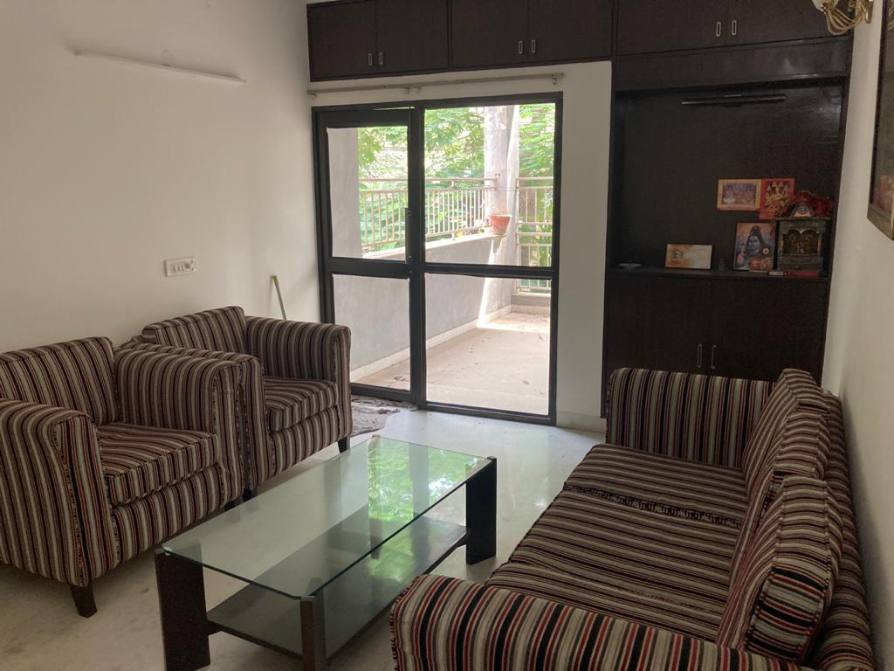

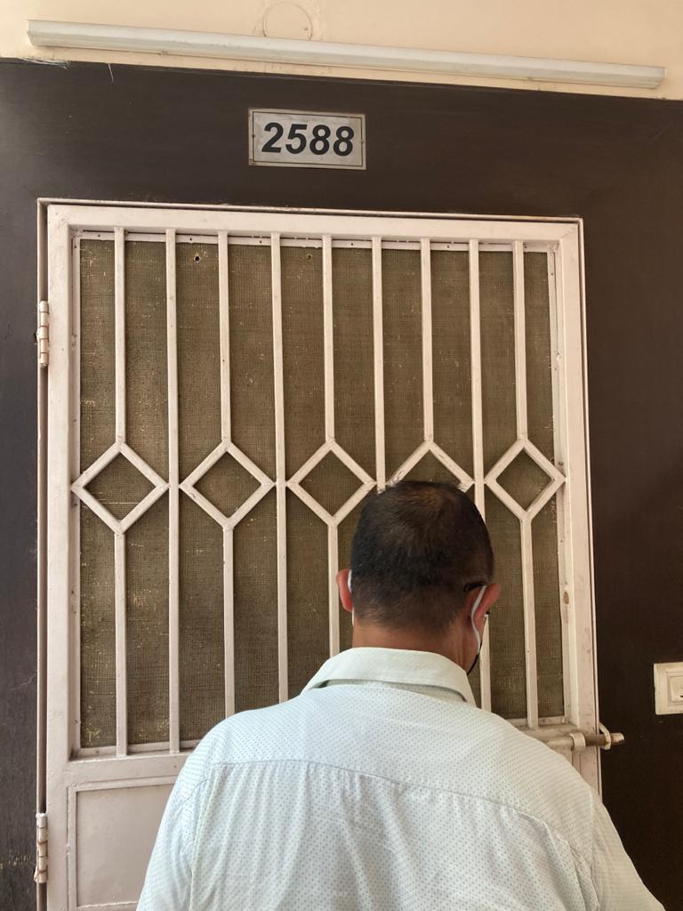

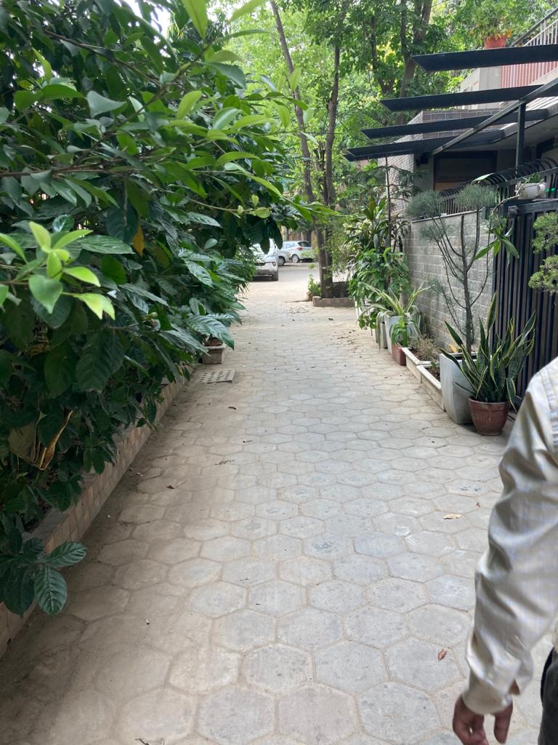

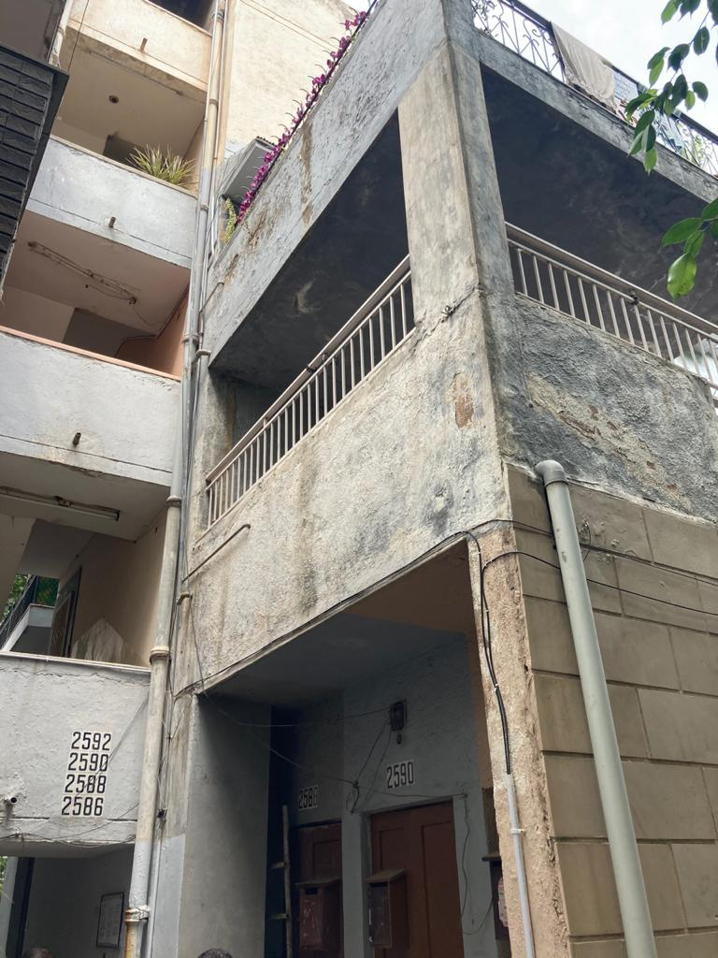

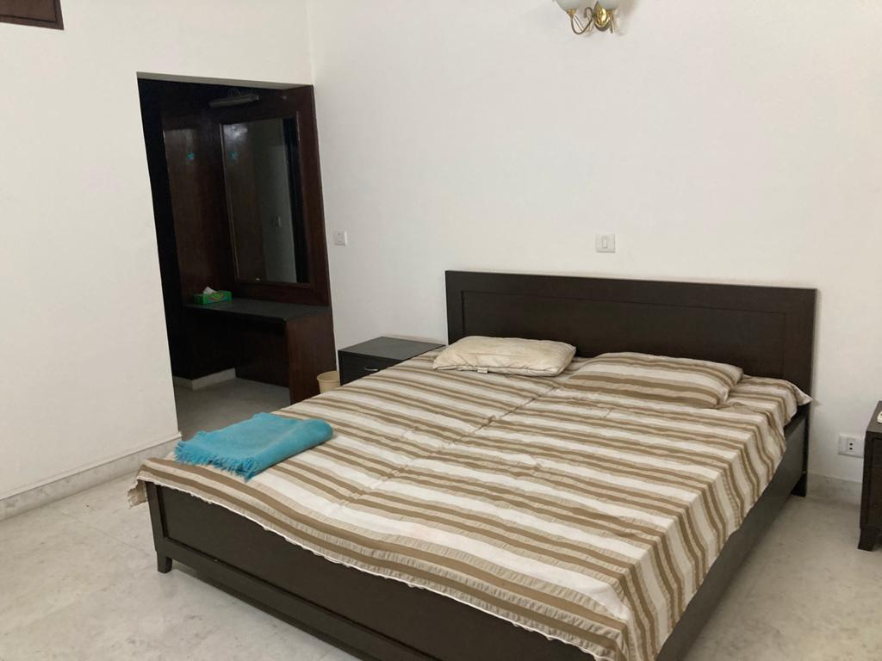

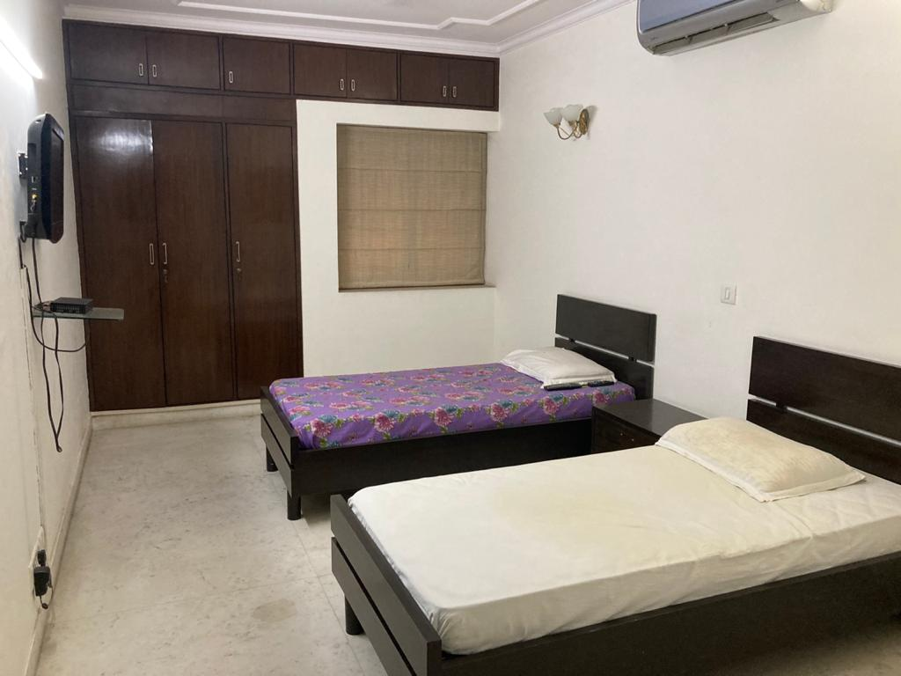

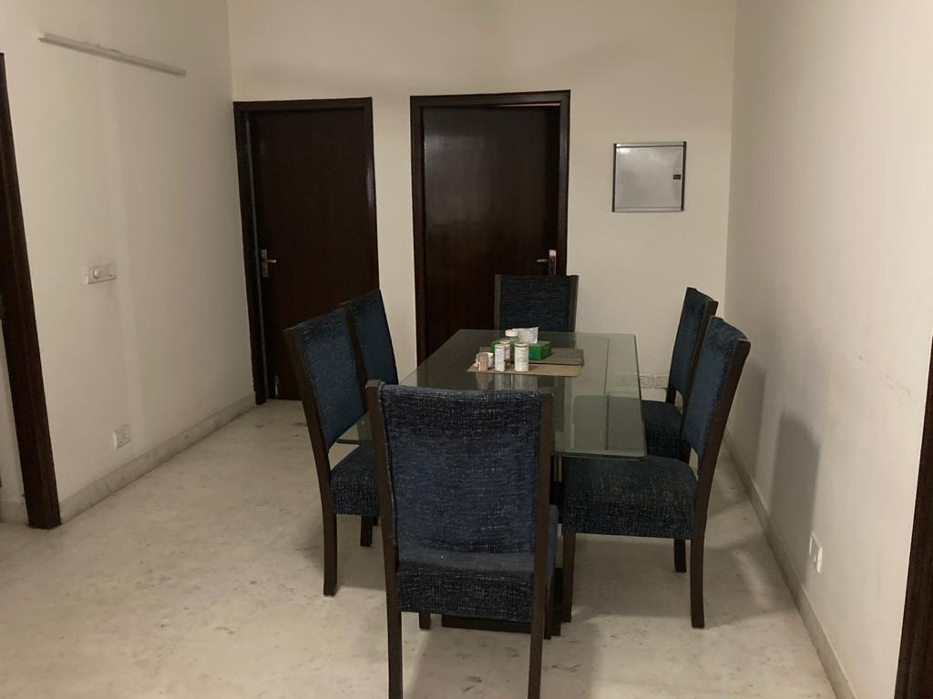

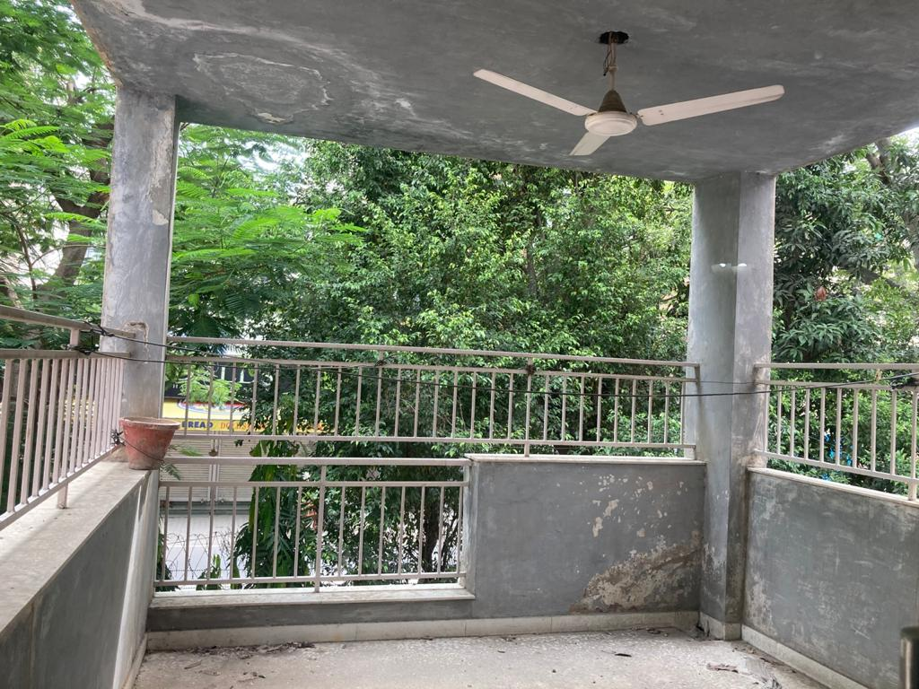

**ENCLOSURE: VI – COPY OF CIRCLE RATE**

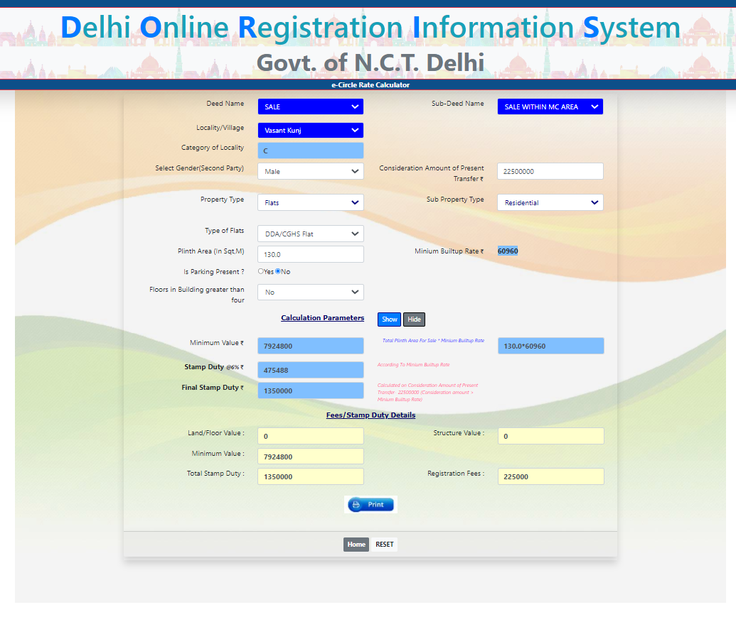

**REFERENCES ON PRICE TREND OF THE SIMILAR RELATED PROPERTIES AVAILABLE ON PUBLIC DOMAIN– ANNEXURE VII**

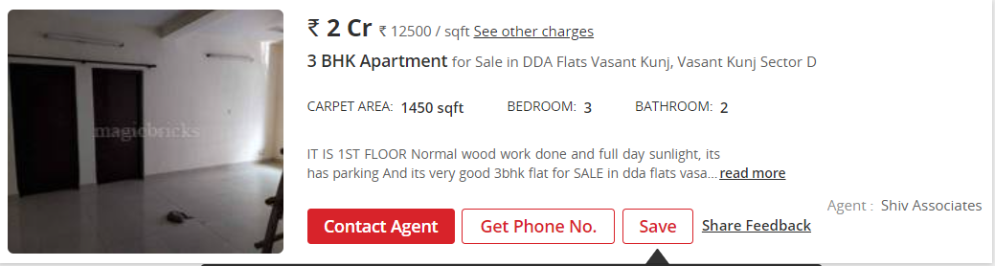

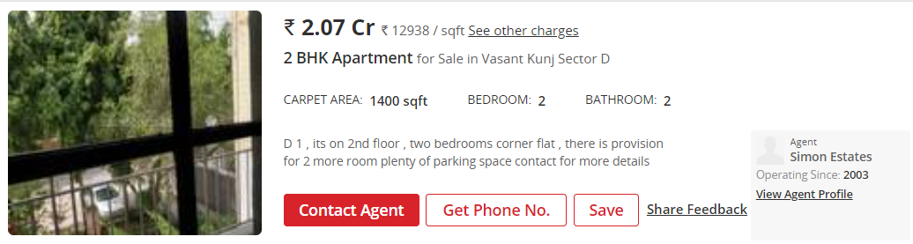

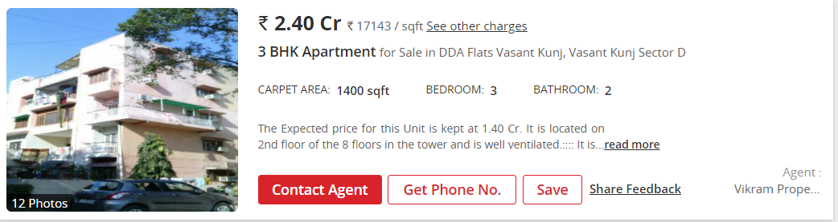

**ENCLOSURE: VIII – CONFIDENTIALITY & DISCLAIMER**

|  |  |
| --- | --- |
|  | Valuation report is prepared for the exclusive use as per appointment by Liquidator,Contents of the valuation, the purpose of the report and the value conclusions will not be revealed to anyone for other than CIRP purposes or state as per regulation; |
|  | This valuation report sets forth the findings and conclusions, and is based upon an investigation of conditions affecting value, and is subject to the Statement of Limiting Conditions and Definitions. Without reading the Statement of Limiting Conditions and Definitions, this report cannot be fully understood; |
|  | Report shall be used only in its entirety. The contents as contained may not be used for any purpose other than the intended purpose mentioned above. Neither the whole nor any part of the report may be presented to any party other than the instructing party; |
|  | Appearance in Hon’ble NCLT court (if required) only once, subsequent each appearance will attract a fees of INR 20,000/- (Rupees Twenty Thousand only) plus applicable taxes, per appearance irrespective of hearing or not. |
|  | Report is produced on best effort basis information/ Plans/ NOC provided by Contact person/ officials of the company, This Report is neither a structural survey nor environmental aspect study of the asset valued; |
|  | The report is based on the assumption that the development site is suitable for development and the land is contaminated and has not been affected by pollutants of any kind; |
|  | Report assume no responsibility for legal aspect or legality of property ownership in nature neither do we render any opinion to the title clearness which is assumed to be good and marketable for transactions; |
|  | Financial liabilities, taxes, duties, dues, royalties etc, if any, for assets under valuation are not taken into consideration; |
|  | This report does not warrant the accuracy or completeness of any Government, public record information or data sources used to prepare the report; |
|  | The data provided in reports may not be re-sold, re marketed, published, or incorporated into other products or services in any form or manner whatsoever; |
|  | The valuation report will remain valid only for the purpose for which it is made. |
|  | The above declaration and information furnished in the report are true and correct to the best of my knowledge and belief. |

**For Futurevalue Advisors India (P) Ltd**

**Regd. No. IBBI/ RV-E/02/2020/117**

**( Ar. Ashish Sawe)**

**(IBBI Regd. Valuer)**

**Director & COO**

**IBBI/RV/02/2020/11384**

**Place :New Delhi**

**Dated: 20.07.2021**