File No.: VIS (2021-22)-PL750-646-827 Dated: 14.01.2021

TECHNO-ECONOMIC
VIABILITY STUDY REPORT

OF

M/S SADASHIVA PSYLLIUM PRIVATE LIMITED

SITUATED AT
KHASRA NO. 352, UMMEDNAGAR, TEHSIL- TINVARI, JODHPUR, RAJASTHAN

REPORT PREPARED FOR
M/S SADASHIVA PSYLLIUM PRIVATE LIMITED

**Important - In case of any query/ issue or escalation you may please contact Incident Manager Valuers@rkassociates.org. We will appreciate your feedback in order to improve our services.

NOTE: As per IBA Guidelines please provide your feedback on the report within 15 days of its submission after which report will be considered to be correct.
IMPORTANT NOTICE

COPYRIGHT FORMAT: This report is prepared on the copyright format of R. K. Associates Valuers & Techno Engineering Consultants (P) Ltd. (R. K. Associates) to serve our clients with the best possible information and analysis to facilitate them to take rational business decisions. Legally no one can copy or distribute this format without prior approval from R. K. Associates. It is meant only for the advisory/ reference purpose for the organization/s as mentioned on the cover page of this report. Distribution or use of this format or report or any of its content/ information/ data by any organization or individual other than R.K Associates will be seen as an unlawful act and necessary legal action can be taken against the defaulters.
This report is intended for the sole use of the intended recipient/s and contains material that is STRICTLY CONFIDENTIAL AND PRIVATE.

DEFECT LIABILITY PERIOD: In case of any query/ issue or escalation you may please contact Incident Manager at valuers@rkassociates.org. Though adequate care has been taken while preparing this report as per its scope, but still we can’t rule out typing, human errors, over sightedness of any information or any other mistakes. Therefore, the concerned organization is advised to satisfy themselves that the report is complete & satisfactory in all respect. Intimation regarding any discrepancy shall be brought into our notice immediately. If no intimation is received within 15 (Fifteen) days in writing from the date of issuance of the report, to rectify these timely, then it will be considered that the report is complete in all respect and has been accepted by the client up to their satisfaction & use and further to which R.K Associates shall not be held responsible in any manner.

Part K: R. K. Associates Important Disclaimer and Remarks are integral part of this report and Feasibility assessment is subject to this section. Reader of the report is advised to read all the points mentioned in these sections carefully.

PART A | REPORT SUMMARY

- Name of the Company: | M/s Sadashiva Psyllium Private Limited
- Address of the Company: | B-20, Third floor, Surajmal Vihar, Delhi East, Delhi - 110092 IN
- Project Name : | Psyllium Husk (Isabgol) manufacturing unit
- Project Location: | Khasra No. 352, Ummednagar, Tehsil- Tinvari, Jodhpur, Rajasthan
- Project Type: | Manufacturing Industry
- Project Industry: | Medicinal food Industry
- Product Type/ Deliverables: | Psyllium (Isabgol) husk & Cattle Feed
- Report Prepared for Organization: | M/s Sadashiva Psyllium Private Limited
- TEV Consultant Firm: | M/s. R.K Associates Valuers & Techno Engineering Consultants (P) Ltd.
- Report type: | Techno-Economic Viability Report
- Purpose of the Report: | To assess Project’s Techno-Economic Viability for the purpose of seeking external financial assistance on the Project.
- Scope of the Report: | To assess, evaluate & comment on Techno-Financial Viability of the Project
- Date of Report: | 13th December, 2021
- Documents referred for the Project | - PROJECT PLANNING DOCUMENTS:  - Project information memorandum  - Financial Projections of the Project  - Project proposed Schedule  - Layout and Master Plan  - PROCUREMEMNT DOCUMENTS:  - List of Plant & Machinery along with acquisition costs for the same  - Product Segregation of three major categories  - List of Raw Material Suppliers  - List of major customers of the company  - Process Flow document  - Manpower requirement plan
- Means of Finance: | Equity + Debt (20% + 80% Approx.)
- Key Financial Indicators | Key Indicators Value  Average DSCR 4.72  Average ISCR 3.97  Average EBITDA Margin 9.53 %

Note: Above financial indicators are based on the financial projections of the proposed project provided by the firm and assessment and analysis of the same done by us.

PART B | INTRODUCTION

- ABOUT THE REPORT:
Techno Economic Viability Study Report of the green field project for production and manufacturing of Psyllium husk and derivatives by M/s. Sadashiva Psyllium Private Limited.

- EXECUTIVE SUMMARY:
M/s. Sadashiva Psyllium Private Limited incorporated on 29th of June, 2021 is established for the manufacturing of organic Psyllium Husk powder, commonly known as Isabgol categorized into different varieties based upon quality and purity of the husk seed and its various by-products such as cattle feed. The company is established as a private company limited by shares with Registration no. 382909 and Corporate Identification Number U15549DL2021PTC382909 and is promoted by the directors who appears to well experienced in business such as galvanized products and allied steel products, herbal and chemical products, etc. as per the profile shared to us by the client.
Company has planned for a total installed capacity of 4800 metric ton per annum on per shift basis which can produce 1200 TPA of 95%/ 98%/ 99% purity grade psyllium husk and 2400 TPA of derivative Cattle feed. The Plant is proposed to be situated at Khasra No. 352, Ummednagar, Tehsil- Tinvari, Jodhpur, Rajasthan.
The Company is having its registered office and works at B-20, third floor, Surajmal Vihar, Delhi East, Delhi - 110092 India under the directorship of Mr. Sunil Mendiratta, and Mr. Rajneesh Wadhwa. It’s subscribed and paid up capital is Rs. 1,00,000. The company is having the registration number 08ABGCS3254G1ZA.
The major shareholder of the company is Mr. Rajneesh Wadhwa, who is holding 41% stake in the company currently. He is having more than 26 years of experience in strategic planning, policy formation, information technology, marketing, goal setting and establishing early warning system in various industries including Sugar, potable and industrial alcohol, bear, and passenger cluster bus service. Currently, he is holding the directorship in several companies such as Sadashiva Psyllium Private Limited, Amistad Spirits Private Limited, Parea Industries Private Limited, Ether Distillers Private Limited, Roman Spirits Private Limited, Medusa Beverages Private Limited, Global bottlers Private Limited, 21st Century Ventures India Private Limited, Adie Broswon Wines and Liquors Private Limited, Adie Broswon Sugars & Industries Private Limited.
The Company is registered as Micro, Small and Medium Enterprises (MSME) from Ministry of Micro, Small and Medium Industries, Government of India having Udyam Registration Number UDYAM-DL-02-0015277.

Proposed Project cost: The total cost of the project is being estimated as INR 8.25 Crore including trial run cost.
The Project funding is planned in 73:27 ratio with 73% bank funding and 27% equity funding by promoters. Initially, equity infusion by the promoters will be INR 2.25 Crore. Further company is planning to fund the project through term loan and working capital loan to initiate the project and approaching the financial institutions to provide the required capital.

Current status of the Project: Total 25,900 Square Metre (16 Bigha) land for the project has been purchased at the described location as per the sale deed provided by the client. Layout and Building plans also have been prepared with the help of appointed local architect/Consultant. However these are yet to be submitted to the concerned authority for sanctioning. Boundary wall of the site has been completed and grading and foundation will be initiated soon as described by company. Company has appointed Manish Engineering Works as an architect to design & prepare the building plan to get it approved from the respective authorities. Contractor appointment is in progress, currently company is in discussion with financial institutions to fund the project. Company envisage to complete the Project by 20th June, 2022 and achieve its COD by July, 2022. Company plans to achieve the financial closure by March, 2022 (expected).
Therefore to check and assess the Techno-Economic viability of the Project for submitting the proposal to financial institutions, company has appointed us as TEV consultant to review technical, commercial and financial viability of the project based on our independent EIC research and information/data provided to us about the project by M/s Sadashiva Psyllium Private Limited.
- PURPOSE OF THE REPORT: To assess the Techno-Economic Feasibility of the green field proposed project for submitting the proposal to financial institutions.

- SCOPE OF THE REPORT: To assess, evaluate & comment on Techno-Financial Feasibility of the proposed Psyllium husk manufacturing project as per the data/information provided by the client/promoter/stakeholder and our independent EIC research.

NOTES:
- Project status is taken as per the information provided by the company/promoter/stakeholder. This has not been independently verified or inspected independently since this was out-of-scope of the work.
- No site inspection has been carried out of the proposed site.
- Scrutiny about the company, its background or its promoters is out-of-scope of this report.
- This report is only an opinion in respect to Technical and Financial Feasibility of the project as per the future Projections provided by the firm and independent analysis done by us and doesn’t contains any recommendations including taking decision on the financial exposure.

- METHODOLOGY/ MODEL ADOPTED:

- Data/ Information collection.
- Review of Data/ Information collected related to TEV study.
- Review of the new proposed project.
- Independent review & assessment of technology used and financial projections provided by the company/promoters.
- Review and analysis of the Projections as per the market trends and futuristic growth opportunity of the industry and company.
- Projections of Revenue, Expenses, P&L, Balance Sheet, fixes assets, COGS.
- Final conclusion.

- DATA/ INFORMATION RECEIVED FROM:

All the data/Information has been received from Mr. Dhananjay Rai and the required details about him shown in the below table:

Table: Person from Whom Data Obtained
Particulars | Details
Name | Mr. Dhananjay Rai
Company | M/s Sadashiva Psyllium Private Limited
Email Address | Dhananjayrai31@gmail.com
Contact No. | +91 9999916364

- DOCUMENTS / DATA REFFERED:

- Financial Projections of the proposed project for next 8 Years.
- Information memorandum and description of the company (DPR).
- Memorandum of Association Article of Association
- Proposed project cost.
- List of Raw Material Suppliers.
- Description of the expected customers of the company.
- List of Plant and Machinery along with their acquisition cost.
- Layout Plan.
- Man power proposal
PART C | COMPANY PROFILE

- COMPANY OVERVIEW:
Sadashiva Psyllium Private Limited is established on 29th of June, 2021, a non- government company limited by shares with its registered office at B-20, Third floor, Surajmal Vihar, Delhi East, Delhi - 110092 IN. It is classified as Non-govt company and is registered at Registrar of Companies, Delhi. It’s subscribed and paid up capital is Rs. 1,00,000.
As per MoA this company has been formed to undertake the business of food products and food processing including manufacturing, processing, trading, etc. of psyllium husk or sat isabgol, psyllium powder.
As per brief description of the company provided by the client, M/s Sadashiva Psyllium Private Limited is formed to be engaged in the business of manufacturing of Organic Psyllium Husk powder, commonly known as Isabgol categorized into different varieties based upon quality and purity of the husk seed and its various by-products such as cattle feed. Products will be manufactured with finest raw materials and will be processed at manufacturing unit, i.e. plant location on Khasra No.352, Village Ummed Nagar, Tehsil Tinwari, Jodhpur Rajasthan, 342305.

The promoters of the company are Mr. Sunil Mendiratta, and Mr. Rajneesh Wadhwa, who are also the Directors of the company. The other Directors of the company are Mr. Dhananjay Ray, Ms. Kusum Shakya, and Mr. Vaibhav Dev Mendiratta. Promoters of the company are friends with each other from long time as per information provided by the company.
The company is newly incorporated for the production of Psyllium and its by-products. Both the directors have experience of many years of manufacturing herbal and chemical products, galvanized products and allied steel products, herbal and chemical products, etc. Now the promoters intends to enter into business of psyllium husk or sat isabgol through this new company for producing various categories of Psyllium Husk (Isabgol) depending upon its grading based on the purity and further by-products such as cattle feed.
Company has planned for a total installed capacity of 4800 metric ton per annum (TPA) on per day basis which can produce 1200 TPA of 95%/ 98%/ 99% purity grades of Psyllium Husk (Isabgol) and 2400 TPA of derivative Cattle feed. The Plant is proposed to be situated at Khasra No. 352, Ummednagar, Tehsil- Tinvari, Jodhpur, Rajasthan. The Company envisage to complete the Project by 20th June, 2022 and achieve its COD by July, 2022. Company plans to achieve the financial closure by March, 2022 (expected).

- PROPOSED SHAREHOLDING DETAILS:
The company is having authorized share capital of Rs. 1,000,000 and the total paid-up capital is Rs 100,000 lakh currently. The shareholder pattern of the company is mentioned below:

Table: Shareholding Details of the Company

Name of Shareholder | No. of Shares | Amount | Percentage of Shareholding
Equity Shares (having face value Rs. 10 per share)
Mr. Rajneesh Wadhwa | 4,100 | 41,000 | 41.00%
Mr. Dhananjay Ray | 1,300 | 13,000 | 13.00%
Ms. Kusum Shakya | 1,200 | 12,000 | 12.00%
Mr. Vaibhav Dev Mendiratta | 1,700 | 17,000 | 17.00%
Mr. Sunil Mendiratta | 1,700 | 17,000 | 17.00%
Total | 10,000 | 1,00,000 | 100.00%
Source: Data/Information provided by the Client.

- PROMOTERS/DIRECTORS PROFILE:
Director’s details have been shown in the below table:
Table: Directors Details
DIN | NAME | APPOINTMENT DATE | Age/Qualifications/Experience
01830144 | Mr. SUNIL MENDIRATTA | 29 June, 2021 | Aged about 51 years. He is graduated from Maharshi Dayanand University, Rohtak. He is working as a businessman since 1990 and having more than 28 years of experience, dealing in the complete range of Galvanized products and allied steel products.  In this new setup he will be responsible for the departments like Financial Management, forecasts, Purchase, Supply Chain Management, Strategic Planning, Accounts & Production.  Currently he is holding the directorship in Standard Strips India Limited, Standard Metal Processors Private Limited, Standard Herbal Products Private Limited, and Sadashiva Psyllium Private Limited.  Out of various companies as mentioned above we could find details about Standard Strips India Private Limited in public domain with a note: “This company is incorporated in 2004 and promoted by Mr Anil Mendiratta and his cousin, Mr Sunil Mendiratta, SSIPL is the exclusive dealer of galvanised steel products of Essar Steel Ltd in Faridabad, Haryana. It also deals in similar products of JSW Steel Ltd, Bhushan Steel Ltd, SAIL Ltd, and Uttam Galva Steel Ltd. This company was having Net turnover of Rs.234.54 Crore in December, 2021 as against Rs 187.59 Crore in December 2020 as per latest information available on public domain.
07092861 | Mr. RAJNEESH WADHWA | 29 June, 2021 | Aged about 44 years. He is graduate in Computer Science. He is having more than 26 years of experience in strategic planning, policy formation, information technology, marketing, goal setting and establishing early warning system in various industries including Sugar, potable and industrial alcohol, bear, and passenger cluster bus service.  Currently he is holding the directorship in Sadashiva psyllium private limited, Amistad spirits private limited, Parea industries Private Limited, Ether distillers Private limited, Roman spirits private limited, Medusa beverages private limited, Global bottlers Private Limited, 21st century Ventures India Private Limited, Adie broswon wines and liquors private limited, Adie broswon sugars & industries private limited.  Out of the various companies mentioned above we could find details about Global bottlers Private Limited, 21st century Ventures India Private Limited, Adie broswon wines and liquors private limited.
Source: Data/Information provided by the client

To give a brief overview of the background of Directors we have listed down the basic company information as found on public domain in general/ tertiary category research.

(Mr. RAJNEESH WADHWA)
S.No. | Company Name | CIN No. | Incorporated On | Nature of Business | Last filing done | Turnover
 | ADIE BROSWON WINES AND LIQUORS PRIVATE LIMITED | U52100UP2011PTC045124 | 03 June 2011 | Non-specialized retail trade in stores | 31 March 2020 | Could Not found
 | AB WINES PRIVATE LIMITED | U52609PB2011PTC035140 | 02 June 2011 | Repair of personal and household goods | 31 March 2020 | Could Not found
 | 21ST CENTURY VENTURES INDIA PRIVATE LIMITED | U45209CH2015PTC035437 | 26 February 2015 | Building of complete constructions or parts thereof, civil engineering | 31 March 2020 | INR 25-50 Crore
 | GURDASPUR SUGARS PRIVATE LIMITED | U15310PB2010PTC034557 | 31 December 2010 | Manufacture of grain mill products, starches and starch products, and prepared animal feeds | 31 March 2020 | Could Not found
 | GLOBAL BOTTLERS PRIVATE LIMITED | U15549HR2015PTC055249 | 23 April 2015 | Manufacture of beverages | 31 March 2020 | INR 2-5 Crore
 | ADIE BROSWON SUGARS & INDUSTRIES PRIVATE LIMITED | U15422DL2010PTC202716 | 15 May 2010 | Manufacture of other food products | 31 March 2020 | Could Not found
 | MEDUSA BEVERAGES PRIVATE LIMITED | U37200DL2017PTC316254 | Could Not found | Could Not found | Not Available | Not Available
 | ADIE BROSWON PINNACLE PRIVATE LIMITED | U63090PB2010PTC033891 | 07 May 2010 | Supporting and auxiliary transport activities; activities of travel agencies | 31 March 2020 | Not Available
 | ROMAN SPIRITS PRIVATE LIMITED | U51909HR2020PTC087151 | 02 July 2020 | Other wholesale | Not Available | Not Available
 | TITE BEVERAGES PRIVATE LIMITED | U15549DL2020PTC365796 | 08 July 2020 | Manufacture of beverages | Not Available | Not Available
 | SIXTH ELEMENT FINSERV PRIVATE LIMITED | U74140DL2020PTC374992 | 25 December 2020 | Legal, accounting, book-keeping and auditing activities, tax consultancy, market research and public opinion polling, business and management consultancy | Not Available | Not Available
 | EVER BRIGHT BUSINESS SOLUTIONS PRIVATE LIMITED | U24290PB2021PTC052654 | 23 January 2021 | Manufacture of other chemical products | Not Available | Not Available
 | ADIE BROSWON SPIRITS PRIVATE LIMITED | U15549DL2021PTC379213 | 25 March 2021 | Manufacture of beverages | Not Available | Not Available
 | MOOOZ BEVERAGES PRIVATE LIMITED | U15490DL2021PTC379892 | 12 April 2021 | Manufacture of other food products | Not Available | Not Available
 | MERAKI DISTILLERS AND BOTTLERS PRIVATE LIMITED | U15530DL2021PTC381475 | 24 May 2021 | Manufacture of beverages | Not Available | Not Available
 | ETHER DISTILLERS PRIVATE LIMITED | U15520HR2021PTC095380 | 02 June 2021 | Manufacture of beverages | Not Available | Not Available
 | PAREA INDUSTRIES PRIVATE LIMITED | U15549DL2021PTC382056 | 08 June 2021 | Manufacture of beverages | Not Available | Not Available
 | AMISTAD SPIRITS PRIVATE LIMITED | U15400DL2021PTC382609 | 23 June 2021 | Manufacture of other food products | Not Available | Not Available
 | SADASHIVA PSYLLIUM PRIVATE LIMITED | U15549DL2021PTC382909 | 29 June 2021 | Manufacture of beverages | Not Available | Not Available
Source: Information extracted from MCA & public domain

(Mr. Sunil Mendiratta)
S.No. | Company Name | CIN No. | Incorporated On | Nature of Business | Last filing done | Turnover
 | STANDARD STRIPS INDIA LIMITED | U27106DL2004PLC130785 | 25 November 2004 | Basic Iron & Steel | 31 March 2020 | INR 232.5 Crore (2017)
 | STANDARD METAL PROCESSORS PRIVATE LIMITED | U13203DL2007PTC161276 | 29 March 2007 | Mining of non-ferrous metal ores, except uranium and thorium ores | 31 March 2020 | Not Available
 | STANDARD HERBAL PRODUCTS PRIVATE LIMITED | U24100DL2007PTC164897 | 19 June 2007 | Manufacture of basic chemicals | 31 March 2020 | Not Available
 | SADASHIVA PSYLLIUM PRIVATE LIMITED | U15549DL2021PTC382909 | 29 June 2021 | Manufacture of beverages | Not Available | Not Available
Source: Information extracted from MCA & public domain

PART E | PLANT INFRASTRUCTURE DETAILS

- PROPOSED PLANT LOCATION:
The manufacturing facility of M/s. Sadashiva Psyllium Private Limited is proposed to be setup at Khasra No. 352, Village Ummed Nagar Tehsil- Tinvari, Jodhpur, and Rajasthan, which is spread over an area of 16 bhiga (2.59 hectare) as per the layout plan provided to us by the company. Land parcel is on khasra no 534/352 of village Ummed Nagar district- Jodhpur Land is around 40 feet far from the mid of Damar road.

Connectivity | Details
Rail | Jodhpur Railway Station, Rajasthan which is 38 km away
Airport | Jodhpur Airport, Rajasthan – 41.2 km
Road | Jaisalmer (Rajasthan) and Rewari (Haryana) NH-11- 46.1 Km

Layout Plan:
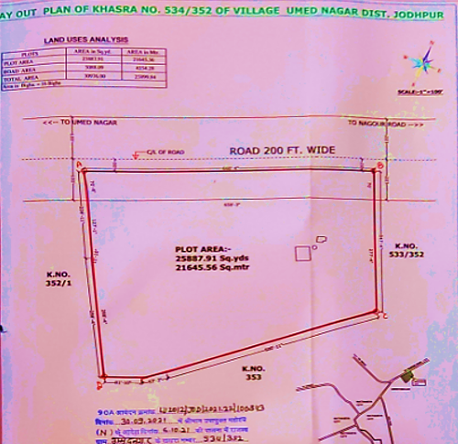
Google Map:
Location: Project location would be 26°34'16.3" North and 73°01'40.5" East in Jodhpur district in the state of Rajasthan and the location as per the Google map guess been attached below with the link.
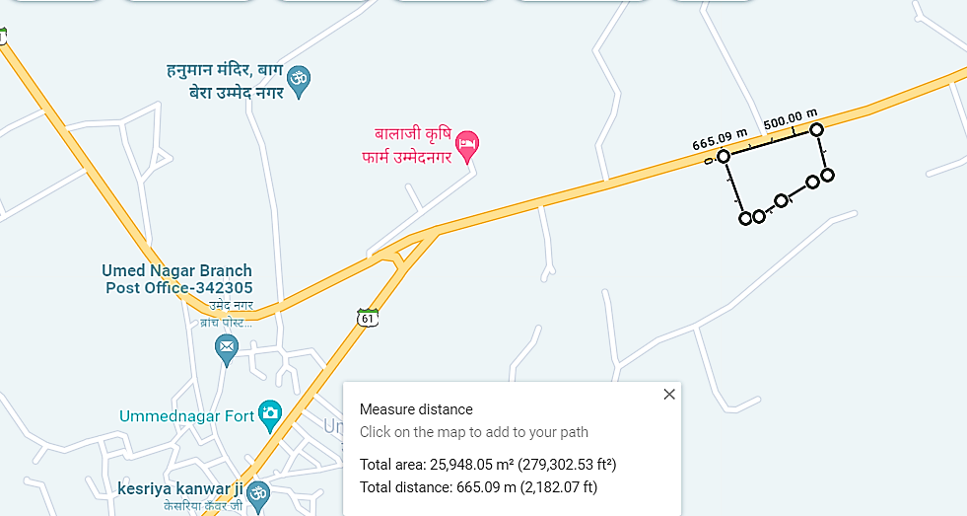

Google Layout Plan:
Demarcation of the land on the Google map is as in the below picture.
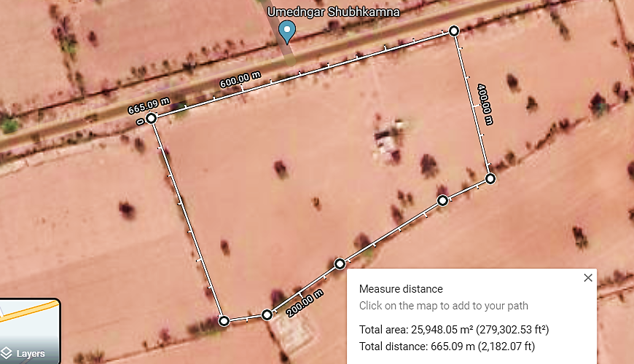
- LAND DETAILS:
For the purpose of setting up manufacturing Unit, M/s. Sadashiva Psyllium Private Limited has acquired a piece of land at Khasra No. 352, Village Ummed Nagar Tehsil- Tinvari, Jodhpur, Rajasthan, which is spread over an area of 25,900 Square meter (16 bhiga) as per the layout plan provided to us by the company. Land parcel is on khasra no 534/352 of village Ummed Nagar district- Jodhpur Land is around 40 feet far from the mid of Damar road.

The subject land is demarcated with boundary wall. Land has been purchased in year 05/07/2021 in total amount of Rs. 39.00 Lakhs as per the deeds given by the company. Currently, the land is an agricultural land as per the sale deed. For the purpose of its conversion to Industrial, company has already submitted the application as per Land Revenue Act of 1956 section 90(k) of Govt. of Rajasthan to Jodhpur development authority. Company envisage that the approval is expected in the month of January, 2022.

Boundary wall for demarcating the plot has been completed and grading and foundation will start soon.

Below is the details of land purchased for the proposed project in the tabulated form:

Sr. No. | Particulars | Plot Details
1. | Khasra no. | 352
2. | Consideration Price | Rs. 39,00,000/-
3. | Stamp Duty | Rs. 39,300/-
4. | Seller Name | Prithvi Raj
5. | Buyer Name | Sunil Mendiratta
6. | Total Area of Land as per Sale deed | 3.7069 Hectares
 | Area sold to M/s Sadashiva Psyllium Private Limited | 2.59 Hectare/ 25,900 Square Meter
7. | Date of Sale Deed | 5th July 2021
8. | Document Number. | 202101076001717

Site Pictures:
Some of the site pictures have been shared by the client on our request are attached below as the site inspection work was out of scope of this TEV report.
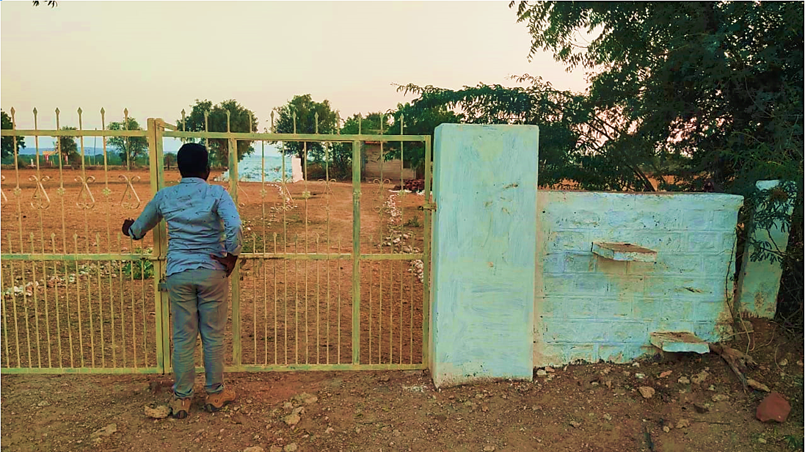

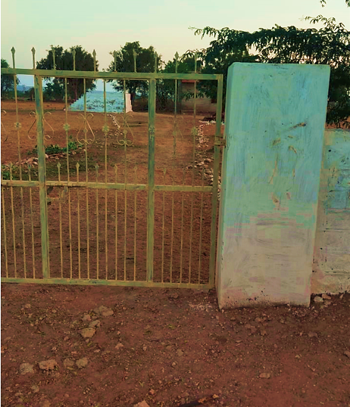
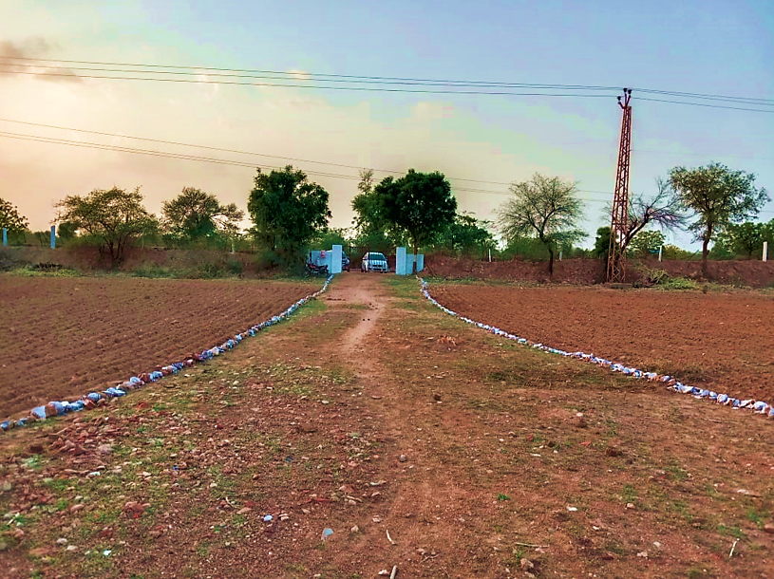

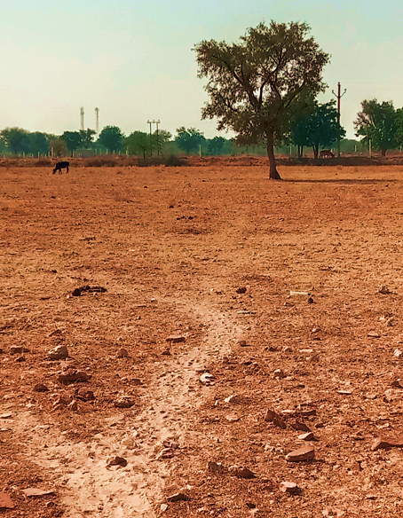


- BUILDING & CIVIL WORKS:
As per the current status of the Building and civil works provided by the company, Boundary wall has been completed, grading and foundation work is about to start soon.

Building plan has been designed by the appointed local architect. The Map is yet to be submitted to concerned authority for sanction. Building & Civil work contractor has not been finalised yet. Boundary wall on the Project land is already erected. Building & civil works has not started yet on site. Out of the complete proposed Plan, company has presently planned to only construct the Production Building measuring about 31814.75 sq.ft as per the architect plan. The Production section is proposed to be constructed on GI Shed mounted on steel columns and beams.

The total proposed cost in Building & Civil works has been estimated at Rs.3.00 cr. On the basis of the quotation received from the building contractor the cost appears to be in-line with Industry standard as per plinth area rate basis. However company has not taken any detailed estimate from any engineering consultant to estimate the cost. In addition to the building, boundary wall and roads has been estimated at Rs.45 Lacs.

LAYOUT - DESIGN OF THE WHOLE PROJECT
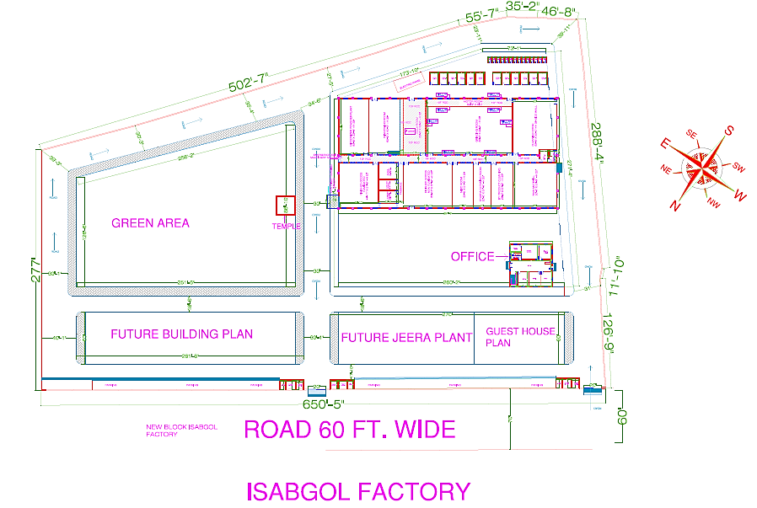
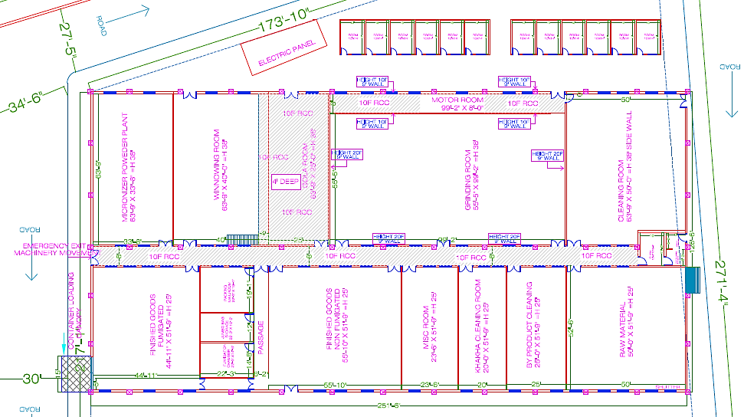
TO BE CONSTRUCTED IN PHASE-1
- PLANT AND MACHINERY DETAILS:
Husk is the main product of Isabgol. It is the outermost skin of the seed which is removed by mechanical process.

The project company has appointed Manish Engineering Works, Jodhpur as their engineering design consultants. For setting up the Plant, the project company has approached Krishna Industries, Gujarat for the quotation of the proposed plant and machinery having installed capacity of 4 ton per day of finished product or 16 ton per day processing capacity.

As per information available on public domain, Krishna Industries are Manufacturer & Supplier of Psyllium Processing Machinery and Cleaning, Grading, Sorting & Handling of all kinds of seeds, grains, pulses, spices, oil seeds etc. established in the year 1992, they are well known player in the industry in terms of manufacture the product according to set industry standards using superior grade raw material and innovative technology. As per the quotation, the project company has proposed to procure all the machinery from Krishna Industries.

As per the quotation, following are the plant & machinery which will be provided by Krishna Industries to the company for setting up the Plant. The machineries list provided by the supplier meets the requirement for setting up the Psyllium Husk Unit:

Below is the tabulated description of Item A, Item B, Item C:

ITEM A: PLANT & MACHINERY
Plant & Machinery
Name of the plant and Machinery | Power Required (KVA) | Total Quantity | Total Amount
CLEANING PLANT SECTION
Pre-Cleaning Round Sieves Two jali with gear motor. | 1 | 1 | 185000.00
Vibro Grader 2 Deck with Vibro motor | 8 | 4 | 840000.00
Aspiration Box 350 | - | 3 | 165000.00
Small Aspiration Box | - | 1 | 28000.00
Cyclone Separator 150 | - | 1 | 115000.00
Centrifugal Blowers 20 hp | 20 | 1 | 180000.00
De stoner 120 | 2 | 1 | 245000.00
De stoner Cyclone Separator 110 | - | 1 | 98000.00
Centrifugal Blowers 7.5 hp | 7.5 | 1 | 89000.00
Gravity Separator 5 Fan | 7 | 1 | 260000.00
Sorrel Machine. (Polishar) | 7.5 | 2 | 330000.00
Horizontal Cyclone Separator | - | 4 | 260000.00
Air Lock with 1hp Gear motor | 5 | 5 | 225000.00
Bucket Elevator 5" Bucket, Height Approx 35 ft. with 1.5 hp gear motor. | 7.5 | 5 | 490000.00
Bucket Elevator 5" Bucket, Height Approx 40 ft. with 2hp gear motor. | 4 | 2 | 216000.00
Intake Slider Gate | - | 1 | 85000.00
Speed Spout & Machinery Hoppers | - | 1 plant | 400000.00
Dust ducting accessories Full Plant | - | 1 plant | 450000.00
Total |  |  | 49,26,000.00
GRAINDING PLANT SECTION
Grinder size 24" Set | 30 HP x 2 Nos. 1440 RPM | 72 | 3600000.00
Section Blower with Cyclone and Its all Duct Pipe Line. |  | 36 | 1575000.00
Bucket Elevator 3" Bucket Size with fabricate Bottom and top. |  | 36 | 1710000.00
All Plant Structure with 4mm Checker Platform with step Ladder Two side. |  | Lot | 1225000.00
All Plant Counter Shaft, Barings, Pedestal, Joint Couplings and Pulleys. |  | Lot | 1125000.00
Slopes type jali Grader with One Jali. |  | 36 | 360000.00
Aspiration wooden Box. |  | 36 | 135000.00
All Plant Foundation Bolts. |  | Set | 37500.00
Total HP | 60 HP
Total |  |  | 9767500.00
PSYLLIUM HUSK WINOWING PLANT SECTION. (S S 304)
Husk Cleaning Sieves 8’-foot-long with Three Jali: Sieves’s structure, Shafting and Eccentric are from MS only sieves body and it's jali with frame are from SS304. | 3 | 2 | 700000.00
Husk Sieve’s Hopper SS 304. | - |  | 75000.00
Winnowing Box Fan. Material touching part SS304 and other parts MS steel. | 4 | 4 | 750000.00
Gravity Separator: Deck Sieves and its Frame are from SS, All Border are SS, five mouth chutes are SS 304, I.e., Touching parts from SS304 and remaining structure is from MS.. | 7.5 | 1 | 325000.00
Gravity Separator Hopper. | - | 1 | 35000.00
Elevator 4" Bucket height Approx. 12’ with its Hopper and Stand. | 1 | 1 | 155000.00
Big Hopper with Demphar SS304 for B. Elevator's. | - | 1 | 105000.00
Pala Grader Fully pack Body type. Material touching part SS304 and other parts MS steel. (in Pala Room) | 1 | 1 | 145000.00
Pala Grader's Hopper SS304 Support MS steel. | - | 1 | 30000.00
Total HP | 16.5
Total Amount |  |  | 2320000.00
Total |  |  | 17213500.00
Add -GST 5 % |  |  | 850675.00
Grand Total |  |  | 17864175.00

ITEM B: ERECTION & COMMISSIONING SERVICES

Service Name | Quantity
Engineering Services | 1
Machinery Erection | 1
Plant Commissioning | 1
Transprtation | 1
Total Amount | INR 20,00,000.00

ITEM C: STRUCTURE FABRICATION
Structure Fabrication Steel and Labour (Approx. 40 Ton) which will be costing INR 34,00,000.00/-.
All the items mentioned below shall be arranged by customer from market after confirmation of order and on completion & after final Structure & Erection drawing. There may be certain changes in the quantities after the final drawings is prepared.

S.No. | Service Name
1 | All the electric motor that does not come with the machine
2 | All Plant Belts. e. V Belts & Flat Belts
3 | Steel Raw Material for machine structure Support
4 | Electric MCC Panel, Power Factor, cabling, Supports & Fitting
5 | RCC Construction Work for Foundation work
6 | Structure Support Colour & Painting Work & other
7 | Erection tools & Tackle’s
8 | Grinding Plant's Storage Silo Extra Per Kg.125/-
9 | Screw conveyor Extra Per foot 2600/-

Price of the machinery is based on ex-factory, Sidhpur which is excluded of freight cost. 40 % advance has been paid by the company and the 60 % advance will be paid once the machinery will be ready to dispatch.

Total machinery cost will be INR 2.50 Crore including the load machine of INR 8.00 Lakhs, Power utility cost will be included as INR 0.98 Crore to operate the machinery. Thus the total cost of plant, machinery and Utility will be INR 3.4 Crore.

The company has proposed to manufacture following types of Psyllium Husk and the grades are differentiated based on the purity:
- 95% purity psyllium husk
- 98% purity psyllium husk
- 99% purity psyllium husk
- Cattle feed

- UTILITIES:
Details of Water, Electricity and other utilities are describes as below:

- Electricity
The project company has approached Rajasthan State Electricity Board to provide power supply to the site via Gensets with a maximum demand of 300 KVA and contracted load of 250 KVA. Total energy consumption will be 3000 KVA per annum and the cost of power consumption per annum at the maximum capacity utilization will be INR 40 Lakhs.

- Water
Manufacturing process doesn’t require water as such. However for general purpose requirement of water will be met through submersible/ borewell/ supply water.

- Fuel
Diesel will be required for the requirement of generator.

PART F | PROJECT TECHNICAL DETAILS

- PLANT CAPACITY:
The company has proposed to design the process flow of production by installing Cleaning Plant Section, Grainding Plant Section, and Psyllium Husk Winowing Plant Section which has a total capacity of 1200 ton per annum. Accordingly the company has proposed the total capacity of plant as 1200 TPA with one shift per day basis and 25 days in a month operational for 12 months.

Production Capacity of the plant
Name of the Required Machinery | Capacity per Shift (Ton) | Number of shift a day | Number of operating days in a month | Total Capacity (per month) | Total Installed Capacity per annum
Cleaning Plant Section | 16 ton per day | 3 shifts per day | 25 | 100 ton per month  (12 Month in a year) | 1200 ton per annum
Grinding Plant Section
Psyllium Husk Winnowing Plant Section | 4 ton per day
Cattle Feed |  |  |  |  | 2400 TPA

- PLANT TECHNICAL SPECIFICATIONS:
As a typical psyllium husk manufacturing process, the raw psyllium seeds need to be cleaned by mechanical process through various steps of processing where no chemicals are used. After cleaning seeds from the cleaning and pre cleaning chambers, de-husking processes begin. The process consists of crushing the seed with emery mills and separation of husk in a closed circuit of an automatic pneumatic aspiration system. The psyllium seed husk is then separated from the remainder of the seed by using slight mechanic pressure.

Name of the Machinery used and Function of the Machinery:

Plant & Machinery
Name of the plant and Machinery | Purpose in the Project
CLEANING PLANT SECTION
Pre-Cleaning Round Sieves Two jali with gear motor. | Agricultural Grain Cleaning Sieve.
Vibro Grader 2 Deck with Vibro motor | Grading of products like grains, seeds, cashew nuts, pulses etc.
Aspiration Box 350 | A good aspiration system is required to maintain cleanliness, safety, sanitation, and efficient operation of the Isabgol seed intake, pre-cleaning, and cleaning of the Isabgol seed in the cleaning house.
Small Aspiration Box
Cyclone Separator 150 | Pressure separation of the waste discharge
Centrifugal Blowers 20 hp | Larger volumes of airflow with high pressure
De stoner 120 | Destoning machine for removing stone, sand or other light and heavy materials from psyllium husk
De stoner Cyclone Separator 110 | Separation of dust and stone
Centrifugal Blowers 7.5 hp | Suck exhaust/ waste gases emitted during the processes of steel, power, cement, mining and furnace used in industries.
Gravity Separator 5 Fan | Seed Cleaning Machine
Sorrel Machine. (Polishar) | Multi-Function Polishers Machine.
Horizontal Cyclone Separator | Remove particulate matter from flue gases.
Air Lock with 1hp Gear motor | Applications that require high output torque and lower output shaft rotational speed, especially where space and available power are limited
Bucket Elevator 5" Bucket, Height Approx. 35 ft. with 1.5 hp gear motor. | Applications that require high output torque and lower output shaft rotational speed, especially where space and available power are limited
Bucket Elevator 5" Bucket, Height Approx. 40 ft. with 2hp gear motor. | applications that require high output torque and lower output shaft rotational speed, especially where space and available power are limited
Intake Slider Gate | sliding longitudinally on the gate operating
Speed Spout & Machinery Hoppers | hold particulate matter or flow-able material of any sort, like dust, gravel, nuts, seeds et
Dust ducting accessories Full Plant | Industrial dust extraction machinery.
Total
GRAINDING PLANT SECTION
Grinder size 24" Set | Grinding Machine is a powerful crushers with multi applications. Its main functions is to crush all kinds of hard and soft grind block into granules.
Section Blower with Cyclone and Its all Duct Pipe Line. | Huge flow of air or gas to the various processes in the industries.
Bucket Elevator 3" Bucket Size with fabricate Bottom and top. | Buckets are used to elevate delicate products.
All Plant Structure with 4mm Checker Platform with step Ladder Two side.
All Plant Counter Shaft, Barings, Pedestal, Joint Couplings and Pulleys. | Common mechanical design component used to transfer or synchronize rotational force in a machine respectively.
Slopes type jali Grader with One Jali. | Jali grader is widely used for the separation of broken husk from full husk seeds.
Aspiration wooden Box. | proper air requirement in gravity- based cleaning equipment
All Plant Foundation Bolts.
Total HP
Total
PSYLLIUM HUSK WINOWING PLANT SECTION. (S S 304)
Husk Cleaning Sieves 8’-foot-long with Three Jali: Sieves’s structure, Shafting and Eccentric are from MS only sieves body and it's jali with frame are from SS304. | Jali grader is widely used for the separation of broken husk from full husk seeds.
Husk Sieve’s Hopper SS 304.
Winnowing Box Fan. Material touching part SS304 and other parts MS steel. | Separate the chaff from the grain so that the grain can be used for human consumption.
Gravity Separator: Deck Sieves and its Frame are from SS, All Border are SS, five mouth chutes are SS 304, I.e., Touching parts from SS304 and remaining structure is from MS.. | An efficient gravity separator will remove foreign seeds from that cannot be removed by any other method
Gravity Separator Hopper. | It also removes mud and other inert matter as well as broken & shriveled
Elevator 4" Bucket height Approx. 12’ with its Hopper and Stand. | Hopper with mixing and heating function mixer heater machine material process equipment for filling machine.
Big Hopper with Demphar SS304 for B. Elevator's. | Fixed-speed or variable-speed velocity control applications
Pala Grader Fully pack Body type. Material touching part SS304 and other parts MS steel. (in Pala Room) | Fixed-speed or variable-speed velocity control applications
Pala Grader's Hopper SS304 Support MS steel. | Fixed-speed or variable-speed velocity control applications

Modern Method/s in more advanced units:
Modern technology involves raw material storage in silos made of galvanized steel re-enforced exteriors. Galvanized Silos are used for storage of grains in bulk for longer periods. These silos are made in Galvanized Steel and bolted in construction. The main parts of the silos are made in corrugated sheets instead of plain sheet, which increases its strength. These silos are generally equipped with accessories like Level Switches, Aeration System, Temperature Monitoring, Ventilation and Sweep Augers. These accessories help us to monitor the quality of stored grain inside the silos.

Galvanized Silo Storage System is also a proven scientific system for storage of and other food grains in Europe and America. This system ensures zero wastage due to moisture, fungus & rodents etc. This also enables units to target premium markets from quality-seeking consumers through direct retailing and export. In India, this system is adopted to some extent by private sector. Fowler Westrup, Rostfrie Steels, Westeel Silos, Buhler, Milltec, Bansal Group etc. are some key supplier options of large silo storage systems.

Pre-Cleaner (Drum Sieve): Careful preliminary cleaning of grain reduces the wear and tear on the downstream equipment in the production process. This enhances the operating reliability of the entire production plant. A Buhler/Fowler Westrup/Cymbria/similar top end technology reliably remove straw fragments, bag tapes, paper, pieces of wood, etc. from fine and coarse-grained bulk materials & other foreign matter.

Magnet Separator: A Buhler/Fowler Westrup/Cymbria/similar top end technology make magnetic separator that is designed to efficiently remove ferrous items from material streams. Self-cleaning mechanism of these separators ensures smooth operations (also avoiding slowdown or breakdown) by avoiding clogging.

Separator Classifier: A Buhler/Fowler Westrup/Cymbria/similar top end technology make is applied for. Using sieves, the separator removes coarse and fine impurities from the Seed. It also grades a wide range of different materials according to size.

Gravity Separator: A Gravity Separator is used for the separation of any kind of kernel and granular product of almost identical size but with different weights. A Buhler/Fowler Westrup/Cymbria/similar top end technology make reliably removes immature grains and other impurities on basis of weight and facilitate grading of Isabgol Seeds.

De-Stoner: A Buhler/Fowler Westrup / Cymbria/similar top end technology make effectively removes even small and lighter-weight stones of the size of a grain kernel from the stream of product, thus ensuring excellent cleaning of the grain. Removal of high-density impurities such as stones, glass, and metal protects the downstream processing equipment and thus perceptibly reduces its wear and tear.

Color Sorter: An efficient colour sorter uses a combination of most advanced camera and shape recognition identifier to ensure detection and removal of the widest range of foreign materials, smallest spot defect, finer product damage and subtler colour defects. Importantly, removal of mycotoxins (produced by fungus) on Isabgol seed is also detected which ensures safety and quality of finished flour. Advanced units generally deploy advanced sorters of Buhler/Satake/Milltec/Cymbria make for optimum results.

Modern Roller De-Husking Unit: Modern Rolls are constructed with non-corrosive material and full accessibility to ensure maximum sanitation. In general, 36 rollers are deployed which grinds the product. The main reason for using 36 rollers is improved economics, as it reduces the need for intermediate transport of product. The overdrive system of machine is equipped with conveyor belts that eliminate the need for oil, which is generally the case for helical.

Hence based on assessment of the modern technology available for the more advanced manufacturing units Psyllium husk (Isabgol) and derivatives, it seems that the company is using similar technology (Plant & Machinery) comparatively with certain changes which will be giving the advantage to the proposed company over the competitors using the traditional technology and process flow. The Capital Expenditure is little high initially comparatively from the conventional process to install latest machinery at the manufacturing facility, but the economic benefits and advantage over the competitors will be higher side to achieve the economies of scale faster as Isabgol and derivative industries are growing rapidly globally as awareness of the demographies regarding the health and changing the life style towards more healthy cultures adoptions.

- MANUFACTURING PROCESS:
The complete process flow involved in the production of Organic Psyllium Husk powder (Isabgol) starting from the initial steps of Production Planning to Final Product Packing and storage in Warehouse as planned and assessed by the company is shown below:

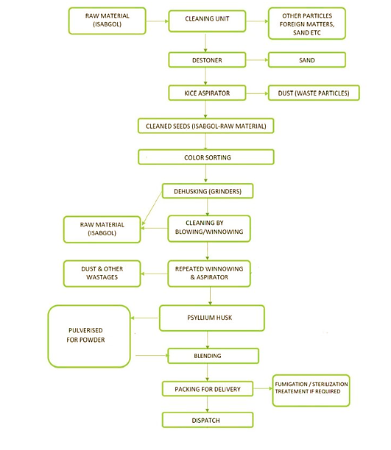

The project company will be producing Organic Psyllium Husk powder, with major stages of production includes:
- Seed Cleaning: The raw Psyllium seeds will be cleaned by mechanical process through various steps of processing where no chemicals is being used, which is followed by the de-husking of the seed.

- De-husking: In this step high yields of pure and quality psyllium seed husk will be obtained from psyllium seeds dehusking. These processes include milling intact psyllium seeds in a mill which causes the husk to be fragmented by collision under conditions whereby the husk is fractured and separated from the non-husk portion of the psyllium seed without substantial breakage and size reduction of the non-husk portion.

- Husk Cleaning and Winnowing: The husk is then passed through gravity separators for further purification before custom packaging. This process is call as winnowing.

- Fumigation: Both raw Psyllium seeds and the final Psyllium products are fumigated as per the requirement of the customers.

- Sterilization: Treatments of the finished product with Ethylene Oxide, Methyl Bromide, and Gamma Rays Irradiation will be provided through contract facilities.

- Packaging: The Company is planning to the premium processed quality in flexible and cost-effective packaging solutions under total hygienic control areas to ensure the product is being kept safe during transit and in storage at the customer end.

Typical types of packaging include:
- Super Sacks
- Paper Bags: HDPE Laminated Paper Bags with Inside food grade Poly liner
- PP Woven Bags: Laminated PP Woven Bags with inside food grade poly liner
- Fiber Drum: Fibre Paper drum and silver plated ring with inner poly-liner

- RAW MATERIALS/ COMPONENTS:
The primary raw material used for the production of Psylliumhusk will bew crushed psyllium seeds. Source of crushed psyllium seeds is the Plantago Ovata plant. The project company has planned to procure the raw material from the farmers directly as Psyllium grows in 119 to 130 days and requires cool and dry weather for a better yield. It is a Rabi crop and grows from October to March. The crop requires moderate water irrigation.

Name/Brief Description of the item
Name of raw material | Psyllium Seed
Quantity Required | 16 ton per shift/ 1200 TPM
Sources of supply | Local Trader
Minimum Purchase Quantity | 4800 Ton per annum
Lead/Procurement Time | 3 TO 5 DAYS
Available throughout the year | Yes

Rajasthan & Gujarat as major contributing states: Rajasthan is one of the main Isabgol producing states of India. The state ranks first in terms of area and production in the country. The mucilage has medicinal properties and used against constipation, irritation of digestive track etc. The left over material of seed after husk removal is used as animal feed. Isabgol thrive well in warm temperate region and requires cool and dry weather during its crop season hence generally it is sown during winter months. It can be grown well in saline soils with poor quality water in western Rajasthan as Rabi crop.

Earlier, Gujarat used to enjoy an absolute monopoly over Isabgol production, with the crop being cultivated in Banaskantha, Kutch, Mehsana and Jamnagar districts of the state. Later, as the demand started shooting up, farmers in Rajasthan – which also has a similar conducive environment and soil conditions for Isabgol – also took up cultivation of this crop. Presently Gujarat, Rajasthan, Haryana and Madhya Pradesh are the only states in India involved in Isabgol production, with about 60,000 hectare under Isabgol cultivation in the states of Gujarat and Rajasthan put together.

- TESTING STANDARDS FOR PSYLLIUM HUSK:
The following tests on regular basis can be performed to ensure outflow of good qulaity products.

SPECIFICATION OF PSYLLIUM HUSK
Sr. No. | Test | Specification as per Indian pharmacopeia | Specification as per British pharmacopeia | Specification as per USA pharmacopeia
 | Description | Pale buff or light brown to pale buff coloured free flowing powder. Material swells rapidly in water, forming a stiff mucilage. | Pale buff or light brown to pale buff coloured free flowing powder. Material swells rapidly in water, forming a stiff mucilage. | Pale buff or light brown to pale buff coloured free flowing powder. Material swells rapidly in water, forming a stiff mucilage.
 | Identification | Positive test for Psyllium husk. | Positive test for Psyllium husk. | Positive test for Psyllium husk.
 | Total Ash | Not more than 4.5 % w/w. | Not more than 4.0 % w/w. | Not more than 4.0 % w/w.
 | Acid Insoluble Ash | Not more than 0.45 % w/w. |  | Not more than 1.0 % w/w
 | Loss on drying | Not more than 12.0 % w/w. | Not more than 12.0 % w/w. | Not more than 12.0 % w/w.
 | Swell Volume | Not less than 40 ml/gm | Not less than 40 ml/gm | Not less than 35 ml/gm
 | Foreign matter | NA |  | NA
 | Light Extraneous Matter | Not more than 2.0 % w/w. |  | Not more than 2.0 % w/w.
 | Insect infestation | NA | NA | Complies as per USP 30/NF25
 | Purity | NA | NA | NA
 | Microbial limits | NA | NA | NMT 1000cfu/gm of Molds  and yeasts.
 | Particle Size | As per buyer requirements

Indian Psylluim husk is being considered one of the best in the world, and the proposed company is planning to export to USA and Europe and both are the largest importer of Indian Isabgol.

Hence in the above table, specification of Psyllium husk has been shown as per Indian, British and USA Pharmacopeia.

In the domestic market as well as globally, the proposed company need to test the final product based on the standards mentioned in the above table which must be the benchmark for the testing and deliver of the quality product.

- SOURCE OF PROCUREMENT OF RAW MATERIAL:
The project company has planned to procure the Psyllium Seeds from the farmers and and raw material supplieirs in the domestic market itself as Rajasthan is the largest producer of Psyllium husk due to its climatic conditions and contribute the largest share among the various other producing states.

Some of the big supplieis within in the state of Rajasthan are Goyal Industries, Dosi Brothers, Nagaur Commercial Corporation, RajendraPrasad Purshotam Moondra. All these are the well known syupplieirs available in the public domain.

The pre intervention value chain of Isabgol has essentially three channels. Though farmers sell the seed either in the local Mandi or to the village level traders, eventually, all stock find their way to Unjha Mandi, Gujarat from where they are taken by processors.

From here, the channel divides into three parts. The 1st part is for domestic markets where Pharma/healthcare companies take the Isabgol either from the processor directly or through distributors and sell it in their branded and packaged form. The 2nd channel includes both processors and distributors, involved in export market which is eventually 90% of the total market share of production across the globe. The third channel is of the animal feed sector, where the animal feed processors take the balance part of the seed to use as animal feed and further distribute it through their channel after mixing it with other feed materials. Almost all the seed is sent to Unjha Mandi for further trading and processing.

- MANPOWER
Based on manufacturing facility, Initially the company has assessed the following manpower in various departments of the manufacturing unit as tabulated below :

Particular | Present | Proposed
Executives | NIL | 5
Supervisory | NIL | 4
Administrative/Office Staff | NIL | 4
Skilled Labor | NIL | 15
Unskilled Labor | NIL | 10
Other(specify) | NIL | 4

The total no. of manpower assesed by the company for the maufacturing of psyllium husk and various by-products will be 42 to run the manufacturing unit for 1 shifts per day.

PART G | PRODUCT PROFILE

- INTRODUCTION:
Plantago ovata commonly known as "Psyllium‟ in English and "Isabgol‟ in Hindi belongs to the family of Plantaginaceae, is a 10-45 cm short-stemmed annual herb known by different names such as ashwagolam, aspaghol, aspagol, bazarqutuna, blond Psyllium. Isabgol has high fiber content and acts like a sponge serving to clean the bowels and is extensively cultivated in many parts of the globe. It is commercially an important Rabi season crop known for its medicinal properties. The seed coat is known as “husk”, and it is also being used in food industry especially in ice creams, biscuits and candies. The crop is mainly cultivated in the states of Rajasthan, Gujarat, Haryana and Madhya Pradesh.

- PRODUCT SPECIFICATIONS:

Psyllium seeds
Psyllium seeds are an Agri-farm product of the dried ripe seeds of Plantago ovata forks and it has been cleaned free of all dust, Agri farm fibers, wastes, mud, stones and iron particles. Psyllium seed typically Light brown to moderate brown color and having faint odor. It contains about 70% soluble fiber and 30% insoluble fiber. It is made up of 40% Linoleic Acid (LA), an important fatty acid essential to health, 19% fiber content, 18.8% proteins, and 10-20% triglycerides. The seed mucilage consists of polysaccharides, which is a soluble fiber.

Psyllium husk
The husk of Psyllium is the actual coating of mucilage around the seed. It is considered pure dietary fiber and are the only part of the plant used in manufacturing Psyllium products. Its nutritional value consists mainly of glycosides, proteins, polysaccharides, vitamin B1, and choline. Fiber content of over 80% compared to less than 15% for oat bran and 10% for bran. The husk is composed mostly of a fiber called hemicellulose which is a complex carbohydrate found in whole grains, fruits and vegetables.

Hemicellulose is indigestible; however, it is partially broken down in the colon and feeds the friendly intestinal flora. Psyllium seeds are processed to remove the outer coating of the seed to get the husk. Psyllium husk contains about 70% soluble fiber and 30% insoluble fiber. This white fibrous material is used in Pharmaceutical, cosmetics and food product industries. Psyllium husk is available in various grades according to the purity and mesh size etc. to match the individual user needs. It is available mostly in four grades of purity: 99% Pure, 98% Pure, 95% Pure and 85% Pure.

Psyllium as a functional food
Psyllium is most frequently added to breakfast cereals, meal replacements, bread, biscuits and other bakery products to improve the fiber content of the food but is also added to juices, shakes, yogurt, soups and even ice creams. It can also be used as a thickener in drinks or frozen desserts.

Although Psyllium fiber has positive physiologic benefits, its high viscosity could make it difficult to incorporate into food products and a task is to get it acceptable to consumers. There are various commercial uses of Psyllium in food, pharmaceutical and other industries. Although obtaining dietary fiber from whole foods is preferable because it is accompanied by additional nutrients and phytochemicals, a fiber supplement should be recommended to close the fiber gap.

It has been a continuous effort to improve the physicochemical, functional, sensory, and biological properties of psyllium for promoting its food utilization and enhancing its safety. It is a great challenge to disperse psyllium in water or aqueous solutions even with vigorous agitation because of its extremely strong water-absorbing capacity.

- PRODUCT PROPERTIES:
The main by-products are:
- Lali: This is an important by-product of psyllium and wildely used as cattle feed globally.
- Chito: It is used as Pig feed.
- Khakho: It is used to prevent ice slipping
- Golaisab: Used as cattle feed

Nutritional Information
NUTRITIONS | 85% PURE | 95% PURE | 98% PURE | 99% PURE
FAT | 1.5 GM | 0.5 GM | NIL | NIL
PROTEINS | 6 GM | 2.5 GM | 1.5 GM | 1 GM
CARBOHYDRATES | 8 GM | 4 GM | 3.5 GM | 3 GM
CALORIES | 70 | 30 | 20 | 16
DIETERY FIBRE | 70 GM | 78 GM | 85 GM | 88 GM
SOLUBLE FIBRE | 42 GM | 47 GM | 51 GM | 53 GM
INSOLUBLE FIBRE | 28 GM | 31 GM | 34 GM | 35 GM
SODIUM (AS NA) | 150 GM | 130 GM | 120 GM | 120 GM

PYSLLIUM SEEDS:
Psyllium seeds is an agri-farm product of dried ripe seeds of plantago ovata forks and it has been cleaned free for all dust, agri farm fibers, wastes, mud, stones and iron particles.
The seed itself is made up of 40% Linoleic Acid (LA), an important fatty acid essential to health. Seed has property of mucilage formation on extraction of moisture. Psyllium seeds are cooling, laxative, soothing, antiacidic, anti diuretic and demulcent.
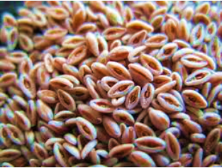
PSYLLIUM HUSK
The husk of Psyllium is the actual coating of mucilage around the seed. It is considered pure dietary fiber and is the only part of the plant used in manufacturing Psyllium products.
Its nutritional value consists mainly of glycosides, proteins, polysaccharides, vitamin B1, and choline. Fiber content of over 80% compared to less than 15% for oat bran and 10% for wheat bran. The husk is composed mostly of a fiber called hemicellulose which is a complex carbohydrate found in whole grains, fruits and vegetables. Hemicellulose is indigestible however, it is partially broken down in the colon and feeds the friendly intestinal flora. Psyllium Husk is separated from the seeds by a mechanical process where no Chemicals are used. Psyllium Husk is available mostly in four grade of purity i.e. 99% pure, 98% pure, 95% pure and 85% pure.
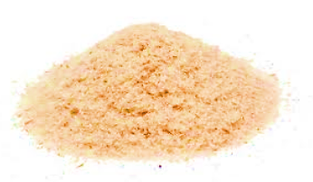
GENERAL SPECIFICATION OF PSYLLIUM HUSK
Nutritions | 85% Pure
Identification A | Mounted in cresol, cell viewed microscopically are composed of polygonal prismatic cells having 4 to 6 straight or slightly wavy walls
Identification B | Mounted in alcohol and irrigated with water, viewed microscopically. The mucilage in the outer part of the epidermal cells swells rapidly and goes into solution.

TEST | P.HUSK 99% | P.HUSK 98% | P.HUSK 95% | P.HUSK 85%
PURITY | MIN. 99% | MIN. 98% | MIN. 95% | MIN. 85%
MOISTURE | NMT 12% | NMT 12% | NMT 12% | NMT 12%
TOTAL ASH | NMT 4% | NMT 4% | NMT 4% | NMT 4%
ACID INSOLUBLE ASH | NMT 1% | NMT 1% | NMT 1% | NMT 1%
LIGHT EXTRANEOUS MATTER | NMT 1% | NMT 2% | NMT 5% | NMT 15%
SWELL VOLUME | NLT 40 ML/GRAM | NLT 40 ML/GRAM | NLT 40 ML/GRAM | NLT 35 ML/GRAM
INSECT FRAGMENTS PER 25 GRAM | NMT  100 PARTS | NMT  100 PARTS | NMT  100 PARTS | NMT  100 PARTS
SALMONELLA PER 10 GRAM | ABSENT | ABSENT | ABSENT | ABSENT
E.COLI PER GRAM | ABSENT | ABSENT | ABSENT | ABSENT
YEAST AND MOULD PER GRAM | NMT 1000 CFU/GRAM | NMT 1000 CFU/GRAM | NMT 1000 CFU/GRAM | NMT 1000 CFU/GRAM

PSYLLIUM HUSK POWDER:
Psyllium Husk Powder is processed from the Psyllium Husk which is grinded using Pulverize Machine in various particle sizes that is 40 meshes, 60 meshes, 80 meshes, 100 meshes in all grades of purity. Psyllium Husk and its Powder is used as a mild laxative spread in the United States and other European countries. Psyllium Husk Powder has high fiber and recently it has been started getting used in low carbohydrate treatment in USA.
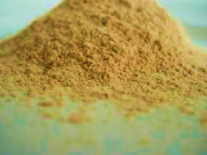

GENERAL SPECIFICATION OF PSYLLIUM HUSK POWDER
PROPERTIES | PSYLLIUM HUSK POWDER 99% | PSYLLIUM HUSK POWDER 98% | PSYLLIUM HUSK POWDER 95% | PSYLLIUM HUSK POWDER 85%
MESH SIZE | AS PER REQUIREMENT | AS PER REQUIREMENT | AS PER REQUIREMENT | AS PER REQUIREMENT
MUCILLOID CONTENT | 99% MIN. | 98% MIN. | MIN. 95% | MIN. 85%
TOTAL ASH | MAX. 4% | MAX. 4% | MAX. 4% | MAX. 4%
ACID INSOLUBLE ASH | MAX. 1% | MAX. 1% | MAX. 1% | MAX. 1%
MOISTURE CONTENT | MAX. 12% | MAX. 12% | MAX. 12% | MAX. 12%
LIGHT ENTRANEOUS MATTER | MAX. 1% | MAX. 2% | MAX. 5% | MAX. 15%
SWELL VOLUME | MINIMUM 40 ML PER GRAM | MINIMUM 40 ML PER GRAM | MINIMUM 40 ML PER GRAM | MINIMUM 40 ML PER GRAM
SIEVE TEST | MINIMUM 95% PASS THROUGH MESH | MINIMUM 95% PASS THROUGH MESH | MINIMUM 95% PASS THROUGH MESH | MINIMUM 95% PASS THROUGH MESH
E.COLI PER GRAM | ABSENT | ABSENT | ABSENT | ABSENT
SALMONELLA PER 10 GRAM | ABSENT | ABSENT | ABSENT | ABSENT
MOULD & YEAST COUNT | 1000 C/G MAXIMUM | 1000 C/G MAXIMUM | 1000 C/G MAXIMUM | 1000 C/G MAXIMUM

- APPLICATION OF PSYLLIUM

Therapeutic benefits of psyllium husk
Psyllium has been reported for the treatment of constipation, diarrhea, and irritable bowel syndrome, inflammatory bowel diseaseulcerative colitis, colon cancer, diabetes and hypercholesterolemia.

Constipation and hemorrhoids
Psyllium has been shown to have the paradoxical property of both improving constipation by increasing stool weight and ameliorating chronic diarrhea. Several studies suggest that psyllium may provide benefits for treating constipation. There is a scientific basis for psyllium working as a mild laxative. Water absorbed by psyllium husk is not absorbed by the intestine resulting in making stools softer and bulkier leading to a smooth defecation process. In hemorrhoids veins in the walls of the anus or rectum are dilated, which is usually caused by untreated constipation but sometimes associated with chronic diarrhea. Adequate fiber supplement combined with the tone method can stop the progression of hemorrhoids and bleeding, and preventing surgery in most patients with advanced hemorrhoids.

Diarrhea
The normal intestine delivers stools that defer widely in quantity but maintain percent fecal water within a narrower range. Stools looseness in diarrhea is determined by the ratio of fecal water too water holding capacity of insoluble solids. Psyllium increases the number of normal stools and decreases the number of liquid stools. A combination of psyllium and calcium seems to be cheap and effective alternative to conventional treatment of chronic diarrhea. Fecal consistency was markedly different in psyllium calves as compare with control.

Ulcerative colitis (Crohn’s disease)
The two primary sites for Crohn‟s disease are the ileum, which is the last portion of the small bowel (ileitis, regional enteritis), and the colon (Crohn‟s colitis). A small number of studies have examined the ability of psyllium to maintain remission in ulcerative colitis. Dietary fiber has been proven to be beneficial in maintaining remission in human ulcerative colitis, an effect related with an increased Luminal production of short-chain fatty acids (SCFA). Dietary fiber Supplementation ameliorated colonic damage in HLA-B27.

Irritable bowel syndrome
Constipation is defined as a symptom chronic constipation -based disorder, for at least 3 months in a year for the unsatisfactory defecation and characterized by infrequent stools, difficult stool passage, or both. On the other hand, the presence of clinically important abdominal discomfort or pain associated with constipation defines IBS with constipation. Intake of psyllium may be effective in alleviating chronic constipation in patients without slow colonic transit or disordered constipation. On the other hand, fiber with lactulose may improve stool consistency in patients with IBS with constipation.

Diabetes
Psyllium has been proposed as a possible treatment for high blood sugar levels. Psyllium is a soluble fiber which forms gel in the intestine which leads to slowing the rate of nutrient absorption and results in lowering postprandial blood glucose level. Studies in humans suggest moderate reductions in blood sugar levels after a single dose of psyllium, with unclear long-term effects. Water- soluble dietary fibers decrease postprandial glucose concentrations and decrease serum cholesterol concentrations to men with type 2 diabetes. Early or uncontrolled studies suggested that psyllium improved glycemic and lipid control in individuals with type-2 diabetes. The ability of soluble fibers to reduce the postprandial glucose response to meals eaten several hours after fiber ingestion (second meal effect) was shown previously in nondiabetic individuals.

Cholesterol lowering
It has been observed that there is a positive association with plasma LDL cholesterol levels and coronary heart disease risk. Intake of dietary fibers known to lower the concentration of LDL in plasma is considered to be highly beneficial. Psyllium intake has consistently shown significant reductions in plasma LDL cholesterol levels ranging from 10 to 24%. Reports of the use of psyllium, largely in hypercholesterolemia men, have suggested that it lowers serum cholesterol as a result of the binding of bile acids in the intestinal lumen and reduced risk of coronary heart disease. The mechanism of action of psyllium‟s hypercholesterolemia effects has not been fully elucidated. Psyllium was shown to stimulate bile acid synthesis by increasing the hydroxylase activity in animal and humans‟ models.

Gastro Esophageal Reflux Disease (GERD)
GERD, is a digestive disorder that affects the lower esophageal sphincter (LES), it has been shown that frequency of symptoms in patients who suffer periodically from Gastro esophageal reflux disease (GERD) with constipation was reduced by the intake of psyllium as compared with omeprazole.

Hypertension
Psyllium, soluble fiber is part of a healthy diet and exerts a protective effect in normalizing the blood pressure. Observational studies show that when fiber is increased in diet (by 7–15 g/day above the usual levels) is significantly associated with reduced blood pressure and hypertension risk compared to the low fiber intake in Western diets. Consumption of soluble fiber is proved to reduce overall Systolic Blood Pressure (SBP) and diastolic blood pressure (DBP) in all populations, and especially psyllium fiber helps to reduce overall SBP.

- PRODUCT PRICING:
M/s Sadashiva Psyllium Private Limited will be engaged in manufacturing of four kind of psyllium husk grading based on the purity described as below:
- 95% purity psyllium husk
- 98% purity psyllium husk
- 99% purity psyllium husk
- Cattle feed

As per our tertiary research there is a variance in the prices of the Isabgol in the public ranges from Rs. 250 to Rs. 1000 per kg based on the grade as variety of the product due to customization of the product on the demand of the customers. The project company has proposed different product pricing for different grades of psyllium husk. For cattle feed are priced at a rate of Rs.15/- per kg, while 95%, 98%, 99% purity psyllium husk are priced at Rs.415/- per kg for the initial years and there is a Rs. 5 escalation in the pricing is being assumed during the forecasted period, which seems to be a reasonable price strategically.

Other major Psyllium husk manufacturers in India are Gayatri Psyllium Industries is a one of the leading manufacturers and exporter of Psyllium Husk, Psyllium Husk Powder, other Psyllium seeds products, Sarvoday Sat Isabgol Factory, Balisana Isabgol Manufacturer & Exporter, Agranye Exports Private Limited.

- PRODUCT CONFIGURATION:
The seed husk finds variety of industrial applications. It is the main constituent of a number of laxative preparations containing sodium bicarbonate and various flavours used in modern medicine. On account of the remarkable property of mucilage from seed husk as a thickener, it could be used as such in food industries. It is employed as a basic stabilizer in ice-creams and as an ingredient of chocolates and other food products. It is also used for sizing purpose and as a base in cosmetics. The husk has been found to be served as a good binder and disintegrant in compressed tablets.

On treatment with hot caustic soda solution and subsequent, the seed husk produces jelly which provides a substitute for agar-agar. Isabgol seed gum has been used to prepare dry dentifrice powder and germicidal lubricating gels. It has also been successfully employed in composition for petroleum well acidization. Water resistant explosive compositions can be prepared with Isabgol seed gum alone or in admixture with other gums. When mixed with guar, seed husk can be used as a cattle feed particularly in cases of lactating animals. The dehusked seed is around 69% by weight of the total seed crop which is used as a bird-feed.

Indian pharmacy companies Like Dabur, Baidynath, Dr. Reddy are also using Isabgol husk for making various drugs. There are various local brands having good market size across the country.

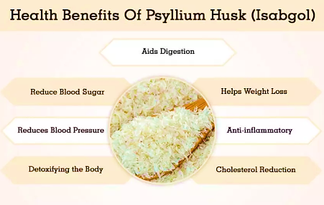
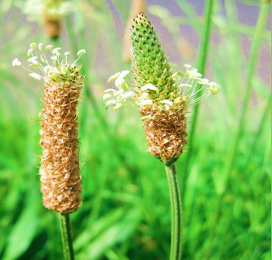

- MARKETING, SELLING & DISTRIBUTION PLAN:
Company is yet to identify its key customers and to form strategic planning for tie-up & product promotion with overseas and domestic customers for selling & distribution of its product which company will be doing in due course.

PART H | INDUSTRY OVERVIEW & ANALYSIS

INTRODUCTION:
“Plantago Ovata” commonly known as ‘Psyllium’ in English and ‘Isabgol’ in Hindi belongs to the family of Plantaginaceae, is a 10-45 cm short-stemmed annual herb known by different names such as Ashwagolam, Aspaghol, Aspagol, Bazarqutuna, blond Psyllium.

Isabgol has high Fiber content and acts like a sponge serving to clean the bowels and is extensively cultivated in many parts of the globe. It is commercially an important Rabi season crop known for its medicinal properties. Apart from its husk (The seed coat is known as “husk”) it is also being used in food industry especially in ice creams, biscuits and candies. The crop is mainly cultivated in the states of Rajasthan, Gujarat, Haryana and Madhya Pradesh.

Notably, India ranks first in Isabgol production (98%) and is the sole supplier of seeds and husk in the international market. Among medicinal plants, Isabgol is the first ranked foreign exchange earner for the country (Rs.30 million annually). It contains a significant amount of proteins and husk yields colloidal mucilage which are valued for medicinal application and is used in Aryuvedic, Unani and allopathic systems of medicines. USA is the chief importer of Isabgol seeds and husk from India. The crop has a large export demand in USA and Western Europe and about 90% of the production is exported to these countries.

Rajasthan is one of the major Isabgol producing states in India after Gujarat. The state ranks first in terms of area and production in the country. Isabgol thrives well in warm temperate region and requires cool and dry weather during its crop season hence generally it is sown during winter months. It grows well in saline soils with poor quality water in western Rajasthan as Rabi crop. The water requirement is low as compared to traditional crop thus, making it suitable for such areas. It matures in about 120 days (November to Feb-March).

The spikes are harvested when they turn red. Isabgol products available in the market are used as laxative that is particularly beneficial in constipation, chronic ailments and dysentery. Seed prices are not governed by any regulations and are solely dependent upon the farmers. The average price of the seed is around Rs 80 to Rs 95 per kg. The crop covers 214188 hectares with the production of 113344 ton and average productivity of 529 kg/ha (Vital Agriculture Statistics, 2011-12) in the state. RI-87, RI-89, AMB-2, GI-1, GI-2, GI 3, MIB-4, HI-34, HI-2, HI-1, HI-5, JI-4 and Niharika are the major varieties of Isabgol grown in India. Gujarat Isabgol-1, variety yields 800-900 kg of seeds per hectare.

Weakness and Opportunity in the Isabgol Value Chain:

Scanty and erratic rainfall, Input and labour cost is very high, harvested seeds need to be kept safe from moisture and non-availability of major Mandi and processing hub in Rajasthan and all the seeds need to be send to Gujarat for further processing.

Support through Rajasthan Agricultural Competitiveness Project (RACP) will help improve crop productivity management, water management, and post-harvest management along with opening up opportunities for local value addition. Scope of establishment of FCSC would help in increasing the share of farmer over consumer rupee.

Some of the major challenges of the Isabgol value chain are it is a high risk crop, the entire crop gets damaged in case of bad weather, and Price volatility which will also hampers the mood of farmers. The farmers share in consumer rupee is very low due to the high level of value addition done in the Rajasthan Agricultural Competitiveness Project 6 Post-harvest value chain. The farmers share is 9%, traders enjoy a share of around 1% processors 47%, health care companies 22%, distributors -8% and retailers 13%.

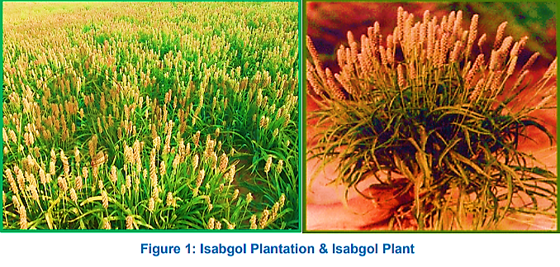
MARKET OVERVIEW:
Industry Outlook and Trend

On the basis of origin, the Psyllium husk market can be segmented into conventional and organic. The organic segment to witness high CAGR over the forecast period owing to the global trend of organic and natural based supplements and nutraceuticals. The conventional segment is expected dominate in terms of volume share owing to cost-effectiveness and low residue presence in the final product.

On the basis of offering, the Psyllium husk market can be segmented into whole, powder, and dust. The whole segment is expected to dominate the global Psyllium market in terms of volume share. The powder segment is anticipated to see strong CAGR over the forecast period owing to its increased application in supplement and pharmaceutical market.

Global Scenario:

Isabgol is economically an important medicinal plant commonly cultivated in different parts of India, Pakistan and Iran and some part of Europe. It has been used in Asia and Europe since 16th century as an herbal medicine for chronic constipation. It has also been used in Chinese and Indian traditional system of medicines as safe laxative and reduces the risk of developing chronic diarrhoea, dysentery and other intestinal disorders.

The seed husk does not irritate the intestine and has specific curing properties when mucous membrane is disturbed by inflammatory infections. Moreover, plant is regarded as a remedy for various ailments in traditional system of medicine in different parts of the world. Mucilage of the dried seed is used externally as an emollient in different parts of the world whereas in Iran water extract of dried seeds used externally for inflammation and orally taken seeds used for indigestion associated with bile secretion abnormalities. In Thailand and Spain, seeds of this plant used in different ways for the treatment of ailments like cold, diarrhea and chronic constipation.

In developing countries agriculture sector has promising effects on economic growth, because of medicinal and pharmaceutical application of Isabgol, it has a high value of market demand and in view of increasing market demand, cultivation of this plant at country level or worldwide is utmost important for uplifting the economy of a country. The crop has a large export demand in USA and Western Europe and about 90% of the production is exported to these countries. India is the largest producer as well as exporter of Isabgol in the world. India provides about 85% of the Isabgol available in the world market.

Indian Scenario

Isabgol is one of the most important medicinal crops grown for its husk. Mucilage yield amounts to approximately 25% or more (by weight) of the total seed yield. Isabgol seed mucilage is often referred to as husk or Psyllium husk. The milled seed mucilage is a white fibrous material that is hydrophilic (water‐ loving). India ranks first in Isabgol production (98%) and the sole supplier of seeds and husk in the international market. Among medicinal plant, Isabgol is the first ranking foreign exchange earner for the country (Rs.30 million annually). It contains a significant amount of proteins and husk yields colloidal mucilage which are valued for medicinal application and used in Aryuvedic, Unani and allopathic systems of medicines. It is an annual herb and cultivated in Rajasthan, Gujarat, and Madhya Pradesh & Haryana.

India is the largest producer and the main supplier of seed and husk to the world market. USA is the chief importer of Isabgol seeds and husk. The crop has a large export demand in USA and Western Europe and about 90% of the production is exported to these countries. Also, the growing of this crop in winter season will not affect the production of succeeding monsoon crop and thus fits well in the cropping system. The seed husk finds variety of industrial applications. It is the main constituent of a number of laxative preparations containing sodium bicarbonate and various flavours used in modern medicine.

On account of the remarkable property of mucilage from seed husk as a thickener, it could be used as such in food industries. It is employed as a basic stabilizer in ice-creams and as an ingredient of chocolates and other food products. It is also used for sizing purpose and as a base in cosmetics. The husk has been found to be served as a good binder and disintegrant in compressed tablets.

On treatment with hot caustic soda solution and subsequent, the seed husk produces jelly which provides a substitute for agar-agar. Isabgol seed gum has been used to prepare dry dentifrice powder and germicidal lubricating gels. It has also been successfully employed in composition for petroleum well acidization. Water resistant explosive compositions can be prepared with Isabgol seed gum alone or in admixture with other gums. When mixed with guar, seed husk can be used as a cattle feed particularly in cases of lactating animals. The dehusked seed is around 69% by weight of the total seed crop which is used as a bird-feed.
Earlier, Gujarat used to enjoy an absolute monopoly over Isabgol production, with the crop being cultivated in Banaskantha, Kutch, Mehsana and Jamnagar districts of the state. Later, as the demand started shooting up, farmers in Rajasthan – which also has a similar conducive environment and soil conditions for Isabgol – also took up cultivation of this crop. Presently Gujarat, Rajasthan, Haryana and Madhya Pradesh are the only states in India involved in Isabgol production, with about 60,000 hectare under Isabgol cultivation in the states of Gujarat and Rajasthan put together.

While, over the years, climatic, pricing and cost vagaries have led to dwindling cultivation in Gujarat, the same in Rajasthan is striving, with the latter edging out the former in Isabgol production. Over the last five years, Gujarat’s share in Isabgol production has declined from 35% of the total output in India to 20%, with both Rajasthan and Madhya Pradesh augmenting their output and share India’s total production of Isabgol is about 1.3 lakh MT. Of this, while Gujarat accounted for about 33,000 MT in FY2008 its production goes down to 20,000 MT in FY2014.

Isabgol has a large export demand in USA and Western Europe and about 90% of the production is exported to these countries. India is the largest producer as well as exporter of Isabgol in the world. India provides about 85% of the Isabgol available in the world market.

The local demand for the Isabgol is also increasing day by day. About 20 to 25% of total production of Husk i.e. 3,000‐ 4,000 MT is consumed in the domestic market. Indian pharmacy companies Like Dabur, Baidynath, Dr Reddy are also using Isabgol husk for making various drugs. There are various local brands having good market size across the country.

Rajasthan State Scenario:

Rajasthan is one of the main Isabgol producing states of India. The state ranks first in terms of area and production in the country. The mucilage has medicinal properties and used against constipation, irritation of digestive track etc. The left over material of seed after husk removal is used as animal feed. Isabgol thrive well in warm temperate region and requires cool and dry weather during its crop season hence generally it is sown during winter months. It can be grown well in saline soils with poor quality water in western Rajasthan as Rabi crop. The water requirement is low as compared to traditional crop makes it suitable for such areas. It matures in about 120 days (November to Feb- March).

Rajasthan produces 67% of the Isabgol and rest is by Gujarat 33%. The spikes are harvested when they turn red. The average yield comes to 800-1000 kg/ha. Isabgol products available in the market are used as laxative that is particularly beneficial in constipation, chronic ailments and Rajasthan Agricultural Competitiveness Project 12 dysentery. Seed prices are not governed by any regulations and are solely dependent upon the farmers. The average price of the seed is around Rs.35 to Rs.55 per kg. The total area under Isabgol cultivation in Rajasthan was 123746 Ha and production was 68872 tonnes in the year 2008-2009. At present the crop covers 214188 hectares with the production of 113344 ton and average productivity of 529 kg/ha (Vital Agriculture Statistics, 2011-12) in the state. However, Isabgol cultivation under arid condition with sandy loam soil is a profitable venture, which is gaining popularity among the farmers of western Rajasthan.

Major Isabgol producing districts in Rajasthan: Major Isabgol producing district in the state of Rajasthan are shown in the below table:
Major Isabgol Producing Districts in Rajasthan
District | Production in Metric Ton
Nagaur | 16712
Chittor | 10614
Jaisalmer | 7637
Partapgarh | 1489
Jhalawar | 398
Bikaner | 202

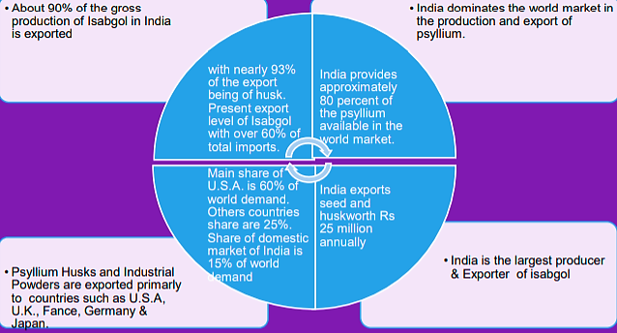
Thus, India dominates the complete world market in the production of Psyllium Seeds, Psyllium Husk and Psyllium Powder. India offers nearly 80% of Psyllium in the global market. Major factories of Psyllium Seeds exporters are located in Unjha, Gujarat in India. The main exporting market for Psyllium Seeds, Husk and Powder are the USA, Germany, Italy, UK, France, Australia and Gulf countries. The major Psyllium Seeds, Husk and Powder are exported to the USA i.e. 60% of the world demand and followed by EU market 25% and domestic market 15%. Gujarat and Rajasthan are major states for exporting Psyllium Seeds from India. Gujarat contributes more than 35% of world production of Psyllium Husk and Powder.

Major manufacture of Psyllium Seeds, Husk and Powder in India:

Major Players of Psyllium & derivatives Industry in India
Sr. No. | Name | Comment
 | Gayatri Psyllium Industries | Leading Processor & Exporter of Psyllium Products in India and all across the world.
 | Mangalmurti Psyllium Industries | Manufacturing company in Psyllium (Sat-Isabgol) Seeds, Psyllium Husk and Pysllium Husk Powder Processing
 | Shakti Isabgol Industries | Processors and exporters of Psyllium Husks, Psyllium Husks Powders, Psyllium Seeds for nearly two decades from Sidhpur, North Gujarat
 | Jyot Overseas Private Limited | Jyot Overseas is leading Manufacturer & Exporter of Psyllium Seed, Husk Powder. Government-Recognized Export House and accredited with GMP, HACCP, SQF2000cm, HALAL, Organic, Kosher, USFDA certified
 | Kadam Exports Pvt. Ltd | Processor, manufacturer, exporter of psyllium, psyllium husk, seeds, powder, industrial khakha husk plantago Ovata, Ispaghula, Isabgula, flea, Ispaghua, spogel for medicinal, animal feed, use in USA, UK, japan, korea, Taiwan, Canada, Philippines.
 | Stallion Laboratories Pvt. Ltd. | Exporter of psyllium husk, husk powder and their related products OF different purities such as 99%, 98%, 95% 85%.
 | Apollo Agro Industries Limited | Apollo Agro Industries Limited is one of the distinguished Manufacturers, Suppliers and Exporters
 | Shree Vinayak Corporation | Worldwide Suppliers and exporters NATURAL INGREDIENTS like Guar Gum, Psyllium Husk
 | Rajganga Agro Product Private Limited | largest manufacturer & Exporter Psyllium Seeds, Whole Husk Powder manufacturing unit situated at Jodhpur
 | Satnam Psyllium Industries | Satnam Psyllium Industries is a leading manufacturing company (Sat-Isabgol) Seeds, Husk Pysllium Powder Processing

Isabgol husk Market: Drivers and Restraints:

The Psyllium husk market is expected to be driven by the increasing demand for natural remedies in OTC pharmaceutical segments as they are considered to be more beneficial and contents less side effects over synthetic offerings. Increasing working class population in developing region is aligned with the increasing laxative drug consumption due to sedentary lifestyle resulting in demand for Psyllium husk over the regions.

The aging population is susceptible to digestive problem which is attributed to fuel demand for Psyllium husk in developed region with an aging population. The Psyllium market is expected to face restraint from other natural laxatives available in the market with added benefits and also from the synthetic laxative available at comparatively cheaper cost.

PART I | SWOT ANALYSIS

SWOT ANALYSIS PSYLLIUM (ISABGOL) INDUSTRY

PART J | PROJECT COST AND MEANS OF FINANCE
Category wise proposed project cost is shown in the below table:

PROJECT COST
PARTICULARS | INR (Lakhs)
Land & Conversion Charges | 104.00
Construction and site development | 300.00
Plant and Machinery | 250.00
Boundary Wall and Road | 45.00
Utilities | 81.00
Furniture and fixtures | 45.00
Total Cost of the Project | 825.00
Note: Cost projections have been provided by the company.

MEANS OF FINANCE
PARTICULARS | INR (Lakhs)
Capital | 100.00
Unsecured Loan | 125.00
Term Loan | 600.00
Total | 825.00
Notes:
- As per the sale deed, the land has been purchased in INR 39.00 Lakhs and INR 65.00 Lakhs will be paid to the Jodhpur development Authority (as per the amount suggested by JDA) for the conversion of land into industrial. Thus INR 104.00 Lakhs has been considered in the total cost.
- Out of the complete proposed Plan, company has presently planned to only construct the Production Building measuring about 31814.75 Square Feet as per the architect plan, which will be costing as INR 3.00 Crore. Cost appears to be in-line with the Industry standard for the type of construction proposed.
- As per the quotation from the supplier, company has planned the Plant & Machinery procurement as Rs. 2.50 Crores out of which Rs 1.7 Crores is for main machinery and Rs. 20.00 Lakhs is for structure fabrication. Cost of the Plant & Machinery is considered based on the estimated quotation. However as per our market enquiry there is a margin of around 15-20% for negotiation in his Price.
- Boundary wall and roads has been estimated at Rs.45 Lakhs which appears to be in-line with the Industry standard.
- As per information provided by the client, Furniture and fixtures has been estimated at Rs.45 Lakhs as per information provided by the customer.
- In Utilities cost majorly electrical equipment purchase and installation is considered. Negotiated cost appears to be fine as per Quotation along with BoQ from SSD Engineers shared with us.
PART K | PROJECT SCHEDULE
Below is the tabulated presentation of the status of the project showing expected duration shared by the project manager of the company. The project is expected to be complete soon.

S.No. | Particulars | Activity | Expected completion date | Status
 | Land | Land Procurement | 5th July 2021 | Achieved as per sale deed.
 |  | Land Development | 15th Feb., 2022 | Will start soon post loan sanction
 | Sanction of Rupee Term Loan | Sanction of Rupee Term Loan
 | Building & Civil Works | Appointment of Architect | Finished | Already achieved
 |  | Building Plan Preparation | Finished | Already achieved
 |  | Building Plan Sanction | 30th May, 2022 | Pending
 |  | Appointment of Civil contractor/ developer | 15th Feb., 2022 | Pending
 |  | Building & Civil Works completion | 15th April, 2022 | Pending
 | Plant & Machinery | Finalization of P&M suppliers | 31st Jan., 2022 | Almost achieved. Company has identified most of the suppliers as per the quotations shared to us.
 |  | Orders to P&M suppliers | 15th Feb., 2022 | Pending
 |  | Arrival of P&M | 30th April, 2022 | Pending
 |  | Installation of P&M | 30th May, 2022 | As per plan, main machine will arrive in March end and will be installed full month of March with some small trial runs till 20th June, 2022.
 |  | Utility Installation | 30th May, 2022
 | Statutory Approvals, registrations & NOCs |  |  | Will be applied in due course
 | Finishing & Trail Run |  | 20th June 2022 | Pending
 | Commercial Operation Date |  | Aiming for 1ST July 2022 | Pending
Notes:
- Schedule has been made as per feasibility to achieve different milestones.
- Achievement of Milestone will depend on sanction of term loan as per proposed timeline.

PART L | STATUTORY APPROVALS | LICENCES | NOC
As per the information provided by the client below is the list of Approvals required for the proposed project:
S.No. | REQUIRED APPROVALS | REFERENCE NO./ DATE | STATUS  (Approved/ Applied For/ Pending)
 | Land conversion to Industrial/ Non agriculture | NA | As per the discussion with the client they have already file for approval to Jodhpur development authority and it is expected to be approved till second week of Jan 2022.
 | Factory Registration | NA | Pending
 | Factories and Boilers Inspection Department, Government of Rajasthan
 | Factory Layout Plan Approval | NA | Pending
 | Factories and Boilers Inspection Department, Government of Rajasthan
 | Provisional Fire NOC (pre sanction) | NA | Pending
 | Chief fire officer, Municipal Corporation
 | Fire NOC (on completion) | NA | To be taken before starting operation
 | Chief fire officer, Municipal Corporation
 | Permission for drawing ground water for Industrial purposes | NA | Pending
 | N/A
 | Information Entrepreneurs Memorandum (IEM) | NA | Pending
 | Department of Industries, Government of Rajasthan
 | Power Load Sanction | NA | Pending
 | Jodhpur Vidyut Vitran Nigam Limited, Government of Rajasthan
 | Import-Export License | NA | Will be applied once the production will start after 1st may 2022.
 | Registration under contract Labour act | NA | Will be applied before start of production
 | Labour Acts Management System, Government of Rajasthan
Observation Note:
- Company has only applied for Land conversion with JDA which is yet to come. Other approvals has not been applied yet.

PART M | COMPANY’S FINANCIAL FEASIBILITY

- PROJECTIONS OF THE FIRM: The projections of the firm are done From FY 2021-22 to FY 2028-29 based on the revenue generation capacity of the project and total expected expenses are shown as below:
- Projected Profit & Loss Account:

Particulars | 2021-22 | 2022-23 | 2023-24 | 2024-25 | 2025-26 | 2026-27 | 2027-28 | 2028-29
Total Income
Turnover | - | 1,207.44 | 2,637.45 | 2,935.71 | 3,127.14 | 3,321.45 | 3,519.36 | 3,720.87
Other Income
Total Income | - | 1,207.44 | 2,637.45 | 2,935.71 | 3,127.14 | 3,321.45 | 3,519.36 | 3,720.87
Gross Profit | 0.00 | 78.64 | 549.85 | 766.17 | 864.43 | 963.61 | 1091.41 | 1249.28
Expenditure
Cost of material consumed | - | 1,128.80 | 2,087.60 | 2,169.54 | 2,262.71 | 2,357.84 | 2,427.95 | 2,471.59
Change in inventory of WIP and Finished Goods | - | -209.60 | -93.24 | -14.42 | -18.02 | -18.96 | -16.56 | -13.84
Direct Exp | - | 180.00 | 385.56 | 420.71 | 450.08 | 481.34 | 514.60 | 549.98
Administrative expense (inlcuding salaries and wages) | - | 36.22 | 79.12 | 88.07 | 93.81 | 99.64 | 105.58 | 111.63
Sales and Marketing | - | 12.07 | 26.37 | 29.36 | 31.27 | 33.21 | 35.19 | 37.21
Repair & Miantenance Expenses | - | - | 2.64 | 5.87 | 6.25 | 8.30 | 8.80 | 9.30
Total Expenditure | - | 1,147.50 | 2,488.06 | 2,699.14 | 2,826.12 | 2,961.39 | 3,075.56 | 3,165.86
 |  | 95% | 94% | 92% | 90% | 89% | 87% | 85%
Profit before Interest, Tax & Depreciation | - | 59.94 | 149.39 | 236.57 | 301.02 | 360.06 | 443.80 | 555.01
Interest on
Term Loans | 0.00 | 43.00 | 37.16 | 29.91 | 22.66 | 15.41 | 8.16 | 1.11
Working Capital | - | 14.50 | 29.00 | 29.00 | 36.25 | 36.25 | 43.50 | 43.50
Other interest
Total Interest | - | 57.50 | 66.16 | 58.91 | 58.91 | 51.66 | 51.66 | 44.61
Profit before Depreciation & Tax | - | 2.45 | 83.24 | 177.67 | 242.12 | 308.41 | 392.14 | 510.40
Depreciation | - | 108.15 | 91.93 | 78.14 | 66.42 | 56.45 | 47.99 | 40.79
Profit before Tax | - | -105.70 | -8.69 | 99.53 | 175.70 | 251.95 | 344.16 | 469.61
Taxes @ 30 % | - | -31.71 | -2.61 | 29.86 | 52.71 | 75.59 | 103.25 | 140.88
Profit for the year | - | -73.99 | -6.08 | 69.67 | 122.99 | 176.37 | 240.91 | 328.73

- Projected Balance Sheet:

Particulars | 2021-22 | 2022-23 | 2023-24 | 2024-25 | 2025-26 | 2026-27 | 2027-28 | 2028-29
EQUITY AND LIABILITIES
Owners' fund
Capital | 100.00 | 100.00 | 100.00 | 159.50 | 159.50 | 159.50 | 159.50 | 159.50
Reserves & Surplus | - | -73.99 | -80.08 | -10.41 | 112.58 | 288.95 | 529.86 | 858.59
Loan Fund
Bank OD | - | 400.00 | 400.00 | 400.00 | 500.00 | 500.00 | 600.00 | 600.00
Unsecured loans | 125.00 | 155.00 | 155.00 | 155.00 | 155.00 | 155.00 | 155.00 | 155.00
Term Loan | 558.33 | 458.33 | 358.33 | 258.33 | 158.33 | 58.33 | 25.00 | 25.00
Current Liabilites
Sundry Creditors | - | 56.44 | 104.38 | 108.48 | 113.14 | 117.89 | 121.40 | 123.58
Provision for Taxation | - | 10.00 | 11.00 | 12.00 | 13.00 | 14.00 | 15.00 | 16.00
Other Current Liabilities |  | 10.00 | 11.00 | 12.00 | 13.00 | 14.00 | 15.00 | 16.00
Current maturity of long term debt | 41.67 | 100.00 | 100.00 | 100.00 | 100.00 | 100.00 | 33.33 | 25.00
Total current Liabilities | 41.67 | 176.44 | 226.38 | 232.48 | 239.14 | 245.89 | 184.73 | 180.58
Total (A) | 825.00 | 1,215.78 | 1,159.64 | 1,194.90 | 1,324.55 | 1,407.68 | 1,654.09 | 1,978.67
ASSETS
Gross Block | 825.00 | 825.00 | 716.85 | 624.92 | 546.78 | 480.37 | 423.91 | 375.92
Depreciation | - | 108.15 | 91.93 | 78.14 | 66.42 | 56.45 | 47.99 | 40.79
Net Block | 825.00 | 716.85 | 624.92 | 546.78 | 480.37 | 423.91 | 375.92 | 335.14
Loans and Advances | - | - | - | - | - | - | - | -
Current Assets
Receivables | - | 260.60 | 338.02 | 470.53 | 649.69 | 737.80 | 918.90 | 1,096.10
Inventories - WIP | - | 132.80 | 142.80 | 149.94 | 161.14 | 173.09 | 183.78 | 192.97
Inventories - Finished Goods | - | 76.80 | 160.04 | 167.32 | 174.14 | 181.15 | 187.01 | 191.66
Subsidy receivable from govt | - | - | - | - | - | - | - | -
Other Current assets |  | 130.00 | 130.00 | 140.00 | 145.00 | 150.00 | 150.00 | 155.00
Bank balance | 0.00 | 10.00 | 10.00 | 10.00 | 10.00 | 10.00 | 10.00 | 10.00
Total current assets | - | 610.20 | 780.86 | 937.79 | 1,139.97 | 1,252.03 | 1,449.69 | 1,645.74
Total (B) | 825.00 | 1,327.05 | 1,405.78 | 1,484.57 | 1,620.33 | 1,675.94 | 1,825.62 | 1,980.87
 | - | -111.27 | -246.15 | -289.67 | -295.78 | -268.27 | -171.53 | -2.21

- Projected Cash Flow Statement:

Particulars | 2021-22 | 2022-23 | 2023-24 | 2024-25 | 2025-26 | 2026-27 | 2027-28 | 2028-29
Sources of fund
Increase in capital | 100.00 | - | - | 59.50 | - | - | - | -
Increase in reserves | - | - | - | 69.67 | 122.99 | 176.37 | 240.91 | 328.73
Increase in unsecured loan from shareholders | 125.00 | 30.00 | - | - | - | - | - | -
Increase in Bank limit | - | 400.00 | - | - | 100.00 | - | 100.00 | -
Increase in term loan | 558.33 |  |  |  |  |  |  | -
Depreciation | - | 108.15 | 91.93 | 78.14 | 66.42 | 56.45 | 47.99 | 40.79
Net increase in current liabilities/ decrease in current assets | 41.67 | 134.77 | 49.94 | 6.10 | 6.66 | 6.76 | -61.16 | -4.15
Total | 825.00 | 672.92 | 141.87 | 213.41 | 296.07 | 239.58 | 327.73 | 365.36
Application of fund
Purchase of Fixed Assets | 825.00 | - | - | - | - | - | - | -
Repayment of current maturity
Increase in Non Curremt Assets | - | - | - | - | - | - | - | -
Increase in Curremt Assets |  | 610.20 | 170.66 | 156.93 | 202.18 | 112.07 | 197.66 | 196.04
Total | 825.00 | 610.20 | 170.66 | 156.93 | 202.18 | 112.07 | 197.66 | 196.04
Opening Balance | - | - | 10.00 | -18.79 | 37.69 | 131.57 | 259.09 | 389.16
Surplus | - | 62.72 | -28.79 | 56.48 | 93.89 | 127.51 | 130.07 | 169.32
Closing Balance | - | 62.72 | -18.79 | 37.69 | 131.57 | 259.09 | 389.16 | 558.48

- Working Capital and MPBF Calculation:

Particulars | Margin | 2021-22 | 2022-23 | 2023-24 | 2024-25 | 2025-26 | 2026-27 | 2027-28 | 2028-29
CURRENT ASSETS
Inventory (WIP) | 25% | - | 132.80 | 142.80 | 149.94 | 161.14 | 173.09 | 183.78 | 192.97
Inventory (Finished Goods) | 25% | - | 76.80 | 160.04 | 167.32 | 174.14 | 181.15 | 187.01 | 191.66
Sundry Debtors | 25% | - | 260.60 | 338.02 | 470.53 | 649.69 | 737.80 | 918.90 | 1,096.10
Other Current Assets | 25% | - | 130.00 | 130.00 | 140.00 | 145.00 | 150.00 | 150.00 | 155.00
Cash and Bank balance | 25% | - | 10.00 | 10.00 | 10.00 | 10.00 | 10.00 | 10.00 | 10.00
Total Current Assets |  | - | 610.20 | 780.86 | 937.79 | 1,139.97 | 1,252.03 | 1,449.69 | 1,645.74
CURRENT LIABILITIES
Sundry Creditors |  | - | 56.44 | 104.38 | 108.48 | 113.14 | 117.89 | 121.40 | 123.58
Other current Liabilites
Current maturity of long term debt |  |  |  |  |  |  |  |  | -
Bank Borrowings |  | - | 400.00 | 400.00 | 400.00 | 500.00 | 600.00 | 600.00 | 700.00
Total Current Liabilities |  | - | 456.44 | 504.38 | 508.48 | 613.14 | 717.89 | 721.40 | 823.58
Working Capital Gap |  | - | 553.76 | 676.48 | 829.31 | 1,026.83 | 1,134.14 | 1,328.30 | 1,522.16
Minimum Margin |  | - | 152.55 | 195.21 | 234.45 | 284.99 | 313.01 | 362.42 | 411.43
Actual Working Capital Margin/ NWC |  | - | 153.76 | 276.48 | 429.31 | 526.83 | 534.14 | 728.30 | 822.16
Item 10 minus 11 |  | - | 401.21 | 481.26 | 594.86 | 741.84 | 821.13 | 965.87 | 1,110.72
Item 10 minus 12 |  | - | 400.00 | 400.00 | 400.00 | 500.00 | 600.00 | 600.00 | 700.00
MPBF |  | - | 400.00 | 400.00 | 400.00 | 500.00 | 600.00 | 600.00 | 700.00

- Revenue Build-Up:

Production has been considered based on the capacity utilization for the year during the forecasted period

Particulars  (INR Lakhs) | 2021-22 E | 2022-23 E | 2023-24 E | 2024-25 E | 2025-26 E | 2026-27 E | 2027-28 E | 2028-29 E
Sales Quantity of Isabgol (kg) | - | 2,73,600 | 5,95,800 | 6,46,200 | 6,82,200 | 7,18,200 | 7,54,200 | 7,90,200
Selling Price (Rs/kg) | - | 415 | 415 | 425 | 430 | 435 | 440 | 445
Sales Value of Isabgol (INR) | - | 11,35,44000 | 24,72,57000 | 27,46,35000 | 29,33,46000 | 31,24,17000 | 33,18,48000 | 35,16,39000
Sales Quantity of Cattle Feed (kg) | - | 480000 | 1099200 | 1262400 | 1291200 | 1315200 | 1339200 | 1363200
Selling Price (Rs./Kg) | - | 15 | 15 | 15 | 15 | 15 | 15 | 15
Sales Value Of Cattle Feed (INR) | - | 7200000 | 16488000 | 18936000 | 19368000 | 19728000 | 20088000 | 20448000
Total Sales For the Year (INR Lakhs) | - | 1207.44 | 2637.45 | 2935.71 | 3127.14 | 3321.45 | 3519.36 | 3720.87

- Estimated Key Financial Metrics:

Particulars  (INR Lakhs) | 2021-22 E | 2022-23 E | 2023-24 E | 2024-25 E | 2025-26 E | 2026-27 E | 2027-28 E | 2028-29 E
Revenue | - | 1207.44 | 2637.45 | 2935.71 | 3127.14 | 3321.45 | 3519.36 | 3720.87
Gross margin | - | 78.64 | 549.85 | 766.17 | 864.43 | 963.61 | 1091.41 | 1249.28
Gross margin % | - | 6.51 % | 20.85 % | 26.10 % | 27.64 % | 29.01 % | 31.01 % | 33.57 %
EBITDA | - | 59.94 | 149.39 | 236.57 | 301.02 | 360.06 | 443.80 | 555.01
EBITDA Margin % | - | 4.96 % | 5.66 % | 8.06 % | 9.63 % | 10.84 % | 12.61 % | 14.92 %
DSCR | - | 0.00 | 0.21 | 0.62 | 1.34 | 4.18 | 11.38 | 19.55
NET Debt/EBITDA | - | 10.23 | 3.44 | 1.75 | 1.04 | 0.59 | 0.41 | 0.32
FACR | 1.21 | 1.17 | 1.22 | 1.32 | 1.53 | 1.99 | 2.09 | 1.86
Current Ratio | - | 1.34 | 1.55 | 1.84 | 1.86 | 1.74 | 2.01 | 2.00
Average DSCR | 4.72
Average EBITDA Margin | 9.53 %
Average ISCR | 3.97

- GRAPHICAL REPRESENTATION OF KEY FINANCIAL METRICS:

Revenue Y-O-Y Basis

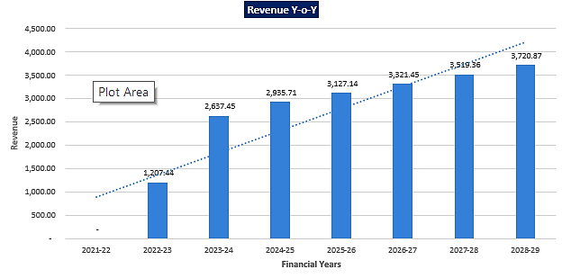

Revenue Growth Rate %

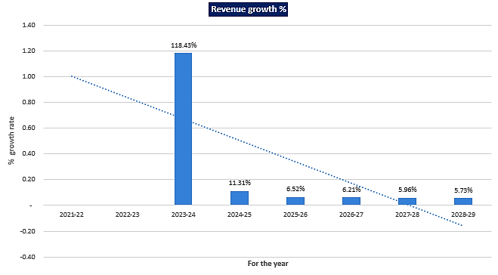

EBITDA Margin %

Below graph shows the EBITDA Margin of the project during the forecasted period, while margin is higher in the initial financial year and lower but gradually growing in the later years.

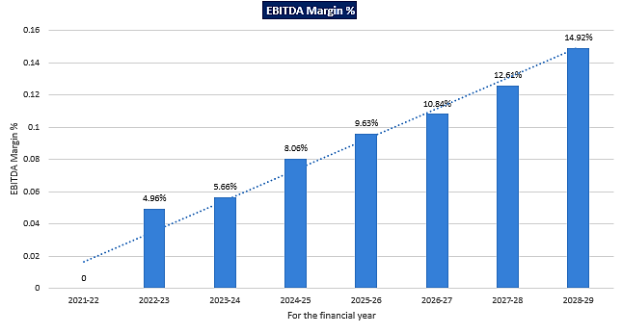
Debt Service Coverage Ratio

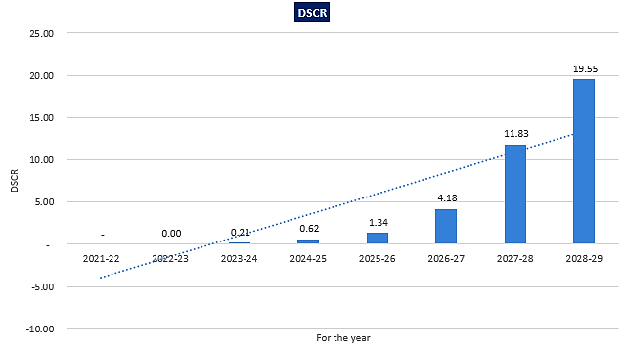

Interest Servcice Coverage Ratio

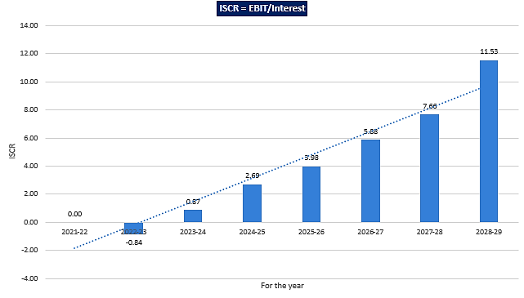

- KEY ASSUMPTIONS & BASIS:

Sl. No. | Item | Assumptions and Basis
 | General | - The projections of the firm are done for the period from FY 2021-22 to FY 2028-29 8 years) to cover the term loan period.  - We have considered Revenue and cost based model while making the future financial projections.
 | Revenue Build up | - Total income for the year will be mainly from selling of Psyllium Husk (Isabgol) and by-products (Cattle Feed).  - Revenue has been calculated based on the assumption of expected quantity sold for the period multiplied by average selling price per unit.  - Quantity sold has been calculated based on the capacity utilization assumed during the forecasted period. Capacity utilization assumption has been described separately below.  - Input to Output ratio is 25% for Psyllium Husk (Isabgol) and 50% for by-products (Cattle Feed).  - Thus INR 1373.03 Lakhs of revenue is being calculated for the initial year and it is increasing up to INR 3459.21 Lakhs till 2028-29 and thus achieving a CAGR of 16.65%.
 | Pricing | - Prices of the Psyllium husk (Isabgol) has been considered as INR 415 per kg which is based on the prices of isabgol in the public domain of the various grades of isabgol and price for the cattle feed has been assumed as INR 15 per kg which is an average price of cattle feed in the various public domain.  - As per our tertiary research there is a variance in the prices of the Isabgol in the public domain as per different quality and grade which ranges from Rs. 250 to Rs. 1000 per kg and cattle feed ranges from Rs.15 per Kg. to Rs.35 per Kg. as per variety of the quality due to customization of the product on the demand of the customers.  - In first 2 years prices has been kept same as Rs.415 per Kg. In next year it has been increased by Rs.10 per Kg. and further by Rs.5 per Kg. during the forcasted period.
 | Capacity Utilization | - Since this is a new Project and company is entering into this sector for the first time therefore for the first year we have considered the utilization capacity as 48% and have further escalated by 3% each year because the new proposed company will take some time to achieve the economies of scale and will operate at a higher capacity in the later years.  - Thus the project will be achieving a 66% capacity utilization in 8th year of the forecasted period.  - We have considered the capacity utilization on conservative basis to keep a mark-up for future market & economic risks in the Project.
 | Expenses | - Major expenses includes the cost of raw material consumed, Inventory, Direct expenses (Labour Expenses and power and fuel Expenses), Administrative expenses (including wages and salaries), Sales and Marketing expenses.  - Cost of raw material (Psyllium Seed) is calculated based on the total consumption for the year multiplied by average price considered of the Psyllium seeds in the Market. Total consumption of raw material is derived based on capacity utilization considered of installed capacity.  - Total installed capacity of the proposed unit is considered as 16 ton per day (considering 3 shifts).  - In the direct expenses Labour expenses and “Power & Fuel expenses” are included. Labour expenses is being calculated as consumption of raw material in MT per annum multiplied by labour charges per ton assumed for the year. Initially INR 5000 per MT labour charge has been taken based on the industry standard and later there is a 5% escalation rate is being considered in the labour charges based on the expected inflation rate.  - Power & fuel expenses are calculated as production multiplied by charges per metric ton. Initially charges is being considered as INR 10,000 per metric ton and there is an escalation rate of 5% has been considered for the later years during the forcasted period.  - Administrative expenses have been considered as 3% of the revenue for the year over the forecasted period.  - Sales & Marketing expenses have been considered as 1% of the revenue for the year over the forecasted period which also includes packaging cost & transportation cost.  - Bank Interest rate has been considered as 7.25% based on RLLR + BSP scheme where RLLR (Repo Linked Lending Rate) is considered as 6.50% with effective from 8.11.2021 + 0.75% BSP.  - Expenses considered are cross checked from the similar Industries which is found as per Industry trend for this sector as per our research.  - Repair and maintenance cost has been considered as 0.1% of revenue for the second year, for 3rd & 4th year it is considered as 0.2% of the revenue and 0.25% for the later years during the forcasted period.
 | Working Capital and MPBF Assessment | - Based on the assessment of the working capital gap and minimum permissible banking finance.  - Minimum margin has been considered as 25% of the total current assets.  - After deduction of minimum margin and actual working capital margin from the working capital gap, the minimum of both has been considered as MPBF which has been come as INR 4.00 Crore to initiate the project and thus the company
Conclusion:
      - DSCR, ISCR and EBIDTA margin is positive in all years starting from initial year on 48% utilization capacity which has assumed maximum up to 66% up to end of 8th year.
      - DSCR, ISCR and EBIDTA margin has achieved more than 1 from FY 2025-26 year onwards.
      - Average DSCR, ISCR and EBIDTA margin is 4.72, 3.97, and 9.53% respectively.
      - Based on the above key financial ratios of the Project during the forecast period for the proposed project shows that the project looks financially viable if the Project company & promoters are able to maintain minimum capacity utilization, revenue and can contain cost as assumed above.
PART N | CONCLUSION

Based on the technological, economical and market analysis done above, various Industry assumptions taken, product pricing to be adopted by the company, the Project appears to be Techno-commercially viable subject to the risks, threats, weaknesses, limitations of the product as detailed previously.

As per financial projections for the estimated period, Average DSCR, ISCR, EBITDA Margin of the project are 4.72, 3.97 and 9.53% respectively, where higher DSCR and ISCR is the indicator of the project capability to pay out its outstanding debt and EBITDA margin shows the capability of the project to generate the operating profits over the forecasted period.

While it is not avoidable that the future projections may change in the upcoming years due to various factors impacting the operation, managerial, financial efficiency and economies of scale of the project.

While it would be depending on the management’s capability in future that how efficiently company adopts marketing and advertisement strategy, supply chain and carry out inventory & resource management to achieve higher profitability. Company is yet to identify its key customers and to form strategic planning for tie-up & product promotion with overseas and domestic customers for selling & distribution of its product which remains a major concern. Bank/ Financial Institution is advised to take firm plan from the company in this regard before taking any decision.

After considering the high demand of the Psyllium husk and by-products in western countries and in India itself, existing machinery proposed in the Plant, easy availability of raw material, financial analysis of the project based on the assumptions taken over the projected period, it appears reasonable to comment that the proposed project is “Technically and Economically” Viable subject to current assumptions considered and occurring the same in the upcoming years same as the forecasted period which is dependent on the sincerity and efforts of the management and various micro and macroeconomic & industry situation.

We have tried our level best to analyse the Project techno-economic feasibility of the Project based on the Industry research, Project information and various futuristic assumption taken. However achieving the financial milestones depends on the ability, sincerity and efforts of the company, promoters and its key managerial performance.

Declaration | - The undersigned does not have any direct/indirect interest in the above property.  - The information furnished herein is true and correct to the best of our knowledge, logical and scientific assumptions.  - This TEV Report is carried out by our Financial Analyst team on the request from M/s. Sadashiva Psyllium Private Limited.  - Meeting of Financial projections will be subject to subject to the market & economy stability factors, judicious business operations and proper & timely implementation of its process & product re-engineering & improvements plans for achieving high productivity, efficiency and achieving cost saving benefits.  - We have submitted TEV report to the Client.
Name & Address of consultant company |  |  | Signature of the authorized person
M/s. R.K. Associates Valuer & Techno Engineering Consultants Pvt. Ltd.
D-39, 2nd Floor. Sector-2, Noida- 201301
Enclosed Documents |  | Disclaimer & Remarks 73-76
Number of Pages in the Report |  | 77
Financial Analyst Team worked on the report |  | PREPARED BY: Mr Gaurav Kumar
 |  | REVIEWED BY: HOD Project
For R.K Associates Valuer & Techno Place: Noida
Engineering Consultants (P) Ltd. Date: 14/01/2022

(Authorized Signatory)

PART O | DISCLAIMER | REMARKS

      - No employee or member of R.K Associates has any direct/ indirect interest in the Project.
      - This report is prepared based on the copies of the documents/ information which the Bank/ Company has provided to us out of the standard checklist of documents sought from them and further based on our assumptions and limiting conditions. The client/owner and its management/representatives warranted to us that the information they supplied was complete, accurate and true and correct to the best of their knowledge. All such information provided to us has been relied upon in good faith and we have assumed that it is true and correct in all respect. I/We shall not be liable for any loss, damages, cost or expenses arising from fraudulent acts, misrepresentations, or wilful default on part of the owner, company, its directors, employee, representative or agents. Verification or cross checking of the documents provided to us from the originals or from any Govt. departments/ Record of Registrar has not been done at our end since this is beyond the scope of our work. If at any time in future, it is found or came to our knowledge that misrepresentation of facts or incomplete or distorted information has been provided to us then this report shall automatically become null & void.
      - Legal aspects for e.g. investigation of title, ownership rights, lien, charge, mortgage, lease, sanctioned maps, verification of documents, etc. have not been done at our end and same has to be taken care by legal expert/ Advocate. It is assumed that the concerned Lender/ Financial Institution has satisfied them with the authenticity of the documents, information given to us and for which the legal verification has been already taken and cleared by the competent Advocate before requesting for this report. I/ We assume no responsibility for the legal matters including, but not limited to, legal or title concerns.
      - This report is a general analysis of the project based on the scope mentioned in the report. This is not an Audit report, Design document, DPR or Techno feasibility study. All the information gathered is based on the facts seen on the site during survey, verbal discussion & documentary evidence provided by the client and is believed that information given by the company is true best of their knowledge.
      - This Techno Economic-Viability study is prepared based on certain futuristic assumption which are intra dependent on economic, market and sectorial growth condition in future and socio-economic, socio-political condition at macro and micro level.
      - Meeting of assumption and financial ratio will entirely depend on the sincerity and efforts of the company, promoters and its key managerial performance.
      - All observations mentioned in the report is only based on the visual observation and the documents/ data/ information provided by the client. No mechanical/ technical tests, measurements or any design review have been performed or carried out from our side during Project assessment.
      - Bank/FII should ONLY take this report as an Advisory document from the Financial/ Chartered Engineering firm and its specifically advised to the creditor to cross verifies the original documents for the facts mentioned in the report which can be availed from the borrowing company directly.
      - In case of any default in loans or the credit facility extended to the borrowing company, R.K Associates shall not be held responsible for whatsoever reason may be and any request for seeking any explanation from the employee/s of R.K Associates will not be entertained at any instance or situation.
      - The documents, information, data provided to us during the course of this assessment by the client are reviewed only up to the extent required in relation to the scope of the work. No document has been reviewed beyond the scope of the work.
      - This report only contains general assessment & opinion as per the scope of work evaluated as per the information given in the copy of documents, information, data provided to us and/ and confirmed by the owner/ owner representative to us at site which has been relied upon in good faith. It doesn’t contain any other recommendations of any sort including but not limited to express of any opinion on the suitability or otherwise of entering into any transaction with the borrower.
      - We have relied on data from third party, external sources & information available on public domain also to conclude this report. These sources are believed to be reliable and therefore, we assume no liability for the truth or accuracy of any data, opinions or estimates furnished by others that have been used in this analysis. Where we have relied on data, opinions or estimates from external sources, reasonable care has been taken to ensure that such data has been correctly extracted from those sources and /or reproduced in its proper form and context, however still we can’t vouch its authenticity, correctness or accuracy.
      - This Report is prepared by our competent technical team which includes Engineers and financial experts & analysts.
      - This is just an opinion report and doesn’t hold any binding on anyone. It is requested from the concerned Financial Institution which is using this report for taking financial decision on the project that they should consider all the different associated relevant & related factors also before taking any business decision based on the content of this report.
      - All Pages of the report including annexure are signed and stamped from our office. In case any paper in the report is without stamp & signature then this should not be considered a valid paper issued from this office.
      - Though adequate care has been taken while preparing this report as per its scope, but still we can’t rule out typing, human errors, over sightedness of any information or any other mistakes. Therefore, the concerned organization is advised to satisfy themselves that the report is complete & satisfactory in all respect. Intimation regarding any discrepancy shall be brought into our notice immediately. If no intimation is received within 15 (Fifteen) days in writing from the date of issuance of the report, to rectify these timely, then it shall be considered that the report is complete in all respect and has been accepted by the client up to their satisfaction & use and further to which R.K Associates shall not be held responsible in any manner.
      - Defect Liability Period is 15 DAYS. We request the concerned authorized reader of this report to check the contents, data and calculations in the report within this period and intimate us in writing if any corrections are required or in case of any other concern with the contents or opinion mentioned in the report. Corrections only related to typographical, calculation, spelling mistakes, incorrect data/ figures/ statement will be entertained within the defect liability period. Any new changes for any additional information in already approved report will be regarded as additional work for which additional fees may be charged. No request for any illegitimate change in regard to any facts & figures will be entertained.
      - R.K Associates encourages its customers to give feedback or inform concerns over its services through proper channel at valuers@rkassociates.org in writing within 15 days of report delivery. After this period no concern/ complaint/ proceedings in connection with the Techno- Economic Viability Study Services will be entertained due to possible change in situation and condition of the subject Project.
      - Our Data retention policy is of ONE YEAR. After this period, we remove all the concerned records related to the assignment from our repository. No clarification or query can be answered after this period due to unavailability of the data.
      - This Techno Economic Viability Study report is governed by our (1) Internal Policies, Processes & Standard Operating Procedures, (2) Information/ Data/ Inputs given to us by the client and (3) Information/ Data/ Facts given to us by our field/ office technical team. Management of R.K Associates never gives acceptance to any unethical or unprofessional practice which may affect fair, correct & impartial assessment and which is against any prevailing law. In case of any indication of any negligence, default, incorrect, misleading, misrepresentation or distortion of facts in the report then it is the responsibility of the user of this report to immediately or at least within the defect liability period bring all such act into notice of R.K Associates management so that corrective measures can be taken instantly.
      - R.K Associates never releases any report doing alterations or modifications from pen. In case any information/ figure of this report is found altered with pen then this report will automatically become null & void.
      - If this report is prepared for the matter under litigation in any Indian court, no official or employee of R.K Associates will be under any obligation to give in person appearance in the court as a testimony. For any explanation or clarification, only written reply can be submitted on payment of charges by the plaintiff or respondent which will be 10% of the original fees charged where minimum charges will be Rs. 15,000/.

