Proposal for

Solar Roof Top Finance

Of

Solar Quest Project Three Pvt Ltd

Executive Summary

Solar Quest LLP (Parent Company) is a 9 years old company having specialization in PV power plant system designing and execution, performance evaluation, yield analysis and techno-economic assessment of PV power plant. Along with routine rooftop and utility scale EPC contracts Solar Quest also provides services related to due diligences, project development progress and optimizing operational enhancements. Having presence across India and experience of all kind of ground activities, Solar Quest has gained knowledge and trust through it more than 25MW’s of association with various government and private entities.

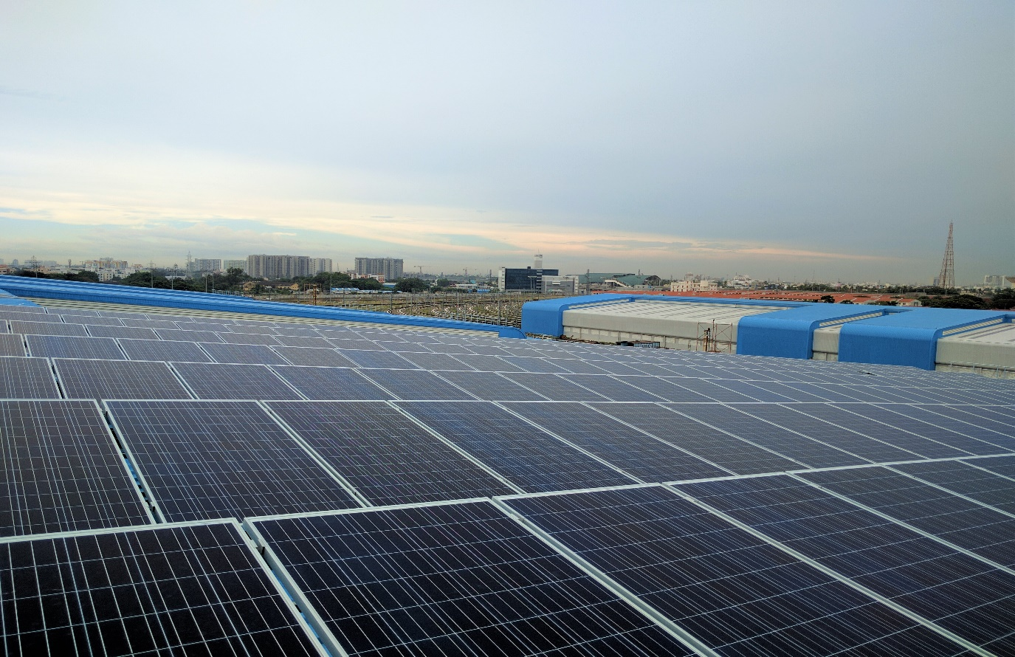

Areas of Expertise

* Project Management & Execution
* Solar Power Plant Layout
* Solar Structure Designing and calculations
* Feasibility Studies (Commercial & Technical)
* Energy Modelling Analysis
* Financial Modelling
* Contracts Management
* Project Implementation & Development

Promoters' Profile

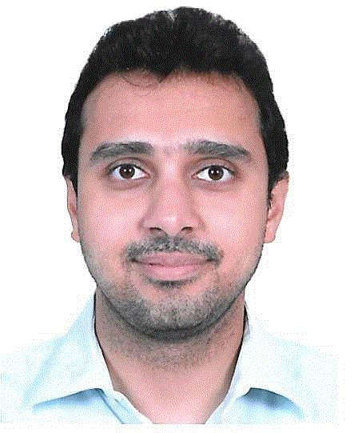

Name Pranjal Dhariwal

Age 34 Years

Designation Managing Director

Education Qualification Chartered Accountant, B.Com

Prior Experience Credit Rating on behalf of Deutsche Bank

Overall Administration in family business

Commercial Manager for Zynergy Group, Chennai

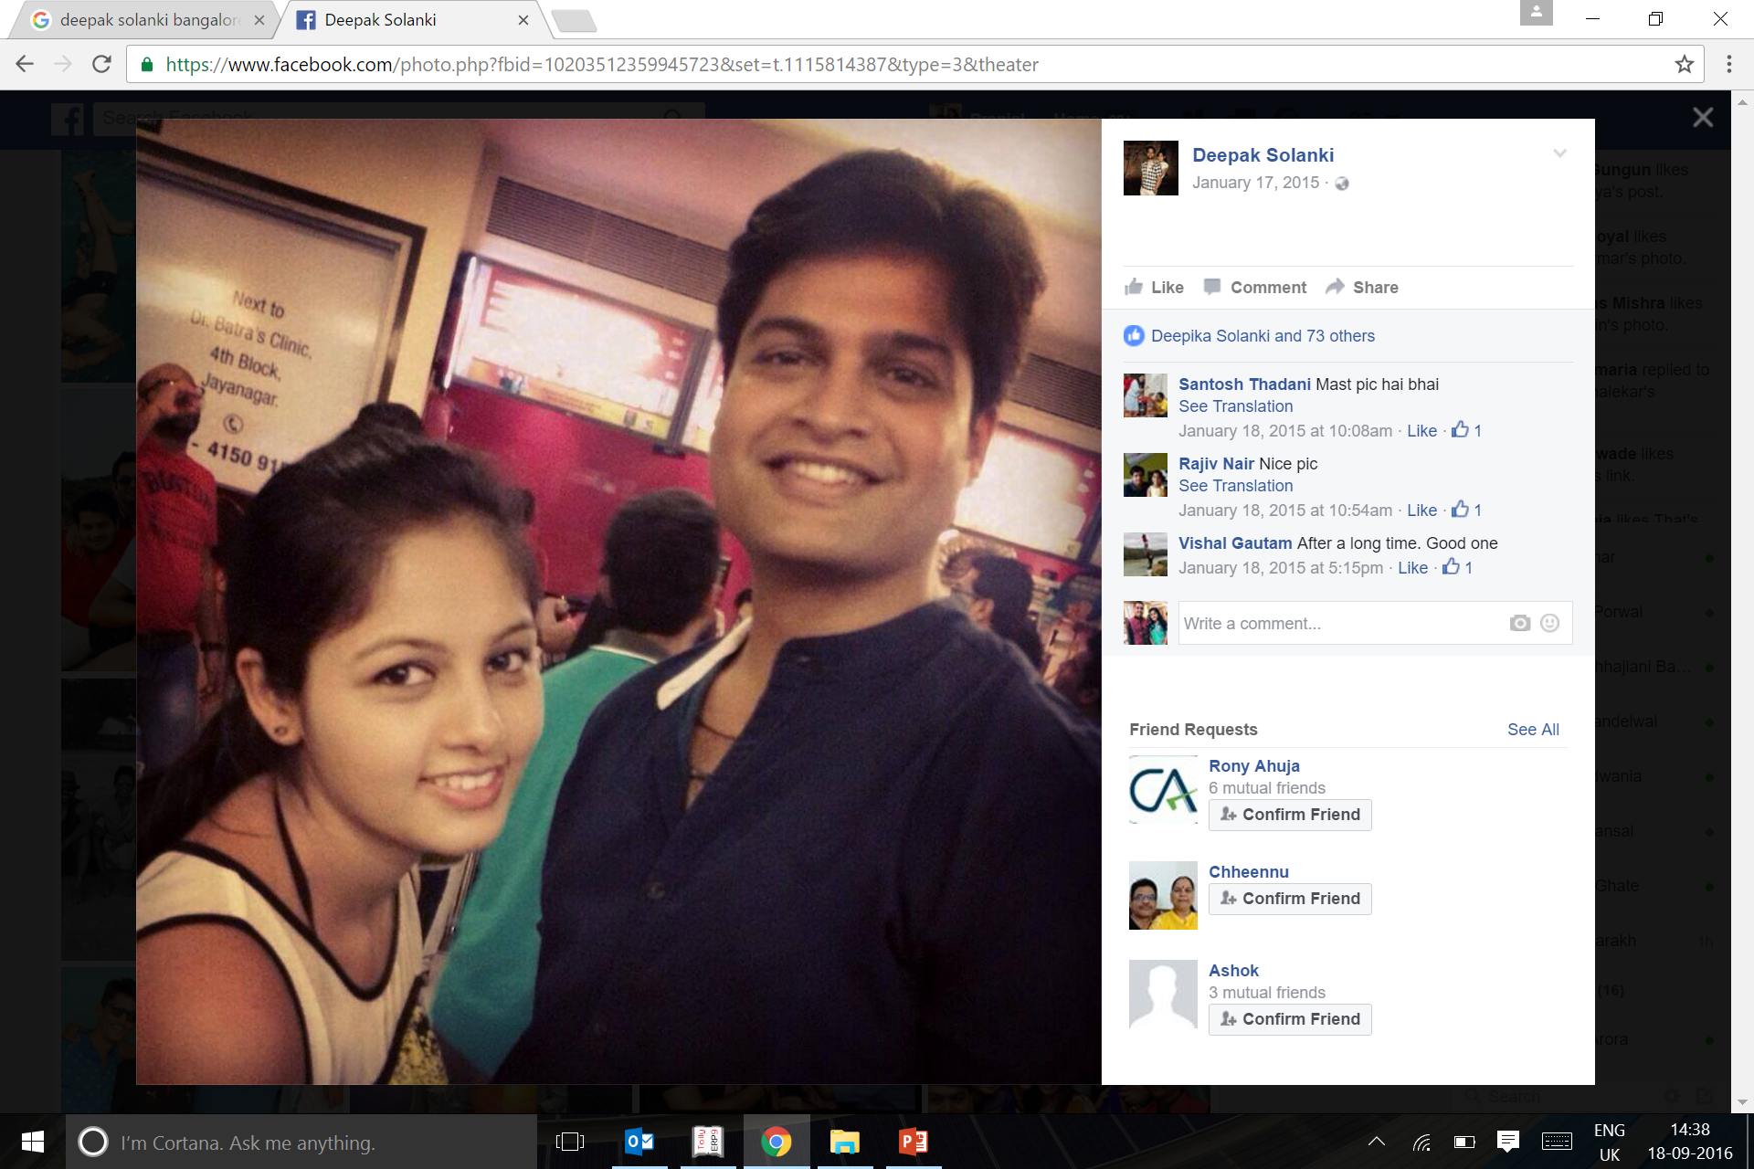

Name Deepak Kumar (Solanki)

Age 36 Years

Designation Partner of Parent Company (Solar Quest LLP)

Education Qualification MBA in Finance & Marketing

Prior Experience Handling family businesses in area of Power Electronics as well as Medicine distribution



Name V. Tamilvanan

Age 32 Years

Designation Partner of Parent Company (Solar Quest LLP)

Education Qualification Masters in Solar Engineering from Chennai

Prior Experience With Solar Quest LLP since inception (2013)



Name Apeksha Parakh

Age 34 Years

Designation Director

Education Qualification Chartered Accountant, B.Com(Hons-ABST)

Prior Experience Manager at ICICI Bank Ltd for 2.5 years

Relevant Experience

Having done projects with various categories of clients, and for various sorts of requirements, we are confident about our output qualities in defined timelines.

|  |  |  |  |
| --- | --- | --- | --- |
| **Sl No.** | **Client** | **Industry** | **Scope** |
| 1 | Chennai Metro Rail Ltd | Railways | Design, Supply, Installation & Commissioning |
| 2 | Bangalore Metro Rail Ltd | Railways | Design, Supply, Installation & Commissioning |
| 3 | State Bank of India | Bank | Design, Supply, Installation & Commissioning of 255 kWp solar plants spread across 7 locations |
| 4 | Postal Training Corp | Dept of Post | Design, Supply, Installation & Commissioning of 102 kWp solar plant |
| 5 | Janatics Pneumatics | Pneumatics | 125kWp Design, Supply, Installation & Commissioning |
| 6 | Indus TMT Rolling Mills | Steel | Design consultancy, EPC Negotiation and Project Planning |
| 7 | Tamil Nadu Energy Development Agency | Government | Planning and execution for implementation of 15000 green houses with solar power |
| 8 | Anupam Stationeries | Stationery Factory | Design, Supply, Installation & Commissioning |
| 9 | Slum Clearance Board | Government | Design finalization, contract agreement and execution progress monitor |
| 10 | IC India | Sub Contract for Govt | Multiple government buildings for requirement assessment, BOQ finalization and execution |
| 11 | Omega International School | Education | Concept to Commissioning of Solar Power Plants at 4 different locations |
| 12 | SA Engineering College | Education | PPA Drafting, Quality Assessment of Project |
| 13 | Sterling & Wilson | Leading Contractors | Design, Supply, Installation & Commissioning |

Registrations (Solar Quest LLP)

* NSIC and MSME Registered
* Udyam Aadhaar Registered
* ISO 9001 and 14001

Loan Proposal

In 2021, Solar Quest LLP bagged allocation of 3500 kWp from Solar Energy Corporation of India from which 1,922 kWp was registered as RESCO Model and PPA’s for which have already been signed. Solar Quest LLP, incorporated Solar Quest Three Pvt. Ltd. as a project company to execute projects under SECI Tender, for the purpose of selling power. Total DC capacity installed against this 1.9 MW is 2.15 MW and the power generation will be based on this 2.15 MW Capacity. Solar Quest Projects Three Pvt Ltd seeks to finance for the 2.15 MW Solar Power Plants being set up under the SECI scheme in Tamil Nadu and Maharashtra.

Following are the three off takers and their details:

|  |  |  |  |  |  |  |  |  |
| --- | --- | --- | --- | --- | --- | --- | --- | --- |
| **Sl. No.** | **Project Name** | **Client Category** | **(kW)** | **Tariff** | **Cost of Project** | **Kwh/yr/kWp** | **Annual Units** | **Revenue/Yr** |
| 1 | Mumbai Port Trust | Govt. – Dockyard | 1045 | 3.25 | 4,49,51,198/- | 1450 | 15,15,540 | 49,25,000/- |
| 2 | Chennai Metro Rail Ltd | Govt. – Railway | 848 | 3.25 | 3,28,10,816/- | 1500 | 12,72,000 | 41,34,000/- |
| 3 | IMSC, Chennai | Govt. – Research | 260 | 3.25 | 1,13,28,746/- | 1500 | 3,90,000 | 12,67,500/- |
|  | **Total** |  | **2,153** |  | **8,90,90,760/-** |  | **28,33,050** | **1,03,25.000/-** |

Promoter Solar Quest LLP has invested in the entire capex for the project as a creditor for the construction of power plants, i.e Rs. 8.9 Crore.

**Summary of Financial Numbers**

Total Capital Cost of Projects : INR 8,90,90,760

Subsidy receivable from SECI (INR 11250/kW) : INR 2,16,22,500

**Net Project Cost : INR 6,74,68,260**

Proposed Financial Assistance (Pre-Subsidy) : INR 6,23,63,530 (70%)

Less: Receipt of Subsidy from SECI : INR 1,51,35,750

**Term Loan for the tenure of 15 years : INR 4,72,22,780**

**Annual Revenue Expected from the above projects : INR 1,03,25,000**

Based on the above Numbers, along with revenue projections, working for the project cash flow has been attached in the sheet below:

**Assumptions :**

Interest Rate : 8.05%

Tenure : 15 Years Door to Door including 1 year moratorium

Extent of Finance : 70%

Term Loan Amount : 4.72 Cr (15 Years)

Bridge Loan Amount : 1.51 Cr (12 months)

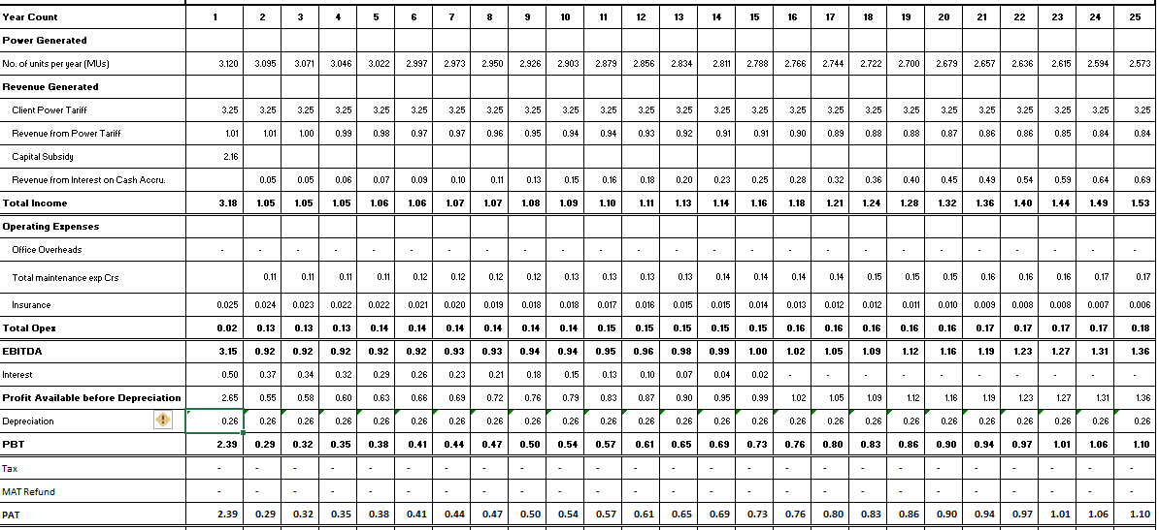

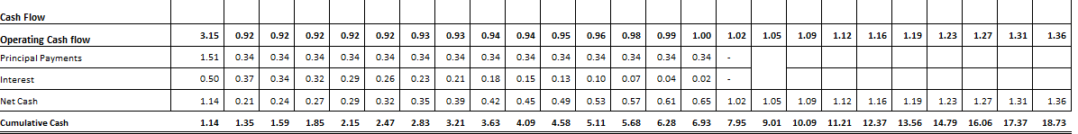

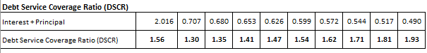

Detailed Report on all of the projects are given in the following pages.

Detailed Project Report

|  |  |  |  |  |  |
| --- | --- | --- | --- | --- | --- |
| **S.No.** | **Project Name** | **Site Name** | **Location** | **kW** | **Page No** |
| 1 | Mumbai Port | Mazgaon | Mumbai | 1045 | 8 |
| 2 | Chennai Metro Rail | Wimco Nagar Metro Station | Chennai | 448 | 10 |
| 3 | Tiruvotriyur Metro Station | Chennai | 400 | 12 |
| 4 | IMSC Chennai | Institute of Mathematical Sciences Chennai | Taramani | 260 | 14 |
| **Total Capacity of SECI Projects** | | | | **2153** |  |

**Mumbai Port, Maharashtra – 1045 kWp**

**Basic Information**

Capacity of Plant : 1045 kWp

Address : Masjid Bandar East, Masjid Bandar, Mumbai, Maharashtra 400009. INDIA

Latitude & Longitude : 18.949273,72.8383673

System Break up : 100 kWp X 10 Nos

Total System Cost : Rs. 4,49,51,198

|  |  |  |  |
| --- | --- | --- | --- |
| **Equipment** | **Brand** | **Specification** | **Qty** |
| Solar Panels | Topsun | 335Wp | 3120 |
| Inverters | Sungrow | 100 kWp | 10 |
| Structures | GI / Aluminum | Sheet Metal Roof | 1.045 MW |
| DC Cables | Siechem | 4sq mm | As Req |

**Plant Layout – (*files shared separately)***

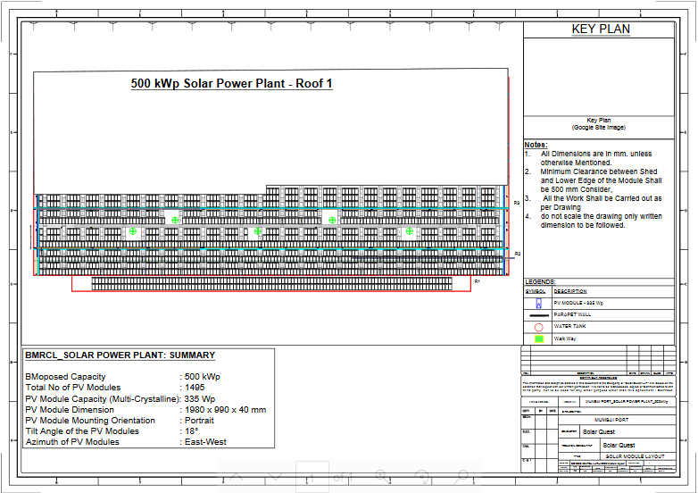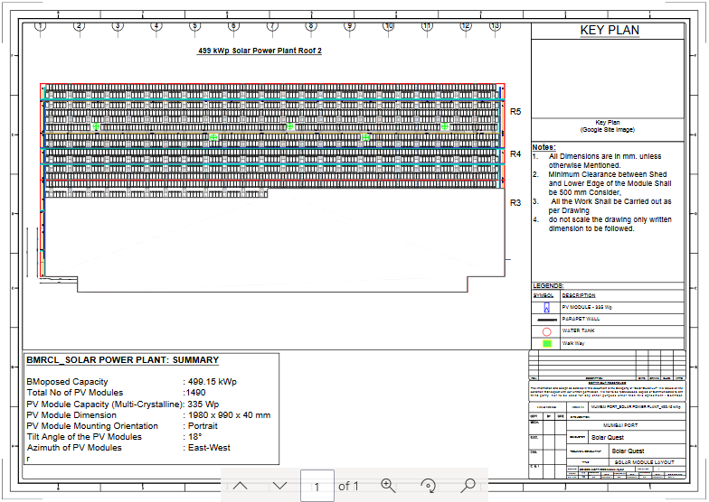

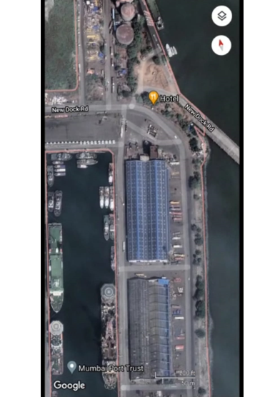

**Savings for the Department**

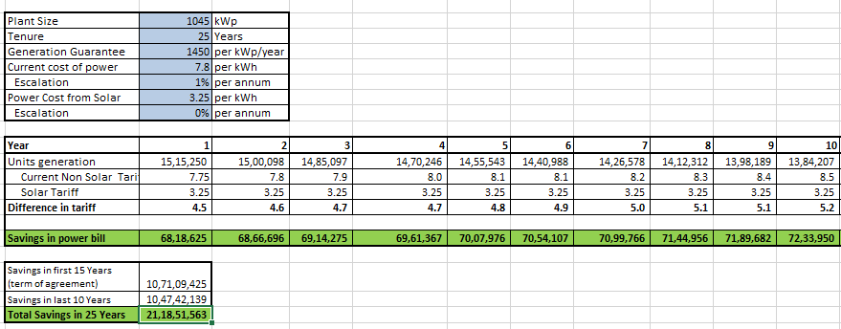

**Returns for Solar Quest Projects Three Pvt. Ltd.**

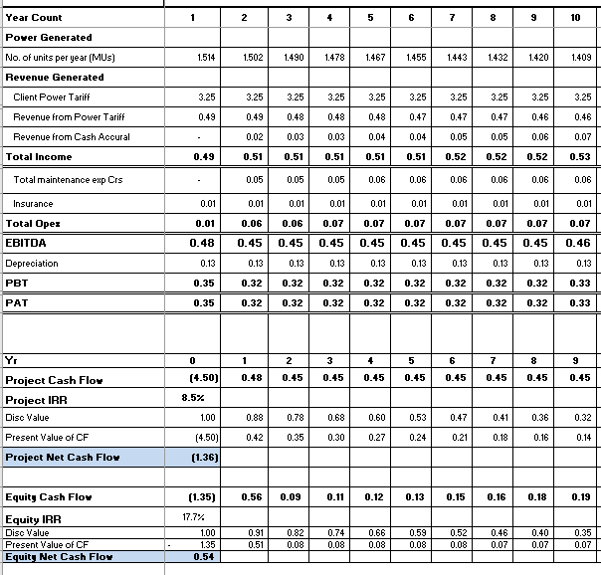

**Chennai Metro Station, Wimco Nagar – 448 kWp**

**Basic Information**

Capacity of Plant : 448 kWp

Site Address : Ramanathapuram, Tiruvottiyur, Chennai, Tamil Nadu 600057

Latitude & Longitude : 13.1803112,80.3053671

No. of Buildings : 2

System Break up : 100 kWp X 4 Nos.

Total System Cost : Rs. 1,73,34,016

|  |  |  |  |
| --- | --- | --- | --- |
| **Equipment** | **Brand** | **Specification** | **Qty** |
| Solar Panels | Topsun | 400Wp | 1120 |
| Inverters | SunGrow | 100kW | 4 |
| Structures | GI / Aluminum | Fixed RCC | 1 |
| Cables | Siechem | 4sq mm | As Req |

**Plant Layout**

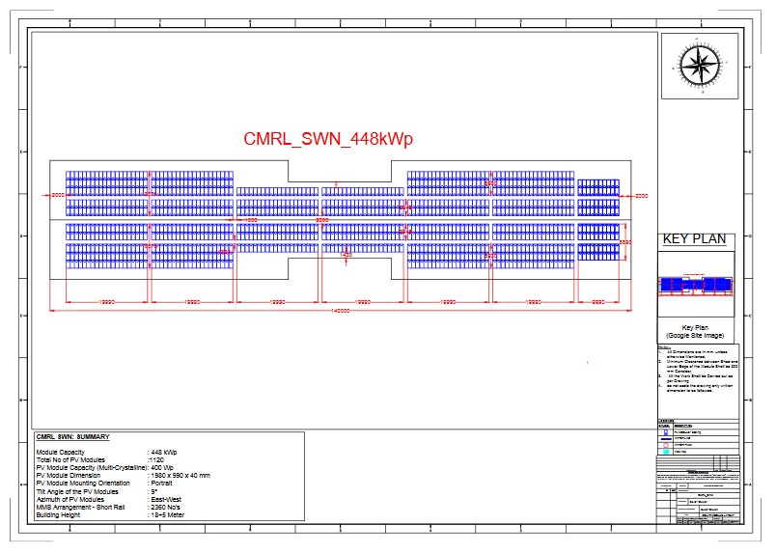

**Returns for Solar Quest Projects Three Pvt Ltd**

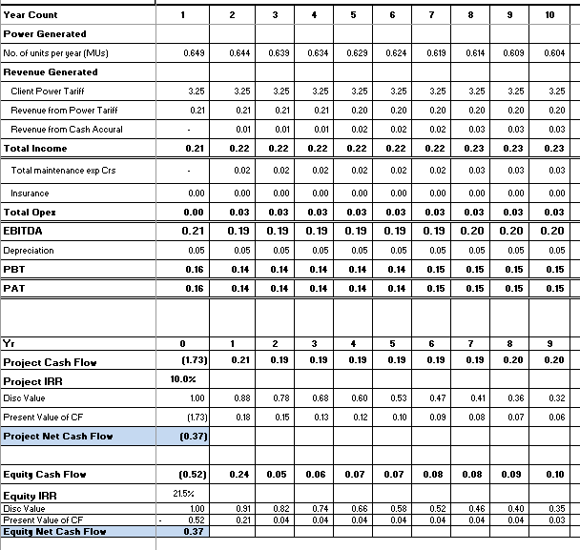

**Savings for the Department**

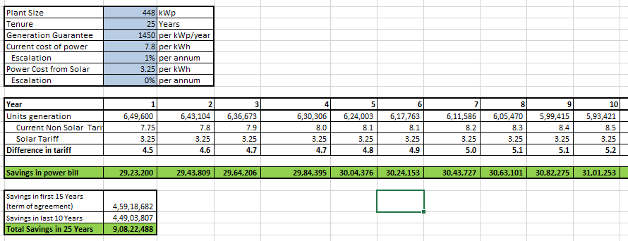

**Chennai Metro Station, Tiruvotriyur – 400 kWp**

**Basic Information**

Capacity of Plant : 400 kWp

Address : Rettai Malai Srinivasan Nagar, Manickam Nagar, Tiruvottiyur, Chennai, Tamil Nadu 600019

Latitude & Longitude : 13.1718833,80.3049771

No. of Buildings : 1

System Break up : 100 kWp X 4 Nos.

Total System Cost : Rs. 1,54,76,800

|  |  |  |  |
| --- | --- | --- | --- |
| **Equipment** | **Brand** | **Specification** | **Qty** |
| Solar Panels | Topsun | 400Wp | 1000 |
| Inverters | SunGrow | 100kW | 4 |
| Structures | GI / Aluminum | Fixed RCC | 1 |
| Cables | Siechem | 4sq mm | As Req |

**Plant Layout**

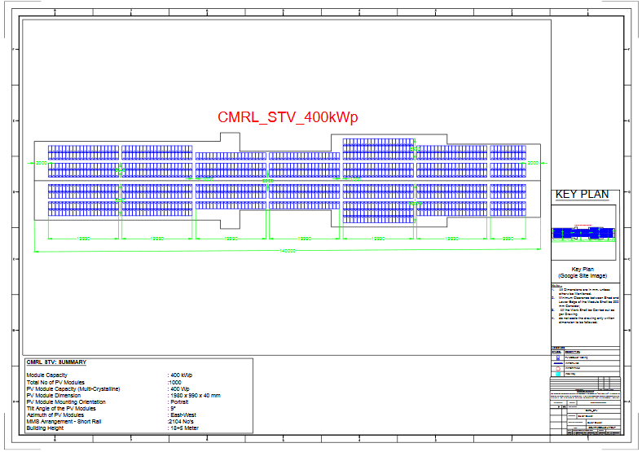

**Returns for Solar Quest Project Three Pvt Ltd**

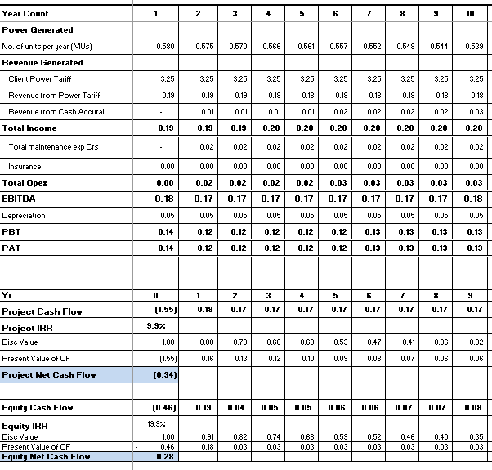

**Savings for Department**

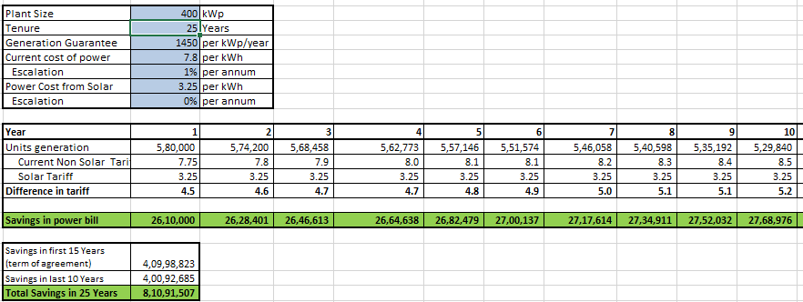

**Institute of Mathematical Sciences Chennai, Taramani – 260 kWp**

**Basic Information**

Capacity of Plant : 260 kWp

Address : 4th Cross Street, CIT Campus, Tharamani, Chennai, Tamil Nadu 600113

Latitude & Longitude : 12.9941453,80.2469537

No. of Buildings : 2

System Break up : 50 kWp + 80 kWp +20 kWp + 33 kWp +30 kWp + 20 kWp

Total System Cost : Rs. 1,13,28,746

|  |  |  |  |
| --- | --- | --- | --- |
| **Equipment** | **Brand** | **Specification** | **Qty** |
| Solar Panels | Waaree | 445Wp | 584 |
| Inverters | SunGrow | 50 kWp 80 kWp 33 kWp 30 kWp 20 kWp | 1 1 1 1 2 |
| Structures | GI / Aluminum | Fixed RCC | 2 |
| Cables | Siechem | 4sq mm | As Req |

**Plant Layout**

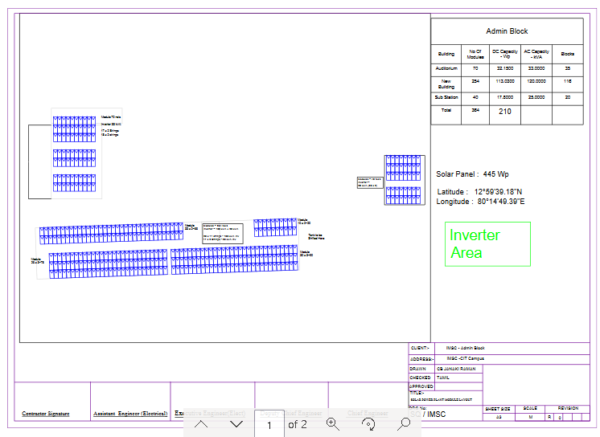 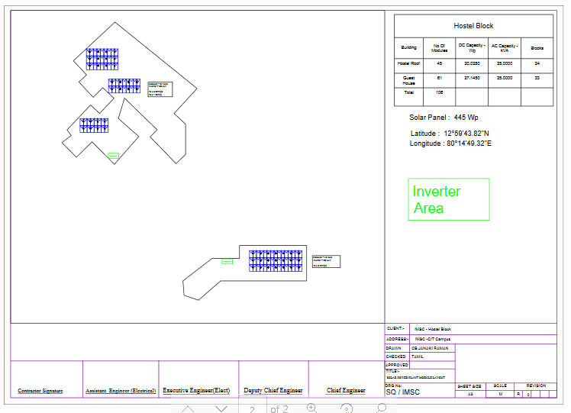

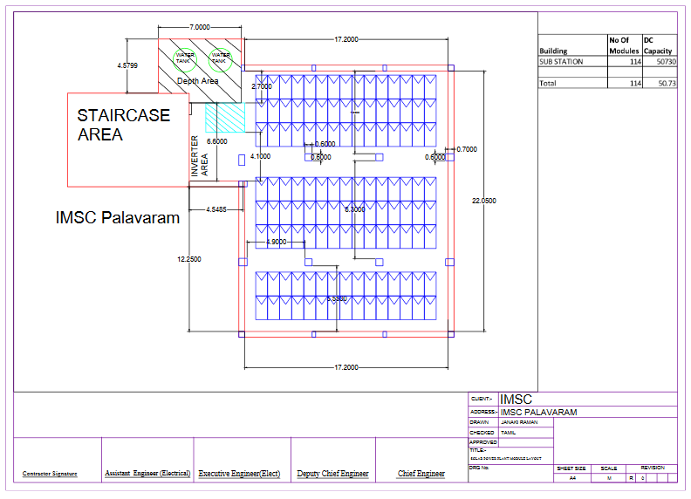

**Returns for Solar Quest Project Three Pvt Ltd**

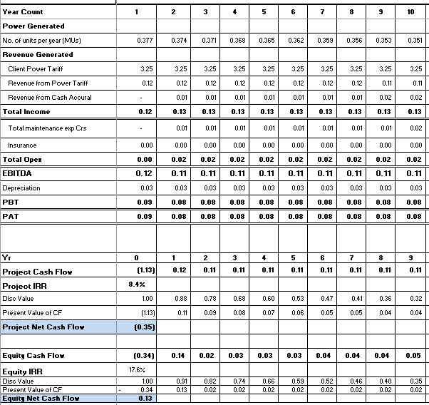

**Savings for Department**

