PRICING OF GODREJ AIR, SECTOR 85, GURUGRAM

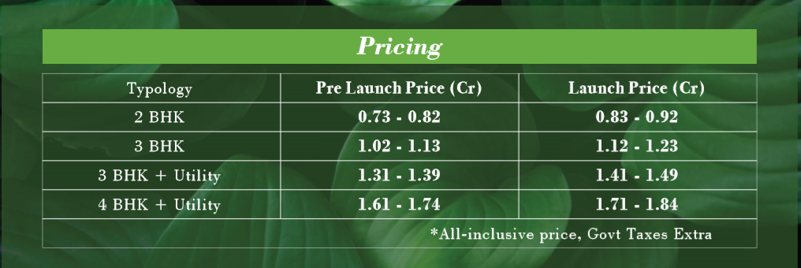

PAYMENT PLAN OF GODREJ AIR, SECTOR 85, GURUGRAM

