**REPORT FORMAT:** V-L1 (Composite) | Version: 9.0_2019

**FILE NO.** **VIS(2021-22)-PL80-Q23-078-095 DATED: 29/06/2021**

**VALUATION ASSESSMENT**

**OF**

**COMMERCIAL PROPERTY**

**SITUATED AT**

**UNIT NO.102, FIRST FLOOR OF THE TOWER NO.I/ TOWER II, SEEPZ SPECIAL ECONOMIC ZONE, MAROL INDUSTRIAL AREA, C.T.S-02, VILLLAGE-VYARAVALI, PARAJAPUR, TALUKA ANDHERI, SUB-DISTRICT & DISTRICT MUMBAI SUBURBAN, MAHARASHTRA**

**OWNER/S**

**M/S PATDIAM JEWELLERY PVT. LTD.**

**A/C: M/S PATDIAM JEWELLERY PVT. LTD.**

**REPORT PREPARED FOR**

**STATE BANK OF INDIA, CGC BRANCH, SEEPZ, MUMBAI-400096**

***\*\*Important - In case of any query/ issue/ concern or escalation you may please contact Incident Manager @ valuers@rkassociates.org. We will appreciate your feedback in order to improve our services.***

***Valuation TOR is available at*** [***www.rkassociates.org***](http://www.rkassociates.org) ***for reference.***

***NOTE: As per IBA Guidelines please provide your feedback on the report within 15 days of its submission after which report will be considered to be correct.***

|  |
| --- |
| **VALUATION ASSESSMENT AS PER SBI FORMAT** |

|  |  |
| --- | --- |
| Name & Address of Branch: | State Bank of India, CGC Branch, SEEPZ, Mumbai-400096 |
| Name of Customer (s)/ Borrower Unit | M/s Patdiam Jewellery Pvt. Ltd |

|  |  |  |  |  |  |  |  |
| --- | --- | --- | --- | --- | --- | --- | --- |
| **I.** | **GENERAL** | | | | | | |
|  | Purpose for which the valuation is made | | | Periodic Re-Valuation for Bank | | | |
|  |  | Date of inspection | | 24/06/2021 | | | |
|  | Date on which the valuation is made | | 29/06/2021 | | | |
|  | List of documents produced for perusal | | | **Documents Requested** | **Documents Provided** | | **Documents Reference No.** |
| Total **04** documents requested. | Total **02** documents provided. | | **02** |
| Copy of TIR | Sub Lease Deeds | | Date: 29/07/2008 |
| Allottment Papers | Last paid Electricity Bill  (Meter No.L984954) | | Date: 05/05/2021 |
| Last paid Municipla Tax receipt | None | | -- |
| Last paid Electricity Bill | None | | -- |
|  | Name of the owner/s | | | M/s Patdiam Jewellery Pvt. Ltd | | | |
| Address and Phone no. of the owner/s | | | Unit No.102, First Floor of The Tower No.I/ Tower II, Seepz Special Economic Zone, Marol Industrial Area, C.T.S-02, Villlage-Vyaravali, Parajapur, Taluka Andheri, Sub-District & District Mumbai Suburban, Maharashtra | | | |
|  | Brief description of the property | | | This opinion on valuation report is prepared for the Commercial Space situated at aforesaid address having total Built-up area measuring 6079.4 sq.ft./ 565 sq.mtr. as per copy of sub-lease deed provided to us by the bank.  This is a leasehold property allotted by Development Commissioner, SEEPZ Special Economic Zone to M/s. Patdiam Jewellery Pvt. Ltd.for 95 years. The subject property is located in SEEPZ++ in the SEEPZ Special Economic Zone The property is at the First floor of the Tower Comprising G+7 floors.  The subject property is located on the first floor and the built-up area details has been taken from the sub-lease deed provided to us i.e. 6079.4 sq.ft./ 565 sq.mtr.  The Zone is Dedicated to the Industries using light weight Equipment like Jewellery and Electronic Hardware Manufacturers and also house offices for these industries.  The Approach Road to the Subject Locality is SEEPZ internal Road and Nearest Main Road to the Subject Property is MIDC road.  Currently Jewellery Business is operational in the Subject Property.  This report only contains general assessment & opinion on the Guideline Value and the indicative, estimated Market Value of the property found on as-is-where basis on site for which the Bank/ customer has shown & asked us to conduct the Valuation for which photographs is also attached with the report. No legal aspects in terms of ownership or any other legal aspect is taken into consideration. It doesn’t contain any due-diligence other than the valuation assessment of the property shown to us on site. Information/ data/ documents given to us by Bank/ client has been relied upon in good faith. This report doesn’t contain any other recommendations of any sort. | | | |
|  | Location of property | | | Unit No.102, First Floor of The Tower No.I/ Tower II, Seepz Special Economic Zone, Marol Industrial Area, C.T.S-02, Villlage-Vyaravali, Parajapur, Taluka Andheri, Sub-District & District Mumbai Suburban, Maharashtra | | | |
|  | Plot No. / Survey No. | | C.T.S-02 | | | |
|  | Door No. | | Unit No.102 | | | |
|  | T. S. No. / Village | | Vyaravali, Parajapur | | | |
|  | Ward / Taluka | | NA | | | |
|  | Mandal / District | | Andheri | | | |
|  | Date of issue and validity of layout of approved map / plan | | Map Not Provided To Us. | | | |
|  | Approved map / plan issuing authority | | Map Not Provided To Us | | | |
|  | Whether genuineness or authenticity of approved map / plan is verified | | Cannot comment since copy of approved map not provided to us. | | | |
|  | Any other comments by our empanelled valuers on authenticity of approved plan | | No | | | |
|  | Postal address of the property | | | Unit No.102, First Floor of The Tower No.I/ Tower II, Seepz Special Economic Zone, Marol Industrial Area, C.T.S-02, Villlage-Vyaravali, Parajapur, Taluka Andheri, Sub-District & District Mumbai Suburban, Maharashtra | | | |
|  |  | City / Town | | Mumbai Suburban | | | |
|  | Residential Area | | No | | | |
|  | Commercial Area | | Yes | | | |
|  | Industrial Area | | Yes | | | |
|  | Classification of the area | | | | | | |
|  | High / Middle / Poor | | Middle. | | | |
|  | Urban / Semi Urban / Rural | | Urban | | | |
|  | Coming under Corporation limit/ Village Panchayat / Municipality | | | Special Economic Zone | | | |
|  | Whether covered under any State/ Central Govt. enactments (e.g. Urban and Ceiling Act) or notified under agency area/scheduled area/ cantonment area | | | NA | | | |
|  | **Boundaries of the property** | | | | | | |
| Are Boundaries matched | | | Yes from the available documents | | | |
| **Directions** | | **As per Sub Sale Deed/TIR** | | | **Actual found at Site** | |
| North | | Jogeshwari Vikhorli Link Road | | | Jogeshwari Vikhorli Link Road | |
| South | | Aarey Milk colony Road | | | Road than colony | |
| East | | Goregaon Marol Road/ Aarey Milk colony Road | | | Road than Cemetery | |
| West | | SEEPZ Internal Road | | | SEEPZ Main Road | |
|  | **Dimensions of the site** | | **A** | | | **B** | |
| **As per the Deed** | | | **Actuals** | |
| North | | Not mentioned in the documents | | | Not measurable at the site | |
| South | | Not mentioned in the documents | | | Not measurable at the site | |
| East | | Not mentioned in the documents | | | Not measurable at the site | |
| West | | Not mentioned in the documents | | | Not measurable at the site | |
|  | Extent of the site | | | 6079.4sq.ft./ 565 sq.mtr. | | | |
| 14.1 | Latitude, Longitude & Co-ordinates of Flat | | | 19°07'44.8"N 72°52'40.2"E | | | |
|  | Extent of the site considered for valuation (least of 13 A & 13 B) | | | 6079.4 sq.ft./ 565 sq.mtr. (Built-Up Area) | | | |
|  | Whether occupied by the owner/tenant? | | | Owner | | | |
| If occupied by tenant, since how long? | | | NA | | | |
| Rent received per month. | | | NA | | | |

|  |  |  |  |
| --- | --- | --- | --- |
| **II.** | **APARTMENT BUILDING** | | |
|  | Nature of the Apartment | | Office in a multistoried buildiing |
|  | Location | | Unit No.102, First Floor of The Tower No.I/ Tower II, Seepz Special Economic Zone, Marol Industrial Area, C.T.S-02, Villlage-Vyaravali, Parajapur, Taluka Andheri, Sub-District & District Mumbai Suburban, Maharashtra |
|  |  | T. S. No. | NA |
|  | Block No. | NA |
|  | Ward No. | NA |
|  | Village/ Municipality / Corporation | SEEPZ |
|  | Door No., Street or Road (Pin Code) | Unit No.102 |
|  | Description of the locality | | Commercial |
|  | Year of Construction | | 2006-07 (Approx.) |
|  | Number of Floors | | Office in a multistoried buildiing |
|  | Type of Structure | | RCC framed pillar, beam, column structure on RCC slab |
|  | Number of Dwelling units in the building | | No such information provided during the site survey |
|  | Quality of Construction | | Good |
|  | Appearance of the Building | | Good |
|  | Maintenance of the Building | | Good |
|  | Facilities Available | | |
|  |  | Lift | Yes |
|  | Protected Water Supply | Yes |
|  | Underground Sewerage | Yes |
|  | Car Parking - Open/ Covered | Yes |
|  | Is Compound wall existing? | Yes |
|  | Is pavement laid around the Building | Yes |

|  |  |  |  |
| --- | --- | --- | --- |
| **III** | **FLAT** | | |
|  | The floor on which the Unit is situated | | First Floor |
|  | Door No. of the Unit | | 102 |
|  | Specifications of the Unit | | --- |
|  | Roof | RCC |
|  | Flooring | Vitrified tiles |
|  | Doors | Aluminum flushed doors & windows |
|  | Windows | Aluminum flushed doors & windows |
|  | Fittings | Internal/ Normal quality fittings used |
|  | Finishing | Simple Plastered Walls |
|  |  | House Tax | No details provided to us |
| Assessment No. | No details provided to us |
|  | Tax paid in the name of | No details provided to us |
| Tax amount | No details provided to us |
|  |  | Electricity Service Connection no. | No details provided to us |
|  | Meter Card is in the name of | No details provided to us |
|  | How is the maintenance of the Unit? | | Good |
|  | Conveyance Deed executed in the name of | | M/s Patdiam Jewellery Pvt. Ltd |
|  | What is the undivided area of land as per Sale Deed? | | NA |
|  | What is the plinth area of the Unit? | | 6079.4sq.ft/ 565 sq.mtr. |
|  | What is the floor space index (app.) | | -- |
|  | What is the Carpet Area of the Unit? | | No details provided to us |
|  | Is it Posh/ I class / Medium / Ordinary? | | Within main city |
|  | Is it being used for Residential or Commercial purpose? | | Commercial |
|  | Is it Owner-occupied or let out? | | Owner Occupied |
|  | If rented, what is the monthly rent? | | NA |

|  |  |  |  |
| --- | --- | --- | --- |
| **V** | **RATE** | | |
|  | After analyzing the comparable sale instances, what is the composite rate for a similar Unit with same specifications in the adjoining locality? - (Along with details/reference of at-least two latest deals/transactions with respect to adjacent properties in the areas) | | As per the discussion with market participants of the subject locality we came to know that the prevailing market rate for general commercial Space in subject locality is between Rs.12,000/- per sq.ft to Rs.15,000/- per sq.ft on Built-Up area. But in the SPEEZ the commercial space can only be used for very limited industry like Jewelry, electronics etc. thus the prevailing market rates are lower in this zone as compared to the prevailing rates in the nearby locality.  Keeping all those factors into the consideration that may affect the value of this property we have adopted the rate of Rs.10,000/- per sq.ft on Built-Up area. which seems reasonable in our opinion. |
|  | Assuming it is a new construction, what is the adopted basic composite rate of the Unit under valuation after comparing with the specifications and other factors with the Unit under comparison (give details). | | Not applicable since the valuation is done by Comparable Market Rate Approach |
|  | Break - up for the rate | |  |
|  | Building + Services | Cannot separate in these components since only composite rate available in the market |
|  | Land + Others | NA |
|  | Guideline rate obtained from the Registrar's office (an evidence thereof to be enclosed) | | Rs.86,540/- per sq.mtr |

|  |  |  |  |
| --- | --- | --- | --- |
| **IV** | **MARKETABILITY** | | |
|  | How is the marketability? | Property is located in developing area | |
|  | What are the factors favoring for an extra Potential Value? | Good developed industrial area | |
|  | Any negative factors are observed which affect the market value in general? | No | --- |

|  |  |  |
| --- | --- | --- |
| **VI** | **COMPOSITE RATE ADOPTED AFTER DEPRECIATION** | |
|  | Depreciated building rate | |
| Replacement cost of Unit with Services {V (3)i} | Not applicable separately since the composite rates available in the market take care of this aspect inherently |
| Age of the building | Approx.15-16 years (2006-07) |
| Life of the building estimated | Approx. 35 to 40 years, subjected to timely maintenance |
| Depreciation percentage assuming the salvage value as 10% | Not applicable separately since the composite rates available in the market take care of this aspect inherently |
| Depreciated Ratio of the building | Not applicable separately since the composite rates available in the market take care of this aspect inherently |
|  | Total composite rate arrived for valuation | |
| Depreciated building rate VI (a) | Not applicable separately since the composite rates available in the market take care of this aspect inherently |
| Rate for Land & other V (3)ii | Not applicable separately since the composite rates available in the market take care of this aspect inherently |
| Total Composite Rate | Rs.10,000/- per sq. ft. on Built Up area |

|  |  |  |  |  |
| --- | --- | --- | --- | --- |
| **VII** | **DETAILS OF VALUATION** | | | |
| **Sr.**  **No.** | **Description** | **Qty.** | **Rate per unit**  **Rs.** | **Estimated Value**  **Rs.** |
|  | Present value of the Unit (incl.car  parking, if provided) | 01 | **For Commercial Space =** Rs.10,000/- to Rs.12,000/- per sq.ft. for Built-Up area. | **Total = Rs.6,07,94,000/- to Rs.7,29,52,800‬/-** |
|  | Wardrobes | The composite rate for the property available in the market and according to which this property has been valued is inherently inclusive of all these components and these are not valued separately. The valuation is done on comparable market rate approach and hence these items cannot be valued separately to arrive at the market value of the property. | | |
|  | Showcases |
|  | Kitchen Arrangements |
|  | Built-Upfine Finish |
|  | Interior Decorations |
|  | Electricity deposits/ electrical fittings, etc., |
|  | Extra collapsible gates / grill works  etc., |
|  | Potential value, if any |
|  | Others |
|  | **Total** | 01 | **For Commercial Space =** Rs.10,000/- per sq. ft. on Built-Up area. | **Total = Rs.6,07,94,000/-** |

|  |  |  |  |  |  |  |  |  |  |
| --- | --- | --- | --- | --- | --- | --- | --- | --- | --- |
| **VII.** | **VALUATION ASSESSMENT** | | | | | | | | |
|  | **ASSESSMENT FACTORS** | | | | | | | | |
|  | Valuation Type | Built-up unit value (sold-purchased as a seperate dwelling unit) | | | | | | Commercial property value | |
|  | Scope of the Valuation | Non binding opinion on the assessment of Plain Asset Valuation of the property identified to us by the owner or through his representative. | | | | | | | |
|  | Property Use factor | **Current Use** | | | | | **Highest & Best Use** | | |
| Commercial | | | | | Commercial | | |
|  | Legality Aspect Factor | Assumed to be positive as per copy of documents & information produced to us. However Legal aspects of the property are out-of-scope of the Valuation Services.  Verification of authenticity of documents from originals or cross checking from any Govt. deptt. Have to be taken care by Legal expert/ Advocate. | | | | | | | |
|  | Land Physical factors | **Shape** | | **Size** | | | **Level** | | **Frontage to depth ratio** |
| Not Applicable | | Not Applicable | | | Not Applicable | | Not Applicable |
|  | Property location category factor | **City Categorization** | | **Locality Categorization** | | | **Property location classification** | | **Floor Level** |
| Metro City | | Good | | | Near to Highway | | First Floor |
| Urban | | Within urban developed area | | | Good location within locality | |
| Not Applicable | |
| **Property Facing** | | North-East Facing | | | | | |
|  | Any New Development in surrounding area | None | | | |  | | | |
|  | Any specific advantage/ drawback in the property | None | | | | | | | |
|  | Property overall usability Factor | Good | | | | | | | |
|  | Comment on Property Salebility Outlook | Easily sellable | | | | | | | |
|  | Comment on Demand & Supply in the Market | Such properties are easily available in the area | | | | | | | |
|  | Any other aspect which has relevance on the value or marketability of the property | Property is located in established old renowned area  Valuation of the same asset/ property can fetch different values under different circumstances & situations. For eg. Valuation of a running/ operational shop/ hotel/ factory will fetch better value and in case of closed shop/ hotel/ factory it will have considerable lower value. Similarly an asset sold directly by an owner in the open market through free market transaction then it will fetch better value and if the same asset/ property is sold by any financer due to encumbrance on it, will fetch lower value. Hence before financing, Lender/ FI should take into consideration all such future risks while financing.  This Valuation report is prepared based on the facts of the property & market situation on the date of the survey. It is a well-known fact that the market value of any asset varies with time & socio-economic conditions prevailing in the country. In future property market may go down, property conditions may change or may go worse, property reputation may differ, property vicinity conditions may go down or become worse, property market may change due to impact of Govt. policies or effect of World economy, usability prospects of the property may change, etc. Hence before financing, Banker/ FI should take into consideration all such future risk while financing. | | | | | | | |
|  | Sale transaction method assumed | Free market transaction at arm's length wherein the parties, after full market survey each acted knowledgeably, prudently and without any compulsion. | | | | | | | |
|  | Best Sale procedure to realize maximum Value | Free market transaction at arm's length wherein the parties, after full market survey each acted knowledgeably, prudently and without any compulsion. | | | | | | | |
|  | Methodology/ Basis of Valuation | **Govt. Guideline Value: Circle Rate of Maharashtra 2020-21** | | | | | | | |
| **Market Value:** Market Comparable Sales approach | | | | | | | |
| *Valuation of the asset is done as found on as-is-where basis.*  *Valuation is done based on the Valuation best practices, standard operating procedures and definitions prescribed by various organizations like IVSC, Income Tax of India, etc. as defined under.*  *For knowing comparable market rates, significant discreet local enquiries have been made from our side representing ourselves as both buyer and seller for the similar properties in the subject area and thereafter based on this information and various factors of the property, a rate has been judiciously taken considering the market scenario.*  *References regarding the prevailing market rates are based on the verbal/ informal/ secondary/ tertiary information collected during market survey in the subject area from the local people, property consultants, recent deals, demand-supply, internet postings which are relied upon. No written record is generally available for such market information and only the verbal information has to be relied upon.*  *Market Rates are rationally adopted based on the facts of the property that came to our knowledge during the course of the assignment considering many factors like nature of the property, size, location, approach, market situation and trends.*  *The indicative value has been suggested based on the prevailing market rates that came to our knowledge during secondary & tertiary market researches and does not split into formal & informal payment components.*  *Secondary/ Tertiary costs related to asset transaction like Stamp Duty, Registration charges, Brokerage, Bank interest, selling cost, marketing cost, etc. pertaining to the sale/ purchase of this property are not considered while assessing the indicative estimated Market Value.*  *This report includes both, Govt. Guideline Value and Indicative Estimated Prospective Fair Market Value. As per the current market practice, in most of the cases, formal transaction takes place for an amount less than the actual transaction amount and rest of the payment is normally done informally.*  *The condition assessment and the estimation of the residual economic life of the structure is only based on the visual observations and appearance found during the site survey. We have not carried out any structural design or stability study; nor carried out any physical tests to assess structural integrity & strength.*  *Sale transaction method of the asset is assumed as free market transaction while assessing Indicative & Estimated Fair Prospective Market Value of the asset.*  *Any kind of unpaid statutory, utilities, lease, interest or any other pecuniary dues on the asset has not been factored in the Valuation.*  *This Valuation is conducted based on the macro analysis of the asset/ property considering it in totality and not based on the micro, component or item wise analysis. Analysis done is a general assessment and is not investigative in nature.*  ***Fair Market Value#*** *suggested by the competent Valuer is that prospective estimated amount in his expert & prudent opinion of the subject asset/ property without any prejudice after he has carefully & exhaustively evaluated the facts & information came in front of him related to the subject asset at which the subject asset/ property should be exchanged between a willing buyer and willing seller at an arm’s length transaction in an open & unrestricted market, after proper marketing, wherein the parties, each acted knowledgeably, prudently and without any compulsion on the date of the Valuation.*  *Forced, under compulsion & constraint, obligatory sales transactions data doesn’t indicate the Fair Market Value.*  ***Realizable Value^*** *is the minimum prospective estimated value of the property which it may be able to realize at the time of actual property transaction factoring in the potential prospects of deep negotiations carried out between the buyer & seller for ultimately finalizing the transaction across the table. Realizable value may be 10-20% less than the Fair Market Value depending on the various salability prospects of the subject property and the needs of the buyer & the seller.*  ***Forced/ Distress Sale Value\**** *is the value when the property has to be sold due to any compulsion or constraint like financial encumbrances, dispute, as a part of a recovery process, any defect in the property, legal issues or any such condition or situation. In this type of sale, minimum fetch value is assessed which can be 25-40% less than the estimated Fair Market Value based on the nature, size & salability prospects of the property. In this type of sale, negotiation power of the buyer is always more than the seller and eagerness & pressure of selling the property is more than buying it. Therefore the Forced/ Distress Sale Value will always fetch significantly less value compare to the estimated Fair Market Value.*  ***Liquidation Value*** *is the amount that would be realized when an asset or group of assets are sold on a piecemeal basis that is without consideration of benefits (or detriments) associated with a going-concern business. Liquidation value can be either in an orderly transaction with a typical marketing period or in a forced transaction with a shortened marketing period.*  ***Difference between Cost, Price & Value:*** *Generally these words are used and understood synonymously. However in reality each of these has a completely different meaning, premise and also having different definitions in the professional & legal terms. Therefore to avoid confusion, it is our professional responsibility to describe the definitions of these words to avoid ambiguity & confusion in the minds of the user of this report.*  *The* ***Cost*** *of an asset represents the actual amount spend in the construction/ actual creation of the asset.*  *The* ***Price*** *is the amount paid for the procurement of the same asset.*  *The* ***Value*** *is defined as the present worth of future rights in the property/ asset and depends to a great extent on combination of various factors such as demand and supply, market situation, purpose, situation & needs of the buyer & seller, saleability outlook, usability factor, market perception & reputation. Needs of the buyer & seller, saleability outlook, usability factor, market perception & reputation.*  *Therefore in actual for the same asset/ property, cost, price & value remain different since these terms have different usage & meaning.* | | | | | | | |
|  | References on prevailing market Rate/ Price trend of the property and Details of the sources from where the information is gathered *(from property search sites & local information)* |  | Name: | | Mr Bakul Haria (Property Consultant) | | | | |
| Contact No.: | | +91-  9821539863 | | | | |
| Nature of reference: | | Property Consultant | | | | |
| Size of the Property: | | Approx. 8500 sq.ft. | | | | |
| Location: | | MIDC | | | | |
| Rates/ Price informed: | | Approx Rs.11,00,00,000/-. | | | | |
| Any other details/ Discussion held: | | As per the discussion held with the above mentioned property dealer we came to know that the rates of Industrial Land in the concerned area on were Approx Rs.11,000/- per Sq.ft. to Rs.15,000/- per sq.ft.on Built-Up area. | | | | |
|  | Name: | | Mahalaxmi Properties (Property Consultant) | | | | |
| Contact No.: | | +91- 9920863431 | | | | |
| Nature of reference: | | Property Consultant | | | | |
| Size of the Property: | | Approx 2500 sq.ft. | | | | |
| Location: | | Marol | | | | |
| Rates/ Price informed: | | Approx Rs.3,25,00,000/- calculated to be Approx. Rs13,000/- per sq.ft. on Built-Up area. | | | | |
| Any other details/ Discussion held: | | As per the discussion held with the above mentioned person the property rate vary in the locality according to the Floor Level. | | | | |
|  | Name: | | NA | | | | |
| Contact No.: | | NA | | | | |
| Nature of reference: | | NA | | | | |
| Size of the Property: | | NA | | | | |
| Location: | | NA | | | | |
| Rates/ Price informed: | | NA | | | | |
| Any other details/ Discussion held: | | NA | | | | |
| *NOTE: The given information above can be independently verified to know its authenticity.* | | | | | | | | |
|  | Adopted Rates Justification | *As per our discussion with market participants and habitants of the subject locality we came to know the following information: -*   1. *The prevailing market rate for commercial space in subject localty depends upon the size, floor level, age of building, zoning of the project and its location.* 2. *The prevailing market rate for the general commercial space in subject locality is ranging in between; Rs.12,000/- to Rs.15,000/-per sq.ft on built-up area.* 3. *The prevailing market rate for commercial space in Special Economic Zone called SEEPZ is less as compared to general commercial spaces because of limited use and large space.* 4. *The demand of the commercial space in this locality is Moderate and availability is Low.*     *We have considered the rate for the property keeping in mind that the subject property is in SEZ with Export only units and dedicated to the specific Jewellery and the electronic Market which affect the Usability of the property. Keeping all the above-mentioned points, factors like size & location into the consideration, we have adopted the rate of Rs.10,000/- per sq.ft. which seems to be reasonable in our view.* | | | | | | | |

|  |  |  |  |  |  |  |
| --- | --- | --- | --- | --- | --- | --- |
|  | **VALUATION CALCULATION** | | | | | |
|  | **GUIDELINE/ CIRCLE VALUE** | | | | | |
|  | **Land Value** *(Not considered since this is a built-up unit valuation)* | **Total Land Area considered as per documents/ site survey**  *(whichever is less)* | **Prevailing Rates Range** | | | **Rates adopted**  (considering all characteristics& assessment factors of the property) |
| NA | NA | | | NA |
| ***Total Land Value (a)*** | NA | | | | |
| NA | | | | |
|  | **Built-up Dwelling Unit Value** | **Built-Up unit value** | | | | |
| **Structure Type** | **Construction category** | | | **Age Factor** |
| RCC framed pillar, beam, column structure on RCC slab | Class B construction (Good) | | | Construction older than 15 years and above |
| **Rate range** | **Rate adopted** | | | **Built-up Area** |
| Rs.86,540/- | Rs.86,540/-per sq.mtr. | | | 6079.4 sq.ft./ 565 sq.mtr. |
| ***Total Built-up Dwelling Unit Value(b)*** | Rs.86,540/- per sq.mtr X 565 sq.mtr. | | | | |
| **Rs.4,88,95,100/-** | | | | |
|  | **TOTAL GUIDELINE/ CIRCLE RATE VALUE: (a+b)** | **Rs.4,88,95,100/-** | | | | |
|  | | | | | | |
|  | **INDICATIVE ESTIMATED PROSPECTIVE FAIR MARKET VALUE** | | | | | |
|  | **Land Value** *(Not considered since this is a built-up unit valuation)* | **Total Land Area considered as per documents/ site survey**  *(whichever is less)* | **Prevailing Rates Range** | | | **Rate adopted**  (considering all characteristics& assessment factors of the property) |
| NA | NA | | | NA |
| ***Total Land Value (a)*** | NA | | | | |
| **NA** | | | | |
|  | **Built-up Dwelling Unit Value** | **Built-Up unit value** | | | | |
| **Structure Type** | **Construction category** | | | **Structure Condition** |
| RCC framed pillar, beam, column structure on RCC slab | Class B construction (Good) | | | Good |
| **Age Factor** | | | **Built-up Area** | |
| Construction older than 15 years and above | | | 6079.4 sq.ft./ 565 sq.mtr. | |
| **Rate range** | | | **Rate adopted** | |
| Rs.10,000/- to Rs.12,000/- per sq.ft. on Built-Up area | | | Rs.10,000/- per sq.ft. | |
| ***Total Built-up Dwelling Unit ValueValue (b)*** | **Rs.10,000/- per sq.ft. X 6079.4 sq.ft.** | | | | |
| **Rs.6,07,94,000/-** | | | | |
|  | **TOTAL VALUE: (a+b+c+d+e)** | | | **Rs.6,07,94,000/-** | | |
|  | **Additional Premium if any** | | | NA | | |
| **Details/ Justification** | | | NA | | |
|  | **Deductions charged if any** | | | NA | | |
| **Details/ Justification** | | | NA | | |
|  | **TOTAL INDICATIVE ESTIMATED PROSPECTIVE FAIR MARKET VALUE#: (vi+vii+viii)** | | | **Rs.6,07,94,000/-** | | |
|  | **ROUND OFF** | | | **Rs.6,00,00,000/-** | | |
|  | **IN WORDS** | | | **Rupees Six Crores Only** | | |
|  | **EXPECTED REALIZABLE/ FETCH VALUE^ (@ ~15% less)** | | | **Rs.5,10,00,000‬/-** | | |
|  | **EXPECTED FORCED/ DISTRESS SALE VALUE* (@ ~25% less)** | | | **Rs.4,50,00,000/-** | | |
|  | **VALUE FOR THE INSURANCE PURPOSE** | | | **Rs. 60,00,000/-** | | |
|  | **Justification for more than 20% difference in Market & Circle Rate** | Circle rates are determined by the District administration as per their own theoretical internal policy and Market rates are adopted based on current practical market dynamics which is explained clearly in Valuation Assessment Factors | | | | |
|  | **Concluding comments & Disclosures if any** | 1. This is an Established Special Zone Created to Enpower Export in Jewellery and Electronic Hardware Market. 2. The SEEPZ++ consist of both Open as well as Covered Parking Space with 33 & 23 covered Car Parking in the Tower I & II Respectively. 3. The restriction of the SEZ to be export only units and specific industry type narrow down the buyer base for the property within the Zone. 4. Presently the property market is not under a free-market condition due to COVID Pandemic disruption. Currently, as per the micro & macro market research, the demand for property is weak and the enquiries and the transactions are negligible. In these uncertain times, people are likely to be very cautious in their expenditures in general and are and will be averse to lock up their available liquidity in the acquisition of fixed assets like property. A potential buyer of property if any, may consider acquiring a property only if he gets a really good bargain, at a substantial discount to the rates prevailing before the COVID Pandemic. Thus the Realizable Value in this Report has been adopted based on this consideration. 5. This Valuation report is prepared based on the copies of the documents/ information which interested organization or customer could provide to us out of the standard checklist of documents sought from them and further based on our assumptions and limiting conditions. All such information provided to us has been relied upon in good faith and we have assumed that it is true and correct. 6. Legal aspects for eg. Investigation of title, ownership rights, lien, charge, mortgage, lease, verification of documents from originals, etc. has to be taken care by legal experts/ Advocates. 7. This report only contains technical & market information which came to knowledge during course of the assignment. It doesn’t contain any recommendations. 8. This report is prepared following our Standard Operating Procedures & Best Practices, Limitations, Conditions, Remarks, Important Notes, Valuation TOR. | | | | |

**ENCLOSURE: II- REFERENCES ON PRICE TREND OF THE SIMILAR RELATED PROPERTIES AVAILABLE ON PUBLIC DOMAIN**

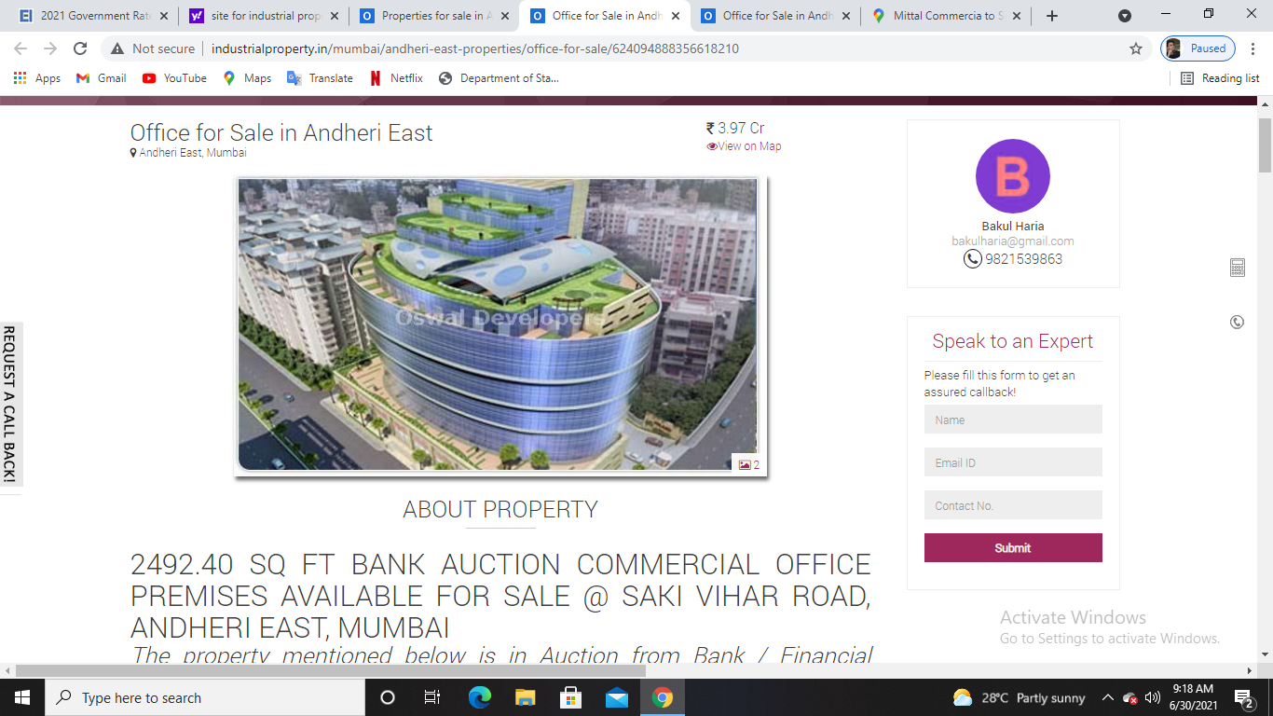

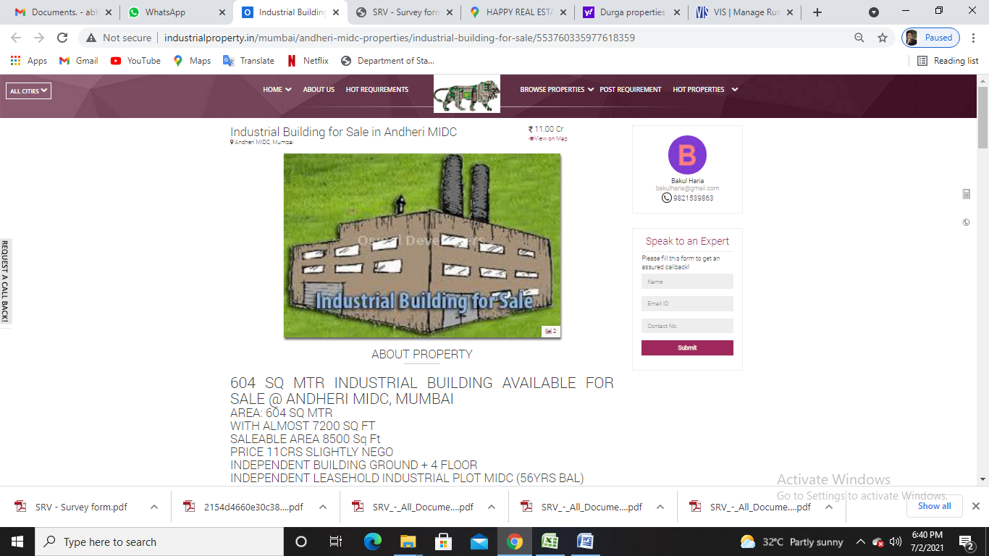

**ENCLOSURE: III – GOOGLE MAP LOCATION**

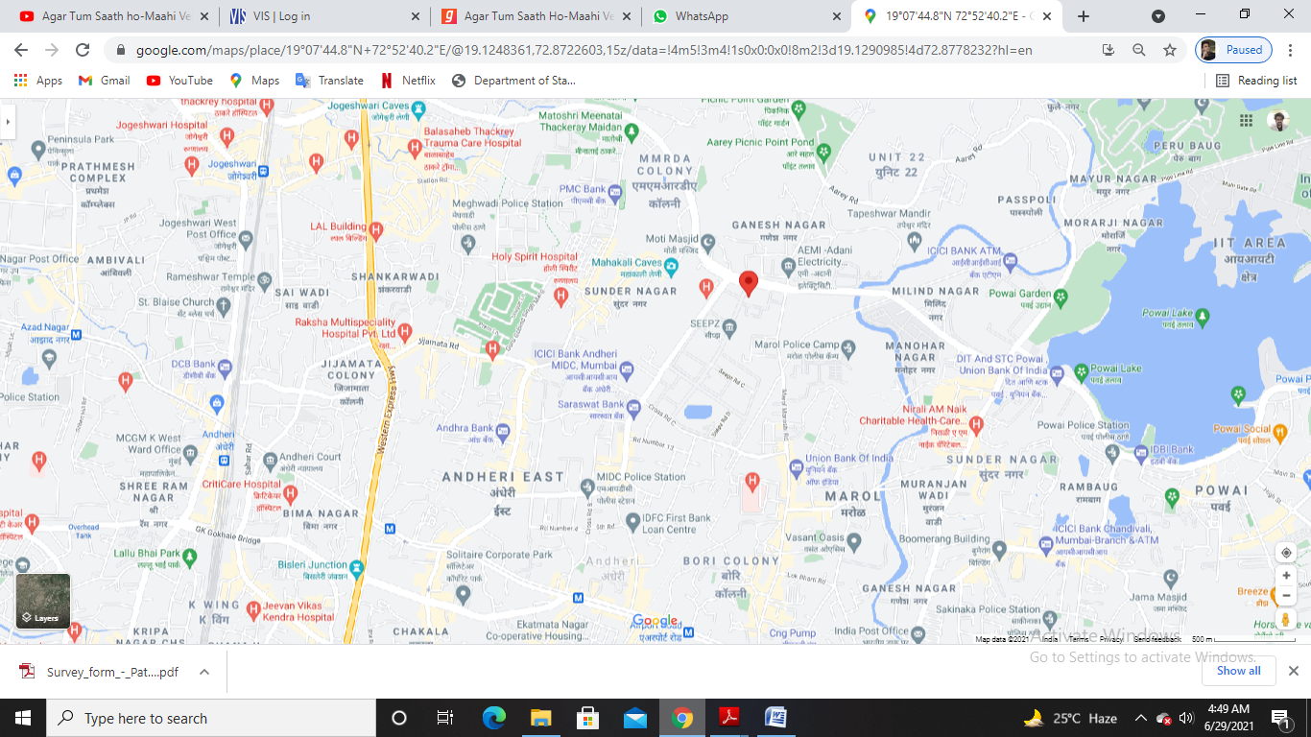

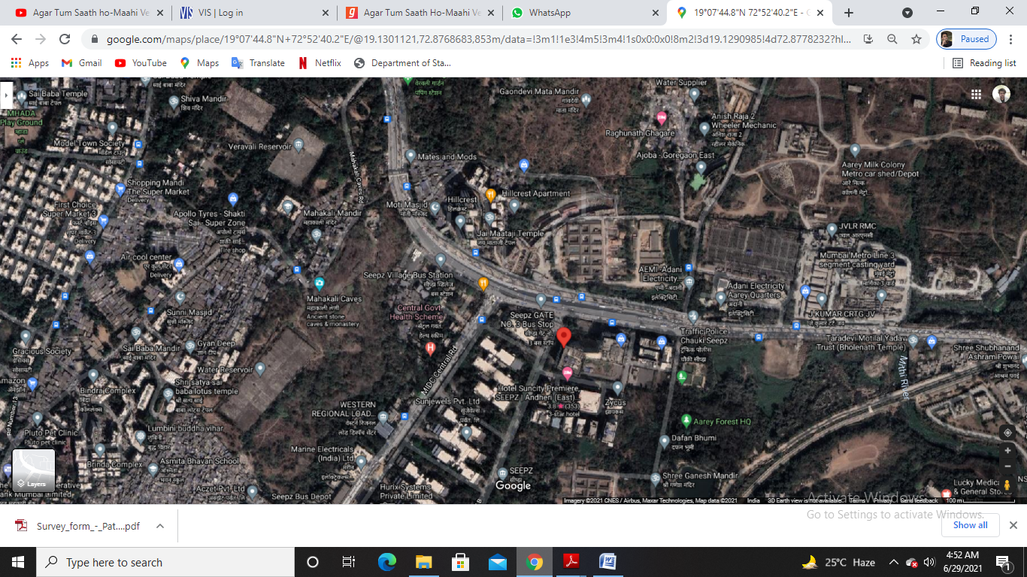

**ENCLOSURE: IV – PHOTOGRAPHS OF THE PROPERTY**

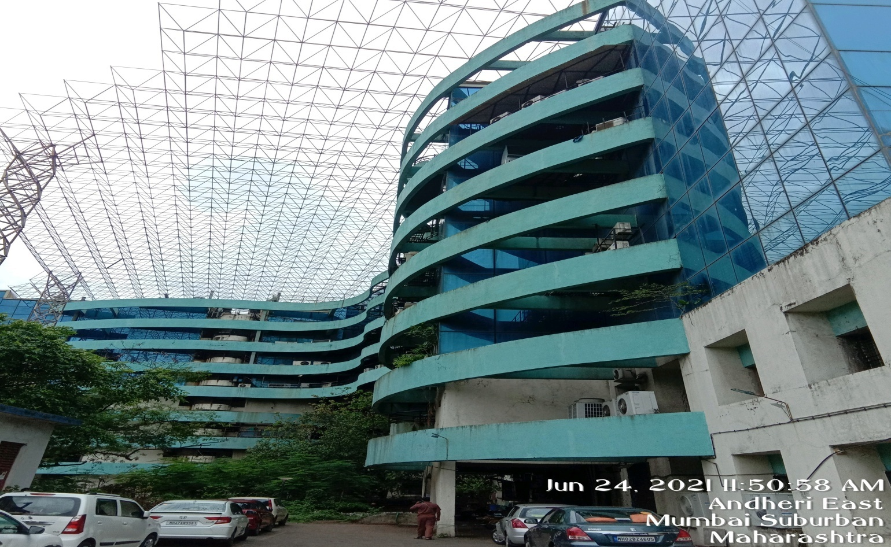

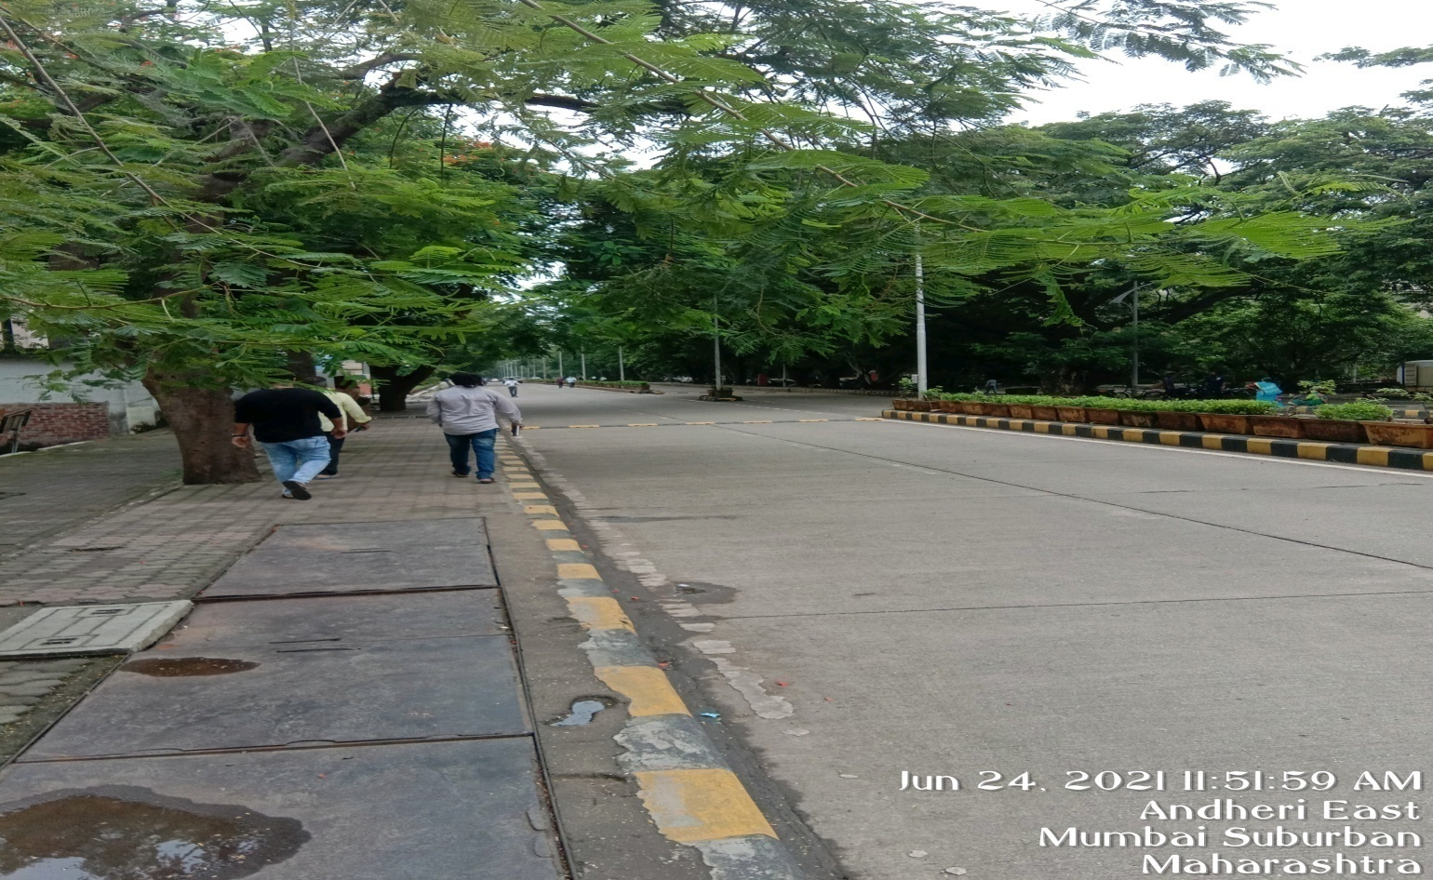

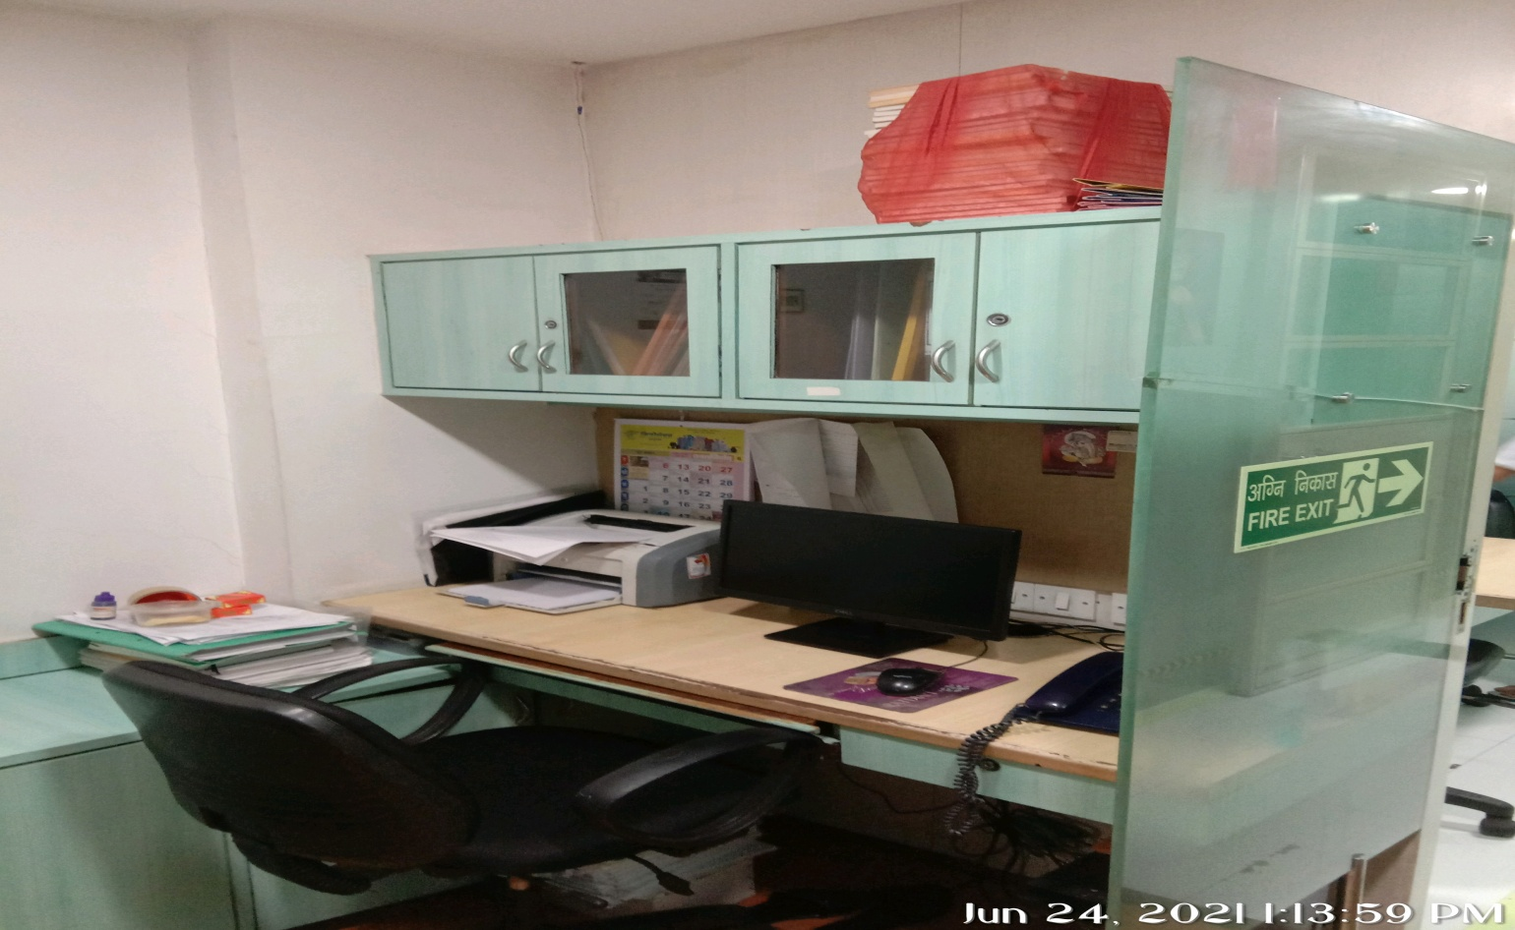

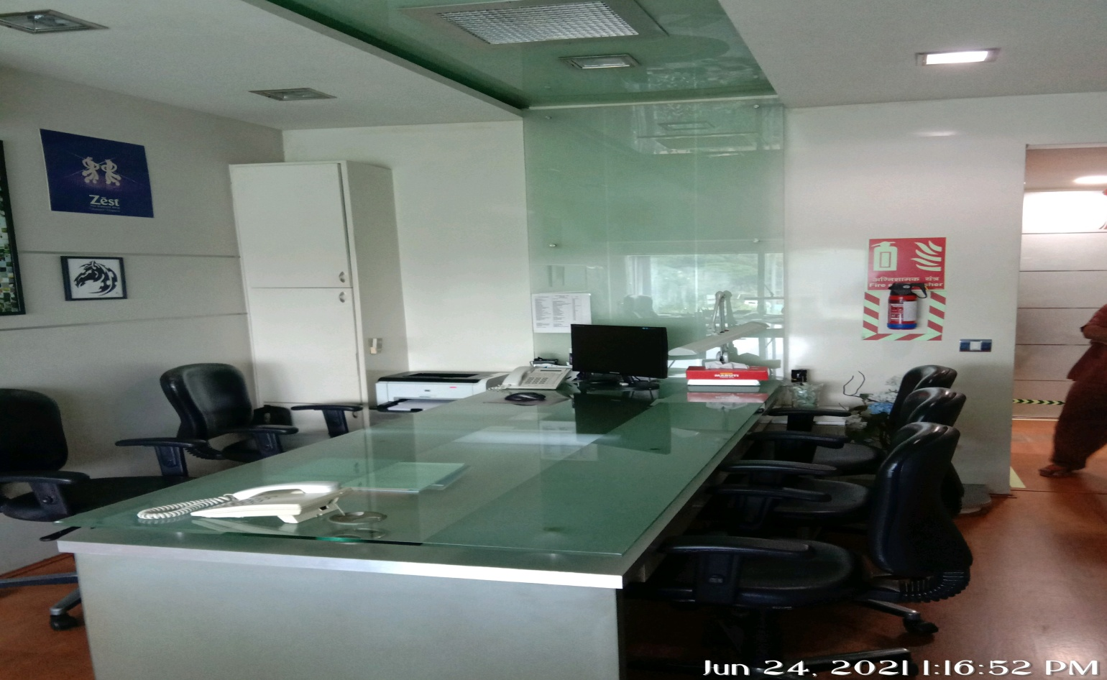 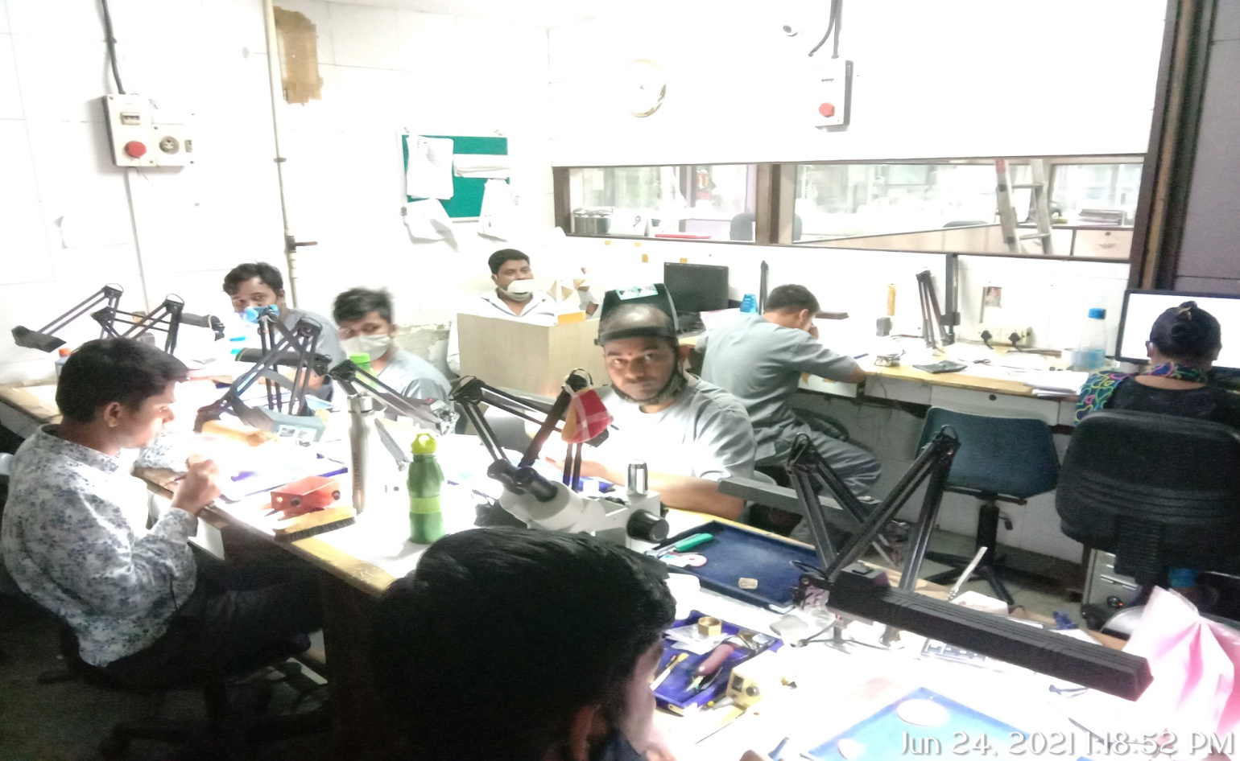

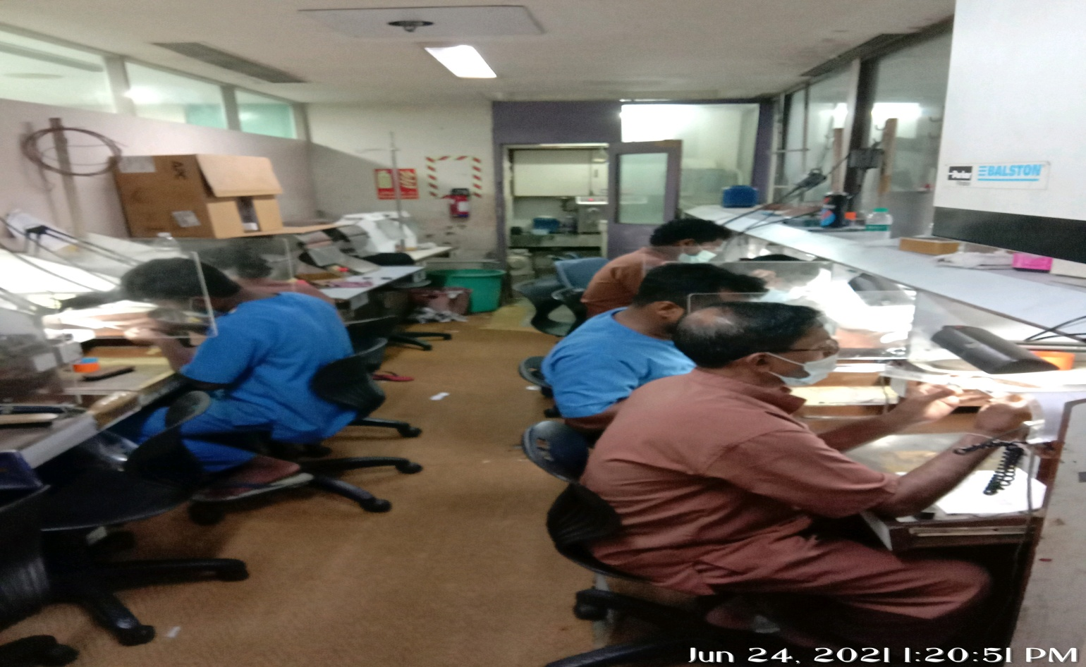 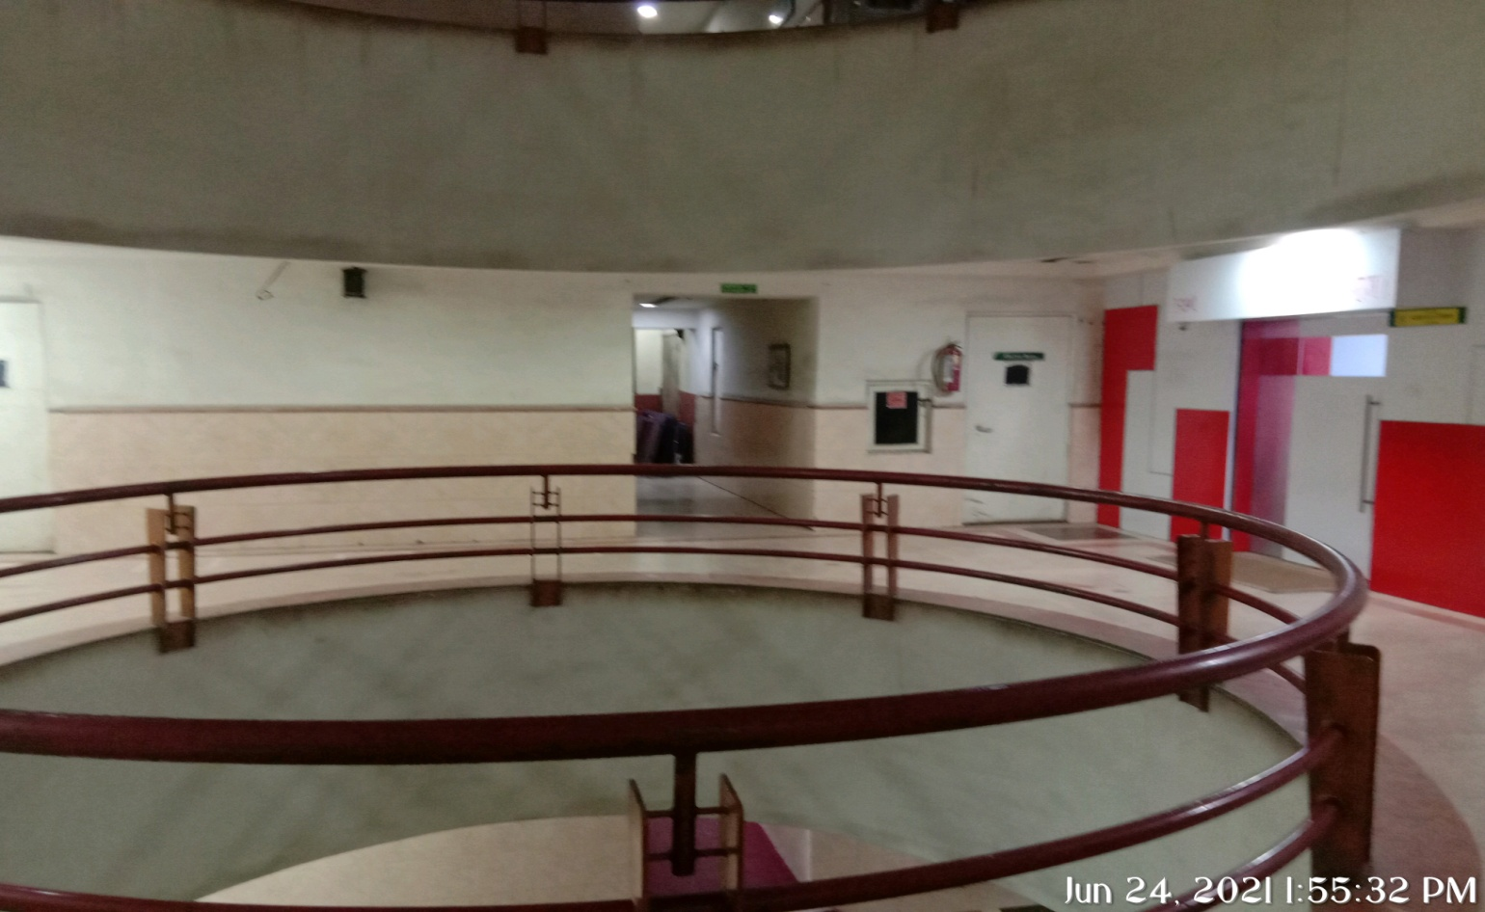

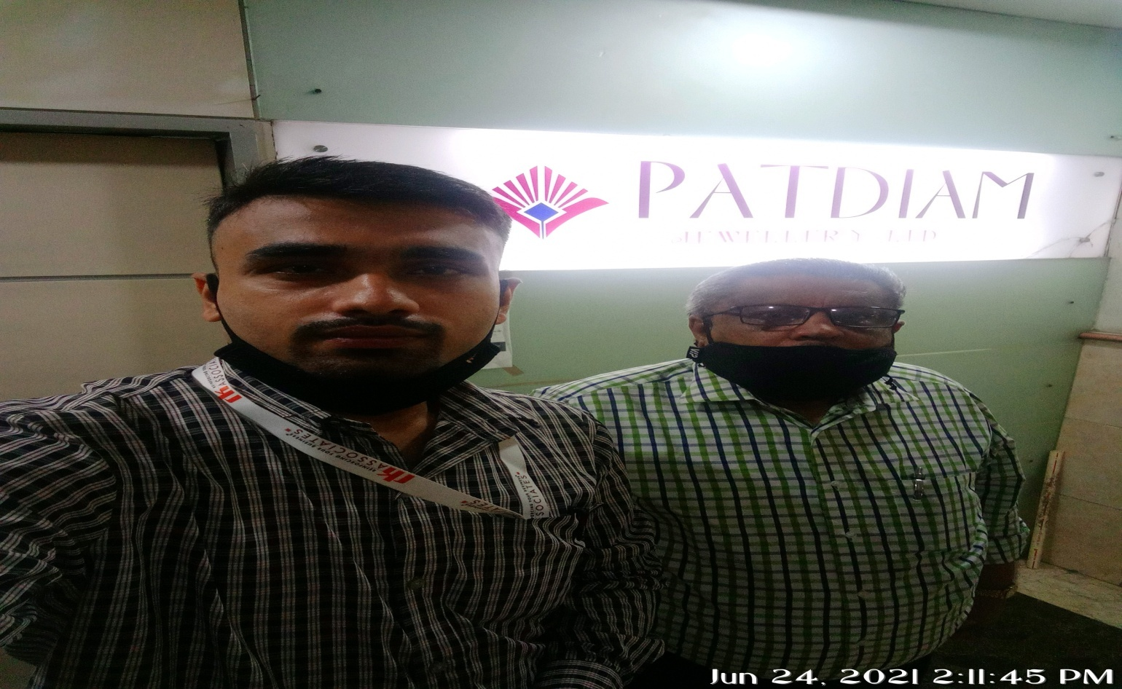

**ENCLOSURE: V– COPY OF CIRCLE RATE**

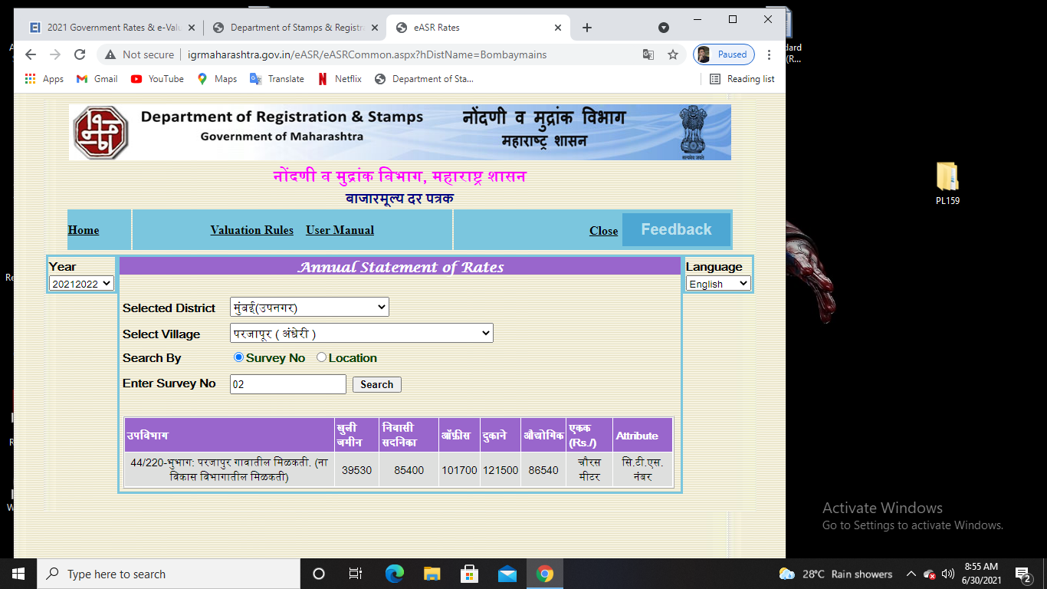

**ANNEXURE: VI- DECLARATION-CUM-UNDERTAKING**

1. I am a citizen of India.
2. No employee or member of R.K Associates has any direct/ indirect interest in the property or become so interested at any time during a period of three years prior to my appointment as valuer or three years after the valuation of assets was conducted by me.
3. The information furnished in our valuation report dated 29/6/2021 is true and correct to the best of my knowledge and belief and we have made an impartial and true valuation of the property.
4. Our authorized Engineer Mr. Abhishek Shanbhag have personally inspected the property on 24/6/2021 the work is not subcontracted to any other valuer and is carried out by us.
5. Valuation report is submitted in the format as prescribed by the Bank.
6. We have not been depanelled/ delisted by any other bank and in case any such depanelment by other banks during my empanelment with you, we will inform you within 3 days of such depanelment.
7. We have not been removed/dismissed from service/employment earlier.
8. We have not been convicted of any offence and sentenced to a term of imprisonment.
9. We have not been found guilty of misconduct in professional capacity.
10. I have not been declared to be unsound mind.
11. We are not undischarged bankrupt, or has not applied to be adjudicated as a bankrupt;
12. We are not an undischarged insolvent.
13. I have not been levied a penalty under section 271J of Income-tax Act, 1961 (43 of 1961) and time limit for filing appeal before Commissioner of Income tax (Appeals) or Income-tax Appellate Tribunal, as the case may be has expired, or such penalty has been confirmed by Income-tax Appellate Tribunal, and five years have not elapsed after levy of such penalty.
14. I have not been convicted of an offence connected with any proceeding under the Income Tax Act 1961, Wealth Tax Act 1957 or Gift Tax Act 1958 and
15. Our PAN Card number/ GST number as applicable is**AAHCR0845G/ 09AAHCR0845G1ZP**
16. We undertake to keep you informed of any events or happenings which would make me ineligible for empanelment as a valuer.
17. We have not concealed or suppressed any material information, facts and records and I have made a complete and full disclosure.
18. We have read the Handbook on Policy, Standards and procedure for Real Estate Valuation, 2011 of the IBA and this report is in conformity to the “Standards” enshrined for valuation in the Part-B of the above handbook to the best of my ability.
19. We have read the International Valuation Standards (IVS) and the report submitted to the Bank for the respective asset class is in conformity to the “Standards” as enshrined for valuation in the IVS in“ General Standards” and “Asset Standards” as applicable.
20. I abide by the Model Code of Conduct for empanelment of valuer in the Bank.
21. I am registered under Section 34 AB of the Wealth Tax Act, 1957. (Strike off, if not applicable).
22. I am valuer registered with Insolvency & Bankruptcy Board of India (IBBI) (Strike off, if not applicable).
23. My CIBIL Score and credit worthiness is as per Bank’s guidelines.
24. I am the proprietor / partner / authorized official of the firm / company, who is competent to sign this valuation report.
25. I will undertake the valuation work on receipt of Letter of Engagement generated from the system (i.e. LLMS/LOS) only.
26. Further, I hereby provide the following information**.**

|  |  |  |  |
| --- | --- | --- | --- |
| **S. No.** | **Particulars** | **Valuer comment** | |
|  | Background information of the asset being valued | This is a Commercial property located at aforesaid address having total built-up area as 6079.4sqft. / 565 sq.mtr. as per the documents/ information provided to us by the Bank/ client. | |
|  | Purpose of valuation and appointing authority | Please refer to Page No.01 of the Report. | |
|  | Identity of the Valuer and any other experts involved in the valuation | **Survey Analyst: Er. Abhishek Shanbhag**  **Engineering Analyst: Er Abhishek Sharma**  **Valuer/ Reviewer: (HOD Engg.)** | |
|  | Disclosure of valuer interest or conflict, if any | No relationship with the borrower or any kind of conflict of interest. | |
|  | Date of appointment, valuation date and date of report | **Date of Appointment:** | **31/5/2021** |
| **Date of Survey:** | **24/6/2021** |
| **Valuation Date:** | **29/6/2021** |
| **Date of Report:** | **29/6/2021** |
|  | Inspections and/or investigations undertaken | Yes by our authorized Survey Engineer Abhishek Shanbhag bearing knowledge of that area on29/6/2021. Property was shown and identified by owner’s representative Mr. Bharat Shah (🕿-9833414244) | |
|  | Nature and sources of the information used or relied upon | Please refer to Page No. 04 of the Report. | |
|  | Procedures adopted in carrying out the valuation and valuation standards followed | Market Comparable Sales Approach | |
|  | Restrictions on use of the report, if any | Value varies with the Purpose/ Date/ Market & Asset Condition& Situation prevailing in the market. We recommend not to refer the indicative & estimated prospective Value of the asset given in this report if any of these points are different from the one mentioned aforesaid in the Report.  This report has been prepared for the purposes stated in the report and should not be relied upon for any other purpose. Our client is the only authorized user of this report and is restricted for the purpose indicated in the engagement letter. I/we do not take any responsibility for the unauthorized use of this report.  During the course of the assignment we have relied upon various information, data, documents provided by Bank/ client in good faith. If at any point of time in future it comes to knowledge that the information given to us is untrue, fabricated, misrepresented then the use of this report at very moment will become null & void.  This report only contains general assessment & opinion on the indicative, estimated Market Value of the property for which Bank has asked to conduct the Valuation and found as per the information given in the copy of documents, information, data provided to us and/ or confirmed by the owner/ owner representative to us at site which has been relied upon in good faith. It doesn’t contain any other recommendations of any sort including but not limited to express of any opinion on the suitability or otherwise of entering into any transaction with the borrower. | |
|  | Major factors that were taken into account during the valuation | Please refer to Page No. 4-8 of the Report. | |
|  | Major factors that were not taken into account during the valuation | NA | |
|  | Caveats, limitations and disclaimers to the extent they explain or elucidate the limitations faced by valuer, which shall not be for the purpose of limiting his responsibility for the valuation report. | Please see attached Annexure. | |

**Date: 29/6/2021**

**Place:** Noida

**Signature**

**(Authorized Person of R.K Associates Valuers & Techno Engg. Consultants (P) Ltd.)**

**ANNEXURE: VII- MODEL CODE OF CONDUCT FOR VALUERS**

**Integrity and Fairness**

1. A valuer shall, in the conduct of his/its business, follow high standards of integrity and fairness in all his/its dealings with his/its clients and other valuers.
2. A valuer shall maintain integrity by being honest, straightforward, and forthright in all professional relationships.
3. A valuer shall endeavour to ensure that he/it provides true and adequate information and shall not misrepresent any facts or situations.
4. A valuer shall refrain from being involved in any action that would bring disrepute to the profession.
5. A valuer shall keep public interest foremost while delivering his services.

**Professional Competence and Due Care**

1. A valuer shall render at all times high standards of service, exercise due diligence, ensure proper care and exercise independent professional judgment.
2. A valuer shall carry out professional services in accordance with the relevant technical and professional standards that may be specified from time to time.
3. A valuer shall continuously maintain professional knowledge and skill to provide competent professional service based on up-to-date developments in practice, prevailing regulations/guidelines and techniques.
4. In the preparation of a valuation report, the valuer shall not disclaim liability for his/its expertise or deny his/its duty of care, except to the extent that the assumptions are based on statements of fact provided by the company or its auditors or consultants or information available in public domain and not generated by the valuer.
5. A valuer shall not carry out any instruction of the client insofar as they are incompatible with the requirements of integrity, objectivity and independence.
6. A valuer shall clearly state to his client the services that he would be competent to provide and the services for which he would be relying on other valuers or professionals or for which the client can have a separate arrangement with other valuers.

**Independence and Disclosure of Interest**

1. A valuer shall act with objectivity in his/its professional dealings by ensuring that his/its decisions are made without the presence of any bias, conflict of interest, coercion, or undue influence of any party, whether directly connected to the valuation assignment or not.
2. A valuer shall not take up an assignment if he/it or any of his/its relatives or associates is not independent in terms of association to the company.
3. A valuer shall maintain complete independence in his/its professional relationships and shall conduct the valuation independent of external influences.
4. A valuer shall wherever necessary disclose to the clients, possible sources of conflicts of duties and interests, while providing unbiased services.
5. A valuer shall not deal in securities of any subject company after any time when he/it first becomes aware of the possibility of his/its association with the valuation, and in accordance with the Securities and Exchange Board of India (Prohibition of Insider Trading) Regulations, 2015 or till the time the valuation report becomes public, whichever is earlier.
6. A valuer shall not indulge in “mandate snatching or offering”convenience valuations” in order to cater to a company or client’s needs.
7. As an independent valuer, the valuer shall not charge success fee.
8. In any fairness opinion or independent expert opinion submitted by a valuer, if there has been a prior engagement in an unconnected transaction, the valuer shall declare the association with the company during the last five years.

**Confidentiality**

1. A valuer shall not use or divulge to other clients or any other party any confidential information about the subject company, which has come to his/its knowledge without proper and specific authority or unless there is a legal or professional right or duty to disclose.

**Information Management**

1. A valuer shall ensure that he/ it maintains written contemporaneous records for any decision taken, the reasons for taking the decision, and the information and evidence in support of such decision. This shall be maintained so as to sufficiently enable a reasonable person to take a view on the appropriateness of his/its decisions and actions.
2. A valuer shall appear, co-operate and be available for inspections and investigations carried out by the authority, any person authorised by the authority, the registered valuers organization with which he/it is registered or any other statutory regulatory body.
3. A valuer shall provide all information and records as may be required by the authority, the Tribunal, Appellate Tribunal, the registered valuers organization with which he/it is registered, or any other statutory regulatory body.
4. A valuer while respecting the confidentiality of information acquired during the course of performing professional services, shall maintain proper working papers for a period of three years or such longer period as required in its contract for a specific valuation, for production before a regulatory authority or for a peer review. In the event of a pending case before the Tribunal or Appellate Tribunal, the record shall be maintained till the disposal of the case.

**Gifts and hospitality.**

1. A valuer or his/its relative shall not accept gifts or hospitality which undermines or affects his independence as a valuer.

Explanation: For the purposes of this code the term ‘relative’shall have the same meaning as defined in clause (77) of Section 2 of the Companies Act, 2013 (18 of 2013).

1. A valuer shall not offer gifts or hospitality or a financial or any other advantage to a public servant or any other person with a view to obtain or retain work for himself/ itself, or to obtain or retain an advantage in the conduct of profession for himself/ itself.

**Remuneration and Costs.**

1. A valuer shall provide services for remuneration which is charged in a transparent manner, is a reasonable reflection of the work necessarily and properly undertaken, and is not inconsistent with the applicable rules.
2. A valuer shall not accept any fees or charges other than those which are disclosed in a written contract with the person to whom he would be rendering service.

**Occupation, employability and restrictions.**

1. A valuer shall refrain from accepting too many assignments, if he/it is unlikely to be able to devote adequate time to each of his/ its assignments.
2. A valuer shall not conduct business which in the opinion of the authority or the registered valuer organisation discredits the profession.

**Miscellaneous**

1. A valuer shall refrain from undertaking to review the work of another valuer of the same client except under written orders from the bank or housing finance institutions and with knowledge of the concerned valuer.
2. A valuer shall follow this code as amended or revised from time to time

Signature of the Valuer: ________________

Name of the Valuer: R.K Associates Valuers & Techno Engg. Consultants (P) Ltd.

Address of the Valuer: D-39, Sector-2, Noida-201301

Date: 29/6/2021

Place: Noida

**ENCLOSURE: VI – VALUER’S REMARKS**

|  |  |
| --- | --- |
|  | This Valuation report is prepared based on the copies of the documents/ information which interested organization or customer could provide to us out of the standard checklist of documents sought from them and further based on our assumptions and limiting conditions. All such information provided to us has been relied upon in good faith and we have assumed that it is true and correct. Verification or cross checking of the documents provided to us from the originals has not been done at our end. |
|  | Legal aspects for eg. investigation of title, ownership rights, lien, charge, mortgage, lease, verification of documents, etc. have to be taken care by legal expert/ Advocate and same are not done at our end. It is assumed that the concerned Lender/ Financial Institution has asked for the valuation of that property for which the legal verification has been already taken and cleared by the competent Advocate before requesting for the Valuation report. |
|  | Analysis and conclusions adopted in the report are limited to the reported assumptions, conditions and information came to our knowledge during the course of the work. |
|  | Value varies with the Purpose/ Date/ Condition prevailing in the market. We recommend not to refer the indicative & estimated prospective Value of the asset given in this report if any of these points are different from the one mentioned aforesaid in the Report. We also recommend that the indicative estimated Value in the Valuation Report holds good only upto the period of 3 months from the date of Valuation. |
|  | This report is having limited scope as per its fields & format to provide only the general basic idea of the value of the property prevailing in the market based on the documents/ data/ information provided by the client. The suggested indicative prospective estimated value should be considered only if transaction is happened as free market transaction. |
|  | This Valuation report is prepared based on the facts of the property on the date of the survey. It is a well-known fact that the market value of any asset varies with time & socio-economic conditions prevailing in the country. In future property Market may go down, property conditions may change or may go worse, Property reputation may differ, Property vicinity conditions may go down or become worse, Property market may change due to impact of Govt. policies or effect of World economy, Usability prospects of the property may change, etc. Hence before financing, Banker/ FI should take into consideration all such future risk and should loan conservatively to keep the advanced money safe in case of the downward trend of the property value. |
|  | Valuation of the same asset/ property can fetch different values in different situations. For eg. Valuation of a running/ operational shop/ hotel/ factory will fetch better value and in case of closed shop/ hotel/ factory it will have considerable lower value. Similarly an asset sold directly by an owner in the market will fetch better value and if the same asset/ property is sold by any financer due to encumbrance on it will fetch lower value. Hence before financing, Banker/ FI should take into consideration all such future risks and should loan conservatively to keep the advanced money safe in case of any such situation. |
|  | Getting cizra map or coordination with revenue officers for site identification is not done at our end. |
|  | Valuation is done for the property identified to us by the owner/ owner representative. At our end we have just cross verified the identification of the property with reference to the documents produced for perusal. Method by which identification of the property is carried out is also mentioned in the report clearly. Responsibility of identifying the correct property to the Valuer/ its authorized surveyor is solely of the client/ owner for which Valuation has to be carried out.It is requested from the Bank to cross check from their own records/ information if this is the same property for which Valuation has to be carried out to ensure that owner has not misled the Valuer company or misrepresented the property due to any vested interest. |
|  | In India more than 70% of the geographical area is lying under rural/ remote/ non municipal/ unplanned area where the subject property is surrounded by vacant lands having no physical demarcation or having any display of property survey or municipal number / name plate on the property clearly. Even in old locations of towns, small cities & districts where property number is either not assigned or not displayed on the properties clearly and also due to the presence of multiple/ parallel departments due to which ownership/ rights/ illegal possession/ encroachment issues are rampant across India and due to these limitations at many occasions it becomes tough to identify the property with 100% surety from the available documents, information & site whereabouts and thus chances of error, misrepresentation by the borrower and margin of chances of error always persists in such cases. To avoid any such chances of error it is advised to the Bank to engage municipal/ revenue department officials to get the confirmation of the property to ensure that the property shown to Valuer/ Banker is the same as for which documents are provided. |
|  | If this Valuation Report is prepared for the Flat/ dwelling unit situated in a Group Housing Society or Integrated Township then approvals, maps of the complete group housing society/ township is out of scope of this report and this report will be made for the specific unit based on the assumption that complete Group Housing Society/ Integrated Township must be approved in all respect.. |
|  | Due to fragmented & frequent change in building/ urban planning laws/ guidelines from time to time, different laws/ guidelines between regions/ states and no strict enforceability of Building Bye-Laws in India specially in non-metro and scale b & c cities & Industrial areas, property owners many times extend or make changes in the covered area/ layout from the approved/ applicable limits. There are also situations where properties are decades old when there was no formal Building Bye-Laws applicable when the construction must have been done. Due to such discrete/ unplanned development in many regions sometimes it becomes tough to determine the exact lawful situation on ground for the Valuer. In case nothing specific is noted on the covered built-up area considered in the Valuation Report, the covered area present on the site as per site survey will be considered in the Valuation. |
|  | Valuation is a subjective field and opinion may differ from consultant to consultant. To check the right opinion, it is important to evaluate the methodology adopted and various data point/ information/ factors/ assumption considered by the consultant which became the basis for the Valuation report before reaching to any conclusion. |
|  | Value analysis of any asset cannot be regarded as an exact science and the conclusions arrived at in many cases will, of necessity, be subjective and dependent on the exercise of individual judgment. Given the same set of facts and using the same assumptions, expert opinions may differ due to the number of separate judgment decisions, which have to be made. Therefore, there can be no standard formula to establish an indisputable exchange ratio. In the event of a transaction, the actual transaction value achieved may be higher or lower than our indicative analysis of value depending upon the circumstances of the transaction. The knowledge, negotiability and motivations of the buyers and sellers and the applicability of a discount or premium for control will also affect actual price achieved. Accordingly, our indicative analysis of value will not necessarily be the price at which any agreement proceeds. The final transaction price is something on which the parties themselves have to agree. However our Valuation analysis can definitely help the stakeholders to make them informed and wise decision about the Value of the asset and can help in facilitating the arm’s length transaction. |
|  | This report is prepared on the RKA V-L1 (Basic) Valuation format as per the client requirement and scope of work. This report is having limited scope as per its fields & format to provide only the general estimated & indicative basic idea of the value of the property prevailing in the market based on the information provided by the client. No detailed analysis, audit or verification has been carried out of the subject property. |
|  | This is just an opinion report and doesn’t hold any binding on anyone. It is requested from the concerned Client/ Bank/ Financial Institution which is using this report for mortgaging the property that they should consider all the different associated relevant & related factors & risks before taking any business decision based on the content of this report. |
|  | All Pages of the report including annexures are signed and stamped from our office. In case any paper in the report is without stamp & signature then this should not be considered a valid paper issued from this office. |
|  | Defect Liability Period is **30 DAYS**. We request the concerned authorized reader of this report to check the contents, data and calculations in the report within this period and intimate us in writing if any corrections are required or in case of any other concern with the contents or opinion mentioned in the report. Corrections only related to typographical, calculation, spelling mistakes will be entertained within the defect liability period. No request for any illegitimate value revision, date change or any other change will be entertained other than the one mentioned above. |
|  | R.K Associates encourages its customers to give feedback or inform concerns over its services through proper channel at [**valuers@rkassociates.org**](mailto:valuers@rkassociates.org) in writing within 30 days of report delivery. After this period no concern/ complaint/ proceedings in connection with the Valuation Services can be entertained due to possible change in situation and condition of the property. |
|  | Our Data retention policy is of **ONE YEAR**. After this period we remove all the concerned records related to the assignment from our repository. No clarification or query can be answered after this period due to unavailability of the data. |
|  | This Valuation report is governed by our (1) Internal Policies, Processes & Standard Operating Procedures, (2) R.K Associates Quality Policy, (3) Valuation & Survey Best Practices Guidelines formulated by management of R.K Associates, (4) Information input given to us by the customer and (4) Information/ Data/ Facts given to us by our field/ office technical team. Management of R.K Associates never gives acceptance to any unethical or unprofessional practice which may affect fair, correct & impartial assessment and which is against any prevailing law. In case of any indication of any negligence, default, incorrect, misleading, misrepresentation or distortion of facts in the report then it is the responsibility of the user of this report to immediately or atleast within the defect liability period bring all such act into notice of R.K Associates management so that corrective measures can be taken instantly. |
|  | R.K Associates never releases any report doing alterations or modifications by pen. In case any information/ figure of this report is found altered with pen then this report will automatically become null & void. |