**REPORT FORMAT:** V-L3 (Medium) | Version: 8.0_2019

**File No.: VIS(2021-22)**-**PL800-699-884 Dated: 28.12.2021**

**VALUATION ASSESSMENT**

**OF**

**RESIDENTIAL FLAT**

**SITUATED AT**

**FLAT NO. A-1403, 14TH FLOOR, A WING, INDIABULLS BLU, GANPATRAO KADAM MARG, LOWER PAREL, MUMBAI-400013**

**OWNER/S**

**M/S. ANUSHNA ESTATES PRIVATE LIMITED**

**A/C M/S. ANUSHNA ESTATES PRIVATE LIMITED**

**REPORT PREPARED FOR**

**M/S. VENUS INDIA ASSET FINANCE PVT LTD, SECTOR 16, NOIDA**

***\*\*Important - In case of any query/ issue or escalation you may please contact Incident Manager***

***at valuers@rkassociates.org. We will appreciate your feedback in order to improve our services.***

***NOTE: As per IBA Guidelines please provide your feedback on the report within 15 days of its submission after which report will be considered to be correct.***

|  |  |
| --- | --- |
| **PART A** | **RKA FORMAT OF OPINION REPORT ON VALUATION** |

|  |  |
| --- | --- |
| Name & Address of Branch | M/s. Venus India Asset Finance Pvt. Ltd, Sector 16, Noida |
| Name of Customer (s)/ Borrower Unit | M/s. Anushna Estates Private Limited |

|  |  |  |
| --- | --- | --- |
| **S.NO.** | **CONTENTS** | **DESCRIPTION** |
|  | **INTRODUCTION** | |
|  | Name of Property Owner | M/s. Anushna Estates Private Limited |
| Address & Phone Number of the Owner | 306, Lusa Tower, Azadpur Commercial Complex, Delhi-110033 |
|  | Purpose of the Valuation | For Value assessment of the asset for creating collateral mortgage for Bank Loan purpose |
|  | Date of Inspection of the Property | 24 December 2021 |
|  | Date of Valuation Report | 28 December 2021 |
|  | Name of the Developer of the Property | Not Applicable |
| Type of Developer | Private builder built property |

|  |  |  |  |  |  |  |  |  |
| --- | --- | --- | --- | --- | --- | --- | --- | --- |
|  | **PHYSICAL CHARACTERISTICS OF THE PROPERTY** | | | | | | | |
|  | **BRIEF DESCRIPTION OF THE PROPERTY UNDER VALUATION**    ***Snapshot of the Asset/ Property Under Valuation***  This Valuation Report is prepared for a residential flat situated at the aforesaid address having total carpet area 72.57 sq. mtr. / 781.15 sq. ft. of the flat as per the agreement for sale provided to us by the client.  The subject flat is being purchased by the virtue of agreement for sale vide dated 29/10/2018 from Indiabulls Infrastructure Limited.  The subject flat is located at the 14th floor of the Indiabulls Blu society consisting of 2B+G+46 floors. The subject property is 2BHK flat which consists of 1 master bedroom, 1 bed room, 2 toilets, 1 hall and 1 kitchen and 2 covered parking.  We have relied upon the information provided by the company only, however the financers are advised to get the legal opinion from the competent authority.  During our site survey we have observed that the subject flat is lying vacant but in the possession of the owner.  The subject property is situated at Ganpatrao Kadam Marg of 45 ft. which is directly connected to the main Dr. Annie Besant Road of 80 ft.  This report only contains general assessment & opinion on the Guideline Value and the indicative, estimated Market Value of the property found on as-is-where basis on site for which the Bank/ customer has shown & asked us to conduct the Valuation for which photographs is also attached with the report. No legal aspects in terms of ownership or any other legal aspect is taken into consideration. It doesn’t contain any due-diligence other than the valuation assessment of the property shown to us on site. Information/ data/ documents given to us by Bank/ client has been relied upon in good faith. This report doesn’t contain any other recommendations of any sort. | | | | | | | |
|  | **Location attribute of the property** | | | | | | | |
|  | Nearby Landmark | | Near Raheja Atlantis | | | | | |
|  | Postal Address of the Property | | Flat No. A-1403, 14th Floor, A Wing, Indiabulls Blu, Ganpatrao Kadam Marg, Lower Parel, Mumbai-400013 | | | | | |
|  | Area of the Plot/ Land | | NA | | | | | |
| *Also please refer to Part-B Area description of the property. Area measurements considered in the Valuation Report is adopted from relevant approved documents or actual site measurement whichever is less. Verification of the area measurement of the property is done only based on sample random checking.* | | | | | |
|  | Type of Land | | Plain Land | | | | | |
|  | Independent access/ approach to the property | | Clear independent access is available | | | | | |
|  | Google Map Location of the Property with a neighborhood layout map | | Enclosed with the Report | | | | | |
| Coordinates or URL: 18°59'50.7"N 72°49'16.5"E | | | | | |
|  | Details of the roads abutting the property | | | | | | | |
|  | 1. Main Road Name & Width | | Dr. Annie Besant Road | | | | 80 ft. | |
|  | 1. Front Road Name & width | | Ganpatrao Kadam Marg | | | | 45 ft. | |
|  | 1. Type of Approach Road | | Bituminous Road | | | | | |
|  | 1. Distance from the Main Road | | Approx. 500 mtr | | | | | |
|  | Description of adjoining property | | It is a mixed used area, commercial & residential. | | | | | |
|  | Plot No./ Survey No. | | Cadastral Survey No.131 & 132 | | | | | |
|  | Ward/ Zone | | G | | | | South | |
|  | Sub registrar | | Mumbai | | | | | |
|  | District | | Mumbai | | | | | |
|  | Any other aspect | | Valuation is done for the property found as per the information given in the copy of documents provided to us and/ or confirmed by the owner/ owner representative to us at site.  Getting cizra map or coordination with revenue officers for site identification is a separate activity and is not part of the Valuation services. | | | | | |
| 1. Identification of the property   *(Property found as per the information given in the documents provided to us and/ or confirmed by the owner/ owner representative to us on site.)* | | ☐ | From Schedule of the Property mentioned in the title deed | | | | |
| ☐ | Done from the name plate displayed on the property | | | | |
| ☐ | Identified by the owner | | | | |
| ☐ | Enquired from local residents/ public | | | | |
| ☒ | Identified by owner’s representative | | | | |
| ☐ | Identification of the property could not be done properly | | | | |
| ☐ | Survey was not done | | | | |
| 1. Type of Survey | | Full survey (inside-out with approximate measurements & photographs). | | | | | |
| 1. Is property clearly demarcated by permanent/ temporary boundary on site | | Yes demarcated properly | | | | | |
| 1. Is the property merged or colluded with any other property | | Yes | | | | | |
| --- | | | | | |
| 1. City Categorization | | Metro City | | | | Urban Developed | |
| 1. Characteristics of the locality | | Good | | | | Within good urban developed area | |
| 1. Property location classification | | Road Facing | | | None | | None |
| 1. Property Facing | | North-West Facing | | | | | |
| Covered Built-up area description  *(Plinth/ Carpet/ Saleable Area)* | | 72.57 sq. mtr. / 781.15 sq. ft. carpet area | | | | | |
| *Also please refer to Part B - Area description of the property. Area measurements considered in the Valuation Report is adopted from relevant approved documents or actual site measurement whichever is less. Verification of the area measurement of the property is done only based on sample random checking.* | | | | | |
|  | **Boundaries schedule of the Property** | | | | | | | |
|  | Are Boundaries matched | | No, boundaries are not mentioned in the documents. | | | | | |
|  | **Directions** | **As per Conveyance Deed/ TIR** | | | **As per Site Survey** | | | |
| East | NA | | | Open to sky | | | |
| West | NA | | | Passage | | | |
| North | NA | | | Staircase / Lift | | | |
| South | NA | | | Open to sky | | | |

|  |  |  |  |
| --- | --- | --- | --- |
|  | **TOWN PLANNING/ ZONING PARAMETERS** | | |
|  | Master Plan provisions related to property in terms of Land use | Residential Apartment in multistoried building | |
| 1. Any conversion of land use done | Not in scope of this report | |
| 1. Current activity done in the property | Residential purpose but vacant at the time of survey | |
| 1. Is property usage as per applicable zoning | Yes | |
| 1. Any notification on change of zoning regulation | No information available | |
| 1. Street Notification | Residential | |
|  | Provision of Building by-laws as applicable | **PERMITTED** | **CONSUMED** |
| 1. FAR/ FSI | Please refer to area chart description | Please refer to area chart description |
| 1. Ground coverage | ----------------do------------- | ----------------do------------- |
| 1. Number of floors | ----------------do------------- | ----------------do------------- |
| 1. Height restrictions | ----------------do------------- | ----------------do------------- |
| 1. Front/ Back/ Side Setback | ----------------do------------- | ----------------do------------- |
|  | Status of Completion/ Occupational certificate | NA | NA |
|  | Comment on unauthorized construction if any | Cannot comment since approved map is not provided to us | |
|  | Comment on Transferability of developmentalrights | Mumbai Metropolitan Region Development Authority-2036 | |
|  | 1. Planning Area/ Zone | Master Plan of Mumbai | |
| 1. Master Plan currently in force | MMRDA-2036 | |
| 1. Municipal limits | Mumbai Municipal Corporation | |
|  | Developmental controls/ Authority | MMRDA | |
|  | Zoning regulations | Residential colony | |
|  | Comment on the surrounding land uses & adjoining properties in terms of uses | All adjacent properties are used for residential purpose | |
|  | Comment of Demolition proceedings if any | Not known to us | |
|  | Comment on Compounding/ Regularization proceedings | Not known to us | |
|  | Any other aspect |  | |
| 1. Any information on encroachment | Not visible at the site | |
| 1. Is the area part of unauthorized area/ colony | No (As per general information available) | |

|  |  |  |  |  |  |  |
| --- | --- | --- | --- | --- | --- | --- |
|  | **DOCUMENT DETAILS AND LEGAL ASPECTS OF THE PROPERTY** | | | | | |
|  | Ownership documents provided | Agreement to Sell | None | | | None |
|  | Names of the Legal Owner/s | M/s. Anushna Estates Private Limited | | | | |
|  | Constitution of the Property | Free hold, complete transferable rights | | | | |
|  | Agreement of easement if any | Not Required | | | | |
|  | Notice of acquisition if any and area under acquisition | No, as per general information available in the public domain | | | | |
|  | Notification of road widening if any and area under acquisition | No, as per general information available in the public domain | | | | |
|  | Heritage restrictions, if any | No | | | | |
|  | Comment on Transferability of the property ownership | Free hold, complete transferable rights | | | | |
|  | Comment on existing mortgages/ charges/ encumbrances on the property, if any | Not known to us the bank is advised to check from the owner | | | NA | |
|  | Comment on whether the owners of the property have issued any guarantee*(personal or corporate)* as the case may be | Not known to us the bank is advised to check from the owner | | | NA | |
|  | **Building plan sanction:** | | | | | |
| 1. Authority approving the plan | Cannot comment since no approved map is provided to us | | | | |
| 1. Name of the office of the Authority | Cannot comment since no approved map is provided to us | | | | |
| 1. Any violation from the approved Building Plan | Cannot comment since no approved map is provided to us | | | | |
|  | Whether Property is Agricultural Land if yes, any conversion is contemplated | No not an agricultural property | | | | |
|  | Whether the property SARFAESI complaint | Yes | | | | |
|  | 1. Information regarding municipal taxes *(property tax, water tax, electricity bill)* | Property Tax | | No information available | | |
| Water Tax | | No information available | | |
| Electricity Bill | | No information available | | |
| 1. Observation on Dispute or Dues if any in payment of bills/ taxes | No information available to us | | | | |
| 1. Is property tax been paid for this property | Information not available. Please confirm from the owner. | | | | |
| 1. Property or Tax Id No. | No information provided. | | | | |
|  | Whether entire piece of land on which the unit is set up / property is situated has been mortgaged or to be mortgaged | Yes, as informed by owner/ owner representative. | | | | |
|  | Qualification in TIR/Mitigation suggested if any | Cannot comment since copy of TIR not made available to us | | | | |
| 1. Title verification | Any other aspect | This is just an opinion report on Valuation based on the copy of the documents/ information provided to us by the client and has been relied upon in good faith of the property found as per the information given in the documents provided to us and/ or confirmed by the owner/ owner representative to us on site.  Legal aspects, Title verification, Verification of authenticity of documents from originals or cross checking from any Govt. deptt. of the property have to be taken care by legal expert/ Advocate. | | | | |
| 1. Since how long owners owing the Property | Approx.4 Years | | | | |
| 1. Year of Acquisition/ Purchase | Year- 2018 | | | | |
| 1. Property presently occupied/ possessed by | Lying Vacant at the time of survey but in possession of the subject owner | | | | |
| 1. Title verification | Title verification needs to be done by competent advocate | | | | |
| 1. Details of leases if any | Not Applicable | | | | |

|  |  |  |
| --- | --- | --- |
|  | **ECONOMIC ASPECTS OF THE PROPERTY** | |
|  | Reasonable letting value/ Expected market monthly rental | NA |
|  | Is property presently on rent | No |
| 1. Number of tenants | NA |
| 1. Since how long lease is in place | NA |
| 1. Status of tenancy right | NA |
| 1. Amount of monthly rent received | NA |
|  | Taxes and other outgoing | NA |
|  | Property Insurance details | NA |
|  | Monthly maintenance charges payable | NA |
|  | Security charges, etc. | NA |
|  | Any other aspect | NA |

|  |  |  |
| --- | --- | --- |
|  | **SOCIO - CULTURAL ASPECTS OF THE PROPERTY** | |
|  | Descriptive account of the location of the property in terms of Social structure of the area in terms of population, social stratification, regional origin, age groups, economic levels, location of slums/squatter settlements nearby, etc. | Urban Developing area |
|  | Whether property belongs to social infrastructure like hospital, school, old age homes etc. | No |

|  |  |  |  |  |  |  |  |
| --- | --- | --- | --- | --- | --- | --- | --- |
|  | **FUNCTIONAL AND UTILITARIAN SERVICES, FACILITIES & AMENITIES** | | | | | | |
|  | Description of the functionality & utility of the property in terms of : | | | | | | |
|  | 1. Space allocation | | | | Yes | | |
| 1. Storage spaces | | | | Yes | | |
| 1. Utility of spaces provided within the building | | | | Yes | | |
| 1. Car parking facilities | | | | Yes | | |
| 1. Balconies | | | | Yes | | |
|  | Any other aspect | | | | | | |
|  | 1. Drainage arrangements | | | | Yes, drainage system available at the site. | | |
| 1. Water Treatment Plant | | | | No | | |
| 1. Power Supply arrangements | | Permanent | | Yes | | |
| Auxiliary | | No | | |
| 1. HVAC system | | | | No information available | | |
| 1. Security provisions | | | | Yes/ Private security guards | | |
| 1. Lift/ Elevators | | | | Yes | | |
| 1. Compound wall/ Main Gate | | | | Yes | | |
| 1. Whether gated society | | | | Yes | | |
| 1. Internal development | | | | | | |
| Garden/ Park/ Land scraping | Water bodies | | Internal roads | | Pavements | Boundary Wall |
| Yes | Yes | | No | | Yes | Yes |

|  |  |  |  |  |  |  |  |  |  |  |  |  |
| --- | --- | --- | --- | --- | --- | --- | --- | --- | --- | --- | --- | --- |
|  | **INFRASTRUCTURE AVAILABILITY** | | | | | | | | | | | |
|  | Description of Aqua Infrastructure availability in terms of: | | | | | | | | | | | |
|  | 1. Water Supply | | | | | Yes | | | | | | |
| 1. Sewerage/ sanitation system | | | | | Underground | | | | | | |
| 1. Storm water drainage | | | | | Yes | | | | | | |
|  | Description of other Physical Infrastructure facilities in terms of: | | | | | | | | | | | |
|  | 1. Solid waste management | | | | | Yes | | | | | | |
| 1. Electricity | | | | | Yes | | | | | | |
| 1. Road and Public Transport connectivity | | | | | Yes | | | | | | |
| 1. Availability of other public utilities nearby | | | | | Transport, Market, Hospital etc. available in close vicinity. | | | | | | |
|  | Proximity & availability of civic amenities & social infrastructure | | | | | | | | | | | |
|  | School | | Hospital | Market | Bus Stop | | Railway Station | | Metro | | | Airport |
| 0.4 Km | | 1.5 km | 0.7 km | 1.1 Km | | 4.5 km | | NA | | | 19.3 Km |
|  | Availability of recreation facilities (parks, open spaces etc.) | | | | Yes ample recreational facilities are available in the vicinity. | | | | | | | |
|  | | **MARKETABILITY ASPECTS OF THE PROPERTY:** | | | | | | | | | | |
|  | | Marketability of the property in terms of | | | | | | | | | | |
|  | | 1. Location attribute of the subject property | | | | Good | | | | | | |
| 1. Scarcity | | | | Similar kind of properties are not easily available in this area. | | | | | | |
| 1. Market condition related to demand and supply of the kind of the subject property in the area | | | | Good demand of such properties in the market | | | | | | |
| 1. Comparable Sale Prices in the locality | | | | Please refer to Part C: Valuation Assessment of the Property. | | | | | | |
|  | | Any other aspect which has relevance on the value or marketability of the property | | | | No | | | | | | |
|  | | 1. Any New Development in surrounding area | | | | No | | NA | | | | |
| 1. Any negativity/ defect/ disadvantages in the property/ location | | | | No | | NA | | | | |
|  | | **ENGINEERING AND TECHNOLOGY ASPECTS OF THE PROPERTY:** | | | | | | | | | | |
|  | | Type of construction & design | | | | RCC framed pillar, beam, column structure on RCC slab | | | | | | |
|  | | Method of construction | | | | Construction done using professional contractor workmanship based on architect plan | | | | | | |
|  | | Specifications | | | | | | | | | | |
| 1. Class of construction | | | | Class B construction (Good) | | | | | | |
| 1. Appearance/ Condition of structures | | | | Internal -Good | | | | | | |
| External - Good | | | | | | |
| 1. Roof | | | | **Floors/ Blocks** | | | | | **Type of Roof** | |
| 2B+G+46 | | | | | RCC | |
| 1. Floor height | | | | 10-12 ft | | | | | | |
| 1. Type of flooring | | | | Vitrified tiles, Italian Marble | | | | | | |
| 1. Doors/ Windows | | | | Aluminum flushed doors & windows | | | | | | |
| 1. Interior Finishing | | | | Neatly plastered and putty coated walls | | | | | | |
| 1. Exterior Finishing | | | | Glass facade | | | | | | |
| 1. Interior decoration/ Special architectural or decorative feature | | | | Beautifully & aesthetically designed interiors | | | | | | |
| 1. Class of electrical fittings | | | | Internal/ Normal quality fittings used | | | | | | |
| 1. Class of sanitary & water supply fittings | | | | Mixed (Internal & External)/ Normal quality fittings used | | | | | | |
|  | | Maintenance issues | | | | No maintenance issue, structure is maintained properly | | | | | | |
|  | | Age of building/ Year of construction | | | | 55-60 years | | | | Year 2013-14 | | |
|  | | Total life of the structure/ Remaining life expected | | | | 55-60 years | | | | Approx.50-55 years | | |
|  | | Extent of deterioration in the structure | | | | No deterioration came into notice through visual observation | | | | | | |
|  | | Structural safety | | | | Structure built on RCC technique so it can be assumed as structurally stable. However no structural stability certificate is available | | | | | | |
|  | | Protection against natural disasters viz. earthquakes etc. | | | | Can't comment due to unavailability of required technical data | | | | | | |
|  | | Visible damage in the building if any | | | | No visible damages in the structure | | | | | | |
|  | | System of air conditioning | | | | Fully centrally AC | | | | | | |
|  | | Provision of firefighting | | | | Automatic Water Sprinkler system with alarm | | | | | | |
|  | | Status of Building Plans/ Maps | | | | Cannot comment since no approved map given to us | | | | | | |
|  | | 1. Is Building as per approved Map | | | | Cannot comment since no approved map given to us | | | | | | |
| 1. Details of alterations/ deviations/ illegal construction/ encroachment noticed in the structure from the original approved plan | | | | ☐ Permissible Alterations | | | | | NA | |
| ☐ Not permitted alteration | | | | | NA | |
| 1. Is this being regularized | | | | NA | | | | | | |

|  |  |  |
| --- | --- | --- |
|  | **ENVIRONMENTAL FACTORS:** | |
|  | Use of environment friendly building materials like fly ash brick, other Green building techniques if any | Not known to us |
|  | Provision of rainwater harvesting | No |
|  | Use of solar heating and lighting systems, etc. | No |
|  | Presence of environmental pollution in the vicinity of the property in terms of industries, heavy traffic, etc. if any | Yes, normal vehicular pollution present |

|  |  |  |
| --- | --- | --- |
|  | **ARCHITECTURAL AND AESTHETIC QUALITY OF THE PROPERTY:** | |
|  | Descriptive account on whether the building is modern, old fashioned, etc., plain looking or with decorative elements, heritage value if applicable, presence of landscape elements,  etc. | Modern structure |

|  |  |  |
| --- | --- | --- |
|  | **VALUATION:** | |
|  | Methodology of Valuation – Procedures adopted for arriving at the Valuation | Please refer to ***Sub-Point ‘n’ of Point 1 of Part C: Valuation Assessment Factors*** of the report. |
|  | Prevailing Market Rate/ Price trend of the Property in the locality/ city from property search sites | Please refer to the ***Sub-Point ‘o’ of Point 1 of Part C: Valuation Assessment Factors*** of the report and the screenshot annexure in the report. |
|  | Guideline Rate obtained from Registrar’s office/ State Govt. gazette/ Income Tax Notification | Please refer to ***Part C: Valuation Assessment Factors*** of the report and the screenshot annexure in the report. |
|  | **Summary of Valuation** | For detailed Valuation calculation please refer to ***Points 1, 2, 3, 4, 5 & 6 of the Part C: Valuation Assessment Factors*** of the report. |
| 1. **Guideline Value** | **Public domain is not working** |
| 1. **Land** | **NA** |
| 1. **Building** | **NA** |
| 1. **Indicative Prospective Estimated Fair Market Value** | **Rs.5,27,00,000/-** |
| 1. **Expected Estimated Realizable Value** | **Rs.4,47,95,000/-** |
| 1. **Expected Forced/ Distress Sale Value** | **Rs.3,95,25,000/-** |
|  | 1. Justification for more than 20% difference in Market & Circle Rate | Circle rates are determined by the District administration as per their own theoretical internal policy for determining the minimum valuation of the property for property registration purpose and Market rates are adopted based on prevailing market dynamics which is explained clearly in Valuation assessment factors. |
| 1. Details of last two transactions in the locality/ area to be provided, if available | No authentic last two transactions details could be known. However prospective transaction details as per information available on public domain and gathered during site survey is mentioned in ***Point ‘o’*** of **Part C: Valuation Assessment Factors** of the report and the screenshots of the references are annexed in the report for reference. |

|  |  |  |
| --- | --- | --- |
|  | **Declaration** | 1. The information provided by us is true and correct to the best of my knowledge and belief. 2. The analysis and conclusions are limited by the reported assumptions, limiting conditions, remarks and the information came to knowledge during the course of the work. Please see the Assumptions, Remarks & Limiting conditions described in the Report. 3. I/ firm have read the Handbook on Policy, Standards and Procedures for Real Estate Valuation by Banks and HFIs in India, 2011 issued by IBA and NHB, fully understood the provisions of the same and followed the provisions of the same to the best of my ability and this report is in conformity to the Standards of Reporting enshrined in the above Handbook. 4. No employee or member of R.K Associates has any direct/ indirect interest in the property. 5. Our authorized surveyor AE Shreyash Shetty has visited the subject property in presence of owner’s representative Mr. Shaikh Parvez Alam on 24/12/2021. 6. I am a registered Valuer under Section 34 AB of Wealth Tax Act, 1957. 7. I/ firm is an approved Valuer under SARFAESI Act – 2002 and approved by the Bank. 8. We have submitted Valuation report directly to the Bank. 9. This valuation work is carried out by our Engineering team on the request from **M/s. Venus India Asset Finance Pvt. Ltd., Sector 16, Noida** |

|  |  |  |
| --- | --- | --- |
|  | **VALUATION COMPANY DETAILS:** | |
|  | **Name & Address of Valuer company** | M/s R.K. Associates Valuers & Techno Engineering Consultants Pvt. Ltd. D-39, 2nd Floor, Sector-02, Noida, U.P |
|  | **Engineering Team worked on the report** | ***SURVEYED BY:*** *AE Praveen Sharma* |
| ***PREPARED BY:*** *Er. Ritesh* |
| ***REVIEWED BY: HOD Valuations*** |

|  |  |  |
| --- | --- | --- |
|  | **ENCLOSED DOCUMENTS:** | |
|  | Layout plan sketch of the area in which the property is located with latitude and longitude | Google Map enclosed with coordinates |
|  | Building Plan | Not provided by the owner/ client |
|  | Floor Plan | Not provided by the owner/ client |
|  | Photograph of the property (including geo-stamping with date) and owner (in case of housing loans, if borrower is available) including a “Selfie’ of the Valuer at the site | Enclosed with the report |
|  | Certified copy of the approved / sanctioned plan wherever applicable from the concerned office | Not provided by the owner/ client |
|  | Google Map location of the property | Enclosed with the Report |
|  | Price trend of the property in the locality/city from property search sites viz Magickbricks.com, 99Acres.com, Makan.com etc | Enclosed with the Report |
|  | Any other relevant documents/extracts  *(All enclosures & annexures to remain integral part & parcel of the main report)* | 1. Part B: Area Description of the Property 2. Part C: Valuation Assessment of the Property 3. Part D: Summary of the Valuation Report 4. Google Map 5. Photographs 6. Copy of Circle Rate 7. Survey Summary Sheet 8. Valuer’s Remark 9. Copy of relevant papers from the property   documents referred in the Valuation |
|  | **Total Number of Pages in the Report with enclosures** | **33** |

|  |  |
| --- | --- |
| **PART B** | **AREA DESCRIPTION OF THE PROPERTY- ANNEXURE-I** |

|  |  |  |  |
| --- | --- | --- | --- |
|  | Land Area | NA since it is a residential flat | |
| Area adopted on the basis of | NA | |
| Remarks & observations, if any | NA | |
|  | Ground Coverage Area | Permissible  (x% of Plot area) | NA |
| Proposed (x%) | NA |
| Present Status | NA |
|  | FAR | Permissible | NA |
| Proposed (x%) | NA |
| Present Status | NA |
|  | Carpet Area considered for Valuation  (As per IS 3861-1966) | 72.57 sq. mtr. / 781.15 sq. ft. carpet area | |
| Area adopted on the basis of | Property documents & site survey both | |
| Remarks & observations, if any | NA | |

***Note:***

1. *Area measurements considered in the Valuation Report pertaining to Land & Building is adopted from relevant approved documents or actual site measurement whichever is less. All area measurements are on approximate basis only.*
2. *Verification of the area measurement of the property is done based on sample random checking only.*
3. *Area of the large land parcels of more than 2500 sq.mtr or of uneven shape, is taken as per property documents which has been relied upon.*
4. *Drawing Map, design & detailed estimation of the property/ building is out of scope of the Valuation services.*

|  |  |
| --- | --- |
| **PART C** | **VALUATION ASSESSMENT OF THE PROPERTY- ANNEXURE-II** |

|  |  |  |  |  |  |  |  |  |  |  |
| --- | --- | --- | --- | --- | --- | --- | --- | --- | --- | --- |
|  | **ASSESSMENT FACTORS** | | | | | | | | | |
|  | Valuation Type | | | Built-up Unit Value (sold-purchased as a seperate dwelling unit) | | | | | Residential flat Value | |
|  | Scope of the Valuation | | | Non binding opinion on the assessment of Plain Asset Valuation of the property is done for the property found as per the information given in the documents and/ or confirmed by the owner/ owner representative. | | | | | | |
|  | Property Use factor | | | **Current Use** | | | | **Highest & Best Use** | | |
| Residential | | | | Residential | | |
|  | Legality Aspect Factor | | | Assumed to be positive as per copy of documents & information produced to us. However Legal aspects of the property have to be taken care by Bank empanelled competent Legal expert/ Advocate.  Verification of authenticity of documents from originals or cross checking from any Govt. deptt. has to be taken care by Bank empanelled Legal expert/ Advocate. | | | | | | |
|  | Land Physical factors | | | **Shape** | | **Size** | | **Level** | | **Frontage to depth ratio** |
| Not Applicable | | Not Applicable | | Not Applicable | | Not Applicable |
|  | Property location category factor | | | **City Categorization** | | **Locality Categorization** | | **Property location classification** | | **Floor Level** |
| Metro City | | Good | | Park Facing | | Above 10th floor |
| Urban Developed | | Within good urban developed area | | None | |
| NA | |
| **Property Facing** | | South-West Facing | | | | |
|  | Any New Development in surrounding area | | | None | | | --- | | | |
|  | Any specific advantage/ drawback in the property | | | No | | | | | | |
|  | Overall property usability Factor | | | Good | | | | | | |
|  | Comment on Property Salability Outlook | | | Easily sellable | | | | | | |
|  | Comment on Demand & Supply in the Market | | | Good demand of such properties in the market. | | | | | | |
|  | Any other aspect which has relevance on the value or marketability of the property | | | NA  Valuation of the same asset/ property can fetch different values under different circumstances & situations. For eg. Valuation of a running/ operational shop/ hotel/ factory will fetch better value and in case of closed shop/ hotel/ factory it will have considerable lower value. Similarly an asset sold directly by an owner in the open market through free market transaction then it will fetch better value and if the same asset/ property is sold by any financer due to encumbrance on it, will fetch lower value. Hence before financing, Lender/ FI should take into consideration all such future risks while financing.  This Valuation report is prepared based on the facts of the property & market situation on the date of the survey. It is a well-known fact that the market value of any asset varies with time & socio-economic conditions prevailing in the country. In future property market may go down, property conditions may change or may go worse, property reputation may differ, property vicinity conditions may go down or become worse, property market may change due to impact of Govt. policies or effect of World economy, usability prospects of the property may change, etc. Hence before financing, Banker/ FI should take into consideration all such future risk while financing. | | | | | | |
|  | Sale transaction method assumed | | | Free market transaction at arm's length wherein the parties, after full market survey each acted knowledgeably, prudently and without any compulsion. | | | | | | |
|  | Best Sale procedure to realize maximum Value | | | Free market transaction at arm's length wherein the parties, after full market survey each acted knowledgeably, prudently and without any compulsion. | | | | | | |
|  | Methodology/ Basis of Valuation | | | **Govt. Guideline Value:** Collector Rates of Maharashtra 2021 | | | | | | |
| **Market Value:** Market Comparable Sales approach | | | | | | |
| *Valuation of the asset is done as found on as-is-where basis.*  *Valuation is done based on the Valuation best practices, standard operating procedures and definitions prescribed by various organizations like IVSC, Income Tax of India, etc. as defined under.*  *For knowing comparable market rates, significant discreet local enquiries have been made from our side representing ourselves as both buyer and seller for the similar properties in the subject area and thereafter based on this information and various factors of the property, a rate has been judiciously taken considering the market scenario.*  *References regarding the prevailing market rates are based on the verbal/ informal/ secondary/ tertiary information collected during market survey in the subject area from the local people, property consultants, recent deals, demand-supply, internet postings which are relied upon. No written record is generally available for such market information and only the verbal information has to be relied upon.*  *Market Rates are rationally adopted based on the facts of the property that came to our knowledge during the course of the assignment considering many factors like nature of the property, size, location, approach, market situation and trends.*  *The indicative value has been suggested based on the prevailing market rates that came to our knowledge during secondary & tertiary market researches and does not split into formal & informal payment components.*  *Secondary/ Tertiary costs related to asset transaction like Stamp Duty, Registration charges, Brokerage, Bank interest, selling cost, marketing cost, etc. pertaining to the sale/ purchase of this property are not considered while assessing the indicative estimated Market Value.*  *This report includes both, Govt. Guideline Value and Indicative Estimated Prospective Fair Market Value. As per the current market practice, in most of the cases, formal transaction takes place for an amount less than the actual transaction amount and rest of the payment is normally done informally.*  *Construction rates are adopted based on the present market replacement cost of construction and calculating applicable depreciation & deterioration factor as per its existing condition & specifications based on only visual observation of the structure. No structural, physical tests have been carried out in respect of it.*  *Construction rates are adopted based on the plinth area rates prevailing in the market for the structure as a whole and not based on item wise estimation or Bills of Quantity method.*  *The condition assessment and the estimation of the residual economic life of the structure is only based on the visual observations and appearance found during the site survey. We have not carried out any structural design or stability study; nor carried out any physical tests to assess structural integrity & strength.*  *Sale transaction method of the asset is assumed as free market transaction while assessing Indicative & Estimated Fair Prospective Market Value of the asset.*  *Any kind of unpaid statutory, utilities, lease, interest or any other pecuniary dues on the asset has not been factored in the Valuation.*  *This Valuation is conducted based on the macro analysis of the asset/ property considering it in totality and not based on the micro, component or item wise analysis. Analysis done is a general assessment and is not investigative in nature*  ***Fair Market Value#*** *suggested by the competent Valuer is that prospective estimated amount in his expert & prudent opinion of the subject asset/ property without any prejudice after he has carefully & exhaustively evaluated the facts & information came in front of him related to the subject asset at which the subject asset/ property should be exchanged between a willing buyer and willing seller at an arm’s length transaction in an open & unrestricted market, after proper marketing, wherein the parties, each acted knowledgeably, prudently and without any compulsion on the date of the Valuation.*  *Forced, under compulsion & constraint, obligatory sales transactions data doesn’t indicate the Fair Market Value.*  ***Realizable Value^*** *is the minimum prospective estimated value of the property which it may be able to realize at the time of actual property transaction factoring in the potential prospects of deep negotiations carried out between the buyer & seller for ultimately finalizing the transaction across the table. Realizable value may be 10-20% less than the Fair Market Value depending on the various salability prospects of the subject property and the needs of the buyer & the seller.*  ***Forced/ Distress Sale Value\**** *is the value when the property has to be sold due to any compulsion or constraint like financial encumbrances, dispute, as a part of a recovery process, any defect in the property, legal issues or any such condition or situation. In this type of sale, minimum fetch value is assessed which can be 25-40% less than the estimated Fair Market Value based on the nature, size & salability prospects of the property. In this type of sale, negotiation power of the buyer is always more than the seller and eagerness & pressure of selling the property is more than buying it. Therefore the Forced/ Distress Sale Value will always fetch significantly less value compare to the estimated Fair Market Value.*  ***Liquidation Value*** *is the amount that would be realized when an asset or group of assets are sold on a piecemeal basis that is without consideration of benefits (or detriments) associated with a going-concern business. Liquidation value can be either in an orderly transaction with a typical marketing period or in a forced transaction with a shortened marketing period.*  ***Difference between Cost, Price & Value:*** *Generally these words are used and understood synonymously. However in reality each of these has a completely different meaning, premise and also having different definitions in the professional & legal terms. Therefore to avoid confusion, it is our professional responsibility to describe the definitions of these words to avoid ambiguity & confusion in the minds of the user of this report.*  *The* ***Cost*** *of an asset represents the actual amount spend in the construction/ actual creation of the asset.*  *The* ***Price*** *is the amount paid for the procurement of the same asset.*  *The* ***Value*** *is defined as the present worth of future rights in the property/ asset and depends to a great extent on combination of various factors such as demand and supply, market situation, purpose, situation & needs of the buyer & seller, saleability outlook, usability factor, market perception & reputation. needs of the buyer & seller, saleability outlook, usability factor, market perception & reputation.*  *Therefore in actual for the same asset/ property, cost, price & value remain different since these terms have different usage & meaning.* | | | | | | |
|  | References on prevailing market Rate/Price trend of the property and Details of the sources from where the information is gathered *(from property search sites & local information):* | | | | | | | | | |
|  | Name: | | | Mr. Vinayak | | | | | |
| Contact No.: | | | 9930110339 | | | | | |
| Nature of reference: | | | Property Consultant | | | | | |
| Size of the Property: | | | 800 sq ft carpet | | | | | |
| Location: | | | Worli, Mumbai | | | | | |
| Rates/ Price informed: | | | Rs.5,25,00,000/- to Rs.5,50,00,000/- Lumpsum | | | | | |
| Any other details/ Discussion held: | | | *As per our discussion with the above mentioned property dealer, we came to know that the rate in the subject locality of a 2 BHK residential flat of 800 sq ft carpet area are around Rs.5,25,00,000/- to Rs.5,50,00,000/- Lumpsum which comes to be around Rs.66,000/- to Rs.69,000/- per sq ft carpet.* | | | | | |
|  | Name: | | | Mr. Himanshu | | | | | |
| Contact No.: | | | 9987253611 | | | | | |
| Nature of reference: | | | Property Consultant | | | | | |
| Size of the Property: | | | 800 sq ft carpet | | | | | |
| Location: | | | Worli, Mumbai | | | | | |
| Rates/ Price informed: | | | Rs.5,50,00,000/- to Rs.5,80,00,000/- Lumpsum | | | | | |
| Any other details/ Discussion held: | | | *As per our discussion with the above mentioned property dealer, we came to know that the rate in the subject locality of a 2 BHK residential flat of 800 sq ft carpet area are around Rs.5,50,00,000/- to Rs.5,80,00,000/- Lumpsum which comes around Rs.69,000/- to Rs.72,000/- per sq ft carpet.* | | | | | |
|  | Name: | | | Mr. Deep Gopalani | | | | | |
| Contact No.: | | | 9867253330 | | | | | |
| Nature of reference: | | | Property Consultant | | | | | |
| Size of the Property: | | | 800 sq ft carpet | | | | | |
| Location: | | | Worli, Mumbai | | | | | |
| Rates/ Price informed: | | | Rs.5,25,00,000/- to Rs.5,50,00,000/- Lumpsum | | | | | |
| Any other details/ Discussion held | | | *As per our discussion with the above mentioned property dealer, we came to know that the rate in the subject locality of a 2 BHK residential flat of 800 sq ft carpet area are around Rs.5,25,00,000/- to Rs.5,50,00,000/- Lumpsum which comes around Rs.66,000/- to Rs.69,000/- per sq ft carpet.* | | | | | |
| *NOTE: The given information above can be independently verified to know its authenticity.* | | | | | | | | | |
|  | Adopted Rates Justification | | *The location of the subject property is in the developed area of Mumbai and demand of the subject property is good. The subject property is fully developed and being used for the residential purpose but lying vacant at the time of survey. As per the present market survey & verbal communication with local dealers we got the mixed information for the flat in this developing area. As per market survey & verbal conversation with local persons & local property consultant we got the following information: -*  *1. The market rates of residential flats will depend upon the location, neighbuorhood, size, shape, etc.*  *2. The asking price for the 800 sq ft residential flat in the subject locality is varying in between Rs.5,25,00,000/- to Rs.5,80,00,000/- Lumpsum which comes around Rs.66,000/- to Rs.72,000/- per sq ft carpet.*  *3. As per the above mentioned property consultant, we came to know that the rates of residential flat in resale are around Rs.5,50,00,000/- to Rs.5,80,00,000/- lumpsum but as per the Mr. Vinayak (Property Consultant) there is one flat in 18th floor of the subject building which the owner is quoting Rs.5,25,00,000/- Lumpsum with 2 covered car parking exclusive of stamp duty charges and amenities charges.*  *Hence taking into consideration all these factors like location, size, shape, etc. we are of the view that the appropriate rate range for a residential flat can be considered between Rs.5,25,00,000/- to Rs.5,80,00,000/- Lumpsum which is ~Rs.66,000/- to Rs.72,000/- per sq. ft. on carpet area for the valuation purpose we have adopted* ***Rs.67,500/- per sq. ft. on carpet area*** *which appears to be reasonable in our view.* | | | | | | | |

|  |  |  |  |
| --- | --- | --- | --- |
|  | **VALUATION OF LAND**  ***Not Applicable (Since this valuation is prepared for built up Dwelling Unit)*** | | |
|  | **Particulars** | **Govt. Circle/ Guideline Value** | **Indicative & Estimated Prospective Fair Market Value** |
|  | Prevailing Rate range | NA | NA |
|  | Rate adopted considering all characteristics of the property | NA | NA |
|  | Total Land Area considered  *(documents vs site survey whichever is less)* | NA | NA |
|  | **Total Value of land (A)** | NA | NA |
| **NA** | **NA** |

|  |  |  |  |  |
| --- | --- | --- | --- | --- |
|  | **VALUATION OF BUILT-UP DWELLING UNIT** | | | |
|  | **Particulars** | | **Govt. Circle/ Guideline Value** | **Indicative & Estimated Prospective Fair Market Value** |
|  | Structure Construction Value | Rate range | **Public domain is not working** | Rs.66,000/- to Rs.72,000/- per sq. ft. |
| Rate adopted | **Public domain is not working** | Rs.67,500/- per sq. ft. |
| Carpet Area | **Public domain is not working** | 72.57 sq. mtr. / 781.15 sq. ft. |
| Class of construction | Class B construction (Good) | Class B construction (Good) |
| Valuation Calculation | NA | Rs.67,500/- Lumpsum |
| **Total Value** | NA | **Rs.5,27,27,625/-** |
|  | Depreciation percentage  *(assuming salvage value % per year)* | | --- | *(Above replacement rate is calculated after deducting the prescribed depreciation)* |
|  | Age Factor | | 2000 onwards | 5-10 years old construction |
|  | Structure Type/ Condition | | NA | RCC framed pillar, beam, column structure on RCC slab |
|  | Built-Up Unit Value **(B)** | | **NA** | **Rs.5,27,27,625/-** |

|  |  |  |  |
| --- | --- | --- | --- |
|  | **VALUATION OF ADDITIONAL BUILDING & SITE AESTHETIC WORKS** | | |
|  | **Particulars** | **Specifications** | **Depreciated Replacement Value** |
|  | Add extra for Architectural aesthetic developments, improvements  *(add lump sum cost)* | ---- | NA |
|  | Add extra for fittings & fixtures  *(doors, windows, wood work, cupboards, modular kitchen, electrical/ sanitary fittings)* | ---- | NA |
|  | Add extra for services  *(Water, Electricity, Sewerage, Main gate, Boundary, Lift, Auxiliary power, AC, HVAC, Firefighting etc.)* | ---- | NA |
|  | Add extra for internal & external development  *(Internal roads, Landscaping, Pavements, Street lights, Green area development, External area landscaping, Land development, Approach road, etc.)* | ---- | NA |
|  | **Depreciated Replacement Value (C)** | **NA** | **NA** |

|  |  |
| --- | --- |
| **PART D** | **CONSOLIDATED VALUATION ASSESSMENT OF THE PROPERTY** |

|  |  |  |  |
| --- | --- | --- | --- |
| **S.No.** | **Particulars** | **Govt. Circle/ Guideline Value** | **Indicative & Estimated Prospective Fair Market Value** |
|  | Land (A) | **Public domain is not working** | **NA** |
|  | Built-up Units Value (B) | **NA** | **Rs.5,27,27,625/-** |
|  | Additional Building & Site Aesthetic Works Value (C) | **NA** | **NA** |
|  | **Total Add (A+B+C)** | **NA** | **Rs.5,27,27,625/-** |
|  | Additional Premium if any | ---- | ---- |
| Details/ Justification | ---- | ---- |
|  | Deductions charged if any | ---- | --- |
| Details/ Justification | ---- | --- |
|  | **Total Indicative & Estimated Prospective Fair Market Value#** | NA | **Rs.5,27,27,625/-** |
|  | **Rounded Off** | ---- | **Rs.5,27,00,000/-** |
|  | **Expected Realizable Value^ (@ ~15% less)** | ---- | **Rs.4,47,95,000/-** |
|  | **Expected Forced Distress Sale Value* (@ ~25% less)** | ---- | **Rs.3,95,25,000/-** |

|  |  |  |
| --- | --- | --- |
|  | **Concluding Comments & Disclosures if any** | 1. This Valuation report is prepared based on the copies of the documents/ information which interested organization or customer could provide to us out of the standard checklist of documents sought from them and further based on our assumptions and limiting conditions. All such information provided to us has been relied upon in good faith and we have assumed that it is true and correct. 2. Legal aspects for eg. investigation of title, ownership rights, lien, charge, mortgage, lease, verification of documents from originals, etc. has to be taken care by legal experts/ Advocates. 3. This report only contains opinion based on technical & market information which came to knowledge during course of the assignment. It doesn’t contain any recommendations. 4. This report is prepared following our Standard Operating Procedures & Best Practices, Limitations, Conditions, Remarks, Important Notes, Valuation TOR. |

**(RUPEES FIVE CRORE TWENTY SEVEN LAKHS ONLY)**

|  |  |
| --- | --- |
| **PART E** | **SUMMARY OF THE VALUATION REPORT- ANNEXURE III** |

|  |  |  |  |  |  |  |
| --- | --- | --- | --- | --- | --- | --- |
| **S.NO.** | **CONTENTS** | **DESCRIPTION** | | | | |
|  | **GENERAL DETAILS** | | | | | |
|  | Report prepared for | Non Banking Financial Institution | | | | |
|  | Name & Address of Organization | M/s. Venus India Asset Finance Pvt. Ltd., Sector 16, Noida | | | | |
|  | Name of Borrower unit | M/s. Anushna Estates Private Limited | | | | |
|  | Name of Property Owner | M/s. Anushna Estates Private Limited | | | | |
|  | Address & Phone Number of the owner | 306, Lusa Tower, Azadpur Commercial Complex, Delhi-110033 | | | | |
|  | Address of the property under Valuation | Flat No. A-1403, 14th Floor, A Wing, Indiabulls Blu, Ganpatrao Kadam Marg, Lower Parel, Mumbai-400013 | | | | |
|  | Type of the Property | Residential Apartment in multistoried building | | | | |
|  | Type of Loan | Loan Against Property | | | | |
|  | Type of Valuation | Residential Flat Value | | | | |
|  | Report Type | Plain Asset Valuation | | | | |
|  | Date of Inspection of the Property | 24 December 2021 | | | | |
|  | Date of Valuation Report | 29 December 2021 | | | | |
|  | Surveyed in presence of | Owner's representative | | Mr. Shaikh Parvez Alam  (🕿+91- 7024172831) | | |
|  | Purpose of the Valuation | For Value assessment of the asset for creating collateral mortgage for Bank Loan purpose | | | | |
|  | Scope of the Report | Non binding opinion on indicative estimated prospective valuation assessment of the property identified by property owner or through its representative | | | | |
|  | Important Disclosures | 1. Legal aspects of the property have to be taken care by legal expert/ advocate. 2. Verification of authenticity of documents from originals or cross checking from any Govt. deptt. has to be taken care by legal expert/ advocate. 3. This is just an opinion report on Valuation based on the copy of the documents/ information provided to us by the client which has been relied upon in good faith of the property found as per the information given in the documents provided to us and/ or confirmed by the owner/ owner representative to us on site. 4. Getting cizra map or coordination with revenue officers for site identification is a separate activity and is not part of the Valuation services. 5. Measurement verification is only limited upto sample random measurement against the documents produced to us. 6. Drawing Map & design of the property is out of scope of the Valuation services. | | | | |
|  | Documents provided for perusal | **Documents Requested** | | **Documents Provided** | | **Documents Reference No.** |
| Total **05** documents requested. | | Total **01** documents provided | | **01** |
| Property Title document | | Agreement to Sales | | Dated:29/10/2018 |
| Copy of TIR | | None | | --- |
| Approved Map | | None | | --- |
| Last paid Electricity Bill | | None | | --- |
| Last paid Municipal Tax Receipt | | None | | --- |
|  | Documents received from | Bank | | | | |
|  | Identification of the property | ☐ | Cross checked from Schedule of the property mentioned in the deed | | | |
| ☐ | Done from the name plate displayed on the property | | | |
| ☒ | Identified by the Owner's representative | | | |
| ☐ | Enquired from local residents/ public | | | |
| ☐ | Identification of the property could not be done properly | | | |
| ☐ | Survey was not done | |  | |

|  |  |  |
| --- | --- | --- |
|  | **VALUATION SUMMARY** | |
|  | Total Govt. Guideline Value | **---** |
|  | Total Indicative & Estimated Prospective Fair Market Value | **Rs.5,27,00,000/-** |
|  | Total Expected Realizable/ Fetch Value | **Rs.4,47,95,000/-** |
|  | Total Expected Distress/ Forced Sale Value | **Rs.3,95,25,000/-** |

|  |  |  |
| --- | --- | --- |
|  | **ENCLOSURES** | |
|  | **Part A** | **Valuation Report as per RKA format** |
|  | **Part B -** Annexure-I | **Area description of the Property** |
|  | **Part C -** Annexure-II | **Valuation Assessment of the Property** |
|  | **Part D -** Annexure-III | **Summary of the Valuation report** |
|  | Annexure - IV | Screenshot of the price trend references of the similar related properties available on public domain - Page No.25 |
|  | Annexure - V | Google Map -Page No.26 |
|  | Annexure - VI | Photographs Page No.27-32 |
|  | Annexure - VII | Copy of Circle Rate – Page No. 33 |
|  | Annexure - VIII | Survey Summary Sheet – Pages xx |
|  | Annexure - IX | Valuer’s Remarks -Page No. 34-35 |
|  | Annexure - X | Copy of relevant papers from the property documents referred in the Valuation -Pages-04 |

**R.K ASSOCIATES IMPORTANT NOTES:**

***DEFECT LIABILITY PERIOD****- In case of any query/ issue or escalation you may please contact Incident Manager by writing at valuers@rkassociates.org. We try our level best to ensure maximum accuracy in the Calculations done, Rates adopted and various other data points & information mentioned in the report but still can’t rule out typing, human errors, assessment or any other mistakes. In case you find any mistake, variation, discrepancy or inaccuracy in any data point of the report, please help us by bringing all such points into our notice in writing at* [*valuers@rkassociates.org*](mailto:valuers@rkassociates.org) *within 30 days of the report delivery, to get these rectified timely, failing which R.K Associates won’t be held responsible for any inaccuracy in any manner. Also if we will not hear back anything from you within 30 days, we will assume that report is correct in all respect and no further claim of any sort will be entertained thereafter. We would welcome and appreciate your feedback & suggestions in order to improve our services.*

*Our* ***DATA RETENTION POLICY*** *is of* ***ONE YEAR****. After this period we remove all the concerned records related to the assignment from our repository. No clarification or query can be answered after this period due to unavailability of the data.*

***COPYRIGHT FORMAT*** *- This report is prepared on the copyright format of R.K Associates to serve our clients in the best possible way. Legally no one can copy or distribute this format without prior approval from R.K Associates. It is meant only for the organization as mentioned on the cover page of this report. Distribution or use of this format other than R.K Associates will be seen as unlawful act and necessary legal action can be taken against the defaulters.*

***IF REPORT IS USED FOR BANK/ FIs***

***NOTE:*** *As per IBA Guidelines in case the valuation report submitted by the valuer is not in order, the banks / FIs shall bring the same to the notice of the valuer within 15 days of submission for rectification and resubmission. In case no such communication is received, it shall be presumed that the valuation report has been accepted.*

***At our end we have not verified the authenticity of any documents provided to us. Bank is advised to verify the genuineness of the property documents before taking any credit decision.***

**REFERENCES ON PRICE TREND OF THE SIMILAR RELATED PROPERTIES AVAILABLE ON PUBLIC DOMAIN– ANNEXURE IV**

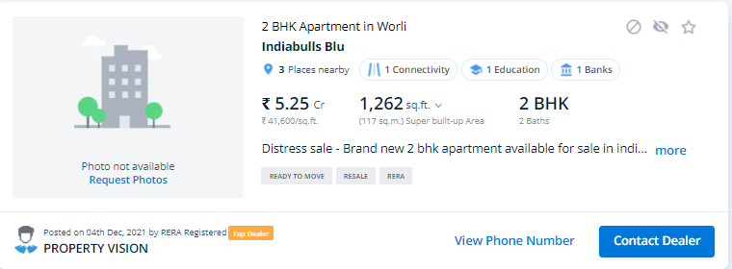

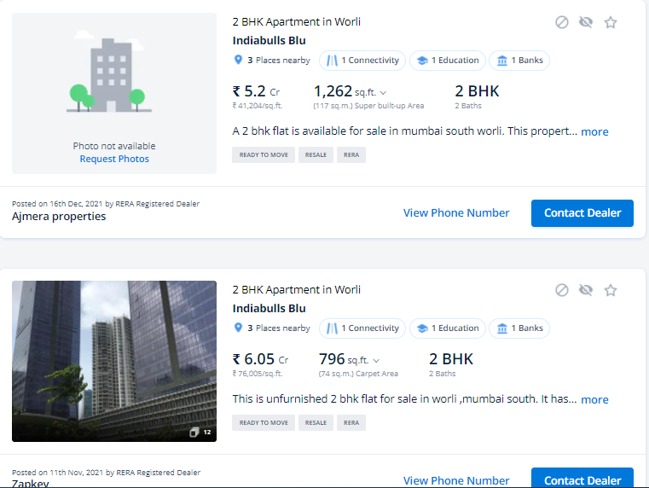

**GOOGLE MAP LOCATION– ANNEXURE V**

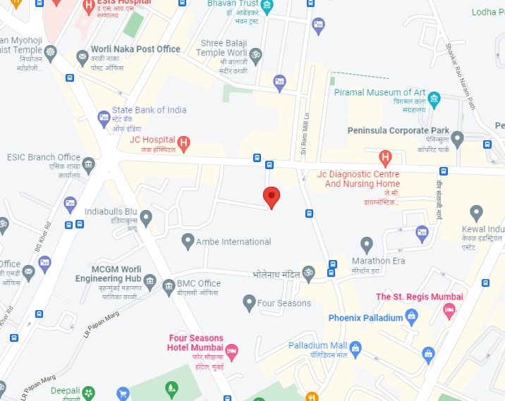

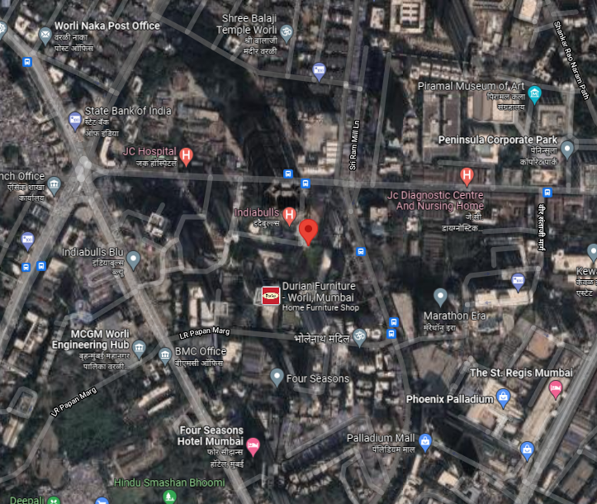

**PHOTOGRAPHS OF THE PROPERTY – ANNEXURE VI**

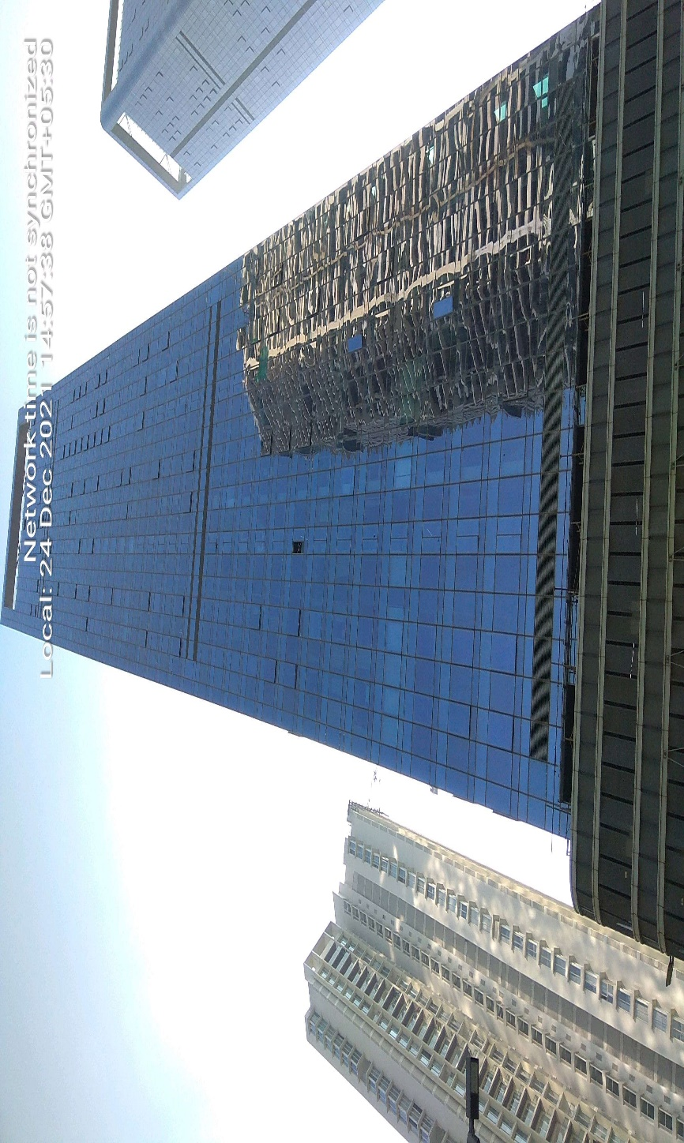

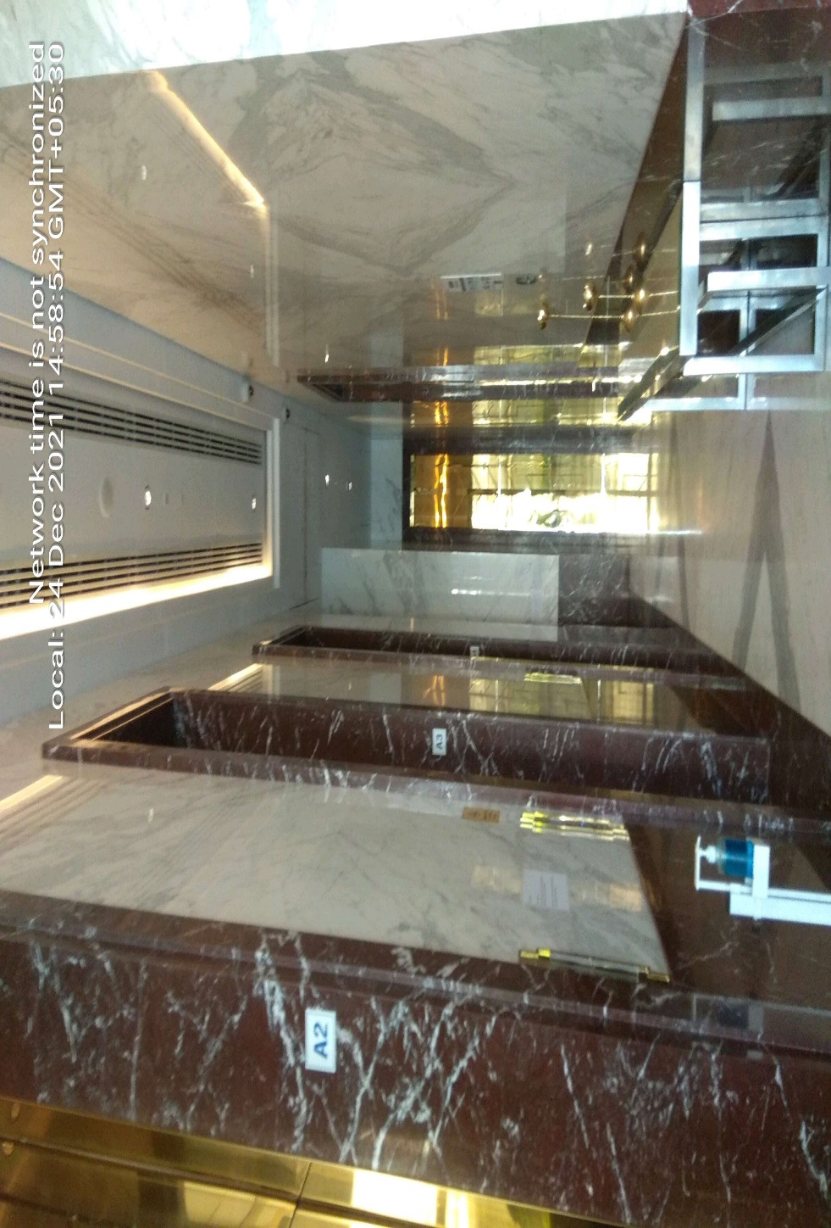

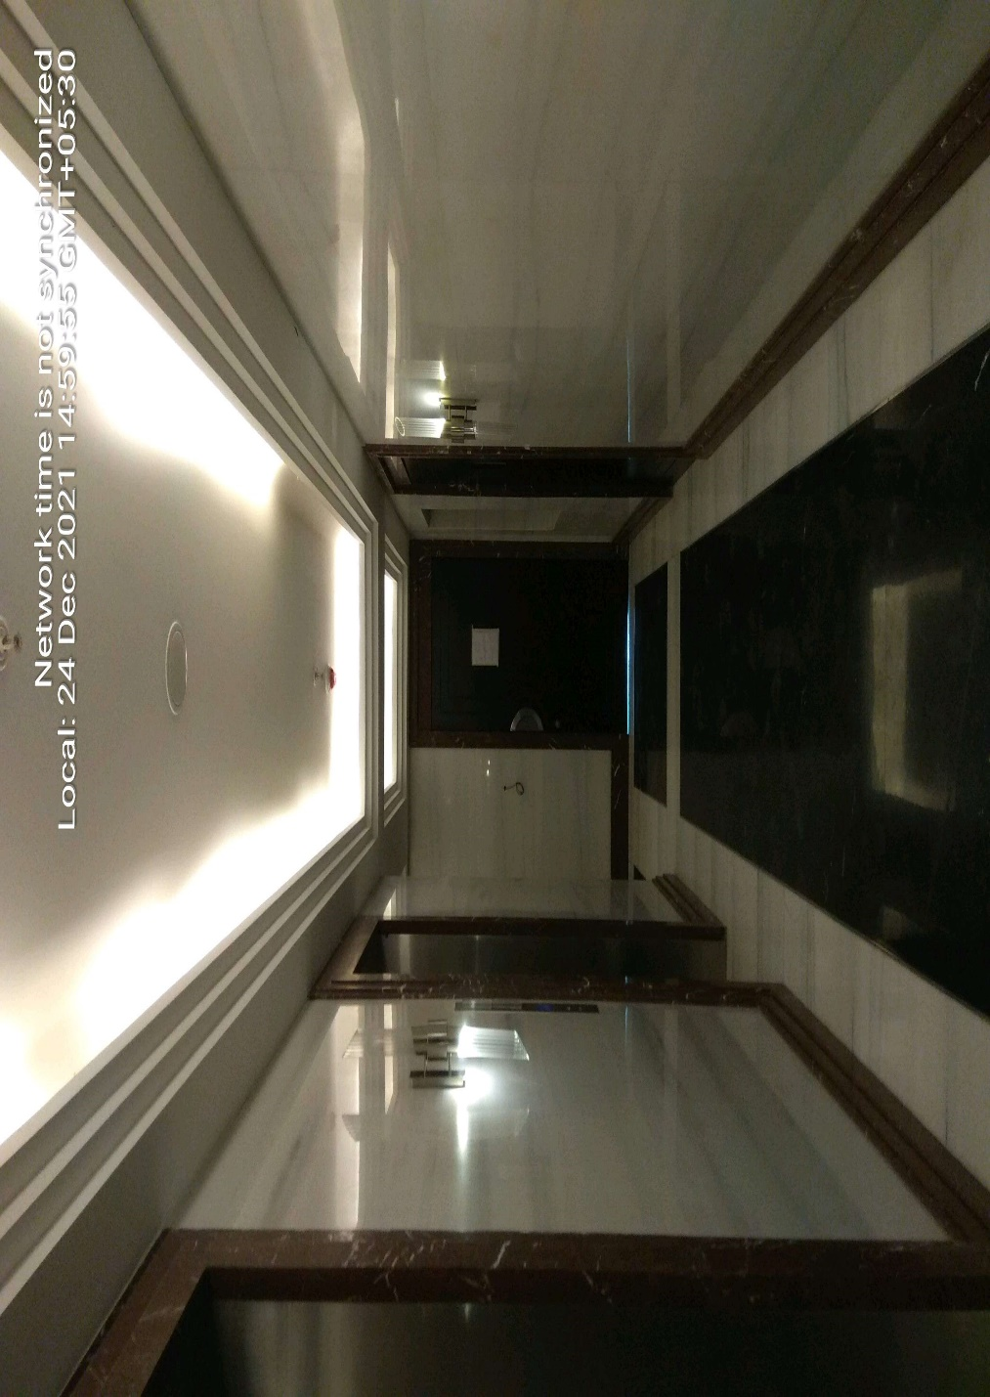

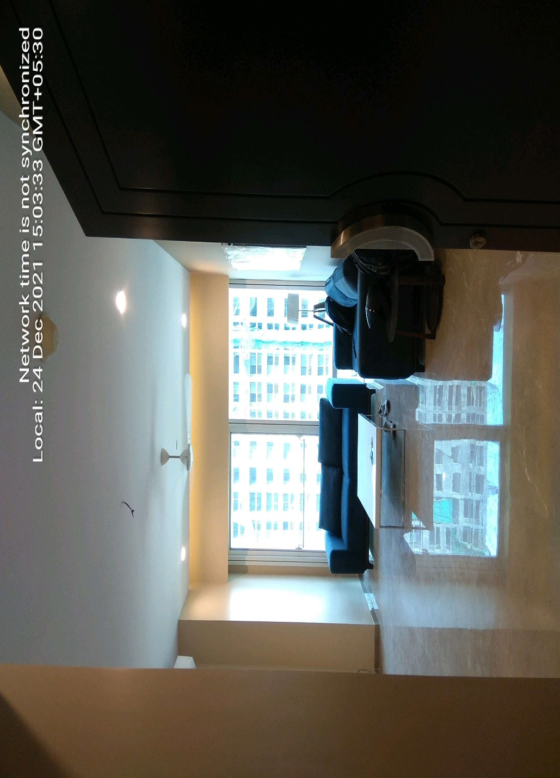

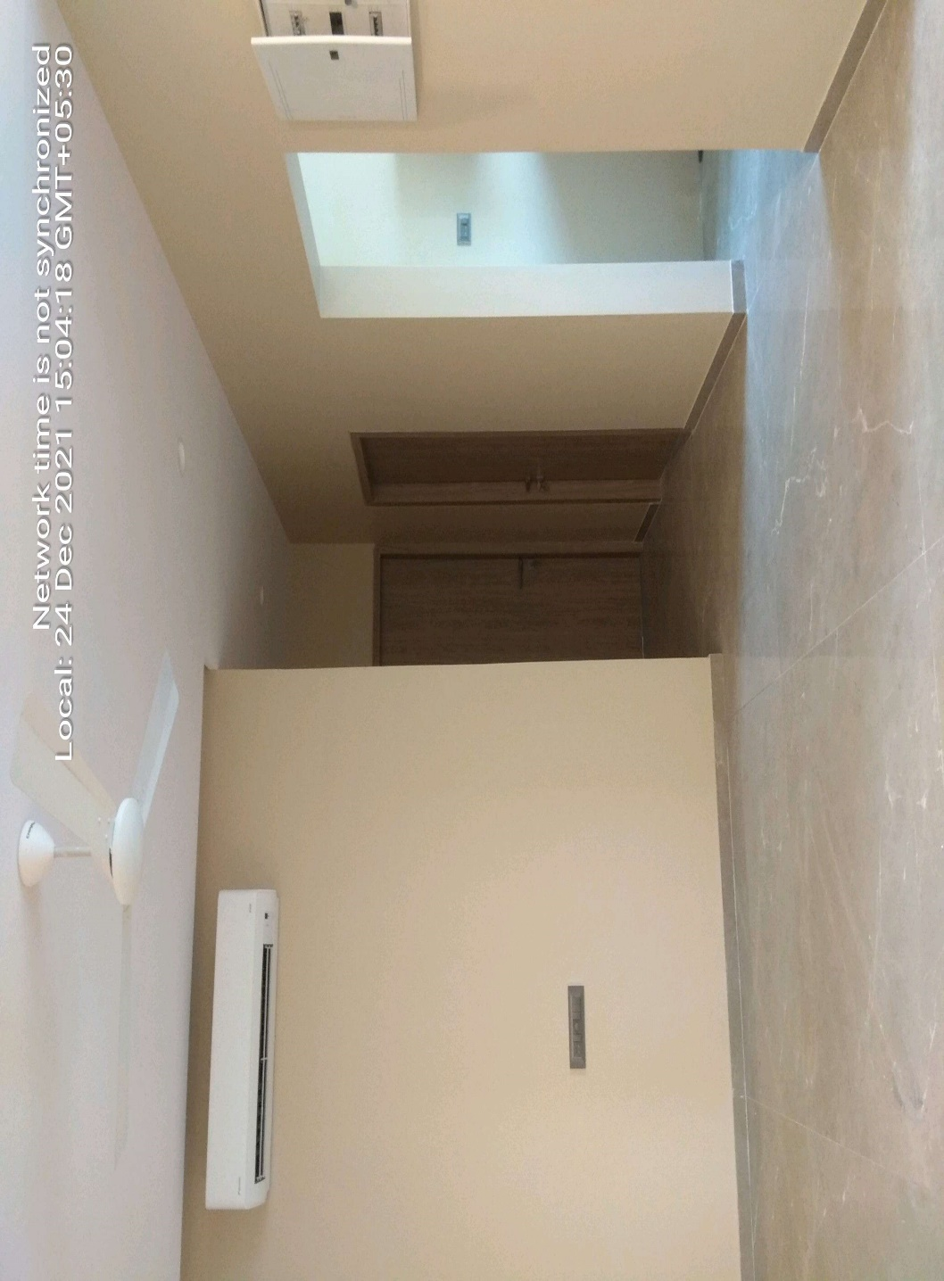

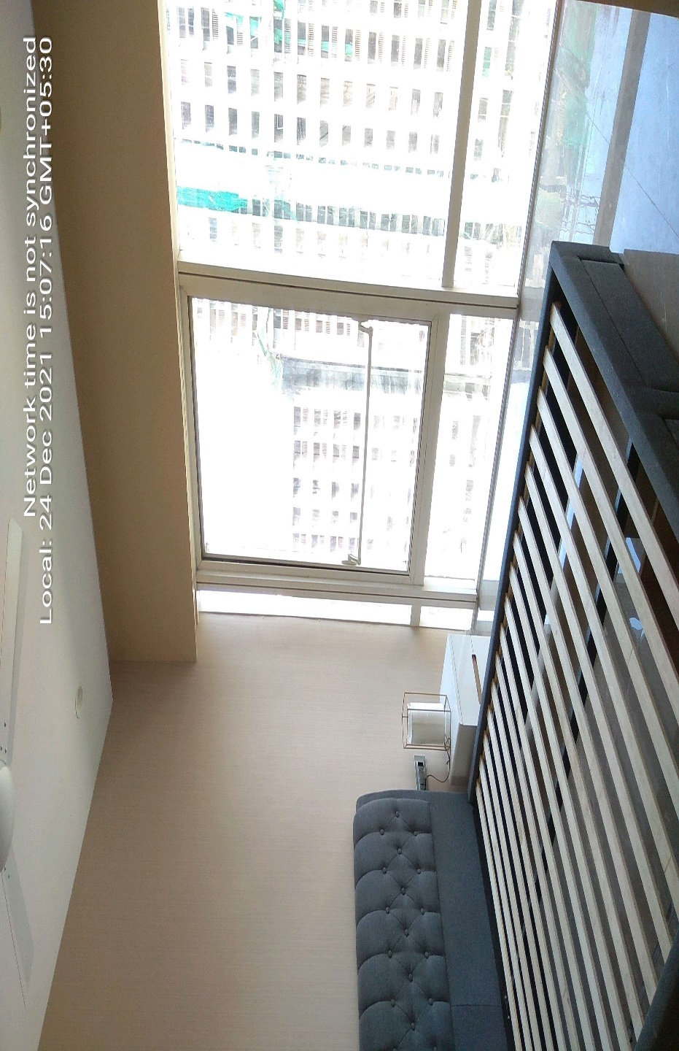

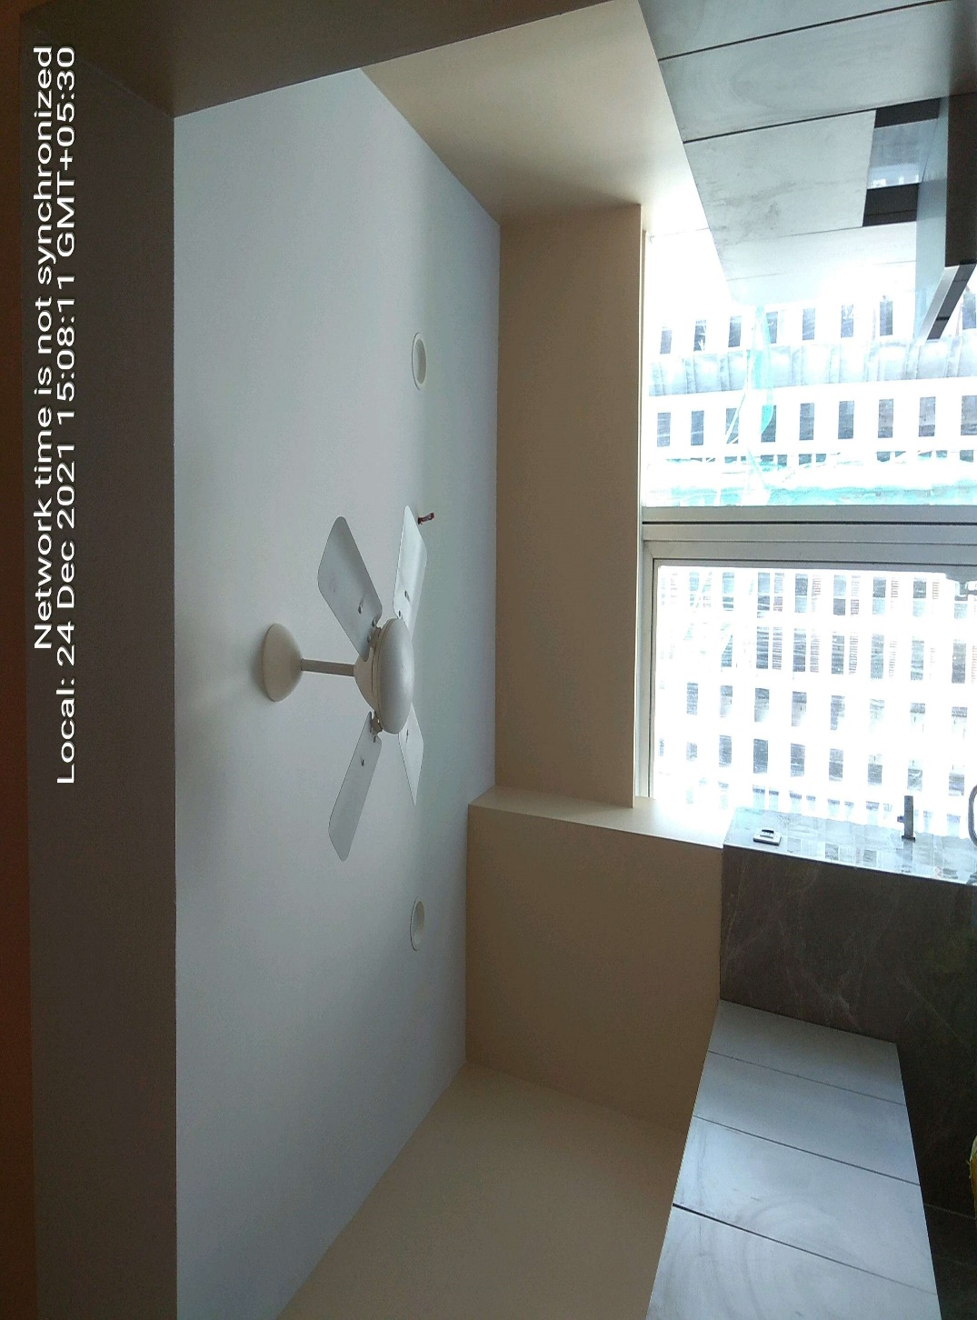

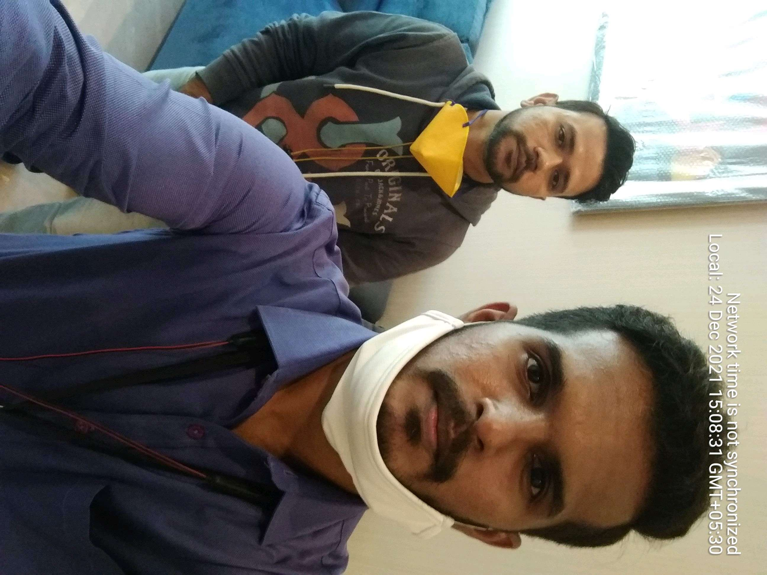

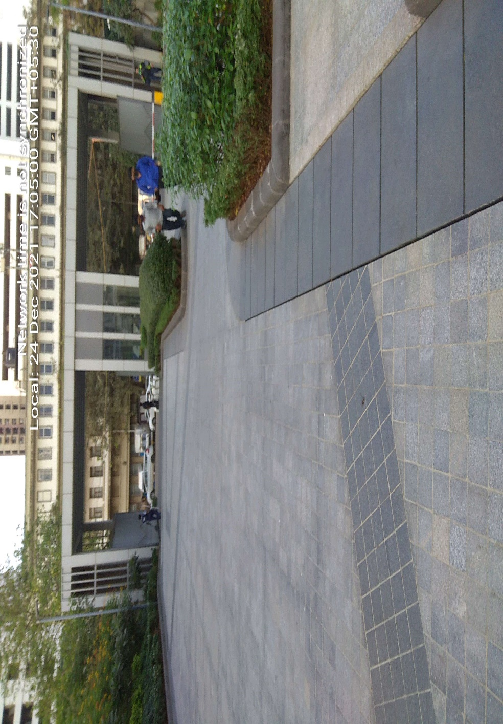

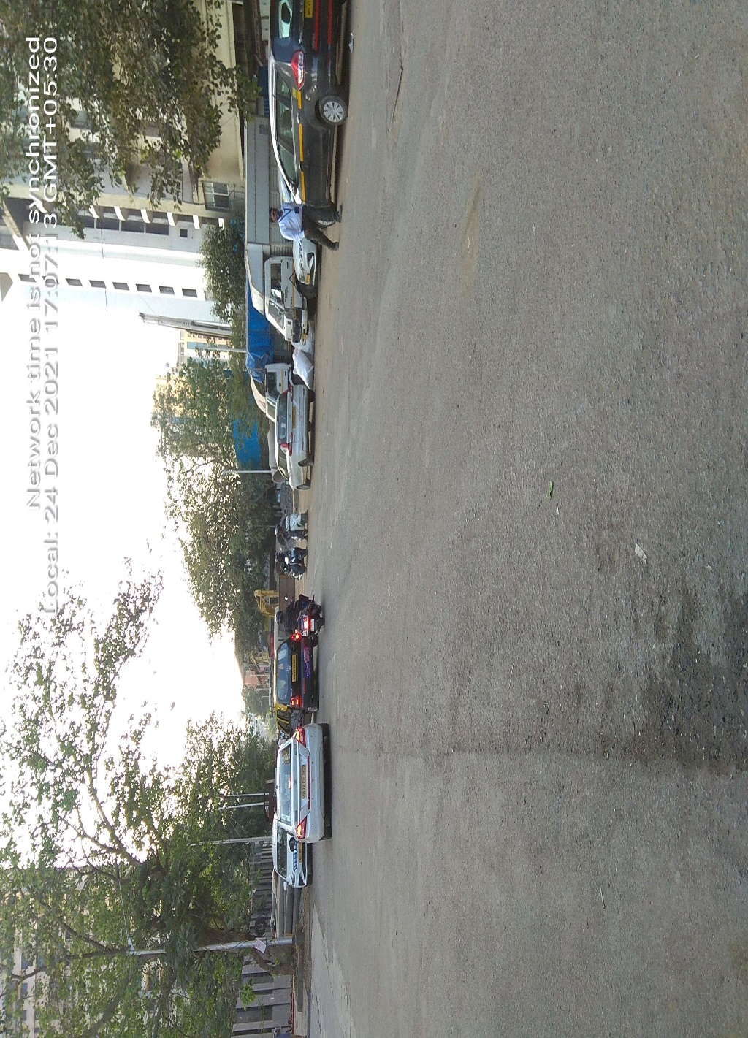

**COPY OF CIRCLE RATE - ANNEXURE VII**

**IGR Maharashtra Not Working**

**VALUER’S REMARKS - ANNEXURE IX**

|  |  |
| --- | --- |
|  | This Valuation report is prepared based on the copies of the documents/ information which interested organization or customer could provide to us out of the standard checklist of documents sought from them and further based on our assumptions and limiting conditions. All such information provided to us has been relied upon in good faith and we have assumed that it is true and correct. Verification or cross checking of the documents provided to us from the originals has not been done at our end. |
|  | Legal aspects for eg. investigation of title, ownership rights, lien, charge, mortgage, lease, verification of documents, etc. have to be taken care by legal expert/ Advocate and same are not done at our end. It is assumed that the concerned Lender/ Financial Institution has asked for the valuation of that property for which the legal verification has been already taken and cleared by the competent Advocate before requesting for the Valuation report. |
|  | Analysis and conclusions adopted in the report are limited to the reported assumptions, conditions and information came to our knowledge during the course of the work. |
|  | Value varies with the Purpose/ Date/ Condition prevailing in the market. We recommend not to refer the indicative & estimated prospective Value of the asset given in this report if any of these points are different from the one mentioned aforesaid in the Report. We also recommend that the indicative estimated Value in the Valuation Report holds good only upto the period of 3 months from the date of Valuation. |
|  | This report is having limited scope as per its fields & format to provide only the general basic idea of the value of the property prevailing in the market based on the documents/ data/ information provided by the client. The suggested indicative prospective estimated value should be considered only if transaction is happened as free market transaction. |
|  | This Valuation report is prepared based on the facts of the property on the date of the survey. It is a well-known fact that the market value of any asset varies with time & socio-economic conditions prevailing in the country. In future property Market may go down, property conditions may change or may go worse, Property reputation may differ, Property vicinity conditions may go down or become worse, Property market may change due to impact of Govt. policies or effect of World economy, Usability prospects of the property may change, etc. Hence before financing, Banker/ FI should take into consideration all such future risk and should loan conservatively to keep the advanced money safe in case of the downward trend of the property value. |
|  | Valuation of the same asset/ property can fetch different values in different situations. For eg. Valuation of a running/ operational shop/ hotel/ factory will fetch better value and in case of closed shop/ hotel/ factory it will have considerable lower value. Similarly an asset sold directly by an owner in the market will fetch better value and if the same asset/ property is sold by any financer due to encumbrance on it will fetch lower value. Hence before financing, Banker/ FI should take into consideration all such future risks and should loan conservatively to keep the advanced money safe in case of any such situation. |
|  | Getting cizra map or coordination with revenue officers for site identification is not done at our end. |
|  | Valuation is done for the property identified to us by the owner/ owner representative. At our end we have just cross verified the identification of the property with reference to the documents produced for perusal. Method by which identification of the property is carried out is also mentioned in the report clearly. Responsibility of identifying the correct property to the Valuer/ its authorized surveyor is solely of the client/ owner for which Valuation has to be carried out. It is requested from the Bank to cross check from their own records/ information if this is the same property for which Valuation has to be carried out to ensure that owner has not misled the Valuer company or misrepresented the property due to any vested interest. |
|  | In India more than 70% of the geographical area is lying under rural/ remote/ non municipal/ unplanned area where the subject property is surrounded by vacant lands having no physical demarcation or having any display of property survey or municipal number / name plate on the property clearly. Even in old locations of towns, small cities & districts where property number is either not assigned or not displayed on the properties clearly and also due to the presence of multiple/ parallel departments due to which ownership/ rights/ illegal possession/ encroachment issues are rampant across India and due to these limitations at many occasions it becomes tough to identify the property with 100% surety from the available documents, information & site whereabouts and thus chances of error, misrepresentation by the borrower and margin of chances of error always persists in such cases. To avoid any such chances of error it is advised to the Bank to engage municipal/ revenue department officials to get the confirmation of the property to ensure that the property shown to Valuer/ Banker is the same as for which documents are provided. |
|  | If this Valuation Report is prepared for the Flat/ dwelling unit situated in a Group Housing Society or Integrated Township then approvals, maps of the complete group housing society/ township is out of scope of this report and this report will be made for the specific unit based on the assumption that complete Group Housing Society/ Integrated Township must be approved in all respect.. |
|  | Due to fragmented & frequent change in building/ urban planning laws/ guidelines from time to time, different laws/ guidelines between regions/ states and no strict enforceability of Building Bye-Laws in India specially in non-metro and scale b & c cities & Industrial areas, property owners many times extend or make changes in the covered area/ layout from the approved/ applicable limits. There are also situations where properties are decades old when there was no formal Building Bye-Laws applicable when the construction must have been done. Due to such discrete/ unplanned development in many regions sometimes it becomes tough to determine the exact lawful situation on ground for the Valuer. In case nothing specific is noted on the covered built-up area considered in the Valuation Report, the covered area present on the site as per site survey will be considered in the Valuation. |
|  | Valuation is a subjective field and opinion may differ from consultant to consultant. To check the right opinion, it is important to evaluate the methodology adopted and various data point/ information/ factors/ assumption considered by the consultant which became the basis for the Valuation report before reaching to any conclusion. |
|  | Value analysis of any asset cannot be regarded as an exact science and the conclusions arrived at in many cases will, of necessity, be subjective and dependent on the exercise of individual judgment. Given the same set of facts and using the same assumptions, expert opinions may differ due to the number of separate judgment decisions, which have to be made. Therefore, there can be no standard formula to establish an indisputable exchange ratio. In the event of a transaction, the actual transaction value achieved may be higher or lower than our indicative analysis of value depending upon the circumstances of the transaction. The knowledge, negotiability and motivations of the buyers and sellers and the applicability of a discount or premium for control will also affect actual price achieved. Accordingly, our indicative analysis of value will not necessarily be the price at which any agreement proceeds. The final transaction price is something on which the parties themselves have to agree. However our Valuation analysis can definitely help the stakeholders to make them informed and wise decision about the Value of the asset and can help in facilitating the arm’s length transaction. |
|  | This report is prepared on the RKA V-L3 (Medium) Valuation format as per the client requirement and scope of work. This report is having limited scope as per its fields & format to provide only the general estimated & indicative basic idea of the value of the property prevailing in the market based on the information provided by the client. No detailed analysis, audit or verification has been carried out of the subject property. |
|  | This is just an opinion report and doesn’t hold any binding on anyone. It is requested from the concerned Client/ Bank/ Financial Institution which is using this report for mortgaging the property that they should consider all the different associated relevant & related factors & risks before taking any business decision based on the content of this report. |
|  | All Pages of the report including annexures are signed and stamped from our office. In case any paper in the report is without stamp & signature then this should not be considered a valid paper issued from this office. |
|  | Defect Liability Period is **30 DAYS**. We request the concerned authorized reader of this report to check the contents, data and calculations in the report within this period and intimate us in writing if any corrections are required or in case of any other concern with the contents or opinion mentioned in the report. Corrections only related to typographical, calculation, spelling mistakes will be entertained within the defect liability period. No request for any illegitimate value revision, date change or any other change will be entertained other than the one mentioned above. |
|  | R.K Associates encourages its customers to give feedback or inform concerns over its services through proper channel at [**valuers@rkassociates.org**](mailto:valuers@rkassociates.org) in writing within 30 days of report delivery. After this period no concern/ complaint/ proceedings in connection with the Valuation Services can be entertained due to possible change in situation and condition of the property. |
|  | Our Data retention policy is of **ONE YEAR**. After this period we remove all the concerned records related to the assignment from our repository. No clarification or query can be answered after this period due to unavailability of the data. |
|  | This Valuation report is governed by our (1) Internal Policies, Processes & Standard Operating Procedures, (2) R.K Associates Quality Policy, (3) Valuation & Survey Best Practices Guidelines formulated by management of R.K Associates, (4) Information input given to us by the customer and (4) Information/ Data/ Facts given to us by our field/ office technical team. Management of R.K Associates never gives acceptance to any unethical or unprofessional practice which may affect fair, correct & impartial assessment and which is against any prevailing law. In case of any indication of any negligence, default, incorrect, misleading, misrepresentation or distortion of facts in the report then it is the responsibility of the user of this report to immediately or atleast within the defect liability period bring all such act into notice of R.K Associates management so that corrective measures can be taken instantly. |
|  | R.K Associates never releases any report doing alterations or modifications by pen. In case any information/ figure of this report is found altered with pen then this report will automatically become null & void. |