**REPORT FORMAT:** V-L10 (P&M) | Version: 8.0\_2019

**FILE NO. : VIS(2021-22)-PL805-704-890 Dated: 12.01.2022**

**VALUATION REPORT**

**OF**

**MACHINERY**

**SITUATED AT**

**PLOT NO.F-551 B, ROAD NO.6, VISHWAKARMA INDUSTRIAL AREA, JAIPUR, RAJASTHAN**

**OWNER/S**

**M/S. JHANDEWAALAS FOODS LIMITED**

**A/C: M/S. JHANDEWAALAS FOODS LIMITD**

**REPORT PREPARED FOR**

**STATE BANK OF INDIA, SAM BRANCH, NEW DELHI**

***\*\*Important - In case of any query/ issue or escalation you may please contact Incident Manager***

***at valuers@rkassociates.org. We will appreciate your feedback in order to improve our services.***

***NOTE: As per IBA Guidelines please provide your feedback on the report within 15 days of its submission after which report will be considered to be correct.***

|  |  |  |
| --- | --- | --- |
| **PART A** | **MACHINERY VALUATION PROCEDURE** |  |

|  |  |
| --- | --- |
| Name & Address of Branch | State Bank of India, SAM Branch, New Delhi |
| Name of Customer (s)/ Borrower Unit | M/s. Jhandewaalas Foods Limitd |

|  |  |  |
| --- | --- | --- |
| **S.NO.** | **CONTENTS** | **DESCRIPTION** |
|  | **INTRODUCTION** | |
|  | Name of Property Owner | M/s. Jhandewaalas Foods Limitd |
| Address & Phone Number of the Owner | Plot No.F-551 B, Road No.6, Vishwakarma Industrial Area, Jaipur, Rajasthan |
|  | Purpose of the Valuation | For Distress Sale of mortgaged assets under NPA a/c |
|  | Date of Inspection of the Property | 10 January 2022 |
|  | Date of Valuation Report | 12 January 2022 |
|  | Name of the Developer of the Property | Owners themselves |
| Type of Developer | Not Applicable |

|  |  |  |  |  |
| --- | --- | --- | --- | --- |
|  | **TECHNICAL DESCRIPTION OF THE MACHINERY** | | | |
|  | Nature of Plant & Machinery | | Food Manufacturing Unit (Ghee) | |
|  | Size of the Plant | | 1. Small scale Plant | |
|  | Type of the Plant | | 1. Semi Automatic | |
|  | Year of Installation/ Commissioning/ COD *(Commercial Operation Date)* | | 1. Sep, 2006 as per the verbal information provided during the site visit | |
|  | Production Capacity | | 1. No such information provided during the site survey. | |
|  | Capacity at which Plant was running at the time of Survey | | The plant was running at 10% capacity | |
|  | Number of Production Lines | | One | |
|  | Condition of Machines | | Average. | |
|  | Status of the industry | | Partially operational | |
|  | Products Manufactured in this industry | | Ghee | |
|  | Recent maintenance carried out on | | No information available | |
|  | Recent upgradation, improvements if done any | | None | |
|  | Total Gross Block & Net Block of Assets | | **Gross Block** | **Net Block** |
| *As on 11-04-2012* | |
| Rs.3,21,66,510/- | Not Provided |
|  | Any other Details if any | | NA | |
|  | **LOCATION/ ADDRESS WHERE MACHINES ARE FOUND TO BE INSTALLED** | | | |
|  | All the machinery were found to be in assembled condition and in the Premise of Jhandewaalas Foods Limited situated at Plot No.F-551 B, Road No.6, Vishwakarma Industrial Area, Jaipur, Rajasthan. | | | |
|  | **SURVEY DETAILS** | | | |
|  | Machines has been surveyed by our Engineering Team on 10/01/2022. | | | |
|  | Site inspection was done in the presence Mr. Vijay (Owner’s Representative). | | | |
|  | Our team examined & verified all the machines and utilities as per the list of machineries provided by the Bank. | | | |
|  | The machines were found to be in assembled condition and has been placed in the Premise of M/s. Jhandewaalas Foods Limited. | | | |
|  | For cross checking the machines only a list of machines provided by the bank which has machine name, year of capitalization and cost of capitalization and other more details. | | | |
|  | Condition of the machines is checked through visual observation only. No technical/ mechanical/ operational testing has been carried out to ascertain the condition and efficiency of machines. | | | |
|  | Site Survey has been carried out on the basis of the physical existence of the assets rather than their technical expediency. | | | |
|  | As per the overall site visit summary, the machines is assembled and partial operational hence we have Considered Discount over the fair Market Value of subject machines. | | | |
|  | **MANUFACTURING PROCESS** | | | |
|  | NA | | | |
|  | **TECHNOLOGY TYPE/ GENERATION USED AND TECHNOLOGICAL COLLABORATIONS IF ANY** | | | |
|  | 1. No Information available | | | |
|  | **RAW MATERIALS REQUIRED & AVAILABILITY** | | | |
|  | **Type of Raw Material:** | Milk and Cream | | |
| **Availability:** | Yes, from the local market | | |
|  | **AVAILABILITY & STATUS OF UTILITIES** | | | |
|  | Power/ Electricity | Yes | | |
| Water | Yes | | |
| Road/ Transport | Yes | | |
|  | **COMMENT ON AVAILABILITY OF LABOUR** | | | |
|  | **Availability:** | During the site visit there is no issue regarding the labor comes in front of us | | |
| **Number of Labours working in the Factory** | As the plant was running only on 10% capacity so only 2-3 person were available | | |
|  | **SALES TRANSACTIONAL PROSPECTS OF SUCH PLANTS/ MACHINERY** | | | |
|  | Individual machine sale on piecemeal basis | | | |
| **Reason:** The subject industry is not functional and operational from last few years. Therefore these machines can be sold as individual on piecemeal basis also in case required.  This is a Small scale Plant and all are general used machines which can be used in similar industry and cost of dismantling and transporation will not be very high. Demand of used machinery in this kind of Industry of such a scale is less since many times it is not easily available in the market & not technically viable therefore the best sale transaction approach to realize maximum value of such assets is through strategic sale to the players who are already into same or similar Industry who have plans for expansion or any one who plans to enter into this new Industry. Since this is small scale Ghee manufacturing unit and its machinery can be easily dissemble and move to any another place. | | | |
|  | **DEMAND OF SUCH PLANT & MACHINERY IN THE MARKET** | | | |
|  | Appears to be moderate as per general information available in public domain. | | | |
|  | **VALUATION PROEDURE** | | | |
|  | **Basic Methodology:** For arriving at fair market value of P&M & other fixed assets our engineering team has rationally applied the mixture of ***‘sales comparison approach (market approach)’ and the ‘cost approach (depreciated replacement cost)’****.* The fair market value of Plant & Machinery on the date of valuation is its cost of reproduction & commissioning on that date less the depreciation & other deterioration deductions (Technological, Economic, Functional obsolescence) or additions for good maintenance from the date of commissioning of the machinery to the date of its valuation. | | | |
|  | Core P&M Asset Valuation is done keeping in mind various factors like technology used, machines availability, its condition, average age, maintenance & service and parts replacement availability of the machines and more importantly demand in the market. | | | |
|  | No Fixed Asset Register has been provided to us, only a list of machinery is provided which having machine name, year of capitalization and cost of capitalization and other details from which we have taken the all the details regarding the machinery. However Valuation has been done independently. | | | |
|  | The machines were found to be in assembled and operational condition at 10% capacity but as per the visual observation all the machinery needs a full scale maintenance before put to use for running at 100%. | | | |
|  | For calculating Replacement Cost of the machines as on date Cost Inflation Index is taken into consideration since this Plant is 15-20 years old and since then fluctuation has occurred in the prices of metals or industrial commodities. | | | |
|  | Market & Industry scenario is also explored for demand of such industrial machines and it is found that not many industry of this type and scale are present in India and the demand for such items and machinery is average as the machinery are already consumed more than half of their economical life. | | | |
|  | On the Depreciated Replacement Cost (DRC) deduction for obsolescence/ deterioration or addition for good maintenance has been taken to arrive at the estimated Prospective Fair Market Value of the machines. | | | |
|  | **Underlying assumption** for the evaluation of this Machinery is that it can be sold individually in market since demand of used & second hand machinery of this type is available in the market. | | | |
|  | **CONSOLIDATED PLANT & MACHINERY VALUATION** | | | |
|  | Consolidated valuation sheet of Plant & Machinery are mentioned below with depreciated current market value cumulated together. The cost of equipment considered from P&M List doesn't includes Pre-operative, Finance, and IDC Charges etc. | | | |

**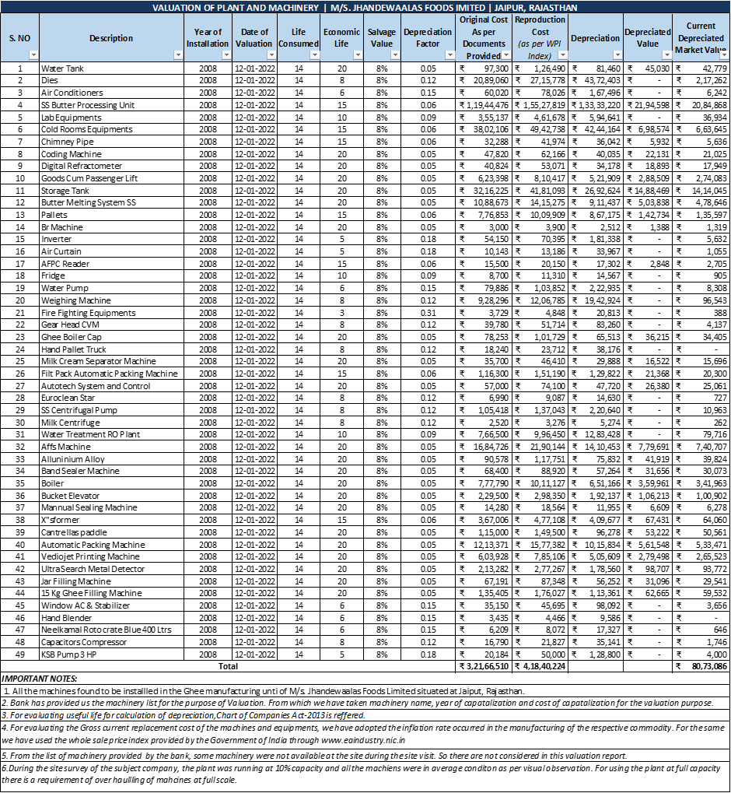**

|  |  |
| --- | --- |
| **PART C** | **CONSOLIDATED VALUATION ASSESSMENT OF PLANT & MACHINERY** |

|  |  |  |  |
| --- | --- | --- | --- |
| **S.No.** | **Particulars** | **Gross Block** | **Prospective Fair Market Value** |
|  | Plant & Machinery Value | **Rs.3,21,66,510/-** | **Rs.80,73,086/-** |
|  | Additional Premium if any | **NA** | **NA** |
| Details/ Justification | **NA** | **NA** |
|  | Deductions charged if any | **NA** | **NA** |
| Details/ Justification | **NA** | **NA** |
|  | **Total Prospective Fair Market Value#** | **NA** | **Rs.80,73,086/-** |
|  | **Rounded Off** | **NA** | **Rs.80,73,000/-** |
|  | **Expected Realizable Value^ (@ ~15% less)** | **NA** | **Rs.68,62,123/-** |
|  | **Expected Forced Distress Sale Value\* (@ ~25% less)** | **NA** | **Rs.60,54,814/-** |

|  |  |  |
| --- | --- | --- |
|  | **Concluding Comments & Disclosures if any** | 1. The machines were found to be in assembled condition and placed in the Premise of M/s. Jhandewaalas Foods Limited situated at Plot No.F-551 B, Road No.6, Vishwakarma Industrial Area, Jaipur, Rajasthan. 2. The machines were found to be in average condition and operational at 10% capacity and as per the visual observation all the machines need full scale maintenance before put to use at 100% capacity. 3. As per the information provided during the site visit and data provided by the bank all the machines already consumes more than half of their economic life. 4. This Valuation report is prepared based on the copies of the documents/ information which interested organization or customer could provide to us out of the standard checklist of documents sought from them and further based on our assumptions and limiting conditions. All such information provided to us has been relied upon in good faith and we have assumed that it is true and correct. 5. Legal aspects for eg. Investigation of title, ownership rights, lien, charge, mortgage, lease, verification of documents from originals, etc. has to be taken care by legal experts/ Advocates. 6. This report only contains opinion based on technical & market information which came to knowledge during course of the assignment. It doesn’t contain any recommendations. 7. This valuation assessment doesn’t cover any Value addition or Enterprise/ Company Valuation factors of the Project/ Industry which may have additional premium or discounting impact on the overall Project/ Industry Value due to various other financial conditions of the Project. 8. This report is prepared following our Standard Operating Procedures & Best Practices, Limitations, Conditions, Remarks, Important Notes, Valuation TOR. |

**(Rupees Eighty Lakh and Seventy Three Thousands Only)**

|  |  |
| --- | --- |
| **PART D** | **SUMMARY OF THE VALUATION REPORT** |

|  |  |  |  |  |  |
| --- | --- | --- | --- | --- | --- |
| **S.NO.** | **CONTENTS** | **DESCRIPTION** | | | |
|  | **GENERAL DETAILS** | | | | |
|  | Report prepared for | Bank | | | |
|  | Name & Address of Organization | State Bank of India, SAM Branch, New Delhi | | | |
|  | Name of Borrower unit | M/s. Jhandewaalas Foods Limited | | | |
|  | Name of Property Owner | /s. Jhandewaalas Foods Limited | | | |
|  | Address & Phone Number of the owner | Plot No.F-551 B, Road No.6, Vishwakarma Industrial Area, Jaipur, Rajasthan. | | | |
|  | Address at which Plant & Machinery located | Plot No.F-551 B, Road No.6, Vishwakarma Industrial Area, Jaipur, Rajasthan. | | | |
|  | Type of the Property | Food Manufacturing Unit (Ghee) | | | |
|  | Nature of Industry | Small Scale Flour Mill | | | |
|  | Type of Loan | Industrial Loan | | | |
|  | Type of Valuation | Machinery Valuation | | | |
|  | Report Type | Plain Asset Valuation | | | |
|  | Date of Inspection of the Property | 10 January 2022 | | | |
|  | Date of Valuation Report | 12 January 2022 | | | |
|  | Plant Technical person name, contact number & designation assisted for Survey | Mr. Vijay Agarwal  🕿- +91-99296 04562 | | | |
|  | Purpose of the Valuation | Distress Sale for NPA a/c | | | |
|  | Scope of the Assessment | Non Binding Opinion on General Prospective Valuation Assessment of the Plant & Machineries as found on site on as-is-where basis. | | | |
|  | Out-of-Scope of the Assessment | 1. Verification of authenticity of documents from originals or cross checking from any Govt. deptt. is not done at our end. 2. Legal aspects & rights of the Plant & Machinery are out-of-scope of this report. 3. Inventorization of P&M is out of scope of work. 4. Componentization of Plant & Machinery is out of scope of this report. 5. Identification of the P&M is only limited to cross verification of major machines & production lines. 6. Technical/ mechanical/ operational testing of the machines is out-of-scope of the report. 7. Comment/ determination on technological aspect is out of scope of this report. 8. Any kind of machine/ process design is out of scope of the report. | | | |
|  | Information provided/ available for assessment | **Documents Requested** | | | **Documents Provided** |
| Total **03** documents requested. | | | Total **01** documents provided. |
| Detailed Fixed Asset Register/ Inventory Sheet | | | Invoices/ Bills |
| EPC contract agreements | | | None |
| Invoices/ Bills | | | None |
| None | | | None |
|  | Identification of the property |  | Cross checked from the name of the machines mentioned in the FAR/ invoices name plate displayed on the machine | | |
|  | Identified by the Owner's representative | | |
|  | Identified from the available Invoices | | |
|  | Identification of the machines could not be done properly | | |
|  | Due to large number of machines/ inventory, only major production lines & machines have been checked | | |
|  | Physical inspection of the machines could not be done |  | |

|  |  |  |  |
| --- | --- | --- | --- |
|  | **BRIEF DESCRIPTION OF THE ASSET UNDER VALUATION** | | |
|  | C:\Users\engineer3\Desktop\uploads\uploads\VIS(2021-22)-PL805-704-890\SiteImage\c_IMG-20220111-WA0094.jpg  ***Snapshot of the Asset/ Property Under Valuation***  This opinion on Valuation report is prepared for the industrial machinery (Ghee manufacturing) situated at the aforesaid address.  The machines were found to be placed in the factory premise of M/s. Jhandewaalas Foods Limited situated at Plot No.F-551 B, Road No.6, Vishwakarma Industrial Area, Jaipur, Rajasthan. All the machines were found to be assembled condition and were operational at 10% capacity during the time of survey.  The condition of the plant & machinery is Average as per visual observations and no maintenance work has been done since long time. The machines were identified by owner’s representative Mr. Vivek Agarwal.   1. This report only contains general assessment & opinion on the Guideline Value and the indicative, estimated Market Value of the property for which Bank has asked to conduct the Valuation and found as per the information given in the copy of documents provided to us and/ or confirmed by the owner/ owner representative to us at site which has been relied upon in good faith. It doesn’t contain any other recommendations of any sort. | | |
|  | **VALUATION SUMMARY** | |
|  | Gross Block | **Rs.3,21,66,510/-** |
|  | Total Prospective Fair Market Value | **Rs.80,73,000/-** |
|  | Total Expected Realizable/ Fetch Value | **Rs.68,62,123/-** |
|  | Total Expected Distress/ Forced Sale Value | **Rs.60,54,814/-** |

|  |  |  |
| --- | --- | --- |
|  | **ENCLOSURES** | |
|  | **Part B** | **Valuation Report as per SBI Format** |
|  | **Part C** | **Consolidated Valuation Assessment of Plant & Machinery** |
|  | Enclosure 1 | Valuer’s Remark - Page No.20-21 |
|  | Enclosure 2 | Google Map Location- Page No.- 12 |
|  | Enclosure 3 | Photographs – Pages 13-14-15 |
|  | Enclosure 4 | Survey Summary Sheet – Page 2 |
|  | Enclosure 5 | Copy of relevant papers from the property documents referred in the Valuation – Pages x |

|  |  |  |
| --- | --- | --- |
|  | **VALUATION COMPANY DETAILS:** | |
|  | **Name & Address of Valuer company** | M/s R.K. Associates Valuers & Techno Engineering Consultants Pvt. Ltd. D-39, Second Floor, Sector 2, Noida-201301. |
|  | **Engineering Team worked on the report** | ***SURVEYED BY:*** *AE Sachin Pandey* |
| ***PREPARED BY:*** *AE Nikhil Rajan* |
| ***REVIEWED BY: HOD Valuations*** |

**R.K ASSOCIATES IMPORTANT NOTES:**

1. ***DEFECT LIABILITY PERIOD****- In case of any query/ issue or escalation you may please contact Incident Manager by writing at valuers@rkassociates.org. We try our level best to ensure maximum accuracy in the Calculations done, Rates adopted and various other data points & information mentioned in the report but still can’t rule out typing, human errors or any other mistakes. In case you find any mistake, variation, discrepancy or inaccuracy in any data point of the report, please help us by bringing all such points into our notice in writing at* [*valuers@rkassociates.org*](mailto:valuers@rkassociates.org) *within 30 days of the report delivery, to get these rectified timely, failing which R.K Associates won’t be held responsible for any inaccuracy in any manner. Also if we will not hear back anything from you within 30 days, we will assume that report is correct in all respect and no further claim of any sort will be entertained thereafter. We would welcome and appreciate your feedback & suggestions in order to improve our services.*
2. *Our* ***DATA RETENTION POLICY*** *is of* ***ONE YEAR****. After this period we remove all the concerned records related to the assignment from our repository. No clarification or query can be answered after this period due to unavailability of the data.*
3. ***COPYRIGHT FORMAT*** *- This report is prepared on the copyright format of R.K Associates to serve our clients in the best possible way. Legally no one can copy or distribute this format without prior approval from R.K Associates. It is meant only for the organization as mentioned on the cover page of this report. Distribution or use of this format other than R.K Associates will be seen as unlawful act and necessary legal action can be taken against the defaulters.*

***IF REPORT IS USED FOR BANK/ FIs***

***NOTE:*** *As per IBA Guidelines in case the valuation report submitted by the valuer is not in order, the banks / FIs shall bring the same to the notice of the valuer within 15 days of submission for rectification and resubmission. In case no such communication is received, it shall be presumed that the valuation report has been accepted.*

***At our end we have not verified the authenticity of any documents provided to us. Bank is advised to verify the genuineness of the property documents before taking any credit decision.***

**GOOGLE MAP LOCATION– ENCLOSURE- I**

**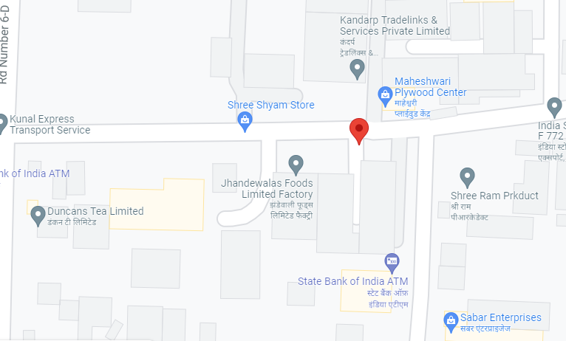**

**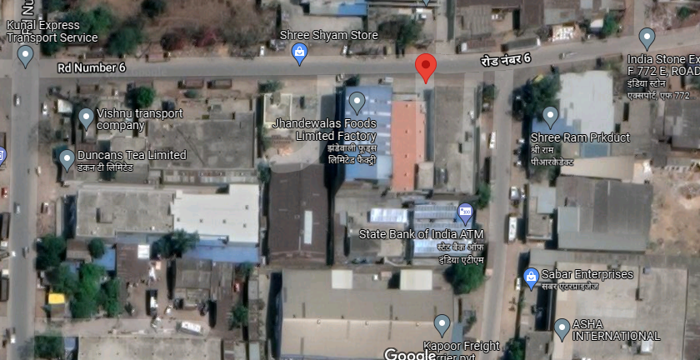**

**PHOTOGRAPHS OF THE MACHINERY – ENCLOSURE- II**

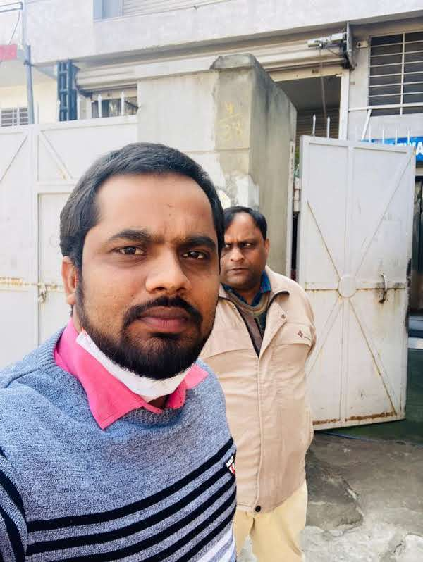

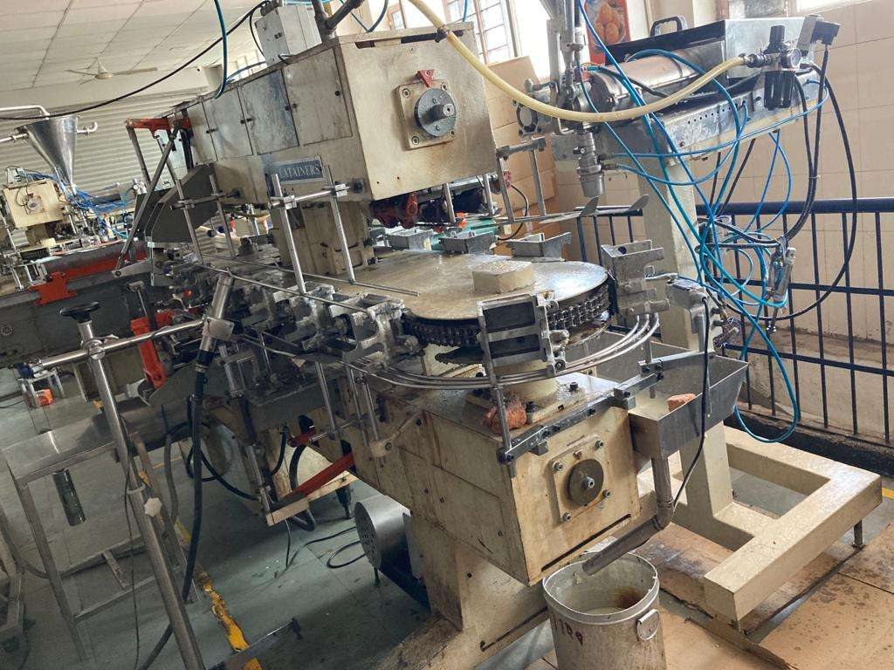

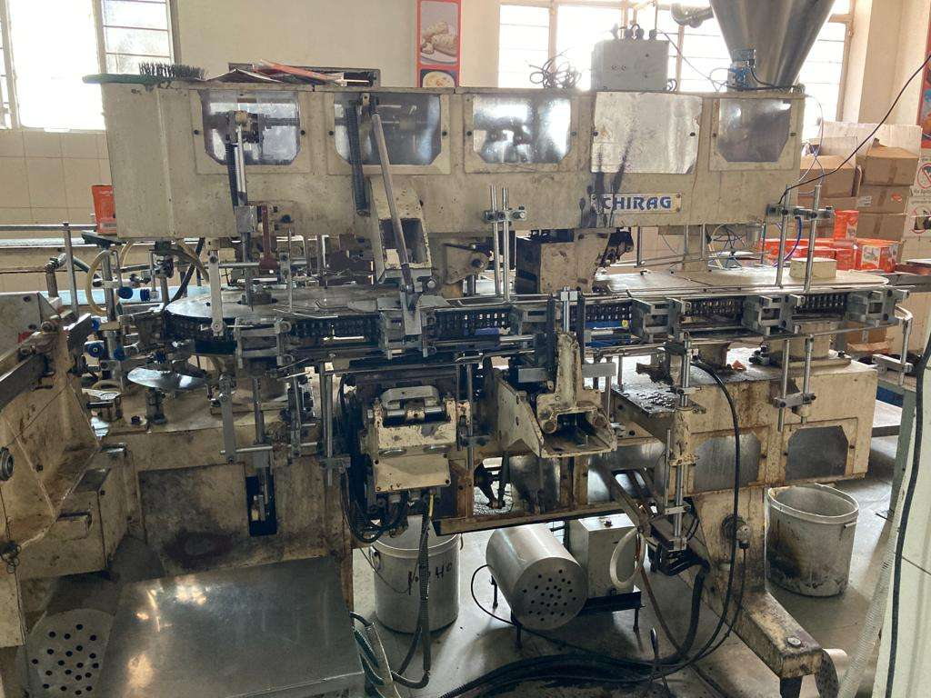

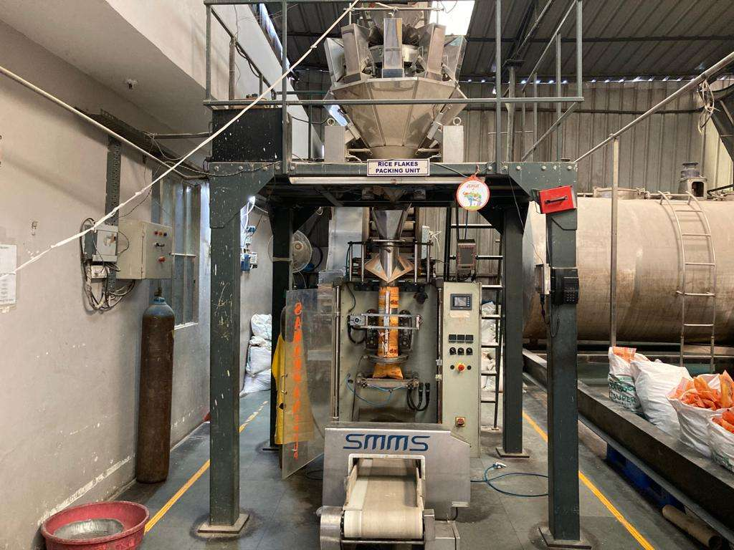

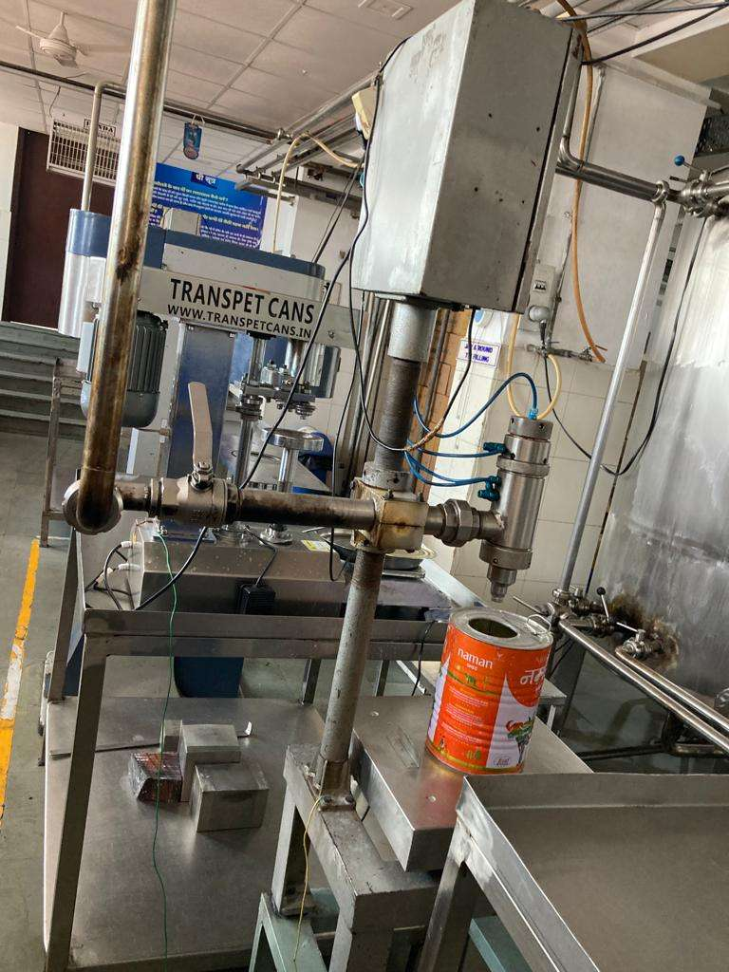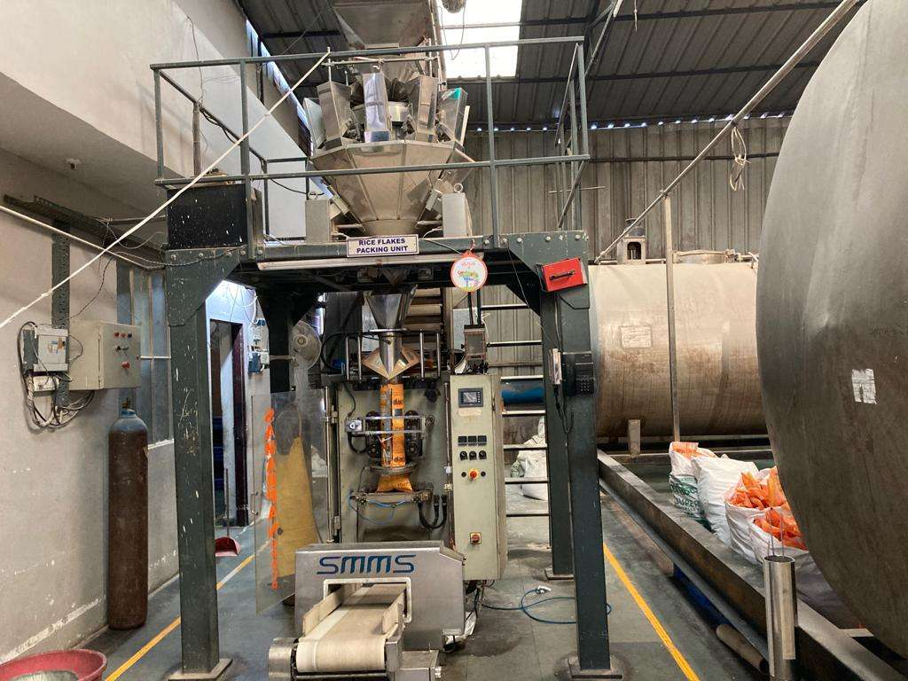

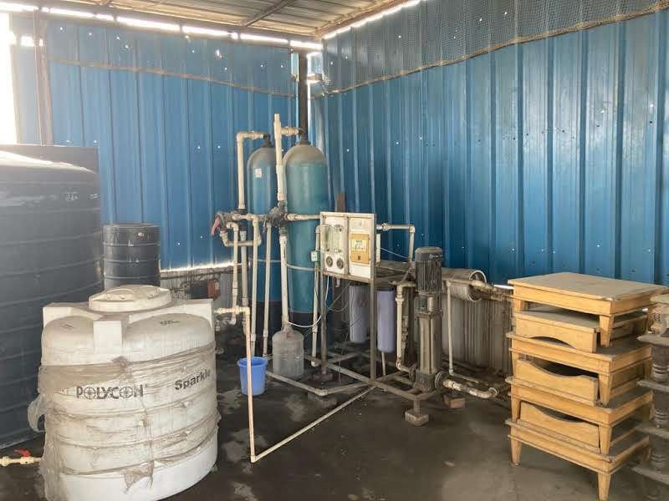

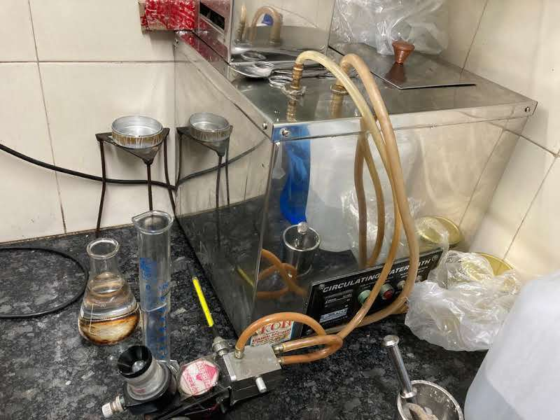

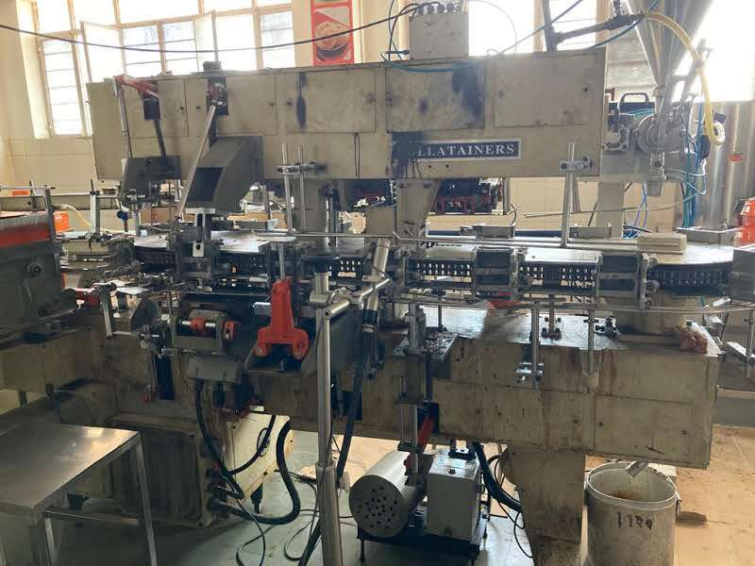

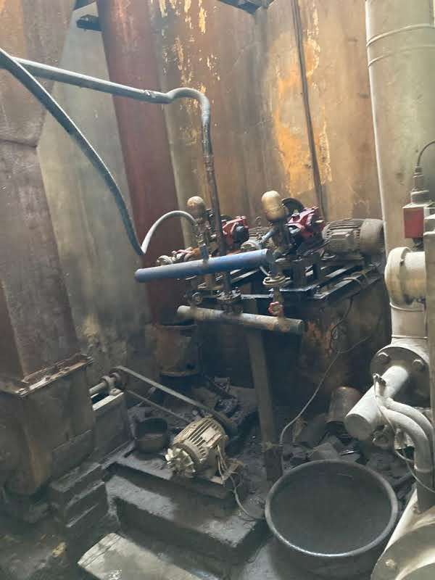

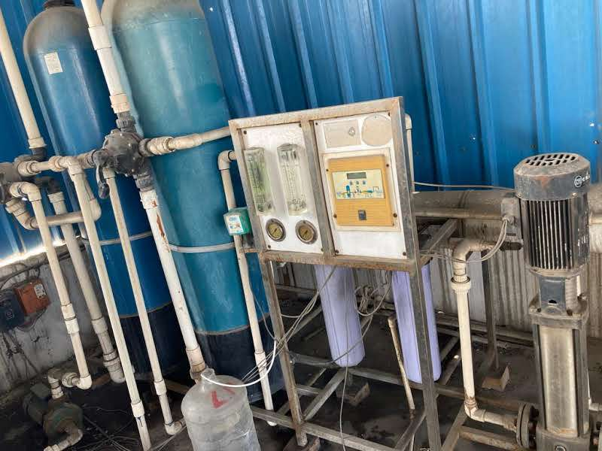

**ENCLOSURE: III DECLARATION-CUM-UNDERTAKING**

1. I am a citizen of India.
2. No employee or member of R.K Associates has any direct/ indirect interest in the property or become so interested at any time during a period of three years prior to my appointment as valuer or three years after the valuation of assets was conducted by me.
3. The information furnished in our valuation report dated 12/12/2021 is true and correct to the best of my knowledge and belief and we have made an impartial and true valuation of the property.
4. Our authorized associate/ surveyor Mr. Sachin Pandey have personally inspected the property on 10/12/2021 the work is not subcontracted to any other valuer and is carried out by us.
5. Valuation report is submitted in the format as prescribed by the Bank.
6. We have not been depanelled / delisted by any other bank and in case any such depanelment by other banks during my empanelment with you, we will inform you within 3 days of such depanelment.
7. We have not been removed/ dismissed from service/employment earlier.
8. We have not been convicted of any offence and sentenced to a term of imprisonment.
9. We have not been found guilty of misconduct in professional capacity.
10. I have not been declared to be unsound mind.
11. We are not undischarged bankrupt, or has not applied to be adjudicated as a bankrupt;
12. We are not an undischarged insolvent.
13. I have not been levied a penalty under section 271J of Income-tax Act, 1961 (43 of 1961) and time limit for filing appeal before Commissioner of Income tax (Appeals) or Income-tax Appellate Tribunal, as the case may be has expired, or such penalty has been confirmed by Income-tax Appellate Tribunal, and five years have not elapsed after levy of such penalty.
14. I have not been convicted of an offence connected with any proceeding under the Income Tax Act 1961, Wealth Tax Act 1957 or Gift Tax Act 1958 and
15. Our PAN Card number/ GST number as applicable is **AAHCR0845G/ 09AAHCR0845G1ZP**
16. We undertake to keep you informed of any events or happenings which would make me ineligible for empanelment as a valuer.
17. We have not concealed or suppressed any material information, facts and records and I have made a complete and full disclosure.
18. We have read the Handbook on Policy, Standards and procedure for Real Estate Valuation, 2011 of the IBA and this report is in conformity to the “Standards” enshrined for valuation in the Part-B of the above handbook to the best of my ability.
19. We have read the International Valuation Standards (IVS) and the report submitted to the Bank for the respective asset class is in conformity to the “Standards” as enshrined for valuation in the IVS in “General Standards” and “Asset Standards” as applicable.
20. I abide by the Model Code of Conduct for empanelment of valuer in the Bank.
21. I am registered under Section 34 AB of the Wealth Tax Act, 1957. (Strike off, if not applicable).
22. I am valuer registered with Insolvency & Bankruptcy Board of India (IBBI) (Strike off, if not applicable).
23. My CIBIL Score and credit worthiness is as per Bank’s guidelines.
24. I am the proprietor / partner / authorized official of the firm / company, who is competent to sign this valuation report.
25. I will undertake the valuation work on receipt of Letter of Engagement generated from the system (i.e. LLMS/LOS) only.
26. Further, I hereby provide the following information.

|  |  |  |  |
| --- | --- | --- | --- |
| **S. No.** | **Particulars** | **Valuer comment** | |
|  | Background information of the asset being valued | The machines were found to be in below Average condition. | |
|  | Purpose of valuation and appointing authority | Please refer to Page No.01 of the Report. | |
|  | Identity of the Valuer and any other experts involved in the valuation | **Survey Analyst: Senior Associate- AE Sachin Pandey**  **Engineering Analyst: AE Nikhil Rajan**  **Valuer/ Reviewer: (HOD Engg.)** | |
|  | Disclosure of valuer interest or conflict, if any | No relationship with the borrower or any kind of conflict of interest. | |
|  | Date of appointment, valuation date and date of report | **Date of Appointment:** | **5/1/2022** |
| **Date of Survey:** | **10/1/2022** |
| **Valuation Date:** | **12/1/2022** |
| **Date of Report:** | **12/1/2022** |
|  | Inspections and/or investigations undertaken | Yes, by our authorized Survey Engineer Mr. Sachin Pandey bearing knowledge of that area on12/1/2022. Property was shown and identified byMr. Vivek Agarwal.(🕿-9929604562). | |
|  | Nature and sources of the information used or relied upon | Please refer to Page No. 04 of the Report. | |
|  | Procedures adopted in carrying out the valuation and valuation standards followed | The fair market value of Machinery on the date of valuation is its cost of reproduction & commissioning on that date less the depreciation & other deterioration deductions (Technological, Economic, Functional obsolescence) or additions for good maintenance from the date of commissioning of the machinery to the date of its valuation. | |
|  | Restrictions on use of the report, if any | Value varies with the Purpose/ Date/ Market & Asset Condition & Situation prevailing in the market. We recommend not to refer the indicative & estimated prospective Value of the asset given in this report if any of these points are different from the one mentioned aforesaid in the Report.  This report has been prepared for the purposes stated in the report and should not be relied upon for any other purpose. Our client is the only authorized user of this report and is restricted for the purpose indicated in the engagement letter. I/we do not take any responsibility for the unauthorized use of this report.  During the course of the assignment we have relied upon various information, data, documents provided by Bank/ client in good faith. If at any point of time in future it comes to knowledge that the information given to us is untrue, fabricated, misrepresented then the use of this report at very moment will become null & void.  This report only contains general assessment & opinion on the indicative, estimated Market Value of the property for which Bank has asked to conduct the Valuation and found as per the information given in the copy of documents, information, data provided to us and/ or confirmed by the owner/ owner representative to us at site which has been relied upon in good faith. It doesn’t contain any other recommendations of any sort including but not limited to express of any opinion on the suitability or otherwise of entering into any transaction with the borrower. | |
|  | Major factors that were taken into account during the valuation | Please refer to Page No. 4-8 of the Report. | |
|  | Major factors that were not taken into account during the valuation | NA | |
|  | Caveats, limitations and disclaimers to the extent they explain or elucidate the limitations faced by valuer, which shall not be for the purpose of limiting his responsibility for the valuation report. | Please see attached Annexure. | |

**Date: 12/1/2022**

**Place:** Noida

**Signature**

**(Authorized Person of R.K Associates Valuers & Techno Engg. Consultants (P) Ltd.)**

**ENCLOSURE: IV- MODEL CODE OF CONDUCT FOR VALUERS**

**Integrity and Fairness**

1. A valuer shall, in the conduct of his/its business, follow high standards of integrity and fairness in all his/its dealings with his/its clients and other valuers.
2. A valuer shall maintain integrity by being honest, straightforward, and forthright in all professional relationships.
3. A valuer shall endeavor to ensure that he/it provides true and adequate information and shall not misrepresent any facts or situations.
4. A valuer shall refrain from being involved in any action that would bring disrepute to the profession.
5. A valuer shall keep public interest foremost while delivering his services.

**Professional Competence and Due Care**

1. A valuer shall render at all times high standards of service, exercise due diligence, ensure proper care and exercise independent professional judgment.
2. A valuer shall carry out professional services in accordance with the relevant technical and professional standards that may be specified from time to time.
3. A valuer shall continuously maintain professional knowledge and skill to provide competent professional service based on up-to-date developments in practice, prevailing regulations/guidelines and techniques.
4. In the preparation of a valuation report, the valuer shall not disclaim liability for his/its expertise or deny his/its duty of care, except to the extent that the assumptions are based on statements of fact provided by the company or its auditors or consultants or information available in public domain and not generated by the valuer.
5. A valuer shall not carry out any instruction of the client insofar as they are incompatible with the requirements of integrity, objectivity and independence.
6. A valuer shall clearly state to his client the services that he would be competent to provide and the services for which he would be relying on other valuers or professionals or for which the client can have a separate arrangement with other valuers.

**Independence and Disclosure of Interest**

1. A valuer shall act with objectivity in his/its professional dealings by ensuring that his/its decisions are made without the presence of any bias, conflict of interest, coercion, or undue influence of any party, whether directly connected to the valuation assignment or not.
2. A valuer shall not take up an assignment if he/it or any of his/its relatives or associates is not independent in terms of association to the company.
3. A valuer shall maintain complete independence in his/its professional relationships and shall conduct the valuation independent of external influences.
4. A valuer shall wherever necessary disclose to the clients, possible sources of conflicts of duties and interests, while providing unbiased services.
5. A valuer shall not deal in securities of any subject company after any time when he/it first becomes aware of the possibility of his/its association with the valuation, and in accordance with the Securities and Exchange Board of India (Prohibition of Insider Trading) Regulations, 2015 or till the time the valuation report becomes public, whichever is earlier.
6. A valuer shall not indulge in “mandate snatching or offering” convenience valuations” in order to cater to a company or client’s needs.
7. As an independent valuer, the valuer shall not charge success fee.
8. In any fairness opinion or independent expert opinion submitted by a valuer, if there has been a prior engagement in an unconnected transaction, the valuer shall declare the association with the company during the last five years.

**Confidentiality**

1. A valuer shall not use or divulge to other clients or any other party any confidential information about the subject company, which has come to his/its knowledge without proper and specific authority or unless there is a legal or professional right or duty to disclose.

**Information Management**

1. A valuer shall ensure that he/ it maintains written contemporaneous records for any decision taken, the reasons for taking the decision, and the information and evidence in support of such decision. This shall be maintained so as to sufficiently enable a reasonable person to take a view on the appropriateness of his/its decisions and actions.
2. A valuer shall appear, co-operate and be available for inspections and investigations carried out by the authority, any person authorized by the authority, the registered valuers organization with which he/it is registered or any other statutory regulatory body.
3. A valuer shall provide all information and records as may be required by the authority, the Tribunal, Appellate Tribunal, the registered valuers organization with which he/it is registered, or any other statutory regulatory body.
4. A valuer while respecting the confidentiality of information acquired during the course of performing professional services, shall maintain proper working papers for a period of three years or such longer period as required in its contract for a specific valuation, for production before a regulatory authority or for a peer review. In the event of a pending case before the Tribunal or Appellate Tribunal, the record shall be maintained till the disposal of the case.

**Gifts and hospitality.**

1. A valuer or his/its relative shall not accept gifts or hospitality which undermines or affects his independence as a valuer.

Explanation: For the purposes of this code the term ‘relative’ shall have the same meaning as defined in clause (77) of Section 2 of the Companies Act, 2013 (18 of 2013).

1. A valuer shall not offer gifts or hospitality or a financial or any other advantage to a public servant or any other person with a view to obtain or retain work for himself/ itself, or to obtain or retain an advantage in the conduct of profession for himself/ itself.

**Remuneration and Costs.**

1. A valuer shall provide services for remuneration which is charged in a transparent manner, is a reasonable reflection of the work necessarily and properly undertaken, and is not inconsistent with the applicable rules.
2. A valuer shall not accept any fees or charges other than those which are disclosed in a written contract with the person to whom he would be rendering service.

**Occupation, employability and restrictions.**

1. A valuer shall refrain from accepting too many assignments, if he/it is unlikely to be able to devote adequate time to each of his/ its assignments.
2. A valuer shall not conduct business which in the opinion of the authority or the registered valuer organization discredits the profession.

**Miscellaneous**

1. A valuer shall refrain from undertaking to review the work of another valuer of the same client except under written orders from the bank or housing finance institutions and with knowledge of the concerned valuer.
2. A valuer shall follow this code as amended or revised from time to time

Signature of the Valuer: \_\_\_\_\_\_\_\_\_\_\_\_\_\_\_\_

Name of the Valuer: R.K Associates Valuers & Techno Engg. Consultants (P) Ltd.

Address of the Valuer: D-39, Sector-2, Noida-201301

**Date: 12/1/2022**

Place: Noida

**VALUER’S REMARKS - ENCLOSURE- V**

|  |  |
| --- | --- |
|  | This Valuation report is prepared based on the copies of the documents/ information which interested organization or customer could provide to us out of the standard checklist of documents sought from them and further based on our assumptions and limiting conditions. All such information provided to us has been relied upon in good faith and we have assumed that it is true and correct. Verification or cross checking of the documents provided to us from the originals has not been done at our end. |
|  | Legal aspects for eg. investigation of title, ownership rights, lien, charge, mortgage, lease, verification of documents, etc. have to be taken care by legal expert/ Advocate and same are not done at our end. It is assumed that the concerned Lender/ Financial Institution has asked for the valuation of that property for which the legal verification has been already taken and cleared by the competent Advocate before requesting for the Valuation report. |
|  | Analysis and conclusions adopted in the report are limited to the reported assumptions, conditions and information came to our knowledge during the course of the work. |
|  | Value varies with the Purpose/ Date/ Condition prevailing in the market. We recommend not to refer the indicative & estimated prospective Value of the asset given in this report if any of these points are different from the one mentioned aforesaid in the Report. We also recommend that the indicative estimated Value in the Valuation Report holds good only upto the period of 3 months from the date of Valuation. |
|  | This report is having limited scope as per its fields & format to provide only the general basic idea of the value of the property prevailing in the market based on the documents/ data/ information provided by the client. The suggested indicative prospective estimated value should be considered only if transaction is happened as free market transaction. |
|  | This Valuation report is prepared based on the facts of the property on the date of the survey. It is a well-known fact that the market value of any asset varies with time & socio-economic conditions prevailing in the country. In future property Market may go down, property conditions may change or may go worse, Property reputation may differ, Property vicinity conditions may go down or become worse, Property market may change due to impact of Govt. policies or effect of World economy, Usability prospects of the property may change, etc. Hence before financing, Banker/ FI should take into consideration all such future risk and should loan conservatively to keep the advanced money safe in case of the downward trend of the property value. |
|  | Valuation of the same asset/ property can fetch different values in different situations. For eg. Valuation of a running/ operational shop/ hotel/ factory will fetch better value and in case of closed shop/ hotel/ factory it will have considerable lower value. Similarly an asset sold directly by an owner in the market will fetch better value and if the same asset/ property is sold by any financer due to encumbrance on it will fetch lower value. Hence before financing, Banker/ FI should take into consideration all such future risks and should loan conservatively to keep the advanced money safe in case of any such situation. |
|  | Getting cizra map or coordination with revenue officers for site identification is not done at our end. |
|  | Valuation is done for the property identified to us by the owner/ owner representative. At our end we have just cross verified the identification of the property with reference to the documents produced for perusal. Method by which identification of the property is carried out is also mentioned in the report clearly. Responsibility of identifying the correct property to the Valuer/ its authorized surveyor is solely of the client/ owner for which Valuation has to be carried out. It is requested from the Bank to cross check from their own records/ information if this is the same property for which Valuation has to be carried out to ensure that owner has not misled the Valuer company or misrepresented the property due to any vested interest. |
|  | In India more than 70% of the geographical area is lying under rural/ remote/ non municipal/ unplanned area where the subject property is surrounded by vacant lands having no physical demarcation or having any display of property survey or municipal number / name plate on the property clearly. Even in old locations of towns, small cities & districts where property number is either not assigned or not displayed on the properties clearly and also due to the presence of multiple/ parallel departments due to which ownership/ rights/ illegal possession/ encroachment issues are rampant across India and due to these limitations at many occasions it becomes tough to identify the property with 100% surety from the available documents, information & site whereabouts and thus chances of error, misrepresentation by the borrower and margin of chances of error always persists in such cases. To avoid any such chances of error it is advised to the Bank to engage municipal/ revenue department officials to get the confirmation of the property to ensure that the property shown to Valuer/ Banker is the same as for which documents are provided. |
|  | If this Valuation Report is prepared for the Flat/ dwelling unit situated in a Group Housing Society or Integrated Township then approvals, maps of the complete group housing society/ township is out of scope of this report and this report will be made for the specific unit based on the assumption that complete Group Housing Society/ Integrated Township must be approved in all respect.. |
|  | Due to fragmented & frequent change in building/ urban planning laws/ guidelines from time to time, different laws/ guidelines between regions/ states and no strict enforceability of Building Bye-Laws in India specially in non-metro and scale b & c cities & Industrial areas, property owners many times extend or make changes in the covered area/ layout from the approved/ applicable limits. There are also situations where properties are decades old when there was no formal Building Bye-Laws applicable when the construction must have been done. Due to such discrete/ unplanned development in many regions sometimes it becomes tough to determine the exact lawful situation on ground for the Valuer. In case nothing specific is noted on the covered built-up area considered in the Valuation Report, the covered area present on the site as per site survey will be considered in the Valuation. |
|  | Valuation is a subjective field and opinion may differ from consultant to consultant. To check the right opinion, it is important to evaluate the methodology adopted and various data point/ information/ factors/ assumption considered by the consultant which became the basis for the Valuation report before reaching to any conclusion. |
|  | Value analysis of any asset cannot be regarded as an exact science and the conclusions arrived at in many cases will, of necessity, be subjective and dependent on the exercise of individual judgment. Given the same set of facts and using the same assumptions, expert opinions may differ due to the number of separate judgment decisions, which have to be made. Therefore, there can be no standard formula to establish an indisputable exchange ratio. In the event of a transaction, the actual transaction value achieved may be higher or lower than our indicative analysis of value depending upon the circumstances of the transaction. The knowledge, negotiability and motivations of the buyers and sellers and the applicability of a discount or premium for control will also affect actual price achieved. Accordingly, our indicative analysis of value will not necessarily be the price at which any agreement proceeds. The final transaction price is something on which the parties themselves have to agree. However our Valuation analysis can definitely help the stakeholders to make them informed and wise decision about the Value of the asset and can help in facilitating the arm’s length transaction. |
|  | This report is prepared on the RKA V-L1 (Basic) Valuation format as per the client requirement and scope of work. This report is having limited scope as per its fields & format to provide only the general estimated & indicative basic idea of the value of the property prevailing in the market based on the information provided by the client. No detailed analysis, audit or verification has been carried out of the subject property. |
|  | This is just an opinion report and doesn’t hold any binding on anyone. It is requested from the concerned Client/ Bank/ Financial Institution which is using this report for mortgaging the property that they should consider all the different associated relevant & related factors & risks before taking any business decision based on the content of this report. |
|  | All Pages of the report including annexures are signed and stamped from our office. In case any paper in the report is without stamp & signature then this should not be considered a valid paper issued from this office. |
|  | Defect Liability Period is **30 DAYS**. We request the concerned authorized reader of this report to check the contents, data and calculations in the report within this period and intimate us in writing if any corrections are required or in case of any other concern with the contents or opinion mentioned in the report. Corrections only related to typographical, calculation, spelling mistakes will be entertained within the defect liability period. No request for any illegitimate value revision, date change or any other change will be entertained other than the one mentioned above. |
|  | R.K Associates encourages its customers to give feedback or inform concerns over its services through proper channel at [**valuers@rkassociates.org**](mailto:valuers@rkassociates.org) in writing within 30 days of report delivery. After this period no concern/ complaint/ proceedings in connection with the Valuation Services can be entertained due to possible change in situation and condition of the property. |
|  | Our Data retention policy is of **ONE YEAR**. After this period we remove all the concerned records related to the assignment from our repository. No clarification or query can be answered after this period due to unavailability of the data. |
|  | This Valuation report is governed by our (1) Internal Policies, Processes & Standard Operating Procedures, (2) R.K Associates Quality Policy, (3) Valuation & Survey Best Practices Guidelines formulated by management of R.K Associates, (4) Information input given to us by the customer and (4) Information/ Data/ Facts given to us by our field/ office technical team. Management of R.K Associates never gives acceptance to any unethical or unprofessional practice which may affect fair, correct & impartial assessment and which is against any prevailing law. In case of any indication of any negligence, default, incorrect, misleading, misrepresentation or distortion of facts in the report then it is the responsibility of the user of this report to immediately or atleast within the defect liability period bring all such act into notice of R.K Associates management so that corrective measures can be taken instantly. |
|  | R.K Associates never releases any report doing alterations or modifications by pen. In case any information/ figure of this report is found altered with pen then this report will automatically become null & void. |