**REPORT FORMAT:** V-L10 (P&M) | Version: 8.0\_2019

**File No.: VIS(2021-22)PL848-Q184-757-964 Dated: 07.02.2022**

**VALUATION REPORT**

**OF**

**INDUSTRIAL PLANT & MACHINERY**

**SITUATED AT**

**AT POST SAKHARWADI, TALUKA PHATTAN, DISTRICT SATARA, MAHARASHTRA - 415522**

**OWNER/S**

**M/S. SHRI DUTT INDIA PVT. LTD.**

**A/C: M/S. SHRI DUTT INDIA PVT. LTD.**

**REPORT PREPARED FOR**

**STATE BANK OF INDIA, INDUSTRIAL ESTATE, SANGLI, MAHARASHTRA**

***\*\*Important - In case of any query/ issue or escalation you may please contact Incident Manager***

***at valuers@rkassociates.org. We will appreciate your feedback in order to improve our services.***

***NOTE: As per IBA Guidelines please provide your feedback on the report within 15 days of its submission after which report will be considered to be correct.***

|  |  |
| --- | --- |
| **PART A** | **PLANT & MACHINERY VALUATION PROCEDURE** |

|  |  |
| --- | --- |
| Name & Address of Branch | State Bank of India, Industrial Estate, Sangli, Maharashtra. |
| Name of Customer (s)/ Borrower Unit | M/s. Shri Dutt India Pvt. Ltd. |

|  |  |  |
| --- | --- | --- |
| **S.NO.** | **CONTENTS** | **DESCRIPTION** |
|  | **INTRODUCTION** | |
|  | Name of Property Owner | M/s. Shri Dutt India Pvt. Ltd. |
| Address & Phone Number of the Owner | At Post Sakharwadi, Taluka Phattan, District Satara, Maharashtra - 415522 |
|  | Purpose of the Valuation | For Value assessment of the asset for creating collateral mortgage for Bank Loan purpose |
|  | Date of Inspection of the Property | 28 January 2022 and 30 January 2022 |
|  | Date of Valuation Report | 7 February 2022 |
|  | Name of the Developer of the Property | Owners themselves |
| Type of Developer | Property built by owner's themselves |

|  |  |  |  |  |
| --- | --- | --- | --- | --- |
|  | **TECHNICAL DESCRIPTION OF THE PLANT/ MACHINERY** | | | |
|  | Nature of Plant & Machinery | | Co-Generation Plant for Sugar Plant | |
|  | Size of the Plant | | 1. Large scale Plant | |
|  | Type of the Plant | | 1. The subject plant is under erection. | |
|  | Year of Installation/ Commissioning/ COD *(Commercial Operation Date)* | | The plant is non –operational since it is under installation. | |
|  | Production Capacity | | Not Applicable since the plant is yet to start operating. | |
|  | Capacity at which Plant was running at the time of Survey | | NA | |
|  | Number of Production Lines | | The production line is under installation. | |
|  | Condition of Machines | | New Machines yet to be installed | |
|  | Status of the Plant | | The subject plant is non-operational since the machines are in installation stage. | |
|  | Products Manufactured in this Plant | | NA | |
|  | Recent maintenance carried out on | | NA | |
|  | Recent upgradation, improvements if done any | | The subject plant is under installation. | |
|  | Total Gross Block & Net Block of Assets | | **Gross Block** | **Net Block** |
| *As per FAR provided* | |
| **Rs.33,18,70,640/-** | Not Provided to us |
|  | Any other Details if any | | NA | |
|  | **LOCATION/ ADDRESS WHERE PLANT/ MACHINES ARE FOUND TO BE INSTALLED** | | | |
|  | All the plant and machinery as per the Fixed Assets Register provided to us is under installation inside the premises of M/s. Shri Dutt India Pvt. Ltd. situated at Sakharwadi, Taluka Phattan, District Satara, Maharashtra – 415522. | | | |
|  | **SURVEY DETAILS** | | | |
|  | Plant has been surveyed by our Engineering Team on dated 28/01/2022 & 29/01/2022 | | | |
|  | Site inspection was done in the presence of Owner's representative Mr. Kiran Patil (+91-9881002128) who were available from the company to furnish any specific detail about the Plant & Machinery. | | | |
|  | Our team examined & verified the machines and utilities from the list provided by the bank. Only major machinery, process line & equipment has been verified. | | | |
|  | Photographs have also been taken of all the Machines. | | | |
|  | The subject plant is non-operational since all the machines are under installation process. | | | |
|  | All the details have been cross checked as per the documents provided to us by the bank and what was observed at the site. | | | |
|  | Condition of the machines is checked through visual observation only. No technical/ mechanical/ operational testing has been carried out to ascertain the condition and efficiency of machines. | | | |
|  | Site Survey has been carried out on the basis of the physical existence of the assets rather than their technical expediency. | | | |
|  | As per the overall site visit summary, machines were found to be under installation stage | | | |
|  | **MANUFACTURING PROCESS** | | | |
|  |  | | | |
|  | **TECHNOLOGY TYPE/ GENERATION USED AND TECHNOLOGICAL COLLABORATIONS IF ANY** | | | |
|  | 1. NA | | | |
|  | **RAW MATERIALS REQUIRED & AVAILABILITY** | | | |
|  | **Type of Raw Material:** | High Pressure Steam | | |
| **Availability:** | No information available | | |
|  | **AVAILABILITY & STATUS OF UTILITIES** | | | |
|  | Power/ Electricity | NA | | |
| Water | NA | | |
| Road/ Transport | NA | | |
|  | **COMMENT ON AVAILABILITY OF LABOUR** | | | |
|  | **Availability:** | NA, since the plant is non operational | | |
| **Number of Labours working in the Factory** | Company Payroll-1050 | | |
|  | **SALES TRANSACTIONAL PROSPECTS OF SUCH PLANTS/ MACHINERY** | | | |
|  | Individual machine sale on piecemeal basis | | | |
| **Reason:** As per the observations made during the site survey, all the machinery were found to be in uninstalled condition as the plant is under erection and the machines were stored in open air, hence under the current condition the machines can be only sold on piecemeal basis. | | | |
|  | **DEMAND OF SUCH PLANT & MACHINERY IN THE MARKET** | | | |
|  | As per the current economic condition demand is in line if transaction happens for the complete integrated Project as a whole but not on piecemeal basis. | | | |
|  | **VALUATION PROEDURE** | | | |
|  | **Basic Methodology:** For arriving at fair market value of P&M & other fixed assets our engineering team has rationally applied the mixture of ***‘sales comparison (market approach)’ and the disposable value approach’****.* The fair market value of Plant & Machinery on the date of valuation is its cost of reproduction & commissioning on that date less the depreciation & other deterioration deductions (Technological, Economic, Functional obsolescence) or additions for good maintenance from the date of commissioning of the machinery to the date of its valuation. | | | |
|  | Core P&M Asset Valuation is done keeping in mind various factors like technology used, machines availability, its condition, average age, maintenance & service and parts replacement availability of the machines and more importantly demand in the market. | | | |
|  | Main Machinery of this Plant are special purpose machines used for power generation and steel production including induction furnaces, Kiln, Boiler, Turbine, generator, bar cutting machine etc. while auxiliary machines include generator, conveyors etc.. | | | |
|  | The main data point for the Valuation of Plant & Machinery is the Fixed Asset Register maintained by the company. Plant & Machinery FAR has been provided by the company which has been relied upon in good faith. Provided FAR included assets in different heads like Land, Building, Plant & Machinery, Electrical equipment’s, Furniture & fittings, Office equipment, etc. Assets under different heads are segregated and are evaluated separately. From the Fixed Asset Register List two key inputs, Date of Capitalization and Cost of capitalization are taken which play vital role in evaluating used Plant & Machinery valuation. | | | |
|  | Provided Capitalization cost include soft cost incurred during the Project establishment like Pre-operative, IDC & Finance cost expenses also. On our request we have not got break-up of hard & soft cost separately hence we have to go by the given figure. | | | |
|  | For evaluating depreciation chart of Companies Act-2013 for ascertaining useful life of different types of machines are followed. Useful life of such Plant is 25 years. For calculating Replacement Cost of the machines as on date Cost Inflation Index is taken into consideration since this Plant is many years old and since then fluctuation has occurred in the prices of metals or industrial commodities. | | | |
|  | On the Depreciated Replacement Cost (DRC) deduction for obsolescence/ deterioration or addition for good maintenance has been taken to arrive at the estimated Prospective Fair Market Value of the machines. | | | |
|  | **Underline assumption** for the evaluation of this Plant & Machinery is that it will be sold as an Integrated Plant and not as discrete/ piecemeal machinery basis. | | | |
|  | **CONSOLIDATED PLANT & MACHINERY VALUATION** | | | |
|  | Consolidated valuation sheet of Plant & Machinery and other asset items are mentioned below with depreciated current market value as per different category of the machines/assets cumulated together. Our engineering team has separated the Cost of Equipment’s in the different sections of the plant.The cost of equipment considered from P&M List doesn't includes Pre-operative, Finance, and IDC Charges etc. The capitalized/ purchase cost of machinery considered from P&M List consists of final commissioning of machines which includes freight, taxes, insurance, etc. | | | |



|  |  |
| --- | --- |
| **PART C** | **CONSOLIDATED VALUATION ASSESSMENT OF PLANT & MACHINERY** |

|  |  |  |  |
| --- | --- | --- | --- |
| **S.No.** | **Particulars** | **Book Value** | **Prospective Fair Market Value** |
|  | Plant & Machinery Value | **Rs.33,18,70,640/-** | **Rs.31,88,41,846 /-** |
|  | Additional Premium if any | ---- | ---- |
| Details/ Justification | ---- | ---- |
|  | Deductions charged if any | ---- | ---- |
| Details/ Justification | ---- | ---- |
|  | **Total Prospective Fair Market Value#** | **Rs.33,18,70,640/-** | **Rs.31,88,41,846 /-** |
|  | **Rounded Off** | ---- | **Rs.31,88,00,000 /-** |
|  | **Expected Realizable Value^ (@ ~15% less)** | ---- | **Rs.27,09,80,000/-** |
|  | **Expected Forced Distress Sale Value\* (@ ~25% less)** | ---- | **Rs.23,91,00,000/-** |

|  |  |  |
| --- | --- | --- |
|  | **Concluding Comments & Disclosures if any** | 1. During the site survey the subject plant was found to under installation, all the machines were non-operational hence the valuation was done considering the same. 2. This Valuation report is prepared based on the copies of the documents/ information which interested organization or customer could provide to us out of the standard checklist of documents sought from them and further based on our assumptions and limiting conditions. All such information provided to us has been relied upon in good faith and we have assumed that it is true and correct. 3. Legal aspects for e.g. investigation of title, ownership rights, lien, charge, mortgage, lease, verification of documents from originals, etc. has to be taken care by legal experts/ Advocates. 4. This report only contains opinion based on technical & market information which came to knowledge during course of the assignment. It doesn’t contain any recommendations. 5. This valuation assessment doesn’t cover any Value addition or Enterprise/ Company Valuation factors of the Project/ Industry which may have additional premium or discounting impact on the overall Project/ Industry Value due to various other financial conditions of the Project. 6. This report is prepared following our Standard Operating Procedures & Best Practices, Limitations, Conditions, Remarks, Important Notes, Valuation TOR. |

|  |  |
| --- | --- |
| **PART D** | **SUMMARY OF THE VALUATION REPORT** |

|  |  |  |
| --- | --- | --- |
| **S.NO.** | **CONTENTS** | **DESCRIPTION** |
|  | **GENERAL DETAILS** | |
|  | Report prepared for | Bank |
|  | Name & Address of Organization | State Bank of India, Industrial Estate, Sangli, Maharashtra. |
|  | Name of Borrower unit | M/s. Shri Dutt India Pvt. Ltd. |
|  | Name of Property Owner | M/s. Shri Dutt India Pvt. Ltd. |
|  | Address & Phone Number of the owner | At Post Sakharwadi, Taluka Phattan, District Satara, Maharashtra - 415522 |
|  | Address at which Plant & Machinery located | At Post Sakharwadi, Taluka Phattan, District Satara, Maharashtra - 415522 |
|  | Type of the Property | Mid Scale Industrial Plant |
|  | Nature of Industry | Co-Generation Plant |
|  | Type of Loan | NA |
|  | Type of Valuation | Plant & Machinery Valuation |
|  | Report Type | Plain Asset Valuation |
|  | Date of Inspection of the Property | 30 January 2022 |
|  | Date of Valuation Report | 7 February 2022 |
|  | Plant Technical person name, contact number & designation assisted for Survey | Mr. Kiran Patil (🕿-+91- 9881002128). |
|  | Purpose of the Valuation | Value assessment of the asset for creating collateral mortgage |
|  | Scope of the Assessment | Non Binding Opinion on General Prospective Valuation Assessment of the Plant & Machineries as found on site on as-is-where basis. |
|  | Out-of-Scope of the Assessment | 1. Verification of authenticity of documents from originals or cross checking from any Govt. deptt. is not done at our end. 2. Legal aspects & rights of the Plant & Machinery are out-of-scope of this report. 3. Inventorization of P&M is out of scope of work. 4. Componentization of Plant & Machinery is out of scope of this report. 5. Identification of the P&M is only limited to cross verification of major machines & production lines. 6. Technical/ mechanical/ operational testing of the machines is out-of-scope of the report. 7. Comment/ determination on technological aspect is out of scope of this report. 8. Any kind of machine/ process design is out of scope of the report. |

|  |  |  |  |  |  |
| --- | --- | --- | --- | --- | --- |
|  | Information provided/ available for assessment | **Documents Requested** | | | **Documents Provided** |
| Total **04** documents requested. | | | Total **01** documents provided. |
| Detailed Fixed Asset Register/ Inventory Sheet | | | Detailed Fixed Asset Register |
| Invoices/ Bills | | | No details/ information provided |
| Purchase Orders | | | No details/ information provided |
| EPC contract agreements | | | No details/ information provided |
|  | Identification of the property |  | Cross checked from the name of the machines mentioned in the FAR/ Inventory list name plate displayed on the machine | | |
|  | Identified by the company's representative | | |
|  | Identified from the available Invoices | | |
|  | Identification of the machines could not be done properly | | |
|  | Due to large number of machines/ inventory, only major production lines & machines have been checked | | |
|  | Physical inspection of the machines could not be done |  | |
|  | **BRIEF DESCRIPTION OF THE ASSET UNDER VALUATION** | | | | |
|  | Z:\In Progress Files\Nikhil Rajan\MS. Shri Dutt India\Co-gen Plant\Photos\TimePhoto_20220128_131340.jpg  ***Snapshot of the Asset/ Property Under Valuation***  This valuation report is prepared for plant & machinery pertaining to M/s. Shri Dutt India Pvt. Ltd.plant situated at Post Sakharwadi, Taluka Phattan, District Satara, Maharashtra – 415522.  M/s. Shri Dutt India Pvt. Ltd. is setting up a cogeneration plant and the subject plant is under installation and as per the information  As per the information provided by the company official there is an amount of Rs.5.70 Cr spent by the company over the maintenance of machines form April 01, 2021 to December 31, 2021 | | | | |

|  |  |  |
| --- | --- | --- |
|  | **VALUATION SUMMARY** | |
|  | Gross Block | **Rs.33,18,70,640/-** |
|  | Total Prospective Fair Market Value | **Rs.31,88,00,000 /-** |
|  | Total Expected Realizable/ Fetch Value | **Rs.27,09,80,000/-** |
|  | Total Expected Distress/ Forced Sale Value | **Rs.23,91,00,000/-** |

|  |  |  |
| --- | --- | --- |
|  | **ENCLOSURES** | |
|  | **Part B** | **Valuation Report as per SBI Format** |
|  | **Part C** | **Consolidated Valuation Assessment of Plant & Machinery** |
|  | Annexure-1 | Google Map Location |
|  | Annexure-2 | Detailed Plant & Machinery calculation |
|  | Annexure-3 | Photographs of Plant & Machinery |
|  | Annexure-4 | Survey Summary Sheet – Pages |
|  | Annexure-5 | Copy of relevant papers from the property documents referred in the Valuation – Pages x |

**R.K ASSOCIATES IMPORTANT NOTES:**

1. ***DEFECT LIABILITY PERIOD****- In case of any query/ issue or escalation you may please contact Incident Manager by writing at valuers@rkassociates.org. We try our level best to ensure maximum accuracy in the Calculations done, Rates adopted and various other data points & information mentioned in the report but still can’t rule out typing, human errors or any other mistakes. In case you find any mistake, variation, discrepancy or inaccuracy in any data point of the report, please help us by bringing all such points into our notice in writing at* [*valuers@rkassociates.org*](mailto:valuers@rkassociates.org) *within 30 days of the report delivery, to get these rectified timely, failing which R.K Associates won’t be held responsible for any inaccuracy in any manner. Also if we will not hear back anything from you within 30 days, we will assume that report is correct in all respect and no further claim of any sort will be entertained thereafter. We would welcome and appreciate your feedback & suggestions in order to improve our services.*
2. *Our* ***DATA RETENTION POLICY*** *is of* ***ONE YEAR****. After this period we remove all the concerned records related to the assignment from our repository. No clarification or query can be answered after this period due to unavailability of the data.*
3. ***COPYRIGHT FORMAT*** *- This report is prepared on the copyright format of R.K Associates to serve our clients in the best possible way. Legally no one can copy or distribute this format without prior approval from R.K Associates. It is meant only for the organization as mentioned on the cover page of this report. Distribution or use of this format other than R.K Associates will be seen as unlawful act and necessary legal action can be taken against the defaulters.*

***IF REPORT IS USED FOR BANK/ FIs***

***NOTE:*** *As per IBA Guidelines in case the valuation report submitted by the valuer is not in order, the banks / FIs shall bring the same to the notice of the valuer within 15 days of submission for rectification and resubmission. In case no such communication is received, it shall be presumed that the valuation report has been accepted.*

***At our end we have not verified the authenticity of any documents provided to us. Bank is advised to verify the genuineness of the property documents before taking any credit decision.***

**GOOGLE MAP LOCATION– ANNEXURE I**

**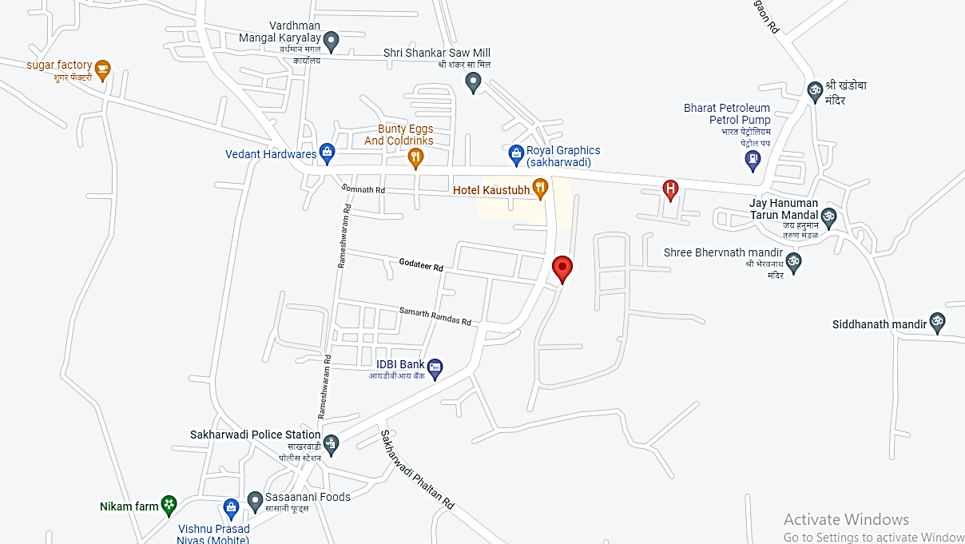**

**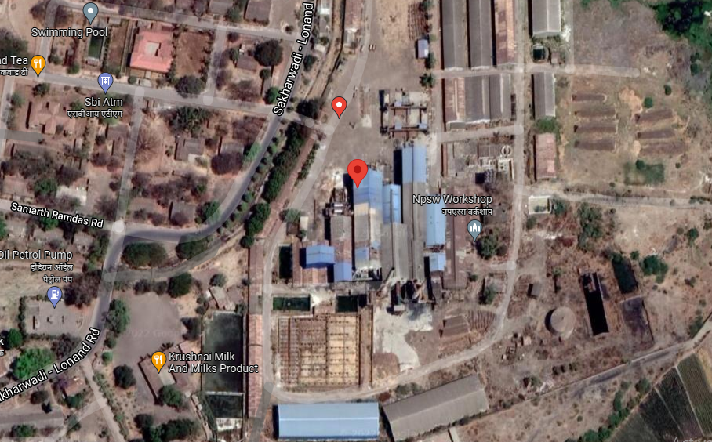**

**PHOTOGRAHS - ANNEXURE II**

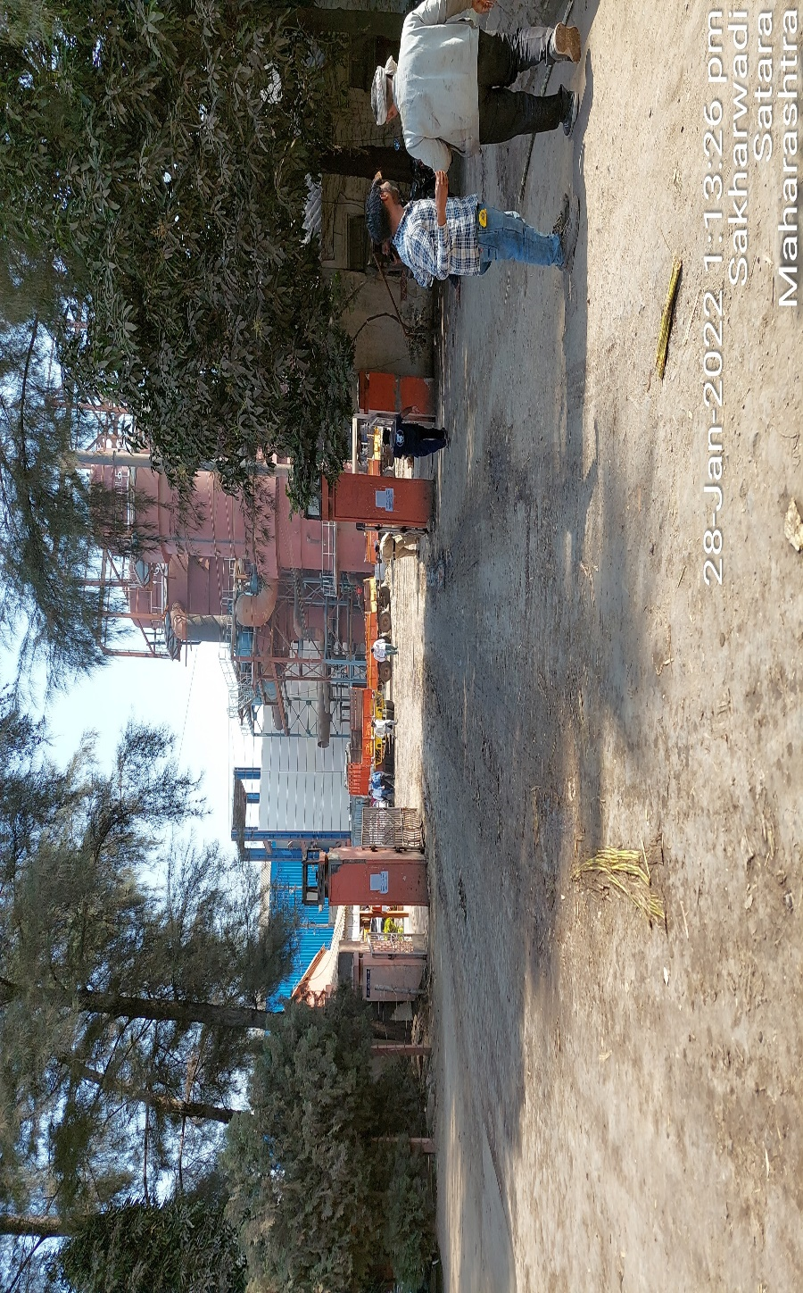

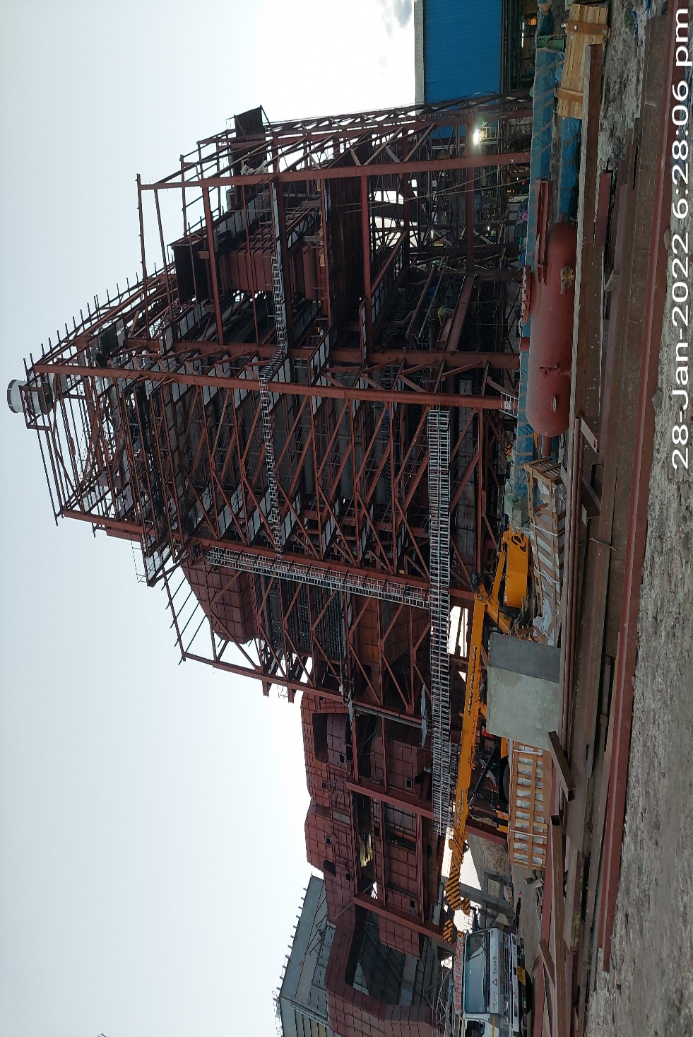

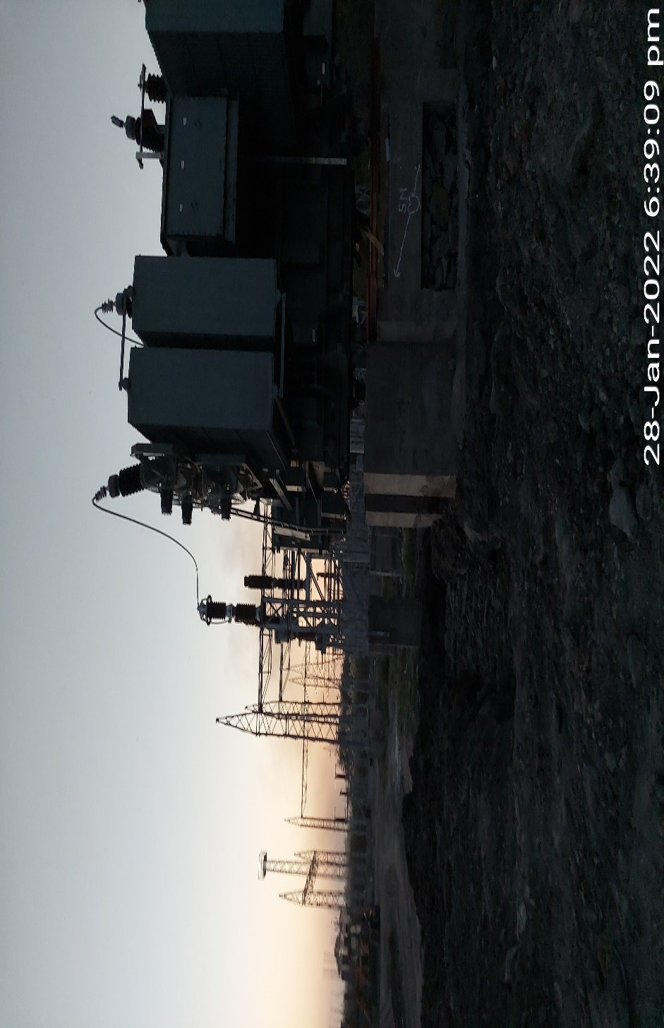

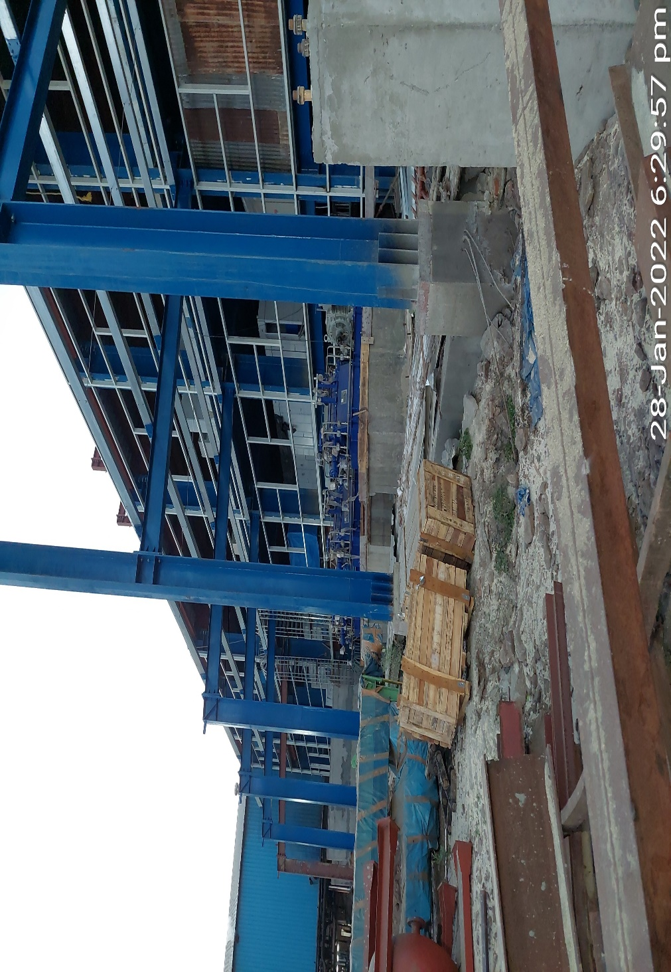

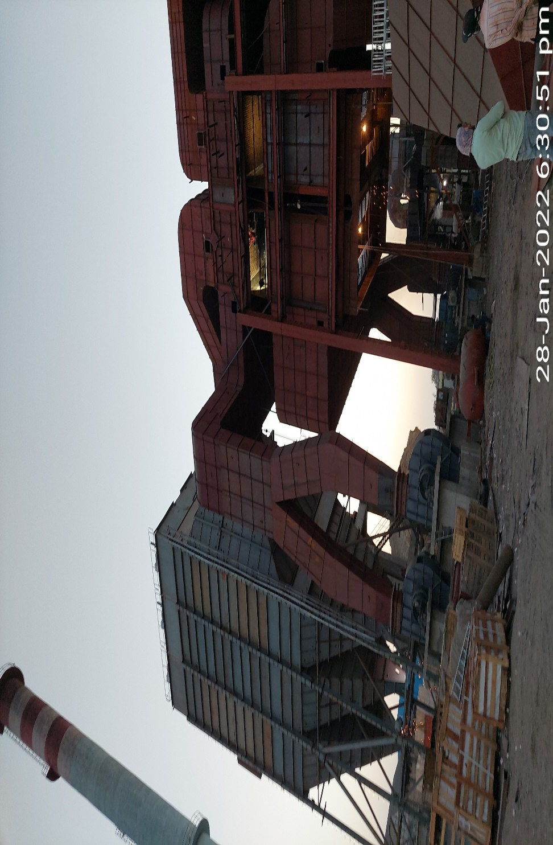

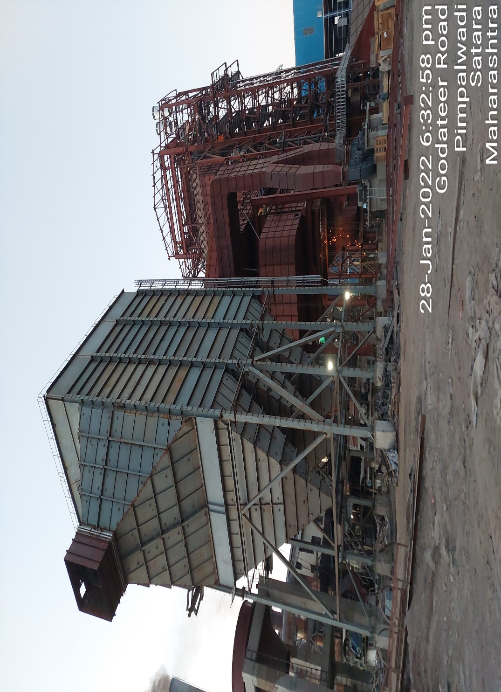

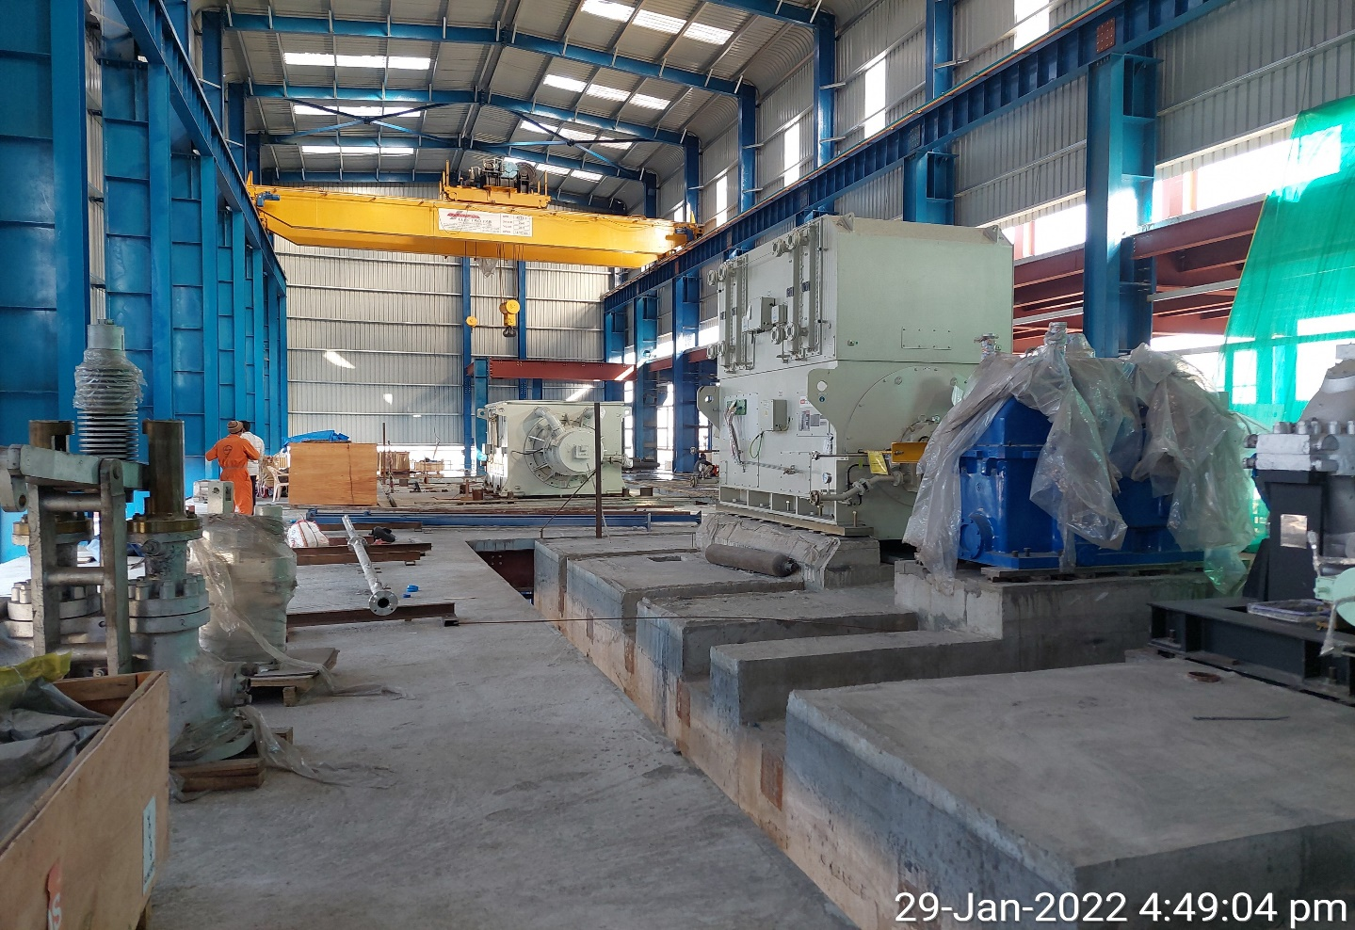

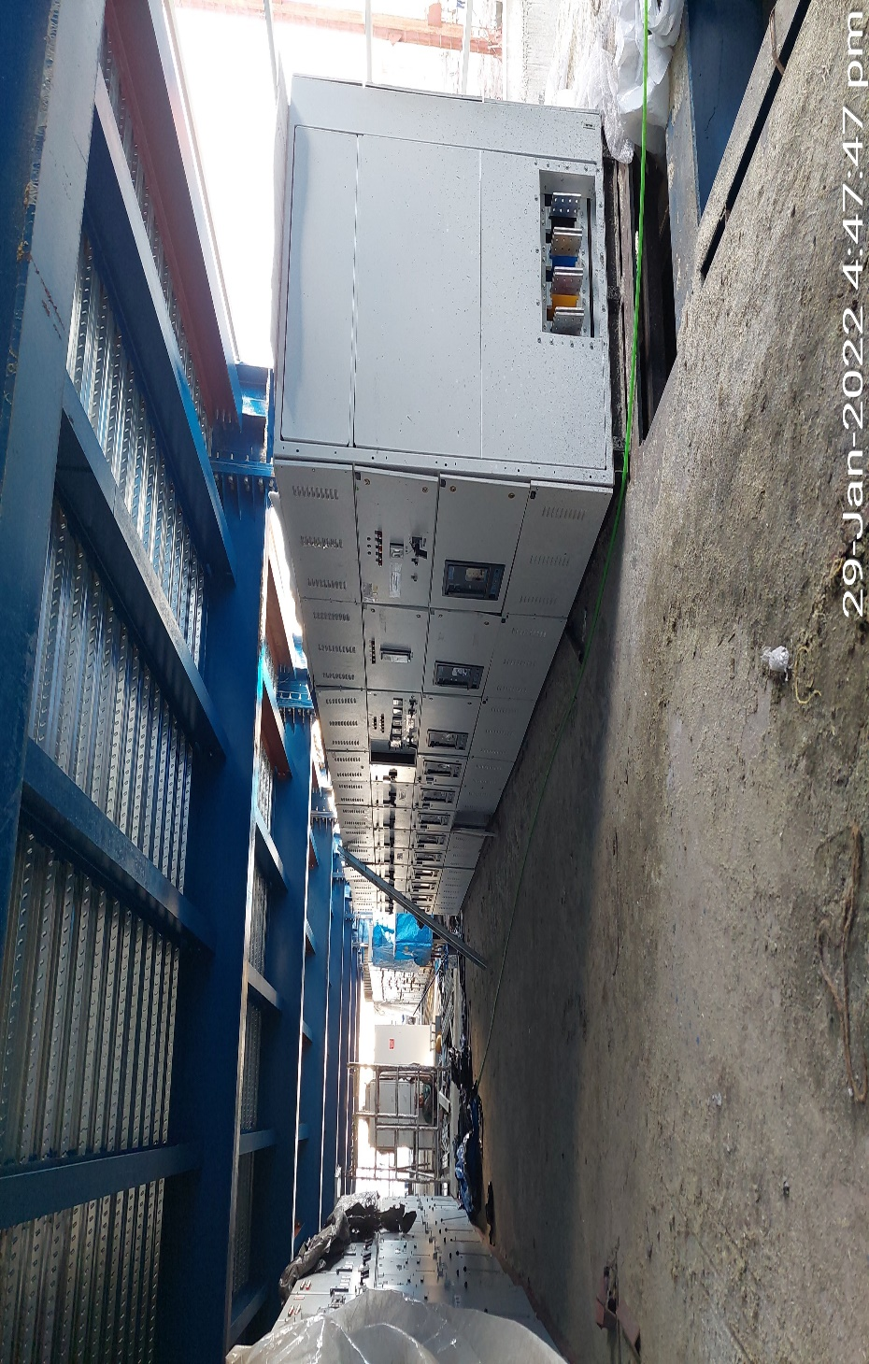

**VALUER’S REMARKS - ANNEXURE III**

|  |  |
| --- | --- |
|  | This Valuation report is prepared based on the copies of the documents/ information which interested organization or customer could provide to us out of the standard checklist of documents sought from them and further based on our assumptions and limiting conditions. All such information provided to us has been relied upon in good faith and we have assumed that it is true and correct. Verification or cross checking of the documents provided to us from the originals has not been done at our end. |
|  | Legal aspects for e.g. investigation of title, ownership rights, lien, charge, mortgage, lease, verification of documents, etc. have to be taken care by legal expert/ Advocate and same are not done at our end. It is assumed that the concerned Lender/ Financial Institution has asked for the valuation of that property for which the legal verification has been already taken and cleared by the competent Advocate before requesting for the Valuation report. |
|  | Analysis and conclusions adopted in the report are limited to the reported assumptions, conditions and information came to our knowledge during the course of the work. |
|  | Value varies with the Purpose/ Date/ Condition prevailing in the market. We recommend not to refer the indicative & estimated prospective Value of the asset given in this report if any of these points are different from the one mentioned aforesaid in the Report. We also recommend that the indicative estimated Value in the Valuation Report holds good only up to the period of 3 months from the date of Valuation. |
|  | This report is having limited scope as per its fields & format to provide only the general basic idea of the value of the property prevailing in the market based on the documents/ data/ information provided by the client. The suggested indicative prospective estimated value should be considered only if transaction is happened as free market transaction. |
|  | This Valuation report is prepared based on the facts of the property on the date of the survey. It is a well-known fact that the market value of any asset varies with time & socio-economic conditions prevailing in the country. In future property Market may go down, property conditions may change or may go worse, Property reputation may differ, Property vicinity conditions may go down or become worse, Property market may change due to impact of Govt. policies or effect of World economy, Usability prospects of the property may change, etc. Hence before financing, Banker/ FI should take into consideration all such future risk and should loan conservatively to keep the advanced money safe in case of the downward trend of the property value. |
|  | Valuation of the same asset/ property can fetch different values in different situations. For egg. Valuation of a running/ operational shop/ hotel/ factory will fetch better value and in case of closed shop/ hotel/ factory it will have considerable lower value. Similarly an asset sold directly by an owner in the market will fetch better value and if the same asset/ property is sold by any financer due to encumbrance on it will fetch lower value. Hence before financing, Banker/ FI should take into consideration all such future risks and should loan conservatively to keep the advanced money safe in case of any such situation. |
|  | Getting cizra map or coordination with revenue officers for site identification is not done at our end. |
|  | Valuation is done for the property identified to us by the owner/ owner representative. At our end we have just cross verified the identification of the property with reference to the documents produced for perusal. Method by which identification of the property is carried out is also mentioned in the report clearly. Responsibility of identifying the correct property to the Valuer/ its authorized surveyor is solely of the client/ owner for which Valuation has to be carried out. It is requested from the Bank to cross check from their own records/ information if this is the same property for which Valuation has to be carried out to ensure that owner has not misled the Valuer company or misrepresented the property due to any vested interest. |
|  | In India more than 70% of the geographical area is lying under rural/ remote/ non municipal/ unplanned area where the subject property is surrounded by vacant lands having no physical demarcation or having any display of property survey or municipal number / name plate on the property clearly. Even in old locations of towns, small cities & districts where property number is either not assigned or not displayed on the properties clearly and also due to the presence of multiple/ parallel departments due to which ownership/ rights/ illegal possession/ encroachment issues are rampant across India and due to these limitations at many occasions it becomes tough to identify the property with 100% surety from the available documents, information & site whereabouts and thus chances of error, misrepresentation by the borrower and margin of chances of error always persists in such cases. To avoid any such chances of error it is advised to the Bank to engage municipal/ revenue department officials to get the confirmation of the property to ensure that the property shown to Valuer/ Banker is the same as for which documents are provided. |
|  | If this Valuation Report is prepared for the Flat/ dwelling unit situated in a Group Housing Society or Integrated Township then approvals, maps of the complete group housing society/ township is out of scope of this report and this report will be made for the specific unit based on the assumption that complete Group Housing Society/ Integrated Township must be approved in all respect.. |
|  | Due to fragmented & frequent change in building/ urban planning laws/ guidelines from time to time, different laws/ guidelines between regions/ states and no strict enforceability of Building Bye-Laws in India specially in non-metro and scale b & c cities & Industrial areas, property owners many times extend or make changes in the covered area/ layout from the approved/ applicable limits. There are also situations where properties are decades old when there was no formal Building Bye-Laws applicable when the construction must have been done. Due to such discrete/ unplanned development in many regions sometimes it becomes tough to determine the exact lawful situation on ground for the Valuer. In case nothing specific is noted on the covered built-up area considered in the Valuation Report, the covered area present on the site as per site survey will be considered in the Valuation. |
|  | Valuation is a subjective field and opinion may differ from consultant to consultant. To check the right opinion, it is important to evaluate the methodology adopted and various data point/ information/ factors/ assumption considered by the consultant which became the basis for the Valuation report before reaching to any conclusion. |
|  | Value analysis of any asset cannot be regarded as an exact science and the conclusions arrived at in many cases will, of necessity, be subjective and dependent on the exercise of individual judgment. Given the same set of facts and using the same assumptions, expert opinions may differ due to the number of separate judgment decisions, which have to be made. Therefore, there can be no standard formula to establish an indisputable exchange ratio. In the event of a transaction, the actual transaction value achieved may be higher or lower than our indicative analysis of value depending upon the circumstances of the transaction. The knowledge, negotiability and motivations of the buyers and sellers and the applicability of a discount or premium for control will also affect actual price achieved. Accordingly, our indicative analysis of value will not necessarily be the price at which any agreement proceeds. The final transaction price is something on which the parties themselves have to agree. However our Valuation analysis can definitely help the stakeholders to make them informed and wise decision about the Value of the asset and can help in facilitating the arm’s length transaction. |
|  | This report is prepared on the RKA V-L10 (Medium P&M) Valuation format as per the client requirement and scope of work. This report is having limited scope as per its fields & format to provide only the general estimated & indicative basic idea of the value of the property prevailing in the market based on the information provided by the client. No detailed analysis, audit or verification has been carried out of the subject property. |
|  | In case of Valuation of Plant & Machinery or equipment, condition of machines is evaluated by visual observation only. No technical/ mechanical testing of any kind has been carried out at our end to ascertain the condition and efficiency of the machines. Valuation of Plant & Machinery is done on the basis of physical existence of the assets rather than their technical expediency. |
|  | This is just an opinion report and doesn’t hold any binding on anyone. It is requested from the concerned Client/ Bank/ Financial Institution which is using this report for mortgaging the property that they should consider all the different associated relevant & related factors & risks before taking any business decision based on the content of this report. |
|  | All Pages of the report including annexures are signed and stamped from our office. In case any paper in the report is without stamp & signature then this should not be considered a valid paper issued from this office. |
|  | Defect Liability Period is **30 DAYS**. We request the concerned authorized reader of this report to check the contents, data and calculations in the report within this period and intimate us in writing if any corrections are required or in case of any other concern with the contents or opinion mentioned in the report. Corrections only related to typographical, calculation, spelling mistakes will be entertained within the defect liability period. No request for any illegitimate value revision, date change or any other change will be entertained other than the one mentioned above. |
|  | R.K Associates encourages its customers to give feedback or inform concerns over its services through proper channel at [**valuers@rkassociates.org**](mailto:valuers@rkassociates.org) in writing within 30 days of report delivery. After this period no concern/ complaint/ proceedings in connection with the Valuation Services can be entertained due to possible change in situation and condition of the property. |
|  | Our Data retention policy is of **ONE YEAR**. After this period we remove all the concerned records related to the assignment from our repository. No clarification or query can be answered after this period due to unavailability of the data. |
|  | This Valuation report is governed by our (1) Internal Policies, Processes & Standard Operating Procedures, (2) R.K Associates Quality Policy, (3) Valuation & Survey Best Practices Guidelines formulated by management of R.K Associates, (4) Information input given to us by the customer and (4) Information/ Data/ Facts given to us by our field/ office technical team. Management of R.K Associates never gives acceptance to any unethical or unprofessional practice which may affect fair, correct & impartial assessment and which is against any prevailing law. In case of any indication of any negligence, default, incorrect, misleading, misrepresentation or distortion of facts in the report then it is the responsibility of the user of this report to immediately or at least within the defect liability period bring all such act into notice of R.K Associates management so that corrective measures can be taken instantly. |
|  | R.K Associates never releases any report doing alterations or modifications by pen. In case any information/ figure of this report is found altered with pen then this report will automatically become null & void. |