**REPORT FORMAT:** V-L2 (L&B) | Version: 9.0_2019

**FILE NO. VIS(2021-22)-PL87-081-097 DATED: 09/06/2021**

**VALUATION ASSESSMENT**

**OF**

**INDEPENDENT HOUSE**

**SITUATED AT**

**SOCIETY PLOT NO. 16, PHASE 1, DOON VALLEY OFFICERS COOPERATIVE HOUSING SOCIETY LIMITED, MAUZA KANWALI, PARGANA CENTRAL DOON, DISTRICT DEHRADUN**

**OWNER/S**

**MR. KISHAN CHAND S/O LATE SHRI VIJAY PAL SINGH**

**A/C: M/S. KUMAR STONE CRUSHER**

**REPORT PREPARED FOR**

**PUNJAB NATIONAL BANK, CIRCLE SASTRA WEST BRANCH, DEHRADUN, UTTARAKHAND**

***\*\*Important - In case of any query/ issue/ concern or escalation you may please contact Incident Manager @ valuers@rkassociates.org. We will appreciate your feedback in order to improve our services.***

***Valuation TOR is available at*** [***www.rkassociates.org***](http://www.rkassociates.org) ***for reference.***

***NOTE: As per IBA Guidelines please provide your feedback on the report within 15 days of its submission after which report will be considered to be correct.***

|  |  |
| --- | --- |
| **PART A** | **PNB FORMAT OF OPINION REPORT ON VALUATION** |

|  |  |
| --- | --- |
| Name & Address of Branch | Punjab National Bank, Circle Sastra West Branch, Dehradun, Uttarakhand |
| Name of Customer (s)/ Borrower Unit | M/S. Kumar Stone Crusher |

|  |  |  |  |  |  |  |  |  |
| --- | --- | --- | --- | --- | --- | --- | --- | --- |
| **S.NO.** | | **PARTICULARS** | **CONTENT** | | | | | |
| **I.** | | **INTRODUCTION** | | | | | | |
| 1. | | Name of Owner | Mr. Kishan Chand S/o Late Shri Vijay Pal Singh | | | | | |
| 2. | | Date of inspection | 07.06.2021 | | | | | |
| Date of Valuation | 09.06.2021 | | | | | |
| 3. | | Purpose of Valuation | For Distress Sale of mortgaged assets under NPA a/c | | | | | |
| 4. | | Name of Property Owner/s | Mr. Kishan Chand S/o Late Shri Vijay Pal Singh | | | | | |
| 5. | | Name of Bank/FI | Punjab National Bank | | | | | |
| 6. | | Name of Developer of the Property | Residential House | | | | | |
| 7. | | Whether occupied by the owner / tenant?  If occupied by tenant, since how long? | Property was locked | | | | | |
|  | | | | | | | | |
| **II.** | | **PHYSICAL CHARACTERISTICS OF THE ASSET** | | | | | | |
|  | | **BRIEF DESCRIPTION OF THE PROPERTY UNDER VALUATION**  **F:\FY2021-22\Files\VIS-PL87\Pics\WhatsApp Image 2021-06-09 at 7.18.58 PM.jpeg**  ***Snapshot of the Asset/ Property Under Valuation***  This opinion on valuation report is prepared for the residential independent house having total land area admeasuring 1127.78 sq.mtr. (1360 sq.yds.) and covered area 400 sq.mtr. (4305.56 sq.ft). as per the Title Deed.  This is a lease hold land purchase by virtue of Transfer deed dated December 17, 2014. This indenture was made in between Mrs. Sneh Virender Singh W/o Late Mr Virendra Singh through her attorney holder Ms. Mamta Suresh D/o Late Mr. Virendra Singh and Mr. Kishan chand S/o Late Mr. Vijay Pal Singh.  Whereas Mrs. Sneh Virender Singh execute a power of attorney in favour of her Ms. Mamta Suresh D/o Late Mr. Virendra Singh and she became the sole and absolute owner of the entire property. And whereas transferor has obtained proposal for transfer of lease of society plot no. 16, phase 1 to Mr. Kishan Chandra.  The subject property is located in urban developing area of Vasant Vihar, Dehradun. This property is clearly approached by the 25 ft wide link road.  During the site survey we have observed that the subject property is locked and no one was present at the time of site survey. So internal survey of the property was not carried out. All the area details and covered area has been taken from title deed.  This report only contains general assessment & opinion on the Guideline Value and the indicative, estimated Market Value of the property for which Bank has asked to conduct the Valuation and found as per information given in the copy of documents provided to us.  **Internal measurements / survey was not carry out by our Survey Engineer because this property is a NPA property**. | | | | | | |
| 1. | | **Location of the property in the city** |  | | | | | |
| Plot No. / Survey No. | Society plot No. 16 | | | | | |
| Door No. | NA | | | | | |
| T. S. No. / Village | Kanwali | | | | | |
| Ward / Taluka | Pargana Centraldoon | | | | | |
| Mandal / District | Dehradun | | | | | |
| 2. | | Municipal Ward No. | Not Available | | | | | |
| 3. | | City / Town | Dehradun | | | | | |
| Residential Area/ Commercial Area/ Industrial Area | Residential Area | | | | | |
| 4. | | Classification of the area: | Urban Area | | | | | |
| High / Middle / Poor | High | | | | | |
| Metro / Urban / Semi Urban / Rural | Urban | | | | | |
| 5. | | Coming under Corporation limit/ Village Panchayat/ Municipality | MDDA | | | | | |
| 6. | | Postal address of the property | Society Plot No. 16, Doon Valley Officers Cooperative Housing Society Limited, Mauza Kanwali, Dehradun | | | | | |
| 7. | | Latitude, Longitude and Coordinates of the site | Enclosed with the Report | | | | | |
| Coordinates or URL: 30°19'47.9"N 77°59'59.9"E | | | | | |
| 8. | | Area of the plot/land ( supported by a plan ) | Approx. 1127.78 sq.mtr. (1360 sq.yds.) | | | | | |
| *Also please refer to Part-B Area description of the property. Area measurements considered in the Valuation Report is adopted from relevant approved documents or actual site measurement whichever is less. Verification of the area measurement of the property is done only based on sample random checking.* | | | | | |
| 9. | | Layout plan of the area in which the property is located | No | | | | | |
| 10. | | Development of surrounding areas | Urban Developed Area | | | | | |
| 11. | | Details of Roads abutting the property | | | | | | |
| 1. Main Road Name & Width | Vasant Vihar Road | | | | 60 ft. | |
| 1. Front Road Name & width | Link road | | | | 25 ft. | |
| 1. Type of Approach Road | Bituminous Road | | | | | |
| 1. Distance from the Main Road | 200 mtr. | | | | | |
| 12. | | Whether covered under any State / Central Govt. enactments (e.g. Urban Land Ceiling Act) or notified under agency area / scheduled area / cantonment area | NA | | | | | |
| 13. | | In case it is an agricultural land, any conversion to house site plots is contemplated | No not an agricultural property | | | | | |
| 14. | | Boundaries of the property | A | | | | B | |
| As per deed/ TIR | | | | Actuals | |
| North | Plot No. 17 | | | | Plot No. 17 | |
| South | Plot No. 15 | | | | Plot No. 15 | |
| East | 25 ft. wide link road | | | | 25 ft. wide link road | |
| West | Plot No. 13 | | | | Plot No. 13 | |
|  | | Extent of the site considered for valuation (least of 14 A & 14 B) | Land area 1127.78 sq.mtr. (1360 sq.yds.) | | | | | |
| 17 | | Type of Building | Residential house | | | | | |
| 18. | | Details of the building/buildings and other improvements in terms of area, height, no. of floors, plinth area floor wise, year of construction, year of making alterations/additional constructions with details, full details of specifications to be appended along with building plans and elevations | Society Plot No. 16, Doon Valley, Officers Cooperative Housing Society Limited, Mauza Kanwali, Dehradun having Covered Area 400 sq.mtr. (4305.56 sq.ft.)  Mr. Kishan chand S/o Late Mr. Vijay Pal Singh.  is the sole and absolute owner of the entire property. The property is located in Urban area of Dehradun and is clearly approached by the 25 ft. wide link road. | | | | | |
| 19. | | Plinth area, Carpet area and Saleable area to be mentioned separately and clarified | Covered area 400 sq.mtr. (4305.56 sq. ft.) | | | | | |
| *Also please refer to Part B - Area description of the property. Area measurements considered in the Valuation Report is adopted from relevant approved documents or actual site measurement whichever is less. Verification of the area measurement of the property is done only based on sample random checking* | | | | | |
| 20. | | Any other aspect | Valuation is done for the property found as per the information given in the copy of documents provided to us and/ or confirmed by the owner/ owner representative to us at site.  Getting cizra map or coordination with revenue officers for site identification is a separate activity and is not part of the Valuation services. | | | | | |
| 1. Identification of the property   *(Property found as per the information given in the documents provided to us and/ or confirmed by the owner/ owner representative to us on site.)* | ☐ | Cross checked from boundaries or address of the property mentioned in the deed | | | | |
| ☐ | Done from the name plate displayed on the property | | | | |
| ☐ | Identified by the owner | | | | |
| ☒ | Enquired from local residents/ public | | | | |
| ☒ | Cross checked from boundaries or address of the property mentioned in the deed | | | | |
| ☐ | Done from the name plate displayed on the property | | | | |
| ☐ | Identified by the owner | | | | |
| 1. Type of Survey | Only photographs taken (No sample measurement verification), | | | | | |
| 1. Is property clearly demarcated by permanent/ temporary boundary on site | Yes demarcated properly | | | | | |
| 1. Is the property merged or colluded with any other property | No | | | | | |
| 1. City Categorization | Urban Developing | | | | | |
| 1. Characteristics of the locality | Scale-B City | | | Urban developing | | |
| 1. Property location classification | Good | | | Within urban developing zone | | |
| 1. Property Facing | East Facing | | Good location within locality | | | Road Facing |
| 1. Type of Survey | Only Photographs Taken (No. Sample Measurement) | | | | | |
| **III.** | | **TOWN PLANNING PARAMETERS** | | | | | | |
| 1. | | Master plan provisions related to the property in terms of land use | Residential | | | | | |
| 2. | | Date of issue and validity of layout of approved map / plan | Approved map not provided to us | | | | | |
| 3. | | Approved map / plan issuing authority | No Map provided | | | | | |
| 4. | | Whether genuineness or authenticity of approved map / plan is verified | NA | | | | | |
| 5. | | Any other comments by our empanelled valuers on authentic of approved plan | No | | | | | |
| 6. | | Planning area/zone | Mussoorie Dehradun Development Authority (MDDA) | | | | | |
| 7. | | Development controls | MDDA | | | | | |
| 8. | | Zoning regulations | Residential colony | | | | | |
| 9. | | FAR/FSI permitted and consumed | NA | | | | | |
| 10. | | Ground coverage | Covered area 400 sq.mtr. (4305.56 sq. ft.) | | | | | |
| 11. | | Transferability of development rights if any, Building bye-law provisions as applicable to the property viz.setbacks, height restrictions, etc. | By the regulations of MDDA | | | | | |
| 12. | | Comment on surrounding land uses and adjoining properties in terms of usage. | All adjacent properties are used for residential purpose | | | | | |
| 13. | | Comment on unauthorized constructions if any | Cannot comment since copy of approved map not provided to us | | | | | |
| 14. | | Comment on demolition proceedings if any | No information available on public domain | | | | | |
| 15. | | Comment on compounding/ regularization proceedings | No such information provided to us | | | | | |
| 16. | | Comment on whether OC has been issued or not | No information provided | | | | | |
| 17. | | Any other aspect | | | | | | |
| 1. Any information on encroachment | No | | | | | |
| 1. Is the area part of unauthorized area/ colony | No (As per general information available) | | | | | |
| **IV.** | | **LEGAL ASPECTS** | | | | | | |
| 1. | | Ownership documents, | Transfer Deed | | None | | | None |
| 2. | | Names of Owner/s | Mr. Kishan chand S/o Late Mr. Vijay Pal Singh | | | | | |
| 3. | | Comment on dispute/issues of landlord with tenant/statutory body/any other agencies, if any in regard to immovable property. | No | | | | | |
| 4. | | Comment on whether the IP is independently accessible? | Yes | | | | | |
| 5. | | Title verification, | Legal aspects or Title verification have to be taken care by competent advocate. | | | | | |
| 6. | | Details of leases if any, | Subject property is lease hold | | | | | |
| 7. | | Ordinary status of freehold or leasehold including restriction on transfer, | Distress sale for NPA A/c | | | | | |
| 8. | | Agreements of easements if any, | NA | | | | | |
| 9. | | Notification for acquisition if any, | No information available on public domain | | | | | |
| 10. | | Notification for road widening if any, | No information available on public domain | | | | | |
| 11. | | Possibility of frequent flooding / sub-merging | No information available on public domain | | | | | |
| 12. | | Special remarks, if any, like threat of acquisition of land for public service purposes, road widening or applicability of CRZ provisions etc. (Distance from sea-coast / tidal level must be incorporated) | No information available on public domain | | | | | |
| 13. | | Heritage restrictions if any, All legal documents, receipts related to electricity, water tax, property tax and any other building taxes to be verified and copies as applicable to be enclosed with the report. | No information available on public domain | | | | | |
| 14. | | Comment on transferability of the property ownership, | Lease hold, have to take NOC in order to transfer | | | | | |
| 15. | | Comment on existing mortgages/ charges/encumbrances on the property if any | NPA A/c | | | Punjab National Bank | | |
| 16. | | Comment on whether the owners of the property have issued any guarantee (personal/corporate) as the case may be | No information available | | | NA | | |
| 17. | | Building plan sanction, illegal constructions if any done without plan sanction/violations. | Approved map not provided to us | | | | | |
| 18. | | Any other aspect | This is just an opinion report on Valuation based on the copy of the documents/ information provided to us by the client and has been relied upon in good faith of the property found as per the information given in the documents provided to us.  Legal aspects, Title verification, Verification of authenticity of documents from originals or cross checking from any Govt. dept.of the property have to be taken care by legal expert/ Advocate. | | | | | |
| **V** | | **ECONOMIC ASPECTS** | | | | | | |
| 1. | | Details of ground rent payable, | NA | | | | | |
| 2. | | Details of monthly rents being received if any, |  | | | | | |
| 1. Number of tenants | NA | | | | | |
| 1. Since how long lease is in place | NA | | | | | |
| 1. Status of tenancy right | NA | | | | | |
| 1. Amount of monthly rent received | NA | | | | | |
| 3. | | Taxes and other outgoings, | NA | | | | | |
| 4. | | Property insurance, | NA | | | | | |
| 5. | | Monthly maintenance charges, | NA | | | | | |
| 6. | | Security charges, etc | NA | | | | | |
| 7. | | Any other aspect | NA | | | | | |
| **VI** | | **SOCIO-CULTURAL ASPECTS** | | | | | | |
| 1. | | Description of the location of property in terms of the social structure of the area, population, social stratification, regional origin, age groups, economic levels, location of slums / squatter settlements nearby, etc. | Urban Developing area | | | | | |
| **VII** | | **FUNCTIONAL AND UTILITARIAN ASPECTS** | | | | | | |
|  | | Description of the functionality and utility of the assets in terms of : | | | | | | |
| 1. | | Space allocation | No information available since internal survey of the property couldn’t be carried out | | | | | |
| 2. | | Storage spaces | No information available since internal survey of the property couldn’t be carried out | | | | | |
| 3. | | Utility of spaces provided within the building | No information available since internal survey of the property couldn’t be carried out | | | | | |
| 4. | | Any other aspect |  | | | | | |
| **VIII** | | **INFRASTRUCTURE AVAILABILITY** | | | | | | |
|  | | Description of aqua infrastructure availability in terms of |  | | | | | |
| 1. Water supply | Available in this area. | | | | | |
| 2. Sewerage/sanitation | Available in this area . | | | | | |
| 3. Storm water drainage | Available in this area . | | | | | |
|  | | Description of other physical infrastructure facilities viz. | | | | | | |
| 1. Solid waste management | Yes, done by the authority . | | | | | |
| 2. Electricity | Yes, available in the subject locality | | | | | |
| 3. Roads & Public transportation connectivity | Yes | | | | | |
| 4. Availability of other public utilities nearby | Yes | | | | | |
|  | | Social infrastructure in terms of | | | | | | |
| 1. Schools | Available nearby in the vicinity | | | | | |
| 2. Medical facilities | Available nearby in the vicinity | | | | | |
| 3. Recreation facilities in terms of parks and open spaces | Available nearby in the vicinity | | | | | |
| **IX** | | **MARKETABILITY** | | | | | | |
|  | | Analysis of the market for the property in terms of | | | | | | |
| 1. | | Locational attributes | Good | | | | | |
| 2. | | Scarcity | Similar kind of properties are easily available on demand. | | | | | |
| 3. | | Demand and supply of the kind of subject property. | Good demand of such properties in the market | | | | | |
| 4. | | Comparable sale prices in the locality | Please refer to Part C: Valuation Assessment of the Property. | | | | | |
| **X** | | **ENGINEERINGAND TECHNOLOGY ASPECTS** | | | | | | |
| 1. | | Type of construction | RCC framed pillar, beam, column structure on RCC slab | | | | | |
| 2. | | Materials and technology used, | Construction done based on daily hire mason & labourers using average quality matierial | | | | | |
| 3. | | Specifications, | | | | | | |
| 1. Class of construction | Cannot comment since internal site survey is not done as the subject property was locked | | | | | |
| 1. Appearance/ Condition of structures | Internal - No information available since internal survey of the property couldn’t be carried out | | | | | |
| External -Average | | | | | |
| 1. Roof | **Floors/ Blocks** | | | **Type of Roof** | | |
| Ground floor | | | NA | | |
| 1. Floor height | No information available since survey couldn't be done from inside | | | | | |
| 1. Type of flooring | No information available since survey couldn't be done from inside | | | | | |
| 1. Doors/ Windows | No information available since survey couldn't be done from inside | | | | | |
| 1. Interior Finishing | No information available since survey couldn't be done from inside | | | | | |
| 1. Exterior Finishing | Class C construction (Simple/ Average) | | | | | |
| 1. Interior decoration/ Special architectural or decorative feature | No information available since internal survey couldn't be carried out | | | | | |
| 1. Class of electrical fittings | No information available since internal survey couldn't be carried out | | | | | |
| 1. Class of sanitary & water supplyfittings | No information available since internal survey couldn't be carried out | | | | | |
| 4. | | Maintenance issues | No information available since internal survey of the property couldn't be carried out. | | | | | |
| 5. | | Age of the building | Approx 10 yrs | | | Apx. 50 – 55 yrs Reaming life | | |
| 6. | | Total life of the building, | 55 to 60 years subject to timely maintenance of the building | | | NA | | |
| 7. | | Extent of deterioration, | No maintenance issue, structure is maintained properly | | | | | |
| 8. | | Structural safety | Structure built on RCC technique so it can be assumed as structurally stable. | | | | | |
| 9. | | Protection against natural disasters viz. earthquakes, | Can't comment due to unavailability of required technical data | | | | | |
| 10. | | Visible damage in the building if any, | No information available since internal survey couldn't be carried out | | | | | |
| 11. | | Common facilities viz. lift, water pump, lights, security systems, etc., | No information available since internal survey couldn't be carried out | | | | | |
| 12. | | System of air-conditioning | No information available since internal survey couldn't be carried out | | | | | |
| 13. | | Provision for firefighting,Copies of plans and elevations of the building to be included. | No information available since full survey of the property couldn’t be carried out | | | | | |
| **XI** | | **ENVIRONMENTAL FACTORS** | | | | | | |
| 1. | | Use of environment friendly building materials, Green building techniques if any, | No information available since internal survey couldn't be carried out | | | | | |
| 2. | | Provision for rain water harvesting, | No information available since internal survey couldn't be carried out | | | | | |
| 3. | | Use of solar heating and lighting systems, etc. Presence of environmental pollution in the vicinity of the property in terms of industries, heavy traffic, etc. | No information available since internal survey couldn't be carried out | | | | | |
| **XII** | | **ARCHITECTURAL AND AESTHETIC QUALITY** | | | | | | |
| 1. | | Descriptive account on whether the building is modern, old fashioned, etc., plain looking or with decorative elements, heritage value if applicable, presence of landscape elements, etc. | Plain looking simple structure | | | | | |
| **XIII** | | **IN CASE OF VALUATION OF INDUSTRIAL PROPERTY** | | | | | | |
|  | | Proximity to residential areas | NA | | | | | |
|  | | Availability of public transport facilities | NA | | | | | |
| **XIV** | | **VALUATION:** | | | | | | | |
|  | | Methodology of Valuation – Procedures adopted for arriving at the Valuation | | Please refer to ***Sub-Point ‘n’ of Point 1 of Part C: Valuation Assessment Factors*** of the report. | | | | | |
|  | | Prevailing Market Rate/ Price trend of the Property in the locality/ city from property search sites | | Please refer to the ***Sub-Point ‘o’ of Point 1 of Part C: Valuation Assessment Factors*** of the report and the screenshot annexure in the report. | | | | | |
|  | | Guideline Rate obtained from Registrar’s office/ State Govt. gazette/ Income Tax Notification | | Please refer to ***Part C: Valuation Assessment Factors*** of the report and the screenshot annexure in the report. | | | | | |
|  | | **Summary of Valuation** | | For detailed Valuation calculation please refer to ***Points1, 2, 3, 4, 5 & 6 of the Part C: Valuation Assessment Factors*** of the report. | | | | | |
| 1. **Guideline Value** | | **Rs.2,37,46,704/-** | | | | | |
| 1. **Land** | | **Rs.1,89,46,704/-** | | | | | |
| 1. **Building** | | **Rs.48,00,000/-** | | | | | |
| 1. **Indicative Prospective Estimated Fair Market Value** | | **Rs.4,00,00,000/-** | | | | | |
| 1. **Expected Estimated Realizable Value**(@ ~15% less) | | **Rs.3,40,00,000/-** | | | | | |
| 1. **Expected Forced/ Distress Sale Value**(@ ~25% less) | | **Rs.3,00,00,000/-** | | | | | |
|  | | 1. Justification for more than 20% difference in Market & Circle Rate | | Circle rates are determined by the District administration as per their own theoretical internal policy for determining the minimum valuation of the property for property registration purposeand Market rates are adopted based on prevailing market dynamics which is explained clearly in Valuation assessment factors. | | | | | |
| 1. Details of last two transactions in the locality/ area to be provided, if available | | No authentic last two transactions details could be known. However prospective transaction details as per information available on public domain and gathered during site survey is mentioned in ***Point ‘o’***of **Part C: Valuation Assessment Factors** of the report and the screenshots of the references are annexed in the report for reference. | | | | | |

|  |  |
| --- | --- |
| **PART B** | **AREA DESCRIPTION OF THE PROPERTY- ANNEXURE-I** |

|  |  |  |  |
| --- | --- | --- | --- |
|  | Land Area | 1127.78 sq.mtr. (1360 sq.yds.) | |
| Area adopted on the basis of | Property documents only since site measurement couldn't be carried out | |
| Remarks & observations, if any | Internal measurements / survey was not carry on by our Survey Engineer because this property is a NPA property. | |
|  | Ground Coverage Area | Permissible  (x% of Plot area) | NA |
| Proposed (x%) | NA |
| Present Status | NA |
|  | FAR | Permissible | NA |
| Proposed(x%) | NA |
| Present Status | NA |
|  | Constructed Area considered for Valuation  (As per IS 3861-1966) | **Covered Area** | 400 sq. mtr / 4305.56 sq. ft |
| Area adopted on the basis of | Property documents only since site measurement couldn't be carried out | |
| Remarks & observations, if any | Internal measurements / survey was not carry on by our Survey Engineer because this property is a NPA property. | |

***Note:***

1. *Area measurements considered in the Valuation Report pertaining to Land & Building is adopted from relevant approved documents or actual site measurement whichever is less. All area measurements are on approximate basis only.*
2. *Verification of the area measurement of the property is done based on sample random checking only.*
3. *Area of the large land parcels of more than 2500 sq.mtr or of uneven shape, is taken as per property documents which has been relied upon.*
4. *Drawing Map, design & detailed estimation of the property/ building is out of scope of the Valuation services.*

|  |  |
| --- | --- |
| **PART C** | **VALUATION ASSESSMENT OF THE PROPERTY- ANNEXURE-II** |

|  |  |  |  |  |  |  |  |  |  |  |
| --- | --- | --- | --- | --- | --- | --- | --- | --- | --- | --- |
|  | **ASSESSMENT FACTORS** | | | | | | | | | |
|  | Valuation Type | | | Land & Building Value | | | | | Residential Land & Building Value | |
|  | Scope of the Valuation | | | Non binding opinion on the assessment of Plain Asset Valuation of the property is done for the property found as per the information given in the documents and/ or confirmed by the owner/ owner representative. | | | | | | |
|  | Property Use factor | | | **Current Use** | | | | **Highest &Best Use** | | |
| Residential | | | | Residential | | |
|  | Legality Aspect Factor | | | Assumed to be positive as per copy of documents & information produced to us.However Legal aspects of the property have to be taken care by Bank empanelled competent Legal expert/ Advocate.  Verification of authenticity of documents from originals or cross checking from any Govt. deptt. hasto be taken care by Bank empanelled Legal expert/ Advocate. | | | | | | |
|  | Land Physical factors | | | **Shape** | | **Size** | | **Level** | | **Frontage to depth ratio** |
| Rectangle | | Medium | | On Road Level | | Normal frontage |
|  | Property location category factor | | | **City Categorization** | | **Locality Categorization** | | **Property location classification** | | **Floor Level** |
| Scale-B City | | Good | | Road Facing | | Ground Floor |
| Urban developing | | Within urban developing zone | | Normal location within locality | |
| None | |
| **Property Facing** | | East Facing | | | | |
|  | Any New Development in surrounding area | | | No | | | --- | | | |
|  | Any specific advantage/ drawback in the property | | | NA | | | | | | |
|  | Overall property usability Factor | | | Normal | | | | | | |
|  | Comment on Property Salability Outlook | | | Easily sellable | | | | | | |
|  | Comment on Demand & Supply in the Market | | | Since this property is mortgaged under NPA account therefore it will have less demand in the market and will have limited target buyers who deals in such kind of stressed properties. . | | | | | | |
|  | Any other aspect which has relevance on the value or marketability of the property | | | Property is located in developing area  Valuation of the same asset/ property can fetch different values under different circumstances &situations. For eg. Valuation of a running/ operational shop/ hotel/ factory will fetch better value and in case of closed shop/ hotel/ factory it will have considerable lower value. Similarly an asset sold directly by an owner in the open market through free market transaction then it will fetch better value and if the same asset/ property is sold by any financer due to encumbrance on it, will fetch lower value. Hence before financing, Lender/ FI should take into consideration all such future risks while financing.  This Valuation report is prepared based on the facts of the property & market situation on the date of the survey. It is a well-known fact that the market value of any asset varies with time & socio-economic conditions prevailing in the country. In future property market may go down, property conditions may change or may go worse, property reputation may differ, property vicinity conditions may go down or become worse, property market may change due to impact of Govt. policies or effect of World economy, usability prospects of the property may change, etc. Hence before financing, Banker/ FI should take into consideration all such future risk while financing. | | | | | | |
|  | Sale transaction method assumed | | | Free market transaction at arm's length wherein the parties, after full market survey each acted knowledgeably, prudently and without any compulsion. | | | | | | |
|  | Best Sale procedure to realize maximum Value | | | Free market transaction at arm's length wherein the parties, after full market survey each acted knowledgeably, prudently and without any compulsion. | | | | | | |
|  | Methodology/ Basis of Valuation | | | **Govt. Guideline Value:** Collector rate of Dehradun | | | | | | |
| **Market Value:**Land Value is calculated on the basis of 'Market Comparable Sales approach' and Building construction value is calculated on the basis of 'Depreciated Replacement Cost approach' | | | | | | |
| *Valuation of the asset is done as found on as-is-where basis.*  *Valuation is done based on the Valuation best practices, standard operating procedures and definitions prescribed by various organizations like IVSC, Income Tax of India, etc. as defined under.*  *For knowing comparable market rates, significant discreet local enquiries have been made from our side representing ourselves as both buyer and seller for the similar properties in the subject area and thereafter based on this information and various factors of the property, a rate has been judiciously taken considering the market scenario.*  *References regarding the prevailing market rates are based on the verbal/ informal/ secondary/ tertiary information collected during market survey in the subject area from the local people, property consultants, recent deals, demand-supply, internet postings which are relied upon. No written record is generally available for such market information and only the verbal information has to be relied upon.*  *Market Rates are rationally adopted based on the facts of the property that came to our knowledge during the course of the assignment considering many factors like nature of the property, size, location, approach, market situation and trends.*  *The indicative value has been suggested based on the prevailing market rates that came to our knowledge during secondary & tertiary market researches and does not split into formal & informal payment components.*  *Secondary/ Tertiary costs related to asset transaction like Stamp Duty, Registration charges, Brokerage, Bank interest, selling cost, marketing cost, etc. pertaining to the sale/ purchase of this property are not considered while assessing the indicative estimated Market Value.*  *This report includes both, Govt. Guideline Value and Indicative Estimated Prospective Fair Market Value. As per the current market practice, in most of the cases, formal transaction takes place for an amount less than the actual transaction amount and rest of the payment is normally done informally.*  *Construction rates are adopted based on the present market replacement cost of construction and calculating applicable depreciation & deterioration factor as per its existing condition &specifications based on only visual observation of the structure. No structural, physical tests have been carried out in respect of it.*  *Construction rates are adopted based on the plinth area rates prevailing in the market for the structure as a whole and not based on item wise estimation or Bills of Quantity method.*  *The condition assessment and the estimation of the residual economic life of the structure is only based on the visual observations and appearance found during the site survey. We have not carried out any structural design or stability study; nor carried out any physical tests to assess structural integrity & strength.*  *Sale transaction method of the asset is assumed as free market transaction while assessing Indicative & Estimated Fair Prospective Market Value of the asset.*  *Any kind of unpaid statutory, utilities, lease, interest or any other pecuniary dues on the asset has not been factored in the Valuation.*  *This Valuation is conducted based on the macro analysis of the asset/ property and not based on the micro, component or item wise analysis. Analysis done is a general assessment and is not investigative in nature.*  ***Fair Market Value#*** *suggested by the competent Valuer is that prospective estimated amount in his expert & prudent opinion of the subject asset/ property without any prejudice after he has carefully & exhaustively evaluated the facts & information came in front of him related to the subject asset at which the subject asset/ property should be exchanged between a willing buyer and willing seller at an arm’s length transaction in an open & unrestricted market, after proper marketing, wherein the parties, each acted knowledgeably, prudently and without any compulsion on the date of the Valuation.*  *Forced, under compulsion &constraint, obligatory sales transactions data doesn’t indicate the Fair Market Value.*  ***Realizable Value^*** *is the minimum prospective estimated value of the property which it may be able to realize at the time of actual property transaction factoring in the potential prospects of deep negotiations carried out between the buyer & seller for ultimately finalizing the transaction across the table. Realizable value may be 10-20% less than the Fair Market Value depending on the various salability prospects of the subject property and the needs of the buyer & the seller.*  ***Forced/ Distress Sale Value\**** *is the value when the property has to be sold due to any compulsion or constraint like financial encumbrances, dispute, as a part of a recovery process, any defect in the property, legal issues or any such condition or situation. In this type of sale, minimum fetch value is assessed which can be 25-40% less than the estimated Fair Market Value based on the nature, size &salability prospects of the property. In this type of sale, negotiation power of the buyer is always more than the seller and eagerness & pressure of selling the property is more than buying it. Therefore the Forced/ Distress Sale Value will always fetchsignificantly less value compare to the estimated Fair Market Value.*  ***Liquidation Value*** *is the amount that would be realized when an asset or group of assets are sold on a piecemeal basis that is without consideration of benefits (or detriments) associated with a going-concern business. Liquidation value can be either in an orderly transaction with a typical marketing period or in a forced transaction with a shortened marketing period.*  ***Difference between Cost, Price & Value:*** *Generally these words are used and understood synonymously. However in reality each of these has a completely different meaning, premise and also having different definitions in the professional & legal terms. Therefore to avoid confusion, it is our professional responsibility to describe the definitions of these words to avoid ambiguity & confusion in the minds of the user of this report.*  *The* ***Cost*** *of an asset represents the actual amount spend in the construction/ actual creation of the asset.*  *The* ***Price*** *is the amount paid for the procurement of the same asset.*  *The* ***Value*** *is defined as the present worth of future rights in the property/ asset and depends to a great extent on combination of various factors such as demand and supply, market situation, purpose, situation & needs of the buyer & seller, saleability outlook, usability factor, market perception & reputation. needs of the buyer & seller, saleability outlook, usability factor, market perception & reputation.*  *Therefore in actual for the same asset/ property, cost, price & value remain different since these terms have different usage & meaning.* | | | | | | |
|  | References on prevailing market Rate/Price trend of the property and Details of the sources from where the information is gathered *(from property search sites & local information):* | | | | | | | | | |
|  | Name: | | | Mr. Piyush aggarwal | | | | | |
| Contact No.: | | | +91-97199998877 | | | | | |
| Nature of reference: | | | Property Consultant | | | | | |
| Size of the Property: | | | 1127 sq.mtr./ 1360 sq.yrd. | | | | | |
| Location: | | | Vasant Vihar | | | | | |
| Rates/ Price informed: | | | Rs.27,000 to Rs.35,000 per sq.yds. | | | | | |
| Any other details/ Discussion held: | | | *As per our discussion with Mr. Piyush, we came to know that demand of the residential property in this locality will depend upon the size, location of the plot.*  *The market rates for the residential land in this locality are ranging in between Rs.*27,000 to Rs.35,000 per sq.yds | | | | | |
|  | Name: | | | Pundir Properties | | | | | |
| Contact No.: | | | +91-9759971666 | | | | | |
| Nature of reference: | | | Property Consultant | | | | | |
| Size of the Property: | | | 1200 sq.yds. | | | | | |
| Location: | | | Vasant Vihar | | | | | |
| Rates/ Price informed: | | | Rs.30,000 to Rs.35,000 per sq.yds. | | | | | |
| Any other details/ Discussion held: | | | *As per our discussion with consultant, we came to know that demand of the residential property in this locality will depend upon the size, location of the plot.*  *The market rates for the residential land in this locality are ranging in between Rs.*30,000 to Rs.35,000 per sq.yds. | | | | | |
|  | Name: | | | None | | | | | |
| Contact No.: | | | --- | | | | | |
| Nature of reference: | | | --- | | | | | |
| Size of the Property: | | | --- | | | | | |
| Location: | | | --- | | | | | |
| Rates/ Price informed: | | | --- | | | | | |
| Any other details/ Discussion held | | | *---* | | | | | |
| *NOTE: The given information above can be independently verified to know its authenticity.* | | | | | | | | | |
|  | Adopted Rates Justification | | *The location of the subject property is in the urban developing area of Vasant Vihar, Dehradun, Uttarakhand and demand of the residential property is good but the subject property is a NAP property because of NPA property. The subject property is using for residential purpose. As per the present market survey & verbal communication with local dealers we got the good information for the property in this developing area. As per market survey & verbal conversation with local persons & local property consultant we got the following information: -*  *As per our discussion with habitants and market participants of the subject locality we came to know that: -*   1. *The market rates for residential plots will depend upon the size, location & shape of the plot.* 2. *Plots in the subject colony is only allotted to officers and cannot be transferred to other persons.* 3. *The asking price for the Residential Property in this locality is varying in between Rs.27,000/- to Rs.35,000/- per sq.yds.* 4. *The subject property is located in the high class locality of Vasant Vihar, Dehradun.* 5. *As per the enquiry made in the micro market the asking rates in this area are high however, the transactions are taking place at lower price.*   *And aforesaid land shape is rectangular in shape, having large land area & useful for residential purpose. Hence taking into consideration all these factors like size and shape of the plot, location of the property, market condition, rate ratio for the land & current activity on the land, we are of the view that the appropriate rate range for such a land parcel cumulatively can be considered between Rs.27,000 to Rs.35,000 per sq.yds but the subject property is a NPA property and for such property any prospective buyer will demand high bargain and these plots can only be transferred to the officers only which reduces the overall value of the property therefore for the valuation purpose we have adopted* ***Rs.27,000/- sq.yds.*** *which appears to be reasonable in our view.* | | | | | | | |

|  |  |  |  |
| --- | --- | --- | --- |
|  | **VALUATION OF LAND**  ***Applicable*** | | |
|  | **Particulars** | **Govt. Circle/ Guideline Value** | **Indicative & Estimated Prospective Fair Market Value** |
|  | Prevailing Rate range | Rs.16,000/- per sq.mtr + 5% =  Rs.16,800/- | Rs.27,000 to Rs.35,000/- per sq.yds |
|  | Rate adopted considering all characteristics of the property | Rs.16,800/- per sq.mtr. | Rs.27,000/- per sq.yds |
|  | Total Land Area considered  *(documents vs site survey whichever is less)* | 1127.78 sq.mtr. (1360 sq.yds.) | 1127.78 sq.mtr. (1360 sq.yds.) |
|  | **Total Value of land (A)** | 1127.78 sq.mtr. x Rs.16,800/- per sq.mtr. | 1360 sq.yds. x Rs.27,000/- per sq.yds |
| **Rs.1,89,46,704/-** | **Rs.3,67,20,000/-** |

|  |  |  |  |  |
| --- | --- | --- | --- | --- |
|  | **VALUATION OFBUILDING STRUCTURE** | | | |
|  | **Particulars** | | **Govt. Circle/ Guideline Value** | **Indicative & Estimated Prospective Fair Market Value** |
|  | Structure Construction Value | Rate range | Rs.12,000/- per sq.mtr | Rs.800/- to Rs.1200/- per sq.ft |
| Rate adopted | Rs.12,000/- per sq.mtr | Rs.800/- per sq.ft |
| Covered Area | 400 sq.mtr/ 4305.56 sq.ft. | 400 sq.mtr/ 4305.56 sq.ft. |
| Class of construction | Class C construction (Simple/ Average) | Class C construction (Simple/ Average) |
| Valuation Calculation | 400 sq.mtr X Rs.12,000/- per sq.mtr. | 4305.56 sq.ft X Rs.800/- per sq.ft. |
| **Total Value** | **Rs.48,00,000/-** | **Rs.34,44,448/-** |
|  | Depreciation percentage  *(assuming salvage value % per year)* | | NA | NA |
|  | Age Factor | | 2000 onwards | 10-15 years old construction |
|  | Structure Type/ Condition | | Pucca (1.0) | RCC framed pillar, beam, column structure on RCC slab |
|  | Estimated Construction Depreciated Replacement Value**(B)** | | **Rs.48,00,000/-** | **Rs.34,44,448/-** |

|  |  |  |  |
| --- | --- | --- | --- |
|  | **VALUATION OF ADDITIONAL BUILDING & SITE AESTHETIC WORKS** | | |
|  | **Particulars** | **Specifications** | **Depreciated Replacement Value** |
|  | Add extra for Architectural aesthetic developments, improvements  *(add lump sum cost)* | ---- | ---- |
|  | Add extra for fittings & fixtures  *(doors, windows, wood work, cupboards, modular kitchen, electrical/ sanitary fittings)* | ---- | ---- |
|  | Add extra for services  *(Water, Electricity, Sewerage, Main gate, Boundary, Lift, Auxiliary power, AC, HVAC, Firefighting etc.)* | ---- | ---- |
|  | Add extra for internal & external development  *(Internal roads, Landscaping, Pavements, Street lights, Green area development, External area landscaping, Land development, Approach road, etc.)* | ---- | ---- |
|  | **Depreciated Replacement Value (C)** | **NA** | **NA** |

|  |  |
| --- | --- |
| **PART D** | **CONSOLIDATED VALUATION ASSESSMENT OF THEPROPERTY** |

|  |  |  |  |
| --- | --- | --- | --- |
| **S.No.** | **Particulars** | **Govt. Circle/ Guideline Value** | **Indicative & Estimated Prospective Fair Market Value** |
|  | Land (A) | **Rs.1,89,46,704/-** | **Rs.3,67,20,000/-** |
|  | Structure Construction Value (B) | **Rs. 48,00,000/-** | **Rs. 34,44,448/-** |
|  | Additional Building & Site Aesthetic Works Value (C) | ---- | ---- |
|  | **Total Add (A+B+C)** | **Rs.2,37,46,704/-** | **Rs.4,01,64,448/-** |
|  | Additional Premium if any | **---** | **---** |
| Details/ Justification | **---** | **---** |
|  | Deductions charged if any | **---** | **---** |
| Details/ Justification | **---** | **---** |
|  | **Total Indicative & Estimated Prospective Fair Market Value#** | **---** | **Rs.4,01,64,448/-** |
|  | **Rounded Off** | ---- | **Rs.4,00,00,000/-** |
|  | **Expected Realizable Value^(@ ~15% less)** | ---- | **Rs.3,40,00,000/-** |
|  | **Expected Forced Distress Sale Value*(@ ~25% less)** | ---- | **Rs.3,00,00,000/-** |

|  |  |  |  |  |  |
| --- | --- | --- | --- | --- | --- |
|  | | **Concluding Comments & Disclosures if any** | 1. **The subject property was found locked at the time of site survey therefore internal site survey of the subject property is not done and we have taken average cost of construction for assessing the structural valuation of the subject property.** 2. **As per the market survey we came to know that the properties in this society can only be transferred to Class A1 Officers and the purchaser should be a member of Doon Co-operative Society.** 3. This Valuation report is prepared based on the copies of the documents/ information which interested organization or customer could provide to us out of the standard checklist of documents sought from them and further based on our assumptions and limiting conditions. All such information provided to us has been relied upon in good faith and we have assumed that it is true and correct. 4. Legal aspects for e.g. investigation of title, ownership rights, lien, charge, mortgage, lease, verification of documents from originals, etc. has to be taken care by legal experts/ Advocates. 5. This report only contains opinion based on technical & market information which came to knowledge during course of the assignment. It doesn’t contain any recommendations. 6. This report is prepared following our Standard Operating Procedures & Best Practices, Limitations, Conditions, Remarks, Important Notes, Valuation TOR. | | |
| **3.** | | **ENCLOSURES** | | | |
|  | | **Part A** | | | **Valuation Report as per PNB format** |
|  | | **Part B -** Annexure-I | | | **Area description of the Property** |
|  | | **Part C -** Annexure-II | | | **Valuation Assessment of the Property** |
|  | | **Part D -** Annexure-III | | | **Summary of the Valuation report** |
|  | | Annexure - IV | | | Screenshot of the price trend references of the similar related properties available on public domain - Page No.24 |
|  | | Annexure - V | | | Google Map |
|  | | Annexure - VI | | | Photographs |
|  | | Annexure - VII | | | Copy of Circle Rate |
|  | | Annexure - VIII | | | Survey Summary Sheet |
|  | | Annexure - IX | | | Valuer’s Remarks |
|  | | Annexure - X | | | Copy of relevant papers from the property documents referred in the Valuation |

|  |  |  |  |  |
| --- | --- | --- | --- | --- |
|  | **DECLARATION BY VALUER FIRM** | | | |
|  | As a result of my appraisal, analysis and based on the data, information, documents provided by the bank/ client and property identified by the owner/ bank, it is my considered opinion that the present fair market value of the above property in the prevailing condition with aforesaid specifications is **Rs.4,00,00,000/-** (Rupees Four Crores only). The Realizable value of the above property is **Rs.3,40,00,000/-** (Rupees Three Crores Forty Only). The book value of the above property as of XXX is Rs. XXX (Rupees XXX only) and the distress value of the above property is **Rs. 3,00,00,000/-** (Rupees Three Crores only). | | | |
|  | **Name & Address of Valuer company** | M/s R.K. Associates Valuers & Techno Engineering Consultants Pvt. Ltd. D- 39, 2nd floor, Sector- 2, Noida | | |
|  | **Enclosed Documents** | **S.No** | **Documents** | **No. of Pages** |
|  | General Details | 02 |
|  | Screenshot of the price trend references of the similar related properties available on public domain | 01 |
|  | Google Map | 01 |
|  | Photographs | 03 |
|  | Copy of Circle Rate | 01 |
|  | Survey Summary Sheet | 02 |
|  | Valuer’s Remark | 02 |
|  | Copy of relevant papers from the property documents referred in the Valuation | 05 |
|  | **Total Number of Pages in the Report with Enclosures** | 37 | | |

**ANNEXURE: I- ASSUMPTIONS | REMARKS | LIMITING CONDITIONS**

|  |  |
| --- | --- |
|  | Qualification in TIR/Mitigation Suggested, if any: ***Cannot comment since copy of TIR not provided to us*** |
|  | Is property SARFAESI compliant: ***Yes*** |
|  | Whether property belongs to social infrastructure like hospital, school, old age home etc.: ***No*** |
|  | Whether entire piece of land on which the unit is set up / property is situated has been mortgaged or to be mortgaged: ***Yes, already mortgaged*** |
|  | Details of last two transactions in the locality/area to be provided, if available:***Information couldn’t be found****.* |
|  | Any other aspect which has relevance on the value or marketability of the property:This report is prepared following our standard operating procedures & best practices, limitations, conditions, remarks, Important Notes, Valuation TOR. |
| 1. This Valuation report is prepared based on the copies of the documents/ information which interested organization or customer could provide to us out of the standard checklist of documents sought from them and further based on our assumptions and limiting conditions. All such information provided to us has been relied upon in good faith and we have assumed that it is true and correct. Verification or cross checking of the copy of the documents provided to us from the originals has not been done at our end. |
| 1. Legal aspects for e.g. investigation of title, ownership rights, lien, charge, mortgage, lease, etc. are not considered in this report. It is assumed and taken into account that the concerned Bank/ Financial Institution has got the legal verification cleared by the competent Advocate while requesting for the Valuation report. |
| 1. Value varies with the Purpose/ Date/ Condition prevailing in the market. We recommend not to refer the Value of the asset given in this report if any of these points are different from the one mentioned aforesaid in the Report. We also recommend that the indicative estimated Value in the Valuation Report holds good only upto the period of 3 months from the date of Valuation. |

**R.K ASSOCIATES IMPORTANT NOTES**

***DEFECT LIABILITY PERIOD****- In case of any query/ issue or escalation you may please contact Incident Manager by writing at valuers@rkassociates.org. We try our level best to ensure maximum accuracy in the Calculations done, Rates adopted and various other data points & information mentioned in the report but still can’t rule out typing, human errors or any other mistakes. In case you find any mistake, variation, discrepancy or inaccuracy in any data point of the report, please help us by bringing all such points into our notice in writing at* [*valuers@rkassociates.org*](mailto:valuers@rkassociates.org)*within 30 days of the report delivery, to get these rectified timely, failing which R.K Associates won’t be held responsible for any inaccuracy in any manner. Also if we will not hear back anything from you within 30 days, we will assume that report is correct in all respect and no further claim of any sort will be entertained thereafter. We would welcome and appreciate your feedback & suggestions in order to improve our services.*

*Our* ***DATA RETENTION POLICY*** *is of* ***ONE YEAR****. After this period we remove all the concerned records related to the assignment from our repository. No clarification or query can be answered after this period due to unavailability of the data.*

***COPYRIGHT FORMAT*** *- This report is prepared on the copyright format of R.K Associates to serve our clients in the best possible way. Legally no one can copy or distribute this format without prior approval from R.K Associates. It is meant only for the organization as mentioned on the cover page of this report. Distribution or use of this format other than R.K Associates will be seen as unlawful act and necessary legal action can be taken against the defaulters.*

***IF REPORT IS USED FOR BANK/ FIs***

***NOTE:*** *As per IBA Guidelines in case the valuation report submitted by the valuer is not in order, the banks / FIs shall bring the same to the notice of the valuer within 15 days of submission for rectification and resubmission. In case no such communication is received, it shall be presumed that the valuation report has been accepted.*

***At our end we have not verified the authenticity of any documents provided to us. Bank is advised to verify the genuineness of the property documents before taking any credit decision.***

**ANNEXURE: II- REFERENCES ON PRICE TREND OF THE SIMILAR RELATED PROPERTIES AVAILABLE ON PUBLIC DOMAIN**

**(No Specific Price Trend Refrences of the Subject Locality Found on Public Domain)**

**ANNEXURE: III – GOOGLE MAP LOCATION**

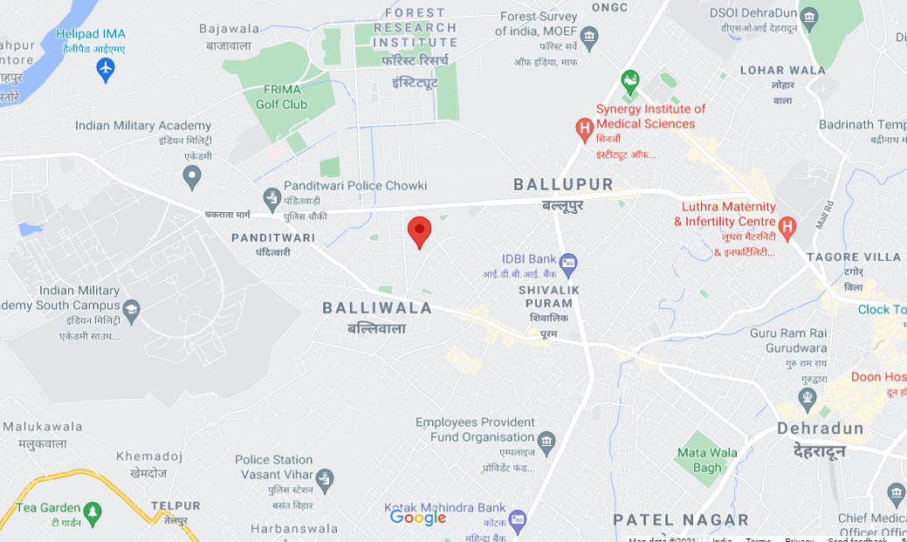

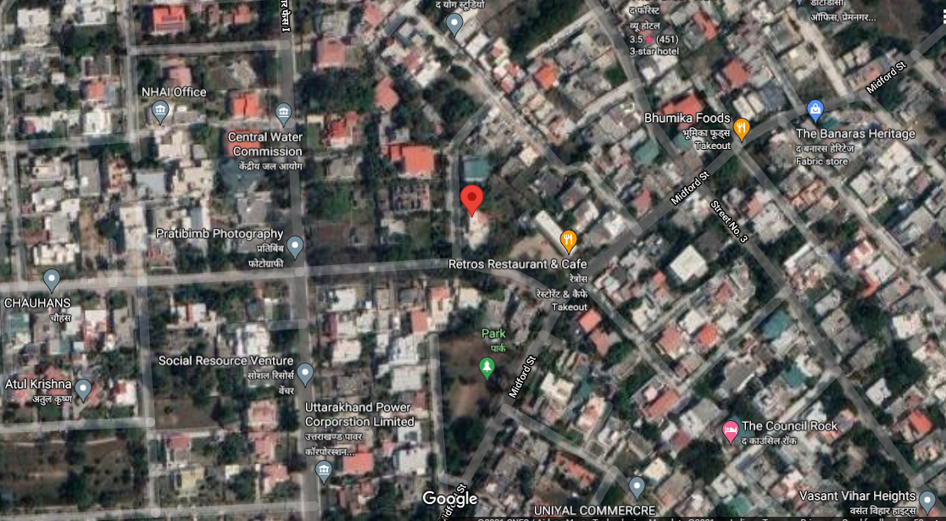

**ANNEXURE: IV – PHOTOGRAPHS OF THE PROPERTY**

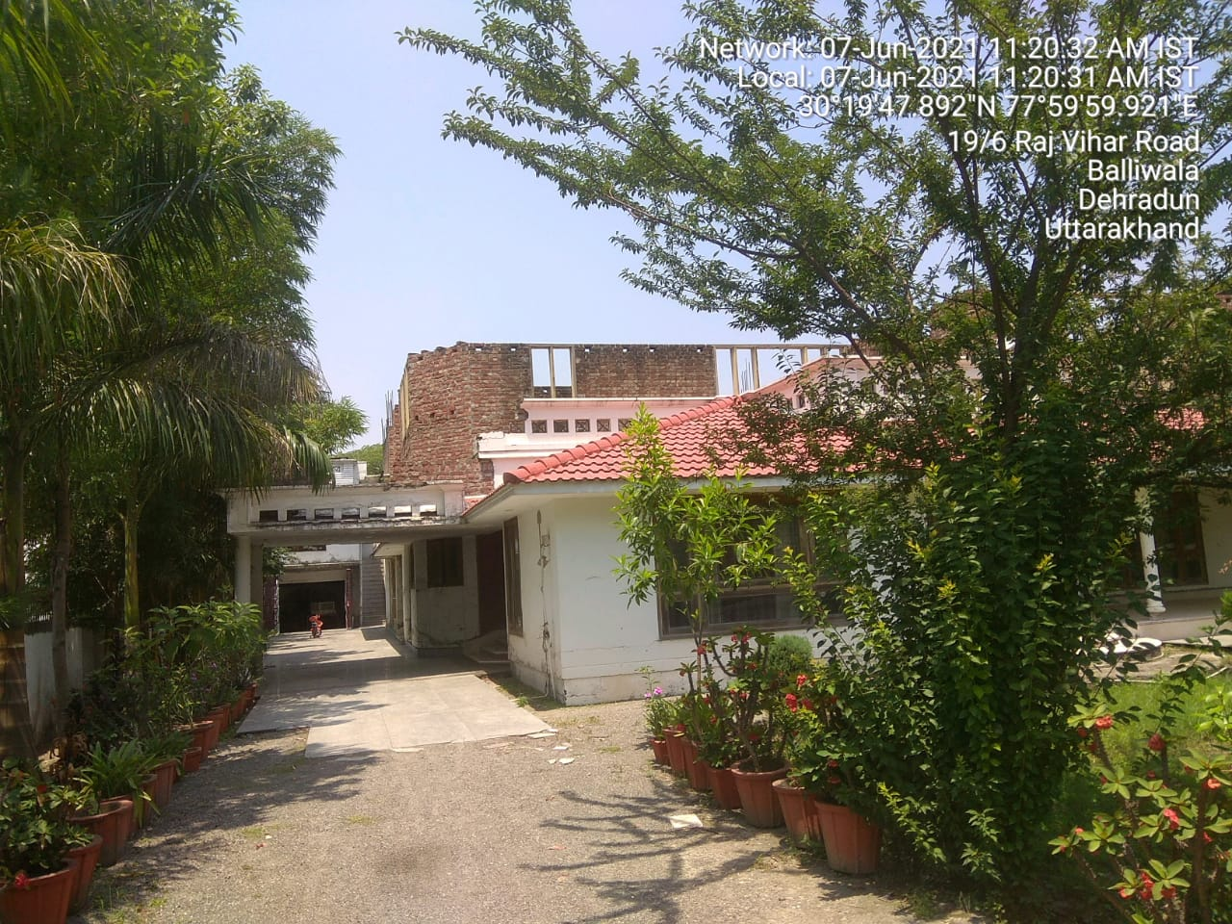

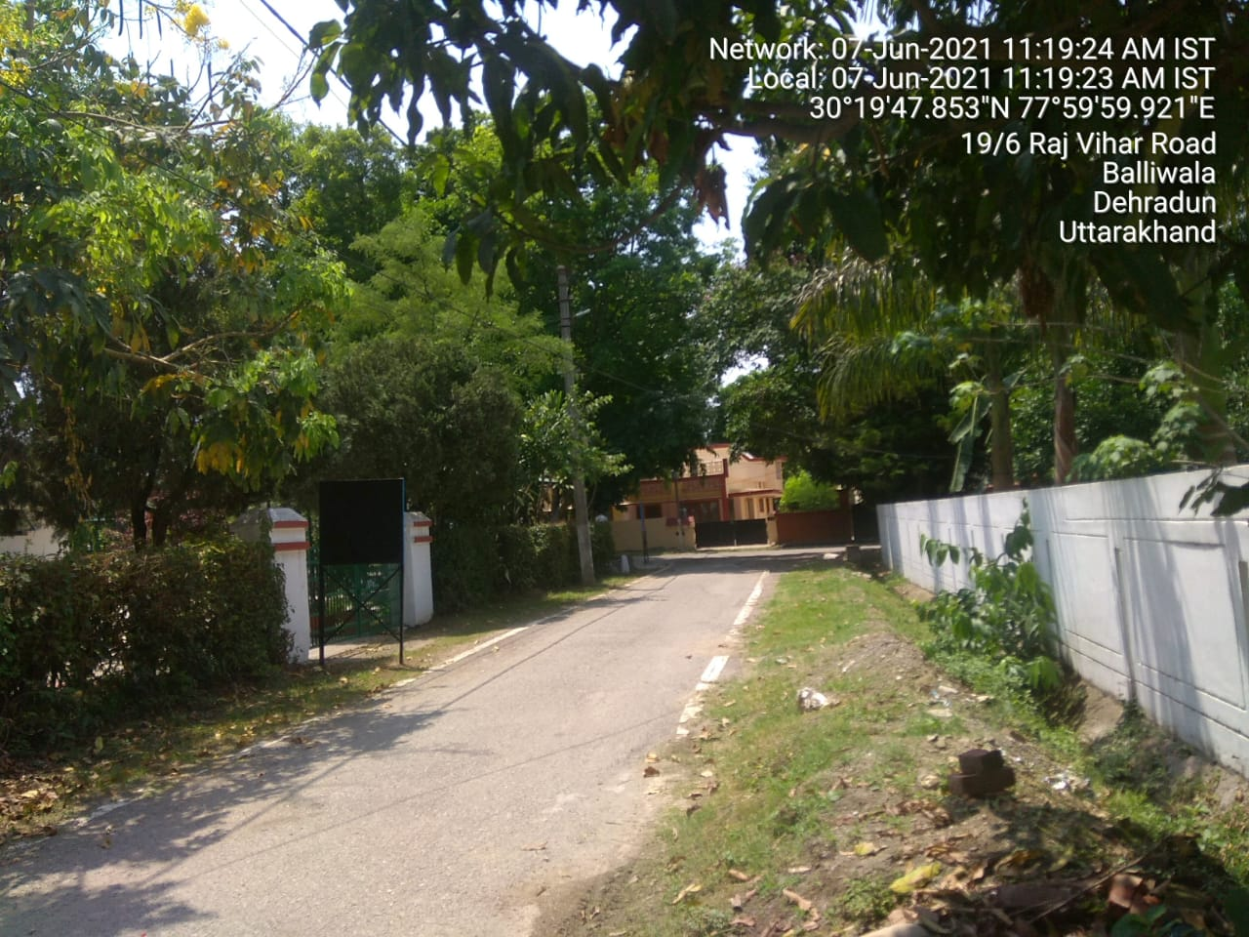

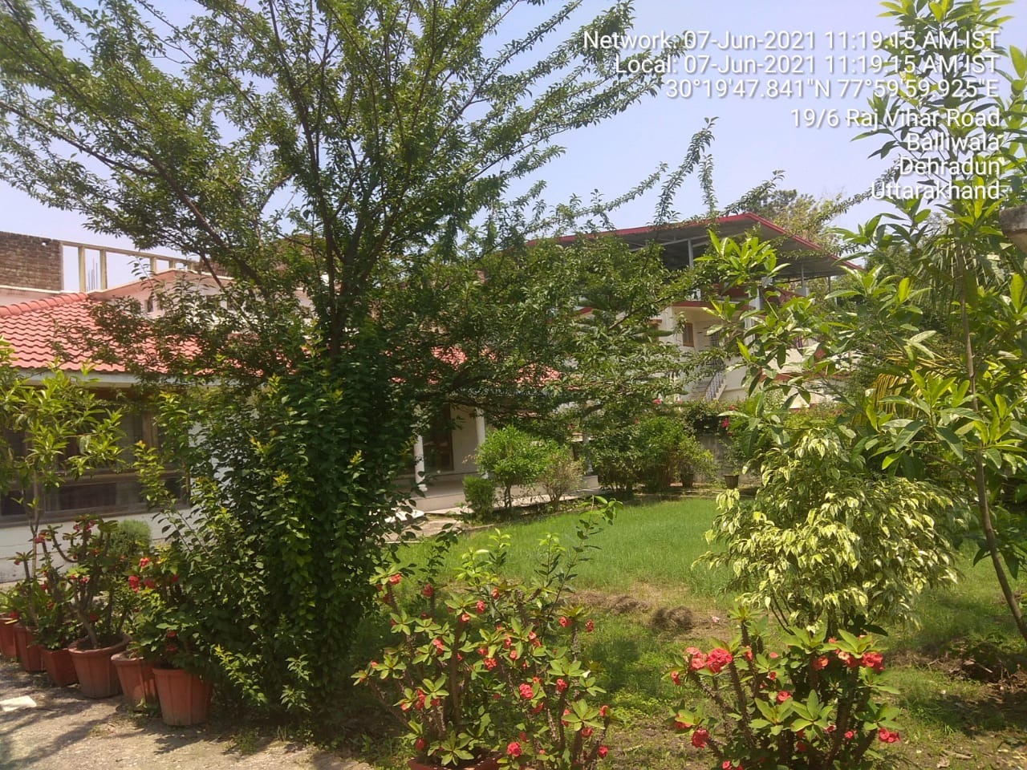

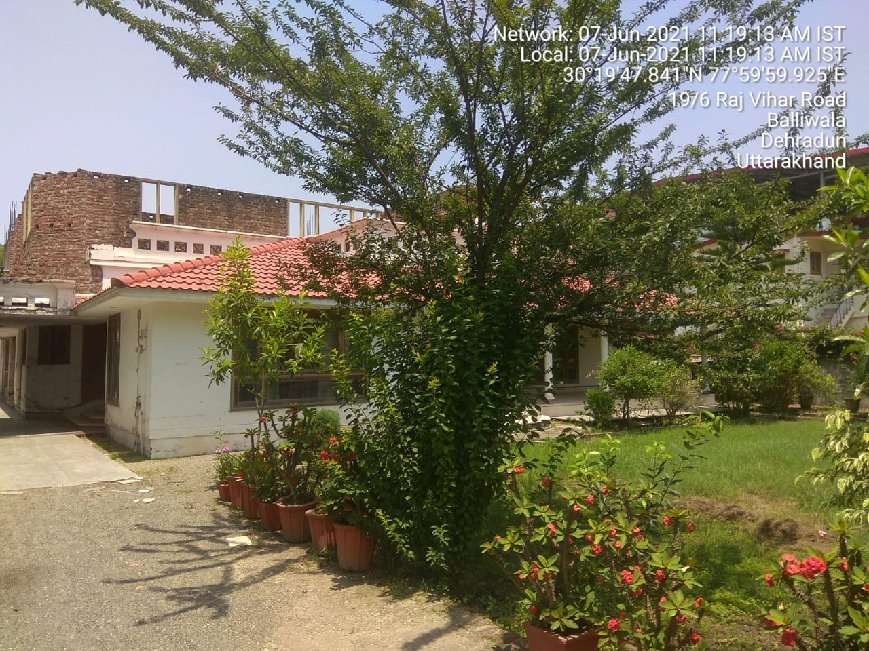

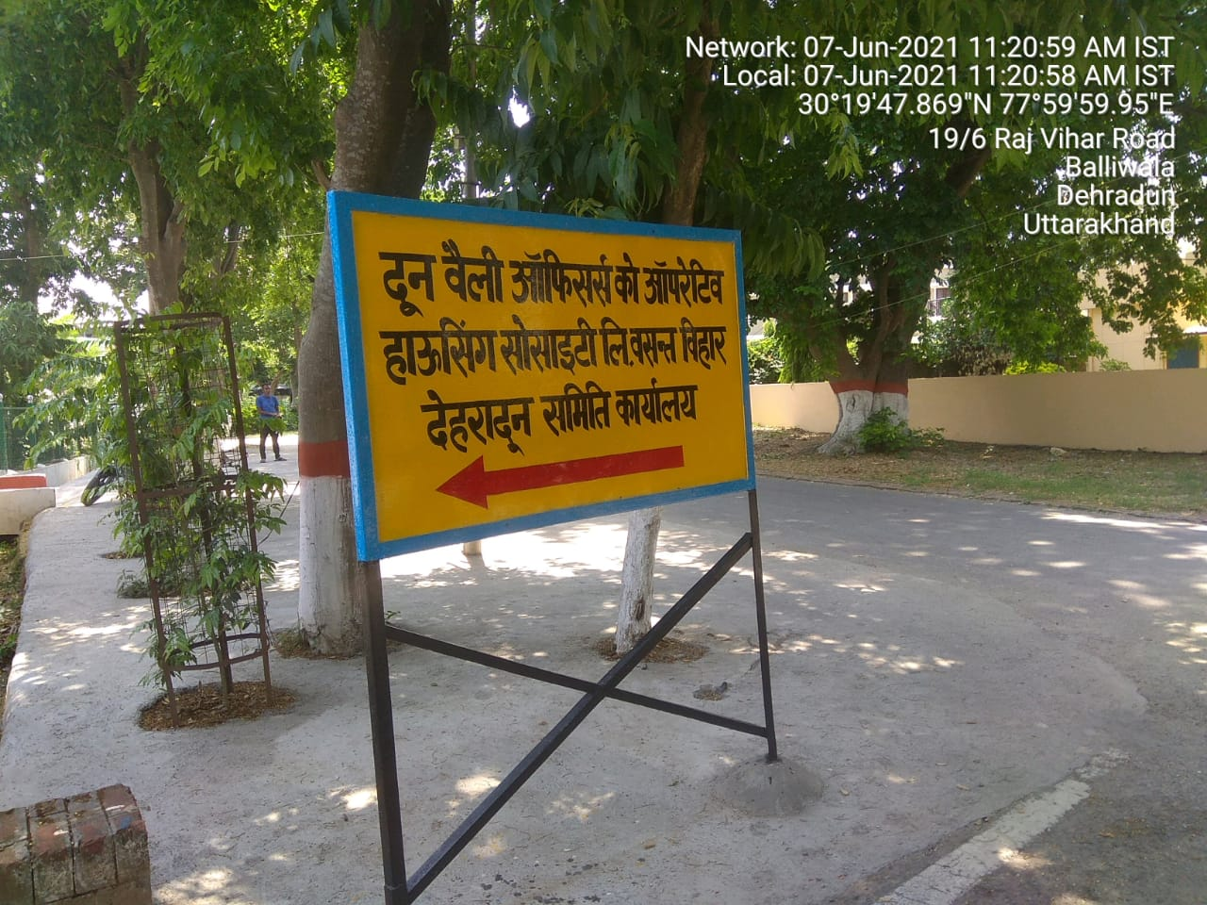

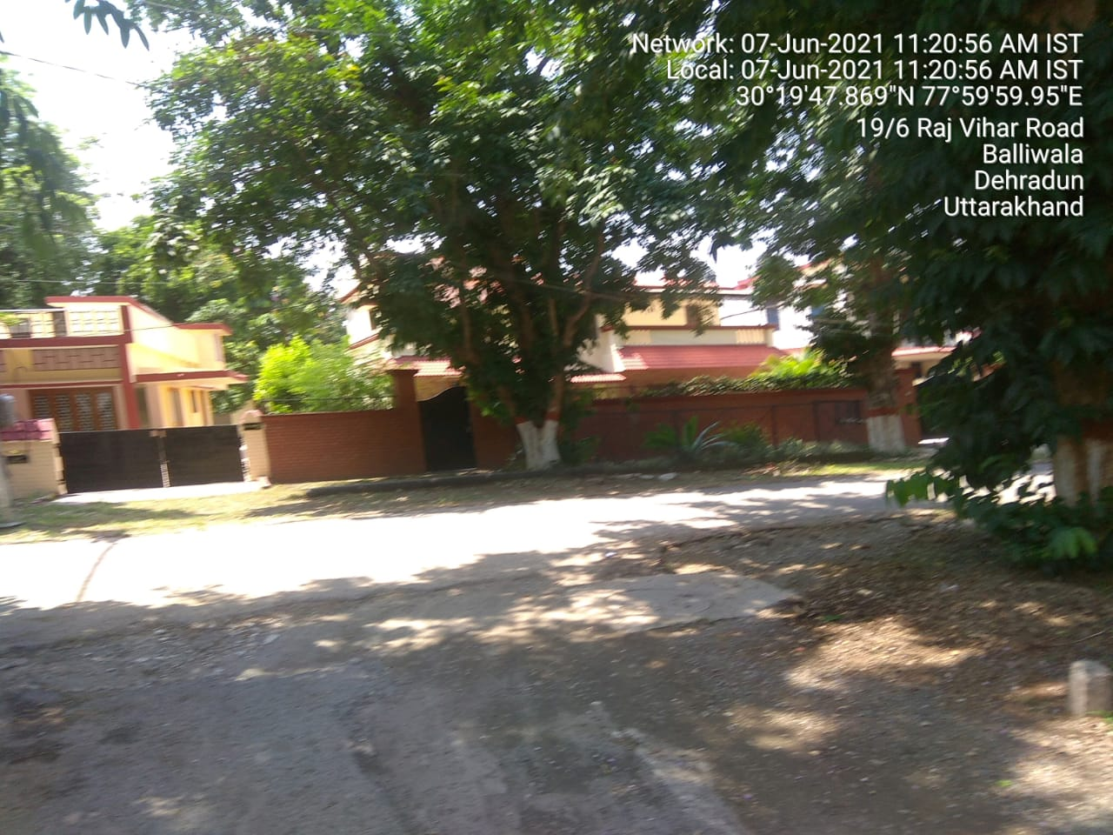

**ANNEXURE: V– COPY OF CIRCLE RATE**

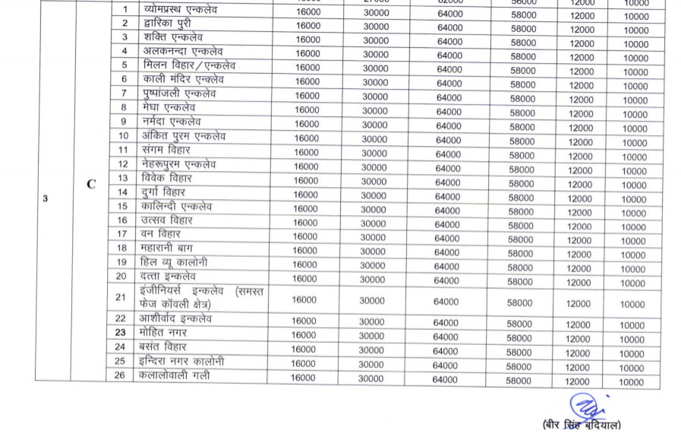

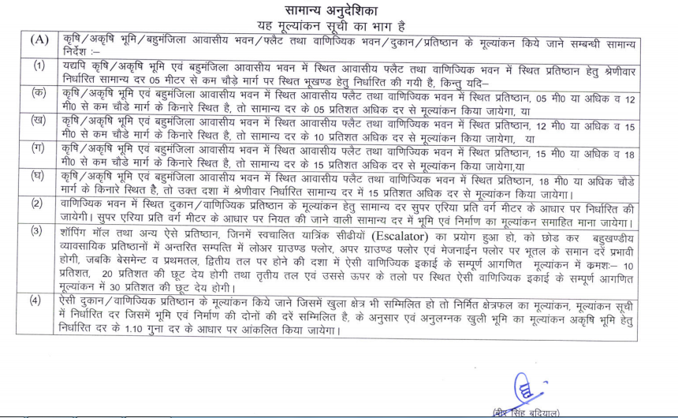

**ANNEXURE: VI- DECLARATION FROM VALUER**

I hereby declare that:

1. The information furnished in our valuation report dated 9/6/2021 is true and correct to the best of my knowledge and belief and we have made an impartial and true valuation of the property.
2. No employee or member of R.K Associates has any direct/ indirect interest in the property or become so interested at any time during a period of three years prior to my appointment as valuer or three years after the valuation of assets was conducted by me.
3. Our authorized Engineer/ surveyor Mr. Deepak Joshi have personally inspected the property on 7/6/2021 the work is not subcontracted to any other valuer and is carried out by us.
4. We have not been convicted of any offence and sentenced to a term of imprisonment.
5. We have not been found guilty of misconduct in professional capacity.
6. We have read the Handbook on Policy, Standards and procedure for Real Estate Valuation, 2011 of the IBA and this report is in conformity to the “Standards” enshrined for valuation in the Part-B of the above handbook to the best of my ability.
7. We have read the International Valuation Standards (IVS) and the report submitted to the Bank for the respective asset class is in conformity to the “Standards” as enshrined for valuation in the IVS in “General Standards” and “Asset Standards” as applicable.
8. I abide by the Model Code of Conduct for empanelment of valuer in the Bank.
9. I am registered under Section 34 AB of the Wealth Tax Act, 1957. (Strike off, if not applicable).
10. I am the proprietor / partner / authorized official of the firm / company, who is competent to sign this valuation report.
11. Further, I hereby provide the following information**.**

|  |  |  |  |
| --- | --- | --- | --- |
| **S. No.** | **Particulars** | **Valuer comment** | |
|  | Background information of the asset being valued | This is a Residential situated at Property situated at Society Plot No. 16, Doon valley, officers cooperative housing society limited, mauza kanwali, Dehradun. having total land area admeasuring 1127.78 sq.mtr. (1360 sq.yds.) and covered area 400 sq.mtr. (4305.56 sq.ft). as per Title deed provided to us by the Bank/ client. | |
|  | Purpose of valuation and appointing authority | Please refer to Page No.01 of the Report. | |
|  | Identity of the Valuer and any other experts involved in the valuation | **Survey Analyst: Er. Deepak Joshi**  **Engineering Analyst: AE Vibhanshu Vaibhav**  **Valuer/ Reviewer: HOD Engg.** | |
|  | Disclosure of Valuer interest or conflict, if any | No relationship with the borrower or any kind of conflict of interest. | |
|  | Date of appointment, valuation date and date of report | **Date of Appointment:** | **7/6/2021** |
| **Date of Survey:** | **7/6/2021** |
| **Valuation Date:** | **9/6/2021** |
| **Date of Report:** | **9/6/2021** |
|  | Inspections and/or investigations undertaken | Yes by our authorized Survey Engineer Mr. Deepak Joshi bearing knowledge of that area on 7/6/2021. | |
|  | Nature and sources of the information used or relied upon | Please refer to Page No. 04 of the Report. | |
|  | Procedures adopted in carrying out the valuation and valuation standards followed | Land value is calculated on the basis of ‘Market Comparable Sales Approach’ | |
|  | Restrictions on use of the report, if any | Value varies with the Purpose/ Date/ Market & Asset Condition& Situation prevailing in the market. We recommend not to refer the indicative & estimated prospective Value of the asset given in this report if any of these points are different from the one mentioned aforesaid in the Report.  This report has been prepared for the purposes stated in the report and should not be relied upon for any other purpose. Our client is the only authorized user of this report and is restricted for the purpose indicated in the engagement letter. I/we do not take any responsibility for the unauthorized use of this report.  During the course of the assignment we have relied upon various information, data, documents provided by Bank/ client in good faith. If at any point of time in future it comes to knowledge that the information given to us is untrue, fabricated, misrepresented then the use of this report at very moment will become null & void.  This report only contains general assessment & opinion on the indicative, estimated Market Value of the property for which Bank has asked to conduct the Valuation and found as per the information given in the copy of documents, information, data provided to us and/ or confirmed by the owner/ owner representative to us at site which has been relied upon in good faith. It doesn’t contain any other recommendations of any sort including but not limited to express of any opinion on the suitability or otherwise of entering into any transaction with the borrower. | |
|  | Major factors that were taken into account during the valuation | Please refer to Page No. 4-8 of the Report. | |
|  | Major factors that were not taken into account during the valuation | NA | |
|  | Caveats, limitations and disclaimers to the extent they explain or elucidate the limitations faced by valuer, which shall not be for the purpose of limiting his responsibility for the valuation report. | Please see attached Annexure. | |

**Date: 9/6/2021**

**Place:** Noida **Signature**

**(Authorized Person of R.K Associates Valuers & Techno Engg. Consultants (P) Ltd.)**

**ANNEXURE: VII- MODEL CODE OF CONDUCT FOR VALUERS**

**Integrity and Fairness**

1. A valuer shall, in the conduct of his/its business, follow high standards of integrity and fairness in all his/its dealings with his/its clients and other valuers.
2. A valuer shall maintain integrity by being honest, straightforward, and forthright in all professional relationships.
3. A valuer shall endeavor to ensure that he/it provides true and adequate information and shall not misrepresent any facts or situations.
4. A valuer shall refrain from being involved in any action that would bring disrepute to the profession.
5. A valuer shall keep public interest foremost while delivering his services.

**Professional Competence and Due Care**

1. A valuer shall render at all times high standards of service, exercise due diligence, ensure proper care and exercise independent professional judgment.
2. A valuer shall carry out professional services in accordance with the relevant technical and professional standards that may be specified from time to time.
3. A valuer shall continuously maintain professional knowledge and skill to provide competent professional service based on up-to-date developments in practice, prevailing regulations/guidelines and techniques.
4. In the preparation of a valuation report, the valuer shall not disclaim liability for his/its expertise or deny his/its duty of care, except to the extent that the assumptions are based on statements of fact provided by the company or its auditors or consultants or information available in public domain and not generated by the valuer.
5. A valuer shall not carry out any instruction of the client insofar as they are incompatible with the requirements of integrity, objectivity and independence.
6. A valuer shall clearly state to his client the services that he would be competent to provide and the services for which he would be relying on other valuers or professionals or for which the client can have a separate arrangement with other valuers.

**Independence and Disclosure of Interest**

1. A valuer shall act with objectivity in his/its professional dealings by ensuring that his/its decisions are made without the presence of any bias, conflict of interest, coercion, or undue influence of any party, whether directly connected to the valuation assignment or not.
2. A valuer shall not take up an assignment if he/it or any of his/its relatives or associates is not independent in terms of association to the company.
3. A valuer shall maintain complete independence in his/its professional relationships and shall conduct the valuation independent of external influences.
4. A valuer shall wherever necessary disclose to the clients, possible sources of conflicts of duties and interests, while providing unbiased services.
5. A valuer shall not deal in securities of any subject company after any time when he/it first becomes aware of the possibility of his/its association with the valuation, and in accordance with the Securities and Exchange Board of India (Prohibition of Insider Trading) Regulations, 2015 or till the time the valuation report becomes public, whichever is earlier.
6. A valuer shall not indulge in “mandate snatching or offering” convenience valuations” in order to cater to a company or client’s needs.
7. As an independent valuer, the valuer shall not charge success fee.
8. In any fairness opinion or independent expert opinion submitted by a valuer, if there has been a prior engagement in an unconnected transaction, the valuer shall declare the association with the company during the last five years.

**Confidentiality**

1. A valuer shall not use or divulge to other clients or any other party any confidential information about the subject company, which has come to his/its knowledge without proper and specific authority or unless there is a legal or professional right or duty to disclose.

**Information Management**

1. A valuer shall ensure that he/ it maintains written contemporaneous records for any decision taken, the reasons for taking the decision, and the information and evidence in support of such decision. This shall be maintained so as to sufficiently enable a reasonable person to take a view on the appropriateness of his/its decisions and actions.
2. A valuer shall appear, co-operate and be available for inspections and investigations carried out by the authority, any person authorized by the authority, the registered valuersorganization with which he/it is registered or any other statutory regulatory body.
3. A valuer shall provide all information and records as may be required by the authority, the Tribunal, Appellate Tribunal, the registered valuers organization with which he/it is registered, or any other statutory regulatory body.
4. A valuer while respecting the confidentiality of information acquired during the course of performing professional services, shall maintain proper working papers for a period of three years or such longer period as required in its contract for a specific valuation, for production before a regulatory authority or for a peer review. In the event of a pending case before the Tribunal or Appellate Tribunal, the record shall be maintained till the disposal of the case.

**Gifts and hospitality.**

1. A valuer or his/its relative shall not accept gifts or hospitality which undermines or affects his independence as a valuer.

Explanation: For the purposes of this code the term ‘relative’shall have the same meaning as defined in clause (77) of Section 2 of the Companies Act, 2013 (18 of 2013).

1. A valuer shall not offer gifts or hospitality or a financial or any other advantage to a public servant or any other person with a view to obtain or retain work for himself/ itself, or to obtain or retain an advantage in the conduct of profession for himself/ itself.

**Remuneration and Costs.**

1. A valuer shall provide services for remuneration which is charged in a transparent manner, is a reasonable reflection of the work necessarily and properly undertaken, and is not inconsistent with the applicable rules.
2. A valuer shall not accept any fees or charges other than those which are disclosed in a written contract with the person to whom he would be rendering service.

**Occupation, employability and restrictions.**

1. A valuer shall refrain from accepting too many assignments, if he/it is unlikely to be able to devote adequate time to each of his/ its assignments.
2. A valuer shall not conduct business which in the opinion of the authority or the registered valuer organization discredits the profession.

**Miscellaneous**

1. A valuer shall refrain from undertaking to review the work of another valuer of the same client except under written orders from the bank or housing finance institutions and with knowledge of the concerned valuer.
2. A valuer shall follow this code as amended or revised from time to time

Signature of the Valuer: ________________

Name of the Valuer: R.K Associates Valuers & Techno Engg. Consultants (P) Ltd.

Address of the Valuer: D-39, Sector-2, Noida-201301

Date: 9/6/2021

Place: Noida

**ENCLOSURE: VI – VALUER’S REMARKS**

|  |  |
| --- | --- |
|  | This Valuation report is prepared based on the copies of the documents/ information which interested organization or customer could provide to us out of the standard checklist of documents sought from them and further based on our assumptions and limiting conditions. All such information provided to us has been relied upon in good faith and we have assumed that it is true and correct. Verification or cross checking of the documents provided to us from the originals has not been done at our end. |
|  | Legal aspects for e.g. investigation of title, ownership rights, lien, charge, mortgage, lease, verification of documents, etc. have to be taken care by legal expert/ Advocate and same are not done at our end. It is assumed that the concerned Lender/ Financial Institution has asked for the valuation of that property for which the legal verification has been already taken and cleared by the competent Advocate before requesting for the Valuation report. |
|  | Analysis and conclusions adopted in the report are limited to the reported assumptions, conditions and information came to our knowledge during the course of the work. |
|  | Value varies with the Purpose/ Date/ Condition prevailing in the market. We recommend not to refer the indicative & estimated prospective Value of the asset given in this report if any of these points are different from the one mentioned aforesaid in the Report. We also recommend that the indicative estimated Value in the Valuation Report holds good only up to the period of 3 months from the date of Valuation. |
|  | This report is having limited scope as per its fields & format to provide only the general basic idea of the value of the property prevailing in the market based on the documents/ data/ information provided by the client. The suggested indicative prospective estimated value should be considered only if transaction is happened as free market transaction. |
|  | This Valuation report is prepared based on the facts of the property on the date of the survey. It is a well-known fact that the market value of any asset varies with time & socio-economic conditions prevailing in the country. In future property Market may go down, property conditions may change or may go worse, Property reputation may differ, Property vicinity conditions may go down or become worse, Property market may change due to impact of Govt. policies or effect of World economy, Usability prospects of the property may change, etc. Hence before financing, Banker/ FI should take into consideration all such future risk and should loan conservatively to keep the advanced money safe in case of the downward trend of the property value. |
|  | Valuation of the same asset/ property can fetch different values in different situations. For eg. Valuation of a running/ operational shop/ hotel/ factory will fetch better value and in case of closed shop/ hotel/ factory it will have considerable lower value. Similarly an asset sold directly by an owner in the market will fetch better value and if the same asset/ property is sold by any financer due to encumbrance on it will fetch lower value. Hence before financing, Banker/ FI should take into consideration all such future risks and should loan conservatively to keep the advanced money safe in case of any such situation. |
|  | Getting cizra map or coordination with revenue officers for site identification is not done at our end. |
|  | Valuation is done for the property identified to us by the owner/ owner representative. At our end we have just cross verified the identification of the property with reference to the documents produced for perusal. Method by which identification of the property is carried out is also mentioned in the report clearly. Responsibility of identifying the correct property to the Valuer/ its authorized surveyor is solely of the client/ owner for which Valuation has to be carried out.It is requested from the Bank to cross check from their own records/ information if this is the same property for which Valuation has to be carried out to ensure that owner has not misled the Valuer company or misrepresented the property due to any vested interest. |
|  | In India more than 70% of the geographical area is lying under rural/ remote/ non municipal/ unplanned area where the subject property is surrounded by vacant lands having no physical demarcation or having any display of property survey or municipal number / name plate on the property clearly. Even in old locations of towns, small cities & districts where property number is either not assigned or not displayed on the properties clearly and also due to the presence of multiple/ parallel departments due to which ownership/ rights/ illegal possession/ encroachment issues are rampant across India and due to these limitations at many occasions it becomes tough to identify the property with 100% surety from the available documents, information & site whereabouts and thus chances of error, misrepresentation by the borrower and margin of chances of error always persists in such cases. To avoid any such chances of error it is advised to the Bank to engage municipal/ revenue department officials to get the confirmation of the property to ensure that the property shown to Valuer/ Banker is the same as for which documents are provided. |
|  | If this Valuation Report is prepared for the Flat/ dwelling unit situated in a Group Housing Society or Integrated Township then approvals, maps of the complete group housing society/ township is out of scope of this report and this report will be made for the specific unit based on the assumption that complete Group Housing Society/ Integrated Township must be approved in all respect.. |
|  | Due to fragmented & frequent change in building/ urban planning laws/ guidelines from time to time, different laws/ guidelines between regions/ states and no strict enforceability of Building Bye-Laws in India specially in non-metro and scale b & c cities & Industrial areas, property owners many times extend or make changes in the covered area/ layout from the approved/ applicable limits. There are also situations where properties are decades old when there was no formal Building Bye-Laws applicable when the construction must have been done. Due to such discrete/ unplanned development in many regions sometimes it becomes tough to determine the exact lawful situation on ground for the Valuer. In case nothing specific is noted on the covered built-up area considered in the Valuation Report, the covered area present on the site as per site survey will be considered in the Valuation. |
|  | Valuation is a subjective field and opinion may differ from consultant to consultant. To check the right opinion, it is important to evaluate the methodology adopted and various data point/ information/ factors/ assumption considered by the consultant which became the basis for the Valuation report before reaching to any conclusion. |
|  | Value analysis of any asset cannot be regarded as an exact science and the conclusions arrived at in many cases will, of necessity, be subjective and dependent on the exercise of individual judgment. Given the same set of facts and using the same assumptions, expert opinions may differ due to the number of separate judgment decisions, which have to be made. Therefore, there can be no standard formula to establish an indisputable exchange ratio. In the event of a transaction, the actual transaction value achieved may be higher or lower than our indicative analysis of value depending upon the circumstances of the transaction. The knowledge, negotiability and motivations of the buyers and sellers and the applicability of a discount or premium for control will also affect actual price achieved. Accordingly, our indicative analysis of value will not necessarily be the price at which any agreement proceeds. The final transaction price is something on which the parties themselves have to agree. However our Valuation analysis can definitely help the stakeholders to make them informed and wise decision about the Value of the asset and can help in facilitating the arm’s length transaction. |
|  | This report is prepared on the RKA V-L1 (Basic) Valuation format as per the client requirement and scope of work. This report is having limited scope as per its fields & format to provide only the general estimated & indicative basic idea of the value of the property prevailing in the market based on the information provided by the client. No detailed analysis, audit or verification has been carried out of the subject property. |
|  | This is just an opinion report and doesn’t hold any binding on anyone. It is requested from the concerned Client/ Bank/ Financial Institution which is using this report for mortgaging the property that they should consider all the different associated relevant & related factors & risks before taking any business decision based on the content of this report. |
|  | All Pages of the report including annexures are signed and stamped from our office. In case any paper in the report is without stamp & signature then this should not be considered a valid paper issued from this office. |
|  | Defect Liability Period is **30 DAYS**. We request the concerned authorized reader of this report to check the contents, data and calculations in the report within this period and intimate us in writing if any corrections are required or in case of any other concern with the contents or opinion mentioned in the report. Corrections only related to typographical, calculation, spelling mistakes will be entertained within the defect liability period. No request for any illegitimate value revision, date change or any other change will be entertained other than the one mentioned above. |
|  | R.K Associates encourages its customers to give feedback or inform concerns over its services through proper channel at [**valuers@rkassociates.org**](mailto:valuers@rkassociates.org) in writing within 30 days of report delivery. After this period no concern/ complaint/ proceedings in connection with the Valuation Services can be entertained due to possible change in situation and condition of the property. |
|  | Our Data retention policy is of **ONE YEAR**. After this period we remove all the concerned records related to the assignment from our repository. No clarification or query can be answered after this period due to unavailability of the data. |
|  | This Valuation report is governed by our (1) Internal Policies, Processes & Standard Operating Procedures, (2) R.K Associates Quality Policy, (3) Valuation & Survey Best Practices Guidelines formulated by management of R.K Associates, (4) Information input given to us by the customer and (4) Information/ Data/ Facts given to us by our field/ office technical team. Management of R.K Associates never gives acceptance to any unethical or unprofessional practice which may affect fair, correct & impartial assessment and which is against any prevailing law. In case of any indication of any negligence, default, incorrect, misleading, misrepresentation or distortion of facts in the report then it is the responsibility of the user of this report to immediately or at least within the defect liability period bring all such act into notice of R.K Associates management so that corrective measures can be taken instantly. |
|  | R.K Associates never releases any report doing alterations or modifications by pen. In case any information/ figure of this report is found altered with pen then this report will automatically become null & void. |