**REPORT FORMAT:** CL-1 | Version: 1.0_2018

**Ref. No.: VIS(2021-22)PL-90-084-100 Date: 05/09/2020**

* ***CERTIFICATE NAME:*** *Valuation Certificate of Stock present at Stone Crusher Plant.*
* ***PREPARED FOR ORGANIZATION:*** *Punjab National Bank, Circle Sastra West, Dehradun.*
* ***BORROWER COMPANY’S NAME:*** *M/s. Kumar Stone Crusher*
* ***ASSET TYPE****: Stock of Crushed Stone Material (Gravels) at Stone Crusher Plant*
* ***CURRENT LOCATION OF THE MATERIAL****: Khata No. 48, 58, 57 & 66, Khasra No. 160, 161, 169, 164, & 163, Village Hardevpur Sehdevpur Alias Rani Majra Ahatmal, Pargana Jawalapur, District & Tehsil Haridwar, Uttarakhand*

**TO WHOM IT MAY CONCERN**

|  |  |  |
| --- | --- | --- |
| **S. NO.** | **PARTICULARS** | **DESCRIPTION** |
|  | Date of Survey | 08-06-2021 |
|  | Date of Certificate | 23-06-2021 |
|  | Documents provided for perusal | List of Stock of Crushed Stone Material of various sizes along with quantity of each type, certified by the owner |
|  | Current Location of the Crushed Stone Material | Khata No. 48, 58, 57 & 66, Khasra No. 160, 161, 169, 164, & 163, Village Hardevpur Sehdevpur Alias Rani Majra Ahatmal, Pargana Jawalapur, District & Tehsil Haridwar, Uttarakhand |
|  | Borrowing Company | M/s. Kumar Stone Crusher |
|  | Type of Asset | Stock of Crushed Stone Material (Gravels) of various sizes lying at the Stone Crusher Plant located at the above site which can be sold in the market. |
|  | Type of Assessment | Market Value of Stock of Crushed Stone Material (Gravels) of various sizes lying at the Stone Crusher Plant located at the above site. |
|  | Scope of Assessment | Assessing the market value of the Stock of Crushed Stone Material (Gravels) of various sizes lying at the Stone Crusher Plant at the above site. |
|  | Nature of Material | Stock of Stone Crushed Material (Gravels) of various sizes, used for construction of various structures and roads. |
|  | Year of Manufacturing | No information available to us |
|  | Total Purchase Cost | Not Available to us |
|  | Current Estimated Market Value | The range of current market rates of such type of Stone Crushed Material (Gravels) is verified from various dealers and on public domain. We are of the view that the Market Value of the total stock as per the list of Stock provided to us by the client is approx. Rs.38,10,000/- |
|  | Condition of Stock | Cannot comment since no quality test has been done. The stock was lying in open at site. |



**OBSERVATIONS:**

1. We have been provided by the bank/borrower company the copy of the list of stock present at the site with quantity and have accepted it in good faith for valuation purposes.
2. As per the information provided to us by the company’s officials at the site, these material are supplied to neaby places in Uttarkhand only like Haridwar etc. and used for the purpose of construction.
3. We have contacted several dealers for the rates of similar material and also enquired in the public domain.
4. The site survey was carried out by our surveyor Mr. Deepak Joshi on June 8, 2021 in the presence of Mr. Raj Kumar ( Owner’s Representative).
5. The stock was identified to our surveyor at the site by the owner’s representative Mr. Raj Kumar.

**Based on the information gathered and enquiries made by us in the market and references found in the public domain for similar materials, it is certified that total current market price of the stock listed in the provided list should be around Rs.38,10,000/- (Rupees Thirty Eight Lakhs Ten Thousand Only)**

*This certificate is issued at the request of* ***Punjab National Bank, Circle Sastra West Branch, Dehradun.***

***Disclaimer:***

1. *This Certificate is to be referred only for the purpose of estimating the market value of the Stock present at site as per the list provided to us by the bank/borrower company.*
2. *We have not carried out any technical or mechanical testing to test the quality or any other technical investigation regarding the specifications or quality of the stock lying at the site.*
3. *Ownership and other legal point of view in respect of the asset is not considered in this report.*
4. *This certificate is made at the request of the Bank.*

**For R.K Associates Valuers** **& Techno** **FOR INTERNAL USE**

**Engineering Consultants (P) Ltd. *TYPED BY: PE Team***

***REVIEWED BY: HOD Engineering***

**(Project Team)**

**GOOGLE MAP LOCATION**

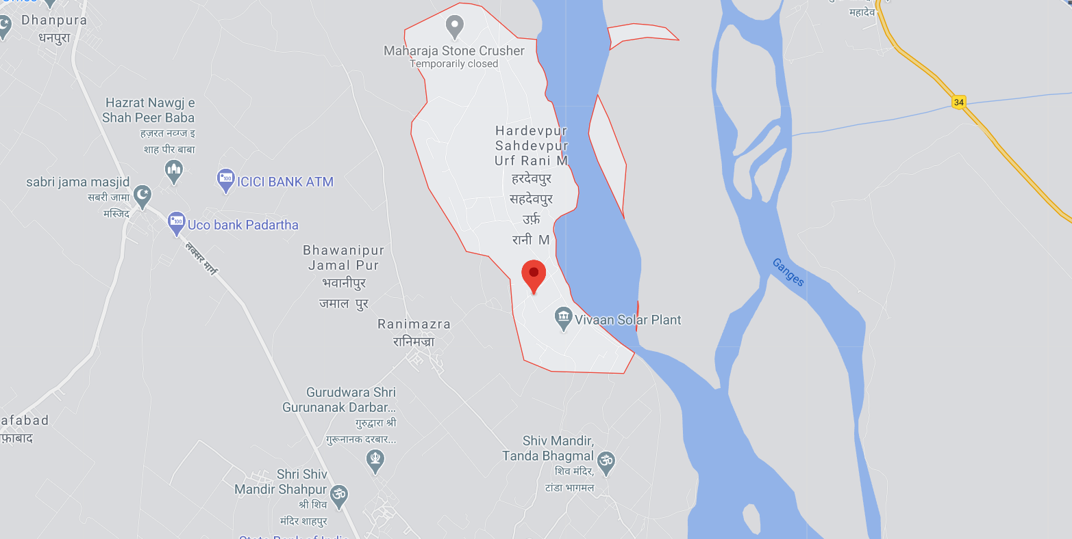

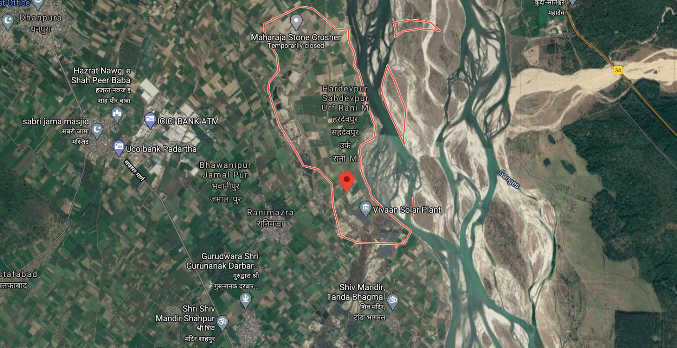

**PHOTOGRAPHS**

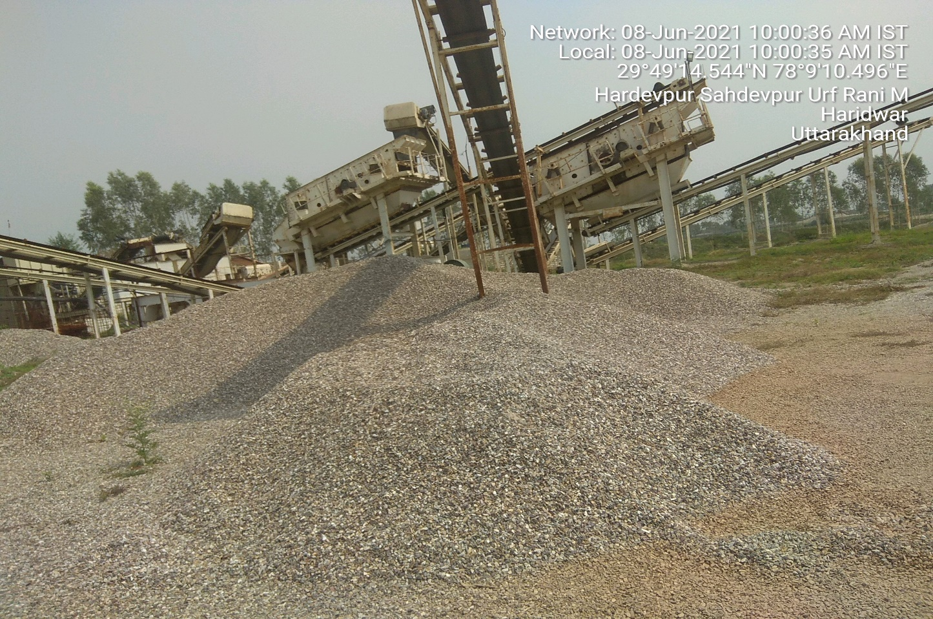

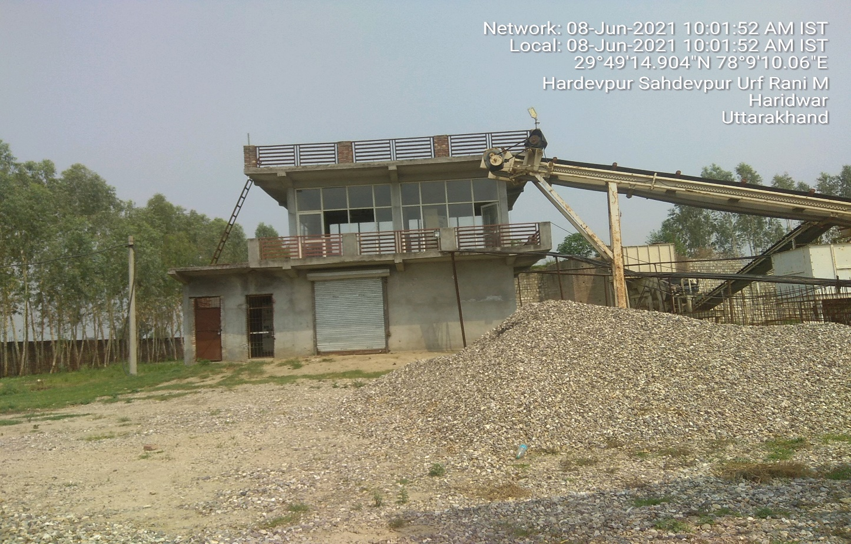

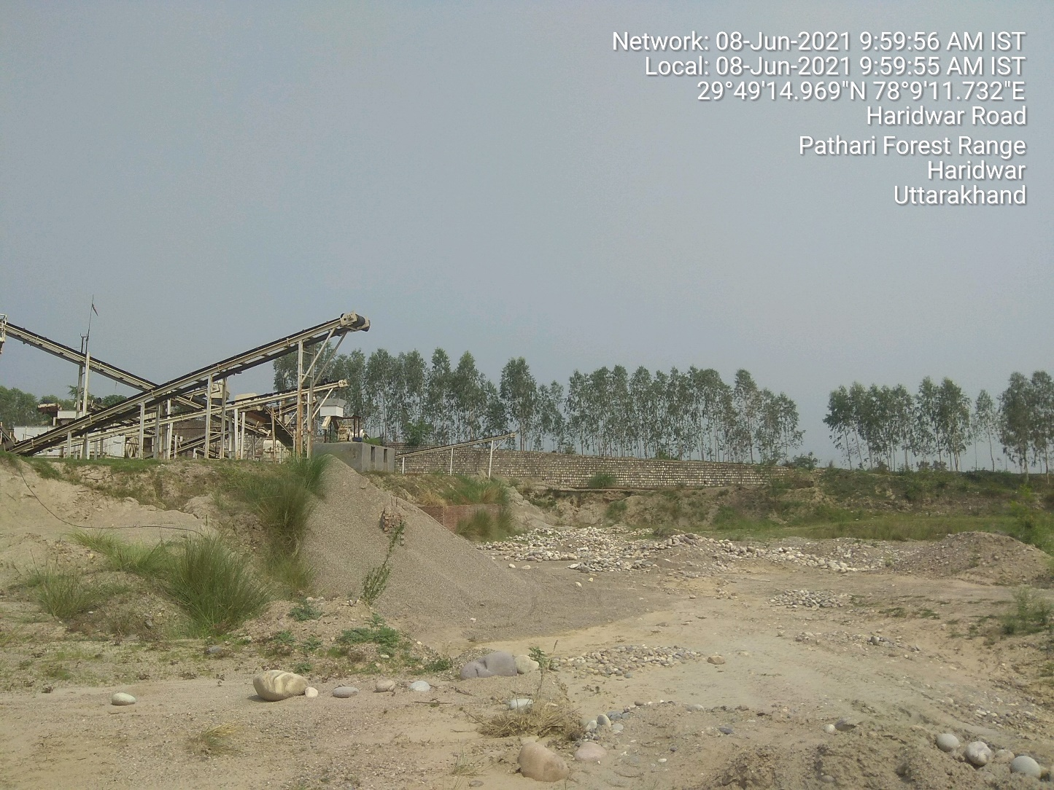

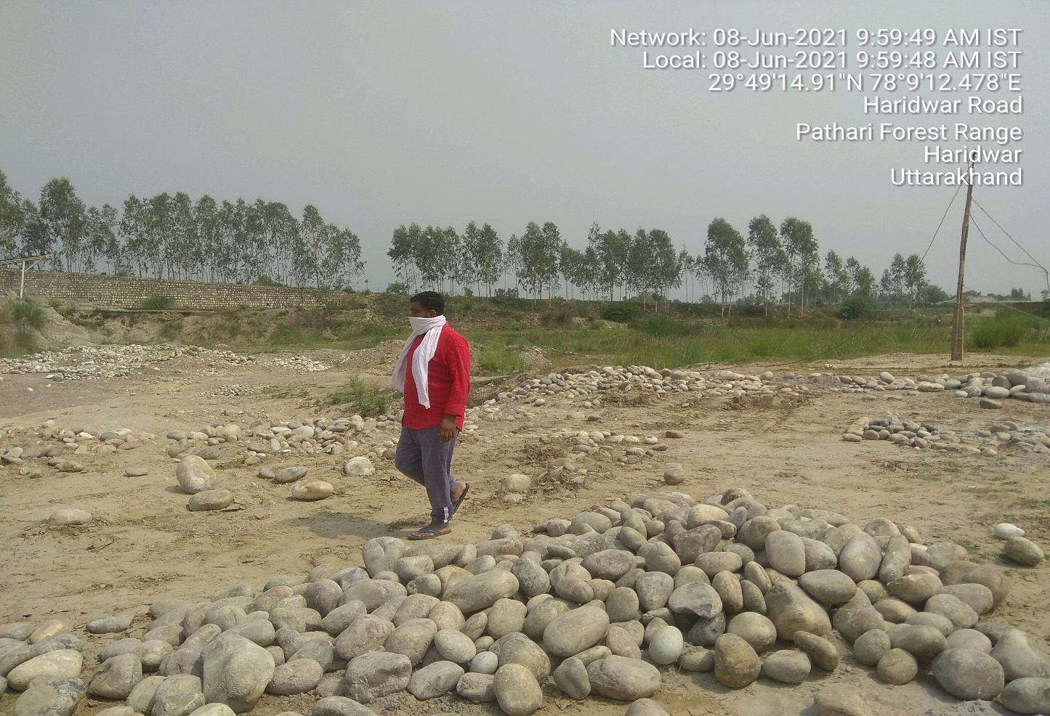

**REFERENCES FROM PUBLIC DOMAIN**

