REPORT FORMAT: V-L15 (Very Large L&B) | Version: 10.2_2022

File No.: VIS(2022-23)-PL008-006-006 Dated: 17.06.2022

FIXED ASSET (LAND AND BUILDING)

VALUATION REPORT

OF

JK TYRE & INDUSTRIES LIMITED

SITUATED AT
PLOT NO. C-1, INDUSTRIAL AREA BANMORE, WITHIN THE VILLAGE LIMITS OF MURBAD, SEWA & TIGHRA, TEHSIL AND DISTRICT-MORENA, MADHYA PRADESH

OWNER/ PROMOTER
M/S. JK TYRE & INDUSTRIES LTD.
REPORT PREPARED FOR | REPORT PREPARED BY
BANK OF INDIA, LCB BRANCH, NEW DELHI | R.K. ASSOCIATES VALUERS & TECHNO ENGINEERING CONSULTANT PVT. LTD.

**Important - In case of any query/ issue or escalation you may please contact Incident Manager
at valuers@rkassociates.org. We will appreciate your feedback in order to improve our services.
NOTE: As per IBA Guidelines please provide your feedback on the report within 15 days of its submission after which report will be considered to be correct.
IMPORTANT NOTICE

COPYRIGHT FORMAT:This report is prepared on the copyright format of R.K Associates to serve our clients with the best possible information and analysis to facilitate them to take rational business decisions. Legally no one can copy or distribute this format without prior approval from R.K Associates. It is meant only for the advisory/ reference purpose for the organization/s as mentioned on the cover page of this report. Distribution or use of this format by any organization or individual other than R.K Associates will be seen as an unlawful act and necessary legal action can be taken against the defaulters.

This report is intended for the sole use of the intended recipient/s and contains material that is STRICTLY CONFIDENTIAL AND PRIVATE.

DEFECT LIABILITY PERIOD: - In case of any query/ issue or escalation you may please contact Incident Manager at valuers@rkassociates.org. We ensure 100% accuracy in the calculations done, rates adopted and various other data points & information mentioned in the report but still can’t rule out typing, human errors or any other mistakes. In case you find any such mistake or inaccuracy in any data point of the report, please help us by bringing all such points into our notice immediately or within 15 days of the report delivery in writing, to rectify these timely failing after which R.K Associates will not be responsible for any such inaccuracy in any manner. We will highly appreciate your feedback in order to improve our services.

Part K: R.K Associates Important Notes and Enclosure 1: Valuer’s Remarks are integral part of this report and Value is assessment is subject to both of these sections. Reader of the report is advised to read all the points mentioned in these sections carefully.

TABLE OF CONTENTS
SECTIONS | PARTICULARS | PAGE NO.
Part A | SNAPSHOT OF THE ASSET/PROPERY UNDER VALUATION | 03
Part B | INTRODUCTION | 04
 | NAME OF THE ASSET | 04
 | PURPOSE OF THE REPORT | 04
 | BRIEF DESCRITPION FO THE PROJECT | 04
 | TYPE OF REPORT | 08
 | SCOPE OF THE REPORT | 09
 | DOCUMENTS/DATA REFFERED | 09
 | DOCUMENTS/DATA PROVIDED BY THE COMPANY | 09
Part C | CHARACTERISTIC DESCRIPTION OF THE PROJECT | 10
Part D | AREA DESCRITPION OF THE ASSET | 17
Part E | INDUSTRY STATUTORY APPROVAL AND NOC DETAILS | 21
Part F | PROCEDURE OF VALUATION ASESSEMENT | 22
Part G | VALUATION OF LAND | 28
Part H | VALUATION OF BULDING AND CIVIL STRUCTURES | 32
Part I | CONSOLIDATED VALUATION ASSESSMENET OF THE PROJECT | 34

PART A | SNAPSHOT OF THE ASSET/ PROPERTY UNDER VALUATION

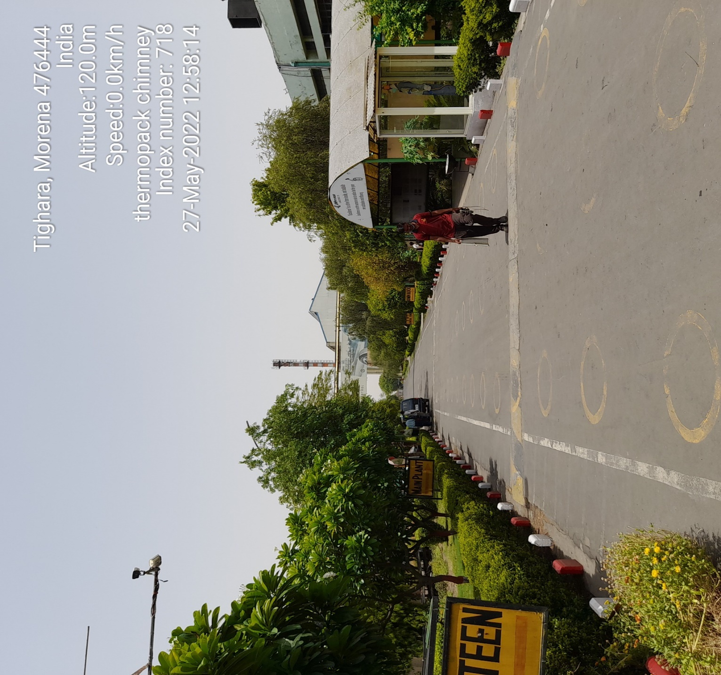

SITUATED AT
PLOT NO. C-1, INDUSTRIAL AREA BANMORE, WITHIN THE VILLAGE LIMITS OF MURBAD, SEWA & TIGHRA, TEHSIL AND DISTRICT-MORENA, MADHYA PRADESH

PART B | INTRODUCTION

- NAME OF THE PROJECT: Tyre Manufacturing Unit (Banmore Tyre Plant) set up by M/s JK Tyre & Industries Ltd. (herewith known as “company” or “JK Tyre”) located at Banmore Industrial area, District-Morena, Madhya Pradesh.

- PURPOSE OF THE REPORT: R.K Associates has been appointed by Bank of India, LCB Branch, New Delhi for carrying out the fixed asset valuation (i.e., valuation of land and building) of the subject property on as-is-where-is basis.

- BRIEF DESCRIPTION OF THE PROJECT: JK Tyre & Industries Ltd. has implemented the Tyre manufacturing Unit. As per the information from the company, the total capacity of Plant Setup is 51,90,000 No./ year of Radial automobile tyre Located at Morena District of Madhya Pradesh.

Details pertaining to Land & Building (Building & Civil Work) are enumerated in different section of this report.

3.1 Location
Subject property is located at Industrial Area Banmore, Within the Village Limits of Murbad, Sewa & Tighra, Tehsil and District-Morena, Madhya Pradesh.
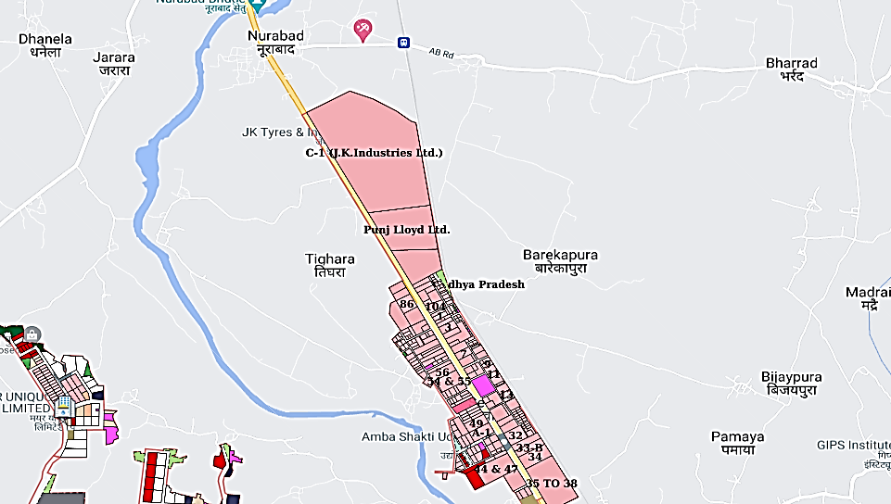

State and District
Madhya Pradesh (meaning Central Province) is a state in central India. Its capital is Bhopal, and the largest city is Indore, with Jabalpur, Ujjain, Gwalior, Satna, and Guna being the other major cities. Madhya Pradesh is the second largest Indian state by area and the fifth largest state by population with over 82,342,793 (82.34 Millions) residents. It borders the states of Uttar Pradesh to the northeast, Chhattisgarh to the southeast, Maharashtra to the south, Gujarat to the west, and Rajasthan to the Northwest.

The economy of Madhya Pradesh is the 10th-largest in India, with a gross state domestic product (GSDP) of ₹9.17 trillion (US$120 billion) and has the country's 26th highest per-capita income of ₹ 1,09,372. Madhya Pradesh ranks 23rd among Indian states in human development index. Rich in mineral resources, Madhya Pradesh has the largest reserves of diamond and copper in India. More than 30% of its area is under forest cover. Its tourism industry has seen considerable growth, with the state topping the National Tourism Awards in 2010–11. In recent years, the state's GDP growth has been above the national average. In 2019–20, state's GSDP was recorded at 9.07.

3.2 Land Requirement
For the purpose of setting up the Plant the company has acquired the said Plot “C-1” with total land area admeasuring 85.4332 Hectares/211.1054 acres. The Land area is considered as per mentioned in the MOE and lease deed provided by the client. Moreover, as per the Google measurement of the subject Plant total land area admeasure approximately the same as stated by the company.

Civil Work
Plant is distributed into different blocks comprising of different buildings as per their utility. These mainly comprise of buildings made out of brickwork and RCC column and beams with G.I. Roofs. Other type of Structures composing of Major portion are Industrial Structures consisting of massive steel structural members embedded in RCC base and covered by Industrial heavy duty corrugated steel sheets/Brickwall.

Main sections of the Plant include Tyre Manufacturing Unit which include long array of buildings divided in different sections Like Green Tyre Area, Tyre Building, Stock area, Tyre Curing area & Finish good warehouse with Raw material unloading Platform.

Other heavy structures like boiler house, ESP control room, turbine building, and switchyard, control room etc. from the captive power plant and ancillary structure like canteen and other departmental building were present at the factory premise mainly consisting the RCC structures.

  - Water Requirement
During site survey we have been informed by the Representative that they have been fulfilling the water requirement by fetching the water through the AKVN (now known as MPIDC). Water supply facility. The MPIDC arrange the water supply from the river nearby. No Bore well or other source of water extraction is present for the Plant.

    - Product and its Distribution:
As per the Information from the company official the Finish product from the said unit are Tyre, Tube & Flap. The Product formed in this unit are Distributed in 25 out of 28 states of India. Ruling out few of the North eastern states Like Manipur, Mizoram, Tripura and Sikkim.

    - Raw Material
The Main Raw material for the Manufacturing of tyre is natural rubber, synthetic rubber, carbon black and oil, other Product used for Manufacturing of Tyre are Tube valve, Bead Wire, TMTD accelerator etc. List of major Vendor to the Company are listed below: -

- Reliance Industries Limited.
- Birla India Private limited. Reliance.
- Philips carbon black Ltd.
- Reliance Sibur Elastomers
- BEKAERT Industries Pvt. Ltd.
- Triton Valves Limited
- SRF Limited
- Tata Steel Limited
- Madura industrial textiles Ltd.
- Demosha Chemicals Pvt. Ltd.
- NOCIL Limited
- Rajsha Chemicals (P) Ltd.
- Raj Petro Specialities Pvt. Ltd.
- Panama Petrochem Ltd.

The list of the vendor is as per the PO’s Provided to us by the Company.
    - Power Requirement
As per the information provided by the company, the power requirement for the plant is fulfilled through the 132 KV connection from MPMKVVCL, Bhopal suitable for High tension Industrial Purpose and to support the fact Last paid electricity bill is provided to us by the client.

    - Operations and Maintenance Contracts
The company is currently doing in-house O&M of the Plant.

    - Status of Plant during Site Survey
Our engineering team has visited the plant project site on 26th May 2022 and 27th May 2022. During the site visit, the plant was found to be in operational condition.

Our Engineering team has made the following observation during the site of the plant:

- The plant is maintained by the company. However, the Structure like the Main tyre curing Building, the Process unit Buildings requires frequent maintenance as compare to other section of the Plant.
- As per the information provided by the company official, the subject plant is operational and new construction is going on in the Factory Premise for the increment of the Production capacity.

- TYPE OF REPORT: Detailed Fixed Asset Valuation of the Project.

- SCOPE OF THE REPORT: Valuation of the Fixed Assets (Land and Building) of M/s JK Tyre & Industries Ltd tyre Manufacturing Plant situated at Banmore Industrial Area.

- This is just the fixed asset valuation of the project based on the cost & market approach methodologies considering the utility of the asset for the business & the company as on-ongoing concern basis. This Valuation shall not be construed as the transactional value of the Project which may be determined through Enterprise/ Business Valuation based on Income approach methodologies.

- This report only contains general assessment & opinion on the Depreciated market value of the assets of the project found on as-is-where basis on site for which the Bank/ customer has shown & asked us to conduct the Valuation for which photographs is also attached with the report. No legal aspects in terms of ownership or any other legal aspect is taken into consideration. It doesn’t contain any due-diligence other than the valuation assessment of the property shown to us on site. Information/ data/ documents given to us by Bank/ client has been relied upon in good faith. This report doesn’t contain any other recommendations of any sort.

- DOCUMENTS/ DATA REFFERED:

- Layout Plan of the Plant
- Memorandum of entry
- Copies of Approvals and NOC’s from various Government agencies and departments.

- DOCUMENTS/ DATA/ INFORMATION PROVIDED BY THE COMPANY:

- Layout Plan of the Plant
- Copies of Approvals and NOC’s from various Government agencies and departments.
- Memorandum of entry
- Lease Deed

PART C | CHARACTERISTICS DESCRIPTION OF THE PROJECT

Name & Address of the Branch | Bank of India, LCB branch, New Delhi
Name & Designation of the concerned officer | NA
Name of the Customer | M/s. JK tyre and industries limited

S.NO. | CONTENTS | DESCRIPTION
 | GENERAL
 | Purpose of Valuation | For Value assessment of the asset for creating collateral mortgage for Bank Loan purpose
 | - Date of Inspection of the Property | 26 May 2022 and 27th 2022
 | - Date of Valuation Assessment | 17 June 2022
 | - Date of Valuation Report | 17 June 2022
 | List of documents produced for perusal (Documents has been referred only for reference purpose) | Documents Requested | Documents Provided | Documents Reference No.
 |  | Total 04 documents requested. | Total 02 documents provided | Total 02 documents provided
 |  | Property Title document | Memorandum of Entry | Dated: 01/10/2020
 |  | Building Sheet | Last paid Electricity Bill | Dated:27/05/2022
 |  | Fixed Asset Register | Oher Approvals & NOC’s | ---
 |  | Other Approvals/NOC | None | None
 | Name of the owner(s) | M/s JK Tyre & Industries Limited
 | Address/ Phone no. | Address: Plot C-1, Banmore Industrial area, Morena
 | Address/ Phone no. | Phone No.: NA

 | Brief description of the property
For the purpose of setting up the Plant the company has acquired the said Plot “C-1” with total land area admeasuring 85.4332 Hectares/211.1054 acres. The Land area is considered as per mentioned in the MOE and lease deed provided by the client. Moreover, as per the Google measurement of the subject Plant total land area admeasure approximately the same as stated by the company 85.4332 Hectares/211.1054 acres.

Plant is distributed into different blocks comprising of different buildings as per their utility. These mainly comprise of buildings made out of brickwork and RCC column and beams with G.I. Roofs. Other type of Structures composing of Major portion are Industrial Structures consisting of massive steel structural members embedded in RCC base and covered by Industrial heavy duty corrugated steel sheets/Brickwall.

Main sections of the Plant include Tyre Manufacturing Unit which include long array of building divided in different sections Like Green Tyre Area, Tyre Building, Stock area, Tyre Curing area & Finish good warehouse with Raw material unloading Platform.

Other heavy structures like boiler house, ESP control room, turbine building, and switchyard, control room etc from the captive power plant and ancillary structure like canteen and other departmental building were present at the factory premise mainly consisting the RCC structures.

This report only contains general assessment & opinion on the Guideline Value and the indicative, estimated Market Value of the property of which Bank/ customer asked us to conduct the Valuation for the property found on as-is-where basis as shown on the site by the Bank/ customer of which photographs is also attached with the report. No legal aspects in terms of ownership or any other legal aspect is taken into consideration. Even if any such information is mentioned in the report it is only referred from the information provided for which we do not assume any responsibility. Due care has been given while doing valuation assessment but it doesn’t contain any due-diligence or audit or verification of any kind other than the valuation computation of the property shown to us on site. Information/ data/ documents given to us by Bank/ client have been relied upon in good faith. This report doesn’t contain any other recommendations of any sort.
 | Location of the property
 | - Plot No. / Survey No. |  |  |  | C-1
 | - Door No. |  |  |  | C-1
 | - T. S. No. / Village |  |  |  | Murbad, Sewa & Tighra
 | - Ward / Taluka |  |  |  | NA
 | - Mandal / District |  |  |  | Morena
 | - Postal address of the property |  |  |  | Plot No. C-1, Industrial area Banmore, Within the Village Limits of Murbad, Sewa & Tighra, Tehsil And District-Morena, Madhya Pradesh
 | - Latitude, Longitude & Coordinates of the site |  |  |  | 26°23'35.7"N 78°04'32.5"E
 | - Nearby Landmark |  |  |  | The project is itself a landmark and Punj Llyod
 | City Categorization |  |  |  | Village |  |  |  |  | Rural
 | Type of Area |  |  |  | Majorly all nearby lands are used for Agriculture purpose
 | Classification of the area |  |  |  | Lower Middle Class (Average) |  |  |  |  | Rural
 |  |  |  |  | Within backward village area
 | Local Government Body Category (Corporation limit / Village Panchayat / Municipality) - Type & Name |  |  |  | Rural |  |  |  |  | Town Panchayat (Nagar Panchayat)
 | Whether covered under any prohibited/ restricted/ reserved area/ zone through State / Central Govt. enactments (e.g. Urban Land Ceiling Act) or notified under agency area / scheduled area / cantonment area/ heritage area/ coastal area |  |  |  | No |  |  |  |  | NA
 | In case it is an agricultural land, any conversion of land use done |  |  |  | As per documents it is not an Agriculture land
 | Boundary schedule of the Property
 | Are Boundaries matched |  |  |  | No, boundaries are not mentioned in the documents.
 | Directions |  |  | As per Documents |  |  |  |  | Actually found at Site
 | North |  |  | NA |  |  |  |  | Nurabad Village
 | South |  |  | NA |  |  |  |  | Punj Llyod
 | East |  |  | NA |  |  |  |  | Railway Track
 | West |  |  | NA |  |  |  |  | N.H. 30 (Mumbai Delhi Highway)
 | Dimensions of the site
 | Directions |  |  | As per Documents (A) |  |  |  |  | Actually found at Site (B)
 | North |  |  | NA |  |  |  |  | Shape uneven, not measurable from sides.
 | South |  |  | NA |  |  |  |  | Shape uneven, not measurable from sides.
 | East |  |  | NA |  |  |  |  | Shape uneven, not measurable from sides.
 | West |  |  | NA |  |  |  |  | Shape uneven, not measurable from sides.
 | Extent of the site |  |  | 85.4332Ha/211.105 acres (Land Area) |  |  |  |  | Shape uneven, not measurable from sides.
 | Extent of the site considered for valuation (least of 14A & 14B) |  |  |  | 85.4332Ha/211.105 acres (Land Area)
 | Property presently occupied/ possessed by |  |  |  | Please Refer to the title deed
 | CHARACTERISTICS OF THE SITE
 | Classification of the locality |  |  |  | Rural Village area
 | Development of surrounding areas |  |  |  | Rural area
 | Possibility of frequent flooding / sub-merging |  |  |  | No such information came into knowledge
 | Proximity to the Civic amenities & social infrastructure like school, hospital, bus stop, market, etc.
 | School | Hospital | Market |  |  | Bus Stop | Railway Station |  |  |  |  | Metro |  | Airport
 | 2 km | 1.5 Km | 2 Km |  |  | 5.6 Km | 5.6 Km |  |  |  |  | NA |  | 35 Km
 | Level of land with topographical conditions |  |  |  | on road level/ Plain Land
 | Shape of land |  |  |  | Irregular
 | Type of use to which it can be put |  |  |  | Best for industrial use
 | Any usage restriction |  |  |  | Yes . The land is only for industrial use
 | Is plot in town planning approved layout?/ Zoning regulation |  |  |  | Yes |  |  |  |  |  | Industrial as per zonal plan made available to us
 | Corner plot or intermittent plot? |  |  |  | It is not a corner plot
 | Road facilities
 | - Main Road Name & Width |  |  |  | Delhi-Mumbai Highway Road |  |  |  |  |  | Approx 100 feet
 | - Front Road Name & width |  |  |  | Delhi-Mumbai Highway Road |  |  |  |  |  | Approx 100 feet
 | - Type of Approach Road |  |  |  | Bituminous Road
 | - Distance from the Main Road |  |  |  | on road mtr.
 | Type of road available at present |  |  |  | Bituminous Road
 | Width of road – is it below 20 ft. or more than |  |  |  | More than 20 ft.
 | Is it a land – locked land? |  |  |  | No
 | Water potentiality |  |  |  | Yes available in the locality from municipal connection
 | Underground sewerage system |  |  |  | Yes
 | Is power supply available at the site? |  |  |  | Yes
 | Advantages of the site |  |  |  | Project site abut National highway
 | Special remarks, if any, like:
 | - Notification of land acquisition if any in the area |  |  |  | No
 | - Notification of road widening if any in the area |  |  |  | No
 | - Applicability of CRZ provisions etc. (Distance from sea-coast / tidal level must be incorporated) |  |  |  | No
 | - Any other |  |  |  | As per information available in public domain the occupancy and operational industries in the Area are declining although all the plots are allotted.
 | VALUATION OF LAND
 | Size of plot |  |  |  | 85.4332 hectare as per MOE and lease deed provided by the company.
 | North & South
 | East & West
 | Total extent of the plot
 | Prevailing market rate (Along with details/reference of at least two latest deals/ transactions with respect to adjacent properties in the areas) |  |  |  | Please refer to Part F - Procedure of Valuation Assessment section.
 | Guideline rate obtained from the Registrar’s Office (an evidence thereof is enclosed with the report)
 | Assessed / adopted rate of valuation
 | Estimated Value of Land
 | VALUATION OF BUILDING
 | Technical details of the building
 | - Type of Building (Residential / Commercial/ Industrial) |  |  |  | INDUSTRIAL / INDUSTRIAL PROJECT LAND & BUILDING
 | - Type of construction (Load bearing /RCC / Steel Framed) |  |  |  | Structure |  |  | Slab |  |  |  |  | Walls
 |  |  |  |  | Steel frame structure and RCC Framed Structure |  |  | Reinforced Cement Concrete |  |  |  |  | Brick walls and RCC Walls
 | - Architecture design & finishing |  |  |  | Interior |  |  |  |  |  | Exterior
 |  |  |  |  | Ordinary regular architecture / Plain ordinary finishing |  |  |  |  |  | Ordinary regular architecture / Simple/ Average finishing
 | - Class of construction |  |  |  | Class of construction: Class C construction (Simple/ Average)
 | - Year of construction/ Age of construction |  |  |  | refer Sheet attached |  |  |  |  |  | refer Sheet attached
 | - Number of floors and height of each floor including basement, if any |  |  |  | NA
 | - Plinth area floor-wise |  |  |  | NA
 | - Condition of the building |  |  |  | Interior |  |  |  |  |  | Exterior
 |  |  |  |  | Good |  |  |  |  |  | Good
 | - Maintenance issues |  |  |  | Building requires some maintenance
 | - Visible damage in the building if any |  |  |  | No visible damages in the structure
 | - Type of flooring |  |  |  | Kota stone, VDF, PCC, Vitrified tiles, Ceramic Tiles
 | - Class of electrical fittings |  |  |  | NA
 | - Class of plumbing, sanitary & water supply fittings |  |  |  | NA
 | Map approval details
 | - Status of Building Plans/ Maps and Date of issue and validity of layout of approved map / plan |  |  |  | Sanctioned by competent authority as per copy of Map provided to us
 | - Approved map / plan issuing authority |  |  |  | MPKVNChoose an item.
 | - Whether genuineness or authenticity of approved map / plan is verified |  |  |  | Approved Plan provided have digital sign on it, any scrutiny regarding the originality of Sign is not done and not under our scope of work as well.
 | - Any other comments on authenticity of approved plan |  |  |  | No
 | - Is Building as per copy of approved Map provided to Valuer? |  |  |  | Yes appears to be as per sample measurement done. Click or tap here to enter text.
 | - Details of alterations/ deviations/ illegal construction/ encroachment noticed in the structure from the approved plan |  |  |  | ☐ Permissible alterations |  |  |  |  |  | NA
 |  |  |  |  | ☐ Non permissible alterations |  |  |  |  |  | NA
 | - Is this being regularized |  |  |  | Not Applicable
 | SPECIFICATIONS OF CONSTRUCTION (FLOOR-WISE) IN RESPECT OF
 | Foundation |  |  |  | This Valuation is conducted based on the macro analysis of the asset/ property considering it in totality and not based on the micro, component or item wise analysis.
 | Basement
 | Superstructure
 | Joinery / Doors & Windows (please furnish details about size of frames, shutters, glazing, fitting etc. and specify the species of timber)
 | RCC works
 | Plastering
 | Flooring, Skirting, dadoing
 | Special finish as marble, granite, wooden paneling, grills, etc
 | Roofing including weather proof course
 | Drainage
 | Compound wall |  |  |  | Yes
 | Height |  |  |  | 6-8 Feet
 | Length |  |  |  | As per Satellite measurement
 | Type of construction |  |  |  | RCC Wall with barbed wiring on top
 | Electrical installation |  |  |  | This Valuation is conducted based on the macro analysis of the asset/ property considering it in totality and not based on the micro, component or item wise analysis.
 | Type of wiring
 | Class of fittings (superior / ordinary / poor)
 | Number of light points
 | Fan points
 | Spare plug points
 | Any other item
 | Plumbing installation |  |  |  | This Valuation is conducted based on the macro analysis of the asset/ property considering it in totality and not based on the micro, component or item wise analysis.
 | No. of water closets and their type
 | No. of wash basins
 | No. of urinals
 | No. of bath tubs
 | No. of water closets and their type
 | Water meter, taps, etc.
 | Any other fixtures

*NOTE:
- For more details & basis please refer to Part F - Procedure of Valuation Assessment section.
- This valuation is conducted based on the comparable composite market rate method which is inherently inclusive of the additional items as mentioned in S.No. 2 to 8 if present in the flat at ordinary level. For any exclusive and superfine finish over and above ordinary finishing, additional value is taken in lumpsum as described in the Procedure of Valuation Assessment section under “Valuation of Additional Aesthetic & Decor Works in the Property”.
- Estimated Value is subject to the assumptions, limitations, basis of computation, caveats, information, facts came during valuation within the limited available time & cost.
- This Valuation is guided by Valuation Terms of Service and Valuer’s Important Remarks which can also be found at www.rkassociates.org.

PART D | AREA DESCRIPTION OF THE ASSET

- TOTAL PROJECT LAND AREA:
For the purpose of setting up the Project, M/s JK Tyre & Industries Limited has acquired the Plot No. C-1 in the Industrial Area Banmore, Morena. The Plot was allotted to Company directly through AKVN (Now known as MPIDC). The Plot Purchased was allotted to the company for a lease period of 99 years as per the copy of lease deed provided dated: - January 1990.

We have also been provided with a copy of TIR dated-27/04/2021. We have not measured the land area on site due to the large size of the plot, it was not viable and moreover was not under our scope of work. Although we have roughly measured the area on Google Maps under the guidance of the company representative Mr. Ajay Chaudhary (DGM Civil) and the area So, measured was around the same as stated by the company but the due to the accuracy concern of the google measurement we have relied in good faith to the information flourished in the MOE and other documents.

BUILDINGS & STRUCTURES AREA:

Several buildings and structures are erected as per the norms & requirement of a Tyre Manufacturing unit which majorly comprise of a single long building housing different steps/Process units involved in Radial automobile Tyre Manufacturing.

Apart from Main Plant Building there exist the structures related to CPP (Captive Power Plant) which include Boiler Section, Silos, TG building etc.

Other Civil Works of the Plant includes construction of roads, Service Building, Switchyard Control Building, site grading, boundary wall, administrative building, Canteen, Control Room, Administrative Block etc.

Note:
- Area measurements considered in the Valuation Report pertaining to Land & Building is adopted from relevant approved documents or actual site measurement whichever is less. All area measurements are on approximate basis only.
- Verification of the area measurement of the Buildings is done based on sample random checking only.
- Area of the large land parcels of more than 2500 sq.mtr or of uneven shape, is taken as per property documents verified with digital survey through google which has been relied upon.
- Drawing Map, design & detailed estimation of the property/ building is out of scope of the Valuation services.

PART E | INDUSTRY STATUTORY APPROVAL & NOC’S DETAILS

SR. NO. | REQUIRED APPROVALS | REFERENCE NO./ DATE | STATUS  (Approved/ Applied For/ Pending/Not provided)
1. | No Objection Certificate from Office of Joint Director/Fire Officer Gwalior | Dispatch No. 6100000766/FNOC/COL/2021/0056  Dated:30/06/2021 | Approved
2. | Renewal of Factory License | Licence No :18/10935/MRN/2m(i)/H  Dated:21/10/2021  Valid Upto: 31/12/2025 | Approved
3. | Renewal Consent to Operate from M.P. Pollution Control Board | Consent No:AW-54797  Dated: 08/12/2021  Valid up to: 30/09/2022 | Approved
4. | Approved Map | Dated : 21/10/2019 | Provided

PART F | PROCEDURE OF VALUATION ASSESSMENT

 | GENERAL INFORMATION
 | Important Dates | Date of Inspection of the Property |  | Date of Valuation Assessment | Date of Valuation Report
 | Important Dates | 26 May 2022 & 26 May 2022 |  | 17 June 2022 | 17 June 2022
 | Client | Bank of India, LCB branch, New Delhi.
 | Intended User | Bank of India, LCB branch, New Delhi.
 | Intended Use | To know the general idea on the market valuation trend of the property as per free market transaction. This report is not intended to cover any other internal mechanism, criteria, and considerations of any organization as per their own need, use & purpose.
 | Purpose of Valuation | For Periodic Re-valuation of the mortgaged property
 | Scope of the Assessment | Non binding opinion on the assessment of Detailed Physical Asset Valuation of the property identified to us by the owner or through his representative.
 | Restrictions | This report should not be referred for any other purpose, by any other user and for any other date other then as specified above.
 | Manner in which the proper is identified | ☒ | Done from the name plate displayed on the property
 | Manner in which the proper is identified | ☐ | Identified by the owner
 | Manner in which the proper is identified | ☒ | Identified by the owner’s representative
 | Manner in which the proper is identified | ☐ | Enquired from local residents/ public
 | Manner in which the proper is identified | ☐ | Cross checked from the boundaries/ address of the property mentioned in the documents provided to us
 | Manner in which the proper is identified | ☐ | Identification of the property could not be done properly
 | Manner in which the proper is identified | ☐ | Survey was not done
 | Type of Survey conducted | Full survey (inside-out with approximate sample random measurements verification & photographs).

 | ASSESSMENT FACTORS
 | Nature of the Valuation |  | Fixed Assets Valuation (Land and Building)
 | Nature/ Category/ Type/ Classification of Asset under Valuation |  | Nature |  |  |  | Category |  |  |  |  |  | Type
 |  |  | LAND & BUILDING |  |  |  | INDUSTRIAL |  |  |  |  |  | INDUSTRIAL PROJECT LAND & BUILDING
 |  |  | Classification |  |  |  | Income/ Revenue Generating Asset
 | Type of Valuation (Basis of Valuation as per IVS) |  | Primary Basis |  |  | Market Value & Govt. Guideline Value
 |  |  | Secondary Basis |  |  | On-going concern basis
 | Present market state of the Asset assumed (Premise of Value as per IVS) |  | Under Normal Marketable State
 |  |  | Reason: Asset under free market transaction state
 | Property Use factor |  | Current/ Existing Use |  |  |  |  | Highest & Best Use  (in consonance to surrounding use, zoning and statutory norms) |  |  |  |  | Considered for Valuation purpose
 |  |  | Industrial |  |  |  |  | Industrial |  |  |  |  | Industrial
 | Legality Aspect Factor |  | Assumed to be fine as per copy of the documents & information produced to us.  However Legal aspects of the property of any nature are out-of-scope of the Valuation Services. In terms of the legality, we have only gone by the documents provided to us in good faith.  Verification of authenticity of documents from originals or cross checking from any Govt. deptt. have to be taken care by Legal expert/ Advocate.
 | Class/ Category of the locality |  | Lower Middle Class (Average)
 | Property Physical Factors |  | Shape |  |  |  |  |  | Size |  |  | Layout
 |  |  | Irregular |  |  |  |  |  | Very Large |  |  | Normal Layout
 | Property Location Category Factor |  | City Categorization |  | Locality Characteristics |  |  |  |  |  | Property location characteristics |  |  | Floor Level
 |  |  | Village |  | Average |  |  |  |  |  | On Highway |  |  | NA
 |  |  | Rural |  | Average |  |  |  |  |  | Good location within locality |  |  | NA
 |  |  |  |  | Within good village area |  |  |  |  |  | Not Applicable |  |  | NA
 |  |  | Property Facing
 |  |  | East Facing
 | Physical Infrastructure availability factors of the locality |  | Water Supply |  | Sewerage/ sanitation system |  |  |  |  |  | Electricity |  |  | Road and Public Transport connectivity
 |  |  | Yes from municipal connection |  | Underground |  |  |  |  |  | Yes |  |  | Easily available
 |  |  | Availability of other public utilities nearby |  |  |  |  |  |  |  | Availability of communication facilities
 |  |  | Transport, Market, Hospital etc. are available in close vicinity |  |  |  |  |  |  |  | Major Telecommunication Service Provider & ISP connections are available
 | Social structure of the area (in terms of population, social stratification, regional origin, age groups, economic levels, location of slums/ squatter settlements nearby, etc.) |  | Rural Area
 | Neighbourhood amenities |  | Average
 | Any New Development in surrounding area |  | None
 | Any specific advantage/ drawback in the property |  | Land mark property with good frontage to National Highway (Delhi-Mumbai Highway)
 | Property overall usability/ utility Factor |  | Good for industrial Unit
 | Do property has any alternate use? |  | No
 | Is property clearly demarcated by permanent/ temporary boundary on site |  | Yes demarcated properly
 | Is the property merged or colluded with any other property |  | No, it is an independent singly bounded property
 |  |  | Comments: NA
 | Is independent access available to the property |  | Clear independent access is available
 | Is property clearly possessable upon sale |  | Yes
 | Best Sale procedure to realize maximum Value (in respect to Present market state or premise of the Asset as per point (iv) above) |  | Fair Market Value
 |  |  | Free market transaction at arm's length wherein the parties, after full market survey each acted knowledgeably, prudently and without any compulsion.
 | Hypothetical Sale transaction method assumed for the computation of valuation |  | Fair Market Value
 |  |  | Free market transaction at arm's length wherein the parties, after full market survey each acted knowledgeably, prudently and without any compulsion.
 | Approach & Method of Valuation Used |  |  | Approach of Valuation |  |  |  |  |  |  | Method of Valuation
 |  |  |  | Mixture of Market & Cost Approach |  |  |  |  |  |  | Market Comparable Sales Method
 | Type of Source of Information |  | Level 3 Input (Tertiary)
 | Other Market Factors
 | Current Market condition | Normal
 | Current Market condition | Remarks: Click here to enter text.
 | Current Market condition | Adjustments (-/+): 0%
 | Comment on Property Salability Outlook | In remote area, will be hard to sell.
 | Comment on Property Salability Outlook | Adjustments (-/+): 0%
 | Comment on Demand & Supply in the Market | Demand |  |  |  |  |  |  |  | Supply
 | Comment on Demand & Supply in the Market | Moderate |  |  |  |  |  |  |  | Low
 | Comment on Demand & Supply in the Market | Remarks: NA
 | Comment on Demand & Supply in the Market | Adjustments (-/+): 0%
 | Any other special consideration | Reason: NA
 | Any other special consideration | Adjustments (-/+): 0%
 | Any other aspect which has relevance on the value or marketability of the property | High utility property as per its nature and location. However utility is only restricted to Power Plant.  Valuation of the same asset/ property can fetch different values under different circumstances & situations. For eg. Valuation of a running/ operational shop/ hotel/ factory will fetch better value and in case of closed shop/ hotel/ factory it will fetch considerably lower value. Similarly, an asset sold directly by an owner in the open market through free market arm’s length transaction then it will fetch better value and if the same asset/ property is sold by any financer or court decree or Govt. enforcement agency due to any kind of encumbrance on it then it will fetch lower value. Hence before financing, Lender/ FI should take into consideration all such future risks while financing.  This Valuation report is prepared based on the facts of the property & market situation on the date of the survey. It is a well-known fact that the market value of any asset varies with time & socio-economic conditions prevailing in the region/ country. In future property market may go down, property conditions may change or may go worse, property reputation may differ, property vicinity conditions may go down or become worse, property market may change due to impact of Govt. policies or effect of domestic/ world economy, usability prospects of the property may change, etc. Hence before financing, Banker/ FI should take into consideration all such future risk while financing.
 |  | Adjustments (-/+): 0%
 | Basis of computation & working
- Valuation of the asset is done as found on as-is-where basis on the site as identified to us by client/ owner/ owner representative during site inspection by our engineer/s unless otherwise mentioned in the report.
- Analysis and conclusions adopted in the report are limited to the reported assumptions, conditions and information came to our knowledge during the course of the work and based on the Standard Operating Procedures, Best Practices, Caveats, Limitations, Conditions, Remarks, Important Notes, Valuation TOR and definition of different nature of values.
- For knowing comparable market rates, significant discreet local enquiries have been made from our side based on the hypothetical/ virtual representation of ourselves as both buyer and seller for the similar type of properties in the subject location and thereafter based on this information and various factors of the property, rate has been judiciously taken considering the factors of the subject property, market scenario and weighted adjusted comparison with the comparable properties unless otherwise stated.
- References regarding the prevailing market rates and comparable are based on the verbal/ informal/ secondary/ tertiary information which are collected by our team from the local people/ property consultants/ recent deals/ demand-supply/ internet postings are relied upon as may be available or can be fetched within the limited time & resources of the assignment during market survey in the subject location. No written record is generally available for such market information and analysis has to be derived mostly based on the verbal information which has to be relied upon.
- Market Rates are rationally adopted based on the facts of the property which came to our knowledge during the course of the assessment considering many factors like nature of the property, size, location, approach, market situation and trends and comparative analysis with the similar assets. During comparative analysis, valuation metrics is prepared and necessary adjustments are made on the subject asset.
- The indicative value has been suggested based on the prevailing market rates that came to our knowledge during secondary & tertiary market research and is not split into formal & informal payment arrangements. Most of the deals takes place which includes both formal & informal payment components. Deals which takes place in complete formal payment component may realize relatively less actual transaction value due to inherent added tax, stamp registration liabilities on the buyer.
- Secondary/ Tertiary costs related to asset transaction like Stamp Duty, Registration charges, Brokerage, Commission, Bank interest, Selling cost, Marketing cost, etc. pertaining to the sale/ purchase of this property are not considered while assessing the indicative estimated Market Value.
- This report includes both, Govt. Guideline Value and Indicative Estimated Prospective Market Value as described above. As per the current market practice, in most of the cases, formal transaction takes place for an amount less than the actual transaction amount and rest of the payment is normally done informally.
- Area measurements considered in the Valuation Report pertaining to asset/ property is adopted from relevant approved documents or sample site measurement whichever is less unless otherwise mentioned. All area measurements are on approximate basis only.
- Verification of the area measurement of the property is done based on sample random checking only.
- Area of the large land parcels of more than 2500 sq.mtr or of uneven shape in which there can be practical difficulty in sample measurement, is taken as per property documents which has been relied upon unless otherwise stated.
- Drawing, Map, design & detailed estimation of the property/ building is out of scope of the Valuation services.
- Construction rates are adopted based on the present market replacement cost of construction and calculating applicable depreciation & deterioration factor as per its age, existing condition & specifications based on visual observation only of the structure. No structural, physical tests have been carried out in respect of it. No responsibility is assumed for latent defects of any nature whatsoever, which may affect value, or for any expertise required to disclose such conditions.
- Construction rates are adopted based on the plinth area rates prevailing in the market for the structure as a whole and not based on item wise estimation or Bills of Quantity method unless otherwise stated.
- The condition assessment and the estimation of the residual economic life of the structure are only based on the visual observations and appearance found during the site survey. We have not carried out any structural design or stability study; nor carried out any physical tests to assess structural integrity & strength.
- Any kind of unpaid statutory, utilities, lease, interest or any other pecuniary dues on the asset or on its owners has not been factored in the Valuation.
- This Valuation is conducted based on the macro analysis of the asset/ property considering it in totality and not based on the micro, component or item wise analysis. Analysis done is a general assessment and is neither investigative in nature nor an audit activity.
- Valuation is done for the asset found on as-is-where basis which owner/ owner representative/ client/ bank has shown to us on site of which some reference has been taken from the information/ data given in the copy of documents provided to us which have been relied upon in good faith and we have assumed that it to be true and correct.
 | ASSUMPTIONS
- Documents/ Information/ Data provided by the client/ property owner or his representative both written & verbally is true and correct without any fabrication and has been relied upon in good faith.
- Local verbal enquiries during micro market research came to our knowledge are assumed to be taken on record as true & factual.
- The assets and interests therein have been valued free and clear of any liens or encumbrances unless stated otherwise. No hidden or apparent conditions regarding the subject assets or their ownership are assumed to exist. No opinion of title is rendered in this report and a good title is assumed unless stated otherwise.
- It is assumed that the concerned Lender/ Financial Institution has asked for the valuation of that property after satisfying the authenticity of the documents given to us and for which the legal verification has been already taken and cleared by the competent Advocate before requesting for the Valuation report. I/ We assume no responsibility for the legal matters including, but not limited to, legal or title concerns.
- Payment condition during transaction in the Valuation has been considered on all cash bases which includes both formal & informal payment components as per market trend.
- Sale transaction method of the asset is assumed as Free market transaction without any compulsion unless otherwise mentioned while assessing Indicative & Estimated Fair Prospective Market Value of the asset unless otherwise stated.
- If this Valuation Report is prepared for the Flat/ dwelling unit situated in a Group Housing Society or Integrated Township then approvals, maps of the complete group housing society/ township is out of scope of this report. This valuation report is prepared for the specific unit based on the assumption that complete Group Housing Society/ Integrated Township is approved and complied with all relevant laws and the subject unit is also approved within the Group Housing Society/ Township.
 | SPECIAL ASSUMPTIONS
 | NA
 | LIMITATIONS
 | None

PART G | VALUATION OF LAND

- LAND VALUATION ASSESSMENT:

- METHODOLOGY ADOPTED:

Land Valuation assessment is done considering the Land use as industrial and considering the same as its highest & best use since the Land parcel is situated in a notified Industrial area and any other use to the land will require Change of Land use from the concern authority. Apart from the fact that subject property is situated in an industrial area, the conversion of the land to the residential use is also not viable considering that this subject land is situated in rural set up It would be difficult and will require time and strategy to sell such a large land parcel.

The land allotment rate in the subject Banmore Industrial area is around ~Rs.2400 per square meter including the Development charges and the maintenance charges. Which is much higher than the market rates available for land in the subject locality. Moreover, the subject industrial area is already developed. But according to the information on the web the industrial area is not doing great and the industries in the area have decreased abruptly in the last two Decades. So, we have valued the subject Land based on the market Inferences.

Apart from all these, the subject Industrial area has also suffered from the adjacent industrial area being set up in the near vicinity called “Sitapur industrial area”. Sitapur industrial area have two phases and the land rates in this Industrial area is much lower as compared to Banmore industrial area. The land allotment rates in the Sitapur industrial area are around. Rs. 850 per square meter. We make it seem reasonable that any prospective buyer would try to fetch a land in this industrial area rather than Banmore industrial area. Until the buyer is interested in the Particular industry i.e. tyre manufacturing. The only scenario this land can fetch a higher value is when someone from the competitors would like to get this plant. Otherwise, this Land will fetch lesser value due to its large size which constrain it’s buyer base.

Overall Valuation assessment is done based on the fact that if any new promoter/ buyer would plan to setup a similar Plant today at same location and similar size then what will cost to him as on date of valuation. To acquire ~85.4332 Hectares of Industrial land parcel, one would either go to Govt. to provide the land for Industry or would approach individual land owners to purchase their land portions. In the Scenario of Person or the organization acquires through Govt. for the allotment the Land of such large scale, it will be treated as a special Case and will be provided at subsidized rates.

The land we have considered for the Valuation assessment is ~85.4332 Hectares of land area as per the information/ data supplied by the company.

Fragmentation sale of a large land may have different values. While assessing the Valuation of the land in this Valuation Report, it is considered as on-is-where basis for the purpose it is used for which was found at the time of site survey.

Value of the Land by Fragmented Sale will require the permission from the MPIDC as the subject Land is allotted to the company as Single Plot called “C-1”. So, the Fragmented sale is doubted and even if considered for the fragmented sale the Land has to be developed for the infrastructure required for the industries to come and the Land rate has to be at par with the Other industrial areas for the timely realization of the plots assumed to be created. The overall assessment of the Land value with the current market condition seems to be best suited by the means of Belting method as shown in the table below attached.

Circle Rate Value: Circle rate of the land is calculated based on “Minimum Value register rates” guidelines issued by Madhya Pradesh Government on their dedicated website https://www.mpigr.gov.in:8080/IGRS/GuideLineTopMenu.do?page=viewFinal under which rates allocated to several villages (on which plant is situated) in District-Morena, Madhya Pradesh are taken into consideration. In the procedure of assessment following points are taken into consideration:

- This subject Land is used for Industrial purpose. So, the Circle rate available for the industrial land is taken into consideration.

- The Subject Land Parcel of 85.4332 Hectares Lies in three villages namely Murbad, Sewa & Tighra but as the land was allotted as a single Plot and no bifurcation detail for the Land in three villages is available to us we have considered the rate of “Tighra” as the circle rate for entire Land and Proceeded accordingly.

- The current ongoing Circle Rates per sq,mtr. of Industrial land located in above mentioned Village is Rs.1200/- per sq,mtr. From Circle rates the total value comes out to be Rs.102,51,98,400/-.

- However, these circle rates give only the indicative values. Actually, this value has no reference to the real market transaction value which is higher for this kind of land for which the land use is Industrial. Also, after implementation of such ultra large projects, market rates extensively go high ↑ in the nearby region. Hence no reference can be derived out of the Circle Guideline Value alone.

Allotment Rate: - The allotment rate to be precise is Rs. 2,399/- per sq.mtr. which include following components Maintenance Charges, Development Charges and land rates (Refer the annexure attached for detail). The value of the land as per allotment rate will be Rs.204,95,42,468/- which seems difficult to realize as per current market condition and spatial features of the Particular Property. The land allotment rates in the nearby industrial area like Sitapur Industrial area are around. Rs. 850 per square meter.

Fair Market Value: Market Value of this Project land would be the value which any new promoter company will be willing to spend in procuring the equal size of the land parcel if the promoter wants to setup a similar plant today on the date of valuation. As of today, if any new promoter goes for setting up a new Greenfield project of such kind, there are only 2 approaches by which Land can be acquired viz., through Land allotment or through direct negotiations with the owners.

As per the Information on the Public Domain and the Office of MPIDC, Gwalior there is no such land which is current up for direct allotment in this particular industrial area. So, the only way out for any buyer to setup a similar Plant is through direct acquisition of the Plant or the Land from the Land owner.

Following points to be noted:

- The subject Land is an industrial area and is allotted to the company as single bounded Plot by the Authority.

- We enquired from multiple Local people and the few dealers dealing in the Locality. Few of the Conversation and the information is listed below: -

- Vinod Phalwan | Contact No.+91-9340190242 (Contractor/Dealer)
As per our conversation with above gentleman we have been informed that the land rates in the area generally prevail in between Rs.20 Lakhs to Rs.40 Lakhs per Bigha for the Land in the interior and any land in the near proximity to National highway will range around Rs. 50-70 Lakhs depending on the Land shape and approach road width and Land abutting the National highway depends on the Seller of the Land for the reference, he told that the Land may go around Rs.1 crores to Rs.1.5 crores per Bigha for industrial Land.

- Mann Singh | Contact No. +91-7224892352 (Local Businessman)
As per our conversation with above Person we have been informed that the land rates in the area generally prevail in between Rs.15 Lakhs to Rs.20 Lakhs per Bigha for the Agricultural Land in the interior and Moreover He has informed us that recently Anmol Mill Property was sold for Rs.1.5 Crore and area of the Plot was 30,000 sq.ft. which approximately derive out the rate to be Rs.2.17 per acres. However no supporting document is available for this information.

- We have arrived the base land rate on the basis of belting method. Considering the Fact that the Market rate of land vary as per the distance of Land from the National highway as observed during the micro market survey for Land Rates. The rates abutting the N.H or the service lane adjacent to the National Highway are sold at higher premium and the Land rates for the land in the Locality is generally practiced in Per Bigha (1acre =1.6 Bigha). The general rate prevailing in the vicinity of subject property Ranges from Rs.20 Lakhs to Rs. 40 Lakhs a Bigha.

- LAND VALUATION CALCULATION: Fair Market Valuation as per current market scenario is described in below table:
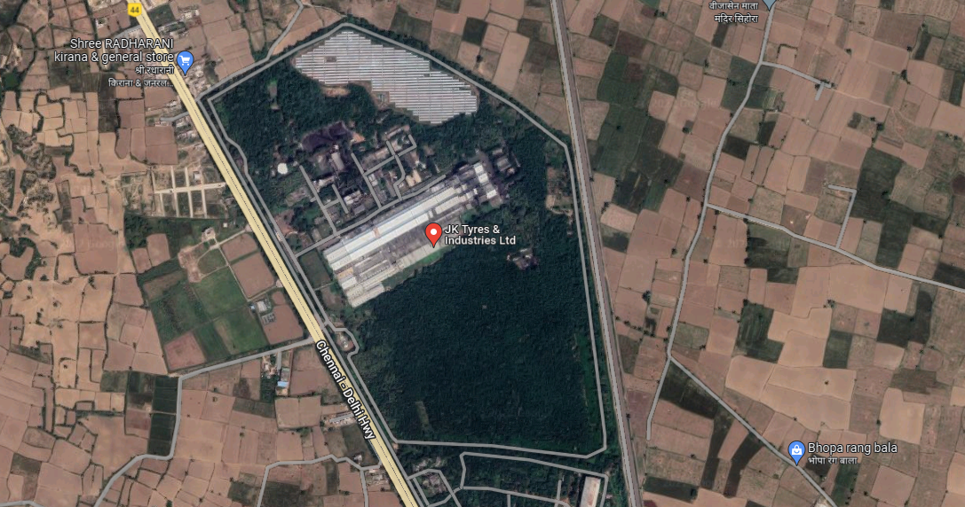
BELTING OF
PLOT

PART H | VALUATION OF BUILDINGS & CIVIL STRUCTURES

      - BUILDING & STRUCTURES VALUATION ASSESSMENT:

- METHODOLOGY ADOPTED: The fair market value of the building on the date of valuation is its cost of reproduction on that date less the depreciation & other deterioration deductions from the date of completion of the building to the date of its valuation.

- We have only considered the Buildings for the Valuation as per the building sheet provided by the company which is verified randomly at the site during the site visit. Although accuracy of the same can’t be ascertain based on sample measurement.

- The Valuation of the civil structure/ building has been carried out on the basis of Cost Approach (plinth area rate basis).

- Reproduction Cost of the structure is calculated as per the Current Market rate prevailing for such industrial building.

- Depreciation is charged on the buildings & structures considering the economic life of civil structure/ building as 30-60 years as per the Industrial Norm for different structures.

- The condition of the buildings and structures found to be average during the site visit. However, the buildings and structures were having old architecture and interiors.

- The Condition of the Structure used primarily for the Manufacturing of Tyre is below average Which include Tyre Building, Tyre Curing Section, Green tyre Building etc.

- Turbine Building and other ancillary Structures related to 50 TPH and 20 TPH boiler were not in use due to no production of power through those units and so are weighed accordingly.

- The Tanks and the Reservoirs are valued as per there capacity i.e. they are valued based on per Volume rates rather than Plinth area rate.

PART I | CONSOLIDATED VALUATION ASSESSMENT OF ASSETS OF THE PROJECT

 | Description | Values
Sr. No. | Valuation of the Property | Govt. Circle/ Guideline Value | Indicative & Estimated Prospective Fair Market Value
 | Land (A) | Rs.102,51,98,400/- | Rs.116,09,23,481/-
 | Buildings (B) | NA | Rs. 57,82,14,554/-
 | Other Civil Works (C) | NA | Rs. 6,73,93,200/-
 | Total Indicative & Estimated Prospective Fair Market Value | Rs.102,51,98,400/- | Rs.180,65,31,235/-
 | Rounded Off | Rs.102,51,98,400/- | Rs.181,00,00,000/-
 | Indicative & Estimated Prospective Value in words | Rupees One Hundred and Two Crores Fifty-One Lakhs Ninety-Eight Thousand Four Hundred Only | Rupees One Hundred Eighty One Crore only
 | Expected Realizable Value (@ ~15% less) | NA | Rs.  153,85,00,000/-
 | Expected Distress Sale Value (@ ~25% less) | NA | Rs.135,75,00,000/-
 | Percentage difference between Circle Rate and Fair Market Value |  | 44%

Concluding Comments/ Disclosures if any
- We are independent of client/ company and do not have any direct/ indirect interest in the property.
- This valuation has been conducted by R.K Associates Valuers & Techno Engineering Consultants (P) Ltd. and its team.
- This Valuation is done for the property found on as-is-where basis as shown on the site by the customer of which photographs is also attached with the report.
- This is just the fixed asset valuation of the project based on the cost & market approach methodologies considering the utility of the asset for the business & the company as on-ongoing concern basis. This Valuation shall not be construed as the transactional value of the Project which may be determined through Enterprise/ Business Valuation based on Income approach methodologies.
- This is just core Asset Valuation and doesn’t cover any prospective sale value of the Power Plant as a whole.
- Any kind of unpaid statutory, utilities, lease, interest or any other pecuniary dues on the asset has not been factored in the Valuation.
- This Valuation is conducted based on the macro analysis of the asset/ property considering it in totality and not based on the micro, component or item wise analysis. Analysis done is a general assessment and is not investigative in nature
- Reference of the property is also taken from the copies of the documents/ information which interested organization or customer could provide to us out of the standard checklist of documents sought from them and further based on our assumptions and limiting conditions. All such information provided to us has been relied upon in good faith and we have assumed that it is true and correct. However, we do not vouch the absolute correctness of the property identification, exact address, physical conditions, etc. based on the documents provided to us since property shown to us may differ on site Vs. as mentioned in the documents or incorrect/ fabricated documents may have been provided to us.
- Legal aspects for eg. Investigation of title, ownership rights, lien, charge, mortgage, lease, verification of documents from originals or from any Govt. department, etc. has to be taken care by legal experts/ Advocates and same has not been done at our end.
- The valuation of an asset is an estimate of the worth of that asset which is arrived at by the Valuer in his expert opinion after factoring in multiple parameters and externalities. This may not be the actual price of that asset and the market may discover a different price for that asset.
- This report only contains opinion based on technical & market information which came to our knowledge during the course of the assignment. It doesn’t contain any recommendations.
- This report is prepared following our Standard Operating Procedures & Best Practices and will be subject to Limitations, Conditions, Valuer’s Remarks, Important Notes, Valuation TOS and basis of computation & working as described above.
- The use of this report will become valid only after payment of full fees as per the Payment Terms. Using this report or any part content created in this report without payment of charges will be seen as misuse and unauthorized use of the report.
IMPORTANT KEY DEFINITIONS
Fair Value suggested by the competent Valuer is that prospective estimated amount in his expert & prudent opinion of the subject asset/ property without any prejudice after he has carefully & exhaustively evaluated the facts & information came in front of him or which he could reasonably collect during the course of the assessment related to the subject asset on an as-is, where-is basis in its existing conditions, with all its existing advantages & disadvantages and its potential possibilities which is just & equitable at which the subject asset/ property should be exchanged between a willing buyer and willing seller at an arm’s length transaction in an open & unrestricted market, in an orderly transaction after proper marketing, wherein the parties, each acted knowledgeably, prudently without any compulsion on the date of the Valuation.
Fair Value without using the term “Market” in it describes that the value suggested by the Valuer may not mandatorily follow or may not be in complete consonance to the established Market in his expert opinion. It may or may not follow market dynamics. But if the suggested value by the valuer is not within the prevailing Market range or is assessed for an asset is located in an un-established Market then the valuer will give reasonable justification & reasoning that for what reasons the value suggested by him doesn’t follow the prevailing market dynamics.
Fair Market Value suggested by the competent Valuer is that prospective estimated amount in his expert & prudent opinion of the subject asset/ property without any prejudice in consonance to the Market dynamics after he has carefully & exhaustively evaluated the facts & information came in front of him or which he could reasonably collect during the course of assessment related to the subject asset on an as-is, where-is basis in its existing conditions, with all its existing advantages & disadvantages and its potential possibilities which is just & equitable at which the subject asset/ property should be exchanged between a willing buyer and willing seller at an arm’s length transaction in an open & unrestricted market, in an orderly transaction after proper marketing, wherein the parties, each acted knowledgeably, prudently without any compulsion on the date of the Valuation.
Here the words “in consonance to the established Market” means that the Valuer will give opinion within the realms & dynamics of the prevailing market rates after exhaustively doing the micro market research. However due to the element of “Fair” in it, valuer will always look for the factors if the value should be better than the market realms which is just & equitable backed by strong justification and reasoning.
Market Value suggested by the competent Valuer is that prospective estimated amount which is average price of the similar comparable assets prevailing in an open & established market during the near period of the date of valuation at which the subject asset/ property should be exchanged between a willing buyer and willing seller on an as-is, where-is basis in its existing conditions, with all its existing advantages & disadvantages and its potential possibilities at an arm’s length transaction in an open, established & unrestricted market, in an orderly transaction, wherein the parties, each acted without any compulsion on the date of the Valuation.
Using the term “Market Value” without “Fair” omits the elements of proper marketing, acting knowledgeably & prudently.
Market and market participants can be sentimental, inclined towards the transaction without the element of complete knowledge & prudence about facts or due diligence of the asset therefore “each acted knowledgeably, prudently” has been removed from the marker Value definition.
Realizable Value is that minimum prospective estimated value of the asset/ property which it may be able to fetch at the time of actual property transaction factoring in the element of discount due to the prospects of deep negotiations between the buyer & seller when the parties in-principally find Fair Market Value reasonable and sits together to close the deal and the transaction across the table. Discount percentage on the Fair Market Value due to negotiation will depend on the nature, size, various salability prospects of the subject asset, the needs of the buyer & the seller and kind of payment terms. In some of the cases Realizable and Fair Market Value may also be equal.
Distress Sale Value* is that value when the property is attached with any process such as mortgaged financing, financial or operational dues which is under any stress condition or situation and the stakeholders are under process of finding resolution towards it to save the property from being attached to a formal recovery process. In this type of sale, minimum fetch value assessed will always be less than the estimated Fair Market Value where the discount of percentage will depend upon various circumstances and factors such as nature, size, salability prospects of the property and kind of encumbrance on the property. In this type of sale, negotiation power of the buyer is always more than the seller and eagerness & pressure of selling the property will be more on the seller than the buyer.
Liquidation Value is the amount that would be realized when an asset or group of assets are sold due to any compulsion or constraints such as in a recovery process guided by statute, law or legal process, clearance sale or any such condition or situation thereof where the pressure of selling the asset/ property is very high to realize whatever maximum amount can be from the sale of the assets in a limited time for clearance of dues or due to closure of business. In other words, this kind of value is also called as forced sale value.
Difference between Cost, Price & Value: Generally, these words are used and understood synonymously. However, in reality each of these has a completely different meaning, premise and also having different definitions in professional & legal terms. Therefore, it is our professional responsibility to describe the definitions of these words to avoid ambiguity & confusion in the minds of the user of this report.
The Cost of an asset represents the actual amount spend in the construction/ actual creation of the asset.
The Price is the amount paid for the procurement of the same asset.
The Value is defined as the present worth of future rights in the property/ asset and is a hypothetical or notional price that buyers and sellers are most likely to conclude for a good or service. Value is not a fact, but an estimate of the likely price to be paid for a good or service at a given time in accordance with a particular definition of value.
Therefore, in actual for the same asset/ property, cost, price & value remain different since these terms have different usage & meaning.
Enclosures with the Report:

- Enclosure: I – Google Map Location
- Enclosure: II – Photographs of the property
- Enclosure: III – Copy of Circle Guideline Rate
- Enclosure IV: Important Property Documents Exhibit
- Enclosure V: Valuer’s Important Remarks

SURVEY ANALYST | VALUATION ENGINEER | REVIEWER
Parveen Sharma and Abhishek Sharma | Abhishek Sharma | Ashish Sawe

ENCLOSURE I: GOOGLE MAP LOCATION

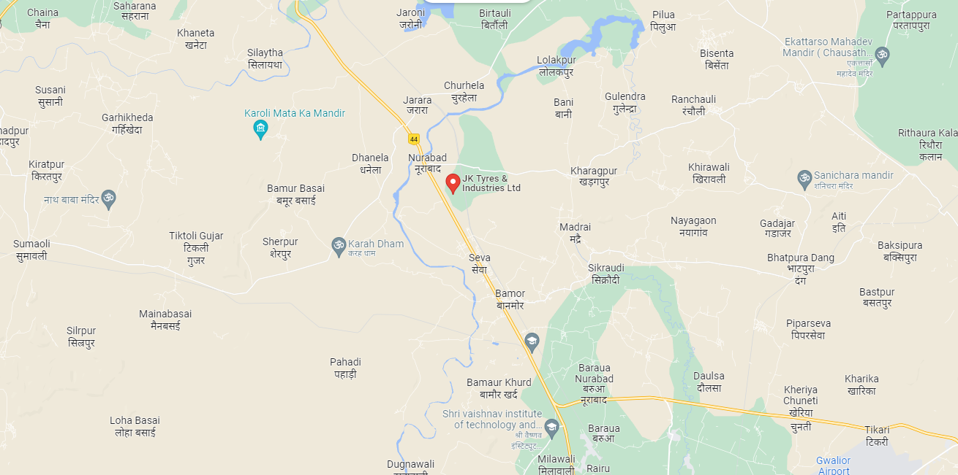

ENCLOSURE II: PHOTOGRAPHS OF THE PROPERTY

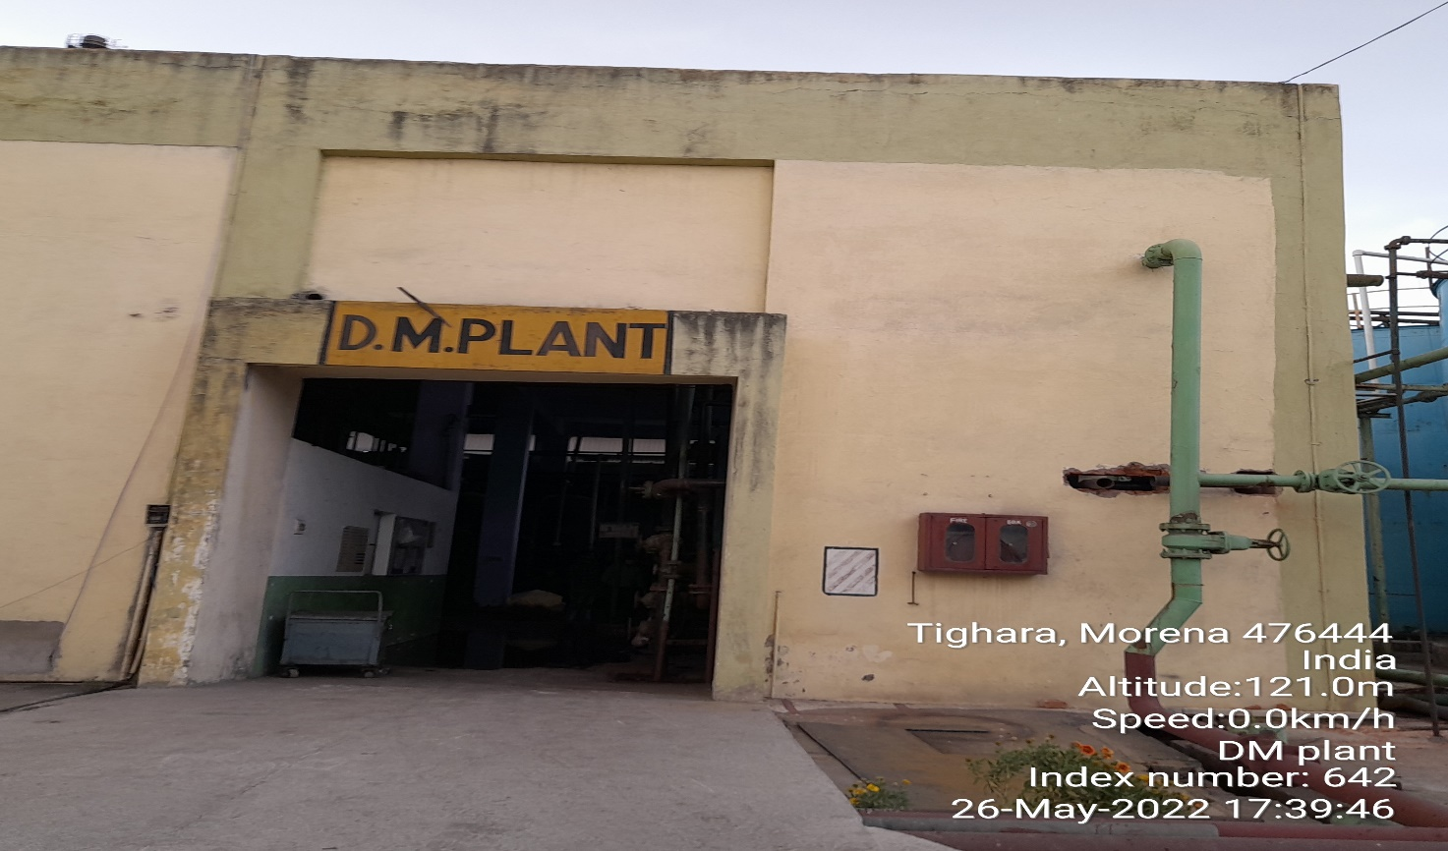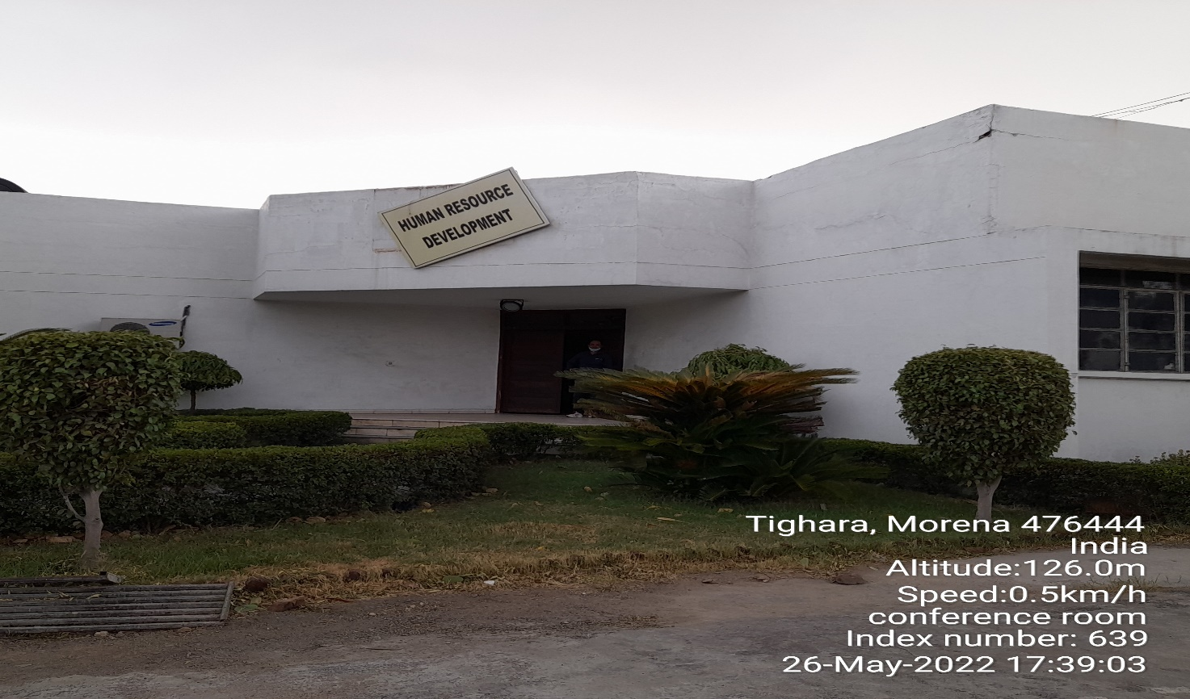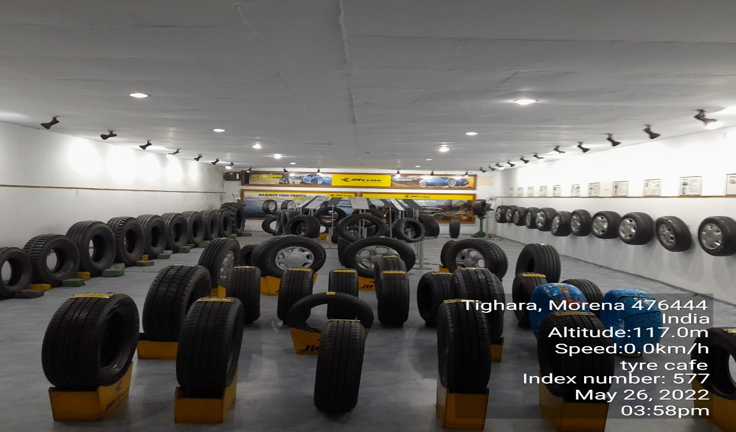

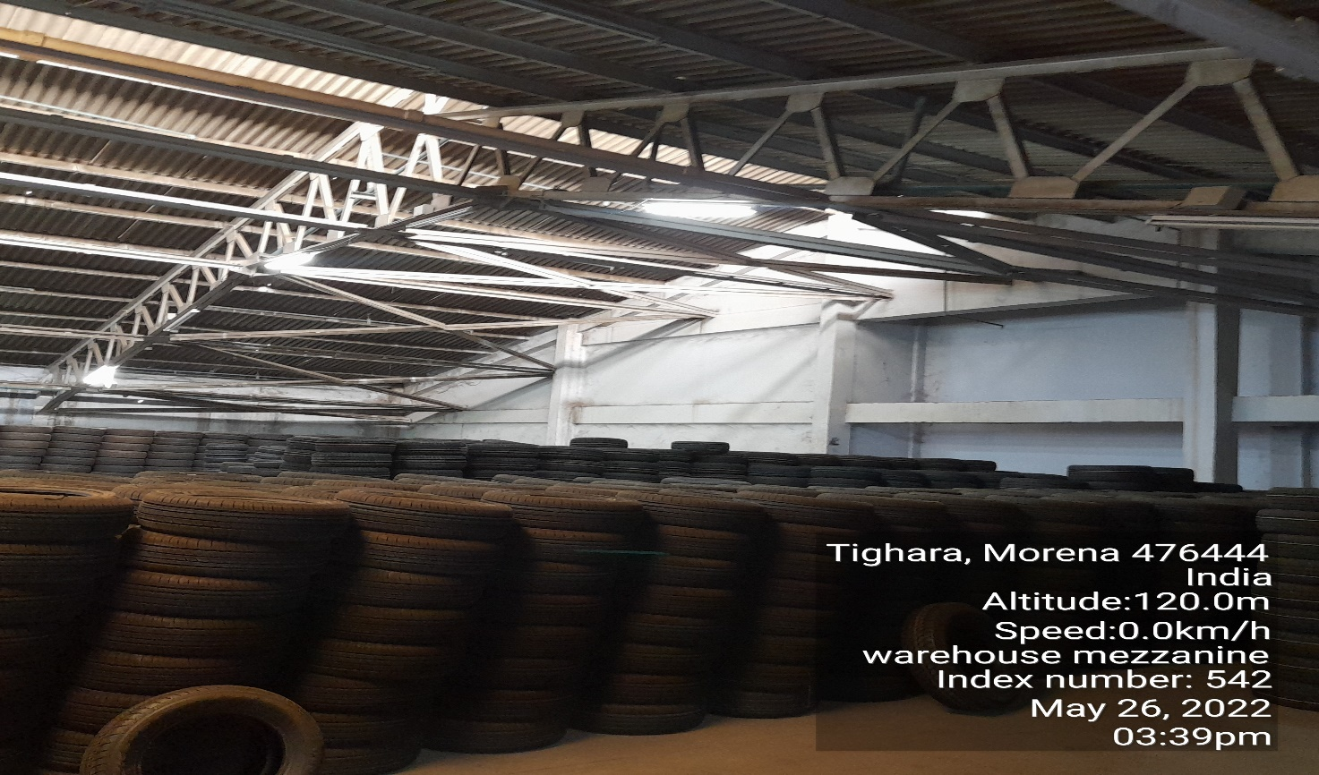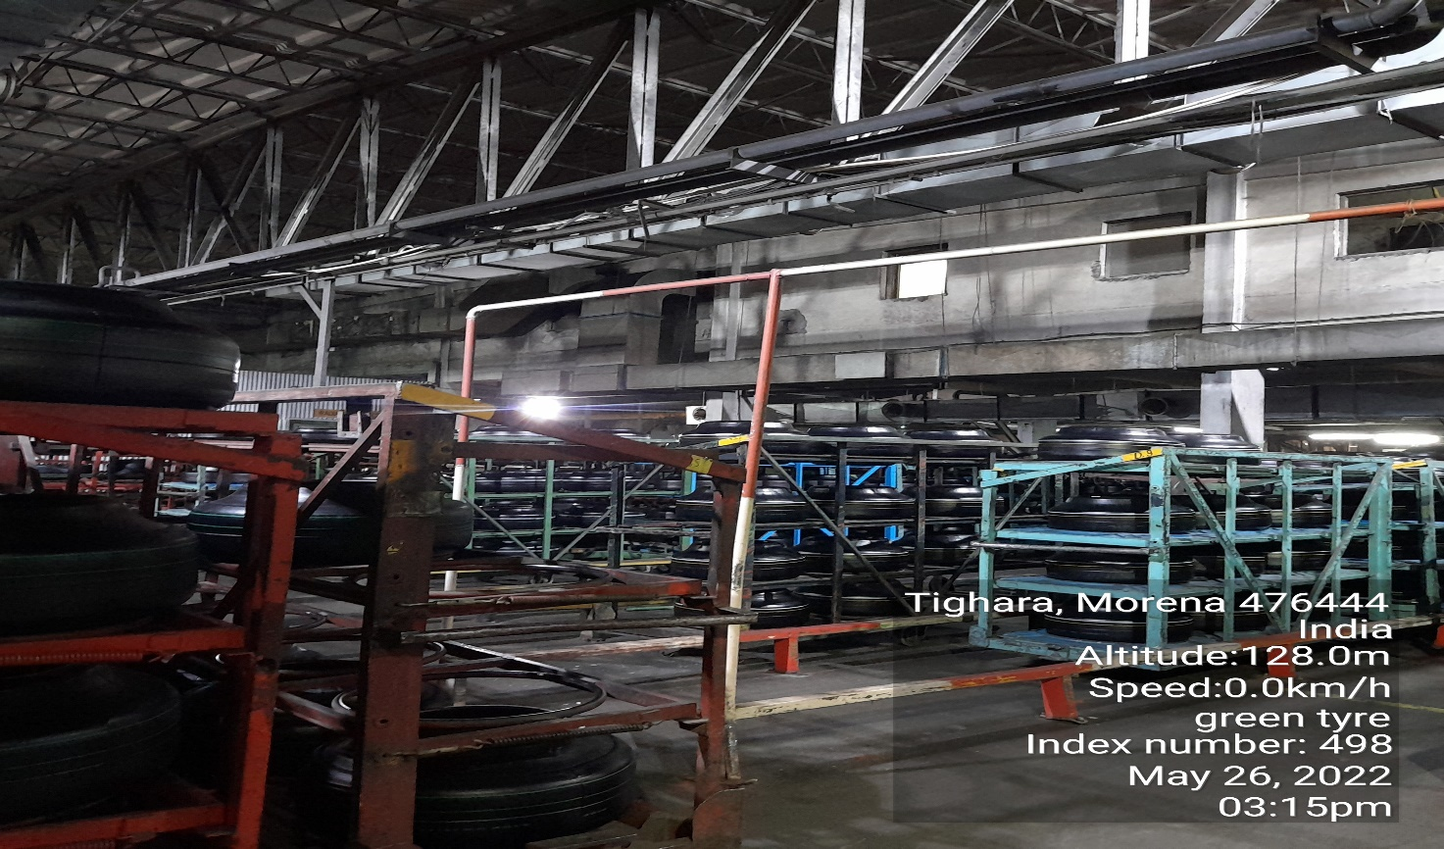

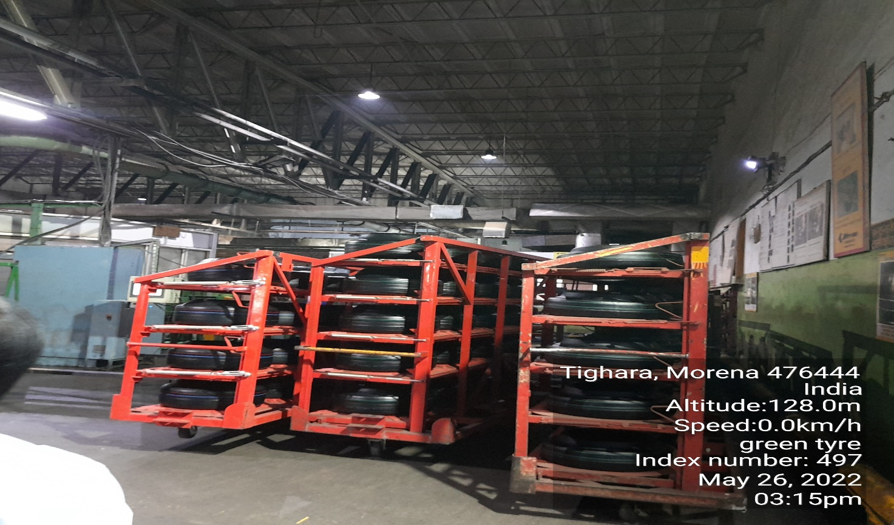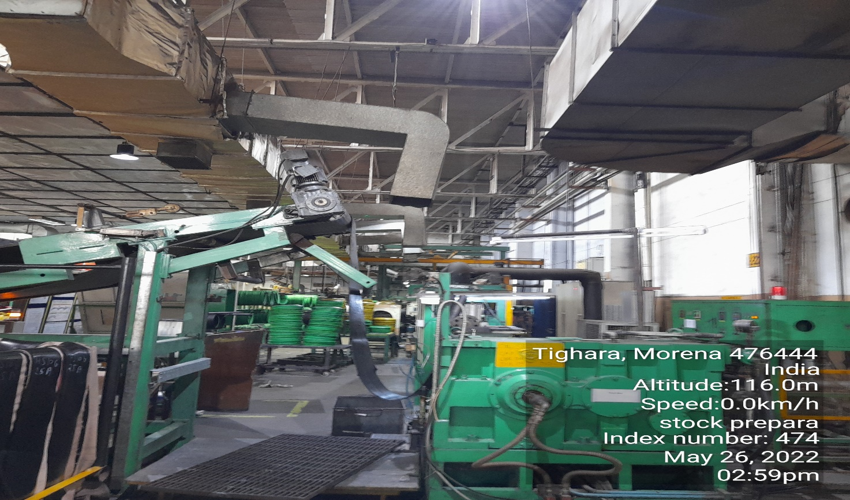
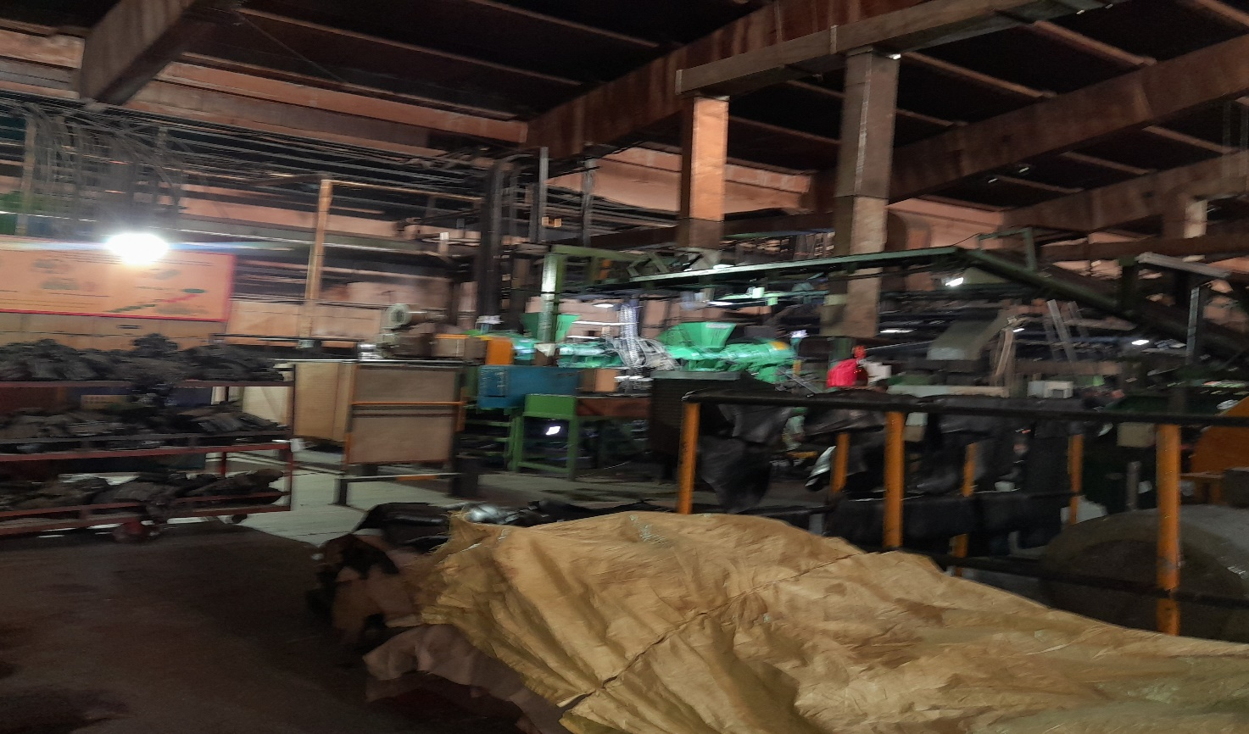
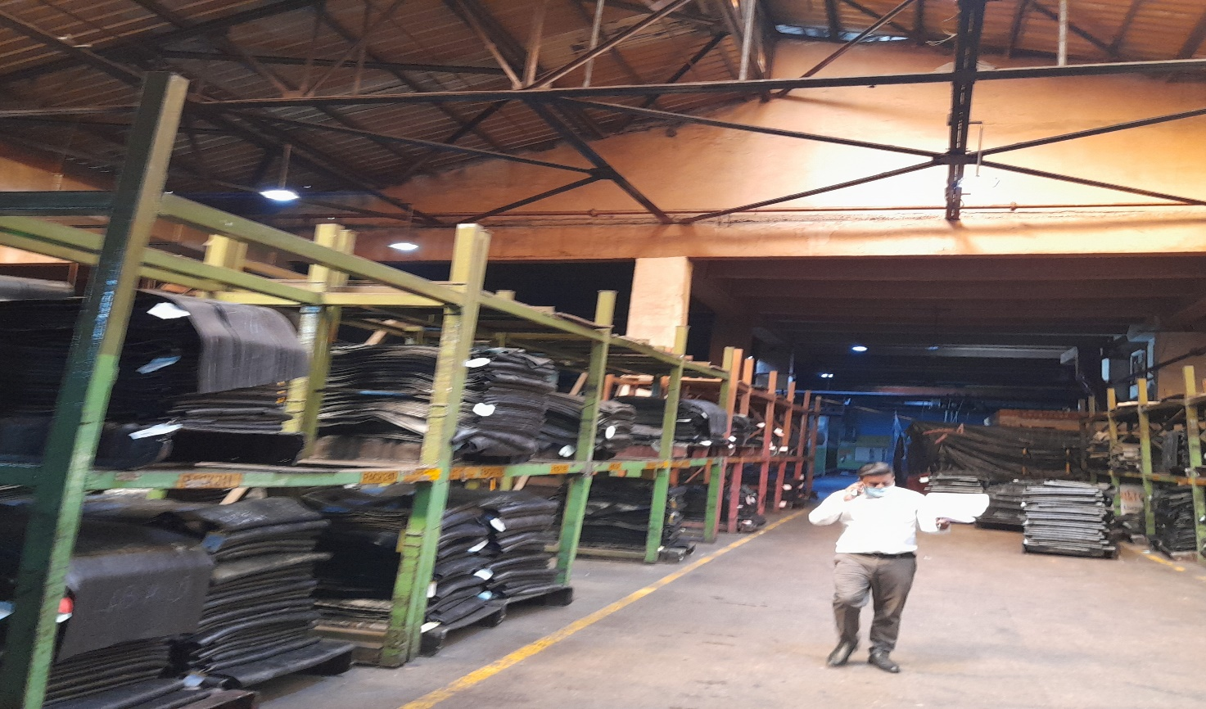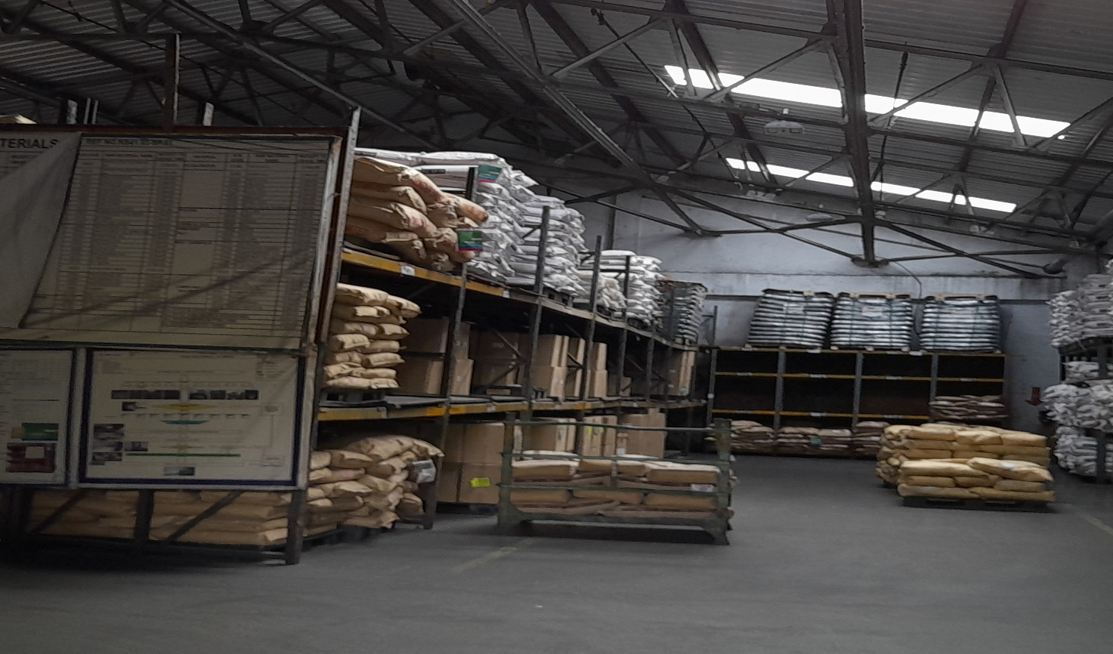

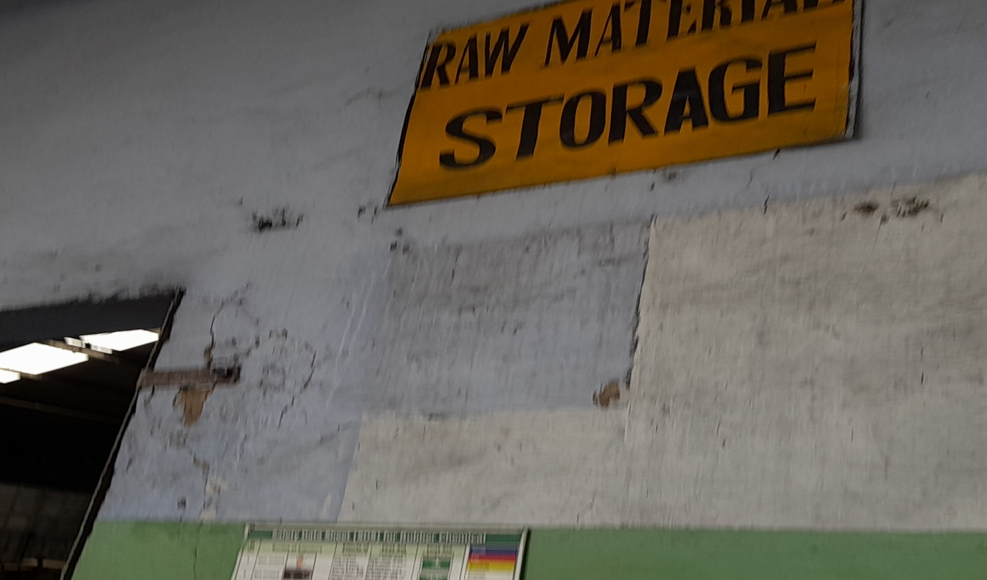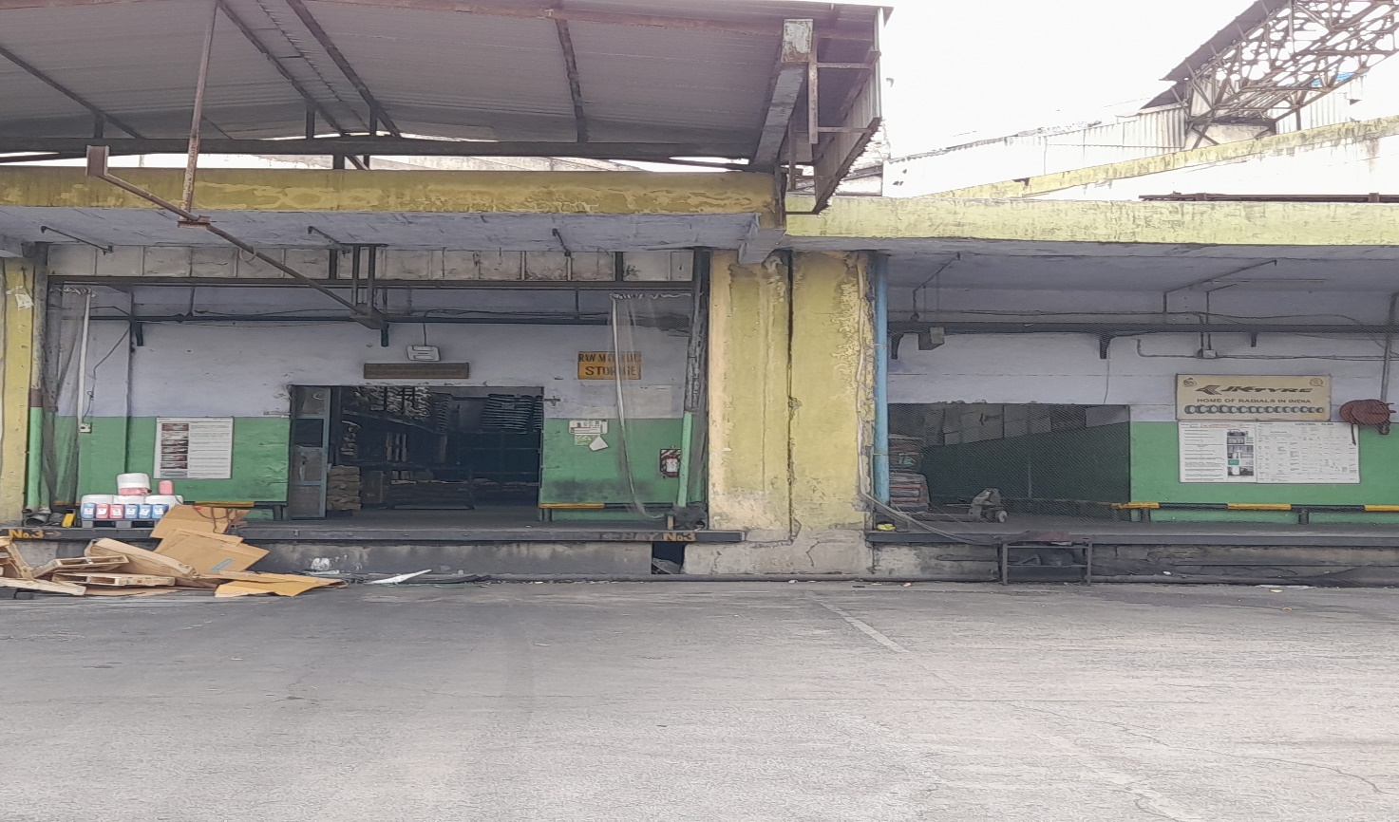
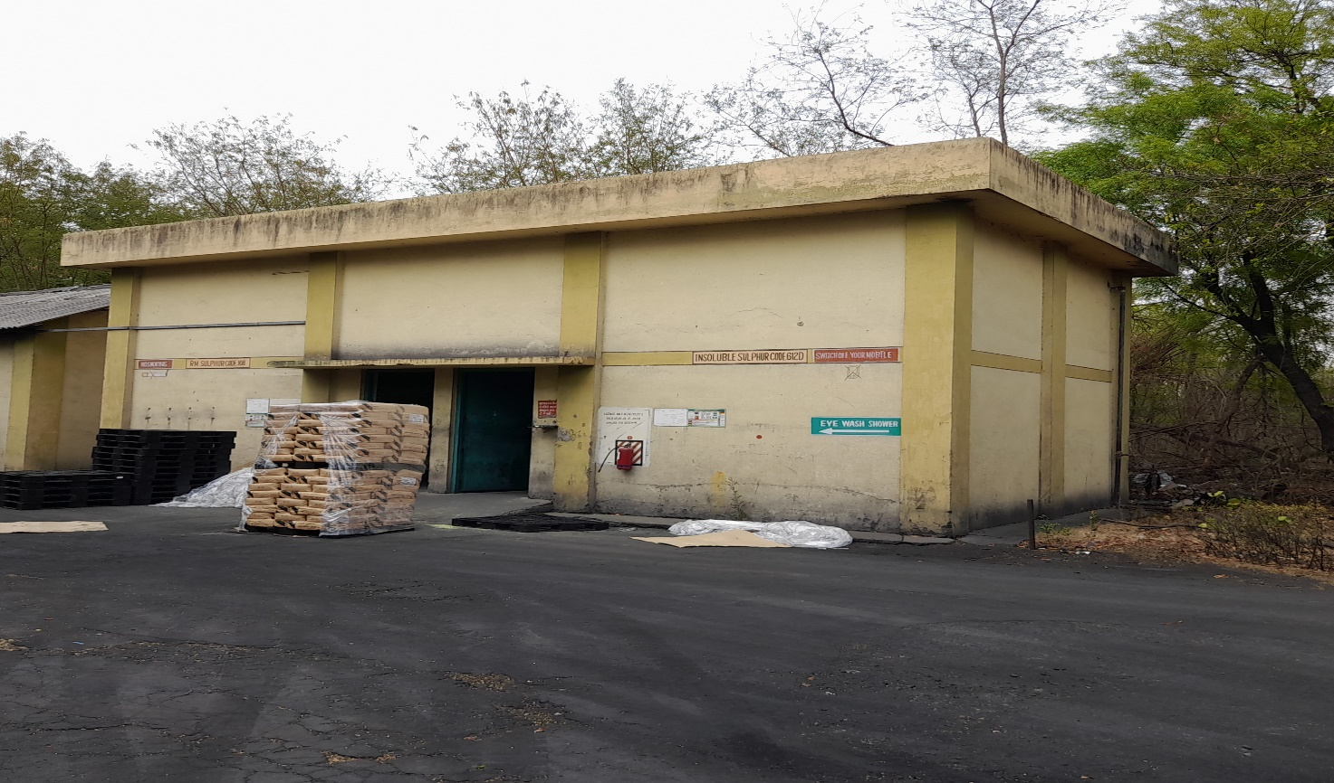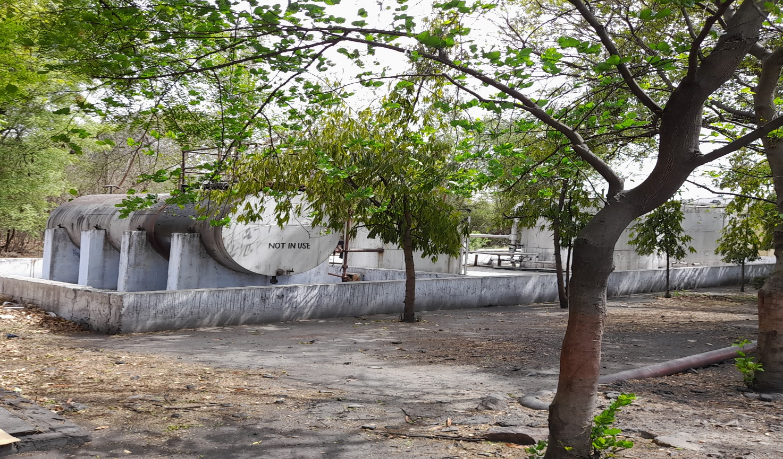

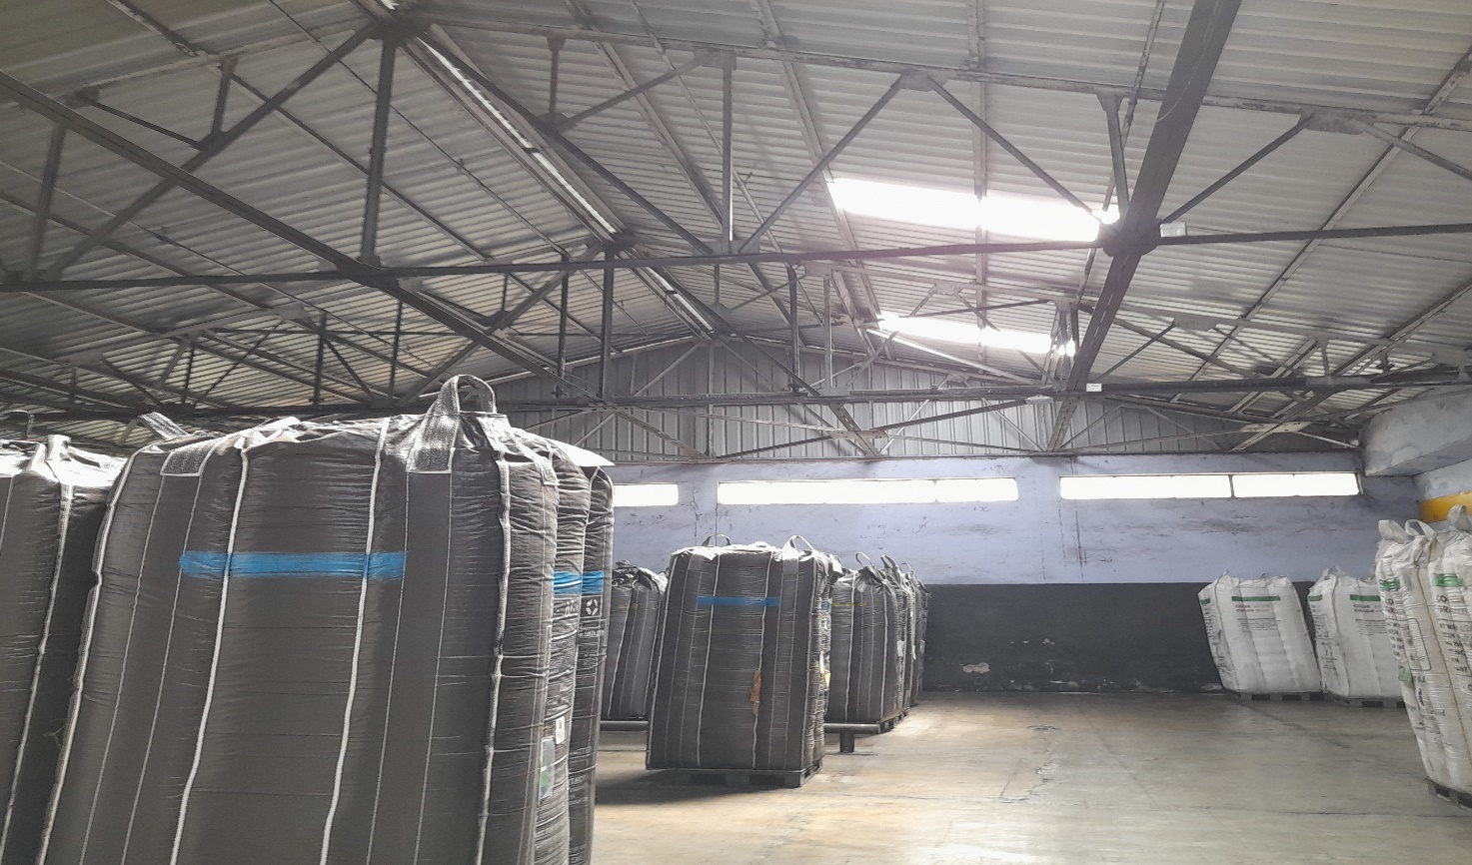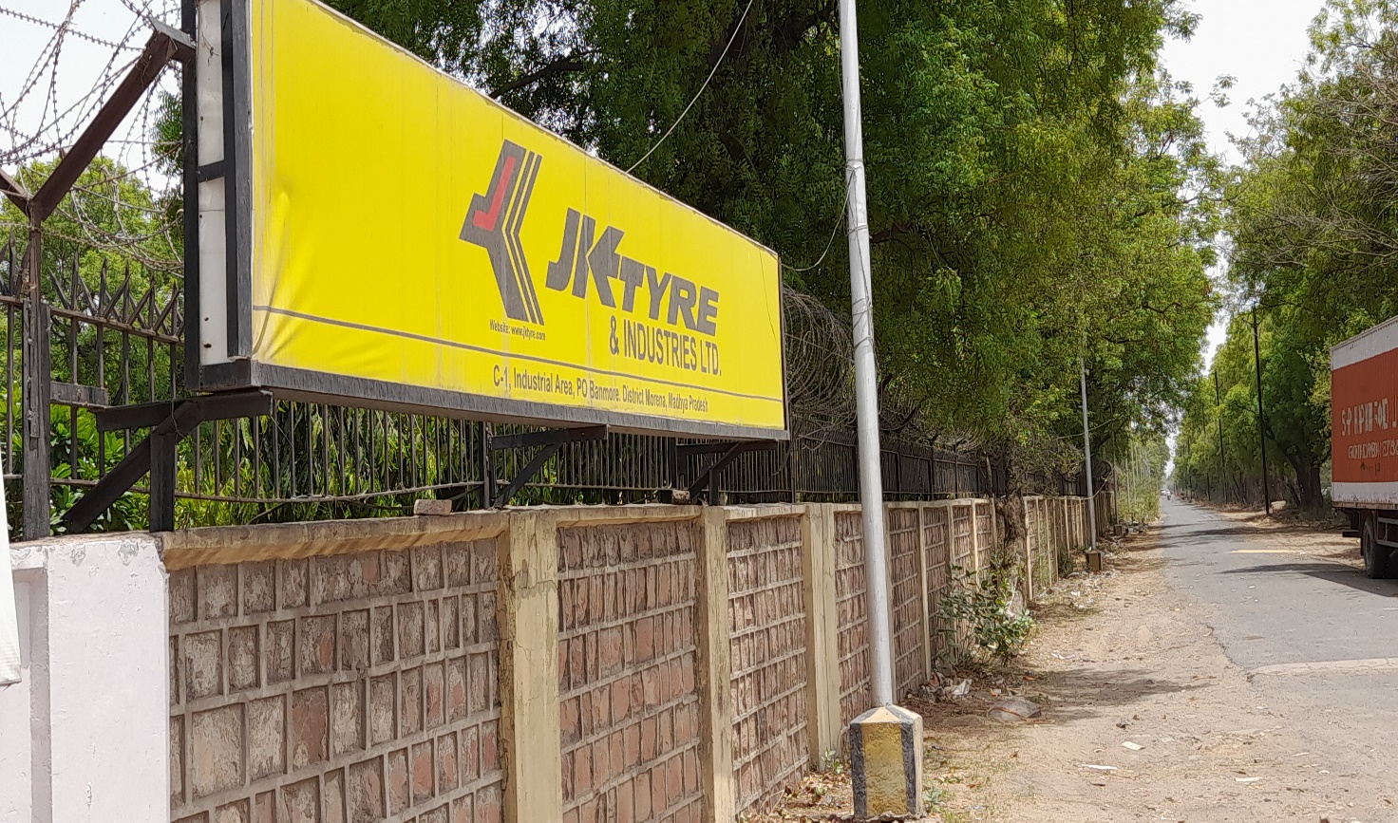
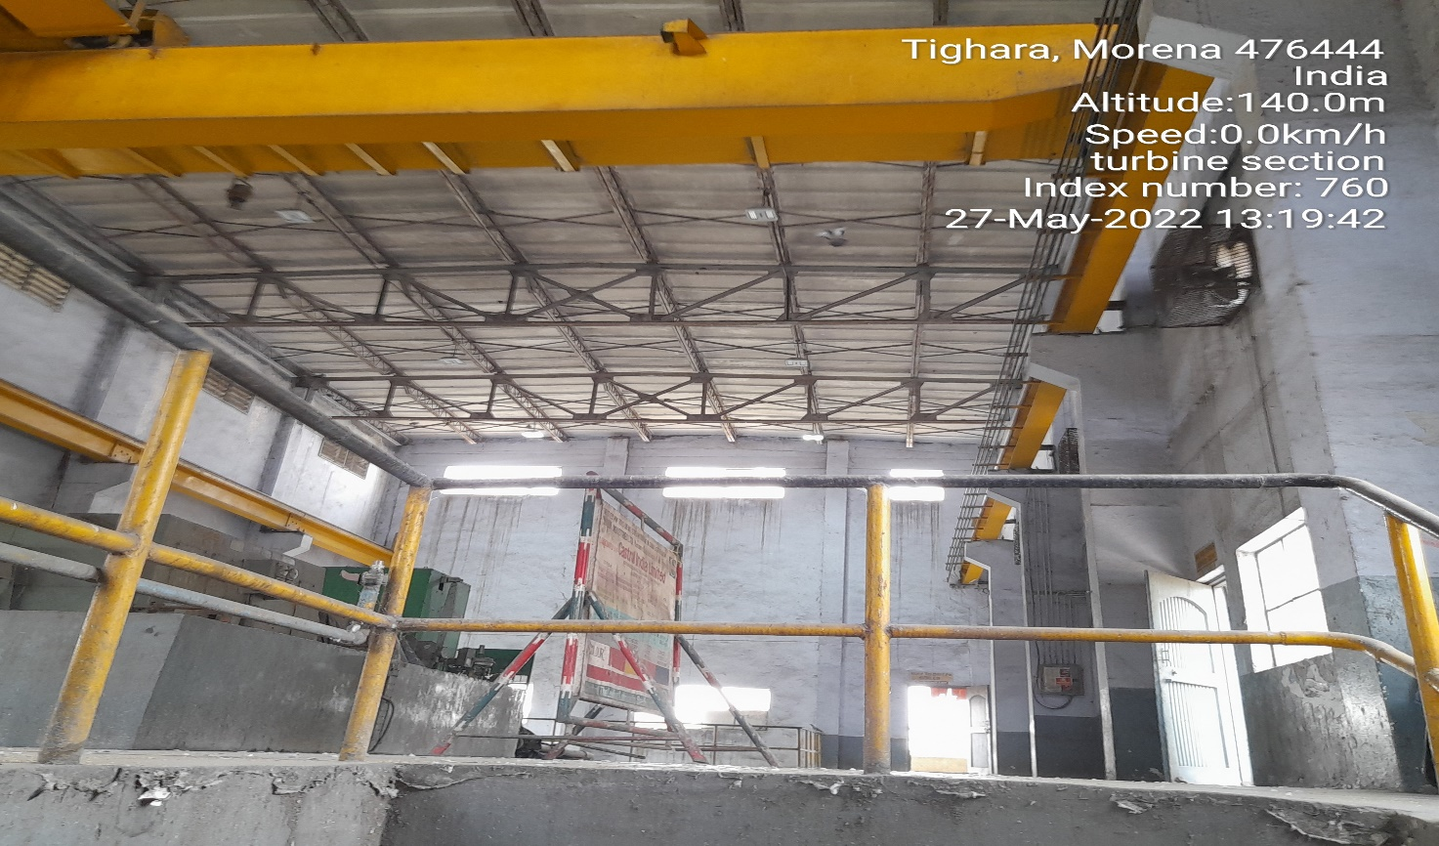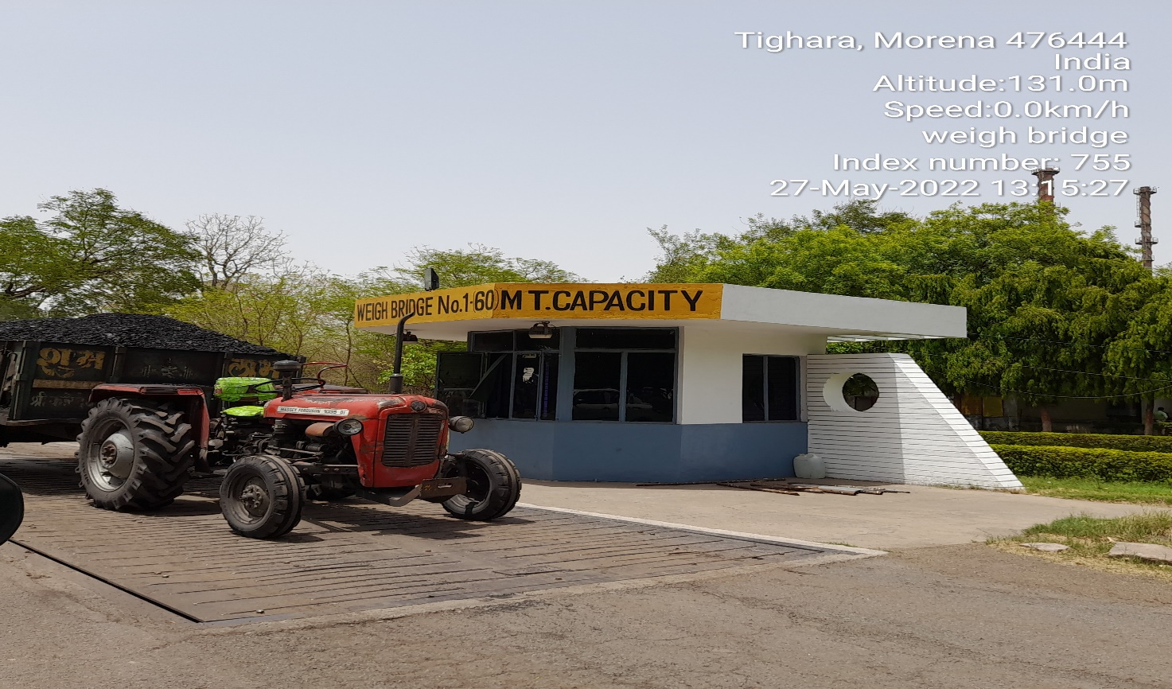
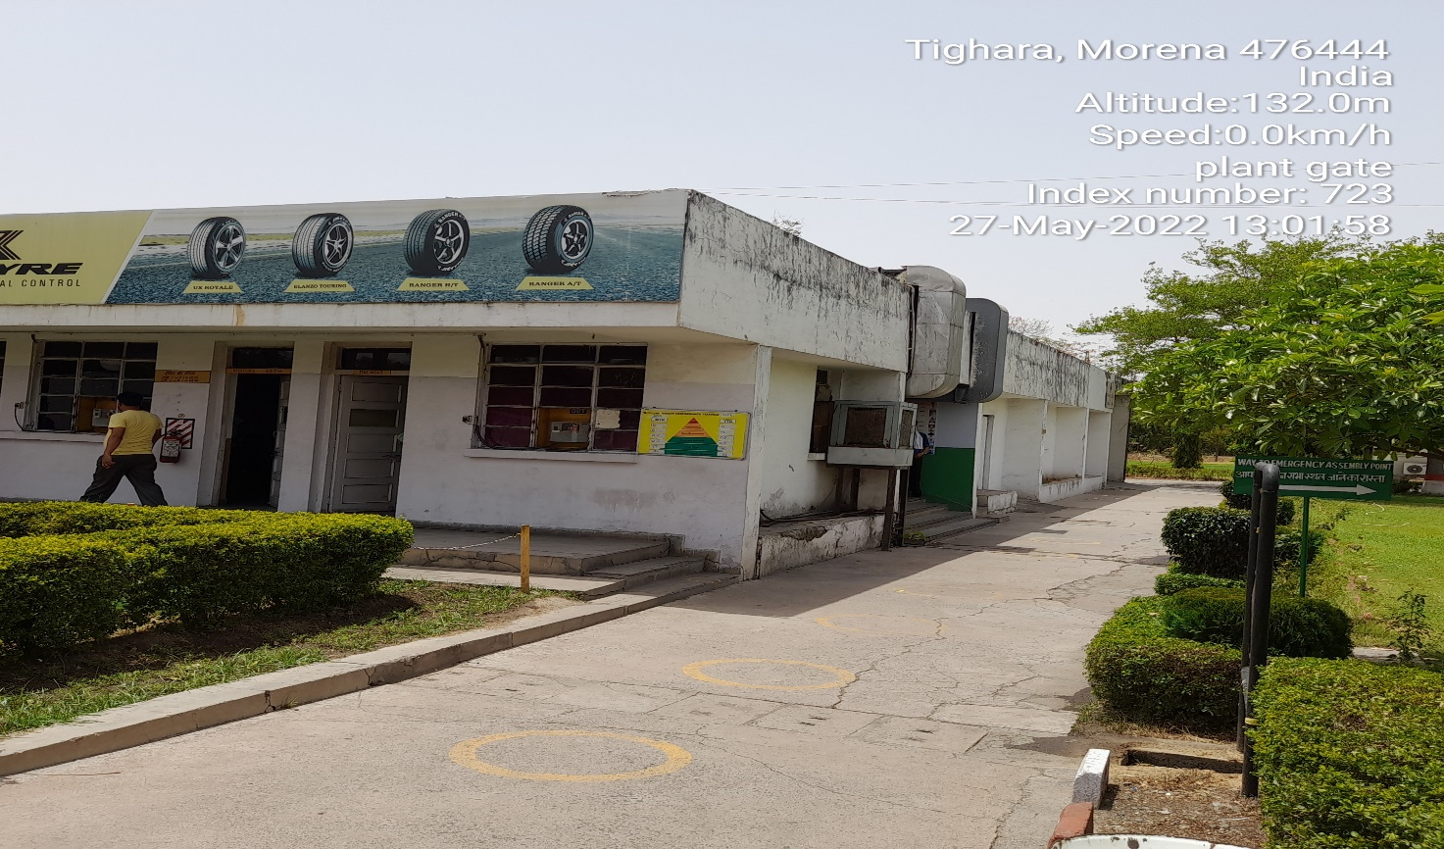
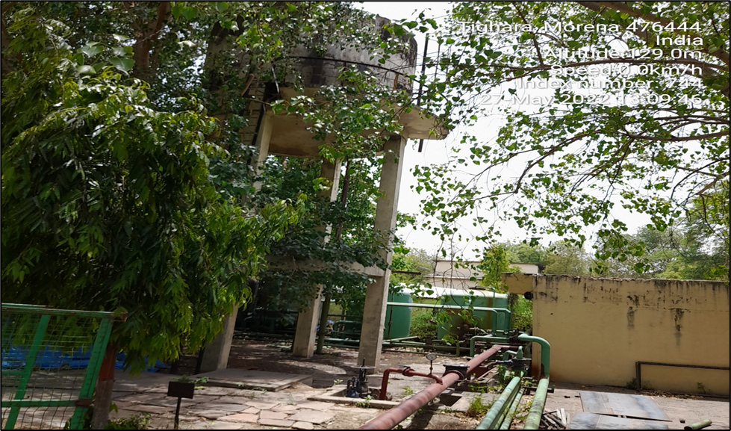

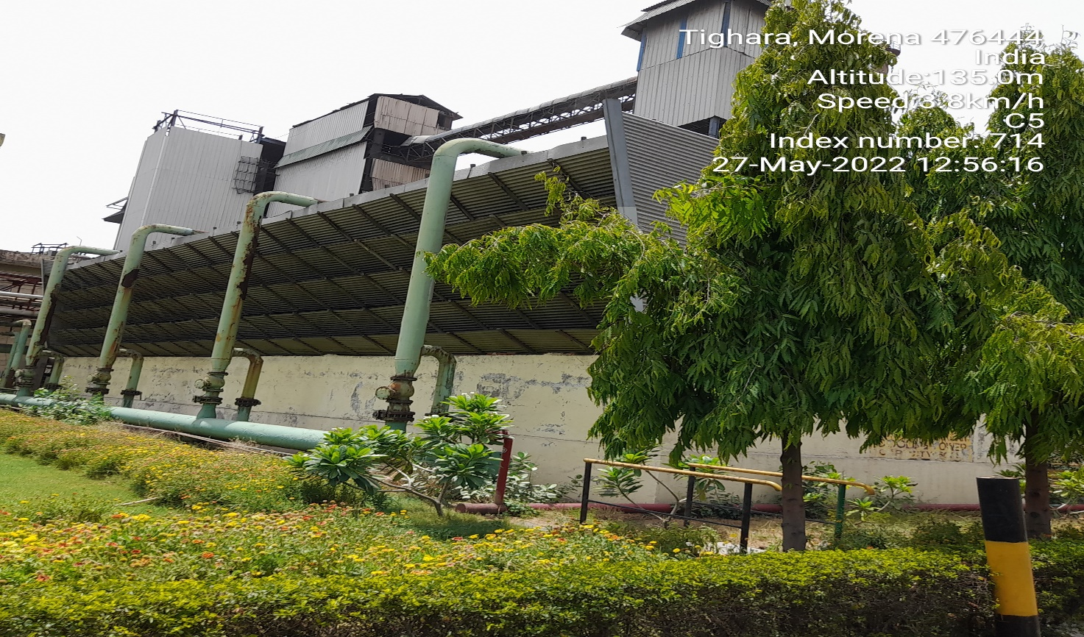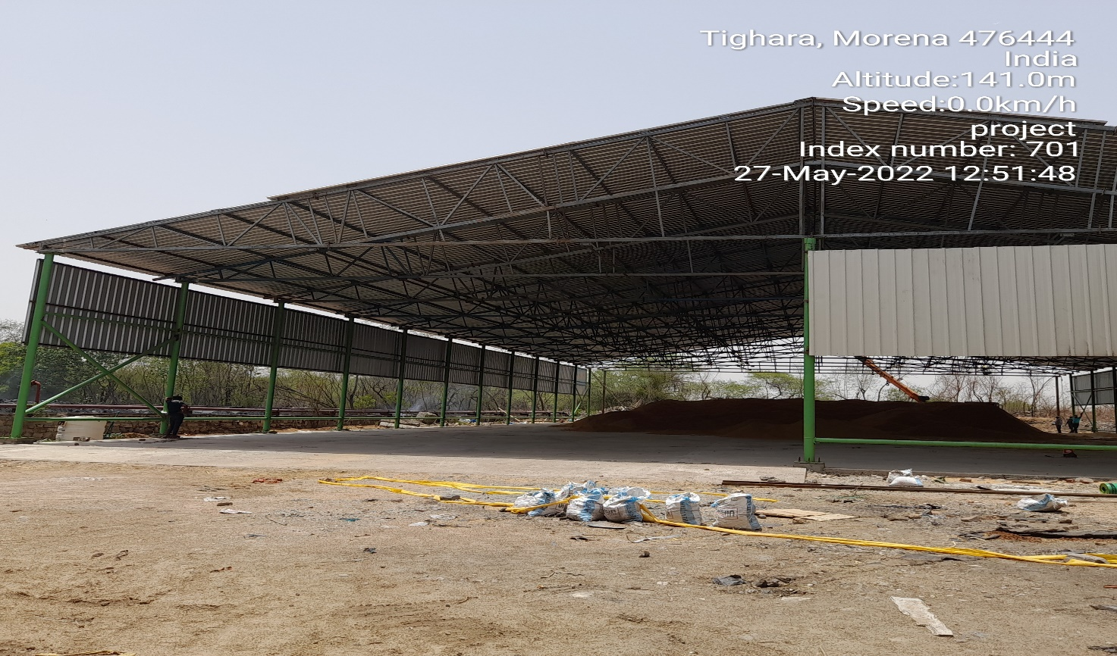

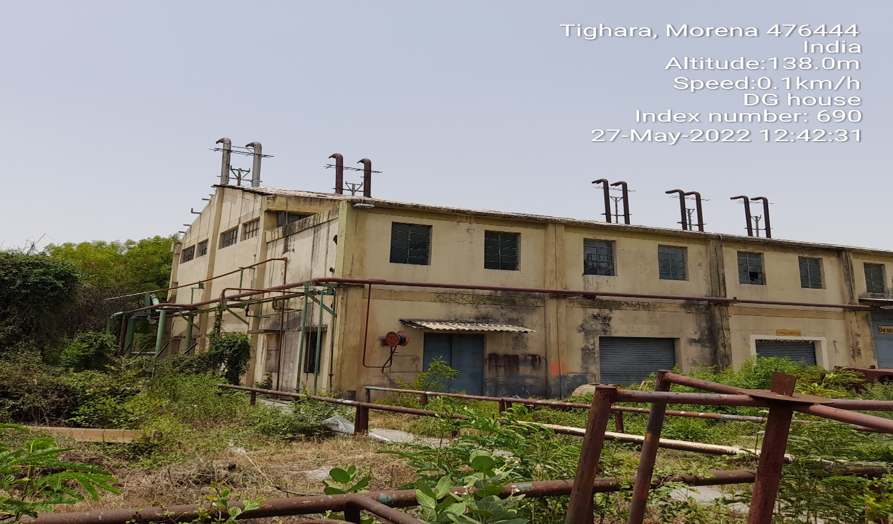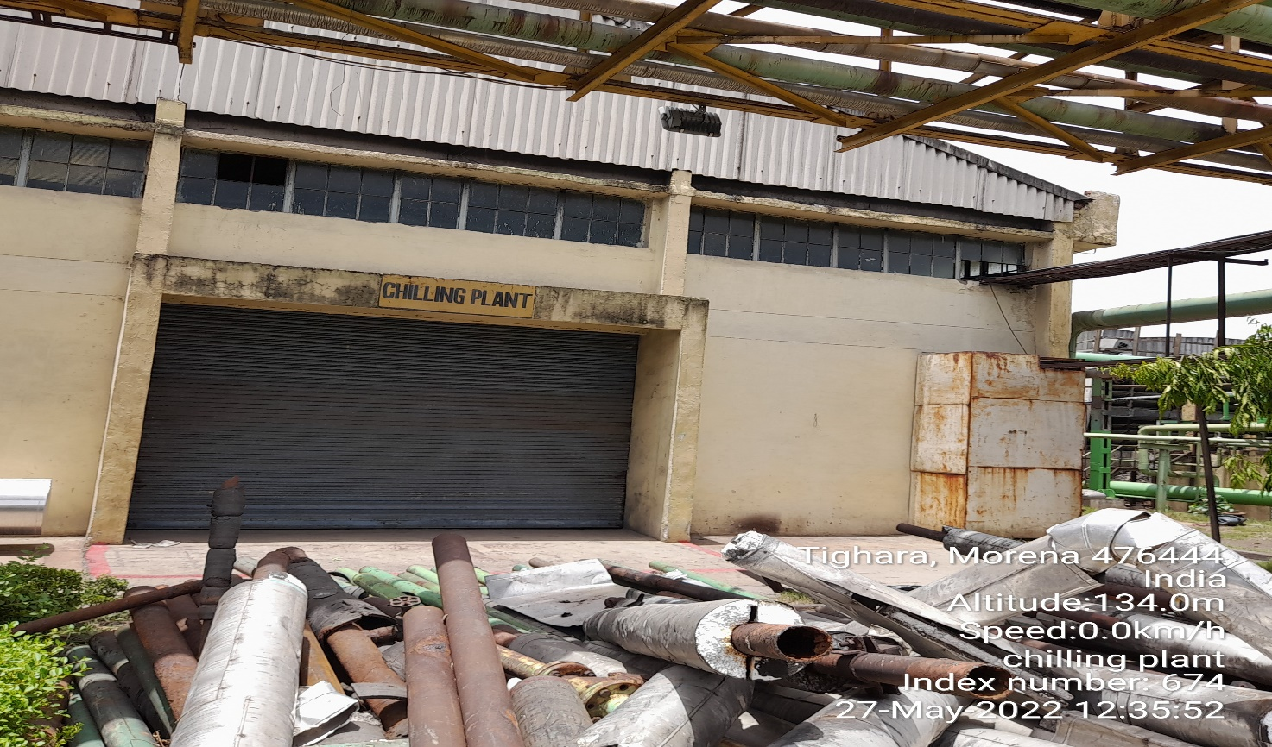

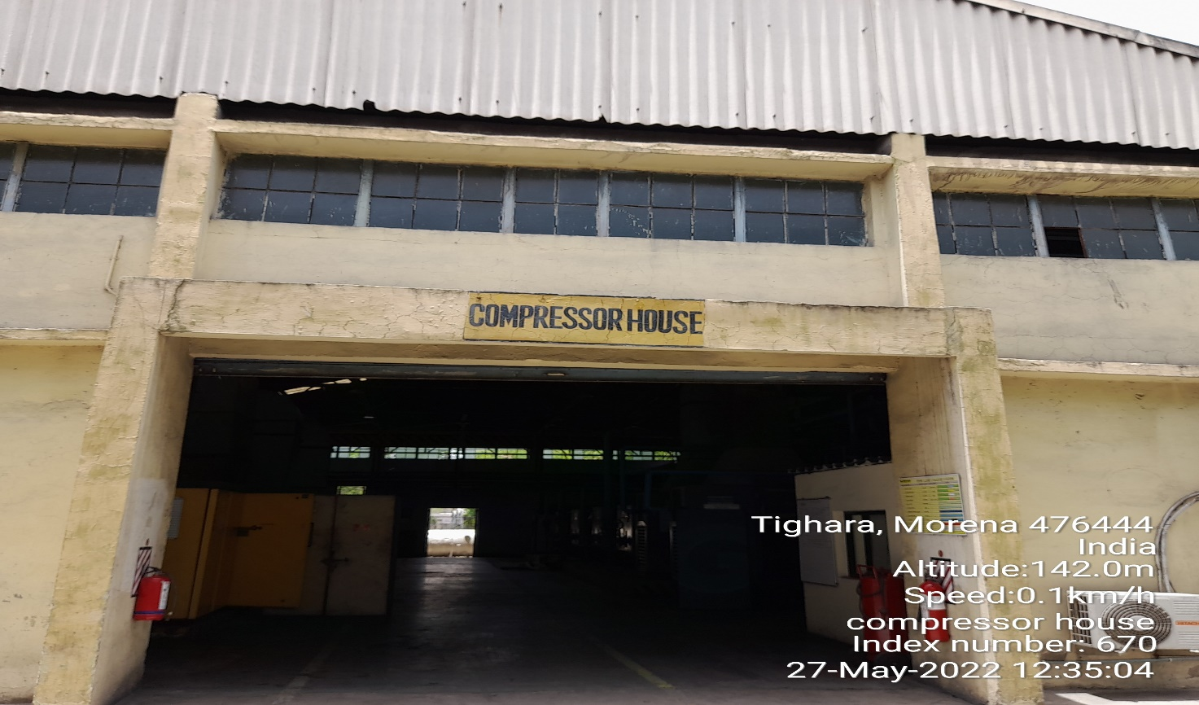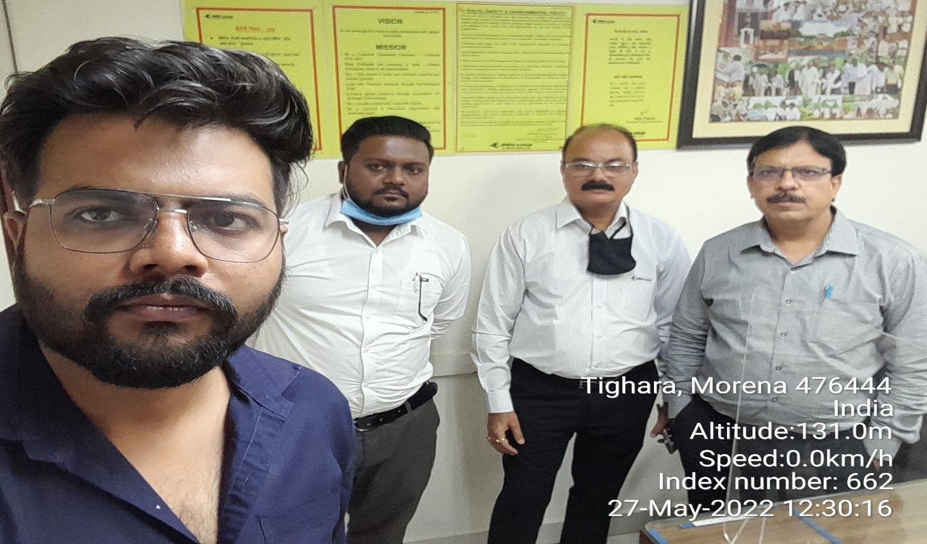

ENCLOSURE III: COPY OF CIRCLE RATES
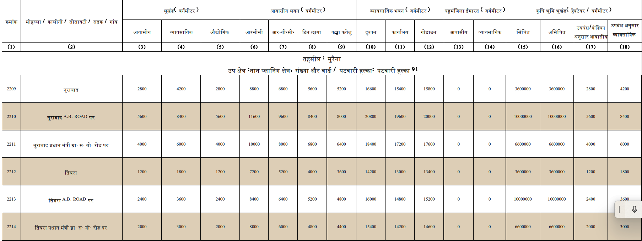

ENCLOSURE IV: ALLOTMENT RATES

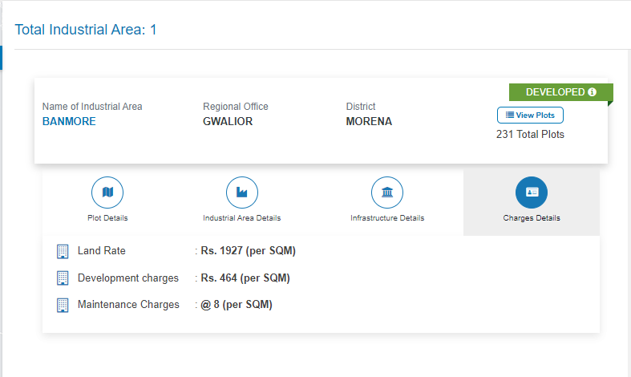
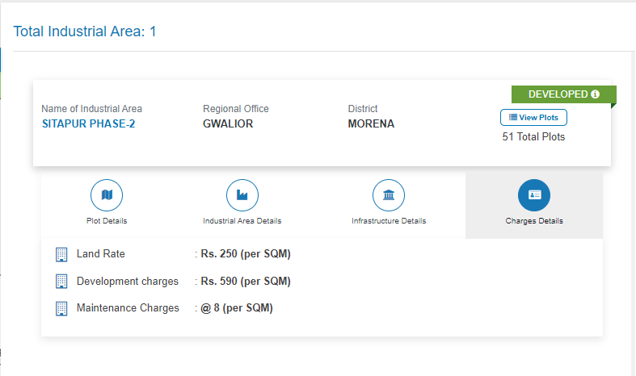

ENCLOSURE V: IMPORTANT PROPERTY DOCUMENTS EXHIBIT

DOCUMENT 1: NEWS ARTICLE 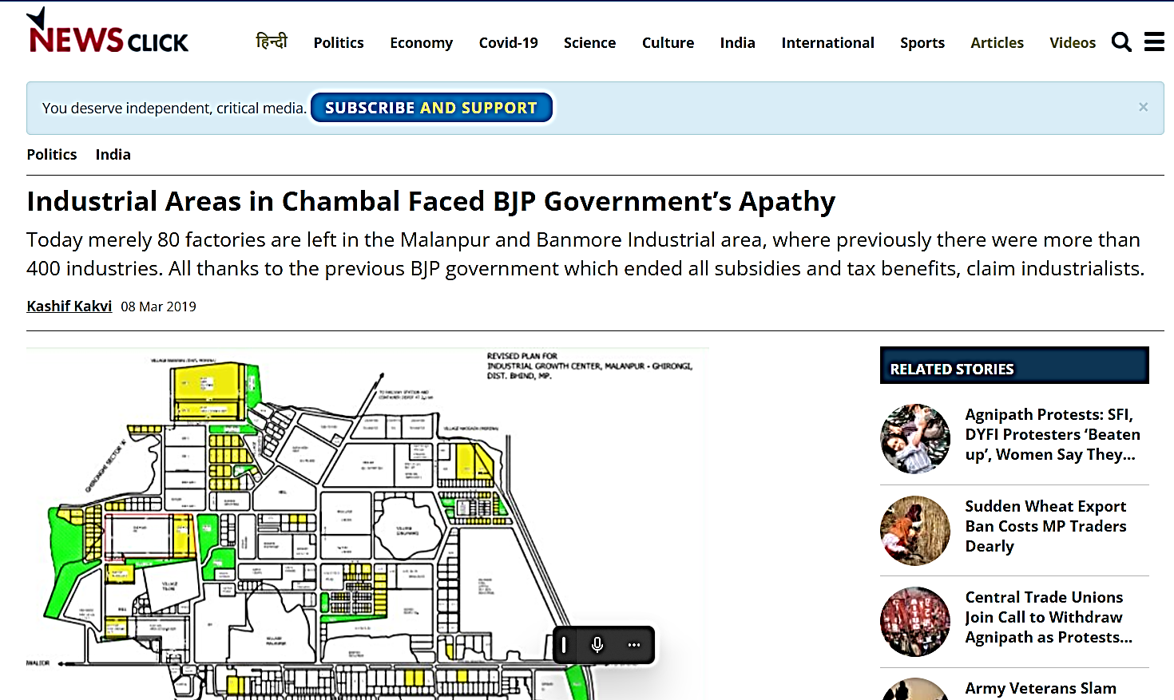
DOCUMENT 2: FIRE NOC FROM FIRE DEPARTMENT GWALIOR
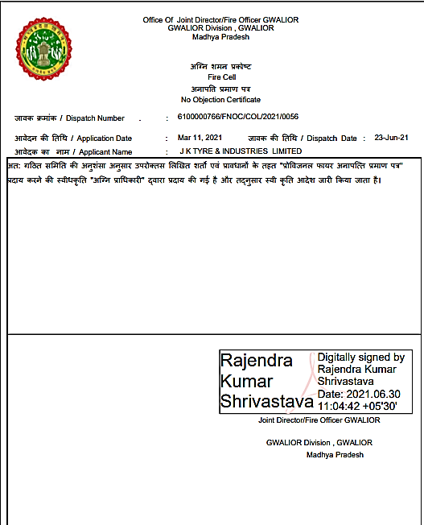
DOCUMENT 3: APPROVED MAP
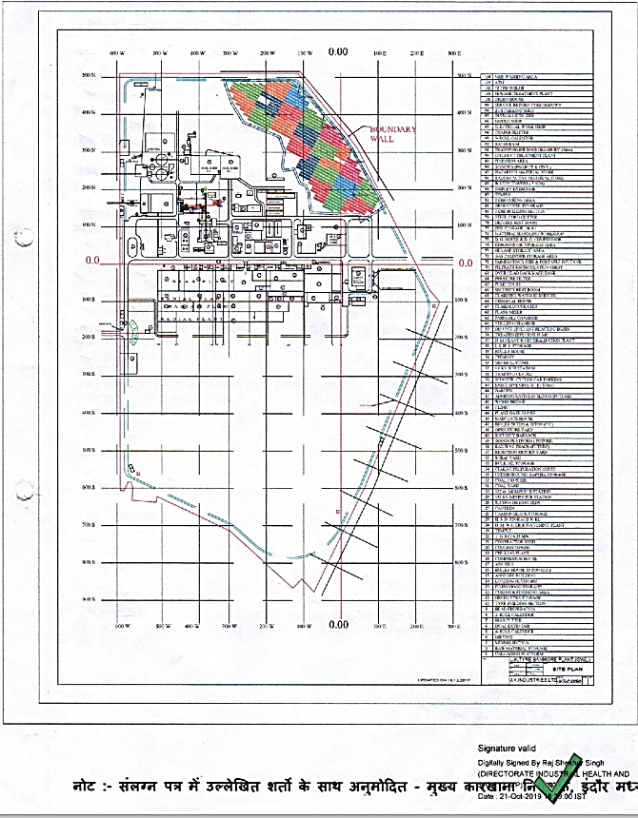

DOCUMENT 4: RENEWAL OF CONSENT TO OPERATE
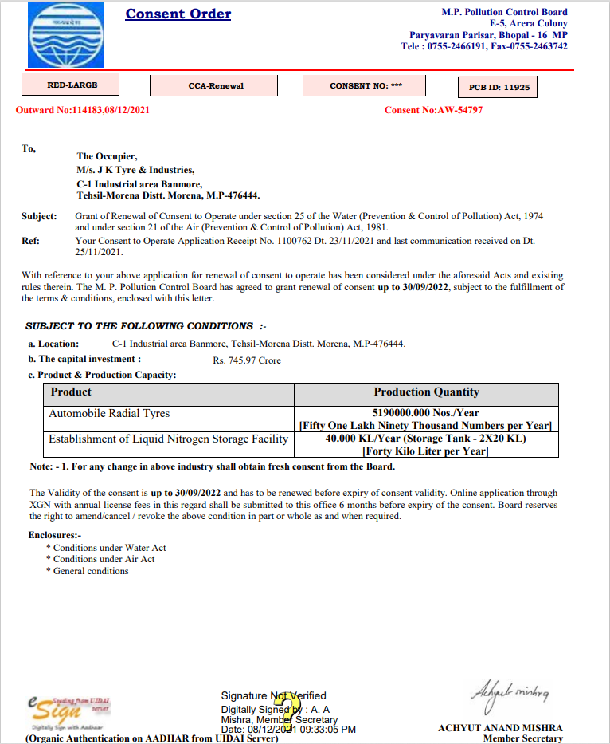

DOCUMENT 5: COPY OF RENEWAL OF FACTORY LICENSE
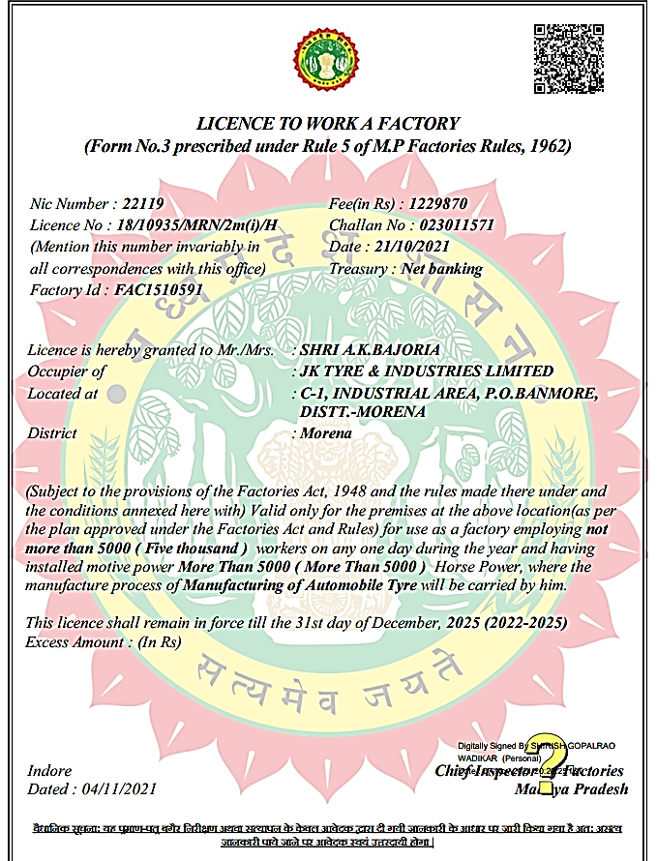

DOCUMENT 5: MEMORANDUM OF ENTRY
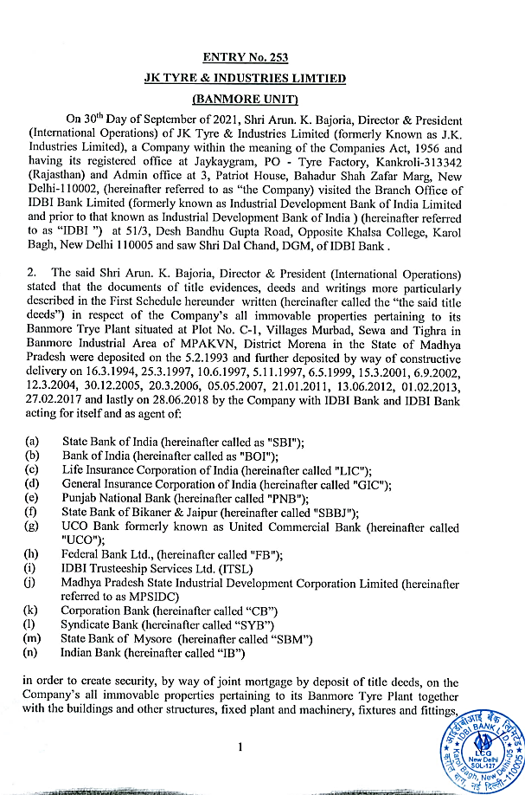

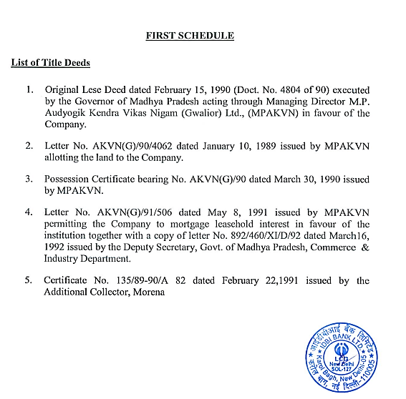
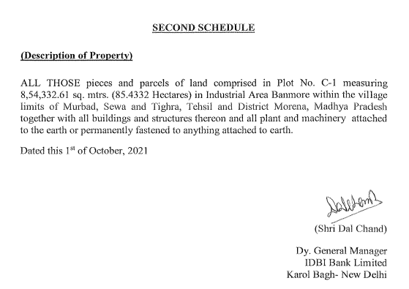

DOCUMENT 6: LATEST ELECTRICITY BILL
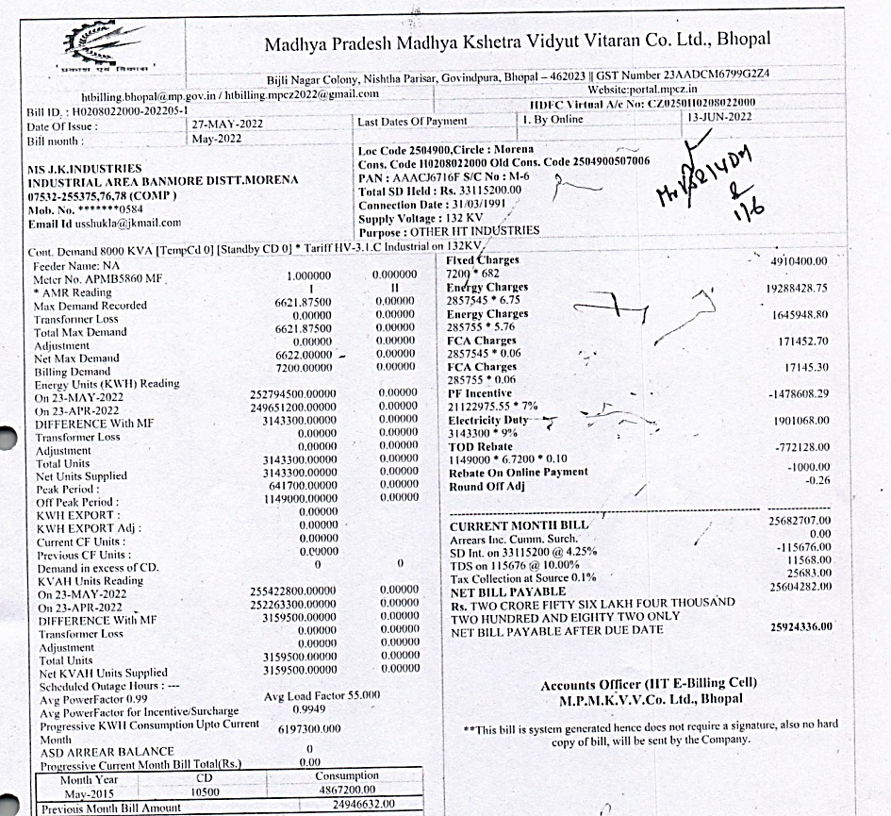

ENCLOSURE VI: VALUERS IMPORTANT REMARKS

Valuation is done for the asset found on as-is-where basis which owner/ owner representative/ client/ bank has shown/ identified to us on the site unless otherwise mentioned in the report of which some reference has been taken from the information/ data given in the copy of documents provided to us and informed verbally or in writing out of the standard checklist of documents sought from the client & its customer which they could provide within the reasonable expected time out of the standard checklist of documents sought from them and further based on certain assumptions and limiting conditions. The information, facts, documents, data which has become primary basis of the report has been supplied by the client which has been relied upon in good faith and is not generated by the Valuer.
The client/ owner and its management/ representatives warranted to us that the information they have supplied was complete, accurate and true and correct to the best of their knowledge. All such information provided to us either verbally, in writing or through documents has been relied upon in good faith and we have assumed that it is true & correct without any fabrication or misrepresentation. I/We shall not be held liable for any loss, damages, cost or expenses arising from fraudulent acts, misrepresentations, or willful default on part of the owner, company, its directors, employee, representative or agents.
Legal aspects for eg. Investigation of title, ownership rights, lien, charge, mortgage, lease, sanctioned maps, verification of documents provided to us such as title documents, Map, etc. from any concerned Govt. office etc. have to be taken care by legal expert/ Advocate and same is not done at our end. It is assumed that the concerned Lender/ Financial Institution has asked for the valuation of that property after satisfying the authenticity of the documents given to us for which the legal verification has been already taken and cleared by the competent Advocate before requesting for the Valuation report. I/ We assume no responsibility for the legal matters including, but not limited to, legal or title concerns.
In the course of the valuation, we were provided with both written and verbal information. We have however, evaluated the information provided to us through broad inquiry, analysis and review but have not carried out a due diligence or audit of the information provided for the purpose of this engagement. Our conclusions are based on the assumptions and other information provided to us by the client during the course of the assessment.
Getting cizra map or coordination with revenue officers for site identification is a separate activity and is not part of the Valuation services and same has not been done in this report unless otherwise stated.
We have made certain assumptions in relation to facts, conditions & situations affecting the subject of, or approach to this exercise that has not been verified as part of the engagement rather, treated as “a supposition taken to be true”. If any of these assumptions prove to be incorrect then our estimate on value will need to be reviewed.
This is just an opinion report based on technical & market information having general assessment & opinion on the indicative, estimated Market Value of the property for which Bank has asked to conduct the Valuation. It doesn’t contain any other recommendations of any sort including but not limited to express of any opinion on the suitability or otherwise of entering into any transaction with the borrower.
We have relied on the data from third party, external sources & information available on public domain to conclude the valuation. These sources are believed to be reliable and therefore, we assume no liability for the truth or accuracy of any data, opinions or estimates furnished by others that have been used in this analysis. Where we have relied on the data, opinions or estimates from external sources, reasonable care has been taken to ensure that such data is extracted from authentic sources, however we still can’t vouch its authenticity, correctness, or accuracy.
Analysis and conclusions adopted in the report are limited to the reported assumptions, conditions and information came to our knowledge during the course of the work and based on the Standard Operating Procedures, Best Practices, Caveats, Limitations, Conditions, Remarks, Important Notes, Valuation TOR and definition of different nature of values.
Value varies with the Purpose/ Date/ Asset Condition & situation/ Market condition, demand & supply, asset utility prevailing on a particular date/ Mode of sale. The indicative & estimated prospective Value of the asset given in this report is restricted only for the purpose and other points mentioned above prevailing on a particular date as mentioned in the report. If any of these points are different from the one mentioned aforesaid in the Report then this report should not be referred.
Our report is meant ONLY for the purpose mentioned in the report and should not be used for any other purpose. The Report should not be copied or reproduced for any purpose other than the purpose for which it is prepared for. I/we do not take any responsibility for the unauthorized use of this report.
We owe responsibility only to the authority/client that has appointed us as per the scope of work mentioned in the report. We will not be liable for any losses, claims, damages or liabilities arising out of the actions taken, omissions or advice given by any other person. In no event shall we be liable for any loss, damages, cost or expenses arising in any way from fraudulent acts, misrepresentations or willful default on part of the client or companies, their directors, employees or agents.
This report is having limited scope as per its fields & format to provide only the general basic idea of the value of the property prevailing in the market based on the site inspection and documents/ data/ information provided by the client. The suggested indicative prospective estimated value should be considered only if transaction is happened as free market transaction.
The sale of the subject property is assumed to be on an all cash basis. Financial arrangements would affect the price at which the property may sell for if placed on the market.
The actual realizable value that is likely to be fetched upon sale of the asset under consideration shall entirely depend on the demand and supply of the same in the market at the time of sale.
While our work has involved an analysis & computation of valuation, it does not include detailed estimation, design/ technical/ engineering/ financial/ structural/ environmental/ architectural/ compliance survey/ safety audit & works in accordance with generally accepted standards of audit & other such works. The report in this work in not investigative in nature. It is mere an opinion on the likely estimated valuation based on the facts & details presented to us by the client and third party market information came in front of us within the limited time of this assignment, which may vary from situation to situation.
Where a sketched plan is attached to this report, it does not purport to represent accurate architectural plans. Sketch plans and photographs are provided as general illustrations only.
Documents, information, data including title deeds provided to us during the course of this assessment by the client is reviewed only upto the extent required in relation to the scope of the work. No document has been reviewed beyond the scope of the work. These are not reviewed in terms of legal rights for which we do not have expertise. Wherever any information mentioned in this report is mentioned from the documents like owners name, etc., it is only for illustration purpose and may not necessary represent accuracy.
The report assumes that the borrower/company/business/asset complies fully with relevant laws and regulations applicable in its area of operations and usage unless otherwise stated, and that the companies/business/assets is managed in a competent and responsible manner. Further, as specifically stated to the contrary, this report has given no consideration to matters of a legal nature, including issues of legal title and compliance with relevant laws, and litigations and other contingent liabilities that are not recorded/reflected in the documents/ details/ information/ data provided to us.
This valuation report is not a qualification for accuracy of land boundaries, schedule (in physical terms), dimensions & identification. For this land/ property survey report can be sought from a qualified private or Govt. surveyor.
This Valuation report is prepared based on the facts of the property on the date of the survey. Due to possible changes in market forces, socio-economic conditions, property conditions and circumstances, this valuation report can only be regarded as relevant as at the valuation date. Hence before financing, Banker/ FI should take into consideration all such future risk and should loan conservatively to keep the advanced money safe in case of the downward trend of the property value.
Valuation of the same asset/ property can fetch different values under different circumstances & situations. For eg. Valuation of a running/ operational shop/ hotel/ factory will fetch better value and in case of closed shop/ hotel/ factory it will have considerable lower value. Similarly, an asset sold directly by an owner in the open market through free market transaction then it will fetch better value and if the same asset/ property is sold by any financer due to encumbrance on it, will fetch lower value. Hence before financing, Lender/ FI should take into consideration all such future risks while financing and take decision accordingly.

Valuation is done for the property identified to us by the owner/ owner representative. At our end we have just visually matched the land boundaries, schedule (in physical terms) & dimensions of the property with reference to the documents produced for perusal. Method by which identification of the property is carried out is also mentioned in the report clearly. Responsibility of identifying the correct property to the Valuer/ its authorized surveyor is solely of the client/ owner for which Valuation has to be carried out. It is requested from the Bank to cross check from their own records/ information if this is the same property for which Valuation has to be carried out to ensure that owner has not misled the Valuer company or misrepresented the property due to any vested interest. Where there is a doubt about the precision position of the boundaries, schedule, dimensions of site & structures, it is recommended that a Licensed Surveyor be contacted.
In India more than 70% of the geographical area is lying under rural/ remote/ non municipal/ unplanned area where the subject property is surrounded by vacant lands having no physical demarcation or having any display of property survey or municipal number / name plate on the property clearly. Even in old locations of towns, small cities & districts where property number is either not assigned or not displayed on the properties clearly and also due to the presence of multiple/ parallel departments due to which ownership/ rights/ illegal possession/ encroachment issues are rampant across India and due to these limitations at many occasions it becomes tough to identify the property with 100% surety from the available documents, information & site whereabouts and thus chances of error, misrepresentation by the borrower and margin of chances of error always persists in such cases. To avoid any such chances of error it is advised to the Bank to engage municipal/ revenue department officials to get the confirmation of the property to ensure that the property shown to Valuer/ Banker is the same as for which documents are provided.
If this Valuation Report is prepared for the Flat/ dwelling unit situated in a Group Housing Society or Integrated Township then approvals, maps of the complete group housing society/ township is out of scope of this report and this report will be made for the specific unit based on the assumption that complete Group Housing Society/ Integrated Township and the subject unit must be approved in all respect.
Due to fragmented & frequent change in building/ urban planning laws/ guidelines from time to time, different laws/ guidelines between regions/ states and no strict enforceability of Building Bye-Laws in India specially in non-metro and scale b & c cities & Industrial areas, property owners many times extend or make changes in the covered area/ layout from the approved/ applicable limits. There are also situations where properties are decades old when there was no formal Building Bye-Laws applicable the time when the construction must have been done. Due to such discrete/ unplanned development in many regions sometimes it becomes tough for the Valuer to determine the exact lawful situation on ground. Unless otherwise mentioned in the report, the covered area present on the site as per site survey will be considered in the Valuation.
Area of the large land parcels of more than 2500 sq.mtr or of uneven shape in which there can be practical difficulty in sample measurement, is taken as per property documents which has been relied upon unless otherwise stated.

Drawing Map, design & detailed estimation of the property/ building is out of scope of the Valuation services.
Valuation is a subjective field and opinion may differ from consultant to consultant. To check the right opinion, it is important to evaluate the methodology adopted and various data point/ information/ factors/ assumption considered by the consultant which became the basis for the Valuation report before reaching to any conclusion.
Although every scientific method has been employed in systematically arriving at the value, there is, therefore, no indisputable single value and the estimate of the value is normally expressed as falling within a likely range.
Value analysis of any asset cannot be regarded as an exact science and the conclusions arrived at in many cases will, of necessity, be subjective and dependent on the exercise of individual judgment. Given the same set of facts and using the same assumptions, expert opinions may differ due to the number of separate judgment decisions, which have to be made. Therefore, there can be no standard formula to establish an indisputable exchange ratio. In the event of a transaction, the actual transaction value achieved may be higher or lower than our indicative analysis of value depending upon the circumstances of the transaction. The knowledge, negotiability and motivations of the buyers and sellers, demand & supply prevailing in the market and the applicability of a discount or premium for control will also affect actual price achieved. Accordingly, our indicative analysis of value will not necessarily be the price at which any agreement proceeds. The final transaction price is something on which the parties themselves have to agree. However, our Valuation analysis can definitely help the stakeholders to take informed and wise decision about the Value of the asset and can help in facilitating the arm’s length transaction.
This Valuation is conducted based on the macro analysis of the asset/ property considering it in totality and not based on the micro, component, or item wise analysis. Analysis done is a general assessment and is not investigative in nature.
This report is prepared on the RKA V-L1 (Basic) Valuation format as per the client requirement and scope of work. This report is having limited scope as per its fields & format to provide only the general estimated & indicative basic idea of the value of the property prevailing in the market based on the information provided by the client. No detailed analysis, audit or verification has been carried out of the subject property. There may be matters, other than those noted in this report, which might be relevant in the context of the transaction and which a wider scope might uncover.
This is just an opinion report and doesn’t hold any binding on anyone. It is requested from the concerned Client/ Bank/ Financial Institution which is using this report for mortgaging the property that they should consider all the different associated relevant & related factors & risks before taking any business decision based on the content of this report.
All Pages of the report including annexures are signed and stamped from our office. In case any paper in the report is without stamp & signature then this should not be considered a valid paper issued from this office.
As per IBA Guidelines & Bank Policy, in case the valuation report submitted by the valuer is not in order, the banks / FIs shall bring the same to the notice of the valuer within 15 days of submission for rectification and resubmission. In case no such communication is received, it shall be presumed that the valuation report has been accepted.
Defect Liability Period is 15 DAYS. We request the concerned authorized reader of this report to check the contents, data, information, and calculations in the report within this period and intimate us in writing at valuers@rkassociates.org within 15 days of report delivery, if any corrections are required or in case of any other concern with the contents or opinion mentioned in the report. If no intimation is received within 15 (Fifteen) days in writing from the date of issuance of the report, then it shall be considered that the report is complete in all respect and has been accepted by the client upto their satisfaction & use and further to which R.K Associates shall not be held responsible in any manner. After this period no concern/ complaint/ proceedings in connection with the Valuation Services will be entertained due to possible change in situation and condition of the property.
Though adequate care has been taken while preparing this report as per its scope, but still we can’t rule out typing, human errors, over sightedness of any information or any other mistakes. Therefore, the concerned organization is advised to satisfy themselves that the report is complete & satisfactory in all respect. Intimation regarding any discrepancy shall be brought into our notice immediately. If no intimation is received within 15 (Fifteen) days in writing from the date of issuance of the report, to rectify these timely, then it shall be considered that the report is complete in all respect and has been accepted by the client upto their satisfaction & use and further to which R.K Associates shall not be held responsible in any manner.
Our Data retention policy is of ONE YEAR. After this period we remove all the concerned records related to the assignment from our repository. No clarification or query can be answered after this period due to unavailability of the data.
This Valuation report is governed by our (1) Internal Policies, Processes & Standard Operating Procedures, (2) R.K Associates Quality Policy, (3) Valuation & Survey Best Practices Guidelines formulated by management of R.K Associates, (4) Information input given to us by the customer and (4) Information/ Data/ Facts given to us by our field/ office technical team. Management of R.K Associates never gives acceptance to any unethical or unprofessional practice which may affect fair, correct & impartial assessment and which is against any prevailing law. In case of any indication of any negligence, default, incorrect, misleading, misrepresentation or distortion of facts in the report then we request the user of this report to immediately or atleast within the defect liability period to bring all such act into notice of R.K Associates management so that corrective measures can be taken instantly.
R.K Associates never releases any report doing alterations or modifications by pen. In case any information/ figure of this report is found altered with pen then this report will automatically become null & void.
We are fully aware that based on the opinion of value expressed in this report, we may be required to give testimony or attend court / judicial proceedings with regard to the subject assets, although it is out of scope of the assignment, unless specific arrangements to do so have been made in advance, or as otherwise required by law. In such event, the party seeking our evidence in the proceedings shall bear the cost/professional fee of attending court / judicial proceedings and my / our tendering evidence before such authority shall be under the applicable laws.
The final copy of the report shall be considered valid only if it is in hard copy on the company’s original letter head with proper stamp and sign on it of the authorized official upon payment of the agreed fees. User shall not use the content of the report for the purpose it is prepared for only on draft report, scanned copy, email copy of the report and without payment of the agreed fees. In such a case the report shall be considered as unauthorized and misused.

