File No.: VIS(2022-23)-PL015-009-089 Dated: 03 June 2022

LENDER’S INDEPENDENT ENGINEER REPORT (1ST)
(FOR QUARTER ENDING MARCH 2022)

OF

COTTON COMBED COMPACT YARN MANUFACTURING PLANT
SITUATED AT

8 KM, KHASRA NO. 71, 72, 73, 83, 84, 85 and 86 VILLAGE HUMAYUPUR, PARGANA, TEHSIL & DISTT. MUZAFFARNAGAR, U.P.

IMPLEMENTED BY
M/S SANGAL INDUSTRIES PVT. LTD. (SIPL) GROUP COMPANY OF

“SIDHARTH GROUP”

REPORT PREPARED FOR
STATE BANK OF INDIA, SME BRANCH JANSATH ROAD, MUZAFFARNAGAR, UTTAR PRADESH.

**Important - In case of any query/ issue or escalation you may please contact Incident Manager at le@rkassociates.org. We will appreciate your feedback in order to improve our services.
NOTE: As per IBA Guidelines please provide your feedback on the report within 15 days of its submission after which report will be considered to be correct.

TABLE OF CONTENTS
SR. NO. | DESCRIPTION | PAGE NO.
PART A | Report Summary | 03
PART B | Introduction | 05
 | - The Project | 05
 | - About the Borrower | 05
 | - Location of the Project | 06
 | - Project Overview | 07
 | - Scope of the Project During Project Duration | 09
 | - Purpose of the Report | 10
 | - Methodology Adopted | 10
PART C | Plant Infrastructure Sections & Facility Details with Actual Progress | 11
 | - Land Details | 11
 | - Building and Structure Details | 11
 | - Plant Machinery and Equipment | 14
PART D | Project Consultants, Contractors & Suppliers | 18
PART E | Project Cost and Means of Finance | 19
 | - Cost of Project | 19
 | - Current Status and Total Expenditure Incurred Till Date | 20
 | - Sources of Finance & Utilization of Funds | 24
PART F | Statutory & Regulatory Approvals, Clearances & NOC | 26
PART G | Project Schedule & Current Status | 28
PART H | Observations and Comments | 29
PART I | Disclaimer | 30

IMPORTANT NOTICE

COPYRIGHT FORMAT: This report is prepared on the copyright format of R.K Associates, to serve our clients with the best available information and analysis to facilitate them to take rational business decisions. Legally no one can copy or distribute this format without prior approval from R.K Associates. It is meant only for the advisory/ reference purpose for the organization/s as mentioned on the cover page of this report. Distribution or use of this format by any organization or individual other than R.K Associates will be seen as unlawful act and necessary legal action can be taken against the defaulters.

This report is intended for the sole use of the intended recipient/s and contain material that is STRICTLY CONFIDENTIAL AND PRIVATE.

DEFECT LIABILITY PERIOD: - In case of any query/ issue or escalation you may please contact Incident Manager: le@rkassociates.org. We try our level best to ensure correctness in the calculations done, rates adopted and various other data points & information mentioned in the report but still can’t rule out typing, human errors or any other mistakes. In case you find any such mistake or inaccuracy in any data point of the report please help us by bringing all such points into our notice immediately or within 15 days of the report delivery in writing, to rectify these timely failing after which R.K Associates won’t be held responsible for any such inaccuracy in any manner. We would highly appreciate your feedback in order to improve our services.

PART A | REPORT SUMMARY

1. | Name of Project: | To Set Up a Greenfield spinning plant for manufacturing of Cotton Combed Compact Yarn with an Installed Capacity of 5500 MT/ annum.
2. | Project Location: | 8 KM, Khasra no. 71, 72, 73, 83, 84, 85 and 86 Village Humayupur, Pargana & Tehsil Distt. Muzaffarnagar, U.P.
3. | Name of the Borrower: | M/s. Sangal Industries Private Limited
4. | Director’s as per MCA | Mr. Shishir Sangal  Mr. Vineet Kumar Sangal  Mr. Vinod Kumar Gupta
5. | Prepared for Bank: | State Bank of India, Jansath Road, Muzaffarnagar, Uttar Pradesh.
6. | LIE Consultant Firm: | M/s. R.K. Associates Valuers & Techno Engineering Consultants (P) Ltd.
7. | Date of Survey: | Not applicable since official appointment letter was handed over in April 2022
8. | Date of Report: | 3rd July 2022
9. | Purpose of the Report: | To provide fair detailed analysis report to the Bank based on the “in-scope points” mentioned below for facilitating them to take appropriate credit decision on the Project.
10. | Scope of the work provided by the Lender: | - Detailed Inception Report for Project Review and Assessment  - Quarterly Construction Monitoring & Status Reports as and when requested by the bank
11. | Documents perused for Proposal: | - Techno economic feasibility report  - CA certificate
12. | Annexure with the report: | - Copies of Project Statutory approvals  - CA Certificate

PART B | INTRODUCTION

- THE PROJECT:
M/s Sangal Industries Private Limited (SIPL) is setting up a Greenfield Cotton Combed Compact Yarn manufacturing plant of 5500 MT/ annum production capacity at Village Humayupur, Pargana & Tehsil Distt. Muzaffarnagar, U.P. SIPL has acquired land adjoining to the existing Kraft paper manufacturing plant of M/s Siddeshwari Industries Pvt Ltd situated at Jansath Road, Muzaffarnagar for setting up the plant. The cost of project is estimated at Rs.74.66 Cr.

- ABOUT THE BORROWER:
SIPL is a private limited company incorporated on 04/05/2021 with the Registrar of Companies, UP with CIN No. U17299UP2021PTC145844 to set-up a spinning plant for manufacturing of Cotton Combed Compact Yarn.

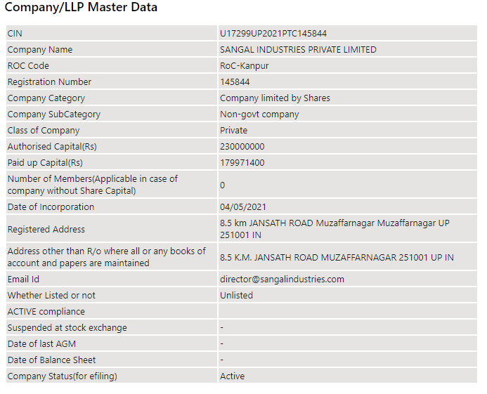

The primary set of directors of “SIPL” as on date are:

- Mr. Shishir Sangal
- Mr. Vineet Kumar Sangal
- Mr. Vinod Kumar Gupta

M/s Sangal Industries Private Limited (SIPL) is setting up a Greenfield Cotton Combed Compact Yarn manufacturing plant of 5500 MT/ annum production capacity at Village Humayupur, Pargana & Tehsil Distt. Muzaffarnagar, U.P.

As per the information available in TEV report, SIPL is a group company of Sidharth Group which is engaged in manufacturing of Duplex and Kraft paper. M/s Sidharth Group is having following units:

- M/s Sidharth Paper Private Limited (SPPL), Kashipur
- M/s Sidharth Paper Private Limited (SPPL), Udham Singh Nagar
- M/s Siddeshwari Paper Udyog Pvt. Ltd. (SPUPL), Kashipur
- M/s Siddeshwari Industries Pvt. Ltd. (SIPL), Muzaffarnagar

- PROJECT LOCATION:
Details about Location of Unit is as below:
Particulars | Description
Latitude | 29°25'03.1"N
Longitude | 77°45'23.6"E
Connectivity Systems
Road | The project site of the subject under construction plant is well connected by road network and Lies 400m in the interior from the Miranpur-Muzaffarnagar Road (National Highway 709 AD). The Project site can be approach from the Road at the back of M/s Siddheshwari Industries Pvt. Ltd. which can be easily accessed via National Highway towards Muzaffarnagar from Miranpur. It is around 10 Km from main Muzaffarnagar city. District Muzaffarnagar is around 133 Km away from Delhi (National Capital).
Rail | The Nearest Railway station to the subject locality is Muzaffarnagar Railway Station which is about 10 Km from the Subject Project or unit toward North -west Direction
Air | The nearest Domestic and international Airport to the subject project is Indira Gandhi Airport which is about 150 Km form the subject project.

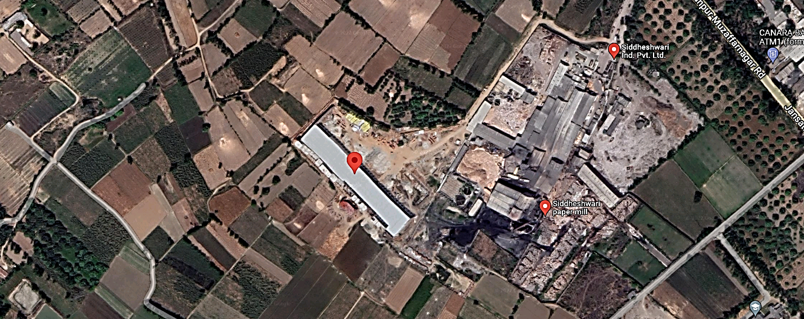

Figure 1: Location of Manufacturing Unit

- PROJECT OVERVIEW:

M/s Sangal Industries Pvt. Ltd. (SIPL) is setting up a Greenfield Plant of 5500 MT/ annum installed Capacity of Manufacturing of Cotton Combed Compact Yarn at 8 Km, KHASRA NO. 71, 72, 73, 83, 84, 85 and 86 Village- Humayupur, Pargana, Tehsil & Distt. Muzaffarnagar, U.P. with a total land area ad measuring 2.7613 Hectares.

The company has estimated The cost of project amounting to Rs.74.66 Crore which includes Rs.62.42 Crore towards Hard cost, Rs.4.15 Crore towards Soft cost and Rs.8.09 Crore towards Margin for working capital requirement. The project is estimated to start the commercial productions by April 2023.

As per the TEV Report the plant is proposed to have installed capacity of 16.60 MT per day which considering 330 working days calculate to be 16.6 x 330 = 5478 MT (approx. 5500 MT/ annum) of cotton combed compact yarn is being Setup at village Humayupur, pargana, tehsil & dist. Muzaffarnagar, U.P. However, the total production Capacity as per the consent to establish is approved at a capacity of 18 MT /day. Thus, the actual production capacity documented in the TEV report is well within the production capacity approved in Consent to establish.

In the Subject unit, SIPL has proposed to produce following Products as listed below: -

SR. NO. | PRODUCT | MARKET SEGMENT | AREA TO BE TARGETED
1. | Single combed yarn | Knitting | Delhi NCR, Ludhiana, Kolkata and Tripura
2. | Double combed yarn | Home furnishing | Meerut and Modinagar
3. | Single woven yarn | Suiting & Shirting | Ludhiana, Kolkata and Mumbai

  - MANUFACTURING PROCES OF PLANT

- Mixing (Mixing various lots of cotton etc. to achieve uniform and desired quality)
- Production stage-1 (Opening and partial cleaning through Blow Room)
- Production stage-2 (To further clean cotton fibre and convert blow room laps into card sliver through Carding)
- Production stage-3 (Lap Former - To convert card sliver into uniform laps for feeding to combers)
- Production stage-4 (Comber to remove short fibers and impurities from cotton laps and convert into clean better quality combed sliver).
- Production stage-5 (Draw Frame- To homogenize and make even sliver so that variation do not occur in yarn)
- Production stage-6 (Simplex (Roving- To convert sliver into roving to feed into Ring Frame)
- Production stage-7 (Spinning (Ring Frame- Converting roving into yarn of required count and twist).
- Production stage-8 (Package Winding through Automatic Package Winders Autoconer X6 Type V / 48 Positions in the Machine Frame 44 Winding Heads Type V; Automatic Package Winders Autoconer X6 Type V / 48 Positions in the Machine Frame 48 Winding Heads Type V; Automatic Package Winders Autoconer X6 Type V / 40 Positions in the Machine Frame 36 Winding Heads Type V; Automatic Package Winders Autoconer X6 Type V / 40 Positions in the Machine Frame 36 Winding Heads Type V; (Use of Uster Jossi Vision Shield with Uster Jossi Magic Eye 2 for Elimination of Foreign Matter and Plastic Parts including White and Transparent Polypropylene: Uster Polypropylene Options for Uster Quantum 4.0 Clearers Installed on 12 ACX6 Winders (Total Spindles 475); (Use of compressed filtered Air thr’ in Winders thr' Rotary Screw Compressor CSD-5; Compressed Air Filter)
- End Products.’ Grey Cotton Combed Yarn,’ Blended Cotton Combed Yarn
- Post-production stage (Quality Testing)
- Post-production stage (Packing)
- Dispatch

  - WATER REQUIREMENT

The water requirement is estimated at 10,000 L/ day (10KL/Day). Water requirement is proposed to be primarily met from tube wells/borewell which is to be installed at the site ensuring regular supply of water. However as per CTE the company has been approved only for 9KL/Day of ground water extraction only.

  - POWER REQUIREMENT

As per TEV report The power requirement for the unit is 2.60 MW for which SIPL has been sanctioned connected load of 3.50 MW from Pashchimanchal Vidyut Vitran Nigam Ltd. U.P. However, no supporting document in this regard is provided to us.

  - GEOGRAPHICAL CONDITIONS ON THE SITE:

- The area has generally hot climate. The maximum temperature is around 100°F while the minimum is 48°F.
- The average annual rainfall of this area is about 593.5 mm.
- The annual relative humidity varies from 30% to 90%.
- The above plant site area falls in Seismic Zone IV.

- SCOPE OF WORK DURING PROJECT DURATION:

- Detailed Inception Report for Project Review and Assessment
- Quarterly Construction Monitoring & Status Reports as and when requested by the bank
- Monitoring of Term loan utilisation amounting to Rs.43.00 Crore sanctioned to the company for the purchase and installation of Plant and machineries.

Note:
- The scope of work is for the complete duration and not for a specific report.
- Carrying out the scope of work will depend on the details/ information/ data provided to us by the borrower from time to time.

- PURPOSE OF THE REPORT: To provide fair detailed analysis report to the Bank based on the “in-scope points” mentioned above for facilitating them to take appropriate credit decision on the Project.

- METHODOLOGY ADOPTED:

- Study of Project Planning documents/ reports to know about the Project.
- Additional information, data, documents collection from the borrower.
- Study and analysis of the documents and information obtained from the borrower.
- Information compilation, analysis and reporting.

PART C | PLANT INFRASTRUCTURE SECTIONS & FACILITY DETAILS WITH ACTUAL PROGRESS

- LAND DETAILS:

The borrower has proposed an expenditure amounting to Rs.74.66 Crore out of which Rs.1.89 cr. is envisaged towards purchase of land and its subsequent development.

As per the copy of sale deed bearing Registration No. 7900 provided to us by the company, M/s Sangal industries Private limited has purchased the Agricultural Land ad measuring 2.7613 Hectare for the purpose of setting up the Subject Plant for the consideration amount of approx. Rs.1.66 Crore and Rs.8.30 Lakh has been paid as stamp duty on the purchase of the same. The company has obtained CLU of 2.7612 ha from agricultural to non-agricultural as per documents below.

Sr. No. | Document No. | CLU Area
1. | Case no. 9826/2021 | 2.3926
2. | Case No. 9050/2021 | 0.3686
 | Total | 2.7612

The copy of Sale deed and CLU document is attached as annexures with this report.

- BUILDING & STRUCTURAL DETAILS:

SIPL Envisages setting up of below mentioned units/Sections in the Project:

For setting up/ development of above listed sections, SIPL has estimated Rs.5.00 Crore out of Total project cost amounting to Rs.74.66 Crore. Bifurcation of Rs.5.00 Crore is as below:

As can be inferred from the TEV report and the sanction letter the construction cost has been submitted for a construction area ad measuring 8600 sq. mtr only. However, the actual stipulated construction area as per approved building plan is 15,316 sq. mtr. Clarification for the cost difference and subsequent funding of the extra area to be constructed was discussed with the company. Accordingly, the company informed that they are constructing area greater than the stipulated area in TEV report and the excess cost will be funded by the company from their own sources only. Lender to take note of it.

Notes:

- The above estimation of cost is as per the TEV report provided to us by the Bank.
- Building Plans have been prepared by Yash Madhu and Associates and is approved by Zilla Panchayat, Muzaffarnagar.
- During site visit it was observed that the building is under construction and apart from the building approved in the building Plan the company is also constructing a workshop and a store which are not approved in the building plan.

As per Layout Plan provided by the borrower following buildings are proposed to be constructed at site:

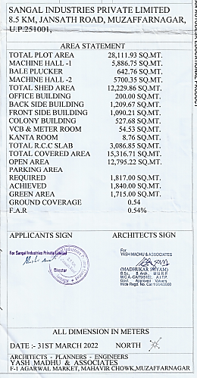

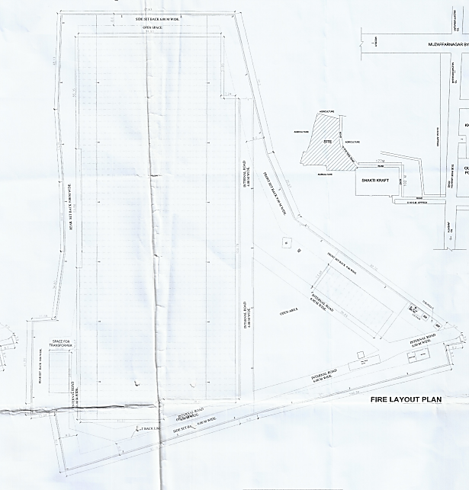

Progress of Building and Civil Structures for the Plant is considered as per the information provided by the Bank about the status of Progress for Civil Work:

- The Physical progress is considered based on approximate observation of Bank during the Course of their visit to the subject Project Site in Month of March. As per the bank following observations were made:

- False Ceiling works completed.
- Most of the machineries were arrived at the premises and were fully covered
- Electrification work was in progress
- Boundary work was in progress
- Flooring work was completed
- The progress was in accordance with the implementation schedule.

The bank has informed about the construction progress of the project in march. However detailed list of machineries that were delivered to the site till March 2022 is not available with us. For the progress of machineries, we have relied on copies of invoices provided to us by the company which were dated before 31st March 2022.

- Since the borrower has not provided us the breakup of expenditure in separate heads and the visit for the March Quarter was not Conducted at our end due to delay in Work order issued to us, we have only given the general analysis of status of construction as observed during site visit by the bank.

- MACHINERIES & OTHER EQUIPMENTS AND UTILITIES:

The total amount envisaged against the purchase and installation of Plant and Machinery amounts to Rs.55.53 cr. Breakup of which is as below:

MACHINERIES AND OTHER EQUIPMENT’S
Sr. No. | Particulars | Amount (Cr.)
1. | Plant & Machinery | 49.6
2. | Electrical Equipment’s | 1.9
3. | Utilities | 4.03
 | Total | 55.53

The details list of machineries and other equipment’s to be delivered to the site area is as below:

Sr.  No. | Detail of Machines | Quantity  (Set/Nos.) | Name of Supplier | Amount  (Cr.)
1. | Automatic Package Winders (Link Coner) | 475 | SAURER SPINNING SOLUTION GMBH & CO. KG, GERMANY | 11.46
2. | Contamination sorter | 2 | USTER TECHNOLOGIES AG, SWITZERLAND | 1.65
3. | Uster Poly Propylrne Options | 12 | USTER TECHNOLOGIES AG, SWITZERLAND | 0.18
4. | Rotary Screw Compressor CSD | 2 | Kaeser Compressors (India) Pvt. Ltd | 0.23
4. | Compressed Air Filter | 2 | Kaeser Compressors (India) Pvt. Ltd | 0.23
5. | Blow room (2 Lines):- Bale Plucker, Vario Clean, Unimix,FlexiClean & Accessories | 35 | LAKSHMI MACHINE WORKS LTD. COIMBATORE | 38.35
5. | Carding LC 363 | 16 | LAKSHMI MACHINE WORKS LTD. COIMBATORE | 38.35
5. | Fine Feed Chute LA7/6 | 16 | LAKSHMI MACHINE WORKS LTD. COIMBATORE | 38.35
5. | Accessories for Carding Machine | 1 | LAKSHMI MACHINE WORKS LTD. COIMBATORE | 38.35
5. | Draw frame LDB3 ( Single Del) | 1 | LAKSHMI MACHINE WORKS LTD. COIMBATORE | 38.35
5. | Draw frame LDB3 ( Double Del) | 2 | LAKSHMI MACHINE WORKS LTD. COIMBATORE | 38.35
5. | Lap Former LH20 S | 2 | LAKSHMI MACHINE WORKS LTD. COIMBATORE | 38.35
5. | Comber LK69 | 11 | LAKSHMI MACHINE WORKS LTD. COIMBATORE | 38.35
5. | Accessories for Combing Machine | 7 | LAKSHMI MACHINE WORKS LTD. COIMBATORE | 38.35
5. | Draw frame- finisher - LDF3S | 6 | LAKSHMI MACHINE WORKS LTD. COIMBATORE | 38.35
5. | Speed frame LF4280/A | 4 | LAKSHMI MACHINE WORKS LTD. COIMBATORE | 38.35
5. | Ring Frame LRJ 9/SX/SXL | 4 | LAKSHMI MACHINE WORKS LTD. COIMBATORE | 38.35
5. | Ring Frame LRJ 9/SX/SXL | 8 | LAKSHMI MACHINE WORKS LTD. COIMBATORE | 38.35
6. | Overhead cleaners Ring Frame ( CWC with) | 12 | ELGI ELECTRIC AND INDUSTRIES LIMITED, COIMBATORE | 0.51
6. | Centralised Waste Collection System | 1 | ELGI ELECTRIC AND INDUSTRIES LIMITED, COIMBATORE | 0.51
6. | Overhead cleaners Link Corner | 12 | ELGI ELECTRIC AND INDUSTRIES LIMITED, COIMBATORE | 0.51
6. | Overhead cleaners Speed Frame | 4 | ELGI ELECTRIC AND INDUSTRIES LIMITED, COIMBATORE | 0.51
7. | Argus Spark Blocker System Fire Protection | 10 | ELGI ELECTRIC AND INDUSTRIES LIMITED, COIMBATORE | 0.16
7. | Digitel Contral Panel Z10 | 1 | ELGI ELECTRIC AND INDUSTRIES LIMITED, COIMBATORE | 0.03
8. | Fire System For Bale Plucker | 1 | ELGI ELECTRIC AND INDUSTRIES LIMITED, COIMBATORE | 0.03
9. | Sieger Yarn Conditioning Plant 1000 NG | 1 | Sieger Spintech Equipments Pvt. Ltd | 0.25
10. | Bobbin Handling System | 1 | AM Innospin System Pvt Ltd | 0.48
11. | Luwa Auto Control Humidification Plant for Ring Spinning and parts there of with standard and essential accessories | 1 | LUWA INDIA PVT LTD | 1.78
12. | Automatic Bale Press | 1 | TINYTOP ENGINEERING INDIA PRIVATE LIMITED | 0.31
13. | HFT Semi Auto High Volume Cotton Testing Equipment. | - | PREMIER EVOLVICS PVT LTD | 1.89
13. | aQura 2 Fibre And Process info System | - | PREMIER EVOLVICS PVT LTD | 1.89
13. | iQ3 Evenness tester | - | PREMIER EVOLVICS PVT LTD | 1.89
13. | Turbo Maxx 7 High Speed Single Yarn Strength Tester | 4 | PREMIER EVOLVICS PVT LTD | 1.89
14. | Godrej 3 Ton Electric Forklift GX 300 E UNO-4.5M LIFT | 1 | Urja Systems | 0.13
15. | Simplex Bobbin | 35000 | IDEAL SHEET METAL STAMPINGS & PRSSINGS PVT. LTD | 0.51
15. | Hig Ring Spinning Tube | 20500 | IDEAL SHEET METAL STAMPINGS & PRSSINGS PVT. LTD | 0.51
15. | HCC Ring Spinning Tube | 16500 | IDEAL SHEET METAL STAMPINGS & PRSSINGS PVT. LTD | 0.51
15. | HCC Ring Spinning Tube | 16500 | IDEAL SHEET METAL STAMPINGS & PRSSINGS PVT. LTD | 0.51
16. | Multi Roller Mouting Machine LC 363 | 1 | Lakshmi Card Clothing Manufacturing Company (P) Ltd | 0.22
16. | Automatic Flat Clipping Machine LCFM40 | 1 | Lakshmi Card Clothing Manufacturing Company (P) Ltd | 0.22
16. | Automatic Flat Grindging Machine AFGM 40 | 1 | Lakshmi Card Clothing Manufacturing Company (P) Ltd | 0.22
16. | Grinding Plate | 2 | Lakshmi Card Clothing Manufacturing Company (P) Ltd | 0.22
17. | Perfect Twin Head Cot Grindign M/C: TWG-TF | 1 | Perfect Equipment’s Pvt Ltd. | 0.32
17. | Perfect Hydraulic Cot Mounting M/C: CMHY | 1 | Perfect Equipment’s Pvt Ltd. | 0.32
17. | Perfevt U.V. Treatment Machine: UVTM | 1 | Perfect Equipment’s Pvt Ltd. | 0.32
17. | Perfect Cot Checking Device: CCD | 1 | Perfect Equipment’s Pvt Ltd. | 0.32
17. | Perfect Automatic Arbour Greasing M/C: ARG | 1 | Perfect Equipment’s Pvt Ltd. | 0.32
17. | Perfect Spindle Lubricating M/C: SL-3 | 1 | Perfect Equipment’s Pvt Ltd. | 0.32
17. | Perfect Clearer roller cleaning M/C: CRCSFAF | 1 | Perfect Equipment’s Pvt Ltd. | 0.32
17. | Perfect Roving Waste Opening M/C: RWO | 1 | Perfect Equipment’s Pvt Ltd. | 0.32
17. | Perfect Flutted roller truing M/C: FRTM | 1 | Perfect Equipment’s Pvt Ltd. | 0.32
17. | Perfect Shore Hardness Tester | 1 | Perfect Equipment’s Pvt Ltd. | 0.32
18. | HDPE CAN SPINNING CAN SIZE 40" x 48" X 3.00 MM | 230 | Rimtex industries | 0.51
18. | HDPE CAN SPINNING CAN SIZE 24" x 48" X 2.5 MM | 115 | Rimtex industries | 0.51
18. | HDPE CAN SPINNING CAN SIZE 20" x 48" X 2.0 MM | 1400 | Rimtex industries | 0.51
19. | Testing equipment (QC) | 15 | Tecchno Qualicon Solutions (P) Ltd. | 0.10
20. | 2500 KVA Electrical Transformer Level2 | 2 | Power Star | 0.53
21. | Main PCC Panel & PDB Panel With Switch Gear | 11 | Shakumbri Enterprises | 0.84
22. | Grandlay 1100 volts XLPE armoured cable with Aluminium Conductor | 2 | Industrial Venture | 0.46
22. | Grandlay 1100 volts XLPE armoured cable with Copper Conductor | 10 | Industrial Venture | 0.34
23. | Identification Band 20" Orange & Green | 720 | Rimtex industries | 0.01
23. | Identification Band 24" Violet | 70 | Rimtex industries | 0.00
23. | Identification Band 40" Yellow. Red | 140 | Rimtex industries | 0.00
24. | Flooring Material and Flooring job | 8537 sqm | Master Floor India Pvt. Ltd. | 0.54
25. | Armoured H.T. cable 3C X185 mm² | 800 Mtr | Gupta Power Infrastructure Ltd. | 0.13
25. | Armoured H.T. cable 3C X300 mm² | 1600 Mtr | Gupta Power Infrastructure Ltd. | 0.35
26. | H.T. VCB Panel | 1 | Asiatic Electrical & Switchgear Pvt. Ltd | 0.27
27. | Lysaght Trimdek Profile Sheet |  | Shree Ji & Company | 0.69
28. | Fiber Glass Insulation | 8487 | Anand Insulation Pvt. Ltd | 0.21
29. | Ducting For H.plant, False Ceiling with Board and installation work | - | Aala Technocraft | 1.21
30. | Roofing Sheeting & Underdeck insulation Installation Work | - | Zetex Marketing (P) Ltd. | 0.17
31. | Hyraulic Hanh Lift pallet Trucks | - | Agromec | 0.01
TOTAL |  |  |  | 64.84

Note:
- The total project cost of purchase and installation of machineries and other equipment’s amounts to Rs.55.53 Crore. However as per the detailed list of machineries and other equipment’s the same amounts to Rs.64.84 Crore which is approximately 9.30 Crore more than the envisaged cost.
- Copies of Purchase Orders/Proforma Invoices were sought from the company. However, the same is not provided to us by the company citing that they do not have any PI or PO for the above machineries.
- The bank has sanctioned term Loan amounting to Rs.43.00 Crore as per the Cost of machineries and other equipment’s amounting to Rs.55.53 Crore. However, the actual cost of machineries and equipment’s to be purchased by the company for this project amounts to Rs.64.84 Crore as per detailed list of machineries and other equipment’s attached above.
- The Machinery for the Plant Comprises of Both Indigenous Machines and imported Machine’s. As per our verbal discussion wih the company The major vendor for the Indigenous Machines is M/s Lakshmi Machine Works Ltd (LMW), Coimbatore and for the Imported machines area M/s Saurer, Germany and M/s Uster, Switzerland. Copies of Purchase Orders/Quotations were sought from the company however the same is not provided to us citing that there are no such formal agreements with the companies.

PART D | PROJECT CONSULTANTS, CONTRACTORS & SUPPLIERS

According to the SIPL officials, the company has not appointed any Construction Contractor and the project is establishing under the in-house engineering team only. However, the company has signed an agreement with the Steinberg Engineering Consultants, Gorakhpur for designing civil infrastructure. Agreement copies of the same is not provided to us. Therefore, we are unable to comment on the terms and condition of the same.
We have sought the copies of Proforma Invoices/Purchase orders of the machineries listed in the previous section. However, the same is not provided to us by the company citing that no formal agreements have been made with the machinery suppliers.

PART E | PROJECT COST & MEANS OF FINANCE

- TOTAL PROJECT COST: Sangal Industries Private Limited has estimated the Total Project Cost amounting to Rs.74.66 Crore which has been proposed to be funded in DER of 2.38. Details of Rs.74.66 Crore is as below:

- CURRENT STATUS & TOTAL EXPENDITURE INCURRED TILL DATE: Details of the expenditure in the Table below is recorded for the expenditure incurred up to 30st March 2022 as per CA Certificate dated 2nd April 2022 with UDIN 22073352AGGSTX4118.

SR. NO. | PARTICULARS | TOTAL ESTIMATED COST | INCURRED TILL 30.03.2022 | CURRENT STATUS OF WORK AND REMARKS
SR. NO. | PARTICULARS | (All figures in cr.) |  | CURRENT STATUS OF WORK AND REMARKS
1. | Land and Development | Allocated Amount | 1.89 | The borrower has estimated an expenditure amounting to Rs.1.89 Crore towards Land and site development.  As per the CA certificate dated 02ND April 2022 with UDIN. 22073352AGGSTX4118 the borrower has made an expenditure amounting to Rs.1.91 Crore towards land and site development. As per sale deed the company has incurred Rs.1.74 cr. including stamp duty cost towards purchase of land parcels. Balance expenditure amounting to Rs.0.17 Crore is spent towards site development works and the seems fine as per the extent of project area.
1. | Land and Development | Incurred up to period ending March 2022 | 1.91
2. | Building & Civil Works | Allocated Amount | 5.00 | The borrower has estimated an expenditure amounting to Rs.5.00 Crore towards Building and Civil Structures.  However, as per the breakup of expenditure mentioned in CA certificate dated 02nd April 2022 with UDIN. 22073352AGGSTX4118 the expenditure shown is Rs.5.96 crore. For the same we have relied on CA certificate only since no supporting document is provided by the company.  Cost overrun is anticipated since the area to be constructed is more than the area envisaged in TEV report and considered by the bank in their records.
2. | Building & Civil Works | Incurred up to period ending March 2022 | 5.96
 | Plant & Machinery | Allocated Amount | 49.60 | As per CA certificate the company has incurred 19.79 Crore towards purchase and installation of machineries and other equipment’s. Rs.19.79 Crore includes Rs.12.71 Crore paid towards plant and machineries under erection, Rs.0.02 Crore paid towards purchase of office equipment’s and Rs.7.06 Crore are paid as advances against plant and machineries.  As per the physical progress provided to us by the bank, detailed list of machineries that have been delivered to the site is not provided to us. Supporting documents of the above expenditure were sought from the company. Accordingly, the company has provided us copies of invoices for the quarter ending March 2022. Therefore, we have Approved the amount of Rs.12.71 Crore under this head based on the Invoices provided to us. Details of advances is not provided by the company.
 | Plant & Machinery | Incurred up to period ending March 2022 | 19.79
 | Electrical Equipment | Allocated Amount | 1.90 | No expenditure is shown under this head.
 | Electrical Equipment | Incurred up to period ending March 2022 | 0.00 | No expenditure is shown under this head.
 | Utilities | Allocated Amount | 4.03 | No expenditure is shown under this head.
 | Utilities | Incurred up to period ending March 2022 | 0.00 | No expenditure is shown under this head.
 | Pre-operative Expenses | Allocated Amount | 1.75 | For expenditure towards soft cost, we have relied on CA certificate only.
 | Pre-operative Expenses | Incurred up to period ending March 2022 | 1.33
 | Pre-operative Expenses | Expenditure approved under his head | 1.33
 | Margin for Bank Guarantee | Allocated Amount | 0.40 | No expenditure is shown under this head.
 | Margin for Bank Guarantee | Incurred up to period ending March 2022 | NA | No expenditure is shown under this head.
 | Interest During Construction | Allocated Amount | 2.00 | No expenditure is shown under this head.
 | Interest During Construction | Incurred up to period ending March 2022 | NA | No expenditure is shown under this head.
 | Margin for Working capital requirement | Allocated Amount | 8.09 | No expenditure is shown under this head
 | Margin for Working capital requirement | Incurred up to period ending March 2022 | NA | No expenditure is shown under this head
 | Margin for Working capital requirement | Expenditure approved under his head | NA | No expenditure is shown under this head
10. | Fixed deposit in Bank | Allocated Amount | NA | There is no head as such in the estimated Proposed Cost. Although as per the CA certificate an amount of Rs.8.82 crore is incurred toward this head.
10. | Fixed deposit in Bank | Incurred up to period ending March 2022 | 8.82
11. | Cash and bank balance | Allocated Amount | NA | There is no head as such in the estimated Proposed Cost. Although as per the CA certificate an amount of Rs.1.29 crore is incurred toward this head.
11. | Cash and bank balance | Incurred up to period ending March 2022 | 1.29
12. | Total | Allocated Amount | 74.66 | Details of expenditure, Copies of PO’s/WO’s are not provided to us by the borrower however the Invoices for the machines purchased are provided to us by the company/borrower. Therefore, we have relied on the invoices and the amount incurred as per the invoices for the machines. But analysis for other heads is not done at our end due to unavailability of related documents and we have relied on CA certificate for them.  We have given a general overview of the project based on expenses shown by chartered accountant in their CA certificate dated 02nd April 2022 with UDIN. 22073352AGGSTX4118 and construction progress up to March 2022 shared by the bank, copies of machinery invoices provided by the company.
12. | Total | Incurred up to period ending March 2022 | 39.10

Comments:
- The borrower has estimated an expenditure amounting to Rs.5.00 Crore towards Building and Civil Structures. However, as per the breakup of expenditure mentioned in CA certificate dated 02nd April 2022 with UDIN. 22073352AGGSTX4118 the expenditure shown is Rs.5.96 crore. For the same we have relied on CA certificate only since no supporting document is provided by the company.
- Cost overrun is anticipated under the head Building works and civil construction since envisaged area of construction in bank records is less than the area being actually constructed on site.
- As per the physical progress provided to us by the bank, detailed list of machineries that have been delivered to the site is not provided to us. Supporting documents of the above expenditure were sought from the company. Accordingly, the company has provided us copies of invoices for the quarter ending March 2022. Therefore, we have approved the amount of Rs.12.71 Crore under this head based on the Invoices provided to us. Details of advances is not provided by the company.
- We have given a general overview of the project based on expenses shown by chartered accountant in their CA certificate dated 02nd April 2022 with UDIN. 22073352AGGSTX4118 and construction progress up to March 2022 shared by the bank and copies of machinery invoices provided by the company.

3. SOURCES OF FINANCE & UTILIZATION OF FUNDS: The Project cost mentioned above has been planned to be covered from following resources:
(Amount in Rs. Crore)
PARTICULARS | ENVISAGED MEANS OF FINANCE
Promoter’s Contribution (Equity) | 18.00
Term Loan (Debt) | 43.00
Unsecured loan | 13.66
TOTAL | 74.66

(Amount in Rs. Crore)
PARTICULARS | PLANNED AMOUNT | AMOUNT INFUSED UP TO 31.03.2022 | BALANCE
Share Capital | 18.00 | 17.97 | 0.03
Term Loan from Bank | 43.00 | 11.05 | 31.95
Unsecured Loan | 13.66 | 10.08 | 3.58
TOTAL | 74.66 | 39.10 | 35.56
Source: As per CA Certificate dated 2nd April 2022 with UDIN. 22073352AGGSTX4118.

Comments:
The sanctioned DER of the project is 2.38 and current DER of the project stands at 0.61.
PART F | STATUTORY & REGULATORY APPROVALS, CLEARANCES & NOC

Sr. No. | NAME OF LICENSE/ REGISTRATION | PURPOSE | DATE OF ISSUE | Current Status
Sr. No. | ISSUING AUTHORITY | PURPOSE | LICENCE NO. | Current Status
1. | Building Plan | Approval of building plans | 13/05/2022 | Approval for the Building Plan is obtained by the Company from the competent Authority.
1. | State PWD | Approval of building plans | 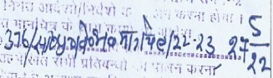
2. | Change of Land Use (143) (for Land area 2.3926 Hectare) | Conversion of Land from Agricultural to Non-Agricultural land | 03/01/2022 | Collector Office, Muzaffarnagar
2. | Change of Land Use (143) (for Land area 2.3926 Hectare) |  | Case No. 9826/2021 | Collector Office, Muzaffarnagar
2.1. | Change of Land Use (143) (for Land area 2.3926 Hectare) | Conversion of Land from Agricultural to Non-Agricultural land | 25/10/2021 | Collector Office, Muzaffarnagar
2.1. | Change of Land Use (143) (for Land area 2.3926 Hectare) |  | Case No. 9050/2021 | Collector Office, Muzaffarnagar
3. | Environment Clearance | Approval as per environment guidelines in the area | NA | Not Provided
3. | Ministry of Environment, Forest and Climate Change | Approval as per environment guidelines in the area | NA | Not Provided
4. | Consent to Establish | Approval as per Pollution norms applicable in that area | 03/09/2021 | As on date the clearance is valid and will be valid up to 02/09/2023
4. | UP State Pollution control board | Approval as per Pollution norms applicable in that area | 132465/UPPCB/MUZAFFARNAGAR(UPPCBRO)/CTE/MUZAFFARNAG  AR/2021
5. | Provisional Fire NOC | Approval of fire protection technique in the project | 24/01/2022 | The company has obtained the Fire NOC from the competent authority.
5. | State Fire authority | Approval of fire protection technique in the project | UPFS/2022/43339/MZN/MUZAFFARNAGAR/355/JD
6. | Groundwater Abstraction Clearance | Approval for groundwater abstraction for construction purpose | NA | Not Provided
6. | Central Groundwater Authority |  | NA | Not Provided
7. | IEM Certificate | Industrial Entrepreneurs memorandum | NA | Not Provided
7. | Ministry of Commerce and Industry | Industrial Entrepreneurs memorandum | NA | Not Provided
8. | Power Connection | Power connection for construction works | NA | Not Provided
8. | State Power Authority | Power connection for construction works | NA | Not Provided
Observations & Comments:

- All approvals including approvals/consents required under local regulations, building codes and approvals required from the Distribution Utility etc. relating to installation of unit are listed above and their current status.

PART G | PROJECT SCHEDULE & CURRENT STATUS

IMPLEMENTATION SCHEDULE OF SIPL, MUZZAFARNAGAR, UTTAR PRADESH
S.No. | Particular | Commencement | Completion | Current Status
1 | Acquisition of land |  | Acquired | The company has already acquired the Land for the Plant
2 | Construction of civil work | Aug-21 | Apr-22 | Flooring work was Complete and False ceiling work, Boundary work was in Progress as per information
3 | Electrical works | Jan 2022 | May-22 | Electrical Works are in progress
4 | Installation of machines | May-22 | Feb-23 | As per the Information provided by the Bank Majority of the Machineries were imported to the site.
5 | Trial operation | - | Mar-23 | ---
6 | Commercial operation |  | Apr-23 | As per the progress analysis of the project based on invoices provided by the company and construction progress informed by the bank the commercial operations of the project are anticipated to start by April 2023.

PART H | OBSERVATIONS & COMMENTS

- The estimation of cost considered in the report is as per the TEV provided to us by the Bank.

- The Physical progress captured in the report is based on approximate observations of status of structures constructed on site during site inspection by the Bank.

- The Progress of the Plant and machinery is considered as per the Invoices provided by the company and the insight of the Project in March as per the Bank visit during the march month.

- As per CA certificate dated 02ND April 2022 with UDIN. 22073352AGGSTX4118 the borrower has made an expenditure on the project amounting to Rs.39.1 Crore out of the total amount of Rs.74.66 crores.

- Detail of Expense, Copies of PO’s/WO’s is not provided to us by the borrower. Therefore, we have not analysed the physical progress of structures and have relied on expense shown by chartered accountant in their CA certificate dated 02-04-2022 with UDIN. 22073352AGGSTX4118 for the project. However, as the Company/ Borrower have provided us with the Invoices for the Machinery So, we have relied on the invoices for the expenses toward Plant and machinery.

- This is the Ist LIE Report of the project and as per CA certificate showing expenditure in the project up to 30st March 2022, Term loan amounting to Rs.11.05 Crore has been disbursed by the lender up to 30st March 2022 out of total amount of Rs. 43 crores.

- The borrower has obtained Building plan approval and Provisional Fire NOC for the Unit. However, we have not been provided by the approved building Plan Letter.

- As per our discussion with the Promoter and subsequent discussion with the Bank, the Project Status as on date matched the Proposed implementation Schedule.

PART I | DISCLAIMER

      - No employee or member of R.K Associates has any direct/ indirect interest in the Project.
      - This report is prepared based on the copies of the documents/ information which the Bank/ Borrower has provided to us out of the standard checklist of documents sought from them and further based on our assumptions and limiting conditions. The client/owner and its management/representatives warranted to us that the information they supplied was complete, accurate and true and correct to the best of their knowledge. All such information provided to us has been relied upon in good faith and we have assumed that it is true and correct in all respect. I/We shall not be liable for any loss, damages, cost or expenses arising from fraudulent acts, misrepresentations, or wilful default on part of the owner, borrower, its directors, employee, representative or agents. Verification or cross checking of the documents provided to us from the originals or from any Govt. departments/ Record of Registrar has not been done at our end since this is beyond the scope of our work. If at any time in future, it is found or came to our knowledge that misrepresentation of facts or incomplete or distorted information has been provided to us then this report shall automatically become null & void.
      - Legal aspects for eg. investigation of title, ownership rights, lien, charge, mortgage, lease, sanctioned maps, verification of documents, etc. have not been done at our end and same has to be taken care by legal expert/ Advocate. It is assumed that the concerned Lender/ Financial Institution has satisfied them with the authenticity of the documents, information given to us and for which the legal verification has been already taken and cleared by the competent Advocate before requesting for this report. I/ We assume no responsibility for the legal matters including, but not limited to, legal or title concerns.
      - This report is a general analysis of the project based on the scope mentioned in the report. This is not an Audit report, Design document, DPR or Techno feasibility study. All the information gathered is based on the facts seen on the site during survey by the bankers since we have been issued the works order in April 2022 were unable to conduct the site visit for the quarter ending March 2022, verbal discussion & documentary evidence provided by the client and is believed that information given by the borrower is true best of their knowledge.
      - All observations mentioned in the report is only based on the visual observation and the documents/ data/ information provided by the client. No mechanical/ technical tests, measurements or any design review have been performed or carried out from our side during Project assessment.
      - Bank/FII should ONLY take this report as an Advisory document from the Financial/ Chartered Engineering firm and its specifically advised to the creditor to cross verify the original documents for the facts mentioned in the report which can be availed from the borrowing borrower directly.
      - In case of any default in loans or the credit facility extended to the borrowing borrower, R.K Associates shall not be held responsible for whatsoever reason may be and any request for seeking any explanation from the employee/s of R.K Associates will not be entertained at any instance or situation.
      - The documents, information, data provided to us during the course of this assessment by the client is reviewed only upto the extent required in relation to the scope of the work. No document has been reviewed beyond the scope of the work.
      - This report only contains general assessment & opinion as per the scope of work evaluated as per the information given in the copy of documents, information, data provided to us and/ and confirmed by the owner/ owner representative to us at site which has been relied upon in good faith. It doesn’t contain any other recommendations of any sort including but not limited to express of any opinion on the suitability or otherwise of entering into any transaction with the borrower.
      - We have relied on data from third party, external sources & information available on public domain also to conclude this report. These sources are believed to be reliable and therefore, we assume no liability for the truth or accuracy of any data, opinions or estimates furnished by others that have been used in this analysis. Where we have relied on data, opinions or estimates from external sources, reasonable care has been taken to ensure that such data has been correctly extracted from those sources and /or reproduced in its proper form and context, however still we can’t vouch its authenticity, correctness or accuracy.
      - This Report is prepared by our competent technical team which includes Engineers and financial experts & analysts.
      - This is just an opinion report and doesn’t hold any binding on anyone. It is requested from the concerned Financial Institution which is using this report for taking financial decision on the project that they should consider all the different associated relevant & related factors also before taking any business decision based on the content of this report.
      - All Pages of the report including annexures are signed and stamped from our office. In case any paper in the report is without stamp & signature then this should not be considered a valid paper issued from this office.
      - Though adequate care has been taken while preparing this report as per its scope, but still we can’t rule out typing, human errors, over sightedness of any information or any other mistakes. Therefore, the concerned organization is advised to satisfy themselves that the report is complete & satisfactory in all respect. Intimation regarding any discrepancy shall be brought into our notice immediately. If no intimation is received within 15 (Fifteen) days in writing from the date of issuance of the report, to rectify these timely, then it shall be considered that the report is complete in all respect and has been accepted by the client upto their satisfaction & use and further to which R.K Associates shall not be held responsible in any manner.
      - Defect Liability Period is 15 DAYS. We request the concerned authorized reader of this report to check the contents, data and calculations in the report within this period and intimate us in writing if any corrections are required or in case of any other concern with the contents or opinion mentioned in the report. Corrections only related to typographical, calculation, spelling mistakes, incorrect data/ figures/ statement will be entertained within the defect liability period. Any new changes for any additional information in already approved report will be regarded as additional work for which additional fees may be charged. No request for any illegitimate change in regard to any facts & figures will be entertained.
      - R.K Associates encourages its customers to give feedback or inform concerns over its services through proper channel at valuers@rkassociates.org in writing within 15 days of report delivery. After this period no concern/ complaint/ proceedings in connection with the Financial Feasibility Study Services will be entertained due to possible change in situation and condition of the subject Project.
      - Our Data retention policy is of ONE YEAR. After this period, we remove all the concerned records related to the assignment from our repository. No clarification or query can be answered after this period due to unavailability of the data.
      - This Lender’s Independent Engineer report is governed by our (1) Internal Policies, Processes & Standard Operating Procedures, (2) Information/ Data/ Inputs given to us by the client and (3) Information/ Data/ Facts given to us by our field/ office technical team. Management of R.K Associates never gives acceptance to any unethical or unprofessional practice which may affect fair, correct & impartial assessment and which is against any prevailing law. In case of any indication of any negligence, default, incorrect, misleading, misrepresentation or distortion of facts in the report then it is the responsibility of the user of this report to immediately or at least within the defect liability period bring all such act into notice of R.K Associates management so that corrective measures can be taken instantly.
      - R.K Associates never releases any report doing alterations or modifications from pen. In case any information/ figure of this report is found altered with pen then this report will automatically become null & void.

Place: Noida | FOR INTERNAL USE
Date: 03rd June 2022 | SURVEYED BY: Bankers
Note: Report contains 94 pages | PREPARED BY: PE Team
For R.K. Associates Valuers and Techno
Engineering Consultants Pvt. Ltd.

- DEFECT LIABILITY PERIOD - In case of any query/ issue or escalation you may please contact Incident Manager by writing at valuers@rkassociates.org. We ensure 100% accuracy in the Calculations done, Rates adopted and various other data points & information mentioned in the report but still can’t rule out typing, human errors or any other mistakes. In case you find any mistake, variation, discrepancy or inaccuracy in any data point of the report, please help us by bringing all such points into our notice in writing at valuers@rkassociates.orgwithin 30 days of the report delivery, to get these rectified timely, failing which R.K Associates Valuers Techno Engineering Consultants (P) Ltd. won’t be held responsible for any inaccuracy in any manner. Also if we will not hear back anything from you within 30 days, we will assume that report is correct in all respect and no further claim of any sort will be entertained thereafter. We would welcome and appreciate your feedback & suggestions in order to improve our services.

COPYRIGHT FORMAT - This report is prepared on the copyright format of R.K Associates Valuers Techno Engineering Consultants (P) Ltd. to serve our clients in the best possible way. Legally no one can copy or distribute this format without prior approval from R.K Associates. It is meant only for the organization as mentioned on the cover page of this report. Distribution or use of this format other than R.K Associates will be seen as unlawful act and necessary legal action can be taken against the defaulter

ENCLOSURE 1: IMPORTANT DOCUMENTS EXHIBIT

DOCUMENT-1: CA CERTIFICATE DATED 2nd April 2022

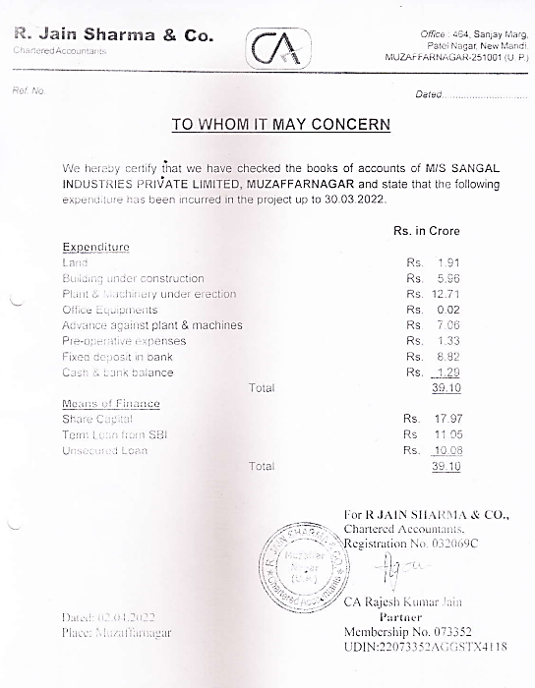

DOCUMENT-2: CLU FOR “0.5530” HECTARE LAND

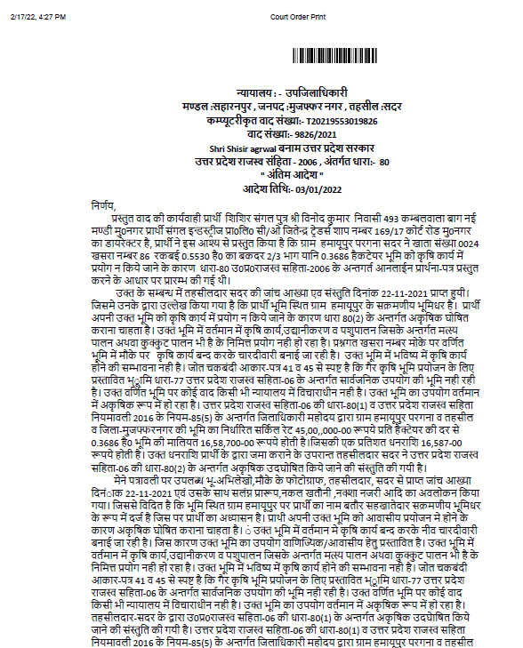

DOCUMENT-3: CLU FOR “2.3926” HECTARE LAND

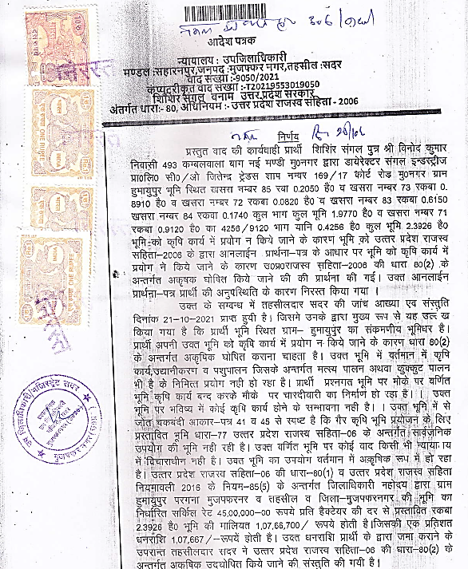

DOCUMENT- 4: SALE DEED

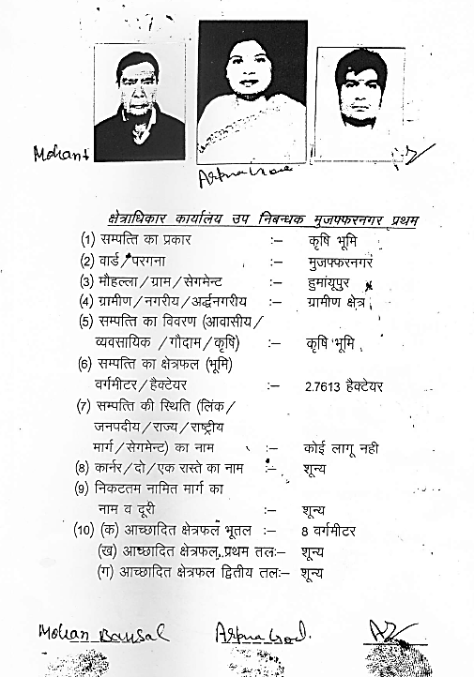

DOCUMENT- 5: NOC FROM U.P. POLLUTION CONTROL BOARD

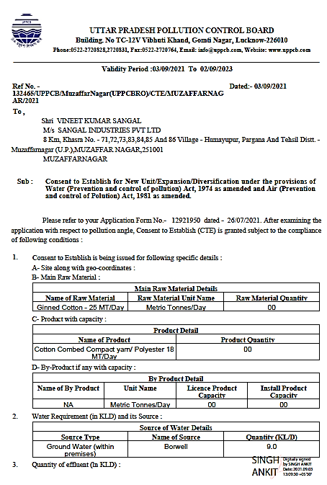

DOCUMENT-7: SANCTION LETTER

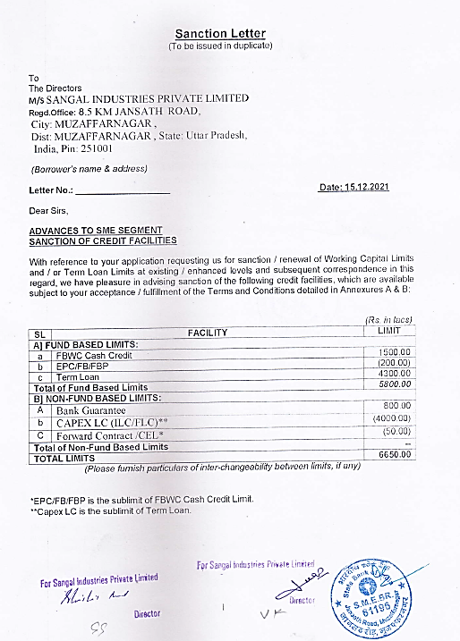

DOCUMENT-7: NOC FROM FIRE DEPARTMENT

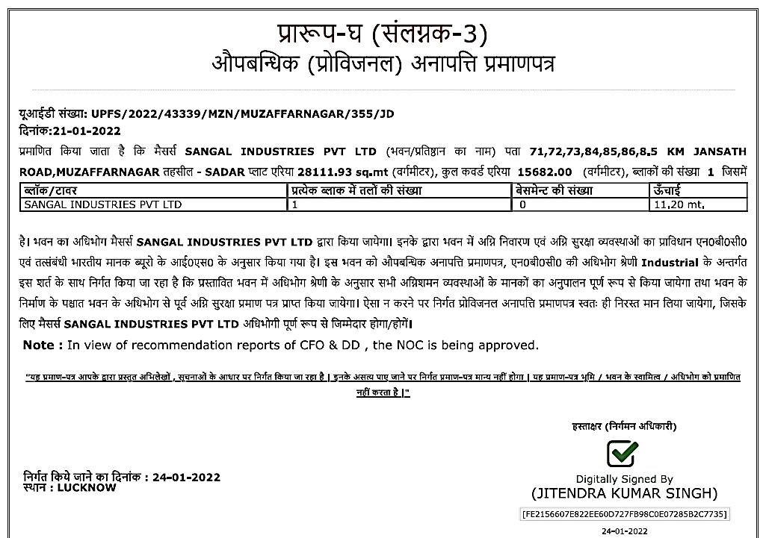

LIST OF MACHINERIES INFERRED FROM INVOICES

ENCLOSURE-3 : - SITE PHOTOGRAPHS

NOT AVAILABLE FOR MONTH OF MARCH

