File No.: VIS(2022-23)-PL034-020-037 Dated:14/03/2022

PROJECT PROGRESS REPORT
(FOR PERIOD ENDING FEBRUARY 2022)

OF

M/s EURO SAFETY FOOTWEAR PRIVATE LIMITED

SITUATED AT
PLOT NO. B-49, B-49/1 TO 3, EPIP, SHASTRIPURAM, SIKANDRA, AGRA-282007

PROMOTER/S
M/S EURO SAFETY FOOTWEAR PVT. LIMITED

ASSOCIATE OF


REPORT PREPARED FOR
PUNJAB NATIONAL BANK, MID CORPORATE CENTRE, AGRA

**Important - In case of any query/ issue or escalation you may please contact Incident Manager at le@rkassociates.org. We will appreciate your feedback in order to improve our services.
NOTE: As per IBA Guidelines please provide your feedback on the report within 15 days of its submission after which report will be considered to be correct.

TABLE OF CONTENTS
S.NO. | DESCRIPTION | PAGE NO.
PART A | Report Summary
PART B | Introduction
 | - The Project
 | - About the Company
 | - Location of the Project
 | - Project Overview
 | - Scope of the Report
 | - Purpose of the Report
 | - Methodology Adopted
PART C | Plant Infrastructure Sections & Facility Details
 | - Land Details
 | - Project Infrastructure Details
PART D | Project Consultants, Contractors & Suppliers
 | - Confirmed Contractors
PART E | Project Cost and Means of Finance
 | - Total Project Cost
 | - Current Status and Total Expenditure Incurred till Date
 | - Sources of Finance & Utilization of Funds
PART F | Statutory & Regulatory Approvals, Clearances & NOC
PART G | Project Schedule & Current Status
 | - Project Schedule Chart
PART H | Observations and Comments
PART I | Disclaimer

IMPORTANT NOTICE

COPYRIGHT FORMAT: This report is prepared on the copyright format of R.K Associates, to serve our clients with the best available information and analysis to facilitate them to take rational business decisions. Legally no one can copy or distribute this format without prior approval from R.K Associates. It is meant only for the advisory/ reference purpose for the organization/s as mentioned on the cover page of this report. Distribution or use of this format by any organization or individual other than R.K Associates will be seen as unlawful act and necessary legal action can be taken against the defaulters.

This report is intended for the sole use of the intended recipient/s and contain material that is STRICTLY CONFIDENTIAL AND PRIVATE.

DEFECT LIABILITY PERIOD: In case of any query/ issue or escalation you may please contact Incident Manager: @ le@rkassociates.org. We try our level best to ensure correctness in the calculations done, rates adopted and various other data points & information mentioned in the report but still can’t rule out typing, human errors or any other mistakes. In case you find any such mistake or inaccuracy in any data point of the report please help us by bringing all such points into our notice immediately or within 15 days of the report delivery in writing, to rectify these timely failing after which R.K Associates won’t be held responsible for any such inaccuracy in any manner. We would highly appreciate your feedback in order to improve our services.

PART A | REPORT SUMMARY

1. |  | Name of Project: |  | Expansion of the existing Shoe Manufacturing Plant of M/s EURO Safety Footwear Pvt. Ltd. from existing footwear production capacity of 20 Lakhs Per annum to 22 lacs per annum.
2. |  | Project Location: |  | Plot No. B-49, B-49/1 to B-49/3 at EPIP Industrial Area, Agra
3. |  | Name of the Borrower Company/Promoter: |  | M/s. Euro Safety Footwear Pvt. Ltd.
4. |  | Director’s |  | Mr. Stella Budhiraja  Mr. Kulbir Singh- Managing Director  Mrs. Dalbir Kaur  Mr. Deepak Budhiraja  Mr. Varun Budhiraja  Ms. Ashika Jindal
5. |  | Prepared for Bank: |  | Punjab National Bank, Mid Corporate Centre, Agra
6. |  | LIE Consultant Firm: |  | M/s. R.K. Associates Valuers & Techno Engineering Consultants (P) Ltd.
7. |  | Date of Survey: |  | 10th March 2022 & 4th June 2022
8. |  | Date of Report: |  | 14th March 2022
9. |  | Purpose of the Report: |  | To provide fair detailed analysis report to the Bank based on the “in-scope points” mentioned below for facilitating them to take appropriate business decision on the Project.
10. |  | Scope of the Report: |  | To provide progress report for the Expansion unit of M/s Euro Safety Footwear Private Limited
11. |  | Documents perused for Proposal: |  | - Excerpts of Techno economic Viability report  - CA certificate dated 25th March 2022  - Invoices/bills of Machineries
12. |  | Annexure with the report: |  | - CA Certificate  - UDIN Verification  - Invoices/bills of Machineries
 | PART B |  | INTRODUCTION

- THE PROJECT:
This is a expansion Project from existing manufacturing capacity of 20 Lakh shoes per annum to 22 Lakhs shoes per annum of M/s Euro safety Footwear private limited at B49, B49/1 to 3, EPIP Industrial Area, Agra.

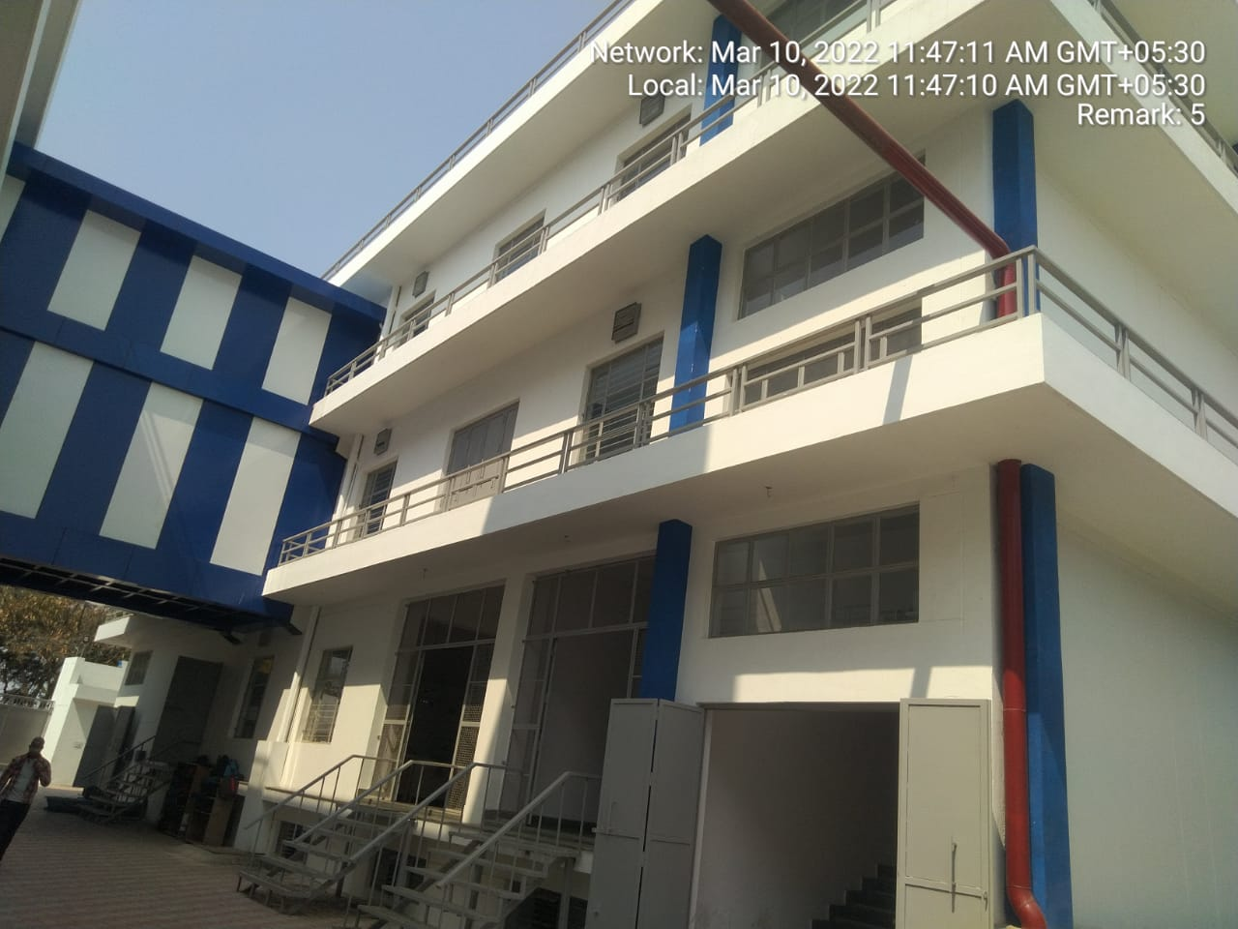

- PROJECT OVERVIEW:
M/s Euro Safety Footwear (India) Pvt. Ltd. is expanding the existing Plant capacity to increase the output capacity of the overall unit. Earlier the output capacity was 20 lakhs shoes per annum which is now proposed to be 22 lakhs after expansion. The total cost of project as envisaged in the TEV report amounts to Rs.20.69 Crore.

As per TEV report the existing Plant of the company is established on B-49/4, B-49/5, B-49/6, B-54/2, B-54/3, Industrial Area, Shashtripuram, Agra – 282007. Expansion of the unit is done on Plot No. B-49, B-49/1 TO 3, EPIP, Shastripuram, Sikandra, Agra-282007.

As per TEV report and rough sketch plan the unit under expansion is developed on the North side Plot of the existing unit bearing address B-49/4, B-49/5, B-49/6, B-54/2, B-54/3, EPIP Industrial Area, Agra. New block of the unit under expansion has 2 main buildings having area measuring 75,076 sq.ft.

The building & structures and Plant & Machinery proposed as per TEV report were found to be completed and the plant was found to be operational and working condition during site visit of our team on 75,076 sq.ft.

In this regard we have been provided with an undertaking from the Company for the commercial operation date and we have relied on the same to validate any information regarding commercial operation is not under the scope of work at our end and bank is advised to take due diligence for the same.

In this regard Bank has also provided us the letter from the company for COD achievement on 01.02.2022 of the expansion unit from 18 Lakh pair of shoes per annum to 22 Lakh pair of shoes per annum.

- PROJECT LOCATION:
Details of Location of the project is as below:
Particulars | Description
Latitude | N 27°11'54.1
Longitude | E 77°55'11.8

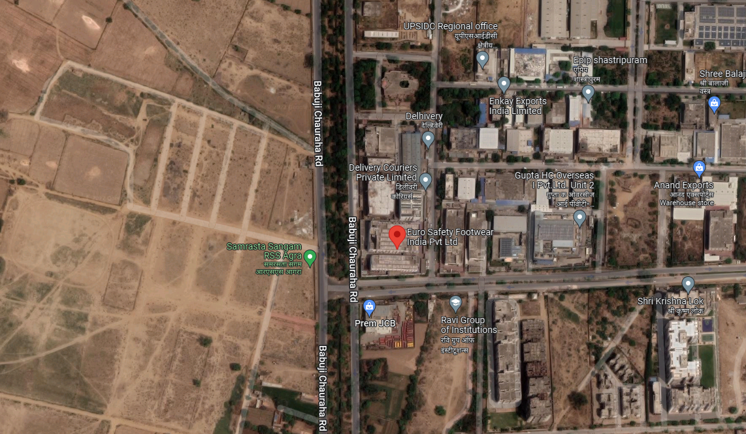

Figure 1: Location of Manufacturing Unit

- SCOPE OF THE REPORT:
To provide progress Report for the Expansion unit of M/s Euro Safety Footwear Private Limited.

- PURPOSE OF THE REPORT: To provide current Progress report of the Project to the Bank for facilitating them to take appropriate business decision on the Project.

- METHODOLOGY ADOPTED:
- Study of Project Planning documents/ reports to know about the Project.
- Additional information, data, documents collection the company.
- Study and analysis of the documents and information obtained from the company.
- Information compilation, analysis and reporting.

PART C | PLANT INFRASTRUCTURE SECTIONS & FACILITY DETAILS WITH ACTUAL PROGRESS

- LAND DETAILS:
As per TEV report the expansion project is being developed at Plot No. B-49, B-49/1 to B49/3 at EPIP, Industrial area, Agra. However, land cost is not part of Project cost as per TEV report.

- BUILDING & STRUCTURAL DETAILS:
As per the proposed plan the expansion project included two new buildings with G+2 floors which house the major equipment’s and machineries. The structures are connected with a passage at Basement, first and second floor level.

As per the site plan provided to us there are 2 major structures in the project apart from some small ancillary structures.

The details for the different sections/structural usage as per copies of drawings provided to us are tabulated below: -

Sr. No. | Particular | ~Area (in sq.ft.) | Usage of Structure
Main Factory Building-1
1. | Basement | 13056 | Consist of Working Hall, Warehouse & Room
2. | Ground floor | 13056 | Consist of Cutting Department, lasting Room, Die Store, Toe Cap Store, Preparation department, Bottom Store, Office area, Toilets
3. | First Floor | 13056 | Consist of Fitter Store, Fitter Department, Consumable Store, Cabin, toilet
4. | Second floor | 13056 | Consist of Hall and store
 | Sub-Total | 52224
Main Factory Building-2
5. | Basement | 5088 | Consist of Working Hall
6. | Ground floor | 5088 | Consist of Lather Store, D.G. Room, Compressor Room
7. | First Floor | 5088 | Consist of Working Hall, Canteen, Kitchen
8. | Second floor | 5088 | Used as Store
 | Sub-Total | 20352
Passage
9. | Basement | 320 | Connecting Passage between the two Main Factory Building
10. | First Floor | 320 | Connecting Passage between the two Main Factory Building
11 | Second floor | 320 | Connecting Passage between the two Main Factory Building
 | Sub-Total | 960
Other Structures
12. | Section-6/ Adhesive store | 150 | Adhesive store
13. | Section-7/ Store | 300 | Store
14. | Section-8/ Toilet | 70 | Toilet
15. | Section-9/ Toilet | 40 | Toilet
16. | Section-10/ First Aid | 80 | First Aid
17. | Section-11/ H.R. Cabin | 150 | H.R. Cabin
18. | Section-12/ Waiting room | 120 | Waiting room
19. | Section-13/ Security Room | 120 | Security Room
20. | Section-14/Store | 110 | Store
21. | Section-15/Store | 110 | Store
22. | Section-16/Store | 110 | Store
23. | Section-17/Store | 180 | Store
 | Sub-Total | 1540
 | Total | 75076

As per TEV report, out of total project cost amounting to Rs.20.69 Crore, borrower has estimated Rs.8.79 Crore for construction of above listed sections. Detailed civil estimate was sought from the borrower, however, the same was not provided to us.

Notes:

- We have been provided with a general Site plan of the Expansion Plant only and no approved map is provided to us.
- The detail estimate for the Construction of the Civil Structures is not provided to us.

As per site Plan provided by the company following buildings are proposed to be constructed at site:

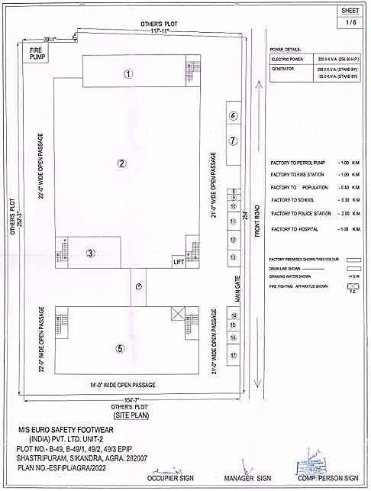

PROGRESS OF BUILDING AND CIVIL STRUCTURES AS PER SITE VISIT DATED 10TH MARCH 2022:

PARTICULARS | DETAILS
Total Estimated Cost allocated in Building & Structures | Rs.8.79 Crore
Total Money outlaid till 28th February 2022 | Rs. 8.82 Crore
Total Approved | Rs. 8.82 Crore
Observations & Remarks:

- All the building structures proposed in the plan provided by the company are complete as per our observation of the said Unit during the site survey.
- The Plinth area for the Structures is randomly cross verified during our site visit and were found to be more or less the same as proposed in the Site Plan.
- Moreover, during site visit it was observed that the project has started commercial operations and footwears were being manufactured at the expansion unit.
- As per CA Certificate company has incurred cost of Rs.8.79 crores in Building & structure work which comes out to be Rs.1170/- per sq.ft as per plinth area rates mechanism and found to be reasonable as per Industry standard.
- Assessment has been done only based on site plan since no approved plan was provided to us.

- PLANT MACHINERY & EQUIPMENT:

List of Plant and machineries which are proposed to be delivered to the site are as below:
Sr. No. | Machine Name | Supplier Name
Cutting Department
1. | Cutting machine | Ares
2. | Material Cutting Machine | Ares
3. | Heavy Duty Beam Press | Ningbo Mama Papa
Preparation Department
4. | Skivining machine | Topson
5. | Cloth Pasting | SIECK
6. | Stamping Machine | Western
7. | Splitting Machine | SIECK
8 | CE Label Pasting machine | Ningbo Mama Papa
9. | Embossing Machine | Sangeetha Ent.
Socks department
10. | 31k Machine | Topson Ent.
11. | 2 KG 2AG Machine | Hind Ent.
12. | Post Bed Single Needle | Iyun Shuaima
13 | Post Bed Double Needle | Iyun Shuaima
14. | Zig Zag Machine | Hind Ent.
15. | Thread Burning | Alra Machine Tools
16. | Glue Spray | Gaitonde
Eyelet
17. | Automatic D-ring | TMC
18. | Eyeletting | TMC
19. | Hook machine | RS Machine Tools
20. | Plastic Hook SPS | TMC
Strobel Department
21. | Counter Moulding Machine | Yili
22. | Strobel Machine | Global
23. | Strobel Machine Heavy Duty | SIECK
Cement Lasting Line
24. | Lasting Conveyor | Kalra Machine Tools
25. | Toe lasting M/c | TMC
26. | Mulling machine | Kalra Machine Tools
27. | Heater Seater | Kalra Machine Tools
28 | Buffing machine | Kalra Machine Tools
29. | Plate Press | Kalra Machine Tools
30. | Heat Activator | Kalra Machine Tools
31. | Last d-lasting machine | Joro Tech
32. | Toe Filling machine | Pioneer Tech
33. | Double Pad sole Press machine | Kalra Machine Tools
34. | Spray Booth | Kalra Machine Tools
35. | Reactivating Plane for soles | TMC
Injection Department
36. | Automatic Rotary Table Polyurethane Injection Moulding Machine | Desma
37. | Chiller | Kalra Machine Tools
38. | Trimming machine | TMC
39. | Sole Buffing Machine | Kalra Machine Tools
Finishing Department
40. | Finishing Conveyor | Kalra Machine Tools
41. | Spray Booth | Kalra Machine Tools
42. | Brushing Machine Double side | Pioneer
Utilities
43. | Generator | Jakson
44. | Compressor | As equipment Private Limited
45. | Air Dryer | As equipment Private Limited
Moulds
46. | PU Mould Double Density | Ningbo Mama Papa
47. | Turning Head | Ningbo Mama Papa
48. | TPU Mould | Ningbo Mama Papa
49. | TPU Outsole Bottom | Ningbo Mama Papa
50. | Transformer | Melcon
51. | Lift | NA
52. | Furniture + Fixtures & Fitting | NA

PROGRESS OF PLANT & MACHINERY AS PER SITE VISIT DATED 10TH MARCH 2022 & 4th JUNE 2022:

PARTICULARS | DETAILS
Total Estimated Cost allocated in Plant Machinery & Equipment | Rs.10.11 Crore
Total Money outlaid till 28th February 2022 | Rs.9.67 Crore
Total Approved Upto 28th February 2022 | Rs.9.18 Crore
Total Approved Upto 4th June 2022 | Rs.10.72 Crore
Observations & Remarks:

- As per CA certificate dated 25th March 2022 with UDIN. 22070428AFOUHH9938 the borrower has incurred Rs.9.67 crore towards the purchase and installation of plant and machinery at the site.
- This report has been prepared considering the CA certificate Dated: - 25/03/2022 showing expenditure in the Project Upto 28TH February 2022. As on date of CA certificate the cost of Project was 10.11 against which the company has incurred 9.67 cr. however as per the copy of invoices provided by the Company they have incurred Rs.10.72 cr clarification was sought from the company accordingly, the company has informed that the CA has only captured expenditure upto 28th feb and some machineries were delivered after the said date the amount of which is not considered in the CA certificate. However, the Machineries mentioned in the Invoices were verified during the physical site visit dated: -10/03/2022 and virtual site visit 4/06/2022. Therefore the Total amount approved is 10.72 cr. Breakup of which is as below.
- Machineries which were proposed to be delivered to the site are in high quantity including small components as they have been assembled on site. Therefore, verifying each and every machine including small components is not practically possible.
- However, during the course of visit we were able to verify some of the major machineries as listed below which were found installed at the site and operational.

PART E | PROJECT COST & MEANS OF FINANCE

- TOTAL PROJECT COST: Borrower has estimated the Total Project Cost amounting to Rs.20.69 Crore which was proposed to be funded in DER of 1.88 i.e., approx. 35% Equity and 65% Debt. Detailed breakup of Rs.20.69 Crore is as below:
(Amount in Rs. Crore)
Sr. No. | Particulars | Cost of Project
1. | Building | 8.79
2. | Plant and Machinery | 10.11
3. | Furniture and fixtures including Industrial Electrification & Lift | 0.80
4. | Contingency and spares etc. | 0.99
 | Total Project Cost | 20.69

- CURRENT STATUS & TOTAL EXPENDITURE INCURRED TILL DATE: Details of expenditure based on CA certificate dated 25th march 2022 with UDIN: 22070428AFOUHH9938 showing expenditure in the project up to 28th February 2022:

SR. NO. | PARTICULARS | TOTAL ESTIMATED COST | IN0CURRED TILL 28.02.2022 | CURRENT STATUS OF WORK AND REMARKS
SR. NO. | PARTICULARS | (All figures in cr.) |  | CURRENT STATUS OF WORK AND REMARKS
 | Land | Allocated Amount | NA | Not applicable since land was not part of the Project cost.
 | Land | Expenses incurred up to last LIE report | NA | Not applicable since land was not part of the Project cost.
 | Land | Incurred up to period ending Feb 2022 | NA | Not applicable since land was not part of the Project cost.
 | Land | Expenditure approved under this head | NA | Not applicable since land was not part of the Project cost.
 | Building | Allocated Amount | 8.79 | The Borrower has estimated an expenditure amounting to Rs.8.79 Crore towards Building and Civil Structures.  As per the breakup of expenditure mentioned in CA certificate dated 25th March 2022 with UDIN. 22070428AFOUHH9938, the borrower has incurred an amount of Rs.8.82 Crore for the construction up to 28th February 2022 and the same is approved by us since as per construction progress observed during site visit the construction of building was found to be completed and shoes were being manufactured in the unit.  The cost of construction as per the expenditure shown is found to be reasonable within industry trend as per plinth area method.
 | Building | Expenses incurred up to last Progress report | NA
 | Building | Incurred up to period ending Feb 2022 | 8.82
 | Building | Expenditure approved under this head | 8.82
 | Plant and Machinery | Allocated Amount | 10.11 | The Borrower has estimated an expenditure amounting to Rs.10.11 Crore towards Plant and machinery as per the TEV report.  As per CA certificate the cost incurred towards plant and machinery till 28th February 2022 is Rs.9.67 cr. But we have been been provided with the invoice/bills of amount Rs.10.72 Crore. We have approved the amount for which Bills/ Invoices have been provided to us based on virtual and physical verification of the Machinery.
 | Plant and Machinery | Expenses incurred up to last Progress report | NA
 | Plant and Machinery | Incurred up to period ending February 2022 | 9.67
 | Plant and Machinery | Approved up to period ending February 2022 | 9.18
 | Plant and Machinery | Expenditure approved under this head (including expenditure of machine delivered after 10/03/2022) | 10.72
 | Furniture and Fixtures including Industrial Electrification & Lift | Allocated Amount | 0.80 | The company has estimated an expenditure amounting to Rs.0.80 Crore towards Furniture and Fixtures including Industrial Electrification & Lift.  As per CA certificate dated 20th January 2022 the company has incurred Rs.0.76 Crore towards Furniture and Fixtures including Industrial Electrification & Lift up to 28th February 2022.  - Invoice of Lift is of amount Rs.12.61 cr.  - For electrification we have not been provided any bill. But as per construction industry practice, cost of electrification can be taken approx. 6%. -7% Based on this trend even if we assume 6.5 % on building cost then it comes out to be Rs.57.33 lakhs.  - Balance Rs.6.06 lakhs is assumed to have been incurred in Furniture & Fixture of which also no Invoice was provided to us. However based on the visual observation and lumpsum estimate it appears that this much of amount of furniture and fixture must be bought for the new unit.  Accordingly it is approved by us based on lump sum based on physical progress of Furniture and Fixtures including Industrial Electrification & Lift observed during site visit.
 |  | Expenses incurred up to last Progress report | NA
 |  | Incurred up to period ending February 2022 | 0.76
 |  | Expenditure approved under his head | 0.76
 | Contingency and spares etc. | Allocated Amount | 0.99 | As per CA certificate dated 25th March 2022 the company has incurred Rs.0.39 Crore towards contingency and spares etc. up to 28th February 2022. Expenditure towards Contingency and spares etc. has not been considered in the approved amount as no Invoices/ Bills for supporting the expenditure was provided to us.
 | Contingency and spares etc. | Expenses incurred up to last Progress report | NA
 | Contingency and spares etc. | Incurred up to period ending February 2022 | 0.39
 | Contingency and spares etc. | Expenditure approved under his head | NA
 | Total | Allocated Amount | 20.69 | Based on physical progress observed during site visit, copies of invoices provided by the borrower and CA certificate provided by the borrower, we have approved approx. Rs.18.76 Crore as against envisaged expenditure amounting to Rs.19.64 Crore which is certified in CA certificate dated 25th March 2022. However, the Total expenditure approved till 4th June is 20.30 cr. against the total Project Cost of 20.69 cr.
 | Total | Expenses incurred up to last Progress report | NA
 | Total | Incurred up to period ending February 2022 | 19.64
 | Total | Incurred up to period ending February 2022 | 18.76
 | Total | Approved Including Expenditure after 28th February | 20.3

Observation and Comments: -

- The Plant Expansion unit was found in running condition, the Plant machineries were installed and operational and construction of all the ancillary structures were also complete, as found during the site survey.

- The Physical progress captured in the report is based on observations of status of structures constructed on site during our site inspection and our subsequent discussions held with the representative with which the site visit was conducted.

- The Physical progress and the amount verified for the plant and machineries captured above is based on visual observations and invoices presented to us by the borrower and our subsequent discussions held with the representative with whom the site visit was conducted.

- This is the Completion Progress Report of the project and as per CA certificate showing expenditure in the project up to 28th February 2022. The company has incurred Rs.19.64 Crore till 28th February 2022 out of which we have approved an amount which is approx. Rs.18.76 Crore as on 28th Feb 2022. However, the Total expenditure approved till 4th June is 20.30 cr. against the total Project Cost of 20.69 cr. which include the expenditure of Machinery delivered after 10/03/2022 and verified on 4th June over virtual call

- As per our observation made during site visit and insights received from the company representatives the Project appears to have achieved the Commercial operations as per the work.

PART F | DISCLAIMER

      - No employee or member of R.K Associates has any direct/ indirect interest in the Project.
      - This report is prepared based on the copies of the documents/ information which the Bank/ Company has provided to us out of the standard checklist of documents sought from them and further based on our assumptions and limiting conditions. The client/owner and its management/representatives warranted to us that the information they supplied was complete, accurate and true and correct to the best of their knowledge. All such information provided to us has been relied upon in good faith and we have assumed that it is true and correct in all respect. I/We shall not be liable for any loss, damages, cost or expenses arising from fraudulent acts, misrepresentations, or wilful default on part of the owner, company, its directors, employee, representative or agents. Verification or cross checking of the documents provided to us from the originals or from any Govt. departments/ Record of Registrar has not been done at our end since this is beyond the scope of our work. If at any time in future, it is found or came to our knowledge that misrepresentation of facts or incomplete or distorted information has been provided to us then this report shall automatically become null & void.
      - Legal aspects for eg. investigation of title, ownership rights, lien, charge, mortgage, lease, sanctioned maps, verification of documents, etc. have not been done at our end and same has to be taken care by legal expert/ Advocate. It is assumed that the concerned Lender/ Financial Institution has satisfied them with the authenticity of the documents, information given to us and for which the legal verification has been already taken and cleared by the competent Advocate before requesting for this report. I/ We assume no responsibility for the legal matters including, but not limited to, legal or title concerns.
      - This report is a general analysis of the project based on the scope mentioned in the report. This is not an Audit report, Design document, DPR or Techno feasibility study. All the information gathered is based on the facts seen on the site during survey, verbal discussion & documentary evidence provided by the client and is believed that information given by the company is true best of their knowledge.
      - All observations mentioned in the report is only based on the visual observation and the documents/ data/ information provided by the client. No mechanical/ technical tests, measurements or any design review have been performed or carried out from our side during Project assessment.
      - Bank/FII should ONLY take this report as an Advisory document from the Financial/ Chartered Engineering firm and its specifically advised to the creditor to cross verify the original documents for the facts mentioned in the report which can be availed from the borrowing company directly.
      - In case of any default in loans or the credit facility extended to the borrowing company, R.K Associates shall not be held responsible for whatsoever reason may be and any request for seeking any explanation from the employee/s of R.K Associates will not be entertained at any instance or situation.
      - The documents, information, data provided to us during the course of this assessment by the client is reviewed only upto the extent required in relation to the scope of the work. No document has been reviewed beyond the scope of the work.
      - This report only contains general assessment & opinion as per the scope of work evaluated as per the information given in the copy of documents, information, data provided to us and/ and confirmed by the owner/ owner representative to us at site which has been relied upon in good faith. It doesn’t contain any other recommendations of any sort including but not limited to express of any opinion on the suitability or otherwise of entering into any transaction with the borrower.
      - We have relied on data from third party, external sources & information available on public domain also to conclude this report. These sources are believed to be reliable and therefore, we assume no liability for the truth or accuracy of any data, opinions or estimates furnished by others that have been used in this analysis. Where we have relied on data, opinions or estimates from external sources, reasonable care has been taken to ensure that such data has been correctly extracted from those sources and /or reproduced in its proper form and context, however still we can’t vouch its authenticity, correctness or accuracy.
      - This Report is prepared by our competent technical team which includes Engineers and financial experts & analysts.
      - This is just an opinion report and doesn’t hold any binding on anyone. It is requested from the concerned Financial Institution which is using this report for taking financial decision on the project that they should consider all the different associated relevant & related factors also before taking any business decision based on the content of this report.
      - All Pages of the report including annexures are signed and stamped from our office. In case any paper in the report is without stamp & signature then this should not be considered a valid paper issued from this office.
      - Though adequate care has been taken while preparing this report as per its scope, but still we can’t rule out typing, human errors, over sightedness of any information or any other mistakes. Therefore, the concerned organization is advised to satisfy themselves that the report is complete & satisfactory in all respect. Intimation regarding any discrepancy shall be brought into our notice immediately. If no intimation is received within 15 (Fifteen) days in writing from the date of issuance of the report, to rectify these timely, then it shall be considered that the report is complete in all respect and has been accepted by the client upto their satisfaction & use and further to which R.K Associates shall not be held responsible in any manner.
      - Defect Liability Period is 15 DAYS. We request the concerned authorized reader of this report to check the contents, data and calculations in the report within this period and intimate us in writing if any corrections are required or in case of any other concern with the contents or opinion mentioned in the report. Corrections only related to typographical, calculation, spelling mistakes, incorrect data/ figures/ statement will be entertained within the defect liability period. Any new changes for any additional information in already approved report will be regarded as additional work for which additional fees may be charged. No request for any illegitimate change in regard to any facts & figures will be entertained.
      - R.K Associates encourages its customers to give feedback or inform concerns over its services through proper channel at valuers@rkassociates.org in writing within 15 days of report delivery. After this period no concern/ complaint/ proceedings in connection with the Financial Feasibility Study Services will be entertained due to possible change in situation and condition of the subject Project.
      - Our Data retention policy is of ONE YEAR. After this period, we remove all the concerned records related to the assignment from our repository. No clarification or query can be answered after this period due to unavailability of the data.
      - This Financial Feasibility Study report is governed by our (1) Internal Policies, Processes & Standard Operating Procedures, (2) Information/ Data/ Inputs given to us by the client and (3) Information/ Data/ Facts given to us by our field/ office technical team. Management of R.K Associates never gives acceptance to any unethical or unprofessional practice which may affect fair, correct & impartial assessment and which is against any prevailing law. In case of any indication of any negligence, default, incorrect, misleading, misrepresentation or distortion of facts in the report then it is the responsibility of the user of this report to immediately or at least within the defect liability period bring all such act into notice of R.K Associates management so that corrective measures can be taken instantly.
      - R.K Associates never releases any report doing alterations or modifications from pen. In case any information/ figure of this report is found altered with pen then this report will automatically become null & void.

Place: | FOR INTERNAL USE
Date: | SURVEYED BY: Er. Manas Upamanyu and Er. Abhishek Sharma
Note: | PREPARED BY: PE Team
For R.K. Associates Valuers and Techno
Engineering Consultants Pvt. Ltd.

- DEFECT LIABILITY PERIOD - In case of any query/ issue or escalation you may please contact Incident Manager by writing at valuers@rkassociates.org. We ensure 100% accuracy in the Calculations done, Rates adopted and various other data points & information mentioned in the report but still can’t rule out typing, human errors or any other mistakes. In case you find any mistake, variation, discrepancy or inaccuracy in any data point of the report, please help us by bringing all such points into our notice in writing at valuers@rkassociates.orgwithin 30 days of the report delivery, to get these rectified timely, failing which R.K Associates Valuers Techno Engineering Consultants (P) Ltd. won’t be held responsible for any inaccuracy in any manner. Also if we will not hear back anything from you within 30 days, we will assume that report is correct in all respect and no further claim of any sort will be entertained thereafter. We would welcome and appreciate your feedback & suggestions in order to improve our services.

COPYRIGHT FORMAT - This report is prepared on the copyright format of R.K Associates Valuers Techno Engineering Consultants (P) Ltd. to serve our clients in the best possible way. Legally no one can copy or distribute this format without prior approval from R.K Associates. It is meant only for the organization as mentioned on the cover page of this report. Distribution or use of this format other than R.K Associates will be seen as unlawful act and necessary legal action can be taken against the defaulter

PART J | REFERENCE DOCUMENTS

UDIN VERIFICATION
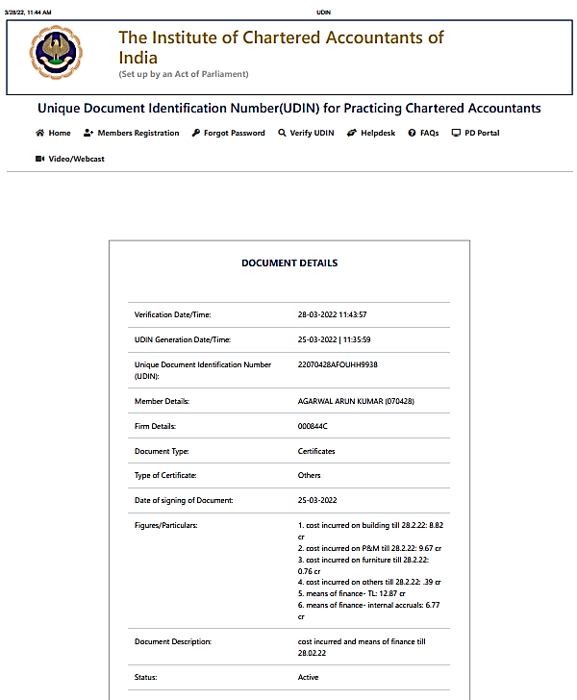

EXTENSION LETTER FOR DCCO
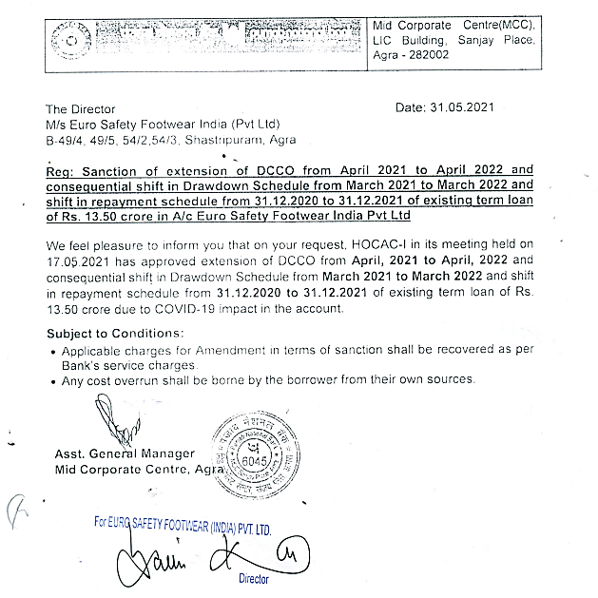

LIST OF MACHINERIES
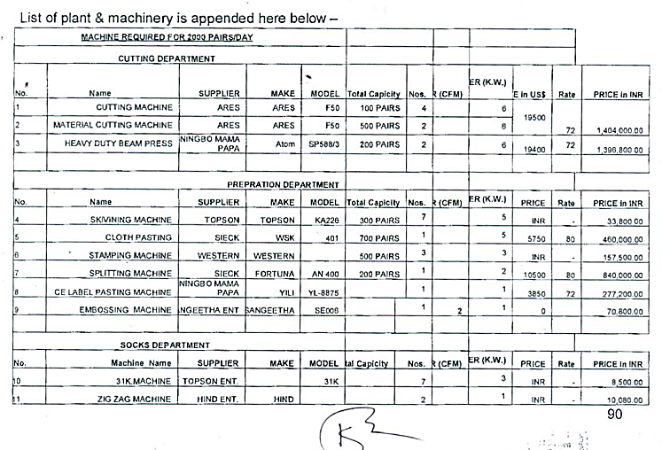
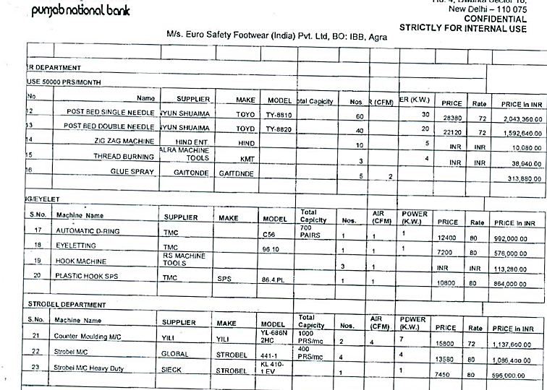

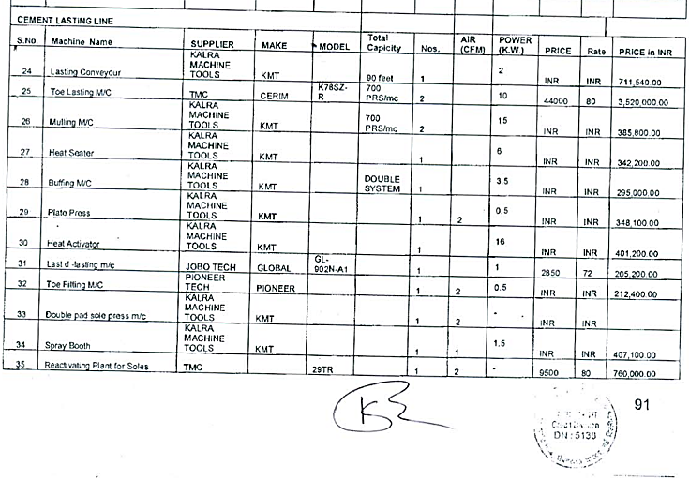
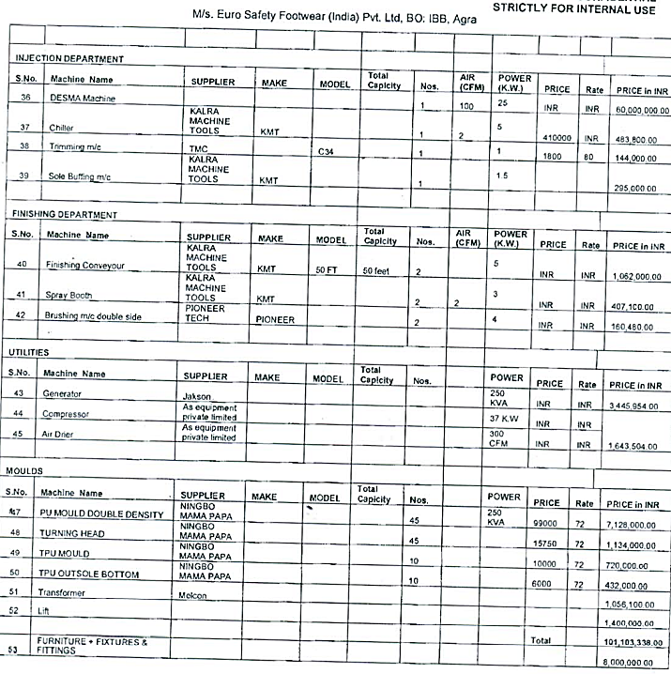
Source: - TEV Report from PNB

PART K | PHOTOS
STRUCTURES
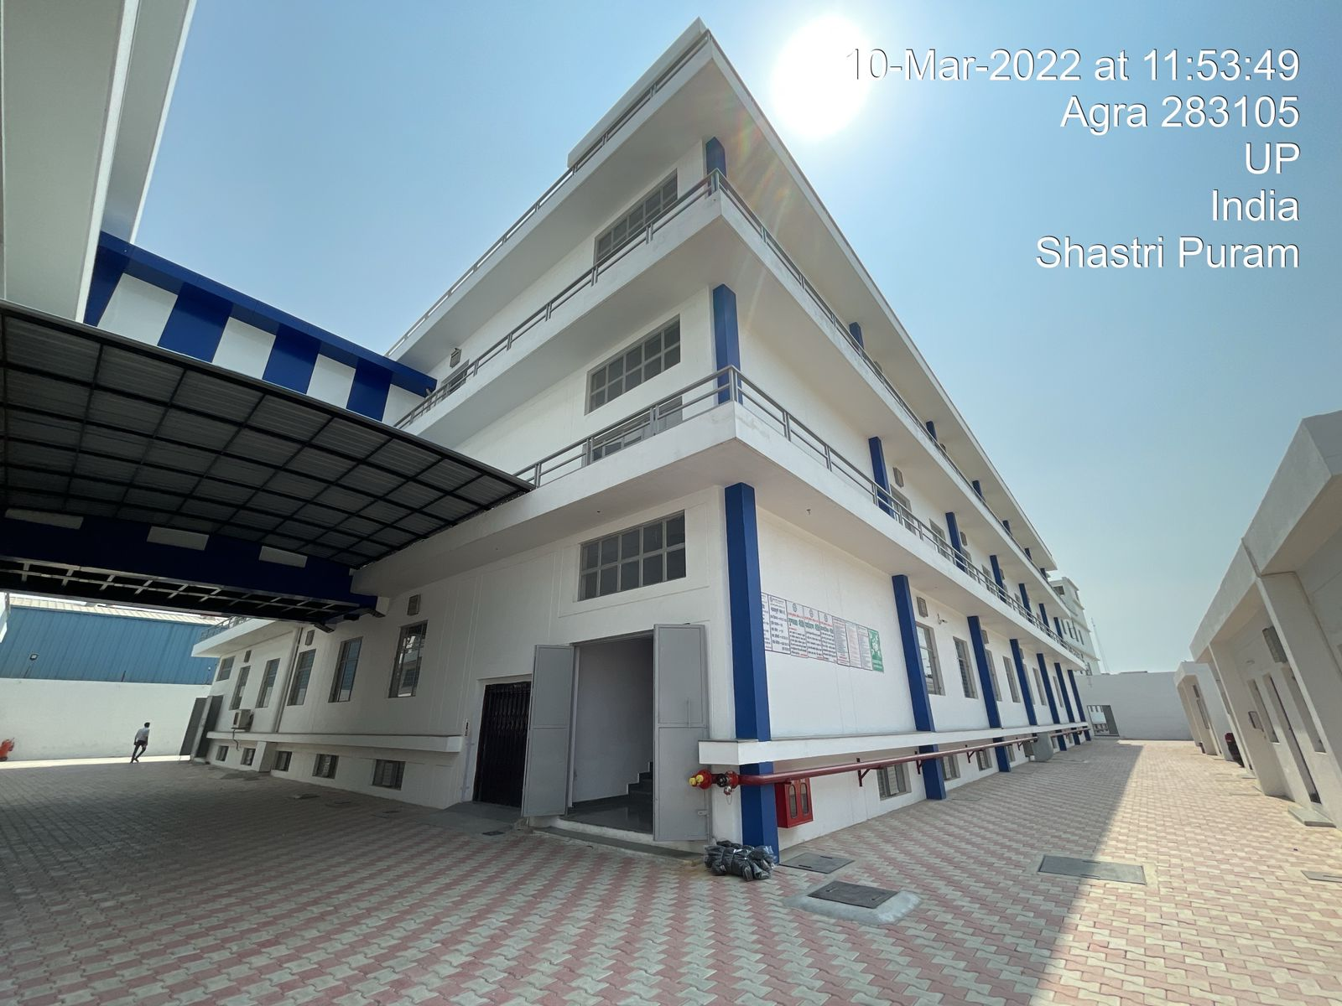
Factory Building-1
Factory Building-2
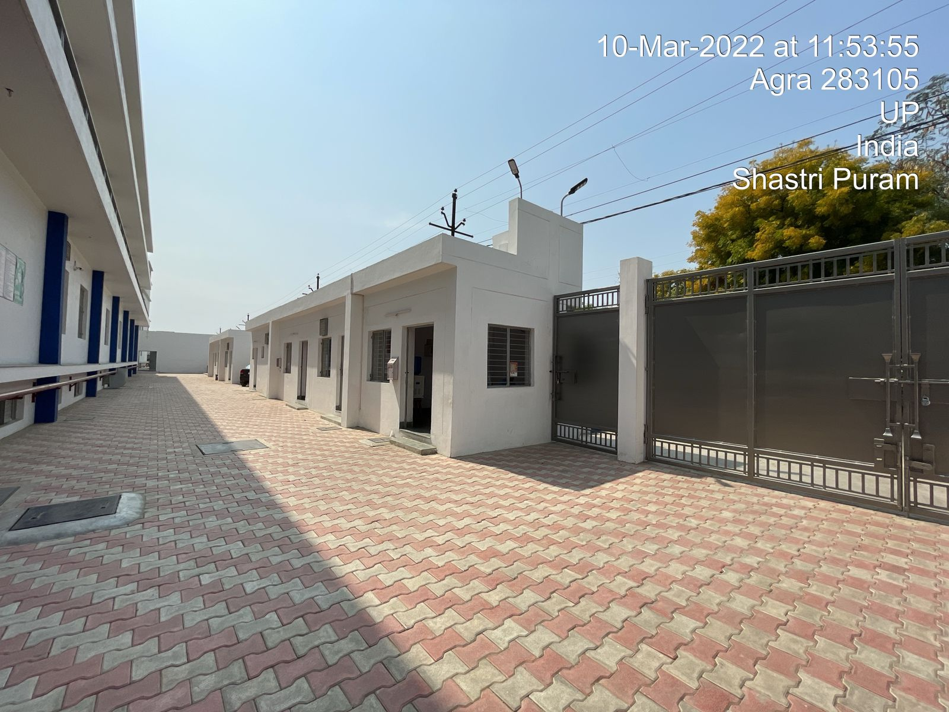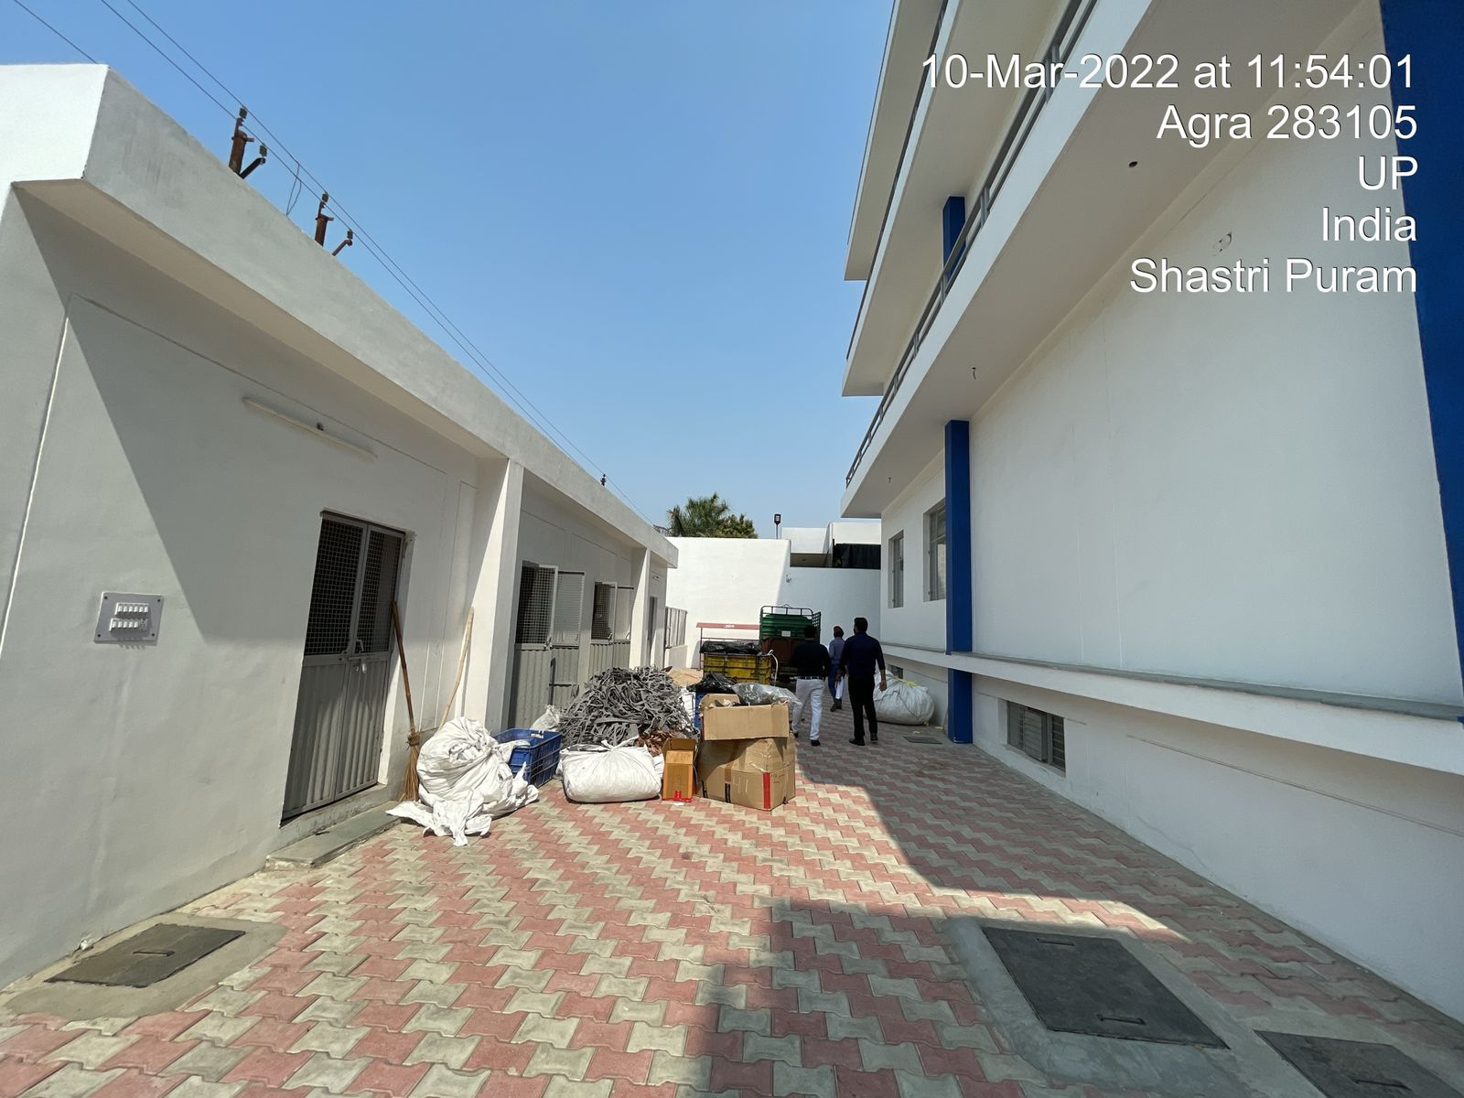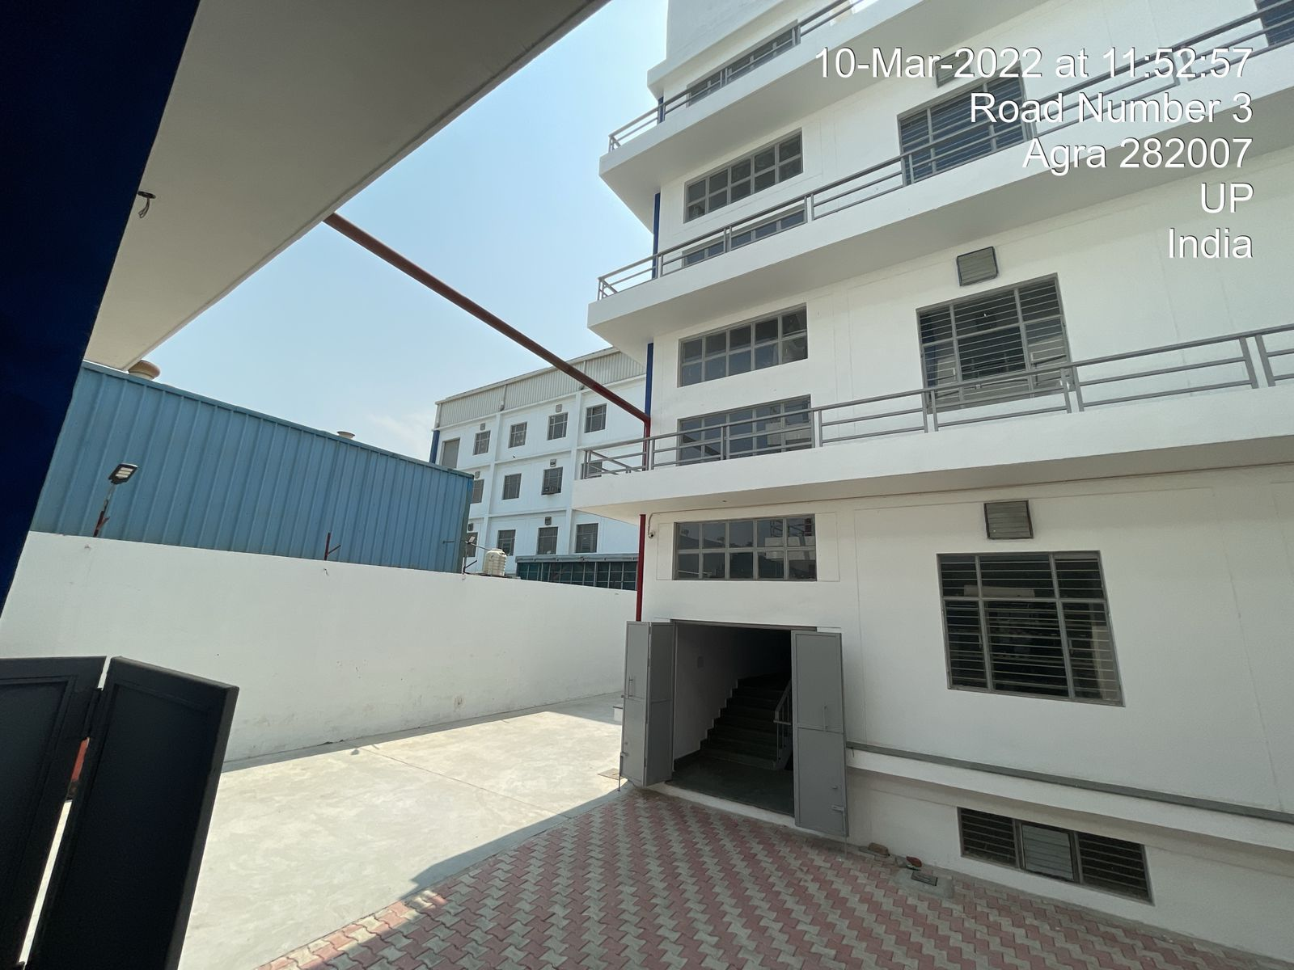
Section 6 to 13 (security office, H.R. Rooms, Stores etc.)
Section 14 to 17 (Stores)
Factory Building-1
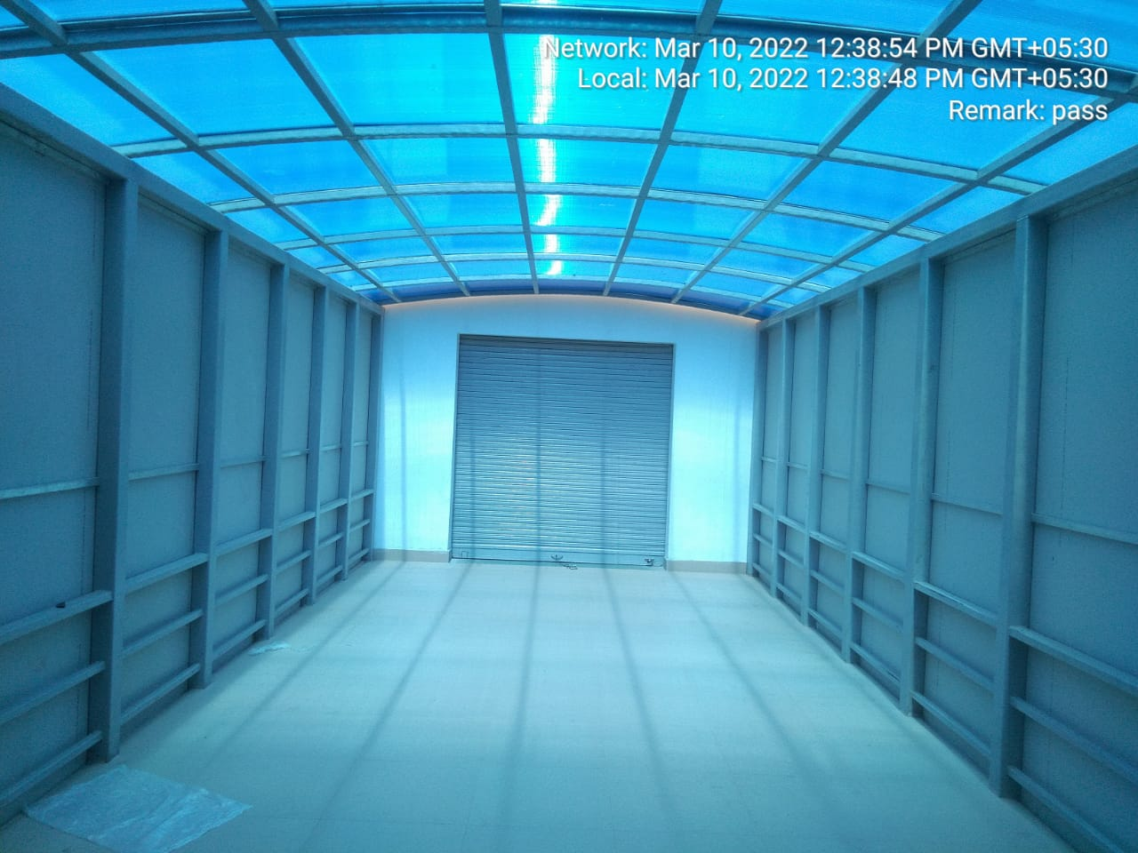
Connecting Passage
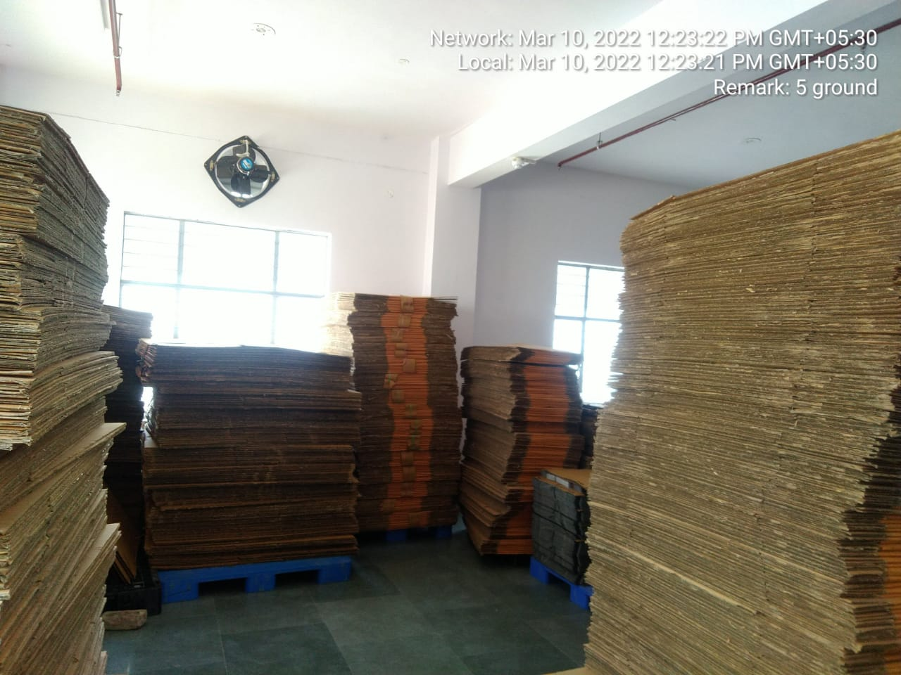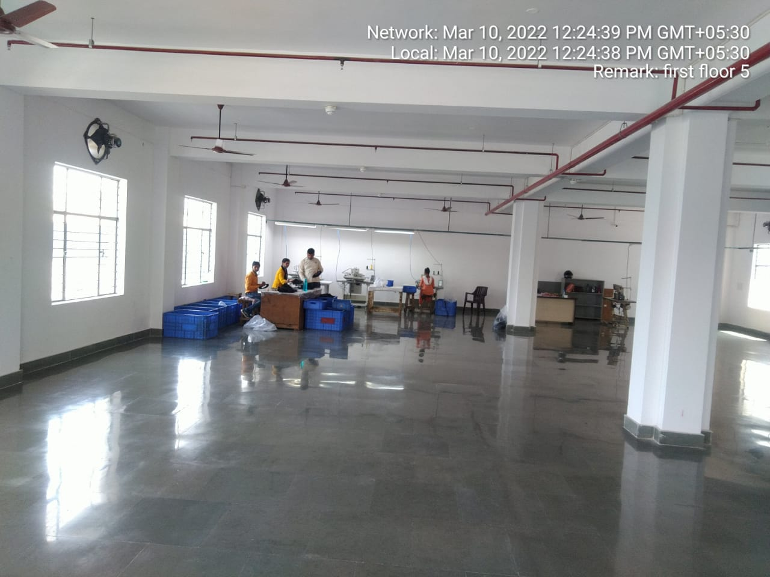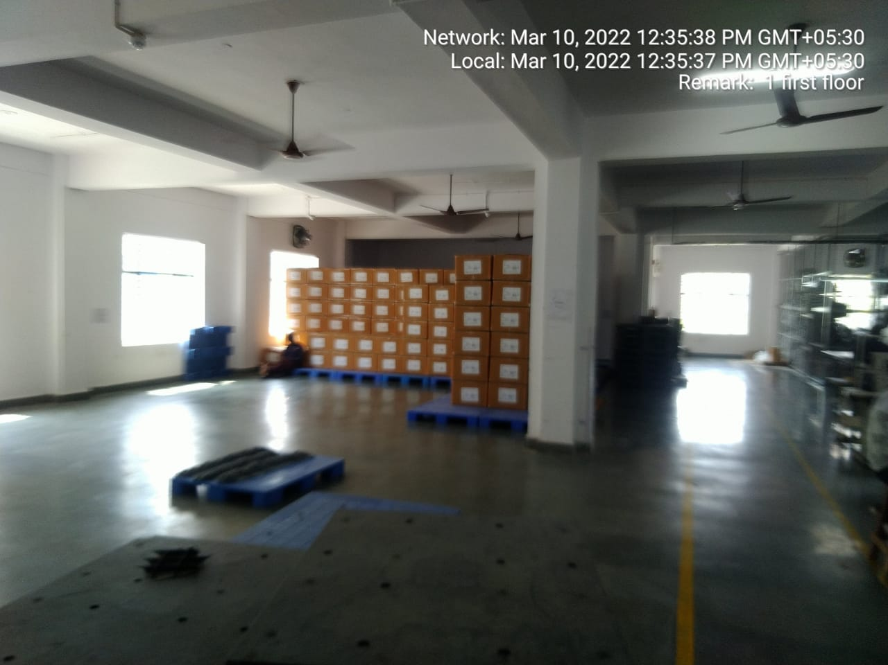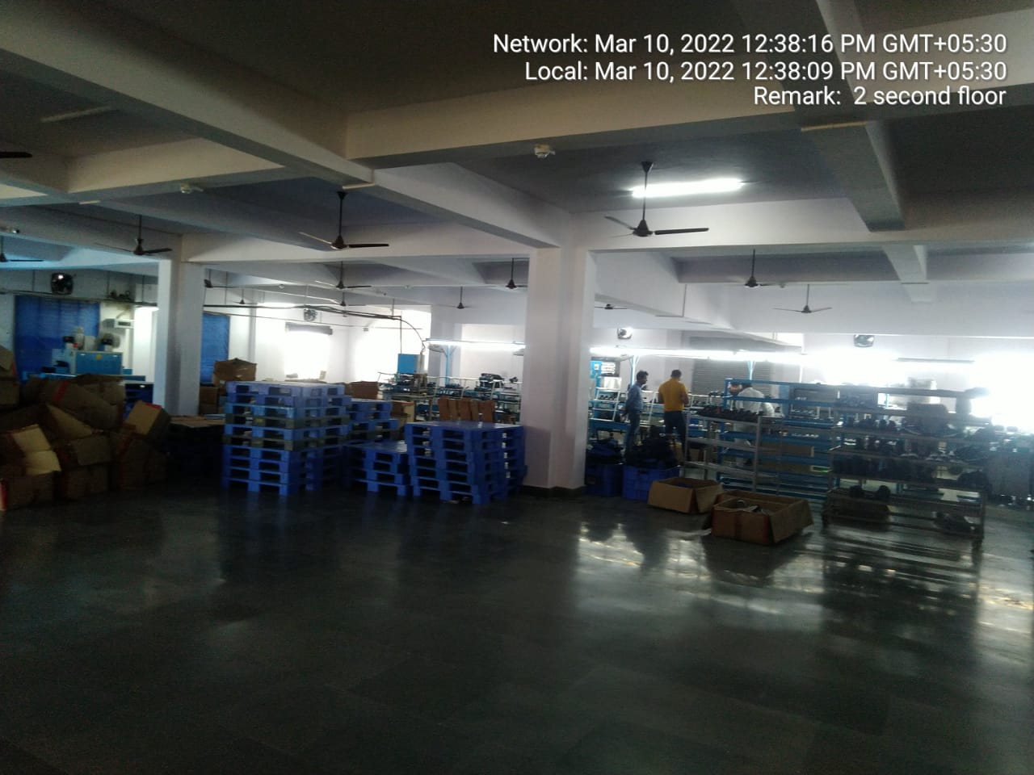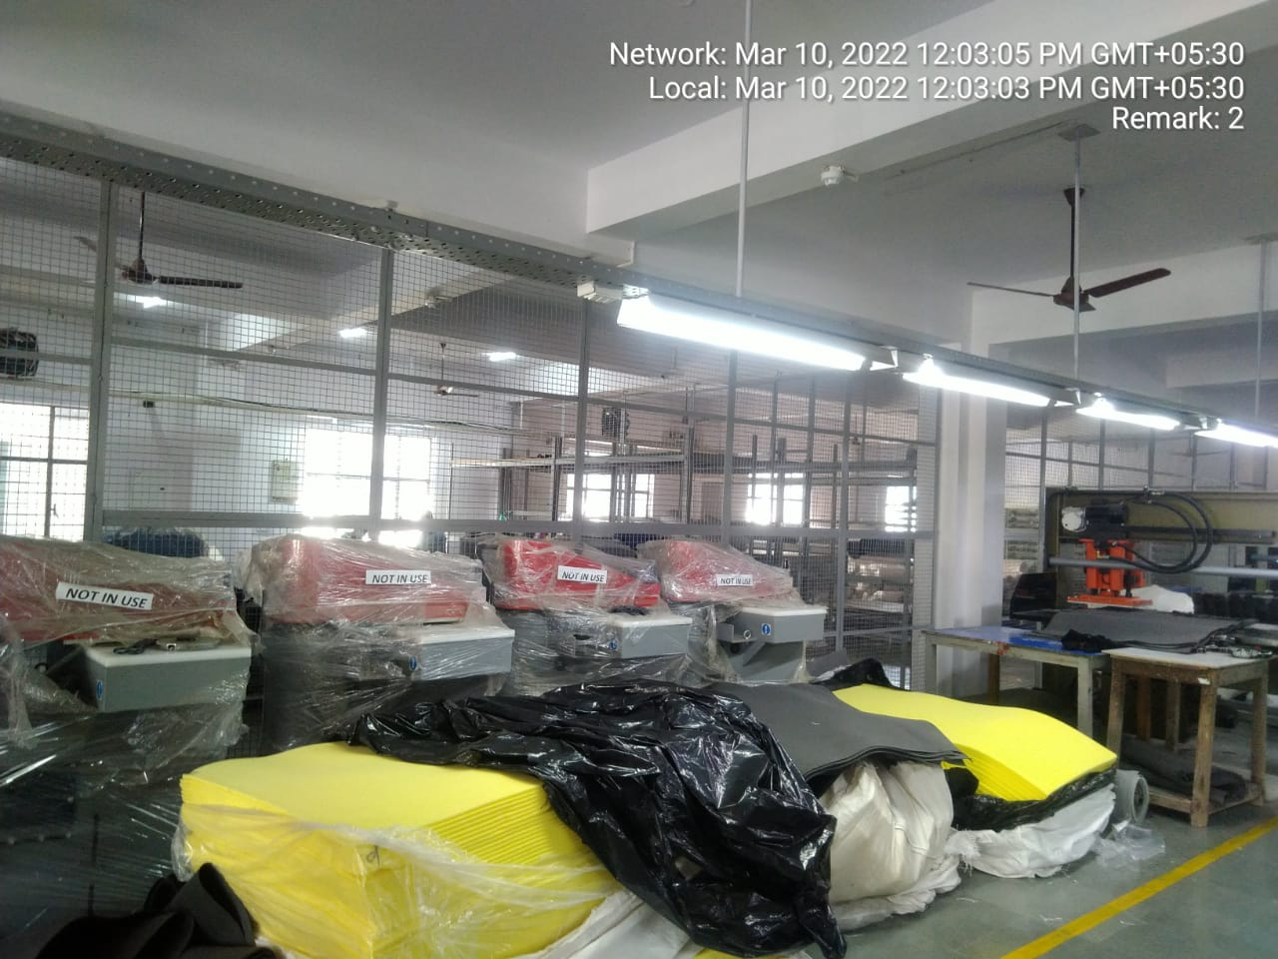
Factory Building-2 (first floor)
Factory Building-2 (Ground floor)
Factory Building-1(first floor)
Factory Building-1(Second floor)
Factory Building-1 (ground floor)
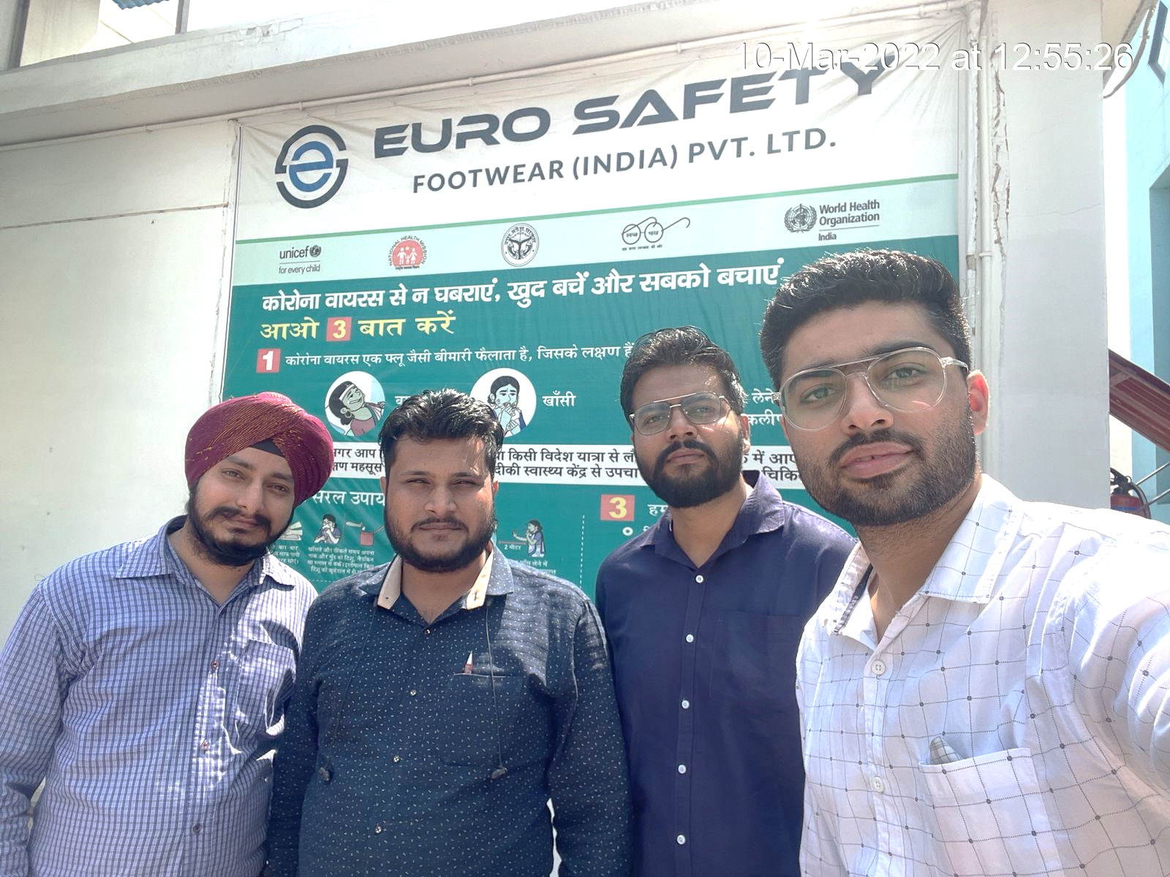
MACHINERIES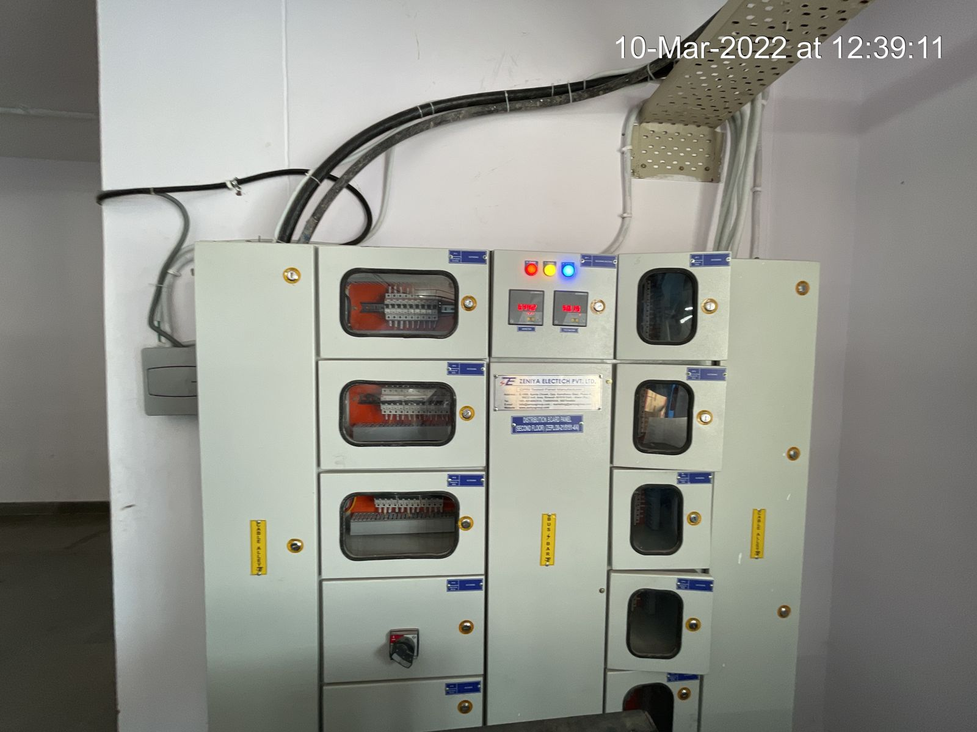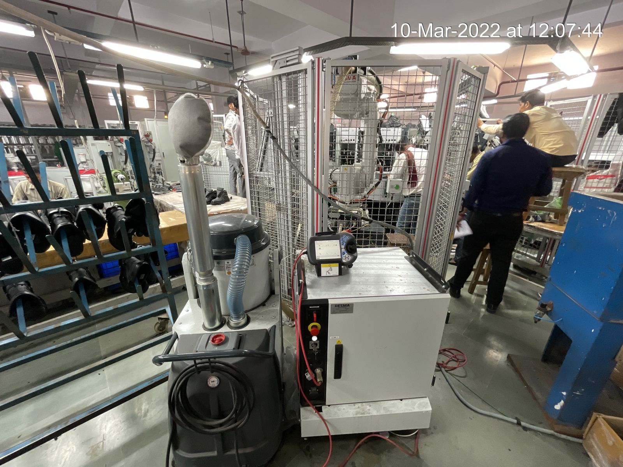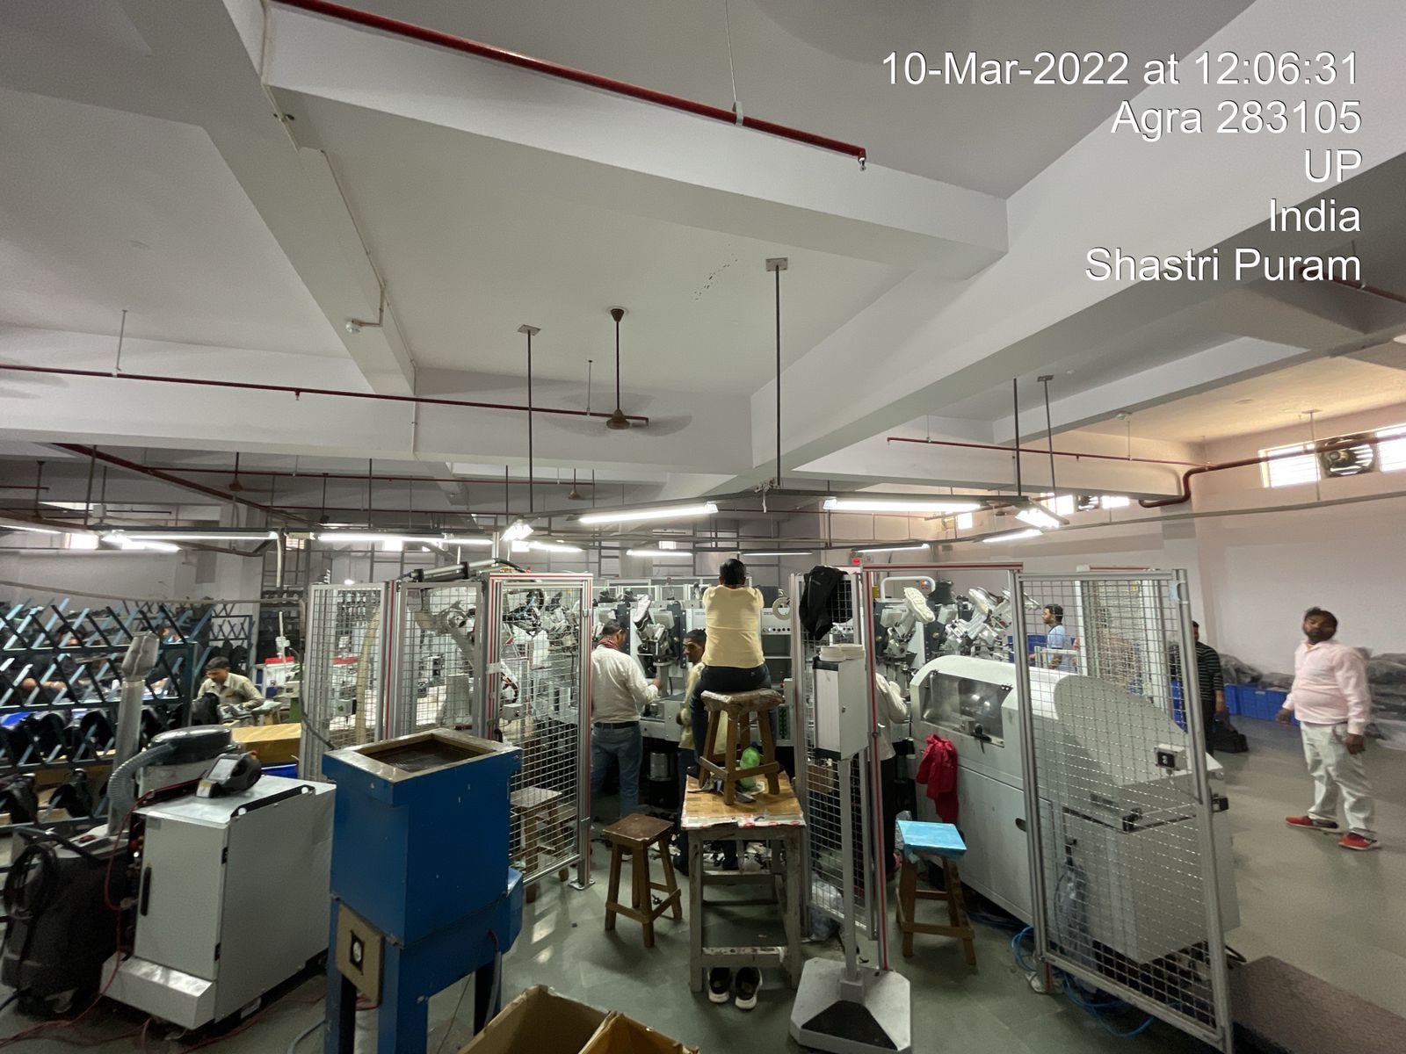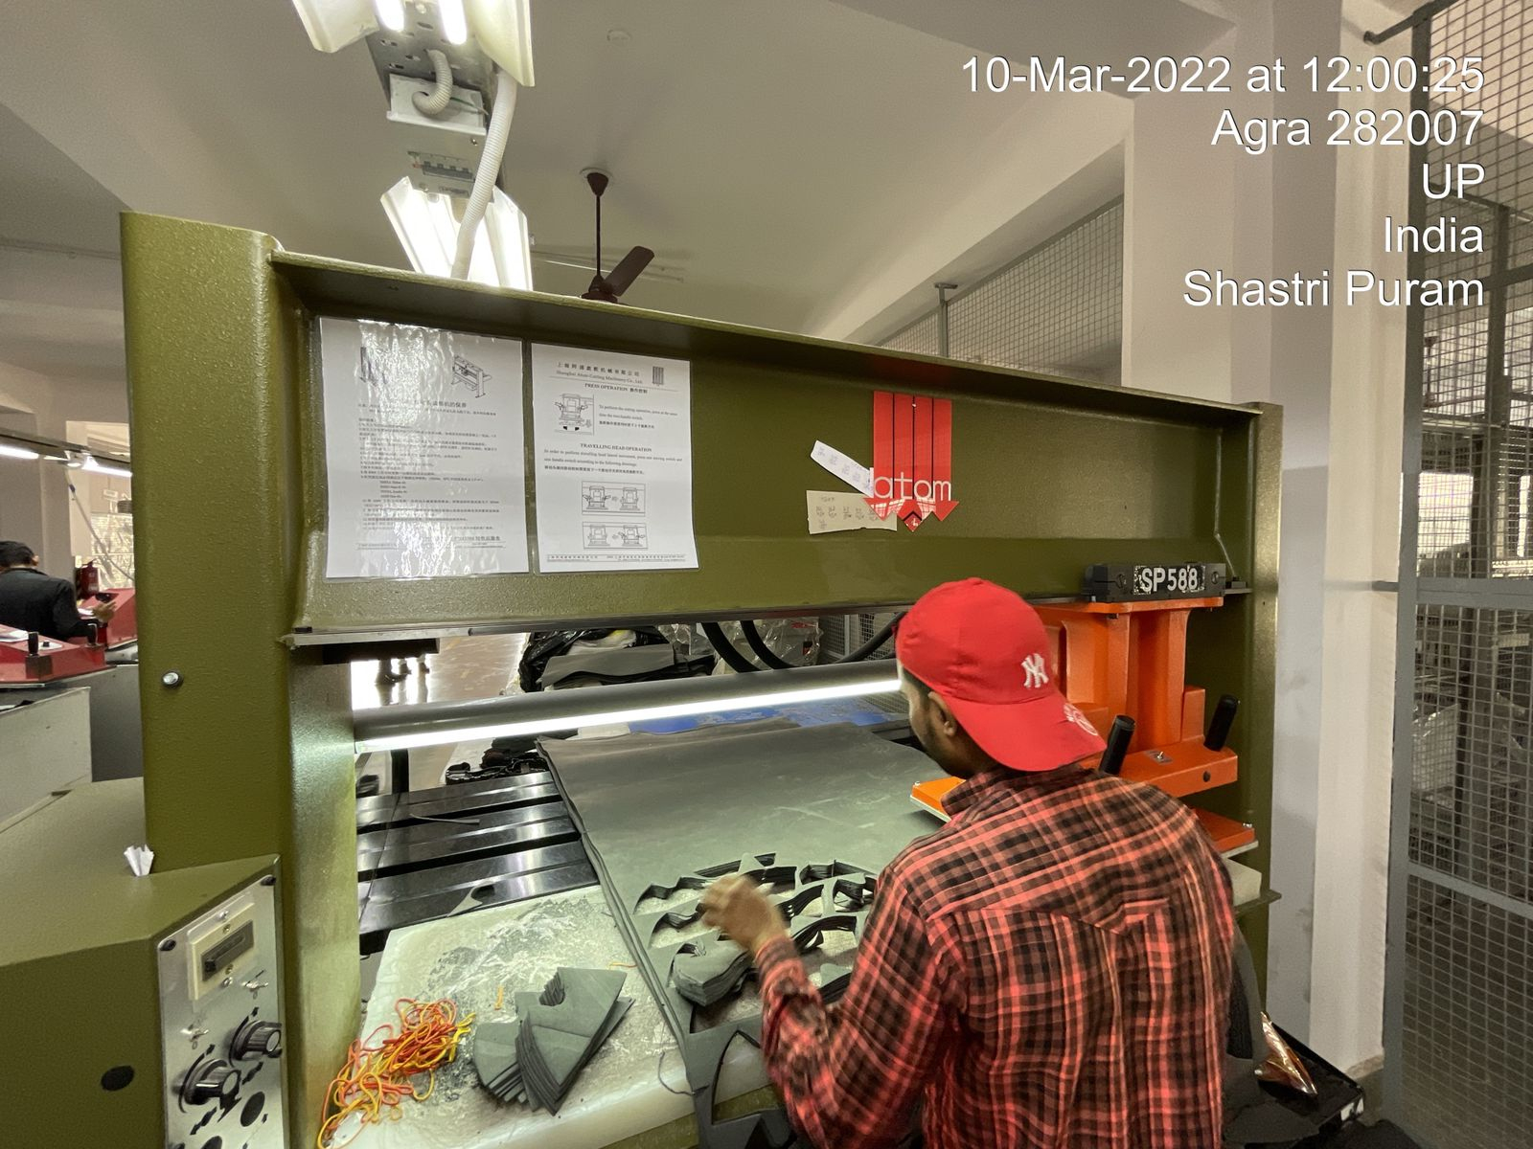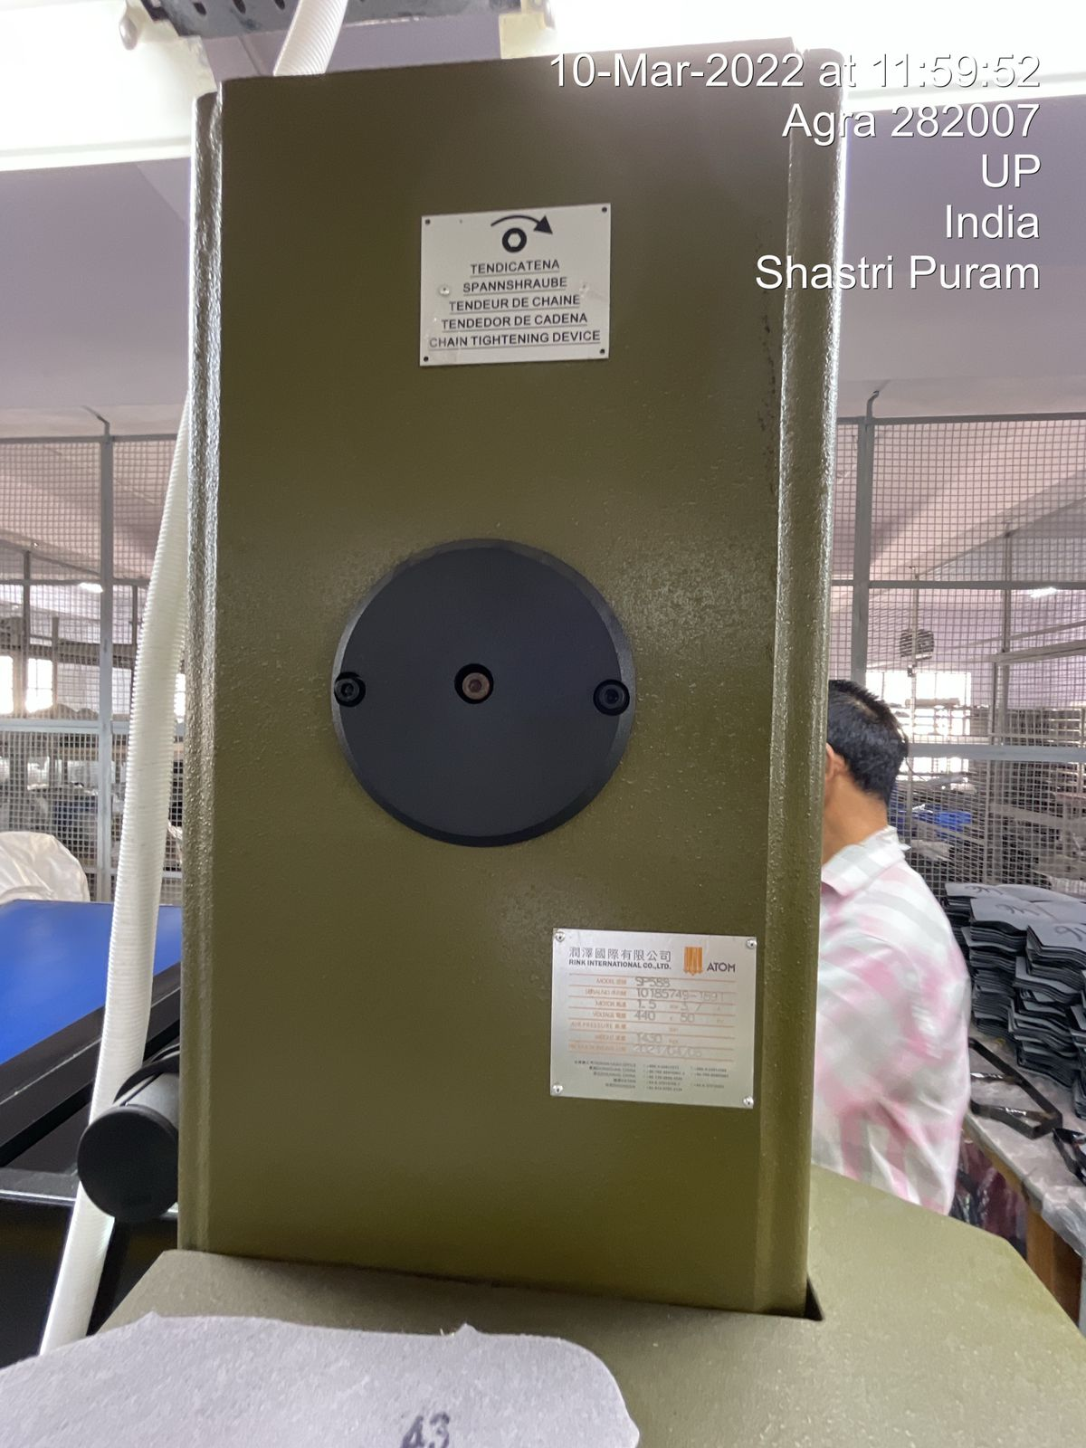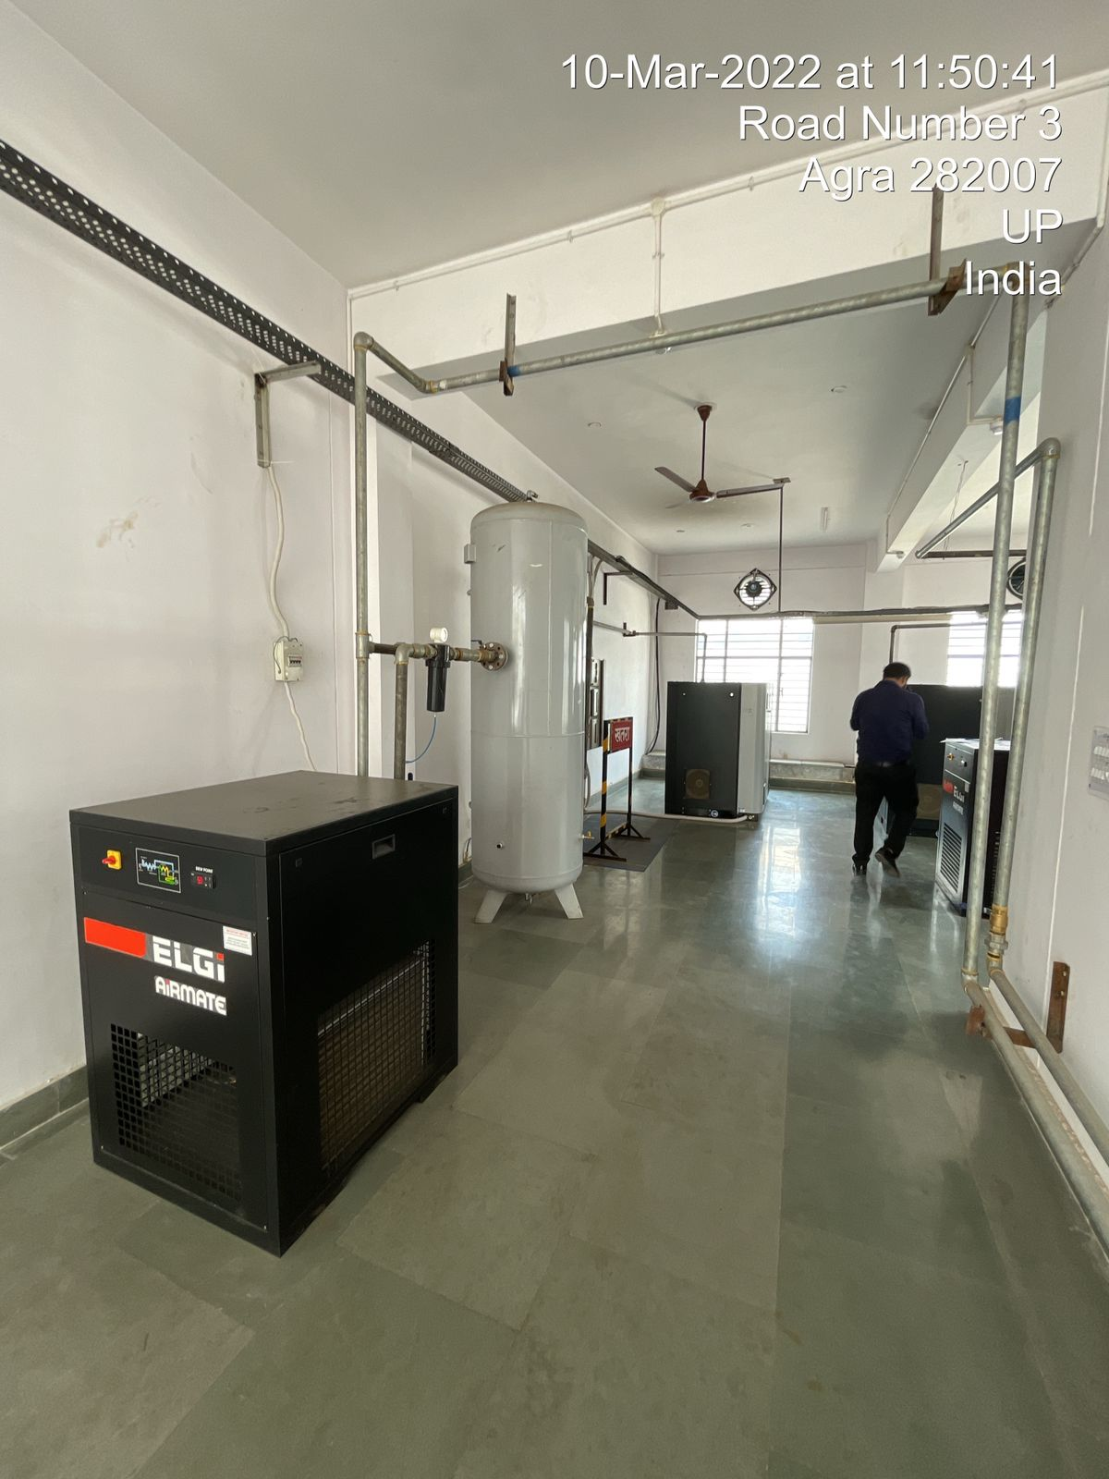 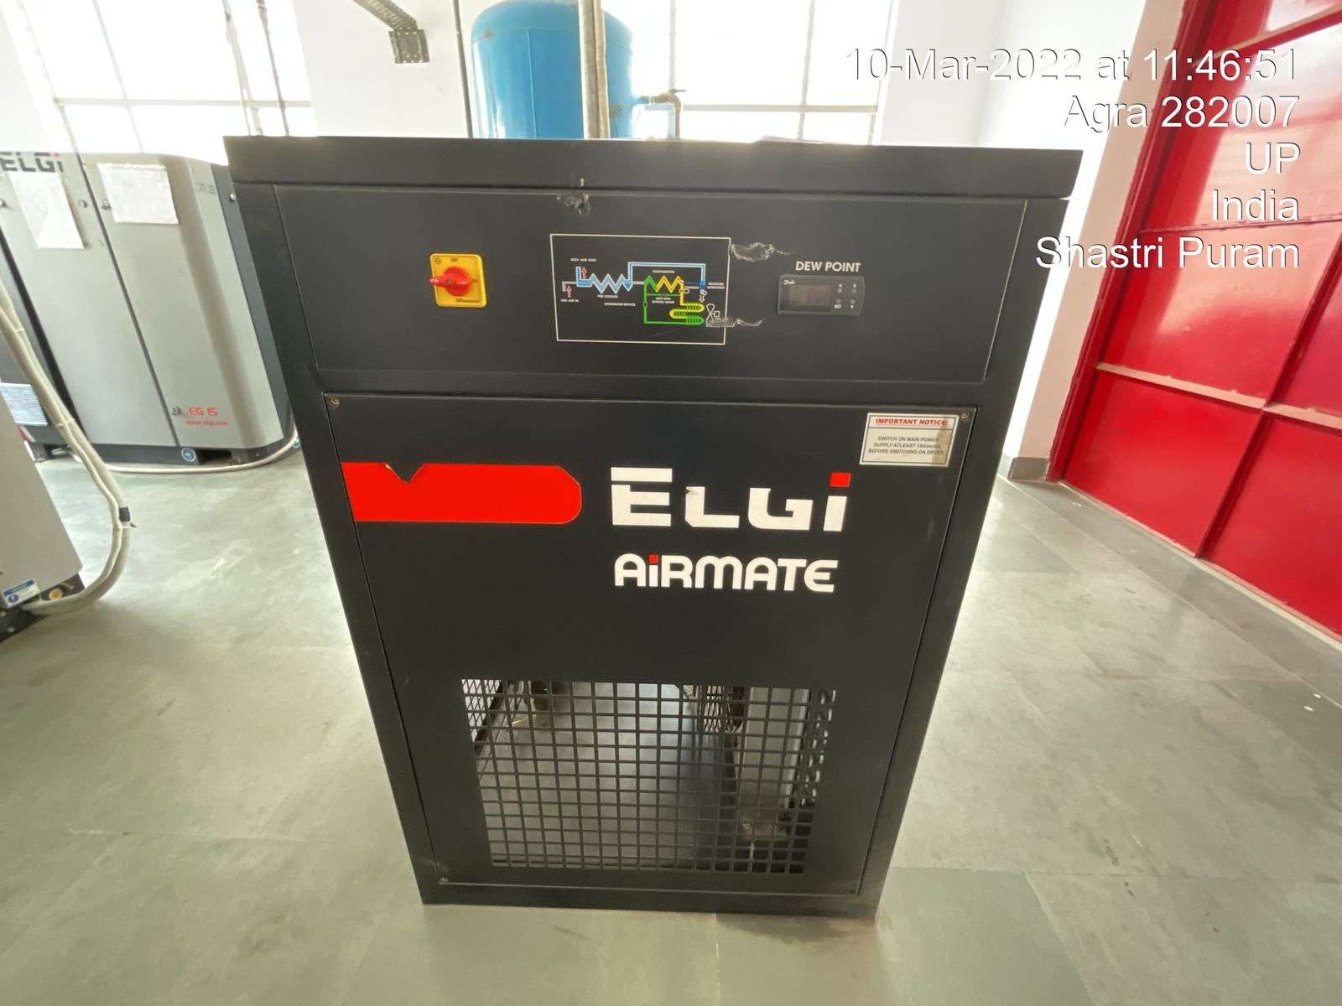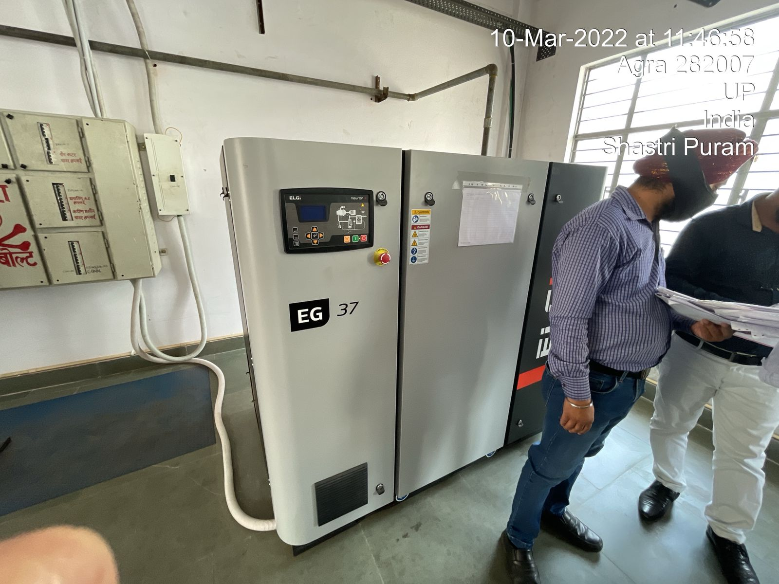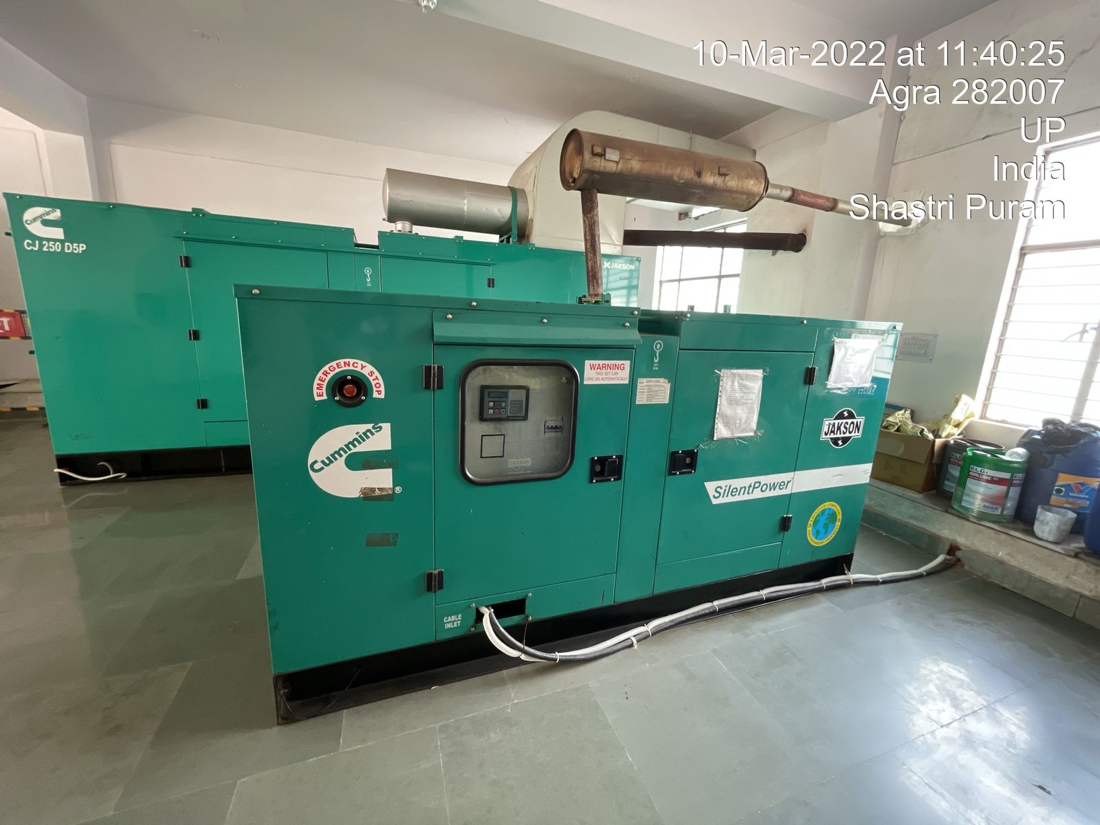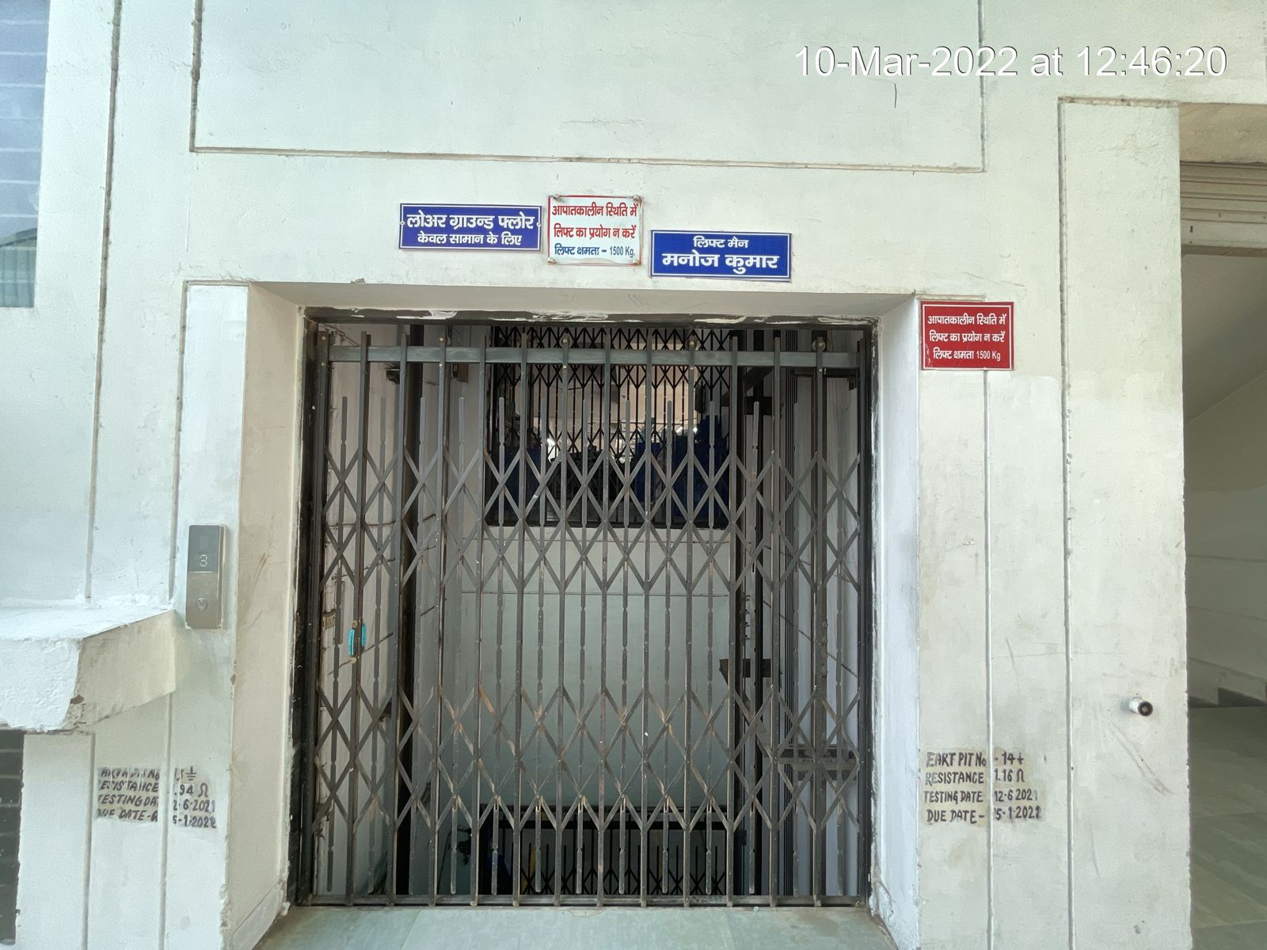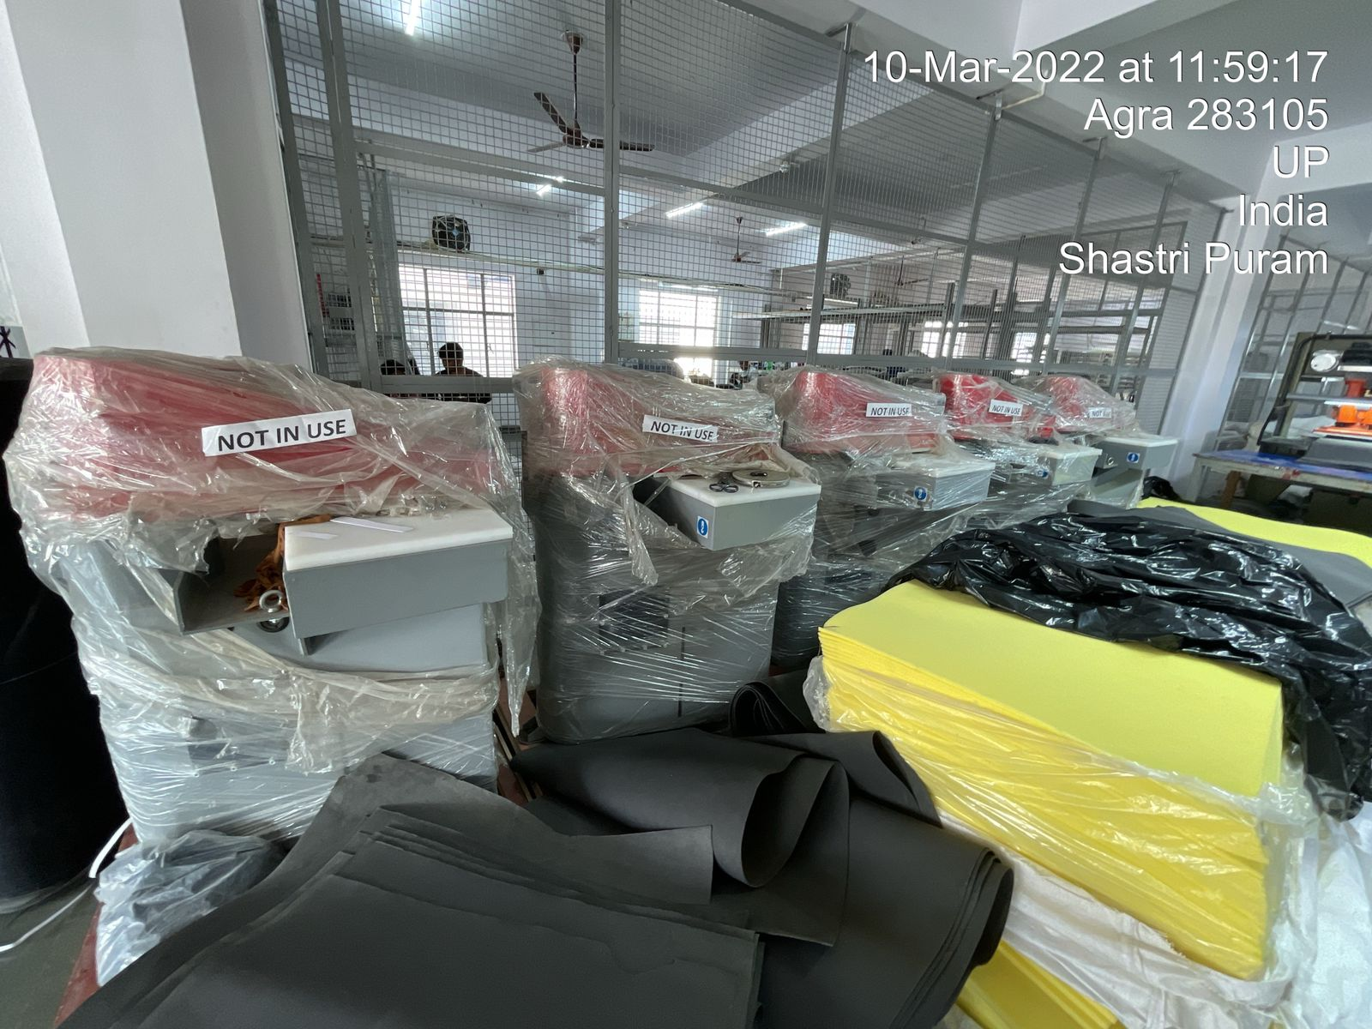
Automatic Rotary Table Polyurethane Injection Moulding Machine
Electrical Panel
Automatic Rotary Table Polyurethane Injection Moulding Machine
Beam Cutter Travelling Head Machine
Beem Cutter Travelling Head Machine

Compressor Room
Air Compressor
AIR DRYER
D.G. Sets
Lift
Clicking machine
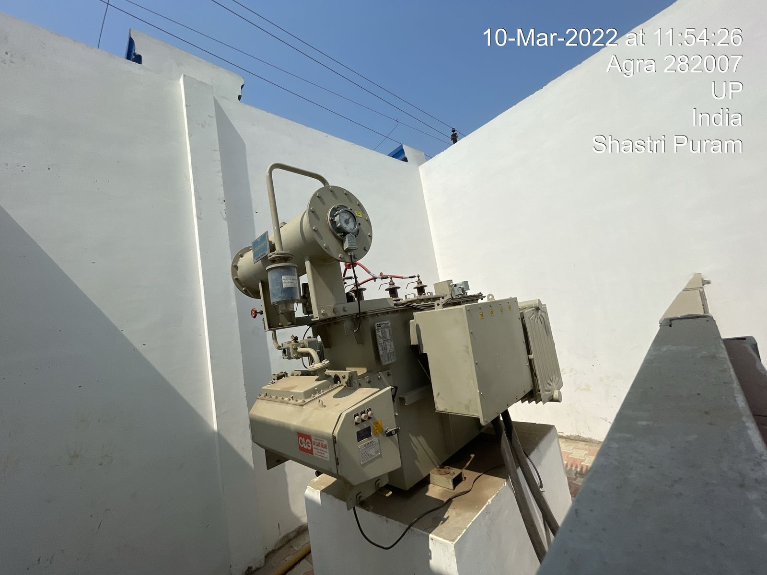
Transformer
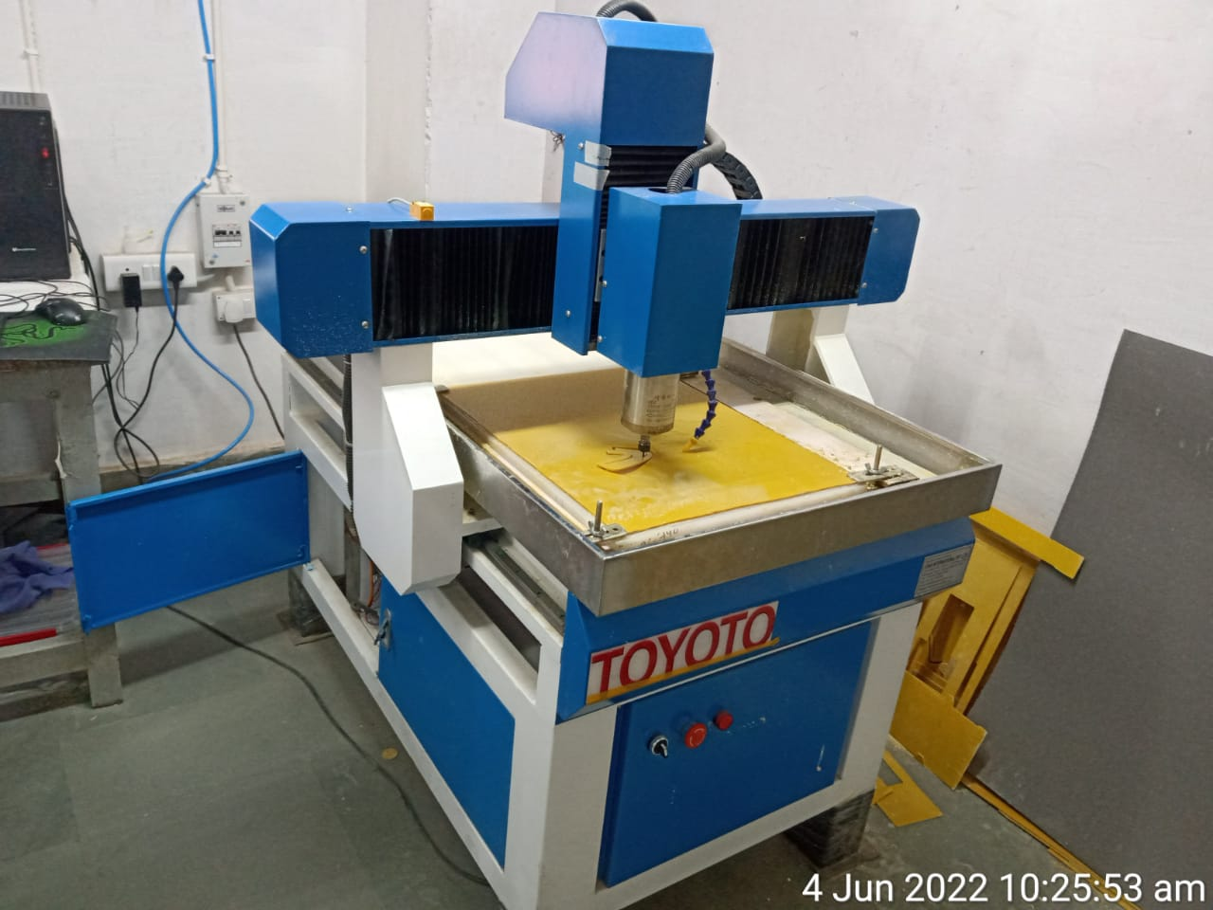
Template Making Machine
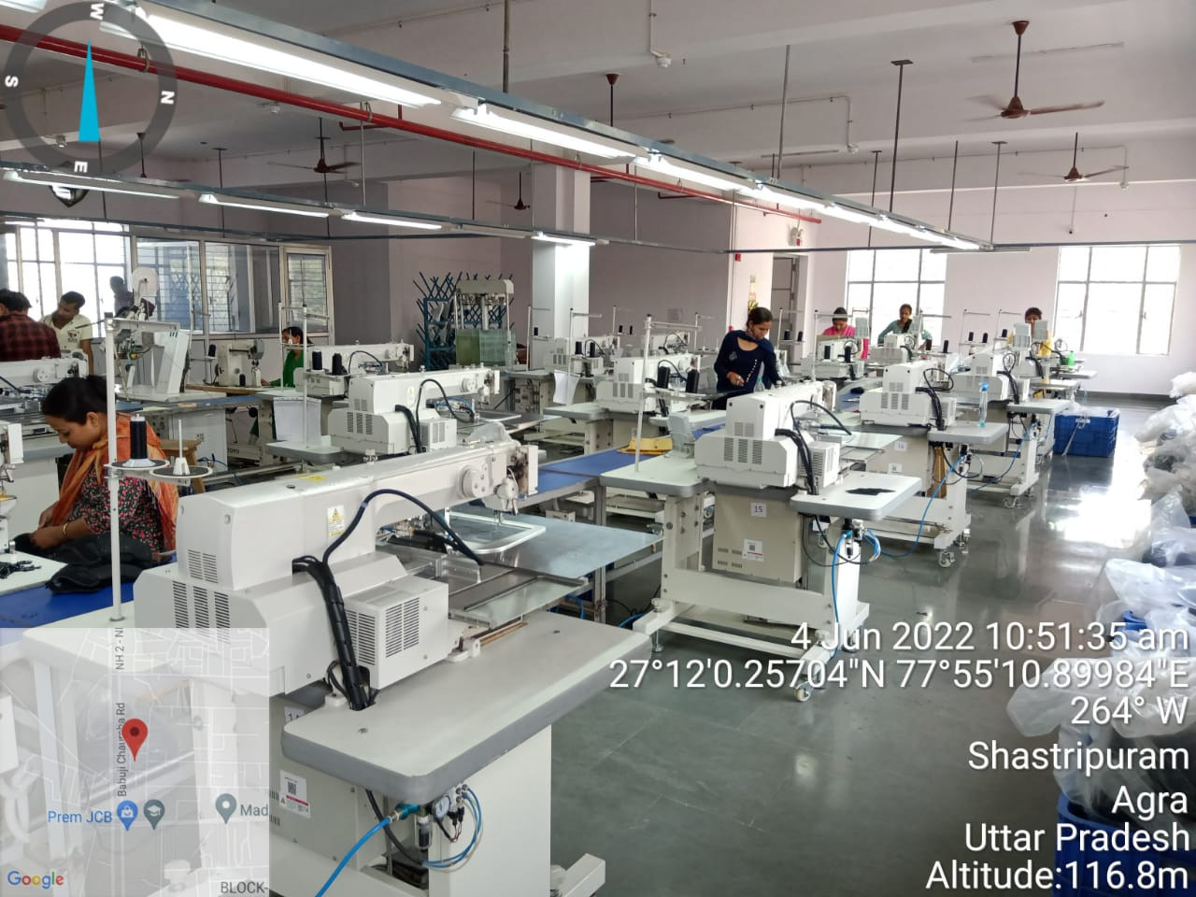
Sewing Machine

