Jaypee Nigrie Supercritical Thermal Power Plant (JNSTPP)

**Project background**

The Nigrie project was implemented pursuant to a Memorandum of Understanding (MOU) with Government of Madhya Pradesh (GoMP) dated 12 December 2007 which gave the Company rights to develop, own and operate a 1,320 MW coal based thermal power plant. The project has 2 units of 660 MW each. Unit-I and Unit-II commenced operations on 3 September 2014 and 21 February 2015 respectively

The Company has entered into a long term PPA with MPPMCL for sale of power equivalent to 30% of installed capacity at tariff to be determined as per MPERC tariff guidelines, and for 7.5% of net power at variable tariff. The project also sells power on bilateral basis for short term PPAs at merchant tariff. For evacuation purposes, a 400 Kilo volt (KV) double circuit (D/C) transmission line from the project bus-bar to PGCIL Satna sub-station (~161 Km) has also been commissioned as part of the project.

Below are few pictures giving a glimpse of the project site:

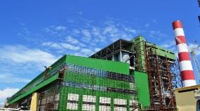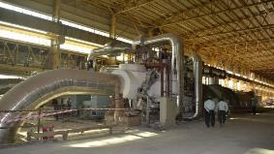

**Location and Land**

Turbine generator 1

Boiler, Turbine & Generator

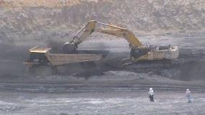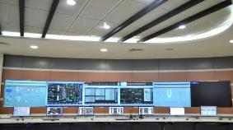

Control room

Amelia mining excavation area

**Location and Land**

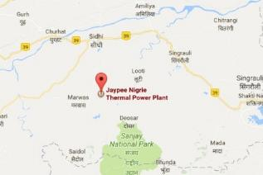

The project is located near Nigrie village of Singrauli district in Madhya Pradesh. The nearest railway station is Niwas, about 8 km from the project site and the nearest airport is Varanasi in Uttar Pradesh. Project site is at a distance of about 70 km from the allotted coal blocks and at a distance of about 500 meters from River Gopad from where the water for the project is sourced. The Company has acquired 523.695 ha till 31.03.2022. The barrage land shall be used for submergence purpose. Further the water drawal from Gopad River is at 324 m level (above msl) even during lean season and hence land required is sufficient for submergence purpose. Below is a snapshot of land acquired for the project:

|  |  |
| --- | --- |
| **Particulars** | **Area acquired**  **(ha)** |
| Power plant (excluding 22 ha of JNCGU) | 418.1824 |
| Raw water intake system | 2.720 |
| Railway sliding | 37.410 |
| Barrage | 64.741 |
| **Total** | **523.695** |

**Permits & clearances**

The project has sought all required approvals and clearances required to run the plant. Clearances such as Consent to operate, Boiler Registration, Storage of Chlorine in Cylinders, Import and Storage of Compressed Gasses and Import and storage of petroleum are required to be extended periodically before validity expires. All other clearances such as water availability, environment clearance, forest clearance, civil aviation clearance, registration to companies, transmission line energization letter, LTOA, BPTA, Rail Transport clearance are required in the form of one time approval. Moreover, the Company is also submitting six monthly environmental compliance report in line with the environmental stipulations.

Below is snapshot of key approvals and clearances obtained by the Company:

|  |  |  |
| --- | --- | --- |
| **Approvals** | **Authority** | **Status** |
| Water allocation | Water Resource Department, GoMP | Agreement signed on 7 November 2014 for 30 years, allowing for drawing 58.32 MCM per annum of water from Gopad River. |
| Consent to establish | State Pollution Control Board | Obtained on 23 October 2010 |
| Environment clearance for project land | MoEF, GoI | Obtained on 25 February 2010. |
| Forest clearance | MoEF | Obtained on April 7, 2013 |
| Civil aviation clearance for chimney height | Airport Authority of India | Obtained for 275 mt chimney height on 4 September 2008 |
| Open access for power transmission | PGCIL | Obtained on 29 July 2009. |
| Forest clearance (11 Km) for transmission line | MOEF, GoI | Obtained in December 2013 |
| Rail transport clearance for siding at project site | Indian Railways | Commissioned |
| Consent to operate | MP Pollution Control Board | Valid till 31 July 2022 |
| Boiler Registration/ License | Chief Inspector of Boiler State Boiler Inspection Dept. | Boiler 1 – Valid till 17 Oct 2022  Boiler 2 – Valid till 03Aug 2022 Auxiliary boiler – Valid till 17Oct 202022 |
| Permits to Store Petroleum | Petroleum and Explosives Safety Organization (PESO) Ministry of Commerce & Industry | Valid till 31 December 2024 |
| Storage for Compressed Gas Cylinders | Petroleum and Explosives Safety Organization (PESO) Ministry of Commerce & Industry | Valid till 31 December 2024 |

**PPA and power evacuation**

The Company has signed PPA with MPPMCL and three DISCOMS namely Madhya Pradesh Poorva Kshetra Vidyut Vitaran Nigam Limited, Madhya Pradesh Madhya Kshetra Vidyut Vitaran Nigam Limited & Madhya Pradesh Paschim Kshetra Vidyut Vitaran Nigam Limited, As per the terms of PPA, power commitment to MPPCL and other DISCOMS is split into Regulated and Variable. Refer below table for summary of the PPA:

|  |  |  |
| --- | --- | --- |
| **Particulars** | **Regulated** | **Variable** |
| Date of PPA | 5 January 2011 | 6 September 2011 |
| Contracted capacity | 30% of the installed capacity  (396 MW) | 7.5% of energy generated  (66 MW) |
| Normative PAF | 85% | - |
| PPA term (Year wise project COD) | 20 years  (up to Feb, 2035) | Life of the plant |
| Delivery point | Plant bus bar | Plant bus bar |
| **Tariff (two parts)*:-** |  |  |
| - Capacity charges | As per MPERC Guidelines | NA |
| - Variable charges (Fuel cost) | Actual pass through as per the tariff orders then prevailing | Actual pass through as per the tariff orders then prevailing |

Source: PPA between JPVL and MPPMCL dated 5 January 2011 & dated 6 September 2011

The project also sells power on bilateral basis for short term PPAs at merchant tariff.

**Power evacuation**

Power from the switchyard will be evacuated at 400 kV level to Power Grid Corporation of India sub-station at Satna, Madhya Pradesh through a double circuit transmission line (~161 km).

**Fuel arrangement**

Amelia (North) is a captive coal mine located at a distance of ~70 km from JNSTPP site having annual capacity of 2.8 MTPA. As per CMDPA, coal procured from Amelia coal mine can be utilised for long term PPAs. Further, it also allows utilisation of coal to the extent of fifteen percent (15%) of peak capacity (~0.42 MTPA) for merchant sales. Any coal requirement for bilateral sales over and above ~0.42 MTPA is sourced from e-auction. The mine is located in Amelia village in Singrauli district of Madhya Pradesh. The total lease area for coal mining is 728.75 Ha. For coal transportation, the nearest railway station is Majhauli on Chopan – Singrauli – Katni line of Central Railway, situated at a distance of about 4 km from the block. Any requirement of coal over and above Amelia capacity is procure through e-auction.