**Vishnuprayag Hydroelectric Project (VHEP)**

VHEP is a run of river hydro-electric power plant having an installed capacity of 400 MW (4X100 MW). CoD of Unit-I, Unit-II, Unit-III and Unit-IV having installed capacity of 100 MW each were 17 June 2006, 14 July 2006, 31 August 2006 and 13 October 2006 respectively. The project cost as approved by UPERC vide order dated 13 October 2008 was INR 1,716 Crores as against actual cost of INR 1,694 Cr, financed by way of equity of INR 509 Cr and debt of INR 1,185 Cr. Lower actual cost as against approved cost is primarily due to lower IDC on account of early commissioning of power plant.

As per the PPA dated 16 January 2007, the Company is required to sell 88% of the net power generated to UPPCL while remaining 12% would be supplied free of cost to GoU for a period of 30 years.

As the project is a run of the river plant, it operates by diverting the requisite water from the river Alaknanda towards the power generation plant. To divert the water, a barrage has been built at Lambagarh.

Below are few pictures giving a glimpse of project site:

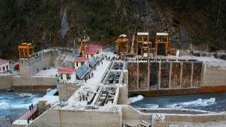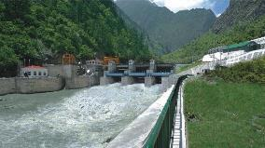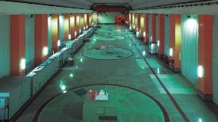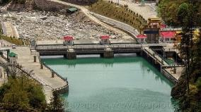

Power house

Barrage arial view

Barrage side view

Barrage downstream view

1. **Location and land**

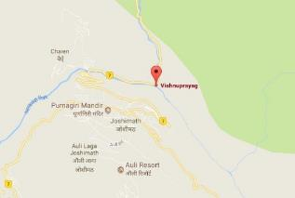

The project is located on the river Alaknanda in Chamoli District of Uttarakhand. The nearest railway station is Rishikesh, which is about 280 kms from the project site. The road access to the project is through Rishikesh - Badrinath highway. The nearest airport is Dehradun, Uttarakhand.

As per the original supplementary lease deed dated 21 January 2004 executed between Government of Uttrakhand and the Borrower, land of 21.119 Hectares was allocated for Vishnuprayag project to JPVL. However, as per original land relinquishment deed dated 3 March 2009 executed between Government of Uttrakhand and the Borrower, 8.685 Hectares of land of Vishnuprayag project was surrendered by JPVL. Further, as per order dated 18 August 2009 of Governor of Uttarakhand, 2.020 Hectares land of Vishnuprayag Project was subsequently surrendered by JPVL leaving the balance of 10.414 hectares of land of Vishnuprayag project with JPVL.

|  |  |
| --- | --- |
| **Particulars** | **Land (ha)** |
| Forest land | 79.939 |
| Government land | 10.414 |
| Free Hold Land | 3.413 |
| **Total** | **93.766** |

**Permits & clearances**

The Company is in possession of all required statutory clearances such as the environmental clearance, forest clearance and clearances from the State Pollution Control Board.

Apart from factory license, VHEP has received all required permits/ clearances for uninterrupted operation of the plant.

Below is snapshot of key approvals and clearances obtained by the Company:

|  |  |  |  |
| --- | --- | --- | --- |
| **Approval / Consent** | **Agency** | **Status** | **Validity till / Remarks** |
| Environmental Clearance | MoEF, GoI | Valid. Received on 30-November-1995 | Valid |
| Forest Clearance | MoEF, GoI | Valid. Received on 15-October-1996 | Valid |
| Certificate for Electrical Installation Inspection of all units | Chief Electrical Inspector, GoU | Valid. Received during May-October-2006 | Valid |
| Power Purchase Agreement | With UPPCL | Valid. PPA signed on 16-January-2007 | Valid |
| Techno Economic Clearance | CEA | Obtained | Valid |
| COD Approval | State Electricity Board | Obtained | Valid |

**PPA and power evacuation arrangement**

The Company has signed a PPA with UPPCL vide agreement dated 16January 2007 for a period of 30 Years, further extendable by 20 years. Summary of PPA is given below:

| **Particulars** | **Details** |
| --- | --- |
| CoD as per PPA | Unit I - 17 June 2006 Unit II - 14 July 2006 Unit III - 31 August 2006 Unit IV - 31 October 2006 |
| Contracted capacity | 100% of Installed Capacity (12% to be supplied free to cost to GoU) |
| Normative PLF | 90% |
| PPA term | 30 Years (extendable by 20 years on mutually agreed terms) |
| Delivery point | Project Bus Bar |
| Tariff (two parts):- |  |
| - Capacity charges | As per PPA |
| - Energy charges | As per PPA |
| Billing cycle | Monthly |
| Payment terms (monthly/ weekly bill) | 30th day |
| Late payment surcharge | SBI base Rate +3% p.a. |
| Incentive on generation (as per ppa term) | 0.6% of equity for each percentage point in availability from 90 to 93%, 0.65% from 93 to 95% and 0.7% for each percentage increase beyond 95% |
| Payment security mechanism | Stand by LC  (1 time of the monthly bill) |

**Power evacuation arrangement**

Entire power of 400 MW (with 10% overload) is being evacuated through double circuit 400 kV transmission line from 400 kV GIS at project site to 400kV Muzzaffarnagar substation. The transmission line length is approximately 280 km. The operation and maintenance of this line is carried out by UPPCL. Necessary tariff meters are installed in Vishnuprayag 400 KV GIS line for billing purposes. The transmission losses are not payable by Vishnuprayag HEP since delivery point as per PPA is Project bus bar.