File No.: VIS (2022-23)-PL072-060-102 Dated: 25.07.2022

TECHNO-ECONOMIC
VIABILITY STUDY REPORT

OF

M/S BAJAJ HINDUSTHAN SUGAR LIMITED

A BAJAJ GROUP COMPANY

REPORT PREPARED FOR

STATE BANK OF INDIA, INDUSTRIAL FINANCE BRANCH RM-1 CREDIT DEVISION 14TH FLOOR JAWAHAR VYAPAR BHAVAN 1, TOLSTOY MARG, NEW DELHI, 110001

**Important - In case of any query/ issue or escalation you may please contact Incident Manager Valuers@rkassociates.org. We will appreciate your feedback in order to improve our services.

NOTE: As per IBA Guidelines please provide your feedback on the report within 15 days of its submission after which report will be considered to be correct.
IMPORTANT NOTICE

COPYRIGHT FORMAT: This report is prepared on the copyright format of R. K. Associates Valuers & Techno Engineering Consultants (P) Ltd. (R. K. Associates) to serve our clients with the best possible information and analysis to facilitate them to take rational business decisions. Legally no one can copy or distribute this format without prior approval from R. K. Associates. It is meant only for the advisory/ reference purpose for the organization/s as mentioned on the cover page of this report. Distribution or use of this format or report or any of its content/ information/ data by any organization or individual other than R.K Associates will be seen as an unlawful act and necessary legal action can be taken against the defaulters.
This report is intended for the sole use of the intended recipient/s and contains material that is STRICTLY CONFIDENTIAL AND PRIVATE.

DEFECT LIABILITY PERIOD: In case of any query/ issue or escalation you may please contact Incident Manager at valuers@rkassociates.org. Though adequate care has been taken while preparing this report as per its scope, but still we can’t rule out typing, human errors, over sightedness of any information or any other mistakes. Therefore, the concerned organization is advised to satisfy themselves that the report is complete & satisfactory in all respect. Intimation regarding any discrepancy shall be brought into our notice immediately. If no intimation is received within 15 (Fifteen) days in writing from the date of issuance of the report, to rectify these timely, then it will be considered that the report is complete in all respect and has been accepted by the client up to their satisfaction & use and further to which R.K Associates shall not be held responsible in any manner.

Part N: R. K. Associates Important Disclaimer and Remarks are integral part of this report and Feasibility assessment is subject to this section. Reader of the report is advised to read all the points mentioned in these sections carefully.

TABLE OF CONTENTS
SECTIONS | PARTICULARS | PAGE NO.
Part A | Report Summary | 4
Part B | INTRODUCTION | 7
 | - About the Report | 7
 | - Executive summary | 7
 | - Purpose of the Report | 13
 | - Scope of the Report | 13
 | - Methodology/ Model Adopted | 13
 | - Data Information received from | 14
 | - Documents/ Data Referred | 14
Part C | Company Profile | 15
 | - Company Overview | 15
 | - Debt Snapshot | 18
 | - Shareholding Details | 19
 | - Promoters/Directors Profile | 21
Part D | Financial Stress & Debt Restructuring Proposal | 27
 | - Reason for Stress | 27
 | - Proposed Resolution Plan | 31
Part E | Infrastructure Details | 33
 | - Introduction | 33
Part F | Technical Assessment of the Company | 56
 | - Plants Capacity & Configuration | 56
 | - Sugar Manufacturing Process | 67
 | - Plants Operational Parameters | 67
 | - Technology Used | 72
 | - Latest Technology | 72
 | - Conclusion | 72
Part G | Product Profile | 74
 | - Introduction | 74
Part H | Industry Overview & Analysis | 78
 | - Market Overview | 78
 | - Global Sugar Market | 79
 | - Indian Sugar Industry | 80
 | - Market Trend | 80
 | - BHSL’s Market Share in Sugar Industry | 81
 | - Sugar Pricing | 83
 | - Sugar Exports | 84
 | - Govt. Policy Support and Ethanol | 86
 | - Policy Initiatives by the Government | 87
Part I | SWOT Analysis | 90
Part J | Risk Assessment & Mitigation | 93
Part K | Statutory Approvals | Licences | NOC | 95
Part L | Company’s Financial Feasibility | 119
 | - Historical Financial Performance of the Company | 119
 | - Projection of the Company | 121
 | - Estimated Key Financial Metrics | 126
 | - Projected Ratio Analysis | 127
 | - Graphical Representation | 128
 | - Conclusion | 129
 | - Key assumptions & Basics | 130
 | - Justification for Escalation Rates Considered | 136
Part M | Conclusion | 139
Part N | Disclaimer | Remarks | 141

PART A | REPORT SUMMARY

- Name of the Company: | M/s Bajaj Hindusthan Sugar Limited
- Address of the Company: | - Registered Office: Golagokaranath, Lakhimpur Kheri, District Kheri, Uttar Pradesh, India – 262802  - Corporate Office: TC-13, Vibhuti Khand, Gomtinagar, Lucknow- 226010 Uttar Pradesh, India
- Project Name : | 14 Sugar manufacturing & Co-generation units and 6 Industrial alcohol / ethanol manufacturing facility across the State of Uttar Pradesh
- Project Location: | - Gola Gokarannath, Khiri, UP-262802  - Palia Kalan, Lakhimpur Kheri, UP-262902  - Kathwari Link road, Village- Kinauni, Meerut, UP-250502  - Shamli-Saharanpur Road, Thanabhawan, Shamli, Uttar Pradesh  - Bhaisana, Khatuali Road, Budhana, Muzaffarnagar, UP West  - PO- Bilai, Bijnor, Uttar Pradesh  - Village- Gangnauli, Post- Tanshipur, Tehsil Deoband, Saharanpur, UP-247551  - Sharda Nagar Road, Khambarkhera, Lakhimpur Kheri, UP-261506  - Bisalpur Road, barkhera Kalan, Pilibhit, Uttar Pradesh  - Village- Maqsoodapur, Tehsil- Powayan, Shahjahanpur, Uttar Pradesh-242042  - Village & Post- Pratappur, District-Deoria, UP-274703  - Village- Athdama, Post- Rudhra Nagar, Tehsil- Rudhauli, Basti, UP-272151  - Village- Kundarki, Govindpara, Gonda, UP-271301  - Village- Itai Maida, Post- Sri Dattaganj, Tehsil- Utraula, Balrampur, UP-271607
- Project Type: | Operational Sugar and Industrial alcohol / ethanol manufacturing Units
- Project Industry: | Sugar and Industrial alcohol / ethanol Industry
- Product Type/ Deliverables: | Sugar, Molasses, Alcohol, Co-gen Power, Bagasse, Press Mud & Others
- Report Prepared for Organization: | State Bank of India, IFB, RM-1 Credit Devision, 14th floor Jawahar Vyapar Bhavan 1, Tolstoy Marg, New Delhi, 110001
- TEV Consultant Firm: | M/s. R.K Associates Valuers & Techno Engineering Consultants (P) Ltd.
- Report type: | Techno-Economic Viability Report
- Purpose of the Report: | To assess Project’s Techno-Economic Viability for the purpose of Restructuring of Debt under RBI Circular dated 7th June 2019 on resolution of stressed assets.
- Scope of the Report: | To assess, evaluate & comment on Techno-Economic & Financial Viability of the Company as per data information provided by the client, independent Industry research, data/ information available on public domain and our independent EIC research.
- Date of Report: | 25th July, 2022
- Documents referred for the Project | - PROCUREMEMNT DOCUMENTS:  - Brief description about the company  - Financial Model Shared by the client  - Details of Satuatory approvals shared by the client  - Informations provided by client  - Consortiummeeting presentation of Apr 28, 2022 for proposed resolution plan shared by the Company  - Unit wise details of Capacity, manpower, Infrastructure details  - Last 5 year Audited Financial Statements of the company
- Key Financial Indicators | Key Indicators Value  Average Cash DSCR 1.33  Average EBITDA Margin 6.72%

Note: Above financial indicators are based on the financial projections of Bajaj Hindusthan Sugar Limited provided by the company and assessment and analysis of the same done by us.

PART B | INTRODUCTION

- ABOUT THE REPORT:
Techno Economic Viability Study Report of M/s Bajaj Hindusthan Sugar Limited having registered office at Golagokaranath, Lakhimpur Kheri, District Kheri, Uttar Pradesh, India – 262802.
- EXECUTIVE SUMMARY:
M/s Bajaj Hindusthan Sugar Limited was incorporated on 24th November, 1931 established for the purpose of manufacturing the Sugar and Industrial alcohol/ethanol. Currently the company is offering many Products like Sugar, Molasses, Alcohol, Co-gen Power, Bagasse, and Press Mud & Others.
The Company was incorporated as ‘The Hindusthan Sugar Mills Limited’ (HSML) in 1931 by Late Shri Jamnalal Bajaj. Subsequently, HSML was renamed as Bajaj Hindusthan Limited in 1988 and presently as Bajaj Hindusthan Sugar Limited (BHSL) since January 2015.The key milestones of the Company are listed in the below table:
Year | Milestones
1931 | - Established its first sugar manufacturing plant at Golagokaranath, District Lakhimpur Kheri in Uttar Pradesh (UP) under the name of Hindusthan Sugar Mills Limited (HSML) with crushing capacity of 400 TCD.  - Amongst the 30 sugar mills that initiated the future of sugar industry in India
1944 | - Company’s first distillery unit successfully commenced operations  - First of its kind to supply alcohol to be mixed/blended with petrol
1967 | - A new subsidiary being, Sharda Sugar and Industries Limited was established as a subsidiary of HSML.  - Under this new subsidiary, a sugar plant with a cane crushing capacity of 1,400 TCD was set up in 1972 at Palia Kalan, a large cane supplying centre at a distance of about 70 kms from Golagokarannath for the purpose of cutting down on transportation costs to help the cane growers.
1990 | - Sharda Sugar and Industries Limited was amalgamated with BHL
2003 – 2007 | - Major greenfield expansion drive by adding sugar (3 units in east UP, 3 units in central UP and 5 units in west UP) and distillery plants (1 in central UP and 2 in west UP and 1 in east UP)  - In December 2005, BHL acquired Pratappur Sugar and Industries Limited (PSIL) in Deoria district in eastern UP with a crushing capacity of 3,200 TCD which increased to 6,000 TCD in the subsequent Sugar Season (SS) of 2007.  - At the end of 2007, BHL had ten sugar manufacturing locations across UP with a cane crushing capacity of 96,000 TCD and was also the country’s largest ethanol producer with a capacity of 480 KLPD  - The total cane crushing capacity (including its subsidiaries) reached 1,36,000 TCD while the total industrial alcohol/ ethanol capacity of the Company, including its subsidiary, was 800 KLPD
2008 | - BHL set up a wholly owned subsidiary, Bajaj Eco-tech Products Limited, which commenced commercial production of environment friendly Medium Density Fibre Boards (MDF) and Particle Boards (PB) based on sugarcane bagasse
2009 | - BHSIL commissioned three bagasse-based co-generation power plants at Kundarkhi, Rudauli and Utraula with an aggregate power generation capacity of 95.8 MW  - Combined with the power generation capacity of 325 MW from BHL, the Company’s total generation capacity was 449 MW  - After meeting its own energy needs, the Company had surplus power, supplied to Uttar Pradesh Power Corporation Limited (UPPCL)
2010 – 2012 | - in April 2010, BHSIL was amalgamated with BHL  - In April 2012, Bajaj Eco-tech Products Limited was amalgamated with BHL
2015 | - BHL was renamed as Bajaj Hindusthan Sugar Limited (BHSL) in January 2015
The company is established as a public (Non-govt.) company limited by shares with Registration no. 65243 and Corporate Identification Number L15420UP1931PLC065243 and has directors on board who appears to be well experience in businesses such as Sugar and FMCG industries, and experienced in the areas of Cane procurement & development, liaisoning with farmers & government officials, supply chain management and operations, minimizing the “cut to crush”-time of sugarcane, corporate law matters etc. as per the profile shared to us by the client/company and information available in the public domain.
The company is registered at Registrar of companies, Kanpur having registered office at Golagokaranath, Lakhimpur Kheri, District Kheri, Uttar Pradesh, India – 262802 & Corporate Office at TC-13, Vibhuti Khand, Gomtinagar, Lucknow- 226010, under the directorship of Mr. Kushagra Bajaj, Mr. Ajay Kumar Sharma, Mr. D. K. Shukla, Ms. Shalu Bhandari, Mr. Atul H. Mehta, Mr. Vinod C. Sampat, Mr. Ashok Mukand, Mr. Ramani Ranjan Mishra. As per the audited financials shared by the client, the company is having the authorised share capital of INR 500 Crore, issued share capital of INR 132.30 Crore and subscribed and paid up capital of INR 127.7 Crore as on 31st March 2022.
As per the information provided by the client/company, currently company is operating 14 Sugar mills, 6 industrial alcohol/ethanol distilleries and 14 co-generation power plants in the state of Uttar Pradesh. The details of all 14 plants along with their capacities are shown in the below table:
Name of Plant | District | Sugar | Distillery | Co-generation (MW)
 |  | TCD | KLPD | Capacity | PPA
Central UP
Gola | Lakhimpur Kheri | 13,000 | 100 | 29 | -
Palia | Lakhimpur Kheri | 11,000 | 60 | 43 | 12
Khambarkhera | Lakhimpur Kheri | 10,000 | 160 | 35 | 12
Barkhera | Pilibhit | 7,000 | - | 34 | 12
Maqsoodpur | Shahjahanpur | 7,000 | - | 28 | 12
West UP
Kinauni | Meerut | 12,000 | 160 | 38 | 12
Thana Bhawan | Muzaffarnagar | 9,000 | - | 34 | 12
Budhana | Muzaffarnagar | 9,000 | - | 33 | 12
Bilai | Bijnor | 9,000 | - | 24 | 12
Gagnauli | Saharanpur | 9,000 | 160 | 25 | 12
East UP
Pratappur | Deoria | 6,000 | - | 13 | -
Utraula | Balrampur | 12,000 | - | 37 | 13
Kunderki | Gonda | 15,000 | - | 59 | 30
Rudhauli | Basti | 7,000 | 160 | 17 | -
Total |  | 1,36,000 | 800 | 449 | 151
Source: Information provided by the company
The Company earns revenue from sale of sugar, ethanol/ industrial alcohol, Co-gen power, and by-products such as molasses, bagasse, press mud and others. Sugar being the major source of revenue constituted ~80% of the total revenue while remaining 20% was contributed by sale of ethanol/ industrial alcohol, Co-gen power and by products in FY 2022. Sugarcane is the key raw material accounting for around 65 - 70% of total sugar production cost of BHSL. BHSL procures sugarcane from farmers at gates and buying centres located at various locations. Historically, cane procurement at gate has ranged between 53% and 56% while at centre, it was between 44% and 47%.
BHSL has a total of 5,50,783.62 hectares of cultivable land under their command area. This area covers 1,344 villages and has over 95 centres. As per information provided by company/client, BHSL purchases cane from over 4,30,417 farmers. Assuming a family of 5 per household the economy of over half a million households is dependent on bajaj hindusthan sugar ltd.
The Company is listed on Bombay Stock Exchange (BSE) and National Stock Exchange (NSE) with the following listing details as on 30th June 2022:
Particulars | Value
Current Market Price | INR 14.03
52 weeks high/ low | INR 24.65/ INR 11.30
Market Capital | INR 1,792.14 Cr
Shares outstanding | 1,27,73,59,942
As per the information provided by the client/company, details of the Subsidiaries and Associate companies as on 31 March 2022, are shown in the below table all of which are presently unlisted:
List of Subsidiaries/Associates | Remarks
Subsidiaries
Bajaj Aviation Private Limited (BAPL) | BAPL, 100% subsidiary of BHSL, holds NSOP licence and is in the business of providing air transportation services
Bajaj Power Generation Private Limited (BPGPL) | BPGPL, 100% subsidiary of BHSL, was set up for exploring opportunities in power sector
Bajaj Hindusthan (Singapore) Private Limited (BH(S)PL) | BH(S)PL, 100% subsidiary of BHSL, is a company incorporated in Singapore which holds the coal mining rights in Indonesia through its subsidiaries
PT. Batu Bumi Persada, Indonesia | Step down subsidiary being 99.00% subsidiary of BH(S)PL
PT. Jangkar Prima, Indonesia | Step down subsidiary being 99.88% subsidiary of BH(S)PL
List of Associates
Bajaj Ebiz Private Limited | Holding 49.50%

HISTORICAL FINANCIAL PERFORMANCE OF THE COMPANY: Below mentioned table shows the historical performance of the company for past 5 years from FY 2018 to FY 2022:
Particular | 31-Mar-18 | 31-Mar-19 | 31-Mar-20 | 31-Mar-21 | 31-Mar-22
Sugar | 5,190.71 | 5,986.52 | 6,100.03 | 5,930.57 | 4,453.62
Alcohol | 462.40 | 500.84 | 258.90 | 397.00 | 932.05
Power | 159.58 | 174.42 | 68.51 | 58.55 | 46.12
By products | 38.72 | 21.57 | 175.76 | 168.60 | 54.13
Others (Sanitizer) | - | - | - | 0.42 | 0.10
Sale of Products | 5,851.42 | 6,683.34 | 6,603.21 | 6,555.13 | 5,486.02
Other operating income | 253.89 | 284.09 | 73.40 | 133.06 | 104.20
Total income | 6,105.31 | 6,967.44 | 6,676.61 | 6,688.20 | 5,590.22
Total expenses | 5,655.54 | 6,500.66 | 6,207.00 | 6,492.63 | 5,344.41
EBITDA | 449.77 | 466.77 | 469.60 | 195.57 | 245.81
Finance cost | 680.17 | 321.78 | 300.75 | 263.08 | 253.55
Depreciation | 196.91 | 211.33 | 215.87 | 215.16 | 214.63
Profit / (Loss) before tax | -427.31 | -66.34 | -47.02 | -282.67 | -222.36
Exceptional Items | - | - | 60.71
PBT | -427.31 | -66.34 | -107.73 | -282.67 | -222.36
Taxes | -4.11 | -2.26 | -2.36 | -3.08 | -4.11
Profit / (loss) after tax | -423.20 | -64.08 | -105.37 | -279.59 | -218.25
EBIT | 252.86 | 255.44 | 253.73 | -19.59 | 31.18
EBITDA Margin % | 7.37% | 6.70% | 7.03% | 2.92% | 4.40%
EBIT Margin % | 4.14% | 3.67% | 3.80% | -0.29% | 0.56%
PBT Margin % | -7.00% | -0.95% | -0.70% | -4.23% | -3.98%
PAT Margin % | -6.93% | -0.92% | -0.67% | -4.18% | -3.90%
Growth rate % Y-o-Y |  | 14.12% | -4.17% | 0.17% | 16.42%
Below is the graphical representation of the key financial metrics of the company:
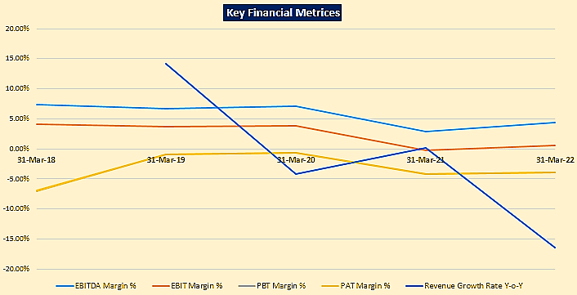
FY 2022:
- During FY22, there has been reduction in cane crushed mainly due to delayed / inadequate supply of cane (driven by farmers’ agitation on account of delayed payment), lower crop yield as the crops were affected by “red rot & root rot” disease as well as untimely rainfall.
- Sugar recovery was lower by 0.67% in FY22 as compared to FY21 mainly due to shifting of sugarcane from C molasses to B heavy molasses for manufacturing of Ethanol through B heavy Molasses and lower ‘pol in cane’ due to inclement weather conditions.
- Thus, decrease in sugar production was driven by lower volume of cane crushed coupled with lower recovery during FY22.
- There has been increase in ethanol / industrial alcohol production in FY22 by 822 lac BL:
- The increase is mainly due to shifting the ethanol / industrial alcohol production from C molasses to B heavy molasses.
- Additionally, the Company has incurred major maintenance expense on the distilleries during FY21 and FY22 so as to make them well equipped to function for 300-330 days to optimally utilize the installed capacity.
- Increase in capacity utilization due to refurbishment of the distilleries has increased the production and sale of ethanol / industrial alcohol.
- Generation and sale of power during FY22 was impacted by inadequate supply of cane.
Currently the company is under financial stress and announced as NPA due to cane-dues built-up, sub-optimal capacity utilization and repair & maintenance expenditure etc. and approached the bank to restructuring the outstanding debt.
Therefore to check and assess the Techno-Economic & Financial viability of the Company for submitting the proposal to BHSL lenders, State Bank of India has appointed R K Associates as TEV consultant to review technical, commercial and financial viability of the company based on our independent EIC research and information/data provided to us about the company by M/s Bajaj Hindusthan Sugar Limited.
Hence, We R.K associate are performing the Techno-Economic Viability study for all the 14 existing manufacturing facilities spread across UP in east, central & west zones considering the Debt restructuring proposal.
- PURPOSE OF THE REPORT: To assess Project’s Techno-Economic Viability for the purpose of Restructuring of Debt under RBI Circular dated 7th June 2019 on Resolution of Stressed Assets.

- SCOPE OF THE REPORT: To assess, evaluate & comment on Techno-Economic Viability of the Company as per data information provided by the client, independent Industry research and data/ information available on public domain and our independent EIC research.

NOTES:
- Project status is taken as per the information provided by the company officials/management.
- Site inspection has been carried out for all the existing Units. Operating details regarding the same is taken as per the information provided by the company which has been relied upon.
- Scrutiny about the company, background check, credibility, credit worthiness of the company or its promoters is out-of-scope of this report.
- This report is only an opinion in respect to Technical and Financial Feasibility of the project as per the future Projections provided by the firm and independent analysis done by us and doesn’t contains any recommendations including taking decision on the financial exposure.
- This is not an audit activity of any kind. We have relied upon the data/ information supplied by the company in good faith that it is true and without any fabrication.
- Existing units infrastructural details wherever mentioned has not been correlated with the documentary evidence such as title deeds, Building Map since the same was out of scope of work.
- This is not a Detailed Project Report or a detailed design or architecture document.
- Land and property details mentioned in the report is only for illustration purpose as per the information provided to us by the client. The same doesn’t tantamount for taking any responsibility regarding its legality, ownership and conforming to statutory norms.

- METHODOLOGY/ MODEL ADOPTED:
- Data/ Information collection.
- Review of Data/ Information collected related to TEV study.
- Independent review & assessment of technology used and financial projections provided by the company/promoters.
- Review and analysis of the Projections as per the market trends and futuristic growth opportunity of the industry and company.
- Projections of Revenue, Expenses, P&L, Balance Sheet, fixed assets, COGS.
- Assessment of Key Financial Ratios
- Final conclusion.

- DATA/ INFORMATION RECEIVED FROM: All the data/Information has been received from the company officials.

- DOCUMENTS / DATA REFFERED:

- Financial Projections of the company for next 8 Years.
- Information Memorandum shared by client/company
- Information/data provided by the company
- Director’s Details.
- Details gathered during our site visit

PART C | COMPANY PROFILE

- COMPANY OVERVIEW: The Company was incorporated as “The Hindusthan Sugar Mills Limited” (HSML) in 1931 by Late Shri Jamnalal Bajaj. Subsequently, HSML was renamed as Bajaj Hindusthan Limited in 1988 and presently as Bajaj Hindusthan Sugar Limited (BHSL) since January 2015.
M/s Bajaj Hindusthan Sugar Limited was incorporated on 24th November, 1931 established for the purpose of manufacturing the Sugar and Industrial alcohol/ethanol. Currently the company is offering many Products like Sugar, Alcohol, Co-gen Power, Molasses, Bagasse, and Press Mud & Others.
BHSL operates in three regions of UP - Western UP, Central UP and Eastern UP. Plant-wise cane crushed, capacity utilization and sugar produced for all three regions for the past two years is presented below:
Particulars | Cane Crushed Lac Qtl. |  | Capacity Utilisation %age |  | Sugar Produced Lac Qtl.
 | FY 21 | FY 22 | FY 21 | FY 22 | FY 21 | FY 22
Western Zone
Kinauni | 187.52 | 179.16 | 80.55% | 80.70% | 22.12 | 20.53
Thanabhawan | 155.78 | 129.38 | 82.03% | 81.68% | 16.82 | 13.04
Budhana | 149.02 | 133.91 | 80.77% | 85.02% | 17.37 | 15.52
Bilai | 151.34 | 131.77 | 81.63% | 81.79% | 18.67 | 16.04
Gagnauli | 110.37 | 92.97 | 68.13% | 70.75% | 11.43 | 9.10
West zone sub-total | 754.03 | 667.19 | 78.99% | 80.35% | 86.40 | 74.23
Central Zone
Gola | 194.31 | 137.44 | 87.92% | 75.52% | 21.19 | 12.68
Palia | 143.22 | 95.01 | 81.38% | 81.48% | 15.80 | 8.78
Khamberkhera | 127.82 | 86.51 | 75.64% | 76.56% | 13.02 | 8.32
Barkhera | 105.94 | 88.21 | 90.63% | 89.37% | 12.46 | 8.85
Maqsoodpur | 73.12 | 58.26 | 75.70% | 78.51% | 8.31 | 5.93
Central zone sub-total | 644.43 | 465.42 | 82.67% | 79.63% | 70.77 | 44.55
Eastern Zone
Pratappur | 14.74 | 11.30 | 45.50% | 34.24% | 1.43 | 0.86
Rudhauli | 19.91 | 18.08 | 44.44% | 29.69% | 1.46 | -
Utraula | 44.09 | 31.97 | 43.22% | 33.30% | 3.94 | 2.93
Kunderki | 83.11 | 64.95 | 60.89% | 51.55% | 8.61 | 6.01
Eastern zone sub-total | 161.85 | 126.30 | 51.27% | 39.98% | 15.43 | 9.81
Total | 1,560.31 | 1,258.92 | 76.12% | 72.74% | 172.60 | 128.59

Average plant capacity utilization was ~75% during past two years. However, it has varied for different zones. While capacity utilization of central and west zones was upwards of ~80%, that of east zone has averaged ~40-50% in the last two years.
Some of the esteem clients of BHSL (for sugar & ethanol) include M/s Varun Beverages, M/s Walmart India Pvt Ltd., M/s Reliance Retail, M/s Indian Oil Corporation Ltd., M/s Bharat Petroleum Corporation Ltd., M/s Hindustan Petroleum Corporation Ltd., M/s Radico Khaitan Limited, M/s Mohan Meakins Limited, M/s Sir Shadi Lal Enterprises etc.
The Company has six distilleries having capacity to produce 800 KLPD of industrial alcohol. Out of the six, five distilleries manufacture ethanol whereas distillery at Kinauni manufactures Extra Neutral Alcohol (ENA). Distillery wise production of ethanol / industrial alcohol for past two years is presented as follows:
Particulars | Ethanol Produced (Lac BL)
 | FY 21 | FY 22
Western Zone
Kinauni | 166.47 | 368.68
Gagnauli | 265.94 | 450.18
West zone sub-total (A) | 432.41 | 818.87
Central Zone
Gola | 192.52 | 197.17
Palia | 26.04 | 18.52
Khamberkhera | 187.52 | 362.27
Central zone sub-total (B) | 406.08 | 577.97
Eastern Zone
Rudhauli | 70.54 | 335.77
Eastern zone sub-total (C) | 70.54 | 335.77
Total (A+B+C) | 909.04 | 1,732.60

Industrial Alcohol: The Company supplies Industrial Alcohol to other Alcohol based chemical manufacturers for the purpose of making chemicals like Ethyl Acetate, Glycols, drugs, etc. Such sale of Alcohol is direct sale in almost all cases. Some of the prominent buyers of Industrial Alcohol are like M/s Jubilant Ingrevia Limited, M/s India Glycols Limited, M/s Nagindas Bhayani, M/s Ester India, etc. The Company’s payment terms invariably are 100% advance before dispatch except credit given under certain market conditions.
Ethanol: Ethanol for blending purpose is sold to following public sector oil companies through EOI / tender route like Indian Oil Corporation Limited, Bharat Petroleum Corporation Limited, and Hindustan Petroleum Corporation Limited etc.
The price and other commercial terms of Ethanol are decided by Government (Ministry of Petroleum & Natural Gas) on annual basis. Ethanol is also supplied to private companies such as Reliance/ Nayara which they procure either directly from BHSL or through traders. Payment terms as per tender are on 21 days credit from the date of receipt of material.
Potable Alcohol: Potable Alcohol is supplied to liquor manufacturers for the purpose of making Indian Made Foreign Liquor (IMFL)/ Country Liquor (CL) to various buyers in the country. Some of the prominent buyers include M/s Radico Khaitan Limited, M/s India Glycols Limited, M/s Mohan Meakins Limited, M/s Sir Shadi Lal Enterprises, M/s Wave Distillery, M/s Superior Distillery, etc. In addition, the Company also exports (whenever commercially viable) potable Alcohol (Extra neutral Alcohol) subject to receipt of permissions from State excise.
Green power (bagasse based) generation capacity of 449 MW, out of which about 151 MW is exportable to Uttar Pradesh Power Corporation Limited. Power is generated through bagasse which is a fibrous residue of cane stalk that is obtained after crushing and extraction of juice. It consists of water, fibre, and relatively small quantities of soluble solids. The yield of bagasse varies from 27% - 29% based on the variety of sugarcane, maturity of cane, method of harvesting and the efficiency of the sugar mill. Plant wise generation of power for the past two years is presented below:
Particulars | Power Generation (Lac kWh)
 | FY 21 | FY 22
Western Zone
Kinauni | 990.84 | 1,008.93
Thanabhawan | 882.67 | 715.58
Budhana | 670.12 | 700.19
Bilai | 841.18 | 754.89
Gagnauli | 418.35 | 457.57
West zone sub-total (A) | 3,803.16 | 3,637.17
Central Zone
Gola | 557.06 | 397.60
Palia | 539.09 | 357.15
Khamberkhera | 506.43 | 475.33
Barkhera | 417.66 | 349.68
Maqsoodpur | 385.99 | 287.21
Central zone sub-total (B) | 2,406.23 | 1,866.97
Eastern Zone
Pratappur | 48.97 | 41.93
Rudhauli | 158.36 | 223.21
Utraula | 454.69 | 203.60
Kunderki | 642.90 | 466.73
Eastern zone sub-total (C) | 1,304.92 | 935.48
Total | 7,514.31 | 6,439.61

- DEBT SNAPSHOT: The Company has outstanding fund-based debt of ~INR 4,866 Cr (including instalment due as on 31 March 2022 and overdue OCD coupon) and outstanding non-fund-based debt of ~INR 45 Cr as on 31 March 2022. State bank of India is the lead Lender with exposure of ~25.07%. Lender-wise and facility wise debt as on 31 March 2022 is presented below:
Lender | Total Sustainable debt | OCD (B) | O/S Interest on OCD | Total FB debt | NFB (II)** | Total debt | % Share
 |  |  |  |  |  | (III= I+II)
State Bank of India | 313.18 | 860.71 | 21.52 | 1,195.41 | 35.69 | 1,231.10 | 25.07%
Punjab National Bank | 284.89 | 798.42 | 19.96 | 1,103.27 | 9.29 | 1,112.56 | 22.66%
Indian Bank | 147.83 | 366.82 | 9.17 | 523.82 |  | 523.82 | 10.67%
Central Bank of India | 102.49 | 287.25 | 7.18 | 396.92 |  | 396.92 | 8.08%
Bank of Maharashtra | 105.64 | 261.76 | 6.54 | 373.94 |  | 373.94 | 7.61%
IDBI Bank | 93.75 | 255.46 | 6.39 | 355.6 |  | 355.6 | 7.24%
Canara Bank | 71.75 | 177.98 | 4.45 | 254.18 |  | 254.18 | 5.18%
Union Bank | 41.78 | 138.99 | 3.47 | 184.24 |  | 184.24 | 3.75%
UCO Bank | 46.67 | 115.68 | 2.89 | 165.24 |  | 165.24 | 3.36%
Bank of Baroda | 35.86 | 88.86 | 2.22 | 126.94 |  | 126.94 | 2.58%
Indian Overseas Bank | 31.13 | 79.01 | 1.98 | 112.12 |  | 112.12 | 2.28%
Bank of India | 20.5 | 52.31 | 1.31 | 74.12 |  | 74.12 | 1.51%
Total | 1,295.48 | 3,483.25 | 87.08 | 4,865.81 | 44.98 | 4,910.79 | 100.00%
- The Company had undergone restructuring by way of Scheme for Sustainable Structuring of Stressed Assets (S4A) of RBI in December 2017.
- As per the implemented resolution under S4A scheme, total debt of the Company (including outstanding non-fund based debt of INR 307 Cr) was INR 8,592 Cr which was split into sustainable (fund based and non-fund based) debt of INR 5,096 Cr (59.32%) and unsustainable debt of INR 3,495 Cr (40.68%).
- Against unsustainable debtsof INR 3,495 Cr., Optionally Convertible Debentures (OCDs) were issued to Lenders amounting to INR 3,483 Cr and Promoter shareholding (approx. 12 crore shares) were transferred to Lenders at INR 1 per share to settle the balance amount of INR 12 Cr of unsustainable debts.
- SHAREHOLDING DETAILS: As on 31st March 2022, the Company is having authorized share capital of Rs. 500 crore and the total subscribed and paid-up capital is Rs 127.74 crore as per the latest audited financials shared by the client. The shareholdinger pattern of the company is mentioned below:
Table: Details of Equity Share Capital of the Company

Particulars | As at  30th June, 2022 |  | As at  31st March, 2022
 | No of Shares | INR Crore | No of Shares | INR Crore
Authorised Share Capital
Equity share of Rs. 1/- each | 5,00,00,00,000 | 500.00 | 5,00,00,00,000 | 500
Subscribed & fully paid up
Equity Share of Re. 10/- each fully subscribed & paid up | 1,27,73,59,942 | 127.74 | 1,27,73,59,942 | 127.74
Source: Data/Information provided by the Client.

Details of Shareholders holding more than 5% shares in the Company

Name of Shareholder | As at  31st March, 2022 |  | As at  31st March, 2021
 | No. of Shares | % of Holding | No. of Shares | % of Holding
Kushagra Bajaj | 9,61,04,867 | 7.52% | 9,61,04,867 | 7.52%
Bajaj Resources Ltd. | 8,79,71,924 | 6.89% | 8,79,71,924 | 6.89%
Source: Data/Information provided by the Client.
Overall, the promoters are holding 24.95% share of the company as on 31st March 2022.

The detailed shareholding of BHSL as of 30th June 2022 & 31st March 2022 is presented below:
Particulars | 30 June 2022 |  | 31 March 2022
 | Number of Shares | Shareholding % | Number of Shares | Shareholding %
Promoters
Mr. Kushagra Bajaj | 9,61,04,867 | 7.52% | 9,61,04,867 | 7.52%
Bajaj Resources Ltd | 8,79,71,924 | 6.89% | 8,79,71,924 | 6.89%
SKB Roop Commercial LLP | 6,05,92,279 | 4.74% | 6,05,92,279 | 4.74%
Bajaj International Realty Pvt. Ltd. | 2,77,77,484 | 2.17% | 2,77,77,484 | 2.17%
A N Bajaj Enterprises Private Limited | 1,83,07,954 | 1.43% | 1,83,07,954 | 1.43%
Mr. Shishirkumar Bajaj | 83,96,341 | 0.66% | 83,96,341 | 0.66%
Ms. Minakshi Bajaj | 42,54,556 | 0.33% | 42,54,556 | 0.33%
Other promoters | 1,53,38,017 | 1.20% | 1,53,38,017 | 1.20%
Total Promoters (A) | 31,87,43,422 | 24.95% | 31,87,43,422 | 24.95%
Banks (Public)
Punjab National Bank | 4,13,758 | 0.03% | 4,13,758 | 0.03%
Indian Bank | 4,35,55,350 | 3.41% | 6,29,28,861 | 4.93%
Central Bank of India | 5,15,48,730 | 4.04% | 5,15,48,730 | 4.04%
Canara Bank | 3,90,04,000 | 3.05% | 4,24,18,366 | 3.32%
Indian Overseas Bank | 2,42,74,728 | 1.90% | 2,42,74,728 | 1.90%
Union Bank of India | 1,31,45,000 | 1.03% | 2,21,80,988 | 1.74%
UCO Bank | 2,10,67,013 | 1.65% | 2,10,67,013 | 1.65%
Bank of India | 71,70,905 | 0.56% | 71,70,905 | 0.56%
Total Banks (public) (B) | 20,01,79,484 | 15.67% | 23,20,03,349 | 18.16%
Other Public (C) | 75,84,37,036 | 59.38% | 72,66,13,171 | 56.88%
Total (A+B+C) | 1,27,73,59,942 | 100.00% | 1,27,73,59,942 | 100.00%

- PROMOTERS/DIRECTORS PROFILE: Below table shows the details of Director’s of M/s BHSL:
DIN | NAME | APPOINTMENT DATE | Qualifications/Experience
00017575 | Mr. Kushagra Bajaj | 26 February 2008 | Mr. Kushagra Bajaj is the Promoter and Non-Executive Chairman of the Bajaj Group. At 45, Kushagra is among India’s youngest and brightest business leaders driving a diverse set of companies with sizeable interests in Sugar, Power and FMCG sectors.  Under his stewardship, the Group businesses have registered enhanced profitability, expanded their footprints, and secured leadership positions in their respective markets. With a B.Sc. in Economics, Political Philosophy, and Finance from Carnegie Mellon and M.Sc. in Marketing from the Northwestern University (Chicago), Kushagra’s academic qualifications are matched only by his expansive business pursuits and clear-eyed vision for the Group. As of today, the revenues of the Bajaj Group stand at USD 2.0 billion with an assets base of USD 5.3 billion.  A scion of the storied Bajaj Family, Kushagra is walking in the footsteps of his predecessors, chiefly his great-grandfather Shri Jamnalal Bajaj, the venerated businessman philanthropist and freedom fighter. Shouldering the weight of the century-old legacy built on the ideas of trust, transparency, leadership, and service to the nation, he is counted among India’s leading young philanthropists - with a special focus on education - and remains a guiding force behind Bajaj Foundation, the Group’s CSR arm engaged in social welfare programs in the farthest corners of the country
09607745 | Mr. Ajay Kumar Sharma | 20 May 2022 | Mr. Ajay Kumar Sharma aged about 55 years (DOB 02.10.1967) and has been working with BHSL since 2016. In a career spanning over three decades, Mr. Sharma has worked extensively in the areas of cane procurement & development, liaising with farmers & government officials, supply chain management and operations.  In his six years at BHSL, his expertise in the aforementioned areas have led to minimizing the “cut to crush” time which in turn led to significant improvements in the operational performance of the company’s Bilai unit. Also, during his tenure the said unit achieved highest ever recoveries during 2018-19, 2019-20 and 2020-21 seasons, and increased high sugar variety percentage cane from 25% to 98% which contributed to a tremendous growth in Pol percentage. Additionally, Mr. Sharma implemented a number of measures which helped optimize costs and brought increased agility in plant operations.  With a M.Sc. in Agriculture and LLB, Mr. Sharma worked in a number of Sugar firms including Triveni Engineering Works, SBEC (Modi Group), RBNS Sugar, Mawana Sugar, and Modi Sugar before moving to BHSL.
00025409 | Mr. D.K. Shukla | 30 October 2001 | Mr. D. K. Shukla has been a member of BHSL’s Board of Directors since October 2001. He has a Bachelor’s Degree in Arts and a Master’s Degree in Social Work. He served as a representative for the Life Insurance Corporation of India on BHSL Board until November 11, 2008. He retired as an Executive Director of LIC in February 2003. Mr. Shukla was re-inducted in the Board with effect from December 21, 2008 as an Independent Director.  In addition, Mr. Shukla is a member and Chairman of BHSL Audit Committee, Chairman of Nomination & Remuneration Committee and Chairman of Stakeholders Relationship Committee.
00012556 | Ms. Shalu Bhandari | 17 September 2016 | Ms. Shalu Bhandari has been a member of BHSL Board of Directors since September 2016. She is a qualified Company Secretary and a fellow Member of the Institute of Company Secretaries of India. Ms. Bhandari is the proprietor of M/s. S.L. Bhandari & Associates, Practicing Company Secretaries operating in Mumbai since 2002. Ms. Bhandari is having experience in providing services in the field of Corporate Law matters with a dedicated focus towards handholding entrepreneurs and corporates.
00112451 | Mr. Atul H Mehta | 01 January 2020 | Mr. Atul H. Mehta has been a member of BHSL Board of Directors since January 01, 2020. He has a Corporate Law Advisor, B.Com, B.G.L. and FCS, is practicing Company Secretary and promoter of Mehta & Mehta Company Secretaries, Mehta & Mehta Advisory Services Private Limited & Mangalam Placement Private Limited. Mr. Mehta comes with an experience of over 27 years in the field of Corporate Law, Capital Market and Human Resource.  He has served the industry as a Company Secretary and Compliance Head for 5 years soon after which he took his pioneering step towards consulting and practicing as a Company Secretary full time. He has also served as secretary of International Association of Company Secretaries which comprises 42 countries as members. He has also shepherded Institute of Company Secretaries of India as President in year 2015-16. He was past Chairman of Western India Regional Council (WIRC) of Institute of Company Secretaries of India (ICSI) in 2009. He has also been elected as Secretary of CISA at Global Level.  He was also a part of MCA Committee. He was member of RBI Restructuring Committee, Company Law Committee (6 members), Ministry of Corporate Affairs 2015 and IOD (Institute of Directors).
09024617 | Mr. Vinod C Sampat | 21 January 2021 | Mr. Vinod C. Sampat (B. Com (Hons.), LL.B.), an Advocate is a wizard in the field of property related laws. He started his career 30 years back as an individual practicing lawyer and has been a litigation lawyer since then. Currently, he is the proprietor of Sampat’s Law Firm.  His expertise lies in co-operative housing societies, self-redevelopment, RERA, Consumer Protection Act, car parking, transfer of flats, recovery of dues etc. He has authored more than 100 books on Co-operative Societies, Transfer of Flat, Recovery of Dues, Registration and Stamp Duty, Car Parking, RERA etc. He has a team of specialists in the fields of Information Technology Laws, Negotiable Instruments Act, Criminal Law, Matrimonial Laws etc.
00324588 | Mr. Ashok Mukand | 14 September 2015 | Mr. Ashok Mukand has been appointed as a Director, nominated by State Bank of India, since September 2015. Mr. Mukand joined SBI on December 14, 1970, he had served SBI in various senior positions like CGM, LHO Kolkata and DMD & CFO, Corporate Centre, Mumbai Until his retirement in 2009.
09389302 | Mr. Ramani Ranjan Mishra | 11 November 2021 | Mr. Ramani Ranjan Mishra aged 55 years is a professional banker having 30 years of experience in Operation, Credit, HRD, General Administration, Recovery, etc. Mr. Mishra is presently designated as Deputy General Manager, Punjab National Bank, ELCB, and New Delhi.  Mr. Mishra holds the degree of M.Com, CAIIB (IIB) PGDCA (IIT Kharagpur).
Source: Data/Information provided by the client
To give a brief overview of the background of Directors we have listed down the basic company information as found on public domain in general/ tertiary category research.
Table: Details of Key Technical and Project Team

Name | Designation | Qualification | Years of experience | Date of appointment | Tenure with BHSL (approx.)
Mr. Ajay Kumar Sharma | Managing director | M. Sc (Agriculture), LLB | 32 | 20 May 2022 | 8
Mr. Akash Sharma | President (Finance & Accounts) | CA, LLB and BCom | 30 | 22 March 2006 | 16
Mr. Sunil Kumar Ojha | Chief Financial Officer | CA, ICWA and BCom (Hons) | 24 | 14 August 2021 | 1
Mr. Vikas Lahoti | Head - Group Corporate Taxation | MBA, CA and BCom | 36 | 22 April 2013 | 9
Mr. Syed Masood Raza | Senior Vice President (Sales & Marketing) | PGDBM and BCom (Hons) | 32 | 15 June 2005 | 17
Mr. Naval Kishore Kashyap | Senior Vice President (Indirect Taxation) | Diploma (Excise & Customs) and BCom | 40 | 1 November 2011 | 11
Mr. Amit Agrawal | Vice President (Sales) | PGDBM and BSc (Hons) | 24 | 1 December 2005 | 17
Mr. Prabhakar Chandra | Vice President (HR) | MBA, LLB and BA | 28 | 9 August 2004 | 18
Mr. Rajeev Gupta | Assistant Vice President (Commercial) | BE and BSc | 28 | 26 February 2018 | 4
Mr. Kausik Adhikari | Sr. General Manager & Company Secretary | CS, M.Com and B.Com (Hons) | 20 | 1 June 2010 | 12
Mr. Sanjay Srivastava | Sr. Dy. General Manager (Internal Audit) | CA and BCom | 20 | 2nd November 2016 | 6
Source: Data/Information provided by the Client.

PART D | FINANCIAL STRESS & DEBT RESTRUCTURING PROPOSAL

- REASONS FOR STRESS: The financial constraints being faced by the Company has led to accumulation of the cane dues, which is affecting its operations in terms of availability of raw material and other constraints impacting the operational efficiency of the Company. Following are the key concerns which have resulted in the financial stress for the Company which requires immediately addressed through deleveraging and realignment of capital structure of BHSL:
- Cane due built-up and its implication:

- Owing to the subdued operational performance, regulated nature of the business and leveraging, BHSL has been unable to make timely payments to the cane farmers. The delay in payment has been a recurring issue for the past 3-4 years.

- As presented in the table below, cane farmer dues (net of stock held) during implementation of S4A (September 2017) was ~INR 72 Cr which increased to ~INR 2,110 Cr (i.e., INR 1,110 Cr after considering transfer of funds from "Lalitpur Power Generation Company Ltd., a Bajaj Group company (LPGCL) and payment to cane farmers) as on 31 March 2022. Cane dues accumulation from September 2017 till March 2022:
(Amount in INR Cr)
Particulars | Mar-17 | Sep-17 (S4A) | Mar-18 | Mar-19 | Mar-20 | Mar-21 | Mar-22
Gross Cane Dues | 2,607 | 334 | 3,162 | 3,960 | 4,156 | 4,084 | 3,741
Inventory
Finished Goods (Sugar, Alcohol & Power) | 2,718 | 142 | 2,655 | 2,517 | 2,398 | 2,093 | 2,184
By-products (Molasses & Bagasse) | 196 | 120 | 71 | 101 | 154 | 302 | 412
Work-in-process | 34 | - | 55 | 56 | 62 | 26 | 35
Total Inventory | 2,948 | 262 | 2,781 | 2,674 | 2,614 | 2,421 | 2,631
Net Cane Dues (Net of Stock) | (341) | 72 | 381 | 1,285 | 1,542 | 1,663 | 1,110
Transfer of funds from LPGCL | - | - | - | - | - | - | 1,000
Net Cane Dues (without funds transfer from LPGCL) | - | - | - | - | - | - | 2,110
- However, it is critical for BHSL to immediately pay off such dues to cane farmers to prevent disruptions in the supply of raw material and to ensure continuity and efficiency of its operations.

- As per the UP Sugarcane Purchase Act, 1953 payment to cane farmers is to be made within 15 days of receipt of sugarcane. UP Government (through the UP State legislative assembly) vide notification in the UP State Gazette on 27 December 2021 has duly amended the UP Sugarcane (Regulation of Supplies and Purchase) Act, 1953.

This amendment, applicable to all sugar units in UP, empowers UP Government to adjust the dues payable to the sugarcane farmers from group companies having receivables from UP Government / UP State entities.

- As per the news articles and the Company, infusion of ~INR 2,361 Cr from LPGCL into BHSL has been effected / is being effected through UP Government action, to be utilized entirely for payment of critical cane dues. The UP Government has already appropriated LPGCL’s part receivables from UPPCL to the extent of INR 1,000 Cr to pay dues of cane farmers of BHSL.

The sum of INR 1,000 Cr has been received by the Company from UPPCL in two tranches of INR 500 Cr each on 21 January 2022 and 03 February 2022 respectively in escrow accounts maintained exclusively for cane price payment for each of its 14 sugar units. The said amount has been paid to the cane farmers towards the cane payment arrears for SS 2020-21 & 2021-22. The balance amount of ~INR 1,361 Cr is expected to be appropriated by UPPCL for payment of cane dues in the near future.

- Operational constraints impacting EBITDA of the Company: During the last 3-4 years, the total income of the Company has increased at an average of ~3.37% from FY19 to FY21 and reduced by ~16% during FY22. The EBITDA margin of the Company have remained at ~7% in FY19 and FY20 and in fact declines to ~3% in FY21 and ~4% in FY22.
(Amount in INR Cr.)
Particulars | FY18 | FY19 | FY20 | FY21 | FY22
Revenue from operations (A) | 5,851 | 6,683 | 6,603 | 6,555 | 5,569
Other income | 254 | 284 | 73 | 133 | 21
Total income | 6,105 | 6,967 | 6,677 | 6,688 | 5,590
% Increase in total income | - | 14.12% | (4.17%) | 0.17% | (16.41%)
Cost of raw material consumed (B) | 4,997 | 5,659 | 5,363 | 5,297 | 4,610
Inventory Changes (C) | (3) | 106 | 60 | 193 | (210)
Employee benefits | 249 | 275 | 299 | 328 | 342
Repairs and maintenance expense | 92 | 130 | 158 | 336 | 242
Other expenses | 321 | 331 | 326 | 338 | 360
Total expenses | 5,656 | 6,501 | 6,207 | 6,493 | 5,344
% Cost of materials consumed | - | 86.26% | 82.31% | 83.76% | 79.01%
EBITDA | 450 | 467 | 470 | 196 | 246
EBITDA margin % | 7.37% | 6.70% | 7.03% | 2.92% | 4.40%

The key reasons for constraint in EBITDA improvement over past few years are as follows:
- Sub-optimal capacity utilization: Cane crushing capacity was underutilized on account of lower cane availability due to delayed payments / farmers agitations and crop yield impacted by disease and weather conditions in FY22.
As per Company, delay in payment of dues to cane farmers has also resulted in them either diverting the sugar cane to other sugar mills in the vicinity or start growing alternate crops from sugar cane. This also results in lower sugar recovery and increased cost of production.
Particulars | FY18 | FY19 | FY20 | FY21 | FY22
Cane crushed (lakh Qtl.) | 1,476.42 | 1,676.16 | 1,584.60 | 1,560.34 | 1,258.94
No. of operational days (Wt. Average) | 140 | 165 | 158 | 150 | 127
% Capacity utilised (Cane crushed) | 76.92% | 74.26% | 73.50% | 76.12% | 72.74%
- Higher cost of material to sales realization ratio: The material cost to sales ratio for BHSL is higher as compared to peers on account of various factors like sales mix, operational performance, capacity utilization, etc. The following are the main reasons for the higher material cost to sales ratio:
- Higher proportion of revenue from sugar: For last 4-5 years, the sugar business has been operating at low margins. Sugar accounted for approx. 85-90% of the revenue of BHSL during FY21, whereas in peers’ case, revenue from sugar is approximately 75-80%. Thus, in case of BHSL, the revenue is primarily consisting of the low margin sugar sales.
- Lower ethanol / industrial alcohol production: Some of the Company’s distilleries were not operating to their optimum capacities during the last two years on account of the major overhauling been undertaken. Accordingly, the percentage share of ethanol / industrial alcohol sales to the total turnover is higher in case of peers which is around 11-17%, as compared to BHSL's of around 4-6% (FY21). Thus, the high margin product of industrial alcohol / ethanol constituted low proportion in total turnover of BHSL.
However, having undertaken major overhaul of distilleries, production of ethanol / industrial alcohol has increased in FY22 to ~1,731 lakh BL and is expected to further ramp up to ~2,500 lakh BL by FY25, thus expecting to improve the overall cost of material to sales ratio.
- Lower sugar recovery in comparison to peers: The sugar recoveries were impacted due to the Company having made lesser investment in cane development activities in comparison to the peers, the same resulted in an adverse cost of material to sales ratio.
- Repairs and Maintenance expenses in FY21 and FY22: The Company carried out major repairs and overhaul of equipment during FY21 and FY22 on account of the following:
- Major repairs of devices: The Company had undertaken major repair works in its sugar mills and distillery units. Besides routine maintenance, the Company had to take up some thorough maintenance due to the aging of equipment. Additionally, with the advent of Government’s ethanol policy, there is increase in ethanol production from B heavy molasses for which distillery units had to be made well equipped for operating throughout the year (around 300-330 days in a year).
- Revamping of pollution control devices to meet the applicable compliances.
- Preventative maintenance: The Company also took up preventive maintenance of sugar and distillery units to mitigate the possibility of sudden breakdowns, especially targeting the critical equipment like boilers, turbines, mills etc. and to be prepared for quick restoration in case any breakdown occurs to avoid major restoration cost. The worn-out spares were either restored or replaced based on Company’s in-house technical assessment.
(Amount in INR Cr.)
Particulars | FY19 | FY20 | FY21 | FY22
Routine maintenance | 130 | 124 | 138 | 141
Major maintenance | - | 34 | 199 | 101
Total | 130 | 158 | 336 | 242

- PROPOSED RESOLUTION PLAN: BHSL has been facing cash flow constraints for the past 3 – 4 years due to leveraged capital structure and sub-optimal operational performance. The financial constraints have also resulted in delays in payments of dues of cane farmers affecting operations in terms of availability of raw material and other constraints impacting the operational efficiency of the Company.
The projected cash flows of the Company are estimated to be insufficient to meet the term debt repayment as per the existing repayment schedule and the financial obligations towards the OCDs (principal, accumulated YTM and coupon for FY22) held by the Lenders. The Company has delayed in debt servicing (instalment of 31 December 2021 was delayed and subsequently paid by March 2022) including the delay in repayment of term debt instalment and OCD coupon for FY22 due on 31 March 2022.
In view of the above, a comprehensive long term Resolution Plan is requested to be adopted which would help in capital structure realignment and deleveraging of BHSL for long term sustainability of the Lenders’ exposure in BHSL.
- The Reference date for the proposed Resolution Plan as per RBI’s Framework for Resolution of Stressed Assets (Circular no. DBR.No.BP.BC.45/21.04.048/2018-19, dated 7 June 2019) is 31 December 2021 and the cut-off date for implementation of the Resolution Plan has been taken on record as 01 April 2022 during the Consortium meeting dated 28 April 2022.
- Infusion of ~INR 2,361 Cr (as per news article and the Company) from LPGCL into BHSL has been effected / is being effected through UP Government action, to be utilized entirely for meeting critical cane dues. Pursuant to the action taken, UP Government has already appropriated LPGCL’s part receivables of LPGCL to the extent of INR 1,000 Cr till 31 March 2022 for payment of cane dues. Balance amount of ~INR 1,361 Cr is expected to be appropriated in the near future. The infusion is proposed to be recognized as preferential allotment of BHSL’s equity shares/ appropriate convertible instrument held by LPGCL in BHSL as per applicable regulations.
- BHSL’s OCDs amounting to INR 3,483 Cr held by the Lenders of BHSL along with accumulated YTM of INR 1,606 Cr (net of TDS) till 31 March 2022 and coupon on OCDs of INR 78 Cr for FY22 (net of TDS), are proposed to be converted into equity shares of BHSL as per the guidelines of RBI’s Prudential Framework for Resolution of Stressed Assets. Conversion of OCD along with accumulated YTM and OCD coupon for FY22 into equity shares would result in Lenders holding a liquid asset (in the form of equity shares), which may be monetized as BHSL is a listed entity.
- The repayment schedule of outstanding term debt of BHSL of INR 1,295 Cr as on 31 March 2022 (including instalment due as on 31 March 2022) is proposed to be elongated till FY30 (as against current maturity in September 2024), with structured repayment schedule based on the yearly projected cash flows. The interest rate spread for the term loan is proposed to remain unchanged.

PART E | UNIT WISE INFRASTRUCTURE DETAILS

- INTRODUCTION: M/s BHSL has an aggregate sugarcane crushing capacity of 136,000 TCD, alcohol distillation capacity of 800 KLPD and Green power (bagasse based) generation capacity of 449 MW across 14 locations in the North Indian state of Uttar Pradesh.
BHSL also produces molasses, bagasse and press mud which are by-products and sells the surplus quantity in market.The Business Operations of BHSL are broadly classified under Sugar units, Ethanol & Industrial Alcohol units, Power Generation Facilities. The sugar plant at each location consists of its own cogeneration plant to meet power and process steam demand of the entire complex.
The additional power after meeting the in-house load is exported to Uttar Pradesh Power Corporation Limited (UPPCL) in majority of the plants. The boilers of these cogeneration units utilize bagasse as fuel for steam and power generation. Below table shows the unit wise infrastructural details of the company as per information provided by client/company:
Particulars | UOM | GOL | PAL | KIN | THB | BDN | BIL | GNL
Name of Unit | Unit | GOLAGOKARANNATH | PALIA KALAN | KINAUNI | THANABHAWAN | BUDHANA | BILAI | GAGNAULI
Year of establishment | Year | 1931-32 | 1972 | 2004 | 2004 | 2004 | 2005-06 | 2006-07
Name of Products Manufactured | Product | Sugar, Molasses, Bagasse, Power & Distillery | Sugar, Molasses, Bagasse, Power, Distillery & Board | Sugar, Molasses, Bagasse, Power, Distillery & Board | Sugar, Molasses, Bagasse & Power | Sugar, Molasses, Bagasse & Power | Sugar, Molasses, Bagasse & Power | Sugar, Molasses, Bagasse, Power & Distillery
Sugar Plant capacity | TCD | 13,000 | 11,000 | 12,000 | 9,000 | 9,000 | 9,000 | 9,000
Distillery Plant Capacity | KLPD | 100 | 60 | 160 | - | - | - | 160
Co-generation Capacity |  | 29 | 43 | 38 | 34 | 33 | 24 | 25
Cogen (Power) Sale Capacity | MW | - | 12 | 10 | 10 | 20 | 10 | 10
Plant Land Area | Hect. | 74.65 | 70.09 | 79.87 | 32.34 | 34.97 | 36.80 | 74.57
Cane Area (Allotted) | Hect. | 40,629 | 24,760 | 29,392 | 20,297 | 21,585 | 26,294 | 18,326
Agriculture Area (Cultivable) | Hect. | 47,415 | 33,740 | 40,000 | 28,605 | 23,783 | 32,830 | 34,860
No. Of Sugar Cane farmers | Nos. | 48369 | 29259 | 54220 | 33660 | 31346 | 36889 | 23526
No Of Staff on roll | Nos. | 825 approx in season & 450 in off season | 654 Approx in season & 256 in off season | 885 approx in Season & 486 approx in Off season | 481 approx in Season & 213 approx in Off season | 498 approx in Season & 250 Approx. In off season | 518 approx in Season & 200 approx in Off season | 578 approx in Season & 368 approx in Off season
Molasses Storage | Nos. | 10 | 9 | 6 | 4 | 4 | 3 | 6
 | Qtls. | 605383 | 663000 | 587000 | 410000 | 370000 | 375000 | 560000
Alcohol Storage | KL | 10,040 | 6,830 | 19,424 | - | - | - | 21,187

Particulars | UOM | KKH | BRK | MQR | PTP | RDL | UTR | KDK
Name of Unit | Unit | KHAMBARKHERA | BARKHERA | MAQSOODAPUR | PRATAPPUR | RUDAULI | UTRAULA | KUNDARKHI
Year of establishment | Year | 2006-07 | 2006-07 | 2007-08 | 1903 | 2007 | 2007-08 | 2007-08
Name of Product | Product | Sugar, Molasses, Bagasse, Power & Distillery | Sugar, Molasses, Bagasse & Power | Sugar, Molasses, Bagasse & Power | Sugar, Molasses, Bagasse & Power | Sugar, Molasses, Bagasse, Power & Distillery | Sugar, Molasses, Bagasse & Power | Sugar, Molasses, Bagasse, Power & Board
Sugar Plant capacity | TCD | 10,000 | 7,000 | 7,000 | 6,000 | 7,000 | 12,000 | 15,000
Distillery Plant Capacity | KLPD | 160 | - | - | - | 160 | - | -
Co-generation Capacity |  | 35 | 34 | 28 | 13 | 17 | 37 | 59
Cogen(Power) Sale Capacity | MW | 12 | 12 | 12 | - | - | 13 | 30
Plant Land Area | Hect. | 82.92 | 54.38 | 50.35 | 26.67 | 64.53 | 65.88 | 77.71
Cane Area (Allotted) | Hect. | 33,340 | 24,968 | 14,904 | 3,676 | 8,418 | 13,183 | 22,754
Agriculture Area (Cultivable) | Hect. | 39,252 | 31,038 | 29,344 | 69,942 | 53,605 | 30,100 | 56,270
No. Of Sugar Cane farmers | Nos. | 41302 | 35677 | 23240 | 10876 | 14030 | 20650 | 27373
No Of Staff on roll | Nos. | 587 approx (488 in Sugar & 99 in Distillery) | 470 approx n season and 196 apprx in off season | 345 Approx. In Season & 185 Approx in Off Season | 243 | 315 | 411 Nos Approx in Season and 177 Nos in Off-Season | 438 during season and 193 in off season
Molasses Storage | Nos. | 6 | 5 | 4 | 3 | 3 | 5 | 4
 | Qtls. | 600000 | 480000 | 390800 | 270000 | 240000 | 346225 | 400000
Alcohol Storage | KL | 18,650 | - | - | - | 18,000 | - | -

- RUDHAULI (BASTI) PLANT
- Google Map Location: Project is located at 27°03'22.9"North and 82°47'07.4"East in Basti district in the state of Uttar Pradesh (East) and the location as per the Google map has been attached below:
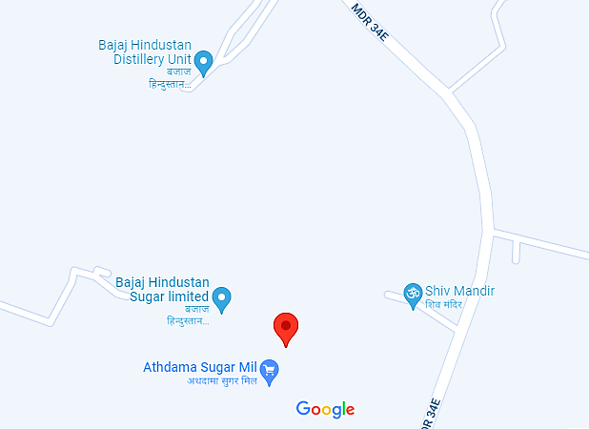
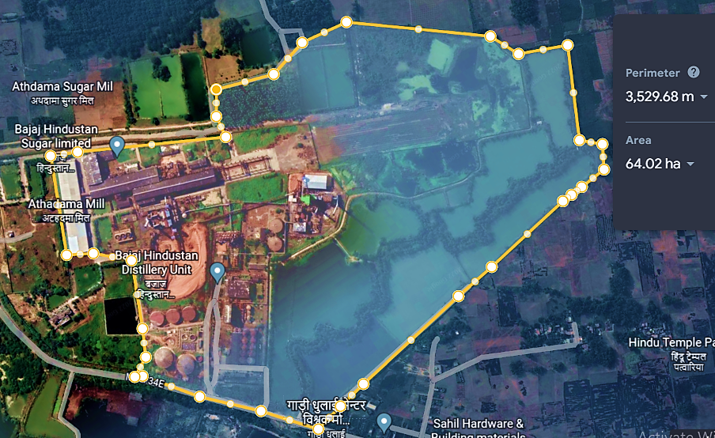
- PRODUCTION DETAILS: Below table shows the details of sugar production in last 5 years’ for Rudhauli Plant:
Particular | Unit | FY 2017 | FY 2018 | FY 2019 | FY 2020 | FY 2021 | FY 2022
Crushing capacity | QCD | 70,000 | 70,000 | 70,000 | 70,000 | 70,000 | 70,000
Number of operational days | Days | 79 | 117 | 124 | 130 | 64 | 87
Total crushing capacity | Lac Qtl. | 55,30,000 | 81,90,000 | 86,80,000 | 91,00,000 | 44,80,000 | 60,90,000
Cane actually crushed | Qtl. | 37,58,439 | 50,86,159 | 55,93,000 | 49,55,011 | 19,90,772 | 18,08,115
Capacity utilization |  | 67.96% | 62.10% | 64.44% | 54.45% | 44.44% | 29.69%

Below table shows the details of distillery production and Power Plant production:
S. No. | Particular | FY 2021 | FY 2022
 | Installed Capacity (KLPD) | 160 | 160
 | Ethanol Produced (Lakh Barrel) | 70.54 | 335.77
Cogeneration:
 | Installed Capacity (MW) | 17 | 17
 | Power Generation (Lakh KWH) | 158.36 | 223.21
- KUNDERKI (GONDA) PLANT
- Google Map Location: Project is located at 27°09'64.6"North and 82°09'16.9"East in Gonda district in the state of Uttar Pradesh (East) and the location as per the Google map has been attached below:
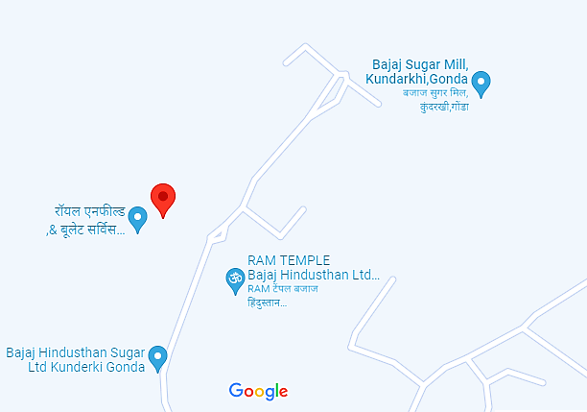
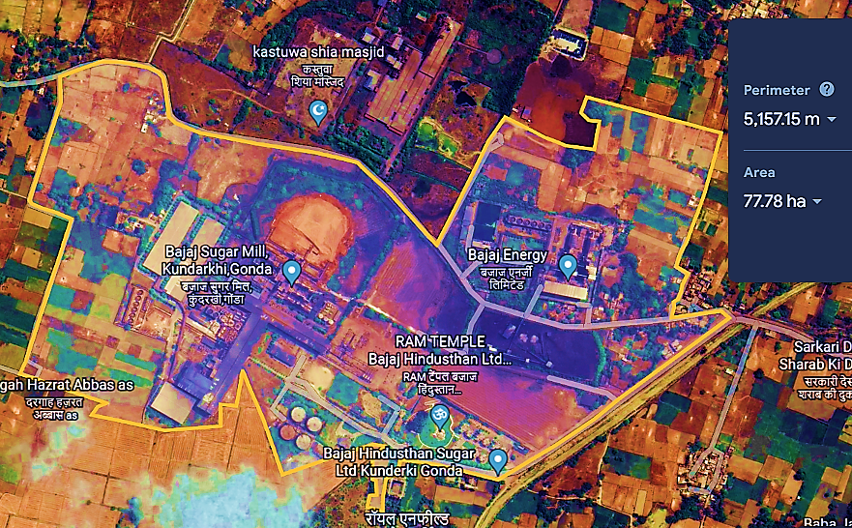
- PRODUCTION DETAILS: Below table shows the details of sugar production in last 5 years’ for Kundarkhi Plant:
Particular | Unit | FY 2017 | FY 2018 | FY 2019 | FY 2020 | FY 2021 | FY 2022
Crushing capacity | QCD | 1,50,000 | 1,50,000 | 1,50,000 | 1,50,000 | 1,50,000 | 1,50,000
Number of operational days | Days | 83 | 126 | 127 | 121 | 91 | 84
Total crushing capacity | Lac Qtl | 12450000 | 18900000 | 19050000 | 18150000 | 13650000 | 12600000
Cane actually crushed | Qtl | 7302026.8 | 10308600 | 10563598 | 10560967 | 8311179.3 | 6495035.5
Capacity utilization |  | 58.65% | 54.54% | 55.45% | 58.19% | 60.89% | 51.55%
The power generation for FY 2021 and FY 2022 is given in the below table:
Particular | FY 2021 | FY 2022
Installed Capacity (MW) | 59 | 59
Power Generation (Lakh KWH) | 642.90 | 466.73

- GOLAGOKARANNATH (LAKHIMPUR KHERI) PLANT
- Google Map Location: Project is located at 28°05'07.7"North and 80°28'20.2"East in Lakhimpur Kheri district in the state of Uttar Pradesh (Central) and the location as per the Google map has been attached below:
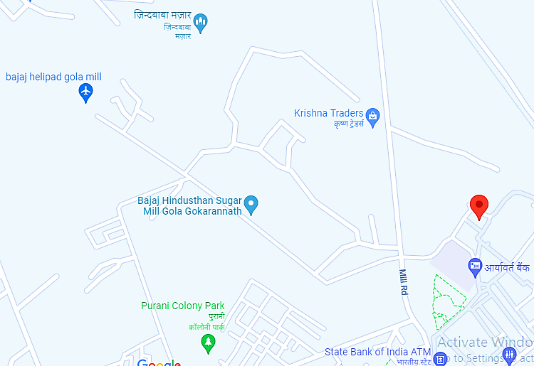
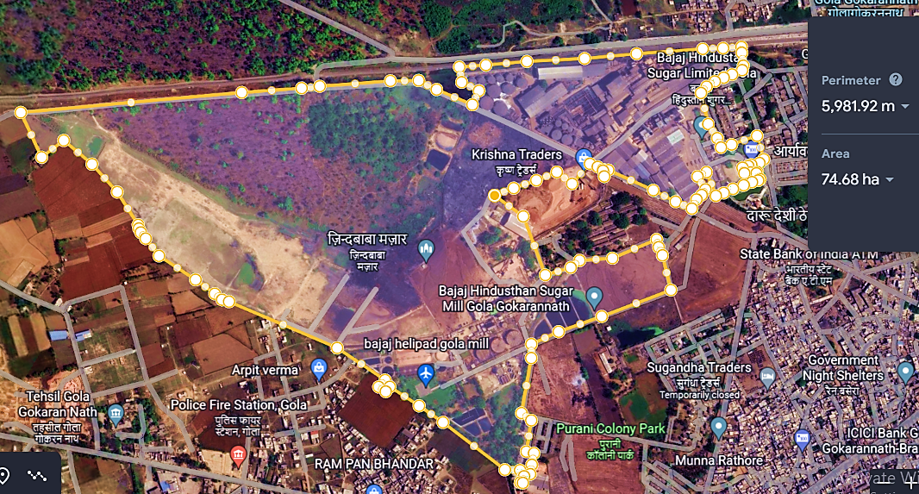
- PRODUCTION DETAILS: Below table shows the details of sugar production in last 5 years’ for Gola Plant:
Particulars | Unit | FY 2017 | FY 2018 | FY 2019 | FY 2020 | FY 2021 | FY 2022
Crushing capacity | QCD | 1,30,000 | 1,30,000 | 1,30,000 | 1,30,000 | 1,30,000 | 1,30,000
Total Operating Days | Days | 145 | 146 | 208 | 172 | 170 | 140
Total crushing capacity | Lac Qtl | 1,88,50,000 | 1,89,80,000 | 2,70,40,000 | 2,23,60,000 | 2,21,00,000 | 1,82,00,000
Cane actually crushed | Qtl | 1,66,17,300 | 1,89,53,079 | 2,44,76,498 | 1,97,75,606 | 1,94,31,873 | 1,37,44,062
Capacity utilization |  | 88.2% | 99.9% | 90.5% | 88.4% | 87.93% | 75.52%
Below table shows the details of distillery production:
S. No. | Particular | FY 2021 | FY 2022
 | Installed Capacity (KLPD) | 100 | 100
 | Ethanol Produced (Lakh Barrel) | 192.52 | 197.17
The power generation for FY 2021 and FY 2022 is given in the below table:
Particular | FY 2021 | FY 2022
Installed Capacity (MW) | 29 | 29
Power Generation (Lakh KWH) | 557.06 | 397.60
- PALIA (LAKHIMPUR KHERI) PLANT
- Google Map Location: Project is located at 28°25'14.4"North 80°34'18.6"East in Lakhimpur Kheri district in the state of Uttar Pradesh (Central) and the location as per the Google map has been attached below:
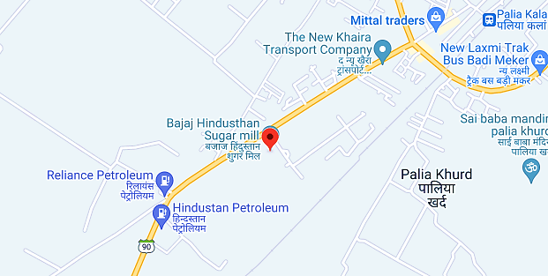
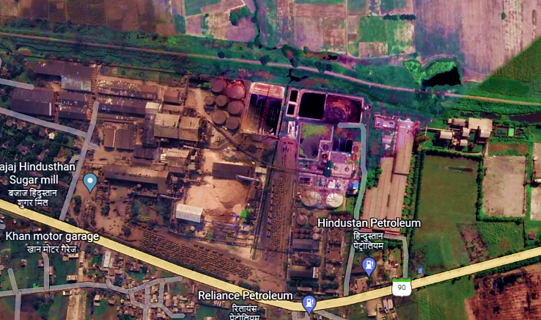
- PRODUCTION DETAILS: Below table shows the details of sugar production in last 5 years’ for Palia Plant:
Particulars | Unit | FY 2017 | FY 2018 | FY 2019 | FY 2020 | FY 2021 | FY 2022
Crushing capacity | QCD | 1,10,000 | 1,10,000 | 1,10,000 | 1,10,000 | 1,10,000 | 1,10,000
Total Operating Days | Days | 138 | 146 | 163 | 161 | 160 | 106
Total crushing capacity | Lac Qtl | 1,51,80,000 | 1,60,60,000 | 1,79,30,000 | 1,77,10,000 | 1,76,00,000 | 1,16,60,000
Cane actually crushed | Qtl | 1,23,80,679 | 1,38,30,644 | 1,49,42,341 | 1,47,32,496 | 1,43,22,732 | 95,00,920
Capacity utilization |  | 81.6% | 86.1% | 83.3% | 83.2% | 81.38% | 81.48%
Below table shows the details of distillery production:
S. No. | Particular | FY 2021 | FY 2022
 | Installed Capacity (KLPD) | 60 | 60
 | Ethanol Produced (Lakh Barrel) | 26.04 | 18.52
The power generation for FY 2021 and FY 2022 is given in the below table:
Particular | FY 2021 | FY 2022
Installed Capacity (MW) | 43 | 43
Power Generation (Lakh KWH) | 539.09 | 357.15
- UTRAULA (BALRAMPUR) PLANT
- Google Map Location: Project is located at 28°25'14.4"North 80°34'18.6"East in Lakhimpur Kheri district in the state of Uttar Pradesh (Central) and the location as per the Google map has been attached below:
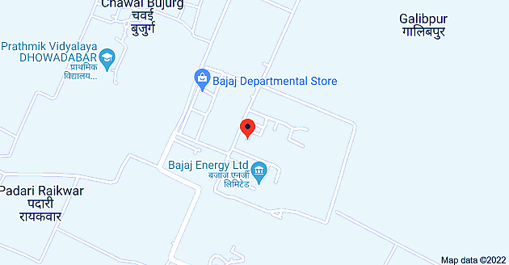
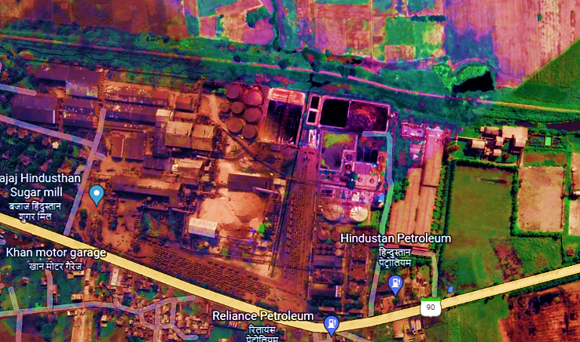
- PRODUCTION DETAILS: Below table shows the details of sugar production in last 5 years’ for Gola Plant:
Particulars | Unit | FY 2017 | FY 2018 | FY 2019 | FY 2020 | FY 2021 | FY 2022
Crushing capacity | QCD | 1,30,000 | 1,30,000 | 1,30,000 | 1,30,000 | 1,30,000 | 1,30,000
Total Operating Days | Days | 145 | 146 | 208 | 172 | 170 | 140
Total crushing capacity | Lac Qtl | 1,88,50,000 | 1,89,80,000 | 2,70,40,000 | 2,23,60,000 | 2,21,00,000 | 1,82,00,000
Cane actually crushed | Qtl | 1,66,17,300 | 1,89,53,079 | 2,44,76,498 | 1,97,75,606 | 1,94,31,873 | 1,37,44,062
Capacity utilization |  | 88.2% | 99.9% | 90.5% | 88.4% | 87.93% | 75.52%
Below table shows the details of distillery production:
S. No. | Particular | FY 2021 | FY 2022
 | Installed Capacity (KLPD) | 60 | 60
 | Ethanol Produced (Lakh Barrel) | 26.04 | 18.52
The power generation for FY 2021 and FY 2022 is given in the below table:
Particular | FY 2021 | FY 2022
Installed Capacity (MW) | 43 | 43
Power Generation (Lakh KWH) | 539.09 | 357.15
- PARTAPPUR (DEORIA) PLANT
- Google Map Location: Project is located at 26°17'16.7"North 84°10'21.4"East in Deoria district in the state of Uttar Pradesh and the location as per the Google map has been
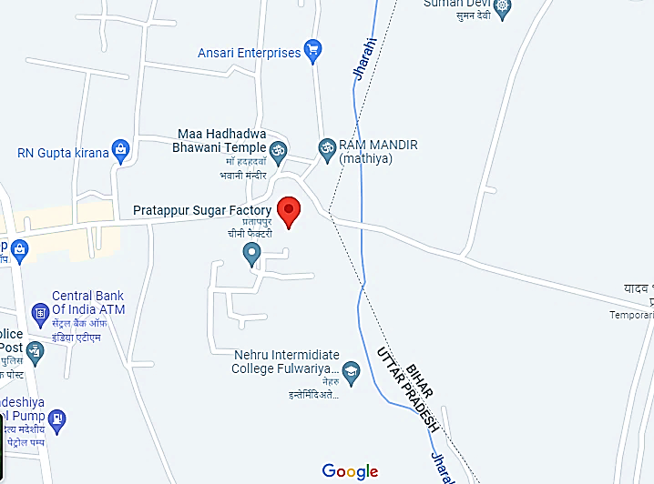
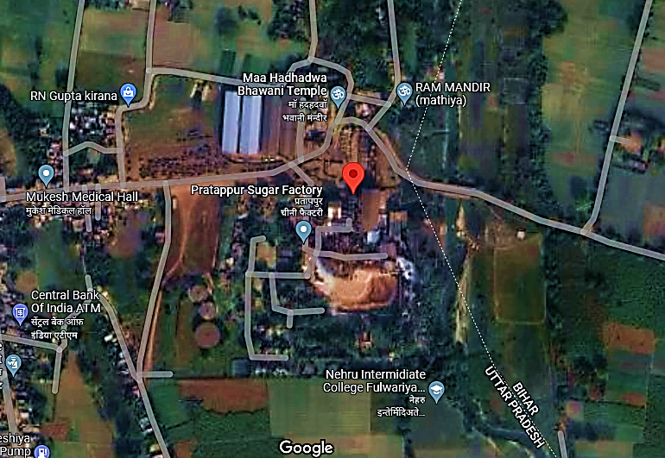
- PRODUCTION DETAILS: Below table shows the details of sugar production in last 5 years’ for Pratappur Plant:
Particular | Unit | FY 2017 | FY 2018 | FY 2019 | FY 2020 | FY 2021 | FY 2022
Crushing capacity | QCD | 60,000 | 60,000 | 60,000 | 60,000 | 60,000 | 60,000
Number of operational days | Days | 42 | 69 | 88 | 89 | 54 | 55
Total crushing capacity | Lac Qtl. | 25,20,000 | 41,40,000 | 52,80,000 | 53,40,000 | 32,40,000 | 33,00,000
Cane actually crushed | Qtl. | 10,90,375 | 18,45,150 | 24,56,822 | 25,83,721 | 14,74,324 | 11,30,075
Capacity utilization |  | 43.3% | 44.6% | 46.5% | 48.4% | 45.50% | 34.24%

Below table shows the details of Power Plant production:
S. No. | Particular | FY 2021 | FY 2022
1. | Installed Capacity (MW) | 13 | 13
2. | Power Generation (Lakh KWH) | 48.97 | 41.93

- BILAI (BIJNOR) PLANT
- Google Map Location: Project is located at 29°19'40.6"N 78°17'29.2"E in Bijnor district in the state of Uttar Pradesh and the location as per the Google map has been shown below:
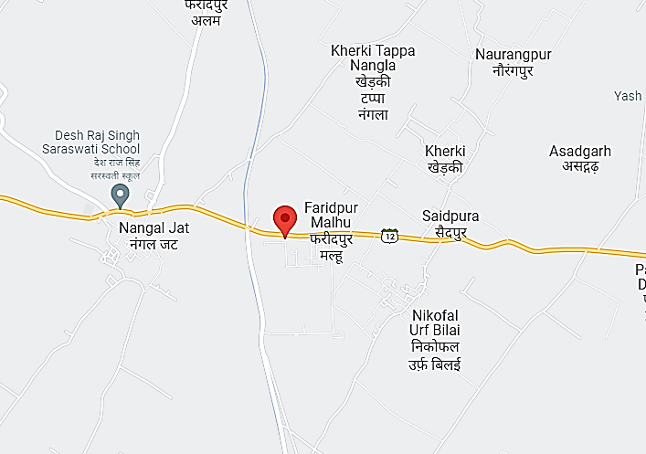
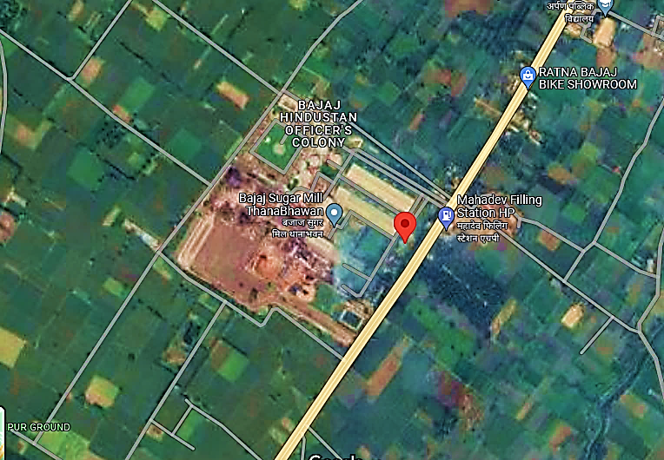
- PRODUCTION DETAILS: Below table shows the details of sugar production in last 5 years’ for Bilai Plant:
Particular | Unit | FY 2017 | FY 2018 | FY 2019 | FY 2020 | FY 2021 | FY 2022
Crushing capacity | QCD | 90,000 | 90,000 | 90,000 | 90,000 | 90,000 | 90,000
Number of operational days | Days | 152 | 159 | 179 | 179 | 206 | 179
Total crushing capacity | Lac Qtl. | 1,36,80,000 | 1,43,10,000 | 1,61,10,000 | 1,61,10,000 | 1,85,40,000 | 1,61,10,000
Cane actually crushed | Qtl. | 1,06,88,938 | 1,14,68,630 | 1,24,64,063 | 1,25,86,267 | 1,51,34,196 | 1,31,76,944
Capacity utilization |  | 78.1% | 80.1% | 77.4% | 78.1% | 81.63% | 81.79%

Below table shows the details of Power Plant production:
S. No. | Particular | FY 2021 | FY 2022
1. | Installed Capacity (MW) | 24 | 24
2. | Power Generation (Lakh KWH) | 841.18 | 754.89
- GANGNAULI (SAHRANPUR) PLANT
- Google Map Location: Project is located at 29°48'26.2"N 77°35'18.9"E in Sahranpur district in the state of Uttar Pradesh and the location as per the Google map has been shown below:
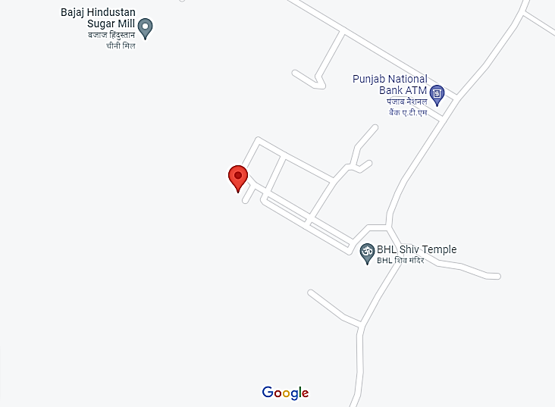
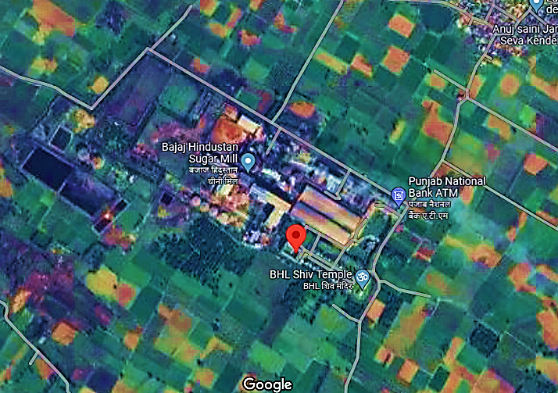
- PRODUCTION DETAILS: Below table shows the details of sugar production in last 5 years’ for Gagnauli Plant:
Particular | Unit | FY 2017 | FY 2018 | FY 2019 | FY 2020 | FY 2021 | FY 2022
Crushing capacity | QCD | 90,000 | 90,000 | 90,000 | 90,000 | 90,000 | 90,000
Number of operational days | Days | 148 | 151 | 163 | 174 | 180 | 146
Total crushing capacity | Lac Qtl. | 1,33,20,000 | 1,35,90,000 | 1,46,70,000 | 1,56,60,000 | 1,62,00,000 | 1,31,40,000
Cane actually crushed | Qtl. | 62,03,500 | 83,48,286 | 87,02,062 | 88,54,950 | 1,10,37,549 | 92,97,272
Capacity utilization |  | 46.6% | 61.4% | 59.3% | 56.5% | 68.13% | 70.76%

Below table shows the details of distillery production:
S. No. | Particular | FY 2021 | FY 2022
1. | Installed Capacity (KLPD) | 160 | 160
2. | Ethanol Produced (Lakh Barrel) | 265.94 | 450.18
Below table shows the details of Power Plant production:
S. No. | Particular | FY 2021 | FY 2022
1. | Installed Capacity (MW) | 25 | 25
2. | Power Generation (Lakh KWH) | 418.35 | 457.57
- THANABHAVAN (MUJAFFARNAGAR) PLANT
- Google Map Location: Project is located at 29°34'03.7"N 77°24'30.1"E in Mujaffarnagar district in the state of Uttar Pradesh and the location as per the Google map has been shown below:
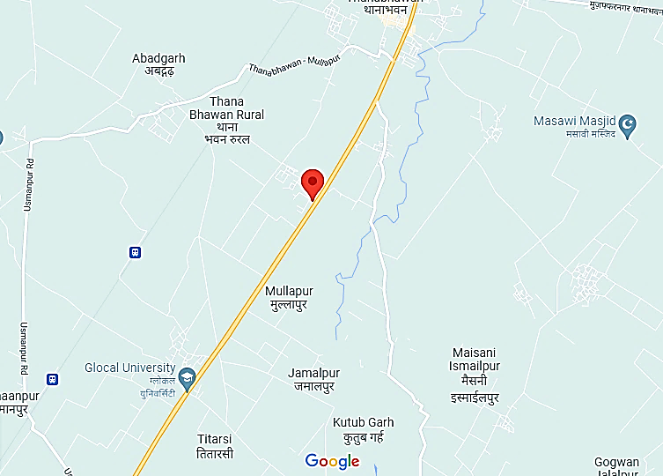
- PRODUCTION DETAILS: Below table shows the details of sugar production in last 5 years’ for Thanbhawan Plant:
Particular | Unit | FY 2017 | FY 2018 | FY 2019 | FY 2020 | FY 2021 | FY 2022
Crushing capacity | QCD | 90,000 | 90,000 | 90,000 | 90,000 | 90,000 | 90,000
Number of operational days | Days | 149 | 166 | 194 | 191 | 211 | 176
Total crushing capacity | Lac Qtl. | 1,34,10,000 | 1,49,40,000 | 1,74,60,000 | 1,71,90,000 | 1,89,90,000 | 1,58,40,000
Cane actually crushed | Qtl. | 1,02,40,400 | 1,24,45,265 | 1,42,47,414 | 1,37,97,649 | 1,55,77,834 | 1,29,38,682
Capacity utilization |  | 76.4% | 83.3% | 81.6% | 80.3% | 82.03% | 81.68%

Below table shows the details of Power Plant production:
S. No. | Particular | FY 2021 | FY 2022
1. | Installed Capacity (MW) | 34 | 34
2. | Power Generation (Lakh KWH) | 882.67 | 715.58
- MAQSOODPUR (SHAHJANPUR) PLANT
- Google Map Location: Project is located at 28°14'46.6"N 79°59'51.6"E in Shahjanpur district in the state of Uttar Pradesh and the location as per the Google map has been shown below:
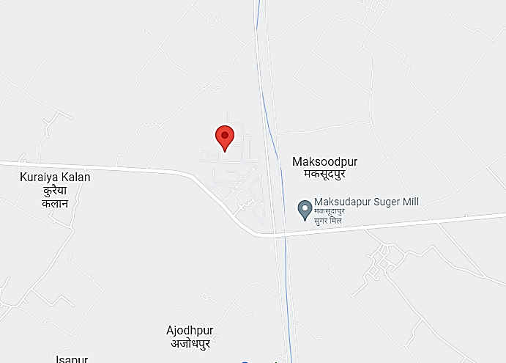
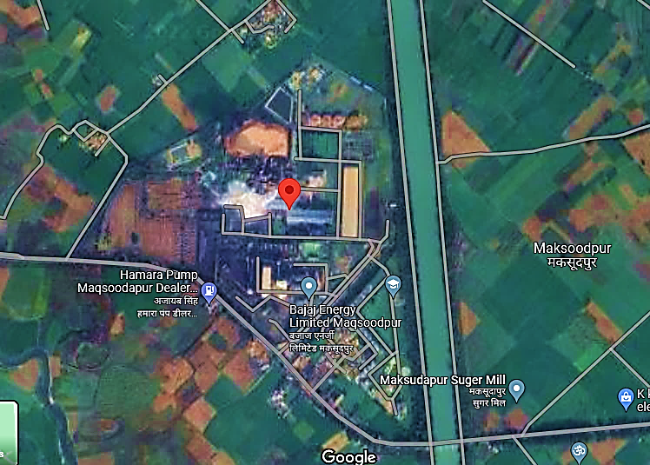
- PRODUCTION DETAILS: Below table shows the details of sugar production in last 5 years’ for Maqsoodpur Plant:
Particular | Unit | FY 2017 | FY 2018 | FY 2019 | FY 2020 | FY 2021 | FY 2022
Crushing capacity | QCD | 70,000 | 70,000 | 70,000 | 70,000 | 70,000 | 70,000
Number of operational days | Days | 128 | 146 | 217 | 161 | 138 | 106
Total crushing capacity | Lac Qtl. | 89,60,000 | 1,02,20,000 | 1,51,90,000 | 1,12,70,000 | 96,60,000 | 74,20,000
Cane actually crushed | Qtl. | 68,26,140 | 82,73,700 | 1,12,11,484 | 88,40,758 | 73,12,610 | 58,25,839
Capacity utilization |  | 76.2% | 81.0% | 73.8% | 78.4% | 75.70% | 78.52%

Below table shows the details of Power Plant production:
S. No. | Particular | FY 2021 | FY 2022
1. | Installed Capacity (MW) | 28 | 28
2. | Power Generation (Lakh KWH) | 385.99 | 287.21
- BUDHANA (MUJAFFARNAGAR) PLANT
- Google Map Location: Project is located at 29°17'25.9"N 77°29'49.4"E in Budhana, Mujaffarnagar district in the state of Uttar Pradesh and the location as per the Google map has been shown below:
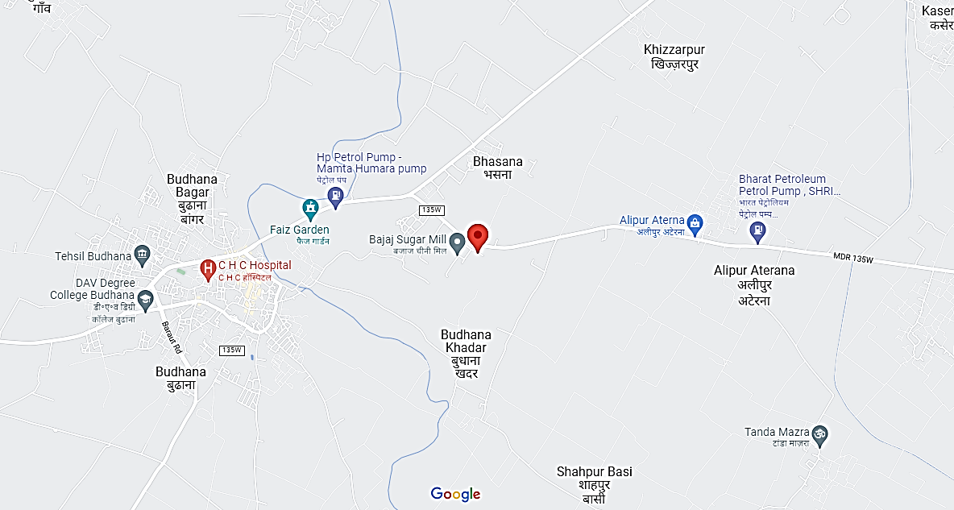
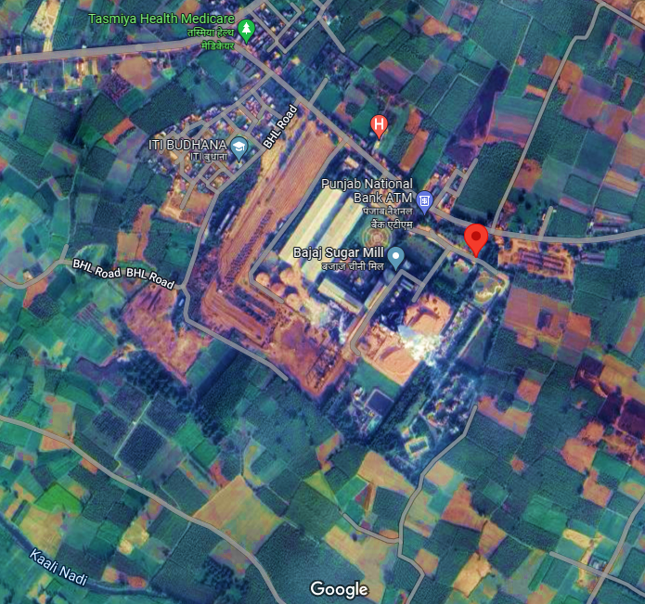
- PRODUCTION DETAILS: Below table shows the details of sugar production in last 5 years’ for Budhana Plant:
Particular | Unit | FY 2017 | FY 2018 | FY 2019 | FY 2020 | FY 2021 | FY 2022
Crushing capacity | QCD | 90,000 | 90,000 | 90,000 | 90,000 | 90,000 | 90,000
Number of operational days | Days | 155 | 171 | 183 | 190 | 205 | 175
Total crushing capacity | Lac Qtl. | 1,39,50,000 | 1,53,90,000 | 1,64,70,000 | 1,71,00,000 | 1,84,50,000 | 1,57,50,000
Cane actually crushed | Qtl. | 1,20,64,195 | 1,35,19,199 | 1,38,46,834 | 1,39,62,477 | 1,49,02,456 | 1,33,90,909
Capacity utilization |  | 86.5% | 87.8% | 84.1% | 81.7% | 80.77% | 85.02%

Below table shows the details of Power Plant production:
S. No. | Particular | FY 2021 | FY 2022
1. | Installed Capacity (MW) | 33 | 33
2. | Power Generation (Lakh KWH) | 670.12 | 700.19

- KAMBHARKHERA (SADAR LAKHIMPUR KHIRI) PLANT
- Google Map Location: Project is located at 28°01'02.2"N 80°49'41.2"E in Sadar Lakhimpur Khiri district in the state of Uttar Pradesh and the location as per the Google map has been shown below:
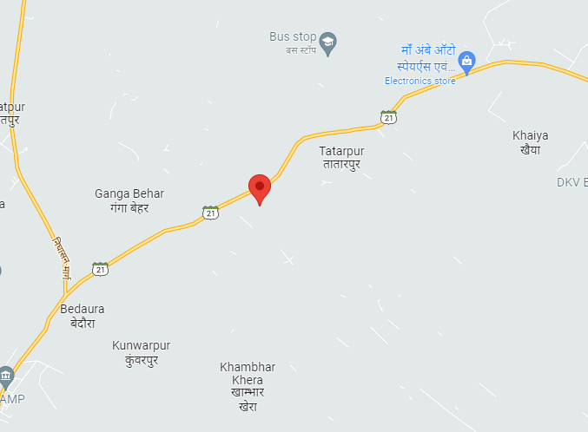
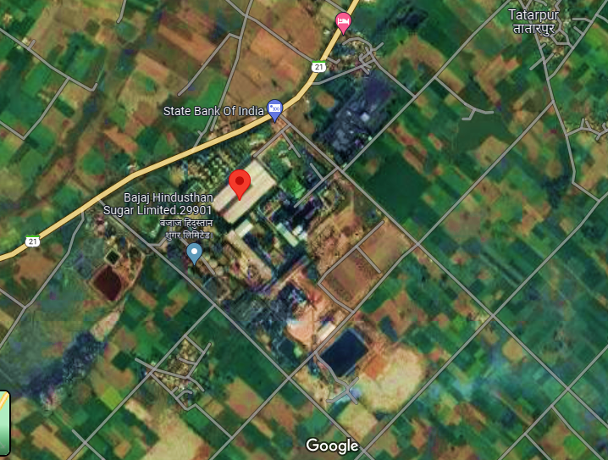
- PRODUCTION DETAILS: Below table shows the details of sugar production in last 5 years’ for Khambarkhera Plant:
Particular | Unit | FY 2017 | FY 2018 | FY 2019 | FY 2020 | FY 2021 | FY 2022
Crushing capacity | QCD | 1,00,000 | 1,00,000 | 1,00,000 | 1,00,000 | 1,00,000 | 1,00,000
Number of operational days | Days | 145 | 146 | 188 | 182 | 169 | 113
Total crushing capacity | Lac Qtl. | 1,45,00,000 | 1,46,00,000 | 1,88,00,000 | 1,82,00,000 | 1,69,00,000 | 1,13,00,000
Cane actually crushed | Qtl. | 1,19,20,295 | 1,21,57,500 | 1,43,35,955 | 1,42,40,574 | 1,27,82,520 | 86,51,379
Capacity utilization |  | 82.2% | 83.3% | 76.3% | 78.2% | 75.64% | 76.56%

Below table shows the details of distillery production:
S. No. | Particular | FY 2021 | FY 2022
1. | Installed Capacity (KLPD) | 160 | 160
2. | Ethanol Produced (Lakh Barrel) | 187.52 | 362.27
Below table shows the details of Power Plant production:
S. No. | Particular | FY 2021 | FY 2022
1. | Installed Capacity (MW) | 35 | 35
2. | Power Generation (Lakh KWH) | 506.43 | 475.33
- BARKHERA (PILIBHIT) PLANT
- Google Map Location: Project is located at 28°28'08.5"N 79°48'19.0"E in Barkhera district Pilibhit in the state of Uttar Pradesh and the location as per the Google map has been shown below:
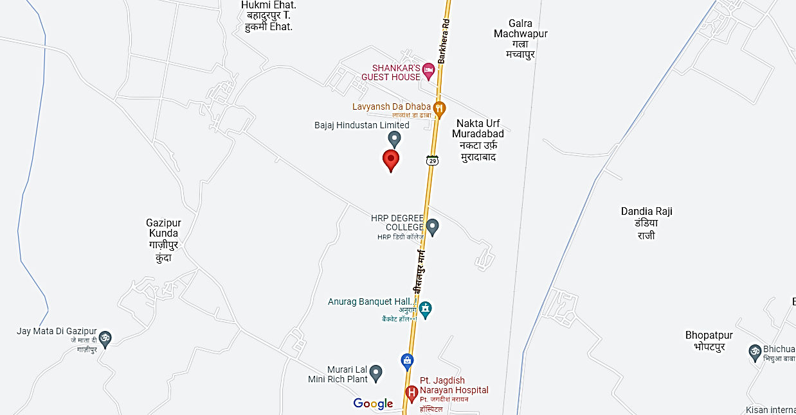
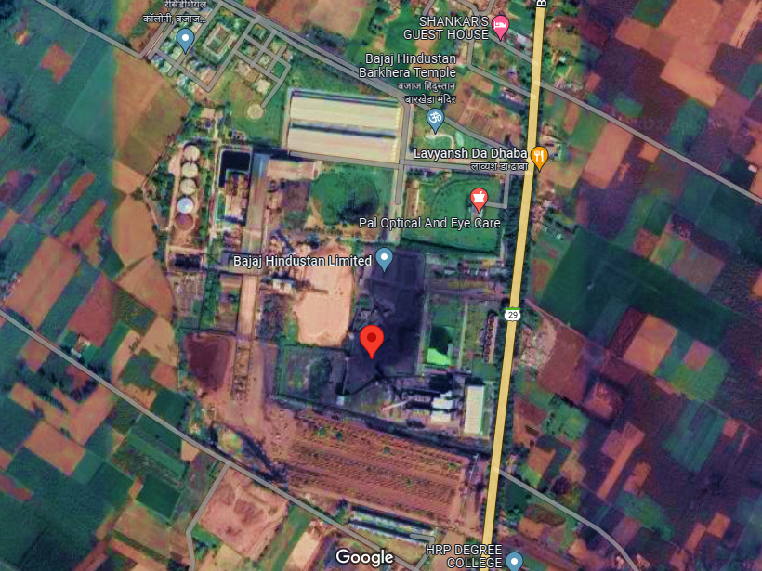
- PRODUCTION DETAILS: Below table shows the details of sugar production in last 5 years’ for Barkhera Plant:
Particular | Unit | FY 2017 | FY 2018 | FY 2019 | FY 2020 | FY 2021 | FY 2022
Crushing capacity | QCD | 70,000 | 70,000 | 70,000 | 70,000 | 70,000 | 70,000
Number of operational days | Days | 119 | 146 | 169 | 156 | 167 | 141
Total crushing capacity | Lac Qtl. | 83,30,000 | 1,02,20,000 | 1,18,30,000 | 1,09,20,000 | 1,16,90,000 | 98,70,000
Cane actually crushed | Qtl. | 71,11,957 | 93,92,300 | 1,05,18,215 | 97,80,643 | 1,05,94,653 | 88,20,651
Capacity utilization |  | 85.4% | 91.9% | 88.9% | 89.6% | 90.63% | 89.37%

Below table shows the details of Power Plant production:
S. No. | Particular | FY 2021 | FY 2022
1. | Installed Capacity (MW) | 34 | 34
2. | Power Generation (Lakh KWH) | 417.66 | 349.68
- KINAUNI (MEERUT) PLANT
- Google Map Location: Project is located at 29°02'57.4"N 77°28'02.4"E in Kinauni district Meerut in the state of Uttar Pradesh and the location as per the Google map has been shown below:
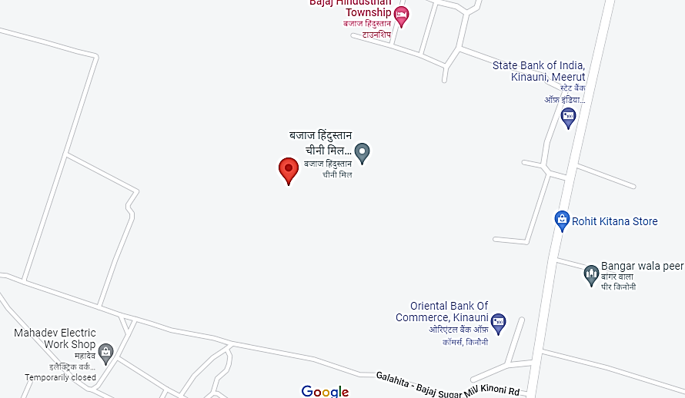
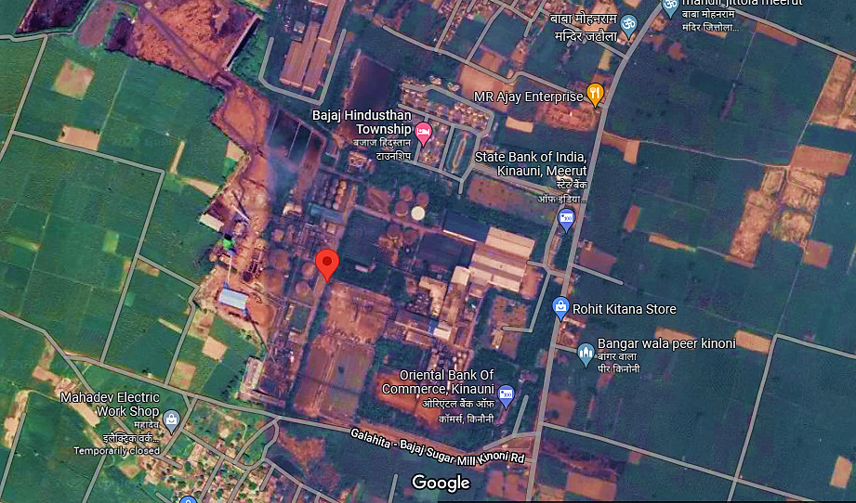
- PRODUCTION DETAILS: Below table shows the details of sugar production in last 5 years’ for Kinauni Plant:
Particular | Unit | FY 2017 | FY 2018 | FY 2019 | FY 2020 | FY 2021 | FY 2022
Crushing capacity | QCD | 1,20,000 | 1,20,000 | 1,20,000 | 1,20,000 | 1,20,000 | 1,20,000
Number of operational days | Days | 148 | 161 | 183 | 178 | 194 | 185
Total crushing capacity | Lac Qtl. | 1,77,60,000 | 1,93,20,000 | 2,19,60,000 | 2,13,60,000 | 2,32,80,000 | 2,22,00,000
Cane actually crushed | Qtl. | 1,33,28,500 | 1,54,72,134 | 1,74,77,326 | 1,71,53,322 | 1,87,52,138 | 1,79,17,690
Capacity utilization |  | 75.0% | 80.1% | 79.6% | 80.3% | 80.55% | 80.71%

Below table shows the details of distillery production:
S. No. | Particular | FY 2021 | FY 2022
 | Installed Capacity (KLPD) | 160 | 160
 | Ethanol Produced (Lakh Barrel) | 166.47 | 368.68

Below table shows the details of Power Plant production:
S. No. | Particular | FY 2021 | FY 2022
 | Installed Capacity (MW) | 12 | 12
 | Power Generation (Lakh KWH) | 990.84 | 1,008.93

PART F | TECHNICAL ASSESSMENT OF THE COMPANY

- PLANTS CAPACITY, TYPE & CONFIGURATION:
Particulars | UOM | GOL | PAL | KIN | THB | BDN | BIL | GNL
Name of Unit | Unit | GOLA | PALIA KALAN | KINAUNI | THANABHAWAN | BUDHANA | BILAI | GAGNAULI
Year of establishment | Year | 1931-32 | 1972 | 2004 | 2004 | 2004 | 2005-06 | 2006-07
Name of Product | Product | Sugar, Molasses, Bagasse, Power & Distillery | Sugar, Molasses, Bagasse, Power, Distillery & Board | Sugar, Molasses, Bagasse, Power, Distillery & Board | Sugar, Molasses, Bagasse & Power | Sugar, Molasses, Bagasse & Power | Sugar, Molasses, Bagasse & Power | Sugar, Molasses, Bagasse, Power & Distillery
Sugar Plant capacity | TCD | 13,000 | 11,000 | 12,000 | 9,000 | 9,000 | 9,000 | 9,000
Distillery Plant Capacity | KLPD | 100 | 60 | 160 | - | - | - | 160
Co-generation Capacity |  | 29 | 43 | 38 | 34 | 33 | 24 | 25
Cogen(Power) Sale Capacity | MW | - | 12 | 10 | 10 | 20 | 10 | 10
Boiler Nos & Capacity | TPH | 330 | 295 | 290 | 180 | 270 | 180 | 216
 |  | 100 TPH Make Thermax | 70 TPH WIL Make | 80 TPH ISGEC Make | (90 TPH S.S.makeX 2 Nos ) | (90 TPH S.S.makeX 2 Nos ) | 90 TPH SS Make | 90 TPH WIL Make
 |  | 80 TPH Make WIL | 70 TPH WIL Make | 40TPH ISGEC Make |  | (90 TPH WIL 1No) | 90 TPH SS Make | 90 TPH WIL Make
 |  | 70 TPH Make LIPI | 80 TPH THERMAX Make | 40PH TEXMACO Make |  |  |  | 36 TPH SS Make
 |  | 50 TPH Make BACKAU Wolf | 50 TPH TEXMACO Make | 90 TPH WIL Make
 |  | 30 TPH Make TAXMACO | 25 TPH TEXMACO Make | 40 TPH WIL Make( Distillery Div)
Turbine Nos & capacity | MW | 29.96 | 43.1 | 41.22 | 33.56 | 32 | 23.56 | 25
 |  | (3 MW x 4 make Triveni) | (3 MW x 6 make Triveni) | (3 MW X 4 Nos)+(6 MW X 1 No) for Captive Use | 10 MW make Kessels | (12 MWx1 No.) for Power Sale Triveni make | 10 MW make Triveni | (10 MW X 1 No) for Captive Use & Power Sale to UPPCL
 |  | (2.5 MW x 1 make Triveni) | (2.5 MW x 1 make Triveni) | (10 MW X 1 No) for Power Sale to UPPCL | 10 MW make Triveni | (10 MWx1No.)+ (5MWx1No.) for Captive Use Triveni Make | 10 MW make Belliss | (3 MW X 2 nos) for Distillery Captive Use
 |  | (1.2 MW x 1 make Brown Boveri) | (1 MW x 1 make Triveni) | (3 MW X 1 nos) for Distillery Captive Use | 10 MW make Belliss | 5 MW make Kessels | 3 MW make Belliss | (4 MW X1 nos) +(1 MW X 5 Nos) Drive Turbine
 |  | (3 MW x 1 make DLF) | (12 MW x 1 make Triveni) | (4 MW X1 nos) +(2.7 Mw X 1 Nos) Drive Turbine | 3 MW make Belliss |  | 0.56 MW make Belliss
 |  | (3 MW x 1 make TEW) | (1.2 MW x 1 make Triveni) | (2.5 MW X1 nos) Back Pressure make Triveni | 0.56 MW make Belliss
 |  | (1.35 MW x 3 make TEW) | (0.85 MW x 4 make Triveni) | (0.64 MW X1 nos) +(0.38 Mw X 1 Nos) Drive Turbine
 |  | (0.75 MW x 2 make Belliss) | (4 MW x 1 make Belliss)
 |  | (0.34 MW x 5 make Belliss) | (0.5 MW x 2 make Belliss)
 |  | (1.01 MW x 1 make Belliss)

Particulars | UOM | KKH | BRK | MQR | PTP | RDL | UTR | KDK
Name of Unit | Unit | KHAMBARKHERA | BARKHERA | MAQSOODAPUR | PRATAPPUR | RUDAULI | UTRAULA | KUNDARKHI
Year of establishment | Year | 2006-07 | 2006-07 | 2007-08 | 1903 | 2007 | 2007-08 | 2007-08
Name of Product | Product | Sugar, Molasses, Bagasse, Power & Distillery | Sugar, Molasses, Bagasse & Power | Sugar, Molasses, Bagasse & Power | Sugar, Molasses, Bagasse & Power | Sugar, Molasses, Bagasse, Power & Distillery | Sugar, Molasses, Bagasse & Power | Sugar, Molasses, Bagasse, Power & Board
Sugar Plant capacity | TCD | 10,000 | 7,000 | 7,000 | 6,000 | 7,000 | 12,000 | 15,000
Distillery Plant Capacity | KLPD | 160 | - | - | - | 160 | - | -
Co-generation Capacity |  | 35 | 34 | 28 | 13 | 17 | 37 | 59
Cogen(Power) Sale Capacity | MW | 12 | 12 | 12 | - | - | 13 | 30
Boiler Nos & Capacity | TPH | 270 | 180 | 180 | 137 | 270 | 270 | 360
 |  | 90TPH x 3 | 90 TPH IJT Make | 90 TPH each WIL make | 75 TPH Siston | 90TPH x 2 WIL | 90 TPH IJT Make | 90TPH x 4 ISGEC
 |  |  | 90 TPH IJT Make | 90 TPH each WIL make | 32 TPH Lipi | 30TPH x 1 SS Eng | 90 TPH IJT Make
 |  |  |  |  | 30 TPH Lipi | 60TPH x 1 ISGEC | 90 TPH IJT Make
Turbine Nos & capacity | MW | 35 | 33.37 | 28.64 | 13.31 | 16.64 | 36.64 | 56.28
 |  | 12 MW Triveni Make | (3 MW X 1 Nos)+(10 MW X 1 No) for Captive Use | 15 MW (Extraction cum condensing), Triveni make, Co-gen Purpose | (3 MW x 2 make Belliss) | 10 MW make Triveni | 3 MW x 2 Triveni Make for Captive Use | (15 MW x 3 make Triveni)
 |  | 10 MW Bellis Make | (12 MW X 1 No) for Power Sale to UPPCL | 10 MW (Back pressure type), Triveni Make | (2 MW x 1 make Triveni) | 3 MW make Triveni | 15 MW Triveni Make for Captive Use | (10 MW x 1 make Triveni)
 |  | 3 MW Bellis Make | (4 MW X 1 nos.) + (0.746Mw X 5Nos) Drive Turbine for mill operation | 3 MW (Back pressure type), Triveni Make | 5.31 MW Drive Turbine | 3 MW make Balliss | 15 MW Triveni Make for Power Sale to UPPCL | 0.64 MWx2 make Balliss
 |  | 6 MW Mill Drive Turbine(Total 5 Nos Turbine 1.2 MW Each) | (0.64 MW X 1No.)for Boiler feed water pump | 0.64 MW (Turbo Feed Pump), Belliss Make |  | 0.64 MW make Balliss | 0.64 MW make Balliss
 |  | 4 MW FibrizerTurbine

Gola
BOILER |  |  |  | Turbine
Make | TPH | Pressure | Temprature | Make | Power MW | Pressure | Type
Thermax | 100 | 45 | 430±5 | Triveni | 3.00 | 42 | Back Pressure
WIL | 80 | 45 | 425±5 | Triveni | 3.00 | 40 | Back Pressure
LIPPI | 70 | 32 | 385±5 | Triveni | 3.00 | 42 | Back Pressure
B&W | 50 | 21 | 350±5 | Triveni | 3.00 | 32/21 | Back Pressure
TEXMACO | 30 | 21 | 315±5 | DLF | 3.00 | 42 | Back Pressure
 |  |  |  | Triveni | 2.50 | 21 | Back Presure
 |  |  |  | ABB | 1.20 | 10.5 | Back Pressure
 |  |  |  | Triveni | 3.00 | 42 | Back Pressure
Sub Total |  |  |  |  | 21.70
 |  |  |  | Mill & Fibrizer Etc | 8.26
Total | 330 |  |  |  | 29.96

Palia
BOILER |  |  |  | Turbine
Make | TPH | Pressure |  | Make | Power MW | Pressure | Type
WIL | 70 | 43 | 410±5 | Triveni | 3.00 | 38 | Back Pressure
WIL | 70 | 45 | 410±5 | Triveni | 3.00 | 38 | Back Pressure
Thermax | 80 | 45 | 420±5 | Triveni | 3.00 | 42 | Back Pressure
TEXMACO | 50 | 45 | 425±5 | Triveni | 3.00 | 42 | Back Pressure
TEXMACO | 25 | 21 | 310 | Triveni | 2.50 | 21 | Back Pressure
 |  |  |  | Triveni | 1.00 | 21 | Back Pressure
 |  |  |  | Triveni | 12.00 | 43 | Back Pressure
 |  |  |  | Triveni | 3.00 | 40 | Back Pressure
Sub Total |  |  |  |  | 30.50
 |  |  |  | Mill & Fibrizer Etc | 12.60
Total | 295 |  |  |  | 43.10

KKH
BOILER |  |  |  | Turbine
Make | TPH | Pressure | Temp | Make | Power MW | Pressure | Type
IJT | 90 | 45 | 425±5 | BELIIS | 10.00 | 45 | Back Pressure
IJT | 90 | 45 | 425±5 | Triveni | 12.00 | 42 | Condensing cum Extraction
IJT | 90 | 45 | 425±5 | Bellis | 3.00 | 45 | Back Pressure
Sub |  |  |  |  | 25.00
 |  |  |  | Mill & Fibrizer Etc | 10.00
Total | 270 |  |  |  | 35.00

BRK
BOILER |  |  |  | Turbine
Make | TPH | Pressure | Temp | Make | Power MW | Pressure | Type
IJT | 90 | 45 | 425±5 | BELIIS | 3 | 45 | Back Pressure
IJT | 90 | 45 | 425±5 | Triveni | 10 | 45 | Back Pressure
 |  |  |  | Triveni | 12 | 45 | Condensing cum Extraction
Sub |  |  |  |  | 25
 |  |  |  | Mill & Fibrizer Etc | 8.37
Total | 180 |  |  |  | 33.37

MQR
BOILER |  |  |  | Turbine
Make | TPH | Pressure | Temp | Make | Power MW | Pressure | Type
WIL | 90 | 45 | 430±5 | BELIIS | 3 | 45 | Back Pressure
WIL | 90 | 45 | 430±5 | Triveni | 10 | 45 | Back Pressure
 |  |  |  | Triveni | 15 | 45 | Condensing cum Extraction
Sub |  |  |  |  | 28
 |  |  |  | Mill & Fibrizer Etc | 0.64
Total | 180 |  |  |  | 28.64

KIN
BOILER |  |  |  | Turbine
Make | TPH | Pressure | Temp | Make | Power MW | Pressure | Type
IJT | 80 | 45 | 430 | Belliss (HES-14) | 3.00 | 42 | Back pressure
IJT | 40 | 45 | 430 | Belliss (HES-14) | 3.00 | 42 | Back pressure
TEXMECO | 40 | 21 | 430 | Belliss (HES-14) | 3.00 | 42 | Back pressure
WIL | 90 | 45 | 320 | Belliss (BD-2) | 3.00 | 20 | Back pressure
wil | 40 | 45 | 430 | Belliss (SBP-450) | 6.00 | 42 | Back pressure
 |  |  |  | Belliss (SBP-560) | 10.00 | 42 | Back pressure
 |  |  |  | Triveni | 2.50 | 42 | Back pressure
 |  |  |  | Triveni | 3.00 | 42 | Back pressure
 |  |  |  | Sub Total: | 33.50
 |  |  |  | Mill & Fibrizer Etc | 7.72
Total | 290 |  |  |  | 41.22

THB
BOILER |  |  |  | Turbine
Make | TPH | Pressure | Temp | Make | Power MW | Pressure | Type
SS | 90 | 45 | 440±5 °C | KESSEL (TG1) | 10 | 45 | Back Pressure
SS | 90 | 45 | 440±5 °C | BELLISS (TG2) | 10 | 45 | Back Pressure
 |  |  |  | TRIVENI (TG3) | 10 | 42 | Back Pressure
 |  |  |  | TRIVENI (TG4) | 3 | 45 | Back Pressure
 |  |  |  | Sub Total: | 33
 |  |  |  | Mill & Fibrizer Etc | 0.56
Total | 180 |  |  |  | 33.56

BDN
BOILER |  |  |  | Turbine
Make | TPH | Pressure | Temp | Make | Power MW | Pressure | Type
SS | 90 | 45 | 430 | TRIVENI (TG1) | 5 | 43 | Back Pressure
SS | 90 | 45 | 430 | TRIVENI (TG2) | 10 | 43 | Back Pressure
WIL | 90 | 45 | 430 | TRIVENI (TG3) | 12 | 43 | Back Pressure
 |  |  |  | Kessel | 5 | 43 | Back Pressure
Total | 270 |  |  |  | 32

Bilai
BOILER |  |  |  | Turbine
Make | TPH | Pressure | Temp | Make | Power MW | Pressure | Type
SS | 90 | 45 | 440°C | TRIVENI (TG1) | 10 | 42 | Back Pressure
SS | 90 | 45 | 440°C | BELLIS (TG2) | 10 | 42 | Back Pressure
 |  |  |  | BELLIS (TG3) | 3 | 42 | Back Pressure
 |  |  |  | Sub Total: | 23
 |  |  |  | Mill & Fibrizer Etc | 0.56
 | 180 |  |  | Total | 23.56

GNL
BOILER |  |  |  | Turbine
Make | TPH | Pressure | Temp | Make | Power MW | Pressure | Type
WIL | 90 | 45 | 430 | Belliss | 10 | 45 | Back Pressure
WIL | 90 | 45 | 430 | BELLIS (TG1) | 3.00 | 45 | Back Pressure
SSK | 36 | 45 | 420 | BELLIS (TG2) | 3.00 | 45 | Back Pressure
 |  |  |  | Sub Total: | 16.00
 |  |  |  | Mill & Fibrizer Etc | 9.00
 | 216 |  |  | Total | 25.00

PTP
Boiler |  |  |  | Turbine
Make | TPH | Pressure | Temp | Make | Power MW | Pressure | Type
Sitson | 75 | 45 | 420+/-5deg.cent | Bellis | 3 | 45 | Back Pressure
New LIPi | 32 | 32 | 370 +/-5 deg.cent | Bellis | 3 | 32 | Back Pressure
Old Lipi | 30 | 32 | 370 +/-5deg.cent | Triveni | 2 | 32 | Back Pressure
 |  |  |  | Sub Total: | 8
 |  |  |  | Mill & Fibrizer Etc | 5.31
 | 137 |  |  | Total | 13.31

RDL
Boiler |  |  |  |  |  | Turbine
Make | TPH | Pressure | Temp |  |  | Make | Power MW |  | Pressure |  | Type
Walchand | 90 | 45 | 430+/-5 Deg C |  |  | Triveni | 10 |  | 43 |  | Back Pressure
Walchand | 90 | 45 | 430+/-5 Deg C |  |  | Triveni | 3 |  | 43 |  | Back Pressure
ISGEC | 60 | 45 | 400+/-10 Deg C |  |  | Bellis | 3 |  | 40 |  | Back Pressure
SS Eng | 30 | 45 | 400+/-5 Deg C |  |  | Sub Total: | 16
 |  |  |  |  |  | Mill & Fibrizer Etc | 0.64
 | 270 |  |  |  |  | Total | 16.64
UTR
Boiler |  |  |  |  | Turbine
Make | TPH | Pressure |  | Temp | Make |  |  | Power MW |  | Pressure |  | Type
IJT | 90 | 45 |  | 425 +/-5Deg C | Triveni |  |  | 3 |  | 42 |  | Back Pressure
IJT | 90 | 45 |  | 425+/-5 Deg C | Triveni |  |  | 15 |  | 42 |  | Back Pressure
IJT | 90 | 45 |  | 425 +/-5Deg C | Triveni |  |  | 15 |  | 43 |  | Extraction-cum-Condensing
 |  |  |  |  | Sub Total: |  |  | 33
 |  |  |  |  | Mill & Fibrizer Etc |  |  | 3.64
 | 270 |  |  |  | Total |  |  | 36.64

KDK
Boiler |  |  |  | Turbine
Make | TPH | Pressure | Temp | Make | Power MW | Pressure | Type
IJT | 90 | 45 | 425 +/-5 Deg C | Triveni | 15 | 45 | Extraction-cum-Condensing
IJT | 90 | 45 | 425 +/-5 Deg C | Triveni | 15 | 45 | Extraction-cum-Condensing
IJT | 90 | 45 | 425 +/-5 Deg C | Triveni | 15 | 45 | Back Pressure
IJT | 90 | 45 | 425 +/-5 Deg C | Triveni | 10 | 45 | Back Pressure
 |  |  |  | Sub Total: | 55
 |  |  |  | Mill & Fibrizer Etc | 1.28
 | 360 |  |  | Total | 56.28
As per information provided by the client/company, unitwise details of Capcity, Pressure, Temperature, Manufacturer and Use of Boilers and Turbines have been shown in the above tables. It can be observed that majority of the core equipment like Mills, Boilers and Turbines have been supplied by market leaders like Thermax, Bukau Wolf, Triveni and Uttam, IJT, SS Eng, WIL, SS etc.
- SUGAR CO-GENERATION MANUFACTURING PROCESS: Below picture shows the flow chart of manufacturing process of M/s BHSL:
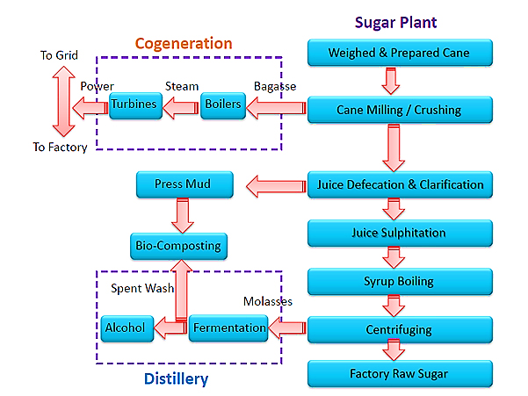

- PLANTS OPERATIONAL PARAMETERS: The Company’s manufacturing capacities include largest cane crushing capacity with 14 sugar mills (1,36,000 TCD), largest distillation capacity with 6 distilleries (800 KLPD) and 14 bagasse based co-generation plants (449 MW). The historical operational performance of the Company for past few years is presented below:
Particulars | Unit | FY19 | FY20 | FY21 | FY22
Sugar unit
Cane crushing | Lakh Qtl. | 1,676.16 | 1,584.60 | 1,560.34 | 1,258.92
Capacity utilization |  | 74.26% | 73.50% | 76.12% | 72.74%
Sugar recovery | % | 11.40% | 11.65% | 11.06% | 10.36%
Sugar production | Lakh Qtl. | 191.01 | 184.35 | 173.78 | 128.59
Units of sugar sold | Lakh Qtl. | 195.32 | 187.04 | 185.27 | 130.53
Distillery unit
Molasses C consumed | Lakh Qtl. | 47.88 | 24.72 | 27.83 | 27.62
Industrial alcohol produced from Molasses C | Lakh BL | 1,077.24 | 572.21 | 615.68 | 591.42
Molasses B consumed | Lakh Qtl. | - | - | 10.08 | 34.05
Industrial alcohol produced from Molasses B | Lakh BL | - | - | 293.35 | 1,014.39
Industrial alcohol produced from Syrup | Lakh BL | - | - | - | 126.80
Capacity utilization |  | 89.77% | 47.68% | 75.75% | 69.86%
Units of industrial alcohol sold | Lakh BL | 1,248.41 | 621.74 | 843.01 | 1,754.80
Power unit
Units of power generated | Lakh kWh | 9,494.21 | 7,805.22 | 7,514.31 | 6,439.61
Units of power available for sale | Lakh kWh | 3,389.00 | 2,179.40 | 1,866.64 | 1,459.67
- Sugar recovery was lower by 0.70% in FY22 as compared to FY21 mainly due to diversion of sugarcane for manufacturing of ethanol / industrial alcohol through B heavy Molasses and lower ‘pol in cane’ due to inclement weather conditions.
- Lower quantity of cane crushed and lower sugar recovery during FY22 led to decrease in sugar production. There has been corresponding increase in ethanol / industrial alcohol production in FY22 by 824 lakh BL.
- The increase is mainly due to shifting the ethanol / industrial alcohol production from C molasses to B heavy molasses. The Company incurred major maintenance expenditure in FY21 and FY22 for preventing breakdowns in sugar mills and distillery units and, refurbished distillery units so as to make them well equipped to function for 300-330 days to optimally utilize the installed capacity. Generation and sale of power during FY22 was affected due to lower cane crushing in the year. Below table shows the analysis of unit wise power usage of per cane crushed from Oct, 2021 to May, 2022:
Power Export from Oct 2021 to May 2022
Unit | Cane Crushed  (Ton) | Power generated  (KWH) | Power Exported  (KWH) | Difference  (KWH) | Percentage Used | Steam Produced  (MT) | Power usage per cane crushed
Gola | 13,74,389 | 3,87,70,860 | - | 3,87,70,860 | 100% | 7,97,014.01 | 28.21
Palia | 10,84,264 | 4,16,06,708 | 24,21,725 | 3,91,84,983 | 94% | 6,51,065.60 | 36.14
Kin | 17,36,057 | 9,38,98,540 | 2,27,36,050 | 7,11,62,490 | 76% | 11,56,005.00 | 40.99
THB | 12,70,793 | 7,04,74,820 | 2,78,51,450 | 4,26,23,370 | 60% | 5,99,074.00 | 33.54
BDN | 12,64,718 | 6,51,03,180 | 2,04,10,675 | 4,46,92,505 | 69% | 6,23,575.00 | 35.34
Bilai | 13,51,475 | 7,74,85,360 | 2,95,89,963 | 4,78,95,398 | 62% | 6,82,107.00 | 35.44
GNL | 10,40,083 | 4,10,94,245 | 400 | 4,10,93,845 | 100% | 7,44,318.00 | 39.51
KKH | 8,65,133 | 3,91,19,540 | 8,34,575 | 3,82,84,965 | 98% | 5,92,120.00 | 44.25
BRK | 8,91,340 | 3,49,37,500 | 79,19,775 | 2,70,17,725 | 77% | 4,71,840.00 | 30.31
MQR | 5,82,577 | 2,77,87,760 | 67,66,325 | 2,10,21,435 | 76% | 2,69,640.00 | 36.08
PTP | 1,13,006 | 41,93,220 | - | 41,93,220 | 100% | 85,453.00 | 37.11
RDL | 1,80,808 | 2,07,42,067 | - | 2,07,42,067 | 100% | 3,29,622.80 | 114.72
UTROLA | 3,19,687 | 2,49,43,000 | 50,95,970 | 1,98,47,030 | 80% | 2,12,356.74 | 62.08
KDK | 6,49,501 | 4,66,77,400 | 1,86,83,375 | 2,79,94,025 | 60% | 3,43,442.50 | 43.10
Total | 1,27,23,830 | 62,68,34,200 | 14,23,10,283 | 48,45,23,918 | 82% | 75,57,633.65

Particulars | UOM | GOL | PAL | KIN | THB | BDN | BLI | GNL
Cane Crushed - Total | Qtl. | 1,37,43,895 | 1,08,42,636 | 1,73,60,566 | 1,27,07,931 | 1,26,47,176 | 1,35,14,748 | 1,04,00,832
Cane Crushed - Total | Kg | 1,37,43,89,472 | 1,08,42,63,568 | 1,73,60,56,565 | 1,27,07,93,134 | 1,26,47,17,624 | 1,35,14,74,847 | 1,04,00,83,181
Cane Crushed - Total | Ton | 13,74,389 | 10,84,264 | 17,36,057 | 12,70,793 | 12,64,718 | 13,51,475 | 10,40,083
Capacity Utilization | % | 75.52% | 80.79% | 79.93% | 83.06% | 86.21% | 82.96% | 70.47%
Capacity Utilization | % | 87% | 80.79% | 80% | 77% | N/A | N/A | N/A
Bagasse Production | KG | 36,87,96,472 | 29,67,41,600 | 46,97,18,365 | 33,82,54,134 | 33,84,77,624 | 37,57,28,651 | 28,11,60,411
Bagasse Production per kg of cane crushed |  | 268 | 274 | 271 | 266 | 268 | 278 | 270
Power Generation Per Tons Cane Crushed |  | 29 | 38 | 55 | 55 | 51 | 57 | 42
KHW/Qtl Bagasse |  | 10.92 | 14.02 | 20.29 | 20.83 | 19.23 | 20.62 | 15.36
Cogen (Power) Sale Capacity | MW | - | 12 | 10 | 10 | 20 | 10 | 10
Cogen(Power) Sale Capacity | KW | - | 12,000 | 10,000 | 10,000 | 20,000 | 10,000 | 10,000
Steam production during last crushing season | MT | 7,97,014 | 6,51,066 | 11,56,005 | 5,99,074 | 6,23,575 | 6,82,107 | 7,44,318
Steam production during last crushing season | KG | 79,70,14,010 | 65,10,65,600 | 1,15,60,05,000 | 59,90,74,000 | 62,35,75,000 | 68,21,07,000 | 74,43,18,000
Steam produced against cane crushed during last crushing season | kg/ton | 579.90 | 600.47 | 665.88 | 471.42 | 493.05 | 504.71 | 715.63
Steam produced against bagasse production during last crushing season | KG | 2.16 | 2.19 | 2.46 | 1.77 | 1.84 | 1.82 | 2.65
Steam produced per hour during last crushing season |  | 237.21 | 222.36 | 266.12 | 146.83 | 159.40 | 157.02 | 189.11

Particulars | UOM | KKH | BRK | MQR | PTP | RDL | UTR | KDK
Cane Crushed - Total | Qtl. | 86,51,329 | 89,13,400 | 58,25,770 | 11,30,063 | 18,08,075 | 31,96,872 | 64,95,005
Cane Crushed - Total | Kg | 86,51,32,860 | 89,13,40,002 | 58,25,77,035 | 11,30,06,327 | 18,08,07,500 | 31,96,87,200 | 64,95,00,500
Cane Crushed - Total | Ton | 8,65,133 | 8,91,340 | 5,82,577 | 1,13,006 | 1,80,808 | 3,19,687 | 6,49,501
Capacity Utilization | % | 76.56% | 88.43% | 78.51% | 34.24% | 29.69% | 33.30% | 51.55%
Capacity Utilization | % | 76.56% | 89.53% | 78.51% | 80% | 80% | N/A | N/A
Bagasse Production | Total in Qtl. | 23,02,129 | 25,22,000 | 15,53,330 | 3,42,898 | 5,85,510 | 10,50,182 | 17,92,493
Bagasse Production | Total in Kg. | 23,02,12,860 | 25,22,00,000 | 15,53,33,035 | 3,42,89,754 | 5,85,51,000 | 10,50,18,200 | 17,92,49,340
Bagasse Production | Per Kg. of cane crushed | 266 | 283 | 267 | 303 | 324 | 329 | 276
Percentage of bagasse against cane crushed | % | 27% | 28% | 27% | 30% | 32% | 33% | 28%
Power Generation | KWH | 4,15,61,640 | 3,49,37,500 | 2,77,87,760 | 41,93,220 | 2,24,70,662 | 2,49,43,000 | 4,66,77,400
Power Generation | MW | 48 | 39 | 48 | 37 | 124 | 78 | 72
KHW/Qtl Bagasse |  | 18.05 | 13.85 | 17.89 | 12.23 | 38.38 | 23.75 | 26.04
Cogen (Power) Sale Capacity | MW | 12 | 12 | 12 | - | - | 13 | 30
Cogen (Power) Sale Capacity | KW | 12,000 | 12,000 | 12,000 | - | - | 13,000 | 30,000
Steam production during last crushing season | MT | 5,92,120 | 4,71,840 | 2,69,640 | 85,453 | 3,29,623 | 2,12,357 | 3,43,443
Steam production during last crushing season | KG | 59,21,20,000 | 47,18,40,000 | 26,96,40,000 | 8,54,53,000 | 32,96,22,800 | 21,23,56,740 | 34,34,42,500
Steam produced against cane crushed during last crushing season | kg/ton | 684.43 | 529.36 | 462.84 | 756.18 | 1823.06 | 664.26 | 528.78
Steam produced against bagasse production during last crushing season | KG | 2.57 | 1.87 | 1.74 | 2.49 | 5.63 | 2.02 | 1.92
Steam produced per hour during last crushing season |  | 218.33 | 136.53 | 105.99 | 64.74 | 157.87 | 110.60 | 170.36

- TECHNOLOGY USED: Sugar Plants mostly uses cogeneration process. Cogeneration systems serve two purposes-generate electricity from steam using waste materials obtained during industrial process and also process heat for industry itself.
Currently, BHSL is mostly using conventional back pressure turbines and mechanical drive mill, gearbox system barring at few places where they are using condensing steam extraction turbines. This is not completely latest technology but not outdated and still widely used, Although, this is still the most widely used technology in trend and most of the Sugar Mills in India are setup and working on this technology itself.
BHSL plants are well maintained and in every off season it goes for full maintenance. Plants are run with adequate efficiency having recovery of 11.71% Sugar, while the industry average is 10.86% but UP average is 11.35%. Other operational parameters of the plant are also well within Industry standard.
- LATEST TECHNOLOGY: The latest technology works on condensing steam extraction turbines, cane diffuser technology and electrical drives & hydraulic system, state-of-the-art dryers, setting up Moisture Control Unit, High Pressure Boilers which has higher steam efficiency, requires less maintenance and consumes less captive power and produces more power. The cost of setting up the diffuser Plant is also less than the new technology.
- CONCLUSION: Although, BHSL plants still run-on back pressure turbines and mechanical drive mill system, whereas newer technology uses cane diffuser, electrical drives & hydraulic system and high-pressure boilers are used which has better operational parameters, efficiency & productivity in terms of power consumption and generation, less maintenance cost, less operational cost. But still the technology used by BHSL is still the most widely used technology across most of the Sugar Plants setup in India is still not outdated.
Also, as evaluated from the operational performance data given by the company, the operational performance parameters of the Plant such as power consumption & production per TC, steam generation and consumption per TC, bagasse production per TC, Boiler pressure and temperature, appear to be in line or even better in some cases with the Industry standard.
We have not come across any instance where any of the plants is majorly lagging on any such parameter. Plants are well maintained, efficient within the class of technology the Plants are using.
Commonly implemented modifications in cogeneration units of sugar mills include:- installing high pressure boilers, use of efficient electric drives instead of the conventional steam turbines that produce mechanical power, use of diffusers for cane juice extraction instead of mill rollers, use of condensing steam extraction turbines together with high efficiency boilers, and bagasse drying. We have evaluated the other similar peer group expenditure on maintenance and found it is line to the peer group but definitely higher than the new Plants.
The current Plant can also be modernised with some changes in the Milling and dryer system to achieve higher efficiency. However, we have not got any reference that what may be the cost required in of the Plants.
It can be commented that the company is seeming “Technically Viable” after considering the latest technology available, peers technological advancement, currently used technology by the company, industry standards of various operational parameters and current status of BHSL’s all units.

PART G | PRODUCT PROFILE

- INTRODUCTION: The Company has fourteen sugar plants, which are all located in the northern Indian state of Uttar Pradesh (UP). These plants have an aggregate sugarcane crushing capacity of 136,000 tcd (tonnes crushed per day), a distillery capacity to produce 800,000 litres of alcohol per day and green power (bagasse based) generation capacity of 449 MW. Below is the flow diagram of the whole manufacturing process of all the products of BHSL:
- SUGAR: Introduction: Bajaj Hindusthan Sugar is an Indian sugar manufacturing company. Sugar is derived from sugarcane which is a plant sources. It is affected by weather conditions, Government regulations and amount of sugarcane crop planted by farmers. BHSL has 14 sugar manufacturing plants in Uttar Pradesh (UP) with aggregate sugarcane crushing capacity of 1,36,000 Tons of Cane per Day (TCD).
Specification: As per information available on the company’s website or other public domain, Bajaj Hindusthan Sugar Ltd. produces sugar of following grades:-
- L-31, M-31, S-31, L-30, M-30 and S-30 out of which maximum production is of 31 colour sugar. (31 is the best colour standard fixed by the Government of India). Here L, M & S denotes grain size and 30 and 31 are color series.
- Sugar grading is done for colour and grain size. Sugar produced is regularly matched with National Sugar Institute (N.S.I.) standards.
- Percentage retention of sugar is currently being maintained at 85%+ as against minimum requirement of 70%.
- As per documents / information provided by the company below table shows the input and output price for sugar division:
Particulars | 31-Mar-18 | 31-Mar-19 | 31-Mar-20 | 31-Mar-21 | 31-Mar-22
Input Price Rs / Qtl
Average basic cane price (State Advised Price) | 317.433 | 319.749 | 320.680 | 321.206 | 344.218
Output prices Rs / Qtl
Sugar | 3495.19 | 3065.04 | 3261.41 | 3201.11 | 3412.07
- The Company has 14 sugar mills which are spread across Western UP, Central UP and Eastern UP. Current markets in all the regions are shown as follows:
Current Market
Regions | No. of Sugar mills | Sold in Indian States
West UP | 5 | Punjab, Haryana, Rajasthan, and Delhi etc
Central UP | 5 | Bihar, Bengal, Jharkhand, M.P. and North East etc
East UP | 4 | Bihar, Jharkhand, West Bengal, Assam, North East etc

- ETHANOL DISTILLERY: BHSL has six distilleries with capacity to produce 800 kilo litres per day (KLPD) of industrial alcohol / ethanol. Out of the six, five distilleries manufacture ethanol whereas distillery at Kinauni manufactures Extra Neutral Alcohol (ENA). Distillery wise production of ethanol / industrial alcohol for past two years is presented as follows:

Particulars | Ethanol Produced (Lac BL)
 | FY 21 | FY 22
Western Zone
Kinauni | 166.47 | 368.68
Gagnauli | 265.94 | 450.18
West zone sub-total (A) | 432.41 | 818.87
Central Zone
Gola | 192.52 | 197.17
Palia | 26.04 | 18.52
Khamberkhera | 187.52 | 362.27
Central zone sub-total (B) | 406.08 | 577.97
Eastern Zone
Rudhauli | 70.54 | 335.77
Eastern zone sub-total (C) | 70.54 | 335.77
Total (A+B+C) | 909.04 | 1,732.60

Specification: As per information available on the company’s website and other public domain, earlier Bajaj Hindusthan Sugar Ltd. used to produce ethanol from molasses C only but starting from 2021, government allowed the production of ethanol from molasses B as well. BHSL produces three types of ethanol from molasses B and C:-
- Industrial Alcohol: The Company supplies Industrial Alcohol to other Alcohol based chemical manufacturers for the purpose of making chemicals like Ethyl Acetate, Glycols, drugs, etc. Such sale of Alcohol is direct sale in almost all cases.
- Ethanol: Ethanol for blending purpose is sold to public sector oil companies through EOI / tender route.
- Potable Alcohol: Potable Alcohol is supplied to liquor manufacturers for the purpose of making Indian Made Foreign Liquor (IMFL)/ Country Liquor (CL) to various buyers in the country.
- As per documents / information provided by the company below table shows the input and output price for distillery division:
Particulars | 31-Mar-18 | 31-Mar-19 | 31-Mar-20 | 31-Mar-21 | 31-Mar-22
Input Price Rs / Qtl
Molasses - C | 220.82 | 80 | 241.17925 | 347.79625 | 500
Molasses - B | - | 950 | 950 | 950 | 965.26
Syrup | - | - | - | - | 1700
Output prices Rs / BL
Alcohol - C Mol | 39.413 | 40.118 | 41.641 | 42.674 | 42.32
Alcohol - B Mol | - | - | - | 57.593351 | 58.23
Alcohol - Syrup | - | - | - | - | 63.41
- CO-GENERATION: Co-generation is the concept of producing two forms of energy from one fuel. Sugar mills in India consume their own bagasse to run their mills during the season and generate steam to run the boilers and turbines; they generate power to run their plants. Surplus energy can be exported to the grid of distribution licensees. BHSL has green power (bagasse based) generation capacity of 449 MW, out of which about 151 MW is exportable to Uttar Pradesh Power Corporation Limited.
Specification:
- The Central Electricity Regulatory Commission (CERC) is the central body which regulates various aspects of generation and supply system at national levels. Besides CERC, there are State Regulatory Commissions in each State to deal with the aspect of tariff and regulation of generation, supply, and distribution of energy.
- At BHSL power is generated through bagasse which is a fibrous residue of cane stalk that is obtained after crushing and extraction of juice. It consists of water, fibre, and relatively small quantities of soluble solids. The yield of bagasse varies from 27% - 29% based on the variety of sugarcane, maturity of cane, method of harvesting and the efficiency of the sugar mill.
- In a cogeneration plant, very high efficiency levels, in the range of 75%–90%, can be reached. This is because the low-pressure exhaust steam coming out of the turbine is not condensed but used for heating purposes in factories or houses.
Rates of Co-generation: As per documents / information provided by the company below table shows the rates for cogen division:

Particulars | 31-Mar-18 | 31-Mar-19 | 31-Mar-20 | 31-Mar-21 | 31-Mar-22
Rate
Power transferred to Distillery Rs/KWh | 3.65 | 3.87 | 7.38 | 10.01 | -
Power Sold Outside Rs/KWh | 0.60 | 0.85 | 1.49 | 0.78 | 0.78
Live steam sent to Distillery Unit Rs/ Qtl | 3.90 | 3.74 | 3.71 | 2.61 | -
Exhaust steam sent to Distillery Unit Rs/ Qtl | 0.64 | 1.31 | 0.00 | 0.02 | -

PART H | INDUSTRY OVERVIEW & ANALYSIS

- MARKET OVERVIEW: As per an economic survey by Indian Govt., India’s GDP is projected to grow in real terms by 8.0-8.5 per cent in 2022-23. Situation and stabilization of the world and Indian economy post Covid-19 disruption, the growth outlook for the Indian economy looks to be firm and positive. Indian economy is expected to grow in the range 7-9% as per various world agencies. Private investment in Indian economy is on upward trajectory and showing up some movement. However, inflation, global supply chain disruptions and mounting risk of global recession are the current major issues in front of the economy and therefore uncertainties have started looming ahead in regard to growth.
As per various Industry estimates, Sugar industry in India is expected to grow by 6-7% in the years 2021-2022 due to growth in exports of sugar and ethanol and further Indian cane sugar market is projected to reach a CAGR of 5.2% during the forecast period (2022-2027). However, over the years, India has become a sugar surplus nation as reflected from the trend of sugar production and consumption.
As per Economic Survey 2021-22, Average annual production of sugarcane is around 35.5 crore tonnes which is used to produce around 3 crore tonnes of sugar. The domestic consumption is estimated to be around 2.75 crore tonnes in 2021-22. It is pertinent to mention here that in every sugar season (October-September), production of sugar is around 320-330 Lakh Metric Tonne (LMT) as against the domestic consumption of 260 LMT which results in huge carry over stock of sugar with mills. Due to excess availability of sugar in the country, the ex-mill prices of sugar remain subdued resulting in cash loss to sugar mills.
India is the second largest producer of sugar in the world and is also the largest consumer. Significance of sugarcane and sugar industry for India’s economy can be gauged from the fact that it is the country’s second largest agro-based industry, next to cotton.
This excess stock of 60 LMT also leads to blockage of funds & affects the liquidity of sugar mills resulting in accumulation of cane price arrears. This also makes the sugar mills ineligible for working capital limits. With a view to maintain the demand supply position of sugar in the country and to stabilize ex-mill prices of sugar and also to ensure sufficient availability of sugar for domestic consumption, mill wise monthly release quota of sugar for domestic sale by sugar mills is allocated by Department of Food and Public Distribution under Ministry of Consumer Affairs, Food and Public Distribution every month on the basis of stocks held by them, export performance and diversion of sugar to ethanol.
Over last 4 years, sugar cane crushing is being shifted in the form Sugar syrup / B heavy Molasses for manufacturing of Ethanol to be used for blending with petrol at 10% level. This year, Indian Sugar Industry’s annual output is worth approx. INR 110,000 Cr for Sugar and approx. INR 20,000 Cr for Ethanol. This year (2021-22) Sugar production is estimated at 35.5 – 36.0 Mn MT produced by 521 operating sugar Mills, which is all time high and makes India the largest sugar producer in World. Over and above, these is estimated to be diversion of 3.4 Mn MT of Sugar towards Ethanol this year.
- GLOBAL SUGAR MARKET: Brazil historically has been the world’s largest sugar producer followed by India, China, and Thailand. However, during 2021-22, India has surpassed Brazil and has become the leading Sugar producer in World. After two consistent years of surplus sugar production during the sugar season years (October – September) (SS) 2018 and 2019, 2020 turned out to be deficit year owing to the lower production in all major sugar producing countries including India, Brazil and Thailand. Historical global sugar production levels are presented below:
(Amount in thousand Metric tonnes)
Year (Oct-Sept) | Production | Import | Consumption | Export | End Stocks
SS 2017 | 1,69,080 | 64,730 | 1,72,691 | 64,989 | 84,870
SS 2018 | 1,80,731 | 62,823 | 1,72,240 | 62,825 | 93,359
SS 2019 | 1,76,118 | 57,927 | 1,74,308 | 58,011 | 95,169
SS 2020 | 1,69,127 | 66,193 | 1,69,180 | 65,926 | 98,879
SS 2021 | 1,69,032 | 62,789 | 1,71,326 | 62,754 | 96,550
SS 2022 | 1,70,512 | 58,053 | 1,72,440 | 58,257 | 94,425
Source: ISMA
Details of the Leading Sugar producers in the world: Brazil historically has been the world’s largest sugar producer followed by India, China, and Thailand. However, during 2021-22, India has surpassed Brazil and has become the leading Sugar producer in World. Production levels for past three sugar season years (October – September) of world’s top five sugar producing countries is presented below:
(Figures in thousand Metric tonnes)
S. No. | Name of country | SS 2018 | SS 2019 | SS 2020
1 | Brazil | 31,049 | 29,030 | 37,394
2 | India | 32,479 | 33,160 | 27,410
3 | China | 10,633 | 10,503 | 10,400
4 | Thailand | 14,674 | 14,441 | 8,284
5 | USA | 7,758 | 7,551 | 6,668
Source: ISMA
- INDIAN SUGAR INDUSTRY: In the past 11 years, Indian sugar industry has produced sugar in excess of the domestic demand barring in the SS 2017. In the last four years, sugar production has exceeded 30 Million MT except SS 2020 wherein it was ~27.4 MMT.
Details of top Indian sugar producing states: UP is the largest sugar producing state in the country followed by Maharashtra, Karnataka, and Gujarat. Top three states i.e., UP, Maharashtra and Karnataka accounted for 84% of India’s total sugar production in SS 2021 increasing from ~81% in SS 2020. Historical production levels of top four states for past few years are presented below:
(Figures in Million Metric tonnes)
S. No. | State | SS 2016 | SS 2017 | SS 2018 | SS 2019 | SS 2020 | SS 2021
1 | Uttar Pradesh | 6.8 | 8.8 | 12.1 | 11.8 | 12.6 | 11.0
2 | Maharashtra | 8.4 | 4.2 | 10.7 | 10.7 | 6.2 | 10.8
3 | Karnataka | 4.1 | 2.2 | 3.8 | 4.4 | 3.5 | 4.3
4 | Gujarat | 1.2 | 0.9 | 1.1 | 1.1 | 0.9 | 1.0
Source: BSHL Annual Report FY21
- Sugar production in UP: UP has consistently been producing sugar in excess of 11.0 Million MT in the last four years with production of ~12.6 million MT in SS 2020. This performance is despite the fact that every year the state is increasing its diversion of Sugar towards Ethanol and is now the largest Ethanol producer and supplier in country. The improvement is due to improved sugar recovery rates in UP.
- Sugar production in Maharashtra: While there was a decrease of ~50% in sugar production during SS 2017 due to critical draught in Maharashtra, it increased by ~155% in SS 2018 on account of favourable monsoons. Again after 2 years during SS 2020, there was a dip in production by 42% due to errant monsoons and during SS 2021 sugar production is estimated to increase by 75%.
- Sugar production in Karnataka: Karnataka is the 3rd largest sugar producer in the country and is also subject to fluctuation in sugar production as Maharashtra being the neighbouring state of Maharashtra working in similar conditions.
- MARKET TREND: As per one of the industry research reports on Sugar by ICICI Direct in July, 2021, with the massive increase in distillery capacities by sugar companies, ethanol sales would contribute 25-30% to revenues of major sugar companies by FY24. Moreover, reducing sugar inventories in the system are likely to push domestic sugar prices upwards. Both these factors would boost earnings for sugar companies in the next three years. The report has estimated 15- 40% earnings growth for a few top companies.
Despite the huge run up in the sugar stocks, valuation multiples are still 5-10x FY23 PE. Given the strong earnings growth visibility, sugar stocks are likely to command higher valuation multiples. We remain positive on the sector. In spite of several issues related to pricing, demand-supply gap, working capital issues, cane dues, not many sugar companies of the similar level have gone into IBC in comparison to other sectors.
The few handful accounts have a single operating unit and have yielded more than 150% from the liquidation value. This shows that there is still demand in this sector. On review of the peer group companies and of the same level playing field, sugar companies are in profit and in the last couple of years Sugar companies EBIDTA has improved significantly.
There are no latest references available for any M&A and transactions in the Sugar sector and regarding resolution of any Sugar account of this level. Thus, the overall outlook of the sector looks positive and promising in future.
We have reviewed the current demand of the Sugar Plants and in spite of issues in the sector related to cane arrears, over production of sugar, the sector is still in demand and many existing sugar companies are either expanding their Plant capacity or many new players are coming in as per the several EC approvals applied for in last 3 years. However, the main traction is towards setting up distillery. BHSL is one of the largest producers of Sugar and ethanol in the country and is a brand name in the industry.
- BHSL’S MARKET SHARE IN SUGAR INDUSTRY: Sugarcane is the key raw material accounting for around 65 - 70% of total sugar production cost of BHSL. BHSL procures sugarcane from farmers at gates and buying centres located at various locations. Historically, cane procurement at gate has ranged between 53% and 56% while at centre, it was between 44% and 47% as presented below:
Particulars | FY17 | FY18 | FY19 | FY20 | FY21 | FY22
Cane at gate | 56% | 55% | 54% | 54% | 53% | 53%
Cane at centre | 44% | 45% | 46% | 46% | 47% | 47%
Total | 100% | 100% | 100% | 100% | 100% | 100%
BHSL has been working towards improving cane quality and making some investing in cane variety development. This has resulted in improved sugar recovery for the Company from ~9.41% in FY15 to ~11.61% in FY20 as presented below:
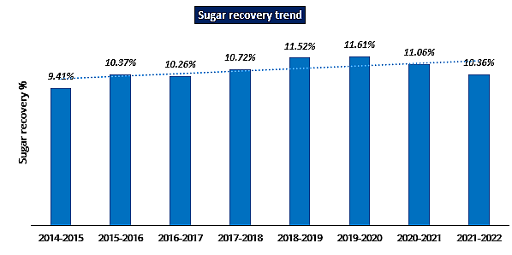
From FY21 onwards, BHSL has started shifting sugar cane for producing B heavy molasses for manufacturing ethanol / industrial alcohol which has reduced sugar production. This has led to a fall in average sugar recovery rate from 11.61% to 11.06% in FY21 and to 10.36% in FY22. In addition to higher sugar cane crushing for producing B heavy molasses (higher than in FY21), the sugar recovery for FY22 was also affected due to lower ‘pol in cane’ on account of inclement weather conditions.
BHSL’s market share in UP has increased from 15.11% in SS 2017 to 15.35% in SS 2020. Similarly, BHSL’s market share in India has increased from 6.55% in SS 2017 to 7.08% in SS 2020. The details of production levels along with the year-on-year trend is presented below:
Particulars | Unit | SS 2017 | SS 2018 | SS 2019 | SS 2020
BHSL Production | Million MT | 1.33 | 1.82 | 1.83 | 1.94
UP Production | Million MT | 8.80 | 12.05 | 11.82 | 12.64
All India Production | Million MT | 20.30 | 32.48 | 33.16 | 27.41
BHSL % of UP | % | 15.11 | 15.10 | 15.48 | 15.35
BHSL % of All India | % | 6.55 | 5.60 | 5.52 | 7.08

The sugar industry is cyclical in nature and is vulnerable to government policies for various reasons. Further, it is included in the Wholesale Price Index (WPI) as it classifies as an essential commodity. The government on its part resorts to various regulations such as price fixation in the form of State Advised Prices (SAP) and Fair & Remunerative Prices (FRP). All these factors impact the cultivation patterns of sugarcane in the country and thus affects the profitability of the sugar companies. Current FRP price and SAP price notified by UP Government are INR 290/quintal and INR 340/quintal respectively.
- SUGAR PRICING: Prices of sugar are market driven & depend on demand & supply of sugar. Sugarcane cultivation, manufacturing & sale are marred by a complex system of pricing, procurement, supply, regulation and demand and supply gap.
- Cost & Prices of Sugar is mainly controlled by Fair & Remunerative Price (FRP) of sugarcane and Minimum Selling Price (MSP) at which a sugar mill can sell the Sugar. However over FRP States have additionally advised SAP (State advisory Price) of sugarcane.
- Fair and Remunerative Price (FRP) for sugar season 2021-22 has been fixed at Rs. 290 per quintal linked to a basic recovery of 10% subject to a premium of Rs. 2.90 per quintal for each 0.1% increase of recovery over and above 10% and reduction in FRP at the same rate for each 0.1% decrease in the recovery rate till 9.5%. However UP SAP is kept at Rs.350/- per quintal
- However, with a view to protect the interests of farmers, concept of Minimum Selling Price (MSP) of sugar has been introduced w.e.f. 07.06.2018 so that industry may get at least the minimum cost of production of sugar, so as to enable them to clear cane price dues of farmers. The MSP of sugar has been fixed after taking into account the Fair & Remunerative Price (FRP) of sugarcane and minimum conversion cost of the most efficient mills.
- Government has notified Sugar Price (Control) Order, 2018. Under the provisions of said order, Government initially fixed Minimum Selling Price (MSP) of white/refined sugar which is presently at Rs.31 per Kg. and has been recommended by the government set task force to increase it to ₹33 Per Kilogram.
- In order to ensure that higher sugar recoveries are adequately rewarded and considering variations amongst sugar mills, the FRP is linked to a basic recovery rate of sugar, with a premium payable to farmers for higher recoveries of sugar from sugarcane. The FRP of sugarcane from sugar season 2015 to SS 2022 are as follows:
Particulars | FRP (INR per quintal) | Basic Recovery Level
SS 2017 | 230.00 | 9.5%
SS 2018 | 255.00 | 9.5%
SS 2019 | 275.00 | 10.0%
SS 2020 | 275.00 | 10.0%
SS 2021 | 285.00 | 10.0%
SS 2022 | 290.00 | 10.0%
Recently, The Cabinet Committee on Economic Affairs has approved Fair and Remunerative Price (FRP) of sugarcane for sugar season 2022-23 (October - September) at ₹305 per quintal. The amount is for sugarcane with a basic sugar recovery rate of 10.25%.
The Centre has also announced a premium of ₹3.05 per quintal for each 0.1% increase in recovery of sugar over and above 10.25% and reduction in FRP by ₹3.05 per quintal for every 0.1% decrease in recovery. The A2 + FL (actual paid out cost plus imputed value of family labour) cost of production of sugarcane for season 2022-23 is ₹162 per quintal.
This FRP of ₹305 per quintal at a recovery rate of 10.25% is higher by 88.3% over cost of production, thereby ensuring the promise of giving the farmers a return of more than 50% over their cost. The FRP for sugar season 2022-23 is 2.6% higher than current sugar season 2021-22 on the recommendation by the Commission for Agricultural Costs and Prices (CACP).
- However, State Governments have the power to fix the price of sugarcane as well called the State Advised Price (SAP). The advised or remunerative price shall always be higher than the minimum price in accordance with the provisions of the Sugarcane (Control) Order, 1966, issued under Section 16 of the Uttar Pradesh Sugarcane (Regulation of Supply and Purchase) Act, 1953. Following are the SAPs of the past sugarcane seasons:
Particulars | SAP INR per quintal
SS 2017 | 305
SS 2018 | 315
SS 2019 | 315
SS 2020 | 315
SS 2021 | 315
SS 2022 | 340
- SUGAR EXPORTS: Exports can be a viable option for disposal of this excess production. However, many times due to higher pricing and quality the competition of the Indian sugar industry becomes tough. The cost of production in India is also high in comparison to other countries.
Export market for Sugar is also growing exponentially. Export of sugar in the current sugar season 2021-22 is the historically highest. Exports taking place from India will rise as Brazil which is the largest producer of sugar in the world is facing weather changes which are impacting crops. Last year in August, global white sugar prices started rallying and had reached a four-and-a-half-year high of $504 per tonne as on 17th of the month, up 28% on-year. Inclement weather is affecting sugar production in Brazil and this, in turn, is expected to impact global supply in the upcoming sugar season (SS 2022; October 2021 to September 2022).
Export subsidies for sugar have benefitted Indian exporters to an extent, but this has resulted in other sugar-exporting countries like Brazil voicing their concerns to the World Trade Organisation (WTO) against excessive Government support being provided to boost sugar shipment from India. Government has announced a quota for export of sugar with some incentive mechanism but that is also likely to be phased out by 2023 due to WTO agreements.
As per the Nairobi Ministerial Declaration of the WTO, India cannot provide export subsidies and any export promotion measures of equivalent effect on agricultural products. However, under special and differential treatment provision of the Uruguay Round Agreement on Agriculture, India can provide reductionist export subsidies in a way to gradually phase them out by 2023.
However, notwithstanding anything, the country's sugar exports in the past few years has increased considerably due to the government's timely and proactive policy decisions. The government has provided assistance to sugar mills to facilitate exports in the last few years. Assistance to sugar mills was extended for defraying expenditure towards internal transport, freight, freight and other charges to facilitate export of sugar. However we couldn’t retrieve any information if this assistance has been extended to current year also. In the marketing year 2021-22, the sugar exports have been boosted without the government subsidy in view of high global prices.
As a result, even without extending any assistance to sugar mills, exports in the 2021-22 marketing year touched a figure of 100 lakh tonnes, which is an all-time high. However, to increase the availability of the commodity in the domestic market and curbing price rise, the government has imposed restrictions on sugar exports from June 1 till 31st Oct., 2022 or till further notice whichever is earlier. However, these restrictions would not be applicable on sugar being exported to the EU and the US under CXL and TRQ.
Unfortunately even though opportunities are growing in Sugar exports but Sugar Mills in Uttar Pradesh are unable to tap that fully because of location disadvantage since being far away from ports. Therefore, due to thin margins, they are unable to export because of transport and freight cost. Therefore BHSL is not exporting Sugar as confirmed by them.
- GOVT. POLICY SUPPORT AND ETHANOL: The Government has taken various steps to handle the surplus production and enhance liquidity of mills, such as incentivising sugar mills to divert excess sugar cane/sugar to ethanol production, providing financial assistance for transport to sugar mills to facilitate export of sugar, etc. The government is taking several steps to boost ethanol production, which can be used as an alternative to fuel in car engines and thereby reduce air pollution.
Ethanol is an alcohol-based fuel produced by fermenting the sugarcane juice.The Government of India has initiated policies to encourage the use of ethanol for blending with gasoline, to lower the dependence on crude oil imports. Ethanol production in India comes largely from molasses, a by-product of the sugar production process.
- Government started the pilot project in 2001. Government first launched a program to mandate the blending of 5% ethanol in gasoline in nine states and four UT’s in January 2003. Beginning November 2006, the Government extended this 5% mandatory blending policy to 20 states and 4 UT’s.
- Under Ethanol Blending Programme (EBP), the Government has scaled up the blending targets from 5% to 10%.
- Government targets to increase to 20% by Ethanol Year 2024-25, which shall improve India’s energy security and reduce its oil import bill.
- Government plans 20% ethanol blending by 2025 in petrol, currently it is 10%. This measure will reduce the debt burden on farmers as a result sugar stocks are to grow. Sugar producing company stocks have rallied up to 25% in 2021 on excitement of double incentive by the government for producing ethanol. Stock prices of many sugar companies doubled in 2021.
In October, 2021, the government announced an incentive to encourage sugar companies to divert excess sugar cane stock in producing ethanol, which can be blended with petrol and used as fuel in vehicles.
- Keeping in view the various benefits of the Ethanol Blending Programme, the Government has advanced the target of achieving 20% blending to 2025, which was earlier scheduled to be achieved in 2030. However, the ethanol production capacity in the country is not sufficient at present to achieve 20% blending by 2025.
Pricing of Ethanol:
- The Company’s payment terms invariably for Industrial Alcohol are 100% advance before dispatch except credit given under certain market conditions.

- The price and other commercial terms of Ethanol are decided by Government (Ministry of Petroleum & Natural Gas) on annual basis. Ethanol is also supplied to private companies such as Reliance/ Nayara which they procure either directly from BHSL or through traders. Payment terms as per tender are on 21 days credit from the date of receipt of material. The Company also exports (whenever commercially viable) potable Alcohol (Extra neutral Alcohol) subject to receipt of permissions from State excise.
- POLICY INITIATIVES BY THE GOVERNMENT: While, Sugar had been decontrolled by the Central Government including levy obligation but in order to maintain Sugar prices and to ensure liquidity, improved cash flow Sugar and enable cane payments, Government from time to time come various controls in form of Minimum Selling Price (MSP), monthly release of Sugar, export assistance, buffer subsidy, soft loans, ethanol price, etc. Some of the key initiatives taken by the Government are mentioned below:
- Promoting exports of sugar: One of the ways out to handle the issue of surplus sugar was exports out of country, which Government has very successfully promoted over the Years in form of various export assistance and favourable process enabling the Industry to create new records every year.
- During Sugar Year 2019-20, country exported all time high Sugar quantity of 5.95 Mn MT. Very next year during 2020-21, country broke this record and exported a quantity of 7.19 Mn MT. Now to the surprise of trade across the Globe, country is poised to create another record by exporting a whopping quantity of 9.5 – 10.0 Mn MT.
- Maintaining sugar price: Due to high sugar production resulting in excess sugar supply in the market, sugar prices across the country started declining (and below the cost of production in certain cases). To arrest falling sugar prices, Government fixed minimum uniform selling price (MSP) of sugar at Mill level, across India.
- Monthly Sales release mechanism: Government imposed reverse stock limit on sugar mills to restrict supply of sugar in market so that sugar mills are able to realise MSP/ viable prices. To arrive at the figure of stocks which sugar mills were required to carry at the end of each month, sugar mills were given Monthly Sales Release Quantity above which sugar mills were not allowed to sell in the domestic market. The purpose of above order was to regulate supply of sugar in the market which was in excess supply due to consistent surplus production.
- Discouraging sugar imports: To avoid sugar imports owing to lower international sugar prices, the Government increased import duty on sugar. There has been no import of sugar in the last three years since FY19.
- Ethanol-pricing/ feedstocks: The Government is aggressively promoting ethanol as a fuel as it is a cleaner fuel (non-fossil biofuel), curbs vehicular pollution and also saves foreign exchange required for importing crude oil. The government has plans to increase ethanol blending percentage to 20% by the Ethanol Year 2024-25 would imply annual supply of 9.9 billion litres as against this year estimated supply of 4.0 billion litres.
In order to boost ethanol supplies from alternate feed stocks, Government is also pushing 2G ethanol which will be manufactured from cellulosic waste. Public Sector Oil companies are in process of setting up their own 2G ethanol plants for generation of ethanol for their requirement of blending with petrol.
- Soft loans for ethanol: During the period 2018–2021, Central Government has notified different interest subvention schemes for Sugar Mills and Distilleries for disbursement of soft loans for Ethanol projects.
- The Financial assistance has been in form of interest subvention @ 6% per annum or 50% of rate of interest charged by banks, whichever is lower, on the loans to be extended by banks for 5 years including one year moratorium.
- Government has recently on 22 April 2022 opened one more window of 6 months for the purpose of soft loans as above for project proponents having required land and Environment clearance for Distillery.
- Ethanol Distillation capacity: Ethanol distillation capacity of Molasses based distilleries was only 215 crore Litres prior to 2014. However, in past 7 years due to policy changes made by the Centre, the capacity of molasses-based Distilleries have increased by one and a half times and currently at 569 Cr Litres.
- Capacity of Grain based distilleries which were 206 Cr Litres in 2013 has increased to 280 Cr Litres. Total Ethanol production capacity in country has reached 849 Cr Litres.
- Total Alcohol requirement by 2025 including requirement of Ethanol for blending at 20% is estimated at 1,350 Cr Litres, for which Alcohol production capacities are required to be enhanced to about 1,700 Cr Litres and above such interest subvention schemes are helping in augmentation of capacities.
- In the latest budget of FY 2022, there is an increase in the Budget Allocation for the sugar industry by about INR 2,507 crore. This is done in view to settle claims of sugar mills and provide assistance in exports.
- In order to support the Ethanol Blending Program (EBP), the government has set aside Rs.160 crore in FY 2022 and another Rs. 300 crores in FY 2023 for providing financial assistance to sugar mills for the enhancement and augmentation of ethanol production capacity. As per the notification No. GSR 90(E) of Department of Revenue dated 1st February 2022, fuel to be categorised as blended fuel (with ethanol/ methanol) has to conform to BIS specifications from time to time.
- As the blending currently is @ 10% ethanol with petrol, the demand and actual offtake from OMCs will improve to ensure that they achieve the blended fuel percentage, and thereby avoid the additional excise duty Rs.2 per litre on unblended petrol. This will further encourage the Ethanol Blend. As per Industry reports, Central Government has target of 20% ethanol blending with petrol by FY 2025 and this will further encourage the demand of ethanol in the country.
Thus as per the above Industry and sector analysis based on micro & macro economic, the Indian Sugar Industry is seeming to grow in future and will be having positive trends as 2nd largest agro-based industry.
Growth of the industry will depend on the technological advancement in a time manner, government policies to promote the export of excess sugar in the global market and improving the infrastructure in the country for better logistics services with faster mobility.

PART I | SWOT ANALYSIS

STRENGHTS
- Indian sugar industry is the second largest producer of sugar in the world after Brazil.
- Bajaj Hindusthan Sugar Ltd. has dealers all over India which helps the business run smoothly in a food supply chain.
- BHSL is one of the largest producers of Sugar and ethanol in the country and is a brand name in the industry.
- BHSL’s portfolio includes sugar, ethanol & alcohol, power, bagasse and agri-inputs. The vast portfolio of products helps BHSL to explore more revenue streams.
- Bajaj Group has leading presence in sugar industry with nine decades of experience. BHSL has the largest manufacturing capacity of Sugar (136,000 TCD) and Distillery (800 KLPD), in India.
- The sugar units are located in Uttar Pradesh, having ample availability of sugarcane, thus ensuring adequate availability of sugarcane, which is the main raw material for production of sugar / ethanol.
- The sugar manufacturing plants are integrated with facility to generate power from bagasse and manufacture alcohol / ethanol. This improves the overall value chain.
- The manufacturing units of the Company are designed to accommodate the overall infrastructure as well as accommodate any likely future expansion.
- All Plants are well operational and maintained and company has been taking up the requisite repairs and maintenance expenditures for keeping the equipment in, well-maintained condition.
- Company's product line includes ethanol, bagasse, ENA etc. which can provide steady revenue flow, especially ethanol, due to various Government policy focus.
- As per various Industry estimates, Sugar industry in India is expected to grow by 6-7% in the years 2021-2022 due to growth in exports of sugar and ethanol and further Indian cane sugar market is projected to reach a CAGR of 5.2% during the forecast period (2022-2027).

WEAKNESS
- Sugar is a highly regulated sector.
- Over the years, India has become a sugar surplus nation as reflected from the trend of sugar production and consumption. As per Economic Survey 2021-22 Average annual production of sugarcane is around 35.5 crore tonnes which is used to produce around 3 crore tonnes of sugar. The domestic consumption is estimated to be around 2.75 crore tonnes in 2021-22 which results in huge carry over stock of sugar with mills. Due to excess availability of sugar in the country, the ex-mill prices of sugar remain subdued resulting in cash loss to sugar mills.
- Highly competitive market with competitors like Dalmia Sugar with available subtitutes in the market.
- The entry of new competitors inside the market who are more technologically advanced and the growth in sugar-free products can lead to a significant decline in the market and other sugar substitutes like jaggery, honey, etc.
- All the manufacturing units of the Company are in the same State (Uttar Pradesh) where presently sugarcane prices are relatively higher than other states due to higher SAP. This may have impact on the overall profitability of UP based sugar mills. This is mostly off-set by higher sugar prices prevailing in UP, as compared with other states.
- Delayed payment to cane farmers is impacting availability of sugarcane for BHSL. This also pulls down the overall performance indicators of the Company.
- Due to location disadvantage of UP Sugar Mills for being away from the Ports, BHSL do not export because of price competitiveness resulting company is lacking behind to reep the benefits of government’s export policy
- Demand and supply mismatch, affects funds & liquidity of sugar mills resulting in accumulation of cane price arrears. This also makes the sugar mills ineligible for working capital limits.

OPPORTUNITY
- Higher crude oil prices will increase the demand for Ethanol due to Switching to organic fuels like Ethanol.
- New and emerging e-commerce industry. India is likely to witness increase in sugar exports.
- Economic recovery and rising consumer spending after the covid-19 lockdown, recession and slow industrial growth are opportunities for Bajaj Hindusthan Sugar to attract new customers and increase market share.
- BHSL operates in the industry which has very high entry barriers, as the new entrant would not be able to secure significant cane allocation for operating the business.
- Supportive policies for ethanol production by the government, immensely benefit the sugar manufacturers like BHSL. Having the largest distillery capacity, BHSL is in a position to capitalize on the policy benefit.
- Investing in Cane development activities, new seed technology and high-quality pesticides offers scope for better sugar recovery, which adds directly to the bottomline of sugar manufacturer.
- Potential of selling higher quantities of refined & branded sugar having better profitability margins.
- BHSL is one of the largest manufacturer of Sugar as well as ethanol in the country. Has already well operated and maintained 14 Sugar Plants thereby give opportunity for well established setup and infrastructure for overall sugar related supply chain.

THREATS
- Company may face legal action due to continuing fluctuations in different laws, e.g., Bajaj Hindusthan Sugar will pay 15% interest per annum on the delayed payment of sugarcane farmers who sold their cane to its five sugar mills only.
- Climate change & Rainfall uncertaining impacts crop yield. Lesser cane availability due to any draught like situation in UP state may affect sugarcane availability for the sugar industry.
- Farmers prefer to opt for more lucrative cash crops as profits / payments from sugarcane cultivation are irregular due to various government policies and financial health of the sugar mills.
- Pricing mechanism in Sugar Industry is highly regulated. Sugar Industry is also highly politically sensitive sector since it is alivelihood of almost 5 Crore famers. There is pressure on pricing and margins since because of fixed FRP/ SAP setup by the Govt., Sugar Mills can’t do anything on input cost.
- Historically, the sugar industry has remained cyclical due to sugar production being higher than the sugar demand which prevents sugar prices to rise commensurate with the increase in cane price, thereby eroding the profitability margins.

PART J | RISK ASSESSMENT & MITIGATION

Risk | Risk mitigation mechanism
Business and Industry risk | - The Company has been producing sugar since 1931 and has the largest sugar and ethanol / industrial alcohol manufacturing capacity in India. It has 14 sugar mills and co-gen power plants and 6 distilleries spread across central, eastern, and western UP.  - With sugarcane being the most important raw material for production of sugar, ethanol / industrial alcohol and other by products, the business activities depend upon the availability of raw material across all the mills. With the proposed payment of cane dues, the Company envisages improvement in the supply of sugarcane as well as improvement in its quality in near term based on various cane development activities.  - Since the Company has the highest cane crushing capacity, with the improvement in cane availability, it envisages to increase its capacity utilization from ~73% in FY22 to ~81% by FY25. Taking the advantage of Government’s policies on ethanol, the Company envisages to increase capacity utilisation of distilleries to ~103% by FY25 by increasing number of days of operation to ~300-330.  - Sugar industry is regulated and cyclical in nature wherein quantity of sugar to be sold and exported by mills is decided by the Government, however, at the same time Government has also provided mills with various subsidies.  - Further, the minimum prices of input raw material (cane) and output of finished goods in the form of sugar and industrial alcohol / ethanol are fixed by Central / State Governments.  - Government through various policies and schemes has been promoting export of sugar, ethanol as a fuel (EBP Programme), promoting different raw materials for production of ethanol like B heavy Molasses, Cane Juice, syrup etc, maintaining price by defining MSP and managing sugar supply in market by giving mill-wise domestic monthly release.  - The proposed Resolution Plan envisages production and sale of more ethanol as compared to its current proportion in the sales for the Company. Accordingly, the Company envisages to realise better margins going forward (ethanol being a higher margin product as compared to sugar). Further, the projections by the Company for cane prices and realization prices for sugar and ethanol are based on the actual cost / prices in past with escalations.  - Thus, business risk may be mitigated improving capacity utilisation of sugar mills and distilleries, improving sugar recovery and thus, enhancing the EBITDA of the Company.
Financial risk | - The financial constraints being faced by BHSL in recent past, have resulted in delays in payment of dues of cane farmers affecting operations in terms of limited availability of raw material and delays in debt servicing.  - The proposed Resolution Plan addresses mitigation of financial risk by payment of cane dues and realignment of the capital structure and deleveraging of BHSL including conversion of OCDs along with accumulated YTM till 31 March 2022 (net of TDS) and coupon for FY22 (net of TDS) into equity and elongation in the repayment schedule of term debt in line with the projected cashflows of the Company.
Operational Risk | - The Company has net cane arrears amounting to ~INR 1,110 Cr as on 31 March 2022 post payment of INR 1,000 Cr already appropriated through UP Government action. These arrears impact seamless availability of raw material which is imperative for the business to operate.  - However, to mitigate this risk, Company proposes to retire cane dues of ~INR 2,361 Cr (incl. INR 1,000 Cr already appropriated) from funds appropriated / expected to be appropriated from LPGCL which would improve the cane availability and thus benefit the operations of the Company.  - The Company incurred ~INR 199 Cr for major maintenance of sugar mills and distilleries in FY21 and ~INR 101 Cr in FY22 which increase production and sale of ethanol / industrial alcohol during FY22 by ~90%.
Management risk | - The Company benefits from wide-ranging experience of the promoters supported by professional management. The management personnel possess rich experience in their area of expertise. This has led to the Company building up strong executional capabilities.

PART K | STATUTORY APPROVALS | LICENCES | NOC

As per the information provided by the client below are the unit wise details of statutory approvals/licence/NOC:
- BUDHANA UNIT
S.No. | NAME OF LICENSE/ REGISTRATION | PURPOSE | LICENCE NO. WITH DATE | Current Status
 | ISSUING AUTHORITY
 | Land Conversion | RoC registration | Date 26.02.2009 | Industrial
 | District Administration |  | SDM Budhana
 | Approval of Building/ site Plans | Grant of approval on building plans | 1304/DF/Rekha dated 29.08.2005 | Approved
 | UPSIDA/ Factories Deptt. |  | DDF Meerut
 | NOC for fire fighting | NOC under firefighting scheme | UPFS/2021/41765/Mzn/Muzaffarnagar/345/CFO | Valid till 27.12.2024
 | Chief Firefighting Officer, MZN |  | Chief Fire Officer, Muzaffarnagar
 | Approval for Ground Water Extraction | NOC for Water & Environment | Reg. no. 202203000046 ,202203000048 & 202203000049 Certificate no. 21-4/5139/UP/IND/2018 | Provisional certificate
 | Ground water Deptt. UP |  | Ground water Deptt. UP
 | Power load sanction/ Electric connection | For Power load sanction | As per PPA Dated 14.06.2006,  Export 17- 20 MW,  Import 4.0 MW. | Export 10- 12 MW, Import 4.0 MW.
 | PVVNL
 | Factory Registration | For Import-Export License | UPFA2000144/DDF Meerut | Valid till 31.12.2024
 | Registration and grant of license under The Factories Act 1948
 | Boiler License | For establishing and operating Boilers | Year 2005. UP/6094 & UP/6095  Year 2006. UP/6221 | UP/6094 , UP/6095 & UP/6221
 | Registration of Boilers under Indian Boilers Act 1923
 | Environmental and Pollution control | Environmental clearance | Air consent No. 141570/UPPCB/MZN/CTO/Air/2021 dated 22/12/2021 Chief Environment Officer, Lucknow  Water consent Letter No. 141575/UPPCB/MZN/CTO/Water/2021 dated 22/12/2021 Chief Environment Officer, Lucknow | Valid till 31.12.2023
 | Consent to Establish & Operate Under Air and Water Act (NOC)
Observations & Comments:
- Company has obtained preliminary statutory clearances and approvals except those which are mentioned as in Process or Pending above.
- BILAI (BIJNOR) UNIT
S.No. | NAME OF LICENSE/ REGISTRATION | PURPOSE | LICENCE NO. WITH DATE | Current Status
 | ISSUING AUTHORITY
 | Land Conversion | RoC registration | SDM Bijnor land conversion granted on dated 28.01.2006 u/s 143 of UPZALR Act | Approved
 | District Administration
 | Approval of Building/ site Plans | Grant of approval on building plans | Letter no. 1302 DF/REKHA. Dated 29.08.2005 dy. Dir. Of factories | Approved
 | UPSIDA/ Factories Deptt.
 | NOC for fire fighting | NOC under firefighting scheme | UPFS/2019/15162/BJN/BIJNOR/132/CFO  Dated 30.12.2019 | Approved valid upto 30.12.2022
 | Chief Fire fighting Officer
 | Approval for Ground Water Extraction | NOC for Water & Environment | Certificate as NOC issued by UPGW authority  NOC019036  NOC010232 | Approved Valid upto 20.06.2026
 | ADM
 | Power load sanction/ Electric connection | For Power load sanction | PPA Dt 14.06.2006  06- 10MW Export  4 MW Import | Export 10 MW  Import 4 MW  PPA Date 14.06.2006
 | PVVNL
 | Factory Registration | For Import-Export License | Issued by Labour Department UP registration no. UPFA3000036 dated 18.11.2019 | Copy of Certificate attach as annexure no.6  Valid upto 31.12.2028
 | Registration and grant of license under The Factories Act 1948
 | Boiler License | For establishing and operating Boilers | UP/6090 Dt 12.08.2005  UP/6091 Dt 09.09.2005  Directors of Boilers UP Kanpur  Registry no.: UP-6090 Dated 28.09.2021  Registry no.: UP-6091 Dated 28.09.2021 | UP/6090 Dt28.09.21  UP/6091Dt28.09.2021  Copy of Certificate attach as annexure no.7 and 8 both are  valid upto 27.09.2022
 | Registration of Boilers under Indian Boilers Act 1923
 | Environmental and Pollution control | Environmental clearance | Ref. No.-141019/UPPCB/Bijnore(UPPCBRO)/CTO/air/BIJNOR/ 2021 dated 27.12.2021  Ref. No.-  139194/UPPCB/Bijnore(UPPCBRO)/CTO/Water/BIJNOR/ 2021 dated 27.12.2021  Ref. No.-  1037/UPPCB/Bijnore(UPPCBRO)/HWM/BIJNOR/ 2018 dated 19.07.2018 | Copy of Certificate attach as annexure no.9,10 and 11  valid upto  31.12.2023  31.12.2023  19.07.2023
 | Consent to Establish & Operate Under Air and Water Act (NOC)
Observations & Comments:
- Company has obtained preliminary statutory clearances and approvals except those which are mentione as in Process or Pending above.
- BARKHERA (PILIBHIT) UNIT
S. No. | NAME OF LICENSE/ REGISTRATION | PURPOSE | LICENCE NO. WITH DATE | Current Status
 | ISSUING AUTHORITY
 | Land Conversion | RoC registration | Wad Shakya 2/05-06 dated 23.01.2006 | Valid
 | District Administration
 | Approval of Building/ site Plans | Grant of approval on building plans | Revised Site Plan No.-703 F/Rekha./Sum. Dated 21.08.15 | Valid
 | UPSIDA/ Factories Deptt. |  | Approved Dy. Director of Factory Bareilly
 | NOC for fire fighting | NOC under firefighting scheme | UPFS/2019/13763/PLB/PILIBHIT/177/CFO  Valid From -13.06.2021 to 12.06.2024 | Valid
 | Chief Firefighting Officer, Pilibhit
 | Approval for Ground Water Extraction | NOC for Water & Environment | - NOC026674  - NOC033625  - NOC039665  Valid From 18/06/2021 To 17/06/2026 | Valid
 | ADM
 | Power load sanction/ Electric connection | For Power load sanction | 1. 22VSNOC05023121 DATED 23.10.2021 ( Safety approval)  2. 901 dated 01.07.2019 (1000KVA transformer installed in 2016) | 1.Valid up to 23.10.2024  2. Valid up to July 2022
 | PVVNL
 | Factory Registration |  | Factory License No.- UPFA22000010  Valid From 01.01.2022 to 31.12.2029 | Valid
 | Registration and grant of license under The Factories Act 1948
 |  | For Import-Export License | For Export -Letter No. 544/GM/PPA/D-3/Co-gen 1 dated 15.6.2006 & PPA dated 14.6.2006  For Import –Letter no. 304 Dated 22.5.2007 for 4 MW | Valid up to 30.6.2027(Up to 20 years from date of commissioning )
 | Boiler License | For establishing and operating Boilers | UP / 6228  UP / 6229 | Valid up to  28.09.2021 to 26.08.2022
 | Registration of Boilers under Indian Boilers Act 1923
 | Environmental and Pollution control | Environmental clearance | CTE No.  F 21395 (C-5/No-93/2005/7) Dated:13.10.2005  CTO Under Air Act  140369/UPPCB/Bareilly(UPPCBRO)/CTO/air/PILIBHIT/2021  Valid from 01/01/2022 to 31/12/2023  CTO Under Air Act  140374/UPPCB/Bareilly(UPPCBRO)/CTO/water/PILIBHIT/2021  Valid from 01/01/2022 to 31/12/2023 | Valid
 | Consent to Establish & Operate Under Air and Water Act (NOC)
Observations & Comments:
- Company has obtained preliminary statutory clearances and approvals except those which are mentioned as in Process or Pending above.

- GANGNAULI DISTILERY AND SUGAR UNIT
S.No. | NAME OF LICENSE/ REGISTRATION | PURPOSE | LICENCE NO. WITH DATE | Current Status
 | ISSUING AUTHORITY
 | Land Conversion | RoC registration | Yes | Valid
 | District Administration |  | SDM Deoband
 | Approval of Building/ site Plans | Grant of approval on building plans | Director of Factories | Valid
 | UPSIDA/ Factories Deptt.
 | NOC for fire fighting | NOC under firefighting scheme | Yes | Valid up to 07-12-2024
 | Chief Firefighting Officer, Saharanpur |  | UPFS/2021/40246/SHR/SAHARANPUR/616/JD
 | Approval for Ground Water Extraction | NOC for Water & Environment | Yes | Valid up to 28-07-2026
 | ADM |  | 202105000277  &  202105000278
 | Power load sanction/ Electric connection | For Power load sanction | Dy. Director Electrical safety Meerut  No. 428 | Valid
 | PVVNL/Saharanpur
 | Factory Registration | For Import-Export License | Yes | Valid
 | Registration and grant of license under The Factories Act 1948
 | Boiler License | For establishing and operating Boilers | UP-8199 | Applied for Renewal
 | Registration of Boilers under Indian Boilers Act 1923
 | Environmental and Pollution control | Environmental clearance | Yes  129779 Water, 129778 Air Consent &  EC No. J-11011/340/2006-IA II (I) | Valid up to 31-12-2022
 | Consent to Establish & Operate Under Air and Water Act (NOC)

S.No. | NAME OF LICENSE/ REGISTRATION | PURPOSE | LICENCE NO. WITH DATE | Current Status
 | ISSUING AUTHORITY
 | Land Conversion | RoC registration | Yes | Valid
 | District Administration |  | SDM Deoband
 | Approval of Building/ site Plans | Grant of approval on building plans | DDF Meerut | Valid
 | UPSIDA/ Factories Deptt.
 | NOC for fire fighting | NOC under firefighting scheme | Yes | Valid up to 22-11-2024
 | Chief Firefighting Officer, Saharanpur |  | UPFS/2021/40213/SHR/SAHARANPUR/615/CFO
 | Approval for Ground Water Extraction | NOC for Water & Environment | Yes | Valid up to 28-07-2026
 | ADM |  | 202105000282 &  202105000283
 | Power load sanction/ Electric connection | For Power load sanction | PPA UPPCL Lucknow | Valid
 | PVVNL Saharanpur
 | Factory Registration | For Import-Export License | Yes | XYZ
 | Registration and grant of license under The Factories Act 1948
 | Boiler License | For establishing and operating Boilers | UP/6205 & 6206, UP/6604 | Valid up to 22-09-2022
 | Registration of Boilers under Indian Boilers Act 1923
 | Environmental and Pollution control | Environmental clearance | Yes  14515 Water & 14517 Air Consent | Valid up to 31-12-2023
 | Consent to Establish & Operate Under Air and Water Act (NOC)
Observations & Comments:
- Company has obtained preliminary statutory clearances and approvals except those which are mentioned as in Process or Pending above.
- GOLA UNIT
S.No. | NAME OF LICENSE/ REGISTRATION | PURPOSE | LICENCE NO. WITH DATE | Current Status
 | ISSUING AUTHORITY
 | Land Conversion | RoC registration | The Factory was established in the year 1931-32. At that time ZA (Zamidari Act) was not exist. On the above land, Factory machines & Colony is in existence. Like inside the plant, machinery and building, Roads & Culverts etc,
 | Approval of Building/ site Plans | Grant of approval on building plans | Plan no. 529 F/Rekha dated 23/10/2010 (Sugar)  &  Plan no.2224 F/Lic Site dated 28/12/2020 (Distillery)
 | UPSIDA/ Factories Deptt. |  | Approved by Dy. Director of Factories UP, Lucknow
 | NOC for fire fighting | NOC under firefighting scheme |  | VALID TILL 30-12-2022
 | Chief Fire fighting Officer, |  | UPFS/2019/15167/KHR/KHERI/82/CFO  DATED- 30-12-2019
 | Approval for Ground Water Extraction | NOC for Water & Environment | 202106000346 DATED- 17-08-2021  202106000347  202106000350  202106000352  202106000661  202106000665 | VALID TILL 16-08-2026
 | ADM |  | XYZ
 | Power load sanction/ Electric connection | For Power load sanction | 500 KVA
 | PVVNL
 | Factory Registration | For Import-Export License | UPFA24000010 (Sugar)  &  UPFA24000020 (Distillery)  Approved by Dy. Director of Factories UP,Lucknow | 31.12.2029  &  31.12.2022
 | Registration and grant of license under The Factories Act 1948
 | Boiler License | For establishing and operating Boilers | Registration No. 5522, 5953,3349,3976 & 4878 on dated 29.09.2021 | VALID TILL 28.08.2022 Except Registration no. 5953 valid till 18.09.2022
 | Registration of Boilers under Indian Boilers Act 1923
 | Environmental and Pollution control | Environmental clearance | CTO Water-  139049/UPPCB/Lucknow(UPPCBRO)/CTO/water/LAKHIMPUR KHIRI/2021  DATED-07/02/2022  CTO AIR-  138827/UPPCB/Lucknow(UPPCBRO)/CTO/air/LAKHIMPUR KHIRI/2021 | VALID TILL 31/12/2023  VALID TILL 31/12/2023
 | Consent to Establish & Operate Under Air and Water Act (NOC)
Observations & Comments:
- Company has obtained preliminary statutory clearances and approvals except those which are mentioned as in Process or Pending above.
- KUNDARKHI UNIT
S.No. | NAME OF LICENSE/ REGISTRATION | PURPOSE | LICENCE NO. WITH DATE | Current Status
 | ISSUING AUTHORITY
 | Land Conversion | RoC registration |  | One Time
 | District Administration |  | O No. 07 dt. 17/11/2006, 08 dt.29/11/2007 and 09 dt.29/11/2007  Sub Divisional Magistrate, Gonda, Gonda
 | Approval of Building/ site Plans | Grant of approval on building plans | BHSIL/GDA/07 Dt 21/12/2007 | One Time
 | UPSIDA/ Factories Deptt.
 | NOC for fire fighting | NOC under firefighting scheme | UPFS/2019/12518/GND/GONDA/4/CFO | VALIDITY FROM 21/10/2019 TO 20/10/2022
 | Chief Fire fighting Officer, GONDA |  | Dt. 11/10/2019
 | Approval for Ground Water Extraction | NOC for Water & Environment | 202105000106 DT 17/06/2021 | VALIDITY FROM 18/06/2021 TO 17/06/2026
 | DM-GONDA
 | Power load sanction/ Electric connection | For Power load sanction | 87/MU.E./HT/NIREESCHHAN/2019-20 DT.11/10/2019 | VALIDITY FROM 11/10/2019 TO 10/09/2022
 | PVVNL/JOINT DIRECTOR ELECTRIC SAFETY, U.P.GOVERNMENT -LUCKNOW
 | Factory Registration | For Import-Export License | UPFA54000003 DT.18/10/2019, OLD REGISTRATION NO.GDA-85 | VALIDITY FROM 01/01/2020 TO 31/12/2024
 | Registration and grant of license under The Factories Act 1948
 | Boiler License | For establishing and operating Boilers | BOILER REGISTRY NO.-UP-6380, UP-6381, UP-6382, UP-6383 DT. 22/10/2021 | VALIDITY FROM 22/10/2021 TO 24/09/2022
 | Registration of Boilers under Indian Boilers Act 1923
 | Environmental and Pollution control | Environmental clearance | 138575/UPPCB/FAIZABAD (UPPCBRO)/CTO/air/GONDA/2021 DT.31/01/2022, 138381/UPPCB/FAIZABAD/(UPPCBRO)/CTO/water/GONDA/2021 DT.31/01/2022 | VALIDITY FROM 01/01/2022 TO 31/12/2023, 01/01/2022 TO 31/12/2023
 | Consent to Establish & Operate Under Air and Water Act (NOC)
Observations & Comments:
- Company has obtained preliminary statutory clearances and approvals except those which are mentioned as in Process or Pending above.
- KINAUNI UNIT
S.no. | NAME OF LICENSE/ REGISTRATION | PURPOSE |  | LICENCE NO. WITH DATE | Current Status Validity till
 | ISSUING AUTHORITY
1. | Land Conversion | RoC registration |  | Sahayak Chakbandi Adhikari Meerut 2nd order dt 12.11.2008
 | District Administration
2. | Approval of Building/ site Plans | Grant of approval on building plans | Sugar | 3006 dt 22.11.2010
 |  |  | Dist | SPR 00060015 dt 30/01/2019
 | UPSIDA/ Factories Deptt.
3. | NOC for fire fighting | NOC under firefighting scheme
 |  |  | Sugar | UPFS/2021/27487/MRT/MEERUT/299/CFO dt 09/02/2021 | 09-02-2024
 |  |  | Dist | UPFS/2020/18083/MRT/MEERUT/192/JD dt 13/03/2020 | 13-03-23
 | Chief Fire fighting Officer, Meerut
4. | Approval for Ground Water Extraction | NOC for Water & Environment | Sugar | 202112000318 dt 20.03.2022 | 19-Mar-27
 |  |  | Sugar | 202112000323 d 20.03.2022 | 19-Mar-27
 |  |  | Sugar | 202112000332 dt 20.03.2022 | 19-Mar-27
 |  |  | Dist | 202202000342 dt 20.03.2022 | 19-Mar-27
 | CGWA, Meerut
5. | Power load sanction/ Electric connection | For Power load sanction | Sugar | Power Purchase Agreement dated 14/06/2006 | 13-Jun-26
 | UP POWER Corporation Ltd
6. | Factory Registration | For Import-Export License | Sugar | UPFA7000038 | 31-12-29
 |  |  | Dist | UPFA7000039 | 31-12-22
 | Registration and grant of license under The Factories Act 1948
7. | Boiler License | For establishing and operating Boilers | Sugar | UP/6016 | 16-Aug-22
 |  |  | Sugar | UP/6007 | 16-Aug-22
 |  |  | Sugar | UP/6198 | 16-Aug-22
 |  |  | Sugar | UP/3315 | 16-Aug-22
 | Registration of Boilers under Indian Boilers Act 1923 |  | Dist | UP/8297 | 14-Sep-22
8. | Environmental and Pollution control | Environmental clearance | Sugar | 140790/UPPCB/Meerut(UPPCBRO)/CTO/water/Meerut/2021 | 31-Dec-23
 |  |  | Dist | 139044/UPPCB/Meerut(UPPCBRO)/CTO/water/Meerut/2021 | 31-Dec-22
 |  |  | Sugar | 140073/UPPCB/Meerut(UPPCBRO)/CTO/air/MEERUT/2021 | 31-Dec-23
 |  |  | Dist | 139053/UPPCB/Meerut(UPPCBRO)/CTO/air/MEERUT/2021 | 31-Dec-22
 | Consent to Establish & Operate Under Air and Water Act (NOC)
Observations & Comments:
- Company has obtained preliminary statutory clearances and approvals except those which are mentioned as in Process or Pending above.
- KHAMBHARKHERA UNIT
S.No. | NAME OF LICENSE/ REGISTRATION | PURPOSE | LICENCE NO. WITH DATE | Current Status
 | ISSUING AUTHORITY
 | Land Conversion | RoC registration | 33 dated 30.06.2006, 20 dated 07.02.2008, 46 dated 14.05.2008, 47 dated 14.05.2008, 48 dated 14.05.2008, 49 dated 04.02.2009, 56 dated 26.04.2010, 62 dated 05.05.2010, 70 dated 20.04.2011
 | District Administration
 | Approval of Building/ site Plans | Grant of approval on building plans | 651F/DDF/Rekhankan/LKO
 | UPSIDA/ Factories Deptt. |  | 19.08.20211
 | NOC for fire fighting | NOC under firefighting scheme | UID No.-UPFS/2020/22971/KHR/KHERI/134/JD | Valid up to 05.10.2023
 | Chief Fire fighting Officer, Lakhimpur Kheri |  | 05.10.2020
 | Approval for Ground Water Extraction | NOC for Water & Environment | NOC041446 | Valid up to 21.06.2026
 | UPGWA, Lucknow |  | 07.05.2021
 | Power load sanction/ Electric connection | For Power load sanction | 23VSNOC05004275  Dt.25.04.2022 | Valid upto-  24.04.2025
 | PVVNL
 | Factory Registration | For Import-Export License | UPFA24000017 | Valid up to 31.12.2022
 | Registration and grant of license under The Factories Act 1948
 | Boiler License | For establishing and operating Boilers | UP-8246 | Valid up to 06.06.2022
 | Registration of Boilers under Indian Boilers Act 1923
 | Environmental and Pollution control | Environmental clearance | Air: 131106/UPPCB/LKO  Water: 131174/UPPCB/LKO | Valid up to 31.12.2022
 | Consent to Establish & Operate Under Air and Water Act (NOC)
Observations & Comments:
- Company has obtained preliminary statutory clearances and approvals except those which are mentioned as in Process or Pending above.

S.No. | NAME OF LICENSE/ REGISTRATION | PURPOSE | LICENCE NO. WITH DATE | Current Status
 | ISSUING AUTHORITY
 | Land Conversion | RoC registration | 33 dated 30.06.2006  20 dated 07.02.2008  46 dated 14.05.2008  47 dated 14.05.2008  48 dated 14.05.2008  49 dated 04.02.2009  56 dated 26.04.2010  62 dated 05.05.2010  70 dated 20.04.2011
 | District Administration
 | Approval of Building/ site Plans | Grant of approval on building plans | 672F/DDF/Rekhankan/LKO
 | UPSIDA/ Factories Deptt. |  | 24.08.20211
 | NOC for fire fighting | NOC under firefighting scheme | UID No.-UPFS/2019/15168/KHR/KHERI/83/CFO | Valid up to 30.12.2022
 | Chief Fire fighting Officer, Lakhimpur Kheri |  | 30.12.2019
 | Approval for Ground Water Extraction | NOC for Water & Environment | NOC028922 | Valid up to 21.06.2026
 | UPGWA, Lucknow |  | 07.05.2021
 | Power load sanction/ Electric connection | For Power load sanction | 22VSNOC05023120  Date:23/10/2021 | Upto 22/10/2024
 | PVVNL
 | Factory Registration | For Import-Export License | UPFA24000008 | Valid up to 31.12.2029
 | Registration and grant of license under The Factories Act 1948
 | Boiler License | For establishing and operating Boilers | - UP-6236  - UP-6237  - UP-6297 | Valid up to 25.08.2022
 | Registration of Boilers under Indian Boilers Act 1923
 | Environmental and Pollution control | Environmental clearance | Air: 138913/UPPCB/LKO  Water: 138833/UPPCB/LKO | Valid up to 31.12.2023
 | Consent to Establish & Operate Under Air and Water Act (NOC)
Observations & Comments:
- Company has obtained preliminary statutory clearances and approvals except those which are mentioned as in Process or Pending above.
- MAQSOODAPUR UNIT
S.No. | NAME OF LICENSE/ REGISTRATION | PURPOSE | LICENCE NO. WITH DATE | Current Status
 | ISSUING AUTHORITY
 | Land Conversion | RoC registration | Ist Land Conversion –Case no.50/2010, U/s ZA & LR Act, dtd.20.09.2010  IInd Land Conversion--- Case no.01/2013-14, dtd.07.10.2013 | Industrial
 | District Administration |  | Asstt. Collector , Powayan ,Shahjahanpur
 | Approval of Building/ site Plans | Grant of approval on building plans | Revised Site Plan No.704 F/Rekha/Sam. Dated 21.08.2015
 | UPSIDA/ Factories Deptt. |  | Approved by Dy.Director of Factories UP., Agra Devision, 32, Garden Road, Agra
 | NOC for fire fighting | NOC under firefighting scheme | UID No. UPFS/2019/14778/SJN/SHAHJAHANPUR/81/CFO  Valid date 30/12/2019 to 29/12/2022 | Valid
 | Chief Fire fighting Officer |  | Mr. Rehan Ali (Chief Fire fighting Officer)
 | Approval for Ground Water Extraction | NOC for Water & Environment | NOC025218 and NOC037091  Valid up to: 16/06/2026 | Valid
 | ADM |  | Ground Water Department
 | Power load sanction/ Electric connection | For Power load sanction | PPA  15 MW Transformer Certificate  132KV Transmission Line NOC  Safety Certificate | Valid
 | PVVNL
 | Factory Registration | For Import-Export License | UPFA21000039  Valid date 21/11/2019 to 31/12/2024 | Valid
 | Registration and grant of license under The Factories Act 1948
 | Boiler License | For establishing and operating Boilers | Registry No UP-6394 and UP-6423  Valid Date 30/09/2021 to 18/09/2022 | Valid
 | Registration of Boilers under Indian Boilers Act 1923
 | Environmental and Pollution control | Environmental clearance | Air Consent :- 142591/UPPCB/Bareilly(UPPCBRO)/CTO/air/Shahjahanpur/2021  Valid Date :- 01/01/2022 to 31/12/2023  Water Consent:- 142855/UPPCB/Bareilly(UPPCBRO)/CTO/water/Shahjahanpur/2021  Valid Date :- 01/01/2022 to 31/12/2023 | Valid
 | Consent to Establish & Operate Under Air and Water Act (NOC)
Observations & Comments:
- Company has obtained preliminary statutory clearances and approvals except those which are mentioned as in Process or Pending above.
- PALIA UNIT
S.No. | NAME OF LICENSE/ REGISTRATION | PURPOSE | LICENCE NO. WITH DATE | Current Status
 | ISSUING AUTHORITY
 | Land Conversion | RoC registration | As per Annexure Accquisition land
 | District Administration
 | Approval of Building/ site Plans | Grant of approval on building plans | 2222/F/Plan/Lic  Dated 28.12.2020 | Revised plan approved of new/extension and revision of factory building
 | UPSIDA/ Factories Deptt.
 | NOC for fire fighting | NOC under firefighting scheme | UPFS/2020/22392/KHR/KHERI/129/3D  Dated 15.09.2020 | Validity from 21.09.2020 to 21.09.2023 (3 years)
 | Chief Fire fighting Officer
 | Approval for Ground Water Extraction | NOC for Water & Environment | NOC041460  Dated 18.04.202022 | Validity from 18.04.2022 to 17.04.2027
 | Power load sanction/ Electric connection | For Power load sanction | 23VSNOC04004273 fo0lq0@e/;e foHko@,p0Vh0@fujh{k.k] 2022&23  Dated 25.04.2022  23VSNOC05004276 fo0lq0@e/;e foHko@,p0Vh0@fujh{k.k] 2022&23  Dated 25.04.2022 | Validity from 25.04.2022 to 24.04.205 (3 years)
 | Factory Registration | For Import-Export License | UPFA24000018  Dated 15.10.2019 | Validity upto 31.12.2022
 | Registration and grant of license under The Factories Act 1948
 | Boiler License | For establishing and operating Boilers | 55/Cok0/dkuiqj  Dated 11.01.2022 | Boiler Registration No. UP/8345
 | Registration of Boilers under Indian Boilers Act 1923
 | Environmental and Pollution control | Environmental clearance | UPPCB Consent No-14645349 Date-15/02/2022 | Validity from 17/02/2022 to 14/05/2022
 | Consent to Establish & Operate Under Air and Water Act (NOC)

S.No. | NAME OF LICENSE/ REGISTRATION | PURPOSE | LICENCE NO. WITH DATE | Current Status
 | ISSUING AUTHORITY
 | Land Conversion | RoC registration | Accquisition land
 | District Administration
 | Approval of Building/ site Plans | Grant of approval on building plans | 312/REKHA | ONE Time
 | UPSIDA/ Factories Deptt. |  | 26/07/2008
 | NOC for fire fighting | NOC under firefighting scheme | UPFS/2019/15169/KHR/KHERI/CFO | Valid up to 30.12.2022
 | Chief Fire fighting Officer, |  | 31.12.2019 to 30.12.2022
 | Approval for Ground Water Extraction | NOC for Water & Environment | LMPH0421NIN0010 | Valid up to 21.06.2026
 | ADM, |  | 21.06.2026
 | Power load sanction/ Electric connection | For Power load sanction | 23VSNOC05004274 Dtd.25.04.2022
 | PVVNL
 | Factory Registration | For Import-Export License | UPFA24000011  13.12.2019 to 31.12.2029 | Valid up to 31.12.2029
 | Registration and grant of license under The Factories Act 1948
 | Boiler License | For establishing and operating Boilers | BOILER NO.UP-5794  BOILER NO.UPE-583  BOILER NO.UP-5952  BOILER NO.UP-4984  BOILER NO.UP-3482 | 28.08.2022  16.09.2023  05.09.2022  28.08.2022  24-09-2022
 | Registration of Boilers under Indian Boilers Act 1923
 | Environmental and Pollution control | Environmental clearance | Air Consent:- 141005/UPPCB/Lucknow(UPPCBRO)/CTO/Air/Lakhimpur kheri/2012 dated 31.01.2022  01.01.2022 to 31.12.2023  Water Consent:- 141007/UPPCB/Lucknow(UPPCBRO)/CTO/Water/Lakhimpur kheri/2012 dated 31.01.2022  01.01.2022 to 31.12.2023 | Valid up to 31.12.2023  Valid up to 31.12.2023
 | Consent to Establish & Operate Under Air and Water Act (NOC)
Observations & Comments:
- Company has obtained preliminary statutory clearances and approvals except those which are mentioned as in Process or Pending above.
- PARTAPPUR UNIT
S.No. | NAME OF LICENSE/ REGISTRATION | PURPOSE | LICENCE NO. WITH DATE | Current Status
 | ISSUING AUTHORITY
 | Land Conversion | RoC registration | No Record is available in Unit | One Time
 | District Administration |  | Sub Divisional Magistrate , Bhatparrani , Deoria (UP)
 | Approval of Building/ site Plans | Grant of approval on building plans | 601 D.D.F Rekha dated 20.08.2009 | One Time
 | UPSIDA/ Factories Deptt. |  | Dy Director of Factories , Lucknow
 | NOC for fire fighting | NOC under firefighting scheme | UPFS/2019/12562/DER/DEORIA/40/CFO | Valid from 29.10.2019 To28.10.2022
 | Chief Firefighting Officer, Deoria |  | 29.10.2019
 | Approval for Ground Water Extraction/abstraction | NOC for Water & Environment | CGWA/NOC/IND/ORIG/2019/5894  Valid upto 21.08.2021 | Under Process & we have obtained Provisional NOC
 | ADM
 | Power load sanction/ Electric connection | For Power load sanction | 275 KVA DT 05.10.2019  Electric Connection No.9262504905420  Purvanchal Vidyut Vitran Nigam Limited, Deoria  EDD SALEMPPUR DEORIA | OK
 | PVVNL /EDD Salemppur
 | Factory Registration | For Import-Export License | UPFA61000002 | Valid From 01.01.2020 to31.12.2029
 | Registration and grant of license under The Factories Act 1948
 | Boiler License | For establishing and operating Boilers | U.P-5144, U.P.-6188 & U.P.-4310 | Valid From  17.11.2021 to 10.10.2022
 | Registration of Boilers under Indian Boilers Act 1923
 | Environmental and Pollution control | Environmental clearance | 140948/UPPCB/GKP(UPPCBRO)/CTO/Air/Deoria/2021  105282/UPPCB/Gorkhpur(UPPCBRO)/CTO/Water/DEORIA/2020 | Valid From  01.01.2022 to 31.12.2023  01.01.2021  To31.12.2022
 | Consent to Establish & Operate Under Air and Water Act (NOC)
Observations & Comments:
- Company has obtained preliminary statutory clearances and approvals except those which are mentioned as in Process or Pending above.
- RUDHAULI UNIT
S.No. | NAME OF LICENSE/ REGISTRATION | PURPOSE | LICENCE NO. WITH DATE | Current Status
 | ISSUING AUTHORITY
 | Land Conversion | RoC registration | Order no 4 dt 28.01.2010 | One Time
 | District Administration |  | SDM Rudhauli
 | Approval of Building/ site Plans | Grant of approval on building plans | Sugar -Order no 1593F/DDF/Rekhankan dt 07.12.2007  Distillery- Order no 936F/DDF/Rekhankan dt 25.07.2007  Order no 145/Rekhankan dt 01.02.2017  Order no SPR00010060 dt 30.06.2021 | One Time
 | UPSIDA/ Factories Deptt. |  | Dy Director of Factories, Lucknow
 | NOC for fire fighting | NOC under firefighting scheme (Distillery) | UID NO.: UPFS/2020/20811/BST/BASTI/JD | Valid up to 28.07.2023
 | Chief Fire Officer, Basti |  | 22.07.2020
 | NOC for fire fighting | NOC under firefighting scheme (Sugar) | UID NO.: UPFS/2021/40935/BST/BASTI/154/CFO | Valid up to 07.12.2024
 | Chief Fire Officer, Basti |  | 06.12.2021
 | Approval for Ground Water Extraction | NOC for Water & Environment (Distillery) | NOC NO. : 038253  NOC NO.: 046515 | Valid from 07.06.2021 to 06.06.2026
 | Ground water Department ,
 | Approval for Ground Water Extraction | NOC for Water & Environment (Sugar) | NOC NO. 047177  NOC NO.: 016101 | Valid from 07.06.2021 to 06.06.2026
 | Ground water Department ,
 | Power load sanction/ Electric connection | For Power load sanction | 21VSNOC05027079 DT 07.01.2021 | Valid 15.10.2023
 | PVVNL/Lucknow
 | Factory Registration | For Import-Export License | Sugar- UPFA56000003 dt 18.10.2019  Distillery-UPFA56000006 dt 15.10.2019 | Valid till 31.12.2029  Valid till 31.12.2022
 | Registration and grant of license under The Factories Act 1948
 | Boiler License | For establishing and operating Boilers | Sugar- (i)UP6385  (ii) UP6419  Distillery UP8051 | 15.11.2021 to26.09.2022  10.11.2020 to 26.09.2021  Under process
 | Registration of Boilers under Indian Boilers Act 1923
 | Environmental and Pollution control | Environmental clearance  (Distillery ) | Consent to established : F066899/c-6/NOC/09/GKP/2006/24 dated 28.09.2006  Water consent : 12781871/Water dated 20.07.2021  Air Consent: 125139/uppcb/basti/uppcbro/cto/air/basti/2021 dated 20.07.2021 | Consent valid up to 31.12.2022
 | Consent to Establish & Operate Under Air and Water Act (NOC)
 | Environmental and Pollution control | Environmental clearance  (Sugar ) | Consent to established : F07405/C-6/NOC/08/GKP/2006 Dated 10.10.2006  Water consent : 13851288/Water dated 17.01.2022  Air Consent: 140021/uppcb/basti/uppcbro/cto/air/basti/2021 dated 14.02.2022 | Consent valid up to 31.12.2023
Observations & Comments:
- Company has obtained preliminary statutory clearances and approvals except those which are mentioned as in Process or Pending above.

- THANABHAVAN UNIT
S.No. | NAME OF LICENSE/ REGISTRATION | PURPOSE | LICENCE NO. WITH DATE | Current Status
 | ISSUING AUTHORITY
 | Land Conversion | RoC registration | 6/2007-08, DHARA-143 (J.V. ADHINIYAM) ADESH DT. 04-03-2008 | DECLARED
 | District Administration |  | Dated 26-04-2008
 | Approval of Building/ site Plans | Grant of approval on building plans | 262 /DF/REKHA/SAM | UPTO ANY MODIFICATION
 | UPSIDA/ Factories Deptt. |  | Dated 10-02-2011
 | NOC for fire fighting | NOC under firefighting scheme | UPFS/2021/40306/SML/SHAMLI/175/CFO | Period 02-12-2021 to 01-12-2024
 | Chief Fire fighting Officer, Shamli |  | Dated 23-11-2021
 | Approval for Ground Water Extraction | NOC for Water & Environment | NOC022318 | Period 04-08-2021 to 03-08-2026
 | ADM, GDE-Lucknow |  | Dated 15-12-2021
 | Power load sanction/ Electric connection | For Power load sanction | As per PPA signed with BHL on Dated 14-06-2006  4 MW Import  6-10 MW Export | 4 MW Import  6-10 MW Export
 | PVVNL/Lucknow
 | Factory Registration | For Import-Export License | UPFA74000003  Dated 18-10-2019 | Period 01-01-2020 to 31-12-2024
 | Registration and grant of license under The Factories Act 1948
 | Boiler License | For establishing and operating Boilers | UP-6093  Dated 23-09-2021 | Period 23-09-2021 to 27-08-2022
 | Registration of Boilers under Indian Boilers Act 1923
 | Environmental and Pollution control | Environmental clearance | Air Consent- 141017/UPPCB/Circle3(UPPCBHO)/CTO/air/SHAMLI/2021  Dated 30-12-2021  Water Consent- 141070/UPPCB/Circle3(UPPCBHO)/CTO/water/ SHAMLI/2021  Dated 30-12-2021 | Period 01-01-2022 to 31-12-2023
 | Consent to Establish & Operate Under Air and Water Act (NOC)
Observations & Comments:
- Company has obtained preliminary statutory clearances and approvals except those which are mentioned as in Process or Pending above.
- UTRAULA UNIT
S.No. | NAME OF LICENSE/ REGISTRATION | PURPOSE | LICENCE NO. WITH DATE | Current Status
 | ISSUING AUTHORITY
 | Land Conversion | RoC registration | Order No. 12 Dtd.05.04.2007  Order No. 13 Dtd.21.05.2007  Order No.14 Dtd.12.05.2009 | One Time
 | District Administration |  | Sub Divisional Magistrate, Utraula, Balrampur
 | Approval of Building/ site Plans | Grant of approval on building plans | 862F/DDF/REKHANKAN  Dtd.20.10.2011 | One Time
 | UPSIDA/ Factories Deptt. |  | Dy Director of Factories, Lucknow
 | NOC for fire fighting | NOC under firefighting scheme | UPFS/2019/12517/BRP/BALRAMPUR/2/CFO | Valid From 22.10.2019 To 21.10.2022
 | Chief Fire fighting Officer, Gonda |  | 10.10.2019
 | Approval for Ground Water Extraction | NOC for Water & Environment | 1-NOC022896  2-NOC045903  3-NOC040290 | Valid From  18.10.2021 To  17.10.2026
 | DM |  | Balrampur
 | Power load sanction/ Electric connection | For Power load sanction | 86 MU E/HT/INSPECTION , 2019  Dtd.11.10.2019 | Valid From  11.10.2019  To: 10.10.2022
 | PVVNL/Lucknow
 | Factory Registration | For Import-Export License | UPFA53000003  Dtd.18.10.2019 | Valid From : 01.01.2020 To : 31.12.2024
 | Registration and grant of license under The Factories Act 1948
 | Boiler License | For establishing and operating Boilers | UP/6442, UP/6443, UP/6444  Dtd.22.10.2021 | Valid From  22.10.2021  To 16.09.2022
 | Registration of Boilers under Indian Boilers Act 1923
 | Environmental and Pollution control | Environmental clearance | Consent to Establish : G00861/C-6/NOC/UPPCB Dtd.11.09.2006  Air : 139063/UPPCB/Basti(UPPCBRO)/CTO/Air/Balrampur/2021 Dtd.14.02.2022  Water : 139945/UPPCB/Basti(UPPCBRO)/CTO/Water/Balrampur/2021  Dtd.14.02.2022 | Consent to Establish : One Time  Air & Water : From Dtd.01.01.22 To 31.12.2023
 | Consent to Establish & Operate Under Air and Water Act (NOC)
Observations & Comments:
- Company has obtained preliminary statutory clearances and approvals except those which are mentioned as in Process or Pending above.

PART L | COMPANY’S FINANCIAL FEASIBILITY

- HISTORICAL FINANCIAL PERFORMANCE OF THE COMPANY: Historical financial performance/analysis has been assessed below:
- Historical Performance of the Company:

Particular | 31-Mar-18 | 31-Mar-19 | 31-Mar-20 | 31-Mar-21 | 31-Mar-22
Sugar | 5,190.71 | 5,986.52 | 6,100.03 | 5,930.57 | 4,453.62
Alcohol | 462.40 | 500.84 | 258.90 | 397.00 | 932.05
Power | 159.58 | 174.42 | 68.51 | 58.55 | 46.12
By products | 38.72 | 21.57 | 175.76 | 168.60 | 54.13
Others (Sanitizer) | - | - | - | 0.42 | 0.10
Sale of Products | 5,851.42 | 6,683.34 | 6,603.21 | 6,555.13 | 5,486.02
Other operating income | 253.89 | 284.09 | 73.40 | 133.06 | 104.20
Total income | 6,105.31 | 6,967.44 | 6,676.61 | 6,688.20 | 5,590.22
Cost of raw material | 4,900.53 | 5,658.63 | 5,363.34 | 5,297.32 | 4,609.94
Excise Duty on goods sold | 95.99 | - | - | -
Inventory Changes | -2.60 | 106.42 | 60.17 | 193.31 | -209.67
Employee benefits | 249.10 | 274.77 | 299.11 | 327.99 | 342.31
Other expenses | 412.52 | 460.84 | 484.39 | 674.01 | 601.83
Stores & Spares | 53.16 | 67.34 | 57.03 | 66.56 | 78.25
Pesticides | - | 19.01 | 36.32 | 41.60 | 46.54
Packing Material | 55.43 | 70.93 | 64.53 | 66.44 | 62.19
Rent Rate and Taxes | 6.27 | 6.50 | 3.24 | 6.12 | 3.66
Insurance | 4.46 | 6.26 | 7.86 | 12.49 | 14.49
Selling & Distribution | 68.43 | 60.87 | 41.90 | 36.69 | 48.69
Selling Commission | 12.65 | 15.48 | 15.14 | 15.42 | 12.46
Repairs and maintenance | 91.73 | 129.51 | 158.12 | 336.17 | 242.06
Power & Fuel | 12.92 | 14.63 | 25.94 | 25.86 | 19.45
Other expense | 107.47 | 70.32 | 74.31 | 66.66 | 74.04
Total expenses | 5,655.54 | 6,500.66 | 6,207.00 | 6,492.63 | 5,344.41
EBITDA | 449.77 | 466.77 | 469.60 | 195.57 | 245.81
Finance cost | 680.17 | 321.78 | 300.75 | 263.08 | 253.55
Depreciation | 196.91 | 211.33 | 215.87 | 215.16 | 214.63
Profit / (Loss) before tax | -427.31 | -66.34 | -47.02 | -282.67 | -222.36
Exceptional Items | - | - | 60.71
PBT | -427.31 | -66.34 | -107.73 | -282.67 | -222.36
Current tax payable | 5.75 | -2.31 | -2.36 | -3.08
Deferred tax | -9.86 | 0.05 |  |  | -4.11
Profit / (loss) after tax | -423.20 | -64.08 | -105.37 | -279.59 | -218.25
Other Comprehensive income | -33.22 | -27.52 | -43.83 | -33.60 | 28.25
Total Comprehensive income | -456.42 | -91.60 | -149.20 | -313.19 | -190.00
EBIT | 252.86 | 255.44 | 253.73 | -19.59 | 31.18
EBITDA Margin % | 7.37% | 6.70% | 7.03% | 2.92% | 4.40%
EBIT Margin % | 4.14% | 3.67% | 3.80% | -0.29% | 0.56%
PBT Margin % | -7.00% | -0.95% | -0.70% | -4.23% | -3.98%
PAT Margin % | -6.93% | -0.92% | -0.67% | -4.18% | -3.90%
Growth rate % Y-o-Y |  | 14.12% | -4.17% | 0.17% | -16.42%

Note: Net operating EBITDA are positive in last five year. Below is the graphical representation of the key financial metrics of the company:
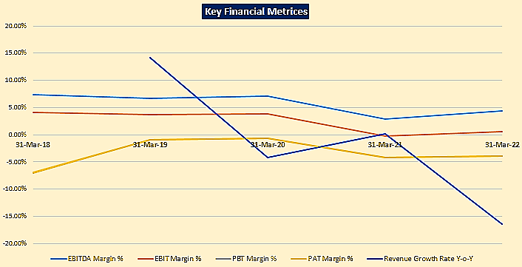
- PROJECTION OF THE COMPANY: The projections of the firm are done From FY 2023 to FY 2030 based on the revenue generation capacity of the project and total expected expenses considering the proposed resolution plan are shown as below:
- Projected Profit & Loss Account: Below table shows the Projected Profit & Loss Account of M/s Bajaj Hindusthan Sugar Limited from the period FY 2023 to FY 2030.
Statement of profit and Loss | 31-Mar-23 | 31-Mar-24 | 31-Mar-25 | 31-Mar-26 | 31-Mar-27 | 31-Mar-28 | 31-Mar-29 | 31-Mar-30
Sugar | 5,360.98 | 5,645.96 | 6,125.31 | 6,355.48 | 6,514.37 | 6,677.23 | 6,844.16 | 7,015.26
Alcohol | 1,125.68 | 1,472.15 | 1,568.83 | 1,623.89 | 1,659.22 | 1,692.49 | 1,726.34 | 1,760.87
Power | 42.96 | 39.94 | 43.76 | 44.71 | 45.57 | 46.48 | 47.41 | 48.36
By products | 33.74 | 37.84 | 39.77 | 40.56 | 41.37 | 42.20 | 43.05 | 43.91
Others (Sanitizer) | - | - | - | - | - | - | - | -
Sale of Products | 6,563.36 | 7,195.90 | 7,777.67 | 8,064.64 | 8,260.53 | 8,458.40 | 8,660.96 | 8,868.40
Other operating income | 70.58 | 71.53 | 72.50 | 73.49 | 74.50 | 75.52 | 76.57 | 77.64
Total income | 6,633.95 | 7,267.43 | 7,850.17 | 8,138.13 | 8,335.02 | 8,533.93 | 8,737.53 | 8,946.04
Growth in income (%) | 18.67% | 9.55% | 8.02% | 3.67% | 2.42% | 2.39% | 2.39% | 2.39%
Cost of raw material consumed | 5,400.38 | 6,079.01 | 6,393.57 | 6,521.74 | 6,652.17 | 6,785.22 | 6,920.92 | 7,059.12
Excise Duty on goods sold | - | - | - | - | - | - | - | -
Inventory Changes | -82.35 | -277.40 | -155.61 | -75.46 | -72.68 | -74.96 | -77.51 | -79.94
Employee benefits | 375.76 | 412.50 | 452.86 | 497.19 | 536.62 | 579.18 | 625.13 | 674.72
Other expenses | 546.95 | 588.03 | 614.57 | 628.96 | 641.67 | 654.51 | 667.60 | 680.95
Stores & Spares | 93.01 | 107.38 | 112.76 | 115.39 | 117.72 | 120.07 | 122.47 | 124.92
Pesticides | 47.47 | 48.42 | 49.39 | 50.38 | 51.38 | 52.41 | 53.46 | 54.53
Packing Material | 73.16 | 82.34 | 86.62 | 88.35 | 90.11 | 91.92 | 93.76 | 95.63
Rent Rate and Taxes | 3.73 | 3.81 | 3.88 | 3.96 | 4.04 | 4.12 | 4.20 | 4.29
Insurance | 14.78 | 15.07 | 15.37 | 15.68 | 16.00 | 16.32 | 16.64 | 16.97
Selling & Distribution | 54.75 | 66.31 | 70.93 | 73.36 | 74.92 | 76.42 | 77.95 | 79.51
Selling Commission | 14.91 | 15.63 | 16.87 | 17.42 | 17.77 | 18.12 | 18.49 | 18.86
Repairs and maintenance | 157.13 | 159.30 | 167.19 | 171.02 | 174.47 | 177.96 | 181.52 | 185.15
Power & Fuel | 19.84 | 20.23 | 20.64 | 21.05 | 21.47 | 21.90 | 22.34 | 22.79
Other expense | 68.17 | 69.53 | 70.92 | 72.34 | 73.78 | 75.26 | 76.77 | 78.30
Total expenses | 6,240.74 | 6,802.13 | 7,305.38 | 7,572.42 | 7,757.78 | 7,943.95 | 8,136.14 | 8,334.85
EBITDA | 393.21 | 465.30 | 544.79 | 565.71 | 577.24 | 589.98 | 601.39 | 611.18
EBITDA margin (%) | 5.93% | 6.40% | 6.94% | 6.95% | 6.93% | 6.91% | 6.88% | 6.83%
Finance cost | 1,927.85 | 115.38 | 149.47 | 143.70 | 129.92 | 113.91 | 93.71 | 74.13
Depreciation | 215.83 | 215.20 | 214.14 | 214.62 | 214.65 | 214.72 | 215.21 | 215.69
Profit / (Loss) before tax | -1,750.47 | 134.71 | 181.18 | 207.39 | 232.68 | 261.35 | 292.47 | 321.36
Exceptional Items
PBT | -1,750.47 | 134.71 | 181.18 | 207.39 | 232.68 | 261.35 | 292.47 | 321.36
Current tax payable | - | - | - | - | - | - | - | 8.79
Deferred tax (Mat credit lapsed + MAT credit created) | - | - | - | - | - | - | - | -8.79
Profit / (loss) after tax | -1,750.47 | 134.71 | 181.18 | 207.39 | 232.68 | 261.35 | 292.47 | 321.36
Other Comprehensive income
Total Comprehensive income | -1,750.47 | 134.71 | 181.18 | 207.39 | 232.68 | 261.35 | 292.47 | 321.36
EBITDA - Unit wise
Corporate | -42.53 | -44.96 | -47.53 | -50.27 | -53.16 | -56.24 | -59.50 | -62.96
Distillery | 164.56 | 219.66 | 235.72 | 244.86 | 250.90 | 256.38 | 261.74 | 266.97
Sugar + Cogen | 271.18 | 290.60 | 356.60 | 371.11 | 379.50 | 389.83 | 399.15 | 407.18
Total EBITDA | 393.21 | 465.30 | 544.79 | 565.71 | 577.24 | 589.98 | 601.39 | 611.18

- Projected Balance Sheet: Below table shows the Projected Balance Sheet of M/s Bajaj Hindusthan Sugar Limited from the period FY 2023 to FY 2030.
Balance Sheet | 31-Mar-23 | 31-Mar-24 | 31-Mar-25 | 31-Mar-26 | 31-Mar-27 | 31-Mar-28 | 31-Mar-29 | 31-Mar-30
ASSETS
Non-current assets
Property, plant and equipment | 6,586.11 | 6,387.46 | 6,188.32 | 5,988.69 | 5,789.05 | 5,589.32 | 5,389.11 | 5,188.42
Right of use assets | 1.55 | - | - | - | - | - | - | -
Capital work-in-progress | 4.29 | 4.29 | 4.29 | 4.29 | 4.29 | 4.29 | 4.29 | 4.29
Other intangible assets | 0.00 | 0.00 | 0.00 | 0.00 | 0.00 | 0.00 | 0.00 | 0.00
Financial assets
Investments | 92.34 | 92.34 | 92.34 | 92.34 | 92.34 | 92.34 | 92.34 | 92.34
Other non-current financial assets | 13.39 | 13.39 | 13.39 | 13.39 | 13.39 | 13.39 | 13.39 | 13.39
Other non-current assets | 137.98 | 137.98 | 137.98 | 137.98 | 137.98 | 137.98 | 137.98 | 146.77
Total Non-Current Assets | 6,835.66 | 6,635.46 | 6,436.32 | 6,236.69 | 6,037.05 | 5,837.32 | 5,637.11 | 5,445.21
Current Assets
Inventories | 2,824.32 | 3,101.72 | 3,257.33 | 3,332.80 | 3,405.48 | 3,480.44 | 3,557.94 | 3,637.88
Financial assets
Current investments | 770.13 | 770.13 | 770.13 | 770.13 | 770.13 | 770.13 | 770.13 | 770.13
Trade receivables | 179.82 | 197.15 | 213.09 | 220.95 | 226.32 | 231.74 | 237.29 | 242.97
Cash and cash equivalents | 27.59 | 101.94 | 174.09 | 252.66 | 322.10 | 406.75 | 479.73 | 607.38
DSRA | 66.67 | 66.67 | 66.67 | 66.67 | 66.67 | 66.67 | 66.67 | -
Bank balances | - | - | - | - | - | - | - | -
Loans and interest accrued | 2,088.79 | 2,088.79 | 2,088.79 | 2,088.79 | 2,088.79 | 2,088.79 | 2,088.79 | 2,088.79
Current tax assets (net) | 7.92 | 7.92 | 7.92 | 7.92 | 7.92 | 7.92 | 7.92 | 7.92
Deferred tax asset (net) | - | - | - | - | - | - | - | -
MAT Credit | - | - | - | - | - | - | - | -
Other current assets | 685.16 | 685.16 | 685.16 | 685.16 | 685.16 | 685.16 | 685.16 | 685.16
Total Current Assets | 6,650.41 | 7,019.48 | 7,263.19 | 7,425.08 | 7,572.56 | 7,737.60 | 7,893.63 | 8,040.23
Total Assets | 13,486.07 | 13,654.93 | 13,699.50 | 13,661.77 | 13,609.61 | 13,574.92 | 13,530.74 | 13,485.44
Equity & liabilities
Equity
Equity share capital | 929.28 | 929.28 | 929.28 | 929.28 | 929.28 | 929.28 | 929.28 | 929.28
Convertible instrument | 639.00 | 639.00 | 639.00 | 639.00 | 639.00 | 639.00 | 639.00 | 639.00
Other equity | 7,086.97 | 7,221.69 | 7,402.87 | 7,610.26 | 7,842.93 | 8,104.28 | 8,396.75 | 8,718.11
Net worth | 8,655.25 | 8,789.97 | 8,971.15 | 9,178.53 | 9,411.21 | 9,672.56 | 9,965.03 | 10,286.39
Non-current liabilities
Financial liabilities
Borrowings | 1,162.05 | 1,033.59 | 905.26 | 764.12 | 623.15 | 417.58 | 212.22 | 20.05
Debentures (OCD) | - | - | - | - | - | - | - | -
Bank borrowings | 1,152.98 | 1,023.43 | 893.88 | 751.38 | 608.87 | 401.60 | 194.32 | -
Loan from promoters | 9.07 | 10.16 | 11.38 | 12.74 | 14.27 | 15.98 | 17.90 | 20.05
Loan from others | - | - | - | - | - | - | - | -
Interest payable on OCD (coupon rate)
Other financial liabilities | 2.46 | 2.46 | 2.46 | 2.46 | 2.46 | 2.46 | 2.46 | 2.46
Provisions | 89.50 | 89.50 | 89.50 | 89.50 | 89.50 | 89.50 | 89.50 | 89.50
Deferred tax liabilities (net) | 505.63 | 505.63 | 505.63 | 505.63 | 505.63 | 505.63 | 505.63 | 505.63
Other non-current liabilities | 22.00 | 22.00 | 22.00 | 22.00 | 22.00 | 22.00 | 22.00 | 22.00
Total Noncurrent liabilities | 1,781.64 | 1,653.18 | 1,524.85 | 1,383.71 | 1,242.74 | 1,037.17 | 831.81 | 639.64
Current liabilities
Financial liabilities
Working Capital | - | - | 924.60 | 1,070.11 | 1,070.11 | 1,070.11 | 1,070.11 | 1,070.11
Cane Creditors (including cane commission) | 2,663 | 2,805 | 1,872 | 1,651 | 1,526 | 1,432 | 1,296 | 1,117
Others | 239.62 | 260.30 | 261.05 | 232.11 | 213.11 | 217.37 | 221.72 | 226.10
Trade payables | 2,902.99 | 3,065.60 | 2,132.72 | 1,883.23 | 1,739.36 | 1,648.89 | 1,517.60 | 1,343.11
Other financial liabilities | 2.38 | 2.38 | 2.38 | 2.38 | 2.38 | 2.38 | 2.38 | 2.38
Other current liabilities | 123.03 | 123.03 | 123.03 | 123.03 | 123.03 | 123.03 | 123.03 | 123.03
Provisions | 20.78 | 20.78 | 20.78 | 20.78 | 20.78 | 20.78 | 20.78 | 20.78
Total Current liabilities | 3,049.18 | 3,211.79 | 3,203.51 | 3,099.53 | 2,955.66 | 2,865.19 | 2,733.90 | 2,559.42
Total Equity & liabilities | 13,486.07 | 13,654.94 | 13,699.50 | 13,661.77 | 13,609.61 | 13,574.92 | 13,530.74 | 13,485.44

- Projected Cash Flow Statement: Below table shows the Projected Cash Flow statement of M/s Bajaj Hindusthan Sugar Limited from the period FY 2023 to FY 2030.
Cash Flow | 31-Mar-23 | 31-Mar-24 | 31-Mar-25 | 31-Mar-26 | 31-Mar-27 | 31-Mar-28 | 31-Mar-29 | 31-Mar-30
Cash flow from operations
Profit before tax (PBT) | -1,750.47 | 134.71 | 181.18 | 207.39 | 232.68 | 261.35 | 292.47 | 321.36
Add
Finance cost | 1,927.85 | 115.38 | 149.47 | 143.70 | 129.92 | 113.91 | 93.71 | 74.13
Depreciation | 215.83 | 215.20 | 214.14 | 214.62 | 214.65 | 214.72 | 215.21 | 215.69
EBITDA - cash generation before working capital changes | 393.21 | 465.30 | 544.79 | 565.71 | 577.24 | 589.98 | 601.39 | 611.18
Working capital changes
Inventory changes | -78.76 | -277.40 | -155.61 | -75.46 | -72.68 | -74.96 | -77.51 | -79.94
(Increase) / Decrease in Trade receivable | 34.05 | -17.33 | -15.94 | -7.86 | -5.37 | -5.42 | -5.55 | -5.68
Increase / (Decrease) in Trade payables | -2,197.97 | 162.61 | -932.89 | -249.49 | -143.87 | -90.47 | -131.29 | -174.49
Increase / (Decrease) in other assets / liabilities | - | - | - | - | - | - | - | -
Working Capital Changes | -2,242.68 | -132.12 | -1,104.44 | -332.81 | -221.91 | -170.85 | -214.34 | -260.11
Tax paid | - | - | - | - | - | - | - | -8.79
Cash flow from operating activity | -1,849.47 | 333.18 | -559.65 | 232.90 | 355.33 | 419.13 | 387.04 | 342.28
Cash flow from investing activities
Purchase of property, plant and equipment (CAPEX) | - | -15.00 | -15.00 | -15.00 | -15.00 | -15.00 | -15.00 | -15.00
Cash flow from financing activity
Promoter infusion | - | - | - | - | - | - | - | -
Capital infusion through LPGCL | 2,361.00
Repayment of Term loan | -142.50 | -129.55 | -129.55 | -142.50 | -142.50 | -207.28 | -207.28 | -194.32
Repayment of unstainable debt (OCD) | - | - | - | - | - | - | - | -
Short term borrowings (CCL) | - | - | 924.60 | 145.51 | - | - | - | -
Repayment of loans | -142.50 | -129.55 | 795.05 | 3.01 | -142.50 | -207.28 | -207.28 | -194.32
Payment of interest
Accrued interest | -0.92 | - | - | - | - | - | - | -
On term loan for the financial year | -121.56 | -108.37 | -95.41 | -82.26 | -68.31 | -52.12 | -31.71 | -11.90
Interest of CCL | - | - | -46.92 | -54.31 | -54.31 | -54.31 | -54.31 | -54.31
Coupon on OCDs | - | - | - | - | - | - | - | -
TDS on YTM | -178.41
YTM | - | - | - | - | - | - | - | -
Other borrowing cost | -21.20 | -5.92 | -5.92 | -5.77 | -5.77 | -5.77 | -5.77 | -5.77
Total Payment of Interest | -322.09 | -114.29 | -148.25 | -142.33 | -128.39 | -112.20 | -91.79 | -71.98
Cash flow from financing activity | 1,896.41 | -243.84 | 646.80 | -139.33 | -270.89 | -319.47 | -299.07 | -266.30
Net increase/(decrease) in cash and cash equivalents | 46.94 | 74.34 | 72.16 | 78.57 | 69.44 | 84.65 | 72.98 | 60.98
Opening balance of cash | 47.33 | 27.59 | 101.94 | 174.09 | 252.66 | 322.10 | 406.75 | 479.73
Closing balance of cash (Before DSRA) | 94.27 | 101.94 | 174.09 | 252.66 | 322.10 | 406.75 | 479.73 | 540.71
DSRA allocation | -66.67 | - | - | - | - | - | - | 66.67
Closing cash after DSRA | 27.59 | 101.94 | 174.09 | 252.66 | 322.10 | 406.75 | 479.73 | 607.38

- ESTIMATED KEY FINANCIAL METRICES:
DEBT SERVICE COVERAGE RATIO
Particulars | 31-Mar-23 | 31-Mar-24 | 31-Mar-25 | 31-Mar-26 | 31-Mar-27 | 31-Mar-28 | 31-Mar-29 | 31-Mar-30
EBITDA | 393 | 465 | 545 | 566 | 577 | 590 | 601 | 611
Less: Tax payments | - | - | - | - | - | - | - | (9)
Less: Capex | - | (15) | (15) | (15) | (15) | (15) | (15) | (15)
Less: WC Changes | (2,243) | (132) | (1,104) | (333) | (222) | (171) | (214) | (260)
Less: WC Interest | - | - | (47) | (54) | (54) | (54) | (54) | (54)
Add: Infusion from LPGCL | 2,361 | - | - | - | - | - | - | -
Less: TDS on YTM | (178) | - | - | - | - | - | - | -
Less: Coupon on OCD | - | - | - | - | - | - | - | -
Less: Other borrowing costs | (21) | (6) | (6) | (6) | (6) | (6) | (6) | (6)
Add: Drawdown of WC | - | - | 925 | 146 | - | - | - | -
Net cash flow available for debt servicing | 312 | 312 | 297 | 303 | 280 | 344 | 312 | 267
Finance Cost
- Term Loan | 122 | 108 | 95 | 82 | 68 | 52 | 32 | 12
- WC | - | - | - | - | - | - | - | -
Term loan repayment | 143 | 130 | 130 | 143 | 143 | 207 | 207 | 194
OCD repayment (with premium) | - | - | - | - | - | - | - | -
Payment of accrued interest | 1 | - | - | - | - | - | - | -
Total debt servicing | 265 | 238 | 225 | 225 | 211 | 259 | 239 | 206
Cash DSCR | 1.36 | 1.31 | 1.32 | 1.35 | 1.33 | 1.33 | 1.31 | 1.30
Average Cash DSCR | 1.33
Net Cash | 46.94 | 74.34 | 72.16 | 78.57 | 69.44 | 84.65 | 72.98 | 60.98
Opening cash balance | 47.33 | 94.27 | 168.61 | 240.77 | 319.34 | 388.77 | 473.43 | 546.40
Closing cash balance | 94.27 | 168.61 | 240.77 | 319.34 | 388.77 | 473.43 | 546.40 | 607.38

EBITDA MARGIN
Statement of profit and Loss | 31-Mar-23 | 31-Mar-24 | 31-Mar-25 | 31-Mar-26 | 31-Mar-27 | 31-Mar-28 | 31-Mar-29 | 31-Mar-30
Total income | 6,633.95 | 7,267.43 | 7,850.17 | 8,138.13 | 8,335.02 | 8,533.93 | 8,737.53 | 8,946.04
Growth in income (%) | 18.67% | 9.55% | 8.02% | 3.67% | 2.42% | 2.39% | 2.39% | 2.39%
Total expenses | 6,240.74 | 6,802.13 | 7,305.38 | 7,572.42 | 7,757.78 | 7,943.95 | 8,136.14 | 8,334.85
EBITDA | 393.21 | 465.30 | 544.79 | 565.71 | 577.24 | 589.98 | 601.39 | 611.18
EBITDA margin (%) | 5.93% | 6.40% | 6.94% | 6.95% | 6.93% | 6.91% | 6.88% | 6.83%
- PROJECTED RATIO ANALYSIS:
Particulars | FY 2023 E | FY 2024 E | FY 2025 E | FY 2026 E | FY 2027 E | FY 2028 E | FY 2029 E | FY 2030 E
EBITDA MARGIN | 5.99% | 6.47% | 7.00% | 7.01% | 6.99% | 6.98% | 6.94% | 6.89%
EBIT MARGIN | 2.70% | 3.48% | 4.25% | 4.35% | 4.39% | 4.44% | 4.46% | 4.46%
NET PROFIT MARGIN | -26.67% | 1.87% | 2.33% | 2.57% | 2.82% | 3.09% | 3.38% | 3.62%
GROWTH RATE (Y.O.Y.) | 19.64% | 9.64% | 8.08% | 3.69% | 2.43% | 2.40% | 2.39% | 2.40%
Current Ratio | 2.18 | 2.19 | 2.27 | 2.40 | 2.56 | 2.70 | 2.89 | 3.14
ROA | -12.98% | 0.99% | 1.32% | 1.52% | 1.71% | 1.93% | 2.16% | 2.38%
ROE | -20.22% | 1.53% | 2.02% | 2.26% | 2.47% | 2.70% | 2.93% | 3.12%
ROIC | 2.65% | 2.60% | 4.23% | 4.04% | 4.23% | 4.50% | 4.85% | 5.22%
ROCE | 1.70% | 2.39% | 3.15% | 3.32% | 3.40% | 3.50% | 3.58% | 3.62%

- GRAPHICAL REPRESENTATION:
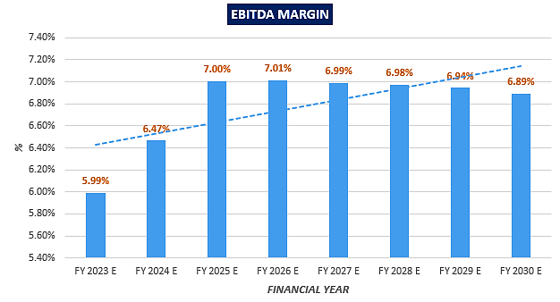
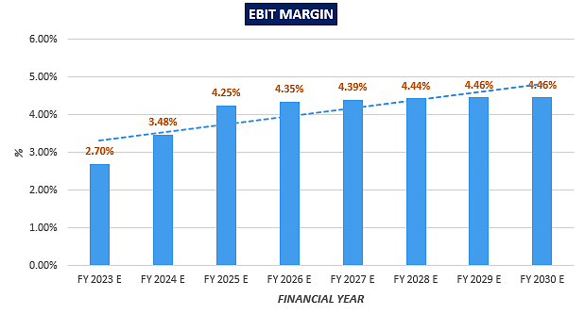
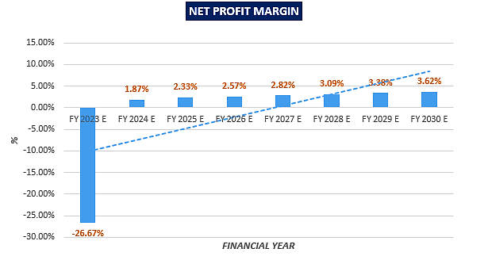
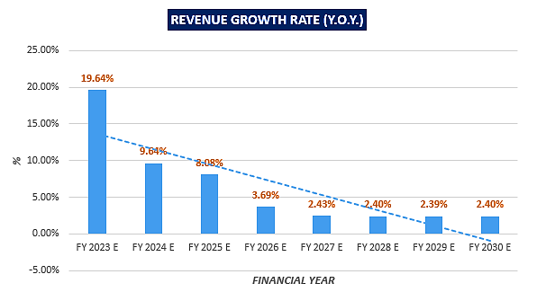
- CONCLUSION:
- DSCR, EBITDA and EBIT margin is positive in all years starting from FY 2023 up to end of 8th year i.e. FY 2030.
- Cash DSCR is expected to remain above 1 during during the entire loan repayment period.
- Average Cash DSCR & EBIDTA margin is 1.33 and 6.72% respectively during the estimated period.
- Based on the above key financial ratios of the Company during the forecast period shows that the Company looks financially viable if the Company & promoters are able to achieve operations parameters as per assumptions above.

- KEY ASSUMPTIONS & BASIS:
Particulars | Assumptions
Operational Assumptions for sugar division
Sugarcane crushing | Operational days:  - The sugar crushing capacity of BHSL is 1, 36,000 TCD. However, the number of days that the plant is functional varies year to year depending on the sugar cane availability.  - The historical number of days the plants were operational is as under:  Year ended FY18 FY19 FY20 FY21 FY22  Number of operational days 140 165 158 150 127  - In view of the past performance, it has been assumed that going forward, the plants would be functional for 150 days a year  Quantity of sugarcane crushed  - Sugarcane is an agricultural product, and it cannot be produced in a controlled environment, unlike an industrial product. Therefore, the volume of availability of sugarcane cannot be predicted with precision.  - The production of the crop is dependent upon climatic conditions, rainfall, temperature, etc. Untimely heavy rains or hailstorms may ruin a healthy, fully grown produce.  - Sugarcane crops may also be affected by various agricultural diseases or by insect attacks.  - The historical total cane crushed (lakh Qtl.) is as under:  Year ended FY18 FY19 FY20 FY21 FY22  Total cane crushed (lakh Qtl.) 1,476 1,676 1,585 1,560 1,259  - In view of the past performance and assuming improved cane availability due to payment of critical cane dues, it has been assumed that the Company would crush 1,450 lakh quintals in FY23, improving to 1,600 lakh quintals in FY24 and 1,650 lakh quintals thereafter.
Sugar recovery rate | - The historical sugar recovery rate is as below:  Year ended FY18 FY19 FY20 FY21 FY22  Average sugar recovery 10.62% 11.40% 11.65% 11.06% 10.36%  - From FY21 onwards, BHSL has started producing B heavy molasses, diverted towards industrial alcohol / ethanol production due to which average sugar recovery is expected to come down, hence, going forward average sugar recovery rate of 10.22% in FY23 and future years has been assumed.
Operational Assumptions for distillery division
Distillery operational days | - The industrial alcohol producing capacity of BHSL is 800 KLPD. However, the run days of the plant varies year to year depending on the availability of molasses which is dependent on sugar cane availability.  - The historical number of run days of the plants were as under:  Year ended FY18 FY19 FY20 FY21 FY22  Number of run days 150 152 91 143 223  - However, going forward the Company is moving towards production of ethanol by diverting B heavy molasses from sugar division to distillery unit.  - Accordingly, it has been assumed that going forward, the plants would be functional for 310 days a year. The increase in the number of operating days for ethanol production is also supported by the major overhauling of the sugar mills and distillery plants undertaken in FY21 and FY22 by additional expenditure on the repairs and maintenance.
Conversion factor for distillery unit | Molasses to industrial Alcohol conversion ratio  Molasses C 23.0  Molasses B 30.0  The above is in line with the conversion factors achieved historically.
Operational Assumptions for co-generation plants
Conversion factors | - Below conversion factors have been assumed for sugar and distillery divisions:  Particulars Sugar division Basis cane crushed Distillery division Basis alcohol produced  Live Steam 15% 1,589  Exhaust Steam 33% 3,464  Power 272% 39,000  - Steam conversion factor is 2.10 times bagasse consumed
Details of various prices and expenses assumed
Prices | For the raw material and various outputs involved, following assumptions have been considered:  Particulars Terms  Sugarcane pricing - The price of sugar cane is determined basis a notification released by the State Government - Based on past trend, the SAP of sugarcane has increased at a CAGR of ~1.93% from FY18 to FY22 - Also, the landed coal cost for the Company has increased at a CAGR of 2.30% from FY18 to FY22. - Thus, for the purpose of projecting the business plan, the Company has considered an increase of 2% over prevailing average basic cane cost of INR 346 / Qtl. in SS 2021-22. The other associated cane cost including transportation, loading/unloading, etc.) is also increased at 2% going forward.  Sugar realisation price The sugar realisation price for FY23 is assumed to be ~INR 3,500 / Qtl. and the same is assumed to increase at 2.5% p.a. from FY24 onwards.  Molasses C for levy Increased at 2.0% p.a.  Molasses C Increased at 2.0% p.a.  Molasses B Increased at 2.0% p.a.  Alcohol produced from Molasses C - For FY22, is on the basis of GOI notification - Post which the same has been assumed to increase at 2.0% p.a.  Alcohol produced from Molasses B - For FY22, is on the basis of GOI notification - Post which the same has been assumed to increase at 2.0% p.a.
Expenses | - Manpower cost has been assumed to increase at 10% p.a. from FY23 till FY26 due to increase in cane crushing and ethanol production. Same is increasing at 8% p.a. thereafter (based on CAGR from FY18 to FY22) considering stabilization in operations and lower employee turnover ratio  - Repairs and maintenance expense for plant and machinery in sugar and co-gen and distillery units for FY23 and FY24 is as follows:  Particulars Sugar division INR per Qtl. of cane crushed Distillery division INR per BL of alcohol produced  FY23 FY24 FY23 FY24  Repair and maintenance (P&M) 8.62 7.50 1.30 1.33  Increased at 2% from FY25 onwards  - Repairs and maintenance expense for building and others has been assumed to increase at 2% p.a. from FY23 onwards in line with other expenses  - Other expenses include stores and spares, packing material, rent, rates and taxes, insurance, selling and distribution, selling commission, power and fuel, etc.  - They constitute ~5 - 6% of total expenses of the company in the past financial years.  - Due to non-existence of a linear trend for other expenses and as they are incurred on account of cane crushing, cane handling etc. therefore, it has been assumed to increase at 2% p.a. in line with growth taken in sugar cane prices.
Working capital assumptions
Receivables | 10 days of operating revenue
Trade payables | - Cane creditors have been assumed as a number of days of the cane cost incurred  Year ended FY23 FY24 FY25 FY26 FY27 FY28 FY29 FY30  Number of days of cane cost 187 175 111 96 87 80 71 60  - Cane dues days are assumed to decline in FY22-23 because of payment of the accumulated cane dues through infusion from LPGCL undertaken by UP Government action / expected to be undertaken in near future. Thereafter, the cane dues days are expected to decline on account of regular payments from the operational cash flows.  - Other creditors have been assumed as a number of days of other expenses incurred  Year ended FY22 FY23 FY24 FY25 FY26 FY27 onwards  Number of days of other expenses 120 120 120 115 100 90
Other assumptions
Maintenance capex | It has been assumed that the Company shall incur yearly capex of INR 15 Cr every year from FY24
Financial assumptions:
Repayment Schedule |  | Year Term Loan – 1 Term Loan – 3 WCTL - 1 WCTL – 2  FY23 11.00% 11.00% 11.00% 11.00%  FY24 10.00% 10.00% 10.00% 10.00%  FY25 10.00% 10.00% 10.00% 10.00%  FY26 11.00% 11.00% 11.00% 11.00%  FY27 11.00% 11.00% 11.00% 11.00%  FY28 16.00% 16.00% 16.00% 16.00%  FY29 16.00% 16.00% 16.00% 16.00%  FY30 15.00% 15.00% 15.00% 15.00%  Total 100% 100% 100% 100%
- JUSTIFICATION FOR ESCALATION RATES CONSIDERED:
- Cane Price

Particular | UoM | 2017-18 | 2018-19 | 2019-20 | 2020-21 | 2021-22 | Average
SAP | Rs/Qtl | 315 | 315 | 315 | 315 | 340
%age of increase | %age |  | 0.00% | 0.00% | 0.00% | 7.94% | 1.98%
Compound Annual Growth Rate |  |  |  |  |  |  | 1.93%

* Compounded annual growth Rate in State Advisory Price (SAP) of Sugarcane is approximately 2%.
Average landed Cane cost:

Particulars | UoM | FY 18 | FY 19 | FY 20 | FY 21 | FY 22 | Ave
Average landed Cane cost | Rs/Qtl | 330 | 336 | 337 | 338 | 361
Increase %age | %age |  | 1.74% | 0.27% | 0.47% | 6.88% | 2.34%
CAGR |  |  |  |  |  |  | 2.30%

CAGR for average landed cane cost is approx. 2.30%, but the basic cane cost increase rate is around ~1.93%. Besides this some of the cost components like cane commission etc. have been stagnant over the last few years and are expected to remain at the same level in subsequent years as well, hence the average increase in cane cost has been considered 2%.
- Manpower Cost:

Manpower Cost | FY 18 | FY 19 | FY 20 | FY 21 | FY 22
Rs in Cr. | 249 | 275 | 299 | 328 | 342
Annual increase (As per Model) |  | 10% | 9% | 10% | 4%
CAGR |  |  |  |  | 8%

Escalation in manpower cost @10% has been considered till FY 25 – with increase in cane crushing and ethanol production – which is higher than the past trend (8%). The same has been projected in line with the past trend @8% from FY 26 onwards – considering stabilization in operations and lower employee turnover ratio.
- Repairs & Maintenance:

Particulars | FY 18 | FY 19 | FY 20 | FY 21 | FY 22
Rs in crore | 92 | 130 | 158 | 336 | 242
Less: Major Repairs* | - | - | (34) | (199) | (101)
Net Repairs Cost | 92 | 130 | 124 | 138 | 141
Y-o-Y Average |  |  |  |  | 2.5%

*There were some major repairs during FY 2020 to FY 2022 due to overdue major overhaul required at the plants level on account of ageing of equipment. This maintenance job was carried out to gear up for the changing scenario in the sugar industry, like production of B-heavy molasses and conversion thereof into ethanol – throughout the year, and improving plant operations. These maintenance works were of exceptional nature and hence, is not a recurring cost.

From FY 23 to FY 25, we have considered average ~6% increase in repairs cost – as there has been increase in the cane crushing & ethanol production. Post FY 25, on stabilization of operations, repairs cost has been considered to increase @ ~2% annually – in line with assumptions for increase in other expenses.
- Other Expenses:
It may be observed that other expenses had increased by ~6% last year (FY 22). However, from FY 23 to FY 25, we have considered average ~8% increase in other expenses – due to increase in the cane crushing & ethanol production. Post FY 25, on stabilization of operations, other expenses have been considered to increase @ ~2% annually.
*Pesticide cost is non-operational expenses and there is corresponding revenue also from the sale of pesticides to cane growers, hence the same has been removed from the other cost.

2% general escalation has been considered for expenses, while some of the expenses will either remain static or come down depending upon the business scenarios, like administrative overhead which comprises traveling, vehicle running, legal, profession, security, sanitation, horticulture etc. Hence even if increase in any expense head goes beyond 2%, the impact will get absorbed by the static expenses which are generally not supposed to increase in a linear trend every year.

Secondly when the operations of plants are optimized and the capacity utilization increases, some plants may crush a higher volume of cane with lower number of days, which may also reduce the expenses. Also the operational expenses are bound to be optimized due to improvement in operational efficiency on account of better cash flow management after restructuring. Hence the linear escalation of 2% is on the conservative side and adequate to take care of any likely increase in expenses.
(Rs in crore)
Particulars | FY 21 | FY 22
Other Expenses | 674 | 602
Less Pesticides* | (42) | (47)
Less Repairs & Maint. | (336) | (242)
Net Other Expenses | 296 | 313
% Increase |  | 5.8%

PART M | CONCLUSION
Based on the technological, economical and market analysis done above, various Industry assumptions taken, product pricing to be adopted by the company, the Company appears to be Techno-commercially viable subject to the risks, threats, weaknesses, limitations of the product as detailed previously.
As per financial projections for the estimated period, Average cash DSCR & EBITDA Margin of the project company are 1.33 and 6.72% respectively, where higher DSCR is the indicator of the project capability to pay out its outstanding debt and EBITDA margin shows the capability of the project company to generate the operating profits after all the operational expenses incurred over the forecasted period.
While it is not avoidable that the future projections may change in the upcoming years due to various factors impacting the operational, managerial, financial efficiency and economies of scale of the project company, it would be depending on the management’s capability in future that how efficiently company adopts marketing and advertisement strategy, supply chain and carry out inventory & resource management to achieve higher profitability. Bank/ Financial Institution is advised to take firm plan from the company in this regard before taking any decision.
After considering past trends and recent developments in the industry, domestically and globally, various initiatives taken by government, financial analysis of the project based on the assumptions taken over the projected period, plants condition, techcnology used by the company at present, market space, demand and supply of finished goods & by-products of the company, it appears reasonable to comment that the “M/s Bajaj Hundusthan Sugar Limited” is “Technically and Economically” Viable subject to current assumptions considered and occurring the same in the upcoming years same as the forecasted period which is dependent on the sincerity and efforts of the management and various micro and macroeconomic & industry situation.
We have tried our level best to analyse the Project techno-economic feasibility of the Project based on the Industry research, Project information and various futuristic assumption taken. However achieving the financial milestones depends on the ability, sincerity and efforts of the company, promoters and its key managerial performance.

Declaration | - The undersigned does not have any direct/indirect interest in the above property.  - The information furnished herein is true and correct to the best of our knowledge, logical and scientific assumptions.  - This TEV Report is carried out by our Financial Analyst team on the request from State Bank of India, IFB, RM-1 Credit Devision, 14th floor Jawahar Vyapar Bhavan 1, Tolstoy Marg, New Delhi, 110001.  - Meeting of Financial projections will be subject to subject to the market & economy stability factors, judicious business operations and proper & timely implementation of its process & product re-engineering & improvements plans for achieving high productivity, efficiency and achieving cost saving benefits.  - We have submitted TEV report to the Client.
Name & Address of consultant company |  |  | Signature of the authorized person
M/s. R.K. Associates Valuer & Techno Engineering Consultants Pvt. Ltd.
D-39, 2nd Floor. Sector-2, Noida- 201301
Enclosed Documents |  | Disclaimer & Remarks 141
Number of Pages in the Report |  | 144
Financial Analyst Team worked on the report |  | PREPARED BY: Mr. GAURAV KUMAR
 |  | REVIEWED BY: HOD Project

For R.K Associates Valuer & Techno Place: Noida
Engineering Consultants (P) Ltd. Date: 25th July 2022

(Authorized Signatory)

PART N | DISCLAIMER | REMARKS

      - No employee or member of R.K Associates has any direct/ indirect interest in the Project.
      - This report is prepared based on the copies of the documents/ information which the Bank/ Company has provided to us out of the standard checklist of documents sought from them and further based on our assumptions and limiting conditions. The client/owner and its management/representatives warranted to us that the information they supplied was complete, accurate and true and correct to the best of their knowledge. All such information provided to us has been relied upon in good faith and we have assumed that it is true and correct in all respect. I/We shall not be liable for any loss, damages, cost or expenses arising from fraudulent acts, misrepresentations, or wilful default on part of the owner, company, its directors, employee, representative or agents. Verification or cross checking of the documents provided to us from the originals or from any Govt. departments/ Record of Registrar has not been done at our end since this is beyond the scope of our work. If at any time in future, it is found or came to our knowledge that misrepresentation of facts or incomplete or distorted information has been provided to us then this report shall automatically become null & void.
      - Legal aspects for e.g. investigation of title, ownership rights, lien, charge, mortgage, lease, sanctioned maps, verification of documents, etc. have not been done at our end and same has to be taken care by legal expert/ Advocate. It is assumed that the concerned Lender/ Financial Institution has satisfied them with the authenticity of the documents, information given to us and for which the legal verification has been already taken and cleared by the competent Advocate before requesting for this report. I/ We assume no responsibility for the legal matters including, but not limited to, legal or title concerns.
      - This report is a general analysis of the project based on the scope mentioned in the report. This is not an Audit report, Design document, DPR or Techno feasibility study. All the information gathered is based on the facts seen on the site during survey, verbal discussion & documentary evidence provided by the client and is believed that information given by the company is true best of their knowledge.
      - This Techno Economic-Viability study is prepared based on certain futuristic assumption which are intra dependent on economic, market and sectorial growth condition in future and socio-economic, socio-political condition at macro and micro level.
      - Meeting of assumption and financial ratio will entirely depend on the sincerity and efforts of the company, promoters and its key managerial performance.
      - All observations mentioned in the report is only based on the visual observation and the documents/ data/ information provided by the client. No mechanical/ technical tests, measurements or any design review have been performed or carried out from our side during Project assessment.
      - Bank/FII should ONLY take this report as an Advisory document from the Financial/ Chartered Engineering firm and its specifically advised to the creditor to cross verifies the original documents for the facts mentioned in the report which can be availed from the borrowing company directly.
      - In case of any default in loans or the credit facility extended to the borrowing company, R.K Associates shall not be held responsible for whatsoever reason may be and any request for seeking any explanation from the employee/s of R.K Associates will not be entertained at any instance or situation.
      - The documents, information, data provided to us during the course of this assessment by the client are reviewed only up to the extent required in relation to the scope of the work. No document has been reviewed beyond the scope of the work.
      - This report only contains general assessment & opinion as per the scope of work evaluated as per the information given in the copy of documents, information, data provided to us and/ and confirmed by the owner/ owner representative to us at site which has been relied upon in good faith. It doesn’t contain any other recommendations of any sort including but not limited to express of any opinion on the suitability or otherwise of entering into any transaction with the borrower.
      - We have relied on data from third party, external sources & information available on public domain also to conclude this report. These sources are believed to be reliable and therefore, we assume no liability for the truth or accuracy of any data, opinions or estimates furnished by others that have been used in this analysis. Where we have relied on data, opinions or estimates from external sources, reasonable care has been taken to ensure that such data has been correctly extracted from those sources and /or reproduced in its proper form and context, however still we can’t vouch its authenticity, correctness or accuracy.
      - This Report is prepared by our competent technical team which includes Engineers and financial experts & analysts.
      - This is just an opinion report and doesn’t hold any binding on anyone. It is requested from the concerned Financial Institution which is using this report for taking financial decision on the project that they should consider all the different associated relevant & related factors also before taking any business decision based on the content of this report.
      - All Pages of the report including annexure are signed and stamped from our office. In case any paper in the report is without stamp & signature then this should not be considered a valid paper issued from this office.
      - Though adequate care has been taken while preparing this report as per its scope, but still we can’t rule out typing, human errors, over sightedness of any information or any other mistakes. Therefore, the concerned organization is advised to satisfy themselves that the report is complete & satisfactory in all respect. Intimation regarding any discrepancy shall be brought into our notice immediately. If no intimation is received within 15 (Fifteen) days in writing from the date of issuance of the report, to rectify these timely, then it shall be considered that the report is complete in all respect and has been accepted by the client up to their satisfaction & use and further to which R.K Associates shall not be held responsible in any manner.
      - Defect Liability Period is 15 DAYS. We request the concerned authorized reader of this report to check the contents, data and calculations in the report within this period and intimate us in writing if any corrections are required or in case of any other concern with the contents or opinion mentioned in the report. Corrections only related to typographical, calculation, spelling mistakes, incorrect data/ figures/ statement will be entertained within the defect liability period. Any new changes for any additional information in already approved report will be regarded as additional work for which additional fees may be charged. No request for any illegitimate change in regard to any facts & figures will be entertained.
      - R.K Associates encourages its customers to give feedback or inform concerns over its services through proper channel at valuers@rkassociates.org in writing within 15 days of report delivery. After this period no concern/ complaint/ proceedings in connection with the Techno- Economic Viability Study Services will be entertained due to possible change in situation and condition of the subject Project.
      - Our Data retention policy is of ONE YEAR. After this period, we remove all the concerned records related to the assignment from our repository. No clarification or query can be answered after this period due to unavailability of the data.
      - This Techno Economic Viability Study report is governed by our (1) Internal Policies, Processes & Standard Operating Procedures, (2) Information/ Data/ Inputs given to us by the client and (3) Information/ Data/ Facts given to us by our field/ office technical team. Management of R.K Associates never gives acceptance to any unethical or unprofessional practice which may affect fair, correct & impartial assessment and which is against any prevailing law. In case of any indication of any negligence, default, incorrect, misleading, misrepresentation or distortion of facts in the report then it is the responsibility of the user of this report to immediately or at least within the defect liability period bring all such act into notice of R.K Associates management so that corrective measures can be taken instantly.
      - R.K Associates never releases any report doing alterations or modifications from pen. In case any information/ figure of this report is found altered with pen then this report will automatically become null & void.
      - If this report is prepared for the matter under litigation in any Indian court, no official or employee of R.K Associates will be under any obligation to give in person appearance in the court as a testimony. For any explanation or clarification, only written reply can be submitted on payment of charges by the plaintiff or respondent which will be 10% of the original fees charged where minimum charges will be Rs. 15,000/.

