**REPORT FORMAT:** CL-1 | Version: 1.0_2018

# FILE No.: VIS(2022-23)-PL083-069-122 Date: 31-05-2022

* ***CERTIFICATE* NAME:** *Cost Vetting Certificate for Textile plant which is proposed to be installed in Panchmehal, Survey No. 26/1, Paiki, Village Ujeti, Taluka Halol, Dist. Panchmehal, Gujarat*
* ***PREPARED FOR ORGANIZATION:*** *State Bank of India, SME Branch, Ranipur, Haridwar*
* ***BORROWER COMPANY’S NAME:*** *M/s. Varhamurti Flexirub Industires Private Limited*
* ***ASSET TYPE****: Textile Industry*
* ***CURRENT LOCATION OF THE MACHINES****: Proposed to be installed Survey No. 26/1, Paiki, Village Ujeti, Taluka Halol, Dist. Panchmehal, Gujarat*

**TO WHOM IT MAY CONCERN**

|  |  |  |
| --- | --- | --- |
| **S. NO.** | **PARTICULARS** | **DESCRIPTION** |
| 1. | Date of Survey | Not Applicable |
| 2. | Date of Certificate | 31-05-2022 |
| 3. | Documents provided for perusal | 1. Purchase Bills 2. Purchase Orders 3. List of Machines |
| 4. | Current Location of the Machines | Proposed to be installed at Survey No. 26/1, Paiki, Village Ujeti, Taluka Halol, Dist. Panchmehal, Gujarat. |
| 5. | Borrowing Company | M/s. Varhamurti Flexirub Industires Private Limited |
| 6. | Type of Asset | Machinery required for installing Textile Mill |
| 7. | Type of Assessment | Cost vetting |
| 8. | Scope of Assessment | Cost Vetting of the new equipment which has to be purchased by the company. |
| 9. | Nature of Machinery | Textile industry machines and other general machines |
| 10. | Year of Manufacturing | Plant is yet to be installed. |
| 11. | Total Purchase Cost | **Rs.3,42,73,725/-** *(excluding GST)* (*Total project Cost including supply and installation as per the List of machinery / quotations / invoices / purchase orders provided by the company)* |
| 12. | Current Estimated Market Value | The range of current market rates of such type of machinery & equipments is verified from various suppliers and also from the public domain for the new machinery and equipment’s.  As per information received from market we are of the view that rate range for establishing the machinery of similar kind of textile mill should be in the range **Rs.3.50 Cr. to Rs.4.00 Cr.**  According to our observation, the rate as per the list of machinery and their total purchase price provided to us by the company/ bank are quite reasonable when compared to the rates of similar machines currently prevailing in the market.  However, in the last few months, the rates of metal have increased, so we have considered the range accordingly. |
| 13. | Condition of Machines | Machines are not installed yet. |

**OBSERVATIONS:**

1. We have been provided with the Proforma Invoices with cost of machines/ equipment by the borrower company.
2. As per the information provided by the company officials these items are already/planned to be installed at Survey No. 26/1, Paiki, Village Ujeti, Taluka Halol, Dist. Panchmehal, Gujarat.
3. We have contacted several suppliers for similar items and also enquired in the public domain. Accordingly we have got the price information from the suppliers and we find that the price given in the list by the client provided to us is well within the price range of similar items available in the market and seems to be reasonable.
4. In the last few months, the rates of metal have increased, so we have considered the range accordingly.
5. In this certificate, we have considered the value only for the main machinery while cost for auxiliary items / softwares have not been included. Due to this, there can be major differences in some items.
6. Based on the information provided by the company (M/s. Varhamurti Flexirub Industires Private Limited) and enquiries made by us in the open market and references found in the public domain for similar machines/items, it is certified that total market cost for setting up plants of similar specification should be around **Rs.3.50 Cr to Rs. 4.00 Cr** and therefore the total purchase price of **Rs.3,42,73,725/- (excluding GST)** (as per the quotations, bills & purchase orders provided to us by the company) appears to be reasonable.

***Disclaimer:***

* 1. *We can’t comment about the current status of machines whether these are purchased, installed or in transit. This cost vetting is done only on the basis of Quotations, Bills and Purchase Orders provided to us by the company and we don’t recommend any sort of recommendation in our Certificate.*
  2. *The estimated cost verification of item to item can’t exactly match as per our vetting due to several market consideration. In some of the items it is lower while in some of the items price comes to be higher but on an average the price as per list provided to us falls in the range as confirmed by us.*
  3. *There can be variation in the estimated price if the specification & make of any items procured is different from the list provided to us during assessment.*
  4. *The estimated cost verification is made based on the third party information which has been replied upon in good faith.*
  5. *The estimated price may vary at the time of actual procurement because of change in prices in the market for such kind of machinery/items for which we will not have any control. The cost vetting is only limited to the date of Certificate issued. We do not assume any responsibility in change of prices of the said machinery/items after this date.*
  6. *This certificate doesn’t include any work related to drawing, design, sketch plan, procurement of the machines.*
  7. *Ownership and other legal point of view in respect of the asset is not considered in this report as same is out of scope of this certificate.*
  8. *This certificate is made at the request of the Bank.*

**For R.K Associates Valuers** **& Techno** **FOR INTERNAL USE Engineering Consultants (P) Ltd. *TYPED BY: Er. Gaurav Sharma***  ***REVIEWED BY: HOD Engineering***

# ANNEXURE: - I (LIST OF MACHINES PROVIDED BY CLIENT)

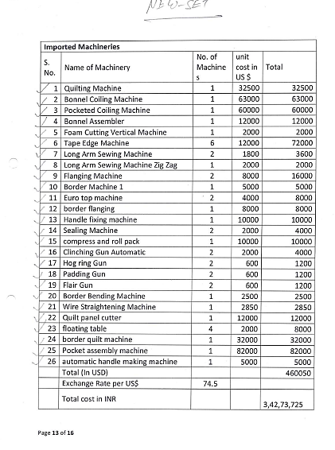

# ANNEXURE: - II (REFERENCES ON PRICE TREND OF THE SIMILAR RELATED PROPERTIES AVAILABLE ON PUBLIC DOMAIN )

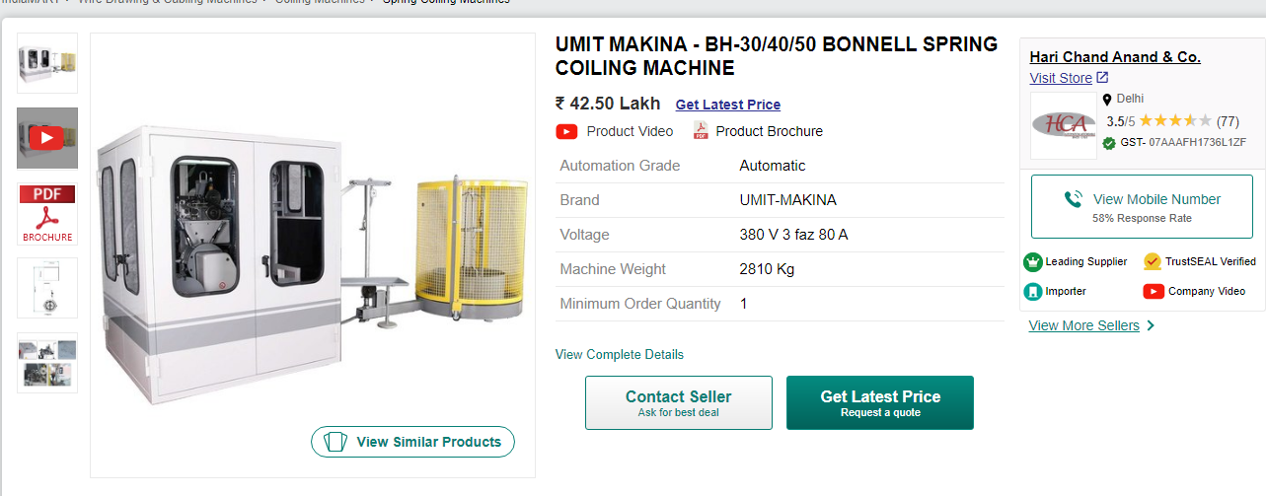

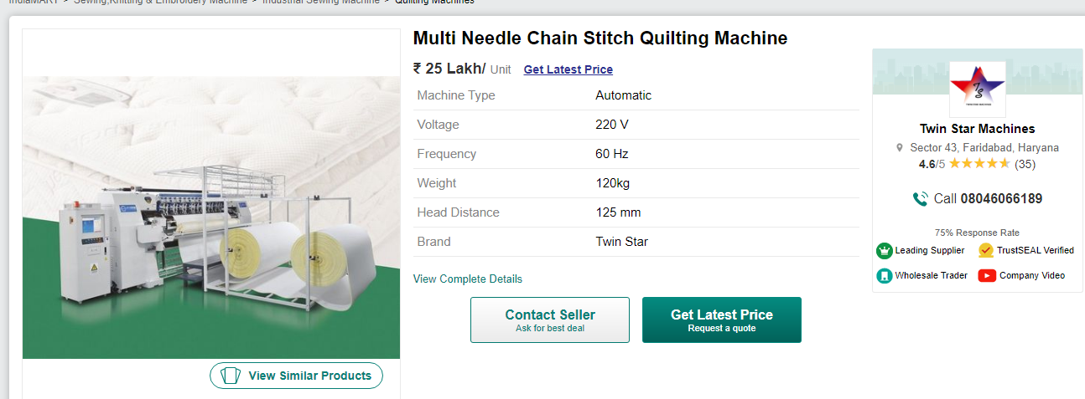

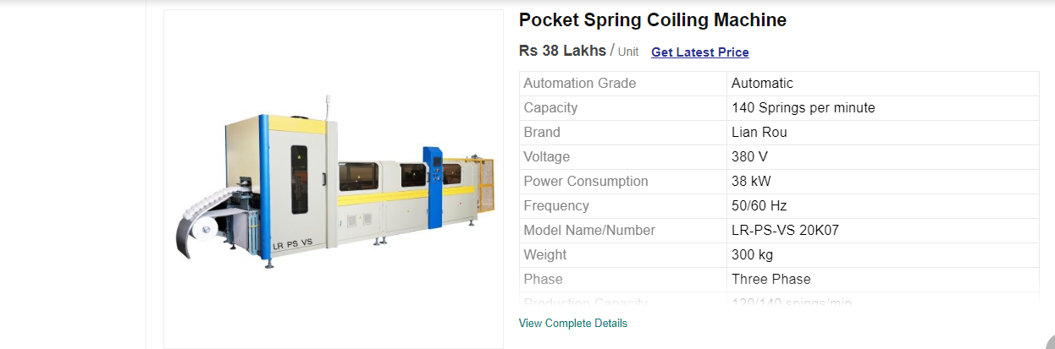

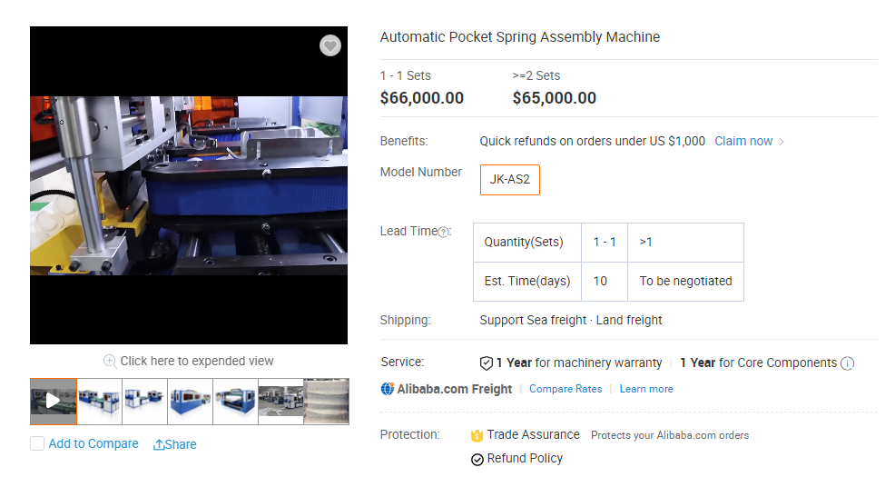

# ANNEXURE: - III (PROFORMA INVOICES)

# 

