**REPORT FORMAT:** V-L5 | Version: 4.2_2017

**File No.: VIS (2022-23)-PL105-088-143 Dated: 11.08.2022**

**ENTERPRISE VALUATION REPORT**

**OF**

**M/S NAGARJUNA FERTILIZERS AND CHEMICALS LIMITED**

**SITUATED AT**

**REGISTERED OFFICE: D.No.8-2-248,** **NAGARJUNA HILLS,**

**HYDERABAD, ANDHRA PRADESH, INDIA - 500 082**

**OWNER/ PROMOTER**

**NAGARJUNA GROUP**

**REPORT PREPARED FOR**

**IDBI BANK, WORLD TRADE CENTER COMPLEX, 7TH FLOOR, LCG, D-WING, IDBI TOWER, CUFFE PARADE, MUMBAI - 400005**

***\*\*Important - In case of any query/ issue or escalation you may please contact Incident Manager***

***at valuers@rkassociates.org. We will appreciate your feedback in order to improve our services.***

***NOTE: As per IBA Guidelines please provide your feedback on the report within 15 days of its submission after which report will be considered to be correct.***

**IMPORTANT NOTICE**

***COPYRIGHT FORMAT:*** *This report is prepared on the copyright format of R. K. Associates Valuers & Techno Engineering Consultants (P) Ltd. (R. K. Associates) to serve our clients with the best possible information and analysis to facilitate them to take rational business decisions. Legally no one can copy or distribute this format without prior approval from R. K. Associates. It is meant only for the advisory/ reference purpose for the organization/s as mentioned on the cover page of this report. Distribution or use of this format or report or any of its content/ information/ data by any organization or individual other than R.K Associates will be seen as an unlawful act and necessary legal action can be taken against the defaulters.*

*This report is intended for the sole use of the intended recipient/s and contains material that is STRICTLY CONFIDENTIAL AND PRIVATE.*

***DEFECT LIABILITY PERIOD:*** *In case of any query/ issue or escalation you may please contact Incident Manager at valuers@rkassociates.org. Though adequate care has been taken while preparing this report as per its scope, but still we can’t rule out typing, human errors, over sightedness of any information or any other mistakes. Therefore, the concerned organization is advised to satisfy themselves that the report is complete & satisfactory in all respect. Intimation regarding any discrepancy shall be brought into our notice immediately. If no intimation is received within 15 (Fifteen) days in writing from the date of issuance of the report, to rectify these timely, then it shall be considered that the report is complete in all respect and has been accepted by the client up to their satisfaction & use and further to which R.K Associates shall not be held responsible in any manner.*

***Part H: R. K. Associates Important Disclaimer and Remarks*** *are integral part of this report and Feasibility assessment is subject to this section. Reader of the report is advised to read all the points mentioned in these sections carefully.*

| **TABLE OF CONTENTS** | | |
| --- | --- | --- |
|  | | |
| **SECTIONS** | **PARTICULARS** | **PAGE NO.** |
| **Part A** | **INTRODUCTION** | **4** |
| 1. About the Report | 4 |
| 1. Background of the Project | 4 |
| 1. Type of Report | 8 |
| 1. Purpose of the Report | 8 |
| 1. Scope of the Report | 8 |
| 1. Methodology/ Model Adopted | 9 |
| 1. Documents/ Data Referred | 9 |
| **Part B** | **Project Company** | **10** |
| 1. Executive Summary | 10 |
| 1. Directors’/Promoters of the Company | 13 |
| 1. Debt Position of the Company | 13 |
| 1. Capital Structure | 14 |
| 1. Shareholding Pattern | 14 |
| 1. Reason for Financial Stress | 15 |
| **Part C** | **The Project** | **18** |
| 1. Brief Description of the Project | 18 |
| 1. Products | 18 |
| 1. Current Plant Condition | 20 |
| 1. Office Memorandum and Escrow Agreement | 22 |
| **Part D** | **Market Overview on Agrochemical Sector** | **23** |
| 1. Introduction | 23 |
| 1. Market Size of the Indian Agrochemical Industry | 27 |
| 1. Latest Investments | 29 |
| 1. Government’s Initiatives | 29 |
| 1. Road Ahead | 30 |
| **Part E** | **Historical Financial Performance** | **31** |
| 1. Historical Profit & Loss Statement | 31 |
| 1. Graphical Representation of Key Financial Metrics | 32 |
| **Part F** | **Valuation of the Company** | **35** |
| 1. Methodology/ Model Adopted | 35 |
| 1. Summary of Valuation Assessment | 37 |
| 1. Enterprise Valuation | 39 |
| 1. Key Assumptions and Workings | 39 |
| 1. Declaration | 43 |
| **Part G** | **Important Definition** | 44 |
| **Part H** | **Disclaimer and Remarks** | 46 |

|  |  |
| --- | --- |
| **PART A** | **INTRODUCTION** |

1. **ABOUT THE REPORT:** Enterprise Valuation Report of agricultural chemical manufacturing industry company M/s Nagarjuna Fertilizers and Chemicals Limited having corporate office at D.No.8-2-248, Nagarjuna Hills, Hyderabad, Andhra Pradesh, India – 500082 and plants at Nagarjuna Road, Kakinada, Andhra Pradesh, India - 533003.
2. **BACKGROUND OF THE PROJECT**: M/s Nagarjuna Fertilizers and Chemicals Limited is a leading manufacturer and supplier of plant nutrients in India. Company’s asset base is around Rs. 21 billion in 1986-87. In Southern India, company have the merit of being the single largest private sector investment. Originated in 1973 by Shri K V K Raju, with a modest investment of Rs.50 million, the Nagarjuna Group is a noticeable industrial house in India with an asset base of Rs.43 billion. In the year 1974, a steel manufacturer, Nagarjuna Steels Limited was launched.

M/s Nagarjuna Fertilizers and Chemicals Limited, started in 1985, with emphasis on plant nutrition business. From 1992 to 1997, Nagarjuna group entered into different business like crop protection business, micro irrigation business, power generation business and petroleum business. In this period, Nagarjuna group setup Nagarjuna Power Corporation Limited and Nagarjuna Oil Corporation Limited. In 1999 company first entered into the Technology Enabled Agri-Informatics Space through ikisan.

In the year 2002, Nagarjuna Fertilizers & Chemicals Ltd and Nagarjuna Agrichem Ltd started Crop Nutrition and Crop Protection Businesses respectively. In 2004, company did long term investments in Crop Protection Business with MNC’s. Nagarjuna group also invested in ventures at overseas locations in R & D Fertilizer manufacturing industry in the same year. Then they continue this R & D efforts in many new Agri-Domains space in India and Overseas.

In 2010, Nagarjuna Crop Nutrition Business was established by making investments in Fertilizer Bulks, Micro-Irrigation and Customized Fertilizer segments. Nagarjuna Crop Nutrition Business made initial investments in the African Markets in 2011. Nagarjuna Fertilizers and Chemicals Ltd enters the Billion Dollar Alliance in 2012, in the same business. Combining its core activities, currently the Group’s major operations cover Agri and Energy sectors.

Gas Authority of India Limited (GAIL) accident (27th June, 2014) impacted production and energy for two years caused severe financial stress. Due to non-availability of working capital, the company shut down/reduced all non-urea businesses.

As per the information provided by the client/company, NFCL had taken forced shutdown of both the plants in July 2018 due to lack of working capital support. The company restarted production from one unit with support from GOI & GAIL (Office Memorandum (OM)) and Banks (HOO & Escrow Agreement) during December 2018. Second plant operation could not start due to lack of LC/BG.

From July 2018 to March 2022, only one Plant could be run due to financial stress. Plant-I & II were under shutdown for 479 days and 903 days respectively. Idling of equipment for such long durations caused damage/deterioration of many of the equipment. Plant I was restarted, and production commenced from December, 2021. Plant II was restarted, and production commenced from April 2022.

The building area details of the Project Company are provided in the table below:

|  |  |  |  |  |  |  |
| --- | --- | --- | --- | --- | --- | --- |
| **BUILDINGS DETAILS** | | | | | | |
| **S.No** | **Name of Building** | **Plinth area (Sq.m.)** | **GF area (Sq.m.)** | **All floors area excl. GF (Sq.m.)** | **Building Height (Mt.)** | **Year of Construction** |
| **1** | Tech Building and Lab Building | 4636 | 2318 | 2318 | 8.5 | 1st Aug 1992 |
| **2** | Plant-1 control room | 1293 | 1293 | NIL | 6.1 | 1st Aug 1992 |
| **3** | Operator cabins | 175 | 175 | NIL | 3.5 | 1st Aug 1992 |
| **4** | Substation 2 | 1618 | 809 | 809 | 9 | 1st Aug 1992 |
| **5** | Substation 3 | 1618 | 809 | 809 | 9 | 1st Aug 1992 |
| **6** | Plant-2 control room | 1543 | 1043 | 500 | 11.1 | 19th March 1998 |
| **7** | Ammonia substation | 1644 | 822 | 822 | 9 | 19th March 1998 |
| **8** | Urea substation | 1644 | 822 | 822 | 9 | 19th March 1998 |
| **9** | Steam and power generation plant | 3940 | 2500 | 1440 | 13.3 | 1st Aug 1992 |
| **10** | GT-C & Substation-21 | 1820 | 1177 | 643 | 9.5/16.25 | 19th March 1998 |
| **11** | Urea silo | 10525 | 10525 |  | 23 | 1st Aug 1992 |
| **12** | Bagging Plant including loco shed | 32631 | 26478 | 9153 | 3.5/7.2/11.2/14/17.35/21/24/28.1/32/35.5 | 1st Aug 1992 |
| **13** | AMF2 | 246 | 246 |  | 7.3 | 19th March 1998 |
| **14** | DM plant | 4134 | 4134 | NIL | 8/13.5 | 1st Aug 1992 |
| **15** | DM mcc | 96 | 96 | NIL | 4.5 | 19th March 1998 |
| **16** | Cooling tower Control room and MCC | 280 | 280 | NIL | 4.5 | 1st Aug 1992 |
| **17** | Clarifier water lift cum fire water pump house | 764 | 764 | NIL | 10.6 | 1st Aug 1992 |
| **18** | Sludge sump and pump house | 210 | 210 | NIL | 8 | 1st Aug 1992 |
| **19** | Filter water pump house | 762 | 762 | NIL | 10.6 | 1st Aug 1992 |
| **20** | ETP | 572 | 572 | NIL | 4.5 | 1st Aug 1992 |
| **21** | IG PLANT | 1467 | 1467 | NIL | 4.0/8.15/9.5 | 1st Aug 1992 |
| **22** | MRSS | 2523 | 1105 | 1418 | 4.50/9.05/12.05/16.8 | 1st Aug 1992 |
| **23** | SS4 | 1524 | 864 | 660 | 3.5/8.1 | 1st Aug 1992 |
| **24** | SS5 | 1226 | 634 | 592 | 3.5/8.1 | 1st Aug 1992 |
| **25** | Chemical house WTP | 1890 | 1120 | 770 | 11.30/6.50 | 1st Aug 1992 |
| **26** | Canteen bldg. | 1113 | 1113 | NIL | 4.3/7.0 | 1st Aug 1992 |
| **27** | Devi canteen | 180 | 180 | NIL | 4 | 31st March 1994 |
| **28** | H- Building | 1648 | 1648 | NIL | 3.6 | 1st Aug 1992 |
| **29** | Project office(Snam building) | 1026 | 1026 | NIL | 4 | 19th March 1998 |
| **30** | Fire & Safety building and fire tender garage | 528 | 528 | NIL | 4.5 | 1st Aug 1992 |
| **31** | Dispensary and first aid center | 420 | 420 | NIL | 4.5 | 1st Aug 1992 |
| **32** | Workshop | 2752 | 2450 | 302 | 6/15 | 1st Aug 1992 |
| **33** | Main store | 3342 | 3342 | NIL | 12 | 1st Aug 1992 |
| **34** | Gate house | 432 | 432 | NIL | 4.5 | 1st Aug 1992 |
| **35** | Weigh bridge | 33 | 33 | NIL | 4.5 | 1st Aug 1992 |
| **36** | Yard toilet(near ws,mrss,igp,sp house and bagging) | 442 | 442 | NIL | 3.5 | 1st Aug 1992 |
| **37** | Akshara school | 8009 | 4099 | 3910 | 3.5/7.5 | 1st Aug 1992 |
| **38** | Club house | 2360 | 2360 | NIL | 4.5 | 30th September 1995 |
|  | **Total Area** | **101066** |  |  |  |  |

**HISTORICAL FINANCIAL PERFORMANCE OF THE COMPANY:** Below table shows the historical financial performance of the company from FY 2017-18 to FY 2021-22:

|  |  |  |  |  |  |
| --- | --- | --- | --- | --- | --- |
| **Particular (INR Lakhs)** | **FY 2018 A** | **FY 2019 A** | **FY 2020 A** | **FY 2021 A** | **FY 2022 A** |
| Revenue From Operations | 392368 | 194035 | 170451 | 157491 | 269233 |
| Other Income | 4497 | 2647 | 2898 | 2435 | 3032 |
| **Total Income** | **396865** | **196682** | **173350** | **159925** | **272265** |
| Total expenses | 359770 | 207802 | 182838 | 168149 | 288184 |
| **EBITDA** | **37095** | **(11121)** | **(9488)** | **(8224)** | **(15919)** |
| Dep. & Amortization | 8928 | 8883 | 8213 | 8224 | 8209 |
| **EBIT** | **28167** | **(20004)** | **(17702)** | **(16448)** | **(24127)** |
| Finance costs | 30821 | 30799 | 32879 | 34779 | 36893 |
| Profit/(loss) before exceptional items and tax | (2654) | (50803) | (50581) | (51227) | (61020) |
| Exceptional Items | 0 | 1886 | 0 | 14082 | 9044 |
| **Profit/(loss) before tax** | **(2654)** | **(52689)** | **(50581)** | **(65309)** | **(70064)** |
| Tax expense: |  |  |  |  |  |
| Adjustments relating to earlier years | 57 | 0 | 78 | 0 | 0 |
| Deferred tax | (559) | (3616) | (3424) | (3776) | (3073) |
| **Profit (Loss) from continuing operations** | **(2095)** | **(49073)** | **(47158)** | **(61533)** | **(66991)** |
| **Total Comprehensive Income / (Loss)** | **(1911)** | **(49064)** | **(46893)** | **(61592)** | **(66904)** |
| ***EBITDA Margin %*** | ***9%*** | ***-6%*** | ***-6%*** | ***-5%*** | ***-6%*** |
| ***EBIT Margin %*** | ***7%*** | ***-10%*** | ***-10%*** | ***-10%*** | ***-9%*** |
| ***Net Profit Margin %*** | ***0%*** | ***-25%*** | ***-28%*** | ***-39%*** | ***-25%*** |
| ***Revenue Growth % (Y.O.Y.)*** |  | ***-51%*** | ***-12%*** | ***-8%*** | ***71%*** |

**Note:** As per the historical analysis, which can be seen in the above table, all the margins are continuously declining which can be attributed to the financial stress faced by the company. As per the discussion with the client, the company is not able to fulfill its financial obligations and hence IDBI Bank and other lenders need to take appropriate decision/resolution on this NPA account.

**Thus for the purpose of decision making on resolution of this stressed account, IDBI bank has assigned R K Associated to assess & determine the Enterprise Value/Fair Market Value of M/s Nagarjuna Fertilizers and Chemicals Limited as per scope of work, to execute the appropriate action by the decision makers on this NPA account.**

1. **TYPE OF REPORT:** Enterprise Valuation Report.
2. **PURPOSE OF THE REPORT:** To assess & determine the Enterprise Value of the company under implementation as a whole as required by the lenders.
3. **SCOPE OF THE REPORT:** To assess & determine the Business Value/ Enterprise Value of the Company based on the appropriate method (NAV) considering the Resolution Plan.

* *This is just the enterprise valuation of the company based on its fair market value of Current and Non-Current Assets. Further the Operational and Contingent liabilities will be adjusted with the Fair market value of Total assets, which will give the Net Assets Value (adjusted) of the company which can be used as proxy of Enterprise Value of the company.*
* *This Valuation only covers the fair market value of Current and Non-Current assets of the company. It does not cover any transaction with the subject company’s subsidiary/ associate/ Joint Venture Companies, as per the requirement by the lender.*
* *This Valuation is prepared based on the current financial status and futuristic operational uncertainty of the company, financial data/ model, future projections, other facts & information provided by the company/ lender/ Client in writing & verbal discussions held during the course of the assignment and based on independent assessment of certain assumptions which are specifically mentioned in the Valuation section of the Report.*
* *We have assumed that the information provided to us is correct and is not manipulated or distorted.*
* *The Market and Industrial assessment of the given company’s industry/ sector has not been done at our end. So, this valuation doesn’t cover the Market & industrial scenario in terms of the product demand & market potential.*

1. **METHODOLOGY/ MODEL ADOPTED: Net assets Value (NAV)** method for the calculation of Enterprise Value of the Company.
2. **DOCUMENTS / DATA REFFERED:**

* Audited Financial Statements and Notes Provided by the Company.
* Detailed profile of the company shared by client/company including the reason for stress and steps taken by the company to mitigate the same
* Letters and proceedings details to NCLT by IDBI.
* Account wise total outstanding dues as on 30th March 2022 shared by company
* Audited Balance Sheet of the company as on 31st March 2022
* In-principle sanction letters
* Details of contingent Liabilities of the company as on date provided by the client/company
* Details of slow-moving stock as on 31st march 2022

|  |  |
| --- | --- |
| **PART B** | **PROJECT COMPANY** |

1. **EXECUTIVE SUMMARY:** M/s Nagarjuna Fertilizers and Chemicals Limited (NFCL) a flagship company of the Nagarjuna Group, started operations in 1986-1987. NFCL's broad portfolio of products and services include Nutrition solutions like Macro and Micro fertilizers and Farm Management services and Micro Irrigation solutions. Company manufactures and distributes ammonia, urea and several plant protection products which consist of herbicides, insecticides, and fungicides.

The Company also sells seeds, and provides assistance on cultivation practices, pest control and planting destiny. The company is involved in the production and marketing of a wide range of fertilizers. Urea, the widely used nitrogenous fertilizer is both manufactured (at Kakinada Plant) and marketed through imports (at Vizag and Kakinada Ports). Plant I was established in 1992 and Plant II was established in 1998. Both the plants are in operations for 30 and 24 years respectively. The company's corporate office is located in D.No.8-2-248, Nagarjuna Hills, Hyderabad, Andhra Pradesh, India – 500082.

The company has the distinction of being the single largest private sector investment in Southern India. In terms of the Composite Scheme, the name of the Company has been changed to Nagajuna Fertilizers and Chemicals Limited w.e.f. August 19 2011.

The incorporation details of the Project Company are provided in the table below:

|  |  |
| --- | --- |
| **INCORPORATION DETAILS** | |
| **Name of the Company** | M/s Nagarjuna Fertilizers and Chemicals Limited (NFCL) |
| **CIN** | L24129TG2006PLC076238 |
| **Address** | **Registered Office:**  D.No.8-2-248, Nagarjuna Hills,,Punjagutta, Hyderabad Telangana 500082 |
| **Constitution** | Public Limited Company / Limited by Shares |
| **Date of Incorporation** | 07 November 2006 |
| **Authorised Capital** | INR 8,010,000,000 |
| **Paid up Capital (Equity)** | INR 598,065,003 |
| **Listed Year** | 2006 |

Below is the graphical representation for annual urea capacity utilization and annual urea production of NFCL for FY 2003 to FY 2022:

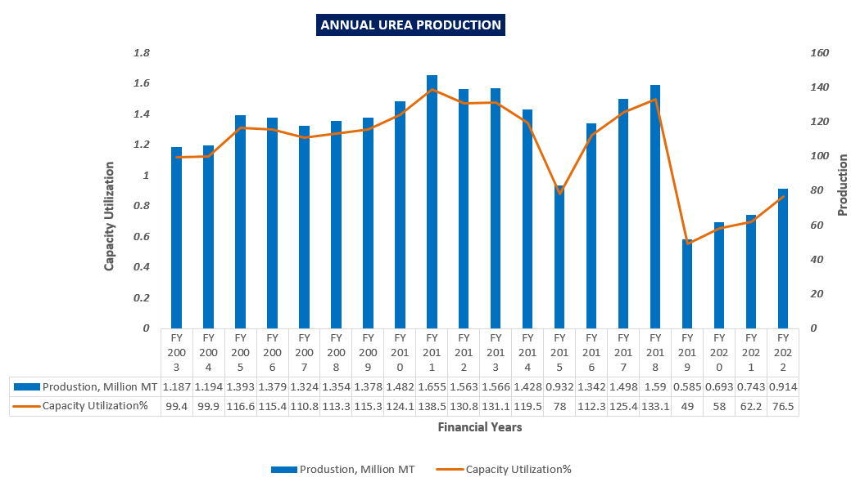

Below is the graphical representation for energy consumption of NFCL for FY 2003 to FY 2022:

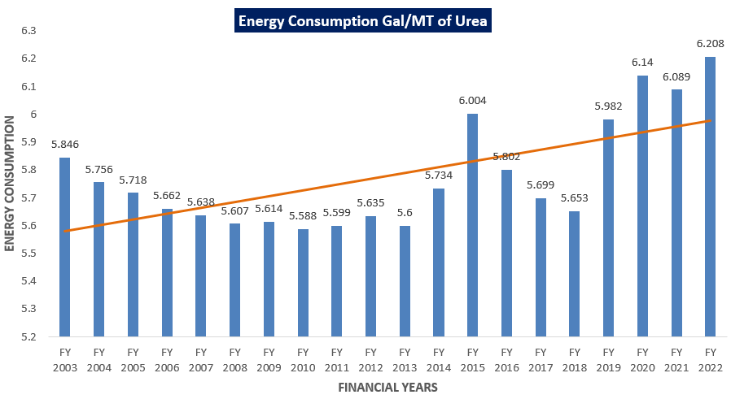

As per information given in the public domain, it is given that industry standards for water consumption is 8 M3 / MT of Urea. Below is the graphical representation for water consumption of NFCL for FY 2003 to FY 2022:

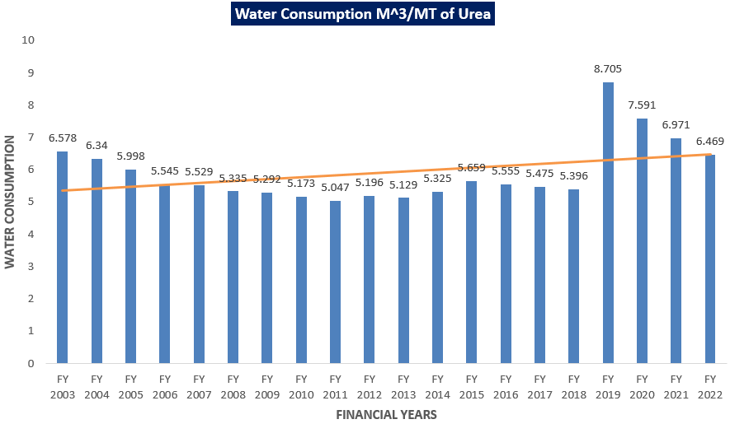

Company hired Mott Macdonald, who gave technical estimate for forward investment. Mott Macdonald help its clients for solving the world's most intricate challenges. Below is the table of technical estimates for path forward investment given by Mott Macdonald, keeping in mind that equipment prices have substantially increased in the past 6 months.

|  |  |
| --- | --- |
| **Description** | **Cost in INR Cr.** |
| Energy Conservation Scheme (Mandated by GOI) | 250 |
| Reliability Scheme | **534** |
| Reliability Measures identified pre ammonia convertor failure | 139 |
| Additional Reliability Measures post ammonia convertor failure | 395 |
| Total – (Energy and Reliability) | **784** |
| Civil Repairs | 87.5 |
| Budgeted Maintenance for 24 months 2 @ 75 Crores per annum (INR 35 Crores + INR 40 Crores) | 150 |
| Grand Total (Energy and Reliability Capex of INS 784 Crores + Maintenance Expenditure for 24 Months + Civil Repairs) | **1021.5** |

1. **DIRECTORS/PROMOTERS DETAILS OF THE COMPANY:** Below table shows the details of directors/Promoters of the company along with their DIN details and date of appointment:

**List of Directors of NFCL**

|  |  |  |  |  |
| --- | --- | --- | --- | --- |
| **S.No.** | **Name** | **DIN** | **Designation** | **Date of Appointment** |
| 1. | KANUMURU RAJU RAHUL | 0000015990 | Managing Director | 1th August, 2014 |
| 2. | CHANDRAPAL SINGH YADAV | 0000023382 | Nominee Director - KRIBHCO | 18th August, 2011 |
| 3. | UDAY JHA SHANKAR | 0000056510 | Non-Executive Director | 6th August, 2016 |
| 4. | RAJENDRA GONELA MOHAN | 0002354356 | Independent Director | 28th May, 2020 |
| 5. | LALITHA RAGHURAM | 0007161344 | Independent Director | 18th April 2015 |
| 6. | VIJAYA BHASKER MASAPATHRI | BPXPB9700F | Company Secretary and Compliance Officer | 29th November 2019 |
| 7. | SUDHAKARA RAO ANNAM | ACDPA7874P | Chief Financial Officer | 24th May 2021 |

We could not found much details of directors/promoters, their educational background and experience in the public domain.

1. **DEBT POSITION OF THE COMPANY:** Below are the details of secured and unsecured borrowing for current and non-current for the period of 2022.

|  |  |  |  |
| --- | --- | --- | --- |
| **S. No.** | **Borrowings** | **Non-Current** | **Current** |
| **O/s. balance as on 31.03.2022** | **O/s. balance as on 31.03.2022** |
| **A** | **Secured - Working Capital Term Loans** |  |  |
| 1 | IDBI Bank Limited | - | 21,800.00 |
| 2 | State Bank of India |  | 16,648.24 |
| 3 | ICICI Bank Limited |  | 5,460.00 |
| 4 | UCO Bank |  | 1,007.50 |
|  | **Total Principal** | - | **44,915.74** |
| 5 | Interest accrued |  | 29,302.35 |
|  | **Total** | **-** | **74,218.09** |
|  | **Corporate Loans** |  |  |
| 6 | State Bank of India -Corporate Rupee Loan |  | 2,398.24 |
| 7 | Interest accrued |  | 1,987.41 |
|  | **Total** | **-** | **4,385.65** |
|  | **Term Loans** |  |  |
| 8 | Department of Bio Technology, GOI | 5.58 | 302.69 |
| 9 | Interest accrued |  | 139.18 |
|  | **Total** | **5.58** | **441.87** |
|  | **Loans repayable on demand - from Banks** |  |  |
| 10 | Cash Credit |  | 123,933.14 |
| 11 | Short Term Loan |  | 6,985.64 |
|  | **Total Principal** |  | 130,918.78 |
| 12 | Interest accrued |  | 42,552.33 |
|  | **Total** | **-** | **173,471.11** |
| **B** | **Unsecured** |  |  |
| 13 | **Sales tax Deferral from Government of AP – Total** | 2,177.95 | 1,352.48 |
|  | **Grand Total** | **2,183.53** | **253,869.20** |

1. **CAPITAL STRUCTURE:** As per the Audited financial statement provided by the client/company, the authorized Share Capital of the Company is INR 801,00,00,000 Crores divided into 801,00,00,000 Equity Shares of Rs. 1/- each.

During the year under review, paid up capital of the Company was INR 59,80,65,003 divided into 59,80,65,003 Equity Shares of Rs. 1/- each fully paid as on 31st March, 2022.

1. **SHAREHOLDING PATTERN:** As per details shared by the client/company, the Shareholding Pattern of the Company as on 31st March 2022 is as follows:-

**Table 3: Shareholding Pattern as on 31st March 2022**

|  |  |  |  |  |
| --- | --- | --- | --- | --- |
| **CATEGORY** | **CATEGORY OF SHAREHOLDER** | **NOS. OF SHAREHOLDERS** | **TOTAL NOS. SHARES HELD** | **SHAREHOLDING AS A % OF TOTAL NO. OF SHARES** |
| (A) | Promoter & Promoter Group | 5 | 34,17,00,129 | 57.13% |
| (B) | Public | 3,01,000 | 25,63,64,874 | 42.87% |
| (C) | Non Promoter- Non Public | 0 | 0 | 0% |
| (C1) | Shares underlying DRs | 0 | 0 | 0% |
| (C2) | Shares held by Employee Trusts | 0 | 0 | 0% |
|  | **Total** | **3,01,005** | **59,80,65,003** | **100%** |

1. **REASON FOR FINANCIAL STRESS:**

NFCL a fast growing private sector fertilizer company went into final stress, on account of an accident in the GAIL Pipeline which supplies gas to the company during 2014. The company is claiming for the losses incurred on account of GAIL negligence.

On account of the GAILs negligence in operating and maintaining its pipelines, the production of the company was disrupted for long time and as a result the company suffered losses. To overcome the financial stress caused due to disruption of production and losses, the company approached its lenders for a Corrective Action Plan (CAP) and the lenders formed Joint Lenders Form (JLF) in 2015 and assessed Rs. 3050 Crs (Rs.850 Cr under Fund Based + Rs.2200 Cr. Under Non-Fund Based) and Rs.800 Cr. Working Capital Term Loan under CAP to shore up the working capital and to enable the company to run.

However, the company did not receive the assessed funds for rectification of account (CAP), in violation of RBI CAP regulations and as a result the account became NPA in 2015. The company has been reporting the disputes on CAP debt (working capital term loans and working capital loans in the books of the company) to the lenders and in the annual reports. The debt in the books (CAP loans) are disputed and are sub-judice.

The lenders approved 'Holding on Operations' (HOO) from December 2018 to amicably resolve the debt issues with the company in the interests of all stakeholders (valid till June 30, 2022). Due to inadequate working capital, financial stress and continued losses on account of stoppage of production of the plants during 2018, without prejudice to the interest that the company had taken up long-term financial Resolution Plan (RP) with its Lenders.

The lenders held series of Joint Lenders Meetings (JLM) for consideration and suggestions on the RP. Consequent to the lenders meetings, a resolution plan was unanimously approved by the lenders in March 2020, which amongst other things, include segregation of debt into sustainable and unsustainable, reduction in the rate of interest, infusion of fresh equity and sanction of additional debt etc. However, post conclusion of the Resolution Plan, the lenders made arbitrary changes in the said RP on 4th June 2020.

The company has filed a Writ Petition in the Hon’ble High court of Telangana, on the arbitrary actions of the lenders against the RBI Regulations. The Hon’ble High Court granted stay against any proceedings that may be initiated by the lenders against the company until further orders and the matter is awaiting final orders. Further, the company had filed contempt cases against 2 lenders who have filed petitions under IBC in violation of the above stay orders of High Court and the matter is pending before the Court.

Further, company had closed the iKisan division operations due to severe financial constraints. As the company is unable to perform the contractual obligations with Small Farmers Agribusiness Consortium (SFAC) for electronic National Agriculture Market (eNAM) project due to closure of iKisan division, the remaining contract work had been outsourced to a vendor who invested their resources to fulfil the contractual obligations of NFCL. As agreed, the entire amount receivable from eNAM project is payable to the vendor.

In view of operating only one plant (out of the two plants) due to lack of working capital, the losses continued, resulting in substantial erosion of net worth and the company faced liquidity issues. As a result of continuous losses, the company’s financial position has become very weak, and it is unable to meet its commitments to the financial and other creditors including statutory dues on the due dates.

Due to default in paying the instalments and interest, the lenders have declared the loans to the company as Non-Performing Assets in 2018 instead of 2015 and the status is continuing till date. As a result of treating the loans as NPAs by the lenders, all the borrowings with a qualification of dispute have been recorded as current liabilities in the Books / Financial statements of the company, leading to the situation that the current liabilities are in excess of current assets in the last three financial years.

**In this regard the IDBI, Mumbai has assigned the project to R K Associates to assess the Enterprise Value/Fair Market Value of M/s Nagarjuna Fertilizers and Chemicals Limited as per scope of work, to execute the appropriate action by the decision makers on this NPA account.**

|  |  |
| --- | --- |
| **PART C** | **THE PROJECT** |

1. **BRIEF DESCRIPTION OF THE PROJECT****:**

**PLANTS AND THEIR CURRENT CONDITION:** As per the information available on the public domain, M/s Nagarjuna Fertilizers and Chemicals Limited has two plants set up in Andhra Pradesh.

1. **Nagarjuna Fertilizers And Chemicals Ltd – Plant I** was established in 1992. Plant I is in operation for 30 years. It is one of the largest manufacturer of the urea in Hyderabad, Andhra Pradesh, with a production capacity of 597300 M. T. per annum.
2. **Nagarjuna Fertilizers And Chemicals Ltd – Plant II** was established in 1998. Plant II is in operation for 24 years. It is also one of the largest manufacturer of the urea in Hyderabad, Andhra Pradesh, with a production capacity of 597300 M. T. per annum.
3. **PRODUCTS:**
4. **Urea (46% N) (White free flowing) –**

**Specifications as per the Fertilizer Control Order 1985**:

* Moisture per cent by weight, maximum 1.0
* Total nitrogen, per cent by weight, (on dry basis) minimum 46.00
* Biuret per cent by weight, maximum 1.5
* Particle size--90 per cent of the material shall pass through 2.8 mm IS sieve and not less than 80 per cent by weight shall be retained on 1 mm IS sieve

**Application:**

* Urea has important uses as a [fertilizer](https://www.britannica.com/topic/fertilizer) and feed supplement.
* Urea is used as a starting material for the manufacture of plastics and drugs.

**Process Flow Diagram:** The production of Urea requires ammonia and CO2 as the inputs, both of which are available from Ammonia plant. As per information provided by the client / company below is the process flow diagram for Urea.

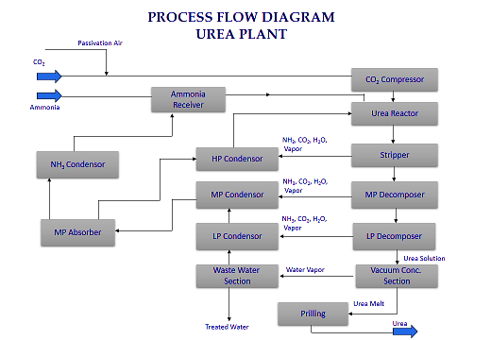

1. **Anhydrous Ammonia –**

**Specifications as per the Fertilizer Control Order 1985**

* Ammonia per cent by weight, minimum 99.0
* Water per cent by weight, maximum 1.0
* Oil per cent by weight, maximum 20 ppm

**Application:**

* Used for production of Urea, DPA, Ammonium Sulphate and Ammonium Nitrate (for fertilizer, explosives, herbicides and insecticides)
* Used for water treatment, fermentation, tanning and food additives.

**Process Flow Diagram:** The production of Anhydrous Ammonia requires Natural Gas as input, which is desulphurised by conversion of stable organic sulphur compounds. As per information provided by the client / company below is the process flow diagram for Anhydrous Ammonia.

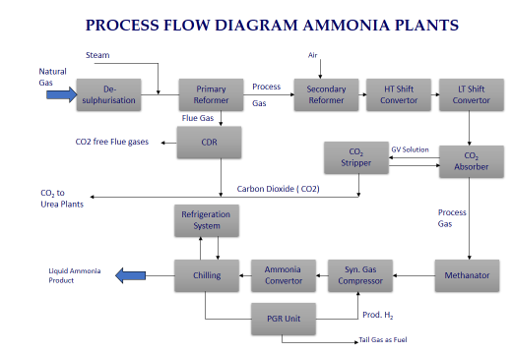

1. **CURRENT PLANT CONDITION:**

Presently NFCL is categorized as Major Accident Hazard (MAH) Industry and inadequate maintenance of Plant will be a serious environmental and safety threat, especially as the plant is situated in a thickly populated area. Polychlorinated Biphenyls (PCB) regulations are already become more vigilant and may not allow operations even if minor accidents take place. Land allocation rules are being enforced strictly by the current govt.

GAIL is supplying imported RLNG @ 36 USD per MMBtu for additional gas requirement, due to non-availability of domestic gas. The current plant operating energy is higher than the target norm fixed by the GOI due to non-implementation of energy reduction capex and break downs (maintenance capex). Due to this, NFCL is currently losing on a daily basis Rs 1,931 PMT on account of higher energy (Rs 87 Lakhs per day / minimum of Rs 300 Crores per year) at prevailing gas price (provided there are no more break downs and shutdowns). It is critical that the company urgently invests on maintenance and energy reduction project to arrest losses.

Plant I and II are struggling to reach full capacity utilisation and continue to face constant equipment failure and require to incur urgent investment. NFCL invested of Rs 25 Crores, after March 2021 failure of Ammonia II convertor, for temporary repair of convertor Basket and catalyst replacement. Plant II was restarted, and production commenced from 14th April 2022.

As per Andhra Pradesh Pollution Control Board (APPCB), the Company cannot operate the plants without Consent for Operations, which was valid till March 2022. Despite having applied for renewal in advance, three months before the due date, APPCB is yet to be renew the Consent for Operation (CFO). From July 2018 to March 2022, only one Plant ran due to financial stress. Plant-I & II were under shutdown for 479 days and 903 days respectively. Idling of equipment for such long durations caused damage/deterioration of many of the equipment.

Based on Technology supplier suggestions and industry expert’s opinion, if plant was attempted to run at partial load it would resulted in huge production and Energy losses. To arrest losses, company should operate both the plants at full capacity and safely, which also required urgent investment. The operations are very corrosive to equipment and closure (idling) will further deteriorate plants as they are adjacent to seacoast.

With continued break downs, complete replacement of sections have to be done which could have been otherwise repaired. Obsolete instrumentation and control systems, if not replaced urgently as planned, it may result in break downs as no more support is available for old systems. If the plants shut down, Gas and Water allocations which are already under threat will be impossible to secure once reallocated.

Due to severe financial stress for the last few years, the company is unable to meet critical operational creditors / vendors, employees’ dues, statutory dues etc in time. Company received notices from statutory authorities for delayed payment of TDS, PF, etc. Payment to PFA and gas supply is generally higher than subsidy amount and some payment from market collections are paid to GAIL. Hence the subsidy receivable is not available as a current asset and reduced from the gas supply and pool payable.

Few of the operating vendors taken the company to NCLT for non-payment of dues, such vendor’s payments were settled. However, there is a threat of other vendors also approaching NCLT against the Company. Company should necessarily pay these liabilities in order to continue the operations.

**Plant Operations History:**

Plant I was established in 1992 and Plant II was established in 1998. Both the plants are in operations for 30 and 24 years respectively. Plant II was built and operated with Naphtha and switched over to Natural Gas during RIL gas availability in 2009. Based on then Natural Gas availability in the area, Plant II was converted to full natural gas operations and Carbon Di oxide Recovery (CDR) plant was added during 2009. GAIL accident (27th June, 2014) impacted production and energy for two years caused severe financial stress. Due to non-availability of working capital, the company shut down/reduced all non-urea businesses.

The company could not spend the capex required for energy project and maintenance capex and operating expenses. NFCL had taken forced shutdown of both the plants in July 2018 due to lack of working capital support. The company restarted production from one unit with support from GOI & GAIL and Banks during December 2018. Second plant operation could not start due to lack of Letter of Credit / Bank Guaranty.

After repeated requests by NFCL for restart of second unit with Department of Fertilizers (DOF), GAIL and IDBI to avoid operational losses on account of single unit operation, DOF sanctioned special disbursement of subsidy of Rs 223 crores to NFCL. GAIL agreed to earmark Rs 30.35 Crores out of above subsidy for Plant II start-up expenditure. Out of above, Rs 12.27 Crores is budgeted to be spent and balance Rs 3.96 Crores also to be utilized for repairs / start-up. Balance Rs 16.23 Crores with IDBI bank out of earmark money is proposed to be spent for repairs / start-up.

NFCL could restart Plant II in March 2021, but could not sustain operations due to equipment failure due to lack of investment cash flows for maintenance. After discussions with technology supplier (HTAS, Denmark) and industry experts, NFCL decided to do a temporary repair of failed convertor basket with an expenditure of about Rs 45 Crores rather than complete replacement of the basket and catalyst (as planned earlier) which will take about 24 months and cost of Rs 50 crores.

1. **OFFICE MEMORANDUM AND ESCROW AGREEMENT:**

The Company is operating in a regulated environment under the Essential Commodities Act, 1955, supported by Government Subsidy. As per the OM and Escrow Agreement, the subsidy receivable is first paid for gas pool and gas supply. The subsidy due from GOI is being credited to an Escrow Account maintained with IDBI Bank. GAIL has a first preference as per Escrow Agreement entered among GAIL, NFCL & IDBI.

Department of Fertilizers ( DOF) has revised the Office Memorandum on subsidy sharing mechanism vide No 12012/30/2013-FPP dated 25.11.2021, to transfer 40% of subsidy to Gas Pool Fund Account and 60% to NFCL for its operations. Out of the company's share, GAIL has a first preference as per Escrow Agreement which was extended on 30.12.2021 till 30.06.2022.

|  |  |
| --- | --- |
| **PART D** | **MARKET OVERVIEW ON AGROCHEMICAL SECTOR** |

1. **INTRODUCTION:**

Agricultural Chemicals are a large and highly regulated sub-industry under the Chemicals industry. Many agricultural chemicals pose significant risk to the environment and to health. Agrichemicals includes a broad range of pesticides, herbicides, insecticides and fungicides, as well as synthetic fertilizers, hormones and other chemical growth agents. They are used for control of disease, weeds, insects and pests. They are also used to enhance crop growth and production. India’s chemical industry is extremely diversified and can be broadly classified into bulk chemicals, specialty chemicals, agrochemicals, petrochemicals, polymers and fertilizers. It covers more than 80,000 commercial products.

Globally, India is the fourth-largest producer of agrochemicals in the world after USA, Japan and China. The India agrochemicals market size reached a value of almost USD 4.5 billion in the year 2020. The market is further expected to grow at a CAGR of 8.6% between 2021 and 2026 to reach a value of almost USD 7.4 billion by 2026. Insecticides share 53% of the total domestic agrochemicals market, followed by Herbicides. Agrochemicals are the key revenue component of India, which exports 50% of its total production.

India’s agrochemical market is a significant region, contributing to the growth of the Asia Pacific agrochemicals market. The Asia Pacific region is growing at the fastest rate on a global basis due to the enormous consumption of pesticides and fertilizers for farming activities. This is a result of adopting modern and advanced farming practices in the region.

The Asia Pacific region gives domestic as well as international companies a place to grow within the region. After the revival of the economy and the stabilization of regional currency rates, the farmers are now focusing on investing in these crop-protecting and growth-boosting chemicals. India, along with China and Japan, exhibits the largest agrochemical markets of the Asia Pacific region.

1. **ROBUST DEMAND:**

* The Indian agrochemicals market is projected to register a CAGR of 8.6% during the forecast period (2022-2026).
* With a market size of around Rs 30000 Cr, the agrochemicals industry will play a critical role in improving India's agricultural capability.
* Global agrochemicals market is estimated to reach USD 281.88 billion in 2026, with a revenue CAGR of 3.8 percent over the forecast period.

1. **INCREASING INVESTMENTS:**

The industry is witnessing consolidation of players, which has led to investment by entities from other sectors. The ongoing alliance also presents an opportunity to global players to enter the Indian market.

The agrochemicals market is fragmented, with major players, including Bayer Crop Science, Syngenta AG, UPL Limited, BASF SE, National Fertilizer Limited, and TATA Rallies. New product launches, mergers and acquisitions, and partnerships are the major strategies adopted by these leading companies in the market. These companies are focusing on making an investment in innovations, collaborations, and expansions to increase their market share.

The results of the market share analysis indicate a consolidated global specialty fertilizer market. Some of the major players are ICL Group, Nutrien Limited, Yara International, Eurochem Group AG, and The Mosaic Company. New product launches, partnerships, and acquisitions are the major strategies adopted by the leading companies in the global market.

1. **POLICY SUPPORT:**

* The government plans to introduce production-linked incentive (PLI) scheme to promote domestic manufacturing of agrochemicals.
* The government urged players in the agrochemicals industry to come out with new molecules of global standards for the farmers' benefit, while Crop Life India, the industry body, pitched for stable policies and regulatory regimes to boost growth in the sector.

**Urea Policy for Old Depreciated Units:**

Urea industry had two separate policies. First for old urea units (For depreciated plants) and second for new urea units (For Plants Commissioned after 2014). NFCL comes under old urea units.

As per the information provided by client/company urea policies for old depreciated unit are given below:

* The natural gas allocation, sale price and the production quantity, where to sell are all fixed by GOI. Urea is an Essential commodity under Essential Commodities Act.
* The revenues are from Market collection (Rs 5292 PMT or around 15%) and balance (around 85%) as subsidy, at current pool gas prices.
* Subsidy becomes eligible once Urea is sold to farmer and recorded in e-POS machine and paid based on weekly submission of Invoices to GOI and budget availability.
* Subsidy comprises of Variable and Fixed costs.
* The freight reimbursement is received upon submission of invoices (about 150 days).
* Current Urea policy for old units, operational fixed cost is based on FY 2003 data and variable cost on normative basis, gas cost based on gas pooling policy. Unlike new green field urea projects, the old depreciated units, new term loans (other than the initial project loan, cap loan in the case of NFCL), working capital cost availed by companies are not recognised or reimbursed. Govt of India fixes norms for Energy (NG), Packing material (bags), water and transport charges. There have been significant under recoveries of variable costs (as the norms are stringent and lower than actual costs).
* Despite annual increases in salaries, factory overheads (Chemicals, Catalysts, maintenance etc.) fixed costs have not been revised since 2003, despite repeated representations. One time increase in fixed cost by Rs 350 per MT from 2014 was approved in 2021 which is a fraction of the actual fixed cost increase, wiping of all the industry margin.
* Significant Fixed Cost under recovery continues by all Urea manufacturers and urea operations is in losses for almost all urea companies. The study by Fertilizer Association of India (FAI) also indicates that most of the urea units are in losses.
* The urea losses are compensated by non-urea businesses.
* Policy for old depreciated urea units results in NFCL incurring loss of Rs 30 Crores in a month, due to, operating costs (without interest) being higher than revenue earned even with two plants operation.
* NFCL’s Plant-I is 30 years old, and Plant-II is 24 years old (fully depreciated), substantial investment (maintenance capex and energy project) is also required to continue production, but these new investments are also not recognised in current urea policy for old units.

**Need Intervention for Growth in agrochemical Sector:**

Policy changes and intervention are needed in a number of areas. The following actions will ensure agrochemicals’ sector’s growth:

* Favorable import-export policies: The industry depend on heavily on imports of raw materials and technical active ingredients to manufacture the formulations. Import/export policies that favor the sector, as well as a push for a Make in India policy for agrochemicals, the resolution of geopolitical issues, and trade sanctions with exporting countries, can all contribute to the sector’s long-term viability.
* Putting the PLI scheme into practice: Creating a digitally led, robust agrochemicals supply chain would aid in ensuring that Indian farmers have access to the right products at the right time. In 2020, the central government announced a production-linked incentive (PLI) programme for agrochemicals. Now that the pandemic is almost over, this policy should be implemented quickly. According to reports, the government has already identified specific products that will benefit from the scheme, and industry consultations are now complete. Agrochemicals will be the 15th industry covered by the PLI scheme.
* Policies that inspire the use of technology: Agriculture in India is extremely dynamic and highly reliant on natural occurrences. Agrochemical consumption is linked to farmers’ willingness to invest in agri inputs, which can vary depending on crop growth, market prices, weather conditions, and pest infestation. If any of the factors change dramatically, this can result in significant supply and demand gaps. Moving to a digital, data-driven demand forecasting approach can aid industry players in addressing this issue and ensuring supply chain efficiency. Several agrochemical companies, including Insecticides (India) Limited, have used digital tools to collect, compile, and analyze data related to demand indicators, resulting in a much more reliable demand forecasting system.
* Policies for new molecules: The pharmaceutical industry is heavily reliant on generic and older molecules, many of which are also hazardous. As a result, the agrochemical industry is at risk of strict regulatory reforms aimed at phasing out such products. As a result, an action plan must be developed in collaboration with industry experts for the gradual replacement of existing products that may be subject to regulatory action. To expand product offerings and de-risk agrochemicals companies’ product portfolios, in-licensing of active ingredients should be encouraged.

The bottom line for decades for the agrochemical industry has been a Champion Sector because it contributes significantly to food security and employs a large workforce. The sector must be given its fair share of ‘Ease of Doing Business,’ while also removing bottlenecks and implementing progressive regulatory measures to protect the environment.

1. **COMPETITIVE ADVANTAGE:**

The agrochemical industry is at a rapid growth phase and it is going through an expansion throughout demographics. The demand for agrochemicals has depends mainly on demand for various crops, which in turn depends on crop prices. So, the profitability of individual companies is linked to efficient operations and marketing. In the competitive scenario and competitive world, the big producers have large economies of scale in production. Usually, the smaller companies can compete effectively by making specialty chemicals or fertilizer mixtures for local markets.

Indian agrochemicals market is driven by the rising population within the country, which has led to maintaining sufficiency in agricultural practices, further boosting the use of Indian agrochemical products for farming activities. The industry is positively influenced by the Indian agrochemical industry, which has fuelled the sales of agrochemical products. Other factors affecting the growth of India agrochemical industry include an increase in the population growth, rising need for food production, and economic growth.

1. **MARKET SIZE OF THE INDIAN AGROCHEMICAL INDUSTRY:**

India is the fourth largest producer of agrochemicals, with domestic consumption of around Rs 32,000 crore in FY2021 and exports of around Rs 40,000 crore. Several growth factors, such as growing population, shrinking arable land, increasing demand for high-value agricultural products, and enhanced efforts from the industry and the government to promote awareness and technology enhancement, are expected to drive industry growth at a CAGR of 8-10 per cent until 2026.

With higher research and development spending, 2022 will undoubtedly be the year of new products and collaborations, propelling market revenue growth throughout the forecast period.

There have been a lot of supply disruptions on account of macro-economic factors like COVID-19 pandemic and the war between Ukraine and Russia, which has triggered oil prices to rise to all new levels affecting the raw material prices. Even exchange rates have been very volatile. India's urea imports declined to around 77 lakh tones in the last fiscal year from 98 lakh tones in the 2020-21 financial year. The imports might further come down to around 60 lakh tones in the current fiscal. So far this fiscal, around 15 lakh tones urea has been imported and another 16 lakh tones will come in the next one and a half month.

The government has announced that the fertilizer subsidy would be around Rs 2.25 lakh crore. The total fertilizers subsidy stood at Rs 1,62,132 crore in the 2021-22 fiscal year and it was at Rs 71,280 crore in 2013-14.

At present, urea is available at a highly subsidized price of Rs 266 for a 45 kg bag while Di-ammonium Phosphate (DAP) is sold at Rs 1,350 for a 50 kg bag. The government is making available fertilizers, namely urea and 25 grades of P&K fertilizers to farmers at subsidized prices through fertilizer manufacturers/importers. In the case of urea, the Centre fixes the maximum retail prices and reimburses the difference between the maximum retail price and production cost in the form of subsidy.

Volume of pesticides produced across India from financial year 2015 to 2021(in 1,000 metric tons)

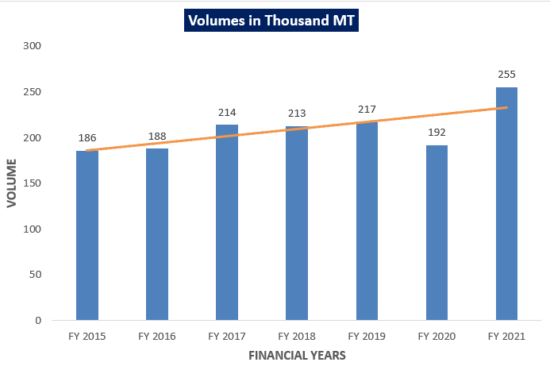

1. **LATEST INVESTMENTS:**

* In May 2021-The Union Cabinet has approved the PLI scheme National Program on Advanced Chemistry Cell Battery Storage which aims to produce 50 GWh of ACC and 5 GWh of Niche ACC battery storage.
* In April 2021- Amid COVID-19's second wave, the Odisha government-approved investment proposals worth over INR 2,570 crore in the metal, cement, chemical, plastic, food processing, and manufacturing sectors, creating 2,755 jobs.
* As per FDI policy for the chemical sector, 100% FDI is allowed under the automatic route in the chemicals sector.

1. **GOVERNMENT’S INITIATIVES FOR ATMANIRBHAR BHARAT:**

The government is firming up a plan to develop alternative sources of plant nutrition, including biofertilisers and organic fertilizers, which will replace urea-based fertilizers, a move aimed at making India 'atmanirbhar' in fertilizer production and controlling the year-on-year increase in fertilizer subsidy on the back of rising input cost.

A long-term plan is being put in place for in-house production of these nutrients to cushion the farmers from abrupt price rise while cutting down on the government's subsidy bill.

The way energy prices are going up, it is natural that fertilizer prices will also go up. It is time that India needs to move towards organic fertilizers on a commercial scale. The government had in April this year substantially enhanced the fertilizer subsidy by ₹1.10 lakh crore, over and above the ₹1.05 lakh crore budgeted for 2022-23. This has taken the total fertilizer subsidy for the fiscal to a record high of ₹2.15 lakh crore for 2022-23 compared to ₹1.62 lakh crore in 2021-22.

As per the plan, the government is eyeing large-scale commercial use of cow manure as biofertiliser and bio-energy from 'gaushalas'. This will help convert cattle into economic assets while providing a sustainable and steady supply of alternative sources of nutrients including vermicomposting and global biogas.

Further, a dedicated policy framework is being developed to support production, packaging, marketing and distribution of biofertilisers. The government is expected to go the PPP way by roping in big gaushalas, dairy cooperatives and farmer producer organizations (FPOs) for production of enriched solid and liquid biofertilisers.

1. **ROAD AHEAD:**

The agrochemical sector is likely to continue with double-digit growth in revenue in the next financial year to 10-12 per cent due to strong exports even as domestic sales might remain stunted by uneven monsoon and slower increase in rural incomes, according to a report.

Exports will help the agrochemical sector maintain double-digit growth in revenue this fiscal and the next (at 12-13 per cent and 10-12 per cent, respectively), compared with 15 per cent last fiscal, even as domestic sales growth will be stunted by uneven monsoon and slower increase in rural incomes.

Agrochemical and pesticide sector has urged the government to increase fund flow to the agriculture sector in the upcoming Budget for improving the infrastructure for farming in all parts of the country to double the income of the farmers. Government will undoubtedly focus on agriculture in line with the last years as agriculture has played a vital role in these pandemic times. And also look forward to increased budgets for better infrastructure for farming in all parts of the country.

It is also critical that the input cost is reduced to whatever possible extent to support the farmers. Industry looks forward to the government's support for research and make in India for the crop protection Industry.

Agrochemical sector in the country is emerging as one of the champions that can become a major global supply hub if provided with better facilities. This has been facilitated due to disruption of supplies from China and everybody looking for a second source. The government should provide regulatory and tax concessions to catch hold of the opportunity. The Indian pesticides and fertilizers market can witness a significant boost in supply and development.

Considering the financial aspects of things, 2021-22 is proving to be a highly crucial time for the agriculture industry. With the Union budget 2022-23 just around the corner, keeping in view the government’s commitment to double farmers income, it is expected that an increased allocation will be there for the sector. Even though the third wave is surging, it is believed that the industry will not be impacted so much, especially when the government is focused on building a perfect agro environment. The government will initiate some remarkable steps to foster the growth of the agrochemical industry.

**Hence, as per the industry analysis, trends of the industry seeming positive.**

|  |  |
| --- | --- |
| **PART E** | **HISTORICAL FINANCIAL PERFORMANCE** |

As per the audited financial statements provided by the company/client, below table shows the historical performance of the company.

1. **HISTORICAL PROFIT & LOSS STATEMENT: (FROM FY 2018 TO FY 2022)**

***(Value in Rs. Crores)***

|  |  |  |  |  |  |
| --- | --- | --- | --- | --- | --- |
| **Particular** | **FY 2018A** | **FY 2019A** | **FY 2020A** | **FY 2021A** | **FY 2022A** |
| Revenue From Operations | 392368 | 194035 | 170451 | 157491 | 269233 |
| Other Income | 4497 | 2647 | 2898 | 2435 | 3032 |
| **Total Income** | **396865** | **196682** | **173350** | **159925** | **272265** |
| Cost of materials consumed | 138146 | 70942 | 78562 | 73241 | 133988 |
| Purchases of Stock-in-Trade | 45854 | 25856 | 1395 | 267 | 182 |
| Changes in inventories of finished goods, Stock-in-Trade and wip | 6605 | 3549 | (501) | 4320 | 81 |
| Power and Fuel | 100243 | 59995 | 70123 | 58749 | 122686 |
| Employee benefits expense | 17351 | 15745 | 10533 | 9680 | 9440 |
| Excise Duty | 228 | 0 | 0 | 0 | 0 |
| Other expenses | 51344 | 31717 | 22726 | 21892 | 21807 |
| **Total expenses** | **359770** | **207802** | **182838** | **168149** | **288184** |
| **EBITDA** | **37095** | **(11121)** | **(9488)** | **(8224)** | **(15919)** |
| Depreciation and amortization expense | 8928 | 8883 | 8213 | 8224 | 8209 |
| **EBIT** | **28167** | **(20004)** | **(17702)** | **(16448)** | **(24127)** |
| Finance costs | 30821 | 30799 | 32879 | 34779 | 36893 |
| **Profit/(loss) before exceptional items and tax** | **(2654)** | **(50803)** | **(50581)** | **(51227)** | **(61020)** |
| Exceptional Items | 0 | 1886 | 0 | 14082 | 9044 |
| **Profit/(loss) before tax** | **(2654)** | **(52689)** | **(50581)** | **(65309)** | **(70064)** |
| Current tax |  | 0 | 0 | 0 | 0 |
| Adjustments relating to earlier years | 57 | 0 | 78 | 0 | 0 |
| Deferred tax | (559) | (3616) | (3424) | (3776) | (3073) |
| **Profit (Loss) for the period from continuing operations** | **(2095)** | **(49073)** | **(47158)** | **(61533)** | **(66991)** |
| Other Comprehensive Income / (Loss) |  |  |  |  |  |
| Items that will not be reclassified to profit or loss | 369 | 13 | 522 | (90) | 126 |
| Income tax relating to items that will not be reclassified to profit or loss | (128) | (4) | (181) | 31 | (39) |
| **Total Comprehensive Income / (Loss) for the period** | **(1911)** | **(49064)** | **(46893)** | **(61592)** | **(66904)** |
| ***EBITDA Margin %*** | ***9%*** | ***-6%*** | ***-6%*** | ***-5%*** | ***-6%*** |
| ***EBIT Margin %*** | ***7%*** | ***-10%*** | ***-10%*** | ***-10%*** | ***-9%*** |
| ***Net Profit Margin %*** | ***0%*** | ***-25%*** | ***-28%*** | ***-39%*** | ***-25%*** |
| ***Revenue Growth % (Y.O.Y.)*** |  | ***-51%*** | ***-12%*** | ***-8%*** | ***71%*** |

**Note**: As per the historical trends, It can be seen that EBITDA Margin, EBIT Margin & Net Profit Margins are continuously declining from the FY2017 to FY2022. The metrices are negative in the last few years which shows that the company is not performing well in the last few years and there are critical concern with the financial health of the company.

Historically, revenues of the company are constantly improving in the last few years, due to its inability to bid for the new projects as the company is unable to procure external financing. In FY 2022 revenue of the company suddenly increased because NFCL’s both plants started working in this year.

Based on the above key indicators, the management is suggested to take the appropriate action to improve the operational efficiency of the firm.

1. **GRAPHICAL REPRESENTATION OF KEY FINANCIAL METRICES:**

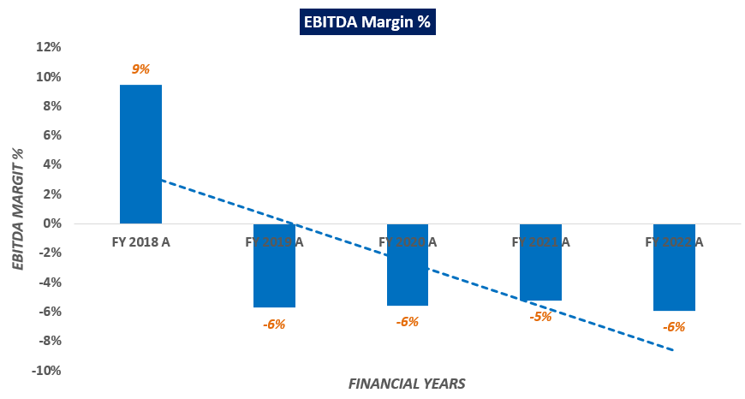

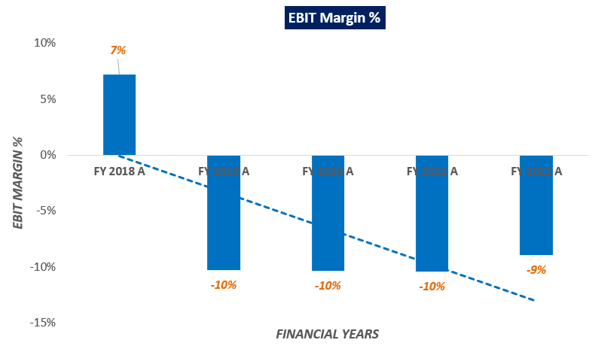

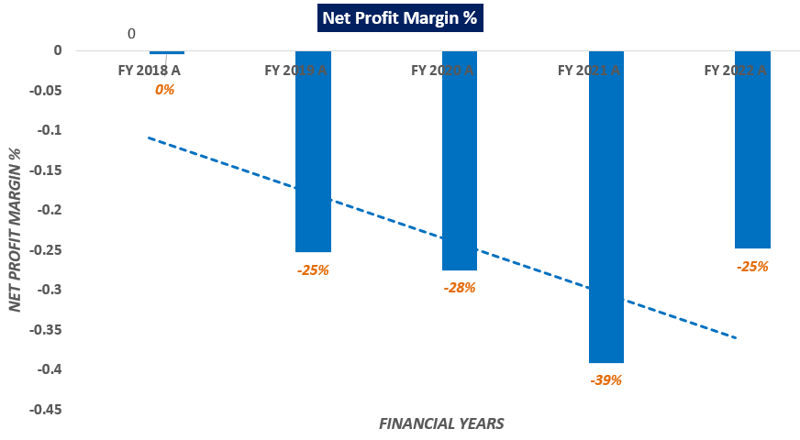

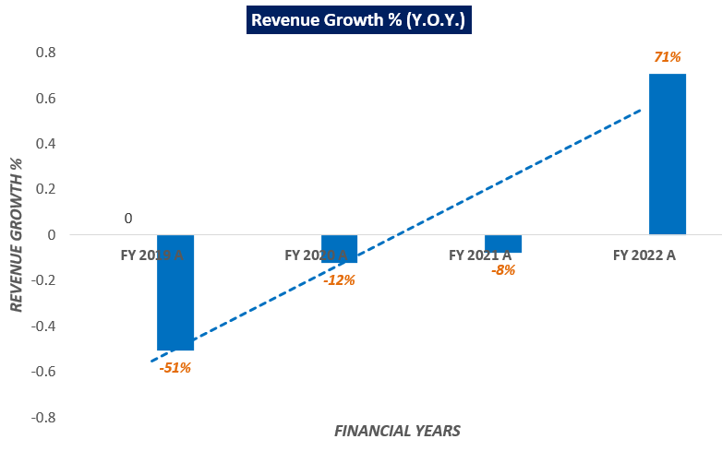

**Note**: As per the information provided by the client/company, numbers shown in the above table for all the Fiscal Years are taken from audited report.

Revenue growth rate was negative from the FY 2019 to FY 2021, as the company constantly losing more revenue because of the shutdown of its plants, which leads to decrease in revenue. While it was positive in FY 2022, as both the Plants were restarted, and production commenced in FY 2021-22.

As per the ratio analysis performed, it is observed that EBITDA and EBIT Margins of the company are continuously decreasing from FY 2018 to FY 2022. As the company is now not able to get any new projects which leads to decrease in EBITDA and EBIT.

As per the historical trends it can be observed that net profit margins are declining constantly, which shows that the lack of operational efficiency and due to this, company is under severe financial stress.

|  |  |
| --- | --- |
| **PART F** | **VALUATION OF THE COMPANY** |

1. **METHODOLOGY/ MODEL ADOPTED:** Out of the various Models & theories available, we have adopted Methodology namely Net Asset Value (NAV) Approach, and the adjusted NAV is being considered as the proxy of the Enterprise Value of M/s Nagarjuna Fertilizers and Chemicals Limited:
2. The NAV approach used here, is based on the present value/fair market value of all its fixed asset and its financial assets.
3. Present/Fair value of fixed assets of the company including property, plant and equipment is calculated based on the Market and Cost Approach as-is-where-is basis for estimating the Current Depreciated Replacement value of the assets.
4. Present value of the financial/ current assets is estimated based on the document/ information provided by the company.
5. Further, the operational liabilities of the company will be net off with the Total asset value estimated based on the present scenario.

**Rationale for using Net Asset Value (NAV) Approach for the Enterprise Valuation:**

1. The 3 Broad Model of Company Valuation are – Income based approach (Discounted Cash Flow Models), Asset Based and Market Multiple.
2. The free cash flow method is not used here because company is in financial stress and all the financial metrices are negative in the last few years which shows that the company is not performing well in the last few years, so future cash flow cannot be projected easily since there is a downward trend in the capacity utilization of the company and currently manufacturing units of the company are running at a very low capacity utilization while the account is already categorized NPA by the financial creditor as per norms of the RBI guidelines.
3. Also, due to uncertain future operations as the same is communicated by the banker/client, estimating accurate future projections becomes negative.
4. Asset Based Model is a more appropriate approach for estimating the Company’s present value/fair market value based on the present value calculation of the assets (fixed asset and financial assets).
5. Market Comparable Approach was also not used since we could not find any suitable market comparable transactions and company of similar scale, scope & nature in the market.
6. Therefore, the most appropriate Model left to Value M/s Nagarjuna Fertilizers and Chemicals Limited is Net Asset Value approach since there is an uncertainty regarding company’s futuristic operations.
7. The best method input option for the NAV Model in the case of M/s Nagarjuna Fertilizers and Chemicals Limited will be present value of the fixed assets based on the market and cost-based approach and financial assets valuation based on the documents/information made available us by the client/company.
8. Further, the Present Value Model gives us a variety of input options to use while calculating the Value of the firm - Dividend, Free Cash Flow to the Firm, Free Cash Flow to Equity, Capitalized Cash Flows and Residual Earnings.
9. Dividends cannot be used as the Company has no history of paying dividends and we don’t foresee any dividend payments to occur in the future due to the high leverage of the firm.
10. Hence, NAV method is used in the valuation process of the company.

Gathering of Information on high level breakup of each head of Current and Non-Current Assets for assessment (as per RKA Format).

* Review of data/ inputs/ information which company could provide to us against the queries raised by the consultant.
* Final assessment as per the data /information available on record.

**Note:**

1. *There is not a fixed criterion, formula or norm for the Valuation of Current Assets. It is purely based on the individual assessment and may differ from consultant to consultant based on the practicality of the analyses in recoveries of the outstanding dues. Ultimate recovery depends on efforts, extensive follow-ups of the individual case by the company. So our values should not be regarded as any judgement in regard to the recoverability of current assets but should only be read in terms of analysis.*
2. *For arriving at the Liquidation Value,* ***appropriate discounting factor against each current asset item is applied based on the nature of current asset and level of difficulty in realization of these.***
3. *No audit of any kind is performed by us at our end from the books of account or ledger statements. All the data/ information/ input/ details provided to us by the company/ lenders are taken by us as-it-is on good faith and assumed that that these are factually correct information.*
4. *This is a general assessment of the estimated fair and liquidation value of the current assets based on the data/ input/ Information Company/ lenders could provide to us against our questions/ queries. In no manner this should be regarded as an audit activity/ report and NO micro analysis or detailed or forensic audit/ scrutiny of the financial transactions or accounts of any kind has been carried out at our end.*
5. **SUMMARY OF VALUATION ASSESSMENT:** Below table shows the assessment summary of the valuation:

|  |  |  |
| --- | --- | --- |
| **Particular (Values in INR Crores)** | **Book Value as on 31.03.2022** | **Fair Market Value** |
| **ASSETS:** |  |  |
| **Non-Current Assets** |  |  |
| Property, Plant and Equipment | 2106.19 | 1281.44 |
| Capital work-in-progress | 0.24 | 0.15 |
| Others Financial Assets | 4.75 | 4.75 |
| **Total Non-Current Assets** | **2111.18** | **1286.34** |
| **Current Assets** |  |  |
| Inventories | 46.40 | 41.40 |
| Investments |  |  |
| Trade receivables | 484.93 | 62.47 |
| Cash and cash equivalents | 21.12 | 5.37 |
| Bank balances, other than (ii) above | 22.47 | 2.47 |
| Others | 7.61 | 1.18 |
| Current Tax Assets (Net) | 3.63 | 3.63 |
| Other current assets | 59.59 | 56.08 |
| **Total Current Assets** | **645.75** | **172.58** |
| **Total Assets** | **2756.92** | **1458.92** |
| **SHAREHOLDER'S EQUITY AND LIABILITIES:** |  |  |
| **Equity** |  |  |
| Equity Share capital | 59.81 | 59.81 |
| Other Equity | (1,231) | (1231.07) |
| **Total Shareholder's Fund** | **(1,171)** | **(1,171)** |
| **Liabilities** |  |  |
| **Non-current liabilities** |  |  |
| Long -Term Borrowings | 21.84 | 21.84 |
| Trade payables |  |  |
| Other financial liabilities | 69.87 | 69.87 |
| Provisions | 5.09 | 5.09 |
| Deferred tax liabilities (Net) | 240.55 | 240.55 |
| Other non-current liabilities | 3.46 | 3.46 |
| **Total Non-current liabilities** | **340.80** | **340.80** |
| **Current liabilities** |  |  |
| Short -Term Borrowings | 2538.69 | 2538.69 |
| Trade payables |  |  |
| Total outstanding dues of Micro enterprises and Small Enterprises | 1.01 | 1.01 |
| Total outstanding dues of creditors other than micro and small enterprises. | 986.67 | 986.67 |
| Other financial liabilities (other than those specified in item (c) below) | 14.75 | 14.75 |
| Other current liabilities | 40.83 | 40.83 |
| Provisions | 5.45 | 5.45 |
| **Total Current liabilities** | **3587.39** | **3587.39** |
| **Total Shareholder's Equity and Liabilities** | **2756.92** | **2756.92** |
| Operational Liabilities | 1048.70 | 1048.70 |
| Contingent Liabilities | 487.49 | 195.87 |
| **Total Adjustable Liabilities** |  | **1243.70** |

|  |  |
| --- | --- |
| **Adjusted Net Asset Value (NAV)** | |
| **Total Assets (A)** | **INR 1458.92 Crore** |
| **Total Operational Liabilities including Contingent liabilities (B)** | **INR 1243.70 Crore** |
| **Net Assets Value (NAV) (A-B)** | **INR 215.22 Crore** |
| **Adjusted NAV** | **INR Two Hundred Fifteen Crore and Twenty Two Lakhs** |

1. **ENTERPRISE VALUATION:**

|  |
| --- |
| **ENTERPRISE VALUE OF M/S NAGARJUNA FERTILIZERS AND CHEMICALS LIMITED** |
| **INR Two Hundred Fifteen Crore and Twenty Two Lakhs (INR 215.22 CRORE)** |

**Hence the “Enterprise Value” of the Firm “M/s Nagarjuna Fertilizers and Chemicals Limited” is INR 215.22 Crores.**

*This is only a general assessment of the current value of the Enterprise/Business based on the data/ input that the Bank/Client/Company could provide to us against our questions/ queries using the appropriate method with respect to the present scenario. In no manner this should be regarded as an audit activity/ report and NO micro analysis or detailed or forensic audit/ scrutiny of the financial transactions or accounts of any kind has been carried out at our end.*

1. **KEY ASSUMPTIONS**:
2. **Non-Current Assets:**

* **Property, Plant and Equipment:**

Fair Market Value of Non-Current Assets has been calculated based on the market comparable approach (Land) and Cost approach (Building, Plant & Machinery), Fair Market Value of land is derived as per **“Andhra Pradesh Assigned Lands (Prohibition of Transfers) Act, 1977 (Act No. 9 of 1977)”** and **“The Telangana Assigned Lands (Prohibition of Transfers) Act, 1977”.**

Accordingly, FMV of Non-Current Assets is being calculated as INR 1281.44 Cr. And the same has been considered for the calculation of Adjusted NAV.

Refer the below mentioned files in the table for the detailed calculation of the FMV of Non-Current Assets:

|  |  |  |  |  |  |  |
| --- | --- | --- | --- | --- | --- | --- |
| **M/S NFCL FIXED ASSET VALUATION SUMMARY** | | | | | | |
| *(Value in Rs. Crores)* | | | | | | |
| **FILE NO.** | **UNIT** | **UNIT TYPE** | **LAND** | **BUILDING** | **P&M** | **Fair Market Value** |
|
| PL-112-096-151 | Kakinada | Urea Fertiliser Plant | 306.46 | 119.10 | 583.61 | 1,009.18 |
| PL-112-096-153 | Sadashivpet | Micro Irrigation facility | 23.92 | 2.49 | 2.32 | 28.74 |
| PL-112-096-152 | Nacharam | Micro Irrigation facility | 19.24 | 2.46 | 10.88 | 32.59 |
| PL-112-096-154 | Halol | Micro Irrigation facility | 9.04 | 5.75 | 11.93 | 26.73 |
| PL-112-096-157 | Wargal and Gouraram | Agricultural Land and R&D Unit | 57.08 | 1.53 | - | 59.33 |
| PL-112-096-160 | Nellore | Agricultural Land and other structures | 57.59 | 1.35 | - | 58.95 |
| PL-112-096-155 | Punjagutta, Hyderabad | Corporate Office | 48.88 | 1.84 | - | 50.73 |
| PL-112-096-158 | Santhinagar, Kakinada | Guest House | 3.06 | 0.48 | - | 3.55 |
| PL-112-096-161 | Kolkata | Branch Office | - | 5.31 | - | 5.31 |
| PL-112-096-156 | Somajiguda, Hyderabad | 2 Residential Flats | - | 5.40 | - | 5.40 |
| PL-112-096-159 | Kapavaram | Agricultural Land | - | - | - | - |
| PL-276-209-398 | Ahmedabad | Branch office | - | 0.09 | - | 0.90 |
| **Total:** | | | | | | **1,281.44** |

* **Capital work-in-progress**

1. Contract workmen Management System & CC Cameras: The Company is active to perform its core operations, so contract workmen management system & CC cameras can be useful for the company in its operation. Company can update the contract and complete the installation work of CC cameras. Hence we have consider fair market value to be at 80% of the book value.
2. Up-gradation of Analyzers: We have not received any document/ supporting regarding the said assets. However the same would means up-gradation of analyzer software, which can be outdated as on 31 March, 2022. Hence we have consider fair market value to be at 50% of the book value.
3. Railway Siding Equipments: Company can recognize sidings as asset only when there are probable future economic benefits from such railway sidings. Hence we have consider fair market value to be at 100% of the book value.
4. Development of Mobile/Web Application for Field Team from Visionnet Systems Pvt Limited: We have not received any document/ supporting regarding the said assets. However the same would means up-gradation / development of mobile/web application for field team from Visionnet Systems Pvt Limited, which can be outdated as on 31 March, 2022. Hence we have consider fair market value to be at 50% of the book value.
5. **Current Assets:** All the adjustments for current assets has been considered as per the audited balance sheet and other documents provided by the client/company/RP. We have performed a detailed analysis of current assets (Refer to the file no. **VIS (2022-23)-PL105-088-143 (Part-B),** which we have dispatched along with this report. Accordingly, Fair Market Value of Current Assets is being calculated as INR 172.58 Crores, and the same has been considered for the purpose of enterprise valuation.

**Thus, the Fair Market Value of Total Assets is being calculated as INR 1458.92 Crores as on valuation date.**

* The fair market value of Operational liabilities has been considered as 100% of the book value as on 31st March 2022.

**Thus, the fair market value of Total Operational liabilities including the contingent liabilities is being calculated as INR 1243.70 Crore as on valuation date, while the detailed break-up of contingent liabilities of the company is shared by the client/company as on date.**

|  |  |
| --- | --- |
| **Total Adjustable Liabilities** | |
| **Particular** | **Amount (INR Crore)** |
| Operational Liabilities | 1048.70 |
| Contingent Liabilities (40% of Book Value) | 195.00 |
| **Total Adjustable Liabilities** | **1243.70** |

Note: We have considered 40% of the total contingent liabilities provided by the client, since, the company is under stress and there are various items included in the contingent liabilities which need not to be considered in the calculation of NAV.

**Hence, after deducting the Total operational liabilities including the contingent liabilities from the fair market value of Total Assets, the Adjusted Net Asset Value (NAV) is being calculated as INR 215.22 Crores, which is being considered as the proxy of Enterprise Value of “M/s Nagarjuna Fertilizers and Chemicals Limited”.**

* *Enterprise Valuation of the subject project has been done by using Net Assets Value (NAV) Method.*
* *The Net Assets Value (NAV) of the project has been calculated after the deduction of Operating Liabilities from the Total Assets Value of the company.*
* *The NAV method has been adopted for the calculation of Enterprise Valuation of the subject project since the project is categorized as NPA and as per the information provided by the banker/company, the future operation of the is uncertain as financial institution is about to execute the decision/resolution plan.*
* *No employee or member of R.K Associates has any direct/ indirect interest in the Project.*
* *This is just an opinion report on Valuation based on the copy of the documents/ information provided to us by the client which has been relied upon in good faith and the assessment and assumptions done by us.*
* *This is only a general assessment of the Enterprise/Business Value of the firm based on the data/ input Company officials could provide to us against our questions/ queries and information available in the public domain. In no manner this should be regarded as an audit activity/ report and NO micro analysis or detailed or forensic audit/ scrutiny of the financial transactions or accounts of any kind has been carried out at our end.*

|  |  |  |  |
| --- | --- | --- | --- |
| **Declaration** | 1. *Since this is Enterprise Valuation hence no site inspection was carried out by us.* 2. *The undersigned does not have any direct/indirect interest in the above property.* 3. *The information furnished herein is true and correct to the best of our knowledge.* 4. *This valuation work is carried out by our Financial Analyst team on the request from IDBI Bank, World Trade Center Complex, 7th floor, ICG, D-Wing, IDBI Tower, Cuffe Parade, Mumbai - 400005* 5. *We have submitted Valuation report to the Client.* | | |
| **Name & Address of Valuer company** | | **Signature of the authorized person** |
| M/s R.K. Associates Valuers & Techno Engineering Consultants Pvt. Ltd.  D-39, Second Floor, Sector-2, Noida, UP-201301 India | |  |
| **Number of Pages in the Report** | | 49 | |
| **Financial Analyst Team worked on the report** | | ***PREPARED BY: Mrs. Chhavi Toshan*** | |
| ***REVIEWED BY: Mr. Gaurav Kumar*** | |

**For R.K Associates Valuers & Techno Place : NOIDA**

**Engineering Consultants (P) Ltd. Date : 11th August 2022**

**(Authorized Signatory)**

**Valuations**

|  |  |
| --- | --- |
| **PART G** | **IMPORTANT DEFINITION** |

***Definitions:***

* ***Enterprise Value:*** *Enterprise value (EV) is the corporate valuation of a company, determined by using market capitalization and total debt. Market cap comprises preference stocks, common stocks, and minority interest; total debt comprises short-term and long-term liabilities of the company. Enterprise value (EV) refers to the overall valuation—equity, debt, cash, and cash equivalents. In other words, it is the cost of acquiring a firm. The EV/EBITDA is an enterprise multiple. It correlates EV with earnings before interest, taxes, depreciation, and amortization. The metric determines whether the firm is undervalued or overvalued.*
* *EV is computed using the following formula: EV = (Market Capitalization + Market Value of Debt – Cash and Equivalents).*
* ***Fair Market Value****suggested by the competent Valuer is that prospective estimated amount in his expert & prudent opinion of the subject asset without any prejudice after he has carefully & exhaustively evaluated the facts & information came in front of him related to the subject asset at which the subject asset should be exchanged between a willing buyer and willing seller at an arm’s length transaction in an open & unrestricted market, after proper marketing, wherein the parties, each acted knowledgeably, prudently and without any compulsion on the date of the Valuation.*

*Forced, under compulsion & constraint, obligatory sales transactions data doesn’t indicate the Fair Market Value.*

* ***Realizable Value*** *is the minimum prospective estimated value of the Company which it may be able to realize at the time of actual transaction factoring in the potential prospects of deep negotiations carried out between the buyer & seller for ultimately finalizing the transaction across the table. Realizable value may be 10-20% less than the Fair Market Value depending on the various salability prospects of the subject asset and the needs of the buyer & the seller.*
* ***Forced/ Distress Sale Value*** *is the value when the company has to be sold due to any compulsion or constraint like financial encumbrances, dispute, as a part of a recovery process, legal issues or any such condition or situation. In this type of sale, minimum fetch value is assessed which can be 15-25% less than the estimated Fair Market Value. In this type of sale, negotiation power of the buyer is always more than the seller and eagerness & pressure of selling the asset is more than buying it. Therefore, the Forced/ Distress Sale Value will always fetch significantly less value compare to the estimated Fair Market Value.*
* ***Liquidation Value*** *is the amount that would be realized when an asset or group of assets are sold on a piecemeal basis that is without consideration of benefits (or detriments) associated with a going-concern business. Liquidation value can be either in an orderly transaction with a typical marketing period or in a forced transaction with a shortened marketing period.*
* ***Difference between Costs, Price & Value:*** *Generally, these words are used and understood synonymously. However, in reality each of these has a completely different meaning, premise and also have different definitions in the professional & legal terms. Therefore, to avoid confusion, it is our professional responsibility to describe the definitions of these words to avoid ambiguity & confusion in the minds of the user of this report.*
* *The* ***Cost*** *of an asset represents the actual amount spend in the construction/ actual creation of the asset.*
* *The* ***Price*** *is the amount paid for the procurement of the same asset.*
* *The* ***Value*** *is defined as the present worth of future rights in the asset and depends to a great extent on combination of various factors such as demand and supply, market situation, purpose, situation & needs of the buyer & seller, salability outlook, usability factor, market perception & reputation. Needs of the buyer & seller, salability outlook, usability factor, market perception & reputation.*
* *Therefore, in actual for the same asset, cost, price & value remain different since these terms have different usage & meaning.*

|  |  |
| --- | --- |
| **PART H** | **DISCLAIMER | REMARKS** |

* + - 1. No employee or member of R.K Associates has any direct/ indirect interest in the Project.
      2. This report is prepared based on the copies of the documents/ information which the Bank/ Company has provided to us out of the standard checklist of documents sought from them and further based on our assumptions and limiting conditions. The client/owner and its management/representatives warranted to us that the information they supplied was complete, accurate and true and correct to the best of their knowledge. All such information provided to us has been relied upon in good faith and we have assumed that it is true and correct in all respect. I/We shall not be liable for any loss, damages, cost or expenses arising from fraudulent acts, misrepresentations, or willful default on part of the owner, company, its directors, employee, representative or agents. Verification or cross checking of the documents provided to us from the originals or from any Govt. departments/ Record of Registrar has not been done at our end since this is beyond the scope of our work. If at any time in future, it is found or came to our knowledge that misrepresentation of facts or incomplete or distorted information has been provided to us then this report shall automatically become null & void.
      3. Legal aspects for e.g., investigation of title, ownership rights, lien, charge, mortgage, lease, sanctioned maps, verification of documents, etc. have not been done at our end and same has to be taken care by legal expert/ Advocate. It is assumed that the concerned Lender/ Financial Institution has satisfied them with the authenticity of the documents, information given to us and for which the legal verification has been already taken and cleared by the competent Advocate before requesting for this report. I/ We assume no responsibility for the legal matters including, but not limited to, legal or title concerns.
      4. This report is a general analysis of the project based on the scope mentioned in the report. This is not an Audit report, Design document, DPR or Techno feasibility study. All the information gathered is based on the facts seen on the site during survey, verbal discussion & documentary evidence provided by the client and is believed that information given by the company is true best of their knowledge.
      5. All observations mentioned in the report is only based on the visual observation and the documents/ data/ information provided by the client. No mechanical/ technical tests, measurements or any design review have been performed or carried out from our side during Project assessment.
      6. Bank/FII should ONLY take this report as an Advisory document from the Financial/ Chartered Engineering firm and its specifically advised to the creditor to cross verify the original documents for the facts mentioned in the report which can be availed from the borrowing company directly.
      7. In case of any default in loans or the credit facility extended to the borrowing company, R.K Associates shall not be held responsible for whatsoever reason may be and any request for seeking any explanation from the employee/s of R.K Associates will not be entertained at any instance or situation.
      8. The documents, information, data provided to us during the course of this assessment by the client is reviewed only up to the extent required in relation to the scope of the work. No document has been reviewed beyond the scope of the work.
      9. This report only contains general assessment & opinion as per the scope of work evaluated as per the information given in the copy of documents, information, data provided to us and/ and confirmed by the owner/ owner representative to us at site which has been relied upon in good faith. It doesn’t contain any other recommendations of any sort including but not limited to express of any opinion on the suitability or otherwise of entering into any transaction with the borrower.
      10. We have relied on data from third party, external sources & information available on public domain also to conclude this report. These sources are believed to be reliable and therefore, we assume no liability for the truth or accuracy of any data, opinions or estimates furnished by others that have been used in this analysis. Where we have relied on data, opinions or estimates from external sources, reasonable care has been taken to ensure that such data has been correctly extracted from those sources and /or reproduced in its proper form and context, however still we can’t vouch its authenticity, correctness or accuracy.
      11. This Report is prepared by our competent technical team which includes Engineers and financial experts & analysts.
      12. This is just an opinion report and doesn’t hold any binding on anyone. It is requested from the concerned Financial Institution which is using this report for taking financial decision on the project that they should consider all the different associated relevant & related factors also before taking any business decision based on the content of this report.
      13. All Pages of the report including annexures are signed and stamped from our office. In case any paper in the report is without stamp & signature then this should not be considered a valid paper issued from this office.
      14. Though adequate care has been taken while preparing this report as per its scope, but still, we can’t rule out typing, human errors, over sightedness of any information or any other mistakes. Therefore, the concerned organization is advised to satisfy themselves that the report is complete & satisfactory in all respect. Intimation regarding any discrepancy shall be brought into our notice immediately. If no intimation is received within 15 (Fifteen) days in writing from the date of issuance of the report, to rectify these timely, then it shall be considered that the report is complete in all respect and has been accepted by the client up to their satisfaction & use and further to which R.K Associates shall not be held responsible in any manner.
      15. Defect Liability Period is **15 DAYS**. We request the concerned authorized reader of this report to check the contents, data and calculations in the report within this period and intimate us in writing if any corrections are required or in case of any other concern with the contents or opinion mentioned in the report. Corrections only related to typographical, calculation, spelling mistakes, incorrect data/ figures/ statement will be entertained within the defect liability period. Any new changes for any additional information in already approved report will be regarded as additional work for which additional fees may be charged. No request for any illegitimate change in regard to any facts & figures will be entertained.
      16. R.K Associates encourages its customers to give feedback or inform concerns over its services through proper channel at [valuers@rkassociates.org](mailto:valuers@rkassociates.org) in writing within 15 days of report delivery. After this period no concern/ complaint/ proceedings in connection with the Financial Feasibility Study Services will be entertained due to possible change in situation and condition of the subject Project.
      17. Our Data retention policy is of **ONE YEAR**. After this period, we remove all the concerned records related to the assignment from our repository. No clarification or query can be answered after this period due to unavailability of the data.
      18. This Financial Feasibility Study report is governed by our (1) Internal Policies, Processes & Standard Operating Procedures, (2) Information/ Data/ Inputs given to us by the client and (3) Information/ Data/ Facts given to us by our field/ office technical team. Management of R.K Associates never gives acceptance to any unethical or unprofessional practice which may affect fair, correct & impartial assessment and which is against any prevailing law. In case of any indication of any negligence, default, incorrect, misleading, misrepresentation or distortion of facts in the report then it is the responsibility of the user of this report to immediately or at least within the defect liability period bring all such act into notice of R.K Associates management so that corrective measures can be taken instantly.
      19. R.K Associates never releases any report doing alterations or modifications from pen. In case any information/ figure of this report is found altered with pen then this report will automatically become null & void.