## File No.: VIS (2022-23) PL-121-100-164 Dated: 20/10/2022

**INDEPENDENT ENGINEERING REPORT**

**OF**

INOX AIR PRODUCTS PVT. LTD.

**(MODINAGAR UTTAR PRADESH UNIT)**

# SITUATED AT

**KHASRA NO. 171, 172, 173 AND 185, YUSUFPUR-ISAPUR, MODINAGAR, GHAZIABAD, U.P. - 245304**

**COMPANY/PROMOTER**



**REPORT PREPARED FOR**

## THE PRADESHIYA INDUSTRIAL & INVESTMENT CORPORATION OF U.P. LIMITED (PICUP), PICUP BHAWAN, GOMTI NAGAR, LUCKNOW-226010 (INDIA)

***\*\*Important - In case of any query/ issue or escalation you may please contact Incident Manager at*** [***le@rkassociates.org.***](mailto:le@rkassociates.org) ***We will appreciate your feedback in order to improve our services.***

***NOTE: Please provide your feedback on the report within 15 days of its submission after which report will be considered to be correct.***

# IMPORTANT NOTICE

***COPYRIGHT FORMAT:*** *This report is prepared on the copyright format of*

*R.K Associates to serve our clients with the best possible information and analysis to facilitate them to take rational business decisions. Legally no one can copy or distribute this format without prior approval from R.K Associates. It is meant only for the advisory/ reference purpose for the organization/s as mentioned on the cover page of this report. Distribution or use of this format by any organization or individual other than R.K Associates will be seen as an unlawful act and necessary legal action can be taken against the defaulters.*

*This report is intended for the sole use of the intended recipient/s and contains material that is STRICTLY CONFIDENTIAL AND PRIVATE.*

***DEFECT LIABILITY PERIOD:*** *- In case of any query/ issue or escalation you may please contact Incident Manager at* [*le@rkassociates.org.*](mailto:le@rkassociates.org) *We try to ensure maximum accuracy in the calculations done, rates adopted, assumptions taken and various other data points & information mentioned in the report but even still can’t rule out typing, human errors or any other bonafide mistakes. In case you find any such mistake or inaccuracy in any data point of the report, please help us by bringing all such points into our notice immediately or within 15 days of the report delivery in writing, to rectify these timely failing after which R.K Associates won’t be held responsible for any such inaccuracy in any manner. We would highly appreciate your feedback in order to improve our services.*

|  |  |  |
| --- | --- | --- |
| **TABLE OF CONTENTS** | | |
|  | | |
| **SECTIONS** | **PARTICULARS** | **PAGE NO.** |
| **Part A** | **REPORT SUMMARY** | 03 |
| **Part B** | **INTRODUCTION** | 05 |
|  | 1. Name of the Project | 06 |
| 1. Project Overview | 06 |
| 1. Project Location | 08 |
| 1. Scope of the Report | 09 |
| 1. Purpose of the Report | 09 |
| 1. Survey Details | 09 |
| 1. Methodology Adopted | 10 |
| **Part C** | **PLANT INFRASTRUCTURE SECTIONS & FACILITY DETAILS** | 11 |
| 1. Land Details | 11 |
| 1. Building & Structural Details | 12 |
| 1. Plant & Equipment Details   3.1 Main Machinery & Storage Facility  3.2 Expenditure incurred in Plant & Machinery | 15-23 |
| 1. Preoperative Expenses | 23 |
| **Part D** | **PROJECT CONSULTANTS, CONTRACTORS & SUPPLIERS** | 24 |
| **Part E** | **PROJECT COST & CURRENT STATUS** | 25 |
| 1. Total Project Cost | 25 |
| 1. Details Of Expenditure (Hard Cost) Incurred    1. Land and Site Development Cost    2. Building Cost    3. Machinery And Miscellaneous Fixed Assets Cost | 25-28 |
|  | Site Photographs of the Project | 29-32 |
|  | Other Annexures | 33-50 |
| **Part F** | **DISCLAIMER** | 51-53 |

|  |  |
| --- | --- |
| **PART A** | **REPORT SUMMARY** |

1. **Name of the Project :** Industrial/Medical gases manufacturing plant
2. **Project Location :** Khasra No. 171, 172, 173 And 185, Yusufpur- Isapur, Modinagar, Ghaziabad, U.P. - 245304

### Name of the Company / Promoter

**:** Inox Air Products Pvt. Ltd.

1. **Prepared for Organization :** The Pradeshiya Industrial & Investment

Corporation of U.P. Ltd. (PICUP), PICUP Bhawan, Gomti Nagar, Lucknow.

1. **Chartered Engineer Firm :** M/s. R. K. Associates Valuers & Techno

Engineering Consultants (P) Ltd.

1. **Date of Survey :** 15th June 2022
2. **Date of Report :** 20th October 2022
3. **Report Type :** Examination & Certification Report of Capital Cost Investment
4. **Purpose of the Report :** To verify and examine the capital expenditure

status of the Project from 3/04/2017 to 31/10/2020 in regard to set up a new unit for manufacture of Liquid Argon (Capacity 2,190 TPA), Liquid Nitrogen (Capacity 19,710 TPA) and Liquid Oxygen (Capacity 54,437 TPA)

1. **Scope of the Report :** To verify and examine capital expenditure status

of the Project.

1. **Documents produced for Perusal :** a) Copy of CA Certificate
   1. Copy of invoices of major machinery
   2. Copy of Detailed Project Report
   3. Copy of Approved Building plans
   4. Break-up of the cost heads List of Invoices with Description of the Items
   5. Copy of Daily Production report dated 15/06/2022
   6. Copy of FAR as on 31.10.20
   7. Commissioning certificate
   8. Copies of various NOCs & Approvals
2. **Annexure with the Report :** a) Capital investment in Building
   1. Photographs
   2. Other annexures (e.g., CA Certificate, Invoices, Factory License and Sanctioned plan)
   3. Copy of contract with Hi-Tech

|  |  |
| --- | --- |
| **PART B** | **INTRODUCTION** |

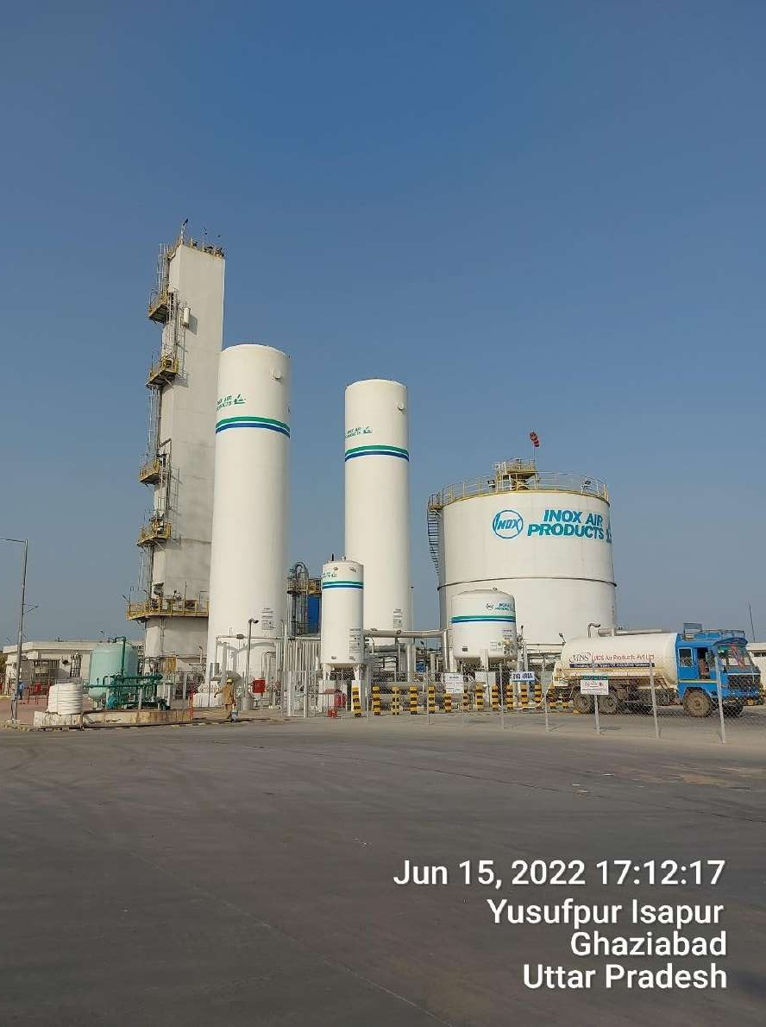

1. **NAME OF THE PROJECT:** Liquid Air Separation Plant by Inox Air Products Pvt. Ltd. at Khasra No. 171, 172, 173 and 185, Yusufpur-Isapur, Modinagar, Ghaziabad, U.P. - 245304.

### PROJECT OVERVIEW:

**INOX Air Products Pvt. Ltd (IAPPL)** manufactures and supplies industrial gases including Oxygen, Nitrogen, Argon, Helium, Carbon- Dioxide, Hydrogen, and specialty gas mixtures throughout India. The company specializes in providing products, technologies and services to a vast cross-section of industries including the chemical, pharmaceutical, metals, steel, food, waste water treatment, cement, glass, textiles, paint, medical and pulp and paper sectors.

The subject company has setup a ‘Liquid Air Separation plant’ in Modinagar, Ghaziabad, U.P. which manufactures Liquid Oxygen (Capacity 54,437 TPA), Liquid Nitrogen (Capacity 19,710 TPA) and Liquid Argon (Capacity 2,190 TPA).

To set up the plant M/s IAPPL had proposed fixed capital investment of Rs. 105.00 crores in the project. In this regard M/s IAPPL has been issued Letter of comfort (LoC) under Industrial investment & Employment Promotion Policy, 2017 (Large-Projects) through its nodal agency PICUP. For the purpose of examining and verifying investment made by the company from 03rd April 2017 (as first date of investment) till 31st October 2020 (cutoff date of investment), PICUP has engaged R.K associates Valuers & Techno Engg. Consultants (P) Ltd.

As per the copy of 3 no. of sale deeds provided by the client, the subject plant has been setup on land area admeasuring 2.1914 Ha /5.41 acres. Details of the same has been tabulated below:

|  |  |  |  |  |
| --- | --- | --- | --- | --- |
| **S. No.** | **Sale Deed No.** | **Khasra, Khata No.** | **Area** | |
| **Hectare** | **Acre** |
| 1 | 597 | Khata No.211, Khasra No.171 | 0.1759 | 0.43 |
| 2 | 621 | (1) Khata No.232, Khasra No.172  (2) Khata No.232, Khasra No.173 ka and 173 kha  (3) Khata No.0065, Khasra No. 185 | 1.7500 | 4.32 |
| 3 | 813 | Khata No.211, Khasra No.171 | 0.2655 | 0.66 |
| **Total** | | | **2.1914** | **5.41** |

As per the copy of sanctioned building plan dated 04/01/2020 details of the Project area are tabulated below:

|  |  |  |  |
| --- | --- | --- | --- |
| **Sr. No.** | **Particulars** | **Description** | **Unit** |
| 1. | Total Plot Area | 21,920.00 | sqm |
| 2. | Permissible Covered Area | 13,152.00 | sqm |
| 60.00 | % |
| 3. | Permissible FAR | 219.20 | sqm |
| 1.00 | % |
| 4. | Proposed Covered Area | 1,129.38 | sqm |
| 5.15 | % |
| 5. | Total Open Area | 20,790.62 | sqm |

For procurement and commissioning of the plant and machinery, the company has given the main contract to M/s Linde India on a turnkey basis and for civil works the main contract is given to M/s Hitech component Builders Private limited. Apart from M/s Linde India and M/s Hitech component Builders private limited, other small-scale builders and minor component suppliers are hired for misc. works related to the project.

As on 31.10.2021 the project cost is revised to Rs. 114.32 Crore as per CA certificate dated 1st June 2021. Comparison table is as below:

|  |  |  |  |
| --- | --- | --- | --- |
| (Amount in Rs. Crore) | | | |
| **Sr. No.** | **Particulars** | **Cost of Project as per DPR** | **COP as per CA certificate** |
| 1. | Land and Site development | 5.25 | 5.34 |
| 2. | Building and Civil works | 10.00 | 9.85 |
| 3. | Plant and machinery | 89.75 | 87.43 |
| 4. | Miscellaneous Fixed Assets | 0.81 |
|  | **Sub Total (Hard Cost)** | **105.00** | **103.43** |
| 5. | Preliminary and Preoperative expenses | 0.00 | 9.07 |
| 6. | Interest During construction | 0.00 | 1.82 |
|  | **Sub Total (Soft Cost)** | **0.00** | **10.89** |
|  |  |  |  |
|  | **Grand Total** | **105.00** | **114.32** |

### CURRENT STATUS OF THE PROJECT

As per the physical progress observed during site visit carried out on 15.06.2022 the project was found to be completed and producing Liquid Oxygen, Liquid Nitrogen and Liquid Argon as all the machineries were found under working condition.

### PROJECT LOCATION

The subject project is addressed as Khasra No. 171, 172, 173 And 185, Yusufpur-Isapur, Modinagar, Ghaziabad, Uttar Pradesh state in India. It is well connected by rail and road. The nearest airport from the site is IGI Airport, Delhi located at the distance of approx. 73 km. The Project site is also well connected through road network and Delhi-Meerut Expressway is at a distance of approx. 4.50 Km from the subject property. Modinagar railway station is the nearest railway station at a distance of approx. 12 Km from the project.

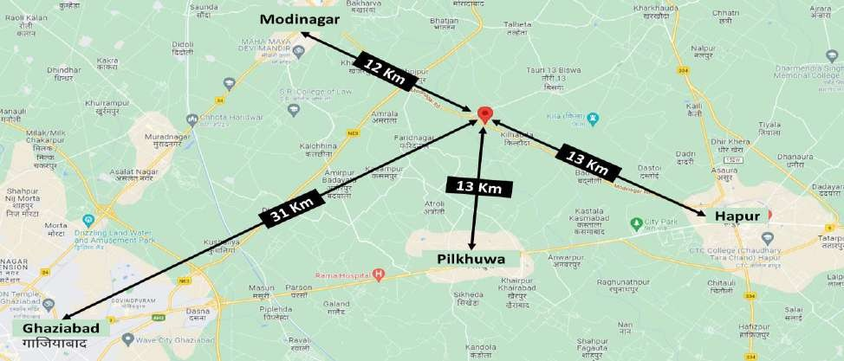

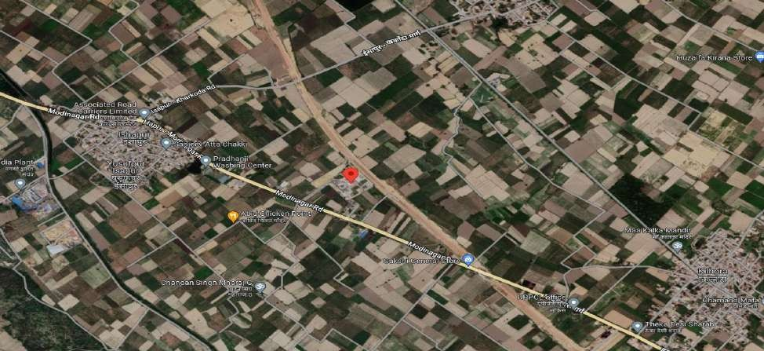

1. **SCOPE OF THE REPORT:** The scope of this report includes the assessment & verification of the capital expenditure incurred on the project from 03rd April 2017 till 31st October 2020 by the company.

*All the assessment carried out for the Project is done based on the documents & information provided to us by IAPPL and its correlation by the Engineering team through site inspection and various other discussions with the Project proponents and its able resources and thus forming an opinion out of it.*

1. **PURPOSE OF THE REPORT:** To provide a comprehensive overview of the current status of the project in terms of Capital Expenditure incurred to enable PICUP to take informed business decision on the project in relation to special facilities & incentives given to Large Projects under Industrial Investment & Employment Promotion Policy-2017 of Govt. of U.P.
2. **SURVEY DETAILS:** The subject plant is inspected by our engineering team comprising Er. Adil Afaque and Er. Abhishek Sharma on 15th June 2022. Site inspection was done in the presence of company’s representatives; Mr. Vinit Kumar Tyagi (Manager - Works) and Mr. Narendra Sharma (Asst. Manager - Accounts). All the details pertaining to the physical setup of the Plant have been cross-checked as per the documents/ information provided to us.

The engineering team visited all the sections of the Plant and verified most of the major machineries installed on site like Cold Box, Air Compressor, Storage Tanks, Heat Exchanger, Transformer, Distributed Control System, various motors, EOT Crane, DG Set, MCC Panel, etc. The machineries verified at site are found to be operational and in good working condition.

As per the information shared by the company, production and capacity utilization of the past one week is depicted below, however, the same has not been verified independently by us since the same is out of our scope of work.

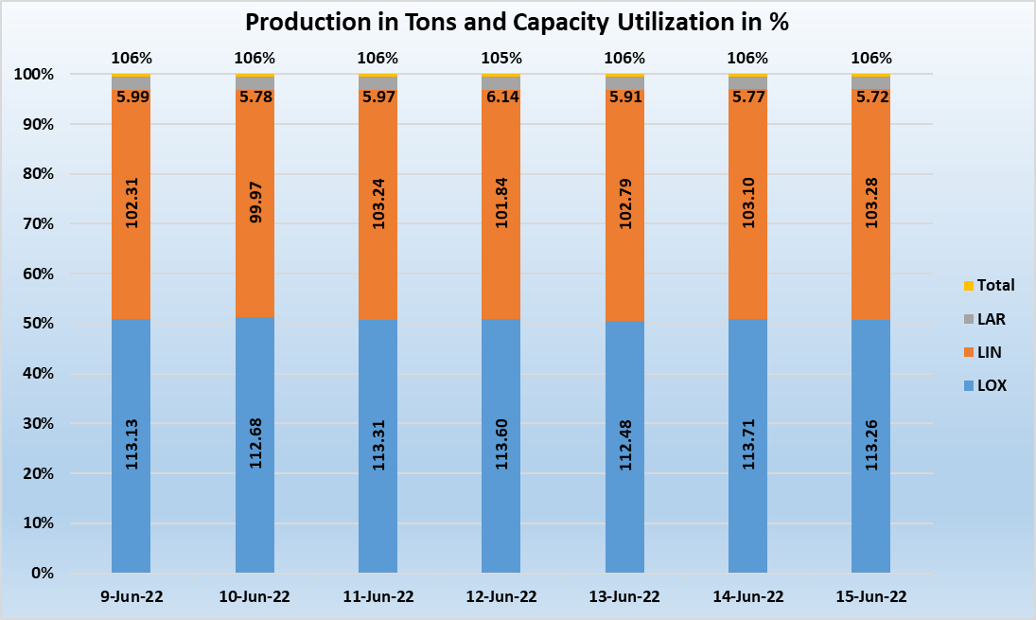

***LAR- Liquid Argon, LIN- Liquid Nitrogen and LOX- Liquid Oxygen***

### METHADOLOGY ADOPTED:

1. Study of Detailed Project Report to know the Project proposed plan & estimates.
2. Study of Project Contract agreements.
3. Site visit by our engineering team to assess the actual status at the site.
4. Discussions with the management of the company about the Project details.
5. Study and analysis of various documents, information & data collected from the company and their correlation with the observations during the site survey.
6. Correlation of the provided information with the industry standards.
7. Other information obtained regarding the project from the sources in the public domain.

|  |  |
| --- | --- |
| **PART C** | **PLANT INFRASTRUCTURE SECTIONS & FACILITY DETAILS** |

1. **LAND DETAILS:** As per the copy of 3 no. of sale deeds executed in the month of January, 2018, the total land area underneath the subject property is 2.1914 Ha or 5.41 acres. However, as per the copy of 3 no. of mutation certificates, the total land area converted from agricultural to non- agricultural is 2.67 Ha or 6.59 acres. The land parcels were purchased during the month of January 2018 and then amalgamated into one to form a contiguous plot for the plant. It is located in an undeveloped locality and surrounded by agricultural land parcels with a few industries located at a distance of approx. 5-10 Km.

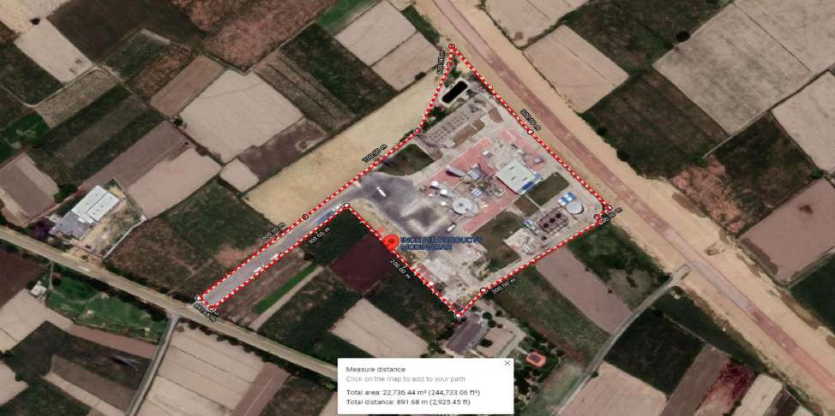

*Area marked with Red is the extent of the subject property.*

As per the CA certificate, the total cost incurred for the purchase and development of the land parcel admeasuring 2.19 Hectares amounts to Rs.5.34 crores which includes Rs. 5.03 Crore paid as consideration price and stamp duty for purchase of land parcels. Details of Rs. 5.03 crore is as below:

|  |  |  |  |  |
| --- | --- | --- | --- | --- |
| **Sale Deed No.** | **Area (Ha.)** | **Area (Ac.)** | **Consideration Amount (Cr.)** | **Stamp Duty Amount (Cr.)** |
| 597 | 0.1759 | 0.43 | 0.38 | 0.02 |
| 621 | 1.7500 | 4.32 | 3.83 | 0.19 |
| 813 | 0.2655 | 0.66 | 0.58 | 0.03 |
| **Total** | **2.1914** | **5.41** | **4.79** | **0.24** |
| **5.03** | |

1. **BUILDING & STRUCTURAL DETAILS:** For the construction on the subject land parcel, M/s Hi- tech has been given the contract on turnkey basis where necessary material, Construction Equipment, Labour etc. are provided by the company and construction work was done by the contractor. Detailed break-up of the structures as per the sanctioned plan has been tabulated below:

|  |  |  |  |  |  |  |
| --- | --- | --- | --- | --- | --- | --- |
| **Sr. No.** | **Building Name** | **Built-up area (Sq. mtr.)** | **Height (Ft.)** | **Type of Structure** | **Floor** | **Type of Construction** |
| 1. | Electrical Room | 390.49 | 11 | RCC Structure with RCC Roofing and Italian Marble Flooring | Ground Floor | Good |
| 2. | Compressor House | 370.00 | 45 | RCC and PEB Structure with GI Sheet roofing and RCC Flooring | Ground Floor | Good |
| 3. | Workshop & Store | 150.00 | 15 | RCC Structure with RCC Roofing and PCC Flooring | Ground Floor | Good |
| 4. | Admin Building | 198.49 | 11 | RCC Structure with RCC Roofing and Italian Marble Flooring | Ground Floor | Good |
| 5. | Security Room + Dispatch Room with Toilet | 20.40 | 11 | Load bearing structure with RCC roofing and PCC flooring | Ground Floor | Good |
| **SUB-TOTAL (A)** | | **1,129.38** | **-** | | | |
| **BUILDINGS CONSTRUCTED AT SITE BUT NOT IN APPROVED PLAN** | | | | | | |
| 6. | Chemical Dosing Room | 23.00 | 10 | PEB Structure | Ground Floor | Good |
| 7. | Pump Room | 75.00 | 10 | PEB Structure | Ground Floor | Good |
| 8. | Driver rest room and toilet | 17.00 | 9 | RCC Structure with RCC roofing and Panel Build Portable cabin | Ground Floor | Good |
| 9. | Meter Room | 28.00 | 9 | RCC Structure with RCC roofing | Ground Floor | Good |
| 10. | Meter room 2 | 6.00 | 9 | RCC Structure with RCC roofing | Ground Floor | Good |
| **SUB TOTAL (B)** | | **149.00** |  | | | |
|  | | | | | | |
| **GRAND TOTAL (A+B)** | | **1,278.38** | - | | | |

As per the copy of CA certificate, M/s Inox Air Products Pvt. Ltd. has shown to have incurred an amount of **Rs.9.85 Cr.** to construct different Plant Buildings like Compressor Shed, Electrical Room, Admin House, Security Room, Metering Room, etc. However, as per the FAR provided to us, the total cost incurred related to the construction of the buildings and other civil work is Rs.10.90 crores. Details of Rs.10.90 Crore is as below:

|  |  |  |
| --- | --- | --- |
| **Sr. No.** | **Asset Description** | **Amount  (Incl. taxes)** |
| 1 | Road and Drainage | 4,91,30,458 |
| 2 | Factory Building | 1,28,23,098 |
| 3 | Compound Wall | 1,24,75,362 |
| 4 | MCC Building | 94,71,927 |
| 5 | PEB Sheds | 70,66,944 |
| 6 | Main Office Building | 68,80,421 |
| 7 | Rain Water Harvesting | 43,66,126 |
| 8 | Store & Workshop | 40,95,049 |
| 9 | Meter Room | 7,83,247 |
| 10 | Motorize Gate-Clear Opening-Nihva | 6,14,825 |
| 11 | EHV Fencing for Metering Room | 4,59,677 |
| 12 | Driver's Rest Room Porta Cabin | 4,00,576 |
| 13 | Metering Room | 2,41,430 |
| 14 | Paver Block Road For Metering Room | 2,18,993 |
| **Total** | | **10,90,28,133** |

**Tabulated below is the building construction cost assessment by us:**

|  |  |
| --- | --- |
| **Total Estimated Cost allocated in Civil & structure Works** | Rs.10.00 crores |
| **Total cost capitalized by the company in their books *(As per FAR)*** | Rs.10.90 crores |
| **Total Cost incurred *(as per CA certificate)*** | **Rs.9.85 crores** |
| **Total Cost Approved *(as per our assessment)*** | **Rs.8.48 crores** |
| ***Observations & Remarks:***   * *Total expenditure capitalized in FAR under the head of ‘Building’ by the subject company from 31st October 2020 is of Rs.10.90 Cr. However, as per the CA certificate dated 01st June 2021 the cost incurred on the project till 31st October 2020 amounts to Rs.9.85 Cr. only.* * *As per the information shared by the company, the difference of Rs.1.05 Cr. pertains to Pre-operative Expenses & Interest Capitalized.* * *As per Rule No. 2.3.2 envisaged in Rules for Implementation of Industrial Investment and employment promotion policy-2017 (IIEPP-2017) "Building means a new building constructed for the project, including administrative building. The cost of new buildings constructed for installation of plant and machinery, R&D activities, in-house testing facilities, storage facilities, and other buildings related to the manufacturing process, shall be considered as per the actual expenditure incurred". Therefore, we have not considered the cost of Driver Rest room & toilet amounting to Approx. Rs. 1 Lakh.* * *We have sought copies of invoices of major bills raised towards civil construction i.e. of billing amount of Rs. 15 lakhs above. Therefore, the company has provided the invoices raised to Hi-tech (the main civil contractor) for a total amount of ~Rs. 4.47 Cr. excluding taxes. Additionally, they have also provided the list of invoices which were raised towards civil construction. According to the list of invoices, the cost of construction amounts to Rs.8.48 Crore without GST and Rs.9.86 with GST. The same seems to be in line with our analysis which is performed by charging reasonable Plinth area rates on the constructed area in the project based on industry standards. Our analysis is also attached in Part E, Clause 2.2 of this report for reference.* * *All items checked at the site from the details provided by IAPPL are as per visual observation and general industry experience. No special tests (Mechanical/ Physical or any other nature) have been carried out to ascertain the authenticity of the same.* * *As per the information received during the site visit, pile-type foundations are used in the structure as the soil in the particular region is compressible and weak. Therefore, the cost of construction is a bit high as compared to the cost of construction where shallow foundations are used. Supporting documents of Pile foundation like soil investigation report, Pile drawings were sought from the company.* * *Accordingly, as per the Additional Recommendations report by Foundtek Consultants Pvt. Ltd. dated 28th October 2017, it has recommended ‘Cast-in-situ bored pile foundations’.* * *For the construction of buildings/structure in the premise the company has signed a work order agreement with M/s Hi-Tech Competent Builders Pvt. Ltd. for an amount of Rs.8.30 Cr. For the same, we have asked a certified list of invoices generated by the contractor. The same is provided by the company and is attached as annexure with this report.* * *To make cost assessment, we have estimated the cost based on specifications available building wise & which we could best estimate from Market trends/ CPWD rates as per the specifications and construction found on site.* * *Detailed break-up of expenses please refer to the attached Annexures.* | |

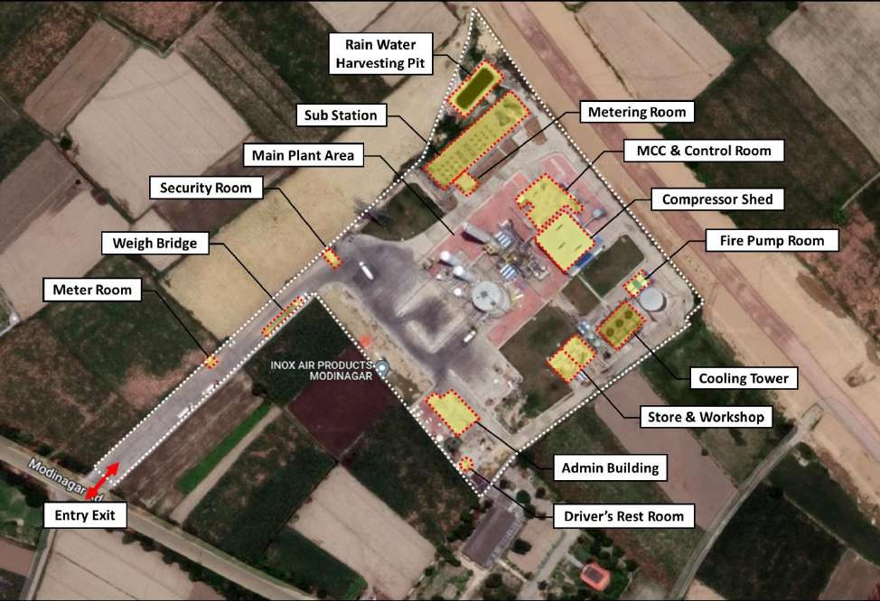

### PLANT & EQUIPMENT DETAILS:

As per the project information provided by the company, the company is engaged in the manufacturing of liquid gases like Oxygen, Nitrogen and Argon. The plant is of the designed capacity of 209 MT/day where production capacity for each gas is tabulated below:

|  |  |  |
| --- | --- | --- |
| **Sr. No.** | **Product** | **Production Capacity**  **(In MT/day)** |
| 1. | Liquid Oxygen (LOX) | 149 |
| 2. | Liquid Nitrogen (LIN) | 54 |
| 3. | Liquid Oxygen (LAR) | 6 |
| **Total** | | **209** |

Cryogenic technology is used in ASU's manufacturing process to separate the gases in the air by fractional distillation. In this method, atmospheric air is cooled to a temperature below zero, at which point it becomes liquid and the constituent gases are separated in the distillation column at their individual boiling points. The major machinery and storage facility involved in the process has been described below:

### Main machinery & storage facility:

* + 1. **Air Cooling and Pre-Cooling System**

The incoming air is first cleared of dust and other debris in an **Air Filter S1146** before being compressed by multistage intercooled turbo-type **Air Compressors C1181** to the necessary process pressure of approximately 23.1 bar(a).

The pre-cooling section consists of **Cooler E1121**, the **Evaporation Cooler** for the cooling part of the cooling water and **single-stage Direct Contact Air Cooler (DCAC)**.

### Molecular Sieve Station

Water vapor, CO2, N2O, and potentially hazardous hydrocarbons are among the last contaminants in the process air that are adsorbed from the air by passing through one of the two **Molecular Sieve Adsorbers A2626 A/B**. One adsorber is in operation while the other one is in a regeneration mode.

The regeneration gas is a waste gas (nitrogen) that is produced by the distillation unit. During the heating phase, it is heated in the **Electrical Regeneration Gas Heater (E2618)**.

### Process Streams distribution and refrigeration:

After passing through the molecular sieve unit A2626A/B, the process air is dried out and cleaned before being further compressed by the **Booster Stages (C3450 and C3420)** of the **Expansion Turbines (X3472 and X3471)** and cooled in the main heat exchanger. The **Rectification Column T3211** receives a portion of the stream through JY Valve. The **Turbo Expander X3471** decrease the other portion of the boosted air to roughly 5.8 bar (a).

### Rectification, pressure column T3211

In the **Pressure column T3211** the process air separates into pure nitrogen, yielding at the top, and into rich liquid at the bottom. A part of gaseous nitrogen is withdrawn from the high-pressure column, warmed up in the **Main Heat Exchanger E3116** and send out as Seal gas. In the **Condenser/Reboiler E3216**, the gaseous nitrogen is condensed against boiling oxygen to produce the necessary reflux for rectification.

### Rectification, low pressure column T3212

The final separation into a pure oxygen fraction at the bottom and a waste nitrogen fraction at the top occurs in the **Low-Pressure Column T3212**. Its bottom is drained of its oxygen-enriched liquid, which is then delivered to the **Liquid Oxygen (LOX) storage tank** after being somewhat subcooled in the **Heat Exchanger E3316.**

### Argon Extraction

The **Argon Column T4111** is where the argon recovery is accomplished. Structured packings are installed in the argon column T4111. Cryogenic rectification is used to eliminate oxygen and nitrogen. The **Sub-Cooler E3316** cools the oxygen-enriched liquid from the bottom of pressure column T3211 before expanding it into argon condensate E4116, which is then fed back into the low-pressure column T3212 as oxygen feed. The crude argon system uses the argon-enhanced gas from the low-pressure column T3212, which is pumped into the bottom of the T4111 column. The primary portion of pure argon is condensed in heat exchanger E4116 in the top condenser against rich liquid from the bottom of the pressure column T3211 to supply reflux for the argon system. Pure liquid argon (LAR) from the upper third of T4111 can be withdrawn and transferred to the storage tank.

### Liquid Storage System:

* + - 1. One 1,000 MT Flat Bottom LOX Tank along with PBU
      2. Two 250 kL Vacuum Insulated Vertical LIN Tanks along with PBU
      3. One 30 kL Vacuum Insulated Vertical LAR Tank along with PBU
      4. One 10 kL LIN Seal Gas Tank along with PBU

**PROCESS FLOW DIAGRAM OF THE PROJECT**

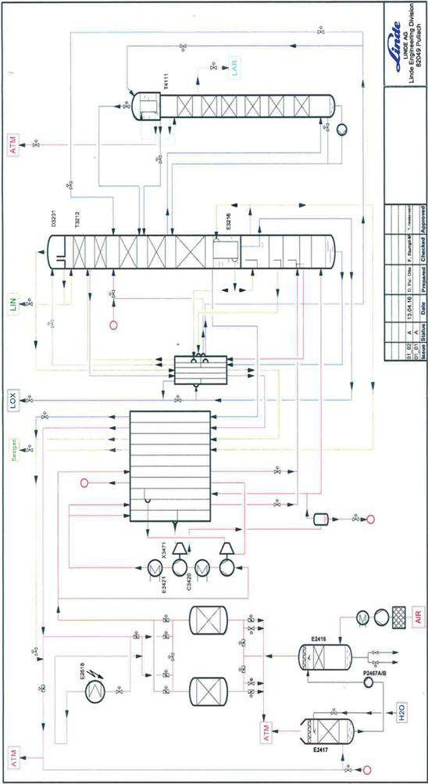

## Expenditure incurred in Plant & Machinery:

As per the details shared by the company the machinery were bought and installed by M/s Linde India Limited where both imported and domestic machinery are installed in the plant.

Copies of invoices of machineries delivered and installed at site were sought from the company as a supporting document to the expenditure shown in CA certificate. Accordingly, the company has provided us the copies of invoices amounting to Rs.83.09 Cr. which is ~95% of the total cost incurred towards plant & machinery and miscellaneous fixed assets.

The cost towards soft cost of the project amounts to Rs.10.89 Crore which includes Rs.9.07 Cr. towards preliminary and preoperative expenses and Rs.1.82 crore as interest during construction which is approximately 11% of hard cost amounting to Rs.103.43 Crore. For the same we have relied on CA certificate since verification of the same is out of our scope of work.

Summary sheets of the same has been tabulated below:

## Plant & Machinery and Miscellaneous fixed assets

## (Amount In Rs. Cr.)

| **Sr. No.** | **Vendor Name** | **INVOICE NOS.** | **DATE** | **AMOUNT** |
| --- | --- | --- | --- | --- |
| 1. | LINDE INDIA LTD-KOLKATA | 2510035664 | 07-02-2018 | 0.63 |
| 2. | LINDE INDIA LTD-KOLKATA | 2510003495 | 15-04-2018 | 15.00 |
| 3. | LINDE INDIA LTD-KOLKATA | 2510011707 | 20-06-2018 | 7.80 |
| 4. | LINDE INDIA LTD-KOLKATA | 2510022799 | 05-09-2018 | 4.37 |
| 5. | LINDE INDIA LTD.-LUCKNOW | 2410000001 | 15-10-2018 | 1.01 |
| 6. | LINDE INDIA LTD.-LUCKNOW | 2410000002 | 15-10-2018 | 4.72 |
| 7. | LINDE INDIA LTD-KOLKATA | 2510034783 | 28-11-2018 | 0.09 |
| 8. | LINDE INDIA LTD-KOLKATA | 2510036108 | 06-12-2018 | 0.05 |
| 9. | LINDE INDIA LTD-KOLKATA | 2510038028 | 20-12-2018 | 0.31 |
| 10. | LINDE INDIA LTD-KOLKATA | 2510038153 | 21-12-2018 | 0.40 |
| 11. | LINDE INDIA LTD-KOLKATA | 2510038929 | 26-12-2018 | 0.03 |
| 12. | LINDE INDIA LTD-KOLKATA | 2510041909 | 15-01-2019 | 1.21 |
| 13. | LINDE INDIA LTD-KOLKATA | 2510044042 | 29-01-2019 | 0.03 |
| 14. | LINDE INDIA LTD.-LUCKNOW | 2410000016 | 01-02-2019 | 1.36 |
| 15. | LINDE INDIA LTD.-LUCKNOW | 2410000017 | 01-02-2019 | 2.62 |
| 16. | LINDE INDIA LTD.-LUCKNOW | 2410000018 | 01-02-2019 | 0.90 |
| 17. | LINDE INDIA LTD-KOLKATA | 2510045389 | 04-02-2019 | 0.55 |
| 18. | LINDE INDIA LTD-KOLKATA | 2510046624 | 04-02-2019 | 0.06 |
| 19. | LINDE INDIA LTD-KOLKATA | 2510003411 | 18-04-2019 | 0.18 |
| 20. | LINDE INDIA LTD.-LUCKNOW | 2410000006 | 24-05-2019 | 1.35 |
| 21. | LINDE INDIA LTD-KOLKATA | 2510010958 | 03-06-2019 | 0.19 |
| 22. | LINDE INDIA LTD.-LUCKNOW | 2410000009 | 27-06-2019 | 1.26 |
| 23. | LINDE INDIA LTD.-LUCKNOW | 2410000013 | 30-07-2019 | 1.03 |
| 24. | LINDE INDIA LTD.-LUCKNOW | 2410000014 | 30-07-2019 | 0.10 |
| 25. | LINDE INDIA LTD-KOLKATA | 2510020302 | 12-08-2019 | 0.03 |
| 26. | LINDE INDIA LTD.-LUCKNOW | 2410000016 | 14-08-2019 | 1.43 |
| 27. | LINDE INDIA LTD.-LUCKNOW | 2410000018 | 27-08-2019 | 4.68 |
| 28. | LINDE INDIA LTD.-LUCKNOW | 2410000019 | 27-08-2019 | 0.20 |
| 29. | LINDE INDIA LTD.-LUCKNOW | 2410000023 | 03-10-2019 | 2.20 |
| 30. | LINDE INDIA LTD.-LUCKNOW | 2410000024 | 03-10-2019 | 0.10 |
| 31. | LINDE INDIA LTD.-LUCKNOW | 2410000025 | 03-10-2019 | 0.39 |
| 32. | LINDE INDIA LTD.-LUCKNOW | 2410000029 | 02-11-2019 | 1.05 |
| 33. | LINDE INDIA LTD.-LUCKNOW | 2410000033 | 10-12-2019 | 2.05 |
| 34. | LINDE INDIA LTD.-LUCKNOW | 2410000034 | 20-12-2019 | 1.17 |
| 35. | LINDE INDIA LTD-KOLKATA | 2510042472 | 10-01-2020 | 0.01 |
| 36. | LINDE INDIA LTD.-LUCKNOW | 2410000003 | 19-05-2020 | 3.02 |
| 37. | LINDE INDIA LTD.-LUCKNOW | 2410000004 | 19-05-2020 | 0.10 |
| 38. | LINDE INDIA LTD.-LUCKNOW | 2410000005 | 20-05-2020 | 1.11 |
| 39. | LINDE INDIA LTD.-LUCKNOW | 2410000011 | 10-07-2020 | 0.43 |
| 40. | LINDE INDIA LTD.-LUCKNOW | 2410000012 | 14-07-2020 | 1.37 |
| 41. | LINDE INDIA LTD.-LUCKNOW | 2410000014 | 15-07-2020 | 0.41 |
| 42. | LINDE INDIA LTD.-LUCKNOW | 2410000028 | 17-10-2020 | 0.30 |
| 43. | LINDE INDIA LTD.-LUCKNOW | 2410000031 | 29-10-2020 | 0.59 |
| 44. | LINDE INDIA LTD.-LUCKNOW | 373543651 | 28-11-2020 | 0.24 |
| 45. | AKSHAR ELECINFRA PVT LTD | L/0005/09/19-20 | 31.07.2019 | 0.54 |
| 46. | AKSHAR ELECINFRA PVT LTD | L/0006/09/19-20 | 02.08.2019 | 0.25 |
| 47. | AKSHAR ELECINFRA PVT LTD | L/0013/09/19-20 | 08.08.2019 | 0.18 |
| 48. | AKSHAR ELECINFRA PVT LTD | L/0022/09/19-20 | 30.08.2019 | 0.40 |
| 49. | AKSHAR ELECINFRA PVT LTD | L/0026/09/19-20 | 12.11.2019 | 0.34 |
| 50. | AKSHAR ELECINFRA PVT LTD | L/0027/09/19-20 | 13.11.2019 | 1.80 |
| 51. | AKSHAR ELECINFRA PVT LTD | SR/0006/09/20-21 | 27-08-2020 | 0.23 |
| 52. | EE EDD PILKHUWA | DEMAND NOTICE NO.319 | 17.01.2019 | 3.00 |
| 53. | HI-TECH COMPETENT BUILDERS (P) LTD | HTCBPL/UP1819-25 | 01.10.2018 | 0.41 |
| 54. | HI-TECH COMPETENT BUILDERS (P) LTD | HTCBPL/UP1819-28 | 30.10.2018 | 0.78 |
| 55. | HI-TECH COMPETENT BUILDERS (P) LTD | HTCBPL/UP1819-31 | 06.12.2018 | 0.52 |
| 56. | HI-TECH COMPETENT BUILDERS (P) LTD | HTCBPL/UP1819-36 | 09.01.2019 | 0.56 |
| 57. | HI-TECH COMPETENT BUILDERS (P) LTD | HTCBPL/UP1819-39 | 13.02.2019 | 0.34 |
| 58. | HI-TECH COMPETENT BUILDERS (P) LTD | HTCBPL/UP1920-02 | 18.04.2019 | 0.23 |
| 59. | HI-TECH COMPETENT BUILDERS (P) LTD | HTCBPL/UP1920-11 | 25.06.2019 | 0.23 |
| 60. | HI-TECH COMPETENT BUILDERS (P) LTD | HTCBPL/UP1920-25 | 12.08.2019 | 0.30 |
| 61. | HI-TECH COMPETENT BUILDERS (P) LTD | HTCBPL/UP1920-37 | 12.10.2019 | 0.29 |
| 62. | HI-TECH COMPETENT BUILDERS (P) LTD | HTCBPL/UP1920-43 | 15.11.2019 | 0.25 |
| 63. | HI-TECH COMPETENT BUILDERS (P) LTD | HTCBPL/UP1920-63 | 20-02-2020 | 0.20 |
| 64. | HI-TECH COMPETENT BUILDERS (P) LTD | HTCBPL/UP2021-57 | 01.01.2021 | 0.38 |
| 65. | INOX INDIA PVT LTD | 1.00019E+13 | 24.03.2019 | 0.44 |
| 66. | KUMAR TRADING CO. | KTC/19-20/K-08 | 16.05.2019 | 0.65 |
| 67. | KUMAR TRADING CO. | KTC/19-20/K-11 | 14.06.2019 | 0.43 |
| 68. | KUMAR TRADING CO. | KTC/19-20/K-20 | 19.07.2019 | 0.40 |
| 69. | KUMAR TRADING CO. | KTC/19-20/K-21 | 19.07.2019 | 0.78 |
| 70. | KUMAR TRADING CO. | KTC/19-20/K-24 | 26.08.2019 | 0.99 |
| 71. | KUMAR TRADING CO. | KTC/19-20/K-33 | 18.09.2019 | 0.52 |
| 72. | N.K. ENGINEERS | 75/19-20 | 08.01.20221 | 0.19 |
| 73. | ROSTFREI STEELS PVT LTD | RSPL/U/1920/291 | 13.10.2019 | 0.18 |
| 74. | Siemens Ltd. | MH1027008367 | 30-06-2020 | 0.41 |
| 75. | UTTAR PRADESH POWER TRANSMISSION CORPORATION LIMITED | DEMAND NOTICE NO.2657 | 26.07.2019 | 0.81 |
| 76. | Others | - | - | 5.15 |
| **TOTAL** | | | | **88.24** |

* Machineries were verified on sample basis based on type and name of machineries as listed in the invoices. The same were found to be available on site and were in good working condition.

### Note:

1. Expenditure amounting to Rs.5.15 Crore out of Rs. 88.24 Crore includes expenditure pertaining to small components and other miscellaneous fixed assets and are approximately 6% of the total expenditure made towards purchase and installation of Plant and machineries and other misc. fixed assets.
2. As per the copy of “Rules for Implementation of Industrial Investment and Employment Promotion Policy-2017 (IIEPP-2017)” **the same are out of the scope of this assessment, hence, excluded from this cost verification assessment**.
3. Out of Rs. 5.15 Crores the MFA details amounting to Rs. 0.81 Crore (Rs.81 Lakh) has been tabulated below:

**(Amount in Rs. Lakh)**

| **SR. NO.** | **ASSET DESCRIPTION** | **DATE OF**  **CAPITALISATION** | **ACQUISITION COST** | |
| --- | --- | --- | --- | --- |
| 1. | OFFICE INTERIOR | 08-10-2020 | 46.14 | |
| 2. | MS OFFICE & WINDOWS | 08-10-2020 | 4.60 | |
| 3. | SERVER WITH STORAGE BACKUP | 08-10-2020 | 4.34 | |
| 4. | THIN CLINETS & MONITORS | 08-10-2020 | 3.14 | |
| 5. | PORTA CABIN 20' x 10' x 8'-6" | 25-04-2018 | 2.83 | |
| 6. | STORE STORAGE RACKS | 08-10-2020 | 2.62 | |
| 7. | AIR CONDITIONER 1.5TR 3 STAR SPLIT-IPLAB-CARRIER Q | 08-10-2020 | 2.11 | |
| 8. | AIR CONDITIONERS-WORKS STATION | 08-10-2020 | 1.62 | |
| 9. | SECURITY CABIN 10' x 8' x 8'-6" | 22-05-2018 | 1.39 | |
| 10. | DESKTOPS | 08-10-2020 | 1.18 | |
| 11. | BIO TOILET | 08-10-2020 | 1.12 | |
| 12. | EPBAX SYSTEM | 08-10-2020 | 1.08 | |
| 13. | 6 KVA UPS WITH SMF BATTERIES-HITACHI | 08-10-2020 | 1.03 | |
| 14. | BREATHING APPARATUS SET | 08-10-2020 | 0.75 | |
| 15. | AIR CONDITIONERS-SERVER ROOM | 08-10-2020 | 0.64 | |
| 16. | AIR CONDITIOER-CONFERENCE ROOM | 08-10-2020 | 0.58 | |
| 17. | LAPTOP-LENOVO, S/N-PG01C00P, THINKPAD E480-VINIT TYA | 21-01-2019 | 0.54 | |
| 18. | LAPTOP-HP348, S/N-5CG0330RHD-NARENDRA | 28-10-2020 | 0.52 | |
| 19. | ARC FLASH SUIT 40 CAL | 08-10-2020 | 0.49 | |
| 20. | PROJECTOR | 08-10-2020 | 0.48 | |
| 21. | AIRCONDITIOER-MANAGER CABIN | 08-10-2020 | 0.47 | |
| 22. | DESKTOP-DELL OPTIPLEX 3050MT(WIN10) | 28-07-2018 | 0.39 | |
| 23. | DESKTOP-LENOVO, V520, S/N-PG01B291 | 21-01-2019 | 0.38 | |
| 24. | MOTOROLA WALKIE TALKIE -DHWANI | 08-10-2020 | 0.32 | |
| 25. | AIR CONDITIOER-CAFETERIA | 08-10-2020 | 0.32 | |
| 26. | SPLIT A.C., M-VOLTAS, TR-1.0-3 Star | 04-06-2018 | 0.30 | |
| 27. | SPLIT A.C., M-VOLTAS, TR-1.5-3 Star | 04-06-2018 | 0.30 | |
| 28. | AIRCONDITIOER-DESPATCH ROOM | 08-10-2020 | 0.24 | |
| 29. | CLAMP & MULTI METER | 08-10-2020 | 0.23 | |
| 30. | OFFICE CHAIRS -MSC-114-7 Nos. | 02-05-2018 | 0.18 | |
| 31. | WATER DISPENSER-BLUE STAR, HOT & COLD | 21-01-2019 | 0.16 | |
| 32. | MATTRESS & PILLOW-6 NOS. | 28-08-2019 | 0.16 | |
| 33. | CONTROLLER CARD | 08-10-2020 | 0.15 | |
| 34. | PROTABLE O2 METER MSA MAKE | 08-10-2020 | 0.15 | |
| 35. | LED TV, M-LG, MO-32LK526BPTA | 28-08-2019 | 0.13 | |
| 36. | BIOMETRIC ATTENDENCE MACHINE, eSSL X-990(B) | 13-05-2019 | 0.11 | |
| 37. | HARD DISK | 08-10-2020 | 0.09 | |
| 38. | 16 PORT SWITCH, ROUTER, PATCH CORD-2,3, & 5 MTR | 21-01-2019 | 0.05 | |
| **Total (Excluded from this cost verification assessment)** | | | | **81.33** |

### PREOPERATIVE EXPENSES

The types of expenses under this head are; Legal fee, Employees’ Travel Expenses, Bank Charges, Advertisement, Vehicle Hire Charges, Staff Welfare Expenses and other miscellaneous expenses. The company has incurred Rs. 9.07 crore towards preliminary and pre-operative expenses. The same are not verified us as the same is out of our scope of work. The amount is just given for representation purpose

|  |  |
| --- | --- |
| **PART D** | **PROJECT CONSULTANTS, CONTRACTORS & SUPPLIERS** |

As per the information shared during the site visit by the site representative, the company had assigned the complete installation of the plant and machinery to M/s Linde. However, the copy of purchase orders is not provided to us citing confidential factors by the company.

For civil work along with the compound wall the company had assigned the major work order to M/s Hi-Tech Competent Builders Pvt. Ltd which was excluding material and labors. Purchase and supply of material and labor has been done by company’s in house team only. Details of the contractors hired by the company is as below:

**(Amount in Rs. Crore)**

|  |  |  |  |
| --- | --- | --- | --- |
| **Civil Contractor Name** | **Nature of Work** | **Item Wise Scope of Work** | **Amount** |
| AK And Associates | Architect | Preparation Of Drawing | 0.01 |
| Aes Laboratories (P) Ltd. | Laboratory | Borewell Water Testing | 0.00 |
| Anurag Trader | Material Supplier | Misc. Items | 0.01 |
| Auracorp Infrastructure Private Limited | Labor Charges | Labor Charges for Gardening | 0.06 |
| Eka Pro Engineers Private Limited | Laboratory | Air Ambient Monitoring | 0.00 |
| Evergreen Impex | Material Supplier | Grass Cutting Machine | 0.00 |
| Ficasoft Safety Inspection | Consultant | Layout Approval and Ccoe Approval | 0.01 |
| Hi Tech Competent Builders Private Limited | Civil Contractor | Building & Machinery Foundation | 8.30 |
| Krishna Udyog | Material Supplier | Tmt Bars | 0.58 |
| Nihva Technologies Private Limited | Material Supplier | Motorise Gate | 0.06 |
| Pk Enterprises | Material Supplier | Tmt Bars | 0.60 |
| Prakash Painters | Painter | Painting Work | 0.01 |
| Sri Ganesh Constructions and Interiors | Fabricator | Fencing | 0.04 |
| Srinivasa Infra Buildcom Private Limited | Fabricator | Fabrication Work | 0.64 |
| Vishay Enterprises | Portacabin Supplier | Portacabin And Bio Toilet | 0.04 |
| Water Solutions | Ground Water Investigation | Ground Water Investigation | 0.01 |
| Welcome City Nursery | Gardening | Carpet Grass & Plant Etc | 0.02 |
| **Grand Total** | | | **10.39** |

**Note:** The major civil contractor for this project was Hi tech competent Builders private limited. The copy of PO of HI tech is attached as annexure with this report.

|  |  |
| --- | --- |
| **PART E** | **PROJECT COST & CURRENT STATUS** |

1. **TOTAL PROJECT COST:** As per the detailed project report prepared by Inox Air Products Pvt. Ltd., the estimated project cost amounts to Rs.105 Cr., against which, the company has incurred Rs.114.32 Crore vide CA certificate with UDIN.21130432AAAAAS6431 dated 1st June 2021:

|  |  |  |  |  |
| --- | --- | --- | --- | --- |
| **(Amount in Rs. Crore)** | | | | |
| **Sr. No.** | **Particulars** | **Envisaged Cost of Project** | **Cost incurred as per CA certificate** | **Cost incurred as per our Assessment** | |
| 1. | Land and Site Development | 5.25 | 5.33 | 5.33 |
| 2. | Building and Civil Works | 10.00 | 9.85 | 8.48 |
| 3. | Plant & Machinery | 89.75 | 87.44 | 87.43 |
| 4. | Misc. Fixed Assets | 0.81 | 0.81 |
| **Sub-Total (Hard Cost)** | | **105.00** | **103.43** | **102.05** |
| 5. | Preliminary & Preoperative Expenses | 0.00 | 9.07 | - |
| 6. | Interest During Construction Period | 0.00 | 1.82 | - |
| **Sub-Total (Soft Cost)** | | **0.00** | **10.89** | **-** |
|  | | | | |
| **Grand Total** | | **105.00** | **114.32** | **102.05** |

**\*Note:** *As per the copy of “Rules for Implementation of Industrial Investment and Employment Promotion Policy-2017 (IIEPP-2017)”* ***the same are out of the scope, hence, excluded from this cost verification assessment.***

### DETAILS OF EXPENDITURE (HARD COST) INCURRED:

**2.1 LAND AND SITE DEVELOPMENT**

|  |  |  |  |  |
| --- | --- | --- | --- | --- |
| **Sale Deed No.** | **Area (Ha.)** | **Area (Ac.)** | **Consideration Amount (Cr.)** | **Stamp Duty Amount (Cr.)** |
| 597 | 0.1759 | 0.43 | 0.38 | 0.02 |
| 621 | 1.7500 | 4.32 | 3.83 | 0.19 |
| 813 | 0.2655 | 0.66 | 0.58 | 0.03 |
| **Total** | **2.1914** | **5.41** | **4.79** | **0.24** |
| **5.03** | |

* 1. **BUILDING COST**

|  |  |  |  |  |  |  |
| --- | --- | --- | --- | --- | --- | --- |
| **BUILDING/WORK NAME** | **NATURE OF CONSTRUCTION** | **BUILT-UP AREA**  **(in sq ft)** | **ADOPTED RATES**  **(per sq. ft.)** | | **AMOUNT** | |
| MCC ROOM | RCC Structure with RCC Roofing and tremix/tile Flooring | 4,203.23 |  | 1,500.00 | 0.63 | |
| Compressor House | RCC and Heavy PEB Structure with GI Sheet roofing and tremix Flooring | 3,982.68 |  | 1,700.00 | 0.68 | |
| Workshop & Store | RCC Structure with RCC Roofing and tremix Flooring | 1,614.60 |  | 1,100.00 | 0.18 | |
| Admin Building | RCC Structure with RCC Roofing and Italian Marble Flooring | 2,136.55 |  | 1,600.00 | 0.34 | |
| Security Room + Dispatch  Room with Toilet | Porta Cabin | 219.59 |  | 800.00 | 0.02 | |
| Chemical Dosing Room | PEB Structure with tremix flooring | 247.57 |  | 900.00 | 0.02 | |
| Pump Room | PEB Structure with tremix flooring | 807.30 |  | 900.00 | 0.07 | |
| Driver rest room and toilet | Porta Cabin with RCC Structure with tremix structure | 182.99 |  | 800.00 | 0.01 | |
| Meter Room | RCC Structure with RCC Roofing and PCC Flooring | 301.39 |  | 800.00 | 0.02 | |
| Meter room 2 | RCC Structure with RCC Roofing and PCC Flooring | 64.58 |  | 800.00 | 0.01 | |
| **SUB TOTAL (A)** | | **13,760** |  | | **₹** | **1.98** |
| Road and Pathway work | Cement concrete road spread over anarea of 13,570 sqm | 13,570 Sq. mtr |  | 2,200 | 3.03 | |
| Boundary Wall | RCC wall with barbed wire fencing on top on all sides (890 m) | 900 mtr. |  | 7,000 | 0.63 | |
| Rain Water Harvesting | Rain water harvesting system having 2  pits and pipes/canals | 500 sq. mtr. |  | 3,000 | 0.15 | |
| Switchyard | Spread over an area of approx. 1,000 sq. mtr. | 1,000 Sq. mtr. |  | 500.00 | 0.05 | |
| Paver blocks in the area  where machinery is installed | In the main plant area | 4,500 Sq. mtr |  | 2,000 | 0.90 | |
| Raft Foundation over pile | 4,500 Sq. mtr |  | 1,500 | 0.68 | |
| Storm Water drains | - | 1,500 mtr |  | 7,000 | 1.05 | |
| Fire water tank | - | 9,600 L |  | 22.00 | 0.02 | |
| **SUB TOTAL (B)** | |  | | | **6.50** | |
|  | | | | | | |
| **Grand Total** | | |  | | **8.48** | |

### MACHINERY AND MISCELLANEOUS FIXED ASSETS COST

***(Amount in Rs. Cr.)***

| **SR. NO.** | **VENDOR NAME** | **INVOICE NO.** | **DATE** | **AMOUNT** |
| --- | --- | --- | --- | --- |
| 1 | LINDE INDIA LTD-KOLKATA | 2510035664 | 07-02-2018 | 0.63 |
| 2 | LINDE INDIA LTD-KOLKATA | 2510003495 | 15-04-2018 | 15.00 |
| 3 | LINDE INDIA LTD-KOLKATA | 2510011707 | 20-06-2018 | 7.80 |
| 4 | LINDE INDIA LTD-KOLKATA | 2510022799 | 05-09-2018 | 4.37 |
| 5 | LINDE INDIA LTD.-LUCKNOW | 2410000001 | 15-10-2018 | 1.01 |
| 6 | LINDE INDIA LTD.-LUCKNOW | 2410000002 | 15-10-2018 | 4.72 |
| 7 | LINDE INDIA LTD-KOLKATA | 2510034783 | 28-11-2018 | 0.09 |
| 8 | LINDE INDIA LTD-KOLKATA | 2510036108 | 06-12-2018 | 0.05 |
| 9 | LINDE INDIA LTD-KOLKATA | 2510038028 | 20-12-2018 | 0.31 |
| 10 | LINDE INDIA LTD-KOLKATA | 2510038153 | 21-12-2018 | 0.40 |
| 11 | LINDE INDIA LTD-KOLKATA | 2510038929 | 26-12-2018 | 0.03 |
| 12 | LINDE INDIA LTD-KOLKATA | 2510041909 | 15-01-2019 | 1.21 |
| 13 | LINDE INDIA LTD-KOLKATA | 2510044042 | 29-01-2019 | 0.03 |
| 14 | LINDE INDIA LTD.-LUCKNOW | 2410000016 | 01-02-2019 | 1.36 |
| 15 | LINDE INDIA LTD.-LUCKNOW | 2410000017 | 01-02-2019 | 2.62 |
| 16 | LINDE INDIA LTD.-LUCKNOW | 2410000018 | 01-02-2019 | 0.90 |
| 17 | LINDE INDIA LTD-KOLKATA | 2510045389 | 04-02-2019 | 0.55 |
| 18 | LINDE INDIA LTD-KOLKATA | 2510046624 | 04-02-2019 | 0.06 |
| 19 | LINDE INDIA LTD-KOLKATA | 2510003411 | 18-04-2019 | 0.18 |
| 20 | LINDE INDIA LTD.-LUCKNOW | 2410000006 | 24-05-2019 | 1.35 |
| 21 | LINDE INDIA LTD-KOLKATA | 2510010958 | 03-06-2019 | 0.19 |
| 22 | LINDE INDIA LTD.-LUCKNOW | 2410000009 | 27-06-2019 | 1.26 |
| 23 | LINDE INDIA LTD.-LUCKNOW | 2410000013 | 30-07-2019 | 1.03 |
| 24 | LINDE INDIA LTD.-LUCKNOW | 2410000014 | 30-07-2019 | 0.10 |
| 25 | LINDE INDIA LTD-KOLKATA | 2510020302 | 12-08-2019 | 0.03 |
| 26 | LINDE INDIA LTD.-LUCKNOW | 2410000016 | 14-08-2019 | 1.43 |
| 27 | LINDE INDIA LTD.-LUCKNOW | 2410000018 | 27-08-2019 | 4.68 |
| 28 | LINDE INDIA LTD.-LUCKNOW | 2410000019 | 27-08-2019 | 0.20 |
| 29 | LINDE INDIA LTD.-LUCKNOW | 2410000023 | 03-10-2019 | 2.20 |
| 30 | LINDE INDIA LTD.-LUCKNOW | 2410000024 | 03-10-2019 | 0.10 |
| 31 | LINDE INDIA LTD.-LUCKNOW | 2410000025 | 03-10-2019 | 0.39 |
| 32 | LINDE INDIA LTD.-LUCKNOW | 2410000029 | 02-11-2019 | 1.05 |
| 33 | LINDE INDIA LTD.-LUCKNOW | 2410000033 | 10-12-2019 | 2.05 |
| 34 | LINDE INDIA LTD.-LUCKNOW | 2410000034 | 20-12-2019 | 1.17 |
| 35 | LINDE INDIA LTD-KOLKATA | 2510042472 | 10-01-2020 | 0.01 |
| 36 | LINDE INDIA LTD.-LUCKNOW | 2410000003 | 19-05-2020 | 3.02 |
| 37 | LINDE INDIA LTD.-LUCKNOW | 2410000004 | 19-05-2020 | 0.10 |
| 38 | LINDE INDIA LTD.-LUCKNOW | 2410000005 | 20-05-2020 | 1.11 |
| 39 | LINDE INDIA LTD.-LUCKNOW | 2410000011 | 10-07-2020 | 0.43 |
| 40 | LINDE INDIA LTD.-LUCKNOW | 2410000012 | 14-07-2020 | 1.37 |
| 41 | LINDE INDIA LTD.-LUCKNOW | 2410000014 | 15-07-2020 | 0.41 |
| 42 | LINDE INDIA LTD.-LUCKNOW | 2410000028 | 17-10-2020 | 0.30 |
| 43 | LINDE INDIA LTD.-LUCKNOW | 2410000031 | 29-10-2020 | 0.59 |
| 44 | LINDE INDIA LTD.-LUCKNOW | 373543651 | 28-11-2020 | 0.24 |
| 45 | AKSHAR ELECINFRA PVT LTD | L/0005/09/19-20 | 31.07.2019 | 0.54 |
| 46 | AKSHAR ELECINFRA PVT LTD | L/0006/09/19-20 | 02.08.2019 | 0.25 |
| 47 | AKSHAR ELECINFRA PVT LTD | L/0013/09/19-20 | 08.08.2019 | 0.18 |
| 48 | AKSHAR ELECINFRA PVT LTD | L/0022/09/19-20 | 30.08.2019 | 0.40 |
| 49 | AKSHAR ELECINFRA PVT LTD | L/0026/09/19-20 | 12.11.2019 | 0.34 |
| 50 | AKSHAR ELECINFRA PVT LTD | L/0027/09/19-20 | 13.11.2019 | 1.80 |
| 51 | AKSHAR ELECINFRA PVT LTD | SR/0006/09/20-21 | 27-08-2020 | 0.23 |
| 52 | EE EDD PILKHUWA | DEMAND NOTICE NO.319 | 17.01.2019 | 3.00 |
| 53 | HI-TECH COMPETENT BUILDERS (P) LTD | HTCBPL/UP1819-25 | 01.10.2018 | 0.41 |
| 54 | HI-TECH COMPETENT BUILDERS (P) LTD | HTCBPL/UP1819-28 | 30.10.2018 | 0.78 |
| 55 | HI-TECH COMPETENT BUILDERS (P) LTD | HTCBPL/UP1819-31 | 06.12.2018 | 0.52 |
| 56 | HI-TECH COMPETENT BUILDERS (P) LTD | HTCBPL/UP1819-36 | 09.01.2019 | 0.56 |
| 57 | HI-TECH COMPETENT BUILDERS (P) LTD | HTCBPL/UP1819-39 | 13.02.2019 | 0.34 |
| 58 | HI-TECH COMPETENT BUILDERS (P) LTD | HTCBPL/UP1920-02 | 18.04.2019 | 0.23 |
| 59 | HI-TECH COMPETENT BUILDERS (P) LTD | HTCBPL/UP1920-11 | 25.06.2019 | 0.23 |
| 60 | HI-TECH COMPETENT BUILDERS (P) LTD | HTCBPL/UP1920-25 | 12.08.2019 | 0.30 |
| 61 | HI-TECH COMPETENT BUILDERS (P) LTD | HTCBPL/UP1920-37 | 12.10.2019 | 0.29 |
| 62 | HI-TECH COMPETENT BUILDERS (P) LTD | HTCBPL/UP1920-43 | 15.11.2019 | 0.25 |
| 63 | HI-TECH COMPETENT BUILDERS (P) LTD | HTCBPL/UP1920-63 | 20-02-2020 | 0.20 |
| 64 | HI-TECH COMPETENT BUILDERS (P) LTD | HTCBPL/UP2021-57 | 01.01.2021 | 0.38 |
| 65 | INOX INDIA PVT LTD | 1.00019E+13 | 24.03.2019 | 0.44 |
| 66 | KUMAR TRADING CO. | KTC/19-20/K-08 | 16.05.2019 | 0.65 |
| 67 | KUMAR TRADING CO. | KTC/19-20/K-11 | 14.06.2019 | 0.43 |
| 68 | KUMAR TRADING CO. | KTC/19-20/K-20 | 19.07.2019 | 0.40 |
| 69 | KUMAR TRADING CO. | KTC/19-20/K-21 | 19.07.2019 | 0.78 |
| 70 | KUMAR TRADING CO. | KTC/19-20/K-24 | 26.08.2019 | 0.99 |
| 71 | KUMAR TRADING CO. | KTC/19-20/K-33 | 18.09.2019 | 0.52 |
| 72 | N.K.ENGINEERS | 75/19-20 | 08.01.20221 | 0.19 |
| 73 | ROSTFREI STEELS PVT LTD | RSPL/U/1920/291 | 13.10.2019 | 0.18 |
| 74 | Siemens Ltd. | MH1027008367 | 30-06-2020 | 0.41 |
| 75 | UTTAR PRADESH POWER TRANSMISSION CORPORATION LIMITED | DEMAND NOTICE NO.2657 | 26.07.2019 | 0.81 |
| 76 | Others | - | - | 4.34 |
| **TOTAL** | | | | **₹ 87.43** |

***Note:*** *As per Rule No. 2.3.2 (Table 2) envisaged in Rules for Implementation of Industrial Investment and employment promotion policy-2017 (IIEPP-2017) “Plant and machinery means new indigenous/imported plant and machinery, utilities, dies and moulds, including cost of transportation, foundation, erection, installation and electrification. The electrification cost will include the cost of sub-station and transformer. Such other tools and equipment, which are helpful for manufacturing the product(s).”*

**SITE PHOTOGRAPHS OF THE PROJECT**

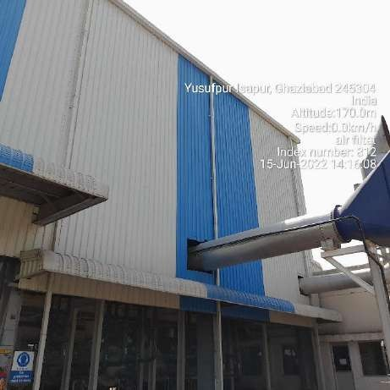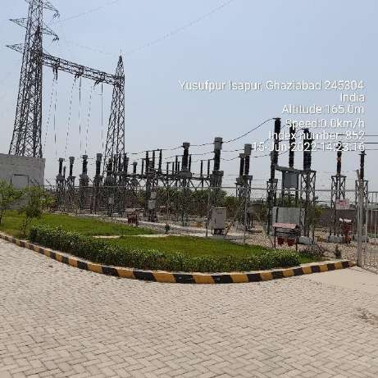

**Compressor Shed Switch Yard**

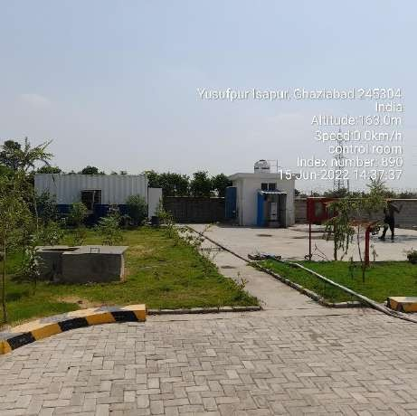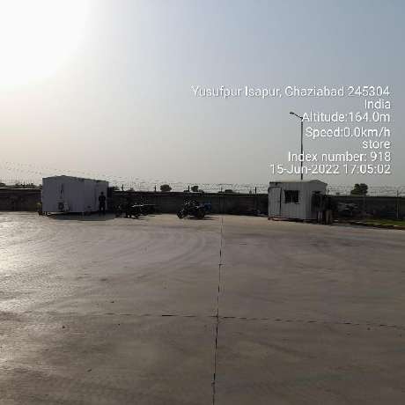

**Driver’s Rest Room and Toilet Security Room and Toilet**

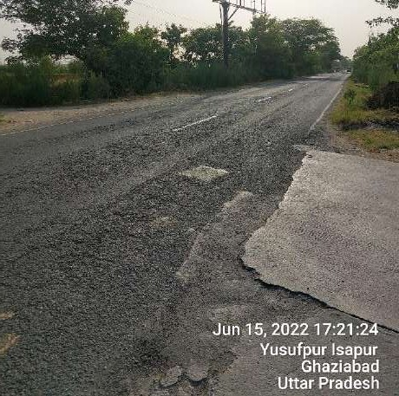 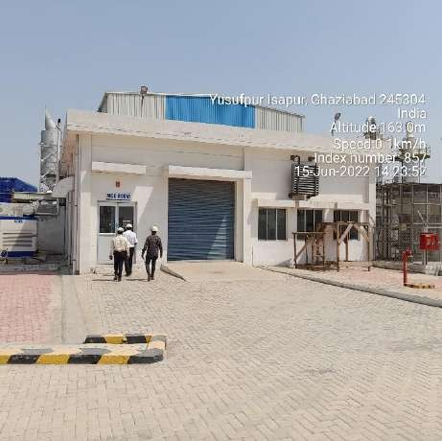

**Approach Road Electrical Room**

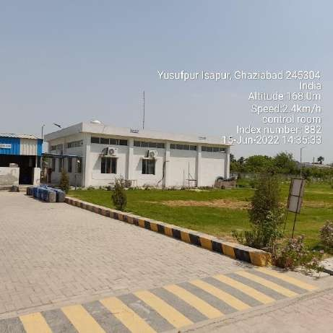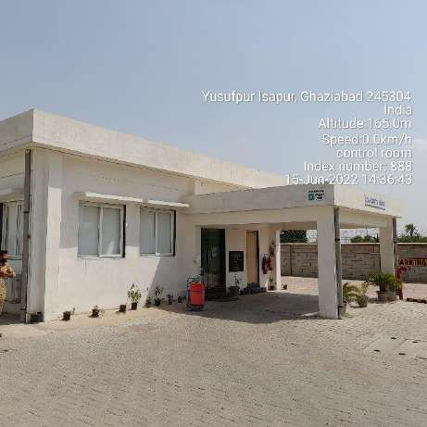

**Workshop and Store Admin Building**

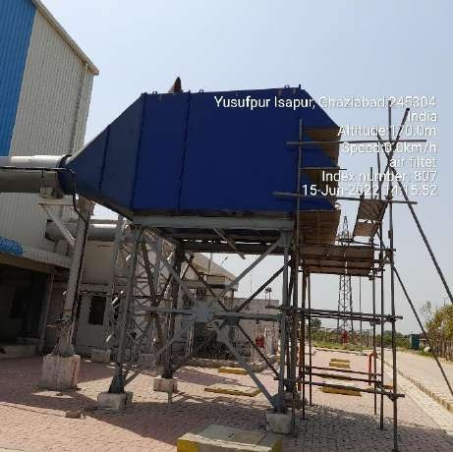 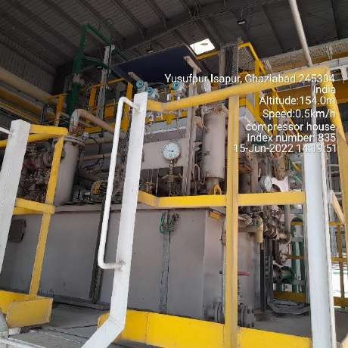

**Air Filter Compressor**

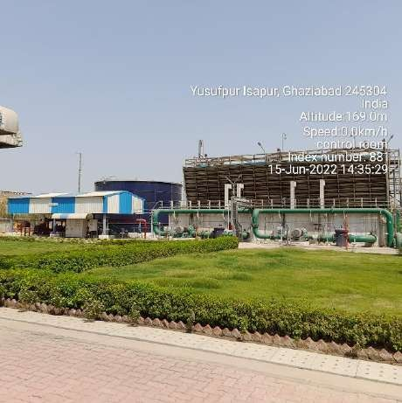

**Substation Pump room and Cooling Tower**

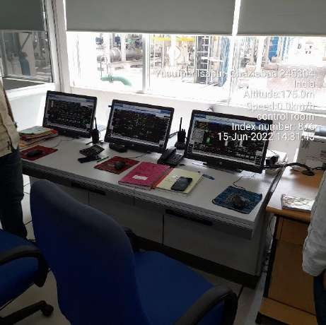 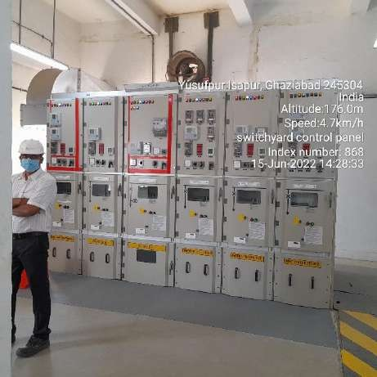

**DCS Panels**

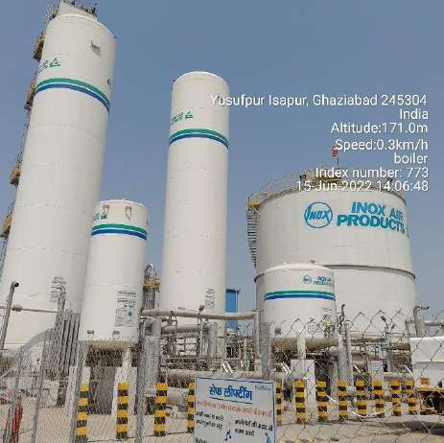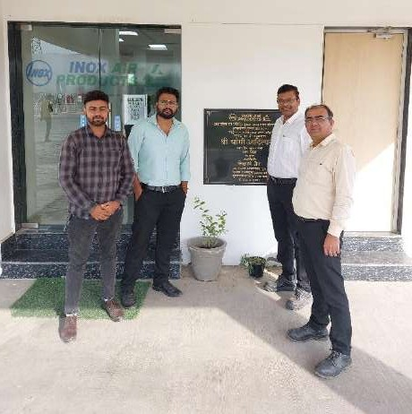

**FG Storage Tanks Surveyors (LHS) with Site representatives (RHS)**

## OTHER ANNEXURES

**ANNEXURE 1: COPY OF CA CERTIFICATE**

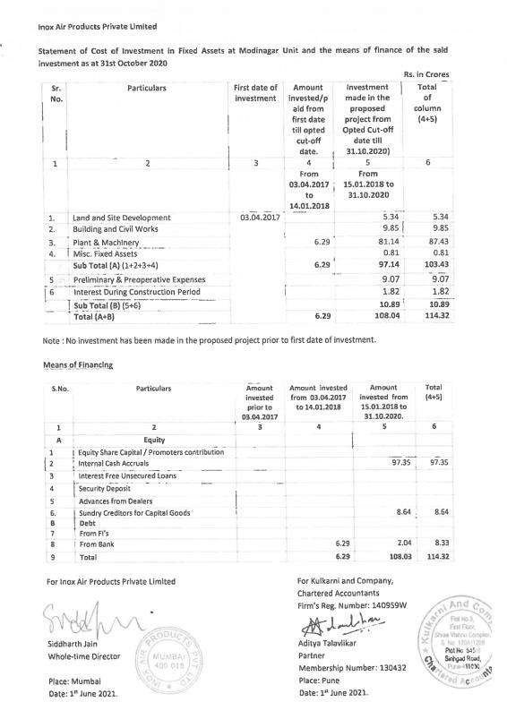

**ANNEXURE 2: COPIES OF SOME MAJOR INVOICES**

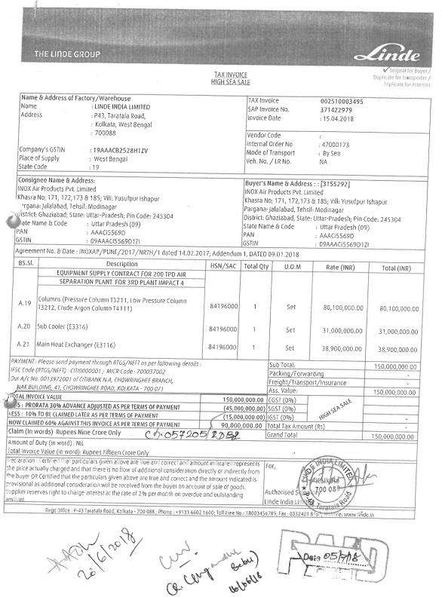

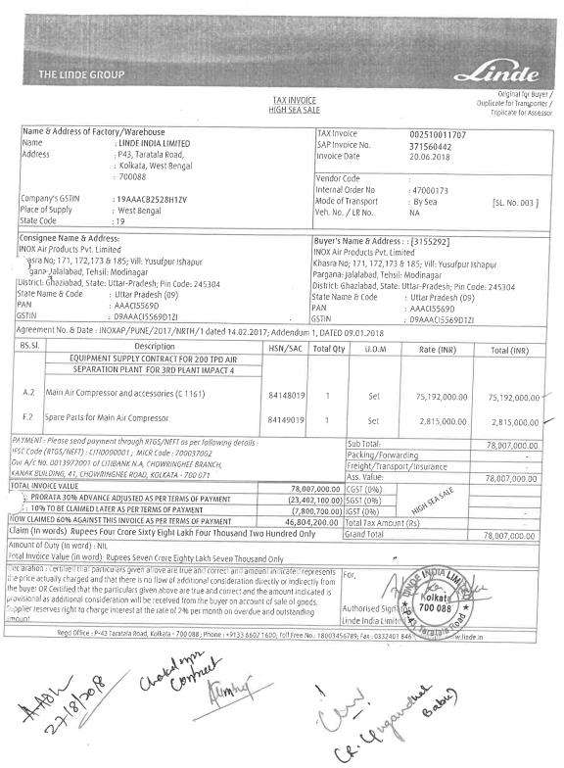

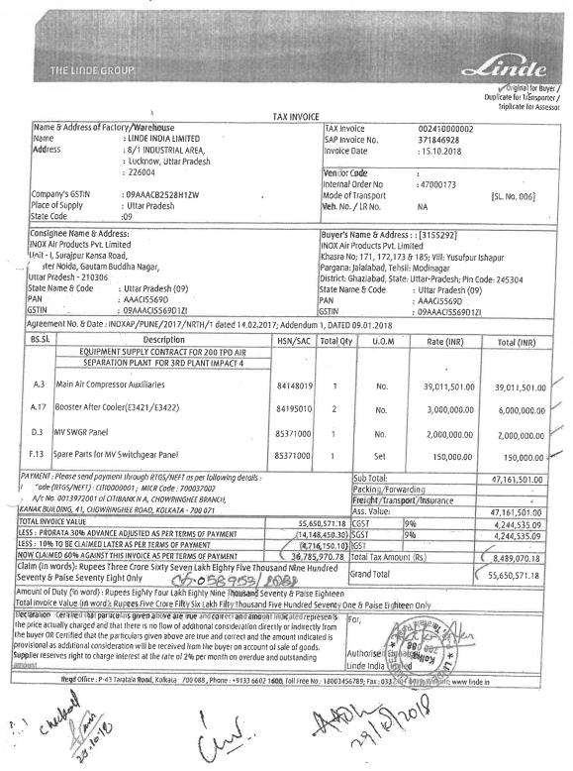

**ANNEXURE 3: LABOR LICENCE**

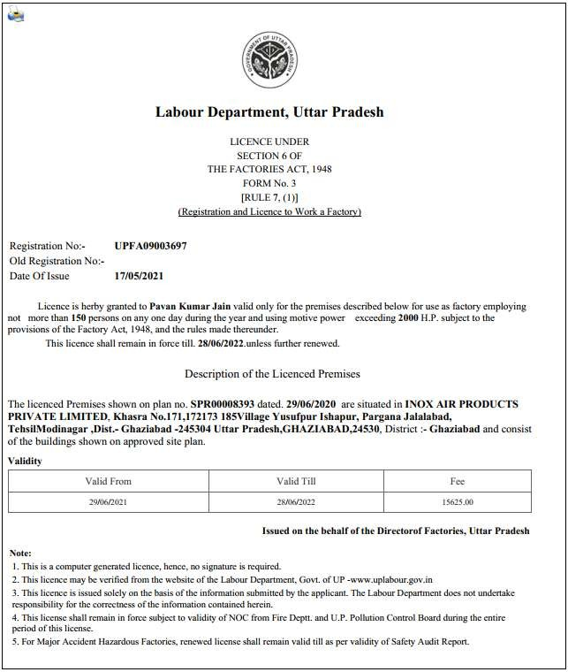

**ANNEXURE 4: COPY OF SANCTIONED PLAN**

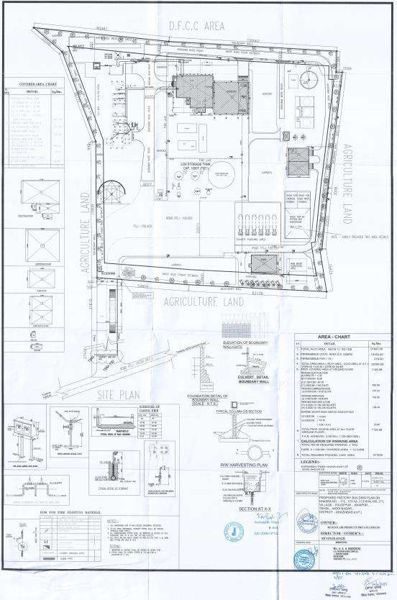

**ANNEXURE 5: EXCERPTS OF COPY OF HI-TECH PURCHASE ORDER (BUILDING**

**+ COMPOUND)**

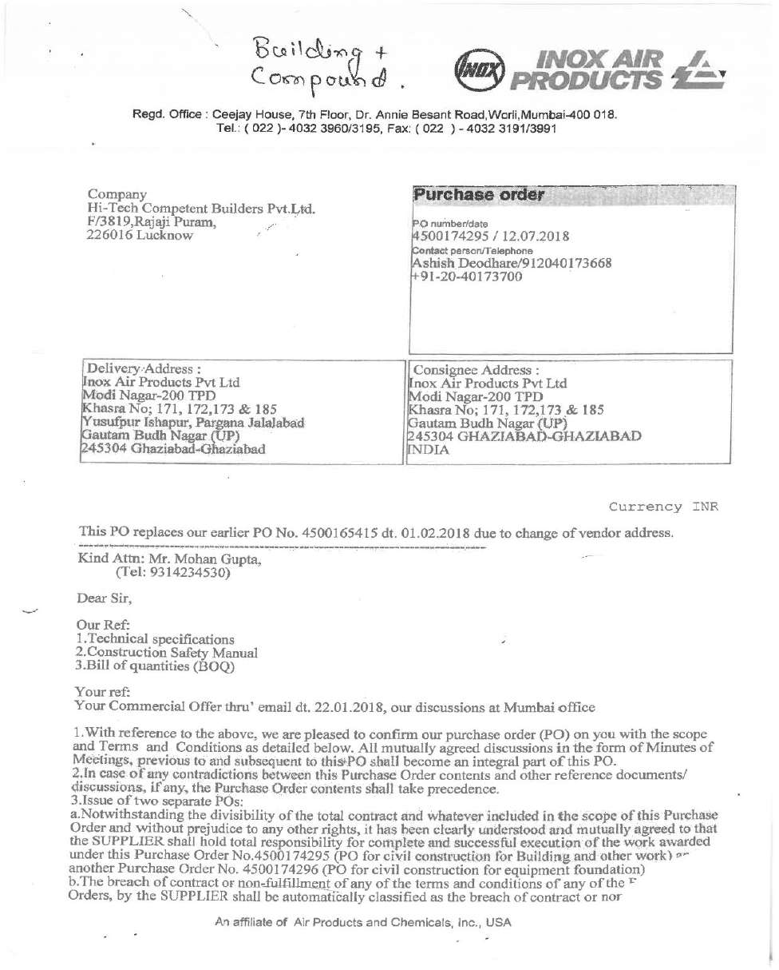

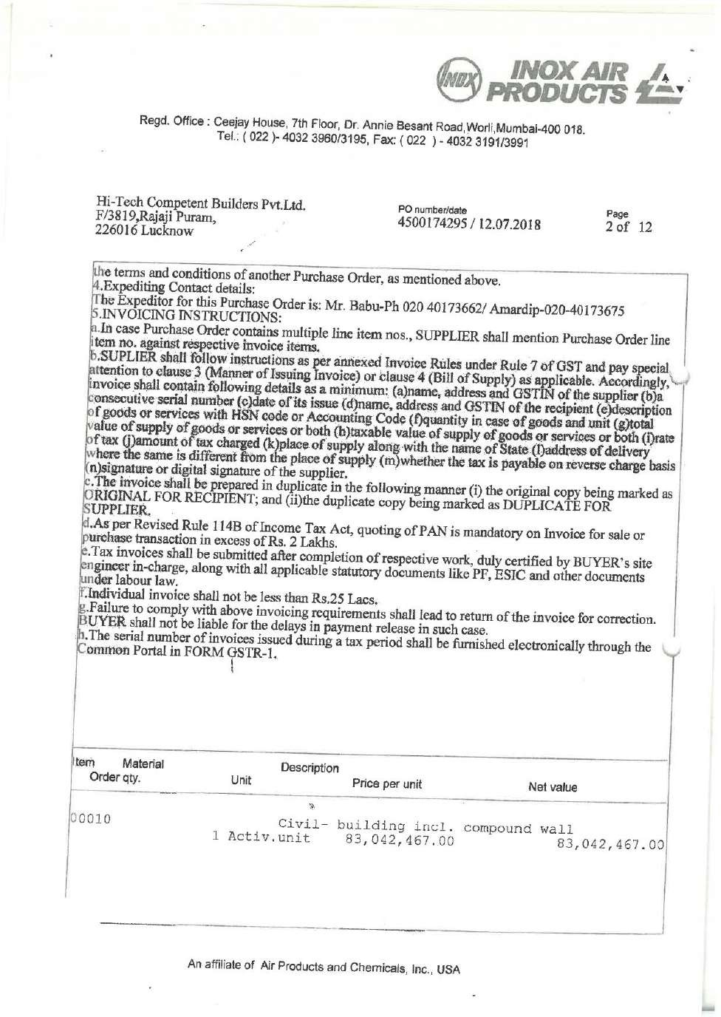

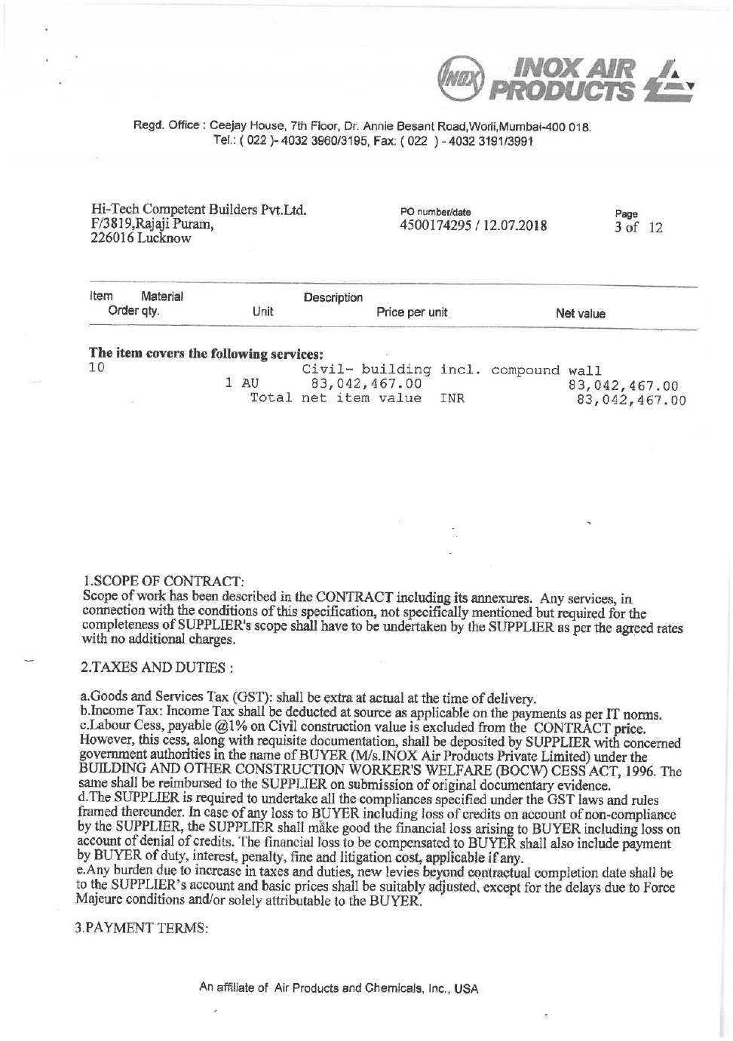

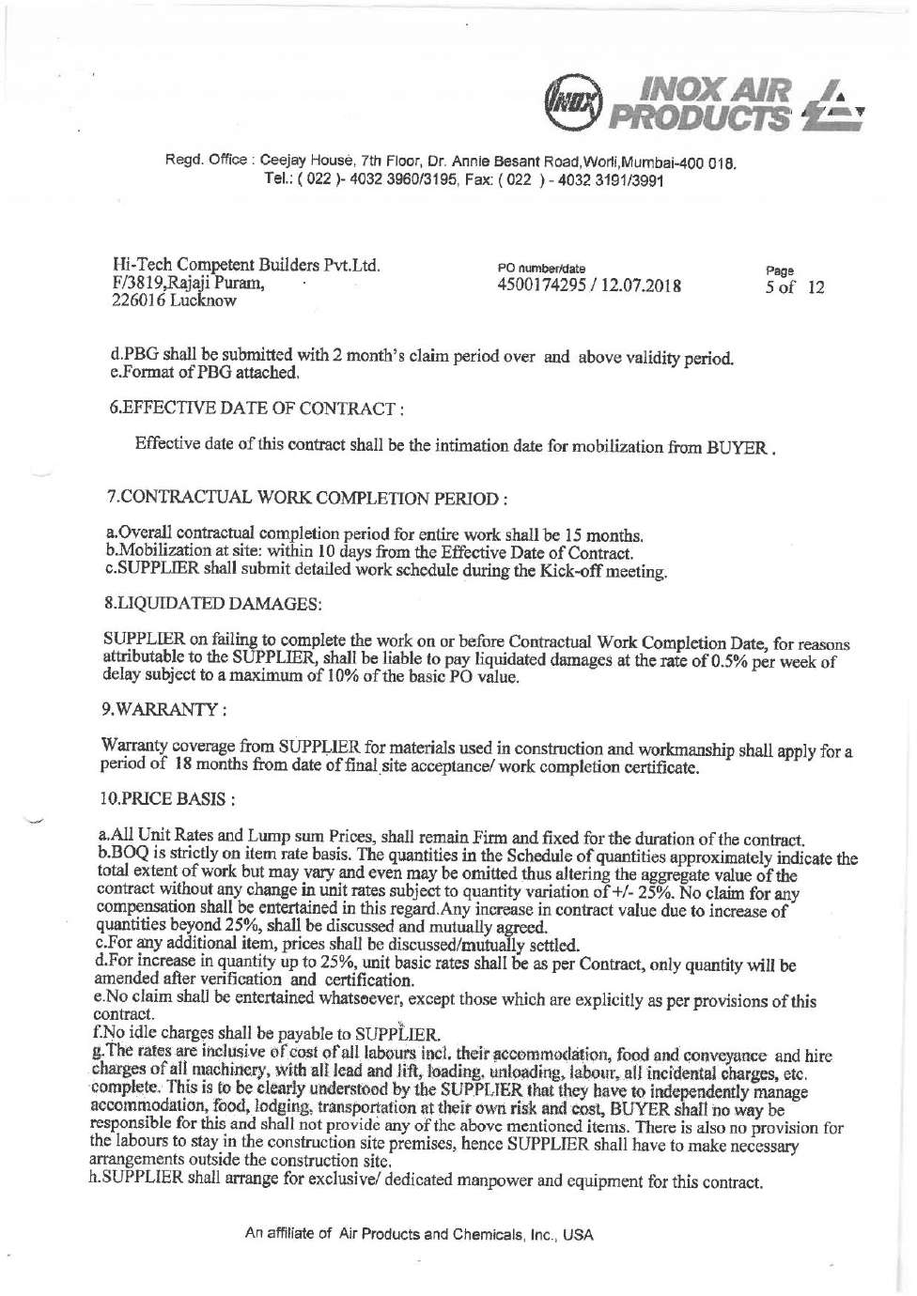

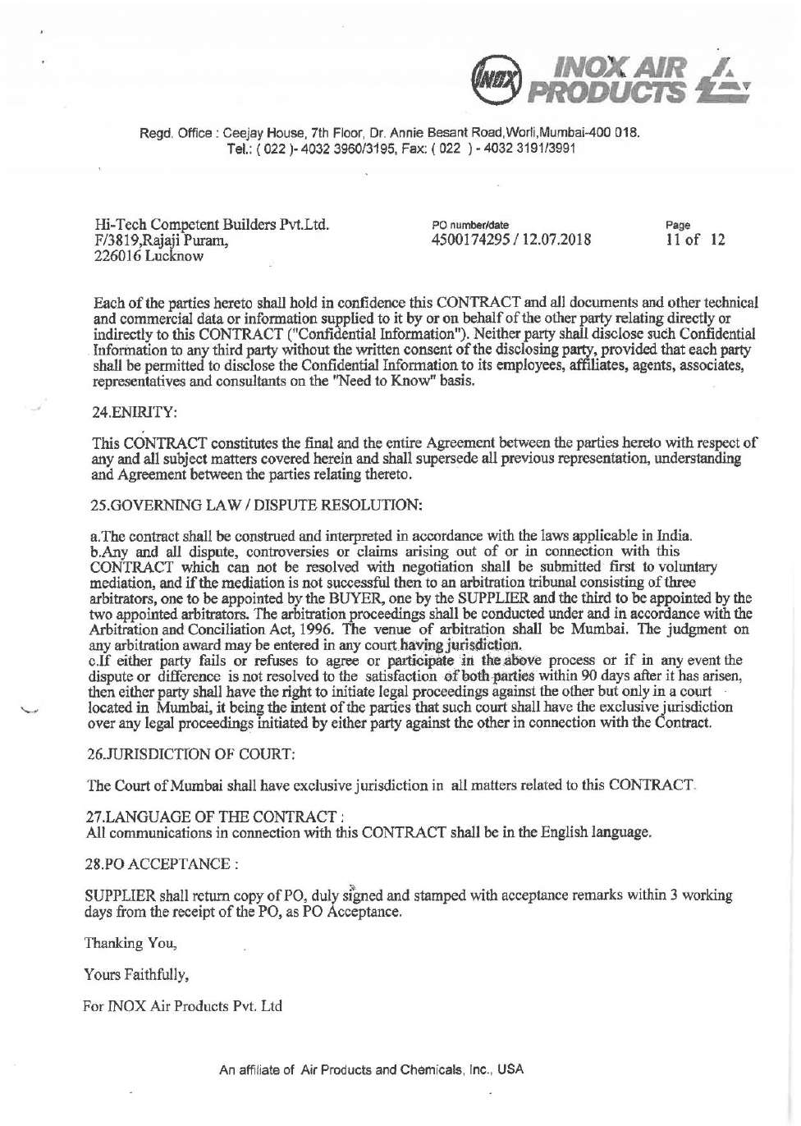

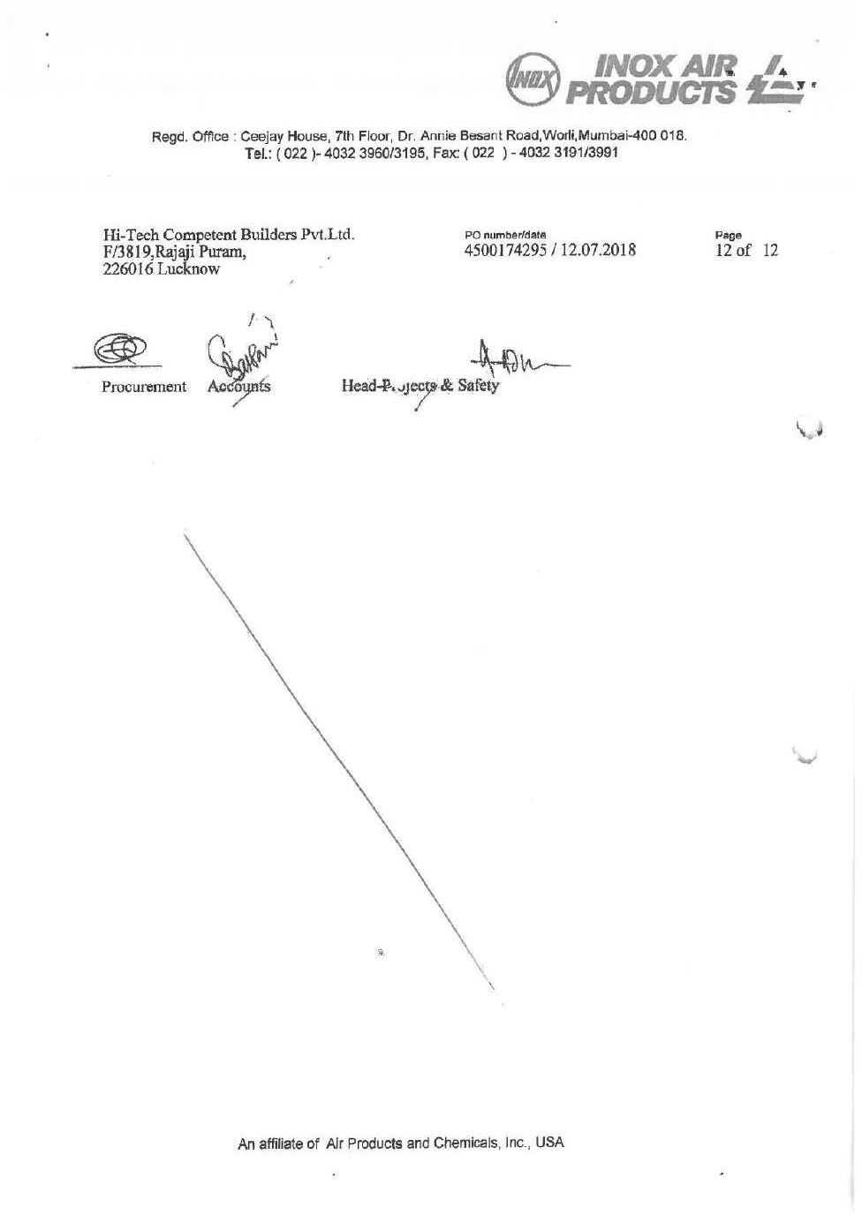

**ANNEXURE 6: EXCERPTS OF COPY OF HI-TECH PURCHASE ORDER (EQUIPMENT FOUNDATION)**

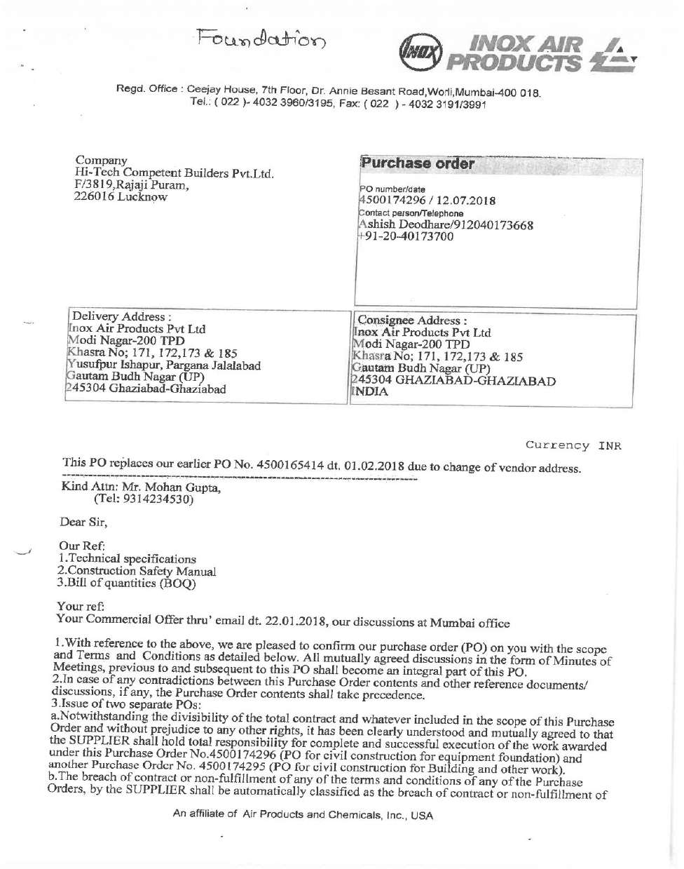

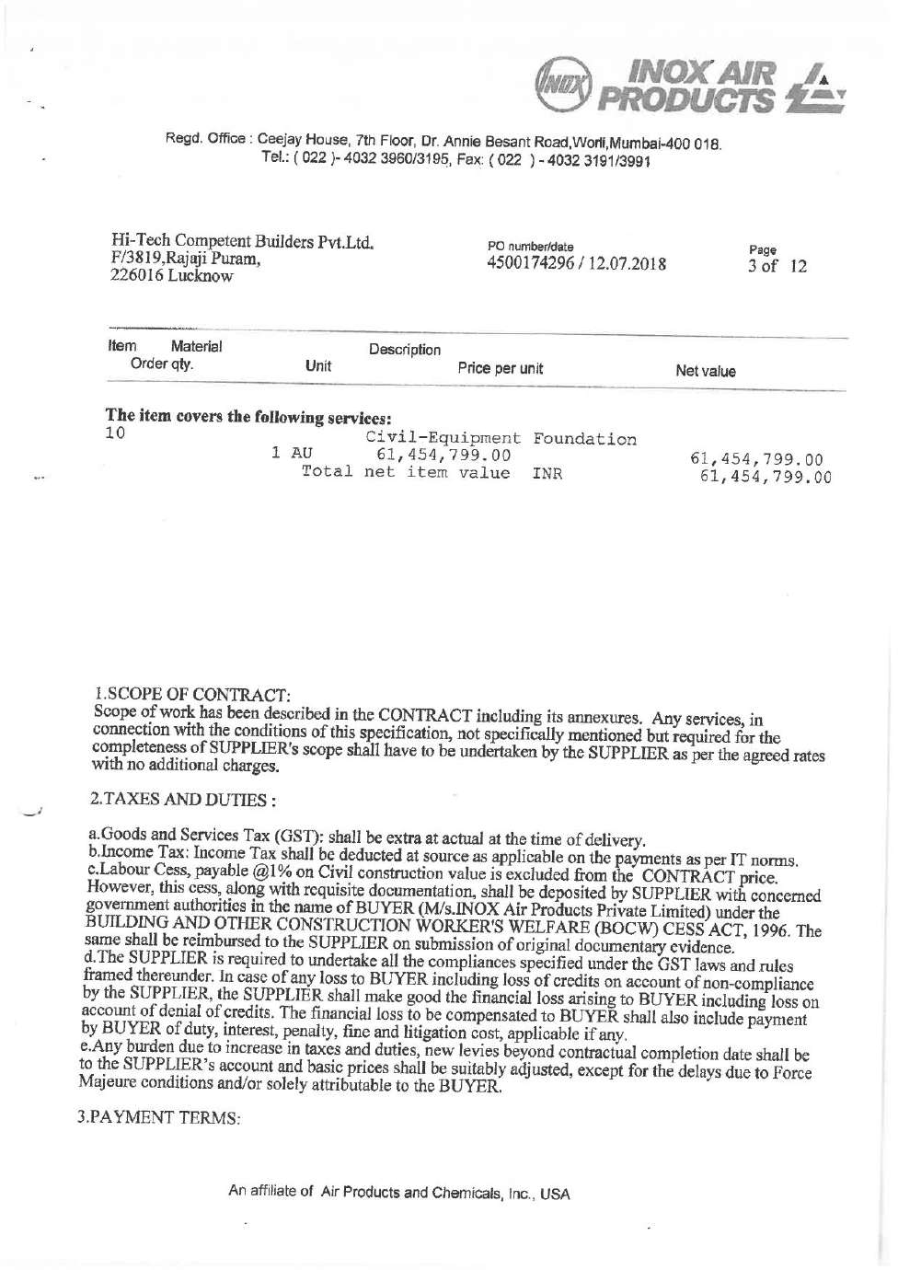

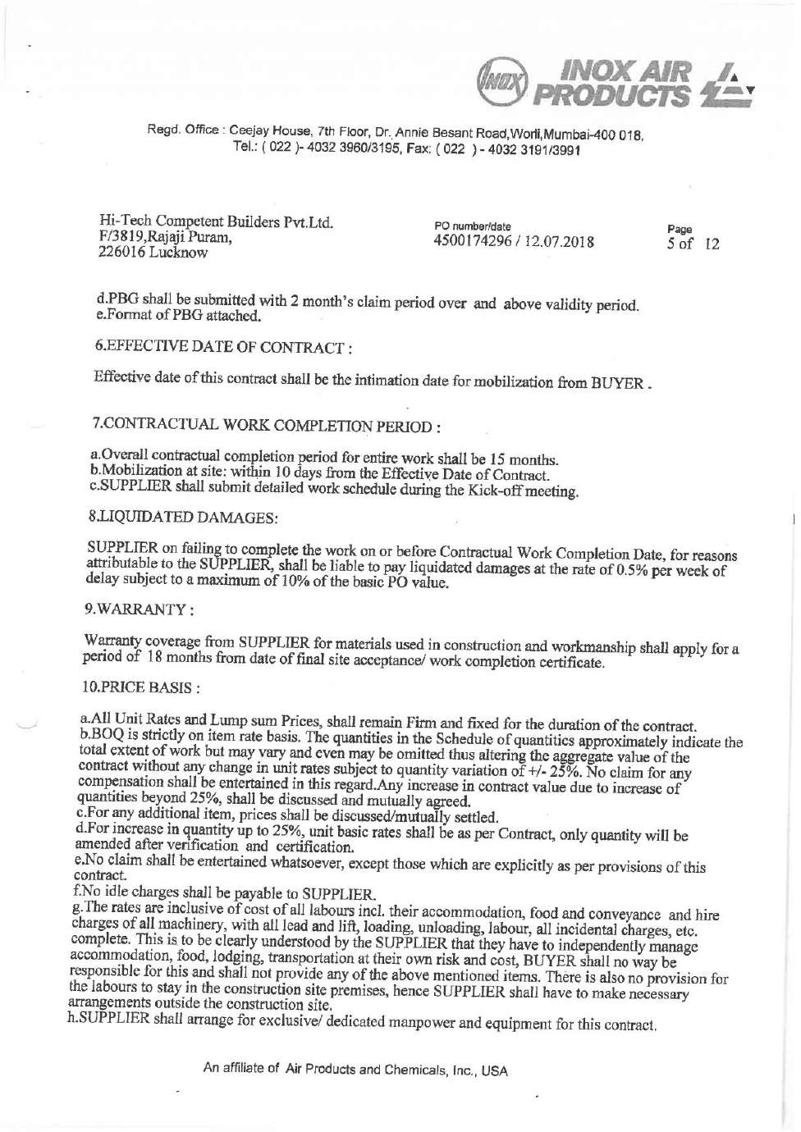

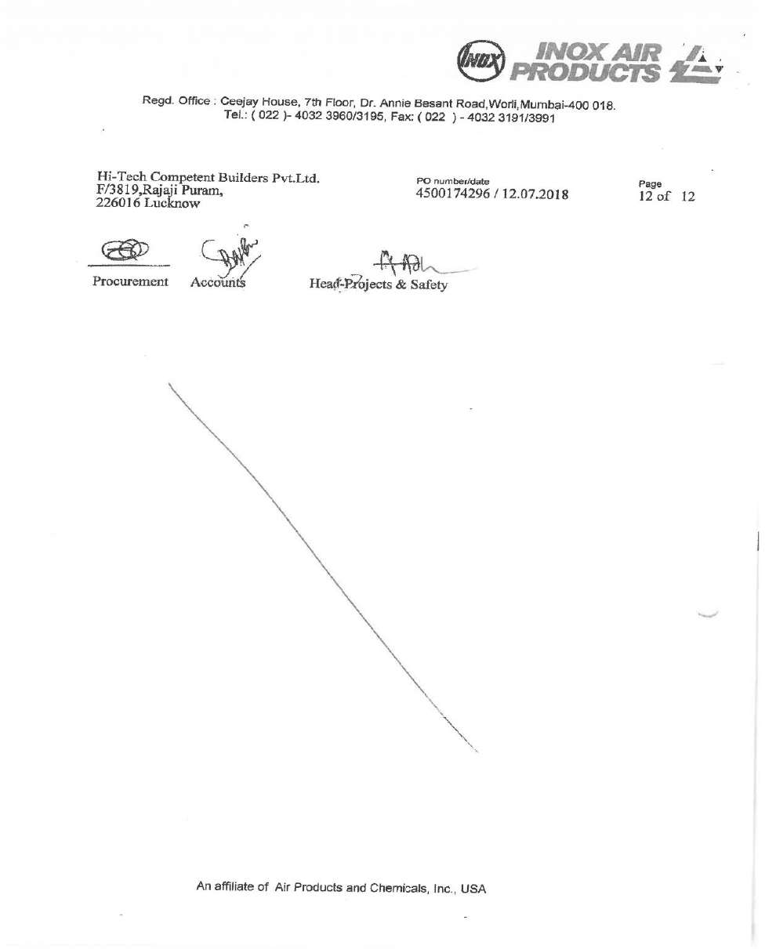

**ANNEXURE 7: COPY OF DOCUMENT WITH LIST OF INVOICES RAISED BY HI-TECH**

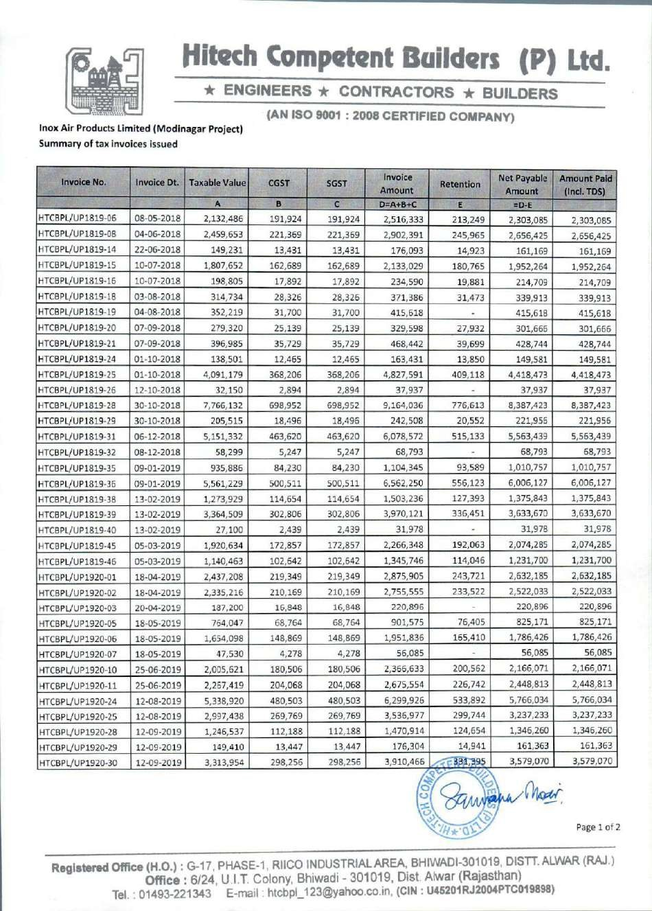

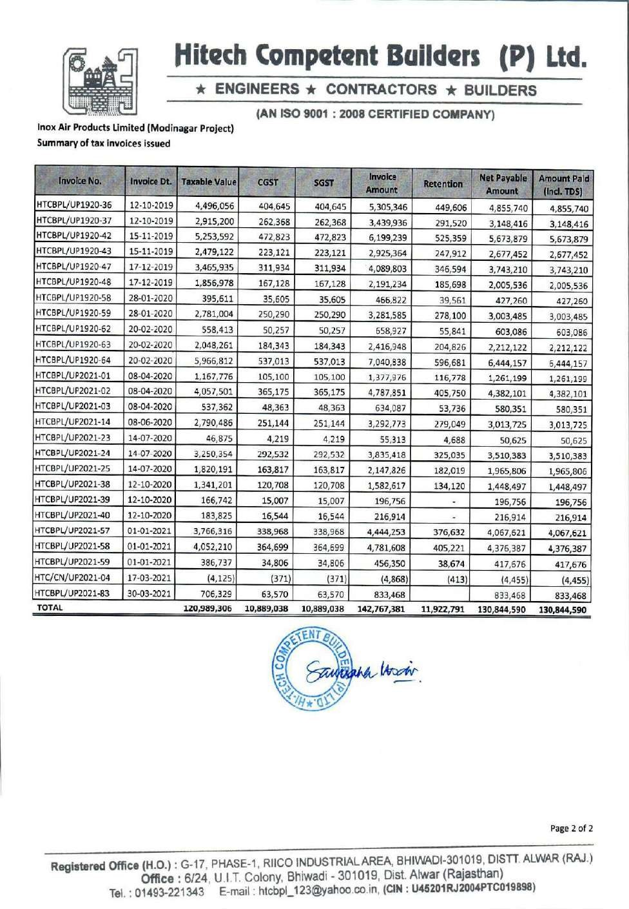

|  |  |
| --- | --- |
| **PART F** | **DISCLAIMER** |

1. No employee or member of R.K Associates has any direct/ indirect interest in the Project.
2. This report is prepared based on the copies of the documents/ information which interested organization or customer could provide to us out of the standard checklist of documents sought from them and further based on our assumptions and limiting conditions. All such information provided to us has been relied upon and we have assumed that it is true and correct. Verification or cross checking of the documents provided to us has not been done at our end from the originals. If at any time in the future, it’s found or came to our knowledge that misrepresentation of facts or incomplete or distorted information has been provided to us then this report shall automatically become null & void.
3. This report is a general analysis of the project and not an audit report. All the information gathered is based on the facts seen on the site during survey, verbal discussion & documentary evidence provided by the client and is believed that information given by the company is true best of their knowledge.
4. All observations mentioned in the report is only based on the visual observation and the documents/ data/ information provided by the client. No mechanical/ technical tests, measurements or any design review have been performed or carried out from our side during Project assessment.
5. Interested organization should ONLY take this report as an Advisory document from the Financial/ Chartered Engineering firm and it’s specifically advised to the stakeholder to cross verify the original documents for the facts mentioned in the report which can be availed directly from the subject company directly.
6. In case of any default in loans or the credit facility extended to the borrowing company, R.K Associates shall not be held responsible for whatsoever reason may be and any request for seeking any explanation from the employee/s of R.K Associates will not be entertained at any instance or situation.
7. This Report is prepared by our competent technical team which includes Engineers and financial experts & analysts.
8. This is just an opinion report and doesn’t hold any binding on anyone. It is requested from the concerned Financial Institution which is using this report for taking financial decision on the project that they should consider all the different associated relevant & related factors also before taking any business decision based on the content of this report.
9. All Pages of the report including annexures are signed and stamped from our office. In case any paper in the report is without stamp & signature then this should not be considered a valid paper issued from this office.
10. Defect Liability Period is **30 DAYS**. We request the concerned authorized reader of this report to check the contents, data and calculations in the report within this period and intimate us in writing if any corrections are required or in case of any other concern with the contents or opinion mentioned in the report. Corrections only related to typographical, calculation, spelling mistakes will be entertained within the defect liability period. No request for any illegitimate value revision, date change or any other facts & figures changes will be entertained other than the one mentioned above.
11. R.K Associates encourages its customers to give feedback or inform concerns over its services through proper channel at @rkassociates.org in writing within 30 days of report delivery. After this period no concern/ complaint/ proceedings in connection with the Valuation Services can be entertained due to possible change in situation and condition of the property.
12. Our Data retention policy is of **ONE YEAR**. After this period we remove all the concerned records related to the assignment from our repository. No clarification or query can be answered after this period due to unavailability of the data.
13. This Valuation report is governed by our (1) Internal Policies, Processes & Standard Operating Procedures, (2) R.K Associates Quality Policy, (3) Valuation & Survey Best Practices Guidelines formulated by management of R.K Associates, (4) Information input given to us by the customer and (4) Information/ Data/ Facts given to us by our field/ office technical team. Management of

R.K Associates never gives acceptance to any unethical or unprofessional practice which may affect fair, correct & impartial assessment and which is against any prevailing law. In case of any indication of any negligence, default, incorrect, misleading, misrepresentation or distortion of facts in the report then it is the responsibility of the user of this report to immediately or at least within the defect liability period bring all such act into notice of R.K Associates management so that corrective measures can be taken instantly.

1. R.K Associates never releases any report doing alterations or modifications from pen. In case any information/ figure of this report is found altered with pen then this report will automatically become null & void.
2. If this report is prepared for the matter under litigation in any Indian court, no official or employee of R.K Associates will be under any obligation to give in person appearance in the court as a testimony. For any explanation or clarification, only written reply can be submitted on payment of charges by the plaintiff or respondent which will be 10% of the original fees charged where minimum charges will be Rs.15,000/-.

Place : Noida **FOR INTERNAL USE**

Date : 20/10/2022 ***SURVEYED BY: Er. Adil Afaque***

***Er. Abhishek Sharma***

Note : This report contains 37 pages ***PREPARED BY: Er. Adil Afaque***

***REVIEWED BY: Er. Tejas Bharadwaj***

### For R.K Associates Valuers & Techno Engineering Consultants Pvt. Ltd.

**Project Engineering Team**

***R.K ASSOCIATES IMPORTANT NOTES :***

1. ***DEFECT LIABILITY PERIOD - In case of any query/ issue or escalation you may please contact Incident Manager by writing at*** [***le@rkassociates.org.***](mailto:le@rkassociates.org) ***We ensure 100% accuracy in the Calculations done, Rates adopted and various other data points & information mentioned in the report but still can’t rule out typing, human errors or any other mistakes. In case you find any mistake, variation, discrepancy or inaccuracy in any data point of the report, please help us by bringing all such points into our notice in writing at*** [***le@rkassociates.org***](mailto:le@rkassociates.org) ***within 30 days of the report delivery, to get these rectified timely, failing which***

***R.K Associates Valuers Techno Engineering Consultants (P) Ltd. won’t be held responsible for any inaccuracy in any manner. Also if we do not hear back anything from you within 30 days, we will assume that report is correct in all respect and no further claim of any sort will be entertained thereafter. We would welcome and appreciate your feedback & suggestions in order to improve our services.***

1. ***COPYRIGHT FORMAT - This report is prepared on the copyright format of R.K Associates Valuers Techno Engineering Consultants (P) Ltd. to serve our clients in the best possible way. Legally no one can copy or distribute this format without prior approval from R.K Associates. It is meant only for the organization as mentioned on the cover page of this report. Distribution or use of this format other than R.K Associates will be seen as unlawful act and necessary legal action can be taken against the defaulter.***