File No.: VIS (2022-23)-PL123-102-182 Dated: 4th November 2022

LENDER’S INDEPENDENT ENGINEER REPORT

(FOR PERIOD ENDING MARCH 2022)

OF

HINGE MANUFACTURING UNITS
SITUATED AT

LOCATION 1: BAWAL, HARYANA; LOCATION 2: BENGALURU, KARNATAKA; AND LOCATION 3: VANOD, GUJARAT

IMPLEMENTED BY
M/S TECHNICO INDUSTRIES LIMITED

REPORT PREPARED FOR
STATE BANK OF INDIA, MID CORPORATE BRANCH, 91 IDC, FIRST FLOOR, GURUGRAM

**Important - In case of any query/ issue or escalation you may please contact Incident Manager at le@rkassociates.org. We will appreciate your feedback in order to improve our services.
NOTE: As per IBA Guidelines please provide your feedback on the report within 15 days of its submission after which report will be considered to be correct.

IMPORTANT NOTICE

COPYRIGHT FORMAT: This report is prepared on the copyright format of R.K Associates, to serve our clients with the best available information and analysis to facilitate them to take rational business decisions. Legally no one can copy or distribute this format without prior approval from R.K Associates. It is meant only for the advisory/ reference purpose for the organization/s as mentioned on the cover page of this report. Distribution or use of this format by any organization or individual other than R.K Associates will be seen as unlawful act and necessary legal action can be taken against the defaulters.

This report is intended for the sole use of the intended recipient/s and contain material that is STRICTLY CONFIDENTIAL AND PRIVATE.

DEFECT LIABILITY PERIOD: - In case of any query/ issue or escalation you may please contact Incident Manager: le@rkassociates.org. We try our level best to ensure correctness in the calculations done, rates adopted and various other data points & information mentioned in the report but still can’t rule out typing, human errors or any other mistakes. In case you find any such mistake or inaccuracy in any data point of the report please help us by bringing all such points into our notice immediately or within 15 days of the report delivery in writing, to rectify these timely failing after which R.K Associates won’t be held responsible for any such inaccuracy in any manner. We would highly appreciate your feedback in order to improve our services.

PART A | REPORT SUMMARY

1. | Name of Project: | Installation and commissioning of machineries for manufacturing of Hinges
2. | Project Location: | Bawal (Haryana), Vanod (Gujarat), Bengaluru (Karnataka)
3. | Name of the Borrower: | M/s. Technico Industries Limited
4. | Director’s as per MCA Website | Mr. Arun Gupta  Mr. Amit Gupta  Mr. Naresh Kumar Sethi  Mr. Deepak Mohalla  Mr. Ashok Kumar Goyal
5. | Prepared for Bank: | State Bank of India, Mid Corporate Branch, 91 IDC First Tower, MG Road Gurgaon
6. | LIE Consultant Firm: | M/s. R.K. Associates Valuers & Techno Engineering Consultants (P) Ltd.
7. | Date of Survey: | Location 1: Bawal, Haryana Dated 5th July 2022  Location 2: Vanod, Gujarat Dated 15th July 2022  Location 3: Bengaluru, Karnataka Dated 12th October 2022
8. | Date of Report: | 4th November 2022
9. | Purpose of the Report: | To provide fair detailed analysis report to the Bank based on the “in-scope points” mentioned below for facilitating them to take appropriate credit decision on the Project.
10. | Scope of the work provided by the Lender: | Detailed project Progress Report for Project Review and Assessment of Manufacturing units located at  - Bawal (Haryana)  - Vanod (Gujarat) and  - Bengaluru (Karnataka)
11. | Documents perused for Proposal: | - Copies of Invoices  - CA Certificate
12. | Annexure with the report: | - Copies of Invoices  - CA Certificate

PART B | INTRODUCTION

- THE PROJECT:

M/s. Technico Industries Limited (TIL) is setting up a manufacturing unit of high-quality sheet metal parts (Sheet thickness 0.8mm ~ 6mm/Raw Material-Ultra high tensile) for Body Parts, Chasis Parts, Axle & Engine Mounting Brackets, BIW parts, Fine Blanking Components and Stampings. The company has estimated the cost of project amounting to approximately Rs.25 Crore.

As per the scope of work provided to us by the bank, we have to provide the verification of installation and commissioning of machines installed by the company at 3 locations viz-e-viz Bawal (Haryana), Vanod (Gujarat), Bengaluru (Karnataka).

- ABOUT THE BORROWER:
Technico industries is a private limited company incorporated on 11th January 1985 with the Registrar of Companies, Delhi with CIN No. U74210DL1985PLC019823 to set-up hinges.

The primary set of directors of “TIL” as on date are:

- Mr. Arun Gupta
- Mr. Amit Gupta
- Mr. Naresh Kumar Sethi
- Mr. Deepak Mohalla
- Mr. Ashok Kumar Goyal

Technico Industries Limited manufactures high quality sheet metal parts (Sheet thickness 0.8mm ~ 6mm/Raw Material-Ultra high tensile) for Body Parts, Chasis Parts, Axle & Engine Mounting Brackets, BIW parts, Fine Blanking Components and Stampings.
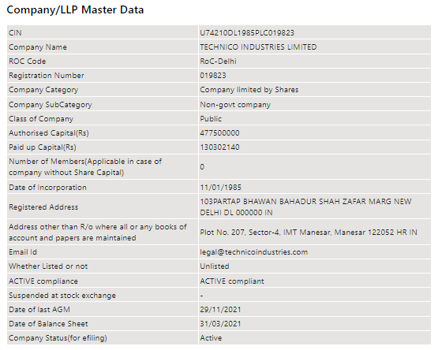

- PROJECT LOCATION(s):
Details about Locations of the Units covered by the Bank is as below:
Particulars | Description
Latitude | 13°13'21.2"N (Bengaluru, Karnataka)  28°06'03.6"N (Bawal, Haryana)  23°26'24.6"N (Vanod, Gujarat)
Longitude | 76°54'25.0"E (Bengaluru, Karnataka)  76°35'14.3"E (Bawal)  77°16'55.2"E(Gujarat)
Connectivity Systems
Road | - The project site of the Bengaluru Plant is well connected by road network.  - The project site of the Bawal Plant is well connected by road network and Lies 2 km in the interior from the main Delhi Jaipur expressway  - The project site of the Ahmedabad Plant is well connected by road network and Lies 2 km from Vanod Village.And Approx 96 km from Main Ahmedabad city.
Rail | - The Nearest Railway station to the subject locality is Nivanda Railway Station which is about 3 Km from the Subject Project or unit.  - The Nearest Railway station to the subject locality is Bawal Railway Station which is about 10 Km from the Subject Project or unit toward South-West Direction  - The Nearest Railway station to the subject locality is Bhankoda Railway Station which is about 37 Km from the Subject Project or unit toward North Direction
Air | - The nearest Domestic and international Airport to the subject project is Kempegowda International airport which is about 73 Km form the subject project.  - The nearest Domestic and international Airport to the subject project is Indira Gandhi Airport which is about 82 Km form the subject project.  - The nearest Domestic and international Airport to the subject project is Sardar Vallabhbhai Patel International Airport which is about 96 Km form the subject project.

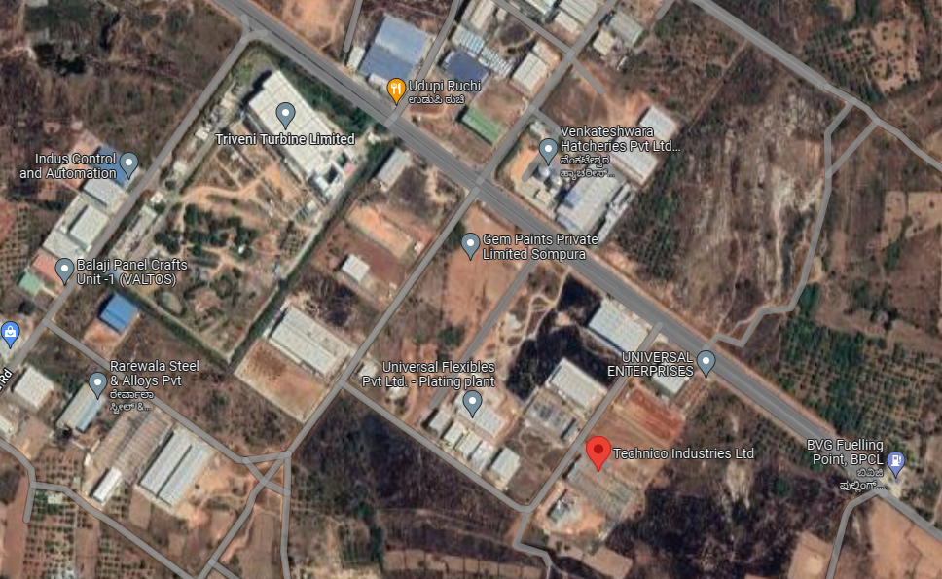

Figure 1: Location of Bengaluru unit

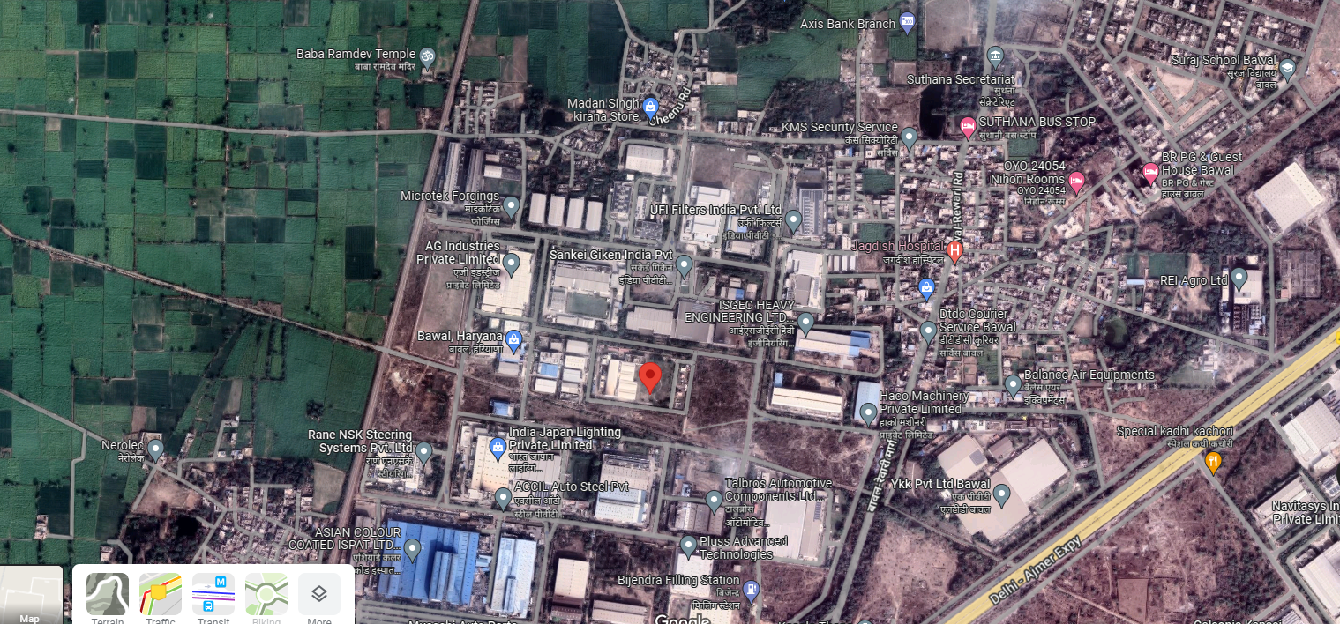

Figure 2: Location of Bawal, Haryana Unit

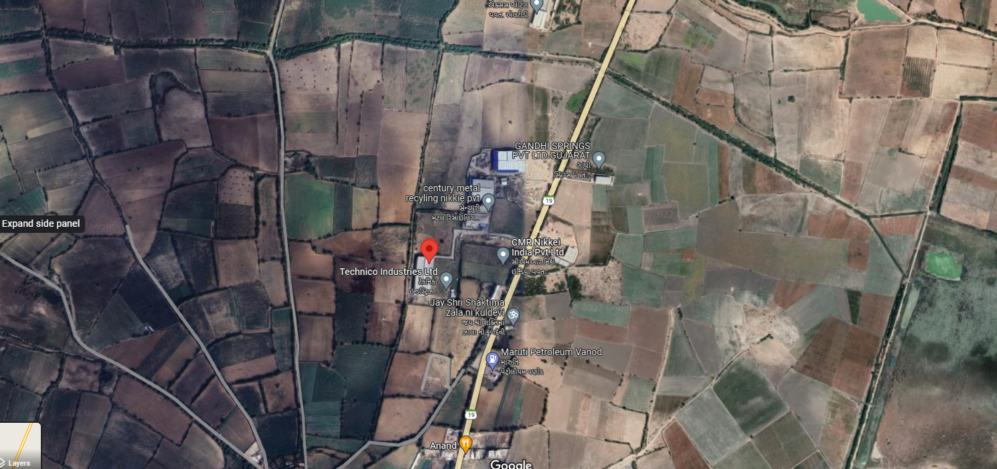

Figure 3: Location of Vanod, Gujarat Unit

- PROJECT OVERVIEW:

M/s. Technico Industries Limited (TIL) is setting up a manufacturing unit of high-quality sheet metal parts (Sheet thickness 0.8mm ~ 6mm/ Raw Material-Ultra high tensile) for Body Parts, Chassis Parts, Axle & Engine Mounting Brackets, BIW parts, Fine Blanking Components and Stampings. The company has estimated the cost of project amounting to approximately Rs.25 Crore.

As per the information provided by the representatives accompanying during the site visits, M/s Technico Industries limited is producing following Products as listed below:

SR. NO. | PRODUCT
1. | Automotive Window Regulators
2. | Automotive Door Hinges
3. | Automotive Set Slider
4. | Automotive Seat Recliner
5. | Automotive Gear Shifter
6. | Automotive Shift Tower

LIST OF MACHINERIES OBSERVED DURING SITE VISIT:

We have verified the machineries on sample basis based on copies of invoices provided by the company and list of machineries provided by the company. Machineries observed during site visit are as below:

- LOCATION: BAWAL, HARYANA

- Robotic Mig Welding Cell With 2 Nos of Fixture
- Servo Based Rotary Arrangement for Fixture
- Axial Flow Fan With 0.75 Hp Motor
- Electrical Distribution Panel
- Arm Riveting & Body Holder Riveting Fixture for Model Yhb Screw Jack
- Epson Dot Matrix Printer Lq310
- Fanuc Mig Welding Robot
- Ps 500(Hollow Positioner Head Stock
- Ratchet Handle, 3/4"
- Tapper Scal 150x15x.5 Mm Make Kristeel
- Plastic Tubing Pun-12x2-Bl 159670 Make Festo
- Relay My2n Dc 24 Volt Omron Make
- Copper Flexible Wire .5 Mm X Single Core
- Coil Spring X-Swh50-125
- Yaskawa Torch Cleaner and Cutter Unit

- LOCATION: VANOD, GUJARAT

- Robotic Mig Welding Cell
- Mig Welding Robot Arc 2010
- Digital Fully Electronic Type Pitless Weigh Bridge
- Servo Based Rotary Arrangement Fixture
- Air Receiver For 8.0 Bar 3000 Lts
- Arm Riveting Fixture Q501
- Fanuc Robot Spot Welding

- LOCATION: BANGALORE (KARNATAKA)

- Promax Pyramid
- LT Main panel with KVAR panel 300 KVA Indoor panel with 400 AAS
- Door hinge test machine
- Battery 180 AH
- Lathe machine
- HVLS fans
- Plastic bins
- Roofing sheet
- Supo wheel fixed
- Trucks

  - MANUFACTURING PROCES OF PLANT

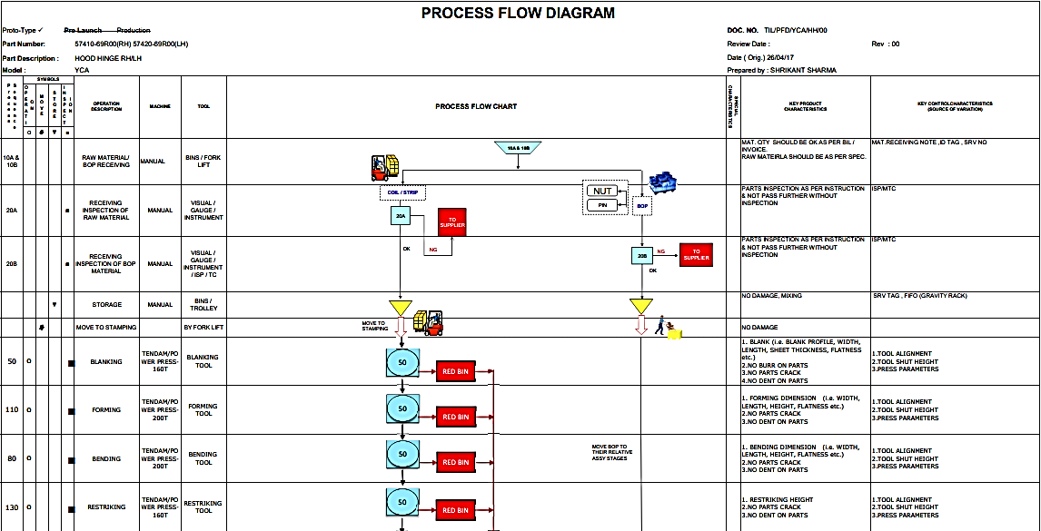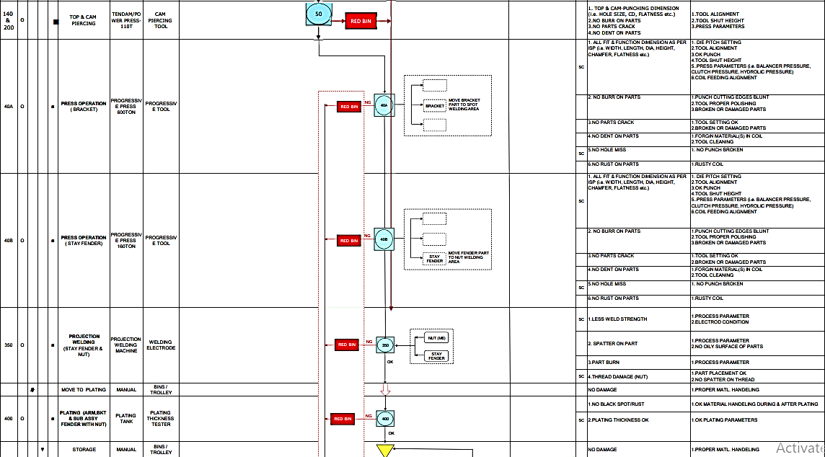
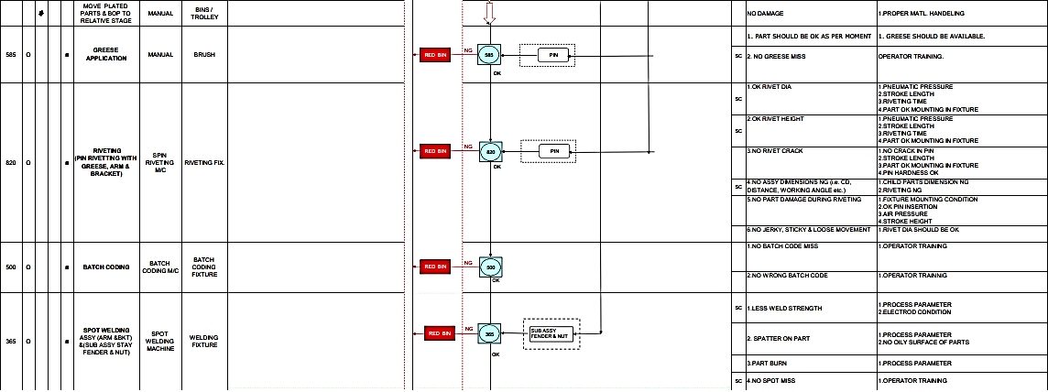
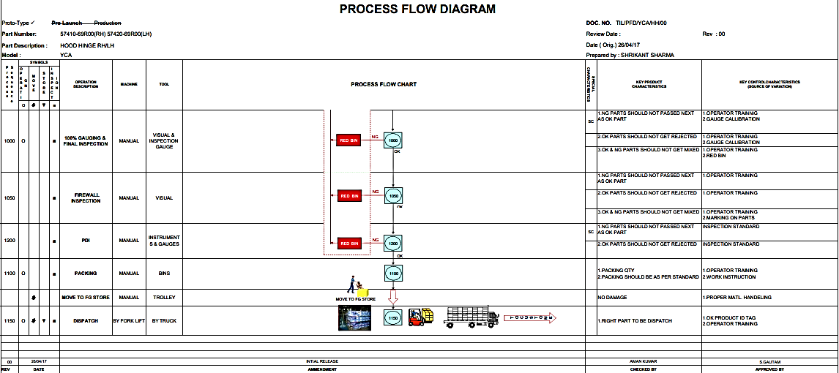

  - WATER REQUIREMENT

Water bills for the Bawal unit is provided to us by the client and the water bill for other units were sought from the company. However, the Bank is advice to fetch the same directly from client.

  - POWER REQUIREMENT

SR. NO. | UNIT LOCATIOIN | SUPPLIER | CUSTOMER NO
1. | GUJRAT | Paschim Gujrat Vij Company Ltd. | 17572
2. | BAWAL | Dakshin Haryana Bijli Vitran Nigam Ltd. | 353302000
3. | BANGALORE | Bangalore Electricity Supply Company (Bescom) | 5078774

- SCOPE OF WORK DURING PROJECT DURATION:

- Project progress Report for machineries envisaged to be delivered at manufacturing locations Bawal (Haryana), Vanod (Gujarat), Bengaluru (Karnataka) respectively.

Note: Carrying out the scope of work will depend on the details/ information/ data provided to us by the borrower from time to time.

- PURPOSE OF THE REPORT: To provide fair detailed analysis report to the Bank based on the “in-scope points” mentioned above for facilitating them to take appropriate credit decision on the Project.

- METHODOLOGY ADOPTED:

- Study of Project Planning documents/ reports to know about the Project.
- Additional information, data, documents collection from the borrower.
- Study and analysis of the documents and information obtained from the borrower.
- Information compilation, analysis and reporting.

PART C | DETAILS OF MACHINERIES AND OTHER EQUIPMENTS

- MACHINERIES & OTHER EQUIPMENTS AND UTILITIES:

The total amount envisaged against the purchase and installation of Plant and Machinery amounts to Rs.25.00 Cr. List of machineries that was envisaged to be purchased and installed by the company is as below:

Supplier Name | Machinery Name
Airmen Engineers & Services Private Limited | Ppr Pipe, Pn-16, 110mm,
 | Ppr Reducer 63x50, Make - Fusion
 | Ppr Elbow 63mm
 | Ball Valve
 | Male Thread Coupler - 75 X 2.5” Make: Fusion
 | Ms Nut Bolt with Washer
 | Ms Flange Silipon
 | Ppr Coupler
Ppr End Cap 63 Mm, Make
Fusion
 | Ppr Coupler, 20 Mm
Anvi Enterprises | Pedal Force Checking Sub Assy Gauge – Clutch Pedal Assy with Mtg
 | Sub Assy Gauge – Sub assy. Hood Hinge Body Side
 | Sub Assy Gauge – Sub Assy Hood Hinge Body
Apex Enterprises | Smps S8fs-C05024 Input 100-240 Vac Output: 24 Vdc 2.1 Amp
 | Copper Hanger
Atandra Energy Private Limited | Servo Controlled Voltage Stabilizer
 | Ultra-Isolation Transformer
Atma Autotech Engineers Pvt Ltd-Capital Goods | Pad Insertion Fixture Change Over Type - Yba Cltuch Pedal
 | Spring Greasing Fixture Change Over Type - Yba Clutch Pedal
 | Spring Greasing Fixture Change Over Type - Yg8 Brake Pedal
 | Reaming Spm Single Station - Yg8 Brake Pedal
 | Reaming Machine for Boss - Brake Pedal (49600-78l00) Yg8
 | Arm Riveting & Body Holder Riveting Fixture for Model Yhb Screw Jack
 | Riveting Spm -Tail Gate Hinge
 | Utm Machine Modification
 | Arm Riveting Fixture Q501
 | Model Addition & Fixture Modification in Nut Tightening (X451 Dct Brake Pedal Addition In X445 Mt Brake Pedal Fixture
 | Proto Tool & Die
 | Riveting Fixture for W601 Hood Hinge
 | Sdh Riveting Fixture
 | Door Hinge Machine Modification for W601 Side Door Hinge (H3d0389-M / H4d0390-M
 | Ecn Modification in Riveting Fixture
 | Reaming Machine/Station
 | Part Holding Fixture
 | Spanner Type Torque
 | Modification In Existing Hood Hinge Riveting Machine for Y0m Hh
 | Pin Fitting Fixture – Side Door Hinge - Z101
 | Riveting Spm - Z101 Sdh
 | Batch Coding Spm – Side Door Hinge - Z101
 | Cmc Hole Reaming Fixture (Change Over Type)
 | Riveting Tool, Dia: 20mm & Length: 105mm
 | Bush Pressing Spm
 | Pick & Place Arrangement
Birani Construction Company | Installation Charges of Axial Flow Fan With 0.75 Hp Motor, Model: Alma-55-10000 Cmh, Make: Air Link
 | Axial Flow Fan With 0.75 Hp Motor
Denyo India Pvt Ltd. | Welding Power Cable
 | Tip Monitor (Colour Sensor) (Npn) Without Adapter Plate Model No: Wts10-12/21/105 (Yg8 - Pedal Assy
 | Chip Collector with Solenoid Valve for Cdk-R Model: Cvc5
 | Straight Shank - Bea-25,
E-Co Electrical Company | Installation Charges - Lt Main Panel
 | Lt Main Panel with Kvar Panel: 300kva Indoor Panel, With 400a As Incomer
Ecoair Cooling Systems Private Limited | Hvls Fans, Dia: 24 Ft, Make: Ecoair, Model: Eahvls-7e
 | Hvls Fans
Electric & Machinery Traders | Cabin Fan - 12" - Ciera Model Make: Havells
 | Led Tube Light
 | Copper Flexible Cable 6 Mm X 4 Core- Make Havells
 | Copper Pin Type Thimble 70 Mm
 | 4 Sq Mm Cable 4 Core Copper Flexible (Havells Make)
 | Emergency Push Button Screw Mounting (Red) Teknic Make
 | Cable 1.0 sq. m (Red/Black/Green) Single Core Make-Havells
 | Flexible Cable 2 Core 1.5 Mm (Make Havells)
 | Cabin Fan
 | Aluminium Armoured Cable
 | Copper Flexible Cable
 | Flexible Cable 2 Core 1.5 Mm (Make Havells)
 | Copper Flexible Cable 6 Mm X 4
 | Copper Flexible Wire 4 Mm Single Core (Havells Make)
 | Copper Flexible Cable 6
Emtex Machinery Pvt Ltd Pbc | Lathe Machine
Eon Networks Pvt Ltd | Sophos Xg-125 Appliance
 | Sophos Xg-210 Appliance
 | Sophos Xg-135 Appliance
Fair Deal Agencies | Welding Torch Yt-40cs4 Panasonic Make
 | Mig/Mag Welding Machine
 | Yta-Carrier Comp Spare Tyre-Std Room Equipment
Fanuc India Private Limited (Blr) | Fanuc Robot
 | Fanuc Mig Welding Robot
 | Fanuc Robot Spot Welding
Gandhi Springs Pvt Ltd | Receiving Gauge – Pipe Cylinder Holder Fr Proto Parts - Proto Mpi0101 - (75611-66t00) - Model: Yxadp
 | Proto-Mpi0101
 | Drilling Jigs,
Kadence Automation and Robotic Systems | Knock Testing Spm-Displacement Check by Lvdt - Pedal Comp
 | Robotic Mig Welding Cell
 | Riveting Spm
 | Motorized Conveyor
 | Manual Handy Stacking Fixture for Holder Comp
 | Robotic Mig Welding Cell
 | Servo Motor Gear Box
 | Motorized Conveyor from Auto Inspection To Work Booth
 | Final Rework Station
 | Robotic Mig Welding Cell
 | Servo Based Rotary Arrangement Fixure
 | Cost For Packaging,
 | Punching Jig for Making
 | Pipe Vice Arrangement
 | Final Rework Station
 | Robotic Mig Welding Cell
Kaeser Compressor India Pvt Ltd | Air Receiver For 8.0 Bar 3000 Lts
 | Compressor
Kalpashri Enterprises & Engineering | Battery
 | Polycarbonate Sheet,
Battery, 180ah, Model:
Fxpo-Xp1800, Make: Exide
 | Nilakamal/Tirupati Plastic Crates
L.Y. Industrial Corporation | Ratchet Handle, 3/4"
 | Air Coupler 80 sn 1/2" (Nitto Make)
 | Ring Spanner, Size: 32x36
 | Cable Tie 300mm
 | Air Coupler 80sn 1/2"
 | Brass Ball Valve
 | Air Gun Plastic Make Legris
 | Csk Allen Bolt M4x10mm Unbrako
 | Welding Rod 10no Make: Mangalam
 | Ratchet Handle
 | Tap Handle 10"
 | Allen Key Set Long Bit In Mm, Make-Taparia, Modelhbhml9l
M K Computer | Nexstgo Primus Nx101 Np14n1, Core I5-8250u, 8gb Ddr4, 256gb Ssd, 14 Fhd 1920x1080, Backlit & Spill Proof Keyboard,
 | Samsung Lu32r590cwwxxl, 80.0cm (32.0") Uhd 4k Curved Led
 | Laptop - Avita
 | It Work Support Charges
Mechease Engineering & Technology Llp | Ms Fg Trolley
 | Roofing Sheet 22x3.5x0.5mm
Milhard Sales Pvt. Ltd. | Dial Type Height Gauge
 | Digital Vernier Calliper
 | Digital Thickness Tester
 | Digital Vernier Calliper Range 0-200 Mm
 | Shore-A Meter Use Rubber Hardness Tester
Misumi India Pvt Ltd | Coil Spring X-Swh50-125
 | Gas Spring Gsv500-50
 | Stripper Bolt Msb10-70
 | Urethane Ce30-500
Mogli Labs India Private Limited | Copper Lugs Pin Type
 | Module Npn
 | Plastic Tubing Pun-12x2-
 | Plastic Tubing Pun
 | Painted Ms Cable Tray
 | Flexible Conduit Pipe_Black Colour_Dia
 | Spiral Plastic TubingPun_8x1.25 S2-Bl_Make: Festo
 | Flexible Conduit
 | One-Way Flow Control Valve, Gr-Qs-8, Make: Festo
 | Spring Washer 8mm
 | Frc-1/2-D-Midi (159590)
 | Led Light, Rc380b Led36s
 | Mcb Box 12x12 Inch
 | Switch Socket Combined Box 16 Amp Make Anchor
Muvton Castors Private Limited (30) | Castor Wheel - Model: Ggse-62s-Tl–Sas
Nilkamal Limited | Plastic Bin Blue
 | Nilkamal Fg Bin
 | Nilkamal Grey Bin Chf64175 - 2 Side Technico Logo - 2 Side Card Holder - 4x1=4 Unequal Pkts
 | Chf64320 Plastic Blue Bin Having 10mm Thickness 2 Pocket
 | Nilkamal Fg Plastic Bin -Ccf64120, Sky Blue Color, 2 Side Card Holder, 2 Side
 | Bin - Chf64175 – Blue Color With 2 Side
 | Bin Chf6545210 - Blue
 | Nilkamal Fg Plastic Bin
Omson Hydro Solutions | Air Drive Hydraulic Pump
Patil Automation Pvt Ltd | Servo Based Rotary Arrangement for Fixture
 | Robotic Mig Welding Cell
 | Servo Based Rotary Arrangement for Fixture
 | Railing Structure
 | Commissioning, Installation & Line Setup C
 | Robotic Mig Welding Cell With 2 Nos of Fixture
 | Robotic Mig Welding
 | Robotic Spot-Welding Cell
 | Enclosed Station, Wire
 | Logic Control In M/C Tip Dressing
 | Logic Control in Machine Tip Dressing
 | Railing Structure
 | Integration Of Mig Welding Fixture
 | Integration Of Mig Welding Fixture – Brake Pedal - X451 Dct
 | Engraving Fixture for Marking - Brake Pedal - X451 Dct
 | Marking Station with Pneumatic Slide (Kanger
 | Spot Welding Fixure Brake Pedal
Prakash Electric Company | Hyrraulic Maunal Hand Pallet Maini Make Capacity-2500 Kgs. Model
 | Hand Lifter 2.5 Ton
Ridhi Infosolutions | Hp 1020 Plus Printer
 | Epson Dot Matrix Printer Lq310
 | D-Link 5-Port Network Switch with Power Adaptor
 | Hp LaserJet Pro Printer - All In One
 | Model Hp T430 Intel 2 Core 4 Gb Ram 32 Gb Flash Drive Dp+ Hdmi Port
 | Keyboard (Make-Dell)
Rollmann Trading Company (30) | Bearing_Cf8buu_Make: Iko
 | Lm Rail_Hsr15-300l_Make: Thk
 | Ball Transfer, Model
Royal Engineering Technologies | 2500 X 1350 X 200 – Having 3 Rows (33x3 =99 Roller)
 | Ms Fabrication Charges with Material and Painting Work
 | 2500 X 1350 X 200 – Having 3 Rows (33x3 =99 Roller)
Ms Material Trolley With
Removable Handle
 | Ms Rack - Roller Type
Sharma Hardware & Iron Store | Ms Square Pipe 25x25mm X2mm Thickness
 | Ms Angle (40x40x5 Mm)
 | Gi Nipple 3/4"X6"
 | Ms Reducer
 | Ms Perforated Sheet
 | Electric Grinder 4'' Make Bosch
 | Ms Angle 35x35x5 Mm
 | Ms Sheet 1.5x1250x2500 Mm
 | Pvc Pipe
 | Welding Rod 10no Make: mangalam
 | Ms Perforated Sheet
 | Ms Square Pipe 25x25mm
Shree Krishna Engineers | Ms Fabrication Charges with Material and Painting Work
Ms Material Trolley With
Removable Handle
 | Ms Roof Sheet Powder Coating 0.6 Mm
 | Canteen Table
Shree Shyam Engineering Works | Assy Gauge - Brake Pedal
 | Go-No Go Plug Gauge for Checking 11.1+/-0.05mm
 | Pilot Pin: Dia: 13mm
 | Receiving Gauge - Hinge Assy Hood Lh - Sk271 (H2h0387-V)
 | Assy Gauge – Clutch Pedal - W601 (C3c0005-M)
 | Assy Gauge – Brake Pedal At - W601 (B3a0014-M) M&M
Smc Corporation India Pvt. Ltd. | Pneumatic Tubing (Make-Smc
 | 5/2 Solenoid Valve 1/4"
 | Pneumatic Cylinder Model No: Cd85f25-300-B-M9bl With Reed Switch Make Smc
 | Blanking Plate, Model: Axt502-9a, Make: Smc
 | Reed Switch, Model: D-Z73,
 | Solenoid Valve Manifold
 | Silencer, 1/4", Model: An20-02, Make: Smc
 | Refrigerated Air Dryer_Idfa3e-23_Make: Smc
Standard Electric Co | Dual Starter 3tw42-90-1a-3.2-5 Amp. Siemens Make
 | Copper Flexible Wire .5 Mm X Single Core
 | Indicator With Buzzer 24v Dc Panal Mounted (Fuji)
 | Counter Digital Model-Ct4s-1p4 Make Autonix
 | 6 Sq Mm Copper Thimble Pin Make Dowells
 | 4-Pin Electrical Female Connector
 | Bed Switch 6a Girish Make
 | Pvc Button
 | Mcb 4-Pole,32amp, Makes: Schneider
Tirupati Marketing | Nilkamal/Tirupati Plastic Pallets
 | Plastic Bin
 | Hdpe Sheet,
 | Nilkamal Fg Plastic Bin
 | Blue Colour Bin 500x325x300 Mm - Fb/Bh With 50mm Insert (Bin Used 500x325x250+50 Mm Insert) With 8 Unequal Pocket
 | Blue Colour Bin
 | Bin - Chf6545315 - Grey Color With 3 Unequal Pockets In 2 Layers Made Of 10mm Hd Sheet Ht 120mm
 | Blue Colour Bin 500x325x175 Mm - Fb/Bh With 25mm Insert (Bin Used 500x325x150+25 Mm Insert) With 5 Unequal Pocket
 | Bin - Chf53150 - Blue Color With 2 Side Technico Logo - 2 Side Card Holder & 6 Nos Hole In Bottom
 | Bin - Ccf43120 - Blue Color With 2 Side Technico Logo
 | Lid Cover - Lid500325 - Grey Color
 | Bin - Ccf43120 - Blue Color With 2 Side Technico Logo
 | Blue Colour Bin 650x450x315 Mm - Fb/Oh With 7 Unequal Pocket
 | Bin - Ccf43120 - Blue Color With 2 Side Technico Logo
 | Bin Chf6545210 - Blue
 | Nilkamal/Tirupati Plastic Pallets Ap1210s8
 | Part Holding Fixture
 | Blue Bin
U & V Enterprise | Robotic Cell Copper Chemical Earthing With 50mm Dia
 | Lighting Arrester Installation
Uvs Engineers | Katashi Tapping Machine
 | Tapper Scal 150x15x.5 Mm Make Kristeel
Vihan Infra Tech | Remodelling & Addition / Alteration Of 2nd Floor By Adding New Meeting Room And Workstation Of 1st Floor With Electrical Work, HVAC Work, Interior Works
Vision Automation & Robotic Solution | Output Module (Remote Terminal)
 | Relay My2n Dc 24 Volt Omron Make
 | Safety Curtain Mounting Bracket
 | Ring Wire Sensor, Model
Vyana Laser | Engreving Machine-Pin Length 110mm With Auto Month Change- Lcd Controlled -Make-Vyana Laser Pedal Comp Brake (49610-78l00 /49610-63h00) (Yg8 - Pedal Assy)
 | Engraving Machine - Pin Length 110mm With Auto Month Change - Lcd Controlled
 | Engraving Machine: vyana Laser
Weldcon India Private Limited | Copper Zirconium Based Welding Electrode
 | Vibratory Type Nut
 | Nut Feeder (M10) (Yba -Clutch,Pedal Assy)
 | Nut Feeder (Feeding Arrangement for M6 Nut Welding with Interlinking to Projection Welding Machine & Auto Loading)
Western Control & Automation | Electrical Distribution Panel
 | Robotic Cell Copper Chemical Earthing With 50mm Dia. & 3mt Long Pipe
Yaskawa India Pvt Ltd | Mg Welding Robot Arc 1440
 | Yaskawa Torch Cleaner and Cutter Unit
 | Mig Welding Robot Arc 2010
 | Start Point Search Function with Wire Torce Clam
 | Ps 500(Hollow Positioner Head Stock
 | Start Point Search Function with Wire Torch Clamp

Note:

The above list of machineries has been extracted from the information provided by the company regarding the cost of project. The machines listed above have been delivered to various project location i.e., Bawal, Bengaluru, Gujarat, Manesar and Pune. However, the Bank has sanctioned the term loan only for project located at Gujarat, Bawal and Bengaluru as per the information provided to us by the bank.

As per the List of expenditure provided by the company, the total expenditure incurred on the project amounts to Rs. 29.37 Crore which includes Rs.25.41 Crore basic amount and Rs.3.96 crore towards GST amount. Rs.29.37 Crore includes expenditure for all the locations i.e., Bawal, Bengaluru, Gujarat, Manesar and Pune. However, our expenditure analysis will be limited to only 3 locations i.e., Gujarat, Bawal and Bengaluru.

PART D | MACHINERY PURCHASE ORDER DETAILS

M/s Technico Industries limited has signed purchase orders with below mentioned companies:
(Amount in Rs. Crore)
Sr. No. | Vendor Name | PO No. | PO Date | Amount
1. | Patil Automation Pvt Ltd (Vp-0092) | IN120-21/234 | 08-08-2020 | 0.15
2. | Patil Automation Pvt Ltd (Vp-0092) | IN120-21/233 | 08-08-2020 | 0.09
3. | Yaskawa India Pvt. Ltd. - Robotics Division (Vy-0010) | IN120-21/424 | 15-09-2020 | 0.18
4. | Yaskawa India Pvt. Ltd. - Robotics Division (Vy-0010) | IN120-21/422 | 15-09-2020 | 0.02
5. | Patil Automation Pvt Ltd (Vp-0092) | 20-21/1CO00102 | 21-11-2020 | 0.06
6. | Atma Autotech Engineers Pvt Ltd-Capital Goods (Va-0166) | IN120-21/347 | 31-08-2020 | 0.02
7. | Atma Autotech Engineers Pvt Ltd-Capital Goods (Va-0166) | IN120-21/342 | 31-08-2020 | 0.00
8. | Om Shanti Infrastructure Pvt. Ltd. (Vo-0032) | 20-21/1CO00179 | 19-02-2021 | 0.00
9. | Patil Automation Pvt Ltd (Vp-0092) | IN120-21/226 | 08-08-2020 | 0.15
10. | Patil Automation Pvt Ltd (Vp-0092) | IN120-21/227 | 08-08-2020 | 0.09
11. | Patil Automation Pvt Ltd (Vp-0092) | IN120-21/228 | 08-08-2020 | 0.13
12. | Yaskawa India Pvt. Ltd.- Robotics Division (Vy-0010) | IN120-21/423 | 15-09-2020 | 0.02
13. | Yaskawa India Pvt. Ltd.- Robotics Division (Vy-0010) | IN120-21/425 | 15-09-2020 | 0.18
14. | Yaskawa India Pvt. Ltd.- Robotics Division (Vy-0010) | IN120-21/412 | 11-09-2020 | 0.22
15. | Kadence Automation and Robotic Systems (Vk-0077) | IN120-21/629 | 26-10-2020 | 0.14
16. | Atma Autotech Engineers Pvt Ltd-Capital Goods (Va-0166) | IN120-21/346 | 31-08-2020 | 0.21
17. | Atma Autotech Engineers Pvt Ltd-Capital Goods (Va-0166) | IN120-21/1028 | 09-02-2021 | 0.04
18. | Atma Autotech Engineers Pvt Ltd-Capital Goods (Va0166) | 20-21/1CO00084 | 16-10-2020 | 0.04
19. | Atma Autotech Engineers Pvt Ltd-Capital Goods (Va-0166) | IN120-21/892 | 11-01-2021 | 0.12
20. | Kadence Automation and Robotic Systems (Vk-0077) | IN120-21/829 | 22-12-2020 | 0.19
21. | Kadence Automation and Robotic Systems (Vk-0077) | IN121-22/353 | 30-06-2021 | 0.16
22. | Denyo India Private Limited (Vd-0041) | IN120-21/1059 | 19-02-2021 | 0.01
23. | Patil Automation Pvt Ltd (Vp-0092) | IN121-22/604 | 17-08-2021 | 0.19
24. | Atma Autotech Engineers Pvt Ltd-Capital Goods (Va0166) | 20-21/1CO00189 | 10-03-2021 | 0.02
25. | Atma Autotech Engineers Pvt Ltd-Capital Goods (Va-0166) | IN121-22/718 | 07-09-2021 | 0.07
26. | Atma Autotech Engineers Pvt Ltd-Capital Goods (Va-0166) | IN121-22/647 | 24-08-2021 | 0.14
27. | Patil Automation Pvt Ltd (Vp-0092) | IN121-22/188 | 25-05-2021 | 0.14
28. | Patil Automation Pvt Ltd (Vp-0092) | IN121-22/189 | 25-05-2021 | 0.15
29. | Atma Autotech Engineers Pvt Ltd-Capital Goods (Va-0166) | IN121-22/573 | 12-08-2021 | 0.12
30. | Lamba Bros. Pvt. Ltd. (Delhi) (Vl-0036) | IN121-22/39 | 15-04-2021 | 10.03
31. | Om Shanti Infrastructure Pvt.Ltd (Vo-0032) | 21-22/1CO00064 | 07-07-2021 | 0.77
32. | Patil Automation Pvt Ltd (Vp-0092) | IN121-22/583 | 13-08-2021 | 0.03
33. | Kadence Automation and Robotic Systems (Vk-0077) | IN121-22/1368 | 18-01-2022 | 0.13
34. | Denyo India Private Limited (Vd-0041) | IN121-22/427 | 15-07-2021 | 0.14
35. | Kadence Automation and Robotic Systems (Vk-0077) | IN121-22/528 | 09-08-2021 | 0.01
36. | Atma Autotech Engineers Pvt Ltd-Capital Goods (Va-0166) | IN120-21/1134 | 04-03-2021 | 0.13
37. | Atma Autotech Engineers Pvt Ltd-Capital Goods (Va-0166) | IN121-22/563 | 12-08-2021 | 0.04
38. | Autosys Industrial Solutions Pvt. Ltd. (Va-0167) | IN121-22/560 | 11-08-2021 | 0.26
39. | Atma Autotech Engineers Pvt Ltd-Capital Goods (Va-0166) | IN520-21/1 | 28-05-2020 | 0.14
40. | Kadence Automation and Robotic Systems (Vk-0077) | IN520-21/49 | 06-08-2020 | 0.15
41. | Kadence Automation and Robotic Systems (Vk-0077) | IN520-21/50 | 06-08-2020 | 0.16
42. | Kadence Automation and Robotic Systems (Vk-0077) | IN520-21/76 | 13-08-2020 | 0.07
43. | Kadence Automation and Robotic Systems (Vk-0077) | IN520-21/51 | 06-08-2020 | 0.03
44. | Kadence Automation and Robotic Systems (Vk-0077) | IN520-21/52 | 06-08-2020 | 0.02
45. | Atma Autotech Engineers Pvt Ltd-Capital Goods (Va0166) | 21-22/5CO00017 | 30-07-2021 | 0.01
46. | Kadence Automation and Robotic Systems (Vk-0077) | IN521-22/1 | 02-04-2021 | 0.01
47. | Fanuc India Private Limited (Blr) (Vf-0032) | IN520-21/353 | 25-01-2021 | 0.21
48. | Yaskawa India Pvt. Ltd. - Robotics Division (Vy-0010) | IN520-21/148 | 15-09-2020 | 0.18
49. | Yaskawa India Pvt. Ltd. - Robotics Division (Vy-0010) | IN520-21/149 | 15-09-2020 | 0.03
50. | Kadence Automation and Robotic Systems (Vk-0077) | IN520-21/42 | 06-08-2020 | 0.15
51. | Kadence Automation and Robotic Systems (Vk-0077) | IN520-21/43 | 06-08-2020 | 0.16
52. | Kadence Automation and Robotic Systems (Vk-0077) | IN520-21/44 | 06-08-2020 | 0.03
53. | Kadence Automation and Robotic Systems (Vk-0077) | IN520-21/45 | 06-08-2020 | 0.02
54. | Eagle Scale Manufacturing Works (Ve-0050) | IN520-21/54 | 06-08-2020 | 0.11
55. | Autosys Industrial Solutions Pvt. Ltd. (Va-0167) | IN520-21/159 | 18-09-2020 | 0.16
56. | Kadence Automation and Robotic Systems (Vk-0077) | IN520-21/463 | 09-03-2021 | 0.21
57. | Kadence Automation and Robotic Systems (Vk-0077) | IN520-21/95 | 20-08-2020 | 0.16
58. | Kadence Automation and Robotic Systems (Vk-0077) | IN520-21/462 | 09-03-2021 | 0.21
59. | Kaeser Compressor (I) Pvt. Ltd. (Vk-0046) | IN520-21/240 | 29-10-2020 | 0.18
60. | Patil Automation Pvt Ltd (Vp-0092) | IN520-21/487 | 23-03-2021 | 0.08
61. | Patil Automation Pvt Ltd (Vp-0092) | IN520-21/503 | 31-03-2021 | 0.03
62. | Patil Automation Pvt Ltd (Vp-0092) | 20-21/5CO00063 | 23-03-2021 | 0.01
63. | Patil Automation Pvt Ltd (Vp-0092) | 20-21/5CO00064 | 23-03-2021 | 0.02
64. | Patil Automation Pvt Ltd (Vp-0092) | IN520-21/485 | 23-03-2021 | 0.02
65. | Atma Autotech Engineers Pvt Ltd-Capital Goods (Va-0166) | IN520-21/422 | 26-02-2021 | 0.11
66. | Atma Autotech Engineers Pvt Ltd-Capital Goods (Va0166) | 20-21/5CO00056 | 26-02-2021 | 0.02
67. | Kadence Automation and Robotic Systems (Vk-0077) | IN521-22/7 | 22-04-2021 | 0.07
68. | Kadence Automation and Robotic Systems (Vk-0077) | IN521-22/149 | 21-07-2021 | 0.04
69. | Kadence Automation and Robotic Systems (Vk-0077) | IN521-22/147 | 21-07-2021 | 0.03
70. | Kadence Automation and Robotic Systems (Vk-0077) | IN521-22/148 | 21-07-2021 | 0.04
71. | Kadence Automation and Robotic Systems (Vk-0077) | IN521-22/146 | 21-07-2021 | 0.03
72. | Patil Automation Pvt Ltd (Vp-0092) | 20-21/4CO00003 | 08-07-2020 | 0.01
73. | Atma Autotech Engineers Pvt Ltd-Capital Goods (Va0166) | 20-21/4CO00006 | 20-07-2020 | 0.01
74. | Atma Autotech Engineers Pvt Ltd-Capital Goods (Va0166) | 20-21/4CO00009 | 20-07-2020 | 0.01
75. | Patil Automation Pvt Ltd (Vp-0092) | 20-21/4CO00004 | 08-07-2020 | 0.01
76. | Patil Automation Pvt Ltd (Vp-0092) | IN420-21/29 | 08-07-2020 | 0.01
77. | Atma Autotech Engineers Pvt Ltd-Capital Goods (Va-0166) | IN420-21/22 | 29-06-2020 | 0.00
78. | Atma Autotech Engineers Pvt Ltd-Capital Goods (Va-0166) | IN420-21/91 | 29-10-2020 | 0.01
79. | Atma Autotech Engineers Pvt Ltd-Capital Goods (Va-0166) | IN420-21/44 | 21-07-2020 | 0.29
80. | Atma Autotech Engineers Pvt Ltd-Capital Goods (Va-0166) | IN420-21/46 | 21-07-2020 | 0.04
81. | Atma Autotech Engineers Pvt Ltd-Capital Goods (Va-0166) | IN420-21/38 | 20-07-2020 | 0.02
82. | Atma Autotech Engineers Pvt Ltd-Capital Goods (Va-0166) | IN420-21/42 | 20-07-2020 | 0.11
83. | Atma Autotech Engineers Pvt Ltd-Capital Goods (Va-0166) | IN420-21/144 | 10-02-2021 | 0.01
84. | Atma Autotech Engineers Pvt Ltd-Capital Goods (Va-0166) | IN421-22/19 | 22-04-2021 | 0.26
85. | Atma Autotech Engineers Pvt Ltd-Capital Goods (Va-0166) | IN420-21/166 | 04-03-2021 | 0.00
86. | Atma Autotech Engineers Pvt Ltd-Capital Goods (Va0166) | 20-21/4CO00058 | 22-03-2021 | 0.05
87. | Patil Automation Pvt Ltd (Vp-0092) | IN421-22/5 | 08-04-2021 | 0.14
88. | Patil Automation Pvt Ltd (Vp-0092) | IN421-22/4 | 07-04-2021 | 0.17
89. | Patil Automation Pvt Ltd (Vp-0092) | 21-22/4CO00002 | 08-04-2021 | 0.06
90. | Ecoair Cooling Systems Private Limited (Ve-0058) | IN421-22/67 | 25-06-2021 | 0.09
91. | Designtech Systems Pvt Ltd (Vd-0085) | 20-21/7CO00037 | 15-09-2020 | 0.02
92. | Designtech Systems Pvt Ltd (Vd-0085) | 20-21/7CO00014 | 30-06-2020 | 0.14
93. | Vihaan Infra Tech (Proprietor Mrs Ritamban Gupta) | 20-21/7CO00074 | 22-01-2021 | 0.26
94. | Ratnaparkhi Electronic Industries Pvt Ltd (Vr-0122) | IN721-22/176 | 28-07-2021 | 0.17
95. | Mitutoyo South Asia Pvt. Ltd. (Vm-0059) | IN721-22/227 | 06-09-2021 | 1.26
96. | E-Co Electrical Company (Ve-0054) | 20-21/3CO00004 | 27-01-2021 | 0.05
97. | Kaeser Compressor (I) Pvt. Ltd. (Vk-0046) | IN321-22/34 | 23-06-2021 | 0.01
98. | Ecoair Cooling Systems Private Limited (Ve-0058) | IN321-22/35 | 29-06-2021 | 0.12
99. | Omson Hydro Solutions (Vo-0004) | IN121-22/1160 | 08-12-2021 | 0.13
100. | Omson Hydro Solutions (Vo-0004) | 21-22/1CO00169 | 08-12-2021 | 0.01
101. | Kadence Automation and Robotic Systems (Vk-0077) | IN121-22/1109 | 25-11-2021 | 0.02
102. | Kadence Automation and Robotic Systems (Vk-0077) | IN121-22/1230 | 16-12-2021 | 0.15
103. | Fanuc India Private Limited (Blr) (Vf-0032) | IN121-22/1270 | 22-12-2021 | 0.27
104. | Fanuc India Private Limited (Blr) (Vf-0032) | IN121-22/1269 | 22-12-2021 | 0.27
105. | Patil Automation Pvt Ltd (Vp-0092) | IN421-22/207 | 17-11-2021 | 0.03
106. | Fanuc India Private Limited (Blr) (Vf-0032) | IN521-22/342 | 30-12-2021 | 0.28
107. | Kadence Automation and Robotic Systems (Vk-0077) | IN121-22/1161 | 08-12-2021 | 0.15
108. | Atma Autotech Engineers Pvt Ltd-Capital Goods (Va0166) | 21-22/4CO00041 | 13-10-2021 | 0.00
109. | Atma Autotech Engineers Pvt Ltd-Capital Goods (Va-0166) | IN421-22/197 | 27-10-2021 | 0.06
110. | Atma Autotech Engineers Pvt Ltd-Capital Goods (Va-0166) | IN421-22/196 | 27-10-2021 | 0.02
111. | Atma Autotech Engineers Pvt Ltd-Capital Goods (Va-0166) | IN421-22/188 | 13-10-2021 | 0.01
112. | Atma Autotech Engineers Pvt Ltd-Capital Goods (Va-0166) | IN521-22/278 | 21-10-2021 | 0.02
113. | Atma Autotech Engineers Pvt Ltd-Capital Goods (Va0166) | 20-21/1CO00023 | 21-07-2020 | 0.03
114. | Atma Autotech Engineers Pvt Ltd-Capital Goods (Va-0166) | IN121-22/981 | 29-10-2021 | 0.07
GRAND TOTAL |  |  |  | 22.26

Note: The company has provided us the unsigned copies of Purchase orders in the form of electronic copy directly raised from company’s portal only. The above list is generated from those electronic copies only. Bank if finds necessary may directly obtain the copies of signed purchase orders form the company.

PART D | PROJECT COST & MEANS OF FINANCE

The company has informed that no project report was prepared by the them before sanction proposal and has verbally informed to us that the project cost amounts to Rs. 25.00 Crore with a funding DER of 4:1 i.e., Rs.20 Crore is funded by a consortium of SBI (Rs.5 Cr) and Indian Bank (Rs.15 Cr.) and balance Rs.5.00 Crore has to be brought in by the M/s TIL from their own sources.

  - COST OF PROJECT
(Amount in Rs. Crore)
Sr. No. | Particulars | Amount | Incurred Till March 2022
1. | Land | 0.00 | 0.00
2. | Building | 0.00 | 0.00
3. | Plant and Machinery | 25.41 | 25.41
4. | Preliminary and preoperative expenses | 0.00 | 0.00
Grand Total |  | 25.41 | 25.41

The Company has provided CA certificate dated 5th May 2022 with UDIN. 22092849A1LMG53890 showing expenditure on the project up to 31st March 2022. According to the CA certificate the company has incurred Rs. 25.41 Crore for purchase of machineries at location Bawal and Gujarat. However, the company has also purchased the machineries for manufacturing units located at Pune, Bengaluru, Corporate office, Manesar. Details of expenditure made towards purchase, installation and commissioning of machineries by the company VS. expenditure approved by LIE is as below:
(Amount in Rs. Crore)
Sr. No. | Manufacturing unit Location | Amount Excl. GST | Amount as per invoices incl. GST | Amount Approved by LIE incl. GST
1. | Bawal | 14.35 | 16.93 | 16.53
2. | Bengaluru | 0.75 | 0.88 | 0.82
3. | Gujarat | 3.28 | 3.84 | 2.83
4. | Tools & dies | 3.00 | 3.00 | 0.00
5. | Corporate | 0.28 | 0.29 | 0.00
6. | Manesar | 1.70 | 2.01 | 0.00
7. | Pune | 2.05 | 2.42 | 0.00
 | Grand Total | 25.41 | 29.38 | 20.18

Note:
- The company has incurred Rs.29.38 crore in total for purchase and installation of machineries on various locations. Rs.29.38 Crore is including GST amounting to Rs.3.96 Crore. Thus, net amount incurred on purchase and installation of machineries amounts to Rs. 25.41 Crore.

- The bank has sanctioned Term loan for purchases and installation of machinery for manufacturing facilities located at Bawal, Gujarat and Bengaluru only. However, the company has also ordered and installed machineries for units located at Manesar, Pune, Corporate offices.

- We have only approved expenditure amounting to Rs. 20.18 Crore against the envisaged expenditure of Rs.29.38 Crore in our assessment since the expenditure made on purchase and installation of machineries for units located Manesar, Pune, Corporate office and Tools & dies manufactured for internal use are out of scope of our analysis as the expenditure on machineries delivered to these locations/machines that are manufactured for internal use are not to be financed by the bank.

  - MEANS OF FINANCE

(Amount in Rs. Crore)
Sr. No. | Particulars | Amount | Infused Till March 2022
1. | Term Loan | 20.00 | 20.00
2. | Internal Resources | 5.41 | 5.41
Grand Total |  | 25.41 | 25.41

LIST OF INVOICES FOR MACHINERIES DELIVERED AT BAWAL LOCATION
(Only Sample verification of machineries delivered at Bawal location was carried out)

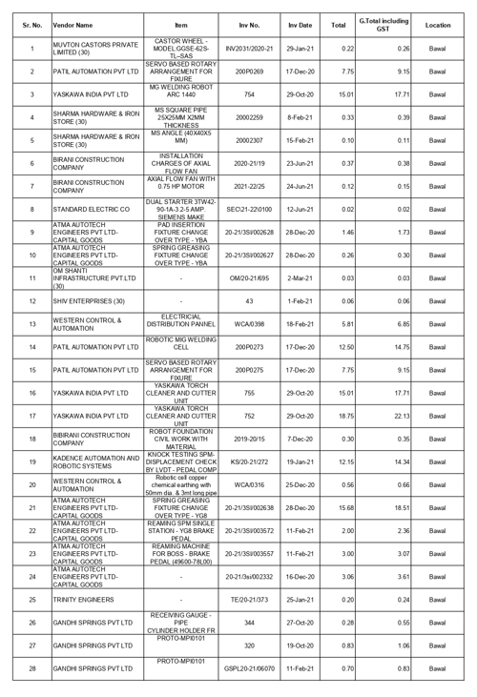

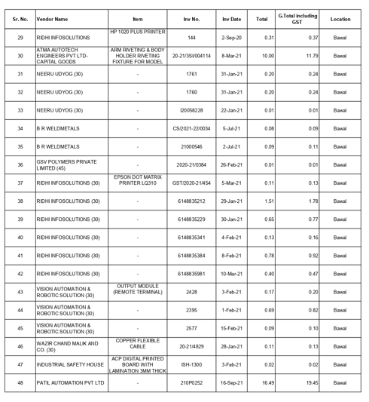
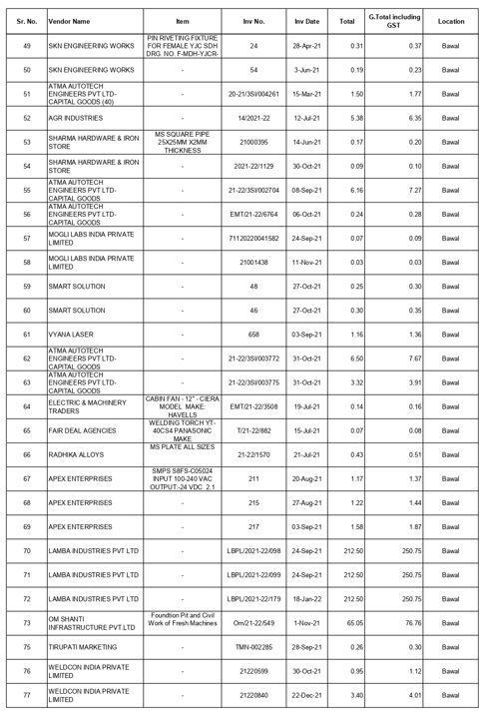
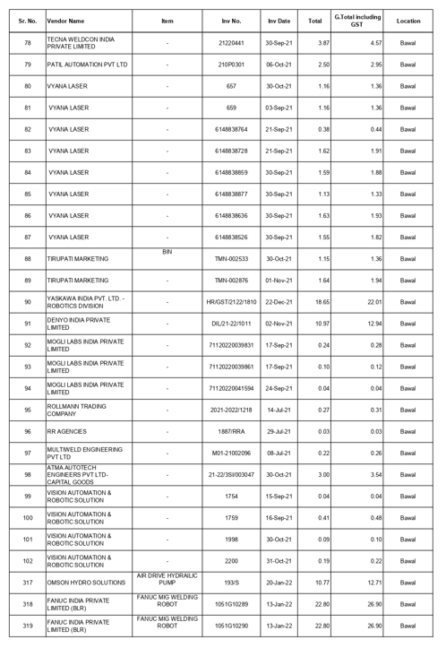
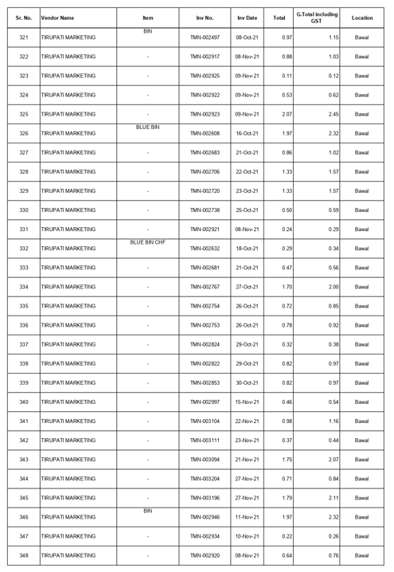
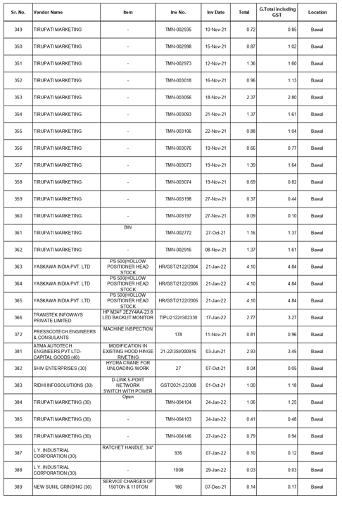
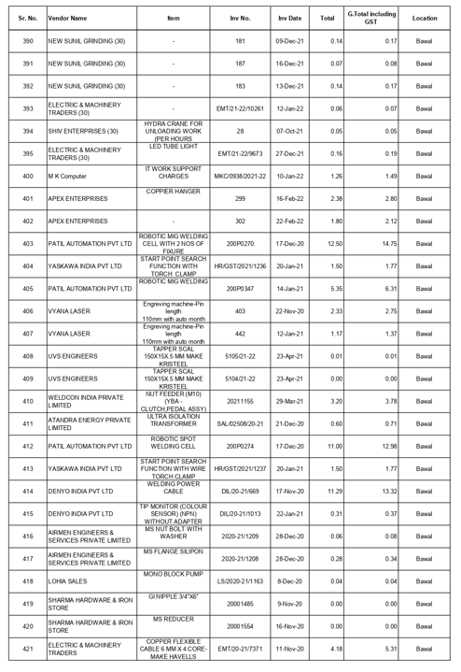
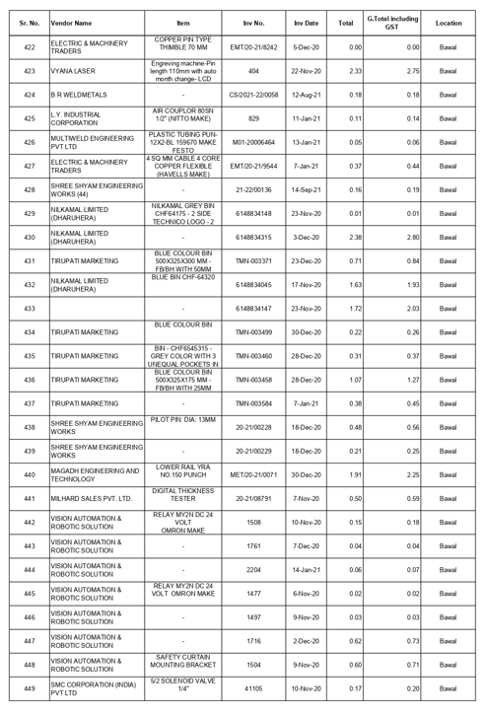
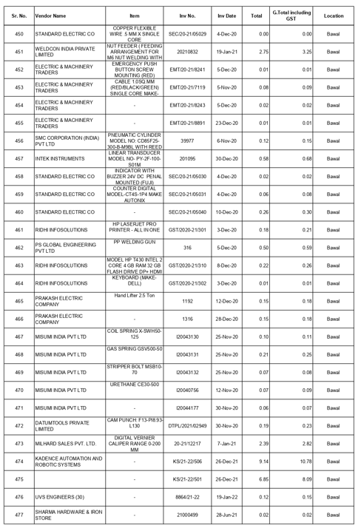
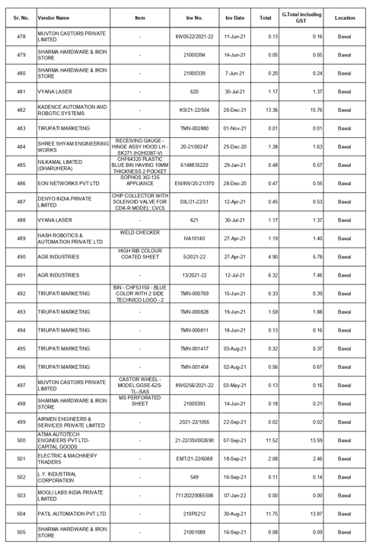
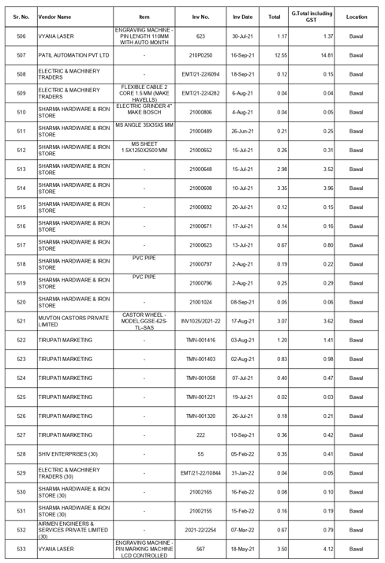
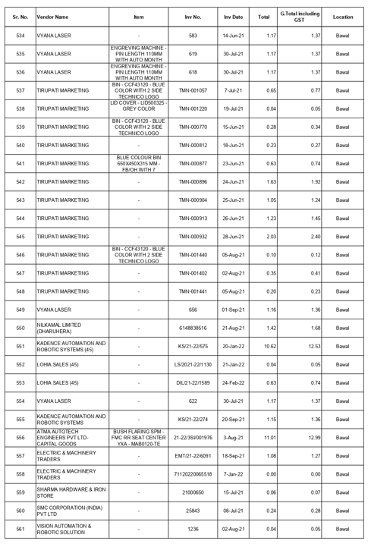
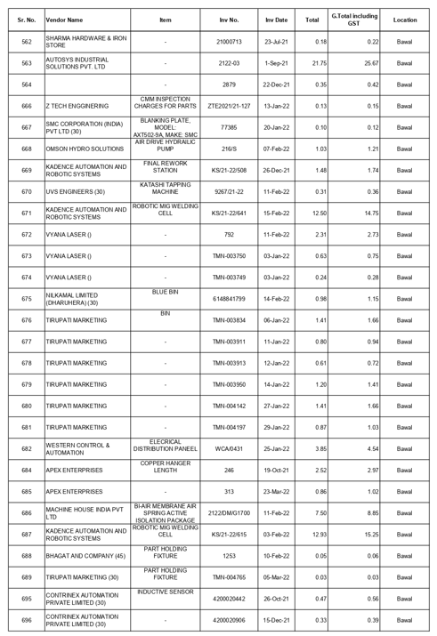
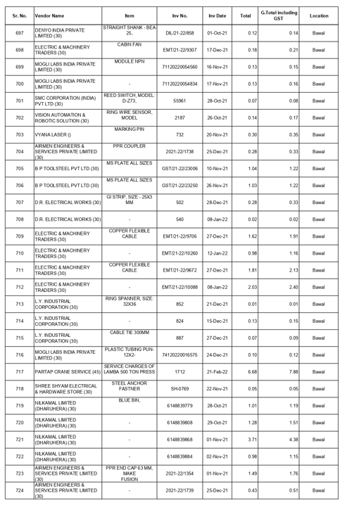
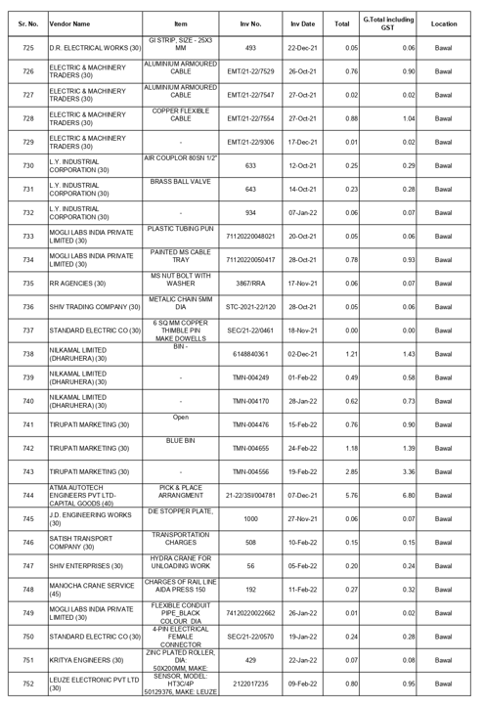
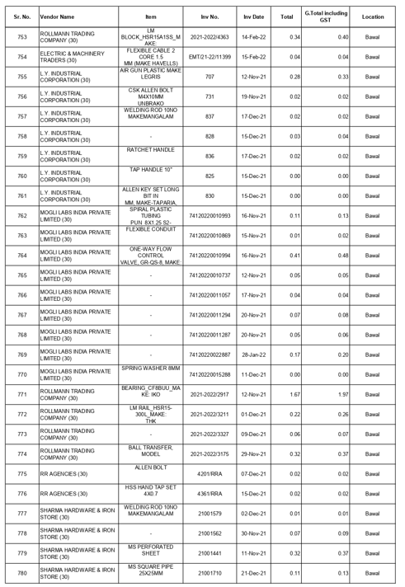
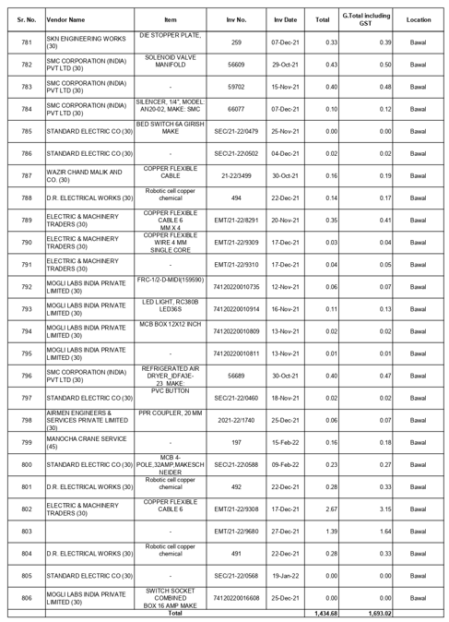
LIST OF INVOICES FOR MACHINERIES DELIVERED AT BENGALURU LOCATION
(Only Sample verification of machineries delivered at Bengaluru location was carried out)

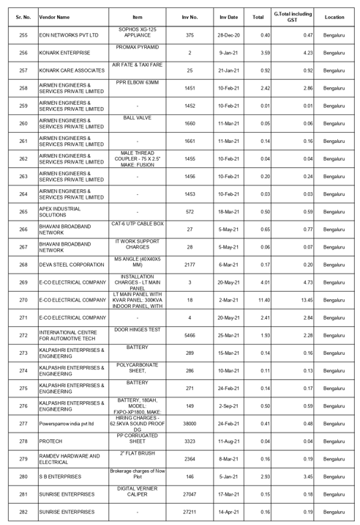
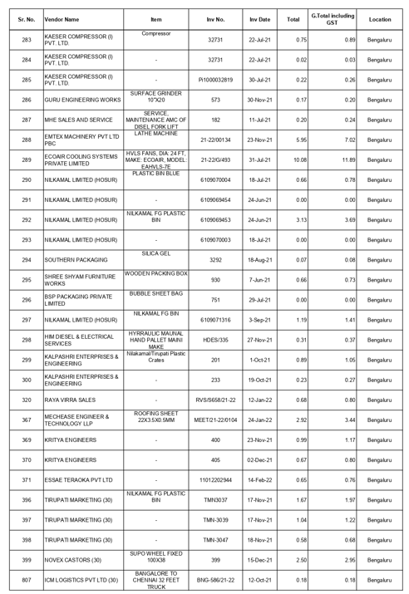
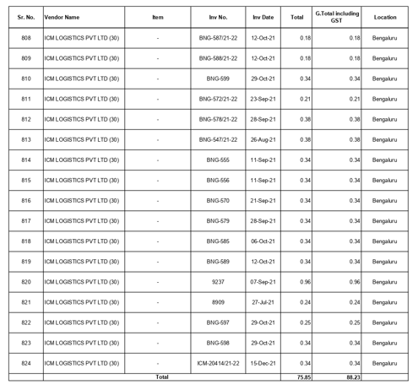
LIST OF INVOICES FOR MACHINERIES DELIVERED AT GUJARAT LOCATION
(Only Sample verification of machineries delivered at Gujarat location was carried out)

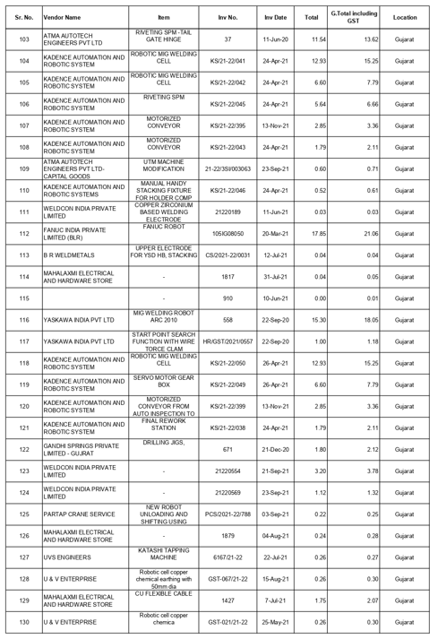
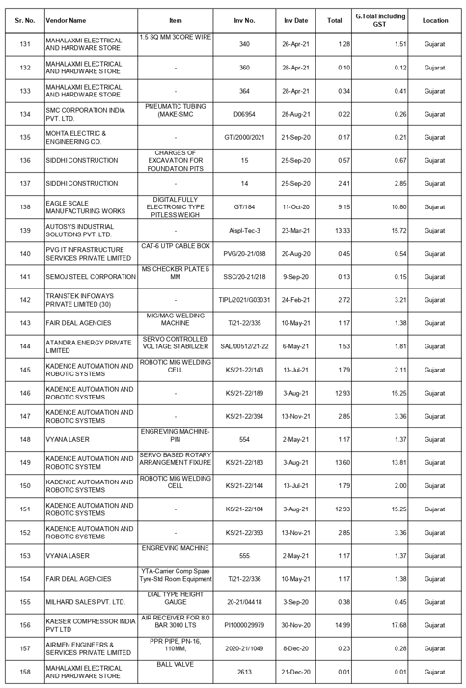
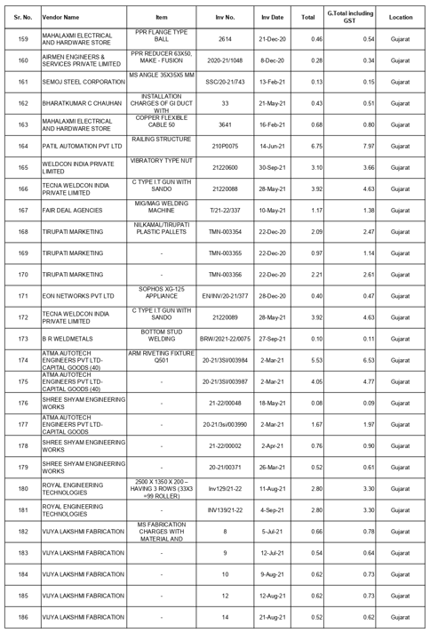

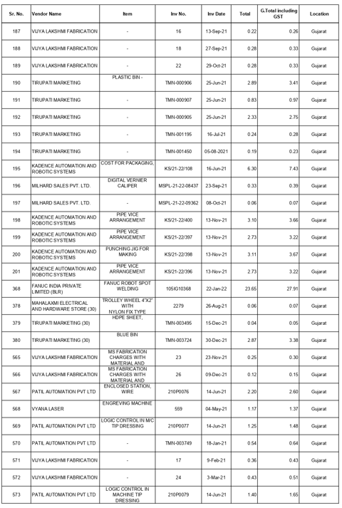

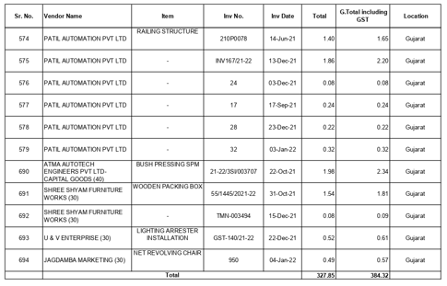

PART I | DISCLAIMER

      - No employee or member of R.K Associates has any direct/ indirect interest in the Project.
      - This report is prepared based on the copies of the documents/ information which the Bank/ Borrower has provided to us out of the standard checklist of documents sought from them and further based on our assumptions and limiting conditions. The client/owner and its management/representatives warranted to us that the information they supplied was complete, accurate and true and correct to the best of their knowledge. All such information provided to us has been relied upon in good faith and we have assumed that it is true and correct in all respect. I/We shall not be liable for any loss, damages, cost or expenses arising from fraudulent acts, misrepresentations, or wilful default on part of the owner, borrower, its directors, employee, representative or agents. Verification or cross checking of the documents provided to us from the originals or from any Govt. departments/ Record of Registrar has not been done at our end since this is beyond the scope of our work. If at any time in future, it is found or came to our knowledge that misrepresentation of facts or incomplete or distorted information has been provided to us then this report shall automatically become null & void.
      - Legal aspects for eg. investigation of title, ownership rights, lien, charge, mortgage, lease, sanctioned maps, verification of documents, etc. have not been done at our end and same has to be taken care by legal expert/ Advocate. It is assumed that the concerned Lender/ Financial Institution has satisfied them with the authenticity of the documents, information given to us and for which the legal verification has been already taken and cleared by the competent Advocate before requesting for this report. I/ We assume no responsibility for the legal matters including, but not limited to, legal or title concerns.
      - This report is a general analysis of the project based on the scope mentioned in the report. This is not an Audit report, Design document, DPR or Techno feasibility studY, verbal discussion & documentary evidence provided by the client and is believed that information given by the borrower is true best of their knowledge.
      - All observations mentioned in the report is only based on the visual observation and the documents/ data/ information provided by the client. No mechanical/ technical tests, measurements or any design review have been performed or carried out from our side during Project assessment.
      - Bank/FII should ONLY take this report as an Advisory document from the Financial/ Chartered Engineering firm and its specifically advised to the creditor to cross verify the original documents for the facts mentioned in the report which can be availed from the borrowing borrower directly.
      - In case of any default in loans or the credit facility extended to the borrowing borrower, R.K Associates shall not be held responsible for whatsoever reason may be and any request for seeking any explanation from the employee/s of R.K Associates will not be entertained at any instance or situation.
      - The documents, information, data provided to us during the course of this assessment by the client is reviewed only upto the extent required in relation to the scope of the work. No document has been reviewed beyond the scope of the work.
      - This report only contains general assessment & opinion as per the scope of work evaluated as per the information given in the copy of documents, information, data provided to us and/ and confirmed by the owner/ owner representative to us at site which has been relied upon in good faith. It doesn’t contain any other recommendations of any sort including but not limited to express of any opinion on the suitability or otherwise of entering into any transaction with the borrower.
      - We have relied on data from third party, external sources & information available on public domain also to conclude this report. These sources are believed to be reliable and therefore, we assume no liability for the truth or accuracy of any data, opinions or estimates furnished by others that have been used in this analysis. Where we have relied on data, opinions or estimates from external sources, reasonable care has been taken to ensure that such data has been correctly extracted from those sources and /or reproduced in its proper form and context, however still we can’t vouch its authenticity, correctness or accuracy.
      - This Report is prepared by our competent technical team which includes Engineers and financial experts & analysts.
      - This is just an opinion report and doesn’t hold any binding on anyone. It is requested from the concerned Financial Institution which is using this report for taking financial decision on the project that they should consider all the different associated relevant & related factors also before taking any business decision based on the content of this report.
      - All Pages of the report including annexures are signed and stamped from our office. In case any paper in the report is without stamp & signature then this should not be considered a valid paper issued from this office.
      - Though adequate care has been taken while preparing this report as per its scope, but still we can’t rule out typing, human errors, over sightedness of any information or any other mistakes. Therefore, the concerned organization is advised to satisfy themselves that the report is complete & satisfactory in all respect. Intimation regarding any discrepancy shall be brought into our notice immediately. If no intimation is received within 15 (Fifteen) days in writing from the date of issuance of the report, to rectify these timely, then it shall be considered that the report is complete in all respect and has been accepted by the client upto their satisfaction & use and further to which R.K Associates shall not be held responsible in any manner.
      - Defect Liability Period is 15 DAYS. We request the concerned authorized reader of this report to check the contents, data and calculations in the report within this period and intimate us in writing if any corrections are required or in case of any other concern with the contents or opinion mentioned in the report. Corrections only related to typographical, calculation, spelling mistakes, incorrect data/ figures/ statement will be entertained within the defect liability period. Any new changes for any additional information in already approved report will be regarded as additional work for which additional fees may be charged. No request for any illegitimate change in regard to any facts & figures will be entertained.
      - R.K Associates encourages its customers to give feedback or inform concerns over its services through proper channel at valuers@rkassociates.org in writing within 15 days of report delivery. After this period no concern/ complaint/ proceedings in connection with the Financial Feasibility Study Services will be entertained due to possible change in situation and condition of the subject Project.
      - Our Data retention policy is of ONE YEAR. After this period, we remove all the concerned records related to the assignment from our repository. No clarification or query can be answered after this period due to unavailability of the data.
      - This Lender’s Independent Engineer report is governed by our (1) Internal Policies, Processes & Standard Operating Procedures, (2) Information/ Data/ Inputs given to us by the client and (3) Information/ Data/ Facts given to us by our field/ office technical team. Management of R.K Associates never gives acceptance to any unethical or unprofessional practice which may affect fair, correct & impartial assessment and which is against any prevailing law. In case of any indication of any negligence, default, incorrect, misleading, misrepresentation or distortion of facts in the report then it is the responsibility of the user of this report to immediately or at least within the defect liability period bring all such act into notice of R.K Associates management so that corrective measures can be taken instantly.
      - R.K Associates never releases any report doing alterations or modifications from pen. In case any information/ figure of this report is found altered with pen then this report will automatically become null & void.

DEFECT LIABILITY PERIOD - In case of any query/ issue or escalation you may please contact Incident Manager by writing at valuers@rkassociates.org. We ensure 100% accuracy in the Calculations done, Rates adopted and various other data points & information mentioned in the report but still can’t rule out typing, human errors or any other mistakes. In case you find any mistake, variation, discrepancy or inaccuracy in any data point of the report, please help us by bringing all such points into our notice in writing at valuers@rkassociates.orgwithin 30 days of the report delivery, to get these rectified timely, failing which R.K Associates Valuers Techno Engineering Consultants (P) Ltd. won’t be held responsible for any inaccuracy in any manner. Also if we will not hear back anything from you within 30 days, we will assume that report is correct in all respect and no further claim of any sort will be entertained thereafter. We would welcome and appreciate your feedback & suggestions in order to improve our services.

COPYRIGHT FORMAT - This report is prepared on the copyright format of R.K Associates Valuers Techno Engineering Consultants (P) Ltd. to serve our clients in the best possible way. Legally no one can copy or distribute this format without prior approval from R.K Associates. It is meant only for the organization as mentioned on the cover page of this report. Distribution or use of this format other than R.K Associates will be seen as unlawful act and necessary legal action can be taken against the defaulter

ANNEXURE 1: CA CERTIFICATE AND UDIN VERIFICATION

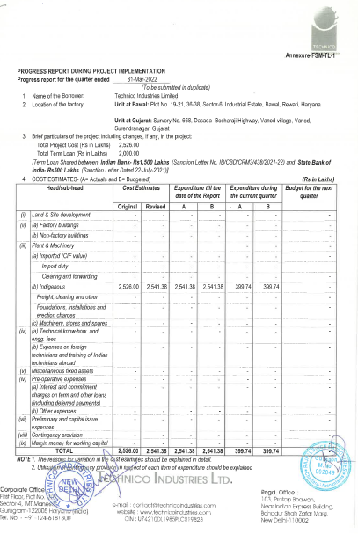

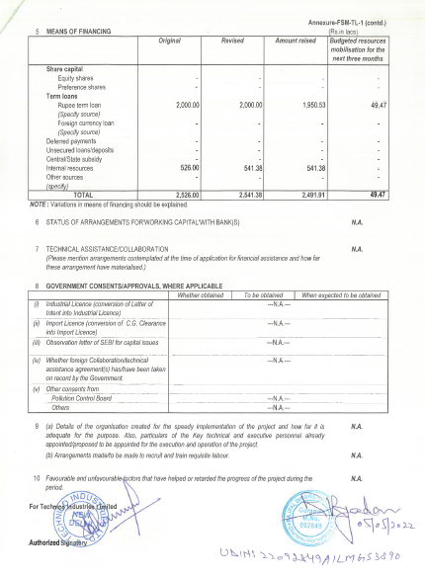
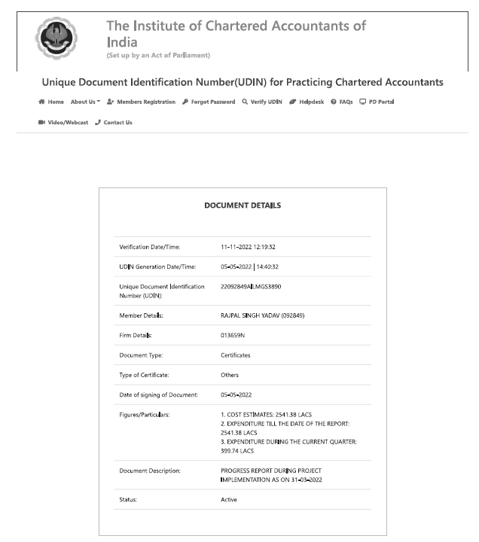
SITE PHOTOGRAPHS
LOCATION 1: BAWAL (HARYANA)

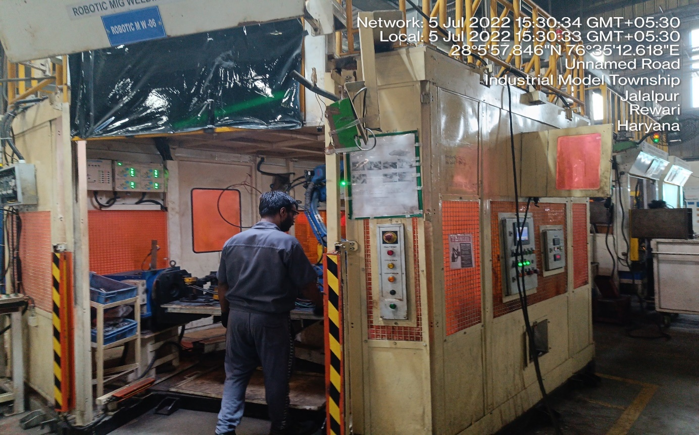
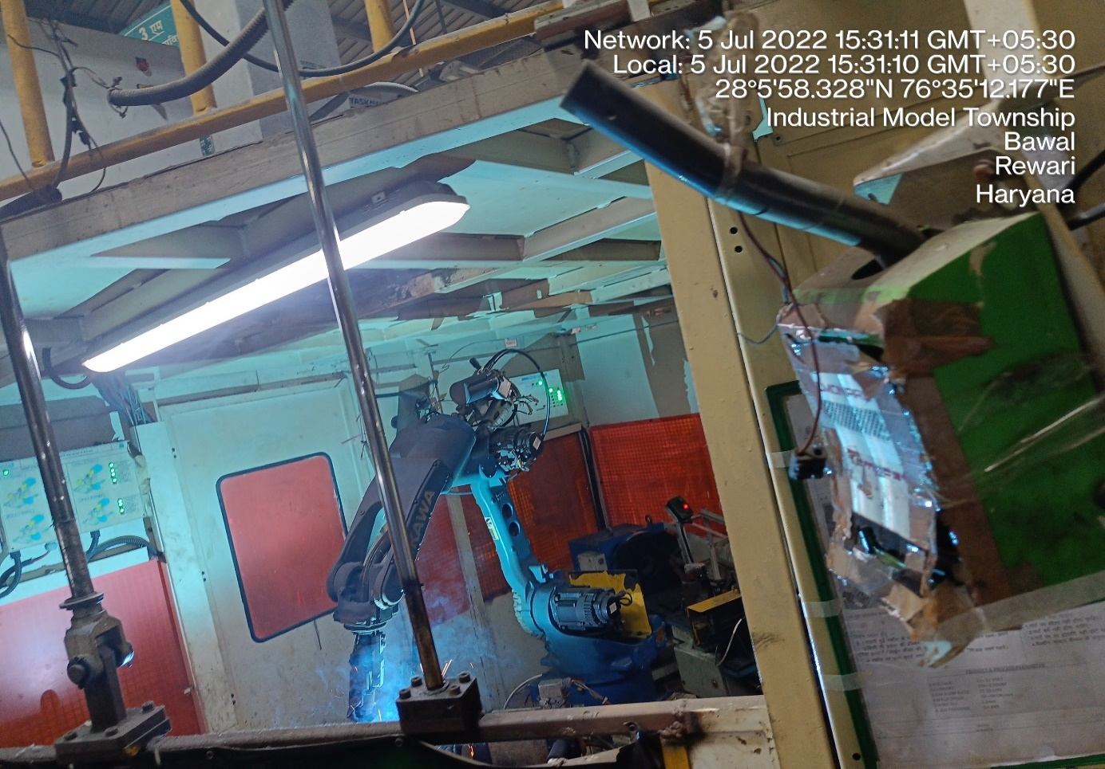
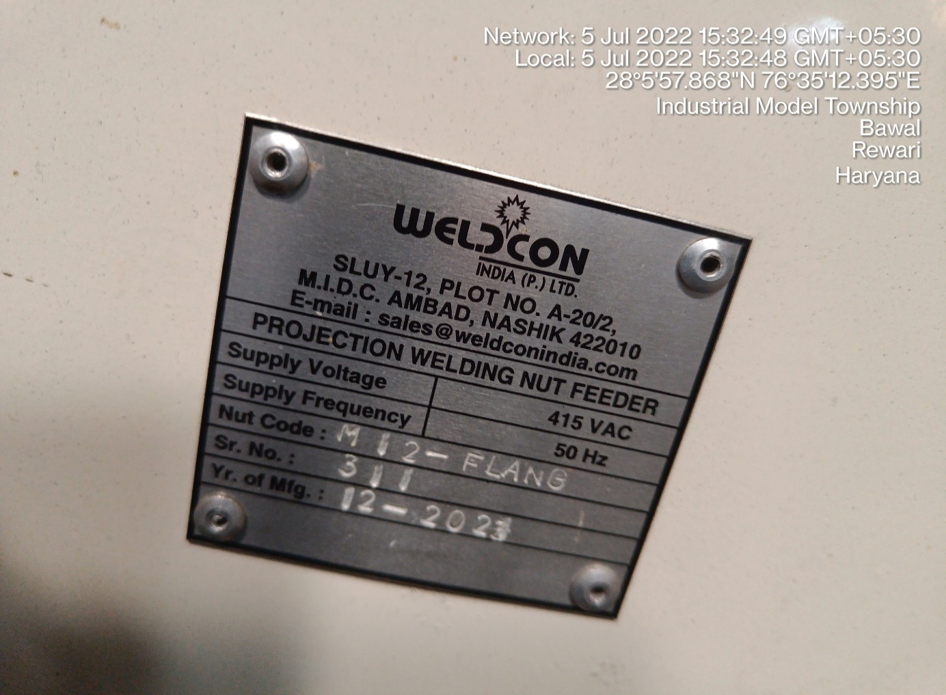
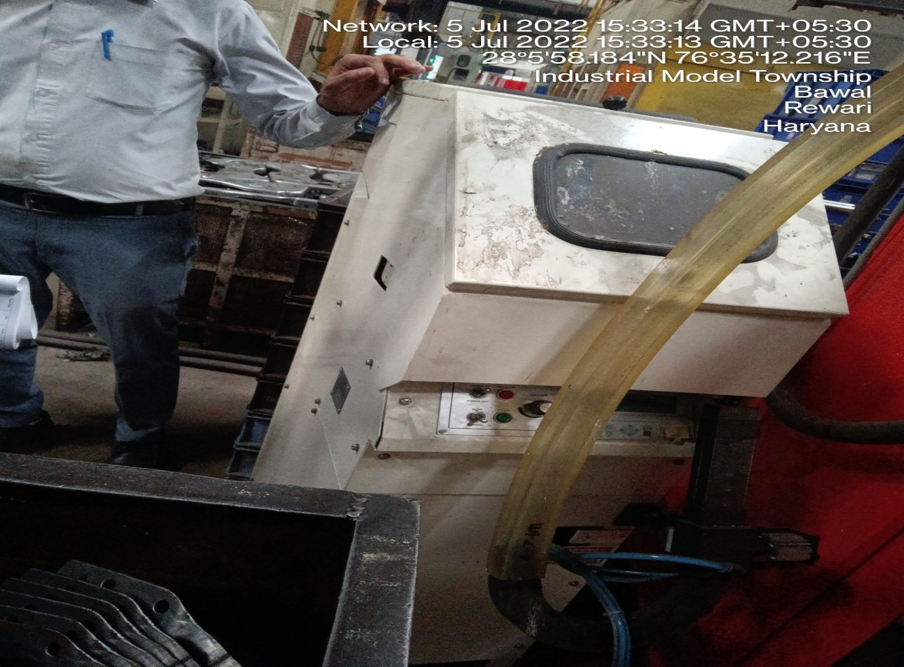
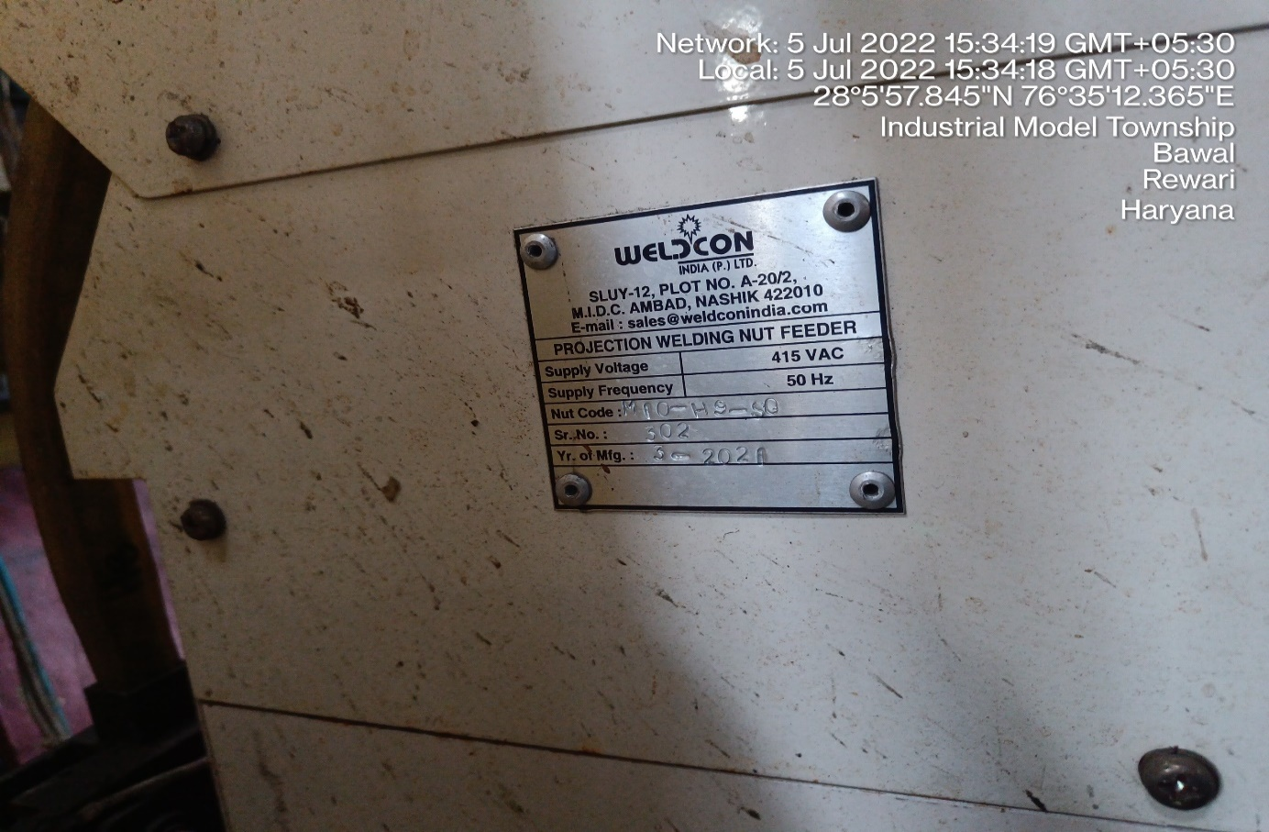
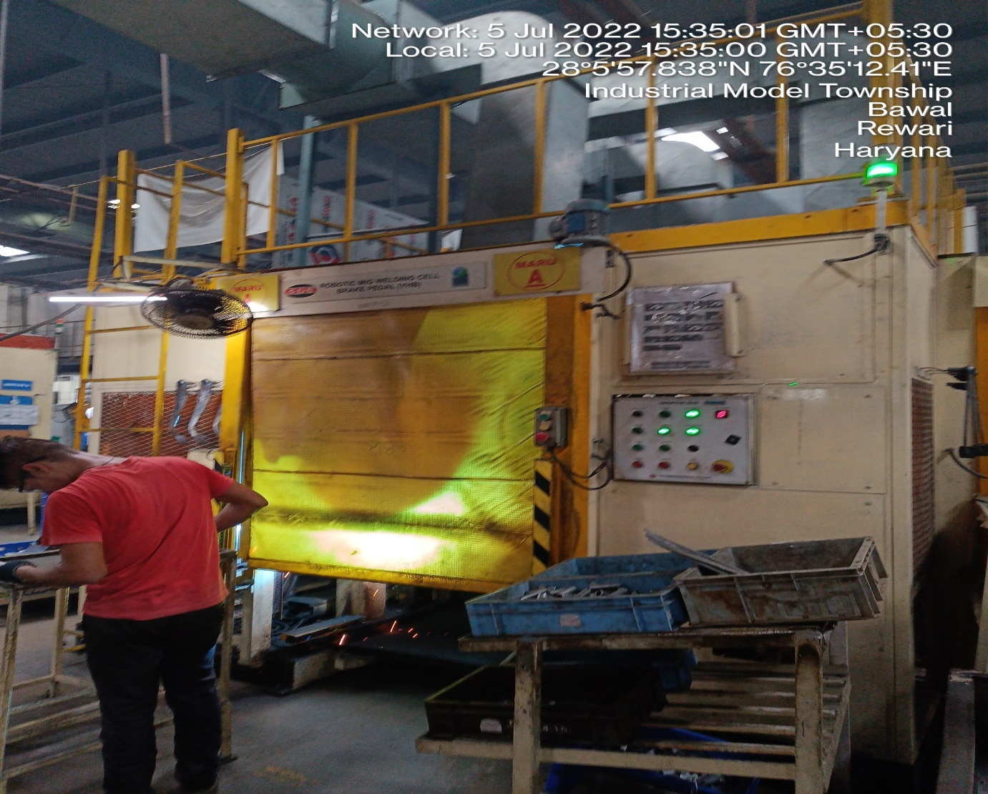
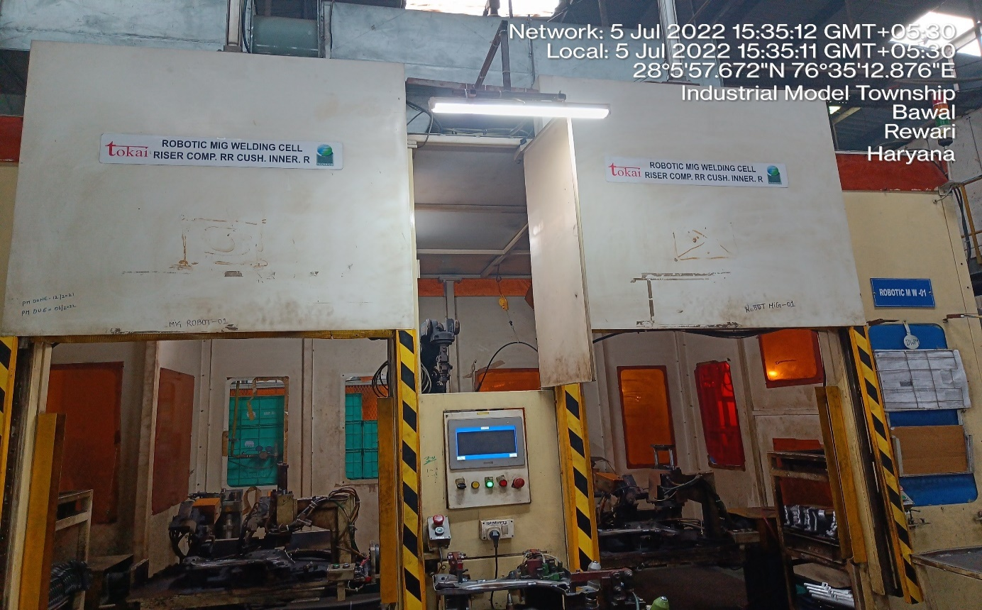

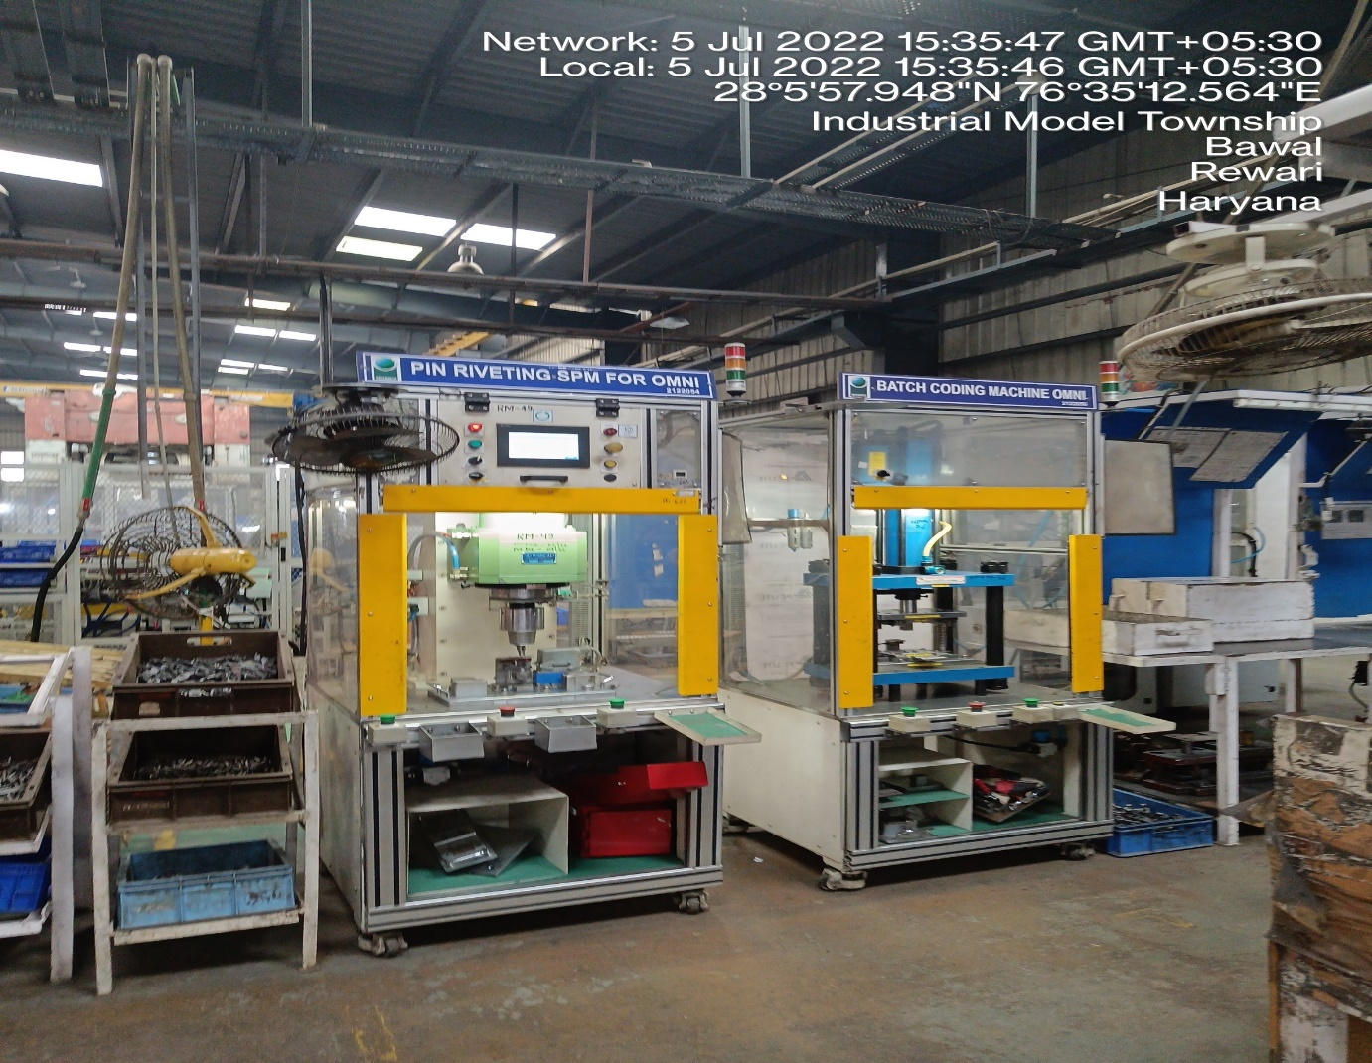
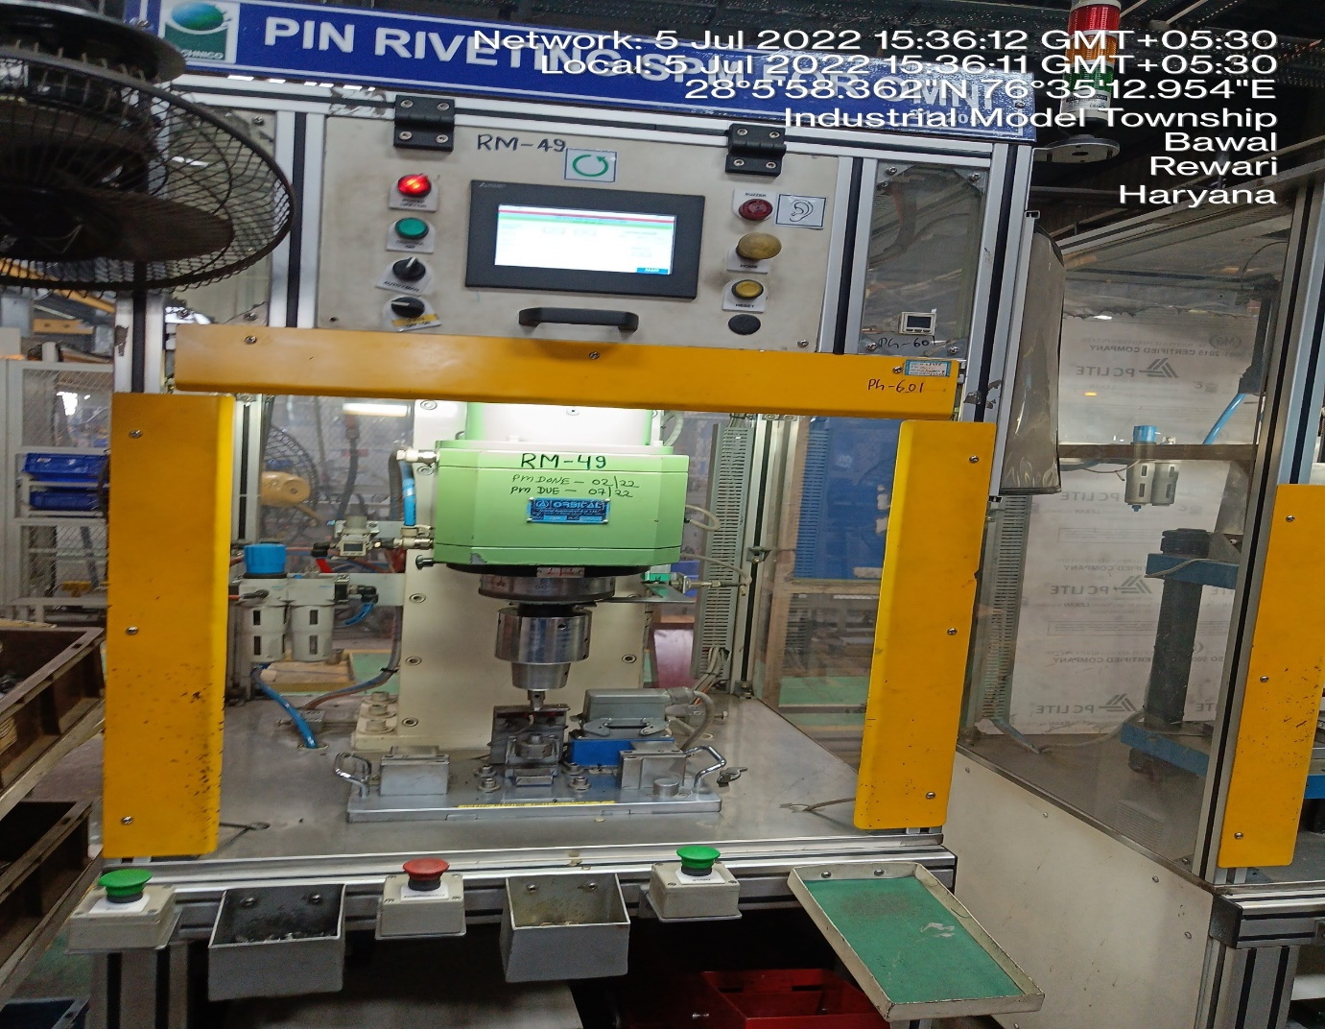
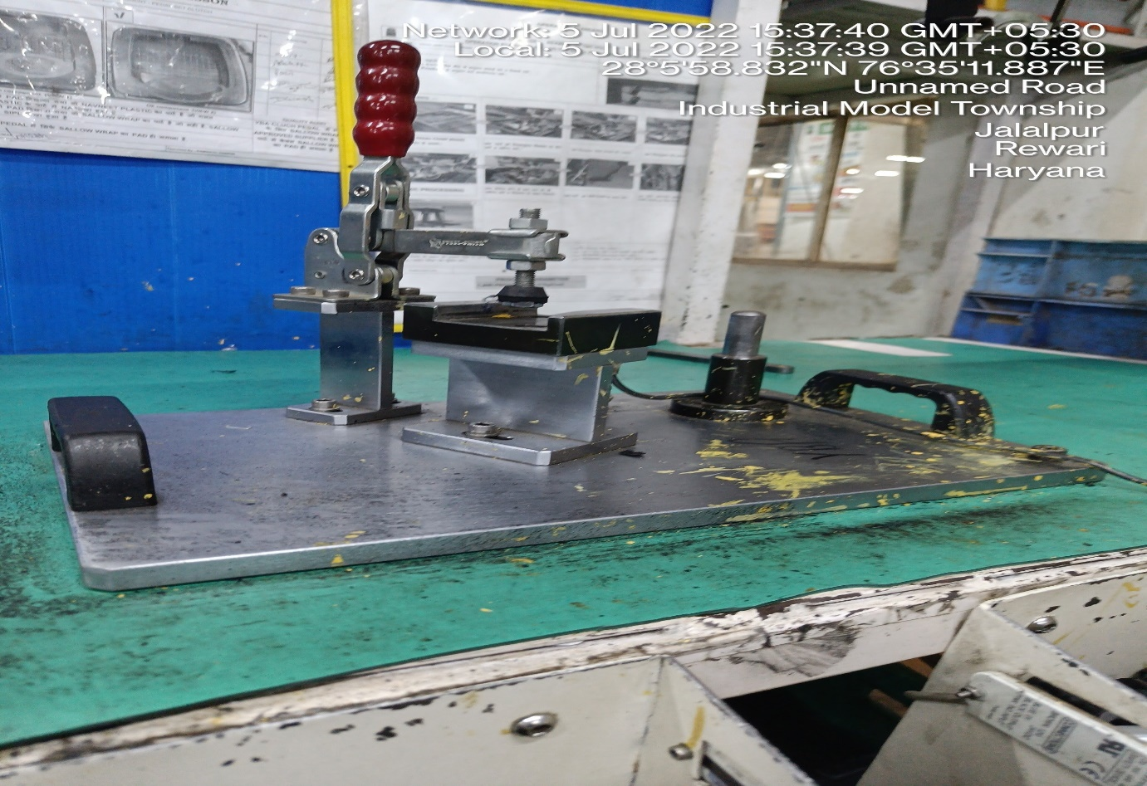
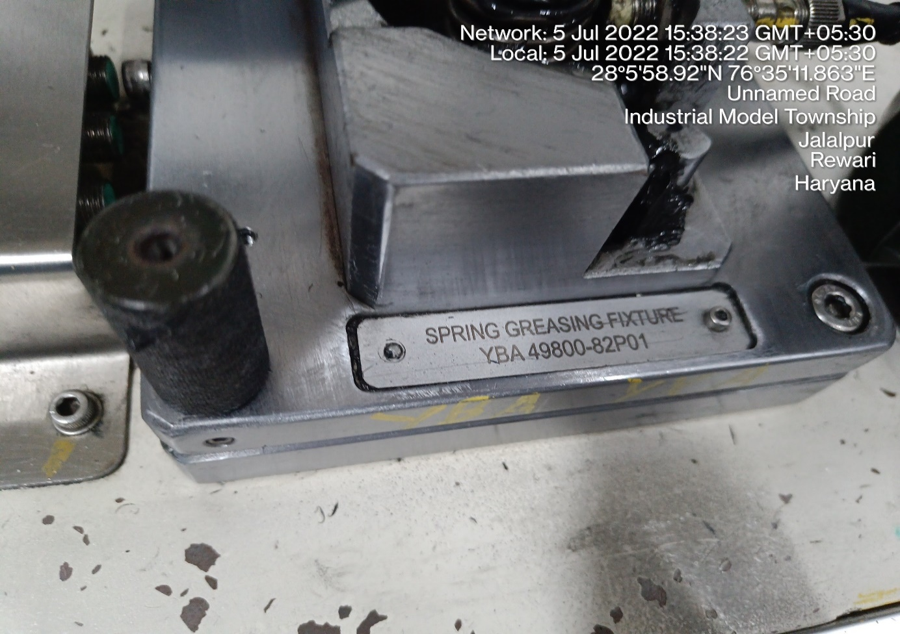
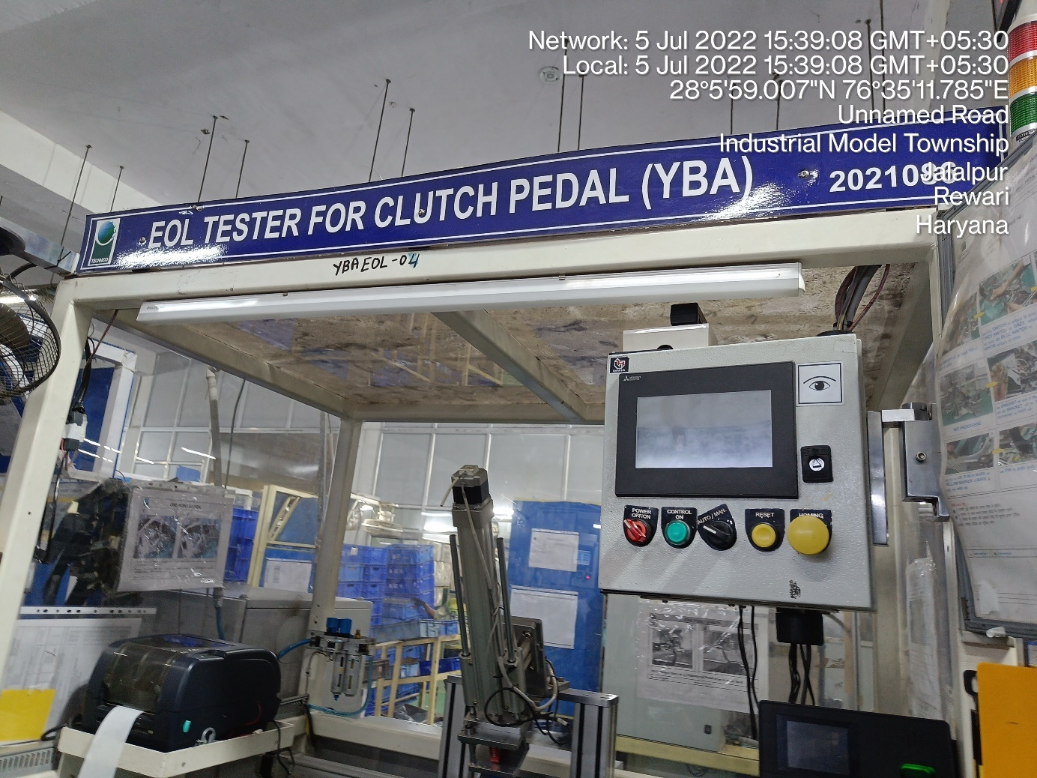
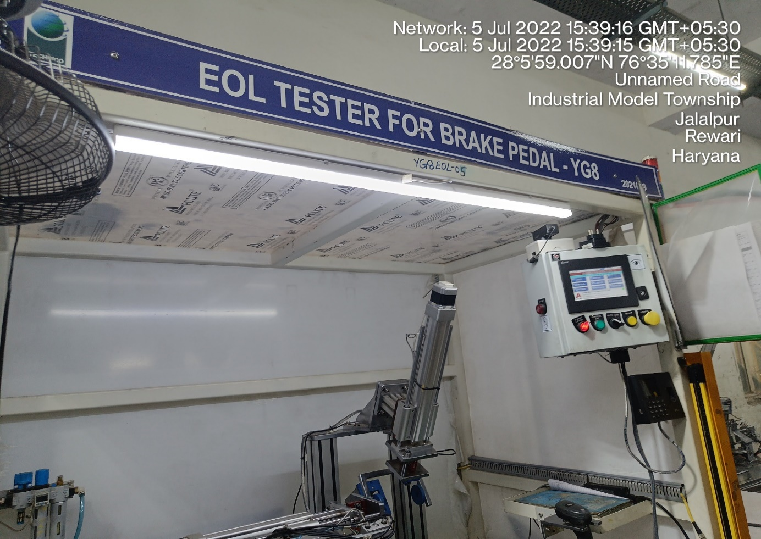
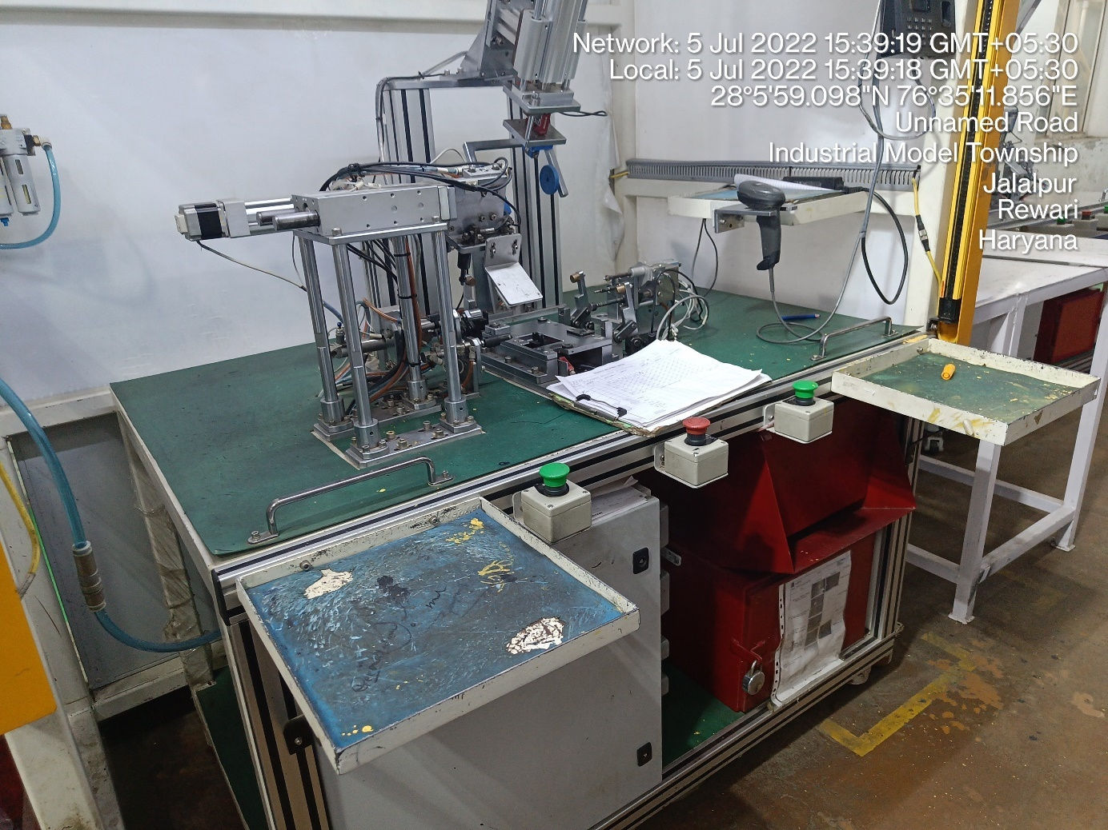
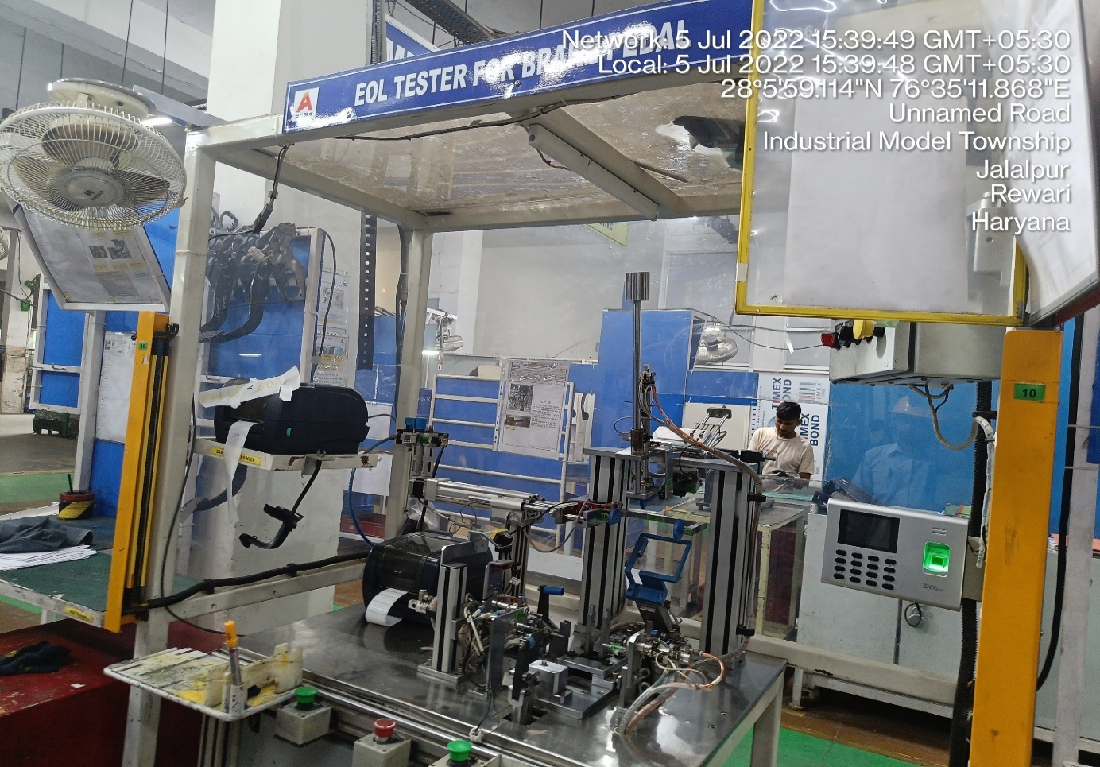
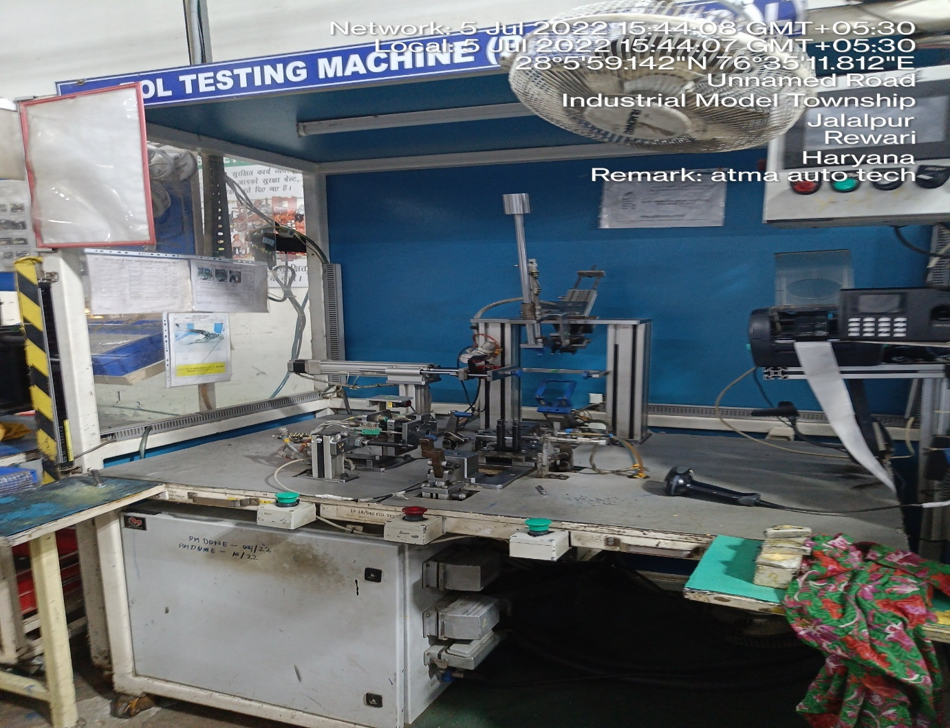

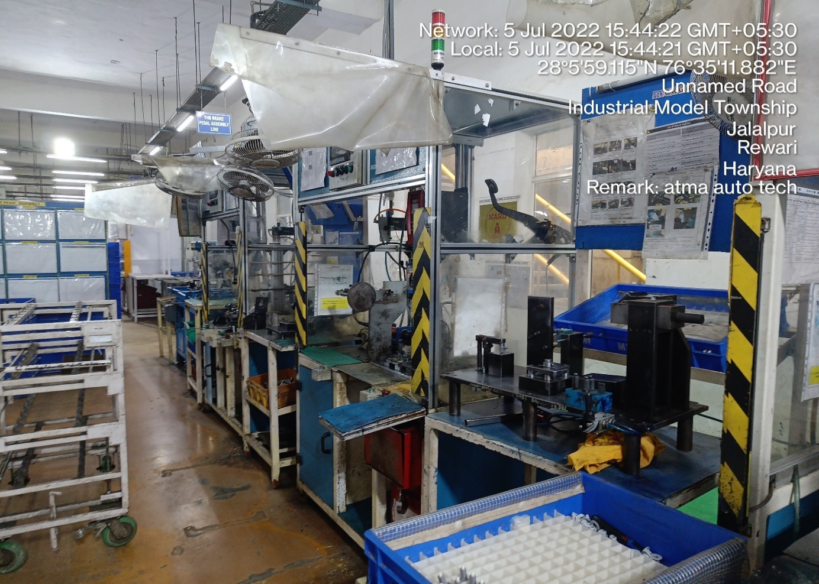

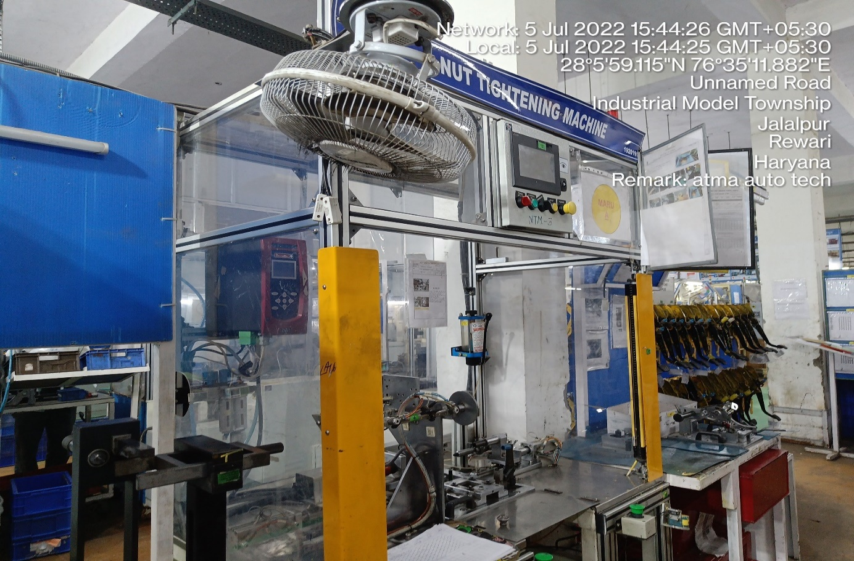
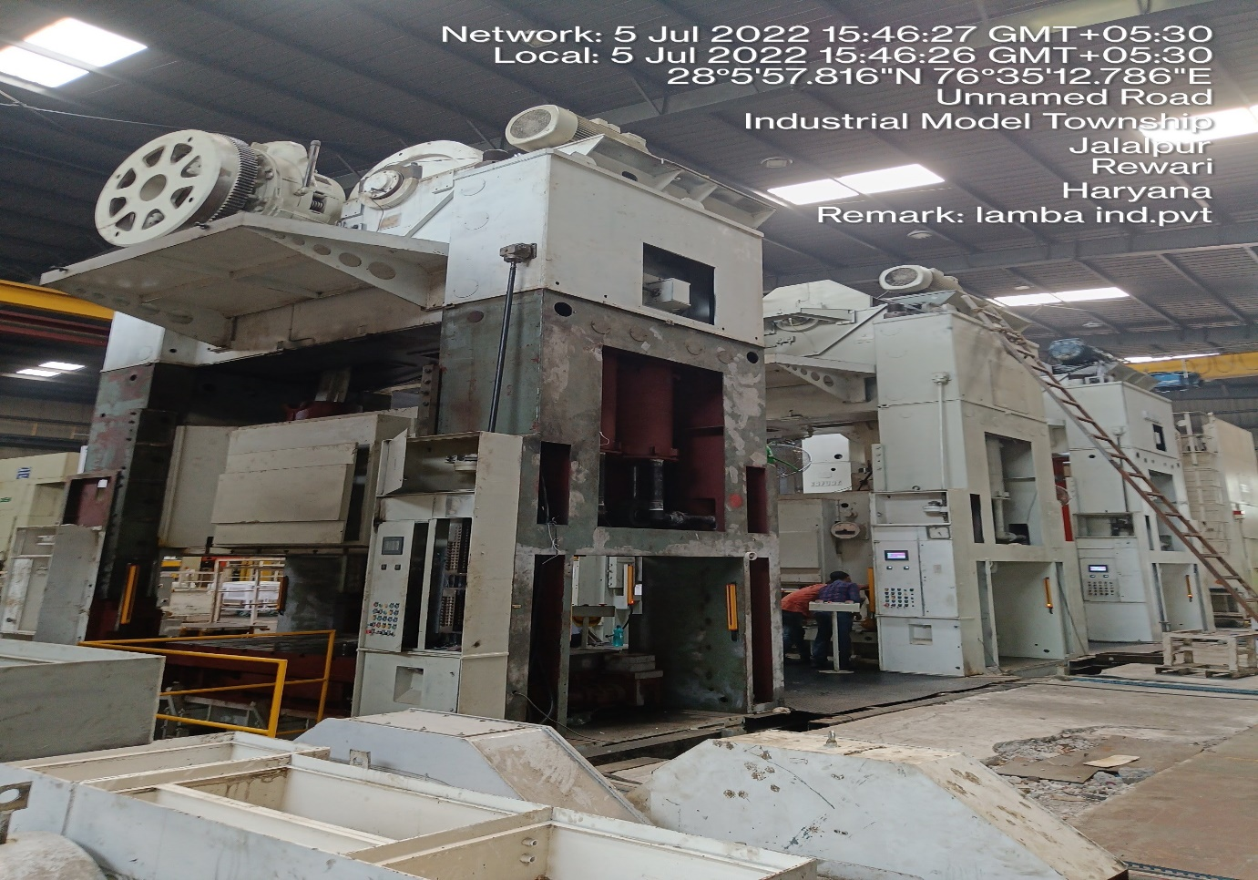
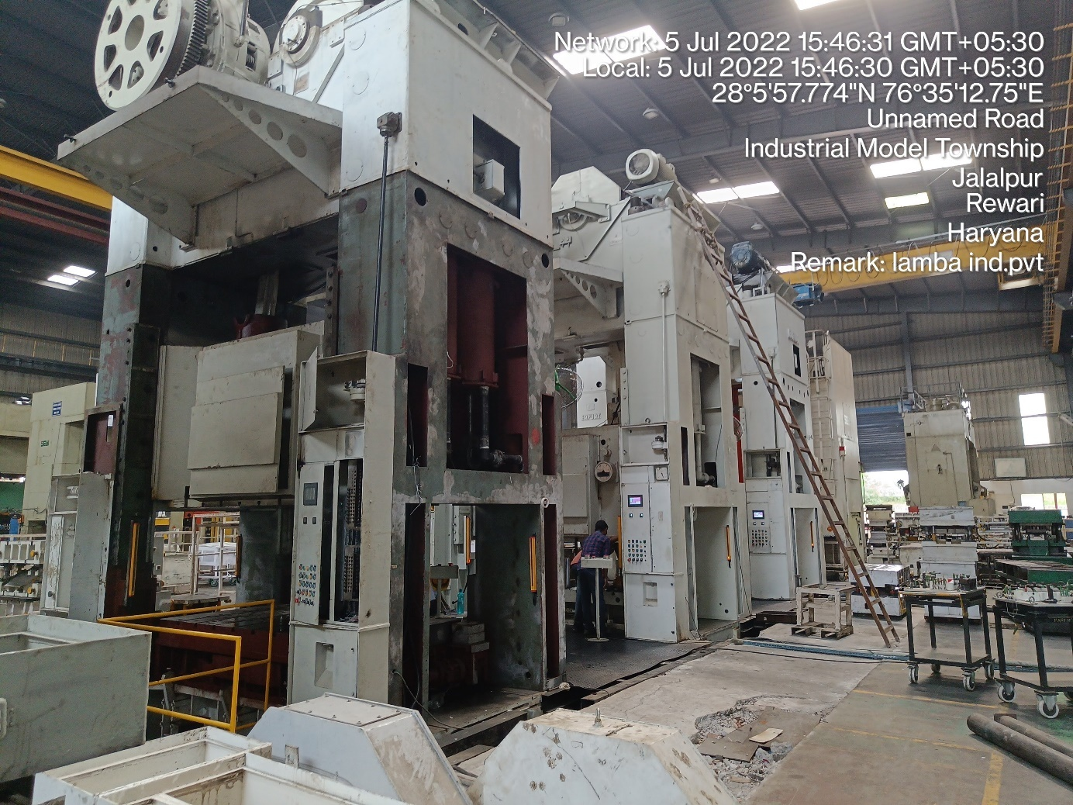
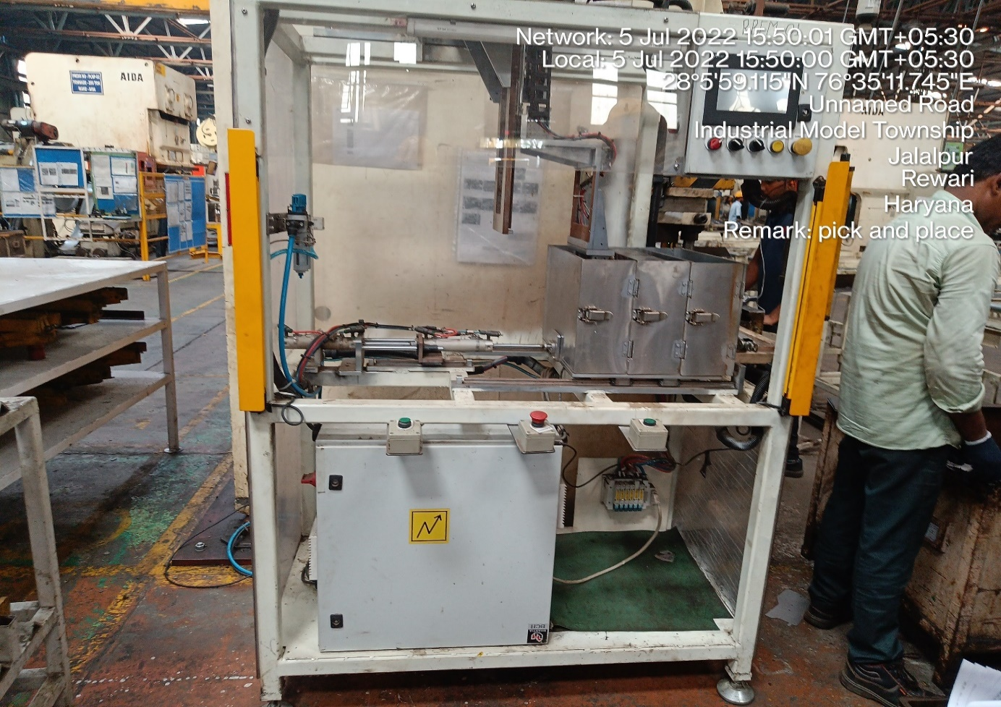

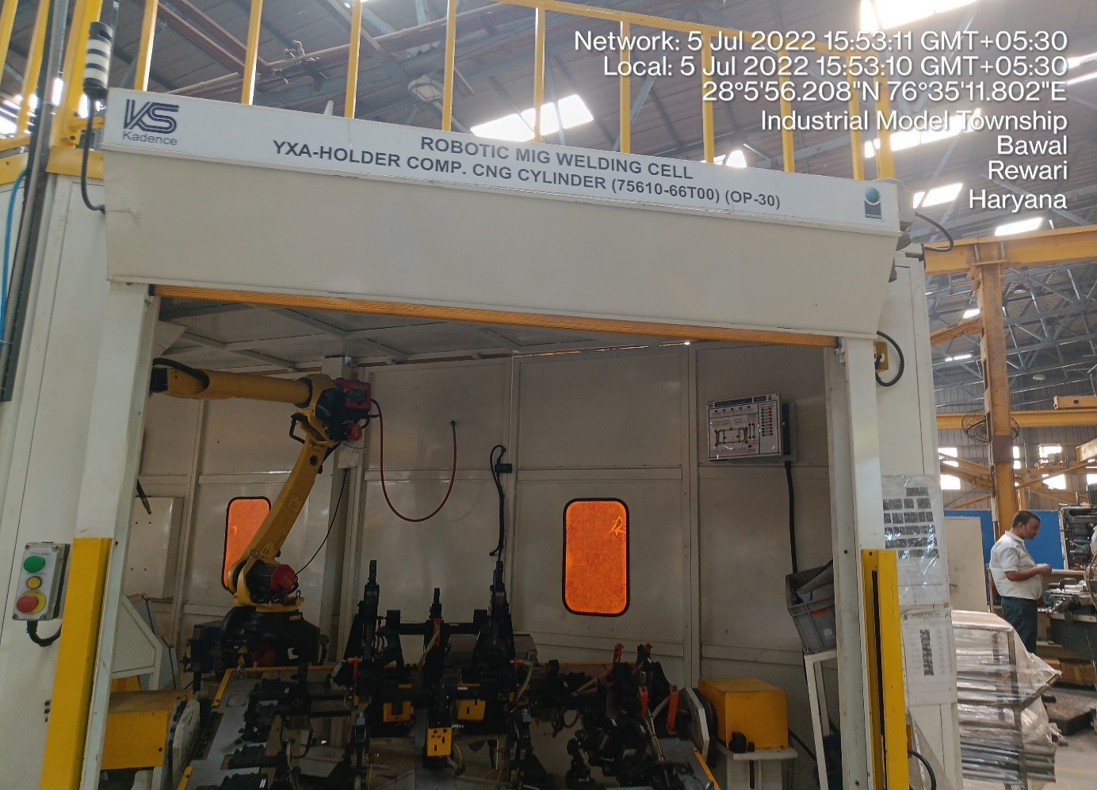
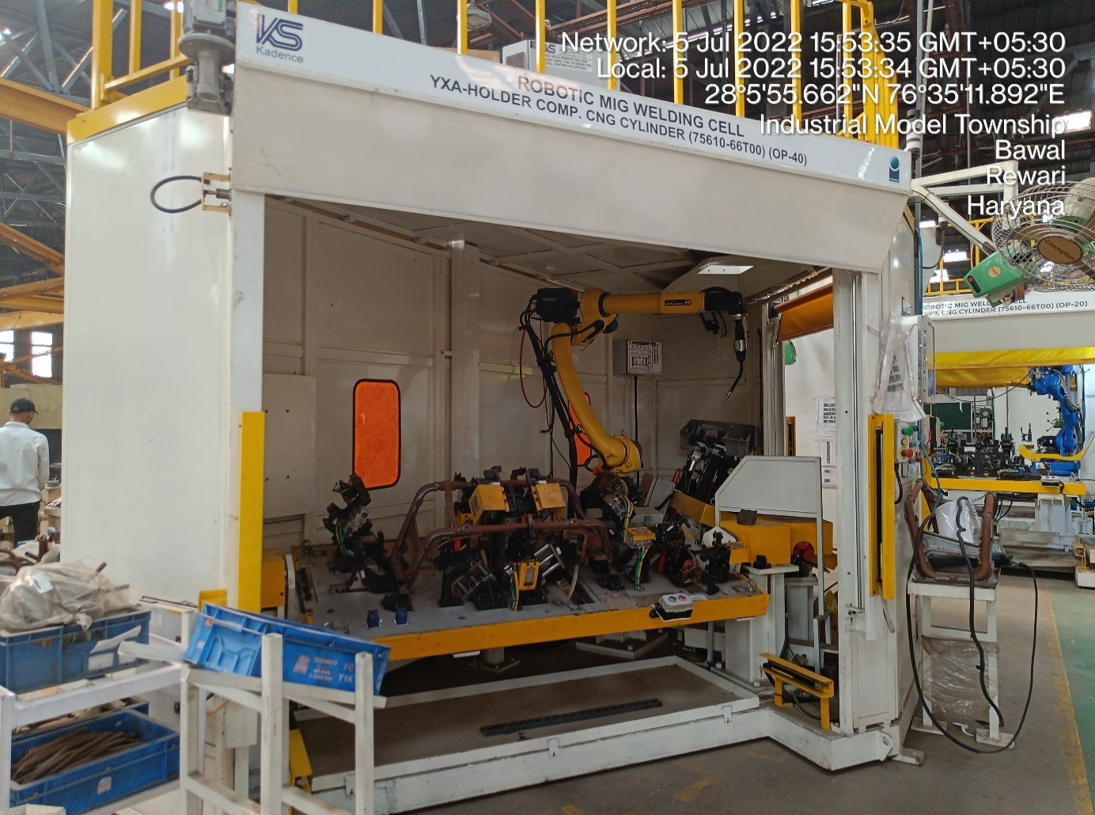
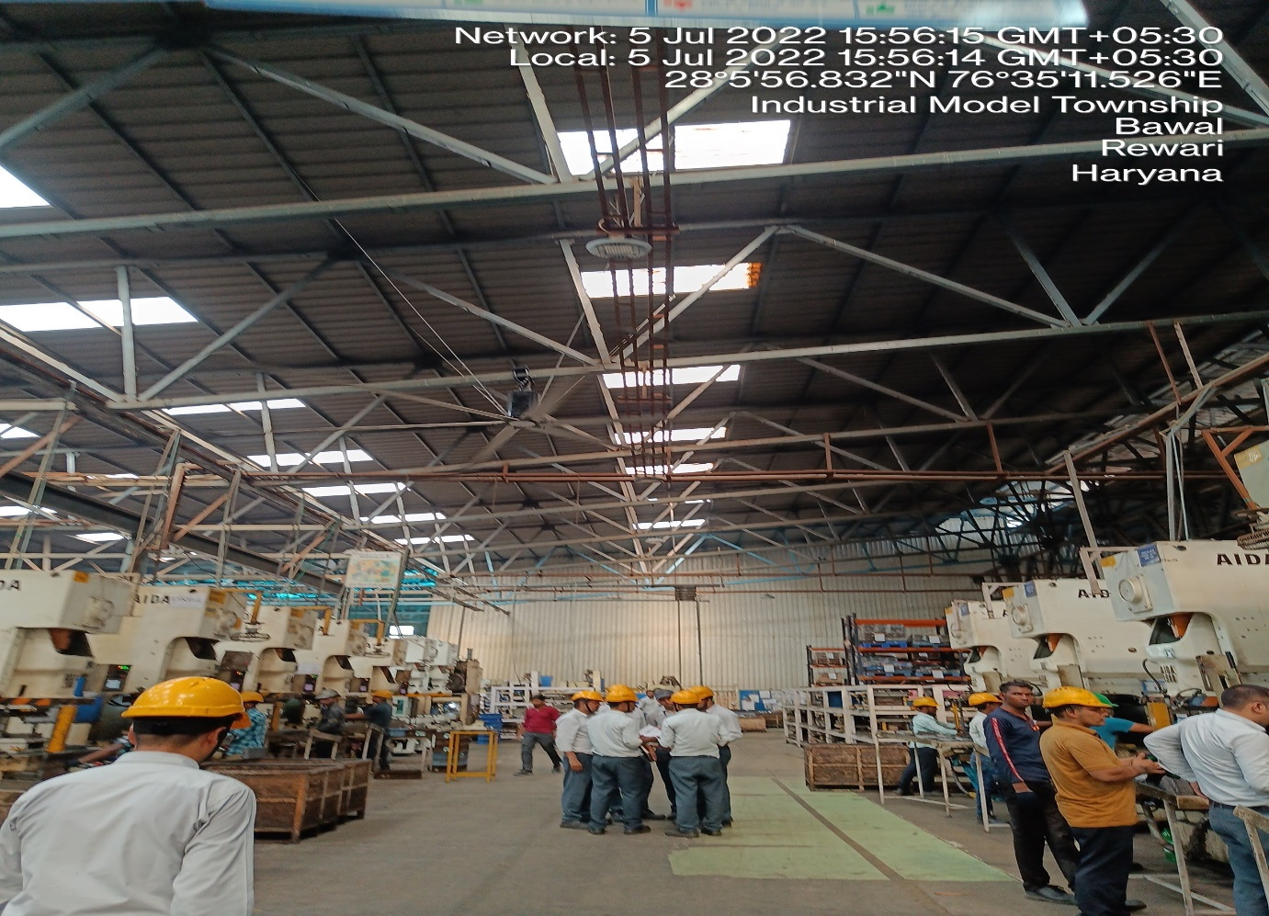
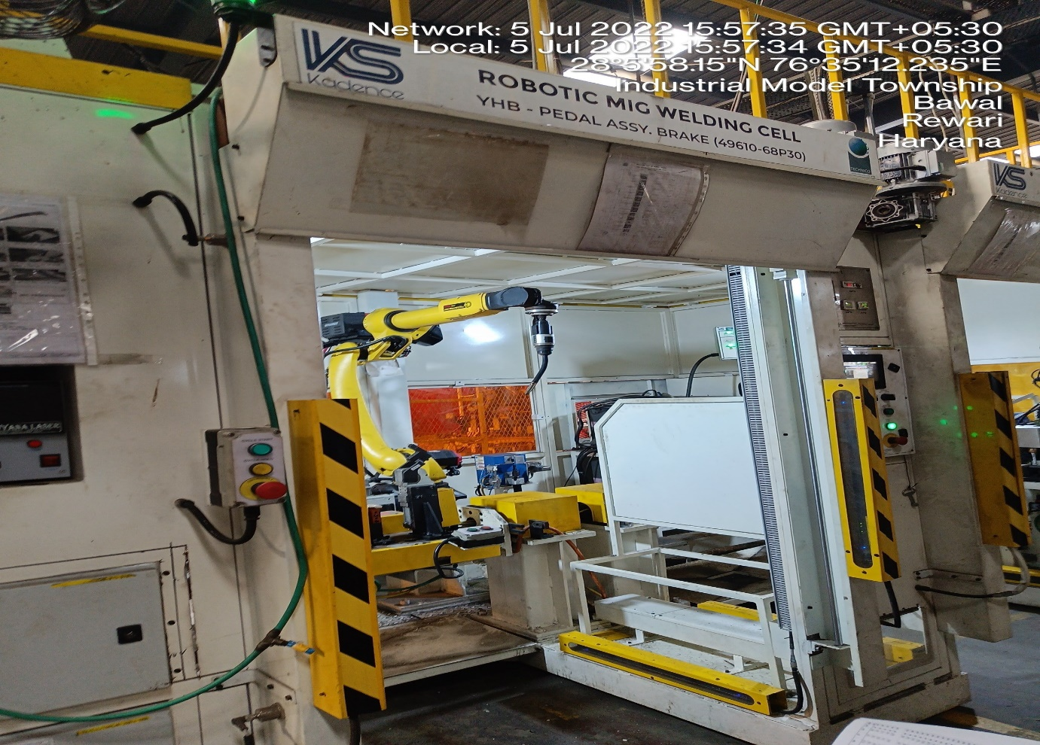
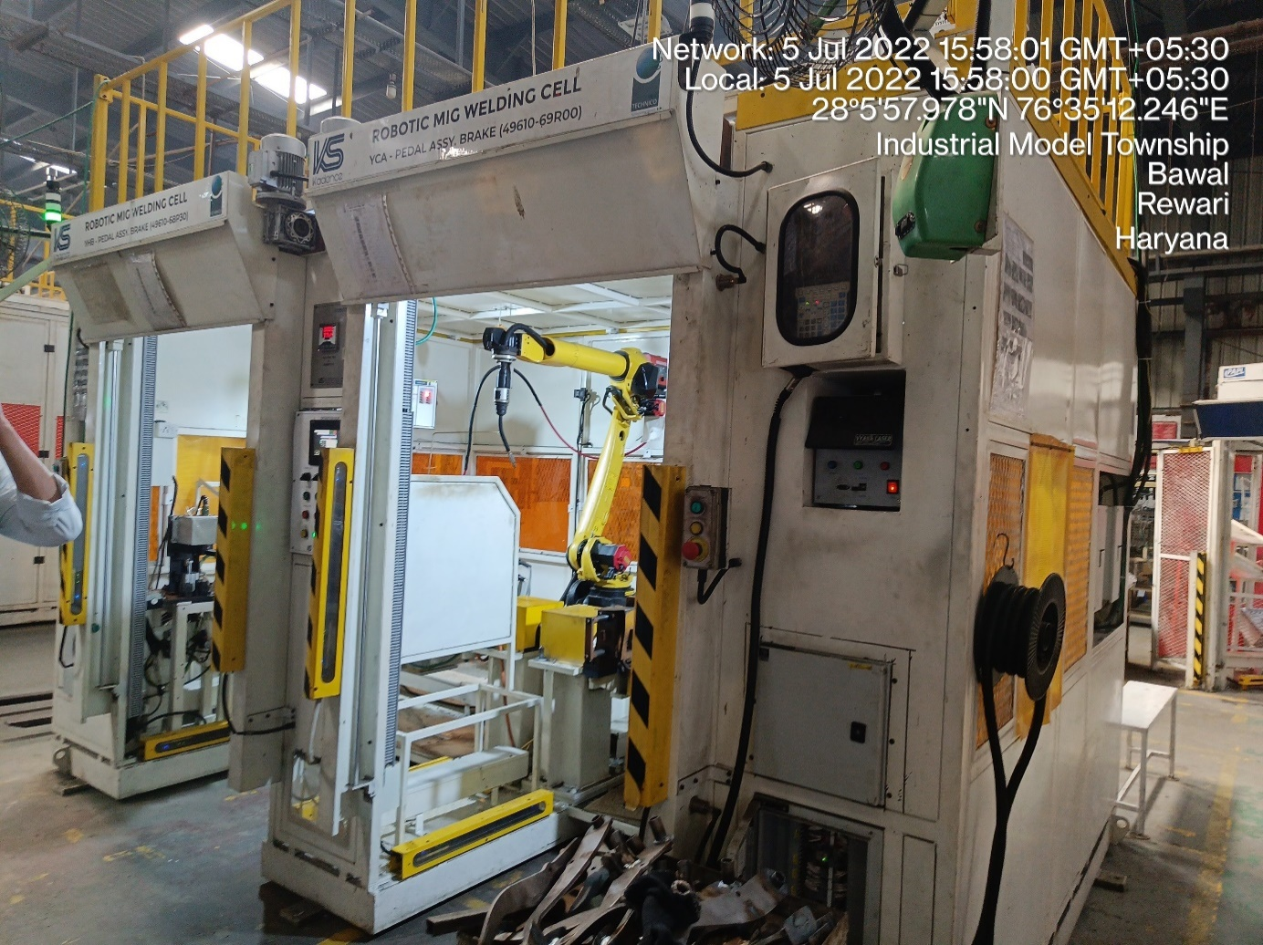
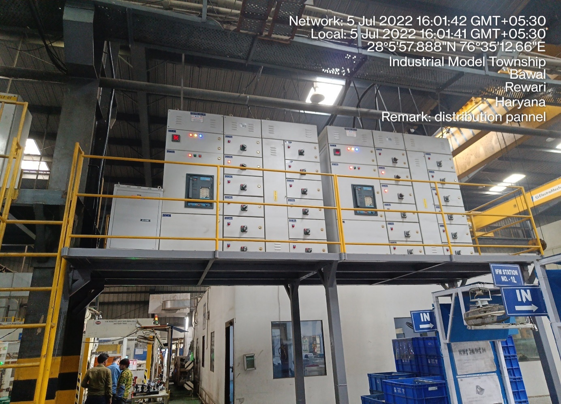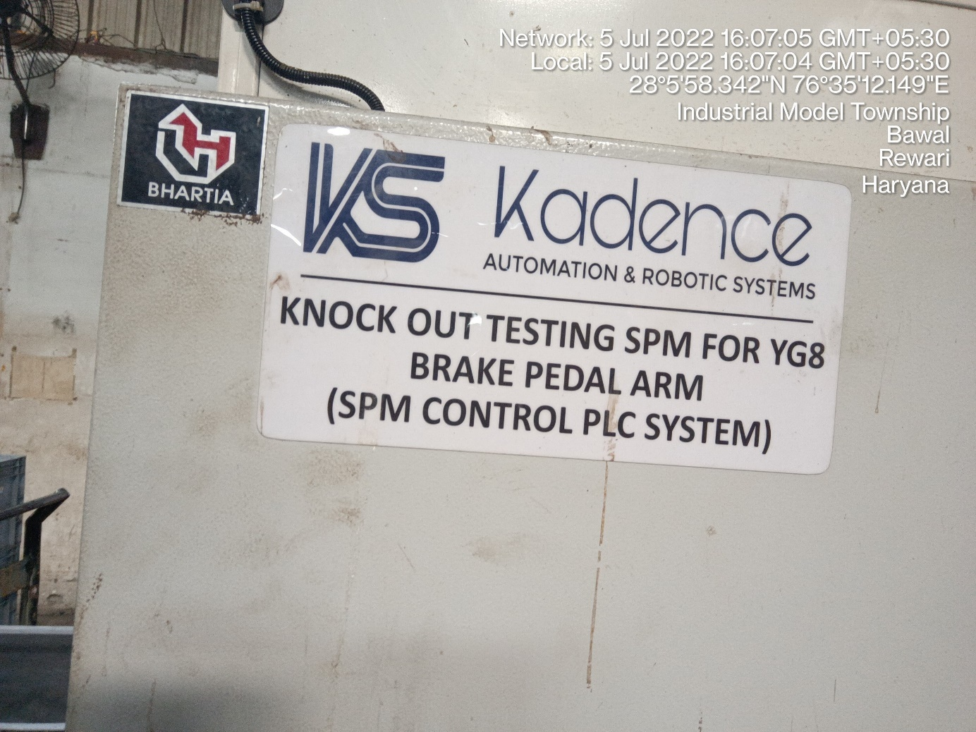
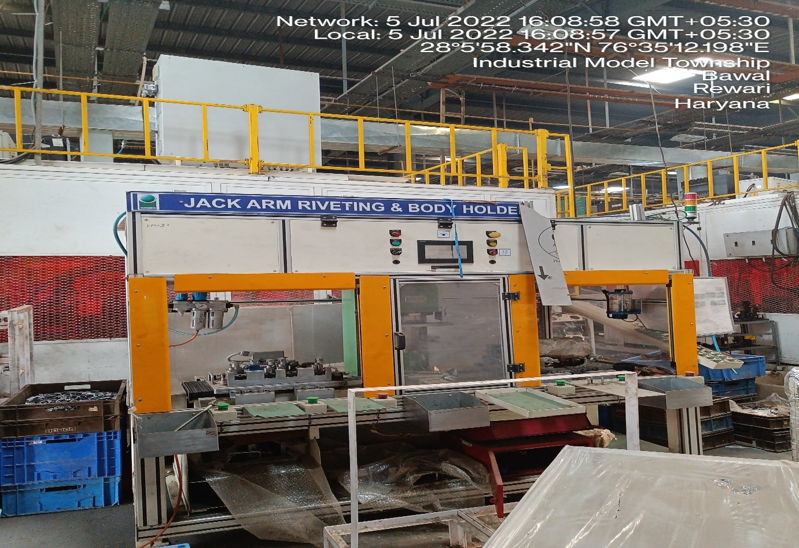
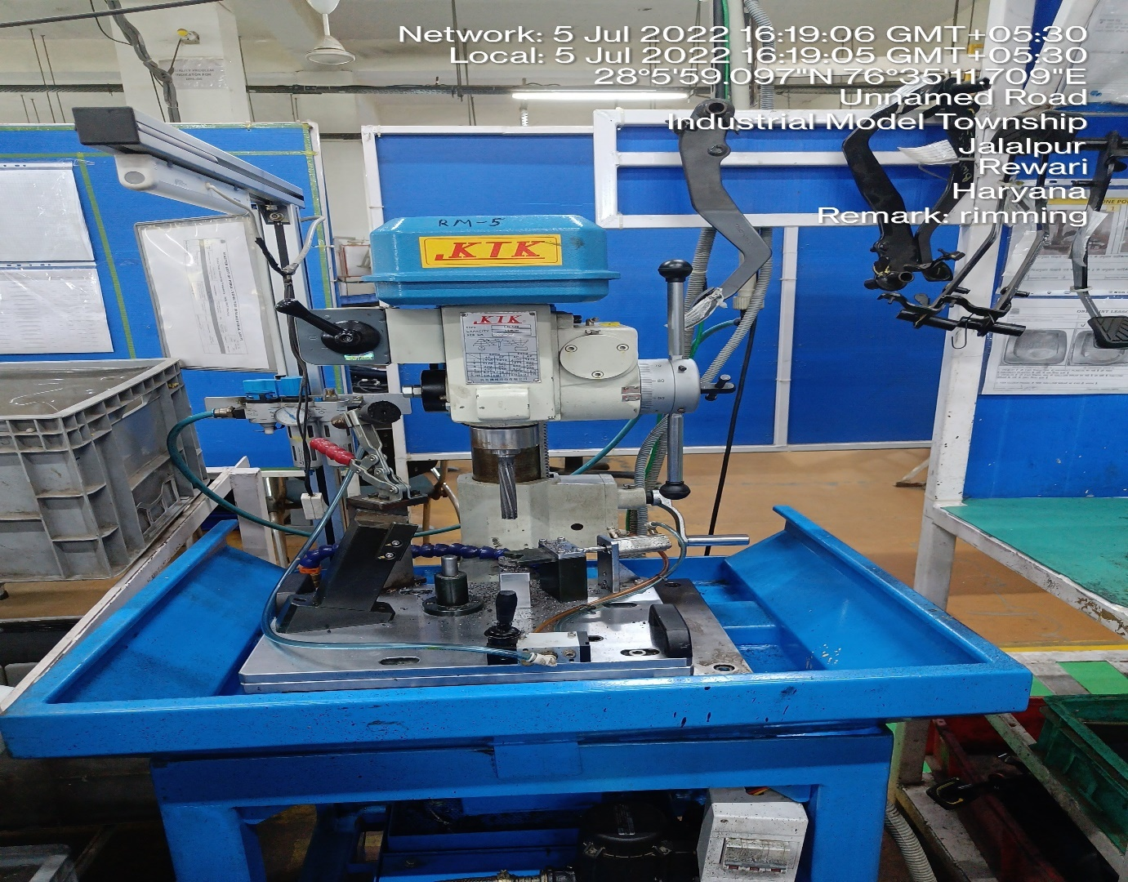
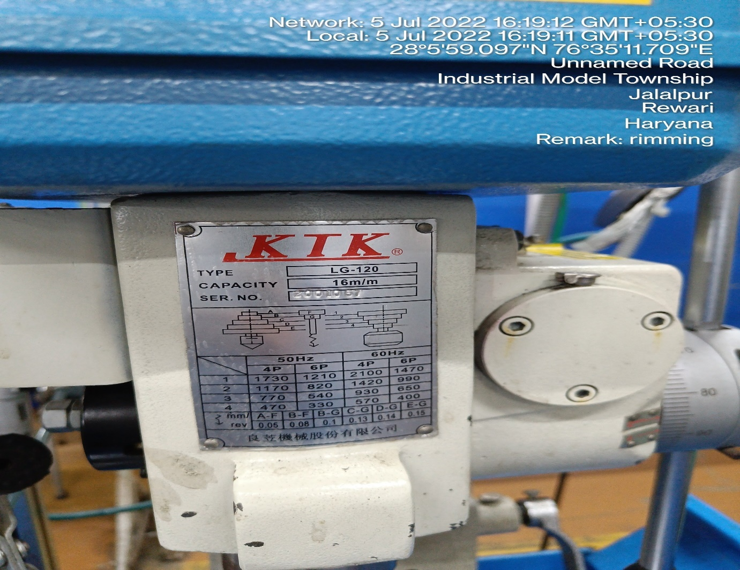
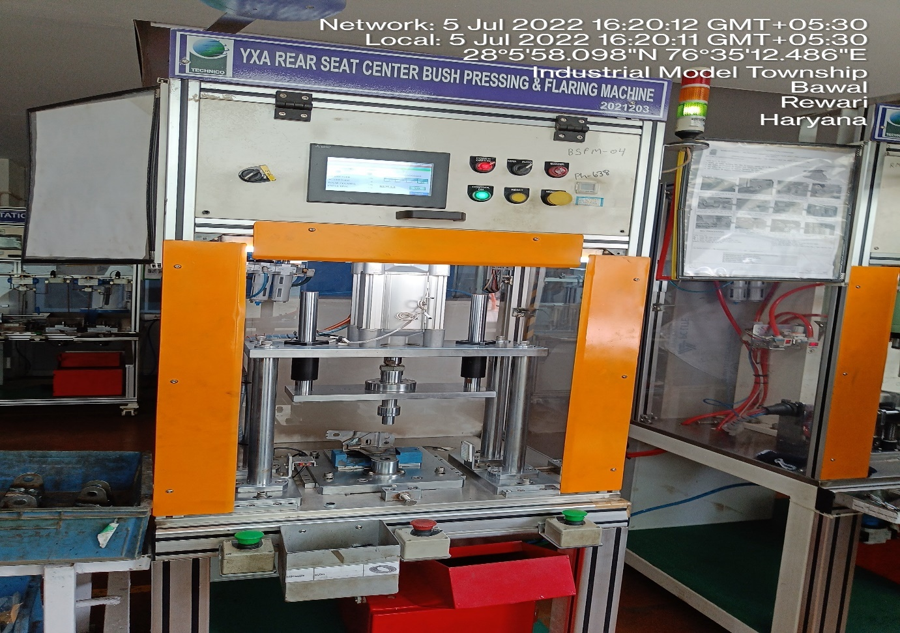
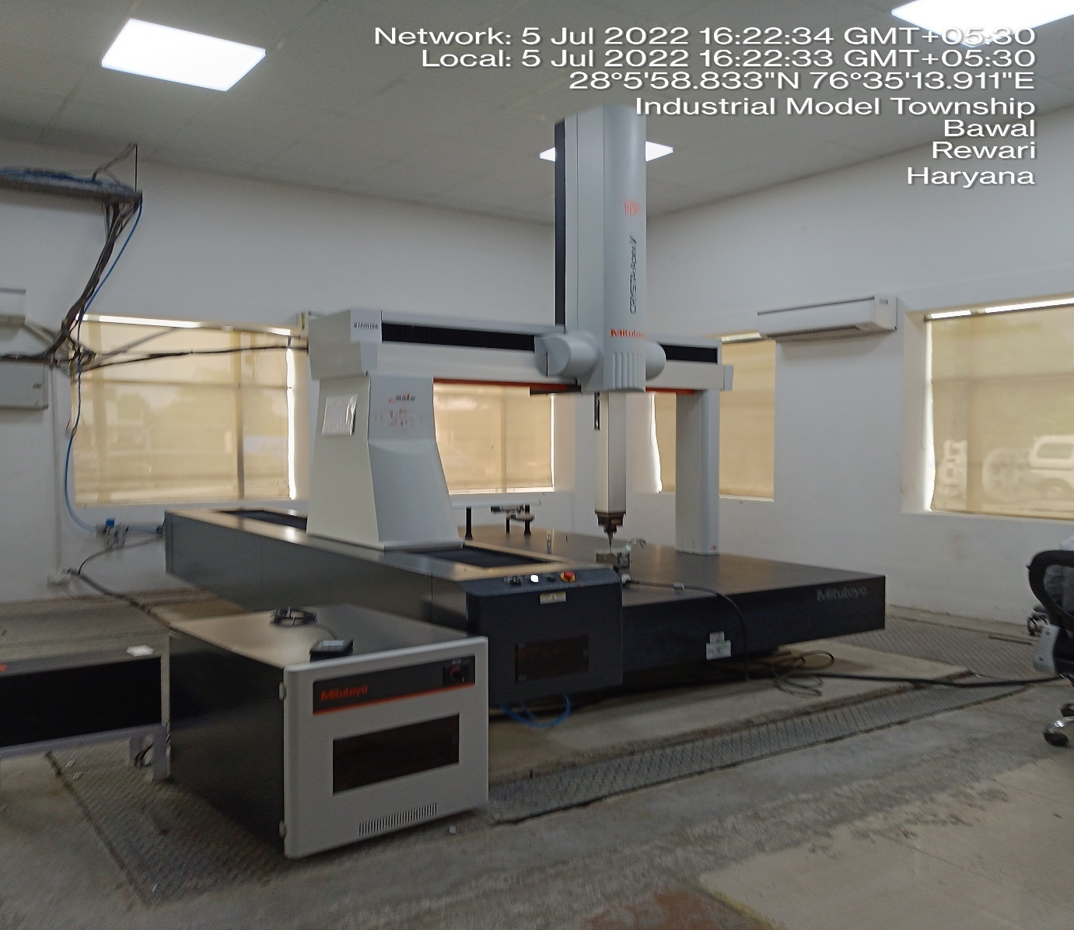
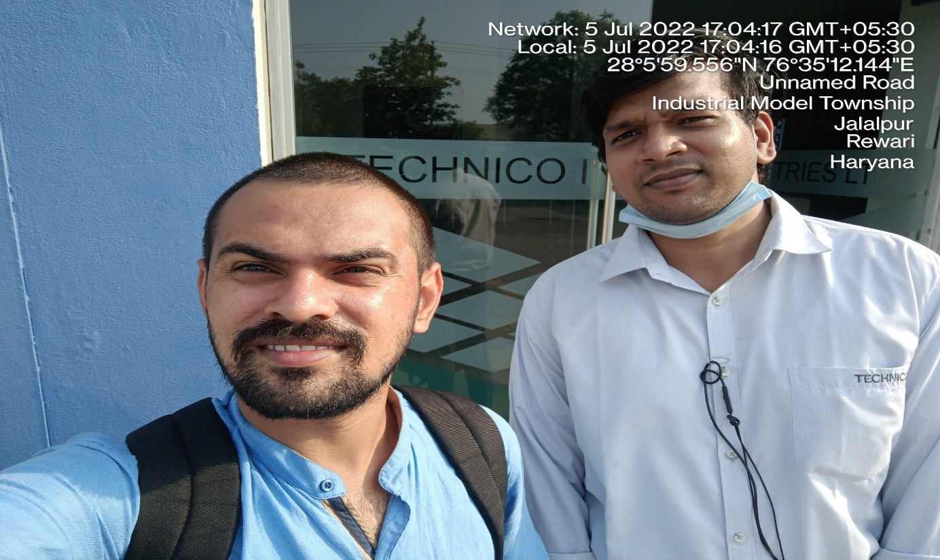
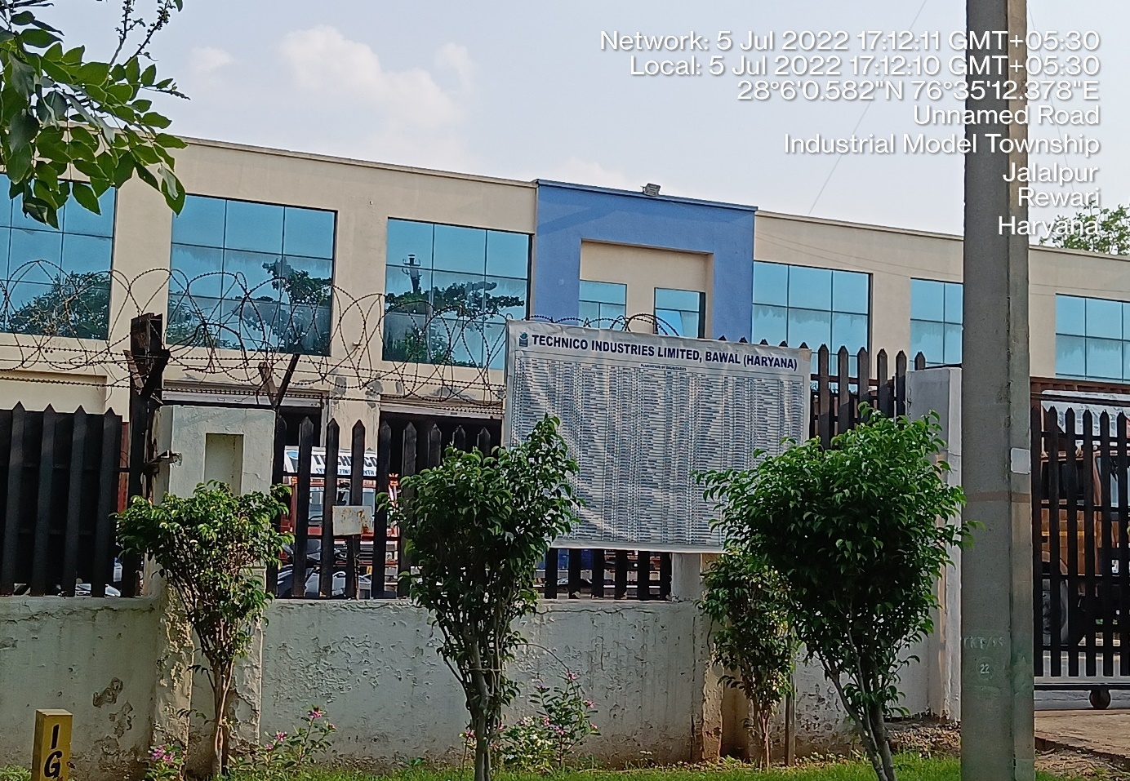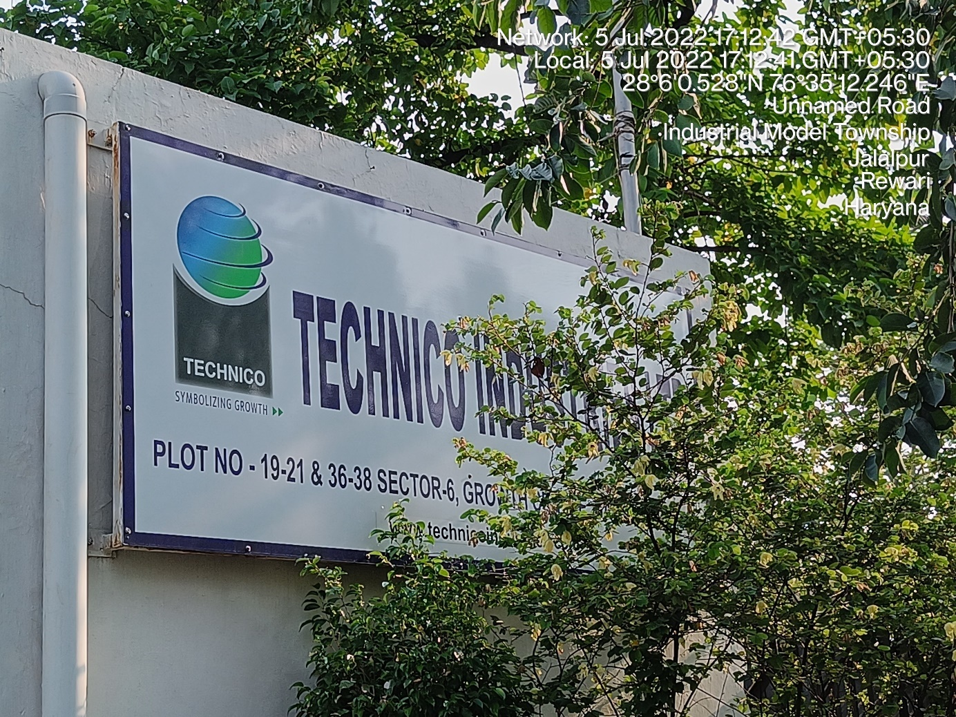
LOCATION 2: BENGALURU (KARNATAKA)

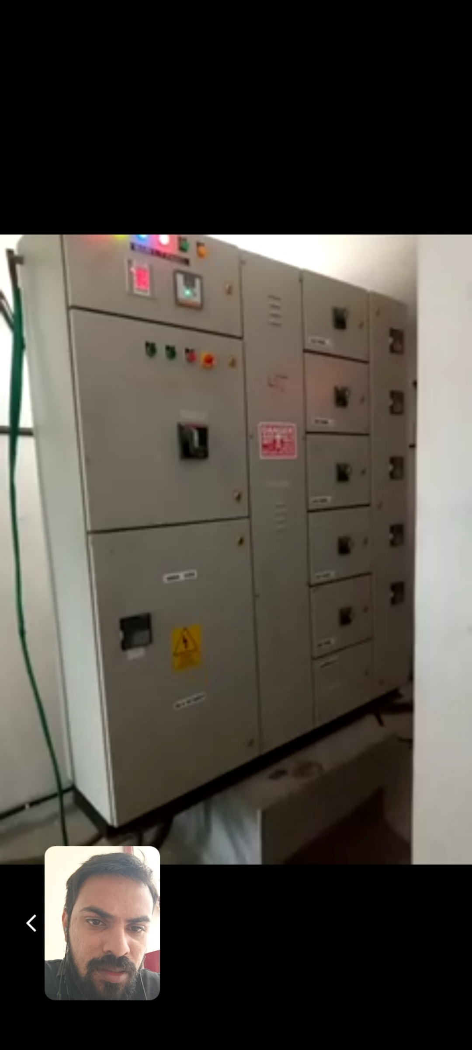
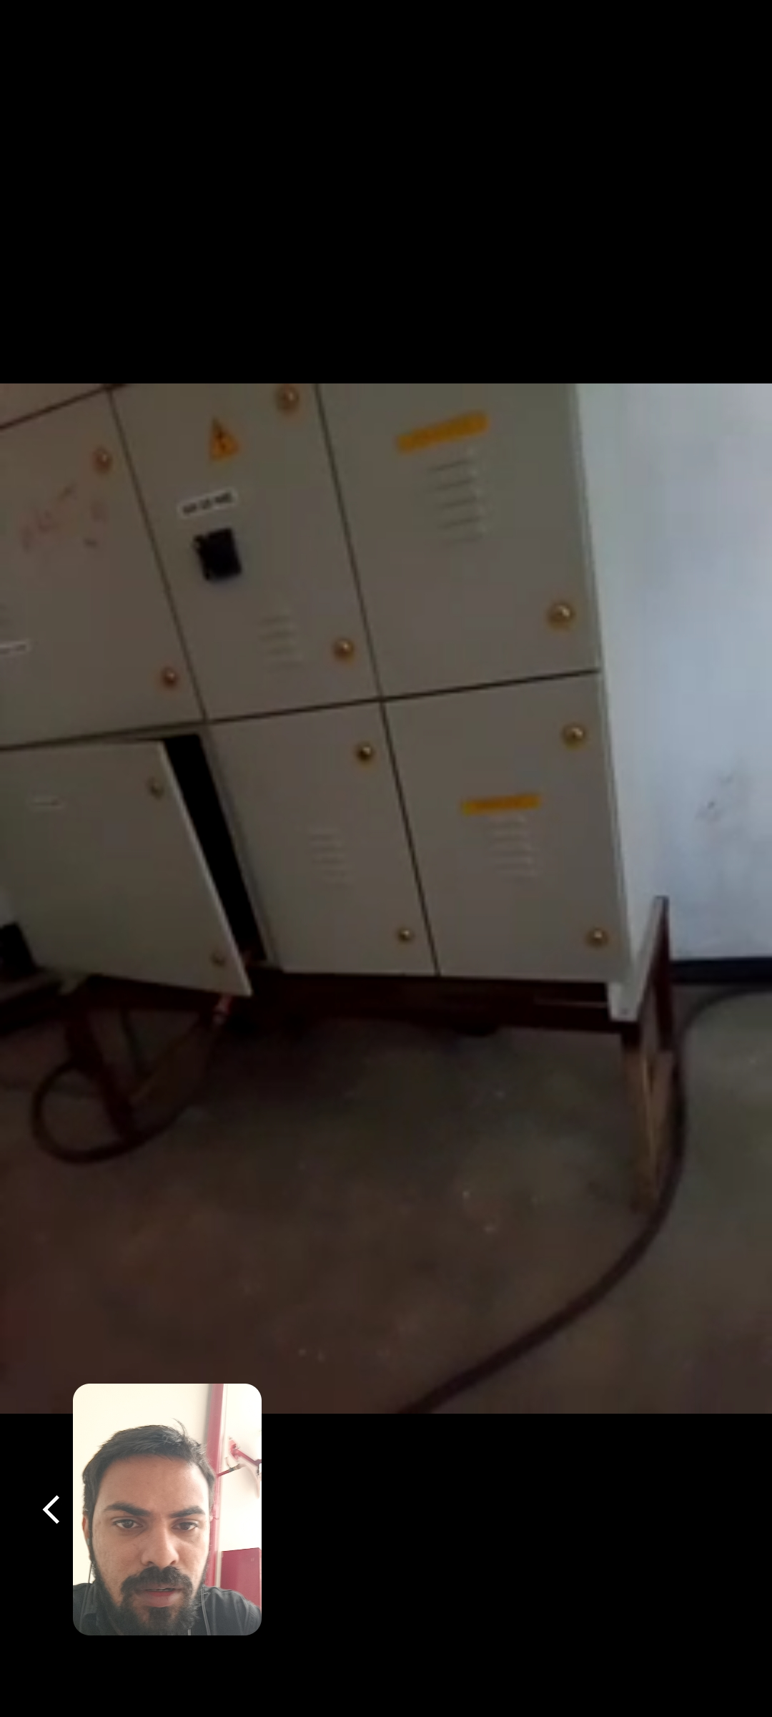
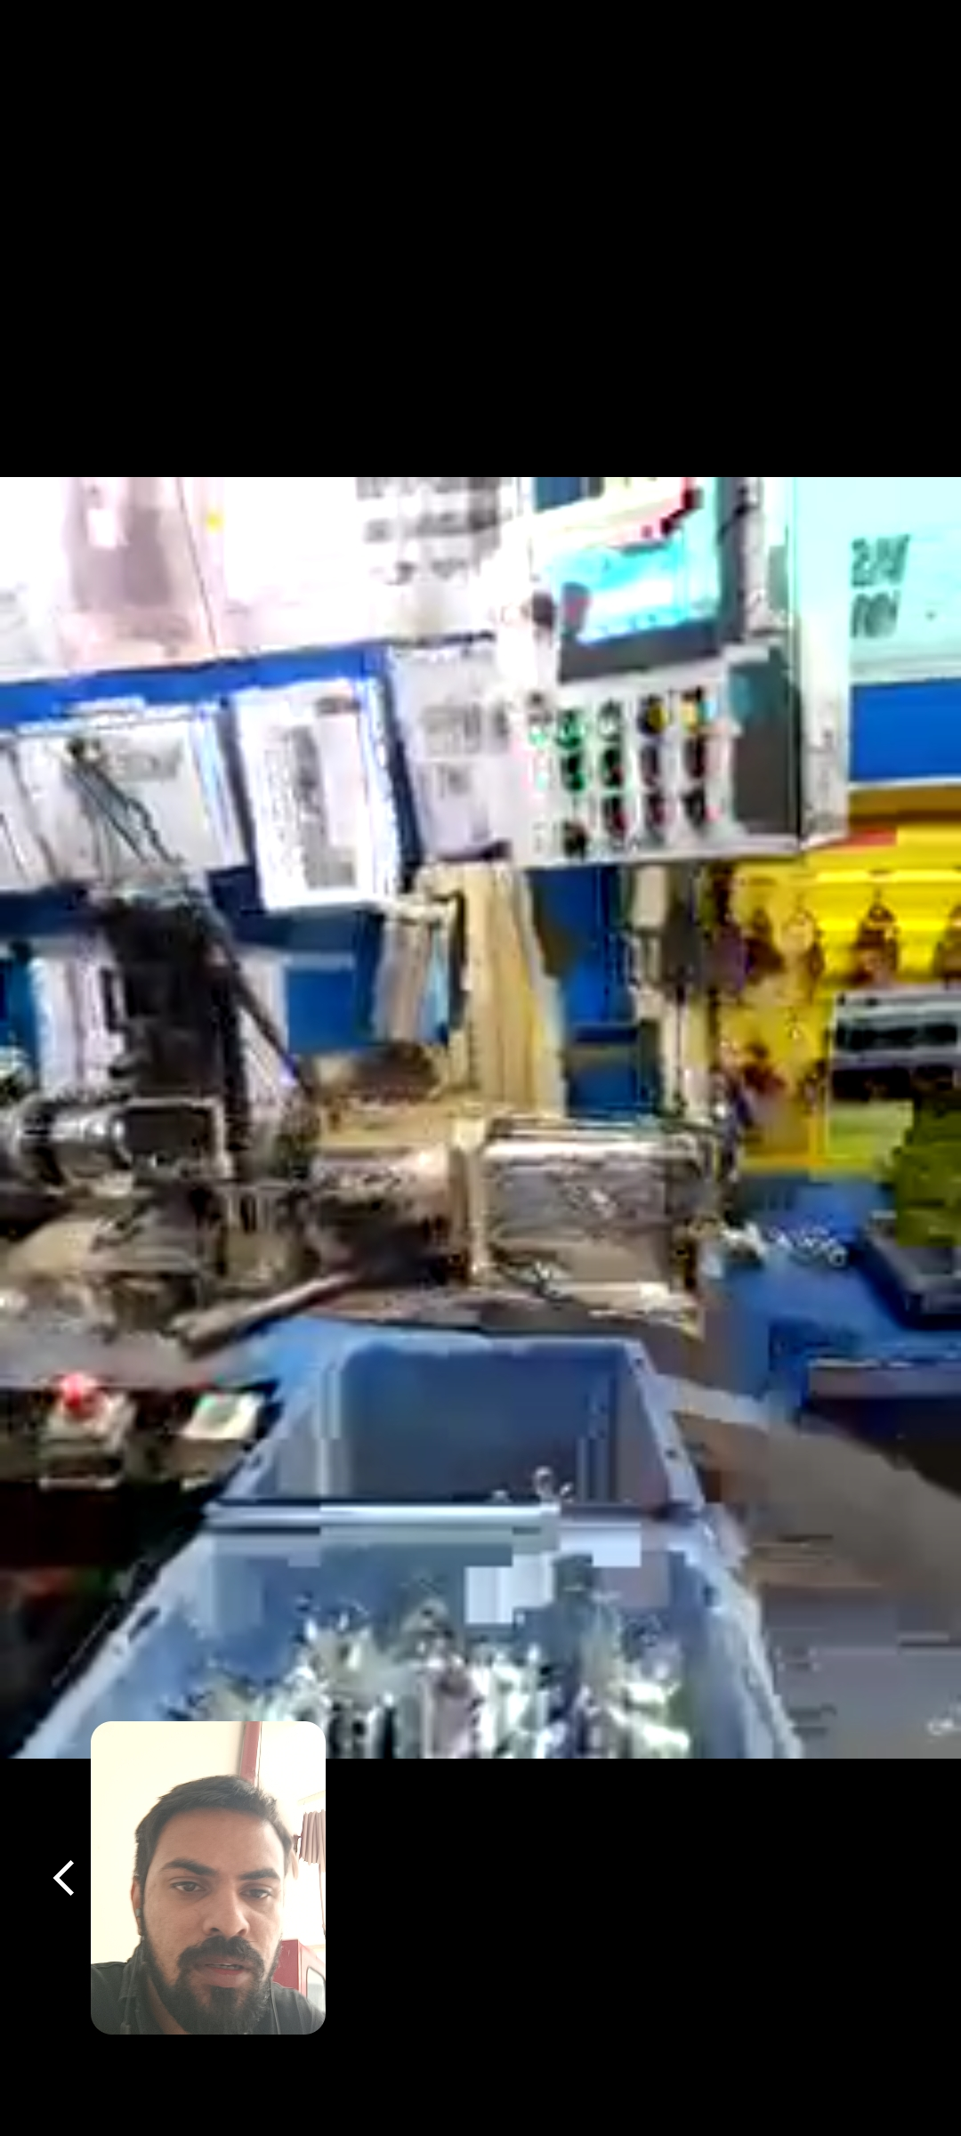
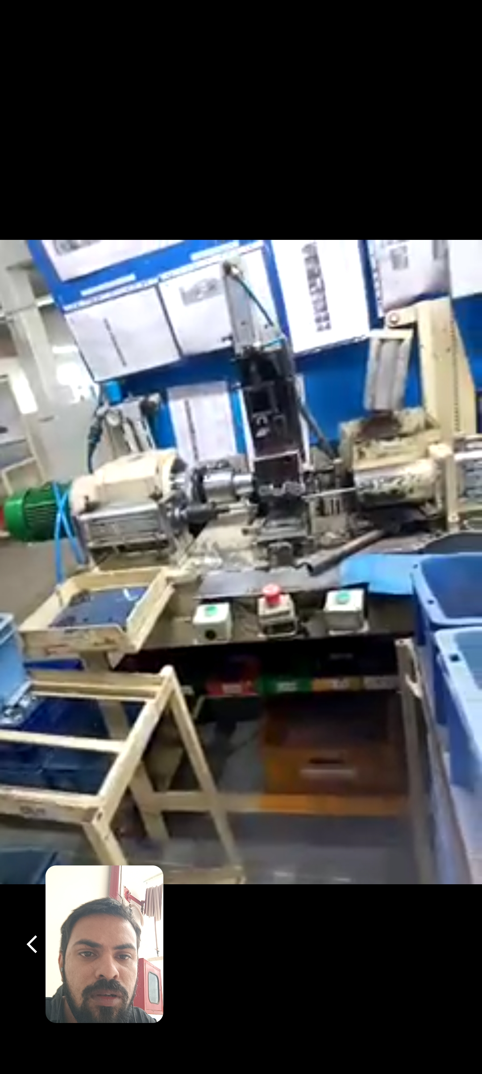
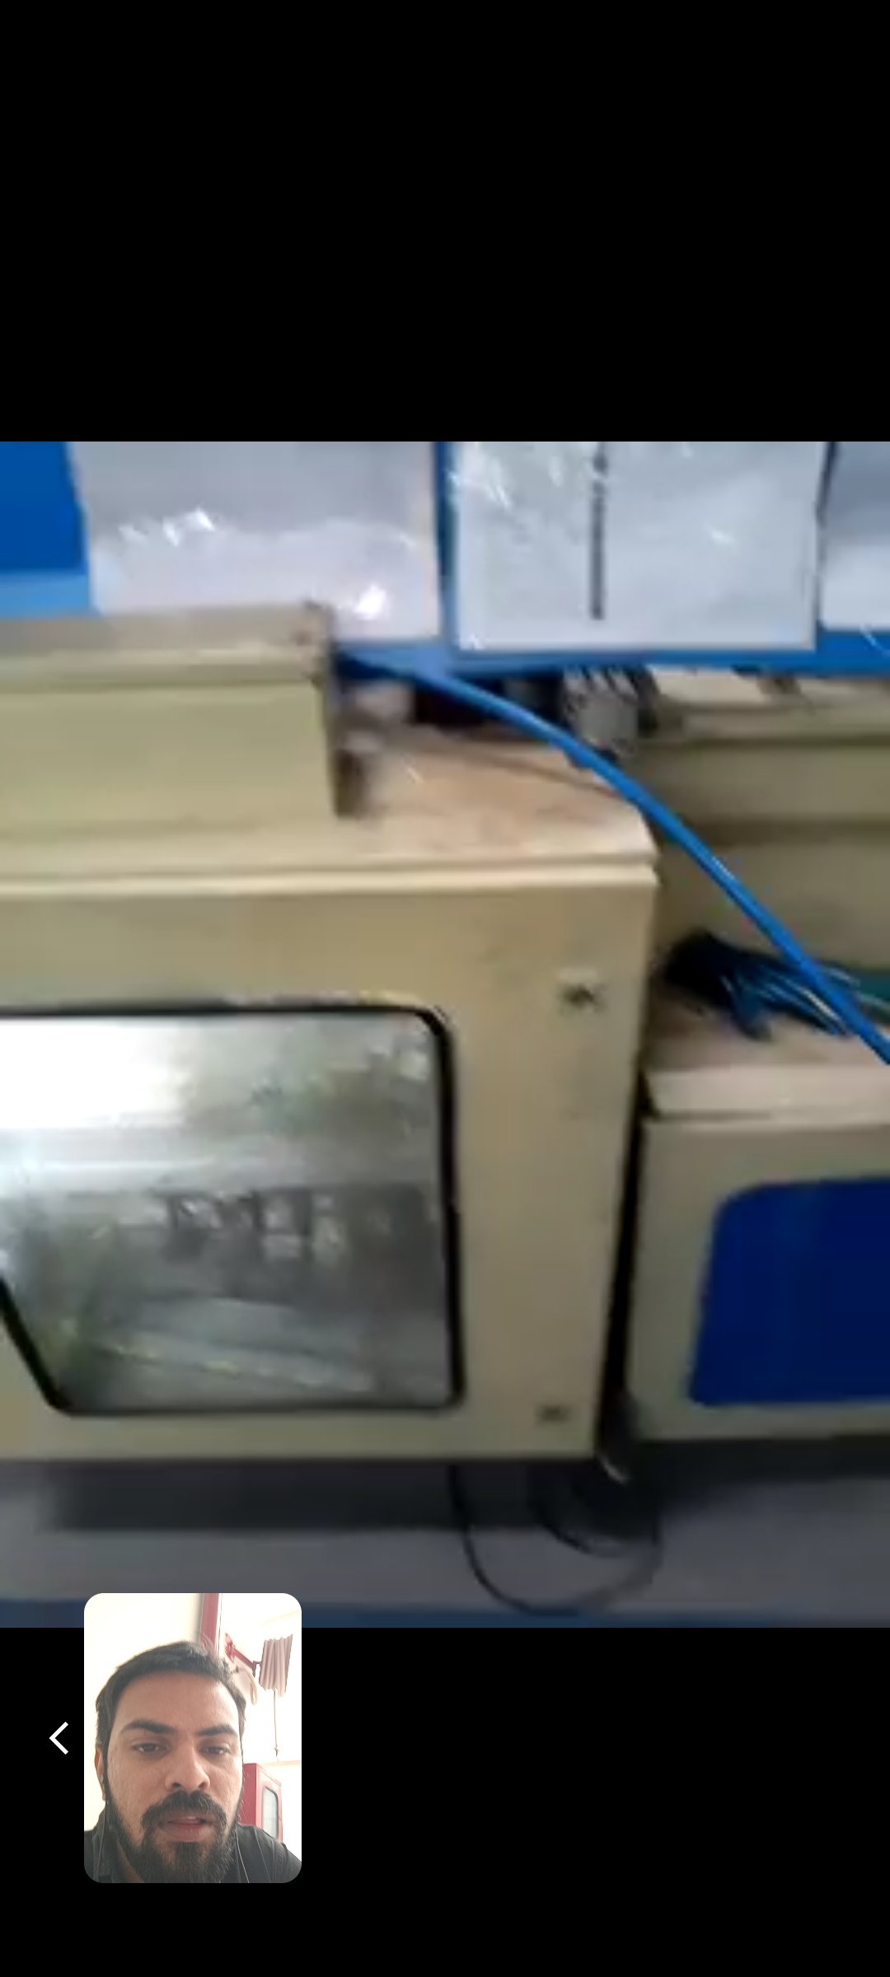
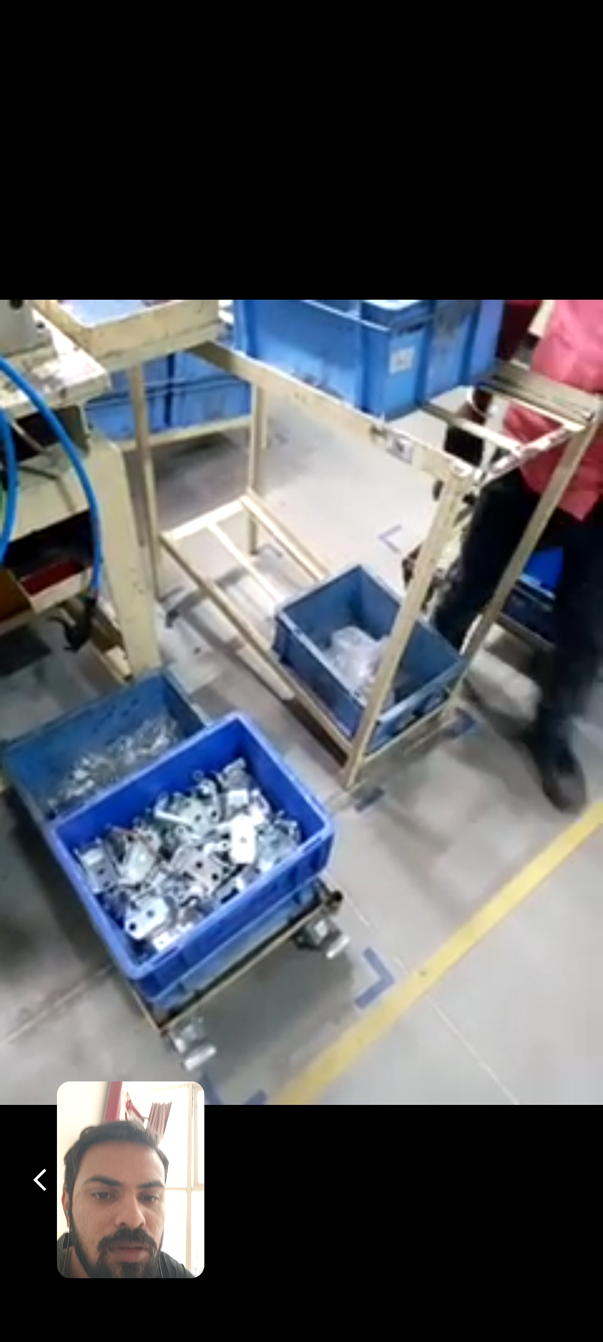
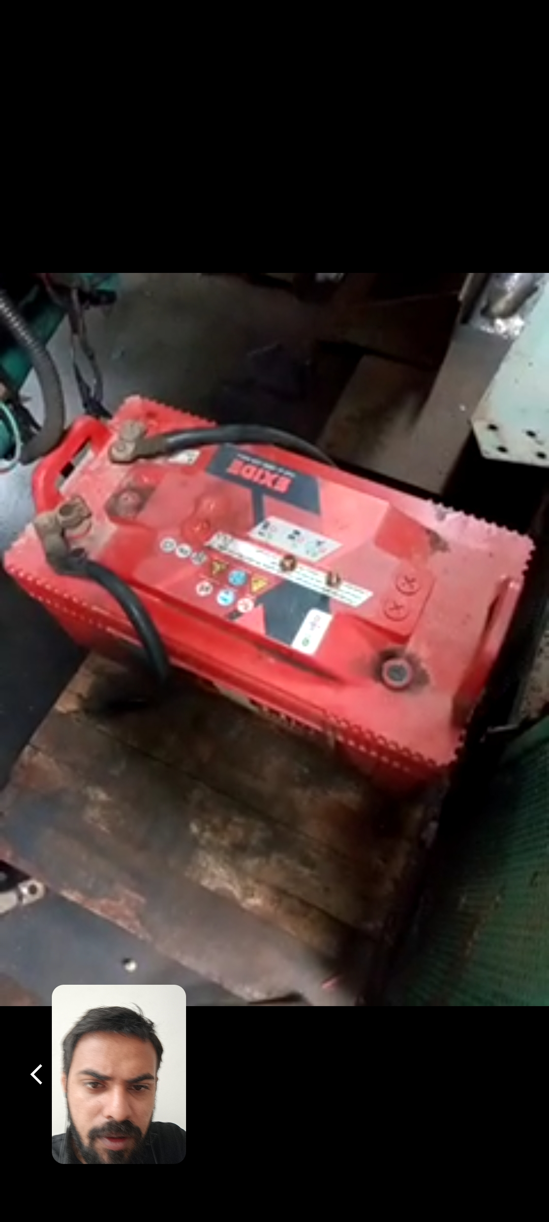
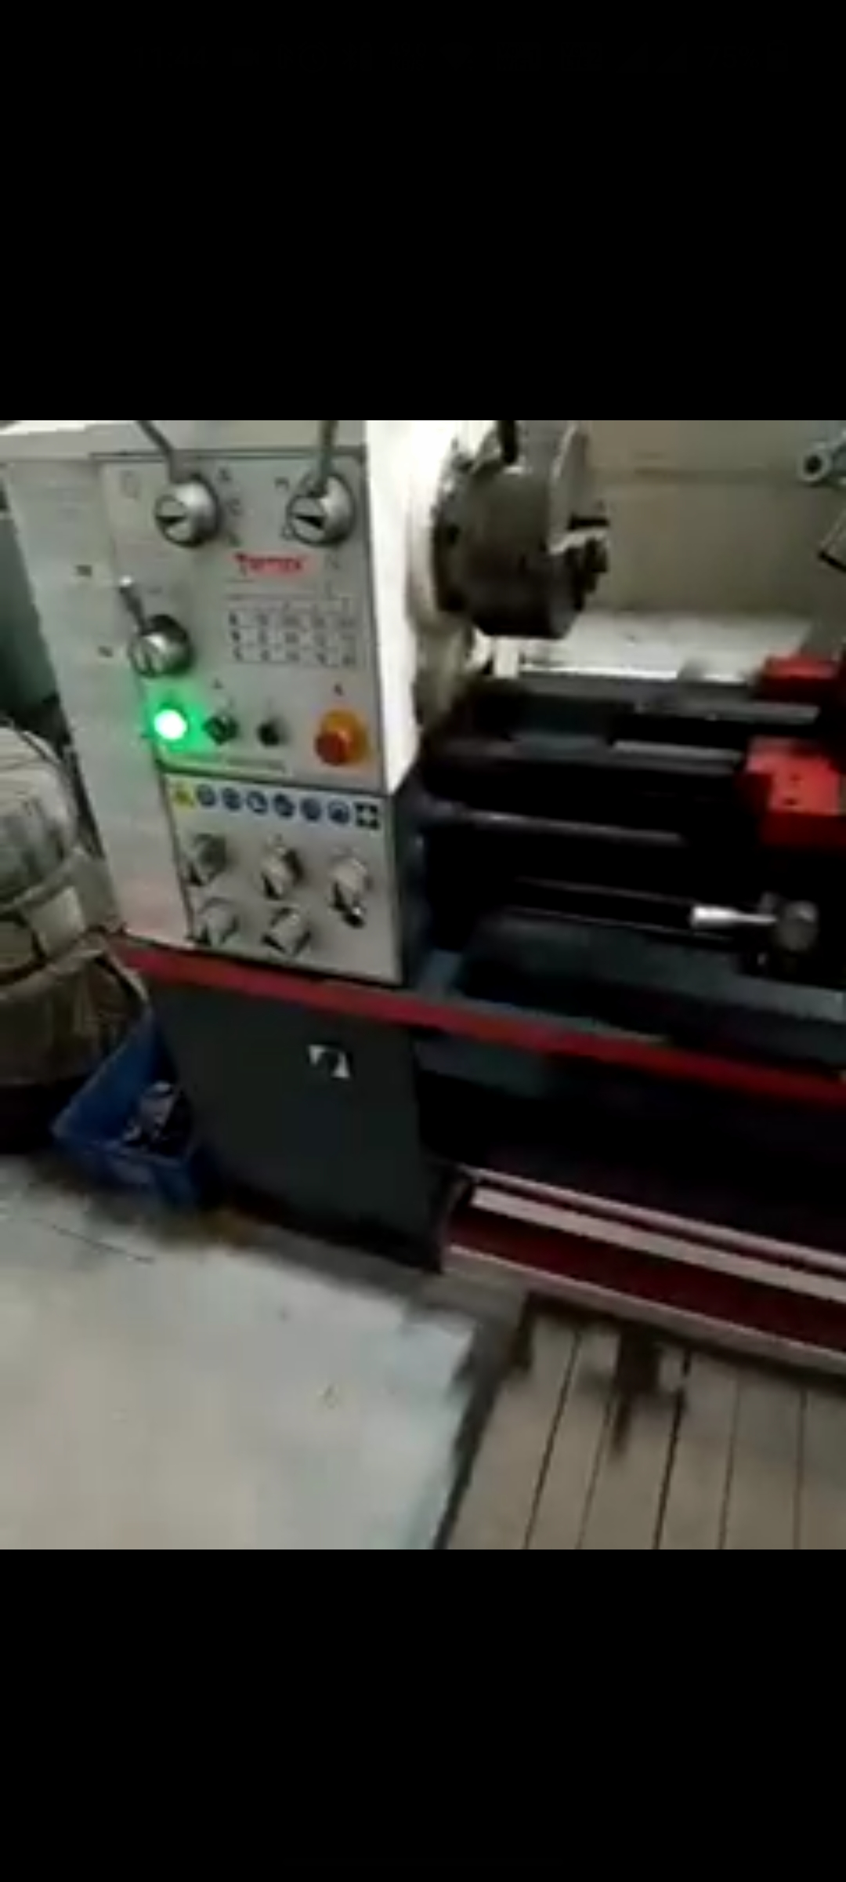
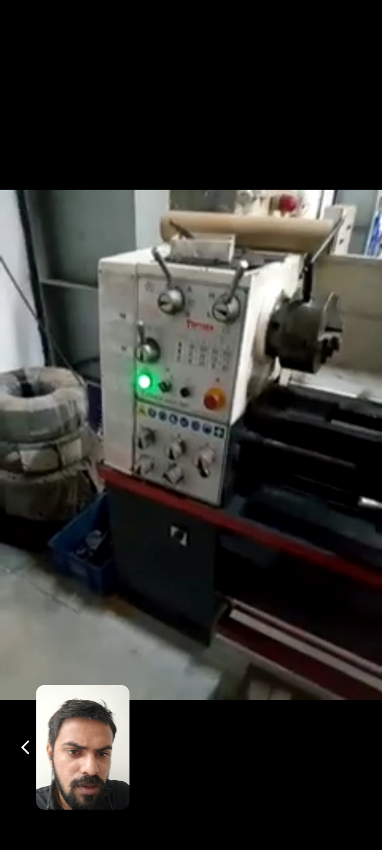

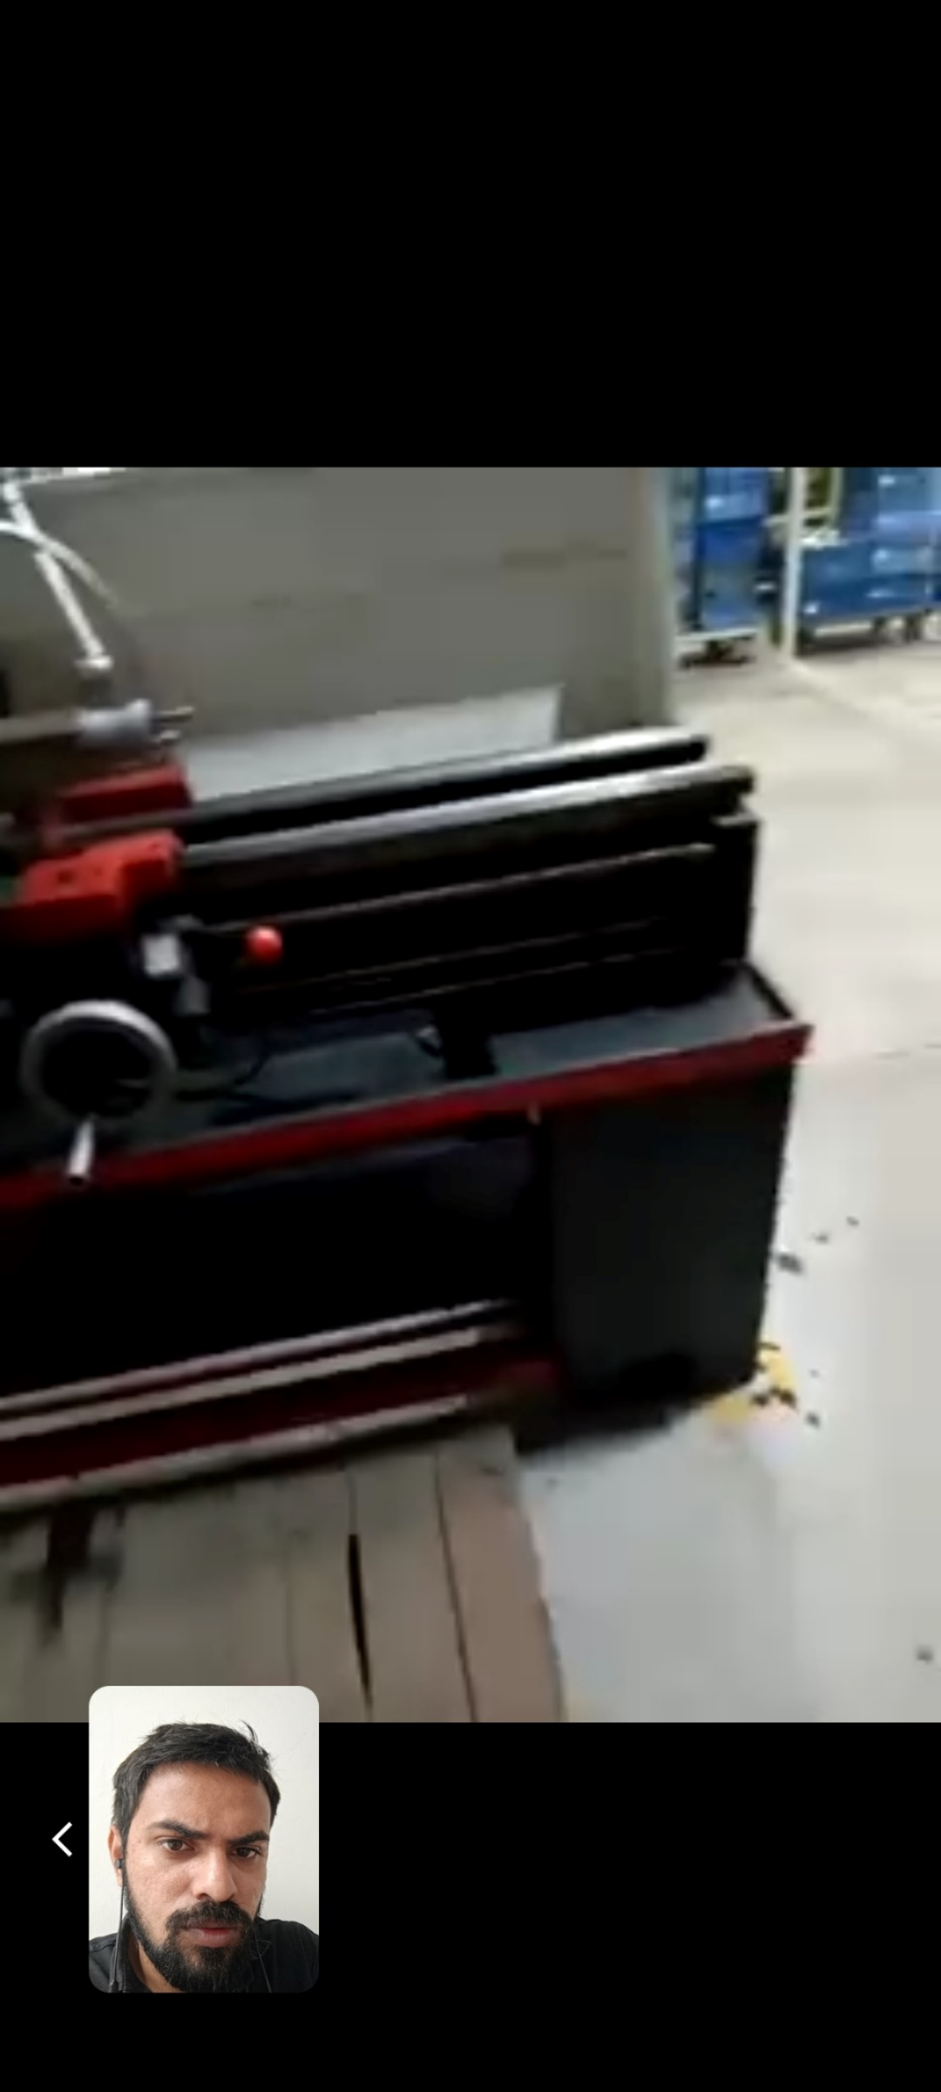
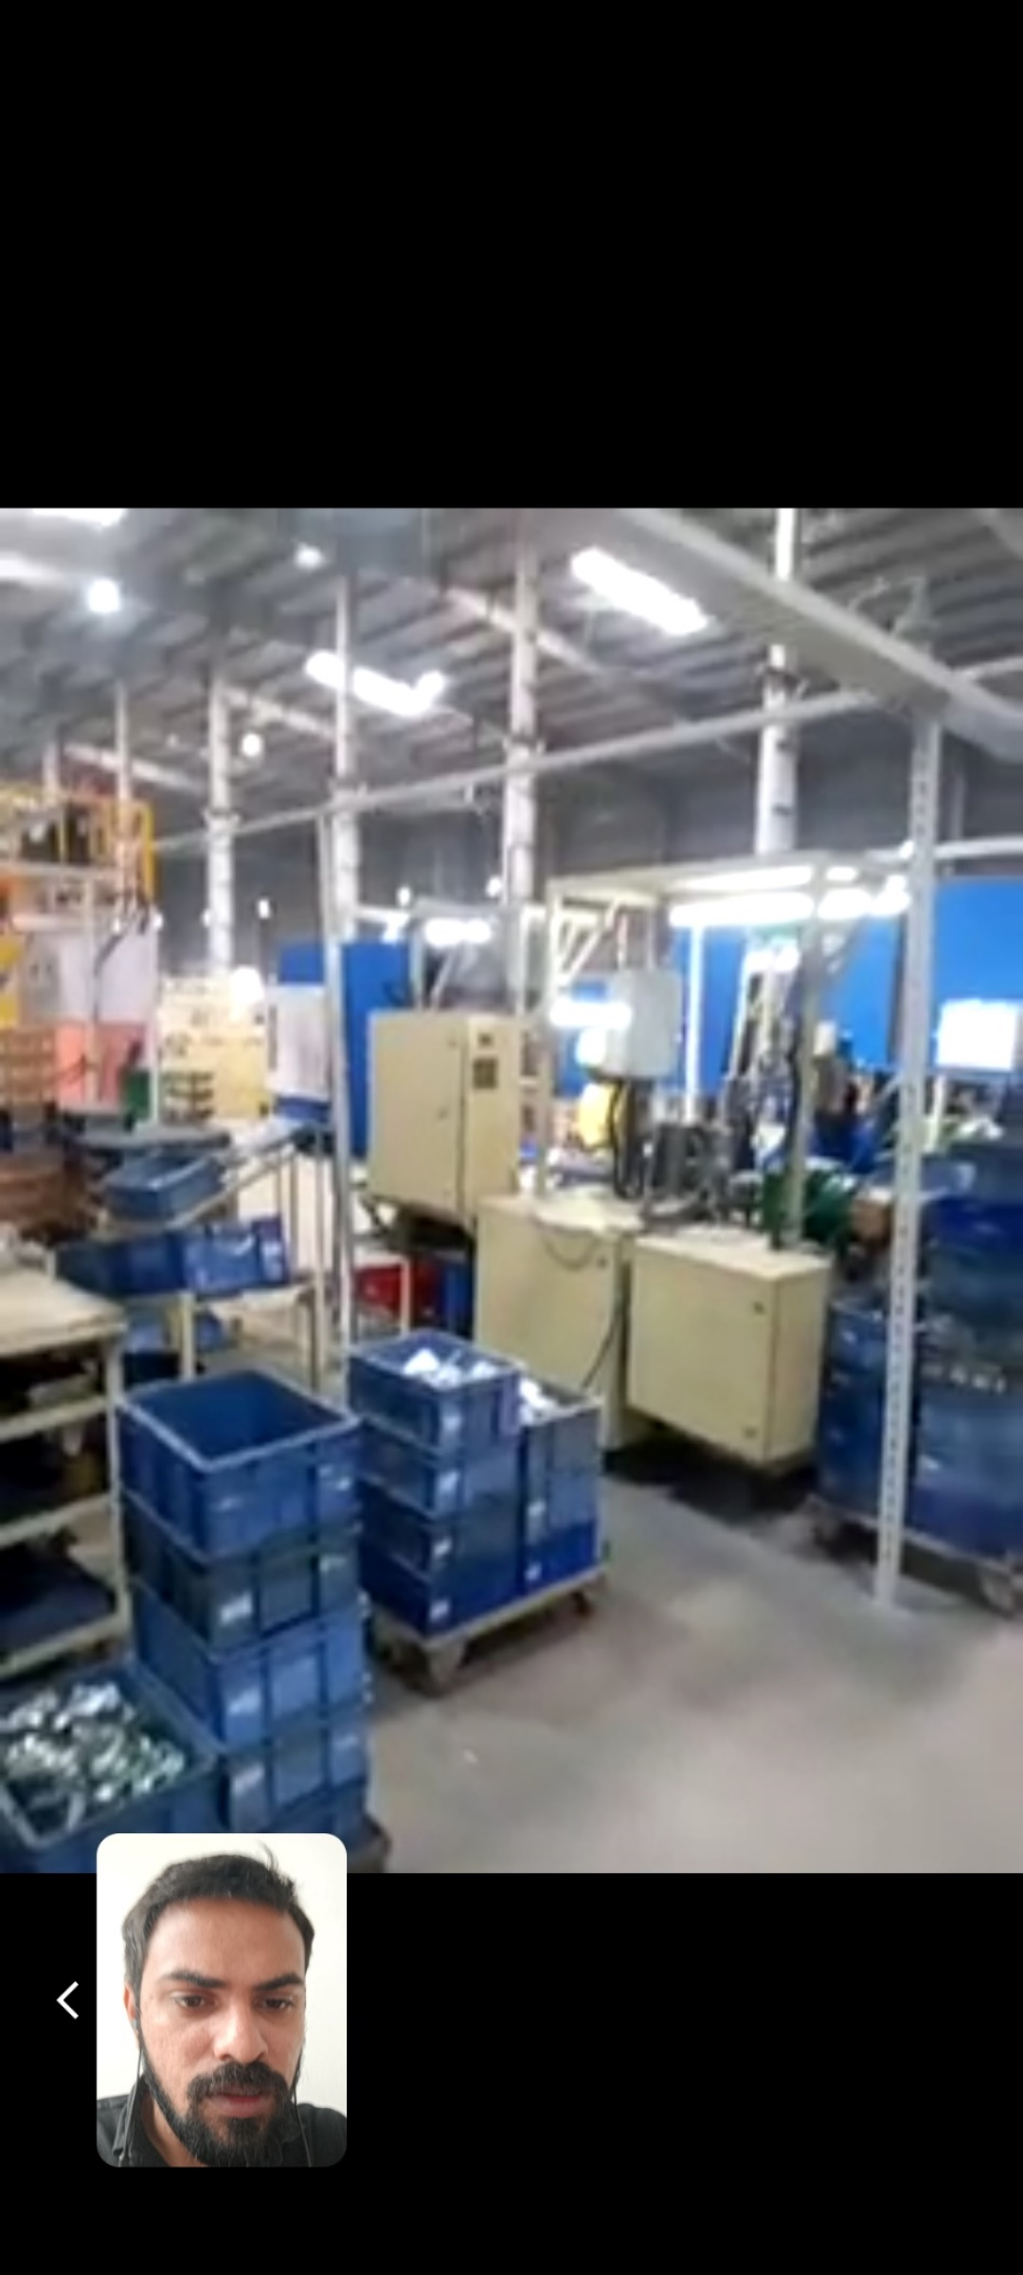
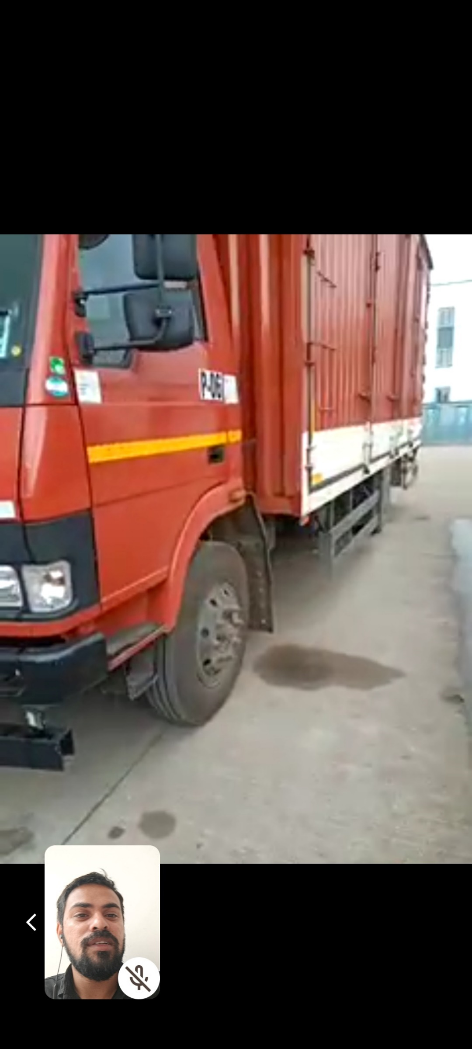
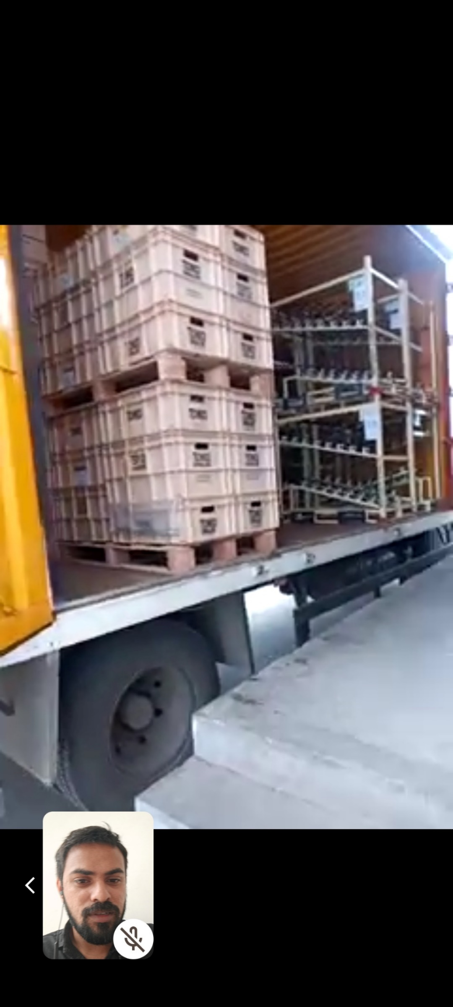
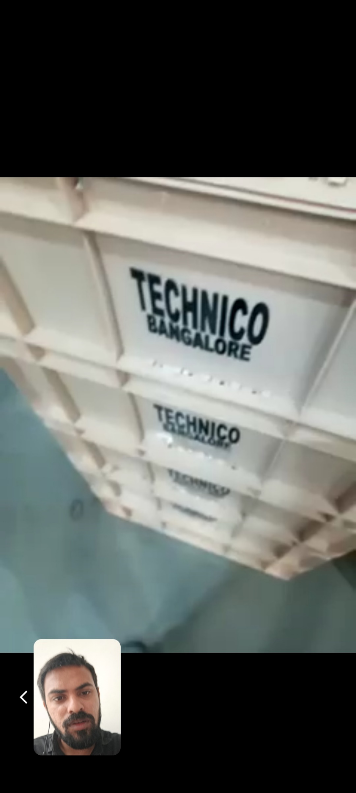
LOCATION 3: VANOD (GUJARAT)
