**REPORT FORMAT:** V-L5 | Version: 4.2_2017

**File No.: VIS (2022-23)-PL127-107-185 Dated: 02.09.2022**

**ENTERPRISE VALUATION REPORT**

**OF**

**M/S VICEROY HOTELS LIMITED**

**SITUATED AT**

**PLOT NO.20, SECTOR-I, SURVEY NO.64, 4th FLOOR, HUDA TECHNO ENCLAVE HYDERABAD TELANGANA - 500081**

**OWNER/ PROMOTER**

**SRI PRABHAKAR REDDY AND ASSOCIATES**

**REPORT PREPARED FOR**

**STATE BANK OF INDIA- STRESSED ASSETS MANAGEMENT BRANCH – II, D.NO.3-4-1013/A, 1st FLOOR, CAC, TSRTC BUS STATION, KACHIGUDA, HYDERABAD TELANGANA -500027**

***\*\*Important - In case of any query/ issue or escalation you may please contact Incident Manager***

***at valuers@rkassociates.org. We will appreciate your feedback in order to improve our services.***

***NOTE: As per IBA Guidelines please provide your feedback on the report within 15 days of its submission after which report will be considered to be correct.***

**IMPORTANT NOTICE**

***COPYRIGHT FORMAT:*** *This report is prepared on the copyright format of R. K. Associates Valuers & Techno Engineering Consultants (P) Ltd. (R. K. Associates) to serve our clients with the best possible information and analysis to facilitate them to take rational business decisions. Legally no one can copy or distribute this format without prior approval from R. K. Associates. It is meant only for the advisory/ reference purpose for the organization/s as mentioned on the cover page of this report. Distribution or use of this format or report or any of its content/ information/ data by any organization or individual other than R.K Associates will be seen as an unlawful act and necessary legal action can be taken against the defaulters.*

*This report is intended for the sole use of the intended recipient/s and contains material that is STRICTLY CONFIDENTIAL AND PRIVATE.*

***DEFECT LIABILITY PERIOD:*** *In case of any query/ issue or escalation you may please contact Incident Manager at valuers@rkassociates.org. Though adequate care has been taken while preparing this report as per its scope, but still we can’t rule out typing, human errors, over sightedness of any information or any other mistakes. Therefore, the concerned organization is advised to satisfy themselves that the report is complete & satisfactory in all respect. Intimation regarding any discrepancy shall be brought into our notice immediately. If no intimation is received within 15 (Fifteen) days in writing from the date of issuance of the report, to rectify these timely, then it shall be considered that the report is complete in all respect and has been accepted by the client up to their satisfaction & use and further to which R.K Associates shall not be held responsible in any manner.*

***Part H: R. K. Associates Important Disclaimer and Remarks*** *are integral part of this report and Feasibility assessment is subject to this section. Reader of the report is advised to read all the points mentioned in these sections carefully.*

| **TABLE OF CONTENTS** | | |
| --- | --- | --- |
|  | | |
| **SECTIONS** | **PARTICULARS** | **PAGE NO.** |
| **Part A** | **INTRODUCTION** | **4** |
| 1. About the Report | 4 |
| 1. Background | 4 |
| 1. Type of Report | 6 |
| 1. Purpose of the Report | 6 |
| 1. Scope of the Report | 6 |
| 1. Methodology/ Model Adopted | 7 |
| 1. Documents/ Data Referred | 7 |
| **Part B** | **Project Company** | **8** |
| 1. Executive Summary | 8 |
| 1. Directors’/Promoters of the Company | 9 |
| 1. Debt Position of the Company | 10 |
| 1. Capital Structure | 10 |
| 1. Shareholding Pattern | 10 |
| 1. Reason for Financial Stress | 11 |
| 1. Current Status of the Company | 13 |
| **Part C** | **The Project** | **14** |
| 1. Brief Description of the Project | 14 |
| 1. Impact of CoVID-19 | 14 |
| 1. Estimation of the Futuristic Operation | 15 |
| **Part D** | **Industry Overview** | **16** |
| 1. Introduction | 16 |
| 1. Market Size | 17 |
| 1. Recent Development/Investments | 18 |
| 1. Government Initiatives | 19 |
| 1. Way Forward | 20 |
| **Part E** | **Historical and Projected Financial Performance** | **21** |
| 1. Historical Profit & Loss Statement | 21 |
| 1. Key Financial Ratios | 21 |
| 1. Graphical Representation of Key Financial Metrics | 22 |
| 1. Historical Balance Sheet | 24 |
| 1. Projected Profit & Loss Statement | 25 |
| 1. Projected Key Financial Ratios | 26 |
| 1. Graphical Representation of Projected Key Financial Metrics | 27 |
| 1. Projected Balance Sheet | 28 |
| **Part F** | **Valuation of the Company** | **31** |
| 1. Methodology/ Model Adopted | 31 |
| 1. Calculation of Free Cash Flow to the Firm | 33 |
| 1. Key Inputs Used to Discount Cash Flows During the Projected Period | 33 |
| 1. Enterprise Valuation | 34 |
| 1. Sensitivity Analysis | 36 |
| 1. Key Assumptions for Financial Model | 37 |
| 1. Declaration | 40 |
| **Part G** | **Important Definition** | **41** |
| **Part H** | **Disclaimer and Remarks** | **43** |

|  |  |
| --- | --- |
| **PART A** | **INTRODUCTION** |

1. **ABOUT THE REPORT:** Enterprise Valuation report of M/s Viceroy Hotels Limited (VHL), Hyderabad having its business in hotel, restaurants and bars, registered at Plot No.20, Sector-I, Survey No.64, 4th Floor, HUDA Techno Enclave Hyderabad, Telangana, 500081.
2. **BACKGROUND**: M/s Viceroy Hotels Limited previously known as Palace Heights Hotels (PHHL) was incorporated in 1965. As per information available on company’s website, Viceroy Hotels Limited took up 150 Room 3 Star Hotel Project and commenced its commercial operations in 1993. From FY 1996 to FY 2006 the company had a major renovation and expansion with an aggregate of 297 rooms, a mega convention Centre, and conference and banquet halls.

Palace Heights Hotels Limited was originally incorporated as Krishna Cold Drinks Private Limited in Andhra Pradesh on 25th February 1965 under the Companies Act, the company name was changed to Shri Krishna Bottlers Private Limited and Palace Heights Hotels Private Limited on 10th November 1966 and 25th September 1990 respectively. Further the company was converted into Public Limited Company as on 28th September 1990 and a fresh incorporation certificate was obtained by it.

During 1994-95, PHHL’s room’s occupancy was 86% and income from food and beverage sales were twice that of the room revenue. It has the valued patronage of more than 400 corporate customers being in a position to offer all the facilities of a five-star hotel. The company has taken up expansion programme by adding 54 rooms with the existing 150 rooms. The capacity of the marriage hall has been increased from 1500 to 3000 person by acquiring additional land adjacent to the hall.

Thereafter the company name was changed to M/s Viceroy Hotel Limited with effect from 26th September 2001. Viceroy Hotels Board approved Rs 30 million investments in wholly owned subsidiary in 2003, to open a second restaurant at Texas, USA and finance the capital expenditure through wholly owned subsidiary company Mayuri India Cuisine Inc., Texas USA. The Board also approved the draft of franchisee agreement between Marriott International and Viceroys Hotels Ltd. The Hotel would have all the benefits/privilege of Marriott International Group for a period of 20 years as per the approved agreement.

Mr. P Chakradhar Reddy has been appointed as an Additional Director of the Company in 2014, currently the company is operating under his directorship. In 2011, registered office of the company has been shifted To D No. 8-2-120/115/14, 5th Floor, Shangrila Plaza, Road No.2, Opp. KBR Park, Banjara Hills, Hyderabad, Andhra Pradesh, 500034.

As per information provided by the company/client and information available in the company’s website & other public domains, currently M/s Viceroy is operating with 473 rooms in total out of which, 297 rooms are operated under the franchisee of hotel Marriot, 120 rooms are operated under the franchisee of courtyard Marriot and capacity of 56 rooms are available at Himayatnagar, Hyderabad. Cafe D Lake Private Limited, a company operating Fine Dine Restaurants and Bars in Hyderabad and Vijayawada, which owns Fine Dine Restaurants in the name and style of "Minerva Coffee Shop" and Fine Dine Bars in the name and Style of "Blue fox" is one of the subsidiary of M/s Viceroy Hotels Limited.

**HISTORICAL FINANCIAL PERFORMANCE OF THE COMPANY:** Below table shows the historical financial performance of the company from FY 2018 to FY 2022:

|  |  |  |  |  |  |
| --- | --- | --- | --- | --- | --- |
| **Particular (In INR Crores)** | **FY 2018 A** | **FY 2019 A** | **FY 2020 A** | **FY 2021 A** | **FY 2022 A** |
| Revenue from Operations | 83.83 | 88.09 | 88.11 | 24.65 | 46.89 |
| Other income | 17.07 | 0.45 | 0.26 | 0.10 | 0.09 |
| **Total Income** | **100.90** | **88.53** | **88.37** | **24.74** | **46.98** |
| **Total expenses** | **73.99** | **81.52** | **86.17** | **36.08** | **47.07** |
| **EBITDA** | **26.91** | **7.01** | **2.20** | **(11.33)** | **(0.09)** |
| Depreciation and Amortization | 8.33 | 9.18 | 8.93 | 8.50 | 8.50 |
| **EBIT** | **18.58** | **(2.17)** | **(6.72)** | **(19.83)** | **(8.59)** |
| Finance Costs | 20.72 | 0.73 | 0.52 | 0.30 | 0.43 |
| Exceptional Items | 426.60 | 7.04 | - | (20.14) | - |
| **Profit/(Loss) before tax** | **(428.74)** | **(10)** | **(7.25)** | **(20.14)** | **(9.02)** |
| Tax expense: |  |  |  |  |  |
| Current Tax | - | - | - |  |  |
| Deferred tax | 9.89 | 2.56 | 1.95 | (3.86) | 0.82 |
| **Profit (Loss) after Tax for the period** | **(438.63)** | **(12.49)** | **(9.20)** | **(16.27)** | **(9.85)** |
| **Total Comprehensive Income for the year** | **(438.63)** | **(12.49)** | **(9.20)** | **(16.27)** | **(9.85)** |
| ***EBITDA Margin %*** | 26.67% | 7.92% | 2.49% | -45.81% | -0.19% |
| ***EBIT Margin %*** | 18.41% | -2.45% | -7.61% | -80.16% | -18.29% |
| ***Net Profit Margin %*** | -434.72% | -14.11% | -10.41% | -65.77% | -20.96% |
| ***Revenue Growth % (Y.O.Y.)*** |  | -12.26% | -0.18% | -72.00% | 89.86% |

**Note:** As per the historical analysis shown above, it can be observed that the Company has achieved a gross turnover of Rs.46.98 Crores for the period ended March 31, 2022 as against Rs. 24.74 Crores for the previous year ended March 31, 2021. On an annual basis, turnover for the current period ended March 31, 2022 increased by 89.86% percent as compared to the previous period. The company is having a negative operating profit margins from last few years which shows the lack of capacity utilization efficiently and financial stress of the company.

As per information provided by the client/company officials and information, the company is not able to fulfill its financial obligation due to financial stress. Currently, the company is announced as NPA and it is under CIRP.

Hon'ble National Company Law Tribunal (NCLT), Hyderabad has vide order dated 12th March 2018, ordered for initiation of Corporate Insolvency Resolution Process (CIRP) against M/s Viceroy Hotels Limited, Hyderabad and the powers of Board of Directors are Suspended vide the said order. As per NCLT order as on 13th April 2022, Dr. G.V Narasimha Rao having registration number IBBI/IPA-003/IP-N00093-2017-2018/1089 is appointed as Resolution Professional of the company.

**Thus for the purpose of decision making on resolution of this stressed account, SBI bank has assigned R K Associated to assess & determine the Enterprise Value/Fair Market Value of M/s Viceroy Hotels Limited** **as per scope of work, to execute the appropriate action by the decision makers on this NPA account.**

1. **TYPE OF REPORT:** Enterprise Valuation Report.
2. **PURPOSE OF THE REPORT:** To assess & determine the Enterprise Value of the company under implementation as a whole as required by the lenders.
3. **SCOPE OF THE REPORT:** To assess & determine the Business Value/ Enterprise Value of the Company by using appropriate approach, considering the fact that Viceroy Hotels Limited is under CIRP.

* *This is just the enterprise valuation of the Business/Company based on the income generating capacity of the project in future years. This report is only limited to enterprise valuation by using income based approach. This Valuation shall not be construed as the physical asset valuation or should not be directly related to cost approach or Project cost.*
* *This Valuation only covers the cash flow from operation of the company. It does not cover any transaction with the subject company’s subsidiary/ associate/ Joint Venture Companies, as per the requirement by the lender.*
* *This Valuation is prepared based on the current financial status and projections of the company, financial data/ model, future projections, other facts & information provided by the company/ lender/ Client in writing & verbal discussions held during the course of the assignment and based on independent assessment of certain assumptions which are specifically mentioned in the Valuation section of the Report.*
* *We have assumed that the information provided to us is correct and is not manipulated or distorted.*
* *The Market and Industrial assessment of the given company’s industry/ sector has not been done at our end. So, this valuation doesn’t cover the Market & industrial scenario in terms of the product demand & market potential.*

1. **METHODOLOGY/ MODEL ADOPTED:** Income based approach(DCF)method for the calculation of Enterprise/Business Value of the Company.
2. **DOCUMENTS / DATA REFFERED:**

* Last 5 years audited financial statement of the company as on 31st March 2022.
* Details of the directors of the company.
* Shareholding pattern of the company.
* Details of outstanding dues as on 31th March 2022.
* Details of Outstanding Debt of M/s Viceroy Hotels Limited.
* Details of Fixed Assets Register and current assets of the company as on 31th March 2022.
* National Company Law Tribunal Order.

|  |  |
| --- | --- |
| **PART B** | **THE PROJECT COMPANY** |

1. **EXECUTIVE SUMMARY:** M/s Viceroy Hotels Limited is a 5 star hotel under the brand of “Marriott”. It is situated Opposite Hussain Sagar Lake, Lower Tank Bund Road, Kavadiguda, Hyderabad, India. This hotel is located at about 3 KM distance from Secunderabad railway station, 5 KM from Hyderabad railway station and 34 KM from Hyderabad International Airport. The incorporation details of the Project Company are provided in the table below:

|  |  |
| --- | --- |
| **INCORPORATION DETAILS** | |
| **Name of the Company** | M/s Viceroy Hotels Limited |
| **CIN** | L55101TG1965PLC001048 |
| **Address** | **Registered Office:** Plot No.20, Sector-I, Survey No.64, 4th Floor, HUDA Techno Enclave Hyderabad TG 500081 |
| **Constitution** | Public Limited Company / Limited by Shares |
| **Date of Incorporation** | 25th February 1965 |
| **Authorised Capital** | INR 55,00,00,000 |
| **Paid up Capital (Equity)** | INR 42,40,52,240 |
| **Listed Year** | 2007 |

Hotel Viceroy is a sophisticated new-generation hotel which provides royal luxury to businessmen and tourists. The hotel is an architectural masterpiece with majestic appeal lush greenery tranquil fountains and it is bestowed with an enchanting view of the Buddha statue in the Hussain Sagar Lake. It has a beauty parlour a health club with gymnasium a swimming pool and a shopping arcade.

The hotel has the facility of three conference rooms of different sizes for organising meetings, seminars, conferences etc. The company has been in the hotel or restaurant business for over 50 years and under the present management for over the past 30 years with successful and popular restaurant and hotel chains in India. As per information available in annual report of the company, M/s VHL has 5 subsidiaries as on 31st March 2021. There has been no material change in the nature of the business of the subsidiaries. Below table shows the details of subsidiaries of M/s VHL:

|  |  |
| --- | --- |
| **Name Of The Subsidiaries** | **Proportion Of Interest** |
| **Cafe De Lake Pvt. Ltd** | 100% |
| **Crustums Products Pvt. Ltd** | 100% |
| **Minerva Hospitalities Pvt. Ltd** | 100% |
| **Viceroy Chennai Hotels & Resorts Pvt. Ltd.** | 100% |
| **Banjara Hospitalities Private Limited** | 100% |

***Source****: Annual Report FY 2020-2021*

**Café D Lake Private Limited:** Café D’ Lake Private Limited which operates all the restaurants businesses of Minerva Coffee-shop, Blue Fox Bar & Restaurant, Eat Street and Water Front has achieved a turnover of Rs. 10.11 crores for the year ended 31st March, 2021 against Rs.34.27 Crores for previous year. However, there was a net Loss of Rs. 2.11 Crores for the year ended 31st March, 2021 as against the loss of Rs. 6.96 Crores for the previous years.

During the Financial year, the company café D lake has entered into business purchase agreement with Minerva Grand Hospitalities LLP for transfer of one of its outlets situated at Ameerpet, Hyderabad as a Going concern basis for a net of Assets & Liabilities of Rs. 4251.96/- on 30th October, 2020 and also the company has sold its outlet situated at Madhapur, Hyderabad for a net of Assets & Liabilities of Rs. 8,756/-.

**Crustum Products Private Limited:** During the year under review there is no income from operations. The net loss for the year ended 31st March, 2021 is Rs. 0.23 Lakhs as against net loss of Rs. 0.23 Lakhs in the previous year.

**Viceroy Chennai Hotels & Resorts Private Limited:** Viceroy Chennai Hotels & Resorts Private Limited has no operations commenced as on 31st March, 2021.

**Minerva Hospitalities Private Limited:** Minerva Hospitalities Private Limited has not commenced operations as on 31st March, 2021.

**Banjara Hospitalities Private Limited:** Banjara Hospitalities Private Limited has not commenced operations as on 31st March, 2021.

1. **DIRECTORS/PROMOTERS OF THE COMPANY:** Below table shows the details of directors/Promoters of the company along with their DIN details and date of appointment:

**List of Directors of VHL**

|  |  |  |  |  |
| --- | --- | --- | --- | --- |
| **S.No.** | **Name** | **DIN** | **Designation** | **Date of Appointment** |
| **1.** | Prabhakar Reddy Parvathareddy | 0001442233 | Chairman & Managing Director | 30th October, 1990 |
| **2.** | Narasimha Rao Koppuravuri | 0001475473 | Director | 1st January, 2002 |
| **3.** | Kameswari Parvathreddy | 0001587727 | Non-Executive Director | 27th March, 2015 |
| **4.** | Govind Raj Devraj | 0007526450 | Independent Non-Executive Director | 30th May, 2016 |
| **5.** | Dasvanth Kumar Jaya | ADHPJ5623J | Chief financial Officer | 28th March 2018 |

1. **DEBT POSITION OF THE COMPANY:** Below are the details of the amount outstanding and due to banks and other institutions as on 31st March 2021:

**(*Amount in Crores)***

|  |  |  |  |
| --- | --- | --- | --- |
| **Name of the Bank/Institution** | **Principle Due** | **Interest Due** | **Total Dues** |
| **Asset Reconstruction Company (India) ltd (ARCIL)** | 131.68 | 91.79 | 223.47 |
| **Edelweiss Asset Reconstruction Co Ltd (EARCL)** | 0.88 | - | 0.88 |
| **International Asset Reconstruction Co Ltd (IARC)** | 1.95 | - | 1.95 |
| **State Bank of India** | 56.18 | 50.55 | 106.73 |
| **Canara Bank** | 24.07 | 34.81 | 58.88 |
| **Total** | **214.76** | **177.15** | **391.91** |

The above balances outstanding are subject to confirmations from banks and other institutions.

1. **CAPITAL STRUCTURE:** As per the Audited financial statement provided by the client/company, the authorized Share Capital of the Company is INR 55, 00, 00,000 divided into Equity 5, 50, 00,000 Shares of Rs. 10/- each. The company is having a paid up capital of the INR 42, 40, 52,240 divided into 4, 24, 05,224 Equity Shares of Rs. 10/- each fully paid as on 31st March, 2022.
2. **SHAREHOLDING PATTERN:** As per details shared by the client/company, the Shareholding pattern of the Company as on 31st March 2022 is as follows:-

|  |  |  |  |
| --- | --- | --- | --- |
| **S. No.** | **Category Of Shareholder** | **Total No. of Shares Held** | **Shareholding %** |
| **1** | **Promoters** | 6049549 | 14% |
| **2** | **General Public** | 30378200 | 72% |
| **3** | **Corporate Body** | 5343425 | 13% |
| **4** | **Others** | 634050 | 1% |
|  | **Total** | **42405224** | **100%** |

1. **REASON FOR FINANCIAL STRESS:** Viceroy Hotel issued Non-Convertible Debentures (NCD) in 2007. Axis Bank Ltd has subscribed 500 secured redeemable NCDs of Rs 10,000/- each aggregating to Rs. 50,00,00,000/- (Rupees Fifty Crores Only) vide sanction letter dated January 31, 2007 and Debenture trust deed dates December 17, 2007. The outstanding portion of NCDs was subsequently restructured by Axis bank for sum of Rs. 42.50 Crores vide modified sanction letter dated May 18, 2011 and supplemental Debenture Trust Deed dated July 30, 2011. The debentures shall be redeemed in 13 unequal instalments commencing from March 31, 2012 till March 31, 2015.

Viceroy also availed term loan of Rs 20 Crores from Axis Bank, its agreement dated December 29, 2009. The term loan was modified and supposed to be repaid in quarterly unequal instalments from March 2011 to December 2012.

From IDFC, VHL availed a term loan of Rs. 76 Crores dated March 22, 2007, for the purpose of expansion and renovation of Marriott Hotel, Hyderabad. This loan had to be repaid along with interest in 36 unequal quarterly instalments commencing from April 15, 2009 as per amortization agreement.

Then total outstanding as on August 22, 2017 in respect of above loans was 321.74 Crores. Viceroy failed to repay the loan amount borrowed from banks. During the course of its business for the past thirty years, Viceroy has availed facilities from financial institutions and serviced the same regularly.

Unfortunately from the year 2010, due to various factors such as ongoing political unrest in the State, agitation for separate Telangana State, downfall in the real estate sector, down turn in the economy etc. the market conditions deteriorated and like other players in the hospitality and restaurant business, Viceroy hotel faced innumerable problems in their business and financial situation. Therefore Viceroy Hotel expressed its inability to the Axis bank and IDFC bank in repayment of the loan amount by due date.

Axis bank and IDFC bank recalled its loan by way of letter dated march 31, 2012 and January 29, 2013 respectively. These term loans had been acquired by the financial creditor as the trustee of ARCIL in the year 2013. By virtue of the agreement of ARCIL, the entire outstanding loan of axis bank and IDFC was transferred to the banks in consideration for payment of 94.50 Crores by the banks out of which the amount of 6.5 Crores was payable by Viceroy. Thereafter viceroy continued servicing the facilities to the banks from time to time.

In the year 2015, with an aim of restructuring its business, the corporate debtor after detailed analysis of its business operations and considering expert opinion on the market trajectory of the Hospitality sector decided to enter into negotiations with its creditors to arrive at an amicable and viable way to service the facility. As such Viceroy approached the financial creditor to restructure the facility by the way of a one-time settlement. And submitted the letter for the same to the financial creditors on July 30, 2015.

In February 2017, approval of corporate debtor’s proposal of OTS was received. OTS agreed between parties is a payment of 243.71 Crores (Principal 155 Crores and interest 88 Crores) over a period of 5 years. OTS also prescribed for a condition of payment of Rs 6 Crores. By March 31, 2017 for issuance of final sanction. Out of 6 Crores, Viceroy Hotel was not able to pay INR 2.00 Crores. Without any response to the Viceroy’s request for extension of time, the financial creditor has sought to revoke the OTS for the delay in the payment of balance amount of 2 Crores.

On May 03, 2017 Viceroy appointed Avendus Capital Private Limited as its strategic and financial advisor, as an effort to run the business as a going concern. By virtue of its consistent efforts in stabilizing restructuring its business operations, viceroy is progressing towards a more financially stable business. As such, Viceroy had been able to close one of its facilities due with International Asset Reconstruction Company Pvt. Ltd. (IARC). The recovery proceeding initiated by IARC against Viceroy, had also been withdrawn and Viceroy was likely to close the related facilities.

Viceroy is a public listed company with a public holding of approximately at 76% and in such circumstances, initiating the corporate resolution process would not only effect the promoter but also public at large. All the other creditors (i.e. SBI, Canara Bank and Lakshmi Vilas Bank) have also classified the account of Viceroy as NPA and initiated recovery proceedings. Below table shows the lender wise details of dates on which the company was announced as a NPA account.

|  |  |
| --- | --- |
| **NPA Announcement Dates By the Lenders** | |
| **Name of the Bank** | **Date of NPA Announced** |
| **Axis Bank NCD Loan** | 29-01-2012 |
| **Axis Bank NCD Loan** | 29-01-2012 |
| **IDFC Term Loan** | 31-12-2011 |
| **Canara Bank** | 31-12-2011 |
| **State Bank Of India** | 01-08-2011 |
| **Union Bank Of India** | 31-03-2014 |
| **UCO Bank** | 31-03-2012 |

There is no other alternative for the adjudicating authority except to initiate CIRP, in order to find a solution to the issue under the provisions of Insolvency and Bankruptcy Code (IBC), 2016. The intent of the code of IBC is to push stakeholders towards formulation of a resolution plan that would enable the industry to survive but not to push industries into liquidation.

On April16, 2018 CIRP directed appointed an interim resolution professional to constitute a committee of creditors, after collation of all claims received against Viceroy Hotel limited and determination of the financial position of the hotel as per section 21 of IBC.

Due to default in paying the instalments and interest, the lenders have declared the loans to the company as Non-Performing Assets in 2018 instead of 2015 and the status is continuing till date. As a result of treating the loans as NPAs by the lenders, all the borrowings with a qualification of dispute have been recorded as current liabilities in the Books / Financial statements of the company, leading to the situation that the current liabilities are in excess of current assets in the last four financial years.

1. **CURRENT STATUS OF THE COMPANY:** Currently the company is under CIRP as Hon'ble National Company Law Tribunal (NCLT), Hyderabad has vide order dated 12th March 2018, ordered for initiation of Corporate Insolvency Resolution Process (CIRP) against M/s Viceroy Hotels Limited, Hyderabad and the powers of Board of Directors are Suspended vide the said order. As per NCLT order as on 13th April 2022, **Dr. G.V Narasimha Rao** having registration number **IBBI/IPA-003/IP-N00093-2017-2018/1089** is appointed as Resolution Professional of the company

**In this regard the SBI, Hyderabad has assigned R K Associates to assess the Enterprise Value/Fair Market Value of M/s Viceroy Hotels Limited as per scope of work, to execute the appropriate action by the decision makers on this NPA account.**

|  |  |
| --- | --- |
| **PART C** | **THE PROJECT** |

1. **BRIEF DESCRIPTION OF THE PROJECT****:** M/s Viceroy Hotels Limited (VHL) is a Hyderabad based listed company, incorporated in 1965. Viceroy Hotels Limited started commercial operations of a 150 room 3-Star Hyderabad Hotel in 1993.

Subsequently, VHL set up a 297 room 5-star Hotel in 2006 under brand name of “Marriott” and a 196 room 4-star Hotel in 2009 under the brand name of “Courtyard” at Hyderabad. Courtyard project was partially completed with commercial operations declared for 112 rooms.

As per information provided by the company/client, currently VHL is owning 297 Room Hotel under the Brand of "Marriott" 120 Room Hotel under the Brand of "Courtyard Marriott" in Hyderabad and 56 Room Hotel in Himayatnagar, Hyderabad. Below table shows the details of Land and build up areas of Marriott and Courtyard hotel:

|  |  |  |
| --- | --- | --- |
| **Particulars** | **Marriott** | **Courtyard** |
| Land | 3.21 Acres | 1.29 Acres |
| Built up Area | 2.94 Lakh Sq. ft. | 2.67 Lakh Sq. ft. |
| Total Rooms | 297 | 196 (112 Operational) |
| Banquet Area | 42,094 Sq.ft. | 8,353 Sq. f |
| No. of Restaurants | 4 | 1 |

VHL is also a Holding company of Cafe D Lake Private Limited which owns Fine Dine Restaurants in the name and style of "Minerva Coffee Shop" and Fine Dine Bars in the name and Style of "Bluefox". The Company is presently owning Fine Dine Restaurants and Bars in Hyderabad and Vijayawada. Both Marriott and Courtyard properties are under 30-year operating contact (till-2036) with Marriott and are extendable by another 10 years.

1. **IMPACT OF COVID- 19:** The lockdowns and restrictions imposed on various activities due to COVID-19 pandemic have posed challenges to all the businesses of the Viceroy Hotels Limited ("VHL") and its Subsidiaries. The company was faced with lot of cancellations of confirmed bookings and thereby impacting the financials of the company.

The Indian hospitality industry is undoubtedly one of the biggest casualties of the COVID-19 outbreak as demand has declined to an all-time low. Global travel advisories, suspension of Visas, the imposition of Section-l44 (prohibition against mass gatherings) and the ramifications of which are unprecedented. Lockdown guidelines issued by Central/State governments mandated closure of hotel operations and cessation of air traffic and other forms of public transport. This has resulted in low occupancies / shutdowns of some of the company hotels.

The Company is taking all necessary measures to reduce fixed cost, rationalize resource, taking initiatives to uplift revenue. The company has put in place serious steps to optimize cost across all the lines namely raw material, manpower, power fuel, corporate overheads & other costs.

1. **ESTIMATION OF THE FUTURISTIC OPERATIONS:** Since the situation is exceptional and is changing dynamically. The Company is not in a position to gauge with certainty, the future impact on its operations. Company believe there will be impact in sales volumes, revenue, and profitability for FY 2020-21 as the hotel operations were shut and gradually ramp up only after the resolution of the pandemic. However, the company is confident about adapting to the changing business environment and respond suitably to fulfill the needs of its customers.

The company is operated under the brand Marriott Hyderabad and Courtyard Hyderabad, the company does not foresee any challenge in recovery, post the revival of the economy and more the tourism and hospitality sector. However, revenues are expected to be softer in the initial phase of the lockdown and for some time after the lifting of the lockdown mainly due to lower occupancies and holiday travel.

|  |  |
| --- | --- |
| **PART D** | **INDUSTRY OVERVIEW** |

1. **INTRODUCTION:** The Indian tourism and hospitality industry have emerged as one of the key drivers of growth among the services sector in India. Tourism in India has significant potential considering the rich cultural and historical heritage, variety in ecology, terrains and places of natural beauty spread across the country. Tourism is an important source of foreign exchange in India similar to many other countries. The foreign exchange earnings from 2016 to 2019 grew at a CAGR of 7% but dipped in 2020 due to the COVID-19 pandemic. Below table shows the market size of Indian tourism and hospitality industry.

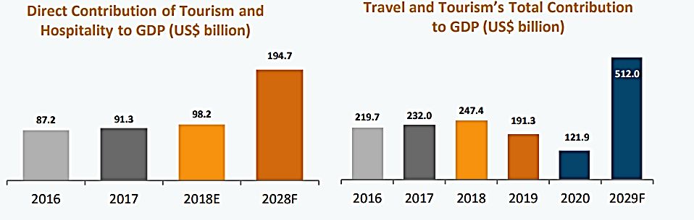

Below table shows the sectoral composition:

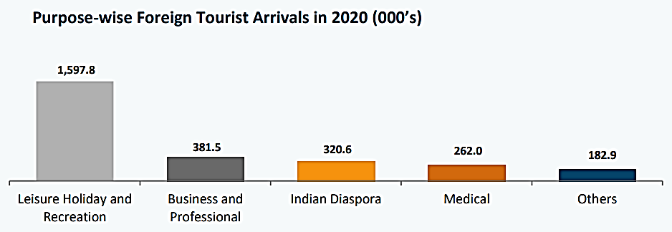

Below table shows the trends of tourism sector historically:

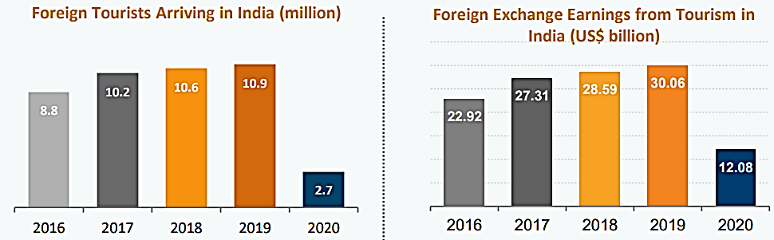

The travel market in India is projected to reach US$ 125 billion by FY27 from an estimated US$ 75 billion in FY20. The Medical Tourism sector is predicted to increase at a CAGR of 21.1% from 2020-27. Diverse Attractions: India offers geographical diversity, attractive beaches, 37 World Heritage sites and 10 biogeographic zones. In October 2021, the Government of India announced plan to resume inbound tourism from November 15, 2021, which is expected to lend a major boost to the tourism sector in India.

* The Medical Tourism sector is predicted to increase at a CAGR of 21.1% from 2020-27.
* The travel market in India is projected to reach US$ 125 billion by FY27 from an estimated US$ 75 billion in FY20.
* International tourist arrivals are expected to reach 30.5 million by 2028.
* Government is providing free loans to MSMEs to help them deal with the crisis and revive the economy, including the tourism sector.
* Post the pandemic crisis, the government plans to tap into regional tourism by opening doors for South Asian country tourists.
* In the Union Budget 2022-23, Rs. 2,400 crore (US$ 309.13 million) has been allocated to the Ministry of Tourism which is 18.42% higher than the allocation for FY 2021-22.
* In October 2021, the Government of India announced plan to resume inbound tourism from November 15, 2021, which is expected to lend a major boost to the tourism sector in India.

India offers geographical diversity, attractive beaches, 37 World Heritage sites, 10 bio-geographic zones, 80 national parks and 441 sanctuaries. The country’s big coastline is dotted with several attractive beaches.

1. **MARKET SIZE:** According to World Travel & Tourism Council (WTTC), India is ranked 10th among 185 countries in terms of travel & tourism’s total contribution to GDP in 2019. During 2019, contribution of travel & tourism to GDP was 6.8% of the total economy, ~ Rs. 1,368,100 crore. In 2020, the Indian tourism sector accounted for 39 million jobs, which was 8% of the total employment in the country. By 2028, Indian tourism and hospitality is expected to earn US$ 50.9 billion as visitor exports compared with US$ 28.9 billion in 2018.

The travel market in India is projected to reach US$ 125 billion by FY27 from an estimated US$ 75 billion in FY20. The Indian airline travel market was estimated at ~US$ 20 billion and is projected to double in size by FY27 due to improving airport infrastructure and growing access to passports. The Indian hotel market including domestic, inbound and outbound was estimated at ~US$ 32 billion in FY20 and is expected to reach ~US$ 52 billion by FY27, driven by the surging demand from travelers and sustained efforts of travel agents to boost the market. Contribution of tourism and travel industry to Indian GDP is shown in the below graph:

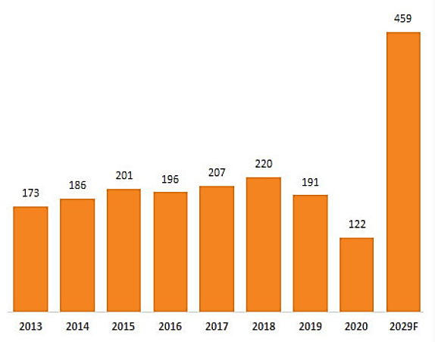

1. **RECENT DEVELOPMENTS/INVESTMENTS:**

* FDI inflows in the Tourism & Hospitality sector reached US$ 16.38 billion from April 2000- March 2022.
* Hospitality unicorn OYO has acquired Europe-based vacation rental company Direct Booker for US$ 5.5 million in May 2022.
* Accor, a French hospitality major will expand its India's portfolio by adding nine additional hotels in the mid-scale and economy categories, bringing the total number of hotels 54 in India.
* The Medical Tourism sector is expected to increase at a CAGR of 21.1% from 2020-2027.
* India was globally the third largest in terms of investment in travel and tourism with an inflow of US$ 45.7 billion in 2018, accounting for 5.9% of the total investment in the country.

Indian government has estimated that India would emerge with a market size of 1.2 million cruise visitors by 2030-31. Dream Hotel Group plans to invest around US$300 million in the next 3-5 years for the development of the cruise sector in India.

India is the most digitally advanced traveler nation in terms of digital tools being used for planning, booking, and experiencing a journey. India’s rising middle class and increasing disposable income has supported the growth of domestic and outbound tourism. The United Nations World Tourism Organization selected Pochampally in Telangana as one of the best tourism villages in November 2021.

1. **GOVERNMENT INITIATIVES:** The Indian Government has realised the country’s potential in the tourism industry and has taken several steps to make India a global tourism hub. Some of the major initiatives planned by the Government of India to boost the tourism and hospitality sector of India are as follows:

In the Union Budget 2022-23:

* Rs. 2,400 crore (US$ 309.13 million) has been allocated to the Ministry of Tourism which is 18.42 %higher than the allocation for FY 2021-22.
* Rs. 1,181.30 crore (US$ 152.16 million) is allocated for the Swadesh Darshan Scheme.
* Rs. 235 crore (US$ 30.27 million) for the Pilgrimage Rejuvenation and Spiritual and Heritage Augmentation Drive (PRASHAD) Scheme.
* The Ministry of Tourism has launched the National Strategy for Sustainable Tourism and Responsible Traveller Campaign in June 2022.
* In November 2021, the Ministry of Tourism signed a Memorandum of Understanding (MoU) with Indian Railway Catering and Tourism Corporation to strengthen hospitality and tourism industry. The ministry has also signed a MoU with Easy My Trip, Clear trip, Yatra.com, Make My Trip and Goibibo.
* In September 2021, the government launched NIDHI 2.0 (National Integrated Database of Hospitality Industry) scheme which will maintain a database of hospitality sector components such as accommodation units, travel agents, tour operators, & others. NIDHI 2.0 will facilitate the digitalization of the tourism sector by encouraging all hotels to register themselves on the platform.
* Government is planning to boost the tourism in India by leveraging on the lighthouses in the country. 71 lighthouses have been identified for development as tourist spots.

1. **WAY FORWARD:** Staycation is seen as an emerging trend were people stay at luxurious hotels to revive themselves of stress in a peaceful getaway. To cater to such needs, major hotel chains such as Marriott International, IHG Hotels & Resorts and Oberoi hotels are introducing staycation offers were guests can choose from a host of curated experiences, within the hotel. The Government is working to achieve 1% share in world's international tourist arrivals by 2020 and 2% share by 2025.

India’s travel and tourism industry has huge growth potential. The industry is also looking forward to the expansion of e-Visa scheme, which is expected to double the tourist inflow in India. India's travel and tourism industry has the potential to expand by 2.5% on the back of higher budgetary allocation and low-cost healthcare facility according to a joint study conducted by Assocham and Yes Bank. Hence, as per the industry analysis, trends of the industry seeming positive.

|  |  |
| --- | --- |
| **PART E** | **HISTORICAL AND PROJECTED FINANCIAL PERFORMANCE** |

As per the audited financial statements provided by the company/client, below table shows the historical performance of the company.

1. **HISTORICAL PROFIT & LOSS STATEMENT: (FROM FY 2018 TO FY 2022)**

***(Value in Rs. Crores)***

|  |  |  |  |  |  |
| --- | --- | --- | --- | --- | --- |
| **Particular (In Crores)** | **FY 2018** | **FY 2019** | **FY 2020** | **FY 2021** | **FY 2022** |
| **INCOME** |  |  |  |  |  |
| Revenue from Operations | 83.83 | 88.09 | 88.11 | 24.65 | 46.89 |
| Other income | 17.07 | 0.45 | 0.26 | 0.10 | 0.09 |
| **Total Income** | **100.90** | **88.53** | **88.37** | **24.74** | **46.98** |
| **EXPENSES** |  |  |  |  |  |
| Cost of material Consumed | 14.79 | 15.23 | 15.40 | 5.52 | 9.67 |
| Employees benefit Expenses | 22.69 | 24.16 | 24.46 | 10.28 | 13.21 |
| Other Operating and General Expenses | 36.51 | 42.13 | 46.30 | 20.28 | 24.19 |
| **Total expenses** | **73.99** | **81.52** | **86.17** | **36.08** | **47.07** |
| **EBITDA** | **26.91** | **7.01** | **2.20** | **(11.33)** | **(0.09)** |
| Dep. and Amortisation Expenses | 8.33 | 9.18 | 8.93 | 8.50 | 8.50 |
| **EBIT** | **18.58** | **(2.17)** | **(6.72)** | **(19.83)** | **(8.59)** |
| Finance Costs | 20.72 | 0.73 | 0.52 | 0.30 | 0.43 |
| Exceptional Items | 426.60 | 7.04 | - | (20.14) | - |
| **Profit/(Loss) before tax** | **(428.74)** | **(10)** | **(7.25)** | **(20.14)** | **(9.02)** |
| Tax expense: |  |  |  |  |  |
| Deferred tax | 9.89 | 2.56 | 1.95 | (3.86) | 0.82 |
| **Profit (Loss) after Tax for the period** | **(438.63)** | **(12.49)** | **(9.20)** | **(16.27)** | **(9.85)** |
| **Total Comprehensive Income** | **(438.63)** | **(12.49)** | **(9.20)** | **(16.27)** | **(9.85)** |

1. **KEY FINANCIAL RATIOS:**

|  |  |  |  |  |  |
| --- | --- | --- | --- | --- | --- |
| Particular | FY 2018 A | FY 2019 A | FY 2020 A | FY 2021 A | FY 2022 A |
| EBITDA Margin % | 26.67% | 7.92% | 2.49% | -45.81% | -0.19% |
| EBIT Margin % | 18.41% | -2.45% | -7.61% | -80.16% | -18.29% |
| Net Profit Margin% | -434.72% | -14.11% | -10.41% | -65.77% | -20.96% |
| Revenue Growth % (Y.O.Y.) |  | -12.26% | -0.18% | -72.00% | 89.86% |

**Note**: As per the historical trends, It can be seen that EBITDA Margins are continuously declining from the FY2018 to FY2021. In FY 2022 revenue of the company is increasing by 89.86% as compaire to previous years. Therefore EBITDA margin is also showing the growth in fiscal year 2022.

EBIT and Net Profit Margins are showing the same trand as EBITDA Margins. In FY 2022 they are less negative as compaired to FY 2021. The metrices are negative in the last few years which shows that the company is not performing well in the last few years and there are critical concern with the financial health of the company.

The decline in revenue was primarily due to Covid-19 pandemic in FY2019-20 & FY2020-21. The renovations undertaken in flagship properties is expected to further enhance the operating margins and revenues in the Coming future. Based on the above key indicators, the management is suggested to take the appropriate action to improve the operational efficiency of the firm.

1. **GRAPHICAL REPRESENTATION OF KEY FINANCIAL METRICES:**

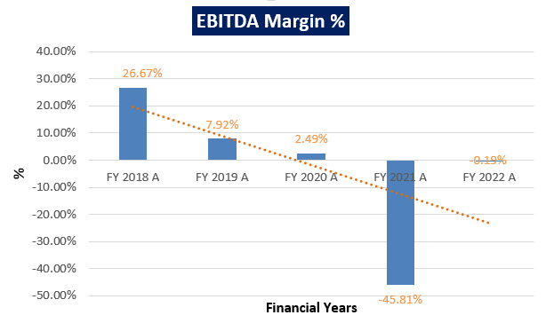

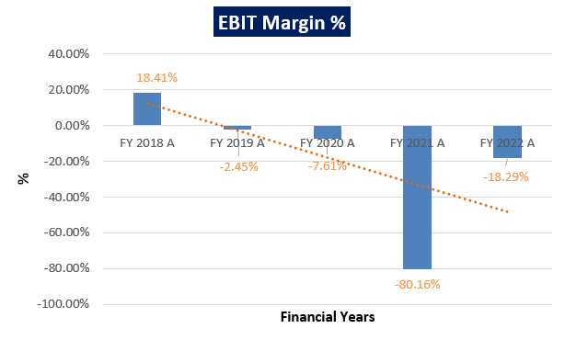

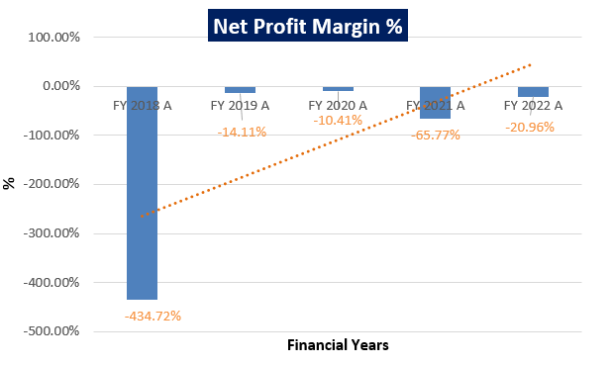

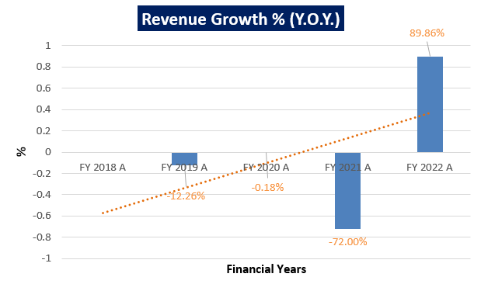

**Note**: As per the information provided by the client/company, numbers shown in the above table for all the Fiscal Years are taken from audited report.

Revenue growth rate was negative from the FY 2019 to FY 2021, as the company constantly losing more revenue due to Covid-19 pandemic, which leads to decrease in revenue. While it was positive in FY 2022, post pandemic, hotel restarted, and commenced its business in FY 2021-22.

As per the ratio analysis performed, it is observed that EBITDA and EBIT and Net Profit Margins of the company are continuously decreasing from FY 2018 to FY 2021. As there was a downfall in the real estate sector, down turn in the economy etc. the market conditions deteriorated and like other players in the hospitality and restaurant business, Viceroy Hotel faced innumerable problems in their business and financial situation, which leads to decrease in these margins.

As per the historical trends it can be observed that revenue growth rate was declining from FY 2019 to FY 2021, which shows that the lack of operational efficiency and due to this, company is under severe financial stress. However in FY 2022 there was an increase in revenue growth rate, which is a positive sign for VHL investors.

1. **HISTORICAL BALANCE SHEET: (FROM FY 2018 TO FY 2022)**

|  |  |  |  |  |  |
| --- | --- | --- | --- | --- | --- |
| **Particular (In Crores)** | **FY 2018 A** | **FY 2019 A** | **FY 2020 A** | **FY 2021 A** | **FY 2022 A** |
| Non-Current Assets |  |  |  |  |  |
| Property, Plant and Equipment | 233.64 | 224.46 | 215.54 | 207.04 | 198.54 |
| Non-Current Investments | 18.90 | 18.90 | 18.90 | 18.90 | 18.90 |
| Loans and Advances | 5.45 | 4.41 | 4.59 | 4.91 | 2.69 |
| Other Non-Current Assets | 1.52 | 6.75 | 5.15 | 6.76 | 6.30 |
| **Total Non-Current Assets** | **259.51** | **254.51** | **244.17** | **237.61** | **226.42** |
| Current Assets: |  |  |  |  |  |
| Inventories | 1.15 | 1.41 | 1.53 | 0.96 | 0.65 |
| Trade Receivables | 10.32 | 11.89 | 8.57 | 4.85 | 3.86 |
| Cash and Cash Equivalents | -1.13 | 5.05 | 1.20 | 0.19 | 2.13 |
| Advances other than Capital Advances | 3.57 | 3.80 | 5.99 | 4.28 | 5.62 |
| **Total Current Assets** | **13.91** | **22.14** | **17.30** | **10.28** | **12.27** |
| **TOTAL ASSETS** | **273.42** | **276.65** | **261.47** | **247.89** | **238.69** |
| Shareholder’s Equity |  |  |  |  |  |
| Equity Share Capital | 42.41 | 42.41 | 42.41 | 42.41 | 42.41 |
| Reserve and Security Premium Account | 181.52 | 181.52 | 181.51 | 181.52 | 181.52 |
| Retained earning | -582.04 | -594.53 | -603.72 | -620.00 | -629.84 |
| Total Other Equity | -400.53 | -413.02 | -422.22 | -438.48 | -448.33 |
| **Total Equity** | **-358.12** | **-370.61** | **-379.81** | **-396.08** | **-405.92** |
| Liabilities |  |  |  |  |  |
| Non-Current Liabilities: |  |  |  |  |  |
| Borrowings | 382.58 | 381.72 | 381.73 | 381.73 | 381.73 |
| Provisions |  |  |  |  |  |
| Deferred Tax Liabilities (Net) | 27.74 | 30.30 | 32.25 | 28.39 | 29.22 |
| Other Non-Current Liabilities | 0.95 | 2.63 | 1.01 | 0.41 | 1.59 |
| **Total Non-Current Liabilities** | **411.27** | **414.65** | **414.99** | **410.54** | **412.54** |
| Current Liabilities: |  |  |  |  |  |
| Borrowings | 4.13 | 0.93 | 1.05 | 1.05 | 1.06 |
| Trade Payables | 19.07 | 24.65 | 21.92 | 25.73 | 17.64 |
| Provisions |  |  |  |  |  |
| Current Provisions | 12.84 | 17.65 | 19.62 | 19.49 | 18.59 |
| Current Tax Liability | 0.14 | 0.00 | 0.00 | 0.00 | 0.00 |
| Other Current Liabilities | 184.11 | 189.38 | 183.69 | 187.15 | 194.79 |
| **Total Current Liabilities** | **220.27** | **232.61** | **226.29** | **233.43** | **232.08** |
| **TOTAL EQUITY & LIABILITIES** | **273.42** | **276.65** | **261.47** | **247.89** | **238.69** |

1. **PROJECTED PROFIT & LOSS STATEMENT: (From FY 2023 to FY 2028)**

As per the information provided by the company, Projections are made from FY 2023 to FY 2028 based on the fact that Hotel Viceroy Limited, Hydrabad is under Corporate Insolvency Resolution Proceedings and Mr G V Narasimha Rao was appointed as Resolution Professional by the Committee of Creditors(CoC). Thus the financial statements will be adjusted during the forecasted period and projections will be made accordingly.

|  |  |  |  |  |  |  |
| --- | --- | --- | --- | --- | --- | --- |
| **Particular (In Crores)** | **FY 2023** | **FY 2024** | **FY 2025** | **FY 2026** | **FY 2027** | **FY 2028** |
| **INCOME** |  |  |  |  |  |  |
| Revenue from Operations | 51.57 | 55.70 | 60.16 | 64.97 | 69.52 | 74.38 |
| Other income | 0.09 | 0.09 | 0.09 | 0.09 | 0.09 | 0.09 |
| **Total Income** | **51.66** | **55.79** | **60.25** | **65.06** | **69.61** | **74.47** |
| **EXPENSES** |  |  |  |  |  |  |
| Cost of material Consumed | 8.11 | 8.76 | 9.46 | 10.21 | 10.93 | 11.69 |
| Employees benefit Expenses | 13.03 | 14.07 | 15.19 | 16.41 | 17.55 | 18.78 |
| Other Operating and General Expenses | 21.44 | 23.16 | 25.01 | 27.00 | 28.89 | 30.91 |
| **Total expenses** | **42.58** | **45.98** | **49.66** | **53.62** | **57.37** | **61.38** |
| **EBITDA** | **9.08** | **9.81** | **10.59** | **11.44** | **12.23** | **13.09** |
| Dep. and Amortisation Expenses | 16.22 | 14.89 | 13.67 | 12.56 | 11.53 | 10.59 |
| **EBIT** | **(7.13)** | **(5.08)** | **(3.09)** | **(1.12)** | **0.70** | **2.50** |
| Finance Costs | 0.43 | 0.43 | 0.43 | 0.43 | 0.43 | 0.43 |
| Exceptional Items | 0 | 0 | 0 | 0 | 0 | 0 |
| **Profit/(Loss) before tax** | **(7.57)** | **(5.52)** | **(3.52)** | **(1.55)** | **0.27** | **2.07** |
| Current Tax | 0 | 0 | 0 | 0 | 0 | 0 |
| Deferred tax | 0 | 0 | 0 | 0 | 0 | 0 |
| **Profit (Loss) after Tax for the period** | **(7.57)** | **(5.52)** | **(3.52)** | **(1.55)** | **0.27** | **2.07** |
| **Total Comprehensive Income** | **(7.57)** | **(5.52)** | **(3.52)** | **(1.55)** | **0.27** | **2.07** |

1. **PROJECTED KEY FINANCIAL RATIOS:**

|  |  |  |  |  |  |  |
| --- | --- | --- | --- | --- | --- | --- |
| Particular | FY 2023 | FY 2024 | FY 2025 | FY 2026 | FY 2027 | FY 2028 |
| EBIT Margin % | -13.81% | -9.11% | -5.12% | -1.73% | 1.01% | 3.36% |
| Net Profit Margin% | -14.65% | -9.89% | -5.84% | -2.39% | 0.39% | 2.78% |
| Revenue Growth % (Y.O.Y.) | 9.98% | 7.99% | 7.99% | 7.99% | 6.99% | 6.99% |

1. **GRAPHICAL REPRESENTATION OF THE PROJECTED KEY RATIOS OF THE COMPANY**:

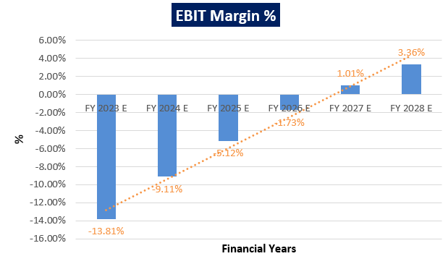

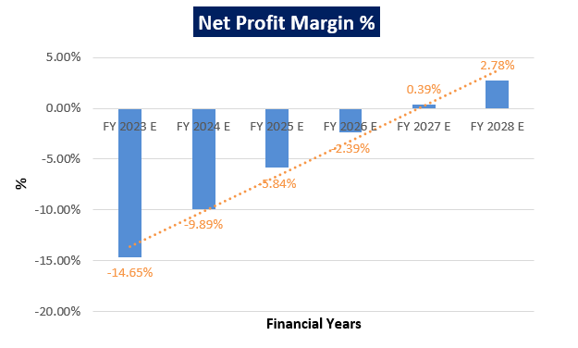

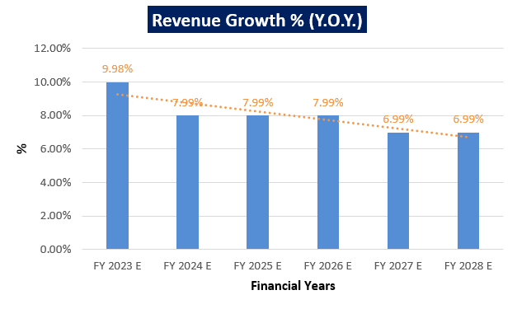

**Notes**:

As per the ratio analysis performed, it is observed that EBIT Margin of the company is increasing continuously from -13.81% in FY 2022-23 to 3.36% in FY 2027-28, as the company is now able to come out from covid19 pandemic, which leads in increasing revenues.

As per information provided by client/company, the Asset Reconstruction Company (India) Ltd (ARCIL) has filed plea under Sec.7 of The Insolvency and Bankruptcy code 2016 against M/s Viceroy Hotels Limited for non-payment of dues and the same has been accepted by the Hon’ble NCLT. However VHL is trying to improve its financial condition. It is observed from projected financials that Net Profit Margin of the company is increasing continuously from -14.65% in FY 2022-23 to 2.78% in FY 2027-28.

As per the historical analysis of the VHL revenue growth rate is very uncertain for future. As per the information available on public domain it is given that hotel industry in India is expected to reach at 13% CAGR during 2018 to 2023. Therefore on conservative side, we have considered the growth in revenue at the rate of 10% in the year 2023.

In the later years, we have considered a growth rate of 8% for next three years, and 7% upto the end of projected period since the company will be leading towards a stable growth rate.

1. **PROJECTED BALANCE SHEET: (From FY 2023 to FY 2028)**

|  |  |  |  |  |  |  |
| --- | --- | --- | --- | --- | --- | --- |
| **Particular (In Crores)** | **FY 2023 E** | **FY 2024 E** | **FY 2025 E** | **FY 2026 E** | **FY 2027 E** | **FY 2028 E** |
| Non-Current Assets: |  |  |  |  |  |  |
| Property, Plant and Equipment | 182.32 | 167.43 | 153.75 | 141.20 | 129.66 | 119.07 |
| Non-Current Investments | 18.90 | 18.90 | 18.90 | 18.90 | 18.90 | 18.90 |
| Loans and Advances | 4.50 | 4.41 | 4.35 | 4.34 | 4.37 | 4.43 |
| Other Non-Current Assets | 6.30 | 6.30 | 6.30 | 6.30 | 6.30 | 6.30 |
| **Total Non-Current Assets** | **212.01** | **197.03** | **183.30** | **170.73** | **159.23** | **148.70** |
| Current Assets: |  |  |  |  |  |  |
| Inventories | 0.70 | 0.76 | 0.82 | 0.89 | 0.95 | 1.01 |
| Trade Receivables | 6.94 | 7.49 | 8.09 | 8.74 | 9.35 | 10.00 |
| Cash and Cash Equivalents | -0.40 | 9.37 | 19.90 | 31.26 | 43.37 | 56.32 |
| Advances other than Capital Advances | 5.62 | 5.62 | 5.62 | 5.62 | 5.62 | 5.62 |
| **Total Current Assets** | **12.87** | **23.24** | **34.43** | **46.51** | **59.29** | **72.96** |
| **TOTAL ASSETS** | **224.87** | **220.27** | **217.73** | **217.24** | **218.51** | **221.65** |
| Equity |  |  |  |  |  |  |
| Equity Share Capital | 42.41 | 42.41 | 42.41 | 42.41 | 42.41 | 42.41 |
| Reserve and Security Premium Account | 181.52 | 181.52 | 181.52 | 181.52 | 181.52 | 181.52 |
| Retained earning | -637.41 | -642.93 | -646.44 | -648.00 | -647.73 | -645.66 |
| Total Other Equity | -455.89 | -461.41 | -464.93 | -466.48 | -466.21 | -464.14 |
| **Total Equity** | **-413.49** | **-419.00** | **-422.52** | **-424.08** | **-423.81** | **-421.74** |
| Liabilities |  |  |  |  |  |  |
| Non-Current Liabilities: |  |  |  |  |  |  |
| Borrowings | 381.73 | 381.73 | 381.73 | 381.73 | 381.73 | 381.73 |
| Provisions |  |  |  |  |  |  |
| Deferred Tax Liabilities (Net) | 29.22 | 29.22 | 29.22 | 29.22 | 29.22 | 29.22 |
| Other Non-Current Liabilities | 1.59 | 1.59 | 1.59 | 1.59 | 1.59 | 1.59 |
| **Total Non-Current Liabilities** | **412.54** | **412.54** | **412.54** | **412.54** | **412.54** | **412.54** |
| Current Liabilities: |  |  |  |  |  |  |
| Borrowings | 1.06 | 1.06 | 1.06 | 1.06 | 1.06 | 1.06 |
| Trade Payables | 11.39 | 12.30 | 13.29 | 14.35 | 15.35 | 16.42 |
| Provisions |  |  |  |  |  |  |
| Current Provisions | 18.59 | 18.59 | 18.59 | 18.59 | 18.59 | 18.59 |
| Current Tax Liability | 0.00 | 0.00 | 0.00 | 0.00 | 0.00 | 0.00 |
| Other Current Liabilities | 194.79 | 194.79 | 194.79 | 194.79 | 194.79 | 194.79 |
| **Total Current Liabilities** | **225.83** | **226.74** | **227.73** | **228.79** | **229.79** | **230.86** |
| **TOTAL EQUITY & LIABILITIES** | **224.88** | **220.27** | **217.74** | **217.25** | **218.52** | **221.66** |

|  |  |
| --- | --- |
| **PART F** | **VALUATION OF THE COMPANY** |

1. **METHODOLOGY/ MODEL ADOPTED:** Out of the various models & theories available, we have adopted the most widely used & acceptable approaches to calculate the Enterprise Value of the Company, which are, Income based approach (Two-Stage Discounted Cash Flow Model) and Relative Valuation based on appropriate market multiple/Comparable Company Analysis (CCA). As per the best practices followed in the industry, we have allocated 50-50% weightage to both the Enterprise Values calculated to minimize the error margin, which will result into a far better and precise Enterprise Value of M/s Viceroy Hotels Limited.
2. **TWO STAGE DCF MODEL:**
3. The free cash flow method used here is a two-stage model.
4. In this method, we calculate the free cash flow to firm (FCFF) for the projected period.
5. Two stage model covers the cash flows of the project during the explicit period and the terminal period i.e., period beyond the explicit or forecasted period.
6. The estimated terminal value captures the value of the business at the end of the initial projection period, which can be calculated by taking an assumed growth rate based on the current trends of industry growth rate, GDP growth rate and various other macro and micro economic factors by using Gordon Growth Model.
7. FCFF is more practical when substantial capital changes are expected because weighted average cost of capital (WACC) is less sensitive to the cost of equity.
8. Finally, we calculate the present value of future cash flows of explicit period and terminal Value by using a required rate of return based on the riskiness of the project, which we determine by using the Weighted Average Cost of Capital (WACC).

**RATIONALE FOR USING TWO-STAGE DCF FOR ENTERPRISE VALUATION:**

1. The three broadly used approaches of the company/Business Valuations are – Income based approach (Discounted Cash Flow Model), Asset Based Approach (Net Asset Value Method) and Relative Valuation Approach (Market Multiple method).
2. Asset Based Model is inappropriate as the Company is a going concern and the model is unable to capture the Value of the company.
3. Market Comparable Approach was also not used since we could not find any suitable market comparable transactions and company of similar scale, scope & nature in the market.
4. Therefore DCF method is used which determines the value of a business based on its ability to generate desired economic benefit/ cash flow for the owners.
5. The DCF Model gives us a variety of input options to use while calculating the Value of the firm - Dividend, Free Cash Flow to the Firm, Free Cash Flow to Equity, Capitalized Cash Flows and Residual Earnings.
6. Dividends cannot be used as the Company has no history of paying dividends and we don’t foresee any dividend payments to occur in the future due to the high leverage of the firm.
7. The best method for the DCF Model in the case of M/s Viceroy Hotel Limited will be FCFF as it represents the benefits accruable to all the stakeholders in the Business enterprise.

**TWO STAGE FCFF MODEL FORMULA AND KEY INPUTS:**

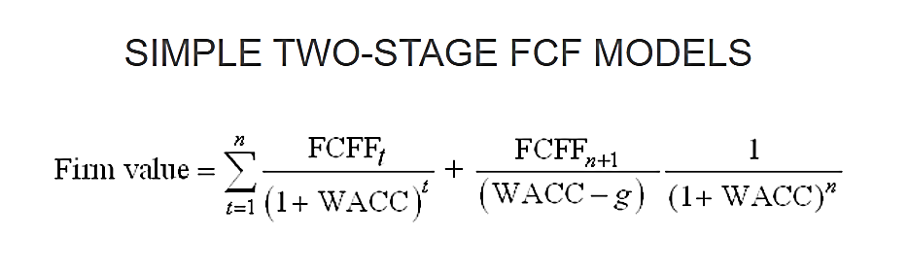

1. **Free Cash Flow to Firm (FCFF)** – FCFF is the [cash](http://www.investinganswers.com/node/5011) available to pay investors after a company pays its costs of doing business, invests in short-term assets like [inventory](http://www.investinganswers.com/node/2474), and invests in assets like property, plants and equipment. It can be calculated by adjusting the Non-Cash Charges, Working Capital Changes & Capex with the Net operating profit after taxes (NOPAT). {FCFF = Net Income + Non-Cash Charges + Interest (1-t) – Working Capital Investment – Fixed Capital Investment}.
2. **Weighted Average Cost of Capital (WACC)** - The weighted average cost of capital (WACC) is the rate that a company is expected to pay on average to all its security holders to finance its assets. The WACC is commonly referred to as the firm’s cost of capital. WACC is used as the discount rate to discount FCFF.

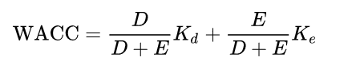

Where D is the total debt, E is the shareholders equity and Kd and Ke are the cost of debt and cost of equity, respectively.

1. **CALCULATION OF FREE CASH FLOW TO FIRM:**

|  |  |  |  |  |  |  |
| --- | --- | --- | --- | --- | --- | --- |
| **Particular** | **FY 2023** | **FY 2024** | **FY 2025** | **FY 2026** | **FY 2027** | **FY 2028** |
| EBIT | -7.13 | -5.08 | -3.09 | -1.12 | 0.70 | 2.50 |
| Tax Rate | 0% | 0% | 0% | 0% | 0% | 0% |
| NOPAT = EBIT*(1+T) | -7.13 | -5.08 | -3.09 | -1.12 | 0.70 | 2.50 |
| Add: Depreciation & Amortization | 16.22 | 14.89 | 13.67 | 12.56 | 11.53 | 10.59 |
| Less: Changes in Working Capital | 9.37 | -0.30 | -0.32 | -0.35 | -0.33 | -0.35 |
| Less: CAPEX | 0 | 0 | 0 | 0 | 0 | 0 |
| **FCFF** | **-0.29** | **10.11** | **10.91** | **11.79** | **12.57** | **13.44** |

1. **KEY INPUTS USED TO DISCOUNT CASH FLOWS DURING THE PROJECTION PERIOD:**

**Calculation of Cost of Equity**

|  |  |
| --- | --- |
| **Cost of Equity** | |
| **Risk Free Rate (Rf)** | 7.22% |
| **Expected Market Return (Rm)** | 11.0% |
| **Beta (B)** | 1.13 |
| **Cost of Equity (Ke)** | 11.49% |

For the calculation of cost of equity, we have consider capital asset pricing model (CAPM) to determine its cost of equity financing. {Cost of Equity = Risk-Free Rate of Return + Beta × (Market Rate of Return – Risk-Free Rate of Return)}.

**Note:** For Risk-Free Rate of Return we have considered India’s 10 years bond yield. For Market Rate of Return we have considered Nifty Fifty 15-year rate of return 2022. Viceroy is a listed company hence we have considered three years Beta for it.

**Calculation of Cost of Debt**

|  |  |  |  |
| --- | --- | --- | --- |
| **Bank Name** | **Total Principal** | **Weightage** | **Rate of Interest** |
| Asset Reconstruction Company (India) ltd | 132 | 61% | 13.75% |
| State Bank of India | 56 | 26% | 14.25% |
| Canara Bank | 24 | 11% | 14.25% |
| International Asset Reconstruction Co Ltd | 2 | 1% | 30.00% |
| Edelweiss Asset Reconstruction Co Ltd | 1 | 0.5% | 14.00% |
| **Total** | **215** | **100%** | **14.09%** |

|  |  |
| --- | --- |
| **Cost of Debt** | |
| **Cost of Debt (Kd)** | 14.09% |
| **Tax Rate (t)** | 34.94% |
| **Post-Tax Cost of Debt (Kd)** | 9.17% |

**Note:** For cost of debt we have considered weighted average interest rate applied by all the lenders, given in annual report of FY 2020-2021.

**Calculation of Weighted Average Cost of Capital (WACC)**

|  |  |  |  |
| --- | --- | --- | --- |
| **Weighted Average Cost of Capital (WACC)** | | | |
| **Particulars** | **Amount** | **Weightage** | **Required Return** |
| Debt | 382.79 | 63.1% | 9.17% |
| Equity Capital | 223.92 | 36.9% | 11.49% |
| **Total** |  | **100%** | **10.02%** |
| Company Risk Premium | | 0.50% | |
| **Appropriate Discount Rate** | | **10.52%** | |

**Note:** For the calculation of WACC we have considered the company risk premium at 0.50% as VHL is an NPA account.

1. **ENTERPRISE VALUATION:**

|  |  |  |  |  |  |  |  |
| --- | --- | --- | --- | --- | --- | --- | --- |
| **Unlevered Free Cash Flow (UFCFF)** | **-0.29** | **10.11** | | **10.91** | **11.79** | **12.57** | **13.44** |
| **Discount Rate (WACC)** | 10.52% |  | |  |  |  |  |
| **Perpetual Growth Rate** | 4.58% |  | |  |  |  |  |
| **Period** | 0.5 | 1.5 | | 2.5 | 3.5 | 4.5 | 5.5 |
| **Discount Factor** | 0.95 | 0.86 | | 0.78 | 0.70 | 0.64 | 0.58 |
| **Present Value (PV) of FCFF** | -0.27 | 8.70 | | 8.50 | 8.30 | 8.01 | 7.75 |
| **Terminal Value (TV)** |  |  | |  |  |  | 236.52 |
| **PV of TV** |  |  | |  |  |  | 136.41 |
| **PV OF FCFF+PV OF TV** | **-0.27** | **8.70** | | **8.50** | **8.30** | **8.01** | **144.17** |
| **Enterprise Value (EV) of the Firm** | | | **177.40** | | | | |

**Note:** For the calculation of Terminal Value we have assumed that business will grow at a set growth rate forever after the forecast period. Here we have used Gordon Growth Model with perpetual growth rate to calculate Terminal Value. To calculate the discount factor we have followed the mid-year convention.

To calculate perpetual growth rate we have evaluate average inflation rate for last 5 years i.e. 4.58%. Below table shows the inflation rate for last five years:

|  |  |
| --- | --- |
| **Inflation for last 5 years in India** | |
| **Years** | **Inflation** |
| 2021 | 5.10% |
| 2020 | 6.60% |
| 2019 | 3.70% |
| 2018 | 3.90% |
| 2017 | 3.60% |
| **Average** | **4.58%** |

**Note:** For Enterprise Value we had considered present value of free cash flows and present value of terminal value.

|  |
| --- |
| **ENTERPRISE VALUE OF M/S VICEROY HOTELS LIMITED** |
| **INR ONE HUNDRED SEVENTY SEVEN CRORES AND FORTY LAKHS**  **(INR 177.40 CRORES)** |

**Hence the “Enterprise Value” of the Firm “M/s Viceroy Hotels Limited” is INR 177.40 Crores.**

***NOTE: This is just the enterprise valuation of the project based on its income generating capacity in future years. This Valuation shall not be construed as the physical asset or should not be directly related to cost approach or Project cost.***

1. **SENSITIVITY ANALYSIS:**
2. **WACC** is the key input which has strong impact on the firm’s value with respect to percentage change. We have considered a change of **1%** to perform the sensitivity analysis.

|  |  |
| --- | --- |
| **Scenario** | **WACC** |
| **Optimistic Case** | 9.52% |
| **Base Case** | **10.52%** |
| **Pessimistic Case** | 11.52% |

1. **Growth Rate** is the key input to calculate the Terminal Value during assessing the firm’s value. We have considered a change of **0.5%** to perform the sensitivity analysis.

|  |  |
| --- | --- |
| **Scenario** | **Growth Rate** |
| **Optimistic Case** | 4.08% |
| **Base Case** | 4.58% |
| **Pessimistic Case** | 5.08% |

1. **Sensitivity** table shows the enterprise value with respect to change in growth rate and WACC. These are the key input to calculate the enterprise Value of the firm. We have considered a change of **1%** in WCAA and **0.5%** change in growth rate, to perform the sensitivity analysis.

|  |  |  |  |  |
| --- | --- | --- | --- | --- |
| **177.40** | | **WACC** | | |
| **9.52%** | **10.52%** | **11.52%** |
| **Growth Rate** | **4.08%** | 198.13 | 166.21 | 142.90 |
| **4.58%** | 214.71 | **177.40** | 150.86 |
| **5.08%** | 235.02 | 190.64 | 160.05 |

1. **KEY ASSUMPTIONS FOR FINANCIAL MODEL:**
2. **Revenue:** We have considered Revenue and cost based model while making the future financial projection, the projections are forecasted for next six years upto FY 2028. As per information provided by the client/company, the major source of revenue will be hotel, restaurants and bars business for the company, similar to the historical trends.

And the historical trends of the VHL revenue growth rate is very uncertain for future. As per the information available on public domain it is given that hotel industry in India is expected to reach at 13% CAGR during 2018 to 2023. Therefore on conservative side, we have considered the growth in revenue at the rate of 10% in the year 2023.

As per information provided by the client/company, below table shows the historical occupancy rate for hotel Marriott:

|  |  |
| --- | --- |
| **Financial Years** | **Occupancy Rates** |
| **2019-20** | 59% |
| **2020-21** | - |
| **2021-22** | 40% |
| **2022-23** | Till August Less than 51% |

Below table shows the occupancy rate in hotel in India from financial year 2001 to 2021, with estimates until 2024:

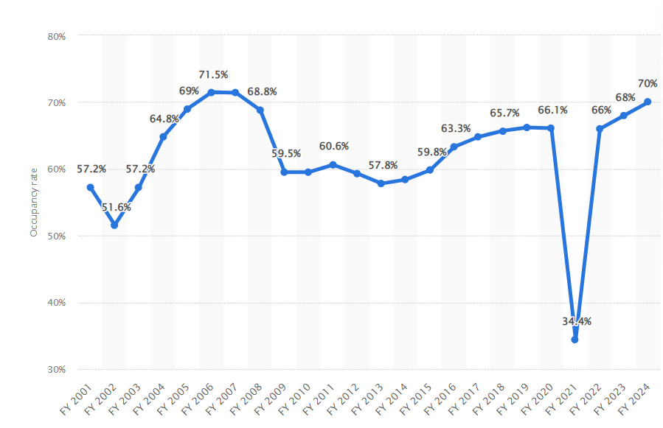

As per historical analysis occupancy rate for viceroy hotel in 2022 till august was 51%. And as per hotel industry growth in India the occupancy rate was showing an increasing trend with an average of 63% from FY 2016 to 2020. In FY 2021 the occupancy rate of hotels in India decreased by 34.4% due to Covid. The future estimate are also showing a positive trend with an average of 68%. Hence as per industry average there is enough scope for growth in occupancy rate of viceroy hotel, which justify the revenue growth rate.

In the later years, we have considered a growth rate of 8% for next three years, and 7% upto the end of projected period since the company will be leading towards a stable growth rate.

For perpetual growth rate we have considered average inflation rate for last 5 years i.e. 4.58% Y-o-Y basis, which seems to be reasonable and on conservative side considering the appropriate micro and macro-economic factors.

1. **Expenses:** As per information available in audited financial statements major expenses includes Cost of material Consumed, Employees benefit Expenses and Other Operating and General Expenses. Escalation rate for all the expenses are based on previous years’ average with respect to revenue growth rate for those years, which is found as per industry trends.
2. **Depreciation**: As per historical trend, we have considered the escalation rate for depreciation as 9% with respect to total assets for those years, which seems to be reasonable to keep a mark-up for future market & economic risks in the Project.
3. **Capital Expenditure**: As per information provided by client/company, for the existing scenario VHL is incompetent to spend on capex as it is under corporate insolvency resolution proceedings.
4. **Working Capital**: As per our tertiary research on hospitality industry, we have considered the escalation rate of current assets and current liabilities are based on revenue growth rate and cost of material consumed.

**Note:**

* *Enterprise Valuation of the subject project has been done by using Discounted Cash Flow (DCF) Method.*
* *No employee or member of R.K Associates has any direct/ indirect interest in the Project.*
* *This is just an opinion report on Valuation based on the copy of the documents/ information provided to us by the client which has been relied upon in good faith and the assessment and assumptions done by us.*
* *This is only a general assessment of the Enterprise/Business Value of the firm based on the data/ input Company officials could provide to us against our questions/ queries and information available in the public domain. In no manner this should be regarded as an audit activity/ report and NO micro analysis or detailed or forensic audit/ scrutiny of the financial transactions or accounts of any kind has been carried out at our end.*

|  |  |  |
| --- | --- | --- |
| **Declaration** | 1. *Since this is Enterprise Valuation hence no site inspection was carried out by us.* 2. *The undersigned does not have any direct/indirect interest in the above property.* 3. *The information furnished herein is true and correct to the best of our knowledge.* 4. *This valuation work is carried out by our Financial Analyst team on the request from State Bank Of India- Stressed Assets Management Branch – II, D.NO.3-4-1013/A, 1st Floor, CAC, TSRTC Bus Station, Kachiguda, Hyderabad Telangana -500027* 5. *We have submitted Valuation report to the Client.* | |
| **Name & Address of Valuer company** | | **Signature of the authorized person** |
| M/s R.K. Associates Valuers & Techno Engineering Consultants Pvt. Ltd.  D-39, Second Floor, Sector-2, Noida, UP-201301 India | |  |
| **Number of Pages in the Report** | | 46 |
| **Financial Analyst Team worked on the report** | | ***PREPARED BY: Mrs. Chhavi Toshan*** |
| ***REVIEWED BY: Mr. Gaurav Kumar*** |

**For R.K Associates Valuers & Techno Place : Noida**

**Engineering Consultants (P) Ltd. Date : 02nd September 2022**

**(Authorized Signatory)**

**Valuations**

|  |  |
| --- | --- |
| **PART G** | **IMPORTANT DEFINITION** |

**Definitions:**

* **Enterprise Value:** Enterprise value (EV) is the corporate valuation of a company, determined by using market capitalization and total debt. Market cap comprises preference stocks, common stocks, and minority interest; total debt comprises short-term and long-term liabilities of the company. Enterprise value (EV) refers to the overall valuation—equity, debt, cash, and cash equivalents. In other words, it is the cost of acquiring a firm. The EV/EBITDA is an enterprise multiple. It correlates EV with earnings before interest, taxes, depreciation, and amortization. The metric determines whether the firm is undervalued or overvalued.
* EV is computed using the following formula: EV = (Market Capitalization + Market Value of Debt – Cash and Equivalents).
* **Fair Market Value**suggested by the competent Valuer is that prospective estimated amount in his expert & prudent opinion of the subject asset without any prejudice after he has carefully & exhaustively evaluated the facts & information came in front of him related to the subject asset at which the subject asset should be exchanged between a willing buyer and willing seller at an arm’s length transaction in an open & unrestricted market, after proper marketing, wherein the parties, each acted knowledgeably, prudently and without any compulsion on the date of the Valuation.

Forced, under compulsion & constraint, obligatory sales transactions data doesn’t indicate the Fair Market Value.

* **Realizable Value** is the minimum prospective estimated value of the Company which it may be able to realize at the time of actual transaction factoring in the potential prospects of deep negotiations carried out between the buyer & seller for ultimately finalizing the transaction across the table. Realizable value may be 10-20% less than the Fair Market Value depending on the various salability prospects of the subject asset and the needs of the buyer & the seller.
* **Forced/ Distress Sale Value** is the value when the company has to be sold due to any compulsion or constraint like financial encumbrances, dispute, as a part of a recovery process, legal issues or any such condition or situation. In this type of sale, minimum fetch value is assessed which can be 15-25% less than the estimated Fair Market Value. In this type of sale, negotiation power of the buyer is always more than the seller and eagerness & pressure of selling the asset is more than buying it. Therefore, the Forced/ Distress Sale Value will always fetch significantly less value compare to the estimated Fair Market Value.
* **Liquidation Value** is the amount that would be realized when an asset or group of assets are sold on a piecemeal basis that is without consideration of benefits (or detriments) associated with a going-concern business. Liquidation value can be either in an orderly transaction with a typical marketing period or in a forced transaction with a shortened marketing period.
* **Difference between Costs, Price & Value:** Generally, these words are used and understood synonymously. However, in reality each of these has a completely different meaning, premise and also have different definitions in the professional & legal terms. Therefore, to avoid confusion, it is our professional responsibility to describe the definitions of these words to avoid ambiguity & confusion in the minds of the user of this report.
* The **Cost** of an asset represents the actual amount spend in the construction/ actual creation of the asset.
* The **Price** is the amount paid for the procurement of the same asset.
* The **Value** is defined as the present worth of future rights in the asset and depends to a great extent on combination of various factors such as demand and supply, market situation, purpose, situation & needs of the buyer & seller, salability outlook, usability factor, market perception & reputation. Needs of the buyer & seller, salability outlook, usability factor, market perception & reputation.
* Therefore, in actual for the same asset, cost, price & value remain different since these terms have different usage & meaning.

|  |  |
| --- | --- |
| **PART H** | **DISCLAIMER | REMARKS** |

* + - 1. No employee or member of R.K Associates has any direct/ indirect interest in the Project.
      2. This report is prepared based on the copies of the documents/ information which the Bank/ Company has provided to us out of the standard checklist of documents sought from them and further based on our assumptions and limiting conditions. The client/owner and its management/representatives warranted to us that the information they supplied was complete, accurate and true and correct to the best of their knowledge. All such information provided to us has been relied upon in good faith and we have assumed that it is true and correct in all respect. I/We shall not be liable for any loss, damages, cost or expenses arising from fraudulent acts, misrepresentations, or willful default on part of the owner, company, its directors, employee, representative or agents. Verification or cross checking of the documents provided to us from the originals or from any Govt. departments/ Record of Registrar has not been done at our end since this is beyond the scope of our work. If at any time in future, it is found or came to our knowledge that misrepresentation of facts or incomplete or distorted information has been provided to us then this report shall automatically become null & void.
      3. Legal aspects for e.g., investigation of title, ownership rights, lien, charge, mortgage, lease, sanctioned maps, verification of documents, etc. have not been done at our end and same has to be taken care by legal expert/ Advocate. It is assumed that the concerned Lender/ Financial Institution has satisfied them with the authenticity of the documents, information given to us and for which the legal verification has been already taken and cleared by the competent Advocate before requesting for this report. I/ We assume no responsibility for the legal matters including, but not limited to, legal or title concerns.
      4. This report is a general analysis of the project based on the scope mentioned in the report. This is not an Audit report, Design document, DPR or Techno feasibility study. All the information gathered is based on the facts seen on the site during survey, verbal discussion & documentary evidence provided by the client and is believed that information given by the company is true best of their knowledge.
      5. All observations mentioned in the report is only based on the visual observation and the documents/ data/ information provided by the client. No mechanical/ technical tests, measurements or any design review have been performed or carried out from our side during Project assessment.
      6. Bank/FII should ONLY take this report as an Advisory document from the Financial/ Chartered Engineering firm and its specifically advised to the creditor to cross verify the original documents for the facts mentioned in the report which can be availed from the borrowing company directly.
      7. In case of any default in loans or the credit facility extended to the borrowing company, R.K Associates shall not be held responsible for whatsoever reason may be and any request for seeking any explanation from the employee/s of R.K Associates will not be entertained at any instance or situation.
      8. The documents, information, data provided to us during the course of this assessment by the client is reviewed only up to the extent required in relation to the scope of the work. No document has been reviewed beyond the scope of the work.
      9. This report only contains general assessment & opinion as per the scope of work evaluated as per the information given in the copy of documents, information, data provided to us and/ and confirmed by the owner/ owner representative to us at site which has been relied upon in good faith. It doesn’t contain any other recommendations of any sort including but not limited to express of any opinion on the suitability or otherwise of entering into any transaction with the borrower.
      10. We have relied on data from third party, external sources & information available on public domain also to conclude this report. These sources are believed to be reliable and therefore, we assume no liability for the truth or accuracy of any data, opinions or estimates furnished by others that have been used in this analysis. Where we have relied on data, opinions or estimates from external sources, reasonable care has been taken to ensure that such data has been correctly extracted from those sources and /or reproduced in its proper form and context, however still we can’t vouch its authenticity, correctness or accuracy.
      11. This Report is prepared by our competent technical team which includes Engineers and financial experts & analysts.
      12. This is just an opinion report and doesn’t hold any binding on anyone. It is requested from the concerned Financial Institution which is using this report for taking financial decision on the project that they should consider all the different associated relevant & related factors also before taking any business decision based on the content of this report.
      13. All Pages of the report including annexures are signed and stamped from our office. In case any paper in the report is without stamp & signature then this should not be considered a valid paper issued from this office.
      14. Though adequate care has been taken while preparing this report as per its scope, but still, we can’t rule out typing, human errors, over sightedness of any information or any other mistakes. Therefore, the concerned organization is advised to satisfy themselves that the report is complete & satisfactory in all respect. Intimation regarding any discrepancy shall be brought into our notice immediately. If no intimation is received within 15 (Fifteen) days in writing from the date of issuance of the report, to rectify these timely, then it shall be considered that the report is complete in all respect and has been accepted by the client up to their satisfaction & use and further to which R.K Associates shall not be held responsible in any manner.
      15. Defect Liability Period is **15 DAYS**. We request the concerned authorized reader of this report to check the contents, data and calculations in the report within this period and intimate us in writing if any corrections are required or in case of any other concern with the contents or opinion mentioned in the report. Corrections only related to typographical, calculation, spelling mistakes, incorrect data/ figures/ statement will be entertained within the defect liability period. Any new changes for any additional information in already approved report will be regarded as additional work for which additional fees may be charged. No request for any illegitimate change in regard to any facts & figures will be entertained.
      16. R.K Associates encourages its customers to give feedback or inform concerns over its services through proper channel at [valuers@rkassociates.org](mailto:valuers@rkassociates.org) in writing within 15 days of report delivery. After this period no concern/ complaint/ proceedings in connection with the Financial Feasibility Study Services will be entertained due to possible change in situation and condition of the subject Project.
      17. Our Data retention policy is of ONE YEAR. After this period, we remove all the concerned records related to the assignment from our repository. No clarification or query can be answered after this period due to unavailability of the data.
      18. This Financial Feasibility Study report is governed by our (1) Internal Policies, Processes & Standard Operating Procedures, (2) Information/ Data/ Inputs given to us by the client and (3) Information/ Data/ Facts given to us by our field/ office technical team. Management of R.K Associates never gives acceptance to any unethical or unprofessional practice which may affect fair, correct & impartial assessment and which is against any prevailing law. In case of any indication of any negligence, default, incorrect, misleading, misrepresentation or distortion of facts in the report then it is the responsibility of the user of this report to immediately or at least within the defect liability period bring all such act into notice of R.K Associates management so that corrective measures can be taken instantly.
      19. R.K Associates never releases any report doing alterations or modifications from pen. In case any information/ figure of this report is found altered with pen then this report will automatically become null & void.