**REPORT FORMAT:** CL-1 | Version: 1.0_2018

# FILE No.: VIS(2021-22)-PL174-134-251 Date: 06/07/2022

* ***CERTIFICATE* NAME:** *Rental Income Certificate for Proposed Commercial Building situated at* *new Municipal No. 161/121, Rajeev Gandhi Marg, District Dehradun, Uttarakhand.*
* ***PREPARED FOR:*** *Punjab National Bank, MCC Branch, Dehradun*
* ***ASSET TYPE****: Proposed Commercial Building Structure*
* ***LOCATION OF THE BUILDING****: New Municipal No. 161/121, Rajeev Gandhi Marg, District Dehradun, Uttarakhand.*

**TO WHOM IT MAY CONCERN**

|  |  |  |
| --- | --- | --- |
| **S. NO.** | **PARTICULARS** | **DESCRIPTION** |
| 1. | Date of Survey | 03-07-2022 |
| 2. | Date of Certificate | 06-07-2022 |
| 3. | Documents provided for perusal | 1. Approved Map. 2. Sanction Letter of Approved Map. |
| 4. | Location of the Building | New Municipal No. 161/121, Rajeev Gandhi Marg, District Dehradun, Uttarakhand. |
| 5. | Borrower | Mrs. Geetika Bisht w/o Mr. Naveen Bisht. |
| 6. | Type of Asset | Proposed Commercial Building Structure |
| 7. | Type of Assessment | Rental Income Certificate |
| 8. | Scope of Assessment | Rental Income of the proposed building structure. |
| 9. | Nature of Building | Commercial |
| 10. | Year of Construction | Construction yet to be started |
| 11. | Total Purchase Cost / Expenses Incurred | No information available. |
| 12. | Total built Up Area of the property. | **As per Approved Map.** |
| 13. | Area Adopted | Area adopted on the basis of Approved Map as the construction is yet to be started. |
| 14. | Current Estimated Market Value | As per the discussion with the property consultant of the subject location we came to know that ongoing rent for commercial building in the subject vicinity varies within the range of Rs. 60 – Rs. 70/- per sq.ft. depending upon the various amenities in the building. Based on this we are of the view to adopt a rate of Rs. 65/- per sq.ft. for First Floor, Rs. 62/- per sq.ft. for 2nd Floor & Rs. 59/- per sq.ft. for 3rd & 4th Floor. Calculation of proposed Rental Income per month is given below: - |

**OBSERVATIONS:**

1. We have been provided with the copy of Approved Map through which we have considered the total built up area of the property.
2. During the time of our site visit we have found that construction is yet to be started.
3. Monthly Rental Income vetted for the subject property is for the proposed structure which is yet to be developed assuming it will be constructed as per the Approved Map provided to us.

***Disclaimer:***

* 1. *This Certificate is to be referred only for the purpose of the Rental Income vetted of the proposed Building Structure situated at the aforesaid address.*
  2. *This certificate doesn’t include any work related to drawing, design, sketch plan, procurement of the building structure.*
  3. *Ownership and other legal point of view in respect of the asset is not considered in this report as same is out of scope of this certificate.*
  4. *This certificate is made at the request of Punjab National Bank, MCC Branch, Dehradun.*

**For R.K Associates Valuers** **& Techno** **FOR INTERNAL USE Engineering Consultants (P) Ltd. *TYPED BY: SE Gaurav Sharma***  ***REVIEWED BY: HOD Engineering*** **(Project Team)**

# ANNEXURE: I- COPY OF APPROVED MAP

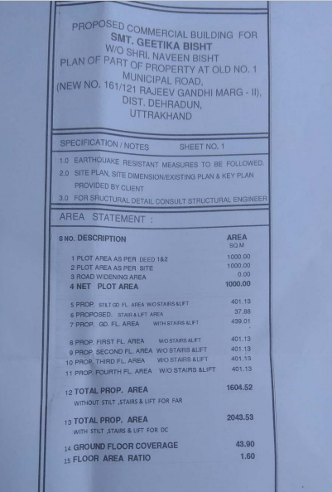

# ANNEXURE: I- COPY OF APPROVED MAP

