REPORT FORMAT: CL-1 | Version: 1.0_2018

FILE No.: VIS(2022-23)-PL174-134-251 Date: 06/07/2022

- CERTIFICATE NAME: Rental Income Certificate for Proposed Commercial Building situated at new Municipal No. 161/121, Rajeev Gandhi Marg, District Dehradun, Uttarakhand.
- PREPARED FOR: Punjab National Bank, MCC Branch, Dehradun
- ASSET TYPE: Proposed Commercial Building Structure
- LOCATION OF THE BUILDING: New Municipal No. 161/121, Rajeev Gandhi Marg, District Dehradun, Uttarakhand.

TO WHOM IT MAY CONCERN

S. NO. | PARTICULARS | DESCRIPTION
1. | Date of Survey | 03-07-2022
2. | Date of Certificate | 06-07-2022
3. | Documents provided for perusal | - Approved Map.  - Sanction Letter of Approved Map.
4. | Location of the Building | New Municipal No. 161/121, Rajeev Gandhi Marg, District Dehradun, Uttarakhand.
5. | Borrower | Mrs. Geetika Bisht w/o Mr. Naveen Bisht.
6. | Type of Asset | Proposed Commercial Building Structure
7. | Type of Assessment | Rental Income Certificate
8. | Scope of Assessment | Rental Income of the proposed building structure.
9. | Nature of Building | Commercial
10. | Year of Construction | Construction yet to be started
11. | Total Purchase Cost / Expenses Incurred | No information available.
12. | Total built Up Area of the property. | As per Approved Map.  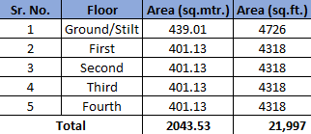
13. | Area Adopted | Area adopted on the basis of Approved Map as the construction is yet to be started.
14. | Current Estimated Market Value | As per the discussion with the property consultant of the subject location we came to know that ongoing rent for commercial building in the subject vicinity varies within the range of Rs. 60 – Rs. 70/- per sq.ft. depending upon the various amenities in the building. These rates are for bare shell structure. Since the subject property is yet to be constructed and no specification of interiors is available. In such a scenario we have considered a nominal ongoing rate for bare shell structure for calculating the rental income of the subject property. As per the copy of approved map the Ground floor/Stilt is proposed to be used only for Parking purpose whereas First, Second, Third & Fourth floor will be available for rent purpose. Therefore, we have calculated rent for only First to Fourth floor.  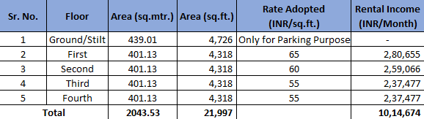

OBSERVATIONS:
- We have been provided with the copy of Approved Map through which we have considered the total built up area of the property.
- During the time of our site visit we have found that construction is yet to be started.
- Monthly Rental Income vetted for the subject property is for the proposed structure which is yet to be developed assuming it will be constructed as per the Approved Map provided to us.
- Based on our market research proposed monthly rental income of the subject property comes out to be Rs. 10,14,674/- (Rupees Ten Lakh Fourteen Thousand Six Hundred Seventy Four)

Disclaimer:
  - This Certificate is to be referred only for the purpose of the Rental Income vetted of the proposed Building Structure situated at the aforesaid address.
  - Since the subject property is yet to be constructed and no specification of interiors is available. In such a scenario we have considered a nominal ongoing rate for bare shell structure for calculating the rental income of the subject property.
  - This certificate doesn’t include any work related to drawing, design, sketch plan, procurement of the building structure.
  - Ownership and other legal point of view in respect of the asset is not considered in this report as same is out of scope of this certificate.
  - This certificate is made at the request of Punjab National Bank, MCC Branch, Dehradun.

For R.K Associates Valuers & Techno FOR INTERNAL USE Engineering Consultants (P) Ltd. TYPED BY: SE Gaurav Sharma REVIEWED BY: RV. ER. Rajani Gupta

ANNEXURE: I- COPY OF APPROVED MAP
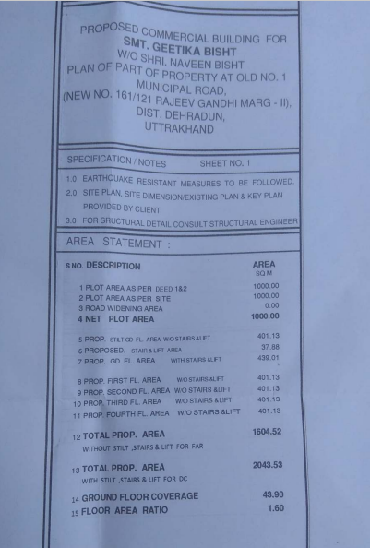

ANNEXURE: I- COPY OF APPROVED MAP
