**REPORT FORMAT:** V-L11 (Enterprise Valuation) | Version: 1.0_2018

**File No.: VIS (2022-23)-PL222-172-323 Dated: 20.11.2022**

**ENTERPRISE VALUATION REPORT**

**OF**

**M/S. TN (DK) EXPRESSWAYS LIMITED**

**REGISTERED AT**

**MADHUCON HOUSE, PLOT NO.1129/A,RD.36,HITECH CITY RD JUBILEE HILLS, HYDERABAD TG 500033 IN**

**PROMOTERS**

**M/S. MADHUCON PROJECTS LIMITED-SREI (CONSORTIUM)**

**REPORT PREPARED FOR**

**STATE BANK OF INDIA- 21st FLOOR, MAKER TOWERS E, CUFFE PARADE, MUMBAI-400005 Branch- SARG**

***\*\*Important - In case of any query/ issue or escalation you may please contact Incident Manager***

***At valuers@rkassociates.org. We will appreciate your feedback in order to improve our services.***

***NOTE: As per IBA Guidelines please provide your feedback on the report within 15 days of its submission after which report will be considered to be correct.***

**IMPORTANT NOTICE**

***COPYRIGHT FORMAT:*** *This report is prepared on the copyright format of R. K. Associates Valuers & Techno Engineering Consultants (P) Ltd. (R. K. Associates) to serve our clients with the best possible information and analysis to facilitate them to take rational business decisions. Legally no one can copy or distribute this format without prior approval from R. K. Associates. It is meant only for the advisory/ reference purpose for the organization/s as mentioned on the cover page of this report. Distribution or use of this format or report or any of its content/ information/ data by any organization or individual other than R.K Associates will be seen as an unlawful act and necessary legal action can be taken against the defaulters.*

*This report is intended for the sole use of the intended recipient/s and contains material that is STRICTLY CONFIDENTIAL AND PRIVATE.*

***DEFECT LIABILITY PERIOD:****In case of any query/ issue or escalation you may please contact Incident Manager at valuers@rkassociates.org. Though adequate care has been taken while preparing this report as per its scope, but still we can’t rule out typing, human errors, over sightedness of any information or any other mistakes. Therefore, the concerned organization is advised to satisfy themselves that the report is complete & satisfactory in all respect. Intimation regarding any discrepancy shall be brought into our notice immediately. If no intimation is received within 15 (Fifteen) days in writing from the date of issuance of the report, to rectify these timely, then it shall be considered that the report is complete in all respect and has been accepted by the client up to their satisfaction & use and further to which R.K Associates shall not be held responsible in any manner.*

***Part H: R. K. Associates Important Disclaimer and Remarks*** *are integral part of this report and Feasibility assessment is subject to this section. Reader of the report is advised to read all the points mentioned in these sections carefully.*

| **TABLE OF CONTENTS** | | |
| --- | --- | --- |
|  | | |
| **SECTIONS** | **PARTICULARS** | **PAGE NO.** |
| **Part A** | **INTRODUCTION** |  |
| 1. About the Report | 4 |
| 1. Executive Summary | 4 |
| 1. Type of Report | 6 |
| 1. Purpose of the Report | 6 |
| 1. Scope of the Report | 6 |
| 1. Methodology/ Model Adopted | 7 |
| 1. Documents/ Data Referred | 8 |
| **Part B** | **About the Company** |  |
| 1. Brief Description About the Company | 9 |
| 1. Company’s Directors | 9 |
| 1. Promoters of The Project Company | 9 |
| 1. Snapshot of Outstanding Debt of the Company | 10 |
| 1. Capital Structure | 11 |
| 1. Shareholding Pattern | 11 |
| 1. Current status of the project company | 12 |
| 1. Reason for Financial Stress | 13 |
| **Part C** | **About the Project** |  |
| 1. Background | 14 |
| 1. Location | 14 |
| 1. Silent Feature of the Project | 14 |
| **Part D** | **Assessment of Infrastructure Sector** |  |
| 1. Introduction | 16 |
| 1. EPC Industry Overview | 16 |
| 1. Regulatory Scenario | 18 |
| 1. Major policy Measures | 18 |
| 1. Government Initiatives | 18 |
| 1. Key Development to be Achieved over the next 3 Years | 19 |
| 1. Key Challenges faced by the Industry | 19 |
| 1. Way Forward | 20 |
| **Part E** | **Financial Projections** |  |
| 1. Historical Profit & Loss Statement | 21 |
| 1. Historical Key Financial Ratios | 21 |
| 1. Graphical Representation of Key Financials | 22 |
| 1. Projected Profit & Loss Statement | 23 |
| 1. Projected Key Financial Ratios | 24 |
| 1. Graphical Representation of Key Financials | 24 |
| **Part F** | **Valuation of the Company** |  |
| 1. Methodology/ Model Adopted | 26 |
| 1. Calculation of Free Cash Flow to Firm | 27 |
| 1. Valuation of Firm | 28 |
| 1. Key Assumptions | 30 |
| **Part G** | **Important Definition** | 34 |
| **Part H** | **Remarks & Declaration** | 36 |

|  |  |
| --- | --- |
| **PART A** | **INTRODUCTION** |

1. **ABOUT THE REPORT:** Enterprise Valuation of M/s TN (DK) Expressways Limited, a Special Purpose Vehicle (SPV) established to undertake the implementation of four lane of Karur to Dindigul bypass (from Km 305.600 to Km 373.275) (The Project) on NH-7 with a total length of 68.125 km and Improvement, Operation and Maintenance of 9.6 km from 292.6 to 305.6 of Karur bypass in the state of Tamil Nadu on NH-7 on a Build Operate and Transfer (”BOT”) basis.
2. **EXECUTIVE SUMMARY:** TN(DK) Expressways Limited, a Special Purpose Vehicle (SPV) promoted by Madhucon Projects Limited (MPL) as lead member and its associates and SREI Infrastructure Finance Limited, was established in January 2006 to undertake the implementation of four lane of Karur to Dindigul bypass (from Km 305.600 to Km 373.275) (The Project) on NH-7 with a total length of 68.125 km and Improvement, Operation and Maintenance of 9.6 km from 292.6 to 305.6 of Karur bypass in the state of Tamil Nadu under a Build, Operate and Transfer (BOT-Toll) concession awarded by NHAI.

|  |  |  |
| --- | --- | --- |
| **Brief Description of the Project** | | |
| **S. No.** | **Particular** | **Details** |
|  | Name of the Company | M/s TN (DK) Expressways Limited |
|  | Project | Widening existing 2 lane to 4 lane Design Construction, Development, Finance Operation and maintenance of Karur to Dindigul Section (Km 305.600 to Km 373.725) and Improvement, Operation and Maintenance of Karur Bypass (Km 292.600 to 305.600) under NHDP-Phase II on NH7 in the state of Tamilnadu. |
|  | Basis | BOT |
|  | Concession Agreement Date | 20th April 2006 |
|  | Financial Closure Date | 11th October 2006 |
|  | Appointed Date | 17th October 2006 |
|  | COD as per Financial Closure Date | 16th April 2009 |
|  | COD as per Appointed Date | 16th April 2009 |
|  | Provisional COD Achieved on | 5th November 2009 |
|  | Final COD Achieved | No |
|  | Project End Date | 16th October 2026 |
|  | Concession Period in Years | 20 Years |
|  | Remaining Concession Period (Years) | 3.9 |
|  | Length of the stretch in Kms | 77.73 kms |

The concession agreement between TN (DK) Expressways Limited and NHAI was signed on April 20th, 2006. The concession granted to TN (DK) is for a period of 20 years starting from the appointed date. Date of Appointment will begin from 180 days from the concession agreement date i.e. October 17th, 2006. The project execution is through a fixed cost-fixed time EPC contract awarded to Madhucon Projects Limited (MPL).

The Project cost at the time of financial closure was estimated at INR 373.32 Crores. The Project was proposed to be funded by a Promoter’s contribution of INR 74.66 Crores, NHAI construction grant of Rs.74.66 Crores and Rupee term loans of Rs.224.00 Crores leading to a debt to equity (including quasi-equity) ratio of 1.5:1. The project was completed at a cost of Rs.375.51 Crores with a cost overrun of INR 2.19 Crores which was funded by way of promoter contribution.

|  |  |
| --- | --- |
| **Project Cost & Means of Finance** | |
| **Particular** | **Value** |
| Project Cost (INR Cr.) | 375.52 |
| Project Asset (INR Cr.) | 385.7 |
| Debt (INR Cr.) | 224.00 |
| Equity (INR Cr.) | 74.66 |
| NHAI Construction Grant (INR Cr.) | 74.66 |
| NHAI Operational Grant (INR Cr.) | 11.34 |
| Unsecured Loan by Promoters during Construction (INR Cr.) | 2.20 |
| Total Unsecured Loan by Promoters (INR Cr.) | 19.05 |

Below table shows the historical financial performance of the company from FY 2015 to FY 2022:

|  |  |  |  |  |  |  |  |  |
| --- | --- | --- | --- | --- | --- | --- | --- | --- |
| **Particulars** | **FY 2015 A** | **FY 2016 A** | **FY 2017 A** | **FY 2018 A** | **FY 2019 A** | **FY 2020 A** | **FY 2021 A** | **FY 2022 P** |
| **Total Income** | **38.17** | **40.93** | **42.21** | **54.18** | **53.76** | **63.55** | **67.44** | **101.53** |
| **Total Expenses** | 11.12 | 10.32 | 12.26 | 12.82 | 30.34 | 37.77 | 68.42 | 71.15 |
| **EBITDA** | **27.05** | **30.61** | **29.95** | **41.36** | **23.42** | **25.78** | **-0.98** | **30.38** |
| *EBITDA %* | *70.87%* | *74.79%* | *70.95%* | *76.34%* | *43.56%* | *40.57%* | *-1.45%* | *29.92%* |
| D &A | 10.66 | 13.41 | 17.99 | 15.93 | 15.12 | 24.07 | 25.58 | 28.77 |
| **EBIT** | **16.39** | **17.2** | **11.96** | **25.43** | **8.3** | **1.71** | **-26.56** | **1.61** |
| *EBIT %* | *42.94%* | *42.02%* | *28.33%* | *46.94%* | *15.44%* | *2.69%* | *-39.38%* | *1.59%* |
| Finance Cost | 25.93 | 24.58 | 23.78 | 21.6 | 13.82 | 9.72 | 1.79 | 2.74 |
| **Profit Before Tax** | **-9.54** | **-7.38** | **-11.82** | **3.83** | **-5.52** | **-8.01** | **-28.35** | **-1.13** |
| *PBT %* | *-24.99%* | *-18.03%* | *-28.00%* | *7.07%* | *-10.27%* | *-12.60%* | *-42.04%* | *-1.11%* |
| Tax Expense | 0.00 | 0.00 | 0.00 | 0.00 | 0.00 | 0.00 | 0.00 | 0.00 |
| *Effective Tax Rate* | 0.00% | 0.00% | 0.00% | 0.00% | 0.00% | 0.00% | 0.00% | 0.00% |
| **Profit (Loss) after Tax** | **-9.54** | **-7.38** | **-11.82** | **3.83** | **-5.52** | **-8.01** | **-28.35** | **-1.13** |
| *PAT %* | *-24.99%* | *-18.03%* | *-28.00%* | *7.07%* | *-10.27%* | *-12.60%* | *-42.04%* | *-1.11%* |

As per historical analysis, it can be observed that EBITDA and EBIT are positive however net profit margins are negative from FY 2015 continuously due to higher finance cost.

The first periodic Maintenance which was due in November, 2014 is almost completed in 2022 after much persuasion with the Lenders. The company had issued work order for second maintenance and copy of the work order was already shared with lenders. Contractor will commence the works once they receive advance amount.

There is a large variation between actual traffic and projected traffic as per the bid documents of the project by 48% affecting the revenues badly. The actual realization during the past 13 years i.e. up to March.2022 is just about Rs.509.93 Crs against projected revenue of Rs.1054.89 Cr., the lenders have adjusted an amount of Rs.372.84 Crs towards interest and principal as on 15th July, 2022 against the debt of Rs.224.00 Crs given by the lenders.

**Hence, State Bank of India has appointed R. K Associates to determine the Fair Market Value/Enterprise Value of the Business/Company to take appropriate course of action on this stressed account.**

1. **TYPE OF THE REPORT:** Enterprise Valuation of M/s TN (DK) Expressways Limited.
2. **PURPOSE OF THE REPORT:** To estimate & determine current Fair Enterprise Value of the SPV Companyto enable the lenders to evaluate the further course of action on this account.
3. **SCOPE OF THE REPORT:** As per the client’s requirement and based on the purpose of the report, RK subject matter expert team has identified following points for arriving at Fair Enterprise Valuation of the Company and describe in-depth detailed assessment of the clear basis of the Valuation assessment.
4. **Business Plan Assessment:**

* Business Model
* Operation and maintenance of Project Site.
* Toll Collection Income from Toll Plazas
* Risk and mitigation strategies

1. **Financial Forecasting:**

* Key Financial Projections
* Key Financial Indicators

1. **Enterprise/ Business Valuation:**

* Based on Discounted Cash Flow Model (Free Cash Flow to Firm)

***NOTES:***

* ***This is just the enterprise valuation of the project based on its income generating capacity/ projections in future years. This Valuation shall not be construed as the physical asset valuation or should be directly related to cost approach or Project cost.***
* ***This Valuation only covers the cash flow generated from 77.725 K.m. toll project of the Company. It does not cover any transaction with the subject company’s subsidiary/ associate/ Joint Venture Companies.***
* ***This Enterprise Valuation report doesn’t cover vetting of the documents/ financial data/ projections or any other information provided to us by the Bank.***
* ***It doesn’t contain the principles of physical asset valuation and is not based on the site inspection of the project.***
* ***This exercise is neither an audit activity nor investigative in nature.***
* ***We have relied on the data provided by the Bank and the Company in good faith.***

1. **METHODOLOGY/ MODEL ADOPTED:** Discounted Cash Flow Model for the calculation of Enterprise Value of the Company.
2. **DOCUMENTS/ DATA REFFERED:**
3. Financial Statements of TN (DK) Expressways Limited from FY 15-16 to FY 2021-22.
4. Financial Model of the TN (DK) Expressways Limited.
5. Concessionaire agreement between NHAI and TN (DK) Expressways Limited.
6. Data collected from Public sources and Government agencies.
7. Monthly toll collection data from Nov, 2009 to March, 2022.
8. Penalty imposed by NHAI on the Company for delay in Major Maintenance Work.

|  |  |
| --- | --- |
| **PART B** | **ABOUT THE COMPANY** |

1. **BRIEF DESCRIPTION ABOUT THE COMPANY:** The incorporation details of the Project Company are provided in the table below:

|  |  |
| --- | --- |
| **Incorporation Details of the Company** | |
| **Name** | M/s. TN (DK) Expressways Limited |
| **CIN** | U45200AP2006PLC048941 |
| **Sector** | Infrastructure - Roads & Highways |
| **Constitution** | Public Limited Company (Closely Held) |
| **Address:** | **Registered Office:** Madhucon House, 8-2-272/82/A/1129/A, Road no. 36, Jubilee Hills, HyderabadDistrict: Karur & Dindigul State: Tamil Nadu |
| **Date of Incorporation** | 31st January 2006 |
| **Authorized Capital** | INR 7,50,00,000/- |
| **Issued, Subscribed and Paid-up Capital** | INR 7,46,60,000/- |

***Source:*** *“http://mca.gov.in/mcafoportal/companyLLPMasterData.do” and Data provided by the Company*

1. **COMPANY’S DIRECTORS:**

|  |  |  |  |
| --- | --- | --- | --- |
| **S. No.** | **DIN No.** | **Director Name** | **Begin Date** |
| 1 | 00022855 | Mr. Srinivasa Rao Kamma | 31/01/2006 |
| 2 | 00368625 | Mr. Madhu Malampati | 16/12/2009 |
| 3 | 02984867 | Mr. Nama Rama Rao | 14/02/2015 |

1. **PROMOTERS OF THE PROJECT COMPANY:** Madhucon group, based out of Hyderabad, Andhra Pradesh, founded and promoted by Mr. N. Nageswara Rao, is one of the major players in Indian infrastructure space having interests in diverse verticals like construction of roads, thermal power projects, mining, real estate, dams, tunnels, aqua ducts, bridges, coal handling plants and other civil projects.
2. **MADHUCON PROJECTS LIMITED (MPL):** MPL is the flagship company of Madhucon Group. MPL originally incorporated on March 15, 1990, as Madhu Continental Constructions Private Limited was converted into a Public Limited Company in the year 1995 and was renamed as Madhucon Projects Limited. MPL has led the groups foray into infrastructure space like road, energy and mining. MPL has its presence in developing hotels, malls and office complexes through its subsidiaries viz., Nama Hotels Private Limited and Madhucon Mega Mall Private Limited.
3. **MADHUCON INFRA LIMITED (MIL):** In order to unlock the group valuation and ensure focus on growth in the infrastructure sector, investment in BOT road projects, energy and mining under MPL have been transferred to its subsidiary, Madhucon Infra Limited (MIL). MIL will focus its investments in infrastructure space across transportation, energy and mining in India and other countries.
4. **MADHUCON TOLL HIGHWAYS LIMITED (MTHL):** Madhucon Group is in the process of reorganizing its structure and has set up a road holding company viz., Madhucon Toll Highways Limited (MTHL). All the road projects under various SPVs are proposed to be vested under MTHL. The group structure of Madhucon is depicted below:

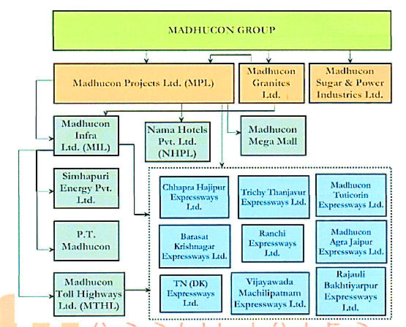

1. **SNAPSHOT OF OUTSTANDING DEBT OF THE COMPANY**: As per information shared by the client/company, below table shows the term loan status of the company as on 15th July 2022:

|  |  |  |  |  |  |  |  |  |
| --- | --- | --- | --- | --- | --- | --- | --- | --- |
| **TN (Dk) Expressways Limited - Statement Of Term Loan Status (INR Crores)** | | | | | | | | |
| **Bank** | **T/L Sanctioned** | **Term Loan % Of Share** | **Loan Disbursed** | **Principal Repaid** | **Interest Paid** | **FITL Repaid** | **Amount Paid** | **Balance O/S** |
|
| SBI (L/B) & associates | 190.00 | 84.82 | 190.00 | 111.13 | 198.14 | 4.91 | 314.18 | 78.87 |
| UBI (Ex. Andhra Bank) | 10.00 | 4.46 | 10.00 | 5.77 | 10.43 | 0.26 | 16.46 | 4.23 |
| Maximus Arc Ltd (Bob - Ex. Vijaya Bank) | 10.00 | 4.46 | 10.00 | 5.99 | 10.43 | 0.26 | 16.68 | 4.01 |
| Bank Of Maharashtra | 14.00 | 6.25 | 14.00 | 10.56 | 14.60 | 0.36 | 25.52 | 0.00 |
| **Total** | **224.00** | **100.00** | **224.00** | **133.45** | **233.60** | **5.79** | **372.84** | **87.11** |

1. **CAPITAL STRUCTURE:** Below table shows the capital structure of the company as on 31st March 2022:

| **Particular (As at March 31,2022)** | **Amount (INR)** |
| --- | --- |
| Authorized Share Capital (Equity Share of INR 10/- each) | 7,50,00,000 |
| Issued, Subscribed and Paid-up Capital (Equity Share of INR 10/- each fully paid-up) | 7,46,60,000 |

1. **SHAREHOLDING PATTERN OF THE COMPANY:** As per provisional financials for FY 2022 provided by the client/company, below table shows the details of shareholding pattern of the company as on 31st March 2022:

| **Particular (March 31,2022)** | **Number of share held** | **% of holding** |
| --- | --- | --- |
| Madhucon Infra Limited(Holding Company) | 3,80,55,000 | 50.98% |
| Madhucon Toll Highways Limited (Subsidiary of Holding Company) | 3,64,77,000 | 48.87% |
| Others | 1,15,000 | 0.15% |
| **Total** | **7,46,47,000** | **99.85 %** |

As per the data shared by the client/company, details of number of shareholders as on 31st March 2022, shown in the below table:

| **Number of Shareholders** | | |
| --- | --- | --- |
| **S.No.** | **Name of the shareholder** | **Number of share held** |
|  | NAMA NAGESWAR RAO | 8888 |
|  | NAMA SEETHAIAH | 2888 |
|  | NAMA KRISHNAIAH | 2888 |
|  | N RAMA RAO | 188 |
|  | MALLAMPATI MADHU | 88 |
|  | KAMMA SRINIVASA RAO | 60 |
|  | SREI INFRASTRUCTURE FINANCE LIMITED | 13000 |
|  | MADHUCON PROJECTS LIMITED | 100000 |
|  | MADHUCON INFRA LIMITED | 38055000 |
|  | MADHUCON TOLL HIGHWAYS LIMITED | 36477000 |
|  | **Total** | **7,46,60,000** |

1. **CURRENT STATUS OF THE PROJECT:** According to the Company, as per the concession agreement once in five years, the company needs to undertake Major maintenance works which were due in Nov. 2014. Second maintenance was fallen due in 2019 and third maintenance is falling due in 2024.

A letter was received by the company from IE vide their letter dated 17/03/2022 levying penalties for first MMR works amounting to Rs.155.20 Crs and for second MMRs works amounting to Rs.64.39 Crs thus total penalties amounting to Rs.219.59 Crs. The bankers are taking entire toll collections towards interest and principal payments and they are not releasing funds towards maintenance works and not following the waterfall mechanism laid down in the Escrow Account.

Hence the company was not able to do the MMR works in 2014. Since bankers are not following the waterfall mechanism as per Escrow Agreement and not releasing funds for maintenance works, the company had filed suit against bankers in the Hon’ble High Court. The Hon’ble High Court had ordered the Escrow Agent to release the amounts for maintenance works and strictly follow the conditions stipulated in the waterfall mechanism of Escrow Account vide its order dated 06/03/2020.

However, due to funding constraints, it was delayed by 50 months and finally commenced in January 2019 with an estimated cost of INR 76.6 Crores, which is being funded through the project cash flows. The first periodic Maintenance which was due in November, 2014 is almost completed in 2022 after much persuasion with the Lenders.

The company had issued work order for second maintenance and copy of the work order was already shared with lenders. Contractor will commence the works once they receive advance amount. As per the latest letter of NHAI as on 5th November 2022, penalty of INR 261.01 Crore has been imposed by NHAI on the company.

1. **REASON FOR FINANCIAL STRESS:** As per the information provided by the lender, the toll collections of the company remain significantly low as compared to the previous projected revenue estimated by it. There is a large variation between actual traffic and projected traffic as per the bid documents of the project by 48% affecting the revenues badly.

The actual realization during the past 13 years i.e. upto March.2022 is just about Rs.509.93 Crs against projected revenue of Rs.1054.89 Cr., the lenders have adjusted an amount of Rs.372.84 Crs towards interest and principal as on 15th July, 2022 against the debt of Rs.224.00 Crs given by the lenders.

It is considered continued delays in repayment of Tamil Nadu Dindigul Karur Expressways Limited’s (TNDK) debt obligations and has also been classified as non-performing asset by the lenders. Despite restructuring of debt in December 2012. The toll collections continue to remain significantly below expectations when compared to initial projected levels.

Further, TNDK witnessed 14.12 % decline in toll collections in FY2021 owing to adverse impact of the COVID-19 pandemic. The prospects for traffic growth along the route are modest, given that the stretch is not an arterial route. Poor toll collections, caused major maintenance (MM) reserve could not be created.

**Hence, State Bank of India has appointed R. K Associates to determine the Fair Market Value/Enterprise Value of the Business/Company to take appropriate course of action on this stressed account.**

|  |  |
| --- | --- |
| **PART C** | **ABOUT THE PROJECT** |

1. **BACKGROUND:** M/s. TN (DK) Expressways Limited, a special purpose vehicle (SPV) promoted by Madhucon Projects Limited (MPL) as lead member and its associates and SREI Infrastructure Finance Limited, was established in January 2006 to undertake the implementation of four lane of Karur to Dindigul bypass (from Km 305.600 to Km 373.275) on NH-7 with a total length of 68.125 km and Improvement, Operation and Maintenance of 9.6 km from 292.6 to 305.6 of Karur bypass in the state of Tamil Nadu under a Build Operate and Transfer (BOT-Toll) concession awarded by NHAI. Currently, The Highway is operational and a 4x4 toll booth is setup at Karur - Dindigul NH-7 Project, Km - 332, Velanchettiyur Post, Aravakurichi Taluk, Karur - District, Tamilnadu - 639 207 where toll is collected by the Concessionaire.
2. **LOCATION:** The project is located at Karur to Dindigul bypass (from Km 305.600 to Km 373.275) on NH-7 in the state of Tamilnadu as per shown in the location map below:

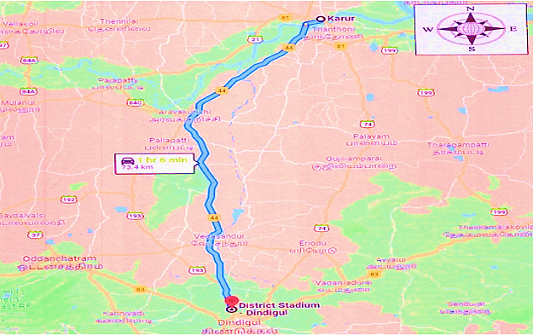

1. **SILENT FEATURE OF THE PROJECT:** As per IE’s report as on 6th July 2022, Below table shows the silent features of the project:

|  |  |  |
| --- | --- | --- |
| **Silent features of the project** | | |
| **S.No.** | **Description** | **Length in Km/No’s** |
|  | Total Length of the project (Km. 290+000 to Km. 367+725) | 77.725 Kms. |
|  | Major Bridges | 03 No’s |
|  | Minor Bridges | 18 No’s |
|  | Slab Culverts/Box Culverts | 20 No’s |
|  | HP Culverts | 81 No’s |
|  | Flyovers | 01 No’s |
|  | ROB+RUB | 01 No’s |
|  | Underpasses (Pedestrians) | 07 No’s |
|  | Underpasses (Vehicular) | 05 No’s |
|  | Major Intersections | 04 No’s |
|  | Minor Intersections | 163 No’s |
|  | Toll Plaza (332+000_ | 01 No’s |
|  | Service Road | 20.753 Km |
|  | Bus Bays | 32 No’s |
|  | Truck Lay Bays | 03 No’s |
|  | Way Side Amenity | 01 No’s |
|  | Bypass & Realignment (349+740 to 355+060) | 01 No’s |

|  |  |
| --- | --- |
| **PART D** | **ASSESSMENT OF INFRASTRUCTURE SECTOR** |

1. **INTRODUCTION:** Road infrastructure is the backbone of the Indian economy. Roads and highways form one of the core areas under the infrastructure sector. The Government has been taking measured efforts in providing more efficient transportation, for which they have signiﬁcantly stepped up the highway development and road building program.

The Government’s thrust on the infrastructure sector has remained strong in the Union Budget 2022-23, as the Ministry of Road Transport and Highways has been allocated nearly INR 68,000 crore more than the revised expenditure in 2021-22.  In absolute terms, this is the highest increase (from revised estimates of 2021-22) among all ministries in 2022-23.  Nearly all of this additional allocation has been earmarked for investment in NHAI.  After many years, NHAI will not have any borrowings, and rely entirely on budgetary resources.

In the Union Budget 2022-23, the government allocated INR 64,573 crores towards Roads & Bridges and INR 1, 34,015 crores towards NHAI. The Government has also announced the Bharatmala Pariyojana Scheme Phase I with an investment of INR 5.35 lakh crores for development National Highways totaling to 34,800 kms. Over a period of 5 years ending in 2021-22.

As of December 2021, road projects with an aggregate length of 19,926 km, and costing INR 5.98 lakh crore have been approved under Bharatmala Pariyojana Phase-I. Of this, road length of 6,976 km has already been completed. This corresponds to 35% of the approved project length. In August 2021, the central government unveiled the National Asset Monetization Pipeline (NMP). The NMP aims to monetize core brownfield infrastructure assets (such as roads, rail, ports, power transmission lines) to mobilize INR 5.97 lakh crore from 2021-25.

The central government targets monetizing 26,700 km of roads, with a potential revenue of INR 1.60 lakh crore (27% of the total potential monetization value). Only NHs with four lanes and above have been considered for asset monetization. As of February 2022, 20 stretches (1,407 km) have already been monetized through TOT mode in four Bundles. A sum of INR 15,703 crore has already been realized and remitted to the Consolidated Fund of India.

| **OVERVIEW OF INDIAN INFRASTRUCTURE SECTOR: KEY HIGHLIGHTS** | |
| --- | --- |
| **Roads (Road & Bridges)** | * With 64 Lakhs Km roads India has second largest road network in the world comprising of National Highway, Expressways, State Highways, District Roads, PWD Roads and Project Roads. * National Highways accounts for about 2% of total road network but carries 40% of traffic. |
| **Power** | * Third largest electricity generation country in the world. * Public sector companies and State electricity boards dominate both generation and T&D sectors. |
| **Railways** | * Fourth largest rail network in the world * Rail network in the country spans 117,996 Kms of tracks over a route of 66,030 Km making it one of the largest rail networks in Asia. * It is also one of the busiest networks in the world with 22,300 trains running daily. |
| **Ports** | * 12 major ports and over 205 notified minor ports along a coastline spanning over 7,517 kms. * Over 90% of total trade in volume terms and 70% of total trade in value terms in the country is handled by ports. |
| **Airports** | * Indian aviation sector comprises of over 449 airports and airstrips out of which 125 are owned and operated by Airport Authority of India. * Key Challenges include inadequate capacity in Runways & Aircraft handling and Congestion in Parking Space and Terminal Buildings |
| **Telecom** | * Second largest telecom market in the world after China in terms of subscriber base. * Around 1058. 86 Million subscribers, with a tele density of 83.36%. * Private operators dominate the sector with ~89.78% market share. |

1. **EPC INDUSTRY OVERVIEW:** With the rapid increase in quantum of projects being announced and complexities in the scope of work, the responsibility of successful project execution has shifted from project owner/developer to EPC contractors. Engineering, Procurement and Construction (EPC) is a contract under which the project is executed under a single point responsibility of a contractor. It is also known as a Lump sum Turnkey (LSTK) contract.

Under EPC contract, a contractor undertakes activities like conceptualizing, designing, procuring equipment and engineering services from various sources for construction, installation and commissioning of the project or plant. EPC is majorly applicable in the industries like infrastructure, transport, chemicals, power, aviation, and oil & gas etc.

1. **REGULATORY SCENARIO:** The government has identified infrastructure as a priority sector to bolster GDP growth. Hence, various reforms have been introduced from time to time to attract investment in the infrastructure industry. The government intends to increase share of infrastructure investment to GDP to 9% by end of 12th five- year plan.

Infrastructure sector was opened to private participation post-liberalization in 1991 and currently up to 100% FDI under automatic route is allowed in most sectors/activities. Under this route, no permission from the Central Government is required for FDI inflow, but the same is subject to applicable laws/regulations, security and other conditions. However, participation was low due to high upfront capital investment, long gestation period, and uncertain returns in investment. Public Private Partnership (PPP) project mode was introduced to circumvent this hurdle.

1. **MAJOR POLICY MEASURES:**

| **Program** | **Focus Area** |
| --- | --- |
| National High Development Program (NHDP) | Highway Development |
| Pradhan Mantri Grameen Sadak Yojana (PMGSY) | Road Infrastructure |
| Deendayal Upadhyaya Gram Jyoti Yojana (DDUGJY) | Power |
| Integrated Power Development Scheme (IPDS) | Power |
| JNNURM | Urban Infrastructure |
| National Maritime Development Program | Ports |

1. **GOVERNMENT’S INITIATIVES:**
   * + - PM GatiShakti National Master Plan to encompass the engines for economic transformation, seamless multimodal connectivity, and logistics efficiency. As a part of ‘Atmanirbhar Bharat’, 2,000 KM of rail network will be brought under ‘Kavach’ i.e., the indigenous world-class technology for safety and capacity augmentation in 2022-23.
       - Contracts to be awarded in 2022-23 for implementation of Multimodal Logistics Parks at 4 locations through PPP mode. INR 20,000 crore will be mobilized through innovative ways of financing to complement public resources.
       - Expressways to be augmented in 2022-23 to facilitate faster movement of people and goods. The National Highways network to be expanded by 25,000 KM in 2022-23.
       - Railways to develop new products and efficient logistics services for small farmers and SMEs to provide seamless solutions for movement of parcels. ‘One Station-One Product’ concept for rail stations to be endorsed to help local businesses and supply chain.
2. **KEY DEVELOPMENTS TO BE ACHIEVED OVER THE NEXT 3 YEARS:** 
   * + - In the Budget Speech 2022-23, the finance minister announced that by March 2023, the NH network will be expanded by 25,000 km.
       - 400 new-generation ‘Vande Bharat Trains’ with better energy efficiency and passenger riding experience; and 100 PM GatiShakti Cargo Terminals for multimodal logistics facilities.
       - Multimodal connectivity between mass urban transport and railway stations to be facilitated on priority basis. Design of metro systems, including civil structures to be re-oriented and standardized for Indian conditions.
       - Contracts for 8 ropeway projects totaling to length of 60 KM to be awarded in 2022-23 under PPP mode as preferred ecologically sustainable alternative to conventional roads in difficult hilly areas.
       - In order to achieve target of 280 GW of installed solar capacity by 2030, additional allocation of INR 19,500 crore for PLI scheme for domestic manufacture of high efficiency modules (with priority to fully integrated manufacturing units from polysilicon to solar PV modules).
       - Battery Swapping Policy to inter-operability standards to be formulated to overcome space constraints in urban areas to setup charging stations.
       - Sovereign Green Bonds to be issued for mobilizing resources for green infrastructure - proceeds to be deployed in public sector projects to reduce carbon intensity. Infrastructure status for Data Centers and Energy Storage Systems including dense charging infrastructure and grid-scale battery systems.
3. **KEY CHALLENGES FACED BY THE INDUSTRY:** Delay in Project Execution due to lack of delay in clearance and Land Acquisition: Major impediments can be attributed to procedural formalities in land acquisition, obtaining environment, foreign and wildlife clearances, clearance from Railways (for over bridge and under bridge construction) and delays in financial closure. The time taken by various ministries to grant clearance for infra projects to proceed for execution range from about 12 months to up to 36 months.

Due to delay in execution, the industry player has to bear both time and cost overrun that is sometime substantially higher than the original estimated cost. To address clearance delays, Ministry of Environment & Forests and the Ministry of Tribal Affairs have taken certain measures to speed up project execution. Majority of construction projects in India are facing approval as well as execution delays leading to cost and time over runs. These delays have pushed breakeven period even further and with high leverage, debt servicing cost has gone up for industry players amidst high interest rate regime in past three fiscal. The unfavorable market condition in past two years has impacted the cash flows of industry players.

1. **WAY FORWARD:** Infrastructure development is key to India’s economic growth. The Infrastructure in India is estimated to grow at a CAGR of approximately 7% during the forecast period. India has a requirement of investment worth 50 trillion in infrastructure by 2022 to have sustainable development in the country.

India is witnessing signiﬁcant interest from international investors in the infrastructure space. Sectors like power transmission, roads & highways and renewable energy will drive the investments in the coming years. Only 24% of the National Highway network in India is four-lane, therefore there is immense scope for improvement.

|  |  |
| --- | --- |
| **PART E** | **FINANCIAL PROJECTIONS** |

1. **HISTORICAL PROFIT & LOSS STATEMENT (FROM FY 2015 TO FY 2022):** As per the audited/provisional financial statements provided by the company/client, below table shows the historical performance of the company:

|  |  |  |  |  |  |  |  |  |
| --- | --- | --- | --- | --- | --- | --- | --- | --- |
| **Particulars** | **Mar-15 A** | **Mar-16 A** | **Mar-17 A** | **Mar-18 A** | **Mar-19 A** | **Mar-20 A** | **Mar-21 A** | **Mar-22 P** |
| **Total Income** | **38.17** | **40.93** | **42.21** | **54.18** | **53.76** | **63.55** | **67.44** | **101.53** |
| **Total Expenses** | 11.12 | 10.32 | 12.26 | 12.82 | 30.34 | 37.77 | 68.42 | 71.15 |
| **EBITDA** | **27.05** | **30.61** | **29.95** | **41.36** | **23.42** | **25.78** | **-0.98** | **30.38** |
| Depreciation And Amortization | 10.66 | 13.41 | 17.99 | 15.93 | 15.12 | 24.07 | 25.58 | 28.77 |
| **EBIT** | **16.39** | **17.2** | **11.96** | **25.43** | **8.3** | **1.71** | **-26.56** | **1.61** |
| Finance Cost | 25.93 | 24.58 | 23.78 | 21.6 | 13.82 | 9.72 | 1.79 | 2.74 |
| **Profit Before Tax** | **-9.54** | **-7.38** | **-11.82** | **3.83** | **-5.52** | **-8.01** | **-28.35** | **-1.13** |
| Tax Expense | 0.00 | 0.00 | 0.00 | 0.00 | 0.00 | 0.00 | 0.00 | 0.00 |
| *Effective Tax Rate* | 0.00% | 0.00% | 0.00% | 0.00% | 0.00% | 0.00% | 0.00% | 0.00% |
| **Profit/Loss after Tax** | **-9.54** | **-7.38** | **-11.82** | **3.83** | **-5.52** | **-8.01** | **-28.35** | **-1.13** |

***Source:*** *Audited Annual Financials provided by the Bank/Company*

1. **HISTORICAL KEY FINANCIAL RATIOS:**

|  |  |  |  |  |  |  |  |  |
| --- | --- | --- | --- | --- | --- | --- | --- | --- |
| **Particulars** | **Mar-15 A** | **Mar-16 A** | **Mar-17 A** | **Mar-18 A** | **Mar-19 A** | **Mar-20 A** | **Mar-21 A** | **Mar-22 P** |
| EBITDA Margin % | *70.87%* | *74.79%* | *70.95%* | *76.34%* | *43.56%* | *40.57%* | *-1.45%* | *29.92%* |
| EBIT Margin % | *42.94%* | *42.02%* | *28.33%* | *46.94%* | *15.44%* | *2.69%* | *-39.38%* | *1.59%* |
| PAT Margin % | *-0.65%* | *-0.44%* | *-0.66%* | *0.13%* | *-0.19%* | *-0.20%* | *-0.62%* | *-0.01%* |
| Revenue growth Rate (%) |  | *7.23%* | *3.13%* | *28.36%* | *-0.78%* | *18.21%* | *6.12%* | *50.55%* |

**Note:** Revenue of the company has increased steadily from FY 2015 to FY 2022 at a CAGR of 15%.However, expenses of the company have been increased at a CAGR of 30.36 % over the same period.

EBIDTA and EBIT Margin has been declined significantly over last four financial years due to significant increase in Operating Expenses of the project which includes Major Maintenance Expenses (MMR).

1. **GRAPHICAL REPRESENTATION OF THE KEY FINANCIALS OF THE COMPANY:**

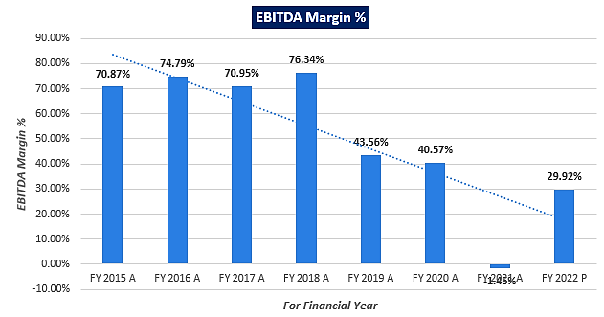

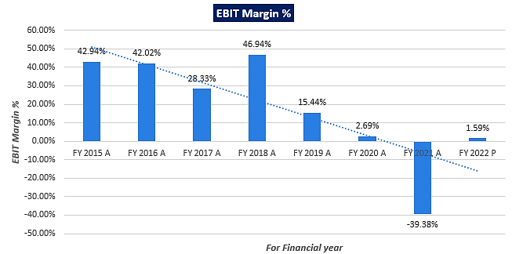

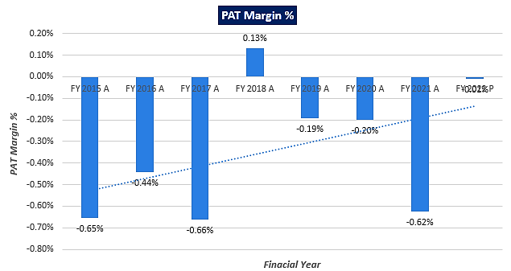

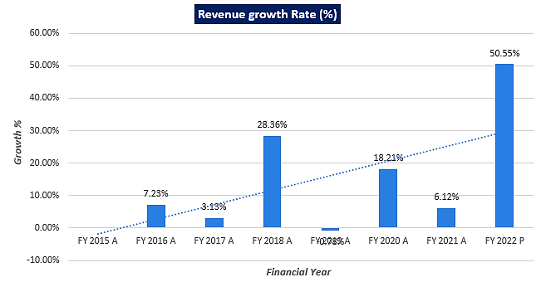

1. **PROJECTED PROFIT & LOSS STATEMENT:** Based on the data/ information/ inputs provided by the client/company and the assessment & analysis conducted by us, financial projections of the company have been estimated as provided below by the way of several different financial indicators and assumptions.

|  |  |  |  |  |  |
| --- | --- | --- | --- | --- | --- |
| **Particulars** | **FY 2023 E** | **FY 2024 E** | **FY 2025 E** | **FY 2026 E** | **FY 2027 E** |
| Operating Income | 61.03 | 66.09 | 71.58 | 77.52 | 49.22 |
| Other Income | 6.04 | 6.04 | 6.04 | 6.04 | 3.00 |
| **Total Income** | **67.07** | **72.13** | **77.62** | **83.56** | **52.22** |
| Operating expenses | 15.27 | 16.80 | 18.48 | 20.33 | 13.04 |
| Employee benefits expenses | 3.54 | 3.86 | 4.21 | 4.58 | 2.91 |
| Other expenses | 0.70 | 0.76 | 0.83 | 0.91 | 0.58 |
| MMW Expenses | 36.67 | 36.67 | 36.67 | 0.00 | 0.00 |
| **Total Expenses** | **56.18** | **58.09** | **60.18** | **25.82** | **16.53** |
| **EBITDA** | **10.89** | **14.05** | **17.44** | **57.74** | **35.68** |
| Dep & Amortization | 28.77 | 28.77 | 28.77 | 28.77 | 16.78 |
| **EBIT** | **-17.88** | **-14.72** | **-11.33** | **28.98** | **18.90** |
| Finance Cost | 3.10 | 3.52 | 3.98 | 4.51 | 2.98 |
| **Profit Before Tax** | **-20.98** | **-18.24** | **-15.32** | **24.46** | **15.92** |
| Tax Expense | 0.00 | 0.00 | 0.00 | 0.00 | 0.00 |
| *Effective Tax Rate* | 0.00% | 0.00% | 0.00% | 0.00% | 0.00% |
| **Profit (Loss) after Tax** | **-20.98** | **-18.24** | **-15.32** | **24.46** | **15.92** |

1. **PROJECTED KEY FINANCIAL RATIOS:**

|  |  |  |  |  |  |
| --- | --- | --- | --- | --- | --- |
| **Particulars** | **FY 2023 E** | **FY 2024 E** | **FY 2025 E** | **FY 2026 E** | **FY 2027 E** |
| EBITDA Margin % | *16.24%* | *19.47%* | *22.46%* | *69.10%* | *68.34%* |
| EBIT Margin % | *-26.66%* | *-20.41%* | *-14.60%* | *34.68%* | *36.20%* |
| PAT Margin % | *-0.47%* | *-0.35%* | *-0.25%* | *0.35%* | *0.58%* |
| Revenue growth Rate (%) |  | *7.55%* | *7.61%* | *7.65%* | *-37.51%* |

1. **GRAPHICAL REPRESENTATION OF THE KEY FINANCIALS OF THE COMPANY:**

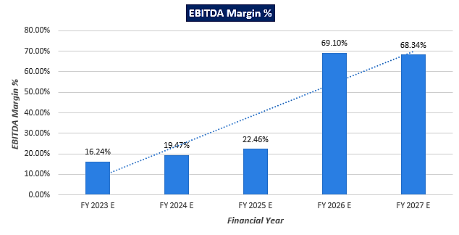

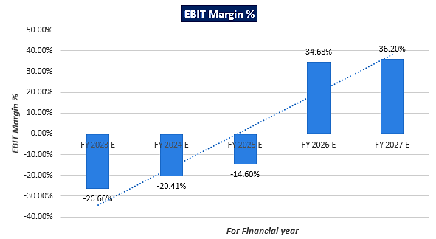

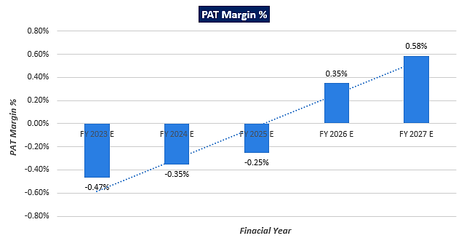

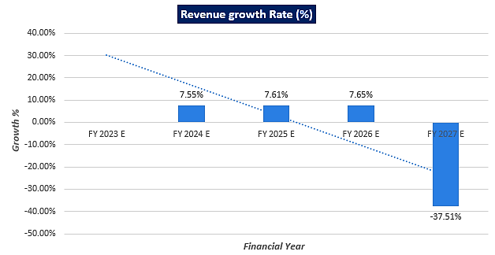

|  |  |
| --- | --- |
| **PART F** | **VALUATION METHODOLOGY** |

1. **METHODOLOGY / MODEL ADOPTED:** Out of the various models & theories available we have adopted the most widely used & acceptable Free Cash Flow to Firm Model for the calculation of Enterprise Value of the Company.
   * + - The Discounted cash flow method is similar to the method used for public companies.
       - FCFF is more practical when substantial capital changes are expected because weighted average cost of capital (WACC) is less sensitive to the changes in capital structure.
       - Finally, we calculate the present value of future cash flows by using a required rate of return based on the riskiness of the project, which we determine by using the Weighted Average Cost of Capital (WACC).

**Rationale for using “FCFF Model” for the Enterprise Valuation:**

1. The three broadly used approaches of the company/Business Valuations are – Income based approach (Discounted Cash Flow Model), Asset Based Approach (Net Asset Value Method) and Relative Valuation Approach (Market Multiple method).
2. Asset Based Model is inappropriate as the Company is a going concern and the model is unable to capture the Value of the company.
3. Considering the limited life of the toll road project and project characteristics not being comparable to other projects/companies in terms of number of operational projects, period of concession, location, traffic situation etc., typically market approach-based methods like CCM or CTM are not used for valuing a road project.
4. Instead, DCF method is used which determines the value of a business based on its ability to generate desired economic benefit/ cash flows for the owners. Thus, considering the nature of business, we have used DCF method for valuing the Company.
5. Dividends cannot be used as the Company has no history of paying dividends and we don’t foresee any dividend payments to occur in the future due to the high leverage of the firm.
6. The DCF Model gives us a variety of input options to use while calculating the Value of the firm - Dividend, Free Cash Flow to the Firm, Free Cash Flow to Equity, Capitalized Cash Flows and Residual Earnings.
7. The best method input option for the NPV Model in the case of M/s TN (DK) Expressways Limited will be FCFF as it represents the benefits accruable to all the stakeholders in the Business enterprise.

**FCFF Model Formula and Key Inputs:**

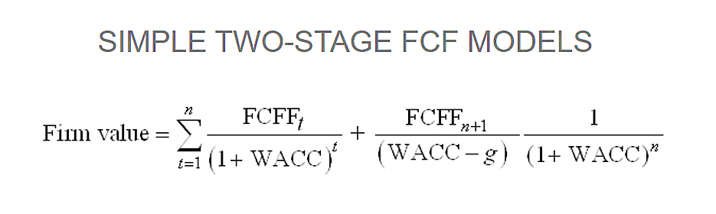

* + - * **Free Cash Flow to Firm (FCFF):** FCFF is the [cash](http://www.investinganswers.com/node/5011) available to pay investors after a company pays its costs of doing business, invests in short-term assets like [inventory](http://www.investinganswers.com/node/2474), and invests in assets like property, plants and equipment.

**FCFF = Net Income + Non-Cash Charges + Interest (1- Tax Rate) – Working Capital Investment – Fixed Capital Investment.**

* + - * **Weighted Average Cost of Capital (WACC):** The weighted average cost of capital (WACC) is the rate that a company is expected to pay on average to all its security holders to finance its assets. The WACC is commonly referred to as the firm’s cost of capital. WACC is used as the discount rate to discount FCFF.

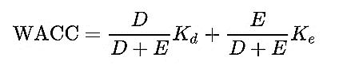

Where D is the total debt, E is the shareholders equity and Kd and Ke are the post-tax cost of debt and cost of equity, respectively.

1. **CALCULATION OF FREE CASH FLOW TO FIRM (FCFF):**

|  |  |  |  |  |  |
| --- | --- | --- | --- | --- | --- |
| **Particular** | **FY 2023 E** | **FY 2024 E** | **FY 2025 E** | **FY 2026 E** | **FY 2027 E** |
| EBITDA | 10.89 | 14.05 | 17.44 | 57.74 | 35.68 |
| (-) Dep & Amortization | 28.77 | 28.77 | 28.77 | 28.77 | 16.78 |
| EBIT | -17.88 | -14.72 | -11.33 | 28.98 | 18.90 |
| (1-tax rate) | 100% | 100% | 100% | 100% | 100% |
| EBIT*(1-t) | -17.88 | -14.72 | -11.33 | 28.98 | 18.90 |
| **NOPAT** | **-17.88** | **-14.72** | **-11.33** | **28.98** | **18.90** |
| Add: Dep & Amortization | 28.77 | 28.77 | 28.77 | 28.77 | 16.78 |
| (+/-) WCC | 0.00 | 0.00 | 0.00 | 0.00 | 0.00 |
| Less: CAPEX | 0.00 | 0.00 | 0.00 | 0.00 | 0.00 |
| **FCFF** | **10.89** | **14.05** | **17.44** | **57.74** | **35.68** |

1. **VALUATION OF FIRM:**

|  |  |  |  |  |  |
| --- | --- | --- | --- | --- | --- |
| **Particular** | **FY 2023 E** | **FY 2024 E** | **FY 2025 E** | **FY 2026 E** | **FY 2027 E** |
| Discount Period | 0.33 | 1.33 | 2.33 | 3.33 | 3.92 |
| Discount Factor | 0.95 | 0.82 | 0.70 | 0.60 | 0.55 |
| **WACC** | **16.57%** | | | | |
| PV of FCFF | 10.35 | 11.45 | 12.19 | 34.64 | 19.57 |
| **Enterprise Value** | **INR 33.99 Crore** | | | | |

**WEIGHTED AVERAGE COST OF CAPITAL CALCULATIONS**

|  |  |
| --- | --- |
| **Weighted Average Cost of Capital (WACC)** | |
| **Particular** | **Input** |
| **Total Capital** | **163.97** |
| **Weight of Debt (Wd) & Equity (We)** | 53.13% & 46.87% |
| **Cost of Debt (Kd)** | 13.30% |
| **Cost of Equity (Ke)** | 16.01% |
| **WACC** | **14.57%** |
| **Company Risk Premium** | 2.00% |
| **Discount Rate** | **16.57%** |

**SENSITIVITY ANALYSIS**

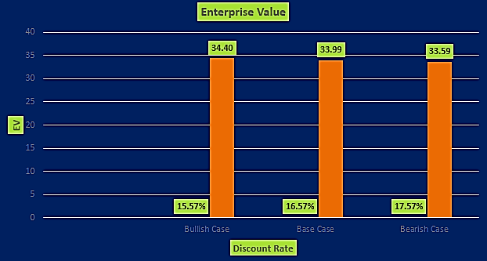

|  |  |  |
| --- | --- | --- |
| **CUMULATIVE DISCOUNTED CASH FLOW OVER THE PROJECTION PERIOD** | | |
| **Scenario** | **Discount Rate** | **Enterprise Value (In Crores.)** |
| ***Bull Scenario*** | 15.57% | 34.40 |
| ***Present Scenario*** | **16.57%** | **33.99** |
| ***Bear Scenario*** | 17.57% | 33.59 |

|  |
| --- |
| **ENTERPRISE VALUE OF M/S TN (DK) EXPRESSWAYS LIMITED** |
| **INR 33.99 CRORES** |
| **INR THIRTY THREE CRORES AND NINETY NINE LAKHS** |

**Notes:-**

* + - * Left over Concession period is about 4.2 years only as per Concession Agreement. No investors are showing interest to come forward due to the left over concession period is only about 4.2 years.
      * As per Clause No.34.11 of Concession Agreement, NHAI will retain the last two years toll revenues in the Escrow Account for renewal works while handing over of the project to NHAI at the end of concession period. Hence toll revenues available to the company is only 2.2 years.
      * Under Valuation Inputs section, the discount rate change measures the sensitivity of Firm Value to a (+/-) 1% change.
      * The Company account has been converted to Non-Performing Asset (NPA) from FY 18-19. We have assumed that the company will repay its pending dues and remaining debt till 31st March, 2025.
      * The overall valuation is estimated based on the financial statements up to FY 2021-22 and further from 2022-23 onward, it has been projected based on the previous data as reference.
      * As per NHAI’s latest letter as on 5th November 2022, NHAI imposed a penalty of INR 261.01 Crore on the company, we have not considered the same for the purpose of valuation anywhere.

**Hence, the “Enterprise Value” of the Firm “M/s TN (DK) Expressways Limited” is INR 33.99 Crores as on 20th November 2022, based on the Industry analysis, historical analysis and assumptions taken for the explicit period up to the date end of the concession period and handed over to NHAI i.e. present value of estimated unlevered free cash flow available to the firm beyond the actuals.**

*This is only a general assessment of the current value of the Enterprise/Business based on the data/ input that the Bank/Client/Company could provide to us against our questions/ queries using the appropriate method with respect to the present scenario. In no manner this should be regarded as an audit activity/ report and NO micro analysis or detailed or forensic audit/ scrutiny of the financial transactions or accounts of any kind has been carried out at our end.*

1. **KEY ASSUMPTIONS:**
2. **KEY INPUTS USED:**

|  |  |
| --- | --- |
| **INPUTS** | |
| **Valuation Date** | **20th November 2022** |
| **WACC** | **14.57%** |
| **Company’s Risk Premium** | **2.00%** |
| **Discount Rate** | **16.57%** |
| **Discount Rate Change (Sensitivity)** | **1%** |

**POST-TAX COST OF DEBT (Kd)**

|  |  |
| --- | --- |
| **Cost of Debt** | **Value** |
| **Cost of Debt** | 13.30% |
| **Effective tax Rate** | 0.00% |
| **(1-t)** | 100% |
| **Post-tax Cost of Debt (Kd)** | **13.30%** |

**COST OF EQUITY (Ke) BY USING CAPM**

|  |  |
| --- | --- |
| **Cost of Equity CAPM** | **Value** |
| **Risk-free rate of return (Rf)** | 7.29% |
| **3- Year Beta** | 1.3 |
| **10-Year Market Return (Rm)** | 14% |
| **Market Risk Premium** | 6.71% |
| **Cost of Equity (Ke)** | **16.01%** |

1. **REVENUE PROJECTIONS:**

* The main source of revenue i.e. toll collection is only considered in the revenue projections. For previous year’s toll collection figures, we have relied upon the data provided by the bank/client and no independent verification of the same done by us.
* Projections have been taken till 17th October 2026 as per concession period end date. The average growth rate in the toll revenue is 8.30 % and 6.73 % for the period of FY 2010-22 and FY 2012-22 respectively.

**SUMMARY OF TOLL COLLECTION TILL JULY, 2021**

|  |  |  |  |  |  |  |  |  |  |  |  |  |  |  |  |
| --- | --- | --- | --- | --- | --- | --- | --- | --- | --- | --- | --- | --- | --- | --- | --- |
| **SUMMARY OF TOLL REVENUE COLLECTION AS ON 31st March, 2022** | | | | | | | | | | | | | | | |
| **Yearly & Month-wise Actual Revenue [in Crores]** | | | | | | | | | | | | | | | |
| **Financial year** | **Apr** | **May** | **Jun** | **Jul** | **Aug** | **Sep** | **Oct** | **Nov** | **Dec** | **Jan** | **Feb** | **Mar** | **Total** | **Monthly Average Toll Collection** | **% Change** |
| 2009-10 |  |  |  |  |  |  |  | 1.65 | 2.10 | 2.05 | 1.89 | 2.03 | **9.72** | 1.94 |  |
| 2010-11 | 1.93 | 2.06 | 1.98 | 1.94 | 1.96 | 2.11 | 2.23 | 2.13 | 2.58 | 2.55 | 2.32 | 2.45 | **26.24** | 2.19 | **12.5%** |
| 2011-12 | 2.29 | 2.51 | 2.42 | 2.47 | 2.29 | 2.61 | 2.45 | 2.52 | 2.74 | 2.74 | 3.05 | 3.36 | **31.45** | 2.62 | **19.9%** |
| 2012-13 | 3.26 | 3.46 | 3.32 | 3.39 | 2.85 | 2.69 | 2.81 | 2.71 | 3.24 | 3.16 | 2.90 | 3.24 | **37.03** | 3.09 | **17.7%** |
| 2013-14 | 3.21 | 3.50 | 3.25 | 3.15 | 2.86 | 3.02 | 3.04 | 2.79 | 3.21 | 3.22 | 2.91 | 3.06 | **37.22** | 3.10 | **0.5%** |
| 2014-15 | 2.93 | 3.24 | 3.07 | 3.11 | 2.98 | 3.03 | 3.05 | 3.10 | 3.49 | 3.49 | 3.18 | 3.37 | **38.04** | 3.17 | **2.2%** |
| 2015-16 | 3.31 | 3.71 | 3.47 | 3.41 | 3.47 | 3.23 | 3.51 | 3.21 | 2.21 | 3.77 | 3.62 | 3.75 | **40.67** | 3.39 | **6.9%** |
| 2016-17 | 3.55 | 3.70 | 3.59 | 3.60 | 3.69 | 3.36 | 3.68 | 1.04 | 3.81 | 3.97 | 3.73 | 4.03 | **41.75** | 3.48 | **2.7%** |
| 2017-18 | 3.94 | 4.22 | 3.99 | 3.81 | 4.13 | 4.20 | 4.12 | 4.28 | 4.73 | 4.60 | 3.90 | 4.31 | **50.23** | 4.19 | **20.3%** |
| 2018-19 | 4.17 | 4.59 | 4.26 | 3.98 | 4.45 | 4.24 | 4.49 | 3.45 | 3.95 | 3.88 | 3.57 | 3.96 | **48.99** | 4.08 | **-2.5%** |
| 2019-20 | 3.88 | 4.28 | 3.98 | 3.99 | 4.11 | 4.22 | 4.27 | 4.28 | 4.70 | 4.51 | 4.17 | 3.23 | **49.62** | 4.14 | **1.3%** |
| 2020-21 | 0.56 | 2.95 | 3.22 | 2.77 | 3.18 | 3.74 | 4.00 | 3.72 | 4.34 | 4.63 | 4.53 | 4.98 | **42.62** | 3.55 | **-14.1%** |
| 2021-22 | 4.30 | 2.91 | 3.48 | 4.75 | 4.75 | 5.08 | 5.12 | 4.60 | 5.78 | 5.26 | 4.85 | 5.47 | **56.35** | 4.70 | **32.2%** |
| **Total** | **37.33** | **41.13** | **40.03** | **40.37** | **40.72** | **41.53** | **42.77** | **39.48** | **46.88** | **47.83** | **44.62** | **47.24** | **509.93** |  |  |
| ***Average growth rate for the period of FY 2010-22*** | | | | | | | | | | | | | |  | **8.30%** |
| ***Average growth rate for the period of FY 2012-22*** | | | | | | | | | | | | | |  | **6.73%** |

**Observations:**

* Average growth for the period of FY 2010 to FY 2022 is 8.30%. The toll collections continue to remain significantly below expectations when compared to initial projected levels. Further, TNDK witnessed 14.12% decline in toll collections in FY2021 owing to adverse impact of the COVID-19 pandemic. The prospects for traffic growth along the route are modest, given that the stretch is not an arterial route.

The toll collection income and other income for the period from December, 2022- October’ 2026 are projected based on the analysis of actual toll collection for the past years i.e. percentage change in the past collections, escalation rate toll income during the projected period has been considered as 8.30%.

|  |  |  |  |  |  |
| --- | --- | --- | --- | --- | --- |
| **Particulars** | **FY 2023 E** | **FY 2024 E** | **FY 2025 E** | **FY 2026 E** | **FY 2027 E** |
| Revenue from Operation | 61.03 | 66.09 | 71.58 | 77.52 | 49.22 |
| Other Income | 6.04 | 6.04 | 6.04 | 6.04 | 3.00 |
| **Total Income** | **67.07** | **72.13** | **77.62** | **83.56** | **52.22** |

1. **COST PROJECTIONS:**

* All the expenses has been projected based on the historical trends and considered escalation rates during the projected period as per industry trends.
* Escalation rate for Operating expenses, Employee benefit expenses and other expenses has been considered as 10%, 9% and 9% respectively as per industry trends during the projected period.
* As per information provided client/company, finance cost has been considered as 13.30% during the projected period.
* As per the information provided by the client, first Major maintenance work is completed and company is supposed to do 2nd MMW for which work order is issued and INR 110.00 Crore is the estimated cost to complete the work.

**Hence, as a base case, the calculated Fair Market Value/Enterprise Value of M/s TN (DK) Expressways Limited is INR 33.99 Crores, subject to the current micro & macro-economic assumptions, market, industry trends and inputs used during the forecasted period, market multiple and peers company used to compare the company, as well as the WACC used to calculate the EV.**

|  |  |
| --- | --- |
| **Declaration** | 1. *The undersigned does not have any direct/indirect interest in the Project Company.* 2. *The information furnished herein is true and correct to the best of our knowledge.* 3. *This valuation work is carried out by our Financial & Market Research Analysis team on the request from* ***STRESSED ASSETS RESOLUTION GROUP****,* ***SBI, 2nd FLOOR, THE ARCADE WORLD TRADE CENTRE, CUFFE PARADE, MUMBAI-400005*** 4. *We have submitted Valuation report directly to the Bank.* |
| **Name & Address of Valuer company** | **Signature of the authorized person** |
| M/s. R.K Associates Valuers & Techno Engineering Consultants (P) Ltd.  **Corporate Office:**  D-39, 2nd Floor, Sector- 2, Noida, Uttar Pradesh- 201301, India |  |
| **Enclosed Documents** | Valuer’s Remark - Page No. **36** |
| **Number of Pages** | **41** |
| **Financial & Market Research Analysis Team worked on the report** | ***PREPARED BY: Mr. Gaurav Kumar*** |

**For R.K Associates Valuers & Techno Place: Noida**

**Engineering Consultants (P) Ltd. Date : 20.11.2022**

**(Authorized Signatory)**

**Valuations**

|  |  |
| --- | --- |
| **PART G** | **IMPORTANT DEFINITION** |

***Important Definitions:***

* ***Enterprise Value:*** *Enterprise value (EV) is the corporate valuation of a company, determined by using market capitalization and total debt. Market cap comprises preference stocks, common stocks, and minority interest; total debt comprises short-term and long-term liabilities of the company. Enterprise value (EV) refers to the overall valuation—equity, debt, cash, and cash equivalents. In other words, it is the cost of acquiring a firm. The EV/EBITDA is an enterprise multiple. It correlates EV with earnings before interest, taxes, depreciation, and amortization. The metric determines whether the firm is undervalued or overvalued.*

*EV is computed using the following formula: EV = (Market Capitalization + Market Value of Debt – Cash and Equivalents).*

* ***Fair Market Value****suggested by the competent Valuer is that prospective estimated amount in his expert & prudent opinion of the subject asset without any prejudice after he has carefully & exhaustively evaluated the facts & information came in front of him related to the subject asset at which the subject asset should be exchanged between a willing buyer and willing seller at an arm’s length transaction in an open & unrestricted market, after proper marketing, wherein the parties, each acted knowledgeably, prudently and without any compulsion on the date of the Valuation.*

*Forced, under compulsion & constraint, obligatory sales transactions data doesn’t indicate the Fair Market Value.*

* ***Realizable Value*** *is the minimum prospective estimated value of the Company which it may be able to realize at the time of actual transaction factoring in the potential prospects of deep negotiations carried out between the buyer & seller for ultimately finalizing the transaction across the table. Realizable value may be 10-20% less than the Fair Market Value depending on the various salability prospects of the subject asset and the needs of the buyer & the seller.*
* ***Forced/ Distress Sale Value*** *is the value when the company has to be sold due to any compulsion or constraint like financial encumbrances, dispute, as a part of a recovery process, legal issues or any such condition or situation. In this type of sale, minimum fetch value is assessed which can be 15-25% less than the estimated Fair Market Value. In this type of sale, negotiation power of the buyer is always more than the seller and eagerness & pressure of selling the asset is more than buying it. Therefore, the Forced/ Distress Sale Value will always fetch significantly less value compare to the estimated Fair Market Value.*
* ***Liquidation Value*** *is the amount that would be realized when an asset or group of assets are sold on a piecemeal basis that is without consideration of benefits (or detriments) associated with a going-concern business. Liquidation value can be either in an orderly transaction with a typical marketing period or in a forced transaction with a shortened marketing period.*
* ***Difference between Costs, Price & Value:*** *Generally, these words are used and understood synonymously. However, in reality each of these has a completely different meaning, premise and also have different definitions in the professional & legal terms. Therefore, to avoid confusion, it is our professional responsibility to describe the definitions of these words to avoid ambiguity & confusion in the minds of the user of this report.*
* *The* ***Cost*** *of an asset represents the actual amount spend in the construction/ actual creation of the asset.*
* *The* ***Price*** *is the amount paid for the procurement of the same asset.*
* *The* ***Value*** *is defined as the present worth of future rights in the asset and depends to a great extent on combination of various factors such as demand and supply, market situation, purpose, situation & needs of the buyer & seller, salability outlook, usability factor, market perception & reputation. Needs of the buyer & seller, salability outlook, usability factor, market perception & reputation.*
* *Therefore, in actual for the same asset, cost, price & value remain different since these terms have different usage & meaning.*

|  |  |
| --- | --- |
| **PART H** | **REMARKS & DECLARATION** |

1. No employee or member of R.K Associates has any direct/ indirect interest in the Project.
2. This is just an opinion report on Valuation based on the copy of the documents/ information provided to us by the client which has been relied upon in good faith and the assessment and assumptions done by us.
3. This report is prepared based on the copies of the documents/ information which the Bank/ Company has provided to us out of the standard checklist of documents sought from them and further based on our assumptions and limiting conditions. The client/owner and its management/representatives warranted to us that the information they supplied was complete, accurate and true and correct to the best of their knowledge. All such information provided to us has been relied upon in good faith and we have assumed that it is true and correct in all respect. I/We shall not be liable for any loss, damages, cost or expenses arising from fraudulent acts, misrepresentations, or willful default on part of the owner, company, its directors, employee, representative or agents. Verification or cross checking of the documents provided to us from the originals or from any Govt. departments/ Record of Registrar has not been done at our end since this is beyond the scope of our work. If at any time in future, it is found or came to our knowledge that misrepresentation of facts or incomplete or distorted information has been provided to us then this report shall automatically become null & void.
4. This Valuation is prepared based on the current financial status of the company, financial data, other facts & information provided by the client in writing & during verbal discussion during the course of the assignment and based on certain assumptions which are specifically mentioned in the Valuation section of the Report.
5. Key assumptions in the report is taken based on data, information, inputs, financial statements etc. provided by the client to us during the course of the assessment and on the basis of the assessment done by us and we have assumed that all such information is true & factual to the best of the knowledge of the promoter company.
6. Sale transaction method of the asset is assumed as free market transaction while assessing Prospective Fair Market Value of the asset.
7. Legal aspects for e.g. investigation of title, ownership rights, lien, charge, mortgage, lease, sanctioned maps, verification of documents, etc. have not been done at our end and same has to be taken care by legal expert/ Advocate. It is assumed that the concerned Lender/ Financial Institution has satisfied them with the authenticity of the documents, information given to us and for which the legal verification has been already taken and cleared by the competent Advocate before requesting for this report. I/ We assume no responsibility for the legal matters including, but not limited to, legal or title concerns.
8. All observations mentioned in the report is only based on the visual observation and the documents/ data/ information provided by the client. No mechanical/ technical tests, measurements or any design review have been performed or carried out from our side during Project assessment.
9. Bank/FII should ONLY take this report as an Advisory document from the Financial/ Chartered Engineering firm and its specifically advised to the creditor to cross verify the original documents for the facts mentioned in the report which can be availed from the borrowing company directly.
10. In case of any default in loans or the credit facility extended to the borrowing company, R.K Associates shall not be held responsible for whatsoever reason may be and any request for seeking any explanation from the employee/s of R.K Associates will not be entertained at any instance or situation.
11. We have relied on data from third party, external sources & information available on public domain also to conclude this report. These sources are believed to be reliable and therefore, we assume no liability for the truth or accuracy of any data, opinions or estimates furnished by others that have been used in this analysis. Where we have relied on data, opinions or estimates from external sources, reasonable care has been taken to ensure that such data has been correctly extracted from those sources and /or reproduced in its proper form and context, however still we can’t vouch its authenticity, correctness or accuracy.
12. This Report is prepared by our competent technical team which includes financial experts & analysts. This report is a general analysis of the project based on the scope mentioned in the report. This is not an Audit report, Design document, DPR or Techno feasibility study. All the information gathered is based on the facts seen on the site during survey, verbal discussion & documentary evidence provided by the client and is believed that information given by the company is true best of their knowledge.
13. Value varies with the Purpose/ Date/ Condition of the market. This report should not to be referred if any of these points are different from the one mentioned aforesaid in the Report.
14. Analysis and conclusions adopted in the report are limited to the reported assumptions, conditions and information came to our knowledge during the course of the work.
15. This report is having limited scope as per its fields to provide only the general indication of the Value of Equity of the companies prevailing in the market based on the documents/ data/ information/ financial statements provided by the client and the assessment and assumption taken by us. The suggested value should be considered only if transaction is happened as free market transaction.
16. Secondary/ Tertiary costs related to transaction like Stamp Duty, Registration charges, Brokerage, etc. pertaining to the sale/ purchase of the company are not considered while assessing the Market Value.
17. Appropriate methodology & assumptions are rationally adopted based on the facts of the case came to our knowledge during the course of the assignment considering many factors like nature of Industry, current market situation and trends.
18. Valuation is a subjective field and opinion may differ from consultant to consultant. To check the right opinion, it is important to evaluate the methodology adopted and various factors/ basis considered during the course of assessment before reaching to any conclusion.
19. At the outset, it is to be noted that Value analysis cannot be regarded as an exact science and the conclusions arrived at in many cases will, of necessity, be subjective and dependent on the exercise of individual judgment. Given the same set of facts and using the same assumptions, expert opinions may differ due to the number of different factors, which have to be made. Therefore, there can be no standard formulae to establish an indisputable exchange ratio. In the event of a transaction, the actual transaction value achieved may be higher or lower than our indicative analysis of value depending upon the circumstances of the transaction. The knowledge, negotiability and motivations of the buyers and sellers and the applicability of a discount or premium for control will also affect actual price achieved. Accordingly, our indicative analysis of value will not necessarily be the price at which any agreement proceeds. The final transaction price is something on which the parties themselves have to agree. However our Valuation analysis can definitely help the stakeholders to make them informed and wise decision about the Value of the asset and can help in facilitating the arm’s length transaction.
20. This report is prepared on the Enterprise Valuation format as per the client requirement. This report is having limited scope as per its fields to provide only the indicative Fair value of the company based on the current financial position, future prospects & current Industry trends. The Valuation assessed in this Valuation Report should hold well only if transaction is happened as per free market transaction. No detailed analysis or verification of the information is carried upon pertaining to the value of the shares of the subject companies. No claim for any extra information will be entertained whatsoever be the reason. For any extra work over and above the fields mentioned in the report will have an extra cost which has to be borne by the customer.
21. As per the scope of the report no site survey has been carried out by us and no thorough vetting of the documents/ information provided to us has been done at our end.
22. This is just an opinion report and doesn’t hold any binding on anyone. It is requested from the concerned stakeholder which is using this report that they should consider all the different associated relevant & related factors also before taking any business decision based on the content of this report.
23. Though adequate care has been taken while preparing this report as per its scope, but still we can’t rule out typing, human errors, over sightedness of any information or any other mistakes. Therefore, the concerned organization is advised to satisfy themselves that the report is complete & satisfactory in all respect. Intimation regarding any discrepancy shall be brought into our notice immediately. If no intimation is received within 15 (Fifteen) days in writing from the date of issuance of the report, to rectify these timely, then it shall be considered that the report is complete in all respect and has been accepted by the client up to their satisfaction & use and further to which R.K Associates shall not be held responsible in any manner.
24. This Valuation report is prepared based on the facts of the companies provided to us during the course of the assignment. However, in future the assumptions taken may change or may go worse due to impact of Govt. policies or effect of World economy, Industry/ market scenario may change, etc. Hence before taking any business decision the user of this report should take into consideration all such future risk.
25. The documents, information, data provided to us during the course of this assessment by the client is reviewed only up to the extent required in relation to the scope of the work. No document has been reviewed beyond the scope of the work.
26. In case of any default in repayment of credit facility extended to the borrowing company, as estimated by us, R.K Associates shall not be held responsible for whatsoever reason may be and any request for seeking any explanation from the employee/s of R.K Associates will not be entertained at any instance or situation.
27. This report only contains general assessment & opinion as per the scope of work evaluated and based on technical & market information which came to knowledge during course of the assignment as per the information given in the copy of documents, information, data provided to us and/ and confirmed by the owner/ owner representative to us at site which has been relied upon in good faith. It doesn’t contain any other recommendations of any sort including but not limited to express of any opinion on the suitability or otherwise of entering into any transaction with the borrower.
28. This report is prepared following our Standard Operating Procedures & Best Practices, Limitations, Conditions, Remarks, Important Notes, Valuation TOR.
29. Valuation is done based on the Industry wide general accepted norms and based on the international standards & best practices for equity valuations.
30. Any kind of unpaid statutory, utilities, lease, interest or any other pecuniary dues on the asset has not been factored in the Valuation.
31. This Valuation is conducted based on the macro analysis of the asset/ property and operations of the companies and not based on the micro, component or item wise analysis. Analysis done is a general assessment and is not investigative in nature.
32. All Pages of the report including annexures are signed and stamped from our office. In case any paper in the report is without stamp & signature then this should not be considered a valid paper issued from this office.
33. Defect Liability Period is **15 DAYS**. We request the concerned authorized reader of this report to check the contents, data and calculations in the report within this period and intimate us in writing if any corrections are required or in case of any other concern with the contents or opinion mentioned in the report. Corrections only related to typographical, calculation, spelling mistakes, incorrect data/ figures/ statement will be entertained within the defect liability period. Any new changes for any additional information in already approved report will be regarded as additional work for which additional fees may be charged. No request for any illegitimate change in regard to any facts & figures will be entertained.
34. R.K Associates encourages its customers to give feedback or inform concerns over its services through proper channel at valuers@rkassociates.org in writing within 15 days of report delivery. After this period no concern/ complaint/ proceedings in connection with the Financial Feasibility Study Services will be entertained due to possible change in situation and condition of the subject Project.
35. Our Data retention policy is of **ONE YEAR**. After this period we remove all the concerned records related to the assignment from our repository. No clarification or query can be answered after this period due to unavailability of the data.
36. This Enterprise Valuation report is governed by our (1) Internal Policies, Processes & Standard Operating Procedures, (2) R.K Associates Quality Policy, (3) Valuation & Survey Best Practices Guidelines formulated by management of R.K Associates, (4) Information input given to us by the customer and (4) Information/ Data/ Facts given to us by our field/ office technical team. Management of R.K Associates never gives acceptance to any unethical or unprofessional practice which may affect fair, correct & impartial assessment and which is against any prevailing law. In case of any indication of any negligence, default, incorrect, misleading, misrepresentation or distortion of facts in the report then it is the responsibility of the user of this report to immediately or at least within the defect liability period bring all such act into notice of R.K Associates management so that corrective measures can be taken instantly.
37. R.K Associates never releases any report doing alterations or modifications from pen. In case any information/ figure of this report is found altered with pen then this report will automatically become null & void.
38. If this report is prepared for the matter under litigation in any Indian court, no official or employee of R.K Associates will be under any obligation to give in person appearance in the court as a testimony. For any explanation or clarification, only written reply can be submitted on the additional payment of charges.