**REPORT FORMAT:** V-L5 | Version: 4.2_2017

**File No.: VIS (2022-23)-PL223-173-324 Dated: 10.09.2022**

**ENTERPRISE VALUATION REPORT**

**OF**

**M/S GVRMP WAGHDHARI RIBBANPALLY TOLLWAY PRIVATE LIMITED**

**REGISTERED AT**

**PLOT NO. 46A, VETTUVANKENI FIRST AVENUE MAIN ROAD, INJAMBAKKAM VILLAGE, SHOLINGANALLUR TALUK, CHENNAI, TAMIL NADU- 600115**

**REPORT PREPARED FOR**

**STATE BANK OF INDIA- 21st FLOOR, MAKER TOWERS E, CUFFE PARADE, MUMBAI-400005 Branch- SARG**

***\*\*Important - In case of any query/ issue or escalation you may please contact Incident Manager***

***at valuers@rkassociates.org. We will appreciate your feedback in order to improve our services.***

***NOTE: As per IBA Guidelines please provide your feedback on the report within 15 days of its submission after which report will be considered to be correct.***

**IMPORTANT NOTICE**

***COPYRIGHT FORMAT:*** *This report is prepared on the copyright format of R. K. Associates Valuers & Techno Engineering Consultants (P) Ltd. (R. K. Associates) to serve our clients with the best possible information and analysis to facilitate them to take rational business decisions. Legally no one can copy or distribute this format without prior approval from R. K. Associates. It is meant only for the advisory/ reference purpose for the organization/s as mentioned on the cover page of this report. Distribution or use of this format or report or any of its content/ information/ data by any organization or individual other than R.K Associates will be seen as an unlawful act and necessary legal action can be taken against the defaulters.*

*This report is intended for the sole use of the intended recipient/s and contains material that is* ***STRICTLY CONFIDENTIAL AND PRIVATE.***

***DEFECT LIABILITY PERIOD:****In case of any query/ issue or escalation you may please contact Incident Manager at valuers@rkassociates.org. Though adequate care has been taken while preparing this report as per its scope, but still, we can’t rule out typing, human errors, over sightedness of any information or any other mistakes. Therefore, the concerned organization is advised to satisfy themselves that the report is complete & satisfactory in all respect. Intimation regarding any discrepancy shall be brought into our notice immediately. If no intimation is received within 15 (Fifteen) days in writing from the date of issuance of the report, to rectify these timely, then it shall be considered that the report is complete in all respect and has been accepted by the client up to their satisfaction & use and further to which R.K Associates shall not be held responsible in any manner.*

***Part H: R.K Associates Disclaimer and Remarks:*** *are integral part of this report and Value assessment is subject to both of these sections. Reader of the report is advised to read all the points mentioned in this sections carefully.*

|  |  |  |
| --- | --- | --- |
| **TABLE OF CONTENTS** | | |
|  | | |
| **SECTIONS** | **PARTICULARS** | **PAGE NO.** |
| **Part A** | **INTRODUCTION** | **4** |
| 1. About the Report | 4 |
| 1. Background | 4 |
| 1. Type of Report | 6 |
| 1. Purpose of the Report | 6 |
| 1. Scope of the Report | 6 |
| 1. Documents/ Data Referred | 7 |
| **Part B** | **PROJECT COMPANY** | **8** |
| 1. Brief Description about the Company | 8 |
| 1. Details of Promoters/Directors | 8 |
| 1. Snapshot of Outstanding Debt of the Company | 8 |
| 1. Capital Structure | 9 |
| 1. Shareholding Pattern | 9 |
| 1. Current Status of the Project | 9 |
| 1. Reason for Financial Stress | 10 |
| **Part C** | **THE PROJECT** | **12** |
| 1. Scope Of the Project | 12 |
| 1. Project Stretch Details and Location | 12 |
| 1. Major Sections | 13 |
| 1. Toll Plazas | 13 |
| 1. Salient Features of the Project | 14 |
| **Part D** | **ASSESSMENT OF INFRASTRUCTURE SECTOR** | **16** |
| 1. Introduction | 16 |
| 1. EPC Industry Overview | 18 |
| 1. Regulatory Scenario | 18 |
| 1. Major Policy Measures | 19 |
| 1. Measures taken by GOI | 19 |
| 1. Key Challenges faced by the industry | 20 |
| 1. Way Forward | 21 |
| **Part E** | **FINANCIAL PROJECTIONS** | **23** |
| 1. Historical P&L Statement | 23 |
| 1. Key Financial Ratios | 23 |
| 1. Graphical Representation of Historical Ratios | 24 |
| 1. Projected P&L Statement | 25 |
| 1. Projected Financial Ratios | 26 |
| 1. Graphical Representation of Projected Ratios | 27 |
| **Part F** | **VALUATION OF THE COMPANY** | **29** |
| 1. Methodology/ Model Adopted | 29 |
| 1. Calculation of Free Cash Flow to Firm | 31 |
| 1. Key Inputs | 31 |
| 1. Calculation Of Enterprise Value | 32 |
| 1. Assumptions for Financial Projections | 33 |
| **Part G** | **IMPORTANT DEFINITIONS** | 42 |
| **Part H** | **DISCLAIMER/REMARKS** | 44 |

|  |  |
| --- | --- |
| **PART A** | **INTRODUCTION** |

1. **ABOUT THE REPORT:**

Enterprise Valuation Report of M/S. GVRMP Whagdhari Ribbanpally Tollway Private Limited, a Special Purpose Vehicle (SPV) engaged in built, operate and transfer (BOT) project having its registered office at Plot No. 46A, Vettuvankeni First Avenue Main Road, Injambakkam Village, Sholinganallur Taluk, Chennai, Tamil Nadu, 600115.

1. **BACKGROUND:**

The Government of Karnataka (GoK), as part of its various programs for development of the state, has identified transportation sector as one of the key growth sectors; road sector in particular. The Karnataka Road Development Corporation Ltd. (KRDCL), a Government of Karnataka enterprise, has been entrusted with the responsibility of development of roads. It proposes to undertake inter-alia improvements to State Highways on BOT (Build, Operate, and Transfer) basis. State Highway - 10 (SH-10) from Maharashtra border to Andhra Pradesh border via Aland, Gulbarga, Malkhed, Sedam, Ribbanpally (Whagdhari-Ribbanpally Road) in Gulbarga District over a length of 135.85 Kms (Project Road) has been identified as one of the roads to be developed under the BOT route.

GoK, had invited bid proposals in May 2009 from private sector developers for Design, Engineering, Finance, Construction, Operation and Maintenance of Whagdhari Ribbanpally section for 135.85 of SH 10. This is the main interstate road connecting Andhra Pradesh and Maharashtra through Karnataka and the corridor traverses through important towns and many villages and has a mix of fast and slow plying traffic.

The Company (GVRMP Whagdhari Ribbanpally Tollway Private Limited) is an unlisted public company. It was incorporated on 29th April, 2010. GVRMP Whagdhari Ribbanpally Tollway Private Limited (GWRTL) is the Special Purpose Vehicle (SPV) incorporated by the Consortium to carry out the project and subsequently, the Concession Agreement (CA) was signed on 4th June 2010 between the SPV, Public Works, Ports and Inland Water Transport Department of GoK, and Karnataka State Road Development Corporation Ltd. (KRDCL) for the project. The Company is owned by GVR Infra Projects Ltd. (51%), RMN Infrastructures Limited (25%) and Prathyusha Associates and Shipping Private Limited (24%).

The Whagdhari-Ribbanpally project was undertaken up by GVR Infra Projects Ltd on a Build-Operate-Transfer (BOT) basis through a special purpose vehicle (SPV) GVRMP Whadhari Ribbanpally Tollway Private Ltd. Construction of road Project was completed and company has achieved its Commercial Operational Date (COD) as on 6th September 2012. The company has started toll collection from 7th September 2012. Currently the company is operating 4 toll plazas with 2 lanes Whagdhari-Ribbanpally State Highway-10 on build-operate and transfer (BOT) basis from last 11 years. The project road starts at Whagdhari, the border of Karnataka and Maharashtra and traverses through Aland, Malkhed and Sedam and ends at Ribbanpally, Karnataka. The company has 30-years concession period from the Karnataka Road Development Corporation Limited (KRDCL).

For the implementation of this Project, company has taken financial assistance from consortium of lenders with SBI being the lead banker. The total Project cost was Rs.314 crores which is implemented in a 68:32 debt-equity ratio.

Below table shows the milestones of the company:

| **S.No.** | **MILESTONE** | **DATE** |
| --- | --- | --- |
| **1** | Concession Signed | June 04, 2010 |
| **2** | Financial Closure | November 30, 2010 |
| **3** | Appointed Date | December 01, 2010 |
| **4** | Start of Construction | December 01, 2010 |
| **5** | Construction Period | 21 Months |
| **6** | COD Achieved | September 06, 2010 |
| **7** | Toll Collection Start Date | September 06, 2010 |
| **8** | Concession Period | 30 Years |
| **9** | Concession End Date | November 30, 2040 |

Below table shows the historical financial performance of the company from FY 2017-18 to FY 2021-22:

*(Figures in INR Crores)*

|  |  |  |  |  |  |
| --- | --- | --- | --- | --- | --- |
| **Particular** | **FY 2018 A** | **FY 2019 A** | **FY 2020 A** | **FY 2021 A** | **FY 2022 P** |
| Total Income | 45.43 | 37.46 | 32.00 | 19.75 | 20.06 |
| Less: Total Expenses | 12.06 | 13.61 | 4.80 | 5.54 | 6.16 |
| **EBITDA** | 33.37 | **23.85** | **27.19** | **14.21** | **13.90** |
| Less: Depreciation | 12.21 | 10.96 | 15.93 | 5.63 | 5.99 |
| **EBIT** | 21.16 | **12.89** | **11.26** | **8.59** | **7.90** |
| Less: Finance Cost | 25.74 | 23.58 | 25.74 | 5.23 | 21.32 |
| **PBT** | (4.58) | **(10.69)** | **(14.48)** | **3.36** | **(13.42)** |
| Less: Tax | 0.00 | (1.35) | (0.14) | 0.16 | 0.00 |
| **PAT** | (4.58) | **(9.34)** | **(14.34)** | **3.20** | **(13.42)** |
| ***Net Profit Margin*** | ***-10.09%*** | ***-24.93%*** | ***-44.80%*** | ***16.18%*** | ***-66.90%*** |
| ***EBITDA Margin*** | ***73.46%*** | ***63.67%*** | ***84.99%*** | ***71.95%*** | ***69.28%*** |
| ***EBIT Margin*** | ***46.58%*** | ***34.40%*** | ***35.20%*** | ***43.47%*** | ***39.40%*** |
| ***Revenue Growth % (YOY)*** |  | ***-17.54%*** | ***-14.58%*** | ***-38.26%*** | ***1.55%*** |

**Notes:** *Financials for FY 2022 are provisional as per provided by client/company.*

Project is in operation since 2010. As per the historical data, which can be seen in the above table, net profit margin in approximately all the years except one, is continuously declining which can be attributed to the financial stress faced by the company.

EBITDA and EBIT margins are positive for all the years, but PAT is showing the declining trend reason is finance cost. As per the discussion with the client, majority of the revenue has gone for debt servicing as depicted above, the company is not able to fulfill its financial obligations and hence SBI Bank and other lenders need to take appropriate decision/resolution on this NPA account.

The Company is facing financial stress due to various reasons such as lower toll collection (actual toll collection in FY 19 and FY 20 is 36.20 and 30.06 Crores respectively and then continuously declining year by year) due to alternative routes and covid-19. The company is announced as NPA since 2019.

**Hence, State Bank of India, SARG has appointed R. K Associates to determine the Fair Market Value/Enterprise Value of the Business/Company to take appropriate course of action on this stressed account.**

1. **TYPE OF REPORT:** Enterprise Valuation of M/s GVRMP Whagdhari Ribbanpally Tollway Private Limited.
2. **PURPOSE OF THE REPORT:** To estimate & determine current Fair Enterprise Value of the SPV Companyto enable the lenders to evaluate the further course of action on this account.
3. **SCOPE OF THE REPORT:** To assess, determine & compute the Enterprise Value of the Company based on Discounted Cash Flows Model

* ***This is just the enterprise valuation of the project based on its income generating capacity/ projections in future years. This Valuation shall not be construed as the physical asset valuation or should be directly related to cost approach or Project cost.***
* ***This Valuation only covers the cash flow generated from 131.50 KM toll project of the Company. It does not cover any transaction with the subject company’s subsidiary/ associate/ Joint Venture Companies.***
* ***This Enterprise Valuation report doesn’t cover vetting of the documents/ financial data/ projections or any other information provided to us by the Bank.***
* ***It doesn’t contain the principles of physical asset valuation and is not based on the site inspection of the project.***
* ***This exercise is neither an audit activity nor investigative in nature.***
* ***We have relied on the data provided by the Bank and the Company in good faith.***
* ***The Market and Industrial assessment of the given company’s industry has not been done at our end. So, this valuation doesn’t cover the Market & industrial scenario in terms of the product demand & market potential.***

1. **DOCUMENTS / DATA REFFERED:**

* Audited / provisional Financial Statements and Notes provided by M/s GWRTL.
* Financial Model of the M/s GWRTL
* Concession agreement
* Data collected from public sources and Government agencies.
* Details of Outstanding Debt of M/s GWRTL
* Previous Valuation Reports of M/s GWRTL
* Traffic Report
* Completion Certificate of the Project
* Write-up on company details

|  |  |
| --- | --- |
| **PART B** | **PROJECT COMPANY** |

1. **BRIEF DESCRIPTION ABOUT THE COMPANY:** The Sponsors and their respective group companies incorporated an SPV in the name of M/s GVRMP Whagdhari Ribbanpally Tollway Private Limited (“GWRTL”) for implementing Two-Laning of SH-10 in the state of Karnataka under KRDLC on BOT basis. As per information available on MCA website, the incorporation details of the Project Company are provided in the table below:

|  |  |
| --- | --- |
| **INCORPORATION DETAILS** | |
| **COMPANY NAME** | M/s GVRMP Whagdhari Ribbanpally Tollway Private Limited |
| **CORPORATE IDENTITY NUMBER** | U45209TN2010PTC092111 |
| **INCORPORATION DATE** | April 29, 2010 |
| **CONSTITUTION** | Private Limited Company/Company limited by Shares |
| **SECTOR** | Infrastructure - Roads & Highways |
| **REGISTERED / CORPORATE OFFICE ADDRESS** | Plot No. 46A, Vettuvankeni First Avenue Main Road, Injambakkam Village, Sholinganallur Taluk Chennai TN 600115 |
| **AUTHORIZED SHARE CAPITAL** | INR 53,00,00,000/- |
| **ISSUED, SUBSCRIBED AND PAID-UP CAPITAL** | INR 52,86,00,000/- |

***Source****: http://www.mca.gov.in/*

1. **DETAIL OF PROMOTERS/DIRECTORS:** As per information provided by the company/client, below table shows the details of directors/promoters of the company along with their DIN details, designation and appointment date:

|  |  |  |  |  |
| --- | --- | --- | --- | --- |
| **S. NO.** | **NAME** | **DIN No.** | **DESIGNATION** | **DATE OF APPOINTMENT** |
| 1. | Nanaji Tananki | 0002590765 | Director | 27th February 2021 |
| 2 | Lakshmi Kantha Mohan Kanneganti | 0002693861 | Director | 27th February 2021 |
| 3 | Chandra Mohan Sriramulu | 0005170468 | Director | 16th May 2012 |
| 4 | Sateesh Thananki | 0008178735 | Director | 2nd December 2020 |
| 5 | Shalem Raju Vempati | AXDPV0944Q | Director | 15th June 2021 |

1. **SNAPSHOT OF OUTSTANDING DEBT OF THE COMPANY** Below table shows the current status of the company with all the lenders as on 31st March 2022.

**Details of Outstanding Debt of the Company**

*(Figures in Rs. Crores)*

|  |  |  |
| --- | --- | --- |
| **Name of the Bank** | **Outstanding Amount as on**  **31st March 2022 (In Crores)** | **Sanctioned Amount**  **(In Crores)** |
| SBI | 56.10 | 75.00 |
| SBM | 19.47 | 25.00 |
| IOB | 36.65 | 48.73 |
| KTK | 41.17 | 50.00 |
| J&K | 14.77 | 15.00 |
| **Total** | **168.16** | **213.73** |

***(Source:*** *Data provided by the Company and Bank)*

1. **CAPITAL STRUCTURE:** As per information available on Ministry of Corporate Affairs, the company is having an authorized share capital is INR 53,00,00,000 and its paid-up capital is INR 52,86,00,000.
2. **SHAREHOLDING PATTERN:** The Shareholding Pattern of M/s. GVRMP Whagdhari Ribbanpally Tollway Private Limited is:

|  |  |  |  |
| --- | --- | --- | --- |
| **S. NO.** | **SHAREHOLDER’S NAME** | **NO. OF SHARES** | **(%)** |
| **1** | GVR Infra Projects Ltd. | 2,69,58,600 | 51% |
| **2** | RMN Infrastructures Limited | 1,32,15,000 | 25% |
| **3** | Prathyusha Resources and Infra Private Limited | 1,26,86,400 | 24% |
|  | **Total** | **5,28,60,000** | **100** |

1. **CURRENT STATUS OF THE PROJECT:** Financial closure of the project was achieved on November 30, 2010. At the time of Financial Closure, the project cost is proposed to be funded through a mix of Shareholders’ Equity, construction grant in form of Equity Support from GoK and Term Debt, as given below:

|  |  |  |
| --- | --- | --- |
| **Source of Funds** | **Amount (Rs. in Cr.)** | **Percentage (%)** |
| Shareholders’ Equity | 50.60 | 16.1 |
| Construction grant from GoK | 49.98 | 15.9 |
| Term Debt | 213.73 | 68.0 |
| **Total** | **314.31** | **100.0** |

The Rupee Term Loan facility of Rs. 213.73 Cr was tied up under consortium lending through signing of Common Loan Agreement (CLA) with OBC as the lead bank. The scheduled COD of the Project was December 01, 2012. But company achieved its COD 3 months prior to the date mentioned in CA i.e. September 6, 2012. Then tolling commenced for 135.85 km from next day.

Currently the company is operating **4 toll plazas** with 2 lanes Whagdhari-Ribbanpally State Highway-10 on build-operate and transfer (BOT) basis from last 11 years. The project road starts at Whagdhari, the border of Karnataka and Maharashtra and traverses through Aland, Malkhed and Sedam and ends at Ribbanpally, Karnataka. The company has 30-years concession period from the Karnataka Road Development Corporation Limited (KRDCL).

1. **REASON FOR FINANCIAL STRESS:** Currently account is in NPA state since July, 2019 due to financial stress in the company. As per the company,project's financial status is NPA due to lower toll collection of the project. Major reasons attributed for lower toll collection are:

* Alternative routes/roads came up in the nearby areas as result of which traffic has got diverted/ dispersed to a greater extent from company’s Toll road.
* Road condition of this toll road has become very poor because major maintenance is not done as per concession agreement.
* Two NHAI future projects in nearby areas.

Considering of the above said facts, toll collection has fallen and showing a downward trend from 2017-18 onwards. Below picture shows the alternative routes of the tollway in nearby areas. It is clear from the picture that these alternative routes can pass TP-1, TP-2 and TP-3. Only TP-4 is left, which is only 20 KM last stretch road of the tollway.

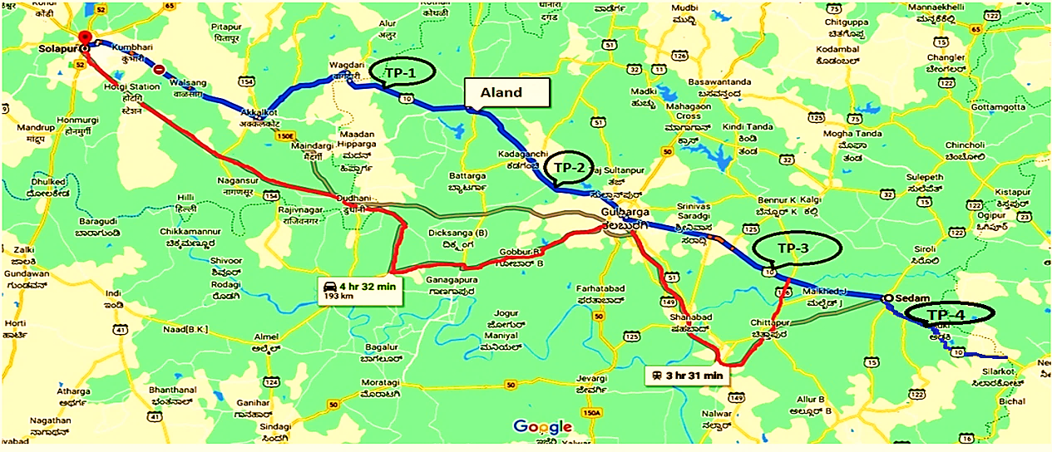

**Hence, State Bank of India, SARG has appointed R. K Associates to determine the Fair Market Value/Enterprise Value of the Business/Company to take appropriate course of action on this stressed account.**

|  |  |
| --- | --- |
| **PART C** | **THE PROJECT** |

1. **SCOPE OF PROJECT**

The scope of the Project as per the resolution plan, Concession Agreement shall mean and include the following, during the Concession Period:

1. Construction of the Project Highway together with provision of project facilities in conformity with the specifications and standards as set forth in CA.
2. Operation and maintenance of the Project Highway in accordance with the provisions of the CA; and
3. Performance and fulfillment of all other obligations of the Concessionaire in accordance with the provisions of the CA and necessary for the performance of any or all of the obligations of the Concessionaire under the CA.
4. **PROJECT STRETCH DETAILS AND LOCATION:** The Project Road is the SH10 stretch of Karnataka, which starts from Whagdhari at Maharashtra border and ends at Ribbanpally at Andhra Pradesh border via Gulbarga district in Karnataka. The project road starts at Whagdhari, the border of Karnataka and Maharashtra and traverses through Aland, Malkhed and Sedam and ends at Ribbanpally, Karnataka and Andhra Pradesh border at Km 135.85.

This is the main interstate road connecting Andhra Pradesh and Maharashtra through Karnataka. It traverses through important towns and many villages and has a mix of fast and slow plying traffic. The project corridor is abutted all through with cultivation land, mainly consisting of sunflower, maize and other annual crops. A site map of Project Road is placed below.

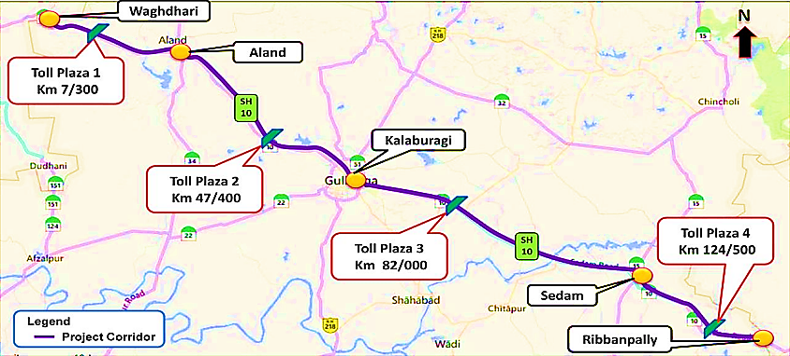

1. **MAJOR SECTIONS**

|  |  |  |
| --- | --- | --- |
| **Section No.** | **Sections** | **Chain age** |
| **1** | Start of the Project Stretch to Aland | km 0 to km 24 |
| **2** | Aland to Gulbarga | km 24 to km 61 |
| **3** | Gulbarga to Sedam | km 66 to km 116 |
| **4** | Sedam to End of the Project Stretch | km 116 to km 135.85 |

As per the information provided by the company, Section-1 starts from the border of Maharashtra and Karnataka and ends at Aland check post near Aland. The entire section is a single road with poor pavement condition. Sarasamba is the only noticeable builtup on this section and there are no major diversions in the section. Majority of the traffic on this section is the through traffic to Maharashtra State.

Section-2 starts from Aland check post to Gulbarga ring road. The pavement condition is also poor in this stretch and section is of single to two lane carriage way. SH-32 branches of from Aland check post which goes in to Aland town and further to Umarga joining NH-9 via Khajuri. There are no major builtups on this section except Kadaganchi. The traffic is uniform in the entire project stretch, the shuttle trips between Aland and Gulbarga are more on this section.

Section 3 starts from the Gulbarga ring road on Sedam side and ends after Sedam town. Lot of improvements are happening on this section, with the new proposed Gulburga airport near Sardagi, major residential layouts and international schools coming up and some are already in existence. Budha Vihar, a major piligrimage centre is located adjoining to this stretch. Major cement industries like Vasavadatta and Rajashree cements are located on this section. The entire section is almost having an Intermediate lane to two lane carriageway, with poor pavement condition, at some places improvements like patch work, overlay has been carried out.

Section 4 starts from the end of Sedam town to end of the project stretch at Karnataka / Andhra Pradesh Border. Mudhol, Adki are the major builtups on this section.

1. **TOLL PLAZAS**

Each toll plaza is having 4 lanes of 4 m width with a fully-automatic system of toll collection comprising equipment for registering of vehicle classification, ticket issuing, data processing and power supply. One toll lane in each direction shall be provided for traffic not required to pay fees and also to cater to the oversized vehicles. As per CA, the four toll plazas are planned at 2.65 Km, 59.50 Km near Gulburga, 69 Km after Gulburga and115 Km near Sedam.

1. **SALIENT FEATURES OF THE PROJECT:**
2. **Concessionaire Agreement Signing**

The Concession Agreement between Public Works, Ports and Inland Water Transport Department of GoK, Karnataka State Road Development Corporation Ltd. (KRDCL) and GWRTL has been signed on 4th June, 2010.

1. **Financial Closure**

Financial Closure was achieved on November 30, 2010. At the time of Financial Closure, the cost of the Project was estimated at Rs. 314.31 Crs, which was proposed to be financed by Sponsors’ Contribution of Rs. 100.58 Cr (including state govt grant during construction period) and Rupee Term Loan facility of Rs. 213.73 Cr i.e. debt to equity ratio of 2.13:1. The Rupee Term Loan facility of Rs. 213.73 Cr was tied up under consortium lending through signing of Common Loan Agreement (CLA) with SBI as the lead bank.

1. **Appointment Date**

The Appointment Date as per the terms of CA was declared on December 1, 2010 including 21 months construction period.

1. **Commercial Operations Date (COD)**

The scheduled COD of the Project was December 1, 2012. But company achieved its COD on 6th September 2012, which was 3 months prior to the scheduled date.

1. **Concessionaire Agreement End Date**

The end date of Concession period given in concession agreement is November 30, 2040.

1. **Debt Funding**

Debt requirement of Rs. 213.73 cr. as envisaged for the project is proposed to be arranged through Rupee Term Loan as per indicative terms mentioned below:

|  |  |
| --- | --- |
| **Borrower** | GVRMP Whagdhari Ribbanpally Tollway Pvt. Ltd. |
| **Facility** | Rupee Term Loan (RTL) of Rs. 213.73 Crore to part fund the project |
| **Availability Period** | Up to 6 months from Commercial Operation Date (COD) |
| **Interest Rate & Interest Reset** | Interest Rate & Interest Reset 3.75% over SBI Base Rate (floating) present effective rate 11.25% p.a up to COD and reset of interest spread at annual intervals thereafter |
| **Bank charges** | 0.9% of the loan amount including upfront fee and under-writing commission |
| **Tenor of Loan** | Door-to-door tenor of 14 years including 2 years of construction period, 6 months of moratorium and 11.5 years of repayment |
| **Security** | * A first mortgage and charge over all the Borrower’s properties and assets, both present and future excluding the project assets (as defined in Concession Agreement). * A first charge/assignment of all the receivables/ revenues of the Borrower from the project or otherwise. * Pledge of 51% shares of the Borrower. * A first charge on Debt Service Reserve Account for 6 months of interest & principal payments. * Assignment of contractor guarantees, liquidated damages, letter of credit, guarantee or performance bond that may be provided by any counter-party under any Project Agreement or contract in favor of the Borrower. Project Information Memorandum GWRTL 17 |
| **Undertakings** | * Promoter shall furnish a shortfall undertaking (to bring in additional funds in a form acceptable to lenders) for cases of any cost overrun during construction period. * Undertaking from GVR Infra Projects Ltd for not reducing its shareholding in the Borrower below 50% without prior written approval of lenders * Undertaking from the Promoter that in the event the Promoter’s contribution for the Project is brought in the form other than equity, then the repayment / redemption of such amount shall be sub-ordinated to servicing of term debt from Lenders. Further, no such repayment/redemption / servicing in respect of promoter contribution shall be allowed during the moratorium period. * All the charges on security shall be ranked Pari-Passu with the participating Lenders. |

1. **Commencement Of Tolling**

Tolling commenced for 135.85 km started on September 7, 2012.

|  |  |
| --- | --- |
| **PART D** | **ASSESSMENT OF INFRASTRUCTURE SECTOR** |

1. **INTRODUCTION:**

Road infrastructure is the backbone of the Indian economy. Roads and highways form one of the core areas under the infrastructure sector. The Government has been taking measured efforts in providing more efficient transportation, for which they have signiﬁcantly stepped up the highway development and road building program.

The Government’s thrust on the infrastructure sector has remained strong in the Union Budget 2022-23. The revised estimate total capital outlay for the year 2021-22 planned by the Ministry of Road Transport and Highways stands at approximately INR 1.27 Lakh Crores which is higher by 35% as compared to the previous year’s actual capital outlay of INR 0.89 Lakh Crores.

In 2022-23, the Ministry of Road Transport and Highways has been allocated nearly INR 68,000 crore more than the revised expenditure in 2021-22.  In absolute terms, this is the highest increase (from revised estimates of 2021-22) among all ministries in 2022-23.  Nearly all of this additional allocation has been earmarked for investment in NHAI.  After many years, NHAI will not have any borrowings, and rely entirely on budgetary resources.  As of November 2021, NHAI’s total debt stood at INR 3.38 lakh crore. This is nearly 150% more than the allocation to NHAI in 2022-23.

The total expenditure on the Ministry of Road Transport and Highways for 2022-23 is estimated at INR 1, 99,108 crore. This is 52% higher than the revised estimates for 2021-22. In 2022-23, capital expenditure is estimated at INR 1, 87,744 crore while revenue expenditure is estimated at INR 11,364 crore.  Since 2015-16, the share of capital expenditure of the Ministry has increased significantly, while revenue expenditure has gradually declined.  In 2022-23, 94% of the Ministry’s spending is estimated to be on capital expenditure.

In the Union Budget 2022-23, the government allocated INR 64,573 crores towards Roads & Bridges and INR 1, 34,015 crores towards NHAI. The Government has also announced the Bharatmala Pariyojana Scheme Phase I with an investment of INR 5.35 lakh crores for development National Highways totaling to 34,800 kms over a period of 5 years ending in 2021-22.

The project will be taken up by the ministry in two phases of 34,800 kilometer (including 10,000 km residual NHDP stretches) and 30,187 km each. Further, the MoRTH announced that it achieved a milestone by constructing 13,298 km of National Highways, with construction of 37 km per day in FY21. As of December 2021, road projects with an aggregate length of 19,926 km, and costing INR 5.98 lakh crore have been approved under Bharatmala Pariyojana Phase-I. Of this, road length of 6,976 km has already been completed. This corresponds to 35% of the approved project length.

Planning Commission came out with a set of factors to identify sectors that can be classified under the broader infrastructure sector. Natural monopoly, high investment and high level of government regulations were few of the factors that were considered. Based on these factors Power, Roads, Railways, Ports, Airports, and Telecom have been grouped under infrastructure sector.

|  |  |
| --- | --- |
| **OVERVIEW OF INDIAN INFRASTRUCTURE SECTOR: KEY HIGHLIGHTS** | |
| **Power** | * Third largest electricity generation country in the world. * Public sector companies and State electricity boards dominate both generation and T&D sectors. * 3.2% peak deficit in FY 2017-18 against 10.6% in FY 2012. |
| **Roads (Road & Bridges)** | * With 64 Lakhs Km roads India has second largest road network in the world comprising of National Highway, Expressways, State Highways, District Roads, PWD Roads and Project Roads. * Road traffic share in total traffic movement of rail & road account for 64.5% of freight and 85.9% of passenger traffic. * National Highways accounts for about 2% of total road network but carries 40% of traffic. |
| **Railways** | * Fourth largest rail network in the world * Rail network in the country spans 117,996 Kms of tracks over a route of 66,030 Km making it one of the largest rail networks in Asia. * It is also one of the busiest networks in the world with 22,300 trains running daily. * Low average speeds (Freight - 25.9 kmph: Mail/ Express – 50.6 kmph). Target to increase average speed of freight trains to 50 kmph and Mail/Express trains to 80 kmph by 2020. * Targets to complete Eastern and Western Dedicated Freight Corridors by the end of Dec 2019. |
| **Ports** | * 12 major ports and over 205 notified minor ports along a coastline spanning over 7,517 kms. * Over 90% of total trade in volume terms and 70% of total trade in value terms in the country is handled by ports. |
| **Airports** | * Indian aviation sector comprises of over 449 airports and airstrips out of which 125 are owned and operated by Airport Authority of India. * Key Challenges include inadequate capacity in Runways & Aircraft handling and Congestion in Parking Space and Terminal Buildings |
| **Telecom** | * Second largest telecom market in the world after China in terms of subscriber base. * Around 1058. 86 Mn subscribers, with a tele density of 83.36%. * Private operators dominate the sector with ~89.78% market share. * Broadband to all villages by 2022 under which 250,000 Gram Panchayats are planned to be connected. * Wi-Fi connectivity to major tourist places and cities. |

1. **EPC INDUSTRY OVERVIEW**

* With the rapid increase in quantum of projects being announced and complexities in the scope of work, the responsibility of successful project execution has shifted from project owner/developer to EPC contractors.
* Engineering, Procurement and Construction (EPC) is a contract under which the project is executed under a single point responsibility of a contractor. It is also known as a Lump sum Turnkey (LSTK) contract.
* Under EPC contract, a contractor undertakes activities like conceptualizing, designing, procuring equipment and engineering services from various sources for construction, installation and commissioning of the project or plant. EPC is majorly applicable in the industries like infrastructure, transport, chemicals, power, aviation, and oil & gas etc.

1. **REGULATORY SCENARIO:**

The government has identified infrastructure as a priority sector to bolster GDP growth. Hence, various reforms have been introduced from time to time to attract investment in the infrastructure industry. The government intends to increase share of infrastructure investment to GDP to 9% by end of 12th five- year plan.

**Impact of Economic Reforms:**

Infrastructure sector was opened to private participation post-liberalization in 1991 and currently up to 100% FDI under automatic route is allowed in most sectors/activities. Under this route, no permission from the Central Government is required for FDI inflow, but the same is subject to applicable laws/regulations, security and other conditions. However, participation was low due to high upfront capital investment, long gestation period, and uncertain returns in investment. Public Private Partnership (PPP) project mode was introduced to circumvent this hurdle.

Prevailing regulatory framework consist of close to 32 regulations / laws / statues with wide variation in implementation from state to state. Currently there is no Pan-India regulatory framework governing the sector. In addition, there is no common regulatory authority and nodal implementation agency despite the sector comprising multiple sub-segments like infrastructure construction, real estate construction and industrial construction.

1. **MAJOR POLICY MEASURES:**

|  |  |
| --- | --- |
| **Program** | **Focus Area** |
| **National High Development Program (NHDP)** | Highway Development |
| **Pradhan Mantri Grameen Sadak Yojana (PMGSY)** | Road Infrastructure |
| **Deendayal Upadhyaya Gram Jyoti Yojana (DDUGJY)** | Power |
| **Integrated Power Development Scheme (IPDS)** | Power |
| **JNNURM** | Urban Infrastructure |
| **National Maritime Development Program** | Ports |
| **Ultra-Mega Power Projects** | Power |
| **Jawaharlal Nehru National Solar Mission** | Solar Power |
| **Saubhagya Scheme** | Power |

1. **MEASURES TAKEN BY GOVERNMENT OF INDIA TO BOOST THE INFRASTRUCTURE FINANCING IN UNION BUDGET 2022-23:**

* PM GatiShakti National Master Plan to encompass the engines for economic transformation, seamless multimodal connectivity, and logistics efficiency.
* Expressways to be augmented in 2022-23 to facilitate faster movement of people and goods.
* The National Highways network to be expanded by 25,000 KM in 2022-23.
* Contracts to be awarded in 2022-23 for implementation of Multimodal Logistics Parks at 4 locations through PPP mode.
* INR 20,000 crore will be mobilized through innovative ways of financing to complement public resources.
* Railways to develop new products and efficient logistics services for small farmers and SMEs to provide seamless solutions for movement of parcels.
* As a part of ‘Atmanirbhar Bharat’, 2,000 KM of rail network will be brought under ‘Kavach’ i.e., the indigenous world-class technology for safety and capacity augmentation in 2022-23.
* ‘One Station-One Product’ concept for rail stations to be endorsed to help local businesses and supply chain.

1. **KEY CHALLENGES FACED BY THE INDUSTRY:** Delay in Project Execution due to lack of delay in clearance and Land Acquisition: Major impediments can be attributed to procedural formalities in land acquisition, obtaining environment, foreign and wildlife clearances, clearance from Railways (for over bridge and under bridge construction) and delays in financial closure. The time taken by various ministries to grant clearance for infra projects to proceed for execution range from about 12 months to up to 36 months. Due to delay in execution, the industry player has to bear both time and cost overrun that is sometime substantially higher than the original estimated cost. To address clearance delays, Ministry of Environment & Forests and the Ministry of Tribal Affairs have taken certain measures to speed up project execution.

New Highway projects, for widening within standard ROW for National Highways i.e., 60m and up to 100km are exempted from Environment Clearance.

* “Special Exemption” or ‘No Objection Certificate’ under Forest Rights Act (FRA), 2006 to be granted in respect of strengthening and widening of the National Highways 17 projects specifically pertaining to diversion of Protected Forest land under Forest Conservation Act, 1980e.
* De-linking of Environment Clearance from Forest Clearance for highway projects that earlier was linked to the forest clearance. Consequently, project could be started only if forest clearance was obtained even if the small portion of project passes through forest.
* Also, Delegation of Power Mechanism to Secretary (Road Transport & Highways) or the Expenditure Finance Committee (EFC) has been enhanced under notification issued (O. M. No. 24/35/PFII/12) dated 12.04.2013. Under this Secretary (Road Transport & Highways) & Expenditure Finance Committee (EFC) will be empowered to grant approval to project worth up to INR 10 billion.
* Other than the above, the EPC industry is faces challenges in terms of Shifting of Utilities, Law and Order problem at local level, Budget Constraint of the Developer.

Majority of construction projects in India are facing approval as well as execution delays leading to cost and time over runs. These delays have pushed breakeven period even further and with high leverage, debt servicing cost has gone up for industry players amidst high interest rate regime in past three fiscal.

The unfavorable market condition in past two years has impacted the cash flows of industry players.

Thus, large numbers of projects are on standstill that has blocked the investment made earlier. This has affected balance sheet of banks with high NPA and as majority of the companies in the sector have high debt on books and banks are cautious in further lending. As on March 2016, gross NPA of commercial banks rose to 7.6% which is highest in last 12 year (bad loans grew by about 80% during FY 2016) and it is further expected to grow to 8.5% by March 2017 as per the Financial Stability Report released by RBI in June 2016. This has led to liquidity crunch impacting further investment needed for completion of the projects.

1. **WAY FORWARD**: Infrastructure development is key to India’s economic growth. The Infrastructure in India is estimated to grow at a CAGR of approximately 7% during the forecast period. India has a requirement of investment worth 50 trillion in infrastructure by 2022 to have sustainable development in the country. India is witnessing signiﬁcant interest from international investors in the infrastructure space. Sectors like power transmission, roads & highways and renewable energy will drive the investments in the coming years. Only 24% of the National Highway network in India is four-lane, therefore there is immense scope for improvement. Some of the recent investments include:

* The Infrastructure in India is estimated to grow at a CAGR of approximately 7% during the forecast period.
* Government plans to invest about INR 102 lakh crore on infrastructure projects by 2024-25. The five-year-long National Infrastructure Pipeline (NIP) will enter its second year in FY21, during which INR 1,950,397 crores are to be invested. About INR 19.5 lakh crore has been budgeted during FY21 as part of the NIP. Urban infrastructure, road transport, energy, and Railways account for about 70% of allocation this 2020.
* About 42% of the projects in the NIP are under implementation, which means construction work is already going on. Another 19% is under a development stage, while a big 31% is still in the conceptual stage
* During the fiscals 2020 to 2025, sectors such as Energy (24%), Roads (19%), Urban (16%), and Railways (13%) amount to around 70% of the projected capital expenditure in infrastructure in India.

|  |  |
| --- | --- |
| **PART E** | **FINANCIAL PROJECTIONS** |

As per the audited/provisional financial statements provided by the company/client, below table shows the historical performance of the company.

1. **HISTORICAL PROFIT & LOSS STATEMENT: (FY 2017-18 to FY 2021-22)**

|  |  |  |  |  |  |
| --- | --- | --- | --- | --- | --- |
| **Particular** | **FY 2018 A** | **FY 2019 A** | **FY 2020 A** | **FY 2021 A** | **FY 2022 P** |
| Toll Revenue | 44.88 | 36.20 | 30.06 | 19.03 | 20.06 |
| Other Income | 0.55 | 1.26 | 1.94 | 0.72 | - |
| **Total Income** | **45.43** | **37.46** | **32.00** | **19.75** | **20.06** |
| Operation & Maintenance Expenses | 0.71 | 0.53 | 0.68 | 0.79 | 0.91 |
| Employee Benefit Expenses | 1.96 | 2.30 | 2.56 | 2.56 | 2.71 |
| Insurance | 0.13 | 0.15 | 0.15 | 0.53 | 0.58 |
| Other Expenses | 1.34 | 1.35 | 1.41 | 1.67 | 1.97 |
| Major Maintenance Expense | 7.91 | 9.28 | - | - | - |
| **Total expenses** | **12.06** | **13.61** | **4.80** | **5.54** | **6.16** |
| **EBIDTA** | **33.37** | **23.85** | **27.19** | **14.21** | **13.90** |
| Depreciation | 12.21 | 10.96 | 15.93 | 5.63 | 5.99 |
| **EBIT** | **21.16** | **12.89** | **11.26** | **8.59** | **7.90** |
| Finance Cost | 25.74 | 23.58 | 25.74 | 5.23 | 21.32 |
| **PBT** | **(4.58)** | **(10.69)** | **(14.48)** | **3.36** | **(13.42)** |
| Tax | - | (1.35) | (0.14) | 0.16 | - |
| **PAT** | **(4.58)** | **(9.34)** | **(14.34)** | **3.20** | **(13.42)** |

1. **KEY FINANCIAL RATIOS:**

|  |  |  |  |  |  |
| --- | --- | --- | --- | --- | --- |
| **Particular** | **FY 2018 A** | **FY 2019 A** | **FY 2020 A** | **FY 2021 A** | **FY 2022 P** |
| **EBITDA Margin** | 73.46% | 63.67% | 84.99% | 71.95% | 69.28% |
| **EBIT Margin** | 46.58% | 34.40% | 35.20% | 43.47% | 39.40% |
| **Net Profit Margin** | -10.09% | -24.93% | -44.80% | 16.18% | -66.90% |
| **Revenue Growth % (YOY)** |  | -17.54% | -14.58% | -38.26% | 1.55% |

1. **GRAPHICAL REPRESENTATION OF THE KEY FINANCIALS OF THE COMPANY**:

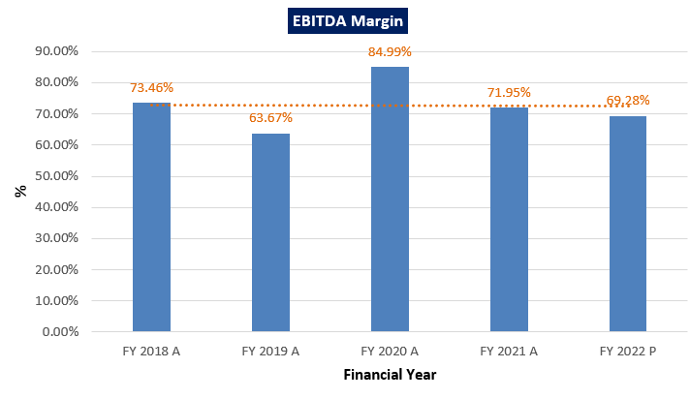

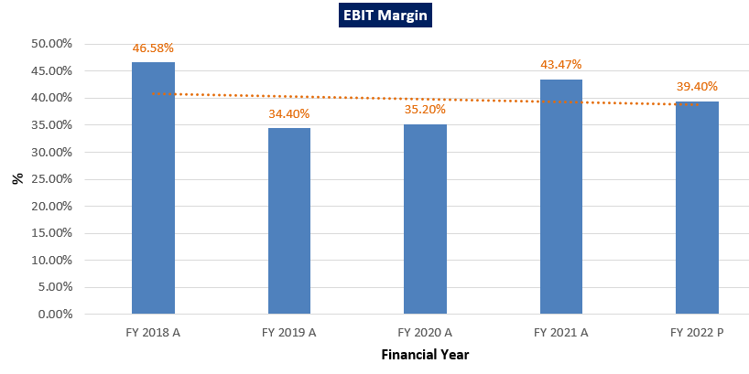

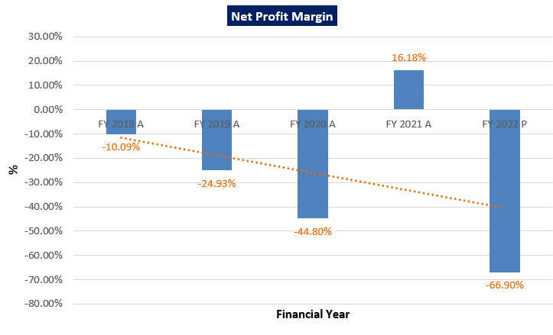

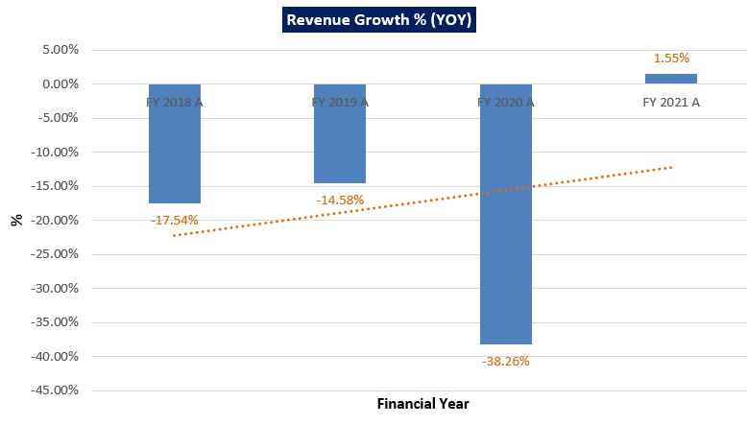

Based on the data/ information/ inputs provided by the Company Officials EBITDA Margin was positive throughout FY 2018 to 2022, it increased to 84.99% from 63,67% in FY 2020, then it falls around 13% in FY 2021 and 2.67% in FY 2022.

EBIT Margin was positive throughout FY 2018 to FY 2022, while in FY 2019, it declined to 34.40% from 46.58%. Then it increased to 43.47% from 32.20% in FY 2021. In FY 2022 it falls again to 39.40%.

Net profit margin is constantly negative from FY 2018 to FY 2022 due to the higher financing costs, except FY 2021.

Revenues of the company are constantly declining in most of the past recent years historically due to the adverse effect of Covid-19 & the traffic leakage issue this highway is facing, but according to FY2022 provisional data the revenue grows by 1.55%.

1. **PROJECTED PROFIT & LOSS STATEMENT (From FY 2023 to FY 2041):** Based on the data/ information/ inputs provided by the Bank/ company, financial projections of the project have been estimated as follows:

|  |  |  |  |  |  |  |  |  |  |
| --- | --- | --- | --- | --- | --- | --- | --- | --- | --- |
| **Particular** | **FY 2023** | **FY 2024** | **FY 2025** | **FY 2026** | **FY 2027** | **FY 2028** | **FY 2029** | **FY 2030** | **FY 2031** |
| Toll Revenue | 21.18 | 22.53 | 23.60 | 24.75 | 25.94 | 27.19 | 28.54 | 29.95 | 31.37 |
| **Total Income** | **21.18** | **22.53** | **23.60** | **24.75** | **25.94** | **27.19** | **28.54** | **29.95** | **31.37** |
| Operation & Maintenance Expenses | 0.94 | 0.98 | 1.02 | 1.06 | 1.10 | 1.15 | 1.19 | 1.24 | 1.29 |
| Employee Benefit Expenses | 2.92 | 3.16 | 3.41 | 3.68 | 3.98 | 4.29 | 4.64 | 5.01 | 5.41 |
| Insurance | 0.60 | 0.61 | 0.62 | 0.63 | 0.65 | 0.66 | 0.67 | 0.68 | 0.70 |
| Other Expenses | 2.04 | 2.13 | 2.21 | 2.30 | 2.39 | 2.49 | 2.59 | 2.69 | 2.80 |
| Major Maintenance Expense | 10.25 | 10.76 | - | - | - | 13.08 | 13.73 | - | - |
| **Total expenses** | **16.75** | **17.63** | **7.26** | **7.67** | **8.12** | **21.66** | **22.82** | **9.62** | **10.20** |
| **EBIDTA** | **4.42** | **4.90** | **16.34** | **17.08** | **17.82** | **5.52** | **5.72** | **20.32** | **21.17** |
| Depreciation | 10.89 | 10.89 | 10.89 | 10.89 | 10.89 | 10.89 | 10.89 | 10.89 | 10.89 |
| **EBIT** | **(6.46)** | **(5.99)** | **5.46** | **6.19** | **6.94** | **(5.36)** | **(5.17)** | **9.43** | **10.28** |
| Finance Cost | - | - | - | - | - | - | - | - | - |
| **PBT** | **(6.46)** | **(5.99)** | **5.46** | **6.19** | **6.94** | **(5.36)** | **(5.17)** | **9.43** | **10.28** |
| Tax | - | - | - | - | - | - | - | - | - |
| **PAT** | **(6.46)** | **(5.99)** | **5.46** | **6.19** | **6.94** | **(5.36)** | **(5.17)** | **9.43** | **10.28** |

|  |  |  |  |  |  |  |  |  |  |  |
| --- | --- | --- | --- | --- | --- | --- | --- | --- | --- | --- |
| **Particular** | **FY 2032** | **FY 2033** | **FY 2034** | **FY 2035** | **FY 2036** | **FY 2037** | **FY 2038** | **FY 2039** | **FY 2040** | **FY 2041** |
| Toll Revenue | 32.95 | 34.55 | 36.35 | 38.13 | 39.97 | 41.88 | 43.94 | 46.08 | 48.31 | 25.24 |
| **Total Income** | **32.95** | **34.55** | **36.35** | **38.13** | **39.97** | **41.88** | **43.94** | **46.08** | **48.31** | **25.24** |
| Operation & Maintenance Expenses | 1.34 | 1.39 | 1.45 | 1.51 | 1.57 | 1.63 | 1.70 | 1.76 | 1.84 | 1.28 |
| Employee Benefit Expenses | 5.84 | 6.31 | 6.81 | 7.36 | 7.95 | 8.58 | 9.27 | 10.01 | 10.81 | 7.81 |
| Insurance | 0.71 | 0.73 | 0.74 | 0.76 | 0.77 | 0.79 | 0.80 | 0.82 | 0.83 | 0.57 |
| Other Expenses | 2.91 | 3.03 | 3.15 | 3.27 | 3.40 | 3.54 | 3.68 | 3.83 | 3.98 | 2.77 |
| Major Maintenance Expense | - | 16.69 | 17.5 | - | - | - | 21.30 | 22.37 | - | - |
| **Total expenses** | **10.81** | **28.15** | **29.68** | **12.90** | **13.69** | **14.54** | **36.76** | **38.79** | **17.47** | **12.42** |
| **EBIDTA** | **22.15** | **6.40** | **6.67** | **25.24** | **26.27** | **27.34** | **7.18** | **7.29** | **30.84** | **12.81** |
| Depreciation | 10.89 | 10.89 | 10.89 | 10.89 | 10.89 | 10.89 | 10.89 | 10.89 | 10.89 | 7.25 |
| **EBIT** | **11.26** | **(4.49)** | **(4.21)** | **14.35** | **15.39** | **16.45** | **(3.71)** | **(3.60)** | **19.96** | **5.57** |
| Finance Cost | - | - | - | - | - | - | - | - | - | - |
| **PBT** | **11.26** | **(4.49)** | **(4.21)** | **14.35** | **15.39** | **16.45** | **(3.71)** | **(3.60)** | **19.96** | **5.57** |
| Tax | - | - | - | - | - | - | - | - | - |  |
| **PAT** | **11.26** | **(4.49)** | **(4.21)** | **14.35** | **15.39** | **16.45** | **(3.71)** | **(3.60)** | **19.96** | **5.57** |

1. **PROJECTED FINANCIAL RATIOS:**

|  |  |  |  |  |  |  |  |  |  |
| --- | --- | --- | --- | --- | --- | --- | --- | --- | --- |
| **Particular** | **FY 2023** | **FY 2024** | **FY 2025** | **FY 2026** | **FY 2027** | **FY 2028** | **FY 2029** | **FY 2030** | **FY 2031** |
| **EBITDA Margin %** | 20.89 | 21.74 | 69.24 | 68.99 | 68.71 | 20.31 | 20.04 | 67.86 | 67.49 |
| **EBIT Margin %** | -30.51 | -26.58 | 23.12 | 25.01 | 26.74 | -19.73 | -18.10 | 31.50 | 32.78 |
| **Net Profit Margin %** | -30.51 | -26.58 | 23.12 | 25.01 | 26.74 | -19.73 | -18.10 | 31.50 | 32.78 |
| **Revenue Growth % (YOY)** |  | 6.38 | 4.77 | 4.87 | 4.80 | 4.81 | 4.98 | 4.92 | 4.75 |

|  |  |  |  |  |  |  |  |  |  |  |
| --- | --- | --- | --- | --- | --- | --- | --- | --- | --- | --- |
| **Particular** | **FY 2032** | **FY 2033** | **FY 2034** | **FY 2035** | **FY 2036** | **FY 2037** | **FY 2038** | **FY 2039** | **FY 2040** | **FY 2041** |
| **EBITDA Margin %** | 67.21 | 18.52 | 18.35 | 66.18 | 65.74 | 65.27 | 16.34 | 15.81 | 63.84 | 67.21 |
| **EBIT Margin %** | 34.17 | -12.99 | -11.59 | 37.63 | 38.50 | 39.28 | -8.44 | -7.81 | 41.31 | 34.17 |
| **Net Profit Margin %** | 34.17 | -12.99 | -11.59 | 37.63 | 38.50 | 39.28 | -8.44 | -7.81 | 41.31 | 34.17 |
| **Revenue Growth % (YOY)** | 5.06 | 4.84 | 5.22 | 4.91 | 4.81 | 4.79 | 4.90 | 4.88 | 4.84 | 5.06 |

1. **GRAPHICAL REPRESENTATION OF THE PROJECTED KEY RATIOS OF THE COMPANY**:

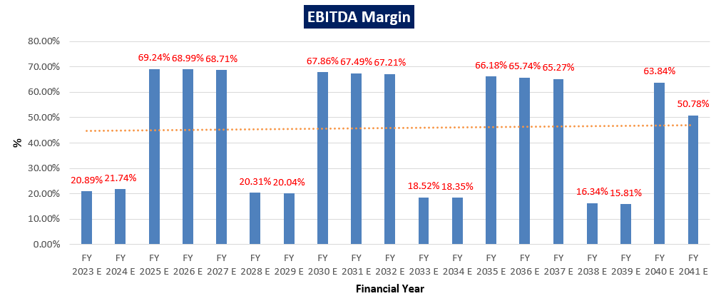

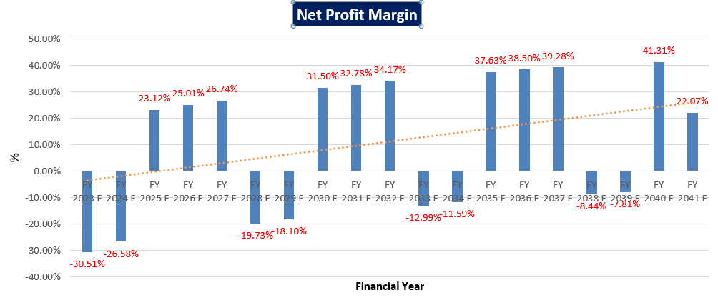

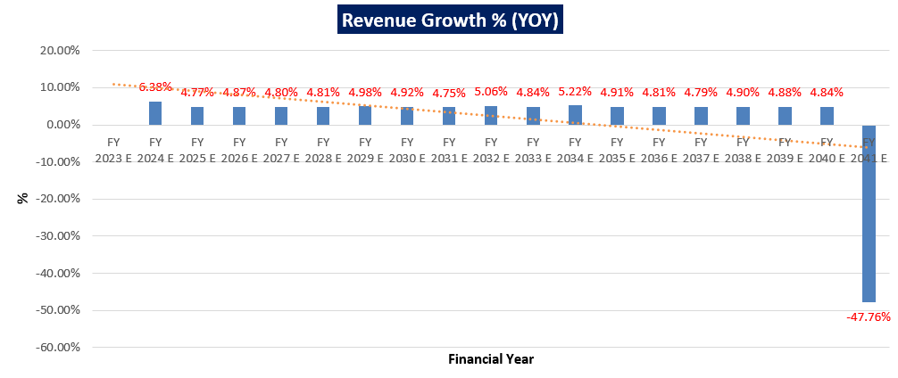

**Notes**:

* As per the ratio analysis performed, it is observed that EBITDA Margin of the company is not showing a constant trend. In FY 2223, 2024, 2028, 2029, 2033 and 2039 it is falling down and in rest of the years it is increasing. But trend line is showing a declining trend. Alternative routes/roads came up in the nearby areas as result of which traffic has got diverted/ dispersed to a greater extent from company’s Toll road. In FY 2023 it is going up by 20.89% and in FY 2041 it is going up by 50.78%.
* Similarly, EBIT Margin and net profit margins are also showing the same trend. In FY 2023 net profit margin is decline by 30.51% and in FY 2041 it is fall by 22.07%.
* Revenue growth rate is showing positive trend throughout FY 2023 to FY 2041. It means that in future traffic is showing a steady growth. In FY 2023 it is going up by 6.38% and then from FY 2024 it is showing approximately constant growth till FY 2040.

|  |  |
| --- | --- |
| **PART F** | **VALUATION OF THE COMPANY** |

1. **METHODOLOGY/ MODEL ADOPTED:**

Out of the various models & theories available, we have adopted the most widely used & acceptable approach to calculate the Enterprise Value of the Company, which is, Income based approach (Discounted Cash Flow Model).

1. The free cash flow method is similar to the method used for public companies.
2. FCFF is more practical when substantial capital changes are expected because weighted average cost of capital (WACC) is less sensitive to the cost of equity.
3. In this method, we calculate the free cash flow to firm (FCFF) for the projected period.
4. Finally, we calculate the present value of future cash flows by using a required rate of return based on the riskiness of the project, which we determine by using the Weighted Average Cost of Capital (WACC).

**RATIONALE FOR USING DCF METHOD FOR ENTERPRISE VALUATION:**

M/s GWRTL is an SPV which operates a toll road project under a long-term concession agreement with SH in the state of Karnataka. The period of operations and toll prices are derived by the terms of the specific agreement between M/s GWRTL, KRDLC and GoK.

1. The three broadly used approaches of the company/Business Valuations are – Income based approach (Discounted Cash Flow Model), Asset Based Approach (Net Asset Value Method) and Relative Valuation Approach (Market Multiple method).
2. Asset Based Model is inappropriate as the Company is a going concern and the model is unable to capture the Value of the company.
3. Considering the limited life of the toll road project and project characteristics not being comparable to other projects/companies in terms of number of operational projects, period of concession, location, traffic situation etc, typically market approach-based methods like CCM or CTM are not used for valuing a road project.
4. Instead, DCF method is used which determines the value of a business based on its ability to generate desired economic benefit/ cash flows for the owners. Thus, considering the nature of business, we have used DCF method for valuing the Company.
5. The DCF Model gives us a variety of input options to use while calculating the Value of the firm - Dividend, Free Cash Flow to the Firm, Free Cash Flow to Equity, Capitalized Cash Flows and Residual Earnings.
6. Dividends cannot be used as the Company has no history of paying dividends and we don’t foresee any dividend payments to occur in the future due to the high leverage of the firm.
7. The best method input option for the PV Model in the case of M/s GVRMP Whagdhari Ribbanpally Tollway Private Limited will be FCFF as it represents the benefits accruable to all the stakeholders in the Business enterprise.

**FCFF Model Formula and Key Inputs:**

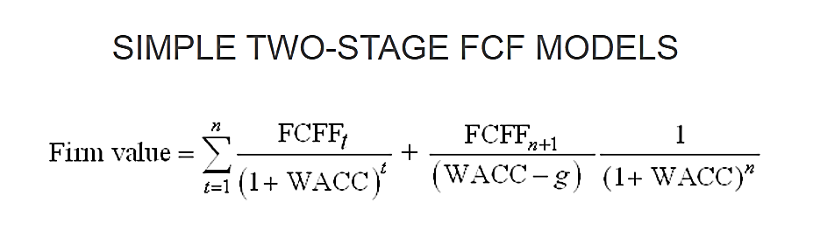

1. **Free Cash Flow to Firm (FCFF):** FCFF is the [cash](http://www.investinganswers.com/node/5011) available to pay investors after a company pays its costs of doing business, invests in short-term assets like [inventory](http://www.investinganswers.com/node/2474), and invests in assets like property, plants and equipment.

*FCFF = Net Income + Non-Cash Charges + Interest (1 - tax rate) – Working Capital Investment – Fixed Capital Investment.*

1. **Weighted Average Cost of Capital (WACC):**The weighted average cost of capital (WACC) is the rate that a company is expected to pay on average to all its security holders to finance its assets. The WACC is commonly referred to as the firm’s cost of capital. WACC is used as the discount rate to discount FCFF.

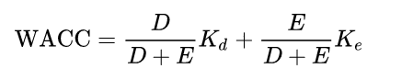

Where D is the total debt, E is the shareholders equity and Kd and Ke are the cost of debt and cost of equity, respectively.

1. **CALCULATION OF FREE CASH FLOW TO FIRM:** Since the company has achieved the COD and collecting the toll revenue post construction. In this scenario the company will not require any kind of working capital and Capex (Major Maintenance Expense) and depreciation & amortization are adjusted while calculating EBITDA. Therefore as per best practice in industry, we have considered the cash EDITDA as a proxy of free cash flow to the firm, which has been shown in the below table:

|  |  |  |  |  |  |  |  |  |  |
| --- | --- | --- | --- | --- | --- | --- | --- | --- | --- |
| **Particular** | **FY 23** | **FY 24** | **FY 25** | **FY 26** | **FY 27** | **FY 28** | **FY 29** | **FY 30** | **FY 31** |
| **Cash EBITDA** | 4.42 | 4.90 | 16.34 | 17.08 | 17.82 | 5.52 | 5.72 | 20.32 | 21.17 |
| **Free Cash Flow to Firm (FCFF)** | 4.42 | 4.90 | 16.34 | 17.08 | 17.82 | 5.52 | 5.72 | 20.32 | 21.17 |
| **Discount Period** | 0.50 | 1.50 | 2.50 | 3.50 | 4.50 | 5.50 | 6.50 | 7.50 | 8.50 |
| **Discount Factor** | 0.95 | 0.85 | 0.77 | 0.69 | 0.62 | 0.56 | 0.50 | 0.45 | 0.41 |
| **Present Value of FCFF** | 4.20 | 4.18 | 12.56 | 11.81 | 11.09 | 3.09 | 2.88 | 9.22 | 8.65 |

|  |  |  |  |  |  |  |  |  |  |  |
| --- | --- | --- | --- | --- | --- | --- | --- | --- | --- | --- |
| **Particular** | **FY 32** | **FY 33** | **FY 34** | **FY 35** | **FY 36** | **FY 37** | **FY 38** | **FY 39** | **FY 40** | **FY 41** |
| **Cash EBITDA** | 22.15 | 6.40 | 6.67 | 25.24 | 26.27 | 27.34 | 7.18 | 7.29 | 30.84 | 12.81 |
| **(FCFF)** | 22.15 | 6.40 | 6.67 | 25.24 | 26.27 | 27.34 | 7.18 | 7.29 | 30.84 | 12.81 |
| **Discount Period** | 9.50 | 10.50 | 11.50 | 12.50 | 13.50 | 14.50 | 15.50 | 16.50 | 17.50 | 18.50 |
| **Discount Factor** | 0.37 | 0.33 | 0.30 | 0.27 | 0.24 | 0.22 | 0.20 | 0.18 | 0.16 | 0.14 |
| **Present Value of FCFF** | 8.14 | 2.12 | 1.99 | 6.76 | 6.34 | 5.93 | 1.40 | 1.28 | 4.88 | 1.82 |

1. **KEY INPUTS USED TO DISCOUNT CASH FLOWS DURING THE PROJECTION PERIOD:**

**Calculation of Weighted Average Cost of Capital (WACC)**

|  |  |  |
| --- | --- | --- |
| **Weighted Average Cost of Capital (WACC)** | | |
| **Particulars** | **Weightage** | **Required Return** |
| Sustainable Debt | 76.4% | 8.88% |
| Equity Shared Capital | 23.6% | 14.09% |
| **Total** | **100%** | **10.11%** |
| Company Risk Premium | | 1.00% |
| **Appropriate Discount Rate** | | **11.11%** |

**Valuation Inputs for M/s GVRMP Whagdhari Ribbanpally Tollway Pvt. Ltd.**

|  |  |
| --- | --- |
| **INPUTS** | |
| **Valuation Date** | 10th September 2022 |
| **Discount Rate** | 11.11% |
| **Discount Rate Change** | 1% |

***Note***: *Change of 1% is used to perform the Sensitivity of the Enterprise Valuation with +/- changes in discount rate of Free Cash Flow.*

1. **CALCULATION OF ENTERPRISE VALUE:**

**Calculation of Enterprise Value**

|  |  |  |
| --- | --- | --- |
| **CUMULATIVE DISCOUNTED CASH FLOW OVER THE PROJECTION PERIOD** | | |
| **Scenario** | **Discount Rate** | **Enterprise Value (in INR Crores)** |
| **Bull Case** | 10.11% | 116.43 |
| **Present Case** | **11.11%** | **108.35** |
| **Bear Case** | 12.11% | 101.09 |

|  |
| --- |
| **ENTERPRISE VALUE OF THE FIRM** |
| **INR ONE HUNDRED EIGHT CRORES AND THIRTY FIVE LAKHS (INR 108.35 CRORES)** |

***NOTE:***

* Under Valuation Inputs section, the discount rate change measures the sensitivity of Firm Value to a (+/-) 1% change.
* The Company account has been converted to Non-Performing Asset (NPA) from FY 2019. We have assumed that the company will repay its pending dues and remaining debt till 30th November, 2040.
* The overall valuation is estimated based on the financial statements up to FY 2021-22 and further it has been projected based on the previous data as reference from 2022-23 onwards.

**Contingencies to the Valuation: -**

1. All the projections are made after considering the macroeconomic effect of Covid-19 pandemic, traffic growth and toll rate in this project.
2. As per concession agreement the company was supposed to complete the construction within the period of 21 months, however company has achieved its COD in the 1st week of September 2012, prior to 3 months of construction end date (3 months additional revenue will be earned by the company).
3. GWRTL started its toll collection next day after achieving its COD i. e. September 7th 2012. So in the current year company will not require any capex and working capital.
4. **ASSUMPTIONS FOR FINANCIAL PROJECTIONS:** Assumptions in the Valuation assessment have been taken based on data/ information/ documents shared by the client/company, Project Cost Figures, Operating History of the Project. Assumptions have been considered after thoroughly reviewing their feasibility.
   * + - 1. **Projection Period:**

Key dates and projection period details are as follows:

|  |  |
| --- | --- |
| **Particulars** | **Detail** |
| **Concession Agreement Signing Date** | 4 June 2010 |
| **Financial Closure Date** | 30 Nov 2010 |
| **Concession Appointed date** | 1 Dec 2010 |
| **Concessionaire Period** | 30 Years |
| **Projection End Date** | 30 November 2040 |

* + - * 1. **Revenue/ Income:**

**Toll Collection Revenue:** Basic toll rates are mentioned in Concession Agreement. It is also mentioned that these toll rates shall be increased annually by 3% thereof for a period of 15 successive years commencing from April 1, 2008 and the last and fifteenth such increase shall be affected on April 1, 2022.

Thereafter in addition to the annual revision effected, the applicable basic toll rates shall be adjusted and revised annually on April 1 of the each year to reflect the variation in WPI occurring.

The annual revision on account of inflation shall be restricted to 40% of the rate of inflation occurring after the revision and such revision shall be effected on April 1 every year. Hence after considering average WPI Growth and the impact of WPI on toll fee the toll growth rate would be 1.86% for each year thereafter, starting from FY 22-23.

WPI series capture the structural changes in the economy. All the series of WPI have their base year, here we have consider 1994-95, 2004-05 and 2011-12 base year’s series. The government is at advance stage of finalizing the new WPI series with base year 2017-18. The WPI growth rate used by the Management are summarized below:

|  |  |  |  |  |  |  |  |  |
| --- | --- | --- | --- | --- | --- | --- | --- | --- |
| **WPI HISTORIC INFLATION - ANNUAL** | Base Year | **Mar-08** | **Mar-09** | **Mar-10** | **Mar-11** | **Mar-12** | **Mar-13** | **Mar-14** |
| No. of Years | 0 | 1 | 2 | 3 | 4 | 5 | 6 |
| WPI Series (94-95) | 208.70 | 216.40 | 229.70 | 248.30 | - | - | - |
| WPI Series (04-05) | - | - | - | - | 146.00 | 157.30 | 168.8 |
| WPI Series (11-12) | - | - | - | - | - | - | - |
| Factor to align with 94-95 | - | - | - | - | 1.873 | 1.873 | 1.873 |
| Factor to align with 04-05 | - | - | - | - | - | - | - |
| WPI Series (Composite) | 208.70 | 216.40 | 229.70 | 248.30 | 273.46 | 294.62 | 316.2 |
| Annual Escalation WPI - historic |  | 3.69% | 6.15% | 8.10% | 10.13% | 7.74% | 7.31% |

|  |  |  |  |  |  |  |  |  |
| --- | --- | --- | --- | --- | --- | --- | --- | --- |
| **WPI HISTORIC INFLATION - ANNUAL** | Base Year | **Mar-15** | **Mar-16** | **Mar-17** | **Mar-18** | **Mar-19** | **Mar-20** | **Mar-21** |
| No. of Years | 7 | 8 | 9 | 10 | 11 | 12 | 13 |
| WPI Series (94-95) | - | - | - | - | - | - | - |
| WPI Series (04-05) | 179.60 | 178.70 | 176.80 | 183.30 | - | - | - |
| WPI Series (11-12) | - | - | - | - | 115.70 | 119.70 | 122.8 |
| Factor to align with 94-95 | 1.873 | 1.873 | 1.873 | 1.873 | 1.873 | 1.873 | 1.873 |
| Factor to align with 04-05 | - | - | - | - | 1.641 | 1.641 | 1.641 |
| WPI Series (Composite) | 336.39 | 334.71 | 331.15 | 343.32 | 355.61 | 367.91 | 377.4 |
| Annual Escalation WPI - historic | 6.40% | -0.50% | -1.06% | 3.68% | 3.58% | 3.46% | 2.59% |
| **AVERAGE WPI** | | | | | | | | |
| From Mar-12 to Mar-21 | | | | | 4.66% | | | |
| WPI Growth Assumption taken for the future years | | | | | **4.66%** | | | |

|  |  |
| --- | --- |
| **Toll Rates** | **Assumptions (Per Single Trip)** |
| **Trip Frequency - Round Trip** | 2 |
| **Trip Frequency - Monthly pass** | 2 |
| **Toll Fee - Round Trip** | 1.5 |
| **Toll Fee - Monthly Pass** | 30 |
| **Toll Fee Rounded to nearest** | 5/10 Rs |
| **Local Traffic** | 100 Rs |
| **WPI - FY 2007** | 206.2 Rs |

|  |  |  |  |  |  |  |  |
| --- | --- | --- | --- | --- | --- | --- | --- |
| **Traffic Projection** | **Toll Plaza-I** | | | | | | |
| **Calendar Year** | **Car/Jeep/Van** | **Mini Bus** | **LCV** | **Standard Bus** | **Two Axle Trucks** | **Three Axle Trucks** | **MAV** |
| **31-Dec-21** | 355 | 96 | 89 | 23 | 74 | 320 | 41 |
| **31-Dec-22** | 366 | 99 | 92 | 24 | 76 | 330 | 42 |
| **31-Dec-23** | 377 | 102 | 94 | 24 | 79 | 339 | 43 |
| **31-Dec-24** | 388 | 105 | 97 | 25 | 81 | 350 | 45 |
| **31-Dec-25** | 400 | 108 | 100 | 26 | 83 | 360 | 46 |
| **31-Dec-26** | 412 | 111 | 103 | 27 | 86 | 371 | 48 |
| **31-Dec-27** | 424 | 115 | 106 | 27 | 88 | 382 | 49 |
| **31-Dec-28** | 437 | 118 | 109 | 28 | 91 | 394 | 50 |
| **31-Dec-29** | 450 | 122 | 113 | 29 | 94 | 405 | 52 |
| **31-Dec-30** | 463 | 125 | 116 | 30 | 97 | 418 | 53 |
| **31-Dec-31** | 477 | 129 | 120 | 31 | 99 | 430 | 55 |
| **31-Dec-32** | 491 | 133 | 123 | 32 | 102 | 443 | 57 |
| **31-Dec-33** | 506 | 137 | 127 | 33 | 106 | 456 | 58 |
| **31-Dec-34** | 521 | 141 | 131 | 34 | 109 | 470 | 60 |
| **31-Dec-35** | 537 | 145 | 135 | 35 | 112 | 484 | 62 |
| **31-Dec-36** | 553 | 150 | 139 | 36 | 115 | 499 | 64 |
| **31-Dec-37** | 570 | 154 | 143 | 37 | 119 | 514 | 66 |
| **31-Dec-38** | 587 | 159 | 147 | 38 | 122 | 529 | 68 |
| **31-Dec-39** | 604 | 163 | 152 | 39 | 126 | 545 | 70 |
| **31-Dec-40** | 622 | 168 | 156 | 40 | 130 | 561 | 72 |
| **31-Dec-41** | 641 | 173 | 161 | 42 | 134 | 578 | 74 |

|  |  |  |  |  |  |  |  |
| --- | --- | --- | --- | --- | --- | --- | --- |
| **Traffic Projection** | **Toll Plaza-II** | | | | | | |
| **Calendar Year** | **Car/Jeep/Van** | **Mini Bus** | **LCV** | **Standard Bus** | **Two Axle Trucks** | **Three Axle Trucks** | **MAV** |
| **31-Dec-21** | 561 | 143 | 290 | 103 | 242 | 501 | 84 |
| **31-Dec-22** | 578 | 147 | 299 | 106 | 249 | 516 | 87 |
| **31-Dec-23** | 595 | 152 | 308 | 109 | 257 | 532 | 89 |
| **31-Dec-24** | 613 | 156 | 317 | 113 | 264 | 547 | 92 |
| **31-Dec-25** | 631 | 161 | 326 | 116 | 272 | 564 | 95 |
| **31-Dec-26** | 650 | 166 | 336 | 119 | 281 | 581 | 97 |
| **31-Dec-27** | 670 | 171 | 346 | 123 | 289 | 598 | 100 |
| **31-Dec-28** | 690 | 176 | 357 | 127 | 298 | 616 | 103 |
| **31-Dec-29** | 711 | 181 | 367 | 130 | 307 | 635 | 106 |
| **31-Dec-30** | 732 | 187 | 378 | 134 | 316 | 654 | 110 |
| **31-Dec-31** | 754 | 192 | 390 | 138 | 325 | 673 | 113 |
| **31-Dec-32** | 777 | 198 | 401 | 143 | 335 | 694 | 116 |
| **31-Dec-33** | 800 | 204 | 413 | 147 | 345 | 714 | 120 |
| **31-Dec-34** | 824 | 210 | 426 | 151 | 355 | 736 | 123 |
| **31-Dec-35** | 849 | 216 | 439 | 156 | 366 | 758 | 127 |
| **31-Dec-36** | 874 | 223 | 452 | 160 | 377 | 781 | 131 |
| **31-Dec-37** | 900 | 229 | 465 | 165 | 388 | 804 | 135 |
| **31-Dec-38** | 927 | 236 | 479 | 170 | 400 | 828 | 139 |
| **31-Dec-39** | 955 | 243 | 494 | 175 | 412 | 853 | 143 |
| **31-Dec-40** | 984 | 251 | 509 | 181 | 424 | 879 | 147 |
| **31-Dec-41** | 1013 | 258 | 524 | 186 | 437 | 905 | 152 |

|  |  |  |  |  |  |  |  |
| --- | --- | --- | --- | --- | --- | --- | --- |
| **Traffic Projection** | **Toll Plaza-III** | | | | | | |
| **Calendar Year** | **Car/Jeep/Van** | **Mini Bus** | **LCV** | **Standard Bus** | **Two Axle Trucks** | **Three Axle Trucks** | **MAV** |
| **31-Dec-21** | 448 | 115 | 129 | 126 | 199 | 467 | 62 |
| **31-Dec-22** | 461 | 118 | 133 | 130 | 205 | 481 | 64 |
| **31-Dec-23** | 475 | 122 | 137 | 134 | 211 | 495 | 66 |
| **31-Dec-24** | 490 | 126 | 141 | 138 | 217 | 510 | 68 |
| **31-Dec-25** | 504 | 129 | 145 | 142 | 224 | 526 | 70 |
| **31-Dec-26** | 519 | 133 | 150 | 146 | 231 | 541 | 72 |
| **31-Dec-27** | 535 | 137 | 154 | 150 | 238 | 558 | 74 |
| **31-Dec-28** | 551 | 141 | 159 | 155 | 245 | 574 | 76 |
| **31-Dec-29** | 568 | 146 | 163 | 160 | 252 | 592 | 79 |
| **31-Dec-30** | 585 | 150 | 168 | 164 | 260 | 609 | 81 |
| **31-Dec-31** | 602 | 155 | 173 | 169 | 267 | 628 | 83 |
| **31-Dec-32** | 620 | 159 | 179 | 174 | 275 | 646 | 86 |
| **31-Dec-33** | 639 | 164 | 184 | 180 | 284 | 666 | 88 |
| **31-Dec-34** | 658 | 169 | 189 | 185 | 292 | 686 | 91 |
| **31-Dec-35** | 678 | 174 | 195 | 191 | 301 | 706 | 94 |
| **31-Dec-36** | 698 | 179 | 201 | 196 | 310 | 728 | 97 |
| **31-Dec-37** | 719 | 185 | 207 | 202 | 319 | 749 | 99 |
| **31-Dec-38** | 740 | 190 | 213 | 208 | 329 | 772 | 102 |
| **31-Dec-39** | 763 | 196 | 220 | 215 | 339 | 795 | 106 |
| **31-Dec-40** | 786 | 202 | 226 | 221 | 349 | 819 | 109 |
| **31-Dec-41** | 809 | 208 | 233 | 228 | 359 | 843 | 112 |

|  |  |  |  |  |  |  |  |
| --- | --- | --- | --- | --- | --- | --- | --- |
| **Traffic Projection** | **Toll Plaza-IV** | | | | | | |
| **Calendar Year** | **Car/Jeep/Van** | **Mini Bus** | **LCV** | **Standard Bus** | **Two Axle Trucks** | **Three Axle Trucks** | **MAV** |
| **31-Dec-21** | 273 | 74 | 108 | 42 | 98 | 547 | 38 |
| **31-Dec-22** | 278 | 75 | 110 | 43 | 100 | 558 | 39 |
| **31-Dec-23** | 284 | 77 | 112 | 44 | 102 | 569 | 40 |
| **31-Dec-24** | 290 | 79 | 115 | 45 | 104 | 580 | 40 |
| **31-Dec-25** | 296 | 80 | 117 | 45 | 106 | 592 | 41 |
| **31-Dec-26** | 301 | 82 | 119 | 46 | 108 | 604 | 42 |
| **31-Dec-27** | 307 | 83 | 122 | 47 | 110 | 616 | 43 |
| **31-Dec-28** | 314 | 85 | 124 | 48 | 113 | 628 | 44 |
| **31-Dec-29** | 320 | 87 | 127 | 49 | 115 | 641 | 45 |
| **31-Dec-30** | 326 | 88 | 129 | 50 | 117 | 654 | 45 |
| **31-Dec-31** | 333 | 90 | 132 | 51 | 119 | 667 | 46 |
| **31-Dec-32** | 339 | 92 | 134 | 52 | 122 | 680 | 47 |
| **31-Dec-33** | 346 | 94 | 137 | 53 | 124 | 694 | 48 |
| **31-Dec-34** | 353 | 96 | 140 | 54 | 127 | 708 | 49 |
| **31-Dec-35** | 360 | 98 | 143 | 55 | 129 | 722 | 50 |
| **31-Dec-36** | 367 | 100 | 145 | 57 | 132 | 736 | 51 |
| **31-Dec-37** | 375 | 102 | 148 | 58 | 135 | 751 | 52 |
| **31-Dec-38** | 382 | 104 | 151 | 59 | 137 | 766 | 53 |
| **31-Dec-39** | 390 | 106 | 154 | 60 | 140 | 781 | 54 |
| **31-Dec-40** | 398 | 108 | 157 | 61 | 143 | 797 | 55 |
| **31-Dec-41** | 406 | 110 | 160 | 62 | 146 | 813 | 56 |

|  |  |  |  |  |  |  |  |  |
| --- | --- | --- | --- | --- | --- | --- | --- | --- |
| **Total Revenue (Rs. Crore)** | | | | | | | | |
| **Calendar Year** | **Car/Jeep/Van** | **Mini Bus** | **LCV** | **Standard Bus** | **Two Axle Trucks** | **Three Axle Trucks** | **MAV** | **SUM** |
| **31-Mar-22** | 1.54 | 0.98 | 1.46 | 1.39 | 2.85 | 11.38 | 1.34 | **20.94** |
| **31-Mar-23** | 1.55 | 0.98 | 1.43 | 1.41 | 2.88 | 11.52 | 1.40 | **21.18** |
| **31-Mar-24** | 1.66 | 1.03 | 1.52 | 1.51 | 3.08 | 12.25 | 1.48 | **22.53** |
| **31-Mar-25** | 1.73 | 1.08 | 1.59 | 1.58 | 3.23 | 12.84 | 1.55 | **23.60** |
| **31-Mar-26** | 1.82 | 1.15 | 1.69 | 1.65 | 3.36 | 13.46 | 1.62 | **24.75** |
| **31-Mar-27** | 1.89 | 1.20 | 1.76 | 1.74 | 3.55 | 14.10 | 1.70 | **25.94** |
| **31-Mar-28** | 2.02 | 1.24 | 1.83 | 1.82 | 3.72 | 14.78 | 1.78 | **27.19** |
| **31-Mar-29** | 2.12 | 1.32 | 1.94 | 1.91 | 3.91 | 15.48 | 1.87 | **28.54** |
| **31-Mar-30** | 2.19 | 1.38 | 2.03 | 2.00 | 4.08 | 16.30 | 1.97 | **29.95** |
| **31-Mar-31** | 2.29 | 1.44 | 2.11 | 2.09 | 4.27 | 17.11 | 2.06 | **31.37** |
| **31-Mar-32** | 2.44 | 1.51 | 2.23 | 2.21 | 4.50 | 17.91 | 2.16 | **32.95** |
| **31-Mar-33** | 2.56 | 1.59 | 2.33 | 2.32 | 4.75 | 18.73 | 2.26 | **34.55** |
| **31-Mar-34** | 2.67 | 1.68 | 2.47 | 2.43 | 4.97 | 19.75 | 2.39 | **36.35** |
| **31-Mar-35** | 2.80 | 1.74 | 2.57 | 2.55 | 5.21 | 20.76 | 2.50 | **38.13** |
| **31-Mar-36** | 2.96 | 1.86 | 2.73 | 2.66 | 5.43 | 21.71 | 2.62 | **39.97** |
| **31-Mar-37** | 3.09 | 1.93 | 2.84 | 2.78 | 5.68 | 22.80 | 2.75 | **41.88** |
| **31-Mar-38** | 3.25 | 2.00 | 2.95 | 2.93 | 5.98 | 23.94 | 2.89 | **43.94** |
| **31-Mar-39** | 3.42 | 2.13 | 3.13 | 3.08 | 6.29 | 25.02 | 3.01 | **46.08** |
| **31-Mar-40** | 3.57 | 2.22 | 3.26 | 3.24 | 6.61 | 26.25 | 3.17 | **48.31** |
| **31-Mar-41** | 2.81 | 1.74 | 2.56 | 2.52 | 5.14 | 20.51 | 2.47 | **37.75** |
| **TOTAL** | | | | | | | **1,103.01** | |

As per documents provided by the company officials/clients, commercial vehicle movement on highways has been picking up since June 2020, therefore it is pushing toll collection closer to the pre-Covid levels, which can be seen as a sign of commercial activities picking up momentum after the disruption caused by the pandemic-triggered lockdown.

Long distance commercial vehicles are decreasing because of parallel national highways. Out of 4 toll plazas, this SH-10 has existing alternative routes on 3 toll plazas. As per our tertiary research, on this tollway two cement factories are situated at Sedam and at Malkhed. So return trips of loaded vehicles are observed to high at both the toll plazas. Some of the new factories are about to set their plants in the upcoming years.

Manufacturing and other industries are going to increase their production in the coming years because of increasing population and post covid rapid economic recovery. Accordingly the escalation rate of traffic is considered for the revenue forecasting.

Hence, for estimated toll collection, we have considered **3%** growth in toll collection Y-o-Y basis, here the base year is FY 2022, which seems to be reasonable and on conservative side considering the appropriate micro and macro-economic factors .

It is expected from FY 2023, that the revenue growth on account of recovery from impact of COVID-19 on traffic. Revenues have been forecast to increase from INR 20.94 Cr in FY23 to INR 37.75 Cr in FY41.

* + - * 1. **Expenses**

1. **Operation & Maintenance Expenses:** As per the information provided by the company, operation expenses are included routine expenses (Excl. Personnel). Escalation rate of 4% is assumed in operation & maintenance expenses throughout the forecasted period.
2. **Employee Benefit Expenses**: Employee benefit expenses are estimated based on previous years’ expenses with an annual expected escalation rate of 8%.
3. **Insurance**: Insurance expenses are estimated based on previous years’ expenses with an annual expected escalation rate of 2%.
4. **Other Expenses**: Other expenses are estimated based on previous years’ expenses with an annual expected escalation rate of 4%.
5. **Major Maintenance Repair Work (MMW) expenses:** As per the information provided by the banker/client, it is estimated that the Company does the Major Maintenance work of 135.85 km highway along with an escalation rate of 5% and 8 Lakhs per km per annum. This MMW will repeat after every 5 years.
   * + - 1. **Taxation:** Corporate tax rate – 34.94%
         2. **Depreciation:** Toll collection rights in respect of road projects are depreciate over period of concession using the Straight line method prescribed under the Companies Act 2013.
         3. **Weights of Debt & Equity:** As per the information provided by the client/company, weight of debt and equity are determined as 76.4% and 23.6%, respectively. In the provisional financial statements for FY22, for the consideration of weight of debt, we only considered senior debt of INR 171.10 Crores and for weight of equity, we considered INR 52.86 Crores.
         4. **Beta:** To calculate the beta of M/s GVRMP Whagdhari Ribbanpally Tollway Private Limited, we have followed the “Pure-Play Method” which is based on the best fit market comparable.

|  |  |  |  |  |  |  |  |  |  |
| --- | --- | --- | --- | --- | --- | --- | --- | --- | --- |
| **Comparable Companies** | **Market Cap. (INR Crores)** | **Levered Beta** | **Debt-Equity** | | | | | **Avg. D/E** | **Unlevered Beta** |
| **2022** | **2021** | **2020** | **2019** | **2018** |
| IRB Infrastructure Developers Ltd | 12,842 | 1.11 | 0.64 | 3.42 | 2.92 | 1.46 | 1.89 | 2.07 | 0.47 |
| Dilip Buildcon Ltd. | 3,419 | 1.28 | 0.71 | 0.7 | 0.76 | 1 | 1.13 | 0.86 | 0.82 |
| JMC Projects (India) Ltd. | 1,323 | 0.94 | 1.11 | 0.77 | 0.75 | 0.71 | 0.82 | 0.83 | 0.61 |
| NCC Infra | 3,547 | 1.07 | 0.2 | 0.28 | 0.32 | 0.37 | 0.27 | 0.29 | 0.90 |
| Hindustan Construction Company Ltd. | 1,838 | 1.16 | 2.87 | 5.22 | 2.31 | 2.16 | 1.19 | 2.75 | 0.42 |
| **Average** | | | | | | | | **1.36** | **0.59** |

|  |  |
| --- | --- |
| **M/s. GWRTL's Data** | |
| **Debt Ratio** | 0.76 |
| **Equity Ratio** | 0.24 |
| **D/E Ratio** | 3.24 |
| **Re-Levered Beta** | **1.85** |

* + - * 1. **Cost of Equity:** The Cost of Equity is calculated as 14.09% using Capital Assets Pricing Model and Beta of 1.85. Expected Market Return is taken as Nifty Fifty 15- year return 2022, which is 11.0%. Risk-free Rate is taken as 10-year govt. bond yield, which is 7.35%.
        2. **Cost of Debt:** As per the information provided by the banker/client, interest rate on total remaining outstanding debt is 13.65%. Therefore after considering effect of corporate tax rate on cost of debt, post-tax cost of debt is calculated at 8.88%.
        3. **Company Risk Premium:** As the company has been declared NPA since 2019 and its financial status haven’t improved since then and also debt servicing will not be possible, which makes this company a risky prospect for any prospective investor. Due to these reasons, we have assumed a company-wide risk premium of 1%.

|  |  |  |
| --- | --- | --- |
| **Declaration** | 1. *Since this is Enterprise Valuation hence no site inspection was carried out by us.* 2. *The undersigned does not have any direct/ indirect interest in the above property.* 3. *The information furnished herein is true and correct to the best of our knowledge.* 4. *This valuation work is carried out by our Financial Analyst team on the request from State Bank Of India, Stressed Asset Resolution Group Branch, Mumbai.* 5. *We have submitted Valuation report to the Client.* | |
| **Name & Address of Valuer company** | | **Signature of the authorized person** |
| M/s R.K. Associates Valuers & Techno Engineering Consultants Pvt. Ltd.  D-39, Second Floor, Sector-2, Noida, UP-201301 India | |  |
| **Number of Pages in the Report** | | 46 |
| **Financial Analyst Team worked on the report** | | ***PREPARED BY: Mrs. Chhavi Toshan*** |
| ***REVIEWED BY: Mr. Gaurav Kumar*** |

**For R.K Associates Valuers & Techno Place : Noida**

**Engineering Consultants (P) Ltd. Date : 10 September 2022**

**(Authorized Signatory)**

**Valuations**

|  |  |
| --- | --- |
| **PART G** | **IMPORTANT DEFINITION** |

**Definitions:**

* **Enterprise Value:**Enterprise value (EV) is the corporate valuation of a company, determined by using market capitalization and total debt. Market cap comprises preference stocks, common stocks, and minority interest; total debt comprises short-term and long-term liabilities of the company. Enterprise value (EV) refers to the overall valuation—equity, debt, cash, and cash equivalents. In other words, it is the cost of acquiring a firm. The EV/EBITDA is an enterprise multiple. It correlates EV with earnings before interest, taxes, depreciation, and amortization. The metric determines whether the firm is undervalued or overvalued.

EV is computed using the following formula: EV = (Market Capitalization + Market Value of Debt – Cash and Equivalents).

* **Fair Market Value**suggested by the competent Valuer is that prospective estimated amount in his expert & prudent opinion of the subject asset without any prejudice after he has carefully & exhaustively evaluated the facts & information came in front of him related to the subject asset at which the subject asset should be exchanged between a willing buyer and willing seller at an arm’s length transaction in an open & unrestricted market, after proper marketing, wherein the parties, each acted knowledgeably, prudently and without any compulsion on the date of the Valuation.

Forced, under compulsion & constraint, obligatory sales transactions data doesn’t indicate the Fair Market Value.

* **Realizable Value**is the minimum prospective estimated value of the Company which it may be able to realize at the time of actual transaction factoring in the potential prospects of deep negotiations carried out between the buyer & seller for ultimately finalizing the transaction across the table. Realizable value may be 10-20% less than the Fair Market Value depending on the various salability prospects of the subject asset and the needs of the buyer & the seller.
* **Forced/ Distress Sale Value**is the value when the company has to be sold due to any compulsion or constraint like financial encumbrances, dispute, as a part of a recovery process, legal issues or any such condition or situation. In this type of sale, minimum fetch value is assessed which can be 15-25% less than the estimated Fair Market Value. In this type of sale, negotiation power of the buyer is always more than the seller and eagerness & pressure of selling the asset is more than buying it. Therefore, the Forced/ Distress Sale Value will always fetch significantly less value compare to the estimated Fair Market Value.
* **Liquidation Value**is the amount that would be realized when an asset or group of assets are sold on a piecemeal basis that is without consideration of benefits (or detriments) associated with a going-concern business. Liquidation value can be either in an orderly transaction with a typical marketing period or in a forced transaction with a shortened marketing period.
* **Difference between Costs, Price & Value:**Generally, these words are used and understood synonymously. However, in reality each of these has a completely different meaning, premise and also have different definitions in the professional & legal terms. Therefore, to avoid confusion, it is our professional responsibility to describe the definitions of these words to avoid ambiguity & confusion in the minds of the user of this report.
* The **Cost** of an asset represents the actual amount spend in the construction/ actual creation of the asset.
* The **Price** is the amount paid for the procurement of the same asset.
* The **Value** is defined as the present worth of future rights in the asset and depends to a great extent on combination of various factors such as demand and supply, market situation, purpose, situation & needs of the buyer & seller, salability outlook, usability factor, market perception & reputation. Needs of the buyer & seller, salability outlook, usability factor, market perception & reputation.
* Therefore, in actual for the same asset, cost, price & value remain different since these terms have different usage & meaning.

|  |  |
| --- | --- |
| **PART H** | **DISCLAIMER | REMARKS** |

* + - 1. No employee or member of R.K Associates has any direct/ indirect interest in the Project.
      2. This report is prepared based on the copies of the documents/ information which the Bank/ Company has provided to us out of the standard checklist of documents sought from them and further based on our assumptions and limiting conditions. The client/owner and its management/representatives warranted to us that the information they supplied was complete, accurate and true and correct to the best of their knowledge. All such information provided to us has been relied upon in good faith and we have assumed that it is true and correct in all respect. I/We shall not be liable for any loss, damages, cost or expenses arising from fraudulent acts, misrepresentations, or willful default on part of the owner, company, its directors, employee, representative or agents. Verification or cross checking of the documents provided to us from the originals or from any Govt. departments/ Record of Registrar has not been done at our end since this is beyond the scope of our work. If at any time in future, it is found or came to our knowledge that misrepresentation of facts or incomplete or distorted information has been provided to us then this report shall automatically become null & void.
      3. Legal aspects for e.g., investigation of title, ownership rights, lien, charge, mortgage, lease, sanctioned maps, verification of documents, etc. have not been done at our end and same has to be taken care by legal expert/ Advocate. It is assumed that the concerned Lender/ Financial Institution has satisfied them with the authenticity of the documents, information given to us and for which the legal verification has been already taken and cleared by the competent Advocate before requesting for this report. I/ We assume no responsibility for the legal matters including, but not limited to, legal or title concerns.
      4. This report is a general analysis of the project based on the scope mentioned in the report. This is not an Audit report, Design document, DPR or Techno feasibility study. All the information gathered is based on the facts seen on the site during survey, verbal discussion & documentary evidence provided by the client and is believed that information given by the company is true best of their knowledge.
      5. All observations mentioned in the report is only based on the visual observation and the documents/ data/ information provided by the client. No mechanical/ technical tests, measurements or any design review have been performed or carried out from our side during Project assessment.
      6. Bank/FII should ONLY take this report as an Advisory document from the Financial/ Chartered Engineering firm and its specifically advised to the creditor to cross verify the original documents for the facts mentioned in the report which can be availed from the borrowing company directly.
      7. In case of any default in loans or the credit facility extended to the borrowing company, R.K Associates shall not be held responsible for whatsoever reason may be and any request for seeking any explanation from the employee/s of R.K Associates will not be entertained at any instance or situation.
      8. The documents, information, data provided to us during the course of this assessment by the client is reviewed only up to the extent required in relation to the scope of the work. No document has been reviewed beyond the scope of the work.
      9. This report only contains general assessment & opinion as per the scope of work evaluated as per the information given in the copy of documents, information, data provided to us and/ and confirmed by the owner/ owner representative to us at site which has been relied upon in good faith. It doesn’t contain any other recommendations of any sort including but not limited to express of any opinion on the suitability or otherwise of entering into any transaction with the borrower.
      10. We have relied on data from third party, external sources & information available on public domain also to conclude this report. These sources are believed to be reliable and therefore, we assume no liability for the truth or accuracy of any data, opinions or estimates furnished by others that have been used in this analysis. Where we have relied on data, opinions or estimates from external sources, reasonable care has been taken to ensure that such data has been correctly extracted from those sources and /or reproduced in its proper form and context, however still we can’t vouch its authenticity, correctness or accuracy.
      11. This Report is prepared by our competent technical team which includes Engineers and financial experts & analysts.
      12. This is just an opinion report and doesn’t hold any binding on anyone. It is requested from the concerned Financial Institution which is using this report for taking financial decision on the project that they should consider all the different associated relevant & related factors also before taking any business decision based on the content of this report.
      13. All Pages of the report including annexures are signed and stamped from our office. In case any paper in the report is without stamp & signature then this should not be considered a valid paper issued from this office.
      14. Though adequate care has been taken while preparing this report as per its scope, but still, we can’t rule out typing, human errors, over sightedness of any information or any other mistakes. Therefore, the concerned organization is advised to satisfy themselves that the report is complete & satisfactory in all respect. Intimation regarding any discrepancy shall be brought into our notice immediately. If no intimation is received within 15 (Fifteen) days in writing from the date of issuance of the report, to rectify these timely, then it shall be considered that the report is complete in all respect and has been accepted by the client up to their satisfaction & use and further to which R.K Associates shall not be held responsible in any manner.
      15. Defect Liability Period is **15 DAYS**. We request the concerned authorized reader of this report to check the contents, data and calculations in the report within this period and intimate us in writing if any corrections are required or in case of any other concern with the contents or opinion mentioned in the report. Corrections only related to typographical, calculation, spelling mistakes, incorrect data/ figures/ statement will be entertained within the defect liability period. Any new changes for any additional information in already approved report will be regarded as additional work for which additional fees may be charged. No request for any illegitimate change in regard to any facts & figures will be entertained.
      16. R.K Associates encourages its customers to give feedback or inform concerns over its services through proper channel at valuers@rkassociates.org in writing within 15 days of report delivery. After this period no concern/ complaint/ proceedings in connection with the Financial Feasibility Study Services will be entertained due to possible change in situation and condition of the subject Project.
      17. Our Data retention policy is of **ONE YEAR**. After this period, we remove all the concerned records related to the assignment from our repository. No clarification or query can be answered after this period due to unavailability of the data.
      18. This Financial Feasibility Study report is governed by our (1) Internal Policies, Processes & Standard Operating Procedures, (2) Information/ Data/ Inputs given to us by the client and (3) Information/ Data/ Facts given to us by our field/ office technical team. Management of R.K Associates never gives acceptance to any unethical or unprofessional practice which may affect fair, correct & impartial assessment and which is against any prevailing law. In case of any indication of any negligence, default, incorrect, misleading, misrepresentation or distortion of facts in the report then it is the responsibility of the user of this report to immediately or at least within the defect liability period bring all such act into notice of R.K Associates management so that corrective measures can be taken instantly.
      19. R.K Associates never releases any report doing alterations or modifications from pen. In case any information/ figure of this report is found altered with pen then this report will automatically become null & void.