**REPORT FORMAT:** CL-1 | Version: 1.0_2018

# FILE No.: VIS(2022-23)-PL231-182-334 Date: 02/08/2022

* ***CERTIFICATE* NAME:** *Structure verification certificate for commercial building located at Kh.No.-92/1, Situated at Mauza-Bagral Gaon, Pargana-Pachwadoon, District- Dehradun*
* ***PREPARED FOR:*** *PNB, MCC Branch, Dehradun*
* ***ASSET TYPE****: Commercial Building Structure*
* ***LOCATION OF THE BUILDING****: Kh.No.-92/1, Situated at Mauza-Bagral Gaon, Pargana-Pachwadoon, District- Dehradun.*

**TO WHOM IT MAY CONCERN**

|  |  |  |  |
| --- | --- | --- | --- |
| **S. NO.** | **PARTICULARS** | **DESCRIPTION** | |
| 1. | Date of Survey | 21-07-2022 | |
| 2. | Date of Certificate | 02-08-2022 | |
| 3. | Documents provided for perusal | 1. Approved Map. 2. Sanction Letter. | |
| 4. | Location of the Building | *Kh.No.-92/1, Situated at Mauza-Bagral Gaon, Pargana-Pachwadoon, District- Dehradun.* | |
| 5. | Borrower | Ok Entertainment & Hospitality Pvt. Ltd. *(as per the documents)* | |
| 6. | Type of Asset | Commercial Building Structure | |
| 7. | Type of Assessment | Structure Verification Certificate | |
| 8. | Scope of Assessment | Structure Verification Certificate of the building structure as on whereas basis. | |
| 9. | Nature of Building | Commercial Building | |
| 10. | Year of Construction | Currently finishing work ongoing at site | |
| 11. | Total Purchase Cost / Expenses Incurred | No information available. | |
| 12. | Total built Up Area of the property. | **As per Approved Map.** | **As per Site Survey.** |
| 13. | Area Details | Total Plot Area- 630 sq.mtr.  Area Under Road Widening- 169.53 sq.mtr.  Net Plot Area- 460.47 sq.mtr.  Total Covered Area- 611.12 sq.mtr.  Lower Stilt Parking- 159.71 sq.mtr.  *(All the above data taken from the approved plan provided to us)* | |
| 14. | Coordinates | 30°24'10.3"N 78°04'50.2"E | |
| 15. | Observations | As per our observation during the time of our site visit, we have found that area mentioned in the approved map is similar with the area constructed on site at present. During the time of survey, we have cross verified each and all details and measurements with the approved documents that was provided to us. We have cross checked all the floors and took sample measurements of the same. Each and all floors are built as per the approved plan. FAR of the same have also been checked and the said building is constructed maintaining the FAR of the region. During the time of our site visit we have found that Super Structure of the building has been completed and finishing work of the same is ongoing. The subject property is a S+G+3 building and is made for commercial purpose. During our site visit it is found that the elevation of the property is same with that of the approved plan. Currently finishing work is ongoing at the subject property. The subject property is located amidst good residential and commercial area and is adjoint with Mussoorie Road which is ~30ft. in width and it has a normal frontage. All major amenities are available within close vicinity of the subject property. | |

**MAP:**

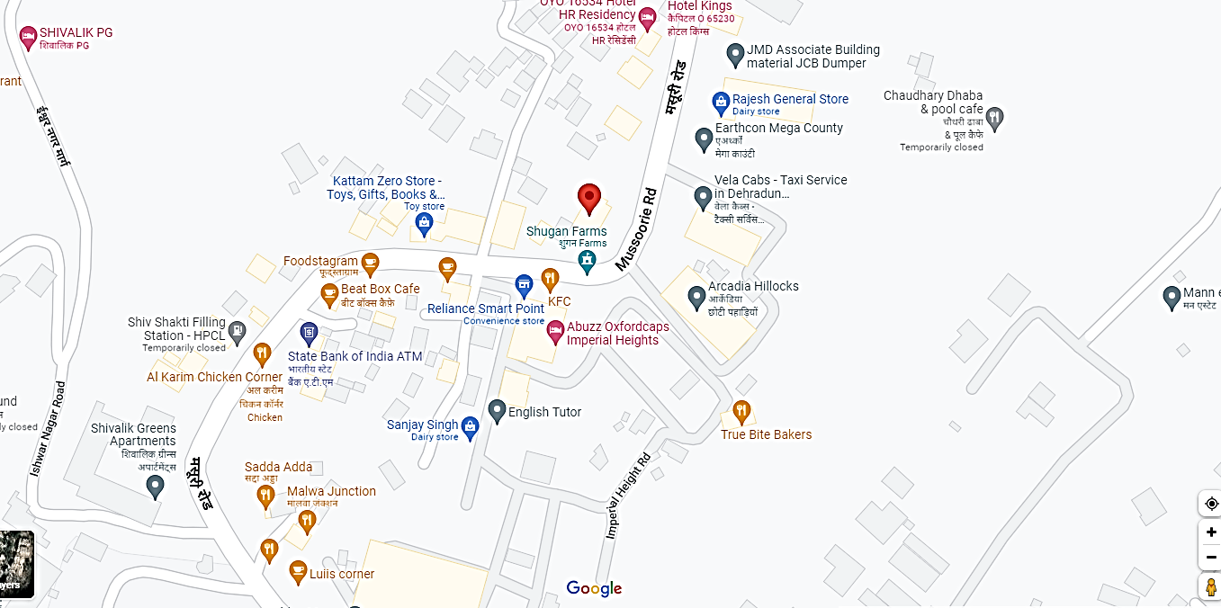

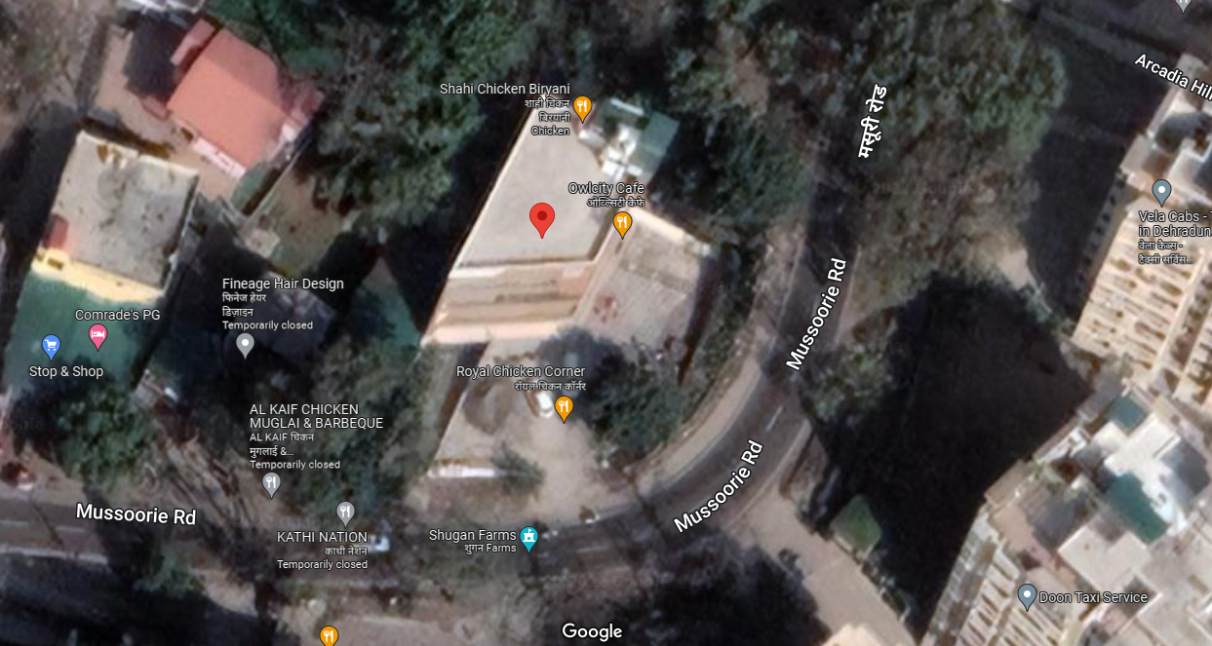

**PHOTOGRAPHS:**

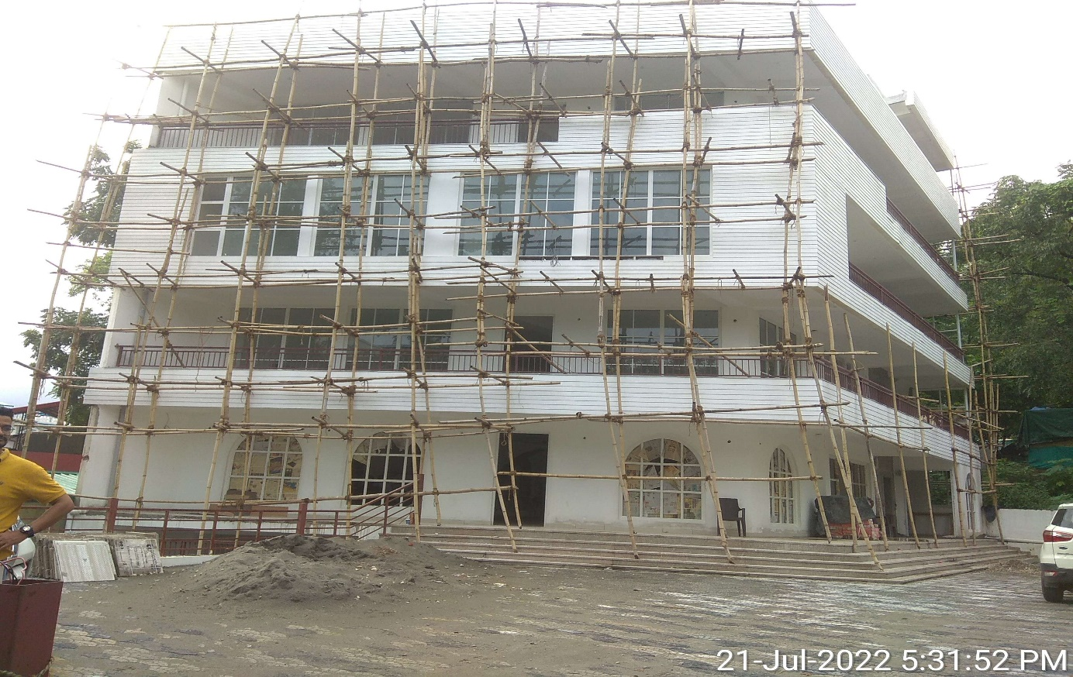

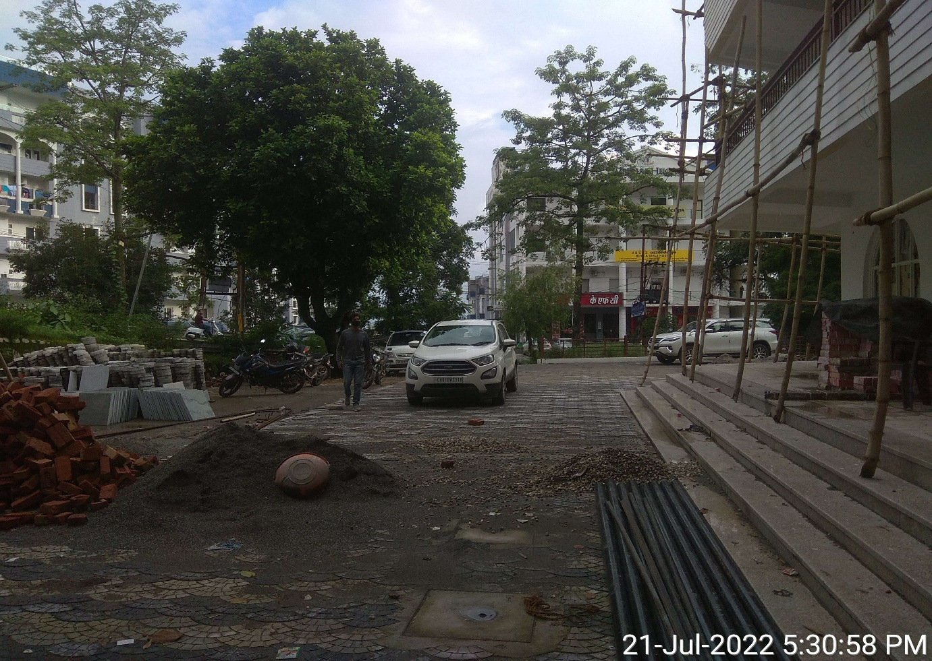

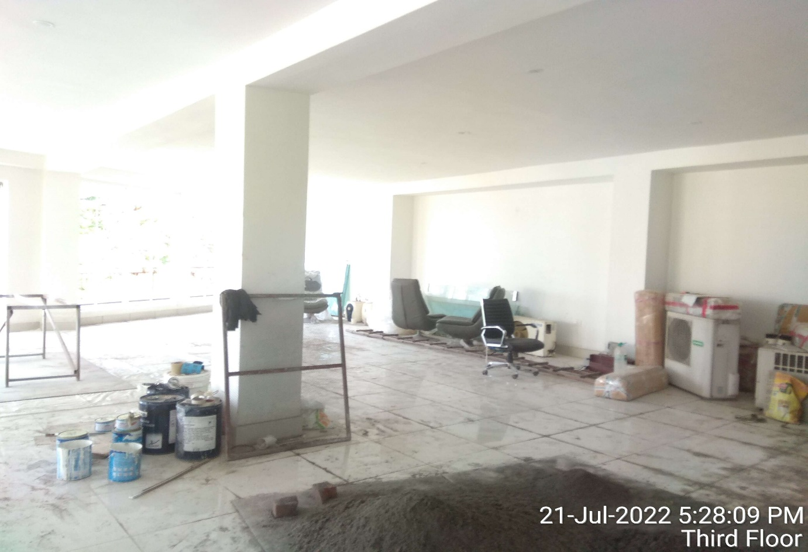

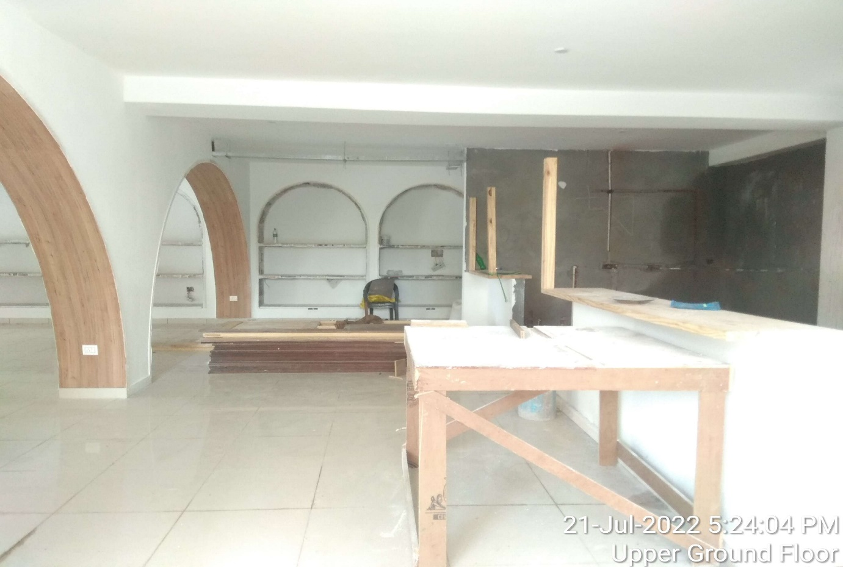

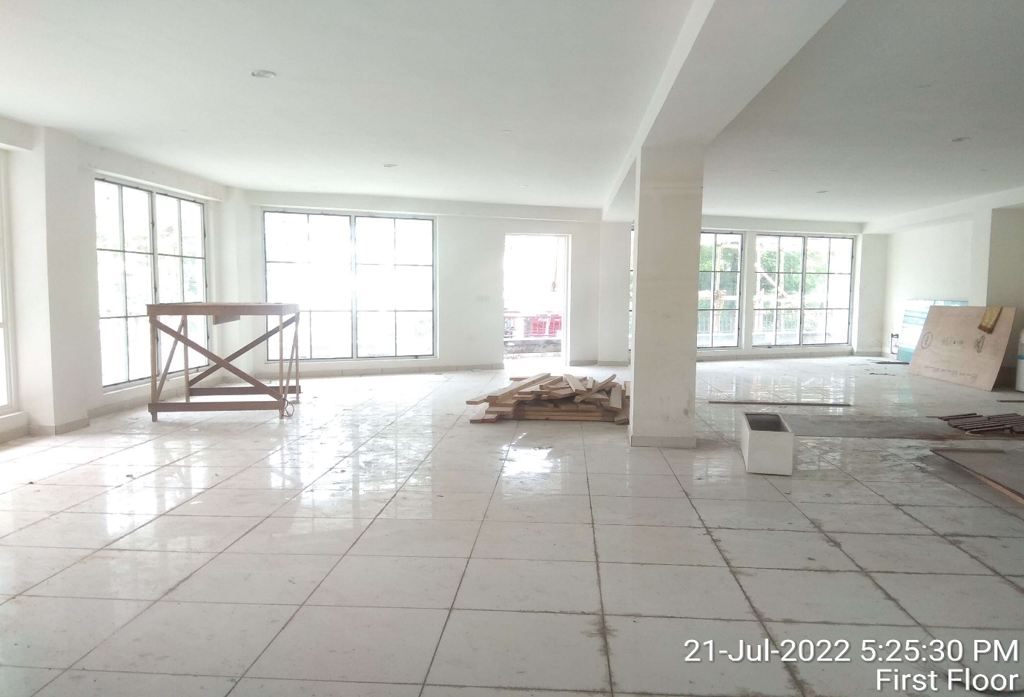

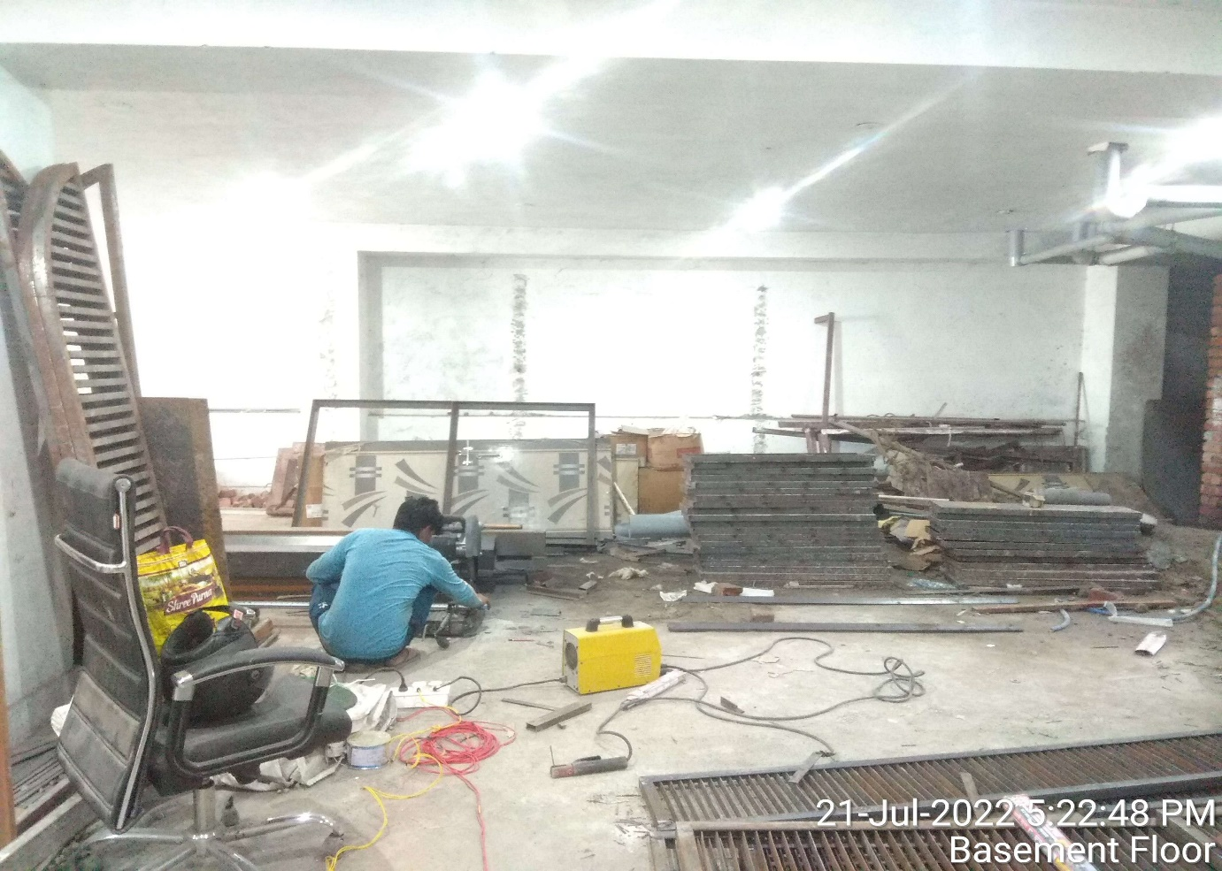

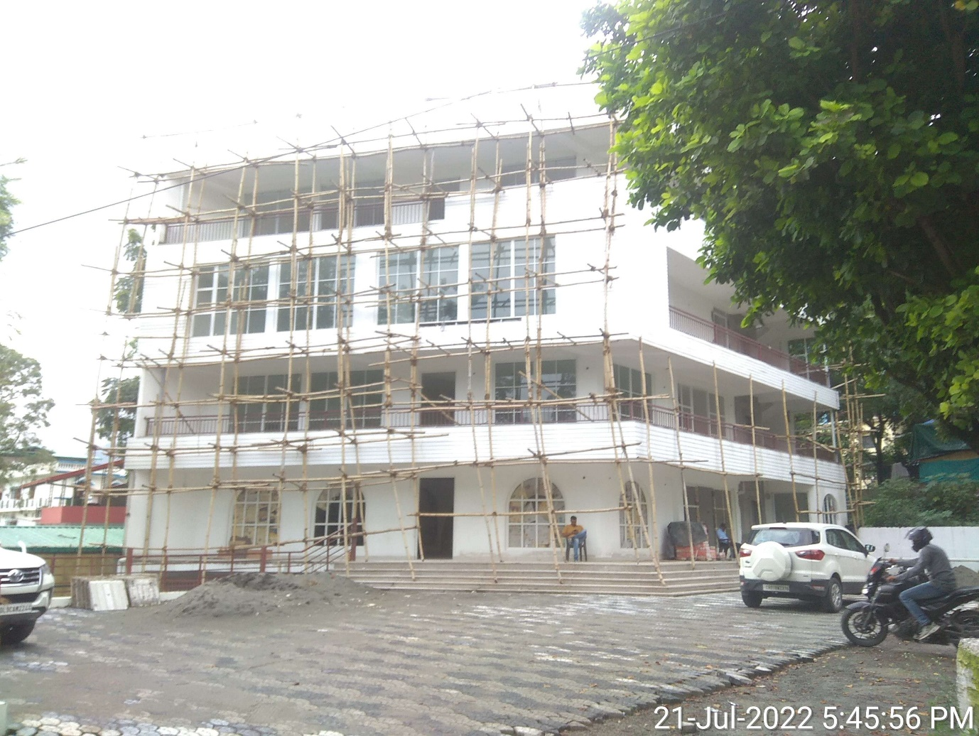

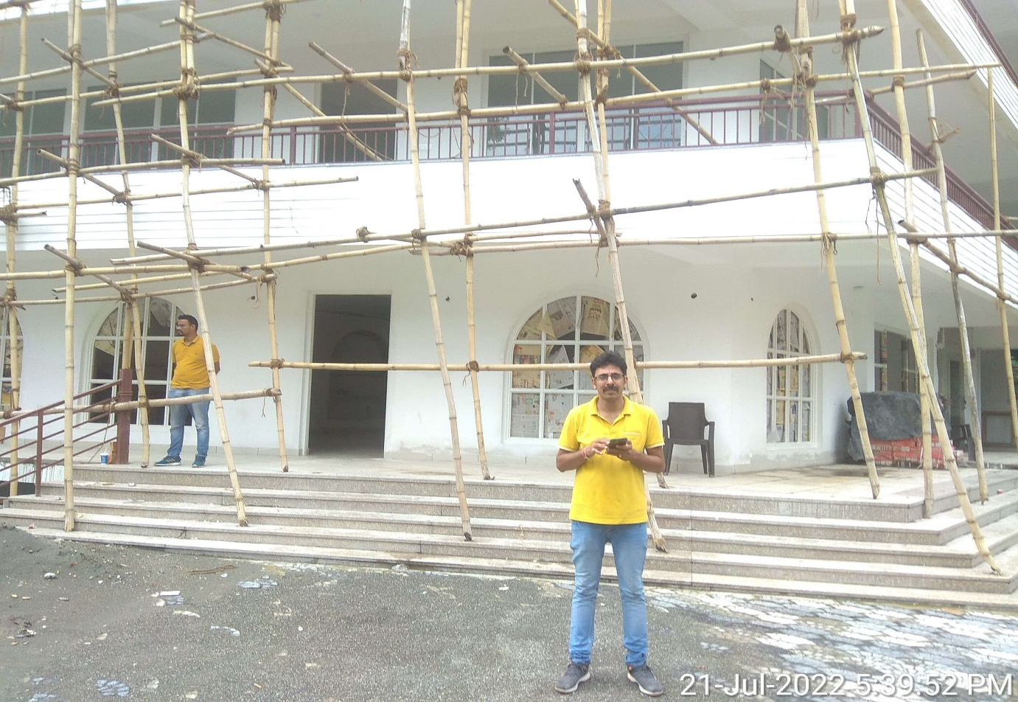

***Disclaimer:***

* 1. *This Certificate is to be referred only for the purpose of the Structure Verification of the Building situated at the aforesaid address.*
  2. *This certificate doesn’t include any work related to drawing, design, sketch plan, procurement of the building structure.*
  3. *Ownership and other legal point of view in respect of the asset is not considered in this report as same is out of scope of this certificate.*
  4. *This certificate is made at the request of Mr. Abhik Sengupta (Phn.No.-9971166144) (PNB, MCC branch, Dehradun)*
  5. *Site inspection was done on 21/7/2022 by Er. Deepak Joshi in presence of Mr. Chiranjiv Anand (Phn.No.-852754466)*

**For R.K Associates Valuers** **& Techno** **FOR INTERNAL USE Engineering Consultants (P) Ltd. *TYPED BY: Engr. Arup Banerjee***  ***REVIEWED BY: RV. Er. Rajani Gupta***

# ANNEXURE: I- COPY OF APPROVED MAP

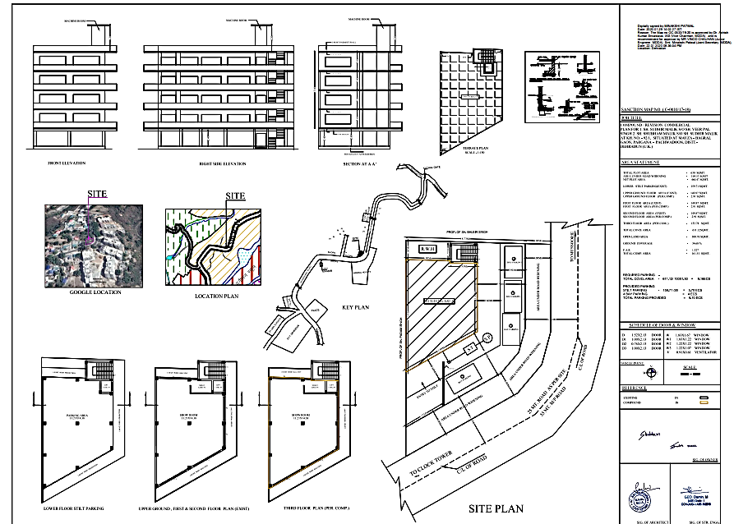

# ANNEXURE: II- COPY OF LEASE AGREEMENT

