VIS (2022-23)-PL278-210-401/402 Dated: 08/09/2022

LENDER’S INDEPENDENT ENGINEER REPORT
OF
1400 kW (1200 Kw + 200 Kw) ROOFTOP SOLAR POWER PLANT PROJECT

PROPOSED TO BE SET UP AT
KULLU, HIMACHAL PRADESH (LOCATION 1)
AND
AZADPUR, DELHI (LOCATION 2)

COMPANY/PROMOTER
M/S INDRAPRASTHA ICE AND COLD STORAGE PRIVATE LIMITED

REPORT PREPARED FOR
STATE BANK OF INDIA, SME, UDYOG SADAN, DELHI

**Important - In case of any query/ issue or escalation you may please contact Incident Manager
at le@rkassociates.org. We will appreciate your feedback in order to improve our services.
NOTE: As per IBA Guidelines please provide your feedback on the report within 15 days of its submission after which report will be considered to be correct.

IMPORTANT NOTICE

COPYRIGHT FORMAT: This report is prepared on the copyright format of R.K Associates to serve our clients with the best possible information and analysis to facilitate them to take rational business decisions. Legally no one can copy or distribute this format without prior approval from R.K Associates. It is meant only for the advisory/ reference purpose for the organization/s as mentioned on the cover page of this report. Distribution or use of this format by any organization or individual other than R.K Associates will be seen as an unlawful act and necessary legal action can be taken against the defaulters.
This report is intended for the sole use of the intended recipient/s and contains material that is STRICTLY CONFIDENTIAL AND PRIVATE.

DEFECT LIABILITY PERIOD: - In case of any query/ issue or escalation you may please contact Incident Manager at le@rkassociates.org.
Though adequate care has been taken while preparing this report as per its scope, but still, we can’t rule out typing, human errors, over sightedness of any information or any other mistakes. Therefore, the concerned organization is advised to satisfy themselves that the report is complete & satisfactory in all respect. Intimation regarding any discrepancy shall be brought into our notice immediately. If no intimation is received within 15 (Fifteen) days in writing from the date of issuance of the report, to rectify these timely, then it shall be considered that the report is complete in all respect and has been accepted by the client up to their satisfaction & use and further to which R.K Associates shall not be held responsible in any manner.

TABLE OF CONTENTS
SECTIONS | PARTICULARS | PAGE NO.
Part A | REPORT SUMMARY | 03
Part B | INTRODUCTION | 04
 | - Name of the Project | 04
 | - Project Overview | 04
 | - Scope of the Report | 05
 | - Purpose of the Report | 05
 | - Methodology Adopted | 05
Part C | PROJECT LOCATION & SITE APPROPRIATENESS | 06
 | - Location | 06
 | - Site Appropriateness | 08
Part D | PROJECT TECHNICAL DETAILS | 26
 | - Plant Configuration | 26
 | - Solar PV energy Production Process | 26
 | - Components And Its Technical Specifications: | 27
Part E | PHYSICAL PROGRESS OF SITE | 31
Part F | PROJECT INFRASTRUCTURE SECTIONS & FACILITY DETAILS | 32
 | - Land Details | 32
 | - Building & Structural Details | 32
 | - Plant, Machinery and Miscellaneous Fixed assets | 32
Part G | MAJOR SUPPLIERS/EPC CONTRACTOR | 53
Part H | PROJECT COST & MEANS OF FINANCE | 54
 | - Project cost for project at Location 1 | 54
 | - Current status and total expenditure incurred till date | 55
 | - Sources of Finance and utilization of funds | 57
 | - Project cost for project at Location 2 | 57
 | - Current status and total expenditure incurred till date | 59
 | - Sources of Finance and utilization of funds | 60
 | - Analysis of Increase in rising cost of Rooftop Solar projects | 60
Part I | CONCLUSION | 66
Part J | DISCLAIMER | 68

PART A | REPORT SUMMARY

1. | Name of Project: | Setting up of 1400 kW (1200 kW + 200 kW) Solar Power Plant Project
2. | Project Location: | Location 1: Indraprastha Ice and Cold storage private Limited, Azadpur Mandi, Delhi (200 kWp)  Location 2: Indraprastha Ice and Cold storage private Limited, Kullu, Himachal Pradesh (1200 kWp)
3. | Name of the Company: | M/s. Indraprastha Ice and Cold Storage Private Limited (IICS)
4. | Director’s | - Sanjay Aggarwal  - Sunila Aggarwal  - Dharamvir
5. | Prepared for Bank: | State Bank of India
6. | LIE Consultant Firm: | M/s. R.K. Associates Valuers & Techno Engineering Consultants (P) Ltd.
7. | Date of Survey: | 25th August 2022 and 26th August 2022
8. | Date of Report: | 8th September 2022
9. | Purpose of the Report: | - Review, evaluate & comment on project implementation & present status details to facilitate bankers to take credit decision on the Project.
10. | Scope of the work provided by the Lender: | - To review Project cost, expenditure and examine the current status of installation and commissioning of the project.
11. | Documents perused for Proposal: | - Project Report  - Copies of Invoices
12. | Annexure with the report: | - MNRE Benchmark Cost  - Site Photographs  - Analysis reference websites

PART B | INTRODUCTION

- NAME OF THE PROJECT: Installation and commissioning of 1400 kW (1200 kW + 200 kW) of Rooftop mounted Solar Power Plant Project at Azadpur Mandi, Delhi (200 Kw) {LOCATION 1} and at Kullu, Himachal Pradesh (1200 Kw) {LOCATION 2}.

- PROJECT OVERVIEW:
Indraprastha Ice and cold storage (P) limited (referred to as “IICS” hereinafter) has proposed to set up Rooftop Solar power plants at rooftop of Under construction cold storage facility at Kullu, Himachal Pradesh and at the rooftop of their cold storage facility at Azadpur mandi respectively. The total project cost proposed for this project is Rs.7.28 Crore. The total project cost includes Rs.1.13 Crore towards rooftop solar power plant installation at Azadpur Mandi and Rs. 6.15 Crore towards rooftop Solar power plant installation at the roof of under construction cold storage facility at Kullu, Himachal Pradesh.

The Delhi cold storage on an average consumes 0.65-0.85 lakh units per month. The 200-kW solar plant will produce around 3 lakh units per annum, which shall easily be consumed by the company.

IICS shall also be installing a solar power plant at its new controlled atmosphere Kullu unit. The company shall install a 1.2 MW solar power plant there. In Himachal, the company has a unit at Shimla. The power rates in Kullu and Shimla are the same since they come under the same Discom (Himachal Pradesh State Electricity Board Limited).

Proposed Capacity of Solar Power Plant | 200 kWp
Site Address | IICS, Azadpur Mandi, Delhi
Latitude and Longitude | 28°42'45.1"N 77°10'24.6"E

Proposed Capacity of Solar Power Plant | 1000 kWp
Site Address | IICS, Kullu, Himachal Pradesh
Latitude and Longitude | 31°23'54.4"N 77°36'34.6"E

We have conducted the visits of the project sites on 25th August for IICS Cold storage facility located at Azadpur mandi, Delhi and 26th August 2022 for IICS Under construction cold storage facility at Kullu, Himachal Pradesh. During site visit it was observed that works related to these projects have not commenced yet. The company’s representatives of both the projects informed that solar power plant erection, installation and commissioning works related to these projects will commence post receipt of sanction of term loans from the concerned Bank.

- SCOPE OF THE REPORT: To verify the Project cost, expenditures and examine the commissioning, installation status of Solar Power Plant set-up by M/s. IICS pvt. Ltd.

- Industry/ sector research and demand & supply trend is out of scope of the report.
- Financial feasibility study of the Project is out of scope of the report.
- Providing any kind of design report or map is out-of-scope of the report.

- PURPOSE OF THE REPORT: To Provide Project Progress Monitoring Report to SBI.

- METHADOLOGY ADOPTED:

- Study of Project Planning documents/ reports to know about the Project.
- Additional information, data, documents collection the company.
- Study and analysis of the documents and information obtained from the company.
- Research about the Project/ sector from the sources in the public domain.
- Correlation of the provided information against Industry/ sector benchmarks/ trend.
- Information compilation, analysis and reporting.

PART C | PROJECT LOCATION & SITE APPROPRIATENESS

      - LOCATION’s:
The company has proposed to install Rooftop Solar power plants at IICS Cold storage facility, Azadpur mandi, Delhi and IICS under construction cold storage facility at Kullu, Himachal Pradesh. Location map of both the location is as below:

LOCATION 1: IICS COLD STORAGE FACILITY AT AZADPUR MANDI, DELHI

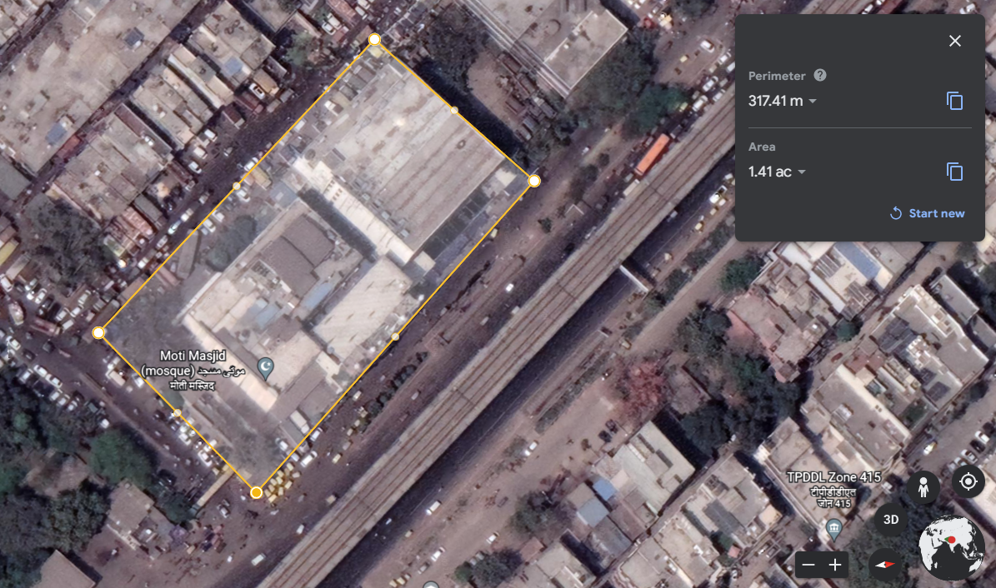
Rooftop Boundary on which Solar panels are proposed to be installed.
IICS Cold Storage Facility Boundary

Note: The Cold storage facility boundary and Rooftop boundary are on approximate basis and are not to scale.

LOCATION 2: IICS UNDER CONSTRUCTION COLD STORAGE FACILITY AT KULLU, HIMACHAL PRADESH

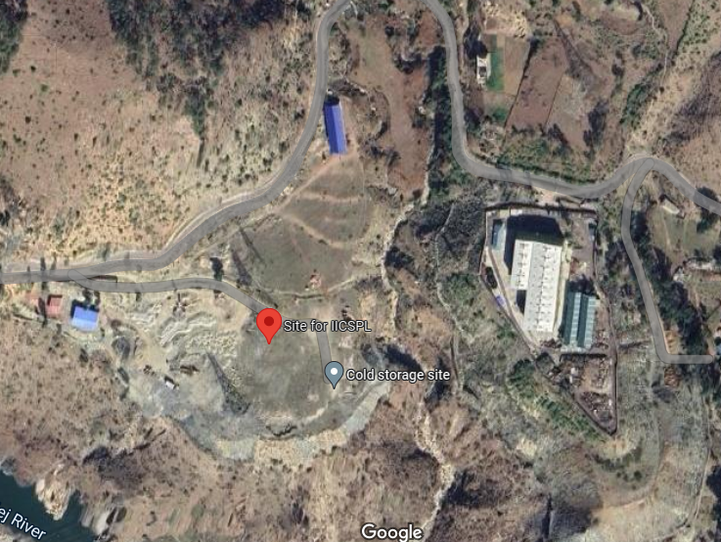
Note: The Cold storage facility of IISCPL at Kullu, Himachal Pradesh is currently under construction and demarcated facility area is not provided to us.

      - SITE APPROPRIATENESS:

  - SITE APPROPRIATENESS FOR LOCATION 1 (IISCPL, AZADPUR MANDI, DELHI):

The site appropriateness for a roof top solar power unit is basically based on the weather and solar radiation parameters since annual energy yield of a PV plant is solely dependent on the solar resource of the site.

Basically, there are three standard test conditions which are the industry standard for the conditions under which a solar panel are tested and give its efficiency rating

            - Temperature of the cell – 25°C. The temperature of the solar cell itself, not the temperature of the surrounding.
            - Solar Irradiance – 1000 Watts per square meter. This number refers to the amount of light energy falling on a given area at a given time.
            - Mass of the air – 1.5. This number is somewhat misleading as it refers to the amount of light that has to pass through Earth’s atmosphere before it can hit Earth’s surface, and has to do mostly with the angle of the sun relative to a reference point on the earth. This number is minimized when the sun is directly above as the light has to travel a minimum distance straight down, and increases as the sun goes farther from the reference point and has to go at an angle to hit the same spot.

In this regard for doing the site appropriateness following site parameters are being evaluated:

- Temperature: The average temperature is measured as per the Metrological Station statistic available at Azadpur. At an average temperature of 44⁰ C, may is the hottest month of the year and at an average temperature of 14⁰ C February is the coldest month.

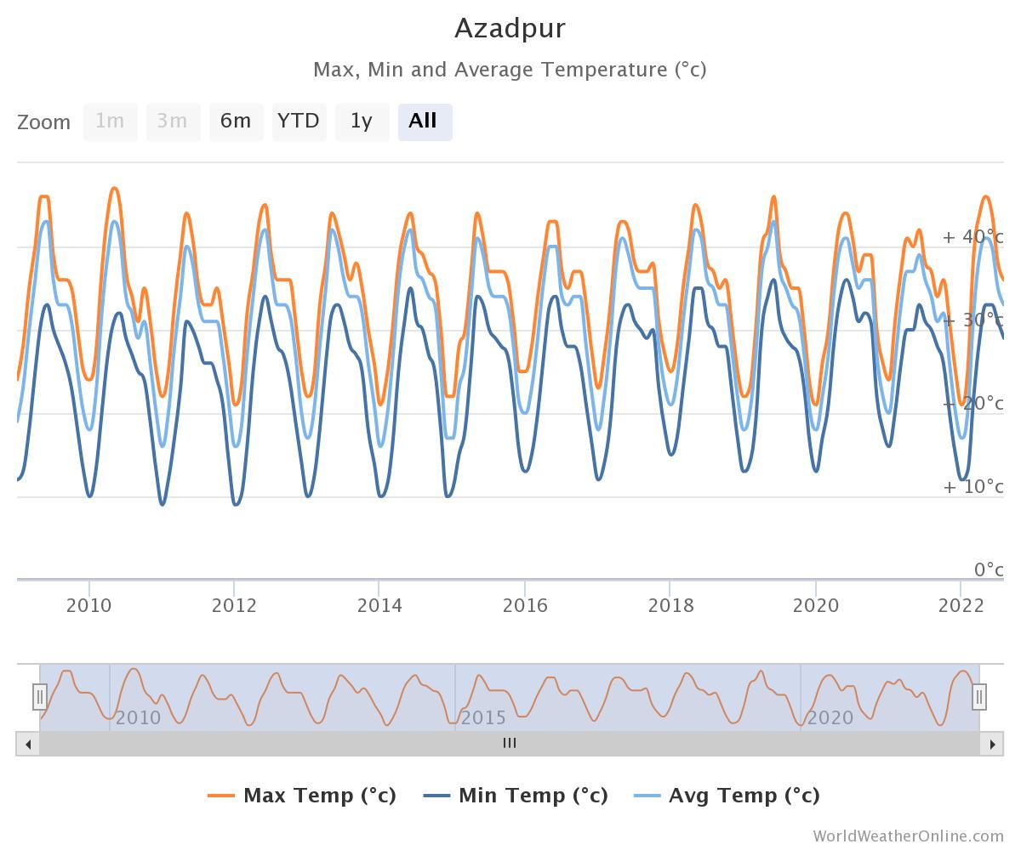
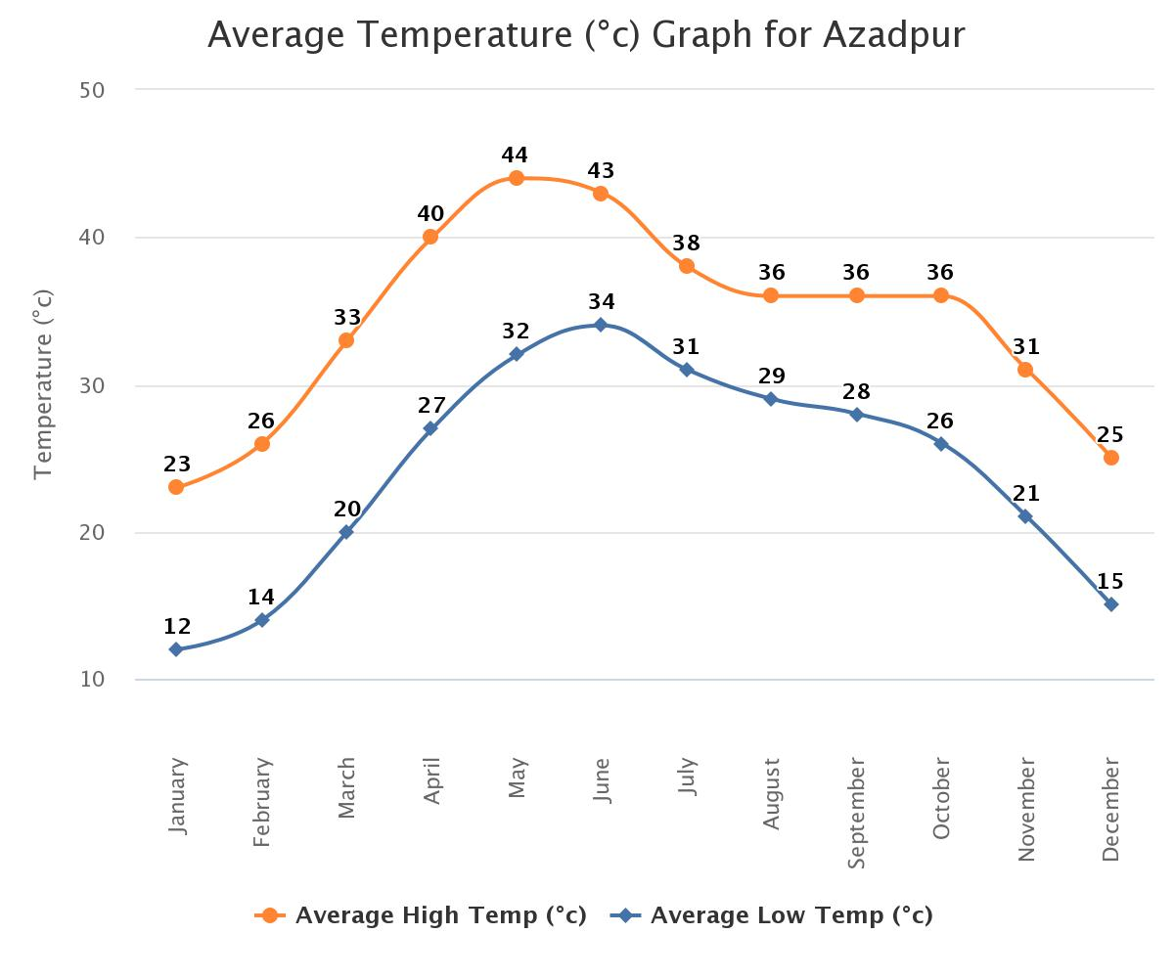
Source: https://www.worldweatheronline.com/azadpur-weather-averages/delhi/in.aspx
Temperature tolerance of solar panels is denoted by temperature coefficient, which denotes the decrease in efficiency of the solar panel with increase in temperature. Typically, temperature coefficient of solar panels is about -0.4% to -0.6% / degree C.

All solar cells have a temperature coefficient. As a solar panel increases in temperature, the power output of the solar panel decreases. Generally, monocrystalline solar cells have a temperature coefficient of -0.5%/degC. This means a mono solar panel will lose half of one percent of its power for every degree the temperature rises. Solar panels are all rated at 25degC, however, when solar panels are installed on a roof, they generally reach much higher temperatures.

EXAMPLE:

All solar cells have a temperature coefficient. As a solar panel increases in temperature, the power output of the solar panel decreases. Generally, monocrystalline solar cells have a temperature coefficient of -0.5%/degC. This means a mono solar panel will lose half of one percent of its power for every degree the temperature rises. Solar panels are all rated at 25degC, however, when solar panels are installed on a roof, they generally reach much higher temperatures.

Let’s say a 250W monocrystalline solar panel installed on a roof is at 65degC. The solar panel’s power loss can be calculated as follows:
65degC – 25degC = 40degC
40degC x -0.5% = 20%
Therefore, panel power loss = 20% x 250W = 50W
Therefore, panel power = 200W+

At an average temperature of 44⁰ C, may is the hottest month of the year and at an average temperature of 14⁰ C February is the coldest month. There will surely be a reduction in power generated in summer months which can also be seen in the performance ratio infographics given in the PVsyst report and is also covered in the below sections of our report. However, temperature coefficient is the inherent property of the solar modules and since the reduction of power generation in summer months will be covered with satisfactory power generation in winter months therefore the temperature in Delhi seems to be favorable for this project.
- Wind Speed: The macro-level wind speed zones of India have been formulated and published in IS: 875 (Part 3) - 1987 titled “Indian Standard Code of Practice for Design Loads (other than earthquakes) for Buildings and Structures, Part 3, Wind Loads”. There are six basic wind speeds `V_{b}’ considered for zoning, namely 55, 50, 47, 44, 39 and 33 m/s. From wind damage view point, these could be described as follows:

- 55 m/s (198 km/h) - Very High Damage Risk Zone – A
- 50 m/s (180 km/h) - Very High Damage Risk Zone – B
- 47 m/s (169.2 km/h) - High Damage Risk Zone
- 44 m/s (158.4 km/h) - Moderate Damage Risk Zone – A
- 39 m/s (140.4 km/h) - Moderate Damage Risk Zone – B
- 33 m/s (118.8 km/h) - Low Damage Risk Zone
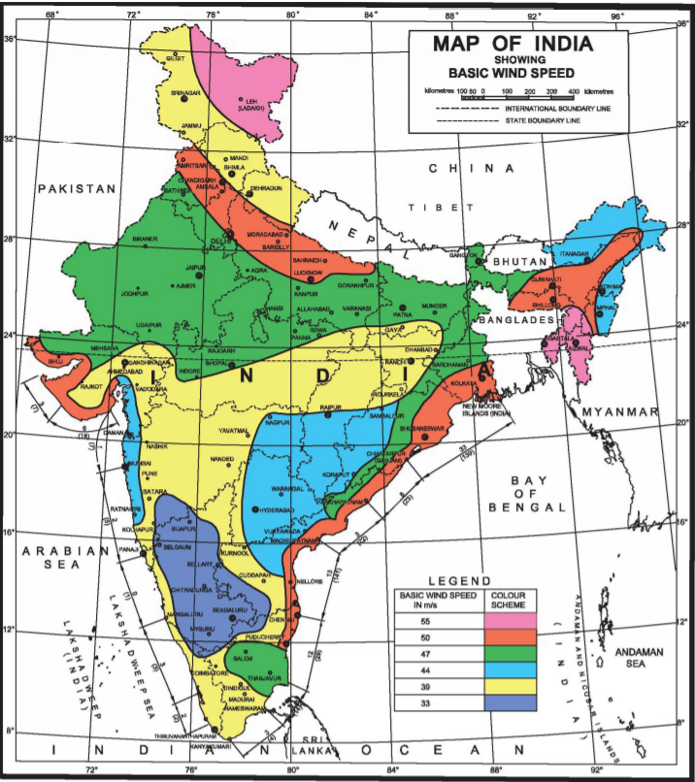
Design Wind Speed (V_{z}) - The basic wind speed (V_{b}) for any site shall be modified to include the following effects to get design wind velocity at any height (V_{z}) for the chosen structure:

a) Risk level;
b) Terrain roughness, height and size of structure; and
c) Local topography. It can be mathematically expressed as follows:

V_{z} = V_{b} k₁k₂k₃

V_{z} = Design wind speed at any height z in m/s;
V_{b} = Basic Wind Speed
k₁ = Probability factor (risk coefficient)
k₂ = Terrain, height and structure size factor
k₃ = Topography factor

The basic wind speeds are applicable to 10 m height above mean ground level in an open terrain with a return period of 50 years. Azadpur, Delhi lies on 50 m/s band of wind speed. Therefore, Delhi lies in Very High Damage Risk Zone-B. However, from production point of view the wind velocity can reduce the thermal losses, therefore high basic wind velocity is favorable for PV solar projects.

- Rainfall: To show variation within the months and not just the monthly totals, we show the average rainfall for Year 2010 to Year 2022 (as on date)
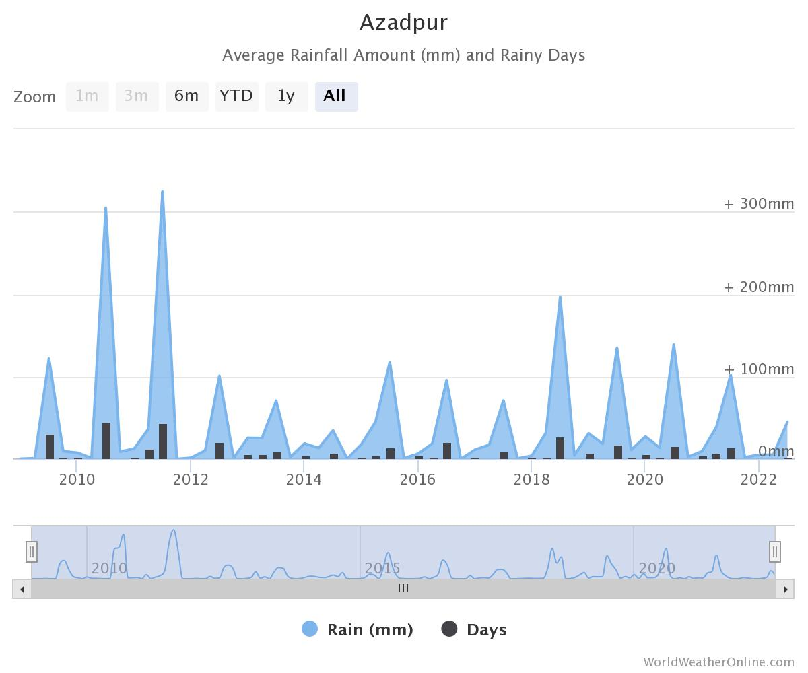
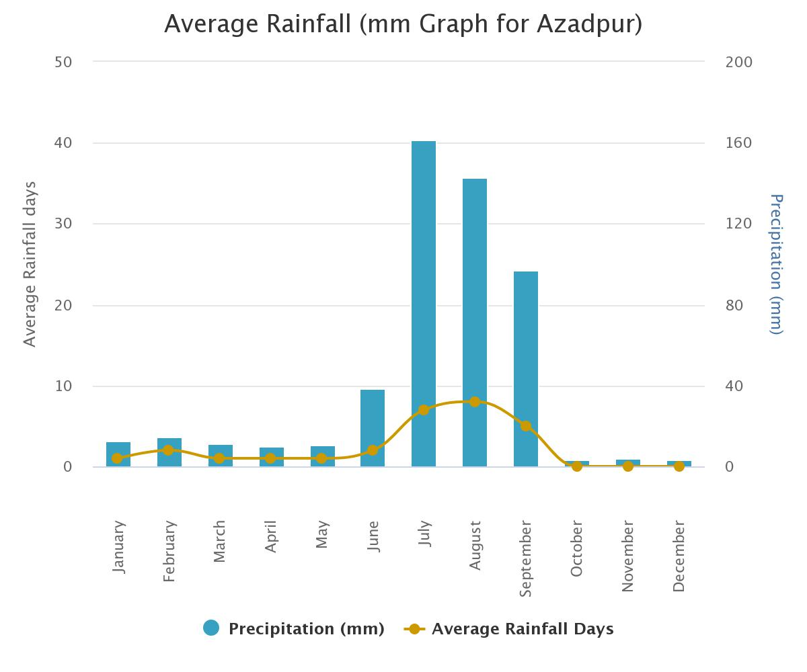Source: https://www.worldweatheronline.com/azadpur-weather-averages/delhi/in.aspx
While the rain itself will have no impact on the panels, the rain clouds can lower the electricity production. However, the occasional rainstorm could actually be good for solar system’s production, because with no extra effort it can naturally clean the panels. Since Delhi falls under low rain zone therefore it is ok for the solar project.

- Average Sun Hours and Sun Days:

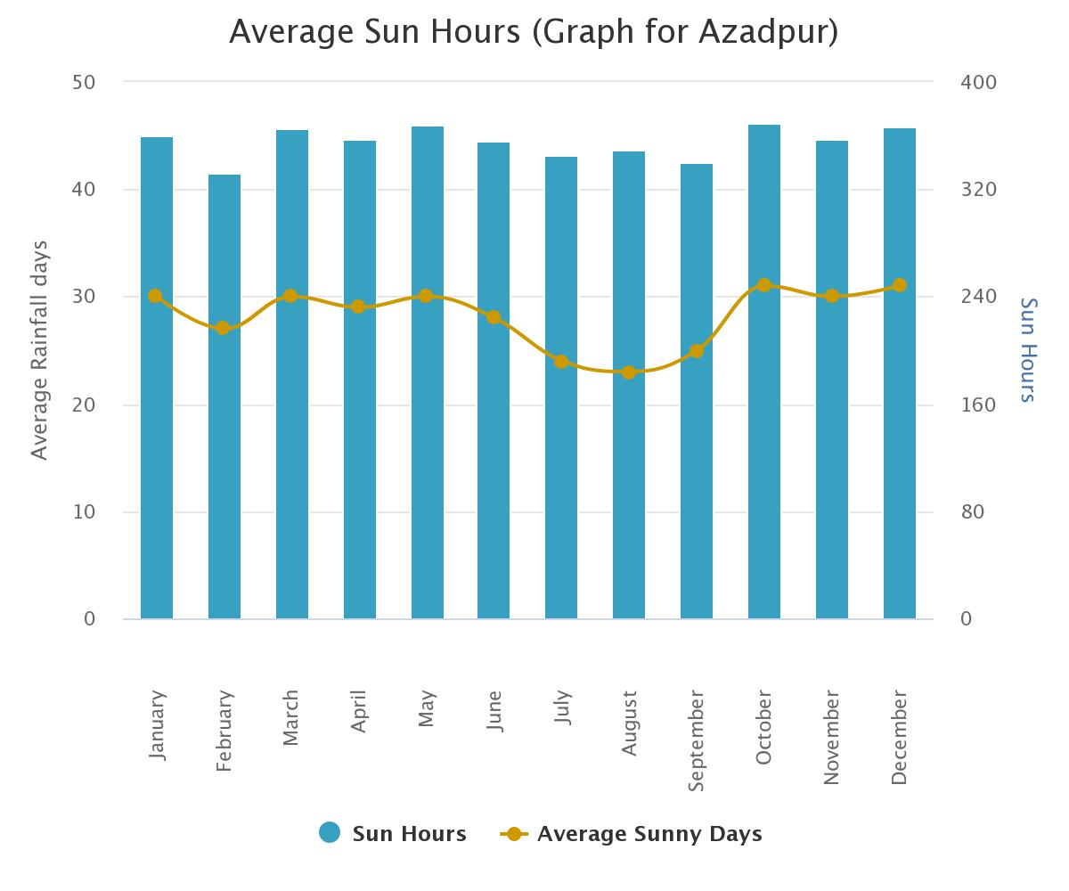
Source: https://www.worldweatheronline.com/azadpur-weather-averages/delhi/in.aspx
{Table: 2}
AZADPUR, DELHI
Years | 2019 |  | 2020 |  | 2021
Months/Days | Sun Day | Sun Hour | Sun Day | Sun Hour | Sun Day | Sun Hour
January | 29 | 357 | 28 | 344 | 29 | 350
February | 22 | 325 | 29 | 343 | 27 | 333
March | 31 | 369 | 27 | 354 | 29 | 353
April | 29 | 359 | 29 | 345 | 29 | 360
May | 31 | 372 | 29 | 360 | 27 | 348
June | 29 | 360 | 29 | 351 | 27 | 346
July | 23 | 358 | 28 | 320 | 22 | 292
August | 24 | 366 | 17 | 308 | 27 | 321
September | 27 | 350 | 30 | 349 | 29 | 299
October | 31 | 366 | 31 | 372 | 30 | 362
November | 27 | 358 | 29 | 356 | 30 | 360
December | 31 | 363 | 31 | 359 | 31 | 352
Total | 334 | 4303 | 337 | 4161 | 337 | 4076

AVERAGE SUN DAYS | AVERAGE SUN HOURS
336 Days | 4180 Hours

As per last 3-year data, average sun days are 336 days and average sun hours in a year is 4180 hours recorded at Azadpur, Delhi zone which is in North Delhi and the subject location for 200 kW solar power plant.

- Irradiation map of Project Location

Solar irradiance is the power per unit area (watt per square metre, W/m2), received from the Sun in the form of electromagnetic radiation as reported in the wavelength range of the measuring instrument.

Global Horizontal Irradiance (GHI) is the total amount of shortwave radiation received from above by a surface horizontal to the ground. This value is of particular interest to photovoltaic installations and includes both Direct Normal Irradiance (DNI) and Diffuse Horizontal Irradiance (DIF).

Diffuse Horizontal Irradiance is the amount of radiation received per unit area by a surface that does not arrive on a direct path from the sun, but has been scattered by molecules and particles in the atmosphere. Basically, it is the illumination that comes from clouds and the blue sky.

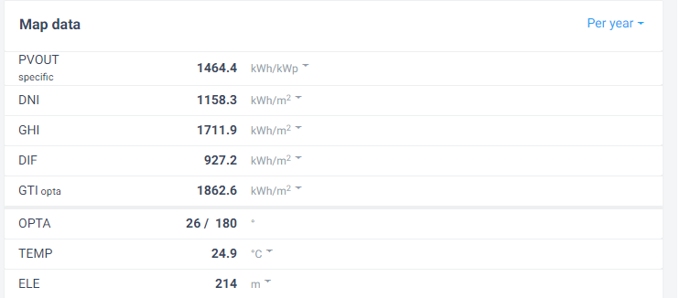

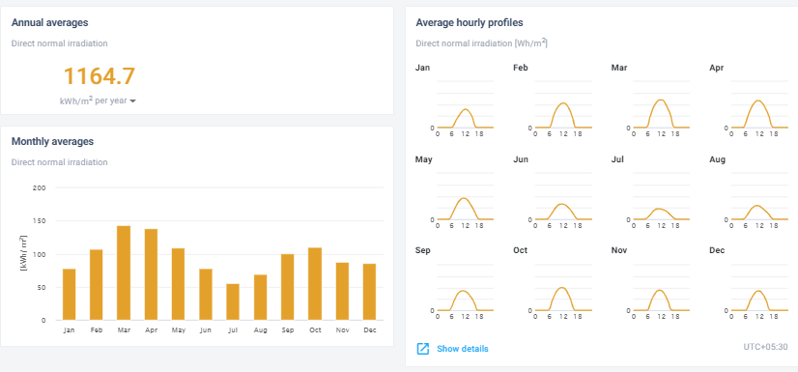
Source: https://globalsolaratlas.info/detail?c=28.71227,77.174149,11&s=28.712528,77.1735&m=site

- Shadow Analysis and Obstruction: The site of a Roof Mounted location should be free from any nearby building or structure. We have verified through google map location and our site visit conducted on 25th August 2022 that there is no obstruction by shadow on the structure from nearby site.

- Water Availability: Plant will require module cleaning during dry spells. Cleaning may require substantial quantities of water approx. 2.0 liters per module depending upon the manpower available and degree of soiling. The company has proposed to use Borewell for the same. Bank to ensure that Groundwater abstraction clearance is available with the company.

  - SITE APPROPRIATENESS FOR LOCATION 2 (UNDER CONSTRUCTION IISCPL, KULLU, HIMACHAL):

The site appropriateness for a roof top solar power unit is basically based on the weather and solar radiation parameters since annual energy yield of a PV plant is solely dependent on the solar resource of the site.

Basically, there are three standard test conditions which are the industry standard for the conditions under which a solar panel are tested and give its efficiency rating

- Temperature of the cell – 25°C. The temperature of the solar cell itself, not the temperature of the surrounding.
- Solar Irradiance – 1000 Watts per square meter. This number refers to the amount of light energy falling on a given area at a given time.
- Mass of the air – 1.5. This number is somewhat misleading as it refers to the amount of light that has to pass through Earth’s atmosphere before it can hit Earth’s surface, and has to do mostly with the angle of the sun relative to a reference point on the earth. This number is minimized when the sun is directly above as the light has to travel a minimum distance straight down, and increases as the sun goes farther from the reference point and has to go at an angle to hit the same spot.

In this regard for doing the site appropriateness following site parameters are being evaluated:

- Temperature: The average temperature is measured as per the Metrological Station statistic available at Narkanda, Himachal Pradesh. At an average temperature of 30⁰ C, June is the hottest month of the year and at an average temperature of 2⁰ C January is the coldest month.
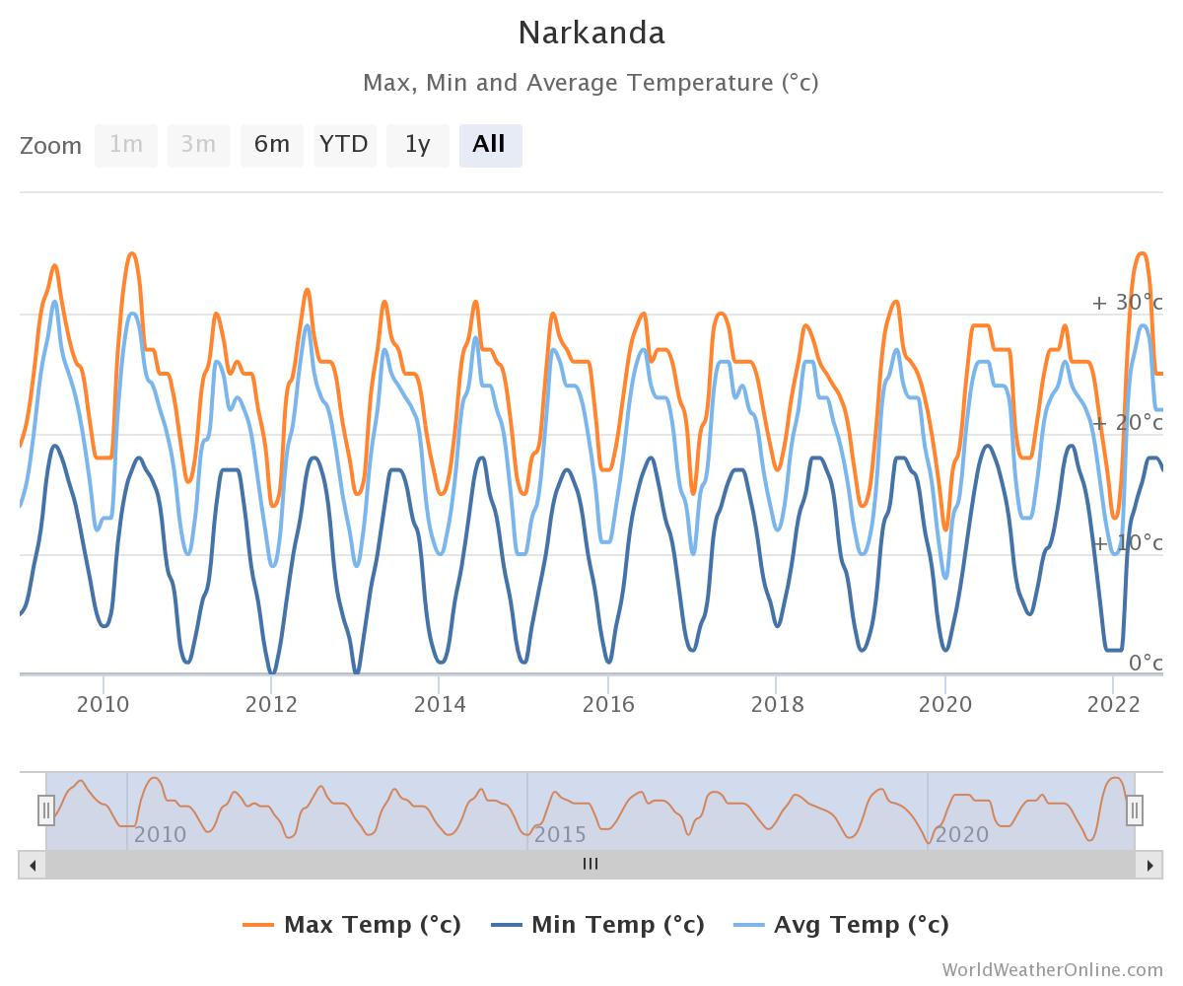

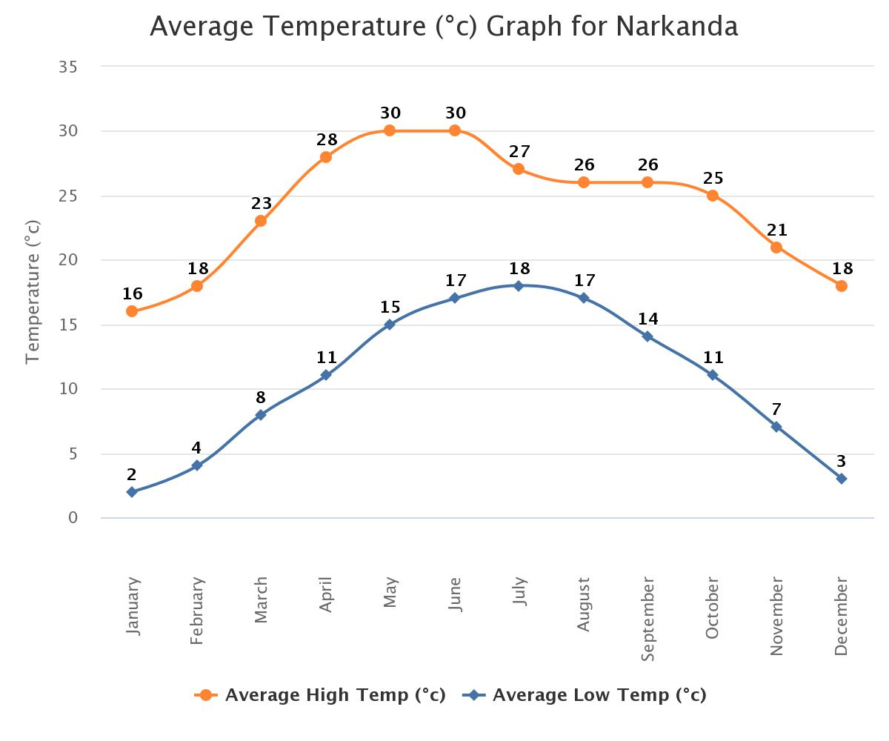
Source:https://www.worldweatheronline.com/narkanda-weather-averages/himachal-pradesh/in.aspx

At an average temperature of 30⁰ C, June is the hottest month of the year and at an average temperature of 2⁰ C January is the coldest month. There will surely be a reduction in power generated in summer months which can also be seen in the performance ratio infographics given in the PVsyst report and is also covered in the below sections of our report. However, temperature coefficient is the inherent property of the solar modules and since the reduction of power generation in summer months will be covered with satisfactory power generation in winter months therefore the temperature in Narkanda Area seems to be favorable for this project.

- Wind Speed: The macro-level wind speed zones of India have been formulated and published in IS: 875 (Part 3) - 1987 titled “Indian Standard Code of Practice for Design Loads (other than earthquakes) for Buildings and Structures, Part 3, Wind Loads”. There are six basic wind speeds `V_{b}’ considered for zoning, namely 55, 50, 47, 44, 39 and 33 m/s. From wind damage view point, these could be described as follows:

- 55 m/s (198 km/h) - Very High Damage Risk Zone – A
- 50 m/s (180 km/h) - Very High Damage Risk Zone – B
- 47 m/s (169.2 km/h) - High Damage Risk Zone
- 44 m/s (158.4 km/h) - Moderate Damage Risk Zone – A
- 39 m/s (140.4 km/h) - Moderate Damage Risk Zone – B
- 33 m/s (118.8 km/h) - Low Damage Risk Zone
Design Wind Speed (V_{z}) - The basic wind speed (V_{b}) for any site shall be modified to include the following effects to get design wind velocity at any height (V_{z}) for the chosen structure:

a) Risk level;
b) Terrain roughness, height and size of structure; and
c) Local topography. It can be mathematically expressed as follows:

V_{z} = V_{b} k₁k₂k₃

V_{z} = Design wind speed at any height z in m/s;
V_{b} = Basic Wind Speed
k₁ = Probability factor (risk coefficient)
k₂ = Terrain, height and structure size factor
k₃ = Topography factor

The basic wind speeds are applicable to 10 m height above mean ground level in an open terrain with a return period of 50 years. Narkanda, Himachal Pradesh lies on 39 m/s band of wind speed. Therefore, Narkanda lies in Moderate Damage Risk Zone-B. However, from production point of view the wind velocity can reduce the thermal losses, therefore moderate basic wind velocity is favorable for PV solar projects.

- Rainfall: To show variation within the months and not just the monthly totals, we show the average rainfall for Year 2010 to Year 2022 (as on date)
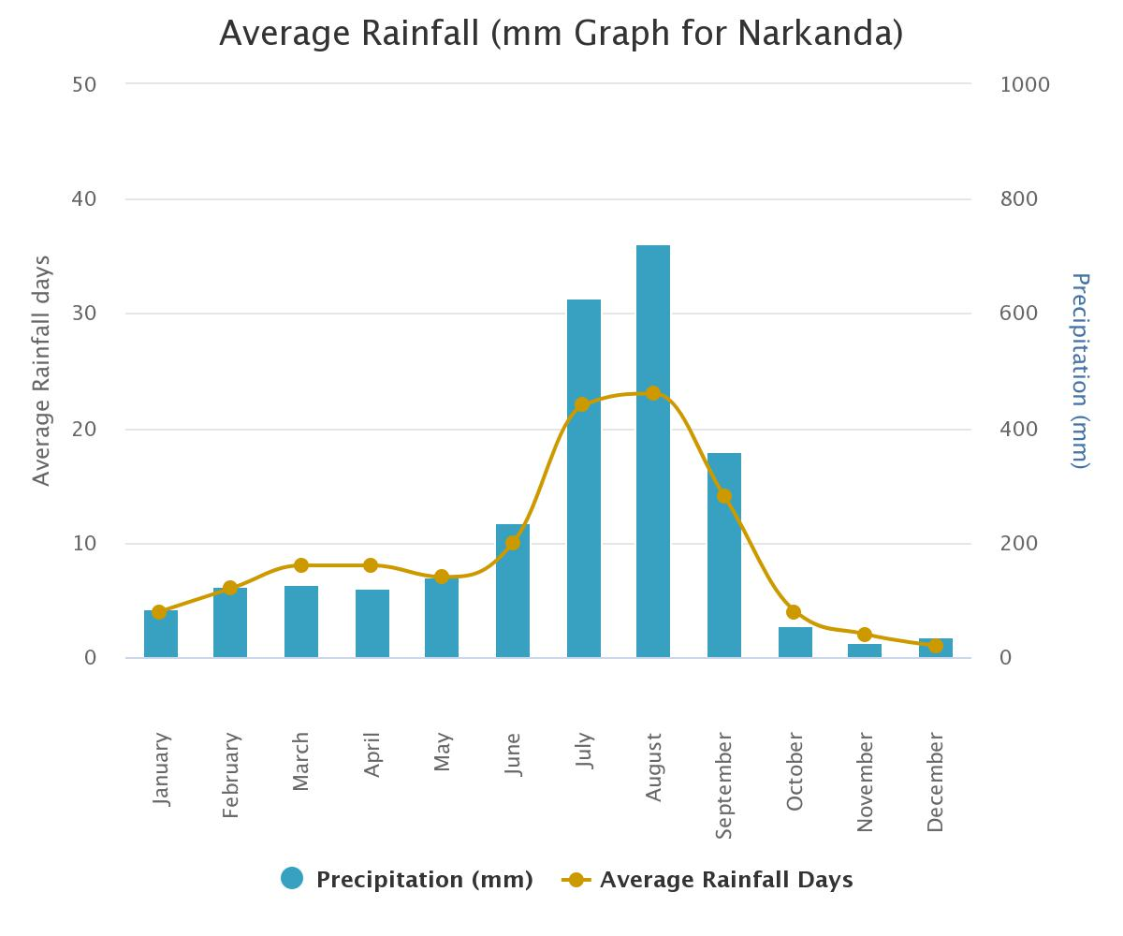
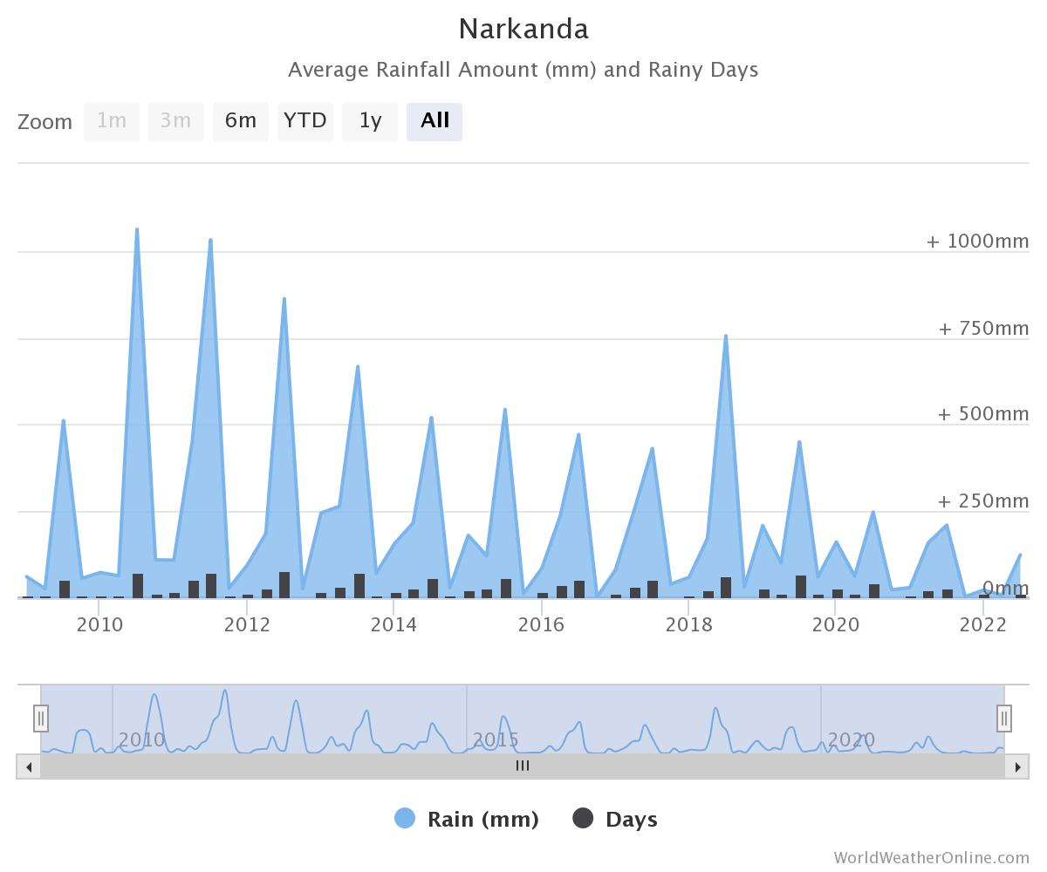
Source: https://www.worldweatheronline.com/narkanda-weather-averages/himachal-pradesh/in.aspx
While the rain itself will have no impact on the panels, the rain clouds can lower the electricity production. However, the occasional rainstorm could actually be good for solar system’s production, because with no extra effort it can naturally clean the panels. Since Narkanda falls under low rain zone therefore it is ok for the solar projects
- Average Sun Hours and Sun Days:
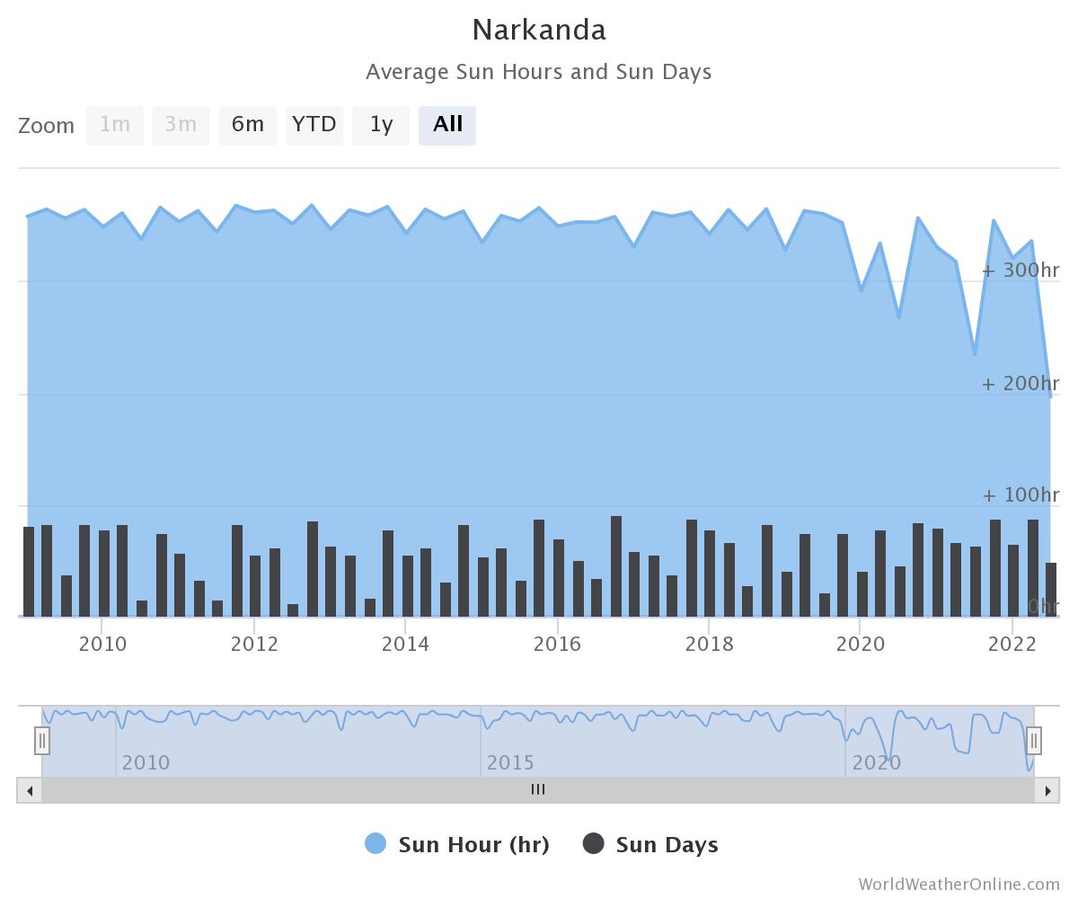
Source:https://www.worldweatheronline.com/narkanda-weather-averages/himachal-pradesh/in.aspx
{Table: 2}
NARKANDA, HIMACHAL PRADESH
Year | 2019 |  | 2020 |  | 2021
Days/Year | Sun Day | Sun Hour | Sun Day | Sun Hour | Sun Day | Sun Hour
January | 16 | 328 | 5 | 271 | 26 | 335
February | 5 | 302 | 20 | 309 | 25 | 309
March | 21 | 353 | 16 | 293 | 29 | 347
April | 26 | 359 | 26 | 338 | 23 | 311
May | 24 | 369 | 28 | 348 | 23 | 314
June | 25 | 360 | 24 | 315 | 22 | 327
July | 5 | 361 | 19 | 262 | 14 | 244
August | 6 | 362 | 4 | 204 | 21 | 232
September | 12 | 357 | 24 | 336 | 29 | 228
October | 23 | 372 | 31 | 372 | 30 | 359
November | 25 | 348 | 26 | 347 | 30 | 360
December | 27 | 336 | 28 | 350 | 28 | 343
Total | 215 | 4207 | 251 | 3745 | 300 | 3709

AVERAGE SUN DAYS | AVERAGE SUN HOURS
255 Days | 3887 Hours

As per last 3-year data, average sun days are 255 days and average sun hours in an year are 3887 hours recorded at Narkanda, Himachal Pradesh.

- Irradiation map of Project Location

Solar irradiance is the power per unit area (watt per square metre, W/m2), received from the Sun in the form of electromagnetic radiation as reported in the wavelength range of the measuring instrument.

Global Horizontal Irradiance (GHI) is the total amount of shortwave radiation received from above by a surface horizontal to the ground. This value is of particular interest to photovoltaic installations and includes both Direct Normal Irradiance (DNI) and Diffuse Horizontal Irradiance (DIF).

Diffuse Horizontal Irradiance is the amount of radiation received per unit area by a surface that does not arrive on a direct path from the sun, but has been scattered by molecules and particles in the atmosphere. Basically, it is the illumination that comes from clouds and the blue sky.
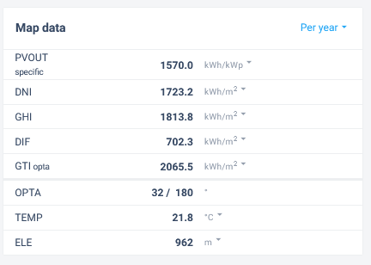
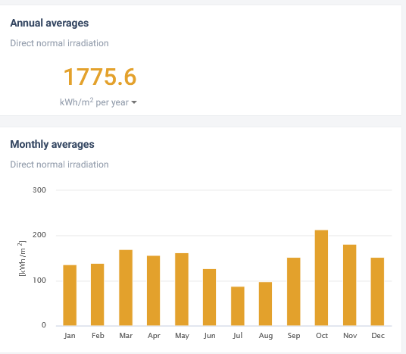
Source: https://globalsolaratlas.info/detail?c=31.398191,77.609482,11&s=31.398444,77.609611&m=site
- Shadow Analysis and Obstruction: The site of a Roof Mounted location should be free from any nearby building or structure. We have verified through google map location and our site visit conducted on 26th August 2022 that there is no obstruction by shadow on the structure from nearby site.

- Water Availability: Plant will require module cleaning during dry spells. Cleaning may require substantial quantities of water approx. 2.0 liters per module depending upon the manpower available and degree of soiling. The company has proposed to use Borewell for the same. Bank to ensure that Groundwater abstraction clearance is available with the company.

PART D | PROJECT TECHNICAL DETAILS

- PLANT CONFIGURATION (LOCATION 1 AND LOCATION 2)

The solar power harnessing in both the Rooftop Solar Power plant projects will be done by using the below mentioned components in the project:
- Solar Panels
- Solar Inverters
- Transformer
- Other ancillary machinery components

- SOLAR PV ENERGY PRODUCTION PROCESS:

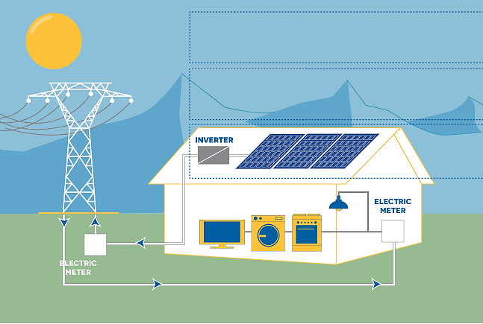

- COMPONENTS AND ITS TECHNICAL SPECIFICATIONS:

        - Plant Type: Basically, there are three types of Solar Power Plants:

- Off Grid Solar Power Plant: Off grid is a battery based solar power system. In the first priority this system will run your home appliances or connect load (as per solar inverter capacity) and surplus power feed in to the solar battery bank, provided with the solar power system. This type of solar power is recommended where power cut is the major problem.

- On Grid Solar Power Plant: On grid solar system is grid (Government electricity supply) connected system. In the first priority this system will run your home appliances or connect load (without any limit). If the connected load will exceed the capacity of installed solar power plant it will automatically use the power from main grid and if the connected load is less, it will supply surplus power to the grid. This type of system is recommended to reduce electricity bills only.

- Hybrid Solar Power Plant: Hybrid is a combination of on grid solar system as well as off grid solar system. One side hybrid solar system connects with the main electricity grid and simultaneously it will also provide battery backup to you.

Indraprastha Ice and Cold Storage (P) Limited has proposed to set-up an On-Grid Rooftop PV Module Solar Power Plant in projects at both the locations. The company has also proposed to use net metering system for the same.

        - PV Module Type and Configuration: Solar panels can be categorized on the basis of various parameters like the number of junctions they have or the generation they belong to. On the basis of the number of junctions, there are single-junction and multi-junction solar panels that differ in terms of the number of layers in the solar panel. Then there is another way of classifying solar panels i.e., with regards to the generation they belong to, which focuses on the material and efficiency of different types of solar panels.

1ST GENERATION SOLAR PANELS
These are basic solar panels that are made up of Mono-crystalline silicon or polycrystalline silicon and are used in conventional surroundings.

- Mono-Crystalline solar panels (Mono-SI): These are made up of mono-crystalline silicon. They have a dark look throughout the panel and rounded edges. These panels have the highest efficiency rate due to the high purity of the silicon used. They are most expensive because of their quality of occupying less space, high power output and long durability.

In India, Mono-Crystalline solar panels are available in a panel efficiency range of 17%, 18% and 19%.

- Polycrystalline solar panels (Poly-SI): Their production technology is based on melting raw silicon. Their outer structure has square cells, angles that are uncut and they are blue in colour. They are cheaper than Mono-SI because they occupy more space to generate the same amount of energy as compared to Mono-SI. Polycrystalline solar panel technology is the more prevalent technology in the world. These solar panels are made out of polycrystalline silicon which can be as much as 99.99% pure. These panels have an efficiency of between 13%-17%. Polycrystalline solar cells have lower efficiency and costs than Mono Crystalline solar cells. But that is changing over time and today few brands of polycrystalline solar panels are offering efficiency levels of 20%+. These are blue in Color.

2ND GENERATION SOLAR PANELS
These panels comprise different types of thin film solar cells that are primarily used to build solar power systems with low power output.

- Thin film solar panels (TFSC): These are a less expensive option. They are made by placing one or more films of photovoltaic material onto a substrate. These are cheaper as less material is used in its manufacturing. They are not suitable for residential purpose because they require large spaces to generate sufficient energy. They have shorter warranties in comparison to their 1st generation counterparts. They are best suited for the areas that have ample open space for installation.

- Amorphous silicon solar panels (A-Si): These types of solar panels use a triple layer technology which is considered to be the best in the thin film variety. They are available c at very low costs but provide efficiency of only 7%.

3RD GENERATION SOLAR PANELS
Solar panels belonging to this generation use organic as well as inorganic materials. These include a variety of thin film panels and some of them, such as ‘bio hybrid solar cells’, are still in the development phase.

- Cadmium Telluride solar panels (CdTe): These solar panels are manufactured using Cadmium Telluride. They are efficient as their manufacturing cost is very low and require very less amount of water to be produced. The primary advantage of these panels is that they can reduce carbon footprints significantly while their only disadvantage is that they can lead to fatalities if ingested or inhaled.
- Concentrated PV panels (CVP or HCVP): These panels are the most efficient type of solar panels with an efficiency of 41%. They use curved mirror surfaces and lenses and cooling systems are also integrated to make them more efficient. These are multi-junction solar panels which can be best efficient when they receive sun rays at a perfect angle.

4TH GENERATION SOLAR PANELS
The fourth-generation solar cell technology is also referred to as the 4G solar cell technology. This technology makes use of the combination of inorganic and organic materials, as a means to boost the efficiency and cost-effectiveness of solar cells. The 4G solar cells are engineered at solar scale and are characterized by the flexibility of conducting polymer films (the organic materials), and the stable nanostructures (inorganic materials).

Indraprastha Ice and Cold Storage Private Limited (IICSPL) has proposed to use either Half cut Mono Crystalline P type PERC bifacial solar cells or Waaree’s WSMD series Mono PERC PV modules in both the projects. These PV panels are readily available in Indian markets at lower unit prices with proven lifelong performance. Technical data of the proposed modules is attached below in this report.

- SURFACE AZIMUTH ANGLE:

The azimuth angle is the compass direction from which the sunlight is coming. For the countries like India which falls in Northern Hemisphere, the best orientation is directly to South. However even if solar panels face outside true south up to maximum 45⁰ (south-west, south-east), the annual production goes rather limited reduction (1-3%). The solar radiation that the panel receives is almost the same. However, if the panel are turned at an angle greater than 45⁰ compared to true south, production begins to decrease significantly.

In the PySyst Report provided by the client, Azimuth angle is taken as 20⁰ in both the projects.

- TILT ANGLE:

Ideally, a fixed, roof-mounted solar energy system should be at an angle that is equal to the latitude of the location where it is installed. However, pitch angles between 30 and 45 degrees will work well in most situations. Overall, the angle of rooftop has less impact on solar panel performance than the direction your roof faces. Optimal electricity production occurs when solar panels face south at a tilt equal to 30°.

The optimal tilt angle of the panel changes for every month, therefore, it is required to have a tilt adjustment schedule on a seasonal basis so that adjustment frequency of angle will be minimized and the output energy of the panel is maximized. However, this is not always feasible practically to adjust the panel at every tilt angle as it also increases the cost and works in the installation process of the panel.

The monthly optimal angle varies between 10° and 40° throughout the year. For fixed tilt angle throughout the year, the angle of the latitude is preferred. This is one fixed orientation where the panel almost always intercepts the greatest amount of solar radiation during the year.

This is not feasible practically to adjust the panel at every tilt angle
and it also increases the cost and works in the installation process
of the panel.
This is not feasible practically to adjust the panel at every tilt angle
and it also increases the cost and works in the installation process
of the panel

The coordinates for the project at Location 1 are 28°42'44.9"N 77°10'24.6"E and coordinates for the project at Location 2 are 31°23'54.8"N 77°36'35.3"E. However, in the PVsyt Report provided by the client, tilt angle is taken as 10⁰ for both the projects.

PART E | PHYSICAL PROGRESS AT SITE

LOCATION 1: Azadpur Mandi, Delhi (Observations as per Site visit date 25th August 2022)

- Erection works of solar PV modules in the project have not yet commenced and no fresh material pertaining to this project was found to be delivered to the site.

- The company’s representative has showed us the Rooftop location where the project is proposed to be erected. Site Photographs of the same are attached as annexures with this report.

- During site visit it was informed to us that the Rooftop Solar power plant will be installed

LOCATION 2: Kullu, Himachal Pradesh (Observations as per Site visit date 26th August 2022)

- The company was setting up a 7500 metric ton controlled atmosphere cold storage for apples. Currently the same was under construction. However, the construction of the same out of scope of this report. Bank to take note of this.

- Erection works in the project (Installation and commissioning of 1.2 MW Solar power plant) have not yet commenced and no fresh material pertaining to this project was found to be delivered to the site.

- The company’s representative has informed us that installation and commissioning of solar modules will be done on the roof of under construction cold storage facility. Site Photographs of the rooftop is not available. However, the site photographs of under construction cold storage facility on which the installation and commissioning of solar power plant is proposed to be done is attached as annexures with this report.

PART F | PLANT INFRASTRUCTURE SECTIONS & FACILITY DETAILS

LOCATION 1: IICSPL facility at Azadpur mandi in Delhi (200 kW Solar Power project)

            - LAND DETAILS:
For setting up of these Power Plants, Indraprastha Ice and Cold Storage private limited (IICSPL) has proposed to use the roof top of Control atmosphere cold storage for apples at IICSPL facility at Azadpur mandi in Delhi. Therefore, no land parcel is required for erection and commissioning of this Rooftop Mounted solar power plant project.

            - BUILDING AND STRUCTURAL DETAILS:
No major Building/ Structures is proposed to be set-up by IICSPL for this project since it is proposed to be setup on the roof of the existing structure at Azadpur mandi, Delhi. However, the basic steel Colum mounting structure will be used since the rooftop is made up of RCC and has some low-level obstructions like spilt units, wires, water tanks, etc.

            - PLANT, MACHINERY AND MISCELLANEOUS FIXED ASSETS:

- SOLAR PANELS

- Features of proposed solar panels by Adani power at both the locations as per Project report:
  - The selected Adani module is the Elan Shine Mono PERC Bifacial PV modules.
  - The module has a capacity of 520-545 Wp peak power and has 144 cells.
  - The Bifacial gain is expected to be around 10-25% of the total power produced.
  - The gain will be due to the bifacial factor and the ground reflection.
  - The Solar PV module provides a warranty for 98% + power output in the first year, thereafter, from year 2 to 30, the maximum decrease in power output shall be 0.55% from module’s nominal power output per year, ending with around 82% in the 30th year after the defined warranty start date.
  - The product warranty shall be 12 years.
  - The performance warranty shall be for 30 years.
  - Data Sheet of proposed Adani Power solar module is as below

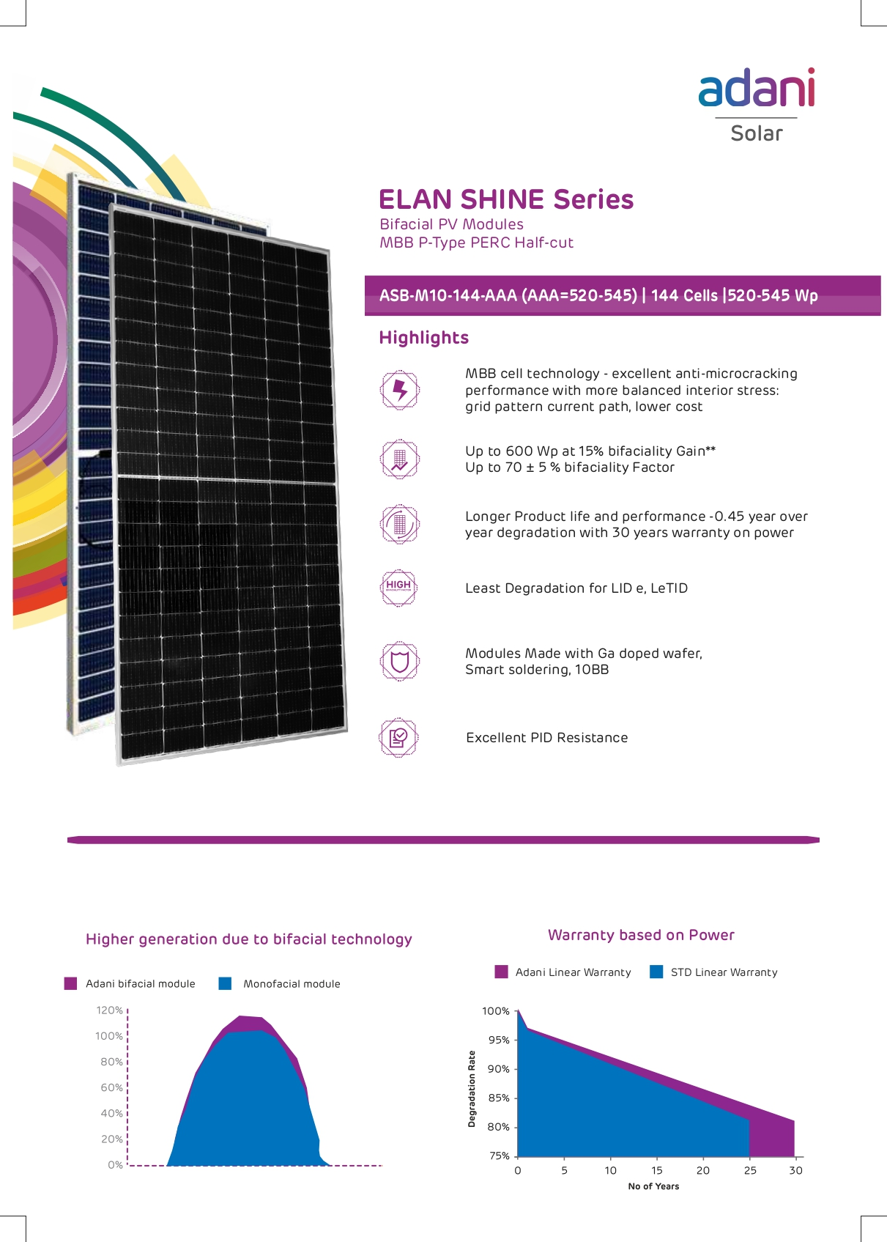

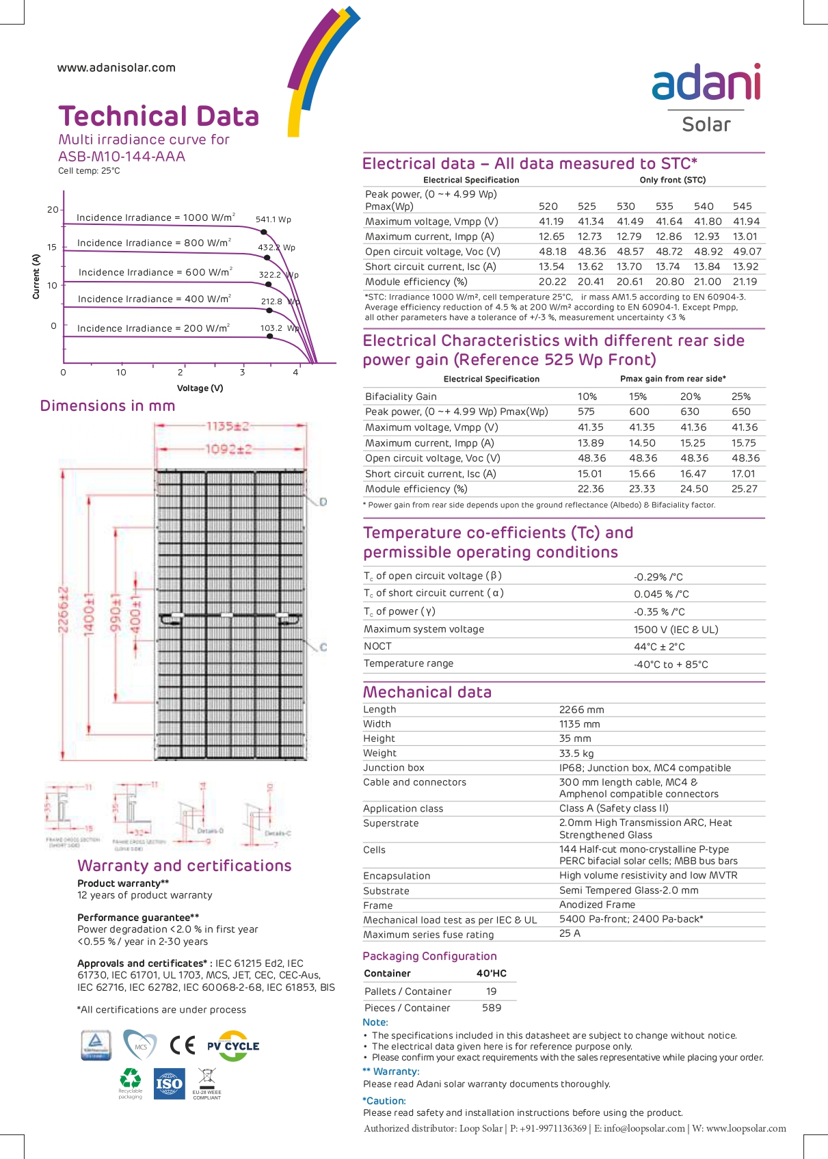
- Features of proposed solar panels by Waaree at both the locations as per Project report:

  - The selected Waaree module is the WSMD Arka series Mono PERC PV mod-ules. The module has a capacity of 515–545 Wp peak power and has 144 cells.
  - The Solar PV module provides a warranty for 98% + power output in the first year, thereafter, from year 2 to 27, the maximum decrease in power output shall be 0.55% from module’s nominal power output per year, ending with around 81.9% in the 27th year after the defined warranty start date.
  - The product warranty shall be 12 years.
  - The performance warranty shall be for 27 years.
  - Data Sheet of proposed waaree solar modules is as below:

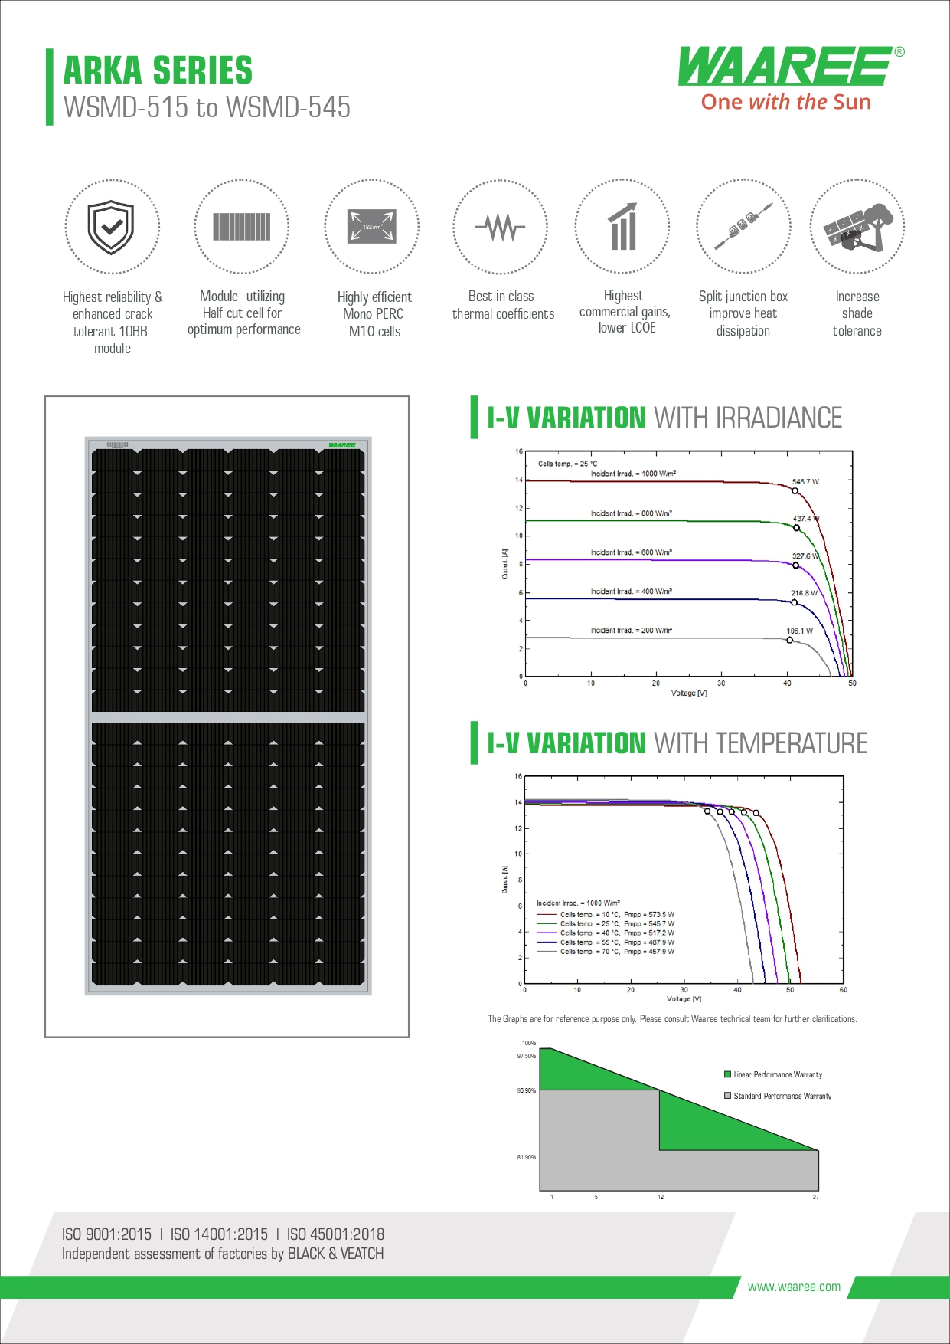
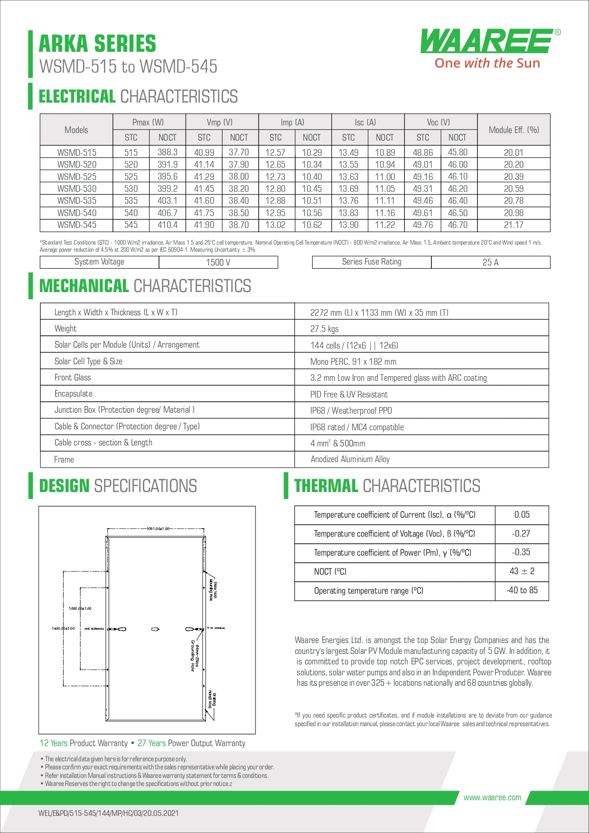
- Technical Details of PV modules as per PVsyst V6.88 report of Location 1 (IICS Cold storage facility, Azadpur mandi, Delhi) is as below:

  - PV Module: Si-Mono Model
  - Model: TSM-540DE18M(II)
  - Manufacturer: Adani Power
  - No. of PV modules in series: 18 Modules
  - Total No. of PV modules: 380 Modules
  - Total Module area: 960 Sq. mtr.
  - Total Cell area: 2262 Sq. mtr.
  - 1 Module capacity: 540 kWp
  - Total Capacity: 540 wP * 380 Modules= 205.20 Kw

Note: As per PV syst report the company has used Adani power solar modules for analysis. However, the manufacturer of the module is yet to be finalized by the company.

- SOLAR INVERTERS

- Features of proposed solar inverters by Solis at both the location as per Project report:

  - Solis is one of the top 3 inverter manufacturers in Asia. The company has opted for 80K PV Solar Inverter - 80K-5G-DC make inverters. The main features of the inverter are as under:
  - Max. 13A per string, support 1.5 DC overloading capability.
  - 10 individual MPPT, lower dismatch loss
  - Efficient logic algorithm, over 99% max. Efficiency
  - String monitoring, shorter O&M time
  - Remote & local intelligent IV scan function
  - Leakage current repression technology
  - Volt-watt work mode integrated
  - DC input reverse alarm
  - Optional anti-PID function integrated
  - Reactive power compensation function.
  - The model has a 5-year warranty which is extendable to 20 years on purchase of extended warranty packages.
  - Data sheet of proposed Solis inverters:

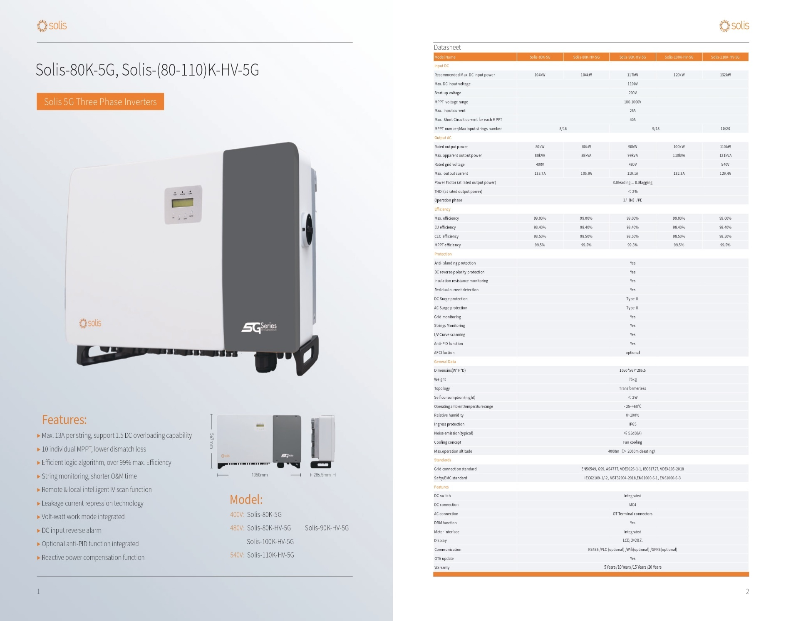
- Technical Details of Solar Inverters as per PVsyst V6.88 report of Location 1 (IICS Cold storage facility, Azadpur mandi, Delhi) is as below:

  - Model: Solar Inverter M100_210
  - Company: Solis energy
  - Number of Inverters: 2 Units
  - Operating Voltage: 590-1000 V
  - Nominal Power: 100Kwac

- Important catch points from PVsyst V6.88 Report dated 11th June 2022

  - Produced Energy: 307.50 MWh/year
  - Performance Ratio: 80.18%
  - PV Field Orientation
    - Tilt: 10 Degrees
    - Azimuth: 20 Degrees
  - No. of Modules: 380 Nos
  - Pnom of Modules: 205 kWp
  - Nos. of Inverters: 2 Units
  - Pnom of Inverters: 200 kW AC
  - Produced Energy (EArray): 307.50MWh/Year, Spec. Production: 1500 kWh/kWp/year (EArray: Effective energy at the output of the array)
  - Performance Ratio: 80.18 % against industrial accepted standard PR of 75%.
    - The Performance ratio is decreasing in the summers because of increase in temperature losses due to summer heat effect in the region.
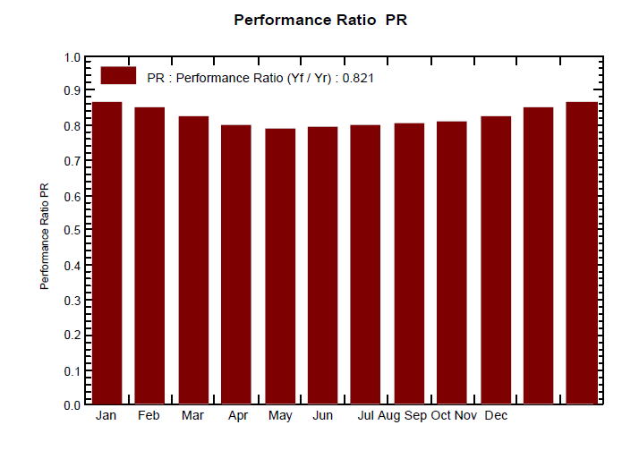

    - There is a difference between Performance ratio as per graph and performance ratio mentioned under main simulation results which is 80.18%.
  - E_Grid Energy: 246.27 MW per year (Electricity injected onto the grid)
  - Horizontal Global Irradiation: 1603.50 kWh/m²
  - Loss Diagram

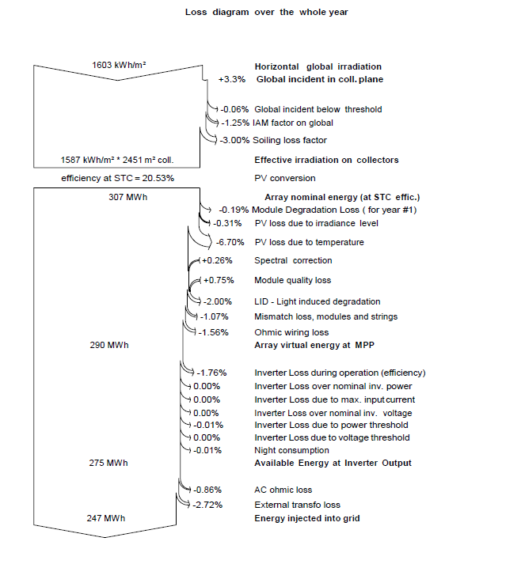
LOCATION 2: UNDER CONSTRUCTION ROOFTOP OF COLD STORAGE FACILITY AT KULLU, HIMACHAL PRADESH

            - LAND DETAILS
For setting up of these Power Plants, Indraprastha Ice and Cold Storage private limited (IICSPL) has proposed to use the roof top under construction cold storage facility at Kullu in Himachal Pradesh. Therefore, no land parcel is required for erection and commissioning of this Rooftop Mounted solar power plant project.

            - BUILDING & STRUCTURAL DETAILS:
No Building/ Structures are proposed to be set-up by IICSPL for this project as this project is proposed to be setup on the roof Under Construction Cold storage facility at Kullu, Himachal Pradesh and construction of this facility is out of scope of this report and company’s proposal for Solar rooftop power plant installation as informed by the company.

            - PLANT, MACHINERY AND MISCELLANOUS FIXED ASSETS:

                - SOLAR PANELS

- Features of proposed solar panels by Adani power at both the location as per Project report:
  - The selected Adani module is the Elan Shine Mono PERC Bifacial PV modules.
  - The module has a capacity of 520-545 Wp peak power and has 144 cells.
  - The Bifacial gain is expected to be around 10-25% of the total power produced.
  - The gain will be due to the bifacial factor and the ground reflection.
  - The Solar PV module provides a warranty for 98% + power output in the first year, thereafter, from year 2 to 30, the maximum decrease in power output shall be 0.55% from module’s nominal power output per year, ending with around 82% in the 30th year after the defined warranty start date.
  - The product warranty shall be 12 years.
  - The performance warranty shall be for 30 years.
  - Data Sheet of proposed Adani Power solar module is as below:

- Features of proposed solar panels by Waaree at both the locations as per Project report:

  - The selected Waaree module is the WSMD Arka series Mono PERC PV mod-ules. The module has a capacity of 515–545 Wp peak power and has 144 cells.
  - The Solar PV module provides a warranty for 98% + power output in the first year, thereafter, from year 2 to 27, the maximum decrease in power output shall be 0.55% from module’s nominal power output per year, ending with around 81.9% in the 27th year after the defined warranty start date.
  - The product warranty shall be 12 years.
  - The performance warranty shall be for 27 years.
  - Data Sheet of proposed Waaree solar modules is as below:

- Technical Details of PV modules as per PVsyst V6.88 report of Location 2 (IISCPL, Kullu, Himachal) is as below:

  - PV Module: Si-Mono Model
  - Model: TSM-540DE18M(II)
  - Manufacturer: Adani Power
  - No. of PV modules in series: 19 Modules
  - Total No. of PV modules: 2225 Modules
  - Total Module area: 5621 Sq. mtr.
  - Total Cell area: 2262 Sq. mtr.
  - 1 Module capacity: 540kWp
  - Total Capacity: 540Wp * 2225 Modules= 1201.50 kW

Note: As per PV syst report the company has used Adani power solar modules for analysis. However, the manufacturer of the module is yet to be finalized by the company.

                - SOLAR INVERTERS

- Solis is one of the top 3 inverter manufacturers in Asia. The company has opted for 80K PV Solar Inverter - 80K-5G-DC make inverters. The main features of the inverter as per project report are as under:
  - Max. 13A per string, support 1.5 DC overloading capability.
  - 10 individual MPPT, lower dismatch loss
  - Efficient logic algorithm, over 99% max. Efficiency
  - String monitoring, shorter O&M time
  - Remote & local intelligent IV scan function
  - Leakage current repression technology
  - Volt-watt work mode integrated
  - DC input reverse alarm
  - Optional anti-PID function integrated
  - Reactive power compensation function.
  - The model has a 5-year warranty which is extendable to 20 years on purchase of extended warranty packages
  - Data sheet of the proposed solar inverter is as below:

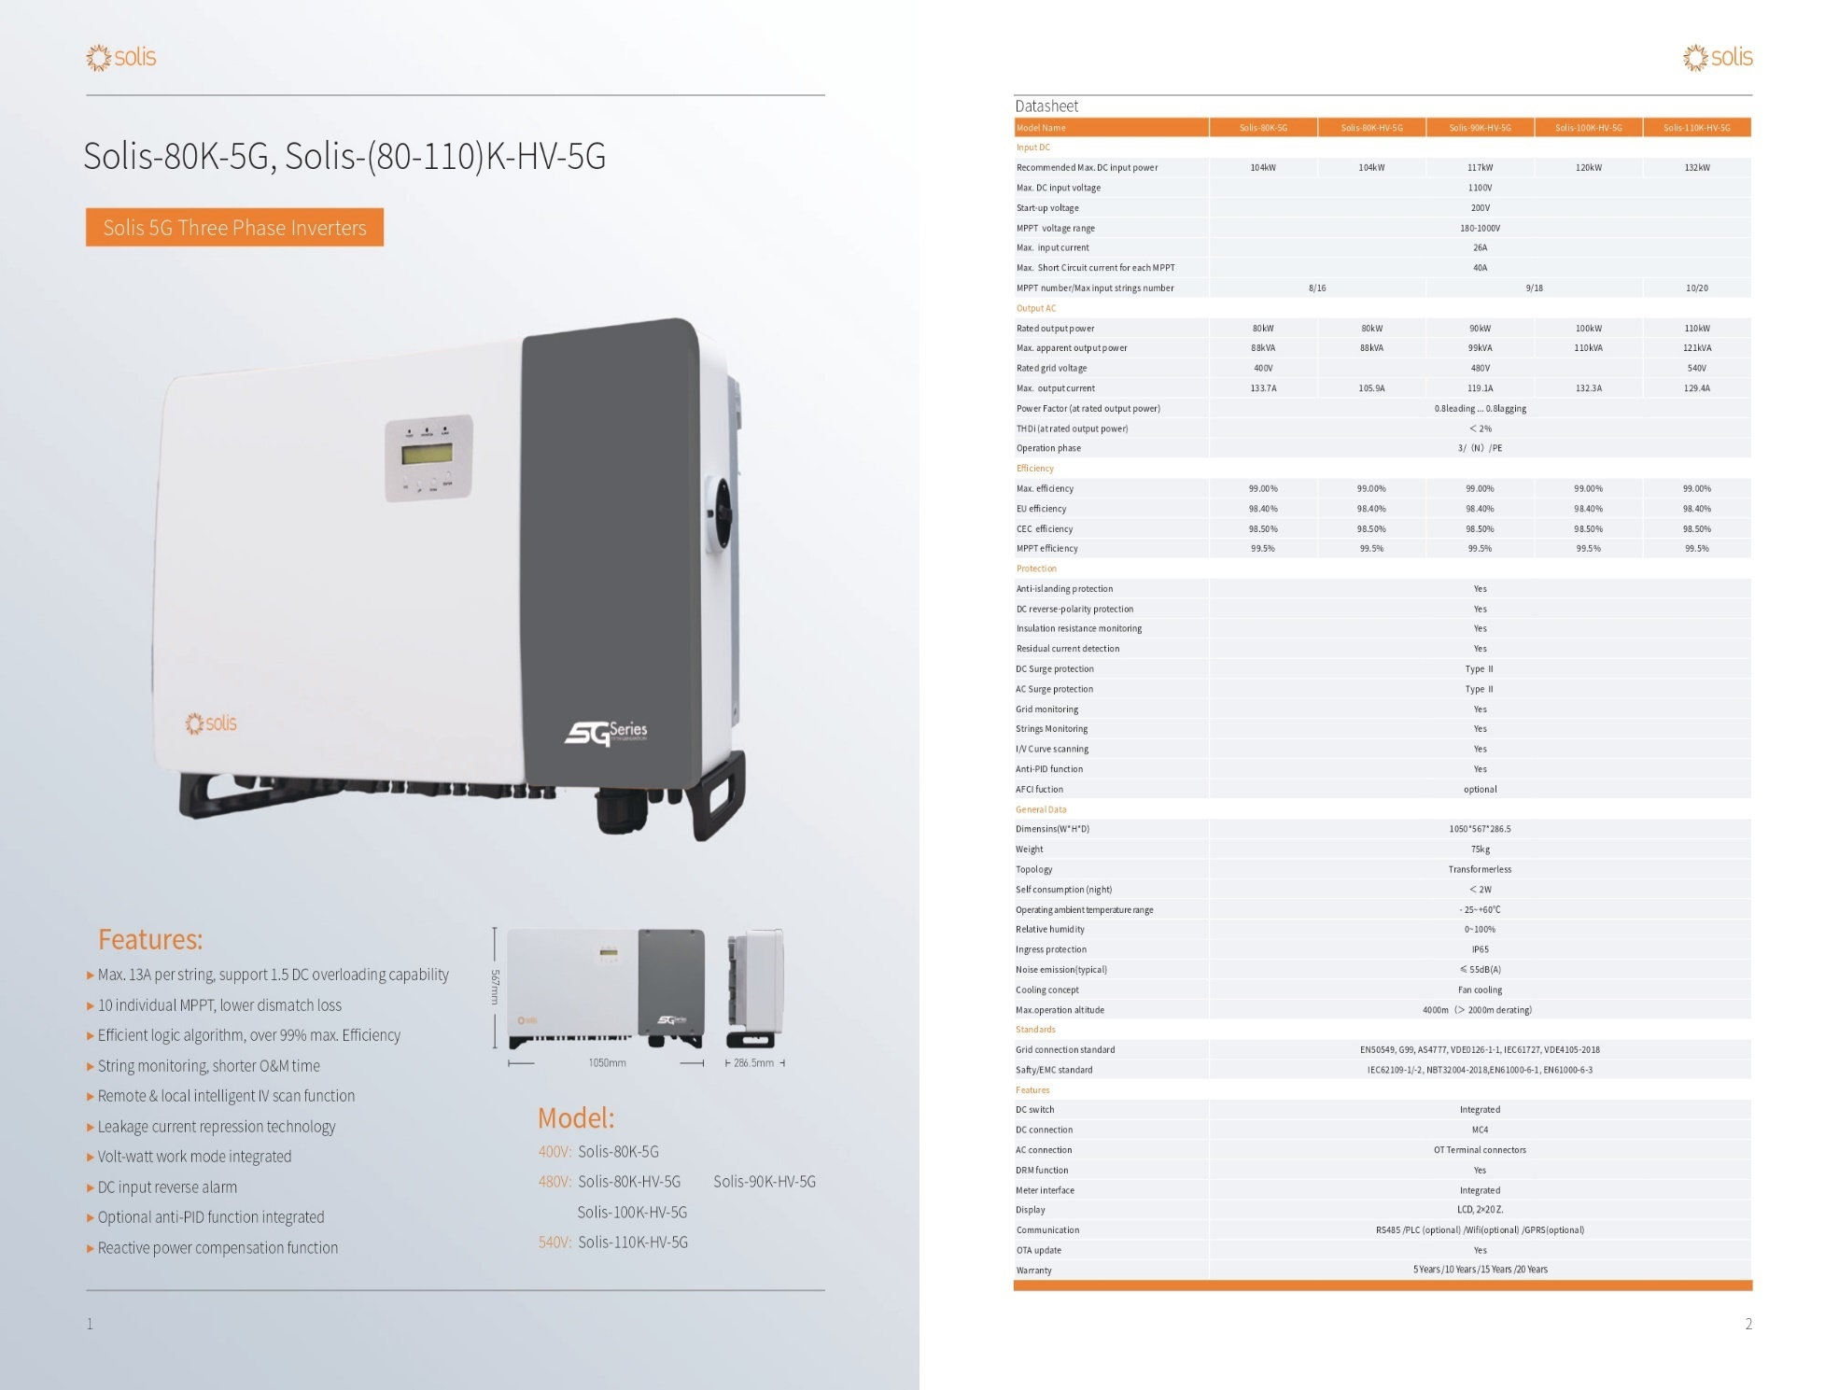

- Technical Details of Solar Inverters as per PVsyst V6.88 report of Location 2 (IISCPL, Kullu, Himachal) is as below:

  - Model: Solar Inverter M200_210
  - Company: Solis energy
  - Number of Inverters: 6 Units
  - Operating Voltage: 590-1000 V
  - Nominal Power: 200 Kwac

                - Important catch points from PVsyst V6.88 Report dated 11th June 2022 for Location 2
  - Produced Energy: 1800 MWh/year
  - Performance Ratio: 80.18%
  - PV Field Orientation
    - Tilt: 10 Degrees
    - Azimuth: 20 Degrees
  - No. of Modules: 2225 Nos
  - Total Pnom of Modules: 1200 kWp
  - Nos. of Inverters: 6 Units
  - Pnom of Inverters: 1200 kW AC
  - Produced Energy (EArray): 1800 MWh/Year (EArray: Effective energy at the output of the array)
  - Performance Ratio: 80.18 % against industrial accepted standard PR of 75%.
    - The Performance ratio is decreasing in the summers because of increase in temperature losses due to summer heat effect in the region.
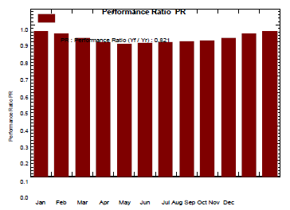

    - There is a difference between Performance ratio as per graph and performance ratio mentioned under main simulation results which is 80.18%. Clarification is awaited.
  - E_Grid Energy: 1450 MW per year (Electricity injected onto the grid)
  - Horizontal Global Irradiation: 1603.50 Kwh/m²
  - Loss Diagram over the whole year

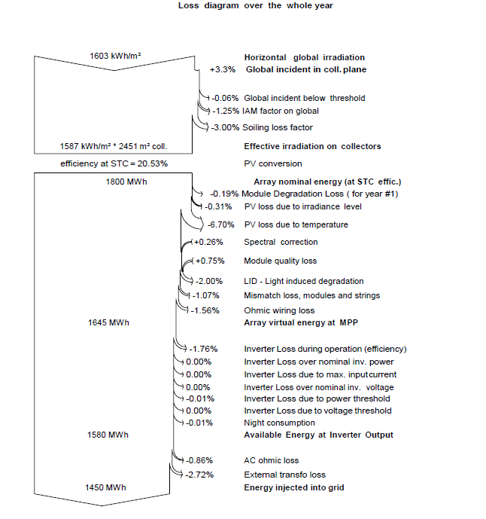

PART G | MAJOR SUPPLIERS/EPC CONTRACTOR

The company has proposed to appoint M/s Sugs Lloyd Private Limited for erection, implementation and commissioning of the Solar rooftop power plants at both the Location 1 as well as Location 2. As per the PVsyst report the EPC Contractor has proposed to purchase solar panels from Adani Power and Solar inverters from Solis Energy for projects at both the Location 1 as well as Location 2.

Details of the Purchase Order is as below:

Sr. No. | Company | PO No. | PO Amount (Cr.) | Scope of Work
1. | Sugs Loyd | - | - | EPC Contractor
a. | Adani Power | - | - | Supply of 380 Modules for Location 1 and supply of 2225 modules for Location 2
b. | Solis Energy | - | - | Supply of 2 units for Location1 and supply of 6 units for Location 2

Note:
- The company has informed that they have appointed EPC contractor M/s Sugs Loyd private limited erection, implementation and commission of the project. However, we have only received the PVsyst report generated by M/s Sugs loyd Pvt. Ltd. for technical information purpose and Techno commercial Proposal by M/s Sugs loyd Pvt. Ltd. For Bill of quantities of the project.
- Final Signed contract document was sought from the company. Accordingly, the company has informed that the final contract document is yet to be signed between both the parties and as soon as the contract document is signed the same will be shared with bank. Bank to take note of this.

PART H | PROJECT COST & MEANS OF FINANCE

- PROJECT COST FOR PROJECT (200 kW) AT LOCATION 1 (AZADPUR MANDI, DELHI):

As per the Project report the project cost amounts to Rs.1.13 Crore. Breakup of Rs.1.13 Crore is as below:

Sr. No. | Component | Amount (Cr.)
1. | PV Modules | 0.67
2. | Inverter | 0.11
3. | Structure | 0.19
4. | Balance of System (includes HT Panel, cables, Installation etc.) | 0.07
5. | Project Management, Regulatory Registration, Liasoing etc. | 0.08
GRAND TOTAL |  | 1.13

Observations & Comments:

- The basis of the above estimated cost is as per the project report provided by the company which is including GST.

- Ministry of New and Renewable Energy which is the nodal Ministry for Solar Projects in India also releases benchmark cost for the purpose of consideration for Project subsidies. Last such benchmark cost for Grid-connected Rooftop Solar Photo-voltaic systems was done in financial year 2021-2022. No such benchmark cost was released by MNRE for the year 2022-23 inspite of input cost of solar projects has risen since 3rd quarter of 2021. The approved MNRE benchmark cost for Grid-connected Rooftop Solar Photo-voltaic systems for the financial year 2021-2022 for the capacity range >100 kW to 500 kW is Rs. 39,080 per Kilo Watt (kW). However, since then the cost escalation has taken place because of the following reasons:

  - Basic custom duty of 40% has been imposed on imported PV modules from April 1, 2022.
  - GST rates on PV modules have increased to 12% from previous 5%.

Our analysis for reasons pertaining to increase in CAPEX for solar power plants is covered in Point 3 of this part.

- The above benchmark cost includes cost of Solar PV panels (with domestic cell and modules), inverter (single/3 phase wherever applicable), balance of system e.g., cable, switches/ circuit breaker/ connectors/ junction box, mounting structure, earthing, lightening arrester, and civil works, installation & commissioning, CMC for 5 years, transportation, insurance, applicable taxes, etc. The above benchmark costs are excluding of net metering cost and battery back-up costs.

- Detailed breakup of Rs.1.13 Crore is as below:
(Amount in Rs. Crore)
Sr. No. | Item | Amount | GST (%) | GST | Total Amount
1. | PV Modules | 0.60 | 12% | 0.07 | 0.67
2. | Inverter | 0.10 | 12% | 0.01 | 0.11
3. | Structure | 0.16 | 18% | 0.03 | 0.19
5. | BOP | 0.06 | 18% | 0.01 | 0.07
6. | Installation and Commissioning | 0.07 | 18% | 0.01 | 0.08
Grand Total |  | 0.99 |  | 0.14 | 1.13

  - CURRENT STATUS & TOTAL EXPENDITURE INCURRED TILL DATE FOR PROJECT LOCATION 1:

The project is yet to take off. Therefore, no expenditure has been incurred on the project till 25th August 2022.

SR. NO. | PARTICULARS | AMOUNT | INCURRED UP TO 25TH AUGUST 2022 | CURRENT STATUS OF EXPENDITURE
 |  | (All figures in cr.)
1. | Solar Panels | Total allocated amount | 0.67 | Project erection works are yet to take off. Therefore, no expenditure has been incurred under this head.
 |  | Total Expenses shown by the company | -
 |  | Total amount Approved by LIE up to 25th August 2022 | -
2. | Solar Inverters | Total allocated amount | 0.11 | Project erection works are yet to take off. Therefore, no expenditure has been incurred under this head.
 |  | Total Expenses shown by the company | -
 |  | Total amount Approved by LIE up to 25th August 2022 | -
3. | Structure | Total allocated amount | 0.19 | Project erection works are yet to take off. Therefore, no expenditure has been incurred under this head.
 |  | Total Expenses shown by the company | -
 |  | Total amount Approved by LIE up to 25th August 2022 | -
4. | Balance of Plant | Total allocated amount | 0.07 | Project erection works are yet to take off. Therefore, no expenditure has been incurred under this head.
 |  | Total Expenses shown by the company | -
 |  | Total amount Approved by LIE up to 25th August 2022 | -
5. | Installation and Commissioning | Total allocated amount | 0.08 | Project erection works are yet to take off. Therefore, no expenditure has been incurred under this head.
 |  | Total Expenses shown by the company | -
 |  | Total amount Approved by LIE up to 25th August 2022 | -
6. | Total | Total allocated amount | 2.27 | Project erection works are yet to take off. Therefore, no expenditure has been incurred under this head.
 |  | Total Expenses shown by the company | -
 |  | Total amount Approved by LIE up to 25th August 2022 | -

  - SOURCES OF FINANCE & UTILIZATION OF FUNDS FOR PROJECT LOCATION 1:

PARTICULARS | PLANNED AMOUNT | CURRENT STATE OF INVESTMENT
 | (Amount in Crore)
Term Loan | - | -
Own Sources | 1.13 | 0.0
TOTAL | 1.13 | -

Comments:
- Term Loan amount is yet to be finalized.
- Project has not commenced yet. Therefore, no expenditure has been incurred on the project.

- PROJECT COST FOR PROJECT (1200 kW) AT LOCATION 2 (KULLU, HIMACHAL PRADESH):

As per the Project report the project cost amounts to Rs.6.15 Crore. Breakup of Rs.6.15 Crore is as below:

Sr. No. | Component | Amount (Cr.)
1. | PV Modules | 3.90
2. | Inverter | 0.34
3. | Structure | 0.78
4. | Balance of System (includes HT Panel, cables, Installation etc.) | 0.57
5. | Project Management, Regulatory Registration, Liasoing etc. | 0.57
Grand Total |  | 6.15

Observations & Comments:

- The basis of the above estimated cost is as per the project report provided by the company which is including GST.

- Ministry of New and Renewable Energy which is the nodal Ministry for Solar Projects in India also releases benchmark cost for the purpose of consideration for Project subsidies. Last such benchmark cost for Grid-connected Rooftop Solar Photo-voltaic systems was done in financial year 2021-2022. No such benchmark cost was released by MNRE for the year 2022-23 in spite of input cost of solar projects has risen since 3rd quarter of 2021. The approved MNRE benchmark cost for Grid-connected Rooftop Solar Photo-voltaic systems for the financial year 2021-2022 for the capacity range >100 kW to 500 kW is Rs.42,980 per Kilo Watt (kW). The cost of Solar power plant projects above 500 kW is project specific and no benchmark cost is available for those projects. However, since then the cost escalation has taken place because of the following reasons:

  - Basic custom duty of 40% has been imposed on imported PV modules from April 1, 2022.
  - GST rates on PV modules have increased to 12% from previous 5%.

Our analysis for reasons pertaining to increase in CAPEX for solar power plants is covered in Point 3 of this part H.

- The above benchmark cost includes cost of Solar PV panels (with domestic cell and modules), inverter (single/3 phase wherever applicable), balance of system e.g., cable, switches/ circuit breaker/ connectors/ junction box, mounting structure, earthing, lightening arrester, and civil works, installation & commissioning, CMC for 5 years, transportation, insurance, applicable taxes, etc. The above benchmark costs are excluding of net metering cost and battery back-up costs.

- Detailed breakup of Rs.6.15 Crore is as below:
(Amount in Rs. Crore)
Sr. No. | Item | Amount | GST (%) | GST Amount | Total Amount
1 | PV Modules | 3.45 | 12% | 0.42 | 3.90
2 | Inverter | 0.30 | 12% | 0.04 | 0.34
3 | Structure | 0.66 | 18% | 0.12 | 0.78
5 | BOP | 0.48 | 18% | 0.09 | 0.57
6 | Installation and Commissioning | 0.48 | 18% | 0.09 | 0.57
Grand Total |  | 5.40 |  | 0.75 | 6.15

- The company has informed that they will be installing 1200 kWp of rooftop solar plant Kullu, Himachal Pradesh (Location 2). However, the bank will only consider 1000 kWp for their term loan facility. Bank to take not of this.

  - CURRENT STATUS & TOTAL EXPENDITURE INCURRED TILL DATE FOR PROJECT LOCATION 1:

The project is yet to take off. Therefore, no expenditure has been incurred on the project till 26th August 2022.

SR. NO. | PARTICULARS | AMOUNT | INCURRED UP TO 26TH AUGUST 2022 | CURRENT STATUS OF EXPENDITURE
 |  | (All figures in cr.)
1. | Solar Panels | Total allocated amount | 3.90 | Project is yet to take off. Therefore, no expenditure has been incurred under this head.
 |  | Total Expenses shown by the company | -
 |  | Total amount approved by LIE up to 26th August 2022 | -
2. | Solar Inverters | Total allocated amount | 0.34 | Project is yet to take off. Therefore, no expenditure has been incurred under this head
 |  | Total Expenses shown by the company | -
 |  | Total amount approved by LIE up to 26th August 2022 | -
3. | Structure | Total allocated amount | 0.78 | Project is yet to take off. Therefore, no expenditure has been incurred under this head
 |  | Total Expenses shown by the company | -
 |  | Total amount approved by LIE up to 26th August 2022 | -
4. | Balance of Plant | Total allocated amount | 0.57 | Project is yet to take off. Therefore, no expenditure has been incurred under this head
 |  | Total Expenses shown by the company | -
 |  | Total amount approved by LIE up to 26th August 2022 | -
5. | Installation and Commissioning | Total allocated amount | 0.57 | Project is yet to take off. Therefore, no expenditure has been incurred under this head
 |  | Total Expenses shown by the company | -
 |  | Total amount approved by LIE up to 26th August 2022 | -
6. | Total | Total allocated amount | 6.15 | Project is yet to take off. Therefore, no expenditure has been incurred under this head
 |  | Total Expenses shown by the company | -
 |  | Total amount approved by LIE up to 26th August 2022 | -

  - SOURCES OF FINANCE & UTILIZATION OF FUNDS FOR PROJECT LOCATION 1:

PARTICULARS | PLANNED AMOUNT | CURRENT STATE OF INVESTMENT
 | (Amount in Crore)
Term Loan | - | -
Own Sources | 6.15 | 0.0
TOTAL | 6.15 | -

Comments:
- Term Loan amount is yet to be finalized.
- Project has not commenced yet. Therefore, no expenditure has been incurred on the project.

- ANALYSIS OF INCREASE IN RISING COST OF ROOFTOP SOLAR PROJECTS:

Excerpts of our Secondary research is as below:

  - GENERAL REASON FOR INCREASE IN PROJECT

One of the key selling features that have helped solar power become the world’s fastest-growing energy source is cost reduction, which had recently encountered a snag due to recent increases in solar module pricing. PV module components account for roughly 50-55% of the total project cost. Solar module prices have increased by 18% since the beginning of 2021, after plummeting by 90% over the previous decade. Thus, giving a significant rise in project cost of solar power plants.

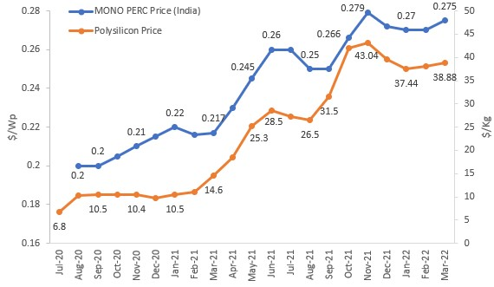

The value of projects awarded in the last six to nine months will be impacted by a rise in solar photovoltaic (PV) module prices. The government has imposed a 40% basic customs duty (BCD) on solar modules and a 25% BCD on solar cells beginning April 1, 2022. The price increase is mostly due to a significant increase in the price of polysilicon, a vital input for cell and module manufacturing. Metal prices have recently increased, putting increasing pressure on the overall capital cost of solar generating installations. Chinese module manufacturers have recently hiked their costs by more than a fifth and begun cancelling contracts to provide equipment.

  - COST OF RAW MATERIALS:
Polysilicon is a key raw material in solar module manufacturing. Over the years, its price reduction has been a significant factor contributing to the decline in solar module prices, leading to competitive tariffs. However, polysilicon prices increased significantly from $10 per kg in August 2020 to $44 per kg in November 2021 (4.4 times increase). This multi fold increase in prices has primarily resulted in higher module prices.

Other disrupting factors in the module supply chain include price hikes for commodities such as glass, steel and aluminum, shortages of containers, and an increase in freight rates. Steel and aluminium prices have increased by around 95% and 115%, respectively, from January 2020 to March 2022. Such disruptions were exacerbated due to various pandemic lockdowns.
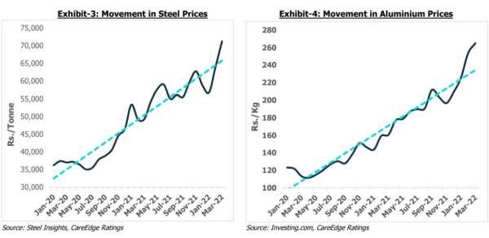

  - IMPACT OF BASIC CUSTOM DUTY (BCD) AND APPROVED LIST OF MODELS AND MACNUFACTURERS (ALMM)
From April 2022 onwards, BCD has been applied on import of solar modules (40%) and cells (25%). As BCD became applicable from April 2022, the developers, to save on costs, have preemptively stocked modules ahead of time. This is reflected by an increase in the imports to 9.7 GW in the fourth quarter of fiscal 2022. Additionally, government mandated solar developers to only use ALMM enlisted modules for government projects, government-assisted projects, those under government schemes and programs (e.g., Component A of PM-KUSUM scheme) as well as open access and rooftop net metering projects. ALMM so far, only contains domestic manufacturers. Anticipating upsurge in demand for domestically manufactured solar modules due to above factors, the leading domestic solar manufacturers have increased their prices by 3-4 cents (viz. 3-4%) between February and March 2022.

The build-up of module prices under different scenarios is tabulated below:
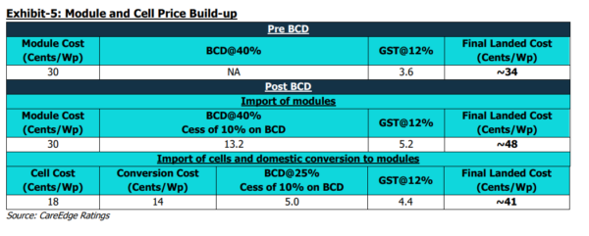
Thus, we can see a direct increase of approximately 30% being reflected on project CAPEX due to increase in GST rate and imposition of Basic customs duty on Solar modules as well as solar cells.

ALMM factor is not applicable to this project since this is not a government project.

  - RISING DEMAND FOR SOLAR MODULES:
Solar power installations have increased at a compounded annual growth rate (CAGR) of 23% from calendar year 2016 to calendar year 2021, as a decline in solar costs have made it competitive compared to other sources of generation. Higher emphasis on procuring power through cleaner sources and global commitment to reduce carbon emissions has supported demand, too. This has resulted in demand outpacing supply over the past few quarters and, in turn, increased the cost of modules. The power crisis in China, which accounts for a major portion of global production, has also impacted the supply of modules.

These inflationary pressures are likely to put upward pressure on the capital cost of solar power projects. At present, the delivered price (on cost, insurance, and freight [CIF] basis) of imported solar modules and cells from China is around $0.30/Wp and $0.18/Wp, respectively. Additionally, modules and cells attract BCD of 40% and 25%, respectively, and cess of 10% on BCD. A GST of 12% is applicable on the solar equipment.

  - INCREASE IN STEEL PRICES
Other disrupting factors in the PV supply chain include price hikes for commodities such as glass and metals, shortage of containers etc. Such disruptions were exacerbated further due to various Covid-19 induced lockdowns across the world which resulted in halting of manufacturing activity. However, In the year 2022 it is observed that the steel prices are coming down which will give some respite to Solar power projects in due course.

This increase is giving an upward trajectory to Project CAPEX since the project will be rooftop but will be mounted over steel frames and columns as the roof which is RCC with obstructions like AHU’s, Water tanks, pipes etc.

  - MISCELLANEOUS
During Q3 CY2021, several countries including China faced an energy crisis. Main reasons were shortage of coal and associated supply chain disruptions in coal supply. The solar manufacturing industry, still highly concentrated in China, was affected by the rolling blackouts implemented by the government of the energy intensive industries. This crisis compounded an already difficult situation and contributed to increase in module prices in short term. With covid cases surging in China post March 2022, the Chinese government has imposed strict lockdowns across several major provinces. Thus, this hindrance to solar manufacturing in China may affect solar module prices at least in the short term.

GIST OF OUR ANALYSIS:
PROJECT AT LOCATION 1 (Azadpur Mandi, Himachal)-200 kWp Solar power Plant
- After analyzing the above information, the Project cost seems to be reasonable. Main reasons from our analysis are as below:
  - 40% BCD on Solar modules imposed in April 2022 which was earlier absent on imported PV modules.
  - GST price increase from 5% to 12% on PV modules.
  - Increase in steel prices which are gradually coming under control in due course.
  - Supply chain disruptions.
- The company has only verbally informed that all the modules being procured by their proposed EPC contractor M/s Sugs Lloyd Pvt. Ltd. will be imported therefore 40% BCD is considered. Bank to do proper Source due diligence for supply of modules.
- MNRE Rooftop solar power plant project Benchmark cost 2021-222 was released in public domain on 18th August 2021 and the major CAPEX increase reasons like 40% BCD imposition and GST increase to 12% took place in April 2022 and October 2021 respectively.
PROJECT AT LOCATION 2 (Kullu, Himachal)-1200 kWp Rooftop solar power plant
- After analyzing the above information, the Project cost seems to be reasonable. Main reasons from our analysis are as below:
  - 40% BCD on Solar modules imposed in April 2022 which was earlier absent on imported PV modules.
  - GST price increase from 5% to 12% on PV modules
  - Supply chain disruptions.
- The company has only verbally informed that all the modules being procured by their proposed EPC contractor M/s Sugs Lloyd Pvt. Ltd. will be imported therefore 40% BCD is considered. Bank to do proper Source due diligence for supply of modules.
- MNRE Rooftop solar power plant project Benchmark cost 2021-222 was released in public domain on 18th August 2021 and the major CAPEX increase reasons like 40% BCD imposition and GST increase to 12% took place in April 2022 and October 2021 respectively.

PART I | CONCLUSION

- The project cost amounting to approx. Rs.1.13 Crore for installation of 200 kWp of Rooftop Mounted solar power plant at Azadpur mandi, Delhi (Location 1) seems to be reasonable considering the economic reasons as discussed in Part H of this report. Major reasons driving the cost of solar power plants is firstly 40% Basic customs duty imposed on Solar PV modules from April 2022 which was earlier absent on PV modules and GST increase to 12% from previous 5%.

- The project cost amounting to approx. Rs.6.15 Crore for installation of 1200 kWp of Rooftop Mounted solar power plant at Kullu, Himachal Pradesh (Location 2) seems to be reasonable considering the economic reasons as discussed in Part H of this report. Major reasons driving the cost of solar power plants is firstly 40% Basic customs duty imposed on Solar PV modules from April 2022 which was earlier absent on PV modules and GST increase to 12% from previous 5%.

- As per observations made during the site visits of both the project locations, the geographical factors responsible for efficient power generation in the project seems to be satisfactory and the site is geographically well suited for such type of solar projects. In addition to satisfactory geographical location, the company should implement the installation exercise as per the parameters mentioned in the PVsyst report to keep the project technically efficient.

- Site inspection for Rooftop Solar power plant proposed to be set up at Azadpur mandi, delhi was carried out on 25th August 2022 and it was observed that erection works in the project have not yet commenced and no fresh material pertaining to this project was found to be delivered to the site. The company’s representative has showed us the Rooftop location where the project is proposed to be erected. Site Photographs of the same are attached as annexures with this report.

- Site inspection for Rooftop Solar power plant proposed to be set up at Kullu, Himachal Pradesh was carried out on 26th August 2022 and it was observed that the company was setting up a 7,500 metric ton controlled atmosphere cold storage for apples. The company’s representative has informed us that installation and commissioning of solar modules will be done on the roof of under construction cold storage facility. Site Photographs of the rooftop is not available since the same is not yet constructed. However, the site photographs of under construction cold storage facility on which the installation and commissioning of solar power plant is proposed to be done is attached as annexures with this report.

- Indraprastha Ice and Cold Storage (P) Limited has proposed to set-up an On-Grid Rooftop PV Module Solar Power Plant and to use Mono-Crystalline PERC technology on both the projects.

- The company has informed that they will be installing 1200 kWp of rooftop solar plant at under construction IICSPL unit location at Kullu, Himachal Pradesh (Location 2). However, the bank will only consider 1000 kWp for their term loan facility. Bank to take note of this.

PART J | DISCLAIMER

      - No employee or member of R.K Associates has any direct/ indirect interest in the Project.
      - This report is prepared based on the copies of the documents/ information which the Bank/ Company has provided to us out of the standard checklist of documents sought from them and further based on our assumptions and limiting conditions. All such information provided to us has been relied upon in good faith and we have assumed that it is true and correct in all respect. Verification or cross checking of the documents provided to us has not been done at our end from the originals. If at any time in future, it is found or came to our knowledge that misrepresentation of facts or incomplete or distorted information has been provided to us then this report shall automatically become null & void.
      - This report is a general analysis of the project based on the scope mentioned in the report. This is not an Audit report, Design document, DPR or Techno-financial feasibility study. All the information gathered is based on the facts seen on the site during survey, verbal discussion & documentary evidence provided by the client and is believed that information given by the company is true best of their knowledge.
      - All observations mentioned in the report is only based on the visual observation and the documents/ data/ information provided by the client. No mechanical/ technical tests, measurements or any design review have been performed or carried out from our side during Project assessment.
      - Bank/FII should ONLY take this report as an Advisory document from the Financial/ Chartered Engineering firm and it’s specifically advised to the creditor to cross verify the original documents for the facts mentioned in the report which can be availed from the borrowing company directly.
      - In case of any default in loans or the credit facility extended to the borrowing company, R.K Associates shall not be held responsible for whatsoever reason may be and any request for seeking any explanation from the employee/s of R.K Associates will not be entertained at any instance or situation.
      - This Report is prepared by our competent technical team which includes Engineers and financial experts & analysts.
      - This is just an opinion report and doesn’t hold any binding on anyone. It is requested from the concerned Financial Institution which is using this report for taking financial decision on the project that they should consider all the different associated relevant & related factors also before taking any business decision based on the content of this report.
      - All Pages of the report including annexures are signed and stamped from our office. In case any paper in the report is without stamp & signature then this should not be considered a valid paper issued from this office.
      - Though adequate care has been taken while preparing this report as per its scope, but still we can’t rule out typing, human errors, over sightedness of any information or any other mistakes. Therefore, the concerned organization is advised to satisfy themselves that the report is complete & satisfactory in all respect. Intimation regarding any discrepancy shall be brought into our notice immediately. If no intimation is received within 15 (Fifteen) days in writing from the date of issuance of the report, to rectify these timely, then it shall be considered that the report is complete in all respect and has been accepted by the client up to their satisfaction & use and further to which R.K Associates shall not be held responsible in any manner.
      - Defect Liability Period is 15 DAYS. We request the concerned authorized reader of this report to check the contents, data and calculations in the report within this period and intimate us in writing if any corrections are required or in case of any other concern with the contents or opinion mentioned in the report. Corrections only related to typographical, calculation, spelling mistakes, incorrect data/ figures/ statement will be entertained within the defect liability period. Any new changes for any additional information in already approved report will be regarded as additional work for which additional fees may be charged. No request for any illegitimate change in regard to any facts & figures will be entertained.
      - R.K Associates encourages its customers to give feedback or inform concerns over its services through proper channel at le@rkassociates.org in writing within 30 days of report delivery. After this period no concern/ complaint/ proceedings in connection with the Lender’s Independent Engineering Services will be entertained due to possible change in situation and condition of the subject Project.
      - Our Data retention policy is of ONE YEAR. After this period, we remove all the concerned records related to the assignment from our repository. No clarification or query can be answered after this period due to unavailability of the data.
      - This Lender’s Independent Engineering report is governed by our (1) Internal Policies, Processes & Standard Operating Procedures, (2) Information/ Data/ Inputs given to us by the client and (3) Information/ Data/ Facts given to us by our field/ office technical team. Management of R.K Associates never gives acceptance to any unethical or unprofessional practice which may affect fair, correct & impartial assessment and which is against any prevailing law. In case of any indication of any negligence, default, incorrect, misleading, misrepresentation or distortion of facts in the report then it is the responsibility of the user of this report to immediately or at least within the defect liability period bring all such act into notice of R.K Associates management so that corrective measures can be taken instantly.
      - R.K Associates never releases any report doing alterations or modifications from pen. In case any information/ figure of this report is found altered with pen then this report will automatically become null & void.
SURVEYED BY | PREPARED BY
ER. ABHISHEK SHARMA AND MR. SACHIN PANDEY | ER. TEJAS BHARADWAJ
DATE: 25th & 26TH AUGUST 2022 | DATE: 8TH SEPTEMBER 2022

DEFECT LIABILITY PERIOD - In case of any query/ issue or escalation you may please contact Incident Manager by writing at valuers@rkassociates.org. We ensure 100% accuracy in the Calculations done, Rates adopted and various other data points & information mentioned in the report but still can’t rule out typing, human errors or any other mistakes. In case you find any mistake, variation, discrepancy or inaccuracy in any data point of the report, please help us by bringing all such points into our notice in writing at valuers@rkassociates.org within 30 days of the report delivery, to get these rectified timely, failing which R.K Associates Valuers Techno Engineering Consultants (P) Ltd. won’t be held responsible for any inaccuracy in any manner. Also, if we will not hear back anything from you within 30 days, we will assume that report is correct in all respect and no further claim of any sort will be entertained thereafter. We would welcome and appreciate your feedback & suggestions in order to improve our services.

COPYRIGHT FORMAT - This report is prepared on the copyright format of R.K Associates Valuers Techno Engineering Consultants (P) Ltd. to serve our clients in the best possible way. Legally no one can copy or distribute this format without prior approval from R.K Associates. It is meant only for the organization as mentioned on the cover page of this report. Distribution or use of this format other than R.K Associates will be seen as unlawful act and necessary legal action can be taken against the defaulter

ANNEXURE 1: MNRE BENCHMARK COST DOCUMENT
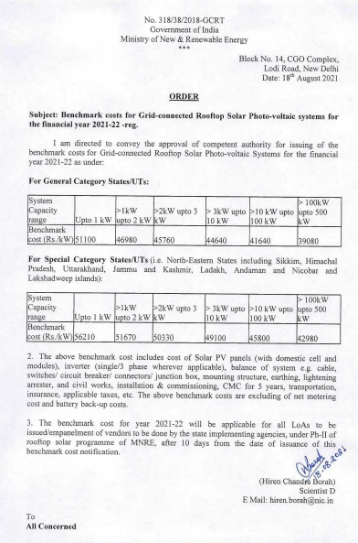
ANNEXURE 2: MERCOM INDIA RESEARCH OF MNRE BENCHMARK COST
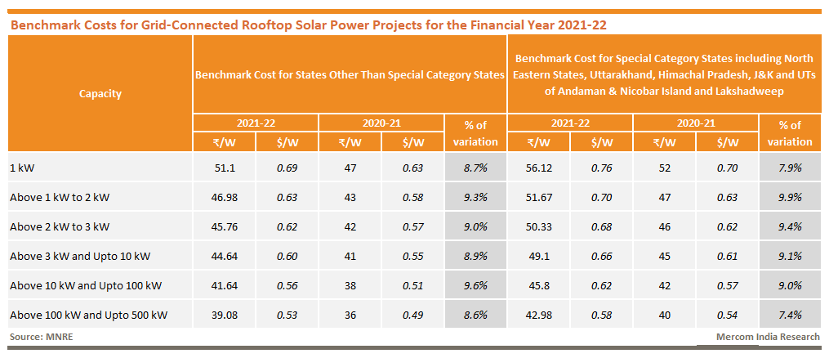

ANNEXURE 3: SECONDARY RESEARCH LINKS FOR HIGH CAPEX AMOUNT

LINK 1: https://mercomindia.com/solar-project-cost-to-increase-azure-power/
LINK 2: https://mercomindia.com/average-cost-large-scale-solar-projects/
LINK 3: https://www.pv-magazine.com/2022/07/01/solar-module-price-increases-to-affect-returns-on-4-4-gw-of-indian-solar/
Link 4: https://www.pv-magazine-india.com/2022/04/22/solar-module-prices-increased-38-in-the-last-20-months/
Link 5: https://energy.economictimes.indiatimes.com/news/renewable/domestic-solar-modules-cost-to-come-down-by-11-per-cent-in-april/89720315
LINK 6: https://www.pv-magazine-india.com/2022/05/25/higher-solar-module-prices-rainy-days-ahead-for-developers/
LINK 7: https://www.statista.com/statistics/1219740/india-steel-price-by-city/

SITE PHOTOGRAPHS
LOCATION 1 (AZADPUR MANDI, DELHI)

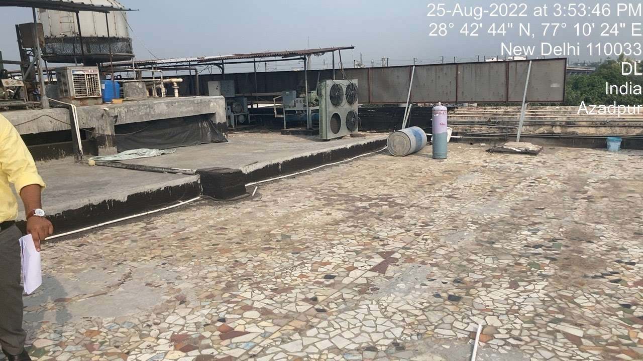
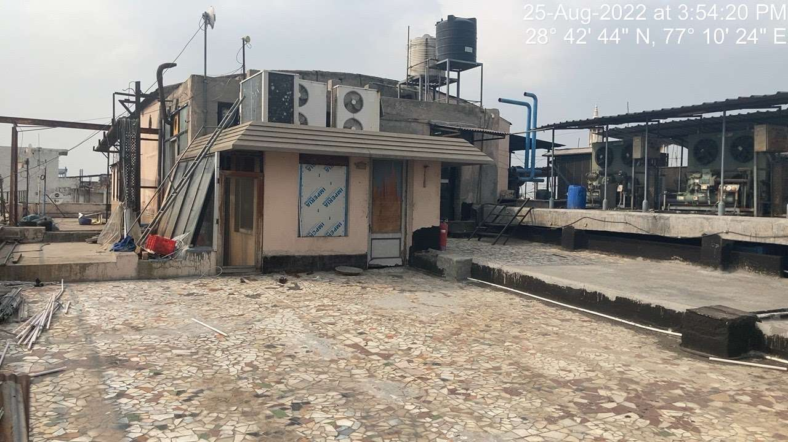
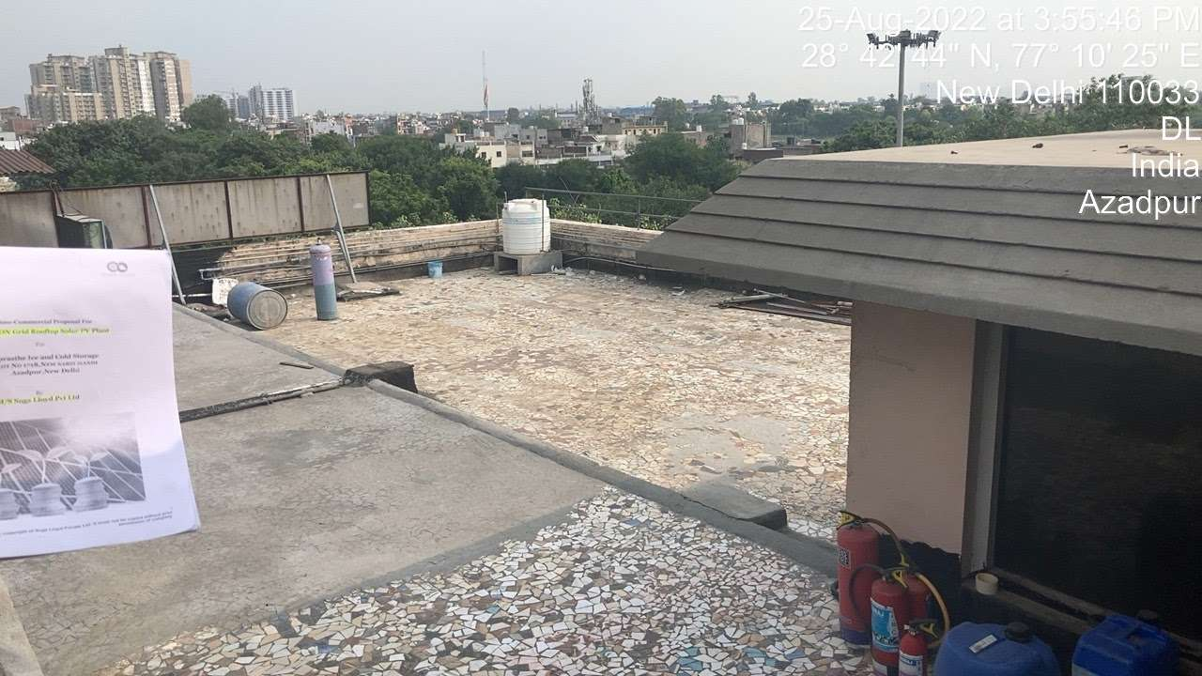

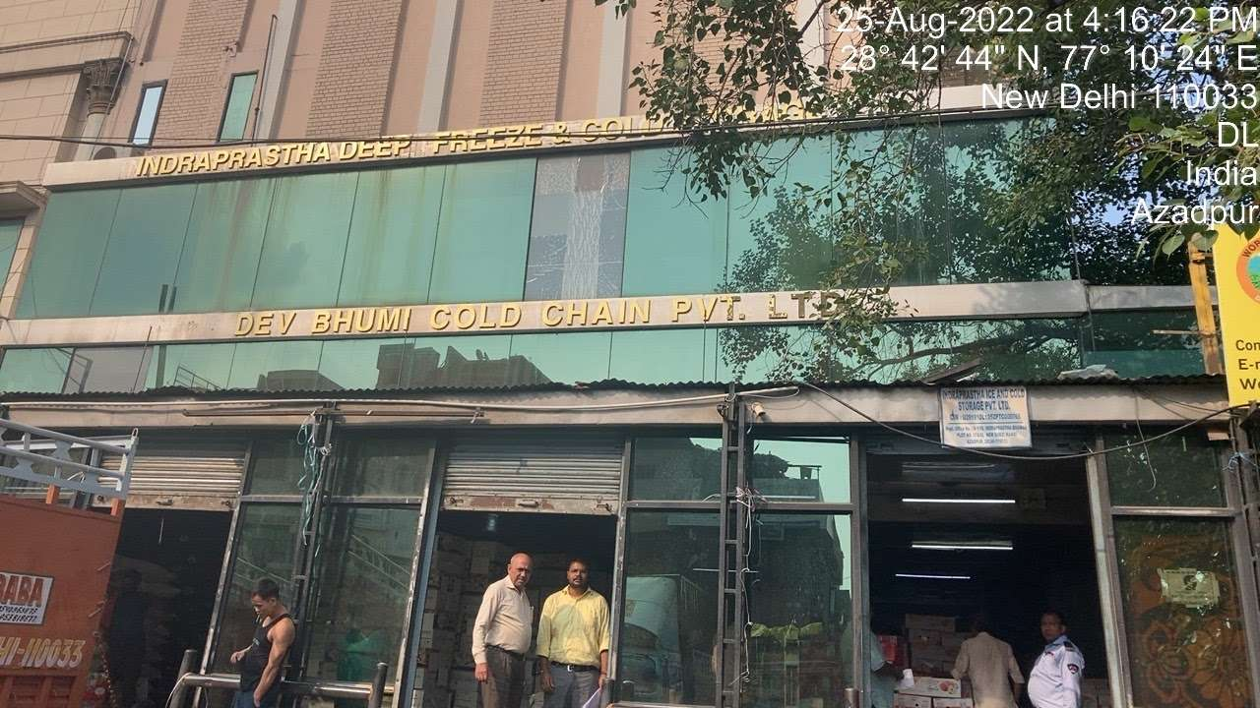

SITE PHOTOGRAPHS
LOCATION 2 (KULLU, HIMACHAL PRADESH)

