FILE NO.: VIS (2022-23) PL283-215-413 Dated: 05/09/2022

LENDER’S INDEPENDENT ENGINEER REPORT
OF
475 kW GROUND MOUNTED SOLAR POWER PROJECT

PROPOSED TO BE SET UP AT
DEVBHUMI COLD CHAIN PRIVATE LIMITED MATIANA FACILITY AT SHIMLA, HIMACHAL PRADESH

COMPANY/PROMOTER

DEV BHUMI COLD CHAIN PRIVATE LIMITED

REPORT PREPARED FOR

STATE BANK OF INDIA, SME, UDYOG SADAN, DELHI

**Important - In case of any query/ issue or escalation you may please contact Incident Manager
at le@rkassociates.org. We will appreciate your feedback in order to improve our services.
NOTE: As per IBA Guidelines please provide your feedback on the report within 15 days of its submission after which report will be considered to be correct.

IMPORTANT NOTICE

COPYRIGHT FORMAT: This report is prepared on the copyright format of R.K Associates to serve our clients with the best possible information and analysis to facilitate them to take rational business decisions. Legally no one can copy or distribute this format without prior approval from R.K Associates. It is meant only for the advisory/ reference purpose for the organization/s as mentioned on the cover page of this report. Distribution or use of this format by any organization or individual other than R.K Associates will be seen as an unlawful act and necessary legal action can be taken against the defaulters.
This report is intended for the sole use of the intended recipient/s and contains material that is STRICTLY CONFIDENTIAL AND PRIVATE.

DEFECT LIABILITY PERIOD: - In case of any query/ issue or escalation you may please contact Incident Manager at le@rkassociates.org.
Though adequate care has been taken while preparing this report as per its scope, but still, we can’t rule out typing, human errors, over sightedness of any information or any other mistakes. Therefore, the concerned organization is advised to satisfy themselves that the report is complete & satisfactory in all respect. Intimation regarding any discrepancy shall be brought into our notice immediately. If no intimation is received within 15 (Fifteen) days in writing from the date of issuance of the report, to rectify these timely, then it shall be considered that the report is complete in all respect and has been accepted by the client up to their satisfaction & use and further to which R.K Associates shall not be held responsible in any manner.

TABLE OF CONTENTS
SECTIONS | PARTICULARS | PAGE NO.
Part A | REPORT SUMMARY
Part B | INTRODUCTION
 | - Name of the Project
 | - Project Overview
 | - Scope of the Report
 | - Purpose of the Report
 | - Methodology Adopted
Part C | PROJECT LOCATION & SITE APPROPRIATENESS
 | - Location
 | - Site Appropriateness
Part D | PROJECT TECHNICAL DETAILS
 | - Plant Configuration
 | - Components And Its Technical Specifications:
 | - Site Inspection Details
Part E | PROJECT INFRASTRUCTURE SECTIONS & FACILITY DETAILS
 | - Land Details
 | - Building & Structural Details
Part F | MAJOR SUPPLIERS
Part G | PROJECT COST & MEANS OF FINANCE
 | - Total Project Cost
 | - Current Stratus & Total Expenditure incurred till date
 | - Source of Finance & Utilization of Funds
Part H | STATUTORY & REGULATORY APPROVALS, CLEARANCES & NOC
Part I | OBSERVATIONS AND COMMENTS
Part J | DISCLAIMER

PART A | REPORT SUMMARY

1. | Name of Project: | Setting up of 475 KW Solar Project
2. | Project Location: | Devbhumi Cold Chain Private Limited Matiana Facility at Shimla, Himachal Pradesh
3. | Name of the Company: | M/s. Devbhumi Cold Chain Private Limited
4. | Director’s | - Sanjay Aggarwal  - SunilA Aggarwal  - Shagun Verma
5. | Prepared for Bank: | State Bank of India
6. | LIE Consultant Firm: | M/s. R.K. Associates Valuers & Techno Engineering Consultants (P) Ltd.
7. | Date of Survey: | 26th August 2022
8. | Date of Report: | 5th September 2022
9. | Purpose of the Report: | To review Project cost, expenditure and examine the current status of installation and commissioning of the project.
10. | Scope of the work provided by the Lender: | To verify the Project cost, expenditures and examine the commissioning, installation status of Solar Power Plant set-up by M/s. IICS Pvt. Ltd.  - Industry/ sector research and demand & supply trend is out of scope of the report.  - Financial feasibility study of the Project is out of scope of the report.  - Providing any kind of design report or map is out-of-scope of the report.
11. | Documents perused for Proposal: | - Project Report  - Copies of Invoices
12. | Annexure with the report: | - Copies of Invoices

PART B | INTRODUCTION

- NAME OF THE PROJECT: Installation and Commissioning of 475 kW of Ground Mounted Solar Power Project.

- PROJECT OVERVIEW: The company has proposed to set up 475 kWp of Ground Mounted Solar Power plant Project at existing vacant land of Control atmosphere cold storage for apples at DBCC’s Matiana facility at Shimla in Himachal Pradesh with the envisaged cost of approx. Rs.2.30 Crore which is proposed to be executed by Delhi based Sugs Loyd Pvt. Ltd. Who is being quoted as proposed EPC contractor of this project. The solar power plant will help the company to reduce its electricity expenses. Thus, this project is a captive solar power project.

Proposed Capacity of Plant | 475 kWp
Site Address | Devbhumi Cold Chain Private Limited Matiana Facility at Shimla, Himachal Pradesh
Latitude and Longitude | 31°12'37.1"N 77°24'21.1"E

We have conducted the visit of the project site on 26th august 2022. During site visit it was informed by the company’s representative that works related to this project have not commenced yet and will commence post receipt of sanction of term loan from the concerned Bank.

However, during visit it was observed that there were already some pre-existing solar panels at the proposed project site which were found to be functional. The company has informed that these Solar panels are totally out of scope of this project and they are planning to install New solar panels under this project with a total power generation capacity of 475 kW.

- SCOPE OF THE REPORT:

To verify the Project cost, expenditures and examine the commissioning, installation status of Solar Power Plant set-up by M/s. DBCC Pvt. Ltd.

- Industry/ sector research and demand & supply trend is out of scope of the report.
- Financial feasibility study of the Project is out of scope of the report.
- Providing any kind of design report or map is out-of-scope of the report.

- PURPOSE OF THE REPORT: To Provide Project Progress Monitoring Report to SBI.

- METHADOLOGY ADOPTED:

- Study of Project Planning documents/ reports to know about the Project.
- Additional information, data, documents collection the company.
- Study and analysis of the documents and information obtained from the company.
- Research about the Project/ sector from the sources in the public domain.
- Correlation of the provided information against Industry/ sector benchmarks/ trend.
- Information compilation, analysis and reporting.

PART C | PROJECT LOCATION & SITE APPROPRIATENESS

      - LOCATION:
The project is located at Devbhumi Cold Chain Private Limited Matiana Facility at Shimla, Himachal Pradesh

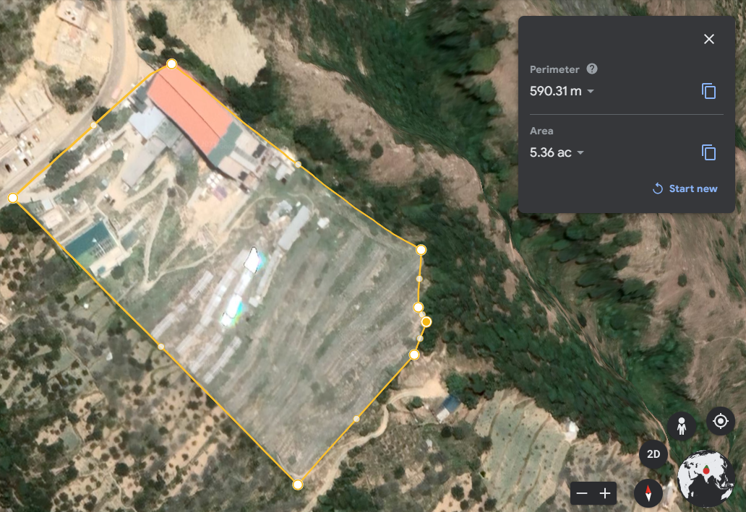
Proposed Site for this Project (475kWp)
Pre-Existing Solar Panels (125 kWp)

      - SITE APPROPRIATENESS:

  - SITE APPROPRIATENESS FOR THIS LOCATION:

The site appropriateness for a ground mounted solar power unit is basically based on the weather and solar radiation parameters since annual energy yield of a PV plant is solely dependent on the solar resource of the site.

Basically, there are three standard test conditions which are the industry standard for the conditions under which a solar panel are tested and give its efficiency rating.

            - Temperature of the cell – 25°C. The temperature of the solar cell itself, not the temperature of the surrounding.
            - Solar Irradiance – 1000 Watts per square meter. This number refers to the amount of light energy falling on a given area at a given time.
            - Mass of the air – 1.5. This number is somewhat misleading as it refers to the amount of light that has to pass through Earth’s atmosphere before it can hit Earth’s surface, and has to do mostly with the angle of the sun relative to a reference point on the earth. This number is minimized when the sun is directly above as the light has to travel a minimum distance straight down, and increases as the sun goes farther from the reference point and has to go at an angle to hit the same spot.

In this regard for doing the site appropriateness following site parameters are being evaluated:

- Temperature: The average temperature is measured as per the Metrological Station statistic available at shimla. At an average temperature of 30⁰ C, May-June is the hottest month of the year and at an average temperature of 2⁰ C January is the coldest month.

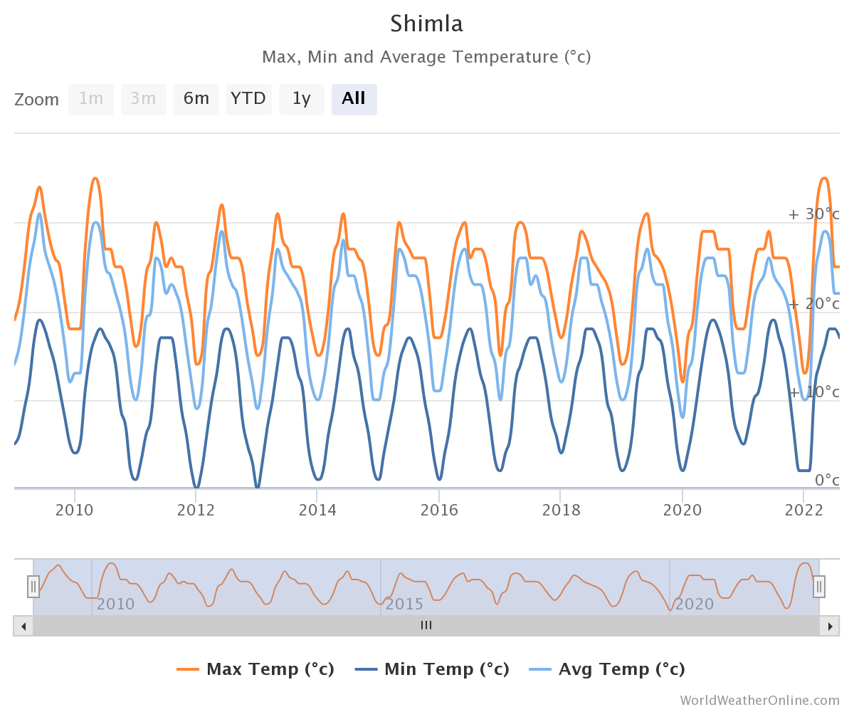
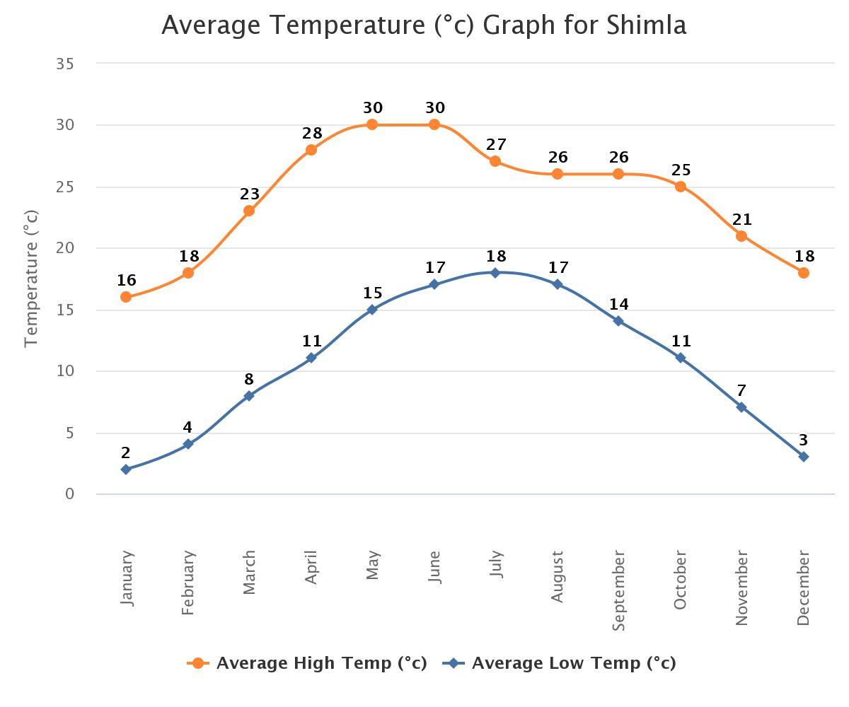
Source: https://www.worldweatheronline.com/shimla-weather-averages/himachal-pradesh/in.aspx
Temperature tolerance of solar panels is denoted by temperature coefficient, which denotes the decrease in efficiency of the solar panel with increase in temperature. Typically, temperature coefficient of solar panels is about -0.4% to -0.6% / degree C.

All solar cells have a temperature coefficient. As a solar panel increases in temperature, the power output of the solar panel decreases. Generally, monocrystalline solar cells have a temperature coefficient of -0.5%/degC. This means a mono solar panel will lose half of one percent of its power for every degree the temperature rises. Solar panels are all rated at 25degC, however, when solar panels are installed on a roof or ground, they generally reach much higher temperatures.

EXAMPLE:

All solar cells have a temperature coefficient. As a solar panel increases in temperature, the power output of the solar panel decreases. Generally, monocrystalline solar cells have a temperature coefficient of -0.5%/degC. This means a mono solar panel will lose half of one percent of its power for every degree the temperature rises. Solar panels are all rated at 25degC, however, when solar panels are installed on a roof or ground, they generally reach much higher temperatures.

Let’s say a 250W monocrystalline solar panel installed on a roof is at 65degC. The solar panel’s power loss can be calculated as follows:
65degC – 25degC = 40degC
40degC x -0.5% = 20%
Therefore, panel power loss = 20% x 250W = 50W
Therefore, Panel Power = 200W+

At an average temperature of 30⁰ C, May-June is the hottest month of the year and at an average temperature of 2⁰ C January is the coldest month. There will surely be a reduction in power generated in summer months which can also be seen in the performance ratio infographics given in the PVsyst report and is also covered in the below sections of our report. However, temperature coefficient is the inherent property of the solar modules and since the reduction of power generation in summer months will be covered with satisfactory power generation in winter months therefore the temperature in Shimla seems to be favorable for this project.
- Wind Speed: The macro-level wind speed zones of India have been formulated and published in IS: 875 (Part 3) - 1987 titled “Indian Standard Code of Practice for Design Loads (other than earthquakes) for Buildings and Structures, Part 3, Wind Loads”. There are six basic wind speeds `V_{b}’ considered for zoning, namely 55, 50, 47, 44, 39 and 33 m/s. From wind damage view point, these could be described as follows:

- 55 m/s (198 km/h) - Very High Damage Risk Zone – A
- 50 m/s (180 km/h) - Very High Damage Risk Zone – B
- 47 m/s (169.2 km/h) - High Damage Risk Zone
- 44 m/s (158.4 km/h) - Moderate Damage Risk Zone – A
- 39 m/s (140.4 km/h) - Moderate Damage Risk Zone – B
- 33 m/s (118.8 km/h) - Low Damage Risk Zone

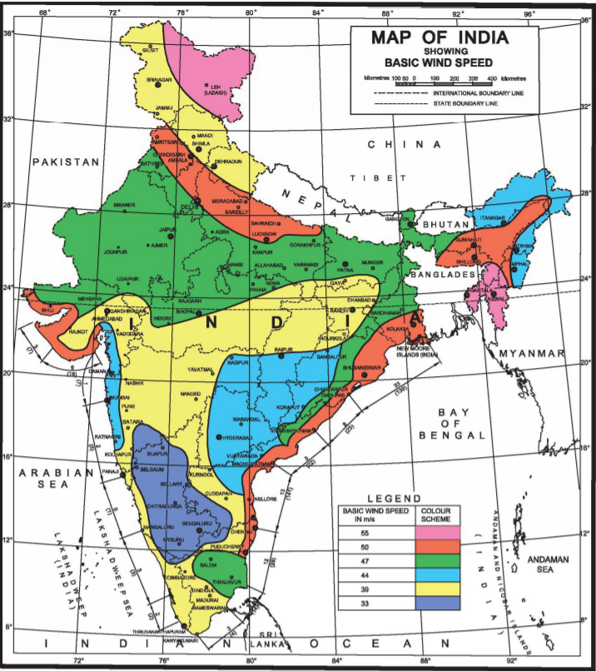
Design Wind Speed (V_{z}) - The basic wind speed (V_{b}) for any site shall be modified to include the following effects to get design wind velocity at any height (V_{z}) for the chosen structure:

a) Risk level;
b) Terrain roughness, height and size of structure; and
c) Local topography. It can be mathematically expressed as follows:

V_{z} = V_{b} k₁k₂k₃

V_{z} = Design wind speed at any height z in m/s;
V_{b} = Basic Wind Speed
k₁ = Probability factor (risk coefficient)
k₂ = Terrain, height and structure size factor
k₃ = Topography factor

The basic wind speeds are applicable to 10 m height above mean ground level in an open terrain with a return period of 50 years. Shimla lies on 39 m/s band of wind speed. Therefore, Shimla lies in Moderate damage risk zone. However, from production point of view the wind velocity can reduce the thermal losses, moderate basic wind velocity is favorable for the PV solar projects.

- Rainfall: To show variation within the months and not just the monthly totals, we show the average rainfall for Year 2010 to Year 2022 (as on date)
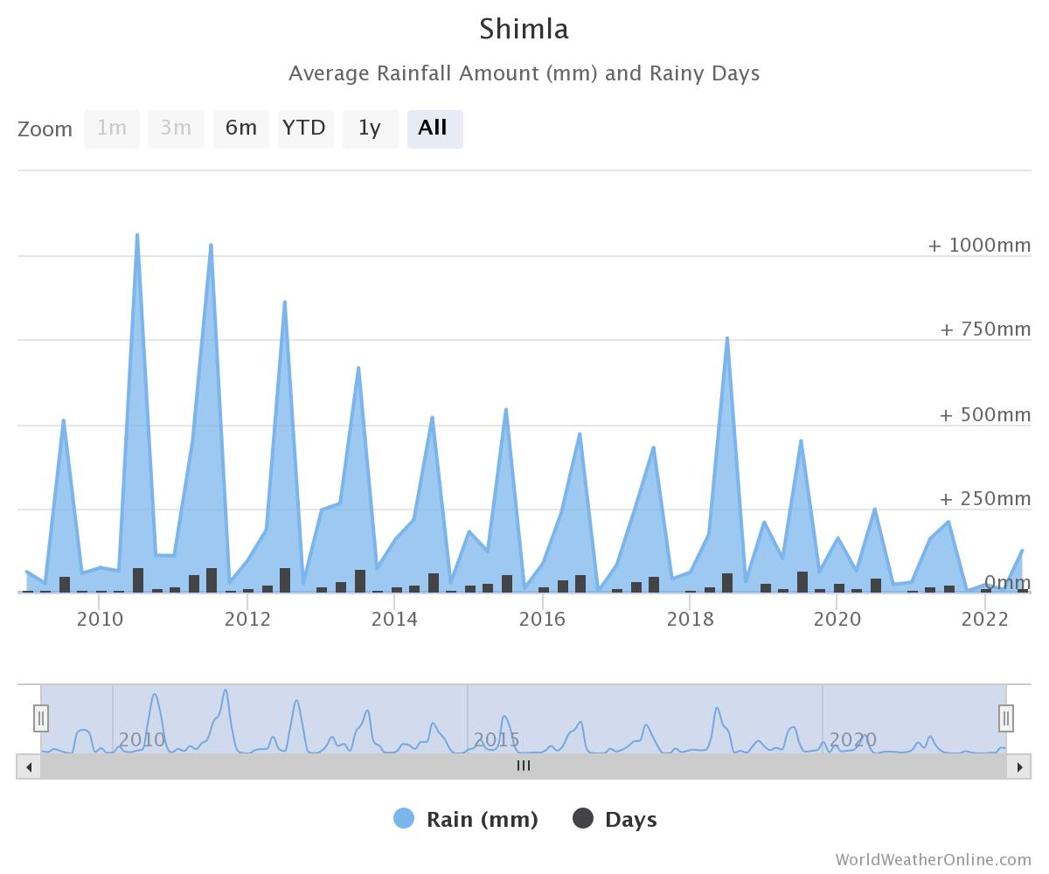
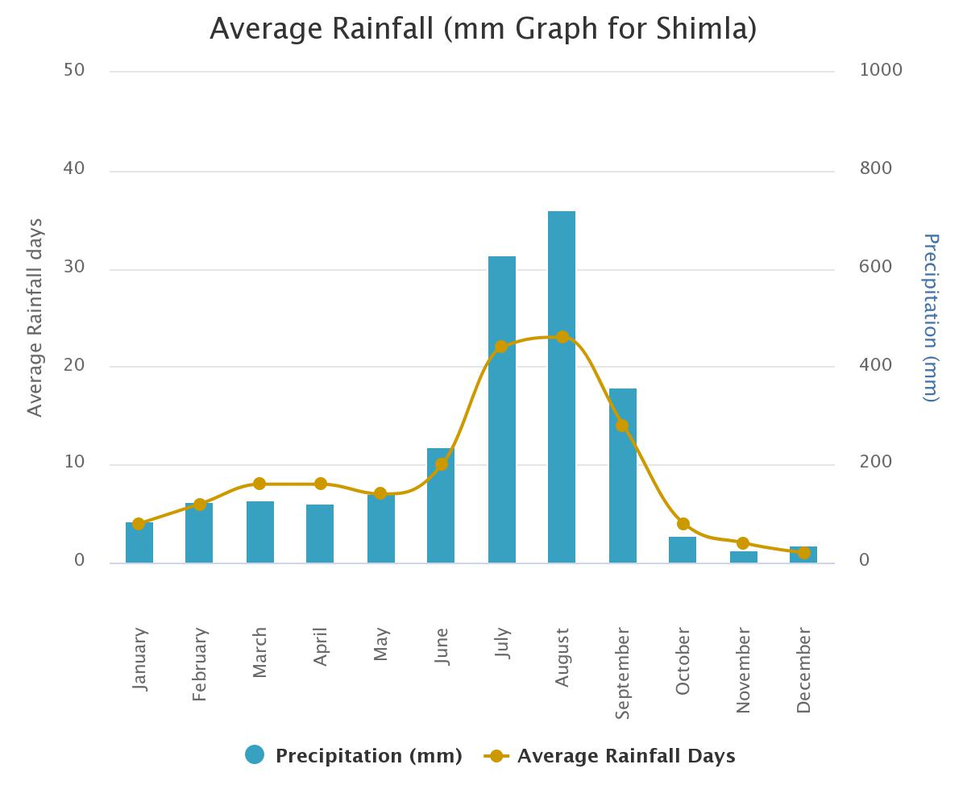Source: https://www.worldweatheronline.com/shimla-weather-averages/himachal-pradesh/in.aspx

While the rain itself will have no impact on the panels, the rain clouds can lower the electricity production. However, the occasional rainstorm could actually be good for solar system’s production, because with no extra effort it can naturally clean the panels. Since Shimla falls under moderate rain zone therefore it is ok for the solar project.

- Average Sun Hours and Sun Days:

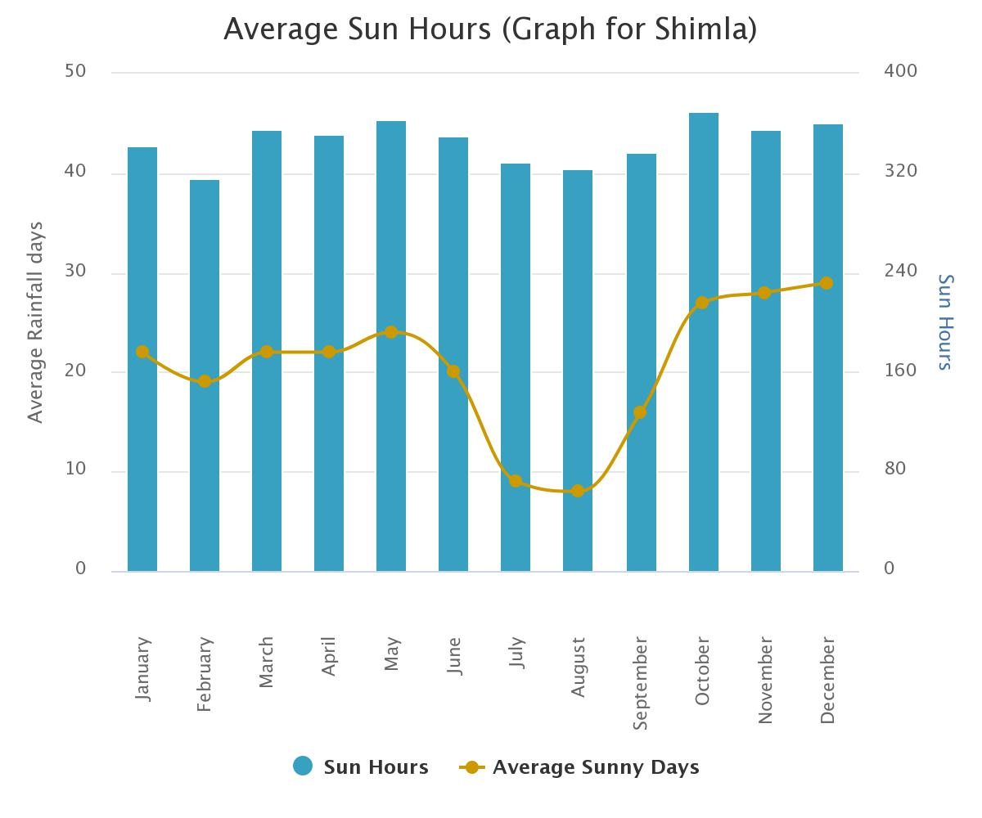
Source: https://www.worldweatheronline.com/shimla-weather-averages/himachal-pradesh/in.aspx

{Table: 2}
SHIMLA
Year | 2019 |  | 2020 |  | 2021
Days/Year | Sun Day | Sun Hour | Sun Day | Sun Hour | Sun Day | Sun Hour
January | 16 | 328 | 5 | 271 | 26 | 335
February | 5 | 302 | 20 | 309 | 25 | 309
March | 21 | 353 | 16 | 293 | 29 | 347
April | 26 | 359 | 26 | 338 | 23 | 311
May | 24 | 369 | 28 | 348 | 23 | 314
June | 25 | 360 | 24 | 315 | 22 | 327
July | 5 | 361 | 19 | 262 | 14 | 244
August | 6 | 362 | 4 | 204 | 21 | 232
September | 12 | 357 | 24 | 336 | 29 | 228
October | 23 | 372 | 31 | 372 | 30 | 359
November | 25 | 348 | 26 | 347 | 30 | 360
December | 27 | 336 | 28 | 350 | 28 | 343
Total | 215 | 4207 | 251 | 3745 | 300 | 3709

AVERAGE SUN DAYS | AVERAGE SUN HOURS
255 | 3887

As per last 3-year data, average sun days are 255 Days and average sun hours in a year is 3887 Hours recorded at Shimla zone.

- Irradiation map of Project Location

Solar irradiance is the power per unit area (watt per square metre, W/m2), received from the Sun in the form of electromagnetic radiation as reported in the wavelength range of the measuring instrument.

Global Horizontal Irradiance (GHI) is the total amount of shortwave radiation received from above by a surface horizontal to the ground. This value is of particular interest to photovoltaic installations and includes both Direct Normal Irradiance (DNI) and Diffuse Horizontal Irradiance (DIF).

Diffuse Horizontal Irradiance is the amount of radiation received per unit area by a surface that does not arrive on a direct path from the sun, but has been scattered by molecules and particles in the atmosphere. Basically, it is the illumination that comes from clouds and the blue sky.

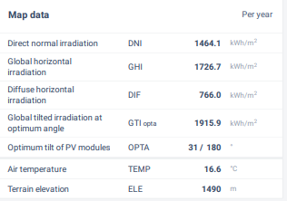

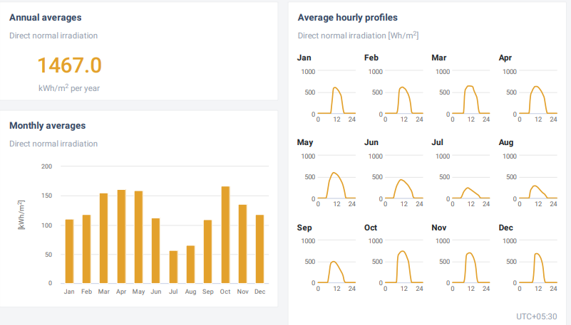
Source: https://globalsolaratlas.info/detail?c=13.083826,80.270233,11&s=13.083694,80.270186&m=site

- Shadow Analysis and Obstruction: The site of a Ground Mounted location should be free from any nearby building or structure. We have verified through google map location and our site visit conducted on 26th august 2022 that there is no obstruction by shadow on the structure from nearby site.

- Water Availability: Plant will require module cleaning during dry spells. Cleaning may require substantial quantities of water approx. 2.0 liters per module depending upon the manpower available and degree of soiling. The company has proposed to use Borewell for the same. Bank to ensure that Groundwater abstraction clearance is available with the company.

PART D | PROJECT TECHNICAL DETAILS

- PLANT CONFIGURATION
The solar power harnessing will be done by using the below mentioned components in the project
- Solar Panels
- Solar Inverters
- Transformer
- Other ancillary machinery components

- SOLAR PV PRODUCTION PROCESS:

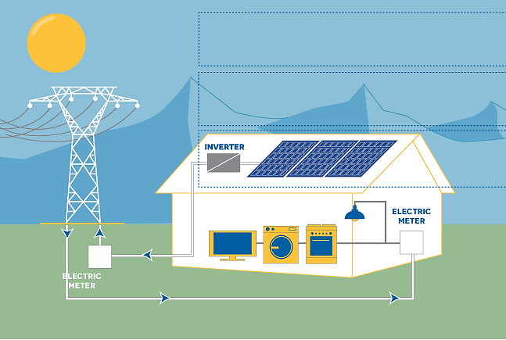

- COMPONENTS AND ITS TECHNICAL SPECIFICATIONS:

        - Plant Type: Basically, there are three types of Solar Power Plants:

- Off Grid Solar Power Plant: Off grid is a battery based solar power system. In the first priority this system will run your home appliances or connect load (as per solar inverter capacity) and surplus power feed in to the solar battery bank, provided with the solar power system. This type of solar power is recommended where power cut is the major problem.

- On Grid Solar Power Plant: On grid solar system is grid (Government electricity supply) connected system. In the first priority this system will run your home appliances or connect load (without any limit). If the connected load will exceed the capacity of installed solar power plant it will automatically use the power from main grid and if the connected load is less, it will supply surplus power to the grid. This type of system is recommended to reduce electricity bills only.

- Hybrid Solar Power Plant: Hybrid is a combination of on grid solar system as well as off grid solar system. One side hybrid solar system connects with the main electricity grid and simultaneously it will also provide battery backup to you.

Devbhoomi Cold chain private limited will set-up an On-Grid PV Module Solar Power Plant. The Incoming and outgoing electricity is proposed to be monitored by net metering systems.

        - PV Module Type and Configuration: Solar panels can be categorized on the basis of various parameters like the number of junctions they have or the generation they belong to. On the basis of the number of junctions, there are single-junction and multi-junction solar panels that differ in terms of the number of layers in the solar panel. Then there is another way of classifying solar panels i.e., with regards to the generation they belong to, which focuses on the material and efficiency of different types of solar panels.

1ST GENERATION SOLAR PANELS
These are basic solar panels that are made up of Mono-crystalline silicon or polycrystalline silicon and are used in conventional surroundings.
- Mono-Crystalline solar panels (Mono-SI): These are made up of mono-crystalline silicon. They have a dark look throughout the panel and rounded edges. These panels have the highest efficiency rate due to the high purity of the silicon used. They are most expensive because of their quality of occupying less space, high power output and long durability.

In India, Mono-Crystalline solar panels are available in a panel efficiency range of 17%, 18% and 19%.

- Polycrystalline solar panels (Poly-SI): Their production technology is based on melting raw silicon. Their outer structure has square cells, angles that are uncut and they are blue in colour. They are cheaper than Mono-SI because they occupy more space to generate the same amount of energy as compared to Mono-SI. Polycrystalline solar panel technology is the more prevalent technology in the world. These solar panels are made out of polycrystalline silicon which can be as much as 99.99% pure. These panels have an efficiency of between 13%-17%. Polycrystalline solar cells have lower efficiency and costs than Mono Crystalline solar cells. But that is changing over time and today few brands of polycrystalline solar panels are offering efficiency levels of 20%+. These are blue in Color

2ND GENERATION SOLAR PANELS
These panels comprise different types of thin film solar cells that are primarily used to build solar power systems with low power output.

- Thin film solar panels (TFSC): These are a less expensive option. They are made by placing one or more films of photovoltaic material onto a substrate. These are cheaper as less material is used in its manufacturing. They are not suitable for residential purpose because they require large spaces to generate sufficient energy. They have shorter warranties in comparison to their 1st generation counterparts. They are best suited for the areas that have ample open space for installation.

- Amorphous silicon solar panels (A-Si): These types of solar panels use a triple layer technology which is considered to be the best in the thin film variety. They are available at very low costs but provide efficiency of only 7%.

3RD GENERATION SOLAR PANELS
Solar panels belonging to this generation use organic as well as inorganic materials. These include a variety of thin film panels and some of them, such as ‘bio hybrid solar cells’, are still in the development phase.

- Cadmium Telluride solar panels (CdTe): These solar panels are manufactured using Cadmium Telluride. They are efficient as their manufacturing cost is very low and require very less amount of water to be produced. The primary advantage of these panels is that they can reduce carbon footprints significantly while their only disadvantage is that they can lead to fatalities if ingested or inhaled.

- Concentrated PV panels (CVP or HCVP): These panels are the most efficient type of solar panels with an efficiency of 41%. They use curved mirror surfaces and lenses and cooling systems are also integrated to make them more efficient. These are multi-junction solar panels which can be best efficient when they receive sun rays at a perfect angle.

4TH GENERATION SOLAR PANELS
The fourth-generation solar cell technology is also referred to as the 4G solar cell technology. This technology makes use of the combination of inorganic and organic materials, as a means to boost the efficiency and cost-effectiveness of solar cells. The 4G solar cells are engineered at solar scale and are characterized by the flexibility of conducting polymer films (the organic materials), and the stable nanostructures (inorganic materials).

Devbhoomi Cold chain Private Limited has proposed to use either Half cut Mono Crystalline P type PERC bifacial solar cells or Waaree’s WSMD series Mono PERC PV modules in both the projects. These PV panels are readily available in Indian markets at lower unit prices with proven lifelong performance. Technical data of the proposed modules is attached below in this report.

- SURFACE AZIMUTH ANGLE:

The azimuth angle is the compass direction from which the sunlight is coming. For the countries like India which falls in Northern Hemisphere, the best orientation is directly to South. However even if solar panels face outside true south up to maximum 45⁰ (south-west, south-east), the annual production goes rather limited reduction (1-3%). The solar radiation that the panel receives is almost the same. However, if the panel are turned at an angle greater than 45⁰ compared to true south, production begins to decrease significantly.

In the PySyst Report provided by the client, Azimuth angle taken is 20⁰ in both the projects.

- TILT ANGLE:

Ideally, a fixed, roof/ground-mounted solar energy system should be at an angle that is equal to the latitude of the location where it is installed. However, pitch angles between 30 and 45 degrees will work well in most situations. Overall, the angle of rooftop has less impact on solar panel performance than the direction your roof faces. Optimal electricity production occurs when solar panels face south at a tilt equal to 30°.

The optimal tilt angle of the panel changes for every month, therefore, it is required to have a tilt adjustment schedule on a seasonal basis so that adjustment frequency of angle will be minimized and the output energy of the panel is maximized. However, this is not always feasible practically to adjust the panel at every tilt angle as it also increases the cost and works in the installation process of the panel.

The monthly optimal angle varies between 10° and 40° throughout the year. For fixed tilt angle throughout the year, the angle of the latitude is preferred. This is one fixed orientation where the panel almost always intercepts the greatest amount of solar radiation during the year.

This is not feasible practically to adjust the panel at every tilt angle
and it also increases the cost and works in the installation process
of the panel.
This is not feasible practically to adjust the panel at every tilt angle
and it also increases the cost and works in the installation process
of the panel

The coordinates for this project are 31°12'37.0"N (Latitude) 77°24'21.1"E (Longitude). However, In the PvSyst Report provided by the client, tilt angle taken is 10⁰.

PART E | PHYSICAL PROGRESS AT SITE

Site inspection for the project was carried out on 26th august 2022. Following observations were made during site visit:

- During site visit approximately 200 Solar panels were found to be pre-existing and installed at site (As per Company’s representatives, the company currently has an installed capacity of 125 kWp. However, the same are not a part of this project having a proposed installed capacity of 475 kW no fund is to be reimbursed for these panels). Bank to take note of it.

- Erection works in the project have not yet commenced and no fresh material pertaining to this project was found to be delivered to the site.

- The company’s representative has showed us the location where the project is proposed to be erected. Site Photographs of the same are attached as annexures with this report.

PART F | PLANT INFRASTRUCTURE SECTIONS & FACILITY DETAILS

            - LAND DETAILS:
For setting up of this Ground mounted solar Power Plant, Devbhoomi Cold chain private limited has proposed to use the existing land parcel of Control atmosphere cold storage for apples at DBCC’s Matiana facility at Shimla in Himachal Pradesh and no extra land is proposed to be purchased by the company for this project. Bank to take note of this.

            - BUILDING & STRUCTURAL DETAILS:
The company has proposed to install a ground mounted solar power plant at their Cold storage facility located at Matiana, Shimla. For the installation of the same the company will be installing steel pillars on which the PV module mounting frame will be placed.

            - PLANT, MACHINERY AND MISCELLANOUS FIXED ASSETS:

- SOLAR PANELS

- Features of proposed solar panels by Adani power at both the locations as per Project report:
  - The selected Adani module is the Elan Shine Mono PERC Bifacial PV modules.
  - The module has a capacity of 520-545 Wp peak power and has 144 cells.
  - The Bifacial gain is expected to be around 10-25% of the total power produced.
  - The gain will be due to the bifacial factor and the ground reflection.
  - The Solar PV module provides a warranty for 98% + power output in the first year, thereafter, from year 2 to 30, the maximum decrease in power output shall be 0.55% from module’s nominal power output per year, ending with around 82% in the 30th year after the defined warranty start date.
  - The product warranty shall be 12 years.
  - The performance warranty shall be for 30 years.
  - Data Sheet of proposed Adani Power solar module is as below

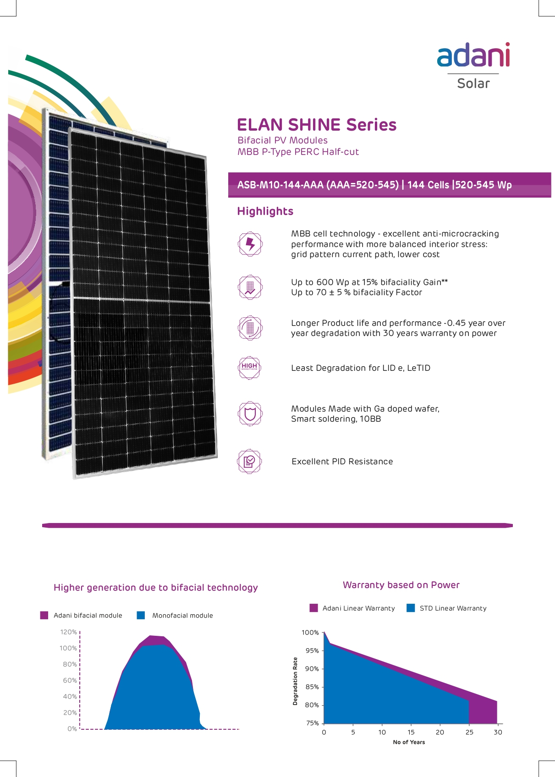

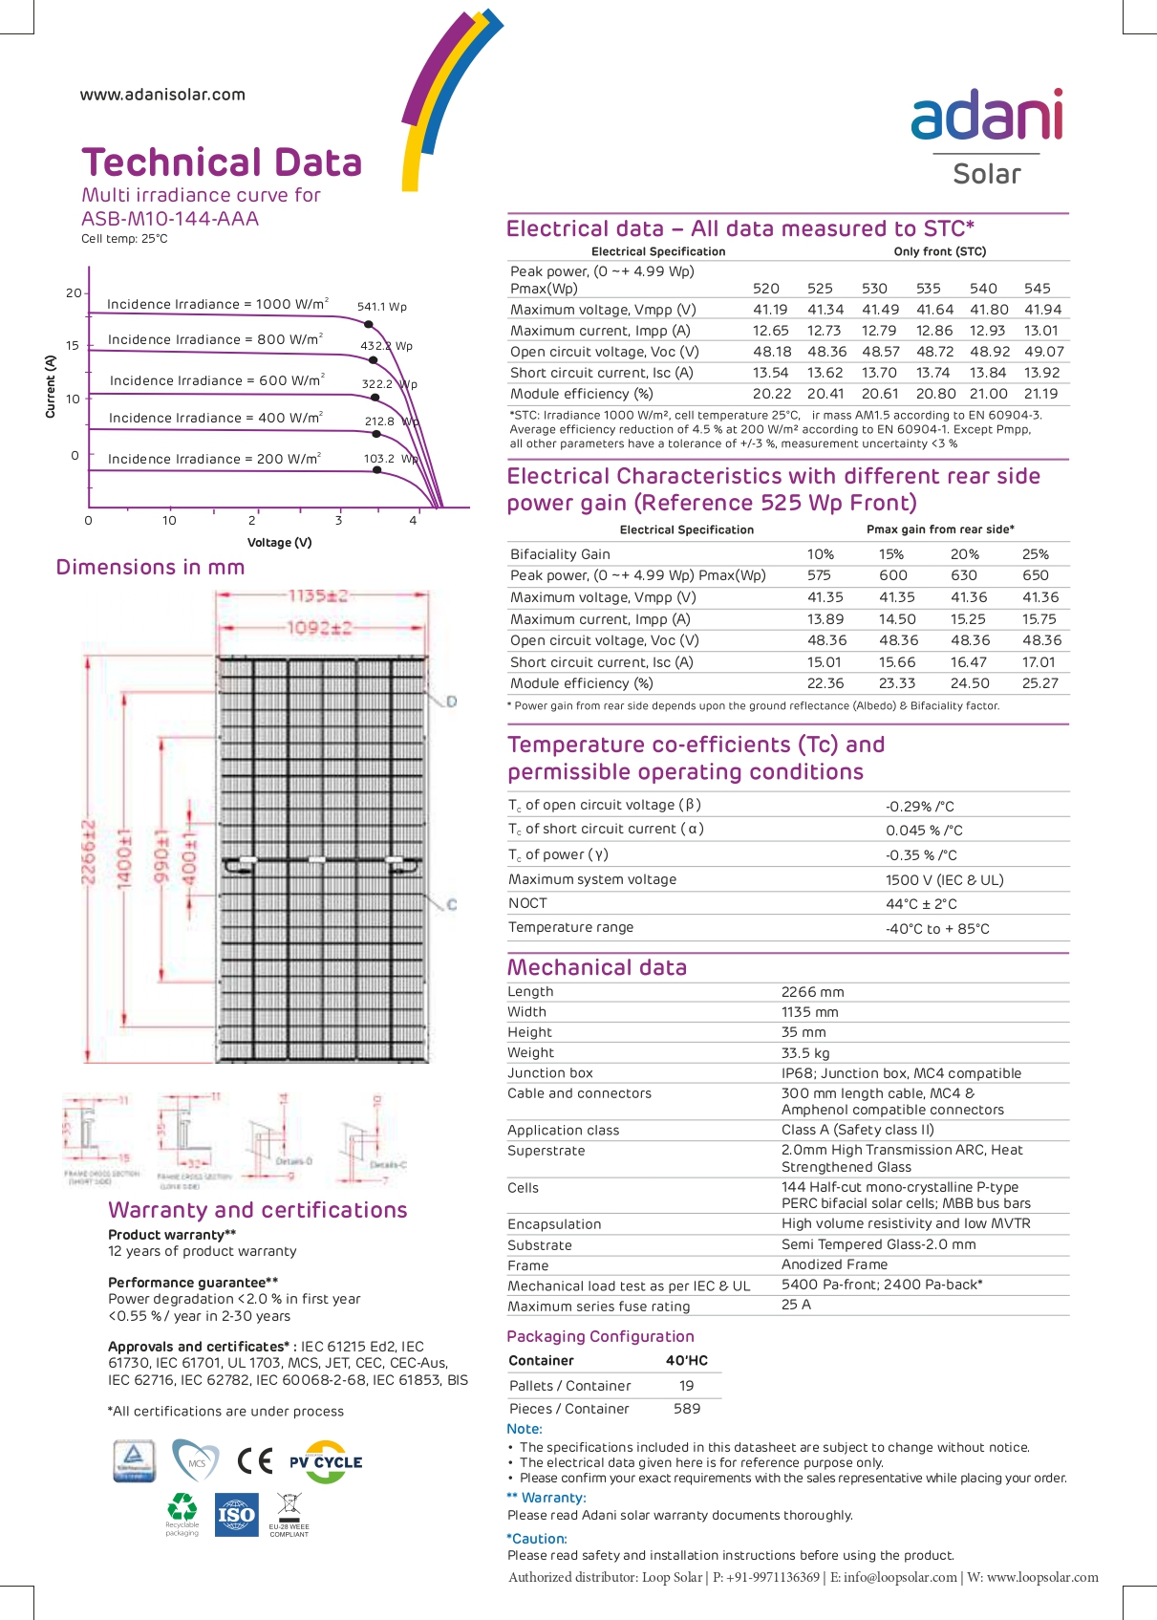
- Features of proposed solar panels by Waaree at both the locations as per Project report:

  - The selected Waaree module is the WSMD Arka series Mono PERC PV modules. The module has a capacity of 515–545 Wp peak power and has 144 cells.
  - The Solar PV module provides a warranty for 98% + power output in the first year, thereafter, from year 2 to 27, the maximum decrease in power output shall be 0.55% from module’s nominal power output per year, ending with around 81.9% in the 27th year after the defined warranty start date.
  - The product warranty shall be 12 years.
  - The performance warranty shall be for 27 years.
  - Data Sheet of proposed waaree solar modules is as below:

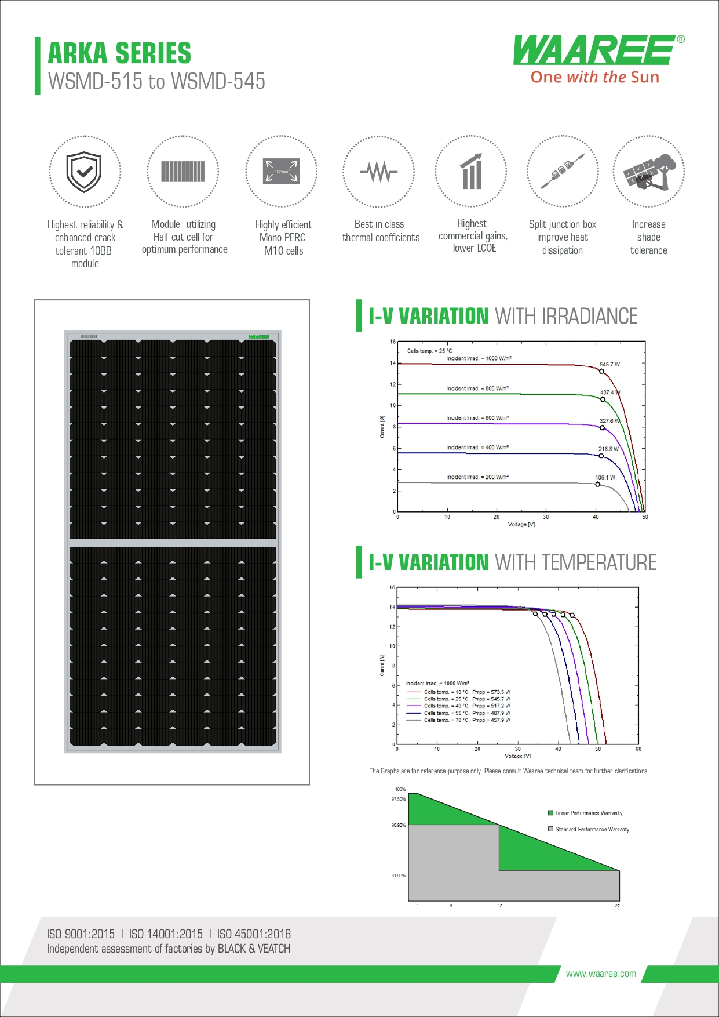
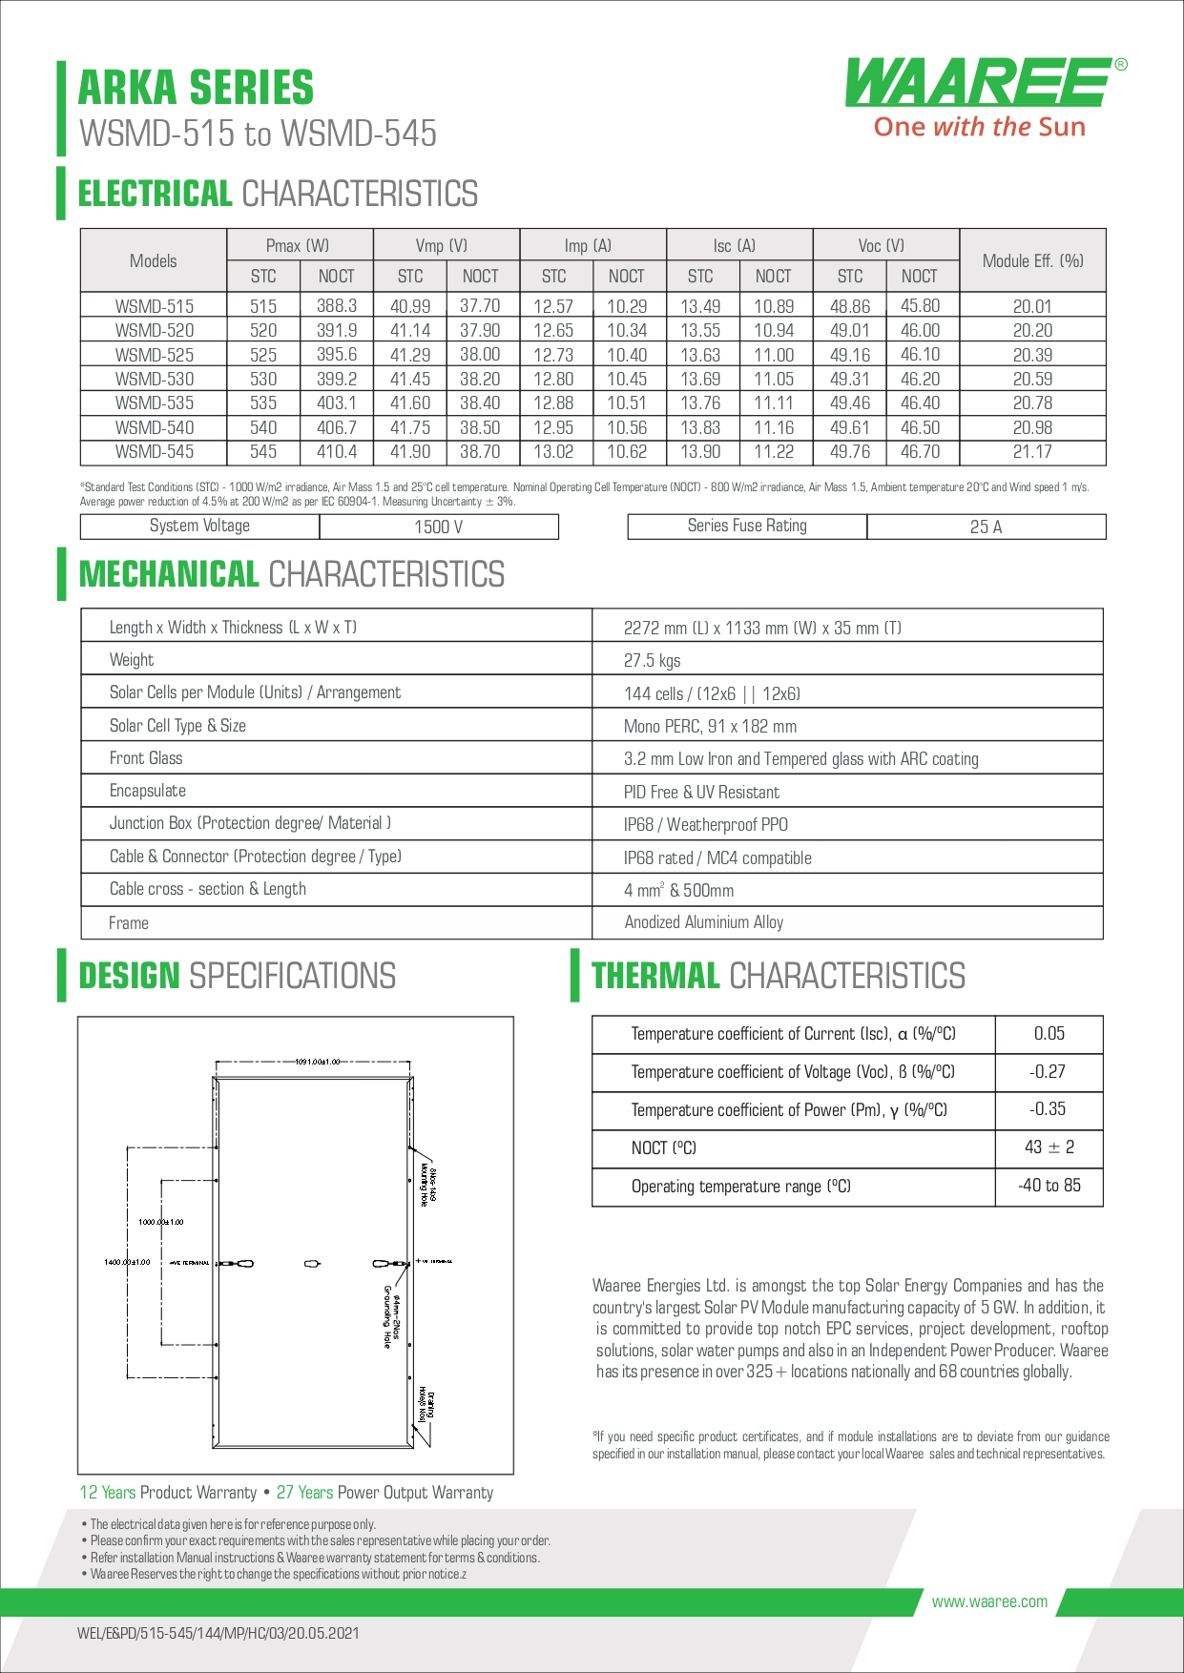
- Technical Details of PV modules proposed to be installed at site as per PVsyst report is as below:

  - PV Module: Si-Mono Model
  - Model: TSM-540DE18M(II)
  - Manufacturer: Adani Power
  - Number of PV modules in series: 18
  - Number of PV Modules to be installed: 880
  - Total Module Area: 2223 Sq. mtr.
  - Cell Area: 2262 Sq. mtr.
  - 1 Module capacity: 540 kWp
  - Total Capacity: 540 wP * 880 no’s =475.20 kW

Note: As per PV syst report the company has used Adani power solar modules for analysis. However, the manufacturer of the module is yet to be finalized by the company.

- SOLAR INVERTERS

- Solis is one of the top 3 inverter manufacturers in Asia. The company has opted for 80K PV Solar Inverter - 80K-5G-DC make inverters. The main features of the inverter are as under:

  - Max. 13A per string, support 1.5 DC overloading capability
  - Efficient logic algorithm, over 99% max. Efficiency
  - String monitoring, shorter O&M time
  - Remote & local intelligent IV scan function
  - Leakage current repression technology
  - Volt-watt work mode integrated
  - DC input reverse alarm
  - Optional anti-PID function integrated
  - Reactive power compensation function
  - The model has a 5-year warranty which is extendable to 20 years on purchase of extended warranty packages.
  - Data sheet of proposed solis inverters:

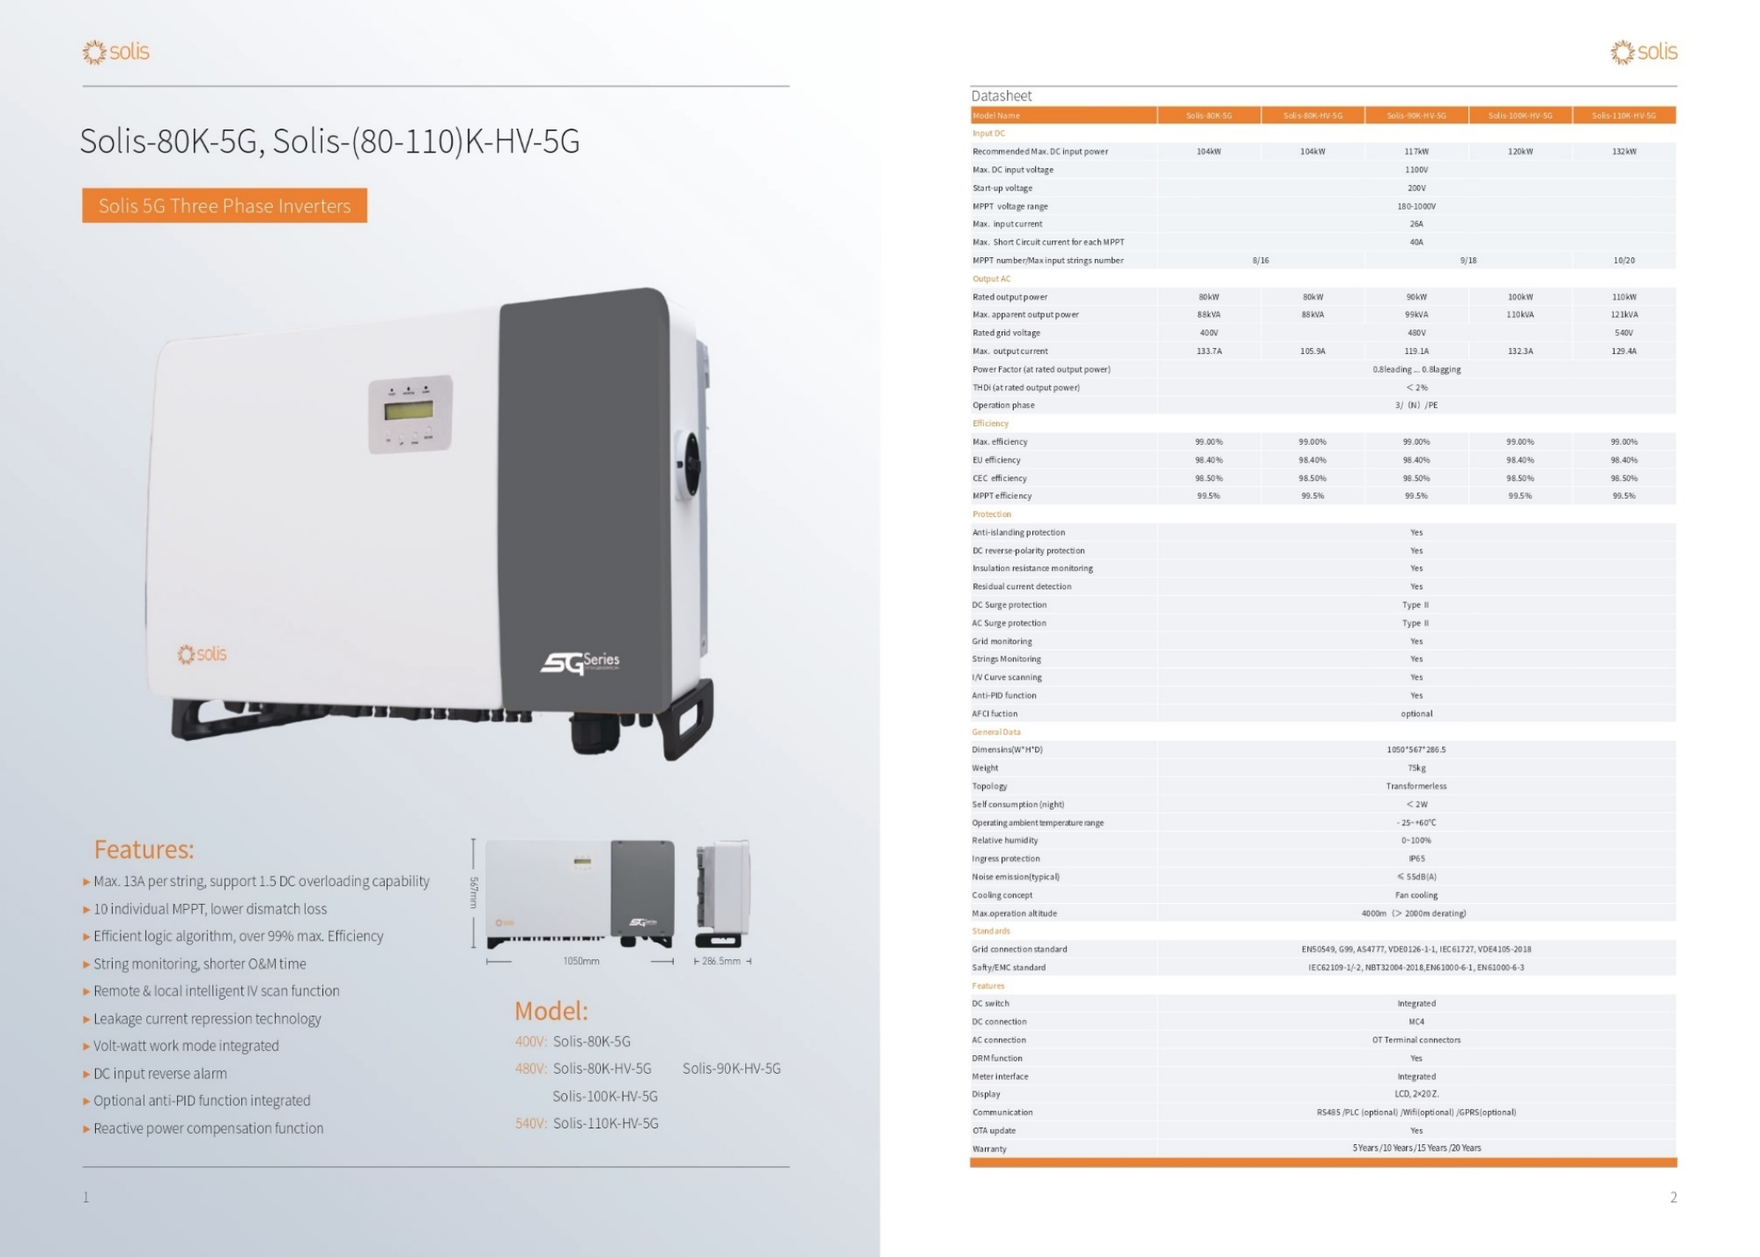

- Technical details of the inverter proposed to be installed at site as per PVsyst report is as below:

  - Model: Solar inverter M100_210/M75
  - Manufacturer: Solis Energy
  - Number of Inverters: 5 Units
  - Operative Voltage: 590-1000 V
  - Unit Nominal Power: 475 Kw
  - Maximum Power (=>40 Degree Celsius): 525 KW ac

- IMPORTANT CATCH POINTS FROM PV SYST. V6.88 REPORT DATED 9TH JUNE 2022

  - Produced Energy: 721.50 MWh/year
  - Performance Ratio: 80.18%
  - PV Field Orientation
    - Tilt: 10 Degrees
    - Azimuth: 20 Degrees
  - No. of Modules: 880 Nos
  - Capacity of 1 module: 540 wP
  - Nos. of Inverters: 5 Units
  - Unit nominal of Inverters: 475 kW AC
  - Produced Energy (EArray): 712.50 MWh/Year (EArray: Effective energy at the output of the array)
  - Performance Ratio: 80.18 % against industrial accepted standard PR of 75%.
    - The Performance ratio is decreasing in the summers because of increase in temperature losses due to summer heat effect in the region.
  - E_Grid Energy: 560 MW per year (Electricity injected onto the grid)
  - Horizontal Global Irradiation: 1603 kWh/m²
  - Loss Diagram

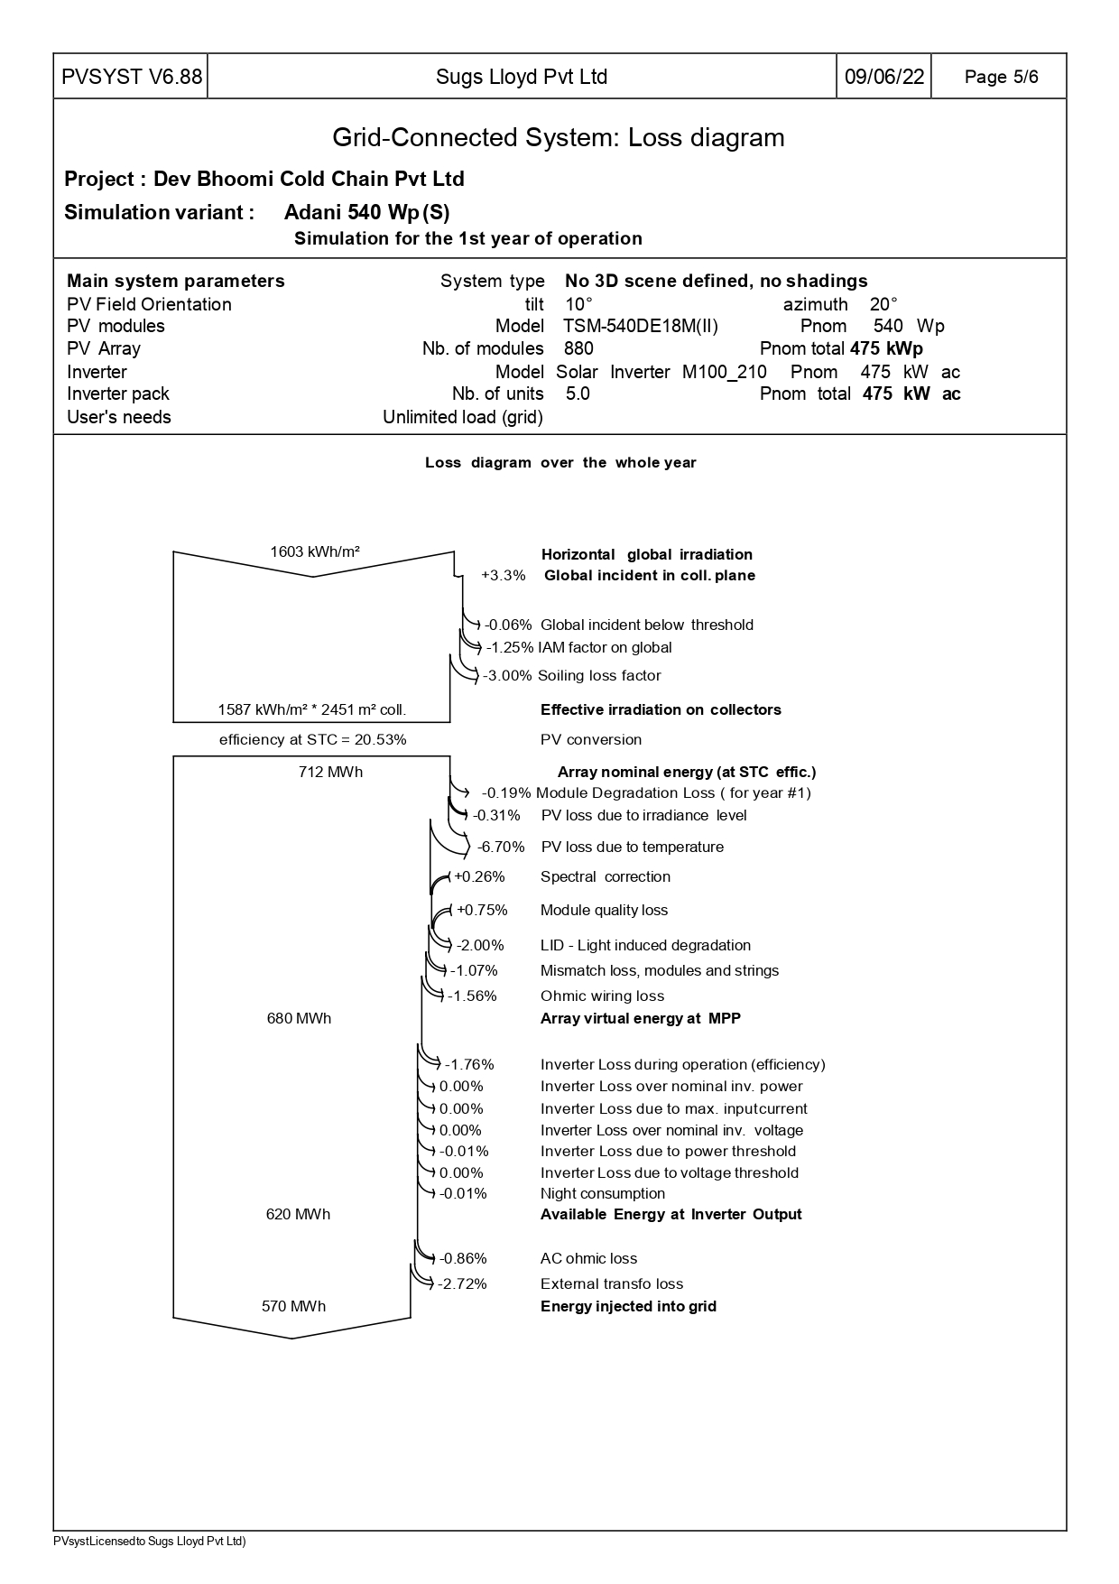
PART F | MAJOR SUPPLIERS/EPC CONTRACTOR

The company has proposed to appoint M/s Sugs Loyd private limited for erection, implementation and commissioning of the project. As per the PVsyst report the EPC Contractor has proposed to purchase solar panels from Adani Power/Waaree and Solis energy for Solar inverters. Details of which is as below:

Sr. No. | Company | PO No. | PO Amount (Cr.) | Scope of Work
1. | Sugs Loyd | - | - | EPC Contractor
a. | Adani Power | - | - | Supply of 880 No’s of Solar Panels
b. | Solis Energy | - | - | Supply of 5 Units of Solar inverters

Note:

- The company has informed that they have appointed EPC contractor M/s Sugs Loyd private limited erection, implementation and commission of the project. However, we have only received the PVsyst report generated by M/s Sugs loyd Pvt. Ltd. for technical information purpose and Techno commercial Proposal by M/s Sugs loyd Pvt. Ltd. For Bill of quantities of the project.
- Final Signed contract document was sought from the company. Accordingly, the company has informed that the final contract document is yet to be signed between both the parties and as soon as the contract document is signed the same will be shared with bank. Bank to take note of this.

PART G | PROJECT COST & MEANS OF FINANCE

- TOTAL PROJECT COST:

As per the Project report the project cost amounts to approx. Rs. 2.30 Crore. Breakup of Rs.2.30 Crore is as below:

Sr. No. | Particulars | Amount (In Crore)
 | Solar Panel | 1.48
 | Inverter | 0.05
 | Structure | 0.27
 | Balance of System (HT Panel, Cables etc.) | 0.28
 | Installation and commissioning | 0.22
Grand Total |  | 2.30
Total Incurred Project cost incurred on the project |  | 0.00

Observations & Comments:

- The basis of the above estimated cost is as per the project report provided by the company which is including GST.

- The benchmark cost for Ground mounted 1MW solar power plant is approx. Rs.4.5 Crore. Accordingly, the cost of solar power plant with 0.475 MW capacity amounts to Rs. 2.14 Crore. However as per companies estimate the same amounts to Rs. 2.30 Crore. Thus, there is approx. 8% increase in their project cost in regard to the industry standards. Clarification was sought from the company regarding 8% increase in cost; accordingly, the company has provided below mentioned clarification’s:

- The government announced a 40 per cent basic customs duty (BCD) on solar modules in 2021 and 25 per cent BCD on solar cells. These came into effect on April 1, 2022 and Benchmark cost is for FY21-22.

- With effect from Friday (1st Oct 2021), the Finance Ministry has announced a 12% goods and services tax (GST) rate for solar photovoltaic (PV) modules and other renewable energy equipment and Benchmark cost for FY21-22 was released on 18th August 2021.

Thus, the project cost amounting to approx. Rs.2.30 Crore for installation of 475 kWp of Ground Mounted solar power plant seems to be reasonable due to economic reasons mentioned above.

- The above benchmark cost includes cost of Solar PV panels (with domestic cell and modules), inverter (single/3 phase wherever applicable), balance of system e.g., cable, switches/ circuit breaker/ connectors/ junction box, mounting structure, earthing, lightening arrester, and civil works, installation & commissioning, CMC for 5 years, transportation, insurance, applicable taxes, etc. The above benchmark costs are excluding of net metering cost and battery back-up costs.

- Detailed breakup of Rs.2.30 Crore is as below:
(Amount in Rs. Crore)
Item | Amount | GST (%) | GST | Total
Solar Panel (Mono Crystalline) | ₹ 1.32 | 12% | ₹ 0.16 | ₹ 1.48
Inverter | ₹ 0.05 | 12% | ₹ 0.01 | ₹ 0.05
Structure | ₹ 0.23 | 18% | ₹ 0.04 | ₹ 0.27
Balance of systems (Includes HT Panel, Cables, | ₹ 0.24 | 18% | ₹ 0.04 | ₹ 0.28
Installation and Commissioning | ₹ 0.19 | 18% | ₹ 0.03 | ₹ 0.22
GRAND TOTAL | ₹ 2.02 |  | ₹ 0.28 | ₹ 2.30

- CURRENT STATUS & TOTAL EXPENDITURE INCURRED TILL DATE:

The project is yet to take off. Therefore, no expenditure has been incurred on the project till 26th August 2022.

SR. NO. | PARTICULARS | TOTAL ALLOCATED AMOUNT | INCURRED UP TO 26TH AUGUST 2022 | CURRENT STATUS OF EXPENDITURE
 |  | (All figures in cr.)
1. | Solar Panels | Total allocated amount | 1.48 | Project is yet to take off. Therefore, no expenditure has been incurred under this head.
 |  | Expenses shown by the company | 0.00
 |  | Approved by LIE up to 26th August 2022 | 0.00
2. | Solar Inverters | Total allocated amount | 0.05 | Project is yet to take off. Therefore, no expenditure has been incurred under this head
 |  | Expenses shown by the company | 0.00
 |  | Approved by LIE up to 26th August 2022 | 0.00
3. | Structure including Balance of system | Total allocated amount | 0.55 | Project is yet to take off. Therefore, no expenditure has been incurred under this head
 |  | Expenses shown by the company | 0.00
 |  | Approved by LIE up to 26th August 2022 | 0.00
4. | Installation and commissioning | Total allocated amount | 0.22 | Project is yet to take off. Therefore, no expenditure has been incurred under this head
 |  | Expenses shown by the company | 0.00
 |  | Approved by LIE up to 26th August 2022 | 0.00
5. | Total | Total allocated amount | 2.30 | Project is yet to take off. Therefore, no expenditure has been incurred under this head
 |  | Expenses shown by the company | 0.00
 |  | Approved by LIE up to 26th August 2022 | 0.00

- SOURCES OF FINANCE & UTILIZATION OF FUNDS:

PARTICULARS | PLANNED AMOUNT | CURRENT STATE OF INVESTMENT
 | (Amount in Crore)
Term Loan | - | -
Own Sources | 2.30 | 0.00
TOTAL | 2.30 | 0.00

Comments:
- Term Loan amount is yet to be finalized by the bank.
- Project has not commenced yet. Therefore, no expenditure has been incurred on the project.
PART H | CONCLUSION

- The project cost amounting to approx. Rs.2.30 Crore for installation of 475 kWp of Ground Mounted solar power plant seems to be reasonable on account of increased GST rates (5% to 12%) and imposition of Basic Custom duty.

- Site inspection for the project was carried out on 27th august 2022. As per observations made during the site visit, the geographical factors responsible for efficient power generation in the project seems to be satisfactory and the site is geographically well suited for such type of solar projects. In addition to satisfactory geographical location, the company should implement the installation exercise as per the parameters mentioned in the PVsyt report to keep the project technically efficient.

- During site visit approximately 200 Solar panels were found to be pre-existing and installed at site (As per Company’s representatives, the company currently has an installed capacity of 125 kWp which is not a part of this project having a proposed installed capacity of 475 kW). On clarification the company’s representative accompanying during site visit informed that these pre-existing solar panels are not the part of this project and no fund is to be reimbursed for these panels. Bank to take note of it.

- Panel identification numbers of pre-existing and installed panels were sought from the company to differentiate between old panels and new panels at the time of progress monitoring in the project. However, the same are awaited.

- The average temperature is measured as per the Metrological Station statistic available at shimla. At an average temperature of 30⁰ C, May-June is the hottest month of the year and at an average temperature of 2⁰ C January is the coldest month.

- The basic wind speeds are applicable to 10 m height above mean ground level in an open terrain with a return period of 50 years. Shimla lies on 39 m/s band of wind speed. Therefore, Shimla lies in Moderate damage risk zone.

- As per last 3-year data, average sun days are 251 and average sun hours in a year is 2023 recorded at Shimla zone.

PART I | DISCLAIMER

      - No employee or member of R.K Associates has any direct/ indirect interest in the Project.
      - This report is prepared based on the copies of the documents/ information which the Bank/ Company has provided to us out of the standard checklist of documents sought from them and further based on our assumptions and limiting conditions. All such information provided to us has been relied upon in good faith and we have assumed that it is true and correct in all respect. Verification or cross checking of the documents provided to us has not been done at our end from the originals. If at any time in future, it is found or came to our knowledge that misrepresentation of facts or incomplete or distorted information has been provided to us then this report shall automatically become null & void.
      - This report is a general analysis of the project based on the scope mentioned in the report. This is not an Audit report, Design document, DPR or Techno-financial feasibility study. All the information gathered is based on the facts seen on the site during survey, verbal discussion & documentary evidence provided by the client and is believed that information given by the company is true best of their knowledge.
      - All observations mentioned in the report is only based on the visual observation and the documents/ data/ information provided by the client. No mechanical/ technical tests, measurements or any design review have been performed or carried out from our side during Project assessment.
      - Bank/FII should ONLY take this report as an Advisory document from the Financial/ Chartered Engineering firm and it’s specifically advised to the creditor to cross verify the original documents for the facts mentioned in the report which can be availed from the borrowing company directly.
      - In case of any default in loans or the credit facility extended to the borrowing company, R.K Associates shall not be held responsible for whatsoever reason may be and any request for seeking any explanation from the employee/s of R.K Associates will not be entertained at any instance or situation.
      - This Report is prepared by our competent technical team which includes Engineers and financial experts & analysts.
      - This is just an opinion report and doesn’t hold any binding on anyone. It is requested from the concerned Financial Institution which is using this report for taking financial decision on the project that they should consider all the different associated relevant & related factors also before taking any business decision based on the content of this report.
      - All Pages of the report including annexures are signed and stamped from our office. In case any paper in the report is without stamp & signature then this should not be considered a valid paper issued from this office.
      - Though adequate care has been taken while preparing this report as per its scope, but still we can’t rule out typing, human errors, over sightedness of any information or any other mistakes. Therefore, the concerned organization is advised to satisfy themselves that the report is complete & satisfactory in all respect. Intimation regarding any discrepancy shall be brought into our notice immediately. If no intimation is received within 15 (Fifteen) days in writing from the date of issuance of the report, to rectify these timely, then it shall be considered that the report is complete in all respect and has been accepted by the client upto their satisfaction & use and further to which R.K Associates shall not be held responsible in any manner.
      - Defect Liability Period is 15 DAYS. We request the concerned authorized reader of this report to check the contents, data and calculations in the report within this period and intimate us in writing if any corrections are required or in case of any other concern with the contents or opinion mentioned in the report. Corrections only related to typographical, calculation, spelling mistakes, incorrect data/ figures/ statement will be entertained within the defect liability period. Any new changes for any additional information in already approved report will be regarded as additional work for which additional fees may be charged. No request for any illegitimate change in regard to any facts & figures will be entertained.
      - R.K Associates encourages its customers to give feedback or inform concerns over its services through proper channel at le@rkassociates.org in writing within 30 days of report delivery. After this period no concern/ complaint/ proceedings in connection with the Lender’s Independent Engineering Services will be entertained due to possible change in situation and condition of the subject Project.
      - Our Data retention policy is of ONE YEAR. After this period, we remove all the concerned records related to the assignment from our repository. No clarification or query can be answered after this period due to unavailability of the data.
      - This Lender’s Independent Engineering report is governed by our (1) Internal Policies, Processes & Standard Operating Procedures, (2) Information/ Data/ Inputs given to us by the client and (3) Information/ Data/ Facts given to us by our field/ office technical team. Management of R.K Associates never gives acceptance to any unethical or unprofessional practice which may affect fair, correct & impartial assessment and which is against any prevailing law. In case of any indication of any negligence, default, incorrect, misleading, misrepresentation or distortion of facts in the report then it is the responsibility of the user of this report to immediately or at least within the defect liability period bring all such act into notice of R.K Associates management so that corrective measures can be taken instantly.
      - R.K Associates never releases any report doing alterations or modifications from pen. In case any information/ figure of this report is found altered with pen then this report will automatically become null & void.
SURVEYED BY | PREPARED BY
ER. ABHISHEK SHARMA AND MR. SACHIN PANDEY | ER. TEJAS BHARADWAJ
DATE: 26TH AUGUST 2022 | DATE: 8TH SEPTEMBER 2022

DEFECT LIABILITY PERIOD - In case of any query/ issue or escalation you may please contact Incident Manager by writing at valuers@rkassociates.org. We ensure 100% accuracy in the Calculations done, Rates adopted and various other data points & information mentioned in the report but still can’t rule out typing, human errors or any other mistakes. In case you find any mistake, variation, discrepancy or inaccuracy in any data point of the report, please help us by bringing all such points into our notice in writing at valuers@rkassociates.org within 30 days of the report delivery, to get these rectified timely, failing which R.K Associates Valuers Techno Engineering Consultants (P) Ltd. won’t be held responsible for any inaccuracy in any manner. Also, if we will not hear back anything from you within 30 days, we will assume that report is correct in all respect and no further claim of any sort will be entertained thereafter. We would welcome and appreciate your feedback & suggestions in order to improve our services.

COPYRIGHT FORMAT - This report is prepared on the copyright format of R.K Associates Valuers Techno Engineering Consultants (P) Ltd. to serve our clients in the best possible way. Legally no one can copy or distribute this format without prior approval from R.K Associates. It is meant only for the organization as mentioned on the cover page of this report. Distribution or use of this format other than R.K Associates will be seen as unlawful act and necessary legal action can be taken against the defaulter

ANNEXURE 1: INDUSTRY BENCHMARK COST (2022) SNAPSHOTS

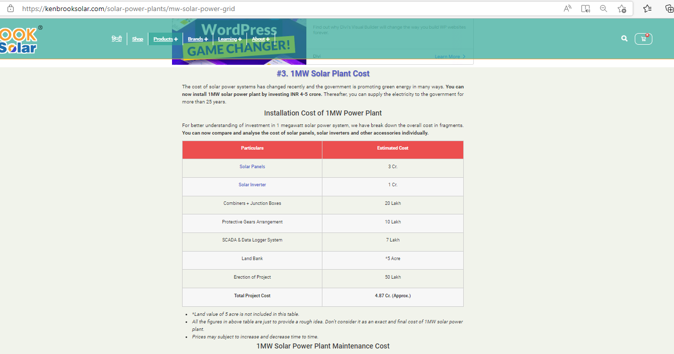



ANNEXURE 2: PV SYST REPORT
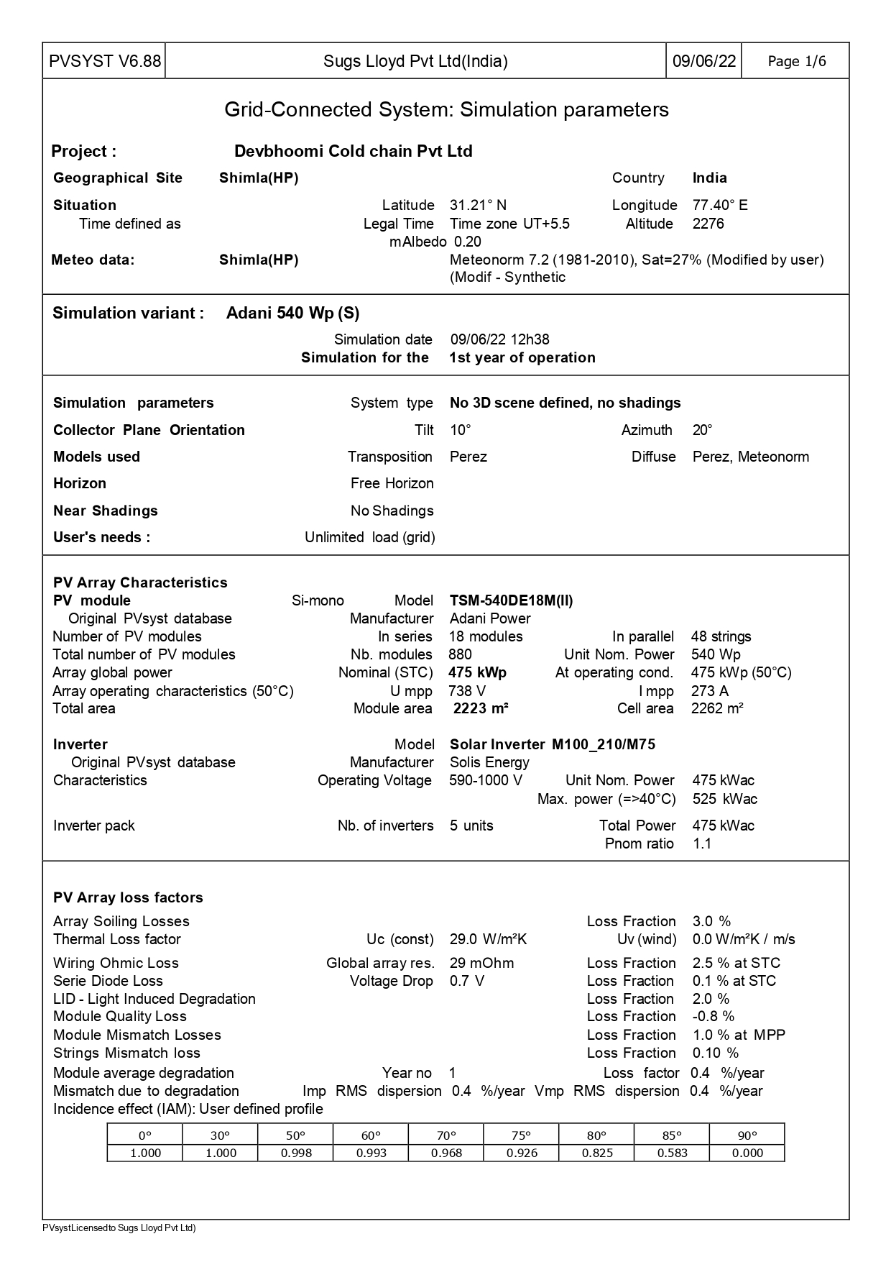
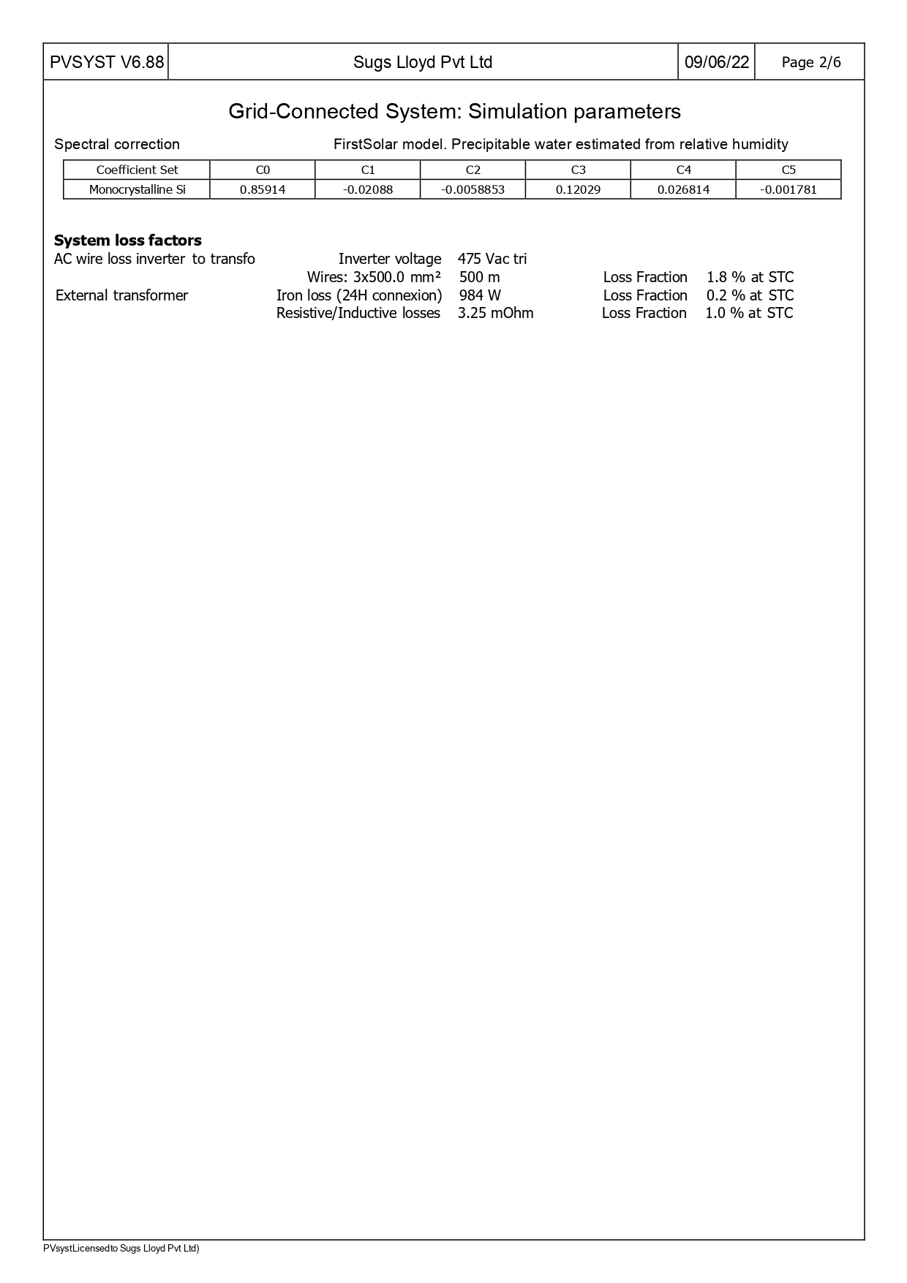
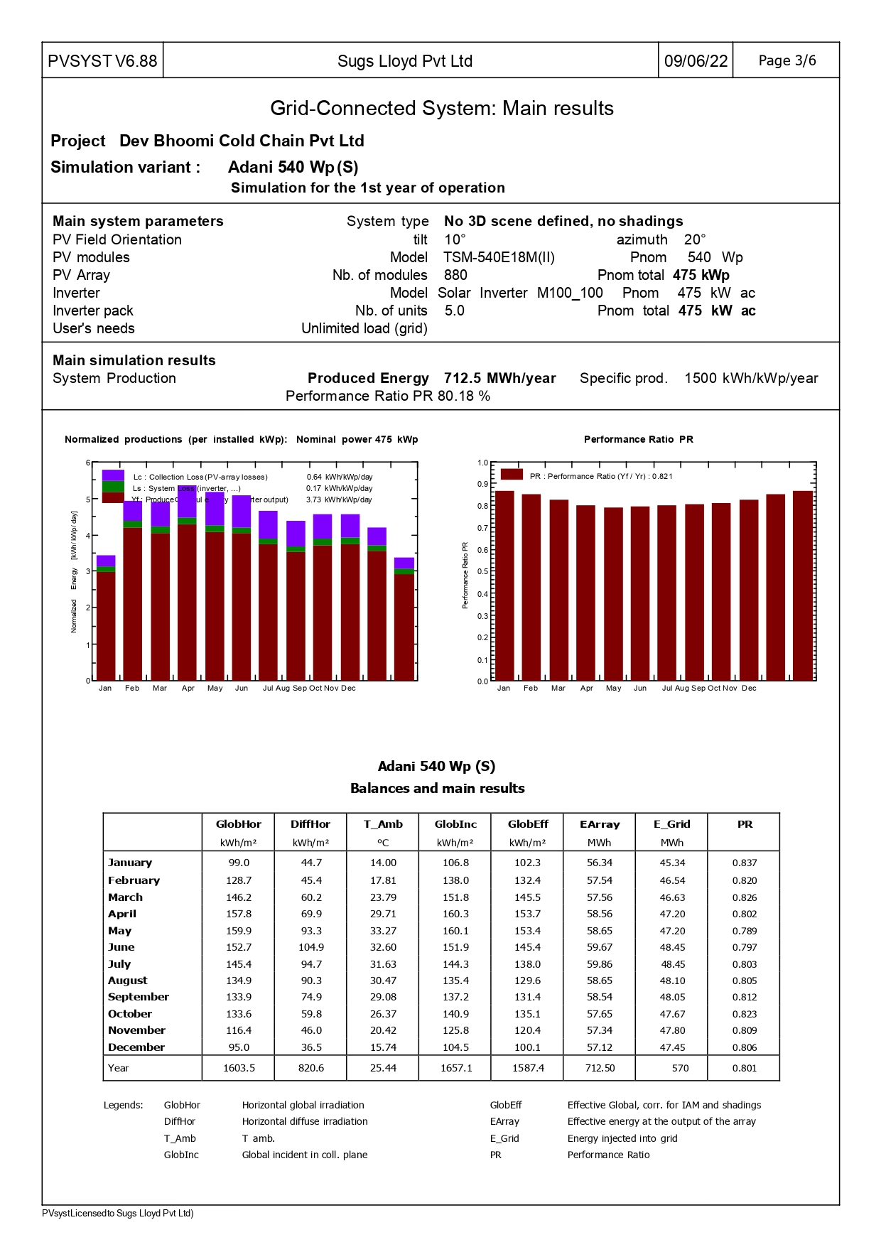
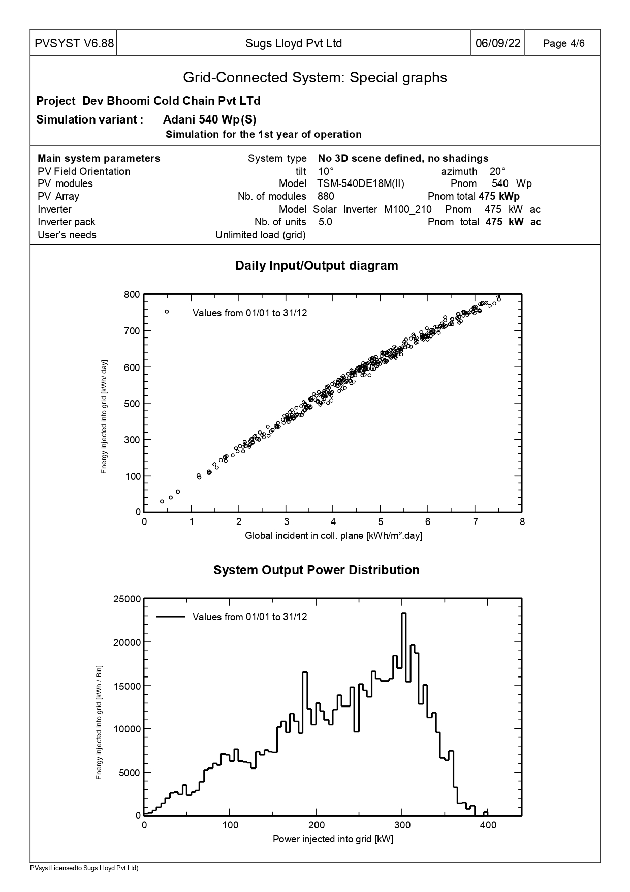
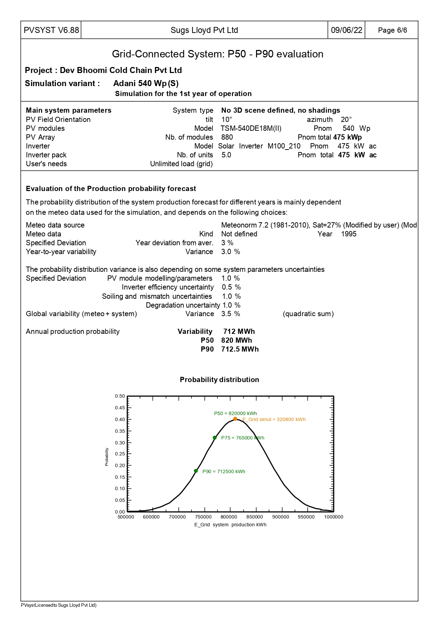

SITE PHOTOGRAPHS

