**REPORT FORMAT:** CL-1 | Version: 1.0_2018

# FILE No.: VIS(2022-23)-PL288-218-417 Date: 02-09-2022

* **CERTIFICATE NAME:** Cost Vetting Certificate for Rigid PVC Sheet plant which is proposed to be installed at part of Khasra No. 361/2, 361/3, 396/1, Village Bhogpur, Pargana Jwalapur, District Haridwar, Uttarakhand.
* **PREPARED FOR ORGANIZATION:** State Bank of India, SME Branch, Ranipur, Haridwar
* **BORROWER COMPANY’S NAME:** M/s. Polypals Global Private Limited
* **ASSET TYPE**: Machines for manufacturing Rigid PVC Sheet.
* **CURRENT LOCATION OF THE MACHINES:** Proposed to be installed at part of Khasra No. 361/2, 361/3, 396/1, Village Bhogpur, Pargana Jwalapur, District Haridwar, Uttarakhand

**TO WHOMSOEVER IT MAY CONCERN**

|  |  |  |
| --- | --- | --- |
| **S. NO.** | **PARTICULARS** | **DESCRIPTION** |
| 1. | Date of Survey | Not Applicable |
| 2. | Date of Certificate | 02-09-2022 |
| 3. | Documents provided for perusal | Copy of quotations of machines to be installed |
| 4. | Current Location of the Machines | Proposed to be installed at part of Khasra No. 361/2, 361/3, 396/1, Village Bhogpur, Pargana Jwalapur, District Haridwar, Uttarakhand. |
| 5. | Borrowing Company | M/s. Polypals Global Private Limited |
| 6. | Type of Asset | Machinery required for installing Rigid PVC Sheet Film plant. |
| 7. | Type of Assessment | Cost vetting |
| 8. | Scope of Assessment | Cost vetting of the new equipment which has to be purchased by the company. |
| 9. | Nature of Machinery | Machines for manufacturing Rigid PVC Sheets. |
| 10. | Year of Manufacturing | Plant is yet to be installed. |
| 11. | Total Purchase Cost | **Rs.5,07,49,050/-** *(as per the copy of quotations provided to us by the client)* |
| 12. | Current Estimated Market Value | The range of current market rates of such type of machinery & equipments is verified from various suppliers and also from the public domain for the new machinery and equipment.  As per the information received from the market, we are of the view that the rates for establishing machinery of a similar kind in a textile mill should be in the range of **Rs.5.00 Cr. to Rs.5.25 Cr.**  According to our observations, the rate as per the list of machinery and their total purchase price provided to us by the company/ bank are quite reasonable when compared to the prevailing market rates of similar machinery. |
| 13. | Condition of Machines | Not Applicable, as the machines are yet to be installed. |

## OBSERVATIONS:

1. We have been provided with the copy of quotations with the cost of machines/ equipment to be purchased/ installed by the borrower company.
2. We have contacted several suppliers and obtained some quotations for similar machinery. Accordingly, it was observed that the price given in the machinery details shared by the client is well within the price range of similar items available in the market.
3. Based on the information provided by the subject company (M/s. Polypals Global Private Limited) and enquiries made by us in the open market and references found in the public domain and quotations for similar machines/items, it is certified that the total cost for setting up plants of similar specification should be around **Rs. 5.00 Cr to Rs. 5.25 Cr.** Therefore, the total purchase price of **Rs.5,07,49,050/-** mentioned in the machinery details shared by the company (as per the quotations provided to us by the company) appears to be reasonable.

***Disclaimer:***

* 1. *We can’t comment about the current status of machines whether these are purchased, installed or in transit. This cost vetting is done only on the basis of Quotations, Bills and Purchase Orders provided to us by the company and we don’t recommend any sort of recommendation in our Certificate.*
  2. *There can be variation in the estimated price if the specification & make of any items procured is different from the list provided to us during assessment.*
  3. *The estimated cost verification is made based on the third party information which has been replied upon in good faith.*
  4. *The estimated price may vary at the time of actual procurement because of change in prices in the market for such kind of machinery/items for which we will not have any control. The cost vetting is only limited to the date of Certificate issued. We do not assume any responsibility in change of prices of the said machinery/items after this date.*
  5. *This certificate doesn’t include any work related to drawing, design, sketch plan, procurement of the machines.*
  6. *Ownership and other legal point of view in respect of the asset is not considered in this report as same is out of scope of this certificate.*
  7. *This certificate is made at the request of the Bank.*

**For R.K Associates Valuers & Techno FOR INTERNAL USE Engineering Consultants (P) Ltd.**

***TYPED BY:*** *Er. Gaurav Sharma*

***REVIEWED BY:*** *Er. Adil Afaque*

# ANNEXURE: - I (LIST OF MACHINES PROVIDED BY CLIENT)

| **Sr. No.** | **Asset Description** | **Specification** | **Quantity** | **Make** | **Model** | **Amount as per quotation** |
| --- | --- | --- | --- | --- | --- | --- |
| 1 | Air Compressor | 203 CFM @ 7.5 KG/CM2 | 1 | Atlas Copco | GA 30 – 7.5 FF | 12,74,000 |
| 2 | Air Handling Unit | EVAPORATIVE COOLING AIR HANDLING UNIT FOR KITCHEN VENTILATION | 2 | Infanite | INF/C-76/AHU/100/SISW/BACKWARD CURVE | 4,40,000 |
| EXHAUST AIR BLOWER FOR PLANT VENTILATION: | 1 | Infanite | INF/C-85/100/SISW/BACKWARD CURVE | 1,50,000 |
| EXHAUST AIR BLOWER FOR CALENDAR EXHAUST | 1 | Infanite | INF/C-58/100/SISW/BACKWARD CURVE | 85,000 |
| UNIFORM AIR DISTRIBUTION (DUCTING) FOR AHU | 1 | Infanite | Square ducting 24g, with GI Flange Joints, Nitrile foam sheet of 9 mm thk. On Exposed Supply Air  Conditioned Ducts. Aluminum powder coated Double deflection grilles with VCD for Uniform Air Distribution | 9,05,000 |
| 3 | Boiler | OIL FIRED THERMIC FLUID HEATERS | 1 | Neotech | NT : 600 [FO] | 15,00,000 |
| 4 | Beta Ray Gauge | Scanning Frame | 1 | Jasch | X-ray Transmission Sensor (5 Watt, 4.9 KV Max.) | 24,00,000 |
| Software Package | 1 | Jasch | Display of Scanned thickness Profile in terms of Physical linear scale on the web |
| Computer Control & Display Station | 1 | Jasch | · 21.5” Capacitive touch screen display,128 GB SSD Hard disc, Industrial Grade CPU, Intel core i3 processor,4 GB RAM |
| Analog & Digital Input / Output | 1 | Jasch | Isolated 0-10V input for machine Speed, Isolated 0-10V / 4-20mA for control |
| 5 | Chiller | 24TR Aircooled Scroll Chiller | 1 | VATANUCOOL | Air cooled Scroll Chiller | 6,46,000 |
| 6 | Cooling Tower | 80 TR | 1 | Nirmal Cooling System | NCS-2020 HL-8 with basin | 1,50,000 |
| 7 | Calender Machine | 250T~300T/Month @ thickness 250um | 1 | SHANGHAI XUANXIN | INV L-type 6-roll calendar machine | 3,10,94,700 |
| 8 | Offline Grinder | BODYSIZE:- 24", BLADESIZE:- 24", Production:- 500 TO 600Kg/H | 1 | Dharam Engineering Work | Motor:- ABB/CROMPTON / Bharat bijli. | 9,00,000 |
| 9 | Slitting Machine | THE DIFFERENTIAL SHAFT REWINDING SYSTEM, THE CUTTING UNIT, UN-WINDER AND GUIDING SYSTEM, RE-WIND SHAFT, NIP UNIT | 1 | Gupta Enterprises | All pneumatics are SMC/ ZENETIC make, All motors are MARATHON / ABB make | 30,00,000 |
| 10 | DG SET | 600 kVA (BHP 723) | 1 | Koel Green | DV12TAG1 | 36,31,750 |
| 11 | EOT crane | 5 M.T | 1 | Motor:- CROMPTON / MARATHON / BBL, . GEAR BOX:- P.B.L {POWER BUILT LIMITED} | I.C BAUER – GERMANY, . BRAKES:- MAGTECH, WIRE ROPE:- USHA MARTIN / MAHADEV, . LIMIT SWITCH:- CRANE CONTROL | DOUBLE GIRDER BOX TYPE E.O.T. CRANE | 16,79,600 |
| 12 | Core Cutting | Core Cutting with motor | 1 | Durga Industries | - | 1,75,000 |
| 13 | Online Sheet Cutting | Line speed:- 20 to 40 pcs/ min, Maximum web width can be cut:- 1100 mm | 1 | EN PLAST | NSM 1200 | 15,00,000 |
| 14 | Corona Treatment | MAX. TREATMENT WIDTH:- 1100 mm, MATERIALS TO TREAT :- PVC RIGID FILM | 1 | IEEC | RFI/5-127-120SL-1HM-D | 8,65,000 |
| 15 | Quality Assurance | HOT AIR CIRCULATING OVEN UNIT:- INNER CHAMBER SIZE: 18 X 18 X 18 inch | 1 | Deepak Poly Plast | REVERSION TEST APPLICATION | 48,000 |
| DIGITAL WEIGHING BALANCE:- 300 gms capacity | 1 | Deepak Poly Plast | GSM WEIGHING SCALE | 21,500 |
| TENSILE TESTING MACHINE | 1 | Deepak Poly Plast | DUTT – 101 | 2,79,000 |
| TENSILE TESTING ACCESSORIES:- RECTANGULAR SIZE: 150 x 25 mm | 1 | Deepak Poly Plast | TEMPLATE FOR SPECIMEN PUNCHING, FOR TENSILE TEST | 4,500 |
| **Total** | | | | | | **5,07,49,050** |

**ANNEXURE: - II (REFERENCES ON PRICE TREND OF THE SIMILAR RELATED PROPERTIES AVAILABLE ON PUBLIC DOMAIN )**

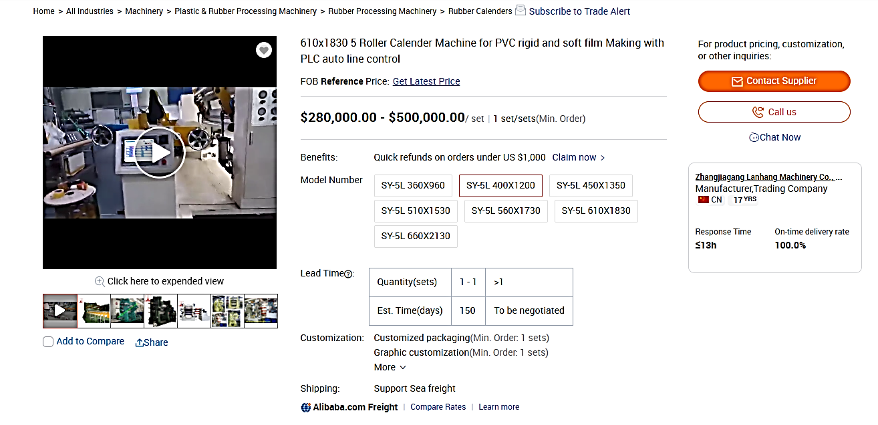

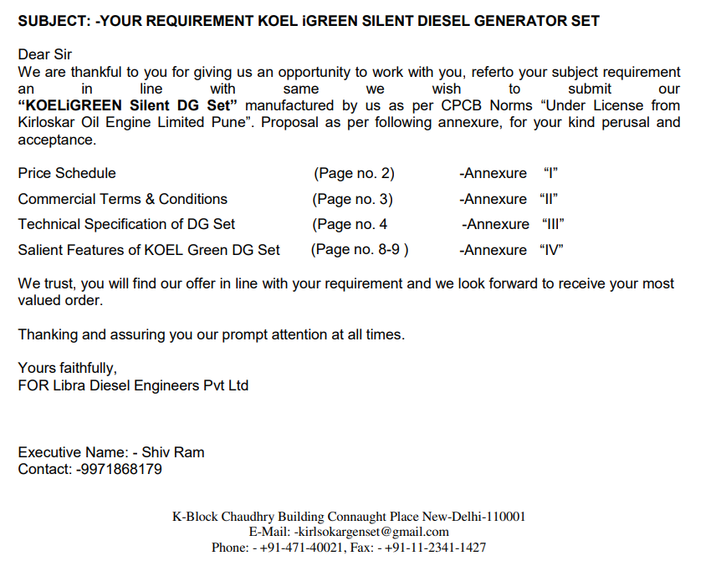

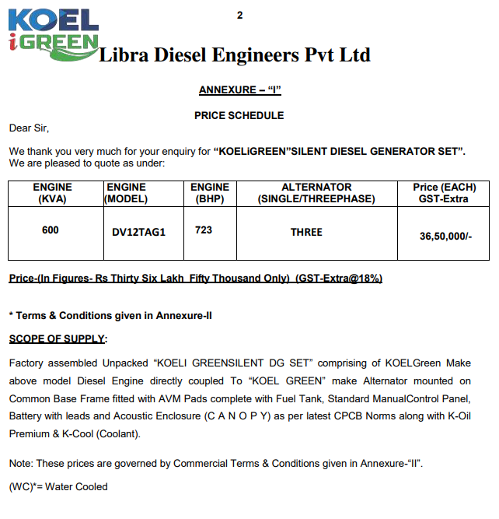

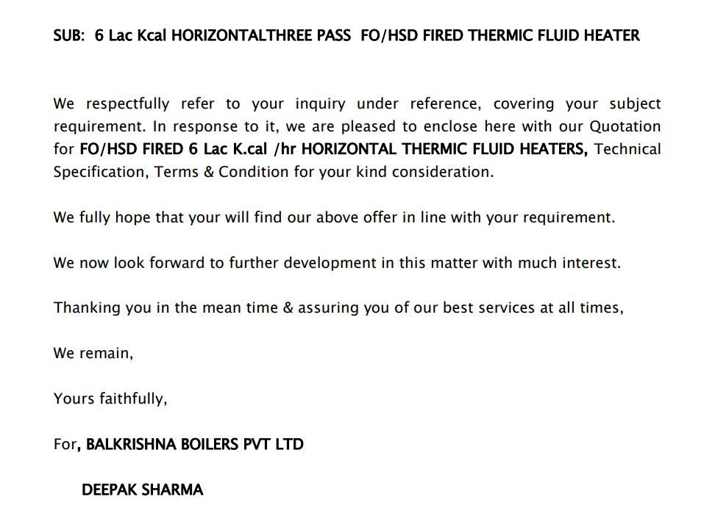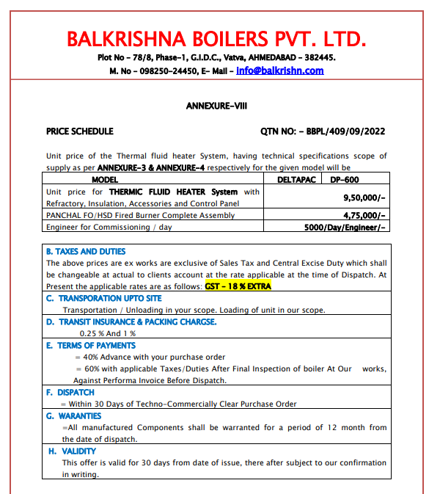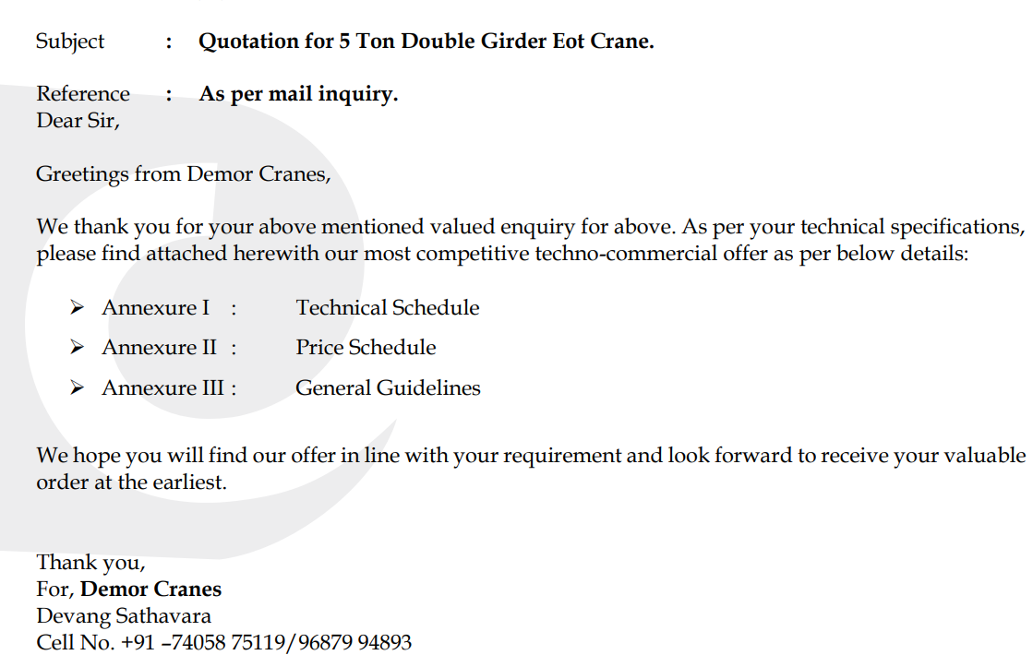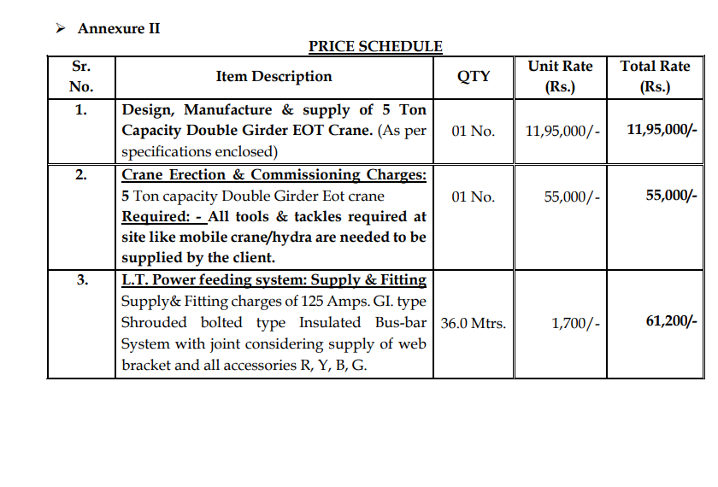

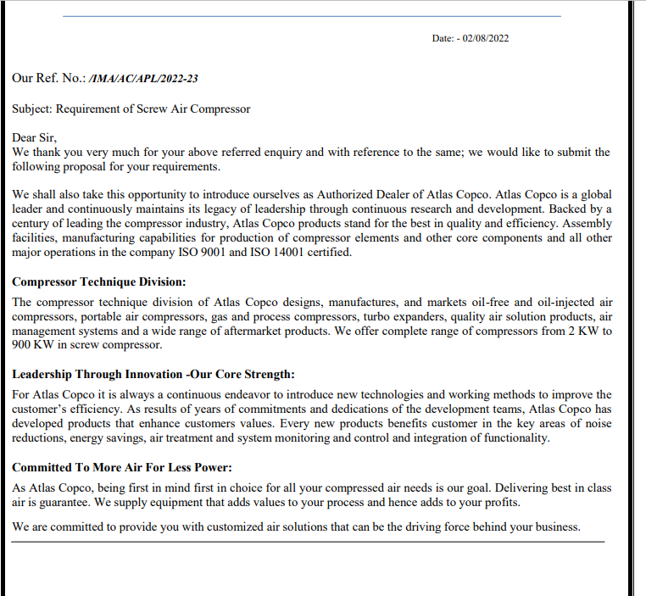

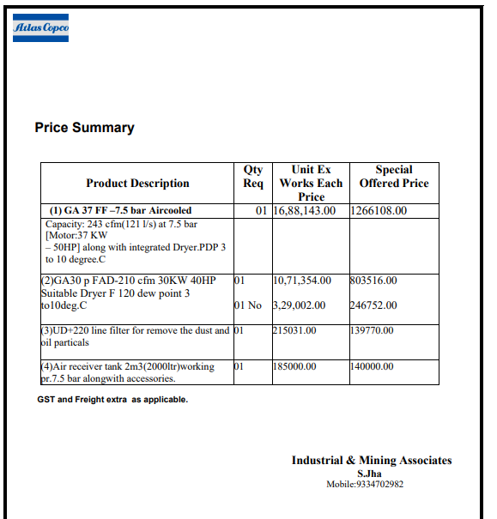

# ANNEXURE: - III (PROFORMA INVOICES)

